Health Loss in New Zealand 1990–2013
A report from the New Zealand Burden of Diseases, Injuries and Risk Factors Study

Acknowledgements
This report was written and the analyses were completed by Martin Tobias (Health and Disability Intelligence, Ministry of Health).

The report is based on data from the Global Burden of Disease 2013 study, led by Professor Christopher Murray and colleagues at the Institute for Health Metrics and Evaluation, University of Washington, Seattle. Population and life expectancy data was sourced from Statistics New Zealand.

The author acknowledges the many people within the Ministry of Health and beyond who provided New Zealand data for the Global Burden of Disease 2013 study, and who peer reviewed this report.
Citation: Ministry of Health. 2016. Health Loss in New Zealand 1990–2013:
A report from the New Zealand Burden of Diseases, Injuries and Risk Factors Study. Wellington: Ministry of Health.
Published in August 2016
by the Ministry of Health
PO Box 5013, Wellington 6140, New Zealand
ISBN 978-0-947515-39-3 (online)
HP 6453
This document is available at health.govt.nz
This work is licensed under the Creative Commons Attribution 4.0 International licence. In essence, you are free to: share ie, copy and redistribute the material in any medium or format; adapt ie, remix, transform and build upon the material. You must give appropriate credit, provide a link to the licence and indicate if changes were made.

Foreword
The New Zealand Burden of Diseases, Injuries and Risk Factors is a systematic analysis of health loss experienced by New Zealanders of all ages and both sexes. Health loss is an internationally accepted measure of how much healthy life is lost due to early death, illness or disability.

This important and influential report on health loss in New Zealand makes it possible to see the big picture: to understand the major causes impacting on health outcomes for each age by sex group, and to compare the relative impacts on health of different diseases, injuries and risk factors.

It provides an evidence base for the refreshed New Zealand Health Strategy – a strategy that will guide the health and disability sector over the next 10 years.

This report, and in particular its executive summary (pages ix–x), gives all of us in the health and disability sector – policy makers, funders, health planners, researchers, front-line providers – a clear outline of New Zealand’s achievements over the past quarter century and the challenges we face over the next decade.

New Zealanders’ health is improving, but not all age groups are benefiting equally. Inequalities in health outcomes still persist between genders, generations, ethnic and socioeconomic groups.

The report enables us to understand the degree to which different risk factors contribute to health loss – this is particularly important from the point of view of prevention. Also, by comparing progress in health expectancy with that in full life expectancy we can see whether New Zealand is succeeding in adding ‘life to years’ as well as ‘years to life’: whether people are not only living longer but are living longer in good health. This question is becoming critical as we enter a period of rapid population ageing with an accompanying rise in long-term conditions (multi-morbidity), frailty and disability.

The report finds that 88% of health loss in this country is now caused by long-term mental and physical conditions (non-communicable diseases), while 8% is attributable to injuries and 4% to infectious diseases, nutritional deficiencies and neonatal disorders. It tells us, among other things, that improving the health of future cohorts of older people will be critical; that transitioning the health system to respond to people with multiple long-term conditions will be a key challenge; that mental illness and dementia are growing challenges; and that better prevention of long-term conditions can bring major benefits.

It affirms the focus in the refreshed New Zealand Health Strategy on all New Zealanders’ life-journeys and on them living well, staying well and getting well. It gives us valuable pointers as we implement the Strategy’s roadmap of actions. In short, it gives all in the sector a common evidence base on which to build our response to these challenges as one team.

This broad picture of health loss, and its regular updates, will continue to inform decisions on resource allocation, priority setting, and investment in health services and prevention programmes.

As a sector we need to grow our capability to measure, both locally and nationally, the contribution of our interventions and services to reducing health loss for all New Zealanders. Recent organisational changes in Ministry of Health structures and accountabilities are designed to support this development.

Comments on this report are welcomed and should be addressed to HDI@moh.govt.nz

Chai Chuah
Director-General of Health
Ministry of Health
July 2016
Contents
Foreword iii
Executive summary ix
Introduction 1
Background 1
Objectives 1
Key findings 3
Health loss from all causes 3
Disability and epidemiological transitions 3
Health loss by condition group 3
Health loss from specific causes 4
Health loss attributable to risk factors 5
Health expectancy and the compression of morbidity 6
International comparisons 6
Health loss in New Zealand 1990–2013: all causes 7
Older people make up one-eighth of the population but experience over one-third of all health loss 7
Health loss is increasing, but the rate of health loss is falling 8
Health has improved least for youth and young adults 9
New Zealand has undergone a ‘disability transition’ 10
Causes of health loss: condition groups 11
Neuropsychiatric disorders are the leading cause of health loss among condition groups, overall and in females 11
Birth defects and pre-transitional disorders are still important in childhood 13
The burden of neuropsychiatric and musculoskeletal disorders is increasing 14
New Zealand is well advanced along the epidemiological transition 15
Causes of health loss: specific diseases and injuries 17
Health loss is heavily concentrated into a small number of diseases and injuries 17
Diabetes and dementia have advanced most in rank 18
Back disorders are the leading specific condition from age 15–64 years 20
The diabetes burden is no longer increasing (once adjusted for demographic drivers) 22
The mesothelioma epidemic is peaking 23
Risks to health: health losses caused by risk clusters 25
Over one-third of all health loss is potentially preventable 26
Health impacts of all risk clusters are falling 27
Risks to health: health losses attributable to specific risk factors 28
Dietary risks are the leading cause of health loss 28
Burden caused by use of illegal psychoactive drugs is low but increasing 29
Health expectancy and the compression of morbidity 32
International comparisons 34
Current level of health loss 34
Trends in health loss 35
Disability transition 36
Epidemiological transition 37
Contribution of different causes to health loss 38
Health expectancy, life expectancy and the compression of morbidity 40
Next steps 41
Using the NZBD to inform policy and planning 41
Future monitoring of health loss and health expectancy 42
Glossary 43
Appendices
Appendix 1: Further information 45
Appendix 2: Global Burden of Disease methods 46
Appendix 3: New Zealand data sources 51

List of tables
Table 1: Condition groups used in analysis 11
Table 2: Contribution of top two leading condition groups to health loss (% total DALYs), by lifecycle stage, 2013 13
Table 3: Contribution of top 10 leading conditions to health loss (% total DALYs), by lifecycle stage, 2013 21
Table 4: Risk clusters used in analysis 25
Table 5: Health expectancy and life expectancy at birth, 1990–2013 33
Table 6: Health expectancy and life expectancy at birth, selected countries, 1990 and 2013 40
Table 7: Absolute and relative compression of morbidity, selected countries,
1990–2013 40
Table A1: Administrative data used in GBD 2013 51
Table A2: Survey data used in GBD 2013 51
Table A3: Administrative data not yet used extensively for GBD 52
Table A4: Survey data not yet used extensively for GBD 52
Table A5: Other data sources used to varying extents for GBD 2013 53

List of figures
Figure 1: Share of total DALYs, by lifecycle stage (%), 2013 7
Figure 2: Age-specific DALY rates per 1000, 2013 8
Figure 3: Total DALYs, 1990–2013 8
Figure 4: Age-standardised total DALY rate per 1000, 1990–2015 9
Figure 5: Fall in DALY rates, by lifecycle stage (%), 1990–2013 9
Figure 6: Contribution of YLD to health loss, whole population (% total DALYs),
1990–2013 10
Figure 7: All-cause YLL and YLD age-standardised rates per 1000, whole population, 1990–2013 10
Figure 8: Contribution of condition groups to health loss (% total DALYs), 2013 12
Figure 9: Age-standardised DALY rate, condition groups, 1990–2015 14
Figure 10: Contribution of pre-transitional disorders to health loss (% total DALYs), 1990–2015 15
Figure 11: Contribution of high-level cause groups to health loss (% total DALYs), 1990 and 2013 16
Figure 12: Contribution of leading major specific conditions to health loss (% total DALYs), by gender, 2013 18
Figure 13: Contribution of ‘top 20’ leading major specific conditions to health loss (% total DALYs), whole of population, by gender, 1990 and 2013 19
Figure 14: Age-standardised DALY rate per 1000, selected conditions, 1990–2015 22
Figure 15: Age-standardised DALY rate per 1000, selected cancers, 1990–2015 23
Figure 16: Age-standardised DALY rate per 10,000, mesothelioma, 1990–2015 24
Figure 17: Health losses caused by risk clusters (% total DALYs), 2013 26
Figure 18: Age-standardised DALY rate per 1000 attributable to risk clusters,
1990–2015 27
Figure 19: Health losses caused by selected risk factors (% total DALYs), 2013 29
Figure 20: Age-standardised attributable DALY rates, selected risk factors, 1990–2015 30
Figure 21: Health loss attributable to BMI and tobacco use, 1990–2015 30
Figure 22: Obesity prevalence (age-standardised rate per 100) and BMI attributable burden (age-standardised attributable DALY rate per 1000) among adults, 1990–2015 31
Figure 23: Health loss, by peer group country (all-cause DALY age-standardised rate), 2013 34
Figure 24: Percentage change in age-standardised, all-cause DALY rate, by peer group country, 1990–2013 35
Figure 25: Extent of disability transition (YLD as % total DALYs), by peer group country, 2013 36
Figure 26: Extent of epidemiological transition (pre-transitional disorders burden as % total DALYs), by peer group country, 2013 37
Figure 27: Health loss from selected conditions, by selected peer group countries (age-standardised DALY rates), 2013 38
Figure 28: Potentially preventable proportion of health loss, by peer group country (% total DALYs), 2013 39

Executive summary
Burden of disease information is widely used internationally as evidence for strategic health policy. Information on the levels and trends in health loss and health expectancy by age, sex, cause, year and country provides the ‘big picture’ of health need and how well a health system is performing.

Two key metrics employed in this report are the disability-adjusted life year (DALY) and health-adjusted life expectancy (health expectancy). The DALY is the unit of health loss. One DALY represents the loss of one year lived in full health. DALYs integrate health losses from premature mortality (years of life lost, YLL) and years lived with disability adjusted for severity (YLD). Health expectancy is a generalisation of life expectancy that takes account of time lived in different health states, defined by level of functioning (disability). So health expectancy can be thought of as the number of years the average person can expect to live in full health.

The New Zealand Burden of Diseases, Injuries and Risk Factors extracted data from the Ministry of Health’s national data collections, health surveys and other sources. The Institute for Health Metrics and Evaluation, University of Washington provided statistical models and standards, as part of the Global Burden of Disease 2013 study.

Key findings are summarised below (and in more detail on pages 3–6).
- Health is improving: New Zealanders are living longer, and are living longer in good health (ie, both life expectancy and health expectancy are increasing). Health loss, measured in DALYs, is declining by an estimated 1.2% per year, once adjusted for changes in population size and age structure – a major achievement for the health and wider social sectors. Yet because the population is growing and ageing, the absolute number of DALYs is still increasing. This finding suggests that improvements in health do not necessarily reduce health care expenditure.
- However, not all age groups are benefiting equally: The rate of fall in DALYs for youth and young adults, 20% and 13% from 1990–2013 respectively, is substantially less than for other age groups, for whom the fall ranges from 24–36%.
- New Zealand is far advanced along the ‘epidemiological transition’: For the population as a whole, less than 4% of health loss still results from pre-transitional causes (common infectious diseases, nutritional deficiency disorders and neonatal disorders). In contrast, 88% of health loss is now caused by non-communicable diseases (NCDs – ie, long-term mental and physical conditions) and 8% is attributable to injuries.
- New Zealand is undergoing a ‘disability transition’: The epidemiological transition described above is also reflected in a disability transition. Disability (defined here in terms of non-fatal health loss, measured in YLD) now accounts for over half of the total health loss experienced by the population as a whole (52% of total DALYs in 2013).
- Morbidity (ill health) is expanding: We may be living longer, and living longer in good health, but we are also living longer in poor health. Put another way, only 70–80% of the years of life gained over the past quarter century have been years lived in good health: our health system and wider society have proved more adept at preventing early death than at avoiding or ameliorating morbidity. A greater focus on addressing the impact of non-fatal disabling conditions, whether through prevention or improved management, will enable people to live more of their ‘extra’ years of life in full health.
- Improving the health of future cohorts of older people will be critical: An ageing population will increase demand pressure on the health system, but the level of this impact will depend on how healthy future cohorts of older people are. As we progress through the epidemiological and disability transitions, it appears that an increasing proportion of frail older people will survive for longer with multi-morbidity and associated disability.
- Transitioning the health system to respond to multi-morbidity is a key challenge: The evidence in this report shows that all-cause DALY rates increase exponentially as people age, to reach very high levels in the rapidly growing 75+ years age group. These high rates of health loss reflect the steeply increasing prevalence of multiple long-term conditions with advancing age. A health system oriented to managing single diseases individually will struggle to cope.
- Mental health and dementia are growing challenges: Neuropsychiatric disorders are now the leading cause of health loss, accounting for 19% of total DALYs. Dementia has risen to become the fifth-ranked cause of health loss in females and thirteenth in males. Providing better care for people living with mental illness, addiction and dementia – including care for their physical health – is a growing challenge for the health and social sectors.
- The burden of musculoskeletal disorders is increasing: Health loss from musculoskeletal disorders, including neck and lower back disorders and arthritis, is increasing – partly because of rising rates of obesity. Musculoskeletal disorders already account for 13% of all health loss.
- At the same time, addressing cardiovascular disorders is an unfinished agenda: Although the coronary heart disease epidemic peaked in the 1970s, this disease still accounts for over 8% of all health lost. About 70–80% of this burden is potentially avoidable through a combination of prevention and treatment. Stroke also continues to account for substantial health loss (over 3%) and again most of this loss is potentially avoidable with existing technologies.
- Burden is becoming decoupled from prevalence: Many long-term conditions, including diabetes, are increasing in prevalence yet their age adjusted per capita burdens are stabilising or even falling. This decoupling of burden from prevalence applies also to risk factors, including obesity. Decoupling reflects the complex interactions of disease or risk factor prevalence with demographic trends, joint exposure to other risk factors or diseases, and improvements in clinical care that have reduced disease progression and case fatality.
- Strengthening prevention could bring major benefits: The opportunity to achieve health gains by reducing exposure to hazards remains strong. Potentially, over one-third of all health loss is preventable. Beyond the benefits to health, a strengthened focus on prevention could help the health system to become more sustainable clinically, fiscally and economically (by reducing demand pressure), depending on the affordability and effectiveness of relevant interventions. Although tobacco use has been declining for almost half a century, its impact on health loss is still large (contributing just under 9% of total DALYs), and the ‘tobacco end game’ remains an important policy objective. Even greater challenges are to address diet, physical inactivity and the obesity epidemic – challenges that go well beyond the health system and will require not only a whole of government but also a whole of society response.
- Internationally, New Zealand is doing well, but inequalities persist: Over the past quarter century New Zealand achieved one of the fastest rates of decline in health loss from all causes combined among high-income countries, although we still have relatively high DALY rates from coronary heart disease, chronic obstructive pulmonary disease, chronic kidney disease, bowel cancer and self-harm. Yet within New Zealand, serious inequalities in health outcomes persist between different genders, generations, ethnic and socioeconomic groups. While not all of these inequalities could not be analysed in the current burden of disease assessment because of data limitations, disaggregation of the data at least by Māori and non-Māori ethnicity is planned for the next edition of this report.

Introduction

Background
Burden of disease information is widely used throughout the world as a valid and valued input to national and global health policy. Information on the levels and trends in health loss by age, sex, cause, year and country paints the ‘big picture’. This provides a frame within which it is possible to systematically set priorities and to design and evaluate strategic policies.

The Institute for Health Metrics and Evaluation (IHME), University of Washington has recently published global, regional and country estimates of the burden of disease for 1990–2013 (Global Burden of Disease 2013 – see Appendix 1 for further information). This database can be used to extract and compile the results for New Zealand and relevant peer group countries, providing a useful source of information for a range of current and future policy needs.

In future (ie, beginning with GBD 2016), IHME and the Ministry of Health will conduct this analysis jointly. The analysis will also include two additional ‘countries’ – Māori New Zealand and non-Māori New Zealand – so that indigenous inequalities can be tracked. However, for the current (2013) analysis, ethnic groups cannot be compared.

This report on the New Zealand Burden of Diseases, Injuries and Risk Factors (NZBD) 1990–2013 supersedes all earlier NZBD reports, which were based on less up-to-date methods and data. This report (which includes re-calculated estimates for all earlier years back to 1990) therefore makes all previous reports obsolete.

Objectives
1. Update estimates of health loss in New Zealand, by age, sex, year and cause.
2. Update estimates of health expectancy (health-adjusted life expectancy) by sex and year.
3. Benchmark New Zealand against an appropriate set of peer group countries in regard to health loss, health expectancy and the compression or expansion of morbidity.

Methods used for this report are summarised in Appendix 2 (pages 46–50).

The DALY metric
The disability-adjusted life year (DALY) is the unit of health loss. It integrates health lost from premature mortality (years of life lost, YLL) and health lost from morbidity (years lived with disability adjusted for severity, YLD).
Non-fatal health loss (morbidity or disability) is adjusted for severity on a 0–1 scale, where 0 represents full health (ie, no health loss) and 1 represents complete health loss (ie, equivalent to being dead).
For this reason, YLDs and YLLs are commensurate and can simply be added together to estimate DALYs. So one DALY represents the loss of one year lived in full health:
DALY = YLL + YLD
Note that the DALYs lost by a population represent the residual health loss experienced by that population in the index year – that is, the health loss that remains despite consumption of health care (including prevention, treatment, rehabilitation and palliation services).
For definitions of other technical terms used in this report, please see the Glossary (pages 43–44).

Key findings

Health loss from all causes
- New Zealanders lose about 1 million disability-adjusted life years (DALYs) per year.
- Adjusting for population size and age structure, males lose 15% more health than females.
- Older people make up 12% of the population but experience one-third of all health lost.
- By contrast, children make up 20% of the population but account for only 7% of all health lost.
- Absolute health loss is increasing slowly over time, from 950,000 DALYs in 1990 to 1,100,000 DALYs in 2013 for the whole population.
- However, once adjusted for growth in population size and structural ageing of the population, health loss has been steadily declining over the past quarter century, by 1.2% per year on average.
- The health of youth and young adults has been improving more slowly than that of other age groups.

Disability and epidemiological transitions
- Premature mortality was the main cause of health loss in New Zealand until 2000–2005.
- Since 2000–2005, however, morbidity (non-fatal outcomes – years lived with disability, YLD) has overtaken mortality (fatal outcomes – years of life lost, YLL) as the main cause of health loss. This change is the ‘disability transition’.
- The reason for this transition is that premature mortality (the YLL rate) has declined steadily, while morbidity (the YLD rate) has remained fairly stable.
- In other words, over the past quarter century New Zealand has been more successful in preventing early death than in preventing or ameliorating non-fatal illness or disability.
- Underlying these trends in mortality and morbidity has been another transition: long-term mental and physical conditions (the so-called non-communicable diseases or NCDs) have displaced infectious diseases, nutritional deficiency diseases, and maternal and neonatal disorders (the so-called ‘pre-transitional disorders’) as the leading causes of health loss. New Zealand is well advanced along this ‘epidemiological transition’: pre-transitional disorders now account for less than 4% of all health lost by the population as a whole.
- By contrast, NCDs now account for 88% of health loss (up from 82% in 1990) and injuries for the remaining 8% (down from 12% in 1990).

Health loss by condition group
- Among condition groups, neuropsychiatric disorders are now the leading cause of health loss in the population as a whole, accounting for 19% of total DALYs.
- Cancers account for 17% of health loss; cardiovascular diseases including diabetes for 17%; musculoskeletal disorders for 13%; and the complex of chronic lung, liver and kidney disease for almost 10%.
- Major sex differences are found for: injury, which is a more important cause of health loss among males (11% of total DALYs versus 5% for females); and neuropsychiatric disorders, which impact more on females (22% of total DALYs versus 16% for males).
- Causes of health loss differ over the lifecycle. For children, pre-transitional disorders (mainly infectious diseases and neonatal disorders) and birth defects are still by far the leading causes of health loss among the condition groups, accounting for over 40% of all health lost.
- Injuries are ranked second in both children and youth, accounting for 10% and 23% of health loss respectively.
- Neuropsychiatric disorders are the leading cause of health loss in both youth and young adults (ie, from ages 15–44 years), accounting for one-third of all health lost in both groups.
- The major chronic physical disorders – cancers, cardiovascular disorders and musculoskeletal disorders – are the main causes of health loss from middle age on, although neuropsychiatric disorders continue to be important.
- Adjusting for demographic trends, health loss from cardiovascular disorders, injuries and pre-transitional conditions is declining steeply; health loss from cancers and other NCDs is declining slowly; while health loss from neuropsychiatric and musculoskeletal disorders is increasing slowly.
- As a result, neuropsychiatric disorders overtook cardiovascular disorders and cancers in or around the year 2000 to become the leading cause of health loss among the condition groups. Cancer in its turn overtook cardiovascular disease in or around the year 2010 to become the second-ranked cause, relegating cardiovascular disease to third place.

Health loss from specific causes
- Among males, coronary heart disease (CHD) is the leading specific cause of health loss in the population as a whole, accounting for 10% of all health lost, followed by back disorders (mainly lower back pain and neck pain) (8%).
- This rank order is reversed among females, with back disorders ranked first (10%) and CHD second (6%).
- The remaining ‘top five’ conditions are (in order): chronic obstructive pulmonary disease (COPD), lung cancer and transport injury in males; and depressive disorders, COPD and dementia in females.
- Although not in the top five, diabetes has advanced the furthest in rank since 1990: from 16th to 7th for males; and from 22nd to 12th for females.
- Dementia has also risen rapidly through the ranks: from 22nd to 13th for males; and from 11th to 5th for females.
- The contribution of specific causes to health loss varies widely by lifecycle stage. Among children, birth defects are the leading specific cause (13.4%), followed by neonatal disorders (13.1%).
- Back disorders are the leading specific cause of health loss from age 15–64 years.
- Other important causes among youth and young adults are transport injuries, self-harm, addiction disorders, and anxiety and depressive disorders.
- Back disorders and depressive disorders continue to be leading causes of health loss in middle age, but are joined in the top five by CHD, lung cancer and COPD.
- Among older people, neither back disorders nor depressive disorders rank in the top five. Instead, CHD, dementia, lung cancer, COPD and stroke comprise the leading specific causes of health loss in this age group.
- Despite rising through the ranks, health loss from diabetes is no longer increasing once demographic trends are taken into account. Burden has become decoupled from prevalence (which is still increasing), reflecting more effective health care for this disease.
- Rates of health loss (adjusted, where relevant, for trends in population age structure) are also decreasing for most other major specific causes. The steepest fall (71%) has been for health loss from sudden unexpected death in infancy (SUDI), most probably reflecting the change in preferred sleeping position for infants since the early 1990s.

Health loss attributable to risk factors
- Over one-third (38%) of all health lost by the New Zealand population as a whole is caused by known modifiable risk factors (ie, is potentially preventable through reducing exposure to these hazards). This estimate is adjusted for overlaps, whereby one risk factor mediates the impact of another.
- Behavioural risks account for 25% of all health lost, biological risks for 19%, and occupational and environmental hazards for 4%. (These proportions cannot simply be added together because of mediation.)
- Adjusting for demographic trends, health losses from all risk clusters have been falling over the past quarter century (by 2.2% per year for behavioural, 2.0% for biological and 1.5% for occupational and environmental clusters).
- Dietary risks are the leading cause of health loss among specific risk factors (accounting for 9.4% of total DALYs). However, diet is actually a composite risk factor. Within diet, low fruit and vegetable intake and high salt intake are the leading risks, accounting for 2.5% and 1.3% of total DALYs respectively.
- High body mass index (BMI) has probably now overtaken tobacco as a risk factor. Higher than optimal BMI might now account for as much as 9.2% of all health lost, compared with 8.7% for tobacco.
- High blood pressure is another major cause of health loss, accounting for 8.3% of total DALYs.
- High blood glucose (including both diabetes and so-called ‘pre-diabetes’) accounts for 5.7% of all health lost. High total blood cholesterol accounts for 4.5%.
- Alcohol accounts for just under 4% of health loss, net of its protective effects against cardiovascular disease. Illegal drug use accounts for 2.3%.
- Low levels of physical activity are estimated to account for approximately 3% of all health lost.
- The burden caused by all major specific risk factors is declining (once adjusted for demographic trends). The sole exception is illegal drug use, for which the attributable burden is increasing slowly.
- The burdens caused by high BMI and high blood glucose are falling (although slowly), once adjusted for trends in population size and age structure. This trend has occurred even though the prevalence of these risk factors continues to increase. The main reasons for this decoupling of burden from prevalence are that (1) health care has improved for some of the diseases that these risk factors act through (the ‘linked conditions’) and (2) the total burdens of these linked conditions have fallen because exposure to other risk factors (such as tobacco) has declined.

Health expectancy and the compression of morbidity
- Both life expectancy and health expectancy have increased over the past quarter century. This trend is a major success story for the health and social sectors.
- However, life expectancy has increased faster (by 6.1 years for males and 4.5 years for females) than health expectancy (which has increased by 4.9 years for males and 3.3 years for females).
- In other words, of the 6.1 years added to their life expectancy over the past quarter century, males lived 4.9 years or 80% in good health; the female percentage is lower (74%).
- So the gap between life and health expectancy has increased in absolute terms: from 9.2 years (1990) to 10.4 years (2013) for males; and from 11.0 to 12.2 years for females over the same period. That is, morbidity has expanded in absolute terms.
- At the same time, the ratio of health to life expectancy may have declined, yet only slightly (and not to a level of statistical significance). That is, whether morbidity has also expanded in relative terms is not clear. Certainly there is as yet no evidence of the reverse trend: compression of morbidity, whereby people spend a higher proportion of their (longer) lives in good health.

International comparisons
- New Zealand’s level of health loss from all causes (adjusted for population size and age structure) is similar to that of most peer group countries (see page 34 for the list of peer group countries).
- However, over the past quarter century, New Zealand has enjoyed one of the fastest rates of decline in health loss from all causes combined.
- All peer group countries, including New Zealand, are well advanced in making their disability and epidemiological transitions.
- New Zealand has a relatively high rate of health loss from CHD, COPD, chronic kidney disease, bowel cancer and self-harm, compared with the peer group countries, although not all differences are statistically significant at the conventional 95% confidence level.
- Health loss caused by all risk factors combined (the ‘potentially preventable proportion’) is about average for New Zealand compared with the peer group countries.
- Life expectancy and health expectancy at birth increased in all peer group countries over the past quarter century. New Zealand’s increases were generally greater than the peer group average, although not all differences were statistically significant.
- For all peer group countries, morbidity expanded over the past quarter century when measured on an absolute scale (that is, life expectancy grew faster than health expectancy). New Zealand’s morbidity expansion was about average among the peer group countries.

Health loss in New Zealand 1990–2013: all causes

Older people make up one-eighth of the population but experience over one-third of all health loss
New Zealanders lose about 1 million years of healthy life each year (1,092,000 DALYs in 2013), shared almost equally between males (51.5%) and females (48.5%). However, adjusting for differences in population size and age structure, males experience 15% more health loss than females (age-standardised DALY rates in 2013 of 225 per 1000 and 195 per 1000 respectively).

Figure 1: Share of total DALYs, by lifecycle stage (%), 2013
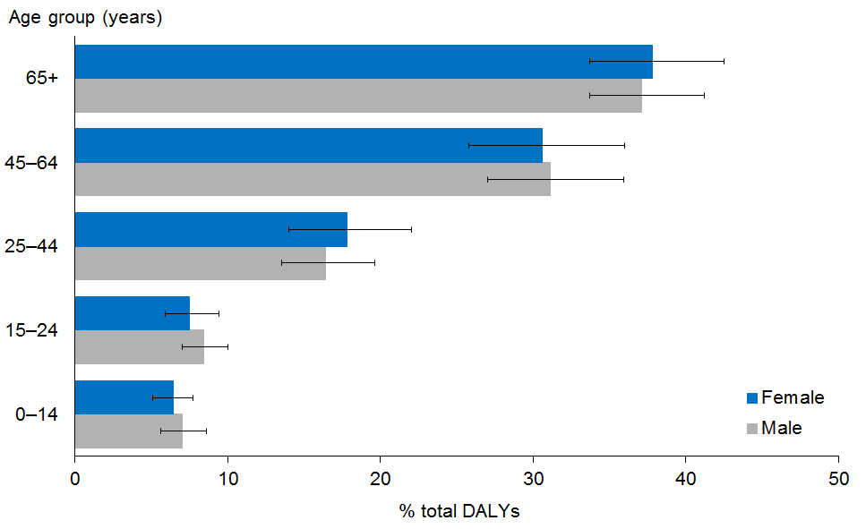

Age patterns of health loss are similar for males and females. Males experience slightly more health loss in childhood and youth, and females slightly more in old age and the reproductive years (young adulthood), although the differences are not statistically significant (Figure 1).

Children make up 20% of the population but account for only 7% of total health loss (of which almost half is contributed by the 0–4 years age group). In contrast, older people make up only 12% of the population but account for 37% of total DALYs. Of this share, over half (58%) is contributed by the 75+ years age group – which makes up only 43% of the older population.

Figure 2: Age-specific DALY rates per 1000, 2013
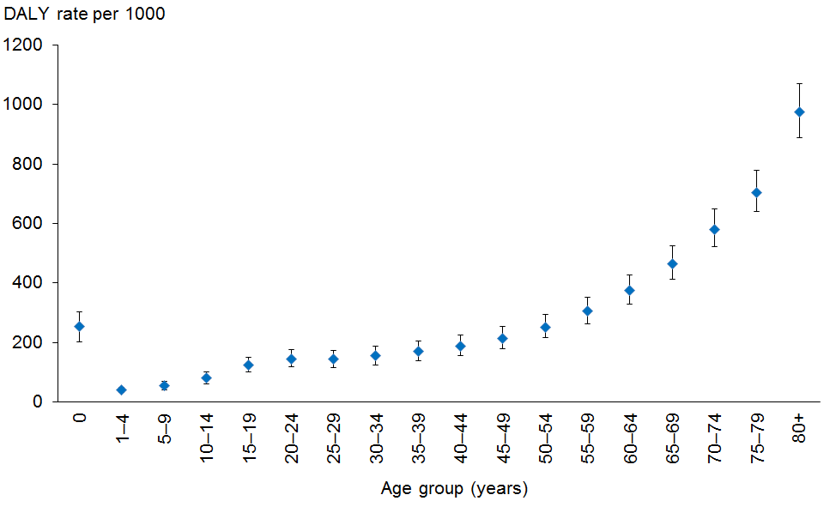

The rate of health loss is moderately high in infancy (255 DALYs per 1000 infants in 2013) and drops to low levels in childhood. It then rises exponentially to reach very high levels in old age (743 DALYs per 1000 older people) (Figure 2).

Health loss is increasing, but the rate of health loss is falling
Total health loss has increased slowly, from approximately 950,000 DALYs in 1990 to just under 1.1 million DALYs in 2013 (Figure 3), although this increase is not statistically significant.

However, once adjusted for trends in the size and age structure of the population, the rate of health loss has been steadily declining. It has fallen by 25% over the past 25 years, or an average of approximately 1.2% per year (Figure 4).

Figure 3: Total DALYs, 1990–2013
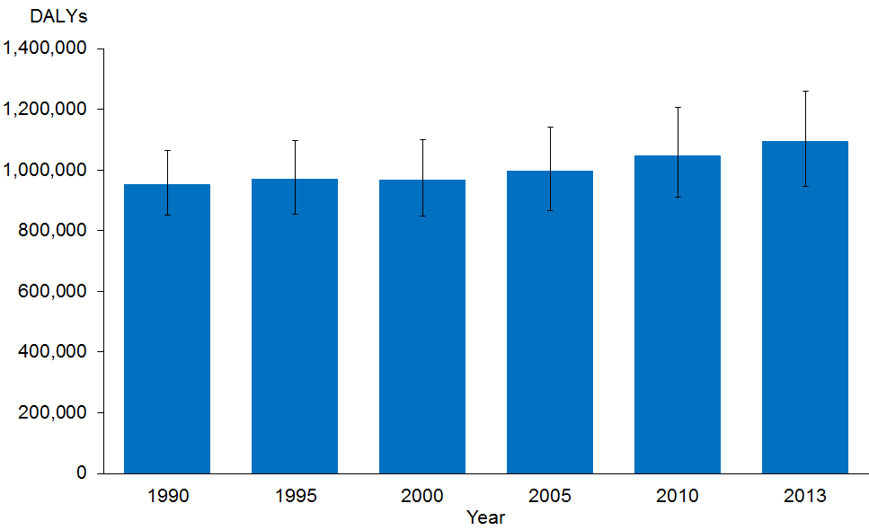

Figure 4: Age-standardised total DALY rate per 1000, 1990–2015
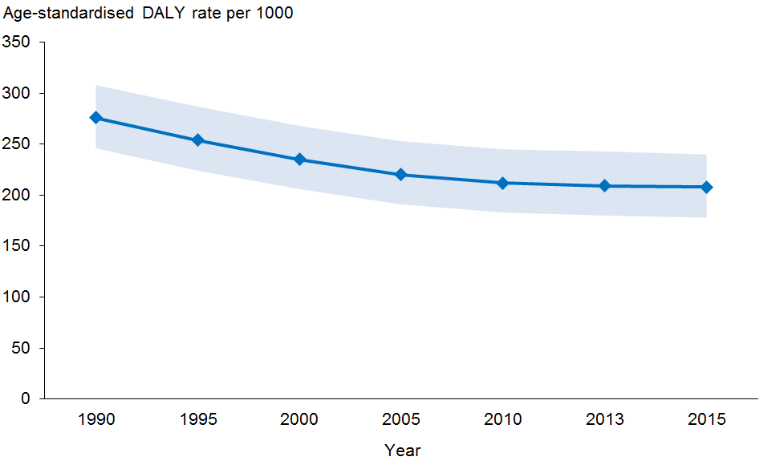
Rates age standardised by the direct method to the GBD model population.
Data has been projected to 2015 to provide equal time intervals.

Health has improved least for youth and young adults
All age groups have benefited from the fall in health loss, but not equally. Young adults and youth show smaller improvements (reduction in DALY rates over the past 25 years of 13% and 20% respectively) than other lifecycle stages (approximately 26–34%), although not all differences are statistically significant at the conventional 95% confidence level (Figure 5).

Figure 5: Fall in DALY rates, by lifecycle stage (%), 1990–2013
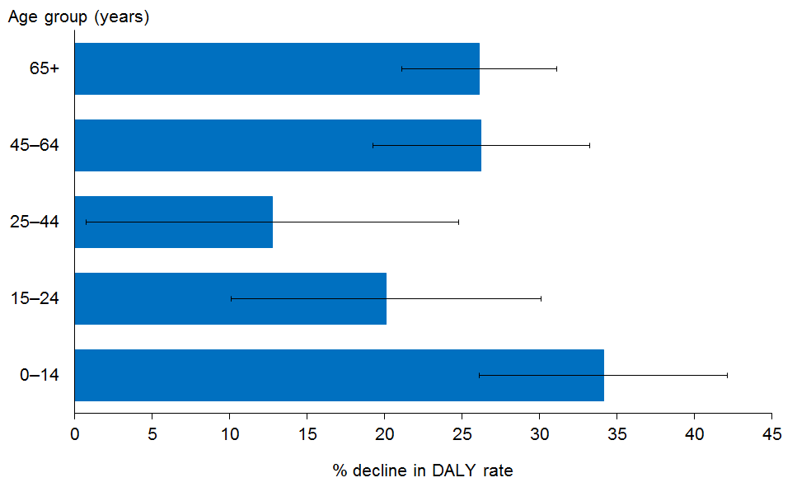

New Zealand has undergone a ‘disability transition’
Until the early years of the 21st century, premature mortality (early death) was the main cause of health loss. Over the period 2000–2004, however, morbidity (YLD) overtook mortality (YLL) as a cause of health loss (DALYs) – this is the ‘disability transition’ (Figure 6).

The reason for the transition is that the YLL rate has declined steadily, while the YLD rate has remained stable, once adjusted for population ageing (Figure 7). That is, New Zealand has been more successful in preventing premature mortality than in preventing or ameliorating ill health and disability.

Perhaps surprisingly, the morbidity contribution appears to have stabilised over the past decade, settling at just over half of total DALYs: the YLD contribution shows only a small increase from approximately 52% of total DALYs in 2005 to a projected 53% in 2015 (Figure 6).

Figure 6: Contribution of YLD to health loss, whole population (% total DALYs), 1990–2013
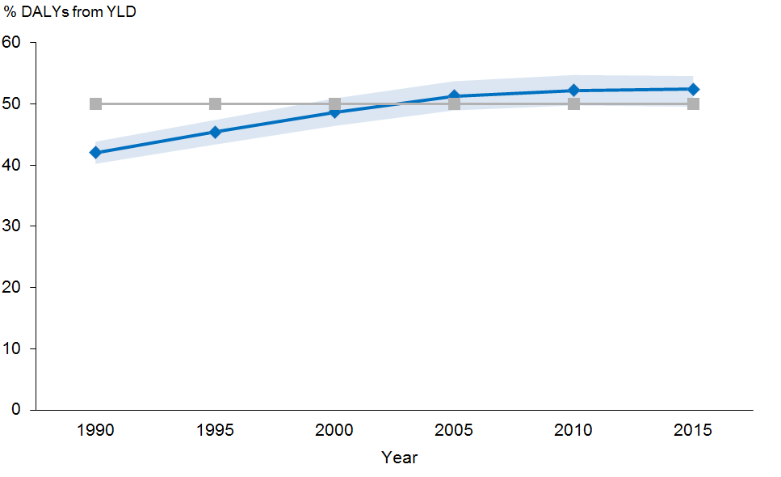
Data projected to 2015. Blue (dark) line = YLD; Grey (light) line = 50% gridline.

Figure 7: All-cause YLL and YLD age-standardised rates per 1000, whole population,
1990–2013
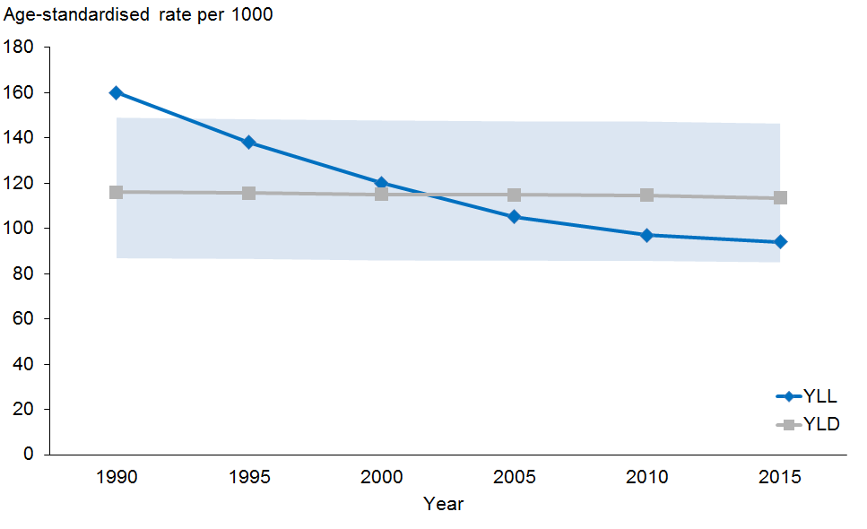

Causes of health loss: condition groups
All diseases and injuries have been mapped into eight condition groups, based on three criteria: organ system involved; pathophysiological mechanism; and medical discipline most involved in managing the condition (Table 1).

Table 1: Condition groups used in analysis
 | Condition group | Conditions included
1 | Cancer (CA) | Benign and malignant neoplasms
2 | Cardiovascular disorders and diabetes (CVDD) | Cardiac and vascular diseases; and diabetes mellitus (included here because most diabetes-related health loss is vascular in nature)
3 | Chronic lung, liver and kidney disease (CLLKD) | Chronic lung disease (asthma, chronic obstructive pulmonary disease (COPD), interstitial lung disease), chronic liver disease (cirrhosis) and chronic kidney disease (CKD, including diabetic nephropathy)
4 | Other non-communicable diseases (ONCD) | Skin disorders, disorders of vision and hearing, endocrine and related disorders except diabetes mellitus, digestive disorders, urological disorders, gynaecologic disorders, dental disorders
5 | Neuropsychiatric disorders (NP) | Neurological disorders, mental disorders and addiction disorders  (These conditions are grouped together because of the difficulty in separating disorders of the mind from disorders of the brain.)
6 | Musculoskeletal disorders (MSK) | Disorders of bone, joints, muscles and related structures, including chronic pain syndromes
7 | Maternal, neonatal, nutritional deficiency and infectious disorders (MNNI) | Maternal (obstetric) disorders, disorders of the neonatal period, micronutrient deficiency diseases, infectious diseases, and birth defects (congenital disorders)
8 | Injury (INJ) | Unintentional injuries and intentional injuries (ie, self-harm and interpersonal violence)

This classification gives priority to injuries, followed by cancers, infections, vascular disorders and finally organ systems. So, for example, rather than being classified as neuropsychiatric disorders, traumatic brain injury is classified under injury, brain cancer under cancer, meningitis under infection, and stroke under cardiovascular disorders. Alternative classifications may be used for specific purposes.

Neuropsychiatric disorders are the leading cause of health loss among condition groups, overall and in females
Just three condition groups account for over half (53%) of all health loss in the total New Zealand population in 2013: neuropsychiatric disorders (19%), cancers (17%) and cardiovascular diseases including diabetes (17%) (Figure 8). Musculoskeletal disorders account for approximately 13% and chronic lung, liver and kidney disease for almost 10% of health loss. Collectively, therefore, these five leading condition groups are responsible for over three-quarters (76%) of all health loss.

Figure 8: Contribution of condition groups to health loss (% total DALYs), 2013
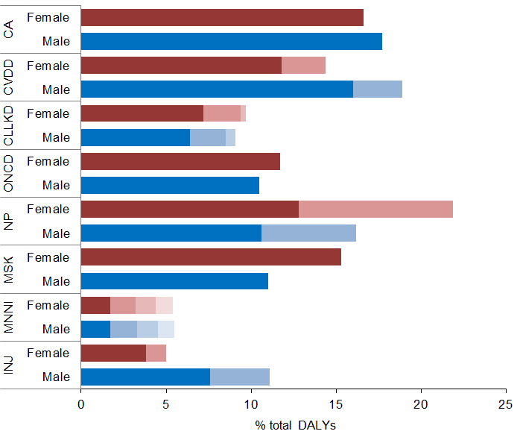
Key
CA = cancers
CVDD = cardiovascular disorders (dark shade) and diabetes (light shade)
CLLKD = chronic lung (dark shade), kidney (mid shade) and liver disease (light shade)
ONCD = other non-communicable diseases
NP = neuropsychiatric disorders: mental disorders (dark shade), neurological disorders including dementia (light shade)
MSK = musculoskeletal disorders
MNNI = birth defects, maternal and neonatal disorders, infectious disorders, nutritional deficiency disorders (in that order from left to right)
INJ = injuries, unintentional (dark shade) and intentional (light shade)
Note: Confidence intervals not shown for clarity of presentation.

Neuropsychiatric disorders are considered a single condition group because it is difficult to clearly separate disorders of the mind from disorders of the brain – although Figure 8 attempts to do so. Given this classification, mental disorders alone would account for 12% of total DALYs and neurological disorders (including dementia) for 7%.

The causal structure of health loss is fairly similar for both genders across condition groups. However, injury is a much more important cause of health loss among males (11% for males versus 5% for females), and neuropsychiatric disorders are a more important cause among females (22% for females versus 16% for males).

Birth defects and pre-transitional disorders are still important in childhood
In each lifecycle stage, the two leading condition groups collectively account for half or more of all health lost (Table 2).

Table 2: Contribution of top two leading condition groups to health loss (% total DALYs), by lifecycle stage, 2013
Ranking of condition group | Lifecycle stage (years)
 | Children  (0–14) | Youth  (15–24) | Young adults  (25–44) | Middle-aged adults  (45–64) | Older people  (65+)
First ranked | MNNI  (41%) | Neuropsychiatric  (35%) | Neuropsychiatric  (31%) | Cancer  (23%) | CVDD  (28%)
Second ranked | Injury  (10%) | Injury  (23%) | Musculoskeletal  (19%) | CVDD and MSK  (both 17%) | Cancer  (22%)
% is percentage of all-cause DALYs in age group. Confidence intervals not shown for clarity of presentation.
Key: MNNI = maternal, neonatal, nutritional deficiency and infectious disorders (so-called ‘pre-transitional disorders’) plus birth defects (congenital disorders); CVDD = cardiovascular disorders and diabetes; MSK = musculoskeletal disorders.

Maternal, neonatal, nutritional deficiency and infectious disorders plus birth defects are still by far the leading condition group in childhood. They account for more than 40% of all health lost by this age group, mostly in under-fives, in 2013. This is followed a long way behind by injury (intentional and unintentional) (10%).

Mental health is the main health challenge for youth: neuropsychiatric disorders account for over one-third (35%) of all health lost by this age group in 2013. Injury is again in second place, with just under one-quarter of total DALYs (23%) – by far the highest relative contribution of injury in any age group.

Similarly, neuropsychiatric disorders are the leading condition group in young adults, accounting for just under one-third (31%) of all health loss in this age group. However, musculoskeletal disorders are the second-ranked cause of health loss (19%), ahead of injuries (13%). Reproductive disorders are another important cause of health loss in young adult females, accounting for almost 4% of their DALYs.

In middle age, cancer is the major cause of health loss, accounting for just under one-quarter (23%) of all health loss. This is followed by cardiovascular disease (including diabetes) and, again, musculoskeletal disorders (both 17%). Neuropsychiatric disorders are ranked fourth (with 15% of total DALYs).

Cardiovascular disorders (including diabetes) are the main cause of health loss (among condition groups) in old age, responsible for 28% of all health loss in this age group in 2013. Cancer is in second place (with 22% of total health loss), followed by neuropsychiatric disorders (14%) and musculoskeletal disorders (9%).

The burden of neuropsychiatric and musculoskeletal disorders is increasing
After adjusting for trends in the size and age structure of the New Zealand population, the rate of health loss can be seen to have fallen steeply for cardiovascular disorders, MNNI disorders and injury over the past quarter century (Figure 9). The decline has been more gradual for cancers and ‘other non-communicable diseases’. By contrast, the rate of health loss has been increasing (though slowly) for neuropsychiatric and musculoskeletal disorders.

Figure 9: Age-standardised DALY rate, condition groups, 1990–2015
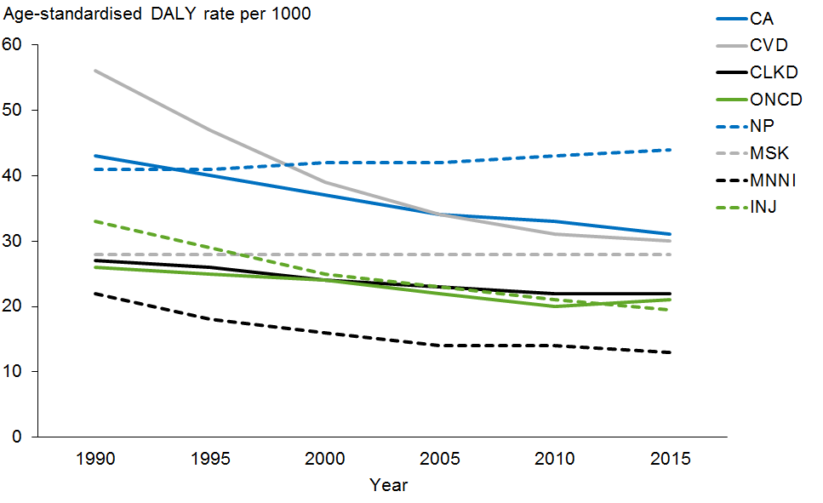

Key: CA = cancers; CVDD = cardiovascular disorders and diabetes; CLLKD = chronic lung, liver and kidney disease; ONCD = other non-communicable diseases; NP = neuropsychiatric disorders; MSK = musculoskeletal disorders; MNNI = maternal, neonatal, nutritional deficiency and infectious disorders plus birth defects; INJ = injuries, unintentional and intentional.
Note: Confidence intervals not shown for clarity of presentation.

As a result, neuropsychiatric disorders overtook cardiovascular disorders and cancers to become the leading cause of health loss (among condition groups) in the New Zealand population as a whole around or shortly before the year 2000. Cancer overtook cardiovascular disease to become the second-ranked cause around 2005–2010.

New Zealand is well advanced along the ‘epidemiological transition’
The epidemiological transition involves the decline of maternal and neonatal disorders, nutritional deficiencies and common infectious diseases (especially diarrhoea and pneumonia in under-fives) – the so-called ‘pre-transitional disorders’ – as the leading causes of health loss in the population as a whole, to be overtaken by long-term physical and mental conditions – the so-called ‘NCDs’ (non-communicable diseases). This process has happened over the long term, accompanying economic development and the demographic transition from a ‘high mortality, high fertility’ to a ‘low mortality, low fertility’ regime in all high-income countries – and indeed has been partly responsible for this demographic shift. How far along the epidemiological transition New Zealand has progressed can be gauged by assessing the trend in the contribution of MNNI disorders excluding birth defects (so-called ‘pre-transitional’ disorders) to total health loss.

Figure 10: Contribution of pre-transitional disorders to health loss (% total DALYs),
1990–2015
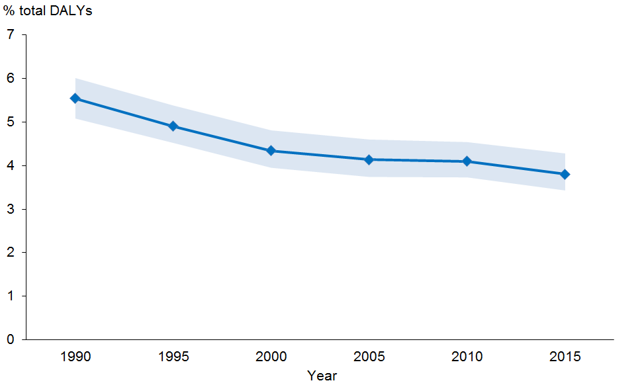
2015 value is extrapolated by fitting a mathematical model to the data.
Pre-transitional disorders are maternal, neonatal, nutritional deficiency and infectious disorders (ie, the MNNI condition group minus birth defects).

The percentage of all-cause health loss arising from ‘pre-transitional’ conditions has declined fairly steadily over the past quarter century. Already very low to begin with (at 5.5% in 1990), it had fallen by one-third to only 3.8% in 2013 (Figure 10).

By contrast, the burden of NCDs (long-term conditions) increased from 82.7% of total health loss in 1990 to 88.0% in 2013, while the contribution from injuries fell from 11.8% to 8.2% (Figure 11).

Figure 11: Contribution of high-level cause groups to health loss (% total DALYs), 1990 and 2013
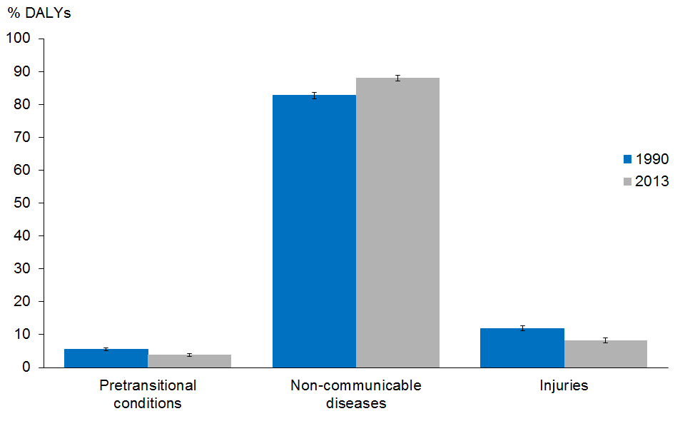

Causes of health loss: specific diseases and injuries
This section describes the contribution of specific diseases and injuries to health loss, regardless of which condition group they belong to. Rather than reporting health loss from all 306 conditions included in the data set, however, it focuses on ‘major’ conditions only, defined as diseases or injuries accounting for more than 1% of total health loss (ie, 10,000 DALYs).

Health loss is heavily concentrated into a small number of diseases and injuries
Of the 306 conditions included in the data set, 31 (approximately 10%) are responsible for three-quarters of all health loss, and 26 of these conditions are common to both genders. Twelve conditions account for 50% of health loss and just four are responsible for 25% of all health loss in each gender, although the specific conditions involved differ for males and females
(Figure 12).

Among males, the first-ranked condition, coronary heart disease (CHD), accounts for 10% of all health loss, followed by back disorders (mainly lower back pain and neck pain) (8%). This rank order is reversed among females, with back disorders ranked first (10%) and CHD second (6%). The remaining ‘top five’ conditions are (in order) COPD, lung cancer and transport injury in males; and depressive disorders, COPD and dementia in females. So three of the top five conditions – CHD, back disorders and COPD – are common to both genders.

Lung cancer, transport injury, self-harm and addiction disorders are more highly ranked among males, while depressive disorders, anxiety disorders, dementia and arthritis are more highly ranked among females. Most other disorders have similar rankings – and percentage shares – in both genders.

Figure 12: Contribution of leading major specific conditions to health loss (% total DALYs), by gender, 2013
Males | Females
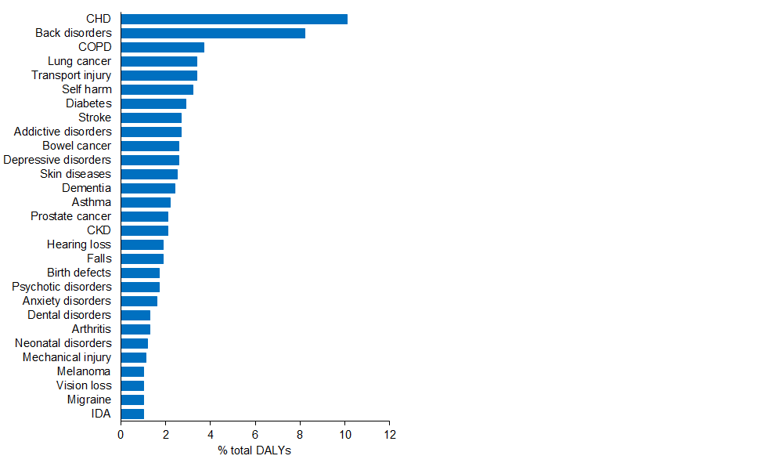 | 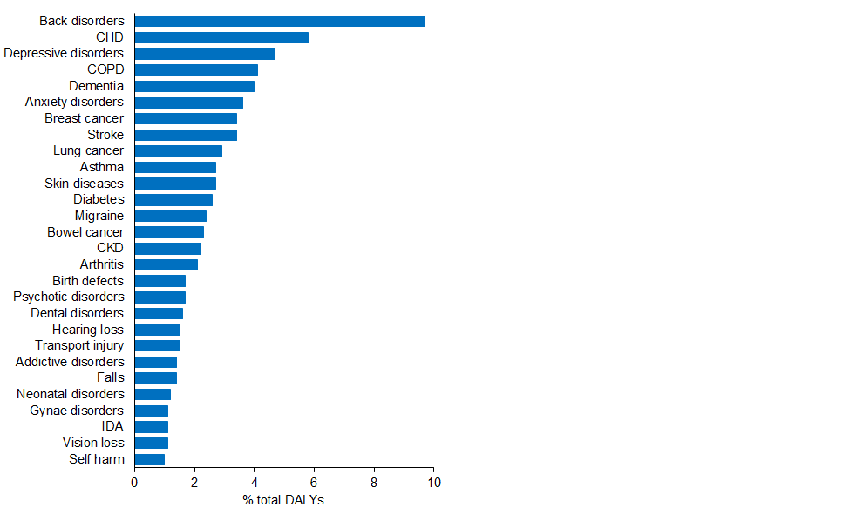
Adverse health care events have not been included because of low data quality; however, such events are estimated to account for approximately 3% of DALYs in both sexes.
Heart failure has not been included as this is considered a sequela (complication) of several different diseases, not a disease in itself.
‘Other’ categories (eg, ‘Other MSK’) have not been included, as these are heterogeneous categories.
Diabetes includes only health loss directly attributable to diabetes as a disease, rather than high blood glucose as a risk factor.
‘Vision loss’ and ‘Hearing loss’ exclude such losses captured under other conditions.
‘Arthritis’ includes osteoarthritis, rheumatoid arthritis and gout.
‘Psychotic disorders’ includes schizophrenia and bipolar disorder.
Key: CHD = coronary heart disease; COPD = chronic obstructive pulmonary disease; CKD = chronic kidney disease; gynae = gynaecological; IDA = iron deficiency anaemia.
Note: Confidence intervals not shown for clarity of presentation.

Diabetes and dementia have advanced most in rank
The ‘top 20’ leading conditions have remained largely the same over the past quarter century, although some have moved up or down in rank order. Figure 13 compares 1990 with 2013, for the population as a whole (all ages combined), by gender.

Figure 13: Contribution of ‘top 20’ leading major specific conditions to health loss (% total DALYs), whole of population, by gender, 1990 and 2013
Males
1990 |  |  |  | 2013
Rank | Condition | % |  | Rank | Condition | %
1 | CHD | 14.9 |  | 1 | CHD | 10.1
2 | Transport injury | 7.0 |  | 2 | Back disorders | 8.2
3 | Back disorders | 6.6 |  | 3 | COPD | 3.7
4 | Lung cancer | 3.7 |  | 4 | Lung cancer | 3.4
5 | COPD | 3.6 |  | 5 | Transport injury | 3.4
6 | Self harm | 3.5 |  | 6 | Self harm | 3.2
7 | Stroke | 3.5 |  | 7 | Diabetes | 2.9
8 | Addictive disorders | 2.4 |  | 8 | Stroke | 2.7
9 | Bowel cancer | 2.3 |  | 9 | Addictive disorders | 2.7
10 | Asthma | 2.3 |  | 10 | Bowel cancer | 2.6
11 | Birth defects | 2.3 |  | 11 | Depressive disorders | 2.6
12 | Depressive disorders | 2.1 |  | 12 | Skin diseases | 2.5
13 | Skin diseases | 1.9 |  | 13 | Dementia | 2.4
14 | Neonatal disorders | 1.9 |  | 14 | Asthma | 2.2
15 | Falls | 1.6 |  | 15 | Prostate cancer | 2.1
16 | Diabetes | 1.5 |  | 16 | CKD | 2.1
17 | Psychotic disorders | 1.4 |  | 17 | Hearing loss | 1.9
18 | Anxiety disorders | 1.4 |  | 18 | Falls | 1.9
19 | Prostate cancer | 1.3 |  | 19 | Birth defects | 1.7
20 | CKD | 1.3 |  | 20 | Psychotic disorders | 1.7
21 | Hearing loss | 1.3 |  | 21 | Anxiety disorders | 1.6
22 | Dementia | 1.2 |  | 24 | Neonatal disorders | 1.2
Females
1990 |  |  |  | 2013
Rank | Condition | % |  | Rank | Condition | %
1 | CHD | 9.2 |  | 1 | Back disorders | 9.7
2 | Back disorders | 7.9 |  | 2 | CHD | 5.8
3 | Stroke | 4.7 |  | 3 | Depressive disorders | 4.7
4 | Depressive disorders | 4.2 |  | 4 | COPD | 4.1
5 | Breast cancer | 3.7 |  | 5 | Dementia | 4.0
6 | COPD | 3.4 |  | 6 | Anxiety disorders | 3.6
7 | Anxiety disorders | 3.3 |  | 7 | Breast cancer | 3.4
8 | Transport injury | 3.2 |  | 8 | Stroke | 3.4
9 | Asthma | 2.8 |  | 9 | Lung cancer | 2.9
10 | Skin diseases | 2.6 |  | 10 | Asthma | 2.7
11 | Dementia | 2.4 |  | 11 | Skin diseases | 2.7
12 | Birth defects | 2.4 |  | 12 | Diabetes | 2.6
13 | Bowel cancer | 2.4 |  | 13 | Migraine | 2.4
14 | Migraine | 2.4 |  | 14 | Bowel cancer | 2.3
15 | Lung cancer | 2.3 |  | 15 | CKD | 2.2
16 | Gynaecological cancer | 1.9 |  | 16 | Arthritis | 2.1
17 | CKD | 1.7 |  | 17 | Gynaecological cancer | 1.7
18 | LRI | 1.7 |  | 18 | Birth defects | 1.7
19 | Neonatal disorders | 1.6 |  | 19 | Psychotic disorders | 1.7
20 | Arthritis | 1.6 |  | 20 | Dental disorders | 1.6
21 | Psychotic disorders | 1.5 |  | 22 | Transport injury | 1.5
22 | Diabetes | 1.5 |  | 25 | Neonatal disorders | 1.2
24 | Dental disorders | 1.4 |  | 29 | LRI | 0.7
Neonatal disorders include complications of prematurity, neonatal encephalopathy, and sepsis only, not birth defects or sudden unexpected death in infancy.
Key: Black arrow = stable rank; green arrow = decreasing rank; red arrow = increasing rank; CHD = coronary heart disease, COPD = chronic obstructive pulmonary disease, CKD = chronic kidney disease.
Notes: (1) Ranks are based on relative shares (percentage contribution to total DALYs). Some conditions (eg, diabetes from 2005 onwards) may increase in relative share (and hence rank) even though their absolute age-standardised DALY rates are stable or decreasing. (2) Confidence intervals not shown for clarity of presentation.
Conditions that have moved up in rank order from 1990–2013 include diabetes and dementia in both genders, prostate cancer in males and lung cancer in females.

Diabetes has advanced most in rank over the past quarter century, from 16th to 7th among males and from 22nd to 12th among females. Dementia has also risen rapidly in rank, from 22nd to 13th among males and from 11th to 5th among females.

Conditions that have moved down in rank order from 1990–2013 include transport injury, birth defects and neonatal disorders in both genders; asthma and anxiety disorders in males; and stroke and lower respiratory infection in females.

Back disorders are the leading specific condition from age 15–64 years
The ‘top 10’ specific conditions account for approximately one-half to three-quarters of all health loss, depending on the lifecycle stage (Table 3).

Leading causes of health loss among young children (0-4 years) are birth defects (especially congenital heart disease) and neonatal disorders (especially complications of prematurity). Sudden unexpected death in infancy (SUDI) still ranks third, despite a 71% fall in health loss from this condition since 1990 – the largest relative decline of any leading condition in any age group.

Among older children (5-14 years), iron deficiency anaemia and asthma are the leading conditions, followed by skin disorders (including eczema, acne and psoriasis).

Among youth, the leading cause of health loss is back disorders. This is followed by two injury categories: transport injuries and self-harm; and then two mental disorders: addictive or substance use disorders (including alcohol and illegal drug use disorders) and depressive disorders.

The pattern in young adults is fairly similar to that in youth. Back disorders continue to rank first, followed by several mental disorders (anxiety and depressive disorders, and addictive disorders) and self-harm. Transport injuries just miss out on inclusion in the top five.

Back disorders remain the leading specific cause of health loss in middle age. However, the common NCDs now also feature in the top five: coronary heart disease is in second place, followed by lung cancer and then COPD. Depressive disorders drop to fifth place, narrowly ahead of diabetes.

Coronary heart disease continues to dominate health loss in older people, but the contribution of dementia is rising rapidly; this cause already ranks second among the very old (75+ years), where it has overtaken stroke. COPD, age-related hearing loss, lung cancer, colorectal cancer and diabetes also rank highly among older people. Back disorders are still an important cause of health loss in this age group, as are falls in the very old.

Table 3: Contribution of top 10 leading conditions to health loss (% total DALYs), by lifecycle stage, 2013
Rank | Lifecycle stage (years)
 | Children  (0–4) | Children  (5–14) | Youth  (15–24) | Young  adults  (25–44) | Middle-aged  adults  (45–64) | Older  people  (65–74) | Older  people  (75+)
1 | Neonatal disorders  (24.6%) | Iron deficiency anaemia  (16.9%) | Back disorders  (11.3%) | Back disorders  (15.4%) | Back disorders  (11.1%) | CHD  (12.0%) | CHD  (15.3%)
2 | Birth  defects  (23.6%) | Asthma  (13.2%) | Transport injuries  (10.6%) | Depressive disorders  (7.1%) | CHD  (7.9%) | Lung  cancer  (6.5%) | Dementia  (12.0%)
3 | SUDI  (12.6%) | Skin  disorders  (8.1%) | Self-harm  (8.1%) | Addiction  (5.7%) | Lung  cancer  (4.7%) | Back disorders  (6.4%) | Stroke  (7.3%)
4 | Common infections  (6.1%) | Anxiety disorders  (7.1%) | Addiction  (7.8%) | Anxiety disorders  (5.1%) | COPD  (4.1%) | COPD  (6.1%) | COPD  (5.7%)
5 | Suffocation (unintentional)  (4.2%) | Back disorders  (4.8%) | Depressive disorders  (7.3%) | Self-harm  (4.9%) | Depressive disorders  (3.8%) | Colorectal cancer  (4.7%) | Age-related hearing loss  (3.9%)
6 | Transport injury  (2.7%) | Depressive disorders  (4.7%) | Anxiety disorders  (6.2%) | Transport injuries  (4.1%) | Diabetes  (3.7%) | Stroke  (4.0%) | Back disorders  (3.8%)
7 | Skin  disorders  (2.2%) | Conduct disorder  (3.9%) | Asthma  (5.9%) | Skin  disorders  (3.9%) | Colorectal cancer  (3.1%) | Diabetes  (3.9%) | Falls  (3.1%)
8 | Drowning  (2.1%) | Birth  defects  (3.9%) | Skin  disorders  (5.6%) | Migraine  (3.8%) | Breast  cancer  (3.0%) | Dementia  (2.6%) | Diabetes  (3.0%)
9 | Haemoglobin-opathies  (1.7%) | Transport injuries  (3.2%) | Migraine  (2.8%) | Asthma  (3.4%) | CKD  (2.5%) | CKD  (2.4%) | Colorectal cancer  (2.9%)
10 | Iron deficiency anaemia  (1.3%) | Haemoglobin-opathies  (3.1%) | Birth  defects  (2.0%) | CHD  (2.0%) | Anxiety disorders  (2.4%) | Age-related hearing loss  (2.3%) | Lung  cancer  (2.7%)
Total ‘top 10’ share | 81.1% | 68.9% | 67.6% | 55.6% | 46.4% | 50.9% | 59.7%
% is percentage of all-cause DALYs in age group. Confidence intervals not shown for clarity of presentation.
Key: CHD = coronary heart disease; COPD = chronic obstructive pulmonary disease; SUDI = sudden unexpected death in infancy. Common infections include pneumonia, bronchiolitis and diarrhoeal disease. Skin disorders include eczema, acne and psoriasis.

Diabetes as a disease (rather than as a risk factor) does not make the top five in any age group, but of course contributes to CHD, stroke and dementia, which do.

The only cancer to make the ‘top five’ list is lung cancer in middle and old age. However, other cancers that make an important contribution to health loss are breast cancer in middle-aged and older females, prostate cancer in older males, and bowel cancer and melanoma in middle-aged and older adults of both sexes.

No injury ranks highly in middle age or beyond, although falls rank fairly highly among older people, especially the 75+ years age group (in which it ranks seventh). The only infectious disease category to rank in the top five is diarrhoea and pneumonia, which still rank highly (fourth) in the 0–4 years age group.

The diabetes burden is no longer increasing (once adjusted for demographic drivers)
Six conditions have been selected for more detailed trend analysis, based on the following criteria: share of burden in the whole population or at a specific lifecycle stage; existence of a trend that is relevant to policy; and balance across NCDs, pre-transitional conditions and injury. The conditions selected were CHD, diabetes, bowel cancer, SUDI, self-harm and transport injury (Figure 14). Trends in the dementia burden are also of great policy interest, but data quality is not good enough to produce a reliable time series for this condition.

Figure 14: Age-standardised DALY rate per 1000, selected conditions, 1990–2015
CHD | Diabetes
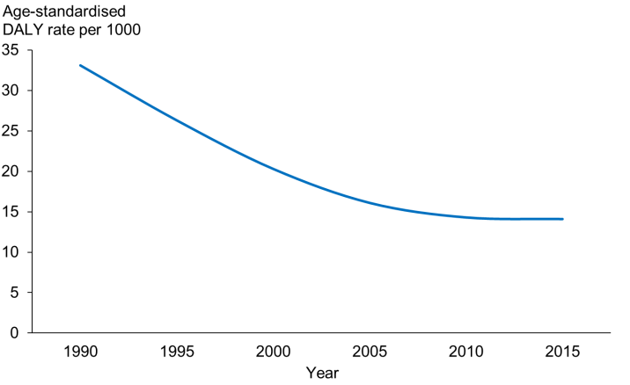 | 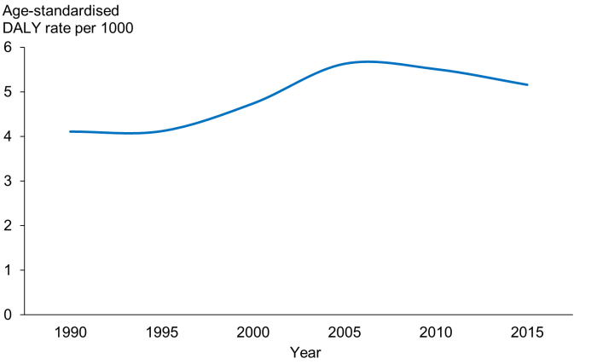
SUDI | Bowel cancer
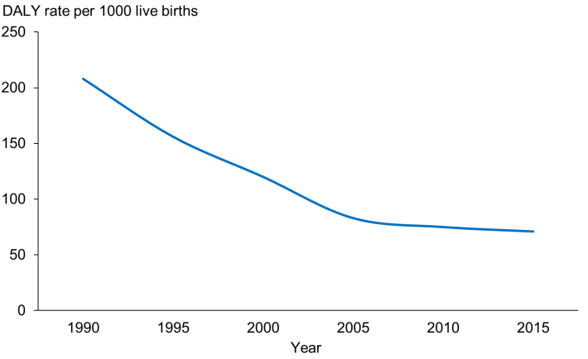 | 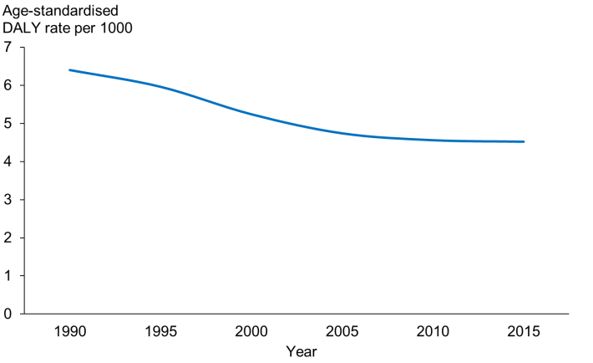
Transport injury | Self-harm
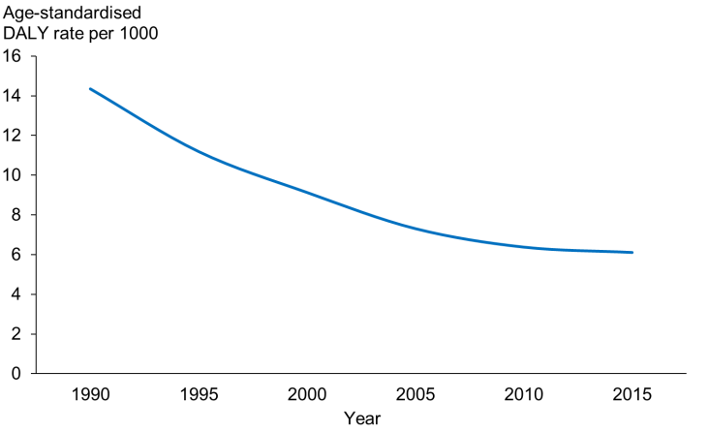 | 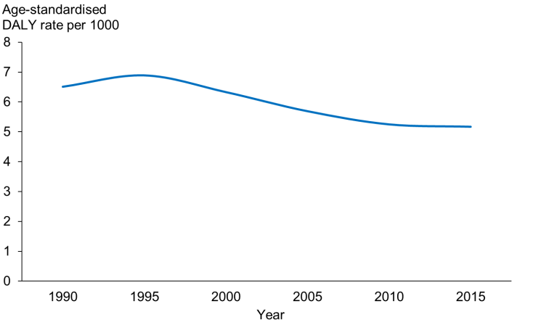
Notes: (1) Scale varies between charts. (2) SUDI rate is per 1000 live births and is not age standardised. (3) Confidence intervals not shown for clarity of presentation.

Once the estimates are adjusted for change in the size and age structure of the population, CHD, transport injury and – to a lesser extent – bowel cancer burdens can be seen to have declined steadily over the past 25 years (at least). Plotting the rates on a log scale shows how steady the decline is: they fit a log linear model reasonably well (ie, are declining by a constant proportion each year) and show little, if any, levelling out. The trend in health loss from bowel cancer began before the screening era and probably reflects improvements in diagnosis and treatment for this condition.

Health loss from self-harm peaked in 1995 and has since also declined, possibly indicating the impact of suicide prevention programmes over the past two decades, at least in part.

Per capita age-adjusted health loss from diabetes began increasing in 1995 and rose steeply to 2005 when it peaked and has since declined slowly, even though the prevalence of diabetes has continued to increase. This finding may reflect earlier diagnosis and/or more effective treatment of this disease – which has had the effect of decoupling burden from prevalence. Decoupling is discussed further below in relation to risk factors, in particular body mass index.

Health loss (premature mortality) from SUDI (the condition formerly known as SIDS or cot death) fell rapidly from 1990–2005. The cause of this dramatic decline was most probably the change in recommended sleep position for infants (from prone to supine – ie, the ‘Back to Sleep’ campaign) beginning around 1991.

The mesothelioma epidemic is peaking
Not only is the combined burden of all cancers declining, but so is that of most individual cancers. Among the major cancers, the contributions to health loss made by lung cancer, bowel cancer and female breast cancer are all falling (Figure 15). The prostate cancer burden rose until the year 2000 (approximately) and has since also begun to decline. The melanoma burden is flat, with no observable trend. Brain cancer, while increasing in incidence, is slowly declining in burden – the result of earlier diagnosis and better treatment.

Figure 15: Age-standardised DALY rate per 1000, selected cancers, 1990–2015
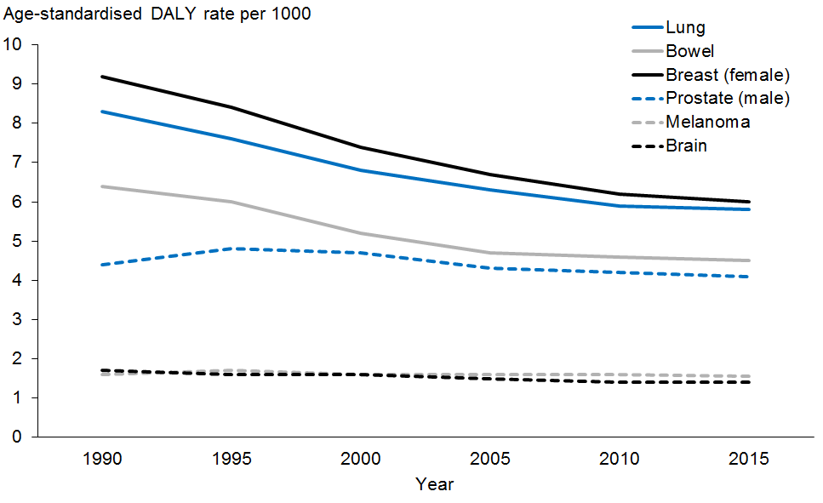
Note: Confidence intervals not shown for clarity of presentation.
The cancer with the most rapidly rising burden over the past quarter century has been mesothelioma – although this trend may now be reversing, as the burden has been stable or possibly even slightly declining since 2010. This probably reflects the historical pattern of exposure of the population to chrysotile asbestos, lagged by about 20–30 years (the induction period for this cancer) (Figure 16).

Figure 16: Age-standardised DALY rate per 10,000, mesothelioma, 1990–2015
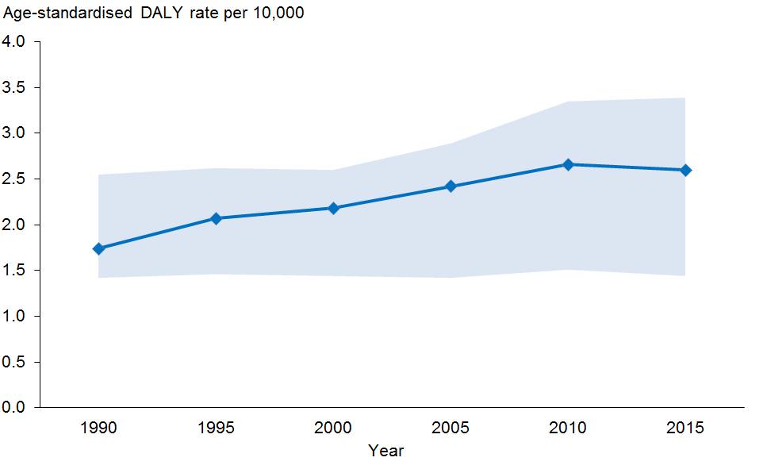
Note: The y axis shows age-standardised DALYs per 10,000 – not per 1000 as in the previous figure.

Risks to health: health losses caused by risk clusters
Health loss caused by exposure to a risk factor (‘attributable burden’) is estimated by calculating the reduction in DALYs from each linked condition that would occur if exposure to the risk factor was reduced to the minimum risk level (see Appendix 2). Linked conditions are diseases and injuries causally associated with exposure to the risk factor of interest. The attributable burden provides an indication of the health gain that could potentially be achieved by preventing disease and injury through risk reduction, if effective and affordable interventions were available.

All major risk factors have been mapped into four ‘risk clusters’, based on the nature of, and route of exposure to, the hazard (Table 4).

Table 4: Risk clusters used in analysis
 | Cluster | Individual risk factors
1 | Biological risks | High body mass index  High fasting plasma glucose  High systolic blood pressure  High total blood cholesterol  Low bone mineral density  Low glomerular filtration rate
2 | Behavioural risks | Alcohol use  Drug use  Tobacco use and second-hand smoke exposure  Unhealthy diet (dietary risks)  Physical inactivity and sedentariness  Poor infant care practices (including lack of breastfeeding)  Unsafe sex  Child sexual abuse  Intimate partner violence  Self-harm
3 | Environmental risks | Indoor air pollution  Ambient air pollution  Lead exposure  Asbestos exposure (non-occupational)  Unsafe sanitation  Unsafe drinking water
4 | Occupational risks | Exposure to carcinogens (including asbestos)  Exposure to other toxic chemicals, gases, fumes and particulate matter  Exposure to noise  Ergonomic and occupational injury risk factors
Note: Many carcinogens (eg, asbestos) can appear in both clusters 3 and 4, depending on the site of exposure.

Over one-third of health loss is potentially preventable
Adjusting for ‘overlaps’ between clusters (the extent to which each cluster’s impact on health is mediated through other clusters), approximately 38% of all health loss could be attributed to known modifiable risk factors in 2013, for the New Zealand population as a whole. Because people can potentially avoid being exposed to these risk factors, this is the ‘potentially preventable proportion’ of health loss our population is currently experiencing.

As Figure 17 shows, behavioural risks account for one-quarter of total health loss (25%), and biological risks for almost one-fifth (19%). Occupational and environmental hazards account for 3% and 1% of total DALYs respectively. (Note that these percentages cannot simply be added together due to cluster overlaps – ie, mediation of the effect of one risk factor by another, as explained above).

Over one-third (37%) of the health loss attributable to behavioural risks comes from cardiovascular disease and diabetes; one-quarter (25%) from cancers; almost one-seventh (14%) from the chronic lung, liver and kidney disease complex; over one-tenth (11%) from neuropsychiatric disorders; approximately 5% from pre-transitional disorders; and the remaining 8% from injury (including self-harm and interpersonal violence).

By contrast, almost three-quarters (71%) of the health loss caused by biological risk factors comes from cardiovascular disease and diabetes, while cancers contribute 6%, the CLLKD complex 11%, other NCDs 1%, musculoskeletal disorders 6% and injuries 5%.

Figure 17: Health losses caused by risk clusters (% total DALYs), 2013
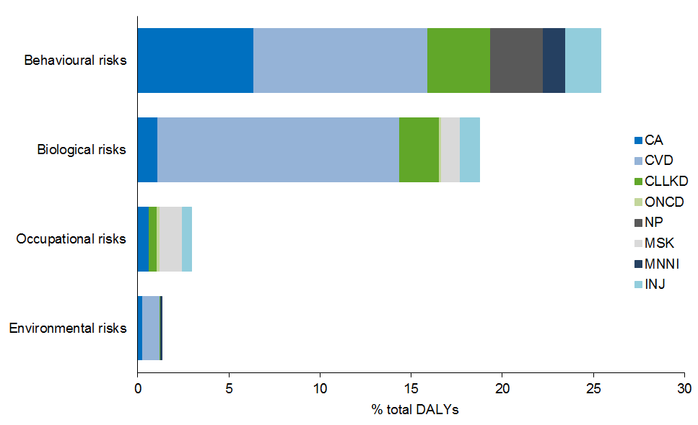
Key: CA = cancers; CVDD = cardiovascular disorders and diabetes; CLLKD = chronic lung, liver and kidney disease; ONCD = other non-communicable diseases; NP = neuropsychiatric disorders; MSK = musculoskeletal disorders; MNNI = maternal, neonatal, nutritional deficiency and infectious disorders plus birth defects; INJ = injuries, unintentional and intentional.
Note: Confidence intervals not shown for clarity of presentation.

Health impacts of all risk clusters are falling
Adjusting for trends in population size and ageing over the past quarter century, health losses have been declining for all risk clusters, at an average rate of 2.2% per year for the behavioural cluster, 2.0% for the biological cluster and 1.5% for the environmental/occupational cluster (Figure 18). Plotting the above rates on a log scale shows no indication that the rate of decline is slowing for any of the clusters.

The declining trends may reflect lesser exposure to these hazards. Alternatively, the total burdens of the conditions (diseases and injuries) linked to these risks may be falling for other, unrelated reasons (eg, better clinical treatments) – so decoupling risk-attributable burden from hazard exposure (prevalence).

Figure 18: Age-standardised DALY rate per 1000 attributable to risk clusters, 1990–2015
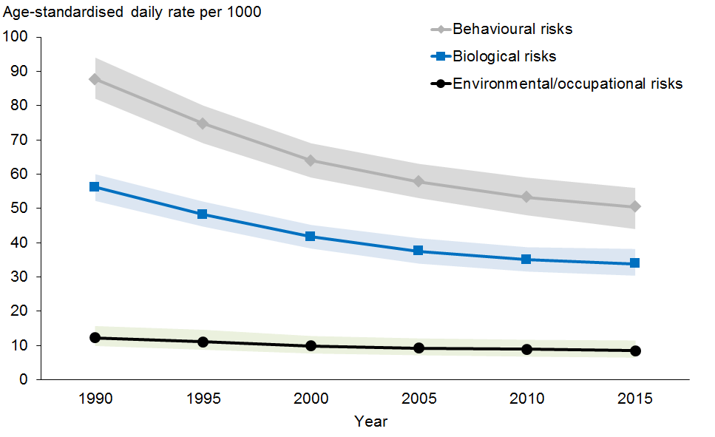
Environmental and occupational risk clusters have been combined so that rate estimates are more stable.

Risks to health: health losses attributable to specific risk factors
This section describes how selected specific risk factors contribute to health loss, regardless of the risk cluster they belong to. All estimates have been adjusted for mediation – that is, the overlap caused by one risk factor influencing exposure to another risk factor (see Appendix 2 for the formula for mediation adjustment). Risk factors were selected for reporting if their attributable burden was more than 2% of total health loss from all causes in the population as a whole in 2013. Ten risk factors (out of more than 60) met this selection criterion – all are behavioural or biological risks.

Dietary risks are the leading cause of health loss
Dietary risks are the leading cause of health loss among the specific risk factors (9.4% of total DALYs) (Figure 19). However, ‘diet’ is actually a composite risk factor that includes several distinct components: low fruit and vegetable consumption; high sodium consumption; high consumption of red meat, trans fat, and sugar; and low intakes of whole grains, fibre, polyunsaturated fatty acids, omega-3 fatty acids, and calcium. Of these components, low fruit and vegetable consumption contributes the most to health loss, accounting for 2.5% of total DALYs, or one-quarter of the total impact of diet. The estimation of health loss attributable to high sodium intake is a controversial topic, but its contribution is almost certainly less than 2% of total DALYs (the current point estimate is 1.3%). The analyses below consider dietary risks separately; among these risks, only low fruit and vegetable consumption therefore reaches the threshold for inclusion in this report.

High body mass index (BMI) is now the second-ranked risk factor after diet, accounting for 9.2% of total DALYs in the whole New Zealand population in 2013. The biggest contributors to the BMI burden are cardiovascular disease (47%) and type 2 diabetes and its renal complications (29.5%).

Tobacco use is still a major cause of health loss, accounting for 8.7% of all DALYs. The major contributors here are lung and several other cancers (43%), COPD (35%) and coronary heart disease (18%).

High blood pressure is another major risk factor, accounting for 8.3% of total DALYs, all through cardiovascular disease and chronic kidney disease. High blood glucose (whether measured as fasting plasma glucose or glycosylated haemoglobin) now accounts for 5.7% of total DALYs, of which 47% is from diabetes as a disease and the remaining 53% is from the macrovascular complications of diabetes and pre-diabetes (ie, high blood glucose as a risk factor for other diseases, in particular CHD and stroke).

Alcohol consumption is ranked seventh, accounting for just under 4% of total DALYs; this estimate subtracts the protective effects of (safe) alcohol consumption on CHD, stroke, diabetes and vascular dementia from alcohol-related harms. Across the whole population, the net harmful impact of alcohol on health is divided almost equally between injury and chronic disease outcomes. This analysis considers only health outcomes, not the wider social impacts of alcohol consumption.

Figure 19: Health losses caused by selected risk factors (% total DALYs), 2013
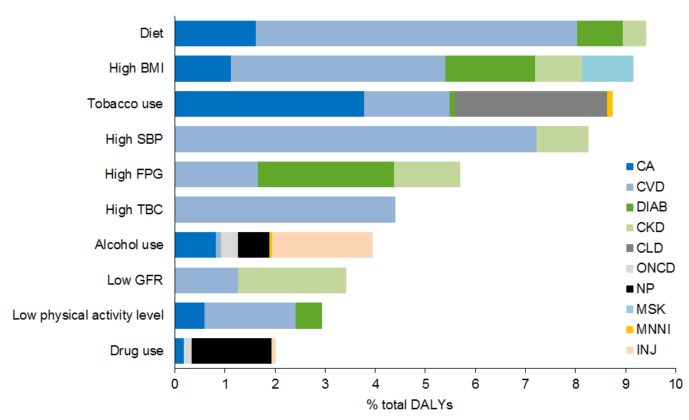
Key: CA = cancers; CVD = cardiovascular disorders; DIAB = diabetes; CKD = chronic kidney disease; CLD = chronic lung disease; ONCD (which here includes chronic liver disease) = other non-communicable diseases; NP = neuropsychiatric disorders; MSK = musculoskeletal disorders; MNNI = maternal, neonatal, nutritional deficiency and infectious disorders plus birth defects; INJ = injuries, unintentional and intentional; BMI = body mass index; SBP = systolic blood pressure; FPG = fasting plasma glucose; TBC = total blood cholesterol; GFR = glomerular filtration rate.
Note: Confidence intervals not shown for clarity of presentation.

Burden caused by use of illegal psychoactive drugs is low but increasing
Adjusting for population growth and ageing over the past quarter century, health loss caused by illegal drug use has been slowly increasing (Figure 20). Currently, illegal drug use accounts for approximately 2.3% of all-cause DALYs in the population as a whole, but approximately 6.5% in youth (the peak age group). Approximately 44% of the overall drug burden is attributable to opioids, 24% to stimulants, 11% to hallucinogens & psychedelics, 9% to cannabinoids, with the remaining 12% attributable to polydrug use or other or unknown substances.

Attributable burdens of all other selected major modifiable risk factors have fallen (once adjusted for demographic trends). Possible explanations for this are given below in relation to the trends in the BMI and tobacco burdens.

Figure 20: Age-standardised attributable DALY rates, selected risk factors, 1990–2015
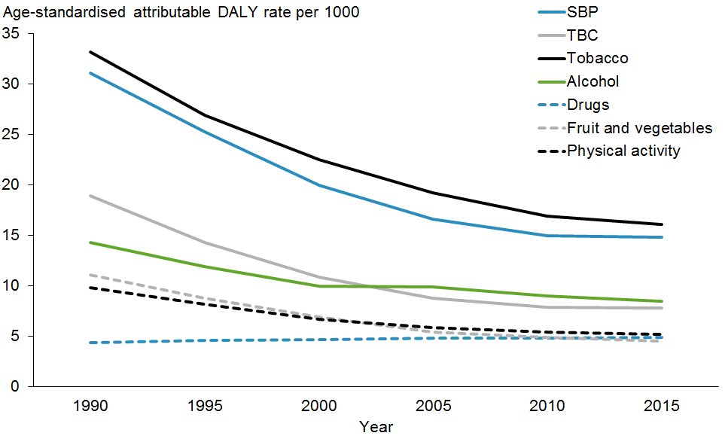
Key: SBP = systolic blood pressure; TBC = total blood cholesterol; PA = insufficient physical activity; Fruit and vegetables = inadequate intake of these foods; Drugs = illegal drug use.
Note: Confidence intervals not shown for clarity of presentation.

The absolute burden (attributable DALY count) has been steadily increasing for BMI and falling for tobacco use (at least until recently) (Figure 21(a)). Yet, once adjusted for population growth and ageing, the rate of attributable health loss has actually been falling for both risk factors, although the trend is gradual for BMI and steep for tobacco use (Figure 21(b)).

Figure 21: Health loss attributable to BMI and tobacco use, 1990–2015
(a) Counts (attributable DALYs)
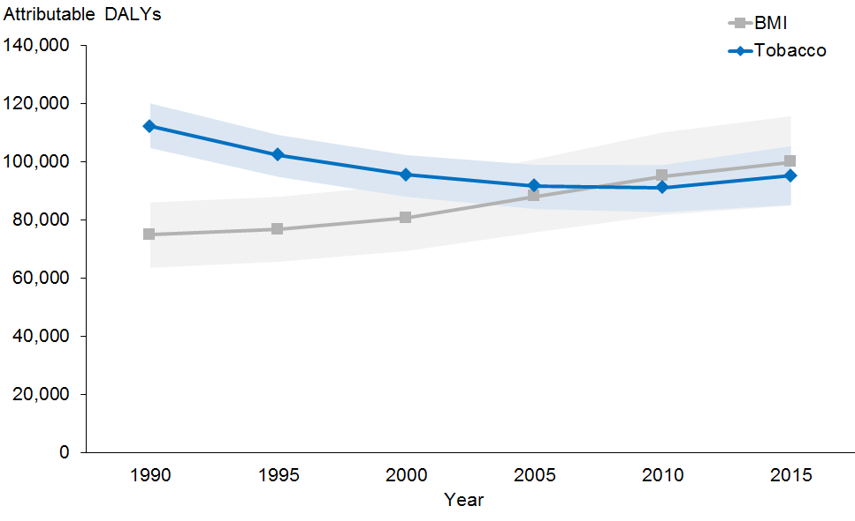

(b) Rates (age-standardised attributable DALY rate per 1000)
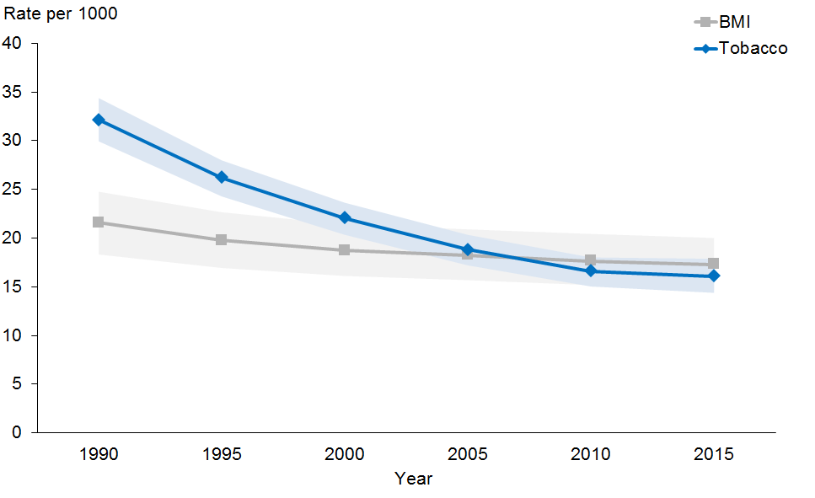

The previous edition of this study suggested BMI would overtake tobacco use as a cause of health loss around 2016. The updated estimates reported here suggest this crossover may have already happened, but the difference is not statistically significant at the 95% confidence level (Figure 21) until 2015 (or even later).

While the BMI burden is slowly falling (once adjusted for demographic trends), the prevalence of obesity continues to increase (Figure 22). This implies that the impact of rising obesity prevalence is being more than offset by the reduction in the total burden of (some of) its linked conditions, in particular coronary heart disease. This finding further implies that the BMI burden may not continue to fall in the long term, unless the prevalence of this risk factor can also be reduced (because the decline in the CHD burden cannot continue forever).

Figure 22: Obesity prevalence (age-standardised rate per 100) and BMI attributable burden (age-standardised attributable DALY rate per 1000) among adults, 1990–2015
Obesity prevalence | BMI burden
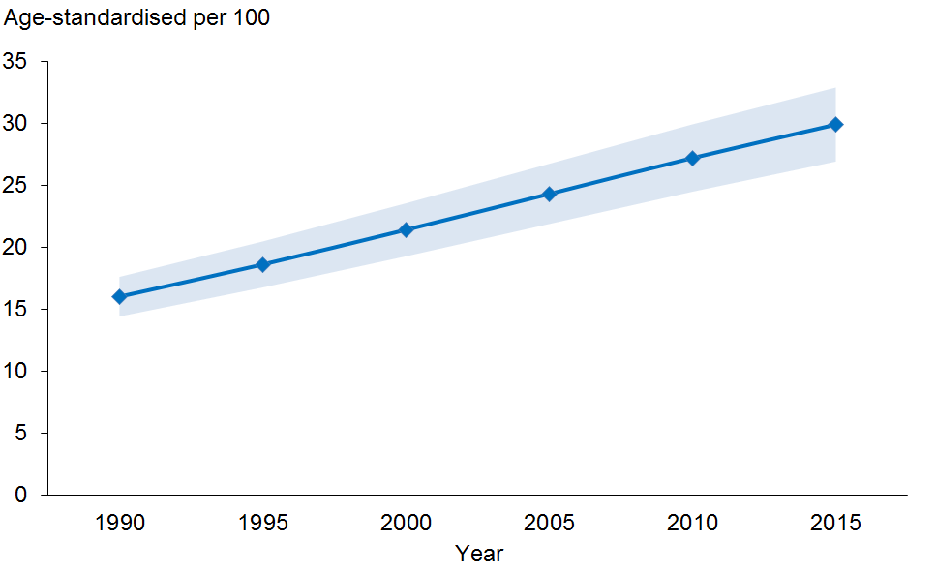 | 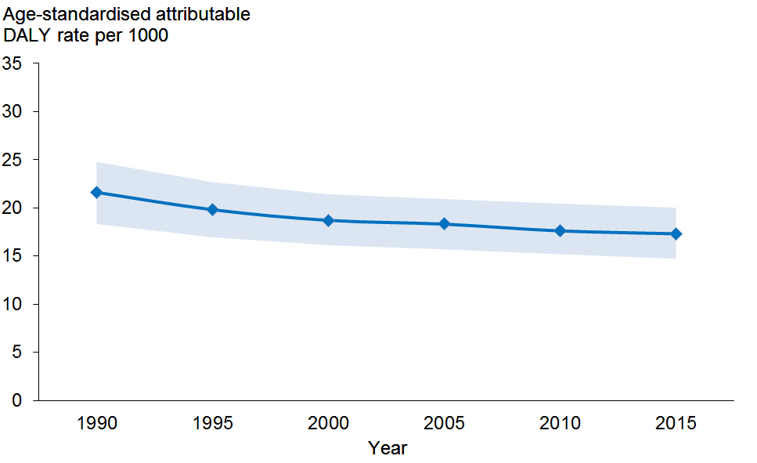

In short, this decoupling of risk factor burden from risk exposure (prevalence) demonstrates that trends in attributable burden are affected by complex interactions between:
- changing hazard exposure (risk factor prevalence)
- demographic forces (population growth and ageing)
- trends in the total burden of the linked conditions that occur for reasons unrelated to the risk factor of interest (eg, improvements in coverage and effectiveness of clinical treatments).

Health expectancy and the compression of morbidity
Health expectancy is a summary index of population health that integrates both fatal (quantity of life) and non-fatal (quality of life) outcomes. Health expectancy is a generalisation of life expectancy that takes account of time lived in different health states defined by level of functioning (morbidity or disability).

The health expectancy metric described here (also known as health-adjusted life expectancy or healthy life expectancy) is based on a continuous weighting of non-fatal health states on a 0–1 scale, where 1 is equivalent to full health and 0 to being dead. So health expectancy, as defined here, is the number of years the average person can expect to live in full health. Operationally, it is calculated by combining the all-cause YLD rates by age and sex from the burden of disease calculations (representing total non-fatal health loss) with the central mortality rates from Statistics New Zealand lifetables or the GBD mortality database (representing total fatal health loss).

An analysis that shows whether morbidity is compressing or expanding over time answers the question: are we adding life to years as well as years to life? That is, are the years gained from improving survival (increasing life expectancy) spent in good or poor health? To measure compression, we compare trends in the number of years the average person can expect to live in good health (health expectancy) with trends in the number of years they can expect to live in total (life expectancy).

Compression can be measured either on:
- an absolute scale – that is, as the difference between the change in health expectancy and the change in life expectancy over the specified period, or
- a relative scale – that is, as the ratio of the change in health expectancy to the change in life expectancy over the specified period.

Both measures are important and may tell different stories, so both are reported here.

Both life and health expectancy have increased over the past (almost) quarter century (Table 5). However, life expectancy has increased faster, so the gap between life and health expectancy has also increased: from 9.2 to 10.4 years for males, and from 11.0 to 12.2 years for females (an average increase for both sexes of just under three weeks per year). In other words, of the 6.12 years that males gained in life expectancy over the past quarter century, they spent 80% in good health and 20% in poor health. Of the 4.45 years that females gained in life expectancy, they spent 74% in good health and 26% in poor health. So, compared with females, males have made better gains in both life and health expectancy over the past quarter century, and consequently the gender gap in health has narrowed.

At the same time, the ratio of health to life expectancy appears to have decreased in both sexes, indicating that morbidity may have expanded in relative as well as in absolute terms. However, this change has been slight (and not statistically significant) and has varied between the sexes and over time. The conclusion then is that morbidity has expanded absolutely (for both sexes), while it may or may not have expanded (slightly) in relative terms.

Table 5: Health expectancy and life expectancy at birth, 1990–2013
(Years) | 1990 |  | 2005 |  | 2013
 | Male | Female | Male | Female | Male | Female
LEo | 72.49 | 78.21 | 77.56 | 81.86 | 78.61 | 82.66
HEo | 63.27 | 67.18 | 67.12 | 70.02 | 68.19 | 70.48
Difference | 9.22 | 11.03 | 10.04 | 11.84 | 10.42 | 12.18
Ratio (%) | 87.28 | 85.90 | 86.54 | 85.54 | 86.74 | 85.26
C_{abs 1990} | – | – | -0.82 years | -0.81 years | -1.20 years | -1.15 years
C_{rel 1990} | – | – | –0.85% | –0.42% | –0.62% | –0.75%
Key: LEo = life expectancy at birth; HEo = health expectancy at birth; C_{abs} = absolute compression; C_{rel} = relative compression; negative compression = expansion.
Notes: (1) The GBD estimates for life expectancy shown above differ slightly from those produced by Statistics New Zealand because of small differences in data and methods. These estimates are used in preference to the Statistics New Zealand estimates as the former are directly comparable with the estimates for the peer group countries. (2) Confidence intervals not shown for clarity of presentation.

These findings mirror those derived from an analysis of independent life expectancy (life expectancy free of disability requiring assistance) that the Ministry of Health and Statistics New Zealand have previously conducted (see Appendix 1 for reference). While the two health expectancy measures – independent life expectancy and health-adjusted life expectancy – are not numerically equivalent, both tell a similar story of absolute expansion of morbidity over the past quarter century.

International comparisons
Based on the criteria noted in the NZBD Methods section of Appendix 2, the following peer group of 15 countries was identified: Australia (AUS), Canada (CAN), Denmark (DEN), Finland (FIN), France (FRA), Germany (GER), Ireland (IRE), Israel (ISR), Netherlands (NET), New Zealand (NZL), Norway (NOR), Sweden (SWE), Switzerland (SWI), the United Kingdom (UK) and the United States of America (US). The unweighted peer group average (PGA) was also calculated.

For some analyses, however, the comparison is restricted to the six English-speaking countries (NZL, AUS, CAN, UK, US, IRE) as these have the most comparable data. In most cases the differences between countries are not significant at the 95% confidence level.

Current level of health loss
After adjusting for differences in population size and age structure, all of the peer group countries except the United States had similar health losses in 2013 (within 10% of the mean) (Figure 23). The United States is a clear outlier, with an age-standardised DALY rate almost 20% higher than the group average.

Figure 23: Health loss, by peer group country (all-cause DALY age-standardised rate), 2013
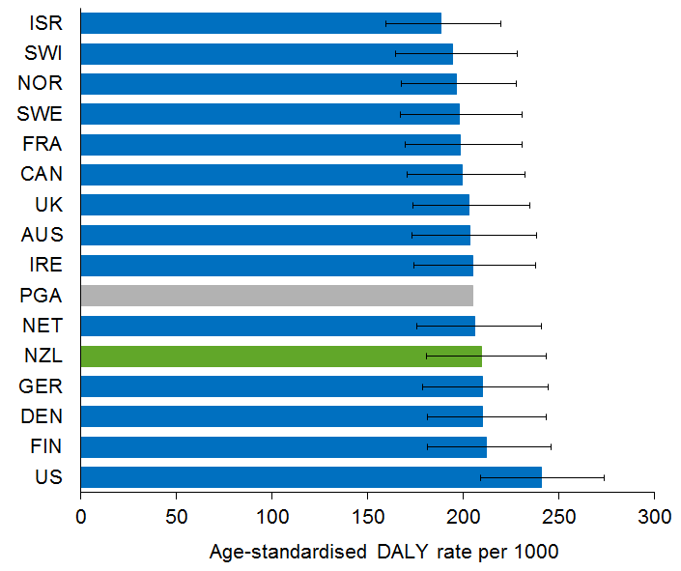

Trends in health loss
Figure 24 shows that all of the peer group countries achieved a fall in age-standardised, all-cause DALY rate between 1900 and 2013. New Zealand experienced one of the steepest reductions (a fall of 24% in age-standardised, all-cause DALY rate from 1990–2013). Only Israel, Ireland, Finland and Germany achieved a steeper fall, although again the differences are not always statistically significant.

Figure 24: Percentage change in age-standardised, all-cause DALY rate, by peer group country, 1990–2013
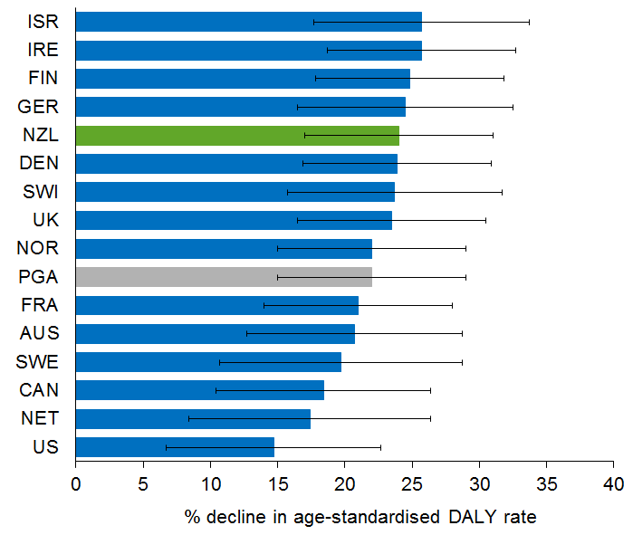

Disability transition
The disability transition is the change in the population’s experience of health loss from one dominated by fatal outcomes (YLL) to one dominated by non-fatal outcomes (YLD). All peer group countries are well advanced along the disability transition (Figure 25). New Zealand is keeping pace with its peers on this indicator. The furthest advanced is Switzerland, where almost two-thirds (62%) of its health loss results from non-fatal outcomes, but again the differences are not always statistically significant.

Figure 25: Extent of disability transition (YLD as % total DALYs), by peer group country, 2013
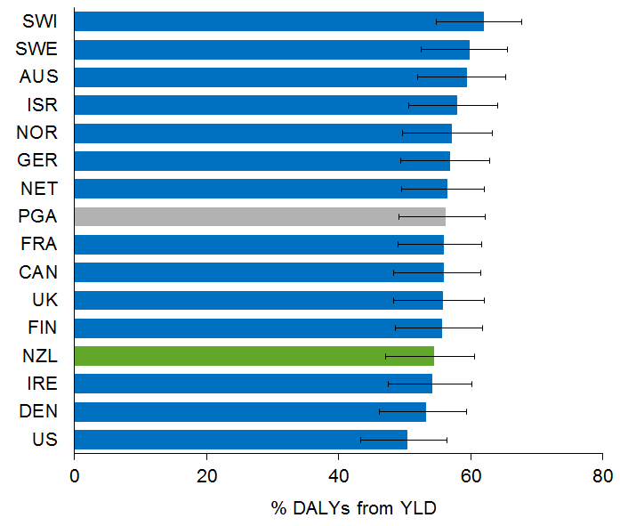
Estimate for NZL (54%) differs from that reported in Figure 6 (52.5%) because it is based on age-standardised rates (to allow fair comparison across countries).

Epidemiological transition
The epidemiological transition is the change in a population’s disease experience from one dominated by infectious diseases (mainly affecting children) to one dominated by long-term conditions (mainly affecting older adults).

Finland has progressed furthest in making this transition (Figure 26), with only 4.2% of its health loss arising from pre-transitional conditions (mainly infectious diseases). It is closely followed by New Zealand and Sweden. Interestingly, both the US and UK are ‘outliers’ in this respect, with pre-transitional shares almost 50% higher than New Zealand’s, a statistically significant difference.

Figure 26: Extent of epidemiological transition (pre-transitional disorders burden as % total DALYs), by peer group country, 2013
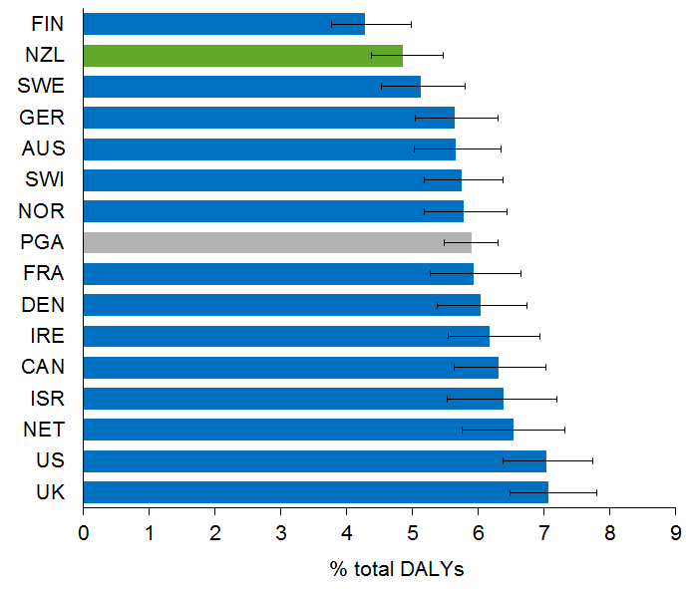
Value for NZL (4.8%) differs from that given in Figure 10 (3.8%), as this estimate is age-standardised to allow cross-country comparison.

Contribution of different causes to health loss
Conditions: Ten conditions have been selected from the leading major specific conditions in New Zealand in Figure 13, based on the comparability of data across countries. The analysis has been restricted to a subset of six peer group countries (the English-speaking countries, which are the most comparable in terms of diagnostic and coding practice).

Among the 10 selected conditions, coronary heart disease is the leading cause of health loss for all the selected countries (Figure 27). Most of the inter-country differences are not statistically significant. It is, however, notable that the US has the highest health loss from most conditions. New Zealand’s health loss from individual conditions is comparable with peer group countries, although higher than all for bowel cancer.

Figure 27: Health loss from selected conditions, by selected peer group countries (age-standardised DALY rates), 2013
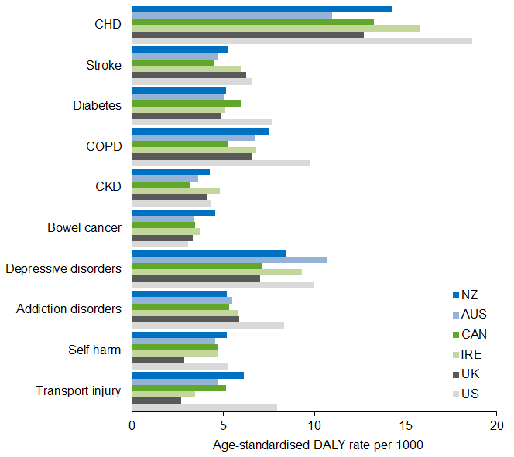
Key: CHD = coronary heart disease; COPD = chronic obstructive pulmonary disease; CKD = chronic kidney disease.
Note: Confidence intervals not shown for clarity of presentation.

Risk factors: Given that risk factors are potentially modifiable causes of health loss, the ‘potentially preventable proportion’ can be defined as the percentage of the age-standardised, all-cause DALY rate that is attributable to all known modifiable risk factors collectively. The lower this proportion, the better the health system is performing in disease prevention.
In 2013 Israel had the lowest potentially preventable proportion (Figure 28), although almost one-third of its health burden (32.5%) is still attributable to known – and modifiable – risk factors. The differences between countries are not all statistically significant, but it is interesting that the worst performer is the US, with almost 40% of its health loss attributable to potentially preventable risk exposures.

Figure 28: Potentially preventable proportion of health loss, by peer group country (% total DALYs), 2013
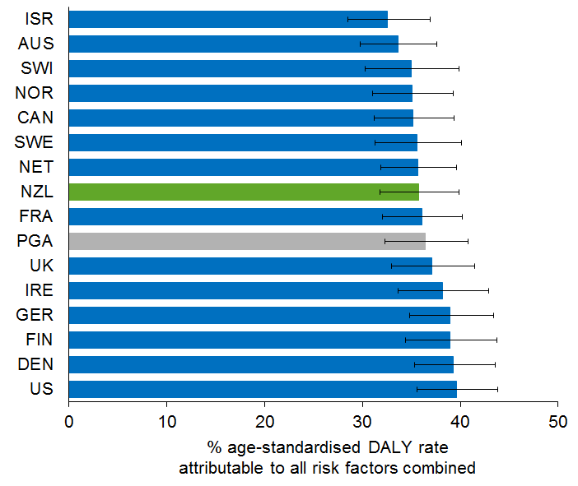
Value for New Zealand (36%) differs from that given on page 26 (38%), as this estimate is age standardised (to allow for cross-country comparison).

Health expectancy, life expectancy and the compression of morbidity
Comparing trends in health and life expectancy in the subset of six peer group countries indicates each health system’s relative performance over the past quarter century (Table 6).
Life expectancy at birth increased from 1990–2013 in all six countries, for both sexes. New Zealand’s increases were 6.1 years for males and 4.5 years for females. Health expectancy at birth also increased in all six countries, and among females has broken through the 70-year barrier everywhere except the US.
Table 6: Health expectancy and life expectancy at birth, selected countries, 1990 and 2013
 | Male |  |  |  | Female
 | Life expectancy |  | Health expectancy |  | Life expectancy |  | Health expectancy
 | 1990 | 2013 | 1990 | 2013 | 1990 | 2013 | 1990 | 2013
NZL | 72.49 | 78.61 | 63.27 | 68.19 | 78.21 | 82.66 | 67.18 | 70.48
AUS | 73.93 | 79.71 | 64.14 | 68.43 | 80.15 | 83.99 | 67.93 | 70.63
CAN | 74.20 | 79.44 | 65.13 | 69.11 | 80.59 | 83.43 | 68.74 | 71.04
US | 71.87 | 76.33 | 62.62 | 65.84 | 78.84 | 81.42 | 66.96 | 68.61
UK | 72.87 | 79.09 | 63.76 | 68.48 | 78.44 | 82.84 | 67.26 | 70.56
IRE | 72.13 | 78.20 | 63.31 | 68.20 | 77.64 | 82.67 | 66.86 | 70.73
Notes: (1) The GBD estimates for New Zealand life expectancy above differ slightly from those produced by Statistics New Zealand due to small differences in data and methods. These estimates are used in preference to the Statistics New Zealand estimates as the former are directly comparable with estimates for the peer group countries. (2) Confidence intervals not shown for clarity of presentation.
Table 7 summarises compression estimates for the six countries over the whole 23-year period (1990–2013).
Table 7: Absolute and relative compression of morbidity, selected countries, 1990–2013
 | Male |  | Female
 | C_{abs} (years) | C_{rel} (%) | C_{abs} (years) | C_{rel} (%)
NZL | –1.20 | –0.54 | –1.15 | –0.64
AUS | –1.49 | –0.91 | –1.14 | –0.66
CAN | –1.26 | –0.78 | –0.54 | –0.14
US | –1.28 | –1.24 | –0.93 | –0.66
UK | –1.50 | –0.92 | –1.10 | –0.57
IRE | –1.18 | –0.56 | –1.16 | –0.56
Key: Negative compression = expansion; C_{abs} = change in (life expectancy at birth – health expectancy at birth) from 1990–2013; C_{rel} = change in (health expectancy at birth / life expectancy at birth) from 1990–2013.
Note: Confidence intervals not shown for clarity of presentation.
In all six countries, morbidity has expanded in absolute terms over the past quarter century. The gap between health and life expectancy has widened by 1.2–1.5 years for males and 0.5–1.2 years for females. As a proportion of life expectancy, health expectancy has declined by 0.5–1.2% for males and 0.1–0.7% for females. Allowing for uncertainty in these estimates, New Zealand is similar to its peer group in showing moderate expansion of morbidity on an absolute scale.

Next steps

Using the NZBD to inform policy and planning
The NZBD provides estimates of health loss and health expectancy, by cause, age, sex, peer group country and year (currently 1990–2013). This information is of interest in its own right, but it can also have a range of policy and planning applications, as described below.
- Health impact assessment: By comparing health losses (DALYs) before and after a particular policy is implemented, it is possible to evaluate the health impact of the policy change on the population as a whole or on specific subpopulations. Also, before a policy is chosen, the impact of different policy options can be simulated to help guide which option to choose.
- Priority setting: To calculate the incremental cost-effectiveness ratio (ICER), change in DALYs under a proposed intervention scenario versus the business-as-usual scenario can be related to the corresponding change in expenditure. The ICER, along with population health impact, equity impact and budgetary impact, is a ‘first order filter’ for priority setting.
- Resource allocation: Budgets can be aligned with outcomes (health loss by cause and population group) as ‘programmes’ (programme budgeting). Priorities can then be set, within and across programmes, using ‘programme budgeting with marginal analysis’ (PBMA) or similar investment decision tools.
- Disease expenditure, national health accounts and productivity monitoring: More generally, trends in expenditure on a particular condition (or risk factor) can be estimated from ‘disease accounts’ linked to the national health accounts. These trends can then be related to suitably lagged trends in the health loss from that condition (or risk factor), to estimate changes in the relative performance of the health system (or, more precisely, of the relevant health service) in dealing with that condition or risk factor.
- Medium-term expenditure framework: The burden of disease approach in principle makes it possible to project the future health needs of the population and future health expenditure (where the latter takes into account not just demographic and economic variables but also the changing epidemiological picture). Such refined projections may be useful in informing a sustainable funding path for the health system.
- Monitoring compression versus expansion of morbidity: By comparing trends in health expectancy with the corresponding trends in full life expectancy, it is possible to assess whether we are succeeding in adding ‘life to years’ as well as ‘years to life’. This information is particularly valuable in a context of rapid population ageing and associated multi-morbidity and frailty.
- International benchmarking: Because DALYs are internationally standardised, benchmarking against peer group countries is possible (as illustrated in this report). Furthermore, specific conditions, risk factors or demographic groups can be benchmarked. Such benchmarking provides insights into where the New Zealand health and social systems are performing well and where more in-depth analysis might be worthwhile. Ultimately such comparative information could prompt corrective action to be taken where necessary and so could contribute to a learning or ‘smart’ system.
- Strategic planning: Burden of disease information can inform strategic plans, such as the recent refresh of the New Zealand Health Strategy. In particular, understanding the ‘big picture’ in terms of identifying the conditions and risk factors that are leading or growing causes of health loss provides an important input to ‘system diagnosis’ – essential if rational decisions on ‘system treatment’ are to be made. This information is a good example of how ‘big data’ accompanied by advanced analytics can generate fresh insights into the complex evolution of population health under different policy settings.
- Time series: Health loss and health expectancy information will become increasingly valuable as the time series extends, making it possible to produce more robust and longer-term projections. Such projections will be more informative for strategic planning and resource allocation than merely relying on estimates of the current situation.

Future monitoring of health loss and health expectancy
- MOU with IHME: This edition of the NZBD has been based on GBD 2013. A memorandum of understanding (MOU) was signed in March 2015 between the Institute for Health Metrics and Evaluation (IHME) at the University of Washington, and the Ministry of Health. From GBD 2016 onwards, the Ministry will work jointly with IHME to ensure that: all relevant New Zealand health data is used in the GBD estimation process; optimal modelling for ‘missingness’ and other bias correction processes are fully employed; the output is thoroughly checked for plausibility and, where necessary, disease or risk factor models are re-specified for New Zealand; international benchmarking uses an optimised set of peer group countries to make data comparable and maximise learning opportunities for New Zealand; and reporting is done in a way that maximises the data’s usability for policy end users and other stakeholders (eg, by making greater use of a wider variety of interactive data visualisations and related web-based tools).
- Extending the NZBD: The current NZBD 2013 is at the national level only. From GBD 2016 onwards, under the MOU with IHME, two additional ‘countries’ will be included in the GBD: Māori New Zealand and non-Māori New Zealand.
- Improving methods and data: The Ministry of Health is working to improve its data feeder systems. At the same time, GBD methods, standards and classifications will no doubt be refined further. For example, the GBD does not currently capture sleep disorders or chronic pain syndromes well, and does not include adverse health care events as a risk factor. Issues around the measurement of gout and HIV/AIDS prevalence are currently being addressed.
- Monitoring health expectancy: Currently in New Zealand, health expectancy is measured both as health-adjusted life expectancy (using burden of disease information) and as independent life expectancy (using disability prevalence data from Statistics New Zealand’s Post-censal Disability Survey). Both measures tell a similar story (that morbidity has been expanding moderately in absolute terms over the past several decades), although the two measures are not numerically equivalent. Health-adjusted life expectancy has some advantages over independent life expectancy as an indicator, in that it does not depend on a threshold to define ‘disability’ but rather takes all levels of disability into account. By regularly updating estimates of health expectancy, the burden of disease work will also allow ongoing and timely monitoring of whether morbidity is compressing or expanding.

Glossary
Attributable burden | The proportion of the total burden of a condition that a given risk factor causes.
Burden | Health loss.
Comorbidity | See multi-morbidity.
Compression of morbidity | Narrowing of the gap between health expectancy and life expectancy.
Condition | Any disease or injury. A condition may consist of one or more health states.
Condition group | Grouping of related conditions (eg, cancers).
Disability | In burden of disease analyses, ‘disability’ refers to any short- or long-term health loss other than death (any non-fatal health loss). In other words, it includes any impairment, functional limitation, dysphoric affective state (eg, depression) or symptom (eg, pain). ‘Disability’ is used synonymously with ‘morbidity’ (ill health) and is adjusted for severity (disability weight).
Disability-adjusted life year (DALY) | Integrated measure of health loss. DALY is the sum of years of life lost (YLL) and years lived with disability adjusted for severity (YLD). So one DALY represents the loss of one year of life lived in full health.
Disability transition | Change in the population’s experience of health loss from one dominated by fatal outcomes (YLL) to one dominated by non-fatal outcomes (YLD).
Disability weight | Multidimensional assessment of the severity of a health state on a scale of 0–1, where 0 = no health loss (ie, equivalent to full health) and 1 = complete health loss (ie, equivalent to being dead).
Epidemiological transition | Change in the population’s experience of disease from one dominated by infectious diseases, nutritional deficiency disorders, and maternal and child conditions, to one dominated by non-communicable diseases (chronic or long-term physical and mental disorders) that mainly affect adults and older people.
Expansion of morbidity | Widening of the gap between health expectancy and life expectancy.
Fatal health loss | Loss of health because of premature mortality. Measured in years of life lost (YLL). See Appendix 2 for the method of calculating YLL.
Health expectancy | How long, on average, a person in a given population can expect to live in full health. Also known as ‘health-adjusted life expectancy’ and ‘healthy life expectancy’.
Health loss | The gap between the population’s current state of health and that of an ideal population in which everyone leads a long life free from ill health or disability. Measured in disability-adjusted life years (DALYs).
Health state | Any state of being. A health state may be a symptom complex, a syndrome, a stage or sequela (complication) of one or more diseases or injuries, or a particular severity level of any of the above. For example, ‘mild anaemia’ is a health state that may be a sequela of more than 30 specific diseases.
Life expectancy | How long, on average, a person in a given population can expect to live.
Long-term conditions | See non-communicable diseases.
Mediation | When a risk factor impacts a disease indirectly, through another risk factor.
Morbidity | Ill health. In burden of disease analyses, ‘morbidity’ is used interchangeably with ‘disability’.
Mortality | Death.
Multi-morbidity | Co-occurrence of conditions in the same individual. In this report, ‘multi-morbidity’ is used interchangeably with ‘comorbidity’.
Non-communicable diseases (NCDs) | Chronic physical or mental disorders. ‘Long-term conditions’ is used interchangeably with ‘NCDs’ in this report.
Non-fatal health loss | Loss of health because of disability or illness (morbidity). Measured in years lived with disability adjusted for severity (YLD). See Appendix 2 for the method of calculating YLD.
Pretransitional disorders | Disorders characteristic of societies prior to the epidemiological transition (ie, infections, nutritional deficiencies and neonatal disorders).
Risk cluster | Grouping of related risk factors (eg, occupational hazards).
Risk factor | Any potentially modifiable cause of a disease or an injury.
Years lived with disability (YLD) | Measure of non-fatal health loss. Takes into account the number of people in the health state of interest (prevalence or incidence times duration) and the severity of that health state (disability weight). See Appendix 2 for the method of calculating YLD.
Years of life lost (YLL) | Measure of fatal health loss. Takes into account the number of deaths and the age at death. See Appendix 2 for the method of calculating YLL.

Appendix 1:
Further information

More results
For more detailed DALY, YLL and YLD estimates (for New Zealand from 1990–2013) than those provided in this report, please use the GBD Compare tool available at:
www.healthdata.org/data-visualization/gbd-compare

If you are unable to find the information you need using GBD Compare, including 95% confidence intervals for estimates, please contact Health and Disability Intelligence, Ministry of Health at:
HDI@moh.govt.nz

GBD reports
For more information on the Global Burden of Disease study, visit the IHME website:
www.healthdata.org

Alternatively, read the following Lancet articles.
- GBD 2013 DALYs and HALE Collaborators. 2015. Global, regional, and national disability-adjusted life years (DALYs) for 306 diseases and injuries and healthy life expectancy (HALE) for 188 countries, 1990–2013: quantifying the epidemiological transition. Lancet 386:
2145–92.
- GBD 2013 Risk Factor Collaborators. 2015. Global, regional, and national comparative risk assessment of 79 behavioural, environmental and occupational, and metabolic risks or clusters of risks in 188 countries, 1990–2013: a systematic analysis for the Global Burden of Disease Study 2013. Lancet 386: 2287–324.
- GBD 2013 Collaborators. 2015. Global, regional, and national incidence, prevalence, and years lived with disability for 301 acute and chronic diseases and injuries in 188 countries, 1990–2013: a systematic analysis for the Global Burden of Disease Study 2013. Lancet 386: 743–800.
- GBD 2013 Mortality and Causes of Death Collaborators. 2015. Global, regional, and national age–sex specific all-cause and cause-specific mortality for 240 causes of death, 1990–2013: a systematic analysis for the Global Burden of Disease Study 2013. Lancet 385: 117–171.

Other reports
For more information on related topics, see:
- Health and Independence Report 2015 (available at www.health.govt.nz/publications)
- Health at a Glance 2015 (available at www.oecd.org)
- Commonwealth Fund website (www.commonwealthfund.org)
- Independent Life Expectancy in New Zealand 2013 (available at www.health.govt.nz/publications)

Appendix 2: Global Burden of Disease methods

Methods used to produce this report
1. Relevant estimates were extracted from the GBD 2013 database. The Global Burden of Disease project, hosted by IHME, collates data supplied by health ministries and other institutions from 188 countries around the world, including New Zealand. It calculates health expectancy and health loss for (currently) 306 diseases and injuries and 69 risk factors by five-year age group and sex for 1990–2013.
2. Condition and risk factor classifications, and age groups, were customised for New Zealand. Earlier sections of this report provide details of the New Zealand modifications to the condition group classification and risk cluster classification.
3. Some disease models (notably HIV/AIDS and gout) were customised to make better use of the available New Zealand data.
4. Data visualisations were produced using the tools provided on the IHME website or Excel.
5. Peer group countries were selected using the following criteria: membership of the Organisation for Economic Co-operation and Development (OECD); population of more than 3 million; gross domestic product per person similar to or higher than New Zealand’s; and inclusion in the Commonwealth Fund’s comparative health system performance study. Fourteen peer countries for comparison with New Zealand were selected on this basis.
6. Corresponding estimates for the selected peer countries were extracted as described above.
7. IHME tools, along with standard statistical tools in Excel, were used to rank and visualise the comparative results.
8. For some analyses, estimates of disability-adjusted life years (DALYs) were projected from 1990–2013 to 2015, by fitting a mathematical model to the trend data.
9. Where necessary, DALY rates were age standardised by the direct method to the GBD Model Population.
10. For details of GBD methods for estimating years of life lost (YLL) and years lived with disability (YLD), and for estimating burdens attributable to risk factors (including adjustment for mediation), see next section of Appendix 2.
11. For a list of the New Zealand data sources that GBD 2013 used, and other potential data sources that could be used in future editions, see Appendix 3.
12. For an assessment of the reliability of the reported DALY estimates, where 95% confidence intervals are not provided in the charts, tables or text for reasons of clarity of presentation, please contact Health and Disability Intelligence, Ministry of Health (see Appendix 1).

Global Burden of Disease methods

YLL estimation
Before years of life lost (YLL) can be estimated, deaths from causes not accepted in GBD as plausible causes of death (so-called ‘garbage codes’) must be redistributed to appropriate acceptable causes. Garbage code redistribution is done using different models for the five different categories of garbage codes (eg, cancers of unknown primary site; intermediate causes of death such as heart failure).

YLL is then estimated from the number of deaths at each age (by cause) multiplied by a weight that reflects the remaining life expectancy at that age.
YLL_{ascto} = Σ deaths_{ascto} ⨯ RLE_{a}
where:
a is the age category
s is the sex
c is the country
t is the year
o is the condition

Remaining life expectancies (RLE) are derived from a model lifetable constructed by GBD. This uses the lowest mortality at each age of any of the 188 countries included in the GBD. The same lifetable is used for both sexes.

YLD estimation
Years lived with disability (YLD) is estimated at health state level, not (initially) at condition level.

For acute events, YLD is calculated as follows:
YLD_{ascth} = Incidence_{ascth} ⨯ Duration_{ash} ⨯ DW_{h}

For chronic health states, the corresponding formula becomes:
YLD_{ascth} = Prevalence_{ascth} ⨯ DW_{h}
where:
a, s, c and t have the same meanings as above
h is health state
DW is disability weight

Incidence, duration and prevalence data may be empirical or modelled using the mathematical relationship between these parameters. (In GBD, this is done using DISMOD software.)

Once YLD has been calculated for all health states, YLD for each condition can then be calculated as the weighted sum of its component health state YLDs. This requires empirical or modelled data as to the cross-sectional distribution of cases of the condition across its component health states.
YLD_{ascto} = Σ YLD_{ascth} ⨯ F_{ascth}
where:
a, s, c, t, h and o have the same meanings as above
F is the proportion of cases of the condition in each component health state

Disability weights
The disability weights on a 0–1 scale (where 0 = no health loss, ie, equivalent to full health, and 1 = complete health loss, ie, equivalent to being dead) for each of 253 unique health states were derived using discrete choice methodology via a combination of internet and face-to-face surveys.

Comorbidity adjustment
Because individuals may experience more than one health state at a time, the disability weights must be adjusted for this so that the YLDs for each health state (and ultimately for each condition) are not overestimated relative to the YLLs.

This adjustment is done using a simple multiplicative formula that assumes health states are independently distributed across populations:
DW_{c} = 1 – π (1 – DW_{i})
where:
DW_{c} is the comorbidity-adjusted disability weight
DW_{i} is the disability weights of the separate health states
π is the product operator

Attributable burden estimation
The burden attributable to a risk factor is derived by multiplying the total burden from the linked condition by the population attributable fraction:
AB_{ioasct} = Σ [TB_{oasct} ⨯ PAF_{ioas}]
where:
i is the risk factor
o is the linked condition
a, s, c and t have the same meanings as above

Population attributable fraction
Three pieces of information are required to calculate the population attributable fraction (PAF) for any risk factor–linked condition pair:
- the observed prevalence of the risk factor in the population group concerned
- the counterfactual prevalence – ie, the theoretical minimum risk exposure level (TMREL)
- the hazard ratio – the increase in risk of the outcome for each unit increase in exposure to the risk factor (relative risk or RR).

Both TMREL and RR for each risk factor–linked condition pair were estimated by systematic literature reviews. The observed prevalence of the risk factor is, of course, empirical, usually being estimated from population-based, cross-sectional household surveys.

For a continuously distributed risk factor, the formula is:
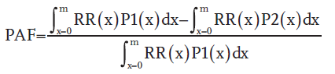
where:
PAF is the population attributable fraction for the risk factor–linked condition pair of interest
RR(x) is the relative risk of a specific disease or injury at exposure level x
P1(x) is the current (or future) population distribution of exposure
P2(x) is the counterfactual distribution (ie, TMREL)
m is the maximum exposure level

For a categorical risk factor, this formula reduces to:
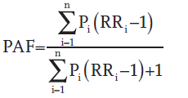
where:
RR_{i} is the relative risk for exposure category i
P_{i} is the proportion of the population in exposure category i
n is the number of exposure categories

Risk factor aggregation and mediation adjustment
Risk factor aggregation is similar in principle to comorbidity adjustment at the condition level (for YLDs). That is, it assumes that the risk factors are independently distributed in the population.

However, population attributable fractions also need to be adjusted for mediation – the extent to which the impact of one risk factor on health outcomes is mediated through another.

This is done by means of a mediation factor (MF). MF is a 2 ⨯ 2 table for each pair of risk factors estimating the extent to which each is mediated through the other for every linked condition. The MFs were derived by a combination of literature review and expert judgement.

The full aggregation model (adjusting for mediation) is:
PAF_{joasct} = 1 – ∏_{j=1to J} (1 – PAF_{joasct} ∏_{j=1to J} [1 – MF_{jio}])
where:
J is the set of risk factors for aggregation
o is the outcome (condition)
a is the age category
s is the sex
c is the country
t is the year
i is the individual risk factor
MF is the mediation factor for risk factor j by risk factor i with respect to condition o
∏ is the multiplication operator
PAF is the joint mediation adjusted population attributable fraction

Lifetables
Lifetables are constructed using conventional demographic methods.

Multistate lifetables for calculation of health expectancy are constructed from all-cause YLD (actually 1 – YLD) and the standard abridged lifetable using Sullivan’s observed prevalence method.

Age standardisation of rates
Where relevant, rates are standardised for age by the direct method, using the GBD Model Population as the reference or standard population.

Uncertainty quantification
Uncertainty around all point estimates is estimated using simulation methods (generally 1000 iterations with the 2.5th and 97.5th centiles being sampled), with the uncertainty being propagated along the causal chain from one epidemiological parameter to the next.

Changes in methods and standards from GBD 2010 to GBD 2013
Beyond improvements in data quality and comprehensiveness, several methodological improvements have been incorporated into GBD 2013 (see www.healthdata.org or the GBD references in Appendix 1 for more detail):
- new standard population for age standardisation
- new model lifetable for YLL calculation
- new version of DISMOD (software for estimating epidemiological parameters such as prevalence and incidence)
- new set of health state disability weights (based on combination of global internet and face-to-face surveys)
- extended sets of conditions, health states and risk factors
- revised disease classification and disease and injury models
- improved method for comorbidity adjustment of health state disability weights
- adjustment for mediation of the impact of one risk factor by another.

Because of these methodological and data quality improvements, all estimates back to 1990 have been recalculated using the new methods and standards. The latest report supersedes all previous reports, which are now obsolete and should no longer be used.

Appendix 3:
New Zealand data sources
Table A1: Administrative data used in GBD 2013
Collection | Content | Years
NZ Health Tracker | Data linkage facility  Currently includes more than 80 health condition prevalence indicators, derived mainly by linking hospitalisation, pharmaceutical prescription and laboratory testing data using the encrypted master National Health Index (unique personal identifier) | Varies with indicator  Mainly from 2000 or thereabouts
Cancer Registry | A population-based register of all primary malignant tumours histologically diagnosed in New Zealand | 1990–current
Mortality Collection | A national collection of all deaths registered in New Zealand, and all registerable stillbirths, classified by the underlying cause of death | 1990–current
National Minimum Dataset | A national collection of public and private hospital discharge information, including coded clinical data for inpatients and day patients | 1990–current
Programme for the Integration of Mental Health Data | A national mental health and addiction information collection of service activity and outcomes data for mental health consumers | 2008–current
Notifiable Diseases Database | A population-based register of all notifiable diseases notified in New Zealand | 1990–current
Birth Defects Register | A population-based register of all birth defects reported in New Zealand | 1990–current

Table A2: Survey data used in GBD 2013
Survey | Content | Years
New Zealand Health Survey | A population-based household survey of health risks, health status, self-reported diagnoses, and health service utilisation | Continuous survey: 2011/12, 2012/13  Earlier surveys: 2006/07, 2002/03
National Mental Health Survey | A population-based household survey of mental health status and mental health service utilisation | 2004
New Zealand Oral Health Survey | A population-based examination survey of dental health and service utilisation | 2009
Adult Nutrition Survey | A population-based household examination survey of diet, nutrition, metabolic risk factors and household food security | 2008/09
Child Nutrition Survey | A population-based household examination survey of children aged 2–14 years covering the topics as listed above for adults | 2002
New Zealand Alcohol and Drug Use Survey | A population-based household survey of alcohol and drug use and related harms | 2007/08
New Zealand Tobacco Use Survey | A population-based household survey of tobacco use | 2009

Table A3: Administrative data not yet used extensively for GBD
Collection | Comment
National Non-admitted Patient Activity Collection (NNPAC) | Emergency department and outpatient clinic utilisation data. Inadequate diagnostic data collected
Accident Compensation Corporation compensated claims | Could be used for minor injury (as in NZBD 2006) but would require extensive cleaning
National Maternity Collection | Little diagnostic data
Client Claims Processing System | No diagnostic data
Socrates (disability support services) | Inadequate diagnostic data
interRAI warehouse (disability, home support) | Inadequate diagnostic data
National Immunisation Register | No diagnostic data
Laboratory Claims Collection | No diagnostic data as holds no test results, but sometimes used by Tracker
Pharmaceutical Claims Collection | No diagnostic data per se, but used by Tracker
National Booking Reporting System warehouse | Little diagnostic data
GMS Collection (general medical service claims) | No diagnostic data
Virtual Diabetes Register | Data linkage product (Tracker used to date but VDR will replace Tracker indicator in future)
Newborn Metabolic Screening | Most common diagnosis is cystic fibrosis – could be used for this
Antenatal HIV Screening | Could be extended to include other routine antenatal tests
B4SC | Screening of four-year-olds for vision, hearing, development
School dental assessments | Dental assessment and treatment of children aged 5–16 years
CVD risk assessments | Assessments of absolute CVD risk carried out by general practitioners
ANZDATA | Register of severe CKD and renal replacement therapy  Only tabulated data available at present, but could be used for stage 4 CKD
Note: This table is included for completeness.

Table A4: Survey data not yet used extensively for GBD
Survey | Comment
Youth Health 2001, 2006, 2013 | Little diagnostic data, but may be of some use with respect to risk factors
Children’s and Young People’s Physical Activity Survey 2008/09 | Survey unlikely to be repeated
Prisoners Health Survey 2005 | Not population based, not repeated
Childhood Immunisation Coverage Survey 2005 | No diagnostic or risk factor data
Post-censal Disability Survey 1996, 2001, 2006, 2013 | Little reliable/usable diagnostic information
Growing Up in New Zealand | Longitudinal cohort study, not population based
Dunedin Multidisciplinary Child Development Study | Longitudinal cohort study, not population based
Christchurch Child Development Study | Longitudinal cohort study, not population based
Note: This table is included for completeness.

Table A5: Other data sources used to varying extents for GBD 2013
Data source | Comments
Published peer reviewed research studies | Several hundred relevant journal articles identified
Published government, non-governmental organisation and industry reports | ‘Grey’ literature
Published reports and databases of intergovernmental organisations | World Health Organization’s Health Database (includes New Zealand)  Organisation for Economic Co-operation and Development’s Health at a Glance database (includes New Zealand)
Unpublished datasets | Several data sets, mainly regional or facility-based, provided by academic, district health board, Accident Compensation Corporation and other government researchers on request

Mitchell E. 2009. SIDS: past, present and future. Acta Paediatrica 98: 1712–9.

