Health and Independence Report 2018
The Director-General of Health’s Annual Report on
the State of Public Health

Acknowledgements | He mihi
This report was jointly prepared by the System Strategy and Policy directorate and the Health System Improvement and Innovation directorate, Ministry of Health.
Pallavi Chhibber, Shari Mason and Kimberly Gilmore would like to thank the peer reviewers and those who contributed to the production of this report.
Citation: Ministry of Health. 2020. Health and Independence Report 2018. Wellington: Ministry of Health.
Published in June 2020 by the Ministry of Health
PO Box 5013, Wellington 6140, New Zealand
ISBN 978-1-98-859759-1 (online)
ISBN 978-1-98-859760-7 (print)
HP 7298
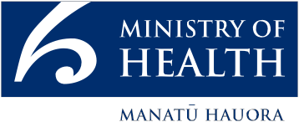
This document is available at health.govt.nz
This work is licensed under the Creative Commons Attribution 4.0 International licence. In essence, you are free to: share ie, copy and redistribute the material in any medium or format; adapt ie, remix, transform and build upon the material. You must give appropriate credit, provide a link to the licence and indicate if changes were made.

Foreword | Kupu whakataki
Tēnā koutou katoa

I am pleased to present the 2018 Health and Independence Report.

This past year has seen the concept of wellbeing strongly embraced across government. This is heartening for us in the health and disability sector because health is both an enabler and an outcome of overall wellbeing: We know investing in health improves our society and we know much of what affects our health happens outside of the health and disability system.

Equally significant has been the recognition that the aim is wellbeing for all. In the health and disability sector, we know persistent inequalities exist in the determinants of health, in disease burden, in access to timely and high-quality treatment and ultimately in our health outcomes. Important health disparities continue to exist for Māori, Pacific peoples, socioeconomically deprived people and disabled people. These inequities exist because of a number of factors, which are discussed in this report. To address these disparities and achieve equity, concerted action is required at all levels of the health system and beyond.

As a country our health continues to improve, but important challenges remain. Looking to the future, as the world around us continues to change, new threats to our health emerge and old threats can re-emerge. The persistence of health inequities means that some people will not have as much resilience to these threats as others.

Delivering a wide range of sustainable, quality health services to New Zealanders is a central challenge in the public health system. It will require new ways of working that enhance wellbeing though investment in prevention and early intervention.

Importantly, equity must be at the heart of everything we do. A goal of any good health system is to meet the unique health needs of its population.

It is my hope and aspiration that this report will inform our current and future work in the health sector, across government and in our local communities to enhance the health and wellbeing of all people in Aotearoa New Zealand.

Ngā mihi

Dr Ashley Bloomfield
Director-General of Health

Contents
Foreword | Kupu whakataki iii
Executive summary | Whakarāpopototanga matua ix
About this report | Kōrero tīmatanga xi
Key sources of information used in this report xi
Starting point | Ōrokotīmatanga 1
Our people 1
Health and wellbeing 5
Diversity 6
The Treaty of Waitangi and equity 9
Responding to diversity and inequity 13
Determinants of health and wellbeing | Ngā whakatau o te hauora me oranga 14
Socioeconomic factors 16
Physical environment 21
Access to health services 22
Health behaviours and biomedical characteristics 24
Population health measures | Ngā mēhua hauora o te taupori 32
Mortality 32
Morbidity 36
Health loss 37
Causes of health loss | Ngā take mo te mate hauora 41
Cancers 41
Cardiovascular and cerebrovascular diseases 44
Musculoskeletal conditions 48
Mental health conditions 48
Neurological conditions 52
Chronic respiratory diseases 52
Other non-communicable diseases 53
Fatal and non-fatal injuries 55
Communicable diseases 60
Maternal and neonatal disorders 67
Our health outcomes | Ngā putanga hauora 68
Self-rated health 68
Life expectancy and health-adjusted life expectancy 69
Addressing the Challenges | Te whakatau i ngā wero 72
The challenges 72
Achieving Pae Ora – Healthy Futures 75
Conclusion | Whakakapi 82
Technical notes | Ngā tuhipoka hangarau 83
References | Ngā tohutoro 85

List of Tables
Table 1: Health workforce statistics 8
Table 2: Domestic students completing qualifications by field of study and ethnic group, 2018 9
Table 3: Leading causes of years of life lost for males, 2017 34
Table 4: Leading causes of years of life lost for females, 2017 34
Table 5: Top five causes of amenable mortality, 2010–2016 (percentage of total amenable mortality) 36
Table 6: Leading specific causes of morbidity 37
Table 7: Cancer registration and mortality rates, 2016, Māori and non-Māori 42
Table 8: Number of cases and deaths from meningococcal disease in 2018 61

List of Figures
Figure 1: Proportions of ethnic groups for the usually resident population, 2018 Census 2
Figure 2: Estimated Resident Population at 30 June 2019, by DHB 4
Figure 3: Ethnicity of people allocated disability support services, 2016 and 2018 13
Figure 4: The determinants of health and their relative contribution to our health outcomes 15
Figure 5: Feelings of loneliness in the last four weeks, by ethnic group, NZ adults 17
Figure 6: Mortality rates by sex, 1948–2016 33
Figure 7: Mortality rates for Māori and non-Māori, 1996–2016 33
Figure 8: Amenable mortality rates by ethnic group, ages 0–74 years, 2009–2016 35
Figure 9: Contribution of various causes to overall disease burden 38
Figure 10: Top 10 causes of health loss by age group 39
Figure 11: Cancer mortality rates, 1948–2016 41
Figure 12: Leading cancers in New Zealand by deaths and DALYs 43
Figure 13: Trends in (a) deaths and (b) health loss (in DALYs) from ischaemic heart disease, 1990–2017 45
Figure 14: Fluoridation and dental ASH rates by area deprivation, children aged under five years 55
Figure 15: Fluoridation and dental ASH rates by area deprivation, children aged 5–12 years 55
Figure 16: Serious non-fatal injury rates, 2000–2017 56
Figure 17: Number of confirmed measles cases for 2019 (up to 4 October), by DHB 62
Figure 18: Number of confirmed measles cases for 2019 (up to 4 October), by ethnic group 63
Figure 19: Infectious syphilis rolling 12 month case counts by quarter, 2013 Q4 to 2019 Q1 63
Figure 20: Life expectancy at birth for females and males, 1997, 2007 and 2017 70
Figure 21: Health expectancy at birth for females and males, 1997, 2007 and 2017 70
Figure 22: Years lived in poor health for females and males, 1997, 2007 and 2017 70

Executive summary | Whakarāpopototanga matua
The New Zealand population has a good level of health ...
- 87.5 percent of adults report having good, very good or excellent health.
- 98 percent of children are considered by their parents as having good, very good or excellent health.
- Life expectancy for a boy born in 2017 is 79.7 years and for a girl is 83.6 years.
- Health expectancy (years lived in good health) for a boy born in 2017 is 68.0 years and for a girl is 70.1 years.

... but there are inequities within measures of health and overall gains have slowed.
- Māori adults are less likely (0.9 times as likely) than non-Māori adults to rate their health as good, very good or excellent. They are more likely (2.4 times as likely) to rate their health as poor.
- People in the most deprived communities are less likely (0.9 times as likely) than those in the least deprived communities to rate their health as good, very good or excellent. They are more likely (3.7 times as likely) to rate their health as poor.
- However, the patterns of inequity seen in self-rated health of adults are not seen in parent-rated health of children. The proportion of children with health rated as good, very good or excellent does not vary significantly by gender, broad ethnic group or neighbourhood deprivation. Neither does the proportion of children with health rated as poor.
- Self-rated health also varies by disability status. Disabled adults are less likely than non-disabled adults to rate their health as good, very good or excellent.
- While 88 percent of non-disabled adults rate their health as good, very good or excellent, only 51.3 percent of disabled adults do.
- Significant differentials in life expectancy exist for Māori and Pacific peoples. An analysis of mortality data from 2013 to 2015 shows that non-Māori/non-Pacific people live approximately seven years longer than Māori and six years longer than Pacific people.
- The increase in New Zealanders’ health expectancy over time has not kept pace with the gains in life expectancy. As a result, the number of years we live in less than full health has increased. Men spend 11.6 years in poor health, while women spend 13.5 years.
- Women live 3.9 years longer than men. The life expectancy gap between men and women has reduced over time, although gains have been slower over the past 10 years than over the past 20 years.
- Life expectancy gains have been slower over the past 10 years than over the past 20 years. Plateaus in life expectancy have been seen in some countries, and it is possible we may be seeing a similar trend in New Zealand.

Non-communicable diseases drive most of our ill-health and premature death.
- Ischaemic heart disease is the leading single disease cause of health loss and premature loss of life in New Zealand, causing one in seven deaths.
- Cancers are the leading group of diseases causing health loss in New Zealand, collectively accounting for 17.4 percent of health loss and causing 3 in 10 deaths. Approximately 66 people are newly diagnosed with cancer every day.
- Other significant contributions to our health loss come from musculoskeletal conditions (especially lower back pain and neck pain), mental health conditions, neurological conditions and chronic respiratory diseases. Ethnic differences occur within many of these areas of health loss, with Māori and Pacific people commonly having higher rates of disease.

Injuries are also an important cause of health loss.
- Road injuries are the ninth leading cause of premature mortality for men and seventh leading cause for women.
- The rate of serious non-fatal injuries from falls has increased over the past decade.
- Our rate of suicide has remained high over the past decade and is consistently higher for Māori. The suicide rate has increased markedly in recent years for Māori men.

Infectious disease vigilance is as necessary as ever to protect public health.
- In 2018 and 2019, meningococcal disease, measles and syphilis were key public health issues affecting New Zealanders.
- Rates of rheumatic fever were in decline, but have increased since 2015.
- Thirty-nine percent of our disease burden is attributed to potentially modifiable risk factors. Poor social conditions and inequality underlie unequal health outcomes among New Zealanders.
- Tobacco, dietary risks, high body-mass index, high blood pressure and high blood glucose and alcohol consumption are leading risk factors for health loss and long-term conditions.
- Ethnic differences exist across poverty indicators such as income and household food insecurity. In 2015/16, one in five children lived in a house experiencing food insecurity in New Zealand. Two in five Pacific children lived in a food insecure household.
- Māori, Asian and Middle Eastern, Latin American or African (MELAA) people were around four times more likely to be living in crowded housing than people with European ethnicity.
- Women, Māori and those in deprived areas experience greater unmet need for primary health care services, indicating they have less access to these services.
- Since 2016, childhood immunisation coverage has decreased and the equity gap between immunisation gaps for Māori and European children has increased.

About this report | Kōrero tīmatanga
The Health and Independence Report presents an overview of the state of health and wellbeing of New Zealanders on behalf of the Director-General of Health. It draws on information from a range of sources. It is prepared annually in line with section 3 of the Health Act 1956. This report complements and informs other key strategic, planning and reporting documents.

Key sources of information used in this report
New Zealand’s findings from the Institute for Health Metrics and Evaluation’s Global Burden of Disease Study (GBD) (Global Burden of Disease Collaborative Network 2018) is a key source of information used in this report. The GBD brings together up-to-date research and evidence and applies this to risk factors, morbidity and mortality to highlight key areas of health loss and life and health expectancy. Total health loss is measured in the population in disability-adjusted life years or DALY units. One DALY represents the loss of one year lived in full health. DALYs integrate health losses from premature mortality and years lived with disability (adjusted for severity). In this report we use the estimates from the GBD 2017 cycle.

For further information from the GBD, go to:
healthdata.org/data-visalization/gbd-compare

The New Zealand Health Survey (Ministry of Health 2019n) provides a rich source of information from New Zealanders about health behaviours, risk factors, health conditions and access to health services. It also provides insights into how these vary between different groups. In the New Zealand Health Survey, an adult is defined as someone aged 15 years or over, and parents respond to the survey for children under the age of 15 years. Every year, over 13,000 randomly selected adults and parents or caregivers of over 4,000 children take part in the survey. The New Zealand Health Survey became a continuous survey in 2011, enabling the publication of annual updates. Modules are often added year to year, to provide further insight on a particular subject. This report draws on the 2017/18 New Zealand Health Survey data as well as earlier survey years.

For further information about the New Zealand Health Survey findings, go to: health.govt.nz/nz-health-statistics/national-collections-and-surveys/surveys/new-zealand-health-survey

Wellbeing statistics give a picture of social wellbeing in the New Zealand population. They are based on people’s assessments of their own lives, such as how satisfied they are; and objective information, such as their income. The information comes from the New Zealand General Social Survey which has surveyed adults aged 15 years and over in New Zealand every other year since 2008. Different modules have been added to each survey since 2014. This report draws on the latest available New Zealand General Social Survey data (from 2018) (Stats NZ 2019o).

For further information about the New Zealand General Social Survey findings, go to:
stats.govt.nz/information-releases/wellbeing-statistics-2018

Starting point | Ōrokotīmatanga
New Zealand has a diverse, growing and ageing population. We must meet the health and disability needs of all New Zealanders.
Achieving good health for all requires us to consider what causes us to be unwell, and how these causes may differentially affect us

New Zealand aspires to be a place of good health for all. Good health is both a contributor to and an outcome of wellbeing across all aspects of our lives.

Previous Health and Independence Reports have highlighted that while New Zealand has an overall good level of health, not everyone enjoys equally good health. These unequal outcomes result from unequal exposure to health risks as well as unequal access to quality health care and treatment. While our lifestyles play a part in determining our health risks, many factors limit our control over our health in our day-to-day lives. Societal, economic and environmental pressures affect our health outcomes, and the impact is greater on some people than others. Understanding how the health of different groups of people is affected is important in order to increase the health and wellbeing of all and achieve health equity.

As a starting point, this section provides the relevant context and concepts to support such a consideration.

Our people
Aotearoa New Zealand is home to nearly five million people: a population that is growing, ageing, diversifying ethnically and highly urbanised

As at December 2018, New Zealand had an estimated resident population of 4.93 million (Stats NZ 2019j). By 2038, this is projected to increase by nearly 1 million, with growth in the numbers of all major ethnic groups (Stats NZ 2016; 2017b).

Similar to other countries that have undergone the ‘demographic transition’, New Zealand has a comparatively older age structure and will continue to get older. In 2018, the median age was 37.3 years, slightly older than in 1999 (34 years) (Stats NZ 2019e). By 2038, the median age is projected to increase to between 41.2 and 42.8 years (Stats NZ 2016). About 19 percent of the estimated resident population is under 15 years of age. Those aged 65 and over represent 15 percent of the population, with 2 percent aged 85 and over (Stats NZ 2019e).

The Māori population has a relatively younger age structure than the non-Māori population, and this difference is expected to continue in future (Stats NZ 2017b). The median age for Māori is 24.6 years – over 10 years lower than for the population overall (Stats NZ 2019i).

Over the next three decades, the number of people aged 65 and over is expected to double, while the number of people 85 and over will more than triple. The proportion aged under 15 years is expected to decrease from 19.3 percent to 17.1 percent.

The European ethnic group comprised 70.2 percent of the usually resident population in 2018 (Figure 1). Māori accounted for 16.5 percent of the population, Asian for 15.1 percent and Pacific peoples for 8.1 percent.

Figure 1: Proportions of ethnic groups for the usually resident population, 2018 Census
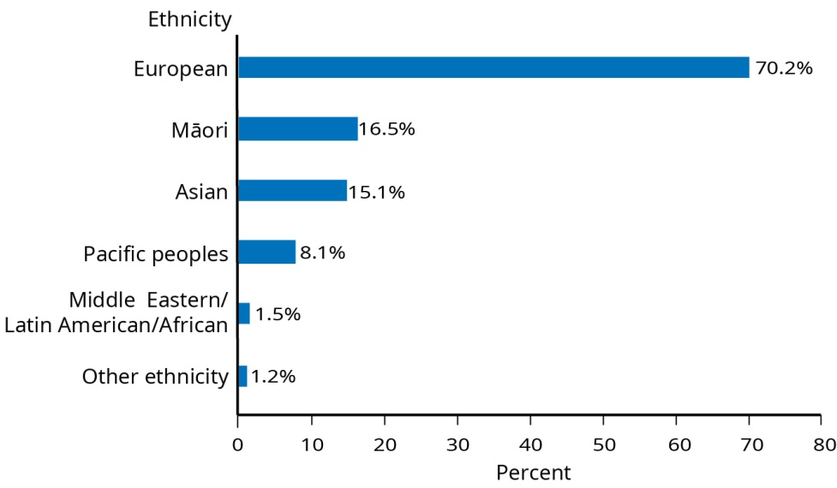
Note: People have been counted once in each ethnic group they reported (grouped total responses). The census counts are not directly comparable with the population estimates (estimated resident population), because the estimates include people not counted by the census.
Source: Statistics New Zealand (2019k)

An increasingly diverse ethnic mix is projected. The broad ethnic group ‘European or Other’ is expected to decrease to 66 percent of the population by 2038 (Stats NZ 2017a).

Conversely, projections indicate increases in the proportion of non-European ethnic groups by 2038 (Stats NZ 2017b):
- 22 percent Asian
- 18 percent Māori
- 10 percent Pacific peoples
- 3 percent Middle Eastern/Latin American/African.

The proportion of children belonging to the European/Other ethnic group is expected to decrease from 72 percent in 2013, to 68 percent in 2038. Proportions of children for other ethnic groups are expected to increase by 2038, with Māori accounting for 30 percent of children (26 percent in 2013), Pacific peoples 18 percent (13 percent in 2013) and Asian 21 percent (12 percent in 2013).

The 2018 Census showed that 27.4 percent of the usually resident population were born overseas, an increase from 25.2 percent in 2013 (Stats NZ 2019a).

The New Zealand population is predominantly based in urban areas (84 percent of the population). Nearly two-thirds of the population (65 percent) live in major or large urban areas with 30,000 or more residents (Stats NZ 2019f). Figure 2 shows the estimated percentage of our population living in each DHB region.

Figure 2: Estimated Resident Population at 30 June 2019, by DHB
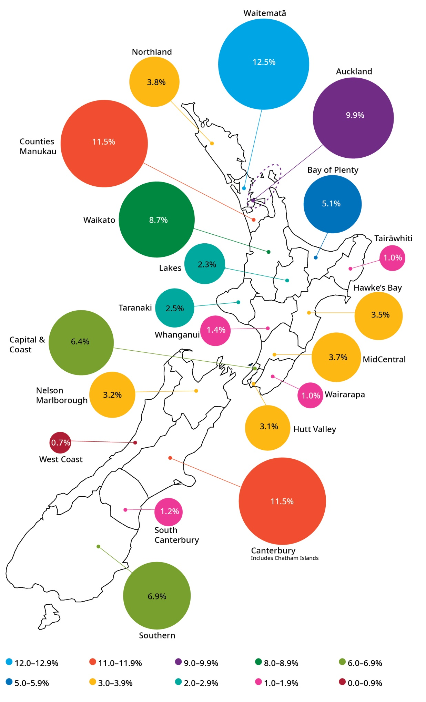
Source: (Stats NZ 2019d)

According to the 2018 Census, Auckland had the largest population increase between 2013 and 2018, but Northland, Bay of Plenty and Waikato had the highest rate of increase. The Auckland region increased by more than 156,000 people over this period, which represents an 11 percent increase. The Northland population increased by 18.1 percent, Bay of Plenty by 15.2 percent and Waikato by 13.5 percent (Stats NZ 2019m).

Health and wellbeing
The World Health Organization provides a holistic and widely accepted definition of health:
a state of complete physical, mental and social well-being and not merely the absence of disease or infirmity (WHO 2014).

Good health is both an enabler and an outcome of wellbeing across all aspects of our lives. Recent years have seen a significant emphasis on wellbeing as the accepted measure underpinning many core aspects of government activity.

In 2019, we saw New Zealand’s first ‘Wellbeing Budget’. This aimed to broaden the Budget’s focus beyond economic and fiscal policy. The Government’s investment priorities and funding decisions were instead informed by a wider set of considerations developed by the Treasury known as the Living Standards Framework.

New Zealand has also shown its commitment to improving wellbeing with the submission of our first voluntary review of progress towards the United Nations’ sustainable development goals (SDGs) (United Nations 2015). The SDGs, established by the United Nations in 2015, set out 17 goals and 169 targets to achieve by 2030. These goals and targets balance the three dimensions of sustainable development: economic, social and environmental. As well as supporting a number of the goals, the Ministry of Health is the lead agency for SDG 3 Ensure healthy lives and promote well-being for all at all ages. The Ministry, DHBs and wider health sector will actively engage with other agencies and sectors responsible for the goals around determinants of health, in particular education, housing, urban design, income, transport and environmental quality.

This year, we also saw the publication of Ngā Tūtohu Aotearoa, a suite of indicators put together by Statistics New Zealand as a source of measures for New Zealand’s wellbeing (Stats NZ 2019h). The indicators cover New Zealand’s current wellbeing, future wellbeing and the impact New Zealand has on the rest of the world. The indicators will support many cross-government initiatives including the Treasury’s Living Standards Framework. It will also support international reporting requirements under the United Nations’ SDGs.

Diversity
Understanding the diversity of our people is an important step in enabling their health and overall wellbeing and for building an inclusive society. Diverse populations mean diverse needs and aspirations.

Diversity relates to the range of personal and cultural characteristics people have. These characteristics include ethnicity, language, religion (or lack of religious beliefs), gender, sexuality and disability. Not only is it necessary to maintain a broad view of the characteristics underlying the concept of diversity, but it is also important to acknowledge that a person’s diverse characteristics intersect.
An intersectional approach to diversity takes into account more than one aspect of a person’s identity when examining their experiences (Chen 2017). This is particularly significant in the health sector, where cumulative disadvantage is often observed.

As seen from the change in our population demographics over time, New Zealand is becoming increasingly ethnically and culturally diverse. More than one in four people usually resident in New Zealand are born overseas. The most recent available data suggests New Zealand has the fifth-highest proportion of foreign-born population among OECD countries.

Although data is often collected at the broad ethnic group level, diversity also exists within groups – such as within Pacific and Asian peoples. There are more than 40 different Pacific ethnic groups in New Zealand – each with its own culture, language and history.

According to the 2017/18 New Zealand Health Survey, 96.4 percent of adults identified as heterosexual (Ministry of Health 2019d).

An estimated 1.8 percent (72,000 adults) identified as bisexual, 1.2 percent (46,000 adults) identified as gay or lesbian, and 0.5 percent (21,000 adults) identified with sexual identities other than heterosexual, gay, lesbian or bisexual.

Migrants and refugees increasingly enrich our society. Tools and resources are available for building system responsiveness to culturally and linguistically diverse communities.

New Zealand offers a home to migrants and refugees and is influenced by the changing composition of new arrivals.

From 1 July 2020, the annual quota of refugees accepted into New Zealand will increase from 1,000 to 1,500. In addition to existing refugee settlement regions (Auckland region, Waikato, Manawatu, Wellington region, Nelson, Christchurch, Dunedin and Invercargill), new settlement regions will soon be established (Timaru, Blenheim, Masterton, Levin, Ashburton and Whanganui) (Immigration New Zealand 2019). Refugees often have uniquely complex health needs. Past trauma, mental and physical challenges of life as a refugee and then the further challenge of adapting to life in a new country can have a number of consequences for health and wellbeing.
A variety of tools and resources are available for those working with culturally and linguistically diverse communities. This includes through the eCALD training programme (Waitematā DHB 2019) (see box below) and a new telephone interpreting service called Ezispeak, which launched in October 2019 as part of the cross-government Language Assistance Services Programme. Forty-three public sector agencies have signed up to a government collaborative contract for these language services, including several DHBs. Eighteen non-public sector agencies contract directly with Ezispeak, including some public health organisations.

These services help to uphold rights enshrined in the Code of Health and Disability Services Consumers’ Rights (Health and Disability Commissioner 2019), including the right to effective communication (Right 5) and the right to be fully informed (Right 6). Health professionals are encouraged to explore and champion use of these services.

Recognition of Waitematā DHB’s eCALD programme at the 2018 Diversity Awards
Waitematā DHB’s Culturally and Linguistically Diverse (CALD) training programme has been developed for New Zealand health providers and professionals. It delivers online and face-to-face training courses and offers a range of resources for developing cultural capability for the health workforce to work with migrant and refugee patients and clients from Asian, Middle Eastern, Latin American and African backgrounds. The online component is known as eCALD.
Initially adopted in Auckland in 2006, the Ministry of Health rolled it out nationally and has engaged more than 27,000 learners. At the 2018 Diversity Awards NZ, the eCALD programme was announced joint winner of the Cultural Celebration Award.
Waitematā DHB’s evaluation of its CALD courses in 2018 found clear evidence of improved learner attitudes and behaviours. This includes consistency of cultural assessment, seeking patient explanations of their health and illness and expectations of their healthcare, more consistent use of interpreters and increased help to patients in navigating the health and disability system.
The Ministry of Health funds eCALD programmes so they are freely available to all health professionals. They are also accredited to meet the professional development requirements of professional registration bodies. Anyone working with CALD patients and clients is encouraged to complete this training. Further information is available at ecald.com.

Diversity in the health workforce is an important factor in understanding and catering for the needs of a diverse population. Māori and Pacific peoples are currently under-represented.

Table 1 shows the proportion of Māori and Pacific peoples in the health workforce. Although Māori account for 16.5 percent of the population in 2018, and Pacific peoples account for 8.1 percent (as seen in Figure 1), they make up a much smaller proportion of the health workforce (note that people who identify as both Māori and Pacific are counted only as Māori in Table 1).

Table 1: Health workforce statistics
Regulatory authority | Health profession and year | Proportion in the total workforce
 |  | Māori | Pacific
Dental Council (2017) | All oral health practitioners (includes dentists, dental specialists, dental therapists, dental hygienists, orthodontic auxiliaries, dental technicians and clinical dental technicians) | 4% | 2%
Medical Council of New Zealand (2017) | All doctors (resident medical officers and specialists, including general practitioners) | 4% | 2%
Midwifery Council of New Zealand (2018) | Midwives | 9% | 2%
Nursing Council of New Zealand (2019) | Nurses (includes enrolled nurses, registered nurses and nurse practitioners) | 8% | 4%
Pharmacy Council (2018) | Pharmacists and pharmacy interns | 3% | 2%
Physiotherapy Board (2018) | Physiotherapists | 5% | 2%
New Zealand Psychologists Board (2018) | All psychologists (includes clinical psychologists, counselling psychologists, educational psychologists, neuropsychologists, psychologists and trainee psychologists) | 5% | 1%
Notes: Health practitioners who identify as both Māori and Pacific are counted only as Māori in this table.
Data are based on workforce surveys by regulatory authorities of health practitioners with annual practising certificates.
Source: Ministry of Health 2019g

Table 2 shows the higher percentages of Māori and Pacific peoples among 2018 graduates in health fields of study, covering qualifications at all levels.

Table 2: Domestic students completing qualifications by field of study and ethnic group, 2018
Fields of study* | Proportion of Māori  among 2018  New Zealand graduates | Proportion of Pacific peoples** among 2018  New Zealand graduates
Dental Studies | 12% | 6%
Medical Studies | 12% | 5%
Nursing & Midwifery | 14% | 9%
Pharmacy | 6% | 4%
Rehabilitation Therapies | 13% | 5%
Behavioural Science | 11% | 6%
* Ministry of Education fields of study do not necessarily correspond exactly to clinical scopes of practice.
** Total response ethnicity data. People who identify as both Māori and Pacific are counted in both categories in this table (this differs from the previous table).
Source: Education Counts 2019

The Treaty of Waitangi and equity
The Treaty of Waitangi (te Tiriti) affirms Māori rights to collective self-determination in New Zealand. The Crown is a partner to te Tiriti and in carrying out its functions must honour this relationship with Māori and their rights as tangata whenua of Aotearoa New Zealand. Within the health sector, Tiriti obligations are specified in the New Zealand Public Health and Disability Act 2000.

The concept of equity in health is an ethical principle, closely related to human rights, particularly the right of all humans to experience good health. These concepts are articulated in a number of international treaties and declarations that New Zealand has ratified, such as the Universal Declaration on the Rights of Indigenous People and the Universal Declaration on the Rights of Disabled Persons.
In Aotearoa New Zealand, people have differences in health that are not only avoidable but unfair and unjust. Equity recognises different people with different levels of advantage require different approaches and resources to get equitable health outcomes.
Ministry of Health 2019a
In the New Zealand context, ōritetanga (equity) is an important concept within te Tiriti. Our laws also reflect this. For example, section 3(1)(b) of the New Zealand Public Health and Disability Act 2000 (New Zealand Government 2000) recognises the need to reduce health disparities by improving the health outcomes of Māori and other population groups.

It is essential to have a common understanding of equity in order to coordinate efforts to achieve it. The Ministry of Health has proposed a working definition of equity (see box to the right).

This definition is designed to align with the third article of te Tiriti and its obligations to ensure mana tangata (fairness and justice) for all New Zealanders.

It is intended to be principle-based and inclusive enough to incorporate all possible dimensions of equity, such as indigeneity, social and economic, geographic and disability. It reflects the international literature on equity and the definition put forward by the World Health Organization:
Equity is the absence of avoidable, unfair, or remediable differences among groups of people, whether those groups are defined socially, economically, demographically or geographically or by other means of stratification. ‘Health equity’ or ‘equity in health’ implies that ideally everyone should have a fair opportunity to attain their full health potential and that no one should be disadvantaged from achieving this potential (World Health Organisation nd).

He Korowai Oranga seeks to achieve the best outcomes for Māori, based on Māori aspirations and priorities.

Data provides evidence of the persistent inequities faced by Māori in New Zealand.

He Korowai Oranga (the Māori Health Strategy) sets the overarching framework that guides the health and disability sector to achieve the best health outcomes for Māori. This includes responding to all of the health and disability system’s obligations under te Tiriti – going beyond just achieving equity in health outcomes for Māori, to enabling Māori to flourish and achieve their aspirations for health.

Pae ora: Healthy futures for Māori is the Government’s vision for Māori health (Ministry of Health 2015). Pae ora includes three interconnected elements:
- mauri ora – healthy individuals
- whānau ora – healthy families
- wai ora – healthy environments.

Mauri ora sets the direction for the health system to ensure that Māori, as consumers of health services, have pathways to care that meet their immediate needs as well as their future needs across all stages of life. Achieving mauri ora will mean that individuals have good health and that the health system delivers services across the continuum, from prevention to treatment, in ways appropriate for Māori at all ages.

Whānau ora is driven by a focus on whānau being self-managing, living healthy lifestyles and confidently participating in te ao Māori and in society. It is a key element of pae ora and is an important part of setting the foundations for healthy futures.

Wai ora reflects the need for Māori to have access to resources and to live in environments that support and sustain a healthy life. Achieving wai ora will mean that the environment in which Māori, and all New Zealanders, live, work and play is safe.

A new Māori health action plan, which provides a roadmap to implement He Korowai Oranga, is currently in development.

The new Pacific Health and Wellbeing Action Plan (Ministry of Health 2019o) is central to achieving health equity for Pacific peoples and aims to strengthen the overall health system’s responsiveness to Pacific peoples.

Pacific peoples continue to experience unacceptable and long-standing inequities across a range of health and socioeconomic indicators. These inequities are complex and multi-faceted, and impact directly on the relatively poorer health status of Pacific peoples.
According to the United Nations Convention on the Rights of Persons with Disabilities (CRPD), disabled people ‘… include those who have long-term physical, mental, intellectual or sensory impairments which in interaction with various barriers may hinder their full and effective participation in society on an equal basis with others’ (United Nations 2008).
The way disability is measured in various data collections differs, and agencies have different eligibility rules for the provision of disability support services. The data in this report is based on a variety of disability questions and criteria, including the Washington Group (Washington Group on Disability Statistics 2019) short-set of disability questions, the more comprehensive set of Disability Survey questions and Ministry of Health criteria for receiving disability support. In New Zealand, health data collection on disabled people is limited.
Improving our national data capability is a key issue identified by the United Nations Committee on Rights of Persons with Disabilities and the Independent Monitoring Mechanism.
The Ministry has engaged with Pacific communities, government agencies and the health and social sectors to develop a new Pacific Health and Wellbeing Action Plan (the plan). The plan will build on the progress the Ministry has made through previous Pacific plans and look at new ways to improve Pacific peoples’ health and wellbeing.

The plan will support Government priorities for improving the wellbeing of New Zealanders and their families and respond to key priorities in the health and disability system including equity, child wellbeing, mental wellbeing, wellbeing through prevention and primary health care.

The plan will promote stronger collective action by government agencies, the social sector (including health) and Pacific communities to improve health. It will include actions that aim to improve the key social determinants of health that impact on the health of Pacific peoples.

The plan will be published in 2020.

The New Zealand Disability Strategy provides a vision for New Zealand as a non-disabling society

According to the 2013 New Zealand Disability Survey (Stats NZ 2014), 24 percent of the population were disabled. Disabled people experience poorer outcomes than non-disabled in a number of areas including income, employment and self-rated health (Stats NZ 2018a; 2019o). The New Zealand Disability Strategy 2016–2026 (Office for Disability Issues 2019) guides various agencies’ work on disability issues. Its aspiration is that New Zealand become a non-disabling society – a place where disabled people have an equal opportunity to achieve their goals and aspirations, and all of New Zealand works together to make this happen.

There is currently limited information available on health outcomes, risk and protective factors for disabled people. However, information will soon be available from the 2018/19 New Zealand Health Survey, which included the Washington Group short-set of disability questions. These questions identify a subgroup of disabled people at greater risk of experiencing restrictions to participation.

A range of data on the wellbeing of disabled people (based on the Washington Group questions) is available from across government. This data shows disabled adults are more likely than non-disabled adults to have poor wellbeing outcomes, including lower overall life satisfaction and sense of purpose and higher rates of discrimination and loneliness (Stats NZ 2019o). Disabled people also faced poorer socioeconomic outcomes in a number of areas including housing, employment and income (Stats NZ 2018a; 2019o).

According to the 2013 Disability Survey, one-third of disabled adults living in private households received regular support with day-to-day activities, such as help with personal care, housework or shopping (Stats NZ 2017c). The most common type of support received was with heavy work around the home or garden. Family members living in the same household were the most likely to provide the support. Approximately one in ten disabled adults had unmet needs for support.

Disability support services are helping an increasing number of New Zealanders to live independently and well

A total of 38,342 people were allocated one or more Ministry-funded disability support services (excluding the Enabling Good Lives programme) in the year to September 2018. This reflects an 18.9 percent increase from 2014, when 32,247 people were allocated disability support services (Ministry of Health 2019f).

More than two-thirds (68.8 percent) of people allocated disability support services are European/Other, while 18.7 percent are Māori. Māori and Asian people accounted for a slightly higher proportion of people allocated services in 2018 compared with 2016 (Figure 3).

Since September 2016, there has been a 23.6 percent increase in the number of Asian clients allocated disability support services, an 11.5 percent increase in the number of Māori clients and 5.8 percent increase in the number of Pacific peoples allocated services.

Figure 3: Ethnicity of people allocated disability support services, 2016 and 2018
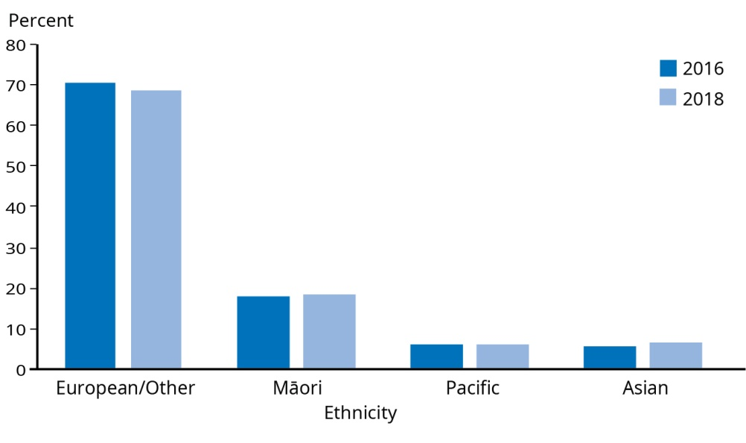
Note: Ethnicity is based on prioritised ethnic group.
Source: Ministry of Health (2019f)

More detailed information on disability support services criteria can be found at:
health.govt.nz/your-health/services-and-support/disability-services/getting-support-disability/am-i-eligible-ministry-funded-support-service

Responding to diversity and inequity
Achieving equitable outcomes will require different approaches and resources for different people. It will also require working at multiple levels, including on health determinants, health access and treatment.

The sections that follow first examine the prevalence and distribution of the factors that make us more or less likely to be unwell, known as the determinants of health. Then we examine the prevalence and distribution of the illnesses that are the leading causes of our health loss. Third, we examine what our health outcomes are, based on traditional measures of health, and how these differ within the population.

Determinants of health and wellbeing |
Ngā whakatau o te hauora me oranga
Various factors have either negative or positive effects on the health of New Zealanders

Many root causes of ill-health lie beyond the span of control of individuals in their day-to-day lives, and even beyond the health system

The factors affecting health are collectively known as the determinants of health. These can support or be barriers to good health and broader wellbeing.

As shown in Figure 4, the determinants of health include:
- socioeconomic factors, such as income
- physical environment, such as access to clean water
- health behaviours, such as tobacco use
- access to health care.

Socioeconomic factors (40 percent) and the physical environment (10 percent) constitute half of the factors that dictate our health outcomes. Our health behaviours account for just under a third (30 percent) and the health care environment is responsible for one-fifth (20 percent) (Institute for Clinical Systems Improvement 2014).

Figure 4: The determinants of health and their relative contribution to our health outcomes
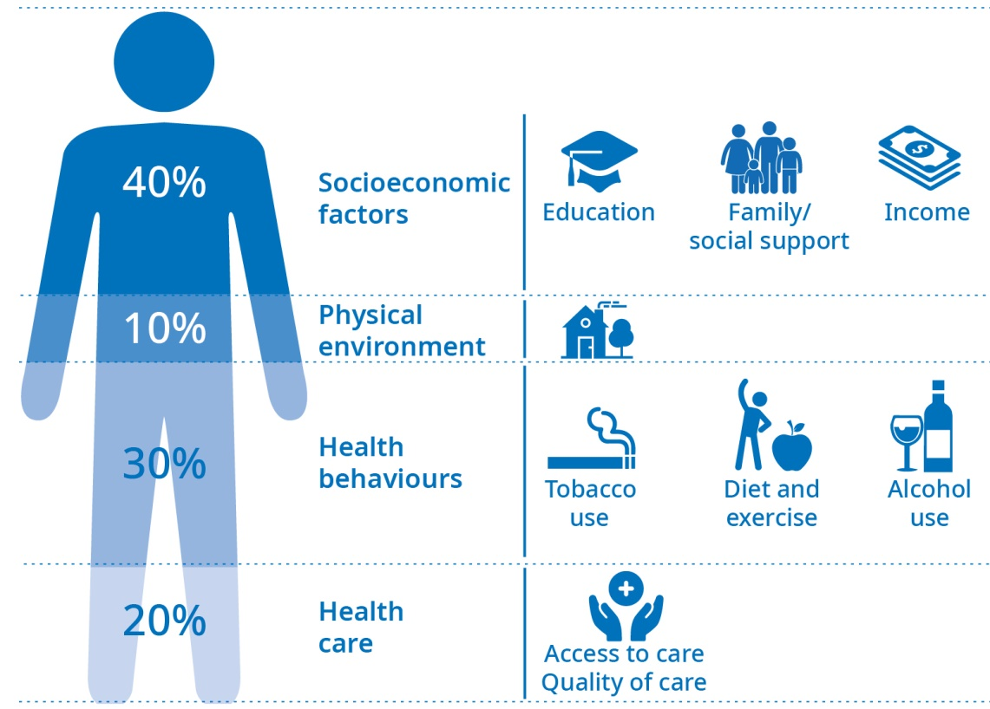
Source: Adapted from the Institute for Clinical Systems Improvement (2014).

Individuals have varying levels of control over these determinants. In many ways these factors are structural – they are embedded in how our society functions and so constrain the level of choice people have. For instance, the food available to us and the amount of money we have affect our ability to make healthy food choices. Evidence suggests that a number of societal-level factors affect an individual’s ability to secure the building blocks of health. These factors include inequality and socioeconomic position (Pickett and Wilkinson 2015), as well as colonisation (Robson and Harris 2007) and ethnicity and racism (Came et al 2018; Williams and Mohammed 2013).
Structural determinants of health have been discussed by the World Health Organization (Solar and Irwin 2010). They are the social and political mechanisms that give rise to and maintain hierarchies in society (such as the labour market, the educational system, institutional processes and societal values), as well as the resulting socioeconomic position of individuals.

For a further discussion of causes of health inequity see HQSC Report
Window on Quality 2019 (Health Quality & Safety Commission 2019).

Impacts of racism on health
Racism may occur on three levels (Jones 2000).
Institutionalised racism refers to differential access to the goods, services and opportunities of society by ethnicity.
Interpersonal (or personally mediated) racism refers to prejudice and discrimination. Prejudice means differential assumptions about the abilities, motives and intentions of others according to their race, and discrimination means differential actions toward others according to their race.
Internalised racism is acceptance by members of the stigmatised groups of negative messages about their own abilities and intrinsic worth.
A recent study found that experiences of interpersonal racism were associated with negative health and wellbeing measures in New Zealand (Harris et al 2018). Recent experiences of racism were consistently associated with negative measures of health and wellbeing, including indicators of mental health, physical health and overall life satisfaction. Reported recent experiences of racism were highest for Asian (especially those born overseas), followed by Māori and Pacific peoples. Therefore the negative health impacts of racism would disproportionately affect these groups.
The Ministry of Health has identified the need for discussions, systems and processes across institutions to address all forms of racism and discrimination in order to help achieve health equity (Ministry of Health 2019b).

Socioeconomic factors
New Zealanders generally report the wellbeing of their family/whānau as high

The New Zealand General Social Survey asks people to rate how well their family is doing on a scale of 0 to 10, where 0 is extremely badly and 10 is extremely well.

Most people (82.6 percent) rated their family/whānau as doing well in 2018 (a rating of 7 or higher). The proportion was slightly higher for Asian people (87.5 percent) and lower for Māori (74.9 percent). It was similar for European (82.6 percent) and Pacific peoples (82.4 percent) (Stats NZ 2019o).

The average family wellbeing rating for the total New Zealand population was unchanged from 2016, at 7.8 out of 10. The average family/whānau wellbeing was lower for non-heterosexual people: 7.3 for gay or lesbian people, 6.8 for bisexual people and 7.2 for other identities (this includes takatāpui, asexual and pansexual).

Most people have good social connections, but disabled people, Māori and young people in particular experience greater isolation and loneliness

The General Social Survey asks about loneliness in the previous four weeks and contact with friends and family. Overall, 61 percent of New Zealand adults reported not feeling lonely in that time period (Stats NZ 2019o). For Pacific peoples, the proportion was higher (69 percent).

One in six (16.6 percent) adults felt lonely at least some of the time over the previous four weeks, with 3.5 percent feeling lonely most or all of the time. Women were more likely to have experienced loneliness than men. More Māori (6.3 percent) felt lonely most or all of the time.

Figure 5: Feelings of loneliness in the last four weeks, by ethnic group, NZ adults
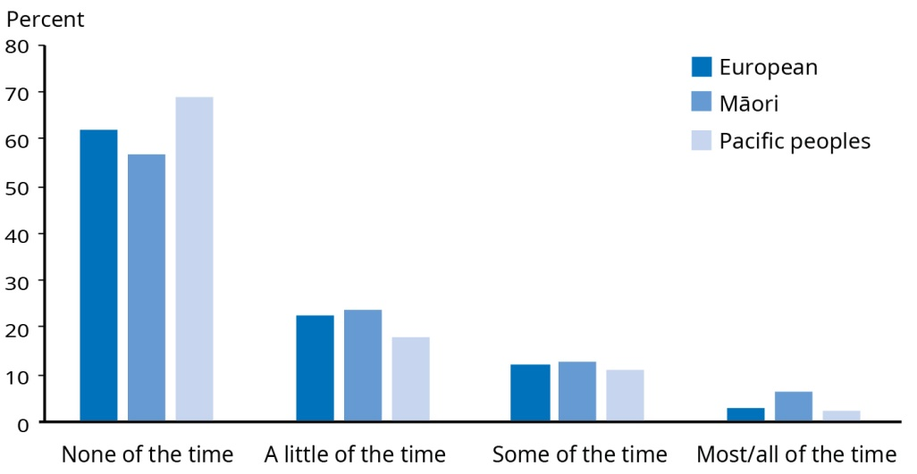
Source: Stats NZ 2019o

Disabled people had a greater level of loneliness than the rest of the population. About half (53 percent) of disabled people had not felt lonely over the previous four weeks, while 8.3 percent felt lonely most or all of the time.

Young adults (aged 15–24) also had higher than average levels of loneliness, with half not feeling lonely over the past four weeks and 5.8 percent feeling lonely most or all of the time.

A higher proportion of those who weren’t living in a family nucleus (5.7 percent) and those living in a single-parent family (6.1 percent) felt lonely most or all of the time.

An estimated 60 percent of people had face-to-face contact with family at least once a week and 80 percent had other types of contact. About three-quarters of people had contact with friends face-to-face and by other means. Contact with family and friends is similar across ethnic groups, except for Asian people, who had a lower rate of face-to-face contact with their family (48.6 percent). Migrants also had similar levels of social contact, other than face-to-face contact with family. A similar proportion of men and women had face-to-face contact with friends once a week, but more women than men had contact with family and other types of contact with friends.

Disabled people were less likely than non-disabled people to have had contact with friends at least once a week, face-to-face or otherwise.

Young adults (15–24) had higher rates of contact with friends but lower rates of contact with family than average.

Māori and Pacific children are more likely to be in a household that is low-income or experiencing food insecurity, which are indicators of poverty

Poverty can negatively affect health in a number of ways, including through poor or no housing, inadequate nutrition or lack of access to health care.

The Child Poverty Reduction Act 2018 was introduced with the purpose of achieving a significant and sustained reduction in child poverty in New Zealand through:
(a) encouraging a focus by government and society on child poverty reduction
(b) facilitating political accountability against published targets
(c) requiring transparent reporting on levels of child poverty.
There is no single measure or threshold of poverty, and the use of a range of measures can provide a comprehensive picture. The Act specifies four primary measures and six supplementary measures of child poverty, and Statistics NZ has been tasked with reporting annually on these measures. Child poverty statistics are not yet available by ethnic group but estimates by ethnicity should be available in 2020.

Income statistics show that in 2019, Māori had a lower median weekly income ($647) than the median income for total New Zealand ($708) (Stats NZ 2019l). An estimated 17.9 percent of Māori adults perceive that they do not have enough money to meet everyday needs, compared with 10 percent of the total population (Stats NZ 2019o). An estimated 16 percent of children live in low-income households (Stats NZ 2019c).
Low-income households in this discussion refers to households with less than 50 percent of the median disposable household income, after adjustments to take into account the number of adults and children in a household, but before housing costs are deducted.
Material hardship is a measure of whether households can afford specific items that most people would consider essential, such as being able to pay the gas or electricity bills on time, or whether they have to do things like put off visits to the doctor due to cost (Stats NZ 2019c).
Food insecurity measures are based on a food security questionnaire that was part of the New Zealand Health Survey Developmental Health and Wellbeing module in 2012/13, 2014/15 and 2015/16. Primary caregivers responded to statements relating to food security (for example, running out of or eating less food due to lack of money over the previous year).

An estimated 13 percent of children live in a household experiencing material hardship, with 5.8 percent experiencing severe material hardship (Stats NZ 2019b).

In 2015/16 an estimated one in five (19 percent) children lived in a home that experienced food insecurity. Inequities exist in household food security: Māori children were more likely (1.8 times) than non-Māori children and Pacific children were more likely (2.3 times) than non-Pacific children to have experienced household food insecurity (Ministry of Health 2019k).

Recent estimates on homelessness are not available, but demand for social housing has increased

Homelessness is associated with worse physical health, mental health and addictions. The 2013 Census estimated there were approximately 41,000 New Zealanders in severe housing deprivation (Amore 2016). This ranges from people sleeping on the street to those in temporary accommodation or sharing with other households. More up-to-date estimates of homelessness across New Zealand are not available. However, demand for social housing is one indicator of the trend in homelessness. At the end of June 2019, there were 12,311 applications on the Housing Register. This reflects an increase of 41.4 percent over the same time last year. Nearly half of these applicants (46 percent) are Māori, a quarter (24 percent) are New Zealand European, 14 percent are Pacific peoples and 13 percent belong to other ethnic groups (Ministry of Social Development 2019). Applications in Auckland account for 39 percent of total demand.

Household crowding affects one in ten New Zealanders. Mould and cold problems affect one in three and one in five New Zealanders respectively. There are significant ethnic differences and children are more affected than adults.

The term ‘household crowding’ generally means that a household has fewer bedrooms, or less space, than will adequately or appropriately house the number of people living there. Measures of household crowding are important in the health context because crowding increases health risks, particularly risks of infectious diseases such as respiratory infections, gastroenteritis, meningococcal disease and acute rheumatic fever (Baker et al 2013; Jaine et al 2011). Perceptions and measures of crowding can be cultural or subjective, but the health effects of crowding are not. Living in crowded conditions can make life difficult for families regardless of ethnicity or culture. Household crowding occurs because of housing availability and affordability pressures as well as cultural expectations.

In 2013, 10.1 percent of people lived in a crowded house (Stats NZ 2018c). Children were more likely to live in crowded houses than adults (15.9 percent of children and 8.6 percent of adults).

Pacific peoples had the highest rate of crowding, at 39.8 percent. After adjusting for age structures in the different ethnic groups, people with Māori, Asian, Middle Eastern, Latin American or African ethnicity were around four times more likely to be living in crowded housing than people with European ethnicity.

There is variation in crowding rates within ethnic groups. For Pacific peoples, crowding was highest among those who identified as Tongan (48.7 percent) and Tokelauan (41.5 percent).

More than one-third of people (35.8 percent) live in a mouldy house or flat (Stats NZ 2019o). Of these people, 16.7 percent live in a house where the mould is larger than an A4 sheet of paper. One-third of people (34.1 percent) live in a house or flat that’s damp, and 21.2 percent live in a house or flat that is always or often colder than they would like.

The proportion of Māori and Pacific peoples living in houses that are always damp, mouldy or always or often colder than they would like was significantly higher than for the overall population.

Disabled people are significantly more likely than non-disabled to reportedly live in a house or flat that is unsuitable or very unsuitable. Disabled people are also more likely to live in a house or flat that’s always or often colder than they would like, or one that’s always damp.

Evaluation of the Healthy Homes Initiatives
Healthy Homes Initiatives (HHIs) (Ministry of Health 2019h) were established as part of the Rheumatic Fever Prevention Programme to reduce household crowding for those at risk of rheumatic fever. They began in Auckland in December 2013 and expanded to the other DHBs with a high incidence of rheumatic fever in March 2015. HHIs are now across 11 DHB regions: Auckland, Northland, Waitematā, Counties Manukau, Bay of Plenty, Waikato, Lakes, Hauora Tairāwhiti, Hawke’s Bay, Capital and Coast and Hutt Valley.
An initial evaluation of the health outcomes associated with HHIs has shown positive results. For every 10 families referred to the HHIs, there is one fewer child hospitalised, six fewer GP visits and six fewer pharmaceuticals dispensed. The costs of the initiatives have been recouped by health sector savings within the first two years of the programme (Pierse et al 2019).
This finding is in line with previous evidence of the cost-effectiveness of retrofitting insulation as part of the Energy Efficiency and Conservation Authority’s Warm Up New Zealand: Heat Smart Programme (Grimes et al 2012).

Physical environment
Available monitoring data suggests our air quality is good in most places most of the time, though air pollutant monitoring is limited in its coverage

It is estimated that, in 2017, 697 deaths in New Zealand were attributable to air pollution (Health Effects Institute 2019). The health effects of air pollution include shortness of breath and coughing, heart attack, stroke, diabetes and premature death. In New Zealand, air pollution monitoring is generally only done where high risks to air quality have already been identified.

A number of pollutants exist in our air. In New Zealand and worldwide, the most significant human health impacts from poor air quality are associated with exposure to particulate matter (Health Effects Institute 2019). The burning of wood and coal for home heating is the single biggest human-generated source of particulate matter in New Zealand. Transport emissions are also an important source (Ministry for the Environment & Stats NZ 2018). The limited monitoring data available from across New Zealand suggests particulate matter concentrations are declining in most places.
Particulate matter is a term for solid and liquid particles suspended in the air that are small enough to be inhaled. Particulate matter is often classified according to size. In general, the smaller the particle, the greater its ability to deeply impact the human body and adversely affect human health.

On-road vehicles are a significant source of human-generated nitrogen oxides, which are also associated with negative health effects, in particular respiratory problems. In 2015, on-road vehicles accounted for 39 percent of nitrogen oxides.

The vast majority of New Zealanders have good access to safe drinking-water, though monitoring data is not available for all types of supplies. Some communities lack adequate drinking-water supplies.

In New Zealand, all suppliers providing drinking-water to over 100 people must be registered and meet appropriate requirements to ensure the water is safe to consume and provided reliably.

In 2017/18, of the New Zealanders who received water from registered and monitored drinking-water supplies, an estimated 85 percent (3.25 million) received water that met all the legislative requirements (Ministry of Health 2019c).

Disadvantaged rural communities often lack adequate drinking-water. Māori are disproportionately likely to be living in these communities, and as a result inadequate or poor quality drinking-water is likely to contribute to health inequities experienced by rural Māori. There are also many rural marae known to lack access to safe or adequate drinking-water.

Changes to drinking-water regulation
In August 2019, the Government announced its decision to establish a dedicated regulator for drinking-water and new water regulations. This follows the findings of an inquiry into the Havelock North campylobacter outbreak in 2016 where an estimated 5,000 people became sick from contaminated drinking-water.
Strong regulatory oversight will enhance confidence that drinking-water is demonstrably safe across the country. The changes also recognise that the quality of all three of our water systems (drinking-water, waste-water and storm- water) affects our wellbeing.
The new regulator is expected to be operational in early 2021, subject to the passage of legislation in 2020.

Access to health services
One in three adults and one in five children experienced at least one type of unmet need for primary health care in the previous 12 months. Women, Māori and those in deprived areas experience greater unmet needs.

In 2017/18, an estimated 31 percent of adults (15 years and over) had experienced one or more types of unmet needs for primary health care in the previous 12 months (Ministry of Health 2019d). This includes not seeing a general practitioner or an after-hours medical centre due to cost or lack of transport, or being unable to get an appointment at the usual medical centre within 24 hours.

The most common unmet need was being unable to get an appointment at a usual medical centre within 24 hours, which affected one in five adults (20.2 percent). The second most common was not visiting a general practitioner due to cost, which affected around one in seven adults (14.9 percent). Women, Māori and those living in our more deprived communities were more likely to experience both of these unmet needs. The proportion citing a cost barrier to seeing a general practitioner has not changed significantly over time. However, the proportion of Māori and European/ Other women unable to get an appointment at their usual practice within 24 hours has increased in comparison to previous years.

Māori were more likely (1.3 times) to have had an unmet need for primary health care than non-Māori, as were those in our most deprived communities (1.4 times) relative to the least deprived. Women are more likely to experience an unmet need (men were 0.67 times as likely as women). The highest proportion of unmet need was seen in women in the 25–34 year age range (47.6 percent).

While unmet need for a general practitioner due to a lack of transport in the previous 12 months was relatively low (3.2 percent of all adults), it was disproportionately high among certain groups. Those in our most deprived communities were 4.3 times as likely as those in our least deprived communities to cite transport as a barrier to seeing a general practitioner. Māori were 2.6 times as likely as non-Māori and Pacific peoples were 2.2 times as likely as non-Pacific peoples. Women were twice as likely as men.

One in five children experienced an unmet need for primary health care in the previous 12 months. Māori children were more likely (1.4 times) to experience an unmet need than non-Māori children. Children in our most deprived communities were more likely (1.5 times) to experience an unmet need than those in least our deprived communities. There was no difference in unmet need between boys and girls. The main driver of the unmet need was being unable to get an appointment at the usual medical centre within 24 hours (affected 15.9 percent of children). Only 2 percent of children did not see a general practitioner due to cost in the past year, a significant decrease from 4.7 percent of children in 2011/12. However, Māori children and those in our most deprived communities are still more affected by cost than non-Māori and those in our least deprived communities.

Four in 10 adults experienced an unmet need for dental health care due to cost in the previous 12 months. Unmet need for dental care in children due to cost is low.

An estimated 43.7 percent of adults had an unmet need for dental health care due to cost in the previous 12 months, with the proportion higher for women than men (men 0.8 times as likely as women) (Ministry of Health 2019d). The unmet need appears higher in Māori, Pacific peoples and those living in deprived communities. Māori were 1.3 times as likely as non-Māori, and Pacific peoples were 1.2 times as likely as non-Pacific to have an unmet need for dental care due to cost. Those in our most deprived communities were 1.5 times as likely as those in our least deprived communities. Women in the 25–34 year age range had the highest proportion of unmet need for dental care (65.9 percent).

An estimated 2.7 percent of children aged 1–14 years experienced an unmet need for dental care due to cost. There were no significant differences by ethnic group or by neighbourhood deprivation level.

Inequity of access to health care services
The Health Quality and Safety Commission reports that health services are less likely to be accessible to Māori than non-Māori across the life course. For a fuller discussion of inequity of access to health care services, see the report Window on Quality 2019 (Health Quality & Safety Commission 2019).

Health behaviours and biomedical characteristics
The Global Burden of Disease Study estimates that 39 percent of New Zealanders’ health loss is attributable to potentially modifiable risks factors. In relation to behavioural and biomedical characteristics, leading risk factors include tobacco use, unhealthy diet, excess weight, high blood pressure, high fasting plasma glucose and alcohol consumption. Each of these factors contributes to between 5 and 10 percent of our disease burden (Global Burden of Disease Collaborative Network 2018).

Physical inactivity is also an important modifiable contributor.

Diet, physical activity and biomedical characteristics
Most New Zealanders do not meet fruit and vegetable intake guidelines

In 2017/18, 39.4 percent of New Zealand adults met the guidelines for daily vegetable and fruit intake (at least three servings of vegetables and two servings of fruit each day) (Ministry of Health 2019d). This represents a decline from 44.5 percent in 2011/12 and 43.0 percent in 2006/07.

Those living in the most deprived communities are less likely to eat the recommended servings (0.68 times as likely) than those in the least deprived communities.

There are also other contributing factors to an unhealthy diet that are important. One example is changes in the food environment.

Increasing serving sizes of fast food in New Zealand – an example of a structural determinant of health
A recent study investigated changes in serving size and energy and sodium contents of fast foods sold at chain restaurants in New Zealand from 2012 to 2016. Serving size and nutritional data were examined from all products sold at 10 major fast food chains over this time. The study found that serving size and energy density of New Zealand fast food products increased significantly over the five years of the study. Sodium concentration was lower in new and reformulated products, but reductions were offset by the overall increases in serving size (Eyles et al 2018).

Half of all New Zealanders meet physical activity guidelines

The Ministry of Health recommends that adults aged 18+ years do at least two and a half hours of moderate-intensity physical activity spread over a week, such as 30 minutes on five days of the week. People who meet this guideline are considered physically active.

In 2017/18, 53.8 percent of people were physically active (achieved 30 minutes of moderate-intensity physical activity on five or more days in the previous seven days) (Ministry of Health 2019d). A higher proportion of men are physically active than women. Women in our most deprived areas are significantly less likely to meet the physical activity guideline than those in our least deprived areas, after adjusting for age and ethnic differences. While Asian and Pacific peoples are less likely to be physically active (after adjusting for age and gender), Māori rates are not significantly different to those of non-Māori.

A greater proportion of Asian men met the physical activity guideline in 2017/18 (54.2 percent) as compared to 2011/12 (37.8 percent), after adjusting for age differences.

Eight in every nine children exceed screen time guidelines

The health risks of sedentary behaviour, such as screen time, have been recognised. ‘Screen time’ refers to the time children and young people spend watching television or looking at a computer, phone or tablet screen, excluding time at school or for homework.

Ministry of Health guidelines recommend that children aged 6–23 months should not have any screen time, while daily screen time should be less than one hour for those aged 2–4 years and less than two hours for those aged 5–14 years.

The proportion of children who meet screen time recommendations for their age group is low (11.4 percent) (Ministry of Health 2019d). Māori children in particular are even less likely to meet screen time recommendations (0.55 times as likely as non-Māori children).

Healthy Active Learning
Healthy Active Learning is a new Wellbeing Budget 2019 initiative that will promote and improve healthy eating and physical activity in schools, kura, early learning services and ngā kōhanga reo across Aotearoa. This is a joint initiative from the Ministries of Health and Education and Sport New Zealand.
This initiative will make support available to all schools and early learning services through guidance, curriculum resources and health promotion staff, including a focus on healthy food and water-only policies and the delivery of the Health and Physical Education curriculum area. In addition, it will fund a workforce to support primary schools to deliver active school environments by enhancing teacher practice, confidence and support for school leadership, generally and in relation to the curriculum.
The Ministry of Health is leading the work to improve the food environment in schools, kura, early learning services and ngā kōhanga reo. This work includes reviewing and updating guidance to schools and early learning services and providing a toolkit of resources and a health promotion workforce.

One in three adults and one in nine children are obese

A high Body Mass Index (BMI) is a significant risk factor for health loss in New Zealand. An estimated one-third of New Zealand adults (34.6 percent) are classed as overweight and a further one-third (32.2 percent) are classed as obese (Ministry of Health 2019d). Nearly half of Māori and two-thirds of Pacific peoples are classed as obese. According to one estimate, if recent trends continue, New Zealand’s average BMI will exceed the obesity threshold by the early 2030s, and by 2038 two million New Zealanders will be obese (Wilson and Abbott 2018).

An estimated one in five children (19.8 percent) are classed as overweight, while one in nine children (11.5 percent of children aged 2–14 years) are obese. The obesity rate is higher for Māori children (16.1 percent) and Pacific children (29.8 percent). Children living in the most socioeconomically deprived areas are more than two times as likely to be obese as children living in the least deprived areas, after adjusting for age, gender and ethnic differences. The child obesity rate has not changed significantly since 2011/12, when it was 10.7 percent, although it has increased since 2006/07 (8.4 percent).

One in six adults are on medication for high blood pressure

High blood pressure is a leading risk factor for health loss in New Zealand (Global Burden of Disease Collaborative Network 2018). An estimated 16.5 percent of adults have been diagnosed with, and are taking medication for, high blood pressure (Ministry of Health 2019d). This is an increase over 2006/07 survey results, but not when compared to more recent years.

Māori and Pacific women are 1.4 times more likely to have diagnosed, medicated high blood pressure than non-Māori and non-Pacific women respectively, after adjusting for age differences.

Substance use
Over the past decade, smoking has declined overall, and most significantly among youth. However, there has been no significant decrease among Pacific people and Māori still have double the smoking rate of non-Māori.

Tobacco is a predominant risk factor for health loss in New Zealand. In 2017/18, about 15 percent of adults were current smokers, down from 20 percent in 2006/07 (Ministry of Health 2019d). Thirty-three percent of Māori adults were current smokers, down from 42 percent in 2006/07. Twenty-three percent of Pacific adults were current smokers, which is not a significant change from previous years (27 percent in 2006/07).

Although men are generally more likely to smoke than women, Māori women have higher smoking rates than Māori men (36.8 percent and 29.8 percent respectively).

There has been a reduction in smoking rates over time for Māori and European/Other men and women, as well as for Asian men. However, the most substantial reduction in the current smoking rate since 2006/07 was for 15–17 year olds, with 3.6 percent smoking in 2017/18, compared with 16 percent in 2006/07.

Adults living in the most socioeconomically deprived areas were three times as likely to smoke as people living in the least deprived areas, after adjusting for age, gender and ethnic differences.

Evidence suggests some current smokers and recent quitters are switching to vaping

An estimated 3.8 percent of adults use electronic cigarettes at least once a month, and 2.6 percent use them at least once a day (Ministry of Health 2019d). Men are more likely to be daily e-cigarette users than women. After adjusting for age, men are 1.56 times more likely to be daily e-cigarette users than women. Māori women are more likely to vape than non-Māori women.

The Health and Lifestyles Survey 2016 found that while 17 percent of New Zealanders had tried e-cigarettes, only 2 percent currently use them. Use of e-cigarettes was highest in current smokers and recent quitters. Very few ‘never’ smokers had used e-cigarettes (2.8 percent) and none were regular users.

Māori and younger adults were more likely to try e-cigarettes but not more likely currently to use them (Oakly et al 2019).

The evidence for e-cigarettes as tools to help people quit smoking is inconclusive (Cancer Council Australia 2019). There is also concern that vaping could be a gateway to smoking (Levy et al 2019). Levy et al (2019) find that trying e-cigarettes may cause smoking to increase among youth. Although the risks associated with vaping are considered to be lower than tobacco smoking, it is important for people to realise that the long-term risks are not known. Therefore, those who do not smoke should not take up vaping.

Recently cases of vaping-associated lung injury and death have received public attention. To date, no such cases are known to have occurred in New Zealand. The US Centers for Disease Control and Prevention (CDC) recently announced that this may be due to THC products being used in vaping machines. However, the CDC’s investigation continues and the cause remains unknown at this time (Centers for Disease Control and Prevention 2019).

New website on vaping
In June 2019, the Ministry of Health launched a new website, Vaping Facts, to provide a credible source of information about vaping. The Ministry feels vaping could contribute to the achievement of the Smokefree 2025 goal. Vaping is not for children or non-smokers. It is not harmless but may be less harmful than smoking tobacco. It is also much cheaper. Vaping Facts shows a comparison of costs and relative harm between vaping and smoking.
The website covers key facts about vaping – what it is, nicotine and vaping, the risks of vaping, vaping and the law and vaping and pregnancy. It also includes tips for success, support for quitting smoking, vaping safety and links to the local stop smoking services.
vapingfacts.health.nz

Four in five New Zealand adults drank alcohol over the previous year and one in five drank in a way that could be harmful to themselves or others

Alcohol consumption is a leading risk factor for health loss in New Zealand. Alcohol consumption is associated with more than 200 disease and injury conditions, including certain types of cancers and mental health conditions. International evidence suggests that the more alcohol a person consumes, the higher their risk of developing alcohol-related cancers (WHO International Agency for Research on Cancer 1998).

In 2017/18, about four in five adults (79 percent) had consumed alcohol in the previous year and one in five adults (20 percent) drank alcohol in a way that could be hazardous to themselves or others (Ministry of Health 2019d). Hazardous drinking rates across the population are higher in men (27 percent) than women (13 percent). One-quarter of all Māori women (25.3 percent) have hazardous drinking patterns.

Asian and Pacific adults were less likely to have drunk alcohol in the past year than non-Asian and non-Pacific adults respectively (adjusted by age and gender). Fifty-five percent of Asian and 54 percent of Pacific adults drank alcohol in the previous year. Māori and Pacific drinkers were more likely (Māori 1.6 times and Pacific 1.25 times) to be hazardous drinkers than non-Māori and non-Pacific drinkers (adjusted by age and gender).
Harmful use of alcohol refers to any use that has adverse health effects. Negative effects include injuries, diseases (such as cancer) mental health impacts (such as depression) and conditions such as fetal alcohol spectrum disorder. There is no amount of alcohol that is considered safe and drinking any alcohol can be potentially harmful.
Hazardous drinking refers to an established pattern of drinking (measured according to internationally agreed methodology)⁴ that indicates a higher risk to health. However, this indicator does not take into account pregnancy or any underlying ill-health.

Fewer people in the most deprived areas (compared to those in the least deprived areas) drank alcohol in the previous year. However, drinkers in the most deprived areas were more likely to be hazardous drinkers than those in the least deprived areas, after adjusting for age, gender and ethnic differences.

Over half (57 percent) of 15–17 year olds consumed alcohol in the previous year, a decrease from 75 percent in 2006/07.

One in nine New Zealanders report using cannabis recreationally

According to the 2017/18 New Zealand Health Survey, an estimated 11.9 percent of adults used cannabis in the previous year for recreational or non–medical purposes – 15.7 percent of men and 8.4 percent of women (Ministry of Health 2019d). In the 15–24 age group, over a quarter of men and a fifth of women had used cannabis in the previous year. Cannabis use is higher among youth than any other age group. Less than 10 percent of those aged 45 years and older use cannabis.

Nearly a third of Māori men and a fifth of Māori women reported using cannabis in the past year. Māori are more than twice as likely to have used cannabis as non-Māori, after adjusting for age and gender. Those in our most deprived communities were nearly twice (1.9 times) as likely to have used cannabis as those in our least deprived communities, after adjusting for age, gender and ethnicity.

Pacific and Asian peoples are less likely to have used cannabis for recreational or non-medical purposes compared to their non-Pacific and non-Asian counterparts (adjusted by age and gender).

Synthetic drugs have emerged as a significant health risk

The use of synthetic drugs has emerged as a major public health problem. The synthetic drug market is rapidly evolving, with new drugs constantly emerging. It is unknown how many New Zealanders may be users of synthetic drugs.

The level of harm associated with some synthetic drugs is particularly acute. From June 2017 to August 2019, there have been an estimated 50–55 deaths provisionally linked to the use of two dangerous synthetic drugs: 5F-ADB (substance known as K2/Spice) and AMB-FUBINACA (an ingredient found in the substance known as TrainWreck2). In August 2019, law changes came into effect classifying these two substances as Class A drugs under the Misuse of Drugs Act 1975.

Amphetamine use is higher among Māori men and women than non-Māori

The 2017/18 New Zealand Health Survey found that an estimated 0.7 percent of the population used amphetamine in the previous year for recreational or non–medical purposes (0.9 percent of men and 0.4 percent of women) (Ministry of Health 2019d).

An estimated 3.4 percent of Māori men and 1.2 percent of Māori women had used amphetamine over the previous year. After adjusting for age differences, Māori men were more likely (1.26 times) than non-Māori men, and Māori women were slightly more likely (1.04 times) than non-Māori women to have used amphetamine over the past year. Amphetamine use rates were 1.2 percent for Pacific men and 0.2 percent for Pacific women. Amphetamine use rates for those in our most deprived communities were similar to those in our least deprived communities. No amphetamine use was reported among Asian people.

Addiction: A taniwha that isolates
The Government Inquiry into Mental Health and Addiction found that over 70 percent of people who attend addiction services have co-existing mental health conditions and estimated that over 50 percent of mental health service users have co-existing substance abuse problems. Mental health issues and addiction go hand-in-hand.
The Inquiry found that a large proportion of people they spoke with discussed New Zealand’s ‘love affair’ with alcohol and how alcohol use fuelled depression and suicidal thoughts or triggered violence and neglect of children. The Inquiry recommended the Government take a stricter regulatory approach to the sale and supply of alcohol (Recommendation 26).
In relation to controlled drugs, the Panel favoured a change from the criminal justice approach to a more health-based approach. The Panel recommended replacing criminal sanctions for the possession for personal use of controlled drugs with civil responses (for example, a fine, a referral to a drug awareness session run by a public health body or a referral to a drug treatment programme). It also recommended that the replacement of criminal sanctions be supported with a full range of treatment and detox services.
While responding to the Inquiry findings will be an ongoing programme of work, the Government has already begun to implement a health-based approach in drug control. As part of its response to curbing the harm caused by synthetic drugs, the Government progressed certain changes to the Misuse of Drugs Act 1975. This also reaffirmed police discretion on whether to pursue a prosecution for drug possession in a given situation. The Act now clearly states that when considering whether the public interest requires a prosecution for drug possession and use, they should consider whether a therapeutic approach would be more beneficial. Specialist drug addiction services are also being strengthened, with $44 million committed over four years for this purpose as part of Budget 2019.

Population health measures | Ngā mēhua hauora o te taupori
We measure the health of our population in various ways to identify health issues affecting New Zealanders and highlight inequity in health outcomes for certain groups.

Mortality
Our mortality rate has declined significantly over time, but progress in terms of closing persistent gaps between Māori and non-Māori and between men and women has been slow

In 2016 there were 31,384 registered deaths, equating to an age-standardised rate of 364.2 deaths per 100,000 population. The rate for men (425.3 per 100,000) is higher than for women (309.6 per 100,000). The rate for Māori (621.2 per 100,000) is higher than for non-Māori (337.1 per 100,000). Mortality rates have declined over time for men and women and for Māori and non-Māori. However, inequalities have been persistent over time and closure of the gap in mortality rates is occurring very slowly (Ministry of Health 2019i – Figure 6 and Figure 7).
Mortality is the loss of life from all causes.
Premature mortality is the premature loss of life from all causes. It is measured in years of life lost (YLL) relative to life expectancy. For example, if a person dies 1 year before reaching their life expectancy in New Zealand, this would contribute 1 YLL to premature mortality in New Zealand.
Avoidable mortality means deaths due to causes that are considered to be amenable or preventable or both.
Amenable mortality means deaths which could have been avoided with effective and timely health care.
Preventable mortality refers to deaths which could have been avoided by addressing wider determinants of health, for example socioeconomic status or environmental factors.

Figure 6: Mortality rates by sex, 1948–2016
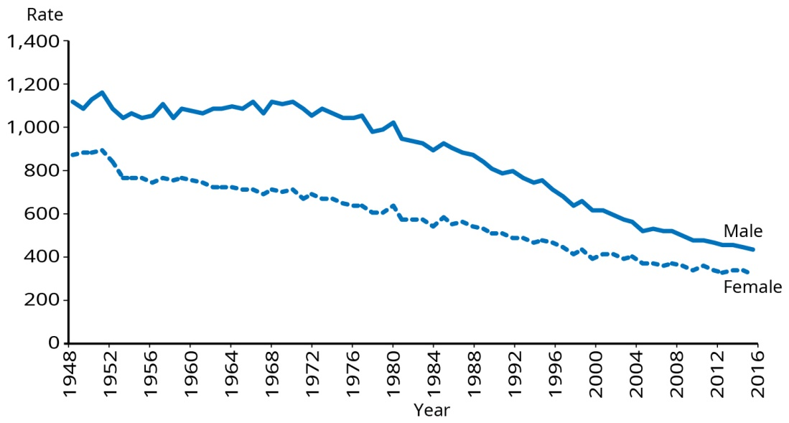
Note: Rates are per 100,000 population and age standardised to the WHO standard world population.
Source: Ministry of Health (2019j)

Figure 7: Mortality rates for Māori and non-Māori, 1996–2016
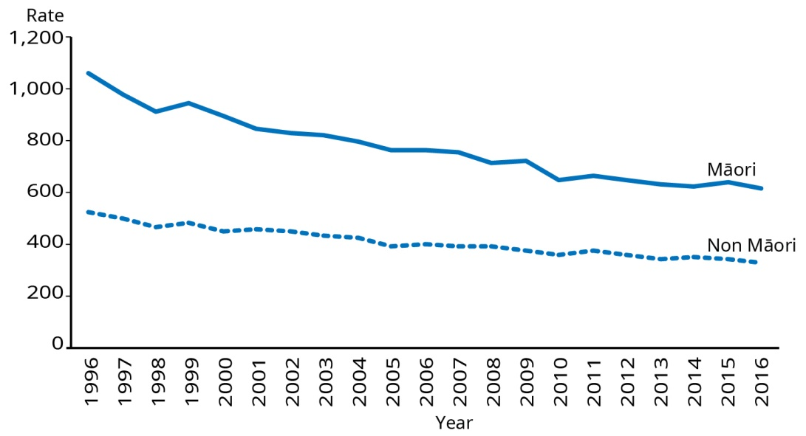
Note: Rates are per 100,000 population and age standardised to the WHO standard world population.
Source: Ministry of Health (2019j)

Ethnic breakdowns of mortality data are only shown from 1996 onwards because there was significant change in the way ethnicity was defined and in the way ethnicity data was collected in 1995. For more information please refer to the Ministry of Health report Mortality and Demographic Data 1996.

The leading causes of death were cancers (30.3 percent of all deaths), ischaemic heart disease (14.9 percent) and cerebrovascular diseases (7.4 percent).

For Māori, the leading causes of death in 2016 were cancers, ischaemic heart disease and chronic lower respiratory diseases.

Similar to previous years, males had higher age-adjusted mortality rates than females. For example, males had higher mortality rates for intentional self-harm, motor vehicle accidents, melanoma and ischaemic heart disease compared with females in 2016.

Age-adjusted mortality rates for Māori were generally higher than for non-Māori. For example, Māori had higher mortality rates for ischaemic heart disease, diabetes mellitus and lung cancer compared with non-Māori in 2016.

Table 3 and Table 4 provide the leading causes of years of life lost for men and women.

Table 3: Leading causes of years of life lost for males, 2017
 | Males | Percent
1 | Ischaemic heart disease | 16.9
2 | Tracheal, bronchus and lung cancer | 6.1
3 | Self-harm | 6.0
4 | Colon and rectum cancer | 4.6
5 | Stroke | 4.5
6 | Chronic obstructive pulmonary disease | 4.3
7 | Road injuries | 3.8
8 | Prostate cancer | 3.0
9 | Alzheimer’s disease and other dementias | 3.0
10 | Chronic kidney disease | 2.1
Source: Global Burden of Disease Collaborative Network 2018

Table 4: Leading causes of years of life lost for females, 2017
 | Females | Percent
1 | Ischaemic heart disease | 11.0
2 | Breast cancer | 7.4
3 | Tracheal, bronchus and lung cancer | 7.3
4 | Alzheimer’s disease and other dementias | 6.5
5 | Stroke | 6.3
6 | Colon and rectum cancer | 5.2
7 | Chronic obstructive pulmonary disease | 5.1
8 | Self-harm | 2.6
9 | Road injuries | 2.1
10 | Chronic kidney disease | 2.1
Source: Global Burden of Disease Collaborative Network 2018

Data on the leading causes of years of life lost is not available by broad ethnic group, socioeconomic deprivation or disability status.

Avoidable mortality makes a significant contribution to the life expectancy gap for Māori and Pacific peoples

A recent study estimated that nearly half of all deaths in Pacific peoples (47.3 percent) and over half of deaths in Māori (53 percent) had an avoidable cause (Walsh and Grey 2019). This compares with just under a quarter of deaths among non-Māori and non-Pacific people (23.2 percent). These findings lend further support to the need to ensure equitable access to health services for amenable conditions and to work to address wider determinants of health for preventable conditions.

Amenable mortality statistics provide further evidence of significant health inequity for Māori and Pacific peoples, specifically in relation to access to health treatment

Overall, amenable mortality has reduced over time. In 2000, the amenable mortality rate was 144.9 per 100,000 population. By 2016, this was 87.6 per 100,000 population. However, the amenable mortality rates are persistently and significantly higher for Māori and Pacific peoples than for non-Māori and non-Pacific respectively (Nationwide Service Framework Library 2019 – Figure 8).

The top five causes of amenable mortality are ischaemic heart disease, suicide, chronic obstructive pulmonary disease, cerebrovascular disease and female breast cancer. These conditions have consistently been the leading causes over recent years (Table 5).

Figure 8: Amenable mortality rates by ethnic group, ages 0–74 years, 2009–2016
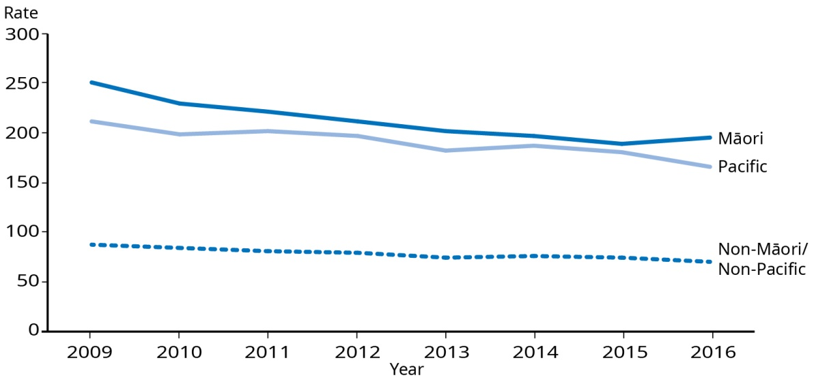
Note: Rates are per 100,000, age standardised to WHO world standard population.
Source: Nationwide Service Framework Library 2019

Table 5: Top five causes of amenable mortality, 2010–2016 (percentage of total amenable mortality)
Condition | 2010 | 2011 | 2012 | 2013 | 2014 | 2015 | 2016 provisional data
Ischaemic heart disease | 26% | 26% | 27% | 25% | 25% | 25% | 25%
Suicide | 9% | 8% | 9% | 9% | 9% | 9% | 10%
COPD | 8% | 9% | 8% | 9% | 10% | 10% | 9%
Cerebrovascular diseases | 9% | 9% | 8% | 8% | 9% | 9% | 9%
Female breast cancer | 8% | 7% | 7% | 8% | 8% | 8% | 8%
Key: 1st 2nd 3rd 4th and 5th
Note: The table is sorted by the top causes in 2016.
Source: Nationwide Service Framework Library 2019

Morbidity
Morbidity is increasing as we live longer and our population ages

Morbidity is an important measure of population health because it tells us about our quality of life. It also affects the risk of developing other health conditions. People who have two or more long-term conditions (multimorbidity) also have more complex needs. This has effects, for instance, in pharmaceutical prescribing.
Morbidity is non-fatal loss of health, measured in years lived with disability (YLD).
Ambulatory sensitive hospitalisations (ASH) refers to mostly acute hospital admissions for conditions that are potentially preventable or that could have been treated earlier in primary care.

In 2017 there were 14,069 YLDs for every 100,000 people (Global Burden of Disease Collaborative Network 2018). As we live longer, the years of morbidity have steadily increased for both men and women. Musculoskeletal issues are the biggest reason for our non-fatal health loss (21.1 percent), followed by mental disorders (15.8 percent), unintentional injuries (13.1 percent) and neurological disorders (7.3 percent). The specific causes are shown in Table 6.

The top 10 causes are responsible for half of all morbidity in New Zealand, while the top four are responsible for a third.

Table 6: Leading specific causes of morbidity
 | Cause | Percent
1 | Low back pain | 14.8
2 | Falls | 7.6
3 | Headache disorders | 5.3
4 | Anxiety disorders | 5.2
5 | Depressive disorders | 4.2
6 | Age-related and other hearing loss | 3.8
7 | Diabetes mellitus | 3.3
8 | Unintentional injury due to exposure to mechanical forces (not firearms) | 2.9
9 | Oral disorders | 2.6
10 | Neck pain | 2.6
Source: Global Burden of Disease Collaborative Network 2018

A recent study found that multimorbidity is common among New Zealand adults (Stanley et al 2018). Although the true prevalence is not known, based on pharmaceutical dispensing data, it was estimated that 27.9 percent of adults suffer from two or more long-term conditions. Age- and sex-standardised prevalence is higher among Māori and Pacific adults and in more deprived areas.

The study also found those with multimorbidity were 4.8 times more likely to die after one year than those without. They were also 3.6 times more likely to experience an ambulatory-sensitive hospitalisation than those without.

Health loss
The vast majority of our disease burden is due to non-communicable diseases

In 2017, New Zealand had an age-standardised rate of health loss of 20,481 DALYs per 100,000 population (Global Burden of Disease Collaborative Network 2018). This rate has decreased from 1990. However, the total number of DALYs has increased over time as our population ages.
Health loss and disease burden refer to all fatal and non-fatal losses of health (as a result of premature mortality and morbidity combined). The collective burden associated with premature mortality and morbidity is of interest in order to prioritise health efforts. The measure known as disability-adjusted life years (DALY) allows us to consider this overall burden of disease. One DALY represents the loss of the equivalent of one year of life lived in good health.

Figure 9: Contribution of various causes to overall disease burden
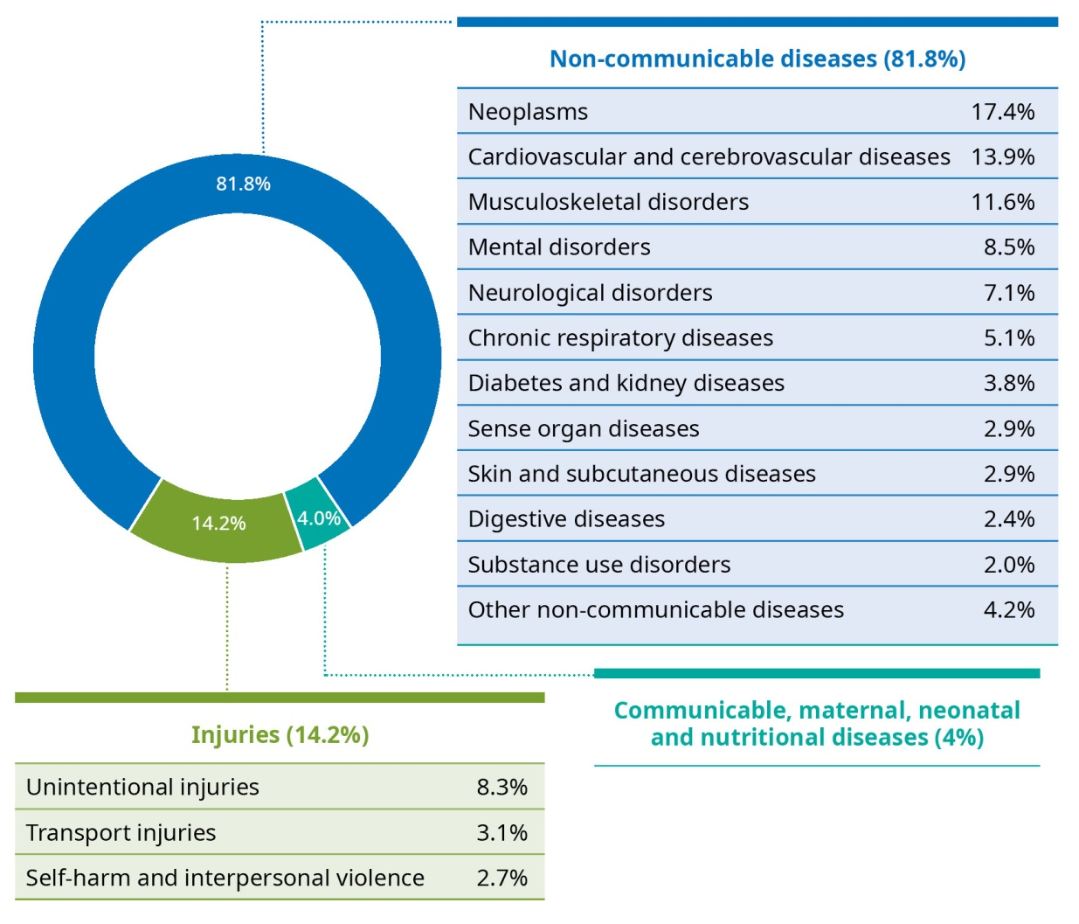
Note: The displayed totals may not add to 100% due to rounding.
Source: Global Burden of Disease Collaborative Network 2018

Non-communicable diseases are responsible for 82 percent of this health loss, with the largest proportion caused by cancers, cardiovascular and cerebrovascular diseases, musculoskeletal disorders and mental disorders, which collectively account for half of our total health loss.

Injuries account for 14 percent of health loss, with unintentional injuries at 8.4 percent and 5.6 percent attributable to intentional injuries (self-harm and interpersonal violence).

Communicable, maternal, neonatal and nutritional causes of health loss account for the remaining 4 percent of DALYs.

Different conditions have a greater impact on people at different life stages. Figure 10 shows the leading causes of health loss at various stages through life, by high-level condition group.

Figure 10: Top 10 causes of health loss by age group
Age group (years) | 1 | 2 | 3 | 4 | 5
0–1
 | Maternal and neonatal disorders | Other non-communicable diseases | Unintentional injuries | Respiratory infections and tuberculosis | Other infectious diseases
1–4
 | Skin and subcutaneous diseases | Unintentional injuries | Maternal and neonatal disorders | Other non-communicable diseases | Chronic respiratory diseases
5–14
 | Mental disorders | Skin and subcutaneous diseases | Unintentional injuries | Chronic respiratory diseases | Neurological disorders
15–24
 | Mental disorders | Musculoskeletal disorders | Unintentional injuries | Self-harm and interpersonal violence | Transport injuries
25–44
 | Mental disorders | Musculoskeletal disorders | Unintentional injuries | Neurological disorders | Cancers
45–64
 | Cancers | Musculoskeletal disorders | Cardiovascular diseases | Mental disorders | Unintentional injuries
65–74
 | Cancers | Cardiovascular diseases | Musculoskeletal disorders | Chronic respiratory diseases | Unintentional injuries
75+
 | Cardiovascular diseases | Cancers | Neurological disorders | Unintentional injuries | Chronic respiratory diseases

6 | 7 | 8 | 9 | 10 | Age group (years)
 |  |  |  |  | 0–1
Neurological disorders | Cancers | Enteric infections | Digestive disorders | Interpersonal violence
 |  |  |  |  | 1–4
Cancers | Respiratory infections and tuberculosis | Transport injuries | Mental disorders | Enteric infections
 |  |  |  |  | 5–14
Maternal and neonatal disorders | Other non-communicable diseases | Musculoskeletal disorders | Cancers | Transport injuries
 |  |  |  |  | 15–24
Neurological disorders | Substance use disorders | Skin and subcutaneous diseases | Other non-communicable diseases | Maternal and neonatal disorders
 |  |  |  |  | 25–44
Self-harm and interpersonal violence | Substance use disorders | Other non-communicable diseases | Transport injuries | Cardiovascular diseases
 |  |  |  |  | 45–64
Neurological disorders | Diabetes and kidney disease | Chronic respiratory diseases | Other non-communicable diseases | Transport injuries
 |  |  |  |  | 65–74
Diabetes and kidney disease | Neurological disorders | Sense organ diseases | Mental disorders | Other non-communicable diseases
 |  |  |  |  | 75+
Musculoskeletal disorders | Diabetes and kidney disease | Sense organ diseases | Digestive disorders | Other non-communicable diseases
Source: Global Burden of Disease Collaborative Network 2018

Causes of health loss | Ngā take mo te mate hauora
Some key non-communicable diseases and intentional and unintentional injuries contribute to our health loss

Cancers
Cancers are the leading group cause of health loss and a major area of health inequity. Although the mortality rate is decreasing, its contribution to the overall disease burden will grow as our population increases and ages.

Collectively, cancers are the leading cause of health loss in New Zealand. They account for 17.4 percent of our DALYs (Global Burden of Disease Collaborative Network 2018).

In 2016, 9,517 people died of cancer (117.5 per 100,000 population) (Ministry of Health 2019l). Although the number of New Zealanders dying of cancer has increased over time, the age-standardised death rate (which takes into account that the population is getting older) has been decreasing steadily since 1995. Figure 11 shows the age-standardised cancer death rate over time.

Figure 11: Cancer mortality rates, 1948–2016
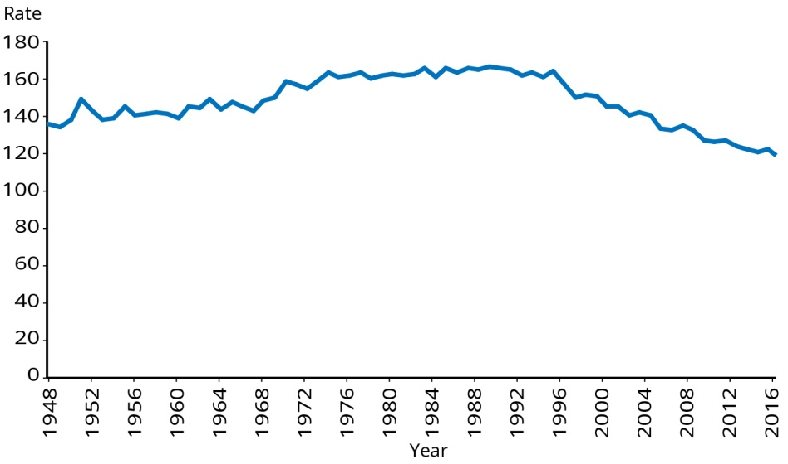
Note: Rates are per 100,000 population and age-standardised to the WHO world standard population.
Source: Ministry of Health (2019e; 2019l)
There were 24,086 new cancer registrations (335.2 per 100,000 population) in 2016 (Ministry of Health 2018b). This is the equivalent of 66 people a day. With our ageing and growing population, it is estimated that by 2040, the number of people diagnosed will increase to the equivalent of 144 people per day (Ferlay et al 2018).

As shown in Table 7, males had a higher rate of new registration and death from cancer than females. Māori men and women had higher rates of new cancer registration than non-Māori. Māori men and women also had higher rates of death from cancer.

Table 7: Cancer registration and mortality rates, 2016, Māori and non-Māori
 | Registration rates |  | Death rates
 | Male | Female | Male | Female
Māori | 405.3 | 425.5 | 206.9 | 175.5
Non-Māori | 352.5 | 304.8 | 126.2 | 97.4
All | 357.7 | 316.0 | 133.4 | 104.7
Note: Rates are per 100,000 population and age-standardised to the WHO world standard population.
Source: Ministry of Health 2018b; 2019l

A new Cancer Action Plan 2019–2029
In September 2019, the Government announced and began to consult on the New Zealand Cancer Action Plan 2019–2029. The plan provides a roadmap to ensure we have a sustainable system to have fewer cancers, better survival rates and equitable outcomes. The plan is equity-led, knowledge-driven and outcomes- focused. It included establishing the Cancer Control Agency within the Ministry of Health to provide clear leadership for improving cancer outcomes in New Zealand. The Cancer Control Agency went live on 1 December 2019.
The plan aims to prevent cancer through supporting Smokefree 2025, encouraging and supporting healthy living, addressing cancer-related infections such as Hepatitis B and C and Helicobacter pylori and reducing avoidable skin and workplace cancers.
The plan also seeks to improve outcomes for people who get cancer by increasing early detection and improving the consistency and quality of cancer treatment.
High-quality population screening, fast-track diagnosis pathways for priority cancers, quality improvement indicators, initiatives to support access to quality cancer treatment, developing options for early access to new medicines and increasing early access to palliative and end-of life care will help achieve this.
The plan also aims to achieve equity by design. Addressing all forms of racism and discrimination is expressly required. A key action outlined is to resource Māori to develop and implement a Māturanga Māori framework for delivering the cancer plan in partnership with the Crown.
Consultation ended in October 2019. The plan is now being finalised and will be implemented in early 2020.
Figure 12 shows the leading cancer causes of death and health loss. The top six cancers account for a one-10th of all health loss. The top two cancers (lung and colorectal) account for a one-10th of all deaths.

Figure 12: Leading cancers in New Zealand by deaths and DALYs
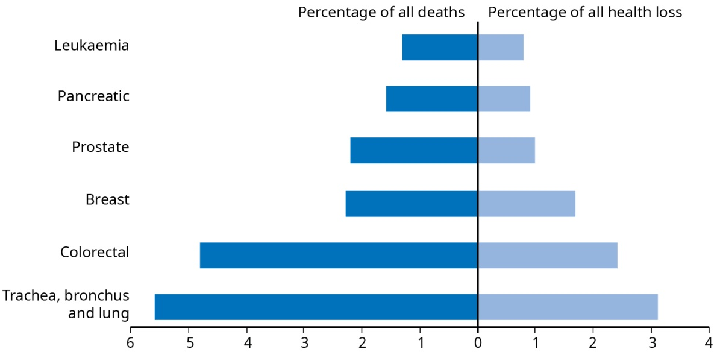
Note DALYs – disability-adjusted life years
Source: Global Burden of Disease Collaborative Network 2018

Screening: An important public health tool to allow early intervention and achieve equitable outcomes
Previous research has found that Māori have significantly poorer cancer survival than non-Māori (Hill et al 2010). In New Zealand, screening exists for three cancers: breast, cervical and bowel. Screening aims to improve health outcomes by either detecting pre-cancerous lesions which can be treated or detecting cancer at an early stage, when it can often be successfully treated. While it may achieve this outcome, screening also has the potential to increase inequities, particularly if screening uptake is low among Māori or other groups. Inequities are known to exist for Māori and Pacific women in relation to breast and cervical screening.
A bowel screening pilot ran in the Waitematā DHB region from 2012 to 2017 and now a national programme based on that pilot is being progressively rolled out. The 2019/20 budget included funding of $36 million over four years for rollout to four DHBs (Canterbury, Capital & Coast, South Canterbury and Tairāwhiti) in 2019/20. The Ministry of Health is considering using a wider screening age for Māori to improve equity of outcomes.

Cardiovascular and cerebrovascular diseases
Cardiovascular and cerebrovascular diseases account for 13.9 percent of DALYs and one in three deaths (33.4 percent) (Global Burden of Disease Collaborative Network 2018). Ischaemic heart disease and stroke are the leading causes within this group.

Ischaemic heart disease is the single leading disease cause of health loss.

Ischaemic heart disease is the single leading disease cause of health loss (7 percent of DALYs) (Global Burden of Disease Collaborative Network 2018).

In 2015, ischaemic heart disease accounted for 54.3 deaths per 100,000 population (73.1 for men, 38.1 for women). The mortality rate for Māori was twice that for non-Māori (101.2 for Māori and 50.3 for non-Māori), with higher rates among both men and women.

A study examining ischaemic heart disease events from 2006 to 2015 found that fatal and non-fatal ischaemic heart disease rates have declined over that period, but Māori and Pacific peoples have disproportionately high rates of mortality. Ischaemic heart disease mortality rates declined by 3.1–5.4 percent each year for most groups, except Pacific women, for whom the decline (1.3 percent each year) was not significant.

Ischaemic heart disease hospitalisation rates declined significantly by 3.6–8.8 percent each year in all groups. Ischaemic heart disease mortality rates were highest in Māori and Pacific peoples, but hospitalisation rates were highest among Indian people.

For every Indian person who died from ischaemic heart disease in 2014/15, 7–8 were hospitalised with it. The comparative rate for every Māori or Pacific death was only 3–4 hospitalisations. The lower ratio of ischaemic heart disease hospitalisations to deaths among Māori and Pacific peoples compared to others suggests there are still important barriers to preventive interventions and acute care for Māori and Pacific men and women (Grey et al 2018).

New Zealand has seen a sustained reduction in ischaemic heart disease mortality rates since the 1960s (Global Burden of Disease Collaborative Network 2018, see Figure 13).

It has been noted that rising rates of obesity and diabetes have the potential to halt, or even reverse, these downward trends in ischaemic heart disease.

Figure 13: Trends in (a) deaths and (b) health loss (in DALYs) from ischaemic heart disease, 1990–2017
(a)
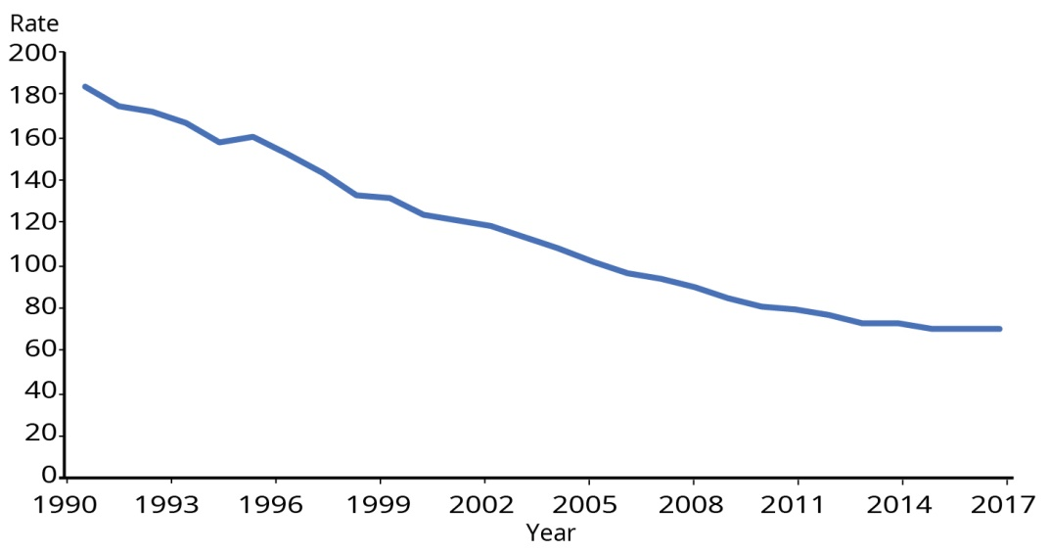
(b)
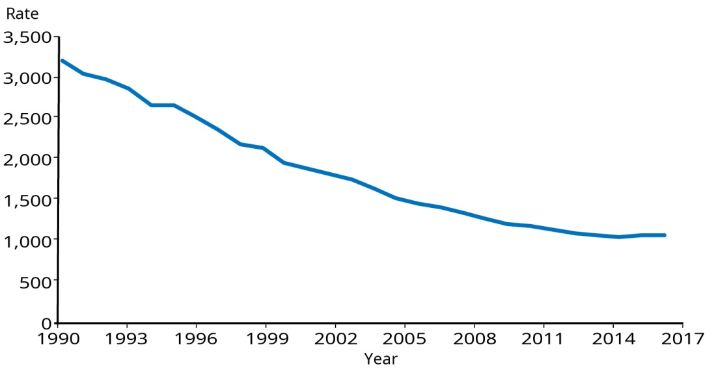
Note: Estimated rates are per 100,000 population, age-standardised to the GBD population.
DALYs – disability-adjusted life years.
Source: Global Burden of Disease Collaborative Network 2018

Guidance on assessing and managing cardiovascular disease risk
Over recent years there has been a focus on systematically identifying ischaemic heart disease in New Zealanders, with 1.2 million people receiving an initial risk assessment in primary care. To help primary care providers better assess and manage cardiovascular disease risk, the Ministry of Health published new guidance: Cardiovascular Disease Risk Assessment and Management for Primary Care, in February 2018. This evidence-based guidance, developed and agreed by experts in the field, will help health professionals assess and discuss cardiovascular disease risk with their patients to manage risk factors.

Stroke continues to be a significant cause of our disease burden, and will likely continue as our population grows and ages

Stroke accounts for 3.2 percent of our disease burden. An estimated 1,550 people died as a result of stroke in 2016. In the year to end of June 2017, there were 8,275 publicly funded hospital discharges due to stroke (97.2 per 100,000). It is estimated that over 95 percent of stroke cases are hospitalised, so this is likely to be similar to the true incidence of stroke in New Zealand (Ranta 2018).

According to the New Zealand Health Survey 2017/18, an estimated 1.5 percent of adults (58,000 people) reported having had a stroke (confirmed by a doctor) (Ministry of Health 2019d). Reported stroke was more likely in Māori women than non-Māori women (2.7 times) and among women in our most deprived communities than our least deprived communities (4.1 times).

Overall stroke incidence has decreased by 23 percent and stroke mortality by 62 percent from 1981 to 2012. Māori and Pacific peoples had a slower rate of decline and continue to experience stroke at a significantly younger age (mean ages 60 and 62 years) compared with NZ Europeans (mean age 75 years) (Brown 2009).

Stroke incidence and mortality are declining due to effective public health initiatives and modern health care advances. However despite these improvements, the number of stroke cases is projected to increase by 40 percent by 2028 due to population growth and, more importantly, ageing.

FAST campaign (Face drooping, Arm weakness, Speech difficulty, Time to take action and call 111)
The majority of the world’s stroke burden is attributable to modifiable risk factors and therefore is largely preventable (Feigin et al 2016). To reduce the burden of stroke, public awareness campaigns, such as FAST, with innovative ideas and messages that reach and resonate with those most at risk, are pivotal.
Evidence shows that the earlier a stroke is identified and treated, the greater the chances are for improved recovery and reduced disability. Although progress has been made through previous campaigns, there are still concerns over limited public awareness of the signs and symptoms of stroke and the need for time- critical hospital-level intervention. This means that people are still presenting too late for potential acute stroke treatment and are therefore likely experiencing greater levels of long-term disability than necessary.
The primary aims of the FAST campaign are to promote early treatment by raising awareness of the signs and symptoms of stroke and to reduce inequities. The campaigns will further roll out the FAST message nationwide over the next three years.
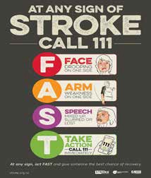
An evaluation of the last two annual national campaigns indicates significantly improved general public knowledge and awareness of stroke symptoms and the need to access hospital-level care by calling ambulance services immediately (Health Promotion Agency 2019). The evaluation shows that although the improvement in awareness has not been as high among Māori and Pacific peoples, their levels of awareness did increase. As Māori and Pacific people are high risk populations for stroke, they will be the primary focus for this year’s campaign, as well as isolated populations.

Musculoskeletal conditions
The rate of health loss from musculoskeletal conditions is increasing over time as our population ages, and it makes up an increasing proportion of our disease burden

Musculoskeletal conditions account for 11.6 percent of our health loss.

The burden of disease from musculoskeletal conditions is largely driven by rates of lower back pain, where DALY rates are higher in women than men. The second biggest contributor is neck pain, which is higher in men than women.

According to the New Zealand Health Survey, an estimated 19.7 percent of people suffer from chronic pain (Ministry of Health 2019d). Māori are more likely to experience chronic pain than non-Māori (adjusted by age and gender). After adjusting for age, gender and ethnic differences, people living in our most deprived areas are 1.5 times as likely as people in our least deprived areas to report having chronic pain.

Although they make a smaller contribution to health loss, other important musculoskeletal conditions include osteoarthritis, gout and rheumatoid arthritis. According to New Zealand Survey 2017/18 findings, the proportion of people with diagnosed osteoarthritis increased from 9 percent in 2011/12 to 10.6 percent in 2017/18. The proportion of people with gout has nearly doubled over the same time, from 1.6 percent to 3.1 percent. After accounting for changing age structures over time, this represents a significant increase. The proportion of people with diagnosed rheumatoid arthritis remained the same, at 2.5 percent.

Mental health conditions
Anxiety and depression are significant causes of health loss.

Mental health conditions are collectively responsible for 8.5 percent of our health loss. The leading conditions are anxiety (2.8 percent) and depression (2.3 percent). Schizophrenia, bipolar disorder, eating disorders and other mental disorders make a lesser contribution to health loss, each contributing less than 1 percent.

Māori women, younger adults and those living in socioeconomically deprived areas are most affected by psychological distress.

In 2017/18, 8.6 percent of people experienced psychological distress in the previous four weeks (Ministry of Health 2019d). This has increased over time, up from 6.6 percent in 2006/07 and 7.6 percent in 2016/17. Women are more likely to experience psychological distress than men.

Ethnic disparities exist in terms of the likelihood of experiencing psychological distress. Māori women in particular were more likely to have experienced psychological distress in the previous four weeks, and their rate increased from 12.7 percent in 2006/07 to 17.5 percent in 2017/18. Rates for European/Other men and women have also increased in comparison with 2006/07. Māori and Pacific men are about 1.4 times as likely as non-Māori and non-Pacific to experience psychological distress, with rates remaining relatively constant over time.
Psychological or mental distress refers to a person’s experience of symptoms such as anxiety, confused emotions, depression or rage in the previous four weeks. The 10-question Kessler Psychological Distress Scale (K10) (Kessler et al 2003) evaluates levels of psychological distress. If people have a K10 score of 12 or more (high or very high levels of psychological distress) there is a high or very high probability that they also have anxiety or depression. This score is likewise strongly associated with having had a mental (depressive or anxiety) disorder in the previous month and in the previous year.

Psychological distress rates are highest among younger adults, aged 15–24 (13.2 percent) and those aged 25–34 years (10.2 percent).

People living in the most socioeconomically deprived areas were 2.5 times more likely to experience psychological distress than people living in the least deprived areas, after adjusting for age, gender and ethnicity.

Mood and/or anxiety disorders and depression have increased over time for every age group.

An estimated 21 percent of adults have a diagnosed mood and/or anxiety disorder, with Māori and European/Others having higher rates than other groups (Ministry of Health 2019d). Māori and European/Other women are particularly affected, with one in three experiencing a mood and/or anxiety disorder. Compared to 2006/07, there has been a significant increase for both men and women and across every age group.

An estimated 16.6 percent of adults report having diagnosed depression, with Māori and European being most affected, and women significantly more affected than men. Those living in the most deprived areas were 1.5 times as likely to report having diagnosed depression than those in the least deprived areas.

Fewer Pacific men and women reported mood and/or anxiety disorders and depression than non-Pacific. The same is also true for Asian people.

According to the New Zealand General Social Survey 2018, nearly one in four New Zealand adults aged 18 and over experienced ‘poor’ mental wellbeing on the WHO-5 scale. Over one-third (35.1 percent) of adults identifying as bisexual experienced ‘poor’ mental wellbeing.

While the majority of children are developing without any significant social, emotional or behavioural problems, as many as one in seven may require some additional support

Early intervention in response to social, emotional and behavioural difficulties in children can reduce the risk or severity of certain types of mental disorders in later childhood, adolescence or adulthood. It also improves children’s developmental, emotional, academic and social outcomes. This enables children to achieve their full potential.

According to the 2017/18 New Zealand Health Survey, 5.6 percent of children have diagnosed emotional or behavioural problems such as depression, anxiety disorder, attention deficit disorder or attention deficit hyperactivity disorder (Ministry of Health 2019d). The prevalence has increased over time (1.8 percent in 2006/07 to 3.3 percent in 2016/17).

New Zealand Health Survey findings based on a Strengths and Difficulties Questionnaire (SDQ) survey of parents and caregivers suggest about 8 percent of children may experience significant difficulties and a further 7 percent have a medium likelihood of difficulties. The prevalence and nature of difficulties differs across subgroups.

The SDQ scores children across four aspects of development: emotions, peer relationships, hyperactivity and conduct. A total difficulties score indicating concern was more likely in Māori children compared with non-Māori children and less likely in Asian children compared with non-Asian children. Rates of ‘concerning’ total difficulties scores were comparable for Pacific and non-Pacific children. Children living in areas of high socioeconomic deprivation were more likely to have a total difficulties score indicating concern than those children living in low deprivation areas.

Mental Health and Addiction Inquiry
In January 2018, the Government Inquiry into Mental Health and Addiction convened to identify unmet needs and develop recommendations for a better mental health and addiction system for Aotearoa New Zealand.
The expert Panel released their report, He Ara Oranga (New Zealand Government 2018), in December 2018. The Panel found that there are significant unmet needs for mental health and wellbeing services, and while successful interventions do exist in places, a significant scale-up is required. Given that 20 percent of people suffer mental distress, there is a need for expansion of services, not only to treat, but also to prevent ill-health and promote wellbeing. Because factors such as addiction, poverty/deprivation, trauma, social isolation and cultural alienation are significant causes of mental ill-health, work is also required at a system-level to create environments that support wellbeing and prevent these causes in the first place. In considering why this hasn’t already occurred, the Panel found we have been successful with the system we designed. As a result of policies stemming from the 1996 Mason Inquiry Report into Mental Health, the 3 percent of people with the most severe mental health needs now receive access to specialist services. But goals of more prevention and early intervention and support beyond ‘the 3 percent’ have not been realised.
He Ara Oranga contains 40 recommendations, which aim to set a clear direction for the next 5 to 10 years for the Government, the mental health and addiction sectors and the community.
In May 2019, the Government announced that it had accepted in principle or in full 38 of those 40 recommendations. Action on implementing those recommendations is now under way. This includes:
setting up a mental health and wellbeing commission to provide leadership and oversight of mental health and addiction
urgently completing the national suicide prevention strategy
significantly increasing access to publicly funded mental health and addiction services for people with mild to moderate needs
committing to increasing choice by broadening the types of services available
repealing and replacing the Mental Health (Compulsory Assessment and Treatment) Act 1992.
As part of Budget 2019, the Government committed to investing $1.9 billion to improve mental health services. This includes $421 million for DHBs for mental health and addiction facilities, $128 million for prisoner mental health and addiction services and $32 million for youth mental health, with a special focus on under-24 year olds.
Regular newsletter updates on work to implement the Government’s response to He Ara Oranga are available on the Ministry’s website.

Neurological conditions
As our population is ageing and increasing in size, there is an increase in the absolute burden from neurological conditions.

Neurological conditions account for 7.1 percent of our health loss (Global Burden of Disease Collaborative Network 2018). The majority of this health loss is a result of Alzheimer’s disease and other dementias (2.7 percent) and migraine (2.4 percent). Smaller contributions to health loss come from Parkinson’s disease (0.5 percent), epilepsy (0.4 percent), tension-type headaches (0.4 percent), motor neurone disease (0.3 percent), and multiple sclerosis (0.2 percent).

Significant differences in health loss between men and women exist for some neurological disorders. Health loss from Alzheimer’s and dementias and multiple sclerosis is higher in women. Health loss from Parkinson’s and motor neurone disease is higher among men.

The disease burden associated with these conditions has increased over time as our aged population has grown, but there has been no significant increase in age-standardised DALY rates over recent decades.

Chronic respiratory diseases
Chronic respiratory diseases make an important contribution to health loss, and feature marked inequalities for Māori and Pacific peoples.

Chronic respiratory diseases include asthma, chronic obstructive pulmonary disease (COPD), pneumoconiosis and other lung conditions. These account for 5.1 percent of health loss (Global Burden of Disease Collaborative Network 2018). The majority of this health loss is due to COPD and asthma. According to the 2013/14 New Zealand Health Survey, 6.5 percent of adults aged 45 years and over have COPD. The 2017/18 New Zealand Health Survey indicates that 12 percent of adults and 14.9 percent of children have diagnosed asthma.

Respiratory disease accounts for one in 10 overnight hospitalisations (Barnard and Zhang 2019). From 2000 to 2017, hospitalisation rates for bronchiectasis, childhood bronchiolitis and total respiratory disease have increased. They remained static for COPD, and declined for asthma and childhood pneumonia.

Between 2000 and 2015, mortality from childhood pneumonia showed no significant trend, remained generally static for childhood asthma and total respiratory disease, but have increased for bronchiectasis. Mortality rates for COPD declined.

Although inequalities have generally reduced, they persist. Inequalities are evident in all indicators in health by ethnic group. Pacific peoples and Māori shared the highest respiratory health burden.

Respiratory hospitalisation rates were 2.0 times higher for Māori and 2.5 times higher for Pacific peoples than for the non-Māori, non-Pacific and non-Asian comparison group. Pacific peoples’ hospitalisation rates were consistently highest across all indicators except for COPD, where Māori rates were higher.

Māori had the highest mortality rates for total respiratory disease, asthma and COPD. Bronchiectasis and childhood pneumonia mortality rates were highest in Pacific peoples. Rates for Asian people, however, were generally the same as or lower than the non-Māori, non-Pacific, non-Asian comparison group.

Inequalities in respiratory hospitalisations by socioeconomic deprivation were marked, with the differences in rates between the most and least deprived areas ranging from 2.1 for childhood pneumonia, to 3.9 for childhood bronchiolitis and 5.1 for adult COPD.

Mortality rates, which appeared to be declining in the 2016 report, have returned to previous higher levels, peaking at 2 deaths per 100,000 in 2014.

Other non-communicable diseases
A quarter of a million New Zealanders have diabetes. Although prevalence rates have plateaued in recent years, people are developing diabetes at a younger age.

The Virtual Diabetes Register provides an estimate of national diabetes numbers and prevalence based on administrative data on the use of diabetes health services. It is updated annually. As at the end of 2018, an estimated 253,500 people in New Zealand had diabetes (Ministry of Health 2019q).

Over the period 2010–2018 the prevalence of diabetes increased from 4.5 percent to 5.5 percent. Since 2010, the rate of increase in the age-standardised prevalence of diabetes has slowed down, with a plateau over the past two to three years. This applies to total prevalence, as well as for Māori, Pacific, Indian and European/Other populations.

However, since 2013, the proportion of people aged 25–39 years with diabetes has increased from 6.4 percent to 7.2 percent. This indicates New Zealanders are developing type 2 diabetes at a younger age. Developing diabetes earlier increases a person’s lifetime risk of complications such as cardiovascular disease, diabetic foot and diabetic retinopathy and risk of early death.

Pacific peoples have the highest prevalence of diabetes (10.4 percent), followed by Indian (9.1 percent) and Māori (6 percent). The rate for European/Other is 4.8 percent.

Type 2 diabetes and associated chronic kidney disease make up an estimated 2.9 percent of our health loss (Global Burden of Disease Collaborative Network 2018).

Oral health issues are a significant area of avoidable health inequity and health loss.

Oral conditions make up 1.4 percent of all health loss. Severe tooth loss, which occurs as a result of dental caries and periodontitis, makes up the majority of this health loss (0.85 percent) (Global Burden of Disease Collaborative Network 2018).

New Zealand Health Survey results show a large proportion of people enjoy a good level of oral health; however, there are underlying ethnic and socioeconomic disparities for adults and children.

In 2017/18, 79.7 percent of adults had excellent, very good or good self-rated oral health (Ministry of Health 2019d). However, gender, ethnic and socioeconomic differences exist.

Excellent, very good or good self-rated oral health is less likely among men than women (0.94 times). It is also less likely among Māori and Pacific adults than non- Māori and non-Pacific (Māori 0.82 times, Pacific 0.93 times). Adults living in the most deprived areas are also less likely (0.83 times) to report excellent, very good or good oral health than those in the least deprived areas.

Ninety-four percent of children aged 14 and under have ‘excellent, very good or good’ parent-rated oral health. Pacific girls are 2.5 times more likely to have had teeth removed due to decay, abscess, infection or gum disease in the previous 12 months than non-Pacific girls.

Relatively fewer Māori children aged 0–4 years (72 percent) are enrolled with the oral health service compared to the national average of 88 percent. Pacific child enrolment rates (82 percent) are slightly below the national average.

Water fluoridation: An example of systemic intervention
Fluoridation is an example of an effective public health intervention to reduce the burden of ill-health and address health inequity.
An analysis of ambulatory sensitive hospitalisations (ASH) (Hobbs et al 2019) among children by area of domicile showed that children in areas defined as fluoridated in 2011 and 2016 had lower dental ASH rates than those in areas defined as not fluoridated. Not only did dental ASH rates for children vary by fluoridation status, they differed significantly by deprivation quintile. ASH rates were higher in more deprived areas and the protective effect of fluoridation appears to be more marked in the most deprived areas. Figure 14 and Figure 15 show this trend for children under five and those aged 5–12 respectively.

Figure 14: Fluoridation and dental ASH rates by area deprivation, children aged under five years
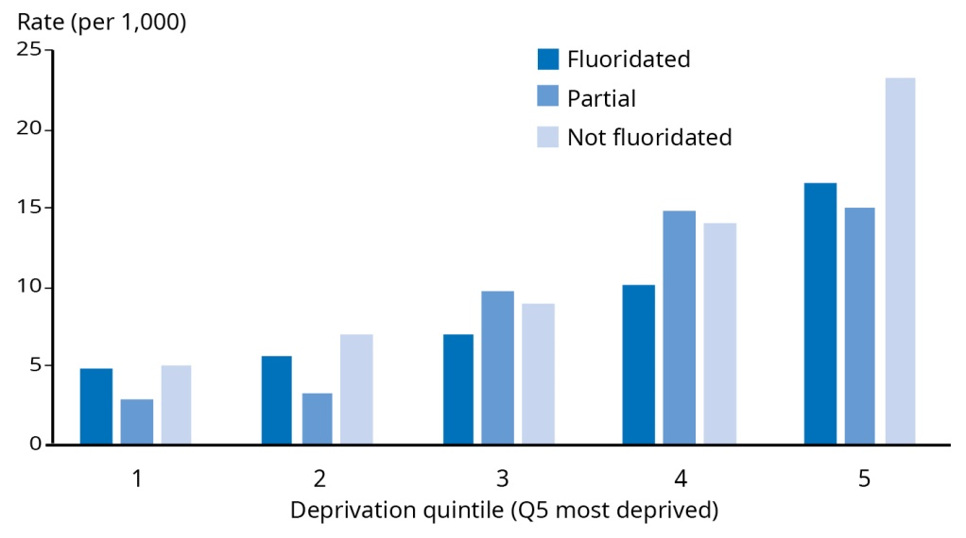

Figure 15: Fluoridation and dental ASH rates by area deprivation, children aged 5–12 years
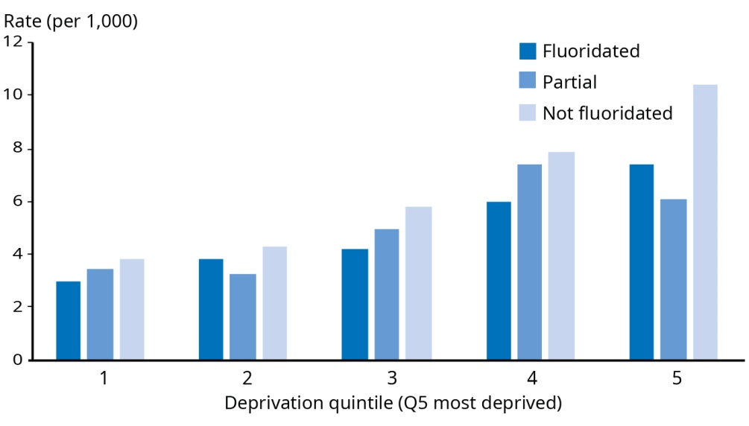
Note: Area-based deprivation. Q5 is most deprived.
Source: Hobbs et al (2019)

Fatal and non-fatal injuries
There has been a small but steady increase in injury hospitalisations for men and women

Injuries account for 14 percent of our health loss and 5.5 percent of all deaths. Over 200,000 publicly funded hospital discharges involving unintentional and intentional injury were reported during 2015/16. There were 39 hospitalisations per 1,000 people (age-standardised rate), 18 percent higher than in 2006/07.

Hospitalisation rates involving injury generally increase with age. Over a third (38 percent) of hospitalisations were for people aged 65 years and over. Males had a higher rate of hospitalisation with injury than females. The Māori rate was 1.2 to 1.3 times the non-Māori rate from 2006/07 to 2015/16.

The rate of serious non-fatal injuries from falls has increased over the past decade
Serious injury is an injury to a patient who is admitted to hospital with a probability of death of 6.9 percent or more (Stats NZ nd-b).
The rate for serious injuries has increased since 2012. A rate of 205.3 serious non-fatal injuries per 100,000 people made 2017 provisional data the highest on record (Stats NZ 2018e).

Figure 16: Serious non-fatal injury rates, 2000–2017
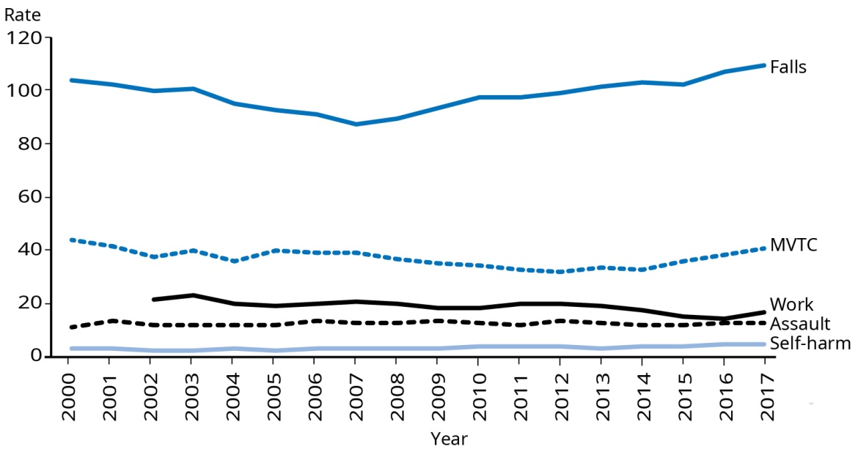
Note: Age-standardised injury rate per 100,000 people
MVTC: motor-vehicle traffic crashes.
Source: Stats NZ 2018d

Falls made the highest contribution to serious non-fatal injuries (109.2 injuries per 100,000 people) (Stats NZ 2018e). This is an increase from 2007, when the age-standardised rate was 87.1 per 100,000. For Māori, the age-standardised rate of serious injury from falls in 2017 was less than half of that for the population as a whole: 49.5 injuries per 100,000 people (Stats NZ 2018b).

For those aged 75 years and over, the age-standardised rate of serious non-fatal injury from falls was 1,313.7 per 100,000 in 2017 (Stats NZ 2018e). The rate has increased since 2007.

Mortality and DALYs from transport injuries have declined since 1990

Health loss from transport injuries has trended down since 1990. Motor vehicle injuries are the highest cause of health loss.

Serious non-fatal motor vehicle injuries have increased since 2014. In 2017, there were 1,998 of these injuries (up from 1,851 in 2016) – a rate of 40.5 injuries per 100,000 people (up from 38.4 in 2016). In 2017, the rate of these injuries for Māori was 67.8 per 100,000, which is 67 percent more than the rate for the total population.

The age-standardised rate of fatal motor vehicle injuries was 6.7 per 100,000 people in 2015 (up slightly from 6.1 in 2014). This tracks closely to the rate of fatal injuries per billion kilometres travelled – 7.4 in 2015 (up from 6.8 in 2014).

The rate of fatal injuries per 10,000 registered vehicles was 0.8 in 2015 (the same as 2014).

Serious non-fatal intentional self-harm injuries were higher in 2017 than the previous 17 years

There were 9,358 intentional self-harm hospitalisations in 2015/16 (Ministry of Health 2018c). Females had twice the number of hospitalisations for intentional self-inflicted harm as males (3,034 males and 6,324 females).

In 2017, the rate of serious non-fatal intentional self-harm injuries was 5.3 per 100,000 people (Stats NZ 2018e).

While the overall suicide rate has been relatively stable over the past 10 years, it has been consistently higher for Māori, and has increased markedly in recent years for Māori men

The rate of suicide has remained relatively stable over 2007 to 2016 (Ministry of Health 2019p). In 2016, 553 people died by suicide in New Zealand, a rate of 11.3 per 100,000 (17 per 100,000 for males and 5.8 per 100,000 for females). For every female suicide, there were 2.9 male suicides. Māori males and females were twice as likely to die by suicide as non-Māori males and females. Māori men and women have both had a consistently higher rate than non-Māori over time. The rate for Māori men increased markedly from 2013 to 2016 (21.2 per 100,000 and 31.7 per 100,000 respectively).

In 2016, the highest rates of suicide were among youth aged 15–24 years (16.8 per 100,000) and those aged 25–44 years (16.3 per 100,000). The rate for youth suicide in 2016 was similar to the rate in 2015. Over the last 10 years the rate of youth suicide has varied, due in part to fluctuations as a result of small numbers. Before 2013 the youth rate was predominantly higher than other age groups, but more recently, the rates for youth and other age groups up to 65 have been similar.

In September 2019, the Government published Every Life Matters – He Tapu te Oranga o ia Tangata: Suicide Prevention Strategy 2019–2029 and the Suicide Prevention Action Plan 2019–2024 for Aotearoa New Zealand. These strategic documents describe the aims for suicide prevention over the next 10 years and provide a road map to achieve those aims. The three overarching aims are:
promote wellbeing
respond to suicidal distress and behaviour
support individuals, whānau and communities after a suicide.
The Government also announced the establishment of a Suicide Prevention Office to coordinate action.

Data on the level of harm from violence in New Zealand is limited

Serious non-fatal assault injuries have remained relatively constant since 2000. However, the 2017 Māori rate of 37 serious injuries per 100,000 people is three times that for the total population – 12.6 per 100,000 (Stats NZ 2018b).

Strong data on incidence harm from family violence and sexual violence is not available. However, it is estimated that one in seven children grow up in a violent home and one in three ever-partnered women report having experienced physical and/or sexual intimate partner violence in their lifetime. That rate rises to one in two when emotional/psychological abuse is included (Family Violence Clearinghouse 2017).

Around one in 10 people over the age of 65 will experience elder abuse – mostly at the hands of family members. These are estimates only, as family violence tends to be under-reported (Waldegrave 2014).

While family violence occurs in all sections of the population, certain populations are disproportionately affected. Māori are more than twice as likely to be a victim of a violent interpersonal offence by an intimate partner. Both Pacific (4.8 times) and Māori (5.5 times) children are more likely to die from child abuse and neglect than children from other ethnicities. Disabled people and those in rainbow communities also face increased risk of victimisation (Family Violence Death Review Committee 2014).

Interpersonal violence is estimated to contribute to 0.54 percent of health loss (Global Burden of Disease Collaborative Network 2018).

Joint venture on family violence and sexual violence and new information-sharing arrangements
Family violence and sexual violence are public health issues in New Zealand. As well as contributing to New Zealand’s child mortality rate, violence and sexual abuse in family and whānau can have cumulative physical and mental health effects that last long after the abuse has ended, particularly for children. These include depression, suicidality, alcohol and drug abuse, post-traumatic stress disorder, eating and sleeping disorders, anxiety disorders and an increased risk of miscarriage, gynaecological problems, sexually transmitted infections and injuries.
Exposure to violence during early childhood (including while in the womb) is particularly damaging to neurodevelopment and increases the risk of poor health and social outcomes. These include substance abuse (and tobacco use), mental health issues and suicidality, disability and chronic health conditions. Exposure at an early age also increases the likelihood of intergenerational family violence (Narayan et al 2017). In September 2018, the Government announced the formation of a joint venture of Chief Executives to deliver an integrated, whole-of- government approach to lead the prevention and reduction of family and sexual violence.
The joint venture includes Chief Executives of the Department of Prime Minister and Cabinet; Oranga Tamariki; Te Puni Kōkiri; New Zealand Police; ACC; Corrections; and the Ministries of Health, Social Development, Education and Justice.
A national strategy and action plan on family violence and sexual violence will be developed in partnership with the Interim Te Rōpū (Māori advisory group). A draft strategy is being developed for public consultation early in 2020.
In Budget 2019, the Government announced $320 million in funding for family and sexual violence programmes. This includes funding to expand the Violence Intervention Programme that delivers screening in health settings.
Additionally, new provisions for information sharing between agencies were introduced on 1 July 2019, under the Family Violence Act 2018 and amendments to the Oranga Tamariki Act 1989. These provisions provide the rationale for health sector representatives to determine if they can share information and/or request information from other designated agencies.
In September 2019, the Ministry of Health published the Information-sharing Guidance for Health Professionals – a practical guide to support decision-making on the sharing of information. This is available at: health.govt.nz/publication/information-sharing-guidance-health-professionals-1-july-2019

Communicable diseases
Health loss from communicable diseases has generally decreased over time and it now makes a low contribution (estimated 1.6 percent) to overall health loss. The most significant communicable causes of health loss are lower respiratory infections (0.6 percent) and upper respiratory infections (0.4 percent).

Sexually transmitted infections and other infectious diseases make a low contribution to health loss (less than 1 percent) but are still a significant risk to public health due to the potential for rates to increase rapidly.

Infectious diseases are also important for the links they can have with other health issues. One such example is hepatitis C infection, which can lead to liver cancer, among other things. A new cure for hepatitis C is now available in New Zealand. There is therefore significant development in terms of reducing the health loss from both communicable and non-communicable disease.

Hepatitis C cure
An estimated 50,000 New Zealanders have hepatitis C. It is possible that almost half are undiagnosed and due to the non-specific symptoms, may be unaware they have the virus. Since 1 February 2019, PHARMAC has funded a new direct-acting antiviral medicine to treat hepatitis C. This new treatment can potentially cure 99 percent of people with chronic hepatitis C, regardless of the type of virus they have.
There has been a high uptake in the first five months, with over 1,700 people starting on the new treatment. All prescribers can prescribe this treatment, so a lot of testing and treatment has taken place in primary care and other community settings, including needle exchanges and alcohol and drug services.
New Zealand was one of 194 countries that adopted the WHO’s Global Hepatitis Strategy in May 2016. This included a goal of eliminating viral hepatitis as a major public health threat by 2030. In response to this call to action, work is under way on development of a National Hepatitis C Action Plan. A cross-sector working group is developing the plan with the Ministry of Health.

Some of the key diseases of current public health significance are discussed below.

Meningococcal disease numbers remain low at a national level, but the rate is increasing. In 2018, a community outbreak of meningococcal W occurred in Northland.

A number of different strains of bacteria are known to cause meningococcal disease. These include meningococcal A, B, C, W and Y.

In 2018, there were 120 cases of meningococcal disease, resulting in 10 deaths (see Table 8 for breakdown of strains). This reflects an increasing rate since 2014, when just 45 cases were reported. This increase has been driven primarily by meningococcal B, which is the predominant strain in New Zealand. However, in 2017 and 2018 there were also increases in meningococcal W cases.

Table 8: Number of cases and deaths from meningococcal disease in 2018
 | Cases | Deaths
Group B | 51 | 3
Group C | 10 | 1
Group W | 33 | 6
Group Y | 16 | –
Other | 10 | –

In 2017, there were 12 cases of meningococcal W, causing three deaths. In 2018, this rose to 33 cases, including six deaths. Seven of the cases, including three of the deaths, occurred in Northland, and in November 2018 a meningococcal W outbreak was declared there. A vaccination campaign against meningococcal W was initiated in December 2018 and ended in April 2019, successfully controlling the outbreak.

For the six months to 30 June 2019, there have been 50 reported cases of meningococcal disease and two deaths.

In 2018, the rate of meningococcal W across New Zealand was 0.69 cases per 100,000.

Imported cases of measles have resulted in outbreaks in Christchurch, Auckland and Northland

In October 2017, New Zealand had been officially declared to be free of endemic cases of measles. During 2018 and 2019, measles notifications increased substantially worldwide. This, coupled with pockets of our community being under vaccinated, placed New Zealand at risk of importation of the disease as a result of international travel. In February 2019, an imported case of measles resulted in a local outbreak of measles.

The first cases were confirmed in Canterbury: 43 cases, as of 4 October 2019. In the whole of New Zealand, there were 1681 confirmed measles cases between 1 January and 4 October 2019. One-third of people (556) were hospitalised. Half (50 percent) of the confirmed cases were not vaccinated, 2 percent were partially vaccinated and 6 percent were fully vaccinated. Immunisation status was unknown in the remaining 42 percent of cases (ESR 2019a).

Most new cases are being notified in South Auckland with an ongoing predominance among Pacific peoples and children under two. Figure 17 shows the number of confirmed measles cases by DHB in 2019 (up to 4 October).

Figure 17: Number of confirmed measles cases for 2019 (up to 4 October), by DHB
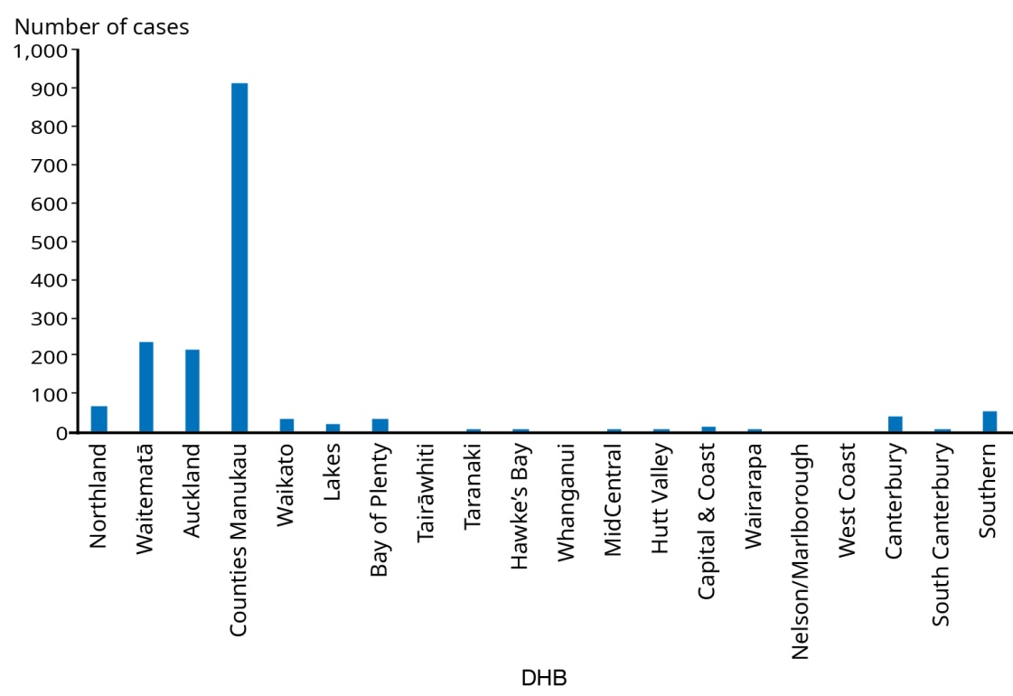
Source: ESR 2019a

Pacific peoples accounted for the largest number of confirmed measles cases, representing 40 percent of confirmed cases (Figure 18).

Figure 18: Number of confirmed measles cases for 2019 (up to 4 October), by ethnic group
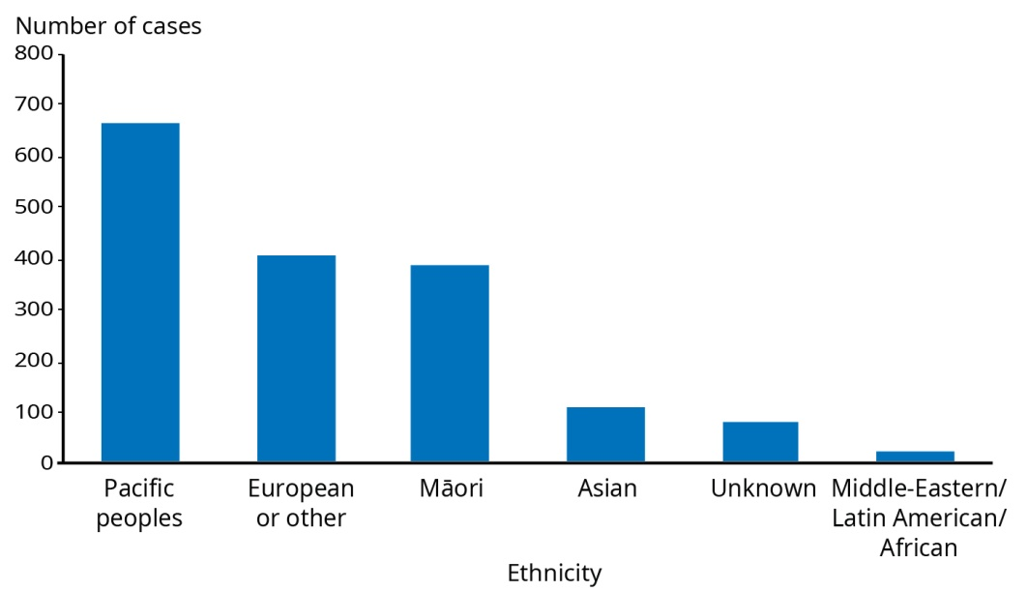
Source: ESR 2019a

A syphilis epidemic is occurring in New Zealand, with associated cases of congenital syphilis

Figure 19: Infectious syphilis rolling 12 month case counts by quarter, 2013 Q4 to 2019 Q1
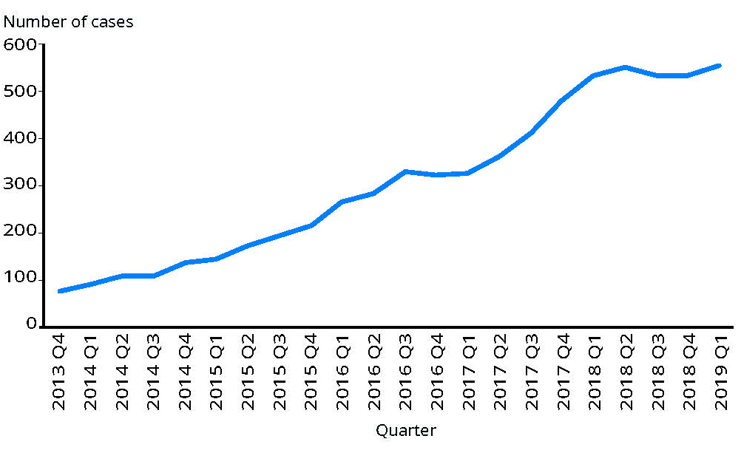
Note: Data were extracted on 4 June 2019 and are provisional for 2018 and 2019.
Infectious syphilis – non-identifiable data is requested and collected from all diagnosing health practitioners (from late 2018), historical trends are based on data collected since 2013 from sexual health clinics.
Source: ESR 2019b

Syphilis cases have increased in New Zealand every year since 2012 (ESR 2019b). In 2018, New Zealand had 543 cases of syphilis: 454 in males and 89 in females. This is more than double the number of cases reported in 2015 (221). The groups most affected by syphilis are men who have sex with men (approximately 70 percent of all cases), Asian and Māori men and Māori women. In 2017 the highest number of cases was reported in males aged 20–39 years, particularly the 25–29 age group. The number of syphilis cases among Māori women has increased markedly – 45 percent of affected heterosexual females are Māori. Since 2013, there has been an 18.5 fold increase in cases of syphilis among heterosexual female Māori.

Congenital syphilis, which is a serious infection in neonates, occurs when the infection is spread from an infected mother to the baby during pregnancy. In 2018, there were five reported cases of congenital syphilis, four in 2017, and one case in 2016. Before 2016, congenital syphilis was very rare in New Zealand.

Most of the syphilis cases have occurred in the Auckland region, followed by the Wellington region.

National Syphilis Action Plan
In June 2019, The Ministry of Health published the National Syphilis Action Plan, after consultation with the wider sexual health sector. This is a long-term plan with four focus areas: primary prevention and health promotion; testing and management; antenatal care; and surveillance. In September 2019, a workshop was held with representatives from the wider sexual health sector to ensure the plan continued to be appropriate and to identify key priority areas.

Although rates have been relatively stable since 2013, chlamydia continues to be the most commonly reported sexually transmitted infection in New Zealand

Chlamydia rates have remained relatively stable in recent years. The majority of cases are reported in people aged 15–29 years. In the 12 months to end of March 2019, 79 percent of reported cases occurred in this group.

Māori and Pacific peoples also continue to have higher rates of chlamydia than other ethnic groups. In the year ending April 2018, the rate of reported cases per 100,000 people was 1,616 among Māori, 1,338 among Pacific peoples, 373 among European/ Other and 351 among Asian people.

There are approximately 60 cases of chlamydia in infants each year.

Rates of rheumatic fever were declining but are now going back up

While rheumatic fever is rare in most developed countries, New Zealand has a persistently high incidence, with highest rates among Māori and Pacific children and young people aged 4–19 years living in the North Island. Among Pacific peoples in New Zealand, rheumatic fever occurs almost solely among Samoan and Tongan ethnic groups.

The Rheumatic Fever Prevention Programme 2011–17, focused on preventing and treating Group A streptococcal throat infection (strep throat), which can lead to rheumatic fever.

In 2018, there were 171 first episode rheumatic fever hospitalisations (3.6 per 100,000). Although the overall rate decreased from 2013 to 2015, it has increased each year since then. The rate is now almost at the level seen before the programme began in 2011, a rate of 4 per 100,000.

There has been a significant decrease in first episode rheumatic fever hospitalisations for Māori since the programme began. However, the number of cases among Pacific peoples has risen over that time. About two-thirds of first episode rheumatic fever hospitalisations occur in the Auckland region, mainly in Counties Manukau DHB and mainly in Samoan and Tongan children and young people.

Budget 2019: $12 million to fight rheumatic fever
It is clear that more needs to be done, given that rheumatic fever is a preventable illness, it disproportionately affects our youngest people and overwhelmingly affects Māori and Pacific peoples. The 2019 Budget provided $12 million to support innovative programmes that will reduce the incidence of rheumatic fever among Māori and Pacific peoples and support better management of the illness. The money will support Māori and Pacific communities to develop their own community-led initiatives in the fight against rheumatic fever.
beehive.govt.nz/release/wellbeing-budget-supports-new-rheumatic-fever-initiative

Childhood immunisation coverage has decreased and the equity gap between Māori and European children has increased

Immunisation coverage is measured at ‘milestone ages’ using data from the National Immunisation Register. The milestone ages are six months, eight months, 12 months, 18 months, 24 months and five years of age.

Childhood immunisation coverage in New Zealand has decreased since 2016, from a high of 93 percent for babies aged eight months, down to the current rate of 90 percent (at 31 March 2019) (Ministry of Health 2019m). This decline has particularly affected Māori, leading to a widening equity gap of nine percentage points between the number of New Zealand European children (92 percent) and Māori children (83 percent) fully immunised at eight months. The goal for childhood immunisation in New Zealand is to achieve coverage of 95 percent or higher. Other milestone ages echo the trend for immunisation at eight months.

Immunisation policy review
An evidence review of international immunisation policy commissioned by the Ministry in 2019 (yet to be published) found that systemic barriers are the leading cause of under-immunisation. These include socioeconomic factors, rurality and parental difficulties in juggling families, work and complex vaccine schedules. The evidence review found that the most successful interventions in immunisation policy are context- and culture-specific, supported by both health professionals and communities and address specific barriers. To be more effective, immunisation policy should be multi-faceted and specific to geographical and community contexts.
International policies which have demonstrated effectiveness in increasing rates of childhood immunisation with a focus on indigenous populations have:
addressed the wider social determinants of health
extended the role of culturally appropriate support for families to attend immunisation sessions, such as health navigators to provide practical support (reminders and transport) and outreach services
addressed health workforce issues to improve access, such as increasing the number of vaccinators (school nurses, Well Child Tamariki Ora nurses, community pharmacists)
incentivised recording, reminding and recalling and provided additional resources to do this work
improved IT systems to enhance tracking and tracing of children and families.
The Ministry is considering how delivery of the National Immunisation Programme should be changed to address the declining rates of childhood immunisation and reduce the equity gap in immunisation coverage.

Maternal and neonatal disorders
Maternal disorders make up a very low proportion of health loss for women (0.1 percent) (Global Burden of Disease Collaborative Network 2018).

Neonatal disorders make up 2.2 percent of health loss. The two leading causes for this health loss are preterm birth (1.1 percent) and brain damage due to asphyxia or trauma (0.5 percent). Rates of health loss as a result of both have decreased over time.

Infant mortality rates have decreased over the past two decades. The rate of fetal death has fluctuated over this time.

In 2015, New Zealand had 6.1 fetal deaths per 1,000 total births and 4.3 infant deaths per 1,000 live births (Ministry of Health 2018a). Between 1996 and 2015, the fetal death rate has fluctuated.
Fetal deaths refers to stillbirths.
Infant deaths refers to babies that die within the first year.

However, the infant death rate has fallen by 41 percent (7.3 infant deaths per 1,000 live births in 1996).

In 2015, the fetal death rate was highest in the European and Other ethnic group (6.5 per 1,000 total births), followed by the rate among the Asian and Pacific peoples (both 6.1 per 1,000 total births). The rate was lowest among Māori (5.6 per 1,000 total births).

The infant death rate was highest among Pacific peoples (7.1 per 1,000 live births). Infant death rates generally increase with increasing levels of deprivation. The infant death rate for the most deprived areas (quintile five, 5.8 per 1,000 live births) was nearly twice the rate of the least deprived areas (quintile one, 3.0 per 1,000 live births) (Ministry of Health 2018a).

Our health outcomes | Ngā putanga hauora
How New Zealanders rate their own health and the outcomes they can expect as they age.

Self-rated health
Most New Zealanders continue to have high levels of self-rated health, but significant health differentials exist for Māori, those living in our most deprived communities and disabled people
Measures of self-rated or perceived health status are a recognised predictor of people’s future health care use and mortality (OECD 2017). In the New Zealand Health Survey, respondents can rate their health as poor, fair, good, very good or excellent. In this report, the term ‘high levels of health’ refers to self-rated health of good, very good or excellent.
In 2017/18, 87.5 percent of adults reported having high levels of self-rated health (Ministry of Health 2019d). The percentages for men and women were similar (88.1 percent of men and 87.0 percent of women). Therefore, as in previous years, the vast majority of New Zealanders appear to have high levels of self-rated health. However, Māori are less likely (0.9 times as likely as non-Māori) to have high levels of self-rated health. Asian people continue to have the greatest proportion of adults with high self-rated health, 1.03 times as likely as non-Asian. Pacific peoples and non-Pacific people did not have a significant difference in self-rated health.

The proportion of people with high levels of self-rated health also varies by socioeconomic deprivation. People living in the most deprived communities are less likely (0.88 times) than those in the least deprived communities to report having high levels of health.

The New Zealand General Social Survey also obtains information on self-rated health. According to the 2018 survey, disabled people are less likely than non-disabled to rate their health as good, very good or excellent (51.3 percent of disabled adults, 88 percent of non-disabled adults) (Stats NZ 2019o). These figures are not adjusted to account for the different age structures of the two groups.

Proportionately more Māori and people living in deprived areas have poor self-rated health

In 2017/18, 2.4 percent of adults overall had poor self-rated health (2.1 percent of men and 2.7 percent of women). Māori were 2.4 times as likely to rate their health as poor than non-Māori. Those living in our most deprived areas were 3.7 times as likely to have poor self-rated health as those in our least deprived areas.

Almost all children have high levels of health according to their parents/ caregivers

An estimated 98 percent of children have high levels of parent-rated health. No significant differences are observed for parent-rated health of children by gender, broad ethnic group or neighbourhood deprivation.

Information for disabled children was not collected in the 2017/18 New Zealand Health Survey.

Life expectancy and health-adjusted life expectancy
Life expectancy and health-adjusted life expectancy have both increased, but so has the gap between the two (that is, the loss of healthy years)

Overall life expectancy at birth is 79.7 years for males and 83.6 years for females. Women in New Zealand live 3.9 years longer than men. For both males and females, overall life expectancy has increased over time. Over the past two decades, men have gained 5.1 years of life and women 3.8 years. While women have historically lived longer and continue to do so, the life expectancy gap between men and women is slowly decreasing. However, life expectancy gains and gap reduction over the past 10 years have been slower than those seen over the previous 20 years (Figure 20).
Life expectancy measures the number of years we live, while health-adjusted life expectancy (health expectancy) represents the number of years we live in good health. Both are indicators of population health (Global Burden of Disease Collaborative Network 2018).

Figure 20: Life expectancy at birth for females and males, 1997, 2007 and 2017
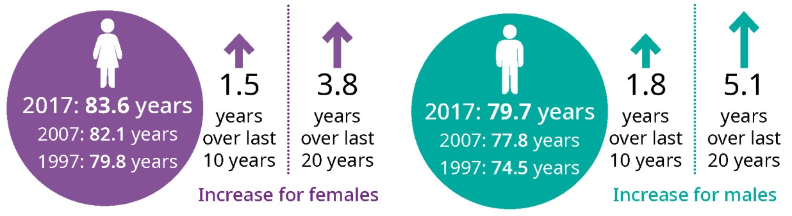
Note: Changes over time have been calculated from unrounded data.
Source: Global Burden of Disease Collaborative Network 2018

Health expectancy at birth is 68.0 years for males and 70.1 years for females. Over time, health expectancy has increased for both men and women. Compared to their counterparts 20 years ago, men in 2017 have an added 3.7 years of healthy life and women in 2017 have an added 2.6 years of healthy life. However, as with gains in life expectancy, gains in health expectancy in the past 10 years have been less than over the previous 20 years (Figure 21).

The increase in health expectancy over time has not been at pace with the gains in overall life expectancy. As a result, there has been an increase in the number of years we live in less than full health. Men are now expected to lose 11.6 healthy years, while women lose 13.5 healthy years (Figure 22).

Figure 21: Health expectancy at birth for females and males, 1997, 2007 and 2017
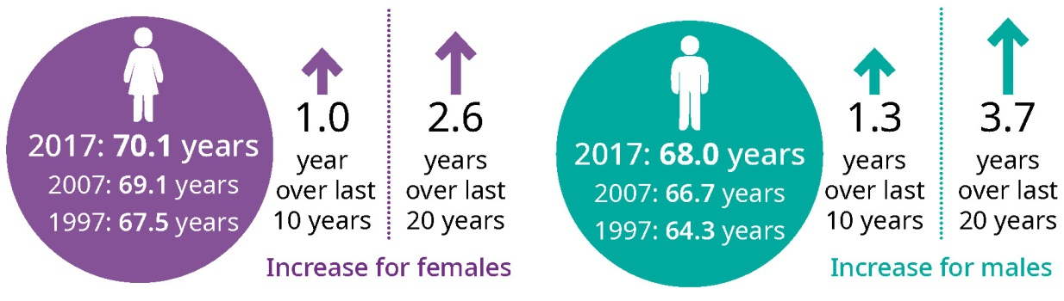
Note: Changes over time have been calculated from unrounded data.
Source: Global Burden of Disease Collaborative Network 2018

Figure 22: Years lived in poor health for females and males, 1997, 2007 and 2017
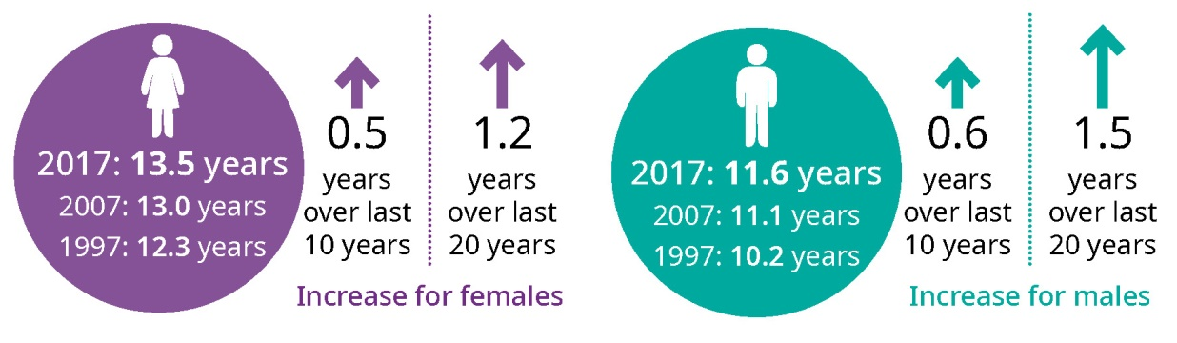
Note: Changes over time have been calculated from unrounded data.
Source: Global Burden of Disease Collaborative Network 2018

Inequalities in life expectancy are the sharp end of health inequities

Life expectancy calculations based on most recent data are not available for Māori and Pacific peoples or by socioeconomic deprivation or disability status. Life expectancy differentials for Māori and non-Māori have previously been well-established (Stats NZ 2015).

A recently published study has estimated life expectancy for Māori, Pacific and non- Māori/non-Pacific men and women based on New Zealand mortality data over the three-year period from 2013 to 2015 (Walsh and Grey 2019).

This study found a significant differential in life expectancy. Among males, the life expectancy was 73.5 years for Māori, 75 years for Pacific peoples and 80.9 years for non-Māori/non-Pacific. Among females, the life expectancy was 77.3 years for Māori, years for Pacific and 84.3 years for non-Māori/non-Pacific.

This equates to approximately seven fewer years of life for Māori and six fewer years for Pacific peoples compared to non-Māori/non-Pacific people in New Zealand.

Similar to trends seen overseas, we may be seeing a plateau in improvements to life expectancy in New Zealand

Improvements in life expectancy have been reported to have stalled in recent years across a number of high income countries, including the United Kingdom, the United States, France, Germany, Sweden and the Netherlands (Raleigh 2019).

A review of recent trends in mortality in England found that since 2011, improvements in mortality rates and life expectancy have slowed considerably and inequalities between the most and least deprived areas have widened. It also found that for some age groups, and in some parts of England, there have been no improvements at all. The review concluded that overall slowdown in improvement is due to a range of factors and work is required on a wider range of determinants of health (Public Health England 2018).

Although many factors are implicated in this general trend, a slowdown in improvements in mortality from cardiovascular disease is a substantial contributor. Internationally, there are concerns that the increasing prevalence of obesity and diabetes could halt reductions in cardiovascular disease and ultimately halt or even reverse life expectancy gains (Raleigh 2019).

Addressing the Challenges | Te whakatau i ngā wero
The Ministry of Health and our partners can drive key shifts in the system to ensure improved outcomes for all New Zealanders now and in the future.

The challenges
Our population is forecast to grow, becoming more diverse and getting older, which increases the demand on health services. These demographic factors, combined with the increasing burden of long-term conditions and associated non-fatal health loss (due to ageing and underlying health determinants), challenge the sustainability of our current approach to health care. As increasingly sophisticated medicines and treatments become available, people’s expectations of what health care services should be available to them also increase.

Not only are there changes in consumers’ expectations of what the health system should deliver, but also how they engage with the health system. Changes have occurred in how consumers access other services and participate in society more generally. The increasing availability of information ‘at your fingertips’, has implications for traditional models of care. Ensuring we have a fit-for-purpose health system that meet people’s needs will require us to think and work differently (see discussion of health app library on page 74). Investment in technological advances also provides opportunities to increase the value of health care and potentially decrease costs, for example through digital health care innovations and personalised medicine.

Non-communicable diseases contribute to over 80 percent of health loss (ill health and premature death measured in disability adjusted life years). Potentially modifiable factors contribute to an estimated 39 percent of our health loss. Key risk factors for this health loss include tobacco use, unhealthy diet, excess weight, high blood pressure, high fasting plasma glucose and alcohol use. Level of physical activity is also an important factor. The societal shift towards a more sedentary, high consumption, technology-driven lifestyle presents a real challenge to our health and wellbeing.

Over half of New Zealand’s health loss (54 percent of DALYs) is non-fatal (YLDs). As such, New Zealand has undergone the ‘disability transition’. The burden of communicable, nutritional, maternal and neonatal disease, which typify pre-transition countries, is low in New Zealand. However, what we have achieved as a country needs to be balanced with the reality that we are still exposed to global health challenges, such as communicable disease outbreaks.

In the year to January 2019, the total traveller movements (the sum of all arrivals and departures in New Zealand) was 14 million (Stats NZ 2019n). This reflects a continually increasing trend over time. International travel presents risk of the spread of communicable disease, as we have seen with measles. It also presents risk of importing multidrug resistant pathogens from places where they are endemic. The rate of antimicrobial resistance is currently relatively low in New Zealand compared with other countries, however certain antibiotic-resistant infections are increasing, including resistant strains of Escherichia coli, Neisseria gonorrhoeae and Staphylococcus aureus. We have also recently seen increasing rates of infection with highly-resistant Carbapenemase-producing Enterobacteriaceae (CPE). We are working with partners to minimise the development and spread of resistant organisms (see box below).

Antimicrobial resistance as a threat to health security
The WHO notes that ‘addressing antimicrobial resistance requires a holistic multi- sectoral approach because … resistant bacteria arising either in humans, animals or the environment may spread from one to the other, and from one country to another’.
New Zealand’s Antimicrobial Resistance Action Plan was developed in 2017 with the Ministry for Primary Industries and stakeholders from the human health, animal health and agriculture sectors. Objectives include improving awareness and understanding; surveillance and research; infection prevention and control; antimicrobial stewardship; and governance, collaboration and investment.
The theme for activities to raise awareness and understanding of antimicrobial resistance in 2019/20 is ‘together we can keep antibiotics working’. Messages reinforce that we all contribute to antibiotic resistance and we can all do something to help combat it.

Climate change is another global health challenge. While it is important we take action to tackle climate change domestically, the global nature of the issue requires us to continue to play our part in the international arena to support collective action.

Finally, underpinning these challenges are the statistics that demonstrate that not all people in our society have equal access to the determinants of good health, resulting in unequal health outcomes in New Zealand. Māori, Pacific peoples, socioeconomically deprived people and disabled people all experience health inequity. Not only is this unfair, but it makes our population as a whole less resilient to the challenges discussed above.

Addressing these challenges requires building a fair, effective and sustainable health system that people trust. Work is under way to achieve this goal.

The Health and Disability System Review currently under way represents a significant opportunity for the system to take stock of the current state and identify improvements that can be made to the health and disability system to ensure the system is better balanced for wellness, access, equity and sustainability. The review panel released an interim report in September 2019 and their final report is due end of March 2020.

New Zealand health app library
As the use of technology grows for everyday activities like online banking and shopping, consumers increasingly turn to digital tools to support their health. Using technology and supporting patients to take a more proactive role in their own health and treatment is essential for supporting their wellness. It is important that the adoption of new technologies is safe, protects privacy and has a positive impact on access and equity.
There are more than 300,000 health-related apps on the market. Since 2016, the Ministry has had an agreement with the Health Navigator Charitable Trust to develop a health app quality assessment framework and to set up and maintain a health app library.
The health app library makes it easier and safer for the public and health professionals to identify useful and relevant health apps to support lifestyle, disease management, mental wellbeing and behaviour change. The library provides clinicians and consumers with a selection of apps and information to decide whether the app might meet their needs.
Apps can have a range of functions, such as:
symptom checking and triaging to reduce after hours visits or calls
supporting medication adherence, diabetes care, addictions and mental health recovery
enabling communication (such as appointment reminders)
health monitoring and surveillance
access to information at the point of care (health records, decision support).
Well-developed and evidence-based apps can help patients and families/whānau take control and access services wherever they are. Such apps can facilitate access to the right information at the right time, enabling better decisions and choices every day.
A systematic review by Whitehead and Seaton found that self-management apps have the potential to promote or support self-management among those living with chronic diseases (diabetes mellitus; cardiovascular diseases such as hypertension, coronary artery disease and congestive heart failure; and chronic lung diseases such as asthma and chronic obstructive pulmonary disease) (Whitehead and Seaton 2016). Similarly, a review found that smartphone apps were either completely or partially effective in assisting with the management of some conditions (Wang et al 2014).
To see how some common health apps have fared in the clinical review process, check out the Health Navigator app library at healthnavigator.org.nz/apps

Achieving Pae Ora – Healthy Futures
These challenges have been recognised by Government and a commitment to addressing them underpins recent work of the Ministry. The Ministry has identified the outcomes the health and disability system needs to focus on to achieve Pae ora – healthy futures. The three high-level outcomes are:
- we live longer in good health
- we have improved quality of life
- we have health equity for Māori and other groups.

To deliver on these outcomes, the Ministry will need to work in partnership in the health and disability sector, with other government agencies and with community partners. Within the public health and disability system, delivering quality health services to New Zealanders in a way that is sustainable is a central challenge. Investing in and enhancing people’s wellbeing will mean new ways of working, guided by the Government’s priorities for the health and disability system.

Government priorities for the health and disability system
The Government is committed to improving the wellbeing of New Zealanders and their families. To help achieve this goal, the Minister of Health has five health system priorities:
improving child wellbeing
improving mental wellbeing
improving wellbeing through prevention
better population health outcomes supported by a strong and equitable public health and disability system
better population health outcomes supported by primary health care.
These priorities underpin the work of the health and disability system through the District Health Board annual planning and reporting process.

Outcome 1: We live longer in good health
Living longer in good health focuses on increasing healthy life expectancy (the amount of time we spend in good health). This is an important challenge because New Zealanders are living longer, but also spending around a decade, on average, in poor health.

Achieving gains in healthy life expectancy will require a focus on the main determinants of health, as discussed earlier in this report. We must work to make the building blocks of good health accessible to all, and reduce exposure to the main risk factors associated with disease burden. We must respond to health concerns early in the life course.

The Child and Youth Wellbeing Strategy provides an example of work under way to enable New Zealanders to live longer in good health.

Child and Youth Wellbeing Strategy
As discussed in the Health and Independence Report 2017, the first 1,000 days of life – from conception until a child’s second birthday – are a time of rapid and crucial development. This time is a window of opportunity to lay the foundations for future health and wellbeing.

The Government’s Child and Youth Wellbeing Strategy acknowledged that this year. The overarching vision of the Child and Youth Wellbeing Strategy is to make New Zealand the best place in the world for children and young people. This means that children and young people are loved, safe and nurtured, have what they need and are happy and healthy.

Spanning the work of several Government agencies, including the Ministry of Health, the strategy prioritises several areas:
- addressing family and sexual violence
- improving quality of care for children and young people in state care and youth justice settings
- reducing child poverty
- mitigating socioeconomic disadvantage
- improving support for child and youth mental wellbeing
- more joined-up whānau centred support, particularly in the first 1,000 days and in the early years of a child’s life
- better learning and development support for children and young people with greater needs.

The Well Child Tamariki Ora programme, which delivers universal health care to children in Aotearoa New Zealand, will be one of the health system’s main contributions to the Government’s work under the Child and Youth Wellbeing Strategy.

The Well Child Tamariki Ora Review
The Well Child Tamariki Ora (WCTO) programme is New Zealand’s comprehensive early childhood health and development service. It provides essential universal health services and checks to all New Zealand tamariki aged five and under as described in the WCTO National Schedule. The programme’s primary goal is to ‘ensure that all families and whānau are supported to maximise their child’s developmental potential and health status in the early years, in order to establish a strong foundation for ongoing health and development’.
A review of the programme (the Review) is currently under way to make sure the programme is delivering the best possible health and wellbeing outcomes for babies, children and their whānau.
The Review aims to strengthen the WCTO programme by:
improving sustainability and performance of the WCTO programme
driving equitable health and development outcomes for children
enabling WCTO services to more effectively contribute to wider child wellbeing
ensuring value for money.
The Review presents multiple opportunities for better integration between services like maternity, the WCTO programme, primary health care, oral health and immunisation, while building connections with other sectors such as education, to which families need easy access.

Outcome 2: We have improved quality of life
A key aspect of wellbeing is not just living longer in good health, but also living an independent and high functioning life despite ill-health. To achieve this, people need to be supported to live well with disability, long-term mental and physical conditions and life limiting conditions. This enables people to connect with each other, receive support in their communities and participate in society.

Transformation of the disability support system is one example of work under way to improve quality of life and enhance personal and whānau independence. System transformation of the mental health and addiction sector following release of the Mental Health Inquiry Report He Ara Oranga, is also under way.

Transforming the disability support system – Mana Whaikaha
A nationwide transformation of the disability support system is a priority for the Ministries of Health and Social Development to improve the wellbeing of disabled people and their whānau. The transformation is underpinned by the Enabling Good Lives vision and principles, developed by the disability community (Enabling Good Lives 2019).

The Government agreed to implement a prototype of a transformed disability support system in the MidCentral DHB area from 1 October 2018 called Mana Whaikaha.

The key objectives of the Mana Whaikaha prototype are:
- provide disabled people and whānau more flexible support options
- give disabled people and whānau more power to make decisions about their lives and support
- ensure all disabled people and whānau are able to take up the opportunities for change.

People are welcomed into the system in multiple ways and provided with information and linked with a Connector, peer network, government agency or disability organisation. Connectors walk alongside disabled people and whānau to help them identify what they want in their lives and the range of supports (universal, community-based, unpaid and paid) available to live that life.

Support is designed to be connected across government, with Government Liaisons in the background supporting access to other services (eg, benefit applications) and building positive relationships with other parts of government (eg, learning support in school). Another important feature of the prototype is that disabled people and their whānau help monitor and evaluate the system, making recommendations to Ministers about potential changes. This builds in greater system accountability to the people Mana Whaikaha serves.

As at 1 June 2019, more than 900 people have engaged with the prototype – around one-third of the people currently supported by disability support services in the area. Mana Whaikaha reaches people who may not have engaged with disability supports before. From 1 October 2018 to 30 June 2019, nearly 200 disabled people engaged with the prototype who were not previously known to any Needs Assessment and Service Coordination service. Of these, more than two-thirds were children and young people aged 21 years and under.

Transforming the mental health and addiction sector
The mental health and addiction system needs to be responsive to people at different life stages and at different levels of need. As well as specialist services at the high- needs end of the spectrum, a range of services are required that span promotion, prevention and early intervention.

The Government inquiry into Mental Health and Addiction estimated that 20 percent of New Zealanders meet the criteria for a diagnosable mental disorder each year. Currently, the services and workforce cannot meet that level of need.

The Mental Health and Wellbeing Commission and the Suicide Prevention Office are being established to support a system transformation of the mental health and addiction sector.

Outcome 3: We have health equity for Māori and other groups
The health and disability system currently does not deliver equitable outcomes for all. Addressing long standing inequities is a responsibility for everyone, in the Ministry and across the sector. The Health Services and Outcomes Kaupapa Inquiry currently under way by the Waitangi Tribunal is examining the breadth of the issues for Māori in depth.

Wai 2575 inquiry under way
The Health Services and Outcomes Kaupapa Inquiry (Wai 2575) (Waitangi Tribunal 2019) has found that Māori continue to face persistent inequity in health outcomes and the key determinants of health and that this inequity occurs across the life course. The Tribunal has reported on stage one of its inquiry, which focused on the primary care sector, in their Hauora Report. The Government is considering the findings in this report. The Inquiry is moving on to the second stage, which focuses on addiction, mental health and disability.

In working to achieve health equity for Māori, rights-based and needs-based approaches must be acknowledged. A rights-based approach stems from the Crown’s role as Treaty partner to give effect to Treaty principles and support Māori aspirations for health and wellbeing. Examples of ways in which we do this include supporting Crown-Māori relations through the Te Hiku Social Accord, increasing Māori innovation through Te Ao Auahatanga Hauora Māori Health Innovation Fund and funding matauranga Māori services such as rongoā health services.

Te Ao Auahatanga Hauora Māori: Māori Health Innovation Fund
The Māori Health Innovation Fund was established in 2009 to address the service gaps and unmet needs of Māori by the health system. This fund develops, tests and implements new models of service delivery over a 3–4 year period. The overarching goal of the fund is Pae Ora or Healthy Futures for whānau.
Te Kākano Māori Nurse Practitioner Led Clinics is one example of an alternative model of care trialled through this fund. This initiative operates in most areas within the Southern District Health Board (SDHB) catchment area. Māori Nurse Practitioners run clinics in response to local community needs and events. Te Kākano clinics are points of reference for other services such as podiatry, which also operate out of some clinics. Nurse practitioners address a wide number of health issues and refer as necessary. The clinics may also include preventative approaches through healthy lifestyle promotion. Local health service providers support Te Kākano by facilitating the clinics and following up with clients, in some cases providing whānau ora support.
Local Māori health providers in Otago and Southland, the Primary Health Organisation WellSouth, the SDHB and the Ministry of Health collaborated to design the Te Kākano Nurse Practitioner Led Clinics. From July 2021, funding of the initiative will transition to the SDHB.

The overarching priority to achieve equitable outcomes also covers other groups known to have disproportionately poorer health outcomes. This includes Pacific peoples, socioeconomically deprived people, people with intellectual disabilities and people with severe mental illness. As well as developing tailored approaches to address health needs within these communities, progress must be made in the delivery of mainstream healthcare. As discussed earlier in this report, there is evidence that racism within the system impacts health outcomes. Investigating and addressing racism and discrimination is therefore an important component of improving health and disability services to achieve health equity.

Achieving health equity also requires a shared understanding of what equity is, and how inequity develops (as covered in Chapter 1 of this report). It also needs to be guided by accurate data collection and insights development.

For a more detailed discussion on achieving health equity, see the Ministry’s recent publication Achieving Equity in Health Outcomes: Highlights of selected papers. This is available at: health.govt.nz/system/files/documents/publications/achieving-equity-in-health-outcomes-important-paper-highlights-nov18_1.pdf

As part of the focus on increasing equity, the Ministry of Health uses data and other insights, including insights from the lived experience of people to improve services and outcomes (such as understanding the drivers of the high rates of young Māori women who smoke).

As we look ahead, an important challenge is deepening our understanding of disabled people’s health needs. The Ministry has a knowledge gap and is working with the Office for Disability Issues to address it.

Disability information from Census 2018
The Washington Group (Washington Group on Disability Statistics 2019) short-set is a group of standard questions used to identify disabled people. The 2018 New Zealand Census included these questions, which will allow for more detailed analysis of the experience of disabled people.

Conclusion | Whakakapi
The overall health of New Zealanders has improved over time. This report highlights that people are living longer and spending more of those years in good health than they did two decades ago.
Public health interventions, advances in treatments and increasing awareness of health over recent decades are bearing fruit. We have seen the overall rate of health loss improve. These are important signs of progress for the health of the nation. However, unacceptable inequities persist particularly for Māori as well as Pacific peoples, socioeconomically deprived people and disabled people.

We also face important challenges to our health and wellbeing. Like many other high-income countries, chronic and long-term conditions are on the rise and forecast to increase as the population grows and ages. This underscores the importance of prevention and the need to continue to address modifiable factors which can lead to poor physical and mental health. This is a key focus for the government and a significant programme of work is under way across the health and disability system (in areas such as child wellbeing and mental wellbeing) to improve the wellbeing of New Zealanders and their families.

Of vital importance is improving health equity for Māori and other groups. This report highlights the shared challenges we face. The rates of illness and mortality for Māori, Pacific Peoples, disabled people and those living in low socioeconomic communities are high, unjust and unfair. As a Ministry and as a sector, we are committed to health equity, today and in the future. This means working more closely with people to help bring about equity by design. Our work in this area is advancing at pace. A range of initiatives signpost health improvement for all New Zealanders. This includes plans to lift health equity in key areas such as cancer (New Zealand Cancer Action Plan), suicide (the Suicide Prevention Action Plan) and provided disabled people with more choice and control in their lives (Enabling Good Lives Programme).

This report has presented an opportunity to take stock, identify key areas of progress and challenge and move forward with renewed vigour in the shared endeavour of achieving ‘Pae Ora: Health Futures’ for all New Zealanders.

Technical notes | Ngā tuhipoka hangarau
This report includes data from a wide range of sources, many of which are produced outside the Ministry of Health.

We have tried to report data only when the data collection and analytical processes are robust. Notes are included if methodological information affects the interpretation of the data. We encourage you to refer to the original data source for further details.

All data reported is the latest available, although the time lag between the most recent data and the present can be substantial. Some data is provisional (such as the 2016 mortality data) and may change.

When possible, we have reported on statistically significant differences between population groups and, when relevant, trends over time.

In many comparisons, the results are adjusted or standardised for factors that may influence (confound) the comparison, such as age and gender. Age standardisation is often used in this report to account for differences in age structure between population groups and over time.

Where age-standardised rates have been presented, Global Burden of Disease data has been age-standardised using a study-specific set of population weights that were originally derived from the World Health Organization world standard population and then refined over time, creating the GBD population. These rates will differ from other figures that have been calculated using different standard populations.

Ethnic comparisons were based on either prioritised ethnicity or total response ethnicity. With prioritised ethnicity, ethnic groups are mutually exclusive. That is, a person can appear in only one ethnic group. With total response ethnicity, a person is classified in all ethnic groups they identify with. This means that a person can appear in more than one ethnic group. For example, prioritised ethnicity is used for analysis based on administrative data (such as mortality data), while total response ethnicity is shown for students completing qualifications.

Selected results are presented by neighbourhood deprivation, as measured by the New Zealand Index of Deprivation 2013. This is an area-based measure of socioeconomic deprivation according to a combination of the following 2013 Census variables: income, benefit receipt, transport (access to car), household crowding, home ownership, employment status, qualifications, support (sole-parent families) and access to a telephone. In this report, ‘most deprived areas’ refers to quintile 5 – the people living in the most socioeconomically deprived 20 percent of small areas in New Zealand. Conversely, ‘least deprived areas’ refers to quintile 1, the people living in the least deprived 20 percent of small areas in New Zealand.
This report includes a range of population statistics, such as population estimates and projections. Updated population estimates based on the 2018 Census are expected to be released by March 2020 (Stats NZ 2019g).

References | Ngā tohutoro
Amore K. 2016. Severe Housing Deprivation in Aotearoa/New Zealand: 2001–2013. Wellington: He Kainga Oranga/Housing & Health Research Programme, University of Otago.
Baker MG, McDonald A, Zhang J, et al. 2013. Infectious Diseases Attributable to Household Crowding in New Zealand: A systematic review and burden of disease estimate. Wellington: He Kainga Oranga / Housing and Health Research Programme, University of Otago.
Barnard LT, Zhang J. 2019. The impact of respiratory disease in New Zealand: 2018 update. URL: https://www.asthmafoundation.org.nz/research/the-impact-of-respiratory-disease-in-new-zealand-2018-update (accessed 15 November 2019).
Brown P. 2009. Economic burden of stroke in New Zealand. Three Decades of Auckland Regional Community Stroke (ARCOS) Studies: What have we learned and what is next for stroke care and stroke research 16.
Came H, Doole C, McKenna B, et al. 2018. Institutional racism in public health contracting: Findings of a nationwide survey from New Zealand. Soc Sci Med 199: 132–9.
Cancer Council Australia. 2019. E-cigarettes. URL: https://www.cancer.org.au/preventing-cancer/smoking-and-tobacco/e-cigarettes.html (accessed 21 November 2019).
Centers for Disease Control and Prevention. 2019. THC Products May Play a Role in Outbreak of Lung Injury Associated with E-cigarette Use, or Vaping. URL: https://www.cdc.gov/media/releases/2019/p0927-thc-vaping.html (accessed 25 October 2019).
Chen M. 2017. The Diversity Matrix. Updating What Diversity Means for Discrimination Laws in the 21st Century. Superdiversity Institute for Law, Policy and Business.
Education Counts. 2019. Retention and Achievement. URL: https://www.educationcounts.govt.nz/statistics/tertiary-education/retention_and_achievement (accessed 15 November 2019).
Enabling Good Lives. 2019. About Enabling Good Lives. URL: http://www.enablinggoodlives.co.nz/about-egl/ (accessed 15 November 2019).
ESR. 2019a. Measles Weekly Report Week 40: 28 September–4 October 2019. URL: https://surv.esr.cri.nz/PDF_surveillance/MeaslesRpt/2019/WeeklyMeasles10072019.pdf (accessed 8 October 2019).
ESR. 2019b. Sexually Transmitted Infection (STI) surveillance. URL: https://www.esr.cri.nz/our-services/consultancy/public-health/sti/ (accessed 29 October 2019).
Eyles H, Jiang Y, Blakely T, et al. 2018. Five year trends in the serve size, energy, and sodium contents of New Zealand fast foods: 2012 to 2016. Nutrition Journal 17(1): 65.
Family Violence Clearinghouse. 2017. Data Summaries 2017: Snapshot. URL: https://nzfvc.org.nz/our-work/data-summaries/snapshot (accessed 30 October 2019).
Family Violence Death Review Committee. 2014. Fourth Annual Report: January 2013 to December 2013. Wellington: Family Violence Death Review Committee.
Feigin VL, Roth GA, Naghavi M, et al. 2016. Global burden of stroke and risk factors in 188 countries, during 1990-2013: a systematic analysis for the Global Burden of Disease Study 2013. The Lancet. Neurology 15(9): 913–24.
Ferlay J, Ervik M, Lam F, et al. 2018. Global Cancer Observatory: Cancer Tomorrow. Lyon, France: International Agency for Research on Cancer.
Global Burden of Disease Collaborative Network. 2018. Global Burden of Disease Study 2017 (GBD 2017) Results. Seattle, United States: Institute for Health Metrics and Evaluation (IHME).
Grey C, Jackson R, Wells S, et al. 2018. Trends in ischaemic heart disease: patterns of hospitalisation and mortality rates differ by ethnicity (ANZACS-QI 21). NZ Med J 131(1478): 21–31.
Grimes A, Denne T, Howden-Chapman P, et al. 2012. Cost Benefit Analysis of the Warm Up New Zealand: Heat Smart Programme. URL: http://www.healthyhousing.org.nz/wp-content/uploads/2012/05/NZIF_CBA_report-Final-Revised-0612.pdf (accessed 15 November 2019).
Harris RB, Stanley J, Cormack DM. 2018. Racism and health in New Zealand: Prevalence over time and associations between recent experience of racism and health and wellbeing measures using national survey data. PLoS One 13(5): e0196476.
Health and Disability Commissioner. 2019. Code of Health and Disability Services Consumers’ Rights. URL: https://www.hdc.org.nz/your-rights/about-the-code/code-of-health-and-disability-services-consumers-rights/ (accessed 20 November 2019).
Health Effects Institute. 2019. State of Global Air. URL: https://www.stateofglobalair.org/ (accessed 20 November 2019).
Health Promotion Agency. 2019. What Have We Learned from the 2017 and 2018 FAST campaigns? Unpublished report prepared for the Ministry of Health.
Health Quality & Safety Commission. 2019. A Window on the Quality of Aotearoa New Zealand’s Health Care 2019. URL: https://www.hqsc.govt.nz/our-programmes/health-quality-evaluation/publications-and-resources/publication/3721/ (accessed 25 October 2019).
Hill S, Sarfati D, Blakely T, et al. 2010. Survival disparities in Indigenous and non-indigenous New Zealanders with colon cancer: the role of patient comorbidity, treatment and health service factors. Journal of Epidemiology & Community Health 64(2): 117–23.
Hobbs M, Tomintz M, Kingham S. 2019. Investigating the Rates and Spatial Distribution of Childhood Ambulatory Sensitive Hospitalisations in New Zealand. URL: https://ir.canterbury.ac.nz/handle/10092/16898 (accessed 18 November 2019).
Immigration New Zealand. 2019. New Refugee Settlement Location Announced. URL: https://www.immigration.govt.nz/about-us/media-centre/media-releases/new-refugee-settlement-location-announced (accessed 20 November 2019).
Institute for Clinical Systems Improvement. 2014. Going Beyond Clinical Walls: Solving Complex Problems. URL: http://www.nrhi.org/uploads/going-beyond-clinical-walls-solving-complex-problems.pdf (accessed 15 November 2019).
Jaine R, Baker M, Venugopal K. 2011. Acute rheumatic fever associated with household crowding in a developed country. The Pediatric Infectious Disease Journal 30(4): 315–9.
Jones CP. 2000. Levels of racism: a theoretic framework and a gardener’s tale. Am J Public Health 90(8): 1212–5.
Kessler RC, Barker PR, Colpe LJ, et al. 2003. Screening for serious mental illness in the general population. Archives of General Psychiatry 60(2): 184–9.
Levy DT, Warner KE, Cummings KM, et al. 2019. Examining the relationship of vaping to smoking initiation among US youth and young adults: a reality check. Tobacco Control 28(6): 629-35.
Ministry for the Environment, Stats NZ. 2018. New Zealand’s Environmental Reporting Series: Our air 2018. URL: https://www.mfe.govt.nz/publications/environmental-reporting/our-air-2018 (accessed 28 November 2019).
Ministry of Health. 2015. Pae Ora – Healthy Futures. URL: https://www.health.govt.nz/our-work/populations/maori-health/he-korowai-oranga/pae-ora-healthy-futures (accessed 15 November 2019).
Ministry of Health. 2018a. Fetal and Infant Deaths 2015. URL: https://www.health.govt.nz/publication/fetal-and-infant-deaths-2015 (accessed 10 November 2019).
Ministry of Health. 2018b. New Cancer Registrations 2016. URL: https://www.health.govt.nz/publication/new-cancer-registrations-2016 (accessed 21 November 2019).
Ministry of Health. 2018c. Publicly Funded Hospital Discharges – 1 July 2015 to 30 June 2016. URL: https://www.health.govt.nz/publication/publicly-funded-hospital-discharges-1-july-2015-30-june-2016 (accessed 15 November 2019).
Ministry of Health. 2019a. Achieving Equity. URL: https://www.health.govt.nz/about-ministry/what-we-do/work-programme-2019-20/achieving-equity (accessed 17 September 2019).
Ministry of Health. 2019b. Achieving Equity in Health Outcomes: Summary of a discovery process. URL: https://www.health.govt.nz/system/files/documents/publications/achieving-equity-in-health-outcomes-summary-of-a-discovery-process-30jul2019.pdf (accessed 5 September 2019).
Ministry of Health. 2019c. Annual Report on Drinking-water Quality. Wellington: Ministry of Health.
Ministry of Health. 2019d. Annual Update of Key Results 2017/18: New Zealand Health Survey. URL: https://www.health.govt.nz/publication/annual-update-key-results-2017-18-new-zealand-health-survey (accessed September 2019).
Ministry of Health. 2019e. Cancer: Historical summary 1948–2016. URL: https://www.health.govt.nz/publication/cancer-historical-summary-1948-2016 (accessed 4 October 2019).
Ministry of Health. 2019f. Demographic Report for Clients Allocated the Ministry of Health’s Disability Support Services. 2018 update. Wellington: Ministry of Health (awaiting publication).
Ministry of Health. 2019g. Health Workforce, Customised Dataset. Wellington.
Ministry of Health. 2019h. Healthy Homes Initiative. URL: https://www.health.govt.nz/our-work/preventative-health-wellness/healthy-homes-initiative (accessed September 2019).
Ministry of Health. 2019i. Historical mortality. URL: https://www.health.govt.nz/publication/historical-mortality (accessed 25 October 2019).
Ministry of Health. 2019j. Historical Mortality (data was extracted from the New Zealand Mortality Collection on 7 June 2019). URL: https://www.health.govt.nz/publication/historical-mortality (accessed 25 October 2019).
Ministry of Health. 2019k. Household Food Insecurity Among Children in New Zealand. URL: https://www.health.govt.nz/system/files/documents/publications/household-food-insecurity-among-children-new-zealand-health-survey-jun19.pdf (accessed 25 October 2019).
Ministry of Health. 2019l. Mortality 2016 data tables. URL: https://www.health.govt.nz/publication/mortality-2016-data-tables (accessed 21 November 2019).
Ministry of Health. 2019m. National and DHB Immunisation Data. URL: https://www.health.govt.nz/our-work/preventative-health-wellness/immunisation/immunisation-coverage/national-and-dhb-immunisation-data (accessed 15 November 2019).
Ministry of Health. 2019n. New Zealand Health Survey. URL: https://www.health.govt.nz/nz-health-statistics/national-collections-and-surveys/surveys/new-zealand-health-survey?mega=Health%20 statistics&title=NZ%20Health%20Survey.
Ministry of Health. 2019o. Pacific Health Action Plan. URL: https://www.health.govt.nz/our-work/populations/pacific-health/pacific-health-action-plan (accessed 20 November 2019).
Ministry of Health. 2019p. Suicide Facts: 2016 data (provisional). URL: https://www.health.govt.nz/publication/suicide-facts-2016-data-provisional (accessed 15 November 2019).
Ministry of Health. 2019q. Virtual Diabetes Register (VDR). URL: https://www.health.govt.nz/our-work/diseases-and-conditions/diabetes/about-diabetes/virtual-diabetes-register-vdr (accessed 10 November 2019).
Ministry of Social Development. 2019. Housing Register Latest Results. URL: https://www.msd.govt.nz/about-msd-and-our-work/publications-resources/statistics/housing/index.html (accessed 16 November 2019).
Narayan AJ, Kalstabakken A, Labella M, et al. 2017. Intergenerational continuity of adverse childhood experiences in homeless families: Unpacking exposure to maltreatment versus family dysfunction. American Journal of Orthopsychiatry 87(1): 3–14.
Nationwide Service Framework Library. 2019. Amenable Mortality SLM Data. URL: https://nsfl.health.govt.nz/dhb-planning-package/system-level-measures-framework/data-support-system-level-measures/amenable (accessed 20 September 2019).
New Zealand Government. 2000. New Zealand Public Health and Disability Act 2000. In 2000 No 91, ed. NZ Government. Wellington.
New Zealand Government. 2018. He Ara Oranga: Report of the Government inquiry into mental health and addiction. Wellington.
Oakly A, Edwards R, Martin G. 2019. Prevalence of e-cigarette use from a nationally representative sample in New Zealand. Addictive Behaviors 98(106024).
OECD. 2017. Health at a Glance 2017: OECD indicators. Paris: OECD Publishing.
Office for Disability Issues. 2019. New Zealand Disability Strategy. URL: https://www.odi.govt.nz/nz-disability-strategy/ (accessed 20 November 2019).
Pickett KE, Wilkinson RG. 2015. Income inequality and health: a causal review. Soc Sci Med 128: 316–26.
Pierse N, White M, Riggs L. 2019. Healthy Homes Initiative Outcomes Evaluation Service: Initial analysis of health outcomes (Interim Report). Wellington: Ministry of Health.
Public Health England. 2018. A Review of Recent Trends in Mortality in England. URL: https://assets.publishing.service.gov.uk/government/uploads/system/uploads/attachment_data/file/827518/Recent_trends_in_mortality_in_England.pdf (accessed 25 October 2019).
Raleigh V. 2019. Trends in Life Expectancy in EU and Other OECD Countries: Why are improvements slowing? Paris: OECD.
Ranta A. 2018. Projected stroke volumes to provide a 10-year direction for New Zealand stroke services. New Zealand Medical Journal 131(1477).
Robson B, Harris R (eds). 2007. Hauora: Māori Standards of Health IV. A study of the years 2000–2005. Wellington: Te Rōpū Rangahau Hauora a Eru Pōmare.
Solar O, Irwin A. 2010. A Conceptual Framework for Action on the Social Determinants of Health. URL: https://www.who.int/sdhconference/resources/ConceptualframeworkforactiononSDH_eng.pdf (accessed 25 October 2019).
Stanley J, Semper K, Millar E, et al. 2018. Epidemiology of multimorbidity in New Zealand: a cross-sectional study using national-level hospital and pharmaceutical data. BMJ Open 8(5): e021689.
Stats NZ. 2014. Disability Survey: 2013. URL: stats.govt.nz/information-releases/disability-survey-2013 (accessed 26 September 2019).
Stats NZ. 2015. Subnational Period Life Tables: 2012–14. URL: https://www.stats.govt.nz/information-releases/subnational-period-life-tables-201214 (accessed 29 October 2019).
Stats NZ. 2016. National Population Projections, Characteristics, 2016(base)–2068. URL: http://nzdotstat.stats.govt.nz/wbos/index.aspx (accessed 14 July 2019).
Stats NZ. 2017a. Ethnic Diversity Projected to Rise. URL: https://www.stats.govt.nz/news/ethnic-diversity-projected-to-rise (accessed 17 September 2019).
Stats NZ. 2017b. National Ethnic Population Projections: 2013(base)–2038 (update). URL: https://www.stats.govt.nz/information-releases/national-ethnic-population-projections-2013base2038-update (accessed 2 September 2019).
Stats NZ. 2017c. Supporting Disabled People: 2013. URL: https://www.stats.govt.nz/reports/supporting-disabled-people-2013 (accessed 29 October 2019).
Stats NZ. 2018a. Disabled People Three Times Less Likely to be in Work. URL: https://www.stats.govt.nz/news/disabled-people-three-times-less-likely-to-be-in-work (accessed 26 September 2019).
Stats NZ. 2018b. Higher Rates of Serious Injuries for Māori from Vehicle Crashes and Assaults. URL: https://www.stats.govt.nz/news/higher-rates-of-serious-injuries-for-maori-from-vehicle-crashes-and-assaults (accessed 30 October 2019).
Stats NZ. 2018c. Living in a Crowded House: Exploring the ethnicity and wellbeing of people in crowded households. URL: https://www.stats.govt.nz/assets/Uploads/Reports/Living-in-a-crowded-house-exploring-the-ethnicity-and-well-being-of-people-in-crowded-households/living-in-a-crowded-house-exploring-the-ethnicity-and-well-being-of-people-in-crowded-households.pdf (accessed 27 September 2019).
Stats NZ. 2018d. Serious Injuries from Falls, Self-harm, and Vehicle Crashes Increase. URL: https://www.stats.govt.nz/news/serious-injuries-from-falls-self-harm-and-vehicle-crashes-increase (accessed 15 November 2019).
Stats NZ. 2018e. Serious Injury Outcome Indicators: 2000–17. URL: https://www.stats.govt.nz/information-releases/serious-injury-outcome-indicators-2000-17 (accessed 31 October 2019).
Stats NZ. 2019a. 2018 Census Totals by Topic – National Highlights. URL: https://www.stats.govt.nz/information-releases/2018-census-totals-by-topic-national-highlights (accessed 25 September 2019).
Stats NZ. 2019b. Child Poverty Statistics Released. URL: https://www.stats.govt.nz/news/child-poverty-statistics-released (accessed 16 September 2019).
Stats NZ. 2019c. Child Poverty Statistics: Year ended June 2018. URL: https://www.stats.govt.nz/ information-releases/child-poverty-statistics-year-ended-june-2018 (accessed 25 October 2019).
Stats NZ. 2019d. Estimated Resident Population at 30 June 2019, by District Health Board. Customised data request.
Stats NZ. 2019e. Estimated Resident Population by Age and Sex (1991+) (Annual–Dec). URL: http://archive.stats.govt.nz/infoshare/ (accessed 4 July 2019).
Stats NZ. 2019f. Estimated Resident Population by Urban Rural Indicator at 30 June 2019. Customised data request.
Stats NZ. 2019g. Expected updates for population statistics 2019–20. URL: https://www.stats.govt.nz/news/expected-updates-for-population-statistics-2019-20 (accessed 15 October 2019).
Stats NZ. 2019h. Indicators Aotearoa New Zealand – Ngā Tūtohu Aotearoa. URL: https://www.stats.govt.nz/indicators-and-snapshots/indicators-aotearoa-new-zealand-nga-tutohu-aotearoa/ (accessed 28 October 2019).
Stats NZ. 2019i. Māori Population Estimates: Mean year ended 31 December 2018. URL: https://www.stats.govt.nz/information-releases/Maori-population-estimates-mean-year-ended-31-december-2018 (accessed 2 September 2019).
Stats NZ. 2019j. National Population Estimated at 4.93 million. URL: https://www.stats.govt.nz/news/national-population-estimated-at-4-93-million (accessed 2 September 2019).
Stats NZ. 2019k. New Zealand’s Population Reflects Growing Diversity. URL: https://www.stats.govt.nz/news/new-zealands-population-reflects-growing-diversity (accessed 25 September 2019).
Stats NZ. 2019l. NZ Stat table ‘Income by sex, age groups, ethnic groups and income source’. URL: https://nzdotstat.stats.govt.nz (accessed 16 September 2019).
Stats NZ. 2019m. Regions around Auckland Lead Population Growth. URL: https://www.stats.govt.nz/news/regions-around-auckland-lead-population-growth (accessed 25 September 2019).
Stats NZ. 2019n. Total International Travellers Pass 14 million. URL: https://www.stats.govt.nz/news/total-international-travellers-pass-14-million (accessed 29 October 2019).
Stats NZ. 2019o. Wellbeing Statistics: 2018. URL: https://www.stats.govt.nz/information-releases/wellbeing-statistics-2018 (accessed 26 September 2019).
United Nations. 2008. United Nations Convention on the Rights of Persons with Disabilities. URL: https://www.un.org/development/desa/disabilities/convention-on-the-rights-of-persons-with-disabilities/convention-on-the-rights-of-persons-with-disabilities-2.html (accessed 30 September 2019).
United Nations. 2015. Sustainable Development Goals. URL: https://www.un.org/sustainabledevelopment/ (accessed October 2019).
Waitangi Tribunal. 2019. HAUORA: Report on Stage One of the Health Services and Outcomes Kaupapa Inquiry. URL: https://www.waitangitribunal.govt.nz/inquiries/kaupapa-inquiries/health-services-and-outcomes-inquiry/ (accessed 20 November 2019).
Waitematā DHB. 2019. Enhancing CALD Cultural Competence. URL: https://www.ecald.com/ (accessed 20 November 2019).
Waldegrave C. 2014. Measuring Elder Abuse in New Zealand: Findings from the New Zealand Longitudinal Study of Ageing. URL: http://www.superseniors.msd.govt.nz/documents/elder-abuse/elder-abuse-technical-report.pdf (accessed 30 October 2019).
Walsh M, Grey C. 2019. The contribution of avoidable mortality to the life expectancy gap in Māori and Pacific populations in New Zealand – a decomposition analysis. New Zealand Medical Journal 132(1492): 46–60.
Wang J, Wang Y, Wei C, et al. 2014. Smartphone interventions for long-term health management of chronic diseases: an integrative review. Telemedicine and e-Health 20(6): 570–83.
Washington Group on Disability Statistics. 2019. Washington Group on Disability Statistics (WG). URL: http://www.washingtongroup-disability.com/ (accessed 20 November 2019).
Whitehead L, Seaton P. 2016. The effectiveness of self-management mobile phone and tablet apps in long-term condition management: a systematic review. J Med Internet Res 18(5): e97.
WHO. 2014. Basic Documents. Geneva: World Health Organisation.
WHO International Agency for Research on Cancer. 1998. Alcohol drinking. IARC Monographs on the Evaluation of Carcinogenic Risks to Humans 44: 1–378.
Williams DR, Mohammed SA. 2013. Racism and Health I: Pathways and scientific evidence. Am Behav Sci 57(8): 1152–73.
Wilson R, Abbott JH. 2018. Age, period and cohort effects on body mass index in New Zealand, 1997–2038. Australian and New Zealand Journal of Public Health
42(4): 396–402.
World Health Organisation. nd. Health Equity. URL: https://www.who.int/topics/health_equity/en/ (accessed 15 November 2019).

This includes information from the NZ General Social Survey, Household Labour Force Survey, New Zealand Crime and Victims Survey, 2018 Census and 2019/20 Household Economic Survey.
Based on prioritised ethnicity of main applicant.
THC (tetrahydrocannabinol) is a psychoactive component of the marijuana plant.
Hazardous drinking (aged 15+ years) is measured using the Alcohol Use Disorders Identification Test (AUDIT) developed by the World Health Organization. The AUDIT is a 10-item questionnaire that covers three aspects of alcohol use: alcohol consumption, dependence and adverse consequences. An AUDIT score is the total of the scores obtained for each of the 10 items. Hazardous drinkers are those who obtain an AUDIT score of 8 or more, representing an established pattern of drinking that carries a high risk of future damage to physical or mental health.
The term amphetamine refers to the class of drugs which includes methamphetamine.
The World Health Organisation-Five Well-being Index (WHO-5) is a short-set of questions that measure subjective wellbeing.
The Virtual Diabetes Register does not identify type of diabetes. Estimates are for type 1 and type 2 diabetes.
Data used is provisional. At the time of data extraction (28 March 2019), 26 deaths registered in 2016 were still subject to coroners’ findings and the cause of death had not yet been determined. Although these deaths are not included in the data here, some may later be classified as suicide.
Findings of the New Zealand General Social Survey are not directly comparable with those of the New Zealand Health Survey. The methodologies of these two surveys differ; therefore, so will the self-rated health results.

