Health and Independence Report 2017
The Director-General of Health’s Annual Report on the State of Public Health

Acknowledgements
This report was prepared by the Strategy and Policy Business Unit in the Ministry of Health with input from a cross-Ministry Advisory Group.
Linda Pannekoek, Mathew Powell, Inbal Salz and Elinor Millar would like to thank the peer reviewers and those who provided data to include in this report.
Citation: Ministry of Health. 2018. Health and Independence Report 2017: The Director-General of Health’s Annual Report on the State of Public Health. Wellington: Ministry of Health.
Published in July 2018 by the Ministry of Health
PO Box 5013, Wellington 6140, New Zealand
ISBN 978-1-98-853966-9 (print)
ISBN 978-1-98-853967-6 (online)
HP 6870
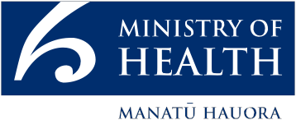
This document is available at health.govt.nz
This work is licensed under the Creative Commons Attribution 4.0 International licence. In essence, you are free to: share ie, copy and redistribute the material in any medium or format; adapt ie, remix, transform and build upon the material. You must give appropriate credit, provide a link to the licence and indicate if changes were made.

Foreword
Tēnā koutou.

I am pleased to present the 2017 Health and Independence Report. The report shows that New Zealand has achieved important health gains in recent years. We are living longer, and living longer in good health. Most New Zealanders have a positive view of their health and independence, with around 90 percent of adults rating their health as excellent, very good or good. The rate of premature deaths that could have been avoided through effective and timely access to health care has also fallen. Success in these areas reflects positively on the ongoing endeavour of our dedicated health workforce across the country and those working closely with individuals and whānau in our communities to improve services and outcomes.

While we are making good overall progress, challenges remain. The report highlights important inequities in physical and mental health between different groups, which are most pronounced for Māori, Pacific peoples and people living in the most socioeconomically deprived areas. These inequities are influenced by the broader determinants of health such as household crowding, material hardship, education and access to transport.

It is a priority for the Ministry of Health to improve equitable health outcomes for all New Zealanders, particularly those that the system does not serve so well at present. Equally important is ensuring the way services are designed and delivered work for the people using them. That is why the Ministry is increasingly seeking to better understand people’s needs by working collaboratively with communities. Examples of this approach include learning from young Māori women about tobacco use and working closely with the disabled community to find out more about how to transform the disability support system so that it is more person-centred.

Looking ahead, our growing, ageing and increasingly diverse population, coupled with the increasing prevalence of long-term conditions and disability, means the current approach to health care will be hard to sustain. A shift in approach, with a greater focus on prevention and wellness, is needed to meet the challenges ahead. This shift includes optimising the skills of the workforce and harnessing new technologies to enable more person-centred care to be delivered in the community, close to where people live, work and learn.

By implementing Government priorities, we are embracing new opportunities to secure health improvements for individuals, whānau, the community and our health system. We are doing this together, in partnership with district health boards, primary care providers, community organisations, social sector agencies and individuals.

Ngā mihi

Dr Ashley Bloomfield
Director-General of Health

Contents
Foreword iii
Executive summary ix
About this report xiii
Section 1: Health status of New Zealanders 1
Most people rate their health as good 2
We are living longer 4
Health loss from long-term conditions has increased over time 7
The rate of premature deaths has fallen 7
Rates of disability vary by age and ethnicity 9
Section 2: Factors impacting on our health 11
Social factors are associated with unequal health outcomes 13
Our physical environment affects our health 16
A closer look at important health behaviours 21
Changing health behaviours remains a significant challenge 22
Section 3: Health across the life course 37
A healthy start to life is vital for healthy long-term outcomes 39
Developing well in adolescence 51
A closer look at intellectual disabilities 58
Long-term conditions are the main cause of health loss among adults 61
Healthy ageing 83
Section 4: Looking forward 89
Promoting good health and delivering care closer to home 90
Technology is opening up ways to improve access and care 93
Improving health sector performance 96
Working collaboratively to meet the health and support needs of New Zealanders 99
Conclusion 105
Technical notes 106
References 107

List of Figures
Figure 1: Estimated contribution of factors that influence health and wellbeing x
Figure 2: Percentage contribution of specific risk factors to health loss – all ages and sexes x
Figure 3: Percentage contribution of certain long-term conditions to health loss – all ages xii
Figure 4: Self-rated health of adults 15 years and over, 2016/17 3
Figure 5: Self-rated health of disabled and non-disabled adults aged 15 years and over 4
Figure 6: Life expectancy at birth for females and males, 1996 and 2016 5
Figure 7: Health expectancy at birth for females and males, 1996 and 2016 5
Figure 8: Years in poor health for females and males, 1996 and 2016 6
Figure 9: Leading causes of health loss in the New Zealand population (percentage of total DALYs), 2016 7
Figure 10: Amenable mortality 0–74 years rate per 100,000 population, 2014 8
Figure 11: Rates of impairment by age group, 2013 10
Figure 12: Estimated contribution of factors that influence health and wellbeing 12
Figure 13: Examples of social determinants of health in New Zealand 14
Figure 14: Health impacts of air pollution 16
Figure 15: Percentage that specific risk factors contribute to disability-adjusted life years for all ages and sexes, 2016 22
Figure 16: Age-standardised percentage of adults (15 years and over) with selected risk factors by DHB, 2014–2017 23
Figure 17: Hazardous and past-year drinkers by age group and sex, 2016/17 32
Figure 18: Proportion receiving the recommended amount of sleep by age group and sex, 2013/14 36
Figure 19: Leading causes of morbidity and mortality for selected age groups 38
Figure 20: Pregnant women registered with a Lead Maternity Carer in the first trimester by socioeconomic deprivation quintile, 2015–2017 40
Figure 21: Percentage of babies exclusively/fully breastfed by ethnicity and age of baby, 2016 42
Figure 22: Percentage of children aged 3–14 years with an SDQ score indicating difficulties in areas related to development and mental health 47
Figure 23: Examples of risk and protective factors for young people 51
Figure 24: Leading areas of health loss for young people aged 15–24 years, 2016 52
Figure 25: Teenage fertility rate – births per 1,000 women aged 15–19 years, 1962–2016 54
Figure 26: Chlamydia cases diagnosed in 2015, by age group among those aged 15–24 years and sex, national rate per 100,000 56
Figure 27: Life expectancy at birth for people with intellectual disabilities, 2014–2016 59
Figure 28: Age-standardised health loss per 100,000 population attributable to cancer, all ages, 1990–2016 61
Figure 29: Leading cancer registrations, rate per 100,000 population by age, 2015 62
Figure 30: Age-standardised COPD hospitalisations in adults aged 40 years and over by ethnicity and socioeconomic deprivation quintile, 2015 76
Figure 31: Hospitalisation rates for asthma and wheeze per 1,000 children aged 0–19 years, by ethnicity, 2014/15 78
Figure 32: Differences in asthma and wheeze hospitalisation rates for Māori and Pacific age groups compared with non-Māori, non-Pacific age groups from 0–49 years, 2014/15 79
Figure 33: Estimated percentage of New Zealand’s adult population living with diabetes by ethnicity, average over 2013–2015 81
Figure 34: ACC claims for a fracture as a result of a fall by sex, rate per 1,000 population, 2017 86
Figure 35: Number of New Zealanders enrolled in a PHO and number of GP and nurse consultations, 2017 91
Figure 36: Average number of GP and nurse consultations per person in one year by age group, 2017 91
Figure 37: Examples of services GPs and nurses can offer through a patient portal 93

List of Tables
Table 1: Ten leading causes of amenable mortality, 0–74 years, 2014, both sexes 9
Table 2: Estimated health impacts from exposure to PM10, 2006 and 2012 18
Table 3: Daily smoking prevalence in 2006/7 and 2016/17 by total population, Māori and Pacific peoples 28
Table 4: Age-standardised cancer mortality rate per 100,000 population for leading cancers, by sex, all ages, 2013 63
Table 5: Examples of barriers to accessing primary health care services, 2016/17 92
Table 6: Health targets and national level results, quarter 4, 2016/17 97

Executive summary
The Health and Independence Report helps us to understand the health of New Zealanders, key factors influencing our health and the leading conditions impacting on health across the life course. The information in this report helps the Ministry of Health and the wider health sector with their planning, with the aim of reducing health inequities and improving population health so that more New Zealanders live well, stay well and get well.

The overall health status of New Zealanders is improving but not everyone is enjoying equally good health
In 2016/17 most New Zealanders self-rated their health as being good, very good or excellent. We are living longer too. The latest findings from the Global Burden of Disease Study show that over the past 20 years, life expectancy (how many years we live) and health expectancy (how many years we live in good health) have increased for New Zealanders. The overall rate of amenable mortality, which is the rate of premature deaths that could potentially have been avoided through effective and timely health care, has declined.

However, these headline results contain important challenges. For example, people with disabilities are much less likely to rate their health as good. Life expectancy has increased at a faster rate than health expectancy, which means New Zealanders are experiencing more of their lives in poor health. There are also inequities in life expectancy and rates of amenable mortality for Māori and Pacific peoples. The number of people with disabilities is increasing and over half of all disabled people (53%) have more than one disability. These are important ongoing challenges for the health and disability system.

Increased focus on the wide range of factors influencing our health is needed to improve outcomes
Figure 1: Estimated contribution of factors that influence health and wellbeing
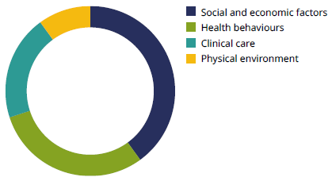
SOURCE: University of Wisconsin Population Health Institute (2018)

A wide range of factors influences health and wellbeing, including social and economic factors (eg, housing and employment), health behaviours, clinical care and the physical environment). To strengthen the focus on those broad factors to improve outcomes, the Ministry of Health needs to work in partnership with district health boards and other agencies.

Modifiable health behaviours account for approximately a third of health loss in New Zealand (measured in disability-adjusted life years or DALYs). Being overweight, having an unhealthy diet, tobacco use, high blood pressure, and alcohol and other drug use are among the leading modifiable risk factors in the population. Although smoking rates have improved somewhat, alcohol use has not changed substantially (as measured by drinkers in the past year), cannabis use has increased, fruit and vegetable consumption has fallen and the obesity rate has increased since 2011/12. These modifiable risk factors are partially influenced by the social and physical environments people live in and they remain an important focus for prevention.

Figure 2: Percentage contribution of specific risk factors to health loss – all ages and sexes
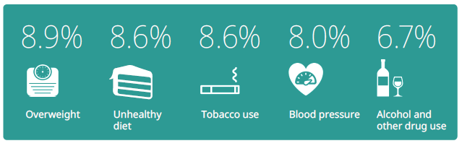
SOURCE: IHME (2016)

Furthermore, inequities exist within the current rates of potentially modifiable risk factors. Māori, Pacific peoples and people living in areas of high socioeconomic deprivation generally have higher rates of these factors. Working to address modifiable risk factors, alongside social and environmental factors, will help improve population health and reduce health inequities.

Ensuring all children have a healthy start in life will help to increase positive longer-term outcomes
The first 1,000 days of life – from conception until a child’s second birthday – are a time of rapid and crucial development. This period presents a window of opportunity to lay the foundations for future health and wellbeing. Around 60,000 babies are born each year and most pregnant women, infants and children are healthy and thriving. Overall infant mortality has decreased, immunisation rates have increased and oral health has improved.

However, key challenges remain. Too many children end up in hospital with conditions that could be prevented or treated earlier, such as respiratory illnesses and skin infections. The emotional wellbeing of children is also important for positive outcomes and it is estimated that around 8 percent of children aged 3–14 years experience emotional or behavioural difficulties related to development and mental health.

Mental illness and suicide remain major contributors to health loss in youth
Adolescence is another important time of development. Most young people (aged 15–24 years) are in good health; however, injuries (such as transport injuries) and mental illness (such as depression and anxiety) contribute significantly to health loss for young people in New Zealand. Although the health loss due to transport injuries has reduced over the past 10 years, health loss as a result of poor mental health in young people has remained largely stable. Some young people, including those identifying as lesbian, gay, bisexual and transgender (LGBT), are more likely to have poorer mental health. Rates of youth suicide remain high, particularly for Māori and Pacific youth.

Government agencies and our communities are joining forces to give young people access to youth-appropriate care and meet their mental health needs more effectively. This includes delivering health services in closer connection with social services, in schools and by making use of digital technologies that fit with young people’s everyday lives and expectations.

The share of health loss due to long-term conditions is increasing over time
The Global Burden of Disease Study shows that long-term conditions make up 87.3 percent of all health loss in New Zealand, up from 82.5 percent in 1990. Injuries, such as road accidents and falls, make up a further 9 percent of health loss and 4 percent is due to communicable, maternal, neonatal and nutritional diseases.

Long-term conditions, such as cardiovascular disease, cancers, musculoskeletal conditions, mental illness, diabetes and other chronic conditions, are most common in the adult population. Frequently Māori and Pacific peoples experience inequities with these conditions.

Figure 3: Percentage contribution of certain long-term conditions to health loss – all ages
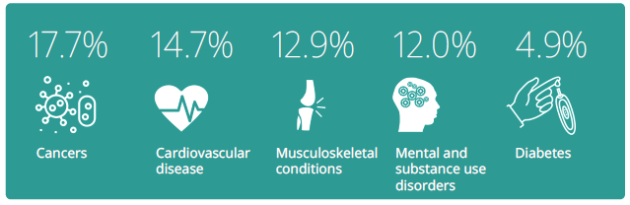
SOURCE: IHME (2016)

Looking forward: our strategic direction focuses on addressing the challenges we face
Our population is forecast to grow, become more diverse and get older, which will increase the demand for health services. Focusing on prevention and improving how services work together for people is vital to improving population health outcomes and making the best use of system resources. Essential areas of work to this end are improving access to primary health care, using technology to help make it easier to access services and supporting the health workforce in its important role of improving health outcomes, including increasing the proportion of Māori professionals in the health workforce.

About this report
The Health and Independence Report presents a picture of the health and independence of New Zealanders, drawing on information from a range of sources. It is prepared annually in line with section 3 of the Health Act 1956. This report complements and helps to inform other key strategic, planning and reporting documents, including the New Zealand Health Strategy, the Four Year Plan and the Ministry of Health’s annual reporting.

Health is a holistic concept
The primary focus of the report is to provide an overview of population health. In doing so, it recognises that health is a holistic concept covering a number of domains. For example, the World Health Organization (WHO) defines health as a ‘state of complete physical, mental and social wellbeing and not merely the absence of disease or infirmity’. Health and wellbeing are also strongly linked to whānau, culture, social connectedness, beliefs and spirituality – concepts that are woven into the fabric of New Zealand society and that have particular prominence in Māori and Pacific models of health and wellbeing.

 | Te Whare Tapa Whā  Te Whare Tapa Whā is a Māori philosophy towards health that is based on a wellness or holistic health model. In a traditional Māori approach, the inclusion of taha wairua (spiritual health), the role of taha whānau (family) and the balance of taha hinengaro (mind) are as important as taha tinana (the physical manifestations of illness). If one of the four dimensions is missing or in some way damaged, a person or collective may become ‘unbalanced’ and, as a result, unwell. | 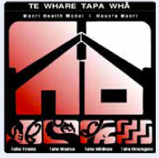
 | www.health.govt.nz/our-work/populations/maori-health/maori-health-models/maori-health-models-te-whare-tapa-wha

Given the holistic view of health, the report explores some of the important factors that influence health, such as social and environmental factors. There are clear inequities in how social factors (such as educational achievement, housing situation and employment status) are distributed in the population. These factors have short- and long-term influences on health.

What New Zealanders tell us about their health is an important source of information
The report benefits from what New Zealanders tell us about their health and disability status. The New Zealand Health Survey provides a rich source of information from New Zealanders about health behaviours, risk factors, health conditions and access and barriers to health services. It also provides insights into how these vary between different groups. In the New Zealand Health Survey, an adult is defined as someone aged 15 years or over, and parents respond to the survey for children under the age of 15 years. This report draws on the latest New Zealand Health Survey (data from 2016/17) as well as earlier survey years.

For further information about the surveys and their findings, go to: www.health.govt. nz/nz-health-statistics/national-collections-and-surveys/surveys/current-recent-surveys/new-zealand-health-survey

The New Zealand Disability Survey (Statistics New Zealand 2014) was last completed in 2013. It is an important source of information about the prevalence of disability – where disability is defined as an impairment that has a long-term, limiting effect on a person’s ability to carry out day-to-day activities. ‘Long-term’ is defined as six months or longer. ‘Limiting effect’ means a restriction on or lack of ability to perform.

National data collections help us understand trends in ill health and mortality
The report also draws on a range of national data collections recorded in our hospitals, primary health organisations and other service settings to understand service use, morbidity, disability and mortality.

One example is the publication (in April 2018) of mortality data on the underlying causes of all deaths registered in New Zealand in 2015 (Ministry of Health 2018b). It presents mortality by age, sex, ethnicity and district health board locality. In addition, time series information is available for certain causes of death from 1948 to 2015. Māori mortality data is also included from 1996 to 2015. For further information, go to: www.health.govt.nz/nz-health-statistics/health-statistics-and-data-sets/mortality-data-and-stats

International sources help us compare health outcomes
The Ministry of Health regularly collaborates with international institutions such as the WHO, the Organisation for Economic Co-operation and Development (OECD) and the Institute for Health Metrics and Evaluation (IHME) to better understand the relative health of our population and the contribution of a range of factors to the overall burden of disease. For example, the OECD Health at a Glance report is a rich source of information about health outcomes across countries. For the most recent Health at a Glance report (OECD 2017), go to: www.oecd.org/health/health-systems/health-at-a-glance-19991312.htm

New Zealand’s findings from the IHME’s Global Burden of Disease Study (GBD) is a key source of information used in this report. The GBD brings together up-to-date research and evidence and applies this to risk factors, morbidity and mortality to highlight key areas of health loss and life and health expectancy. Total health loss is measured in the population in disability-adjusted life years or DALY units. One DALY represents the loss of one year lived in full health. DALYs integrate health losses from premature mortality and years lived with disability (adjusted for severity). In this report we use the estimates from the GBD 2016 cycle. For further information from the GBD, go to: healthdata.org/data-visualization/gbd-compare

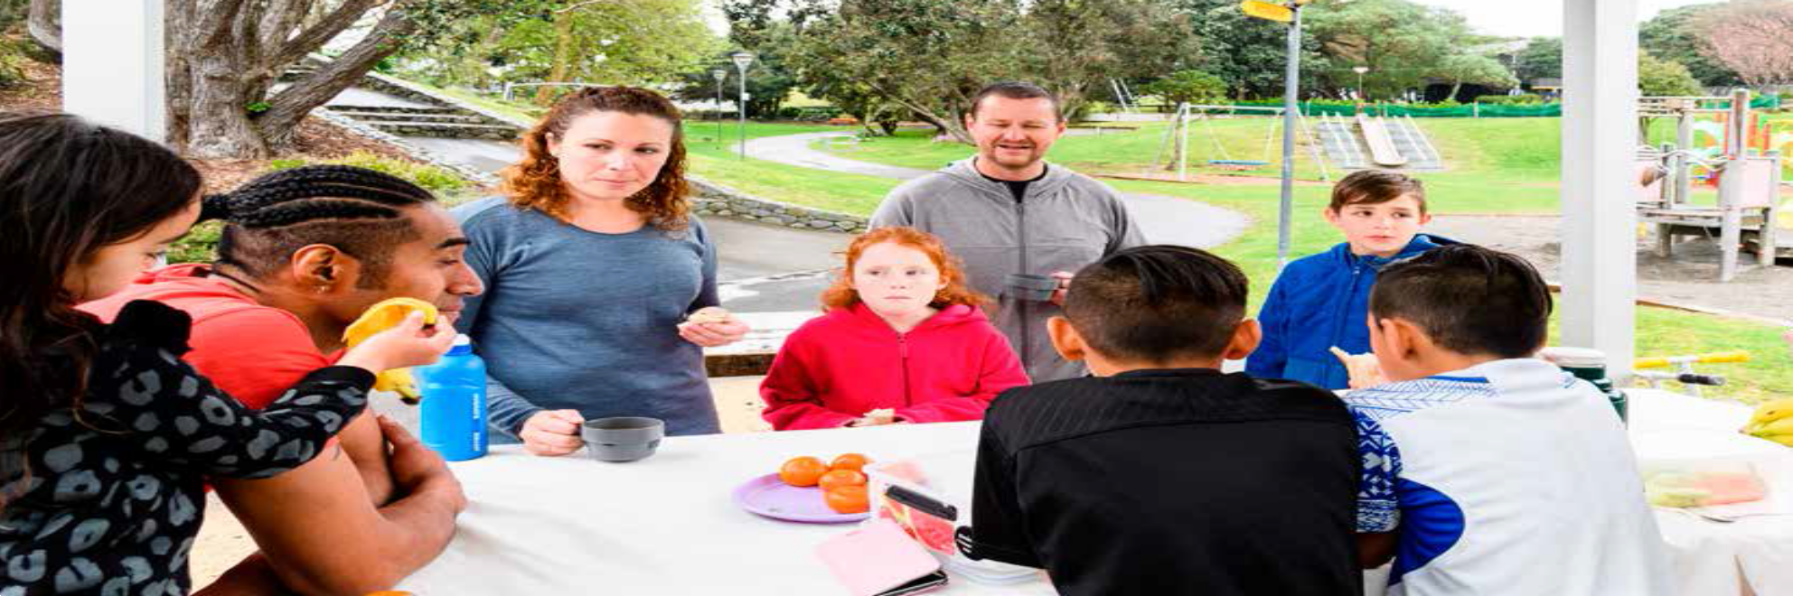

Section 1:
Health status of New Zealanders
New Zealanders’ health is improving, but not everyone is enjoying equally good health
This section outlines the health and disability status of New Zealanders at a whole population level. It includes information on how people rate their own health, and draws on a range of high-level health outcomes such as life expectancy, health expectancy and the number of years lived in poor health. This section also includes information on amenable mortality, which highlights important health inequities for Māori and Pacific peoples.

Most people rate their health as good
The Ministry of Health surveys New Zealanders about their health every year through the New Zealand Health Survey. One component of the survey measures people’s perception of their own health. Statistics New Zealand’s General Social Survey also includes measures of self-rated health among disabled people.

Measures of self-rated or perceived health status are a commonly reported population health indicator. They are recognised as a predictor of people’s future health care use and mortality (OECD 2017). These are subjective measures of health and people vary in what they consider to be good or poor health.

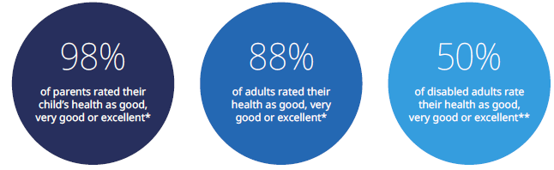
SOURCE: *NZHS 2016/17 (Ministry of Health 2017h); **General Social Survey 2016 (Statistics New Zealand)

Self-reported health is good for most adults and children
In 2016/17 nearly all parents (98.1%) reported that their child was in good health (ie, good, very good or excellent health). The parents of about 17,000 children in New Zealand rated their child’s health as fair or poor (1.9%). These rates have not changed substantially since 2006/07, when 97.6 percent of parents reported that their child was in good health. Parent-rated child health status was similar for all age groups and ethnicities (NZHS 2016/17).

The New Zealand Health Survey indicates most adults (88.2%) rated their health as good (ie, good, very good or excellent) in 2016/17 (Figure 4), down from 89.6 percent in 2006/07. Conversely, 11.8 percent of adults considered themselves in fair or poor health (an estimated 452,000 adults), up from 10.4 percent in 2006/07. The percentages of males and females who reported that they were in good health in 2016/17 were similar.

Figure 4: Self-rated health of adults 15 years and over, 2016/17
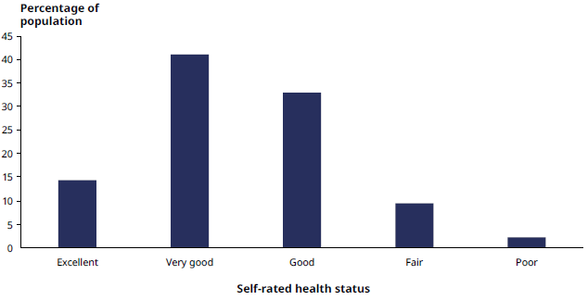
SOURCE: NZHS 2016/17 (Ministry of Health 2017h)

The percentage of adults who reported being in good health in 2016/17 was high for all age groups. However, it did decline with increasing age: the percentage of young people aged 15–24 years who reported being in good health (89%) was higher than the percentage of older people aged 75 years and over who reported being in good health (85%).

Eighty-two percent of both Māori and Pacific adults reported they were in good health, down from 86% for both ethnicities in 2006/07. Māori and Pacific adults were less likely to report being in good health than non-Māori and non-Pacific adults respectively, after adjusting for age and sex differences.

Adults living in the most socioeconomically deprived areas were nearly twice as likely to rate themselves as being in fair or poor health than adults living in the least deprived areas, after adjusting for age, sex and ethnic differences. In the most deprived areas, 83 percent of adults reported being in good health and 17 percent reported being in fair or poor health. In the least deprived areas, these rates were 92 percent and 8 percent respectively.

Disabled people are less likely to rate their health as good
The General Social Survey contains wellbeing measures, including self-rated general health status, and provides an analysis by disability status. In the 2016 Social Survey, 50.1 percent of disabled adults aged 15 years and over rated their health as good (excellent, very good or good) compared with 89.1 percent of non-disabled adults (Figure 5).

Figure 5: Self-rated health of disabled and non-disabled adults aged 15 years and over
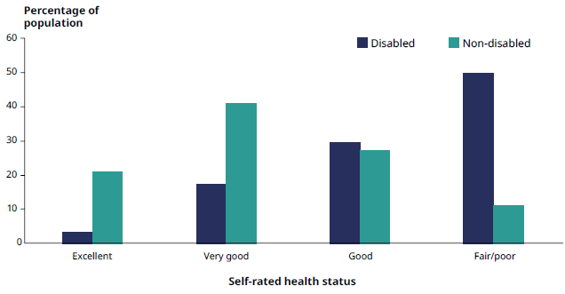
SOURCE: General Social Survey 2016 (Statistics New Zealand)

Improving the wellbeing of people with disabilities is an important focus for the Ministries of Health and Social Development. Work in this area is guided by the cross-agency New Zealand Disability Strategy and work to transform disability support services (see page 107).

We are living longer
Life expectancy is an important indicator of overall population health status, reflecting how the health and disability system, living conditions and wider societal efforts contribute to the length of a person’s life. This section discusses changes in life expectancy at birth and at the age of 65 years for males and females. In New Zealand life expectancy at birth is increasing over time and on average New Zealanders are living longer than they were 20 years ago.

Using the New Zealand findings from the Global Burden of Disease Study between 1996 and 2016, life expectancy at birth has increased by 3.6 years for females (from 79.8 to 83.4 years) and by 5.0 years for males (from 74.5 to 79.5 years) (IHME 2016 – Figure 6).

Life expectancy at 65 years has also increased between 1996 and 2016, by 2.4 years for females and 3.3 years for males. A female aged 65 years in 2016 can expect to live a further 21.5 years, whereas for a female aged 65 years in 1996 the expected time was 19.1 years. Males at 65 years in 2016 can expect to live a further 18.9 years, compared with 15.6 years for males aged 65 years in 1996 (IHME 2016).

Although life expectancy has increased for all groups, with larger increases for Māori than for non-Māori, inequities remain. Māori males born from 2012–2014 had a life expectancy at birth that was 7.3 years below that of non-Māori males born over the same period. For Māori females in this age group, life expectancy was 6.8 years below that for non-Māori females (Statistics New Zealand 2017a).

Figure 6: Life expectancy at birth for females and males, 1996 and 2016
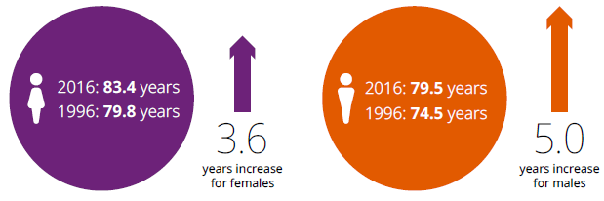
SOURCE: IHME (2016)

We are living more years in good health
Health expectancy, which is the average number of years people spend in good health, is another measure commonly used together with life expectancy to understand the health of our population. New Zealanders’ health expectancy increased between 1996 and 2016 for both females (from 68.9 years to 71.8 years) and males (from 65.7 years to 69.8 years). This means, on average, females lived 2.9 years longer and males 4.1 years longer in good health than they did 20 years ago (Figure 7).

Health expectancy at 65 years has also increased. Between 1996 and 2016, average health expectancy increased by 1.8 years for females (from 14.8 years to 16.6 years) and by 2.5 years for males (from 12.1 years to 14.6 years) (IHME 2016).

Figure 7: Health expectancy at birth for females and males, 1996 and 2016
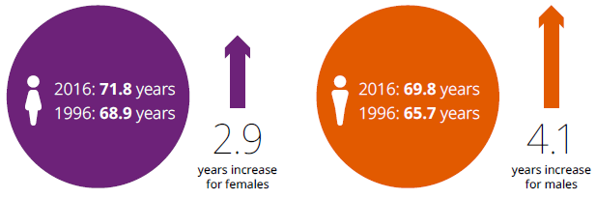
SOURCE: IHME (2016)

We are also living longer in poor health
While, on average, we are living longer and health expectancy has increased, life expectancy has increased faster than health expectancy, which means on average New Zealanders are living for around a decade in poor health. Between 1996 and 2016, the average number of years females spent in poor health increased from 10.9 years to 11.6 years (0.7 years) and males from 8.8 years to 9.8 years (1.0 years) (IHME 2016 – Figure 8).

Figure 8: Years in poor health for females and males, 1996 and 2016
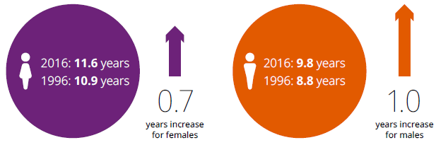
SOURCE: IHME (2016)

Adding life to years is an important focus for the health and disability system
Health loss in the population can be measured as disability-adjusted life years (DALYs). One DALY represents the loss of one year lived in full health. After accounting for differences in the age structure of the population (referred to as age-standardisation), health loss has declined from 26,900 DALYs per 100,000 population in 1990 to 19,800 DALYs per 100,000 population in 2016.

An important challenge for the health and disability system is to ensure people live longer and in good health, and to give the best possible quality of life to those who experience poor health. Responding to this challenge is vital as we enter a period of a rapidly ageing population, with more and more New Zealanders living into their seventies, eighties and beyond. It is forecast that, by the middle of the century, one in five New Zealanders will be aged 65 years or over and the proportion of people aged 85 years and over will have tripled (Statistics New Zealand 2016). An ageing population brings an accompanying rise in long-term conditions, multimorbidity, frailty and disability.

Health loss from long-term conditions has increased over time
In 2016 long-term physical and mental health conditions caused 87.3 percent of health loss in New Zealand, while injuries were responsible for 9.2 percent and communicable diseases, nutritional deficiencies and neonatal disorders for 3.5 percent (Figure 9). The overall proportion of health loss from long-term conditions increased from 82.5 percent to 87.3 percent between 1990 and 2016 (IHME 2016).

Figure 9: Leading causes of health loss in the New Zealand population (percentage of total DALYs), 2016
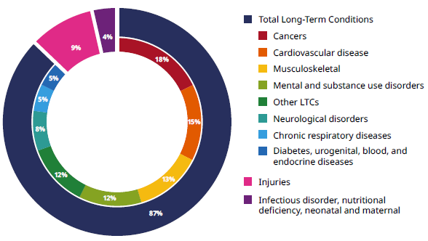
SOURCE: IHME (2016) Note: due to rounding the displayed totals may not equal 100%.

The rate of premature deaths has fallen
Amenable mortality is a way of measuring the effectiveness of the health and disability system. It is defined as premature deaths (under the age of 75 years) that could potentially be avoided, given effective and timely use of health services. That is, amenable mortality consists of early deaths from causes (diseases or injuries) for which effective health care interventions exist and are available to New Zealanders.

Amenable mortality rates have declined over time. In 2000 the age-standardised amenable mortality rate was 145.7 per 100,000 population. Over a decade later (2014) the rate dropped to 92.6 per 100,000 population. This decrease reflects important progress within the health system and by those working closely with whānau in the community to improve health outcomes.

Between 2000 and 2014 the age-standardised amenable mortality rate has seen a relative decrease of 39.2 percent for Māori, 33.6 percent for Pacific and 39.2 percent for non-Māori, non-Pacific populations. However, significant ethnic inequities remain. Figure 10 shows the amenable mortality rate was substantially higher for Māori (196.8 per 100,000) and Pacific peoples (186.4 per 100,000) compared with the non-Māori, non-Pacific population (75.6 per 100,000) in 2014.

Figure 10: Amenable mortality 0–74 years rate per 100,000 population, 2014
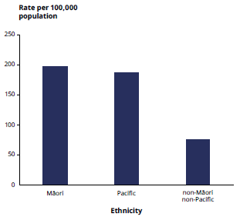
SOURCE: Ministry of Health, Mortality Collection

In 2014, 10 conditions accounted for just over four-fifths (81.7%) of amenable mortality (see Table 1). Improving prevention, screening and early intervention efforts is vital to reduce amenable mortality rates and health inequities and to increase the number of years New Zealanders live in good health. For example, coronary heart disease, chronic obstructive pulmonary disease (COPD), cerebrovascular diseases and diabetes, which are largely associated with modifiable lifestyle factors, accounted for around half (49.3%) of all amenable mortality in 2014.

Table 1: Ten leading causes of amenable mortality, 0–74 years, 2014, both sexes
Cause of amenable mortality | Proportion of amenable mortality
Coronary heart disease | 24.8
Chronic obstructive pulmonary disease | 9.8
Suicide | 8.7
Cerebrovascular diseases (including stroke) | 8.7
Breast cancer (female) | 7.5
Diabetes | 6.1
Accidents (land transport, excluding trains) | 5.1
Rectal cancer | 4.0
Melanoma (type of skin cancer) | 3.7
Prostate cancer | 3.3
Other | 18.3
Total | 100.0
SOURCE: Nationwide Service Framework Library, System Level Measures

Rates of disability vary by age and ethnicity
The New Zealand Disability Survey is the official source of statistics on disability prevalence rates across key demographic groups in New Zealand. In the 2013 Disability Survey, almost one in four New Zealanders (24%) reported having some sort of long-lasting (six months or longer) impairment that limited their ability to carry out day-to-day activities.  The 2013 Disability Survey found that the leading areas of impairment in the population were physical limitations, sensory (hearing/vision), mental (psychological/psychiatric/ psychosocial) and intellectual disability. Over half of all disabled people (53%) had more than one disability. | Disability rates by impairment type, all ages, 2013  - Physical (14%)  - Sensory (11%)  - Mental (5 %)  - Intellectual (2%)  - Other (8%)  SOURCE: Statistics New Zealand 2014

For children the most common type of impairment was learning difficulty, affecting 6 percent of the total child population. The most common cause of disability for children was a condition that existed at birth (49%).

For adults, physical limitations were the most commonly reported type of impairment. Eighteen percent of people over the age of 15 years reported that a physical impairment limited their everyday activities. Disease or illness was the most common cause of physical impairment in adults.

People aged 65 years or over were much more likely to be disabled (59%) than adults under 65 years (21%) or children under 15 years (11%). Figure 11 illustrates that physical (mobility and/or agility) and sensory (hearing and/or vision) impairments are the areas that increase most with age.

Figure 11: Rates of impairment by age group, 2013
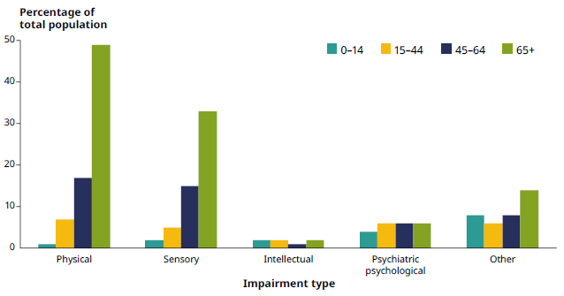
SOURCE: Statistics New Zealand, 2013 Disability Survey

The rate of disability also varies by ethnicity. Taking all ages together, Māori had a higher than average disability rate (27%) than European (25%), Pacific (19%) or Asian (13%) populations, despite having a younger population age profile than the total population.

It is difficult to capture the full complexity of the disability experience and accurately assess all levels of disability severity in a survey like the Disability Survey. Data on service use offers a way of estimating the prevalence of more severe types of impairment. In September 2016, a total of 33,804 disabled people were allocated one or more Ministry-funded disability support services, which is less than 1.0 percent of the total New Zealand population. People with intellectual disabilities (49.8%) and physical disabilities (25.2%) make up the largest share of disability support users (Ministry of Health 2017c).

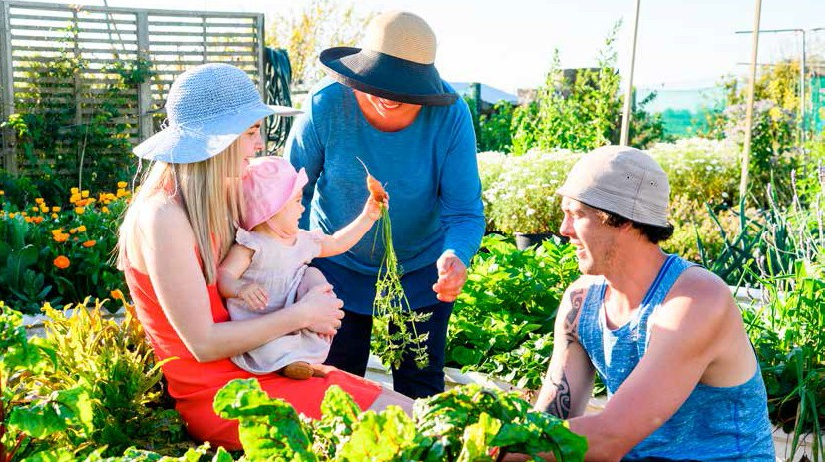

Section 2: Factors impacting on our health
A broad range of social, environmental and behavioural factors influences our health
Various factors have either positive or negative impacts on the health of
New Zealanders. Although the causes of illness are complex, we are better placed to improve health if we understand some of the key underlying factors that influence it. This section looks at some of those factors.

Factors that impact on health and wellbeing include social determinants, health behaviours, clinical care and the physical environment. These factors interact with genetic and biological factors to influence health and wellbeing outcomes. Figure 12 illustrates the relative impact each one has on health, based on work from the University of Wisconsin. Other studies on determinants of health, for example in Europe (Deloitte 2017), have found similar patterns in the way these factors contribute to health and wellbeing.

Figure 12: Estimated contribution of factors that influence health and wellbeing
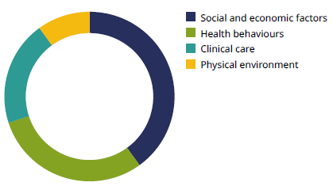
SOURCE: University of Wisconsin Population Health Institute (2018)

These factors all interact with and influence each other. For this reason, it is important to work collaboratively within and across sectors, as improvements in one area can affect others. For example, changes to the built environment that encourage active transport may have a positive impact on climate change and may also increase physical activity and improve health.

The World Health Organization defines the social determinants of health as the ‘conditions in which people are born, grow, work, live, and age, and the wider set of forces and systems shaping the conditions of daily life’.
(WHO 2017)

Social factors are associated with unequal health outcomes
Social determinants of health are the social and economic conditions people are born and live in that affect their health. They include housing, education, income, social support and connection. Figure 13 outlines some examples of particular relevance to New Zealand.

The different social determinants of health are closely linked. For example, level of education will impact on income, and income level will subsequently impact on housing. These links lead to an accumulation of disadvantage among some people and an accumulation of privilege among others. Social and economic factors also impact on health behaviours: those living in poverty have fewer choices available to them, greater stress and poorer access to opportunities such as education, and all of these experiences can lead to higher levels of risk behaviours (WHO 2005).

Good health is a valuable resource that can impact on social determinants and poor health can be a negative influence on them. For example, poor health can make it more difficult to gain employment and access to housing. This can lead to an ongoing negative cycle between poor health and social and economic determinants.

Disparities in social determinants create unfair and avoidable differences in health for individuals, whānau and communities, including different ethnic groups. Overall people living in the most socioeconomically deprived areas experience worse health outcomes than those living in the least deprived areas. When they are unwell, people in more deprived areas are more likely to have difficulty accessing health services due to cost. As a result, they may delay seeking treatment, which can contribute to more serious health problems.

Figure 13: Examples of social determinants of health in New Zealand
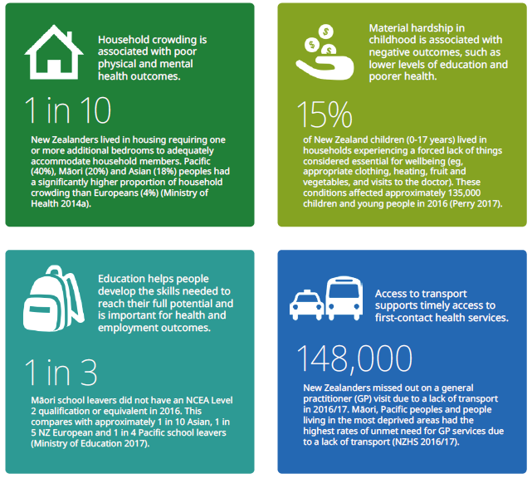

The impact of deprivation can also be seen in hospital admissions for children. Between 2009 and 2013, children aged 0–14 years from the most deprived neighbourhoods had higher rates of hospital admissions for a range of conditions than children from the least deprived neighbourhoods. Asthma and wheeze, bronchiolitis and acute respiratory infections made the largest contributions to hospitalisations for medical conditions with a social gradient (Simpson et al 2016).

District health boards (DHBs) and their primary health organisations (PHOs) are working to reduce the number of avoidable hospitalisations for children. This initiative involves improving timely access to health services as well as working in the community to improve the day-to-day living situations that contribute to poor health, such as housing.

Improving housing is an opportunity to improve health
Housing is an important determinant of health. Homelessness is associated with long-term physical and mental health conditions, and housing security, quality and crowding also impact on health outcomes. Poor living conditions, including dampness, cold and crowding, are significant risk factors for several illnesses, including acute rheumatic fever and respiratory conditions. In December 2017 the Healthy Homes Guarantee Act 2017 was passed. This Act amends the Residential Tenancies Act 1986 with the purpose of ensuring that every rental home in New Zealand meets minimum standards of heating and insulation.

Well Homes Programme: A Healthy Homes Initiative
As part of a programme to reduce the incidence of rheumatic fever, the Ministry of Health established the Healthy Homes Initiatives (HHIs). The HHIs in each region identify and work with eligible whānau to undertake a free housing assessment to make the home warmer, drier and healthier for children and their whānau.

The Well Homes Programme is the HHI operating across Hutt Valley and Capital & Coast DHBs. The programme is run by Regional Public Health in partnership with Tu Kotahi Māori Asthma Trust, He Kāinga Oranga (University of Otago, Wellington) and Sustainability Trust. Staff from the Well Homes Programme worked alongside staff from the two DHBs to ensure that every child admitted to hospital with a housing-sensitive condition is referred to the Well Homes Programme. Whānau can also be referred from a range of primary care and social agencies. Someone from the Well Homes team then contacts the whānau and offers a free and comprehensive housing assessment.

Well Homes staff provide education to improve how people live in their homes, as well as interventions such curtains, heaters, draught stoppers, beds and bedding. They also work across agencies such as the Energy Efficiency and Conservation Authority to help access insulation, and Work and Income to ensure that whānau are receiving the benefits they are entitled to and to access social housing. In addition to improving the house itself, the HHIs link whānau with other health or social services they need.

A range of sources offer further information on social determinants. Examples are Statistics New Zealand’s Social Indicators (Statistics New Zealand 2017b) and the Ministry of Social Development’s Social Report (Ministry of Social Development 2016), which bring together indicators from a range of domains, such as education, health, labour market, standard of living and social connection.

Our physical environment affects our health
Both the built and natural environments have an important influence on health and wellbeing. Minimising risk factors such as air and water pollution, improving workplace safety and changing urban design to promote active lifestyles by making green space available and providing easy and safe active transport are important for improving health and environmental outcomes. Healthy environments – wai ora – are also a vital component of He Korowai Oranga (New Zealand’s Māori Health Strategy).

Lowering air pollution has a positive impact on health
Having clean air to breathe is vital for health and wellbeing. Outdoor air pollution is a major environmental threat to health and can contribute to the development of several health conditions such as cardiovascular disease, stroke, respiratory disease and some cancers.

Figure 14 illustrates some ways in which air pollution can affect people’s health. Some people, including young children, elderly people and those with long-term health conditions, are more susceptible to the negative impacts of air pollution than others.

Figure 14: Health impacts of air pollution
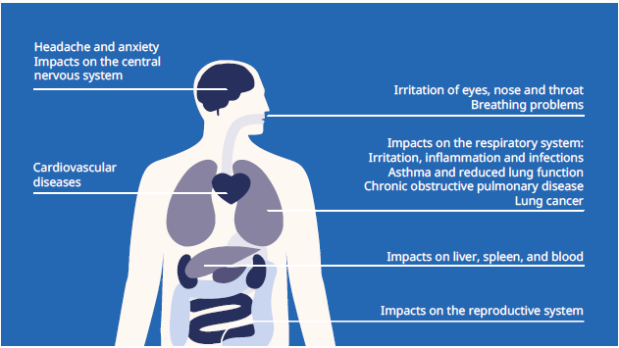
SOURCE: European Environment Agency (2013)

Relative to other countries, New Zealand has good air quality and some of the lowest population exposure to air pollution (OECD 2017). This is largely due to its low population density, being surrounded by the sea and relatively long distance from other countries. In New Zealand the two major sources of air pollution are wood or coal fires and vehicle emissions.

Wood and coal fire use is decreasing
Wood and coal fires produce several pollutants that can be harmful to health, including particulate matter, carbon monoxide and nitrogen dioxide.

The New Zealand Census asks about home heating methods. It has found that the number of households using wood and coal fires has decreased between 2006 and 2013.

In 2013, 37 percent of households were using wood fires, compared with 41 percent in 2006. Only 4 percent of households were using coal fires in 2013, down from 7 percent in 2006 (EHINZ 2017a).

Overall vehicle emissions have decreased
Motor vehicles produce a number of air pollutants that can be detrimental to health. Emissions tend to be higher from older and diesel vehicles.

New Zealand has one of the highest rates of car ownership in the world. The number of vehicles on the road has steadily increased from 2.6 million in 2000 to 3.97 million in 2016. The majority are light passenger vehicles.

Despite the increase in vehicles on the road, emissions from vehicles have decreased for all key pollutants. This is due to improvements both in fuel quality and in the vehicle fleet. (EHINZ 2017b).

One of the key pollutants related to poor health outcomes is particulate matter less than 10 micrometres (PM10). The concentrations of PM10 in New Zealand decreased between 2006 and 2012. Using modelling, the Ministry for the Environment estimated that this resulted in 170 fewer premature deaths; 90 fewer hospital admissions for cardiac and respiratory conditions; and 140,000 fewer days of restricted activity from exposure to human-made PM10 over this period (Table 2).

Table 2: Estimated health impacts from exposure to PM10, 2006 and 2012
Health impact | 2006 | 2012 | Percentage improvement
Premature deaths | 1,170 | 1,000 | 14
Hospital admissions | 610 | 520 | 15
Restricted activity days | 1,490,000 | 1,350,000 | 9
SOURCE: Ministry for the Environment and Statistics New Zealand (2014)

Most New Zealanders have access to safe drinking-water
Access to a safe and adequate supply of drinking-water is a prerequisite for health. If water that is contaminated with bacteria or protozoa is inadequately treated so that the pathogens are not removed, it can lead to illness. In New Zealand numerous agencies are responsible for the quality, allocation and management of drinking-water. Most New Zealanders receive their drinking-water from council-owned, networked supplies.

The Ministry of Health reports on the quality of drinking-water each year. The report covers water supplies serving more than 100 people (covering an estimated 79% of the population or 3.8 million people) (Ministry of Health 2017a). In 2015/16, a total of 98 percent of New Zealanders with these water supplies had access to bacteriological-compliant drinking-water, which is the most important criterion. Achievement against the Drinking-water Standards was generally highest for the large supplies and decreased progressively through medium, minor and small population size categories.

Learning from the Havelock North contaminated drinking-water outbreak to improve water management
In August 2016 Havelock North experienced a major outbreak of campylobacteriosis due to contaminated water supply. As a result, an estimated 5,500 people (of the town’s 14,000 residents) became unwell. Approximately 45 people were hospitalised and the outbreak may have contributed to three deaths.

The Ministry of Health commissioned a report to explore the impact of the outbreak on both Havelock North and the wider community. The report estimated the total economic costs to society as $21 million (Moore et al 2016). Among its findings, the report estimated health-related costs were relatively modest given the spread of the outbreak. This likely reflected the prominent role primary health care played in dealing with affected patients in an efficient and cost-effective manner. In addition, the wide array of support services that was mobilised in response to the outbreak helped reduce the need for costly hospital stays.

Following the outbreak, a government inquiry concluded that the most likely cause of the contamination was that sheep faeces entered an unprotected source of water, which was then supplied as untreated drinking-water (Government Inquiry into Havelock North Drinking Water 2017). The report highlighted systemic issues and lessons to be learned. It also provided 51 wide-ranging recommendations, some of which are considered urgent while others require a longer-term view. As part of an all-of-government response to the inquiry, the Ministry of Health is taking several actions to ensure New Zealanders have access to clean, safe, drinking-water.

Too much exposure to UV is harmful: New Zealand has one of the highest melanoma rates in the world
Ultraviolet (UV) radiation is part of a broad spectrum of wavelengths that comes from the sun. New Zealand has high UV levels; it is estimated that levels are around 40 percent higher than similar latitudes in North America (EHINZ 2017c). Too much exposure to UV radiation can cause skin cancers, while too little UV can cause vitamin D deficiency and bone disease. In New Zealand UV levels peak during the middle of the day and during summer. UV levels are lower in winter and in the south of the country. | In 2016 the country had an average of 27 days with ‘extreme’ UV intensity nationwide. This is a level of UV that can cause damage to fair skin within minutes.  (Ministry for the Environment and Statistics New Zealand 2017)

Melanoma, one type of skin cancer, is the fourth most common cancer diagnosed in New Zealand. In 2014 a total of 378 New Zealanders died due to melanoma. New Zealand has one of the highest melanoma rates in the world, and registration rates have shown very little change in the last decade. Males have higher melanoma rates than females, and Māori have lower rates than non-Māori. The best way to prevent melanoma and other skin cancers is to protect the skin from UV radiation. This protection can be achieved by using physical methods (shade, hats, long-sleeved clothing and sunglasses) and by using sunscreen.

Sunbeds are now banned for under 18s
From the beginning of 2017 it became illegal for sunbed operators to allow people under the age of 18 years to use sunbeds. The ban was introduced due to the increased risk of skin cancer associated with the high UV from sunbeds. This risk is even greater for young people. The new regulation was introduced as part of amendments to the Health Act 1956.

The changing climate presents health challenges
Climate change and its consequences cause a wide range of direct and indirect risks to the health of individuals and society. These risks include direct effects from extreme weather events, heat waves and air pollutants; indirect effects from microbial contamination and increased carriers of new disease; and social effects such as mental health effects, internal migration, loss of food security and disruption to health services.

Certain populations are more vulnerable to these health risks than others, depending on ethnicity, age, health and socioeconomic status, which may lead to an increase in inequities. Māori may be particularly impacted due to their indigenous relationship with the environment and customary practices (such as collection of kaimoana/seafood).

In 2017, New Zealand experienced several major flooding events, including in Edgecumbe in April and Otago and Canterbury in July. These events have direct and indirect health impacts on the populations exposed. The average annual temperature in New Zealand is also rising and has increased by 1°C since 1909 (Ministry for the Environment and Statistics New Zealand 2017).

Environmental Health Action Plan
The Ministry of Health is currently developing an Environmental Health Action Plan. This will identify local, national and regional environmental health risks and will provide environmental health risk management strategies and reporting. While it will focus on wide aspects of environmental health, climate change is an important aspect that will be prominent throughout the Action Plan.

Massey University runs the Environmental Health Indicators Programme to monitor key aspects of environmental health. For more information on the indicators, go to: www.ehinz.ac.nz

A closer look at important health behaviours
The environment we live in influences our day-to-day behaviours. Health behaviours have a large impact on our health and wellbeing. Behaviours that have a negative effect on health are referred to as risk factors (eg, tobacco use and hazardous drinking), while behaviours that have a positive effect on health are referred to as protective factors (eg, regular exercise, healthy diet and sufficient sleep). The leading risk factors that contribute to health loss in New Zealand are obesity, diet, tobacco use, high blood pressure, and alcohol and other drug use (Figure 15).

Many of these factors can be modified by making changes to the environment to support people to live healthier and more active lifestyles. Together modifiable risk factors account for approximately 36 percent of all health loss in New Zealand (IHME 2016) – contributing significantly to a range of chronic and long-term conditions.

Figure 15: Percentage that specific risk factors contribute to disability-adjusted life years for all ages and sexes, 2016
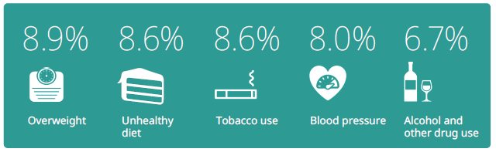
SOURCE: IHME (2016)

Changing health behaviours remains a significant challenge
The Ministry of Health regularly monitors trends in exposure to risk factors in the population through the New Zealand Health Survey and other data sources. Despite their large impact, little positive change has been achieved in modifiable health behaviours over the past years. Although smoking rates have improved somewhat, alcohol use has not changed substantially (as measured by drinkers in the past year), cannabis use has increased, fruit and vegetable consumption has fallen and the obesity rate has increased since 2011/12.

Figure 16 illustrates how selected risk factors are distributed across the adult population by DHB. The variation in risk and protective factors across New Zealand contributes to health inequity.

Figure 16: Age-standardised percentage of adults (15 years and over) with selected risk factors by DHB, 2014–2017
National average |  |  |  |  | 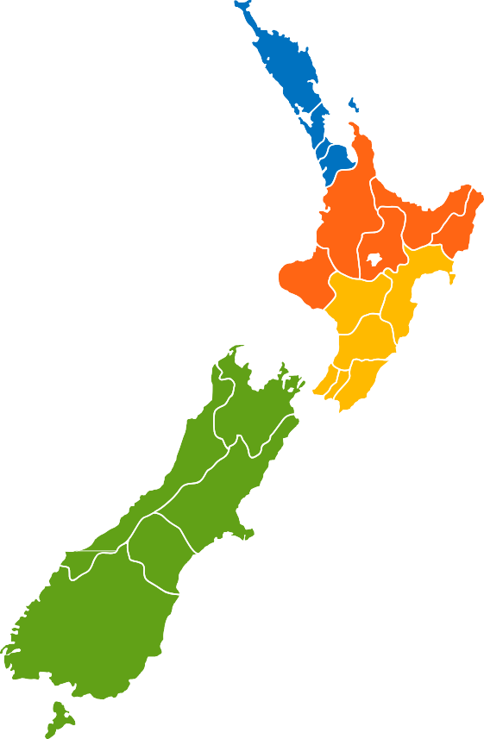  Key  % obese (BMI >30 and over)  % meeting vegetable and fruit intake guidelines (3+ servings of vegetables and 2+ servings of fruit per day)  % daily smoking  % did at least 2.5 hours of activity in the past week, spread out over the week
National average | 31.5 | 39.8 | 14.3 | 49.5
DHBs – Northern region (%)
Auckland | 23 | 36 | 9 | 47
Counties Manukau | 38 | 32 | 15 | 43
Waitemata | 25 | 35 | 11 | 43
Northland | 37 | 40 | 24 | 46
DHBs – Midland region (%)
Lakes | 39 | 42 | 24 | 40
Bay of Plenty | 31 | 37 | 17 | 61
Tairawhiti | 39 | 39 | 30 | 45
Taranaki | 30 | 36 | 21 | 47
Waikato | 36 | 35 | 18 | 49
DHBs – Central region (%)
Capital & Coast | 25 | 45 | 9 | 59
Hutt Valley | 34 | 41 | 15 | 54
Wairarapa | 32 | 37 | 21 | 48
Whanganui | 38 | 33 | 24 | 51
Mid Central | 35 | 36 | 17 | 45
Hawke’s Bay | 38 | 33 | 24 | 38
DHBs – Southern region (%)
Nelson Marlborough | 25 | 47 | 17 | 61
West Coast | 31 | 42 | 25 | 65
Canterbury | 27 | 41 | 13 | 52
South Canterbury | 31 | 40 | 20 | 56
Southern | 29 | 45 | 17 | 64
Note: For small DHBs, the confidence intervals for the estimates will be wide. For more information, see: https://minhealthnz.shinyapps.io/nz-health-survey-2014-17-regional-update
SOURCE: NZHS 2014–17

What we eat impacts our health
Diet makes an important contribution to health and wellbeing. Dietary risk factors include having a low intake of fruit and vegetables, a high intake of salt, sugar and red meat, and low fibre consumption. Together dietary risk factors account for 8.6 percent of all health loss (IHME 2016).

Around half of children are eating the recommended amount of fruit and vegetables
The Ministry of Health recommends that children aged 2–14 years consume at least two servings of fruit every day. For vegetables, the recommended intake is at least two servings for children aged 2–4 years and at least three servings for those aged
5–14 years.

The New Zealand Health Survey found that children were more likely to meet the recommended daily fruit intake than the recommended vegetable intake. In 2016/17 just over half of children (51.4%) met the recommended vegetable consumption, a decrease from 58.1 percent in 2011/12. Over 7 in 10 (72.4%) ate at least two servings of fruit, with little change since 2011/12. Just under half (49.8%) met both the fruit and vegetable recommendations, down from 55.5 percent in 2011/12.

The proportions of Māori and non-Māori children meeting the combined recommended fruit and vegetable intake did not differ; however, Pacific and Asian children were less likely to meet the recommendations than non-Pacific and non-Asian children respectively. Those living in the most socioeconomically deprived areas were less likely than those living in the least deprived areas to meet the combined recommended intake.

Eating breakfast at home every day is an indicator of healthy eating behaviours. The majority of children (84.6%) ate breakfast at home every day (NZHS 2016/17). However, there were marked inequities: Pacific and Māori children were less likely to eat breakfast at home five or more days a week than non-Pacific and non-Māori children respectively. Those living in the most deprived areas were three times less likely than those living in the least deprived areas to have eaten breakfast at home on at least five days in the week.

The number of adults eating five plus a day is decreasing
The Eating and Activity Guidelines for New Zealand Adults (Ministry of Health 2015a) recommend adults eat at least three servings of vegetables and at least two servings of fruit each day. Only 38.8 percent of adults met the combined vegetable and fruit guidelines in 2016/17 (NZHS 2016/17). About 6 in 10 adults (61.7%) ate at least three servings of vegetables each day and just over half (53.9%) ate at least two servings of fruit per day.

These figures have decreased since 2011/12, when 44.5 percent met the combined guidelines, 68.6 percent met the vegetable guidelines and 58.6 percent met the fruit guidelines. These decreases are significant and have occurred across nearly all subgroups. Inequities persist between different groups. Māori, Pacific and Asian adults were less likely to meet the combined fruit and vegetable guidelines compared with non-Māori, non-Pacific and non-Asian adults respectively. Males were also significantly less likely than females to meet the combined vegetable and fruit guidelines.

Physical activity helps to protect against physical and mental illness
Physical activity is an important factor for health and wellbeing and helps protect against cardiovascular disease, diabetes, some cancers and mental health conditions such as anxiety and depression. It is estimated that low physical activity accounted for 1.3 percent of all health loss in New Zealand in 2016 (IHME 2016). The Ministry of Health recommends that adults do at least 30 minutes of moderate-intensity physical activity on most, if not all, days of the week. For children and young people aged
5–18 years, the Ministry of Health recommends at least 60 minutes or more of moderate to vigorous physical activity each day.

Close to half of children use active transport to get to and from school
Nearly half (45%) of children used active transport (walking, cycling or other non-motorised modes) to get to and from school in 2016/17. This proportion has not changed significantly since 2006/07 and did not differ significantly by sex, ethnicity or neighbourhood socioeconomic deprivation.

The New Zealand Health Survey asked about screen time for children for the first time in 2016/17. The Ministry of Health recommends no more than two hours per day of recreational screen time for children aged 5–17 years (Ministry of Health 2017k). Few children are meeting this recommendation, with over 8 out of 10 (83.4%) of those aged 2–14 years spending two or more hours a day (excluding at school or for homework) watching TV or looking at a screen. Again differences by sex, ethnicity or socioeconomic deprivation were minimal.

Around half of adults are physically active
According to the New Zealand Health Survey, around half (50.2%) of adults were physically active; undertaking 2.5 hours of moderate activity or 1.25 hours of vigorous activity spread throughout the week. This is a decrease from 54.4 percent in 2011/12, but a slight increase from 47.7 percent in 2015/16. Pacific and Asian adults were less likely to be physically active than non-Pacific and non-Asian adults respectively. Adults living in the most socioeconomically deprived areas were also less likely to meet the physical activity guidelines than those living in the least deprived areas. Over 1 in 10 adults (13.4%) did little or no physical activity (less than 30 minutes in total in the seven days before completing the survey).

Using data from the Health Promotion Agency’s Health and Lifestyles Survey, researchers found that people who walk or cycle to their main weekday activity were 76 percent more likely to meet the physical activity guidelines than those who travel by car (Shaw et al 2017). This is an example of how the physical environment – where people live and what their transport options are – can influence physical health and wellbeing.

Food, drink and activity guidelines for adults
In November 2017 the Ministry of Health released the clinical guidelines for weight management in New Zealand adults (Ministry of Health 2017b). Based on its review of the latest high-quality evidence, the publication provides guidance for health practitioners and others who advise adults on weight management.

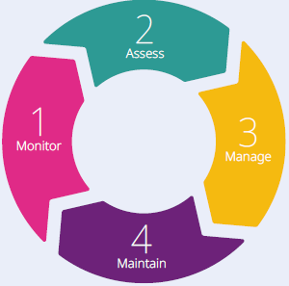
The guidelines present a four-stage process: monitor, assess, manage and maintain. They identify three key components of management – FAB: food and drink, activity (including reducing sedentary time and getting enough sleep) and behavioural strategies. To support the guidelines, the Ministry of Health has also published a series of tips on diet and sleep on its website: www.health.govt.nz/publication/clinical-guidelines-weight-management-new-zealand-adults

Obesity is a significant health challenge that contributes to a range of long-term conditions
Obesity is a critical health challenge for New Zealand. Our obesity rates are among the highest in the developed world (OECD 2017). High body mass (overweight and obesity) accounts for 8.9 percent of overall health loss (IHME 2016). It contributes to a range of New Zealand’s leading long-term conditions, including cardiovascular disease, cancers (eg, bowel, post-menopausal breast, kidney and endometrial), osteoarthritis and type 2 diabetes. | It is estimated that over 1.2 million adults aged 15 years and over and 99,000 children aged  2–14 years are obese.  (Ministry of Health 2017b)

An obese person is defined as having a body mass index (BMI) of 30 or more, while an overweight person has a BMI of 25.0–29.9 (or equivalent for those younger than 18 years – using the International Obesity Taskforce definitions). The New Zealand Health Survey measures height and weight of participants to calculate BMI.

A healthy weight in childhood is important for good health in the short and longer term
Obese children are also more likely to be obese into adulthood and to have abnormal lipid profiles, impaired glucose tolerance and high blood pressure at a younger age. The 2016/17 New Zealand Health Survey found that one in three children aged
2–14 years was either overweight (21.0%) or obese (12.3%). Pacific (29.1%) and Māori (18.1%) children had higher rates of obesity than non-Pacific and non-Māori children. Children living in the most socioeconomically deprived areas were 2.5 times more likely to be obese than those living in the least deprived areas, after adjusting for age, sex and ethnicity (NZHS 2016/17).

Around 1.3 million New Zealanders are obese
Rates of obesity in 2016/17 were higher for adults compared with children, ranging between 14.7 percent of youth aged 15–17 years and 39.3 percent of those aged
65–74 years (NZHS 2016/17). Overall, one in three adults over the age of 15 years was obese (32.2%), up from over one in four (26.5%) in 2006/07. A further third of adults (34.4%) were overweight but not obese in 2016/17. Females were slightly more likely than males to be obese (1.1 times), but males were more likely to be overweight (1.3 times). Compared with other Organisation for Economic Co-operation and Development (OECD) countries, New Zealand had the third-highest rate of obesity, after Mexico and the United States of America (OECD 2017).

Obesity rates among adults varied by ethnic group: 68.7 percent of Pacific adults, 50.2 percent of Māori, 30.5 percent of European or Other and 14.8 percent of Asian adults were obese in 2016/17. Also, adults living in the most socioeconomically deprived neighbourhoods were 1.5 times more likely to be obese than those living in the least deprived neighbourhoods, after adjusting for age, sex and ethnicity (NZHS 2016/17).

Reducing obesity
The Ministry of Health is working with other agencies to reduce childhood obesity. The Ministry of Health’s role includes offering guidance for the public on healthy eating and regular physical activity, funding initiatives such as Green Prescriptions, Health Promoting Schools and Healthy Families NZ, and partnering with government agencies. Families referred through the B4 School Check programme are also able to access nutrition and physical activity programmes, such as Active Families.

The Government has signalled areas for ongoing investment to reduce obesity including a focus on school- and community-based programmes; a target for reducing childhood obesity; creating healthier environments by working with industry to reduce sugar, salt, saturated fat and total energy in processed food and improving front-of-label packaging; and policy around advertising unhealthy food to children and school food requirements.

Fewer New Zealanders are smoking
Smoking is one of the leading modifiable risks to health in New Zealand, accounting for about 8.6 percent of all illness and premature mortality in 2016 (IHME 2016). An estimated 529,000 New Zealanders are daily smokers (NZHS 2016/17) and an estimated 4,627 smoking-related deaths occur each year (IHME 2016). Smoking leads to a range of poor health outcomes; half of all long-term smokers will die from a smoking-related disease and around 80 percent of lung cancers in New Zealand are caused by smoking. Smoking increases health inequity due to differences in smoking rates between population groups.

In 2016/17, 13.8 percent of New Zealand adults were daily smokers (NZHS 2016/17). Adults aged 25–34 years had the highest rate of daily smoking, at 18.6 percent. The New Zealand Health Survey shows that overall daily smoking rates are declining. Since 2006/07 smoking rates have fallen in relative terms by 25 percent for adults, 17 percent for Māori and 12 percent for Pacific peoples. However, significant inequities remain (Table 3).

Table 3: Daily smoking prevalence in 2006/7 and 2016/17 by total population, Māori and Pacific peoples
 | 2006/07 | 2016/17 | Percentage improvement
Total population | 18.3% | 13.8% | 25%
Māori | 39.2% | 32.5% | 17%
Pacific peoples | 24.8% | 21.8% | 12%

SOURCE: NZHS 2016/17 (Ministry of Health 2017h)

The most marked inequities are in smoking by socioeconomic status. Adults living in the most socioeconomically deprived areas were 3.8 times more likely to be daily smokers than adults living in the least deprived areas, after adjusting for age, sex and ethnicity.

Inequity in smoking rates is increasing among young women
Young people are experiencing the fastest rate of decline in smoking rates, with a relative decrease in daily smoking rates of 76.6 percent among those aged 15–17 years over the past decade (3.2% smoked daily in 2016/17, compared with 13.7% in 2006/07). This downward trend reflects changes in both smoking initiation and quitting.

Among young people aged 15 –24 years, Māori males smoked at almost twice the rate of non-Māori males (27.0% and 15.0% respectively) and Māori females at over four times the rate of non-Māori females (34.0% and 8.0% respectively) in 2015/16.

Smoking among young males declined at about the same rate for Māori and non-Māori between 2006/07 and 2015/16, given their different starting points. However, for young females, smoking declined more slowly for Māori than for non-Māori, resulting in an increase in relative inequity. This increase in inequity was caused by the fast decline in smoking among young non-Māori females, a fall of almost 49 percent overall or 8 percent a year over this time.

The implications of this trend are significant. While smoking is declining for all young New Zealanders, if current trends continue, ethnic inequities among young men who smoke will narrow only slowly, if at all, and will continue to widen among young women.

Designing smokefree solutions together: a focus on young Māori women who smoke
Given the significant inequities in smoking prevalence, particularly for young Māori women, the Ministry of Health is working to improve understanding of the influences on young Māori women starting, continuing and stopping smoking. In 2017 the Ministry of Health used data from Statistics New Zealand’s Integrated Data Infrastructure to gain a snapshot of the lives of young Māori women who smoke and engaged with young Māori women, listening to the stories of their lives and their relationship with smoking.

Further work is under way to develop services better tailored to meeting the complex needs of young Māori women who smoke. This involves working with stop-smoking services to design and evaluate new approaches that directly relate to the lives and needs of young Māori women. These learnings will be applied to benefit other groups for whom our stop-smoking services are not working well.

For more information on this project, go to: www.health.govt.nz/our-work/preventative-health-wellness/tobacco-control/smokefree-2025#insightsmws

Getting to Smokefree 2025
In 2011, New Zealand adopted a goal of reducing smoking prevalence and tobacco availability to minimal levels, making us essentially smokefree by 2025. This goal is generally agreed to mean that less than 5 percent of the population will smoke. Mid-term targets have been set for 2018 for the daily smoking rate to fall to 10 percent for adults overall and to 19 percent and 11 percent for Māori and Pacific adults respectively.

The objectives of New Zealand’s Smokefree goal is to reduce smoking initiation, increase quitting and reduce exposure to second-hand smoke. A wide range of tobacco control initiatives, both regulatory and non-regulatory, have been implemented over the past two decades. These initiatives include progressively increasing the tax on tobacco, establishing smokefree areas, banning the display and advertising of tobacco products, providing stop-smoking services and establishing a ‘better help for smokers to quit’ health target.

Achieving Smokefree 2025 will be challenging and we are likely to miss it by a wide margin for Māori in particular. Based on current projections, the mid-term targets set for 2018 will not be met. The key challenge and priority for the programme is to reduce the inequities that are present. To support this, the Ministry of Health is working with consumers and providers to redesign stop-smoking initiatives so that they focus more strongly on their impact on Māori in particular.

E-cigarettes: an option to help smokers to quit
Although the best thing smokers can do for their health is to quit smoking completely, the Ministry of Health considers that e-cigarettes have the potential to contribute to the Smokefree 2025 goal and could disrupt the significant inequities that are present. How much e-cigarettes can help improve public health depends on the extent to which they are a route out of smoking for New Zealand’s 529,000 daily smokers, without providing a route into smoking for youth and non-smokers.

Expert opinion is that e-cigarettes are significantly less harmful than smoking tobacco but not completely harmless. A range of toxicants have been found in e-cigarette vapour, including some cancer-causing agents. In general, levels of these toxicants are much lower than they are in tobacco smoke or are unlikely to cause harm. Smokers switching to e-cigarettes are highly likely to reduce their health risks and that of those around them.

Where smokers want to use e-cigarettes to quit smoking, the Ministry of Health encourages them to seek the support of local stop-smoking services. Local
stop-smoking services provide smokers with the best chance of quitting successfully and should support smokers who want to quit with the help of e-cigarettes (Ministry of Health 2017f).

Hazardous drinking is associated with higher risks of a range of illnesses
While alcohol is a popular recreational drug in New Zealand, it can have both short- and long-term impacts on people’s health, including impacts on the: heart (raised blood pressure and damage to heart muscle), stomach (gastritis and bleeding), liver (cirrhosis) and brain (dementia and tremors). Alcohol is also a risk factor for several cancers (including breast, bowel and liver). Five percent of health loss in New Zealand is due to alcohol use (IHME 2016). Alcohol use is the leading cause of health loss in people aged 15–49 years in New Zealand, at 7.3% of health loss (IHME 2016).

In the 2016/17 New Zealand Health Survey, four out of five adults (79.3%) reported having drunk alcohol in the past year, a rate that has remained relatively stable over the past six years. Pacific and Asian adults and those living in the most socioeconomically deprived areas were less likely to have consumed alcohol in the last year than non-Pacific adults, non-Asian adults and those in the least deprived areas respectively.

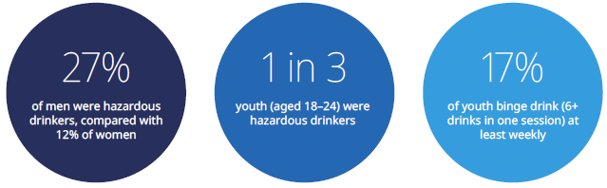
SOURCE: NZHS 2016/17 (Ministry of Health 2017h)

One in five adults drinks in a way that could cause harm to themselves or others
Hazardous drinking refers to a pattern of drinking that carries a risk of harming the drinker’s health or having a negative social impact. The World Health Organization developed a 10-question Alcohol Use Disorders Identification Test (AUDIT) to assess hazardous drinking. The test takes into account a combination of factors including binge drinking, dependency and the impact alcohol has on people’s lives. Based on this test, the 2016/17 New Zealand Health Survey found that 19.5 percent of the adult population had a hazardous drinking pattern. Figure 17 summarises the findings by age group and sex.

Figure 17: Hazardous and past-year drinkers by age group and sex, 2016/17
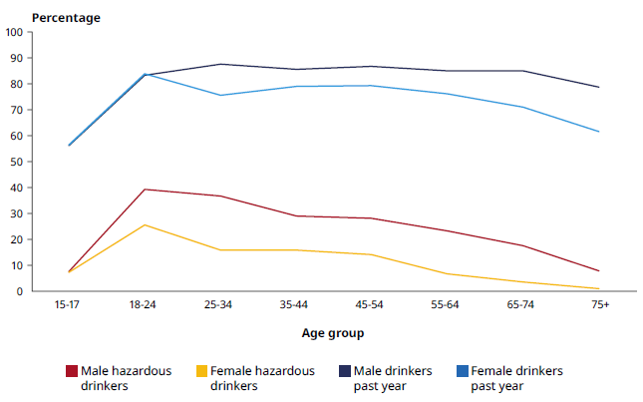
SOURCE: NZHS 2016/17 (Ministry of Health 2017h)

The high rates of hazardous drinking among youth are concerning because early exposure to alcohol in young people under the age of 25 years is particularly harmful to the developing brain. Youth drinking is also associated with other harms, including unprotected and unwanted sex, injury, assault, arrests and harmful effects on social life, finances or work/study (Health Promotion Agency 2017).

Although the proportion of non-drinkers is higher in the most socioeconomically deprived areas, adult drinkers in the most deprived areas were 1.7 times more likely to be hazardous drinkers than those in the least deprived areas, after adjusting for age, sex and ethnic differences.

Alcohol-related emergency department presentations
Alcohol consumption contributes to injuries and hospitalisations. Since July 2017 it is mandatory for all DHBs to routinely record whether an emergency department (ED) presentation was associated with alcohol. To be recorded in this category, the person does not need to be intoxicated; it is sufficient that they have consumed alcohol before they present to the ED and that the ED staff consider the alcohol contributed to their presentation. Alternatively people may not have consumed alcohol, but their presentation is a consequence of someone else’s alcohol consumption.

In the seven DHBs that already collected this information in the six months leading up to June 2017, on average 3.9 percent of ED presentations among those aged
20–24 years were alcohol related over this period. Among those aged 15–19 years, the figure was 4.1 percent. For both age groups, rates were higher for males.

DHBs are also responding to alcohol-related harm in different ways. For example, Counties Manukau DHB has developed a programme to reduce alcohol-related harm. The programme focuses on alcohol as a key determinant of population health and wellbeing outcomes and prioritises prevention and early intervention actions.

A key component of the programme is promoting the systematic use of an Alcohol ABC Approach (Assessment, Brief advice and referral for Counselling) in general practice, hospital emergency departments and community-based settings, following a similar model to the Smokefree brief intervention work. The work includes customised training and sustained support for front-line staff to enable them to have skilled and empathetic conversations with people and their whānau about alcohol use.

Most women stop drinking when pregnant
Drinking alcohol during pregnancy increases the risks of complications, including miscarriage, stillbirth, prematurity and fetal alcohol spectrum disorder (FASD, an umbrella term used to describe a range of effects on the baby after being exposed to alcohol in the womb). It is recommended that women do not drink alcohol when planning a pregnancy or while pregnant. No level of alcohol consumption during pregnancy is known to be safe.

The majority of New Zealanders recognise that drinking during pregnancy is harmful, with 84 percent disagreeing with the statement ‘during pregnancy drinking small amounts of alcohol is OK’ (Health Promotion Agency 2017). Opinions differ somewhat across groups: women are more likely than men, and those aged 15–24 years are more likely than older age groups, to think it is not okay to consume alcohol while pregnant.

The Growing Up in New Zealand Study found that most women stop or substantially reduce their drinking when pregnant, including: 29 percent who did not drink before or during pregnancy, 43 percent who stopped drinking when they became aware that they were pregnant, 16 percent who stopped drinking later in the pregnancy and 9 percent who stopped drinking and then restarted at some point during their pregnancy. A small percentage (2%) kept drinking throughout their pregnancy (Superu 2015).

The Ministry of Health is working with other social sector agencies to implement an action plan on preventing alcohol-related harm during pregnancy (FASD Working Group 2016).

The Health Promotion Agency is leading a programme of work that includes providing information and advice, undertaking research and developing resources to help prevent and reduce alcohol-related harm and inspire New Zealanders to make better decisions about drinking alcohol. For more details, go to: www.alcohol.org.nz

Most New Zealanders get enough sleep
Getting the right amount of sleep is important for good health. Insufficient sleep is associated with a range of physical and mental health problems, such as weight gain (Ministry of Health 2017b) and a higher risk of type 2 diabetes (Dutil and Chaput 2017). Even a small but habitual sleep deficit can have a negative effect on health. The relationship between sleep and health involves influence in both directions: health problems such as sleep apnoea in their turn impact on sleep. It is not just the length of sleep but also its quality that is important.

Recommended sleep duration
The Ministry of Health has adopted and adapted* the USA’s National Sleep Foundation guidelines for recommended sleep duration. These form part of evidence-based guidance on recommended levels of sleep for children and adults in recent publications, including the Clinical Guidelines for Weight Management in New Zealand Adults (Ministry of Health 2017b) and Sit Less, Move More, Sleep Well: Active play guidelines for under-fives (Ministry of Health 2017k). The guidelines acknowledge that some people may naturally sleep slightly more or slightly less than the recommended hours.
 | Age group | Recommended hours of sleep
 | Toddlers (0–2 years) | 11–14
 | Preschoolers (3–4 years) | 10–13
 | School age children (5–13 years) | 9–11
 | Teenagers (14–17 years) | 8–10
 | Younger adults (18–25 years) | 7–9
 | Adults (26–64 years) | 7–9
 | Older adults (65 years and over) | 7–8
 | * It adapted the school age category in the National Sleep Foundation sleep guidelines to reflect the age New Zealand children start school (at five years rather than six years as in the USA).

The Ministry of Health surveyed New Zealanders about their sleep in the 2013/14 New Zealand Health Survey. The survey revealed that the majority of children (aged
2–14 years) are getting the recommended amount of sleep (around 78% for both boys and girls).

This was supported by the Growing Up in New Zealand Study, which found that the majority of preschoolers (aged 3–4 years) were meeting the recommended hours of sleep (around 90%) and that the average length of overnight sleep was 10 hours, 45 minutes. This study found that children who had a regular bedtime were more likely to meet the minimum sleep requirements than children who rarely or never had a regular bed time (Morton et al 2017).

The majority of adults (aged 15 years and over), 72.6 percent of adult males and 69.4 percent of adult females, met the recommended amount of daily sleep (NZHS 2013/14). However, the prevalence of adults meeting the recommended hours of sleep decreased with age (Figure 18). While 80.5 percent of young adult males and 77.7 percent of young adult females got the recommended amount of sleep, the proportions fell markedly for those aged 65 years and over, with 55.6 percent of males and 52.3 percent of females in this age group meeting the recommendations.

Figure 18: Proportion receiving the recommended amount of sleep by age group and sex, 2013/14
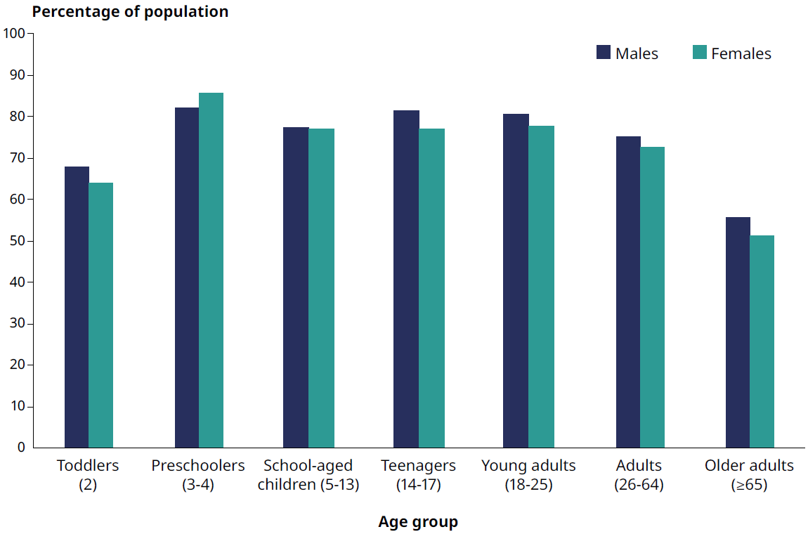
SOURCE: NZHS 2013/14 (Ministry of Health 2014b)

In the 2013/14 New Zealand Health Survey, 63.1 percent of Māori adult males reported they got the recommended amount of sleep, compared with 76.0 percent of non-Māori adult males. Māori adult females were also less likely to meet the recommendations than non-Māori adult females (62.9% and 73.2% respectively).

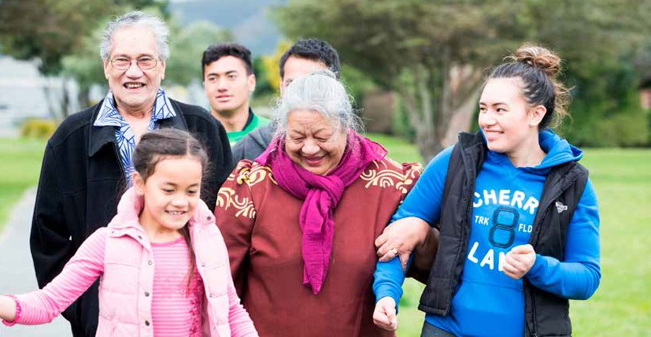

Section 3: Health across the life course
Different health conditions have a greater impact on different age groups
This section looks more closely at some of the leading causes of health loss across the life course. First, it focuses on the key influences on early development and the importance of the first 1,000 days of life – the days from conception through to a child’s second birthday. It then looks at some of the unique challenges adolescents face. Moving on from adolescence, the adult population is increasingly affected by long-term conditions, which develop earlier for Māori, Pacific peoples and those living in areas of higher socioeconomic deprivation. This section discusses some of the leading causes of health loss in this age group. Finally, it considers some key determinants of healthy ageing, which is particularly important in the context of New Zealand’s ageing population.

Different conditions have a greater impact on people at different life stages. Figure 19 illustrates leading causes of morbidity and mortality at various stages through life. This section discusses a selection of these conditions in more detail.

Figure 19: Leading causes of morbidity and mortality for selected age groups
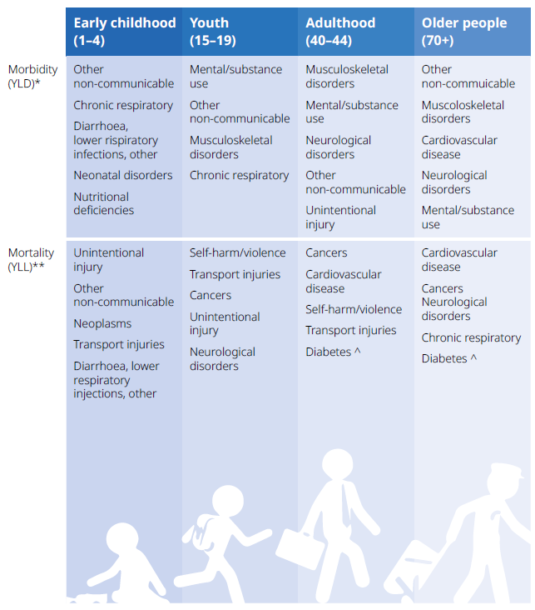
^ Diabetes mortality also includes urogenital/blood/endocrine, * YLDs (years lived with disability/morbidity), ** YLL (years of life lost)

A healthy start to life is vital for healthy long-term outcomes
There is growing recognition of the importance of the first 1,000 days of life – the days from conception through to a child’s second birthday. This is a time of rapid and crucial development, which is strongly influenced by both the physical and social environment. By optimising the first 1,000 days for every child, we can set the foundation for positive future health and wellbeing. An expanding body of evidence shows that the health and wellbeing of the parents before conception can also impact on the future health of their children (Moore et al 2017). | ‘Many challenges in adult society have their roots in the early years of life, including major public health problems such as obesity, heart disease, and mental health problems.’  (WHO 2008)

Good maternal nutrition is important for a healthy start
The mother’s nutrition is one important component for healthy fetal growth and development. Having a balanced diet with a range of healthy foods is the best way to make sure the fetus has all the nutrients it needs for optimal growth and development.

However, even with a healthy diet it can be difficult for the mother to get all the nutrients the fetus needs. For this reason, it is recommended that women take subsidised folic acid and iodine tablets. Folic acid is recommended from at least one month before becoming pregnant through to 12 weeks of pregnancy to minimise the risk of neural tube defects. Iodine is recommended throughout pregnancy and while breastfeeding.

Of women who had been pregnant in the five years before completing the 2014/15 New Zealand Health Survey, 47.6 percent had taken folic acid to prepare for the pregnancy and 32.5 percent had improved their diet in preparation for their pregnancy. Young women were less likely than older women to take folic acid or change their diet before they conceived. Ensuring optimal nutrition before women conceive may be challenging as it is estimated that in New Zealand 40 to 60 percent of pregnancies are unplanned (Hohmann-Marriott 2017; Morton et al 2010). Where their pregnancy is unplanned, it is recommended that women start taking the subsidised folic acid and iodine tablets as soon as they find out they are pregnant.

Early access to maternity care is increasing, but not for all women
The Ministry of Health recommends all pregnant women register with a Lead Maternity Carer (LMC) during the first trimester of pregnancy. Early and ongoing regular engagement with a LMC (usually a midwife) is associated with an increased rate of healthy births and better pregnancy outcomes. As well as providing health care and advice, LMCs can ensure that women are connected with other health and social services they or their whānau may need.

Early registration with an LMC is improving over time. In total, 71 percent of all women were registered with an LMC in the first trimester of pregnancy in the 12 months to February 2017, compared with 66 percent in the 12 months to February 2015. However, early registration with an LMC differs considerably by ethnicity, age and neighbourhood socioeconomic deprivation.

Figure 20 shows that the proportion of women registering with an LMC in the first trimester increased for all neighbourhood deprivation quintiles between 2015 and 2017. However, pregnant women living in areas of high socioeconomic deprivation were less likely (eg, 57% in quintile 5) to be registered with an LMC than those living in areas of low socioeconomic deprivation (eg, 78% in quintile 1).

Figure 20: Pregnant women registered with a Lead Maternity Carer in the first trimester by socioeconomic deprivation quintile, 2015–2017
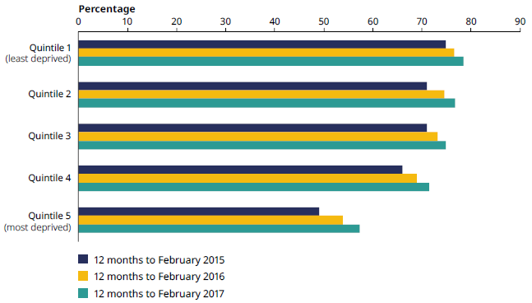
SOURCE: Ministry of Health, National Maternity Collection

Registrations with an LMC in the first trimester are increasing across all age groups; however, younger women (aged 20 years or under) were less likely to register with an LMC (54%) than women aged  30–34 years (75%). Registrations also differed between ethnicities, with Pacific women (44%) and Māori women (58%) being less likely than non-Māori/non-Pacific women (79%) to register with an LMC in the first trimester (National Maternity Collection). | Free immunisation for pregnant women  Immunisation against influenza and whooping cough is free to all pregnant women  Mothers pass some of their immunity from vaccination on to their babies during pregnancy. This provides protection to newborn babies during the first few weeks of life until they are old enough to be immunised.

Breastfeeding helps support optimal growth and development
Breastfeeding helps support optimal growth and development of newborn babies and helps boost babies’ immunity to protect against infections. Breastfeeding also helps support the psychological development of babies, as well as having a positive impact on the mother’s health (including reducing the risk of some cancers) and wider wellbeing. For these reasons, the Ministry of Health recommends exclusively breastfeeding babies until they are ready for and need solid food, which will be around six months of age.

Although breastfeeding rates in New Zealand are relatively high at two weeks, they decrease rapidly over the first three months of life (Figure 21). Of added concern is that although initial breastfeeding rates are similar across ethnic groups, disparities quickly emerge, with a faster decline in breastfeeding rates for Māori and Pacific women. Rates of breastfeeding are also lower among young mothers and those living in areas of high socioeconomic deprivation.

Figure 21: Percentage of babies exclusively/fully breastfed by ethnicity and age of baby, 2016
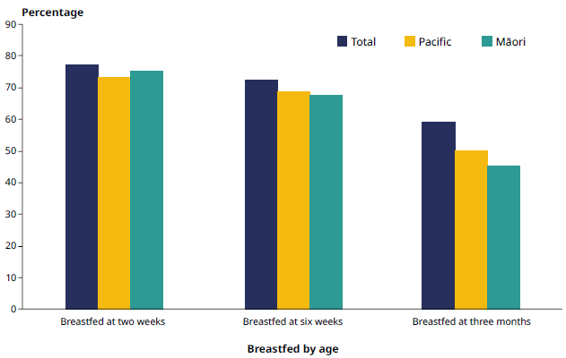
SOURCE: Well Child / Tamariki Ora Quality Improvement Framework Indicators – September 2017 reporting period

Perinatal mortality is at the lowest rate since recording began
Preventing deaths during pregnancy, in the period soon after birth and in the first year of life is an important focus for the health and disability system. Understanding the factors that contribute to avoidable mortality and how to best respond is an important part of quality improvement in our system. The Health Quality & Safety Commission (HQSC) Perinatal and Maternal Mortality Review Committee (PMMRC) plays a key role in this regard, regularly reporting on progress and making recommendations for improvement.

In 2015 perinatal mortality (which includes late terminations of pregnancy, stillbirths, and early and late neonatal deaths, from 20 weeks of gestation to 27 days of life) was 9.7 per 1,000 total births – the lowest rate recorded since reporting began in 2007. This included a statistically significant decrease in stillbirths since 2007 (PMMRC 2017). A number of factors are considered to have contributed to this decline, including a decrease in smoking during pregnancy, earlier access to antenatal care and increased access to contraception (PMMRC 2017).

In 2014 the infant mortality rate was 5.7 per 1,000 live births (Ministry of Health 2017d). The rate in New Zealand has consistently been above the OECD average (which was 3.9 per 1,000 live births in 2015) and reflects inequities for Māori and Pacific infants. Infant mortality rates per 1,000 live births for Māori (7.2) and Pacific (7.1) were around 1.5 times higher than the rate for the European or Other (4.6) and were also higher than the Asian rate (5.0). Infant mortality in the most deprived demographic areas (9.1 per 1,000 live births), was nearly three times the rate in the least deprived areas in New Zealand (3.2 per 1,000 live births). Babies of young women (under 20 years of age) had the highest infant mortality rate, at 12.3 per 1,000 live births (Ministry of Health 2017d).

Sudden unexpected death in infancy is decreasing
Sudden unexpected death in infancy (SUDI) is an umbrella term that describes the death of an infant that was not anticipated, within the first year of life (Hāpai 2017). It is a leading cause of preventable death for New Zealand infants (Child and Youth Mortality Review Committee 2017).

SUDI deaths have decreased significantly since the 1980s; it is estimated that the ‘Back to Sleep’ campaign in the 1990s – advising that babies should sleep on their backs – saved over 3,000 lives (Mitchell and Blair 2012). The focus has now shifted to address the other two key risk factors: maternal smoking during pregnancy and bed sharing. The combination of smoking during pregnancy and bed sharing is associated with a 32-fold increase in the risk of SUDI compared with babies not exposed to either risk factor (Mitchell et al 2017). | In 2015, 44 babies died from SUDI; 20 of these were Māori and 14 were Pacific infants. Younger infants, infants of younger mothers and infants from areas of high deprivation had the highest rates of SUDI.

Although SUDI has decreased since the 1980s, persistent ethnic inequities are concerning, with higher overall rates for Māori and Pacific infants than non-Māori and non-Pacific infants. There are also significant inequities in SUDI rates by neighbourhood socioeconomic deprivation. Between 2002 and 2015, the SUDI rate for infants living in the most deprived 10 percent of areas was over seven times higher than the rate for infants living in the least deprived 10 percent of areas (Child and Youth Mortality Review Committee 2017).

In August 2017 a new national SUDI prevention programme was launched with the aim of reducing the number of SUDI deaths annually from 44 in 2015 to six or fewer by 2025. Hāpai Te Hauora, the largest Māori public health provider in New Zealand, was selected as the national provider to deliver the national SUDI prevention coordination service. Safe sleep devices will be provided to whānau identified as needing them during the baby’s first year of life.

Protecting infants and children from vaccine-preventable illnesses
Immunisations are an important way of keeping infants and children well by protecting them from harmful vaccine-preventable infections. The National Immunisation Schedule sets out a series of vaccines offered free of charge in New Zealand, including for illnesses such as measles, mumps and rubella (MMR) and pertussis (whooping cough). The human papillomavirus (HPV) vaccination, for older children and young adults, is protective against a number of cancers, including cervical cancer. Progress in this area is reported as part of the adolescents discussion later in this section.

The health sector has set a target for 95 percent of infants aged eight months to have completed their primary course of immunisations on time. Immunisation rates have increased significantly in the last decade. For the 12 months up to 30 September 2017, the national immunisation coverage for eight-month-olds was 94 percent. Immunisation coverage differs by ethnicity, with the highest rates among Asian (97%) and Pacific (95%) infants and lower rates among Māori infants (92%).

WHO recognises New Zealand’s measles-free and rubella-free status
Progress continues to be made in reducing infectious diseases through vaccination. In October 2017 the World Health Organization (WHO) declared New Zealand is free of endemic measles and rubella. This means no measles and rubella cases have originated in New Zealand for the past three years, but cases may arise from people bringing these illnesses with them from overseas. This is an important achievement for health professionals, schools and whānau – helping to eliminate two dangerous childhood diseases from within our resident population.

Diseases like measles and mumps can spread quickly in schools and colleges. The MMR vaccine protects against measles, mumps and rubella, all of which can be serious in children and young adults. Very high population coverage of this vaccine is necessary to prevent the spread of disease and no vaccination opportunity should be missed (Immunisation Advisory Centre 2017). New Zealand continues to aim to further improve coverage rates of people fully vaccinated against MMR, including young children and teenagers.

More children are starting school with good oral health, but inequities remain a challenge
Poor oral health is largely preventable, yet is a common chronic health problem experienced by New Zealanders of all ages. Oral health affects general health, and is related to risk factors and determinants common to other long-term conditions, particularly cardiovascular diseases, cancer, chronic respiratory diseases and diabetes. Publicly funded oral health care is available free of charge for children and adolescents up to their 18th birthday.

Prevention and early intervention provide the best opportunity to reduce oral health disparities across the life course. One of the aims of the ongoing work to improve the model of care in the Community Oral Health Service is to increase the enrolment and engagement of preschoolers and their whānau.

Good progress is being made. The percentage of preschool children enrolled in the Community Oral Health Service increased from 43 percent in 2007 to 85 percent in 2016. There are also encouraging signs of improvement in child oral health outcomes over this same period. For example around 60 percent of all children at five years of age were caries-free in 2016, an increase from around 51 percent in 2007 (DHB reporting).

However, disparities in outcomes between populations remain, particularly for Māori and Pacific children and children living in areas of high socioeconomic deprivation. In 2016, 41 percent of Māori and 34 percent of Pacific children were caries-free at the age of five years, compared with 70 percent of European or Other children. Māori and Pacific children are also more likely to end up in hospital with conditions related to their oral health. For example, ambulatory sensitive hospitalisations for the 12 months up to September | The term ‘ambulatory sensitive hospitalisations’ (ASH) refers to mostly acute hospital admissions for conditions that are potentially preventable or that could have been treated earlier in primary care.
2017 for dental conditions for those aged 0–4 years were 1.6 times higher for Māori than non-Māori and 1.7 times higher for Pacific than non-Pacific preschool children.

The Ministry of Health and DHBs have undertaken initiatives to improve oral health status and address disparities, including promoting community water fluoridation and implementing the current Oral Health Promotion Initiative (see below). Preschool children from Māori, Pacific and low-income whānau are the priority groups.

Baby teeth matter – the Oral Health Promotion Initiative
A social marketing campaign to help whānau increase tooth brushing and encourage regular attendance at the Community Oral Health Service began in 2016.

Children’s oral health is strongly influenced by their parents or caregivers. The campaign, including a popular television commercial featuring a re-imagined tooth fairy, picks up on this idea and highlights the importance of maintaining healthy baby teeth to develop healthy adult teeth by brushing with fluoride toothpaste morning and night.

Some children require help to ensure they have the building blocks for positive mental health
Although the majority of New Zealand children are developing well, some children require help to ensure they have the building blocks for positive mental health and wellbeing. The New Zealand Health Survey indicated that around 8 percent of children (an estimated 57,000 children) between the ages of 3 and 14 years experienced some difficulties, as assessed by the Strengths and Difficulties Questionnaire (SDQ). The SDQ asks parents to rate their child’s behaviour across different areas that are considered essential for development and mental health: emotions, peer relationships, conduct and hyperactivity. Overall, reported difficulties were more prevalent among boys (9.4%), Māori children (12.0%) and children living in areas of high socioeconomic deprivation (12.4%).

Difficulties were more common for some areas assessed by the SDQ than for others (Figure 22). For example, based on the SDQ an indication of peer problems was prevalent in around 14 percent of children aged 3–14 years. The adjusted prevalence was 1.2 times more likely in boys than girls, 1.5 times more likely in Māori compared with non-Māori children, 1.7 times more likely in Pacific compared with non-Pacific children and 2.5 times more likely in children living in the most socioeconomically deprived areas compared with those living in the least deprived areas.

Figure 22: Percentage of children aged 3–14 years with an SDQ score indicating difficulties in areas related to development and mental health
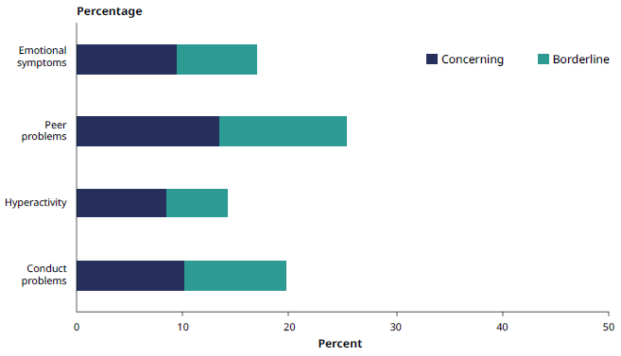
Note: ‘Borderline’ indicates a medium likelihood that the child has a social, emotional and/or behavioural problem, while ‘concerning’ indicates a high likelihood. Based on previous work internationally, it is expected that around 10 percent of children will be in the ‘borderline’ category and 10 percent in the ‘concerning’ category (Youth in Mind 2014).

For just over 10 percent (10.3%) of children aged 3–14 years, the SDQ indicated difficulties in the area of conduct. In 2016 conduct disorder was one of the top five conditions contributing to health loss in children aged 5–14 years (IHME 2016). If children at risk of difficulties in the area of conduct are identified at a young age, they can be provided support to minimise the risk of developing a conduct disorder and to promote positive development. Early intervention in response to difficulties can reduce the risk or severity of certain types of mental health conditions later in childhood, adolescence or adulthood and improve children’s developmental, emotional, academic and social outcomes. The earlier the intervention occurs, the greater those improvements are (Manning 2017).

In New Zealand all parents get asked to complete the SDQ as part of the B4 School Check when their child is aged four years. The SDQ is used only as an initial screening tool and cannot be used to make a formal diagnosis. Children with an SDQ score indicating difficulties in the B4 School Check can be referred to specialist services. Early identification of warning signs, such as through the B4 School Check, and referral to appropriate services aim to help all New Zealand children to achieve their full potential.

Adverse childhood experiences impact on health and wellbeing throughout the life course
A growing body of evidence shows that adverse experiences in childhood, such as abuse, neglect and household dysfunction, have both a short- and long-term impact on health and development (Felitti et al 1998; Moore et al 2017).

The Treasury reported four indicators to identify children at risk factors for poor outcomes later in life (Treasury 2016). These were:  - a finding of abuse or neglect, or having spent time in the care of child protection services  - having spent most of childhood supported by benefits  - having a parent who has received a community or custodial sentence  - having a mother with no formal qualifications. | ‘It has been shown that considerable and prolonged stress in childhood has life-long consequences for a person’s health and wellbeing. It can disrupt early brain development and compromise functioning of the nervous and immune systems.  (WHO 2018)

Compared with children who had none of the indicators, children aged 0–5 years with two or more of these indicators were more likely to be hospitalised for conditions that could have been managed in primary care, more likely to need a dental referral at the B4 School Check and less likely to have participated in early childhood education before starting school.

The Treasury report estimated that 53,000 children aged 0–5 years (14.6% of children in this age group) experienced two or more of these adversity indicators. However, within this number were significant ethnic inequities, with 65 percent of those children being Māori (The Treasury 2016).

As children with these risk factors aged, they accumulated disadvantage. They were more likely to leave school without any qualification, to spend time in jail before the age of 21 years and to receive benefits for over two years by the age of 21 years. These experiences, in turn, mean they are more likely to have children exposed to these risk factors and the associated poor health and wellbeing outcomes.

As well as problems in childhood and adolescence, adverse childhood experiences increase the risk of adverse health outcomes in adulthood. Adverse childhood experiences have been linked to increased likelihood of adverse health behaviours, such as smoking, drug use and lack of physical activity, as well as adverse health and social outcomes such as poverty and homelessness, mental illness, cardiovascular disease, diabetes and obesity (Moore et al 2017).

The Ministry of Health, DHBs and community providers are working together with social sector partner agencies to improve outcomes for all children through universal and targeted programmes. This includes programmes and initiatives such as the Well Child / Tamariki Ora programme, Whānau Ora, supporting Oranga Tamariki’s Family Start Programme and contributing to the holistic assessment of health and wellbeing for children entering into, and on the cusp of entering, the care of the state.

The Ministry of Health and Oranga Tamariki Ministry for Children are working together to support the health and wellbeing of children and whānau most in need
Family Start is a voluntary intensive home support programme run by Oranga Tamariki that works with children aged 0–5 years and their whānau. The focus is on supporting parents and improving children’s health and development, learning and relationships, family circumstances, environment and safety. Family Start is designed for families with mental health or addiction issues, care and protection history, parenting and child development issues, relationship problems or other issues. In 2017 funding to Family Start was expanded, which will allow the programme to provide intensive support to over 7,000 children and whānau.

Both the Ministry of Health and Oranga Tamariki acknowledge that meeting the needs of the most vulnerable children and whānau requires an integrated cross-agency approach. The Cross-Agency Consolidated Joint Work Plan is an initiative between Oranga Tamariki and the Ministry of Health that aims to improve access to and use of universal health services for children and whānau enrolled in the Family Start programme.

Health impacts of child abuse and inter-partner violence
Family violence is a population health issue that occurs globally and is not limited to one sex or any one religious, cultural or income group. Violence and abuse in families can have an immediate, delayed and long-term negative impact on physical and mental health. Living in a home where violence and abuse occur affects children’s brain development, can impact on their behaviour and can lead to social and educational problems and long-term health conditions (Fanslow et al 2016; Ministry of Social Development 2017a).

Improving the approach to identifying and supporting victims of family violence is an important focus for successive governments and social sector ministers. This focus recognises that addressing family violence and abuse requires a whole-of-system approach within and between sectors and agencies.

Examples are:
- the Campaign for Action on Violence within Families, hosted by the Ministry of Social Development, which comprises a national media campaign and community-based-action projects www.areyouok.org.nz
- Work and Income’s Family Violence Intervention programme (Fanslow et al 2016; Work and Income 2011)
- a new Family and Sexual Violence Central Agent being set up to coordinate public sector and NGO effort to address domestic and sexual violence.

The Family Violence Integrated Response System (IRS) is another promising initiative that brings together a range of agencies to deliver more effective safety responses. Families referred to it may come via a Police call-out to a family harm episode or via Corrections when a high-risk perpetrator of family harm is about to be released from prison (Superu 2017a).

The Violence Intervention Programme operates in all DHBs
Health providers come into contact with the majority of the population through routine health care, illness or injury and are well placed to identify violence and abuse early and to support and refer victims. The Ministry of Health’s Violence Intervention Programme is implemented in DHBs nationally with the goal of creating a whole-of-health systems approach to reducing family violence.

Family Violence Assessment and Intervention Guideline for health professionals
The Family Violence Assessment and Intervention Guideline (Fanslow et al 2016) helps health professionals make safe and effective interventions to help victims of interpersonal violence and abuse.

The guideline presents a six-step model for identifying and responding to family violence within health care settings. It is intended for health professionals to use in conjunction with health professional training offered through the Ministry of Health’s Violence Intervention Programme.

Reducing child poverty and improving child wellbeing
Poverty is recognised as an important determinant of poor health, impacting on the lives of thousands of New Zealand children and whānau. Between 150,000 and 290,000 children are currently living in poverty or hardship, with the number depending on the measure used, and around 80,000 live in more severe hardship (Duncanson et al 2017). The level of poverty has been increasing since the 1980s. Sustained child poverty leads to considerably worse health and wellbeing outcomes.

Child poverty reduction legislation has been introduced to achieve a significant and sustained reduction in child poverty, and to improve child wellbeing over time by encouraging:
- a greater focus on the issue of child poverty across government and society
- transparent and robust reporting on the levels of child poverty in New Zealand
- current and future governments to make a greater commitment to action
- governments to be held accountable for the results they achieve.
The development of a Child Wellbeing Strategy provides an opportunity for government to improve outcomes for all children up to 18 years of age. This will include a focus on equity. The Child Wellbeing Strategy will enable the Ministry of Health to further develop integrated responses to challenging health issues for children, and create opportunities to address the various social determinants of health.

Developing well in adolescence
Young people undergo a period of significant growth and development during adolescence and have their own specific health needs as they transition from childhood to adulthood. Important transitions specific to this period include, for example, moving from primary school to secondary school, and from secondary school to work or further study. Adolescents can also experience other transitions that can occur at any life stage, such as the loss of a close whānau member or friend (HQMNZ 2017).

Figure 23 highlights examples of factors in young people’s lives that can be protective of, or present risks to, good health and positive wider social outcomes.

Figure 23: Examples of risk and protective factors for young people
Domain | Protective factors (+) | Risk factors (–)
Individual | + Coping skills and problem-solving skills  + Academic achievement  + Emotional self-regulation  + Good self-esteem | – Insecure attachment and low self-esteem  – Emotional problems in childhood  – Early substance use  – Conduct disorder
Whānau | + Supportive relationships with whānau  + Whānau provides structure, limits, rules, monitoring and predictability | – Parent conflict and whānau dysfunction (including transience)  – Parental anxiety, depression, substance use  – Poor parental supervision
School and community | + Opportunities for engagement within school and community, eg, in sports, employment, religion, culture  + Presence of mentors and support for developing skills and interest | – Loss of close relationship with peers  – Low commitment to school and poor academic performance  – School and community violence  – Poverty  – School level stressful or traumatic events
SOURCE: Adapted from the National Research Council and Institute of Medicine (2009)

Mental illness and injuries are the leading areas of health loss for young people
While most young people in New Zealand experience good health during adolescence, the experience of health loss in some areas, including injury, mental illness, respiratory illness and skin disorders is significant for this group. Figure 24 highlights the leading areas of health loss for young people aged 15–24 years in 2016.

Figure 24: Leading areas of health loss for young people aged 15–24 years, 2016
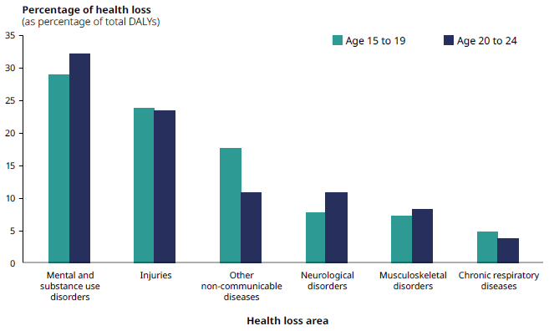
SOURCE: IHME (2016)

Mental illness and substance use disorders are the leading cause of health loss for young people. The leading contributor to this type of health loss across both age groups in 2016 was depressive disorder, followed by anxiety and drug use. The impact of mental health is further seen in other causes of health loss. Specifically, self-harm was the leading contributor to health lost from injuries for both age groups; the next greatest contributor in this category was transport injuries. The majority of health loss from ‘other non-communicable diseases’ was from skin and subcutaneous disease.

The Youth Mental Health Project, SPARX and OurSCHOOL Survey
In 2012 the Youth Mental Health Project was established as an investment in prevention and early intervention, designed to increase youth resilience and respond to mental health issues as they emerge. The project aims to promote the mental health and wellbeing of young people (with a focus on those who are 12–19 years of age) with or at risk of developing mild to moderate mental health issues. It consists of various initiatives across the Ministries of Health, Education and Social Development and Te Puni Kōkiri. For example, SPARX is a self-help e-therapy tool that teaches young people the key skills needed to help combat depression and anxiety. Since the tool’s launch in April 2014, approximately 5,000 of those aged 12–19 years have registered to use SPARX.

In its evaluation of the Youth Mental Health Project, Superu (2017b) surveyed over 3,000 youth around New Zealand (OurSCHOOL Survey, year 9 to 13 students). The results provided some important insights into groups for which limited information is currently available. Overall, the majority of youth reported a positive sense of belonging (74%). However, on average, 12 percent of surveyed students had experienced moderate to severe bullying and 32 percent felt unsafe at school. Of students completing the OurSCHOOL Survey, 59 percent reported having good whānau support.

Young people of minority genders and sexualities have poorer mental health outcomes
In the New Zealand Health Survey, 94.4 percent of youth aged 16–24 years identified as heterosexual, 1.4 percent as gay/lesbian, 2.7 percent as bisexual and 1.6 percent as other (NZHS 2014/15). In the Youth’12 study of high school students, 1.2 percent of respondents reported being transgender and 2.5 percent reported being unsure about their gender (Clark et al 2014). Some evidence indicates that the number of people identifying as transgender who present for advice on gender reassignment hormone therapy is increasing, particularly among the young adult age group (Delahunt et al 2018).

Of those that completed the OurSCHOOL Survey, youth that identified as lesbian, gay, bisexual and transgender (LGBT) (7%) reported poorer emotional health, fewer protective factors and more risk factors than other students surveyed. Discrimination and exclusion are factors influencing the health of LGBT young people. Half (50%) of all LGBT youth reported not having a positive sense of belonging, compared with one in four (25%) of all other youth. LGBT youth also exhibited more risky behaviours than other youth: they were over three times as likely to regularly use alcohol, tobacco or marijuana and over twice as likely to regularly truant. About half (51) of LGBT youth reported self-harming in the last 12 months, compared with 17 percent of all other students. LGBT youth were substantially more likely than other youth to report experiencing multiple indicators of anxiety, depression and low self-esteem (Superu 2017b).

These findings are supported by the Youth‘12 study, which found that young people in New Zealand who identify as LGBT had significantly poorer health and wellbeing than other high school students. Students who identified as lesbian, gay or bisexual were more likely to engage in self-injury than heterosexual adolescents (Fraser et al 2017). The survey also found that over half of transgender students were afraid someone at school would hurt or bother them, and nearly one in every five reported being bullied at school at least weekly (nearly five times more than non-transgender students). One in five (19.8%) transgender students had attempted suicide in the 12 months before completing the survey (Clark et al 2014).

Sexual and reproductive health is important for youth health and development
Giving youth access to comprehensive sexuality education and to sexual and reproductive health services is a vital component of positive development. Sexual and reproductive health influences and is influenced by other areas of health and wellbeing including education, violence prevention and mental health. According to the 2014/15 New Zealand Health Survey, 68.7 percent of youth aged 16–24 years reported that they had had sex at some time.

Teenage pregnancy is decreasing
The teenage birth rate has decreased consistently since 2008. The 2016 rate was a record low of 16 births per 1,000 women aged 15–19 years, which is half the 2008 rate (33 births per 1,000 women) (Figure 25). This trend is consistent with global trends, with similar decreases seen in Australia and the United States of America.

Figure 25: Teenage fertility rate – births per 1,000 women aged 15–19 years,
1962–2016
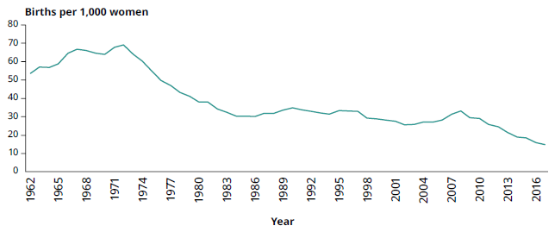
SOURCE: Statistics New Zealand (2017c)

The abortion rate for women aged 15–19 years has similarly fallen from 26.2 per 1,000 in 2008 to 9.4 per 1,000 women in 2016 (Statistics New Zealand 2017d). Again, this trend is consistent with trends in other high-income countries. Many factors are likely to contribute to the decrease in the teenage pregnancy rate, which is reflected in the decreased abortion and birth rates. However, a contributing factor is thought to be an increase in access to and use of long-acting reversible contraceptives.

Too many youth experience unwanted sexual contact
Experiencing unwanted sexual contact can have a major impact on the lives of young people. Young people who have experienced unwanted sexual contact are more likely than those who have not experienced unwanted sexual contact to report poorer mental health, substance use and difficulty accessing health care, in particular contraception and pregnancy care (Clark et al 2015).

In the 2014/15 New Zealand Health Survey, 6.2 percent of females and 2.1 percent of males aged 16–24 years reported that they had been made to have sex against their will at some point since the age of 13 years. In the Youth’12 survey, 14.8 percent of high school students reported that they had experienced unwanted sexual contact; females were more than twice as likely as males to report experiencing unwanted sexual contact (19.5% of females, 9.0% of males) (Clark et al 2015).

Chlamydia is the most commonly diagnosed STI in New Zealand
Rates of sexually transmitted infection (STI) have shown little change over recent years, with small reductions in rates of some STIs and increased rates of others. Of New Zealanders who have ever been sexually active, one in seven (14.3%) report that they have had an STI at some time in their lives (NZHS 2014/15). The rate is higher for women (19.7%) than for men (12.0%) (NZHS 2014/15). The likely reason for the higher rates of STIs among women is that women are considerably more likely to be tested for STIs than men. For example, in 2015 females aged 15–24 years were around four times more likely to be tested for chlamydia than their male counterparts (Nationwide Service Framework Library 2017).

Chlamydia is the most commonly diagnosed STI in New Zealand, with the highest rates among those aged under 25 years (Institute of Environmental Science and Research 2015) (Figure 26). Chlamydia may not have any symptoms, so people may not be aware they have it. However, if left untreated it can cause long-term problems for both males and females. There are notable differences in rates of chlamydia by ethnicity, with particularly high rates among young Māori women. Chlamydia rates also vary widely by region, which will partly be due to differences in access to testing services.

Figure 26: Chlamydia cases diagnosed in 2015, by age group among those aged
15–24 years and sex, national rate per 100,000
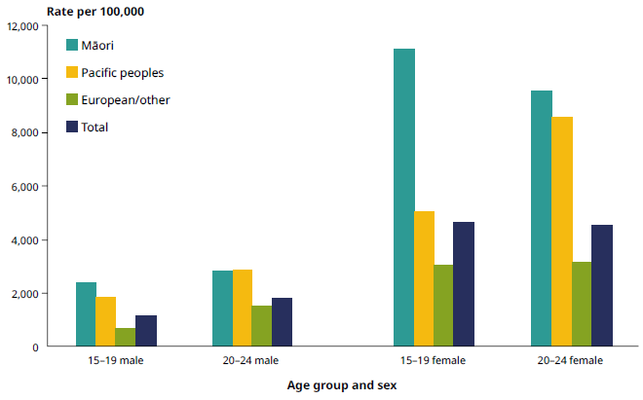

HPV immunisation protects against cervical and other cancers
Immunisation is an important preventive measure to protect against the human papillomavirus (HPV) that can lead to cancer. HPV is a very common virus that infects four out of five people during their lifetime. It is mainly spread through sexual contact. Most people who become infected with HPV will not have any symptoms and their body will clear the infection without requiring any treatment. However, over time some HPV infections can cause abnormal cell changes and lead to cancers, particularly cervical cancer, but also other genital, throat and mouth cancers. | Around 150 women are diagnosed with cervical cancer and 50 women die from it each year in New Zealand.  (Ministry of Health 2016)

The HPV vaccine can protect against 90 percent of cervical cancer, as well as other HPV-related cancers and genital warts. The HPV immunisation programme started in 2008 for girls only. In January 2017 it was expanded so that the free vaccine is now funded for everyone aged 9–26 years, including boys and young men. The immunisation programme is largely run through a school-based immunisation programme in year eight.

HPV immunisation programme – reducing inequalities
The Ministry of Health has set a DHB performance target for 75 percent of girls born in 2004 to be fully immunised by 30 June 2018. Currently, around 66 percent of girls born in 2003 have been fully immunised against HPV. Vaccination rates are higher among Māori, Pacific and Asian girls and young women compared with other ethnicities. This is positive progress from an equity perspective, especially given that Māori women are 2.3 times as likely to be diagnosed with cervical cancer as non-Māori women (New Zealand Cancer Registry). Although no official data on immunisation coverage for boys and young men is available yet (as a full birth cohort of boys has not yet completed the programme), early indications are that uptake rates are similar to girls in the school-based programmes.
 |  | Māori | Pacific | Asian | Other | Total
 | HPV immunisation coverage for girls born in 2003, measured at 30 June 2017 | 72% | 75% | 73% | 61% | 66%

A closer look at intellectual disabilities
This year’s report takes a closer look at the health of people with intellectual disabilities. There is no consistent definition of intellectual or learning disability in New Zealand. The term preferred by people in the disability sector is ‘learning disability’. When discussing the provision of services, the Ministry of Health uses the term ‘intellectual disability’ to clarify the set diagnostic criteria it is referring to (generally people with an IQ score of 70 or below).

People with a learning disability are a diverse group; what they have in common are intellectual impairment and impaired adaptive functioning. Adaptive functioning is how a person manages their day-to-day living and how independent they are compared with others of a similar age and background. The impact of a learning disability varies between individuals: some need more intensive support systems while others require less support to gain independence. Environmental factors such as living conditions, social attitudes, support systems and policies can have a critical effect on adaptive functioning.

What are the estimates around intellectual disability based on?
The Ministry of Health undertook analysis using administrative data (service use, including hospitalisations and disability support service) to generate estimates of the prevalence of intellectual disability in New Zealand. Due to the nature of the data available, the estimates are based on a broad definition of intellectual disability that includes people with a range of causes of intellectual disability, which may have started at any time during their life. The estimates are more likely to include people with moderate or severe intellectual disability, who need support services or who have serious health conditions that require hospital treatment. This analysis is the start of further work in increasing the amount of high-quality data and knowledge available for this population.

Why are estimates provided for those aged 10–34 years only?
Depending on the cause, intellectual disability may not be diagnosed until later in childhood, or initially may be diagnosed as a developmental disorder or delay, resulting in very low estimates for children under the age of 10 years. Also, as a result of improvements in identifying people with intellectual disability over recent years, estimates are less reliable for older age groups. For these reasons, the most accurate data is available for those aged 10–34 years, which is the age group we are reporting on below.

Using the Ministry of Health’s estimates, around 1.3 percent of the New Zealand population aged 10–34 years were classified as having intellectual disability in 2016. The prevalence was higher in males (1.7%) than in females (0.9%). The reasons for the higher prevalence in males may include that males have a higher prevalence of congenital conditions associated with intellectual disability, such as Fragile X syndrome, and that boys with intellectual disability are more likely than girls to have behavioural and developmental problems that are brought to the attention of support services (Bray 2003; Harris 2006).

The prevalence of intellectual disability (10–34 years) was highest among Māori and European or Other individuals (age-standardised rate of 1.5% and 1.4% respectively). The age-standardised rate for Pacific peoples in this age range was 1.0 percent and for Asian people was 0.7 percent.

People with intellectual disabilities are more likely to experience poor health outcomes
People with intellectual disability are more disadvantaged, in terms of their health as well as their life expectancy, compared with people without intellectual disability.

Figure 27: Life expectancy at birth for people with intellectual disabilities, 2014–2016
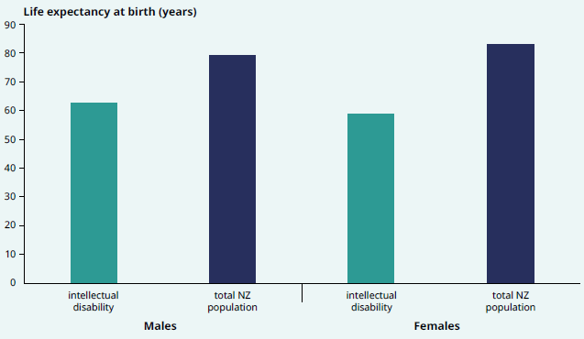

Technical note: This data is based on New Zealanders across the full age range, not those aged 10–34 years only, to ensure it is comparable with national estimates. However, it is unlikely that the estimates would be substantially impacted by the lower accuracy of data for younger and older age groups because the most severe cases are likely to have been identified as having intellectual disability, who are also those individuals most likely to die prematurely.

In the three most recent years for which data is available (2014–2016), the life expectancy at birth was considerably lower for those with an intellectual disability compared with the general New Zealand population. The life expectancy for males with intellectual disability was 63.0 years (up from 59.7 years in 2006–2009), compared with 79.9 years for all New Zealand males – a difference of 16.9 years (Ministry of Health 2011). The life expectancy for females with intellectual disability was 59.3 years (59.5 years in 2006–2009), compared with 83.4 years for all New Zealand females – a difference of 24.1 years (Figure 27).

People with intellectual disability use health services more often
People with an intellectual disability have higher health risks and experience poorer health outcomes compared with people without an intellectual disability. This is partly a result of a higher rates of co-morbid health conditions in this group combined with barriers in access and communication experienced when accessing health care services. Forty-four percent of individuals with intellectual disability receive care or treatment for diabetes, chronic kidney disease, ischemic heart disease, cancer or respiratory. This is 1.6 times the rate in the rest of the population.

People with intellectual disability have a high use of health services. For example, they were 1.9 times more likely than the rest of the population to receive an elective or arranged public hospital treatment in 2016 and 1.5 times more likely to have visited a GP in any three-month period in 2016. Improving health outcomes for this population requires responsive health services with a strong focus on access and communication, as well as health promotion, health literacy and prevention.

Long-term conditions are the main cause of health loss among adults
Long-term conditions are the leading cause of morbidity and mortality for adults living in New Zealand. This section looks at some of the key conditions that contribute most to health loss: cancer, cardiovascular and cerebrovascular disease, musculoskeletal conditions, mental illness, respiratory conditions and diabetes.

Cancer is a leading contributor to health loss in New Zealand
Cancer accounts for around 18 percent of total health loss in New Zealand. Health loss from cancer is a combination of the impact of cancer and as its treatment on health status, as well as of premature mortality as a result of cancer. The Global Burden of Disease Study estimates that the age-standardised rate of health loss attributable to cancer decreased by around 25 percent between 1990 (4,095 per 100,000) and 2016 (3,073 per 100,000) (Figure 28). However, the rate of overall decline in health loss due to cancer has slowed in recent years.

Figure 28: Age-standardised health loss per 100,000 population attributable to cancer, all ages, 1990–2016
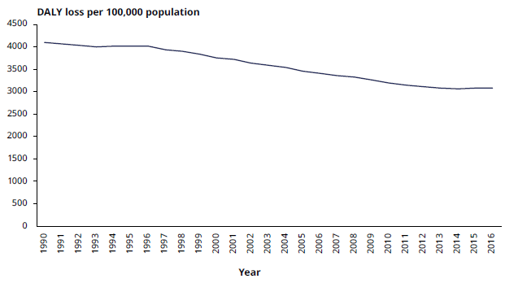
SOURCE: IHME (2016)

Around 23,000 cancer diagnoses are made each year
In 2015, 23,149 new cancer registration were made. The five leading cancers registered in New Zealand were breast cancer (3,315), bowel cancer (3,081), prostate cancer (3,068), melanoma (2,424) and lung cancer (2,177). Together these cancers accounted for around 60 percent of all new cancers registered in 2015 (Ministry of Health 2017g).

Figure 29 shows registration rates of the 10 leading cancers by age in 2015. It illustrates that cancer impacts people across the life course and that the likelihood of being diagnosed with cancer increases significantly for people entering middle age onwards. People aged 65 years and over accounted for approximately 60 percent of new cancer registrations in 2015.

Figure 29: Leading cancer registrations, rate per 100,000 population by age, 2015
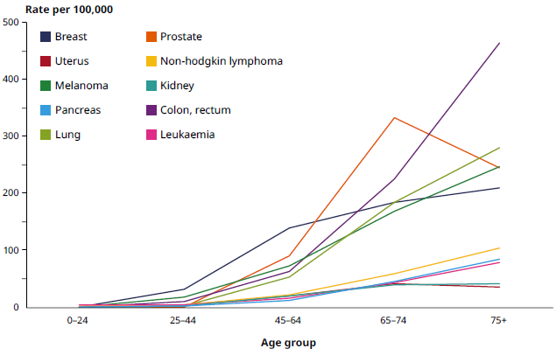
SOURCE: Ministry of Health (2017g)

Cancer accounts for a third of all deaths in New Zealand
Around a third of all deaths in New Zealand are due to cancer. There were 9,702 deaths from cancer in 2015 (Ministry of Health 2018b). Table 4 outlines the leading 10 conditions contributing to cancer mortality by sex.

Table 4: Age-standardised cancer mortality rate per 100,000 population for leading cancers, by sex, all ages, 2013
Males | Rate per 100,000 |  | Females | Rate per 100,000
Lung | 25.3 |  | Lung | 20.7
Colon | 19.1 |  | Breast | 17.7
Prostate | 17.4 |  | Colon | 14.3
Melanoma | 6.9 |  | Pancreas | 6.1
Pancreas | 6.5 |  | Ovarian | 5.2
Non-Hodgkin lymphoma | 5.8 |  | Brain | 3.6
Leukaemia | 5.7 |  | Uterine | 3.2
Liver | 5.5 |  | Leukaemia | 3.2
Stomach | 5.3 |  | Melanoma | 3.1
Brain | 5.1 |  | Non-Hodgkin lymphoma | 2.9
SOURCE: Ministry of Health (2016b)

Māori are more likely to be diagnosed with cancer and more likely to die from cancer than non-Māori
A closer look at cancer registrations by ethnicity reveals that Māori females were 1.4 times and Māori males 1.2 times more likely than non-Māori females and males respectively to have been diagnosed with cancer in 2015, after adjusting for age differences (Ministry of Health 2017g). This inequity is reflected in higher rates of some cancers for Māori compared with non-Māori, such as lung (3.6 times higher for Māori females, 3.0 times for Māori males), breast (1.4 times higher for Māori) and uterine (2.0 times higher for Māori) cancers (Ministry of Health 2017g).

As well as being more likely to be diagnosed with cancer, Māori were also more likely to die from cancer. In 2015 Māori had an age-standardised cancer mortality rate of 200.7 per 100,000 Māori population, which was 1.7 times the rate for non-Māori (115.3 per 100,000 non-Māori population) (Ministry of Health 2018b).

Mental health service users, people with multiple health conditions and Pacific peoples also have poorer survival from cancer. These inequities in outcomes come from disparities that build up for these groups at each stage of the cancer pathway.

Improving cancer outcomes is an important ongoing focus
Although the age-standardised rate of health loss due to cancer has declined over the past decades (see Figure 28), the total number of people diagnosed each year with cancer is increasing because the population is growing and ageing. This will continue to place demand on health services in the home, community and hospital settings.

Prevention, early detection and fast access to treatment provide the best opportunities to improve cancer outcomes in New Zealand. A number of important initiatives are under way, which focus on addressing modifiable risk factors for cancer such as smoking cessation, improved nutrition/diets, promoting healthy lifestyles through community action (such as Healthy Auckland Together) and targeted interventions (such as Green Prescriptions issued by general practitioners to individuals and whānau to support lifestyle changes). Improving preventive screening coverage rates, health literacy, increasing timely access to primary health care and decreasing differential access to cancer services are also important to guard against late diagnosis, reduce inequities, and to lift overall outcomes (Tin Tin et al 2018).

Early detection of cancer can save lives
Screening for cancer provides an opportunity to detect and treat cancer early and to address important inequities through a non-stigmatising service available to all eligible New Zealanders. The National Screening Unit in the Ministry of Health provides oversight of key cancer screening programmes, including breast screening, cervical screening and, most recently, bowel screening. Screening rates for key populations have made important improvements, including an increase in breast and cervical screening for Pacific women.

For more detail about the National Screening Unit and its work, go to: www.nsu.govt.nz/about-us-national-screening-unit/nsu-screening- programmes

New Zealand has high rates of bowel cancer when compared internationally. In 2015, bowel cancer was the second most registered cancer (3,081 registrations, Ministry of Health 2017g) and was also the second-highest cause of cancer deaths in 2013 (1,252 deaths, Ministry of Health 2016b). Bowel cancer registrations increase with age: around 70 percent of people registered with bowel cancer were aged 65 years or over in 2015 (Ministry of Health 2017g).

The national bowel screening programme is being progressively rolled out through New Zealand. Once it is fully implemented, which is expected by 2021, about 700,000 men and women aged between 60 and 74 years will be invited for screening every two years. The bowel screening programme was piloted between 2012 and 2017.

Of the people diagnosed during the pilot, the cancer was at an early localised stage for 39 percent of participants, compared with 13 percent in the non-screened population. Diagnosis at the most advanced stage, where cancer has spread to other organs, was significantly lower in the pilot, at 8 percent compared with 24 percent of the non-screened population. Having fewer advanced-stage diagnoses shows the screening is effective in early detection, which results in better participant outcomes. Those with localised disease at diagnosis have a 95 percent chance of a five-year survival compared with a 10 percent chance for those with the most advanced-stage cancer at diagnosis.

Nurse endoscopies – increasing the capacity and capability of the workforce
Health Workforce New Zealand established a nurse endoscopy project to increase the capacity and capability of the gastroenterology workforce. This initiative responds to the anticipated increase in demand for colonoscopies as a result of the national bowel screening programme.

The project will develop nurses’ knowledge and skills and enable them to expand their scope of practice in gastroenterology clinics. Nurses in the training programme will be able to perform diagnostic endoscopies, which will free up gastroenterologists’ time to perform more complex procedures and therefore improve service delivery. The training programme will be subject to the same standards as the endoscopy training for gastroenterologists and general surgeons. The first cohort of nurses started their training in in 2016.

Cardiovascular and cerebrovascular disease
Cardiovascular and cerebrovascular diseases are two groups of disorders of the blood vessels of the heart (cardio-) and the brain (cerebro-). The major contributor to cardiovascular disease (CVD) is ischaemic heart disease, which includes heart attack and angina.

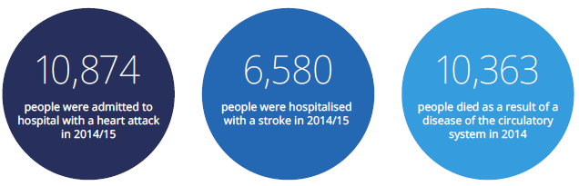

The underlying causes of cardiovascular and cerebrovascular disease
Ischaemic heart disease is almost always a consequence of atherosclerosis. This is a build-up of cholesterol and other material in the walls of arteries. The build-up can cause insufficient oxygen supply to the heart muscle, called ischaemia. Lack of oxygen can cause discomfort in the chest, such as a tightness or squeezing known as angina. If a lack of blood supply persists for too long, then this can lead to death of some heart muscle, referred to as myocardial infarction (heart attack).

Atherosclerosis can also block access of blood to the brain, leading to ischaemic stroke. Other causes of ischaemic stroke include cardioembolic sources (blood clots forming in the heart and travelling to the brain where they block a vessel), where atrial fibrillation is the most common cause. Haemorrhagic stroke is caused by a burst blood vessel in the brain, with hypertension as the most important risk factor.

Preventing cardiovascular and cerebrovascular disease
Ischaemic heart disease accounted for 7.7 percent of all health loss in New Zealand in 2016 and cerebrovascular disease for 3.4 percent (IHME 2016). Between 2000 and 2016, the age-standardised rate of health loss due to ischaemic heart disease fell by 42.5 percent in relative terms and the rate due to cerebrovascular disease fell by 31.4 percent. Despite these improvements, cardiovascular and cerebrovascular disease remain among the leading causes of health loss and mortality in New Zealand.

Health loss from cardiovascular and cerebrovascular disease can be reduced through prevention. Being smokefree, maintaining healthy blood pressure and cholesterol levels, having a low-salt diet, limiting alcohol consumption, regular exercise and eating fresh produce are the best defence against cardiovascular and cerebrovascular disease.

CVD risk assessment and management for primary care
In February 2018 the Ministry of Health published the new consensus statement on CVD risk assessment and management for primary care (Ministry of Health 2018a). A CVD risk assessment estimates someone’s risk of having a cardiovascular event and helps identify strategies to improve their heart health. The intensity of recommended interventions should be proportional to the estimated CVD risk.

CVD risk assessment and management is based on new primary prevention CVD risk prediction equations from the New Zealand PREDICT study. New Zealand is one of the only countries internationally to have developed its own country-specific risk equations. Outcomes predicted are the combination of hospitalisations and deaths from ischaemic heart disease, stroke, and transient ischaemic attack, heart failure and peripheral vascular disease.

Ischaemic heart disease is a leading cause of death in New Zealand
Ischaemic heart disease, which is a major component of CVD, accounted for one in six deaths in 2015 (15.8%) (Ministry of Health 2018). In 2014/15 a total of 21,658 individuals were hospitalised in public hospitals with ischaemic heart disease (Ministry of Health 2017j), which is a rate of 480 per 100,000 population. Between 2005 and 2015, both deaths and hospitalisations related to ischaemic heart disease have fallen significantly.

Once people have had an ischaemic heart disease event, they are at increased risk of another one. A study examining ischaemic heart disease events between 2005 and 2013 in New Zealand found that by 2013 recurrent events accounted for approximately half of all ischaemic heart disease hospitalisations. A fatal outcome is more likely with recurrent events than with the first one (Grey et al 2016). In 2015 ischaemic heart disease mortality rates for males and females with prior events were 6 and 12 times higher, respectively, than for males and females without a history of ischaemic heart disease (Grey et al 2018).

Fewer people are dying from strokes; however, the number of Māori and Pacific peoples having strokes has increased
In the 2016/17 New Zealand Health Survey, about 57,000 adults (1.5%) reported that they had experienced a stroke at some stage in their lives. By the age of 75 years, 8 percent of adults had experienced a stroke at some point in their lives. As the information from the New Zealand Health Survey is self-reported, it can only provide an estimate of the stroke prevalence in New Zealand.

Population-based data from the four Auckland Regional Community Stroke Studies (ARCOS I-IV) found that stroke incidence (number of strokes in a year) decreased by 23 percent between 1981 and 2012. Over the same period, one-year mortality (number of deaths occurring within one year of a stroke) decreased by 62 percent (Feigin et al 2015).

The stroke mortality rates decreased across all ethnicities (Feigin et al 2015). However, stroke incidence rates increased for Māori and Pacific peoples (New Zealand European changed from an age-standardised 153 per 100,000 people per year in 1981 to 122 in 2012, Māori from 134 to 156, Pacific from 147 to 197). Inequities also exist in the age at which people are having strokes. In 2012 the average age at stroke was 75.3 years for New Zealand Europeans, compared with 59.6 years for Māori and 61.6 years for Pacific peoples. For all groups, the average age of onset has increased since 1991–1992; the biggest increase was by 4.6 years for Māori (Feigin et al 2015).

After a stroke, many people recover well. However, some may be permanently disabled or die as a result of a stroke. Cerebrovascular deaths (mostly stroke) accounted for 7.8 percent of all deaths in 2015 (Ministry of Health 2018b). A follow-up study of the ARCOS study participants found that 84 percent of stroke survivors had cognitive impairment that indicated post-stroke dementia at four years after their stroke (Mahon et al 2017).

Musculoskeletal conditions affect the quality of life of thousands of New Zealanders
Musculoskeletal conditions are a group of disorders affecting the bones, muscles, tendons, soft tissue and joints. They include osteoarthritis, rheumatoid arthritis, osteoporosis and neck and back pain. They are a leading cause of health loss in New Zealand and have a significant impact on quality of life. According to the Global Burden of Disease Study, musculoskeletal disorders as a group caused 12.9 percent of health loss in New Zealand in 2016. Among these disorders, the largest contributor to this health loss was low back and neck pain (IHME 2016).

Arthritis is a leading musculoskeletal condition
As part of the 2016/17 New Zealand Health Survey, 16.9 percent of adults self-reported that they had arthritis. The most common form of arthritis reported was osteoarthritis (10.1%), followed by gout (2.9%) and rheumatoid arthritis (2.8%). Osteoarthritis and rheumatoid arthritis were more prevalent in women, while gout was more often reported by men. Those living in the most socioeconomically deprived areas also more often reported both osteoarthritis and rheumatoid arthritis than those living in the least deprived areas.

The prevalence of arthritis, particularly osteoarthritis, increases with age. While only 3.0 percent of those aged 35–44 years had osteoarthritis in 2016/17, the proportion increases to 36.0 percent of adults aged 75 years and over (NZHS 2016/17). One in two (50.6%) individuals self-reported that they had some sort of arthritis at the age of 75 years and over (NZHS 2016/17). Given that the number of people over the age of 65 years is expected to double in the next 20 years, the number of people affected by musculoskeletal disorders (and the associated disability, along with the impact on quality of life and system costs) is expected to increase.

More people are accessing hip replacement surgery
Arthritis can cause severe joint damage, which may require joint replacement surgery (or arthroplasties). Hip replacement surgery may also be required following a hip fracture. In 2016 a total of 8,785 primary hip arthroplasties were registered on the New Zealand Joint Registry (up from 8,373 in 2015), along with 7,765 knee arthroplasties (up from 7,268 in 2015) (New Zealand Orthopaedic Association 2017). Improving access to elective surgery (such as hip and knee replacements) is a national health target. The target of increasing the volume of elective surgeries by an average of 4,000 discharges per year was surpassed at a national level in 2016/17, with 6.1 percent more surgeries completed than planned (Ministry of Health 2017e).

Consequences of musculoskeletal issues
The consequences of musculoskeletal issues are wide ranging, often limiting individuals’ ability to participate in activities that are important to them. For older populations, musculoskeletal conditions are also associated with more falls and fractures. Ministry of Social Development data indicates that 7.5 percent of all jobseeker support payments were provided for musculoskeletal disorders in 2016/17 (including payments for those with a health condition or disability that affects the ability to work). In addition, over this same period musculoskeletal disorders were responsible for 9.4 percent of all supported living payments (assistance for people who have, or are caring for someone with a health condition, injury or disability) (Ministry of Social Development 2017b).

One in five adults report experiencing chronic pain
Musculoskeletal conditions may lead to chronic pain, defined in the New Zealand Health Survey as pain that is present almost every day and has lasted (or is expected to last) over six months. Other types of chronic pain include abdominal/pelvic pain, headaches and neuropathic pain. Chronic pain can decrease quality of life and mobility, which can contribute to increased risk of developing other conditions such as cardiovascular disease and diabetes.

In the 2016/17 New Zealand Health Survey, one in five (20.2%) New Zealanders reported that they experienced chronic pain, up from 17.0 percent in 2006/07. That is an estimated 772,000 adults who experienced pain almost every day. Those living in the most socioeconomically deprived areas were 1.7 times more likely to report chronic pain than those living in the least deprived areas, and Māori adults were 1.4 times more likely to report chronic pain than non-Māori adults. Chronic pain also increased with age. Among those aged 25–34 years, 12.4 percent reported experiencing chronic pain, as did one in three (34.7%) of those aged 75 years and over.

Improving outcomes for people with musculoskeletal conditions
A lack of physical activity and obesity are important contributors to the risk of developing musculoskeletal disorders, alongside environmental and metabolic factors. Reviewing joint replacements registered between 2010 and 2016, the New Zealand Joint Registry found that the average BMI for patients getting a primary hip replacement was 29.1 and for knee replacements it was 31.2 (someone with a BMI over 30 is considered obese). This means any interventions that decrease the rate of obesity in New Zealand will likely have positive effects on musculoskeletal health.

For some musculoskeletal conditions, such as osteoarthritis, evidence shows that pain can be relieved, disability reduced and the need for surgery postponed or avoided with appropriate multidisciplinary care, which includes education, lifestyle modification, exercise and weight loss. In recognition of this potential, the Ministry of Health is working with DHBs and others to implement the Mobility Action Programme (MAP). The aim of the MAP is for people with musculoskeletal health conditions to fulfil their health potential and become more independent. The aim will be achieved through improved access to high-quality advice, assessment, diagnosis and treatment, including education and rehabilitation.

To find out more about the Mobility Action Programme, go to: www.health.govt.nz/our-work/preventative-health-wellness/mobility-action-programme

Mental health
Good mental health is fundamental to the wellbeing of individuals, their whānau and the population as a whole. Just as we experience challenges with our physical health, many people will struggle or have a challenge with their mental health at some or many stages in life. Different factors interact to influence mental health and wellbeing, such as our history, experiences, cultural background, genetics and social determinant. | Mental health is ‘a state of wellbeing in which every individual realises his or her own potential, can cope with the normal stresses of life, can work productively, and is able to make a contribution to her or his community.’  (WHO 2014)

Mental health is also strongly linked to alcohol and other drug problems, which are more common among people with serious mental illness. The Global Burden of Disease Study indicates that mental health and substance use disorders were among the five leading contributors to health loss in New Zealand (IHME 2016). It is estimated that mental health and substance use accounted for 12.0 percent of health loss in 2016 (IHME 2016).

Around 300,000 New Zealanders reported experiencing psychological distress
An estimated 290,000 adults (7.6%) reported experiencing psychological distress (based on the Kessler Psychological Distress Scale – K10) in the four weeks before taking part in the 2016/17 New Zealand Health Survey. Specifically, 6.4 percent of males and 8.7 percent of females reported psychological distress. The rates were higher for young adults than for older adults. Of adults aged 15–24 years, 11.8 percent reported experiencing psychological distress, compared with 4.3 percent of adults aged 75 years and over.

Rates of psychological distress were higher for Māori and Pacific adults, in particular females (14.2% of Māori women and 17.2% of Pacific women). Adults living in the most socioeconomically deprived areas also reported higher rates of psychological distress (11.5%) than those living in the least deprived areas (4.8%).

One in five people report experiencing a mood or anxiety disorder at some point in their lives
While psychological distress can be temporary and relatively mild, a proportion of the New Zealand population experiences symptoms that last longer and are severe enough to meet the diagnostic criteria for a mental health condition. The most commonly diagnosed disorders include anxiety and depression. The New Zealand Health Survey identifies someone as having had a mood and/or anxiety disorder when a doctor has told the person that they have depression, bipolar and/or anxiety disorder at some point in their lives.

In the 2016/17 New Zealand Health Survey, one in five New Zealand adults (19.9% or an estimated 764,000 adults) indicated that they had a mood and/or anxiety disorder at some point in their lives. Rates were higher for females compared with males and for people living in the most socioeconomically deprived areas compared with those in the least deprived areas. Rates for Māori and non-Māori adults were comparable, while Pacific and Asian adults had lower rates than non-Pacific and non-Asian adults respectively (NZHS 2016/17). The actual rates of mood and/or anxiety disorder may be higher than those found by the New Zealand Health Survey, as some people may not have been diagnosed.

Mental and physical health are strongly linked
People living with a serious mental health condition are at a greater risk of many chronic physical health conditions, and in particular cardiovascular disease. They are at higher risk because they tend to be more exposed to known risk factors, including: low socioeconomic status; high rates of smoking, alcohol and other drug use; reduced physical activity; poor nutrition; the side effects of psychotropic medication as well as polypharmacy, comorbidities; and reduced access to physical health care (including stigma) (Te Pou o te Whakaaro Nui 2017).

New Zealanders who experience mental illness and/or addiction have more than twice the mortality rate of the general population. This is reflected in a gap in life expectancy between those who live with a mental illness and the general population (Royal Australian and New Zealand College of Psychiatrists 2016). Reducing disparities in physical health status and life expectancy between people with mental health conditions and addiction and those without is the focus of the Equally Well collaborative led by Te Pou o te Whakaaro Nui.

Higher rates of physical health conditions
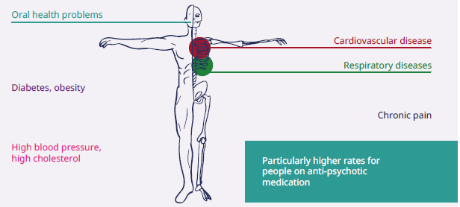
SOURCE: Oakley Browne et al, 2006 Wheeler et al, 2013

New Zealand’s high rates of suicide impact the lives of individuals, whānau and communities
Suicide affects the lives of many beyond the individual who dies – whānau, friends, colleagues and communities. Suicide has no single cause; it is usually the result of interactions between many different factors that impact different people in different ways. In 2015, a total of 525 people died by suicide in New Zealand (Ministry of Health 2018b). With an age-standardised rate of 12.5 deaths per 100,000 population in 2012, New Zealand had a suicide rate above the OECD average of 12.1 per 100,000 (OECD 2017).

Some groups within our population have disproportionately high rates of suicide compared with others. For instance, almost three in four (73.0%) people who died by suicide in 2015 were male (Ministry of Health 2018b). Age-standardised rates were higher for Māori males and females (25.3 and 11.5 per 100,000 respectively) compared with non-Māori males and females (14.7 and 4.6 per 100,000 respectively).

Around 10,000 people were hospitalised for self-injury
Although suicide deaths are more prevalent among males, females are over-represented in hospitalisations for intentional self-harm. In 2017 New Zealand had 9,853 hospitalisations involving self-harm. Almost half of these hospitalisations (4,643) happened in those aged 10–24 years. Self-harm hospitalisations were most prevalent among those aged 15–19 years, with a rate of 123.0 per 10,000 females and 32.3 per 10,000 males in 2017. Hospitalisations for self-harm were more common among Māori than other ethnic groups, and among those living in the most socioeconomically deprived areas than those in the least deprived areas (Nationwide Service Framework Library 2018).

Improving mental health services and outcomes
The health sector is working to improve mental health and wellbeing. This includes raising awareness of mental health, improve mental health services and working together with others to prevent suicide. Initiatives such as the Youth Mental Health Project and Like Minds, Like Mine programme are working to counter stigma and discrimination associated with mental health. A new national mental and addictions helpline, 1737, was launched during 2017 to further improve access for those seeking help.

The uptake of community and specialist mental health services has been increasing. In 2016 a record number of people accessed specialist mental health and addiction services. This increase is consistent with international trends, and has occurred in the context of population growth, growing social awareness and increasingly open discussion of mental health issues.

Work is also under way to lift the quality of services, including the Mental Health and Addiction Quality Improvement Programme led by the Health Quality and Safety Commission, and a planned review of the Mental Health (Compulsory Assessment and Treatment) Act 1992.

For more information on service use, see the Mental Health Commissioner’s monitoring and advocacy report (2018) and the Office of the Director of Mental Health Annual Report 2016 (Ministry of Health 2017i).

Mental health and addictions helpline launched in 2017
In 2017 a new national helpline, 1737, was launched for anyone who wants to talk to a mental health professional. The 1737 helpline is free to text or call 24 hours a day, 7 days a week. It was created to be an easy to remember number that is not tied to a specific mental health issue or condition. It is part of the National Telehealth Service.

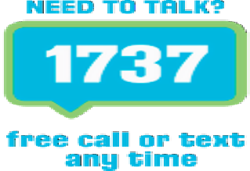
Since its launch in June 2017 until March 2018, more than 11,480 people used 1737. Over this period there have been approximately 24,350 contacts, with 54 percent of contacts made via text message and 46 percent via calling.

The main reasons for making contact are: wanting to talk, relationship problems, feeling lonely and physical health issues. People of all ages have been using the service, with age groups ranging from 6–12 years to 65–74 years, although the most common age groups to use the service have been 13–19 years and 20–24 years.

Government Inquiry into Mental Health and Addiction
The Government announced an independent inquiry into Mental Health and Addiction (the Inquiry) on 23 January 2018, as part of its 100-Day Plan.

The purpose of the Inquiry is to:
- hear the voices of the community on New Zealand’s current approach to mental health and addiction, and what needs to change – it will involve people with lived experience of mental health and addiction problems, people affected by suicide and people involved in preventing and responding to mental health and addiction problems
- report on how New Zealand is preventing mental health and addiction problems and responding to the needs of people experiencing those problems
- recommend specific changes to improve New Zealand’s approach to mental health, with a particular focus on equity of access, community confidence in the mental health system and better outcomes, particularly for Māori and other groups with disproportionately poorer outcomes.

The Department of Internal Affairs is responsible for administering the Inquiry to ensure it is independent, impartial and fair. The Ministry of Health’s role in the Inquiry will be to respond to requests made by the Inquiry panel. The recommendations of the Inquiry will help inform the Government’s decisions on future arrangements for the mental health and addiction system. The Inquiry has been tasked with reporting to the Minister of Health by 31 October 2018.

For more information on the Inquiry, go to:
www.dia.govt.nz/Government-Inquiry-into-Mental-Health-and-Addiction

New Zealand has high admission rates for respiratory-related conditions
Chronic respiratory conditions are responsible for a large share of New Zealand’s total disease burden. Collectively they accounted for 5.2 percent of total health loss in 2016. After adjusting for changes in the age-structure of the population, the rate of health loss from chronic respiratory conditions has declined by 29 percent since 1990. Chronic obstructive pulmonary disease (COPD, 2.8% of all health loss) and asthma (2.1% of all health loss) are the respiratory conditions that contribute the most to health loss, as discussed below (IHME 2016). Of all the OECD countries, New Zealand had the fifth-highest rate of adult hospital admissions for asthma and COPD combined in 2015 (OECD 2017).

Smoking causes most COPD cases
COPD is an umbrella term for progressive lung diseases including emphysema and chronic bronchitis. In people with COPD, the airways are permanently obstructed and the tissue inside the lungs is damaged, making it hard to breathe. The most important risk factor for COPD is smoking. COPD can be managed, but is not curable and progresses over time. The majority of people diagnosed are over the age of 40 years. COPD is commonly associated with other long-term conditions, including cardiovascular disease, lung cancer, stroke, pneumonia and depression.

A recent publication estimated the prevalence of severe COPD by identifying people who had been hospitalised with COPD between 1988 and 2015 (Barnard and Zhang 2017). This method estimated that around 37,000 New Zealanders were living with COPD at the end of 2015, giving a prevalence of 0.8 percent for the total population. This estimate does not include those who have been able to manage their COPD effectively in the community and primary care. COPD is often undiagnosed. According to the Global Burden of Disease Study, COPD is the fifth leading contributor to health loss in New Zealand (IHME 2016).

COPD hospitalisations have remained stable over time, but deaths from COPD have declined
COPD was the fifth-largest contributor to ambulatory sensitive hospitalisations in adults aged 45–64 years in the 12 months up to March 2017. Rates were 5.2 times higher for Māori compared with non-Māori and 2.3 times higher for Pacific compared with non-Pacific peoples (Nationwide Service Framework Library 2018).

COPD hospitalisation rates rise markedly with greater socioeconomic deprivation. In 2015 the rates for those aged 40 years and over were 5.7 times higher in the most deprived areas than in the least deprived areas. The same pattern is evident within each ethnic group (Figure 30). The COPD mortality rate also varied by level of socioeconomic deprivation. In 2013 the age-standardised mortality rate for those aged 40 years and over was 2.4 times higher for those living in the most socioeconomically deprived areas compared with those living in the least deprived areas (Barnard and Zhang 2017).

Figure 30: Age-standardised COPD hospitalisations in adults aged 40 years and over by ethnicity and socioeconomic deprivation quintile, 2015
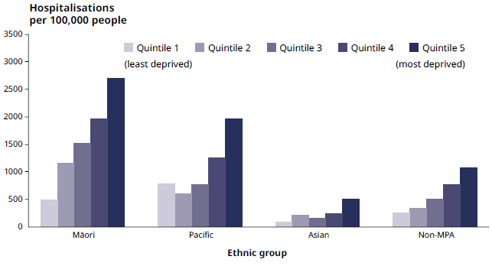
Note: NZDep = New Zealand Deprivation Index; Non-MPA = Non-Māori, Non-Pacific, Non-Asian

Hospitalisation rates for COPD in adults aged 40 years and over have remained stable over the period 2000–2015. However, mortality rates due to COPD have declined from an age-standardised 111.9 deaths per 100,000 in 2000 to 83.5 deaths per 100,000 in 2013 (Barnard and Zhang 2017). Despite these declines, COPD is the third-leading cause of death in New Zealand (IHME 2016).

One in seven children is taking medication to treat asthma
Asthma rates among New Zealand children were last measured as part of the International Study of Asthma and Allergies in Children (ISAAC) in 2001–2003. However, the New Zealand Health Survey provides current estimates for medicated asthma based on self-report. In 2016/17, the New Zealand Health Survey reports that around one in seven children aged 2–14 years (14.3%) had been told by a doctor that they have asthma and are currently taking medication to treat it. In the child population, boys (17.2%) were more likely to be taking medication for asthma than girls (11.3%) in 2016/17. For adults, on the other hand, females (14.0%) were more likely than males (9.9%) to report having medicated asthma (overall adult rate 12.0%).

Many factors, including genetic and environmental factors, are known to contribute to the development of asthma. Once asthma has developed, asthma symptoms can increase because people are exposed to various ‘triggers’ such as viral infections, indoor dampness and mould, second-hand smoke, exercise and/or allergens. For the majority of individuals, asthma can be controlled most of the time by using the right medication and avoiding triggers.

Māori children and children living in the most deprived areas are more likely to have medicated asthma
With a prevalence of 17.8 percent, as reported by parents, Māori children were 1.4 times more likely to have medicated asthma compared with non-Māori children; Māori adults were likewise 1.5 times more likely to have the condition than non-Māori adults, according to their self-reports (NZHS 2016/17). Rates were comparable for Pacific and non-Pacific children and adults.  Children living in the most socioeconomically deprived areas were 1.6 times more likely to have asthma than those living in the least deprived areas (17.0% and 11.7% respectively). For adults, rates did not vary by neighbourhood deprivation. | A recent study of 36 primary care practices in Wellington found that respiratory conditions were responsible for 46 percent of all child consultations with their general practitioner between 2008 and 2013.  (Dowell et al 2017)

Pacific preschoolers have high rates of asthma-related hospitalisations
If asthma is not well controlled, it can result in hospitalisation. Rates of hospitalisation for asthma and wheeze are highest in the age group of 0–4 years. The rates are particularly notable for Pacific and Māori children in this age group (Figure 31): for Pacific children, asthma and wheeze was the greatest cause of ambulatory sensitive hospitalisations and for Māori children, it was in the top five causes in the year up to September 2017.

Figure 31: Hospitalisation rates for asthma and wheeze per 1,000 children aged
0–19 years, by ethnicity, 2014/15
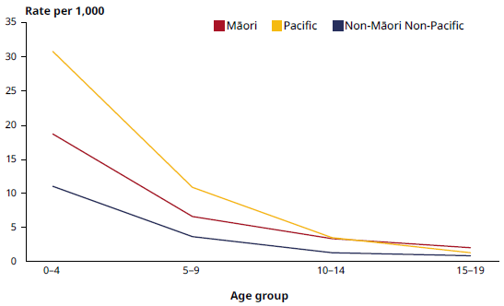
SOURCE: Ministry of Health, National Minimum Dataset 2014/15

Not everyone’s asthma is being well managed in the community
Although the rates of hospitalisations for asthma and wheeze are highest in early childhood, differences between ethnic groups in the rate of hospitalisations for asthma and wheeze are greatest at older ages (Figure 32): Māori adults aged 40–49 years were 3.8 times more likely than non-Māori, non-Pacific adults in this age group to be hospitalised for asthma in 2014/15. Such hospitalisation was 4.1 times more likely for Pacific adults aged 40–49 years compared with non-Māori, non-Pacific adults in the same age group.

The above comparisons do not take into account the differences in prevalence of asthma in the different groups (Māori adults have higher rates of asthma, but rates are comparable for Pacific and non-Pacific adults). Nonetheless, they do indicate that there are inequities in how well asthma is managed in the community.

Figure 32: Differences in asthma and wheeze hospitalisation rates for Māori and Pacific age groups compared with non-Māori, non-Pacific age groups from
0–49 years, 2014/15
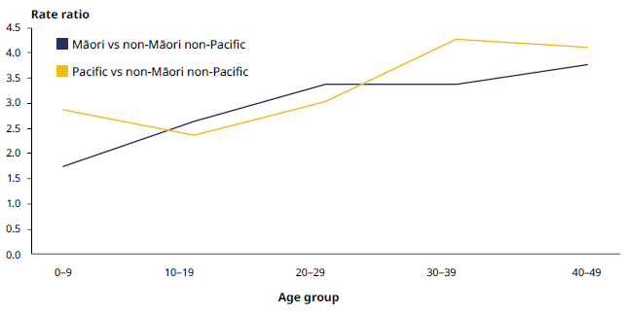
SOURCE: Ministry of Health, National Minimum Dataset 2014/15
NOTE: Data is not presented for people aged 50 years and over because they are increasingly likely to be diagnosed with COPD, making an asthma diagnosis less accurate.

NOTE: How to read this graph
Here, rate ratios indicate how much more likely one group is than another to be hospitalised for asthma. A rate ratio above 1 indicates the group of interest (eg, Māori) is more likely than the reference group (eg, non-Māori, non-Pacific) to be hospitalised.
For example, the graph shows that Māori adults aged 40–49 years were almost four times more likely than non-Māori, non-Pacific adults of the same age to be hospitalised with asthma.

Improving asthma outcomes
In 2015 the Asthma and Respiratory Foundation published Te Hā Ora (The Breath of Life): National Respiratory Strategy. This strategy aims to help reduce the incidence of respiratory disease and its impact, as well as to help eliminate inequalities in respiratory health in New Zealand. It includes a focus on the wider environment, with work to eliminate poverty, improve access to good-quality housing and accelerate efforts towards Smokefree 2025. Other objectives are aimed at individuals and whānau (eg, health literacy), the health community (eg, improve diagnosis and treatment) and the health and disability system (eg, improve access to primary care).

My Asthma app
One example of an initiative to improve care for asthma is the ‘My Asthma app’, launched in May 2017. The app features customisable Asthma Action Plans for both children and adults to complete with a health professional. If a user experiences worsening asthma symptoms, they can simply open the app to view their important medical information. The plans can be easily shared electronically with whānau, caregivers and sports coaches so these others are aware of what steps to take if asthma symptoms worsen. The app also has vital information on asthma first aid.

Around a quarter of a million New Zealanders are living with diabetes
Diabetes is a long-term condition characterised by high levels of glucose in the blood. The three main forms of diabetes are type 1, type 2 and gestational diabetes (which occurs during pregnancy).

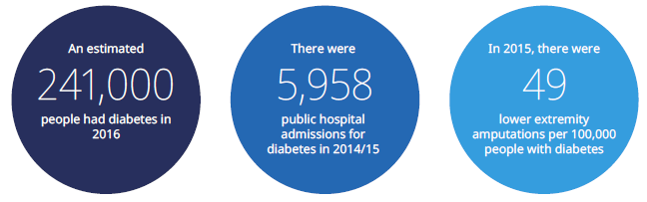

About diabetes
Type 1 diabetes is an auto-immune condition where the pancreas stops producing the hormone insulin. Generally, most people aged 0–24 years with diabetes have type 1 diabetes. Type 2 diabetes occurs because cells of the body do not respond properly to the insulin produced. It is associated with lifestyle-related risk factors such as poor diet, low physical activity, smoking and alcohol consumption. Being overweight or obese is a major risk factor for type 2 diabetes. At least 90 percent of people living with diabetes have type 2 diabetes.

The number of people living with diabetes varies by ethnicity
Diabetes affected approximately 7.3 percent of adults aged 20–79 years in New Zealand in 2015, which was just above the average prevalence across OECD countries (7.0%) (OECD 2017). As Figure 33 shows, the prevalence of diabetes increases with age and varies by ethnicity. Overall, 20 percent of Pacific adults live with diabetes, compared with 10 percent of Māori, 8 percent of Asian and 6 percent of European or Other adults. Rates of diabetes vary widely within the Asian ethnic grouping; notably, rates for people of Indian ethnicity are similar to those of Pacific peoples.

Figure 33: Estimated percentage of New Zealand’s adult population living with diabetes by ethnicity, average over 2013–2015
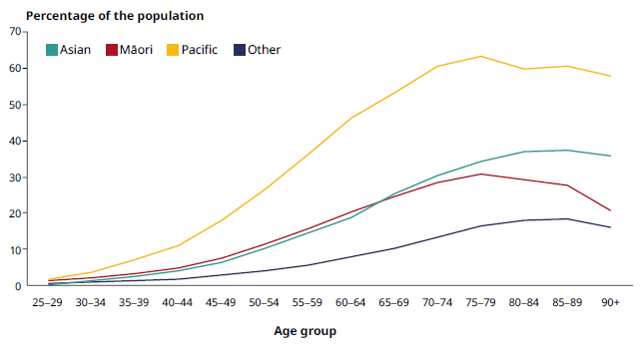
SOURCE: Ministry of Health, Virtual Diabetes Register

Diabetes contributes to premature death
Approximately 6–7 percent of all deaths in New Zealand were attributable to diabetes over the 2012–2015 period (Ministry of Health). This percentage represents around 2,000–2,200 deaths each year. On average, people with diabetes live four to five fewer years than people who are not diabetic. People living with diabetes are more likely to suffer from cardiovascular disease, blindness, foot and leg amputation, kidney failure, dementia, depression and anxiety, all of which can contribute to premature death. Diabetes is also considered an important risk factor for many cancers, such as liver, pancreatic, endometrial, colon, breast and bladder cancers.

Work is under way to prevent, detect early and improve the management of diabetes
Initiatives such as Green Prescriptions and Active Families aim to prevent type 2 diabetes through improving nutrition and weight management. Although diabetes has no cure, it can be managed through routine monitoring, medication, diet and good self-care, including regular exercise. Several activities outlined in the Living Well with Diabetes plan for 2015–2020 (Ministry of Health 2015b) are already under way and more are under development. For example, Quality Standards for Diabetes Care have now been introduced, outlining the services all people with diabetes should expect to receive as part of high-quality care.

Telehealth is supporting children with type 1 diabetes
Delivering health services using telehealth can reduce the barriers of time and distance for rural and urban patients needing specialist consultations and mental health advice and support. Increasingly health providers are using telehealth consultations to reduce travel budgets, improve patient outcomes for long-term conditions and lower hospital admissions.

For example, a paediatric endocrinologist in Southern DHB runs a paediatric diabetes telemedicine clinic. This endocrinologist, as one of only two paediatric endocrinologists in the South Island, provides paediatric diabetes services to about 100 children and young people with type 1 diabetes in the Otago area. For the central Otago children under his care, long car journeys to Dunedin every three months have been replaced by a half-hour video conference with the specialist in the clinic at Dunstan Hospital.

More New Zealanders are living with life-limiting conditions
This section has highlighted a large proportion of New Zealanders are living with a range of long-term conditions and often with multiple long-term conditions (multimorbidity). As well as work to prevent and effectively manage these conditions, it is important to give people access to high-quality care at the end of life.

Providing people with choices on how they manage their life-limiting conditions is an increasingly important focus as our population ages. This includes advance care planning, which enables people to form a care plan along with their whānau and health professionals involved with their care. To support improved end-of-life care, recent investment is increasing the capacity of community palliative care services, including hospices. This means people can be supported to remain in their homes and community for as long as possible.

As part of the Government’s 100-Day Plan, work is under way to improve access to medicinal cannabis for people who are terminally ill by amending the Misuse of Drugs Act 1975. The Misuse of Drugs (Medicinal Cannabis) Amendment Bill aims to improve access to affordable, high-quality medicinal cannabis products. The Bill, a key element in establishing a Medicinal Cannabis Scheme, makes three key amendments to the Misuse of Drugs Act by:
- providing an exception and statutory defence for those who are terminally ill (less than 12 months to live), allowing them to possess and use illicit cannabis
- allowing quality standards to be set for all medicinal cannabis products (both domestically produced and imported)
- descheduling cannabidiol (a substance found in cannabis, with potential therapeutic benefits and minimal or no psychoactive properties) as a controlled drug, making it a prescription medication. This means it will no longer require Ministry of Health approval to prescribe.

Healthy ageing
In 1970 the median age of New Zealanders was 25.6 years; in 2016 it was 37.1 years and by early 2030 the median age is projected to be 40 years (Statistics New Zealand 2016). Currently older people (aged 65 years and over) make up 12 percent of the New Zealand population, but it is estimated that by 2050, 38 percent of the population will be aged 65 years and over (Statistics New Zealand 2016). The leading causes of health loss among older adults are cardiovascular disease, dementia, COPD and lung cancer (IHME 2016). The contribution of dementia to health loss is rising rapidly.

Older adults rate their health better than the OECD average
Eighty-six percent of adults aged 65 years and over reported themselves to be in good, very good or excellent health in 2015. This percentage is considerably higher than the OECD average of 44 percent and is the highest out of the 34 OECD countries (OECD 2017).

Care needs are expected to increase in the next decade  The LiLACS study (see box) found that 17 percent of Māori (aged 80–90 years) and 15 percent of non-Māori (aged 85 years) required assistance with personal care and household tasks at least daily and over half of both groups required help at least weekly. Despite having similar care needs, Māori were less likely to access housework assistance than non-Māori. Because the older population is growing, particularly among Māori, it is estimated that the need for care will increase substantially; the number of those needing care more than daily may increase by more than 200 percent for Māori and by about 75 percent for non-Māori by 2026.  Older Pacific peoples are the least likely to be lonely  Loneliness in old age is associated with negative health status and poorer wellbeing. Using interRAI data for older adults (65 years and over) living at home, researchers found that over one in five (21%) felt lonely. Those living alone were more likely to feel lonely than those living with others. Living arrangements and levels of loneliness differed by ethnicity. Around half of European or Other lived alone, compared with 38 percent of Māori, 18 percent of Asian and 16 percent of Pacific peoples. Pacific peoples were the least likely to report being lonely, at 17 percent, compared with 23 percent of Asian people (Jamieson 2017). | Research to improve the health and wellbeing of older New Zealanders  LiLACS study  Life and Living in Advanced Age, a Cohort Study in New Zealand (LiLACS) is a longitudinal study started in 2010 at the University of Auckland. It aims to determine the predictors of healthy ageing in New Zealand to better understand how to support older New Zealanders. The study follows Māori aged 80–90 years and non-Māori aged 85 years within the Bay of Plenty and Lakes DHB areas.  interRAI  The International Residential Assessment Instrument (interRAI) is a comprehensive clinical assessment tool, used for assessing all aspects of an older person’s life: living circumstances, social support, cognition, and physical and mental health. The interRAI assessment is now used nationwide for all older people being considered for publicly funded community services or residential care. As such, it provides a unique and valuable source of data on older New Zealanders. In 2016/17 over 120,000 interRAI assessments were completed.

With an ageing population, dementia is a growing health concern
Dementia is a degenerative brain condition that changes a person’s thinking abilities. It is associated with a decline in a person’s ability to complete everyday tasks, emotional distress and/or behaviour changes. Among the many different types of dementia, Alzheimer’s disease is the most common (affecting two-thirds of people with dementia), followed by vascular and then Lewy Body dementias. The prevalence of dementia increases with age, but it can affect younger people as well.

It is estimated that in 2016 around 62,000 people in New Zealand had dementia. This number is expected to almost treble to around 170,000 people by 2050 (Alzheimer’s New Zealand 2017). Alzheimer’s disease and other dementias accounted for 7.8 percent of health loss for adults aged 70 years and over in 2016 (IHME 2016).

Dementia was present in 16 percent of LiLACS participants in the first wave of the study, with no significant differences in prevalence between Māori and non-Māori. Dementia was associated with lower quality of life related to physical and mental health, lower functional status, increased frailty and higher health care use and cost.

As well as impacting on the life of the individual, dementia has an impact on the life of whānau, friends and the wider community. According to data from the interRAI home care assessments, 55 percent of people caring for someone with dementia report feeling overwhelmed by the person’s support needs (interRAI 2017).

Falls are a leading cause of injuries for older people
Each year approximately one in three New Zealanders aged 65 years and over who live in the community will have a fall, with the vast majority of falls happening in or around the home. While over 95 percent of falls occur in the community, other care settings, such as hospitals and residential care facilities, also present risks for falls. Falls account for nearly 75 percent of hospital trauma admissions for older people (HQSC 2017).

Falls can have serious short- and longer-term consequences such as trauma, head injury, loss of mobility and independence, loss of confidence and increased risk of future falls. ACC data shows the rate of claims for injuries as a result of a fall increases with age. The rate for people aged 85 years and over (355.8 claims per 1,000 individuals in 2017) is almost double that of those aged 50–64 years (144.0 claims per 1,000). Females have higher rates of falls resulting in an ACC claim than males and are more likely to have a fracture as a result of a fall (Figure 34).

The number of falls resulting in a fracture also increases with age. For females, between 10.4 percent (50–64 years) and 18.5 percent (85 years and over) of falls claims involved a fracture, while for males the range was between 8.3 percent (50–64 years) and 12.6 percent (85 years and over) (ACC 2017).

Figure 34: ACC claims for a fracture as a result of a fall by sex, rate per 1,000 population, 2017
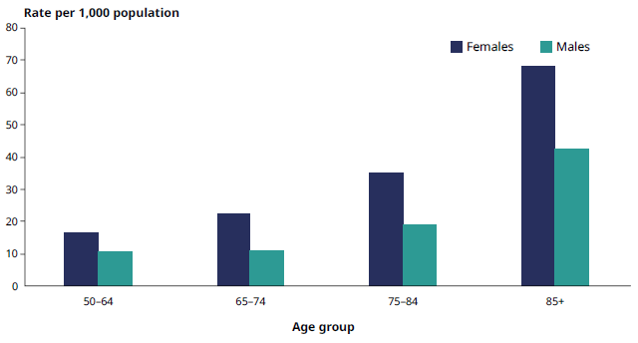
SOURCE: ACC (2018)

Having a hip fracture is a serious injury. It is estimated that around 27 percent of older people with a hip fracture will die within a year of getting the injury, 10–20 percent will be admitted to residential care and 50 percent will need ongoing support with their daily living activities (HQSC 2017). As well as impacting the individual, hip fractures often increase the care and support role that spouses and whānau have to provide.

Collaborative work is under way to reduce falls and their impact
Strong evidence shows that falls among older people can be prevented. Since 2013 HQSC has been leading a programme of work to reduce falls in hospital settings, and working with ACC and DHBs to better coordinate the management of care for people who have had a hip fracture. As a result, the rate of patients falling and breaking their hip in hospital has reduced. Since June 2013, there have been 110 fewer falls resulting in a broken hip, saving an estimated $5.2 million. These achievements are world leading and a first to be achieved on a national scale.  Work is also under way to prevent falls in the home and in community. HQSC, ACC and the Ministry of Health are partnering to deliver the Live Stronger for Longer programme to prevent falls and fractures. Together the partner agencies are | Community-based and in-home strength and balance programmes are being rolled-out around the country during 2017 and 2018. Exercise providers that meet nationally agreed standards can use a ‘tick’ logo, to help older people identify approved providers.
providing collective leadership as well as information, resources and funding for services to prevent falls and reduce their impact. Through the programme, DHBs, exercise providers, carers and health professionals throughout the country have joined forces to better support older people to stay independent and injury-free.

These actions form part of the implementation of the Healthy Ageing Strategy. They relate to other activities focused on building physical resilience and improving care for older people with acute care needs.

Older people are more likely to be taking multiple medications
As people are living longer, they are also living longer with multiple long-term conditions (multimorbidity). Multimorbidity is often associated with polypharmacy – when one person uses multiple medications at one time.  Polypharmacy may be beneficial (‘appropriate polypharmacy’) and may prolong or improve life if the risks and benefits of multiple medications are adequately managed. However, polypharmacy may also be harmful (‘problematic polypharmacy’), where a person has adverse medication reactions, is less likely to follow the requirements for therapies and has a lower quality of life. | About 35% of people aged 65 years and over received five or more long-term medications in 2016.  (HQSC 2018)

Polypharmacy increases greatly with age: 25 percent of those aged 65–74 years receive five or more medications, compared with over half (59%) of those aged 85 years and over (HQSC 2018). Polypharmacy also varies by ethnicity, with Māori and Pacific peoples receiving more medications at a younger age than Asian and European or Other ethnic groups.

For an interactive map of polypharmacy in older people by DHB, go to the Health Quality & Safety Commission website: www.hqsc.govt.nz/assets/Health-Quality-Evaluation/Atlas/PolypharmacySFNov2017/atlas.html

Pharmacist medicine optimisation service
The Pharmacist Facilitation Team at Hawke’s Bay DHB is an example of a collaborative approach to improve issues with polypharmacy. Clinical pharmacists work with primary health care teams in general practice and local community pharmacy services to improve prescribing and medicine safety. The clinical pharmacists work in a number of different ways, including completing medicines reviews, medicine reconciliation and education. This collaborative, integrated approach has been associated with improved health outcomes, reduced medicines use and a decrease in medicine-related admissions to the emergency department. As well as being highly effective, it has been identified as a highly rewarding way of working for pharmacists and general practitioners. This initiative highlights the value of health care professionals working in an integrated way to make best use of every point of care.

Section 4:
Looking forward
Addressing challenges:
our strategic direction
The previous sections have outlined areas of progress as well as important population health challenges. This final section looks ahead: our population is forecast to grow, become more diverse and get older, all of which will increase the demand for health services. At the same time, we are experiencing rapid technological and medical advances, which have practical applications for addressing pressing health issues. These developments, coupled with changes in our physical environment and people’s expectations of what a modern health service can deliver, bring new opportunities and challenges.

Promoting good health and delivering care closer to home
As the population grows and ages, it is important to reorient the health and disability system towards prevention. This preventive focus includes supporting people to
live physically active and healthy lives. Primary health care, which is at the centre of our health system, has a vital role to play in this reoriented system by promoting good health, addressing health concerns early and supporting people living in the community with long-term conditions. Timely access to primary health care services is important for reducing health inequities, preventing the development of health conditions, avoiding hospitalisations and ensuring the system as whole works for optimal health and wellbeing.

A wide range of health professionals deliver primary health care in a variety of settings – such as primary health care centres, drop-in health clinics, health care homes, schools, pharmacies, mobile clinics, Youth One Stop Shops, marae, churches and hospices. By using a range of settings, health professionals can deliver care in ways that suit people’s needs and allow them to access care closer to their homes. Increasingly, models of care are developing that include co-locating a range of health services under one roof or through a network of providers as part of a person’s health care home.

School-based health services support the physical and mental health of young people
School settings provide an opportunity to meet the health needs of young people and to make timely referrals to improve their health and education outcomes. Around 55,000 students from decile 1–3 secondary schools have access to a nurse in school. Services are also provided with teen parent units and alternative education facilities. The nurses help students access relevant primary health services and provide youth development checks, as well as referring students who present with mental health problems.

General practice teams play a vital role in delivering primary health care. Most New Zealanders (94 percent) are enrolled in a primary health organisation (PHO) through their general practice (Figure 35). Benefits associated with belonging to a PHO can include cheaper doctor and nurse visits, lower costs of prescription medicines, and access to PHO services delivered in the community, which are tailored to meet local needs, for enrolled patients.

In 2017 around 17 million GP and nurse consultations were delivered in primary care. Figure 34 illustrates that the frequency of visits varied by sex and ethnicity.

Figure 35: Number of New Zealanders enrolled in a PHO and number of GP and nurse consultations, 2017
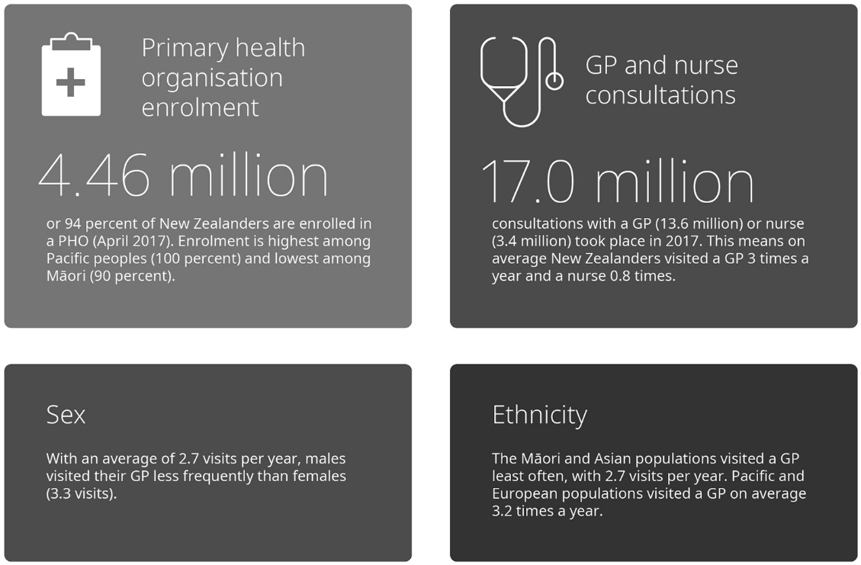
SOURCE: Ministry of Health (2017), based on PHO reporting

Figure 36 illustrates the number of GP and nurse consultations individuals in each age group made. With the exception of the youngest age group, the average annual number of visits increases as people get older (eg, 1.8 GP consultations for children aged 5–14 years compared with 5.6 GP consultations for those aged 65 years and over). An increase in the use of primary care services with age is consistent with the increase in health needs and prevalence of long-term conditions as people grow older.

Figure 36: Average number of GP and nurse consultations per person in one year by age group, 2017
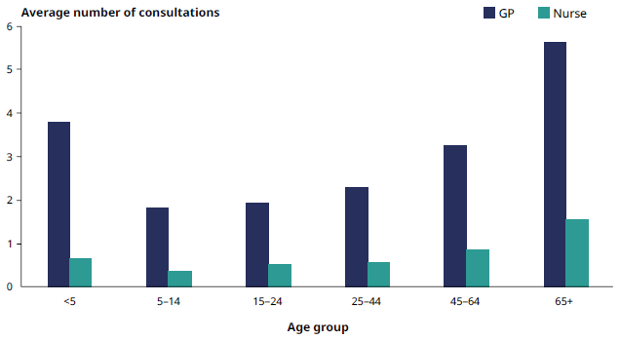
SOURCE: Ministry of Health (2017)

Some people have difficulty accessing primary care services
Some people have difficulty accessing health services because of cost, availability of appointments, and transport. Health literacy is another, often hidden, barrier to access that can prevent people from seeking help until their condition worsens and becomes more difficult to treat or manage. Table 5 presents examples of barriers to access reported through the 2016/17 New Zealand Health Survey.

Table 5: Examples of barriers to accessing primary health care services, 2016/17
Total unmet need for primary care for any reason | Cost barriers for GP services | Appointment not available at usual medical centre | Lack of transport to access GP services
Based on self-report (or parents’ reports on children), 28.1% of adults and 20.3% of children had an unmet need for primary health care in the past 12 months. | 14.3% of adults reported an unmet need for GP services due to cost in the past 12 months. For children this was 3.0%. | Based on self-report or parents’ reports, 18.4% of adults and 15.8% of children were unable to get an appointment at this usual medical centre within 24 hours at some time in the past 12 months. | Overall, based on self-report or parents’ reports, 3.2% of adults and 2.6% of children had an unmet need for GP services due to a lack of transport in the past 12 months.
Some groups are more affected than others
Adults aged 25–34 years reported the highest frequency of unmet need for any reason: 39.6% of females and 28.0% of males reported an unmet need in this group. | 11.0% of adults living in the areas of lowest socioeconomic deprivation reported an unmet need for a GP due to cost, compared with 19.9% of those living in areas of highest deprivation. | Māori women most frequently reported an unmet need because an appointment was not available (25.0%). | Māori and Pacific women (both 9.7%) and women living in the areas of highest deprivation (9.1%) most frequently reported an unmet need for a GP due to lack of transport.
SOURCE: NZHS 2016/17 (Ministry of Health 2017h)

Addressing barriers and improving access to primary care services is an important focus for the Government and Ministry of Health. This work includes implementing low fee initiatives such as the Very Low Cost Access (VLCA) scheme, reducing co-payments for doctors’ visits for community service card holders, and extending the zero fees scheme for GP visits to children under 14 years.

Technology is opening up ways to improve access and care

Patient portals make it easier to interact with the primary care team
Making it easy to access services, over the phone and online, can help people receive timely advice about their own health or the health of a loved one in their care. For example, patient portals give people convenient and secure electronic access to their health information and allow them to interact with their GP or practice nurse (Figure 37). This kind of access strengthens people’s ability to manage their own health.

Figure 37: Examples of services GPs and nurses can offer through a patient portal
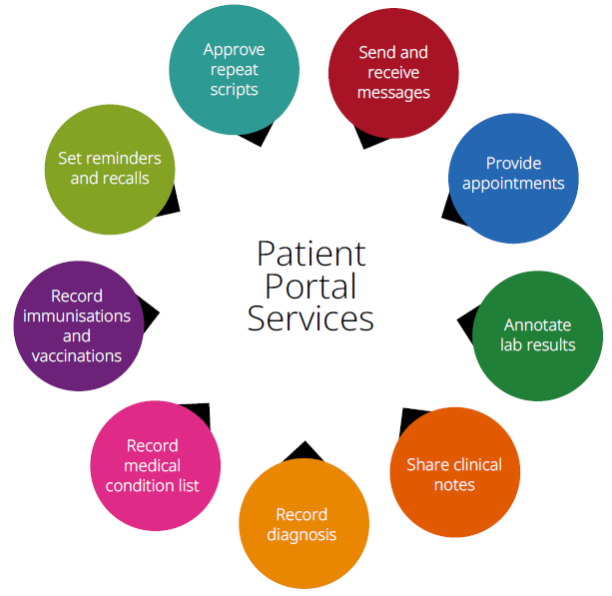
SOURCE: Royal New Zealand College of General Practitioners and the National Health IT Board (2015)

Use of patient portals continues to grow, with 472,894 patients registered to access a portal as at September 2017 (up from 37,000 patients in September 2014). At the same time, 509 practices have implemented the portal, compared with 96 practices in September 2014, which means that over half of general practices now use the portal.

Over half a million contacts were made to the National Telehealth Service in 2016/17
Increasingly, information and services are available through smartphone applications and other digital technologies. The National Telehealth Service (NTS) offers one example. An NTS team of over 300 registered nurses, psychologists, psychotherapists, counsellors and clinical experts supports New Zealanders 24 hours a day, seven days a week. Support provided includes physical health advice (eg, poisons advice), mental health advice (eg, depression and anxiety support) and addictions support (eg, stop smoking).

NTS provides an integrated platform for people to access support and counselling, at a time and with a level of anonymity that suits them. Channels available include phone, text, email, web chat and social media such as blogs and online forums, as well as online assessments and guides, website self-help and health information. People can also be referred to face-to-face services through NTS. During the 2016/17 year, there were over 570,000 contacts to the NTS.

Virtual reality has practical application in our health services
New technologies are helping health professionals to deliver information and care to patients in different ways. One example is the use of cross reality in care settings.

Cross reality is a term for the continuum of immersive technologies that blur the line between the physical and digital world, including virtual, augmented and mixed reality (Ministry of Business, Innovation and Employment 2017).

Emerging technologies such as augmented and virtual reality, artificial intelligence and the Internet of Things have important, practical application for our health and wellbeing. For example, using virtual reality patients will increasingly be able to better understand and prepare for procedures and also will gain a useful distraction when they are receiving treatment such as chemotherapy. Virtual and augmented reality can also be useful as learning aids for clinicians; for example, by creating immersive 3D environments it can help their training in providing radiation therapy (Boejen and Grau 2011).

Reducing patient anxiety with virtual reality – Auckland DHB
Auckland DHB is exploring the use of virtual reality technology to improve the experience of its young Starship Hospital patients. The project aims to improve the overall hospital experience for children, reduce the need for medication to manage anxiety and so help achieve better clinical outcomes. The project was developed with VR Staples with support from HP and Vodafone.

For more information, go to: www.adhb.health.nz/about-us/news-and-publications/ latest-stories/reducing-patient-anxiety-with-virtual-reality

A vision for digital health technology, developed in 2017
Digital Health 2020 guides the strategic digital investments across the health and disability sector over the five years from 2016–2020. During 2017 the Ministry of Health led the development of a vision for health technology in New Zealand as part of the wider Digital Health 2020 work programme. The vision was an inclusive process, involving engagement with health professionals and consumers and supported by online discussions. The resulting Vision for Health Technology consists of nine themes, which will help guide how we use technology to improve health for all New Zealanders.

A Digital Health Strategy for New Zealand will be developed to guide actions and make the Digital 2020 vision a reality. The vision will be refined and adapted over time in response to changing needs and emerging technologies, as well as feedback from stakeholders.

Improving health sector performance

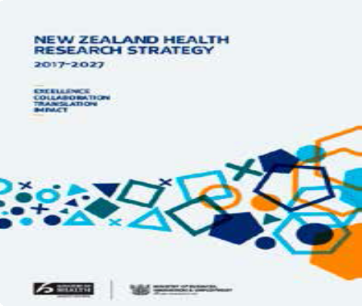
Using evidence to improve outcomes
In 2017 New Zealand’s first Health Research Strategy was launched. The New Zealand Health Research Strategy 2017–2027 (Ministry of Business, Innovation and Employment and Ministry of Health 2017) sets a vision that, by 2027, New Zealand will have a world-leading health research and innovation system.

The Strategy has four guiding principles: research excellence; transparency; partnership with Māori; and collaboration for impact. It encourages the science, academic and health sectors to collaborate and work with communities and individuals.

Health research can improve prevention, early detection and treatment of illness. For example, the Burden of Disease Epidemiology, Equity and Cost-Effectiveness Programme (BODE³) has created league tables specific to New Zealand. Using these tables, it is possible to compare different health-related interventions (eg, tobacco tax, reducing tobacco retail outlets) on their health gains, costs, cost-effectiveness and impact on improving equity.

For more information on BODE³ and the league tables, go to: www.otago.ac.nz/wellington/departments/publichealth/research/bode3/ index.html

Monitoring health sector performance
In 2017 New Zealand had six health targets that together spanned prevention, early intervention, improving quality of life and timely access to services. Targets are set nationally and provide outcome goals for DHBs in their communities. Results are reported quarterly at national and DHB levels. Table 6 presents the national performance across the health targets for the final quarter of 2016/17. The targets are reviewed annually to ensure they align with Government priorities for the health and disability system.

Table 6: Health targets and national level results, quarter 4, 2016/17
Health target | Measure | % target | 2016/17 quarter 4 results
Shorter stays in emergency departments | 95% of patients will be admitted, discharged, or transferred from an emergency department within six hours | 95% | 93%
Improved access to elective surgery | The volume of elective surgery will be increased by an average of 4,000 discharges per year. | 100% | 106%
Faster cancer treatment | 85% of patients receive their first cancer treatment (or other management) within 62 days of being referred with a high suspicion of cancer and a need to be seen within 2 weeks. | 85% | 81%
Increased immunisation | 95% of 8-months-olds will have their primary course of immunisation (6 weeks, 3 months and 5 months immunisation events) on time | 95% | 92%
Better help for smokers to quit | 90% of PHO-enrolled patients who smoke have been offered help to quit smoking by a health care practitioner in the last 15 months. | 90% | 89%
Raising healthy kids | 95% of obese children identified in the B4 School Check programme will be offered a referral to a health professional for clinical assessment and whānau-based nutrition, activity and lifestyle interventions. | 95% | 91%
SOURCE: Ministry of Health (2017e)

To achieve good outcomes, health system partners must work together. The System Level Measures Framework is designed to improve health outcomes for people by supporting the DHBs to work in collaboration with their local health system partners (primary, community and hospital) using a quality improvement methodology. With a whole-of-system focus, it provides a framework for continuous quality improvement and system integration. The measures were chosen in collaboration with health sector clinicians and managers to focus on children, youth and reducing equity gaps for Māori.

The system level measures are:
- A healthy start: Babies living in smokefree homes | - Keeping children out of hospital: Ambulatory Sensitive Hospitalisation (ASH) rates for 0–4 year olds | - Youth are healthy, safe and supported: Youth access to and utilisation of youth appropriate health services
- Person-centred care: Patient experience of care | - Prevention and early detection: Amenable mortality rates | - Using health resources effectively: Acute hospital bed days per capita
SOURCE: Nationwide Service Framework Library

There are equity gaps between Māori and non-Māori as well as Pacific and non-Pacific populations across all System Level Measures and for nearly all districts. The Ministry of Health provides data by ethnicity and deprivation so that regions can examine their data to better understand the health needs of their population. This work includes identifying patients and population groups that are underserved or are consistently experiencing poorer health outcomes and targeting activities and investment to provide equitable health care and improve health outcomes.

For more information about System Level Measures, including a number of district alliance improvement plans for 2016/17, go to: https://nsfl.health.govt.nz/dhb-planning-package/system-level-measures-framework/slm- improvement-plans

Working collaboratively to meet the health and support needs of New Zealanders
The health workforce has a critical role in ensuring all New Zealanders live well, stay well and get well. Every day health professionals deliver community and person-centred care in homes, communities, hospitals and residential care facilities. Part of providing this care is to work closely with other social services to help address the causes of poor health. Health promotion programmes, such as Healthy Auckland Together and Healthy Christchurch, are examples of this collaborative work.

The diverse health workforce includes people from a variety of occupational groups. In 2017 approximately 102,400 health professionals were regulated under the Health Practitioners Competence Assurance Act 2003, including: 55,289 nurses and 15,761 medical professionals, 4,909 physiotherapists and 3,718 pharmacists. A number of other non-regulated health workers make up the kaiāwhina workforce, which includes support workers, drug and alcohol addiction support roles and health-related administrative positions. Collectively these workers are a large and vital group in the health and disability system.

By joining up the efforts of different health care teams close to where people live, work and learn, it is possible to improve access to preventive services as well as the diagnosis and management of health conditions in the community. Important progress has been made in this area. For example, regulations that came into effect in 2016 enable nurses to prescribe certain medicines, while changes to the Pharmaceutical Schedule in 2017 enable community pharmacists to give flu vaccinations to pregnant women and people aged 65 years and over (see box).

Community pharmacists give flu vaccinations to pregnant women and people aged 65 years and over
Community pharmacists are one of the most accessible points of care in our communities. Around 1.3 million people visit community pharmacies each month
for prescriptions alone. In April 2017 the New Zealand Pharmaceutical Schedule was changed to enable registered pharmacist vaccinators to provide funded influenza vaccines to people aged 65 years and over and pregnant women. Increasing access to influenza vaccination is a way of improving uptake among eligible individuals, especially for those who have difficulty accessing general practices, to reduce hospitalisations and improve health outcomes for vulnerable population groups.

Working across sectors to address emerging challenges
A number of cross-agency projects are under way to address challenging health and social issues. Some examples, discussed earlier in the report, include addressing family violence, health promotion, improving child wellbeing and reducing injuries from falls in the community.

Work is also under way, across agencies and sectors, to respond to the global threat of antimicrobial resistance. The rate of antimicrobial resistance in New Zealand is currently relatively low. However, certain antibiotic-resistant infections have increased, including resistant strains of Escherichia coli, Neisseria gonorrhoeae and Staphylococcus aureus. While antimicrobial resistance does develop naturally, the improper use of antibiotics is the biggest driver of antimicrobial resistance. In New Zealand community-based consumption of antibiotics is estimated to have increased by up to 49 percent between 2006 and 2014 (Williamson et al 2016). The level of consumption of antibiotics in New Zealand is high compared with many other countries.

Working together to respond to antimicrobial resistance
Antimicrobial resistance is a well-documented threat to health around the world. It occurs when micro-organisms change in such a way that antimicrobial medicine (such as antibiotics, antivirals, antiparasitics and antifungals) stops working against them. As a result of antimicrobial resistance, standard treatments become ineffective so that infections can persist and may spread to other people.

The WHO notes that ‘addressing antimicrobial resistance requires a holistic multi-sectoral approach because … resistant bacteria arising either in humans, animals or the environment may spread from one to the other, and from one country to another’. In August 2017 New Zealand released its Antimicrobial Resistance Action Plan. The Ministry of Health and the Ministry for Primary Industries developed it jointly, along with stakeholders from the human, animal and agriculture sectors in New Zealand. The Action Plan describes priority actions that need to be undertaken over the next five years to minimise the impact of antimicrobial resistance in New Zealand. Key areas of focus include: awareness and understanding; surveillance and research; infection prevention and control; antimicrobial stewardship; and government collaboration and investment.

Positioning the workforce for the future
It is important to ensure the workforce continues to develop to meet the changing health and support needs of New Zealanders. The country currently faces issues over the uneven distribution of the workforce both geographically, such as between rural and provincial areas, and by speciality.

Health Workforce New Zealand (HWNZ), a unit in the Ministry of Health, provides national leadership and works with stakeholders involved in the development of the health workforce. HWNZ has overall responsibility for planning and development of the health workforce and ensuring that our health care workforce is fit for purpose. The box below outlines two examples of its initiatives.

The Voluntary Bonding Scheme
The Voluntary Bonding Scheme aims to encourage newly qualified health professionals to work in the communities and specialties where the need is greatest. The HWNZ initiative enables those on the scheme to receive annual payments to help repay their student loan or use as top-up income.

The scheme, launched in 2009, initially focused on new doctors, midwives and nurses. However, it has now expanded to include postgraduate GPs, radiation therapists, medical physicists, sonographers and dentists.

A total of 364 health professionals registered to the Voluntary Bonding Scheme in 2017. They included 242 nurses, 53 midwives, 39 new graduate doctors and 19 GPEP (GP) trainees.

For more information, go to: www.health.govt.nz/our-work/health-workforce/voluntary-bonding-scheme

Community-based placements
HWNZ is working collaboratively with the Medical Council of New Zealand, the Royal College of General Practitioners, Royal New Zealand College of Urgent Care and DHBs to implement community-based attachments for prevocational medical training.

Community-based placements are attachments in a community-focused service, where the junior doctor is engaged in caring for the patient and managing their illness in the context of their whānau and community. This includes a placement within a GP practice, hospice, rural hospital, urgent care or another community-based organisation.

Every intern is required to complete one community-based attachment during their two-year prevocational medical training.

HWNZ undertakes forecasting to identify workforce supply for medical, nursing and some allied health professions, using current models of care, to inform workforce planning. Given the ageing population, it anticipates the need will increase for services such as dermatology and plastic surgery (particularly for skin lesions and skin cancer), orthopaedics (particularly for hip and knee replacements), ophthalmology (particularly for cataract surgery and age-related macular degeneration) and radiation oncology.

As in the past, international health practitioners continue to make an important contribution to meeting our workforce needs. Compared with other OECD countries, New Zealand has a high proportion of overseas-trained doctors and nurses: 40 percent of all doctors and 25 percent of all nurses trained overseas (OECD 2017).

Because health needs are changing, we must:
- improve access to an enhanced primary health care workforce, including GPs, primary care nurses and Whānau Ora workers, to support the shift in delivery of health services to the community
- increase the number of Māori and Pacific health practitioners
- increase the number of registered nurse prescribers managing long-term conditions and more diabetes nurses
- improve access to mental health care, including through primary mental health care
- increase the number of aged care nurses, and provide more and better-trained carers (kaiāwhina) to support older people in their homes or residential care
- strengthen support to address the needs of vulnerable communities, whānau and children, in conjunction with other agencies
- make greater use of dieticians, pharmacists, psychologists and others in the primary health workforce.

Increasing the number of Māori and Pacific in the workforce
Having a strong, stable and capable Māori and Pacific health workforce is vital to ensure Māori and Pacific peoples receive appropriate, safe and high-quality care.

Currently Māori make up approximately 15 percent of the total population, yet only 3 percent of doctors and 7 percent of nurses are Māori. The Nursing Taskforce Governance programme aims to match the percentage of the nursing workforce that identifies as Māori to the percentage of Māori in the population by 2028. To do so, an estimated additional 10,209 Māori nurses will be needed by 2028. Work to achieve this goal is focused on supporting all Māori new graduates into employment, building on current initiatives to promote nursing careers and building a Māori faculty at universities and other providers.

The Ministry of Health along with the University of Otago and the University of Auckland has put considerable effort into increasing the number of Māori graduates from medical school. In 2016 for the first time the proportion of Māori graduates from Otago University Medical School equalled the proportion of Māori in the New Zealand population.

Efforts are also focused on increasing the number of Pacific peoples entering the health workforce. The Pacific Provider Workforce Development Fund and the Pacific Innovation Fund are supporting this work. Funded activities aim to increase the Pacific health workforce through encouraging more Pacific students to take science subjects at secondary school, increasing enrolments in tertiary health qualifications, and supporting Pacific health workers to continue to upskill and advance in professional and clinical development.

Transforming the disability support system together
In 2016 the Government revised the New Zealand Disability Strategy to enable New Zealand to better support disabled people to achieve their potential and fully participate in their community. The Strategy for 2016–2026 sets out an agenda for promoting change in thinking about disabled New Zealanders. Developed in partnership with disabled people and their representative organisations, it is aligned with the United Nations Convention on the Rights of Persons with Disabilities.

The Strategy’s vision is that ‘New Zealand is a non-disabling society – a place where disabled people have an equal opportunity to achieve their goals and aspirations, and all of New Zealand works together to make this happen’. Improving the health and wellbeing of disabled people is one of the eight outcomes underpinning the Strategy. The Ministry of Health and wider health sector have an important and ongoing contribution to make to achieve a non-disabling society.

A nationwide transformation of the existing disability support system is under way. The aim of the transformed system is to give disabled people and their whānau more options and decision-making authority over their lives and supports. Towards this end, a partnership between the disability sector and government agencies set up the Enabling Good Lives approach. A vision and principles for this approach were presented to the Government in 2011. Two small demonstration projects were jointly designed with disabled people, whānau and service providers in Christchurch and Waikato. These projects are now in progress to test and learn from the approach of Enabling Good Lives. This approach included reconfiguring supports and services for disabled people, and providing opportunities for whānau and friends to gain the skills, confidence and information they need to support disabled people to live an everyday life in everyday places.

Using these experiences and based on the vision and principles of Enabling Good Lives, a high-level design has been created which will form the basis of the transformed system. The Government has now approved the trialling of the new system for disability support, starting in MidCentral DHB later in 2018.

Disability transformation – giving disabled people greater choice and control
The vision for disability transformation is based on disabled people having greater choice and control in their lives. It sets out eight principles based on what is needed to improve the quality of life of disabled people. These principles include: self-determination; early investment to support disabled children to become independent; supports that are person-centred; supports that are easy to use; allowing access to mainstream services where possible; and helping disabled people to live an everyday life in everyday places. The two other principles focus on building and strengthening relationships between disabled people, their whānau and community and recognising the abilities and contributions of disabled people and their whānau.

A team, including disabled people and their representative organisations, worked intensively for several months on how a new system could work better for disabled people. Suggested changes included: creating an information hub that provides accessible information about disability and the support available; providing capability funding for disabled people and their whānau to build their skills; supporting an expansion of peer and whānau networks; and establishing a new funding model that increases choice and control.

Conclusion
This report presents a picture of the health and wellbeing of New Zealanders, drawing on recent health data and other information. It shows that as a nation we are living longer than ever before and most people report their health as being excellent or very good. Overall, age-standardised rates of health loss have declined significantly over the past two decades.

The pace of this improvement has, however, slowed in recent years. As our population grows and ages, we are seeing more New Zealanders living with disability, long-term physical and mental health conditions, and increasing multimorbidity (with two or more conditions). Many factors contribute to health, including environmental, social, biological, behavioural and cultural factors. These factors interact to determine health outcomes.

This report highlights that some populations are affected more than others by disability and ill health, particularly Māori and Pacific peoples. People living in areas of high socioeconomic deprivation are also more likely to experience ill health than those living in less deprived neighbourhoods. Poor health affects the quality of life of individuals and can also have impacts that ripple out through whānau into the wider community.

Reducing health inequities is vital if we are to improve the lives of all New Zealanders. Achieving this goal has important implications for how our health services work together and with the wider sector to prevent and manage ill health for all. It includes a focus on addressing determinants of health and improving access to primary health care services, while also managing care in the community close to where people live, work and learn. Together this work contributes to the New Zealand Health Strategy’s goal that all New Zealanders live well, stay well and get well.

Technical notes
This report includes data from a wide range of sources, many of which are produced outside of the Ministry of Health. We have tried to report data only where the data collection and analytical processes are robust. Notes are included where methodological information impacts on the interpretation of the data. We encourage you to refer to the original data source for further methodological information.

All data reported is the latest available, although the time lag between the most recent data and the present can be substantial. For example, the most recent complete set of mortality data comes from 2015.

Where possible, we have reported on statistically significant differences between population groups and, when relevant, trends over time. For example, significant differences by sex, age group, ethnic group and level of neighbourhood socioeconomic deprivation are reported for various indicators.

In many comparisons, the results are adjusted or standardised for factors that may be influencing (confounding) the comparison, such as age, sex and ethnicity. Age-standardisation is often used in this report to account for differences in age structure between population groups.

Ethnic comparisons were based on either prioritised ethnicity or total response ethnicity. With prioritised ethnicity, ethnic groups are mutually exclusive. That is, a person can appear in only one ethnic group. With total response ethnicity, a person is classified in all ethnic groups they identify with. This means that a person can appear in more than one ethnic group. For example, prioritised ethnicity is used for analysis based on administrative data (eg, national collection and mortality data), while total response ethnicity is used for analysis based on data derived from the New Zealand Health Survey.

Selected results are presented by neighbourhood deprivation, as measured by the New Zealand Index of Deprivation 2013 (NZDep2013). This index measures the level of socioeconomic deprivation for each neighbourhood (Primary Sampling Unit, PSU) according to a combination of the following 2013 Census variables: income, benefit receipt, transport (access to car), household crowding, home ownership, employment status, qualifications, support (sole-parent families) and access to a telephone. In this report, ‘most deprived areas’ refers to quintile 5; that is, the people living in the most socioeconomically deprived 20 percent of small areas in New Zealand. Conversely, ‘least deprived areas’ refers to quintile 1, the people living in the least deprived 20 percent of small areas in New Zealand.

References
ACC. 2017. Stronger for Longer Outcome Framework 2017. Wellington: Accident Compensation Corporation.
Alzheimer’s New Zealand. 2017. Dementia Economic Impact Report 2016. Wellington: Alzheimer’s New Zealand. URL: www.alzheimers.org.nz/getmedia/79f7fd09-93fe-43b0-a837-771027bb23c0/ Economic-Impacts-of-Dementia-2017.pdf (accessed 8 May 2018).
Asthma and Respiratory Foundation. 2015. National Respiratory Strategy, Te Hā Ora: The Breath of Life. Wellington: Asthma and Respiratory Foundation.
Barnard LT, Zhang J. 2017. The Impact of Respiratory Disease in New Zealand: 2016 update. Wellington: Asthma and Respiratory Foundation. URL: www.asthmafoundation.org.nz/research/the-impact-of-respiratory-disease-in-new-zealand-2016-update (accessed 8 May 2018).
Boejen A, Grau C. 2011. Virtual reality in radiation therapy training. Clinical Colorectal Cancer 20(3): 185–8s.
Bray A. 2003. Demographics and Characteristics of People with an Intellectual Disability: Review of the literature prepared for the National Advisory Committee on Health and Disability to inform its project on services for adults with an intellectual disability. Wellington: National Advisory Committee on Health and Disability.
Child and Youth Mortality Review Committee, Te Rōpu – Arotake Auau Mate o te Hunga Tamariki, Taiohi. 2017. Sudden Unexpected Death in Infancy (SUDI): Special report. Wellington: Health Quality & Safety Commission.
Clark TC, Lucassen MF, Bullen P, et al. 2014. The health and well-being of transgender high school students: results from the New Zealand adolescent health survey (Youth’12). Journal of Adolescent Health 55(1): 93–9.
Clark TC, Moselen E, Dixon R. 2015. Sexual and Reproductive Health & Sexual Violence among New Zealand Secondary School Students: Findings from the Youth’12 national youth health and wellbeing survey. Auckland: The University of Auckland.
Delahunt JW, Denison HJ, Sim DA, et al. 2018. Increasing rates of people identifying as transgender presenting to Endocrine Services in the Wellington region. New Zealand Medical Journal 131(1468): 33–42.
Deloitte. 2017. Breaking the Dependency Cycle. Tackling health inequalities of vulnerable families. London: Deloitte Centre for Health Solutions. URL: www2.deloitte.com/content/dam/Deloitte/ global/Documents/Life-Sciences-Health-Care/gx-lshc-uk-breaking-dependency-cycle.pdf (accessed 8 May 2018).
Dowell A, Darlow B, Macrae J, et al. 2017. Childhood respiratory illness presentation and service utilisation in primary care: a six-year cohort study in Wellington, New Zealand, using natural language processing (NLP) software. BMJ Open 7(7): p.e017146.
Duncanson M, Oben G, Wicken A, et al. 2017. Child Poverty Monitor Technical Report. Dunedin: New Zealand Child and Youth Epidemiology Service, University of Otago. URL: www.nzchildren.co.nz (accessed 8 May 2018).
Dutil C, Chaput JP. 2017. Inadequate sleep as a contributor to type 2 diabetes in children and adolescents. Nutrition & Diabetes 7(5): e266.
Environmental Health Indicators New Zealand. 2017a. Air quality – wood and coal fires. URL: www.ehinz.ac.nz/indicators/air-quality/wood-and-coal-fires (accessed 8 May 2018).
Environmental Health Indicators New Zealand. 2017b. About UV exposure and health. URL: www.ehinz.ac.nz/indicators/uv-exposure/about-uv-exposure (accessed 8 May 2018).
Environmental Health Indicators New Zealand. 2017c. Motor vehicles. URL: www.ehinz.ac.nz/ indicators/air-quality/motor-vehicles/ (accessed 8 May 2018).
European Environment Agency. 2013. Air quality in Europe – 2013 report. URL: www.eea.europa.eu (accessed 8 May 2018).
Fanslow JL, Kelly P, Ministry of Health. 2016. Family Violence Assessment and Intervention Guideline: Child abuse and intimate partner violence (2nd edn). Wellington: Ministry of Health.
FASD Working Group. 2016. Taking Action on Fetal Alcohol Spectrum Disorder: 2016–2019: An action plan. Wellington: Ministry of Health.
Feigin VL, Krishnamurthi RV, Barker-Collo S, et al. 2015. 30-year trends in stroke rates and outcome in Auckland, New Zealand (1981–2012): a multi-ethnic population-based series of studies. PloS One 10(8): e0134609.
Felitti VJ, Anda RF, Nordenberg D, et al. 1998. Relationship of childhood abuse and household dysfunction to many of the leading causes of death in adults: The Adverse Childhood Experiences (ACE) Study. American Journal of Preventive Medicine 14(4): 245–58.
Fraser G, Wilson MS, Garisch JA, et al. 2017. Non-suicidal self-injury, sexuality concerns, and emotion regulation among sexually diverse adolescents: a multiple mediation analysis. Archives of Suicide Research 22(3):432–52.
Government Inquiry into Havelock North Drinking Water. 2017. Report of the Havelock North Drinking Water Inquiry: Stage 2. Auckland. URL: www.dia.govt.nz/Government-Inquiry-into-Havelock-North-Drinking-Water (accessed 8 May 2018).
Grey C, Jackson R, Wells S, et al. 2016. Recurrent ischaemic heart disease hospitalisations in New Zealand are declining more rapidly than first hospitalisations: an ANZACS-QI national data-linkage study. Heart, Lung and Circulation 25(1): S14–S15.
Grey C, Jackson R, Wells S, et al. 2018. First and recurrent ischaemic heart disease events continue to decline in New Zealand, 2005–2015. Heart 104: 51–7.
Hāpai National SUDI Coordination Service. 2017. Sudden unexpected death in infancy. www.sudinationalcoordination.co.nz/sudi (accessed 12 December 2017).
Harris JC. 2006. Intellectual Disability: Understanding its development, causes, classification, evaluation, and treatment. New York: Oxford University Press.
Health and Disability Commissioner. 2018. Mental Health Commissioner’s Monitoring and Advocacy Report 2018. Wellington: Health and Disability Commissioner.
Health Promotion Agency. 2017. Alcohol and its effects. URL: www.alcohol.org.nz (accessed 28 November 2017).
Hohmann-Marriott BE. 2017. Unplanned pregnancies in New Zealand. Australian New Zealand Journal of Obstetrics and Gynaecology. doi:10.1111/ajo.12732
HQMNZ. 2017. Diagnoses of Common Mental Disorder. Health Quality Measures in New Zealand. URL: www.hqmnz.org.nz/library/Diagnoses_of_Common_Mental_Disorder (accessed 20 November 2017).
HQSC. 2017. Reducing Harm from Falls: Primary and community care. Wellington: Health Quality & Safety Commission. URL www.hqsc.govt.nz/our-programmes/reducing-harm-from-falls/projects/ primary-and-community-care (accessed 16 October 2017).
HQSC. 2018. Polypharmacy in people aged 65 and over. Wellington: Health Quality & Safety Commission. URL www.hqsc.govt.nz/our-programmes/health-quality-evaluation/projects/ atlas-of-healthcare-variation/polypharmacy/ (accessed 21 May 2018).
Institute for Health Metrics and Evaluation (IHME). 2016. GBD Compare. Seattle, WA: IHME, University of Washington.
Immunisation Advisory Committee. 2017. Vaccines – M-M-R II. URL: www.immune.org.nz/vaccines/ available-vaccines/m-m-r-ii (accessed 8 December 2017).
Institute of Environmental Science and Research Ltd. 2015. Sexually Transmitted Infections in New Zealand: Annual Surveillance Report 2014. Porirua: Institute of Environmental Science and Research Ltd.
interRAI. 2017. Annual Report 2016/17. Wellington: interRAI. URL: www.interrai.co.nz/assets/ Documents/Publications-and-Reports/Annual-Report-2016-17-web-version.pdf (accessed 8 May 2018).
Jamieson HA, Gibson HM, Abey-Nesbi R, et al. 2017. Profile of ethnicity, living arrangements and loneliness amongst older adults in Aotearoa New Zealand: a national cross-sectional study. Australasian Journal of Ageing. doi:10.1111/ajag.12496.
Mahon S, Parmar P, Barker-Collo S, et al. 2017. Determinants, prevalence, and trajectory of long-term post-stroke cognitive impairment: results from a 4-year follow-up of the Auckland Stroke Regional Outcomes Study-IV Study. Neuroepidemiology 49(3–4): 129–34.
Manning M. 2017. Addressing developmental challenges to improve the wellbeing of children. In S Garvis, D Pendergast, Health and Wellbeing in Childhood (2nd edn, pp 39–56). Cambridge: Cambridge University Press.
Mental Health Commissioner. 2018. New Zealand’s Mental Health and Addiction Services: The monitoring and advocacy report of the Mental Health Commissioner. Auckland: Health and Disability Commissioner.
Ministry for the Environment, Statistics New Zealand. 2014. New Zealand’s Environmental. Reporting Series: 2014 air domain report. URL: www.mfe.govt.nz and www.stats.govt.nz.
Ministry for the Environment, Statistics New Zealand. 2017. New Zealand’s Environmental Reporting Series: Our atmosphere and climate 2017. Retrieved from www.mfe.govt.nz and www.stats.govt.nz (accessed 8 May 2018).
Ministry of Business, Innovation and Employment. 2017. Report highlights growth potential of New Zealand’s virtual reality sector. URL: www.mbie.govt.nz/about/whats-happening/news/2017/rep ort-highlights-growth-potential-of-new-zealands-virtual-reality-sector (accessed 20 November 2017).
Ministry of Business, Innovation and Employment, Ministry of Health. 2017. New Zealand Health Research Strategy 2017–2027. Wellington: Ministry of Business, Innovation and Employment and Ministry of Health.
Ministry of Education. 2017. School leavers with NCEA Level 2 or above. URL: www.educationcounts. govt.nz/statistics/indicators/main/education-and-learning-outcomes/1781 (accessed 3 October 2017).
Ministry of Health. 2011. Health Indicators for New Zealanders with Intellectual Disability. Wellington: Ministry of Health.
Ministry of Health. 2014a. Analysis of Household Crowding based on Census 2013 data. Wellington: Ministry of Health.
Ministry of Health. 2014b. Annual Update of Key Results 2013/14: New Zealand Health Survey. Wellington: Ministry of Health.
Ministry of Health. 2015a. Eating and Activity Guidelines for New Zealand Adults. Wellington: Ministry of Health.
Ministry of Health.2015b. Living Well with Diabetes: A plan for people at high risk of or living with diabetes 2015–2020. Wellington: Ministry of Health.
Ministry of Health. 2016a. Cancer: Historical summary 1948–2013. Wellington: Ministry of Health.
Ministry of Health. 2016b. Cancer: New registrations and deaths 2013. Wellington: Ministry of Health.
Ministry of Health. 2016c. Content Guide 2015/16: New Zealand Health Survey. Wellington: Ministry of Health.
Ministry of Health. 2017a. Annual Report on Drinking-water Quality 2015–2016. Wellington: Ministry of Health.
Ministry of Health. 2017b. Clinical Guidelines for Weight Management in New Zealand Adults. Wellington: Ministry of Health. URL: https://www.health.govt.nz/publication/clinical-guidelines-weight-management-new-zealand-adults
Ministry of Health. 2017c. Demographic Report on Clients Allocated the Ministry of Health’s Disability Support Services as at September 2016. Wellington: Ministry of Health.
Ministry of Health. 2017d. Fetal and Infant Deaths 2014. Wellington. Ministry of Health. URL: www.health.govt.nz/publication/fetal-and-infant-deaths-2014 (accessed 8 May 2018).
Ministry of Health. 2017e. How Is My DHB Performing? Wellington: Ministry of Health. URL: www.health.govt.nz/new-zealand-health-system/health-targets/how-my-dhb-performing (accessed 8 May 2018).
Ministry of Health. 2017f. Ministry of Health position statement – E-cigarettes. Wellington: Ministry of Health. URL: www.health.govt.nz/our-work/preventative-health-wellness/tobacco-control/vaping-e-cigarettes (accessed 8 May 2018).
Ministry of Health. 2017g. New Cancer Registrations 2015. Wellington: Ministry of Health.
Ministry of Health. 2017h. New Zealand Health Survey 2016/17. Wellington. Ministry of Health.
Ministry of Health. 2017i. Office of the Director of Mental Health Annual Report 2016. Wellington: Ministry of Health.
Ministry of Health. 2017j. Publicly Funded Hospital Discharges – 1 July 2014 to 30 June 2015. Wellington. Ministry of Health. URL: www.health.govt.nz/publication/publicly-funded-hospital-discharges-1-july-2014-30-june-2015 (accessed 9 May 2018).
Ministry of Health. 2017k. Sit Less, Move More, Sleep Well: Physical Activity Guidelines for Children and Young People. Wellington: Ministry of Health.
Ministry of Health. 2018a. Cardiovascular Disease Risk Assessment and Management for Primary Care. Wellington: Ministry of Health.
Ministry of Health. 2018b. Mortality 2015 data tables (Provisional). URL: www.health.govt.nz/ publication/mortality-2015-data-tables (accessed 9 May 2018).
Ministry of Health, Ministry for Primary Industries. 2017. Antimicrobial Resistance: New Zealand’s current situation and identified areas for action. Wellington: Ministry of Health and Ministry for Primary Industries.
Ministry of Social Development. 2016. The Social Report 2016 – Te pūrongo oranga tangata. Wellington: Ministry of Social Development.
Ministry of Social Development. 2017a. Family Violence. URL: www.areyouok.org.nz/family-violence (accessed 23 November 2017).
Ministry of Social Development. 2017b. Benefit fact sheets archive – National level data tables. URL: www.msd.govt.nz/about-msd-and-our-work/publications-resources/statistics/benefit/archive-2017. html (accessed 8 May 2018).
Mitchell EA, Blair OS. 2012. SIDS prevention: 3000 lives saved but we can do better. New Zealand Medical Journal 125(1359): 50.
Mitchell EA, Thompson JM, Zuccollo J, et al. 2017. The combination of bed sharing and maternal smoking leads to a greatly increased risk of sudden unexpected death in infancy: the New Zealand SUDI Nationwide Case Control Study. The New Zealand Medical Journal 130(1456): 52.
Moore D, Drew R, Davies P, et al. 2016. The Economic Costs of the Havelock North August 2016 Waterborne Disease Outbreak. Wellington: Sapere Research Group.
Moore TG, Arefadib N, Deery A, et al. 2017. The First Thousand Days: An evidence paper. Parkville, Victoria: Centre for Community Child Health, Murdoch Children’s Research Institute.
Morton SMB, Atatoa Carr PE, Bandara DK, et al. 2010. Growing Up in New Zealand: A longitudinal study of New Zealand children and their families. Report 1: Before we are born. Auckland: Growing Up in New Zealand.
Morton SMB, Grant CC, Berry SD. 2017. Growing Up in New Zealand: A longitudinal study of New Zealand children and their families. Now We Are Four: Describing the preschool years. Auckland: Growing Up in New Zealand.
National Research Council, Institute of Medicine. 2009. Preventing Mental, Emotional, and Behavioural Disorders among Young People: Progress and possibilities. Washington, DC. URL: http://dhss.alaska.gov/dbh/Documents/Prevention/programs/spfsig/pdfs/IOM_Matrix_8 percent205x11_FINAL.pdf (accessed 1 November 2017).
Nationwide Service Framework Library. 2017. Youth SML Data. https://nsfl.health.govt.nz/dhb-planning-package/system-level-measures-framework/data-support-system-level-measures/youth-slm-0 (accessed 21 May 2018).
Nationwide Service Framework Library. 2018. System Level Measure Framework. URL: nsfl.health.govt.nz/dhb-planning-package/system-level-measures-framework (accessed 8 May 2018).
New Zealand Orthopaedic Association. 2017. The New Zealand Joint Registry. Eighteen Year Report January 1999 to December 2016. Wellington: New Zealand Orthopaedic Association.
Oakley-Browne M, et al. 2006. Te rau hinengaro: The New Zealand mental health survey. Wellington: Ministry of Health.
OECD. 2017. Health at a Glance 2017: OECD Indicators. Paris: OECD Publishing. URL: dx.doi.org/10.1787/health_glance-2017-en (accessed 8 May 2018).
Perry B. 2017. Household incomes in New Zealand: Trends in indicators of inequality and hardship 1982 to 2016. Wellington: Ministry of Social Development. URL: www.msd.govt.nz/ about-msd-and-our-work/publications-resources/monitoring/household-incomes/index.html (accessed 8 May 2018).
PMMRC. 2017. Eleventh Annual Report of the Perinatal and Maternal Mortality Review Committee: Reporting mortality 2015.Wellington: Health Quality & Safety Commission.
Royal Australian and New Zealand College of Psychiatrists. 2016. The Economic Cost of Serious Mental Illness and Comorbidities in Australia and New Zealand. Royal Australian and New Zealand College of Psychiatrists.
Royal New Zealand College of General Practitioners, National Health IT Board (Ministry of Health). 2015. Patient Portals. Practical guidelines for implementation. Version 1.0. Wellington: Royal New Zealand College of General Practitioners and National Health IT Board. URL: www.health.govt.nz/system/files/documents/pages/patient-portals-guidelines-for-implementati onapril2015.pdf (accessed 8 May 2018).
Shaw C, Keall M, Guiney H. 2017. What modes of transport are associated with higher levels of physical activity? Cross-sectional study of New Zealand adults. Journal of Transport & Health 7, Part B: 125–33. doi.org/10.1016/j.jth.2017.09.010.
Simpson J, Oben G, Craig E, et al. 2016. The Determinants of Health for Children and Young People in New Zealand. Dunedin: NZ Child & Youth Epidemiology Service, University of Otago.
Statistics New Zealand. 2014. The New Zealand Disability Survey 2013. Wellington: Statistics New Zealand.
Statistics New Zealand. 2016. National Population Projection: 2016 (base)–2068. Wellington. URL: http://archive.stats.govt.nz/browse_for_stats/population/estimates_and_projections/ NationalPopulationProjections_HOTP2016.aspx (accessed 8 May 2018).
Statistics New Zealand. 2017a. Life expectancy. August 2017. URL: http://archive.stats.govt.nz/ browse_for_stats/snapshots-of-nz/nz-social-indicators/Home/Health/life-expectancy.aspx (accessed 8 May 2018).
Statistics New Zealand. 2017b. Social Indicators. He kete tatauranga. URL: www.stats.govt.nz/browse_for_stats/snapshots-of-nz/nz-social-indicators/Home.aspx (accessed 16 October 2017).
Statistics New Zealand. 2017c. Abortion Statistics: Year ended December 2016. URL: www.archive. stats.govt.nz/browse_for_stats/health/abortion/AbortionStatistics_HOTPYeDec16.aspx (accessed 21 May 2018).
Superu. 2015. Patterns and Dynamics of Alcohol Consumption During Pregnancy in a Recent New Zealand Cohort of Expectant Mothers. Wellington: Social Policy Evaluation and Research Unit.
Superu. 2017a. Evaluation of the Family Violence Integrated Safety Response Pilot. Wellington: Social Policy Evaluation and Research Unit.
Superu. 2017b. Youth Mental Health Project Evaluation: Spotlight on youth less well served by the existing programme. Wellington: Social Policy Evaluation and Research Unit. URL: www.superu.govt.nz/sites/default/files/YMHP%20At%20a%20Glance.pdf (accessed 7 May 2018).
Te Pou o te Whakaaro Nui. 2017. The Physical Health of People with Mental Health Conditions and/or Addiction: Evidence update – December 2017. Auckland: Te Pou o te Whakaaro Nui.
Tin Tin S, Elwood JM, Brown C, et al. 2018. Ethnic disparities in breast cancer survival in New Zealand: which factors contribute? BMC Cancer 18(1): 58.
Treasury. 2016. Characteristics of Children at Greater Risk of Poor Outcomes as Adults. Wellington: New Zealand Treasury. URL: treasury.govt.nz/sites/default/files/2016-02/ap16-01.pdf (accessed 8 May 2018).
University of Wisconsin Population Health Institute. 2018. County Health Rankings. URL: www.countyhealthrankings.org/what-is-health (accessed 8 May 2018).
Wheeler A, et al. 2013. Stereotypes do not always apply: Findings from a survey of the health behaviours of mental health consumers compared with the general population in New Zealand. The New Zealand Medical Journal 126(1385): 35–46.
WHO. 2005. Preventing Chronic Diseases: A vital investment. Geneva: World Health Organization.
WHO. 2008. Closing the Gap in a Generation: Health equity through action on the social determinants of health: Commission on Social Determinants of Health Final Report. Geneva: World Health Organization.
WHO. 2014. Mental health: a state of well-being. URL: www.who.int/features/factfiles/mental_health/en (accessed 8 May 2018).
WHO. 2017. What are the social determinants of health? www.who.int/social_determinants/en (accessed 6 October 2017).
WHO. 2018. Adverse Childhood Experiences International Questionnaire (ACE-IQ). URL: http://www.who.int/violence_injury_prevention/violence/activities/adverse_childhood_experiences/en/ (accessed 21 May 2018).
Williamson DA, Roos RF, Verrall A. 2016. Antibiotic Consumption in New Zealand
2006–2014. Prepared for the Ministry of Health. Porirua: Institute of Environmental Science and Research Ltd. URL: https://surv.esr.cri.nz/PDF_surveillance/AntibioticConsumption/2014/Antibiotic_Consumption_Report_Final.pdf (accessed 8 May 2018).
Work and Income. 2011. Family Violence Intervention Programme. URL: www.workandincome.govt. nz/community/programmes-and-projects/family-violence-intervention-programme.html (accessed 8 May 2018).
Youth in Mind. 2014. SDQ: information for researchers and professionals about the Strengths and Difficulties Questionnaires. Retrieved from www.sdqinfo.com/

Particulate matter less than 2.5 micrometres (PM2.5) is also strongly associated with health effects, but is not currently measured across the whole country. The size of the fraction of particulate matter is important because it determines the likelihood and site of deposition within the respiratory tract. PM10, or coarse particles, are inhalable particles that are sufficiently small to penetrate the thoracic region. Particulate matter less than 2.5 microns in diameter (PM2.5), also referred to as fine particles, have a high probability of deposition in the smaller conducting airways and alveoli.
The SDQ figures are a yearly average based on data from 2012/13, 2014/15 and 2015/16.
Suicide data for most other OECD countries was for the year 2013 or 2014. All data was age-standardised to the 2010 OECD population.

