Health and Independence Report 2020

The Director-General of Health’s annual report on the  
state of public health

2020

### Acknowledgements

This report was prepared by the Health System Improvement and Innovation directorate, Ministry of Health.

The authors would like to thank the content providers, peer reviewers and others who contributed to the production of this report.

Citation: Ministry of Health. 2021. *Health and Independence Report 2020: The Director-General of Health’s annual report on the state of public health*. Wellington: Ministry of Health.

Published in November 2021 by the Ministry of Health  
PO Box 5013, Wellington 6140, New Zealand

ISBN 978-1-99-100783-4 (print)  
ISBN 978-1-99-100784-1 (online)  
HP 7954



This document is available at [health.govt.nz](http://www.health.govt.nz)

|  |  |
| --- | --- |
| **CCBY** | This work is licensed under the Creative Commons Attribution 4.0 International licence. In essence, you are free to: share ie, copy and redistribute the material in any medium or format; adapt ie, remix, transform and build upon the material. You must give appropriate credit, provide a link to the licence and indicate if changes were made. |

# Foreword | Wāhinga kōrero

Tēnā koutou katoa

I am pleased to present *Health and Independence Report 2020*.

This report provides an overview of the state of public health in Aotearoa New Zealand, it does this by drawing on and presenting data from a range of sources. While there are many positive health improvements to relay over the following pages, there is also continuing inequity of health outcomes to report, in particular for Māori, Pacific peoples, the socioeconomically disadvantaged and disabled people. For this reason, this report includes a detailed equity section that describes future direction and actions underway for addressing equity.

The year 2020 will go down in history as the year the COVID‑19 global pandemic started. This health and independence report also presents information about the COVID‑19 situation for New Zealand and our country’s response to the pandemic. While the report covers the calendar year of 2020, the COVID‑19 story is an ongoing one, with impacts likely to last for many years to come.

I trust that the report will be useful for all those working to improve the health and wellbeing of people living in New Zealand.

Ngā mihi

Dr Ashley Bloomfield

Director-General of Health

Contents

Foreword | Wāhinga kōrero iii

Executive summary | Whakarāpopototanga matua ix

*Health and Independence Report 2020* overview ix

The New Zealand population ix

The COVID‑19 section x

Health sections x

Determinants of health and wellbeing xi

Equity xi

Looking forward xi

Introduction | Tīmatanga 1

Starting point | Ōrokotīmatanga 2

Our country’s population 2

COVID‑19 | Mate Korona 8

The global COVID‑19 story of 2020 9

The New Zealand COVID‑19 story of 2020 11

Population health measures | Ngā mēhua hauora o te taupori 21

Self-rated health 21

Life expectancy 22

Health expectancy 23

Mortality 24

Causes of health loss | Ngā take mo te mate hauora 29

Leading causes of death 29

Cancer 30

Cardiovascular and cerebrovascular diseases 32

Diabetes 33

Mental health conditions 34

Child health | Hauora tamariki 38

Parent-rated child health 38

Mental health for children 38

Oral health 39

Respiratory illness 40

Nutrition and body size 40

Immunisation coverage 42

Youth health | Hauora rangatahi 43

Self-rated health 43

Mental health 43

Smoking 44

Vaping (electronic cigarettes) 45

Older people’s health | Hauora mātāpuputu 46

Self-rated health 46

Mental health 47

Dementia 47

Aged care services 47

Determinants of health and wellbeing | Ngā whakatau o te hauora me oranga 48

Socioeconomic factors and physical environment 49

Health behaviours 51

Health care 55

Equity | Mana taurite 64

Māori health 65

Pacific people’s health 68

Disabled people’s health 69

Looking forward | Whakataretare 72

COVID‑19 72

The New Zealand Health and Disability System Review 72

Technical notes | Ngā tuhipoka hangarau 73

References | Ngā tohutoro 75

List of Tables

Table 1: Projected population, by ethnic group, 2020 4

Table 2: Global timeline of major COVID‑19 events, 2020 9

Table 3: New Zealand timeline of major COVID‑19 events, 2020 13

Table 4: Road traffic deaths New Zealand, 2015–2020 17

Table 5: Life expectancy at birth, by sex, 1995–97 to 2018–20 22

Table 6: Health expectancy (years), by sex, 1990–2019 24

Table 7: Time spent in poor health (years), by sex, 1990–2019 24

Table 8: Eight leading specific causes of morbidity, 2019 28

Table 9: Barriers to accessing health care for adults, 2019/20 57

List of Figures

Figure 1: Percentage of estimated resident population, by DHB, 2020 3

Figure 2: Total population estimates, by age, 2020 5

Figure 3: COVID‑19 events and response in New Zealand, 2020 12

Figure 4: New Zealand COVID‑19 case rates, by age group, 2020 14

Figure 5: New Zealand COVID‑19 case rates, by ethnic group, 2020 15

Figure 6: New Zealand hospitalisations for COVID‑19, by age, 2020 15

Figure 7: Excess mortality rates in New Zealand, by week, 2020 16

Figure 8: Self-reported influenza-like illness, February–December 2020 17

Figure 9: Weekly primary health care qualifying encounters, 2019 and 2020 18

Figure 10: Phone calls to NTS Healthline and COVID Healthline services, 2019 and 2020 19

Figure 11: Life expectancy at birth, by sex, 1950–52 to 2017–19 23

Figure 12: Mortality rates, by sex, 1950–2018* 25

Figure 13: Mortality rates, Māori and non-Māori, 1996–2018 25

Figure 14: New Zealand infant mortality rate, 1950–2020 26

Figure 15: Amenable mortality rates, by ethnic group, 0–74 years, 2000–2017 27

Figure 16: Cancer survival disparity between Māori and non-Māori, 2007–2016 31

Figure 17: Cancer survival disparity, by deprivation, 2007–2016 32

Figure 18: Prevalence of diabetes, by age and ethnic group, 2020 34

Figure 19: Access to specialist health services, by age and sex, 2019/20 36

Figure 20: Access to specialist health services, by ethnic group and sex, 2019/20 36

Figure 21: Confirmed suicide deaths or suspected intentionally self-inflicted deaths, 2009–2018 37

Figure 22: Prevalence of emotional or behaviour problems in children aged 2–14 years, 2006/07–2019/20 39

Figure 23: Percentage of 5-year-old children caries-free, by ethnic group, 2019 40

Figure 24: Immunisation rates at eight months of age, by ethnic group, 2017–2020 42

Figure 25: The determinants of health and their contribution to health outcomes 49

Figure 26: Neighbourhood deprivation, for Māori and non‑Māori, 2018 50

Figure 27: Prevalence of current smoking, by age group, 2011/12 and 2019/20 53

Figure 28: Breast cancer screening rates among women aged 45–69 years, by ethnic group, 2016–2020 59

Figure 29: Cervical cancer screening rates among women aged 25–69 years, by ethnic group, 2016–2020 60

Figure 30: First episode rheumatic fever hospitalisation rate, by ethnic group, 2002–2020 61

Figure 31: ASH rates for children aged 0–4 years, by ethnic group, 2016–2020 62

Figure 32: ASH rates for adults aged 45–64 years, by ethnic group, 2020 63

# Executive summary | Whakarāpopototanga matua

## *Health and Independence Report 2020* overview

* This report covers the 2020 calendar year. The body of the report provides a representation of the state of public health in New Zealand. To do this, it includes the latest data for a range of measures, such as life expectancy, causes of health loss and determinants of health.
* The 2020 report includes New Zealand’s response to the COVID‑19 pandemic and provides specific information on case numbers and demographics. It also discusses the impact of COVID‑19 on people’s health, wellbeing and the wider health system.

## The New Zealand population

* New Zealand has an estimated resident population of 5.1 million. Our population is becoming older and increasingly ethnically diverse and these changes are projected to continue.
* As our population ages, it is likely the demand for health services will increase, since older people tend to use more health services than younger people.
* Disability is a common thread throughout this report. On most measures, disabled people do not fare as well as non-disabled people. The rate of disability increases with age so is likely to increase with the ageing of the population.
* Information on child poverty is included in the population section of this report. There is considerable inequality in rates of child poverty for Māori, Pacific peoples and disabled people in New Zealand.

## The COVID‑19 section

* New Zealand had 2,172 COVID‑19 cases and 25 deaths related to COVID‑19 in 2020.
* New Zealand had lower than expected mortality in 2020 compared with previous years, possible contributing factors were fewer road traffic deaths and lower rates of influenza.
* Long COVID is estimated to impact 20 percent of people who tested positive for COVID‑19 for at least five weeks after their initial diagnosis and impacts at least 10 percent for three months or more.

## Health sections

* The health sections of the report provide a wide range of information on various health topics. Most adults in New Zealand (87.2 percent) report their health as being good, very good or excellent. However, Māori and Pacific adults more commonly rate their health at a lower level, and these self-ratings have worsened over time. Disabled adults also report lower levels of self-rated health, with only 56 percent of disabled adults reporting good, very good or excellent health.
* Life expectancy continues to increase, however, at a slower rate than at any time since the decade ending 1965. Life expectancy varies between population groups, with men having a lower life expectancy than women, Māori and Pacific peoples lower than non-Māori and non-Pacific peoples and disabled lower than non‑disabled.
* The leading cause of death for both Māori and non-Māori was Ischaemic heart diseases, the rate for Māori (81.3 per 100,000 population) was nearly double that of non-Māori (44.8 per 100,000 population).
* Information on several conditions is also covered, for example cancer survivability is poorer in high deprivation areas and the mental health conditions of anxiety and depression are among the top causes of death and disability combined.
* The health sections also provide information on children, youth and older people for various topics such as:
* differences in the occurrence of asthma in children between ethnic groups (Māori: 22.4 percent, European or Other: 13.6 percent)
* the increasing prevalence of psychological distress in youth (2011/12 health survey: 5 percent, 2019/20 health survey: 11.1 percent)
* more older people having dementia in 2016 (62,287) compared with 2011 (48,182).

## Determinants of health and wellbeing

The determinants of health section describes wider factors that contribute to people’s health and wellbeing.

* Socioeconomic factors can both directly and indirectly impact a person’s health, for example living in an area with higher levels of deprivation is associated with worse health.
* Barriers to accessing health care can include organisational structures, staff interactions and ineffective communication. These barriers can result in a lower likelihood of early detection of diseases, such as lung cancer, in Māori patients.
* Behaviours that contribute to health loss, such as smoking, account for about 10 percent of illness, disability and premature mortality.

## Equity

Throughout this report, there are multiple examples of avoidable differences in health outcomes for different population groups in New Zealand.

* Life expectancy of Māori (males: 73.4 years, females: 77.1 years) and Pacific peoples (males: 80.0 years, females: 79.0 years) is shorter than life expectancy of European or Other (males: 81.0 years, females: 84.5 years).
* There is a lack of data about disabled people that makes it difficult to evaluate the true extent to which disabled New Zealanders are currently experiencing poorer health that the rest of the population. However, in 2011 the gap in life expectancy between disabled and non-disabled people was around 19 years for males and 23 years for females.

There are recommendations, planned actions and work in progress to address inequity; the main reform underway is as a result of the New Zealand Health and Disability System Review. This Review recommended that a new authority be created for Māori health, a health and disability charter be developed and a sector-wide workforce strategy designed and implemented.

## Looking forward

The health and independence report for 2021 will provide up-to-date information on two major areas of work that have been ongoing throughout 2020 and beyond. The first is the response to the COVID‑19 pandemic, which will remain a significant focus and the second is the New Zealand Health and Disability System Review and resulting changes to our national health system.

# Introduction | Tīmatanga

This report provides an overview of the current state of public health and wellbeing. It is prepared annually on behalf of the Director-General of Health in line with section 3c of the Health Act 1956. The report presents data on various health topics, along with breakdowns by ethnicity where available. More information, for additional detail and interpretation, is supplied by indicator tables for the major topics covered in this report.

This report covers the calendar year of 2020, so has a focus on COVID‑19. In particular, the report provides national and international timelines of significant events, covers the New Zealand response to the pandemic outbreak and provides information on the impact of COVID‑19 on New Zealanders’ health and wellbeing.

The body of the report is structured to reflect the strategic direction of the Ministry of Health (the Ministry); working to achieve pae ora – healthy futures. Pae ora is a holistic concept that includes three interconnected elements: mauri ora (healthy individuals), whānau ora (healthy families) and wai ora (healthy environments). These provide the foundations for three major health and disability outcomes of significance to the health and wellbeing of New Zealanders.

* We live longer in good health
* We have improved quality of life
* We have health equity for Māori and all other people.

The *Health and Independence Report* *2020* covers the following sections.

* Starting point – an overview of the New Zealand population
* COVID‑19 – a summary of global and New Zealand COVID‑19
* Health – population health measures and causes of health loss
* Child health
* Youth health
* Older people’s health
* Determinants of health and wellbeing
* Equity
* Looking forward.

# Starting point | Ōrokotīmatanga

## Our country’s population

As of December 2020, New Zealand had an estimated resident population of 5.1 million – representing a steady increase since 1991, when the population was estimated at 3.5 million (Stats NZ 2020d). It is projected that our population will increase to 6.1 million by 2043 (Stats NZ 2021i).[1]

Key changes in the population demographic are its increasing ethnic diversity and its considerable structural ageing, that is the growing proportion of older people within it. These changes are projected to continue.

### Distribution of New Zealand’s population

In 2018, most of our population lived in urban areas (Massey University 2020):

* 51.2 percent of the population lived in the major urban areas of Auckland, Hamilton, Tauranga, Lower Hutt, Wellington, Christchurch and Dunedin
* 14.1 percent lived in large urban areas (such as Rotorua, Whanganui and Invercargill)
* 8.4 percent lived in medium urban areas (such as Cambridge, Te Awamutu and Rolleston)
* 10.0 percent lived in small urban areas (such as Thames, Stratford and Gore)
* 16.3 percent of New Zealanders lived in rural areas.

In 2020 there were 20 district health boards (DHB) serving their local populations. More than one-third of our population (34.2 percent) resided in the area served by the three Auckland DHBs: Waitematā, Auckland and Counties Manukau (Stats NZ 2020c). A further 9.5 percent lived in the Wellington area with 3.1 percent in the Hutt Valley DHB and 6.4 percent in the Wellington DHB. The largest DHB area in the South Island was Canterbury DHB, servicing 11.5 percent of the total New Zealand population.

Figure 1 shows the percentage of our country’s estimated resident population living in each DHB region.

Figure 1: Percentage of estimated resident population, by DHB, 2020

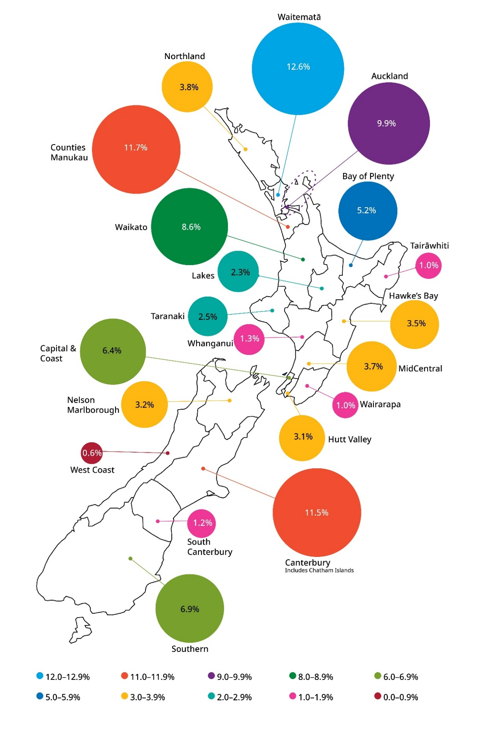

Source: [Stats NZ (2020d)](http://nzdotstat.stats.govt.nz/wbos/Index.aspx?DataSetCode=TABLECODE7509)

### Ethnic diversity

The ethnic group breakdown of the New Zealand population is shown in Table 1 below.

Table 1: Projected population, by ethnic group, 2020

|  |  |  |
| --- | --- | --- |
| **Ethnic group** | **2020** | |
| **Number** | **Percent** |
| European or Other (including New Zealander) | 3,529,300 | 69.3 |
| Māori | 854,500 | 16.8 |
| Pacific peoples | 430,800 | 8.5 |
| Asian | 867,300 | 17.0 |
| Middle Eastern, Latin American, and African (MELAA) | 90,300 | 1.8 |
| **Total\*** | **5,084,300** | **100.0** |

* New Zealand’s ethnic population is not mutually exclusive because people often identify with more than one ethnicity. This overlap is projected to increase as more people identify with multiple ethnicities, especially at younger ages. In table 1, people are included in each ethnicity they identify with, therefore the total exceeds the estimated number of New Zealand resident population.

Note: Median population projection, as of 30 June 2020.

Source: [Stats NZ (2021j)](https://www.stats.govt.nz/news/population-projected-to-become-more-ethnically-diverse)

### Structural ageing

The population is getting older. The median age of New Zealanders increased from 35.9 years in 2006, to 38.0 years in 2013, then steadied at 37.4 years in 2018 (Stats NZ 2020b). Older adults make up an increasingly large proportion of our country’s population, with numbers of people over 65 years old increasing rapidly.

* 2006: 495,606 people aged 65+ years (12.3 percent of the population)
* 2013: 607,035 people aged 65+ years (14.3 percent of the population)
* 2018: 715,167 people aged 65+ years (15.2 percent of the population).

The projections indicate that all ethnic populations will gradually age over the coming decades (Stats NZ 2021i). However, the Māori and Pacific populations will continue to have a much younger age structure than the total New Zealand and European or Other populations because of higher birth rates and lower life expectancy (Stats NZ 2020b).

The age distribution of the population by ethnic group in 2018 is:

* European: median age of 41.4 years, with 26 percent under 20 years of age
* Māori: median age of 25.4 years, with 41 percent under 20 years of age
* Pacific: median age of 23.4 years, with 44 percent under 20 years of age.

The increasing size, diversity and age profile of the New Zealand population impacts on the health and disability system by increasing the demand for its services. Our ageing population is likely to have a significant impact, as older people generally use more health services than younger people. According to the Ministry, approximately 42 percent of all health funding is currently spent on the 15 percent of the population aged over 65 years (Ministry of Health 2016b).

Many diseases, such as cancer, heart disease and Alzheimer’s disease, are more common in older people, and therefore, New Zealand is likely to see increases in these conditions, as it is projected that the New Zealand population over 65 years old will double within the next 20 years.

The current age profile for the total population, by age and sex, is shown in Figure 2 below.

Figure 2: Total population estimates, by age, 2020

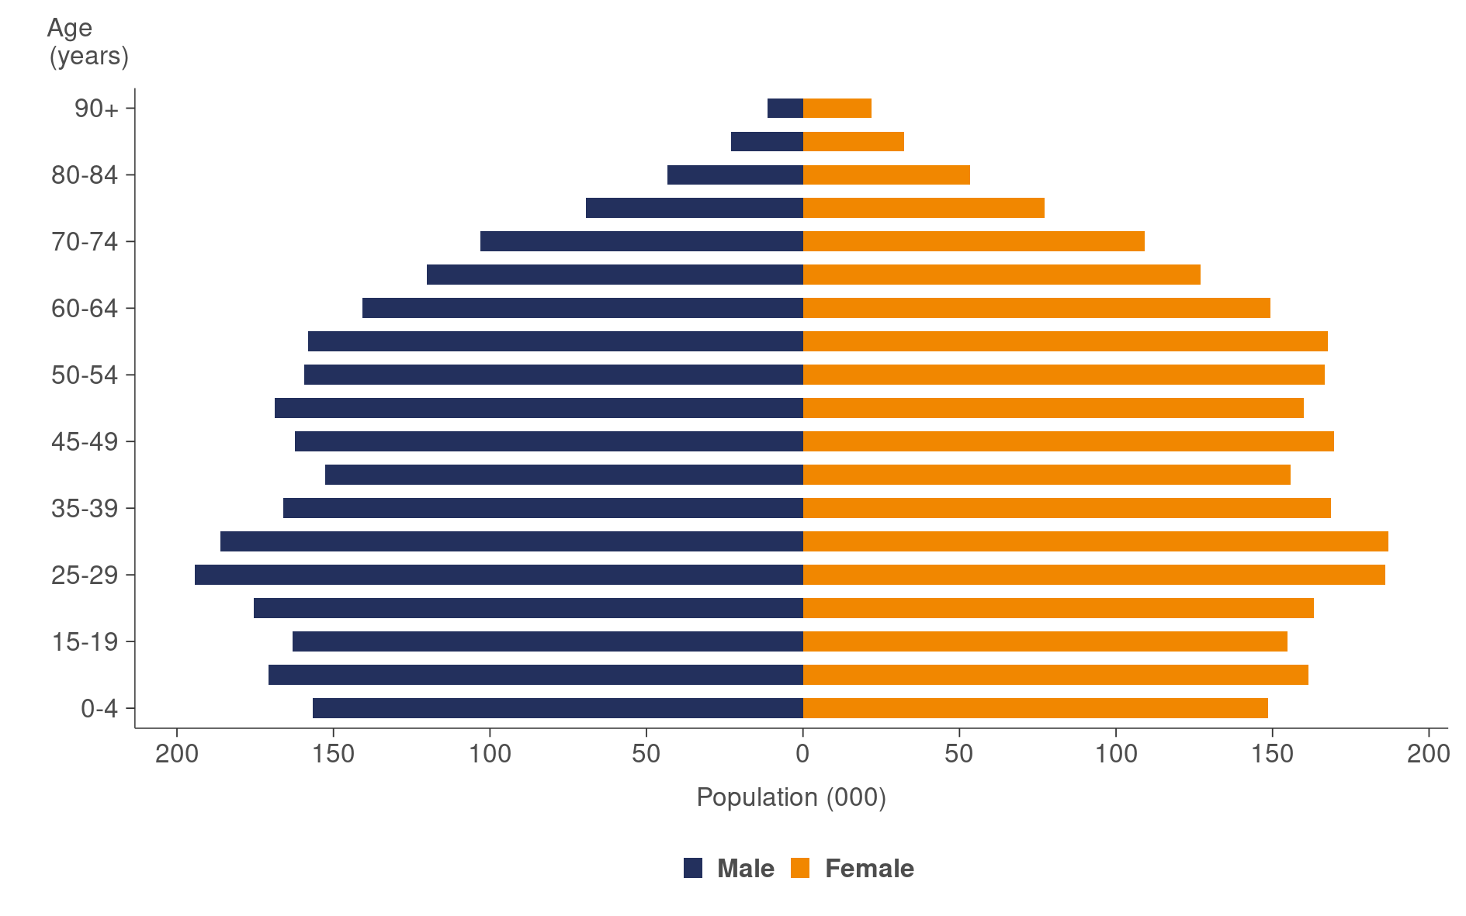

Source: [Stats NZ (2020d)](http://nzdotstat.stats.govt.nz/wbos/Index.aspx?DataSetCode=TABLECODE7509)

### Disabled population

The most recent data on the prevalence of disability comes from the 2013 New Zealand Disability Survey (Stats NZ 2014a). The survey defines disability as ‘an impairment that has a long-term, limiting effect on a person’s ability to carry out day-to-day activities’, with ‘long-term’ meaning lasting six months or longer and ‘limiting effect’ meaning a restriction or lack of ability to perform. People are not considered to have a disability if an assistive device, such as glasses or crutches, ended their impairment.

The survey found that:

* 24 percent of the population (1.1 million people) identified as having a disability
* Māori and Pacific peoples had higher-than-average disability rates, after adjusting for differences in ethnic population age profiles
* people aged 65 years or older were much more likely to be disabled (59 percent) than adults under 65 years old (21 percent) or children under 15 years old (11 percent).

Disabled adults fared worse than non-disabled adults across many measures (Stats NZ 2020a):

* for the June 2018 quarter (most recent data available), 22.4 percent of disabled people were working, compared with 70.0 percent of non-disabled people
* disabled people aged between 15 and 64 years received a median personal income of $353 per week in 2018, less than half that of non-disabled people in the same age group ($806)
* disabled people living in private dwellings are less likely than non-disabled people to live in an owner-occupied home
* 71.4 percent of disabled people reported their life to be highly worthwhile, compared with 87.2 percent of non-disabled people, a gap of 15.8 percentage points.

### Child poverty

This report uses the Stats NZ definition and measures of child poverty and material hardship (Stats NZ 2021g). While children from all ethnic groups live in households with relatively low income and in material hardship, the rates for Māori and Pacific children in the year ended June 2020 were higher across all measures compared with New Zealanders overall (Stats NZ 2021b). In the year ended June 2020, about 1 in 5 Māori children (61,000 or 21.1 percent) lived in households that had less than 50 percent of the median disposable household income remaining after deducting housing costs. The rate is about the same for children in Pacific peoples’ households (30,700 or 21.0 percent). This is higher than the rate across all New Zealand children at 18.4 percent.

Rising rates of child poverty in New Zealand have been linked to increasing rates in hospital admissions for asthma, pneumonia, rheumatic fever and serious skin infections (Shackleton et al 2021). Children living in poverty in New Zealand have a 40 percent higher risk of dying during childhood, are sick three times as often, are more than twice as likely to be admitted to hospital for an acute infectious disease, miss out on more days of school due to ill health and are more likely to have poor health outcomes in adulthood, including cardiovascular disease, dental decay, lowered longevity and mental illness.

In the year ended June 2020, almost 1 in 5 Māori children (19.5 percent) lived in households that reported going without 6 or more of the 17 basic needs (examples of basic needs include serious restrictions on eating fresh fruit or vegetables, putting off a visit to the doctor because of a lack of money or not being able to pay the gas or electricity bill; Stats NZ 2021f). The rate was higher for Pacific children at 26.1 percent. The rate was 11.3 percent across all New Zealand children.

### Child poverty and disability

Children who are disabled or who live in a household with a disabled person are more likely to be living in poverty, according to the child poverty measures (Stats NZ 2021a).

In the year ended June 2020, disabled children were more likely than non-disabled children to be in low-income households, and one in five disabled children experienced material hardship (20.4 percent). This was more than double the rate of non-disabled children who experienced material hardship (10.1 percent).

Furthermore, less than half (47.5 percent) of disabled children lived in a home owned by a member of their household, compared with almost two-thirds (64.5 percent) of non-disabled children (Stats NZ 2020a).

Similarly, children who lived in a household where at least one person was disabled were more likely to live in households with low income and material hardship than children whose household had no disabled individuals (Stats NZ 2021a). In addition, one in five children (20.4 percent) who lived in a household where at least one person was disabled lived in material hardship. This is more than two-and-a-half times the rate for children who did not live in a household with at least one disabled person (7.5 percent; Stats NZ 2021a).

# COVID‑19 | Mate Korona

The year 2020 will be forever linked with COVID‑19 as the virus impacted every country in the world. From late 2019, when authorities in China alerted the [World Health Organization](https://www.devex.com/organizations/world-health-organization-who-30562) (WHO) to a mysterious viral pneumonia, to the end of December 2020, more than 83.5 million people became infected with COVID‑19, and more than 1.8 million people died from the disease.

## The global COVID‑19 story of 2020

Table 2 below provides a timeline of international key events and milestones from the global pandemic of 2020.

Table 2: Global timeline of major COVID‑19 events, 2020

|  |  |  |  |
| --- | --- | --- | --- |
| **January** | **February** | **March** | **April** |
| 03: China investigates viral pneumonia of 44 people in Wuhan | 01: First death outside China, in the Philippines | 06: Number of global cases hit 100,000 | 02: More than 1 million cases and 50,000 deaths worldwide |
| 09: China confirms novel (new strain) coronavirus | 10: Global death toll reaches 1,000 | 11: WHO declares the outbreak a pandemic | 09: 1.5 million cases and more than 100,000 deaths worldwide |
| 11: China reports first death from the coronavirus | 11: WHO names the disease COVID‑19 | 20: Global death toll reaches 10,000 | 22: Germany approves vaccine trials |
| 28: 100 deaths reported in China; cases in 16 other countries worldwide |  | 24: Olympics postponed for the first time since World War II |  |
| 30: WHO declares public health emergency of international concern |  | 26: Nearly one-third of world’s population in COVID‑19 restrictions |  |
| **May** | **June** | **July** | **August** |
| 10: Number of global cases passes 4 million | 28: Number of global cases passes 10 million | 14: Global COVID‑19 cases increased by 1 million over the past five days | 11: Russia is the first country to approve a COVID‑19 vaccine |
| 21: Number of global cases passes 5 million | 29: More than 500,000 deaths worldwide |  | 15: WHO reports record number of daily new cases at 294,237 |
| **September** | **October** | **November** | **December** |
| 02: COVID‑19 cases in Europe increase back to March 2020 level | 19: More than 40 million COVID-19 cases worldwide | 09: Global cases top 50 million | 02: Vaccines approved in the United Kingdom |
| 28: Global COVID‑19 deaths pass 1 million | 28: WHO reports a record of 3 million new cases in one week |  | 31: Global cases 83.5 million; global deaths 1.8 million |

### Global deaths higher than reported

As high as the world death toll appears, there is increasing research to indicate that the number may in fact be considerably higher. This is based on calculations of ‘excess deaths’ or ‘excess mortality’, defined as the difference between the observed count of deaths and the average number of deaths over several years.

Analysis by the Institute for Health Metrics and Evaluation (IHME) estimates that global COVID‑19 deaths may be more than double what official numbers show (IHME 2021a). They found that COVID‑19 deaths are significantly underreported in almost every country when calculated on usual mortality, pre-pandemic trends. These estimates are based on IHME’s long-standing methodology for measuring the burden of diseases on a global scale. According to a range of COVID‑19 studies, New Zealand had the lowest level of ‘excess deaths’ among Organisation for Economic Co‑operation and Development (OECD) countries and within a grouping of 29 high-income countries (Wilson et al 2021b).

### Long COVID

It is estimated that 20 percent of people who have tested positive for COVID‑19 experience a range of health symptoms more than five weeks after their initial diagnosis and 10 percent experience at least one enduring symptom three months later (Ministry of Health 2021i). The ongoing symptoms of long COVID are varied and severity can range from mild to disabling, with multiple body systems affected. Relapses may also occur in an irregular pattern or in response to specific triggers, such as stress or alcohol.

Long COVID is seen in all age groups, including children. But the risk of long COVID being identified is increased for those who: are older, have multiple underlying chronic medical conditions, a higher body mass index, are female, or experience more than five symptoms during the first week of illness. Work is underway globally to better understand ongoing COVID symptoms and the best ways to manage and treat it.

## The New Zealand COVID‑19 story of 2020

### COVID‑19 management strategy

Throughout 2020, the New Zealand Government followed an elimination strategy for COVID‑19 (Ministry of Health 2021d). That is, the government applied a range of control measures to stop the transmission of COVID‑19. Measures included controlling entry at the border, encouraging physical distancing and hygiene measures, using personal protective equipment (including masks), testing and contact tracing and isolating cases and close contacts.

Researchers (Wilson et al 2021b) reported that the elimination strategy has been very successful in both health and economic terms compared with other OECD countries. New Zealand had the lowest COVID‑19 cumulative death rate and was one of only a few high-income countries where life expectancy increased between 2018 and 2020. New Zealand also performed better than the OECD average in terms of quarterly Gross Domestic Product (GDP) and had relatively lower increases in unemployment.

### COVID‑19 in New Zealand

Figure 3 and Table 3 below show New Zealand events and responses throughout the 2020 year. From detection of the first case on 28 February to the end of the year, there were 2,172 cases and 25 deaths related to COVID‑19 in New Zealand (ESR 2021). The cases were made up of 1,680 community cases, 487 managed isolation cases and five managed isolation facility staff.

New Zealand was in alert level four (the highest level) from 24 March to 28 April 2020, when the entire country went into self-isolation. Auckland underwent higher alert levels than the rest of New Zealand from 12 August to 7 October 2020, as the Government introduced measures to control a community outbreak in that area (Ministry of Health 2021c).

Figure 3: COVID‑19 events and response in New Zealand, 2020

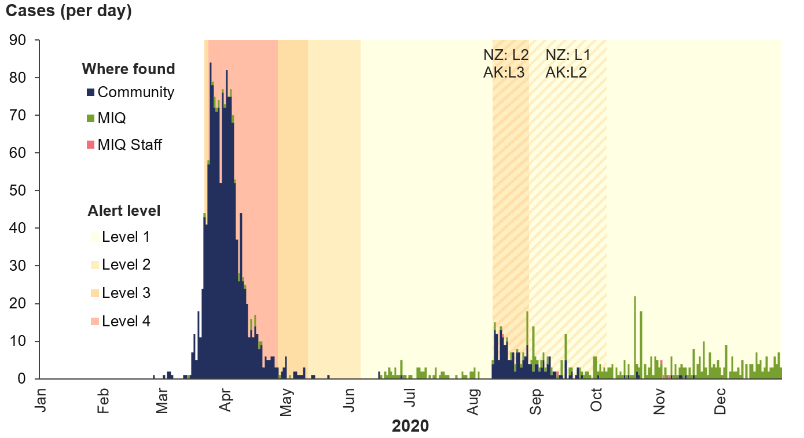

Source: [ESR (2021)](https://nzcoviddashboard.esr.cri.nz/#!/)

Table 3: New Zealand timeline of major COVID‑19 events, 2020

|  |  |  |  |
| --- | --- | --- | --- |
| **January** | **February** | **March** | **April** |
|  | **28:** First case reported in NZ | **19:** Borders close; 28 cases in total  **21:** Four-tiered alert system starts; NZ moves to alert level 2  **22:** NZ moves to alert level 3  **24:** NZ moves to alert level 4 – entire nation in self-isolation  **25:** State of emergency declared; 50 new cases reported  **29:** NZ reports first COVID death; 514 cases in total  **31:** 58 new cases, 647 cases in total | **02:** NZ reports a record of 89 new cases  **04:** 82 new cases, 950 cases in total  **10:** Compulsory quarantine for people arriving into NZ  **14:** More deaths over the past week, 9 deaths in total  **20:** Level 4 extended for five more days  **27:** 19 deaths in total  **28:** NZ moves to alert level 3 |
| **May** | **June** | **July** | **August** |
| **02:** One more death reported  **08:** 1,490 cases in total  **10:** 21 deaths in total  **13:** NZ moves to alert level 2  **20:** COVID‑19 tracer app launched  **28:** 22 deaths in total | **08:** NZ moves to alert level 1  **16:** After 24 days with no community cases, two new cases reported | **12:** 25 active cases in NZ, all in managed isolation | **11:** Four positive tests after 102 days of no community cases; infection source unknown  **12:** Auckland moves to alert level 3; the rest of NZ to alert level 2  **17:** New cases continue to be reported; NZ election delayed to October  **29:** Routine testing for border workers introduced  **30:** Auckland moves to alert level ‘2.5’ (level 2 with additional restrictions) |
| **September** | **October** | **November** | **December** |
| **04:** A COVID‑19 death is reported today; 23 deaths in total  **12:** A large anti-lockdown protest takes place in Auckland  **15:** A further death is reported; new cases continue to be recorded  **21:** All NZ moves to alert level 1 except Auckland  **23:** Six historic cases amend NZ first case to 21 February, one week earlier | **07:** Auckland moves to alert level 1  **12:** NZ agrees to buy 1.5 million doses of Pfizer vaccine  **17:** NZ general election goes ahead  **18:** A new case is reported | **03:** Travellers to NZ must have a managed isolation voucher before flying  **05:** Wastewater testing for COVID‑19 is introduced  **16:** Mask wearing is now mandatory for Auckland public transport and all domestic flights | **10:** Bluetooth upgrade to COVID‑19 tracer app is launched  **31:** 2,172 cases in total; 25 deaths in total |

### New Zealand COVID‑19 cases

There were 2,172 COVID‑19 cases in New Zealand in 2020, these cases were distributed evenly across sexes. But cases were unevenly distributed across age groups and ethnicity (ESR 2021). The highest COVID‑19 case rates were in the 20–29 age group followed by the 30–39 age group (Figure 4).

Figure 4: New Zealand COVID‑19 case rates, by age group, 2020

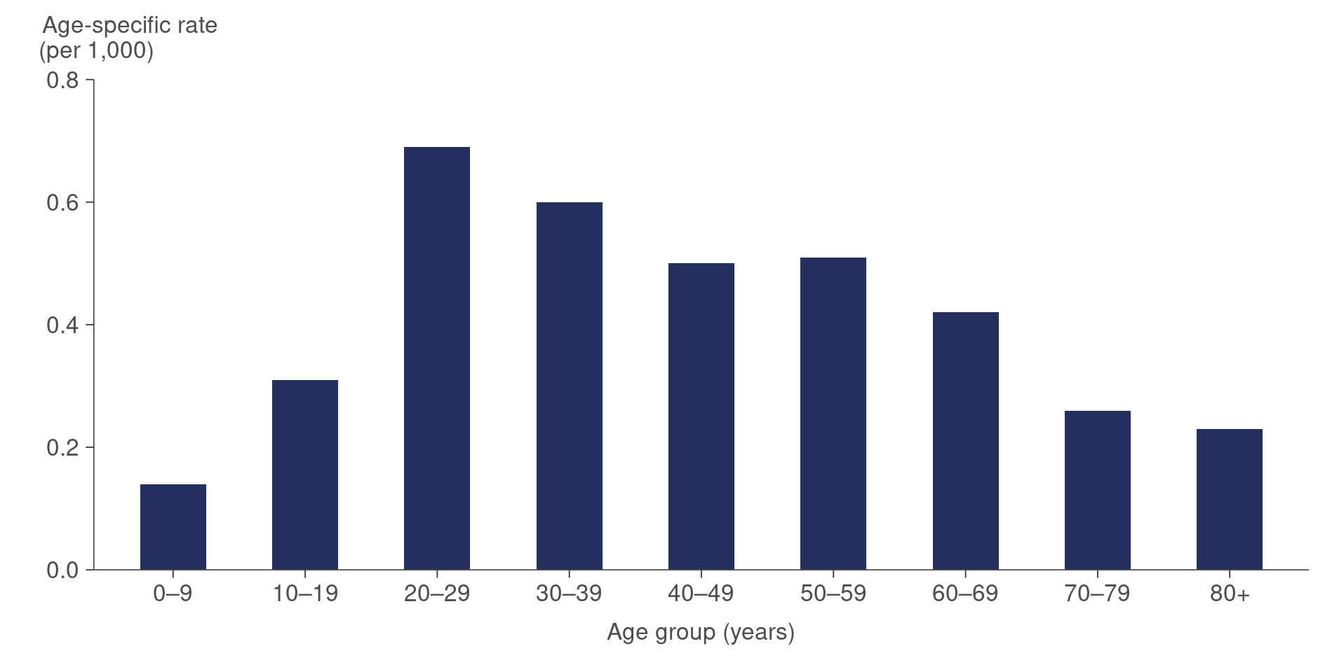

Source: [ESR (2021)](https://nzcoviddashboard.esr.cri.nz/#!/)

The ethnicity of cases in New Zealand comprised 191 Māori, 184 Pacific peoples, 393 Asian and 1,404 European or Other. Figure 5 below shows New Zealand COVID‑19 cases by ethnicity, as a rate per 1,000 population.

Most of the New Zealand community cases in 2020 were associated with one of two outbreaks: the first in March/April and the second in August/September. The August/September cluster differed substantially from the initial outbreak in that most cases in the second cluster resulted from workplace, community, public transport and household transmission rather than international travel. In addition, the August cluster contained a much higher proportion of cases among Māori and Pacific peoples than the first outbreak (Steyn et al 2021).

Steyn et al (2021) research concludes that, after controlling for age, underlying health conditions and socioeconomic deprivation, Māori and Pacific peoples have a substantially higher risk of hospitalisation and death from COVID‑19 than non-Māori and non-Pacific peoples.

Figure 5: New Zealand COVID‑19 case rates, by ethnic group, 2020

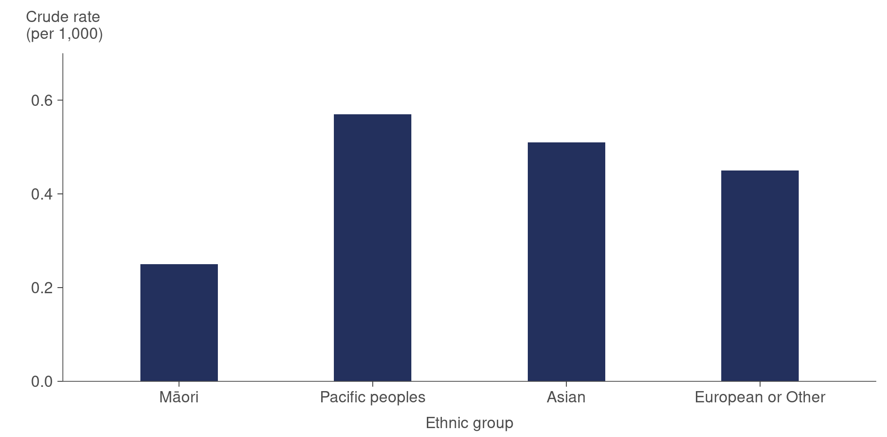

Source: [ESR (2021)](https://nzcoviddashboard.esr.cri.nz/#!/)

#### Hospitalisations for COVID‑19

During 2020 in New Zealand, 122 people required hospitalisation because of COVID‑19. Of these, 18 people required care in an intensive care unit (ICU). Hospitalisations by age are shown in Figure 6 below.

Figure 6: New Zealand hospitalisations for COVID‑19, by age, 2020

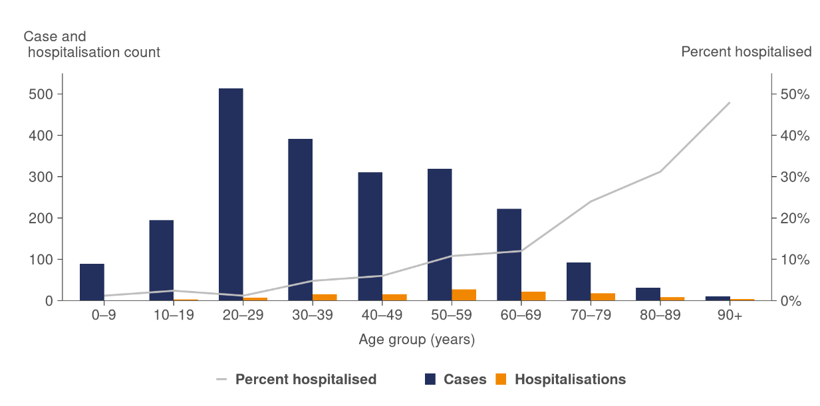

Source: [ESR (2021)](https://nzcoviddashboard.esr.cri.nz/#!/)

#### The impact of COVID‑19 on population – New Zealand

##### Migration

COVID‑19-related border and travel restrictions resulted in record annual falls in both migrant arrivals and migrant departures (Stats NZ 2021e). Migration estimates, available from 2001 onwards, show that both annual migrant arrivals and migrant departures in the year ended December 2020 were the lowest of any annual period. There were provisionally 85,730 migrant arrivals and 44,554 migrant departures. As a result, net migration in the year ended December 2020 is provisionally estimated at 44,177, with the majority of people arriving in the first three months of the year before border and travel restrictions came into place in March 2020.

##### Deaths

New Zealand had a relatively low number of COVID‑19 cases, with correspondingly low COVID‑19 related hospitalisations and deaths. There were 25 COVID‑19 deaths in New Zealand in 2020 (ESR 2021). People who are older are more likely to die of COVID‑19: there were two deaths in the 50- to 59-year age group, three deaths in the 60- to 69‑year age group and 20 deaths (80 percent) in the 70 years and older age group.

Weekly all-cause mortality in 2020 was similar to mortality in the years from 2015 to 2019 until week 17, which was the fifth week of public health measures for COVID‑19, when mortality rates were lower than in previous years (Figure 7). At this time, mortality fell below historical rates. Possible contributing factors that reduced all-cause mortality in 2020, were fewer road traffic deaths and lower rates of influenza. These are discussed in more detail below.

Figure 7: Excess mortality rates in New Zealand, by week, 2020

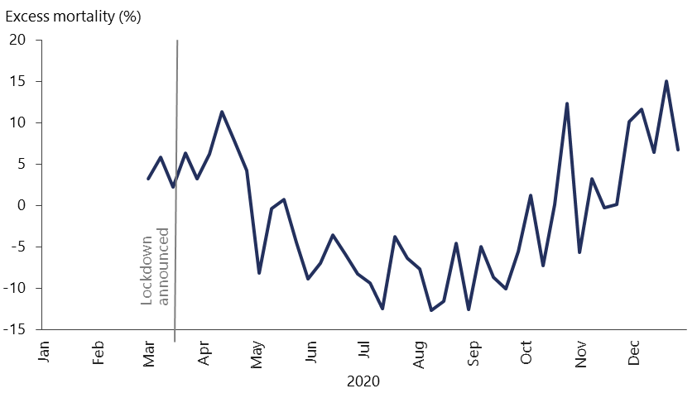

Note: Excess mortality is the percentage difference between the reported number of weekly deaths in 2020 and the average number of deaths in the same period over the years 2015 to 2019.

Source: [Our World in Data (2021)](https://ourworldindata.org/grapher/excess-mortality-p-scores-average-baseline?time=2020-03-01..2020-12-27&country=~NZL)

##### Fewer road traffic deaths

In 2020, road traffic deaths in New Zealand were the lowest since 2015, with 318 deaths recorded (Ministry of Transport 2021a; see Table 4 below). Furthermore, Easter weekend in 2020 recorded zero road traffic deaths, which was the first year with zero deaths at Easter since 2012 (Ministry of Transport 2021b).

Table 4: Road traffic deaths New Zealand, 2015–2020

|  |  |  |  |  |  |  |
| --- | --- | --- | --- | --- | --- | --- |
| **Year** | **2015** | **2016** | **2017** | **2018** | **2019** | **2020** |
| No. deaths | 317 | 327 | 378 | 378 | 352 | 318 |

Source: [Ministry of Transport (2021a)](https://www.transport.govt.nz/statistics-and-insights/safety-road-deaths/sheet/death-on-nz-roads-since-1921)

##### Lower rates of influenza

Figure 8 shows self-reported influenza-like illness (flu tracking) data for the past three years. As can be seen, there were very low levels of influenza-like illness circulating in 2020, which is likely to be attributed to COVID‑19 hygiene safety measures (social distancing, handwashing and wearing masks in public places; Ministry of Health 2021h).

Figure 8: Self-reported influenza-like illness, February–December 2020

This line chart shows the percentage of people self-reporting influenza-like illness (fever and cough) for the calendar years 2018, 2019, and 2020. The years 2018 and 2019 show a pattern peaking at 4.4% and 3.9% respectively over the winter months. In 2020, the percentage of people reporting fever and cough ranged between 0.1% and 1.4%, with no distinct winter peak.


Source: [FluTracking (2021)](https://info.flutracking.net/reports-2/new-zealand-reports/)

### COVID‑19 health and wellbeing survey

The COVID‑19 health and wellbeing survey (Ministry of Health 2021b) ran for six months from the end of March 2020 to the end of September 2020.

* Most adults surveyed (between 96 and 99 percent) reported that the alert level rules were clear.
* A very high proportion of adults (between 87 and 93 percent) reported their health as good, very good or excellent.
* The proportion of respondents who experienced one or more COVID‑19 symptoms ranged from 8 to 17 percent over the six-month period, with the high (17 percent) in the week ending 28 June 2020.

### Impacts of COVID‑19

#### The impact of COVID‑19 on primary health care

The term ‘qualifying encounters’ refers to a range of interactions between a patient and the general practice they are enrolled with. Qualifying encounters include, but are not limited to, doctor and nurse consultations (face-to-face and remote), follow-up communications, prescription requests and immunisations (Ministry of Health 2021n).

Figure 9 shows primary health care qualifying encounters for 2020 compared with 2019, with encounters decreasing markedly from the end of March to mid October 2020.

Figure 9: Weekly primary health care qualifying encounters, 2019 and 2020

This line chart shows qualifying encounters per 1,000 enrolees for the calendar years 2019 and 2020. The data are shown as a 7-day running total. The 2020 COVID-19 lockdown is marked on the chart and highlights that for most of the year following the lockdown in 2020, the number of qualifying encounters was lower compared to 2019. Public holidays (New Year, Waitangi Weekend, Easter, Queen’s Birthday, Labour weekend, and Christmas) are also labelled on the chart and are coincide with periods of lower qualifying encounters.

Source: Ministry of Health unpublished data

#### The impact of COVID‑19 on the National Telehealth Service – Healthline

The National Telehealth Service (NTS) COVID‑19 response began on 7 February 2020, with the establishment of a dedicated service called COVID Healthline. This service was available 24 hours a day, seven days a week, as a central front door for COVID‑19-related clinical and general advice to the public. The service evolved due to the impact of COVID‑19 on the existing Healthline service delivered through the NTS.

Figure 10 shows the total number of calls received through the NTS Healthline and COVID Healthline services in 2020 compared with 2019. Overall, the total number of calls remained at an elevated level once the pandemic began, with spikes in call volumes during the initial outbreak in March 2020 and following a resurgence of COVID‑19 in the community in August 2020.

Figure 10: Phone calls to NTS Healthline and COVID Healthline services, 2019 and 2020

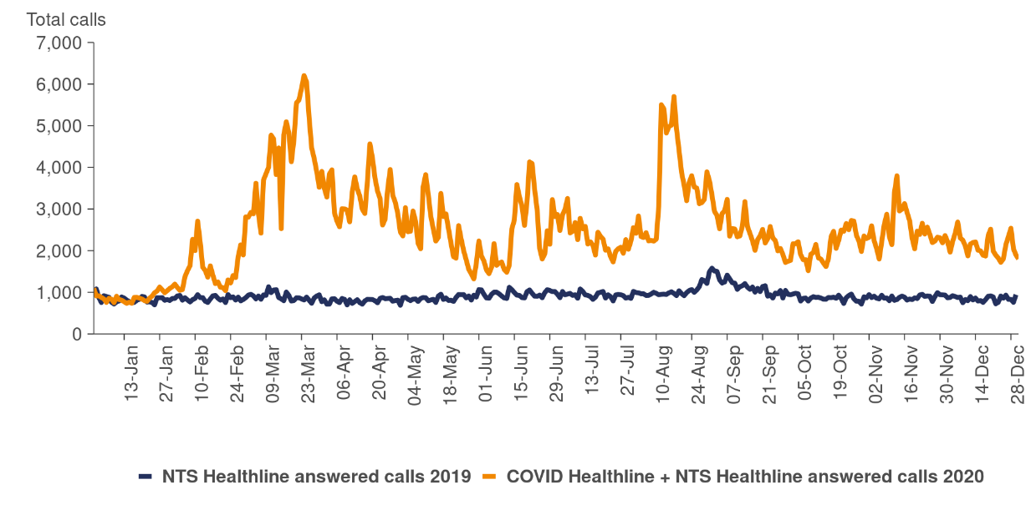

Source: Ministry of Health unpublished data

#### Wider health and wellbeing impact of COVID‑19 in New Zealand

As noted above, the New Zealand elimination strategy for COVID‑19 in 2020 was successful in health terms compared with strategies followed by other OECD countries. However, there were considerable impacts that challenged New Zealanders and our health system. A summary of some of these challenges is provided below.

* Alcohol-related emergency department visits increased by 37 percent in 2020 (Truebridge 2021). Paramedics attended 22,000 alcohol-related incidents in 2020, compared with 16,000 such incidents over the same time period in 2019. The DHB areas with the largest increases in alcohol-related harm were Counties Manukau (51 percent) and Auckland (41 percent).
* Nearly half of daily smokers reported smoking more during than before the lockdown – on average, an increase of six cigarettes a day. Increased daily cigarette consumption was associated with loneliness and isolation (Gendall et al 2021).
* During the higher alert levels, general practices tended to provide many services using ‘telehealth’ in place of face-to-face consultations. Telehealth consultations were most successful when there was a pre-existing relationship between the health care provider and the patient (Wilson et al 2021a). However, reported barriers included technological challenges, communication difficulties, concern regarding cost and difficulty making online payments. It was noted that telehealth can create extra barriers for those who are already disadvantaged, such as those in rural areas, those with hearing impairments or cognitive decline and populations with language barriers.
* Health care workers were at risk of being infected with COVID‑19. As of 12 June 2020, there were 167 cases of COVID‑19 among health care and support workers, which represented 11 percent of the total cases in New Zealand at that time (Ministry of Health 2020e).
* According to Te Aho o Te Kahu Cancer Control Agency (2021), there was a drop in new registrations of cancer during the nationwide alert level four period, with 1,031 fewer cancers registered in April 2020 compared with April 2019 (a 47 percent decrease). The decrease was seen across all tumour groups and impacted all ethnic groups equally. In the months following alert level four, there was a health system focus on delayed diagnostic procedures. As a result, the number of cancer registrations was back in line with expected levels by the end of September 2020.
* The August 2020 community outbreak of COVID‑19 in New Zealand was primarily centred in South Auckland. Face-to-face interviews were held with 500 Pacific South Aucklanders regarding the impact of COVID‑19 on their lives in 2020. It was reported that over one-third of Pacific households were financially impacted by COVID‑19, with 18 percent losing half or more of their income and 25 percent experiencing reduced pay, reduced hours or job losses (Ministry of Health 2021g). It was also reported that alert levels impacted Pacific peoples’ ability to access both mental health support and health care (such as general practitioner care, prescription items and dental care) when needed.

# Population health measures | Ngā mēhua hauora o te taupori

This section provides information about the health of New Zealanders. It includes people’s self-rated health and measures life expectancy, health expectancy, mortality and morbidity.

## Self-rated health

The New Zealand Health Survey (Ministry of Health 2021o) has been run in various forms since 1992/93 (annually since 2011) as part of a population health survey programme.

Data was collected for the 2019/20 New Zealand Health Survey from July 2019 to March 2020. A specific COVID‑19 Health and Wellbeing survey (Ministry of Health 2021b) was conducted from 30 March 2020 until 27 September 2020, when the usual New Zealand Health Survey resumed. The COVID‑19-specific survey results are included in the COVID-19 section above.

In the 2019/20 survey, 87.2 percent of adults reported their health as being good, very good or excellent (combined as ‘good health’ in the following narrative). There has been a general decrease over recent years in self-reported good health, from a high of 91.4 percent in 2013/14.

In the 2019/20 survey, self-reported good health varied between different population groups:

* Asian adults – 91.9 percent
* European or Other adults – 87.9 percent
* Pacific adults – 79.5 percent
* Māori adults – 77.2 percent.

The rates differed for disabled adults, with 56.0 percent of disabled adults reporting they were in good health, compared with 89.9 percent of non-disabled adults.

After adjusting for age, gender and ethnicity, adults living in the most socioeconomically deprived areas were less likely to say they were in good health (adjusted ratio 0.85) than people in less deprived areas. The prevalence rates were recorded as 80.4 percent of those in most deprived areas rating their health as good, compared with 93.3 percent of those in the least deprived areas.

## Life expectancy

### Life expectancy by sex

New Zealanders are living longer than ever before. Female life expectancy at birth is now approximately 3.5 years higher than male life expectancy at birth, down from the largest difference of 6.5 years from 1975 to 1977. Table 5 below shows life expectancy at birth, by sex, from 1995–97 to 2018–20.

Table 5: Life expectancy at birth, by sex, 1995–97 to 2018–20

|  |  |  |  |  |  |  |
| --- | --- | --- | --- | --- | --- | --- |
|  | **1995–97** | **2000–02** | **2005–07** | **2012–14** | **2017–19** | **2018–20** |
| Females | 79.7 | 81.1 | 82.2 | 83.2 | 83.5 | 83.9 |
| Males | 74.4 | 76.3 | 78.0 | 79.5 | 80.0 | 80.3 |

Source: [Stats NZ (2021g)](https://www.stats.govt.nz/topics/life-expectancy)[2]

### Life expectancy by ethnicity

Life expectancy varies by ethnicity (Stats NZ 2021h; note, updated life expectancy by ethnicity was not available for 2018–20 (as per population numbers used in Table 5 above), therefore ethnic breakdowns are only provided for the period 2017–19. This shows life expectancies of:

* 85.1 years for Asian males, and 87.9 years for Asian females
* 81.0 years for European or Other males, and 84.5 years for European or Other females
* 75.4 years for Pacific males, and 79.0 years for Pacific females
* 73.4 years for Māori males, and 77.1 years for Māori females.

In 2017–19, life expectancy was more than seven years lower for Māori compared with non-Māori. This gap in life expectancy has narrowed over time to 7.5 years for males and 7.3 years for females, down from 8.8 years for males and 9.3 years for females in 1995–97.

### Life expectancy for disabled people

There is limited up-to-date, New Zealand-specific data available regarding life expectancy for disabled people. However, a New Zealand study from 2011 of more than 31,000 people with an intellectual disability (Ministry of Health 2011) found the average life expectancy was 59.7 years for intellectually disabled men and 59.5 years for intellectually disabled women. The life expectancy gap between disabled and non‑disabled people at the time of the study was around 19 years for men and 23 years for women.

### The slowing life expectancy growth

While life expectancy for both sexes increased, the increase between 2012–14 and 2017–19 (0.5 years for males and 0.3 years for females) was the lowest since between 1965 and 1967 (Stats NZ 2021h).

Figure 11: Life expectancy at birth, by sex, 1950–52 to 2017–19

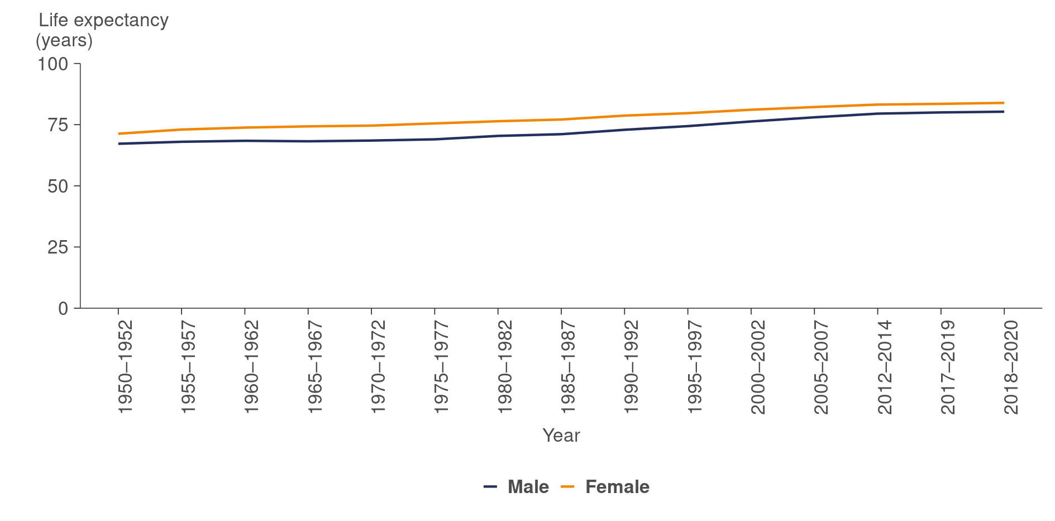

Source: [Stats NZ (2021i)](https://www.stats.govt.nz/information-releases/national-and-subnational-period-life-tables-2017-2019)

## Health expectancy

Health-adjusted life expectancy (health expectancy) represents the number of years people live in good health. Although both life expectancy and health expectancy have improved for the New Zealand population, the increase in health expectancy is slightly lower than the increase in life expectancy (Ministry of Health 2020h). This means that, while New Zealanders are living longer, they are also spending more time in poor health.

Health expectancy at birth is 68.9 years for males and 70.3 years for females (IHME 2021b). Over time, health expectancy has increased for both men and women. Since 1990, men have gained 5.6 years of healthy life and women 4.2 years (Table 6).

Table 6: Health expectancy (years), by sex, 1990–2019

|  |  |  |  |  |  |
| --- | --- | --- | --- | --- | --- |
| **Sex** | **1990** | **2000** | **2010** | **2019** | **Change from 1990 to 2019** |
| Males | 63.3 | 65.9 | 68.4 | 68.9 | 5.6 |
| Females | 66.1 | 68.3 | 70.0 | 70.3 | 4.2 |

Source: [IHME (2021b)](http://ghdx.healthdata.org/gbd-results-tool)

Table 7: Time spent in poor health (years), by sex, 1990–2019

|  |  |  |  |  |  |
| --- | --- | --- | --- | --- | --- |
| **Sex** | **1990** | **2000** | **2010** | **2019** | **Change from 1990 to 2019** |
| Males | 9.4 | 10.0 | 10.5 | 11.0 | 1.6 |
| Females | 12.3 | 12.5 | 12.8 | 13.4 | 1.1 |

Source: [IHME (2021b)](http://ghdx.healthdata.org/gbd-results-tool)

## Mortality

In 2018 (the most recent data available), there were 33,316 registered deaths in New Zealand (Ministry of Health 2021k). This equates to an age-standardised rate of 370 deaths per 100,000 population. The rate for men, at 432.7 per 100,000, was higher than for women, at 314.4 per 100,000. There are many reasons for higher mortality rates for men, such as higher rates of heart disease, some cancers, road traffic deaths and suicide. However, that gap is narrowing.

Figure 12: Mortality rates, by sex, 1950–2018*

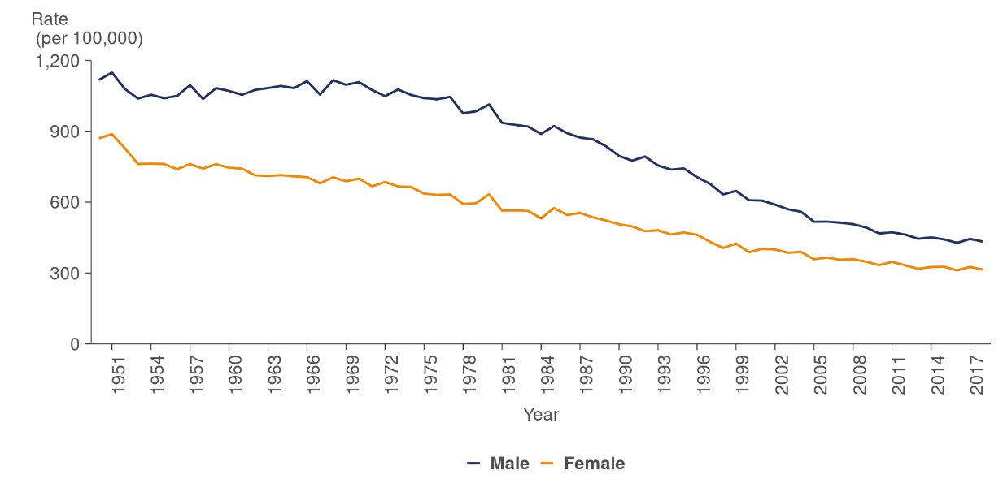

* 2018 data is provisional.

Rates are age-standardised to the WHO’s standard world population.

Source: [Ministry of Health (2021j)](https://www.health.govt.nz/publication/mortality-web-tool)

### Mortality rates for Māori and non-Māori

The mortality rate for Māori, at 594.6 per 100,000, is higher than that for non-Māori (343.5 per 100,000; Ministry of Health 2021k). Mortality rates have declined over time; however, inequalities have been persistent, and the gap in mortality rates is closing very slowly.

Figure 13: Mortality rates, Māori and non-Māori, 1996–2018

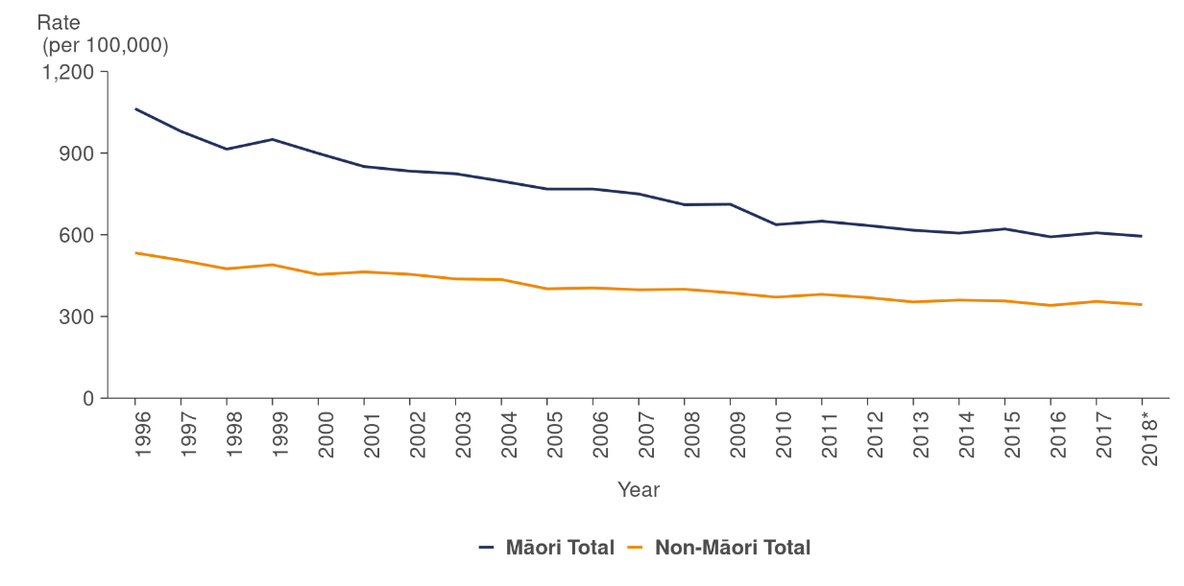

* 2018 data is provisional.

Rates are age-standardised to the WHO’s standard world population.

Source: [Ministry of Health (2021j)](https://www.health.govt.nz/publication/mortality-web-tool)

### Infant mortality

During 2020, there were 228 infant deaths (under one year of age) in New Zealand (Stats NZ 2020d). The infant mortality rate (infant deaths per 1,000 live births) was 4.0 per 1,000, down from 5.0 per 1,000 in 2008. This is a similar rate to that of the United Kingdom, France and Canada (3.8) (Stats NZ 2019). It is slightly higher than Australia (3.1), but lower than the United States (5.9).

Figure 14: New Zealand infant mortality rate, 1950–2020

This line chart shows that infant mortality has declined, but the rate of decline is slowing. The rate for Māori is higher compared to the total population, however this gap is narrowing.


* The line break indicates missing data.

Source: [Stats NZ (2020d).](http://infoshare.stats.govt.nz/Default.aspx)

### Amenable mortality

The Ministry defines ‘amenable mortality’ as premature deaths (deaths under the age of 75 years) that could potentially be avoided if given effective and timely health care. Premature deaths are early deaths from causes (diseases or injuries) for which effective health care interventions exist and are accessible to New Zealanders (Ministry of Health 2016a).

Data on amenable mortality for disabled people is limited, but the 2011 New Zealand study *Healthy Indicators for New Zealanders with Intellectual Disability* (Ministry of Health 2011) found that people with intellectual disability had poorer health and were more at risk of illness, disease and death than those without intellectual disability. This is consistent with international studies, showing adults with an intellectual disability experience premature mortality and over-representation of potentially avoidable deaths (Troller et al 2017).

According to Walsh and Grey (2019), the contribution of amenable mortality to differences in life expectancy highlights the need for health services to ensure timely and equitable access to appropriate health care for all population groups.

Overall, amenable mortality rates for the total population have reduced over time, but rates are persistently higher for Māori and Pacific peoples than for non-Māori and non-Pacific peoples (see Figure 15 below; Nationwide Service Framework Library 2021b).

* For Māori, coronary disease and cancers of the trachea, bronchus and lung in both males and females, and avoidable injuries, such as suicide and land transport accidents in Māori males, were the leading cause-specific contributors to differences in life expectancy.
* For Pacific peoples – both males and females – coronary disease, diabetes and stroke, along with uterine cancer for Pacific females, were the leading cause-specific contributors to the differentials.

Figure 15: Amenable mortality rates, by ethnic group, 0–74 years, 2000–2017

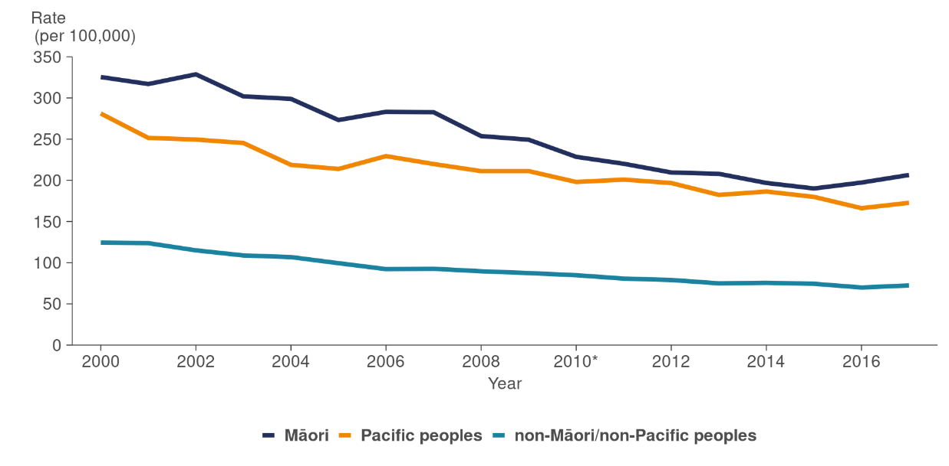

* 2016 amenable mortality codes used from this year.

Rates are age-standardised to WHO’s standard world population.

Source: [Nationwide Service Framework Library (2021](https://nsfl.health.govt.nz/dhb-planning-package/system-level-measures-framework/data-support-system-level-measures/amenable))

### Morbidity

Morbidity refers to non-fatal health loss, such as illness and disability. Morbidity is measured in years lived with disability (YLD), that is, the number of years of expected healthy life that were instead spent in states of less than full health. YLD measures non‑fatal health loss and considers both the prevalence and severity of a health condition. Morbidity is increasing in New Zealand as our population ages.

Table 8 below shows the eight leading causes of non-fatal health loss and their change in rank, if any, between 1990 and 2019, according to the Global Burden of Disease Study (IHME 2020a). Musculoskeletal conditions (such as low back pain) contribute to health loss because they are highly prevalent in the population, whilst other less prevalent conditions, such as depressive disorders, contribute to population disability due to their more severe impacts.

Table 8: Eight leading specific causes of morbidity, 2019

|  |  |  |  |  |
| --- | --- | --- | --- | --- |
| **Rank** | **Cause** | **Rank 1990** | **Rank 2019** | **Change** |
| 1 | Low back pain | 1 | 1 | – |
| 2 | Falls | 5 | 2 | 🡱 |
| 3 | Anxiety disorders | 2 | 3 | 🡳 |
| 4 | Depressive disorders | 3 | 4 | 🡳 |
| 5 | Headache disorders | 4 | 5 | 🡳 |
| 6 | Age-related and other hearing losses | 10 | 6 | 🡱 |
| 7 | Exposure to mechanical forces | 7 | 7 | – |
| 8 | Oral disorders | 9 | 8 | 🡱 |

Source: [IHME (2021b)](http://ghdx.healthdata.org/gbd-results-tool)

# Causes of health loss | Ngā take mo te mate hauora

This section discusses all health loss, including fatal (mortality) and non-fatal (morbidity) health loss. Health loss refers to the gap between a population’s actual health and an ideal level where every individual is able-bodied and lives in full health for their estimated life span.

Much of the data in this section comes from the 2019 cycle of the Global Burden of Disease Study (IHME 2020b), which estimates disability and death from a multitude of causes worldwide. Its estimates are updated annually, but 2020 data was not available at the time of publishing this report.

According to the Global Burden of Disease Study 2019, non-communicable diseases are responsible for 83.5 percent of all health loss. Four condition groups contribute to half of this loss: cancers (18.5 percent), cardiovascular and cerebrovascular diseases (15.1 percent), mental disorders (8.7 percent) and musculoskeletal disorders (8.6 percent).

Injuries account for 12.8 percent of health loss, including unintentional injuries (8.1 percent), self-harm and interpersonal violence (2.6 percent) and transport injuries (2.1 percent). Communicable, maternal, neonatal and nutritional causes account for the remaining 3.7 percent of health loss. Communicable diseases (diseases that can spread from person to person) may account for a greater percentage of health loss in 2020 and beyond, due to the global impact of COVID‑19.

## Leading causes of death

The Ministry’s mortality web tool presents mortality and demographic data for selected causes of deaths registered in New Zealand (Ministry of Health 2021k).

* Grouped together, the leading causes of death for the total population in 2018 were Ischaemic heart diseases, Cerebrovascular diseases, and Trachea, bronchus and lung cancer (with 48, 23.1, and 21 deaths per 100,000 population respectively)
* For Māori, the leading causes of death in 2018 were Ischaemic heart diseases, Trachea, bronchus and lung cancer, and Chronic lower respiratory diseases (with 81.3, 56.5, and 41.9 deaths per 100,000 Māori population respectively).

According to the 2011 New Zealand study of people with intellectual disabilities, intellectually disabled people had higher rates of the health problems listed above. For example, intellectually disabled people were 1.5 times more likely to require treatment for cancer than people with no intellectual disability, were twice as likely to receive treatment for coronary heart disease, and 1.5 times more likely to receive care for chronic respiratory disease (Ministry of Health 2011).

## Cancer

In 2018, a total of 26,158 people were diagnosed with cancer (new cancer registrations), which is an average of 72 people diagnosed every day (Ministry of Health 2021k). The age-standardised cancer incidence rate was 345.9 per 100,000 population. This is an increase from the rate in the previous year, which was 332.6 per 100,000 population in 2017. New Zealand has an increasing number of people developing cancer, mainly due to population growth and ageing (HQSC 2017).

### Comparisons of cancer survival rates

When all types of cancer are combined, cancer is the biggest killer in New Zealand. Ministry of Health data shows that 9,818 people died from cancer in 2018, representing 29 percent of all deaths recorded in New Zealand. This equates to 27 people dying from cancer every day (Ministry of Health 2021k).

Every year for the last 50 years, lung cancer has killed more New Zealanders than any other cancer – more than breast cancer, prostate cancer and melanoma combined (IHME 2020a; Ministry of Health 2021k). Over the past 20 years, cancer survival rates in New Zealand have increased substantially, with more people surviving cancer than ever before. However, survival rates are not improving as quickly as survival rates in other high-income countries, and now New Zealand ranks lower than in the past relative to other high-income countries for survival rates.

New Zealand’s Cancer Control Agency, Te Aho o Te Kahu in its inaugural report on the state of cancer in New Zealand (Te Aho o Te Kahu 2021), emphasise that Māori are approximately 20 percent more likely to develop cancer than non-Māori and twice as likely to die from cancer. This leads to survival disparity between Māori and non-Māori that changes depending on cancer type (Gurney et al 2020), see Figure 16 below.

Figure 16: Cancer survival disparity between Māori and non-Māori, 2007–2016

This bar chart shows the survival disparity between Māori and non-Māori. For 22 of the 23 cancer types Māori had lower survival compared to non-Māori. Excess mortality for Māori was highest for Melanoma, with 156% excess mortality.


* CNS = central nervous system

Source: [Gurney et al (2020)](https://www.ncbi.nlm.nih.gov/pmc/articles/PMC7328125/figure/f2/)

### Cancer survivability by deprivation

According to Te Aho o Te Kahu Cancer Control Agency, poverty has been described as a carcinogen; something that causes cancer (Te Aho o Te Kahu 2021). In *The State of Cancer in New Zealand 2020*, poverty is identified as a barrier to accessing early diagnosis and best-practice treatment for cancers, leading to inequities in cancer survival between the poor and the affluent. This is particularly important for highly treatable cancers, where finding a cancer early and treating it quickly can significantly improve survival outcomes.

Figure 17 below shows the impact of deprivation on cancer survival. Cancer survival is poorer as deprivation increases (Te Aho o Te Kahu 2021). This pattern is more pronounced for cancers with high survival rates (for example, breast and prostate) than for cancers with low survival rates (for example, lung and pancreas).

Figure 17: Cancer survival disparity, by deprivation, 2007–2016

This line chart shows cancer survival rates by deprivation by cancer type. For all cancer types, excess mortality was 26.7% higher in most the most deprived areas compared to the least deprived areas.


Source: [Te Aho o Te Kahu Cancer Control Agency (2021](https://teaho.govt.nz/reports/cancer-state))

## Cardiovascular and cerebrovascular diseases

Cardiovascular diseases account for 15.1 percent of all health loss (IHME 2020b). Ischaemic heart disease and stroke are the leading causes of health loss within this group.

### Ischaemic heart disease

In 2018, ischaemic heart disease accounted for 4,675 deaths, an age‑standardised rate of 48.0 deaths per 100,000 population (Ministry of Health 2021k). However, within the total deaths from this disease, the rate for Māori was almost twice the total rate at 81.3 per 100,000 population.

According to the New Zealand Health Survey 2019/20 (Ministry of Health 2021o), 4.4 percent of adults had ischaemic heart disease (5.2 percent for men and 3.7 percent for women). This is defined as having been admitted to hospital with a heart attack or being diagnosed with angina. The rate of ischaemic heart disease increases with age, so the rate is likely to increase with the ageing of the New Zealand population.

### Cerebrovascular disease

Cerebrovascular disease refers to a group of conditions, diseases and disorders that affect the blood vessels and blood supply to the brain (Kraft 2019). Stroke is the most common form of such a disease.

In 2018, cerebrovascular disease accounted for 2,391 deaths, an age‑standardised rate of 23.1 deaths per 100,000 population (Ministry of Health 2021k). However, within the total deaths from this disease, the rate for Māori was 29.9 per 100,000 population.

## Diabetes

Diabetes is a chronic disease that occurs when the pancreas is no longer able to make insulin or when the body cannot make good use of the insulin it produces. Not being able to produce insulin or use it effectively leads to raised glucose levels in the blood (known as hyperglycaemia). Over the long term, high glucose levels are associated with damage to the body and failure of various organs and tissues (Diabetes New Zealand 2021).

In 2020, an estimated 277,803 people in New Zealand had been diagnosed with diabetes (Ministry of Health 2021t). According to New Zealand Health Survey data, the prevalence of diabetes increased from 2010 to 2015, but has been relatively stable since then (Ministry of Health 2020c).

In 2018, diabetes accounted for 902 deaths, a rate of 10.4 deaths per 100,000 population (Ministry of Health 2021k). However, within the total deaths from this disease, the rate for Māori was more than four times the rates for non-Māori; at 34.2 deaths per 100,000 population, compared with 8.1 deaths per 100,000 population for non-Māori. Rates of renal failure (one of the complications of diabetes) with concurrent diabetes for Māori aged 15 years and over were more than five times those for non-Māori in the same age groups. While some of these differences can be attributed to the higher prevalence of diabetes among Māori, the disproportionately higher rate suggests that Māori with diabetes are more likely to have renal failure than non-Māori with diabetes (Ministry of Health 2018b).

Figure 18 below shows the prevalence of diabetes by age group for major ethnic groups. The Indian ethnic group is included as the Indian and Pacific peoples ethnic groups have the highest rates of diabetes, with around 50 percent of people in these two groups having diabetes by age 75.

Figure 18: Prevalence of diabetes, by age and ethnic group, 2020

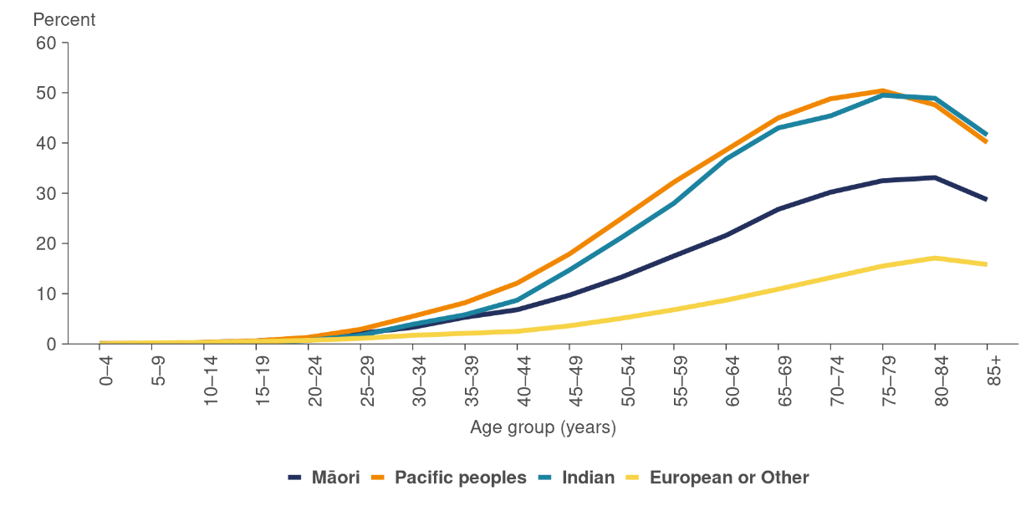

Source: [Ministry of Health (2021r)](http://www.diabetes.org.nz/whatisdiabetes)

## Mental health conditions

According to the Ministry of Health (2020h), the mental health conditions of anxiety and depression are among the top causes of health loss (death and disability) combined.

### Psychological distress

The New Zealand Health Survey (NZHS) measures psychological (mental) distress using the Kessler Psychological Distress Scale (K10) (Kessler et al 2003), which assesses how frequently a person experienced symptoms such as anxiety, psychological fatigue or depression in the past four weeks. People who receive a score of 12 or more have a high probability of having an anxiety or depressive condition (Ministry of Health 2020b).

In 2019/20, 7.4 percent of adults reported having experienced psychological distress in the four weeks before taking part in the NZHS. The survey responses to K10 questions[3] indicate that potential symptoms of psychological distress are increasing over time, up from 4.5 percent in 2011/12. The prevalence of psychological distress varied by gender, age, ethnic group, level of socioeconomic deprivation and disability status as follows.

* Women were around 1.4 times as likely as men to have experienced psychological distress in the past four weeks, after adjusting for age differences (the unadjusted rates were 8.5 percent and 6.3 percent, respectively).
* 13.6 percent of Māori, 9.7 percent of Pacific, 7.5 percent of European or Other, and 3.9 percent of Asian adults reported experiencing psychological distress in the four weeks before taking part in the survey. Māori adults were 1.9 times as likely to have experienced psychological distress as non-Māori adults after adjusting for age and gender differences. The prevalence of psychological distress has increased since 2011/12 in both Māori and European or Other adults (up from 7.4 percent and 3.9 percent respectively).
* Adults living in the most socioeconomically deprived areas were 3.7 times as likely to have experienced psychological distress as those in the least deprived areas, after adjusting for age, gender and ethnic differences. Poverty has been shown to be directly related to psychological distress and mental health, as well as poorer consequences of mental health conditions (Isaacs et al 2018).
* 27.0 percent of disabled adults experienced psychological distress in the four weeks before the survey, compared with 5.7 percent of non-disabled adults. After adjusting for age and gender differences, disabled adults were 6.1 times as likely as non-disabled adults to have experienced psychological distress in the four weeks before the survey.

The Counting Ourselves Survey is a comprehensive national survey of the health (and factors related to health) of trans and non-binary people aged 14 years and older living in New Zealand. The first report from the survey revealed that five out of every seven participants aged 15 years and older (71 percent) reported high or very high psychological distress (Veale et al 2021).

### Mental health services

In 2019/20, a total of 184,711 clients were seen by specialist mental health and addiction services. Of these clients, 94,978 (51 percent) were male, and 89,733 (49 percent) were female (Ministry of Health 2021j).

Figure 19: Access to specialist health services, by age and sex, 2019/20

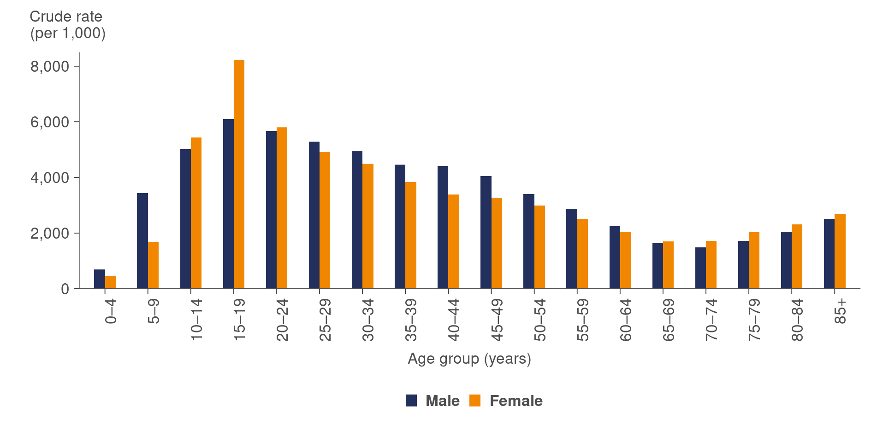

Source: [Ministry of Health (2021i)](https://www.health.govt.nz/publication/mental-health-and-addiction-service-use-2019-20-tables)

People living in the most deprived areas were 2.2 times more likely to be seen by mental health and addiction services than people living in the least deprived areas (6,522 compared with 2,921 per 100,000 population respectively), mirroring the link between poverty and mental health described above (Ministry of Health 2021j). Of the ethnic groups reported, Māori were the most likely to be seen by mental health and addiction services, with 6,400 clients seen for every 100,000 Māori population, while Asian were the least likely, with 1,136 clients seen for every 100,000 Asian population,[4] reflecting the rates of psychological distress reported above.

Figure 20: Access to specialist health services, by ethnic group and sex, 2019/20

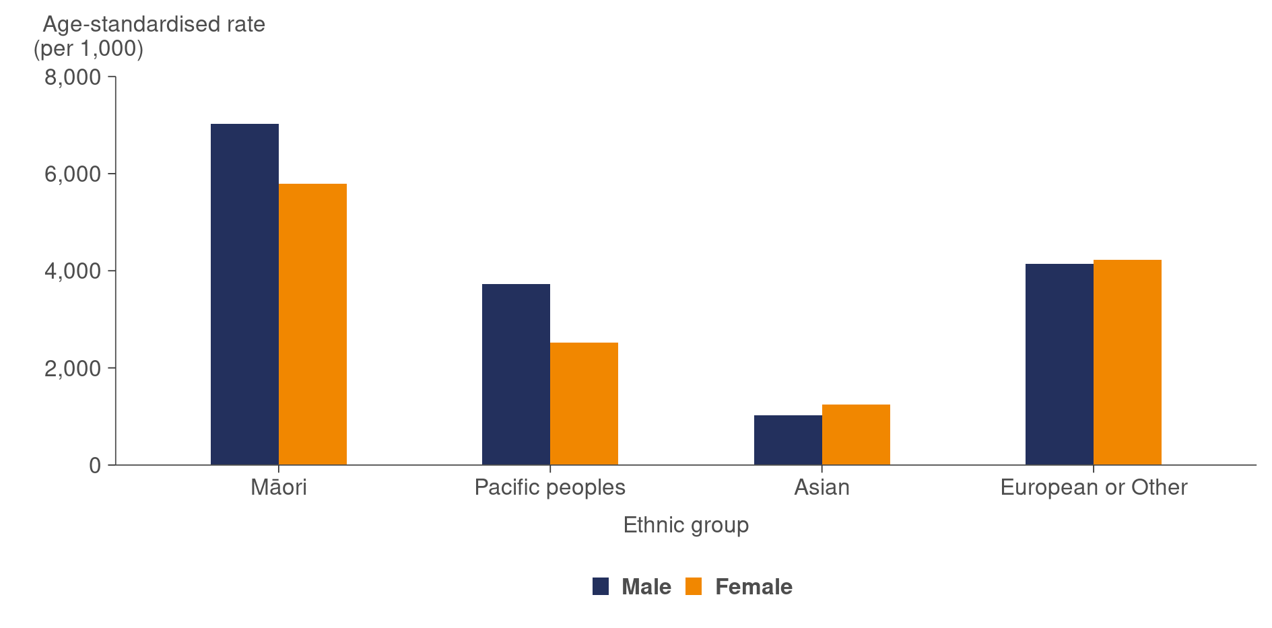

Source: [Ministry of Health (2021i)](https://www.health.govt.nz/publication/mental-health-and-addiction-service-use-2019-20-tables)

### Suicide

Suicide is a highly complex societal issue that affects people from all communities and walks of life. However, some populations, such as Māori, youth, men and people who use mental health and addiction services, are more likely to die by suicide (Ministry of Justice 2021). Pacific peoples, Rainbow communities and people who have been bereaved by suicide are also disproportionately affected (Ministry of Health 2019c).

In 2018, 623 people died by suicide in New Zealand (Ministry of Health 2021s). This equates to an age-standardised rate of 12.1 per 100,000, as shown in Figure 21 below. In 2018, the number of suicide deaths among Māori was higher than that among non-Māori – 18.2 per 100,000 compared with a rate of 10.6 per 100,000 for non-Māori. The highest rates of suicide were among youth aged 15–24 years (20.4 per 100,000) and those aged 45–64 years (16.9 per 100,000).

Figure 21: Confirmed suicide deaths or suspected intentionally self-inflicted deaths, 2009–2018

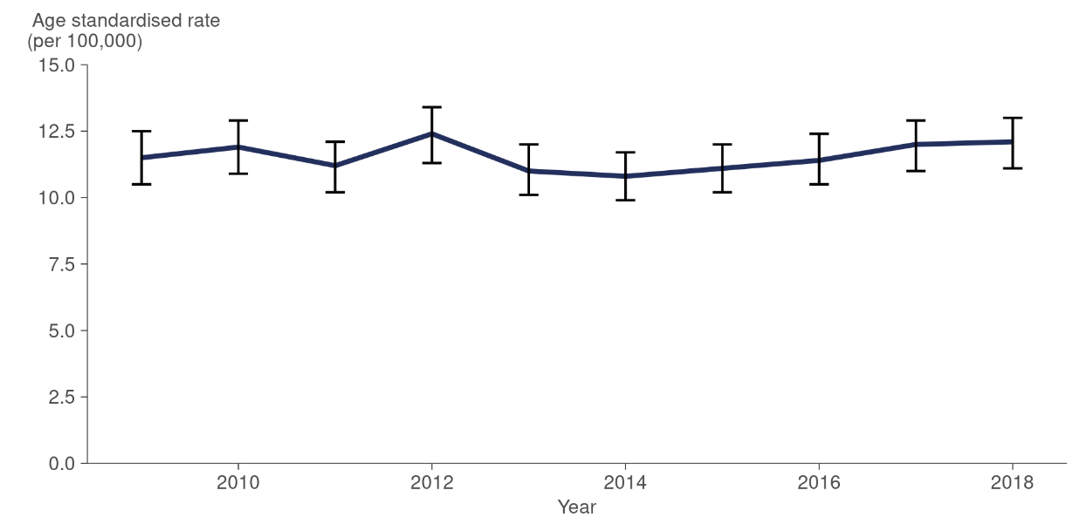

Source: [Ministry of Health (2021q)](https://minhealthnz.shinyapps.io/suicide-web-tool/)

# Child health | Hauora tamariki

The child population, defined as people under the age of 15 years, made up an estimated 966,400 (19 percent) of the New Zealand resident population in 2020 (Stats NZ 2020c). This section of the report looks at the following indicators of health for children.

* Parent-rated child health
* Mental health for children
* Oral health
* Respiratory illness
* Nutrition and body size
* Immunisation coverage

## Parent-rated child health

In the 2019/20 New Zealand Health Survey, according to their parents, 97.4 percent of children were in good, very good or excellent health (combined as ‘good health’; Ministry of Health 2020c). Parent-rated child good-health status was similar between girls and boys and across all age groups and ethnicities, and this has been consistent since 2011/12.

## Mental health for children

Child respondents to the New Zealand Health Survey (aged 2–14 years) are defined as having emotional or behavioural problems if the child’s parents or caregivers have ever been told by a doctor that the child has depression, anxiety (which includes panic attacks), phobia, post-traumatic stress, obsessive-compulsive disorder, attention deficit disorder (ADD) or attention deficit hyperactivity disorder (ADHD).

As shown in Figure 22 below, the percentage of children diagnosed with emotional or behaviour problems increased significantly between 2011/12 and 2019/20 (Ministry of Health 2020c). Diagnosed anxiety (panic attacks, phobia, post-traumatic stress and obsessive-compulsive disorder) has contributed considerably to the overall increase in emotional or behavioural problems.

Figure 22: Prevalence of emotional or behaviour problems in children aged  
2–14 years, 2006/07–2019/20

This line chart shows that emotional or behaviour problems in children 2-14 years increased from 1.8% in 2006/07, to 4.4% in 2011/12, and to 6% in 2019/20.


Source: [Ministry of Health (2020c](https://minhealthnz.shinyapps.io/nz-health-survey-2019-20-annual-data-explorer/_w_efe8bf2a/#!/explore-indicators))

## Oral health

Dental caries, primarily a preventable disease, remains the most common chronic disease of childhood and one of the most common reasons for hospital admissions for children in New Zealand. The most vulnerable children are shouldering the burden of the disease, with children living in the poorest areas, Māori and Pacific children showing poorer oral health (Bach and Manton 2014).

Figure 23 below shows the percentage of children who are caries-free (free of dental decay) at five years of age. As shown, 41.1 percent of Māori children and 34.0 percent of Pacific children are caries-free at this milestone age, compared with 68.4 percent of European or Other children (Ministry of Health 2020a).

Figure 23: Percentage of 5-year-old children caries-free, by ethnic group, 2019

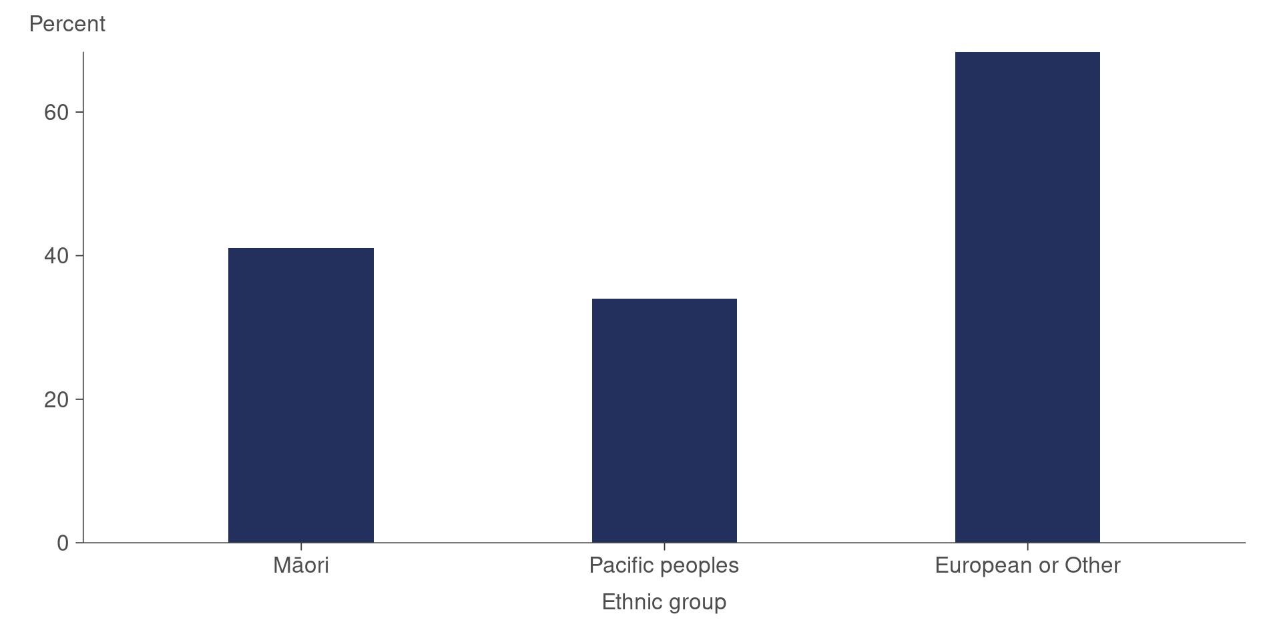

Source: [Ministry of Health (2020a](http://www.health.govt.nz/nz-health-statistics/health-statistics-and-data-sets/oral-health-data-and-stats/age-5-and-year-8-oral-health-data-community-oral-health-service))

## Respiratory illness

According to the 2019/20 New Zealand Health Survey, 13.5 percent of children had asthma (defined as being told by a doctor they have asthma and currently taking medication for the condition; Ministry of Health 2020c). The prevalence of asthma amongst children varied by ethnicity as follows: Māori (22.4 percent), Pacific peoples (17.5 percent), Asian (7.6 percent) and European or Other (13.6 percent). Risk factors for respiratory conditions like asthma include poverty, mouldy, damp or poorly heated homes, crowded households, unhealthy diets and exposure to tobacco smoke.

Around 35 percent of acute child admissions to hospital are due to respiratory infections, of which asthma and wheeze are the most common causes hospitalisation (Cure Kids 2020). Pacific children and children living in the highest deprivation areas have the highest rates of.

## Nutrition and body size

### Body size

According to the New Zealand Health Survey, nearly one in ten children aged 2–14 years (9.4 percent) were classified as obese in the 2019/20 year (Ministry of Health 2020c). This rate has remained relatively unchanged since 2011/12. The prevalence of obesity amongst children varied by ethnicity as follows: Pacific peoples (29.1 percent), Māori (13.2 percent), Asian (3.4 percent) and European or Other (7.2 percent).

Pacific children were 4.7 times as likely and Māori children 1.6 times as likely to be obese as non-Pacific and non-Māori children respectively, after adjusting for age and gender differences. Asian children were less likely to be obese than non-Asian children, after adjusting for age and gender differences.

After adjusting for age, gender and ethnic differences, children living in the most socioeconomically deprived areas were 2.7 times as likely to be obese as children living in the least deprived areas.

A United Nations Children’s Fund (UNICEF) report from 2019 shows that New Zealand has the second-highest rate of child obesity among OECD countries, second only to America (UNICEF 2019). According to The Royal New Zealand College of General Practitioners and the University of Otago, factors contributing to childhood obesity are numerous and complex. Many are linked to poverty and the marketing of processed foods, which tend to be accessible and convenient and are often cheaper than fresh nutrient-dense foods (Stuff 2019).

### Nutrition – breastfeeding

There are many known benefits of breastfeeding. Some of these benefits are: protecting babies from colds, tummy bugs, infections and allergies, as well as reducing the risk of sudden unexpected death in infancy (SUDI). According to Yan et al (2014), there is mounting evidence indicating that breastfeeding also has longer-term benefits, such as reducing the risk of childhood obesity.

The Well Child Tamariki Ora (WCTO) programme supports the health, development and wellbeing of tamariki in New Zealand from birth to five years of age (Ministry of Health 2021u). The programme captures a range of information measuring child health, including rates of exclusive or fully breastfed babies at three months of age. According to WCTO data, Māori and Pacific babies and babies living in higher deprivation areas are less likely to be exclusive or fully breastfed at three months of age. The rates are: 47 percent each for Māori and Pacific babies, 48 percent for babies living in high deprivation areas, 61 percent for non-Māori babies and 59 percent for non-Pacific babies (Nationwide Service Framework Library 2021c).

### Nutrition – vegetable and fruit intake

There are differences in vegetable and fruit intake for children aged 2–14 years by ethnic group and deprivation. According to the 2019/20 New Zealand Health Survey, only 26.2 percent of Pacific children consumed the recommended number of servings of vegetables and fruit each day, compared with 28.5 percent of Asian children, 40.4 percent of Māori children and 51.4 percent of European or Other children. Only 36.4 percent of children living in the most deprived areas consume the recommended number of servings of vegetables and fruit each day, compared with 51.7 percent of children in the least deprived areas. The recommended number of servings of vegetable and fruit is based on Ministry guidelines (Ministry of Health 2020f).

## Immunisation coverage

Over the past four years, childhood immunisation rates in New Zealand have fallen for Māori and Pacific children (Ministry of Health 2021l). Figure 24 below shows immunisation rates for eight-month-old children.

Figure 24: Immunisation rates at eight months of age, by ethnic group, 2017–2020

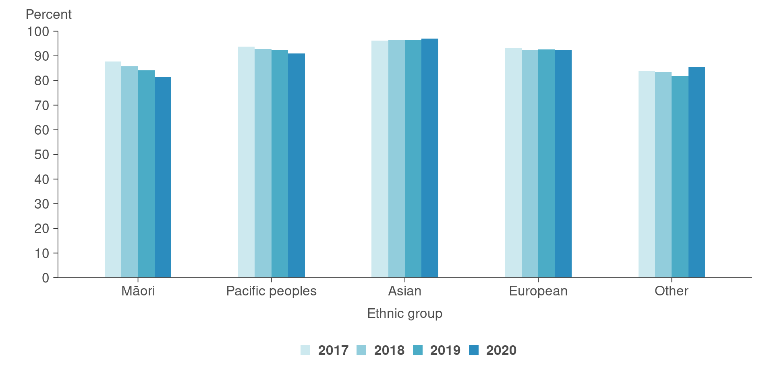

Source: [**Ministry of Health (2021k)**](https://www.health.govt.nz/our-work/preventative-health-wellness/immunisation/immunisation-coverage/national-and-dhb-immunisation-data)

In 2019, New Zealand experienced its largest measles outbreak since 1997, with 2,185 notified cases. The outbreak started in February and lasted more than a year. Most cases were reported in the Auckland region. Māori and Pacific populations were disproportionately affected, with incidence rates 4 and 14 times higher (respectively) than the incidence rate in the New Zealand European population (Sonder and Ryan 2020).

Research in New Zealand and overseas has identified that systemic barriers are the leading cause of under-immunisation. Barriers to accessing vaccinations include socioeconomic factors, rurality, parental difficulties in juggling families, work and complex vaccine schedules (Ministry of Health 2019b).

# Youth health | Hauora rangatahi

The youth population, defined as people aged between 15 and 24 years, made up an estimated 656,530 (12.9 percent) of the New Zealand resident population in 2020 (Stats NZ 2020c). This section looks at the following indicators of youth heath.

* Self-rated health
* Mental health
* Smoking
* Vaping (electronic cigarettes)

## Self-rated health

Self-rated health is a widely used indicator of a population’s health status. In the 2019/20 New Zealand Health Survey, 90.5 percent of youth rated their health as good, very good, or excellent (Ministry of Health 2020c). This is a drop from a high of 93.8 percent in 2013/14.

## Mental health

Psychological (mental) distress refers to a person’s experience of symptoms such as anxiety, psychological fatigue or depression in the past four weeks. According to the 2019/20 New Zealand Health Survey, the prevalence of psychological distress is highest in the youth population, where 11.1 percent (approximately 72,000 youth) are affected (Ministry of Health 2020c). This compares with 7.4 percent of all adults. There has been a steady increase in psychological distress for youth from a low of 5 percent in 2011/12.

A 2020 report by Analysis & Policy Observatory (2020) on youth mental health in New Zealand shows that, worldwide, 16 percent of the global burden of disease and injury for adolescents aged 10–19 years is attributable to mental morbidity, such as depression and anxiety. For youth belonging to disadvantaged populations and marginalised communities, the risks of mental illness, addictions and suicide are much higher. Ethnicity, poverty and sexual orientation are particularly critical determinants of mental health and wellbeing.

The report states that youth mental health rates have more than doubled over the last two decades (Analysis & Policy Observatory 2020). The national teenage (15–19 years) suicide rates are among the highest in the OECD, and findings from the Youth12 survey of secondary school students reported 29 percent of female students and 18 percent of male students had intentionally self-harmed in the preceding 12 months (Clark et al 2013). Preliminary findings from the Youth19 survey (the 2019 wave of the series) of 7,721 school students aged 13–19 years paint a bleak picture of youth mental health and wellbeing, with only 69 percent reporting good emotional wellbeing (Fleming et al 2020). Particularly concerning are the findings that 57 percent of the Rainbow (T&LGBTQA) young people surveyed experienced symptoms of depression.

## Smoking

According to the Ministry of Health (2020c), 12.9 percent of young adults (18–24 years old) reported daily smoking, which is a decrease from 24.3 percent in 2011/12. Only 3 percent of 15 to 17-year-olds reported daily smoking. This is a similar rate to the last few years, but is down from 6.4 percent in 2011/12. Similar findings are reported in a biennial study of year 10 students (14 to 15-year-olds) that found daily smoking rates of 2.1 percent (ASH 2018). This is at an all-time low and is down from 15.2 percent when the survey began in 2000.

The largest smoking inequities are among teenage girls aged 14–15 years (year 10). In 2019, 6.8 percent of year 10 Māori girls smoked daily compared with 0.8 percent of Year 10 non-Māori, non-Pacific girls (ASH 2018). These inequities carry through into young adulthood and pregnancy. For example, among women aged 15–24 years, Māori females smoke at over four times the rate of non-Māori females (34 percent and 8 percent respectively in 2015/16; Ministry of Health 2021p).

Smoking in pregnancy or exposure to second-hand smoke in the early stages of a baby’s life dramatically increases the risk of SUDI. Second-hand smoke exposure increases a child’s risk of serious infections that affect breathing, including pneumonia and bronchitis. Second-hand smoke causes around 15,000 asthma attacks in children aged under 16 years in New Zealand every year (Ministry of Health 2021f; p). Furthermore, children who grow up in smoking households are at higher risk of smoking in future than children who grow up in non-smoking households.

## Vaping (electronic cigarettes)

According to the 2019/20 New Zealand Health Survey, 23.9 percent of adults reported having ever tried an electronic cigarette, up from 16.2 percent in 2015/16 (Ministry of Health 2020c). Varying percentages of different age groups reported having tried electronic cigarettes. The highest percentage was in the age group 18–24 years (53.5 percent), followed by the 15–17 years age group (39.5 percent) and the  
25–34 years age group (37.4 percent). Only 3.5 percent of the population report daily electronic cigarette use, and 5.2 percent of the total population report using electronic cigarettes at least once a month.

# Older people’s health | Hauora mātāpuputu

The older population, defined as people aged 65 years and over, made up an estimated 791,000 (15.6 percent) of the New Zealand resident population in 2020. Within this group, there were approximately 331,450 people aged 75 years and older (Stats NZ 2020c).

Māori currently account for 16.8 percent of the total population (Stats NZ 2021j). However, the Māori population age structure is relatively young, with only 5.8 percent of the over-65-years population identifying as Māori (Parr-Brownlie et al 2020). Higher fertility rates and lower life expectancy for Māori contribute to these differences.

Pacific people account for 8.5 percent of the total population (Stats NZ 2021j), but, like the Māori population, the age structure is young, with only 2.5 percent of the population aged over 65 years identifying as Pacific (Parr-Brownlie et al 2020).

Over the next 20 years, higher birth rates that occurred between 1945 and 1975 and the increase in immigration from the Pacific that took place from the 1970s onwards will contribute to an increasing rate of growth for older Māori and Pacific populations, resulting in the ethnic makeup of the over-65-years population becoming more diverse.

This section looks at the following indicators of older people’s health.

* Self-rated health
* Mental health
* Dementia
* Aged care services

## Self-rated health

According to the 2019/20 New Zealand Health Survey, 88.7 percent of 65 to 74-year-olds and 84.7 percent of those aged 75 years and over, rated their health as good, very good or excellent (Ministry of Health 2020c). This is higher than in 2011/12, when rates were 85.6 percent and 81.9 percent respectively.

## Mental health

Psychological (mental) distress refers to a person’s experience of symptoms such as anxiety, psychological fatigue or depression. According to the 2019/20 New Zealand Health Survey, the prevalence of psychological distress is lowest in the older population, where 4.0 percent of 65 to 74-year-olds and 3.5 percent of 75 years and over are affected (Ministry of Health 2020c). This compares with 7.4 percent of all adults. Rates have remained stable for these older population groups over time.

## Dementia

Dementia is the term used when a person experiences a gradual loss of brain function, due to physical changes in the structure of their brain. Dementia is not a normal part of the ageing process; however, it is more common in people over the age of 65 years. The most common form of dementia is Alzheimer’s disease (Ministry of Health 2021e).

There were an estimated 62,287 people in New Zealand with dementia in 2016, an increase of around 29 percent over the previous estimate of 48,182 people in 2011 (Deloitte 2017). Economic costs associated with dementia totalled $2.46 billion in 2020 (Alzheimers New Zealand 2021).

## Aged care services

Most older people live independently in New Zealand. However, some older people require residential-level care because their needs surpass what can be provided in the community.

A total of 34,646 residents were receiving care at aged residential care (ARC) facilities on 31 March 2020. Of these residents, 45 percent were receiving rest home level care, 40 percent hospital level care, 12 percent dementia care and 3 percent psychogeriatric care. Combined, residents receiving higher care levels (hospital, dementia and psychogeriatric) outnumber those receiving rest home care.

In March 2015, there were 15,354 rest home residents, and this number grew by only 1.5 percent over the five years to March 2020, when there were 15,583 rest home residents. In contrast, those at the higher care levels combined grew 13 percent over the same five-year period, from 16,844 in March 2015 to 18,961 in March 2020 (New Zealand Aged Care Association 2020).

# Determinants of health and wellbeing | Ngā whakatau o te hauora me oranga

The wider factors affecting health are collectively known as the determinants of health. These are circumstances and wider forces that contribute to people’s health, wellbeing and quality of life (ICSI 2014).

Figure 25 below estimates the contribution each factor makes to a person’s quality of life, although these determinants are connected and overlap. Within these high-level determinants, there are many aspects that can strongly influence health and wellbeing. The determinants can be broken into four categories.

* Socioeconomic factors, such as education, job status, family and social support, income, and community safety is estimated to contribute 40 percent toward a person’s health and wellbeing.
* Physical environment, such as good, affordable housing and access to clean water contributes 10 percent towards a person’s health and wellbeing.
* Health behaviours, such as tobacco use, diet and exercise, and alcohol use contributes 30 percent toward a person’s health and wellbeing.
* Health care, including access to health services contributes 20 percent toward a person’s health and wellbeing.

Figure 25: The determinants of health and their contribution to health outcomes

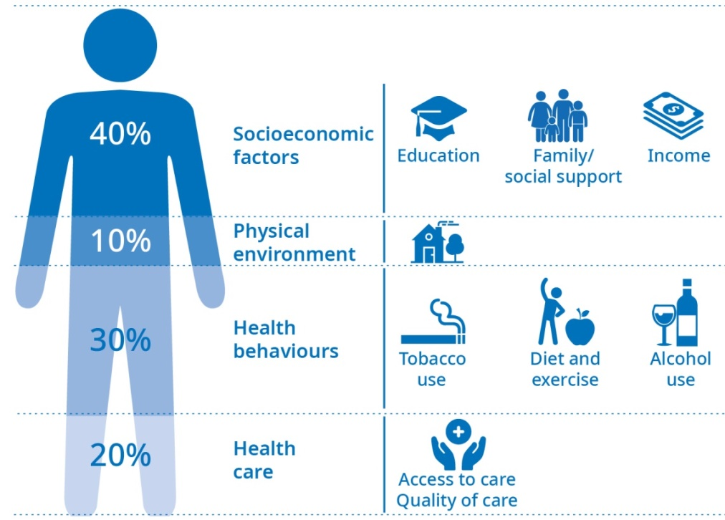

Source: Adapted from the[ICSI (2014)](http://www.icsi.org/wp-content/uploads/2019/08/1.SolvingComplexProblems_BeyondClinicalWalls.pdf)

## Socioeconomic factors and physical environment

Socioeconomic factors, such as income, employment status, housing and education, along with physical environment, can have both direct and indirect impacts on a person’s health. These impacts can be cumulative over the person’s lifetime (Ministry of Health 2018c).

### Income

According to Stats NZ, the median disposable household income in New Zealand in 2020 was $41,000 (Stats NZ 2021c), and 16.7 percent of New Zealanders lived in households with less than half the median disposable household income (Stats NZ 2021c). The equivalised[5] disposable income of a high-income household was 2.7 times larger than that of a low-income household in 2020 (Stats NZ 2021c). The degree of income inequality is often regarded as an important aspect of the fairness of the society people live in.

The New Zealand Deprivation Index (NZDep) is an area-based measure of socioeconomic deprivation in New Zealand (Atkinson et al 2019). It measures the level of deprivation for people in each small area based on nine census variables. Higher levels of socioeconomic deprivation are associated with worse health.

Figure 26 below shows that the Māori population in New Zealand is much more likely to live in areas of higher deprivation, whereas the non-Māori population is evenly spread (Ministry of Health 2019d).

Figure 26: Neighbourhood deprivation, for Māori and non‑Māori, 2018

This bar chart shows Māori are more likely to reside in the most deprived neighbourhoods compared to non-Māori. 27% of Māori live in decile 10 (most deprived) neighbourhoods compared to 8% of non-Māori.


Source: [Atkinson et al (2021)](https://ourarchive.otago.ac.nz/handle/10523/12052)

### Housing

According to Stats NZ wellbeing data for New Zealanders, 30.3 percent of households spent more than 30 percent of their disposable household income on housing costs in 2020. This is similar to 2019 and lower than 31.4 percent recorded in 2018 (Stats NZ 2021c).

Homelessness data is available from 2018 (Stats NZ 2021c). At this time, it was estimated that at least 41,644 people were severely housing deprived. This was defined as a person being without shelter, in temporary accommodation (emergency and transitional accommodation, camping grounds, etc) or shared accommodation (defined as a temporary resident in a severely crowded private dwelling).

### Employment

In the December 2020 quarter, 66.8 percent of New Zealanders aged 15 years and over were employed. The unemployment rate was 4.9 percent (this includes people who were not in employment, were available to start work and were actively seeking work; Stats NZ 2021d). This rate has been relatively stable over the past two years (ranging from 4.0 to 5.3 percent), falling from 6.7 percent in 2012. According to Stats NZ (2021d), the unemployment rates in 2020, by ethnicity were:

* 3.7 percent – European
* 5.2 percent – Asian
* 9.0 percent – Māori
* 9.6 percent – Pacific peoples.

### Family wellbeing

This measure shows the percentage of people 15 years and over who rated how well their family was doing on a scale of 0–10, where 0 is extremely badly and 10 is extremely well. The self-rated high family wellbeing (seven or higher; Stats NZ 2021c) were:

* 87.5 percent – Asian
* 82.6 percent – European
* 82.5 percent – Pacific
* 74.9 percent – Māori.

## Health behaviours

This section covers activities that contribute to health loss, such as smoking, diet, high body mass index (BMI) and alcohol consumption (Stats NZ 2021c). While these measures can be attributed to an individual’s behaviour, the role that society, inequity and poverty have on health behaviours should also be considered (Short and Mollborn 2015).

### Substance use

According to the NZ Drug Foundation (2021), there is less illicit drug use in New Zealand than people generally think. Cannabis is the most common illicit drug used in New Zealand, with 15 percent of adults having used cannabis in the past year, and 8.5 percent, or 330,000 adults, smoking cannabis monthly. Use is higher in Māori, young people and those in more deprived neighbourhoods (NZ Drug Foundation 2021).

Methamphetamine use has remained relatively stable over the past five years but is a serious concern in some communities. Overall, numbers of people using amphetamines (including methamphetamine) have remained relatively stable in the past five years, at around 1 percent of the population (NZ Drug Foundation 2021).

Use of other illicit drugs is relatively low in New Zealand. The last Ministry of Health survey of illicit drug use was completed over a decade ago in 2007/08. It found that the use of other drugs, such as LSD and opiates, was not widespread (Ministry of Health 2010). More recent figures from 2012/13 show that fewer than 3 percent of New Zealanders had used ecstasy in the past year (NZ Drug Foundation 2021).

According to the New Zealand Drug Foundation, the drugs that cause the most harm in New Zealand are alcohol and tobacco, and that harm is most sharply felt by those already suffering socioeconomic deprivation (NZ Drug Foundation 2021).

### Tobacco use

Smoking was considered one of the leading modifiable health risks in New Zealand in 2017, accounting for 9.7 percent of all illness, disability and premature mortality (Ministry of Health 2020h). Smoking harms nearly every organ and system in the body. It is the main cause of lung cancer and chronic obstructive pulmonary disease (COPD). It is also a major cause of many other cancers, heart disease and stroke. The government’s aspirational goal is to make New Zealand essentially smokefree by 2025 (Stats NZ 2021c).

According to the 2019/20 New Zealand Health Survey, 13.4 percent of adults are current smokers. For Māori adults, 31.4 percent are current smokers, which is down from 40.2 percent in 2011/12 (Ministry of Health 2020c). Amongst Pacific adults, 22.4 percent were current smokers in 2019/20, which is not a statistically significant change from 2011/12, when the percentage for Pacific adults was 25.9 (Ministry of Health 2020c).

After adjusting for age and gender:

* Māori were 2.8 times as likely to be current smokers as non-Māori. Māori women were 3.6 times as likely to be current smokers as their non-Māori counterparts
* Pacific adults were 1.7 times as likely to be current smokers as non-Pacific adults
* adults living in the most socioeconomically deprived areas were 4.5 times as likely to be current smokers as adults living in the least deprived areas
* disabled adults were 1.9 times as likely to be current smokers as non-disabled adults.

While smoking rates have declined in most population subgroups, the level of decline varies by age. The most marked reduction in smoking since 2011/12 was for young people, with smaller decreases in older age groups (Figure 27).

Figure 27: Prevalence of current smoking, by age group, 2011/12 and 2019/20

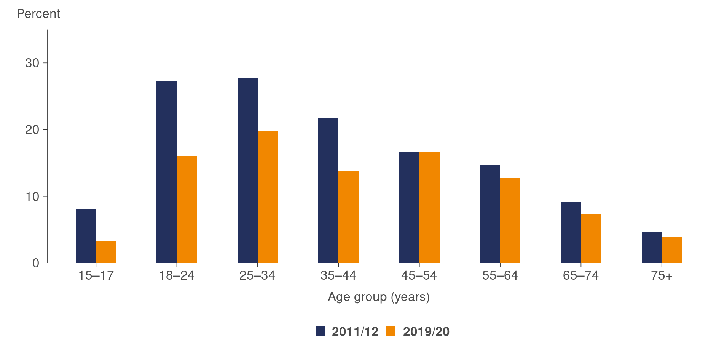

Source: [Ministry of Health (2020c)](https://www.health.govt.nz/publication/annual-update-key-results-2018-19-new-zealand-health-survey)

### Diet

In the 2019/20 New Zealand Health Survey, adults were asked how many servings of vegetables and fruit they eat each day. In 2019/20, only one-third (33.5 percent) of adults consumed the recommended number of servings of vegetables and fruit each day. A higher percentage of older people (44.1 percent of adults aged 65–74 years and 42.4 percent of adults aged 75 years and over) consumed the recommended servings of vegetables and fruit each day, compared with 26.4 percent for youth (Ministry of Health 2020c).

By ethnicity, deprivation and disability grouping, the rates of adults consuming the recommended number of servings of vegetables and fruit each day were:

* Māori adults – 28.4 percent
* Pacific adults – 24.9 percent
* Asian adults – 21.2 percent
* European or Other adults – 36.7 percent
* Adults living in the most socioeconomically deprived areas – 25.4 percent
* Disabled adults – 26.8 percent.

Most people consumed more unhealthy snacks and drinks during our COVID‑19 lockdowns, according to a study led by researchers from The University of Auckland. The COVID Kai Survey of 3,028 people ran from 24 April to 13 May 2020, when New Zealand was at alert levels three and four for the first time (New Zealand Nutrition Foundation 2020). The study found that the COVID‑19 pandemic created new challenges in the physical access to, and affordability of, healthy food in New Zealand. Supermarkets and food banks struggled to meet increased demand, with many running out of necessary food supplies.

#### Obesity

In the New Zealand Health Survey 2019/20, the prevalence of obesity among adults aged 15 years and over was 30.9 percent, an estimated 1.24 million adults. This prevalence has remained relatively stable since 2012/13. By ethnic group, prevalence was highest amongst Pacific peoples (63.4 percent), followed by Māori (47.9 percent), European or Other (29.3 percent) and Asian adults (15.9 percent; Ministry of Health 2020c). In addition, the New Zealand Health Survey found that 47.4 percent of disabled adults were obese compared with 29.6 percent of non-disabled adults (Ministry of Health 2020c).

After adjusting for age and gender:

* Māori adults were 1.8 times as likely to be obese as non-Māori, and Pacific adults were 2.3 times as likely to be obese as non-Pacific adults
* adults living in the most socioeconomically deprived neighbourhoods were 1.8 times as likely to be obese as those living in the least deprived neighbourhoods
* disabled adults were 1.6 times as likely to be obese as non-disabled adults.

### Alcohol

Alcohol harm is driven by both the total volume consumed and the patterns of drinking (Ministry of Health 2019a). Alcohol use accounted for around 5 percent of total health loss in New Zealand in 2017 (Ministry of Health 2020h).

According to the 2019/20 New Zealand Health Survey, four in five adults (81.5 percent) drank alcohol in the past year (Ministry of Health 2020c). Men were 1.1 times as likely to have been past-year drinkers as women, after adjusting for age. Although the legal age for purchasing alcohol in New Zealand is 18 years old, 57.5 percent of those aged 15–17 years drank alcohol in the past year. This rate has not changed significantly since 2011/12.

#### Hazardous drinking

In the New Zealand Health Survey, hazardous drinking refers to an established alcohol drinking pattern that carries a risk of harming the drinker’s physical or mental health or having harmful social effects on the drinker or others. The Alcohol Use Disorders Identification Test (AUDIT) is a 10-item questionnaire that covers three aspects of alcohol use: alcohol consumption, dependence and adverse consequences (Ministry of Health 2020b).

One in five adults (20.9 percent) were hazardous drinkers in 2019/20, representing no change since the time series began in 2015/16 (Ministry of Health 2020c). The prevalence of hazardous drinking among men was 28.7 percent, whereas it was 13.6 percent in women.

The highest prevalence of hazardous drinking was among those aged 18–24 years, at 32.4 percent (Ministry of Health 2020c). The prevalence of hazardous drinking was also high in those aged 25–34 years (23.8 percent), 35–44 years (21.5 percent) and  
45–54 years (27.7 percent). Of those aged 15–17 years, 11.6 percent had engaged in hazardous drinking over the year before taking part in the survey, which is a statistically significant increase on the previous year, when it was 6.3 percent. From 55 years of age, the rate of hazardous drinking drops with increasing age.

Of Māori adults, 36.1 percent were hazardous drinkers in 2019/20. Māori adults were 1.8 times as likely as non-Māori adults to be hazardous drinkers, after adjusting for age and gender differences (Ministry of Health 2020c). In contrast, only 5.5 percent of Asian adults were hazardous drinkers over the same period.

## Health care

Health care in New Zealand is a mixture of free and subsidised services. The following health services are free in New Zealand for people eligible for publicly funded health care (New Zealand Government 2021).

* Inpatient and outpatient treatment at public hospitals
* Hospital care because of an accident
* Maternity care
* Support services for people with disabilities, including aged care services
* Fertility services
* Visits to a general practitioner (GP) for children aged under 13 years

### Barriers to accessing health care

A systematic review of two decades of qualitative research that was published in April 2020 studied the experiences of Māori using New Zealand’s public health system. Māori patients and whānau mentioned both barriers and facilitators to health. The main barriers were identified as organisational structures (racism, cultural alienation), staff interactions (lack of rapport, ineffective communication, rushed staff) and practical barriers (cost, transport, time). Facilitators included the provision of whānau support in the form of practical assistance, emotional care and health system navigation (Graham and Masters-Awatere 2020).

Research into barriers to early presentation and diagnosis of lung cancer within the primary health care setting in New Zealand published in December 2020 found that culturally responsive, patient-centred health care and positive GP-patient relationships are significant factors for Māori patients and whānau, serving as enablers of early diagnosis of lung cancer (Cassim et al 2021).

The WHO describes common barriers that disabled people encounter when they attempt to access health care as:

* prohibitive costs – affordability of health services and transportation
* limited availability of services – lack of appropriate services for people with disability, especially in rural and remote areas
* physical barriers – uneven access to buildings, inaccessible medical equipment, poor signage, narrow doorways, internal steps, inadequate bathroom facilities and inaccessible parking areas
* inadequate skills and knowledge of health workers (WHO 2020).

### Unmet need for health care

Unmet need for primary health care for adults (aged 15+ years) is defined in the New Zealand Health Survey as a person having experienced one or more of the following types of unmet needs in the past 12 months:

* a GP due to cost
* an after-hours medical centre due to cost
* a GP due to lack of transport
* an after-hours medical centre due to lack of transport
* an appointment at their usual medical centre within 24 hours (Ministry of Health 2020c).

According to the Health Quality and Safety Commission New Zealand (HQSC), appointment cost was the most common barrier to accessing health services (HQSC 2020). Of those aged 65 years and over who reported cost being a barrier (8 percent), appointment cost was the most common barrier (95 percent). For those aged under 65 years, appointment cost was also the highest barrier (89 percent), followed by the cost of taking time off work (29 percent).

In addition, barriers to health care include unmet need for dental care due to cost. This is the most commonly recorded unmet need, affecting more than half of all Māori, Pacific and disabled adults and more than 4 in 10 other adults. The second highest unmet need was being unable to get an appointment at a usual medical centre within 24 hours, which affected one in five adults (21.9 percent), but 29.2 percent of all Māori adults and 32.3 percent of all disabled adults (Table 9).

Table 9: Barriers to accessing health care for adults, 2019/20

|  |  |  |  |  |
| --- | --- | --- | --- | --- |
| **Population group (adults)** | **Unable to get an appointment within 24 hours** | **Unmet need for GP due to cost** | **Unfilled prescription due to cost** | **Unmet need for dental care due to cost** |
| All adults | 21.9% | 13.3% | 5.1% | 42.0% |
| Māori | 29.2% | 20.5% | 12.7% | 53.7% |
| Pacific peoples | 19.6% | 16.0% | 13.7% | 51.5% |
| Asian | 16.1% | 11.1% | 2.7% | 42.0% |
| European or Other | 22.9% | 13.2% | 4.2% | 40.3% |
| Disabled | 32.3% | 21.5% | 13.0% | 54.2% |

Note: GP = general practitioner

Source: [Ministry of Health (2020c)](https://www.health.govt.nz/publication/annual-update-key-results-2019-20-new-zealand-health-survey)

#### Unmet need due to cost – GP

In the 2019/20 New Zealand Health Survey, 13.3 percent of people surveyed (representing 535,000 adults in New Zealand) reported not visiting a GP due to cost in the past 12 months. Rates varied by gender, age, ethnic group, disability and level of neighbourhood deprivation (Ministry of Health 2020c).

In 2019/20, experiencing cost as a barrier to visiting the GP was more common amongst women (15.9 percent) than men (10.6 percent), even after adjusting for age (ratio for men vs women is 0.66). Around one in five Māori adults (20.5 percent) had not visited a GP due to cost in 2019/20, a rate relatively unchanged since 2011/12. The highest group experiencing cost as a barrier to visiting the GP in 2019/20 was disabled people at 21.5 percent.

#### Unmet need due to cost – unfilled prescription

In the 2019/20 New Zealand Health Survey, 5.1 percent (or an estimated 205,000 adults) had been unable to collect a prescription due to the cost of that prescription in the previous 12 months. There was considerable inequity across population groups with rates varying by gender, age, ethnic group, level of socioeconomic deprivation and disability status, as follows.

* Women were twice as likely as men to not have collected a prescription due to cost in the past 12 months, after adjusting for age differences.
* Around 14 percent of Pacific adults and 13 percent of Māori adults had not collected a prescription due to cost in the past 12 months. Pacific and Māori adults were 2.7 and 2.8 times as likely as non-Pacific and non-Māori adults, respectively, to not have collected a prescription due to cost after adjusting for age and gender differences. In contrast, just 2.7 percent of Asian adults had been unable to collect a prescription due to cost in the past 12 months.
* Adults living in the most socioeconomically deprived areas were six times as likely to have been unable to collect a prescription due to cost as adults living in the least deprived areas, after adjusting for age, gender and ethnic differences.
* Disabled adults were 3.8 times as likely as non-disabled adults to be unable to collect a prescription due to cost, after adjusting for age and gender. The rates were 13.0 percent and 4.5 percent, respectively (Ministry of Health 2020c).

### Preventative health services

#### Breast cancer screening

Breast cancer is New Zealand’s third most common cancer and accounts for more than 600 deaths every year (Ministry of Health 2021k). The risk of being diagnosed with breast cancer increases with age: around 70 percent of women who are diagnosed with breast cancer and 80 percent of women who die from it are 50 years or older (Ministry of Health 2020d). The national breast screening programme, BreastScreen Aotearoa (BSA), provides free mammography screening every two years to women who have no symptoms of breast cancer and are aged 45–69 years (Ministry of Health 2020d).

The current breast cancer screening system works on an ‘opt-in’ model, which relies on women firstly knowing they are eligible for free breast screening and secondly understanding how to make an appointment. A new breast screening system is planned within the next two years that will proactively identify and enrol eligible women. It is hoped the new system will reach 271,000 more people who are not currently using the programme (Little and Verral 2021).

Breast cancer screening rates have declined slightly in recent years for women overall and for Māori women (Ministry of Health 2021a). The lower coverage rates in 2020 are partly due to pauses in routine screening during March to April 2020 as part of the national COVID‑19 response.

Figure 28: Breast cancer screening rates among women aged 45–69 years, by ethnic group, 2016–2020

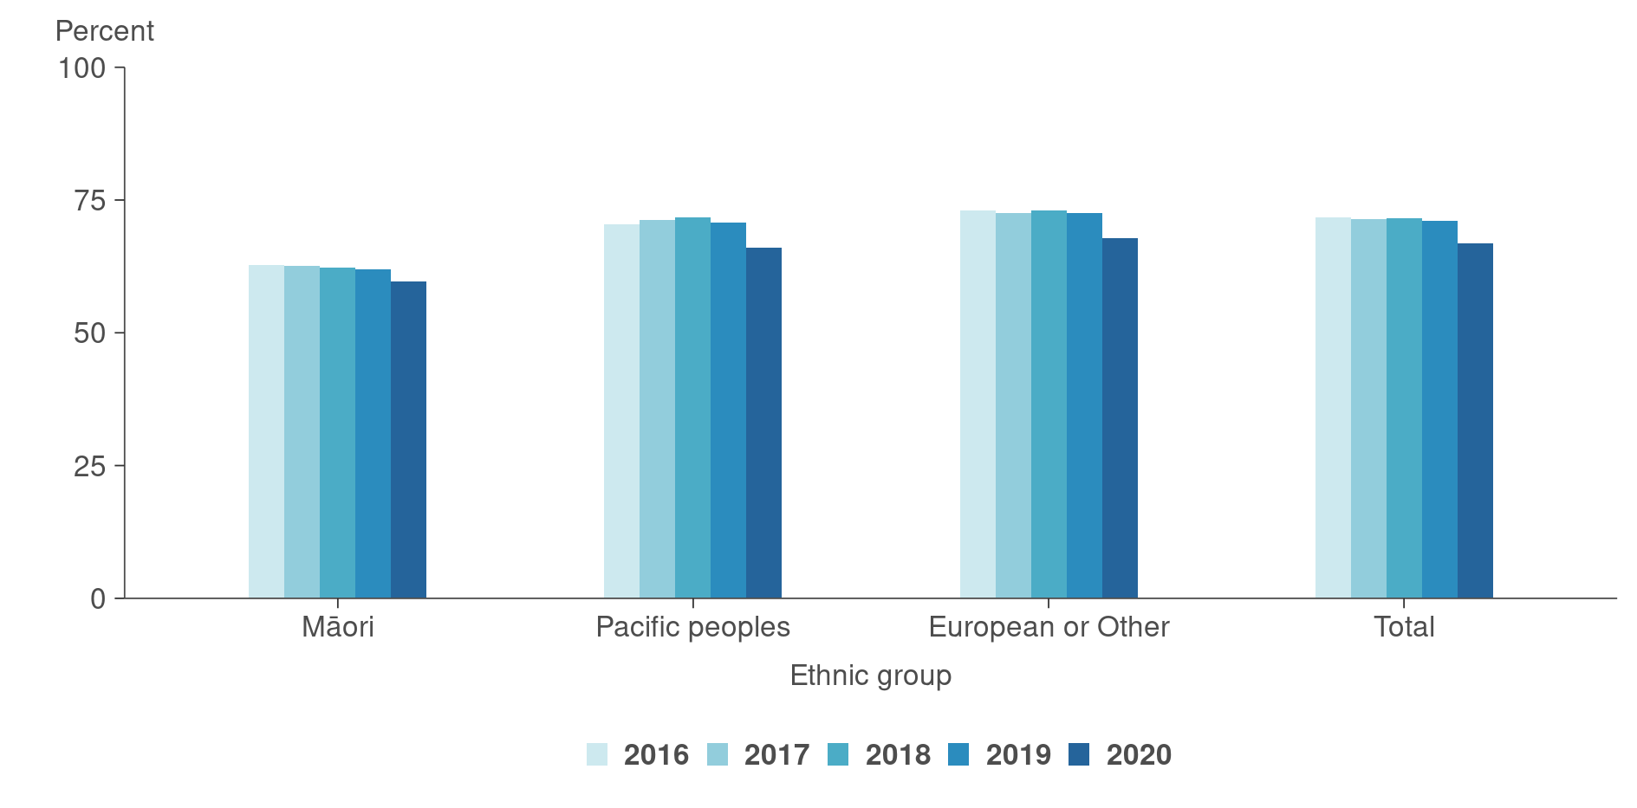

Source: [Ministry of Health (2021a)](https://minhealthnz.shinyapps.io/nsu-bsa-coverage-dhb/)

#### Cervical cancer screening

In New Zealand each year, approximately 160 women develop cervical cancer and around 50 die from the disease (Ministry of Health 2014). According to the cervical screening website Time to Screen, early treatment is highly successful and, since the national screening programme started in 1990, the number of women who die of cervical cancer has dropped by nearly two-thirds (Time to Screen 2021). Despite the national screening programme, [Māori women](https://www.wgtn.ac.nz/health/centres/centre-for-womens-health-research/eliminating-cervical-cancer) living in New Zealand are one-third less likely to attend cervical cancer screening and more than twice as likely to be diagnosed with, and die from, cervical cancer than their European counterparts (Cervical cancer screening and New Zealand’s uncomfortable truths 2021).

A new test for human papillomavirus (HPV), the cause of 99 percent of cervical cancers, is being currently designed and will be implemented in 2023. This test will replace the current smear test for approximately 1.4 million eligible women with a simple and quick swab that women can choose to do themselves. Clinical modelling predicts that the move to HPV screening will prevent about 400 additional cervical cancers over 17 years and will save around 138 additional lives (Little and Verral 2021). Around one-third of the cases prevented and lives saved will be Māori women.

Current cervical screening rates are trending downwards, especially for Pacific women (Ministry of Health 2021m). However, the lowest cervical screening rates are in Māori and Asian women. The lower coverage rates in 2020 are partly due to pauses in routine screening during March and April 2020 as part of the national COVID‑19 response.

Figure 29: Cervical cancer screening rates among women aged 25–69 years, by ethnic group, 2016–2020

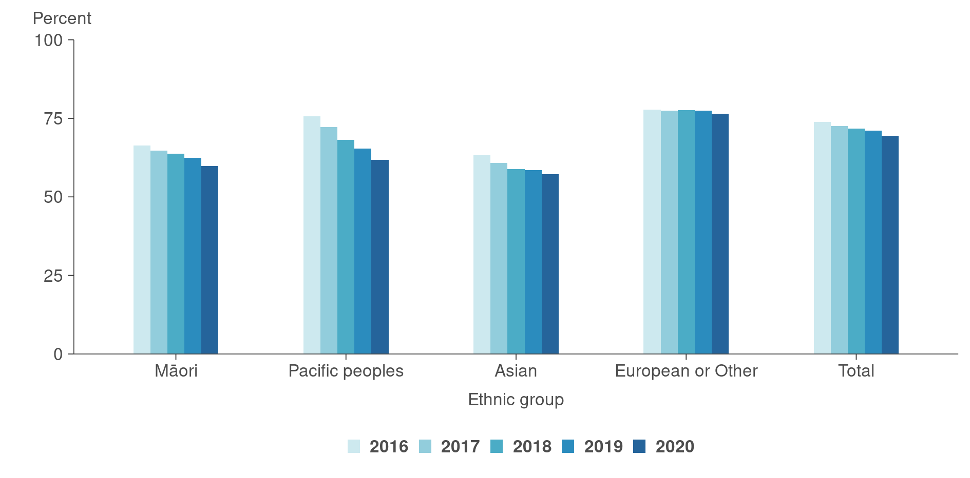

Source: [Ministry of Health (2021m)](https://minhealthnz.shinyapps.io/nsu-ncsp-coverage/)

#### Rheumatic fever

Rheumatic fever is a serious but preventable illness. It mainly affects Māori and Pacific children and young people (aged 4–19 years), especially if they have other family members who have had rheumatic fever (Ministry of Health 2021r).

There is a rheumatic fever prevention programme in New Zealand, which has three main strategies to reduce rheumatic fever rates. These are:

* to increase awareness of rheumatic fever, what causes it and how to prevent it
* to reduce household crowding and therefore reduce household transmission of streptococcal pharyngitis (strep throat) bacteria within households
* to improve access to timely and effective treatment for strep throat infections in priority communities.

In the 12 months ending 1 December 2020, there were 151 people diagnosed for the first time with rheumatic fever in New Zealand (Ministry of Health 2021q). Figure 30 below shows the rate by ethnicity of people admitted to hospital with rheumatic fever for the first time between 2002 and 2020.

Figure 30: First episode rheumatic fever hospitalisation rate, by ethnic group,  
2002–2020

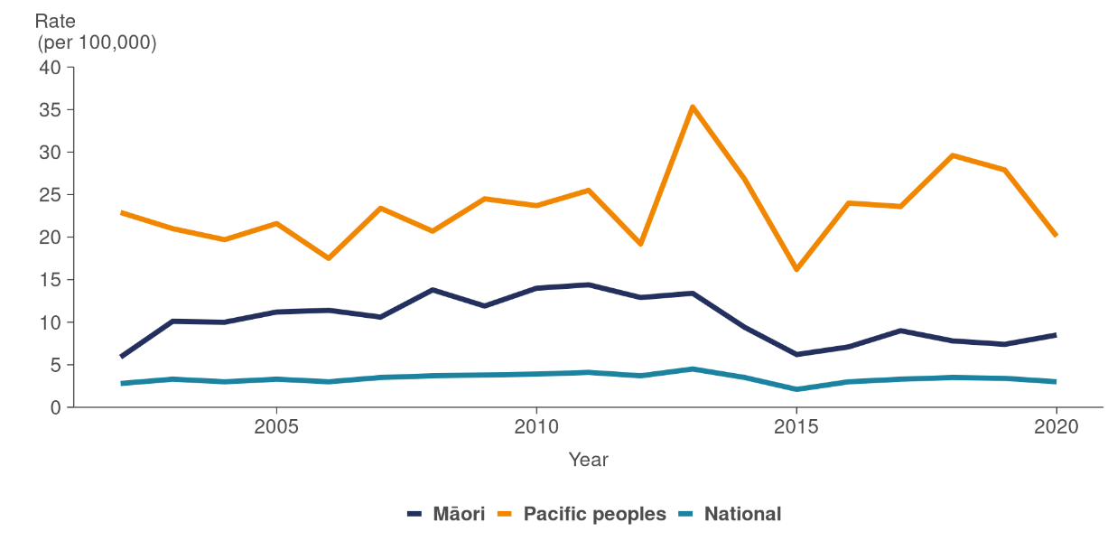

Source: [Ministry of Health (2021r)](https://www.health.govt.nz/our-work/diseases-and-conditions/rheumatic-fever/reducing-rheumatic-fever)

#### Ambulatory sensitive hospitalisations

Ambulatory sensitive hospitalisations (ASH) are hospital admissions that are considered potentially reducible through prophylactic (disease-preventing) or therapeutic interventions deliverable in a primary health care setting. For adults, ASH accounts for approximately 20 percent of all acute and arranged medical and surgical discharges each year (HQSC 2021a). The rate is approximately 30 percent of all child admissions (HQSC 2021c).

##### Ambulatory sensitive hospitalisations – children (0–4 years old)

The top five ASH conditions for children are:

* upper and ear, nose and throat (ENT) respiratory infections
* asthma
* gastroenteritis/dehydration
* dental conditions
* cellulitis.

Figure 31 shows ambulatory sensitive hospitalisations over the past five years for children up to four years old (Nationwide Service Framework Library 2021a). As shown, the rates for Pacific and Māori children are consistently higher than rates for European or Other children.

There has been a marked drop in ASH admissions for the 12 months to December 2020. This could be due to factors such as health hygiene measures lowering the rates of infections, as well as lower injury rates during lockdown periods, but may also be due to reduced access to hospital care as a result of COVID‑19 events.

Figure 31: ASH rates for children aged 0–4 years, by ethnic group, 2016–2020

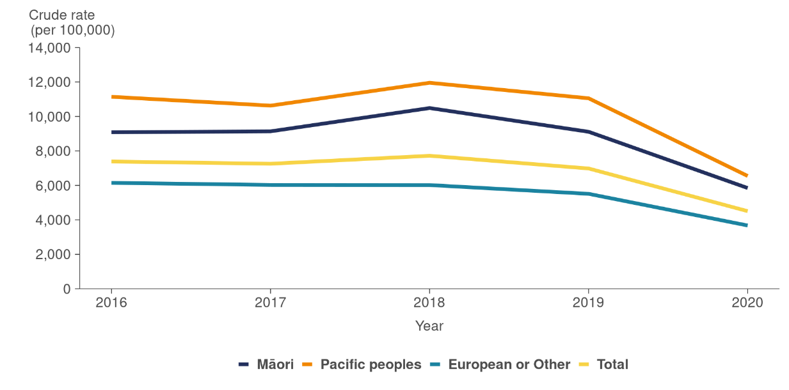

Source: [Nationwide Service Framework Library (2021)](https://nsfl.health.govt.nz/accountability/performance-and-monitoring/data-quarterly-reports-and-reporting/ambulatory-sensitive)

##### Ambulatory sensitive hospitalisations – adults (45–64 years)

The top five ASH conditions for adults aged 45–64 years (Nationwide Service Framework Library 2021a) are:

* angina and chest pain
* myocardial infraction (heart attack)
* cellulitis
* gastroenteritis/dehydration
* chronic obstructive pulmonary disease (COPD).

Over the past five years, the rates of these five conditions have remained relatively stable for adults aged 45–64 years. During this time, the rates for Māori adults and Pacific adults have been consistently and markedly higher than rates for European or Other, as shown in Figure 32 below.

Figure 32: ASH rates for adults aged 45–64 years, by ethnic group, 2020

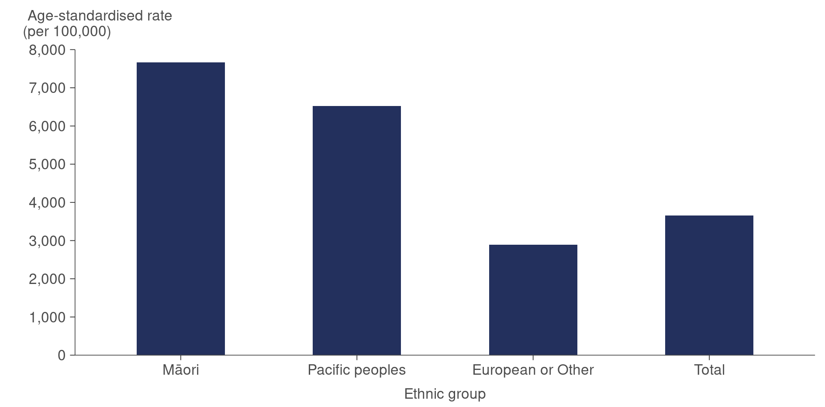

Source: [Nationwide Service Framework Library (2021)](https://nsfl.health.govt.nz/accountability/performance-and-monitoring/data-quarterly-reports-and-reporting/ambulatory-sensitive)

# Equity | Mana taurite

The WHO (2021) defines health equity as the absence of unfair, avoidable or remediable differences in health among population groups (defined socially, economically, demographically or geographically). The Ministry of Health (2018a) defines equity in New Zealand as the differences in health that are not only avoidable but unfair and unjust. Equity recognises that different people with different levels of advantage require different approaches and resources to get equitable health outcomes.

Throughout this report, there are multiple examples of unfair, avoidable and remediable differences in health outcomes for population groups in New Zealand. This adds weight to the ‘inverse care’ law, which states that the availability of health care varies inversely with the population’s need for it – in effect, “those most in need of health care have the least access to it” (Hart 1971).

A wide-ranging review of the New Zealand Health and Disability System (the Review) commenced in 2018. The Review was charged with recommending system-level changes that would be sustainable, lead to better and more equitable outcomes for all New Zealanders and shift the balance from treatment of illness towards health and wellbeing. The final report on the findings of the Review was released on 16 June 2020.

The message from the Review Chair, Heather Simpson, highlighted:

“… the changes being proposed by this Review have the potential to deliver a system which is a truly New Zealand system. A system which embeds te Tiriti principles throughout, where Māori have real authority to develop and implement policies which address their needs in ways which respect te Ao Māori, and a system where all New Zealanders, Māori, Pacific, European, Asian, disabled, rural or urban, understand how to access a system which is as much about keeping them well, as it is about treating them when they become sick” (HDSR 2020).

The Review proposes the following key changes.

* The Ministry retains responsibility as the chief steward of the health and disability system.
* A new agency is created, called Health NZ, accountable to the Minister of Health.
* Leadership for hauora Māori is strengthened with the creation of a Māori Health Authority to sit alongside the Ministry and Health NZ.
* Population health functions become foundational elements of the entire health system to underpin a shift to a health and wellness focus.
* A health and disability system charter is developed, setting out shared values and guiding the culture, behaviours and attitudes expected of all parts of the health system.
* Service design and delivery is driven by the needs of local communities, and resources are directed to the areas of greatest need.
* A sector-wide workforce strategy is designed and implemented.
* A more transparent planning and reporting system is developed, with a clearly articulated New Zealand health plan that looks ahead at least 20 years.
* Consistent and connected digital and data enablers are in place.
* Health NZ is responsible for developing a long-term investment plan for health facilities, major equipment and digital technologies.

Many different groups experience inequities, including people who are socioeconomically disadvantaged, ethnic minority groups, rainbow communities, refugees and those living rurally. The sections below discuss equity in relation to the following groups: Māori, Pacific and disabled people.

## Māori health

There is overwhelming evidence that health outcomes are not equitable for Māori. Examples are documented throughout this report and there are many other illustrations from multiple sources. Specific examples highlighted in this report include:

* Māori living on average seven years less and dying from diseases that health care can address (amenable mortality) at a rate two-and-a-half times higher than non-Māori
* more than half of five-year-old Māori children having dental caries, which is more than one-third higher than that of non-Māori children
* lower cancer survival rates, higher childhood asthma rates, more unmet need for primary health care due to cost and other barriers, higher suicide mortality rates, etc.

### *A Window on the Quality of Aotearoa New Zealand’s Health Care 2019*

In 2019, the HQSC published *A Window on the Quality of Aotearoa New Zealand’s Health Care 2019: A view on Māori health equity*. The executive summary outlined:

“… current systems are supporting non-Māori to live healthier, longer lives than Māori. Across the life course, we see inequity in many indicators from before birth, through childhood and youth, through adulthood and into old age. We see the diseases commonly associated with older age starting earlier in Māori than non-Māori, along with higher rates of disability and of multiple disabilities for Māori. We see clear differences in a range of other outcomes too, including, despite 60 years of constant improvement, a stark difference in life expectancy” (HQSC 2019).

The reason for health inequities is complex and long-standing. The HQSC report states that wider determinants of health (social, political, environmental and economic) create a level of health advantage and disadvantage for individuals and groups of people in New Zealand, even before they engage with the health system. The differences in health outcomes are contributed to by:

* differential access or exposure to the determinants of health
* differential access to health care
* differences in the quality of health care received.

The report outlines structural causes of inequity, including colonisation, the Crown’s failure to meet its obligations under te Tiriti o Waitangi and institutional racism. It advises that these structural factors have established and maintained advantages for non-Māori and disadvantages for Māori within the wider determinants of health (social, political, environmental and economic), and within health itself.

### Wai 2575: Health Services and Outcomes Kaupapa Inquiry

Initiated in November 2016, the Waitangi Tribunal Health Services and Outcomes Inquiry (Wai 2575) will hear all claims concerning grievances relating to health services and outcomes of national significance for Māori (Ministry of Health 2020k). The claims are historical as well as contemporary, covering a range of issues relating to the health system, specific health services and outcomes, including health equity; primary health care; disability services; mental health and alcohol, tobacco and substance abuse.

Wai 2575 consists of three stages.

* Stage one inquired into the legislative and policy framework of the primary health care system.
* Stage two will cover three priority areas:
* Tāngata whaikaha Māori (Māori with disabilities)
* Māori mental health (including suicide and self-harm)
* Issues of alcohol, tobacco and substance abuse.
* Stage three will cover the remaining nationally significant and eligible historical issues.

On 1 July 2019, the Waitangi Tribunal released their report on stage one (Ministry of Health 2020k). The Waitangi Tribunal found that the Crown has breached te Tiriti o Waitangi by failing to design and administer the current primary health care system to actively address persistent Māori health inequities and by failing to give effect to the guarantee of tino rangatiratanga as specified in te Tiriti o Waitangi (autonomy, self-determination, sovereignty, self-government). The report includes several findings and recommendations for the Crown to consider.

The New Zealand Health and Disability System Review (2020) recommends the following to address equity for Māori.

* Incorporating te Tiriti o Waitangi principles across the system and updating legislation accordingly
* Establishing a Māori Health Authority
* Reflecting te Tiriti o Waitangi partnership in governance structures
* Investing in kaupapa Māori services
* Embedding Māori knowledge and world view perspectives across the health and disability system.

The Ministry confirms that the health and disability system is committed to fulfilling the special relationship between Māori and the Crown under te Tiriti o Waitangi (Ministry of Health 2020j).

### He Korowai Oranga

The New Zealand Māori Health Strategy, He Korowai Oranga, provides the overarching framework to guide the Government and the health and disability sector to achieve the best health outcomes for Māori (Ministry of Health 2020g). To realise the strategy, the Ministry developed Whakamaua: Māori Health Action Plan 2020–2025 (Ministry of Health 2020l). This is the implementation plan for He Korowai Oranga and sets a five‑year course for Māori health advancement.

There are four high-level outcomes of Whakamaua:

* iwi, hapū, whānau and Māori communities exercising their authority to improve their health and wellbeing
* ensuring the health and disability system is fair and sustainable and delivers more equitable outcomes for Māori
* addressing racism and discrimination in all its forms
* protecting mātauranga Māori throughout the health and disability system.

To achieve these outcomes, the following priority areas have been identified:

* increasing Māori-Crown partnerships
* supporting Māori leadership
* building the capacity and capability of the Māori health and disability workforce
* supporting high-quality Māori health and disability sector and provider development
* fostering collaboration and coordination across government agencies to maximise Māori health and wellbeing
* improving quality and safety
* advancing Māori health and disability insights and evidence
* increasing performance and accountability.

These recommendations align with the changes proposed in the Health and Disability System Review, which recommends that local communities, iwi partners, consumers and whānau, clinical experts and other stakeholders should have meaningful opportunities to influence planning and be engaged throughout the life of strategic plans to understand priorities, implications for services and outcomes achieved.

A key step in realising the outcomes above will be the formation of the Māori Health Authority. The Health and Disability System Review proposed that the Māori Health Authority have the following functions:

* advising the Minister on all aspects of Māori health policy
* partnering with all other parts of the health and disability system to ensure mātauranga Māori and other Māori health issues are appropriately incorporated into all aspects of the system
* monitoring and reporting to the Minister of Health on the performance of the health and disability system with respect to Māori health outcomes and equity
* investing in kaupapa Māori health services and providers
* developing and leading the implementation of the Māori health workforce strategy
* developing or supporting innovative Māori-specific population health initiatives.

## Pacific people’s health

The Health and Disability System Review 2020 highlights long-standing inequities in health outcomes between Pacific and non-Māori, non-Pacific people in New Zealand. Inequities include shorter life expectancy (75.4 years for Pacific males compared with 80.0 years for all males and 79.0 years for Pacific females compared with 83.5 years for all females; Stats NZ 2021h), higher amenable mortality, multimorbidity and a higher rate of death from cancer compared with non-Māori non-Pacific people (HDSR 2020).

Pacific peoples are disproportionately affected by intergenerational poverty and are more likely to reside in high-deprivation areas, live in crowded households, be unemployed, and have a lower median income than non-Māori, non-Pacific people (HDSR 2020).

In 2021, the HQSC published *Bula Sautu: A window on quality 2021: Pacific health in the year of COVID‑19*. This is a comprehensive analysis of the health status of Pacific people in New Zealand (HQSC 2021b). The report provides examples of inequities for Pacific peoples.

* In 2018, less than half (47 percent) of pregnant Pacific women were registered with a lead maternity carer, compared with 81 percent of non-Māori, non-Pacific women.
* Pacific children experience a higher incidence of a range of conditions, including asthma, dental problems and ear and skin infections.
* Only 34 percent of five-year-old Pacific children are free of caries (tooth decay), compared with 68 percent of non-Māori, non-Pacific children.
* Pacific peoples bear a disproportionate burden of long-term conditions, including gout, cardiovascular disease, kidney disease, cancer, asthma and diabetes.
* Pacific peoples are significantly underrepresented across the entire health workforce (HQSC 2021b).

The HQSC recommended four system-level changes to address Pacific peoples’ health issues.

* + - 1. Encourage the health and disability system to provide a structural response to address whole-family issues and social determinants of health through comprehensive inter-agency cooperation.
      2. Consult Pacific communities and stakeholders over whether Pacific health needs its own specific leadership and commissioning context to access and draw on the strengths and creativity of Pacific communities and consumers. (The health and disability system must enable Pacific peoples to identify and design Pacific solutions.)
      3. Support and grow the Pacific workforce at all levels of the system.
      4. Address racism in the health system and establish appropriate measures, benchmarks and local actions to address Pacific health inequities and drive measurably improved outcomes for all Pacific peoples in New Zealand.

In addition, the report outlines key actions that organisations and individual services can take, presented as a seven-step framework to improve Pacific health. These actions include: focusing on using data in a meaningful way to inform continuous improvements in service delivery by facilitating access; ensuring continuity of care; promoting high-quality interactions with patients and families; communicating effectively; addressing health and social issues holistically; supporting the Pacific workforce and engaging authentically with Pacific communities.

## Disabled people’s health

The 2013 New Zealand Disability Survey found that 24 percent of the population are disabled, a total of 1.1 million people. Furthermore, Māori and Pacific people had higher-than-average disability rates, likely leading to compounded inequity (Stats NZ 2014b).

As documented in this report, and reiterated in the Health and Disability System Review, disabled New Zealanders report lower life satisfaction on average, are more likely to live in low-income households and have poorer outcomes across health, economic and social indicators. Disabled people aged 15–64 years are half as likely to be employed compared with non-disabled people of the same age. Disabled children are more likely to be in households that have low incomes and that report having just enough or not enough money (New Zealand Health and Disability System Review 2020).

The Ministry recognises there is a distinct lack of up-to-date, New Zealand-specific health status and health care utilisation data for people with intellectual disability (Ministry of Health 2011), which is true for people with other disabilities as well. This lack of data makes it difficult to evaluate the true extent to which disabled New Zealanders are currently experiencing poorer health than the rest of the population.

According to the Health and Disability Review, disabled people have not been well served by the existing health and disability system. Their health outcomes are worse, and the way the disability support system operates is complex and confusing. The Health and Disability Review found that there is wide unexplained variability in the way assessment processes work around the country, and this should be addressed.

The Health and Disability Review recommends that disability support should use the Enabling Good Lives principles (discussed below) so that an individual’s disability does not define their life chances. As our population ages and the prevalence of neurological conditions increases, the proportion of the population living with some form of disability is likely to grow. The health and disability system must be more focused on ensuring a non-disabling approach to service delivery.

The Health and Disability Review proposes the following changes to improve equity of health outcomes for disabled people:

* better data collection, analytics and meaningful engagement of disabled people
* improved information, advice and early intervention
* access to disability support services that is easy for disabled people and their whānau
* service coordination support that works more closely with other agencies to ensure disabled people receive more joined-up services
* a consistent commissioning framework developed by Health NZ for disability support contracts
* Health NZ commissioning rules aimed at building a better trained and more secure disability support services workforce
* a programme of work led by Health NZ that engages and supports the health and disability system to become a leading employer of disabled people in New Zealand.

### Enabling Good Lives

The recommendations above align with the Enabling Good Lives approach to supporting disabled people (Enabling Good Lives 2021). Enabling Good Lives is a partnership between the disability sector and government agencies aimed at long-term transformation of how disabled people and families are supported to live everyday lives.

The Enabling Good Lives vision is:

In the future, disabled people and their families will have greater choice and control over their lives and supports and make more use of natural and universally available supports (Enabling Good Lives 2021).

The Enabling Good Lives principles are:

* **Self-determination**  
  Disabled people are in control of their lives.
* **Beginning early**  
  Invest early in families and whānau to support them; to be aspirational for their disabled child; to build community and natural supports; and to support disabled children to become independent, rather than waiting for a crisis before support is available.
* **Person-centred**  
  Disabled people have supports that are tailored to their individual needs and goals, and that take a whole life approach rather than being split across programmes.
* **Ordinary life outcomes**  
  Disabled people are supported to live an everyday life in everyday places; and are regarded as citizens with opportunities for learning, employment, having a home and family, and social participation – like others at similar stages of life.
* **Mainstream first**  
  Disabled people are supported to access mainstream services before specialist disability services.
* **Mana enhancing**  
  The abilities and contributions of disabled people and their families are recognised and respected.
* **Easy to use**  
  Disabled people have supports that are simple to use and flexible.
* **Relationship building**  
  Supports build and strengthen relationships between disabled people, their whānau and community (Enabling Good Lives 2021).

# Looking forward | Whakataretare

There are two major areas of work that will be covered in detail in the 2021 year’s health and independence report. Key points are provided below.

## COVID‑19

The Health and Independence Report 2021 will have a focus on COVID‑19. This will include:

* the impact of COVID‑19 on health services in New Zealand, such as any delayed treatment, preventative care or screening services
* the COVID‑19 vaccination programme in New Zealand, which began as a staggered roll-out from February 2021
* an update on the impacts of long COVID and any long-term consequences on the health of individuals and their whānau who have been infected with COVID‑19
* an update on the impact of COVID‑19 on the world’s population.

## The New Zealand Health and Disability System Review

In 2018, the Government announced a wide-ranging review of the health and disability system in New Zealand, which had the aim of future-proofing our health and disability services. The review looked at the overall function of our health and disability system and whether the system is balanced towards wellness, access, equity and sustainability.

The final report on the review’s findings was released on 16 June 2020. The *Health and Independence Report 2021* will provide details of health system changes that have followed as a result of the review.

# Technical notes | Ngā tuhipoka hangarau

This report contains reference to all the data provided in previous reports and adds a volume of new series. All data is available in an accompanying Excel file and hyperlinks to sources where available. The report includes data from a wide range of sources, some of which are produced outside the Ministry. We have aimed to report data only when the data collection and analytical processes are robust. Notes are included if methodological information affects the interpretation of the data. We encourage you to refer to the original data source for further details.

All data reported is the latest available at the time of the report’s publication, although the time lag between the most recent data and the present can be substantial. Some data is provisional, such as the 2018 mortality data, and may change.

When possible, we have reported on statistically significant differences between population groups and, when relevant, trends over time. In many comparisons, the results have been adjusted or standardised for factors that may influence (confound) the comparison, such as age and gender. Age standardisation is often used in this report to account for differences in age structure between population groups and over time (Ministry of Health 2020i).

Where age-standardised rates have been presented, Global Burden of Disease (GBD) data has been age-standardised using a study-specific set of population weights that were originally derived from the World Health Organization (WHO) standard world population and then refined over time, creating the GBD population. These rates will differ from other numbers that have been calculated using different standard populations.

Ethnic comparisons have been based on either prioritised ethnicity or total response ethnicity. With prioritised ethnicity, ethnic groups are mutually exclusive. That is, a person can appear in only one ethnic group. With total response ethnicity, a person is classified in all ethnic groups they identify with. This means that a person can appear in more than one ethnic group. For example, prioritised ethnicity is used for analysis based on administrative data (such as mortality data), while total response ethnicity is shown for New Zealand Health Survey data.

Selected results are presented by neighbourhood deprivation, as measured by the New Zealand Index of Deprivation 2018. This is an area-based measure of socioeconomic deprivation according to a combination of the following 2018 Census variables: income, benefit receipt, transport (access to car), household crowding, home ownership, employment status, qualifications, support (sole-parent families) and access to a telephone. In this report, ‘most deprived areas’ refers to quintile 5 – the people living in the most socioeconomically deprived 20 percent of small areas in New Zealand. Conversely, ‘least deprived areas’ refers to quintile 1, the people living in the least deprived 20 percent of small areas in New Zealand.

This report includes a range of population statistics from Stats NZ, as well as data from some of its household surveys.

# References | Ngā tohutoro

Alzheimers New Zealand. 2021. *Facts and figures*. URL: <https://alzheimers.org.nz/explore/facts-and-figures/> (accessed 22 September 2021).

Analysis & Policy Observatory. 2020. *Youth mental health in Aotearoa New Zealand: Greater urgency required*. Auckland: Koi Tū: The Centre for Informed Futures, University of Auckland. URL: <https://apo.org.au/node/308042> (accessed 7 October 2021).

ASH. 2018. *2017 ASH Year 10 snapshot: Topline results.* Auckland: Action for Smokefree 2025 (ASH). URL: <https://d3n8a8pro7vhmx.cloudfront.net/ashnz/pages/70/attachments/original/1521962541/2017_ASH_Y10_Snapshot_Topline_DRAFT_27Mar18.pdf?1521962541> (accessed 22 September 2021).

Atkinson J, Salmond C, Crampton P. 2019. NZDep2018 Index of Deprivation, Final Research Report, December 2020. *Wellington: University of Otago*.

Bach K, Manton DJ. 2014. Early childhood caries: a New Zealand perspective. *Journal of Primary Health Care* 6(2): 169–74.

Cassim S, Kidd J, Rolleston A, et al. 2021. Hā ora: Barriers and enablers to early diagnosis of lung cancer in primary healthcare for Māori communities. *European Journal of Cancer Care* 30(2): e13,380.

Cervical cancer screening and New Zealand’s uncomfortable truths. 2021. *The Lancet Oncology* 22(5): 571.

Clark T, Fleming T, Bullen P, et al. 2013. *Youth’12 Overview: The health and wellbeing of New Zealand secondary school students in 2012*. URL: <https://www.fmhs.auckland.ac.nz/assets/fmhs/faculty/ahrg/docs/2012-overview.pdf> (accessed 26 October 2021).

Cure Kids. 2020. *State of Child Health in Aotearoa New Zealand*. Auckland: Cure Kids. URL: <https://curekids.org.nz/state-of-child-health/> (accessed 22 September 2021).

Deloitte. 2017. *Dementia Economic Impact Report 2016*. Wellington: Alzheimers New Zealand. URL: <https://cdn.alzheimers.org.nz/wp-content/uploads/2021/05/Economic-Impacts-of-Dementia-2017.pdf> (accessed 22 September 2021).

Diabetes New Zealand. 2021. *What is Diabetes?* URL: [www.diabetes.org.nz/what-is-diabetes](https://mohgovtnz-my.sharepoint.com/personal/kristy_udy_health_govt_nz/Documents/Microsoft%20Teams%20Chat%20Files/www.diabetes.org.nz/what-is-diabetes) (accessed 22 September 2021).

Enabling Good Lives. 2021. URL: [www.enablinggoodlives.co.nz](https://mohgovtnz-my.sharepoint.com/personal/kristy_udy_health_govt_nz/Documents/Microsoft%20Teams%20Chat%20Files/www.enablinggoodlives.co.nz) (accessed 20 October 2021).

ESR. 2021. *NZ COVID‑19 Dashboard (Data file)*. Science for communities. URL: <https://nzcoviddashboard.esr.cri.nz/#!/> (accessed 26 October 2021).

Fleming T, Tiatia-Seath J, Peiris-John R, et al. 2020. *Youth19 Rangatahi smart survey, initial findings: Hauora hinengaro / emotional and mental health*. The Youth19 Research Group, The University of Auckland and Victoria University of Wellington. URL: www.youth19.ac.nz/publications/emotional-and-mental-health-report (accessed 19 October 2021).

Gendall P, Hoek J, Stanley J, et al. 2021. Changes in tobacco use during the 2020 COVID‑19 lockdown in New Zealand. *Nicotine & Tobacco Research* 23: 866–71.

Graham R, Masters-Awatere B. 2020. Experiences of Māori of Aotearoa New Zealand’s public health system: A systematic review of two decades of published qualitative research. *Australian and New Zealand Journal of Public Health* 44(2): 1–8.

Gurney J, Stanley J, McLeod M, et al. 2020. Disparities in cancer-specific survival between Māori and non-Māori New Zealanders, 2007–2016. *JCO Global Oncology* 6.

Hart JT. 1971. The inverse care law. *The Lancet* 297(7696): 405–12.

HDSR. 2020. *Health and Disability System Review: Final report / Pūrongo whakamutunga*. Health and Disability System Review. URL: <https://systemreview.health.govt.nz/final-report/download-the-final-report/> (accessed 23 September 2021).

HQSC. 2017. *Incidence Rates for all Cancer and the Five Most Common Cancer Types*. Health Quality and Safety Commission New Zealand. URL: [www.hqsc.govt.nz/our-programmes/health-quality-evaluation/projects/atlas-of-healthcare-variation/cancer/](https://mohgovtnz-my.sharepoint.com/personal/kristy_udy_health_govt_nz/Documents/Microsoft%20Teams%20Chat%20Files/www.hqsc.govt.nz/our-programmes/health-quality-evaluation/projects/atlas-of-healthcare-variation/cancer/) (accessed 22 September 2021).

HQSC. 2019. *A Window on the Quality of Aotearoa New Zealand’s Health Care 2019: A view on Māori health equity*. Health Quality and Safety Commission New Zealand. URL: [www.hqsc.govt.nz/our-programmes/health-quality-evaluation/publications-and-resources/publication/3721/](https://mohgovtnz-my.sharepoint.com/personal/kristy_udy_health_govt_nz/Documents/Microsoft%20Teams%20Chat%20Files/www.hqsc.govt.nz/our-programmes/health-quality-evaluation/publications-and-resources/publication/3721/) (accessed 23 September 2021).

HQSC. 2020. *Updated Data Shows Cost the Main Barrier to Accessing Health Services*. Health Quality and Safety Commission New Zealand. URL: [www.hqsc.govt.nz/our-programmes/health-quality-evaluation/news-and-events/news/4042/](https://mohgovtnz-my.sharepoint.com/personal/kristy_udy_health_govt_nz/Documents/Microsoft%20Teams%20Chat%20Files/www.hqsc.govt.nz/our-programmes/health-quality-evaluation/news-and-events/news/4042/) (accessed 23 September 2021).

HQSC. 2021a. *Adult Ambulatory Sensitive Hospitalisations*. Health Quality and Safety Commission New Zealand. URL: [www.hqsc.govt.nz/our-programmes/health-quality-evaluation/projects/atlas-of-healthcare-variation/adult-ambulatory-sensitive-hospitalisations/](https://mohgovtnz-my.sharepoint.com/personal/kristy_udy_health_govt_nz/Documents/Microsoft%20Teams%20Chat%20Files/www.hqsc.govt.nz/our-programmes/health-quality-evaluation/projects/atlas-of-healthcare-variation/adult-ambulatory-sensitive-hospitalisations/) (accessed 23 September 2021).

HQSC. 2021b. *Bula Sautu: A window on quality 2021: Pacific health in the year of COVID‑19*. Health Quality and Safety Commission New Zealand. URL: [www.hqsc.govt.nz/our-programmes/health-quality-evaluation/publications-and-resources/publication/4299/](https://mohgovtnz-my.sharepoint.com/personal/kristy_udy_health_govt_nz/Documents/Microsoft%20Teams%20Chat%20Files/www.hqsc.govt.nz/our-programmes/health-quality-evaluation/publications-and-resources/publication/4299/) (accessed 23 September 2021).

HQSC. 2021c. *Childhood Ambulatory Sensitive Hospitalisations*. Health Quality and Safety Commission New Zealand. URL: [www.hqsc.govt.nz/our-programmes/health-quality-evaluation/projects/atlas-of-healthcare-variation/childhood-ambulatory-sensitive-hospitalisations](https://mohgovtnz-my.sharepoint.com/personal/kristy_udy_health_govt_nz/Documents/Microsoft%20Teams%20Chat%20Files/www.hqsc.govt.nz/our-programmes/health-quality-evaluation/projects/atlas-of-healthcare-variation/childhood-ambulatory-sensitive-hospitalisations) (accessed 18 October 2021).

ICSI. 2014. *Going Beyond Clinical Walls: Solving complex problems*. Bloomington: Institute for Clinical Systems Improvement. URL: [www.icsi.org/wp-content/uploads/2019/08/1.SolvingComplexProblems_BeyondClinicalWalls.pdf](https://mohgovtnz-my.sharepoint.com/personal/kristy_udy_health_govt_nz/Documents/Microsoft%20Teams%20Chat%20Files/www.icsi.org/wp-content/uploads/2019/08/1.SolvingComplexProblems_BeyondClinicalWalls.pdf) (accessed 23 September 2021).

IHME. 2020a. *GBD Compare | Viz Hub (Data file)*. Seattle, WA: Institute for Health Metrics and Evaluation. URL: <https://vizhub.healthdata.org/gbd-compare/> (accessed 28 September 2021).

IHME. 2020b. *Global Burden of Disease (GBD)*. Seattle, WA: Institute for Health Metrics and Evaluation. URL: [www.healthdata.org/gbd/2019](https://mohgovtnz-my.sharepoint.com/personal/kristy_udy_health_govt_nz/Documents/Microsoft%20Teams%20Chat%20Files/www.healthdata.org/gbd/2019) (accessed 22 September 2021).

IHME. 2021a. *COVID‑19 has caused 6.9 million deaths globally, more than double what official reports show*. Seattle, WA: Institute for Health Metrics and Evaluation. URL: **http://www.healthdata.org/news-release/covid-19-has-caused-69-million-deaths-globally-more-double-what-official-reports-show** (accessed 28 September 2021).

IHME. 2021b. *GHDx (healthdata.org): GBD results tool*. Seattle, WA: Institute for Health Metrics and Evaluation. URL: <http://ghdx.healthdata.org/gbd-results-tool> (accessed 18 October 2021).

Isaacs AN, Enticott J, Meadows G, et al. 2018. Lower income levels in Australia are strongly associated with elevated psychological distress: Implications for healthcare and other policy areas. *Frontiers in Psychiatry* 9(536).

Kessler RC, Barker P, Colpe L, et al. 2003. Screening for serious mental illness in the general population. *Archives of General Psychiatry* 60(2): 184–9.

Kraft S. 2019. What to know about cerebrovascular disease. *Medical News Today*. URL: [www.medicalnewstoday.com/articles/184601](https://mohgovtnz-my.sharepoint.com/personal/kristy_udy_health_govt_nz/Documents/Microsoft%20Teams%20Chat%20Files/www.medicalnewstoday.com/articles/184601) (accessed 20 September 2021).

Little A, Verral A. 2021. *Budget Delivers Improved Cervical and Breast Cancer Screening*. Beehive.govt.nz. URL: <https://www.beehive.govt.nz/release/budget-delivers-improved-cervical-and-breast-cancer-screening> (accessed 23 September 2021).

Massey University. 2020. *Urban–Rural Profile*. Environmental Health Intelligence New Zealand. URL: [www.ehinz.ac.nz/indicators/population-vulnerability/urbanrural-profile/](https://mohgovtnz-my.sharepoint.com/personal/kristy_udy_health_govt_nz/Documents/Microsoft%20Teams%20Chat%20Files/www.ehinz.ac.nz/indicators/population-vulnerability/urbanrural-profile/) (accessed 17 September 2021).

Ministry of Health. 2010. *The 2007/08 New Zealand Alcohol and Drug Use Survey: Online Data Tables*. URL: [www.health.govt.nz/publication/2007-08-new-zealand-alcohol-and-drug-use-survey-online-data-tables](https://mohgovtnz-my.sharepoint.com/personal/kristy_udy_health_govt_nz/Documents/Microsoft%20Teams%20Chat%20Files/www.health.govt.nz/publication/2007-08-new-zealand-alcohol-and-drug-use-survey-online-data-tables) (accessed 19 October 2021).

Ministry of Health. 2011. *Health Indicators for New Zealanders with Intellectual Disability*. URL: [www.health.govt.nz/publication/health-indicators-new-zealanders-intellectual-disability](https://mohgovtnz-my.sharepoint.com/personal/kristy_udy_health_govt_nz/Documents/Microsoft%20Teams%20Chat%20Files/www.health.govt.nz/publication/health-indicators-new-zealanders-intellectual-disability) (accessed 7 October 2021).

Ministry of Health. 2014. *Cervical Cancer*. URL: [www.health.govt.nz/your-health/conditions-and-treatments/diseases-and-illnesses/cervical-cancer](https://mohgovtnz-my.sharepoint.com/personal/kristy_udy_health_govt_nz/Documents/Microsoft%20Teams%20Chat%20Files/www.health.govt.nz/your-health/conditions-and-treatments/diseases-and-illnesses/cervical-cancer) (accessed 23 September 2021).

Ministry of Health. 2016a. *Defining Amenable Mortality*. URL: <https://nsfl.health.govt.nz/system/files/documents/pages/defining_amenable_mortality_sept2016.docx> (accessed 20 September 2021).

Ministry of Health. 2016b. *DHB Spending on Services for Older People*. URL: [www.health.govt.nz/nz-health-statistics/health-statistics-and-data-sets/older-peoples-health-data-and-stats/dhb-spending-services-older-people](https://mohgovtnz-my.sharepoint.com/personal/kristy_udy_health_govt_nz/Documents/Microsoft%20Teams%20Chat%20Files/www.health.govt.nz/nz-health-statistics/health-statistics-and-data-sets/older-peoples-health-data-and-stats/dhb-spending-services-older-people) (accessed 17 September 2021).

Ministry of Health. 2018a. *Achieving Equity in Health Outcomes: Highlights of selected papers*. URL: [www.health.govt.nz/publication/achieving-equity-health-outcomes-highlights-selected-papers](https://mohgovtnz-my.sharepoint.com/personal/kristy_udy_health_govt_nz/Documents/Microsoft%20Teams%20Chat%20Files/www.health.govt.nz/publication/achieving-equity-health-outcomes-highlights-selected-papers) (accessed 23 September 2021).

Ministry of Health. 2018b. *Diabetes*. URL: [www.health.govt.nz/our-work/populations/maori-health/tatau-kahukura-maori-health-statistics/nga-mana-hauora-tutohu-health-status-indicators/diabetes](https://mohgovtnz-my.sharepoint.com/personal/kristy_udy_health_govt_nz/Documents/Microsoft%20Teams%20Chat%20Files/www.health.govt.nz/our-work/populations/maori-health/tatau-kahukura-maori-health-statistics/nga-mana-hauora-tutohu-health-status-indicators/diabetes) (accessed 7 October 2021).

Ministry of Health. 2018c. *Ngā Awe o te Hauora: Socioeconomic determinants of health*. URL: [www.health.govt.nz/our-work/populations/maori-health/tatau-kahukura-maori-health-statistics/nga-awe-o-te-hauora-socioeconomic-determinants-health](https://mohgovtnz-my.sharepoint.com/personal/kristy_udy_health_govt_nz/Documents/Microsoft%20Teams%20Chat%20Files/www.health.govt.nz/our-work/populations/maori-health/tatau-kahukura-maori-health-statistics/nga-awe-o-te-hauora-socioeconomic-determinants-health) (accessed 23 September 2021).

Ministry of Health. 2019a. *Alcohol*. URL: [www.health.govt.nz/your-health/healthy-living/addictions/alcohol-and-drug-abuse/alcohol](https://mohgovtnz-my.sharepoint.com/personal/kristy_udy_health_govt_nz/Documents/Microsoft%20Teams%20Chat%20Files/www.health.govt.nz/your-health/healthy-living/addictions/alcohol-and-drug-abuse/alcohol) (accessed 21 October 2021).

Ministry of Health. 2019b. *Improving New Zealand’s Childhood Immunisation Rates*. URL: [www.health.govt.nz/publication/improving-new-zealands-childhood-immunisation-rates](https://mohgovtnz-my.sharepoint.com/personal/kristy_udy_health_govt_nz/Documents/Microsoft%20Teams%20Chat%20Files/www.health.govt.nz/publication/improving-new-zealands-childhood-immunisation-rates) (accessed 22 September 2021).

Ministry of Health. 2019c. *Understanding Suicide in New Zealand*. URL: [www.health.govt.nz/our-work/mental-health-and-addiction/suicide-prevention-new-zealand/understanding-suicide-new-zealand](https://mohgovtnz-my.sharepoint.com/personal/kristy_udy_health_govt_nz/Documents/Microsoft%20Teams%20Chat%20Files/www.health.govt.nz/our-work/mental-health-and-addiction/suicide-prevention-new-zealand/understanding-suicide-new-zealand) (accessed 20 September 2021).

Ministry of Health. 2019d. *Wai 2575 Māori Health Trends Report*. Wellington: Ministry of Health (23 September 2021).

Ministry of Health. 2020a. *Age 5 and Year 8 Oral Health Data from the Community Oral Health Service*. URL: [www.health.govt.nz/nz-health-statistics/health-statistics-and-data-sets/oral-health-data-and-stats/age-5-and-year-8-oral-health-data-community-oral-health-service](https://mohgovtnz-my.sharepoint.com/personal/kristy_udy_health_govt_nz/Documents/Microsoft%20Teams%20Chat%20Files/www.health.govt.nz/nz-health-statistics/health-statistics-and-data-sets/oral-health-data-and-stats/age-5-and-year-8-oral-health-data-community-oral-health-service) (accessed 22 September 2021).

Ministry of Health. 2020b. *Annual Data Explorer 2019/20: New Zealand Health Survey (Data file)*. URL: <https://minhealthnz.shinyapps.io/nz-health-survey-2019-20-annual-data-explorer/_w_d42a7869/#!/> (accessed 22 September 2021).

Ministry of Health. 2020c. *Annual Update of Key Results 2019/20: New Zealand Health Survey*. URL: [www.health.govt.nz/publication/annual-update-key-results-2019-20-new-zealand-health-survey](https://mohgovtnz-my.sharepoint.com/personal/kristy_udy_health_govt_nz/Documents/Microsoft%20Teams%20Chat%20Files/www.health.govt.nz/publication/annual-update-key-results-2019-20-new-zealand-health-survey) (accessed 20 September 2021).

Ministry of Health. 2020d. *Breast Cancer*. URL: [www.health.govt.nz/your-health/conditions-and-treatments/diseases-and-illnesses/breast-cancer](https://mohgovtnz-my.sharepoint.com/personal/kristy_udy_health_govt_nz/Documents/Microsoft%20Teams%20Chat%20Files/www.health.govt.nz/your-health/conditions-and-treatments/diseases-and-illnesses/breast-cancer) (accessed 23 September 2021).

Ministry of Health. 2020e. *COVID‑19 in Health Care and Support Workers in Aotearoa New Zealand*. URL: [www.health.govt.nz/publication/covid-19-health-care-and-support-workers-aotearoa-new-zealand](https://mohgovtnz-my.sharepoint.com/personal/kristy_udy_health_govt_nz/Documents/Microsoft%20Teams%20Chat%20Files/www.health.govt.nz/publication/covid-19-health-care-and-support-workers-aotearoa-new-zealand) (accessed 20 September 2021).

Ministry of Health. 2020f. *Eating and Activity Guidelines for New Zealand Adults*. URL: [www.health.govt.nz/publication/eating-and-activity-guidelines-new-zealand-adults](https://mohgovtnz-my.sharepoint.com/personal/kristy_udy_health_govt_nz/Documents/Microsoft%20Teams%20Chat%20Files/www.health.govt.nz/publication/eating-and-activity-guidelines-new-zealand-adults) (accessed 22 September 2021).

Ministry of Health. 2020g. *He Korowai Oranga*. URL: [www.health.govt.nz/our-work/populations/maori-health/he-korowai-oranga](https://mohgovtnz-my.sharepoint.com/personal/kristy_udy_health_govt_nz/Documents/Microsoft%20Teams%20Chat%20Files/www.health.govt.nz/our-work/populations/maori-health/he-korowai-oranga) (accessed 20 October 2021).

Ministry of Health. 2020h. *Longer, Healthier Lives: New Zealand’s health 1990–2017*. URL: [www.health.govt.nz/publication/longer-healthier-lives-new-zealands-health-1990-2017](https://mohgovtnz-my.sharepoint.com/personal/kristy_udy_health_govt_nz/Documents/Microsoft%20Teams%20Chat%20Files/www.health.govt.nz/publication/longer-healthier-lives-new-zealands-health-1990-2017) (accessed 20 September 2021).

Ministry of Health. 2020i. *Methodology Report 2019/20: New Zealand Health Survey*. URL: [www.health.govt.nz/publication/methodology-report-2019-20-new-zealand-health-survey](https://mohgovtnz-my.sharepoint.com/personal/kristy_udy_health_govt_nz/Documents/Microsoft%20Teams%20Chat%20Files/www.health.govt.nz/publication/methodology-report-2019-20-new-zealand-health-survey) (accessed 20 September 2021).

Ministry of Health. 2020j. *Te Tiriti o Waitangi*. URL: [www.health.govt.nz/our-work/populations/maori-health/te-tiriti-o-waitangi](https://mohgovtnz-my.sharepoint.com/personal/kristy_udy_health_govt_nz/Documents/Microsoft%20Teams%20Chat%20Files/www.health.govt.nz/our-work/populations/maori-health/te-tiriti-o-waitangi) (accessed 23 September 2021).

Ministry of Health. 2020k. *Wai 2575 Health Services and Outcomes Kaupapa Inquiry*. URL: [www.health.govt.nz/our-work/populations/maori-health/wai-2575-health-services-and-outcomes-kaupapa-inquiry](https://mohgovtnz-my.sharepoint.com/personal/kristy_udy_health_govt_nz/Documents/Microsoft%20Teams%20Chat%20Files/www.health.govt.nz/our-work/populations/maori-health/wai-2575-health-services-and-outcomes-kaupapa-inquiry) (accessed 23 September 2021).

Ministry of Health. 2020l. *Whakamaua: Māori Health Action Plan 2020–2025*. URL: [www.health.govt.nz/our-work/populations/maori-health/whakamaua-maori-health-action-plan-2020-2025](https://mohgovtnz-my.sharepoint.com/personal/kristy_udy_health_govt_nz/Documents/Microsoft%20Teams%20Chat%20Files/www.health.govt.nz/our-work/populations/maori-health/whakamaua-maori-health-action-plan-2020-2025) (accessed 20 October 2021).

Ministry of Health. 2021a. *BreastScreen Aotearoa DHB coverage report (Data file)*. URL: <https://minhealthnz.shinyapps.io/nsu-bsa-coverage-dhb/> (accessed 26 October 2021).

Ministry of Health. 2021b. *COVID‑19 Health and Wellbeing Survey*. URL: [www.health.govt.nz/our-work/diseases-and-conditions/covid-19-novel-coronavirus/covid-19-resources-and-tools/covid-19-health-and-wellbeing-survey#reporting](https://mohgovtnz-my.sharepoint.com/personal/kristy_udy_health_govt_nz/Documents/Microsoft%20Teams%20Chat%20Files/www.health.govt.nz/our-work/diseases-and-conditions/covid-19-novel-coronavirus/covid-19-resources-and-tools/covid-19-health-and-wellbeing-survey) (accessed 20 September 2021).

Ministry of Health. 2021c. *COVID‑19: Data resources*. URL: <https://www.health.govt.nz/our-work/diseases-and-conditions/covid-19-novel-coronavirus/covid-19-data-and-statistics/covid-19-data-resources> (accessed 26 October 2021).

Ministry of Health. 2021d. *COVID‑19: Elimination strategy for Aotearoa New Zealand*. URL: [www.health.govt.nz/our-work/diseases-and-conditions/covid-19-novel-coronavirus/covid-19-response-planning/covid-19-elimination-strategy-aotearoa-new-zealand](https://mohgovtnz-my.sharepoint.com/personal/kristy_udy_health_govt_nz/Documents/Microsoft%20Teams%20Chat%20Files/www.health.govt.nz/our-work/diseases-and-conditions/covid-19-novel-coronavirus/covid-19-response-planning/covid-19-elimination-strategy-aotearoa-new-zealand) (accessed 20 September 2021).

Ministry of Health. 2021e. *Dementia*. URL: [www.health.govt.nz/your-health/conditions-and-treatments/diseases-and-illnesses/dementia](https://mohgovtnz-my.sharepoint.com/personal/kristy_udy_health_govt_nz/Documents/Microsoft%20Teams%20Chat%20Files/www.health.govt.nz/your-health/conditions-and-treatments/diseases-and-illnesses/dementia) (accessed 22 September 2021).

Ministry of Health. 2021f. *Health Effects of Smoking*. URL: [www.health.govt.nz/your-health/healthy-living/addictions/smoking/health-effects-smoking](https://mohgovtnz-my.sharepoint.com/personal/kristy_udy_health_govt_nz/Documents/Microsoft%20Teams%20Chat%20Files/www.health.govt.nz/your-health/healthy-living/addictions/smoking/health-effects-smoking) (accessed 22 September 2021).

Ministry of Health. 2021g. *Impact of COVID‑19 on Pacific peoples living in South Auckland*. URL: [www.health.govt.nz/about-ministry/information-releases/general-information-releases/impact-covid-19-pacific-peoples-living-south-auckland](https://mohgovtnz-my.sharepoint.com/personal/kristy_udy_health_govt_nz/Documents/Microsoft%20Teams%20Chat%20Files/www.health.govt.nz/about-ministry/information-releases/general-information-releases/impact-covid-19-pacific-peoples-living-south-auckland) (accessed 10 October 2021).

Ministry of Health. 2021h. *Influenza*. URL: [www.health.govt.nz/your-health/conditions-and-treatments/diseases-and-illnesses/influenza](https://mohgovtnz-my.sharepoint.com/personal/kristy_udy_health_govt_nz/Documents/Microsoft%20Teams%20Chat%20Files/www.health.govt.nz/your-health/conditions-and-treatments/diseases-and-illnesses/influenza) (accessed 20 September 2021).

Ministry of Health. 2021i. *Long COVID*. URL: [www.health.govt.nz/our-work/diseases-and-conditions/covid-19-novel-coronavirus/covid-19-health-advice-public/long-covid](https://mohgovtnz-my.sharepoint.com/personal/kristy_udy_health_govt_nz/Documents/Microsoft%20Teams%20Chat%20Files/www.health.govt.nz/our-work/diseases-and-conditions/covid-19-novel-coronavirus/covid-19-health-advice-public/long-covid) (accessed 21 October 2021).

Ministry of Health. 2021j. *Mental health and addiction: Service use 2019/20 tables*. URL: [www.health.govt.nz/publication/mental-health-and-addiction-service-use-2019-20-tables](https://mohgovtnz-my.sharepoint.com/personal/kristy_udy_health_govt_nz/Documents/Microsoft%20Teams%20Chat%20Files/www.health.govt.nz/publication/mental-health-and-addiction-service-use-2019-20-tables) (accessed 22 September 2021).

Ministry of Health. 2021k. *Mortality Web Tool (Data file)*. URL: [www.health.govt.nz/publication/mortality-web-tool](https://mohgovtnz-my.sharepoint.com/personal/kristy_udy_health_govt_nz/Documents/Microsoft%20Teams%20Chat%20Files/www.health.govt.nz/publication/mortality-web-tool) (accessed 22 September 2021).

Ministry of Health. 2021l. *National and DHB Immunisation Data*. URL: [www.health.govt.nz/our-work/preventative-health-wellness/immunisation/immunisation-coverage/national-and-dhb-immunisation-data](https://mohgovtnz-my.sharepoint.com/personal/kristy_udy_health_govt_nz/Documents/Microsoft%20Teams%20Chat%20Files/www.health.govt.nz/our-work/preventative-health-wellness/immunisation/immunisation-coverage/national-and-dhb-immunisation-data) (accessed 19 October 2021).

Ministry of Health. 2021m. *National Cervical Screening Programme Coverage Report (Data file)*. URL: <https://minhealthnz.shinyapps.io/nsu-ncsp-coverage/> (accessed 26 October 2021).

Ministry of Health. 2021n. *National Enrolment Service: Questions and answers*. URL: [www.health.govt.nz/system/files/documents/pages/national-enrolment-service-faq-sept17.docx](https://mohgovtnz-my.sharepoint.com/personal/kristy_udy_health_govt_nz/Documents/Microsoft%20Teams%20Chat%20Files/www.health.govt.nz/system/files/documents/pages/national-enrolment-service-faq-sept17.docx) (accessed 28 September 2021).

Ministry of Health. 2021o. *New Zealand Health Survey*. URL: [www.health.govt.nz/nz-health-statistics/national-collections-and-surveys/surveys/new-zealand-health-survey](https://mohgovtnz-my.sharepoint.com/personal/kristy_udy_health_govt_nz/Documents/Microsoft%20Teams%20Chat%20Files/www.health.govt.nz/nz-health-statistics/national-collections-and-surveys/surveys/new-zealand-health-survey) (accessed 15 October 2021).

Ministry of Health. 2021p. *Proposals for a Smokefree Aotearoa 2025 Action Plan*. URL: [www.health.govt.nz/publication/proposals-smokefree-aotearoa-2025-action-plan](https://mohgovtnz-my.sharepoint.com/personal/kristy_udy_health_govt_nz/Documents/Microsoft%20Teams%20Chat%20Files/www.health.govt.nz/publication/proposals-smokefree-aotearoa-2025-action-plan) (accessed 22 September 2021).

Ministry of Health. 2021q. *Reducing Rheumatic Fever*. URL: [www.health.govt.nz/our-work/diseases-and-conditions/rheumatic-fever/reducing-rheumatic-fever](https://mohgovtnz-my.sharepoint.com/personal/kristy_udy_health_govt_nz/Documents/Microsoft%20Teams%20Chat%20Files/www.health.govt.nz/our-work/diseases-and-conditions/rheumatic-fever/reducing-rheumatic-fever) (accessed 18 October 2021).

Ministry of Health. 2021r. *Rheumatic Fever*. URL: [www.health.govt.nz/your-health/conditions-and-treatments/diseases-and-illnesses/rheumatic-fever](https://mohgovtnz-my.sharepoint.com/personal/kristy_udy_health_govt_nz/Documents/Microsoft%20Teams%20Chat%20Files/www.health.govt.nz/your-health/conditions-and-treatments/diseases-and-illnesses/rheumatic-fever) (accessed 23 September 2021).

Ministry of Health. 2021s. *Suicide Web Tool (Data file)*. URL: <https://minhealthnz.shinyapps.io/suicide-web-tool/> (accessed 22 September 2021).

Ministry of Health. 2021t. *Virtual Diabetes Register Web Tool (Data file)*. URL: <https://minhealthnz.shinyapps.io/virtual-diabetes-register-web-tool/> (accessed 22 September 2021).

Ministry of Health. 2021u. *Well Child Tamariki Ora Review Report*. URL: [www.health.govt.nz/publication/well-child-tamariki-ora-review-report](https://mohgovtnz-my.sharepoint.com/personal/kristy_udy_health_govt_nz/Documents/Microsoft%20Teams%20Chat%20Files/www.health.govt.nz/publication/well-child-tamariki-ora-review-report) (accessed 28  September 2021).

Ministry of Justice. 2021. *Annual Provisional Suicide Statistics for Deaths reported to the Coroner between 1 July 2007 and 30 June 2020*. URL: <https://coronialservices.justice.govt.nz/assets/Documents/Publications/2020-Annual-Provisional-Suicide-Statistics.pdf> (accessed 26 October 2021).

Ministry of Transport. 2021a. *Death on New Zealand Roads since 1921*. URL: [www.transport.govt.nz/statistics-and-insights/safety-road-deaths/death-on-nz-roads-since-1921/](https://mohgovtnz-my.sharepoint.com/personal/kristy_udy_health_govt_nz/Documents/Microsoft%20Teams%20Chat%20Files/www.transport.govt.nz/statistics-and-insights/safety-road-deaths/death-on-nz-roads-since-1921/) (accessed 28 September 2021).

Ministry of Transport. 2021b. *New Zealand Holiday Period Deaths and Injuries*. URL: [www.transport.govt.nz/statistics-and-insights/safety-road-deaths/holiday-periods/](https://mohgovtnz-my.sharepoint.com/personal/kristy_udy_health_govt_nz/Documents/Microsoft%20Teams%20Chat%20Files/www.transport.govt.nz/statistics-and-insights/safety-road-deaths/holiday-periods/) (accessed 20 September 2021).

Nationwide Service Framework Library. 2021a. *Ambulatory Sensitive (Avoidable) Hospital Admissions*. URL: <https://nsfl.health.govt.nz/accountability/performance-and-monitoring/data-quarterly-reports-and-reporting/ambulatory-sensitive> (accessed 23 September 2021).

Nationwide Service Framework Library. 2021b. *Amenable Mortality SLM Data*. URL: <https://nsfl.health.govt.nz/dhb-planning-package/system-level-measures-framework/data-support-system-level-measures/amenable> (accessed 26 October 2021).

Nationwide Service Framework Library. 2021c. *Well Child / Tamariki Ora Quality Improvement Framework*. URL: <https://nsfl.health.govt.nz/dhb-planning-package/well-child-tamariki-ora-quality-improvement-framework> (accessed 28 September 2021).

New Zealand Aged Care Association. 2020. *Aged Residential Care: Industry profile 2019–20*. URL: <https://nzaca.org.nz/wp-content/uploads/2020/08/ARC-Industry-Profile-2019-20-Final.pdf> (accessed 22 September 2021).

New Zealand Government. 2021. *Getting Publicly Funded Health Services*. URL: [www.govt.nz/browse/health/public-health-services/getting-publicly-funded-health-services/](https://mohgovtnz-my.sharepoint.com/personal/kristy_udy_health_govt_nz/Documents/Microsoft%20Teams%20Chat%20Files/www.govt.nz/browse/health/public-health-services/getting-publicly-funded-health-services/) (accessed 23 September 2021).

New Zealand Health and Disability System Review. 2020. *Final Report / Pūrongo whakamutunga*. URL: <https://systemreview.health.govt.nz/final-report/> (accessed 23 September 2021).

New Zealand Nutrition Foundation. 2020. *Covid-19 Lockdowns Took Toll on our Diets*. URL: <https://nutritionfoundation.org.nz/article/covid-19-lockdowns-took-toll-our-diets> (accessed 23 September 2021).

NZ Drug Foundation. 2021. *Drugs in New Zealand – An overview*. URL: [www.drugfoundation.org.nz/policy-and-advocacy/drugs-in-nz-an-overview/](https://mohgovtnz-my.sharepoint.com/personal/kristy_udy_health_govt_nz/Documents/Microsoft%20Teams%20Chat%20Files/www.drugfoundation.org.nz/policy-and-advocacy/drugs-in-nz-an-overview/) (accessed 7 October 2021).

Parr-Brownlie LC, Waters DL, Neville S, et al. 2020. Aging in New Zealand: Ka haere ki te ao pakeketanga. *The Gerontologist* 60(5): 812–20.

Shackleton N, Li E, Gibb S, et al. 2021. The relationship between income poverty and child hospitalisations in New Zealand: Evidence from longitudinal household panel data and census data. *PLoS ONE* 16(1): e0243920.

Short SE, Mollborn S. 2015. Social determinants and health behaviours: Conceptual frames and empirical advances. *Current Opinion in Psychology* 5: 78–84.

Sonder G, Ryan D. 2020. *Health Sector Response to the 2019 Measles Outbreaks*. Ministry of Health.

Stats NZ. 2014a. *Disability Survey: 2013*. URL: [www.stats.govt.nz/information-releases/disability-survey-2013](https://mohgovtnz-my.sharepoint.com/personal/kristy_udy_health_govt_nz/Documents/Microsoft%20Teams%20Chat%20Files/www.stats.govt.nz/information-releases/disability-survey-2013) (accessed 3 October 2019).

Stats NZ. 2014b. *One in Four New Zealanders Identified as Disabled*. URL: [www.stats.govt.nz/news/one-in-four-new-zealanders-identified-as-disabled](https://mohgovtnz-my.sharepoint.com/personal/kristy_udy_health_govt_nz/Documents/Microsoft%20Teams%20Chat%20Files/www.stats.govt.nz/news/one-in-four-new-zealanders-identified-as-disabled) (accessed 23 September 2021).

Stats NZ. 2019. *Infant Mortality Rate Declines*. URL: [www.stats.govt.nz/news/infant-mortality-rate-declines](https://mohgovtnz-my.sharepoint.com/personal/kristy_udy_health_govt_nz/Documents/Microsoft%20Teams%20Chat%20Files/www.stats.govt.nz/news/infant-mortality-rate-declines) (accessed 20 September 2021).

Stats NZ. 2020a. *Measuring Inequality for Disabled New Zealanders: 2018*. URL: [www.stats.govt.nz/reports/measuring-inequality-for-disabled-new-zealanders-2018](https://mohgovtnz-my.sharepoint.com/personal/kristy_udy_health_govt_nz/Documents/Microsoft%20Teams%20Chat%20Files/www.stats.govt.nz/reports/measuring-inequality-for-disabled-new-zealanders-2018) (accessed 17 September 2021).

Stats NZ. 2020b. *NZ.Stat: Age and sex by ethnic group (grouped total responses), for census usually resident population counts, 2006, 2013, and 2018 Censuses (RC, TA, SA2, DHB) (Data file)*. Stats NZ. URL: <http://nzdotstat.stats.govt.nz/wbos/Index.aspx?DataSetCode=TABLECODE8277> (accessed 30 August 2021).

Stats NZ. 2020c. *NZ.Stat: Subnational population estimates (DHB, DHB constituency), by age and sex, at 30 June 1996-2020 (2020 boundaries) (Data file)*. NZ.Stat. *Stats NZ*. URL: <http://nzdotstat.stats.govt.nz/wbos/Index.aspx?DataSetCode=TABLECODE7509> (accessed 30 August 2021).

Stats NZ. 2020d. *Stats NZ: Infoshare (Data file)*. URL: <http://infoshare.stats.govt.nz/Default.aspx> (accessed 18 October 2021).

Stats NZ. 2021a. *Child Poverty Statistics for Households with Disabled People Released for the First Time – Corrected*. URL: [www.stats.govt.nz/news/child-poverty-statistics-for-households-with-disabled-people-released-for-the-first-time](https://mohgovtnz-my.sharepoint.com/personal/kristy_udy_health_govt_nz/Documents/Microsoft%20Teams%20Chat%20Files/www.stats.govt.nz/news/child-poverty-statistics-for-households-with-disabled-people-released-for-the-first-time) (accessed 28 September 2021).

Stats NZ. 2021b. *Child Poverty Statistics: Year ended June 2020 – corrected*. URL: [www.stats.govt.nz/information-releases/child-poverty-statistics-year-ended-june-2020](https://mohgovtnz-my.sharepoint.com/personal/kristy_udy_health_govt_nz/Documents/Microsoft%20Teams%20Chat%20Files/www.stats.govt.nz/information-releases/child-poverty-statistics-year-ended-june-2020) (accessed 20 September 2021).

Stats NZ. 2021c. *Indicators Aotearoa New Zealand: Wellbeing data for New Zealanders (data file)*. URL: <https://statisticsnz.shinyapps.io/wellbeingindicators/> (accessed 23 September 2021).

Stats NZ. 2021d. *Labour Market Statistics: December 2020 quarter*. URL: [www.stats.govt.nz/information-releases/labour-market-statistics-december-2020-quarter](https://mohgovtnz-my.sharepoint.com/personal/kristy_udy_health_govt_nz/Documents/Microsoft%20Teams%20Chat%20Files/www.stats.govt.nz/information-releases/labour-market-statistics-december-2020-quarter) (accessed 7 October 2021).

Stats NZ. 2021e. *Largest Ever Annual Drop in Net Migration*. URL: [www.stats.govt.nz/news/largest-ever-annual-drop-in-net-migration](https://mohgovtnz-my.sharepoint.com/personal/kristy_udy_health_govt_nz/Documents/Microsoft%20Teams%20Chat%20Files/www.stats.govt.nz/news/largest-ever-annual-drop-in-net-migration) (accessed 20 September 2021).

Stats NZ. 2021f. *Latest Release of Child Poverty Statistics – corrected*. URL: [www.stats.govt.nz/news/latest-release-of-child-poverty-statistics](https://mohgovtnz-my.sharepoint.com/personal/kristy_udy_health_govt_nz/Documents/Microsoft%20Teams%20Chat%20Files/www.stats.govt.nz/news/latest-release-of-child-poverty-statistics) (accessed 18 October 2021).

Stats NZ. 2021g. *Measuring Child Poverty: Concepts and definitions (second edition)*. URL: [www.stats.govt.nz/methods/measuring-child-poverty-concepts-and-definitions#about](https://mohgovtnz-my.sharepoint.com/personal/kristy_udy_health_govt_nz/Documents/Microsoft%20Teams%20Chat%20Files/www.stats.govt.nz/methods/measuring-child-poverty-concepts-and-definitions) (accessed 20 September 2021).

Stats NZ. 2021h. *National and Subnational Period Life Tables: 2017–2019*. URL: [www.stats.govt.nz/information-releases/national-and-subnational-period-life-tables-2017-2019](https://mohgovtnz-my.sharepoint.com/personal/kristy_udy_health_govt_nz/Documents/Microsoft%20Teams%20Chat%20Files/www.stats.govt.nz/information-releases/national-and-subnational-period-life-tables-2017-2019) (accessed 20 September 2021).

Stats NZ. 2021i. *National Ethnic Population Projections: 2018 (Base)–2043*. URL: [www.stats.govt.nz/information-releases/national-ethnic-population-projections-2018base-2043](https://mohgovtnz-my.sharepoint.com/personal/kristy_udy_health_govt_nz/Documents/Microsoft%20Teams%20Chat%20Files/www.stats.govt.nz/information-releases/national-ethnic-population-projections-2018base-2043) (accessed 28 September 2021).

Stats NZ. 2021j. *Population Projected to Become More Ethnically Diverse*. URL: [www.stats.govt.nz/news/population-projected-to-become-more-ethnically-diverse](https://mohgovtnz-my.sharepoint.com/personal/kristy_udy_health_govt_nz/Documents/Microsoft%20Teams%20Chat%20Files/www.stats.govt.nz/news/population-projected-to-become-more-ethnically-diverse) (accessed 14 October 2021).

Steyn N, Binny R, Hannah K, et al. 2021. Māori and Pacific people in New Zealand have a higher risk of hospitalisation for COVID‑19. *New Zealand Medical Journal* 134(1538): 28–43.

Stuff. 2019. *New Zealand’s High Child Obesity Rate caused by Poverty, Media and Poor Education – experts*. URL: <https://www.stuff.co.nz/life-style/well-good/116691025/nzs-high-child-obesity-rate-caused-by-poverty-media-and-poor-education--experts> (accessed 7 October 2021).

Te Aho o Te Kahu. 2021. *The State of Cancer in New Zealand 2020*. URL: <https://teaho.govt.nz/reports/cancer-state> (accessed 22 September 2021).

Te Aho o Te Kahu. 2021. *Cancer Care and COVID‑19*. URL: <https://teaho.govt.nz/reports/cancer-care> (accessed 15 October 2021).

Time to Screen. 2021. *Cervical Screening*. URL: [www.timetoscreen.nz/cervical-screening/](https://mohgovtnz-my.sharepoint.com/personal/kristy_udy_health_govt_nz/Documents/Microsoft%20Teams%20Chat%20Files/www.timetoscreen.nz/cervical-screening/) (accessed 23 September 2021).

Troller J, Srasuebkul P, Xu H, et al. 2017. Cause of death and potentially avoidable deaths in Australian adults with intellectual disability. *BMJ Open* 7: e013489.

Truebridge N. 2021. *Alcohol-related Emergency Department Visits Increased in 2020 – data*. URL: [www.rnz.co.nz/news/national/445055/alcohol-related-emergency-department-visits-increased-in-2020-data](https://mohgovtnz-my.sharepoint.com/personal/kristy_udy_health_govt_nz/Documents/Microsoft%20Teams%20Chat%20Files/www.rnz.co.nz/news/national/445055/alcohol-related-emergency-department-visits-increased-in-2020-data) (accessed 20 September 2021).

UNICEF. 2019. The state of the world’s children 2019. *Children, Food and Nutrition: Growing well in a changing world*. New York: United Nations Children’s Fund. URL: [www.unicef.org/media/60806/file/SOWC-2019.pdf](https://mohgovtnz-my.sharepoint.com/personal/kristy_udy_health_govt_nz/Documents/Microsoft%20Teams%20Chat%20Files/www.unicef.org/media/60806/file/SOWC-2019.pdf) (accessed 7 October 2021).

Veale J, Byrne J, Tan K, et al. 2021. *Community Report*. Hamilton: Transgender Health Research Lab, The University of Waikato. URL: <https://countingourselves.nz/index.php/community-report/> (accessed 28 September 2021).

Walsh M, Grey C. 2019. The contribution of avoidable mortality to the life expectancy gap in Māori and Pacific populations in New Zealand – a decomposition analysis. *New Zealand Medical Journal* 132(1492): 46–60.

WHO. 2020. *Disability and Health*. World Health Organization. URL: [www.who.int/news-room/fact-sheets/detail/disability-and-health](https://mohgovtnz-my.sharepoint.com/personal/kristy_udy_health_govt_nz/Documents/Microsoft%20Teams%20Chat%20Files/www.who.int/news-room/fact-sheets/detail/disability-and-health) (accessed 7 October 2021).

WHO. 2021. *Social Determinants of Health*. World Health Organization. URL: [www.who.int/health-topics/social-determinants-of-health#tab=tab_3](https://mohgovtnz-my.sharepoint.com/personal/kristy_udy_health_govt_nz/Documents/Microsoft%20Teams%20Chat%20Files/www.who.int/health-topics/social-determinants-of-health) (accessed 23 September 2021).

Wilson G, Currie O, Bidwell S, et al. 2021a. Empty waiting rooms: The New Zealand general practice experience with telehealth during the COVID‑19 pandemic. *New Zealand Medical Journal* 134(1538): 89–101.

Wilson N, Summers J, Grout L, et al. 2021b. Bumper issue of COVID‑19 pandemic studies of relevance to Aotearoa New Zealand. *New Zealand Medical Journal* 134(1538): 9–14.

Yan J, Liu L, Zhu Y, et al. 2014. The association between breastfeeding and childhood obesity: a meta-analysis. *BMC Public Health* 14: 1,267.

1. Stats NZ projects the population in five-year increments, aligning with census years.
2. Life expectancy figures for 2018–20 provide an interim indication of trends from abridged period life tables. All other figures are based on complete period life tables.
3. NZHS questions are as follows. ‘In the past four weeks: How often did you feel tired out for no good reason? How often did you feel nervous? How often did you feel so nervous that nothing could calm you down? How often did you feel hopeless? How often did you feel restless or fidgety? How often did you feel so restless you could not sit still? How often did you feel depressed? How often did you feel so depressed that nothing could cheer you up? How often did you feel that everything was an effort? How often did you feel worthless?’
4. Rates have been age-standardised to the WHO’s standard world population.
5. The term equivalised means household incomes have been adjusted to account for different household sizes and compositions.