Health and Independence Report 2019

The Director-General of Health’s Annual Report on the  
State of Public Health

### Acknowledgements

This report was prepared by the Health System Improvement and Innovation directorate, Ministry of Health.

The authors would like to thank the content providers, peer reviewers and others who contributed to the production of this report.

Citation: Ministry of Health. 2020. *Health and Independence Report 2019: The Director-General of Health’s Annual Report on the State of Public Health*. Wellington: Ministry of Health.

Published in March 2021 by the Ministry of Health  
PO Box 5013, Wellington 6140, New Zealand

ISBN 978-1-99-002982-0 (online)  
ISBN 978-1-99-002981-3 (print)  
HP 7549



This document is available at [health.govt.nz](http://www.health.govt.nz)

|  |  |
| --- | --- |
| **CCBY** | This work is licensed under the Creative Commons Attribution 4.0 International licence. In essence, you are free to: share ie, copy and redistribute the material in any medium or format; adapt ie, remix, transform and build upon the material. You must give appropriate credit, provide a link to the licence and indicate if changes were made. |

# Foreword

Tēnā koutou katoa

I am pleased to present the *Health and Independence Report 2019*. Whilst overall New Zealanders’ health and wellbeing continues to improve year on year, some population groups continue to experience worse health outcomes. We need to achieve better health outcomes for Māori, Pacific peoples, socioeconomically disadvantaged people and disabled people.

This report is data-driven, describing health issues that affect New Zealanders and how they have changed over time. It presents data on determinants of health and wellbeing, which shows us where government agencies will need to take a collective approach to improve health outcomes – because much of what affects our health happens outside of the health and disability system. Poverty, housing, alcohol use and engagement in physical activity all have an important impact on health outcomes in New Zealand.

Of course, outcomes are only one part of the story. There is also a story to tell about how the health and disability system, including the Ministry of Health, has responded to health needs and significant events over the year. The Ministry’s Annual Report is a great source of this information, which you can access on the Ministry website.

By collating data from a range of information sources this report provides an overview of the state of public health in New Zealand. I trust that the report will be useful for all those working to improve the health and wellbeing of all New Zealanders.

Ngā mihi

Dr Ashley Bloomfield

Director-General of Health

Contents

Foreword iii

Executive summary | Whakarāpopototanga matua ix

About this report | Kōrero tīmatanga 1

Starting point | Ōrokotīmatanga 3

Our population 3

Population health measures | Ngā mēhua hauora o te taupori 7

Self-rated health 7

Life expectancy and health expectancy 8

Health loss 11

Morbidity 13

Mortality 14

Causes of health loss | Ngā take mo te mate hauora 17

Cancers 17

Cardiovascular and cerebrovascular diseases 20

Diabetes 21

Mental health conditions 22

Musculoskeletal conditions 24

Chronic respiratory diseases 24

Oral health 25

Communicable diseases 26

Determinants of health and wellbeing | Ngā whakatau o te hauora me oranga 29

Socioeconomic factors 30

Physical environment 33

Health behaviours and risk factors 35

Health care 44

Technical notes | Ngā tuhipoka hangarau 50

References | Ngā tohutoro 51

List of Figures

Figure 1: Estimated resident population, by age group, 2013 and 2018 4

Figure 2: Percentage of estimated resident population, by DHB, June 2019 6

Figure 3: DALY count and age-standardised DALY rate, 1990 to 2019 11

Figure 4: Mortality rates, by sex, 1948 to 2017* 15

Figure 5: Mortality rates, Māori and non-Māori, 1996 to 2017* 16

Figure 6: Cancer incidence rate, by cancer type and sex, 2008 to 2017 18

Figure 7: Cancer mortality rate, by cancer type and sex, 2008 to 2017* 19

Figure 8: Prevalence of diabetes, by age and ethnic group, 2019 22

Figure 9: Measles notification rate, by age group, 2019 26

Figure 10: Measles notification rate, by ethnic group, 2019 27

Figure 11: First episode rheumatic fever hospitalisation rate, by ethnic group, 2002 to 2019 28

Figure 12: The determinants of health and how much each one contributes to our health outcomes 30

Figure 13: Primary measures of child poverty, by ethnic group, 2018/19 32

Figure 14: Housing dampness, by household tenure, 2018 33

Figure 15: Prevalence of current smoking, by age group, 2011/12 and 2018/19 36

Figure 16: Prevalence of current smoking, by neighbourhood deprivation and gender, 2018/19 37

Figure 17: Prevalence of hazardous drinking, by age group and gender, 2018/19 38

Figure 18: Prevalence of obesity, by age group, 2011/12 and 2018/19 42

Figure 19: Prevalence of raised blood pressure, by age group and gender, 2018/19 43

Figure 20: Immunisation rates at eight months of age, by ethnic group, 2016 to 2019 45

Figure 21: Immunisation rates at five years of age, by ethnic group, 2016 to 2019 46

Figure 22: Breast cancer screening rates among women aged 50–69 years, by ethnic group, 2015 to 2019 47

Figure 23: Cervical cancer screening rates among women aged 25–69 years, by ethnic group, 2015 to 2019 48

Figure 24: ASH rates for children aged 0–4 years, by ethnic group, 2016 to 2019 49

Figure 25: ASH rates for adults aged 45–64 years, by ethnic group, 2016 to 2019 49

List of Tables

Table 1: Estimated resident population, by ethnic group, June 2013 and June 2018 4

Table 2: Life expectancy at birth (years), by sex, 1990 to 2019 8

Table 3: Health expectancy (years), by sex, 1990 to 2019 9

Table 4: Time spent in poor health (years), by sex, 1990 to 2019 9

Table 5: Life expectancy at birth, by ethnic group and sex, 2013 to 2016 10

Table 6: Leading specific causes of health loss, 2019 12

Table 7: Leading specific causes of morbidity, 2019 13

Table 8: Leading specific causes of premature mortality, 2019 14

Table 9: Cancer incidence and mortality rates, Māori and non-Māori, 2017 19

Table 10: Proportion of people living in homes with damp and mould, by ethnic group, 2018 33

Table 11: Percentage of health loss (DALYs) due to leading risk factors, 1990 to 2019 35

Table 12: Prevalence of current smoking, by ethnic group, 2011/12 and 2018/19 36

Table 13: Barriers to accessing health care, 2018/19 44

# Executive summary | Whakarāpopototanga matua

#### Overview of this year’s report

* The 2019 report covers the period up to the end of 2019, so it does not include COVID-19 information. The *Health and Independence Report 2020* will canvas the impact of COVID-19 on the health and disability system and people’s health and wellbeing.
* This report presents the latest data for various measures of health, including life expectancy, causes of health loss, and determinants of health. It complements the Ministry’s Annual Report, which includes detailed information about the strategic direction of the health and disability system and measures of the system’s performance and impact.

#### Our population has grown rapidly and has become increasingly ethnically diverse

* Our population has grown by an average of nearly 92,000 people every year for the last five years. This population growth was driven by high levels of net migration, with natural increase (births minus deaths) accounting for one-third of this growth.
* The size of all major ethnic groups increased, but the rate of growth was higher in the Māori, Pacific, Asian, and Middle Eastern, Latin American and African (MELAA) ethnic groups. Although the European or Other ethnic group has also increased in size, its rate of growth was slower and so it now makes up a smaller proportion of the population.
* At the same time, our population is ageing. One in six people is now aged 65 years or older.

#### Most New Zealanders rate their health highly

* Most adults (86 percent) report their health as good, very good or excellent. However, this figure is slowly trending downwards, while the proportion of adults rating their health as only fair or poor is slowly increasing.
* Māori and Pacific adults have lower levels of self-rated health and these self-ratings have worsened over time.

#### Life expectancy and health expectancy are increasing

* A boy born in 2019 could expect to live 79.9 years, and a girl 83.6 years. This has increased by 7.2 and 5.2 years respectively since 1990.
* Health expectancy, which is the number of years lived in good health, is 68.9 years for males and 70.3 years for females. This has increased by 5.6 and 4.2 years respectively since 1990.
* New Zealand’s life expectancy and health expectancy compare well with other similar countries.
* Although both life expectancy and health expectancy have improved, the increase in health expectancy is slightly lower than for life expectancy. This means that while we are living longer, we are spending more time in poor health.

#### Morbidity accounts for an increasing proportion of health loss

* ‘Health loss’ means the gap between the state of health of the current population and that of an ideal population in which everyone experiences a long life free from illness or disability.
* The overall rate of health loss has declined since 1990, once population growth and ageing are taken into account.
* In 1990 premature mortality was the main cause of health loss (accounting for about 60 percent of health loss). However, morbidity (non-fatal health loss) and premature mortality now each account for about half of all health loss.
* The reason for this transition is that the premature mortality rate has declined more quickly than the morbidity rate. In other words, we have been more successful in preventing early death than in preventing or improving non-fatal illness or disability.

#### Non-communicable diseases are the reason for most of our health loss

* Over 80 percent of our health loss is due to non-communicable diseases.
* Four condition groups together contribute to half of this health loss: cancers (18.5 percent), cardiovascular and cerebrovascular diseases (15.1 percent), mental disorders (8.7 percent) and musculoskeletal disorders (8.6 percent).

#### Total cancer mortality rates are declining slowly

* Total cancer mortality rates are declining slowly, but trends differ by cancer type and population group.
* The most common causes of cancer mortality are lung cancer, colorectal cancer, prostate cancer, female breast cancer and pancreatic cancer. These five cancers account for about half of all cancer deaths.
* Total cancer mortality rates are substantially higher for Māori and Pacific peoples. Lung, stomach and breast cancers are leading causes of ethnic inequities in cancer mortality.

#### Ischaemic heart disease and stroke remain major causes of health loss

* Cardiovascular diseases (mainly ischaemic heart disease) and cerebrovascular diseases (mainly stroke) remain major causes of health loss, even though mortality from both these diseases has declined substantially over many decades.
* Ischaemic heart disease mortality rates are nearly twice as high in Māori as in non-Māori.

#### Diabetes accounts for an increasing proportion of health loss

* Diabetes prevalence has increased since 2010, although rates have stabilised in the last few years.
* The Pacific and Indian ethnic groups have the highest prevalence of diabetes – by age 75 years around half are affected.
* Over half of the health loss from diabetes is due to excess weight (high body mass index).

#### Mental health conditions are a leading cause of health loss

* About one in twelve adults experiences high levels of psychological distress, which indicates a high or very high probability of having an anxiety or depressive disorder. Māori and Pacific women have the highest rates of psychological distress.
* Symptoms of severe anxiety and severe depression are more common in women than in men. The highest rates are in young women aged 15–24 years.
* Māori are about 1.6 times as likely as non-Māori to experience symptoms of severe anxiety and severe depression.
* Adults living in the most deprived areas are 2.4 times as likely as adults living in the least deprived areas to have symptoms of severe anxiety.

#### Staying vigilant for infectious diseases remains necessary to protect public health

* Although non-communicable diseases account for most of the burden of disease in New Zealand, numerous outbreaks of communicable (or infectious) diseases still occur and lead to avoidable hospitalisations.
* In 2019 New Zealand experienced its largest measles outbreak in nearly three decades. It affected Pacific peoples disproportionately. Just over one-third of measles cases were hospitalised. Most cases of measles occurred in those who had not been immunised.
* Rates of rheumatic fever declined from 2013 to 2015, but then began increasing, especially among Pacific peoples. Rates of rheumatic fever in Pacific peoples are about nine times higher than the national average.

#### The health and disability system needs a stronger focus on keeping people well

* Reducing exposure to risk factors through a combination of prevention and treatment could potentially prevent over a third (39 percent) of health loss.
* The top five risk factors for health loss in New Zealand are smoking, high body mass index, high systolic blood pressure, dietary risks and high fasting plasma glucose.
* While the contribution of smoking, high systolic blood pressure and dietary risks to health loss has decreased over time, the rate of improvement has slowed over the last decade. Other risk factors (eg, high body mass index, high fasting plasma glucose) are making an increasingly larger contribution to health loss.

#### Smoking contributes strongly to inequities in health outcomes, including life expectancy

* Smoking contributes to inequities in life expectancy, mainly due to inequities in mortality from lung cancer, chronic obstructive pulmonary disease and ischaemic heart disease.
* Smoking rates are declining, but the rate of decline is slower for Māori and Pacific peoples. If this trend continues, inequities in smoking and related diseases could increase.
* The largest declines in smoking have been in young people, while rates are declining more slowly in older age groups. This indicates that we have been more successful in reducing the number of people who start smoking than getting people to stop.
* The most marked inequities in smoking are by socioeconomic status. After adjusting for age, gender and ethnic differences, adults living in the most deprived communities are more than three times as likely to smoke as adults living in the least deprived communities.

#### Obesity is a major risk factor for potentially avoidable health loss

* A high body mass index accounts for 8 percent of all health loss.
* Although obesity rates appear to have stabilised, they remain high (30.9 percent of adults and 11.3 percent of children).
* Adults aged 45–64 years have the highest rates of obesity and have had the largest increase since 2011/12.
* There are considerable inequities in obesity, with the highest rates among Pacific peoples, Māori, and people living in socioeconomically deprived areas.

#### Barriers to accessing health care disproportionately affect some groups

* Pacific children are at least four times as likely to experience unmet need for a general practitioner (GP) due to cost and to have an unfilled prescription due to cost. Māori and Pacific adults are more likely to have an unfilled prescription due to cost.
* Pacific peoples and Māori have higher rates of ambulatory sensitive hospitalisations, which means they are more likely to be admitted to hospital with conditions that could have been prevented or treated in out-of-hospital settings such as primary health care.

#### There is scope to improve preventive health services

* In the last four years, childhood immunisation coverage at the age of eight months has declined, especially for Māori.
* Breast cancer screening rates have declined slightly in recent years for women overall and for Māori women. In contrast, coverage has improved for Pacific women, who now have the highest breast screening rates.
* Cervical screening rates are trending downwards, especially for Pacific women. However, the lowest cervical screening rates are in Māori and Asian women.

#### Health equity continues to be a challenge

* Māori, Pacific peoples, socioeconomically disadvantaged groups and disabled people generally experience worse health outcomes than other New Zealanders.
* Life expectancy for Māori and Pacific people is currently five to seven years lower than for non-Māori and non-Pacific people.
* Māori have worse health outcomes than non-Māori for most health indicators, including higher mortality rates for ischaemic heart disease, stroke, all cancers combined and chronic respiratory diseases. Some of these differences are due to higher exposure to risk factors, particularly smoking. Māori experience higher rates of unmet need for health care and have lower coverage rates for preventive health services (eg, immunisation and cancer screening).
* Pacific peoples also do less well for many health indicators. For example, they have very high rates of obesity and diabetes. Pacific children are disproportionately affected by infectious diseases, such as measles and rheumatic fever. Pacific peoples experience higher levels of unmet need for primary health care; key barriers to access are the costs of GP visits and prescriptions. Rates of ambulatory sensitive hospitalisations in Pacific peoples are about twice the national average.
* Currently, information on health outcomes, risk factors and protective factors for disabled people is limited. However, from 2019/20 the New Zealand Health Survey will include results by disability status.

#### Some determinants of health lie outside the control of individuals and the health and disability system

* Many underlying causes of ill health lie beyond what individuals can control in their day-to-day lives, and even beyond the health and disability system’s influence. Addressing the socioeconomic determinants of health will both help reduce health inequities between groups and improve the health of all New Zealanders.
* Poverty can negatively affect health in a number of ways, including through poor or no housing, inadequate nutrition and lack of access to health care. Just under one in seven children lives in a household that receives less than half of the median household income. Although children from all ethnic groups live in households with low income and relative material hardship, Māori and Pacific children are disproportionately affected.
* About one in five homes is affected by damp. About 4 percent of homes always have visible mould larger than an A4 sheet of paper. Pacific peoples, Māori and disabled people are more likely to live in houses with damp and mould.
* Household crowding increases health risks, particularly risks of infectious diseases. About one in ten New Zealanders lives in a crowded house. The rate is much higher for Pacific peoples.

# About this report | Kōrero tīmatanga

The Health and Independence Report presents an overview of the state of health and wellbeing of New Zealanders on behalf of the Director-General of Health. It draws on information from a range of sources. It is prepared annually in line with section 3 of the Health Act 1956. This report complements the Ministry’s Annual Report (Ministry of Health 2020a), which includes detailed information on the strategic direction of the health and disability system and measures of the health and disability system’s performance and impact.

The 2019 report covers the period up to the end of 2019, so it does not include any data on COVID-19. The Ministry has begun planning for the *Health and Independence Report 2020*, which will be published in 2021. COVID-19 has revealed a lot about the strengths, weaknesses, and performance of the health and disability system, and there is still a lot to understand about the impact this has had on New Zealanders. The 2020 report will canvas this impact, including how primary and community care had to shift to providing appointments over the phone or internet, the disruption of other services as the health and disability system dedicated their resources to preparing for widespread community transmission, and the impact the pandemic has had on people’s mental health and wellbeing. Due to time lags in data, some of these topics may be covered in reports after 2020.

This year’s Health and Independence Report contains the following sections:

* Starting point – an overview of our population
* Population health measures – including life expectancy, health expectancy, health loss, morbidity and mortality
* Causes of health loss – including cancers, cardiovascular and cerebrovascular diseases, diabetes, mental health conditions, musculoskeletal conditions, chronic respiratory diseases and oral health
* Determinants of health and wellbeing – socioeconomic, physical environment, health behaviours and health care.

Health can be measured in many different ways. This report uses measures of the occurrence of diseases and risk factors (eg, incidence and prevalence), mortality and health loss. Health loss is the gap between the state of health of the current population and that of an ideal population in which everyone lives a long life free from illness and disability. Health loss is measured using the disability-adjusted life year (DALY), which combines information on both fatal (early death) and non-fatal (illness or disability) outcomes. One DALY represents the loss of one year of life lived in good health.

This report uses data available from a range of sources, including the national administrative data sets (such as the Mortality Collection), the New Zealand Health Survey and the Global Burden of Disease Study, as well as data from other agencies, such as Stats NZ. This report describes the latest data and trends. It tells us what is happening, but not why.

All data reported is the latest available at the time of writing, although the time lag between the most recent data and the present can be substantial. For example, the most recent mortality data is for 2016 (although the report includes provisional 2017 data where possible). For recent years, data from the Global Burden of Disease Study is based on modelling.

Where possible, the report includes time trends and presents information by sex, age and ethnic group. It also presents selected results by neighbourhood deprivation, as measured by the New Zealand Index of Deprivation.

# Starting point | Ōrokotīmatanga

New Zealand has a diverse, growing and ageing population. We must meet the health and disability needs of all New Zealanders.

## Our population

|  |
| --- |
| Aotearoa New Zealand is home to five million people: a population that has grown rapidly and become more ethnically diverse |

Our population is growing and changing. The increasing size, diversity and age of the New Zealand population impacts on the health and disability system by increasing the demand for its services.

As at December 2019, New Zealand had an estimated resident population of 5.04 million (Stats NZ 2020a).

Data from June 2018 and 2013 shows how our population has changed in recent years (Stats NZ 2020b). Over this five-year period, our population increased by 458,500 (10 percent). The average annual growth was 91,700, which is equivalent to a new city between the size of Palmerston North and Dunedin every year. This population growth was driven by high levels of net migration, with natural increase (births minus deaths) accounting for one-third of this growth (Stats NZ 2020c).

|  |
| --- |
| The biggest growth has occurred among those aged 25–34 years |

As Figure 1 shows, the size of all age groups has increased since 2013 but the rate of growth was highest among those aged 25–34 years (a 29 percent increase) – this is a result of net migration. The next highest rate of growth was among those aged 65 years and over (17 percent overall), which is mainly due to population ageing. One in six (15 percent) people is now aged 65 years or older.

Figure : Estimated resident population, by age group, 2013 and 2018

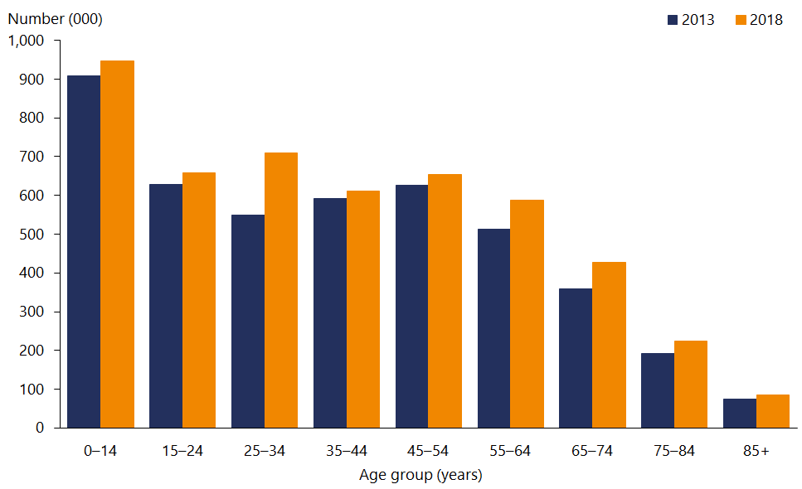

Source: Stats NZ (2020b)

|  |
| --- |
| The ethnic mix of our population has changed |

As Table 1 shows, the size of all major ethnic groups increased from 2013 to 2018. However, the rate of growth was higher in the Māori, Pacific, Asian and Middle Eastern, Latin American and African (MELAA) ethnic groups. As a result, these groups now make up an increased proportion of New Zealand’s population. Although the European or Other ethnic group has also increased in size, its rate of growth was slower and so it now makes up a smaller proportion of the population.

Table : Estimated resident population, by ethnic group, June 2013 and June 2018

|  |  |  |  |  |
| --- | --- | --- | --- | --- |
| **Ethnic group** | **2013** | | **2018** | |
| **Number** | **Percent** | **Number** | **Percent** |
| European or Other (including New Zealander) | 3,312,100 | 74.6 | 3,441,700 | 70.2 |
| Māori | 692,300 | 15.6 | 816,500 | 16.7 |
| Pacific | 344,400 | 7.8 | 407,700 | 8.3 |
| Asian | 541,300 | 12.2 | 770,600 | 15.7 |
| Middle Eastern, Latin American and African | 53,100 | 1.2 | 77,000 | 1.6 |
| **Total** | **4,442,100** |  | **4,900,600** |  |

Note: Ethnic groups are based on total response ethnicity.

Source: Stats NZ (2020b)

|  |
| --- |
| One in six New Zealanders is Māori |

As of June 2018, there were 816,500 Māori in New Zealand, which is 16.7 percent of the total population (up from 15.6 percent in 2013). The Māori population has a younger age structure than most other New Zealanders, with a median age of 25.6 years compared with the national median of 37.2 years.

|  |
| --- |
| Pacific peoples in New Zealand are diverse and youthful |

As of June 2018, there were 407,700 Pacific peoples in New Zealand, which is 8.3 percent of the total population (up from 7.8 percent in 2013). Samoan, Tongan, Cook Islands Māori and Niuean are the largest Pacific ethnic groups in New Zealand. About two-thirds (66.4 percent) of Pacific peoples are New Zealand born. The Pacific population has a younger age structure than other New Zealanders, with a median age of 23.7 years.

|  |
| --- |
| The Asian population is diverse and growing rapidly |

As of June 2018, there were 770,600 Asian people in New Zealand, which is 15.7 percent of the total population (up from 12.2 percent in 2013). The Asian ethnic group is highly diverse. The largest Asian ethnic groups are Chinese, Indian, Filipino and Korean. The median age of the Asian population is 31.5 years.

|  |
| --- |
| One in four New Zealanders is disabled |

The most recent data on the prevalence of disability comes from the 2013 New Zealand Disability Survey, which found that 24 percent of the population (1.1 million) had a disability (Stats NZ 2014). The disability rate increases with age, to the point that 59 percent of adults aged 65 years and over are disabled. For adults, the most common types of impairment were physical limitations, whereas for children it was learning difficulties. Just over half of disabled people (53 percent) had more than one type of impairment.

|  |
| --- |
| More than half of New Zealanders live in major urban areas |

The New Zealand population is largely based in major, large or medium-sized urban areas (74 percent of the population). More than half of people (51 percent) live in major urban areas that have 100,000 residents or more (Stats NZ 2020d). Sixteen percent of the population live in rural areas.

Figure 2 shows the percentage of the estimated resident population living in each district health board (DHB) region. The estimated population of New Zealand increased by 16 percent overall between 2009 and 2019 (Stats NZ 2020d). The DHB regions with the largest percentage increase in population over this time were Bay of Plenty (23 percent increase), Counties Manukau (22 percent) and Northland (20 percent).

Figure : Percentage of estimated resident population, by DHB, June 2019

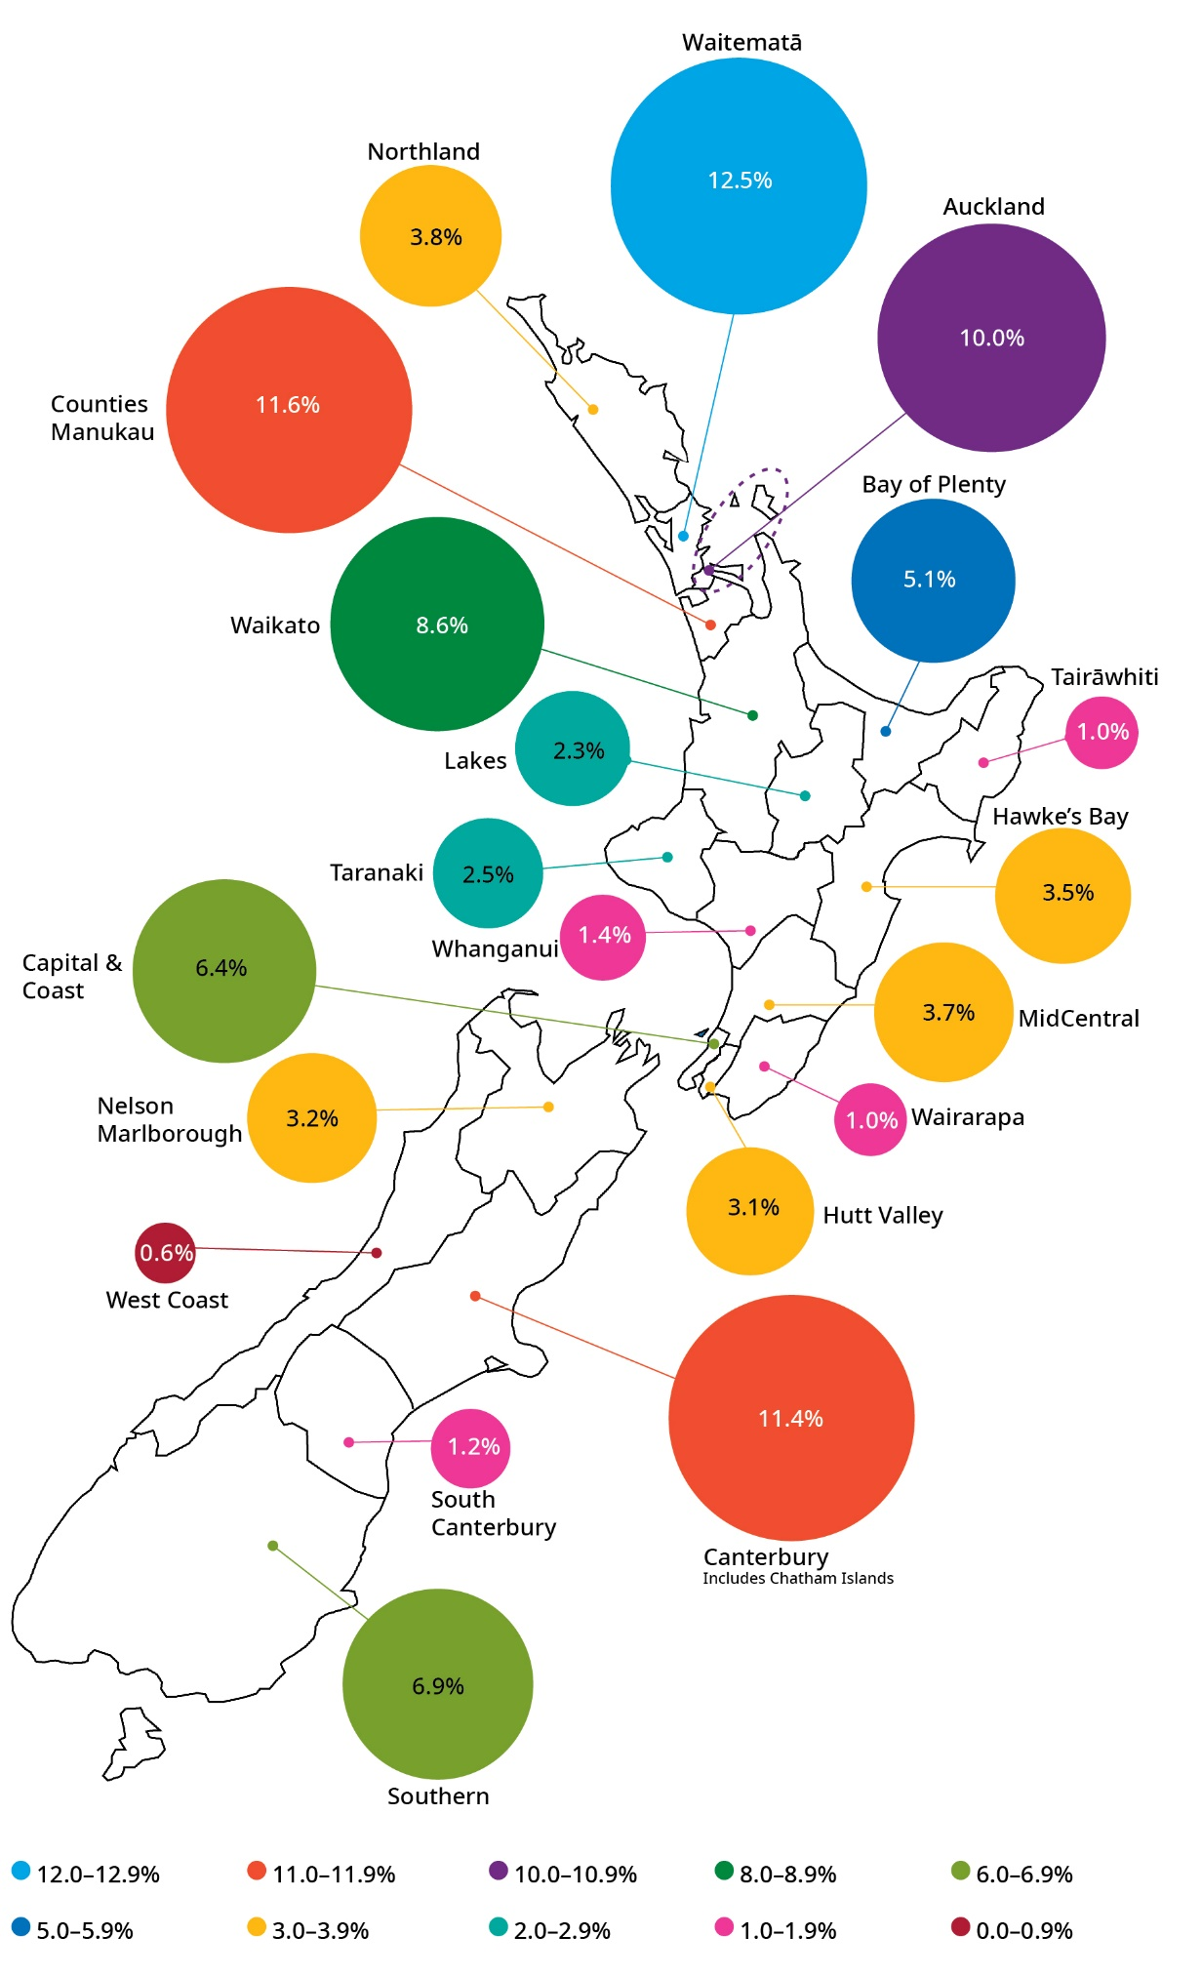

Source: Stats NZ (2020b)

# Population health measures | Ngā mēhua hauora o te taupori

We measure the health of our population in various ways to identify health issues affecting New Zealanders and to highlight inequity in health outcomes for certain groups.

## Self-rated health

|  |
| --- |
| Most New Zealanders continue to rate their health as good, very good or excellent |

In the 2018/19 New Zealand Health Survey, 86.2 percent of adults reported their health was good, very good or excellent (Ministry of Health 2019a). Results were similar for men (87.2 percent) and women (85.3 percent).

Since 2011/12, the proportion of adults rating their health as good, very good or excellent has decreased by a small but statistically significant amount (from 89.3 to 86.2 percent). Over the same period, the proportion of adults rating their health as fair or poor has increased from 10.7 to 13.8 percent.

Māori and Pacific adults have lower levels of self-rated health and these have worsened over time. For Māori adults, 77.3 percent reported their health was good, very good or excellent in 2018/19, down from 83.6 percent in 2011/12. For Pacific adults, 78.7 percent reported their health was good, very good or excellent in 2018/19, down from 87.2 percent in 2011/12. The proportion of Māori and Pacific adults rating their health as fair or poor has increased since 2011/12 – from 16.4 to 22.7 percent for Māori and from 12.8 to 21.3 percent for Pacific peoples.

Self-rated health varies by socioeconomic deprivation. Adults living in the most deprived areas were less likely to report their health was good, very good or excellent (79.4 percent) than adults living in the least deprived areas (91.0 percent). This difference was statistically significant after adjusting for differences in age, gender and ethnicity.

Nearly all parents (98.2 percent) rated their child’s health as good, very good or excellent in 2018/19. Levels of parent-rated child health have not changed since 2011/12. There are no significant differences in parent-rated child health by ethnic group or socioeconomic deprivation.

## Life expectancy and health expectancy

Data on life expectancy and health expectancy comes from the 2019 cycle of the Global Burden of Disease Study. Results are available by age and sex but not for other population sub-groups. In future cycles of the Global Burden of Disease Study estimates will be available for Māori and non-Māori, which will be the first comparison by ethnicity this international project has ever produced.

|  |
| --- |
| Life expectancy continues to increase but more slowly than before |

New Zealanders are living longer than ever before. In 2019, life expectancy at birth was 79.9 years for males and 83.6 years for females (Global Burden of Disease Collaborative Network 2020). Since 1990, men have gained 7.2 years of life and women 5.2 years (Table 2). While women have historically lived longer and continue to do so, the life expectancy gap between men and women is slowly decreasing.

Table : Life expectancy at birth (years), by sex, 1990 to 2019

|  |  |  |  |  |  |
| --- | --- | --- | --- | --- | --- |
| **Sex** | **1990** | **2000** | **2010** | **2019** | **Change from 1990 to 2019** |
| Males | 72.7 | 75.9 | 79.0 | 79.9 | 7.2 |
| Females | 78.4 | 80.8 | 82.8 | 83.6 | 5.2 |

Source: Global Burden of Disease Collaborative Network (2020)

New Zealand’s life expectancy compares well with other similar countries. In 2019, life expectancy at birth in high socioeconomic development index (SDI) countries was 78.6 years for males and 83.8 years for females (Global Burden of Disease Collaborative Network 2020).

|  |
| --- |
| Health-adjusted life expectancy is increasing |

Health-adjusted life expectancy (health expectancy) represents the number of years we live in good health – that is, without functional limitation. Health expectancy is an important indicator of health and disability system performance, reflecting the contribution that all sectors make to keeping people healthy and independent throughout their lives.

Health expectancy at birth is 68.9 years for males and 70.3 years for females (Global Burden of Disease Collaborative Network 2020). Over time, health expectancy has increased for both men and women (Table 3). Since 1990, men have gained 5.6 years of healthy life and women 4.2 years.

Table : Health expectancy (years), by sex, 1990 to 2019

|  |  |  |  |  |  |
| --- | --- | --- | --- | --- | --- |
| **Sex** | **1990** | **2000** | **2010** | **2019** | **Change from 1990 to 2019** |
| Males | 63.3 | 65.9 | 68.4 | 68.9 | 5.6 |
| Females | 66.1 | 68.3 | 70.0 | 70.3 | 4.2 |

Source: Global Burden of Disease Collaborative Network (2020)

New Zealand’s health expectancy compares well with other similar countries. In 2019, health expectancy at birth in high SDI countries was 68.2 years for males and 70.2 years for females (Global Burden of Disease Collaborative Network 2020).

|  |
| --- |
| The number of years spent in poor health is relatively stable |

Although both life expectancy and health expectancy have improved, the increase in health expectancy is slightly lower than the increase in life expectancy. This means that while we are living longer, we are spending more of our time in poor health (Table 4).

Table : Time spent in poor health (years), by sex, 1990 to 2019

|  |  |  |  |  |  |
| --- | --- | --- | --- | --- | --- |
| **Sex** | **1990** | **2000** | **2010** | **2019** | **Change from 1990 to 2019** |
| Males | 9.4 | 10.0 | 10.6 | 11.0 | 1.6 |
| Females | 12.3 | 12.5 | 12.8 | 13.3 | 1.0 |

Source: Global Burden of Disease Collaborative Network (2020)

|  |
| --- |
| Life expectancy is five to seven years lower for Māori and Pacific |

Life expectancy calculations based on the most recent data is not available for Māori and Pacific peoples or by socioeconomic or disability status. Stats NZ will publish period life tables for the period 2017 to 2019, including life tables for major ethnic groups, in 2021.

A recent study estimated life expectancy for Māori, Pacific and non-Māori, non-Pacific men and women over the three-year period from 2013 to 2015 (Walsh and Grey 2019). Life expectancy at birth was about seven years lower for Māori and more than five years lower for Pacific peoples compared with non-Māori, non-Pacific peoples (Table 5).

Table : Life expectancy at birth, by ethnic group and sex, 2013 to 2016

|  |  |  |
| --- | --- | --- |
| **Ethnic group** | **Male** | **Female** |
| Māori | 73.5 | 77.3 |
| Pacific | 75.0 | 78.3 |
| Non-Māori, non-Pacific | 80.9 | 84.3 |

Source: Walsh and Grey (2019)

For Māori, the leading avoidable causes of death contributing to lower life expectancy were cancers of the trachea, bronchus and lung, along with coronary heart disease and diabetes. For Pacific peoples, the leading avoidable causes of death contributing to lower life expectancy were coronary heart disease and cancers (Walsh and Grey 2019).

The researchers also examined how much smoking contributes to differences in life expectancy. They found that higher rates of smoking were responsible for reducing life expectancy by 2.1 years in Māori men, 2.3 years in Māori women, 1.4 years in Pacific men and 0.3 years among Pacific women (Walsh and Wright 2020). The conditions contributing to these smoking-related differences in life expectancy were cancers of the trachea, bronchus and lung, chronic obstructive pulmonary disease and ischaemic heart disease.

## Health loss

Health loss refers to the gap between the state of health of the current population and that of an ideal population in which everyone experiences a long life free from illness or disability.[1] Data on health loss comes from the 2019 cycle of the Global Burden of Disease (GBD) study, which produces global, regional and national estimates (Global Burden of Disease Collaborative Network 2020). Future cycles of the GBD study will produce estimates for the Māori and non-Māori populations.

Health loss is measured using a metric called the disability-adjusted life year (DALY). The DALY combines information on both fatal outcomes (early death) and non-fatal outcomes (illness or disability) in a way that makes it possible to compare the burden of different diseases and injuries across population groups and over time. One DALY represents the loss of one year of life lived in good health.

|  |
| --- |
| Since 1990 the rate of overall health loss has declined, after adjusting for population growth and ageing |

As Figure 3 shows, the absolute DALY number has increased over time. However, the age-standardised DALY rate, which adjusts for population growth and ageing, has decreased over time (from 28,551 per 100,000 in 1990 to 20,682 per 100,000 in 2019).

Figure : DALY count and age-standardised DALY rate, 1990 to 2019

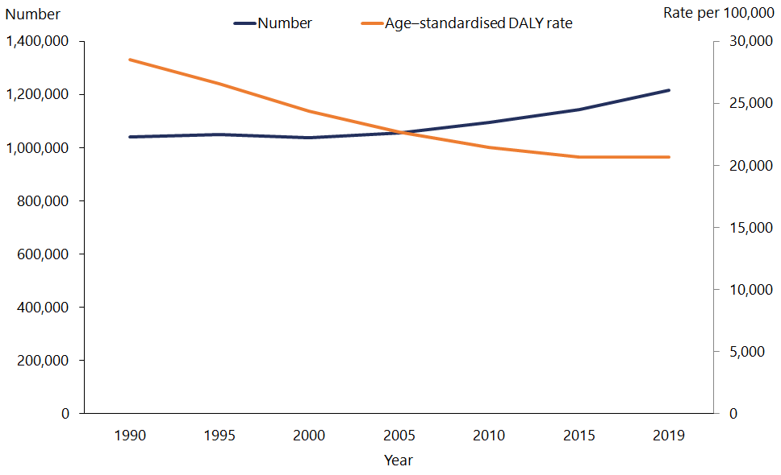

Source: Global Burden of Disease Collaborative Network (2020)

|  |
| --- |
| The majority of our health loss is due to non-communicable diseases |

Non-communicable diseases are responsible for 83.5 percent of all health loss. Four condition groups contribute to half of this health loss: cancers (18.5 percent), cardiovascular and cerebrovascular diseases (15.1 percent), mental disorders (8.7 percent) and musculoskeletal disorders (8.6 percent).

Injuries account for 12.8 percent of health loss, including unintentional injuries (8.1 percent), self-harm and interpersonal violence (2.6 percent) and transport injuries (2.1 percent). Communicable, maternal, neonatal and nutritional causes account for the remaining 3.7 percent of health loss.

Table 6 shows the top 10 specific causes of health loss in 2019, which accounted for 37 percent of total DALYs. Since 1990, the largest declines in the age-standardised DALY rate were for ischaemic heart disease (falling by 66 percent) and stroke (53 percent).

Table : Leading specific causes of health loss, 2019

|  |  |  |
| --- | --- | --- |
|  | **Cause** | **Percent of total DALYs** |
| 1 | Ischaemic heart disease | 7.7 |
| 2 | Low back pain | 4.5 |
| 3 | Chronic obstructive pulmonary disease | 3.9 |
| 4 | Falls | 3.7 |
| 5 | Stroke | 3.5 |
| 6 | Lung cancer | 3.4 |
| 7 | Colorectal cancer | 2.6 |
| 8 | Diabetes | 2.6 |
| 9 | Anxiety disorders | 2.6 |
| 10 | Depressive disorders | 2.4 |

Source: Global Burden of Disease Collaborative Network (2020)

## Morbidity

Morbidity is non-fatal health loss (illness and disability), measured in years lived with disability (YLD). YLDs take into account both the prevalence and severity of a health state.

|  |
| --- |
| Morbidity now accounts for just over half of all health loss |

In 2019, New Zealand had an age-standardised rate of non-fatal health loss of 11,560 YLDs per 100,000 population (Global Burden of Disease Collaborative Network 2020). This rate has not changed significantly since 1990, when it was 11,884 per 100,000. Over the same period, the rate of fatal health loss declined more quickly (see the ‘Mortality’ section). As a result, morbidity now accounts for over half of all health loss (up from around 40 percent in 1990).

The leading condition group responsible for non-fatal health loss is mental disorders (17.2 percent). It is followed by musculoskeletal disorders (16.4 percent) and unintentional injuries (13.3 percent).

Table 7 shows the top 10 specific causes of non-fatal health loss in 2019, which accounted for 48 percent of total YLDs. Since 1990, the largest declines in the age‑standardised YLD rate were for oral disorders (falling by 15 percent) and mechanical forces (12 percent). Over this period, the age-standardised YLD rate increased for diabetes (by 58 percent) and falls (28 percent).

Table : Leading specific causes of morbidity, 2019

|  |  |  |
| --- | --- | --- |
|  | **Cause** | **Percent of total YLDs** |
| 1 | Low back pain | 8.9 |
| 2 | Falls | 6.0 |
| 3 | Anxiety disorders | 5.1 |
| 4 | Depressive disorder | 4.8 |
| 5 | Headache disorder | 4.4 |
| 6 | Age-related hearing loss | 4.2 |
| 7 | Mechanical forces | 4.0 |
| 8 | Oral disorders | 3.7 |
| 9 | Osteoarthritis | 3.7 |
| 10 | Diabetes | 3.3 |

Source: Global Burden of Disease Collaborative Network (2020)

## Mortality

Mortality is the loss of life from all causes. The Global Burden of Disease Study measures premature mortality in years of life lost (YLL). A death that occurs at a young age has a higher weighting than a death that occurs in old age.

In 2019, New Zealand had an age-standardised premature mortality rate of 9,122 YLLs per 100,000 population (Global Burden of Disease Collaborative Network 2020). This rate has declined substantially from 1990, when it was 16,667 per 100,000.

Table 8 shows the top 10 specific causes of premature mortality in 2019, which accounted for 53 percent of total YLLs. Since 1990, the age-standardised YLL rate declined by 30 percent or more for eight of these conditions. The largest declines were for ischaemic heart disease (falling by 66 percent) and stroke (57 percent). Over this period the age-standardised YLL rate increased for chronic kidney disease (by 23 percent).

Table : Leading specific causes of premature mortality, 2019

|  |  |  |
| --- | --- | --- |
|  | **Cause** | **Percent of total YLLs** |
| 1 | Ischaemic heart disease | 15.0 |
| 2 | Lung cancer | 6.8 |
| 3 | Stroke | 5.9 |
| 4 | Chronic obstructive pulmonary disease | 5.1 |
| 5 | Colorectal cancer | 4.9 |
| 6 | Self-harm | 3.9 |
| 7 | Alzheimer’s disease | 3.4 |
| 8 | Breast cancer | 3.0 |
| 9 | Road injuries | 2.7 |
| 10 | Chronic kidney disease | 2.3 |

Source: Global Burden of Disease Collaborative Network (2020)

|  |
| --- |
| Our total mortality rate has declined over time but the rate of decline has slowed in recent years for both Māori and non-Māori |

In 2017 there were 33,599 registered deaths in New Zealand, equating to an age‑standardised mortality rate of 378.6 deaths per 100,000 population (Ministry of Health 2019b). The age‑standardised mortality rate was higher for males (440.6 per 100,000) than for females (323.4 per 100,000). Mortality rates have declined over time (Figure 4), with the relative decline similar for males (60 percent) and females (62 percent).

Figure : Mortality rates, by sex, 1948 to 2017*

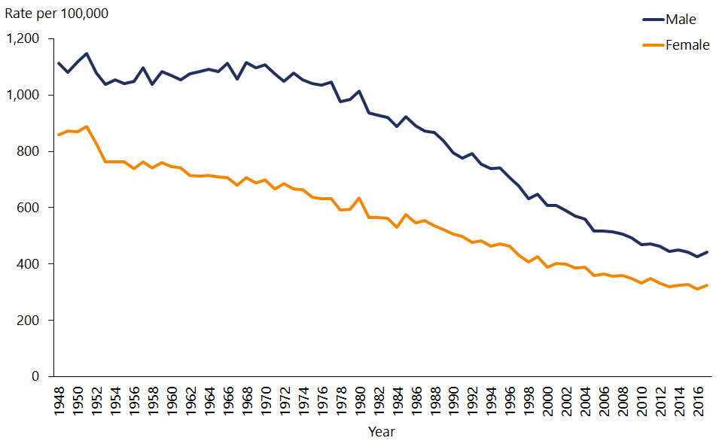

Notes: Rates are per 100,000 population and age-standardised to the World Health Organization’s world standard population. * 2017 mortality data is provisional.

Source: Ministry of Health (2019b, 2020b)

In 2017 the age-standardised mortality rate was nearly twice as high for Māori (641.2 per 100,000) as for non-Māori (350.1 per 100,000). As Figure 5 shows, mortality rates have declined since 1996 for both Māori (by 40 percent) and non-Māori (34 percent). However, the decline in mortality rates has slowed over the last decade, especially for Māori (Ministry of Health 2020b).

Figure : Mortality rates, Māori and non-Māori, 1996 to 2017*

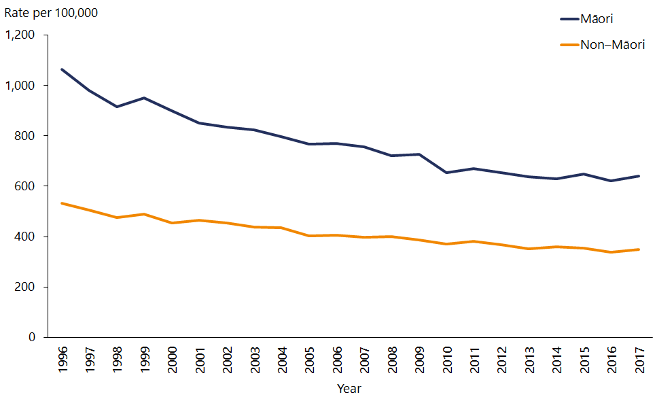

Notes: Rates are per 100,000 population and age-standardised to the World Health Organization’s world standard population. * 2017 mortality data is provisional.

Source: Ministry of Health (2019b, 2020b)

|  |
| --- |
| The infant mortality rate is declining, but rates continue to be higher among Māori and Pacific children aged under one year |

In 2016, there were 241 deaths in children aged under one year (Ministry of Health 2019c). This equates to an infant mortality rate of 4.0 per 1,000 live births, which is down from 7.3 per 1,000 live births in 1996.

In 2016, infant mortality rates were significantly higher Pacific peoples and Māori ethnic groups (6.2 and 5.9 per 1,000 live births, respectively) than in European/Other and Asian ethnic groups (2.8 and 2.5 per 1,000 live births, respectively).

There were 42 sudden unexpected death in infancy (SUDI) deaths in 2016, including 23 sudden infant death syndrome (SIDS) deaths. The SUDI rate has halved since 2000 (from 1.4 to 0.7 per 1,000 live births). In the five year period from 2012 to 2016, SUDI rates for babies in the Māori and Pacific peoples ethnic groups were significantly higher than for babies in other ethnic groups.

# Causes of health loss | Ngā take mo te mate hauora

Major causes of health loss include cancers, cardiovascular and cerebrovascular diseases, mental disorders and musculoskeletal disorders.

## Cancers

|  |
| --- |
| Collectively, cancers are the leading cause of health loss in New Zealand |

Collectively, cancers account for 18.5 percent of all health loss in New Zealand (Global Burden of Disease Collaborative Network 2020). Risk factors for cancer that can be modified include smoking, poor diet, physical inactivity, obesity and harmful use of alcohol. A person’s chance of surviving cancer depends on a number of factors, including age at diagnosis, type of cancer, cancer stage at diagnosis and the availability of specialist cancer treatment and follow-up care.

|  |
| --- |
| The incidence rate for all cancers combined is declining slowly |

In 2017 there were 24,582 new cancer registrations. This is the equivalent of 67 people being diagnosed with cancer every day. The age-standardised cancer incidence rate was 332.6 per 100,000 population in 2017, down slightly from 347.1 per 100,000 in 2008 (Ministry of Health 2020c).

The most commonly registered cancers in 2017 were prostate cancer (3,857), female breast cancer (3,290), colorectal cancer (3,085), melanoma (2,555) and lung cancer (2,255). Together these five cancers accounted for 61 percent of all cancer registrations.

Figure 6 shows trends in the four leading causes of cancer registrations for males and females over the last decade. For males, age-standardised incidence rates for lung cancer, colorectal cancer and melanoma have declined. For females, incidence rates for colorectal cancer and melanoma have declined.

Figure : Cancer incidence rate, by cancer type and sex, 2008 to 2017

|  |  |
| --- | --- |
| This line graph shows that the highest cancer incidence in men is prostate cancer, followed by colorectal, melanoma and lung cancers.  The rates for all four have remained relatively steady over time, but prostate cancer rates have fluctuated more than the others. | This line graph shows that the highest cancer incidence in women is breast cancer, followed by colorectal, melanoma and lung cancers.  The rates for all four have remained relatively steady over time. |

Notes: Rates are per 100,000 population and age-standardised to the World Health Organization’s world standard population.

Source: Ministry of Health (2020c)

|  |
| --- |
| The mortality rate for all cancers combined is declining, but trends differ by cancer type and sex |

In 2017 a total of 9,638 people died of cancer. This is equivalent to 26 people dying of cancer every day. The age-standardised cancer mortality rate was 114.9 per 100,000 population in 2017, down from 132.7 per 100,000 in 2008 (Ministry of Health 2020c).

The most common causes of cancer mortality in 2017 were lung cancer (1,781 deaths), colorectal cancer (1,229), prostate cancer (695), female breast cancer (672) and pancreatic cancer (542). Together these five cancers accounted for 51 percent of all cancer deaths.

Figure 7 shows trends in the four leading causes of cancer mortality for males and females over the last decade. For males, age-standardised mortality rates for lung cancer, colorectal cancer and prostate cancer have declined. For females, mortality rates for breast cancer and colorectal cancer have declined.

Figure : Cancer mortality rate, by cancer type and sex, 2008 to 2017*

|  |  |
| --- | --- |
| This line graph shows that men have the highest mortality rates for lung cancer, followed by colorectal, prostate and pancreatic cancer. The rates for lung, colorectal and prostate cancers have declined over time, while the rate for pancreatic cancer has increased slightly. | This line graph shows that women have the highest mortality rates for lung cancer, followed by breast, colorectal and pancreatic cancer. The rates for lung, colorectal and breast cancers have declined over time, while the rate for pancreatic cancer has remained steady. |

Notes: Rates are per 100,000 population and age-standardised to the World Health Organization’s world standard population. *2017 mortality data is provisional.

Source: Ministry of Health (2020c)

|  |
| --- |
| Cancer incidence and mortality rates are higher among Māori |

Cancer incidence and mortality rates are higher in Māori than in non-Māori (Table 9). A comprehensive analysis done to inform the Wai 2575 Health Services and Outcomes Kaupapa Inquiry (Wai 2575) showed that the gap in cancer incidence and mortality between Māori and non-Māori did not change significantly between 1996–98 and 2012–14 (Ministry of Health 2019d). The inequities were particularly marked for the incidence and mortality of lung, stomach and liver cancers. For breast and cervical cancers, the gap was greater for mortality than for incidence.

Table : Cancer incidence and mortality rates, Māori and non-Māori, 2017

|  |  |  |  |  |
| --- | --- | --- | --- | --- |
| **Ethnic group** | **Registration rate** | | **Death rate** | |
| **Male** | **Female** | **Male** | **Female** |
| Māori | 422.9 | 437.9 | 214.3 | 173.3 |
| Non-Māori | 354.9 | 291.0 | 123.9 | 94.4 |
| All | 363.0 | 306.1 | 131.2 | 101.9 |

Note: Rates are per 100,000 population and age-standardised to the World Health Organization’s world standard population.

Source: Ministry of Health (2019b, 2020c)

|  |
| --- |
| Cancer mortality rates are higher among Pacific peoples |

A detailed analysis of cancer deaths from 2006 to 2011 showed that cancer mortality rates are declining for Pacific peoples, but not as quickly as for European and other ethnic groups and they remain significantly higher for Pacific than for non-Pacific ethnic groups (Teng et al 2016). The cancers contributing most to inequities in cancer death rates are lung cancer (Pacific men), breast cancer (Pacific women) and stomach cancers (Pacific men and women).

## Cardiovascular and cerebrovascular diseases

Cardiovascular and cerebrovascular diseases together account for 15.1 percent of all health loss (Global Burden of Disease Collaborative Network 2020). Ischaemic heart disease and stroke are the leading causes within this group. It is possible to avoid most of this health loss through a combination of prevention and treatment. Risk factors that can be modified include smoking, high blood pressure, poor diet, physical inactivity, obesity and diabetes. A person has a greater chance of surviving heart disease and stroke through early detection, effective treatment and rehabilitation.

|  |
| --- |
| Ischaemic heart disease remains the leading specific cause of health loss even though mortality from this disease has fallen substantially since the late 1960s |

Ischaemic heart disease is the leading specific cause of health loss, accounting for 7.7 percent of DALYs in 2019 (Global Burden of Disease Collaborative Network 2020). Nearly all (93 percent) of this health loss is due to established risk factors.

According to the 2018/19 New Zealand Health Survey, 4.3 percent of adults have been diagnosed with ischaemic heart disease (Ministry of Health 2019a). This is likely to be an underestimate, because the measure includes only heart attacks requiring admission to hospital or people told by a doctor that they have angina. The prevalence of ischaemic heart disease has declined since 2011/12, when 5.5 percent of adults had it. The prevalence of ischaemic heart disease was significantly higher in Māori women than in non-Māori women, after adjusting for age differences.

In 2017 ischaemic heart disease accounted for 4,856 deaths, which is an age‑standardised rate of 50.2 deaths per 100,000 population (Ministry of Health 2019b). This is substantially lower than the rate in the late 1960s, when ischaemic heart disease mortality rates peaked at about 250 per 100,000 population (Ministry of Health 2020b).

Ischaemic heart disease mortality rates were much higher in men (70.4 per 100,000) than women (32.6 per 100,000) in 2017 (Ministry of Health 2019b). Ischaemic heart disease contributes to ethnic inequities: in 2017 the mortality rate was nearly twice as high for Māori (86.4 per 100,000) as for non-Māori (46.5 per 100,000).

A study examining ischaemic heart disease events from 2006 to 2015 found that fatal and non-fatal ischaemic heart disease rates have declined over that period, but Māori and Pacific peoples have disproportionately high rates of mortality (Grey et al 2018). Ischaemic heart disease mortality rates declined by 3.1–5.4 percent each year for most groups. For Pacific women, however, the decline (1.3 percent each year) was not statistically significant.

|  |
| --- |
| Stroke continues to be a significant cause of our disease burden |

In 2019 stroke was the fifth leading specific cause of health loss, accounting for 3.5 percent of all health loss (Global Burden of Disease Collaborative Network 2020).

The 2018/19 New Zealand Health Survey found that 1.6 percent of adults had been diagnosed with a stroke at some time in their life (Ministry of Health 2019a). This estimate excludes transient ischaemic attacks, which are sometimes called mini-strokes. The prevalence of stroke has not changed significantly since 2011/12, when it was 1.8 percent. The prevalence of stroke was significantly higher in Māori compared with non-Māori, after adjusting for age and gender differences.

In 2017 cerebrovascular diseases accounted for 2,477 deaths, which is an age‑standardised rate of 24.1 deaths per 100,000 population (Ministry of Health 2019b). This is substantially lower than the rate in the early 1970s, when the cerebrovascular mortality rate peaked at about 120 per 100,000 population (Ministry of Health 2020b).

In 2017 the mortality rate for cerebrovascular diseases was similar in men (23.8 per 100,000) and women (23.9 per 100,000). The cerebrovascular mortality rate was higher for Māori (33.1 per 100,000) than for non-Māori (23.1 per 100,000).

## Diabetes

|  |
| --- |
| Health loss from diabetes is increasing |

Diabetes accounted for 2.6 percent of all health loss in 2019, up from 1.6 percent in 1990 (Global Burden of Disease Collaborative Network 2020). Diabetes can cause blindness and nerve damage and may eventually require amputation of a foot or lower leg. It can lead to other health conditions, such as heart disease, stroke and kidney disease. Over half of health loss from diabetes is attributable to high body mass index (Global Burden of Disease Collaborative Network 2020).

As at the end of 2019, an estimated 263,900 people in New Zealand had diabetes[2] (Ministry of Health 2020d). The prevalence of diabetes increased from 2010 to 2015, but it has been relatively stable since then.

Figure 8 shows the prevalence of diabetes by age group for major ethnic groups. The Pacific and Indian ethnic groups have the highest rates of diabetes, with about half affected by age 75 years.

Figure : Prevalence of diabetes, by age and ethnic group, 2019

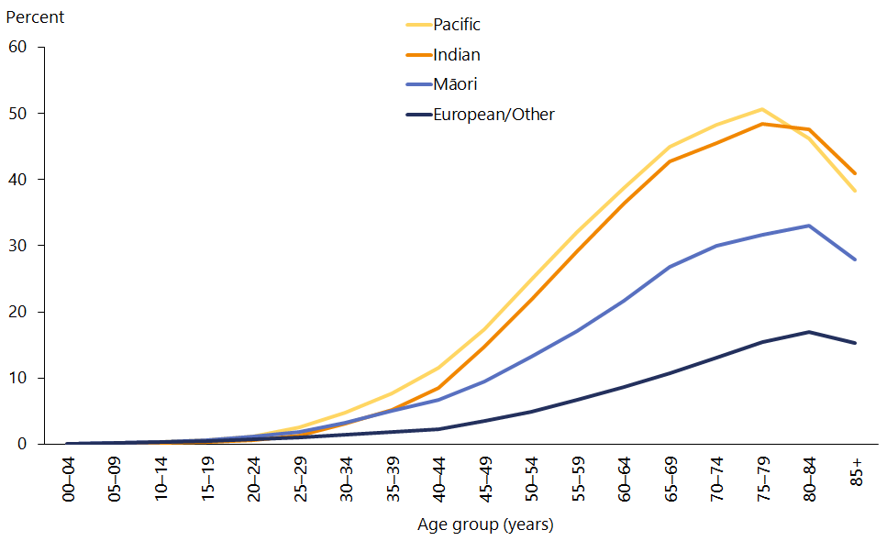

Source: Ministry of Health (2020d)

In 2017 diabetes accounted for 917 deaths, which is an age-standardised rate of 10.6 deaths per 100,000 population (Ministry of Health 2019d). Diabetes mortality rates were slightly higher in men (12.8 per 100,000) than in women (8.6 per 100,000). The diabetes mortality rate was about four times higher in Māori (33.7 per 100,000) than in non-Māori (8.5 per 100,000).

## Mental health conditions

Mental health conditions are collectively responsible for 8.7 percent of total health loss and 17.2 percent of non-fatal health (Global Burden of Disease Collaborative Network 2020). The leading conditions within this group are anxiety (2.6 percent of total health loss) and depression (2.4 percent). About half of adults with mental illness will have developed their condition before the age of 15 years. For this reason, early detection and treatment are important.

|  |
| --- |
| Psychological distress has the greatest impact on Māori women, young adults and people living in socioeconomically deprived areas |

Psychological (mental) distress refers to a person’s experience of symptoms such as anxiety, psychological fatigue or depression. It is measured using the 10-question Kessler Psychological Distress Scale (Kessler et al 2003). High levels of psychological distress indicate that a person has a high or very high probability of having an anxiety or depressive disorder.

In 2018/19, 8.2 percent of adults experienced psychological distress in the previous four weeks (Ministry of Health 2019a). This is a significant increase since 2006/07, when the prevalence of psychological distress was 6.6 percent.

Women (10.4 percent) were more likely to experience psychological distress than men (5.9 percent). Psychological distress rates were highest among young people aged  
15–24 years at 14.5 percent, up from 5.0 percent in 2011/12.

Māori women had the highest prevalence of psychological distress (17.5 percent), followed by Pacific women (13.1 percent). After adjusting for age, gender and ethnic differences, adults living in the most socioeconomically deprived areas were 2.1 times as likely to experience psychological distress as adults living in the least deprived areas.

|  |
| --- |
| Adults living in socioeconomically deprived areas are more than twice as likely to have symptoms of severe anxiety |

The 2016/17 New Zealand Health Survey collected detailed data on mental health using the GAD-7 and PHQ-9 screening tools, which identify symptoms (Ministry of Health 2020e).

In 2016/17, 2.4 percent of adults had experienced symptoms of severe anxiety (based on a score of 15 or higher on the GAD-7) in the past two weeks (Ministry of Health 2020e). Symptoms of severe anxiety were more common in women (3.2 percent) than in men (1.6 percent). Young women aged 15–24 years were most likely to have symptoms of severe anxiety (5.8 percent).

Māori were 1.6 times as likely as non-Māori to have symptoms of severe anxiety, after adjusting for differences in age and gender. The most pronounced differences were seen for adults living in the most deprived areas, who were 2.4 times as likely as those living in the least deprived areas to have symptoms of severe anxiety after adjusting for age, gender and ethnic differences.

|  |
| --- |
| Young women are most likely to have symptoms of depression |

In 2016/17, 1.3 percent of adults had experienced symptoms of severe depression (based on a score of 20 or higher on the PHQ-9) in the past two weeks (Ministry of Health 2020e). Symptoms of severe depression were more common in women (1.7 percent) than in men (0.9 percent). Young women aged 15–24 years were most likely to experience symptoms of severe depression (3.5 percent).

Māori were 1.6 times as likely as non-Māori to have symptoms of severe depression, after adjusting for differences in age and gender.

## Musculoskeletal conditions

|  |
| --- |
| One in six adults has arthritis, most commonly osteoarthritis |

Collectively, musculoskeletal disorders accounted for 8.6 percent of health loss in 2019 (Global Burden of Disease Collaborative Network 2020). Major conditions within this group include lower back pain (4.5 percent) and osteoarthritis (1.9 percent).

About 639,000 adults (16.2 percent) have been diagnosed with arthritis, according to the 2018/19 New Zealand Health Survey (Ministry of Health 2019a). The prevalence of arthritis has not changed significantly since 2011/12.

Arthritis is more common in women (17.5 percent) than men (14.9 percent). The prevalence of arthritis increases markedly with age: nearly half (46.2 percent) of all adults aged 75 years or older have been diagnosed with arthritis.

Osteoarthritis is the most common type of arthritis, affecting 10.2 percent of adults in 2018/19. Other types of arthritis New Zealanders experienced were rheumatoid (2.6 percent) and gout (2.7 percent). Gout was much more common in men (4.5 percent) than in women (1.0 percent). After adjusting for age differences, Māori men were 2.5 times as likely as non-Māori men, and Pacific men were 3.2 times as likely as non-Pacific men, to have gout.

## Chronic respiratory diseases

|  |
| --- |
| Chronic respiratory diseases are a major cause of ethnic inequities |

Chronic respiratory diseases accounted for 5.3 percent of health loss in 2019 (Global Burden of Disease Collaborative Network 2020). The majority of this health loss is due to chronic obstructive pulmonary disease (3.9 percent) and asthma (1.0 percent).

Chronic obstructive pulmonary disease (COPD) is a lung disease that prevents normal breathing. Common types of COPD include chronic bronchitis and emphysema, which are permanent conditions that are usually caused by smoking.

According to the 2013/14 New Zealand Health Survey, 6.4 percent of adults aged 45 years and over had COPD. Rates of COPD were highest in Māori (9.7 percent) and lowest in Asian (2.4 percent) adults. After adjusting for age, gender and ethnic differences, adults living in the most deprived neighbourhoods were 2.3 times as likely as adults living in the least deprived areas to have COPD.

Chronic lower respiratory diseases accounted for 1,898 deaths in 2017, which is an age‑standardised rate of 20.3 deaths per 100,000 population (Ministry of Health 2019d). The mortality rate for chronic lower respiratory diseases was similar in men (21.0 per 100,000) and women (20.0 per 100,000), but nearly three times higher in Māori (49.9 per 100,000) than in non-Māori (17.8 per 100,000).

|  |
| --- |
| Over half a million New Zealanders have asthma |

In 2018/19, 11.5 percent of adults (452,000) and 13.1 percent of children aged 2–14 years (110,000) had asthma[3] (Ministry of Health 2019a). The prevalence of asthma has not changed since 2011/12 for either adults or children.

Among children, the prevalence of asthma is higher in boys (15.4 percent) than girls (10.8 percent), whereas in adults it is higher in women (13.7 percent) than men (9.2 percent).

After adjusting for age and gender, Māori adults are 1.7 times as likely to have asthma as non-Māori adults. Māori children are 1.3 times as likely to have asthma as non‑Māori children.

## Oral health

|  |
| --- |
| Oral health issues contribute to health inequities |

In the 2018/19 New Zealand Health Survey, 6.8 percent of adults reported having one or more teeth removed due to decay, abscess, infection or gum disease in the past 12 months (Ministry of Health 2019a). About 40,000 children aged 1–14 years (4.5 percent) had had one or more of their teeth removed in the past 12 months, due to decay, an abscess, infection or gum disease.

Māori and Pacific adults were nearly twice as likely as their non-Māori and non-Pacific counterparts to have had a tooth removed in the past 12 months due to decay, abscess, infection or gum disease. The pattern was the same for Māori and Pacific children, especially for boys.

These ethnic disparities are reflected in results for self-rated oral health among adults. Overall, 78.4 percent of adults rated their oral health as excellent, very good or good (Ministry of Health 2019a). These positive self-ratings were less common among Māori (65.2 percent) and Pacific adults (73.2 percent). Adults living in the most deprived areas were also less likely to report excellent, very good or good oral health, after adjusting for age, gender and ethnic differences.

Overall, 93.6 percent of children aged 1–14 years had ‘excellent, very good or good’ parent-rated oral health. There were some differences in parent-rated oral health by ethnic group and neighbourhood deprivation, but these differences were smaller than you would expect based on other oral health results.

## Communicable diseases

Health loss from communicable (or infectious) diseases has decreased over time. It now makes a low contribution (1.9 percent) to overall health loss (Global Burden of Disease Collaborative Network 2020). However, ongoing vigilance is needed because outbreaks of communicable diseases still occur and lead to avoidable hospitalisations.

|  |
| --- |
| Imported cases of measles led to outbreaks in Christchurch, Auckland and Northland |

In October 2017, New Zealand had been officially declared to be free of endemic cases of measles. However, New Zealand became at risk of importing the disease again when, during 2018 and 2019, measles notifications increased substantially worldwide. Low vaccination rates in pockets of our community heightened this risk. In February 2019, an imported case of measles resulted in a local outbreak of measles.

By the end of 2019 a total of 2,213 confirmed cases of measles had been notified, which is a rate of 45 per 100,000 (ESR 2020a). This is similar to the number of cases notified in the 1997 outbreak (2,169), but fewer than during the measles epidemic in 1991 when the number of cases was estimated to be in the tens of thousands.

The DHB with the largest number of confirmed measles cases as of 23 December 2019 (ESR 2020b) was Counties Manukau (1,150), followed by Waitematā (303) and Auckland (273). Young people aged 20–29 years accounted for one-third (32.4 percent) of all measles cases, but the highest rate was in children aged under one year (Figure 9).

Figure : Measles notification rate, by age group, 2019

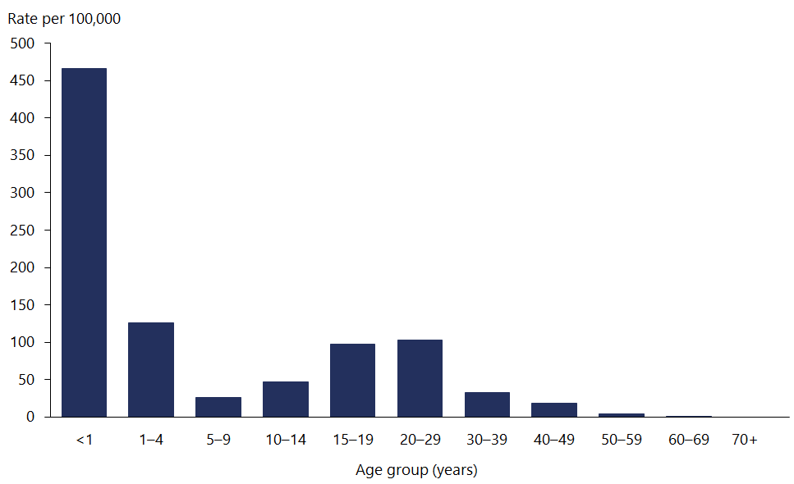

Source: ESR (2020a)

Measles disproportionately affected Pacific peoples, who accounted for 41 percent of all cases. The measles rate for Pacific peoples was 281 per 100,000 (Figure 10), which was more than six times higher than the national rate (45 per 100,000).

Figure : Measles notification rate, by ethnic group, 2019

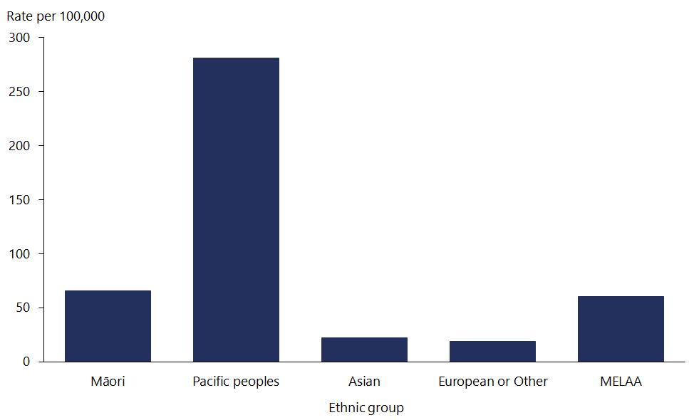

Source: ESR (2020a)

As at 23 December 2019, just over one-third (35 percent) of measles cases had been hospitalised (ESR 2020b). Immunisation status was known for nearly all (88 percent) cases. Of these, 8 percent had been fully immunised, 4 percent were partially immunised and the vast majority (87 percent) had not been immunised.

|  |
| --- |
| Cases of meningococcal disease have increased in the last few years but remain lower than the number of cases at the peak of the epidemic |

In total, 139 cases of meningococcal disease were notified in 2019 (2.8 per 100,000). Case numbers have increased since 2014, but remain significantly lower than the peak annual incidence rate of 16.7 per 100,000 during the epidemic from 1997 to 2007 (Ministry of Health 2020f).

In 2019, the highest notification rates for meningococcal disease were in children aged under one year (52.0 per 100,000). Compared with the total population, meningococcal incidence rates were more than three times higher in Pacific peoples (9.2 per 100,000) and two times higher in Māori (6.1 per 100,000).

|  |
| --- |
| Rates of rheumatic fever were declining but are now on the rise again |

Rheumatic fever is an autoimmune reaction to a group A streptococcal infection. It is a leading cause of acquired heart disease in New Zealand children. While rheumatic fever is rare in most developed countries, its incidence in New Zealand is persistently high. The highest rates are among Māori and Pacific children. Among Pacific peoples in New Zealand, rheumatic fever is limited almost entirely to Samoan and Tongan ethnic groups.

In 2019, there were 168 hospitalisations for first episode rheumatic fever (3.2 per 100,000). As Figure 11 shows, the national incidence rate declined from 2013 to 2015 but then began increasing, especially in Pacific peoples (Ministry of Health 2020g).

The incidence rate for Pacific children in 2019 was 28.9 per 100,000, which is about nine times the national rate. The incidence rate for Māori children (7.6 per 100,000) is about twice the national rate.

Figure : First episode rheumatic fever hospitalisation rate, by ethnic group, 2002 to 2019

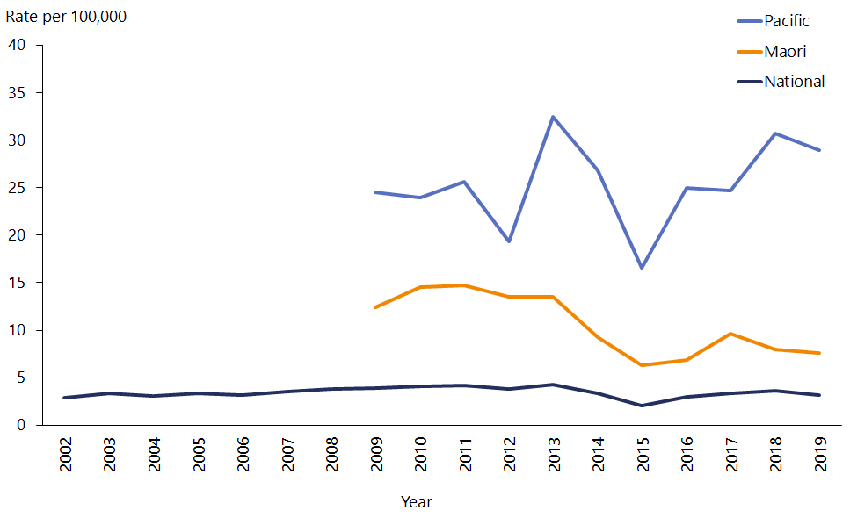

Notes: Rate per 100,000 population. Māori and Pacific data is only available from 2009.

Source: Ministry of Health (2020g)

# Determinants of health and wellbeing | Ngā whakatau o te hauora me oranga

Many underlying causes of ill health lie beyond what individuals can control in their day-to-day lives, and even beyond the health and disability system’s influence.

The factors affecting health are collectively known as the determinants of health. These can support or be barriers to good health and broader wellbeing.

As Figure 12 shows, the determinants of health include:

* socioeconomic factors, such as income and poverty
* physical environment, such as good housing and access to clean water
* health behaviours, such as tobacco use and healthy diet
* health care, including access to health services.

Socioeconomic factors (40 percent) and the physical environment (10 percent) together make up half of the factors that dictate our health outcomes. Our health behaviours account for just under a third (30 percent) and the health care environment is responsible for one-fifth (20 percent) (Institute for Clinical Systems Improvement 2014).

Figure : The determinants of health and how much each one contributes to our health outcomes

This infographic shows that the determinants of health are:
40% socioeconomic factors, like education family/social support and income.
10% physical environment, like where people live.
30% health behaviours, like tobacco use, diet and exercise and alcohol use.
20% access to and quality of health care.

Source: Adapted from the Institute for Clinical Systems Improvement (2014)

## Socioeconomic factors

The social and economic conditions that people are born into and live in have a major impact on their health. These conditions include education, income, social support and social connection. Social and economic factors also impact on health behaviours: people living in poverty have fewer choices available to them, greater stress and less access to opportunities such as education. All of these experiences can lead people to undertake more risk behaviours, have greater exposure to adverse environments, or poorer access to information, services and opportunities that support good health.

|  |
| --- |
| Most New Zealanders are satisfied or very satisfied with their lives |

Wellbeing statistics are based on how people assess their own lives, such as their view of how satisfied they are. Data on wellbeing comes from the General Social Survey, which scores most indicators on a scale of 0 (low) to 10 (high).

Most New Zealand adults (81 percent) rate their overall life satisfaction as 7 out of 10 or higher (Stats NZ 2020e). The average rating for all New Zealand adults was 7.7 out of 10. Overall life satisfaction was highest in people aged 75 years or older (8.2). Among ethnic groups, Asians had the highest overall life satisfaction score (7.8), followed by European (7.7), Māori (7.6) and Pacific peoples (7.5).

The average family wellbeing rating for New Zealanders was 7.8 out of 10, which has not changed since 2016 (Stats NZ 2020f). Māori rated their family wellbeing lower than other ethnic groups (7.4, compared with 7.8 for European and Pacific peoples, and 8.2 for Asians).

Overall life satisfaction varied by disability status. Disabled adults had lower average levels (6.9) than non-disabled adults (7.8) (Stats NZ 2020g). Average family wellbeing was also lower in disabled people (7.5) than in non-disabled people (7.8).

|  |
| --- |
| Māori and Pacific peoples have the strongest sense of belonging to New Zealand |

A strong sense of belonging is positively associated with wellbeing and mental health. The 2016 General Social Survey asked people about their sense of belonging to New Zealand; a score of 7 or higher (on a scale of 10) indicates a strong sense of belonging.

Overall, 88.5 percent of New Zealanders aged 15 years and over reported a strong sense of belonging (Stats NZ 2020h). The proportion of people reporting this increased with age. Māori (90.5 percent) and Pacific peoples (90.1 percent) were also more likely to report a strong sense of belonging.

|  |
| --- |
| About one in five children lives in relative poverty (after deducting housing costs) |

Poverty can negatively affect health in a number of ways, including through poor or no housing, inadequate nutrition or lack of access to health care.

In the year ending June 2019, just under one in seven New Zealand children (168,500) was living in a household with less than 50 percent of the median household income (Stats NZ 2020i). This increases to about one in five children (235,400) once housing costs are taken into account.[4]

Another indicator of poverty is material hardship, which indicates the number of households missing out on 6 or more of the 17 basics most people would regard as essentials. Examples include missing out by not eating fresh fruit and vegetables, putting off a visit to the doctor, or not being able to pay the electricity bill on time. An estimated 13 percent of children live in a household experiencing material hardship, which has not changed since 2017/18.

Although children from all ethnic groups live in households with low income and relative material hardship, Māori and Pacific children are disproportionately affected (Figure 13).

Figure : Primary measures of child poverty, by ethnic group, 2018/19

This bar graph shows that 19% of Māori have below half the median household income, about 25% of Māori have below half median household income (housing costs deducted), and about 23% have material hardship. For Pacific peoples, about 22% have below half median household income, about 24% have below half median household income (housing costs deducted) and 28% have material hardship. For Europeans, about 12% have below half median household income, about 17% have below half median household income (housing costs deducted) and 10% have material hardship. For the total population, about 15% have below half median household income, about 20% have below half median household income (housing costs deducted) and 13% have material hardship.

Source: Stats NZ 2020i)

In 2018/19 about one in five Māori and Pacific children lived in a household with less than 50 percent of the median household income, compared with one in nine European children. After housing costs were deducted, this increased to about one in four Māori and Pacific children (both 24.7 percent), compared with 17 percent for European children. Looking at material hardship, 23.3 percent of Māori children and 28.6 percent of Pacific children lived in households that are doing without 6 or more of the 17 material basic needs, compared with 9.8 percent of European children.

## Physical environment

Both the built and natural environments have an important influence on health and wellbeing.

|  |
| --- |
| Pacific peoples, Māori and disabled people are more likely to live in houses with damp and mould |

The 2018 Census results showed that one in five homes (318,891) was affected by damp (Stats NZ 2019). Of homes affected by damp, 44,520 were damp all of the time (3 percent of all homes). A further 274,371 were sometimes damp (18.5 percent of all homes). Compared with homes that the household owned or held in a family trust, the homes of renters were about seven times more likely to be always damp (Figure 14).

Figure : Housing dampness, by household tenure, 2018

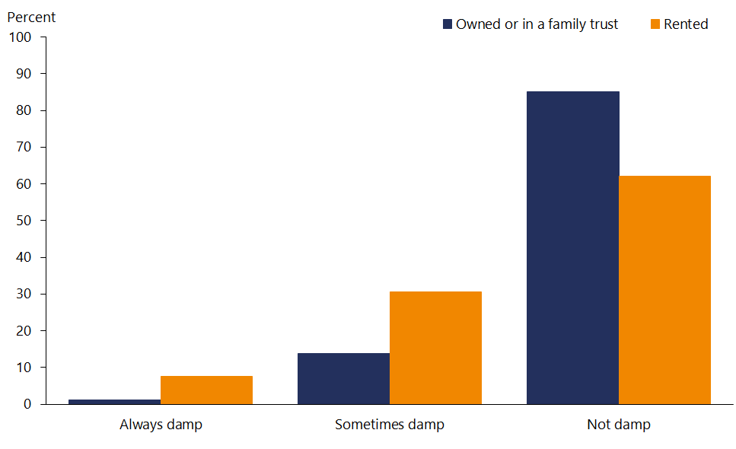

Source: Stats NZ (2019)

Visible mould larger than an A4 sheet of paper was always present in 4.3 percent of homes and sometimes present in 12.6 percent of homes. As with dampness, mould was more common in rented houses.

As Table 10 shows, Māori and Pacific peoples were more likely than other ethnic groups to live in damp homes and mouldy homes (Stats NZ 2020j).

Table : Proportion of people living in homes with damp and mould, by ethnic group, 2018

|  |  |  |
| --- | --- | --- |
| **Ethnic group** | **Always/sometimes damp** | **Always/sometimes mould** |
| Māori | 40.3 | 33.0 |
| Pacific | 45.9 | 41.8 |
| Asian | 22.5 | 19.9 |
| MELAA | 29.2 | 23.9 |
| European | 21.3 | 16.7 |
| Other | 24.4 | 19.4 |

Note: MELAA = Middle Eastern, Latin American and African.

Source: Stats NZ (2020j)

Housing quality indicators are worse for disabled people. In the 2018 Census, 24.0 percent of disabled people lived in a house with mould compared with 18.5 percent of non-disabled people (Stats NZ 2020g). Disabled people were also more likely to be living in a house that was sometimes or always damp (29.0 percent) than non-disabled people (22.8 percent).

The 2018 Census also asked people about the availability of seven basic amenities in their home: cooking facilities, tap water that was safe to drink, a kitchen sink, a refrigerator, a toilet, a bath or shower, and electricity. While most private households (93 percent) had access to all these basic amenities, nearly 6,000 homes had none of the basic amenities. Disabled people were more likely to live in a home with fewer than six of the seven basic amenities (2.9 percent), compared with 1.5 percent of non‑disabled people (Stats NZ 2020g).

|  |
| --- |
| Just over one in ten New Zealanders lives in a crowded house, and Pacific peoples are four times more likely to live in a crowded house |

The term ‘household crowding’ generally means that a household has fewer bedrooms, or less space, than will adequately or appropriately house the number of people living there. Measures of household crowding are important in the health context because crowding increases health risks, particularly risks of infectious diseases such as respiratory infections, gastroenteritis, meningococcal disease and acute rheumatic fever. Perceptions and measures of crowding can be cultural or subjective, but the health effects of crowding are not. Living in crowded conditions can make life difficult for families regardless of ethnicity or culture. Household crowding occurs because of housing availability and affordability pressures as well as cultural expectations.

The 2018 Census results showed that 10.8 percent of people lived in a crowded house (Stats NZ 2020k). Pacific peoples had the highest rate of crowding, with almost four in ten (38.5 percent) living in a crowded house. Among Pacific peoples, crowding was most common in those aged 15–24 years (46 percent). Over a quarter (27 percent) of Pacific adults aged 70 years or older lived in a crowded house, compared with 2.7 percent of people aged 70 years or older in the total population.

|  |
| --- |
| The vast majority of New Zealanders have good access to safe drinking‑water |

In New Zealand, all suppliers providing drinking-water to over 100 people must be registered. They must meet appropriate requirements to ensure the water is safe to consume and provided reliably.

In 2018/19 New Zealand had 490 registered networked drinking-water suppliers that serviced populations of more than 100 people, which represents 4,077,000 people. During this period, 97.1 percent of these people received drinking water that met all the legislative requirements (Ministry of Health 2020h).

## Health behaviours and risk factors

|  |
| --- |
| Potentially modifiable risk factors account for more than one-third of all health loss |

The Global Burden of Disease Study estimates that 39 percent of New Zealanders’ health loss is due to risk factors that can be modified (Global Burden of Disease Collaborative Network 2020). Leading behavioural risk factors include smoking, unhealthy diet, high body mass index and alcohol consumption. Although these risk factors are defined as behavioural, individuals vary in their level of control over some of them. For example, the food available to us and our level of income and education influence our food choices.

The amount that some leading risk factors contribute to health loss has declined over time (eg, smoking, high systolic blood pressure, dietary risks), but these improvements have slowed over the last decade. Also, some risk factors (eg, high body mass index, high fasting plasma glucose, low physical activity) are making an increasingly larger contribution to health loss (Table 11).

Table : Percentage of health loss (DALYs) due to leading risk factors, 1990 to 2019

|  |  |  |  |  |
| --- | --- | --- | --- | --- |
| **Risk factor** | **1990** | **2000** | **2010** | **2019** |
| Smoking | 14.9 | 12.3 | 10.4 | 9.6 |
| High body mass index | 6.9 | 7.3 | 7.3 | 8.2 |
| High systolic blood pressure | 12.3 | 9.9 | 7.9 | 7.8 |
| Dietary risks | 10.2 | 8.9 | 7.4 | 7.4 |
| High fasting plasma glucose | 3.9 | 4.6 | 4.6 | 5.9 |
| Alcohol use | 5.1 | 4.5 | 4.6 | 4.9 |
| High (LDL) cholesterol | 7.4 | 5.9 | 4.4 | 4.2 |
| Illicit drug use | 1.1 | 1.4 | 1.5 | 1.5 |
| Low physical activity | 1.0 | 0.9 | 0.9 | 1.2 |

Source: Global Burden of Disease Collaborative Network (2020)

|  |
| --- |
| Smoking rates continue to decline, but the rate of decline is slower for Māori and Pacific adults |

Smoking is a major risk factor for potentially avoidable health loss in New Zealand. It accounted for 9.6 percent of all illness and premature mortality in 2019 (Global Burden of Disease Collaborative Network 2020).

In 2018/19, 14.2 percent of adults were current smokers, down from 18.2 percent in 2011/12 (Ministry of Health 2019a). While smoking rates have declined in most population subgroups, the level of decline varies by age and ethnic group. The most marked reduction in smoking since 2011/12 was for young people, with smaller decreases in older age groups (Figure 15).

Figure : Prevalence of current smoking, by age group, 2011/12 and 2018/19

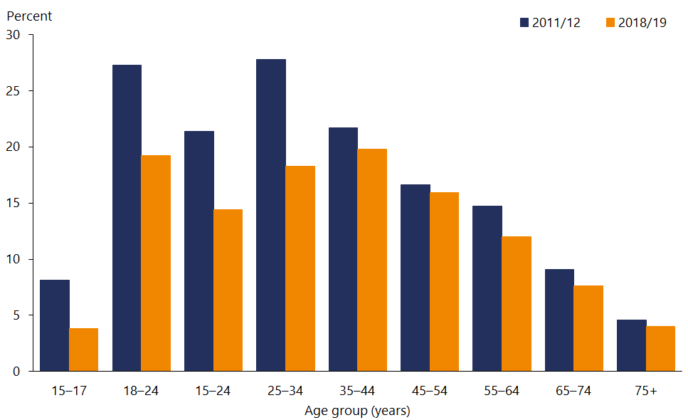

Source: Ministry of Health (2019a)

Among Māori adults, 34.0 percent were current smokers in 2018/19, down from 40.2 percent in 2011/12 (Table 12). Although Māori had the largest absolute decline in smoking (by 6.2 percentage points), the largest relative decline was for European/Other (by 25 percent). From 2011/12 to 2018/19 there was a small decrease in current smoking rates for Pacific and Asian adults, but these changes were not statistically significant.

Table : Prevalence of current smoking, by ethnic group, 2011/12 and 2018/19

|  |  |  |  |  |
| --- | --- | --- | --- | --- |
| **Ethnic group** | **2011/12** | **2018/19** | **Absolute change** | **Relative change** |
| Māori | 40.2 | 34.0 | –6.2 | –15% |
| Pacific | 25.9 | 24.4 | –1.5 | –6% |
| Asian | 9.4 | 8.4 | –1.0 | –11% |
| European/Other | 16.5 | 12.4 | –4.1 | –25% |
| Total population | 18.2 | 14.2 | –4.0 | –22% |

Source: Ministry of Health (2019a)

Although men are generally more likely to smoke than women, Māori women have higher smoking rates (36.3 percent) than Māori men (31.5 percent).

|  |
| --- |
| The most marked inequities in smoking are by socioeconomic status |

As shown in Figure 16, adults living in the most socioeconomically deprived areas are 3.6 times as likely to smoke as adults living in the least deprived areas, after adjusting for age, gender and ethnic differences.

Figure : Prevalence of current smoking, by neighbourhood deprivation and gender, 2018/19

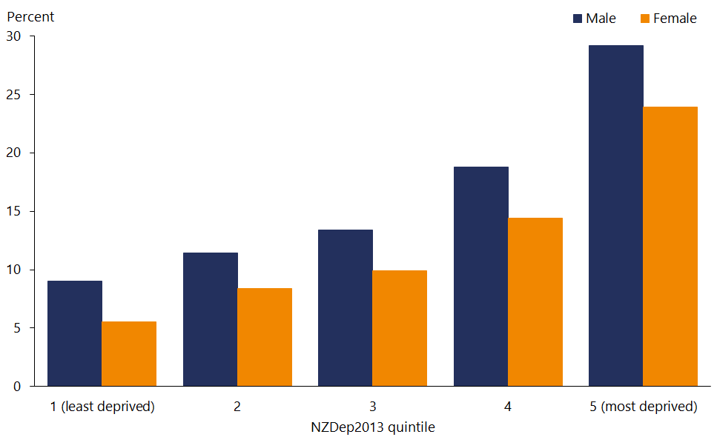

Source: Ministry of Health (2019a)

|  |
| --- |
| One in five adults drinks alcohol in a way that could be harmful to themselves or others |

Alcohol consumption accounted for 4.9 percent of all health loss in 2019 (Global Burden of Disease Collaborative Network 2020).

In this report, ‘hazardous drinking’ means an established pattern of drinking (measured according to internationally agreed methods) that indicates a higher risk to the person drinking or to others. However, this indicator does not take account of all harmful negative effects of alcohol and no level of intake is considered safe.

In 2018/19, four in five adults (80.3 percent) had consumed alcohol in the previous year and one in five (20.0 percent) drank alcohol in a way that could be hazardous to themselves or others (Ministry of Health 2019a).

Hazardous drinking rates differ by gender and age (Figure 17). Hazardous drinking rates are much higher in men (27.5 percent) than women (12.8 percent). Young adults aged 18–24 years had the highest hazardous drinking rate (35.4 percent).

Figure : Prevalence of hazardous drinking, by age group and gender, 2018/19

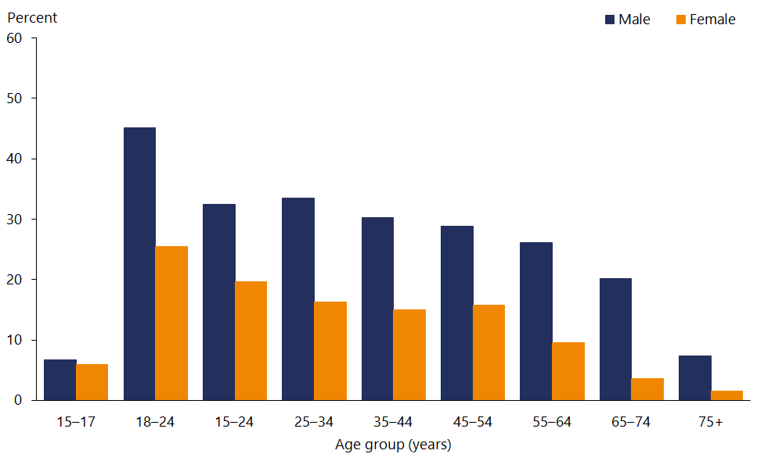

Source: Ministry of Health (2019a)

Hazardous drinking rates vary by ethnicity, with the highest rates in Māori adults (33.2 percent) and lowest rates in Asian adults (6.2 percent). After adjusting for age and gender differences, Māori adults were 1.6 times as likely as non-Māori adults to be hazardous drinkers.

In the 2016/17 New Zealand Health Survey, 15.2 percent of adults had a moderate or high risk of problematic alcohol use based on a score of eleven or more on the ASSIST tool[5] (Ministry of Health 2020e). Problematic use of alcohol was more common in men (18.7 percent) than in women (12.0 percent). After adjusting for age and gender, Māori were 1.4 times as likely as non-Māori to have a moderate or high risk of problematic alcohol use.

|  |
| --- |
| Problematic cannabinoid use is more common in Māori adults |

Drug use accounted for 1.5 percent of all health loss in 2019 (Global Burden of Disease Collaborative Network 2020).

In the 2016/17 New Zealand Health Survey, 7.3 percent of adults had a moderate or high risk of problematic cannabinoid use based on a score of four or more on the ASSIST tool (Ministry of Health 2020e). Problematic cannabinoid use was more common in men (9.6 percent) than in women (5.1 percent). After adjusting for age and gender, Māori adults were 2.9 times as likely as non-Māori adults to have a moderate or high risk of problematic cannabinoid use.

|  |
| --- |
| Collectively, dietary risks account for about 7 percent of all health loss |

The foods and drinks we consume play a major role in our health and wellbeing. A healthy diet throughout life can help prevent nutritional deficiencies, protect against infection and help maintain a healthy body weight. It also reduces the risk of cardiovascular diseases, type 2 diabetes and some cancers. Collectively, dietary risks accounted for about 7.4 percent of all health loss in New Zealand in 2019 (Global Burden of Disease Collaborative Network 2020).

|  |
| --- |
| Only one-third of adults meet recommendations for vegetable and fruit intake |

The Ministry of Health recommends that adults eat at least three servings of vegetables and at least two servings of fruit each day.

In 2018/19, one-third (32.5 percent) of adults met the guidelines for daily vegetable and fruit intake (Ministry of Health 2019a). Those living in the most deprived communities were less likely to eat the recommended number of servings than those in the least deprived communities.

|  |
| --- |
| Sodium intake continues to be higher than recommended |

Diets high in sodium put strain on the kidneys and raise blood pressure. Most dietary sodium comes from salt (sodium chloride) in manufactured or processed foods.

Based on the most recent data on urinary sodium excretion (Ministry of Health 2020i), adults consume about 3,000 mg of sodium each day. This level of sodium intake is well above the World Health Organization recommendation of less than 2,000 mg per day. It is unlikely that sodium intake has declined in recent years given there was no change in urinary sodium between 2008/09 and 2014/15, even though the sodium content of some foods had fallen over that period. Recent monitoring of the food supply shows that decreases in the sodium content of some foods (eg, bread) were offset by increases in the serving size (and so also in sodium levels) in other foods (Eyles et al 2018).

|  |
| --- |
| Half of New Zealand adults meet physical activity guidelines |

Physical activity helps protect against heart disease, stroke, type 2 diabetes, certain cancers, osteoarthritis and depression. It is also important for maintaining a healthy weight and preventing and reducing obesity. Low levels of physical activity accounted for 1.2 percent of health loss in 2019 (Global Burden of Disease Collaborative Network 2020).

The Ministry of Health recommends that adults (18 years and older) do at least 2½ hours of moderate or 1¼ hours of vigorous physical activity spread throughout the week. Physical activity includes deliberate exercise (such as running and sports), incidental activity (such as housework), work-related activity and active transport.

In 2018/19, 50.8 percent of adults were physically active[6] (Ministry of Health 2019a). This is a decline since 2011/12 when 54.4 percent of adults were physically active.

Men (54.7 percent) were more likely to be physically active than women (47.1 percent). Pacific (44.8 percent) and Asian (42.8 percent) adults were slightly less likely to be physically active. Women in our most deprived areas are the least likely to be physically active (39.0 percent).

In 2018/19, 14.0 percent of adults did little or no physical activity (defined as less than 30 minutes of activity in the last seven days). This is an increase since 2011/12 when 12.5 percent did little or no physical activity.

|  |
| --- |
| Few children meet screen time guidelines |

The health risks of sedentary behaviour, such as screen time, are increasingly recognised. ‘Screen time’ means the time children and young people spend watching television or looking at a computer, phone or tablet screen, excluding time at school or for homework.

Ministry of Health guidelines recommend that children aged 6–23 months should not have any screen time, while daily screen time should be less than one hour for those aged 2–4 years and less than two hours for those aged 5–14 years.

Few children meet these screen time recommendations. In 2018/19 only 8.5 percent of children met the screen time recommendations for their age group (Ministry of Health 2019a). Māori children were less likely to meet screen time recommendations than non-Māori children.

|  |
| --- |
| Obesity is a major risk for potentially avoidable health loss |

Excess weight is a risk factor for a number of health conditions, including type 2 diabetes, cardiovascular diseases, some common types of cancer (eg, colorectal), osteoarthritis, gout, sleep apnoea, reproductive disorders, gallstones, mental health conditions (especially depression) and dementia. A high body mass index accounted for 8.2 percent of all health loss in 2019 (Global Burden of Disease Collaborative Network 2020).

|  |
| --- |
| 1.3 million New Zealand adults and children are classified as obese |

In 2018/19, 30.9 percent of adults (1.2 million) were classified as obese (Ministry of Health 2019a). The proportion of adults with obesity has increased since 2011/12 (when it was 28.6 percent), but it is slightly lower than it was in 2016/17 and 2017/18 (32.2 percent).

Obesity rates are higher in Māori (48.2 percent) and Pacific (66.5 percent) adults, but the majority of adults with obesity are of European/Other ethnicity (an estimated 872,000 people in 2018/19).

In 2018/19, 11.3 percent of children aged 2–14 years (94,000) were classified as obese (Ministry of Health 2019a). The proportion of children with obesity has not changed significantly since 2011/12, when it was 10.7 percent.

Adults aged 45–64 years have high rates of obesity and have had the largest increase since 2011/12 (Figure 18).

Figure : Prevalence of obesity, by age group, 2011/12 and 2018/19

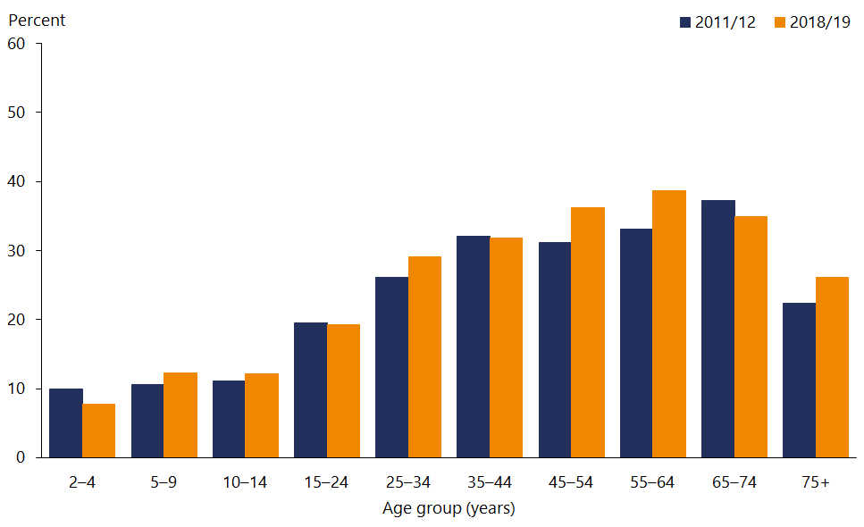

Source: Ministry of Health (2019a)

|  |
| --- |
| There are marked inequities in obesity by socioeconomic status, especially in children |

Socioeconomic deprivation is associated with higher rates of obesity, especially in children. After adjusting for age, gender and ethnic differences, adults living in the most deprived areas were 1.6 times as likely as adults living in the least deprived areas to have obesity. Children living in the most deprived areas are 2.7 times as likely as children living in the least deprived areas to have obesity.

|  |
| --- |
| Around half of older adults have raised blood pressure |

High blood pressure or hypertension is a risk factor for ischaemic heart disease, stroke, hypertensive heart disease, kidney failure and dementia. It accounted for 7.8 percent of all health loss in 2019 (Global Burden of Disease Collaborative Network 2020) and a much higher proportion of ischaemic heart disease (52 percent) and stroke (48 percent).

In 2018/19 just over one in five adults (21.6 percent) had raised blood pressure, defined as a measured systolic blood pressure of 140 mmHg or higher and/or diastolic blood pressure of 90 mmHg or higher (Ministry of Health 2019a). Raised blood pressure is more common in men (24.1 percent) than women (19.2 percent). The prevalence of raised blood pressure increases with age, affecting nearly half of adults aged 75 years and over (Figure 19).

Figure : Prevalence of raised blood pressure, by age group and gender, 2018/19

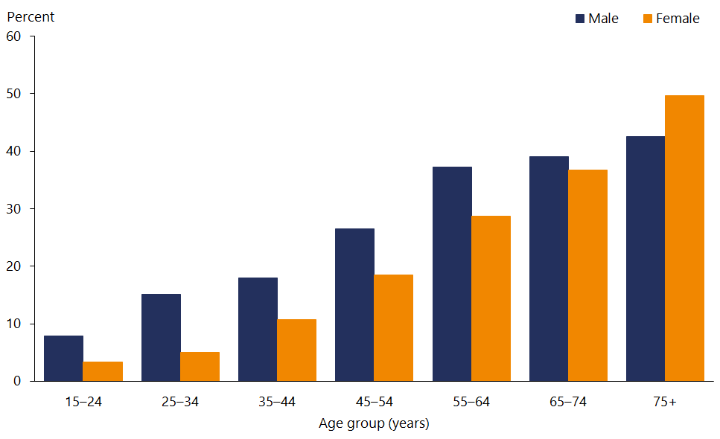

Source: Ministry of Health (2019a)

After adjusting for age, gender and ethnicity, adults living in the most deprived areas were 1.4 times as likely to have raised blood pressure as adults living in the least deprived areas.

## Health care

The health and disability system plays an important role in helping people stay healthy in a range of ways: through providing preventive care, treating acute and serious illness, and helping with managing long-term conditions. Good access to health care includes being able to get affordable and appropriate health care in a timely manner. Health services are generally provided where and when New Zealanders need them, but there are some barriers to accessing primary care and different patterns of use by ethnic group.

|  |
| --- |
| Cost is a barrier to accessing health care, especially for Pacific peoples and Māori |

In 2018/19, about one in five adults and one in six children were unable to get an appointment at their usual medical centre within 24 hours (Table 13). The percentage of adults and children unable to get an appointment within 24 hours has increased over time (Ministry of Health 2019a).

Cost was a barrier to seeing a general practitioner for 13.4 percent of adults and 1.8 percent of children. The proportion of adults citing cost as a barrier to seeing a general practitioner (GP) has not changed since 2011/12, but it has decreased significantly for children (down from 4.7 percent).

In 2018/19, cost was a barrier to collecting a prescription for 5.3 percent of adults and 2.0 percent of children. The proportion of adults and children for whom cost was a barrier to collecting a prescription has declined since 2011/12.

Table : Barriers to accessing health care, 2018/19

|  |  |  |  |  |
| --- | --- | --- | --- | --- |
| **Type of barrier** | **Adults** | **Trend** | **Children** | **Trend** |
| Unable to get appointment with usual medical centre within 24 hours | 20.8% | 🡹 | 16.3% | 🡹 |
| Unmet need for GP due to cost | 13.4% | **=** | 1.8% | 🡻 |
| Unmet need for GP due to lack of transport | 2.8% | 🡻 | 2.3% | **=** |
| Unmet need for GP due to lack of child care | NA | NA | 2.4% | **=** |
| Unmet need for after-hours due to cost | 6.0% | **=** | 2.0% | 🡻 |
| Unmet need for after-hours due to transport | 1.0% | 🡻 | 0.8% | 🡻 |
| Unfilled prescription due to cost | 5.3% | 🡻 | 2.0% | 🡻 |
| Unmet need for dental health care due to cost | 43.7% | **=** | 2.4% | NA |

Note: GP = general practitioner; NA = not applicable. A trend up or down indicates a statistically significant change compared with 2011/12.

Source: Ministry of Health (2019a)

Most barriers to accessing health care were more common in certain population groups. For example, Pacific children were 4.3 times as likely to experience unmet need for a GP due to cost and 5.1 times as likely to have an unfilled prescription due to cost, compared with non-Pacific children. Māori adults were 2.4 times as likely as non-Māori adults, and Pacific adults were 2.7 times as likely as non-Pacific adults, to have an unfilled prescription due to cost. While unmet need for a general practitioner due to a lack of transport or child care was uncommon overall, these barriers to accessing health care disproportionately affected Pacific peoples.

|  |
| --- |
| Childhood immunisation coverage is declining, particularly for Māori |

Immunisation is one of the most effective and most cost-effective interventions to protect people against harmful infections that can cause serious complications or death. It provides protection by reducing the incidence of vaccine-preventable diseases and preventing the spread of those diseases to vulnerable people.

Immunisation coverage is measured at ‘milestone ages’ using data from the National Immunisation Register. The milestone ages are 6 months, 8 months, 12 months, 18 months, 24 months and 5 years. The goal for childhood immunisation in New Zealand is to achieve coverage of 95 percent or higher.

Childhood immunisation coverage in babies aged eight months has declined over the last five years, from 93 percent in 2016 to 90 percent in 2019 (Ministry of Health 2020j). Although the decline has occurred in most ethnic groups, it has been most pronounced for Māori (Figure 20). Over this period the gap between Māori and European children has widened from 3 to 8 percentage points.

Figure : Immunisation rates at eight months of age, by ethnic group, 2016 to 2019

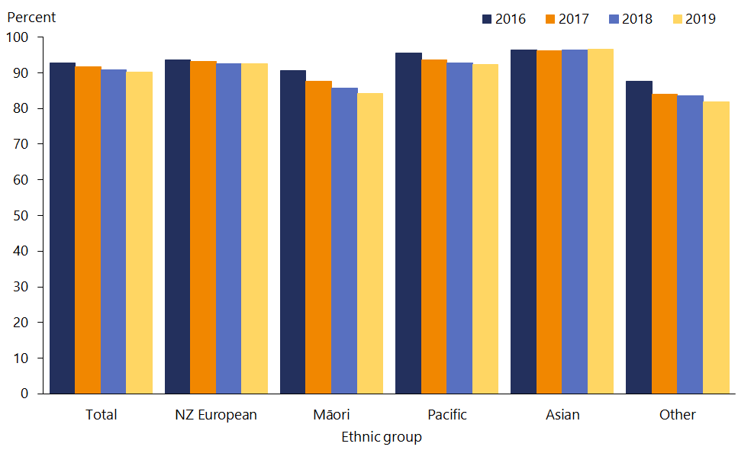

Source: Ministry of Health (2020j)

Trends in immunisation coverage at age five years are better than at eight months, with rates stable over the last four years for all ethnic groups (Figure 21). However, Māori and the ‘Other’ ethnic group continue to have lower immunisation rates than other ethnic groups at age five years.

Figure : Immunisation rates at five years of age, by ethnic group, 2016 to 2019

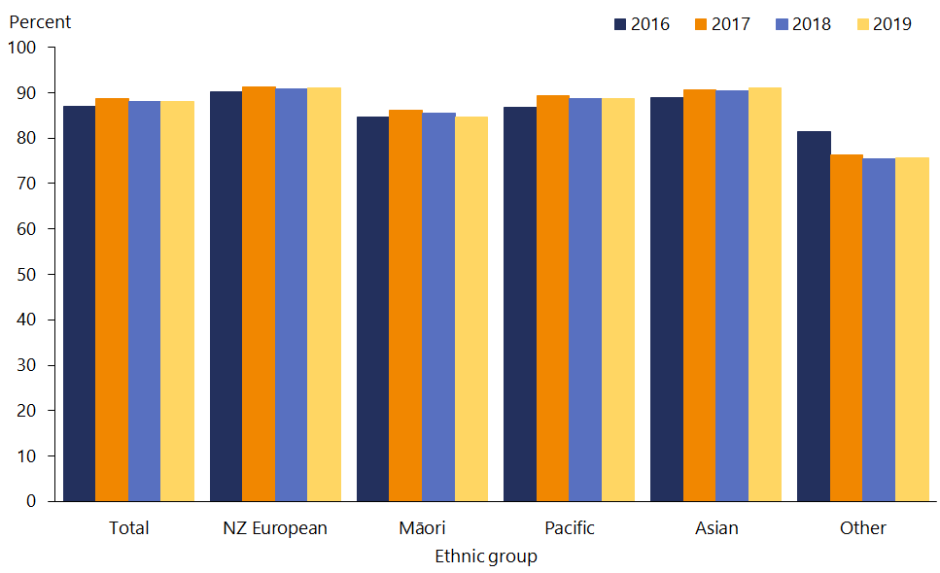

Source: Ministry of Health (2020j)

|  |
| --- |
| Breast screening rates are highest for Pacific women |

In New Zealand, national screening already exists for two cancers (breast and cervical) and screening for bowel cancer is gradually being rolled out across the country. Screening aims to improve health outcomes by either detecting pre-cancerous lesions that can be treated or detecting cancer at an early stage, when it can often be successfully treated. While it may achieve this outcome, screening also has the potential to increase inequities, particularly if screening uptake is low among Māori and other groups.

In 2019, 71.6 percent of eligible women aged 50–69 years had been screened for breast cancer in the past two years, down slightly from 72.2 percent in 2015 (Ministry of Health 2020k). Over this period, breast screening rates improved for Pacific women (from 74.1 to 75.3 percent), to the point that they now have the highest breast screening rate (Figure 22). Māori women have the lowest breast screening rates (63.6 percent in 2019, down from 64.8 percent in 2015).

Figure : Breast cancer screening rates among women aged 50–69 years, by ethnic group, 2015 to 2019

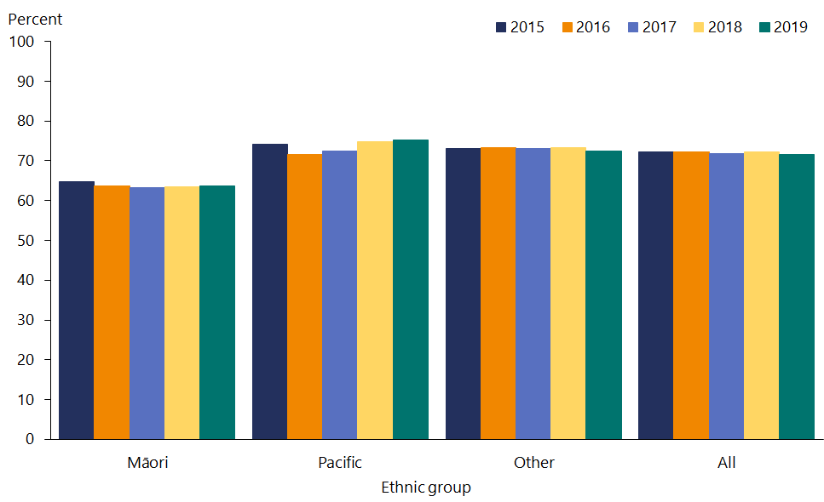

Source: Ministry of Health (2020k)

|  |
| --- |
| Cervical screening rates are lowest for Māori and Asian women |

In 2019, 72.3 percent of women aged 25–69 years had been screened for cervical cancer in the past three years, down from 74.5 percent in 2015 (Figure 23). Cervical screening rates declined most for Pacific women (from 75.5 to 67.6 percent). Māori women (64.1 percent) and Asian women (62.9 percent) continued to have the lowest screening rates in 2019 (Ministry of Health 2020l).

Figure : Cervical cancer screening rates among women aged 25–69 years, by ethnic group, 2015 to 2019

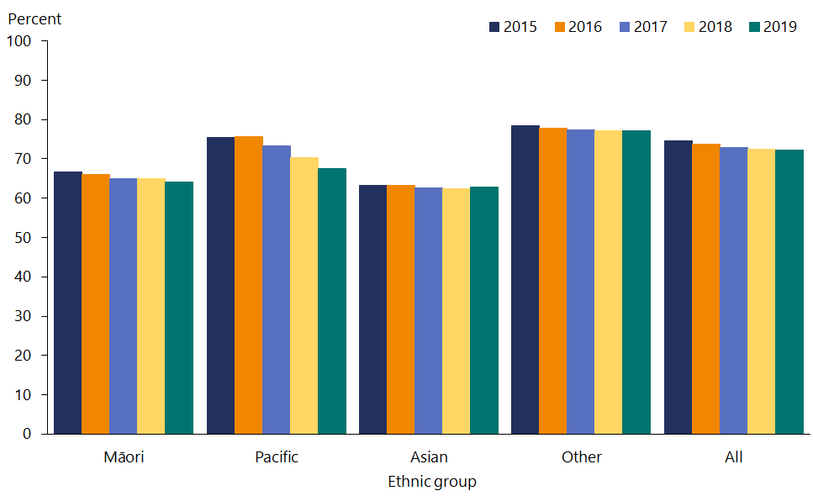

Notes: Coverage includes eligible women screened by the National Cervical Screening Programme in the previous 36 months. Populations are Stats NZ 2013 Census-based population projections and adjusted for hysterectomy prevalence.

Source: Ministry of Health (2020l)

|  |
| --- |
| Pacific peoples and Māori are more likely to be hospitalised for conditions that could have been treated in the community |

Ambulatory sensitive hospitalisation (ASH) rates measure the number of people who appear in hospital with conditions that could have been prevented or treated in out-of-hospital settings such as primary health care.

Overall, ASH rates for children aged 0–4 years and adults aged 45–64 years have been stable from 2016 to 2019 (Figure 24 and Figure 25). The trend differs by ethnic group. ASH rates are slightly lower for the ‘Other’ group, higher for Māori and substantially higher in Pacific peoples aged 0–4 and 45–64 years (Ministry of Health 2020a).

The top five conditions leading to ASH at age 0–4 years are asthma, upper respiratory diseases, dental conditions, gastroenteritis and cellulitis. The top five conditions leading to ASH at age 45–64 years are angina and chest pain, myocardial infarction, cellulitis, pneumonia and COPD (Ministry of Health 2020m).

Figure : ASH rates for children aged 0–4 years, by ethnic group, 2016 to 2019

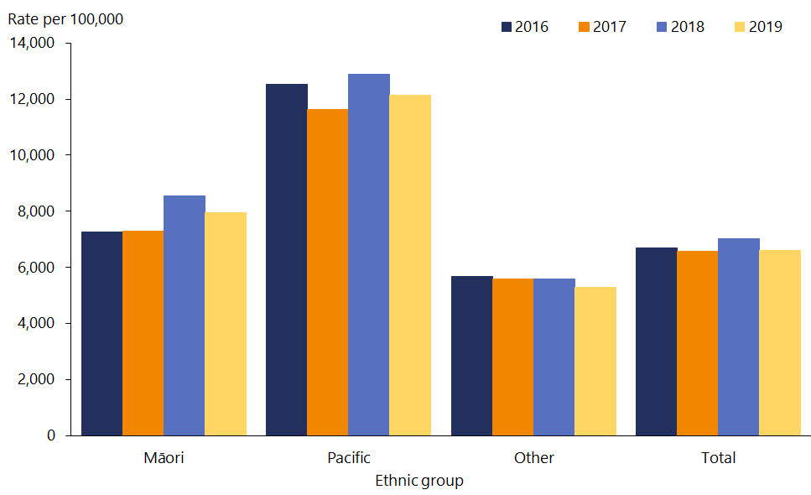

Source: Ministry of Health (2020a)

Figure : ASH rates for adults aged 45–64 years, by ethnic group, 2016 to 2019

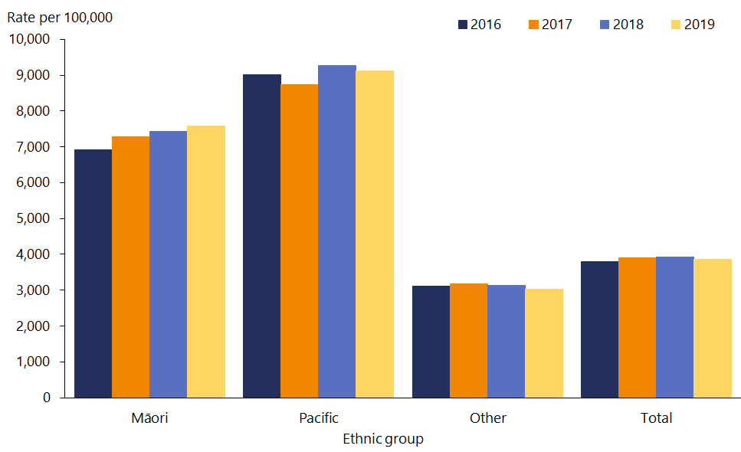

Source: Ministry of Health (2020a)

# Technical notes | Ngā tuhipoka hangarau

This report includes data from a wide range of sources, some of which are produced outside the Ministry of Health. We have aimed to report data only when the data collection and analytical processes are robust. Notes are included if methodological information affects the interpretation of the data. We encourage you to refer to the original data source for further details.

All data reported is the latest available, although the time lag between the most recent data and the present can be substantial. Some data is provisional (such as the 2017 mortality data) and may change.

When possible, we have reported on statistically significant differences between population groups and, when relevant, trends over time. In many comparisons, the results are adjusted or standardised for factors that may influence (confound) the comparison, such as age and gender. Age-standardisation is often used in this report to account for differences in age structure between population groups and over time.

Where age-standardised rates have been presented, Global Burden of Disease data has been age-standardised using a study-specific set of population weights that were originally derived from the World Health Organization world standard population and then refined over time, creating the GBD population. These rates will differ from other figures that have been calculated using different standard populations.

Ethnic comparisons were based on either prioritised ethnicity or total response ethnicity. With prioritised ethnicity, ethnic groups are mutually exclusive. That is, a person can appear in only one ethnic group. With total response ethnicity, a person is classified in all ethnic groups they identify with. This means that a person can appear in more than one ethnic group. For example, prioritised ethnicity is used for analysis based on administrative data (such as mortality data), while total response ethnicity is shown for New Zealand Health Survey data.

Selected results are presented by neighbourhood deprivation, as measured by the New Zealand Index of Deprivation 2013. This is an area-based measure of socioeconomic deprivation according to a combination of the following 2013 Census variables: income, benefit receipt, transport (access to car), household crowding, home ownership, employment status, qualifications, support (sole-parent families) and access to a telephone. In this report, ‘most deprived areas’ refers to quintile 5 – the people living in the most socioeconomically deprived 20 percent of small areas in New Zealand. Conversely, ‘least deprived areas’ refers to quintile 1, the people living in the least deprived 20 percent of small areas in New Zealand.

This report includes a range of population statistics from Stats NZ, as well as data from some of its household surveys.

# References | Ngā tohutoro

ESR. 2020a. *Measles and Meningococcal Disease, Customised Dataset*. Wellington.

ESR. 2020b. *Measles Weekly Report Week 51: 14–20 December 2019*. URL: <https://surv.esr.cri.nz/PDF_surveillance/MeaslesRpt/2019/WeeklyMeasles23122019.pdf> (accessed 15 October 2020).

Eyles H, Jiang Y, Blakely T, et al. 2018. Five year trends in the serve size, energy, and sodium contents of New Zealand fast foods: 2012 to 2016. *Nutrition Journal* 17(1): 65.

Global Burden of Disease Collaborative Network. 2020. *Global Burden of Disease Study 2019 (GBD 2019) Results*. Seattle, WA: Institute for Health Metrics and Evaluation. URL: <https://vizhub.healthdata.org/gbd-compare/> (accessed 23 November 2020).

Grey C, Jackson R, Wells S, et al. 2018. Trends in ischaemic heart disease: patterns of hospitalisation and mortality rates differ by ethnicity (ANZACS-QI 21). *New Zealand Medical Journal* 131(1478): 21–31.

Institute for Clinical Systems Improvement. 2014. Going beyond clinical walls: solving complex problems. URL: <http://www.nrhi.org/uploads/going-beyond-clinical-walls-solving-complex-problems.pdf> (accessed 15 November 2019).

Kessler RC, Barker PR, Colpe LJ, et al. 2003. Screening for serious mental illness in the general population. *Archives of General Psychiatry* 60(2): 184–9.

Ministry of Health. 2019a. *Annual Update of Key Results 2018/19: New Zealand Health Survey*. URL: <https://www.health.govt.nz/publication/annual-update-key-results-2018-19-new-zealand-health-survey> (accessed 23 November 2020).

Ministry of Health. 2019b. *Mortality 2017 data tables*. URL: <https://www.health.govt.nz/publication/mortality-2017-data-tables> (accessed 30 November 2020).

Ministry of Health. 2019c. *Fetal and Infant Deaths 2016*. URL: <https://www.health.govt.nz/publication/fetal-and-infant-deaths-2016>(accessed 23 November 2020).

Ministry of Health. 2019d. *Wai 2575 Māori Health Trends Report*. Wellington: Ministry of Health. URL: <https://www.health.govt.nz/publication/wai-2575-Māori-health-trends-report> (accessed 23 November 2020).

Ministry of Health. 2020a. *Annual Report for the year ended 30 June 2020*. Wellington: Ministry of Health.

Ministry of Health. 2020b. *Historical Mortality*. URL: <https://www.health.govt.nz/publication/historical-mortality> (accessed 21 October 2020).

Ministry of Health. 2020c. *Cancer: Historical summary 1948–2017*. URL: <https://www.health.govt.nz/publication/cancer-historical-summary-1948-2017> (accessed 16 October 2020).

Ministry of Health. 2020d. *Virtual Diabetes Register (VDR)*. URL: <https://www.health.govt.nz/our-work/diseases-and-conditions/diabetes/about-diabetes/virtual-diabetes-register-vdr> (accessed 21 October 2020).

Ministry of Health. 2020e. *Mental Health 2016/17: New Zealand Health Survey*. URL: <https://www.health.govt.nz/publication/mental-health-2016-17-new-zealand-health-survey> (accessed 4 November 2020).

Ministry of Health. 2020f. *Immunisation Handbook 2020.* Wellington: Ministry of Health. URL: <https://www.health.govt.nz/our-work/immunisation-handbook-2020>/12-meningococcal-disease (accessed 15 October 2020).

Ministry of Health. 2020g. *Reducing Rheumatic Fever.* URL: <https://www.health.govt.nz/our-work/diseases-and-conditions/rheumatic-fever/reducing-rheumatic-fever> (accessed 13 October 2020).

Ministry of Health. 2020h. *Annual Report on Drinking-water Quality*. Wellington: Ministry of Health.

Ministry of Health. 2020i. *Biomedical Results 2014/15: New Zealand Health Survey*. URL: <https://www.health.govt.nz/publication/biomedical-results-2014-15-new-zealand-health-survey> (accessed 16 October 2020).

Ministry of Health. 2020j. *National and DHB Immunisation Data*. URL: <https://www.health.govt.nz/our-work/preventative-health-wellness/immunisation/immunisation-coverage/national-and-dhb-immunisation-data> (accessed 21 October 2020).

Ministry of Health. 2020k. *National Screening Unit, Customised Dataset*. Wellington.

Ministry of Health. 2020l. *National Cervical Screening Programme Coverage Report.* URL: <https://minhealthnz.shinyapps.io/nsu-ncsp-coverage/> (accessed 21 October 2020).

Ministry of Health. 2020m. *Ambulatory sensitive (avoidable) hospital admissions.* URL: <https://nsfl.health.govt.nz/accountability/performance-and-monitoring/data-quarterly-reports-and-reporting/ambulatory-sensitive> (accessed 18 November 2020).

Stats NZ. 2014. *Disability Survey: 2013*. URL: [stats.govt.nz/information-releases/disability-survey-2013](http://www.stats.govt.nz/information-releases/disability-survey-2013) (accessed 17 November 2019).

Stats NZ. 2019. *One in Five Homes Damp.* URL: <https://www.stats.govt.nz/news/one-in-five-homes-damp> (accessed 16 October 2020).

Stats NZ. 2020a. *National Population Estimates: At 31 December 2019 – Infoshare tables.* URL: <https://www.stats.govt.nz/information-releases/national-population-estimates-at-31-december-2019-infoshare-tables> (accessed 23 October 2020).

Stats NZ. 2020b. *Subnational Population Estimates (DHB, DHB constituency), by Age and Sex, at 30 June 1996–2019 (2020 boundaries)*. URL: <http://nzdotstat.stats.govt.nz/wbos/Index.aspx?DataSetCode=TABLECODE7509> (accessed 3 November 2020).

Stats NZ. 2020c. *Estimated Resident Population (2018-base): At 30 June 2018.* URL: <https://www.stats.govt.nz/information-releases/estimated-resident-population-2018-base-at-30-june-2018> (accessed 17 November 2020).

Stats NZ. 2020d. *Subnational Population Estimates (Urban Rural), by Age and Sex, at 30 June 1996–2020 (2020 boundaries)*. URL: <http://nzdotstat.stats.govt.nz/wbos/Index.aspx?DataSetCode=TABLECODE7981> (accessed 3 November 2020).

Stats NZ. 2020e. *Wellbeing Data for New Zealand*. URL: <https://wellbeingindicators.stats.govt.nz/en/life-satisfaction/> (accessed 17 November 2020).

Stats NZ. 2020f. *Wellbeing Data for New Zealand*. URL: <https://wellbeingindicators.stats.govt.nz/en/whanau-wellbeing/> (accessed 17 November 2020).

Stats NZ. 2020g. *Measuring Inequality for Disabled New Zealanders: 2018.* URL: <https://www.stats.govt.nz/reports/measuring-inequality-for-disabled-new-zealanders-2018> (accessed 5 November 2020).

Stats NZ. 2020h. *Wellbeing Data for New Zealand*. URL: <https://wellbeingindicators.stats.govt.nz/en/sense-of-belonging/> (accessed 17 November 2020).

Stats NZ. 2020i. *Child Poverty Statistics: Year ended June 2019*. URL: <https://www.stats.govt.nz/information-releases/child-poverty-statistics-year-ended-june-2019> (accessed 22 October 2020).

Stats NZ. 2020j. *More than 2 in 5 Māori and Pacific People Live in a Damp House – corrected.* URL: <https://www.stats.govt.nz/news/more-than-2-in-5-Māori-and-pacific-people-live-in-a-damp-house-corrected> (accessed 16 October 2020).

Stats NZ. 2020k. *Almost 1 in 9 people Live in a Crowded House.* URL: <https://www.stats.govt.nz/news/almost-1-in-9-people-live-in-a-crowded-house> (accessed 16 October 2020).

Teng A, Atkinson J, Disney G, et al. 2016. Ethnic inequalities in cancer incidence and mortality: census-linked cohort studies with 87 million years of person-time follow-up. *BMC Cancer* 16(1): 755.

Walsh M, Grey C. 2019. The contribution of avoidable mortality to the life expectancy gap in Māori and Pacific populations in New Zealand – a decomposition analysis. *New Zealand Medical Journal* 132(1492): 46–60.

Walsh M, Wright K. 2020. Ethnic inequities in life expectancy attributable to smoking. *New Zealand Medical Journal* 133(1509): 28–38.

1. In relation to burden of disease, the term ‘disability’ refers to any short-term or long-term health loss other than death.
2. This estimate comes from the Virtual Diabetes Register, which is based on administrative data on the use of diabetes health services and does not identify type of diabetes.
3. A person is defined as having asthma if they have ever been told by a doctor they have asthma and are currently taking treatments for asthma (inhalers, medicine, tablets or pills, or any other treatments).
4. The two measures used in this paragraph are selected from the 10 measures of child poverty specified in the Child Poverty Reduction Act, and reported on annually by Stats NZ.
5. The ASSIST is the **A**lcohol, **S**moking and **S**ubstance **I**nvolvement **S**creening **T**est. It is a simple method of screening for hazardous, harmful and dependent use of alcohol, tobacco and other psychoactive substances.
6. ‘Physically active’ is defined as doing at least 30 minutes of moderate-intensity activity (or equivalent vigorous activity), for at least 10 minutes at a time, on five or more days of the week.