Haematopoietic Stem Cell Transplant (Bone Marrow Transplant) Services in New Zealand

Update document 2018

Citation: Ministry of Health. 2018. *Haematopoietic Stem Cell Transplant (Bone Marrow Transplant) Services in New Zealand: Update document 2018*. Wellington: Ministry of Health.

Published in August 2018  
by the Ministry of Health  
PO Box 5013, Wellington 6140, New Zealand

ISBN 978-1-98-853980-5 (online)  
HP 6909

This document is available at www.health.govt.nz



 This work is licensed under the Creative Commons Attribution 4.0 International licence. In essence, you are free to: share ie, copy and redistribute the material in any medium or format; adapt ie, remix, transform and build upon the material. You must give appropriate credit, provide a link to the licence and indicate if changes were made.

Contents

Executive summary iv

Introduction 1

Purpose 1

Authors 1

Audience 1

Scope 1

Overview of bone marrow transplant advances 2

Changes 2

Future developments in BMT therapies 2

Actuals vs forecast to 2016 3

Growth in demand 4

Projected treatment rates for New Zealand 4

List of figures

Figure 1: Total forecasted New Zealand BMT transplant activity 2000–2010 3

Figure 2: Total actual New Zealand BMT transplant activity 2002–2016 3

Figure 3: Projected rates of allogeneic BMT to 2025 5

Figure 4: Projected rates of autologous BMT to 2025 5

# Executive summary

Haematopoietic stem cell transplants (historically referred to as bone marrow transplants, BMTs) in New Zealand are provided by five district health boards (DHBs): Auckland, Waikato, MidCentral, Capital & Coast and Canterbury.

There has been significant growth in demand for BMT services in New Zealand, which is in keeping with the increased demand seen internationally. This was previously most evident at Auckland DHB but is now evident at the other New Zealand BMT centres.

This companion document (the BMT Update Document 2018) updates *The Bone Marrow Transplant Services in New Zealand for Adults – Service Improvement Plan 2011*. The BMT Update Document updates the projected demand forecasts in the 2011 document and has been developed to assist DHBs to develop the capacity for BMT services to 2025.

The plan recommends that the current configuration of adult BMT services be continued in New Zealand; that is, that autologous BMT services continue to be provided at Auckland, Waikato, MidCentral, Capital & Coast and Canterbury DHBs and allogeneic BMT services at Auckland, Capital & Coast and Canterbury DHBs.

Paediatric BMT services are predominantly provided at Starship Children’s Hospital, with occasional autologous BMT procedures done in Canterbury as deemed clinically appropriate.

The update document to the *Bone Marrow Transplant Services in New Zealand for Adults – Service Improvement Plan 2018* has been developed by the Ministry of Health and the National Haematology Work Group (NHWG).

The 2011 plan was endorsed with the proviso that if clinical indications or eligibility are reviewed and amended, then the plan will need to be updated accordingly. This update document provides an update on projected demand for BMT services in New Zealand.

The NHWG recommends that DHBs discuss the implications of these projected demands with their local and regional haematology teams to plan for current and future BMT service delivery.

# Introduction

## Purpose

This document provides an overview of current BMT services in New Zealand, focusing on projected growth and demand.

## Authors

This document has been developed by the Ministry of Health and the NHWG, an advisory group to the National Cancer Programme.

## Audience

This document has been updated for DHBs, to guide service planning. It is relevant to:

* DHB chief executive officers
* DHB clinicians
* DHB planners and funders
* regional cancer networks
* Ministry of Health.

## Scope

This document projects demand up to 2025 for all BMT services in New Zealand, including both adult and paediatric populations (at Starship Children’s Hospital). The 2011 document did not include paediatrics.

# Overview of bone marrow transplant advances

## Changes

Since the BMT plan was first published in 2011, there have been significant advances in the BMT field that have increased the number of patients eligible for BMT. This is primarily on the basis of being able to deliver BMT more safely to an older population by reducing the toxicity of the procedure and an increase in donor availability with the use of haploidentical (half match) family members.

International BMT practice recognises that the upper age limit for BMT should not be based on chronological age but focus on biological age and comorbidities as the basis for eligibility for a BMT. This is reflected in the increasing number of patients over 65 years of age being transplanted both in New Zealand and overseas.

Disease indications for BMT remain largely unchanged from 2011, with recent international publications referring to both disease and patient selection criteria in this area referenced as follows:

* 1. N Majhail, et al. 2015. Indications for autologous and allogeneic hematopoietic cell transplantation: guidelines from the American Society for Blood and Marrow Transplantation. *Biology of Blood and Marrow Transplantation* 21(11): 1863–9.
  2. A Sureda, et al. 2015. Indications for allo and auto SCT for haematological diseases, solid tumours and immune disorders: current practice in Europe, 2015. *Bone Marrow Transplantation* 50: 1037–56.
  3. S Okamato. 2017. Current indication for hematopoietic cell transplantation in adults. [*Hematology/Oncology and Stem Cell Therapy*](https://www.sciencedirect.com/science/journal/16583876) 10(4): 178–83.

These advances have resulted in significant growth and demand for BMT services internationally. This has been replicated in New Zealand, where transplant numbers have increased from 118 to 305 per annum between 2002 and 2016.

## Future developments in BMT therapies

Cellular therapies including Chimeric Antigen Receptor T cells (CAR-T cells) are an exciting novel therapy for the treatment of haematological malignancies. These have potential significant resource and cost implications. The NHWG view further developments in this field as being under the guidance of the national BMT plan with reference to clinical indication recommendations and service delivery specifications.

It is recognised that autologous BMT procedures for the treatment of autoimmune disease, such as multiple sclerosis and scleroderma, are becoming more validated and internationally accepted. The NHWG intends to liaise with neurology and rheumatology services to review the evidence around these indications and the resourcing impact of any increase in autologous BMT numbers and to develop service delivery specifications.

**Survivorship / late effects**: BMT survivors are at risk of developing treatment-related complications that may continue to present year after treatment (eg, graft versus host disease (GHVD), second malignancies, cardiac disease, radiation-induced hypothyroidism). These complications have surfaced as significant causes of increased morbidity and mortality. Long-term patient follow-up and screening for some of these entities is advised in the hope that early detection may lead to better management. As such, BMT survivorship / late-effect programmes are an essential component to patient care and need to be considered with BMT service planning. Comprehensive joint consensus guidelines from the European Group for Blood and Marrow Transplantation (EBMT), the Center for International Blood and Marrow Transplant Research (CIBMTR), and the American Society of Blood and Marrow Transplantation (ASBMT) were published in 2006 and updated in 2012 and recommend appropriate screening studies to monitor for the long-term complications of BMT.

## Actuals vs forecast to 2016

Figure 1: Total forecasted New Zealand BMT transplant activity 2000–2010

Figure 1: Total forecasted New Zealand BMT transplant activity 2000–2010

Figure 2: Total actual New Zealand BMT transplant activity 2002–2016

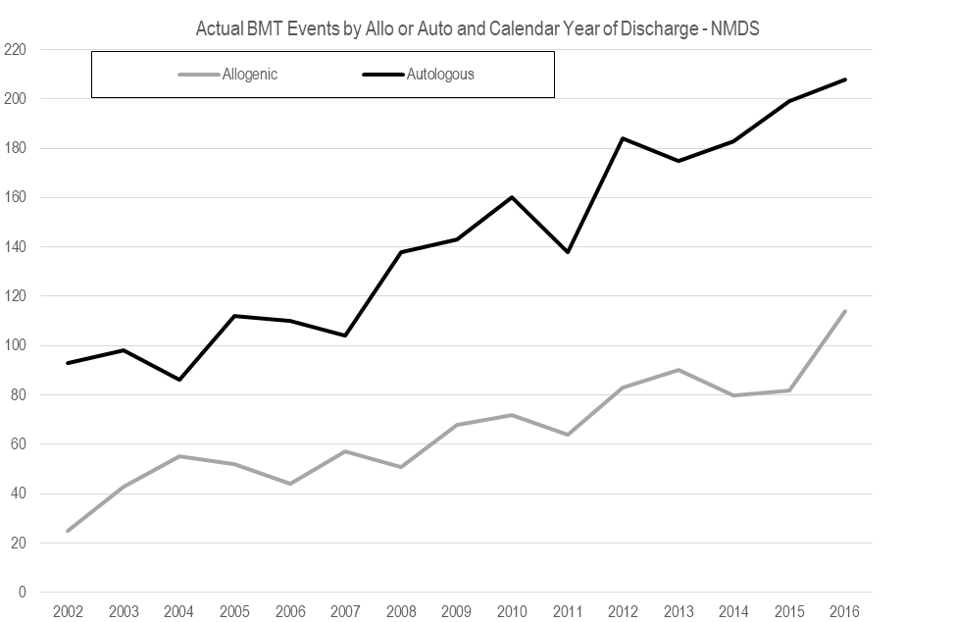

## Growth in demand

Demand for BMT in New Zealand is growing due to a number of factors, including:

* wider application of transplantation for haematological malignancies, including acute leukaemia, myeloproliferative disease, multiple myeloma and lymphoma
* an increase in the population eligible for BMT, due to reduced treatment-related toxicities (allowing older patients or those with more significant co-morbidities to undergo BMT)
* greater use of alternative donor sources, including matched unrelated donors (MUDs), haploidentical donors (half match family members) and cord Blood donors (predominantly in paediatric service).

## Projected treatment rates for New Zealand

The forecasted demand to 2025 assumes:

* clinical indications remain unchanged; the forecast will be updated should there be changes in the existing clinical indications treated
* patient cohort numbers across indications have increased due to treatment advances.

### Projected allogeneic BMT volumes

The forecast ranges of BMT cases for allogenic and autologous transplants in figures 3 and 4 represent an opinion based on the Statistics New Zealand population growth projection, historical cases trends in National Minimum Dataset and related forecasting assumptions and knowledge of status quo that we currently have.

The actual situations of case numbers may be inside or outside the forecast range. Please exercise caution when interpreting the forecast results.

Five scenarios are provided in each range. The ranges are values between low growth and high growth scenarios. The high growth scenarios assume the population grows relatively quickly and the incident rate of BMT procedures grows at a similar rate to 2013–2016 on a straight line basis. The low growth scenario assumes the population grows relatively slowly and the incident rate will gradually drop from the 2016 incident rate level to 2013 incident rate level.

Figure 3: Projected rates of allogeneic BMT to 2025

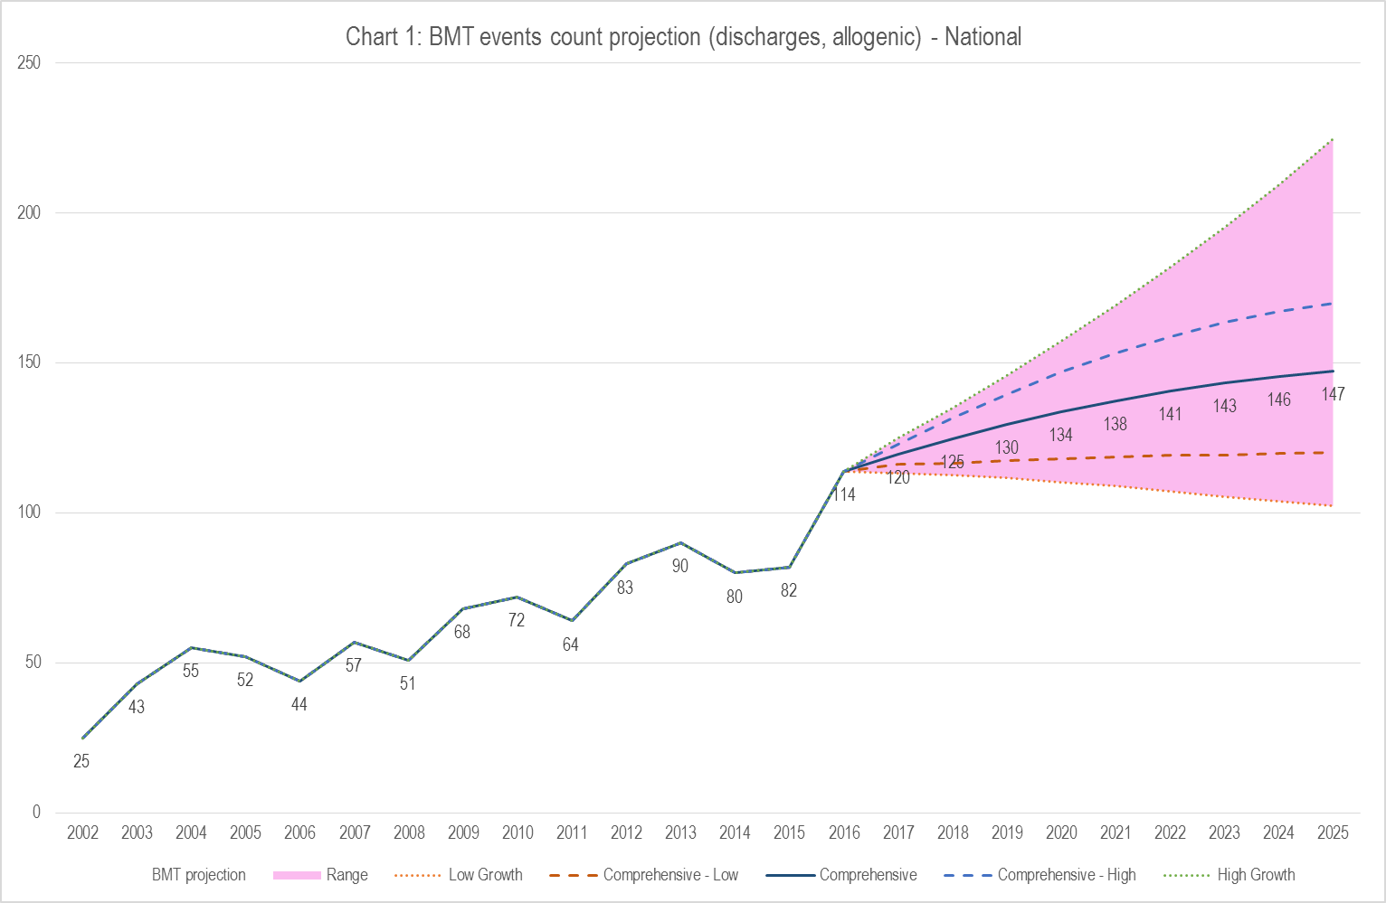

Figure 4: Projected rates of autologous BMT to 2025

