Healthy Eating Guidelines for New Zealand Babies and Toddlers (0–2 years old) | Infosheet

Eating Statements for New Zealand babies and toddlers (0–2 years old)
Aim to exclusively breastfeed your baby until they are around six months of age  Continue to breastfeed for up to two years or longer |  | 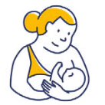 | 1
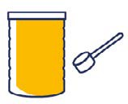 | If your baby is not breastfed, a commercial infant formula is the only suitable alternative to breast milk in the first year of life

Around six months of age, when your baby is showing signs of readiness, introduce complementary foods |  |  | 2
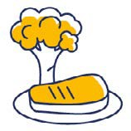 | Offer iron-rich foods, vegetables and fruit as first foods, and continue to offer these foods every day

Once you have started complementary feeding, offer your baby or toddler a variety of nutritious foods every day, including: |  | 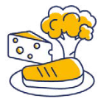 | 3
 | vegetables and fruit
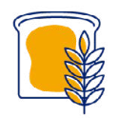 | grain foods (such as iron-fortified infant cereal, oats (porridge), bread, rice, noodles and pasta)
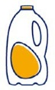 | milk* and milk products (such as yoghurt and cheese)
 | legumes (such as lentils, tofu and beans), nut butters, eggs, fish, seafood and chicken or lean red meat
* Not recommended as a drink for babies under one year of age.
When preparing food for your baby or toddler, do not add salt or sugar. If using commercially prepared foods, choose those that are low in salt (sodium) and with no added sugars |  | 4

Recommended drinks for your baby or toddler are breast milk* and water (once they are eating complementary foods). Cow’s milk can be offered as a drink from 12 months of age |  |  | 5
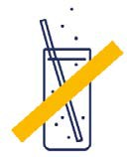 | Do not give your baby or toddler juice, cordial, fruit drink, flavoured milk, soft drinks, tea, coffee or alcohol
* Or, if necessary, a commercial infant formula until 12 months of age.

Let your baby or toddler guide you about how much they eat. Encourage your child to eat, but don’t force them. |  |  | 6
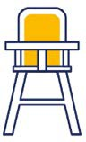 | Sit with your baby or toddler while they eat or drink, and include them in family mealtimes
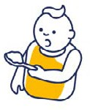 | From a young age, encourage your child to feed themselves

