Guidance on

Using Active
Surveillance
to Manage Men with Low-risk

Prostate Cancer

Citation: Prostate Cancer Working Group and Ministry of Health. 2015.
Guidance on Using Active Surveillance to Manage Men with
Low-risk Prostate Cancer. Wellington: Ministry of Health.
Published in July 2015 by the
Ministry of Health
Po Box 5013, Wellington 6145, New Zealand
ISBN: 978-0-478-44832-0 (online)
HP 6208
This document is available at: health.govt.nz

Introduction

About this guidance
This guidance is for urologists and other health professionals involved in the management of men with localised, low-risk prostate cancer. The guidance clarifies what active surveillance is and the roles and responsibilities of the different health professionals involved.

This guidance should be used to support decision-making between a man and his health professional and will help to standardise the level of care that men receive, no matter where in New Zealand they live.

This guidance has been endorsed by:
- the Urological Society of Australia and New Zealand
- New Zealand’s Genito Urinary Special Interest Group
- the New Zealand Society of Pathologists
- the New Zealand branch of the Royal Australian and New Zealand College of Radiologists.

Need for this guidance
After a man is diagnosed with prostate cancer, he and his family/whānau need to make a decision about treatment. Treatment will differ for each individual and will be influenced by the man’s age and general health, the grade and stage of his cancer, as well as symptoms, lifestyle and personal choice.

Active surveillance is a relatively new management option for men with localised, low-risk prostate cancer. Other management options include curative treatment (such as radical prostatectomy or radiation therapy), androgen deprivation therapy and watchful waiting. Active surveillance was introduced because the disparity between the incidence and death rate for prostate cancer (which is 12 percent and 3 percent, respectively, in New Zealand) suggested that many men were more likely to die with prostate cancer than from it. Men with localised, low-risk prostate cancer, in particular, are less likely to benefit from curative treatment options than men with more advanced disease and can end up being exposed to unnecessary treatment-related harms. Traditionally, older men with limited life expectancy, asymptomatic men with advanced prostate cancer, and some men with localised, low-risk prostate cancer have been offered watchful waiting. However, watchful waiting is not an appropriate management option for men with localised, low-risk prostate cancer because there is no intention to cure the disease (Albertson et al 2005; Johansson et al 2011). Active surveillance presents these men with an alternative treatment option, whereby they can have their disease actively monitored and can still pursue curative treatment if their disease progresses.

Development process for this guidance
This guidance was developed by the Specialist Sub-group of the Prostate Cancer Working Group, with input from other health specialties, including general practice, pathology, radiation oncology, nursing and public health. The Prostate Cancer Working Group is guiding the implemention of the Prostate Cancer Awareness and Quality Improvement Programme (the AQIP), which aims to address current deficiencies in prostate cancer care by:
- ensuring that men have better and more equitable access to information about prostate cancer
- supporting primary care practitioners to manage men presenting with prostate-related concerns
- removing barriers that restrict men’s access to diagnostic and treatment services
- ensuring that men receive consistent care and have equitable outcomes across the entire care pathway.

This guidance is largely based on the recommendations of the Prostate Cancer Taskforce, with additional evidence considered where appropriate.

The Specialist Sub-group acknowledges that the evidence on prostate cancer testing and treatment continues to evolve, which is why this guidance will be revised every two years, with subsequent versions published on the Ministry of Health’s website.

This guidance was sent out to numerous stakeholders for feedback prior to publication, including:
- district health boards (DHBs)
- primary health organisations (PHOs)
- relevant professional colleges
- non-governmental organisations, such as the Prostate Cancer Foundation and the Cancer Society.

The guidance is part of a suite of resources that will be developed under the AQIP. Other resources that will be developed over the next two years include:
- guidance for managing and referring men presenting to primary care with prostate-related concerns
- an electronic decision support tool to aid men’s decision-making on prostate cancer testing and treatment
- guidance on the diagnosis and staging of prostate cancer
- guidance on managing men with advanced or metastatic prostate cancer
- patient information for men and their family/whānau.

Integrating this guidance into routine clinical practice
DHBs and PHOs will be responsible for integrating this guidance into their clinical pathways for prostate cancer.

When integrating the guidance, we encourage each DHB’s urology and radiology departments to discuss how the guidance should be integrated into their clinical pathways and to discuss what resource implications the guidance will have for magnetic resonance imaging (MRI). Nationally, MRI is a constrained resource for both diagnostic and surveillance imaging. Therefore, it is important to ensure that each DHB can meet the diagnostic and active surveillance demands for prostate-related MRIs, within clinically appropriate timeframes, before its pathways are confirmed.

DHBs and PHOs should also be conscious of the disparities in prostate cancer outcomes for different men (such as Māori men and men who live in rural communities) before implementing this guidance. For example, Māori men are less likely to be diagnosed with prostate cancer than non-Māori men, but are 36 percent more likely to die from the disease (Ministry of Health 2014). The reasons behind these disparities are not well understood. However, in part, they appear to be related to differences in men’s access to appropriate information, and to diagnostic and treatment services.

Some men may also experience social and cultural barriers when dealing with the health system. Where possible, health practitioners should try to address these individual or system-level barriers. This could include finding ways to overcome transport issues or difficulties making appointment times outside work hours.

What is active surveillance?
Active surveillance (sometimes referred to as active monitoring) is a management option for men with localised, low-risk prostate cancer. Active surveillance aims to avoid or delay the need for curative treatment, thereby reducing the potential for treatment-related harms (Loeb et al 2014). Active surveillance involves actively monitoring the prostate cancer with regular prostate-specific antigen (PSA) tests, digital rectal examinations (DREs), prostate biopsies and MRIs. This allows the urologist to determine whether the cancer is progressing. If progression is confirmed, the man then has the option to undergo curative treatment (Klotz et al 2010; Dall’Era et al 2012).

Survival rates for men on active surveillance are approximately 80 percent. Contemporary evidence suggests that this rate is similar to the survival rate for men with low-risk prostate cancer who undergo curative treatment (Dall’Era et al 2012). Only 20–30 percent of men with localised, low-risk prostate cancer will choose active surveillance as their preferred treatment option. This is because many men will find the thought of not treating their prostate cancer too stressful and will prefer to undergo curative treatment immediately (Daubenmier et al 2006; Heijnsdijk et al 2012).

What does active surveillance involve?
It is essential that every man on active surveillance has an agreed active surveillance care plan that details how frequently he should receive each test. Figure 1 shows the basic protocol for a man on active surveillance. However, this should be adapted to suit each man’s individual needs/preferences.

Watchful waiting is another management option for men with prostate cancer, where there is no intention to cure the disease. Watchful waiting is different from active surveillance; the key differences are shown in Table 1.

Table 1: Differences between active surveillance and watchful waiting for prostate cancer
 | Active surveillance | Watchful waiting
Treatment intent | Curative | Palliative
Follow-up | Predefined schedule | Patient-specific
Assessment/markers used | PSA, DRE, repeat biopsy and optional MRI | PSA and DRE
Life expectancy | ≥ 10 years | < 10 years
Aim | Minimise treatment-related harms without compromising survival | Minimise treatment-related harms
Comment | Only for men with localised, low-risk prostate cancer | Can apply to men with prostate cancer of any stage
Note: Based on the table from the European Association of Urology’s Guidelines on Prostate Cancer (European Association of Urology 2015)

Figure 1: Basic protocol for a man on active surveillance
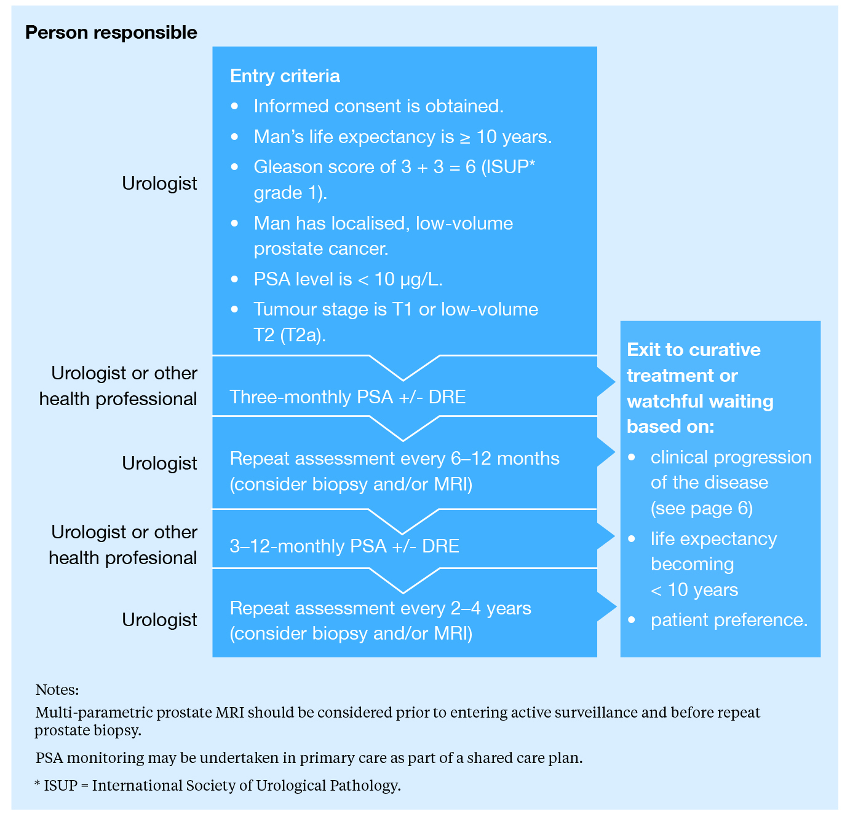

Who is responsible for managing men on active surveillance?
The care of men on active surveillance should be led by a urologist. This is because urologists are responsible for making key decisions about prostate biopsies and the frequency of MRIs.

In certain circumstances it may be appropriate to share aspects of a man’s care with other health professionals. This should be discussed with the man and agreed with the health professional on a case-by-case basis. The responsibilities of the urologist and the other health professional should be clearly documented in the man’s active surveillance care plan.

Where an aspect of care has been devolved to another health professional, regular contact with the lead urologist is required. Urologists are responsible for reviewing men’s active surveillance care plans. This should be done at least every 12 months.

How do you know if a man has low-risk prostate cancer?
Establishing the risk of prostate cancer progression is an essential part of determining which men are suitable for active surveillance. This involves measuring the man’s PSA level and determining the tumour stage and Gleason score. The role of the pathologist in determining Gleason pattern 3 from Gleason pattern 4 tumours is a critical part of this assessment. Consensus has recently been reached on the reporting criteria for prostate biopsy specimens (Amin et al 2014).

The following criteria should be used to identify whether a man’s prostate cancer is at low, intermediate or high risk of progressing.

Prostate cancer has a low risk of progressing when all of the following criteria are met:
- PSA < 10 µg/L
- Gleason score 3 + 3 = 6 (ISUP grade 1)
- tumour stage is T1 or low-volume T2 (T2a).

When low-risk cancer is suspected from the PSA and Gleason score, clinical staging using DRE and/or prostate MRI (using T2 and diffusion-weighted imaging) is appropriate. Technetium Tc99 bone scans or sodium fluoride positron emission tomography (NaF/PET) scans are rarely indicated in the absence of clinical symptoms and should not be routinely used.

Prostate cancer has an intermediate risk of progressing when any one of the following criteria
are met:
- PSA > 10 µg/L and < 20 µg/L
- Gleason score 3 + 4 = 7a (ISUP grade 2)
- Gleason score 4 + 3 = 7b (ISUP grade 3)
- tumour stage is higher-volume T2.

Prostate cancer has a high risk of progressing when any one of the following criteria are met:
- PSA ≥ 20 µg/L
- Gleason score 4 + 4 = 8, 3 + 5 = 8 or 5 + 3 = 8 (ISUP grade 4)
- Gleason score 4 + 5 = 9, 5 + 4 = 9 or 5 + 5 = 10 (ISUP grade 5)
- tumour stage is ≥ T3.

Which men are eligible for active surveillance?

Entry criteria for active surveillance
Men who meet all of the following criteria should be considered for active surveillance:
- life expectancy ≥ 10 years
- Gleason score 3 + 3 = 6 (ISUP grade 1)
- localised, low-volume prostate cancer
- PSA < 10 µg/L
- tumour stage is T1 or low-volume T2 (T2a).

Active surveillance may be considered for some men with favourable, localised, intermediate-risk prostate cancer, but not for men with high-risk prostate cancer (see page 5 for more information on the risk stratification of prostate cancer). In men with favourable, localised, intermediate-risk prostate cancer, a multi-parametric pelvic MRI should be considered.

The suitability of active surveillance for men who do not meet the above entry criteria should be discussed in a multidisciplinary team environment whenever possible.

Exit criteria for active surveillance
- If a man meets any of the following criteria for exiting active surveillance, his treatment should be changed to curative treatment or watchful waiting:
- life expectancy < 10 years
- repeat biopsy shows Gleason score > 3 + 3 = 6 (ISUP grades 2, 3, 4 or 5)
- higher-volume prostate cancer
- PSA ≥ 10 µg/L
- tumour stage is > T1 or low-volume T2 (T2a).

It is anticipated that 30 percent of men undergoing active surveillance will exit their active surveillance care plan and undergo curative treatment. A man can decide to exit active surveillance at any time, having decided it is no longer his preferred option. This typically occurs within the first two years (Dall’Era et al 2012).

Obtaining informed consent for active surveillance
The urologist must obtain informed consent before entering a man into an active surveillance programme. The decision to pursue active surveillance is entirely the man’s, but it is the urologist’s responsibility to make sure that the man fully understands all the benefits and risks of active surveillance (including the benefits and risks of the different tests involved), as well as the benefits and risks of the other treatment options available.

The information provided to each man will vary depending on his needs and level of health literacy. Best practice involves presenting information in a way that men and their family/whānau can understand.

When considering the other treatment options available, men should be offered the opportunity to discuss radiation therapy with a radiation oncologist.

Additional information
Further information about prostate cancer testing and treatment can be found on the Ministry of Health’s website www.health.govt.nz

Men and their family/whānau may wish to contact the Cancer Society (0800 226 237) or the Prostate Cancer Foundation (0800 477 678) for additional support. Some areas may also have local support services available for men. Men should contact their general practitioner for more information on these services.

References
Albertsen PC, Hanley JA, Fine J. 2005. 20-year outcomes following conservative management
of clinically localized prostate cancer. JAMA 293: 2095−2101.

Amin MB, Lin DW, Gore JL, et al. 2014. The critical role of the pathologist in determining eligibility for active surveillance as a management option in patients with prostate cancer. Archives of Pathology and Laboratory Medicine 138: 1387-405

Dall’Era MA, Albertsen PC, Bangma C, et al. 2012. Active surveillance for prostate cancer: a systematic review of the literature. European Urology 62: 976–983.

Daubenmier JJ, Weidner G, Marlin R, et al. 2006. Lifestyle and health-related quality of life of men with prostate cancer managed with active surveillance. Urology 67: 125–130.

European Association of Urology. 2015. Guidelines on Prostate Cancer.
URL: http://uroweb.org/guideline/prostate-cancer/

Heijnsdijk EA, Wever EM, Auvinen A, et al. 2012. Quality-of-life effects of prostate-speciﬁc antigen screening.
New England Journal of Medicine 367: 595–605.

Johansson E, Steineck G, Holmberg L, et al. 2011. Long-term quality-of-life outcomes after radical prostatectomy or watchful waiting: the Scandinavian Prostate Cancer Group-4 randomised trial. Lancet Oncology 12: 891–899.

Klotz LH, Zhang L, Lam A, et al. 2010. Clinical results of long-term follow-up of a large, active surveillance cohort with localized prostate cancer. Journal of Clinical Oncology 28: 126−131.

Loeb S, Bjurlin MA, Nicholson J, et al. 2014. Overdiagnosis and overtreatment of prostate cancer. European Urology 65: 1046–55.

Ministry of Health. 2014. Cancer Registrations and Deaths 2011. Wellington: Ministry of Health.

For more information on the Prostate Cancer Working Group, go to: www.health.govt.nz/our-work/diseases-and-conditions/cancer-programme/prostate-cancer-programme/prostate-cancer-working-group
For more information on the AQIP, go to: www.health.govt.nz/publication/prostate-cancer-awareness-and-quality-improvement-programme-improving-outcomes-men-prostate-cancer
For more information on the Prostate Cancer Taskforce, go to: www.health.govt.nz/publication/diagnosis-and-management-prostate-cancer-new-zealand-men-recommendations-prostate-cancer-taskforce
The clinical criteria for low-volume prostate cancer vary, but typically include All of the following: ≤ 3 cores involved, ≤ 50 percent of one core involved and ≤ 4 mm length positive histology in one core.
The clinical criteria for higher-volume prostate cancer vary, but typically include any one of the following: > 3 cores involved, > 50 percent of one core involved or > 4 mm length positive histology in one core.

