Greenhouse Gas Emissions for the 2021/22 Financial Year
Report and inventory
2021/22

Citation: Ministry of Health. 2023. Greenhouse Gas Emissions for the 2021/22 Financial Year: Report and inventory. Wellington: Ministry of Health.
Published in June 2023 by the Ministry of Health
PO Box 5013, Wellington 6140, New Zealand
ISBN 978-1-991075-31-4 (online)
HP 8788
This document is available at health.govt.nz
This work is licensed under the Creative Commons Attribution 4.0 International licence. In essence, you are free to: share ie, copy and redistribute the material in any medium or format; adapt ie, remix, transform and build upon the material. You must give appropriate credit, provide a link to the licence and indicate if changes were made.

Contents
Introduction 1
Our commitment 2
Statement of intent 2
Organisation description 3
Base year selection 3
Organisational and operational boundaries of this reporting period 4
Operational boundaries excluded from inventory 6
GHG emissions source inclusions 7
GHG emissions source exclusions 8
Data collection and uncertainties 10
Greenhouse gas emissions report summary 13
Calculations and results 14
Variances from base year 15
Conclusion 16
Reduction plan (in development) 16
Appendix A – Manatū Hauora GHG inventory – FY 2021/22 17

List of Figures
Figure 1: : Organisational boundaries 4
Figure 2: Operational boundaries 5
Figure 3: GHG emissions by category for Manatū Hauora 14
Figure 4: GHG emissions by source for Manatū Hauora 14

List of Tables
Table 1: Properties included in the Ministry’s organisational boundaries 6
Table 2: Operational boundary exclusions 7
Table 3: GHG emission sources inclusion summary 8
Table 4: Emissions source exclusions 9
Table 5: GHG emission source inclusion detail 11
Table 6: GHG emission summary for Manatū Hauora 13
Table 7: Emission variances from base year 15

Introduction
This document provides the report and inventory for the greenhouse gas (GHG) emissions of Manatū Hauora | Ministry of Health (the Ministry) for the financial year 2021/22 (1 July 2021 to 30 June 2022).

The inventory has been prepared in accordance with the requirements of:
- the Carbon Neutral Government Programme (CNGP)
- the Greenhouse Gas Protocol (GHG Protocol)
- International Standards ISO 14064-1:2018.

The Ministry for the Environment (MfE) and Hīkana Whakatutuki | Ministry of Business, Innovation and Employment (MBIE) provided guidance in its development.

Inventory reports and any GHG assertions are expected to be verified by a third-party verifier. This assurance statement will be published with this report when available.

Our commitment
This GHG inventory forms part of the Ministry’s commitment to measure and manage our emissions in support of the CNGP.

Statement of intent
We aim to:
- achieve carbon neutrality by the year 2025
- measure, manage, verify and report on our emissions annually
- reduce our emissions and implement a reductions plan by the end of 2022 with a 1.5°C target reduction pathway
- optimise our vehicle fleet to electric vehicles (EVs) or hybrids where practicable
- build or lease energy efficient building with ratings no less than 4 stars (5 stars for new builds) for government office accommodation over 2,000 m²
- offset our remaining emissions where it is impractical to reduce.

Organisation description
The Ministry leads the health and disability system and has overall responsibility for the management and development of that system.

As kaitiaki of the health and disability system, the Ministry has a role and responsibility of stewards to sustain, nurture, grow and develop the system. It steers improvements that help New Zealanders live longer, healthier and more independent lives.

The Ministry funds an array of national services (including disability support services and public health services) and provides clinical and sector leadership.

It ensures the health and disability system is delivering on the Government’s priorities and that health sector organisations are well governed and soundly managed from a financial perspective. To do this, the Ministry:
- advises the Government
- funds, monitors and drives the performance improvements of health sector crown entities, including Te Watu Ora ǀ Health New Zealand (formerly DHB’s)
- supports the planning and accountability functions of health sector crown entities, including
- regulates the sector and ensures legislative requirements are being met.

The Ministry is made up of directorates and business units, each with its own functions and areas of responsibility.

The property portfolio under the Ministry’s operational control covers a variety of property types across the country, from Auckland to Invercargill.

Base year selection
In determining the base year, the Ministry has consulted with MfE and other government agencies and agreed that, due to the variabilities presented through the unique COVID-19 situation, the base year should fall before March 2020. Thus, the Ministry’s base year for its GHG emissions reports is 1 March 2019 to 29 February 2020.

Where data was impractical to source for the base year period, we sourced an alternative time period of data (as close to the base year as possible) to best represent ‘business as usual’ for those specific emissions sources as noted in the inventory.

Organisational and operational boundaries of this reporting period
Organisational boundaries refer to the legal composition of an organisation and determine whether the Ministry has direct control over the sources of its emissions.

The organisational boundaries at the time of the base year (March 2019 to February 2020) were set with reference to the methodology described in the GHG Protocol standards.

The GHG Protocol allows for 2 approaches to consolidate GHG emissions: the equity share (financial) approach and the control (operational) approach. For the purposes of the Ministry’s reporting, we have used the control approach.

Figure 1 shows the Ministry’s organisational boundaries, including any ‘excluded’ services or services that would otherwise be assumed to be under the Ministry’s operational control.
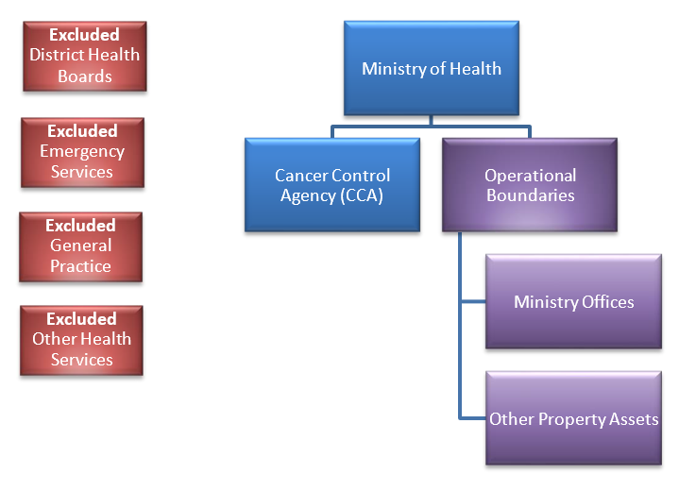
Figure 1: : Organisational boundaries
Te Aho o Te Kahu (Cancer Control Agency)
Manatū Hauora

Figure 2 explains the structure of the operational boundaries defined in the GHG emissions inventory, which include all owned and leased properties directly under the Ministry’s operational control or co-located premises where noted.
Figure 2: Operational boundaries
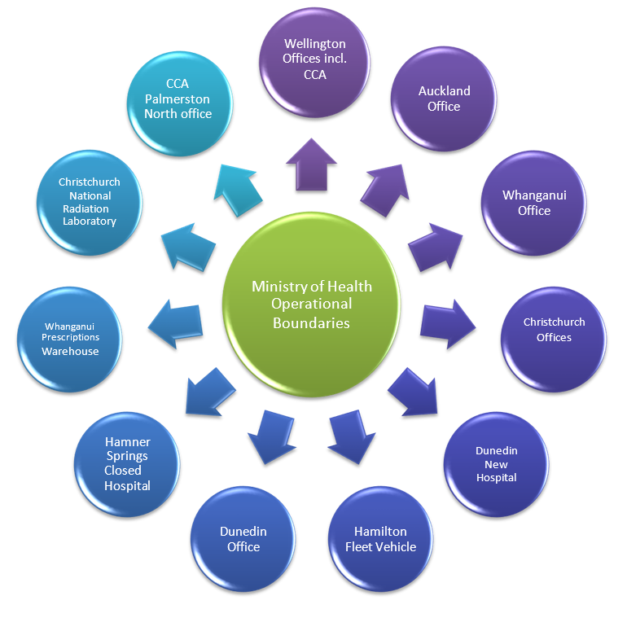

Note: Hospitals that have closed but are included in the Ministry’s organisational boundaries are the result of a transfer of assets from the respective DHBs. These sites are therefore reported under the Ministry’s operational control and form part of the Ministry’s emissions inventory. As such, they are excluded from DHB GHG reports.
Table 1: Properties included in the Ministry’s organisational boundaries
Property | Address | Description
Wellington head office | 133 Molesworth Street | Head office, responsible for oversight and operational management of property portfolio. This includes Te Aho o Te Kahu staff accommodated within this location.
Wellington office | 83 Molesworth Street | Secondary Ministry office, housing approx. 160 workers.
Wellington office | 42-56 Willis Street | Ministry office, housing approx. 22 workers.
Auckland office | 650 Great South Road | Ministry office, housing approx. 93 workers.
Whanganui office | 179 Hill Street | Ministry office and call centre, housing approx. 67 workers.
Whanganui prescriptions warehouse | 137 London Street | National prescriptions warehouse and storage.
Christchurch office | 48 Hereford Street | Co-located office with Ministry of Education as lead agency.
Christchurch national radiation laboratory | 108 Victoria Street | National radiation laboratory and storage site.
Dunedin office | 481 Moray Place | Ministry office, housing approx. 71 workers.
Dunedin new hospital building | 174 Castle Street | Not yet open.
Hamilton office | 87 Alexandra Street | Fleet vehicle on site to be reported only.
Hanmer Springs closed hospital | 28 Amuri Avenue | Closed hospital, minor maintenance conducted at this site.
Palmerston North Te Aho o Te Kahu | 619 Featherston Street | Te Aho o Te Kahu, housing approx. 5 workers

Operational boundaries excluded from inventory
Table 2 lists the properties that were leased recently or that produced no emissions within the 2021/22 financial year. These properties are not relevant to the base year in which this report and GHG emissions inventory are consolidated from. For transparency, this provides an overview of the current state of the Ministry’s property portfolio and potential for inclusion in future GHG reports and inventories.

Some properties do not sit under the Ministry’s operational control (for example, co-located tenancies), however, if the Ministry’s emissions data can be sourced, future GHG emissions reports will note the relevant portion of their emissions outputs as per their associated categories. If this is not achievable, each lead agency shall report their emissions inclusive of their co-located tenants.
Table 2: Operational boundary exclusions
Property | Address | Description
Hamilton | 16 Clarence Street | Te Aho o Te Kahu. Not under the Ministry’s operational control, however, the agency agreement sits with the Ministry. Due to low staffing numbers (4–5 staff), this site has been excluded from this report.
Christchurch | 32 Oxford Street | Te Aho o Te Kahu. Not under the Ministry’s operational control, and the Ministry has no influence over the operation of this building. Due to low staffing numbers (4–5 staff), this site has been excluded from this report.
Invercargill | 194 Dee St | Closed hospital, minor maintenance conducted as required, however, no emissions produced in base year where data could practically be sourced.
Hamilton | 87 Alexandra Street | Low staffing numbers (approx. 8). Part of the Waikato DHB, and not under the Ministry’s operational control as the lease agreement is per seat. The Ministry’s fleet vehicle, however, is included in the inventory.

GHG emissions source inclusions
The GHG emissions sources included in this inventory were identified with reference to the methodology described in the GHG Protocol and ISO14064-1:2018 standards.

The emissions sources are also referenced in the MfE’s, Measuring Emissions: A Quick Guide 2020,7 which specifies the various types of emissions an organisation would typically report on, depending on the type of organisation and its operational functions.

As adapted from the GHG Protocol, the emissions were classified under the following categories.
- Direct GHG emissions (Category 1): Emissions from sources owned or controlled by the agency.
- Indirect GHG emissions from imported energy (Category 2): Emissions from the generation of purchased electricity, heat and/or steam consumed by the agency.
- Indirect GHG emissions from transportation (Category 3): Emissions occurring as a result of the agency’s activities but from sources not owned or controlled by the agency.
- Indirect GHG emissions from products an agency uses (Category 4): Emissions occurring as a result of the agency’s activities but from sources not owned or controlled by the agency.
The actual emissions sources in figure 3 have been identified and included in the GHG emissions inventory which are relevant to the Ministry’s operational boundaries.
Table 3: GHG emission sources inclusion summary
Category | Description
1 | Fleet vehicles fuel
2 | Electricity
3 | Air travel – Long haul  Air travel – Short haul  Air travel – Domestic  Taxi travel  Rental vehicles  Accommodation  Freight  Staff mileage claim  Staff travel claim  Working from home
4 | Electricity transmission and distribution losses  Waste to landfill  Water supply  Waste water

GHG emissions source exclusions
For the financial year 1 July 2021 to 30 June 2022, we excluded the emissions sources listed in table 4 below from the operational boundaries (as per table 2).

Where a property is deemed outside Ministry operational control (for example, small co-located tenancies as shown in table 1), these may be ‘de minimis’ (too trivial or minor to be worthy of consideration) and will be reported as an exclusion.

Various factors may be involved in the decision to exclude an emissions source relevant to the Ministry’s organisation boundaries for the 2021/22 period. Such factors can include:
- the type of lease agreement in place
- the practicality of locating the emissions
- total occupied space
- the number of full-time equivalents (FTEs) in the premises
- the emissions source being less than 1% of the total emissions within that source and not greater than 5% of the total emissions.
Table 4: Emissions source exclusions
Categories | Address | Reason | Source
Categories 2 & 4 | 87 Alexandra Street, Hamilton | The site is outside the Ministry’s operational control; it is part of the DHB and will be reported in their emissions report; Ministry data is unpractical to source as it would require apportioning building data only for 8 desks occupied by the Ministry. | Electricity  Waste to landfill  Water supply  Waste water
Categories 2 & 4 | 32 Oxford Street, Christchurch  16 Clarence St, Hamilton | These sites are outside the Ministry’s operational control; they have low staffing numbers (4–5 staff); they are part of the DHBs and will be reported in their emissions reports. | Electricity  Waste to landfill  Water supply  Waste water
Category 4 | All sites | Data for the base year was sourced for the largest building and extrapolated on a square meter basis for all other sites and found to be de minimis. | Water supply
Category 4 | All sites | These sites have a water supply that is de minimis; waste water for the sites is also considered de minimis. | Waste water

Data collection and uncertainties
Table 5 provides an overview and explanation of uncertainties or assumptions. The calculation methodology has been used for quantifying the emissions inventory using emissions source activity data, multiplied by the emissions factors. Further detail of how the data was sourced is included in the GHG inventory (see Appendix A). All emissions factors have been sourced from guidance provided by the MfE, specifically the GHG reporting emissions factor workbook for 2022.
Table 5: GHG emission source inclusion detail
Business unit | Activity | Categories |  | Data source | Data unit |  | Uncertainty/assumption (description)
All | Fleet fuel | Category 1 |  | Fuel card monthly summary and monthly fuel invoices | Litre |  | The Fleet card summary are cross checked with fuel card invoices for accuracy and completeness. Then there is a limited amount of uncertainty.
All | Purchased Electricity | Category 2 |  | Smart Power report, and Smart Power sourced the consumption for 1 site recharged by ACC, which was not in their system | kWh |  | Smart Power receives, verifies, and pays all energy bills on the Ministry’s behalf following strong QA internal process that results in only a limited amount of uncertainty.
All | T&D* losses | Category 4 |  | As above | kWh |  | As above.
All | Air travel | Category 3 |  | Tandem, reconciliation report | Passenger.km |  | Tandem reconcile and process all the Ministry’s invoices for flights, accommodation and rental cars and can only charge back against an approved booking, therefore there would be no data that has not been approved in the report, resulting in only a limited amount of uncertainty.
All | Accommodations | Category 3 |  | Tandem, reconciliation report | Room / night
All | Rental vehicles | Category 3 |  | Tandem, reconciliation reports | km
All | Taxis travel | Category 3 |  | Taxi charge summary report | km |  | It is assumed the report is complete and accurate. Kilometres are used for consistency across the inventory, and default emissions factors are used. There is a moderate amount of uncertainty.
All | Freight | Category 3 | Courier Post emissions report |  |  | Tonne km (tkm) and other |  | It is assumed the report is complete and accurate. Especially since Courier Post had their calculation audited and certified by Toitū Envirocare. There is a limited amount of uncertainty.
All | Freight | Category 3 | Kiwi Express |  |  | km |  | It is assumed the report is complete and accurate. Kiwi Express couldn’t provide accurate weight, but they provided accurate type of vehicle used and km, therefore road freight for light vehicle emissions factors have been used. Then is a moderate amount of uncertainty.
All | Working from home | Category 3 | Attendance record from security record for head office and the other Wellington office and FTE and assumption provided by the Ministry |  |  | Employee per day |  | As the Ministry has no formal ways of measuring the number of employees per day working from home, there is reasonable amount of uncertainty.
All | Use private car | Category 3 | Staff expenses financial report |  |  | km |  | Estimated assumption based on national vehicle ownership data to determine the split between petrol (91%) and diesel (9%) for light passenger vehicle use; use of IRD conversion rate between $ and km; default emissions factors used. Then is a moderate amount of uncertainty.
All | Air travel | Category 3 | Staff expenses financial report |  |  | Passenger km (pkm) |  | A number of assumptions had to be made as the expenses claim report was not detailed enough. Therefore, there is a reasonable amount of uncertainty.
All | Taxi | Category 3 | Staff expenses financial report |  |  | $
All | Accommodation | Category 3 | Staff expenses financial report |  |  | Room/ night
All | Waste to landfill | Category 4 | Waste Management customer sales transaction report |  |  | kg |  | It is assumed the report is complete and accurate. Especially since Waste Management had their process audited via Toitū Envirocare. Emission factor with gas recovery has been used as all the Ministry’s sites’ waste have landfill with gas recovery. There is a limited amount of uncertainty.
Note
* T&D = Transmission and distribution.

Greenhouse gas emissions report summary
Table 6 shows the Ministry’s total emissions for the period 1 July 2021 to 30 June 2022. The sums are expressed as kilograms of carbon dioxide equivalent (kg CO2-e). A complete and quantified breakdown of this information is found in the GHG inventory, Appendix A.
Table 6: GHG emission summary for Manatū Hauora
Category | CO₂ | CH₄ | N₂O | HFCs | PFCs | SF₆ | Total  t-CO₂e
Category 1 Direct | 6,971.34 | 60.31 | 199.25 |  |  |  | 7.23
Category 2 Direct | 208,709.36 | 4,957.34 | 412.35 |  |  |  | 214.08
Category 3 Indirect | 1,052,962.87 | 9,638.23 | 12,563.09 |  |  |  | 1,075.16
Category 4 Indirect | 19,159.32 | 28,344.24 | 37,79 |  |  |  | 47.54
Total |  |  |  |  |  |  | 1,344.01
Notes
CO₂ = carbon dioxide
CH₄ = methane
N₂O = nitrous oxide
HFCs = hydrofluorocarbons
PFCs = perfluorinated compounds
SF₆ = sulfur hexafluoride
t-C0₂e = metric tonnes in carbon dioxide equivalent.

Calculations and results
Figure 3 provides the totals of the Ministry’s emissions per category (see table 3 for the definition of each category).
Figure 3: GHG emissions by category for Manatū Hauora

Figure 4 lists the totals of the Ministry’s emissions per source.
Figure 4: GHG emissions by source for Manatū Hauora

Variances from base year
For the 2021/22 financial year, this report concludes that the Ministry’s highest emissions source was air travel.
Table 7: Emission variances from base year
Emission sources | FY 2021/22  Emission (t-CO₂e) | Emission variances from base year  (t-CO₂e) | % variance from  base year
Working from home | 156.5 | 156.5 | 0
Freight | 1.3 | -9.1 | -88%
Fleet | 7.2 | -16.1 | -69%
T&D losses | 19.7 | 7.0 | 55%
Rental vehicles | 25.4 | -3.4 | -12%
Taxis | 21.8 | -20.0 | -48%
Use of private cars | 26.4 | -11.6 | -31%
Waste to landfill | 27.9 | -76.1 | -73%
Accommodation | 51.9 | -3.2 | -6%
Electricity | 214.1 | 66.6 | 45%
Air travel | 791.8 | -712.6 | -47%
Total | 1,344.0 | -622.0 | -31.7%

Conclusion
Several emissions sources for 2021/22 were influenced by the COVID-19 pandemic, and the pandemic required the Ministry to make a number of operational changes, including setting up short-term office accommodation in Wellington to host an increased workforce. This resulted in a significant increase in electricity consumption and associated emissions. In addition, more Ministry staff worked from home, resulting in the associated emissions increasing. In contrast, air travel emissions reduced compared with our base year, resulting in a 47% reduction in emissions in this category.

Reduction plan (in development)
This report provides a framework for the Ministry to measure, verify and report on our emissions annually. The Ministry is currently developing a reductions plan with a 1.5°C target reduction pathway. Planned initiatives include:
- improving internal process to ensure accuracy and completeness of reporting
- continuing to engage with suppliers to improve reporting
- reviewing travel guidance and rules to ensure sustainability is a key consideration when deciding if travel is required
- investigating fleet utilisation for downsizing and if required replacing with hybrid/electrical or full electrical by 2025/26 (50% complete)
- investigating the potential for reducing electrical sources emissions, including improved renewable sourced electricity generation.

As travel-based sources are responsible for over 85% of the Ministry’s base year emissions, category 3 will remain a significant focus for reduction activities.

Appendix A – Manatū Hauora GHG inventory – FY 2021/22
See attached.

Ministry for the Environment. Carbon Neutral Government Programme URL: https://environment.govt.nz/what-government-is-doing/areas-of-work/climate-change/carbon-neutral-government-programme/
Greenhouse Gas Protocol. About Us. URL: https://ghgprotocol.org/about-us.
ISO. 2018. ISO 14064-1:2018: Greenhouse Gases – Part 1: Specification with guidance at the organization level for quantification and reporting of greenhouse gas emissions and removals. Geneva: International Organization for Standardization (ISO). URL: www.iso.org/standard/66453.html (accessed 30 November 2021).
In line with the government’s policy for reducing emissions – see the Reducing government fleet emissions webpage on the New Zealand Government Procurement website at: www.procurement.govt.nz/broader-outcomes/reducing-emissions-and-waste/reducing-government-fleet-emissions
GHG Protocol. nd. The Public Sector GHG Accounting and Reporting Standard, Provisional draft. URL: https://ghgprotocol.org/sites/default/files/standards_supporting/provisional-draft.pdf (accessed 7 December 2021).
GHG Protocol. nd. The Public Sector GHG Accounting and Reporting Standard, Provisional draft. URL: https://ghgprotocol.org/sites/default/files/standards_supporting/provisional-draft.pdf (accessed 7 December 2021).
ISO. 2018. ISO 14064-1:2018: Greenhouse Gases – Part 1: Specification with guidance at the organization level for quantification and reporting of greenhouse gas emissions and removals. Geneva: International Organization for Standardization (ISO). URL: www.iso.org/standard/66453.html (accessed 30 November 2021).
MfE. 2022. MfE Measuring Emissions Guidance 2022. Wellington: Ministry for the Environment (MfE). URL: https://environment.govt.nz/publications/measuring-emissions-a-guide-for-organisations-2022-detailed-guide/ (accessed 1 March 2023).

