# NZICHC logo.jpg Description: CDHB.bmp

**Canterbury District Health Board’s**

**Gerontology Acceleration Programme (GAP)**

**EVALUATION REPORT**

**September 2015**

**Authors:**

**Dr Chris Hendry,** Evaluator, NZ Institute of Community Health Care

[chris.hendry@nzichc.org.nz](mailto:chris.hendry@nzichc.org.nz)

**Dr Gail Prileszky,** Evaluator, NZ Institute of Community Health Care

# Acknowledgements

# The authors would like to thank the following for their contribution to this evaluation:

* The GAP co-sponsors, Kate Gibb and Diana Gunn
* Jenny Gardner, Nursing Nurse Co-ordinator, Postgraduate Nursing Education
* The 2013 and 2014 GAP nurses
* The GAP mentors
* The nurse managers for all clinical rotation placements

# 

# Copyright

The copyright owner of this publication is the Ministry of Health. Permission is given to reproduce material from this publication provided that the following conditions are met:

* The content is not distorted or changed
* The information is not sold
* The material is not used to promote or endorse any product
* The material is not used in an inappropriate or misleading context with regard to the nature of the material
* Any relevant disclaimers, qualifications or caveats included in the publication are reproduced

# 

# Disclaimer

The report authors have taken great care to ensure the information supplied within the project timeframe is accurate. However, neither the New Zealand Institute of Community Health Care nor the contributors involved can accept responsibility for any errors, or omissions. All responsibility for action based on any information in this report rests with the reader. The authors accept no liability for any loss of whatever kind or damage arising from reliance in whole, or part, by any person, corporate or natural, on the contents of this report. The views expressed in this report are those of the authors and do not necessarily represent those of the CDHB or the Ministry of Health.



*Providing clinician led research and consultancy services througout the country; Improving Outcomes Through Community Health Research*

**New Zealand Institute of Community Health Care**

15 Mansfield Avenue  |  PO Box 36 126  |  Merivale  |  Christchurch 8146

DDI:  03 375 4101 | T: 03 375 4200  Ext 7801|  Mob:  021 655 355

Email: [Chris.Hendry@nzichc.org.nz](mailto:Chris.Hendry@nzichc.org.nz)  or [director@nzichc.org.nz](mailto:director@nzichc.org.nz)

# Executive summary

## Background

The New Zealand Institute of Community Health Care was commissioned by the Office of the Chief Nurse, Ministry of Health, to undertake an evaluation of the Canterbury District Health Board’s (CDHB) Gerontology Acceleration Programme (GAP) which was first introduced in July 2013. This programme is funded primarily by employers with an allocation of Health Workforce New Zealand (HWNZ) postgraduate nursing funds. Established through across-sector engagement, GAP is aimed at actively raising the profile of nursing in the aged care sector as a career pathway both within DHB facilities and the aged residential care sector. The twelve month programme incorporates a number of structured activities for participants including clinical placement exchanges, mentorship by experienced nurses, achievement of a higher level in the Nursing Professional Development and Recognition programme (PDRP) and completion of gerontology-focused postgraduate papers.

To enable this, Health Workforce New Zealand (HWNZ) funding was allocated to participants as a priority from the CDHB’s contract to support the postgraduate education requirement of the programme. This funding, open to both DHB and non-DHB nurses in aged care, covered fee payment, study release to attend compulsory study blocks and some clinical supervision if required by the paper. Participant and programme eligibility are consistent with HWNZ specifications. The first programme intake commenced in May 2013 and a further nine nurses commenced the second intake in May 2014.

## Evaluation objectives

While only 15 nurses have participated in the programme and 14 completed since its inception two years previously, an evaluation was considered of value because of the national interest this innovative model had generated and the potential for its application in other nursing settings. Using feedback from various sources, the GAP evaluation focused on determining the following:

* **personal and professional** impact of the programme on participants, including the impact on clinical practice, collegial networks across the system, career intentions and on-going professional development
* impact on the **wider nursing workforce** of participants’ organisations
* impact on **service delivery** and relationships across organisations.

Encompassing both a formative and summative component, the evaluation also informed further refining of the programme itself to maximise the experience for the participants and efficiency of the process.

## Evaluation methodology

We were tasked with providing **a formative evaluation report**, **setting in place process evaluation indicators for** the programme and providing a **final evaluation report** on completion of the current programme in July 2015. A Programme Logic-based framework was used to guide our evaluation process and information gathering. A mixed methods approach to data gathering included the use of standardised tools to measure the progress and impact of the programme over time. Surveys, focus groups and key informant interviews were undertaken, as well as a review of relevant literature to contextualise the programme.

## Rationale for the programme

The CDHB Gerontology Acceleration Programme was designed to meet a number of needs, including to:

* provide access to a supported programme of professional development activities for nurses in settings with a focus on the care of older people, including academic papers, mentoring and clinical rotation
* promote gerontology nursing as a specialty by providing skill acquisition and nursing knowledge in this area
* positively impact on clinical teaching, quality improvement and nursing leadership development in the sector
* build relationships across the system to foster a better understanding across the different areas of the service, both for the nurses undertaking the programme and also their colleagues, managers, etc.

## Programme overview

The GAP programme commenced at the end of May each year and finished in July of the following year, at the end of the academic term. It consisted of four specific experiences:

1. The provision of **mentorship by a designated senior nurse** currently working in either Older Persons’ Health, Rehabilitation and Medical / Surgical divisions or aged residential care.
2. Completion of **two postgraduate nursing papers relevant to the care of older people** that constitute a postgraduate qualification.
3. **Rotation to obtain 12 weeks’ clinical practice experience as a reciprocal secondment** in two clinical practice areas relevant to older persons’ health that are not the participant’s base setting.
4. Attainment of the employing organisation’s **Professional Development and Recognition Programme** (PDRP) at proficient level.

The registered nurse is viewed as completing the programme when they have passed the two postgraduate nursing papers, completed their clinical rotations and submitted (and had approved) their PDRP at proficient level.

## Programme co-ordination and funding

The programme has two **co-sponsors**, the CDHB’s Nursing Director, Older People – Population Health and the CDHB’s Director of Nursing, Older Person’s Health and Rehabilitation, as well as a sector-wide representative governance group.

All activities of the participants, mentors and clinical managers related to the programme are subsidised by their workplace and/or they volunteer their time to support the programme. Co-ordination and administration are provided by the co-sponsors and the CDHB’s Nursing Workforce Development team.

## Evaluation findings

This 13 month programme used HWNZ postgraduate nursing funding in a creative way by combining clinical practice rotations, mentorship from expert nurses and the formalised PDRP with the postgraduate paper running concurrently to enable registered nurses in aged care to explore and more fully develop their clinical and leadership skills.

### Planned impact of the programme

The programme was viewed as providing varying opportunities for those involved. Participants saw it as an opportunity for career progression and networking within the sector; similar to managers who were interested in development of their staff’s leadership skills and the opportunity to maintain interest in the sector in order to retain and build staff capability and capacity. Mentors viewed the programme’s primary role as developing the clinical skills of nurses who had been in the sector for a while, particularly those in the aged residential care sector, and educators supported this view. As popularity of the programme increases and competition emerges for placement, greater clarity of the programme’s potential would enable recruitment into the programme to be more targeted, participants’ goals more strategic and impact measures more focused.

### Programme resources

While the programme is funded primarily by employers, funding has also been allocated to participants as a priority from the (HWNZ) contract with the CDHB for postgraduate education for registered nurses for the education requirement of the programme. This funding covers fee payment, study release to attend compulsory study blocks and some clinical supervision if required by the paper. Participant and programme eligibility is consistent with HWNZ specifications. A grant from the CDHB’s Planning and Funding arm has also been sourced to cover the cost of orientation with each clinical rotation. Thus the programme makes very efficient use of a number of limited resources.

Communication about and during the programme was identified as a weakness, but issues raised by the formative evaluation are in the process of being addressed. The GAP Handbook will likely become a very valuable programme support with suggested changes and the inclusion of more information on programme logistics. This booklet in a revised format could also be used to inform the development of other specialist nursing programmes similar to GAP.

### Programme components

**The most valuable components of the programme** were identified by all support people and participants as the mentorship component, closely followed by the clinical rotations, particularly to the ARC and Rehabilitation facilities, then the postgraduate papers (these were judged most challenging in the formative evaluation). The PDRP component received mixed reviews, but was considered an important integrator in the programme. The value of this component was felt to increase when all future participants will have already completed a PDRP process prior to commencement of GAP.

**Mentors reflected** that they felt confident as mentors, but preparation for their GAP role and workplace support were viewed as needing improvement. They also indicated that their role supporting participants’ transition to the new clinical rotations was difficult. In future, programme conveners will include more information for mentors and also use past GAP students as mentors.

**The postgraduate papers**, while a struggle for some, were judged to be a valuable component of the programme. Future GAP participants are recommended to have better preparation for postgraduate study which will be supported by the offering of more flexible pre-course study skills workshops by education providers. The Advanced Health Assessment paper was rated by participants as of great value, providing them with a more sophisticated approach to clinical decision-making.

The **clinical practice rotations** (reciprocal secondments) were considered a valuable component by participants, with the ARC and Rehabilitation placements being the most popular. The current workplace of each participant on the programme governs the availability and type of rotations in the programme as a whole. This component is the most complex and requires the most negotiation and programme co-ordinator time, particularly for a public/private sector ‘swap’, however the value of this opportunity for the participants is extremely high.

### Programme outputs

By the end of the evaluation, 14 nurses had completed the programme in two intakes a year apart. Most were mid-career nurses, over 40 years of age, with no postgraduate qualifications and half were internationally qualified registered nurses. Given this profile it is an accomplishment that the programme supported these nurses to complete all components and demonstrate the level of professional development evident through the evaluation process.

Although the number of respondents was small, information obtained from participants about their **before and after GAP** nursing role and levels of confidence indicated a trend towards them mentoring staff more, feeling more supported in the workplace, having greater confidence in providing leadership and being more able to access updated resources. In terms of their experience of the course following completion and compared with their responses part way through (formative evaluation findings), they indicated they received greater support, were better prepared for their postgraduate study, better orientated into the clinical rotations and better supported by their mentors. This change in findings likely indicates the participant’s growth in confidence and support-seeking behaviour as the programme progressed.

### Programme impact

The concern that nurses undertaking the programme will be tempted to leave following exposure to other health settings has not eventuated to date. While only 14 nurses in two intakes have now completed the programme, most movement has occurred within the sector.

Examples of **positive outcomes and change** as a result of the GAP programme included:

* feeling confident as leaders and even obtaining a leadership role post-GAP, within the sector,
* becoming a role model to junior nurses, nursing students and a resource person to colleagues, doctors and allied health members
* extending their knowledge base and opportunity to complete the big picture of a patient’s journey which provides better understanding of the service as a whole
* nurses noting their transition from basic to expert practitioner during the programme
* confidence in their ability to correct or address gaps in their clinical practice, knowledge and experience

**Results that have emerged out of this programme**, based on feedback from a variety of sources that may be of interest to other sectors included:

* a more integrated working relationship between those in the aged care sector generally, including both public and private providers and more networking among nurse clinicians
* a cohort of experienced and well qualified nurse leaders is now working in the sector locally
* a culture of mentorship for registered nurses working in the sector
* identification and transferring of initiatives and tools from one locality to another, such as streamlining discharge from Rehabilitation to the ARC facility and development of a standard means of communication between providers
* greater understanding of components of the continuum of care for older people,
* the value of partnering between industry and tertiary provider to develop a more meaningful and practical postgraduate education experience for staff
* provision of a model for investing in nursing leadership through the application of a shared governance across aged residential care and DHBs .

The programme has enabled an area of nursing to be highlighted that in the past has not been considered as having ‘career potential’ for nurses. The fact that the programme attracted both young and older nurses as well as a greater number of applicants and participants in the second year, demonstrates that there is interest among nurses in this growing sector.

# Recommendations

The evaluation concluded that the programme appears to have added significant value to the sector and nurses working within it and has the potential to be replicated within other areas of nursing. Therefore, **we recommend that the programme continues** with the enhancements recommended in the interim report.

1. **Improve programme readiness**

As identified in the formative report, having participants, clinical rotations and mentors aware of their responsibilities for the programme and clarifying the ‘pre-entry’ requirements for applicants would fast track the entire process and reduce co-ordinator effort.

1. The Handbook should contain more specific information for potential participants so they can prepare themselves in advance for the programme
2. Include more logistical information for those planning to apply and/or organisations wishing to become involved, because of the reciprocal secondment requirements
3. All applicants should have completed their PDRP at competent level and plan to attend an academic study preparation programme if they have not undertaken academic study before
4. Provide greater clarity of the programme’s intent so that recruitment into the programme can be more targeted participant’s goals more strategic and impact measures more focused
5. Utilise past participants for advice on and support for programme readiness

1. **Facilitate programme integration and maintenance**

Programme integration is an important success factor. This reduces stress for both participants and mentors. Understanding the programme as a whole and how each component can build on the other is identified as a way to make the experience more constructive for the nurse. Allocation of a programme co-ordinator (or designated facilitator) would achieve continuity for all involved in the programme. There should be dedicated hours for this role.

1. Appoint a specific programme co-ordinator/facilitator role while the programme is running. This person would also be responsible for communication and programme logistics.
2. **Continue programme development**

As more nurses undertake the programme, more placements will need to be identified, the components will need to be reviewed and updated and the programme tools (such as the GAP Handbook) reviewed and updated. Building in a post-programme review process will inform these changes.

* 1. Build into the programme a pre and post GAP e-survey to inform further development of the programme
  2. Utilise the experience of those involved in the CDHB GAP programme to inform the on-going programme development
  3. Develop a set of indicators against which the success of the programme, both short and long term can be measured

1. **Enable replication of the programme model**

Already interest has been shown in replicating the GAP model in other parts of the country and in other areas of nursing as a strategy to make more effective use of the HWNZ postgraduate nursing funding and to increase service capability and capacity.

* 1. Utilise the experience and hindsight of those involved in the CDHB GAP programme to inform the establishment of such programmes in other sectors and parts of the country
  2. Ensure good across-sector engagement of industry (non-DHB and DHB) and education, both pre and post programme implementation to embed the programme within the local context

# Glossary

The following glossary explains terms used in this report and their meaning in this particular context.

|  |  |
| --- | --- |
| **Older Persons’ Health (OPH)** | Used throughout the international literature to describe the gerontology sector as a whole including hospital inpatient, community based and aged residential care settings. In Canterbury, OPH is often understood as referring to services provided by Canterbury District Health Board only. For the purpose of the GAP evaluation OPH is used in its broadest sense to describe the whole sector. |
| **Aged Residential Care (ARC)** | Aged Residential Care refers to care provided for an older person in a residential setting where the service is not directly provided by Canterbury District Health Board but by an external NGO or service provider such as BUPA. |
| **Assessment, Treatment and Rehabilitation (AT&R)** | Assessment Treatment and Rehabilitation refers to CDHB’s hospital inpatient services for older people which focus on acute gerontology and rehabilitation |
| **Clinical Rotations** | These involved reciprocal secondments between students. That is, one student swapped their work place role with another. This required negotiation between employers (both DHB and non-DHB) to ensure the student’s employment status remained. Problems were encountered when one student worked part time and the other full time. These issues were resolved on a case by case basis. |
| **Registered Nurse (RN)** | Qualified nursing professional who may be a Registered General and Obstetric Nurse or a Comprehensive Nurse with a Diploma in Nursing |
| **Interdisciplinary Team (IDT)** | A team of health professionals with different skills and professional knowledge working alongside each other to provide care for older people. |
| **Multi-disciplinary team (MDT)** |
| **Professional Development and Recognition Programme (PDRP)** | These are formal programmes that allow nurses to be rewarded and recognised for their level of expertise in nursing from competent to proficient <http://www.cdhb.health.nz/Hospitals-Services/Health-Professionals/pdrp/Pages/default.aspx> . |
| **Nursing Entry to Practice Programme (NETP)** | A formal programme to build on and consolidate the clinical, cognitive and leadership skills learnt by nurses during their undergraduate education programme. |
| **Reference for respondents and informants** | R = Respondent  M = Mentor  P = Participant |

# Table of Contents

Introduction 9

Background 11

The context of older people’s health services in New Zealand 11

Evaluation objectives 13

Evaluation methodology 13

Rationale for the programme 14

Programme overview 15

Programme governance 16

Programme co-ordination and management 16

Programme funding 16

Marketing and promotion of the programme 16

Programme timetable 17

Selection Process 17

Formative evaluation findings 18

Planned impact of the programme 18

Programme resources 18

Programme components 18

Programme outputs 19

Programme impact 19

Recommendations made in the interim report 19

Summative evaluation findings 20

The programme as a whole 20

The mentorship component of the programme 21

The postgraduate nursing education component 23

The clinical practice rotations 23

The Professional Development and Recognition Programme component 25

Programme outputs 25

Programme communication 25

Programme participants 26

Programme completion 28

Programme Impact 28

Impact of GAP on the participants 29

learning and development. 29

Impact of GAP on service delivery and inter-organisational relationships 31

Impact of GAP on the nursing workforce 32

Summary of findings 33

Conclusion 34

Recommendations 35

References 36

# Introduction

The New Zealand Institute of Community Health Care was commissioned by the Office of the Chief Nurse, Ministry of Health to undertake an evaluation of the Canterbury District Health Board’s (CDHB) Gerontology Acceleration Programme (GAP) which was first introduced in July 2013. This programme is funded primarily by employers with use of resources from the CDHB allocation of Health Workforce New Zealand (HWNZ) postgraduate nursing funds and is aimed at supporting the growth of nursing leadership in the aged care sector.

In May 2014, the second intake of Nurses was recruited into the programme. At this point, the Ministry of Health funded a full evaluation of the programme, initially to identify if changes should be made midway through the current programme, and also to identify the value of the programme as a whole to the sector.

This leadership development programme in gerontology has four components:

1. The provision of **mentorship for participants** by a designated experienced nurse currently working in Older Persons’ Health, Rehabilitation, Medical / Surgical divisions or aged residential care.
2. Completion of **two postgraduate nursing papers relevant to the care of older people** that constitute a postgraduate qualification.
3. **Rotation (reciprocal secondment)** to obtain 12 weeks’ clinical practice experiencein two clinical practice areas relevant to older persons’ health that are not the participant’s base setting.
4. Attainment of the employing organisation’s **Professional Development and Recognition Programme** (PDRP) at proficient level.

The registered nurse is viewed as completing the programme when they have passed the two postgraduate nursing papers, completed their clinical rotations and submitted (and had approved) their PDRP at proficient level.

This 12-month programme is run as a joint venture between the aged residential care sector and secondary care in order to build and retain talented registered nurses working in gerontology across the sector to strengthen the skill mix and flexibility within the workforce.

The expected attributes of the nurse completing the programme are aligned with the attributes of a ‘Proficient’ RN, and are described as:

* Acts as a **role model** and a **resource person** for other nurses and members of the health care team when nursing older people.
* Actively contributes to **clinical learning** for colleagues/caregivers and education for families/whanau.
* Engages in collaborative practice to **achieve positive outcomes** for older people inclusive of transitional care.
* Participates in **quality improvement** and **change** to improve gerontological nursing practice.
* Demonstrates in-depth understanding of the complex factors that contribute to the older person’s health outcomes and applies this knowledge to **plan care** which meets their particular needs.
* Demonstrates inclusiveness when managing the care of older people and their families/whanau.
* **Advocates for and protects the rights of** older people.
* Demonstrates **autonomous** and **collaborative** evidence-based aged care nursing practice.
* Participates in changes in gerontology settings that recognise and integrate the principles of **Te Tiriti o Waitangi** and **cultural safety.**
* Demonstrates **leadership** in the sector (CDHB GAP Handbook, 2014).

# Background

The CDHB has endeavoured to maximise the use of the postgraduate nursing HWNZ funding to target specific areas in which they would like to grow and develop their registered nursing staff. In the 2010/2011 year they ran a Specialist Nursing Acceleration Programme (SNAP) for those working in medical nursing. This required the nurses to:

* Enrol in a postgraduate nursing programme and complete at least two papers
* Rotate to alternative but related clinical placements to broaden their experience
* Submit a PDRP portfolio at proficient level.

The programme was facilitated by the CDHB’s Nurse Co-ordinator of Postgraduate Education and designed to ‘support highly motivated, enthusiastic and resilient junior registered nurses early in their professional careers’. Feedback on this programme guided the development of the GAP programme.

The published literature (Manchester, 2006; Chenoweth et al, 2009; McCann et al, 2010) suggests that a combination of negative and inaccurate attitudes held by society towards the elderly, along with misconceptions about what a career in Older Person’s Health (OPH) means, have both contributed to the current recruitment and retention challenges.

Strategies to address these misconceptions are recommended to include a combination of access to education at both undergraduate and post-graduate level, mentorship, secondment and challenging of the stigma relating to the consumer group and the OPH nursing workforce (Howard-Brown and McKinlay 2014). As standalone measures these approaches are reported to have limited effect (Chenoweth et al, 2009), but in combination they can promote OPH as a rewarding career that has many possibilities. These are the principles that underpin the on-going development of GAP with a long term view towards strengthening the OPH nursing workforce.

In 2012, two Aged Residential Care (ARC) providers expressed willingness to collaborate with the CDHB on the inaugural Gerontology Acceleration Programme. A governance group was established with representation from the Aged Care sector, postgraduate nursing programme providers, Directors of Nursing, Older Person’s Health Specialist Services, Nursing Leadership, the Nursing Workforce Development Team and Rural Nursing Leaders to ensure a comprehensive analysis of workforce recruitment and retention needs was undertaken.

# The context of older people’s health services in New Zealand

A report commissioned by HWNZ (2011) identified key changes in the workforce required to meet the challenges of the growing elderly population:

* Significant changes in models of care and workforce orientation and skills.
* Greater focus on restorative care.
* Focus on needs assessment and care planning.
* Skills in co-ordination and integration of care for clients.
* Ability to develop the capability of interfacing workforces (support workers and specialists).

Key enablers are identified as:

1. Enhancing communication and information technology.
2. Flexible funding to support and incentivise desired outcomes (HWNZ, 2011).

The report concludes that a focus on prevention and rehabilitation and an increase in community and primary health-based care will enable sustainable funding path in the face of an increasing ageing population. The workforce requirements associated with this shift in locus of care are likely to be wide ranging. While the funding and focus of residential care is currently on long-term care and support, there is a need to direct more attention towards healthier ageing in place (the home).

The Nursing Council of New Zealand (NCNZ) and HWNZ were sufficiently concerned about the future size, skills and attributes of the nursing workforce to commission a forecasting report ‘The Future Nursing Workforce; Supply Projections 2010 – 2035’ (NCNZ, 2013). It is predicted that by 2035, 50% of the current nursing workforce will have retired even though there is an ever-increasing demand for nurses in the sector. With nurses being the largest regulated occupational workforce in the health sector, there is interest in strategies to grow this workforce at a faster rate than is presently the case. This has the potential to place gerontology, acknowledged as an unattractive working environment for new graduates (Stevens, 2011), on the back foot if they do not have workable strategies in place to attract new nurses to work in their settings as a career option.

## Nursing Workforce in Older Person’s Health Services

Comparing the Nursing Council of New Zealand 2002 workforce statistics on nurses working in ‘continuing care (elderly)’ with those reporting to work in these settings in 2013, there is only an increase of 1,226 registered nurses, and the proportion of registered nurses working in these settings has dropped from 9.8% to 9.5% of the total nursing population.

The profile of registered nurses working in ‘continuing care (elderly)’ in 2013 when compared with the total RN workforce in that year, tended to be:

* Older (23.7% are 60 years or older compared with 14.5% of the total nursing population in this age group)
* Had lower levels of postgraduate qualifications (26.2% compared with an average of 44% for all other ‘practice areas’)
* Were less ethnically diverse than the total RN population (85% identified as New Zealanders compared with 74.9% in the total RN population). Only the Philippines was slightly higher than the national average (6% compared with 5%) (NCNZ, 2014).

One of the ways the CDHB encourages nurses to consider a career in gerontology is through the Nursing Entry to Practice programme (NETP); by supporting new graduate RNs working in ARC through a Memorandum of Understanding with their employer. In 2015 a number of facilities are employing new graduate RNs with support from HWNZ’s funding for NETP in ARC. Within the CDHB a number of new graduate RNs undertake the NETP working in clinical areas with a focus on care of older people, including areas which have participated in GAP. Anecdotal feedback indicated that the generation of interest in GAP and the confidence and formalised knowledge provided to the nurse participants, also have a flow-on effect in attracting new graduates to the area.

## Older Person’s Health services

Care of older people within the Canterbury health system is both provided by the CDHB in inpatient and community settings, and funded through contractual arrangements with partner organisations, including aged residential care providers. The GAP, in its current form, is intended for nurses working in in-patient and aged residential care settings.

**Care of older people within CDHB settings**

**Acute services** are provided in Christchurch Hospital, with the medical service including Wards 23 and 24 which are identified as having a high proportion of older people. Ashburton Hospital also provides acute medical services for older people.

**Rehabilitation services** for the elderly are provided at The Princess Margaret Hospital (TPMH) in their Older Person’s Health Specialist Service (OPHSS), which includes:

* Assessment, treatment and rehabilitation (AT&R) (inpatient)
* Community Services (interdisciplinary team)
* Psychiatric services for the elderly (both in-patient and community).

**Orthopaedic Rehabilitation Unit** and outpatients at Burwood Hospital which cater for a significant number of older people.

**Aged Residential Care Facilities**

These are mainly operated by private providers and NGOs. In the Canterbury region there are understood to be just over 100 facilities ranging from large combined-bed rest home and hospital facilities to small boutique rest home services. There are a number of large multi-complex providers and several smaller providers in Canterbury. The CDHB also has ARC beds in their six community hospitals.

# Evaluation objectives

The GAP evaluation objectives included determining the:

* **personal and professional** impact of the programme on participants, including the impact on clinical practice, collegial networks across the system, career intentions and on-going professional development
* impact on the **wider nursing workforce** of participants’ organisations
* impact on **service delivery** and relationships across organisations.

Encompassing both a formative and summative component, the evaluation also informed further refining of the programme itself to maximise the experience for the participants and efficiency of the process.

# Evaluation methodology

Evaluators were tasked with providing **a formative evaluation report**, **setting in place process evaluation indicators** for the programme and providing a **final evaluation report** on completion of the current cohort of participants in July 2015. A Programme Logic-based framework was used to guide the evaluation process and information gathering. This included the use of standardised tools to measure the progress and impact of the programme over time.

**Figure 1. GAP programme evaluation process**

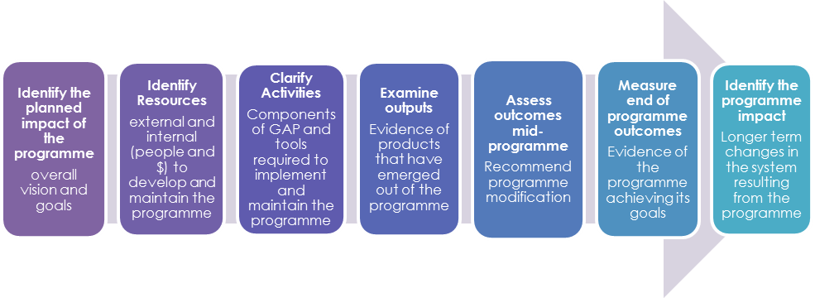

Using this framework the programme was examined at four levels;

* **nationally**, against policy directives, funding initiatives and nursing development frameworks
* at **DHB level** against identified needs and cross sector support, including the programme sponsors, governance group, University, private/NGO aged care provider organisations
* at **sector level** **including wards and facilities** wherenurses were supported during the programme and rotated through
* at individual **programme participant level,** both GAP Nurses and mentors.

A mixed methods approach was used for information gathering, including surveys, focus groups, telephone interviews and document analysis.

To obtain best value from this evaluation (which commenced part way through the second intake of GAP nurses) **the formative evaluation report** provided:

* an overview of the programme context and progress to date,
* a summary of feedback on the programme from a variety of sources,
* recommendations for initial changes to the programme which are likely to enhance the experience and outcomes for current participants and workplaces.

**This summative/final evaluation report** backgrounds the programme and provides a summary of changes made in response to the interim report and feedback from key stakeholders on completion of the programme in June 2015.

# Rationale for the programme

The CDHB Gerontology Acceleration Programme (GAP) was designed to meet a number of needs, including to:

* provide access to a supported programme of professional development activities for nurses working in settings with a focus on the care of older people
* promote gerontology nursing as a specialty by providing skill acquisition and nursing knowledge in this area
* positively impact on clinical teaching, quality improvement and nursing leadership development in the sector
* build relationships across the system to foster a better understanding across the different areas of the service including the GAP nurses as well as their colleagues, managers, etc
* promote gerontology nursing as a genuine career pathway

Early discussions in planning the programme highlighted the need to build a ‘critical mass’ of nurses working in different areas of aged care who have a cross-sector understanding. The programme aimed to enhance career pathways for those within aged care, attract others to gerontology and foster nursing leadership within the services.

### Recruitment and retention challenges in aged care services

In a recent study into new graduate career preferences in New Zealand, Huntington, Wilkinson & Neville (2014) acknowledged that OPH remains the least popular choice. This has consistently been the case for the past 20 years and is not restricted to nursing. The medical profession has similar recruitment issues (Simpson et al., 2005), as does social work (Adler, 2008). Stevens & Crouch (1998) argue that the unpopularity of OPH is due to the emphasis placed on ‘curative’ practice that pervades both medicine and nursing. Huntington et al (2014) identified three factors that influenced students’ career preferences; undergraduate curricula, clinical placements and practical issues. These concepts are supported by the literature.

The introduction of a Nurse Entry to Practice (NETP) programme in ARC aimed to encourage new graduates to consider gerontology as a positive career choice (HWNZ, 2011). This has had some success but the lack of resources and professional isolation in ARC has created some challenges for services. NETP is supported in ARC in Canterbury by the CDHB.

### Strategies for invigorating older people’s health nursing

Studies into attitudes of nurses towards OPH identified that those professionals working in gerontology were incredibly passionate and dedicated to their job (Kydd, Touhy, Newman, Fagerberg, & Engstrom, 2014). Negative attitudes came from undergraduate students and nurses working in acute care (Kydd, et al, 2014). They also found that nurses working in OPH believed that **OPH should be considered a specialised area** of nursing, but that their contemporaries considered their status to be poor. This is an area for debate. Whilst specialisation has both positive and negative consequences, undergraduate students and nurses seemed to be less aware of the complexity of the specialisation issue.

Maas et al. (2006) identified **mentorship** as the primary factor contributing to the success of a Gerontology Nursing programme. They assert that for mentorship to be most effective there needs to be commitment from all parties involved. The executive and managerial bodies need to provide adequate resources; the mentor and protégé need to be willing to fulfil their roles.

Other studies have recommended the value of **role models with** **post-graduate qualifications** and expertise status to attract new graduates (Manchester, 2006). Huntington et al (2014) support this focus, as they found that nurses with higher qualifications were more stable in their positions and less likely to look elsewhere. It is important, therefore to invest in the workforce already employed in OPH and particularly ARC.

Dryden & Rice (2008) emphasise that **secondments** can be a very effective way to build collegial relationships between services. Despite the challenges of organising and supporting the secondment, nurses have the opportunity to experience different working environments first hand. This approach has the potential to challenge misconceptions that health professionals hold about ARC and the skills that ARC nurses have. It also has the advantage of giving the seconded nurse support from peers and has been shown to improve retention (Dryden & Rice, 2008).

The limited access to **funded post-graduate education** and inadequate support from experienced mentors leads potential employees to assume there are few benefits to a stressful and unrewarding career (Chenoweth et al, 2009). This combined with a projected (and anecdotally reported to the evaluators) increase in acuity and shorter stays in aged residential care will impact on the workload of carers in this setting. A shift of skilled clinicians from DHB hospital care locations to primary and community settings is suggested as a key component of the workforce strategy to cope with the projected health needs of the ageing population (HWNZ, 2012). A programme such as GAP which utilises education and clinical rotation has the potential to enable this.

# Programme overview

The GAP programme (see figure 2 below) was planned to commence at the end of May each year and finish in July of the following year to coincide with the end of the academic term. It consists of four specific experiences.

1. The provision of **mentorship by a designated senior nurse** currently employed by the CDHB working in older person’s health, rehabilitation or medical / surgical divisions.
2. Completion of **two postgraduate nursing papers relevant to the care of older people** that constitute a postgraduate qualification.
3. **Rotation to obtain 12 weeks’ clinical practice experience** in two clinical practice areas relevant to older person’s health that are not the participant’s base setting.
4. Attainment of the employer’s **Professional Development and Recognition Programme** (PDRP) at proficient level.

The registered nurse is viewed as completing the programme when they have passed the two postgraduate nursing papers, completed their clinical rotations and submitted (and had approved) their PDRP at proficient level.

**Figure 2. Diagrammatic representation of the GAP** Figure 2. Diagrammatic representation of the GAP 

Programme governance

The programme has two co-sponsors; the CDHB Nursing Director, Older People – Population Health and the CDHB’s Director of Nursing, Older Person’s Health and Rehabilitation. The GAP governance group consists of representatives from:

* the aged residential care sector; BUPA and Ultimate Care Group
* the South Island Regional Training Hub
* the University of Otago Postgraduate Nursing School and CPIT
* primary care (through the Rural PHO)
* CDHB Nursing Workforce Development and Professional Development Unit teams
* Nursing leadership from within OPHSS and the medical service of the CDHB
* Service Manager of the OPHSS Community teams & Psychiatric Services for the Elderly

This group has been involved in the planning, implementation and continued development of the programme.

## Programme co-ordination and management

The CDHB’s Nursing Director, Older People – Population Health is the official programme co-ordinator, with the Nurse Co-ordinator for the CDHB’s Postgraduate Nursing Education managing the day-to-day co-ordination and issues. The University of Otago Lecturer in Gerontology provides an informal academic co-ordination role, while one of the mentors has been identified as the ‘lead mentor’ to provide support for the mentors.

## Programme funding

The programme is funded primarily by employers. Funding has also been allocated to participants as a priority from the Health Workforce New Zealand (HWNZ) contract with the CDHB for postgraduate education for registered nurses for the education requirement of the programme. This funding covers fee payment, study release to attend compulsory study blocks and some clinical supervision if required by the paper. Participant and programme eligibility is consistent with HWNZ specifications. A subsidy from the CDHB’s Planning and Funding arm has also been sourced to cover the cost of orientation with each clinical rotation. This constitutes the effective use of a number of limited resources.

## Marketing and promotion of the programme

Information is available on the CDHB’s website [www.canterburydhb.health.nz](http://www.canterburydhb.health.nz) including a copy of the GAP Handbook, a brochure and various briefings on the programme that have been given to the Board and media. The programme is also promoted at various opportunities, including postgraduate education fairs, internal and external study days, and through items in the weekly CEO Update to the CDHB’s staff.

## Programme timetable

A review of the GAP timetable identifies considerable activity towards the end of the year, with the first academic paper overlapping both of the clinical rotations as well as the PDRP development.

**Table 1. GAP timetable**

Programme timetable

‘Preparation for academic study’ refers to the study skills and academic writing workshops/courses available to participants (along with others planning to undertake university study for the first time) prior to the beginning of the academic year.

## Selection Process

### The mentors

Clinical Nurse Specialists and Nurse Educators with experience in the care of older people were asked to take on the mentorship role. Ideally, mentors had postgraduate qualifications. Each participant was allocated a mentor.

### The participants

A maximum of ten places are available on the programme each year. Applicants need to meet a number of criteria to be eligible for the programme including:

* Have an interest in undertaking the programme
* Have the support of their manager to participate
* Currently working 0.8 to 1.0 FTE within a participating CDHB inpatient area or an aged residential care organisation that is willing to receive other participants during their rotation
* Meet the HWNZ funding criteria for postgraduate study

A career plan is a requirement of HWNZ funding and nurses are required to confirm that they have one on the application for funding form. This information can be captured on their annual appraisal with their line manager. On the application for funding form participants are asked:

1. “How is this study relevant to your career intentions?”  (This is where they usually indicate their preferred leadership development pathway – clinical/ management/ educator.)
2. “How will this study enhance your ability to contribute to nursing in the Canterbury region?” (This question is looking for understanding of service provision across the sector.)
3. “How is it relevant to the Canterbury strategic priority and recovery plan?” (This question is looking for an understanding of changing models of care/ advanced practice roles.)

Participants are expected to be able to understand their own personal development needs as well as looking at the Canterbury “big picture” and articulate how they are doing this.

### The preceptors

Preceptors are nominated by their manager and have a responsibility for orientating the GAP nurse to their new rotation placement. They are registered nurses who ideally have undertaken the CDHB’s preceptorship workshops.

### Clinical Rotations

Ideally each GAP nurse has the experience of three placements; their base and two others. Potential rotation settings include:

* ARC facility
* Assessment Treatment and Rehabilitation (TPMH)
* Psychiatric Services for the Elderly (TPMH)
* Acute medicine (ChCh Hospital)

Each of the placement organisations needs to agree to a reciprocal arrangement, supporting a nurse from their area to participate, and to have a GAP Nurse work in their facility for two 12-week placements, with the organisation providing preceptorship and learning experiences for them.

# Formative evaluation findings

The formative evaluation process was completed and a report given to the programme conveners in February 2015. In this section a summary of these findings is followed by the recommendations made and the response to these as the programme continued.

### Planned impact of the programme

There were varying views on the intent of the programme depending on the informant. Participants viewed it as an opportunity for career progression and networking within the sector, while managers were interested in development of their staff’s leadership skills and the opportunity to maintain interest in the sector to reduce staff turnover. Mentors viewed the programme’s primary role as developing the clinical skills of nurses who had been in the sector for some years, particularly those in the residential care sector, and educators supported this view. As popularity of the programme increases and competition emerges for placement, greater clarity of the programme’s intent would enable recruitment into the programme to be more targeted, participant’s goals more strategic and impact measures more focused.

### Programme resources

The programme is funded primarily by employers. Funding has also been allocated to participants as a priority from the (HWNZ) contract with the CDHB for postgraduate education for registered nurses for the education requirement of the programme. This funding covers fee payment, study release to attend compulsory study blocks and some clinical supervision if required by the paper. Participant and programme eligibility is consistent with HWNZ specifications.

Programme co-ordination, administration and communication were viewed as less structured to start with, but in a way this encouraged more ingenuity among the managers, mentors and participants to make the programme work. Now is the time to provide more structure, because the informal, ad hoc arrangements are becoming more frustrating for mentors and managers. This could impact on the level of ‘goodwill’ they put into the programme in the future.

### Programme components

The programme’s four component parts did seem rather disconnected from each other, but this is likely to be the result of its organic development. All informants were supportive of each component remaining part of the programme and provided feedback on how components could be more integrated to obtain the best experience for participants. They recommended a longer length of time for the clinical rotations, integration of the PDRP process with the postgraduate papers and clinical rotations, and attendance at a pre-academic study workshop/course if they have not previously undertaken a postgraduate paper.

On reflection for the participants, the rotations were the highlight of the programme, particularly if they were well supported by their mentor and the nurse manager. Their learning and opportunities for networking were invaluable and could be improved through greater integration with their PDRP development and postgraduate papers. The GAP conveners are already considering ways to improve integration of the four components.

### Programme outputs

Communication about the programme, as well as during the programme, could be improved. This was likely a by-product of its incremental development. The programme handbook needed to be made more explanatory so that stakeholders and participants gained a better understanding of the programme as a whole.

To date two cohorts of nurses have experienced the programme; in 2014 there were three of five who met completion criteria at the end of the programme and nine nurses started the second intake. The participants tended to be mid-career nurses, over 40 years of age, with no postgraduate qualifications and half were overseas registered nurses.

Issues such as preparation for the programme, support for academic study and PDRP engagement were cited as enabling successful completion of the programme. The second cohort seems more aware of the expectations of the programme and the mentors more prepared.

### Programme impact

The participants and their managers indicated the programme had a positive impact, including increased confidence, broader clinical skills and knowledge as well as enhanced collegial networks for the nurse. It provided the participants with an opportunity to evaluate their career intentions and obtain leadership skills and experience.

The programme was also reported to have a positive influence on the workforce due to the exposure to nurses in other practice settings. Enthusiasm for the programme was generated by participants as others saw the opportunities they were provided with and their associated professional growth.

From a service delivery perspective, many examples were given of the impact of cross-fertilisation of initiatives as the nurse participants moved from one setting to another; another added value of the programme. Adaptation and standardisation of some processes and procedures were undertaken, e.g. forms used in one area are now being used more widely. The transfer of care for consumers from one locality to another is undertaken more swiftly and smoothly for the patients due to the development of closer professional relationships and it is believed that a greater interest is being fostered in gerontology nursing as a specialty area.

# Recommendations made in the interim report

As the programme was half way through its second intake, the programme seemed to be adding significant value to the sector and nurses working within it. In light of this the evaluators recommended that the programme continued in its current form with enhancements recommended under the headings of communication, preparation, co-ordination and integration.

**1. Develop a more planned approach to communication about the programme**.

|  |
| --- |
| **Response to recommendations relating to communication.** |
| The programme was on hold for 12 months following completion of the current cohort of nurses owing to major changes in CDHB Older Person’s Health Specialist Services including preparations for transfer to another facility. These included:   * greater targeting of participants in future, so marketing will be more explicit * more information on the programme in the handbook including examples under the domains of practice, giving a bit more structure * more frequent meetings between mentors * more formality in the meetings held with participants to ensure all information is passed on, rather than increasing the number of times the participants meet. Also dates of meetings will be planned in advance to achieve greater attendance * creation of a standard information sheet for each participant to complete as a form of introduction. |

**2. Provide more information on programme expectations so participants can be more prepared.**

|  |
| --- |
| **Response to recommendations relating to preparation.** |
| There is an intention to move to requiring **completion of PDRP** at competent level prior to commencement on the programme.  Strategies to achieve this include:   * NETP currently includes this process and as more have completed NETP prior to this programme, they will have experienced the PDRP process. Some are completing the next level in anticipation of the programme * ARC providers are now able to access the CDHB PDRP programme for staff.   Education providers are happy to provide **postgraduate preparation programmes** specifically for the cohort. In anticipation of entering the programme, some nurses are commencing postgraduate study so they will be better prepared.  The programme conveners are firm on the mentees ‘driving’ **the mentoring component** of the programme. In this role they are not ‘students’ but active workplace participants, therefore, they are viewed as needing to take responsibility for maximising their opportunities during the GAP experience.  It is anticipated that previous **GAP participants will become mentors** and therefore have a greater understanding of the role. Likewise, the participant is expected to take responsibility for the completion of the ‘**induction sheet and goals’** at the beginning of their placement. |

**3. Formalise the programme structure and provide a dedicated co-ordinator**

|  |
| --- |
| **Response to recommendations relating to co-ordination** |
| The evaluation process has enabled more reflection on the support roles for the programme. In future a specific programme convenor will be identified and the programme will be more structured, now that the essence has been identified. **A balance needs to be achieved between being provider driven and participant directed.**  In future, nursing sensitive indicators will ideally be able to be linked to the programme impact as well as such indicators as a reduction of admissions from ARC to hospitals. |

**4. More fully integrate the four programme components**

|  |
| --- |
| **Response to recommendations relating to integration** |
| The evaluation highlighted the potential for greater integration of the components of the programme. The Governance Group relationships were felt to enable this integration. Having a specific **postgraduate lecturer as the key contact** with the programme convenor had greatly assisted with programme improvement, communication and integration.  A **more informative GAP handbook** was also viewed as pivotal in enabling a shared understanding of the programme and its parts. |

# Summative evaluation findings

This section provides a summary of findings obtained throughout the evaluation process and is focused initially on the experience of those supporting and participating in the programme.

While only 15 nurses participated in the programme and 14 completed since its inception 2 years previously, an evaluation at this point was considered of value because of the national interest this innovative model had generated and the potential for its application in other nursing settings. Co-participants also included the nursing leaders and key stakeholders who championed the programme, mentors, postgraduate lecturers, educators and managers from the clinical settings where nurses worked and other rotated through. They all contributed feedback to this evaluation process.

## The programme as a whole

Feedback from those involved in the programme suggested it was extremely valuable to the sector. It was described by participants as ‘comprehensive and interesting’, ‘fantastic and highly recommended’ with the potential to ‘improve the quality of residential care and deliver optimal care to residents’. The increased acuity of clients in aged residential care was noted along with the need for access to higher level education for nurses working in the sector. Participants strongly encouraged others to do the programme.

**Figure 3. Collective value placed on the components of the programme as a whole**

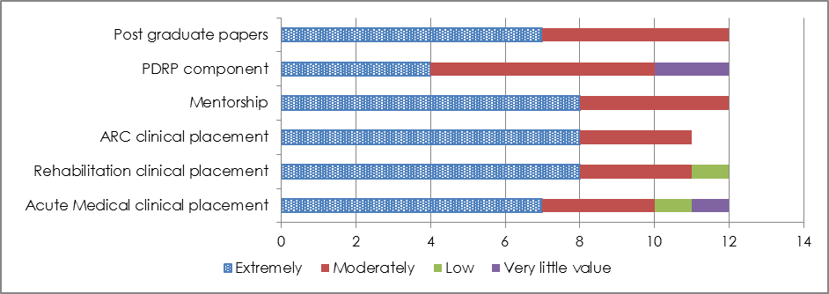

Overall the component parts of the programme were viewed as interdependent. Lower values placed on some components were identified in the interim evaluation and were being attended to, such as the integration of PDRP requirements within other GAP components and more active seeking of mentor support by participants when they are in clinical placements.

## The mentorship component of the programme

Mentorship was considered by all evaluation informants to be a **key strength** of the programme. The GAP mentor was expected to provide an on-going point of contact and support for the GAP participant for the duration of the programme, consistently throughout all components, including clinical rotation, PDRP and postgraduate study.

**Mentors’ profile**

In total ten GAP mentors were sent a survey as part of this evaluation and seven (64%) returned the completed responses. All have experience in postgraduate education, most had more than five years’ experience in older person’s health and more than 10 years post registration. Their workplace positions included clinical educators and clinical nurse specialists.

**Figure 4. Mentors’ reflections on their role in GAP**

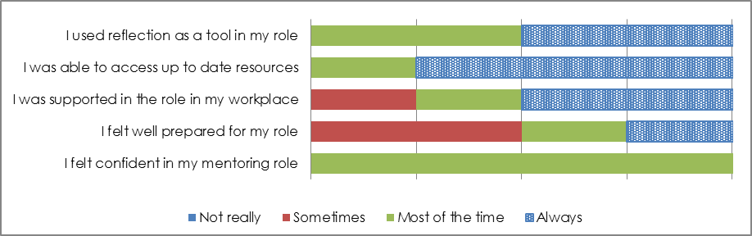

The issue of preparation and expectations of the mentor role was identified as an issue with such a new programme. As identified in the figure above, support from the workplace and preparation for the role were areas mentors felt less supported in. It is anticipated that previous GAP participants will be able to provide mentorship in future and will have a much better understanding of the implications of the role.

**The mentor role.**

Key characteristics that supported the mentoring relationship were mentors who were: knowledgeable and experienced, had completed postgraduate papers and were flexible, accessible and supportive. Participants stated that the mentor needed to be familiar with the GAP programme and what was required from both participants and themselves as mentors.

The most useful actions and activities of mentors were identified as:

* Planning (personalising) with the participant the most useful programme of contact, such as phone calls, visiting in placement and debriefing
* Providing a consistent contact throughout the programme and providing encouragement
* Supporting through rotation changes as some environments can be vastly different to their usual workplace
* Providing “permission” to critically reflect on certain aspects of care and the implications of these that often arose following a change of rotation and/or postgraduate study.

In response to questions relating to their experience with the GAP programme, the only areas that needed strengthening related to their preparation and orientation to the mentoring role.

**Figure 5. Mentors’ reflections on the GAP programme**

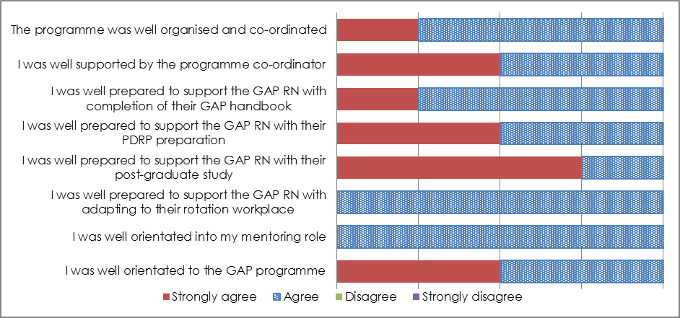

The figure below indicates that the mentorship component of the programme was highly valued.

**Figure 6. Value placed on the mentor component of the programme**

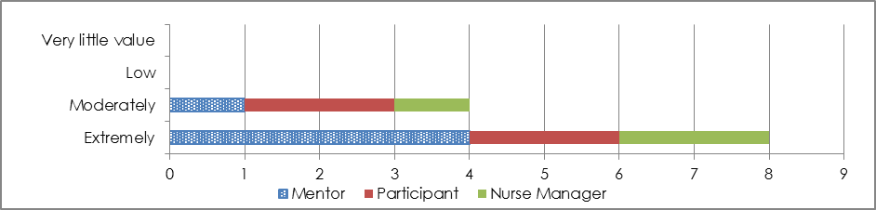

**Impact of GAP from the mentors’ perspective**

The overall end-of-programme comments from mentors reflecting on the programme reiterated earlier feedback that the programme was very valuable to the sector and that the inclusion of the PDRP component and the postgraduate papers on top of the workplace rotations made the programme ‘full on’. The participants needed to be well prepared and supported to cope with the challenge.

From their perspective it was well worth the effort as they had noticed the ‘growth’ in participants, particularly demonstrated through their critical thinking, increased confidence, adaptability and keenness to ‘step up’ into leadership roles. They also felt that the participants gained a greater understanding of the continuum of care for older people.

### The postgraduate nursing education component

The two postgraduate papers recommended for completion of the GAP programme were enjoyed by most participants and felt to be **relevant to their GAP programme goals**. The papers had a strong clinical focus, reflecting the University of Otago postgraduate team’s philosophy that **clinical competence and expert knowledge** are the first steps towards leadership; whether clinical or managerial leadership. The ‘Advanced Health Assessment’ paper was strongly suggested for GAP participants as it is part of the University of Otago’s certificate structure. Completion of a qualification is a requirement for HWNZ funding, and completion of the Advanced Health Assessment paper is a requirement for most Postgraduate Certificates, including Gerontology. While ideally the gerontology and advance health assessment were the papers of choice for participants, a few chose other papers that better matched their career pathway and prior learning.

**Figure 7. Collective value placed on the Postgraduate papers component of the GAP**

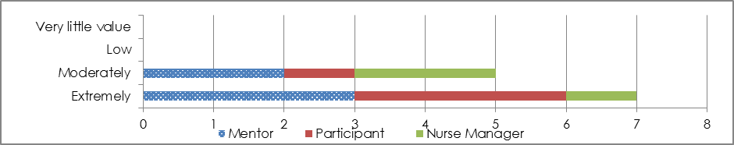

The figure above illustrates that high value was placed on the postgraduate papers component of the programme. The participants valued this more highly than the nurse managers.

Past GAP participants had found the clinical component and the examination of the Advanced Health Assessment paper challenging due to a number of factors, including access to clinical support and managing their other work and home commitments whilst studying for this paper. A number of evaluation informants, particularly mentors, highlighted a need for participants to complete an academic preparation workshop if they had not undertaken academic study before. The ARC sector also has an increasing number of staff for whom English is a second language. They also require additional support from the University. One solution was for potential GAP applicants to undertake postgraduate study in preparation for the programme, forming part of the career planning required in their application for HWNZ funding.

While previous GAP participants had suggested the programme be extended by six months to accommodate all the requirements, organisational changes made following the formative evaluation at the end of 2014 seem to have suited the most recent cohort of students who made no mention of needing to increase the length of the programme in their end of programme feedback.

### The clinical practice rotations

Considering the ideal placement, mentors identified the importance of a **welcoming, organised environment** with a **distinct and** **appropriate orientation** and knowledge of GAP expectations. Other characteristics included a high performance culture, excellent level of care, and commitment to GAP at management level. Suggestions were made that placements should be longer than 12 weeks; they should include an ARC, rehabilitation and acute placement and that placements should be different from the participant’s usual clinical area.

All participants valued the **increased relationships** with other settings and gained an appreciation of the specific challenges of different clinical areas. They acknowledged that ARC areas have a **high level of autonomy** and the combination of hospital and residential settings provides opportunities for proactive learning and knowledge. The value placed on the type of setting differed between the participants, mentors and nurse managers.

**Figure 8. Value placed on the components of the programme**

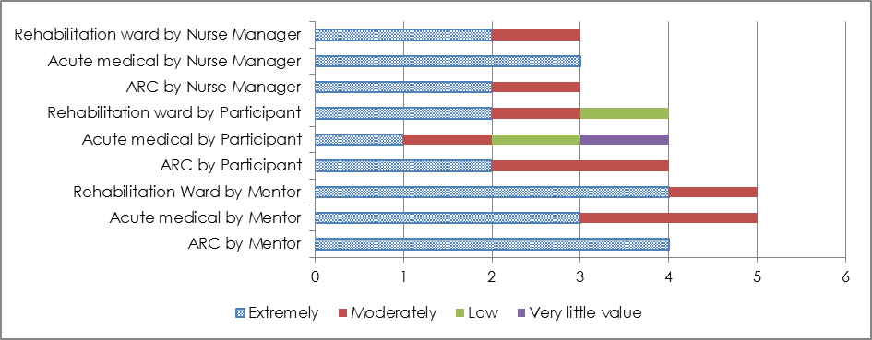

The previous graph highlights that the most recent GAP participants valued the rotation to acute medical less than to ARC and the rehabilitation setting. Mentors also rated the acute medical experience as less valuable for these nurses. It was noted in discussion with participants that the Rehabilitation and ARC localities also had patients/residents/ with high acuity, but had the value add over the medical rotation of a different focus on service delivery. Collectively, the ARC and Rehabilitation rotations were more highly valued.

**Figure 9. Collective value placed on the clinical rotation placements**

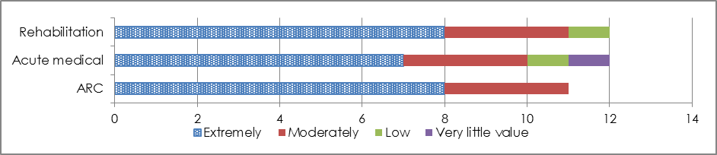

Managers viewed their role as pivotal in keeping the programme ‘alive’, by providing a well-structured experience for the visiting GAP nurse and looking out for potential GAP participants among their staff. The rotation plan below provides a potential solution to alleviate the frustration of matching GAP participants with an appropriate clinical experience. This is based on feedback from the managers and agreement that all CDHB hospital staff need to have residential care placement, but those based in residential care should focus on the CDHB hospital (acute and rehabilitation) experience. This is a complex issue as some GAP participants are 1.0 FTE and some are 0.8 FTE and effort must be made to ensure that workplaces are not disadvantaged.

**Table 2. Potential rotation plan to include six DHB & four ARC based nurses**

|  |  |  |
| --- | --- | --- |
| **Base (10)** | **Rotation 1** | **Rotation 2** |
| Acute Medical CHCH Hospital | Aged Residential Care Facility | Ward 2B TPMH |
| Acute Medical CHCH Hospital | Ward 1A TPMH | Aged Residential Care Facility |
| Ward 1A TPMH | Aged Residential Care Facility | Acute Medical CHCH Hospital |
| Ward 2A TPMH | Aged Residential Care Facility | Aged Residential Care Facility |
| Ward 2B TPMH | Aged Residential Care Facility | Aged Residential Care Facility |
| Ward K1 TPMH | Acute Medical CHCH Hospital | Aged Residential Care Facility |
| Aged Residential Care Facility | Ward K1 TPMH | Ward 1A TPMH |
| Aged Residential Care Facility | Acute Medical CHCH Hospital | Ward 2A TPMH |
| Aged Residential Care Facility | Ward 2B TPMH | Acute Medical CHCH Hospital |
| Aged Residential Care Facility | Ward 2A TPMH | Ward 1A TPMH |

### The Professional Development and Recognition Programme participation

The incorporation of PDRP participation into the programme, was designed to provide a framework for GAP participants to articulate and evidence how their learning experiences throughout GAP contributed to their growth in practice. As with mentorship, the PDRP activities were expected to be integrated into GAP to provide participants with an ongoing process for reflecting on and challenging themselves to transition from a ‘competent’ nurse to a ‘proficient’ one, using professionally recognised standards.

The subtlety of the rationale for inclusion of PDRP participation in GAP and the absence of this programme in some ARC settings, may have contributed to some participants’ view of its value.

Several participants felt that this was a **challenging aspect** of the programme and recommended expansion of the length of rotations along with integration of PDRP requirements / indicators in the GAP programme handbook and postgraduate papers. Some participants felt that attainment of ‘Competent’ level on the PDRP should be a prerequisite. The figure below illustrates that the nurse managers place a higher value on this component than the participants.

**Figure 10. Collective value placed on the PDRP component of the programme**

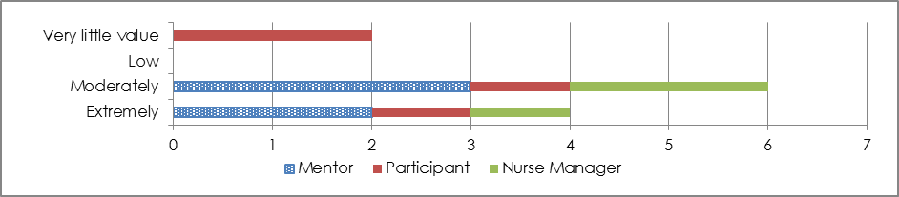

Prior to participating in GAP, some ARC nurses did not have access to an approved PDRP. GAP has raised awareness of such a programme and if ARC nurses do not have access to their own, they can access the DHB PDRP  either on an individual basis or by Memorandum of Understanding with their organisation.

Some participants clearly saw the value.

“*PDRP made me realise my achievements and increased my confidence.*” (Participant 14)

It is recommended to potential GAP participants that part of the preparation process for the next GAP intake will include having achieved PDRP at competent level. It was suggested that it would be more effective and less stressful to more overtly, integrate requirements of PDRP at proficient level into the clinical placement rotation expectations and the post graduate papers so that steady progress towards PDRP can be achieved throughout the GAP programme.

## Programme outputs

### Programme communication

Initial GAP participants and mentors found out about the programme mainly through **word of mouth**. A number of participants were “*shoulder tapped”* to take part by their manager; a recruitment strategy that may not be practical in the future.

The GAP Handbook was considered a valued source of information and recommendations were made in the interim evaluation report on how the handbook could be enhanced.

**Figure 11. Collective value placed on the GAP handbook**

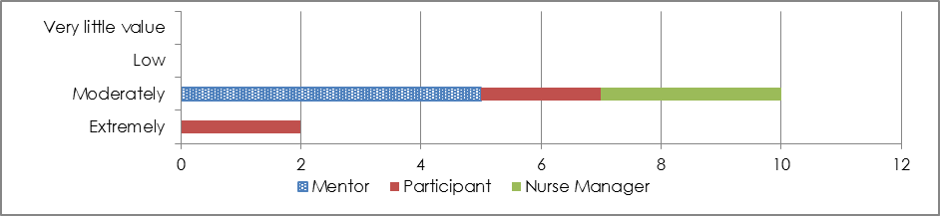

The handbook should clarify the programme structure and provide a clear overview of expectations and ensure that all people involved are aware of the rationale for these.

More detailed information on preparation for the programme should also be made available in marketing material.

### Programme participants

**First cohort of GAP nurses**:

* 10 nurses applied for the programme and 6 nurses commenced the programme.
* One (1) nurse withdrew part way through the programme for family reasons.
* Five (5) nurses completed the programme.

**Second cohort of GAP nurses:**

* 15 nurses applied for the programme and nine (9) were selected.
* Nine (9) nurses completed the programme in June 2015.

**2015/16 intake**

Because the Older Person’s Health Specialist Support Service is involved in relocating its services into a new build, the GAP programme has been put on hold for 12 months. It has been considered that such a programme in a specialist area may be more effective if only run every second year as it does require significant logistical planning and support.

**Ideal participants**

The majority of mentors identified a **passion for gerontology** as an essential characteristic of GAP participants. The second most frequently mentioned theme was motivation to learn or being “keen” (Mentor 2, 7). Mentors discussed whether the GAP was suitable for early or mid-career nurses, with a minority stating that ideal candidates would be new graduates. Most felt that **some experience would be advantageous** before commencing the GAP. The consensus was that all candidates should display confidence and maturity and that **selection interviews** were the ideal opportunity to identify the most appropriate candidates.

It was reiterated, that the participants ‘are not students’. They are expected to be active participants in the workplace, replacing a colleague who is in their workplace, therefore they need to be self-motivated, proactive and driven to make the most of the opportunities the programme provides.

**Participants’ profile**

At this point in the programme’s history fourteen (14) nurses have completed the programme. Because of the rotation plan (three settings each, including their home base), a third came from ARC facilities and the majority from Older Persons Health-focused CDHB hospital settings.

* Most were over 40 years of age, but two were under 30 years
* More than a third of the participants identified as non-European, one Pacific, three Asian and two as “other” ethnicity
* Half had more than five years’ experience in older person’s health
* Only a third had an undergraduate nursing degree
* Just over a half of the participants had experience in postgraduate education

This small sample suggested that the participants were likely to be mid-career nurses who were interested in consolidating their knowledge and experience through a formalised programme. The work profile of the GAP participants (figure 12) indicates that they did have some experience mentoring and managing staff, most felt well supported in their workplace and confident in their role.

In November 2014 both past and current GAP participants completed an electronic questionnaire to rate the impact of the programme on them. Then in June 2015, the current participants were asked the same set of questions to determine any changes in reflection on the programme as a whole and/or impact of changes to the programme following recommendations made part way through their programme.

While the number of participants who responded to the 2015 questionnaire represented just under half of the final participants, the changes in responses seemed worth commenting on as well as honouring the effort these nurses went to completing the questionnaire again. Those who completed the 2015 questionnaire overall appeared to be mentoring staff more, have increased support in the workplace, feel more confident to provide leadership and access up-to-date resources more.

|  |  |
| --- | --- |
| **Figure 12. GAP participants in their Pre-GAP role (2014)** | **Figure 13. GAP participants in their Post-GAP role (2015)** |
| GAP participants in their Pre-GAP role (2014) | Figure 13. GAP participants in their Post-GAP role (2015) |

As with the previous set of questions, the 2015 GAP nurses who responded to the questionnaire rated the level of support and mentorship particularly higher than those responding to the 2014 questionnaire.

|  |  |
| --- | --- |
| **Figure 14. GAP participants’ experience at formative evaluation where some were part way through the programme (2014)** | **Figure 15. GAP participants’ experience at summative evaluation after reflection on the programme as a whole and changes made (2015)** |
| GAP participants’ experience at formative evaluation where some were part way through the programme (2014) | GAP participants’ experience at summative evaluation after reflection on the programme as a whole and changes made (2015) |

### 

### Programme completion

Participants who had completed the programme were justifiably **proud of their achievements** and increased knowledge, confidence and competence. They valued the programme and **would recommend** it to their colleagues. There were, however, two past participants who had not yet completed and were still working towards their PDRP. Both current and past participants acknowledged that the GAP programme was ‘*hard* work’ and ‘*stressful*’ but **worth the effort**.

Examples of positive outcomes and change as a result of the GAP programme included:

* obtaining a leadership role
* becoming a role model to junior nurses, nursing students and a resource person to colleagues, doctors and allied health members
* extending my knowledge base and opportunity to complete the big picture of a patient’s journey which provided better understanding.

Comments included:

* ‘I have become more confident in my nursing practice. I am able to manage the complex patient’s care’
* ‘I am able to make an optimal decision about patient’s care based on best practice’
* ‘I advanced my knowledge in gerontology that allows me to make improvements in older person care’
* ‘I am able to make a difference and deliver skilful care to the patients’

‘This programme was very useful as aged care nurses do not really have access to a quality education. The GAP programme should be strongly encouraged amongst the ARC nurses as it will allow us to improve the quality of residential care and to deliver optimal services to the care users. Also, the overall acuity in ARC facilities is growing and residential care is becoming more complex to manage, therefore, it is vital to provide continuous support and access for nurses who work in ARC to valuable education’ (GAP RN Participant).

# Programme Impact

The programme impact is described in three parts to reflect the evaluation objectives; the impact on the participants, the impact on the service delivery and inter-organisational relationships and the impact on the wider nursing workforce.

Information was obtained through key informant interviews, e-surveys and GAP participants’ reflections and PDRP assessment documentation that were submitted as part of their requirements for their PDRP portfolio for GAP.

The experiential learning cycle (illustrated below) was used to form a framework for capturing reflective exemplars completed by the participants during the final stages of the programme. These were then thematically analysed using the framework below to inform analysis to gain a greater understanding of how GAP directly influenced the individual participant’s development.

**Figure 16. Framework for describing GAP exemplar**

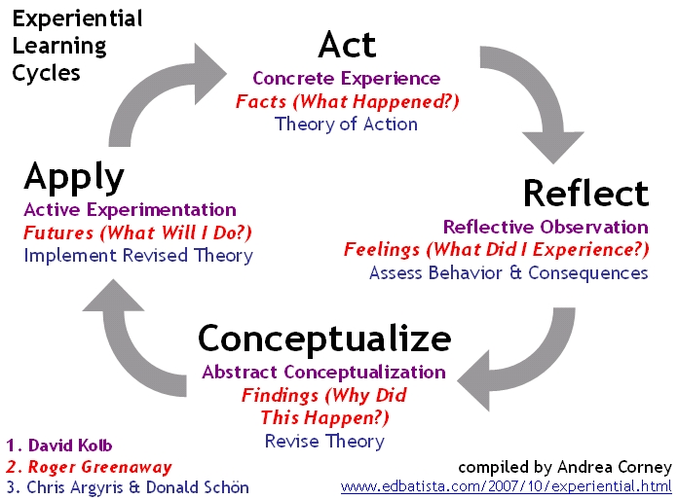

<http://edbatista.typepad.com/edbatista/images/2007/10/Experiential_Learning_Cycles_696.jpg>

## Impact of GAP on the participants

Twenty five reflections and PDRP excerpts were collated from nine GAP participants. A wide range of subjects and topics were included in the reflections and **three core categories emerged** from data analysis:

* 1. The benefits and value of GAP from participants’ perspectives
  2. The development of enhanced clinical competence and understanding of aged care
  3. The emergence of GAP participants as leaders

### The benefits and value of GAP from the participants’ perspective

# Three key themes from the participants’ reflections on the value of GAP were described with reference to the participants’ personal development and in relation to specific programme components.

# During GAP, participants transitioned from ‘basic’ to ‘expert’ practitioners and were aware of this transition within themselves.

*“Your strength as a well rounded leader is portrayed in your portfolio. You coach and mentor staff, you are a member of a number of committees within your organisation to improve quality in care delivery to the residents in the facility.”* R1

# Mentoring was a key component in developing GAP participants’ clinical and leadership skills, as well as personal confidence and personal growth.

*“[Mentor’s name] has given me the encouragement to stretch my knowledge and skills supporting me in my learning curve. [Mentor’s name] has supported my clinical learning, encouraging me to see and participate in as much as I could. This has actively propelled me to ask, discuss and participate in decision-making involving patients. I have always been a good patient advocate but I now see myself as being a pro-active advocate; this has been with [mentor’s name]’ encouragement.”* R9

# Clinical rotation to two different areas was extremely beneficial to GAP participants’ learning and development.

*“The first placement was within [ward] for the assessment and treatment of the older people who have been difficult to manage by their GP in the community, rest home or in the general hospital; all being recognised as requiring expert psychiatric assessment. Staff were expert in their field and were excellent in answering my questions.* *The staff work as primary nurses and know the patients in their care very well. I thoroughly enjoyed my placement and gained much from observation as well as participation.”* R4

*“I was very fortunate to have two outstanding placements that were vastly different in care culture and patient management. Studying post graduate papers (Advanced Health Assessment and Gerontology,) although very difficult at times, gave me the academic background by which to increase my knowledge in this area. I was able to practice things I had learnt, and at the same time pass on some of that knowledge to the people I was working with.”* R7

### The development of enhanced clinical competence and understanding of aged care

Key themes that emerged from the PDRP data were very much focused on an increased awareness of the need for a holistic approach to patients / clients.

Through reflective processes undertaken as part of GAP, **participants developed a more holistic understanding of aging and aged care.**

*“I have learnt so much from this course and have recommended it to others. On my recent training day, one nurse was asking the SW how to go about accessing money for her patients’ hairdo. Her daughter had been washing/ cutting the patient’s hair. I would normally have agreed had I not completed this course. I asked her to think about whether this was how the daughter still had some contact with her mother, through touch and engaging with her. Thank you for encouraging me to think in a different way, and using options of care and analysis.”* R12

*“One thing that captured my attention is the argument that people over the age of 70 are asexual beings. As an RN in a psycho-geriatric hospital, I was actually challenged by this assumption of asexuality in the aged. One that really stands out in my [assignment] interview was a couple who were over the age of 80. They were competent individuals and very open-minded and willing to share their perspective. Sex is only one element and sexuality is comprehensive. [The subsequent interview and further reading] disproved the assumption that people over the age 70 are asexual beings. This particular assignment has changed my attitude and beliefs in the way I see elderly people and their sexuality in my work place.”* R20

GAP participants **acknowledged** and were **able to correct or address gaps in their clinical practice, knowledge and experience.**

*“I felt my acute practice grow in the weeks to come, rather than follow what everyone else usually did, I began to critically think about each situation and deal with the acuity first and foremost. I still returned to the notes to gather a bigger picture of the patient, however I did this once I was sure the patient was stable. Going back to my base ward, I noticed a change in the way I approached things and had a greater awareness if a patient started to deteriorate. The learning in the acute ward was incredibly satisfying.”* R6

*“By learning the changes in the physiology of the human body brought about by aging, I am able to better understand the presentations that are exhibited by our residents and I am able to distinguish which of these presentations are expected of the elderly client or related to pathological changes in the body brought on by a disease process. I become more confident in coaching my colleagues on their assessment, planning and management of the elderly client.”* R14

*“Highly motivated tutors at Otago (University) along with the preceptors at each placement area were an inspiration and made me so glad that I had undertaken this course to increase my limited knowledge of the elderly in our care.”* R4

GAP participants gained a greater understanding of the aged care sector, **particularly in relation to the patient’s journey.**

*“I had formed some incredible relationships with staff and felt a lot more rounded and knowledgeable returning to my home base. It was valuable for completing the circle of a patient’s journey and getting a better understanding of the pressure the nurses are under in that environment. Rather than get annoyed at the lack of rehabilitative aspects, continence, bowel and family situations in handovers from the acute setting, I became far more aware of the priorities and the need for the two different models of care.”* R7

### The emergence of GAP participants as leaders

Several GAP participants were already in senior roles within their organisations, however a number of them were promoted during or shortly after completing GAP. Those who remained in their previous role described taking on more of a leadership role.

GAP facilitated participants’ perceptions of themselves as **clinical or managerial leaders** in their own area and beyond.

*“You show leadership by having high standards, by advocating for your patients and nurses and your ability to discuss and mentor, all of which you have provided evidence for.”* R3

*“I spoke with the care staff member who claimed to be left out of the team. She said she feels offended when other members of staff speak in their own language. After a discussion about cultural diversity in these modern times, we both agreed that the team does not mean to offend her. Later that day we all discussed the issue. I reminded them that as respect of their colleagues it is important that we speak in a language that can be understood by all – English. They apologised for their lack of sensitivity. In the end they all got along fine and have worked along well since.”* R25

During and after completion of GAP, participants felt more **prepared for leadership roles** in aged care.

GAP **participants grew in confidence and led innovation** **and clinical practice improvement** in their home base areas and other clinical areas.

“*You are active in reviewing policy and procedures, including documentation within the organisation as a whole. “* R1

*“The situation involved an elderly gentleman who was admitted with a lung infection. He lived independently in the community and of late was requiring increased support from his family to the extent that his family had decided (on his behalf) that he would be better suited in a rest home. The medical team conveyed this information to the patient in an abrupt manner; in fact they discussed it amongst themselves (medical team) in front of the patient asking the nurse about his functioning in the hospital and making comments about him being better off in care. They did not direct their questioning to the patient. I had spoken to the patient earlier in that shift and he was so looking forward to going home. After the medical team left, the patient became very distressed about the fact that decisions were being made on his behalf without him having any input.*

*He had not appeared to have been considered in the decision-making process. I mentioned this to my buddy nurse and asked her if they ever considered family meetings for situations like this. My actions were based on holistic rationale and my experience in ensuring all options were covered before making decisions about a life-changing outcome for the patient. In my base place of work, family meetings are an integral part of the decision-making process. She said she hadn’t really thought about that. She informed me later in the shift that she had talked to the medical team and they had since organised a family meeting.”* R5

The following **narrative account** from a participant who completed GAP in 2015 and was promoted shortly after, illustrates her personal growth and development through GAP.

*“I found the rotations were the biggest component of the GAP in terms of engagement with older persons health. Seeing the pathway that an older adult had when admitted to ED through to their entry to ARC. I was very fortunate to rotate to all three areas i.e. gen med, A T and R and ARC. I think those that did not have the three different rotations may not have had the same experience. It certainly gave me a lot of insight and I guess increased my sense of what it must be like for an older adult through the health system. I can honestly say that my empathy for the experiences the older adult has to go through was heightened. Alongside the rotations, doing the PG study gave me clinical skills through the health assessment paper and introduced me to a broader range of community supports and ways of thinking about older persons’ health in the gerontology paper.*

*In terms of promotion and career, I felt the GAP gave me an edge when I applied for the role I’m currently in. At the interview I was able to elaborate on the numerous areas of health the older adult enters and actually from experience demonstrate the part I played at each level. I’m finding in IDT now, particularly since the role as clinical assessor involves seeing older adults not just in the community but in ARC and hospital, I have a greater understanding of the channels they have to go through and can articulate some of the issues that might arise from their journey. It has really broadened my horizons.*

*So in brief, I think I have certainly gained huge amounts from the program, can see my horizons broadened substantially in terms of career and promotion as well as increased my love of older persons’ health and I guess a bit of desperation to make it much better for the older adult as well in whatever way I can.”*

## Impact of GAP on service delivery and inter-organisational relationships

Information obtained in key informant interviews, focus groups and as a result of e-surveys informed this component of the impact assessment. There was evidence that GAP was improving and **enhancing collegial networks** across the system.

*‘When I am in the community now, I can talk from experience to older adults about the different health areas.  I think if I had just stayed in A T & R and not ventured outside my comfort zone, I would not have the same outlook. I remember discussing patients at weekly IDT whilst in my former job and not truly understanding the impacts moving into ARC would be. I also saw this lack of understanding within the nursing staff particularly in the acute area. Now I am a strong advocate for doing all I can for keeping them functioning in the community for as long as possible. I also feel very motivated to ease the journey through the acute system for older adults in any way I can and see some great potential for increased geriatric services particularly nursing’ (GAP participant who changed roles following the programme).*

All participants valued the opportunity to experience clinical practice in other aged care settings and most built up relationships with staff that they use to facilitate better co-ordination and communication about patients as they move through the sector.

‘*I have increased my baseline knowledge and ensured more understanding of acute care and long term care situations and the crossover that occurs*’ (R 2).

GAP participants **led enhanced communication within the aged care sector** in Canterbury through networking and greater understanding of the patient journey.

*“You act as a role model in facilitating the development of communication skills in staff you work with. You facilitate a strong culture of open communication within the facility.”* R1

*“Staff [in ARC] felt “bad” about contacting doctors on weekends or out of hours. One such example was of a woman who was in increasing pain; palliative COPD not being controlled by the regime put in place earlier in the week. Staff were reluctant to call the doctor claiming they would organise a pump on Monday. She became increasingly unwell and when I came on duty, staff were very upset. I wasn’t happy with this and rang the doctor, however I had learnt (having been there a few weeks) that a case would have to be formed and I would have to be very assertive in what I wanted. The phone call went well. I had all the facts and a plan of action I saw as resolving the situation. The doctor came in that night and we managed to provide the patient with the pain relief and symptom control she needed.”* R18

Participants described **networking** and **making connections** as an important positive impact on the whole sector. **Greater understanding** of different clinical areas within the OPH sector was thought to facilitate **better management of patients** as they journeyed through OPH care and **improved quality of care**. Much of this impact was related to collaboration and networking.

## Impact of GAP on the nursing workforce

With increased confidence in their nursing skills and knowledge, most participants also had begun to **evaluate career intentions** and on-going professional development needs. A number felt that they had gained **leadership qualities** and would be seeking a leadership role in the near future; some in their current position and some applying for promotion where suitable positions were available.

Other comments identified an increased appreciation and understanding of other services. “*Much more aware of ARC sector and differences in resources”* (M1).

Participants valued the increased relationships with ARC placements and appreciation of the **specific challenges of different clinical areas**. They acknowledged that ARC areas have a high level of autonomy and the combination of hospital and residential settings provides opportunities for proactive learning and knowledge.

Overall the impact of GAP was considered to have a **positive influence on the workforce culture**. It was suggested that if the participant is engaged in the programme then the whole team becomes enthusiastic. The opportunity to share increased knowledge with other nurses in OPH has been a positive impact for participants, both enhancing the quality of clinical care and developing a culture of learning and on-going professional development.

*“[GAP has] increased my knowledge and also given me a chance to educate other staff at times*” (R 2)

One participant described the impact of GAP on OPH, the nursing workforce and herself as follows:

*“OPH – GAP has motivated ‘them’ [understood to mean nursing leaders in this sector] to find ways in which to encourage RNs to enhance their career in this field, also finding ways to seek younger participants. The workforce is motivated to further their careers through higher levels of education. As a nurse, GAP is empowering! I have grown in confidence and ambition. Also I have inspired others to consider this programme”* (P4)

Participants also spoke of the GAP as being influential in creating a knowledgeable and highly skilled workforce and **developing leadership potential** from both a personal perspective and also for the broader OPH workforce.

“*More potential leaders [due to]educated workforce in OPH.*” (R 1) “*The programme has stirred awareness on the importance of moulding leaders in this sector.”* (R13)

Mentors also acknowledged the programme is “growing future leaders in gerontology nursing” (M3). Networking was mentioned a number of times and the advantages of **collegial relationships** throughout the OPH sector. Several mentors acknowledged the value of “…*awareness of the other side of the fence*” (M1) and recognition of the challenges that individual areas face. Only one mentor stated it was too soon to know the GAP’s impact.

When considering indicators of success of the GAP programme the focus was mainly directed towards how success would look for the staff. Suggestions made included “…*reliable, knowledgeable carers*” (M4), and “…*confidence, enthusiasm, increased interest in Gerontology*” (M7). Mentors identified increased understanding and respect across the sector and “*greater and better outcomes for patients*” (M5).

# Summary of findings

This 12 month programme has combined efficient use of the HWNZ postgraduate nursing funding with clinical practice rotations, mentorship from expert nurses and the formalised PDRP to enable registered nurses in aged care to explore and more fully develop their clinical and leadership skills.

**The most valuable components of the programme** were identified by all support people and participants as the mentorship component, closely followed by the rotations to ARC and Rehabilitation facilities, then the postgraduate papers (that were judged most challenging in the formative evaluation). The PDRP component received mixed reviews, but was considered an important integrator in the programme. The value of this component was likely to increase when all future participants will have already completed a PDRP process prior to commencement of GAP.

**Mentors’ reflected** that they felt confident in their role, but preparation for the role and workplace support scored less highly. They also indicated more difficulty in their role supporting participants’ transition to the new clinical rotations. This prompted programme conveners to plan included more information for mentors and also start to use past GAP students as mentors in future.

**The postgraduate papers**, while a struggle for some, were a valuable component of the programme. Future GAP participants are expected to have more preparation for postgraduate study. The Adult Health Assessment paper was rated by participants as of great value, providing them with a more sophisticated approach to clinical decision making.

The **clinical practice rotations (reciprocal secondments)** were a valuable component for participants, with the ARC and rehabilitation most popular. The participants on the programme govern the availability of rotations, hence the evaluators suggested a rotation based on two other placements than their home base. This component is the most complex and requires the most negotiation and programme co-ordinator time, particularly for a public/private sector ‘swap’, but the value for the participants of this opportunity is extremely high.

**Communication** about and during the programme was identified as a weakness, but issues raised by the formative evaluation are in the process of being addressed. The GAP Handbook will likely become a very valuable programme support with suggested changes and the inclusion of more information on programme logistics. The revised booklet could also be used to inform the development of other specialist nursing programmes similar to GAP.

Although the number of respondents were small, information obtained from participants about their **before and after GAP** nursing role and levels of confidence, indicated a trend towards more mentoring of staff, feeling more supported in the workplace, greater confidence in providing leadership and more able to access updated resources. In terms of their experience of the course now they had completed it, compared with their feeling part way through, they indicated they felt greater support, better preparation for their postgraduate study, better orientated into the clinical rotations and better supported by their mentors. The before and after measures may indicate their growth in confidence and support seeking behaviour as the programme progressed.

Examples of **positive outcomes and change** as a result of the GAP programme included:

* feeling confidence as leaders and even obtaining a leadership role post GAP, within the sector,
* becoming a role model to junior nurses, nursing students and resource person to colleagues, doctors and allied health members,
* extending their knowledge base and opportunity to complete the big picture of a patients journey which provides better understanding of the service as a whole,
* nurses noting their transition from competent to proficient practitioner during the programme,
* confidence in their ability to correct or address gaps in their clinical practice, knowledge and experience.

The concern that nurses undertaking the programme will be tempted to leave following exposure to other health settings has not eventuated to date. While only 15 nurses in 2 intakes have now completed the programme to date, most movement has occurred within the sector.

**Results that have emerged as a result of this programme**, based on feedback from a variety of sources have included:

* a more integrated working relationship between those in the aged care sector generally, including both public and private providers and more networking among nurse clinicians
* a cohort of experienced and well qualified nurse leaders is now working in the sector locally
* a culture of mentorship for registered nurses working in the sector
* identification and transferring of initiatives and tools from one locality to another, such as streamlining discharge from Rehabilitation to the ARC facility and development of a standard means of communication between providers
* greater understanding of components of the continuum of care for older people,
* the value of partnering between industry and tertiary provider to develop a more meaningful and practical postgraduate education experience for staff
* provision of a model for investing in nursing leadership through the application of a shared governance across aged residential care and DHBs .

# Conclusion

Overall this programme has the potential to become a useful process for growing and networking nursing leadership within the older people’s health sector. The programme has been resourcefully developed by ‘piggy backing’ on existing activities and pulling together a synergistic programme that has the potential to remain dynamic and meet the changing needs of nursing leadership and the sector.

A particularly innovative feature of this programme is the clinical rotations, which are effectively reciprocal secondments. These provide opportunities for nurses to experience the reality of working in another environment for a number of weeks, fully supported, without the ‘risk’ of leaving one place of employment to move to another. This experience both challenges and enriches the nurse’s experience during the programme.

This programme has shone a light on an area of nursing that in the past has not been considered as having ‘career potential’ for nurses. The fact that the programme attracted both young and older nurses as well as a greater number of applicants and participants in the second year, demonstrates that there is interest among nurses in this growing sector.

Evidence provided by this evaluation supports the continuation of the programme with recommendations for enhancement that should make the programme even more attractive to nurses and organisations with a desire to enhance their nursing workforce and ultimately the quality of care for their clients. There is also the potential of this GAP model to be replicated for other nursing specialties.

# Recommendations

The evaluation concluded that the programme appears to have added significant value to the sector and nurses working within it and has the potential to be replicated within other areas of nursing. Therefore, **we recommend that the programme continues** with enhancements recommended in the interim report.

1. **Improve programme readiness**

As identified in the formative report, having participants, clinical rotations and mentors aware of their responsibilities for the programme and clarifying the ‘pre-entry’ requirements for applicants would fast track the entire process and reduce co-ordinator effort.

1. The Handbook should contain more specific information for potential participants so they can prepare themselves in advance for the programme.
2. Include more logistical information for those planning to apply and/or organisations wishing to become involved, because of the reciprocal secondment requirements.
3. All applicants should have completed their PDRP at confident level and plan to attend an academic study preparation programme if they have not undertaken academic study before.
4. Provide greater clarity of the programme’s intent so that recruitment into the programme can be more targeted, participant’s goals more strategic and impact measures more focused.
5. Utilise past participants for advice on and support for programme readiness.

1. **Facilitate programme integration and maintenance**

Programme integration is an important success factor. This reduces stress for both participants and mentors. Understanding the programme as a whole and how each component can build on the other is identified as a way to make the experience more constructive for the nurse. Allocation of a programme co-ordinator (or designated facilitator) would achieve continuity for all involved in the programme. There should be dedicated hours for this role.

1. Appoint a specific programme co-ordinator/facilitator role while the programme is running. This person would also be responsible for communication and programme logistics.

1. **Continue programme development**

As more nurses undertake the programme, more placements will need to be identified, the components will need to be reviewed and updated and the programme tools, such as the GAP Handbook, reviewed and updated. Building in a post-programme review process will inform these changes.

* 1. Build into the programme a pre and post GAP e-survey to inform further development of the programme.
  2. Utilise the experience of those involved in the CDHB GAP programme to inform the on-going programme development.
  3. Develop a set of indicators against which the success of the programme, both short and long term can be measured.

1. **Enable replication of the programme model**

Already interest has been shown in replicating the GAP model in other parts of the country and in other areas of nursing as a strategy to make more effective use of the HWNZ postgraduate nursing funding and to increase service capability and capacity.

* 1. Utilise the experience and hindsight of those involved in the CDHB GAP programme to inform the establishment of such programmes in other sectors and parts of the country.
  2. Ensure good across sector engagement of industry (non-DHB and DHB) and education, both pre and post programme implementation to imbed the programme within the local context.

# References

Chenoweth, L., Jeon, Y., Merlyn, T., & Brodaty, H. (2010). A systematic review of what factors attract and retain nurses in aged and dementia care. *Journal of Clinical Nursing, 19*(1-2), 156-167. doi: 10.1111/j.1365-2702.2009.02955.x

Dryden, H., and [Rice, A.M.](http://eprints.gla.ac.uk/view/author/2262.html) (2008) [Using guidelines to support secondment: a personal experience.](http://eprints.gla.ac.uk/49905/) [*Journal of Nursing Management*](http://eprints.gla.ac.uk/view/journal_volume/Journal_of_Nursing_Management.html), 16 (1). pp. 65-71. ISSN 0966-0429 (doi:[10.1111/j.1365-2934.2007.00794.x](http://dx.doi.org/10.1111/j.1365-2934.2007.00794.x))

Howard-Brown C, McKinlay E (2014). ARC NETP Programme Evaluation Final Report Ministy of Health. http://health.govt.nz/arc-netp-programme-evaluation-report.doc

Health Workforce New Zealand (2011). Workforce for the Care of Older People (Phase 1 Report) http://www.health.govt.nz/system/files/documents/pages/care-of-older-people-phase1-report.pdf

Kydd, A., Touhy, T., Newman, D., Fagerberg, I., & Engstrom, G. (2014). Attitudes towards caring for older people in Scotland, Sweden and the United States. *Nursing Older People, 26*(2), 33-40. doi: 10.7748/nop2014.02.26.2.33.e547

Maas, M., Strumpf, N., Beck, C., Jennings, D., Messecar, D., & Swanson, E. (2006). Mentoring geriatric nurse scientists, educators, clinicians, and leaders in the John A. Hartford Centers of Geriatric Nursing Excellence. *Nursing Outlook. 54* (4), 183‐188.

Manchester, A. (2006). A passion for gerontology. *Kai Tiaki Nursing New Zealand, 12*(3), 28-28.

McCann, T. V., Clark, E., & Lu, S. (2010). Bachelor of Nursing students career choices: A three-year longitudinal study. *Nurse Education Today, 30*(1), 31-36. doi: <http://dx.doi.org/10.1016/j.nedt.2009.05.014>

Nursing Council of New Zealand (2014) Registered Nurse and Enrolled Nurses Workforce Statistics (2013). http://www.nursingcouncil.org.nz/Publications/Reports

Nursing Council of New Zealand (2013) The future Nursing Workforce; Supply Predictions 2010 - 2035. http://www.nursingcouncil.org.nz/Publications/Reports

Scott, S., Huntington, A., Baker, H., & Dickinson, A. (2011). The graduate nursing workforce: does an international perspective have relevance for new zealand? *Nursing Praxis in New Zealand, 27*(3), 4-12.

Simpson, C. F., Durso, S. C., Fried, L. P., Bailey, T., Boyd, C. M., & Burton, J. (2005). The Johns Hopkins Geriatric Summer Scholars Program: a model to increase diversity in geriatric medicine. *Journal of the American Geriatrics Society, 53*(9), 1607-1612. doi: 10.1111/j.1532-5415.2005.53527.x

Stevens, J.A. and Crouch, M. Frankenstein's nurse: what are schools of nursing creating?*Collegian*. 1998; 5: 10–15

Stevens, J. A. (2011). Student nurses’ career preferences for working with older people: A replicated longitudinal survey. *International Journal of Nursing Studies, 48*(8), 944-951. doi: <http://dx.doi.org/10.1016/j.ijnurstu.2011.01.004>

Stodart K (2014). Fast tracking a gerontology career. *Kai Tiaki Nursing New Zealand, 20*(10), 12-13