Fixated Threat Assessment Centre New Zealand
Annual Report July 2019–June 2020

Citation: Fixated Threat Assessment Centre. 2021. Fixated Threat Assessment Centre New Zealand: Annual Report July 2019–June 2020. Wellington: Ministry of Health.
Published in December 2021 by the Ministry of Health
PO Box 5013, Wellington 6140, New Zealand
ISBN 978-1-99-100774-2 (online)
HP 7924
This document is available at health.govt.nz
This work is licensed under the Creative Commons Attribution 4.0 International licence. In essence, you are free to: share ie, copy and redistribute the material in any medium or format; adapt ie, remix, transform and build upon the material. You must give appropriate credit, provide a link to the licence and indicate if changes were made.

Acknowledgements
It is timely, at the point of reviewing the first year of operations of FTAC to acknowledge the debt of gratitude owed to a number people and services. The establishment of a service that spans several discrete organisations requires a high level of cooperation, good will and intent. Thanks, are extended to all who were involved including those within Police, the Ministry of Health, Parliamentary Services, and the Forensic Mental Health services of Capital and Coast District Health Board. We offer a special acknowledgement to our colleagues within the Security Enablement Team. It is their expertise and skill that allows FTAC to do our core work, with its emphasis on prevention and intervention to reduce harm to people in the community and public office holders.

A critical aspect of the functioning of FTAC is the sharing of information. The development of a sophisticated process for dealing with the inevitable privacy issues that arise was a key aspect of the establishment of the service. The basis for information sharing sets out the provisions under which this is made (Appendix C). We are grateful for the assistance of the Ministry of Health and Police experts in this area and the advice provided by the Privacy Commission in the establishment of our privacy impact assessment. Privacy remains a salient issue that influences our practice and thinking day-to-day. It is achieving the balance between the respect for an individual’s privacy and the good that comes from appropriately sharing information in a considered way between agencies that lies at the heart of how the service operates.

Finally, we would like to thank the police and mental health colleagues that work alongside us for their expertise, commitment and work over the last year.

Dr Justin Barry-Walsh
Consultant Forensic Psychiatrist

Aidan Neville
Detective Sergeant

Caveat
The Annual Report is primarily constructed on the data collected by FTACNZ (Appendix D) and is based on information recorded during FTACNZ’s first operational year, 1 July 2019 to 30 June 2020. Due to the trial activity of FTACNZ between 1 August 2017 and 30 June 2019 and the improvements in reporting processes, FTAC has undergone several amendments to the data recorded. The data used for this report was that available on 1 July 2020.

Contents
Introduction 1
Operational review 2
Key engagement and training 3
Governance 4
The year in review 5
Referrals 5
Concern level 6
Demographic 7
Target 8
Method of contact 9
Presenting problems 9
Police history 10
Mental health history 11
Intervention and outcome 13
Cases and sub-groups 14
Grievance 14
The querulous 15
Individual 15
Lone actor grievance-fuelled violence 16
Appendices 17
Appendix A: Service structure 17
Appendix B: Fixation definitions 19
Appendix C: Basis for information sharing 20
Appendix D: FTAC data collection 21
Appendix E: Concern level definitions 22
Appendix F: Harassment, stalking, threats and attacks targeting New Zealand politicians 23
Appendix G: Fixated threat assessment centers preventing harm 24

Introduction
The Fixated Threat Assessment Centre New Zealand (FTACNZ) is a prevention-focused collaboration that brings police and mental health professionals together to appropriately share information, conduct assessments, and facilitate mental health, law enforcement or other interventions to address the risks posed by fixated individuals (Fixation Definitions, Appendix B).

The concept of a FTAC has its origins in research by the Fixated Research Group in the United Kingdom which identified the critical role of mental illness in those that threaten and approach royalty. This lead to the first FTAC in the United Kingdom (UKFTAC) initially as a pilot in 2006. There has been impressive growth in the research base and the development of services since that time. The second dedicated FTAC opened in Queensland in 2013, after a similar service was established in the Netherlands. Since then all states and territories in Australia have established some capacity, with well-developed services in Victoria, Queensland, New South Wales and Western Australia.

After a pilot project which ran from September 2017, FTACNZ was established on 1 July 2019. The development of the New Zealand service took several years and was the result of dedicated work and commitment to the concept by a small group of interested individuals. The demonstration of the high level of harassment experienced by New Zealand Members of Parliament in a survey in 2014, published in 2015 (Appendix F) and a dramatic event at Parliament in May 2016 were important springboards to the establishment of the service.

FTACNZ operates as a joint service with police staff and senior clinicians from the forensic mental health service working together (Service Structure, appendix A). An important function of the FTAC is to identify individuals who may be fixated upon a cause or individual. As the 2014 survey demonstrated, fixated people frequently petition, approach, communicate in concerning ways or threaten Members of Parliament and their staff. Overseas research and the data from our first year of operations demonstrates that these people are commonly mentally ill. Further, the recognition of warning behaviours and impact of their communications on themselves and others provides the opportunity for intervention. From a mental health perspective this allows for a unique opportunity to intervene by facilitating treatment for a group who may have fallen out of treatment, never received treatment or are in treatment in situations where the full extent of their activities is not known.

These interventions have been proven to reduce harm to the individual themselves, those around them in the community and those that are the subject of their attentions. Thus, a key aspect of FTAC is that it provides a public health intervention and has an emphasis on prevention. In addition, other interventions occur including liaison with police in ways that reduce the burden on resources and facilitate better outcomes for those involved. The importance of Police in the service is emphasised by the high rates of Police involvement including criminal convictions in those referred.

Operational review
This report has been prepared to provide an overview of FTACNZ operations and outcomes during the first year.

The value of the service is demonstrated in the pages that follow, and a deliberate effort has been made to provide both a holistic overview and a more focussed observation of particular behaviours exhibited.

New Zealand’s political open-door policy and approachable image provides the perfect platform for individuals to correspond and/or approach Members of Parliament. With the general public having access to both their MP’s office and the Beehive, the system inspires person-to-person interactions, with politicians trying to promote their approachability. The impression from our first year of operations is that this feature of our political landscape, valued by both politicians and the public, increases the likelihood people will communicate with and fixate upon politicians and their staff and heightens the need for an FTAC service.

One statistic that stands out is that of the 87 referrals received in the year, 44 had a serious psychotic illness of whom 14 had never previously been in treatment, 20 were not in treatment at the time of referral and the remaining 10 were in treatment. Given the research and what has been learnt from other FTACs these numbers while concerning are not surprising. The ability to share appropriate information between Police, Parliament and Mental Health Services allowed for much better treatment and outcomes for this group of people.

The value of speaking directly to these troubled people, including those where there is no clear mental illness is also highlighted. A number of cases could be resolved by listening to and understanding a person’s concerns and identifying ways that they can be supported and assisted. This also allowed for tailored advice and support to be provided to those making the referrals including vulnerable electorate offices. The feedback we received both directly and via the Security Enablement Team was that this advice was highly valued.

The advent of the COVID-19 pandemic had a substantial impact on the functioning of the service and the threat environment. Changes in behaviour forced by lockdown reduced the number of direct referrals coming from Parliament. This is consistent with anecdotal reports from overseas, particularly Australia. It appears people fixated on causes and grievances moved more to online expressions of their distress. This shift emphasises the value of having the service located within the National Intelligence Centre as there has been a natural education within that environment of the functioning of the FTAC leading to appropriate referrals to the FTAC when such online activity has been identified through general reporting processes.

Future direction
It is expected that the operational demand for an FTAC service will continue and likely grow as has been seen in overseas jurisdictions. In anticipation of this FTACNZ continue to engage with partners and report to Governance Group on areas of likely future demand.

Key engagement and training
During the first year of operation, engagement has occurred with key partners and government agencies, including the Independent Police Conduct Authority, the Office of the Ombudsman and the Human Rights Commission amongst others. The purpose of this engagement has been to identify FTACNZ to those organisations and provide them with an understanding of what FTACNZ is and does. While this is useful so that these agencies are informed of the FTACNZ’s existence, it has become obvious those agencies also receive attention from similar, if not in some instances the same, individuals. This poses an important question on how FTACNZ should operate and whether it should be widened to receive referrals from other agencies.

Staff within FTACNZ have attended international events. This included the Asia Pacific Association of Threat Assessment Professionals (APATAP) conference in Melbourne in February 2020. Dr Barry- Walsh in conjunction with colleagues from Western Australia and Canberra presented a forum on the FTAC model in Singapore in November 2019. This event was a joint conference between the Royal Australian and New Zealand College of Psychiatrists Faculty of Forensic Psychiatry and the Australia and New Zealand Association of Psychiatry, Psychology and the Law.

Although COVID-19 has meant international conferences are not occurring in person at the moment, staff from FTAC will also be presenting as part of a webinar series developed by APATAP.

In April a review paper on FTAC (Appendix G) co- written by Dr Barry-Walsh was published in the widely read CNS Spectrums Journal and a book chapter is also planned.

Liaison with other FTACs continues, with regular meetings taking place with the other jurisdictions facilitated both by the ANZCTC and a less formal community of practice model. In the past year FTAC staff have taken the opportunity to visit United Kingdom FTAC (Justin Barry-Walsh), Victoria FTAC (Emily Pike, Aidan Neville and Justin Barry-Walsh) and Queensland FTAC (Justin Barry-Walsh.)

Engagement with mental health services within New Zealand is ongoing. This has included presentations by senior clinicians at inpatient units within the region; a presentation to the crisis response service for the region; and a presentation at the Southern District Health Board mental health grand round (Continuing Professional Development sessions) which was widely zoomed. Referrals to mental health services provide an opportunity to explain and educate about the service. When referrals are made there is routine liaison with the Director of Area Mental Health Services (DAMHS).

Governance
FTAC is overseen by Governance Group members from senior levels of the agencies currently involved.

The key legislative tools under which the team operates include the Privacy Act 1993, Health Information Privacy Code 1994, and the Mental Health (Compulsory Assessment and Treatment) Act 1992.

The year in review

Referrals
For the purpose of this report, a referral means a person referred to FTAC believed to be exhibiting fixated or otherwise concerning behaviours that come under FTAC scope.

Between 1 July 2019 and 30 June 2020, FTAC received a total of 87 referrals; 62 were accepted, seven were declined with no further action and a further 16 that were declined referrals with alternative action completed (DRAAC). Two were referred on to other FTACs overseas.

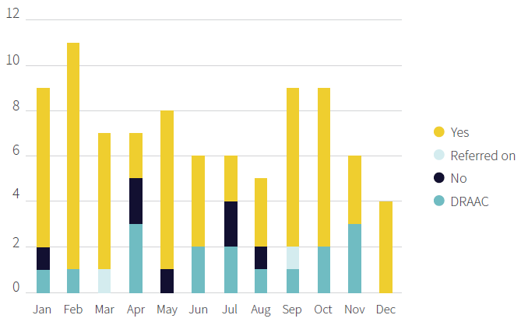

Data is collected for each referral for reporting and analysis. The data reported on within this report is consistent with that collected by other FTAC services and in line with guidance provided by the Australia New Zealand Counter Terrorism Committee (ANZCTC).

FTAC received referrals from the Parliamentary Security Enablement Team (SET), New Zealand Police (NZP), District Health Boards (DHB), United Kingdom FTAC (UKFTAC) and Queensland FTAC (QFTAC).

SET provided the most referrals with 59, NZP 21, UKFTAC four, QFTAC two and DHB one.

As of 1 July 2021, 73% (n = 64) of referrals were closed, 21% (n = 18) open and 6% (n = 5) were currently being monitored.

With the exception of onward referrals to overseas jurisdictions, all referrals considered by FTAC are assessed against a tool called the Risk Aide Memoire (RAM). This tool is utilised by all FTACs to assist in determination of the concern level posed by an individual. Where possible the RAM concern level for onward referrals is obtained from that FTAC.

Concern level
Referrals are assessed with the assistance of the RAM. Concern levels fall into three categories unless further information is required or there is insufficient information to conduct a RAM determination. These are High, Moderate and Low (Appendix E).

The initial concern level of the referral determines the urgency of interventions and if the concern level is low the referral is not accepted. However, there may be an underlying duty of care or other constructive input that FTAC can provide. Thus, it is common for those not accepted to require further input hence the DRAAC category. Initial concern levels were recorded as low (n = 33), moderate (n = 30) and high (n = 24).

Of those cases where the concern level was reviewed within the timeframe of the report (some were still active and subject to on-going intervention) as the table below demonstrates all but two had reduced in their level of concern including all initially rated as of high concern.

Concern level | #
High–Low | 17
High–Moderate | 3
Moderate–Low | 20
Moderate–Moderate | 1
Low–Low | 8
Low–Moderate | 1

Not all referrals can have their concern level reduced, nor can FTAC achieve a reduction in concerning behaviours in all instances, however wider knowledge of these behaviours allows for mitigations to be put in place. Where a low level of concern is initially determined, a review of the concern level is only conducted where deemed necessary.

Demographic
Demographic information recorded are age, gender, ethnicity and location (location recorded by town and policing district).

Sixty two of the referrals were male (71%) and 25 (29%) female.

Age ranges are from 17 to 71, the most common age range of referrals were aged between 47–56 years; the median age is 47.

Age range | #
17–26 | 4
27–36 | 14
37–46 | 25
47–56 | 27
57–66 | 17
67–76 | 2

Ethnicity of referrals include African, Asian, European, Indian, Maori, Middle Eastern and Pacific Island. Europeans are the highest represented ethnicity with 69%.

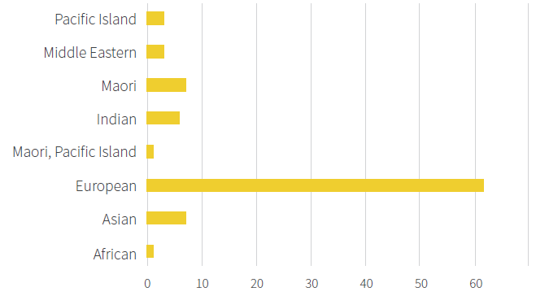

The geographical location of referrals to FTAC is categorised by the 12 police districts, with ‘Other’ representing referrals residing internationally. The top three where FTAC Persons of Interest (POI) reside are Wellington 25% (n = 22), Canterbury 15% (n = 13) and Auckland 10% (n = 9). (Auckland City, Counties Manakau and Waitemata combined, n = 18).

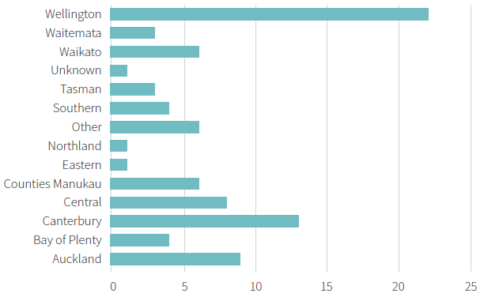

Target
Target refers to a specific entity an individual is directing their messages to and is detailed into nine categories; government organisation, royal, judiciary, politician, police, community, workplace, school and other.

Target | #
Politicians | 65
Government organisation | 23
Police | 9
Royals | 6
Other | 6
Judiciary | 4
Community | 5
Workplace | 1

As expected, politicians (75%) and government organisations (26%) were the two most targeted entities. There is overlap as fixated individuals are known to target multiple entities. 29% (n = 25) of referrals sent correspondence to more than one target.

Method of contact
The method of contact records the form of communication (where identified), that a referral used.

Method of contact | #
Email | 50
Approach indirectly | 24
Social media | 18
Handwritten or typed letter | 14
Telephone | 13
Approach directly | 5

Emails (57%) are the most common method of corresponding. A concerning outcome is the number of referrals which involved indirect and direct approaches. Approach behaviours are a well- recognised warning sign in the threat assessment literature.

Indirect approach was the second most utilised method of contact with 28%, whereas approach directly is 6%. Approach indirectly refers to when a referral would visit the representative’s building, eg, parliamentary precinct, MP’s electorate office, etc in person. Approach directly refers to approaching the target (public figure) in person.

Presenting problems
Presenting problems represents the concerning behaviour that is initially observable at time of referral and are recorded as self-harm, conspiracy theorist, threat, delusions, violence to family/ friends/acquaintances, violence to general public, suicide, sexual nature, drug use, use of weapons, arson, property damage, harassment and stalking. The categories are not mutually exclusive. Delusions are an ANZCTC Category and encompasses a range of behaviours driven by delusional beliefs. The most common behaviour in this group is petitioning of politicians. Often these individuals communicate a high level of distress which raises concern for their welfare and those close to them.

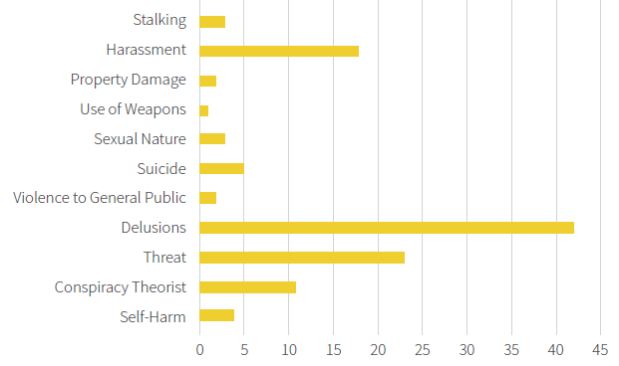

Delusion (48%, n = 42) is the most common observed concerning behaviour, followed by threat (26%, n = 23) and harassment (21%, n = 18).

Police history
Police history is split into two datasets and the relevant data is pulled from the Police National Intelligence Application (NIA).

The first dataset identifies whether or not police had previously interacted with a referral and is split into three categories; no interaction prior to referral (n = 6), interaction but not criminal prior to referral (n = 23) and criminal interaction prior to referral (n = 58).

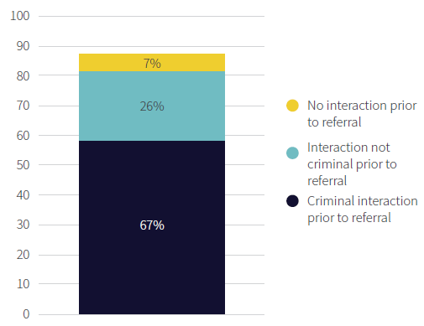

The second set identifies a referral’s mental health diagnosis and is recorded as psychotic disorders (n= 44), major affective disorders (n = 5), personality disorders (n = 8), anxiety and PTSD (n = 4), any psychiatric diagnosis (n = 0), nil diagnosis (n = 21) and other (n = 6). All diagnoses were determined by the psychiatrist.

Conviction | #
Assaults | 28
Driving offences | 24
Other | 20
Disorder | 16
Property damage | 15
Drugs | 13
Theft/burglary | 12
Car conversion | 9
Family violence | 7
Fraud | 6
Alcohol related | 6
Breach of intervention | 5
Sexual | 4
Dishonesty/deception | 3
Weapons | 2
Stalking/harassment | 2
Arson | 1

Assaults was the most common conviction, with 32% previously being convicted of violent offences.

Mental health history
Mental health history is split into two datasets.

The first dataset identified whether or not a referral has interacted with mental health and is split into three categories; no previous or existing mental health care (n = 40), mental health care prior to referral (n = 31) and mental health care at time of referral (n= 16).

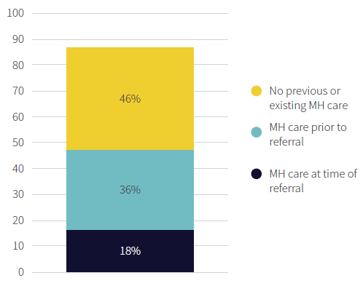

The second set identifies criminal history (exclusively includes convictions) and is categorised by the following; fraud, disorder, alcohol related, car conversion, dishonesty, weapons, drugs, property damage, family violence, arson, theft/burglary, sexual, driving offences, stalking/harassment, breach of intervention, assaults and other. All diagnoses were determined by the psychiatrist.

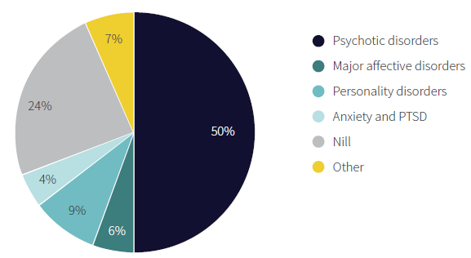

No history of mental health care and psychotic disorders are the highest represented data within their separate dataset. Sixteen percent of referrals had no prior mental health history; but were diagnosed with a psychotic disorder.

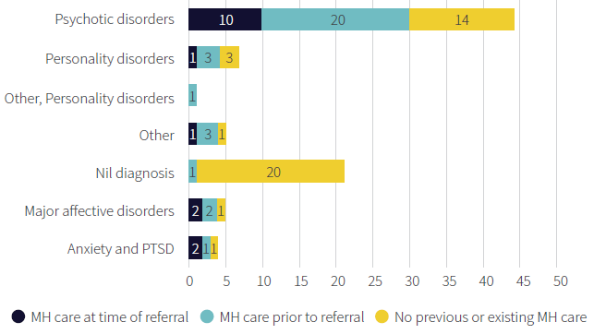
NB. Only one referral had a history of interacting with mental health but had no formal diagnosis.

Intervention and outcome
Interventions utilised are as follows; contact GP, contact POI, external law enforcement agency, external security agency, mental health service, other, police and nil attempted.

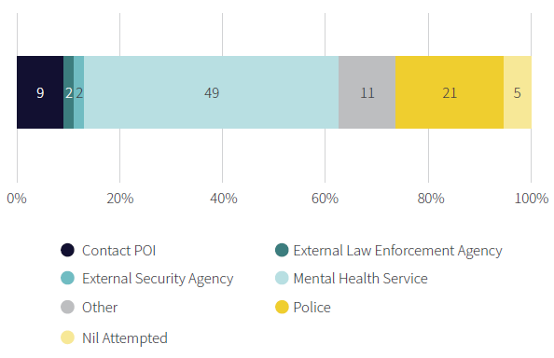

The two most utilised interventions are referral to mental health services (56%, n = 49) and liaison with police (24%, n = 21). Half required more than one intervention (52%, n = 45).

At the point of closure, cases were assessed on the basis of evidence of change in concerning behaviour. This was either reduction in concerning behaviour (n = 31), increase in concerning behaviour (n = 0) or no change in concerning behaviour (n = 8).

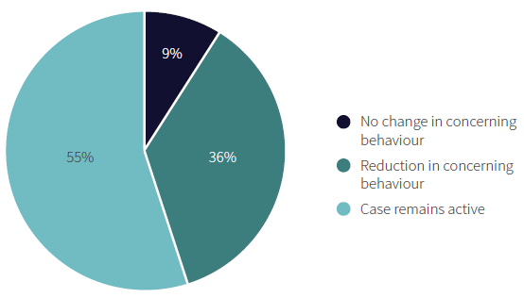

The case remains active section refers to cases where the case had not yet been closed or there was insufficient elapse of time to determine whether there had been a change in concerning behaviour.

Cases and sub-groups
Most POIs were referred as they had established or possible grievances. This included a number of people with identifiable mental illness. However, there were several subgroups which differed. These included those fixated-on individuals, the querulous and those who may best be seen as presenting a risk of lone actor grievance-fuelled violence. Several illustrative cases and further consideration of these sub-groups are below.

Grievance
Most POIs are preoccuppied with a grievance arising from a perceived injustice and have a feeling of resentment from being unjustly treated. The actions of POIs fixated in this manner are directed at Public Office Holders (POH) usually either because they believe the POH will support or assist them or because the POH has become the focus of their resentment, often because they believe the POH has ultimate responsibility in their case.

The querulous
The querulous are people who feel like they have been wronged by a person, agency, system or government as a whole, and obsessively pursue this injustice. The main distinction between grievance and querulous is that querulous people are complainants in a relentless pursuit of justice.

Despite this distinction there is a great deal of overlap between the two groups.

Using a narrow definition there were two querulants. Both had convictions prior to referral to FTAC. One had a diagnosis of an anxiety disorder and prior contact with Mental Health, the other no diagnosis.

One case was initially assessed of low concern, but as their behaviour worsened were increased to moderate concern. With further intervention they were reduced again to low concern. The other was initially of moderate concern but later reduced to low. Both required both Police and Mental Health intervention.

Individual
The subcategory of individual refers to a POI fixated on an individual as opposed to fixation a grievance. This fixation type often occurs in individuals who develop delusions about a relationship with a Public Office Holder.

In total 20 POIs were fixated on an individual. The gender make-up of this referral type was divided evenly between males and females (n = 10) and 85% (n = 17) were European.

Age ranged from 17 to 66 years. 50% (n = 10) were aged 57 to 66. All but two had had contact with Police and/or Mental Health.

Of this group, 22% (n = 4) were already engaged with mental health treatment when the referral was made, and 44% (n = 8) had received mental health treatment prior to being referred.

The three most frequent diagnoses among referrals who had a history of mental health treatment were psychotic disorders (n = 10), personality disorders (n = 2) and major affective disorders (n = 2). 25% (n = 5) had no diagnosis.

All referrals in this group who were closed by 31 June 2020 had their concern level reduced; or unchanged in the case of those initially assessed as low concern. Forty percent (n = 8) were initially assessed as low concern, 25% (n = 5) assessed as moderate concern and 35% (n = 7) as high concern.

Lone actor grievance-fuelled violence
Lone actor grievance-fuelled violence (LAGFV) refers to the use of hostile acts with the aim of achieving objectives that have significance for the individual. Perpetrators of LAGFV are often motivated by a sense of victimisation, injustice, loss or injury. LAGFV encompasses those that threaten or engage in lone act terrorism, mass shootings and other mass homicides. These individuals often exhibit warning behaviours.

While FTAC does not currently offer a service of dealing with the LAGFV cohort as a wraparound service, there are overlaps with FTAC scope that result in FTAC involvement with a number of individuals who fall under this group.

All seven referrals who could be regarded as LAGFV were male and five were European. They ranged in age from 17 to 56 years.

Two referrals had no prior interaction with Police or mental health services. One had mental health care previous to the time of referral (n=1, 14%); five had no prior contact with mental health and one was in treatment at the time of referral. Four had a diagnosis of psychosis, one of Autistic Spectrum Disorder and two no diagnosis. Five had interacted with Police for criminal matters prior to referral. One individual had perpetrated serious physical violence leading to his referral. This man and several others had exhibited a range of warning behaviours on-line. No referrals had non-criminal Police interactions prior to referral. Five were initially rated of moderate concern, one of high concern and one of low concern. Following intervention all were reduced to low concern. Four were referred to mental health services, two to Police and two to Australian FTAC counterparts.

Appendices

Appendix A:
Service structure
FTAC is comprised of three full-time Police staff and three part-time CCDHB staff. Each organisation has a separate reporting line (refer to Figure 1).

Figure 1: Service structure
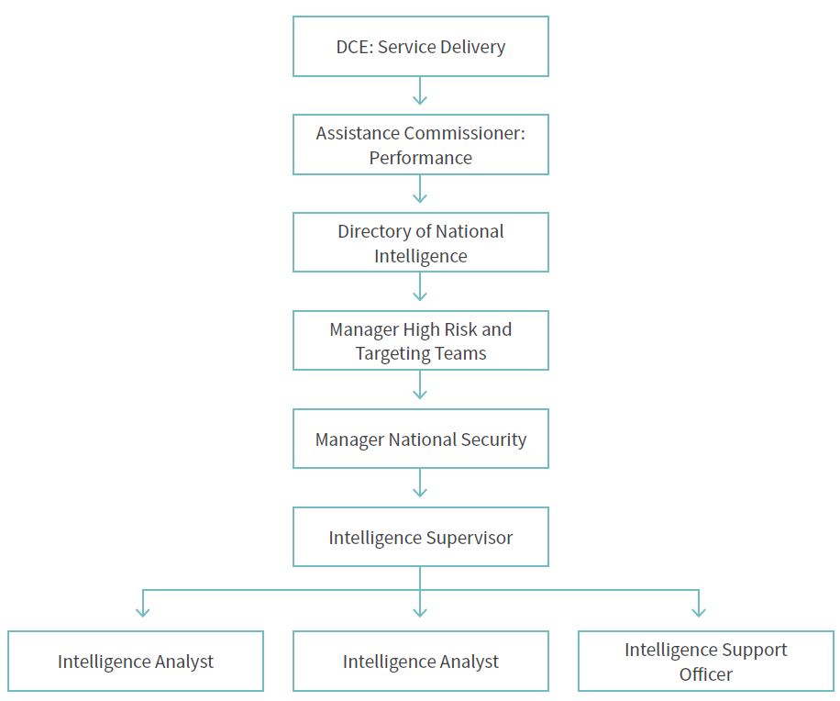

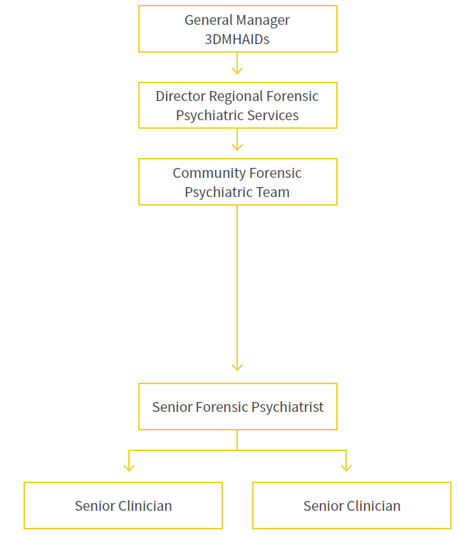

Appendix B:
Fixation definitions
Fixation: ‘Fixation’ is defined as “intense preoccupations with an individual, place or cause that are pursued to an excessive or irrational degree”, where a cause’ refers to “some intense, personal and occasionally bizarre grievance or quest for justice”. Fixation generally fall into one of two categories:
      - Cause: an individual becomes fixated with a particular issue, which they then believe a public figure has caused or has responsibility for; or
      - Individual: an individual becomes fixated with a specific public figure (eg, a member of the Royal Family) owing to an imagined relationship of some nature.
Querulent behaviour: This is “a pattern of behaviour involving the unusually persistent pursuit of personal grievance in a manner seriously damaging to the individual’s economic, social and personal interests, and disruptive to the functioning of the courts and/or other agencies attempting to resolve the claims”.
Lone Actor Grievance-Fuelled Violence (LAGFV): A ‘lone actor’ is any individual who engages in hostile acts against others in pursuit of aims that have a particular meaning for them. Grievance-fuelled violence arises from a real or imagined grievance, injustice or loss.
Suspected Mental Illness (SMI): An individual who does not necessarily meet the criteria of fixated; however, presents as someone who displays an undiagnosed mental illness.
Grievance: A grievance occurs when an individual has a strong belief that they (or others/a group with which they identity) have been the subject of a perceived injustice and this generated feelings of outrage/ desperation and a sense of victimisation.

Appendix C:
Basis for information sharing
In most circumstances’ information will be shared due to the serious threat of harm, and the FTACNZ agencies consider that information-sharing is justified to lessen the threat. Further, the sharing of information will only be to the extent to enable each party to do its job for the purposes of FTACNZ. Where circumstances enable such action, FTACNZ may interact with the fixated individual and seek authority to share information. However, it is likely that in most circumstances the basis for sharing personal information between parties is that:
- the disclosure of the personal information is one of the purposes in connection with which the personal information was obtained or is directly related to the purpose in connection with which the personal information was obtained (Principle 11 (a) Privacy Act 1993 and HIPC Rule 11 (c)). The personal information was obtained and will be shared to further the statutory roles and purposes of each of the FTACNZ Agencies; OR
- that personal information sharing is necessary to avoid prejudice to the maintenance of the law by a public sector agency in (Principle 11(e) Privacy Act 1993 and HIPC Rule 11 (2)(i)(l)) […]; OR
- that the disclosure of the personal information is necessary to reduce or lessen a serious threat to public health or public safety or the life or health of the fixated person or other individuals (Principle 11 (f) Privacy Act 1993 and HIPC Rule 11 (2)(d)).

In addition, section 22C of the Health Act 1956 authorises disclosure of health information by health service providers to various persons including probation officers, social workers, and constables for the purpose of performing their powers, duties and functions.

Appendix D:
FTAC data collection
Data has been collated and examined and stored for all cases referred to FTAC during the period 1 July 2019 to 30 June 2020. Qualitative characteristics recorded include:
- number of referrals
- accepted, declined, alternative action completed (DRAAC) and referred on to another FTAC
- personal identification variables
- referral demographics
- date of birth, gender, ethnicity, location (town and police district)
- referral agency, date of referral and closure
- fixation type
- fixation, grievance, lone actor grievance fuelled violence, querulous and possible mental illness
- fixation target
- government organisation, royals, judiciary, politicians, police, community, workplace, school, other
- type of contact
- social media, email, handwritten or typed letter, telephone, SMS, approach, physical assault
- presenting problems
- self-harm, conspiracy theorist, threat, delusions, violence to family/friends/ acquaintances, violence to general public, suicide, sexual nature, drug use, use of weapons, arson, property damage and harassment/stalking
- criminal conviction history and alerts
- mental health history and diagnosis
- initial levels of concern and reassessed concern level.
- interventions taken by FTAC
- outcome of FTAC interaction
- reduction in concerning behaviour
- increase in concerning behaviour
- no change in concerning behaviour.

Appendix E:
Concern level definitions

Low concern
No problematic approach behaviours and no stated intention to engage in any. None of checklist criteria satisfied, or initial investigation has found them to be non-significant. Subject’s interest contains no form of threat or desperation, and/or is generally at a nuisance level. Initial presentation indicates a low potential for adverse consequences:
- The items listed in the RAM have not presented.
- Referred persons have not previously engaged in inappropriate approach.
- The referred person’s interest contains no form of threats or desperation and is generally at a mild nuisance level.

Moderate concern
Initial presentation indicates a moderate potential for adverse consequences (disruption, distress, persistence, escalation or violence):
- One or more of the factors listed within the RAM are present.
- The referred person has exhibited an unusual interest and displayed this in a manner that suggests problematic behaviours will continue or escalate.
- The referred person has stated an intention
- The referred person has made direct or indirect threats towards the POH.

High concern
Initial information and/or investigations reveal behaviours which indicate a high likelihood of adverse consequences (disruption, distress, persistence, escalation and/or violence) which require prioritised intervention. Risk factors indicate a capacity or intent to cause such consequences. High-profile intrusions fall into this category, even in temporary custody.
- Any case where a ‘red flag’ indicator is clearly present,
- Cases where risk factors indicate a clear capacity and/or intent to cause adverse consequences,
- Includes cases where intrusive harassment has occurred, or is highly likely to occur,
- Cases where a clear propensity for violence is evident.

Appendix F: Harassment, stalking, threats and attacks targeting New Zealand politicians
See Harassment, stalking, threats and attacks targeting New Zealand politicians: A mental health issue - Susanna Every-Palmer, Justin Barry-Walsh, Michele Pathé, 2015 (sagepub.com).

Appendix G: Fixated threat assessment centers preventing harm
See https://www.cambridge.org/core/terms. https://doi.org/10.1017/S1092852920000152.

Michele T. Pathé, Debbie J. Haworth, Terri-Ann Goodwin, Amanda G. Holman, Stephen J. Amos, Paul Winterbourne & Leanne Day (2018) Establishing a joint agency response to the threat of lone-actor grievance-fuelled violence, The Journal of Forensic Psychiatry & Psychology, 29:1.
(Mullen, Pathé & Purcell, 2009).
(Mullen, Pathé & Purcell, 2009).
Mullen, P.E. and Lester, G. (2006), Vexatious litigants and unusually persistent complainants and petitioners: from querulous paranoia to querulous behaviour. Behav. Sci. Law, 24: 333-349.
VFTAC Training Resources
Pathé et al. 2018

