First Heterosexual Sex
Findings from the
2014/15 New Zealand Health Survey
2019

Acknowledgements
The New Zealand Health Survey would not have been possible without the support and enthusiasm of many individuals, including the many thousands of New Zealanders who gave their time to participate in it and the interviewers who worked so diligently to collect the data. Thank you for your generosity.
This data brief was written by Nigel Dickson (University of Otago), Bridget Murphy (Ministry of Health), Jennie Connor (University of Otago), Antoinette Righarts (University of Otago) and Peter Saxton (University of Auckland). The data analysis was undertaken by Barry Gribben (CBG Health Research), Thomas Zhang (CBG Health Research) and James Stanley (University of Otago).
Citation: Ministry of Health. 2019. First Heterosexual Sex: Findings from the 2014/15 New Zealand Heath Survey. Wellington: Ministry of Health.
Published in November 2019 by the Ministry of Health
PO Box 5013, Wellington 6140, New Zealand
ISBN 978-1-98-859747-8 (online)
HP 7271
This document is available at health.govt.nz
This work is licensed under the Creative Commons Attribution 4.0 International licence. In essence, you are free to: share ie, copy and redistribute the material in any medium or format; adapt ie, remix, transform and build upon the material. You must give appropriate credit, provide a link to the licence and indicate if changes were made.

Contents
Key findings v
Introduction 1
Age at first sex 3
Contraception at first sex 8
Willingness at first sex 12
View on timing of first sex 15
Interpretation notes 17
Overview of survey methodology 19
References 22
Appendix 1 23

List of Tables
Table 1: Participation in the Sexual and Reproductive Health module of the New Zealand Health Survey, by ethnicity 20
Table A1: Cumulative percentage of men and women reporting first heterosexual sex between 13 to 25 years of age, by age group 23

List of Figures
Figure 1: Cumulative percentages by age at first heterosexual sex, by age group and gender 3
Figure 2: Median age at first heterosexual sex, by age group and gender 4
Figure 3: Median age at first heterosexual sex, by ethnic group and gender 5
Figure 4: Heterosexual sex before the age of 16, by age group 6
Figure 5: Heterosexual sex before the age of 16, by ethnic group and gender 7
Figure 6: Contraception used at first vaginal or anal heterosexual sex, by age group 8
Figure 7: Contraception used at first vaginal or anal heterosexual sex, by ethnic group 9
Figure 8: Condom used at first vaginal or anal heterosexual sex, by age group and gender 10
Figure 9: Condom used at first vaginal or anal heterosexual sex, by ethnic group and gender 11
Figure 10: Willingness of partner at first heterosexual sex, by age group 12
Figure 11: Willingness of partner at first heterosexual sex, by ethnic group and gender 13
Figure 12: View on timing of first heterosexual sex (among those who had ever had heterosexual sex), by age group and gender 15
Figure 13: View on timing of first heterosexual sex (among those who had ever had heterosexual sex), by ethnic group and gender 16

Key findings
This report describes New Zealanders’ first experience of sex, including whether it was consensual and protected from unplanned pregnancies and sexually transmitted infections (STIs).

Key findings include the following.
- Half of New Zealand adults had had sex by the time they were 17 years old. The median age for first sex declined, from 18 and 19 years for men and women respectively aged 65–74 at the time of the survey to 17 years old for both men and women aged under 55 at the time of the survey.
- 20 percent of adults had had sex before they were 16 years old. Among those aged 65–74 years, 12 percent of men and six percent of women had first had sex before aged 16; this increased to around one in four men and women now aged 16–24 years.
- Sex before the age of 16 was most common among Māori men and women and least common among Asian men and women. It was more common among those living in the most deprived areas.
- The majority (78 percent) of respondents used contraception on the occasion of their first sex. Condom use and use of contraception more generally (including condoms) on the occasion of first sex has become progressively more common, but is generally practised less by Māori and Pacific people than non-Māori and non-Pacific people.
- Most respondents (87 percent) said that they and their partners were ‘both equally willing’ to have sex on the first occasion. Sixteen percent of women and four percent of men said their partner was more willing than they were.
- Around one in 40 women said they were forced the first time they had sex. Māori women were twice as likely to experience this than non-Māori.
- Overall, 16 percent of men and 40 percent of women felt they should have waited longer to have sex for the first time. This sentiment was more common in younger people; it was reported by about one-quarter of men and one-half of women aged 16–24 years.
- Compared with other ethnicities, both Māori and Pacific people were 1.6 times as likely to think they should have waited longer to have sex for the first time. Similarly, those living in more deprived areas were 1.5 times more likely to think they should have waited longer than those living in less deprived areas.

Introduction
We seek a better understanding of the context of people’s first sex to inform sexuality education and thereby improve young people’s first sexual experience, which fits within the broader area of relationship education. Sexuality education focuses on empowering and informing youth to have healthy, positive relationships and safe sexual experiences (Ministry of Education 2015).

The timing of first sex is of both legal and public health interest. The rationale for having a legal age of consent for sex has generally been to protect young people from sexual exploitation by adults, but also to acknowledge that below a certain age young people may be unable to give full consent, due to their limited understanding of the implications of sexual activity. The public health rationale includes the association of early sexual activity with increased risk of STIs, unintended pregnancy and early parenthood, all of which have physical and psychosocial implications (for example, an impact on a person’s ability to access education).

Although age is associated with readiness for first sex, age at first sex is not the most important factor for healthy first sex. Other factors, including positive sexual relationships (partners being equally willing) and safe sex, are key to having a good ‘first time’ (Palmer et al 2019). Negative early sexual experiences, such as being forced to have sex, have been shown to be associated with sexual dysfunction, more sex guilt, poorer general health, experience of STIs and poorer life satisfaction (Else-Quest 2005). The use of contraception at first sex is predictive of future use (Parkes et al 2009).

Analyses of the Dunedin Multidisciplinary Health and Development Study (the Dunedin Study) have shown that a person’s age, the context and retrospective views on the appropriateness of the timing are related (Dickson et al 2015). For women, younger first sex was associated with more coercion, and more reports that in retrospect they should have waited longer. Questions about first sex depend on a person’s recall of an event that may have occurred some years ago, and this recall might involve some reinterpretation. The Dunedin Study explored this effect: it asked people questions on first sex twice: first at age 21 and then at age 38. Analysis showed no bias in reports of age of first sex many years after the event, and that views on the appropriateness of timing persisted. However, it also found that, the second time they were asked the question, both men and women were more likely to report mutual willingness.

The Ministry of Health included questions on the circumstances of respondents’ first sex covering in the Sexual and Reproductive Health module of the 2014/15 New Zealand Health Survey (the survey). These questions covered age at first sex, whether both partners were equally willing, whether respondents felt the sex happened at the ‘right time’ and use of contraception. All the results except age at first sex, refer to first sex since turning 13. Respondents were asked about first sex since turning 13 years old to avoid distress from thinking about early experiences. The survey asked these questions of people who had sex with people of the same gender and those who had sex with people of a different gender. The results for people having sex with a person of the same gender are not included in this report because the small number of people reporting this reduced the reliability of the statistics.
This report presents key findings about first sex by gender, age group, ethnicity and neighbourhood deprivation at the time of the survey interview. Care is required interpreting findings for the youngest age group as this group will contain a greater proportion of people who had first sex when they were younger; this might impact on comparison of data for this group with that for older age groups.

You can find more information and results from the survey, including statistics on first heterosexual sex and data tables, in the data explorer, online at https://www.health.govt.nz/publication/sexual-and-reproductive-health-2014-15-new-zealand-health-survey

Age at first sex
This section sets out responses to questions about people’s age at their first experience of sex. Sex was defined as vaginal, oral or anal sex between a male and a female.

Any experience of sex was reported by 71 percent of men and 64 percent of women aged 16–24 years, and 92–96 percent of men and women in the older age groups.

Figure 1 shows the cumulative proportion of men and women who had had sex by the end of each individual year of age between 13 and 25 years, by age group.

The biggest change in when people first had sex was between people aged 65–74 years and 55–64 years
- 25 percent of men aged 65 to 74, had had sex by age 16, compared with 33 percent of men aged 55–64. For younger age groups this percentage was between 33 percent and 37 percent.
- 14 percent of women aged 65 to 74, had had sex by age 16, compared with 35 percent of women aged 55–64. For all the younger age groups this percentage was between 35 percent and 42 percent.

Figure 1: Cumulative percentages by age at first heterosexual sex, by age group and gender
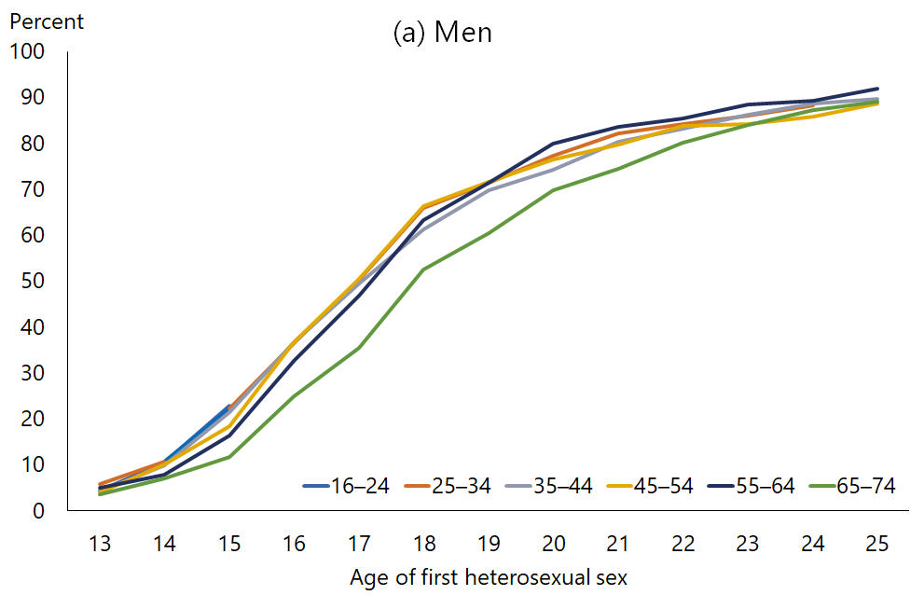 | 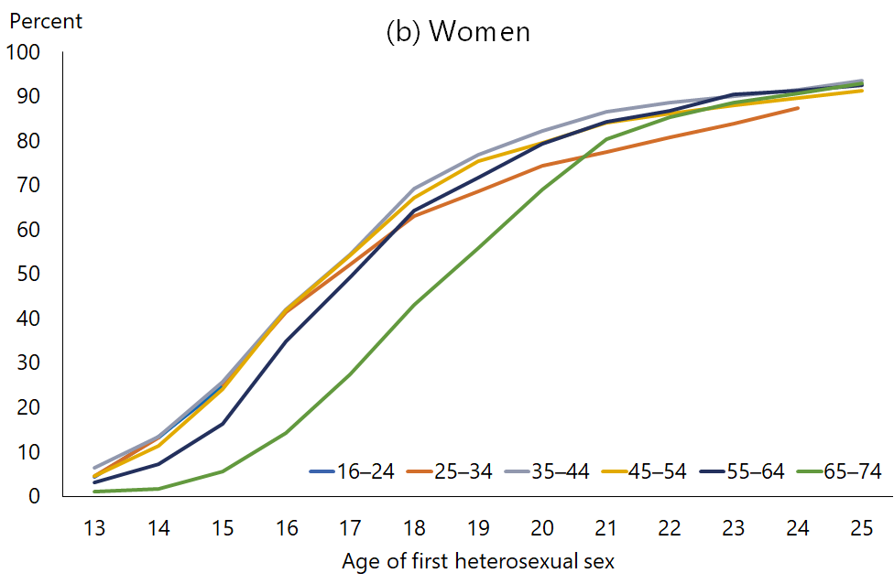
Note: The cumulative rates for 16–24 years and 25–34 years stop at age 15 and 24 years respectively as later ages will not be appropriate for all in these age groups as not all will have achieved them. Some lines are obscured, indicating similarities between age groups. Data tables are available in Appendix 1.

The median age at first sex is 17
- Overall, the median age of first sex for both men and women aged 16–74 years was 17 years (Figure 2).
- For both men and women, the median age was highest in those aged 65–74 years, among whom it was 18 years for men and 19 years for women.

Figure 2: Median age at first heterosexual sex, by age group and gender
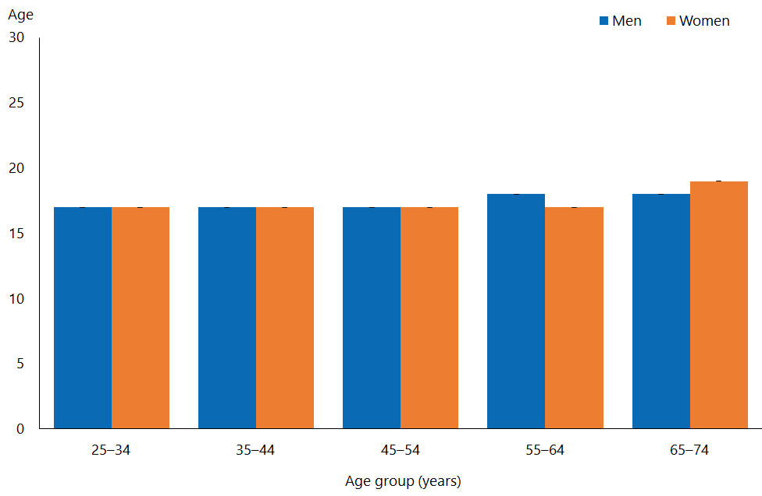
Note: The median is not shown for the lowest age group (16–24 years), as a significant proportion of people within that age group are younger and have not had sex, making the median an unreliable measure for the whole age group.

The median age of first sex was lowest among Māori (16 years), followed by those of European/Other ethnicity and Pacific people. It was highest among those of Asian ethnicity (21 years).

Figure 3: Median age at first heterosexual sex, by ethnic group and gender
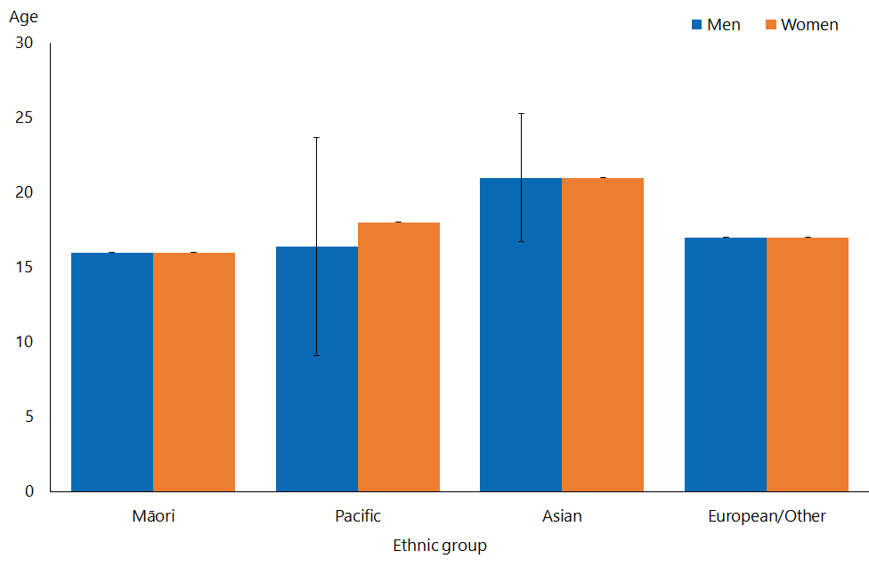
Note: Adults who reported more than one ethnic group are counted once in each group reported. This means that the total number of responses for all ethnic groups can be greater than the total number of adults who stated their ethnicities.

There was no trend in the median age of first sex by level of deprivation.

The proportion of men and women having early sex was lowest among older age groups
- The proportion of people having sex before the age of 16 was higher in younger age groups. Nearly one-quarter of those aged 16–44 years (22 percent of men and 25 percent of women) had had sex before age 16, compared with 12 percent of men and 6 percent of women aged 65–74 years (Figure 4).
- Overall, 19 percent of men and 21 percent of women aged 16–74 years had had sex before age 16.

Figure 4: Heterosexual sex before the age of 16, by age group
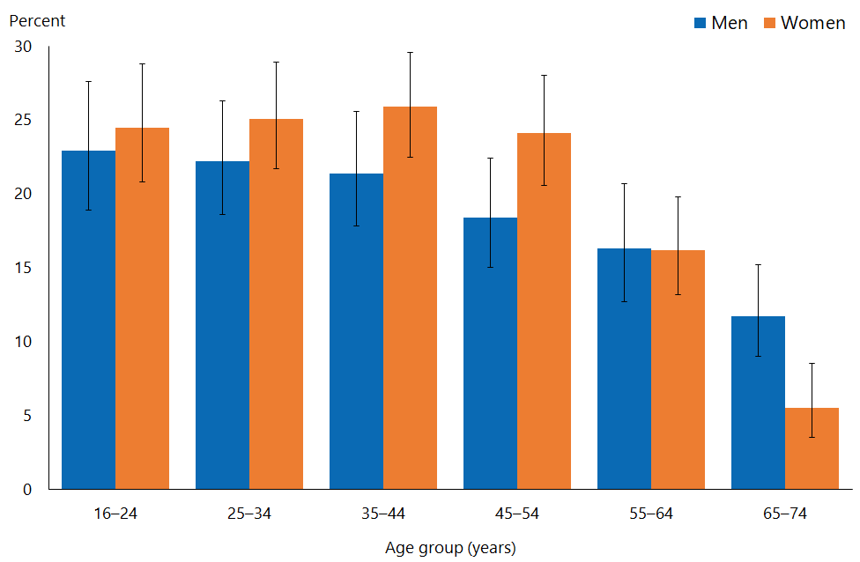

Early sex was most common among Māori men and women and least common among Asian people
- Among ethnic groups, first sex under 16 was most common among Māori men (39 percent) and women (40 percent), and least common among Asian men (5.4 percent) and women (2.5 percent) (Figure 5).
- Among men, after adjustment for age, Māori were 2.2 times as likely to have had sex before 16 as non-Māori, and Pacific men 1.4 times as likely as non-Pacific men. Asian men were 0.2 times as likely to have to have had sex before 16 as non-Asian men.
- Among women, after adjustment for age, Māori were twice as likely to have had sex before 16 as non-Māori, and Pacific women half as likely as non-Pacific women; Asian women were 0.1 times as likely to have had sex before 16 as non-Asian women.

Figure 5: Heterosexual sex before the age of 16, by ethnic group and gender
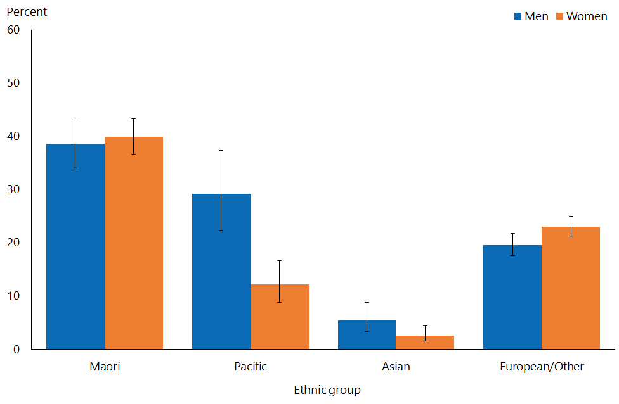
Note: Adults who reported more than one ethnic group are counted once in each group reported. This means that the total number of responses for all ethnic groups can be greater than the total number of adults who stated their ethnicities.

- There was a consistent trend for the percentage of both men and women who had had sex under age 16 to increase with increasing levels of neighbourhood deprivation.
- After adjustment for age and ethnicity, first sex under 16 was 1.6 times as likely among men living in the most deprived neighbourhoods, and 1.5 times as likely among women living in those neighbourhoods, as it was among men and women living in the least deprived neighbourhoods.

Contraception at first sex
In this section, ‘contraception’ includes condoms, the pill and ‘other contraception’.

Contraception at first sex was more common in younger age groups
- Contraception use at first sex became progressively more common in those under 55 (Figure 6). It was used by 66 percent of men and 70 percent of women aged
55–64 years, rising to 88 percent of men and women aged 16–24 years.

Figure 6: Contraception used at first vaginal or anal heterosexual sex, by age group
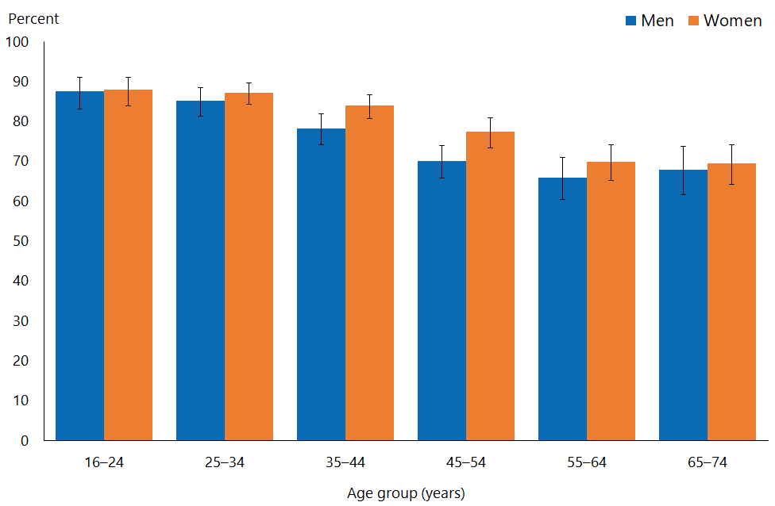
Note: Contraception excludes morning after pill, withdrawal and natural family planning. Includes condoms, the pill and ‘other contraception’.

Use of contraception at first sex was less common among Māori and Pacific men and women than among non-Māori and non-Pacific people
- By ethnic group, contraception at first sex was most commonly used by Asian men and women, and next most commonly by those of European/Other ethnicity (Figure 7).
- After adjustment for age, Māori men and women were both 0.8 times as likely to have used contraception at first sex as non-Māori; Pacific men and women were both 0.7 times as likely to have used contraception at first sex as non-Pacific men and women.

Figure 7: Contraception used at first vaginal or anal heterosexual sex, by ethnic group
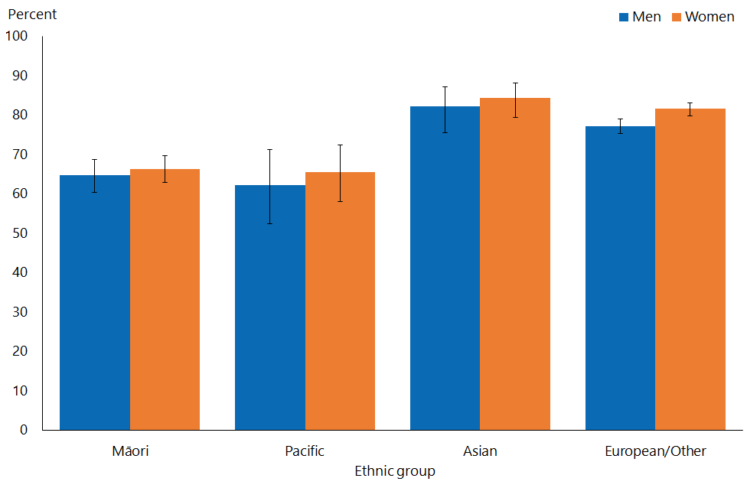
Note: Adults who reported more than one ethnic group are counted once in each group reported. This means that the total number of responses for all ethnic groups can be greater than the total number of adults who stated their ethnicities.
Note: Contraception excludes morning after pill, withdrawal and natural family planning. Includes condoms, the pill and ‘other contraception’.

Contraception use at first sex was less common among those living in most deprived neighbourhoods
- There was a general trend among both men and women for contraception to be less likely to be used at first sex with increasing levels of deprivation.
- After adjustment for age and ethnicity, both men and women in the most deprived neighbourhoods were 0.8 times as likely to have used contraception at first sex as those in the least deprived neighbourhoods.

Condom use at first sex was much more common in younger age groups
- Like contraception use more generally, condom use at first sex was progressively more common in those under 55; condoms were used at first sex by 46 percent of men and 43 percent of women aged 55–64 years, rising to 82 percent of men and 77 percent of women aged 16–24 years (Figure 8).

Figure 8: Condom used at first vaginal or anal heterosexual sex, by age group and gender
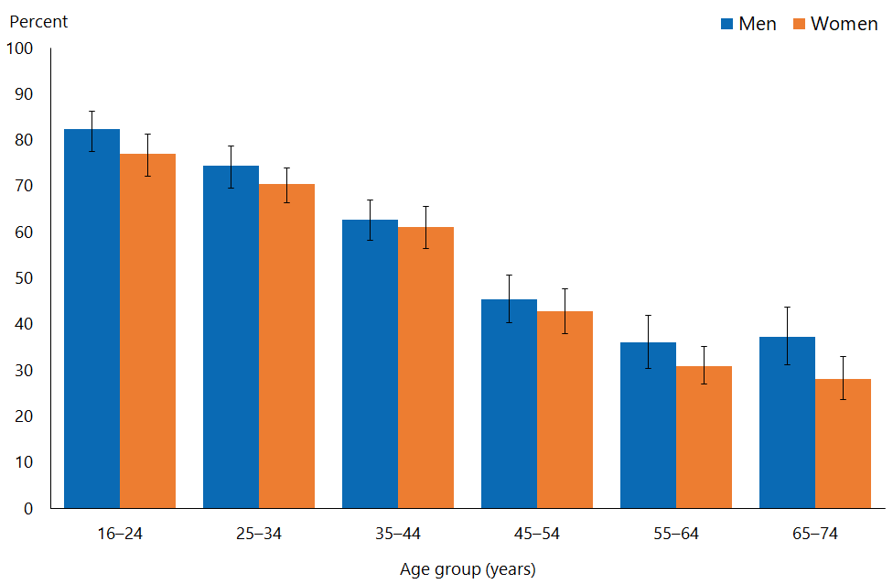

Condom use at first sex was less common among Māori and Pacific men and women than non-Māori and non-Pacific
- Among ethnic groups, condom use at first sex was most common among Asian men and women. Condoms at first sex were used by similar percentages of Māori men, Pacific men and those of European/Other ethnicity. Among women, by ethnicity, they were used least by Māori and Pacific women (Figure 9).
- After adjustment for age, Māori men were 0.8 times and Māori women 0.7 times as likely to have used condoms at first sex as non-Māori. Pacific men were 0.8 times and Pacific women 0.6 times as likely to have done so as non-Pacific men and women. Asian men were 1.2 times as likely to have used condoms at first sex as non-Asian men.

Figure 9: Condom used at first vaginal or anal heterosexual sex, by ethnic group and gender
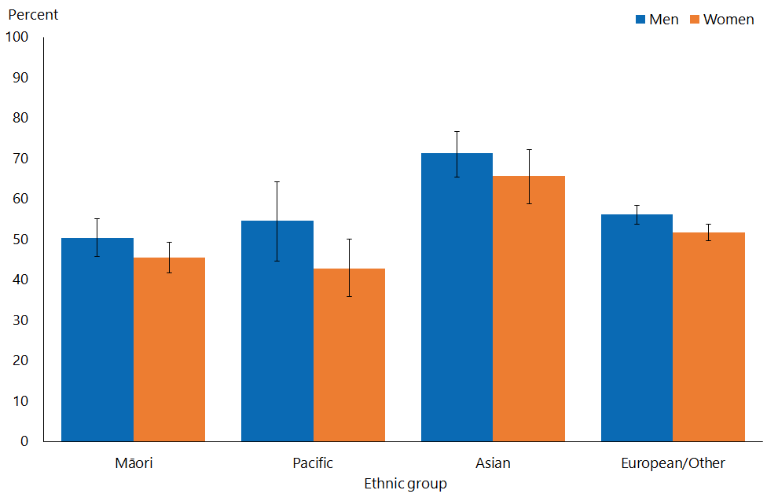
Note: Adults who reported more than one ethnic group are counted once in each group reported. This means that the total number of responses for all ethnic groups can be greater than the total number of adults who stated their ethnicities.

Condom use was less likely in the most deprived neighbourhoods
- There was no clear trend in condom use at first sex by level of neighbourhood deprivation, among men or women.

Willingness at first sex
The survey asked participants whether they and their partner were equally willing the first time they had sex, or whether one of them was more willing than the other. This section reports willingness for participants that had had sex, 89 percent of the population.

The youngest age group – those aged 16–24 years – contains fewer people (68 percent) who have had sex than the older age groups (92–94 percent). Those who have had sex within this age range would disproportionately have had sex when they were younger. Comparisons between data for this age group and data for other age groups should take this factor into consideration.

Men were generally more willing at first sex
- Overall, among all respondents aged 16–74, significantly more men (92 percent) than women (83 percent) reported that they and their partner were equally willing the first time they had sex; more men (4.1 percent) than women (0.6 percent) reported that they themselves were more willing; and more women (16.1 percent) than men (4.3 percent) reported that their partner was more willing.
- The proportion of men or women reporting that they had been equally willing at first sex was fairly similar across the different age groups; there was no clear trend (Figure 10). Among men, there was a trend for those in the younger age groups to be more likely to report they were more willing. There was no clear trend among women.

Figure 10: Willingness of partner at first heterosexual sex, by age group
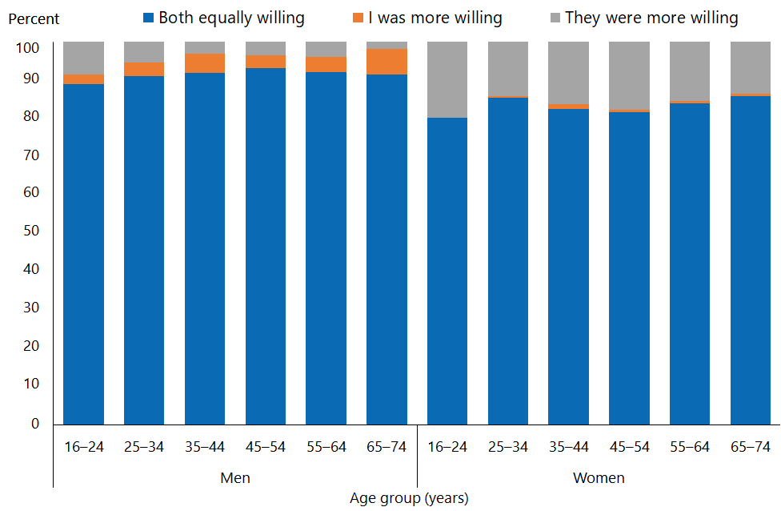

Asian women were more likely to say they were equally willing at first sex than non-Asian women
- Among women, Māori were the least and Asian women the most likely to report that they and their partner were equally willing; Māori women were the most and Asian women the least likely to report that their partner was more willing (Figure 11).
- After adjustment for age, Māori women were 1.2 times as likely to report that their partner was more willing as non-Māori; Asian women were 1.1 times as likely to report that they and their partner were equally willing as non-Asian women.

Figure 11: Willingness of partner at first heterosexual sex, by ethnic group and gender
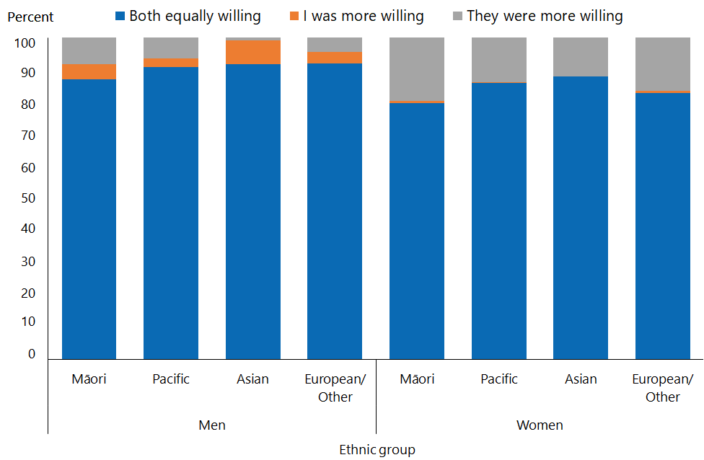
Note: Adults who reported more than one ethnic group are counted once in each group reported. This means that the total number of responses for all ethnic groups can be greater than the total number of adults who stated their ethnicities.

First sex forced for 2.4 percent of women
- Those who reported that their partner had been more willing at first sex were asked if they had been forced.
- Overall, 2.4 percent of women reported that they had been forced to have sex the first time, and fewer than 1 percent of men.

Māori women were twice as likely to report being forced at first sex as non-Māori
- More Māori women (4.4 percent) reported being forced at their first sex than women of European/Other ethnicity (2.4 percent). The numbers for women in the other ethnic groups, and for all men, are too small to provide reliable estimates.
- After adjustment for age, Māori women were 2.1 times as likely to have been forced at their first sex as non-Māori women.
- Numbers reporting being forced at first sex were too small for analysis by level of deprivation.

View on timing of first sex
The survey asked all participants, except those who had been forced, if they now felt that their first experience of sex since turning 13 years had occurred at the right time, whether they felt they should have waited longer or whether they felt they should not have waited so long.

The youngest age group – those aged 16–24 years – contains fewer people (68 percent) who have had sex than the older age groups (92–94 percent). Those who have had sex within this age range would disproportionately have had sex when they were younger. Comparisons between data for this age group and data for other age groups should take this factor into consideration.

Men were less likely to say that they should have waited longer
- Overall, 73 percent of men and 58 percent of women aged 16–74 years thought that their first sex had occurred at the right time; 16 percent of men and 40 percent of women felt that they should have waited longer; and 11 percent of men and 2 percent of women felt that they should not have waited so long (Figure 12).
- At all ages, many more men than women thought they should not have waited so long.

Figure 12: View on timing of first heterosexual sex (among those who had ever had heterosexual sex), by age group and gender
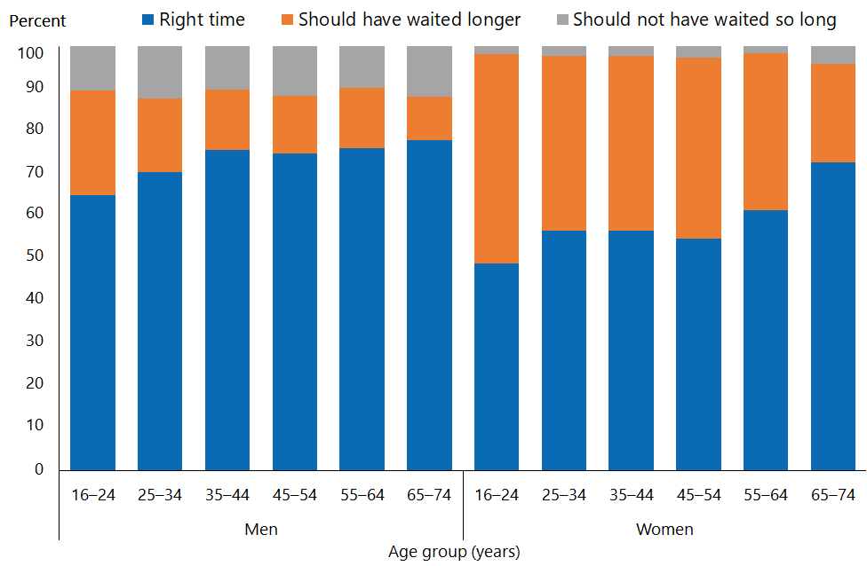
Note: Excludes respondents who were forced the first time they had sex.

Asian people were less likely to say they should have waited longer before they had sex
- Māori and Pacific men and women were less likely than those of Asian and European/Other ethnicity to say that they felt their first sex was at right time, and more likely to say that they should have waited longer (Figure 13).

Figure 13: View on timing of first heterosexual sex (among those who had ever had heterosexual sex), by ethnic group and gender
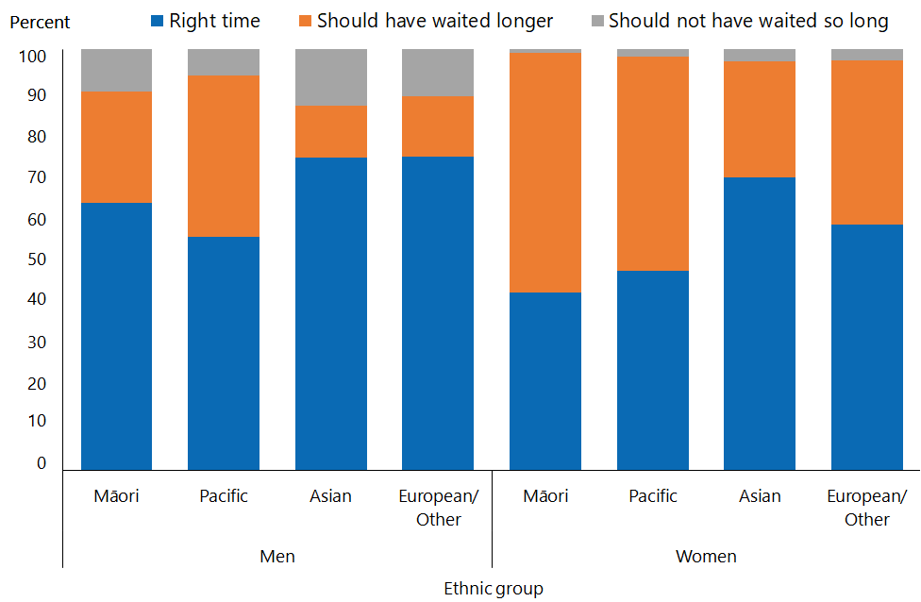
Note: Excludes respondents who were forced the first time they had sex.
Adults who reported more than one ethnic group are counted once in each group reported. This means that the total number of responses for all ethnic groups can be greater than the total number of adults who stated their ethnicities.

People in the most deprived neighbourhoods were less likely to say their first experience of sex had occurred at the right time
- There was a trend that a greater proportion of people felt they should have waited longer before having sex with increasing levels of neighbourhood deprivation. In the most deprived neighbourhoods, 37 percent of people said they felt they should have waited longer, compared with 22 percent in the least deprived neighbourhoods
- After adjustment for age and ethnicity, women living in the most deprived neighbourhoods were 1.5 times as likely to have felt they should have waited longer before their first sex as those living in the least deprived neighbourhoods.
- Men living in the most deprived neighbourhoods were 0.8 times as likely to think their first sex was at the right time as men living in the least deprived neighbourhoods.

Interpretation notes
This section provides some key points for interpreting the survey results presented in this report. For more details about the survey methodology, see the Methodology Report 2014/15: New Zealand Health Survey (Ministry of Health 2015b) and Sexual and Reproductive Health Indicator Interpretation Guide 2014/15: New Zealand Health Survey (Ministry of Health 2019).

Statistical significance
Unless otherwise specified, the results discussed in this report only refer to differences that are statistically significant at the 5 percent level (ie, those with a p-value of less than 0.05). ‘Statistically significant’ means that the difference between the sample groups is likely to reflect real differences in the population groups, rather than being caused by chance. A statistically significant difference does not necessarily mean the difference between the population groups is meaningful.

Confidence intervals
We use 95% confidence intervals to show the statistical precision of the estimates. Wider confidence intervals indicate less precise estimates than narrow intervals, caused by higher variation with a sample and/or smaller numbers in a sample. Confidence intervals generally agree with statistical significance. When confidence intervals for two estimates don't overlap, there is a statistically significant difference between the estimates. However, the opposite may not always be true.

Comparing population subgroups
This report uses adjusted ratios to test if the prevalence of indicators is statistically significantly different between groups. We have adjusted these ratios for demographic factors that may be influencing the comparison, such as age, gender and ethnicity. The adjusted ratio indicates whether the results are less or more likely in the group of interest than the comparison group. A ratio of less than 1 indicates that the result is less likely and a ratio greater than 1 indicates that it is more likely.

The survey uses the New Zealand Index of Deprivation 2013 (NZDep2013) to measure neighbourhood deprivation. The survey groups neighbourhoods into five quintiles (the label ‘quintile 1’ applies to neighbourhoods with the lowest levels of deprivation, and ‘quintile 5’ to those with the highest). Indicators are reported for each quintile. The adjusted ratios for deprivation compare the highest and lowest deprivation areas, after adjusting for age, ethnic group, gender and the pattern across all five quintiles.

Gender
Gender is self-defined by respondents in the survey. For some people, their gender is not the same as their biological sex at birth. Respondents were asked if they were male or female, and while what these options meant was open to the respondent’s interpretation, gender-diverse options (eg, ‘gender non-conforming’ or ‘other’) were not available. The Ministry of Health acknowledges the need to improve data collection in this area, and is considering implementing the statistical standard for gender identity in future surveys (Statistics New Zealand 2015).

Non-sampling error
The survey results may underestimate or overestimate some indicators because the data is self-reported. The accuracy of a person’s memory may vary depending on many factors, including social norms, the importance of the event being recalled, the individual’s age at the time and the period of time that has passed since the event occurred.

Overview of survey methodology
This section gives a brief overview of the survey methodology for the New Zealand Health Survey.

How were people selected for the survey?
The 2014/15 results refer to the sample selected for the period July 2014–June 2015. The survey has a multi-stage sampling design that involves randomly selecting a sample of small geographic areas, households within the selected areas and individuals within the selected households. One adult aged 15 years or older and one child aged 14 years or younger (if there were any) were chosen at random from each selected household. Adults aged 16–74 years who had completed the 2014/15 survey were invited to participate in the Sexual and Reproductive Health module. Further details are available in The New Zealand Health Survey: Sample design, years 1–3 (2011–2013) (Ministry of Health 2011).

How was data collected?
Professional surveyors from CBG Health Research Ltd collected data in respondents’ homes. For the core part of the survey, data was collected through a face-to-face interview. However, participants completed the Sexual and Reproductive Health module by themselves, directly entering responses into a program run on a tablet computer. Surveyors provided minimal assistance, and reiterated that they would not be able to see the answers. Respondents could answer ‘Don’t know’ or ‘Choose not to answer’ to any question. If they chose either of those options for the question about having ever had sex with someone of a different gender, then they were not asked to complete the rest of the survey module.

How many people took part?
11,993 adults aged 16–74 years completed the core 2014/15 survey and were eligible for the Sexual and Reproductive Health module. This report is based on the responses from 10,198 adults (or 87 percent of eligible respondents). Some eligible respondents were not included in the final data set for the following reasons.
- 668 respondents (5.6 percent of those who were eligible) did not start the module, either because they refused or because of English language and/or cognitive difficulties.
- 991 respondents (6.5 percent of eligible respondents) started the module but stopped before the end of the module.
- 123 respondents (1.2 percent of eligible respondents) completed the module but their records were discarded because at least half of their responses were ‘Don’t know’ or ‘Choose not to answer’.

Of the people who completed the Sexual and Reproductive Health module, 4,358 gave their gender as male and 5,840 as female. The table below summarises the 10,198 survey respondents by ethnic group.

Table 1: Participation in the Sexual and Reproductive Health module of the New Zealand Health Survey, by ethnicity
Ethnic group | Number
Māori | 2,460
Pacific | 619
Asian | 814
European/Other | 7,542
Note: Adults who reported more than one ethnic group are counted once in each group reported. This means that the total number of responses for all ethnic groups can be greater than the total number of adults who stated their ethnicities.

Survey weights
The Sexual and Reproductive Health data set was weighted so that the responding sample represented the New Zealand ‘usually resident’ population in that year, using external population benchmarks (age, sex, ethnicity and neighbourhood deprivation) and demographic and behavioural benchmarks (eg, educational level and hazardous drinking). After an initial selection weight was calculated, it was adjusted for those who did not complete the module (for any reason). This should have minimised the impact of any differences in the characteristics of people who did or did not participate in the Sexual and Reproductive Health module. For more detail about the survey methodology, refer to the Methodology Report 2014/15 (Ministry of Health 2015b).

Additional information
See also the following documents:
- The New Zealand Health Survey: Sample design years 1–3 (2011–2013) (Ministry of Health 2011). Note, despite the report title being 2011–13, this sample design was used for the 2014/15 Health Survey
- Methodology Report 2014/15: New Zealand Health Survey (Ministry of Health 2015b)
- Content Guide 2014/15: New Zealand Health Survey (Ministry of Health 2015a)
- Questionnaires for the New Zealand Health Survey 2014/15 (Ministry of Health 2016a; Ministry of Heath 2016b)
- Sexual and Reproductive Health Indicator Interpretation Guide 2014/15: New Zealand Health Survey (Ministry of Health 2019).

References
Dickson NP, Righarts AA, van Roode T, et al. 2015. Do reports of age and circumstances of first intercourse differ in a birth cohort when asked 17 years apart? Journal of Sex Research 53(3): 321–30.
Else-Quest NM, Hyde JS, DeLamater J. 2005. Context counts: long-term sequelae of premarital intercourse or abstinence. Journal of Sex Research 42(2): 102–12.
Ministry of Education. 2015. Sexuality Education: A guide for principals, boards of trustees, and teachers. URL: http://health.tki.org.nz/Teaching-in-HPE/Policy-guidelines/Sexuality-education-a-guide-for-principals-boards-of-trustees-and-teachers (accessed 21 June 2019).
Ministry of Health. 2011. The New Zealand Health Survey: Sample design, years 1–3 (2011–2013). Wellington: Ministry of Health.
Ministry of Health. 2015a. Content Guide 2014/15: New Zealand Health Survey. Wellington: Ministry of Health.
Ministry of Health. 2015b. Methodology Report 2014/15: New Zealand Health Survey. Wellington: Ministry of Health.
Ministry of Health. 2016a. Adult Sexual Reproductive Health Module (Year 4). Wellington: Ministry of Health.
Ministry of Health. 2016b. New Zealand Health Survey Adult Questionnaire (Year 4). Wellington: Ministry of Health.
Ministry of Health. 2019. Sexual and Reproductive Health Indicator Interpretation Guide 2014/15: New Zealand Health Survey. Wellington: Ministry of Health.
Parkes A, Wight D, Henderson M, et al. 2009. Contraceptive method at first sexual intercourse and subsequent pregnancy risk: findings from a secondary analysis of 16-year-old girls from the RIPPLE and SHARE studies. Journal of Adolescent Health 44(1): 55–63.
Statistics New Zealand. 2015. Statistical Standard for Gender identity. Wellington: Statistics New Zealand.

Appendix 1
Table A1: Cumulative percentage of men and women reporting first heterosexual sex between 13 to 25 years of age, by age group
 | 16–24 | 25–34 | 35–44 | 45–54 | 55–64 | 65–74
Men
13 | 4.4 | 5.8 | 4.3 | 3.9 | 4.9 | 3.6
14 | 10.4 | 10.7 | 9.8 | 9.9 | 7.8 | 6.9
15 | 22.9 | 22.2 | 21.4 | 18.4 | 16.3 | 11.7
16 |  | 36.4 | 36.6 | 36.6 | 32.6 | 24.8
17 |  | 50.3 | 49.4 | 50.4 | 46.7 | 35.5
18 |  | 65.9 | 61.2 | 66.3 | 63.2 | 52.5
19 |  | 71.4 | 69.8 | 71.7 | 71.3 | 60.5
20 |  | 77.2 | 74.3 | 76.4 | 79.9 | 69.8
21 |  | 82.0 | 80.4 | 79.8 | 83.6 | 74.4
22 |  | 84.2 | 83.3 | 83.7 | 85.4 | 80.2
23 |  | 85.9 | 86.2 | 84.2 | 88.5 | 84.1
24 |  | 88.2 | 88.7 | 85.8 | 89.2 | 87.2
25 |  |  | 89.6 | 88.7 | 91.8 | 89.0
Women
13 | 4.3 | 4.6 | 6.3 | 4.6 | 3.1 | 1.0
14 | 13.5 | 13.2 | 13.4 | 11.3 | 7.2 | 1.7
15 | 24.5 | 25.1 | 25.9 | 24.1 | 16.2 | 5.5
16 |  | 41.4 | 42.0 | 41.8 | 34.8 | 14.2
17 |  | 52.0 | 54.3 | 54.3 | 49.3 | 27.4
18 |  | 63.0 | 69.2 | 67.1 | 64.3 | 43.1
19 |  | 68.7 | 76.8 | 75.4 | 71.6 | 55.9
20 |  | 74.3 | 82.2 | 79.4 | 79.3 | 69.1
21 |  | 77.5 | 86.5 | 84.0 | 84.2 | 80.4
22 |  | 80.8 | 88.6 | 86.0 | 86.7 | 85.2
23 |  | 83.8 | 90.0 | 88.0 | 90.4 | 88.6
24 |  | 87.4 | 91.4 | 89.6 | 91.3 | 90.7
25 |  |  | 93.6 | 91.3 | 92.4 | 92.9

This was defined as vaginal, oral or anal sex between a male and a female. In this report “sex” means heterosexual sex.
The condom use question was asked for first vaginal and anal sex.

