Paerewa mō te Tumu Kōrero Whakatahe i Aotearoa

Standard for Abortion Counselling in Aotearoa New Zealand

2022

Citation: Manatū Hauora. 2022. Standard for Abortion Counselling in Aotearoa New Zealand. Wellington: Ministry of Health.
Published in August 2022 by the Ministry of Health
PO Box 5013, Wellington 6140, New Zealand
ISBN 978-1-99-110070-2 (online)
HP 8541
This document is available at health.govt.nz
This work is licensed under the Creative Commons Attribution 4.0 International licence. In essence, you are free to: share ie, copy and redistribute the material in any medium or format; adapt ie, remix, transform and build upon the material. You must give appropriate credit, provide a link to the licence and indicate if changes were made.

Ngā mihi | Acknowledgements
The members of the Standard for Abortion Counselling Working Group and the Ministry of Health (the Ministry) gratefully acknowledge and thank all those who have given generously of their time and expertise in developing this standard.

Copyright in NZS 8134:2021 is owned by the Crown and administered by the New Zealand Standards Executive. The tables in this publication have been reproduced with permission from Standards New Zealand, on behalf of New Zealand Standards Executive, under copyright licence LN001446.

This work was undertaken by public sector consultancy firm Allen + Clarke on the Ministry’s behalf. The Ministry would like to acknowledge and thank the Standard for Abortion Counselling Working Group for its advice and guidance on the wide range of topics discussed in this analysis and final standard. This group includes:
- Charmaine Norton (Canterbury District Health Board)
- Chris Hannah (Tairāwhiti District Health Board)
- Christine Macfarlane (New Zealand Association of Counsellors)
- Diane Garrett (Social Workers Registration Board New Zealand)
- Donna Truman (West Coast District Health Board)
- Helen Garrick (Whakarongorau Aotearoa)
- Margaret Pack (Capital & Coast District Health Board)
- Orna McGinn (Auckland District Health Board)
- Shelley Kirk (Lakes District Health Board).

Arotake i te paerewa | Review of standard
We intend to review this standard regularly and welcome suggestions for ways to improve it. Please send any suggestions to the Ministry’s Abortion Services team at email: CSAAct@health.govt.nz.
Ihirangi | Contents
Ngā mihi | Acknowledgements iii
Arotake i te paerewa | Review of standard iii
Kaupapa | Purpose 1
Te whānuitanga | Scope 1
Ko wai ka āhei ki te whakarato tumu kōrero? | Who can provide counselling? 2
Ngā mātāpono | Principles 3
Ngā Paerewa o ngā Ratonga Hauora me te Hauātanga NZS 8134:2021 | Ngā Paerewa Health and Disability Services Standard NZS 8134:2021 4
Te Tiriti o Waitangi 5
Ōrite o te hauora | Health equity 7
Tika ki ngā tikanga ahurea | Cultural safety 8
Ngā whakaritenga ā-ture | Legal duties 10
Ngā tika o te hunga kei te whiwhi i ngā ratonga tumu kōrero whakatahe | The rights of people receiving abortion counselling services 11
Whai wāhi mai o te whānau | Whānau participation 14
Ngā whiriwhiringa mō te tumu kōrero whakatahe me ngā tautoko | Considerations for abortion counselling and support 15
Tumu kōrero whakatahe me ngā tautoko i muri i te 20 wiki | Post 20-week abortion counselling and support 16
Kōwhiringa i runga i te mōhio | Informed choice 17
Te whakarato tautoko tāpiri | Providing additional support 19
Ngā amuamu me ngā whakaaro | Complaints and feedback 21
Āpitihanga 1: Tā mātou pou tarāwaho Tiriti o Waitangi | Appendix 1: Our Tiriti o Waitangi framework 22
Āpitihanga 2: Ngā momo tohunga ka taea te whakarato ngā ratonga tumu kōrero whatatahe | Appendix 2: Types of practitioners who can provide abortion counselling 25
Ngā tohutoro | References 26

Kaupapa | Purpose
The purpose of abortion counselling is to provide comprehensive support and enhance a person’s ability to assess and understand their situation, evaluate their options and make an informed choice or decision around abortion. It also includes post-abortion support, including grief counselling.

Abortion counselling is intended to provide therapeutic support to people who are considering having, or have had, an abortion. People should be supported by abortion counsellors to explore their emotions, thoughts and feelings around their abortion, including healthy grieving strategies where appropriate.

According to the Whakamaua: Māori Health Action Plan 2020–2025, to be more responsive to Māori needs, abortion counsellors must enable mana Māori and achieve mana tangata when delivering counselling services to Māori (Ministry of Health 2020b). Abortion counselling should provide a space for people to safely express and explore their emotions regarding abortion, and abortion counsellors cannot hold any conscientious objection to abortion or abortion counselling.

Discussions around procedural or clinical information pertaining to abortion are not considered to be a function of abortion counselling.

Te whānuitanga | Scope
The Standard for Abortion Counselling in Aotearoa New Zealand (the Standard) has been developed to ensure best practice in the provision of abortion counselling services. It does not cover:
- training resources for abortion counselling
- grief and loss counselling outside the scope of abortion counselling.

Ko wai ka āhei ki te whakarato tumu kōrero? | Who can provide counselling?
A person seeking to be an abortion counsellor must:
- hold a relevant health qualification (for example, counselling or social work qualification)
- be a registered professional of an appropriate professional body and hold a current practicing certificate
- not hold any conscientious objection to abortion
- have regular professional supervision from a suitably qualified and experienced supervisor
- undertake regular professional development relevant to abortion counselling
- have a working understanding of the abortion process and the possible complications of abortion, including initial training and regular professional development of knowledge in this area
- have a working understanding of contraceptive options and services available to access contraceptive options, including initial training and regular professional development of knowledge in this area
- treat all communications between themselves and the person who is seeking abortion counselling as confidential and privileged information as per the Health Information Privacy Code 2020 (Privacy Commissioner 2020) and their relevant professional code of ethics.

A full list of the types of practitioners who can provide abortion counselling is provided in Appendix 2.

Ngā mātāpono | Principles
The following principles will guide abortion counsellors in their delivery of abortion counselling services.
- Give effect to Crown obligations under Te Tiriti o Waitangi, considering the interests and needs of Māori.
- Be objective, impartial and non-judgemental.
- Ensure counselling services are accessible, equitable and high quality.
- Offer timely, person-specific and tailored support.
- Screen for and acknowledge trauma and follow a trauma-informed approach in such circumstances.

Ngā Paerewa o ngā Ratonga Hauora me te Hauātanga NZS 8134:2021 | Ngā Paerewa Health and Disability Services Standard NZS 8134:2021
This Standard is intended to be read alongside Ngā Paerewa Health and Disability Services Standard NZS 8134:2021 (Ngā Paerewa)(Standards New Zealand 2021). Ngā Paerewa sets out the minimum requirements for acceptable care and support within specified services. It focuses on putting people and whānau at the centre of health and disability services and supporting providers to meet their obligations under Te Tiriti o Waitangi.

‘Whānau’ include the extended family or family group of people who are important to a person who is receiving a service. ‘Family’ includes a person’s extended family and whānau and their partners, friends, guardian or other representatives chosen by the person.

Specific sections, sub-sections and criteria from Ngā Paerewa are referred to throughout this Standard to be followed and adapted to suit the specific abortion counselling context.

Te Tiriti o Waitangi
The health and disability sector is committed to fulfilling the special relationship between Māori and the Crown under Te Tiriti o Waitangi (Te Tiriti) (Ministry of Health 2020a). Counsellors should interpret the Standard in a way that is consistent with our Tiriti obligations. The health sector’s Tiriti framework (see Appendix 1) is embedded in Whakamaua: Māori Health Action Plan 2020–2025 (Ministry of Health 2020b). This framework draws on the findings of the Hauora Report on Stage One of the Health Services and Outcomes Kaupapa Inquiry (Wai 2575)(Waitangi Tribunal 2019) and adopts an approach based on both the principles and articles of Te Tiriti. For more detail, see Whakamaua: Māori Health Action Plan 2020–2025 (Ministry of Health 2020b). The New Zealand Association of Counsellors (NZAC) and the Social Workers Registration Board (SWRB) policy documents also contain obligations under Te Tiriti.

Also see Ngā Paerewa for more guidance on how to apply Te Tiriti principles.

Specifically, when working with Māori, counsellors should be familiar with and follow the intent of Section 1.1: Pae ora healthy futures in Ngā Paerewa (Standards New Zealand 2021).

E mātau ana ahau he aha tōna tikanga ki a au
Te Tiriti  Ka pāhautea ka whakapuāwai te Māori i tētahi taiao e whakarite ana i te hauora me te oranga pai. | Hei kaiwhakarato ratonga  Ka mahi tahi mātou ki te awhi, tautoko me te whakatairanga i tētahi tirohanga Māori ki te hauora me te whakarato i ngā ratonga kounga nui, manarite, whaihua hoki mō te Māori, e tāparetia ana e Te Tiriti o Waitangi.
I know what it means for me
Te Tiriti  Māori flourish and thrive in an environment that enables good health and wellbeing. | As service providers  We work collaboratively to embrace, support, and encourage a Māori worldview of health and provide high-quality, equitable and effective services for Māori framed by Te Tiriti o Waitangi.

Practitioners should apply the following principles when delivering abortion counselling.
- Tino rangatiratanga – Abortion counsellors support the right of Māori to have abortion counselling, conceptualising the person’s decision to have abortion counselling as a continuation of a much older, Māori collective-endorsed practice of determining one’s own health and wellbeing and that of one’s whānau.
- Partnership – Abortion counsellors work in partnership with Māori who are having abortion counselling to make decisions that will enhance the person’s rangatiratanga, or self-determination, over the process while exercising mana motuhake, or authority, over their bodies and reproductive health.
- Active protection – Abortion counsellors ensure Māori have evidence-based information about the abortion counselling process so that the person can make decisions and preparations that will uphold their tikanga, or cultural practice, (for example, karakia (pray), rongoā (traditional medicine), support people and a container for and a location to place products of conception).
- Options – Abortion counsellors ensure that Māori have abortion counselling that enables them to uphold their tikanga regardless of whether the counselling takes place at a kaupapa Māori provider or at a general counselling service. Wherever the abortion counselling takes place, the process must complement a Māori person’s mana or inherent authority and dignity, support their tikanga and be culturally safe as defined by Māori.
- Equity – Abortion counsellors can contribute to equitable abortion counselling health outcomes for Māori by ensuring that, at a minimum, abortion counselling outcomes match those of other New Zealanders. Equitable abortion counselling outcomes will be achieved when the Standard is implemented in ways that gives effect to the principles of Te Tiriti and when relevant professional competencies and the outcomes of Ngā Paerewa are met.

Ōrite o te hauora | Health equity
In Aotearoa New Zealand, people experience differences in health that are not only avoidable but unfair and unjust. Equity recognises that different people with different levels of advantage require different approaches and resources to achieve equitable health outcomes.

These differences in health are also the result of differential access to the resources necessary for people to lead healthy lives. People who are poor, suffer from chronic conditions/diseases, live with disabilities, live rurally and are of different ethnicities will experience poorer health, greater exposure to health risks and poorer access to health services (Ministry of Health 2002; TAS 2019).

These variables are unlikely to exist in isolation as they are deeply interwoven. The concept of intersectionality is vital when exploring the fundamental causes of inequity (TAS 2019). In Aotearoa New Zealand, inequalities between Māori and non-Māori are the most consistent and compelling inequities in the health system. These differences are not random. They exist because of institutional racism (Jones 2000; TAS 2019) and the impact of colonisation and its continuing processes (Ministry of Health 2018; TAS 2019). Achieving equity for Māori is a priority as the health gaps across the life-course are significant for Māori (TAS 2019).

Counsellors should:
- keep abreast of the latest information on what works to achieve equity of access, increase their awareness on how inequity is acting at all levels of abortion services and commit to eliminating inequity at all micro, meso and macro levels
- improve pathways through care for all groups (increasing their focus on integrating the health and disability services to achieve equity)
- demonstrate an understanding of Māori indigenous rights and current issues in relation to health and health equity.

Tika ki ngā tikanga ahurea | Cultural safety
The cultural safety of all people seeking abortion counselling in Aotearoa New Zealand is important. Counsellors need to be culturally competent and safe.

Ngā Paerewa says cultural safety requires service providers and health care and support workers to examine themselves and the potential impact of their own culture in their interactions with people using a health service. To practise cultural safety, service providers and health care and support workers must acknowledge and address their own biases, attitudes, assumptions, stereotypes, prejudices, structures and characteristics that may affect the quality of the service they provide. Cultural safety benefits all people and communities. This may include communities based on indigenous status, age/generation, gender, sexual orientation, socioeconomic status, ethnicity, religious or spiritual belief and disability.

Cultural safety must be part of professional development – and part of counsellors’ own scopes of practice for their relevant professional memberships or registrations. To help counsellors develop cultural safe and competent practices, refer to the general guidance from your professional association or regulatory authority. Examples of such guidance includes:
- Counsellor Education Standards Policy (NZAC 2016)
- NZAC Counsellors 'Registered' Under New Self-Regulatory Process (NZAC 2017)
- Ngā Paerewa Kaiaktanga Matua | Core Competence Standards (SWRB nd).

Some examples of culturally competent and safe practices include:
- providing a person with the opportunity to speak with a counsellor of their own culture or ethnicity (However, counsellors should recognise that diversity exists within ethnic and cultural groups and should not assume that additional or amended support based on culture or ethnicity is always required.)
- working with a licenced interpreter or cultural advocate/advisor (not a family member but rather an independent third party)
- where the person approves it, having support people with the person during some of or all the counselling
- ensuring critically reflective supervision and continuing professional development are ongoing features of social work practice
- the NZAC showing a commitment to Puawānanga Kaitiakitanga (cultural supervision) in accordance with Te Tiriti
- upholding tikanga and respecting Māori cultural concepts, such as whānau and wairua.

Other material to consider include:
- Te Whariki Tākapou’s Critical Commentary: Abortion and Māori rights to health and wellbeing. Systemic support of tino rangatiratanga (Southey 2019)
- Medical Council of New Zealand’s Statement on Cultural Safety (MCNZ 2019).

Ngā whakaritenga ā-ture | Legal duties
Abortion counsellors must deliver counselling services in a way that meets all their legal, ethical and professional obligations as listed below.
- Contraception, Sterilisation, and Abortion Act 1977
- New Zealand Aotearoa Abortion Clinical Guideline (2021)
- Human Rights Act 1993
- Privacy Act 2020
- Health Information Privacy Code 2020
- Health Practitioners Competence Assurance Act 2003
- Social Workers Registration Act 2003
- Oranga Tamariki Act 1989
- Code of Health and Disability Services Consumers’ Rights
- Ngā Paerewa Health and Disability Services Standard (NZS 8134:2021)
- The international human rights instruments to which New Zealand Aotearoa has committed, including:
              - Convention on the Elimination of All Forms of Discrimination against Women, 1979 (CEDAW)
              - International Covenant on Civil and Political Rights, 1966
              - International Covenant on Economic, Social and Cultural Rights, 1966
              - International Convention on the Elimination of All Forms of Racial Discrimination, 1965
              - Convention on the Rights of the Child, 1989
              - Convention on the Rights of Persons with Disabilities, 2006 (CRPD)
              - Declaration on the Rights of Indigenous Peoples, 2007.

Ngā tika o te hunga kei te whiwhi i ngā ratonga tumu kōrero whakatahe | The rights of people receiving abortion counselling services
Ngā Paerewa gives direction on how to provide rights-based services. Specifically, abortion counselling service providers must be familiar with and follow the intent of the following sections and relevant criterion from Ngā Paerewa when offering counselling services.

The first outcome statement of Ngā Paerewa is relevant to counsellors providing abortion counselling.

Outcome 1: Ō tatou motika | Our rights
Ka whiwhi te tangata i ngā ratonga haumaru, i tētahi paerewa tōtika, e ū ana hoki ki te ture motika kiritaki. E tukuna ana ngā ratonga i runga i te wairua whakaute ki ngā motika tangata, e whakarite ana i te whakaaetanga whai mōhio e whakaiti ana i te tūkino me te pupuri i ngā uara me ngā whakapono ahurea o ia tangata.
People receive safe services of an appropriate standard that comply with consumer rights legislation. Services are provided in a manner that is respectful of people’s rights, facilitates informed choice, minimises harm and upholds cultural and individual values and beliefs.

a. Section 1.2: Ola manuia o ngā iwi o Te Moana-nui-a-Kiwa kei Aotearoa | Ola manuia of Pacific peoples in Aotearoa
E mātau ana ahau he aha tōna tikanga ki a au
Ngā tāngata  E tika ana kia whiwhi hauora me te oranga pai rawa ngā iwi o Te Moana-nui-a-Kiwa kei Aotearoa e noho ana. | Te Tiriti  Ka āhukahuka ngā iwi o Te Moana-nui-a-Kiwa i te mana whenua o Aotearoa hei tuakana ki a rātou, ā, ka ū ki te tautoko i te mana whenua e tutuki ai te tino rangatiratanga. | Hei kaiwhakarato ratonga  Ka whakarato mātou i ngā ratonga hauora me te hauātanga matawhānui, tautika hoki, e pūtaketia ana e ngā tirohanga o Te Moana-nui-a-Kiwa, ā, e whanaketia ngātahitia ana ki ngā iwi o Te Moana-nui-a-Kiwa mō ngā putanga hauora pai rawa.
I know what it means for me
The people  Pacific peoples in Aotearoa are entitled to live and enjoy good health and wellbeing. | Te Tiriti  Pacific peoples acknowledge the mana whenua of Aotearoa as tuakana and commit to supporting them to achieve tino rangatiratanga. | As service providers  We provide comprehensive and equitable health and disability services underpinned by Pacific world views and developed in collaboration with Pacific peoples for improved health outcomes.

b. Section 1.3: Aku motika i te wā e tukuna ana ngā ratonga | My rights during service delivery
E mātau ana ahau he aha tōna tikanga ki a au
Ngā tāngata  He pānga whaitake tō ōku motika mā roto i ngā mahi me ngā whanonga a ētahi atu. | Te Tiriti  E whakarangatira ana ngā kaiwhakarato ratonga i te mana motuhake a te Māori. | Hei kaiwhakarato ratonga  Ka whakarato ratonga me te tautoko mātou ki te hunga e puritia ana ō rātou motika, e ū ana hoki ki ngā whakaritenga ā-ture.
I know what it means for me
The people  My rights have meaningful effect through the actions and behaviours of others. | Te Tiriti  Service providers recognise Māori mana motuhake (self-determination). | As service providers  We provide services and support to people in a way that upholds their rights and complies with legal requirements.

c. Section 1.4: E whakautetia ana ahu | I am treated with respect

E mātau ana ahau he aha tōna tikanga ki a au
Ngā tāngata  Ka taea e au te noho māori ina whakautetia ahau, ina manaakitia ahau. | Te Tiriti  Ka ū ngā kaiwhakarato ratonga ki te mana motuhake Māori. | Hei kaiwhakarato ratonga  Ka whakarato ratonga me te tautoko ki te tangata mā te huarahi manaaki i te katoa ā, e whakautea ana hoki tō rātou tuakiri me ā rātou wheakotanga.
I know what it means for me
The people  I can be who I am when I am treated with dignity and respect. | Te Tiriti  Service providers commit to Māori mana motuhake. | As service providers  We provide services and support to people in a way that is inclusive and respects their identity and their experiences.

Whai wāhi mai o te whānau | Whānau participation
Whānau participation, where the person approves it, is an important aspect in providing abortion counselling. Specifically, counsellors must be familiar with and follow the intent of Ngā Paerewa, criterion 2.3.14, when providing counselling services. This criterion supports whānau participation and involvement in the abortion counselling service, including the counsellor collecting and responding to whānau feedback as appropriate.

Criterion 2.3.14
Service providers shall have policies and procedures relating to whānau participation. These are used to maximise whānau involvement in the service and ensures their collective feedback is sought.

Ngā whiriwhiringa mō te tumu kōrero whakatahe me ngā tautoko | Considerations for abortion counselling and support
For all people seeking an abortion, abortion counsellors should be prepared to consider and discuss:
- planned/intended pregnancies
- fetal movement
- fetal abnormality
- health risks to the pregnant person
- where someone can be referred to receive an abortion as applicable
- healthy grieving strategies
- the return of products and the burial or cremation of the fetus.

Tumu kōrero whakatahe me ngā tautoko i muri i te 20 wiki | Post 20-week abortion counselling and support
Twenty weeks’ gestation is the point at which legislative criteria to accessing abortion is increased, however, some people seeking abortion before 20 weeks’ gestation will also require additional support for many of the reasons noted above. Care should be provided to all people on an individualised basis, according to the person’s specific needs.

In addition to the above considerations, people seeking an abortion after 20 weeks’ gestation may require additional support from counsellors, including grief and loss counselling. Abortion counsellors working with people who are having, or have had, an abortion at or after 20 weeks’ gestation should be aware of the potential additional ramifications of second trimester pregnancy and termination, including:
- social determinants leading to late detection of pregnancy
- inequity of access to health and disability services leading to late detection of pregnancy and referrals to counselling
- registering a post 20-week abortion as a stillbirth with the Perinatal and Maternal Mortality Review Committee (PMMRC)
- registering a stillbirth on the births, deaths and marriages register with the Department of Internal Affairs.

Kōwhiringa i runga i te mōhio | Informed choice
Abortion counsellors must ensure that the person has made the decision to receive abortion counselling independently. The counsellor must ensure that they remain objective, impartial and non-judgemental throughout the whole counselling process.
Every person has the right to be supported to make an informed decision about receiving abortion counselling, regardless of their age or disability. Specifically, counsellors must be familiar with and follow the intent of 1.7: Kua whai mōhio ahu, ā, ka taea a au te mahi whiringa | I am informed and able to make choices.

E mātau ana ahau he aha tōna tikanga ki a au
Ngā tāngata  E mōhio ana au ka pātaitia he aha aku tirohanga. Ka whakautetia aku whiringa i te wā e whakatau take ana mō taku oranga. Ki te kore e whakatinanahia aku whiringa, ka whakaratoa mai ētahi mōhiohio e tautoko ana ahau kia mōhio he aha ai. | Te Tiriti  E whakaratoa ana ngā ratonga kounga nui e ngāwari ana hoki te urunga me te whakaterenga. Ka tukuna e ngā kaiwhakarato ngā karere mārama, hāngai hoki kia taea ai e ngā tāngata me ngā whānau te whakahaere tika i tō rātou hauora ake, te noho hauora, me te noho pai. Motuhake a te Māori. | Hei kaiwhakarato ratonga  Ka whakarato mātou i ngā tāngata e whakamahi ana i ā rātou ratonga, ō rātou māngai ā-ture rānei ki ngā mōhiohio e tika ana ki te whakatau i ngā take i runga i te mōhio, e ai hoki ki ō rātou motika me tō rātou āhei ki te noho motuhake, te whai whiringa me te whakahaerenga motuhake.
I know what it means for me
The people  I know I will be asked for my views. My choices will be respected when making decisions about my wellbeing. If my choices cannot be upheld, I will be provided with information that supports me to understand why. | Te Tiriti  High-quality services are provided that are easy to access and navigate. Providers give clear and relevant messages so that individuals and whānau can effectively manage their own health, keep well and live well. | As service providers  We provide people using our services or their legal representatives with the information necessary to make informed decisions in accordance with their rights and their ability to exercise independence, choice and control.

Every person has the right to be given information about their abortion counselling in a way they understand. Specifically, counsellors must be familiar with and follow the intent of 1.6: Ka kitea ngā whakawhitiwhitinga whai hua | Effective communication occurs.

E mātau ana ahau he aha tōna tikanga ki a au
Ngā tāngata  E mōhio ana ahau kei te whakarangona, kei te uaratia aku kōrero, ā, e whai wāhi ana ngā mōhiohio katoa e whakawhitia ana ki te pikinga o taku oranga. | Te Tiriti  He ngāwari noa te tiki i ngā ratonga me te toro haere, ā, e tukuna ana ngā karere hauora mārama, hāngai hoki ki te Māori. | Hei kaiwhakarato ratonga  Ka whakarongo, ka whakaute mātou i ngā reo o ngā tāngata e whakamahi ana i ā mātou ratonga me te whakawhitiwhiti pai ki a rātou mō ō rātou whiringa.
I know what it means for me
The people  I feel listened to and that what I say is valued, and I feel that all information exchanged contributes to enhancing my wellbeing. | Te Tiriti  Services are easy to access and navigate and give clear and relevant health messages to Māori. | As service providers  We listen and respect the voices of the people who use our services and effectively communicate with them about their choices.

Te whakarato tautoko tāpiri | Providing additional support
A person has the right to participate in the development of their pathway to wellbeing and to receive timely assessment, followed by services that are planned, coordinated and delivered in a manner that is tailored to their needs. Counsellors should be familiar with and follow the intent of 3.2: Taku huarahi ki te oranga | My pathway to wellbeing and criteria 3.2.1 to 3.2.7.

E mātau ana ahau he aha tōna tikanga ki a au
Ngā tāngata  Ka mahi tahi ahau me aku kaiwhakarato kia mōhio ai rātou ki ngā take e whai pānga ana ki ahau, ka whakatau ngātahi he aha te tautoko pai rawa mō taku oranga. | Te Tiriti  Ka mahi ngā kaiwhakarato i te taha o te Māori me ngā whānau me te tautoko i ō rātou wawata, te mana motuhake me te rangatiratanga o te whānau. | Hei kaiwhakarato ratonga  Ka mahi tahi mātou ki ngā tāngata me ngā whānau ki te tautoko i te oranga.
I know what it means for me
The people  I work together with my service providers so they know what matters to me, and we can decide what best supports my wellbeing. | Te Tiriti  Service providers work in partnership with Māori and whānau and support their aspirations, mana motuhake and whānau rangatiratanga. | As service providers  We work in partnership with people and whānau to support wellbeing.

As part of service integration, counsellors should build good inter-professional collaborations within their workforce/professions to strengthen timeliness of care and informed communication, that is, they should work closer with nurses and nurse practitioners. In particular, this relates to those counsellors involved with secondary and tertiary education, primary health care, Māori and Pacific providers and community mental health (such as health improvement practitioners and health coaches / kaupapa Māori mental health services).

Abortion counsellors must ensure comprehensive and individualised psychosocial assessment of all people who seek abortion counselling, identify those who require additional support and direct people to other health or social services and broader wellbeing supports they might require.

Individualised psychosocial assessment will encompass some or all of:
- health history and disabilities
- age
- health literacy/understanding
- family/social history
- cultural and spiritual assessment
- financial assessment
- mental wellbeing assessment
- family violence risk assessment
- sexual violence risk assessment
- assistance with housing or other social services
- referral to grief and loss counselling.

If people attending an abortion service reveal additional areas of social or health concern, including circumstances of family and/or sexual violence, counsellors must inform them of relevant services in their area that are available to them, including the offer of referral and follow-up care to ensure they are supported to access the assistance they need. Counsellors must also follow their obligations to report instances of family or sexual violence where applicable.

Ngā amuamu me ngā whakaaro | Complaints and feedback
Any person has the right to complain, in any form appropriate to them, about the abortion counselling services they have received. Specifically, abortion counselling providers should be familiar with and follow the intent of 1.8: Nōku te mana ki te tuku amuamu | I have the right to complain.

E mātau ana ahau he aha tōna tikanga ki a au
Ngā tāngata  He ngāwari noa ki a au te tuku amuamu. Ina tuku amuamu ahau, ka arotia nuitia ahau, ā, ka whai whakautu wawe. | Te Tiriti  Ko te Māori me ngā whānau te pūtake o te pūnaha hauora me te hauātanga, hei hoa hohe i te whakapaitanga o te pūnaha, me te manaaki, tautoko hoki i a rātou. | Hei kaiwhakarato ratonga  He pūnaha tōkeke, pūataata, tautika hoki tā mātou e ngāwari ai te whiwhi me te whakatau, te whakateitei rānei i ngā amuamu i tētahi āhuatanga e hua mai ana he whakapaitanga.
I know what it means for me
The people  I feel it is easy to make a complaint. When I complain, I am taken seriously and receive a timely response. | Te Tiriti  Māori and whānau are at the centre of the health and disability system, as active partners in improving the system and their care and support. | As service providers  We have a fair, transparent and equitable system in place to easily receive and resolve or escalate complaints in a manner that leads to quality improvement.

If a person or whānau has a complaint, in the first instance, they are encouraged to talk to the counsellor who provided the service.

If a complaint is made to an abortion counselling provider, the complainant may also be referred to the Health and Disability Commissioner. Independent agencies, such as the Nationwide Health and Disability Advocacy Service, offer free advocacy advice and support (https://advocacy.org.nz/submit-a-complaint-to-the-advocacy-service/).

People can also provide feedback about their experiences with abortion services to the Ministry by emailing: CSAAct@health.govt.nz.

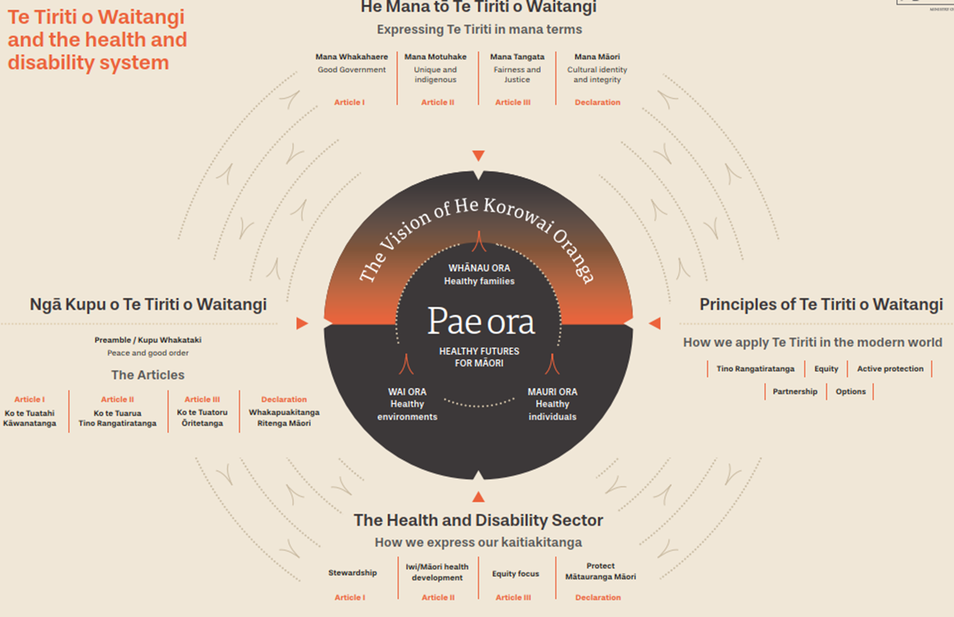
Āpitihanga 1: Tā mātou pou tarāwaho Tiriti o Waitangi | Appendix 1: Our Tiriti o Waitangi framework

(Ministry of Health 2020a)
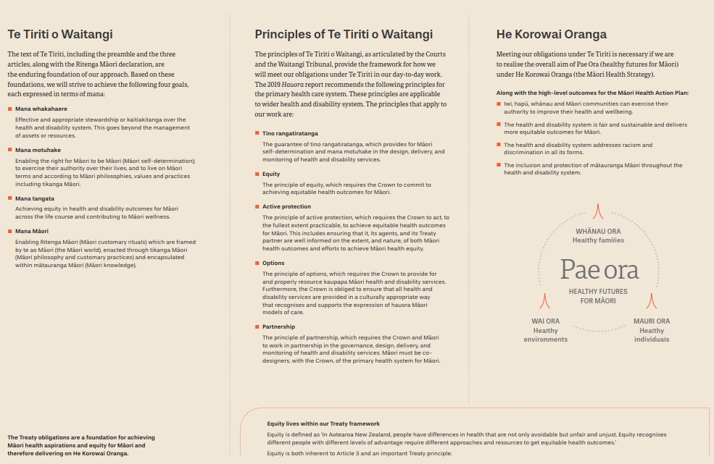

Āpitihanga 2: Ngā momo tohunga ka taea te whakarato ngā ratonga tumu kōrero whatatahe | Appendix 2: Types of practitioners who can provide abortion counselling
The following practitioners can provide abortion counselling.
- Qualified and registered social workers working in an abortion or abortion counselling context
- Qualified counsellors who are members of the New Zealand Association of Counsellors working in an abortion or abortion counselling context
- Qualified counsellors who are members of the New Zealand Christian Counsellors Association (NZCCA) working in an abortion or abortion counselling context
- Qualified and registered psychologists working in an abortion or abortion counselling context
- Qualified and registered psychotherapists working in an abortion or abortion counselling context.

Ngā tuhipoka | Notes
- Practitioners providing abortion counselling must not hold any conscientious objection to abortion or abortion counselling.
- This list may be updated from time to time in response to the growing qualified workforce.

Ngā tohutoro | References
Jones C. 2000. Levels of racism: a theoretical framework and a gardener’s tale. American Journal of Public Health, 90(8): 1,212–15. DOI: https://doi.org/10.2105/ajph.90.8.1212 (accessed 21 July 2022).
MCNZ. 2019. Statement on Cultural Safety. Wellington: Medical Council of New Zealand (MCNZ). URL: www.mcnz.org.nz/assets/standards/b71d139dca/Statement-on-cultural-safety.pdf (accessed 21 July 2022).
Ministry of Health. 2002. Reducing Inequalities in Health. Wellington: Ministry of Health. URL: www.health.govt.nz/system/files/documents/publications/reducineqal.pdf (accessed 21 July 2022).
Ministry of Health. 2018. Achieving Equity in Health Outcomes: Highlights of important national and international papers. Wellington: Ministry of Health. URL: www.health.govt.nz/publication/achieving-equity-health-outcomes-highlights-selected-papers (accessed 21 July 2022).
Ministry of Health. 2020a. Te Tiriti o Waitangi. URL: www.health.govt.nz/our-work/populations/Māori-health/te-tiriti-o-waitangi (accessed 21 July 2022).
Ministry of Health. 2020b. Whakamaua: Māori Health Action Plan 2020–2025. Wellington: Ministry of Health. URL: www.health.govt.nz/system/files/documents/publications/whakamaua-maori-health-action-plan-2020-2025-2.pdf (accessed 21 July 2022).
Ministry of Health. 2021. New Zealand Aotearoa Abortion Clinical Guideline. Wellington: Ministry of Health.
NZAC. 2017. NZAC Counsellors 'Registered' Under New Self-Regulatory Process. Wellington: New Zealand Association of Counsellors (NZAC). URL: www.nzac.org.nz/assets/Uploads/nzac_self_regulation_booklet1.pdf (accessed 21 July 2022).
NZAC. 2016. Counsellor Education Standards: Policy. Wellington: New Zealand Association of Counsellors (NZAC). URL: www.nzac.org.nz/assets/Ethics/Counsellor-Education-Standards-2020-v2.pdf (accessed 21 July 2022).
Privacy Commissioner. 2020. Health Information Privacy Code 2020. Wellington: Office of the Privacy Commissioner. URL: www.privacy.org.nz/assets/New-order/Privacy-Act-2020/Codes-of-practice/Health-information-privacy-code-2020/Health-Information-Privacy-Code-2020-website-version.pdf (accessed 21 July 2022).
Southey K. Critical Commentary: Abortion and Māori rights to health and wellbeing. Systemic support of tino rangatiratanga. Te Whāriki Takapou. URL: https://tewhariki.org.nz/assets/abortion-and-maori-rights-to-health-and-wellbeing.pdf (accessed 21 July 2022).
Standards New Zealand. 2021. Ngā Paerewa Health and Disability Services Standard NZS 8134:2021. Wellington: Standards New Zealand. URL: www.standards.govt.nz/shop/nzs-81342021/ (accessed 21 July 2022).
SWRB. nd. Ngā Paerewa Kaiaktanga Matua | Core Competence Standards. URL: https://swrb.govt.nz/practice/core-competence-standards/ (Social Workers Registration Board).
TAS. 2019. Central Region Equity Framework: DHBs’ Central Region Service Planning Forum. Wellington: Central Region Technical Advisory Services (TAS). URL: tas.health.nz/assets/Regional-Programmes/Central-Region-Equity-Framework-August-2019.pdf (accessed 27 July 2022).
Waitangi Tribunal. 2019. Hauora: Report on Stage One of the Health Services and Outcomes Kaupapa Inquiry. Wai 2575: Waitangi Tribunal Report 2019. Wellington: Waitangi Tribunal. URL: https://forms.justice.govt.nz/search/Documents/WT/wt_DOC_152801817/Hauora%20W.pdf (accessed 21 July 2022).

Healthy grieving strategies are strategies to reduce or prevent grief consequences, such as depression, anti-social behaviours, suicidality etc.
Contraception, Sterilisation, and Abortion Act 1977, section 11.
This can include those who require counselling above and beyond the scope of abortion counselling as set out above under Post 20-week abortion counselling and support.

