**Final report**

**Ngā Paerewa Implementation Evaluation**

**March 2024**

**Table of contents**

Executive summary 4

1. Background 9

1.1. Ngā Paerewa 9

1.2. The sector 10

1.3. Regulation of Ngā Paerewa 11

2. The evaluation 13

2.1. The evaluation aims and questions 13

2.2. Scope 13

2.3. The theoretical foundation for the evaluation 14

2.4. Information sources 14

2.5. Analysis 16

2.6. Interpreting recommendations and future considerations 16

2.7. Strengths and limitations of the evaluation 16

3. The implementation landscape 18

3.1. Regional differences 18

4. HealthCERT team 19

4.1. The HealthCERT team 19

4.2. Implementation process 19

4.3. Audit pilots 19

4.4. Implementation management 20

4.5. Implementation management challenges 21

4.6. Recommendations and future considerations 22

5. Communicating changes to the sector 24

5.1. Communication 24

5.2. Areas for improvement 24

5.3. Communication challenges 25

5.4. Recommendations and future considerations 26

6. Training and resources 27

6.1. Nga Paerewa resources and training 27

6.2. The extent training and resources prepared providers to implement Ngā Paerewa 29

6.3. Additional resource requests 31

6.4. Recommendations and future considerations 33

7. Support for the sector to implement changes 35

7.1. Provider understanding of Ngā Paerewa requirements 35

7.2. Provider approaches to implementation 36

7.3. Grace period 36

7.4. Ongoing support 37

8. Auditing and regulation activities 39

8.1. Areas for improvement 40

8.2. Recommendations and future considerations 40

9. Te Tiriti obligations 41

9.1. HealthCERT activities 41

9.2. The sector 42

9.3. Recommendations and future considerations 44

10. Summary 45

10.1. Healthcare providers 45

10.2. Designated auditing agencies 46

10.3. Funders and corrective action managers 46

10.4. HealthCERT 46

10.5. Summary of recommendations 48

10.6. Summary of future considerations 50

Appendix 1: Evaluation framework 52

Appendix 2: Measurement framework 53

Appendix 3: Survey respondents 56

# Executive summary

**Ngā Paerewa**

The Health and Disability Services (Safety) Act 2001 requires all regulated health providers to be audited against the health and disability services standard. Some non-regulated providers are also contractually obligated to be audited against the standard. Ngā paerewa Health and disability services standard NZS8134:2021 (Ngā Paerewa) came into effect for regulated providers on 28 February 2022 and for Home and Community Support Services on 1 July 2023.

Ngā Paerewa reflects the shift towards more person- and whānau-centred health and disability services. Key changes include enhancing infection prevention and antimicrobial stewardship, a greater focus on fulfilling Te Tiriti obligations and strengthening clinical governance to ensure people get the care and support they need. Each of the six sections is outcome-focused, which gives service providers flexibility in how they demonstrate they are achieving the requirements within the context of their service.

**Ngā Paerewa implementation evaluation**

In August 2023, The Ministry of Health - Manatū Hauora (MOH) commissioned Malatest International to complete an independent evaluation to determine:

* The effectiveness of the MOH implementation of Ngā Paerewa.
* To what extent HealthCERT had met their objectives considering the preparedness of key stakeholders.
* To what extent HealthCERT had established sufficient operational processes to enable the successful execution of the above.

The information included in this report was sourced from a document review, 71 stakeholder interviews and an online survey completed by 65 providers.

**Evaluation findings**

The implementation of Ngā Paerewa had to meet the diverse needs of providers ranging from small standalone facilities to large public hospitals. External influences such as the impact of COVID-19 and legislative changes within the sector affected implementation.

|  |
| --- |
| To what extent has HealthCERT established sufficient operational processes to enable the successful implementation of Ngā Paerewa? |
| The HealthCERT team underwent significant staffing changes during the implementation, but by 2022 the team had stabilised. Implementation management involved various strategies, including the formation of an oversight group, development and adherence to a transition plan, regularly gathering and responding to stakeholder feedback, development of training resources and collaboration with external stakeholders.  The audit pilots conducted in late 2021 informed the transition planning process and aided in resource development and internal preparedness. However, wider utilisation of the audit pilots and establishing a formal process to review and evaluate the insights gained could have further enhanced the transition plan.  Ongoing challenges include the need to maintain regulatory responsibility while fulfilling educator roles (to help providers understand the regulatory requirements), updating relevant policies to align with Ngā Paerewa and addressing gaps in te ao Māori expertise within the team. Despite these challenges, the commitment of the HealthCERT team has facilitated progress in addressing key implementation issues. |
| **The effectiveness of the MOH implementation of Ngā Paerewa.** |
| Stakeholders, including providers, were generally positive about the implementation efforts of the HealthCERT team. In response to the survey, 77% of providers considered they had a good understanding of Ngā Paerewa, but 38% wanted more information.  Challenges in understanding the cultural aspects of Ngā Paerewa persist and some Aged Residential Care (ARC) facilities struggled with new restraint criteria. A common struggle with workforce shortages across all stakeholder groups was identified.  **How adequate was the implementation COMMUNICATION** **provided by HealthCERT?**  HealthCERT communicated with the sector through various channels. Stakeholders generally found HealthCERT’s communication satisfactory. Key areas for enhancing communication included adding additional features to the website, simplifying language and streamlining implementation updates.  Although HealthCERT utilised a range of communication channels, there was still variability in awareness of training and resources available, indicating potential gaps in reaching all intended audiences effectively. HealthCERT communication often relied on intermediaries to pass information onto their facilities. A more direct way for all staff to connect with HealthCERT messages would improve the reach.  **How adequate was the implementation TRAINING provided by HealthCERT?** HealthCERT developed a range of resources and training opportunities for providers, which providers widely accessed. Reasons for not accessing training included time constraints, inability to release staff, and gaps in communication between HealthCERT and providers, as well as within providers themselves.  Providers appreciated the availability of free online training, but many asked for face-to-face training to network and seek feedback. Despite available resources, providers still sought more information on how Ngā Paerewa requirements applied to their facility, requesting that training include more real-life examples of what were acceptable practices.  Suggestions for additional resources included tailored materials, policy templates, translated materials, and a centralised repository. Some of these resources are not for HealthCERT to provide, although HealthCERT could play a role in directing providers to existing resources. Providers commonly requested resources that already existed, highlighting the need for improved awareness and accessibility of existing training and resources.  **How adequate was the implementation SUPPORT provided by HealthCERT?**  The HealthCERT team supports the sector by providing resources and direct assistance to help the sector understand and meet Ngā Paerewa. Providers were positive about HealthCERT’s accessibility and responsiveness.  Providers also accessed support from Designated Audit Agencies (DAAs), funders, and portfolio managers. Regular meetings between HealthCERT and DAAs facilitated coordination and support, fostering positive relationships.  Provider’s implementation approaches varied, with some benefiting from expertise, resources and peer support networks. The grace period was generally valued by providers, but those who had not had an audit during the grace period found it less useful.  **Has HealthCERT met its obligations under Te Tiriti?**  HealthCERT undertook various activities to fulfil their Te Tiriti obligations including supporting the sector with guidance from Te Apārangi - Māori Partnership Alliance (Te Apārangi). As Te Apārangi was not initially formed to provide day-to-day cultural support to the sector, moving forward, there is a need to explore ways to access additional cultural support and enhance HealthCERT’s internal cultural knowledge and confidence, possibly with the support of the Māori Health Directorate – Te Pou Hauora Māori.  Many stakeholders were committed to meeting their Te Tiriti obligations, but some required additional support to strengthen their cultural confidence. While some providers had access to resources facilitating compliance, others faced barriers such as uncertainty about engagement methods and limited capacity of cultural advisors.  Providers’ perspectives on Ngā Paerewa varied, with some viewing it as an opportunity to strengthen services while others expressed concerns about potential marginalisation of other ethnic groups and diverting attention from clinical outcomes. These varying perspectives can influence implementation. A poor understanding of Te Tiriti may lead to inadequate implementation. Therefore, ongoing education on Te Tiriti is necessary to emphasise its inclusive approach, promoting equitable outcomes for all populations and potentially bridging the gap between perspectives and effective implementation.  Despite challenges, stakeholders noted improvements in interpretation and confidence over time. Continued training and ongoing support for all stakeholders, particularly focusing on cultural aspects, was desired to ensure consistent application of Ngā Paerewa across different provider settings. |
| **To what extent did HealthCERT meet their objectives considering the preparedness of key stakeholders?** |
| **Providers:** Ngā Paerewa implementation varied among providers, requiring minimal changes for some and larger adjustments for others. The level of support needed by providers depended on factors such as location, experience, organisation size and the availability of dedicated resources. A significant and ongoing struggle across all service provider types was understanding what constituted an acceptable outcome around meeting Te Tiriti obligations. Early in the implementation, some providers also struggled with the criteria outlined in Section 5 and Section 6, but this difficulty has diminished over time.  **Designated Auditing Agencies:** commented on the robust relationship established with HealthCERT facilitated by open and regular communication. The audit pilots benefitted the DAAs and providers involved, albeit COVID-19 lockdowns hindered wider utilisation. Some DAAs highlighted the challenge of balancing their role as independent auditors with the provider's need for education. DAAs also noted the expectation of providers that auditors could give practical examples, suggesting the potential need for an educator role independent of DAAs and HealthCERT.  **Funders and corrective action managers:** were satisfied with HealthCERTs support for their role. However, there were discussions about improving support for smaller providers with limited resources in effectively implementing Ngā Paerewa. |

**Recommendations**

Detailed recommendations are provided in each section of the report. The key messages are:

* A substantial change in the sector requires resourcing that extends beyond business as usual. An experienced project manager and an effective infrastructure facilitate implementation.
* The Ngā Paerewa changes were implemented by the regulator. During the early implementation period, many facilities, particularly smaller standalone facilities, did not have resources to draw on to support them in making changes. While HealthCERT plays a role in helping providers understand their regulatory requirements its scope does not extend to giving tailored advice for specific provider situations. This ‘educator’ role cannot be filled by the regulator or auditor, so other resourcing is required, such as resourcing national organisations, funding an ‘educator’ or setting expectations with contract holders.
* Although providers are becoming more familiar with Ngā Paerewa, implementation is ongoing. There is an opportunity for HealthCERT to respond to providers’ requests for increased peer support by enhancing the visibility of existing peer support initiatives led by external stakeholders. Additionally, HealthCERT can continue to highlight instances of good practices and peer support models that have the potential for replication elsewhere.

# Background

## Ngā Paerewa

The Health and Disability Services (Safety) Act 2001 requires all regulated health providers to be audited against the health and disability services standard[1]. Some non-regulated providers are also contractually obligated to be audited against the standard. Ngā paerewa Health and disability services standard NZS8134:2021 (Ngā Paerewa) came into effect for regulated providers on 28 February 2022 and for Home and Community Support Services on 1 July 2023. Ngā Paerewa replaced several older service standards[2].

Ngā Paerewa reflects the shift towards more person- and whānau-centred health and disability services. People are empowered to make decisions about their care and supported to achieve their goals, with a stronger focus on outcomes for people receiving support[3].

Ngā Paerewa adopts a modular certification framework. This means that services are only audited against the sections, sub-sections and criteria relevant to those services. Each of the six sections is outcome-focused, which gives service providers flexibility in how they demonstrate they are achieving the requirements within the context of their service.

Each section’s outcome statements have been updated to reflect the partnership between service providers and the people and whānau who use their services - and the service provider’s additional responsibilities under Te Tiriti to be responsive to the needs of Māori.

A timeline of key Ngā Paerewa implementation activities is provided below (Figure 1) for context.

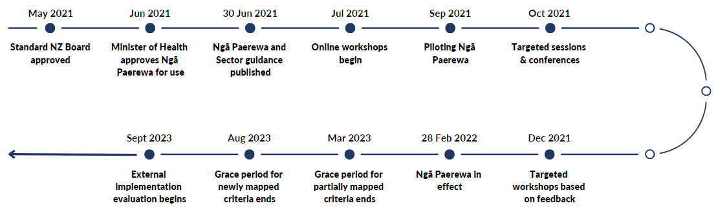

Figure : Timeline of key implementation activities

## The sector

Ngā Paerewa applies to over 950 different health and disability service providers (providers), including fertility services, primary birthing centres, hospices, overnight hospital inpatient services (public and private), age-related residential care services, residential mental health and addiction services and disability services[4]. Ngā Paerewa is also fit for use by home and community support services and abortion service providers in Aotearoa, New Zealand (New Zealand).

The healthcare providers in the sector are diverse in terms of organisation size, ranging from single-owner-operator services to large, publicly funded hospitals. They are also unique in their community context, the complexity of their services, and resources available to dedicate to implementation, among other factors. Table 1, shows the number of certified providers by service type as of March 2024[5].

Table : Certified providers by service type

|  |  |
| --- | --- |
| Service provider | Count |
| Aged Residential Care | 672 |
| Residential Disability | 118 |
| Fertility | 3 |
| NGO or Private Hospital | 77 |
| Public Hospital | 19 |

Aged residential care (ARC) is the largest service provider type. Two professional agencies represent the majority of ARC providers in New Zealand: the New Zealand Aged Care Association (NZACA) and the Care Association New Zealand (CANZ). Providers pay a membership fee. Among other things, the organisations offer training and workshops to their members.

## Regulation of Ngā Paerewa

HealthCERT is the business unit within the Regulation and Monitoring Directorate of the MOH responsible for:

…ensuring hospitals, rest homes, residential disability care facilities and fertility providers provide safe and reasonable levels of service for consumers, as required under the Health and Disability Services (Safety) Act 2001[6].

HealthCERT’s role is to administer and enforce the legislation, issue certifications, review audit reports and manage legal issues[7].

To provide health and disability services, regulated healthcare providers must be certified by HealthCERT. Providers must be audited by an independent designated auditing agency (DAA) as part of the certification process. The Director-General of Health designates auditing agencies. There are currently five DAAs. All except one have a local base in New Zealand. Providers can choose which DAA they use.

There are four types of audits:

* Provisional: undertaken to establish a prospective provider’s preparedness to provide a health and disability service and the level of conformity of the existing provider’s service that is under offer to the prospective provider.
* Partial provisional: undertaken to establish a provider's preparedness level (certified or prospective) to provide a new or reconfigured health and disability service.
* Certification: undertaken to determine if a provider is meeting the relevant service standards.
* Surveillance: undertaken at mid-point through a service provider’s period of certification to assure HealthCERT that the provider continues to meet all relevant sections.

Providers pay their DAA for audit services. Certification audits are scheduled between the provider and the DAA. This allows the provider to know when the audit will happen and provides time for preparation.

It is the provider's responsibility to ensure their certification remains current. The certification period can range from one to five years, depending on how well a provider complies with Ngā Paerewa. Figure 2 provides an overview of a typical certification audit.

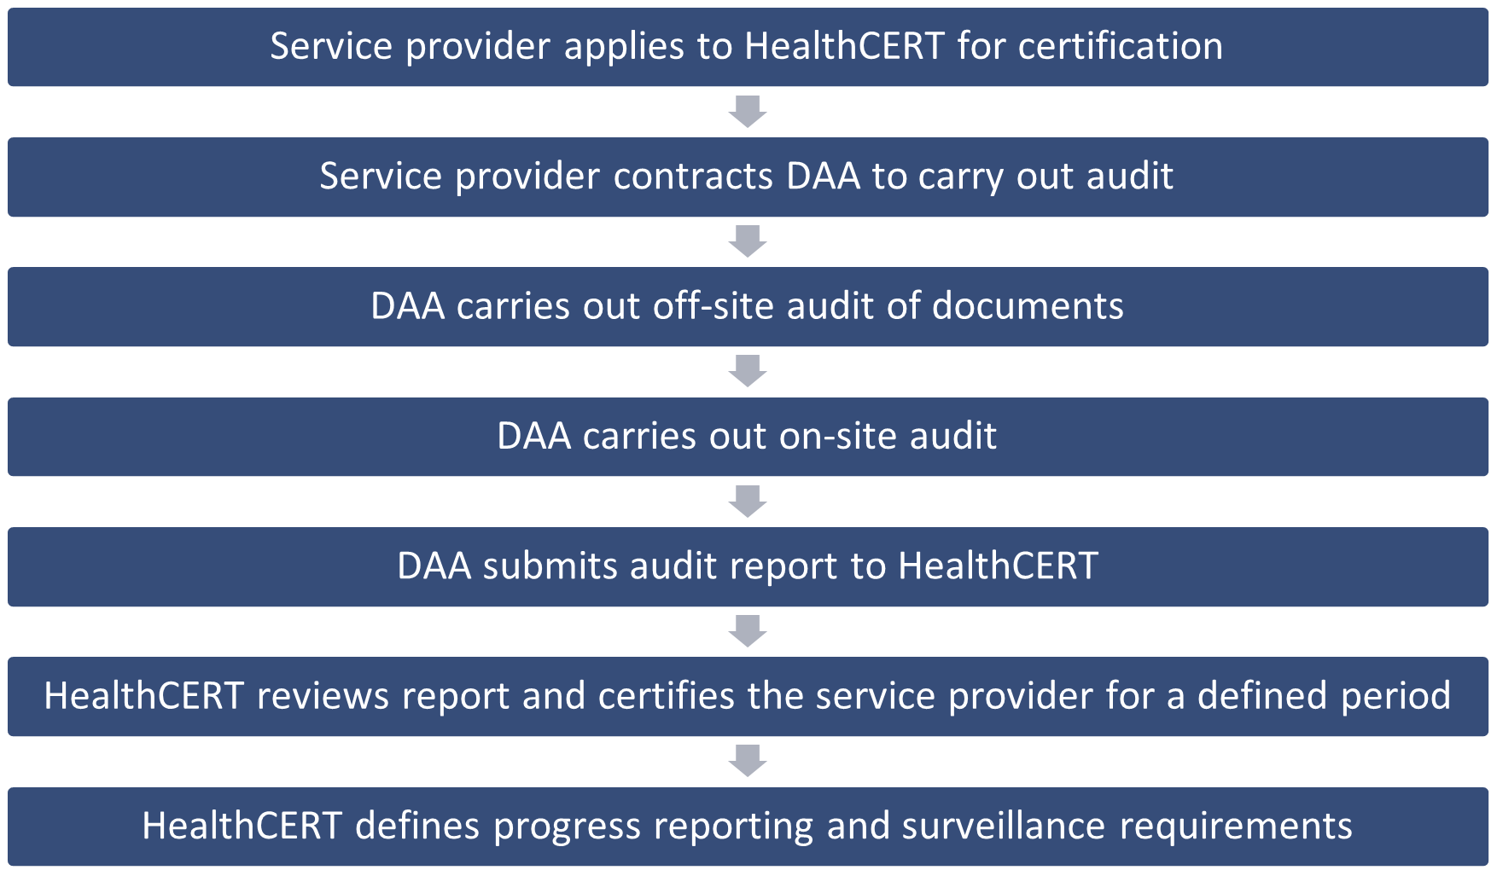

Figure 2: A typical process for auditing and certifying service providers[8]

HealthCERT carries out observation audits as part of its performance monitoring. These observation audits involve a HealthCERT advisor accompanying a DAA auditor on selected audits. This allows HealthCERT to observe and compare audit practices across audits and also to assess the competency of the individual auditors.

# The evaluation

## The evaluation aims and questions

When developing Ngā Paerewa, MOH committed to commissioning an external company to complete an independent evaluation of the implementation of Ngā Paerewa. Malatest International was commissioned in August 2023. The evaluation aims to determine the effectiveness of MOH implementation of Ngā Paerewa, including:

* Training.
* Support and communications provided by HealthCERT to the sector.
* Preparation for auditing processes.
* The internal preparedness of HealthCERT.

The evaluation also seeks to determine to what extent HealthCERT has met these objectives, considering the preparedness of:

* Healthcare providers to be audited against Ngā Paerewa, including increased Te Tiriti compliance and equity of healthcare provision.
* Designated auditing agencies to audit against Ngā Paerewa.
* Funders and corrective action managers to support the Ngā Paerewa audit process.
* HealthCERT to process Ngā Paerewa audit reports and appropriately certify health providers.

Additionally, the evaluation considers to what extent HealthCERT has established sufficient operational processes to enable the successful execution of the above.

## Scope

The focus is a post-implementation evaluation. A review of the development and content of Ngā Paerewa is out of scope, noting that Ngā Paerewa will be reviewed in 2025. See Table 2 for a detailed list of what falls within and outside the scope of the evaluation.

Table : In-scope vs. out-of-scope evaluation parameters

|  |  |
| --- | --- |
| In scope | Out of scope |
| * Implementation strategies developed as part of the development of Ngā Paerewa. * Infrastructure to support implementation. * Training and support for stakeholders. * Communication strategies. * Complaints and feedback processes. * Adaptions for Māori. * Audit framework – the grace periods. * Te Apārangi: Māori Partnership Alliance (Te Apārangi) – advice and guidance sought from Te Apārangi when developing the training material, survey questions, sector guidance, etc. | * Ngā Paerewa content. * Development of Ngā Paerewa. * Establishment of governance/advisory committees (governance group, advisory panels, operative alliance, Te Apārangi, working groups). * Experiences of people using health and disability services. * Current work on redesigning the audit framework for public hospitals. * Audit framework – who, how often, etc. (Public hospitals audit under the reformed health system). * Funding and payment system for DAAs. * Te Apārangi – current work about future engagement between HealthCERT and Te Apārangi. * Home and Community Support Services. * Date of implementation. |

## The theoretical foundation for the evaluation

An evaluation framework (Appendix 1) was developed following the document review and planning interviews with key MOH stakeholders. The framework provides the foundation for the evaluation design, analysis and reporting.

The measurement framework (Appendix 2) aligns with the evaluation framework and builds on the evaluation aims and questions to provide a basis for the development of questionnaires and other data collection methods.

## Information sources

The evaluation employed a mixed-method approach, drawing on various data collection sources, including a document review, in-depth interviews with a wide range of key stakeholders, and the administration of an online survey.

|  |  |
| --- | --- |
|  | The document review focused on post-implementation documentation supplied by HealthCERT or available on the MOH website. Some earlier documents were included to provide context. Relevant documents and resources included:   * Implementation Transition Programme Plan * Stakeholder surveys * Audit outcomes * Sector Guidance * Online training and support (e-learning resources, informal teaching sessions, etc.) * External queries monitoring * Designated Auditing Agency Handbook * Standards mapping document * Internal policies and procedures |
|  | In-depth interviews with:  Internal stakeholders (12)  External stakeholders (59)   * Te Apārangi and Te Whatu Ora (n = 2) * Clinical Quality and Safety team, including public hospitals (n = 12) * Mental Health and Addiction team (n = 2) * Funders of regulated healthcare providers (n = 6) * DAAs (n = 5) * National associations and independent contractors (n = 3) * Whaikaha Ministry of Disabled People (n = 4) * Health care providers, including aged residential care, residential disability, fertility and private hospitals (n = 25) |
| Online Network with solid fill | In October 2023, HealthCERT notified 953 certified providers about the evaluation and requested them to opt-out of the survey invitation if they chose not to participate. A total of 665 emails were sent, accounting for situations where providers shared a single contact person for their group of care facilities.  Malatest sent a survey invitation to 427 unique email addresses, some of which represented multiple facilities. The survey was intended for completion by individual sites with national headquarters asked to forward the invitation and survey link to the appropriate individuals. Due to the inability to track the number of individuals who received the invite, the response rate cannot be calculated.  In total, there were 65 survey responses, including:   * 44 (68%) individual or standalone providers * 21 (32%) providers who were part of a group of care facilities.   There was good representation from both individual and standalone providers as well as those part of a group of care facilities and from all regions. More details of the survey demographics are documented in Appendix 3. |

## Analysis

A general inductive approach was used to analyse the qualitative data with guidance from the logic model and evaluation framework. Key themes and sub-themes that aligned with the evaluation framework were identified and common themes within and across different stakeholder groups.

The codes used in this report include:

* MOH and HealthCERT (past and present): coded as Internal stakeholders
* Te Apārangi, Te Whatu Ora governance, DAAs, national associations and external contractors: coded as External stakeholders
* All health care providers: coded as Provider
* Qualitative survey responses: coded as Survey provider

Survey data were analysed using descriptive statistics aligned with the evaluation framework.

## Interpreting recommendations and future considerations

For this report, recommendations offer specific actions to address or improve the current situation. While some recommendations may fall outside the remit of HealthCERT, they could still have a beneficial impact on the implementation of Ngā Paerewa. In such cases, we recommend that HealthCERT partner with or support the responsible agency in implementing these recommendations. Therefore, the recommendations also identify the responsible agency for action.

Future considerations provide suggestions for potential areas of focus or planning for future implementation of new standards.

## Strengths and limitations of the evaluation

The evaluation was strengthened by:

* A mixed-method approach. Using both quantitative and qualitative methods enhanced the comprehensiveness of the evaluation.
* Diverse perspectives. Given the diverse nature of the healthcare sector, it was important to interview a wide range of stakeholders and include as many perspectives as possible.
* Being grounded in a theoretical framework. This provided a basis for designing research questions and a structure for interpreting findings.
* A good working relationship with HealthCERT. Regular progress catch-ups with the HealthCERT team helped integrate their knowledge into the evaluation, address any potential risks promptly and provide opportunities to highlight and discuss preliminary findings.

The evaluation was limited by:

* Not having interview representation from English as a second language (ESL) providers. However, national association representatives were interviewed and were able to highlight common themes encountered by ESL providers.
* The data collection period coincided with the Christmas and New Year holidays which may have reduced the survey response rate. The survey closing date was extended to accommodate more providers.
* Although there was a breadth of responses across different types of service providers we do not know how similar or different the providers responding to the survey were compared to those that did not respond.

# The implementation landscape

While the timing of the implementation is not within the scope of this evaluation[9], it is important to acknowledge implementation coincided with major events in the international and local health landscape, including the COVID-19 pandemic, Pae Ora - Healthy Futures health reform, and IT software changes for MOH.

The passing of the Pae Ora (Healthy Futures) Act 2022 resulted in significant changes in the health sector. The MOH is focused on policy, strategy and regulation, while Health New Zealand - Te Whatu Ora (Te Whatu Ora) has taken over the national planning and commissioning of health services through the four regional divisions (previously functioning as 20 District Health Boards).

The convergence of these events added further strain to an already stretched sector, eliciting strong emotions from many stakeholders.

I remain very angry that the rollout of Standard 2021 occurred in the midst of COVID. For a standalone organisation, it was overwhelming to focus on learning the new requirements and then to get [into] the headspace to re-write policy and process when we had a staffing crisis and were in and out of lockdowns. (Survey provider)

The diversity of healthcare services and providers in New Zealand presents HealthCERT and providers with distinct challenges and opportunities in implementing Ngā Paerewa. Acknowledging and addressing this diversity was essential for the successful implementation of Ngā Paerewa.

## Regional differences

The changes brought about by the Pae Ora (Healthy Futures) Act were still being integrated at the time of the Ngā Paerewa implementation. The District Health Boards were integrated into new health regions. District Health Board roles including the role of Te Whatu Ora funder portfolio managers that interfaced with health providers were evolving.

Different regions within New Zealand have very different demographic profiles. Differences in ethnicity influence health provider staff and health user profiles. These differences have an impact on the extent te ao Māori was integrated into provider practices.

# HealthCERT team

## The HealthCERT team

The HealthCERT team underwent significant changes during the implementation, including the departure of experienced staff, secondment and promotions. By 2022, the team had stabilised and, at the time of the evaluation, consisted of 11 full-time equivalents (FTEs), with all positions filled.

## Implementation process

The implementation transition period was intended to ensure:

…all providers have early support in their implementation of the new Te Tiriti criteria, irrespective of whether they are due for a certification or surveillance audit[10].

The implementation process comprised:

* Implementation management
* Communication of changes to the sector – providers and DAAs – and introduction of Ngā Paerewa
* Availability of training and resources to support the sector – providers and DAA
* Support for the sector to implement changes
* Business-as-usual (BAU) auditing and regulation activities
* Response to feedback.

## Audit pilots

Four audit pilots were conducted in late 2021. Because of COVID-19 outbreaks and subsequent alert level 4 lockdowns, the audit pilots only involved South Island providers.

Using certification and surveillance audits to test the HealthCERT Certification Framework, the provider’s contracted DAAs ran an audit against Ngā Paerewa. A HealthCERT staff member observed and mapped the Ngā Paerewa audit results to the 2008 Standards. The provider received an audit outcome under the 2008 Standards and the Ngā Paerewa standards.

Information from the pilots was used to further inform the transition planning, including determining a provider’s certification period against Ngā Paerewa and the duration of the grace period.

The DAAs and providers involved in the pilot audits considered them useful. DAAs used the audit pilots to test the parameters of audit evidence and expectations required to meet Ngā Paerewa and inform the development of their own resources.

In terms of preparing our systems…we have a number of audit tools that we need to develop or modify so that [audit pilot] assissted us to do that. [It] was really valuable from that perspective, and I know that it would have been very valuable for the clients that were involved in it. (External stakeholder)

All four providers viewed the audit pilots as a learning experience and three of the four providers, being part of larger organisations, applied the lessons learnt to their other sites in preparation for their audits.

[Before the audit pilot], our policies hadn’t been updated. We very much wanted to be in the pilot so that we could learn and I could use that as an opportunity for understanding where we need to go and what we need to do. If we hadn’t been part of it, we wouldn’t have been able to progress so quickly… (Provider)

One key aspect of the rationale for the audit pilots was to inform the development of internal HealthCERT Certification Framework processes, including templates, decision matrix and policies[11]. Establishing a formal process to review and evaluate the insights gained could have further enhanced the benefit of the audit pilots for HealthCERT.

## Implementation management

Implementing Ngā Paerewa was a major activity for the HealthCERT team on top of BAU activities. To manage the implementation, they:

* Set up an oversight group to meet fortnightly to manage, mitigate risks and monitor progress on the implementation. Participants included the Group Manager of Quality Assurance and Safety, the HealthCERT Manager, Principal Advisor Quality Assurance and Safety, Principal Advisor HealthCERT, and Senior Advisor Implementation HealthCERT (a temporary role to support the implementation process).
* Developed an Implementation Transition Programme plan outlining workstreams, persons responsible, progress and areas of risk, with a timeline through to 28 February 2022.
* Established an Evaluation Effectiveness Framework to regularly collect stakeholder feedback to inform ongoing implementation activities.
* Developed and published the Sector Guidance for Ngā paerewa Health and disability services standard (NZS 8134:2021).
* Contracted a fixed-term Senior Advisor Implementation and additional short-term contractors.
* Upskilled staff, e.g. Lead Health Auditor training.
* Contracted out the development of the online eLearning modules.
* Sought advice and guidance from Te Apārangi and the MOH Māori Health Directorate on the implementation, including the development of training resources.
* Collaborated with the MOH Communications team to reinforce key messages and disseminate published information on the MOH website.

Stakeholders, including providers, were generally positive about the implementation efforts of the HealthCERT team.

I think the Ministry have done an absolutely marvelous job, really, considering there was a whole lot of new staff. It was troubled times with COVID and the changes that we’re experiencing. (External stakeholder)

## Implementation management challenges

Throughout the implementation phase, various challenges emerged, including:

* Staff turnover across all levels of HealthCERT: Loss of institutional knowledge and auditing experience strained both new and existing staff.
* Inexperience in crucial areas for implementation: Different skill sets, such as auditing, education resource development, and project management, were required. While HealthCERT possessed adequate clinical expertise for BAU operations, it lacked implementation experience.
* High workload for a relatively new team: Balancing BAU tasks, implementation responsibilities, and acclimating to new team dynamics and systems proved challenging.
* A change in project manager hindered the process: The initial project manager was seconded to another agency and another project manager was appointed.

Many of the challenges mentioned have been successfully addressed, largely owing to the commitment of the current team to increasing their experience in their respective roles and support from the senior leaders in MOH to bring in short-term contractors when needed. However, some remain, and new gaps have emerged and are progressively being addressed by the team. These include:

* The HealthCERT team needs to maintain their role as regulators which leaves a gap for the educator role.
* A need to update policies. Relevant policies and procedures require updating to align with Ngā Paerewa. They are prioritised and gradually being updated as team resources and capacity allow. A simultaneous systematic internal review of internal systems and processes, alongside updating policies, could be advantageous.
* Gaps in te ao Māori expertise within the HealthCERT team or available for the team to draw on. This hindered their ability to confidently respond to cultural inquiries from providers and demonstrate adherence to Ngā Paerewa implementation practices.

## Recommendations and future considerations

|  |  |
| --- | --- |
| Recommendations | Lead agency |
| Explore opportunities to retain institutional knowledge.   * Update documents, including policies, standard operating procedures and manuals, to support smooth knowledge transfer. * Explore training and mentoring opportunities within HealthCERT and MOH to encourage knowledge sharing and knowledge retainment within HealthCERT. * Establish or adhere to standardised naming conventions and folder structures for easy organisation and retrieval of information in a timely manner. | HealthCERT, MOH |
| Explore opportunities for internal evaluation of implementation progress. This might include:   * Scheduling regular debrief sessions to identify improvement opportunities and ensure that lessons learned are integrated into future initiatives. * Establishing internal feedback mechanisms. | HealthCERT |

|  |  |
| --- | --- |
| Future considerations | Lead agency |
| Early identification of the skills and resources needed for implementation, coupled with an assessment of the team’s capacity and capability to execute and the resources available. Early identification of gaps allows for strategic planning to address them effectively and for discussions about resource allocation. Considering the need for an ‘educator’ could be part of this process. | HealthCERT, MOH |
| Allocate resources to prioritise hiring a project manager, ideally involved in the development phase. A dedicated project manager can focus on planning, implementation and monitoring without the distraction of business as usual. | HealthCERT, MOH |
| Consider how to conduct more audit pilots across more service types and earlier (contingent upon provider willingness) to thoroughly test internal HealthCERT processes and documents, enabling early identification and resolution of issues. | HealthCERT |

# Communicating changes to the sector

|  |
| --- |
| **Communication** |
| 30 June 2021: Sector Guidance was published.  The Sector Guidance was finalised in preparation for implementation and made available on the MOH website. |
| Ongoing: HealthCERT employs various communication channels to engage stakeholders and facilitate communication in both directions. |

## Communication

HealthCERT communicated with the sector through regular meetings, emails and via the DAAs. HealthCERT distributed via email and MOH website.

Most providers ‘strongly agreed’ or ‘agreed’ that the HealthCERT communication was frequent enough (63%), was clear (71%) and had the right information for them (60%) (Figure 3).  
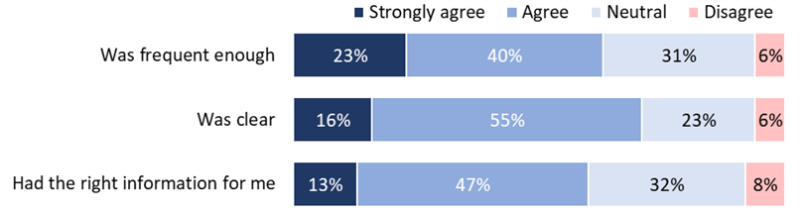

Figure : To what extent do you agree or disagree that the HealthCERT communication was a) frequent enough, b) was clear, c) had the right information for me? (Survey, n = 62)

## Areas for improvement

When asked how communication with HealthCERT could be improved, providers reiterated requests for more practical examples and were frustrated with their absence. This feedback may indicate areas where providers feel they need more resources, rather than solely reflecting on HealthCERT’s communication efforts.

Other areas identified for improvement include:

* Improving the usability of the MOH website. MOH is redeveloping its website; once updated, these issues are expected to be improved.
* Simplifying language to improve clarity and understanding for all stakeholders, particularly for ESL providers.

The terminology throws people. We have a lot of people in the sector [who] manage facilities that have English as a second language. I have people asking a question and I think ‘why did they [think that]’ and then I look at the criteria they are referring to…the language used is not that user friendly. (External stakeholder)

* Enhancing how implementation updates are communicated. Providers sought a more reliable method to track updates as emails can be overlooked or misdirected, resulting in missing HealthCERT Bulletin notifications and implementation updates.

## Communication challenges

Despite utilising numerous communication channels, there was still wide variation in awareness of Ngā Paerewa. This suggests that communication may not have always reached the intended audiences in a timely manner.

I missed the first couple of modules because I didn’t know about them. There was, for me, a lack of awareness about where to find support, particularly the webinars...I just came across the Health[CERT] Bulletins and that drove me [to the website]. (Provider)

Our facility manager was able to access MOH resources and has done a great job of ensuring we are fully up-to-date with implementation. The support she has received for this kaupapa has been fantastic. Well done MOH. (Survey provider)

Many stakeholders said they received HealthCERT communication through intermediary channels, such as their DAA, Te Whatu Ora portfolio manager, national association, or other providers.

I get [emails] directly from the Ministry of Health and also through the [association name]…they’ll send us updates as well. (Provider)

Some providers also appear to use intermediaries to communicate with MOH. This use of intermediaries highlights a broader challenge in communication within the sector and the importance of ensuring accurate and consistent second-hand information.

Smaller, new, and ESL providers may hesitate to contact HealthCERT, fearing unwanted attention on their facility. As a result, these providers have often relied on intermediaries to communicate with HealthCERT, leading to limited support due to incomplete information.

Compounding the communication challenges is the potential issue when a single conduit connects MOH and large providers. If communication is missed or the key contact drops the ball just with time constraints and not being as responsive to the Ministry, it can cause many individuals to miss important information as it fails or is delayed in filtering down. Keeping contact information up to date will facilitate this process.

## Recommendations and future considerations

|  |  |
| --- | --- |
| Recommendations | Lead agency |
| Continue to maintain relationships with external stakeholders to ensure consistent and accurate information dissemination across all stakeholders. | HealthCERT, external stakeholders |
| Support and identify cultural training opportunities for auditors outside of New Zealand to ensure that, regardless of location, auditors are equipped with the same cultural knowledge and skills, contributing to consistency in audit reports across locations. | HealthCERT |
| Establish multiple points of contact for large providers, such as public hospitals, to improve information dissemination and minimise the risk of critical information not being communicated in a timely manner. | HealthCERT |
| Establish a dedicated section on the MOH website for implementation updates. This section could include an option for notification subscriptions or search functionality to help users easily locate and access updated information on the website. | HealthCERT |
| Explore including a ‘click here to subscribe’ link to the HealthCERT Bulletin. Although privacy concerns and list maintenance may pose challenges, such a link would enable interested individuals to easily sign up for regular updates, addressing some intermediary issues and broadening the Bulletin’s audience reach. | HealthCERT,  MOH |

# Training and resources

|  |
| --- |
| **Training and resources** |
| July 2021: Online workshops begin. |
| October 2021: Targeted sessions and conferences.  HealthCERT organised multiple internal and external virtual hui to introduce and assist in implementing Ngā Paerewa with various stakeholders. |

## Nga Paerewa resources and training

HealthCERT developed a range of resources and training opportunities for providers.

Table : Implementation training and support offered by HealthCERT

|  |  |  |
| --- | --- | --- |
| **Online resources** | | |
| MOH website | | Serves as a crucial communication platform for HealthCERT. Some of the key content available includes education resources, reports and publications, and contact information. |
| eLearning modules | | The first module provides an overview of Te Tiriti o Waitangi requirements in Ngā Paerewa and their application. It is suitable for those seeking a basic understanding of these principles.  The second module equips senior management, leaders, and frontline workers in health and disability services to deliver culturally responsive care for all, particularly whānau Māori. |
| Online lunch sessions  (Jul – Oct 21) | | These provided an overview of the different sections within Ngā Paerewa, focusing on the changes from the previous standards. The sessions are available on YouTube, and the presentations are available on the MOH website. |
| Online training sessions  (Nov 22 – Aug 23) | | These were in response to the sector's desire for ongoing training. The first presentation focuses on infection prevention and microbial stewardship. More training presentations are to come. |
| Sector-specific information seminars  (Sep – Dec 21) | | Due to COVID-19 disruptions in 2021, HealthCERT could not hold planned seminar roadshows. As a result, pre-recorded sector-specific sessions were published, covering the development of Ngā Paerewa, including a summary of partially new and new criteria. |
| Workshops on topics of interest | | HealthCERT’s quarterly feedback surveys indicated the sector’s preference for targeted workshops to support their preparedness for implementation. Tailored workshops are developed and delivered on an ad-hoc basis. |
| **Other implementation resources** | | |
| Designated Audit Agency Handbook | Details the requirements of DAAs for auditing and audit reporting for the certification of health care services under the Health and Disability Services (Safety) Act 2001. It also gives providers a guide to specific requirements for various types of audits. | |
| Sector Guidance | Assists different service types in interpreting the criteria for each section of Ngā Paerewa. It serves as a non-mandatory guide and is not subject to audits. The guidance is general and may not cover all methods for meeting the criteria. | |
| Standards Mapping Analysis | Compares the previous standards with the 2021 standard, showing which criteria have changed and which have stayed the same. This document supports providers to plan and prepare for meeting the updated requirements. | |
| HealthCERT Bulletin | This quarterly newsletter provides sector updates, spotlights healthcare providers, HealthCERT operational matters and other relevant information. Distributed by email to a stakeholder list maintained by HealthCERT, the Bulletin is also publicly available on the MOH website. | |
| Direct contact with HealthCERT | HealthCERT has a widely promoted generic email address available for stakeholders to use for general inquiries. This inbox is regularly monitored and cleared. Additionally, stakeholders can call the MOH general enquiries 0800 number and the HealthCERT team will follow up. | |

The different forms of training and resources were widely accessed by providers. Thirty-five percent of survey respondents said they had accessed all 10 types of training provided by HealthCERT (Figure 4).

Bar graph of the extent to which providers accessed training and resources provided by HealthCERT, where 35% of providers accessed all 10 types of training and support and 3% did not access any.

Figure . The extent to which providers accessed training and resources provided by HealthCERT (Survey, n = 65)

MOH communicated information about HealthCERT training through the HealthCERT Bulletin, which is distributed via email and shared on the MOH website. The most common reasons providers gave for not accessing training were:

* Insufficient time (not a high priority)
* Inability to release staff for training
* Not knowing about training opportunities – indicating gaps in communication between HealthCERT and providers or within the providers’ service.

## The extent training and resources prepared providers to implement Ngā Paerewa

The types of training and resources that were accessed the most were sector guidance (used by 83% of survey respondents), eLearning modules and the HealthCERT bulletin (each accessed by 80% of survey respondents). The DAA handbook was the resource most often considered useful by those who accessed it (64%) (Figure 5).

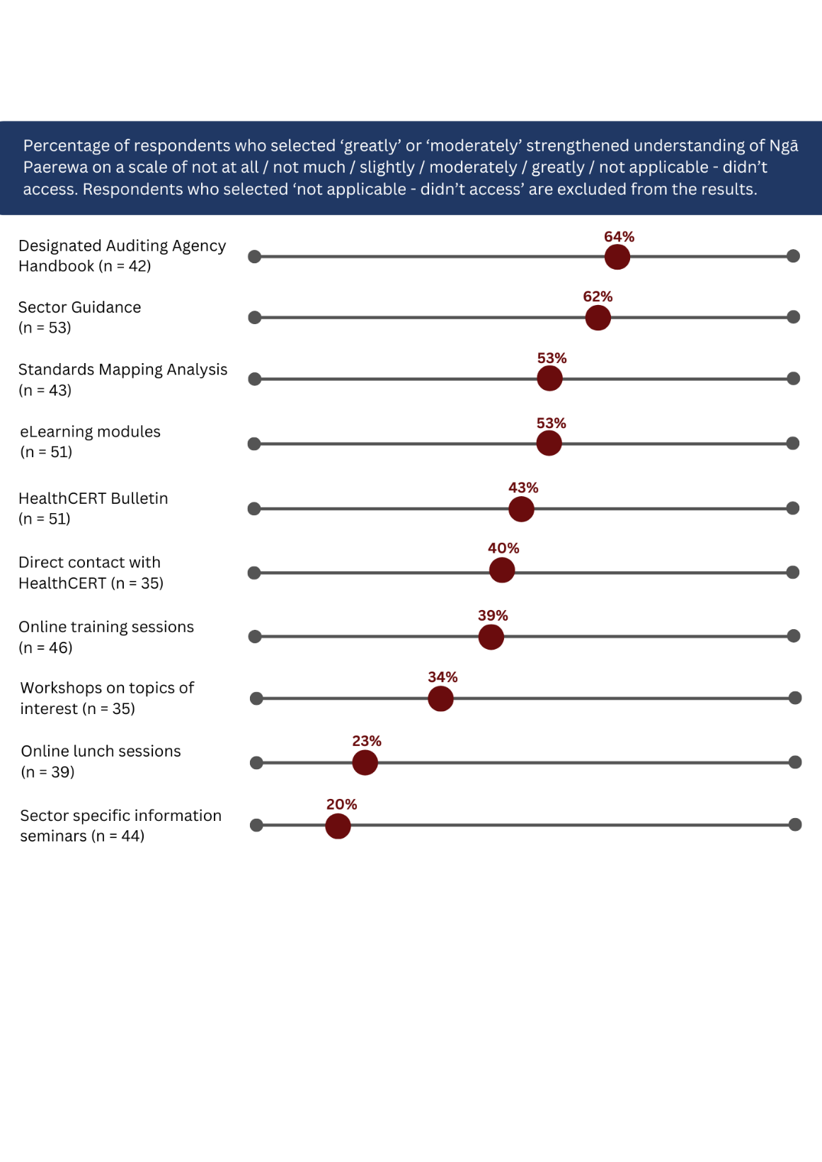

Figure : How much did each of the following forms of training, documentation and support from the Ministry of Health strengthen your understanding of Ngā Paerewa? (Survey)

Providers liked that the training was free and that it was available online, allowing people to access it when convenient and revisit it as needed.

I don't think many providers attended … because there's so much going on, the whole COVID thing threw a spanner in the works and people[are] just catching up on things. (External stakeholder)

Despite the popularity of online training, there is still a strong desire for face-to-face training. Providers request opportunities to network with other providers, ask questions and share feedback. Face-to-face training had initially been planned before COVID-19 disruptions.

The old adage of you can take a horse to water, but you can’t make it drink, sort of applies here in some respects because you’re providing it [training], but you’re expecting that they will come and access and use it. For those people that don’t, I don’t know what more you can do. (External stakeholder)

Of those who accessed the training, there was variation in the extent people in different roles found different training opportunities useful (Figure 6).

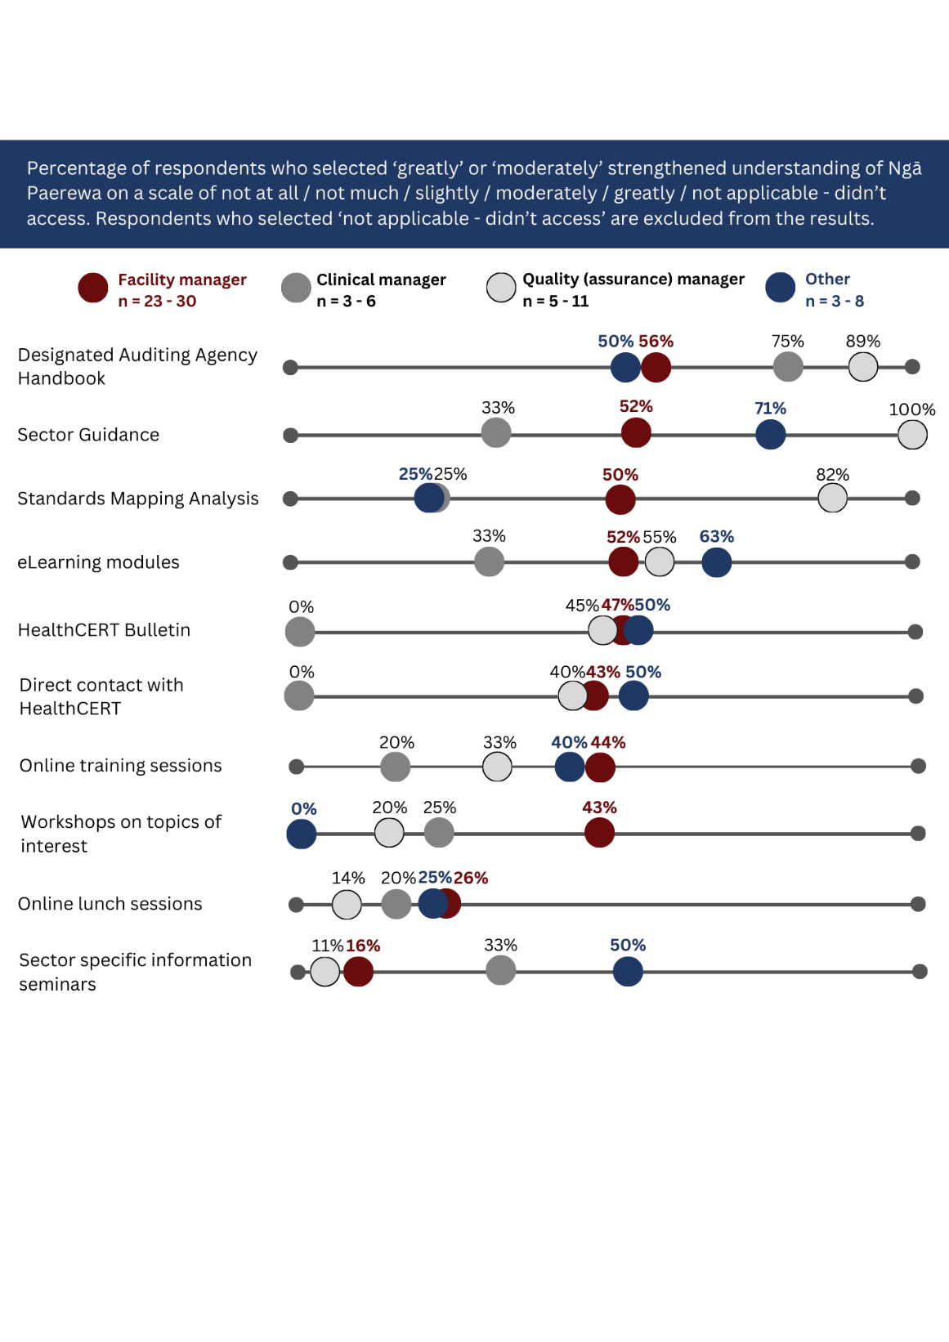

Figure : How much did each of the following forms of training, documentation and support from the Ministry of Health strengthen your understanding of Ngā Paerewa, by role (Survey)

## Additional resource requests

Despite the training and resources available, 38% of providers wanted more information about how any of the Ngā Paerewa requirements applied to their facility (Figure 7).



Figure . Would you like any information about how any of the Ngā Paerewa requirements apply to your facility (Survey, n = 64)

A focus on outcomes, rather than compliance with guidelines, is new for providers and isn't universally understood. Consequently, many providers asked for training to be enhanced with more real-life examples. Stakeholders commonly requested HealthCERT provide additional examples or offer more specific examples on meeting Ngā Paerewa, particularly regarding Te Tiriti. This request may arise from not fully understanding that Ngā Paerewa intentionally permits flexibility in achieving compliance. Being overly prescriptive risks providers viewing the prescribed methods as the only route to compliance, disregarding the sector’s diversity and inadvertently discouraging providers from making other efforts.

It would be nice to have some debate [with HealthCERT] on what people have seen and what they’ve assumed to be an adequate interpretation of the standard … it would be nice to know what the tolerance level was for working towards something and fully achieving it. (External stakeholder).

While not directly involved in establishing and maintaining support networks, HealthCERT could play a role in guiding providers to existing support networks or to providers who excel in specific areas, thus facilitating peer support.

Providers accessed a range of other training, potentially leading to inconsistencies in the interpretation of Ngā Paerewa. While there were reports of variability in the interpretation of Ngā Paerewa between providers and DAAs, there are signs of improvement.

Some stakeholders offered suggestions for resources that could facilitate easier implementation. While some were beyond HealthCERT’s scope, there may be opportunities to collaborate with other agencies or within the wider MOH to address these needs or direct stakeholders to relevant agencies.

Additional resource requests included:

* Tailored resources for different audiences, including frontline, governance, and consumers and whānau. Different levels of detail are required for different roles, prompting some providers to develop their own ‘cheat sheets’ or ‘abridged versions’ of Ngā Paerewa. Centralising resources could ensure consistency and efficiency.
* Materials to promote engagement. For large providers, Ngā Paerewa may become a checkbox activity primarily limited to quality assurance roles. Some suggest using materials such as infographics to effectively convey the rationale, benefits and implications to busy audiences who may not read Ngā Paerewa in its entirety.
* Policy templates. Due to limited resources (time, money, expertise), updating policies to align with Ngā Paerewa is challenging for some providers.
* Translated materials - In an effort to fulfil Te Tiriti obligations, some providers sought translations of resources into Te Reo Māori but lacked the necessary resources. They proposed that commonly used materials could be pre-translated to address this need across providers.
* A centralised repository, similar to the one for online training materials, to access all resources.

It’s fabulous that there are resources there, but you have to get a login and it’s only when you get to the end of the presentation that you see there are additional resources there. It would be nice if those resources were put up first [in the presentation] or made easier to access…(External stakeholder)

It was common for providers to request resources that already existed, either from HealthCERT or another agency. This highlights the need to enhance awareness of existing resources and improve the accessibility to HealthCERT training and resources.

Although providers did not always specifically request more support implementing the Pacific cultural aspects, it is noted that some providers highlighted challenges to meeting those aspects of Ngā Paerewa. The focus on addressing the Pacific cultural aspects of Ngā Paerewa was often overshadowed by the more prominent issues related to incorporating Māori cultural requirements (discussed further in section 9). Challenges in accessing Pacific cultural expertise mirrored the challenges in accessing Māori cultural expertise, discussed further in section 9.2.

Additional challenges included:

* How to address the diversity among Pacific peoples.

Then you’ve got the other issue of thirteen Pacific nations all [being] slightly different. Not values but slightly different cultural needs. (Provider)

* Pacific peoples do not have a singular framework like Te Tiriti. Consequently, determining how to address Pacific health and ensuring fair treatment across cultures can be difficult.

This might suggest a need to connect providers struggling to implement the Pacific cultural aspects of Ngā Paerewa with existing Pacific cultural supports.

## Recommendations and future considerations

|  |  |
| --- | --- |
| Recommendations | Lead agency |
| Consider how to respond to requests for more practical examples of what meets Ngā Paerewa. | HealthCERT |
| Consider how to respond to requests for peer support networks. Although providing peer support falls outside the remit of HealthCERT, there may be a place for indirectly supporting the establishment of peer support networks. | HealthCERT, Te Whatu Ora |
| Explore the role of the Te Whatu Ora portfolio managers in supporting implementation. | HealthCERT, Te Whatu Ora |
| Establish a centralised online repository for resources with search functionality. This may become unnecessary following the completion of the MOH website redevelopment currently underway. Where HealthCERT is not the owner of the material, provide links for reference. | HealthCERT, MOH |
| Continue to promote HealthCERT training for provider staff new to the sector or who have yet to take it. | HealthCERT |
| Continue to maintain current feedback mechanisms for stakeholders to identify emerging training needs and respond accordingly, as they have been effective. | HealthCERT |
| Explore ways for struggling providers to access existing Pacific cultural supports. Pacific cultural support is available but not uniformly distributed or widely known about nationwide. Improve methods to facilitate access to cultural knowledge need to be developed. | HealthCERT |

|  |  |
| --- | --- |
| Future considerations | Lead agency |
| In addition to online resources, consider including face-to-face training sessions, such as travelling roadshows nationwide, to improve training engagement and effectiveness. | HealthCERT |

# Support for the sector to implement changes

|  |
| --- |
| **Support** |
| **Grace periods** applied to new (unmapped) and partially new (partially mapped) criteria, where awarding of a full attainment occurred if the provider could demonstrate progress toward implementation. Partially new criteria had a grace period of 12 months (ending March 2023), and new criteria had a grace period of 18 months (ending August 2023). A partially attained rating was applied if a provider couldn’t demonstrate any progress toward implementing a new or partially new criteria.  March 2023: The grace period for partially mapped criteria ended.  August 2023: The grace period for new criteria ended. |
| Ongoing support is available for providers and DAA through the HealthCERT team. |

The HealthCERT team provides general sector support by developing and providing resources to support the sector's understanding of Ngā Paerewa and preparation to meet them. HealthCERT also offers direct support, readily available to address enquiries via calls and emails, ensuring a swift response to any question that may arise.

I’ve never asked [HealthCERT] a question and not got an answer. I get a good sense that there is a process there…things are debated and someone senior is advising, so if that individual doesn’t have an understanding, they’re certainly going to somebody who might do. (External stakeholder)

## Provider understanding of Ngā Paerewa requirements

Overall, most providers surveyed (77%) had a good understanding of Ngā Paerewa requirements (Figure 8). There was minimal difference in understanding between independent standalone providers and those part of a group of care facilities.

Bar graph showing to what extent providers agree or disagree that they understand what Ngā Paerewa requires of them, where 22% strongly agree, 55% agree, 15% are neutral, 5% disagree or 3% strongly disagree. 

Figure : To what extent do you agree or disagree: we understand what Ngā Paerewa requires of us (Survey, n = 65)

Provider confidence was slightly lower, with 68% of providers expressing some agreement with the statement ‘I am confident in our ability to meet the standards for Ngā Paerewa’ and 9% disagreeing (Figure 9).

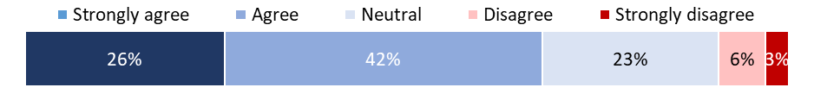

Figure : To what extent do you agree or disagree: I am confident in our ability to meet the standards for Ngā Paerewa (Survey, n = 65)

## Provider approaches to implementation

Implementation approaches varied among providers, from endeavouring to be prepared for an audit to struggling to dedicate time and expertise. Some providers had an advantage over others due to a variety of factors:

* Access to expertise with dedicated time, e.g. cultural advisors and quality assurance personnel.
* More resources to allocate to compliance activity, including contracting additional support where needed.
* Advance preparation through involvement in the standards review process.
* Access to peer support networks.

Because I’m part of a large network, we have a quality team and a lot of expertise up at the national office, so we were [given a] heads up straight away. The minute I knew we could access the Standards I printed it off and we started a gap analysis. The entire network did an analysis on each section, and we did a local one as quality manager of [our] local practices, systems and processes. (Provider)

## Grace period

A main avenue of support for providers was a grace period. This non-punitive period aimed to enable providers to develop the policies and processes they needed to meet Ngā Paerewa without incurring a corrective action if they fell short of meeting Ngā Paerewa. Most stakeholders found the grace period to be a valuable learning experience.

We took it as an opportunity to really look deeply and properly into proper fixes…having that grace period allowed us to put things in place and tweak them before getting penalised. (Provider)

A small number indicated that it had made little to no difference in their preparation for auditing. These were mainly providers who felt they were already largely compliant with Ngā Paerewa, particularly actions related to Te Tiriti obligations.

… we didn’t really need the grace period. There had been enough lead up … we knew they were coming and we kind of knew what they were going to have in them [because] we saw the draft. (Provider)

Providers’ perspectives on the duration of the grace period varied. Just over half (54%) of survey respondents ‘strongly agreed’ or ‘agreed’ that the duration was sufficient for them (Figure 10).

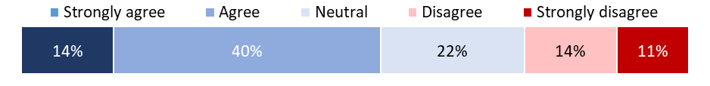

Figure : To what extent do you agree or disagree: The grace period was sufficient for us to prepare for the implementation of Ngā Paerewa (Survey, n = 65).

Respondents from group care facilities were slightly less likely to ‘strongly agree’ or ‘agree’ (48%) on the sufficiency of the duration compared to their individual/standalone counterparts (57%) (Figure 11). Some providers wanted a longer grace period to accommodate auditing more providers and to implement changes, like policy updates, which can take longer in large organisations.

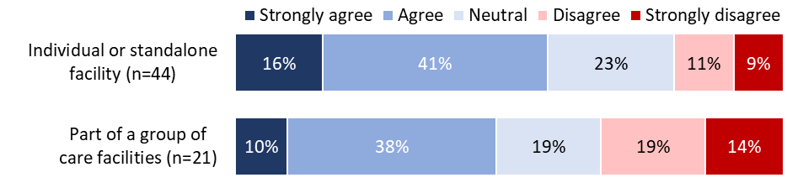

Figure : To what extent do you agree or disagree: The grace period was sufficient for us to prepare for the implementation of Ngā Paerewa, by facility type (Survey, n = 65).

A recommendation by Te Apārangi to include a reward system for providers who fully implemented new Te Tiriti criteria earlier than required was actioned. As a result, where a provider demonstrated full implementation of new or partially new Te Tiriti criteria during the transition period; this was recognised when awarding a certification period.

## Ongoing support

In the initial stages of implementation, providers frequently sought assistance to understand Sections one (Ō tatou motika: Our rights ), five (Te kaupare pokenga me te kaitiakitanga patu huakita: Infection prevention and antimicrobial stewardship) and six (Here taratahi: Restraint and seclusion ) of Ngā Paerewa. Many continue to seek support, particularly for understanding Section one. Requests for support for Section six was mostly from ARC.

Across all stakeholders – large or small, public or private, frontline or governance – a common struggle with a shortage in the health workforce was identified as a key factor in how well and easily providers were able to action Ngā Paerewa. While this shortage is widely acknowledged, the evaluation recognises that addressing it requires a systems-wide approach and cannot be solely remedied by the providers or the MOH.

**Support for providers**

Providers are accessing support from various sources, including funders, DAAs, associations of which they are members, private contractors and HealthCERT. One DAA noted that, at times, they find themselves walking “a very fine line between educating and auditing”. ARC providers observed that their more regular contact with funders, DAAs and national associations led to “stronger relationships”. As a result, they tended to seek support from these entities before turning to HealthCERT.

Providers and DAAs could call the HealthCERT team and ask for support. HealthCERT provided generalised support and advice while refraining from giving advice on specific scenarios. Providers and DAAs who used the support offered by HealthCERT commented that the team was easy to reach and quick to respond to their needs.

I believe that communication from HealthCERT was really good. There was regular communication, we had regular meetings, and they were invaluable…[Sector Guidance] only goes so far. If you ring up [HealthCERT name] with a query, [name] will come and present, there’s no problems with it, which is so fantastic. (External stakeholder)

Similarly, the HealthCERT team valued open and regular communication with DAAs and Te Whatu Ora portfolio managers, recognising it as a key to implementation success.

There’s a real sense that even if we don’t always agree with each other, we’re a team working through this together. (Internal stakeholder)

**Support for DAAs**

HealthCERT held regular group meetings with DAAs, which became more frequent during the early stages of implementation, reflecting a need for greater coordination and support at the time. While ongoing, these meetings are less frequent, signalling growing confidence as the implementation has progressed. DAAs generally reported receiving good support from HealthCERT. The regular meetings helped foster positive relationships, enabling DAAs to seek support from HealthCERT directly and engage in robust conversations if needed.

# Auditing and regulation activities

|  |
| --- |
| Auditing and regulation activities |
| Regular and ongoing meetings with DAAs. See section 7.4.  Online lunch sessions – a session specifically for auditors. Te Tiriti guidance specifically for auditors was delivered by Te Apārangi. The DAAs also had access to the same training and resources as providers (see Table 3).  Audit pilots. See section 4.3.  Designated Auditing Agency Handbook. The Designated Auditing Agency Handbook was updated to include new Ngā Paerewa criteria. (See also Table 3). |

The DAAs are integral to the implementation process. Their understanding and preparedness for Ngā Paerewa has been facilitated by:

* A strong relationship with HealthCERT, facilitated by frequent and open communication.

The communication from HealthCERT was really good. We had regular meetings, and they were invaluable…It feels like the relationship between the DAAs and HealthCERT [is] really good and productive and healthy. It’s not always been the case. (External stakeholder)

* Involvement in the audit pilots. The level of involvement and subsequent benefit varied among DAAs (See also section 4.3).
* Involvement in the Standards Review (2019-2021).

I think if you were involved in the development of the Standards and so on, those people probably did start out with a better understanding, but at the end of the day, we all eventually acquired an understanding. (External stakeholder)

HealthCERT took a co-design approach to developing resources, frequently seeking feedback and input from DAAs on auditing tools and resources. Efforts should be made to ensure that the influence of larger DAAs is balanced with that of smaller ones.

The DAAs and HealthCERT operate independently of each other. While HealthCERT offers training and support, DAAs also upskilled independently which falls beyond the scope of this evaluation.

Some stakeholders observed differences in the interpretation of criteria between providers and DAAs or between HealthCERT and DAAs. These instances seem to be decreasing in frequency as Ngā Paerewa has become more embedded. Some DAAs are hopeful that HealthCERT will continue to offer training opportunities, particularly around consistency in interpreting the cultural aspects of Ngā Paerewa.

Ongoing cultural competence top-up training is what we need now … (External stakeholder)

The overall consensus among auditors is that progress takes time. While incremental, they have noted an improvement in understanding across the board.

In every new standard, there is a lag time where we’re all getting used to it, the regulator as well as the auditors, as well as the providers… When you start cycling and you’re at the bottom of the hill, it’s very slow going to get to the top. (External stakeholder)

## Areas for improvement

Some of the challenges DAAs face mirror the concerns other stakeholders raised. Challenges include:

* Interpretation of the cultural requirements. The diversity within the health sector meant DAAs faced the challenge of determining how the cultural aspects could be correctly understood and applied across a multitude of different settings. DAAs located overseas may need additional support.
* Timing of audit pilots. Unlike providers, DAAs did not have the benefit of a grace period. In the future, it could be beneficial to conduct pilot audits before standards are legislated.
* Maintaining independence as an auditor and not an educator. Sometimes, there was tension for DAAs between being put in a position of educating providers who were asking for help and staying in the role of an independent auditor.

Our providers that we audited, wanted some guidance on how to interpret the Standard. We found it very difficult because we didn’t feel we could be involved in that education process…I think the Ministry do that education [and it is] far more appropriate. (External stakeholder)

## Recommendations and future considerations

|  |  |
| --- | --- |
| Recommendations | Lead agency |
| Support and identify cultural training opportunities for auditors outside of New Zealand to ensure that, regardless of location, auditors are equipped with the same cultural knowledge and skills, contributing to consistency in audit reports across locations. | HealthCERT |

# Te Tiriti obligations

|  |
| --- |
| Te Tiriti activities |
| Online lunch sessions (Jul – Oct 21). Te Apārangi facilitated two online sessions focused on Te Tiriti-related requirements, one aimed at providers and one at auditors. The sessions are available on YouTube and on the MOH website.  eLearning modules launched. Two eLearning modules were developed in partnership with the sector and Te Apārangi to support the sector in meeting Te Tiriti-related criteria within Ngā Paerewa. The first module was designed for anyone interested in understanding how Te Tiriti principles are applied in the health sector. The second module was designed for senior and executive management but is of benefit to all audiences.  The modules give an overview of Te Tiriti and mātauranga Māori and provide real-world examples of how healthcare providers have enacted Te Tiriti-related criteria into practice. The modules also link to external resources such as Te Kāhui Māngai website, a directory of iwi and Māori organisations and contact details. |

## HealthCERT activities

HealthCERT has implemented the range of activities above to meet their obligations under Te Tiriti.

A main source of input during the development of Ngā Paerewa was Te Apārangi. Te Apārangi was formed during the Standards Review (2019-2021) to ensure Māori participation and decision-making across all four phases of the standards review work programme. They had the final say on all Māori content within Ngā Paerewa.

Te Apārangi has now shifted to a governance role supporting HealthCERT to implement Ngā Paerewa across the sector. Te Apārangi meets quarterly and provides direction on how HealthCERT’s internal processes and policies can give effect to the principles of Te Tiriti[12].

During the review process, the mandate of Te Apārangi was well-defined and understood by stakeholders. However, as the implementation has progressed, some stakeholders have expressed some ambiguity about their role.

[The role of Te Apārangi] was it to support Māori providers or non-Māori providers with implementation? Consumers to know what their rights are? The health professionals? What exactly are we seeking their advice on? (Internal stakeholder)

In the future, it could be beneficial to evaluate HealthCERTs cultural requirements during the implementation phase, as it appears there is a disconnect between the current expertise offered by Te Apārangi and the practical support needed for day-to-day implementation. While Te Apārangi is not resourced, nor was it intended to provide day-to-day implementation support, there could be merit in exploring other options. This could involve Te Apārangi retaining oversight and guidance at the governance level while seeking additional resources for practical support. Noting the challenges of sourcing Māori cultural expertise alongside contracting support, it would also be beneficial to enhance internal knowledge and confidence among existing staff. The Māori Health Directorate – Te Pou Hauora Māori, could provide support in this space both now and in any future implementation.

A Specialist Māori Advisor was appointed to the Standards Review project team to focus on equity, Māori health and Te Tiriti as it related to the review. The role helped bridge recommendations from Te Apārangi and integrate them into practice. A similar role during implementation could have been beneficial.

Given the extent of the changes relating to Te Tiriti, strong cultural leadership for HealthCERT, the providers and DAAs was essential. The gap in te ao Māori expertise may have contributed to challenges for some in the sector in understanding what was required from them.

## The sector

Most stakeholders are committed to meeting their Te Tiriti obligations. These providers show a willingness to engage but may benefit from further support to strengthen their cultural confidence and boost their progress.

Confidence around the cultural aspects was still a work in progress for some providers and DAAs.

Our cultural advisor is just wonderful, but she’s not mana whenua. But, the marae has endorsed her. We tried to get Māori representation onto our board, but it has to be mana whenua, and we can’t find anyone. The board is a voluntary position but they are too stretched, our local marae. (Provider)

Some providers had access to more resources, which made it easier for them to meet their obligations. Enablers included:

* Being a kaupapa Māori service provider, having cultural advisors on staff and having residents and/or staff of Māori identity.
* Existing relationships with the local Māori community or having the financial resources to initiate and maintain relationships.
* Access to a third party who can facilitate contact with a cultural advisor.

A [Samoan] Reverend agreed to be interviewed and talk about aged care services where he had quite a bit of involvement and a registered nurse that is a Samoan lady … I was able to interview them, record that and put that up as a resource for our clients to use. (External stakeholder)

Many providers identified barriers that hindered their ability to meet their Te Tiriti obligations, including:

* Not knowing who to engage with and/or how to engage culturally appropriately.
* Knowing who and how to engage, but cultural advisors not having the capacity to support providers.
* Knowing who to engage but finding the costs of engagement prohibitive.

For some stakeholders and providers, the expertise they traditionally relied upon became inaccessible resulting in a notable gap in available resources and support internally. For example, the difficulty in accessing Māori cultural expertise was exacerbated by COVID-19, diverting resources that would typically be available to the response efforts. While COVID-19 was unavoidable, broader consultation with Māori and Pacific leaders could have smoothed the way for providers and helped cultural leaders anticipate and prepare for a potential increase in requests for support.

The evaluation notes that the sector remains in a state of transition with the recent legislation to disestablish Te Aka Whai Ora. This legislative change introduces uncertainty in many regards, including the retention of Māori expertise within the health sector.

Some Māori and non-Māori service providers said even before Ngā Paerewa, they were meeting their obligations. These providers could be a good source of peer support for others. Others have viewed Ngā Paerewa as an opportunity to strengthen their service.

Some providers were concerned that the emphasis on Māori, and to a lesser extent Pacific health, may marginalise other ethnic groups and divert attention from clinical outcomes, possibly leading to disparities or neglect in addressing the needs of other populations. There is a need to continue with broader education on Te Tiriti. Emphasising that a commitment to honouring Te Tiriti principles fulfils our obligations to Māori and enriches health practices, benefitting all individuals and communities. A Te Tiriti approach is inclusive and considers the diverse needs of all populations, promoting equitable outcomes across the board.

## Recommendations and future considerations

|  |  |
| --- | --- |
| Recommendations | Lead agency |
| Continue to build Te Tiriti knowledge and confidence within HealthCERT, DAAs and some providers. | HealthCERT |
| Explore ways for struggling providers and DAAs to understand and access existing Māori cultural support. Māori cultural support is available but not uniformly distributed nationwide. Improved methods for facilitating access to cultural knowledge need to be developed. | HealthCERT, MOH |
| Continue to highlight instances where stakeholders have effectively fulfilled Te Tiriti obligations and secured cultural support. Consider replicating, scaling up and formalising these arrangements to address cultural support gaps in other areas. | HealthCERT |
| Include existing cultural resources in an online resource depository. HealthCERTs cultural resources, while available online, are not widely known about. Relocating them to a more prominent position alongside other resources could help address the demand for increased cultural support. | HealthCERT, MOH |

|  |  |
| --- | --- |
| Future considerations | Lead agency |
| Explore methods to engage with local iwi/hapu (and Pacific) leaders regarding changes that may affect them, including potential requests for support, to ensure preparedness. | HealthCERT |
| Consider expanding the role of Specialist Māori Advisor into both the development *and* implementation phase of any future rollout. | HealthCERT, MOH |

# Summary

## Healthcare providers

*Preparedness of health care providers to be audited against Ngā Paerewa, including increased Te Tiriti compliance and equity of healthcare provision.*

Ngā Paerewa required minimal changes for some organisations and major changes for others. HealthCERT provided effective communication and developed training and resources to support the sector. However, some providers struggled. The main aspect many struggled with was to understand what an acceptable outcome was for their organisation. Many requested practical examples to provide guidance.

The extent of support needed by providers varied and can be influenced by:

* Location. Providers and DAAs in communities with significant Māori and Pacific populations may access cultural support more easily.
* Experience. Experienced stakeholders typically possess broader networks and awareness of resources.
* Ethnicity. Providers and DAAs with Māori or Pacific residents/patients or staff may access cultural support more easily.
* The size of an organisation. Larger organisations report drawing on the strengths of different facilities and distributing the cost of accessing external support across them.
* Availability of a dedicated quality assurance role. Some organisations had dedicated and experienced quality assurance managers who could effectively communicate changes and what was needed to other staff. Organisations where quality assurance was the responsibility of someone who also had clinical or other responsibilities found it harder to dedicate the time required to making changes.

Throughout the implementation, HealthCERT and DAAs had to balance their role of regulator with provider need for education and expectations of practical examples. Completion of audits during the grace period helped providers who experienced these. Over time, as all providers are audited they will become more confident about what an acceptable outcome is for their organisation.

However, some providers need ongoing support and the gap for an educator role was evident through the evaluation. Health provider organisations or ‘portfolio’ or similar managers are well placed to provide networks and discussions, give examples of what works, etc, through their provider networks. They may need additional resources to do so.

Understanding and fulfilling Te Tiriti responsibilities remains a challenge for some providers, especially those in regions with a low proportion of Māori in their community and client group. More generic education about Te Tiriti principles and how adhering to these principles benefits all clients is required.

## Designated auditing agencies

*Preparedness of DAA to audit against Ngā Paerewa.*

The DAAs had access to the same formal forms of training, such as eLearning modules and online workshops as providers. However, they also had access to informal but equally beneficial learning opportunities, such as involvement in the development of Ngā Paerewa and firsthand experience of pilot audits.

Stakeholders noted decreasing differences in the interpretation of criteria over time, with some DAAs hopeful that HealthCERT will continue to provide training opportunities, particularly around the cultural aspects of Ngā Paerewa. This would help embed their understanding and ensure consistent application of Ngā Paerewa across the multitude of different provider settings and DAAs.

Auditors noted that progress takes time, but there is an overall improvement in understanding and confidence. Ongoing challenges for DAAs include interpreting the cultural requirements with confidence and balancing their role as an independent auditor with provider need for education and expectations that auditors can give them practical examples.

## Funders and corrective action managers

*Preparedness to support the Ngā Paerewa audit process.*

Funders and corrective action managers commended HealthCERT on the support they received. The primary concern raised by funders revolved around how they and HealthCERT could support smaller providers, acknowledging that they had fewer resources than their larger counterparts to implement Ngā Paerewa effectively.

## HealthCERT

*Preparedness to process Ngā Paerewa audit reports and appropriately certify health providers.*

The implementation of Ngā Paerewa by the HealthCERT team involved a number of challenges, including staff turnover, sufficient clinical experience but limited experience in other areas crucial to implementation, and a high workload for a relatively new team balancing BAU with implementation management.

The implementation was comprehensive, focusing on communication, training and support, and responding to feedback. The audit pilots, intended to test the HealthCERT Certification Framework, provided valuable insights for transition planning and internal process development. Wider use of the audit pilots across a broader range of health service types could have yielded greater benefits for HealthCERT and DAAs.

To effectively manage the implementation, the team established an oversight group, developed a detailed transition plan, and set up an Evaluation Effectiveness Framework to collect stakeholder feedback regularly. They also collaborated with external entities, such as Te Apārangi, to address gaps in knowledge or skill.

The HealthCERT team faced a number of challenges early in the implementation, including the loss of experienced staff members and the lack of consistent project management. Many of these challenges have been successfully addressed, largely due to the commitment of the current team to increasing their experience in their respective roles. HealthCERT could strengthen implementation efforts by aligning its policies and internal processes with Ngā Paerewa and leveraging the increased experience gained from processing audit reports and issuing certifications. Additionally, enhancing te ao Māori expertise within the team or establishing an external source for frontline practical support would further strengthen HealthCERT’s capabilities.

## Summary of recommendations

Based on the findings, the following recommendations are made for improvements:

|  |
| --- |
| Recommendations for HealthCERT |
| 1. **Explore opportunities for internal evaluation of implementation progress.**   This might include:   * 1. Scheduling regular debrief sessions to identify improvement opportunities and ensure that lessons learned are integrated into future initiatives.   2. Establishing internal feedback mechanisms. |
| 1. **Support and identify cultural training opportunities for auditors outside of New Zealand** to ensure that, regardless of location, auditors are equipped with the same cultural knowledge and skills, contributing to consistency in audit reports across locations. |
| 1. **Establish multiple points of contact for large providers**, such as public hospitals, to improve information dissemination and minimise the risk of critical information not being communicated in a timely manner. |
| 1. **Establish a dedicated section on the MOH website for implementation updates.** This section could include an option for notification subscriptions or search functionality to help users easily locate and access updated information on the website. |
| 1. **Consider how to respond to requests for more practical examples of what meets Ngā Paerewa standards.** |
| 1. **Continue to promote HealthCERT training for staff new to the sector or who have yet to take it.** |
| 1. **Continue to maintain current feedback mechanisms for stakeholders to identify emerging training needs and respond accordingly**, as they have been effective. |
| 1. **Explore ways for struggling providers to access existing Pacific cultural supports.** Pacific cultural support is available but not uniformly distributed or widely known about nationwide. Improve methods to facilitate access to cultural knowledge need to be developed. |
| 1. **Continue to build Te Tiriti knowledge and confidence within HealthCERT, DAAs and some providers.** |
| 1. **Continue to highlight instances where stakeholders have effectively fulfilled Te Tiriti obligations and secured cultural support.** Consider replicating, scaling up and formalising these arrangements to address cultural support gaps in other areas. |

|  |  |
| --- | --- |
| Recommendations for HealthCERT and other stakeholders | Partner stakeholder |
| 1. **Explore opportunities to retain institutional knowledge.** 2. Update documents, including policies, standard operating procedures and manuals, to support smooth knowledge transfer. 3. Explore training and mentoring opportunities within HealthCERT and MOH to encourage knowledge sharing and knowledge retainment within HealthCERT. 4. Establish or adhere to standardised naming conventions and folder structures for easy organisation and retrieval of information in a timely manner. | HealthCERT, MOH |
| 1. **Continue to maintain relationships with external stakeholders** to ensure consistent and accurate information dissemination across all stakeholders. | HealthCERT, DAA and external stakeholders |
| 1. **Explore including a ‘click here to subscribe’ link to the HealthCERT Bulletin.** Although privacy concerns and list maintenance may pose challenges, such a link would enable interested individuals to easily sign up for regular updates, addressing some intermediary issues and broadening the Bulletin’s audience reach. | HealthCERT, MOH |
| 1. **Consider how to respond to requests for peer support networks.** Although providing peer support falls outside the remit of HealthCERT, there may be a place for indirectly supporting the establishment of peer support networks. | HealthCERT, Te Whatu Ora |
| 1. **Explore the role of the Te Whatu Ora portfolio managers in supporting implementation**. | HealthCERT, Te Whatu Ora |
| 1. **Establish a centralised online repository for resources with search functionality.** This may become unnecessary following the completion of the MOH website review currently underway. Where HealthCERT is not the owner of the material, provide links for reference. | HealthCERT, MOH |
| 1. **Explore ways for struggling providers and DAAs to understand and access existing cultural supports.** Māori (and Pacific) cultural support is available but not uniformly distributed nationwide. Improved methods for facilitating access to cultural knowledge need to be developed. | HealthCERT, MOH |
| 1. **Include existing cultural resources in an online resource depository.** HealthCERTs cultural resources, while available online, are not widely known about. Relocating them to a more prominent position alongside other resources could help address the demand for increased cultural support. | HealthCERT, MOH |

## Summary of future considerations

Future considerations are intended to inform or guide future implementation efforts based on the lessons learned from the experiences and observations during the current implementation. They may help anticipate and address similar challenges or opportunities in the future.

| Future considerations | Partner stakeholder |
| --- | --- |
| 1. **Early identification of the skills and resources needed for implementation, coupled with an assessment of the team's capacity to execute and the resources available.** Early identification of gaps allows for strategic planning to address them effectively and for discussions about resource allocation. | HealthCERT, MOH |
| 1. **Allocate resources to prioritise hiring a project manager, ideally involved in the development phase.** A dedicated project manager can focus on planning, implementation and monitoring without the distraction of business as usual. | HealthCERT, MOH |
| 1. **Consider how to conduct more audit pilots across more service types and earlier** (contingent upon provider willingness) to thoroughly test internal HealthCERT processes and documents, enabling early identification and resolution of issues. | HealthCERT, DAAs and providers |
| 1. **In addition to online resources, consider including face-to-face training sessions**, such as travelling roadshows nationwide, to improve training engagement and effectiveness. | HealthCERT |
| 1. **Explore methods to engage with local iwi/hapu (and Pacific) leaders regarding changes that may affect them**, including potential requests for support, to ensure preparedness. | HealthCERT, MOH |
| 1. **Consider expanding the role of Specialist Māori Advisor into both the development and implementation phase of any future rollout.** | HealthCERT, MOH |

Appendix 1: Evaluation framework

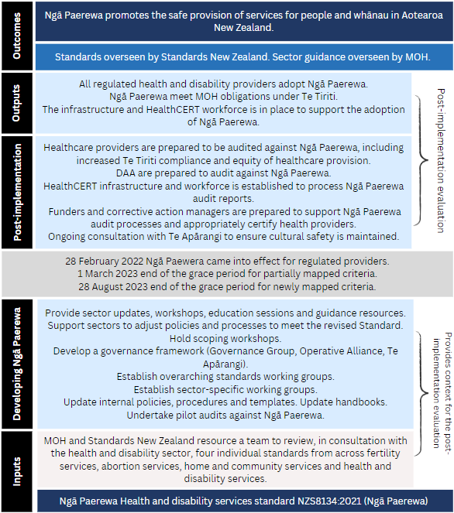

Appendix 2: Measurement framework

|  |  |  |
| --- | --- | --- |
| Evaluation questions (sub-questions) | Measures/indicators | Information sources |
| **What is the context for the implementation of Ngā Paerewa?** | | |
| What has been implemented?  How well did the implementation plan adapt to respond to emerging conditions and feedback? | Description of the implementation delivery given the budget, timeline and capacities.  Measures:  Implementation was as planned and/or reasons for any deviations.  Continuous improvement processes used. | Document review: Implementation Transition Programme Plan  Interviews: internal and external stakeholders |
| **Who was involved in the implementation?** | | |
| What has been the experience of implementation stakeholders? | Description of HealthCERT governance and leadership roles and functions.  Description of stakeholder roles to support implementation.  Interface between HealthCERT and external stakeholders. | Document review: HealthCERT Bulletin  Interviews: internal and external stakeholders |
| **How adequate was the implementation TRAINING provided by HealthCERT?** | | |
| What training was provided to stakeholders – HealthCERT, healthcare providers, DAA, and funders/corrective action managers?  Was the training appropriate and sufficient? | Descriptions of the training provided for different groups.  Perspectives of how training could be strengthened.  Measures:  Rating scale assessment of implementation adequacy.  HealthCERT and stakeholder clarity about Ngā Paerewa requirements.  Stakeholder uptake of training and training feedback.  Stakeholder confidence and preparedness for Ngā Paerewa. | Interviews: HealthCERT, external stakeholders  Document review: HealthCERT surveys  Malatest survey |
| **How adequate was the implementation SUPPORT provided by HealthCERT?** | | |
| What support was offered to stakeholders – HealthCERT, healthcare providers, DAA, and funders/corrective action managers?  Was the support appropriate and sufficient? | Descriptions of the support provided.  Perspectives of how support could be strengthened.  Measures:  Rating scale assessment of implementation adequacy.  Stakeholder uptake of support and support feedback.  Stakeholder confidence and preparedness for Ngā Paerewa. | Interviews: HealthCERT, external stakeholders  Document review: HealthCERT surveys  Malatest survey |
| **How adequate was the implementation COMMUNICATION provided by HealthCERT?** | | |
| How effective was the communication from HealthCERT to stakeholders (clarity and timeliness)? | Descriptions of methods used to communicate information including how HealthCERT messages reach individual healthcare providers through their national managers.  Perspectives of how communication could be strengthened.  Measures:  Effective and regular communications and engagement between stakeholders established for learning, continuous improvement and system change. | Interviews: HealthCERT team, external stakeholders  Document review: HealthCERT surveys  Malatest survey |
| **Has HealthCERT met its obligations under Te Tiriti?** | | |
| How well did the implementation uphold and enhance Māori rights, dignity and self-determination? | Māori stakeholder perspectives on the cultural suitability of the implementation process | Interviews: all stakeholders  Malatest survey |
| **Were the operational processes within HealthCERT in place to enable effective implementation?** | | |
| Were the appropriate governance and leadership systems in place? | Description of governance and leadership functions.  Extent stakeholders consider governance and leadership support implementation. | Interviews: internal stakeholders  Document review |
| **Was there adequate funding and resourcing for effective implementation?** | | |
| What resources were required?  Did resource constraints hinder implementation? | Extent HealthCERT and external stakeholders consider resourcing was adequate.  Description of any implementation constraints imposed by funding. | Interviews: all stakeholders  Document review |
| **What can be learned?** | | |
| How well has it been implemented? | Healthcare providers are prepared to be audited against Ngā Paerewa.  DAA are prepared to audit against Ngā Paerewa.  Funders and corrective action managers are prepared to support Ngā Paerewa audit processes.  HealthCERT team members are prepared to process Ngā Paerewa audit reports and appropriately certify health providers. | Interviews: all stakeholders  Document review: HealthCERT survey  Malatest survey |

Appendix 3: Survey respondents

|  |  |  |
| --- | --- | --- |
|  | N | % |
| **What is your role in your facility? If you have multiple roles, select the one that is most involved with the implementation of Ngā Paerewa.**  ***Providers could select more than one option*** | | |
| Facility manager | 35 | 54% |
| Quality (assurance) manager | 14 | 22% |
| Clinical manager | 6 | 9% |
| Other: Includes administration, governance and CEO | 10 | 15% |
| **Is your organisation…** | | |
| Neither a Māori or Pacific service provider | 60 | 92% |
| A Pacific service provider | 0 | 0% |
| A Māori service provider | 5 | 8% |
| **Which of the following services do you provide?**  ***Providers could select more than one option – 62 0f the 65 providers selected at least one of the services listed*** | | |
| Aged residential care | 38 | 59% |
| Residential mental health services | 13 | 20% |
| Residential disability services | 12 | 19% |
| Public or private overnight inpatient services | 9 | 14% |
| Many providers also selected another category: Including home and community support services, residential addiction services, maternity services, hospice services and abortion services. | 15 | 23% |
| **Which region does your facility operate in?** | | |
| Auckland and Tai Tokerau | 18 | 37% |
| Central North Island | 7 | 14% |
| Lower North Island | 4 | 10% |
| Canterbury | 9 | 18% |
| Other South Island | 10 | 20% |
| Missing (excluded from percentages) | 16 | - |

1. The standard provides the foundation for describing best practice and fostering continuous improvement in the quality of health and disability services. It sets out the rights of people and ensures service providers know their responsibilities for safe outcomes. Standards New Zealand. (2021). *Ngā Paerewa Health and Disability Services Standard (NZS 8134:2021).* <https://www.standards.govt.nz/shop/nzs-81342021/>
2. Ngā Paerewa replaces the Health and Disability Services Standards NZS 8134:2008, the Fertility Services Standard NZS 8181:2007, the Home and Community Support Sector Standards NZS 8158:2012, and the Interim Standards for Abortion Services in New Zealand.
3. Standards New Zealand. (2021). *Ngā Paerewa Health and Disability Services Standard (NZS 8134:2021).* <https://www.standards.govt.nz/shop/nzs-81342021/>
4. Ministry of Health. (2023). *Standards Mapping Analysis*. Wellington: Ministry of Health.
5. The number of certified providers can vary over time. For the most up-to-date information, visit the MOH [website to access the interactive databases of providers](https://www.health.govt.nz/your-health/services-and-support/certified-providers).
6. Standards New Zealand. (2021). *Ngā Paerewa Health and Disability Services Standard (NZS 8134:2021).* <https://www.standards.govt.nz/shop/nzs-81342021/>
7. "Training and Support." Ministry of Health New Zealand. Accessed March 2024. URL: <https://www.health.govt.nz/our-work/regulation-health-and-disability-system/certification-health-care-services/services-standard/resources-nga-paerewa-health-and-disability-services-standard/training-and-support>
8. Based on: Ministry of Health. 2023. *Designated Auditing Agency Handbook: Ministry of Health Auditor Handbook (revised 2023)*. Wellington: Ministry of Health.
9. The timing of the implementation is stipulated in the Health and Disability Services (Safety) Act 2001 and cannot be changed once set.
10. Ministry of Health. (2021). *Transition Surveillance Audit.* Ministry of Health: Wellington.
11. HealthCERT. *Audit Pilot Framework* [Internal Document]. Unpublished document.
12. Ministry of Health. (2023). Te Apārangi: Māori Partnership Alliance. [Te Apārangi: Māori Partnership Alliance | Ministry of Health NZ](https://www.health.govt.nz/our-work/regulation-health-and-disability-system/certification-health-care-services/services-standard/resources-nga-paerewa-health-and-disability-services-standard/te-aparangi-maori-partnership-alliance)