**EVALUATION OF THE PARTNERS FOR CHANGE OUTCOME MANAGEMENT SYSTEM (PCOMS) IN A GAMBLING TREATMENT SETTING**

**FINAL Report**

**21 June 2019**

|  |  |
| --- | --- |
| **Prepared for** | **Authors** |
| Ministry of Health | Maria E Bellringer |
| PO Box 5013 | Komathi Kolandai-Matchett |
| Wellington | Stéphane Janicot |
|  | Ellen Michie |
|  | Nick Garrett |
|  | Kirsten van Kessel |
|  | Max Abbott |

ACKNOWLEDGEMENTS

The authors are highly appreciative of our partner service, PGF Group, for all their support with this evaluation including providing access to their database and facilitating researcher access to staff and clients for interviews. Grateful acknowledgement is made of everyone who agreed to be interviewed for this evaluation, which included people from several organisations as well as individuals. The authors also thank Dr Katie Palmer du Preez who assisted with project management at various stages of the evaluation. Thanks are due to Dr Simone Rodda and Dr Brian Rodgers who peer reviewed the report and provided helpful comments.

This evaluation was funded by the New Zealand Ministry of Health.

**Disclaimer**

This report was prepared under contract (Number 359188) to the New Zealand Ministry of Health. The copyright in this article is owned by the Crown and administered by the Ministry. The views of the authors do not necessarily represent the views or policy of the New Zealand Ministry of Health. The Ministry makes no warranty, express or implied, nor assumes any liability or responsibility for use of, or reliance on, the contents of this report.

**Suggested citation**

Bellringer, M.E, Kolandai-Matchett, K., Janicot, S., Michie, E., Garrett, N., van Kessel, K., & Abbott, M. (2019). *Evaluation of the Partners for Change Outcomes Management System (PCOMS) in a gambling treatment setting*. Auckland: Auckland University of Technology, Gambling and Addictions Research Centre.

**CONTENTS**

ACKNOWLEDGEMENTS 1

GLOSSARY OF ACRONYMS 7

EXECUTIVE SUMMARY 8

INTRODUCTION AND LITERATURE REVIEW 12

Introduction 12

What is PCOMS? 13

Outcome Rating Scale 13

Kaupapa Outcome Rating Scale 14

Session Rating Scale 15

Group Session Rating Scale 15

Inconsistent effects of PCOMS on treatment outcomes 16

Studies showing the value of PCOMS 16

Studies showing that PCOMS results in little or no effect on treatment outcomes 17

PCOMS and ethnicity and culture 18

Advantages of PCOMS 20

Disadvantages of PCOMS 21

Contribution of PCOMS to therapist development and learning 23

Developer recommended processes for using PCOMS 24

Scoring and interpreting the ORS and SRS 24

Using the SRS and ORS with clients 25

Developer recommended organisational implementation aspects 26

Results Based Accountability, its purpose and processes 26

How PCOMS relates to RBA 27

EVALUATION DESIGN AND METHODS 28

Evaluation method selection 28

Quality assurance 29

Ethical approval 29

Cultural advice and consultation 30

Cultural advice 30

Consultation 30

Evaluation aims 30

Evaluation design 31

Key informant interviews method 31

Participant recruitment 31

Data collection and transcription 32

Database analysis method 32

Case note analysis method 33

Data analysis 33

Key informant interview analysis 33

Database analysis 33

Case notes analysis 34

RESULTS - KEY INFORMANT INTERVIEWS 35

Overall thoughts on PCOMS 35

The purpose of PCOMS 36

PCOMS Provider Adherence Scale 37

Resource and time efficiency when using PCOMS 37

Skills to implement PCOMS 38

Introducing PCOMS to a client 39

Ensuring clients relate ratings from the ORS to reasons for seeking help 41

Recording ratings in the action plan and case notes 42

Difficulties using the scales with clients 42

The scales can be confusing to clients 44

Using PCOMS with Māori, Pacific and Asian clients 45

Using the kaupapa Māori version of the ORS 48

Belief that treatment outcomes are related to PCOMS scale use 49

Typical use of ORS data in the counselling approach 50

Using SRS data to develop the therapeutic relationship 51

Using PCOMS in group sessions 52

Using PCOMS data in clinical supervision 53

PCOMS contribution to professional development 54

Improving PCOMS 55

Using PCOMS data for results-based accountability (RBA) purposes 55

RESULTS - DATABASE ANALYSES 57

Use of PCOMS assessments 57

PCOMS is not used with all clients in all sessions 57

There are more missing SRS data than ORS data in the database 57

The percentages of missing ORS and SRS data were similar between the genders 59

There were some ethnic differences in percentages of missing ORS and SRS data 60

Profiles of full intervention clients receiving PCOMS assessments 61

Numbers of full intervention clients receiving PCOMS assessments 61

Numbers of individual full intervention sessions attended by clients receiving PCOMS 62

More PCOMS assessments occurred if more counselling sessions were attended 62

ORS data 63

A ‘multiple of 4’ scoring pattern is evident for ORS 63

Median ORS scores and changes across sessions 64

Median ORS scores and changes across sessions were similar by gender 65

Median ORS scores and changes across full intervention sessions differed by ethnicity 66

Change in median first to last ORS scores by number of full intervention sessions showed overall improvement in client wellbeing 67

ORS scoring profiles by clinical cut-off score 69

ORS score transitions from first to last score 71

SRS data 72

A ‘multiple of 4’ scoring pattern is evident for SRS 72

Median SRS scores and changes across sessions 73

Median SRS scores and changes across sessions were similar by gender 74

Median SRS scores and changes across full intervention sessions were similar by ethnicity 75

Change in median first to last SRS scores by number of full intervention sessions showed overall improvement in the client-therapeutic relationship 76

SRS scoring profiles by cut-off score 80

SRS score transitions from first to last score 82

Use of PCOMS with clients is associated with improved client outcomes 82

Use of PCOMS (ORS and/or SRS) is associated with improved client outcomes 82

Change in ORS and SRS scores and PGSI score changes 83

Change in PGSI scores is weakly correlated with change in ORS scores, not SRS scores 83

Logistic regression analysis of change in ORS score vs. change in PGSI score 84

Logistic regression analysis of change in SRS score vs. change in PGSI score 85

RESULTS - CASE NOTES ANALYSIS 87

DISCUSSION AND CONCLUSION 89

Has PCOMS been implemented as recommended? 89

Implementation at an organisational level 89

Use of ORS and SRS in every counselling session 90

Scoring of ORS and SRS 91

What evidence is there of PCOMS informing treatment practice? 91

Recording of client ORS and SRS data in multiple counselling sessions 91

Clients below or higher than the ORS clinical cut-off at first rating 92

How does PCOMS support counsellors in developing and demonstrating their skills and competencies? 93

Has the use of PCOMS resulted in any unexpected outcomes for clients or treatment services? 93

What evidence is there of PCOMS improving therapeutic relationships between clients and counsellors (e.g. is the tool culturally appropriate for all populations)? 94

The therapeutic relationship 94

Cultural appropriateness of PCOMS for different populations 94

Does PCOMS have the potential to function as an RBA tool? 97

Limitations 97

Conclusions 98

REFERENCES 99

APPENDIX 1: Interview schedules 107

**LIST OF TABLES**

Table 1: Missing ORS and SRS scores by session type from 2011 to 2017 58

Table 2: Transition from first to last ORS score 72

Table 3: Transition from first to last SRS score 82

**LIST OF FIGURES**

Figure 1: Keywords and search terms 12

Figure 2: Outcome Rating Scale 14

Figure 3: Session Rating Scale 15

Figure 4: Evaluation Standards for Aotearoa New Zealand 29

Figure 5: Numbers of all clients receiving PCOMS by year 57

Figure 6: Percentage of full intervention sessions missing ORS and SRS scores by year 59

Figure 7: Percentage of full intervention sessions missing ORS and SRS scores by gender by year 59

Figure 8: Percentage of full intervention sessions missing ORS scores by ethnicity by year 60

Figure 9: Percentage of full intervention sessions missing SRS scores by ethnicity by year 61

Figure 10: Numbers of individual full intervention clients receiving at least one ORS/SRS by year 62

Figure 11: Percentage of full intervention clients with at least two PCOMS assessments by number of full intervention sessions 63

Figure 12: ORS scores over time 64

Figure 13: Median ORS score by number of full intervention sessions 65

Figure 14: Change in median ORS score by number of full intervention sessions 65

Figure 15: Median ORS score by gender by number of full intervention sessions 66

Figure 16: Change in median ORS score by gender by number of full intervention sessions 66

Figure 17: Median ORS score by ethnicity by number of full intervention sessions 67

Figure 18: Change in median ORS score by ethnicity by number of full intervention sessions 67

Figure 19: Change in median first to last ORS scores by number of full intervention sessions and gender 68

Figure 20: Change in median first to last ORS scores by number of full intervention sessions and ethnicity 69

Figure 21: Average percentage of ORS scores higher than the clinical cut-off score of 25 69

Figure 22: Average percentage of ORS scores higher than the clinical cut-off score of 25 by gender 70

Figure 23: Average percentage of ORS scores higher than the clinical cut-off score of 25 by ethnicity 70

Figure 24: Median ORS score by clinical cut-off score by number of full intervention sessions 71

Figure 25: Change in median ORS score by clinical cut-off score by number of full intervention sessions 71

Figure 26: SRS scores over time 73

Figure 27: Median SRS score by number of full intervention sessions 74

Figure 28: Change in median SRS score by number of full intervention sessions 74

Figure 29: Median SRS score by gender by number of full intervention sessions 75

Figure 30: Change in median SRS score by gender by number of full intervention sessions 75

Figure 31: Median SRS score by ethnicity by number of full intervention sessions 76

Figure 32: Change in median SRS score by ethnicity by number of full intervention sessions 76

Figure 33: Change in median first to last SRS scores by number of full intervention sessions and gender 77

Figure 34: Change in median first to last Group SRS scores by number of group sessions and gender 78

Figure 35: Change in median first to last SRS scores by number of full intervention sessions and ethnicity 79

Figure 36: Change in median first to last Group SRS scores by number of group sessions and ethnicity 79

Figure 37: Average percentage of SRS scores at the cut-off score or higher 80

Figure 38: Average percentage of SRS scores at the cut-off score or higher by gender 80

Figure 39: Average percentage of SRS scores at the cut-off score or higher by ethnicity 81

Figure 40: Median SRS score by cut-off score by number of full intervention sessions 81

Figure 41: Change in median SRS score by cut-off score by number of full intervention sessions 82

Figure 42: Final PGSI category based on treatment episode including or not including PCOMS assessment 83

Figure 43: Plot of change in PGSI score with change in ORS score 84

Figure 44: Plot of change in PGSI score with change in SRS score 84

Figure 45: Final PGSI category based on first and last ORS category 85

Figure 46: Final PGSI category based on first and last SRS category 86

GLOSSARY OF ACRONYMS

|  |  |
| --- | --- |
| **ETR** | Expected treatment response |
| **KORS** | Kaupapa Outcome Rating Scale |
| **MSD** | Ministry of Social Development |
| **ORS** | Outcome Rating Scale |
| **PCOMS** | Partners for Change Outcome Management System |
| **PGSI** | Problem Gambling Severity Index |
| **POFA** | Partnering for Outcomes Foundation Aotearoa |
| **RBA** | Results Based Accountability |
| **SRS** | Session Rating Scale |

EXECUTIVE SUMMARY

The Partners for Change Outcome Management System (PCOMS) is a tool that was developed for counselling situations to improve therapeutic (counsellor-client) relationships and to collect and use client data to measure client outcomes and monitor client-counsellor relationships.

This study was an exploratory evaluation to investigate the use of, and effectiveness of, PCOMS in the provision of gambling treatment services in New Zealand. A mixed-methods approach was used involving collaboration with a gambling treatment service currently using PCOMS (referred to as the partner service). Data were collected via key informant interviews with the partner service’s clients, counsellors and managers; external clinical supervisors; and additional Māori, Pacific and Asian counsellors from within and external to the partner service. Further data were obtained from the partner service’s database and client case notes.

The specific aims of the evaluation were to answer six questions:

* Has PCOMS been implemented as recommended?
* What evidence is there of PCOMS informing treatment practice?
* How does PCOMS support counsellors in developing and demonstrating their skills and competencies?
* Has the use of PCOMS resulted in any unexpected outcomes for clients or treatment services?
* What evidence is there of PCOMS improving therapeutic relationships between clients and counsellors (e.g. is the tool culturally appropriate for all populations)?
* Does PCOMS have the potential to function as a Results Based Accountability (RBA) tool?

The main findings from the evaluation are presented below in summary form, identifying for each of the six questions: the main findings, the implications of each finding and actions for consideration based on each finding. Light green shading has been used for those findings considered to be beneficial to client outcomes and counsellor-client relationships. Pink shading has been used where there is room for improvement or adjustment of the processes currently in place.

Has PCOMS been implemented as recommended?

| **Finding** | **Implications** | **Actions for consideration** |
| --- | --- | --- |
| Most counsellors do not report any issues in using ORS and SRS with their clients. | PCOMS is used as intended. |  |
| An interactive in-house data collection and reporting application is in development. | Could make the process more efficient and reduce client confusion. | Complete development of the interactive application. |
| Lack of consistent use of PCOMS checklists. | Some aspects of PCOMS use may be forgotten. | Consider whether the checklists are important. |
| Some clinical supervisors and counsellors have missed training sessions. | PCOMS use may not be thorough. | Consider alternative training methods for such people, e.g. by video-linkage. |
| PCOMS is not routinely used with all clients, with SRS implemented less often than ORS, particularly in follow-up calls and group sessions. | Client progress and the therapeutic approach are not monitored in cases where data are not collected. Clients may not receive the best service. | Consider whether PCOMS is suitable for use in follow-up calls and other unique populations such as prison inmate group sessions. Consider a standard approach for when PCOMS is used or not.  Consider additional training to use the GSRS and in introducing PCOMS to challenging clients.  Consider that PCOMS may not be useful for clients with high wellbeing. |
| Whole number scoring or recording of ratings continues to be common. | Precise ratings are either not created or measured. Could reduce efficiency of the PCOMS process. | Use of the interactive application could alleviate these issues. |

What evidence is there of PCOMS informing treatment practice?

|  |  |  |
| --- | --- | --- |
| **Finding** | **Implications** | **Actions for consideration** |
| Overall, clients who only attended one counselling session had a median initial ORS score higher than the clinical cut-off, whilst clients attending multiple sessions initially scored lower than the clinical cut-off. | Clients scoring higher than the clinical cut-off on the ORS in the first session have a higher risk of dropping out of counselling, whilst clients scoring lower than the clinical cut-off are likely to remain in treatment. | Completing the ORS in the first counselling session is important and if the score is higher than the clinical cut-off, should alert a counsellor to consider the potential of client drop-out. |
| Multiple high or low ORS scores were discussed by counsellors with clients and in supervision. | More effective treatment approaches could be considered for such clients. | Continue with this approach as it is likely to benefit clients. |
| The median number of counselling sessions attended by clients was three. | If PCOMS is not used in every session, multiple ratings are less likely to be obtained. | It would be prudent to attempt to include ORS and SRS in each counselling session. |
| The level of detail and documentation in client case notes is variable. | Where minimal detail is documented, it is possible that clients may not receive the optimal treatment. | Standardise the level of detail documented in client case notes. |

How does PCOMS support counsellors in developing and demonstrating their skills and competencies?

| **Finding** | **Implications** | **Actions for consideration** |
| --- | --- | --- |
| Most counsellors discuss relevant client PCOMS data with their clinical supervisors. | Practice can be reflected on and different treatment approaches can be explored. | Ensure that new counsellors and clinical supervisors are aware of PCOMS and how to use data. |
| Most counsellors discuss relevant client PCOMS data in their team reviews. | Practice can be reflected on and different treatment approaches can be explored. | Ensure that team leaders continue to encourage and support PCOMS discussions. |
| No counsellors reported PCOMS data being used as a punitive performance measure. | Counsellors do not feel threatened. | Continue with the organisational stance. |

Has the use of PCOMS resulted in any unexpected outcomes for clients or treatment services?

|  |  |  |
| --- | --- | --- |
| **Finding** | **Implications** | **Actions for consideration** |
| A significant minority of clients have a final recorded ORS or SRS score that is below the cut-off. | Repeated low ORS/SRS scores are indicative of potential poor outcomes/treatment failure. | At an early stage, proactively discuss repeated low scores in clinical supervision/team reviews and change treatment approach or counsellor as deemed necessary. |

What evidence is there of PCOMS improving therapeutic relationships between clients and counsellors (e.g. is the tool culturally appropriate for all populations)?

| **Finding** | **Implications** | **Actions for consideration** |
| --- | --- | --- |
| Most counsellors did not report problems using ORS and SRS with clients of non-European ethnicity. | PCOMS can be used with most clients. | Continue the approach with these clients. |
| There was an indication that PCOMS may be an appropriate tool for use with Māori clients but this this remains to be examined and confirmed. For some Māori and Pacific clients, KORS could be more appropriate than ORS. | Māori may benefit from PCOMS use but this should be examined and confirmed. | On a case-by-case basis, consider using KORS rather than ORS for Māori and Pacific clients. Alternatively, give these clients the choice of completing either the ORS or KORS. |
| KORS use cannot be entered into the database. | KORS data are collected as ORS data. This is misleading as they measure slightly different wellbeing concepts. | Include ability to collect KORS data in the database. |
| There was less support for SRS from some counsellors and clients. | Some therapeutic relationships may not be optimal. | Consider provision of further training on the purpose of the SRS and how to effectively facilitate productive discussion if ratings are low as well as how a counsellor manages their own reactions to scores. |
| SRS scores are not a useful indicator for potential client drop-out from treatment. | SRS measures the therapeutic relationship not client outcomes. | SRS scores should be used to improve the therapeutic relationship. |
| The purpose of PCOMS may be less understood by some Pacific and Asian clients. | ORS and SRS scales may not be completed accurately if their purpose is not understood. PCOMS may not be an appropriate tool for use with Pacific and Asian clients. | Consider alternative methods of introducing PCOMS, explaining the purpose of the scales and how to complete them, particularly for migrants. Consider use of oral rather than written versions of ORS and SRS. |

Does PCOMS have the potential to function as an RBA tool?

| **Finding** | **Implications** | **Actions for consideration** |
| --- | --- | --- |
| Clients receiving at least one PCOMS assessment had a higher likelihood of reducing or stopping their gambling. | PCOMS use can help to improve client outcomes. | Continue to use PCOMS and consider alternative approaches to introducing and implementing PCOMS for populations where it is currently less understood/ less used. |
| Increasing ORS scores are weakly correlated with decreasing PGSI scores. | ORS could be used as a proxy for assessing client outcome where other measures are not available. | Do not rely on ORS as an RBA measurement tool but it could be considered an adjunct. |

INTRODUCTION AND LITERATURE REVIEW

Introduction

In psychotherapy and counselling, it has long been recognised that the quality of the client-therapist relationship, or the therapeutic alliance, is predictive of treatment outcomes (Ardito & Rabellino, 2011; Horvath & Symonds, 1991; Lambert & Barley, 2001; Martin, Garske, & Davis, 2000).

The Partners for Change Outcome Management System (PCOMS) measures, monitors and aims to improve treatment outcomes for clients when therapists seek and use client responses to improve their practice and therapeutic relationships (Duncan, 2012b). PCOMS is based on the premise that seeking real time responses from clients enables problematic aspects of treatment to be identified and the therapeutic approach adapted to better assist clients (Duncan, 2012b). PCOMS is currently used by one gambling treatment service in New Zealand.

As Drury (2007) aptly noted, in the “climate of increased accountability, feedback tools for measuring the client’s perception of the process and progress of therapy need to be reliable, valid and feasible” (p. 23). This suggests that feedback tools should be evaluated for their usefulness to all stakeholders - funders, service providers and service users.

In order to understand PCOMS in terms of recommended methods of use, outcomes, potential benefits, challenges and limitations, we identified and reviewed existing literature. The review identified important aspects to assess, from which we developed the evaluation criteria; a set of benchmarks used to assess PCOMS use in terms of its effectiveness and worth.

Academic articles were sourced using the search engines EBSCO, ProQuest and Google Scholar. A general internet search was also conducted to seek for non-academic literature or ‘grey’ literature (e.g. conference papers and proceedings, service evaluations and government reports). Grey literature was important as PCOMS is novel within the context of gambling treatment services in New Zealand, and this type of literature tends to be more recent and immediately accessible relative to academic publications (Benzies, Premji, Hayden, & Serrett, 2006; Mahood, Van Eerd, & Irvin, 2014).

Between 2 October 2017 and 15 March 2018, several combinations of the search terms and keywords listed in Figure 1 were used to identify relevant articles.

Figure 1: Keywords and search terms

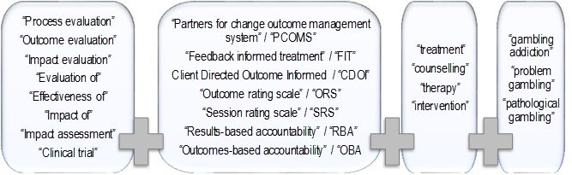

Initially, articles that directly related to gambling interventions were identified. Due to the small number of articles found, the search was expanded to include articles on interventions for other health and social issues. PCOMS-related articles on the Child Outcome Rating Scales and Child Session Rating Scales were excluded from the search, as these were not relevant to the current evaluation, which concerns adults. Only articles published in English were included.

For readability, the word ‘therapists’ has been consistently used throughout the following review to refer to mental health professionals providing interventions. For studies related to PCOMS, authors in different jurisdictions used a range of different terms (e.g. clinicians, counsellors, psychologists, psychiatrists and therapists) to describe these professionals. Samples often consisted of a mix of professionals with different titles. For instance, one study referred to a sample of 25 licensed ‘clinicians’ comprising counsellors, mental health workers, psychologists, social workers and marriage/family therapists (Ionita, Fitzpatrick, Tomaro, Chen, & Overington, 2016) while another referred to a sample of 18 ‘therapists’ comprising clinical psychologists, psychiatrists and other health care professionals (Brattland et al., 2016). Although these professionals have a common role in that they assess, diagnose and provide mental health treatment, it is important to note that they hold different qualifications, which may determine how they respond to, and use, a tool such as PCOMS. While this variable was beyond the scope of this evaluation, we believe it to be important to consider in future studies.

What is PCOMS?

In the early 2000s, Miller (2014) and his colleagues formed the Partners for Change Outcome Management System (PCOMS) in the United States of America (USA). PCOMS is often referred to as an evidence-based method or outcome measurement system, which provides a model for continuous monitoring and response in counselling services (Duncan, 2012a; Miller, Duncan, et al., 2005).

PCOMS involves the use of two simple four-item visual analogue scales to collect client responses: The Outcome Rating Scale (ORS), used at the start of a treatment session; and the Session Rating Scale (SRS), used at the end (Miller, Duncan, et al., 2005). Client data collected using these scales are used to enable Feedback-Informed Treatment (FIT), an approach that uses clients’ comments about the therapeutic relationship and outcomes to inform, adapt and improve services (PCOMS, 2014).

Outcome Rating Scale

The ORS measures aspects of client wellbeing. The first three items (Figure 2) measure wellbeing individually (personal wellbeing), interpersonally (family, close relationships) and socially (work, school, friendships), while the fourth item measures overall wellbeing (Miller & Bargmann, 2012; Miller, Duncan, et al., 2005).

The ORS was developed by Miller, Duncan, Brown, Sparks and Claud (2003) as a brief substitute for the much longer Outcome Questionnaire 45.2 (OQ-45.2); a validated and widely used scale (Lambert et al., 1996). In a preliminary study involving a clinical sample of 435 clients of a community family service in South Florida, USA and a nonclinical sample of 86 people working at that service (78 post-graduate students, and nine therapists and staff), the authors reported internal consistency (coefficient alpha .87 to .96), reliability (coefficient alpha .93) and a moderate level of concurrent validity (Pearson’s *r* .59) of the ORS Miller et al., 2003). Although its test-retest reliability was significantly lower than that of OQ-45.2, they concluded that the ORS offered “a balanced trade-off between the reliability and validity of the longer measures, and the feasibility of” a brief scale (Miller et al., 2003, p. 91). In a replication study also based in the USA, Bringhurst, Watson, Miller and Duncan (2006) used a non-clinical sample of 98 university students to confirm concurrent validity of the ORS though comparison with the OQ-45.2 using correlation statistics. Their findings showed that the ORS had high test-retest reliability, strong internal consistency and moderate concurrent validity.

Figure 2: Outcome Rating Scale

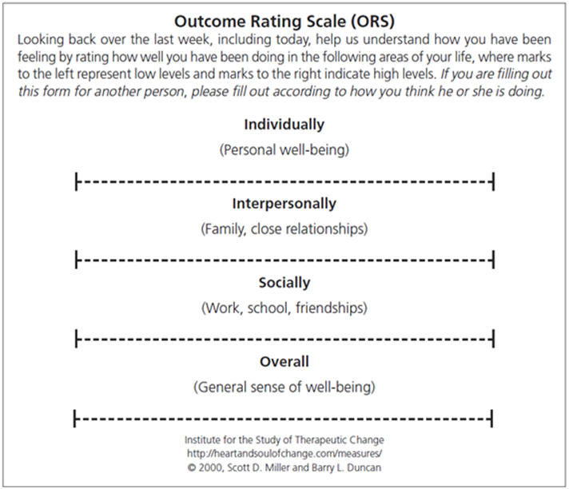

Reproduced from Manthei (2015, p. 67)

Kaupapa Outcome Rating Scale

Based on Te Whare Tapa Whā (Māori health model) and Hua Oranga (Māori mental health measure), Drury (2007) developed the Kaupapa Outcome Rating Scale (KORS). The KORS reinterprets “the three domains of the ORS from a Māori perspective and in ways which better resonate with the cultural expectations of Māori” (Kingi et al., 2014, p. 19). The KORS measures four areas of a client’s life:

* Wairua - feeling valued, strong and content within yourself as a person, healthy from a spiritual point of view
* Hinengaro - thinking, feeling and acting in a manner that allows you to set goals for yourself
* Tinana - looking after your physical health in a manner which will maximise your ability to move without pain or distress
* Whānau - communication and relating with your whānau in a manner that is confident and clear (Drury, 2007, p. 32).

The KORS emulates the ORS and uses similar implementation, rating and scoring methods. In a comparison of KORS and ORS ratings provided by 40 clients of a kaupapa mental health service, Drury (2007) found a significant correlation between the two scales. Drury argued that the KORS better meets cultural safety practices in New Zealand and is a feasible clinical tool. Besides the preliminary validation study reported by Drury, our review did not find other studies or reports on the use of KORS in New Zealand.

Session Rating Scale

The SRS measures client perceptions of the relationship with their therapist and of the session. The first three SRS items (Figure 3) assess aspects of the therapeutic relationship based on a client’s perceptions about being understood and respected, relevance of session goals, and suitability of the therapist’s approach (Miller & Bargmann, 2012; Miller, Duncan, et al., 2003). The fourth SRS item measures a client’s overall impression of the session.

Figure 3: Session Rating Scale

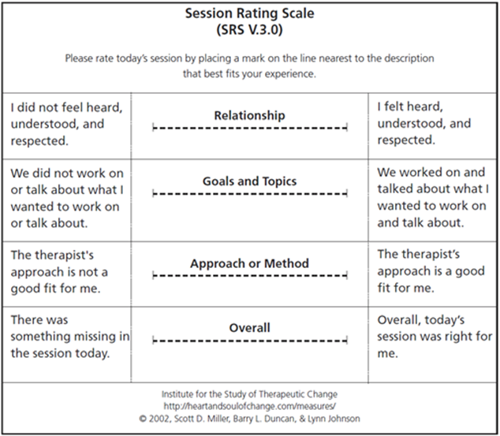

Reproduced from Manthei (2015, p. 68)

In their development and validation of the SRS, Duncan et al. (2003) reported that test-retest coefficients showed that the SRS had moderate reliability (Pearson’s *r* .64), and internal consistency (coefficient alpha .88) was high for the whole scale and for subscale scores. They regarded the scale to be a clinical tool that offered a balanced trade-off between losses in reliability and validity compensated by gains in feasibility, due to its brevity.

Group Session Rating Scale

Adapting the SRS, Quirk, Miller, Duncan and Owen (2013) developed a Group Session Rating Scale (GSRS) for measuring therapeutic alliance in group therapy. Alliance in individual treatment is conceptualised as a collaborative experience between client and therapist based on their agreements about treatment goals and ways to achieve those goals, and their relational bond (Bordin, 1979 as cited in Quirk et al., 2013). In group therapy, alliance is influenced by the multiple relationships between group members (MacKenzie, 1998; Yalom & Leszcz, 2005 as cited in Quirk et al., 2013). Similar to the SRS, the GSRS is a four-item visual analogue scale. The four aspects (relationship, goals and topics, the approach used, and overall fit) are assessed jointly for the leader and the group. Testing the GSRS (against other group measures, e.g. Group Climate Questionnaire) with 105 clients undergoing group therapy in an Australian-based substance abuse treatment centre, Quirk et al. (2013) found support for reliability based on alpha estimates and test-retest coefficients. They also reported concurrent validity as they found correlations between GSRS scores and other measures of group processes.

Inconsistent effects of PCOMS on treatment outcomes

Assessments of PCOMS use in New Zealand and elsewhere show inconsistent findings. While some studies show that PCOMS use resulted in improved treatment outcomes, others show little or no effect.

Studies showing the value of PCOMS

A recent meta-analysis of 18 randomised controlled trials and non-randomised trials of PCOMS use has concluded that a small positive effect was found in counselling settings but not psychiatric settings. However, the researchers cautioned that the positive results may have been due to researcher allegiance and use of ORS as the only outcome measure (Østergård, Randa, & Hougaard, 2018). A different meta-analysis of nine studies using PCOMS similarly found that PCOMS use can enhance client outcomes but the authors noted substantial heterogeneity in the study results, with insufficient information to identify the reason for this (Lambert, Whipple, & Kleinstäuber, 2018).

Reese, Norsworthy, et al. (2009) evaluated PCOMS using two USA-based samples. In the first study, clients underwent individual therapy at a university counselling centre (n=74) whilst in the second study, clients underwent marriage and family therapy at a graduate training clinic (n=74). In the first study, clients were randomly assigned to feedback or no-feedback groups while in the second study, therapists were randomly assigned to these groups. In both studies, clients with whom PCOMS was used showed statistically significant treatment gains and were also more likely to have reliable change over fewer sessions.

Using a sample of 250 couples undergoing therapy in two community family counselling clinics in Norway, Anker et al. (2009) demonstrated that clients with whom PCOMS was used showed significantly higher improvements than those who underwent treatment as usual. Similarly, in a randomised clinical trial involving 46 couples receiving therapy at a graduate training clinic for marriage and family therapy in the USA, Reese et al. (2010) reported that clients whose therapists used PCOMS achieved greater and more rapid improvement than clients who received treatment as usual.

In an evaluation of group therapy in a university counselling centre (n=84) in the USA, using a cluster randomised clinical trial design, Slone et al. (2015) also found that PCOMS use resulted in greater clinically significant change when compared to clients with whom PCOMS was not used. Additionally, with PCOMS use, clients attended more group sessions. Schuman et al. (2015) investigated ORS use in group therapy for substance use in an Army Substance Abuse Outpatient Treatment Program in the USA where clients (n=263) were randomised into a feedback or treatment-as-usual group. Compared to clients who received treatment as usual, clients with whom ORS was used showed significantly more improvement and greater rates of clinically significant change.

A number of other quantitative studies on PCOMS in different treatment settings (e.g. family counselling, alcohol treatment, community services for youth and children, and psychiatry and psychotherapy treatment) have reported positive results such as client engagement, enhanced alliance, improved treatment outcomes and reduced readmissions (Anker et al., 2010; Miller, Mee-Lee, Plum, & Hubble, 2005; Reese et al., 2014; Reese et al., 2017; Sparks & Muro, 2009). Additionally, in a case study involving one client and her therapist, which investigated the effectiveness of client responses within psychodynamic therapy, the PCOMS process aided alliance formation and decision making about therapeutic tasks (Black et al., 2017).

The Heart and Soul of Change Project has carried out five randomised controlled trials (RCTs) (Anker, Duncan, & Sparks, 2009; Reese, Norsworthy, et al., 2009; Reese, Toland, Slone, & Norsworthy, 2010; Schuman et al., 2015; Slone, Reese, Mathews-Duvall, & Kodet, 2015) that showed improved client outcomes with PCOMS use in couples, individual and group therapy. However, these clinical trials were not independent as they were all conducted by the PCOMS developers and their colleagues who may have had a vested interest in showing the positive effects of PCOMS use.

There is some evidence of PCOMS implementation in New Zealand but very little has been reported regarding efficacy or effectiveness. The Problem Gambling Foundation of New Zealand (PGF) has used PCOMS with its clients since 2008 (Siegel-Woodward, 2016a). PGF is probably the sole user of PCOMS within gambling treatment in New Zealand, as an online search did not find any documentation of similar use among other local providers. In an analysis of PGF’s PCOMS data, Bridgman (2015) identified that some variables, for example, client ethnicity, number of counselling sessions and therapist experience predicted change scores (final minus first scores) for ORS and SRS. His analysis found trends indicating that clients who attended more counselling sessions tended to rate the service more positively on the SRS, than clients attending fewer sessions, and clients of more experienced therapists tended to make higher gains in SRS and ORS scores.

Manthei and Nourse (2012) reported on the use of ORS within a counselling programme for elders in Wellington and concluded it was useful for demonstrating counselling outcomes for clients because they found it easy to complete. Clients (n=204) were asked to complete the ORS at least twice, at the initial session and last session, with total before and after scores compared to show differences. As 76% of clients showed a gain of more than 3.5 points in post-counselling ORS scores, Manthei and Nourse concluded that the counselling programme was effective.

Studies showing that PCOMS results in little or no effect on treatment outcomes

However, several studies have found that PCOMS use had minimal or no effect on treatment outcomes, suggesting that PCOMS use has not consistently demonstrated positive results.

Findings from a meta-analysis and systematic review have cast doubt over the effectiveness of PCOMS. In a meta-analysis of 12 studies on routine outcome monitoring in mental health services, which included studies using ORS and OQ-45, Kendrick et al. (2016) found “no evidence of a difference between feedback and no-feedback groups in terms of symptom scores” (p. 25). They concluded that evidence was insufficient to support the use of routine outcome monitoring for improving treatment outcomes for common mental health disorders. Similarly, a systematic review and critical analysis of continuous outcome monitoring studies (10 studies with original data and two meta-analyses including PCOMS studies) by Davidson, Perry and Bell (2015) found that the studies were of variable quality with few providing diagnostic information and randomisation details. While feedback improved outcomes for clients at-risk of treatment failure, effect sizes were smaller for clients with more severe psychiatric conditions. They cautioned that findings from the studies were not generalisable.

Five randomised controlled trials in Denmark, Ireland, Norway and the Netherlands, (Davidsen et al., 2017; Murphy, Rashleigh, & Timulak, 2012; Rise, Eriksen, Grimstad, & Steinsbekk, 2012, 2016; van Oenen et al., 2013) found no differences between the PCOMS and treatment-as-usual groups. In other words, these studies showed that PCOMS had no effect on outcomes and therapeutic alliance. In one of these RCTs, the authors suggested that the ORS may not be a reliable outcome measure as it is part of the treatment (Rise et al., 2016). In another RCT that tested PCOMS use in crisis intervention, where clients in the PCOMS group showed less improvement compared to clients receiving treatment-as-usual, the authors concluded that PCOMS-based client responses may not benefit those with psychiatric problems and severe distress in emergency situations (van Oenen et al., 2016). Clients in the study had a broad range of issues including psychosocial difficulties, personality disorders and psychosis (van Oenen et al., 2013). In crisis, such clients, who are often unable to think about their circumstances or have difficulties cooperating with mental health services, may not benefit from PCOMS reflection and, to the contrary, this may impose extra burden on the relationship (van Oenen et al., 2013).

The authors of these RCTs suggested the use of additional measures (besides the ORS and SRS) to provide findings that are more reliable. A study that included the Schwartz Outcomes Scale-10 (SOS-10) as an additional measure in a between-subject RCT design to investigate the effect of PCOMS, found that treatment gains were demonstrated in clients in the feedback condition when measured by the ORS but not the SOS-10 (Kellybrew-Miller, 2014). That study found no statistically significant difference in retention rates between the feedback and treatment-as-usual groups. This suggests that PCOMS used in isolation as an outcome measure may show deceptively positive outcomes.

Other quantitative studies that have used different methodologies and additional measures in the Netherlands, (Hafkenscheid et al., 2010; Janse, De Jong, Van Dijk, Hutschemaekers, & Verbraak, 2017) have similarly found no significant results to demonstrate effective outcomes from PCOMS use.

Thus, PCOMS may not be suitable for some client types, for instance, clients undergoing crisis intervention (van Oenen et al., 2016). Grossl’s (2016) research is worthy of mention as it highlights another client type with whom PCOMS use may not be effective. Grossl evaluated the effectiveness of ORS use in a group substance abuse programme for parolees referred by the criminal justice system. The use of client responses did not result in improved treatment outcomes whilst the effect size for parolees in the treatment-as-usual group was large. Grossl concluded that unlike voluntary clients, for those who are referred to treatment, feedback leads to only modest effects on treatment outcomes. Among plausible reasons are that clients who are referred to treatment may minimise their level of “distress for fear of how acknowledging a problem may impact their standing with the referral source. For example, a client may fear repercussions from the criminal justice system for admitting to struggles with substance use” and may downplay the level of their problem to be viewed positively by the referral source (Grossl, 2016, p. 89).

Finally, although PCOMS is based on an integration of ORS and SRS, not many studies have made clear which of the two contributes to beneficial outcomes. In their research comparing the efficacy of using PCOMS in full, with using only ORS or SRS, Mikeal, Gillaspy Jr, Scoles and Murphy (2016) found that the three conditions resulted in similar outcomes. The authors concluded that the elements of PCOMS essential for improving treatment remain unclear.

PCOMS and ethnicity and culture

There are few studies that have examined PCOMS and its recommended use for different ethnicities and cultures. Reese, Duncan, Bohanske, Owen and Minami (2014) evaluated the effectiveness of psychotherapy services for individuals of lower socio-economic backgrounds (n=5,168) by a public behavioural health service in Arizona, USA. As demonstrated in pre-post ORS scores, no significant differences in outcomes were found for the different ethnic groups (i.e. Hispanic, African American, Native American, Asian American and Euro-American; Reese et al., 2014). Although this suggests suitability across ethnicities, Manthei (2015) cautioned that possible cultural and national differences in ORS and SRS scores across countries should be considered and noted that the scales’ cultural neutrality have been taken for granted in a number of countries. Manthei (2015) also noted that the ORS and SRS scales have been translated and used in different languages based on the assumption that the USA clinical cut-off scores are internationally applicable.

Hafkenscheid, Duncan and Miller (2010) found that the cut-off scores for the Dutch-translated ORS and SRS (based on a sample of 126 clients of a mental health service in the Netherlands) tended to be lower than those identified for the USA. The authors suggested that the lower SRS scores in the Dutch sample might be indicative of cross-cultural differences between Americans and non-Americans. Furthermore, while an ORS change score of five points has been regarded as an estimate of statistically reliable change for USA populations, for the Dutch ORS the statistically reliable change score was 7.73. Although first session ORS scores were comparable between the American and Dutch samples, the Dutch sample had lower scores in later sessions. They reasoned that while this may reflect an overall lack of change in the Dutch sample, it could also be indicative of cross-cultural differences.

In another Dutch study, Janse, Boezen-Hilberdink, van Dijk, Verbraak and Hutschemaekers (2014) assessed the Dutch-translated ORS and SRS using the Reliable Change Index (RCI) (Jacobson & Truax, 1991) with a sample of 587 clients of an outpatient mental health service, to determine the clinical significance of changes in the ORS scores. The authors found that the ORS clinical cut-off score was 24 (a point lower than the score of 25 identified for the USA) and based on the RCI, a reliable change score was nine rather than five (Janse et al., 2014). This means that for Dutch clients, a higher degree of change in the ORS is needed for the change to be reliably measured (Janse et al., 2014). The researchers recommended that while the SRS and ORS may be regarded as track-and-trace tools for enhancing treatment engagement, more valid measures are required to corroborate treatment outcome.

In the New Zealand study, ethnicity strongly predicted client outcomes and service satisfaction. When changes in ORS scores were considered (final score minus initial score), clients of Chinese, Korean, Indian and South East Asian ethnicities demonstrated an average gain of 4.6 to 5.5. In comparison, European/Other clients scored two to three points higher, demonstrating significantly higher outcomes. Clients of Māori and Pacific ethnicity also demonstrated strong gains on the ORS scale (Bridgman, 2015). Changes in SRS scores indicated that Chinese, Indian, South East Asian and European clients showed fewer improvements than other ethnic groups. Clients of Māori and Pacific ethnicity, and a small group of African and Middle Eastern clients demonstrated stronger positive shifts in satisfaction with services (Bridgman, 2015).

In a qualitative study, Sundet (2012b) invited four therapists in a family therapy unit in Norway to explain how they used the ORS and SRS, and found that therapists encountered difficulties when working with non-Norwegian clients. Responses were affected if clients did not understand the subtle meaning of the scales items or if they were not accustomed to thinking in a way that the scales required. Furthermore, within Norwegian culture, high ORS scores “might be understood as a sign that service users would have to end contact with the helping agency whereas a low score might be produced in order to secure continued contact with the unit” (p. 125). High ORS scores may reflect a culture of focusing on good life aspects. High SRS scores may reflect “a desire to maintain a good relationship with the therapists in order to receive the services of the Family Unit” (p. 125).

Nevertheless, other culture-related aspects of PCOMS appear promising. PCOMS is based on therapists’ open and transparent conversations with clients about treatment sessions and client-therapist relationships (Duncan, 2012b; Miller & Bargmann, 2012). Conversations and relationships are both significant cultural aspects that have been identified as important for effective therapies and informed the development of “talking therapies” within mental health and addiction services for Māori and Pacific people (Hirini, 1997; Kingi-Uluave & Olo-Whaanga, 2010; Milne, 2010; Southwick, Kenealy, & Ryan, 2012).

Advantages of PCOMS

An advantage of PCOMS is that it is integrated within therapy enabling ongoing assessment of the therapeutic relationship and providing a way to respond to client requirements. Its brevity, capacity to facilitate conversations and potential for improving retention are also advantageous.

PCOMS is designed to make collection and use of data easy, ensuring time and resource efficiency (Miller, Duncan, et al., 2005). Both the ORS and SRS generally take less than a minute to complete, which is important in clinical settings where time is often a constraint (Miller & Bargmann, 2012; Miller, Duncan, et al., 2005). In response to critique by Halstead, Youn and Armijo (2013) on the brevity of the scales, Duncan and Reese (2013) agreed that longer measures have “increased reliability and validity” and are likely to “result in better detection, prediction, and ultimate measurement of outcome” (p. 135). However, they argued that the briefness of the ORS and SRS were important to ensure feasibility and routine use among therapists, as therapists are unlikely to use measures if they are too long (Duncan & Reese, 2013).

A review of the ORS and SRS, referred to as “ultra-brief measures of alliance and outcome”, concluded that the scales offer a feasible client response collection method as they address the time constraint barrier (Shaw & Murray, 2014). This is likely to be a reason for its popularity in the USA and rapid spread to other countries, including translation into other languages (Hafkenscheid et al., 2010).

A qualitative study of 25 therapists (of whom 19 were PCOMS users) who explored motivation towards, and use of, progress monitoring measures, showed that 11 of the therapists preferred PCOMS as an outcome measure because of its convenience and the little time required. Convenience was also a typical reason for continued use (Knoll, Ionita, Tomaro, Chen, & Fitzpatrick, 2016).

In an Australian study with clients of psychological services of a rural primary health-care service, the ORS and SRS demonstrated good reliability and concurrent validity when compared to longer measures such as the Outcome Questionnaire-45, Working Alliance Inventory, Depression Anxiety Stress Scale-21, Quality of Life Scale, Rosenberg Self-Esteem Scale and General Self-efficacy Scale (Campbell & Hemsley, 2009). The ORS and SRS were reported to be of value because of their “cost-effectiveness, brevity, simple administration, and easy interpretation of results in the measurement of clinical outcomes when compared to their longer counterparts” (Campbell & Hemsley, 2009, p. 1).

Sundet (2012a) reported on a qualitative outcome study at a family therapy unit in a Norwegian hospital where therapists used the ORS and SRS as conversational tools. Thirty individuals (four therapists and ten families) were interviewed. For families, the scales enabled open conversations on acceptance and change, and a process for the conversations to take different directions. For therapists, the scales offered perspectives about therapy, and created a process for exploring and structuring the therapeutic direction. Reporting on the views of four therapists, Sundet (2012b) noted the feasibility and usefulness of the scales as conversational tools as they provided a start for discussions, a basis for questioning and a way for separating the person from the problem. The scales “were described as useful both within a single session and across sessions” (p. 125), and therapists felt safe when they were able to identify useful ways of working and when clients acknowledged the usefulness of the scales. The ORS and SRS, when used as conversational tools, expanded collaborations between therapists and families to reach desired goals.

Many people who access gambling treatment services only attend for a small number of sessions (Melville, Casey, & Kavanagh, 2007). Furthermore, many clients relapse into harmful gambling behaviours (Hodgins & el-Guebaly, 2004; Thygesen & Hodgins, 2003). As PCOMS aims to improve the therapeutic alliance, it also holds potential to minimise dropouts and improve client outcomes. Within gambling treatment, the therapeutic alliance has been shown to be positively related to treatment outcomes (Dowling & Cosic, 2011; Smith, Thomas, & Jackson, 2004). However, while therapeutic alliance is important for retention in drug addiction treatment (Meier, Barrowclough, & Donmall, 2005; Meier, Donmall, McElduff, Barrowclough, & Heller, 2006), little is known about its role in retaining clients in gambling treatment.

Thus, the advantages of PCOMS include the simplicity of the ORS and SRS scales, and the minimal implementation time with clients. It also serves as a tool for initiating meaningful conversations in a manner that leads to better outcomes. The potential of PCOMS for reducing dropout rates in gambling treatment is an important aspect for consideration.

Disadvantages of PCOMS

Very brief measures such as the ORS might not offer as much reliability as more comprehensive measures with normative indices of distress that are more effective for detecting early improvement or early deterioration, and for clinically meaningful tracking of change (Halstead et al., 2013). A national Canadian survey of 1,668 registered psychologists found that among the 12% who used progress-monitoring measures, PCOMS was the most commonly used (Ionita & Fitzpatrick, 2014). However, the large number of psychologists who used more than one measure or produced their own measures was indicative of the difficulty in selecting a generic measure that covered all their monitoring requirements (Ionita & Fitzpatrick, 2014).

Manthei (2015) noted that since the ORS only measures general wellbeing, a disadvantage is that it cannot be used to assess the particular problem for which counselling was sought. Similarly, Hafkenscheid et al. (2010) noted that the ORS does not measure “clinical risk factors such as suicide or alcohol or drug use” (p. 10). They concluded that outcome evaluations based on PCOMS “is far from comprehensive and does not contain multiple perspectives (e.g. therapists, outside judges, community criteria, etc)” (p. 10) and suggested the necessity for supplementary instruments such as the seven-item Therapist Satisfaction Scale to enhance client-therapist conversations.

The experiences of 25 therapists who used progress-monitoring measures in their practice (76% of whom used PCOMS) were examined through semi-structured interviews. Twenty-one of the therapists were based in either Canada or the USA and four were based in Australia, New Zealand, the United Kingdom and India. “Dissatisfaction with specific characteristics” of the measures was found to be ‘typical’ (Ionita et al., 2016, p. 177). Dissatisfaction included scepticism about the usefulness and validity of very brief measures that ask “vague questions to get at something as hard to pin down as wellbeing” (p. 177) and concerns over variability in scores, which seem to reflect how the day or week might have been for the client (rather than their actual wellbeing).

While Shaw and Murray (2014) noted the simplicity of PCOMS for ensuring use among therapists, they also cautioned that improper use might result in three risks to therapy: 1) the scales are used in a mechanical way rather than as a clinical tool to encourage meaningful discussion of the relationship, monitoring change and tailoring treatment to suit each individual; 2) the therapist has power over a client if a client is forced, rather than invited, to complete the scales; and 3) there is reduced understanding of the therapeutic alliance if the relationship is reduced to client responses to the four SRS questions and the quantitative data are considered the endpoint.

In the previously mentioned qualitative study involving four therapists in a family therapy unit in Norway, Sundet (2012b) noted that while the therapists were positive about the feasibility of the scales, they had concerns that the scales could disrupt therapy. One concern was the possibility that “the scales could become an occasion for deflecting attention and focus away from the central agenda of the therapy towards aspects of the scales” (p. 125). For instance, wording such as “overall”, “best fits”, and “last week” could steer discussions towards semantics, which the therapists believed were irrelevant to their therapeutic work.

Sundet (2012b) was also concerned about the ORS item on client social wellbeing as this includes both work colleagues and friendships. “This could create feelings of conflict and contradiction, because the relationships between these two areas have potentially different emotional connotations for the service user” (p. 125). Similarly, the item concerning family may cause difficulties if the client has good relationships with one family member but not another. Sundet (2012b) stated “this generality complicated the making of appropriate distinctions in such matters. Focus on the scoring process on both the ORS and SRS as a process of measurement could raise questions about exactness of measurement” (p. 125).

In a later report on client perspectives of the ORS and SRS, involving qualitative interviews with ten families receiving support from the same mental health facility in Norway, Sundet (2014) noted that although most families confirmed the usefulness of the scales, a few did not. Although the scales were useful for those who preferred to express themselves non-verbally, for others, providing verbal responses was preferred. Two families found the ORS difficult to use; for them, talking to the therapist was easier. As they were receiving family therapy, the ORS also caused confusion about whether to score parent or child wellbeing. When a therapist’s behaviour varied during the course of a session (e.g. sometimes they listened well and sometimes not), families found it difficult to provide SRS ratings. Some had difficulties with the measurement of the scales; their suggestions included replacing the visual analogue scales with graded versions with numbered intervals. Client difficulties were also connected to special situations such as individuals with dyslexia, reading difficulties and Attention Deficit Hyperactivity Disorder. Additionally, parents were concerned about the effects of scores on relationships between family members; for instance, if a therapist exposed issues that were delicate or difficult to handle. An important conclusion of client perspectives was that although the scales were useful and should continue to be used, when they are regarded inappropriate, clients should not feel obligated to use them. If difficulties are experienced with the scales, clients should have the chance to discuss and adapt their use.

Negative reactions to PCOMS from clients have also been reported, particularly by clients who did not understand the value of progress measures (e.g. those with mental health issues such as personality disorder or paranoia). Routine use has also led some clients to become bored with the measures, completing them as quickly as possible (Ionita et al., 2016).

Other limitations of the ORS and SRS include reliance on self-assessments and lack of control for social desirability influences (Hafkenscheid et al., 2010) and circumstances associated with issues of power such as when a client has been referred for treatment by another agency. In such cases, clients may provide higher ORS scores to show that everything is fine and to hide their feelings of vulnerability or failure (Sundet, 2012b).

Therapists have also reported their own concerns over the use of PCOMS. These have ranged from initial worries, discomfort and self-doubts associated with the novelty of using the scales and effectively introducing them to clients, to anxiety about being evaluated and the access co-workers and managers would have to client results (Ionita et al., 2016). Technical concerns have included time constraints, administration frequency, keeping track of administration, and software problems. Additionally, mandated use of PCOMS could be perceived to be a challenge to therapist authority and lead to a negative reception (Ionita et al., 2016).

Similarly, Sundet (2012a) cautioned of the risks of using the ORS and SRS in an organisational context, as they are also “a technology with controlling and disciplining functions according to norms and standards set by the agency or health authorities” (p. 304). In other words, the client data may be used for therapist performance monitoring. This becomes an issue when scale scores are no longer therapeutic tools, but tools for survival (e.g. therapists with low test scores can be fired) and reward (e.g. therapists with clients who score highly receive a bonus). A possible scenario is a situation where the economic and workplace wellbeing of therapists increasingly depends on the ORS and SRS scores. This can lead therapists, in open or subtle ways, to influence clients to change scores in a direction that supports the organisation (Sundet, 2012a, pp. 304-305). Partnering for Outcomes Foundation Aotearoa (2017a) noted that concerns over the possibility of PCOMS data being used for performance monitoring caused anxiety over job security for some staff, leading to an averseness towards PCOMS. Some therapists found it difficult to openly discuss their PCOMS-related concerns with their managers. This was due to concerns that “their struggles with PCOMS would be treated as performance issues”; “less than perfect scores on the Session Rating Scale (SRS) would lead to them being seen as inadequate”; and “low scores on the SRS would be judged negatively in the absence of context” (p. 6).

Contribution of PCOMS to therapist development and learning

Use of client PCOMS data during clinical supervision may be a way to enhance therapist development. Duncan and Reese (2015, 2016) regarded the use of PCOMS-identified client cases in the supervision process to be important as this brings client voice into supervision. Moving away from the tradition of therapist selection of clients to discuss with their supervisors, clients are selecting themselves on account of their ORS scores and their non-progress (Duncan & Reese, 2015, 2016). Duncan (2016) clarified that what makes PCOMS-based supervision different from other methods is its emphasis on clients. PCOMS supervision aims to improve outcomes via the identification of at-risk clients, then focuses on the supervisee and professional development using ORS data as an objective standard of effectiveness over time.

However, only a few studies have investigated the outcomes of using client PCOMS data in clinical supervision. According to Partnering for Outcomes Foundation Aotearoa (2017a), when practitioners were confident about PCOMS they reflected on client responses and used them to improve their practice through supervision. At an organisational level, client PCOMS data were useful to identify recurring trends in practice, which informed management decisions around staff development and productivity. For some teams, this led to changes in practice “e.g. moving from sporadic, unfocused work with a large number of clients, to intensive, goal-directed work with fewer people” (p. 6). However due to the anxiety some staff may experience from concerns that PCOMS is used as a performance measure, it is important for managers “to understand that PCOMS exposed staff vulnerabilities in a way which other tools do not” (Partnering for Outcomes Foundation Aotearoa, 2017a, p. 7). According to the report, supervisors have roles in good practice and should be coaching workers for PCOMS success.

Improvement may also naturally occur because of client PCOMS data. In a qualitative study of therapist reactions to negative client responses in a mental health hospital in Norway, Brattland et al. (2016) analysed 18 “written descriptions of episodes where they had received negative verbal feedback from clients” (p. 1). Written descriptions were elicited using a questionnaire that asked therapists to identify a specific event when they had received negative client responses and to provide details of that event in subsequent questions. All therapists in the study regarded client responses to be educational. As the sample consisted of ten therapists who used PCOMS and eight who did not, it enabled the researchers to see if PCOMS affected the way therapists interpreted and responded to client responses. They found that only two therapists mentioned PCOMS in their descriptions of client reasons for seeking therapy. None of the therapists mentioned PCOMS in their description of the negative event nor in their description of ensuing consequences. Nevertheless, the researchers classified the descriptions of the majority of PCOMS users as ‘Immediately Applied Learning’ (i.e. changes were made to improve processes for the client). Some PCOMS users’ descriptions (more than half of the cases) were classified as ‘Retrospectively Applied Learning’ (i.e. changes were made with future clients). Descriptions from therapists who did not use PCOMS, suggested non-applied learning (i.e. no changes that benefitted present or future clients were made). The researchers concluded that this suggests that PCOMS users elicit, understand and/or respond to negative responses differently (Brattland et al., 2016).

Developer recommended processes for using PCOMS

The PCOMS developers recommend protocols for use of the scales, client processes and organisational implementation. ORS is designed to be used at the start of each counselling session, and SRS at the end of each session.

Scoring and interpreting the ORS and SRS

The ORS and the SRS are scored similarly but interpreted differently. For both scales, items are presented in visual analogue format of 10 centimetre length lines with instructions to place a mark (e.g. ‘x’) closer to the left end of the line to indicate lower/negative rating and a mark closer to the right end to indicate higher/positive rating (Miller & Bargmann, 2012). The lengths of the four lines to the nearest millimetre, from the left end to the point marked by clients are summed to generate scores (Manthei, 2015; Miller & Bargmann, 2012). This means a minimum score of zero and a maximum score of 40. Scores can be added by hand using paper and pencil versions of the scales. Web-based applications are also commercially available, automatically calculating ORS and SRS data to generate instant results on how treatment is progressing (Miller & Bargmann, 2012) and aggregate statistics for different effectiveness and efficiency variables (Lambert & Cattani, 2012). While single session scores indicate client perceptions of wellbeing and the client-therapist relationship at that point in time, when scores are plotted across sessions, they show change over time.

Manthei (2015) regards the pen and paper method to be somewhat “clumsy” and suggested that it be modified to a 10-point scale. In an analysis of New Zealand PCOMS data (collected between 2011 and 2015), Bridgman (2015) noticed a peculiar pattern of a higher frequency of ORS and SRS scores that were a multiplication of four (e.g. 28, 7x4; 32, 8x4; 36, 9x4), which suggested the possibility of an estimate rather than a precise measurement of the four lines. Additionally, Bridgman (2015) noted that most of the ORS and SRS scores were not detailed in “fine grain measurement (i.e. decimal points)” (p. 11) as recommended. Although he believed such imprecision would not affect measurement of overall change score, it would limit sensitivity in terms of the scales’ individual items.

For the ORS, a score of 25 at intake based on a study of pre-post change for non-clinical and clinical samples (Miller et al., 2003). However, this cut-off score was identified in a USA population and may not be relevant to other populations, as previously mentioned. A higher intake score can be due to several reasons such as being mandated to attend treatment, that overall wellbeing is good but the person requires help for a specific issue (e.g. gambling), or because the purpose and meaning of the ORS has not been understood (e.g. for migrant clients) (Miller & Bargmann, 2012). As cited in Reese, Norsworthy and Rowlands (2009), the administration and scoring manual (Miller & Duncan, 2004) provides protocols for responding to changes in clients’ ORS scores.

For the SRS, a score of 36 is regarded as the cut-off score as research shows the tendency of clients to rate the client-therapist relationship relatively highly (Miller & Bargmann, 2012). Again, this cut-off score was identified in a USA population and may not be relevant to other populations. If a client’s total score is less than 36 or if one item is below nine, it should alert a “cause for concern” and should be discussed with the client before ending the session (Miller & Bargmann, 2012; Reese, Norsworthy, et al., 2009). However, a score of greater than 36 in the SRS does not necessarily confirm a strong alliance (Miller & Bargmann, 2012). A high SRS score may be indicative that a client is not at a stage where he or she feels comfortable about giving ratings (Bertolino, 2018). Clients may also provide high scores to avoid tension or hurting therapists’ feelings, or they may be simply responding based on what they think their therapists want to hear (Bertolino, 2018).

For SRS scores higher than 36, therapists are advised to thank the client, ask what they found especially helpful, and invite their suggestions on how to improve the therapy (Duncan & Reese, 2015). Therapists could also find ways to introduce the SRS to clients in a way that emphasises “the collaborative nature of therapy and the therapist as ‘learner’ to attain useful feedback” (Bertolino, 2018, p. 100).

Using the SRS and ORS with clients

The quality of data collected from clients using the SRS and ORS is dependent on each client’s clear understanding of the purpose of the scales and on their honest responses. Miller and Bargmann (2012) emphasised the importance of taking the time to explain the tool’s rationale to clients. As systems such as PCOMS are dependent on accurate client self-reporting, therapists must be aware of situations where clients may feel it is in their interest to understate or overstate their levels of distress (Lambert & Shimokawa, 2011).

With the SRS, a concern is that the effects of demand characteristics and social desirability are unknown (Owen, Duncan, Reese, Anker, & Sparks, 2014; Reese et al., 2013). Demand characteristics are cues that make participants aware of what an evaluator is expecting to find out about their behaviours, which in turn can influence their responses (Nichols & Maner, 2008). Social desirability refers to a type of bias that results from a participant’s tendency to respond in a way that portrays socially desirable traits to gain the evaluator’s approval (King & Bruner, 2000). This tendency may be “evoked by the nature of the experimental or testing setting, the individual subject’s motives (e.g., achievement, approval or dependence goals), or the subject’s expectancies regarding the evaluative consequences of their behaviour” (King & Bruner, 2000, p. 81). For clients receiving counselling from trainee therapists, fear of hurting a trainee’s feelings or affecting their grades may mean clients are not honest with their ratings (Reese, Usher, et al., 2009). Clients may provide higher scores because they are completing the measure in front of their therapist and are aware that their ratings are likely to be discussed (Anker, Owen, Duncan, & Sparks, 2010).

To test the effects of demand characteristics and social desirability on SRS responses, Reese et al. (2013) randomly assigned 102 clients from two USA-based private university counselling centres to three conditions. In the first condition, the SRS was completed in front of therapists and results immediately discussed. In the second condition, the SRS was completed privately with results discussed at the following session, while in the third condition, the SRS was completed privately and not given to the therapist. Reese et al. found no difference in scores across the conditions. As therapist presence neither lowered nor increased SRS scores, the authors believed this should reduce concerns over scale administration methods and possible demand characteristic effects. As their analysis showed no correlations between SRS scores and the 13-item Marlowe-Crowne Social Desirability Scale, Reese et al. (2013) concluded that social desirability did not cause inflation of alliance scores.

In the analysis of New Zealand ORS and SRS data, Bridgman (2015) observed that clients tended to provide almost identical scores for each of the scales’ four items suggesting that they may not have been differentiating the scale items. He identified this as needing improvement:

“The lack of discrimination in the data between the ORS and SRS sub-scales suggests that clients pay little attention to the differences in emphasis between the subscales, which in turn suggests that the data from the ORS and SRS is not discussed with clients and they are not encouraged to make distinctions.” (p. 11).

A recent study, which involved interviews with 12 clients, 13 therapists and 16 managers from six organisations based in Auckland, Wellington and Dunedin found that it takes time for therapists to create a safe environment where clients are comfortable providing honest responses (Partnering for Outcomes Foundation Aotearoa, 2017a). Concerns about the SRS included clients withholding their true feelings about the sessions or relationship quality because of cultural norms or perceptions about power dynamics. Partnering for Outcomes Foundation Aotearoa (2017a) also stressed the importance of therapists creating an environment where clients know that constructive responses are sought and acted upon.

Developer recommended organisational implementation aspects

Implementation of PCOMS can be challenging as it requires organisational investment in training and support, practitioner realisation of the value of client responses and client capacity to think broadly about their lives (Partnering for Outcomes Foundation Aotearoa, 2017a). The earlier mentioned research carried out by POFA (2017a) found that systematic implementation of PCOMS is essential for it to be well received. This means an organisation’s attention to implementation details such as staff role, and data gathering, monitoring and usage. Important implementation aspects include “continuous planning, training, monitoring and review”, “on-going support, coaching and supervision”, “sound organisational infrastructure”, and “PCOMS-friendly software” (p. 4). For success, PCOMS should be endorsed by managers, match the organisation’s culture, and be embedded in its values and practice. The study also found that while managers were able to quickly grasp the value of PCOMS, staff acceptance of the system required changes to their perceptions and practice (Partnering for Outcomes Foundation Aotearoa, 2017a).

A PCOMS Implementation Readiness Checklist, which lists 10 organisational aspects for successful implementation is available (Duncan, n.d.-a). The list includes, as prime service delivery features, approval and support for PCOMS at board level, a financial plan for PCOMS training and data collection, technical infrastructure, and consumer partnership and accountability. Additionally, a PCOMS Provider Adherence Scale is available, which provides a method for organisations to self-evaluate their level of adherence to various implementation protocols using a five-point scale from ‘never’ to ‘always’ (Duncan, n.d.-b). The Adherence Scale includes ORS and SRS administration regularity, ensuring client understanding of the purpose of ORS and SRS, graphing client progress from session to session, identifying those who are improving and worsening, and discussing ORS scores with clients in each session (Duncan, n.d.-b).

Furthermore, as listed in the SAMHSA National Registry of Evidence-based Programs and Practices (2012) database, PCOMS resources include the PCOMS Therapist Adherence Scale, PCOMS Therapist Skill Checklist and the CDOI/PCOMS Confidence Rating Scale (CCRS) that may serve to assess other aspects of implementation.

Results Based Accountability, its purpose and processes

Results Based Accountability™ (RBA), developed by Friedman (2005), is also referred to as Outcomes-Based Accountability (McAuley & Cleaver, 2006). It is a structured way for community organisations to measure if they are making a difference. The RBA framework is based on the idea of starting with goals (desired outcomes) and working backwards to look at how those outcomes might be achieved (Friedman, 2005). There are two levels of accountability within the RBA framework: population accountability and performance accountability (Friedman, 2005). Population accountability concerns broad outcomes such as the wellbeing of families and communities within a geographical area where a group of servicing agencies are responsible (Clear Impact, 2016; Weir & Watts, 2013). Performance accountability concerns performance improvement and demonstration of outcomes to funders at a system, programme or individual organisation level (Clear Impact, 2016; Weir & Watts, 2013). A prime feature of the RBA approach is connecting population and performance accountabilities to show how client outcomes achieved by individual organisations contribute to wellbeing-related population outcomes (Weir & Watts, 2013).

RBA may be regarded as a performance measurement system with three underpinning concepts: (1) using outcomes to justify service provision, (2) using data-based evidence to demonstrate outcomes, and (3) the assumption that setting outcome targets and progress measurement can improve services (Keevers, Treleaven, Sykes, & Darcy, 2012). As implied in the name RBA, “expected results/goals are clearly articulated, and data are regularly collected and reported to assess whether results have been achieved” (Weir & Watts, 2013, p. 14). An RBA system’s components include “a strategic planning process, goals and indicators (measures of progress), benchmarks or targets, and mechanisms for regular public reporting” (Weir & Watts, 2013, p. 14).

For performance accountability, the RBA framework uses three measures: (1) how much was done, (2) how well it was done, and (3) if clients are better off as a result (Friedman, 2005). By focusing on results, RBA has the capacity to encourage practitioners to collect not only process or output-related data (e.g. number of clients served) but also outsomes data that can demonstrate service effectiveness (Wandersman, Imm, Chinman, & Kaftarian, 2000). RBA associates the idea of results (i.e. outcomes) with performance indicators and measures to demonstrate the effectiveness of services or programmes in achieving those results (Friedman, 2005). In other words, accountability in this sense means that services are expected to account for not just outputs and expenditure but also demonstrate that they are making a measurable difference in clients’ lives (Weir & Watts, 2013).

Since early 2000, New Zealand national health strategies have emphasised the importance of outcome measurements for ensuring the improvement of mental health and addictions services, and for increasing resource efficiency (Smith & Baxendine, 2015). Although some local organisations and communities have started using RBA, there are only a few documented investigations of its use.

How PCOMS relates to RBA

PCOMS and RBA both periodically measure clients’ treatment progress (e.g. symptom severity, wellbeing and functioning) during the course of therapy, with assessments made prior to, during and following treatment (Carlier & van Eeden, 2017). Although both are systems intended for improving outcomes for clients, our review of the literature did not find any documented evidence of PCOMS use within an RBA framework.

Highlighting the simplicity of the ORS, Miller et al. (2003) argued that “measures that are easy to integrate into treatment and that have face validity encourage a partnership between the client and therapist for monitoring the effectiveness of services” making the notion of accountability “integral to alliance building, rather than simply more paperwork” (p. 90). As PCOMS use results in a record of client progress, this suggests the potential for PCOMS to function as a data collection system for demonstrating RBA performance accountability. PCOMS may offer a way for ensuring a results-based delivery model and quality assurance for funders in a gambling treatment setting (Siegel-Woodward, 2016b).

In a recent seminar on outcome measures in Australia, the RBA framework was identified as a relevant and feasible framework for ensuring outcomes for service users, and the framework’s flexibility was noted to be an advantage as it allowed the use of data generated from other evaluation tools such as PCOMS (Atkinson, 2016). However, aside from mention of the potential connection between PCOMS and RBA and the availability of converging data management systems, our review of the literature did not find any documented examples of convergent use of the two systems.

RBA has similar objectives to PCOMS in ensuring better outcomes for clients. However, the RBA framework is new to the gambling treatment sector. As gambling treatment providers in New Zealand vary in size (from large multi-centre providers to smaller centres operating in rural settings) it is important that future studies consider their capacity for using tools such as PCOMS and RBA.

EVALUATION DESIGN AND METHODS

Evaluation method selection

When this evaluation commenced, PCOMS was being used with all clients at the partner service. This eliminated the possibility of a between-groups experimental evaluation method, that is, one that would compare outcomes for clients experiencing PCOMS use in their treatment with clients who did not. The possibility of comparing the partner service clients with clients of a different gambling treatment service (not using PCOMS) was considered; however, this approach would have had major limitations as it would not have been possible to control for other important variables such as treatment approach, different counsellors and different treatment environment. Although an experimental method (often used in previous studies of PCOMS) would have provided the most robust estimate of effectiveness, an evaluation in real-world settings requires pragmatism in terms of using available data in the most practical way to demonstrate the potential of a treatment approach.

The PCOMS data to which we were granted access was limited due to some inconsistencies in methods of data collection. Furthermore, in our review of the literature, a lack of formally documented evidence about expected measurable outcomes of PCOMS use within gambling treatment, and a lack of formal documentation concerning its use for achieving RBA were noted. Considering these limitations, an exploratory evaluation was considered appropriate to provide a preliminary overview of the potential of PCOMS use for improving treatment outcomes and for functioning as an RBA tool. The exploratory evaluation approach is useful in circumstances where evaluators face a lack of clarity about programme goals and evaluation criteria (Wholey, 2015). We also selected the exploratory evaluation approach because of its capacity for generating findings that can be useful in the short-term as well as being informative for designing more definitive future evaluations by identifying priorities of use to treatment services, funders and other evaluators (Wholey, 2015). In other words, the “exploratory evaluation produces evaluation findings while helping to focus future evaluations” (Wholey, 2015, p. 88).

As PCOMS use had been in place at the partner service for several years, we regarded a process evaluation (Stufflebeam & Coryn, 2014) to be appropriate for assessing its implementation (i.e. if it was implemented as intended) and its potential in the context of service improvement and the Ministry of Health (2017) endorsed Results Based Accountability (RBA) guidelines.

Our evaluation employed selected features of Patton’s (2008) utilisation-focused evaluation. By considering stakeholder input in the evaluation design, the utilisation-focused evaluation approach aims to ensure the usefulness and applicability of findings (Patton, 2008). As defined by Patton (1994), the utilisation-focused evaluation “is a process for making decisions about and focusing an evaluation on intended use by intended users” (p. 317). It is a user-oriented approach, where evaluators make judgments about merit or worth of a programme or system based on standards considered important by the primary users rather than their own (independent) judgments about what the standards should be (Patton, 1994).

Our evaluation was method-driven in that we used a mixed-methods approach and data triangulation as a basis to guide our evaluation design. A mixed-methods design was selected because it offered a richer insight by providing several means of understanding PCOMS processes that could be triangulated (Creswell, 2014; Duffy, 1987; Jick, 1979). This design had the capacity to produce informative findings while also identifying priorities for future outcomes-focused evaluations. Thus, the mixed-methods approach used quantitative data to demonstrate the effect of PCOMS use on treatment outcomes, and qualitative data that reflected the views of services users (i.e. clients) and PCOMS implementers (managers, counsellors and associated personnel such as external clinical supervisors).

Quality assurance

To ensure the quality of our evaluation, the principle-based Evaluation Standards for Aotearoa New Zealand (ANZEA & Superu, 2015) were adhered to (Figure 4). The evaluation standards align with the Auckland University of Technology Ethics Committee (AUTEC) principles for conducting research.

Figure 4: Evaluation Standards for Aotearoa New Zealand

Evaluation standards for respectful, meaningful relationships; ethic of care; responsive methodologies and trustworthy results; and competence and usefulness.

Reproduced from ANZEA & Superu (2015, p. 15)

These standards were demonstrated through an inclusive approach in evaluation design, respectful communication with study participants, the employment of competent evaluators, and the use of robust methods to produce findings that are useful to the partner service, and informative for the wider sector.

Additionally, the research team included a clinical psychologist who was familiar with the use of PCOMS both in a clinical capacity as well as through the teaching and supervision of postgraduate counselling psychology students. The inclusion of this team member contributed to the integrity of the evaluation from a clinical perspective.

Ethical approval

Ethical approval for interviews and client case notes analysis was granted by AUTEC on 26 February 2018 (Reference 18/28 An evaluation of the Partners for Change Outcome Management System (PCOMS) in a gambling treatment setting).

Each interview participant was allocated a code by the research team to ensure confidentiality, and no personal identifying information was reported. Interviewees were informed that their participation was voluntary and that they could withdraw from the study at any time. Participants could also decline to answer any questions with which they felt uncomfortable.

Case notes were redacted to remove all potentially identifying information before being given to the researchers. The database was provided to researchers without any personal identifying information.

Cultural advice and consultation

Cultural advice

Prior to commencement of the evaluation, advice was sought from Māori, Pacific and Asian colleagues in AUT’s Taupua Waiora Centre for Māori Health Research, Centre for Pacific Health and Development Research, and Centre for Migrant and Refugee Research, to ensure that engagement with participants was conducted in an appropriate, respectful and culturally sensitive manner.

Additionally, the evaluation included participants who were experts in the provision of specialist gambling treatment services to Māori, Pacific and Asian gamblers (both within and outside the partner service). This meant that the specific relevance, and possibilities inherent in PCOMS for treatment processes with these populations could be explored and included.

Consultation

Prior to commencement of the evaluation, from 12 to 21 March 2018, five face-to-face and video-conference consultation meetings were held with different teams of counsellors in the partner service. All counsellors were invited to the consultation meetings, which took place with three teams of mainstream counsellors, the Pacific-specific team and the Asian specific team[1]. The purpose of these meetings was to align the evaluation aims and results with the partner service’s requirements. Thus, at the meetings, the purpose and scope of the evaluation were discussed, and the counsellors were encouraged to comment on the applicability of the evaluation. The evaluation themes and questions were provided to the partner service in advance. Some changes were made to the questions based on this consultation, particularly in regard to the client interviews.

An important change to the planned methods arose from the consultation meetings. Both the Pacific and Asian teams recommended that all counsellors should be given the opportunity to take part in interviews rather than a few ‘representative’ interviews taking place because of the number of different ethnicities comprising the Pacific and Asian teams.

Evaluation aims

The evaluation of PCOMS use in the provision of gambling treatment addressed the following questions:

1. Has PCOMS been implemented as recommended?
2. What evidence is there of PCOMS informing treatment practice?
3. How does PCOMS support counsellors in developing and demonstrating their skills and competencies?
4. Has the use of PCOMS resulted in any unexpected outcomes for clients or treatment services?
5. What evidence is there of PCOMS improving therapeutic relationships between clients and counsellors (e.g. is the tool culturally appropriate for all populations)?
6. Does PCOMS have the potential to function as an RBA tool?

Evaluation design

The mixed methods design combined the strengths of qualitative and quantitative research, and provided several ways for understanding the topic since the research was exploratory. Thus, our exploratory utilisation-focused process evaluation of PCOMS comprised:

1. Key informant interviews
2. PCOMS database analysis
3. Qualitative analysis of de-identified client case notes.

Key informant interviews method

PCOMS is an organisational tool designed to enhance service provision, as well as document and improve client outcomes. To understand the context and use of PCOMS, semi-structured interviews were conducted with counsellors, clients and managers from the partner service, and external clinical supervisors. Participants were recruited from Auckland, Hamilton, Wellington and Christchurch in case there was regional variability. Additional Māori, Pacific and Asian participants were interviewed from the partner service and/or other gambling treatment services who do not use PCOMS, so that cultural perspectives could be included. The interviews were conducted between 30 May and 7 August 2018. The interview schedules are presented in Appendix 1.

Most of the interviews were individual (i.e. conducted one-to-one) and a few were group (i.e. focus groups). Auckland-based participants were interviewed face-to-face (in a room provided by the partner service or at an AUT Campus), and the rest of the participants were interviewed by telephone or video-link. Focus groups were held in Auckland, in a room provided by the partner service; the majority of participants were present in person and a few took part via video-link. The reason for conducting focus groups was in response to comments received in the consultation process whereby it was deemed imperative that the different ethnicities encapsulated under the terms ‘Pacific’ and ‘Asian’ had an opportunity to participate. All interviews were facilitated by a trained AUT researcher skilled in interviewing participants for evaluation research.

The purpose of the interviews was to document how PCOMS was working in practice at the partner service, in relation to PCOMS and RBA guidelines, and to identify benefits and drawbacks of the PCOMS system.

Participant recruitment

*Counsellor interviews*: All counsellors at the partner service were invited to participate in individual interviews. The invitation to participate was given to counsellors in the consultation meetings and subsequently via a formal invitation passed on to counsellors by the partner service’s management staff. Counsellors self-selected into the study by directly contacting the researchers. Eleven counsellors were interviewed, comprising eight mainstream counsellors, two Pacific counsellors and one Asian counsellor. The counsellors were assigned identifier codes of C1 to C11. Additionally, two focus groups each were conducted with Pacific counsellors and Asian counsellors (identified as Pacific or Asian Focus Group 1 and 2). Each Pacific group comprised two participants; the Asian groups comprised four and five participants, respectively.

*External clinical supervisor interviews*: All external clinical supervisors of the partner service counsellors were invited to participate in individual interviews. They self-selected into the study by directly contacting the researchers. Five clinical supervisors were interviewed and assigned identifier codes of CS1 to CS5.

*Client interviews*: It was important to ensure that a range of PCOMS ratings and length of intervention experiences were captured. From the provided database (see later), 185 clients were identified who had attended one or two counselling sessions where PCOMS was used, and 211 clients were identified who had attended three or more counselling sessions where PCOMS was used. Since the database was anonymised, the researchers provided the client identification number for these 396 clients to the partner service counsellors, who systematically worked through the lists attempting to contact clients and inviting those contacted to participate in individual interviews. Clients self-selected into the study by directly contacting the researchers, so that the counsellors had no knowledge of who did or did not take part. Eleven clients were interviewed and assigned identifier codes of CL1 to CL11. At the end of the interview, each participant was given (face-to-face interview) or posted (telephone interview) a $30 petrol voucher as a thank you for their time.

*Manager interviews*: Staff in management positions at the partner service were invited to participate in individual interviews. They self-selected into the study by directly contacting the researchers. Three managers were interviewed and were assigned identifier codes of M1 to M3.

*Cultural perspective interviews*: Counsellors in Māori and Pacific specialist gambling treatment services (including other than the partner service) were invited to participate in individual interviews. They self-selected into the study by directly contacting the researchers. Three interviews were conducted with one participant talking from both Māori and Pacific perspectives (separately). Thus, the thoughts from two Māori and two Pacific perspectives were captured. As there is not a separate Asian gambling treatment service, the aforementioned Asian counsellor focus groups included the questions asked in the cultural perspective interviews so that Asian perspectives would be captured.

Data collection and transcription

The semi-structured interviews employed a funnelling technique (Smith, 1995) starting with a general open-ended question about experiences with, or views on, using PCOMS before more specific evaluative questions ascertaining whether and how PCOMS contributed to client progress and the therapeutic relationship. The interview schedule (Appendix 1) was similar for the different participant groups (i.e. counsellors, clinical supervisors, clients, managers and cultural perspectives) but with some variations.

Face-to-face interviews were recorded using a portable digital recorder. Telephone and video-link interviews were digitally recorded using a commercial VOIP service that offers confidential recordings retrieved via a secure web interface. All recordings are stored on an AUT limited access network drive. A professional audio transcription service, after signing a confidentiality agreement, transcribed the interview recordings using ‘intelligent transcription’ (i.e. filler words such as ‘um’, ‘ah’ and ‘like’ were ignored). Researchers reviewed the transcripts for accuracy.

Database analysis method

The partner service has used PCOMS in counselling sessions with people seeking help for gambling issues (either their own or someone else’s) since the end of 2010. They provided the researchers with an anonymised copy of their client database from late 2010 to early 2018 for analysis as part of this evaluation. The data included:

* Client demographics and characteristics (e.g. gambler or affected other[2])
* PCOMS (ORS and SRS) scores
* Counselling session details (i.e. individual, couple, group, family, whānau)
* Intervention details (i.e. Brief intervention[3], Full intervention[4], Follow-up calls[5])
* Session details (i.e. number of sessions attended in a treatment episode)
* Problem Gambling Severity Index (PGSI[6]) scores.

The purpose of the database analyses was to examine PCOMS data quality (e.g. completeness of data, consistency of ratings) and to look at the data in relation to client outcomes.

Case note analysis method

Further evidence of the PCOMS relationship to counselling practice was examined by analysing the de-identified (personal identifying details redacted) copies of case notes of 20 partner service clients, randomly selected by the researchers from clients nationwide who had attended more than one counselling session. Case notes were provided to the researchers for 10 clients who had attended two to five sessions, and 10 clients who had attended more than five sessions. Case notes from clients who only attended one counselling session were not sought as the purpose of the analysis was to examine how PCOMS data were used over time.

Data analysis

Key informant interview analysis

Each transcription was analysed separately using an inductive descriptive approach (Burnard, Gill, Stewart, Treasure, & Chadwick, 2008; Sandelowski, 1995, 2000). The goal was to provide a rich descriptive account of the participants’ practices, views and experiences (Sandelowski, 2000) in relation to use of PCOMS. Thus, data summaries convey the events and perceptions as they were reported with the meanings and interpretations conveyed by the participants themselves, ensuring a degree of ‘interpretive validity’ (Maxwell, 1992). Data summaries were compared across the different stakeholder groups to produce an assessment of PCOMS use in practice at the partner service, in relation to the requirements and expectations of the different groups.

As similar questions were asked across the stakeholder groups, in the Results section, findings from the key informant interviews are presented under headings that reflect the interview schedule topics, with quotes from all relevant stakeholder groups included, where relevant. Usual convention would have presented results from each stakeholder group separately; however, this would have resulted in much duplication, detracting from the readability of the results.

Database analysis

Known issues with the PCOMS database included inconsistency in the administration and scoring of ORS and SRS scales, and a large proportion (approximately 20%) of zero scores (especially in the early period of PCOMS use), which were difficult to interpret as it was unknown whether they actually represented ‘true’ zero scores (which can be interpreted as poor outcome or engagement) or whether they indicated that scoring was not undertaken (Bridgman, 2015). After review of the data and consultation with the partner service, the zero scores were deemed to be missing data and, therefore, excluded from analysis. The patterns of missingness of the ORS and SRS scores were examined by descriptive and graphical analysis. Due to the general sparseness of the SRS and ORS scores it was decided to not impute any of the scores. Where relevant, Student’s t test was used to examine the difference between the first and last recorded ORS or SRS scores for clients, to examine the statistical significance of any change.

Additional to these data management processes, a multiple variable logistic regression modelling procedure was employed to examine trends in ORS and SRS scores over cumulative sessions and to examine the demographic and process data associated with the counselling. Models examined changes in gambling risk level (PGSI) over time, and the contribution of the ORS and SRS scores in explaining these changes.

Case notes analysis

Case notes were analysed descriptively (Sandelowski, 1995); in other words, they were first examined as a whole, then key topics relating to PCOMS use were identified and quantified. We looked for what the case notes revealed about the use of PCOMS data in action during session planning; for example, evidence of counselling approaches or therapeutic relationship changing/evolving as a result of working with client comments through PCOMS.

RESULTS - KEY INFORMANT INTERVIEWS

Overall thoughts on PCOMS

PCOMS is the partner service’s approach to assess and improve counselling relationships at an organisational level. Counsellors reported discussing ORS and SRS scores with their teams. However, it was apparent that the different teams used PCOMS data in different ways.

*In my experience, coming to [Service] was very much, ‘You can have whatever discipline you like, we just want you to work with the clients’. It’s almost the backbone of it if you like, and other things can come of this, but ‘we need you to be using PCOMS’.* [C8]

*Honestly, I think a different team has a different effect.* [C9]

One counsellor noted that newer counsellors tended to use PCOMS more, whereas those who had been at the partner service longer were sometimes more sceptical.

*I have new staff … I find that they use it more than the older batch of staff. Even when doing supervision, they will tell me that ‘Hey, the ORS has improved’.* [C9]

Overall, counsellors said they believed that PCOMS was a practical tool that was useful for engaging with clients. Several counsellors explained that it was helpful to receive comments from their clients, whilst clients said it was helpful to see their progress charted. Similarly, external clinical supervisors reported that it led to counsellor self-reflection on the therapeutic relationship and, therefore, was beneficial to counsellors and their clients because counsellors gained an awareness of how things are for their clients during each session that they otherwise may not have known.

*I think it's really helpful because it's direct feedback from the client.* [C9]

*Yes, that was fantastic. When you hit a low, you could see it on the graph. It was really helpful.* [CL10]

*So, yeah, they would be more overall focused on how things are going, rather than goal orientated, and only noticing when problems reared their head at a counselling session, they might notice; we might talk about that, but they wouldn’t be turning their minds to it each week, as you would with the PCOMS.* [CS5]

Many of the counsellors thought that using the ORS was a good way to engage with their client at the beginning of a session because it assisted clients to monitor their own progress in the counselling sessions. Several counsellors and clinical supervisors thought that using PCOMS gave clients the chance to discuss what was important; it gave clients a voice and the sense that their counsellor was working alongside them rather than ‘doing something’ to them.

*It's a very good tool that enables clients to self-monitor their progress, and also to let me know if the work that I’m doing isn’t meeting their needs or isn’t the right fit for them.* [C3]

*I think anything that can invest that sense of empowerment in our clients to be critically reflecting on themselves as well as the service they’re being provided, then it all works to a person having self-efficacy and looking for change that they take the lead in.* [CS1]

PCOMS data are a guide for counsellors to work with, enabling them to look at patterns in client responses. This may make counsellors more aware of their role and inform them of the effectiveness of their engagement with each client.

*If the Session Rating Scales seem to be good, it might indicate to them that the engagement is good and that they’re doing some things that obviously are working well for the client, and the client is making progress. So, really, it's reinforcing that they’re doing a lot of things right.* [CS3]

A few counsellors made comparisons between working in services which use PCOMS and those that do not. A couple thought that it was better to use PCOMS than not, as it was a way to account for a client’s progress and provide valuable information about how a client can be supported to achieve their goals.

*They had goals to achieve throughout, and we reviewed their goals, but it was specifically around, ‘how are they achieving their goals’? It was never around, ‘How are the staff supporting you to achieve your goals?’* [C2]

An organisational challenge appeared to be ensuring that counsellors used PCOMS as there was some resistance, possibly due to it being ineffectively introduced. Supporting this supposition, a couple of counsellors explained that they had not liked to use PCOMS and did not understand its purpose until they received training. Before this, they had only received a brief introduction from another staff member, on how to use PCOMS. One counsellor thought that it would be useful to have more than one training session and the opportunity to learn how to use the data appropriately.

*I have to say if you asked me two weeks ago, I would have said it was an absolute pain in the neck, but I have changed my view considerably in the last two weeks. And that’s because we had some training around it.* [C4]

*I got introduced to it by another staff member; just a run down on how to use it, but there wasn’t a workshop around it necessarily. But, more recently I did … training and I found that a hundred percent more useful.* [C11]

The purpose of PCOMS

Several counsellors stated that the purpose of using PCOMS in counselling sessions was to help clients to progress therapeutically. Usually, this was by a counsellor using the responses to the PCOMS scales to start a discussion with the client.

*For me, it’s about getting feedback from the client, their thoughts or feelings on exactly how these areas of their life are going; their perception of how that counselling session felt for them. How I see it, and how they see it, could be quite different. Their voice is the core reason.* [C2]

Counsellors can then use PCOMS to evaluate client progress and the therapeutic relationship.

*Obviously, its purpose is to evaluate the client growth; the relationship between the counsellor and the client. I think that’s its purpose, to get a good gauge on the benefit of the client and, also, a clinician’s practice.* [C10]

One counsellor discussed how using the PCOMS graphs of scores over time allowed clients to visually see their progress and to facilitate discussion between counsellor and client on the client’s progress.

*It enables them to see progress - they can see it via the graph, they can see whether they are making progress or not … it invites them to be critical of the counselling or to give feedback; to give critical information about whether it's going the way they want it to, and whether it's meeting their needs.* [C3]

These counsellor opinions were supported by managers who viewed PCOMS as a simple and useful tool that honoured a client’s voice, helping counsellors to ensure that they were focused on each client’s requirements and expectations. Managers highlighted the importance of client satisfaction.

*I like the idea of PCOMS data telling us if we’ve been effective with the client, their experiences, and that we are meeting their expectations. I like the idea of the practitioner being able to keep their practice focused on the needs of the client.* *[M2]*

Counsellors had mixed opinions on how PCOMS use affected the service that was provided. These included increasing counsellor accountability, and that pressure to use the PCOMS in every counselling session may have a negative effect on practice.

*I don't know that it has affected treatment approach really. I think we are not working any differently but there is more accountability, which is actually healthier.* [C4]

*I never want the PCOMS to be the focus of a session because … some people believe it has so much value that it is the answer for conducting our sessions - and it is not at all.* [C10]

PCOMS Provider Adherence Scale

Only one of the counsellors and one of the managers had used the PCOMS Provider Adherence Scale. Most of the counsellors and managers had not seen it before being shown it by the interviewer; one manager had previously seen it but had not used it.

*I've been given it to use with staff I think. [Trainer] gave it to us about three years ago, and at the time I filled it in myself. It was at a training with him, but I haven’t used it with this team.* [M1]

Resource and time efficiency when using PCOMS

When asked to think about the resource and time implications of operating a PCOMS system, managers generally raised financial issues. These included the cost of counsellor training, particularly if an external trainer was used. The partner service had invested in training some staff to be certified trainers in order to reduce future costs, as then the training could be conducted internally rather than externally.

*There is a cost outside of when [trainer] comes, and we’ve got experts. We do send our staff to those but we have also invested in train-the-trainers, with our practice leaders here; and we have champions that can do the training … that could do training to their own teams, whenever and however many times we wanted.* [M2]

One manager explained that the partner service could not afford to purchase a licence to access the international PCOMS database; thus, an internal system was created. However, this had limitations as, although reducing operational costs, access to the international database would provide more pertinent information.

*We’ve had to create reports. You can buy a licence to the international database, and we haven’t got the funds for that. So, we’ve had to create that ourselves; that ability to get those reports.* [M1]

Counsellors, however, generally talked about time implications. Many counsellors felt that using PCOMS did not take too much time out of a counselling session due to its simplicity, though counsellors had to remember to keep copies of the forms in their files, especially when seeing clients outside the clinic. However, measuring the scales and inputting the data into the database took time, which could be problematic if the workload was heavy.

*It doesn’t require too much resource, because it’s just that double-sided piece of paper that was in a new client’s files. It’s more about the counsellor, and the offsite [sessions] remembering to have copies in the files; organisation perhaps on our part.* [C2]

*Resource and time efficiency; I don’t think there’s any issues with that. I think it’s part of what we do when we see clients. It doesn’t take that much time. It’s a pretty simple sort of process.* [C8]

*If you’ve got four clients, you’ve got to take it back, get a ruler, get the right measurements and load it. You’re trying to do notes, load notes, then you’ve got to do a ruler and load this; it's another add-on and that’s the challenge I find with the time restraints - time management.* [Pacific Focus Group 2]

A few counsellors stated that it was the first use of PCOMS with a client that was time consuming, as often the purpose and scoring method had to be explained multiple times. Then the ORS ratings had to be added up and discussed by a counsellor with their client, which could also be time consuming. For this reason, it was apparent that a few counsellors did not ask clients to complete the ORS at the start of counselling.

*It's an explanation the first time, which takes a little bit of time. I like to re-explain it each time to make sure that there’s no misunderstanding.* [C5]

*My preference isn’t to start with the ORS; and I think it eats up a lot of session time, or the counselling time because it does take quite a bit of time to complete it.* [C10]

Skills to implement PCOMS

From an operational perspective, managers emphasised the importance of initial training and then continual reinforcement as one-off training would not be satisfactory due to staff turnover. This included the necessity of refresher courses for the certified trainers as well as training for external clinical supervisors and the use of supervision to ensure accurate and efficient use of PCOMS.

*We need to be talking about PCOMS data at every point ... It’s not something you can just have a one-off training with and then think ‘right I’m going to use this from now on’.* [M1]

*The champions, who are certified trainers. They need to also have refreshers and be at courses.* [M2]

The level of training, including refresher courses, provided to/received by counsellors appeared adequate as, overall, the counsellors felt that they were sufficiently skilled to implement PCOMS efficiently and effectively.

*I think it’s a really good thing to have a refresher on, and do some role playing on, and learning from each other.* [C2]

*I think that for me, obviously as a counsellor, I already have the counselling skills, but the ability to explain PCOMS and its purpose, yes, I do have that skill to implement it in that way.* [C3]

However, each of the three managers had a different view about PCOMS. Whilst one checked that his/her staff used PCOMS in every client session and incorporated this into training, another did not use it in his/her management work, and the third manager identified that because PCOMS was used differently by each counsellor, that the information was not used consistently at a managerial level.

*I think it’s used in a mixed way, so not everybody knows how to do it, or they have forgotten about it.* [M1]

*I use it [data] for overall training needs if I see that there is not consistency in using … the PCOMS data at every session … usually [the] feedback is; I don’t use it, because I don’t like it, or I don’t know how to use it properly or, I need more training, so that conversation would lead to another training session.* [M2]

*If they’ve actually got to some level of consistency, I would imagine the management could use it to some degree, to find out whether or not there’s some person who’s hitting a wall at a time that is continually happening always at that point.* [M3]

One counsellor explained that when first using PCOMS s/he was anxious to get it right but through supervision and training s/he became more confident. Another counsellor described that in the beginning, s/he had to practice introducing PCOMS to the client every time. Once confidence with the tool was gained, it was easier to use.

*Once I became more confident with the tool, I then found it easier to introduce it at the beginning of the session. If the person wasn’t presenting in crisis.* [C1]

*Earlier on I was very anxious - not very anxious - but wanting to get it right. Then I did the training with …, and I did the supervision training as well, and I felt that was really useful.* [C8]

However, it was apparent that counsellors may miss out on training, particularly if they only work part-time. In some cases, the training may not have been clear causing confusion amongst counsellors about whether using the PCOMS scales should specifically focus on a client’s gambling or include other issues.

*Because I work two days a week, I often miss what may be vital training.* [C5]

*I think that some of the staff thought that it was around reasons of service; that was solely about a gambling problem, and that it couldn’t be about other things necessarily.* [C11]

Introducing PCOMS to a client

Most of the counsellors introduced PCOMS early in their counselling sessions with clients, and all clients said that they remembered completing the ORS and SRS in their sessions.

*After each session I was requested to fill that out; at the beginning of the session and at the end of the session.* [CL2]

However, it was sometimes difficult to use PCOMS in the first session as counsellors wanted to show interest in their clients whilst trying to do an assessment with them, as well as building rapport and getting to know the client. Subsequently, counsellors tried to make PCOMS the first thing they did in the sessions.

*In a typical session, fairly early on, not straight away because there’s an initial induction time with a brand-new client that involves just building a little bit of an engagement and getting to know them a little bit.* [C3]

After counsellors introduced PCOMS, they invited each client to make the marks on the scales before using a ruler to measure the scales and determine the scores.

*We have a little iddy biddy ruler, that fits exactly on there, so you measure it.* [C2]

PCOMS was sometimes used as a conversation starter in sessions. Some counsellors and clients explained that the plotted scores on a graph were brought to each session and discussed, to establish what they meant for the client. One Pacific perspective participant thought that if a client’s graph line decreased over time, this could be negative for Pacific clients because those clients go to counselling to get help for their problems, not to be reminded of their mistakes. Seeing the decreasing graph line could make some clients feel negatively about themselves as it reminded them that they had not progressed. However, this could be averted by not showing the graphs to those clients.

*That’s how we would start the session, she would look at what I’d rated, and compare it to the weeks prior, or especially the week before or whatever, and then she would ask me, if she’d see I declined in one area, or an increase here, she would say, ‘Okay, I see you did well. You’re doing good here, or not so good here. Tell me a bit about that’.* [CL5]

*I use it alongside a graph, so I will plot up the scores on a graph and bring it to each session and have that discussion around that. That’s how I typically use it.* [C6]

*My clients don’t like to be reminded of their wrongdoings, because they’re here to get some help for their addiction problems, and if they were to see the graph going down, it makes them feel bad, and I’m trying to uplift them.* [Pacific Perspective]

One counsellor found it difficult to use PCOMS in certain situations that arose during home visits, such as when clients would only speak to the counsellor from behind a closed door. It was also difficult to introduce PCOMS when a client was presenting in crisis. Counsellors have had training on how to use PCOMS in those sorts of situations; nevertheless, they still found it difficult.

*Crisis - there is so much inside going on there; it's not just clients having big emotions, we ourselves as workers as well. So, it's very hard for us to be so grounded and say, ‘Okay, let's do PCOMS’. It's not possible. When I have talked to some of our staff, they find it hard too.* [C9]

Another counsellor found it easier to use PCOMS with self-referred clients (i.e. those who sought counselling) compared with clients mandated to attend counselling (e.g. by the Department of Corrections). That counsellor explained that there was more consistency from one session to another with self-referred clients, whereas they were not certain that PCOMS showed an accurate representation of a Corrections client’s progress, as those clients did not necessarily want to be attending counselling sessions.

*It is a lot easier to use the PCOMS with community clients because there is more consistency in basically doing a one-to-one session. The Corrections clients are slightly harder and I am not sure how accurate the progress is.* [C4]

A couple of counsellors mentioned using PCOMS with clients who received a full intervention by telephone. To do this, these counsellors said that they explained to the client what the scale was and then asked him/her for a rating on a scale of 1 to 10. Generally, clients had seen the scales in the first session of counselling, which was face-to-face, so understood what was required.

*Most of the time for me, for phone sessions; if they’re raised in other cities, they go to the [Service] for the first session; so they would have seen the hard copy. Then the successive sessions would be over the phone, so they would know.* [Asian Focus Group 1]

The situation was different for hotline clients who had not had a face-to-face session, when it was more difficult to explain by telephone because some clients did not understand the terminology; for example, what ‘personal wellbeing’ meant. This necessitated additional explanation by counsellors. Sometimes the counsellors on the hotline felt that they did not have time to do the ORS with a client because they were listening to, and responding to, the presenting issues.

*I do struggle with the scales myself in explaining, because I know if there’s different ethnicities, sometimes they don’t know what personal wellbeing is, so you have to explain it more; just that ‘wellbeing’ word probably.* [C11]

*For the hotline it's very hard because they [clients] haven’t seen us, and it's the first-time phone call and we needed to listen to their stories. It's really hard to explain we are doing a measure.* [Asian Focus Group 1]

These difficulties in using PCOMS with clients were reflected in the responses by a couple of clients who reported irregular use of PCOMS in their counselling sessions, and who did not understand the purpose of PCOMS.

*They were never really used to maybe what they were supposed to do, and my attitude towards them was probably negative, and [I] never ever felt that I knew what the heck they were for.* [CL3]

*I’ve only had two over the whole entire history.* [CL9]

Ensuring clients relate ratings from the ORS to reasons for seeking help

When a client begins counselling sessions, their reasons for seeking help are discussed with their counsellor in order to set a counselling goal. Clients often come into counselling sessions with many different issues that they would like to discuss; however, counsellors will try to narrow down the issues to find the most important one and focus on assisting clients to regain control of this area of their lives. Thus, the initial conversation between clients and counsellors involves talking about why the client is there, with the counsellor introducing the ORS and emphasising that gambling should be considered foremost in the ratings.

*They’re either a gambler who wants to make changes, or they are person who is affected either directly, or indirectly, by someone else’s gambling. So, given that that is the primary reason for service, that initial conversation will include a statement about reason for service.* [C3]

*We would talk about the reason for seeking help to narrow down the counselling goal. So, they would say, I would ABCD issues and all that, and then let's prioritise it and see what is most important for you now.* [C9]

One counsellor found it difficult to understand how to ensure clients related the ratings from the ORS to gambling. S/he explained that this was due to mixed messages received from other counsellors about how to use PCOMS.

*It's not until more recently that I’ve realised that it is about reason for service, and I hadn’t quite got that.* [C11]

However, a couple of clients said that the ORS was valuable to them because it provided a tangible way of seeing if there was any progress in regard to controlling their gambling behaviour.

*Just shows if I was making any progress or not. Relationships, family and also my gambling, whether I was actually gambling more or less and how much money I was putting on it.* [CL7]

*What was valuable is the fact that you can see over a period of time the trend of the different measurements of individuals.* [CL9]

Recording ratings in the action plan and case notes

Counsellors varied in whether they recorded the rating scores in the case notes of clients. Some did whilst others did not. However, most counsellors said they recorded the ratings in each client’s action plan because it was part of the process and there was a space to record this on the plan.

*I do, because there’s a note in the action plan that says first ORS and first SRS scored, so I do make a note of it.* [C5]

Difficulties using the scales with clients

Although a few counsellors said that they had not had any problem when using PCOMS with clients, many expressed a variety of difficulties. Some counsellors discussed that sometimes clients were not really thinking about the ratings they were giving so had to be reminded to think about it.

*It's just reminding them saying, ‘Well, actually, think about things. You could mark that down because I wasn’t fully prepared when you came in the room’.* [C7]

*I don’t know how effective; did they think about it, just to put that, the mark.* [Asian Focus Group 1]

Another difficulty was getting the right balance between doing the ORS at the beginning of a session and listening to a client. One counsellor stated that it was more challenging in the first session; however, when it had been completed once it became easier to introduce to a client in subsequent sessions.

*They just want to talk to someone. So, that’s why sometimes you don’t always get it done right in that very first five minutes, because once they sit down, the flood gates open*. [C2]

Counsellors have also experienced difficulties in getting scales rated by certain groups of clients such as those who have comprehension difficulties or low literacy levels, new migrants (who may not have friends in New Zealand, or who have family abroad who do not know about the gambling) and Corrections clients (where it is important to first build rapport as they may not wish to be there). Comprehension difficulties were also mentioned by some clients.

*In my culture it’s quite an embarrassment to admit that you can’t read or write, especially when you’re in recovery and trying to deal with a gambling addiction or a drinking addiction.* [CL6]

*She can’t read English; she can’t read at all. So, it's hard for the person to fully understand.* [C9]

*… particularly for the people who are migrant and very new to New Zealand and they don’t have some friends here, so when they mark about their relationship with families, they always say, ‘We don’t have anyone here’.* [Asian Focus Group 1]

Some counsellors also reported experiencing difficulties in using PCOMS with prison inmates who do not tend to have close relationships with others due to the prison environment. For example, an inmate client in a group counselling session may look at the ORS ratings of the person sitting beside them, copying the scores instead of rating their own feelings. However, other counsellors did not report such difficulties.

*Ones in prison being offended … It is just the wording on the form, it does not fit. They go I can't do anything about this, I’m in prison.* [C4]

*I do believe that it does work better in a prison environment.* [C10]

*Sometimes I see when the other people doing the ORS, the other people sitting beside them, and have a look and just copy them.* [Asian Focus Group 1]

Clients who were attending mandatory counselling sessions in order to gain re-entry to a casino after a period of self-exclusion may also not have rated ORS accurately because they thought they were currently in control of their gambling.

*The ORS, I feel if we use it, it's not a correct picture of where their life is at the moment as opposed to what it was two years ago when they were in the midst of the gambling issue or problem.* [Asian Focus Group 1]

Some counsellors speculated that the PCOMS ratings were not accurate much of the time. This conjecture was echoed by a couple of clients. To try and understand why the ratings were low, counsellors stated they may try and frame the scores in a more positive rather than negative way.

*I think sometimes I felt I just rushed it a wee bit and they may not have spent enough time; not that there was any expectation. I could have taken as long as I wanted considering it.* [CL1]

*Sometimes when they ask you the questions it’s really hard to say exactly how I feel. Sometimes the scale might not be accurate though. Like regarding my family life, sometimes I don’t know how to put a number on it.* [CL7]

*I may use words like, ‘I’m wondering what could have been better’, or ‘I’m wondering what I could have done to improve that session’. I may use some gentler terms if it's particularly low; or, if it's been high in the past and low.* [C5]

*When you give them a piece of paper and you try to explain it the best you can, you can just see when they’re putting the marks, it's not really a true indication of what they really feel. [Pacific Focus Group 2]*

Sometimes, the problem could be because of counsellor attitude, with a clinical supervisor suggesting that unless counsellors are invested in using PCOMS, their clients may not want to participate and it could prevent them from returning to counselling.

*I could see it possibly being something where a client may not want to be part of, and it may be one of the things that stops them coming back. They don’t want to be seen as judge and jury to the session they’re having.* [CS1]

The scales can be confusing to clients

The word ‘therapist’ is detailed on the PCOMS scales. Whilst a majority of counsellors did not experience issues with this wording, one counsellor stated that for some clients, the word ‘therapist’ was confusing. That counsellor tended to leave out the word ‘therapist’, preferring to use language which ensured clients were comfortable. Another counsellor explained that in the training s/he learned that it was acceptable to cross out the word therapist and write in their own name instead.

*Just changing the language a little bit for the client to be more comfortable. Because you’re right; ‘therapist’ is like, ‘Therapist? What’s therapist? Oh, counsellor!’* [C7]

*Once [Trainer] had said, we could cross it [therapist] out and put our name; I would do that a lot.* [C8]

Counsellors explained that some of their clients had problems remembering which side of the scales was negative and which was positive. The explanation on the forms states that a mark on the left represents low levels and a mark on the right represents high levels. This language was confusing for some clients. Thus, it was important for counsellors to clearly explain to clients what each side of the scale represented. Many of the counsellors mentioned how they take the time to ensure it is clear for clients.

*The use of those words low and high can be confusing to some people, because to some people they might see a high mark, and they might think of the word ‘high’ meaning that’s not good; if you have a high score they might have a different interpretation.* [C3]

*Very often I will write down the words in Chinese from the left side to the right of what it means. The left is not good and right is very good. So, I will write down the words to show the client.* [Asian Focus Group 1]

A couple of counsellors experienced clients trying to mark the last line along the bottom of the page. One counsellor stated that as long as it was clearly explained that there were four components to the scales, this did not happen. Another counsellor said that some clients began to read the line or put a mark on it but then realised that it was not part of the scale.

*I’ve had a couple who have quite a mark on it and then I’ve seen some people start to do it and then they read it and then they [say], ‘Oh’.* [C6]

*If you explain that these are the four components, usually not.* [C9]

One counsellor mentioned that s/he had clients who marked the lines in different ways. Some used a symbol and, in those cases, the counsellor put a line through the centre of it in order to get the rating score.

*I do get people doing different things; some might do a cross, some might do a line, some do circles.* [C11]

Client confusion specific to the SRS scale arose when a client thought that the rating should be about how their counselling session went rather than about how the therapeutic relationship.

*I think the clients often get confused and think it's still about the session and not about marking how the session went from the counsellor; basically, they still think it might be about them. So, there is some confusion that has to be clarified sometimes around that.* [C11]

Some of these mentioned difficulties may be alleviated by technology that is currently in development by the partner service. Two of the managers talked about the development of an interactive application that will be used by clients on tablets in their counselling sessions. The managers explained that instead of clients marking paper forms, they will score the scales on a tablet using a ‘slider’. Although the application was still in development, some counsellors were already using it with their clients.

*We created an app that can be used on our touch pad screen … but we’re not using it fully because its half working.* [M1]

Using PCOMS with Māori, Pacific and Asian clients

Many counsellors reported having used the PCOMS scales with Māori, Pacific and Asian clients without any issues, and a majority of the interviewed clients felt that the ORS and SRS were respectful and appropriate.

*I don’t really see where it would be disrespectful.* [CL5]

However, some issues with using PCOMS with Māori, Pacific and Asian clients were discussed. These issues usually revolved around cultural inappropriateness of the scales. One counsellor explained that because s/he was instructed to use PCOMS, s/he had to find a way to fit it into his/her practice even when s/he did not believe it was valuable nor did it align with his/her cultural beliefs and practices.

*I think the point that’s not being heard is; if we don’t value something [it] doesn’t necessarily mean that we’re not going to do a good job at doing it if we don’t value it; it’s because it goes against everything that we are about as people.* [C10]

Several counsellors said that non-European clients tended to give higher ratings compared to European clients, particularly for the SRS, as they were trying not to offend their counsellor. This was echoed by clients and clinical supervisors.

*I think the scales are very scientific in how they look … Obviously some cultures would be feeling very awkward to give a negative rating to the counsellor, and then some would [say] ‘What the hell is this? It just looks like a line’.* [CL9]

*Sometimes for the other ethnicities it's that cultural, ‘I must not offend’, and stuff like that, so I’ll put a high mark.* [C7]

*… particularly if it's some cultural aspects of some people and the way they work culturally. Pacific, Māori for instance who are quite concerned with relationships and wanting to please, or make sure that they’re saying the right thing because even though they might be aware that there’s no risk to their treatment programme of giving honest feedback if it wasn’t as positive, they still may have that overriding way of relating that they want to say the best thing about their counsellor to support them.* [CS3]

In contrast, one counsellor thought it was not a cultural issue but simply that some individuals preferred to score themselves higher on the ORS because it made them feel better.

*I don’t know if it’s so much a cultural difference. I think just some people naturally want to score themselves higher, so that they feel better. But it’s not specifically Asian or Māori, but just generally.* [C2]

Counsellors, managers and cultural perspective participants suggested that some of the difficulties with non-European clients could be circumvented by ensuring that a strong initial rapport was built between the counsellor and client, and delaying use of PCOMS and other assessment forms and tools until a session when the client was at ease with the counsellor. This was often during the second or third session.

*Sometimes it's really challenging to use it [ORS] in the first session with clients, because some clients come and they’re quite overwhelmed with their own issues, so they just sit in the counselling room and they just blurt out whatever is in their heart. It's really challenging at that point to say, ‘You need to do the ORS’.* [Asian Focus Group 1]

*We think that PCOMS, as well as assessment forms; they come out the second or third session, once we’ve built rapport ... We find that the assessments in PCOMS comes easier when clients feel at ease with the clinician.* [M2]

*I take the details and do the paperwork that is really necessary for me to get their file opened in our system. So, everything else, I’ll wait until the second session, because it allows me to just hear them on that first day, because they’ve got a lot that they’re wanting to talk about.* [Māori Perspective]

There was a belief among some counsellors and a Pacific perspective participant that although Pacific clients preferred PCOMS to be in their own language, it was more important that a client expressed him/herself verbally throughout the counselling session. Some counsellors said that Pacific clients did not like filling in forms, so these counsellors verbally translated the scales in order that the clients could better understand PCOMS.

*I’ve just verbalised it. I’ve had the paper - I don’t translate the evaluation on paper; I just verbalised it in the language.* [C10]

*If it was already translated in their language, then yes, they would rather that, but with the Pacific people though, I’m finding they talk a lot; it’s more about them expressing verbally.* [Pacific Perspective]

Counsellors noted that some Pacific clients did not appear to like to use numbers, preferring to put words on the scales. In such cases, a client placed a word such as ‘fair’ or ‘excellent’ on the scale and the counsellor put a mark in the middle of the word to get the rating.

*I have had some people that have been adamant that they’d just rather place a word on the scale in the location on the scale where they feel they are.* [C3]

Additionally, in Pacific culture it is disrespectful for someone younger to counsel an elder and, in such circumstances, trust must be earned. In those instances, using PCOMS when first meeting Pacific clients could hinder the development of a strong therapeutic relationship.

*If a client turns up, and if he or she is older than me, well in our culture, for me a young person to counsel an elder, that’s un-respectful. So, that’s the lens they see me. So, I have to earn their trust upon myself as a counsellor.* [Pacific Focus Group 2]

Pacific cultural advisors discussed that PCOMS is an individualistic tool that does not align with Pacific culture, which is more collective. This issue was evident for counsellors using PCOMS with Pacific clients whose family were also present in the counselling session. This led to client awkwardness in being honest in the ORS scores because of what the family members might think and feel.

*My concern would have been how they viewed me from hearing what happened in a counselling session, as opposed to how they viewed me outside that area. So, that would have been difficult.* [CL2]

*With the Te Ariari tool, we’re not individualistic; therefore, that helps us to assess, or gives us the full picture around the way we live, in terms of collectively. PCOMS is the opposite*. [Pacific Focus Group 1]

Asian counsellors reported that for Asian clients, it was generally useful to have ORS as a starting point for the counselling session and to begin the counselling session in a formal way. This was particularly the case for understanding whether general issues in a client’s life were improving. However, there were times when it seemed more appropriate to a counsellor to do the ORS rating at a later time during a session.

*It’s very helpful to have the plan to describe their feeling because, especially for Asian people, it’s very hard to say, ‘How do you feel’? And if there's a scale, and you can use a number, use the score to show whether you’re good or not; in the next session … you just compare these two sessions and why you decrease, or why you increase; what happened in your life? For this point, [it] is very helpful.* [Asian Focus Group 2]

*If I'm not familiar with client, we use it as a part to begin the talk, to start the talk. But if I am familiar with this client, I prefer to do it at the last because I didn’t want to interrupt the conversation.* [Asian Focus Group 2]

Counsellors noted that understanding the terminology of the scales was challenging, particularly for Asian clients. The concept of ‘personal wellbeing, and the difference between ‘interpersonal’ and ‘social’’ are different in Asian cultures so it became difficult for counsellors to explain, particularly to those who were less educated. Additionally, Asian people often desired ‘completeness’ so asking about different components of their lives independently was not necessarily helpful.

*I don’t think this is going to help the culture at all, because as Asian we want completeness and wholeness. So, by teasing out different components, I’m not sure how that’s helping them to go back to that balance.* [C9]

*The friendship, sometimes they go to interpersonally, if they feel really close; but there are parts that I really have to explain clearly otherwise they get a little bit confused.* [Asian Focus Group 1]

Counsellors also noted that Asian clients often perceived their counsellor as a teacher. A teacher knows more than a student and should always be respected. This led some Asian clients to score the SRS very highly in every session.

*Honestly for me, SRS, sometimes I don’t even want to take a look at it, because they’ll just put ten, ten, ten and when you ask them, it's still the same thing. Unless, the client, because he’s actually a 1.5 generation so he’s more honest and says, ‘I don’t like the drawing’.* [C9]

*I feel the SRS needs a bit more explanation for them to be honest. Just because if you're older than the person; for Asians in general, the respect is there, and when you go in it’s the teacher/student relationship with the client. They feel they can’t really say anything bad about you.* [Asian Focus Group 1]

Another reported issue, particularly with Chinese clients, was that they tended not to give a rating higher than nine. This left room for improvement as a score of nine was viewed as ‘good enough’. Some clients put their rating in the middle of the scale because the middle was viewed as the balanced part and they were happy to stay in the middle.

*I also notice some Chinese they give, not over nine point; because they say always have some room to improve. Nine is best already; it's good enough, so they don’t want to give you ten, they want to give you about a nine or a point nine or something.* [Asian Focus Group 1]

Using the kaupapa Māori version of the ORS

Few counsellors had used the kaupapa Māori version of the ORS (KORS). Those who had used it cautioned that although a client may have a Māori name, it was important to avoid making assumptions that the client could, or would want to, speak te reo Māori. For that reason, the KORS might not be introduced in the first session of counselling in order to ensure that a client was comfortable with the approach.

*It will take a couple of sessions for me to gauge whether or not they’re comfortable with that approach. So initially, no I won’t introduce kaupapa Māori because they can be offended or embarrassed.* [C1]

*We have a lot of people that don’t really know what we’re saying, not everybody speaks te reo and I am mindful of that. How do you make forms like these culturally appropriate without making people feel like they are lacking, I suppose, culturally?* [Māori perspective]

One counsellor who had seen the KORS, but had not used it, explained how it may be more suitable for some Māori clients as when s/he used the ORS, s/he often needed to explain what was meant by ‘individual wellbeing’ through Māori models of health such as Te Whare Tapa Whā. Having the KORS meant that problems with a direct translation of a western tool, that missed cultural contexts, were removed.

*When I’m using the ORS: ‘Individual wellbeing? What are you talking about?’ ‘It's like Te Whare Tapa Whā and think about the four corners, think about personal wellbeing, whānau and everything, and bringing that into it’. And, they [say] ‘Oh, yeah, got ya’.* [C7]

Pacific clients may also be able to relate to the KORS better than the ORS due to similar concepts in Māori and Pacific culture.

*Te Whare Tapa Whā, a Pacifica model. It's similar and so you just change it around into the Tongan and they know it straight away because it's practice, mental, physical, the body, the soul. And, as soon you say that, they [say] ‘Oh yeah’, and they’ll tick it straight away.* [Pacific Focus Group 2]

A technological issue that was identified was that there was no capacity in the partner service’s system to enter KORS data into the database, so the data were entered as ORS.

*That’s an implication for data entry, if you’re using a specific scale compared to the English one, and even the low literacy ones as well, we don’t have a space in our system at the moment to be able to enter them as such.* [Pacific Focus Group 1]

Belief that treatment outcomes are related to PCOMS scale use

Some counsellors believed that treatment outcomes were linked to PCOMS use. The reason for this belief was that clients could reflect on their counselling sessions and see where they had made progress. Clients also iterated this belief, further mentioning that PCOMS helped them to understand in which areas they had made the most progress and where they could further improve. Thus, it was a focused way of measuring progress, particularly when multiple graphs of scores over time could be shown to a client and discussed.

*I think it was valuable because it gave a sense of where I was at each time and we could look back and say, ‘Well, this is where you were at two months ago and this is where you’re at now’, so it gave me a guideline as to how I was.* [CL8]

*That was fantastic. When you hit a low, you could see it on the graph. It was really helpful.* [CL10]

*When you’ve got someone who comes up and they have complete loss of control over their gambling; and then over the weeks progressively, they reflect back on the PCOMS and think, ‘Oh god, I have made some progress’.* [C1]

*In that sense the treatment outcome this is quite positively affected by ORS procedure. Yeah, it’s giving him a quite good, positive feedback, ‘Oh, you’re moving forward’, without ORS we can’t have any to show him that, ‘Okay, last time you were below average; but now you're almost 70 percent. You're doing great!’* [Asian Focus Group 2]

Other counsellors thought that treatment outcomes were only partially due to PCOMS use. One counsellor explained that it depended on the motivation of a client. If a client was motivated to change then the scales captured this. Another counsellor believed that treatment outcomes were partially due to the therapeutic relationship between counsellor and client, and partly because the client could see their progress on a weekly basis. That counsellor thought that if clients used PCOMS from the beginning of their counselling sessions, they would be invested in completing the ORS.

*I think that is what it can do … It’s dependent on the client.* [C4]

*My general feeling is that it’s really about the relationship with the client. That’s one part of it.* [C6]

However, one counsellor disagreed believing that the use of PCOMS was not explicitly connected to a client’s counselling goals, and this was echoed by a client.

*Their use of PCOMS isn’t necessarily connected to the client goals; the client goals are something totally different to PCOMS; therefore, the work that PCOMS produces, such as the conversation doesn’t necessarily link to what the client wants to achieve at the end of their counselling sessions.* [C10]

*I usually had an agenda I wanted to talk about.* [CL11]

Several clients indicated that it was the counsellor (as a person) who helped them the most, rather than use of PCOMS, because of the objective and non-judgemental approach, and discussion of strategies to reduce or stop gambling.

*The reflective listening and summarising what I had said, so I knew I was listened to.* [CL1]

*She was very good; she was very experienced and listened and offered great advice.* [CL2]

*Things that helped me, just finding steps to prevent my gambling; like doing certain activities like reading and going on walks and everything and visiting areas where I could just get my mind off gambling.* [CL7]

Typical use of ORS data in the counselling approach

Many clients started counselling sessions with preconceived ideas and expectations of what counselling involved. Using the ORS was a way for counsellors to identify those expectations and to establish clear boundaries about what could be achieved in counselling; for example, to start a discussion about the focus and goals of counselling sessions and then to monitor client progress across sessions. Several counsellors talked about how they tailored counselling sessions to suit individual clients. However, if after several counselling sessions, the same ORS scores were being recorded, this might indicate to the counsellor that the ORS was not being used as intended or was being misunderstood and the counsellor might stop using it with such clients.

*The sessions themselves would start off with these; and so, she would focus on the areas where she could see possibly where I wasn’t rating so high, and she would focus on that area, only if I was comfortable with it ... I feel like they’re icebreakers. Even though I’ve been to her several times, if I didn’t have the rating scale, I actually wouldn’t know where to start … So, because I’m able to go in and tick, tick, tick; and, like I said, that starts the conversation.”* [CL5]

*It gives them a bit more, some boundaries; some really clear boundaries about what the session is about, and how their feedback can support them, and support me as well, to better understand what their needs are.* [C1]

*I do make it a practice to try and use it every session, but after four sessions of getting the same scores, and after introducing it different ways many times, then no I’ll park it, this isn’t going to work, clearly.* [C10]

Additionally, ORS scores over time could be taken into consideration by counsellors to identify clients at risk of dropping out of counselling or who required extra support. When they saw that a client was not improving after a number of sessions or who consistently had low scores, this could prompt them to consider what was not working for that client. With client progress in mind, often the ORS data were used in clinical case reviews during clinical supervision or supervision with practice leaders, to identify drop-out risk and ways to better support clients within the counselling.

*I’ve got a client at the moment who is not reaching 25 and maintaining it; they’re constantly sitting below it ... I have just been talking about that in my external supervision, around having a conversation with that person; to change counsellors, because they’re not making any progress.* [C2]

*If it was something that was part of the discussion within a peer supervision or with the practice leader, to reflect on the scoring, like you say if someone has continued to decrease their scores in three sessions, I think that would be an indicator of a possible [drop-out].* [C6]

However, counsellors stressed that low ORS scores were not necessarily indicative of potential drop-out or issues with the counselling process/counsellor. If a client had low scores in one area of wellbeing, it may have been because they were not yet ready to discuss and reflect on that area of their life, or the low scores may have reflected non-gambling-related issues that a client was receiving support for elsewhere.

*It might just then mean that this might be ‘too big’ for the client right now; they might not be coming to the service for this issue. They might have a plan for this somewhere else, or for some other time.* [C10]

Using SRS data to develop the therapeutic relationship

Counsellors had mixed views on the usefulness of SRS data for developing and improving the therapeutic relationship with clients, with some counsellors not using the data at all and others finding that it provided the opportunity for honest discussions with clients.

*Sometimes it can seem like the counsellor is in control of the session; and so, to gauge some of their input through the session, in terms of my approach, that is beneficial not just for me, but also for them.* [C1]

*I didn’t really notice it at the time or focus on it enough, but the next time she came in, I actually said to her, ‘Can we go back to the score you gave, because I notice that you scored me quite low on this?’ And, she [said], ‘Oh, I didn’t really want to say anything, but it was really big deal for me to come and talk to you, and you didn’t ask me how I was going to take care of myself - I thought that’s what you would ask me’.* [C8]

Some counsellors and a Pacific perspective participant believed that the SRS helped to identify specific issues in the counselling approach that may not have been discussed, and they used the SRS as a prompt to check that everything the client wanted to talk about in the session had been covered.

*It helps me for my practice, because I’m aware of the SRS, at the end, as we’re getting near wrapping up, I’ll say, ‘We’re just about out of time today, before we complete the SRS, is there any questions, or anything that we didn’t cover today that we could look at in the last few minutes that we’ve got available?’* [C2]

*I can see even though my client is saying, ‘I’ve been good’. On the piece of paper, he or she is not, and it’s like a sign for me, that next time I’ve got to maybe ask questions around whether that person is okay; are there any other issues I need to address.* [Pacific Perspective]

However some counsellors said that that SRS data were not useful. Concurring with this, some clients found it embarrassing or difficult to rate the counsellor sitting in front of them because they did not want to offend the counsellor or felt pressured to give a high rating. Some suggested that the SRS should be completed away from the counsellor.

*You don’t want to make them feel bad or make them feel like they’re not doing their job ... Whereas, if it was after the session without her there, and it was an anonymous rating, that’s different; my markings would be different. Not a lot different, but they would be more honest* [CL5]

*I would say ultimately it’s really embarrassing to put someone in a position like that in front of them to rate them. It’s a lot of pressure.* [CL6]

*I didn’t want to offend her, and say, ‘Well, I didn’t feel heard or understood’. Because it’s your first session, you don’t actually know what you’re in for really.* [CL10]

*For example, a client came to the counselling and then after the first session she said, ‘I’m sorry, but I’m not happy with the counselling, and I don’t feel quite comfortable with you’. She sent [this] through the text. But I checked the SRS of the first session; she put quite a high number.* [Asian Focus Group 2]

*When we’ve formed a relationship with our clients they actually may not want to be completely honest about things, I’m not too sure because I think this might put them on the spot.* [Māori Perspective]

However, this was not a universal client opinion with some clients seeing the value of the SRS. One client explained how his/her counsellor clarified that no offence would be taken if they felt they were not the right fit for each other.

*It was important feedback from myself because if I wasn’t giving the right feedback, then I wouldn’t be getting the right help.* [CL2]

*It’s just a tool, there’s no emotion to it. Maybe that’s a good thing about them, is there isn’t really a lot of emotion attached to them.* [CL4]

*She said to me, ‘Please, if you’re not comfortable with me, please say so. I won't be offended if you want to. If you want someone else. Not everyone fits together, and if you’re not comfortable with me, then I’m not going to be offended, just say and we’ll organise another counsellor’.* [CL10]

Using PCOMS in group sessions

Only a few counsellors had used the ORS in group sessions. One counsellor explained that it was useful in a structured group programme with a set number of sessions because it was a reminder that everyone was at a different stage in their recovery, which could be seen by the different ratings given by each individual. However, there was concern from some counsellors that with the group ORS it was difficult to talk to a client who scored low on the scale in front of the group.

*It gives a better awareness of what people are needing, so we can be talking about something, and someone could be scoring 10 for goals and topics. Whereas somebody else, because it wasn’t what they needed from the group, might score an 8 or something.* [C2]

*It's really hard with a group too. I don’t want to identify that person in front of everyone else and put them on the spot.* [C5]

*I think it’s quite effective - for short-term groups probably maybe not so much, but for longer-term groups, people are more likely to start feeling what they’re entitled to.* [C8]

Likewise, a counsellor mentioned that group participants perhaps did not want to show weakness to other members of the group. In some cases, everyone in the group scored 10. It was unlikely that this was a true representation of what everyone in the group was feeling.

*We use a group PCOMS, using for the group sessions and even harder to gather correct information out there - true feelings, how each person looks at each other … What’s the relationship with the other group members?* [Asian Focus Group 2]

A few counsellors had also used the group SRS (GSRS). This version of the SRS appeared to have less support from some counsellors particularly when used in long-term counselling/support groups because of a perception that it was tiresome for clients to have to rate every session.

*But with an open, ongoing group … it may not have that same meaning or impact.* [C6]

One counsellor had used the GSRS with prison inmates but had difficulty explaining the scale to each individual in the group and ensuring they all understood. Such difficulties may also have arisen in other group situations as indicated by one client who did not understand the purpose of PCOMS and suggested that other people in his counselling group were of a similar opinion.

*I did recognise that we all didn’t like the scales. We all [said], ‘Well, what’s the purpose of this’? etc., and we just popped down what we thought was best.* [CL6]

*We have many different presentation extremes in that group and explaining it to them, making sure that they each individually understand … It is harder to get alongside individuals in a group process.* [C4]

Using PCOMS data in clinical supervision

Initially, some external clinical supervisors did not know much about PCOMS and, in fact, all but one had only recently received training in using PCOMS, although all had previously been provided with information. Receiving thorough training was deemed important.

*I’ve just done some training in the PCOMS system and before I started doing supervision, [Supervision organisation] sent all the information about it to us for reading; so they had information and education but in the last few months [Service] have provided some PCOMS training.* [CS2]

The clinical supervisor who had not received training in how to use PCOMS had looked at online material and educated him/herself about PCOMS. S/he suggested that online or video-conference training could be considered for supervisors who were unable to physically attend sessions.

*I’ve looked at the material but that is online. I’ve watched some of their videos online but I haven’t attended anything live.* [CS4]

*… some sort of Skype training. Or, even opportunities for people, and I guess there’s other supervisors other than me in this region.* [CS4]

Most counsellors reported they discussed the PCOMS data from their counselling sessions with their clinical supervisors because it was a compulsory organisational policy. This did not occur in every supervision session because it depended on the particular issues each counsellor had experienced in sessions and that they wished to discuss with their supervisor.

*I think we’re instructed to; we have to - there’s no choice, particularly now that [Supervision organisation] are doing all the supervising, so now that we don’t have individual supervisors. It's even one of the topics that we have to discuss.* [C5]

*If they are talking about a particular client it's helpful if they can bring that [PCOMS data] along, but it doesn’t always happen.* [CS3]

However, some counsellors appeared not to be aware that they could take PCOMS data to their clinical supervision sessions. Other counsellors stated that they rarely discussed PCOMS data with their clinical supervisors; one because his/her supervisor had not received PCOMS training.

*I rarely use this with my supervisor, because my supervisor; I don’t think got PCOMS training.* [Asian Focus Group 1]

Counsellors and clinical supervisors described that when PCOMS data were used in supervision sessions, a counsellor brought a case to discuss, including a summary of the data. The supervisor and counsellor looked at the data over the period in which the counsellor was working with a client. The discussions may have focused on how the therapeutic relationship was progressing, whether the outcome rating improved over time and what was happening in the client’s life to reflect the PCOMS data. These discussions could lead to a counsellor being guided in new approaches to use with the client. However, some supervisors did not value PCOMS as a tool, thus, did not discuss it much in the supervision sessions.

*That was part of their supervision that they take PCOMS to their services, and they take the graphs, and they discuss them.* [C11]

*Looking at the outcome rating over time. Has the client improved, and if something is happening with the client clinically whether that’s actually reflected in the outcome rating scale over time as well, because sometimes there can be a particular incident going on, perhaps a relapse, or perhaps some crisis and that might be reflected; so, that can be discussed as well.* [CS3]

Most clinical supervisors acknowledged that it was a positive reinforcement for counsellors when incremental increases were seen in the PCOMS data. Clinical supervisors used such information to engage with counsellors, reflecting on what was done in that circumstance to provide a positive outcome.

*Really it's reinforcing that they’re doing a lot of things right.* [CS3]

However, fluctuations in client PCOMS data were also considered to be a positive sign by counsellors and supervisors as it could mean that the client felt comfortable enough to be honest with their counsellor. To one clinical supervisor, fluctuating PCOMS data were a sign of good engagement and openness between counsellor and client.

*If I can see some variation, it means that the client feels safe enough to say, ‘This isn’t working too well today’. And, the counsellor could say, ‘Why, what would you like us to focus on?’ Which is a good thing. I’d say if it was constantly at the maximum, I’m a bit worried. If it was fluctuating, I’d be quite pleased for the client.* [CS5]

PCOMS contribution to professional development

Many counsellors stated that they had weekly or fortnightly peer review sessions with their team where they discussed client PCOMS data. This was a way for counsellors to monitor their own performance and helped to ensure they were accountable for their work with clients.

*Every two weeks, well actually every week we have our case reviews, and part of that process is it's mandatory for us to give our totals, our PCOMS totals, and also have some discussion around the reason why those totals are the way they are.* [C3]

Generally, though not universally, this was considered to contribute to professional development by assisting counsellors to reflect on their work with clients.

*I think professional development is about being able to hear what other people interpret, as well as your own interpretations. So, that open discussion is often helpful in that.* [C5]

One counsellor explained that it had contributed to professional development by ensuring client information was obtained in a culturally appropriate way.

*The importance of evaluating our practice in a specific sense; the absolutely culturally appropriate way of getting this information ... It has made me look into, not only ways of training and encouraging staff; it’s made me look into my own personal values and beliefs. It has made me look into different tools.* [C10]

None of the counsellors had concerns about PCOMS data being used as a performance measure, whether that was for themselves or the staff whom they supported. As one counsellor emphasised:

*[Service] really enforced the fact that PCOMS scales are not used to measure; they don’t go back and [say] ‘All right, all your clients are saying that you’re at 30 for an SRS score, that’s the average, you get 30; the ideal score is 36, so, that means that you don’t work as well, or you’re not as good at your job as someone else, so we’re not going to give you a pay review, or we’re not going to do that’.* [C2]

Improving PCOMS

All of the counsellors had some ideas about how PCOMS could be improved. These included:

* Having a statement about the purpose of ORS and SRS on the forms
* Being able to separate work and friendships on the third line of the ORS
* Including a question on whether cultural requirements were met
* Translation into different languages, taking cultural aspects into consideration
* Not having to use PCOMS in every session
* Being able to use technology to immediately retrieve a client’s scores in a counselling session
* Being able to edit data in the database if a client’s goal changed
* Printing the PCOMS report from the database to use for case review discussions
* Ensuring that the ORS and SRS lines print out at exactly 10 cm.

Suggestions for improvement from clients included:

* Being able to see tracking graphs of progress (e.g. *If I was given more of a visual on how I was tracking; that would maybe help me to see I am doing all right, and things are tracking in the right direction. Whereas, like I said, blindly just marking where I think things are going.* [CL5]
* Having numbers on the lines or emoticons (e.g. *It probably would help even better if the form had numbers on it … or a smiley face system, might have made it a little bit better for males to talk about.* [CL3]).

Using PCOMS data for results-based accountability (RBA) purposes

According to managers, counsellors were familiarised with the RBA requirements through team training and discussions. Most counsellors and managers thought that PCOMS data could be used for RBA purposes because PCOMS tracks a client’s progress alongside collection of gambling risk level through the PGSI. However, there was some concern that PCOMS data were not necessarily an accurate measure.

*Then the Ministry would have data also on whether there were improvements in other areas specifically. So, it could go alongside the PGSI, and then we could see whether the actual person’s feeling better even though the gambling has or hasn’t changed, for instance.* [M1]

*I think it can be used; in terms of its accuracy, I don’t know if it will do it justice.* [C10]

However, the consensus was that other measures were also required to capture change across a range of factors in the more complex cases.

*I think it's appropriate to measure a lot of things where people are trying to change their lives, or improve their lot, or their family’s lot, or whatever it is.* [M3]

*They would want to know more, ‘Well how, how did you get her from 8 to 32? What went on there?’ I think it’s a good indicator of change, but not the whole answer; in terms of reporting I mean.* [C2]

*All our cases are very, very complex, so just one measure is quite simplistic, too simplistic.* [C9]

RESULTS - DATABASE ANALYSES

Database data were accessed from 2010 to 2018. Whole years of data collection available for analysis were 2011 to 2017, with 2010 and 2018 comprising partial years of data. In this chapter, data are only presented for full intervention[7] sessions for gamblers (unless otherwise stated), as these were the most common type of session providing the most data for analysis. Potentially, full intervention sessions were also the type of session where use of PCOMS was most valuable, as clients generally attended multiple one-hour sessions in a full intervention.

Use of PCOMS assessments

PCOMS is not used with all clients in all sessions

PCOMS (use of ORS and/or SRS) is designed to be used in each session that a client has with a counsellor. Therefore, the expectation was that the total number of clients with PCOMS scores would equal the number of client sessions recorded in the database (for all types of sessions). However, this was not the case. Only between 32% and 42% of all clients in each of the years from 2011 to 2015 had at least one PCOMS assessment, although the percentage of clients increased slightly in 2016 to 46%, then increased again in 2017 to 56% (Figure 5).

Figure 5: Numbers of all clients receiving PCOMS by year

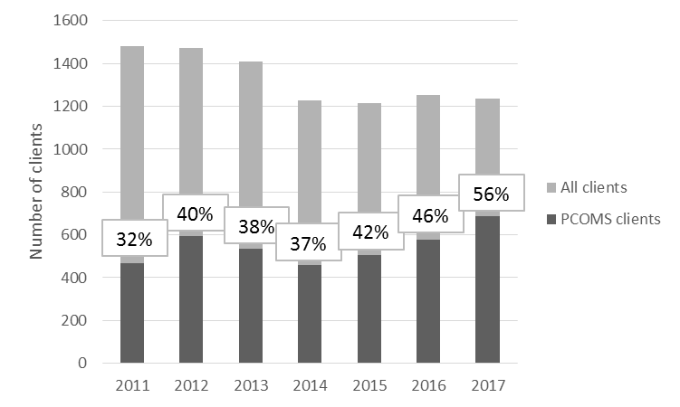

There are more missing SRS data than ORS data in the database

We had also expected that for all types of session there would be equal numbers of ORS scores and SRS scores, and that the total number of ORS and SRS scores would equal the number of client sessions recorded in the database (all years). However, as shown in Table 1, this was not the case with two percent of ORS scores and 12.5% of SRS scores missing overall; in other words, the scores were not recorded for those sessions. On further examination, it was apparent that most of the missing SRS scores related to follow-up calls[8] (69.6% missing).

For full interventions, 2.1% of the sessions were missing ORS scores and 10.9% were missing SRS scores. The highest proportion of missing scores was for group sessions, with 5.3% missing ORS scores and 40% missing SRS scores.

The percentage of missing scores was similar for gambler clients and affected other clients receiving a full intervention with 2.0% and 2.3% of sessions respectively where ORS scores were not recorded, and 11.0% and 10.1% of sessions respectively where SRS scores were not recorded.

Table 1: Missing ORS and SRS scores by session type from 2011 to 2017

|  | **Missing ORS scores** | | **Missing SRS scores** | |
| --- | --- | --- | --- | --- |
| **Session type** | **n** | **%** | **n** | **%** |
| Total | 708 | 2.0 | 4355 | 12.5 |
| Gambler | 576 | 2.0 | 3129 | 11.0 |
| Affected other | 115 | 2.3 | 495 | 10.1 |
|  |  |  |  |  |
| Brief intervention[9] | 6 | 4.4 | 21 | 15.6 |
| Full intervention | 691 | 2.1 | 3624 | 10.9 |
| Follow-up | 8 | 0.8 | 697 | 69.6 |
| Non-gambling | 3 | 0.9 | 13 | 4.0 |
|  |  |  |  |  |
| **Full intervention type** | |  |  |  |
| Individual | 380 | 1.5 | 1995 | 7.8 |
| Couple | 66 | 2.7 | 144 | 6.0 |
| Group | 181 | 5.3 | 1366 | 40.0 |
| Family/whānau | 28 | 2.0 | 73 | 5.3 |

Note: n values do not always add up to total as data identifiers not always included in supplied database

The percentage of full intervention sessions missing ORS scores reduced from 2011 to 2012, remained relatively constant from 2012 to 2014, and then reduced again from 2014 to 2015 before stabilising once more (Figure 6).

The percentage of missing SRS scores was stable from 2011 to 2014, increased slightly in 2015, followed by a substantial increase in 2016, then stabilising in 2017 (Figure 6).

Figure 6: Percentage of full intervention sessions missing ORS and SRS scores by year

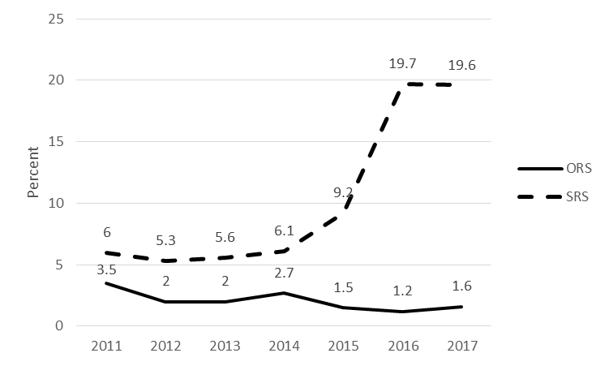

The percentages of missing ORS and SRS data were similar between the genders

When examined by gender, the percentages of missing ORS and SRS assessment data were similar for males and females apart from in 2017 when substantially more female full intervention sessions did not have SRS scores recorded compared with males (Figure 7).

Figure 7: Percentage of full intervention sessions missing ORS and SRS scores by gender by year

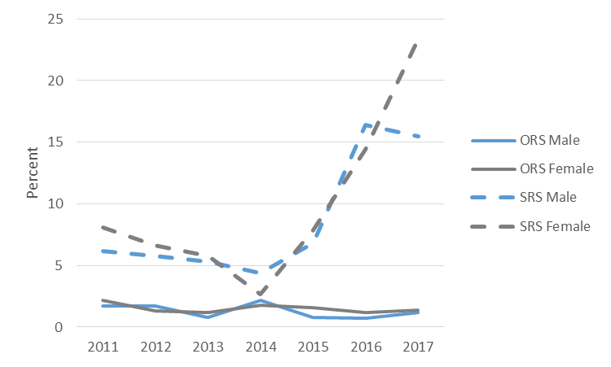

There were some ethnic differences in percentages of missing ORS and SRS data

From 2011 to 2014, Asian clients were the least likely to have missing ORS assessment scores. In 2015 and 2016, the percentages of full intervention counselling sessions for Māori, Pacific and European/Other clients with missing scores were similar to those for Asian clients. However, in 2017, there was a substantial increase in the percentage of Pacific client sessions without ORS scores recorded, compared with the other ethnicities (Figure 8).

Figure 8: Percentage of full intervention sessions missing ORS scores by ethnicity by year

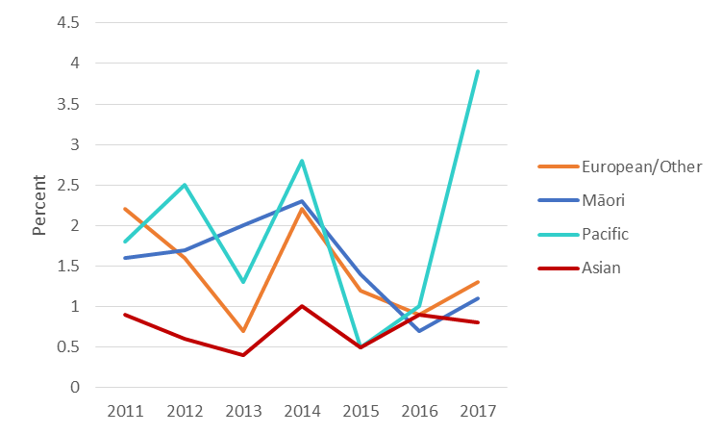

As with missing ORS scores, Asian clients generally had the lowest percentage of missing SRS scores. For all ethnicities, the percentage of full intervention sessions with missing SRS scores increased from 2015 to 2017, with Māori and European/Other clients showing the highest percentages. Pacific clients had a slightly different profile in that although the percentage with missing SRS scores increased from 2015 to 2016, it then decreased from 2016 to 2017 (Figure 9).

Figure 9: Percentage of full intervention sessions missing SRS scores by ethnicity by year

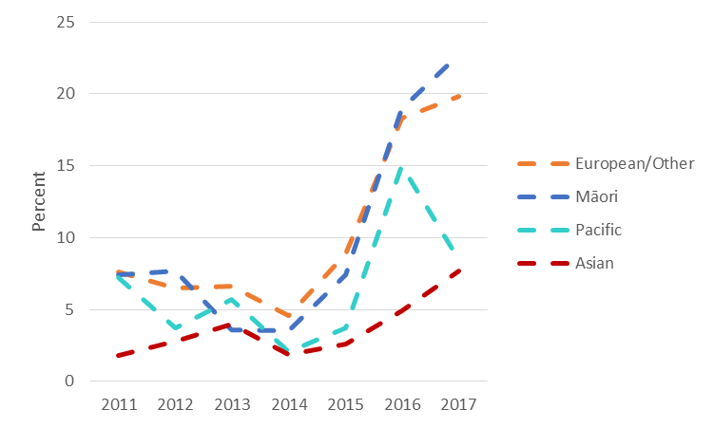

Profiles of full intervention clients receiving PCOMS assessments

Numbers of full intervention clients receiving PCOMS assessments

When examined for full intervention clients only, the numbers receiving at least one ORS and/or SRS assessment each year was relatively stable from 2011 to 2015, then showed an increasing trend in 2016 and 2017 (Figure 10).

Figure 10: Numbers of individual full intervention clients receiving at least one ORS/SRS by year

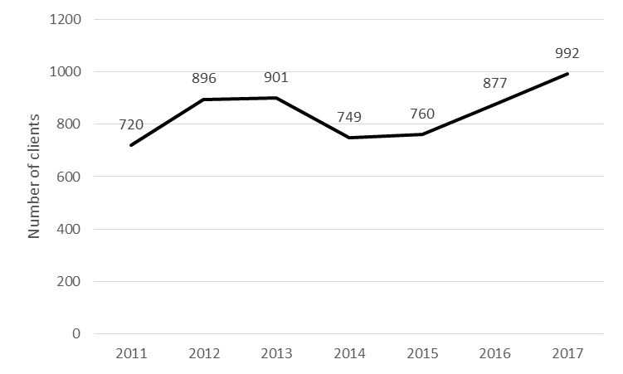

Numbers of individual full intervention sessions attended by clients receiving PCOMS

Overall, the median number of attended by individual clients who received at least one ORS and/or SRS assessment was three, though the range was large, from one session to 147 sessions per client. There was no difference between males and females in median number of full intervention sessions attended. However, examination of the data by ethnicity showed that Māori and Pacific clients generally attended fewer full intervention sessions. The median number of sessions for these two populations was two, compared with three for European/Other clients and Asian clients. Additionally, the range was smaller with the maximum number of sessions recorded as 59 for Māori clients and 26 for Pacific clients, compared with 147 and 86 for European/Other clients and Asian clients, respectively.

The median number of days between full intervention sessions for individual clients who received PCOMS was 14, indicating that clients generally attended fortnightly counselling sessions. There was no difference when comparing median number of days between sessions by gender and ethnicity, apart from for Asian clients for whom the median number of days between sessions was 10, rather than 14.

More PCOMS assessments occurred if more counselling sessions were attended

Whilst a single ORS and/or SRS assessment can aid the direction of a single counselling session, it is multiple ORS and SRS measurements that can help a counsellor to gauge whether the therapeutic approach is benefitting a client. When examined by number of full intervention sessions attended, it was apparent that the use of ORS and SRS on at least two occasions was more likely the more counselling sessions that were attended. Thus, whilst about two-thirds of clients who attended six to eight counselling sessions had at least two ORS and SRS scores recorded, this was the case for only about one-third of clients who attended three sessions (Figure 11).

Figure 11: Percentage of full intervention clients with at least two PCOMS assessments by number of full intervention sessions

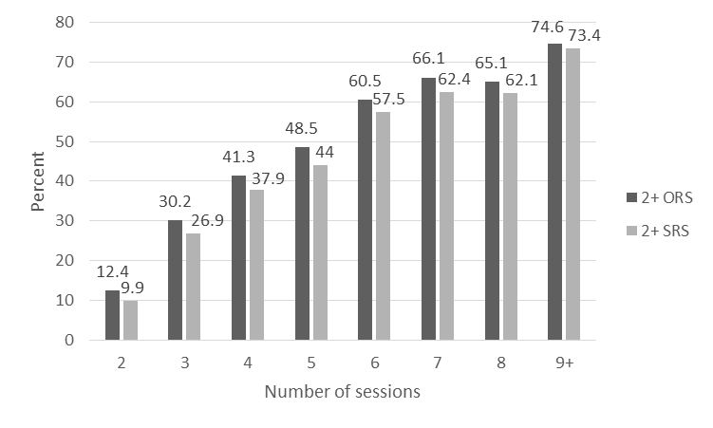

ORS data

A ‘multiple of 4’ scoring pattern is evident for ORS

In his analysis of data from 2010 to 2014, Bridgman (2015) identified a “*curious pattern in which ORS scores that are a multiple of 4 are generally much more frequent than the surrounding data. This tells that there is [a] substantial number of data sets where the four contributing subscales to the ORS are both whole numbers and likely to have 2-4 numbers which are the same. This means that in many cases the measuring for the contributing scores has been approximate rather than precise*.” (p. 2)

When ORS scores were examined from 2011 to 2018 for clients who had only a single session of data recorded (Figure 12 A), the ‘multiple of 4’ scoring pattern was evident with a peak in ORS scores of 16, 20, 24, 28, 32, 36 and 40. However, peaks were also noted at other even numbered scores such as 18, 26 and 30. The Bridgman analysis only investigated data to 2014, so we specifically analysed data from 2015 to 2018 (Figure 12 B). Although less clear, distinct peaks for ORS scores of 20, 24, 28, 36 and 40 were still noticeable.

When all data were considered, that is, investigating the first ORS score from clients who had attended more than one full intervention session, the ‘multiple of 4’ peaks are clear for scores of 16, 20, 28, 32, 36 and 40 when examined from 2011 to 2018 (Figure 12 C). However, whilst still evident, they are less obvious for data only from 2015 to 2018 (Figure 12 D). Similar findings were noted for ORS scores from the final session of several sessions (Figure 12 E and F).

Figure 12: ORS scores over time

**A B**

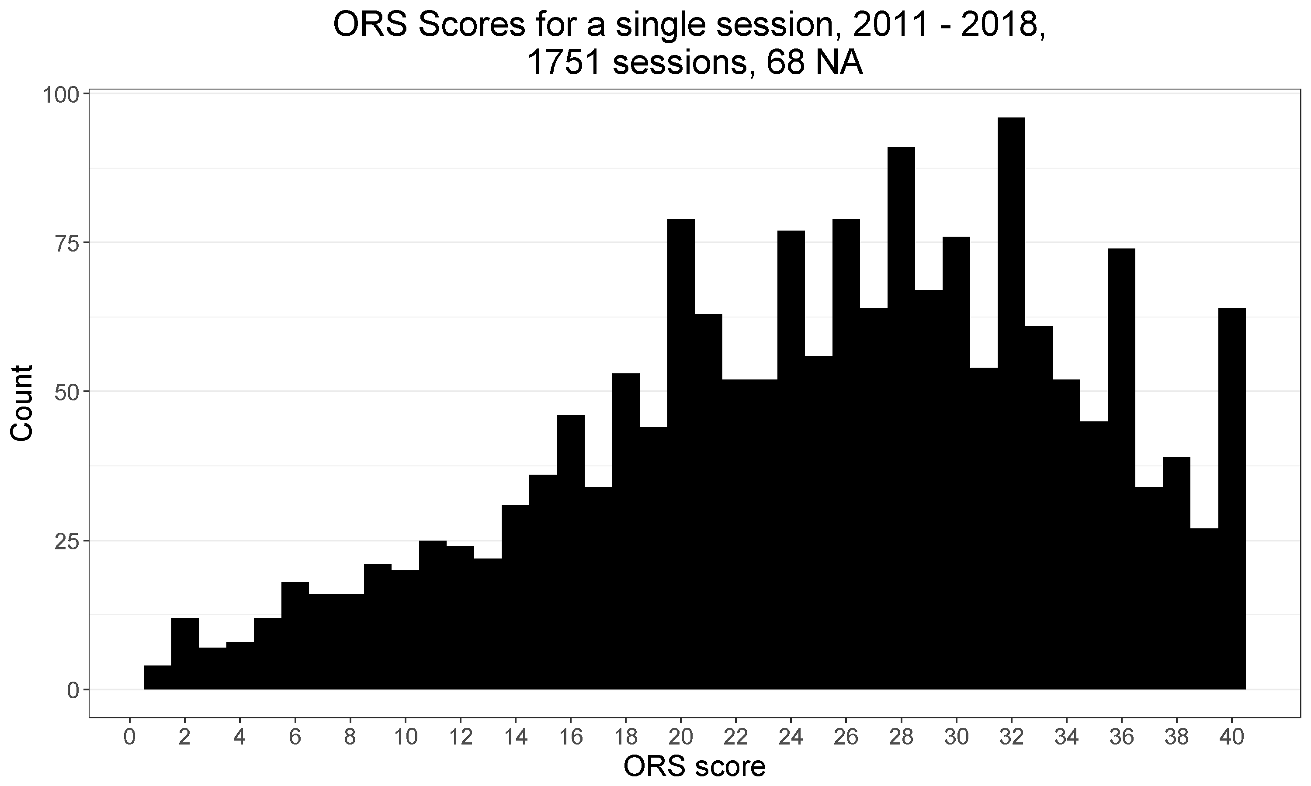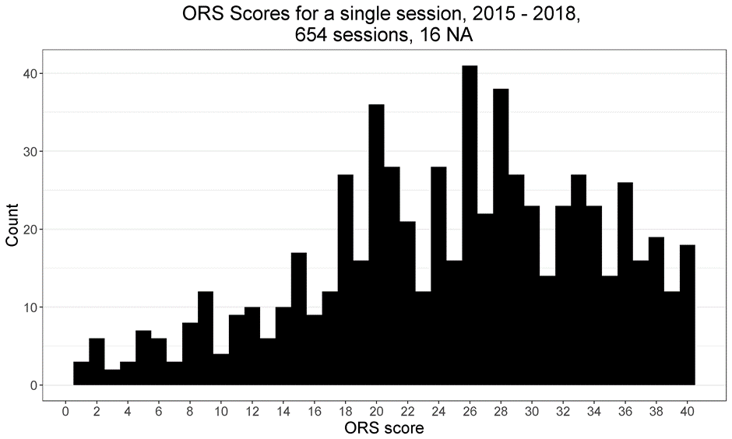

**C D**

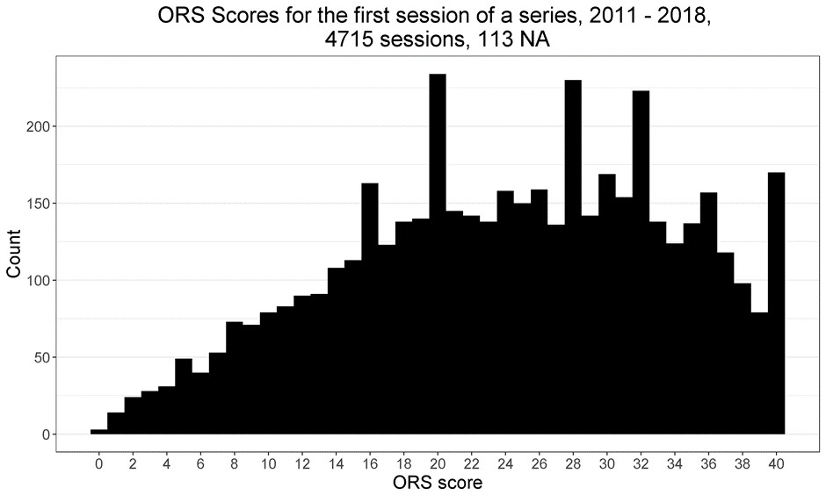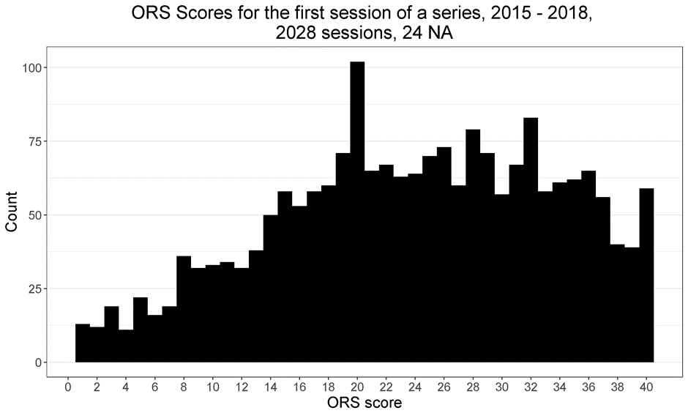

**E F**

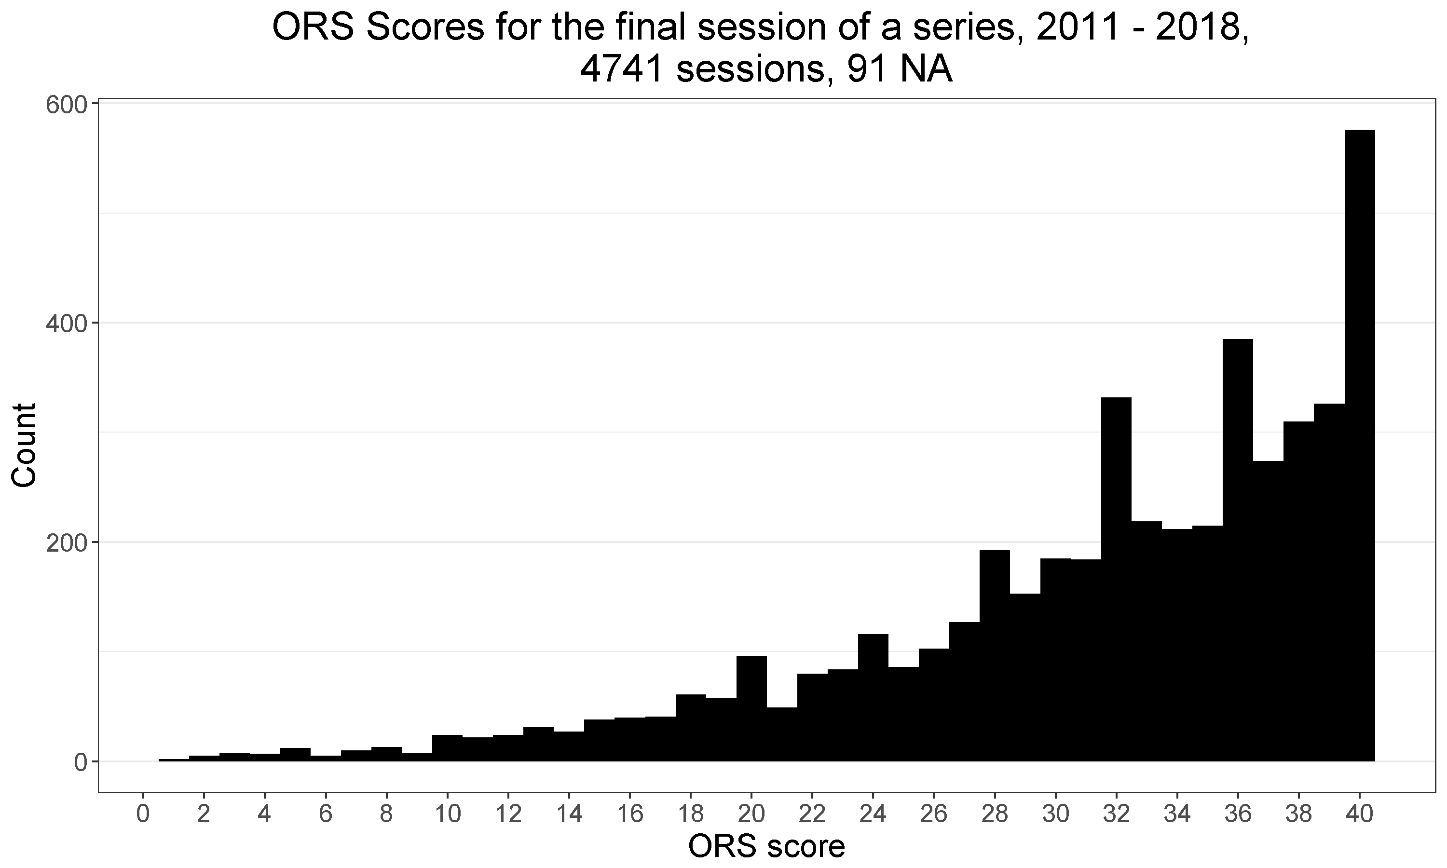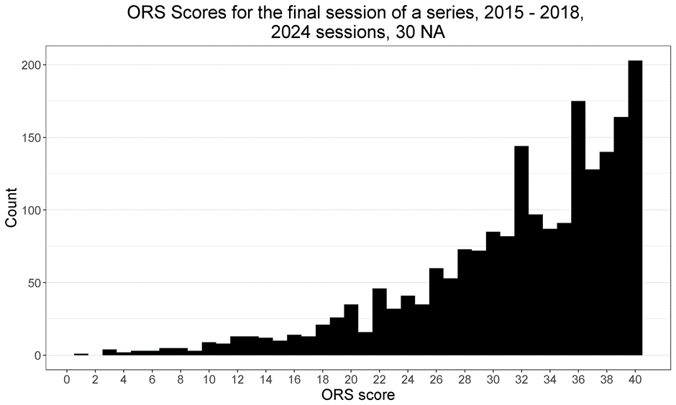

Median ORS scores and changes across sessions

The median first ORS score for clients who had multiple full intervention sessions was 23.9 (Figure 13). This was anticipated as the initial ORS score is expected to be less than the clinical cut-off score of 25 for people who are seeking help.

In the second session the median score increased to 29.3, then to 31.6 in the third session and to 32.4 in the fourth session. The median score remained relatively stable for clients who had subsequent counselling sessions (Figure 13).

It is noteworthy that for clients who only attended a single full intervention counselling session, the median ORS score was 28.0, above the clinical cut-off of 25 (Figure 13).

Figure 13: Median ORS score by number of full intervention sessions

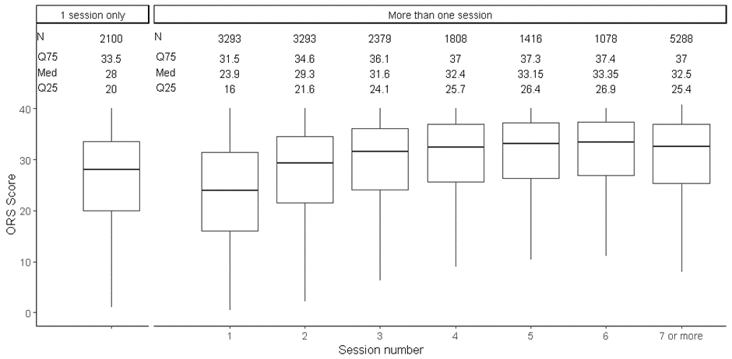

Examination of median change in ORS scores between sessions showed that the greatest gains were from the first to the second session (median gain of 3.5), and then from the second to the third session (median gain 1.5). Smaller gains were made for each subsequent counselling session. However, lower quartile data show that some clients reduced rather than increased their ORS scores from one session to another, indicating a reduction in wellbeing for those clients on those occasions (Figure 14).

Figure 14: Change in median ORS score by number of full intervention sessions

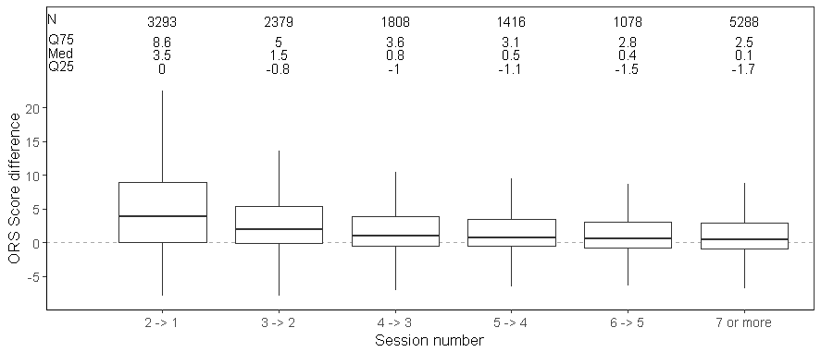

Median ORS scores and changes across sessions were similar by gender

There was very little difference in median ORS scores across the sessions between males and females (Figure 15). Changes in ORS scores across sessions were similar for both genders too (Figure 16).

Figure 15: Median ORS score by gender by number of full intervention sessions

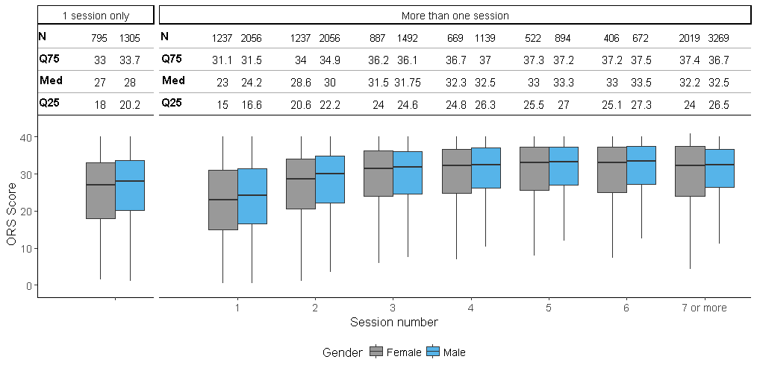

Figure 16: Change in median ORS score by gender by number of full intervention sessions

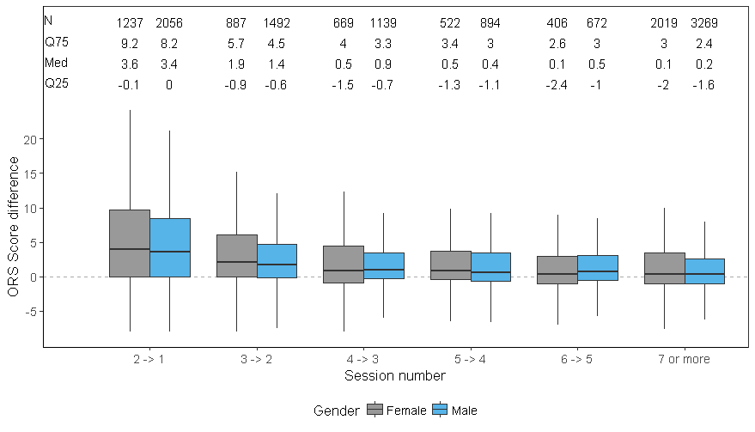

Median ORS scores and changes across full intervention sessions differed by ethnicity

Asian clients receiving full interventions showed a different profile in ORS scores compared with clients of Māori, Pacific or European/Other ethnicity, tending to have a higher median score. For Asian clients the median ORS score was 32 for those who only attended one counselling session compared with a median score of 26 to 28 for the other ethnicities. Similarly, the median score for the first session of multiple counselling sessions was 31 for Asian clients, compared with 22 to 23 for the other ethnicities. The median ORS score for Asian clients remained slightly higher than that for the other ethnicities in subsequent counselling sessions up to the sixth session. However, for clients who attended seven or more counselling sessions, the median score was lower for Asian clients rather than higher, at 30 compared with 32 to 35 (Figure 17).

Figure 17: Median ORS score by ethnicity by number of full intervention sessions

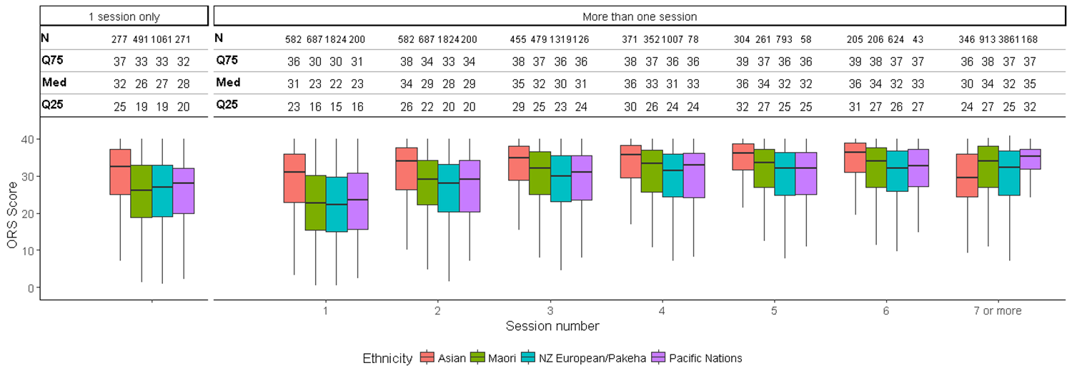

Possibly due to the higher initial median score, Asian clients showed smaller changes in ORS score across sessions, compared with the other ethnicities. However, the greatest gain was made from the first to second session as was noted for the other ethnicities (Figure 18).

Figure 18: Change in median ORS score by ethnicity by number of full intervention sessions

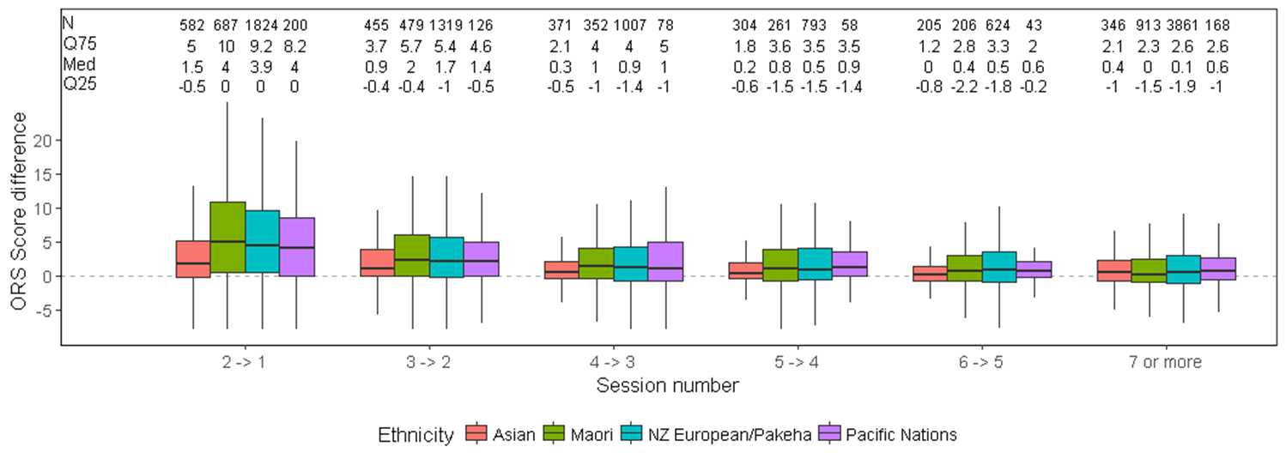

Change in median first to last ORS scores by number of full intervention sessions showed overall improvement in client wellbeing

Examination of the median first and last ORS scores recorded by number of full intervention sessions attended indicated that, overall, client wellbeing improved the more sessions that were attended, up to four sessions. There was an improvement of 6.0 points from the first to second sessions, increasing in subsequent sessions to 10.3 points between the first and fourth sessions. Long-term clients who had seven or more counselling sessions showed the greatest improvement in wellbeing with a median 13.3 point change. The findings were similar for males and females, with mean change in scores similar to the overall sample (Figure 19). Using Student’s *t* test, there was a statistically significant difference between first and last ORS score at each counselling session for both genders (in all cases, p < 0.0001).

Figure 19: Change in median first to last ORS scores by number of full intervention sessions and gender

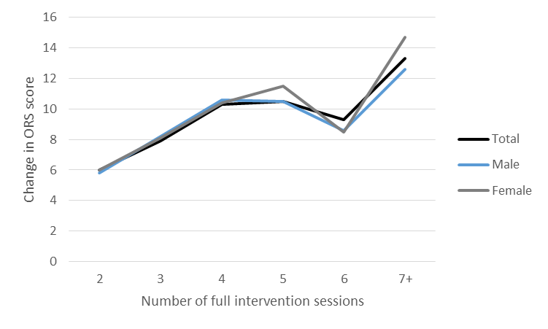

However, there were some differences by ethnicity although general increased improvement with more sessions was apparent for each ethnicity (Figure 20).

Asian clients showed the greatest difference from the overall sample, with smaller score changes noted at all counselling sessions, although the overall trend for improvement, with the greatest improvement for long-term clients, was a similar finding to that for the overall sample. This implies that the wellbeing of Asian clients was improved with the counselling sessions but that perhaps the ORS was not used or understood in the same way as by clients of other ethnicities.

Pacific clients showed the largest fluctuations in ORS score changes, with a lower change than the overall sample noted in the second and fifth sessions, but a higher change noted for clients attending seven or more sessions. This may imply that the ORS does not work so well for Pacific clients in initial sessions but may be more appropriate for use with longer term clients.

Māori clients were similar to the overall sample for those attending two, three, five or seven sessions but showed greater change in ORS scores for clients attending four or six sessions. European/Other clients were most similar to the overall sample.

Using Student’s *t* test, there was a statistically significant difference between first and last ORS score at each counselling session for all ethnicities (in all cases, p ≤ 0.01).

Figure 20: Change in median first to last ORS scores by number of full intervention sessions and ethnicity

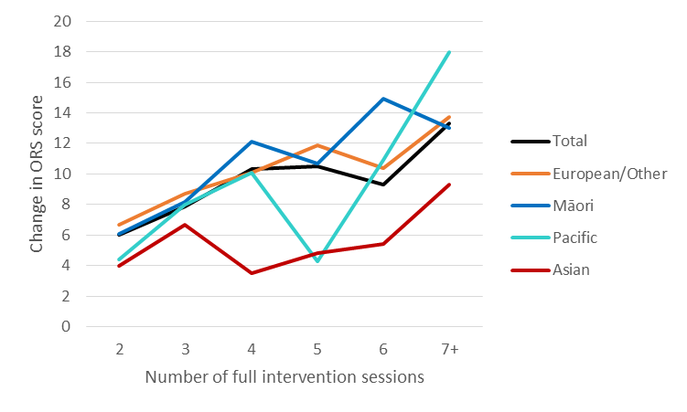

ORS scoring profiles by clinical cut-off score

When the data were analysed by percentage of clients with an ORS score of less than or equal to the clinical cut-off score of 25, it was noted that slightly less than half (47%) of the full intervention clients who attended one session were above the cut-off. This increased to about two-thirds (62.5%) in the second session, 70.8% in the third session and then about three-quarters in subsequent sessions (Figure 21). These findings are expected as clients scoring higher than 25 at intake are at risk of becoming worse rather than better between sessions (Miller & Bargmann, 2012), although it is perhaps surprising that as many as 47% of clients were above the cut-off in the first session. The findings indicate that, overall, client wellbeing increased from the first to fourth sessions before plateauing.

Figure 21: Average percentage of ORS scores higher than the clinical cut-off score of 25

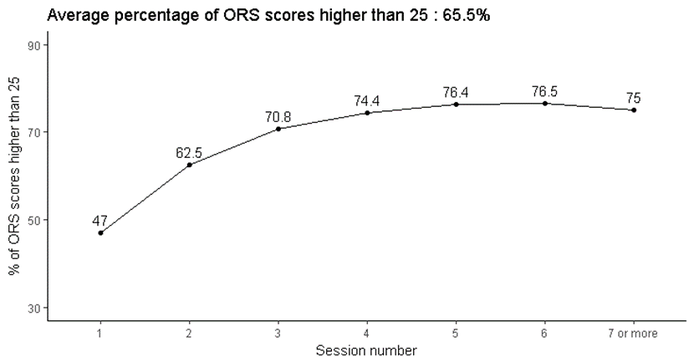

A similar trend was noted for males and females when the genders were examined separately, although the proportion of females higher than the cut-off at each session was lower than the percentage of males at the corresponding session (Figure 22).

Figure 22: Average percentage of ORS scores higher than the clinical cut-off score of 25 by gender

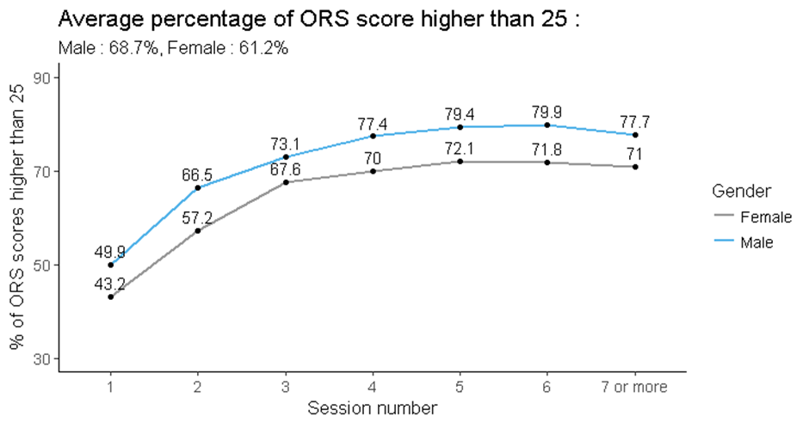

Similar trends were also noted when ORS scores were examined by ethnicity, although only Māori and European/Other clients had less than half of clients above the cut-off score in the first session, with 56% of Pacific clients and 62% of Asian clients having an ORS score higher than 25 (Figure 23). This could imply that the ORS is either less understood or less useful for clients of these ethnicities. Another noteworthy difference is that almost all (90%) long-term Pacific clients (attending seven or more full counselling sessions) were above the cut-off score, whilst for Asian clients a decrease was noted for long-term clients with only 71% above the cut-off score compared with 80% in the sixth session (Figure 23).

Figure 23: Average percentage of ORS scores higher than the clinical cut-off score of 25 by ethnicity

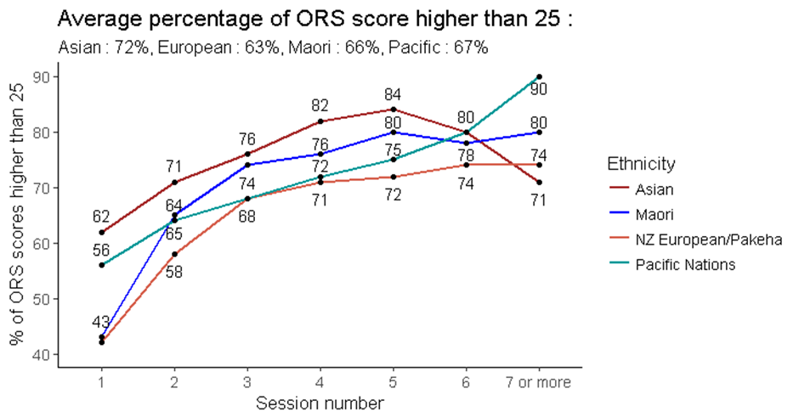

It was apparent that larger increases in score were noted across the first four counselling sessions for clients who started below or at the clinical cut-off score of 25, compared with those who started above the cut-off, with a substantial increase from the first (median score 16.8) to the second (median score 24.0) sessions. There was little change in scores across sessions for clients with a first ORS score above the cut-off (Figure 24).

Figure 24: Median ORS score by clinical cut-off score by number of full intervention sessions

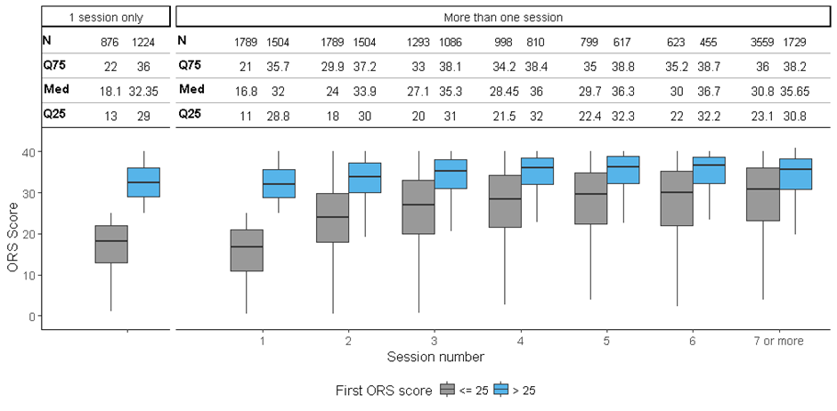

Similarly, the largest changes in scores between sessions were noted for clients whose first ORS score was below or at the cut-off, compared with clients who first ORS score was greater than 25 (Figure 25).

Figure 25: Change in median ORS score by clinical cut-off score by number of full intervention sessions

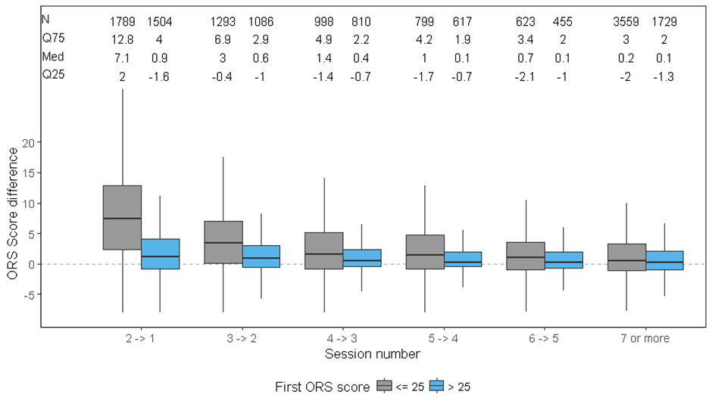

ORS score transitions from first to last score

Two-thirds (65.8%) of full intervention gambler clients who started counselling with an ORS score of below or at the cut-off score of 25 had a final ORS score higher than 25, indicating improvement in well-being. Conversely, one-third (34.2%) remained with a final ORS score of less than or equal to 25 indicating no improvement in wellbeing (Table 2).

Almost all clients (92.1%) who started counselling with an ORS score higher than 25 also had a final ORS score higher than 25, indicating either no change in well-being or a slight improvement in wellbeing (Table 2). Conversely, 7.9% of clients showed clinically significant deterioration in terms of wellbeing, moving from a score representative of a non-clinical population to that of a clinical population.

Table 2: Transition from first to last ORS score

|  |  |  |  |
| --- | --- | --- | --- |
| **First ORS score** | | **Last ORS score** | |
| **Below/at cut-off**  **(≤ 25)** | **Above cut-off**  **(> 25)** |
| **Below/at cut-off (≤ 25)** | *n*  *percentage* | 589  34.2% | 1131  65.8% |
| **Above cut-off (> 25)** | *n*  *percentage* | 111  7.9% | 1282  92.1% |

SRS data

A ‘multiple of 4’ scoring pattern is evident for SRS

In his analysis of data from 2010 to 2015, Bridgman (2015) also noted that “*The same ORS pattern, in which scores that are a multiple of 4 are generally much more frequent than the surrounding data, is also seen in SRS scales... most likely for the same reasons*.”

When SRS scores were examined from 2011 to 2018 for clients who had only a single session of data recorded (Figure 26 A), the ‘multiple of 4’ scoring pattern was evident with a peak in SRS scores of 20, 24, 28, 32, 36 and 40. As the Bridgman analysis only investigated data to 2014, we also specifically analysed data from 2015 to 2018 (Figure 26 B) where distinct peaks were only noted for SRS scores of 32 and 40.

When all data were considered, that is, investigating the first SRS score from clients who had attended several full intervention sessions, the ‘multiple of 4’ peaks remained clear for scores of 20, 28, 32, 36 and 40 when examined from 2011 to 2018 (Figure 26 C), and for data from 2015 to 2018 (Figure 26 D). Similar findings were noted for SRS scores from the final session of several sessions (Figure 26 E and F).

These data indicate that no real change to practice has occurred since the Bridgman report, with the practice of using whole number scoring continuing to be used with, or by, clients.

Figure 26: SRS scores over time

**A B**

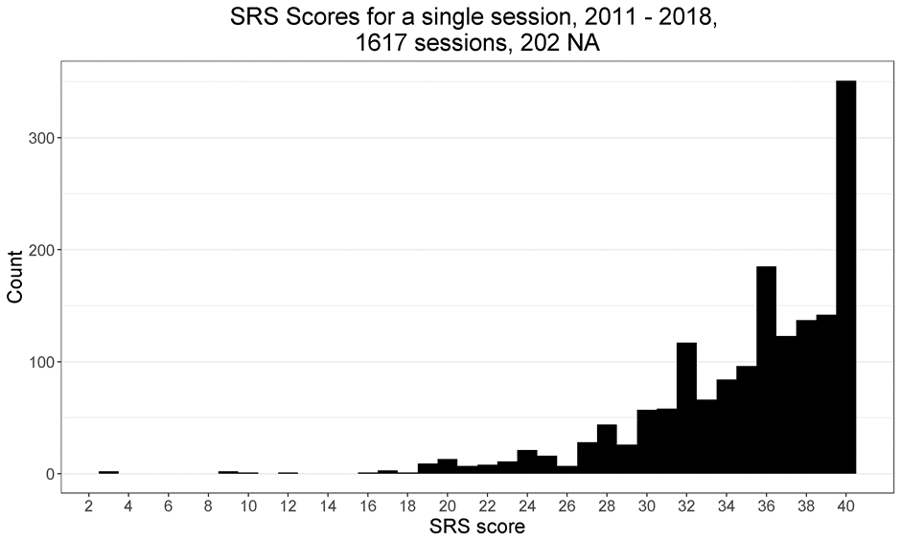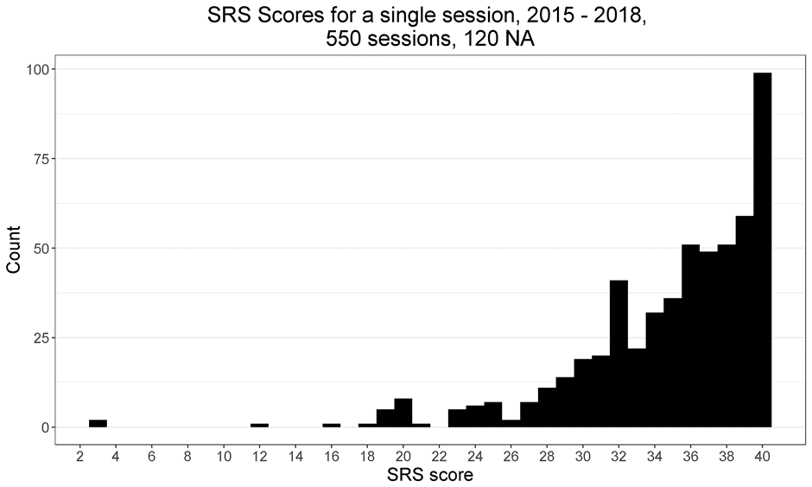

**C D**

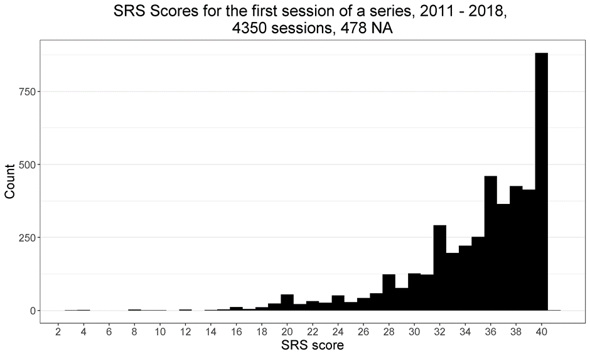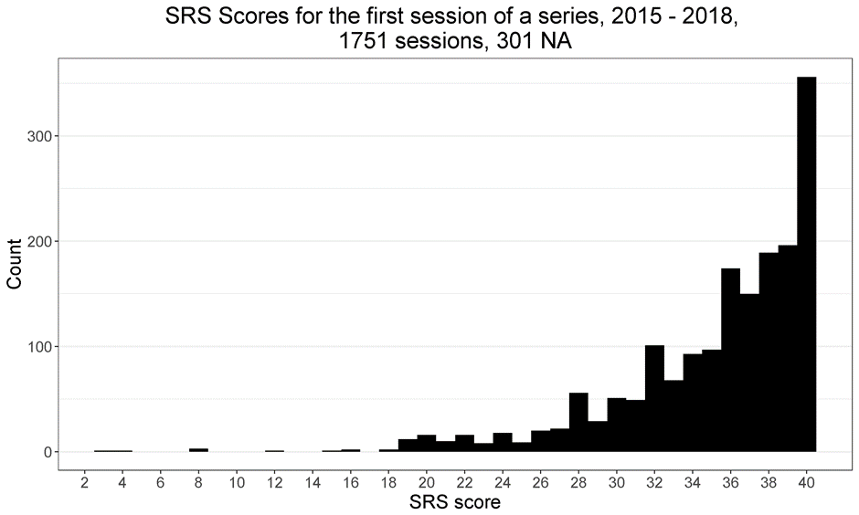

**E F**

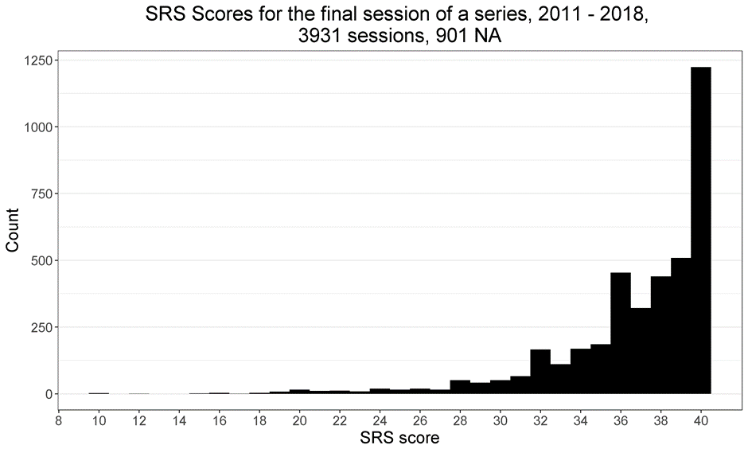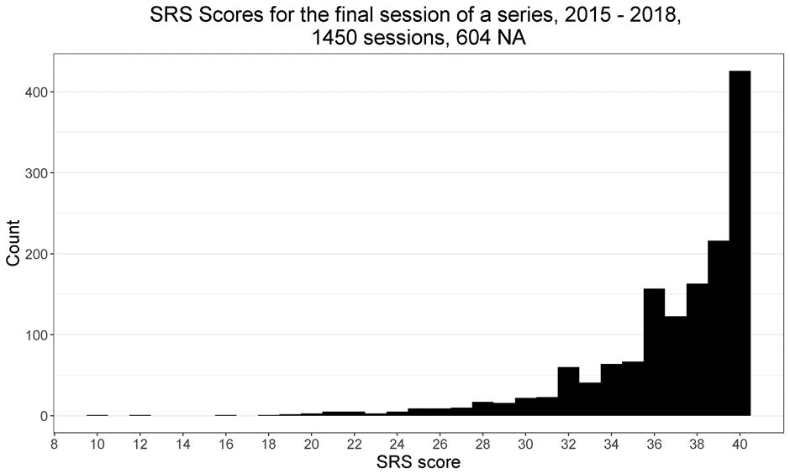

Median SRS scores and changes across sessions

The median first SRS score for gambler clients who had multiple full intervention sessions was 36.5 (Figure 27). This is above the cut-off score of 36. The initial SRS score is expected to be 36 or higher as clients tend to rate the client-therapeutic relationship relatively highly (Miller & Bargmann, 2012).

In the second session the median score increased to 37.4 and remained relatively stable for clients who had subsequent counselling sessions (Figure 27).

For clients who only attended a single full intervention counselling session, the median SRS score was 36.4, similar to the 36.5 score noted for clients who had multiple sessions (Figure 27).

Figure 27: Median SRS score by number of full intervention sessions

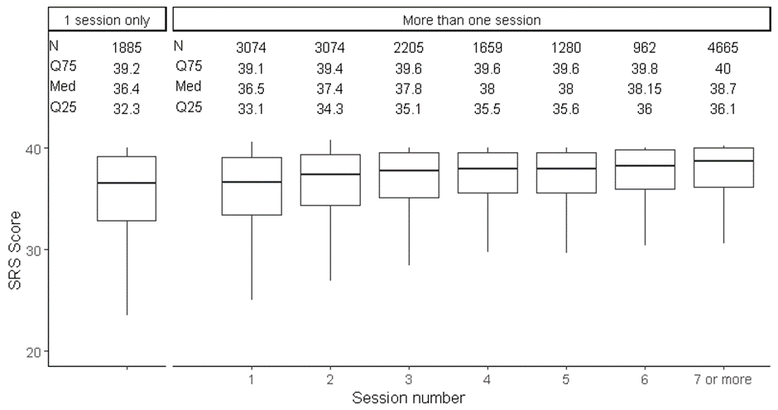

Examination of median change in SRS scores between sessions showed that the only increase was from the first to the second session (median gain of 0.1 points), with no increase for each subsequent counselling session. However, lower quartile data showed that some people had reduced SRS scores from one session to another indicating, that for these people, there may have been a deterioration in the therapeutic relationship, alternatively they may have been scoring more honestly as trust was established (Figure 28).

Figure 28: Change in median SRS score by number of full intervention sessions

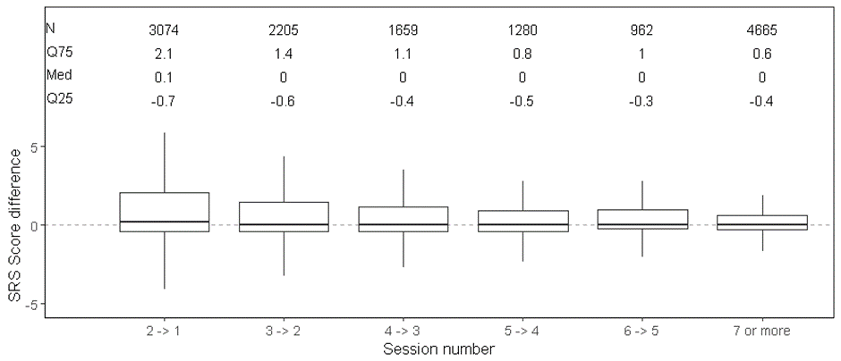

Median SRS scores and changes across sessions were similar by gender

There was very little difference in median SRS scores across the sessions between males and females (Figure 29). Changes in SRS scores across sessions were similar for both genders too (Figure 30).

Figure 29: Median SRS score by gender by number of full intervention sessions

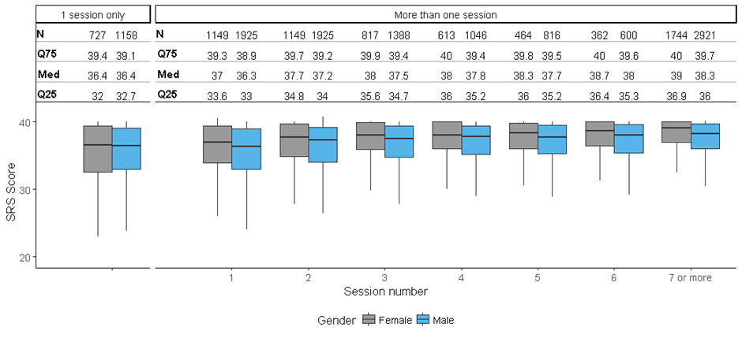

Figure 30: Change in median SRS score by gender by number of full intervention sessions

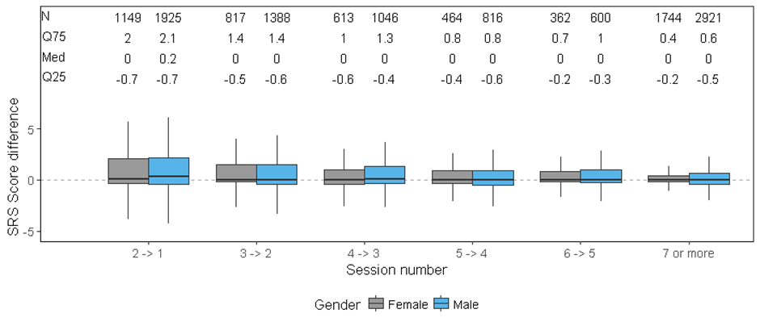

Median SRS scores and changes across full intervention sessions were similar by ethnicity

Overall, there was very little difference in median SRS scores across the full intervention sessions between the ethnicities, although there was some fluctuation between sessions (Figure 31).

Figure 31: Median SRS score by ethnicity by number of full intervention sessions

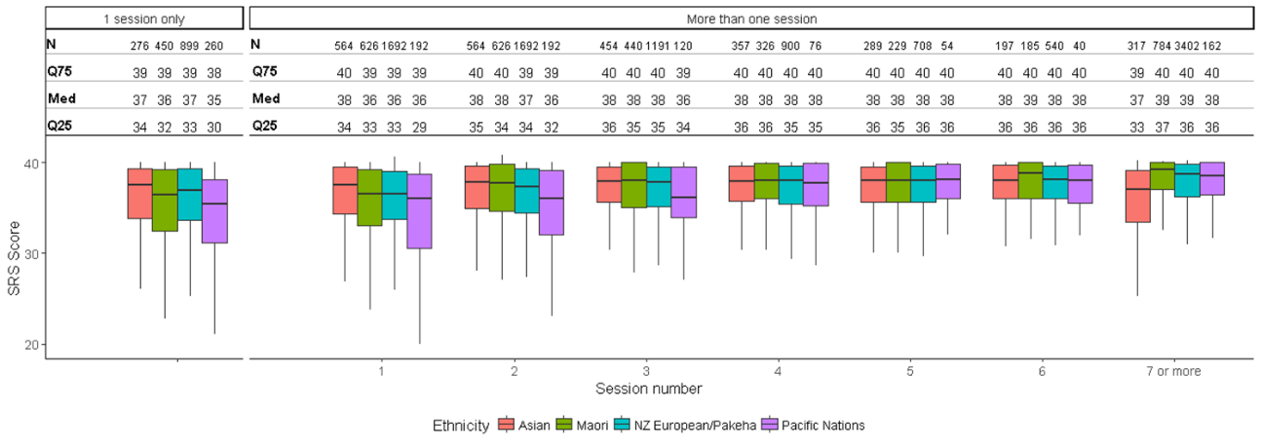

Generally, there was either a very small change or no change in SRS scores from one full intervention session to the next, noted across ethnicities. However, Pacific clients showed a slightly larger change in SRS scores from the first to the second session (median score change of 0.7 points), compared with the other ethnicities (median score changes of 0 to 0.3 points). Subsequently, there was no change in median scores from one session to the next (Figure 32).

Figure 32: Change in median SRS score by ethnicity by number of full intervention sessions

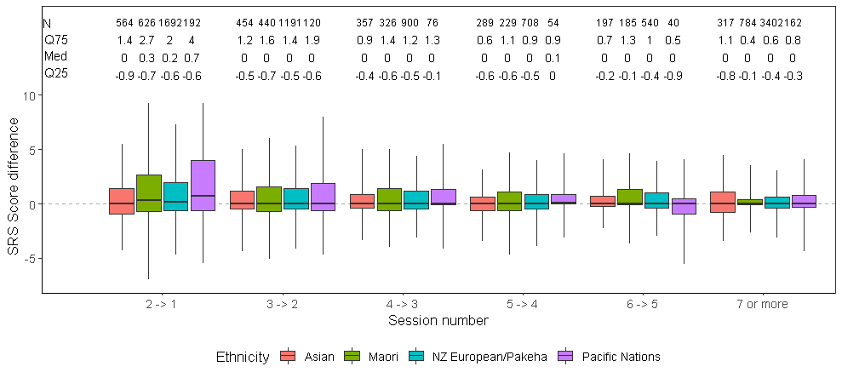

Change in median first to last SRS scores by number of full intervention sessions showed overall improvement in the client-therapeutic relationship

Examination of the median first and last SRS scores recorded by number of full intervention sessions attended indicated that, overall, clients rated the client-therapeutic relationship more highly the more sessions they attended, up to five sessions. There was an improvement of 0.9 points from the first to second sessions, increasing in subsequent sessions to 1.7 points between the first and fifth sessions. Long-term clients who had seven or more counselling sessions showed the greatest improvement in wellbeing with a median 2.4 point change.

When examined by gender, the profile for males was similar to the overall sample. However, for females, improvement in the therapeutic relationship was not seen until the fourth counselling session, with the change in improvement then becoming similar to that for the overall sample (Figure 33). Using Student’s *t* test, there was a statistically significant difference between first and last SRS score at each counselling session for both genders (in all cases, p ≤ 0.01).

Figure 33: Change in median first to last SRS scores by number of full intervention sessions and gender

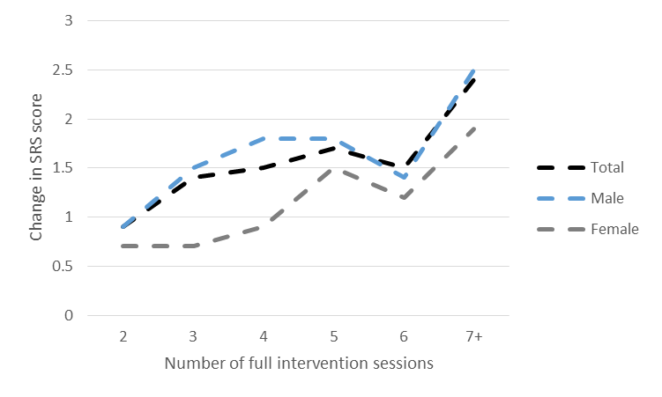

For clients undertaking Group SRS (GSRS) assessments, the median change in scores was higher for the fourth to sixth sessions, than for clients attending individual sessions; however, overall there was an improvement in the therapeutic relationship the more counselling sessions attended. Males attending group sessions and undergoing the GSRS had broadly similar changes in scores between sessions as the overall sample, though there was a slight difference for the fifth and sixth sessions. Female clients showed a different profile with those attending four to six group sessions and completing the GSRS showing a markedly greater change in scores than the overall sample, peaking at the fifth session. There was no gender difference in change in GSRS scores for long-term clients attending seven or more group sessions (Figure 34).

Figure 34: Change in median first to last Group SRS scores by number of group sessions and gender

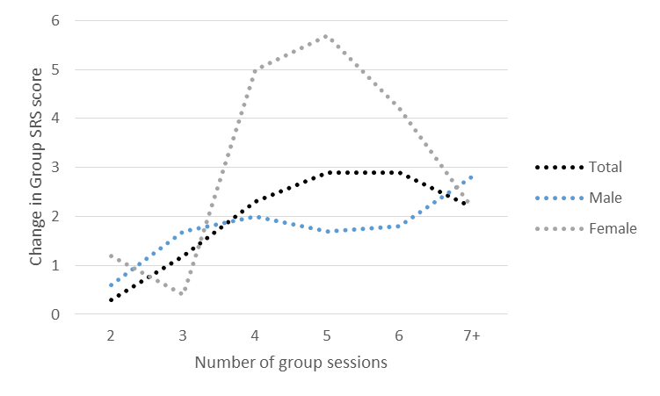

Ethnic differences were also apparent in median SRS score changes across full intervention sessions, although general increased improvement with more sessions was apparent for each ethnicity (Figure 35). European/Other clients were the most similar to the overall sample.

Pacific clients had the greatest difference in median SRS change scores from the overall sample. There was no, or only a very slight change in median score from the first to the second and third sessions. Subsequently, the change in median score substantially increased such that by the fifth and subsequent counselling session, the change was markedly more than for the overall sample. This might indicate that for Pacific clients, it takes a few sessions for rapport to be established within the therapeutic relationship, after which the relationship substantially improves.

Asian clients had the lowest median score changes compared with the overall sample, noted at all counselling sessions, although a trend for continued improvement to the fourth session was apparent. As with the overall sample, there was an indication that long-term Asian clients had the largest improvement in the client-therapeutic relationship.

Māori clients were similar to the overall sample for the second session and for long-term clients attending seven or more sessions. For the intermediate sessions, the median change in SRS score was higher for Māori clients than for the overall sample.

Using Student’s *t* test, there was a statistically significant difference between first and last SRS score at each counselling session for Māori and European/Other clients (in all cases, p ≤ 0.05). However, for Pacific clients, there was only a statistically significant difference between first and last SRS score for those attending two full intervention sessions or those attending seven or more sessions. For Asian clients, the statistical difference was noted for those attending three sessions, or five or more sessions.

Figure 35: Change in median first to last SRS scores by number of full intervention sessions and ethnicity

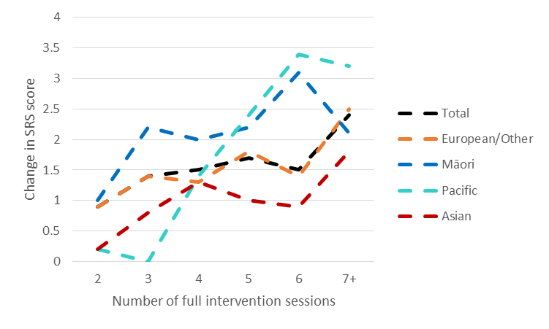

For clients undertaking Group SRS assessments, Pacific people showed the greatest difference in median change in GSRS scores from the overall sample with larger differences noted at all sessions apart from for long-term clients attending seven or more sessions. Substantially larger changes were noted at the fifth and sixth group sessions. Māori and European/Other clients showed broadly similar changes to the overall sample in the group sessions, whilst Asian clients showed a slightly lower change for the first five group sessions (Figure 36).

Figure 36: Change in median first to last Group SRS scores by number of group sessions and ethnicity

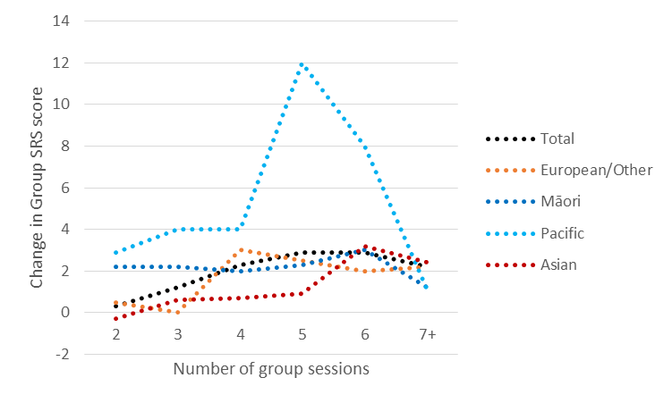

SRS scoring profiles by cut-off score

Analysis of the first SRS score being at or higher than the cut-off score of 36, versus below the cut-off score, showed that almost two-thirds (63.5%) of the full intervention clients who attended one session were at or above the cut-off score. This increased at each subsequent session to 83.5% for clients attending seven or more sessions (Figure 37). It is expected that clients initially rate the therapeutic relationship highly (Miller & Bargmann, 2012), and the continual increase in percentage above the cut-off score with subsequent counselling sessions indicates an overall client satisfaction with the counselling relationship/process.

Figure 37: Average percentage of SRS scores at the cut-off score or higher

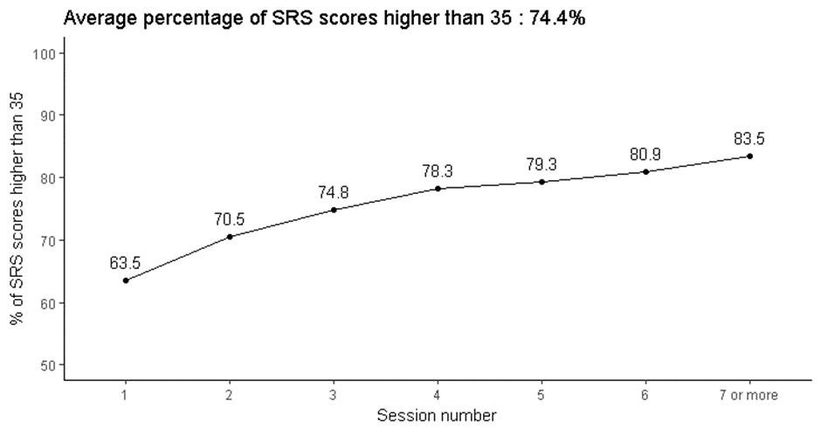

A similar trend was noted for males and females when the genders were examined separately, although the proportion of females at or higher than the cut-off score at each session was higher than the percentage of males at the corresponding session (Figure 38).

Figure 38: Average percentage of SRS scores at the cut-off score or higher by gender

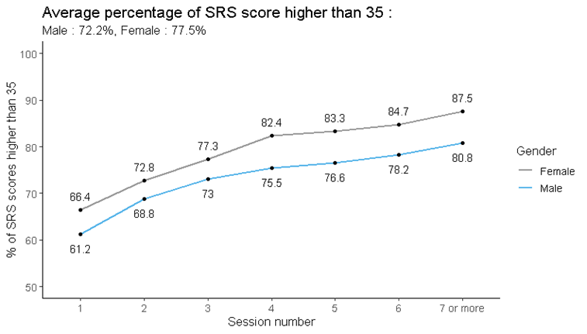

Similar trends were also noted when SRS scores were examined by ethnicity, although there were some fluctuations in percentages for long-term clients attending seven or more full intervention sessions. Of note is that lower percentages of Māori and Pacific clients were at or above the cut-off score in the first session (less than 60%) compared with European/Other clients (65%), whilst Asian clients were the highest proportion at 69%. However, improvements were apparent for all ethnicities although, similar to ORS scores, for Asian clients a reduction was noted for long-term clients with only 74% above the cut-off score compared with 79% in the sixth session (Figure 39).

Figure 39: Average percentage of SRS scores at the cut-off score or higher by ethnicity

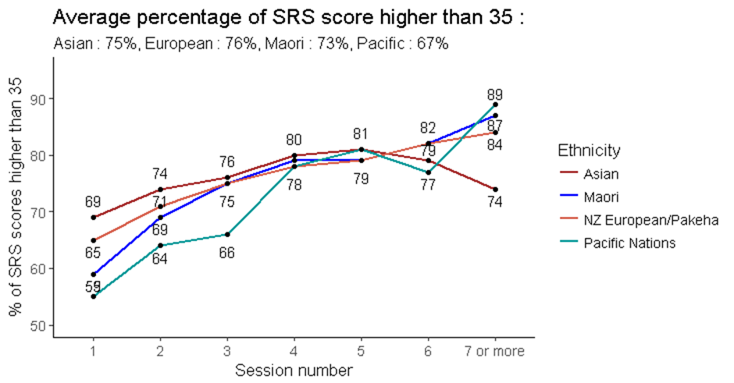

It was apparent that greater increases in score were noted across the first four counselling sessions for clients who started below the cut- off score, with a substantial increase from the first (median score 31.8) to the second (median score 34.1) sessions. There was little change in scores across sessions for clients with a first SRS score above the cut-off score (Figure 40). These findings mirrored those noted for ORS scores.

Figure 40: Median SRS score by cut-off score by number of full intervention sessions

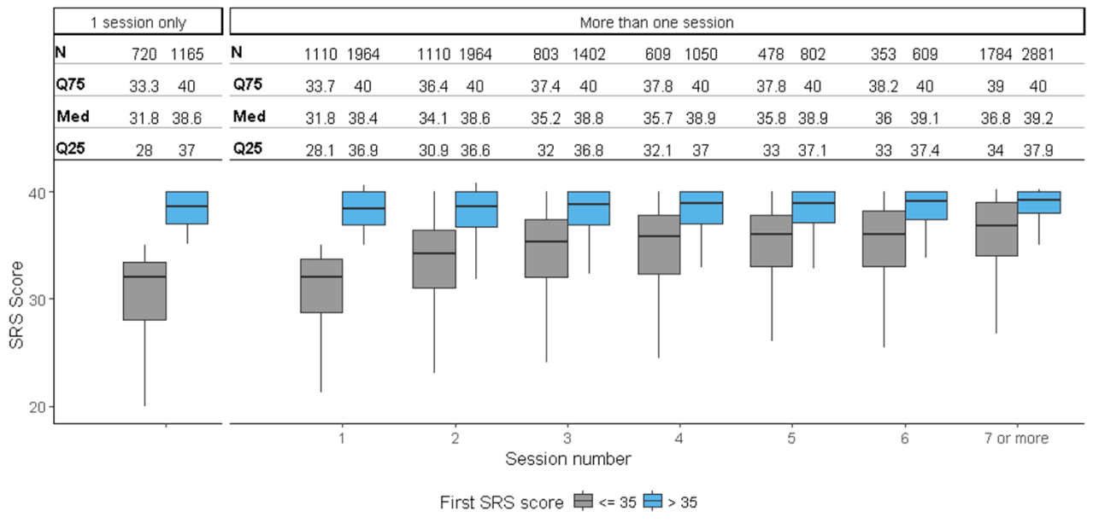

Similarly, the largest changes in scores between sessions were noted for clients whose first SRS score was less than the cut-off score of 36, compared with clients who first SRS score was at or higher than 36 (Figure 41). Again, this mirrored ORS score findings.

Figure 41: Change in median SRS score by cut-off score by number of full intervention sessions

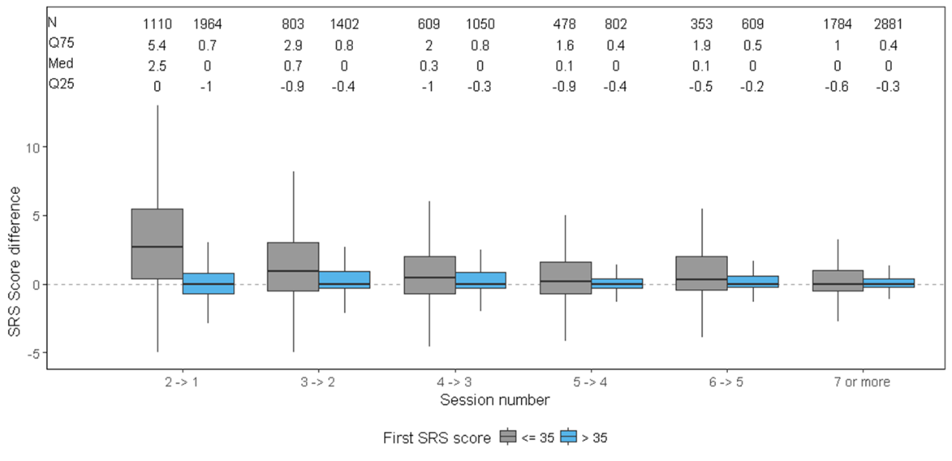

SRS score transitions from first to last score

Almost all full intervention clients (90.4%) who started counselling with an SRS score at or higher than the cut-off score of 36 also had a final SRS score at this level, indicating improvement or no deterioration in the therapeutic relationship (Table 3).

Slightly more than half (57.3%) of clients who started counselling with an SRS score less than 36 had a final SRS score at or higher than 36, indicating improvement in the therapeutic relationship. However, two-fifths (42.7%) remained with a final SRS score less than 36 indicating no improvement in the therapeutic relationship (Table 3).

Table 3: Transition from first to last SRS score

|  |  |  |  |
| --- | --- | --- | --- |
| **First ORS score** | | **Last SRS score** | |
| **Below/at cut-off score**  **(< 36)** | **Above cut-off score**  **(≥ 36)** |
| **Below/at cut-off score (< 36)** | *n*  *percentage* | 465  42.7% | 624  57.3% |
| **Above cut-off score (≥ 36)** | *n*  *percentage* | 184  9.6% | 1730  90.4% |

Use of PCOMS with clients is associated with improved client outcomes

Use of PCOMS (ORS and/or SRS) is associated with improved client outcomes

An analysis was performed investigating full intervention treatment episodes (i.e. the series of counselling sessions that comprise a full intervention) that included at least one PGSI assessment and at least one PCOMS (ORS and/or SRS) assessment vs. no PCOMS assessment. Of clients whose initial PGSI score indicated that they were a moderate-risk/problem gambler (90% of clients), two-fifths (41.9%) who had at least one PCOMS assessment remained moderate-risk/problem gamblers at the end of treatment whilst 58.2% transitioned into low-risk or non-problem gambling. Conversely, for moderate-risk/problem gamblers who did not have any PCOMS assessments, almost two-thirds (60.7%) were still moderate-risk/problem gamblers at the end of treatment and only 39.3% had transitioned to a lower risk level (Figure 42). This finding was statistically significant (p < 0.001).

Figure 42: Final PGSI category based on treatment episode including or not including PCOMS assessment

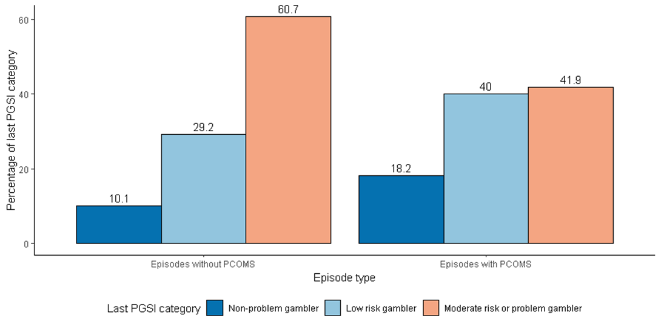

A multiple logistic regression analysis was conducted to examine the effect of including PCOMS assessments on change in PGSI score, controlling for demographic variables (gender, age and ethnicity), co-existing issues (alcohol and drug use, depression and suicidality), and counselling (number of counselling sessions and year of counselling).

The analysis showed that compared with clients who did not have any PCOMS (ORS and/or SRS) assessments during their treatment episode, clients who had at least one PCOMS assessment were significantly more likely to be a low-risk gambler/non-problem gambler after completing treatment (odds ratio 1.64, p < 0.0001).

Thus, using PCOMS (ORS and/or SRS) in the counselling sessions appears to be associated with the probability of a client becoming a non-problem gambler or a low-risk gambler at the end of a treatment episode.

Change in ORS and SRS scores and PGSI score changes

Change in PGSI scores is weakly correlated with change in ORS scores, not SRS scores

Change in PGSI score from first recorded score to last recorded score[10] was examined in relation to change in ORS and SRS scores from first to last recorded score[11]. Overall, a very weak correlation was found for ORS scores (correlation 0.266, p < 0.001) (Figure 43) but not for SRS scores (correlation 0.05, p = 0.16) (Figure 44).

Figure 43: Plot of change in PGSI score with change in ORS score

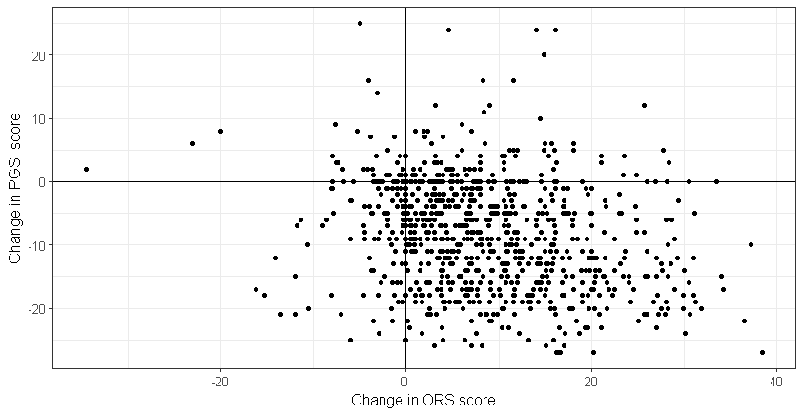

Figure 44: Plot of change in PGSI score with change in SRS score

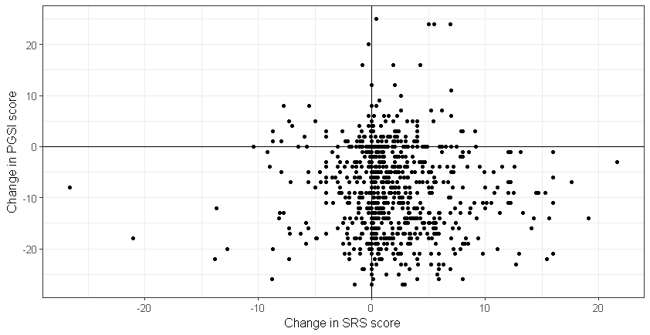

Logistic regression analysis of change in ORS score vs. change in PGSI score

Bivariate analysis was undertaken of full intervention clients who had at least two ORS scores and two PGSI scores recorded. ORS scores were categorised into ≤ 25 (the clinical cut-off score) and > 25. PGSI scores were categorised into moderate-risk/problem gambler, low-risk gambler and non-problem gambler, with the analysis conducted on all clients whose first PGSI score indicated that they were a moderate-risk or problem gambler (90% of full intervention clients).

Figure 45 shows that the greatest improvement in gambling risk level was for clients whose wellbeing improved with counselling or who started with a high wellbeing that was maintained with counselling. In other words, for clients whose first ORS score was ≤ 25 but whose last ORS score was higher than 25, and for clients whose first and last ORS scores were higher than the cut-off, about one-third (38.3% and 34%, respectively) remained as moderate-risk/problem gamblers with the remainder transitioning into low-risk gambling or non-problem gambling (61.8% and 66%, respectively).

Conversely, the least improvement in gambling risk level was noted for clients whose wellbeing decreased or stayed low with only 29.4% and 42.7%, respectively, transitioning out of moderate-risk/ problem gambling into low-risk gambling or non-problem gambling. Thus, more than half of these clients remained as moderate-risk/problem gamblers after completing counselling treatment.

These findings were statistically significant (p < 0.0001).

Figure 45: Final PGSI category based on first and last ORS category

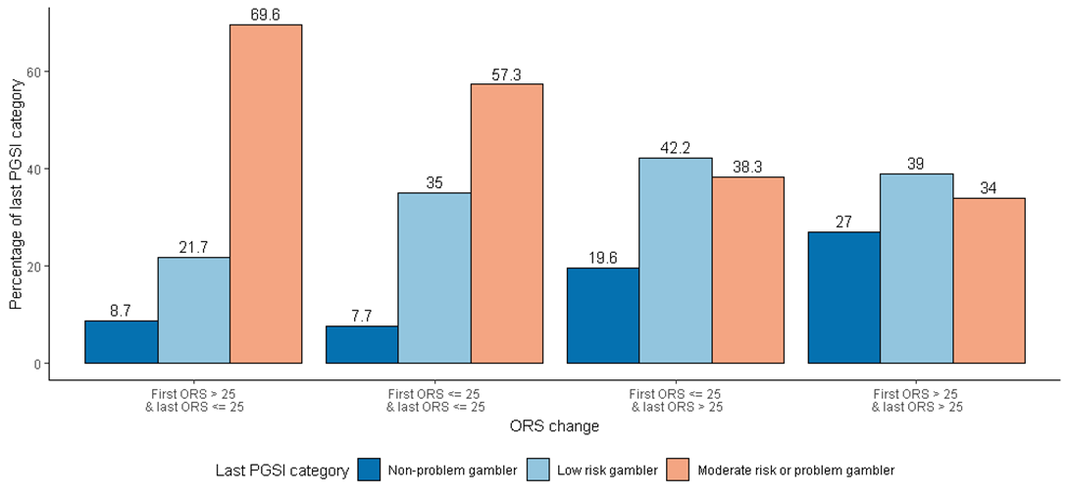

A multiple logistic regression analysis examined the effect of ORS score change on change in PGSI score, controlling for demographic variables (gender, age and ethnicity), co-existing issues (alcohol and drug use, depression and suicidality), and counselling (number of counselling sessions and year of counselling).

The analysis showed that compared with clients whose wellbeing decreased (last ORS score decreased to below the clinical cut-off score from starting above the cut-off score), clients whose wellbeing improved with counselling (odds ratio 3.38, p = 0.009) or who started with a high wellbeing that was maintained with counselling (odds ratio 3.93, p = 0.004) were significantly associated with the client more likely to be a low-risk gambler/non-problem gambler after completing counselling treatment.

Logistic regression analysis of change in SRS score vs. change in PGSI score

Bivariate analysis was undertaken with full intervention gambler clients who had at least two SRS scores and two PGSI scores recorded. SRS scores were categorised into < 36 (the cut-off score), and ≥ 36. PGSI scores were categorised into moderate-risk/problem gambler, low-risk gambler and non-problem gambler, with the analysis conducted on all clients whose first PGSI score indicated that they were a moderate-risk or problem gambler.

Figure 46 shows that the greatest improvement in gambling risk level was for clients who had improvement or no deterioration in the therapeutic relationship with their counsellor. In other words, for clients whose first SRS score was < 36 but whose last SRS score was ≥ 36, and for clients whose first and last SRS scores were ≥ 36, about one-third (35.5% and 38.9%, respectively) remained as moderate-risk/problem gamblers with the remainder transitioning into low-risk gambling or non-problem gambling (64.5% and 61.1%, respectively).

Conversely, the least improvement in gambling risk level was noted for clients whose therapeutic relationship deteriorated or remained poor with only half (50% and 46.7%, respectively) transitioning out of moderate-risk/problem gambling into low-risk gambling or non-problem gambling. Thus, about half of these clients remained as moderate-risk/problem gamblers after completing counselling treatment.

These findings were statistically significant (p < 0.001).

Figure 46: Final PGSI category based on first and last SRS category

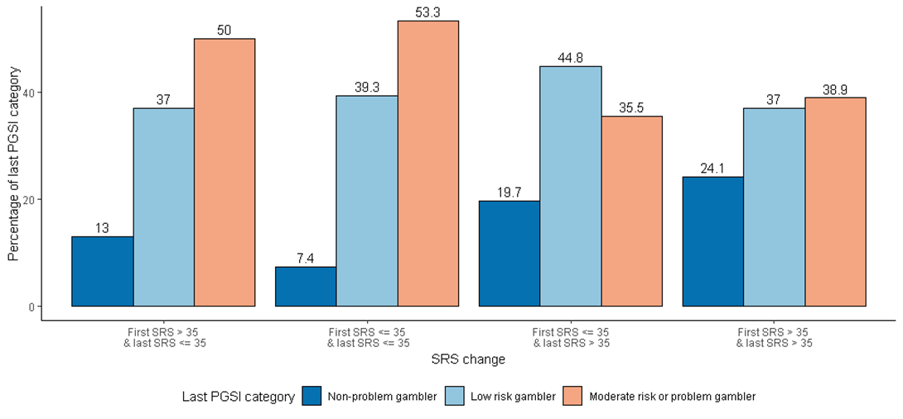

A multiple logistic regression analysis examined the effect of SRS score change on change in PGSI score, controlling for demographic variables (gender, age and ethnicity), co-existing issues (alcohol and drug use, depression and suicidality), and counselling (number of counselling sessions and year of counselling).

Changes in the therapeutic relationship (i.e. changes in SRS scores) were not significantly associated with the probability of a client becoming a non-problem gambler or a low-risk gambler at the end of treatment.

RESULTS - CASE NOTES ANALYSIS

Of the 20 randomly selected client case notes examined from clients who had attended two to five sessions (10 client case notes), and clients who had attended more than five sessions (10 client case notes), 17 were for clients receiving individual counselling, one was for a client receiving counselling in prison, and two were for clients who were receiving group therapy. Although the case notes varied, there were no documented differences apparent in the case notes in the way ORS and SRS were used with the different types of client. Neither was there any noticeable difference in the way ORS and SRS use were documented for clients who had attended two to five counselling sessions compared with those who had attended more than five sessions.

Nine case notes detailed that ORS was used in the first counselling session, and six case notes detailed SRS use in the first session. Although two of the case notes referred to group counselling, only one specifically mentioned use of the Group SRS.

Whilst consistent implementation of the ORS and SRS in each counselling session is the recommended approach, analysis of the 20 case notes did not always show recorded evidence of such consistency. In eight case notes, there was no record of SRS being used and, in one case, neither ORS nor SRS was mentioned. In some cases, it was specifically documented that the scales were not implemented. Nevertheless, there were multiple records of ORS use in 17 of the 20 case notes and multiple records of SRS use in 12 case notes. The use of ORS and SRS was apparent in telephone counselling sessions as well as face-to-face sessions, with eight case notes indicating the former.

As noted in the literature review, the utility of PCOMS data is dependent on client understanding of the purpose of the ORS and SRS, their honest self-reporting on the scales, and discussion of the scores by counsellors with clients to aid in the counselling process. Initial explanation of the scales did not appear to be documented and discussion of how to use the scales was only apparent in three of the case notes.

*Given the consistency of high scores over the past few sessions, I asked what he was measuring when he completed the ORS today. He replied how he’s felt over the past week. We discussed his ORS scores and the clinical cut-off of 25. A further prompt about what it may look like if it was in relation to the gambling. [He] marked it again. The ORS remained high and the individual scores changed more so in the interpersonal scale*. (Case note 20)

In other cases where scores were recorded, there was no documentation of whether the scores were discussed even if there was a large change in score from the previous session. However, it was evident from one case note that when a client had not understood the point of completing the ORS and SRS, the counsellor changed the approach from a paper exercise to a verbal one, which better suited the client.

*Client reported he found rating sessions difficult and at times did not see the point as he found counselling good and the counsellor approach a good fit. We discussed changing approach he used for rating. Instead of rating scores on paper, we would talk it through first and used scaling 0-10 to come to a score. Client reported he found this much [more] useful and meaningful.* (Case note 3)

In eight of the case notes, there was evidence that ORS ratings were related to clients’ gambling behaviours and effects.

*His scores have progressed slightly since the previous session … this relates to non-gambling and the completion of local exclusions.* (Case note 7)

*Topics discussed and interventions employed (based on ORS): [She] says she is feeling on top of the moon. Since last week, she has talked to her husband about the gambling and the financial situation commenting on the difficulty of doing so. He has offered to support her and will look after her finances. She has also visited the budgeting service again which helped make the financial situation less scary.* (Case note 1)

The case notes provided minimal evidence of PCOMS data being used to inform treatment practice. In five case notes, increased ORS scores exceeding five points were discussed with clients but in seven case notes there was no mention of them being discussed. In two cases, reduced ORS or SRS scores were discussed with clients and in one case a decrease in the SRS score was discussed with the client.

*His low ORS and SRS scores have been discussed. Especially, his SRS score below 36 has been mentioned. He was happy to discuss the matter openly.* (Case note 10)

In three case notes, counsellor discussions with clients focused on how to increase ORS scores.

*When asked what would bring 8 to a 10, [Name] stated not playing pokies, however this would require her to fill her spare time with something else. She is already volunteering at … so does not want to take on another job, however [Name] stated that when she goes back to work after … she believes she will not be gambling any more.* (Case note 11)

*[Name’s] ORS 'socially' score was very low on .1 and she said, ‘I want this to improve - not sure how at this stage’. [Name] said her overall score of 6.2 would improve if she was more physically active but [she] is limited physically.* (Case note 12)

However, in three other case notes there was no evidence of low SRS and ORS scores being discussed with clients.

In two case notes, there was evidence of PCOMS being used alongside other measures.

*Today [Name] scored 11 on the Kessler, 'moderate probability'. This was reflected on her ORS today of 37.1; on [date][Name] scored .7 on her ORS; [Name] was asked what has contributed to this large improvement.* (Case note 12)

Analysis of case notes revealed variability in the way they were completed, ranging from two pages to 41 pages. Some documented discussions around each item in the PCOMS scales whilst others simply documented total scores. This inconsistency in case note recording means that PCOMS may well have been used, and discussed with clients, more often than was documented.

DISCUSSION AND CONCLUSION

The Partners for Change Outcome Management System (PCOMS) was developed to improve therapeutic (counsellor-client) relationships and to collect and use client data to measure client outcomes and monitor client-counsellor relationships. This exploratory process evaluation was conducted to investigate the use of, and effectiveness of, PCOMS in the provision of gambling treatment services. It was a mixed-methods approach that involved collaboration with a gambling treatment service currently using PCOMS (referred to as the partner service) and included key informant interviews, database analysis and client case notes analysis.

The specific aims of the evaluation were to answer six questions:

1. Has PCOMS been implemented as recommended?
2. What evidence is there of PCOMS informing treatment practice?
3. How does PCOMS support counsellors in developing and demonstrating their skills and competencies?
4. Has the use of PCOMS resulted in any unexpected outcomes for clients or treatment services?
5. What evidence is there of PCOMS improving therapeutic relationships between clients and counsellors (e.g. is the tool culturally appropriate for all populations)?
6. Does PCOMS have the potential to function as an RBA tool?

Has PCOMS been implemented as recommended?

Implementation at an organisational level

PCOMS was designed to be used within a counselling service, at all levels of the organisation. If used as recommended by its developers, PCOMS requires organisational investment, and consistent active use by all staff, clients and counselling supervisors (Partnering for Outcomes Foundation Aotearoa, 2017a, 2017b). To assist organisations to effectively introduce and implement PCOMS, there is a set of developer recommended checklists. One of these is the PCOMS Provider Adherence Scale (Duncan, n.d.-b). To gauge whether the checklists were used by the partner service, all counsellors and managers who were interviewed as part of this evaluation were asked if they were aware of, and had used, the Provider Adherence Scale. Only one counsellor and one manager had used the scale, with most not having seen it prior to the interview. *This suggests that the partner service is not routinely using these checklists to ensure that PCOMS is being fully implemented at an organisational level. This could be because PCOMS is now such an integral part of the service (PCOMS has been used since the end of 2010) that the checklists are no longer required, or it may indicate an aspect that has been overlooked and which requires attention.*

To fully implement PCOMS at an organisational level requires significant commitment and resources. Comprehensive training is fundamentally important, and it appeared from the key informant interviews that this had recently taken place, initially with an external trainer and subsequently by internally trained staff who are accredited in PCOMS training. Training appeared up-to-date with refresher courses mentioned by counsellors. However, it seemed that the training was not easily accessible by everyone, as one external clinical supervisor had not received any training but had educated him/herself, and one counsellor had missed training because s/he only worked part time. *The recent comprehensive training shows a renewed organisational commitment to PCOMS; however, some counsellors and clinical supervisors may ‘fall through the cracks’ and miss the training. With in-house trainers now available, this may not be an issue in the future. However, consideration of alternative means of training such as through video-linkage may be warranted.*

The cost of implementing PCOMS and using the collected data to its full extent (e.g. comparing client data with normative data collected by the developers) is somewhat fiscally prohibitive; thus, the partner organisation has created an internal collection and reporting system for the data. This is in the process of being upgraded to an interactive application that counsellors will be able to access and use in sessions with clients. *Such an application may alleviate some of the frustrations experienced by counsellors and clients in terms of understanding how to score the scales and by giving counsellors the ability to retrieve a client’s previous scores during a session.*

Use of ORS and SRS in every counselling session

During counselling sessions, the ORS is recommended to be used at the start of each treatment session and the SRS at the end of each session with every client (Miller, Duncan et al., 2005). The database analyses showed that in 2017, the ORS and/or SRS had only been used with 56% of clients. However, this was a substantial improvement from 32% in 2011 and, in fact, had been steadily improving, particularly from 2014. *This may have been due, in part, to greater organisational commitment to PCOMS as comprehensive training only appeared to have recently taken place, despite PCOMS being used since the end of 2010. It may also have been due to the partner service’s requirements, where use may not have been mandated except for in full intervention sessions.*

Investigation of the ORS and SRS data revealed that there were more missing SRS scores than ORS scores, particularly for follow-up calls and group sessions. The main purpose of follow-up calls is to offer continued support to a client in the year following completion of treatment. There could be several reasons why the SRS was not employed at the end of those calls; for example, the call could have been short because the client was no longer gambling or use of the SRS in follow-up calls may not be required by the partner service. Nonetheless, *as some SRS scores have been recorded for follow-up calls there is inconsistency in its use*.

Although only 5.3% of group sessions were missing ORS scores it was somewhat surprising that 40% were missing SRS scores as a version of the SRS is available specifically for use in groups - the Group SRS (GSRS). Counsellors explained difficulties in using ORS in group sessions, which included clients being in different stages of recovery and challenges in talking about low scores to a client in front of others. On the whole, however, the ORS was considered to be useful in group counselling. This was not the case with the SRS in group settings, with fewer counsellors having used it and supporting its use, particularly for certain population groups such as prison inmates*. It appears that the GSRS is not particularly favoured by counsellors, may not be mandated for use by the partner service and may not be understood by clients. It could be that further training is required to provide counsellors with the resources to confidently explain and implement the GSRS with clients in group settings, or it could be that the GSRS is not appropriate for some types of client groups within gambling treatment settings (e.g. if these involve groups of prison inmates).*

The fact that the ORS and SRS were not always routinely used was confirmed by a couple of clients, one of whom mentioned that because s/he found the scales to be a waste of time, his/her counsellor did not ask for their completion very often. Counsellors also discussed various practical reasons as to why it was not always possible to ask clients to complete the ORS and SRS in each session. These included time constraints because sometimes it was necessary to explain the scales multiple times before a client understood what to do, and difficulties in certain counselling settings such as home visits and telephone counselling. Other challenges occurred with clients who had comprehension difficulties or low literacy levels, who were new migrants without family in New Zealand, prison inmates, clients mandated to attend counselling (as opposed to choosing to attend), and clients wishing to regain entry to a casino after a period of exclusion. Such clients found the purpose or necessity for completing the scales difficult to grasp. In some cases, this may have been because a counsellor was not fully committed to using PCOMS. Analysis of case notes further corroborated these findings, with statements that the scales were not implemented in sessions and several that were missing data (i.e. no mention of ORS or SRS data). *The issues of ORS and SRS not being used because clients or counsellors did not like it, were not committed to it, or did not understand it, implies that further counsellor training may be required so that the purpose of completing the scales is clear and can be explained in a simple way to more challenging clients. As completion of the ORS and SRS takes minimal time, once the purpose is understood, time should not be a barrier to completion. However, it may be that ORS and SRS are not suitable for certain populations in unique settings such as prison inmate group counselling, where clients are under constrained circumstances.* Earlier work by Grossl (2016) had found that PCOMS use was less effective on treatment outcomes for mandated clients from the criminal justice system. *It is also possible that use of the ORS is ineffective for clients seeking help only for issues with gambling but who otherwise have high levels of wellbeing.*

Nonetheless, most counsellors did not report issues with using ORS and SRS with their clients, and the fact that some difficulties and challenges have been experienced reflects the complexity of the counselling process and highlights the individuality and uniqueness of each client and situation. It also raises the issue for consideration of when PCOMS use is suitable and useful. It was developed for use in counselling sessions - the equivalent of the full interventions in the partner service. However, provision of gambling treatment also involves brief interventions and follow-up calls and it may be that PCOMS is not suitable for use in those situations, as it was not designed for them.

Scoring of ORS and SRS

Scoring of the ORS and SRS scales occurs when a client physically marks their rating for the particular aspect in question on lines of 10 centimetres length (Miller & Bargmann, 2012). Thus, scores can range from 0 to 10 for each line, with a total score of up to 40, accurately measured to the nearest millimetre. In an earlier evaluation of PCOMS use at the partner service, it was noted that scoring of ORS and SRS data showed a pattern of scores divisible by four, indicating estimation of the scores to the nearest whole number rather than precise measurement (Bridgman, 2015). The current database analyses indicated that since the Bridgman report, some change to practice has occurred and ORS and SRS scoring is more accurate overall, though it is evident that the practice of using whole number scoring continues with, or by, many clients. Some of this may have been in relation to clients who received counselling by telephone. In such cases, it appeared that clients were asked for the rating on a scale of 1 to 10 and would, therefore, most likely have given a whole number score. Similarly, one client’s case notes revealed that the scoring was done verbally on a scale of 0 to 10, instead of on the paper forms, because the client was more comfortable completing them verbally. However, this is unlikely to be the sole reason for whole number recording and, as client suggestions for improvement to the scales included having numbers on the lines, there may be cases where clients try and put their marks where they think a whole number would be. There could also be occasions where, because of time constraints, counsellors do not measure the lines but make a guess of the number. Although this was not explicitly stated by any counsellors, it could be inferred from comments on the length of time required to measure multiple clients’ data as well as the time taken to load the data into the database, concurrent with writing up case notes. Thus, w*hole number scoring and/or recording of ratings on the ORS and SRS remains common and is probably due to a variety of reasons. Implementation of an online data collection application may mitigate this issue (apart from for telephone clients) as clients will be able to create their ratings using a drag and drop ‘slider’.*

What evidence is there of PCOMS informing treatment practice?

Recording of client ORS and SRS data in multiple counselling sessions

The database analyses showed that whilst about two-thirds of clients who attended six to eight counselling sessions had at least two ORS and SRS scores recorded, this was the case for only about one-third of clients who attended three sessions. This means that multiple scores for clients were generally not obtained unless clients attended more than three counselling sessions. However, although the number of counselling sessions attended by clients had a large range from one session to 147 sessions, the median number of sessions attended by clients who completed ORS and SRS ratings was three, meaning that, overall, many clients did not have multiple ratings for ORS and SRS that could be used to inform treatment practice. Some of the reasons discussed by counsellors for not introducing PCOMS to clients in the first session related to the nature of the initial contact with clients wherein a counsellor was trying to build rapport, show an interest in what was being said and complete a comprehensive assessment. Thus, as mentioned earlier, lack of time to explain PCOMS and for a client to complete the ratings, was a problem in some cases. Appropriateness of timing the introduction of PCOMS was also deemed important especially in the first session when it might be more important just to listen to a client. *As a large proportion of clients do not attend many counselling sessions, the importance of introducing PCOMS in the first session and using it in every session seems of prime importance if the data are to be used to improve treatment for clients by focusing on the relevant issues (from the ORS) and the therapeutic relationship (from the SRS).*

Nonetheless, a previous evaluation of New Zealand gambling treatment services identified that, generally, gambler clients attended seven to eight full intervention sessions, although this could include a number of facilitation sessions to other services (Kolandai-Matchett et al., 2015). As the median number of sessions attended by clients who had ORS and SRS included in their counselling was three, this may indicate that PCOMS use improves the counselling experience for clients such that they require fewer counselling sessions. This supposition, however, remains to be tested.

Clients below or higher than the ORS clinical cut-off at first rating

As discussed in the literature review, the ORS clinical cut-off score is 25. Clients scoring higher than 25 have an increased risk of not improving with treatment (Miller & Bargmann, 2012). Thus, it would be expected that clients who scored lower than 25 at the initial rating would attend multiple counselling sessions and show improvement, whilst clients who scored higher than 25 might not improve. The database analysis showed that this was the case, with clients who attended multiple sessions having a median initial ORS score of 23.9; overall, the score increased in subsequent counselling sessions, stabilising in about the fourth session. Conversely, clients who dropped out of counselling after only a single session had a median first ORS score of 28. *This finding underscores the importance of including ORS in the first counselling session despite time constraints and other difficulties. Clients who score higher than 25 may be more vulnerable or, at the least, more likely to drop out of treatment and such a score could alert counsellors to this potential outcome.* However, this approach would have to be considered case-by-case because it is possible that some clients score highly on the ORS because overall wellbeing is good but the person only requires help for a specific issue (in this case, gambling). *Thus, counsellors may wish to discuss with clients scoring higher than 25 at the initial session, what the focus of the counselling should be, for example, maybe specifically focusing on gambling rather than other areas of general wellbeing or distress.* Other reasons for a high initial ORS score could be because of literacy problems or misunderstanding of the purpose and use of the scale (Miller & Bargmann, 2012) or, as one counsellor noted, some clients rate the ORS higher to “feel better” about themselves. These reasons should also be considered by counsellors when undertaking the first counselling session with a client.

Although counsellors discussed that multiple ORS scores were taken into consideration regarding a client’s risk of dropping out of treatment, there was no explicit mention of what is done if an initial score is higher than 25. Rather, consistently low ratings often led to discussions with clinical supervisors or in team reviews, where ways of improving support to the relevant client were discussed. One client’s case notes showed that his/her consistently high ORS scores of greater than 25 were discussed and re-framed around his/her gambling. However, there was no mention of discussion of the high score in the first session. Similarly, a few other case notes indicated that counsellors discussed large changes in scores, or decreased ratings with clients in order to improve the treatment process. However, it was apparent that this was not always recorded, or it may have been that the discussion did not occur. *Due to the inconsistency of detail in the case notes, the extent of how PCOMS data are used to improve treatment practice is not fully understood.*

*Overall, it appeared that ORS scores were used to inform treatment practice if multiple ratings were collected, but if the initial overall ORS rating was higher than the clinical cut-off score the risk of drop-out, and other reasons for the high score, were not necessarily considered or documented.*

How does PCOMS support counsellors in developing and demonstrating their skills and competencies?

The purpose of clinical supervision is to provide counsellors with a safe and confidential environment in which they can discuss their work with clients, reflect on their practice and be guided and supported to improve their practice. Most counsellors reported that they discussed client PCOMS data of concern with their clinical supervisors. Although this seemed to occur because it was “compulsory”, as is to be expected since the use of PCOMS requires a ‘whole of organisation’ approach, it was generally considered to be of benefit both to counsellors and clients.

Additional to using PCOMS data in supervision, counsellors discussed the data in their in-house team reviews. This was generally considered by counsellors to be a positive experience for monitoring and improving counselling performance and, thus, assisting with professional development.

A positive finding was that none of the interviewed counsellors felt that PCOMS data would be used in a punitive way as a performance measure. Thus, this risk to correct implementation of PCOMS, raised by both Sundet (2012a) and Partnering for Outcomes Foundation Aotearoa (2017a) was unfounded in the partner service.

*Overall, it appeared that clients’ PCOMS data were being regularly reviewed in clinical supervision and in team reviews, with the aim of supporting counsellors to improve their practice. This, then, had a knock-on effect to clients who may have benefitted from different treatment approaches.*

Has the use of PCOMS resulted in any unexpected outcomes for clients or treatment services?

Database analyses identified that about one-third (34.2%) of full intervention clients remained with a final ORS score of less than or equal to the clinical cut-off score of 25. This indicated that for those clients there was either no or little improvement in wellbeing. Similarly, about two-fifths (42.7%) of full intervention clients remained with a final SRS score of less than 36, indicating no or little improvement in a therapeutic relationship that did not achieve the expected level. Whilst there was some evidence from the counsellor interviews and client case notes that consistently low scores were explored with clients, detail of alternative treatment approaches being explored with these clients or detail regarding clients being offered a different counsellor was lacking. Although alternative approaches may have been undertaken with some clients (and not captured in the evaluation), *it may be that more intensive attention should be paid to clients who are consistently scoring low on the ORS and/or SRS, and a more proactive approach taken to consider mitigating actions (e.g. by changing treatment approach or counsellor)*. However, since the median number of sessions attended by clients was only three (as previously discussed), *this underscores the importance of completing the scales at every session and perhaps, at counsellor discretion, discussing data with clinical supervisors or in team reviews at an early stage*.

No other unexpected outcomes were identified.

What evidence is there of PCOMS improving therapeutic relationships between clients and counsellors (e.g. is the tool culturally appropriate for all populations)?

The therapeutic relationship

As discussed in the literature review, the SRS cut-off score was 36 because clients tended to give high ratings for the client-therapist relationship. Clients scoring lower than 36, or who rated any item less than nine, may not be responding well to the counsellor and this concern should be addressed before the end of the counselling session (Miller & Bargmann, 2012). Counsellors varied in their views of the usefulness of collecting and discussing SRS data with clients, with some embracing the opportunity for discussions that it facilitated, whilst others avoided discussing the scores with clients. Similarly, clients had mixed views on the SRS with some finding it to be a useful tool and others not being honest because they did not want to offend their counsellor. Thus, for some clients there was an element of demand characteristics and social desirability bias. Overall, there appeared to be less support for the SRS from counsellors and clients, than for the ORS. *This may indicate that further training is required on the purpose of the SRS, and how to effectively facilitate productive discussion if ratings are low, in order to improve the therapeutic relationship. It may also be prudent to focus on how individual counsellors manage their own reactions to clients’ ratings of them in the counselling sessions.*

The database analysis found that, overall, almost two-thirds (63.5%) of the full intervention clients were at or above the cut-off score in their first counselling session, with the percentage increasing at each subsequent session to 83.5% for clients attending seven or more sessions. *The overall continued increase in percentage above the cut-off score with subsequent counselling sessions indicated an overall client satisfaction with the counselling relationship/process.* Median first and last SRS scores recorded by number of full intervention sessions attended indicated that, overall, clients rated the client-therapeutic relationship more highly the more sessions they attended, up to five sessions. This showed that as rapport was built and established, clients generally became more comfortable with their counsellors.

However, unlike with the ORS score where there was a difference in median rating between clients who dropped out after one session and those who attended multiple sessions, this was not the case with SRS scores whereby the median values were almost the same between the drop-outs and those who stayed (36.4 and 36.5, respectively). *Therefore, SRS scores do not appear to be a useful indicator for potential drop-out from treatment; this is expected as the SRS is a relational measure (of therapeutic alliance) rather than an outcome measure.*

Cultural appropriateness of PCOMS for different populations

Most of the interviewed counsellors did not report any problems with using ORS and SRS with clients of non-European ethnicity and most clients concurred that the scales were culturally respectful and appropriate. However, as participant demographic data were not collected to protect participant identities (particularly for clients), it may be that some participants were not qualified to make comments about cultural appropriateness. Nonetheless, some points of difference for Māori, Pacific and Asian clients were identified that are discussed below.

Māori clients

The kaupapa Māori version of the ORS (KORS) had been used by a few counsellors, not only with Māori clients but also with clients of Pacific ethnicity. As the KORS was based on Māori models of health and mental health, it appeared to be more understandable by some Pacific clients due to similar health concepts in both Māori and Pacific cultures. However, counsellors stressed that assumptions about a client’s cultural identity were not made without consideration and that the KORS was not introduced until a counsellor was sure that a client would feel more comfortable with it than with the ORS. *Introduction of the KORS at an appropriate stage, which might not be in the first session, may assist in better understanding of the purpose of the scale by some Māori and Pacific clients and, consequently, in terms of ratings for each item of wellbeing. Alternatively, Māori and Pacific clients could be offered both the ORS and KORS in the first session and invited to complete the scale with which they are most comfortable.* It was noted that *the database did not have the ability for KORS use to be recorded* so that all data were entered as ORS. The implications of this are unknown but it would seem pertinent to ensure that a record of KORS use is made as the concepts recorded on the ORS and KORS are understood slightly differently, with the former being more individualistic and the latter being more holistic.

A finding apparent from the database analyses was that the median number of treatment sessions attended by Māori clients was two (compared with three for European/Other clients), with a shorter duration for long-term clients. Whether the small number of counselling sessions attended related to the use of PCOMS or was specific for Māori clients compared with European/Other clients seeking gambling interventions could not be determined by this evaluation.

Examination of the database did not reveal any other major differences for Māori compared with European/Other clients and neither was anything specifically mentioned during the interviews. However, the implications of this for Māori clients remains unknown as the partner service does not have a Māori-specific unit and Māori voices were not captured in the interviews in the same way that they were for Pacific and Asian counsellors and clients. *This evaluation indicates that PCOMS may be an appropriate tool for use with Māori clients and, for some, that the KORS could be more appropriate than the ORS; however, this remains to be examined and confirmed.*

Pacific clients

The database analysis showed that Pacific clients had the largest fluctuations in ORS score changes, with a lower change than the overall sample noted in the second and fifth sessions, but a higher change noted for clients attending seven or more sessions. It also showed that, in 2017, Pacific clients were the most likely to be missing ORS scores compared with all clients. Overall, 47% of all clients were above the ORS clinical cut-off in the first session; for Pacific people it was 56%. Thus, a greater proportion of Pacific clients commenced counselling in the group who may have had an increased risk of not improving in counselling sessions, who may have had overall good wellbeing and only required help for gambling, may have had literacy problems or who misunderstand the purpose and use of the scale. Similar to the finding for Māori, the median number of treatment sessions attended by Pacific clients was two (compared with three for European/Other clients), with a shorter duration for long-term clients. Again, whether the small number of counselling sessions attended related to the use of, or lack of use of, PCOMS or is specific to Pacific clients requiring less intervention could not be determined by this evaluation.

Interview responses indicated that for some Pacific clients, trust had to be built in the therapeutic relationship before the introduction of paper-based scales. Furthermore, due to difficulties in comprehension of the purpose of PCOMS and how to complete the scales, alternative ways had to be found by counsellors to introduce PCOMS as well as finding a way for Pacific clients to be comfortable completing the scales, such as doing it verbally rather than making marks on pieces of paper. The verbal approach has been sanctioned by the developers of PCOMS who have documented a script for oral administration of the ORS and SRS (Miller et al., 2006). There also appeared to be issues with completing the ORS for some Pacific clients who were receiving counselling in the presence of other family members. This was due to feelings of awkwardness when asked to rate family and close relationships. As previously mentioned, it could be that the KORS would be a more appropriate tool to use, instead of the ORS, for some Pacific people. To fully ascertain the relevance and appropriateness of PCOMS use with Pacific people requires further research.

Likewise, median SRS change scores for Pacific clients varied more from the overall sample than was noted for other ethnicities. There was no, or only a very slight, change in median score from the first to the second and third sessions. Subsequently, the change in median score substantially increased such that by the fifth and subsequent counselling sessions, the change was markedly more than for the overall sample. Again, this could have be related to the time taken to build trust in the counselling relationship and may be more noticeable when an elder is being counselled by a younger person.

*These findings may imply that the ORS and SRS were less understood or less useful for some Pacific clients in initial sessions but may have been more appropriate for use with longer-term clients, particularly after trust was built between counsellor and client. Alternatively, it may have been that for migrant Pacific people for whom English was not a first language, that it took time for a client to feel comfortable and at ease with their counsellor, and for the purpose of PCOMS to be understood enabling honest completion of the scales. It may be that alternative methods of introducing PCOMS, explaining the purpose of the scales and how to complete them is warranted for Pacific people, particularly those who are not New Zealand born; for example, by using the oral version. These suppositions remain to be examined and confirmed.*

Asian clients

Although Asian clients may be considered similar to Pacific clients in regard to many elders being migrants and English not being their first language, some differences were noted in the database analyses and from interview responses. Overall, 62% of Asian clients were above the ORS clinical cut-off in the first session. Thus, almost two-thirds of Asian clients commenced counselling in the group who had an increased risk of becoming worse between counselling sessions, of not improving in counselling sessions, who had overall good wellbeing and only required help for gambling, had literacy problems or misunderstood the purpose and use of the scale. Conversely, although smaller ORS score changes were noted at all counselling sessions for Asian clients, the overall trend for improvement was similar to that for the overall sample. Thus, Asian clients, in general, appeared to be scoring more highly on the ORS than clients of other ethnicities. *This implies that the wellbeing of Asian clients was improved by the counselling sessions but that perhaps the ORS was not used or understood in the same way as by clients of other ethnicities.* Although several counsellors had commented that non-European clients tended to give higher ratings than European clients, the database analysis only showed this for Asian and, to a lesser extent, Pacific clients. For some Asian clients, there appeared to be problems in understanding the terminology of the scales, particularly the wellbeing aspects of the ORS. This may have contributed to the higher scores. Counsellors also suggested that some Asians scored SRS highly due to respect for the ‘teacher’ (counsellor).

*The findings indicated that Asian clients were benefitting from counselling but that there were some issues with the use of PCOMS related to language and cultural traditions. As for Pacific clients, it may be that alternative methods of introducing PCOMS, explaining the purpose of the scales and how to complete them is warranted for Asian clients, particularly those who are not New Zealand born. Again, further research is required to test these suppositions.*

Does PCOMS have the potential to function as an RBA tool?

Database analyses showed that clients who had at least one PCOMS (ORS and/or SRS) assessment were significantly more likely to be a low-risk gambler/non-problem gambler after completing treatment (odds ratio 1.64), compared with clients who did not have any PCOMS assessments. *Thus, the use of PCOMS (ORS and/or SRS) in the counselling sessions was statistically associated with the probability of a client reducing, or stopping, their gambling by the end of a treatment episode*.

Counsellors had some concerns about PCOMS results being solely used as an RBA measure, suggesting that other measures should be concurrently considered, such as the PGSI. Case notes analysis indicated that on some occasions, counsellors indeed used PCOMS scores alongside other measures such as for depression. Nonetheless, from an RBA perspective, the counsellors’ concerns were legitimate as database analyses showed that whilst ORS scores were correlated with change in PGSI score, the association was weak. In other words, overall, a client who gained a level of control over their gambling behaviour (measured as a decreased score on the PGSI), had a very weak but significant increased wellbeing (measured as an increased ORS score). However, a similar relationship between gaining control over gambling and relationship with the counsellor (measured with the SRS) was not evident. *This finding implies that ORS scores could be used as a proxy, or an adjunct, for assessing improved client outcome in cases where other outcome measures (e.g. a final PGSI score) have not been obtained. However, as the correlation was weak, change in ORS scores should not be used as a definitive measure of improved client outcomes for gambling behaviour*.

Limitations

The findings discussed in this chapter should be contextualised in relation to the limitations of the evaluation. First, clients of the partner service were amongst the key informants interviewed. Although an effort was made to identify clients at random to reduce selection bias, the interviews were limited to clients who chose to take part (i.e. of a random list of clients who had attended one or more counselling sessions where PCOMS was used, clients self-selected into the research). Second, there was the possibility of response biases amongst interviewees, particularly counsellors and clients, caused by evaluation apprehension. Anxiety can be experienced by respondents as a natural reaction towards performance evaluation or due to fear of receiving a poor appraisal, which may influence their responses (Geva-May & Thorngate, 2003). To minimise the effects of evaluation apprehension, the researchers highlighted the overall benefits of the evaluation (i.e. identification of areas that were working well and areas for improvement) to participants. Although the identity of individual partner service staff who participated in the evaluation may have been known to others at the service, all interviews took place in private rooms and care has been taken to present aggregated data and anonymised quotations.

Database analysis was constrained by the quality of the data provided. The use of ORS and SRS varied over time and from client to client. It was recognised that many clients did not complete all sessions in a full intervention, meaning that relevant measures to this analysis were not necessarily always collected. Additionally, some clients declined to participate in ORS or SRS scoring. However, there was enough core data available to identify general trends and associations.

Additionally, although the 20 client case notes were randomly chosen to remove selection bias, they varied in content detail, with some documenting discussions on each item in the ORS whilst others simply recorded total scores. In some instances, ORS and/or SRS scores or use of the data were not mentioned at all.

Finally, it is important to understand that the findings of this evaluation have not been compared with counselling approaches that have not used PCOMS. It is possible that the positive aspects of PCOMS use identified in this evaluation would also occur in gambling treatment approaches that do not use PCOMS.

Conclusions

This evaluation of the Partners for Change Outcome Management System identified certain useful aspects to PCOMS, particularly in relation to the use of the ORS. It identified some beneficial aspects in regard to client outcomes (i.e. where PCOMS made a positive difference) and indicated aspects for consideration by the partner service and other organisations that contemplate the use of PCOMS (i.e. where improvements could be made to the implementation, or use, of PCOMS).

Overall, the main beneficial aspects included:

* PCOMS may improve client outcomes (as it is statistically associated with reducing or stopping gambling).
* Ease of use of PCOMS with all ethnicities (though more research is required to ascertain if this is the case, particularly for Māori clients). KORS may be more appropriate than ORS for some Māori and Pacific clients.
* PCOMS data were discussed in clinical supervision and team review sessions meaning that improved treatment approaches for clients could be considered.
* Initial ORS above the clinical cut-off score was indicative of the potential for client drop-out of treatment (i.e. it could be used as an alert).
* Multiple high or low ORS scores were discussed by counsellors with clients and supervisors, which could lead to improved treatment approaches.
* The partner service used PCOMS as a supportive counsellor performance measure rather than as a punitive process.

The main general aspects for improvement included:

* More consistent use of PCOMS with each client in each counselling session (though PCOMS use may not be suitable for all clients).
* An organisational decision on whether ORS and/or SRS should be used outside full intervention sessions; that is, whether it should be used in brief interventions and follow-up calls.
* A standardised approach for recording PCOMS data in client case notes.
* Proactive alternative counselling approaches or a change in counsellor may be warranted for some clients with repeated low scores who may not have improved.
* SRS appeared to be less supported (favoured) by counsellors and clients compared with ORS.
* The purpose of PCOMS was less understood by some Pacific and Asian clients, and potentially by Māori clients. Alternative methods of introducing PCOMS may be warranted, especially for migrants. Using the oral rather than the written version of ORS and SRS may be warranted in these cases. However, more research is required to ascertain the suitability of PCOMS for Māori, Pacific and Asian clients.
* PCOMS is not suitable as an RBA tool, although ORS scores can be used as a proxy when other outcome data are not available.

Finally, it is important to note that due to the exploratory nature of this evaluation, the findings are indicative and further robust research is required to verify and understand the nature of the current findings. For example, the findings for Pacific and Asian clients in this evaluation may be indicative of cultural differences whereby different cut-off scores for the ORS or SRS would be more suitable. Furthermore, as the partner service does not have a Māori-specific service, no robust conclusions can be drawn in regard to the benefit, or otherwise, of using PCOMS with Māori clients who are seeking assistance because of gambling-related harms.

REFERENCES

Anker, M. G., Duncan, B. L., & Sparks, J. A. (2009). Using client feedback to improve couple therapy outcomes: A randomized clinical trial in a naturalistic setting. *Journal of Consulting and Clinical Psychology, 77*(4), 693-704.

Anker, M. G., Owen, J., Duncan, B. L., & Sparks, J. A. (2010). The alliance in couple therapy: Partner influence, early change, and alliance patterns in a naturalistic sample. *Journal of Consulting and Clinical Psychology, 78*(5), 635-645.

ANZEA & Superu. (2015). *Evaluation standards for Aotearoa New Zealand*. New Zealand: Aotearoa New Zealand Evaluation Association (ANZEA) and Social Policy Evaluation Research Unit. Retrieved from http://www.anzea.org.nz/evaluation/evaluation-standards/

Ardito, R. B., & Rabellino, D. (2011). Therapeutic alliance and outcome of psychotherapy: Historical excursus, measurements, and prospects for research. *Frontiers in Psychology, 2*(270). https:// doi.org/10.3389/fpsyg.2011.00270

Atkinson, L. (2016). *Seminar: RBA and “turn the curve” thinking: A strategic framework for organising data and activities that demonstrate how outcomes have collaborative impact*. Retrieved from https://www.aes.asn.au/events-archive-qld.html.

Benzies, K. M., Premji, S., Hayden, K. A., & Serrett, K. (2006). State‐of‐the‐evidence reviews: Advantages and challenges of including grey literature. *Worldviews on Evidence‐Based Nursing, 3*(2), 55-61.

Bertolino, B. (2018). *Effective Counseling and Psychotherapy: An Evidence-Based Approach*. New York: Springer Publishing Company.

Black, S. W., Owen, J., Chapman, N., Lavin, K., Drinane, J. M., & Kuo, P. (2017). Feedback informed treatment: An empirically supported case study of psychodynamic treatment. *Journal of Clinical Psychology, 73*(11), 1499-1509.

Bordin, E. S. (1979). The generalizability of the psychoanalytic concept of the working alliance. *Psychotherapy: Theory, research & practice, 16*(3), 252-260.

Brattland, H., Høiseth, J. R., Burkeland, O., Inderhaug, T. S., Binder, P. E., & Iversen, V. C. (2016). Learning from clients: A qualitative investigation of psychotherapists’ reactions to negative verbal feedback. *Psychotherapy Research*. https:// doi.org/10.1080/10503307.2016.1246768

Braun, V., & Clarke, V. (2006). Using thematic analysis in psychology. *Qualitative Research in Psychology, 3*(2), 77-101.

Bridgman, G. (2015). *Analysis of PGF ORS and SRS data 2011-2014: Report for the Problem Gambling Foundation*. Auckland: Department of Social Practice, Unitec. Retrieved from

http://unitec.researchbank.ac.nz/bitstream/handle/10652/3525/PGF%20analysis.pdf?sequence=1&isAllowed=y

Bringhurst, D. L., Watson, C. W., Miller, S. D., & Duncan, B. L. (2006). The reliability and validity of the Outcome Rating Scale: A replication study of a brief clinical measure. *Journal of Brief Therapy, 5*(1), 23-30.

Burnard, P., Gill, P., Stewart, K., Treasure, E., & Chadwick, B. (2008). Analysing and presenting qualitative data. *British Dental Journal, 204*(8), 429-432.

Campbell, A., & Hemsley, S. (2009). Outcome Rating Scale and Session Rating Scale in psychological practice: Clinical utility of ultra-brief measures. *Clinical Psychologist, 13*(1), 1-9.

Carlier, I. V. E., & van Eeden, W. A. (2017). Routine outcome monitoring in mental health care and particularly in addiction treatment: Evidence-based clinical and research recommendations. *Journal of Addiction Research & Therapy, 8*(4). https:// doi.org/10.4172/2155-6105.1000332

Clear Impact. (2016). *Results-Based AccountabilityTM Guide*. Rockville, Maryland: Clear Impact. Retrieved from

https://1r65612jvqxn8fcup46pve6b-wpengine.netdna-ssl.com/wp-content/uploads/2016/07/RBA_Guide_Clear_Impact-1.pdf

Creswell, J. W. (2014). *Research design: Qualitative, quantitative and mixed methods approaches (4th ed.)*. California: SAGE Publications, Inc.

Davidsen, A. H., Poulsen, S., Lindschou, J., Winkel, P., Tróndarson, M. F., Waaddegaard, M., & Lau, M. (2017). Feedback in group psychotherapy for eating disorders: A randomized clinical trial. *Journal of Consulting and Clinical Psychology, 85*(5), 484-494.

Davidson, K., Perry, A., & Bell, L. (2015). Would continuous feedback of patient's clinical outcomes to practitioners improve NHS psychological therapy services? Critical analysis and assessment of quality of existing studies. *Psychology and Psychotherapy: Theory, Research and Practice, 88*(1), 21-37.

Dowling, N. A., & Cosic, S. (2011). Client engagement characteristics associated with problem gambling treatment outcomes. *International Journal of Mental Health and Addiction, 9*(6), 656-671.

Drury, N. (2007). The kaupapa Outcome Rating Scale. *New Zealand Journal of Counselling, 27*(1), 21-32.

Duffy, M. E. (1987). Methodological triangulation: A vehicle for merging quantitative and qualitative research methods. *Image: The Journal of Nursing Scholarship, 19*(3), 130-133.

Duncan, B. L. (2012a). *Implementing PCOMS: Organizational readiness, therapist fidelity, and data integrity*. Retrieved from

https://heartandsoulofchange.com/content/resources/viewer.php?resource=handout&id=114

Duncan, B. L. (2012b). The partners for change outcome management system (PCOMS): The heart and soul of change project. *Canadian Psychology, 53*(2), 93-104.

Duncan, B. L. (2016). Commentary: Client v. therapist‐directed supervision: A question of emphasis. *Australian and New Zealand Journal of Family Therapy, 37*(3), 299-300.

Duncan, B. L. (n.d.-a). *PCOMS Implementation Readiness Checklist*. Beach, FL: Heart and Soul of Change Project. Retrieved from

http://www.people.ku.edu/~tkrieshok/pcoms/implementation.pdf

Duncan, B. L. (n.d.-b). *PCOMS Provider Adherence Scale*. Beach, FL: Heart and Soul of Change Project. Retrieved from http://www.people.ku.edu/~tkrieshok/pcoms/adherence.pdf

Duncan, B. L., Miller, S. D., Sparks, J. A., Claud, D. A., Reynolds, L. R., Brown, J., & Johnson, L. D. (2003). The Session Rating Scale: Preliminary psychometric properties of a “working” alliance measure. *Journal of Brief Therapy, 3*(1), 3-12.

Duncan, B. L., & Reese, R. J. (2013). Clinical and scientific considerations in progress monitoring: When is a measure too long? *Canadian Psychology, 54*(2), 135-137.

Duncan, B. L., & Reese, R. J. (2015). The Partners for Change Outcome Management System (PCOMS): Revisiting the client’s frame of reference. *Psychotherapy, 52*(4), 391-401.

Duncan, B. L., & Reese, R. J. (2016). Using PCOMS technology to improve outcomes and accelerate counselor development. In T. Rousmaniere & E. Renfro-Michel (Eds.), *Using Technology to Enhance Clinical Supervision* (pp. 135-157): Wiley.

Ferris, J., & Wynne, H. (2001). *The Canadian Problem Gambling Index: Final report*. Ottawa: Canadian Centre on Substance Abuse.

Friedman, M. (2005). *Trying hard is not good enough: How to produce measurable improvements for customers and communities*. Victoria, Canada: Trafford Publishing.

Geva-May, I., & Thorngate, W. (2003). Reducing anxiety and resistance in policy and programme evaluations: A socio-psychological analysis. *Evaluation, 9*(2), 205-227.

Grossl, A. B. (2016). *Evaluating the effectiveness of a continuous client feedback system for parolees referred to treatment: Benchmarking treatment outcomes*. University of Kentucky, Lexington, Kentucky.

Hafkenscheid, A., Duncan, B. L., & Miller, S. D. (2010). The outcome and session rating scales. A cross-cultural examination of the psychometric properties of the Dutch translation. *Journal of Brief Therapy, 7*(1), 1-12.

Halstead, J., Youn, S. J., & Armijo, I. (2013). Scientific and clinical considerations in progress monitoring: When is a brief measure too brief? *Canadian Psychology, 54*(1), 83-85.

Hirini, P. (1997). Counselling Māori clients: He whakawhiti nga whakaaro i te tangata whaiora Māori. *New Zealand Journal of Psychology, 26*(2), 13-18.

Hodgins, D. C., & el-Guebaly, N. (2004). Retrospective and prospective reports of precipitants to relapse in pathological gambling. *Journal of Consulting and Clinical Psychology, 72*(1), 72-80.

Horvath, A. O., & Symonds, B. D. (1991). Relation between working alliance and outcome in psychotherapy: A meta-analysis. *Journal of Counseling Psychology, 38*(2), 139-149.

Ionita, G., & Fitzpatrick, M. (2014). Bringing science to clinical practice: A Canadian survey of psychological practice and usage of progress monitoring measures. *Canadian Psychology, 55*(3), 187-196.

Ionita, G., Fitzpatrick, M., Tomaro, J., Chen, V. V., & Overington, L. (2016). Challenges of using progress monitoring measures: Insights from practicing clinicians. *Journal of Counseling Psychology, 63*(2), 173-182.

Jacobson, N. S., & Truax, P. (1991). Clinical significance: A statistical approach to defining meaningful change in psychotherapy research. *Journal of Consulting and Clinical Psychology, 59*(1), 12-19.

Janse, P., Boezen-Hilberdink, L., van Dijk, M. K., Verbraak, M. J. P. M., & Hutschemaekers, G. J. M. (2014). Measuring feedback from clients: The psychometric properties of the Dutch outcome rating scale and session rating scale. *European Journal of Psychological Assessment, 30*(2). https:// doi.org/10.1027/1015-5759/a000172

Janse, P., De Jong, K., Van Dijk, M. K., Hutschemaekers, G. J. M., & Verbraak, M. J. P. M. (2017). Improving the efficiency of cognitive-behavioural therapy by using formal client feedback. *Psychotherapy Research, 27*(5), 525-538.

Jick, T. D. (1979). Mixing qualitative and quantitative methods: Triangulation in action. *Administrative Science Quarterly, 24*(4), 602-611.

Keevers, L., Treleaven, L., Sykes, C., & Darcy, M. (2012). Made to measure: Taming practices with results-based accountability. *Organization Studies, 33*(1), 97-120.

Kellybrew-Miller, A. (2014). *The impact of systematic client feedback on client outcomes in a community mental health center*. University of Central Arkansas, Conway, Arkansas.

Kendrick, T., El‐Gohary, M., Stuart, B., Gilbody, S., Churchill, R., Aiken, L., . . . de Jong, K. (2016). Routine use of patient reported outcome measures (PROMs) for improving treatment of common mental health disorders in adults. *Cochrane Database of Systematic Reviews, 7*. https:// doi.org/10.1002/14651858.CD011119.pub2

King, M. F., & Bruner, G. C. (2000). Social desirability bias: A neglected aspect of validity testing. *Psychology and Marketing, 17*(2), 79-103.

Kingi-Uluave, D., & Olo-Whaanga, E. (2010). *Talking therapies for Pasifika peoples: Best and promising practice guide for mental health and addiction services*. Auckland, New Zealand: Te Pou o te Whakaaro Nui.

Retrieved from https://www.mentalhealth.org.nz/assets/ResourceFinder/Talking-Therapies-for-Pasifika-Peoples.pdf

Kingi, T. K., Durie, M. K., Durie, M. H., Cunningham, C., Borman, B., & Ellison-Loschmann, L. (2014). *Te puawaitanga o ngā whānau: Six markers of flourishing whānau - A discussion document*. Palmerston North, New Zealand: Office of Assistant Vice Chancellor, Māori & Pasifika, Massey University. Retrieved from

http://www.maramatanga.co.nz/sites/default/files/Te%20Puawaitanga%20o%20nga%20whanau%20report.pdf

Knoll, M., Ionita, G., Tomaro, J., Chen, V., & Fitzpatrick, M. (2016). Progress monitoring measures: The interaction of clinician initial motivation with selection and maintenance issues. *Psychology, 7*(3), 444-458.

Kolandai-Matchett, K., Landon, J., Bellringer, M., Garrett, N., Mundy-McPherson, S., Abbott, M., Haapu, B., & Cumming, S. (2015). *Evaluation and clinical audit of problem gambling intervention and public health services*. Auckland: Auckland University of Technology, Gambling and Addictions Research Centre.

Lambert, M. J., & Barley, D. E. (2001). Research summary on the therapeutic relationship and psychotherapy outcome. *Psychotherapy: Theory, Research, Practice, Training, 38*(4), 357-361.

Lambert, M. J., Burlingame, G. M., Umphress, V., Hansen, N. B., Vermeersch, D. A., Clouse, G. C., & Yanchar, S. C. (1996). The reliability and validity of the outcome questionnaire. *Clinical Psychology & Psychotherapy, 3*(4), 249-258.

Lambert, M. J., & Cattani, K. (2012). Practice‐friendly research review: Collaboration in routine care. *Journal of Clinical Psychology, 68*(2), 209-220.

Lambert, M. J., & Shimokawa, K. (2011). Collecting client feedback. *Psychotherapy, 48*(1), 72-79.

Lambert, M. J., Whipple, J. L., & Kleinstäuber, M. (2018). Collecting and delivering progress feedback: A meta-analysis of routine outcome monitoring. *Psychotherapy, 55*(4), 520-537.

MacKenzie, K. R. (1998). The alliance in time limited group psychotherapy. In J.D. Safran & J.C. Muran (Eds.), *The therapeutic alliance in brief psychotherapy* (pp. 193-215). Washington, DC: American Psychological Association.

Mahood, Q., Van Eerd, D., & Irvin, E. (2014). Searching for grey literature for systematic reviews: Challenges and benefits. *Research Synthesis Methods, 5*(3), 221-234.

Manthei, R. (2015). Evaluating counselling outcome: Why is it necessary? How can it be done? *New Zealand Journal of Counselling, 35*(1), 60-85.

Manthei, R., & Nourse, R. (2012). Evaluation of a counselling service for the elderly. *New Zealand Journal of Counselling, 32*(2), 29-53.

Martin, D. J., Garske, J. P., & Davis, M. K. (2000). Relation of the therapeutic alliance with outcome and other variables: A meta-analytic review. *Journal of Consulting Clinical Psychology, 68*(3), 438-450.

Maxwell, J. (1992). Understanding and validity in qualitative research. *Harvard Educational Review, 62*(3), 279-301.

McAuley, C., & Cleaver, D. (2006). *Improving service delivery–introducing outcomes-based accountability*. Southampton, England: University of Southampton. Retrieved from

http://davidburnby.co.uk/wp-content/uploads/ImprovingserviceDeliveryIntroOBA_UniSouthampton_IDeA.pdf

Meier, P. S., Barrowclough, C., & Donmall, M. C. (2005). The role of the therapeutic alliance in the treatment of substance misuse: A critical review of the literature. *Addiction, 100*(3), 304-316.

Meier, P. S., Donmall, M. C., McElduff, P., Barrowclough, C., & Heller, R. F. (2006). The role of the early therapeutic alliance in predicting drug treatment dropout. *Drug and Alcohol Dependence, 83*(1), 57-64.

Melville, K. M., Casey, L. M., & Kavanagh, D. J. (2007). Psychological treatment dropout among pathological gamblers. *Clinical Psychology Review, 27*(8), 944-958.

Mikeal, C. W., Gillaspy Jr, J. A., Scoles, M. T., & Murphy, J. J. (2016). A dismantling study of the Partners for Change Outcome Management System. *Journal of Counseling Psychology, 63*(6), 704-709.

Miller, S. D. (2014). *What’s in an Acronym? CDOI, FIT, PCOMS, ORS, SRS … all BS*? Retrieved from http://www.scottdmiller.com/feedback-informed-treatment-fit/whats-acronym-cdoi-fit-pcoms-ors-srs-bs/

Miller, S. D., & Bargmann, S. (2012). The Outcome Rating Scale (ORS) and the Session Rating Scale (SRS). *Integrating Science and Practice, 2*(2), 28-31.

Miller, S. D., & Duncan, B. L. (2004). *The Outcome and Session Rating Scales: Administration and scoring manual*. Chicago, IL: Authors.

Miller, S. D., Duncan, B. L., Brown, J., Sorrell, R., & Chalk, M. B. (2006). Using formal client feedback to improve retention and outcome: Making ongoing, real-time assessment feasible. *Journal of Brief Therapy, 5*(1), 5-22.

Miller, S. D., Duncan, B. L., Brown, J., Sparks, J. A., & Claud, D. A. (2003). The outcome rating scale: A preliminary study of the reliability, validity, and feasibility of a brief visual analog measure. *Journal of Brief Therapy, 2*(2), 91-100.

Miller, S. D., Duncan, B. L., Sorrell, R., & Brown, G. S. (2005). The Partners for Change Outcome Management System. *Journal of Clinical Psychology, 61*(2), 199-208.

Miller, S. D., Mee-Lee, D., Plum, B., & Hubble, M. A. (2005). Making treatment count: Client-directed, outcome-informed clinical work with problem drinkers. *Psychotherapy in Australia, 11*(4), 42-56.

Milne, M. (2010). *He rongoā kei te kōrero. Talking therapies for Māori: Wise practice guide for mental health and addiction services*. Auckland, New Zealand: Te Pou o Te Whakaaro Nui. Retrieved from https://www.mentalhealth.org.nz/assets/ResourceFinder/Talking-Therapies-for-Maori.pdf

Ministry of Health. (2017). *Results Based Accountability*. Retrieved from http://www.health.govt.nz/about-ministry/what-we-do/streamlined-contracting/results-based-accountability

Murphy, K. P., Rashleigh, C. M., & Timulak, L. (2012). The relationship between progress feedback and therapeutic outcome in student counselling: A randomised control trial. *Counselling Psychology Quarterly, 25*(1), 1-18.

Nichols, A. L., & Maner, J. K. (2008). The good-subject effect: Investigating participant demand characteristics. *The Journal of General Psychology, 135*(2), 151-166.

Østergård, O. K., Randa, H., & Hougaard, E. (2018). The effect of using the Partners for Change Outcome Management System as feedback tool in psychotherapy - A systematic review and meta-analysis. *Psychotherapy Research*. https://doi.org/10.1080/10503307.2018.1517949

Owen, J., Duncan, B., Reese, R. J., Anker, M., & Sparks, J. (2014). Accounting for therapist variability in couple therapy outcomes: What really matters? *Journal of Sex & Marital Therapy, 40*(6), 488-502.

Partnering for Outcomes Foundation Aotearoa. (2017a). *The Partners for Change Outcome Management System: Supporting PCOMS in Aotearoa New Zealand*. Report to Wesley Community Action on behalf of Methodist Mission Aotearoa. Retrieved from http://www.pcoms.nz/assets/pcoms-report-document.pdf

Partnering for Outcomes Foundation Aotearoa. (2017b). *What is PCOMS. The Partners for Change Outcome Management System (PCOMS) - A new paradigm for quality and efficiency improvement*. Retrieved from http://www.pcoms.nz/about.html

Patton, M. Q. (1994). Developmental evaluation. *Evaluation Practice, 15*(3), 311-319.

Patton, M. Q. (2008). *Utilization-focused evaluation* (4th ed.). Thousand Oaks, CA: Sage publications.

PCOMS. (2014). *About PCOMS. What is PCOMS?* Retrieved from

http://www.whatispcoms.com/about-pcoms/

Quirk, K., Miller, S., Duncan, B., & Owen, J. (2013). Group Session Rating Scale: Preliminary psychometrics in substance abuse group interventions. *Counselling and Psychotherapy Research, 13*(3), 194-200.

Reese, R. J., Duncan, B. L., Bohanske, R. T., Owen, J. J., & Minami, T. (2014). Benchmarking outcomes in a public behavioral health setting: Feedback as a quality improvement strategy. *Journal of Consulting and Clinical Psychology, 82*(4), 731-742.

Reese, R. J., Duncan, B. L., Kodet, J., Brown, H. M., Meiller, C., Farook, M. W., . . . Bohanske, R. T. (2017). Patient feedback as a quality improvement strategy in an acute care, inpatient unit: An investigation of outcome and readmission rates. *Psychological Services, 15*(4), 470-476.

Reese, R. J., Gillaspy Jr, J. A., Owen, J. J., Flora, K. L., Cunningham, L. C., Archie, D., & Marsden, T. (2013). The influence of demand characteristics and social desirability on clients’ ratings of the therapeutic alliance. *Journal of Clinical Psychology, 69*(7), 696-709.

Reese, R. J., Norsworthy, L. A., & Rowlands, S. R. (2009). Does a continuous feedback system improve psychotherapy outcome? *Psychotherapy: Theory, Research, Practice, Training, 46*(4), 418-431.

Reese, R. J., Toland, M. D., Slone, N. C., & Norsworthy, L. A. (2010). Effect of client feedback on couple psychotherapy outcomes. *Psychotherapy: Theory, Research, Practice, Training, 47*(4), 616.

Reese, R. J., Usher, E. L., Bowman, D. C., Norsworthy, L. A., Halstead, J. L., Rowlands, S. R., & Chisholm, R. R. (2009). Using client feedback in psychotherapy training: An analysis of its influence on supervision and counselor self-efficacy. *Training and Education in Professional Psychology, 3*(3), 157-168.

Rise, M. B., Eriksen, L., Grimstad, H., & Steinsbekk, A. (2012). The short-term effect on alliance and satisfaction of using patient feedback scales in mental health out-patient treatment. A randomised controlled trial. *BMC Health Services Research, 12*(348). https:// doi.org/10.1186/1472-6963-12-348

Rise, M. B., Eriksen, L., Grimstad, H., & Steinsbekk, A. (2016). The long-term effect on mental health symptoms and patient activation of using patient feedback scales in mental health out-patient treatment. A randomised controlled trial. *Patient Education and Counseling, 99*(1), 164-168.

SAMHSA National Registry of Evidence-based Programs and Practices. (2012). *Partners for Change Outcome Management System (PCOMS): The Heart and Soul of Change Project*. Retrieved from https://nrepp.samhsa.gov/Legacy/ViewIntervention.aspx?id=250

Sandelowski, M. (1995). Qualitative analysis: What it is and how to begin. *Research in Nursing & Health, 18*(4), 371-375.

Sandelowski, M. (2000). Focus on research methods: Whatever happened to qualitative description? *Research in Nursing and Health, 23*(4), 334-340.

Schuman, D. L., Slone, N. C., Reese, R. J., & Duncan, B. (2015). Efficacy of client feedback in group psychotherapy with soldiers referred for substance abuse treatment. *Psychotherapy Research, 25*(4), 396-407.

Shaw, S., & Murray, K. (2014). Monitoring alliance and outcome with client feedback measures. *Journal of Mental Health Counseling, 36*(1), 43-57.

Siegel-Woodward, L. (2016a). Obstacles, benefits and learnings from the implementation of PCOMS. *DAPAANZ Bulletin, 15*(6), 17-18. Retrieved from

http://www.dapaanz.org.nz/vdb/document/13

Siegel-Woodward, L. (2016b). *Using an outcomes framework: Implementation, the benefits and the possibilities*. Presented at the meeting of the Cutting Edge: Celebrating transformation, Rotorua, New Zealand.

Slone, N. C., Reese, R. J., Mathews-Duvall, S., & Kodet, J. (2015). Evaluating the efficacy of client feedback in group psychotherapy. *Group Dynamics: Theory, Research, and Practice, 19*(2), 122-136.

Smith, J. A. (1995). Semi structured interviewing and qualitative analysis. In J.A. Smith, R. Harré, & L.V. van Langenhove (Eds.), *Rethinking Methods in Psychology* (pp. 9-26). London: Sage.

Smith, M., & Baxendine, S. (2015). Outcome measurement in New Zealand. *International Review of Psychiatry, 27*(4), 276-285.

Smith, S. A., Thomas, S. A., & Jackson, A. C. (2004). An exploration of the therapeutic relationship and counselling outcomes in a problem gambling counselling service. *Journal of Social Work Practice, 18*(1), 99-112.

Southwick, M., Kenealy, T., & Ryan, D. (2012). *Primary care for Pacific people: A Pacific and health systems approach*. Wellington: Pacific Perspectives.

Retrieved from https://www.health.govt.nz/system/files/documents/publications/primary-care-pacific-people-pacific-health-systems-approach.pdf

Sparks, J. A., & Muro, M. L. (2009). Client-directed wraparound: The client as connector in community collaboration. *Journal of Systemic Therapies, 28*(3), 63-76.

Stufflebeam, D. L., & Coryn, C. L. S. (2014). *Evaluation theory, models, & applications* (2nd ed.). San Francisco, CA: Jossey-Bass.

Sundet, R. (2012a). Postmodern-oriented practices and patient-focused research: Possibilities and hazards. *Australian and New Zealand Journal of Family Therapy, 33*(4), 299-308.

Sundet, R. (2012b). Therapist perspectives on the use of feedback on process and outcome: Patient-focused research in practice. *Canadian Psychology, 53*(2), 122-130.

Sundet, R. (2014). Patient‐focused research supported practices in an intensive family therapy unit. *Journal of Family Therapy, 36*(2), 195-216.

Thygesen, K. L., & Hodgins, D. C. (2003). Quitting again: Motivations and strategies for terminating gambling relapses. *Journal of Gambling Issues, 9*. https:// doi.org/10.4309/jgi.2003.9.11

van Oenen, F. J., Schipper, S., Van, R., Schoevers, R., Visch, I., Peen, J., & Dekker, J. (2013). Efficacy of immediate patient feedback in emergency psychiatry: A randomized controlled trial in a crisis intervention & brief therapy team. *BMC Psychiatry, 13*(331). https:// doi.org/10.1186/1471-244X-13-331

van Oenen, F.J., Schipper, S., Van, R., Schoevers, R., Visch, I., Peen, J., & Dekker, J. (2016). Feedback-informed treatment in emergency psychiatry: A randomised controlled trial. *BMC Psychiatry, 16*(110). https://doi.org/10.1186/s12888-016-0811-z

Wandersman, A., Imm, P., Chinman, M., & Kaftarian, S. (2000). Getting to outcomes: A results-based approach to accountability. *Evaluation and Program Planning, 23*(3), 389-395.

Weir, A., & Watts, R. (2013). Results-Based Accountability: Evaluating program outcomes in a social services organisation in New Zealand. *Evaluation Journal of Australasia, 13*(2), 13-19.

Wholey, J. S. (2015). Exploratory evaluation. In K.E. Newcomer, H.P. Hatry, & J.S. Wholey (Eds.), *Handbook of practical program evaluation* (4 ed., pp. 88-107). New Jersey: John Wiley & Sons.

Yalom, I. D., & Leszcz, M. (2005). *The theory and practice of group psychotherapy* (5 ed.). New York: Basic Books.

APPENDIX 1: Interview schedules

Client interviews

|  |
| --- |
| 1. Ask client to say what they remember about each counselling session that helped them the most.   *Prompt: Show the Session Rating Scale (SRS) and Outcome Rating Scale (ORS) and ask if they remember completing these at the start and end of every session? Was it done in every session?* |
| 1. Their thoughts on how their counsellors used the ORS/SRS results with them. |
| 1. What was valuable about using the ORS and SRS within counselling? |
| 1. Why they found ORS/SRS valuable or not valuable?   *Prompt: If their ORS/SRS results were taken into account in the treatment they received.* |
| 1. In what way did the use of scales encourage the client to talk about things they might otherwise not have raised with their counsellor?   *Prompt: If the scales helped them (or their counsellor to help them) open up and express things they otherwise might not have. If they experienced difficulties or discomfort in using the scales (e.g. concerns about rating their counsellors or how their ratings might be interpreted).* |
| 1. Did ORS/SRS use affect the client’s relationship with their counsellor, and was it culturally respectful/appropriate? |
| 1. Could the ORS/SRS be improved to be more useful to the client, how and why? |

Counsellor interviews

|  |
| --- |
| 1. Overall thoughts on PCOMS use. What do they believe the purpose of using PCOMS is? |
| 1. Do they follow/are they aware of the PCOMS Provider Adherence Scale?   *Prompt: Show scale. If used, ask if/how it is reviewed, who does the review, how often is the review, how are the results used from the review (e.g. are training needs identified?)?* |
| 1. Their thoughts on resource and time efficiency when using PCOMS scales.   *Prompt: If they believe they have everything they need (e.g. sufficient skills and time) to implement PCOMS scales effectively.* |
| 1. How they typically use PCOMS scales with their clients.   *Prompt: Are PCOMS scales administered at each session? Are the scales’ objectives explained to clients at onset? How do they ensure clients relate their outcome ratings with their help-seeking reasons? If they experienced any difficulty when using scales with clients?* |
| 1. Do they consider that treatment outcomes causally link to PCOMS use and reasons for their views. |
| 1. How they use ORS data in their counselling approach/sessions?   *Prompt: Are ORS data reviewed across a number of sessions to identify and support disengaged clients, those at risk of leaving treatment or who do not progress after 3 sessions? How are ORS data discussed with clients? How ORS data are used to identify if something in the counselling approach is working well or not working?*  *How is it used in group sessions?*  *How is it used with Māori/Pacific/Asian clients? Is the Kaupapa Maori Outcome rating scale used?*  *How is it used for clients counselled in a prison environment?* |
| 1. How they use SRS data to develop therapeutic relationships with their clients and if any cultural aspects made a difference? How do they use these data to tailor a response to individual clients? |
| 1. What are the effects on PGF’s treatment services or treatment approach as a result of PCOMS use? |
| 1. If and how PCOMS data are discussed with clinical supervisors? And if not, why not?   *Prompt: If and how PCOMS data are discussed with others (e.g. in peer supervision)?* |
| 1. If and how PCOMS contributes to their professional development. And if not, why not?   *Prompt: If and how client feedback (obtained via PCOMS scales) might have helped them self-reflect and improve their counselling skills and competencies, and subsequently demonstrate this in their professional development process? Or if they experienced any challenges resulting from the scales use (e.g. PCOMS data used as a performance measure)?* |
| 1. Do/have they used the kaupapa Māori version of the ORS?   Prompt: How well does this work for Māori? Is it better for Māori than the standard ORS? |
| 1. How could PCOMS be improved, and why? |

Clinical supervisor interviews

|  |
| --- |
| 1. Do their PGF supervisees (counsellors) discuss PCOMS use and show them client data in their supervision sessions?   *Prompt: Have they had formal training in the PCOMS system?* |
| 1. How are PCOMS data typically used in their supervision work?   *Prompt: If and how client PCOMS data are used to help counsellors improve their practice? If and how client PCOMS data are used to reinforce counsellors’ skills when they are performing well?* |
| 1. How do they support counsellors when discussing PCOMS or reviewing client PCOMS data?   *Prompt: Does this include methods for identifying and supporting clients who may be at higher risk of leaving treatment or who are not progressing after three sessions? Does it include methods for improving the therapeutic relationship? If yes, how?* |
| 1. Do treatment outcomes causally link to PCOMS use and reasons for their views? |
| 1. What they do to ensure their supervisees make ongoing improvements in PCOMS use with clients to inform / improve treatment practice? |
| 1. Have their supervisees talked about client outcomes as a result of PCOMS use? How is this information used in supervision? |
| 1. What are the effects on their supervisees from using PCOMS? |
| 1. Do they themselves use ORS/SRS with their supervisees? How does this influence the supervision process? |
| 1. What are the pros and cons of their supervisees using PCOMS scales with clients vs. not using PCOMS? |
| 1. How could the supervision process be improved to support supervisees who use PCOMS? |

Manager interviews

|  |
| --- |
| 1. Overall thoughts on PCOMS use. What do they believe the purpose of using PCOMS is? |
| 1. Do they follow/are they aware of the PCOMS Provider Adherence Scale?   *Prompt: Show scale* |
| 1. How are PCOMS data typically used in their management work?   *Prompt: Has PCOMS data been used for planning overall service provision, for informing training needs or for making any organisational changes? How?* |
| 1. What are the current processes (or plans) for ensuring ongoing improvements in PCOMS use for informing / improving treatment practice? |
| 1. What are the pros and cons for client outcomes as a result of PCOMS use? |
| 1. What are the pros and cons on operations (treatment services and structure) as a result of PCOMS use? |
| 1. Can PCOMS data be used for RBA-related purposes?   *Prompt: How this might affect current practice? Are there plans for familiarising staff with RBA requirements? Are PCOMS data alone sufficient for RBA reporting?* |
| 1. What plans are there for improving PCOMS data and processes?   *Prompt: Are there plans for securing computer software to facilitate PCOMS data collection and enable wider analysis of data?* |
| 1. What are the pros and cons of using PCOMS scales with clients vs. not using PCOMS? |
| 1. How could PCOMS use be improved, and why from an operational perspective? |

Cultural perspectives*

|  |
| --- |
| 1. Their views on PCOMS use in counselling Māori/Pacific/Asian clients and the cultural reasons for those views.   *Prompt: Thoughts from their experience or their perspective on seeing the scales if they haven’t used them before. Thoughts on how PCOMS may affect relationships between counsellors and Māori/Pacific/Asian clients.* |
| 1. Views on implementing PCOMS in a client’s preferred language (i.e. using translated versions of PCOMS scales)? |
| 1. Pros and cons of using PCOMS in counselling clients of Māori/Pacific/Asian ethnicity. |
| 1. [*For Māori interviews only*] Views about the kaupapa Māori version of the Outcome Rating Scale relative to the standard English version? [*Sample of both scales will be presented*]. |

*Details about PCOMS, SRS and ORS were sent to informants who may not have been familiar with these prior to interview.

1. Note that the partner service does not have a Māori-specific team.
2. A person affected by someone else’s gambling.
3. Brief intervention: Up to three short sessions typically delivered in public settings.
4. Full intervention: Up to eight sessions typically of one-hour duration.
5. Follow-up calls: Scheduled contacts with clients who have finished a Full intervention episode in order to provide continued support - they occur one, three, six and 12 months after the final intervention session.
6. PGSI (Ferris & Wynne, 2001).
7. Up to eight sessions typically of one-hour duration.
8. Scheduled contacts with clients who have finished a Full intervention episode in order to provide continued support - they occur one, three, six and 12 months after the final intervention session.
9. Up to three short sessions typically delivered in public settings.
10. Note that this does not necessarily correlate with first and last counselling sessions.
11. Ditto.