Report Information

Prepared for | The Ministry of Health
Prepared by | Nan Wehipeihana, Kahiwa Sebire, Kellie Spee, Judy Oakden
Acknowledgements
Our thanks to Māori health and disability providers, District Health Boards and the Ministry of Health who gave generously of their time and knowledge to this interim report. COVID-19 impacted on your whānau, your colleagues and your wellbeing, making your contribution to this work even more valued.
Tuku mihi ki a koutou katoa.

Citation
Wehipeihana, N., Sebire, K., Spee, K. & Oakden, J. (2022). In Pursuit of Māori Health Equity. Evaluation of the Māori Influenza and Measles Vaccination Programme. Wellington: Ministry of Health.
Published in May 2022 by the Ministry of Health
PO Box 5013, Wellington 6140, New Zealand
ISBN 978-1-99-110042-9 (online)
This document is available at health.govt.nz

Disclaimer
We developed this report in good faith using the information available to us at the time. We provide it on the basis that the authors of the report are not liable to any person or organisation for any damage or loss that may occur from acting or not acting with respect to any information or advice within this report.

Contents
Executive summary 5
Conclusion 8
1 Context 12
2 MIMVP results 15
3 The role of commissioning in the pursuit of equity 22
4 A whānau-centred approach is an essential equity strategy 24
5 Commissioning, contracting, and funding 31
6 Communications and learning 41
Appendix: Programme overview 47
Appendix: Methodology 51
References 54
Tables
Table 1: MIMVP funding allocation in each region 47
Table 2. Flu vaccination rates of Māori 65+ 2015-2021, by DHB region 50
Table 3: The phasing of COVID-19 and flu vaccinations in 2021 50
Table 4: MIMVP 2021 Monitoring report survey responses 52
Figures
Figure 1: Shifting the locus of power model (9) 10
Figure 2: Flu immunisation rates for Māori 65+ in 2015-2021, as a percentage of Māori 65+ population 16
Figure 3 Flu immunisations rates for Māori 65+ in 2018-2021, as a percentage of Māori 65+ population 17
Figure 4: Flu immunisations rates for Non-Māori non-Pacific 65+ in 2018-2021, as a percentage of Non-Māori non-Pacific 65+ population 17
Figure 5: Equity gap of flu immunisation rates for Māori 65+ vs non-Māori non-Pacific 65+, 2018-2021 18
Figure 6: Flu immunisation rates for Māori 65+ in 2021, comparing Whanganui (highest), Waitematā (lowest) and four regions with highest estimated population of Māori 65+ 19
Figure 7: Flu immunisation rates for Māori 65+ in 2021, comparing Whanganui, Wairarapa, and Hutt Valley (three highest), and three Auckland Metro regions (Counties-Manukau, Auckland, and Waitematā) 20
Figure 8: Pou of equitable commissioning diagram 23
Figure 9: Activities and approaches providers delivered as part of their MIMVP-funded work 28
Figure 10: Organisations providers partnered with to deliver MIMVP in 2021 29
Figure 11: Cumulative number of providers who said they started flu or MMR vaccinations vs when they received funding over time 33
Figure 12: Types of practical support providers said they received from their DHBs 34
Figure 13: Providers’ perceptions of relationships with DHBs to a moderate or high degree 35
Figure 14: Providers’ perceptions of relationships with DHBs to a moderate or high degree 36
Figure 15: Response rate of providers to monitoring report surveys 38
Figure 16: Split of funding per provider, assuming an even distribution between providers and DHBs take no share. Diamond annotation shows share of funding for DHB-funded providers assuming even split with DHBs 38
Figure 17: Visual depiction of the communications landscape of Māori Health Providers 42
Figure 18: Communication channels providers indicated they used to contact Māori 43
Figure 19: Communication channels providers indicated they used to find Māori 44
Figure 20: Allocated MIMVP funding per region (across all contracts) in 2021 vs 2020 48

Executive summary

Introduction
The Māori Influenza and Measles Vaccination Programme (MIMVP) is a Ministry of Health programme. MIMVP supports Māori service providers and District Health Boards (DHBs) to improve equity for Māori by increasing their access to influenza (flu) and measles (MMR) vaccinations. The Programme builds on the learning and insights from the 2020 Māori Influenza Vaccination Programme (MIVP) evaluation.
The Ministry of Health (the Ministry) allocated $7.86m (from a budget of $8.35m) for MIMVP and funded activities in all 20 DHB regions in 2021. Overall, 51 providers took part in MIMVP. The Ministry contracted with 12 providers directly, (known as “direct-funded providers”) for a combined total of $2.40m, and 10 DHBs for $5.32m. The DHBs contracted with 39 providers, of which 36 were independent Māori health providers, and three were internal provider arms of DHBs.
This evaluation aimed to: assess the contribution of MIMVP to increasing Māori flu vaccination and equity rates, identify what worked and increase understanding of why things worked. Also of interest was whether the flu vaccination gains from MIVP 2020 could be sustained and also whether other vaccinations could be leveraged off the back of delivering COVID-19 vaccines. The back-to-back evaluations aimed to embed what works and what was needed to both support practical vaccination approaches that achieve equity for Māori and to reiterate these insights for policymakers and health sector leaders. The evaluation employed a mixed-methods, rapid-insight cycle approach (for further evaluation methodology details, see page 56).

Overall findings
MIMVP made a valuable and worthwhile contribution to Māori health equity. While the overall flu vaccination rates and equity rates were lower than 2020, the rates achieved were still a notable improvement on 2019 and previous years. In addition, providers built on the learnings and capacity developed through MIVP 2020, applied these strategies to their COVID-19 activities as relevant, and new relationships and ways of working emerged.
MIMVP achieved these outcomes despite a complex hauora and vaccination landscape. For example, the COVID-19 vaccination campaign was a priority for the Ministry, DHBs and the public, and vaccine hesitancy was a bigger challenge for all, which resulted in lower vaccination uptake. At times, providers found it difficult to deliver a whānau-centred approach, including integrated immunisations.
The Ministry is responsible for delivering on health equity for Māori, and this responsibility will extend soon to the new organisations: Health NZ (HNZ) and the Māori Health Authority (MHA), as well as other health stakeholders. MIMVP is a relatively small programme that seeks to impact longstanding vaccination inequity, which the current health system has failed to deliver. All in the health system share responsibility for Māori vaccination outcomes and Māori health equity.
The success of MIMVP is not just about flu and MMR vaccinations. MIMVP (and MIVP) have:
- elevated a whānau-centred, holistic approach as essential for Māori health equity
- affirmed Māori health providers as crucial to engaging with Māori in the pursuit of equity
- highlighted Māori provider-led service design as critical within a whānau-centred approach
- identified the need for the Ministry, HNZ and MHA to develop the capacity to engage, contract and fund Māori health providers directly.

Māori 65+ vaccination rates are lower in 2021 than 2020, and the equity gap is worse
Flu vaccination rates for Māori 65+ in 2021 (49.8 percent) were lower than the same period in 2020 (58.9 percent) but still showed a notable improvement on 2019 and previous years. At the same time, fewer non-Māori, non-Pacific people 65+ received a flu vaccination in 2021 than in 2020, suggesting the lower uptake of flu vaccinations in 2020 occurred across the population and not just among Māori.
The equity gap for Māori is defined as the difference when compared with the non-Māori, non-Pacific vaccination rate for the same age group. The equity gap for flu vaccination rates for Māori 65+ is worse in 2021 than in 2020. In Week 20, the equity gap was minus 17.4 percentage points – the greatest at any time since 2018. The equity gap persists because while Māori vaccination rates have improved incrementally, they are not achieving parity with non-Māori. To improve equity for Māori, the Ministry needs a specific plan to vaccinate more Māori.
Actions
- Set clear targets that provide a motivational goal everyone can work towards
- Resource providers as part of a contracting environment that enables responsiveness and innovation
- Openly track progress publicly to increase accountability.

Ngā pou: a framing for equitable commissioning
Under Te Tiriti o Waitangi, the Ministry is the kaitiaki and steward of the health and disability system. The Ministry has the responsibility to enable Māori to exercise authority over their health and wellbeing and achieve equitable health outcomes to allow them to live, thrive and flourish (1).
As the primary health policy-making agency, the Ministry is responsible for designing and commissioning health programmes and services that result in equitable outcomes. MIMVP has proven, as did MIVP in 2020, the benefits for Māori of targeted programmes and funding that enable providers to deliver services in ways that work better for Māori. However, there remains a gap between MIMVP intentions and the anticipated outcomes. An important element within the Ministry’s control is the design and commissioning of MIMVP.
Overall, the main difference the Ministry can make to influence Māori health equity positively is improving commissioning with a focus on both the programme's design – what it funds, how, and how much – and the broader context in which the programme operates. Based on the emergent patterns and insights and principles of better commissioning developed by Riboldi and colleagues (2), the evaluators’ framing or “pou of equitable commissioning” explores the design, outcomes, and future opportunities for MIMVP. The main evaluation findings are presented through the core elements of the pou: whānau-centred approach; commissioning, contracting, and funding; and communications and learning.

Whānau-centred approach
- Whānau access to services is critical.
- A whānau-centred approach is an essential equity strategy to improve Māori access to vaccination
- Māori providers are pivotal to the design and delivery of whānau-centred services.
- Māori providers deliver a holistic, wrap-around, culturally anchored service.
- Māori providers do more than just vaccinate; they respond to whānau needs. This may include providing food parcels, hygiene packs, and other support and healthcare services.
- Māori providers collaborate with a range of partners to deliver these whānau-centred services.
- Māori providers take services to whānau, bring whānau to the service, and reduce barriers to access.
Actions
- Prioritise a whānau-centred approach to accelerate equity for Māori.
- Contract and resource providers for the full scope of whānau-centred approaches.
- Embed a whānau-centred approach across the new integrated immunisation programme
- Change health policy to enable providers to take a whānau-centred approach.

Commissioning, contracting and funding
- MIMVP planning started earlier in 2021 than it had the previous year. However, it was still not early enough for providers to plan for MIMVP and organisational purposes, particularly workforce requirements.
- The Ministry favoured contracting through DHBs, despite Māori providers’ clear preference in 2020 (and in 2021) to be direct-funded by the Ministry.
- The Ministry got funding out to direct-funded providers and DHBs earlier than in 2020, in most cases by late March 2021. But many DHBs were slow to get funding out to providers, some as late as September and October 2021. As a result, many Māori providers started delivering their MIMVP activities before they received funding.
- Simplified reporting was less time-consuming, enabling faster feedback.
- DHBs and DHB-funded providers were less engaged in monitoring reporting.
- Māori providers used the funding to develop their workforce and support increased collaboration with other Māori and non-Māori providers and organisations.
Actions
- Provide advance notice to providers of funding intentions.
- Get funding out to providers earlier – before the scheduled vaccination start dates.
- Change commissioning processes to ensure a provider-led approach is enabled and prioritised.
- Direct-fund providers to deliver MIMVP vaccinations.
- Fund DHBs (or their equivalent) as partners and collaborators.
- Implement multi-year contracts.

Communications and learning
- Providers used multiple channels and messages for communication with whānau and the community.
- Providers faced challenges addressing vaccine misinformation and hesitancy, and community confusion about COVID-19 as opposed to the flu and MMR vaccinations.
- Providers generally found communications from the Ministry helpful, but they needed further help to address the concerns of whānau and the community.
- Providers want opportunities to share with and learn from each other.
Actions
- Resource providers to develop communications tailored to local needs, communities and whānau.
- Fund providers for the time and effort needed to build and maintain trusting relationships with partner organisations and local Māori and community groups.
- As part of a shift towards integrated immunisations, refine messaging from the Ministry to present a balanced and integrated view of all immunisations.
- Continue to offer and expand training and support materials, especially clinical advice in plain English and te reo Māori.
- Resource providers directly to support them sharing insights with one another in a provider-led space.

Conclusion
This section considers the implications for the pursuit of Māori health equity at a programme level, informed by Riboldi et al’s (2) principles of better commissioning. It also proposes high-level implications for the Ministry, HNZ and the MHA in pursuit of Māori health equity.

A programme focused on Māori health equity
Achieving effective delivery of whānau-centred models of care requires funding for the full scope of work. Whānau-centred care goes to where Māori live, work, and play, and also brings whānau to services. It is holistic, addresses the broad wellbeing needs of whānau and focuses on building relationships with groups of people rather than individuals. Therefore, whānau-centred care costs more, because it is often delivered as outreach in the community and requires greater mobility of the Māori healthcare workers. This is what is needed to address the failings of the current primary healthcare system.

Put relationships with providers first
Effective relationships are fundamental to effective programme implementation, particularly when working with Māori and in a holistic and whānau-centred way. Therefore, one of the goals of MIMVP was to support collaboration and strengthen relationships.
Providers deliver MIMVP-funded and other whānau-centred services in collaboration with many partners. The needs of MIMVP spurred providers to amplify the existing relationships. Positive relationships already in place, or where partners had a goal of collaborating, were strengthened. However, where there were challenging relationships or where key stakeholders wished to exert control, the relationships did not improve and, sometimes, worsened. Sometimes vaccination rates suffered in these regions as a result.
Providers engage with the Ministry mainly through the contract and commissioning process. The Ministry aimed to contract providers and DHBs in a high-trust model. They offered a substantial first payment, provided more latitude about how Māori providers could spend funding, and tried to reduce the administrative burden of milestone reporting. On the other hand, the contracts were short-term (annual), separated flu and MMR from other immunisations, and funded providers through DHBs – despite many providers signalling a desire for direct funding.
In our view, there is a need to shift to a high-trust model that fully empowers providers, which includes:
- Offer longer-term (multi-year) contracts to provide greater certainty to the workforce and enable providers to plan and deliver integrated approaches across immunisation and the suite of health services. Longer-term contracts would also reduce the administrative burden within the ministry of running many small contracts.
- Contract for a range of services (flu vaccinations, mmr, covid-19 vaccinations, childhood vaccinations) all under one contract to reduce the provider's administrative burden, rather than holding a separate contract for each type of immunisation.
- Higher levels of funding to allow for a whānau-centred model of care.
- Communicate the intent to fund as early as possible, ideally before planning for time-specific services occurs.

Let communities lead
Māori providers know what works in their community, and they want to be trusted to do the mahi. Māori providers put relationships with whānau first. They listen to their communities and want to respond to what whānau tell them.
Providers have many conversations with whānau and the community about various hauora topics throughout the year, including immunisations. They deliver integrated services across discrete programmes and contracts, but this increases the administrative burden on providers.
The traditional model is based on immunisations and healthcare delivery occurring mainly through GPs and pharmacies. However, providers report that whānau have said they want access to vaccinations at work, at home, in the community, and sometimes at their GPs.
These whānau needs make sense when one considers that:
- some whānau work in places where it's hard, or they can’t afford, to take time off work
- some whānau do not have transport or money for fuel and therefore need to be seen at home
- some whānau have had poor experiences with GPs and the primary healthcare system, and so they do not have the confidence to go to a GP
- some whānau are struggling with fundamental needs, such as housing and food.
Providers need contracts, funding and reporting requirements that are designed to enable them to offer the full scope of services whenever and wherever they engage with whānau.

Invest in people (resource sufficiently, including in people)
Māori providers want to invest in staff and resources so that they are able to respond to their community. To do this, these providers need more money and more certainty for their workforce.
Māori providers identified a strong need for Māori clinicians and health workers with a Te Ao Māori (Māori world view) to work with whānau. Whānau want to connect with Māori staff, who know them and the local community. Whānau are more comfortable with Māori staff and put up fewer blocks and barriers to engagement. Māori staff are more likely to be able to work in a way that gives effect to kaupapa Māori and tikanga Māori.
A skilled, qualified Māori workforce is a critical element in the delivery of whānau-centred services. One of the most urgent calls from Māori providers in this regard is for multi-year contracts. Longer-term contracts of three to five years would give providers:
- more confidence to recruit and retain their workforce
- more confidence to take an organisational-wide approach to learning and professional development
- support their planning and ongoing innovation
- reduce administering contracting on an annual or more frequent basis.

Support a culture of continuous learning
Collaboration and relationships are fundamental to working in a kaupapa Māori, whānau-centred way. A learning community is more likely to bring about longer term collaboration (3).
Māori providers already have a culture of continuous learning. They have a deep passion for helping their community and, as Māori, they are motivated to make a difference. They reach out to one another, sharing knowledge and strategies about what works. This typically happens in an informal, ad hoc way, yet service delivery demands makes it difficult for some providers to share and connect as much as they would like. Nevertheless, providers said they would value the opportunity to share their knowledge and learn from other Māori providers and other people and organisations within the broader health sector.
In 2020, one DHB brought together providers and collaborators to share data and learnings and identify actions to improve and strengthen their MIVP-funded activities. In 2021, some MIMVP providers employed a similar approach for their COVID-19 response.
Recognising the benefit of this work, the Ministry, in collaboration with the evaluation team, designed an insights dashboard that included both vaccination rates (at national, regional and provider levels) and learnings from the monthly monitoring report surveys. Providers and DHBs who commented positively about the dashboards valued the examples shared and took pride in their efforts being recognised nationally.
The Ministry should fund learning opportunities for providers to share and learn directly with one another.

A strategic focus on Māori health equity
The Aotearoa New Zealand health system is transitioning, with HNZ and the MHA poised to become part of the system on 1 July this year. There is an opportunity for the Ministry, HNZ and the MHA to redesign the healthcare focus on Māori health equity, and to implement new policies, strategies, and ways of working that pursue health equity for Māori.
The Ministry’s definition of equity acknowledges that “in Aotearoa New Zealand, people have differences in health that are not only avoidable but unfair and unjust. Equity recognises different people with different levels of advantage require different approaches and resources to get equitable health outcomes” (4).
Equity is about everyone receiving what they need to have access, opportunities, and a fair chance to succeed. Equity recognises that the same for everyone doesn’t always address the critical needs or individualized solutions necessary to achieve greater fairness of treatment and outcomes. For Māori, it is about their rights guaranteed by Te Tiriti o Waitangi.

Hand over decision-making and funding to Māori
Central to the notion of Māori health equity is Māori control (5). Kaupapa Māori theory (6) asserts Māori rights to be self-determining and to exercise control and decision-making over their lives and the things that matter to Māori. “By Māori, for Māori, as Māori” approaches show how the strengths, resources, principles and values within Te Ao Māori, and used by Māori providers, communities and whānau, are critical to public health action in Aotearoa and particularly to reduce and prevent inequities (7). Māori providers know their communities and are best-placed to engage whānau and administer vaccinations (8).
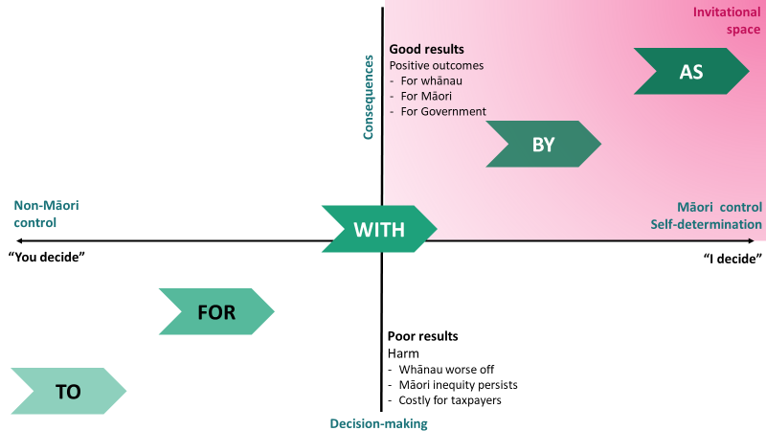

Figure 1: Shifting the locus of power model (9)
One way of comparing ‘by Māori, as Māori’ with other approaches is the “shifting the locus of power model” (9) (see Figure 1, page 12). This model considers power along a decision-making and consequences continuum. Implicit in the model is the assumption that more control and autonomy by Māori leads to better outcomes. The current health system often works in a “done to” or “done for” space. In these contexts, Māori have no or little power, and the results are harmful and ineffective for Māori. In the “done with” and “done by” spaces, Māori and non-Māori share power and decision-making. However, in these contexts it often requires Māori to educate, explain and justify their decisions and actions. In a “done as” space, Māori have full control over decision-making, and the legitimacy and validity of their decisions and actions is taken for granted. This “invitational space” in the model assumes no automatic or guaranteed place for non-Māori; instead, non-Māori participation is by invitation only.
The transition to a new health system provides the opportunity to first shift the locus of power and decision-making to the MHA and, secondly, hand over decision-making and resources to Māori providers.

Hold the health system accountable for Māori health equity through clear targets, public monitoring and evaluation
If equity is the goal, organisations, leaders, and their people need to be held accountable for progressing towards achieving it. In two years of evaluating MIVP and MIMVP, the evaluators have observed no consequences for poor performance. The Ministry offered support to particular regions of concern, but those regions did not take it up. In the following year, similar poor performance, while questioned, incurred no consequences. Failure to learn or to share what works in the context, to adapt and innovate, and to hold organisations accountable is why poor performance – and inequity – persists.
Visible public targets, regular monitoring, performance reviews and evaluation are ways to achieve equitable performance. The value of targets can be seen in the COVID-19 vaccination programme. When the Ministry sets clear targets and monitors progress publicly, organisations, leaders, workforce, and partners are visibly held accountable for their performance.
COVID-19 vaccination targets have also signalled that extra effort is needed to achieve Māori vaccination targets and that achieving Māori health equity is the responsibility of all. Non-Māori organisations in the health system need to shoulder their responsibilities and their Tiriti obligations to deliver services equitably to Māori. Currently, Māori providers carry a disproportionate load in delivering services to Māori. A true equity approach means non-Māori organisations adapt their services to ensure they complement the work of Māori providers to meet the needs of Māori.
There is a need to set firm equity targets, resource appropriately, hold the system accountable through public monitoring and evaluation, and ensure suitable data capture systems track performance. There need to be consequences for ongoing poor performance.

Māori leadership is critical for Māori health equity
Successful Māori initiatives are often criticised and over-scrutinised (10), but the failure of mainstream services to do the job they are funded for – including to engage successfully with Māori – is rarely appraised or questioned.
Māori leadership is critical in this space. This function is primarily carried out within the Ministry by the Māori Health Directorate (MHD). An important step is funding a larger MHD to provide leadership across the Ministry. However, there needs to be resourcing across the Ministry to ensure equity occurs, including expanding the equity advisory function across the Ministry.

1 Context
Like many countries worldwide, COVID-19, and its variants including Delta and Omicron continue to impact our liberty and livelihoods, health systems and economy in Aotearoa New Zealand. In many countries the measures being used to control the spread of COVID-19 include temporary restrictions on movement and socialising, hygiene practices and vaccination. Governments worldwide measure their success in dealing with COVID-19 by the absence of COVID-19 in the community, hospitalisation numbers – including the numbers in intensive care units, death rates from COVID-19 and COVID-19 population vaccination rates.
As we write this report, Aotearoa New Zealand is now dealing with transmission of Omicron in the community, and experts advise that cases are likely to rise from hundreds to thousands of cases per day in the coming weeks. New Zealand has benefitted from a strong COVID-19 vaccination campaign, with a fully vaccinated target of 90% of the population over 12 years. As of 7 February 2022, 93% of New Zealanders over 12 years are fully vaccinated, and Māori vaccination rates are increasing, with 86% of Māori now fully vaccinated. To further protect New Zealanders from the worse effects of COVID-19 and stop the overrun of the New Zealand health system, the Ministry now recommends a third “booster” vaccination, and vaccinations for 5 to 11-year-olds are underway.
The Government has been strongly criticised by the Waitangi Tribunal and by Māori health experts for prioritising a generalist, non-equity focused approach to the COVID-19 vaccine rollout. This is considered to be for political expediency reasons. It occurred despite advice from the Director-General of Health Dr Ashley Bloomfield and Ministry officials to adopt an age adjustment for Māori in the vaccine roll-out, due to the Māori population’s greater risk of infection and health inequities. In addition, past pandemics (the Spanish Flu, the H1N1 virus) have disproportionately impacted Māori, and there was a fear expressed that death rates from COVID-19 would devastate Māori and Māori communities.
Things are beginning to change. Significant new funding has been made available to Māori health providers to support their communities’ response to COVID-19. Māori providers and communities were enabled to accelerate whānau-centred services. In addition, there is now greater visibility and accountability for reporting and tracking of Māori COVID-19 vaccination rates.

COVID-19 has put a spotlight on inequity, particularly Māori health inequity
Prime Minister Jacinda Ardern, (11) in her 2022 Waitangi Day address, reiterated the Government’s commitment to equity.
“As a Government we know we have a responsibility to protect the most vulnerable, and we know in many cases that can be our Māori communities. …
We want all New Zealanders to live longer and healthier lives, and that is why we are working hard to reform the health sector. And we have an obligation to make sure everyone has access to the healthcare they need, and that you don’t die younger than everyone else in New Zealand because you are Māori.
And yet that is not the case. Here we have such an obvious example of where we must do better, and where we are not passing the test of our partnership together.
Māori die at twice the rate as non-Māori from cardiovascular disease. Māori tamariki have a mortality rate one-and-a-half times the rate found in non-Māori children. Māori are more likely to be diagnosed and die from cancer. And Māori die on average 7 years earlier than non-Māori.
That is the problem that we have to address. And if we are to make progress as a nation, we have to be willing to question practices that have resulted over and over in the same or even worse outcomes.”

Over-representation of Māori occurs for almost every type of illness and every known determinant that leads to poor health. “Māori health is characterised by systemic inequities in health outcomes, differential exposure to the determinants of health, inequitable access to health and social systems, disproportionate marginalisation and inadequate representation in the health workforce” (12). As a result, Māori experience inequitable rates of many chronic conditions and co-morbidities and are at an increased risk of COVID-19 infection and mortality.
Health equity has been defined as the principle underlying a commitment to reduce and eliminate disparities in health and its determinants.
“In Aotearoa New Zealand, people have differences in health that are not only avoidable but unfair and unjust. Equity recognises [that] different people with different levels of advantage require different approaches and resources to get equitable health outcomes” (4).

Doing more of the same is rarely effective for social groups whose needs are not met. Instead, different social groups need targeted interventions, policies and programmes designed to meet their specific needs (13). This representation of equity was the premise of MIVP.

MIVP (2020) and MIMVP (2021)
In 2020, in the early stages of the COVID-19 pandemic, there was concern about the potential health impacts of Māori getting influenza (the flu). Therefore, as part of its COVID-19 Māori health response, the Ministry initiated a new approach to flu immunisations, MIVP.
Māori have lower rates of flu immunisation than Pacific Peoples and non-Māori non-Pacific populations. The aim of MIVP, led by the Māori Health Directorate (MHD), was to reduce the equity gap between Māori and non-Māori influenza vaccination rates. MIVP supported Māori service providers and District Health Boards (DHBs) to improve equity for Māori by increasing access to flu vaccinations. In addition, the Ministry commissioned an evaluation to assess its effectiveness and generate insights about what works to support the vaccinations of Māori.
Building off the findings of what works, as outlined in the 2020 evaluation report, the Ministry implemented MIVP for a second year. The 2021 programme included a focus on both influenza and measles, and became known as the MIMVP.

COVID-19 has been the biggest disruptor to flu and measles vaccinations
In 2021, the spread of COVID-19 presented a real risk to the health and wellbeing of all New Zealanders, particularly to our senior citizens (over 65 years) and those with underlying health conditions. Research showed being fully vaccinated presents the best protection. Providers and DHBs prioritised and shifted resources to COVID-19 testing and vaccinations. While this may not have been the plan, it is what eventuated. This focus on COVID-19 had an impact on MIMVP.
Amongst unimmunised populations, COVID-19 presents a crisis, and therefore it has priority over other vaccination programmes within Aotearoa New Zealand (as it does worldwide). However, while COVID-19 is one of the vaccination priorities, the Ministry of Health nevertheless funded and planned for providers to continue to deliver other vaccination programmes such as flu and MMR to improve equity for Māori. Longer-term, while the scale of the health and economic impacts from the flu are less than for COVID-19, the flu still results in around 500 deaths per year in this country, many of which are preventable. (14)
Measles, mumps and rubella can devastate unvaccinated communities, as seen during the measles epidemic in 2019. Currently, immunisation rates in Aotearoa New Zealand, are below the 95% level required for herd immunity. There is also evidence that regular childhood immunisations are falling behind. Sinclair and Grant (15) observe, “The current age six-months immunisation percentage for Māori is a dire 54%” (p.92). Again, there may be significant, preventable impacts if children miss these immunisations.
If we keep focusing on COVID-19 at the expense of the flu, MMR and other childhood immunisations, there is a risk of longer-term effects for whānau and the health system. An outbreak of any of these illnesses is preventable. Yet, longer-term lower immunisation rates set Māori up for being more severely affected by these illnesses in future, resulting in deaths and further entrenching Māori health inequity.

Enabling a shift towards integrated immunisations
The Ministry is in the early stages of its response to this predicament. In late 2021, the Ministry combined its COVID-19 and immunisation teams into one unit – The National Immunisation Programme, and the plan for 2022 is an integrated approach to immunisations. The MIMVP funding both flu and MMR vaccinations and seeking learnings for childhood immunisations was one step towards a more integrated approach to immunisations.
The World Health Organisation (WHO) suggests the purpose of integrated health services is to manage and deliver services so that people receive a continuum of care and treatment, coordinated across the different level and sites of care within and beyond the health sector and according to their needs throughout the course of the life. (16) The Global Vaccine Action Plan (GVAP) 2011–2020 emphasises strong immunisation systems, as part of broader health systems and closely coordinated with other primary health care delivery programmes as essential for achieving immunisation goals. (17)
Deciding on how to structure the integration of health services to achieve optimal service delivery efficiency, alongside optimal service quality, is reported as a critical decision for countries and their health organisations. (16)
It is not yet clear how the National Immunisation Programme will work. Currently, each immunisation programme has its own: systems and processes, separate contracts, different funding rates per vaccination, data entry requirements and reporting conditions.
For Māori providers integration would ideally combine and streamline systems and processes across all immunisations. This would include:
- A single contract combining all of the vaccinations that a provider will deliver and funding
- An integrated payment system – as currently providers need to claim separately for reimbursement of vaccine costs for each vaccine
- A single reporting system – each immunisation programme has its own reporting requirements
There are currently different levels of funding for different vaccinations, and some immunisation contracts provide for after-hours or weekend delivery. For example, COVID-19 funding per vaccination is higher than for flu and MMR. Further, COVID-19 supported the use of incentives to reduce barriers and encourage vaccinations. Continuing the use of incentives for other known vaccination barriers such as the cost of birth certificates for childhood immunisations warrants consideration.
Integrated immunisations are, at their core, an example of a whānau-centred approach. As much as possible, Māori providers already aim to administer multiple immunisations. A whānau-centred approach means Māori providers will support whānau, irrespective of age or the ability to pay. It will be important for Māori providers to have clinical research and operational policy to support whānau-centred delivery, and assistance to build vaccination capacity across the suite of vaccines.
Going forward, it will be important to track how an integrated National Immunisation Programme meets the need of Māori providers, delivers greater efficiencies and ultimately results in improved vaccination rates and equity for Māori.

2 MIMVP results
This section summarises the flu vaccination results achieved in 2021, including trends across the country. Vaccination results between regions were tracked on three indicators:
- The vaccination rate, that is, the percentage of Māori 65+ vaccinated as a proportion of the estimated Māori 65+ population
- The equity gap, that is, the difference between the vaccination rate of Māori 65+ and non-Māori non-Pacific 65+
- The number of vaccinated people, that is, the cumulative sum of actual Māori 65+ vaccinated.

Key findings
- The percentage of Māori 65+ who received a flu vaccination in 2021 was less than 2020 but remains a notable improvement on 2019 and previous years.
- Fewer non-Māori non-Pacific people 65+ received a flu vaccination in 2021 than in 2020, indicating the lower uptake of flu vaccinations in 2020 indicating Māori were not alone in this.
- The equity gap (the gap between Māori and non-Māori non-Pacific vaccination rates) persists and is worse in 2021 than in 2020.
- Auckland Metro regions continue to perform poorly in comparison to other areas. Given the proportion of Māori who live in these regions, it is crucial to improve vaccination rates there in order to achieve equity nationally.
Actions
- Set clear targets that provide a motivational goal that everyone can work towards.
- Resource providers as part of a contracting environment that enables responsiveness and innovation
- Track progress publicly to increase accountability.

Flu vaccination rates for Māori 65+ are lower in 2021 than 2020, and the equity gap worsened.
MIMVP achieved lower vaccination rates in 2021 than in 2020. As of 10 September, 49.8 percent of the Māori population aged 65+ were vaccinated, compared with 58.9 percent at a similar time the previous year. However, the 2021 Māori immunisation rates were higher than for 2019 (43.6 percent) and previous years.
The vaccination trajectory reached a plateau slightly later than in previous years. Due to the DHBs and the Ministry prioritising COVID-19 vaccinations, in 2021 providers either delayed or extended their flu vaccination activity.

Flu vaccination rates were lower in 2021 than 2020 for both Māori and non-Māori non-Pacific
The increase in flu vaccinations by Māori 65+ in 2020 did not continue in 2021. However, the 2021 rates were still a notable increase on 2019 and previous years. Further, Māori were not alone in a lower uptake of flu vaccinations in 2021. The flu vaccination rate for non-Māori non-Pacific 65+ was lower in 2021 than in 2020. For both Māori and non-Māori non-Pacific groups, the increase between 2019 and 2021 (not including 2020) shows a marked increase on the years preceding 2019.
The evaluators note that MIVP 2020 occurred during the beginning of the COVID-19 pandemic when there was little the general public could do to mitigate risks and address concerns about COVID-19. In 2021, the flu vaccination season occurred at a similar time to the roll-out of the COVID-19 vaccination. In the context of COVID-19 vaccination, the public become increasingly anxious and hesitant about vaccinations and sometimes refused vaccinations.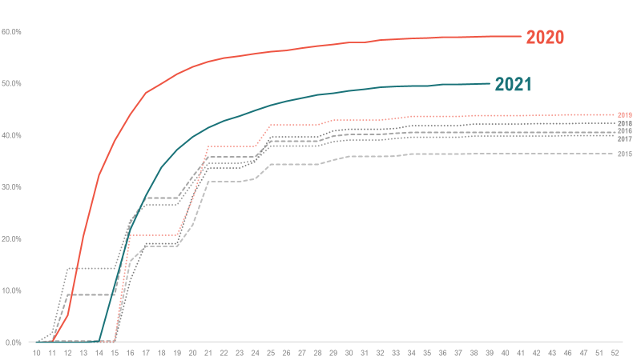

Figure 2: Flu immunisation rates for Māori 65+ in 2015-2021, as a percentage of Māori 65+ population

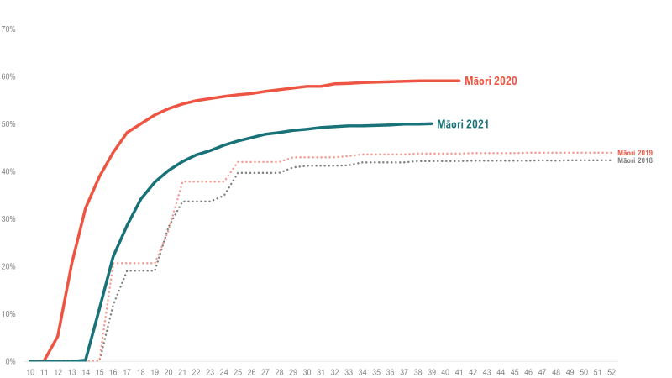

Figure 3 Flu immunisations rates for Māori 65+ in 2018-2021, as a percentage of Māori 65+ population
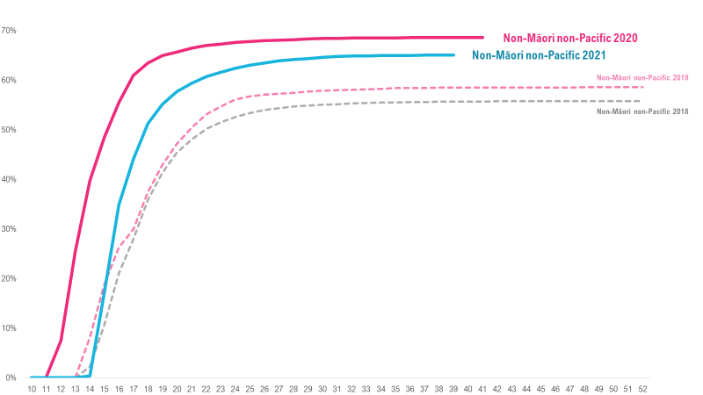

Figure 4: Flu immunisations rates for Non-Māori non-Pacific 65+ in 2018-2021, as a percentage of Non-Māori non-Pacific 65+ population

The overall equity gap for flu vaccination rates for Māori is worse in 2021 than 2020
In 2021, cumulatively fewer Māori 65+ were vaccinated for the flu than in 2020, while other ethnic groups retained or improved their flu vaccination levels. Therefore, a greater equity gap occurred for Māori – particularly at the start of the flu vaccination season around Week 20 (21 May).
In 2021 the equity gap for Māori 65+ flu immunisations was higher than for the past three years. In Week 20, the equity gap was minus17.4 percent – the greatest at any time since 2018. While the gap between flu immunisation rates of Māori 65+ and non-Māori, non-Pacific 65+ in 2021 reduced somewhat by 10 September 2021, (to minus 15.1 percent), the gap was still worse than either 2020 or 2018.
The 2021 equity gap was on par with the equity gap at the end of 2019 (minus 15.1 percent) despite a larger proportion of the Māori 65+ population receiving a flu vaccination in 2021. This may seem counterintuitive as more Māori got flu vaccinations in 2021 than in any other year except 2020. The equity gap has grown because improvements in vaccination rates for Māori have not kept pace with the rest of the population. There remains a need for a focused approach to reducing the equity gap.
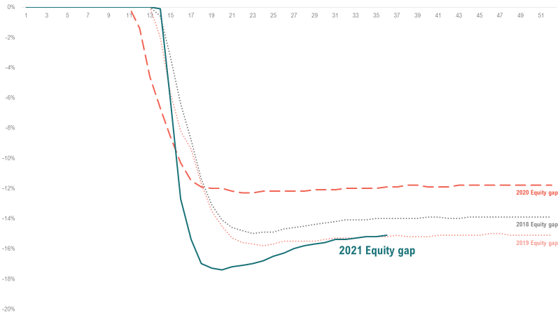

Figure 5: Equity gap of flu immunisation rates for Māori 65+ vs non-Māori non-Pacific 65+, 2018-2021

Regional disparity persists
Whanganui remained a high performer in 2021, building on 2020, with the highest proportion of the estimated Māori 65+ population (64.5 percent) vaccinated for flu, and one of the lowest equity gaps across the country (minus 6.5 percentage points).
Waikato and Northland achieved high numbers of vaccinated Māori (3408 and 3285 respectively), which is important given their higher numbers of Māori overall. For Northland, although they achieved a modest vaccination rate as a percentage of the Māori 65+ population (50.3 percent), the vaccination of a high number of Māori resulted in the second-lowest equity gap (minus 6.3 pts).
The evaluators note that there are limitations to comparing regions with each other without a flu vaccination target. In contrast to COVID-19 vaccinations, there is no mandated target for flu vaccinations. However, one DHB used a target of 75 percent to assess the performance of their contracted providers.
There is a clear need to set national flu vaccination targets. The COVID-19 vaccination campaign has demonstrated that national vaccination targets are achievable and valuable. Using national targets demonstrated that additional effort is needed to achieve Māori vaccination targets. Māori providers were at the forefront in terms of attaining Māori COVID-19 vaccination rates.
Observations of the COVID-19 vaccination response indicated that organisations are more visibly held accountable for their performance in cases where targets are clearly set and progress is publicly monitored and assessed. However, there is a risk that targets can fail to recognise the different implementation contexts and stifle innovation. When this occurs, service providers can feel demoralised and unsupported. For targets to act as motivational and aspirational, they need to be accompanied by sufficient resourcing and a permissive environment that empowers providers to be responsive to the needs of their community.

Regions with higher proportion of Māori 65+ population
Regions with a higher proportion of Māori 65+ and the Auckland Metro area had middling to low overall flu vaccination rates, compared with the higher-performing regions (Whanganui) and lower performing regions (Waitematā). As in 2020, if we want to make a difference to equity, there needs to be a targeted effort to improve vaccination rates in regions with higher numbers of Māori 65+.
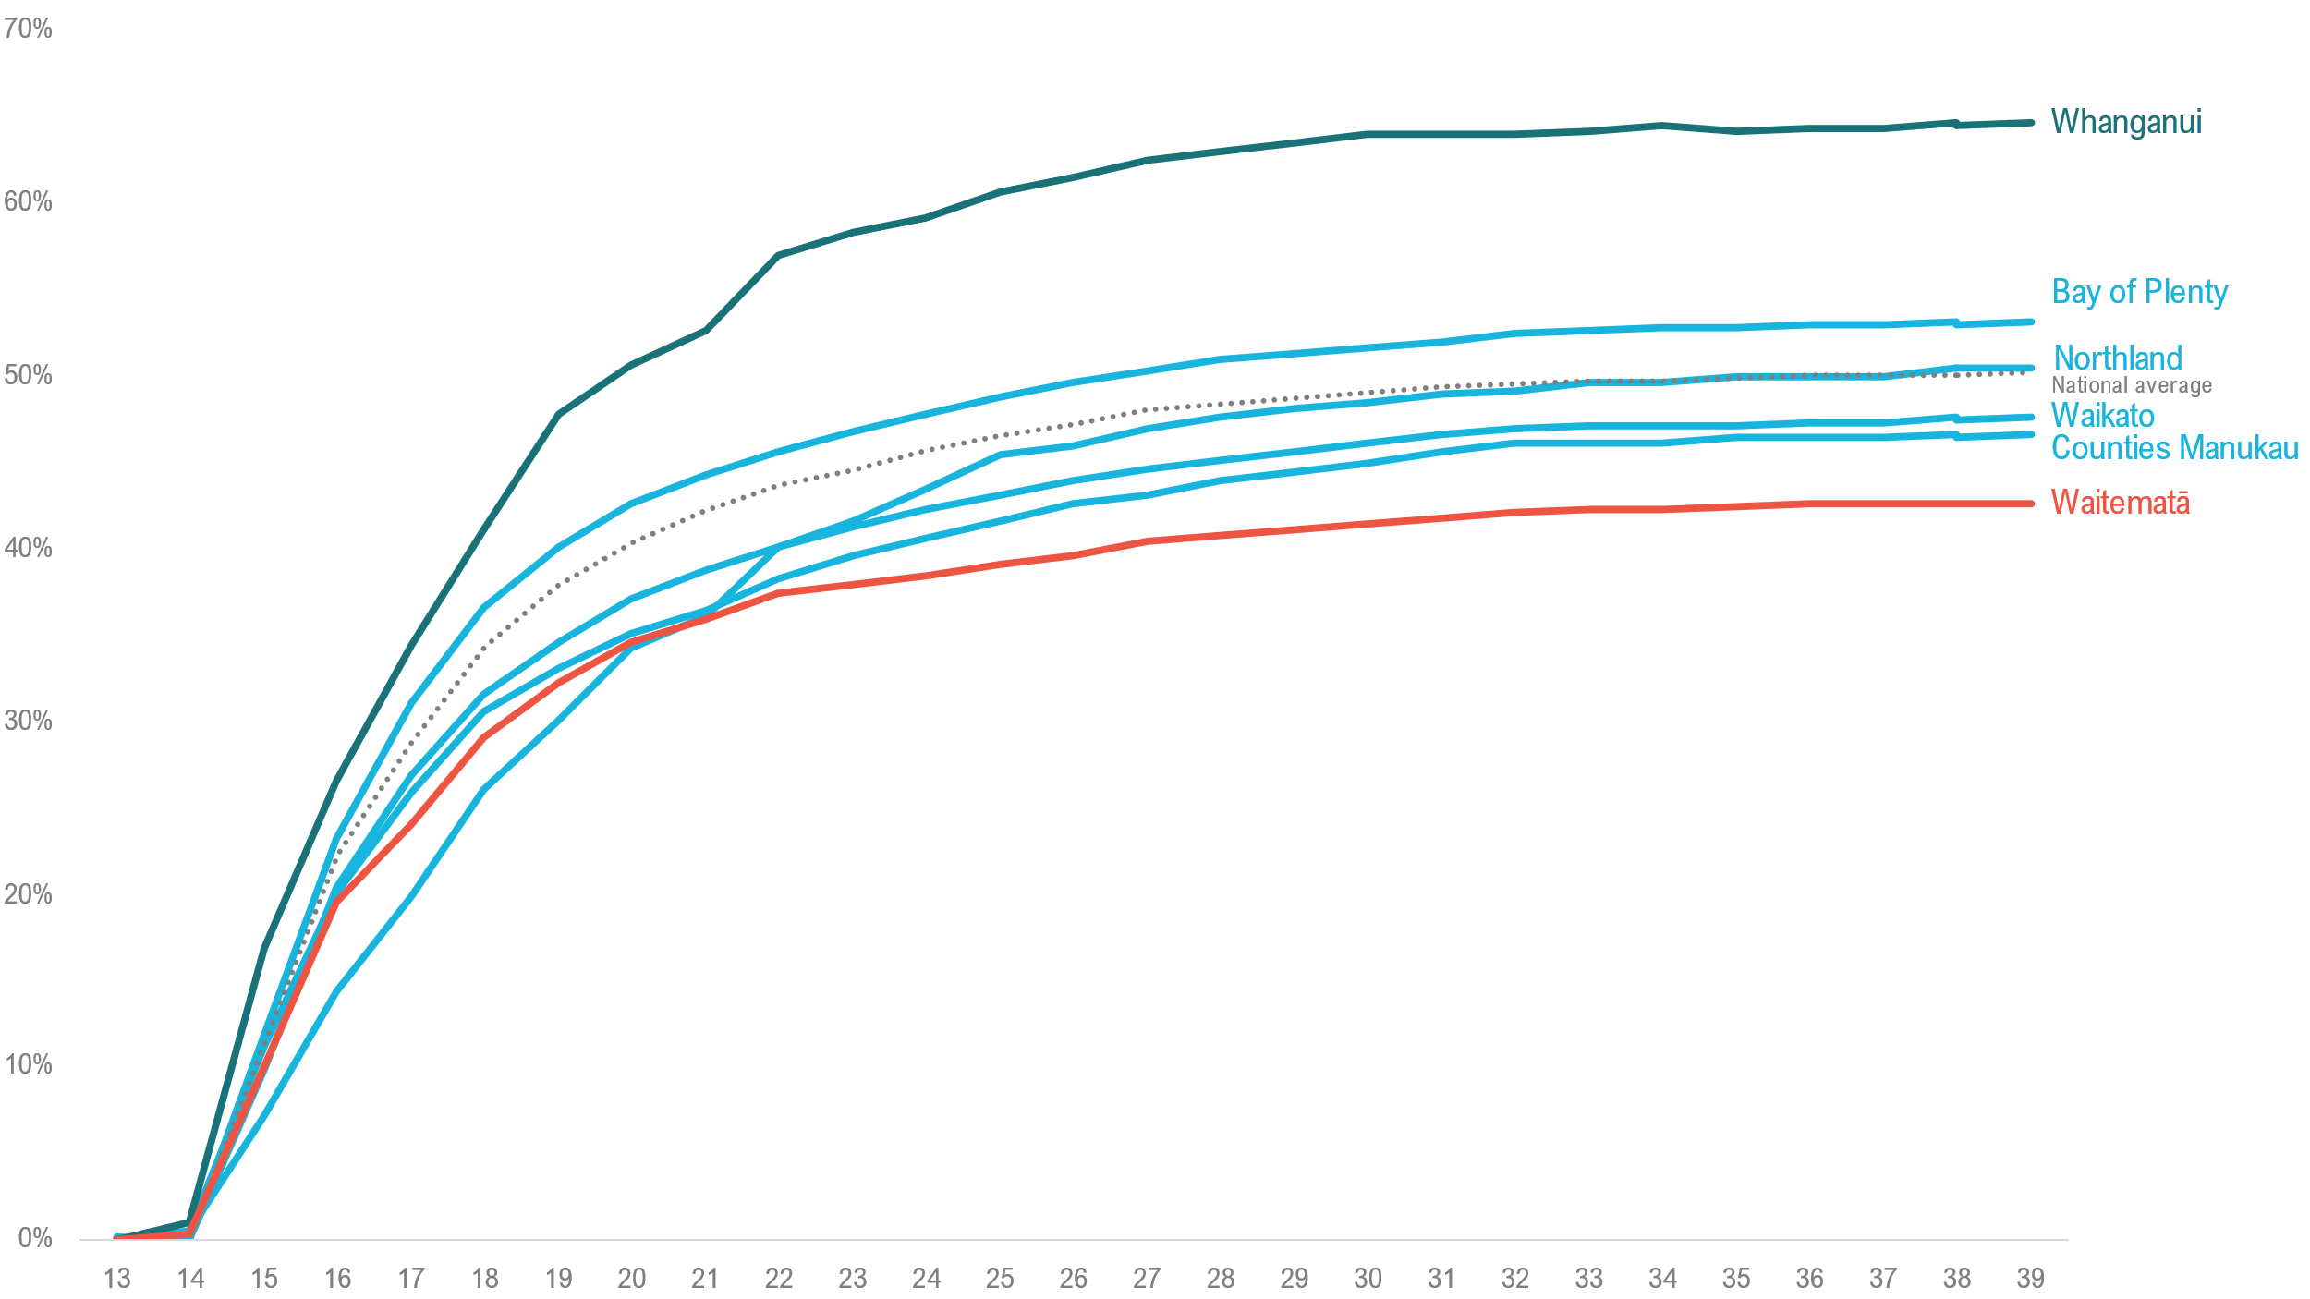

Figure 6: Flu immunisation rates for Māori 65+ in 2021, comparing Whanganui (highest), Waitematā (lowest) and four regions with highest estimated population of Māori 65+

Auckland Metro regions continue to perform poorly
A high proportion of the Māori population live in the Auckland Metro DHB regions (Auckland, Counties Manukau and Waitematā), including 22 percent of Māori aged over 65 years. To positively impact equity for Māori nationally, it is crucial to make a difference to immunisation rates in these regions. Despite significant funding for Auckland Metro DHBs, inequity for Māori persists.
The results in 2021 reflect a persistent and ongoing trend. For the sixth year running, Auckland Metro DHBs have struggled to deliver well on getting vaccinations to Māori (see Table 1, page 63). As in 2020, the Auckland Metro DHBs got some of the lowest vaccination rates in the country.
As in 2020, the Auckland Metro DHBs received the largest amount of contract funding. They were late in contracting providers and getting funding out, and they struggled to secure provider services. Impending changes to the New Zealand health system will exacerbate the challenges for the Auckland Metro DHBs.
As of 1 October 2021, vaccination data showed:
- Counties Manukau performed moderately well in terms of equity, with an equity gap of minus12.9 pts (ranking ninth in the country). However, despite having the fourth-largest number of Māori 65+ vaccinated (2501), they have the fourth-lowest percentage of Māori 65+ vaccinated (46.5 percent)
- Auckland and Waitematā are among the poorest performers nationally for equity gap and the percentage of Māori 65+ population vaccinated. Auckland has the greatest equity gap (minus 23.1 pts) and second-lowest percentage of Māori 65+ vaccinated (42.6 percent). Waitematā has the lowest percentage of Māori 65+ vaccinated (42.5 percent) with the fourth-lowest equity gap (minus 18.7 pts).
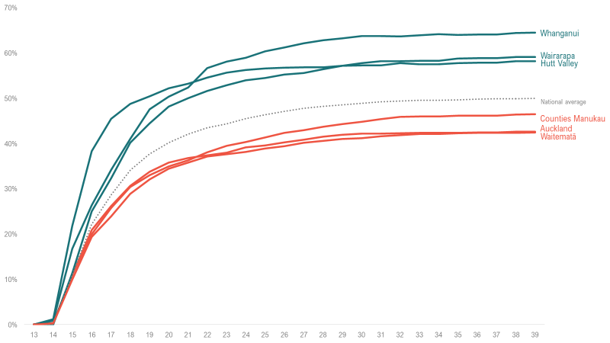

Figure 7: Flu immunisation rates for Māori 65+ in 2021, comparing Whanganui, Wairarapa, and Hutt Valley (three highest), and three Auckland Metro regions (Counties-Manukau, Auckland, and Waitematā)

At the same time, in 2021, Auckland Metro shouldered a significant burden of New Zealand’s COVID-19 testing and vaccinations, with two Alert Level 4 lockdowns and notably the 17 August Delta variant outbreak.
In contrast to flu vaccination results, the evaluators note the performance of Auckland Metro DHBs in achieving COVID-19 vaccination targets for Māori. Māori providers played a critical role in connecting with, educating and vaccinating Māori.
“It was Māori and Pacific whānau who stood up and did the mahi, kanohi ki te kanohi, showing us what it takes to reach out and engage. It was incredible... We have seen what happens when the funding is put with the right people. Bring on the Māori Health Authority/Te Mana Hauora Māori and let’s start to get some equity.” (Dr Lucy O’Hagan) (18)

These findings signal that the Auckland Metro region should be able to achieve improved flu and MMR vaccination rates. Māori vaccination equity must be at the forefront of programme design, with a permissive environment allowing providers to be innovative and responsive to local needs.

The immunisation landscape was already complicated; COVID-19 disrupted it further

The flu vaccination rollout was more complicated in 2021 than in 2020
In 2021, several factors complicated the MIMVP rollout, including:
- two new flu vaccines approved for different age groups, compared to two in 2020
- flu vaccines and the COVID-19 vaccine used age as a critical criterion for eligibility (see Table 2, page 63)
- the flu immunisation campaign for people over 65 years began earlier than other age groups.
Overall, the age-based eligibility for timing and funding made it difficult for some providers to deliver a whānau-centred approach, for example, where the whole whānau can present and be seen together. Many providers have multiple vaccination contracts. However, often these contracts are each managed in isolation, and not all providers are contracted to deliver all vaccines. As a result, different providers may offer additional vaccinations in the same community. Multiple concurrent vaccination campaigns also confused providers and whānau with competing messaging and conflicting priorities.

The impact of COVID-19
This year, providers and DHBs said the most significant factor impacting on their MIMVP-funded plans was COVID-19. About half of providers contracted for MIMVP also held a contract for COVID-19 testing, education and vaccination.
Many providers noted that for flu, there is an identified window of time when vaccination is more effective and deemed more relevant to whānau. Flu vaccinations this year have competed with and lost out to speculation about, and availability of, COVID-19 vaccinations throughout that time. Providers said the message to them from DHBs and the Ministry, was that COVID-19 was the priority. Also, whānau themselves prioritised getting their COVID-19 vaccine over the flu vaccine. To respond to the need, many providers and DHBs diverted people and resources from flu vaccination to COVID-19 testing and vaccination.
Despite published dates for the age-based rollout for COVID-19 vaccinations, the community was confused and hesitant. Providers said that in some cases, whānau were affected by delays in COVID-19 vaccine availability and communications.
“Even though we are meant to be vaccinating Tier 3 for COVID-19 we have many over-65s here that have not had their letters to get vaccinated yet for COVID-19. So they are postponing their flu in case they suddenly get their letter.” (Provider)

Providers applied learnings between MIVP, MIMVP and COVID-19
MIMVP providers shared that they utilised the activities and lessons learned in 2020 as part of their MIMVP and COVID-19 approaches in 2021. Two-thirds of providers believed their work in 2020 helped them prepare for 2021. In particular, providers continued with the following communications activities that were effective in 2020: mobile outreach, community champions and using multiple communications channels.
Some providers said COVID-19 activities helped them build and strengthen relationships that they could leverage for other immunisation and health initiatives in the future. Some providers noted that COVID-19 activities allowed them to expand and test their whānau-centred approaches.
“Working with the [local community] on the COVID-19 Vaccination roll-out has worked well. We have worked collaboratively to book people in for vaccinations and developed a Community Awareness Raising plan and Communications Strategy.” (Provider)

3 The role of commissioning in the pursuit of equity
This section discusses the Ministry’s design and commissioning responsibilities. Here we describe four principles of better commissioning to frame the analysis of MIMVP design and results. This section then proposes an adaptation of these principles, to align with the key emergent themes and findings of the MIMVP evaluation.

Principles of better commissioning
Under Te Tiriti o Waitangi, the Ministry – as the kaitiaki of the health and disability system – is responsible for enabling Māori to exercise authority over their health and wellbeing. The Ministry also has to achieve equitable health outcomes for Māori in ways that allow Māori to live, thrive and flourish as Māori (1).
MIMVP has demonstrated, as MIVP did in 2020, the benefits for Māori of targeted programmes and funding that enable providers to deliver services in ways that work better for Māori. However, there remains a gap between the intentions of MIMVP and the anticipated outcomes.
The evaluators note multiple factors that may have contributed to this gap, many outside the Ministry's control and influence and outside the scope of MIMVP evaluation. An important factor within the Ministry’s control is the design and commissioning of MIMVP and how the Ministry commissions programmes to enable or hinder equitable outcomes.
Research by Riboldi et al, 2021 (2) identified a gap between commissioning and implementation and outlines four principles for better commissioning in the public sector:
Principle 1: Put relationships first – is fundamental to successful commissioning (irrespective of funding and timing constraints), building trust and social capital.
Principle 2: Let communities lead – engaging community members in commissioning practice and developing local solutions anchored in community needs and aspiration.
Principle 3: Embed learning – within a flexible environment of continual learning aligned with context-specific and localised solutions.
Principle 4: Invest in people – funding strategic and collaborative activities and aligning with community-orientated, network-led approaches, and strengths-based approaches to service delivery.
Similarly, Oakden et al (3) found a need for effective contracting of public health services that: builds trusted relationships, encourages funders and providers to learn together, and focuses on the needs of the community.

Adapting Riboldi's principles as a framing for analysing MIMVP
Overall, the main difference the Ministry can take to influence Māori health equity positively is to improve commissioning.
Māori providers know what works in their community, and they want to be trusted to do the mahi. Māori providers put relationships with whānau first. They listen to their communities and want to respond to their needs. They want to invest in staff and resources sufficiently to respond to their community. Māori providers also have a culture of continuous learning because they are intrinsically motivated, with a deep passion for helping their community. They would value the opportunity to share their knowledge and learn from others within the broader health system to improve immunisation and more general health outcomes for Māori.
Recent research in Aotearoa New Zealand on strengthening public health contracting also confirms these findings. Came et al (10) observe:
“Māori providers were frustrated by contracting environments. They wanted to be recognised as Te Tiriti o Waitangi partners, with flexibility, certainty of investment (longer contracts) and support (infrastructure investment) to be able to meet the high needs of their communities” (p1).
Riboldi et al’s principles resonated with the emerging findings of MIMVP and the insights gathered from MIVP 2020. The evaluators adapted Riboldi et al’s principles based on the links, patterns and associations observed in the data. The resulting framework provides a series of lenses to analyse and interpret findings. The framework also offers a way to explore when MIMVP commissioning design and implementation is aligned with the principles of better commissioning what the principles look like for MIMVP.

The pou of equitable commissioning
Equitable commissioning results from a focus on both the design of the programme itself – what it funds and how – and the broader context in which the programme runs.
In this diagram, equity is the focus and intentionally prioritised. The pou are represented by the programme-specific elements and the broader context elements. The programme-specific elements that enable and support equity are: whānau-centred approach; contracting and funding; and communications and learning relationships and collaboration. The contextual elements that enable equity and drive commissioning change are: urgency – working at pace to make a difference for equity; sustainability – implement sustainable long-term changes.
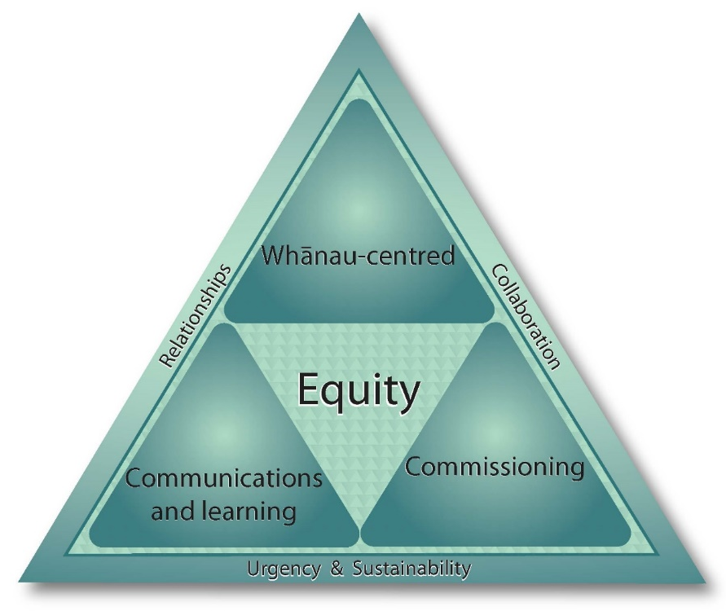

Figure 8: Pou of equitable commissioning diagram
The next three sections explore MIMVP outcomes and future opportunities through the programme-specific lenses: whānau-centred approach; contracting and funding – supports equity when contracts put empowering relationships first and invest in providers; and communications and learning – support equity when providers can take multiple approaches to reach and talk to whānau, and use contracts that support continuous learning.

4 A whānau-centred approach is an essential equity strategy
This section describes a whānau-centred approach, its key elements, and application in MIMVP 2021. It then reflects on the value and impact of whānau-centred approaches and suggests ways to better respond in the future. The implications and actions for a whānau-centred approach in MIMVP are then discussed.

Key findings
- Whānau access to services is critical.
- A whānau-centred approach is an essential equity strategy and improves Māori access to vaccination services and contributes to improved health equity.
- Māori providers are pivotal to the design and delivery of whānau-centred services.
- Māori providers deliver a holistic, wrap-around, culturally anchored service. Such a service is underpinned by whakapapa, whanaungatanga, manaakitanga and rangatiratanga.
- Māori providers do more than just vaccinate; they respond to whānau needs. This may include providing food parcels, hygiene packs, and other support and healthcare services.
- Māori providers collaborate with a range of partners to deliver whānau-centred services.
- Whānau access to services is critical. Māori providers take services to whānau, bring whānau to the service, and reduce barriers to access.
Actions
- Prioritise a whānau-centred approach to accelerate equity for Māori.
- Contract and resource providers for the full scope of whānau-centred approaches.
- Embed a whānau-centred approach across the new integrated immunisation programme
- Change health policy to enable providers to take a whānau-centred approach.

What is a whānau-centred approach?
The key attributes of a whānau-centred approach from the perspective of providers and DHBs are outlined below.
Through a Te Ao Māori (Māori world view) and ngā matapono (values), providers connect with whānau and their community. Initial engagement is relational: connections are made through whakapapa and whanaungatanga. Providers engage as whānau first and then as kaimahi.
The principle of manaakitanga means providers take a holistic view of wellbeing, respond to broad whānau needs, and focus on vaccinations and healthcare. Whānau-centred service is whānau-led – supporting whānau to determine what they will do about vaccinations and what they do next, giving expression to rangatiratanga. For Māori providers, this means there are no fixed pathways or ways of working, and at times they need to think outside the box to respond to whānau needs and aspirations.
This was the approach that Māori providers employed successfully in 2020 as part of the MIVP (8) and again in 2021.

A whānau-centred approach
- It takes a whole-of-whānau approach, working in a dynamic and flexible way with individuals, immediate whānau and broader collectives. Examples include working with marae, kura, kōhanga reo, iwi and Māori clubs and organisations, or the koro and nanny. Importantly, whānau define the whānau unit, which becomes the focus of engagement.
- It acknowledges health equity issues for Māori and is anchored by a deep understanding of the concept of whānau – based on whakapapa, collectivism and inherent roles and responsibilities.
- It draws on the cultural capital (understanding, knowledge and intuition) that comes from being Māori and relational capital (whanaungatanga, whakapapa and tikanga) that guides ways of engaging with whānau.
- It provides holistic services that respond to whānau needs and aspirations, not only the condition they present with at the time. This includes looking after physical, emotional, spiritual health and welfare needs. It also includes providing support and services to other whānau members at the same time as delivering a single targeted service (such as a vaccination) to one member of a whānau, irrespective of the original engagement purpose. For example, within MIMVP 2021 (and in the COVID-19 pandemic context), there was considerable need for food in addition to vaccinating and testing.
- It reaches out to where whānau are, making it as easy as possible for whānau to be vaccinated, by taking services to whānau or transporting whānau to the services.
“It has been so important being able to take services out to whānau, removing access problems. While also being able to build relationships with whānau who haven't always had the chance to access health services.” (DHB)

“Having a broad conversation with whānau on what matters to them and their health care, providing support on their priorities, respecting their decisions without judgement.” (Provider)

“We offer vaccination to the whole whānau – Covid-19 Vaccinations were a good example of this – rather than just offering the vaccination to the MOH-approved age group, we took the opportunity to offer the vaccination to the whole whānau so they were all able to be vaccinated at the same time.” (Provider)

“We make a real effort to deliver our services at a whānau, hapū and iwi level by taking our services to the people and we prioritise whānau needs, in terms of how we deliver the vaccinations.” (Provider)

What does a whānau-centred approach look like in practice?
The following example, constructed from a range of providers and provider feedback, illustrates what a whānau-centred approach might look like in practice.
Whānau-centred practice in action  Not distracted by several unanswered phone calls, Nurse Janice grabs the resources she will need and drives two hours to visit whānau, who she knows are isolated from accessing healthcare because of distance from any services and past negative experiences. Although cold-calling can be challenging, with the ability to connect with whānau through te reo and whakawhanaungatanga, she feels confident. Knocking on the door, she is greeted with suspicion and reservation. However, Nurse Janice knows that whānau want the best for their pakeke and mokopuna. She presents the kai she has bought with her – hot chicken, coleslaw and buns – enough for a good, shared lunch. Nurse Janice at this point is quite ready to hand over the kai and leave some printed material. However, as hoped, she is invited into the whare. The relationship has begun. She joins the whānau in the kitchen, helping get the kai ready. No clinical information has been shared, instead, they are learning about each other, “Ko wai au?”  After lunch, Koro says, “Well you better tell us what you’re here for then.” With that opening, she shares information about COVID-19 and flu vaccines. Nurse Janice uses language like “protecting whakapapa”, “looking after mokopuna.” She explains she can administer the flu vaccine today if they feel comfortable with that. Whānau are not forced to comply; they are free to choose what best suits them and their whānau. Without saying a word, Koro picks up the phone. Speaking in te reo, he appears to be inviting more whānau to the whare. He then rolls up his sleeve and says, “Let’s get on with it then.” Within 30 minutes, Nurse Janice has met at least 10 other whānau or community members and shared the information on vaccines. She has also taken the time to do some wellbeing assessments for two young mums who have turned up with their tamariki. Together they have decided that Nurse Janice will visit the following week, and she will bring her Whānau Ora work colleague with her so whānau can learn about additional supports and resources available.  The following week Nurse Janice and her colleague return. The kawa and tikanga of the whare is respected, and once again the visit starts with mihi, karakia and kai, followed with vaccinations. A long-term relationship establishes with the community, and over time whānau learn to trust her and her colleagues as health providers. Most importantly, for Nurse Janice, whānau becomes active participants in their wellbeing, pushing her to deliver the best whānau-centred practice she can. | Reaches out to where whānau are  Anchored by a deep understanding of the concept of whānau  Draws on cultural knowledge  A whole-of-whānau approach  Provides holistic services that respond to needs and aspirations

Impacts and value of whānau-centred approaches in 2021
Throughout MIMVP delivery both DHB and direct-funded providers applied whānau-centred approaches to vaccinate whānau. In practice, they were holistic and responsive. Providers focused their practice through a whānau-centred lens, zooming in on whānau needs and then panning out to encompass the community context, provider relationships and support.
“Having Iwi Māori lead in the decisions of locations and time. Providing space and time to inform the approach, being in locations that they are to provide that feedback and taking a whānau-inclusive approach.” (Provider)

When needed, providers take services out to where whānau are
Whānau access to services is critical. Māori providers take services to whānau or bring whānau to the service, and reduce any other barriers to access.
In the final monitoring report survey, most providers (74 percent) felt that their MIMVP-funded approach was centred on whānau with an overarching goal to serve the Māori community better. In 2021, as in 2020, providers understood the need to connect with whānau in the places they frequent, including work, home, community settings and at doctors’ surgeries.
Providers felt that MIMVP accelerated and spread the delivery of kaupapa Māori and whānau-centred services across DHB and direct-funded providers.
“We were able to get services out to whānau who typically either could not or would not engage with primary care services. We’re finally being able to take services out to our most vulnerable, with a true kaupapa Māori approach.” (DHB)

Providers utilised a diversity of approaches and activities when engaging with whānau
Across all MIMVP activities, providers used diverse engagement, delivery and partnering options to engage in their communities and reach whānau in their local environments.
Many providers delivered educational activities and raised awareness of flu and MMR vaccinations. Travelling to provide vaccinations in the community, transporting kaumatua and whānau to a clinic, and making home visits were the next most frequently mentioned activities, cited by around half of the providers. A third of all providers also described setting up temporary pop-up clinics such as in a supermarket carpark. Nearly all direct-funded providers mentioned setting up temporary pop-up clinics in a Māori-connected site, such as a marae. Many also partnered with other organisations delivering vaccinations on their sites, such as in a pharmacy or workplace.
Most DHB-funded providers and all direct-funded providers delivered flu vaccinations in 2021. Many providers also offered COVID-19 vaccinations and MMR vaccinations. A half or fewer administered childhood immunisations and other vaccinations.
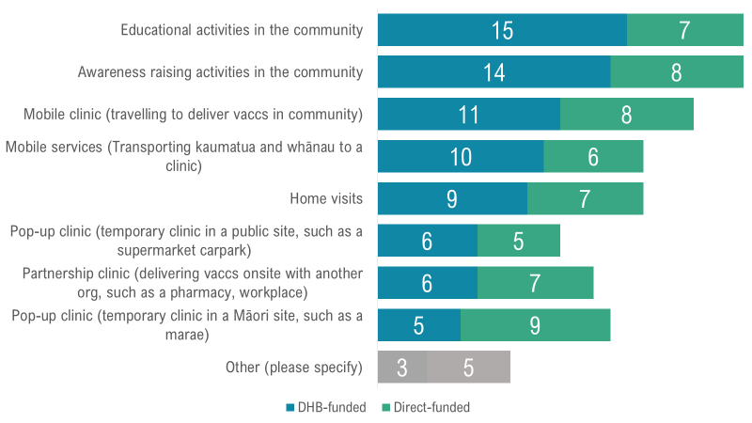

Figure 9: Activities and approaches providers delivered as part of their MIMVP-funded work

Holistic services are responsive to whānau need
In line with Te Whare Tapa Wha (19), the provider whānau-centred approaches recognised that health care is only one aspect of wellbeing.
“Assessing a whānau as a whole [are they] financially ok; just about everyone has a need for food.” (Provider)

Māori providers understood that whānau could not respond to their health needs if they were stressed and overwhelmed with bills, rent and a lack of food. To alleviate these situations, whānau received food parcels, petrol and supermarket vouchers. Providers also gave flu vaccinations to whānau who did not meet the criteria and supported their needs for medication and supplies. In addition, healthcare assessments linked whānau to relevant services.
On average, direct-funded providers offered seven different types of support, while DHB-funded providers offered, on average, five other types of support. The kinds of support provided included:
- hygiene packs and food parcels
- COVID-19 vaccination and testing
- other vaccines such as measles and shingles and catch-up vaccines for babies and young children
- flu vaccination for other whānau, including flu vaccinations for whānau who did not meet the eligibility criteria (some providers asked ineligible whānau to pay for flu vaccinations and others did not)
- other medical assistance and health care assessments
- vouchers for the supermarket or for petrol.

Māori providers know their communities and have or build trusted relationships with whānau
Whānau commented on the importance of a “by Māori, for Māori” approach. Māori providers connected and engaged whānau in a non-judging, affirming way. Similarly to MIVP in 2020, the general sentiment in 2021 was, “Māori providers know their communities best, and are the best-placed to administer vaccinations.”
“Having the services led by Māori providers. Many whānau commented they accessed the services mainly because it was run by Māori for Māori. Things like whakawhanaungatanga and the manaakitanga staff offered was key to this programme.” (DHB)

Māori providers build trusted relationships. Use of community champions – those people well-known and trusted in the community – provided an effective way to reach out in community settings such as schools, marae, and sports clubs.
“We make a real effort to deliver our services at a whānau, hapū and iwi level by taking our services to whānau and the community.” (Provider)

Māori providers collaborate with a broad range of partners
Māori providers incorporated a whole community approach, looking across social and health services to address multiple whānau needs. Working with a diverse range of organisations, providers improved access to whānau.
In the final 2021 survey, DHB and direct-funded providers indicated that local iwi, hapū, and Māori providers were the most helpful. In addition, connecting with local education organisations such as kōhanga reo and kura was beneficial. Again, in line with a whānau-centred approach, building relationships with organisations and places that whānau frequently engage with helped the providers connect with whānau. Collective approaches, including sharing data and information, supported seamless service. On average, Māori providers collaborated with four to five different organisations when connecting and engaging with whānau.
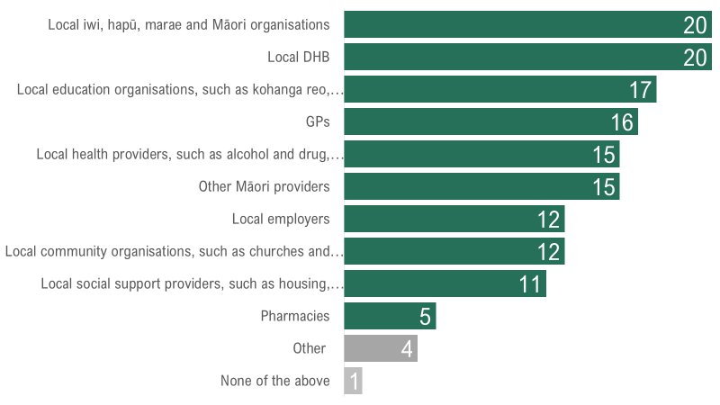

Figure 10: Organisations providers partnered with to deliver MIMVP in 2021
Partnering with other organisations extended Māori providers’ reach to those more vulnerable and not connected to primary healthcare services. New organisations included:
- emergency and transitional housing providers
- providers who work with the homeless
- mental health providers
- drug and alcohol providers.

Missed opportunities for a whānau-centred approach
MIMVP highlighted what is needed to continue to deliver whānau-centred services. Māori providers and Ministry staff commented on the importance of Māori providers leading and designing whānau-centred approaches to recognise their deep connection and understanding of their communities.
Support and resources need to acknowledge and value the efforts of Māori providers and in particular the fusion between clinical and cultural expertise in whānau-centred practice. As one provider commented,
“There needs to be recognition that engaging Māori whānau is different to non-Māori – so let’s price this work accordingly.” (Provider)
Māori vaccinations and Māori health equity are the responsibility of all who work in the health system. There is a need for a whole-system approach to strengthen and sustain whānau-centred primary healthcare across Aotearoa New Zealand. Māori identified the need to have funding, resources and Māori at the decision-making table to demonstrate and lead initiatives for whānau-centred programmes.
Governance and Māori leadership in the health sector is needed to continue to grow whānau-centred approaches that build relational trust with whānau.
“Commitment to more whānau-centred models of care, that allow us to support our Māori clients, whānau in a more holistic manner.” (Provider)
The outstanding efforts of Māori providers in vaccinating Māori for COVID-19 has elevated the value of whānau-centred approaches. MIMVP 2021 provided opportunities for Māori providers to focus and commit to whānau-centred models of care, to reach and support whānau. Applying whānau-centred strategies to the COVID-19 vaccination programme resulted in favourable vaccination rates for all New Zealanders. We know that these were the strategies that providers employed in 2020 and again in 2021.
Across the funded MIMVP services, Māori providers have pursued equity by privileging whānau experience, context and knowledge. Values critical to Māori have underpinned engagement processes, and whānau-centred approaches have continued to utilise tikanga Māori and kaupapa Māori frameworks. Māori providers understand that context matters and where whānau live impacts their access to healthcare. In these situations, holistic assessments and the whole-whānau approach are even more critical.

5 Commissioning, contracting, and funding

Key findings
- MIMVP planning started earlier in 2021 than it had the previous year. However, it was still not early enough for providers to plan for MIMVP and organisational purposes, particularly workforce requirements.
- The Ministry favoured contracting through DHBs, despite Māori providers’ clear preference in 2020 (and in 2021) to be direct-funded by the Ministry.
- The Ministry got funding out to direct-funded providers and DHBs earlier than in 2020, in most cases by late March 2021. But many DHBs were slow to get funding out to providers, some as late as September and October 2021. As a result, many Māori providers started delivering their MIMVP activities before they received funding.
- Simplified reporting was less time-consuming, enabling faster feedback.
- DHBs and DHB-funded providers were less engaged in monitoring reporting.
- Māori providers used the funding to develop their workforce and support increased collaboration with other Māori and non-Māori providers and organisations.
Actions
- Provide advance notice to providers of funding intentions.
- Get funding out to providers earlier – before the scheduled vaccination start dates.
- Change commissioning processes to ensure a provider-led approach is enabled and prioritised.
- Direct-fund providers to deliver MIMVP vaccinations.
- Fund DHBs (or their equivalent) as partners and collaborators.
- Implement long-term multi-year contracts.

Context: MIMVP commissioning intentions
In response to feedback and insights from MIVP 2020, the Ministry aimed to improve commissioning and contracting for MIMVP 2021. Specifically, the Ministry wanted to:
- empower providers to adapt MIMVP to their local context by contracting through a high-trust model
- get funding out earlier by starting the planning and commissioning process earlier and offering a higher first milestone payment
- ensure MIMVP-funded activities occurred in all 20 DHB regions streamlining application for DHBs and Māori providers
- continue to offer two contracting alternatives – contracting with DHBs (to then sub-contract local providers) or contracting directly with Māori providers
- simplify milestone reporting and improve feedback and continuous learning opportunities for the Ministry and providers through short monitoring reports (delivered as surveys)
- achieve more collaboration between i) DHBs and Māori providers, ii) Māori providers, and iii) Māori providers, other health and community services and businesses by encouraging DHBs to act as contract holders.
In total, 51 providers took part in MIMVP. The Ministry contracted with 12 providers directly, (known as “direct-funded providers”) and 10 DHBs covering 13 DHBs. The DHBs contracted with 39 providers, of which 36 were independent Māori health providers, and three were internal provider arms of DHBs.

Timing of contracting and funding was an improvement on 2020, but needs to be improved further

Ministry planning started earlier in 2021, but too late to optimise provider planning
In 2021, the national influenza vaccination programme and MIMVP programme officially started on 14 April. The Ministry completed most contracts in late March 2021 and distributed most of the first round of funding by 20 April. This was earlier than the 2020 funding distribution and demonstrated an improvement in the Ministry’s activities.
However, according to providers, starting the application process in February 2021 was still not early enough. Late MIMVP application and contracting processes impacted many providers ability to carry out MIMVP-funded activities.
Flu and MMR vaccinations are just one part of the suite of hauora services that providers deliver. Providers need to design and implement MIMVP as part of an overall integrated organisational approach with workforce recruitment, retention and training a critical consideration. They would like advance notice of the intention to implement MIMVP as early as possible.

DHBs were generally slower to release funds
DHBs exhibited variable capability to sub-contract local providers and get funding out to providers quickly. While some DHBs got funding out to Māori providers relatively quickly, in other regions DHB-funded providers experienced a challenging commissioning process. Some DHB-funded providers commented that they did not receive their MIMVP funding until September or October. In some cases DHBs contributed to delays because they were slow to identify and contract their providers, and slow to determine what proportion of MIMVP funding to allocate to providers (and how much DHBs would retain for administration and coordination).
Of particular note, the Auckland Metro DHBs did not have a plan for contracting Māori providers to deliver MIMVP until months after the Programme started. Instead, they wanted to reallocate the funding for COVID-19 initiatives. Despite a lack of a confirmed MIMVP plan and findings from the MIVP 2020 evaluation calling for increased scrutiny and accountability on the Auckland Metro DHBs, the Ministry still funded the Auckland Metro DHBs rather than take an alternative course of action and look to fund Māori providers directly.

Many providers started flu and MMR vaccinations before they received funding
The delays in the notice about MIMVP and funding dispersal meant that many providers started giving flu and MMR vaccinations before receiving funding.
In 2021, the Ministry used a higher-trust model, paying out 80 percent of the contracted budget to DHBs and Māori service providers at Milestone One. However, despite the Ministry distributing most of its funding in April 2021, some direct-funded providers and DHBs were slow to invoice the Ministry. As a result, most direct-funded providers received their funding by July 2021, compared with only a third of the DHB-funded providers. Some DHB-funded providers did not receive funds until September or October.
“Providers started vaccinations prior to funding agreement to ensure a start to the programme.” (DHB)
Nevertheless, most providers (especially direct-funded) started giving flu vaccinations by the end of June 2021, and many started giving MMR vaccinations by the end of May 2021. This was later than first planned by the Ministry. Most direct-funded providers started giving flu vaccinations by May, and almost half began work after the contract confirmation but before receiving funding.

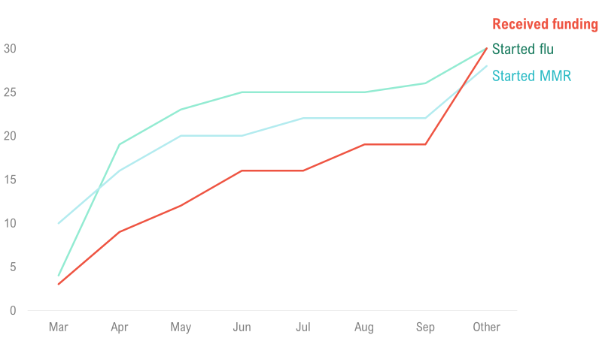

Figure 11: Cumulative number of providers who said they started flu or MMR vaccinations vs when they received funding over time

MIMVP funded activities in every region
MIMVP-funded activities occurred in all DHB regions in 2021, up from 19 regions in 2020. The Ministry invited MIVP contract holders to apply for funding and intentionally sought applications from regions not funded in 2020 (South Canterbury) and to increase regional coverage (Tairāwhiti).

Relationships and collaboration was mixed

Providers have mixed perceptions of the value of contracting through DHBs.
In 2021, as in 2020, the Ministry envisaged that MIMVP would support stronger working relationships between DHBs and Māori providers. This would lead to better local coordination and delivery of services between DHBs and providers. The plan assumed that DHBs had good working relationships with their providers, who in turn had strong relationships with their community, and that DHBs could provide necessary coordination and support to providers. In addition, having DHBs subcontract providers reduced the Ministry’s administration and contracting load and shifted this on to DHBs.
There are mixed views amongst providers of the value of contracting through DHBs.

Positive perceptions
On the one hand, in some regions providers found the coordination and resource support of DHBs helpful. In these regions, the DHBs focused on providing complementary services to support local Māori providers acquiring and managing resources. There were many ways providers indicated receiving practical support from their DHB, in particular supply of vaccines, equipment, and training.
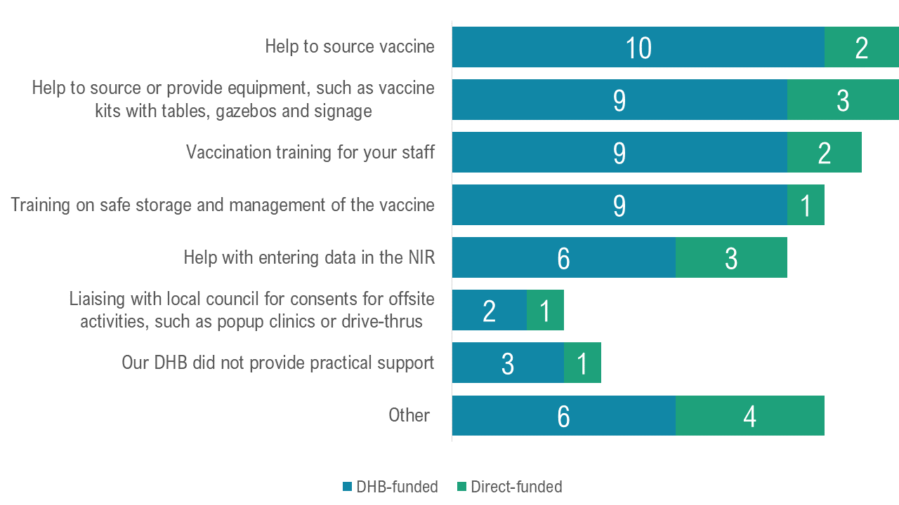

Figure 12: Types of practical support providers said they received from their DHBs
Most Māori providers believed DHBs trusted their organisation. Many also thought DHBs were helpful and realistic in developing plans to a moderate or high degree.
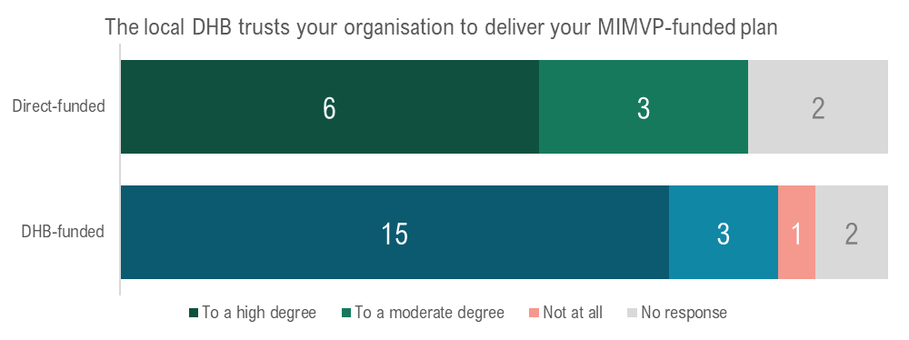
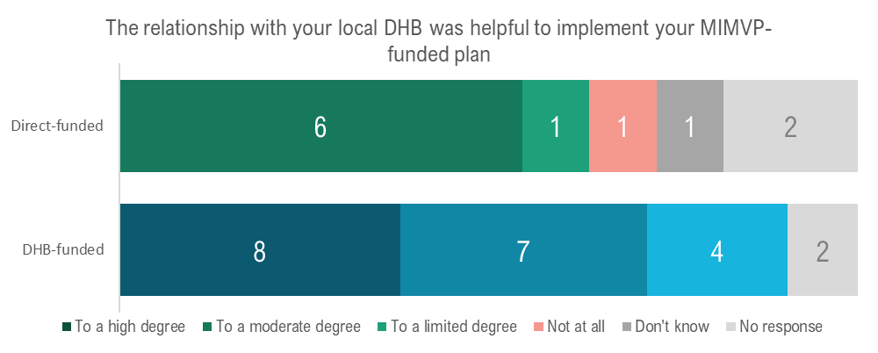

Figure 13: Providers’ perceptions of relationships with DHBs to a moderate or high degree

Negative perceptions
In other regions, the relationship between providers and the local DHB is less amicable. Some providers felt forced into an “unhappy arranged marriage”, required to contract through their DHB despite their preference to contract directly with the Ministry. Some providers commented that their DHB tried to direct or restrict their MIMVP activities. In the providers’ view, DHBs did not have an in-depth understanding of the needs for effectively engaging whānau and their communities. Providers wanted to design and determine what they did in their communities.
Providers also had some “grumblings” about the lack of transparency regarding the funding DHBs retained as part of the total regional budget. There was no explanation to providers about the share of MIMVP regional funding DHBs allocated themselves and how they used it, leaving an impression that DHBs took more than their fair share.
Further, three DHBs allocated MIMVP funding to their internal provider arms. Some providers believed this was somewhat disingenuous and not in the spirit of MIMVP. Regardless of the work carried out by these units, it reinforced a perception that some DHBs were self-serving. Providers suggested funding should only go to independent Māori providers.
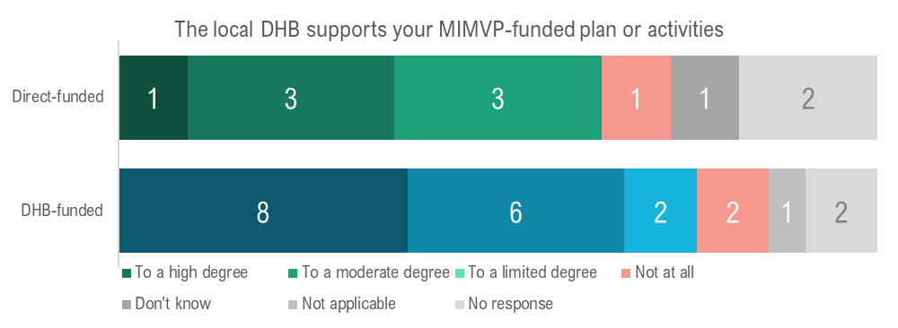
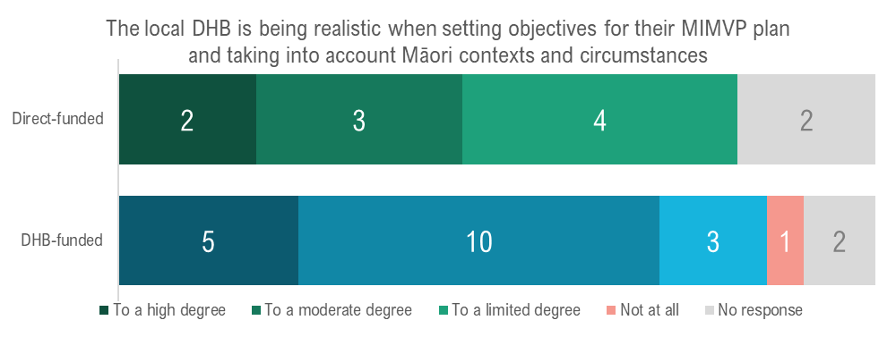
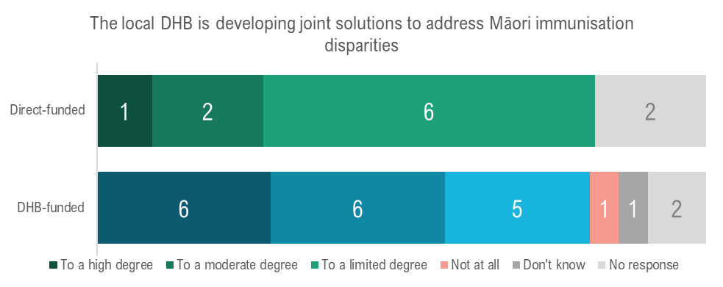

Figure 14: Providers’ perceptions of relationships with DHBs to a moderate or high degree

The MIMVP contracts did not reinforce the goal of collaboration
One of the primary levers that the Ministry has as a policy agency to achieve its goals of collaboration and nurturing relationships is the nature and wording of its contracts.
The contract language gave the DHBs the autonomy for regional decision-making. For example: “Māori providers are expected to collaborate with broader stakeholders that support the success of their initiatives”, whereas “DHBs are expected to engage with Providers to achieve an outcome that represents an efficient use of DHB and Provider resources,” (emphasis added).
This wording differed from the stated intent that DHBs collaborate with Māori providers, jointly deciding how best to meet the needs of Māori whānau, hapū and iwi in the area. The contract language did not force a partnership to occur. Instead, it was left to the discretion of DHBs to engage with providers. Thus the contract wording suggests and supports a model where DHBs have power over providers, where actions are “done to” them (9). In contrast, contracts with appropriate language can explicitly support a partnership with Māori providers. This promotes a learning community, which is necessary for continued change in complex settings (2).

Providers shared a clear preference for direct funding
In 2021, as in 2020, half of the providers overall signalled their preference for future contracting directly with the Ministry. Most direct-funded providers indicated this preference in 2021, however views of providers who contracted through their DHB were divided. About half preferred direct funding with the Ministry; a few preferred contracting through their local DHB (or its future equivalent), and a few were unsure.
As identified in 2020, DHBs varied in their ability to sub-contract local Māori providers. Also Māori providers that had a less-than-optimal relationship with their DHB could not altogether bypass them. For example, those delivering influenza and measles vaccinations also needed a vaccination services agreement with the DHB to claim back vaccine costs.

Simplified reporting enabled faster feedback
New in 2021, was a monthly monitoring reporting process for providers and DHBs. Designed to simplify the contracting process by replacing a final written report at the end of the contract, the monthly monitoring reports were administered as short (5 to 8-minute) surveys. This monthly survey-based reporting enabled providers and DHBs to share information faster and more regularly with the Ministry. In turn, this allowed the Ministry to respond to the needs of providers. Almost all providers indicated that they preferred the monthly monitoring report survey approach over final written reports.
In a few cases, DHBs also imposed additional monitoring requirements. In one instance, a DHB added extra reporting over that needed by the Ministry as part of their internal contract milestone reporting. Thus four Māori health and disability providers did not benefit from the intended streamlined contracting process planned by the Ministry.
Also, as one DHB-funded provider noted, monitoring reports are not necessarily the only way to track progress.
“Any opportunity to provide data is important. [Also it would be good if ] every provider gets an opportunity for a face-to-face korero.” (DHB)

Lower engagement from DHBs and DHB-funded providers
The evaluators utilised the monthly monitoring reports and invited some providers to share additional feedback about their MIMVP activities, experiences and outcomes. This information was used to inform MIMVP monthly insights dashboards which were distributed to DHB and provider contacts and used for sense-making sessions with the Ministry.
As noted, the evaluators received more monitoring reports from the direct-funded providers. DHBs and DHB-funded providers appeared to be less aware of the reporting requirements, despite the Ministry communicating the reporting requirements to DHBs. The evaluators also contacted the DHBs directly seeking their providers' names and the DHB contact who would best be responsible for completing the monitoring reports.
The reduced awareness of reporting requirements suggests a lack of attention to the reporting requirements as part of their contacts and communication between DHBs and the Ministry and between DHBs and DHB-funded providers. In addition, at times different people were involved in contracting from those delivering the contracts and they were unaware of the reporting requirements.
Another possible explanation for the lower engagement of DHB-funded providers is that some DHBs were slow to contract their Māori providers, and they shared provider contact details later in the year, or not at all. Therefore, the evaluators could not identify providers subcontracted by the DHBs nor invite them to complete their monitoring reports without this information. This partially explains why only 21 of the 39 DHB-funded providers responded to the surveys.
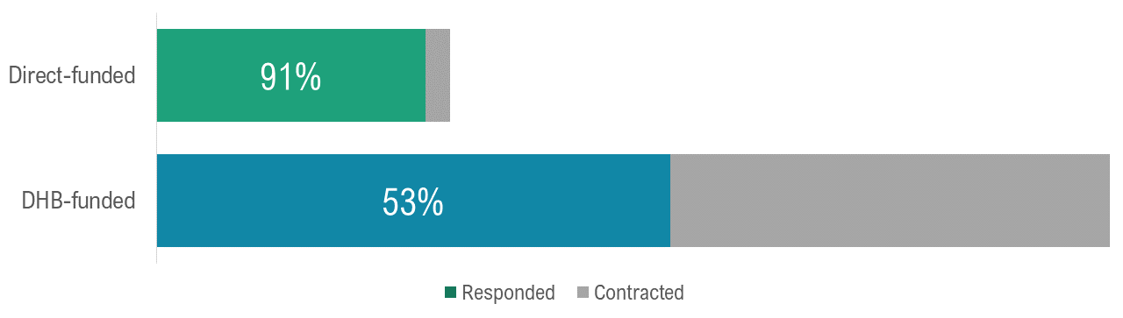

Figure 15: Response rate of providers to monitoring report surveys

Funding was not split evenly between direct-funded and DHB-funded providers
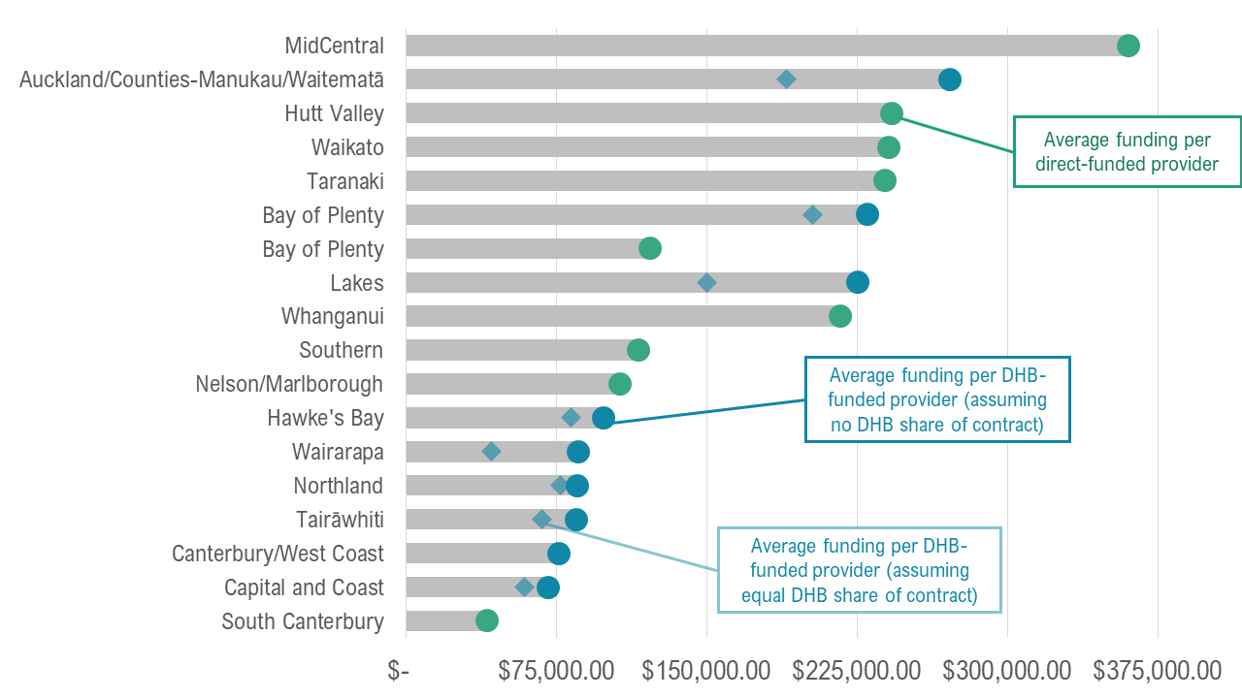

Figure 16: Split of funding per provider, assuming an even distribution between providers and DHBs take no share. Diamond annotation shows share of funding for DHB-funded providers assuming even split with DHBs
In 2021, most direct-funded providers received more funding than DHB-funded providers. Overall, direct-funded providers received on average $186,636. By comparison, assuming DHBs passed all funding from contracts to providers, DHB-funded providers received an average of $136,626. Moreover, the share for providers reduces further if we presume that DHBs split the funding evenly between the DHB and their sub-contracted providers; in this scenario, DHB-funded providers received an average of only $105,366 for each provider.
The contracts and funding information between DHBs and their subcontracted providers was not available for this evaluation. As a result, it is unclear what the $71,000 on average per provider is intended to deliver (being the difference between the average amount direct-funded providers received compared to the amount DHB-funded providers received when assuming an equal share with DHBs). For example, it may reflect the DHBs’ costs of coordination and administration or possible efficiencies of scale.
Irrespective of how DHBs allocate funding, the value of the services that DHBs provide is difficult to assess.
The lack of information about the amount of funding that DHBs withhold to support the MIMVP provider effort in comparison to the amount they allocate to providers therefore contributes to the sense that DHB-funded providers are worse off. For some, there is the perception that DHBs are ‘taking more than their fair share’ and being self-serving.

Funding was used to adapt and expand existing services and to develop the workforce
In 2021, as in 2020, some providers used MIMVP-funding to enhance and extend existing activities, deliver new activities, and work with current and new providers, communities and partners.

Supporting workforce development
Overall, about half of providers thought that vaccinator capacity (having enough people to deliver vaccinations) significantly affected their ability to implement their MIMVP-funded plan in 2021.
In 2021, a small number of providers commented that they had lost vaccinator staff or administrative staff. All providers undertook two to three actions on average to develop their workforce. The most common actions were:
- hiring new vaccinator staff
- hiring new administrative support staff
- attending or delivering flu vaccinator training
- attending or facilitating flu vaccination planning sessions
The main challenge that providers found deeply affected their ability to carry out their MIMVP-funded plan in 2021 was to find available training spots for their staff (for example, for CPR training). For DHB-funded providers, the next main challenge was finding time to send staff to other relevant training. In comparison, direct-funded providers also found it challenging to find time for staff to attend vaccination-specific training.
Both finding and keeping vaccinator staff were a challenge, and to a slightly lesser extent, so was recruiting administration and operation support staff.
The Ministry is focusing on delivering the following objectives for Māori by 2025, and many Māori providers believe these following objectives are evident in MIMVP to a moderate or high degree:
- speed up and spread the delivery of kaupapa Māori and whānau-centred services
- shift cultural and social norms
- strengthen system accountability settings
- reduce health inequities and health loss for Māori.

Missed opportunities for commissioning, contracting and funding
While COVID-19 heavily impacted the delivery of MIMVP, the pandemic also provided opportunities for Māori providers. On the one hand, Ministry personnel said it was easier to get money out to Māori providers, and funding was often timely. But in other cases, funding time lags meant funding was slow to arrive. Slow distribution of funding was critical as it impacted hiring of staff and left providers exposed until the money came. This is not unusual for Māori health providers (10). But managing slow payments is challenging for Māori providers who are also developing and trying to retain a workforce.
Māori providers found the 2021 MIMVP commissioning favoured the Ministry’s needs at their expense. As there is a high administrative burden from annual contracting, we suggest the current policy does not meet the needs of the Ministry particularly well either.
Plus, funding is not always suitable for the job. First, there is a need for the broader health system to focus on Māori needs, including the welfare of the Māori community. Second, there is a need to fund administrative support and programme delivery. Third, there is a need to invest in longer term, that is, multi-year delivery rather than short-term contracts as these breed uncertainty in the workforce and programme delivery. Fourth, there is a need to allow capable providers latitude to spend the funding in opportunistic ways. For instance, some providers have money that was allocated to them but is unspent because their focus was on other areas. If they had longer-term contracts, providers could carry this funding over to start work on next year’s immunisations rather than repaying it.
Of course one of the challenges is that spending has to fit within accounting practices. These current accounting requirements mean timing of the expenditure can be at odds with delivering equity for Māori. The Ministry may need to challenge the timing constraints around payments and work around current accounting accrual practices. Overall, there needs to be a consistent approach to managing the funding that supports greater sustainability and innovation within Māori provider organisations.

6 Communications and learning
This section describes the communications activities and needs of providers. It also describes the organisational learning activities that providers, DHBs and the Ministry undertook.

Key findings
- Providers used multiple channels and messages for communication with whānau and the community.
- Providers faced challenges addressing vaccine misinformation and hesitancy, and community confusion about COVID-19 as opposed to the flu and MMR vaccinations.
- Providers generally found communications from the Ministry helpful, but they needed further help to address the concerns of whānau and the community.
- Providers want opportunities to share with and learn from each other about means to communicate effectively with whānau and the community.
Actions
- Resource providers to develop communications tailored to local needs, communities and whānau.
- Fund providers for the time and effort needed to build and maintain trusting relationships with partner organisations and local Māori and community groups.
- As part of a shift towards integrated immunisations, refine messaging from the Ministry to present a balanced and integrated view of all immunisations.
- Continue to offer and expand training and support materials, especially clinical advice in plain English and te reo Māori.
- Resource providers directly to support them sharing insights with one another in a provider-led space.

Context: The communications and information landscape for providers and whānau is complex
The environment in which providers are trying to communicate with whānau and the community is complex, with multiple competing messages. At the same time, providers communicate and share information with numerous partners and stakeholders, adding further complexity.
Many providers spoke of communications and information flowing in multiple directions.
- With whānau and the broader community, providers share general information about immunisations and specific vaccination programs. Whānau also receive this information from the Ministry through national campaigns and, at times, through mainstream health partners such as their DHB, GP and local pharmacy. In addition, providers receive information from whānau about their concerns and needs concerning immunisation and other aspects of health.
- With partners in the mainstream health system, providers share information about eligible whānau and immunisations.
- With the Ministry of Health, providers share information about their immunisation activities and receive information about immunisations in general and specific vaccination programs.
- With other providers, providers want to share information about their innovations and learnings about what is working.
- Although they may have occurred through other means, communications from whānau and the community to the Ministry or to mainstream health partners was not a part of MIMVP.
Providers competed with and had to counter the noise of informal communications that whānau inevitably receive through friends, social media and news media. In some circumstances, providers also felt they competed with messaging from the Ministry and DHBs. In particular, communications about the importance of the flu and MMR vaccinations were overwhelmed by the urgency of COVID-19 vaccinations. When the communications and information that whānau receive is not aligned, providers have additional work and effort to address confusion and encourage whānau to receive vaccinations.
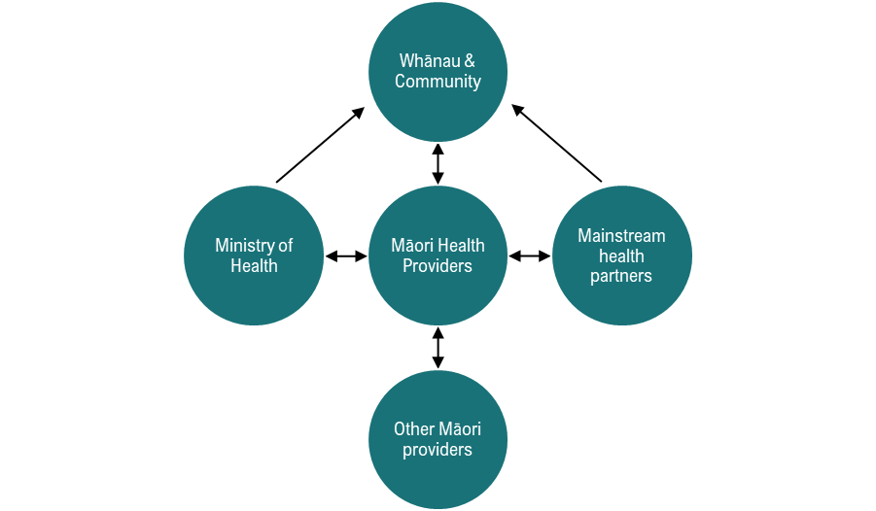

Figure 17: Visual depiction of the communications landscape of Māori Health Providers

Effective communications with whānau and the community weave multiple channels and messages
Providers continued to use the successful strategies and actions identified in MIVP 2020 as a core tenet of working in a whānau-centred way. They used multiple methods and channels to reach and engage whānau, combining technology-based methods and the “kumara vine”. They tailored their messages to the needs of their community and used multiple approaches to ensure their messages reached Māori.
Many of these effective communications channels require strong and trusted relationships, especially between providers and whānau and between providers and their local DHB or primary health organisation(s) (PHOs). Providers are a connecting glue between the community and the clinical system.
Trusted relationships are built and maintained over time. They are nurtured through kanohi ki te kanohi (face-to-face) engagement, regular conversations (both formal and informal), and by parties being tika (correct) and pono (with integrity) about what they do and say.

Providers combined a variety of channels, places, times to find and engage Māori
Providers used a variety of channels to find and talk to unvaccinated Māori, from direct referrals or using a database to social media, word of mouth, community champions, being present in the community or at the local marae, and mass text messages.
All providers used, on average, six different ways of contacting Māori about flu and MMR vaccinations this year. Direct-funded providers used seven different ways to contact Māori whānau, whereas DHB-funded providers used six. The most frequently mentioned ways of reaching whānau were: direct communication by phone, social media posts and just having a presence in the community. Providers also mentioned using networks such as trusted Māori contacts, schools, workplaces and sports groups, and home visits. Finally, social media ads, messages through newsletters, direct communication by email and ads on other media were other ways of reaching Māori mentioned by providers.
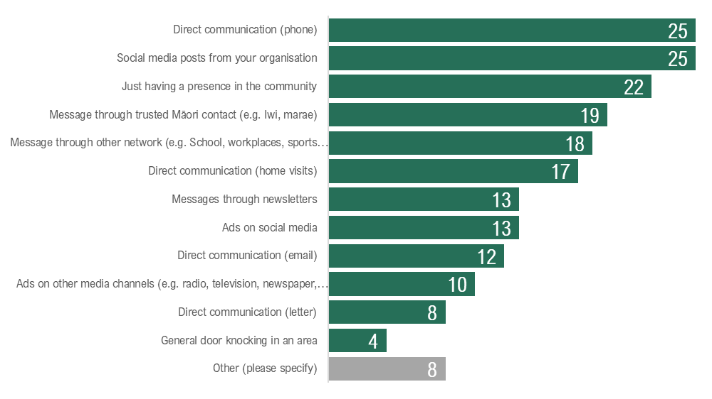

Figure 18: Communication channels providers indicated they used to contact Māori
Māori providers used, on average, four approaches to find Māori who hadn't had the flu vaccine. Direct-funded providers tended to use one more method than DHB-funded providers, with more using general word of mouth and working with iwi, hapū, marae and Māori organisations.
Many providers use social media to reach whānau and their community. Some commented on the success of using social media in 2021 and planned its continued use in the future, with sufficient funding.
“The funding helped with social media campaigns and advertising – this was something new we have been doing and has worked well.” (Provider)

New in 2021, some providers spoke of the importance of “opportunistic” communications. For example, they used educational activities or booking conversations about COVID-19 vaccinations to generally discuss immunisation, offer or administer a flu vaccination, or screen for the MMR vaccination.
“While we are doing the booking for the COVID-19 vaccinations we have been utilising this contact to talk about other vaccinations and talking to other whānau members while we have them on the phone. Also during our visits we are able to schedule other members of the whānau at home at the same time to educate.” (Provider)

“Delivering COVID-19 information sessions throughout our community has provided an opportunity to provide flu vaccines to those present and still waiting for their COVID-19 [vaccinations]; this has worked well in some cases. Attending other community events like Regional Kapa Haka competition proved successful.” (Provider)

Providers indicated several communication channels were most effective. This variety suggests that a combination of communications channels is required. No one communication channel will work for all. Instead, using a mix of channels and messaging is needed to ensure reach and coverage across the Māori community.
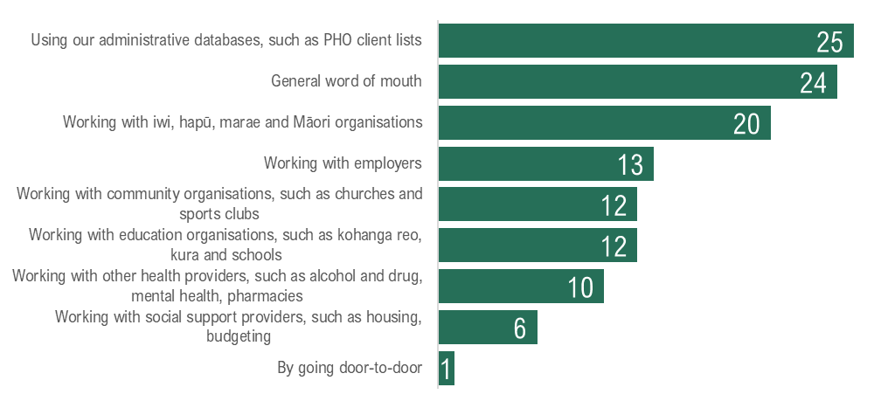

Figure 19: Communication channels providers indicated they used to find Māori

Providers developed a variety of tailored messages to address vaccine hesitancy
There was increased focus on awareness-raising to: address vaccine misinformation and hesitancy, and address community confusion about COVID-19 as compared to the flu and MMR vaccination.

Addressing vaccine misinformation and hesitancy was a challenge
“There is saturation on all forms of mainstream media which is causing hesitancy and for whānau to become disinterested, as they are bombarded and feeling harassed.” (Provider)

Many providers spoke of the challenge of addressing vaccination misinformation that is occurring on social media. Although the misinformation mainly was related to COVID-19, it influenced general perceptions of immunisation and overall vaccine hesitancy.
Many providers spoke of intentionally upskilling and training kaimahi to be able to address whānau about the importance of getting vaccinated.
Many providers offered general educational and awareness-raising sessions in the community, together with GPs and pharmacies. They noted these sessions allowed them to understand the concerns of whānau and provide evidence to address those concerns. They were also able to take the opportunity to offer vaccines or bookings while whānau were present.
“One thing that has worked well are Q&A sessions where the community can ask any questions. We have had people coming in that have not had vaccinations in over 40 years.” (Provider)

Addressing community confusion about COVID-19 as compared to flu and MMR vaccination was a challenge
Providers felt that the direct and indirect messaging from the Ministry about COVID-19 vaccinations affected the messaging for flu and MMR vaccinations and resulting uptake from the community.
Providers noted a substantial focus on public-facing messaging from the Ministry relating to COVID-19 vaccinations and comparatively little national messaging about flu and MMR vaccination. This established and reinforced a sense in the community that COVID-19 was more important than flu and MMR vaccination.
The public focus of the COVID-19 rollout was an age-based eligibility. Some providers noted that whānau chose not to receive a flu vaccine during the peak flu season. They worried it might impact receiving a COVID-19 vaccination when it became available.
“Whānau are prioritising COVID-19 vaccines and choosing to do flu and MMR after they have completed COVID-19 so we are prioritising that currently, to ensure we get whānau in and engaged.” (Provider)

Some DHBs and the Ministry redirected experienced vaccination personnel to work on COVID-19 ahead of other vaccinations. As a result, some providers and DHB staff confirmed being told to prioritise COVID-19 vaccinations. In addition, the COVID-19 vaccinations received a higher reimbursement fee. These actions reinforced to providers that flu and MMR were less critical than COVID-19.
Some providers faced challenges managing multiple vaccinations concurrently. For example, regardless of whether providers were administering COVID-19 vaccinations and flu and MMR vaccination, the clinical advice for most of 2021 was not to administer COVID-19 and flu vaccinations simultaneously.
As a result, providers faced a community that was less interested in flu and MMR vaccination and primarily concerned about receiving COVID-19 vaccinations.

Effective communications with the Ministry empower providers to meet the needs of their community
Providers generally found the messaging support from the Ministry helpful, particularly about scheduling and managing multiple vaccinations. However, many providers felt that the Ministry’s COVID-19 messaging reinforced a lower priority of flu and MMR vaccination for whānau and the community, which affected the interest in and uptake of flu and MMR vaccinations. Providers needed messaging from the Ministry to support all immunisations.
“The Ministry can support us by driving a national message about getting their flu vaccinations as well as COVID-19, including television and radio advertisements.” (Provider)

More recently, the clinical advice changed to support administering COVID-19 and flu vaccinations simultaneously (known as “concomitant vaccination”). At that point, providers overwhelmingly said they needed supporting communications and messaging from the Ministry as a primary enabler. Providers wanted support to develop resources to share with whānau. Providers wanted help to explain to whānau in the simplest terms why the clinical advice had changed.
“To be able to administer multiple vaccinations, we need a clear strategy to administer both MMR, COVID-19 vaccinations to all Māori across a range of community settings, supported by appropriate clinical, cultural and financial resources.” (Provider)

“To be able to administer multiple vaccinations, we need messaging and getting the information out to the community that it is safe to deliver both vaccinations simultaneously. There appears to be a high level of mistrust from whānau about vaccinations” (Provider)

Providers found the training and educational resources from the Ministry and the Immunisation Advisory Centre (IMAC) helpful, as in 2020. However, they noted that training and resources need constant updating as advice changes.
“Online training courses were helpful, clear written instructions.” (Provider)

However, some providers faced challenges accessing training courses at times and suitable locations. In one instance, a provider contacted the Ministry noting that the next available time for a vaccinator training course was August – after the traditional flu season had finished.
“Offer more training for vaccinators to get them (nurses) vaccinator ready. We have had trouble accessing training for CPR level 4. Without this you cannot vaccinate. Huge barrier. We have the workforce - just not the capacity to all do vaccination.” (Provider)

Effective communications with partner organisations and other providers enable providers to share and learn
Providers do overwhelmingly want opportunities to share and learn. However, many feel there are not sufficient opportunities to do so. In particular, direct-funded providers felt the lack of opportunities to share and learn stronger than DHB-funded providers.
“We would like to hear what is working really well across the country, so we can learn from others and replicate for the local setting as appropriate.” (Provider)

About half of the regions had just one or two providers delivering a MIMVP-funded plan in their region. As a result, these providers had limited opportunities to share and learn.
In 2020, one successful region coordinated a regular sharing and reflection activity into their implementation that included representation from multiple providers, PHO, pharmacies and midwives. In 2021, they faced challenges continuing this, with key staff from 2020 diverted to the local COVID-19 response.
In 2021, one region coordinated sharing of vaccination rates across providers and partners. However, providers in this region felt there was little opportunity to share the context around vaccination rates. They thought they were penalised for not meeting targets rather than being supported to share, learn and adapt.
New in 2021, the Ministry shared monthly dashboards with all providers and DHBs of the vaccination rates in each region and emerging themes, lessons and tips received through the monthly monitoring report surveys.
The monthly monitoring report surveys and dashboards are one way to capture and share insights and tips with other providers and partners. Although only some providers indicated they found the dashboards useful, there was a significant increase over time in responses to the final survey question, “Is there anything else you’d like to share?” (which was the primary source for tips and lessons shared in the dashboards). Furthermore, individual respondents were contacted before their tip was published in the following dashboard and all those contacted agreed. This indicates that a regular capture and dissemination of learnings, such as the survey and dashboards, may be helpful for a broader learning sharing approach.

Missed opportunities for communications and learning
Providers noted that whānau need clear messaging about safety of vaccination from people they trust. They need easy-to-understand resources, to be able to ask questions of those they trust and to hear from trusted local messengers. Providers found the educational resources from the Ministry and IMAC helpful. However, they noted that these resources need to be updated as advice changes.

Appendix: Programme overview
This section outlines the allocation of MIMVP funding nationally, including the spread of providers contracted directly by the Ministry (direct-funded providers) and providers sub-contracted by their local DHB (DHB-funded providers). This section also describes the activities of MIMVP-funded providers and DHBs.

Programme funding
MIMVP contracts in 2021 included funding for the following:
- communications, phone or digital outreach support for pakeke and kaumātua to provide reminders of appointments
- additional costs for workforce to deliver the provider’s specific initiative to increase Māori influenza and measles immunisations under the contract
- cost of venue hire, tents, chairs, tables and other equipment as needed to deliver the provider’s specific initiative to increase Māori influenza and measles immunisations
- PPE gear and other clinical requirements to provide protection, sanitation and security as part of the operational set up of this initiative (if required for COVID-19 alert levels)
- transport costs to and from clinics or homes or to enable whānau to attend appointments for this Māori influenza and measles immunisation initiative
- consumables, and other expenses as deemed necessary as part of the provider’s specific initiative to increase Māori immunisations” (20 p. 2).
The Ministry of Health (the Ministry) allocated $7.86m (from a budget of $8.35m) for MIMVP The Ministry contracted with 12 providers directly, (known as “direct-funded providers”) for a combined total of $2.40m, and 10 DHBs for $5.32m. One DHB contract covered multiple regions (the Auckland Metro contract held by Counties Manukau covered Auckland, Counties-Manukau and Waitematā regions). Two DHBs collaborated to deliver their MIMVP activities (Canterbury and West Coast). In one region (Bay of Plenty) the Ministry contracted with both the DHB and one provider directly.

DHB region | Total funding awarded | DHB-held contracts | Provider-held contracts
Auckland/Counties-Manukau/Waitematā | $1,900,000 | $1,900,000
Waikato | $961,134 |  | $961,134
Bay of Plenty | $811,370 | $690,000 | $121,370
Northland | $770,000 | $770,000
Hawke's Bay | $494,000 | $494,000
Lakes | $451,108 | $451,108
Canterbury/West Coast | $377,735 | $228,747
MidCentral | $360,000 |  | $360,000
Capital and Coast | $355,220 | $355,220
Tairāwhiti | $340,000 | $340,000
Hutt Valley | $241,624 |  | $241,624
Taranaki | $238,467 |  | $238,467
Whanganui | $216,071 |  | $216,071
Southern | $115,637 |  | $115,637
Nelson/Marlborough | $106,270 |  | $106,270
Wairarapa | $86,000 | $86,000
South Canterbury | $40,000 |  | $40,000
Total | $7,864,636 | $5,315,075 | $2,400,573

Table 1: MIMVP funding allocation in each region

Provider contracting
MIMVP contracts funded activities in all 20 DHB regions in 2021, compared to 19 regions in 2020. This was partially a result of the Ministry’s targeted efforts to contact and invite applications from all DHB regions.
In total, 51 providers took part in MIMVP. Twelve providers were contracted directly with the Ministry. The DHBs contracted with 39 providers, of which 36 were independent Māori health providers, and three were internal provider arms of DHBs.
This is a small reduction in the number of providers, compared with 58 in 2020, when 18 providers were direct-funded by the Ministry and approximately 40 providers were contracted through 8 DHBs.
Over half of the providers said they delivered the flu vaccinations in 2020 through MIVP, while two in five providers delivered them in 2020 but not through MIVP. Only one provider offering MIMVP in 2021 did not provide vaccinations in 2020.

Funding across the motu
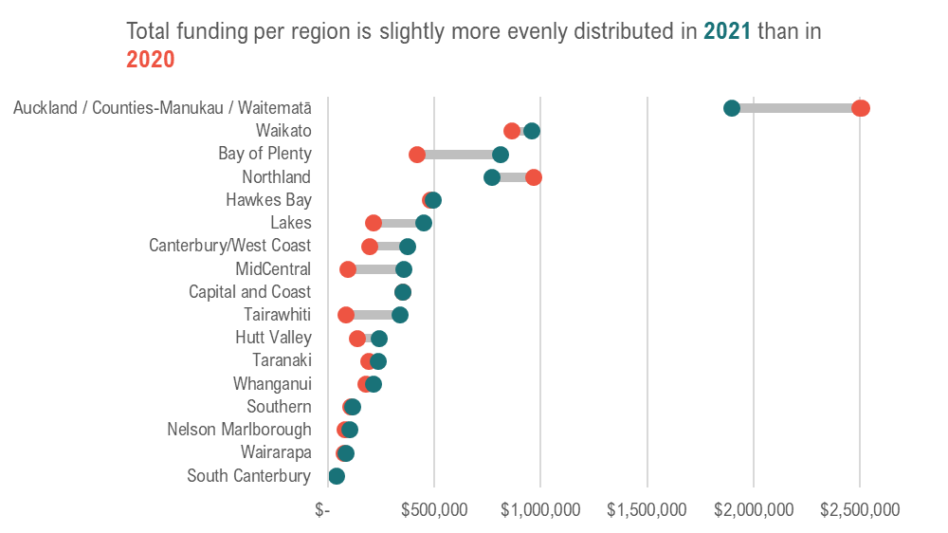

Figure 20: Allocated MIMVP funding per region (across all contracts) in 2021 vs 2020
In 2020, MIVP funding was awarded in response to application submissions. As a result, the funding was slightly uneven. For example, one region (South Canterbury) received no funding as no providers from this region applied.
In 2021, the Ministry proactively sought applications in regions with less involvement in 2020. As a result, funding in 2021 is slightly more evenly distributed and all regions received funding for MIMVP activities.

MIMVP-funded providers delivered a variety of vaccinations
Most DHB-funded providers (17/x) and all direct-funded providers (11/x) delivered flu vaccinations in 2021. Many providers also delivered MMR vaccinations.
A half or fewer delivered childhood immunisations and other vaccinations.
Many providers delivered COVD-19 vaccinations and about half of all known MIMVP-funded providers also had a COVID-19 specific contract.

Delivering flu, MMR and other vaccinations was a challenge to manage for many providers
Many MIMVP-funded providers faced significant challenges to managing multiple vaccinations, including
- managing multiple campaigns
- workforce capacity
- patient preferences for vaccines - COVID-19 over flu and MMR vaccination
- different vaccines managed by different providers and different centres.
Many providers experienced competing priorities for their limited resources. Nevertheless, providers overwhelmingly felt capable and prepared to deliver multiple vaccinations to whānau and the community. As at the end of June, almost all providers felt their organisation was able to answer whānau questions and concerns to a moderate or high degree, schedule multiple vaccinations efficiently to a moderate or high degree, and deliver multiple vaccinations efficiently to a moderate or high degree.
However, many providers struggled with confusion, uncertainty and hesitation from whānau and the community. For instance:
- most providers believed whānau were confused about the safety of the COVID-19 vaccine
- many providers believed whānau were confused about whether they need both the COVID-19 and flu vaccinations.
Misinformation was a significant challenge in 2021
“There is saturation on all forms of mainstream media which is causing hesitancy and for whānau to become disinterested, as they bombarded and feeling harassed” (Provider)

Many providers spoke of the challenge of addressing vaccination misinformation on social media. Although the misinformation mainly was related to COVID-19, it influenced general perceptions of immunisation and overall vaccine hesitancy. As a result, awareness-raising and educational messaging to whānau was critical in 2021.
Many providers spoke of conducting awareness-raising communications activities as a new activity in 2021, compared to 2020.
“We think education to all Māori and Pacifica is needed in a space that meets their needs.” (Provider)

“Taking the time to kōrero with whānau ... was especially helpful for those whānau who were hesitant to get vaccinated.” (Provider)

Many providers spoke of intentionally upskilling and training kaimahi to be able to address whānau about the importance of getting vaccinated.

Additional data, tables and graphs

Māori 65+ who received flu vaccinations 2015 to 2021
Table 2 presents the percentage of Māori over 65 years that received a flu vaccination in each region, as at Week 39 from 2015 to 2021, sorted by 2021 rates. The five highest performing and five lowest performing regions are highlighted.
DHB | 2015 | 2016 | 2017 | 2018 | 2019 | 2020 | 2021
Whanganui | 48.3% | 52.3% | 53.5% | 56.2% | 55.6% | 85.3% | 64.5%
Wairarapa | 49.6% | 44.1% | 47.6% | 51.6% | 54.2% | 59.7% | 59.1%
Hutt Valley | 33.4% | 36.9% | 38.4% | 42.3% | 46.6% | 64.3% | 58.2%
West Coast | 17.9% | 48.8% | 48.5% | 50.7% | 53.7% | 56.9% | 57.9%
Canterbury | 21.3% | 25.0% | 25.5% | 26.6% | 28.8% | 54.1% | 57.7%
Capital and Coast | 38.5% | 39.6% | 40.7% | 42.1% | 45.1% | 60.6% | 54.1%
Bay of Plenty | 39.4% | 41.7% | 43.6% | 44.2% | 48.3% | 67.8% | 53.0%
Southern | 31.7% | 37.5% | 40.5% | 45.3% | 46.3% | 56.2% | 52.6%
South Canterbury | 36.7% | 42.1% | 45.5% | 43.5% | 46.9% | 44.4% | 52.3%
Hawkes Bay | 41.5% | 46.8% | 43.7% | 43.6% | 45.3% | 77.1% | 50.9%
Lakes | 19.7% | 23.0% | 25.7% | 26.4% | 42.2% | 68.9% | 50.7%
Northland | 40.1% | 40.5% | 41.0% | 37.6% | 36.1% | 59.7% | 50.3%
Taranaki | 31.6% | 38.2% | 37.8% | 42.6% | 41.3% | 51.4% | 49.0%
Waikato | 37.4% | 42.9% | 41.0% | 45.0% | 45.4% | 60.7% | 47.5%
Nelson Marlborough | 38.7% | 42.9% | 43.2% | 45.4% | 44.9% | 63.8% | 47.1%
MidCentral | 41.4% | 43.5% | 40.7% | 38.8% | 40.3% | 56.3% | 46.8%
Counties Manukau | 37.1% | 43.2% | 36.7% | 45.4% | 44.2% | 52.7% | 46.5%
Tairāwhiti | 33.2% | 39.4% | 39.8% | 40.1% | 39.1% | 58.9% | 45.6%
Auckland | 32.1% | 35.7% | 33.4% | 39.1% | 39.0% | 39.7% | 42.6%
Waitematā | 29.8% | 34.5% | 30.9% | 38.1% | 38.2% | 48.3% | 42.5%

Table 2. Flu vaccination rates of Māori 65+ 2015-2021, by DHB region

COVID-19 and influenza vaccination rollout and eligible groups
In 2021, there were four flu vaccines approved for different age groups, compared to two in 2020. There was one vaccine for adults 65 years and older, another for people aged 5–64 years, one for children aged 3–4 years, and one for babies and toddlers aged 6–35 months. In 2021, the phased rollout of the flu vaccines and the COVID-19 vaccine used age as a key criterion for eligibility. The flu immunisation campaign for people over 65 years began earlier than other age groups. For both the flu and COVID-19 vaccines, the phased approach was a response to vaccine supply and targeting of priority groups.
Activity | Timing
COVID-19 Group 1: MIQ and Border workers | Mid-February 2021
COVID-19 Group 2: High risk frontline workers | March 2021
COVID-19 Group 3: Those over 65 or at risk of getting very sick | March 2021
Influenza Immunisation Programme starts for people 65 years and over  Fluad Quad Vaccine for this age group only.  Vaccine available to the end of December 2021 | 14 April, 2021
Influenza Immunisation Programme starts for people under 65.  Afluria Quad for people aged 5 to 64  Influvac Tetra for children aged to 3 to 4 years  Afluria Quad Junior for children aged 6 to 35 months  Children from 6 months to 35 months need two doses of the flu vaccine given at least 4 weeks apart | 17 May, 2021
COVID-19 Group 3: Main population rollout started  New age groups were allowed to book each fortnight  As of 25 August, those aged 30+ can book and can take their children aged 12 – 15 with them | Started late July 2021

Table 3: The phasing of COVID-19 and flu vaccinations in 2021

Appendix: Methodology
This final report builds on findings and insights described in the interim report.
It draws on data and findings from:
- monthly monitoring report surveys, completed by DHBs with MIMVP contracts and providers (both direct-funded by the Ministry and sub-contracted through their DHB) (5)
- interviews with representatives from the Ministry (7), DHBs (3) and providers (11)
- sense-making meetings with representatives from the Ministry (4)
- analysis of provider and DHB applications and contracts
- correspondence and background papers with representatives from the Ministry and DHBs
- National Immunisation Register data of flu vaccination rates, provided by the Ministry
- the published evaluation report of MIVP 2020
- the internal MIVP 2020 Auckland Deep Dive report
- relevant literature, including journal articles and research and evaluation reports.
The evaluation was designed as a collaborative, tailored approach to meet the commissioner and broader stakeholder needs for rapid insight. The evaluators aimed to work with the Ministry of Health in the fast-moving COVID-19 environment. The project, therefore, highlighted responsive changes that occurred in the community while maintaining the rigour and integrity of the data and insights.
The evaluation used rapid insight cycles (RICs), a mixed-method and iterative evaluation approach developed for MIVP 2020. The term rapid is contextual, with timeframes mutually agreed. Typically, a cycle is a minimum of four weeks of data collection (and up to 6 weeks) with reporting the following week, that is, within 5 to 7 working days. Emerging insights were shared in a one-hour collaborative sense-making and pattern-spotting session with key stakeholders. This process helps the stakeholders and evaluators make sense of, at times, contradictory findings during the evaluation and conundrums. The insights and collective sense-making at the end of each cycle inform the questions, analysis, methods and focus of subsequent cycles, in agreement with key stakeholders and in response to their emergent information needs. However, each cycle contributes to more profound and broader answers to the key evaluation questions.
The MIMVP evaluation used four RICs with approximately 4–5 weeks duration. Each RIC aligned with a monthly monitoring report survey, enabling collaborative sense-making of the survey and NIR data with key Ministry stakeholders at the end of each cycle.
The evaluation team supported the Ministry in the design of monitoring reporting requirements for the MIMVP contract for DHBs and providers in anticipation of a RIC approach to the MIMVP evaluation. This design recognised the benefits to the Ministry that the RIC approach used in MIVP in 2020. That design included short 7-minute surveys to capture monitoring data and share insights with providers and DHBs using monthly dashboards. The monthly insights dashboards prepared by the Ministry, in collaboration with the evaluation team, included flu vaccination data at national, regional and provider levels, and key quotes and insights from each monthly monitoring report survey. The evaluation team disseminated the monthly insights dashboards to DHB and provider contacts.

Monitoring report surveys
Monthly monitoring reports were captured via a short survey. Each cycle's emerging insights and data needs informed the selection of some questions in subsequent monitoring report surveys. In each monthly monitoring report survey, respondents were asked for one thing that was working well, if they had a tip to share, and any other comments. In collaboration with the Ministry, other questions in the monitoring reports changed each month. In addition, providers were asked for the Clinic Names their organisation enters into NIR, to enable the Ministry to identify flu vaccinations delivered as part of MIMVP from overall flu vaccinations. This data was used in the monthly insights dashboards prepared by the Ministry and the evaluation team.

Monitoring Report Survey | Month in focus (release date) | Total responses from Providers | Total responses from DHBs
1 | April (sent 3 May) | 12/39 | 10/19
2 | May (sent 2 June) | 32/41 | 7/17
3 | June (sent 3 July) | 28/48 | 8/15
4 | July (sent 1 August) | 19/26 | 3/7
5 | Final (sent 28 September) | 32/51 | 8/10

Table 4: MIMVP 2021 Monitoring report survey responses
Each monitoring report survey was analysed as part of the RIC process. There was a cut-off point for responses for analysis purposes for the RICs. However, respondents could submit responses after the cut-off date. All responses were later analysed for the interim report and this final report.
The evaluation team managed the distribution of monthly monitoring report survey invitations, using contact details provided by the Ministry for each contracted organisation. The Ministry relied on DHBs to confirm their sub-contracted providers and nominated contacts. Some DHBs were slow to organise their sub-contracted providers and slow to confirm the contact details to the Ministry and the evaluators. As a result, the number of providers that received the invitation to complete the monthly monitoring report surveys was smaller at the beginning of the programme, and increased each month. In June, there was a conscious effort to reach out to contacts who had not completed surveys, which increased the May monitoring report survey responses.
In the lead up to monitoring report Survey 4, the evaluators and the Ministry noted a lower completion rate of Survey 3 than desired. The original finish date of MIMVP of September was nearing. Survey 4 was intentionally designed to be data- lite and to ascertain whether organisations were interested in a contract extension. As a result, Survey 4 was only sent to contacts that had responded to Survey 3. Provider and DHB contacts who had not responded to Survey 3 were sent a repeat invitation to complete Survey 3, increasing the overall response rate for Survey 3, with an additional question about their interest in a contract extension.
At the outset of the evaluation, monitoring report survey invitations were sent to contacts from all DHBs, including DHBs where providers were direct-funded and the DHB did not hold a contract. The intention was that this might further enable a more accurate view of the national vaccination landscape. However, these DHBs had no obligation to respond, and none did. Survey 5 was, therefore, only sent DHBs that held MIMVP contracts with the Ministry.

Limitations
All evaluations, evaluation approaches and methods have limitations.
A significant limitation of this evaluation is the lack of agreed criteria, including the lack of national targets for vaccination rates or the equity gap between Māori and non-Māori non-Pacific vaccination rates.
The evaluation was guided by a suite of evaluative questions that provided indicative areas of interest, rather than acting as Key Evaluation Questions to be answered. However, this enabled the evaluators to be responsive to the Ministry's emerging learnings and data needs.
The evaluation collected and analysed qualitative, quantitative and administrative data. However, as in 2020, the evaluation did not collect feedback from whānau or communities about their experience of MIMVP.
The evaluation sought data from representatives of all 20 DHB regions participating in MIMVP.
In one region, Wairarapa, neither the DHB nor its sub-contracted provider responded to any monitoring report surveys. As a result, the perspectives of this region are not reflected in the findings.
The Ministry's monitoring report surveys were a contractual requirement with its contracted providers and DHBs. However, the evaluation team did not have access to the contracts between DHBs and their sub-contracted providers. In addition, the lower response rates from DHB-funded providers indicates that the DHBs may not have explicitly passed on the Ministry’s reporting requirements. As a result, findings are not as representative of DHB-funded providers as compared with direct-funded providers.
The evaluation used the National Immunisations Register data to track changes in Māori flu vaccination rates. To address a limitation identified in the evaluation of MIVP 2020, in collaboration with the Ministry, the evaluation team sought a mechanism to report on the number of vaccinations administered at a provider level. Vaccinating providers gave the clinic names or clinic IDs used when entering their vaccination data into the NIR. The Ministry then filtered out vaccination data using these names and IDs, and presented this in the monthly insights dashboards. However, not all providers responded to the monitoring report surveys, and some listed clinic names or IDs that did not match vaccination data in the NIR.
Further, the evaluation used NIR data for 65+ as the NIR does not capture other vulnerable groups. However, as in 2020, many providers indicated they worked with other eligible cohorts and Māori of other age groups.

References
1. Ministry of Health. Whakamaua: Māori Health Action Plan 2020-2025. Wellington : Ministry of Health, 2020.
2. Making commissioning work: The relational gap between intent and implementation in the transition to ‘commissioning’ community services in New South Wales. Riboldi, M, et al. 2021, Australian Journal of Public Administration, Vol. 2021, pp. 1-12.
3. Contracting public health and social services: insights from complexity theory for Aotearoa New Zealand. Oakden, J, Walton, M and Foote, J. 1, 2021, Kōtuitui: New Zealand Journal of Social Sciences Online, Vol. 16, pp. 180-195.
4. Bloomfield, A,. Achieving equity. 2019.
5. Durie, M. Whaiora: Māori Health Development. 2nd Revised ed. s.l. : Oxford University Press, 1999.
6. Smith, G. H. The development of Kaupapa Māori: Theory and praxis. Auckland, New Zealand : University of Auckland, 1997.
7. COVID‐19 and Indigenous knowledge and leadership: (Re)centring public health curricula to address inequities. Severinsen, C, et al. 1, 2021, Australian and New Zealand Journal of Public Health, Vol. 45, pp. 6-8.
8. Wehipeihana, N, et al. More Than Just a Jab: Evaluation of the Māori Influenza Vaccination Programme as part of the COVID-19 Māori Health Response. Wellington : Ministry of Health, 2021.
9. Increasing cultural competence in indigenous-led evaluation: A necessary step toward indigenous-led evaluation. Wehipeihana, N. 2, 2019, Canadian Journal of Program Evaluation, Vol. 34, pp. 369-384.
10. Strengthening public health contracting: findings of a follow-up nationwide survey from Aotearoa. Came, H, et al. 2022, Kōtuitui: New Zealand Journal of Social Sciences Online, pp. 1–17.
11. Ardern, J. Prime Minister’s Waitangi Day Speech. 2022.
12. Colonial histories, racism and health – The experience of Māori and Indigenous peoples. Reid, P, Cormack, D and Paine, S.J. Public Health, Vol. 172, pp. 119-124.
13. Health Quality and Safety Commission NZ. He tirohanga ki te ōritenga hauora o te Māori | A view on Māori health equity. Wellington : Health Quality and Safety Commission, 2019.
14. Modelled seasonal influenza mortality shows marked differences in risk by age, sex, ethnicity and socioeconomic position in New Zealand. Khieu, Trang Q.T., et al. 3, 2017, Journal of Infection, Vol. 75.
15. New Zealand’s immunisation policy fails again and entrenches ethnic disparities. Sinclair, O and Grant, C. 1542, 2021, New Zealand Medical Journal, Vol. 134.
16. World Health Organization. Working together: an integration resource guide for immunisation services throughout the life course. Geneva : World Health Organization, 2018.
17. —. Global Vaccine Action Plan (GVAP) 2011–2020. Geneva : World Health Organization, 2013.
18. O'Hagan, Lucy. Confronting times on the equity front line. NZ Doctor | Rata Aotearoa. [Online] 4 2 2022. https://www.nzdoctor.co.nz/article/opinion/confronting-times-equity-front-line.
19. Durie, Mason. Te Whare Tapa Whā | Hauora Māori, Māori Health Model.
20. Ministry of Health. Service specification: Māori Influenza and Measles Vaccination Programme 2021 (MIMVP 2021). Wellington : Ministry of Health, 2021.
21. Wehipeihana, N, et al. Protecting our Whakapapa: Māori Influenza and Measles Vaccination Programme 2021 - Interim Monitoring Report. Wellington : Ministry of Health, 2022.
22. Waitangi Tribunal. Haumaru: The COVID-19 Priority Report in pre-publication format. 2021.

Endnotes

Source: Ministry of Health https://www.health.govt.nz/covid-19-novel-coronavirus/covid-19-data-and-statistics/covid-19-vaccine-data#total-vaccinations accessed 21 February 2022, data as at 11:59pm 19 February 2022
As at February 2022, “fully vaccinated” refers to two approved doses of a COVID019 vaccine.
Waitangi Tribunal. (2021). Haumaru: The COVID-19 Priority Report in pre-publication format. https://waitangitribunal.govt.nz/assets/Documents/Publications/Covid-Priority-W.pdf
Herd immunity is an approach to controlling infectious diseases “to protect individuals against disease and also prevent the onward spread of disease within the population as a whole”. “When a high percentage of the population is vaccinated, it is difficult for infectious diseases to spread because there are not many people who can be infected” Source: Ministry of Health, Vaccine Effectiveness https://www.health.govt.nz/our-work/preventative-health-wellness/immunisation/vaccine-effectiveness accessed 21 February 2022
Although MIMVP provided funding for flu and MMR vaccinations, many DHBs and providers delayed their MMR-specific activities due to a focus on COVID-19 and flu. Some providers indicated in monitoring reports that they had delivered MMR vaccinations, however, MMR vaccination data was not available for this evaluation.
Source: NIR data 2021-2015, supplied by Ministry of Health
Note: some immunisation reports sent from the Ministry in 2021 had 2018 and 2019 gaps labelled incorrectly.
Source: NIR data 2021. Four regions with highest estimated Māori 65+ population: Waikato,7180; Northland, 6530; Bay of Plenty, 5700; Counties Manukau, 5380, from Statistics NZ data supplied by Ministry of Health
Source: Population data, from Statistics NZ, supplied by Ministry of Health
Source: analysis of NIR data 2015 to 2021.
24/32 provider respondents in final monthly monitoring report survey, released September 2021. Total survey responses: 32/52 contracted providers, 8/10 contracted DHBs. 4 respondents chose not to answer this question. From Ministry documentation, at least 26 of 52 contracted providers, although information was not available for providers from some regions where DHBs were late finalising contracts with providers.
21/32 provider respondents indicated that the work they did in 2020 helped them prepare for 2021 to a moderate or high degree in final monthly monitoring report survey, released September 2021. Total survey responses: 32 providers, 8 DHBs. 4 respondents chose not to answer this question.
22/32, 22/32 provider respondents indicated that had delivered educational activities in the community and awareness raising activities in the community (respectively) in final monthly monitoring report survey, released September 2021. Total survey responses: 32 providers, 8 DHBs. 0 respondents chose not to answer this question.
19/32, 16/32. 16/32 provider respondents indicated that had delivered a mobile clinic (travelling to deliver vaccinations in the community), mobile services (transporting kaumatua and whānau to a clinic) and home visits (respectively) in final monthly monitoring report survey, released September 2021. Total survey responses: 32 providers, 8 DHBs. 0 respondents chose not to answer this question.
9/11 direct-funded provider respondents indicated that had delivered a pop-up clinic (temporary clinic in a Māori site, such as a marae), compared to 5/21 DHB-funded providers in final monthly monitoring report survey, released September 2021. Total survey responses: 32 providers, 8 DHBs. 0 respondents chose not to answer this question.
Provider respondents indicated that they had delivered any of the following activities as part of their MIMVP-funded plan in 2021 in final monthly monitoring report survey, released September 2021. Total survey responses: 32 providers, 8 DHBs. 0 respondents chose not to answer this question.
Provider respondents indicated that that they had worked with any of the following organisations to implement their MIMVP-funded plan in 2021 in final monthly monitoring report survey, released September 2021. Total survey responses: 32 providers, 8 DHBs. 0 respondents chose not to answer this question.
The Auckland Metro contract held by Counties Manukau covered three DHBs, Auckland, Counties-Manukau and Waitematā regions). Two DHBs collaborated to deliver their MIMVP activities (Canterbury and West Coast). DHBs went on to contract 39 providers.
21/28 respondents indicated that one of the top three biggest impacts on their ability to carry out MIMVP-funded vaccination plans was that the Ministry started the application and contracting process too late in monthly monitoring report survey 3, released 3 July. Total survey responses: 28 providers, 8 DHBs. 4 respondents chose not to answer this question
Note that the information about DHB contracting, relationships and responsiveness is limited and primarily taken from provider monitoring reports. Only two DHBs responded to all five monitoring report surveys, four responded to one or two, and one DHB did not respond to any.
9/11 direct-funded provider respondents indicated that they had received their first MIMVP funding payment in June or earlier in final monthly monitoring report survey, released September 2021. Total survey responses: 32 providers, 8 DHBs. 2 respondents chose not to answer this question.
7/21 DHB-funded provider respondents indicated that they had received their first MIMVP funding payment in June or earlier in final monthly monitoring report survey, released September 2021. Total survey responses: 32 providers, 8 DHBs. 2 respondents chose not to answer this question.
10/11 direct-funded provider and 12/21 DHB-funded provider respondents in indicated that they started administering flu vaccinations funded by MIMVP in June or earlier in final monthly monitoring report survey, released September 2021. Total survey responses: 32 providers, 8 DHBs. 2 respondents chose not to answer this question.
9/11 direct-funded provider and 11/21 DHB-funded provider respondents indicated that they started administering MMR vaccinations funded by MIMVP in May or earlier in final monthly monitoring report survey, released September 2021. Total survey responses: 32 providers, 8 DHBs. 4 respondents chose not to answer this question.
11/11 direct-funded provider respondents indicated that they started administering flu vaccinations funded by MIMVP in May or earlier in final monthly monitoring report survey, released September 2021. Total survey responses: 32 providers, 8 DHBs. 2 respondents chose not to answer this question.
5/11 direct-funded provider respondents indicated that they started MIMVP-funded activities after the contract was confirmed but before they received funding in final monthly monitoring report survey, released September 2021. Total survey responses: 32 providers, 8 DHBs. 2 respondents chose not to answer this question.
11 direct-funded provider and 21 DHB-funded provider respondents in final monthly monitoring report survey, released September 2021. Total survey responses: 32 providers, 8 DHBs. 4 respondents chose not to answer this question.
11 direct-funded provider and 21 DHB-funded provider respondents in final monthly monitoring report survey, released September 2021. Total survey responses: 32 providers, 8 DHBs. 4 respondents chose not to answer this question.
11 direct-funded provider and 21 DHB-funded provider respondents in final monthly monitoring report survey, released September 2021. Total survey responses: 32 providers, 8 DHBs. 4 respondents chose not to answer this question.
16/32 provider respondents indicated that if they were to deliver MIMVP activities in 2022 they would prefer to contract and be funded directly with the Ministry in final monthly monitoring report survey, released September 2021. Total survey responses: 32 providers, 8 DHBs. 4 respondents chose not to answer this question.
7/11 direct-funded provider respondents indicated that if they were to deliver MIMVP activities in 2022 they would prefer to contract and be funded directly with the Ministry in final monthly monitoring report survey, released September 2021. Total survey responses: 32 providers, 8 DHBs. 2 respondents chose not to answer this question.
9/21, 5/21. 4/21 DHB-funded provider respondents indicated that if they were to deliver MIMVP activities in 2022 they would prefer to contract and be funded directly with the Ministry, through their DHB or that they didn’t know (respectively) in final monthly monitoring report survey, released September 2021. Total survey responses: 32 providers, 8 DHBs. 2 respondents chose not to answer this question.
11 direct-funded provider and 21 DHB-funded provider respondents in final monthly monitoring report survey, released September 2021. Total survey responses: 32 providers, 8 DHBs. 4 respondents chose not to answer this question.
14/32 provider respondents indicated that having sufficient vaccinator staff significantly affected their ability to implement their MIMVP-funded plan in 2021 in final monthly monitoring report survey, released September 2021. Total survey responses: 32 providers, 8 DHBs. 8 respondents chose not to answer this question.
5/21 DHB-funded and 0/11 direct-funded provider respondents indicated that they had lost vaccinator staff, 3/21 DHB-funded and 1/11 direct-funded provider respondents indicated that they had lost administrative or operation support staff in final monthly monitoring report survey, released September 2021. Total survey responses: 32 providers, 8 DHBs. 6 respondents chose not to answer this question.
18/32, 17/32, 14/32, 12/32 provider respondents indicated that they had hired new vaccinator staff, attended or delivered flu vaccinator training, hired new administrative or operation support staff, attended or facilitated flu vaccination planning sessions (respectively) in final monthly monitoring report survey, released September 2021. Total survey responses: 32 providers, 8 DHBs. 6 respondents chose not to answer this question.
13/32 provider respondents indicated that finding available spots in other relevant (non-vaccination specific) training for staff significantly affected their ability to implement their MIMVP-funded plan in 2021 in final monthly monitoring report survey, released September 2021. Total survey responses: 32 providers, 8 DHBs. 9 respondents chose not to answer this question.
6/21 DHB-funded provider respondents indicated that finding time to send staff to other relevant training for staff significantly affected their ability to implement their MIMVP-funded plan in 2021 in final monthly monitoring report survey, released September 2021. Total survey responses: 32 providers, 8 DHBs. 9 respondents chose not to answer this question.
4/11 direct-funded provider respondents indicated that finding time to send staff to vaccination-specific training significantly affected their ability to implement their MIMVP-funded plan in 2021 in final monthly monitoring report survey, released September 2021. Total survey responses: 32 providers, 8 DHBs. 9 respondents chose not to answer this question.
11/32, 10/32, 8/32 provider respondents indicated that finding or recruiting new staff to administer vaccines, keeping or retaining staff who administer vaccines, and finding or recruiting new administrative or operation staff (respectively) significantly affected their ability to implement their MIMVP-funded plan in 2021 in final monthly monitoring report survey, released September 2021. Total survey responses: 32 providers, 8 DHBs. 8 respondents chose not to answer this question.
24/32, 23/32, 23/32, 23/32 provider respondents indicated that they believe that the following Whakamaua objectives are evident in the MIMVP: speed up and spread the delivery of kaupapa Māori and whānau-centred services, shift cultural and social norms, strengthen system accountability settings, reduce health inequities and health loss for Māori (respectively) in final monthly monitoring report survey, released September 2021. Total survey responses: 32 providers, 8 DHBs. 4 respondents chose not to answer this question.
An average of 5.8 channels per provider, based on provider respondents in final monthly monitoring report survey, released September 2021. Total survey responses: 32 providers, 8 DHBs. 2 respondents chose not to answer this question.
25/32, 25/32, 22/32 respondents indicated that they used direct communication (phone), social media posts from their organisation, and just having a presence in the community (respectively) in final monthly monitoring report survey, released September 2021. Total survey responses: 32 providers, 8 DHBs. 3 respondents chose not to answer this question.
19/32, 18/32, 17/32 respondents indicated that they used messages through trusted Māori contacts (e.g. iwi, marae), messages through other networks (e.g. school, workplaces, sport groups) and direct communication (home visits) (respectively) in final monthly monitoring report survey, released September 2021. Total survey responses: 32 providers, 8 DHBs. 3 respondents chose not to answer this question.
13/32, 13/32, 12/32, 10/32 respondents indicated that they used ads on social media, messages through newsletters, direct communication (email) and ads on other media (e.g. radio, television, newspaper, community newsletters) (respectively) in final monthly monitoring report survey, released September 2021. Total survey responses: 32 providers, 8 DHBs. 3 respondents chose not to answer this question.
Provider respondents in final monthly monitoring report survey, released September 2021. Total survey responses: 32 providers, 8 DHBs. 3 respondents chose not to answer this question.
An average of 3.8 channels per provider, based on provider respondents in final monthly monitoring report survey, released September 2021. Total survey responses: 32 providers, 8 DHBs. 3 respondents chose not to answer this question.
Provider respondents in final monthly monitoring report survey, released September 2021. Total survey responses: 32 providers, 8 DHBs. 3 respondents chose not to answer this question.
18/32, 13/32 respondents indicated that they delivered the flu vaccinations in 2020 through MIVP, or delivered them in 2020 but not through MIVP (respectively) in final monthly monitoring report survey, released September 2021. Total survey responses: 32 providers, 8 DHBs. 4 respondents chose not to answer this question.
17/21 DHB-funded and 11/11 direct-funded provider respondents indicated that they delivered flu vaccinations in 2021 in final monthly monitoring report survey, released September 2021. Total survey responses: 32 providers, 8 DHBs. 0 respondents chose not to answer this question.
21/32 provider respondents indicated that they delivered MMR vaccinations in 2021 in final monthly monitoring report survey, released September 2021. Total survey responses: 32 providers, 8 DHBs. 0 respondents chose not to answer this question.
24/32 provider respondents indicated that they delivered COVID-19 vaccinations in 2021 in final monthly monitoring report survey, released September 2021. Total survey responses: 32 providers, 8 DHBs. 0 respondents chose not to answer this question. 23/52 contracted providers were known to the Ministry to have a COVID-19 contract.
24/32 respondents indicated that they felt their organisation was able to answer whānau questions and concerns to a moderate or high degree in the second monthly monitoring report survey, released June 2021. Total survey responses: 32 providers, 8 DHBs. 5 respondents chose not to answer this question.
23/32 respondents indicated that they felt their organisation was able to schedule multiple vaccinations efficiently to a moderate or high degree in the second monthly monitoring report survey, released June 2021. Total survey responses: 32 providers, 8 DHBs. 5 respondents chose not to answer this question.
23/32 respondents indicated that they felt their organisation was to deliver multiple vaccinations efficiently to a moderate or high degree in the second monthly monitoring report survey, released June 2021. Total survey responses: 32 providers, 8 DHBs. 5 respondents chose not to answer this question.
25/32 respondents indicated that they believed that whānau were confused about the safety of the COVID-19 vaccine in the second monthly monitoring report survey, released June 2021. Total survey responses: 32 providers, 8 DHBs. 5 respondents chose not to answer this question.
25/32 respondents indicated that they believed that whānau were confused about whether they need both the COVID and flu vaccinations in the second monthly monitoring report survey, released June 2021. Total survey responses: 32 providers, 8 DHBs. 5 respondents chose not to answer this question.
Source: NIR data 2015 to 2021. 2021 data as at Week 39 (week ending 1 October 2021). Showing top five regions each year (in green) and poorest performing regions each year (in orange), and DHB regions that make up Auckland Metro (in bold).
Source: The Immunisation Advisory Centre, https://www.influenza.org.nz/2021-influenza-vaccines

