Evaluation of the Cancer Nurse Coordinator Initiative
Annual Report
6 October 2014

Contents
Introduction 3
CNCI profile 8
Engagement and patient profile 13
Knowledge of CNCI role 17
Relationship between CNC and providers 20
Contribution to system improvements 23
Coordination of patient pathway 26
Contribution to timely diagnosis and treatment 28
CNCs linking to other services 30
Improving patient experience 32
Conclusions 39
Evaluation reflections 40
Appendices 41

Introduction

CNCI and evaluation purpose
CNCI purpose:
- to improve patient outcomes by coordinating care for patients with cancer and facilitating timely diagnosis and initiation of treatment.

Evaluation purpose to assess CNCI implementation:
- improve patients’ experience
- improve access and timeliness of access to diagnostic and treatment services.

CNCI success defined as:
- targeted those with greatest need
- positive patient experience
- identified improvements in care coordination and patient pathway.

Report written to answer agreed outputs and short and mid-term outcomes for CNCI
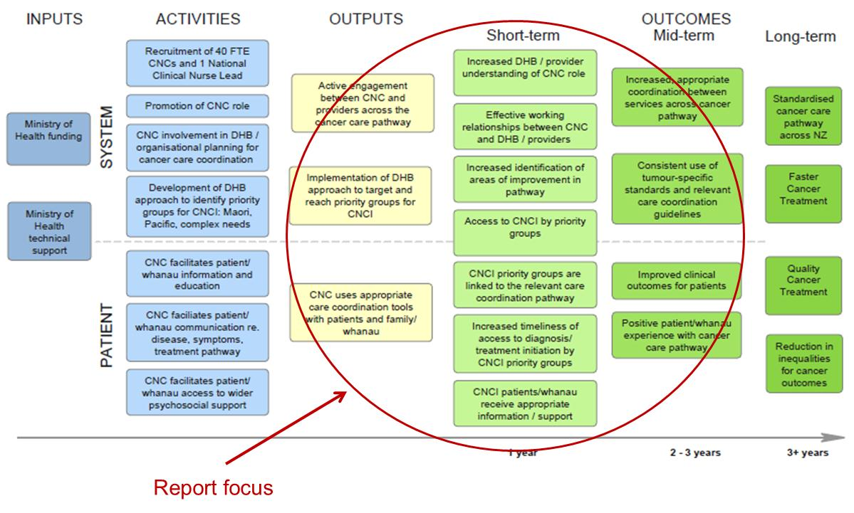

Report draws on range of data sources

Development phase
The development and testing of surveys and CNCI database was completed in April 2014. The surveys and database were distributed to the CNCs in May 2014 with a view to receiving some preliminary data in June for the first annual report and CNC forum.
Refer evaluation plan for description of methods and CNCI website for tools; tools pretested and informed consent procedures used.
CNCI database provides information about the activity and function of the nurses such as patients accessing CNCI, meetings attended by CNCs, tools used and system initiatives. CNCI database distributed to each CNC in April 2014 and returned June 2014. Thirty-eight CNCs responded.
- Thirty-three CNCs across 16 DHBs provided information on patient care activity (excludes two system-focused DHBs and includes composite data from one DHB).
- Inpatient profile section of the database, there was variation in time periods completed. To consistently profile patients accessing CNCI, a snapshot analysis for a month period was undertaken.
- Five comprehensive reports on system reviews were received from two system-focused DHBs.
- Thirteen CNCs from 12 DHBs also provided information about systems activity.

CNC online survey which profiles CNCs and their activities, contribution and perceived effect on patient experience:
- n=43; response rate 68%; CNC survey profile in Appendix 1.

Provider online survey to assess understanding and perceived effects of CNC role:
- n=485 across 20 DHBs; provider survey profile in Appendix 1.

Patient survey to assess patient experience of new role and its contribution:
- n=204 across 13 DHBs: patient survey profile in Appendix 1.

Qualitative interviews with three Māori, three Pacific and three Pākehā patients in three DHBs to understand their experience of CNCI. Kaipuke undertook the qualitative research with Māori patients, and integrity professionals with Pacific patients.

Data sources | Quality | Comments on quality
CNCI database | Low | Incomplete DHB and CNC coverage: In the time available not all CNCs across all DHBs completed or returned the database.  Incomplete and inconsistent data:  - Missing data in databases completed (eg, system log not completed in all completed databases; this may reflect incompletion or no system initiatives).  - Variation in data completion.  - Some categories need review as not meaningful (eg, travel codes).  - Not known if data validated.  Limited time period: for patient profile analysis a ‘one-month’ period was used and the month completed varied by CNC (ie, some completed April, others May).  Note: Quality of data will increase if database is consistently completed.
CNC survey | High | –
Provider survey | Medium | Potential selection bias: providers selected by CNC to reflect engagement; CNCs distribute survey.  Potential focus on CNC performance: Use of photos to identify CNC (from other nurses) may create focus on individual performance and not initiative; without photos unknown if providers are focusing on CNCI or other cancer nursing services.
Patient survey | Low | Potential selection bias: Patients and whānau selected by CNCs as may not be clinically appropriate for patients to receive questionnaire.  Exclusions: Patients with high suspicion currently excluded due to questionnaire design (under review).  Incomplete DHB coverage: Excluding the system-focused DHBs, patient surveys were not received from five DHBs; completion rates varied across DHBs (ranged from 1 to 40); response rates unknown.  Note: Quality of data may increase as more CNCs distribute the patient survey across all DHBS excluding system-focused ones.
Qualitative patient interviews | Medium | Sample size: undertaking three Māori, three Pacific and three Pākehā patient interviews means that not all patient experiences will have been identified. However, it is anticipated that significant themes have been identified.  Targeted sub-groups: This approach offers no understanding of other groups’ CNCI experiences or address the diversity of Māori or Pacific patients.

Report structure
Each findings section corresponds to noted components of the CNCI outcomes model.

The first chart presents a summary of key findings for this section; the following charts present the evidence.

Findings have been presented at a total level as data quality limits analysis by key sub groups.

In future annual reports (assuming data quality has improved), results will be presented by (as appropriate) by CNCI models Generalist, Tumour Stream, System-focused and population.

Graphs are coloured coded to differentiate:
- CNC are green
- providers are blue
- patients are purple.

CNCI profile

Overview of CNCI profile
Four CNCI approaches:
- Generalist, Tumour Stream, System-focused and Population
- System-focused CNCI approaches have no patient interface and appear to be less satisfying for CNCs
- variation in CNCI models adopted as implementation responding to DHB population needs, existing care pathways and nursing structures.

Sixty-five CNCs – very experienced nurses, respected cancer expertise and leadership, settling into role.

Most CNCs in permanent roles.

CNCs’ daily activities focused on care coordination (excludes System-focused DHBs):
- communicating with health professionals about patient care management, ensuring patients have timely access to services and effective and timely care coordination for patients.

As reflects intent of CNCI, system improvement activities and direct nursing care are less frequent activities (excludes System-focused DHBs were this is a daily role).

Key enablers of the CNCI are building on existing nursing strengths; IT systems both an enabler and barrier.

Overview of the four CNCI approaches
1. Generalist: Specialist nurses who focus on care coordination for all cancer patients in the region. Generalist CNCs tend to be individual roles based in small DHBs. These CNCs have a strong focus on the front of the pathway. They work with patients considered most at-risk of experiencing problems with care coordination and they are closely linked to Faster Cancer Treatment (FCT) work programmes and systems improvement.
2. Tumour stream: Specialist nurses responsible for care of patents in a particular tumour stream. There are two sub-categories:
a. Tumour stream coverage: Where a DHB does not have full CNS coverage in all tumour streams, a CNC is placed in a tumour stream where there is no existing CNS. While a focus of this role is facilitating care and treatment in a specific part of the patient journey (much like a CNS), the CNC also prioritises care coordination activity particularly from a systems perspective and supports the implementation of this across the whole CNS team.
b. Front of pathway: The CNC supports patients with high suspicion of cancer at the front of the pathway and facilitates their transition to an established CNS or another identified health professional where they are in place. These CNCs also identify and address systems improvements associated with the front of the pathway.
3. Population focus: Specialist nurses focus on reducing barriers to care through working with a specific population such as Māori, Pacific and Asian patients. These CNCs are a key point of contact at the front end of the pathway, and are focused on improving equity.
4. Systems approach: The focus of these roles is system improvements in key areas of care that support coordination such as equity, multidisciplinary care and supportive care. Adopted by Capital & Coast and Auckland DHB the CNC role was defined as identifying gaps in service delivery and undertaking projects around the tumour pathway.

The system-focused CNCI approach has no patient interface and feedback from the nurses in the roles suggest it is less satisfying for CNCs. Both DHBs are reconfiguring these roles: Auckland DHB to tumour stream; Capital & Coast to front of pathway.

CNCI – variation in implementation responding to DHB population needs, existing care pathways and nursing base
Type | District Health Board | Number of CNCs  65 | More than the funded number of positions as some DHBs use a whole-of-systems approach so includes other nurses (ie, Counties Manukau, Waitemata).  These DHBs tend to have a lead CNC to inform other nurses’ practice on meeting the CNCI requirements. The lead CNC participates in regional and national CNCI activities.
System | Auckland | 3
 | Capital & Coast | 3
Tumour stream | Counties Manukau (population and CNCI lead) | 14
 | Waitemata (population and CNCI lead) | 13
 | Waikato (equity-focus) | 5
 | Canterbury | 4
 | Northland | 4
 | MidCentral | 2
Generalist | Hawke’s Bay | 2
 | Hutt Valley | 2
 | Southern | 3
 | Lakes | 1
 | Nelson Marlborough (CNCI lead) | 2
 | South Canterbury (CNCI lead) | 1
 | Bay of Plenty | 1
 | Taranaki | 1
 | Tairawhiti | 1
 | Wairarapa | 1
 | West Coast | 1
 | Whanganui | 1

CNCs very experienced, respected, settling into role
Highly experienced CNCs:
- 88% over 11 plus years; 51% more than 20 years
- 72% postgraduate qualification.

Fifty-eight percent been in role more than 12 months:
- 35% 6–12 months
- 7% less than 6 months.

Ninety-three percent are permanent roles.

Seventy percent on 0.7–1 FTE:
- 37% are on a 1 FTE
- 19% 0.5 FTE or less
- 19% other position in DHB.

Agreement CNCs have cancer expertise and leadership:
- 67% agreement providers (source provider survey)
- 89% agreement CNCs.

Source: CNCs who answered the survey (n=43); refer Appendix 1.

CNCs and providers perceive role offers cancer expertise and leadership; providers rated tumour stream CNCs higher than generalist CNCs on cancer expertise and leadership
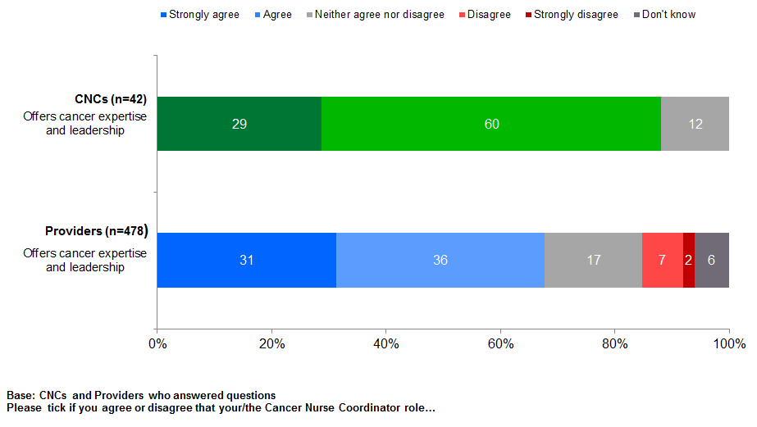

Care coordination role a daily activity (except for system-focused roles)
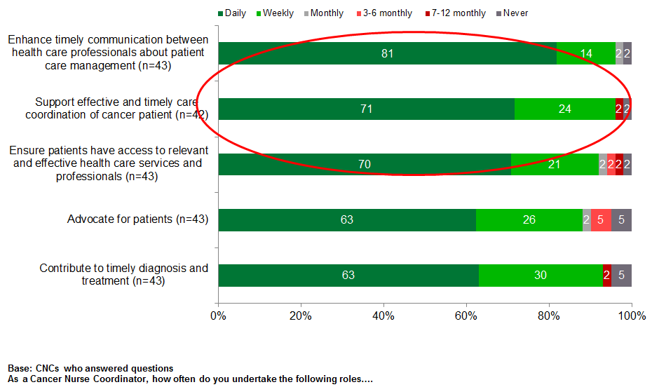

System improvements and direct nursing care present but less frequent activities
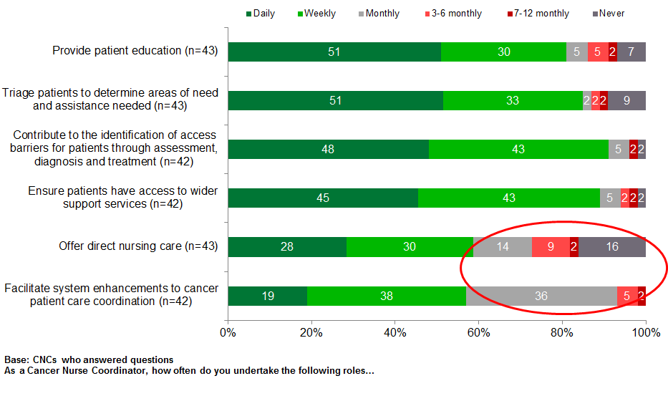

Nursing expertise an enabler for CNCI implementation; IT is an enabler and barrier
Enablers | Barriers
Multidisciplinary governance groups to create wider provider buy-in  Building and strengthening existing nursing structures particularly around CNS roles  Role location to enable early access to patients (ie, where patients are referred into the DHB)  IT capacity and capability to monitor patients’ journey  CNCI is a nursing initiative so able to offer patients and their whānau clinical nursing support and contribute to MDMs  CNC regional and national network fosters connections within and across DHBs  CNCI tools enable practice (eg, triage tool)  Input at MDMs  CNCI nurse lead | Establishing awareness and understanding of CNCI amongst other health professionals  Managing the range of activities including managerial, administrative, IT and reporting  Lack of IT support/ too much data collection for a range of purposes which are not interlinked  Geographical reach in rural areas  Lack of resources/ capacity  Identifying eligible patients
Source: CNC survey refer Appendix 4; provider survey refer Appendix 5.

 | Engagement and patient profile
Outputs |  | Short-term outputs  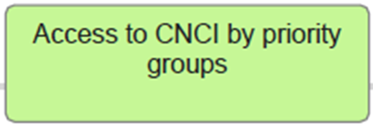

Provider engagement and patient profile
Evidence of engagement with providers across the cancer pathway:
- Refer Appendix 1 for providers who engaged with CNCs and completed survey and for providers’ location compared to location of CNC they engaged with.

Triage tool being used to assess patients by 31 CNCs across 15 DHBs (refer Appendix 6 for draft triage tool).
- Distress Screen & Comprehensive Assessment to be developed.

Surgeons and physicians make half the referrals in 15 DHBs (31 CNCs); 9% of patient referrals are from primary care.

Evidence of some priority groups accessing CNCs (indicative only as data from CNCI databases incomplete across DHBs and CNCs):
half of CNC patients classified as Triage 1 and 2
- Māori represented (13%) but not known if this is an under- or over-representation due to incomplete data
- No evidence Pacific people are accessing CNCs due to missing data from one DHB with higher Pacific populations and two DHBs with high Pacific populations are system-focused.
- DHBs targeting strategies not known – prioritisation tool under-development.

Half of patient referrals in 15 DHBs are from surgeons and physicians; 9% from primary care
Referrer  Base: Patients for which referrer details were completed in CNCI database | Number  n=527 |  | %  n=527
Surgeon | 206 |  | 39%
Physician | 81 |  | 15%
GP | 55 |  | 10%
Systems referral (eg, lab result or review of admission database) | 50 |  | 9%
Booking clerk / administrative | 34 |  | 6%
Other nurses | 26 |  | 5%
MDM | 21 |  | 4%
CNS | 20 |  | 4%
Source: CNCI database of 600 patients for 31 CNCs across 15 DHBs for one-month period. |  | 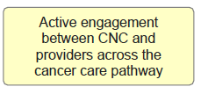

Māori patients and those assessed as triage 1 and 2 accessed CNCI; Pacific patients not present |  |  |  |  | 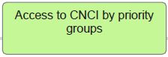
 | Due to data quality issues, we are unable to assess if Māori patients are under- or over-represented.
 | Ethnicity | Number  n=639 | %
 | Māori | 82 | 13%
 | Pacific people | 7 | 1%
 | NZ European | 461 | 72%
 | Chinese | 10 | 2%
 | Indian | 3 | 0%
 | Other ethnicity | 52 | 8%
 | Not coded | 23 | 4%
 | Pacific patients are not represented which reflects missing data from one DHB with high Pacific populations; two DHBs are system-focused and CNCs do not have patients.
Source: CNCI database of 639 patients for 33 CHCs across 16 DHBs for one-month period.

Triage | Number  n=600 | %
1 | 95 | 16%
2 | 207 | 35%
3 | 175 | 29%
4 | 57 | 10%
Not coded | 66 | 11%

Triage  Māori | Number  n=75 | %
1 | 11 | 15%
2 | 41 | 55%
3 | 17 | 23%
4 | 5 | 7%
Not coded | 1 | 1%
Source: CNCI database of 600 patients for 31 CNCs across 15 DHBs for one-month period.

Older patients accessing CNCI
Age range | Number  n=639 | % |  | Biological sex |  | Number  n=639 | %
15–24 years | 5 | 1% |  | Female |  | 330 | 52%
25–34 years | 19 | 3% |  | Male |  | 306 | 48%
35–44 years | 27 | 4%
45–54 years | 56 | 9%
55–64 years | 120 | 19%
65–74 years | 201 | 31%
75+ years | 180 | 28%
Not coded | 31 | 5%
Source: CNCI database of 639 patients for 33 CHCs across 16 DHBs for one-month period.

Two-thirds of patients (where there was data) were referred to CNCs in under a month; a third in less than a week
Time from referral to DHB and referral to CNC | Number  n=486 | %  n=486
Within 1 week | 177 | 36%
More than 1 week, within a fortnight | 61 | 13%
More than a fortnight, within 1 month | 73 | 15%
1–3 months | 85 | 17%
3–6 months | 45 | 9%
6–12 months | 23 | 5%
1–2 years | 7 | 1%
2–5 years | 8 | 2%
5+ years | 7 | 1%
Source: CNCI database of 600 patients for 31 CNCs across 15 DHBs for one-month period; for 114 patients this data was not completed.

Knowledge of CNCI role
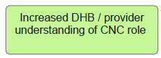

Understanding of CNCI role building amongst providers but more work to do to increase understanding and fit of role
Two-thirds CNCs perceive their role is not well understood by health professionals:
- Qualitative feedback from CNCs highlights relationships building with other health professionals is both their biggest success and greatest challenge.

Most providers understand CNC role is about care coordination, timely communications, patient advocacy, service access and system improvement.

Less agreement by providers that CNC role enables timely diagnosis and provides direct nursing care:
- as providers were selected by CNCs, it would be expected their understanding of the CNC role would be high. It likely non-responders to the provider survey may have less understanding about the role, which would reflect the CNCs’ perceptions
- providers’ suggestions to improve CNC role reflected a lack of understanding of the criteria for the CNC role, and the boundaries with other health professional roles (refer Appendix 5).

Four in ten of CNCs perceive their role is not understood by other health care professionals
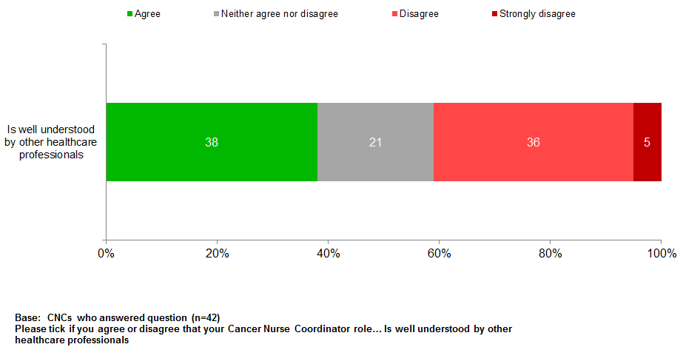

Providers who responded to survey understood CNC role about care coordination, timely communications, patients advocacy, service access and system improvement
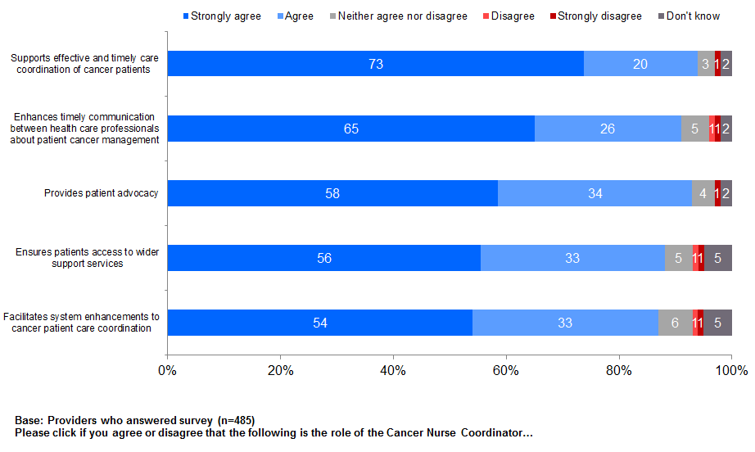

Less agreement by providers that CNC role enables timely diagnosis and provides direct nursing care
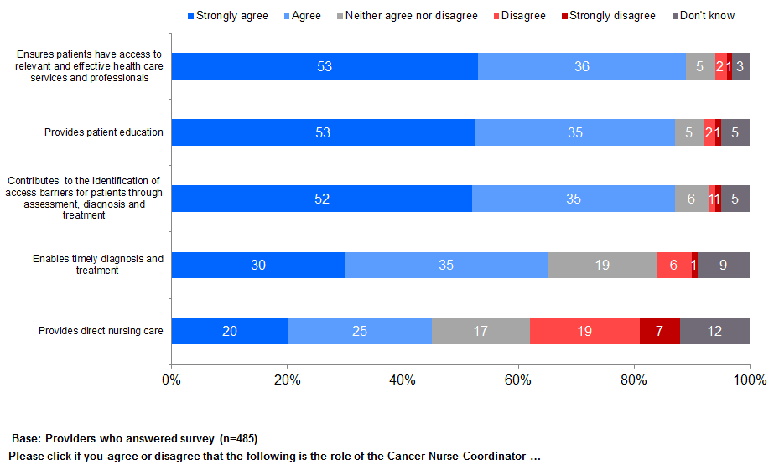

Relationship between CNC and providers
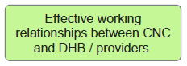

Evidence of effective working relationship with health professionals engaged
Majority of CNCs and providers surveyed note an effective working relationship.

Most providers who responded to survey agreed:
- CNCs improve communication about patient care management
- CNCs are important team member:
- a third of CNCs do not agree with this which may reflect their awareness of those health professionals who do not understand their role.

Over half of providers feel CNCs alleviate clinical workload by providing patient education and reduces DNA events:
- Providers who answered survey are more likely to agree Tumour Stream CNCs alleviate clinical workload (67% agree/ strongly agree) than Generalist CNCs (54%).

Only two in ten providers agree CNC role duplicates other roles and services.

CNCs agree they work effectively with other health professionals; some uncertain about team role and alleviating clinical load of other health professionals
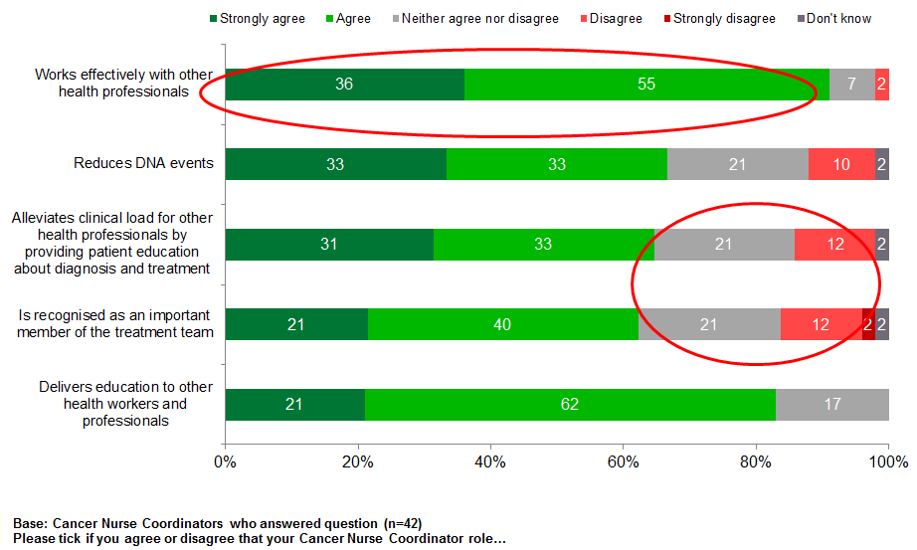

Providers agree there is an effective working relationship with CNCs; CNCs not duplicating other roles
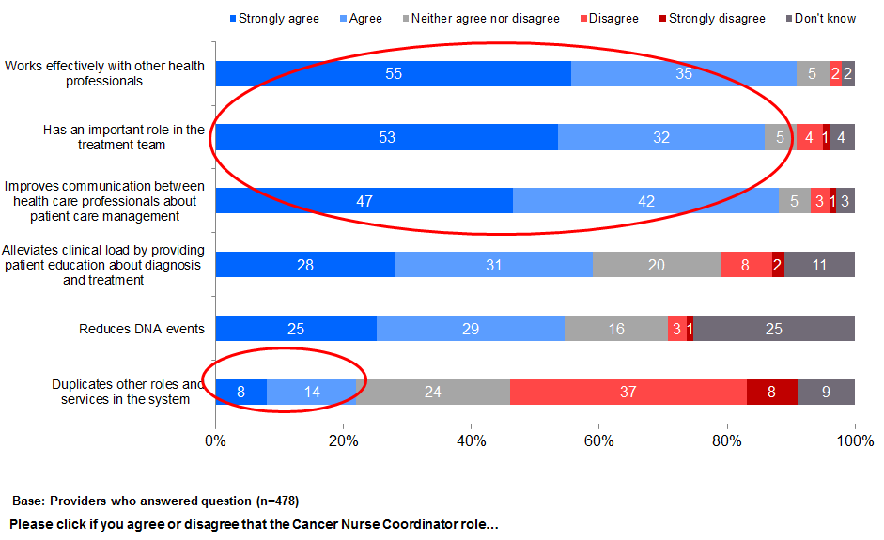

Providers feedback on strengths (CNC is single point of patient contact) and improvements (more CNCs and clarification of role)
Best thing about CNCs | Improvements to CNC role
Dedicated person tasked with patient oversight  Patients having a single point of contact  Improved coordination of patient cancer pathway and treatment process  Improved communications and relationships across health professional team  Facilitates system enhancements by identifying and addressing service delivery barriers and gaps | Increase FTE and number of CNC roles  Clarification of criteria for CNC role  Better clarification of role boundaries in patient cancer pathway  Increase awareness and understanding of CNC role with other health care professionals  Better clarification of cancer patient criteria for CNC service
Source: Provider survey refer Appendix 5.

Contribution to system improvements
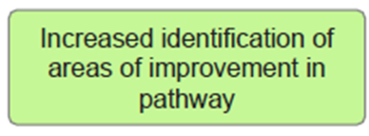

Evidence CNCs are identifying system issues in system-focused DHBs and Generalist and Tumour Stream DHBs
Most CNCs and providers both agree that the CNC role is identifying system barriers to patients’ cancer care coordination and facilitating enhancements.

In the two system-focused DHBs, a range of projects have been initiated around pathway mapping against standards, supportive care, concurrent treatment and MDMs:
- some evidence of system change; impact on patient experience not known.

CNCs in 12 DHBs have also focused on equity projects, referral pathways across DHBs, patient information, and patient tracking:
- system change is occurring in these DHBs, the effectiveness of the system projects to create sustainable change is not known.

The extent to which CNCs in the remaining six DHBs are identifying system improvements in care coordination and patient pathway is not known.

CNCs and providers agree CNCI contributes to identifying system issues and facilitating change
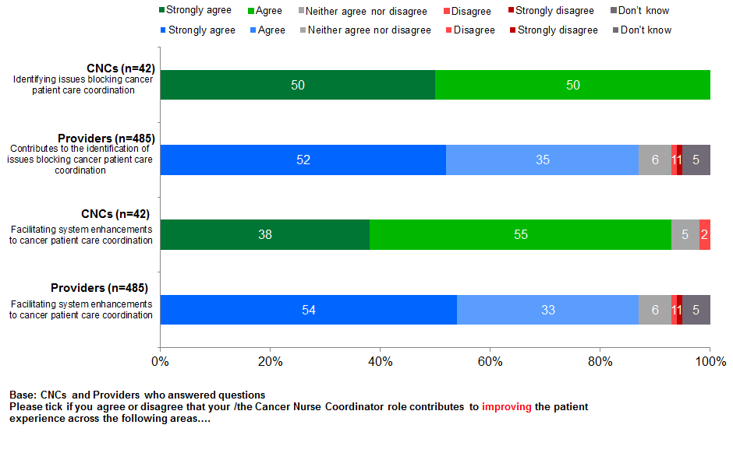

CNCI system roles (two DHBs): analysing and supporting system change

Pathway map and standards review
- Mapped pathway for patients with CRC and lung cancer from high suspicions to first treatment and identified barriers and system improvement, and set up CR and lung tumour working groups.
- Understanding patient experience from diagnosis under GP care through to first treatment.
- Established working groups to implement best practice in the total management of bowel and lung cancer.
- Regional review against National Bowel and Lung Cancer Standards.
- Developed head and neck treatment pathways.

Supportive care projects
- Tested the acceptability and feasibility of a psychosocial screening tool.
- Implemented supportive care screening across all tumour streams.
- Integrated Shared Care into Cancer and Blood Service to facilitate patient self-care management and improve information visibility between primary and secondary care.
- Developed oncology specific communications skills programme for health professionals.

CNCI system roles (two DHBs): analysing and supporting system change

Multidisciplinary care
- Tele-health solution to support Cancer MDM.
- Cancer MDM stocktake and gap analysis.
- Gynae-oncology combined MDM.
- MDM Terms of Reference.
- Scoped and developed administrative support role for MDMs.

Concurrent treatment
- Removing communication barriers Medonc and Radonc schedulers.
- Integrated referral pathway to remove risk of delays and process variance.
- Combined clinics to reduce the number of patient appointments.
- Referral process.

Other CNCs in 12 Generalist and Tumour Stream DHBs focused on system projects
13 CNCs from 12 DHBs noted their involvement in the following system projects
Equity projects (Screening for Distress, DNAs, National Travel Assistance, improving cancer care pathway for Māori)
Referral process – secondary care
Referral process – primary care
Regional patient tracking system
Review of patient pathway and experience
Patient information resources
Professional development programme for other nurses working with patients and whānau effected by cancer
Multiple site; one service model (eg, MDM)
Increase understanding of tumour standards; review
Develop protocols and tools (eg, electronic patient record template, DNA, Screening for Distress and Triage)
Improve communication processes to ensure timeliness of support and services
FCT data

Coordination of patient pathway
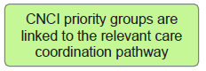

CNCs contributing to a more coordinated patient journey
Nine in ten patients agreed CNCs helped them to know the next steps in their treatment:
- Qualitative interviews with patients highlighted a key benefit was the ability of the CNC to proactively help them navigate the complexity of cancer services and clashing appointments at a time when they were tired, stressed, and physically and emotionally unable to cope with this additional burden.
- CNCs’ internal knowledge were seen as enabling them to negotiate and facilitate patients’ progress along the pathway particularly when they needed to travel across DHBs boundaries.

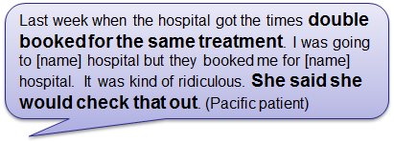 | 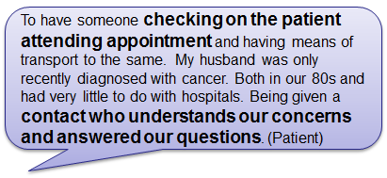

Most CNCs and providers agreed the CNCI has contributed to improving patient experience by enabling a more coordinated cancer journey and ensuring they know the next steps in their treatment.

CNC the ‘go to person’ so know next steps; explained in way patients and whanau understood
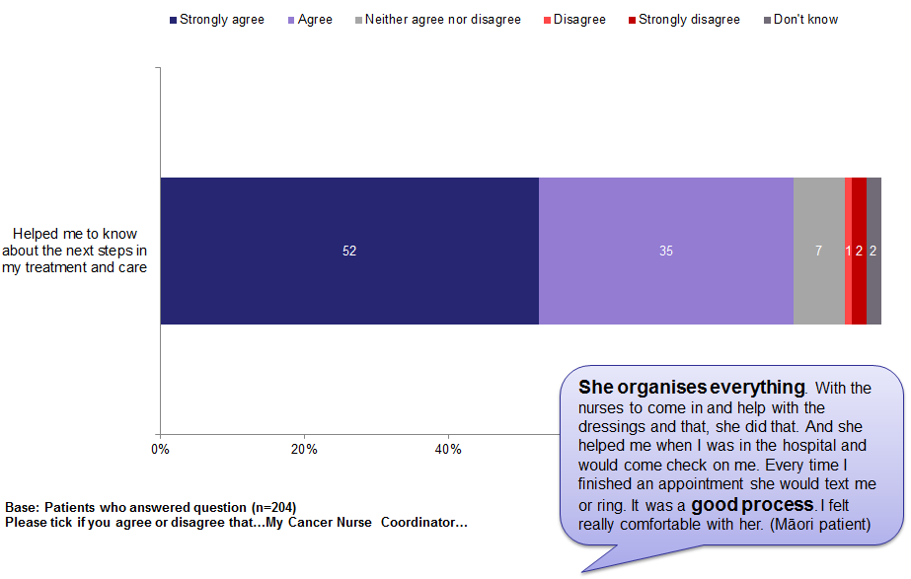

CNCs contribute to more coordinated patient journey
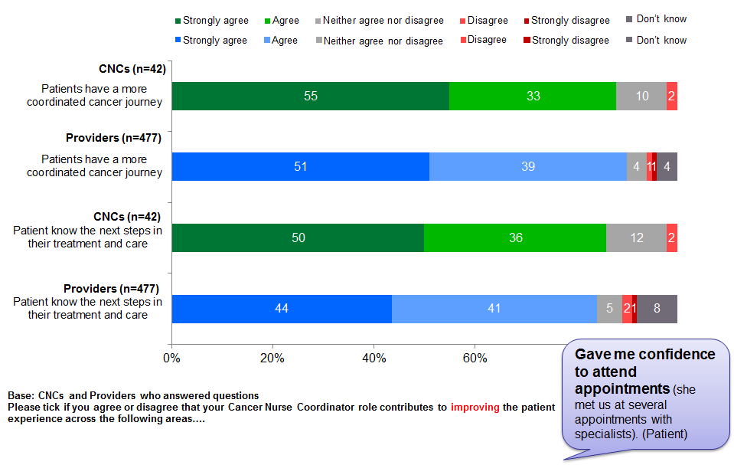

Contribution to timely diagnosis and treatment
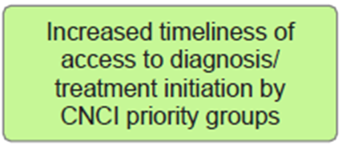

Agreement amongst patients, providers and CNCs the role helps to facilitate timely appointments
Currently there are no ‘hard’ measures on patients’ increased timeliness and access to diagnosis and treatment.

As timeliness is subjective, patients were asked whether the CNC explained the appointment process and likely timeframes – most CNCs did.

CNCs agreed they contribute to timely diagnosis and manage patients’ appointment expectations.

Providers also acknowledged the CNC role in facilitating appointments; however they are less certain about contribution to ensuring timely diagnosis. The latter may reflect there are a range of factors contributing to a timely diagnosis beyond the influence of the CNCs.

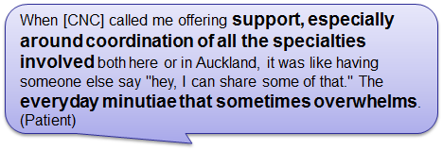

Patients aware of appointment and test process and likely timeframes
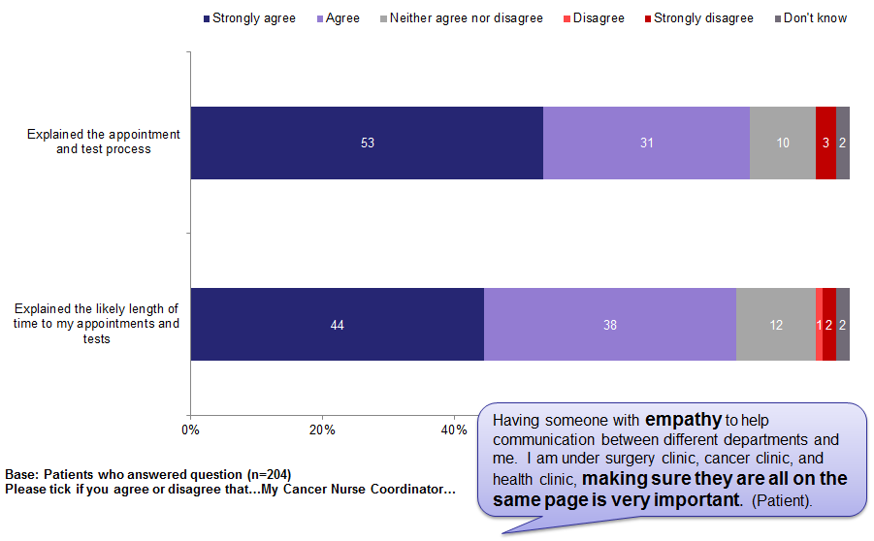

CNCs contribute to timely diagnosis and process expectations; providers acknowledge CNC role in facilitating timely process; less so timely diagnosis
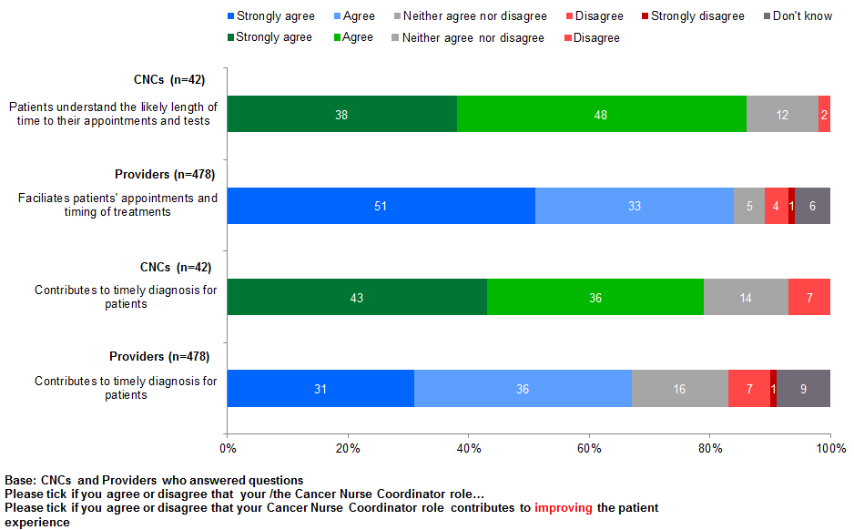

CNCs linking to other services
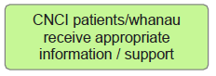

Patients are mainly getting the services they need; however a few do not
Cancer Nurse Coordinator helped with ...  Base: Patients who answered the question and said they needed the service | Patients who did not receive help from CNC when needed
 | Number | %
Services to help with my worries, fears or emotional issues (n=70) | 9 | 13%
Services I needed, eg, nurse specialists, physios, culturally appropriate groups (n=94) | 11 | 19%
Services about transport to and from treatment appointments (n=77) | 8 | 12%
Services to help me with financial support (n=58) | 4 | 5%
Written information and resources about my cancer (n=113) | 5 | 14%

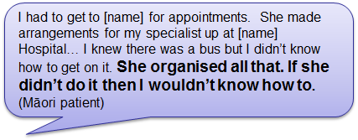

Qualitative feedback suggests young solo mums are not getting the support they need, particularly when they have limited family/whānau support (ie, childcare, meals).

CNCs and providers both agree that CNCI improves the patient experience by connecting them to other services as needed
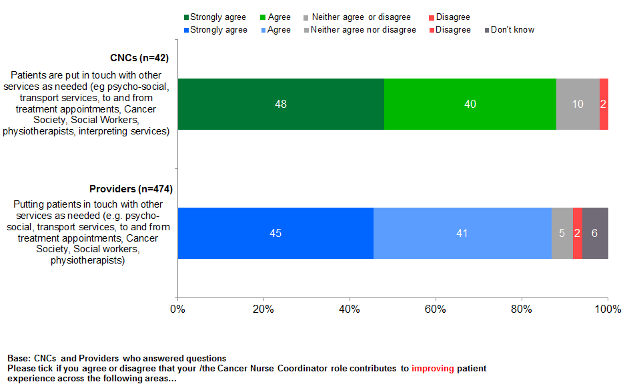

Improving patient experience
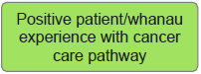

Positive patient experience: CNCI valued and making a difference to patients and their family/whānau
Being diagnosed with a high suspicion of cancer or cancer is extremely traumatic for people and their family/whānau. It is a time when people may be physically unwell and tired and they and their family/whānau are emotionally fragile and stressed. People and family/whānau, who have little exposure to the health system, can find the diagnosis process bewildering, particularly if they have other health or social needs.

In this context, patients describe their CNC as their ‘go-to’ person who enables the coordination of the process by ensuring appointments are set up, and they can access their appointments. For patients, CNCs’ clinical nursing expertise underlie the benefits they gain from the role, by having an expert who understands what they are going through, able to explain clinical information in lay terms, knowledgeable about next steps in care and how to navigate the system to ensure they occur, and being aware of other support services and how to access.

For patients, the CNC role is much more than an administrative navigation role. Having a CNC resulted in patients being more confident about what is happening and when, knowing more about their cancer and treatment, and having their family/whānau involved as wanted.

Feedback suggests being referred to the CNC early in the diagnosis process maximises patients’ benefits. Although for some patients with a high suspicion of cancer being referred to a CNC can be concerning as the word ‘cancer’ in their title can be seen to confirm they have cancer.

Feedback from patients, who have had cancer or experience of cancer services before the initiative, suggests the introduction of CNCs has enhanced their and their family/ whānau service experience compared to their pre-CNCI experience.

Patients surveyed were mainly happy with the role. Only two improvement areas were noted: more regular face-to-face contact and more CNCs (refer Appendix 3).

These benefits were also noted by CNCs and providers, although compared to patients and providers, CNCs are less likely to strongly agree patients are more confident about what is happening.

While overall ratings of CNCs is high, areas to strengthen going forward are respecting culture, values and beliefs, helping family/whānau, and involving patients in decisions about their cancer and treatment.

CNCI – better than before, a go-to person for whole family/whānau, emotional support, reassurance and a sense of certainty
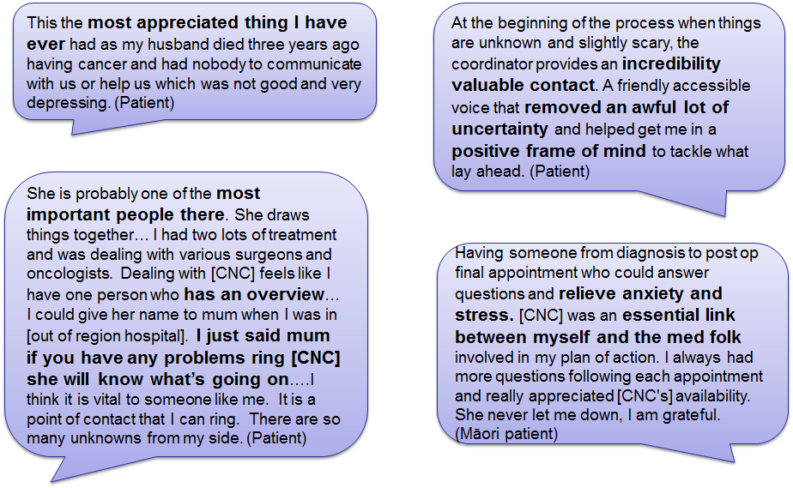

Māori patients’ positive CNC experience
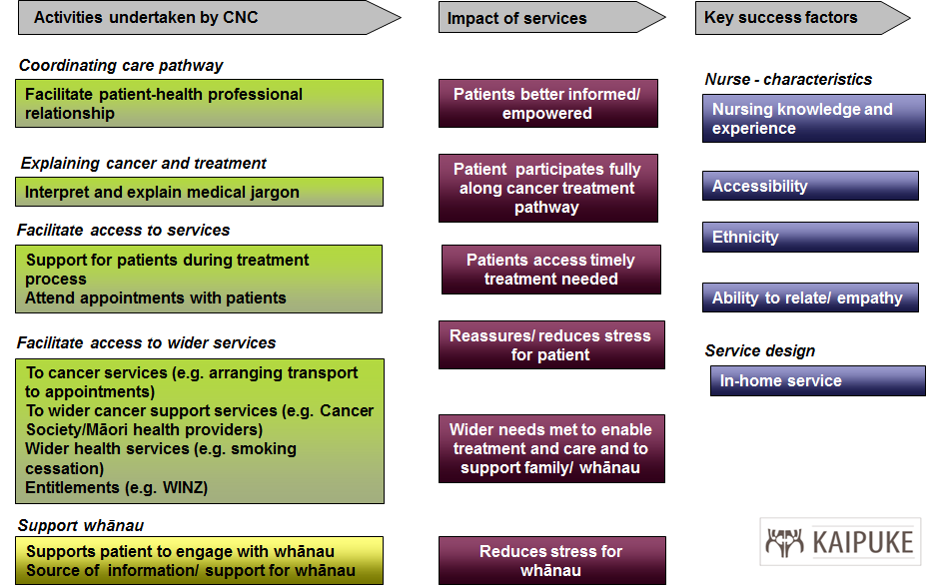
Source: Qualitative interviews with Māori patients.

Māori patients’ feedback
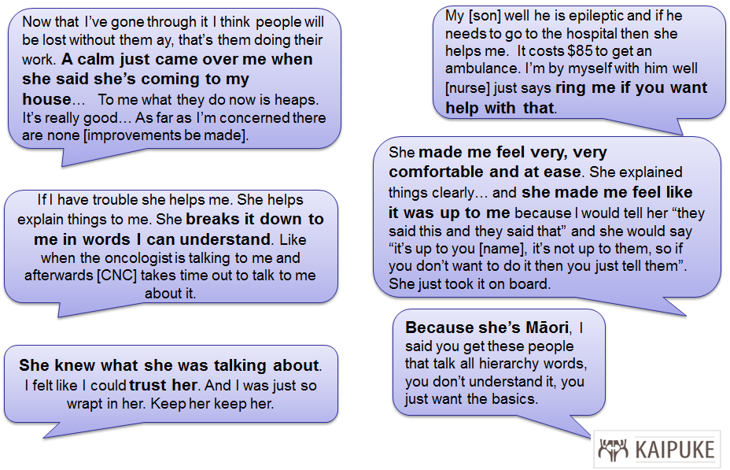

Pacific patients’ positive CNC experience
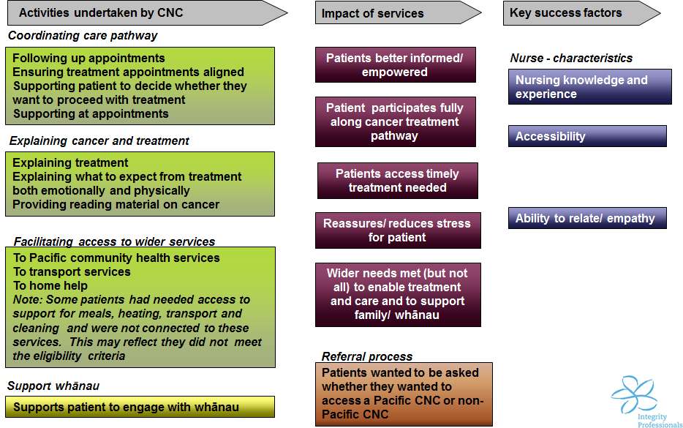
Source: Qualitative interviews with Pacific patients.

Pacific patients’ feedback
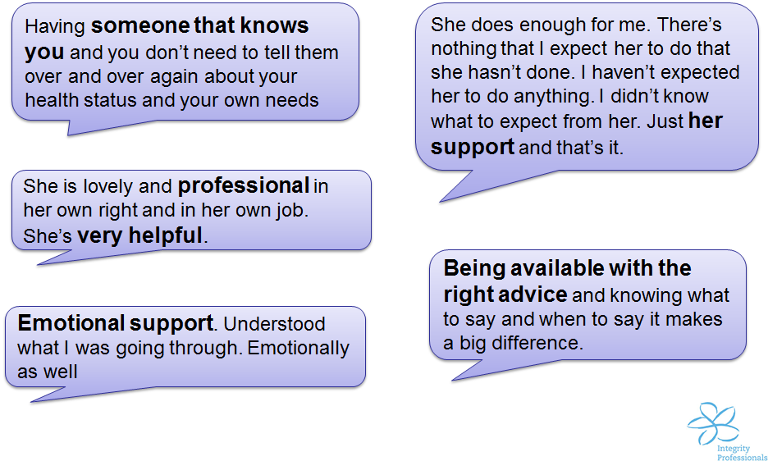

Meeting patients’ cultural and belief needs; not rated as highly as other attributes; room to improve linking to other services for Māori patients
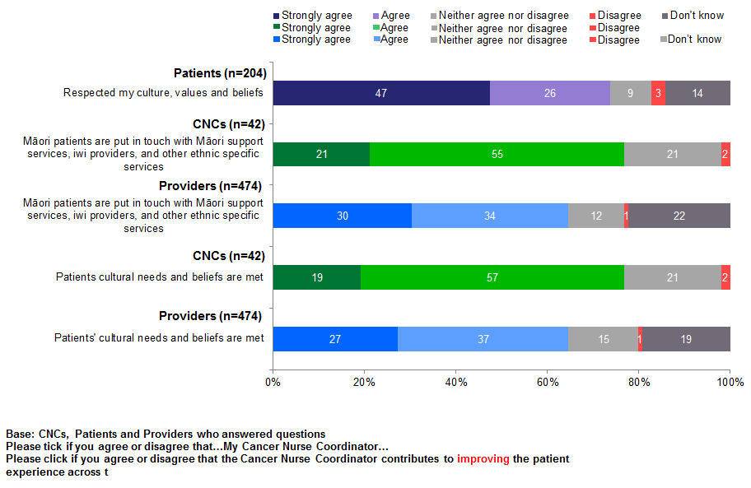

Referral to Māori support services the key activity used by CNCs to improve the experience of Māori patients and their whanau in the cancer pathway
What are the two most important activities you undertake in your Cancer Nurse Coordinator role to improve the experience of Māori patients and their whānau in the cancer pathway?  Base: number of CNC who answered question; multiple response | n=42  %
Referral to Māori support services | 57%
Cultural awareness and acknowledgement, if appropriate | 21%
Explaining and mapping patient cancer pathway | 19%
Ensuring timely and accessible contact and communication | 19%
Inclusion of whānau | 17%
Coordination of care/transport/appointments | 17%
Identification of barriers | 10%
Education (non-specific) | 7%

Strong agreement by patients that CNCs listen, answer questions, are accessible and offer support
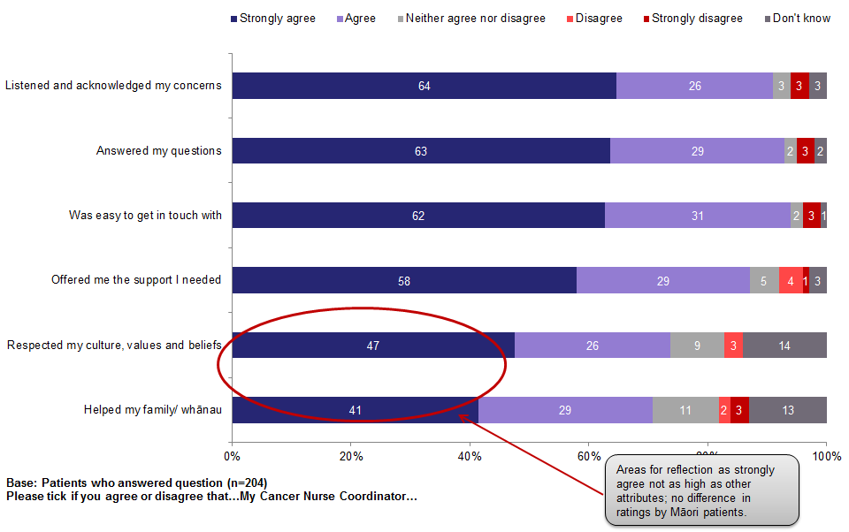

Patients agree CNCs make them feel confident about what is happening and to know more about their treatment and care
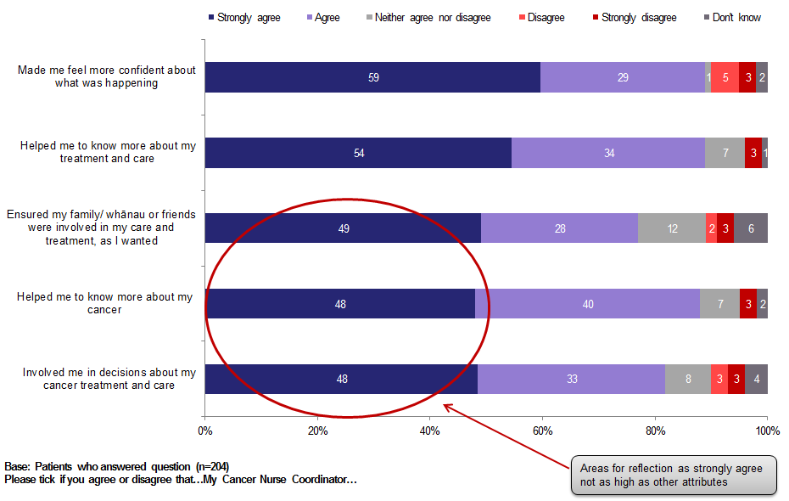

CNCs perceive patients know more about treatment, care and cancer, but not so confident and not involved in decision-making
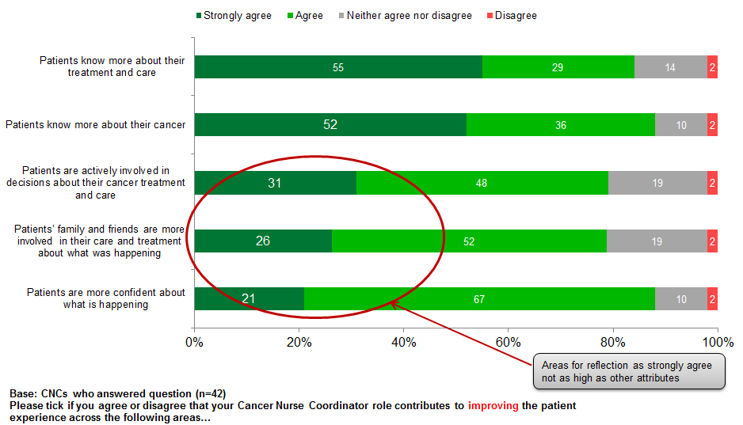

Providers agree CNCs improve patients’ knowledge about their treatment, care and cancer, and are more confident about what is happening
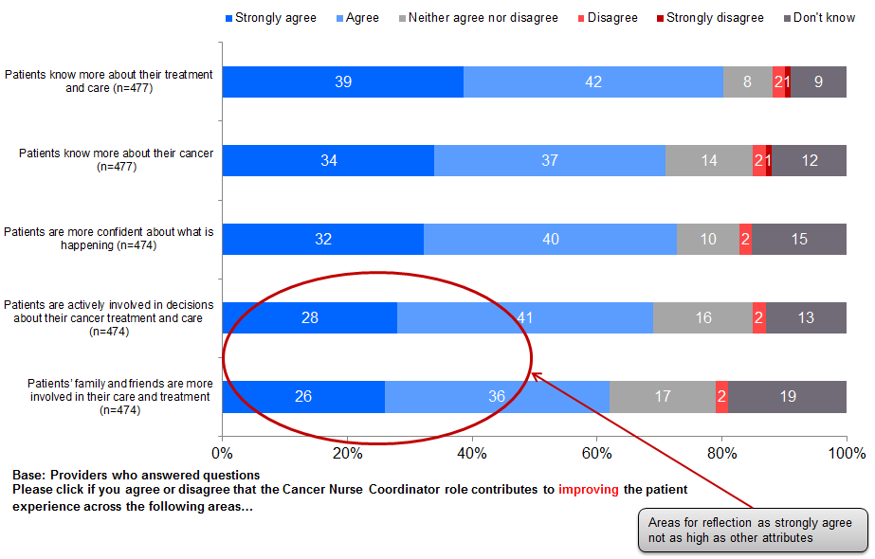

Conclusions

Conclusions against success criteria

Implementation status
Providers have an improved understanding of CNC role.

CNCs have an effective working relationship other health professionals; CNCs recognise more work to do in ensuring wider understanding and more clarity about role and its boundaries.

CNC is a key and very valued contact for patients and family/whānau.

Success criteria
Indicative evidence suggests CNCI delivering against purpose; not known if this is consistent across all DHBs:
- targeting Māori and those with complex needs (extent across DHBs not known) ; not known if Pacific people with cancer are accessing CNCI
- positive patient experience
- perceived by providers surveyed as contributing to improved access and timeliness of access; patients feel care is coordinated
- system issues are being identified and acted on in some DHBs (not known for seven DHBs). Not known if system change actions will have positive impact on patients.

Areas to focus
- Patient access to support services.
- Ensuring patients’ cultural needs met and linked to appropriate services.
- Facilitating patients’ involvement in their treatment and care decisions.

Evaluation reflections

CNCI database
- Review to enhance useability, particularly the category that identifies if patients experience issues with travel.
- Discussion with DHBs who did not complete or provide data solutions to ensure data for future reports.

Patient survey
- Determine the inclusion of high suspicion patients; will require patient questionnaire to be revised.
- Review distribution method and frequency (ie, point in time or ongoing).

Provider survey
- Review distribution and responses from providers interfacing with multiple CNCs across DHBs.
- Agree distribution time.

DHB level report
- Litmus to prepare 15 DHB dashboard reports (5 DHBs have no or insufficient data to develop a dashboard report).

Appendices

Appendix 1: CNC survey profile
Profile  Base: answered CNC survey |  | Number  n=43 | %  n=43
Years qualified as a nurse | 5–10 years | 5 | 12%
 | 11–15 years | 9 | 21%
 | 16–20 years | 7 | 16%
 | Greater than 20 years | 22 | 51%
Highest nursing qualification | Registered Nurse | 4 | 9%
 | Bachelors Degree | 8 | 19%
 | Postgraduate Certificate | 15 | 35%
 | Postgraduate Diploma | 10 | 23%
 | Masters Degree | 6 | 14%
Professional groups  (multiple choice questions; adds to more than 100%) | NZNO | 38 | 88%
 | NZNO Cancer Nurses Section | 28 | 65%
 | NZNO College of Practice Nurses | 3 | 7%
 | Cancer Nursing Society of Australia | 2 | 5%
 | Oncology Nursing Society | 4 | 9%
 | Other | 9 | 21%
Ethnicity | Māori | 2 | 5%
 | New Zealand European | 35 | 81%
 | Other | 6 | 14%

CNC survey profile
Profile  Base: answered CNC survey |  | Number  n=43 | %  n=43
Length of time in role | Less than 3 months | 2 | 5%
 | More than 3 months and less than 6 months | 1 | 2%
 | More than 6 months and less than 12 months | 15 | 35%
 | More than 12 months and less than 24 months | 21 | 49%
 | More than 24 months | 4 | 9%
Permanent or fixed term | Fixed term | 3 | 7%
 | Permanent | 40 | 93%
FTE | 0.1 | 1 | 2%
 | 0.2 | 0 | 0%
 | 0.3 | 2 | 5%
 | 0.4 | 1 | 2%
 | 0.5 | 4 | 9%
 | 0.6 | 5 | 12%
 | 0.7 | 3 | 7%
 | 0.8 | 2 | 5%
 | 0.9 | 9 | 21%
 | 1 | 16 | 37%
Nursing position in same DHB | Yes | 8 | 19%
 | No | 35 | 81%

Provider sample profile
Positions  Base: Answered Provider survey | Number  n=485 | %  n=485
Administration support | 47 | 10%
Allied health and NGOs | 30 | 6%
Māori/Pacific/Asian providers | 18 | 4%
Primary care | 38 | 8%
Secondary care nurses | 139 | 29%
Senior medical officers | 163 | 34%
System support/management | 31 | 6%
Blank/refused | 19 | 4%

Provider sample profile
Provider DHB locations  Base: Answered Provider survey | Number  n=485 | %  n=485
Auckland | 19 | 4%
Bay of Plenty | 27 | 6%
Canterbury | 104 | 21%
Capital & Coast | 4 | 1%
Counties Manukau | 35 | 7%
Hawke’s Bay | 8 | 2%
Hutt Valley | 5 | 1%
Lakes | 3 | 1%
Mid-Central | 2 | 0%
Nelson-Marlborough | 25 | 5%
Northland | 10 | 2%
South Canterbury | 10 | 2%
Southern | 57 | 12%
Tairawhiti | 41 | 8%
Taranaki | 37 | 8%
Waikato | 38 | 8%
Wairarapa | 13 | 3%
Waitemata | 19 | 4%
West Coast | 8 | 2%
Whanganui | 3 | 1%
Blank | 17 | 4%

Provider sample profile
DHB locations of provider | DHB locations of CNCs | Number  n=485 | %  n=485
Auckland | Auckland | 10 | 2%
 | Counties-Manukau | 1 | 0%
 | Northland | 4 | 1%
 | Waitemata | 4 | 1%
Bay of Plenty | Bay of Plenty | 25 | 5%
 | Lakes | 1 | 0%
 | Waikato | 1 | 0%
Canterbury | Canterbury | 36 | 21%
 | Southern | 1 | 0%
 | West Coast | 1 | 0%
Capital & Coast | Capital & Coast | 1 | 0%
 | Hutt Valley | 1 | 0%
 | Don’t know | 2 | 0%
Counties-Manukau | Counties-Manukau | 35 | 7%
Hawke’s Bay | Hawke’s Bay | 8 | 2%
Hutt Valley | Hutt Valley | 5 | 1%
Lakes | Lakes | 1 | 0%
 | Southern | 1 | 0%
 | Waikato | 1 | 0%
MidCentral | Hawke’s Bay | 1 | 0%
 | MidCentral | 1 | 0%
Nelson-Marlborough | Nelson-Marlborough | 25 | 5%
Northland | Northland | 10 | 2%
South Canterbury | South Canterbury | 10 | 2%
Southern | Southern | 57 | 12%
Tairawhiti | Tairawhiti | 40 | 8%
 | Waikato | 1 | 0%
Taranaki | Taranaki | 37 | 8%
Waikato | Tairawhiti | 3 | 1%
 | Waikato | 35 | 7%
Wairarapa | Wairarapa | 13 | 3%
Waitemata | Waitemata | 19 | 4%
West Coast | West Coast | 8 | 2%
Whanganui | Northland | 1 | 0%
 | Whanganui | 2 | 0%
Did not answer | Did not answer | 17 | 4%

Patient sample profile
Profile  Base: Answered Patient survey |  | Number  n=204 | %  n=204
Ethnicity | Māori | 26 | 13%
 | Pacific | 3 | 1%
 | New Zealand European | 160 | 78%
 | Other | 13 | 6%
 | Refused | 2 | 1%
Gender | Female | 105 | 51%
 | Male | 96 | 47%
 | Refused | 3 | 1%
Age | 20–29 | 3 | 1%
 | 30–39 | 9 | 4%
 | 40–49 | 16 | 8%
 | 50–59 | 38 | 19%
 | 60–69 | 49 | 24%
 | 70–79 | 65 | 32%
 | 80 years or older | 22 | 11%
 | Refused | 2 | 1%
DHB locations | Bay of Plenty | 6 | 3%
 | Canterbury | 40 | 20%
 | Hutt Valley | 2 | 1%
 | Lakes | 12 | 6%
 | Nelson-Marlborough | 1 | 0%
 | Northland | 14 | 7%
 | Southern | 18 | 9%
 | Tairawhiti | 20 | 10%
 | Taranaki | 17 | 8%
 | Waikato | 37 | 18%
 | Waitemata | 6 | 3%
 | West Coast | 27 | 13%
 | Whanganui | 4 | 2%

Appendix 2: CNC training needs
What other training would be the most useful in your Cancer Nurse Coordinator role?  Base: Number of CNC who answered question | %  n=27
Excel | 22%
Postgraduate papers | 19%
Project management | 15%
Process Mapping | 11%
Change management | 11%
Supervision | 11%
Computer skills (general) | 11%
Tumour specific study days and meetings | 7%
Cultural training | 7%
PowerPoint | 4%
Quality improvement training | 4%
Psycho social | 4%
Other | 33%

Appendix 3: Patients’ best things and improvements

For patients CNCs’ availability, oversight and support are key, while improving communications and follow-up as well as more resources are the key improvements
Best things for patients about having CNC  Base: Number of patients who answered question | %  n=179
Availability and ease of contact for questions/results | 30%
Alleviated stress/more confident as someone has dedicated oversight and indepth understanding | 22%
Overall support for patient and family/whānau | 22%
Provided information and educated patient on treatment process/cancer/services using layman terms | 20%
Approachable ‘go-to’ person for patient and family/whānau | 19%
Coordination of appointments, meetings and travel/ensuring timeliness of referrals | 16%
Single point of contact for patient/ identifiable contact person for queries | 12%
Regular contact and communication | 10%

Improvements to CNC role  Base: Number of patients who answered question | %  n=109
More regular communication and improve follow up procedures/ more hands-on contact and less phone calls to support patient and family/whānau | 17%
More CNCs/more resources and supports for CNCs (IT resources, leave cover, training and information resources) | 12%
Better information sharing about patient’s progress on cancer pathway with other health professionals | 6%

Appendix 4: CNCs’ successes and challenges

For CNCs building relationships with other health professionals and facilitating system change both a success and challenge
What are the biggest successes in this role to date?  Base: Number of CNCs who answered question | %  n=41
Building relationships with other health professionals/ being part of a team/increased awareness and use of role by other health professionals | 41%
Identification of system barriers/ Facilitating system enhancements such implementation of tumour stream standards, establishment of patient tracking database and implementation of clinics, and improving cancer pathway for Māori | 35%
Being ‘go-to’ person for patients/supporting patients | 27%
Improved patient care coordination/referral process | 27%
Patient satisfaction | 24%
Improved timeliness (non-specific) | 24%
Input at MDMs/ presenting reviews and reports | 24%
Educating patients | 12%

What are the biggest challenges to date in this role?  Base: Number of CNCs who answered question | %  n=41
Educating other health care professionals about role/ negative perceptions of role from other health care professionals | 44%
Managing intersection of management duties with other role components/workload of administration and reporting duties/unclear role description | 29%
Facilitating system change/changing ingrained attitudes about process (advocating patient-centred approach) | 27%
Not enough FTE/lack of funding/resource | 22%
Coordination of patients through patient cancer pathway/ensuring timeliness of process | 22%
Lack of patient database/IT resources/tracking patients between DHBs | 10%
Identification of eligible patients | 12%

Appendix 5: Providers’ best things and improvements

For providers key strengths of CNCI are having a single point of contact for patient information, improved coordination and improved communication
Best thing about the Cancer Nurse Coordinator role  Base: Number of providers who answered question | %  n=408
Dedicated person tasked with patient oversight/single point of contact for information on patient | 28%
Improved coordination of patient cancer pathway and treatment process | 19%
Facilitates improved communication and relationships with other health care professionals/ ensures smoother interaction and transfer of patients from different DHBs/support for and alleviates workload for other health care professionals | 17%
Provides patients with information and education on cancer, treatment process, services available; patients less confused about process | 13%
Patient has a ‘go to’ person for queries and advice | 13%
Facilitates system enhancements/addressing barriers and gaps in service delivery | 11%
Provides overall support for patients and family/whānau from diagnosis/reduces patient stress | 10%
Improved timeliness (non-specific and referral/treatment process) | 9%
Good link between patients and secondary care; makes referrals to primary care services | 4%
Patients’ cultural needs met (Māori/Pacific/Asian), links to Māori services and providers are good | 1%

For providers key improvements are increasing number of CNC roles, clearer definition of CNC and interface with other health professionals
Improvements to the CNC role  Base: Number of providers who answered question | %  n=303
Increase FTE/ CNC roles | 23%
Clarification of criteria for CNC role/ better definition of role specification | 12%
Better clarification of role boundaries in patient cancer pathway/ better communication and relationships with other health care professionals | 10%
Increase awareness and understanding of CNC role with other health care professionals/ better clarification of cancer patient criteria for CNC service | 10%
CNC role still evolving and will develop with time/ has made little/no impact | 6%
Timely and appropriate handover of services and less duplication of roles | 6%
Ongoing and increased education for CNCs | 5%
More cultural literacy (Māori/Pacific/Asian) and better links with Māori support services and providers/dedicated CNCs for different ethnic groups | 4%
Creation of a user-friendly IT systems in the form of an electronic database, accessible to all relevant staff for information sharing and tracking patients across different DHBs | 4%
Have dedicated CNCs for tumour streams | 4%
Ensure timely and streamlined coordination of services for patient by following up delays and addressing gaps in system, having authority to order tests/make referrals | 3%
Increase visibility of role/make CNC more accessible and easily contactable to wider range of patients | 3%
Patient-centric focus resulting in greater communication and psychosocial and social work support for patients | 2%
Greater admin support for CNC role | 2%
More MDMs and case conferencing with greater involvement and coordination by CNCs and increased frequency of MDMs and meetings between CNCs | 2%
Establishment of nurse-led follow up clinics | 1%

Draft: Triage and management of referrals to Cancer Nurse Coordinator
Triage category | Presentation | Action | Outcome
1 | Confirmed diagnosis  Requires psycho-social support  AND/OR  Has complex care coordination needs  Has poor understanding of treatment trajectory  Nurse Coordinator acts as primary nurse | Comprehensive assessment  Liaise with MDM to identify a coordinated plan of care  Act as first point of contact  Lead role in facilitating care  Patient care is focused on symptom management, information and supportive care  Recognise barriers in care and opportunities to progress service development
2 | High suspicion of cancer or confirmed diagnosis  Requires psycho-social support  AND/OR  Has complex care coordination needs  Clear treatment pathway identified  Engaged with HCP at key points on treatment trajectory | Comprehensive assessment  Liaise with MDM to identify a coordinated plan of care  Patient care is focused on support and information  Manage transition between treatment services  Referral to support services  Recognise barriers in care and opportunities to progress service development
3 | Confirmed cancer diagnosis  Single modality treatment  Psychosocial needs are met  Does not meet DHB criteria for complex care coordination  Engaged with established treatment team | Review referral and patient information  Liaise with treatment teams as necessary  Signpost availability of information and education materials  Update patient records as required  Maintain data
4 | High suspicion of cancer  Psychosocial needs met  Does not meet DHB criteria for complex coordination  Patient has clear understanding of the diagnostic pathway | Review referral and patient information  Liaise with treatment team as necessary, eg, GP, MDM  Update patient records as required  Maintain data

