Evaluation of the Implementation of the Varicella Vaccine Introduction Final Report
6 July 2018

Acknowledgements
The Allen + Clarke evaluation team warmly acknowledges the contribution made to this evaluation by all participants, especially the families who were interviewed about their experience of the varicella vaccine; and the health professionals who welcomed us to their organisations and both helped to organise and participated in the evaluation interviews. Thank you to you all.

Document status: | Final report | Allen + Clarke has been independently certified as compliant with ISO9001:2015 Quality Management Systems
Version and date: | Version 4, 16 July 2018
Author(s): | Marnie Carter, Nicole Waru, John Marwick, Jacqui Haggland
Filing Location: | W/MOH Public Health/MOH056VAR/3. Analysis and reporting/Final report
Peer / technical review: | John Marwick, Odette Frost-Kruse, Jacinta Cording, Carolyn Hooper
Verification that QA changes made: | Nicole Waru
Formatting: | Jacqui Haggland
Design | Salman Abbasnejad
Final QA check and approved for release: | Ned Hardie-Boys, Evaluation and Research Practice Lead
CONTENTS
Acknowledgements 1
List of Figures 3
List of Tables 4
Executive Summary 5
Purpose and methods of the evaluation 5
Findings and conclusions 6
Recommendations 9
1. Background and context 10
1.1. Evaluation context 10
1.2. The World Health Organization Post-Introduction Evaluation Tool 11
2. The evaluation 12
2.1. Evaluation purpose 12
2.2. Evaluation scope 12
2.3. Evaluation questions 12
2.4. Standards of performance 13
2.5. Evaluation methods 14
2.6. Structure of this report 17
3. Key Findings 18
3.1. Communications and training to the health sector 18
3.2. Education and communication to the public 30
3.3. Acceptability 34
3.4. Coverage 38
3.5. Impact on cold chain management 46
3.6. Impact on monitoring and information systems 48
4. Conclusions and Recommendations 50
Appendix A: Key evaluation questions, desired achievements and performance indicators 54
Appendix B: Evaluation rubric 60
Appendix C: Evaluation key informants 63
Appendix D: Survey respondent demographics 65

List of Figures
Figure 1: Percentage of survey respondents who saw or used varicella vaccine communication mechanism (source: vaccinator workforce survey n = 322) 19
Figure 2: Effectiveness of communication methods to inform the health sector about the varicella vaccine (source: vaccinator workforce survey n=322) 20
Figure 3: Survey respondents’ uptake of training related to the varicella vaccine (source: vaccinator workforce survey, n=322) 24
Figure 4: Effectiveness of training methods (source: vaccinator workforce survey n=322) 26
Figure 5: Effectiveness of the training in preparing vaccinators to administer the varicella vaccine (source: vaccinator workforce survey n = 322) 29
Figure 6: Survey respondents' use of consumer-facing resources (source: vaccinator workforce survey n=322). 31
Figure 7: Resources seen or used by whānau engaged with during this evaluation (source: whānau questionnaire n=52) 32
Figure 8: Survey respondents’ perceptions of varicella vaccine acceptance (source: vaccinator workforce survey n=322) 34
Figure 9: Parent/whānau confidence in receiving the varicella vaccine (source: whānau questionnaire n=52) 37
Figure 10: Vaccination coverage at 18-month milestone age for October 2017 - February 2018 by ethnicity (source: National Immunisation Register) 39
Figure 11: Vaccination coverage at 18-month milestone age for October 2017 - February 2018 by NZDep areas (source: National Immunisation Register). 39
Figure 12: Varicella vaccine (measured at 18 months of age) and rotavirus vaccine (measured at 8 months of age) compared to other vaccines for the same events in the first full quarter after introduction of new vaccines, by ethnicity (source: National Immunisation Register). 40
Figure 13: Coverage by DHB: Varicella vaccine compared to other 15-month vaccines at 18-month milestone age for October 2017 - February 2018 (source: National Immunisation Register). 41
Figure 14: Vaccination coverage by PHO at 18-month milestone age for October 2017 - February 2018; PHOs at or above the national average (source: National Immunisation Register) 42
Figure 15: Vaccination coverage by PHO at 18-month milestone age for October 2017 - February 2018; PHOs below the national average (source: National Immunisation Register). 43
Figure 16: National 15-month vaccination coverage (excluding varicella vaccine) measured at 18-month milestone age for October - December 2016 and October - December 2017, by ethnicity (source: National Immunisation Register). 44
Figure 17: National vaccination coverage measured at 8-month milestone age for October - December 2016 and October - December 2017, by ethnicity (source: National Immunisation Register). 45
Figure 18: DHB area aligned with the survey respondents place of work (source: vaccinator workforce survey n=322) 65

List of Tables
Table 1: Key evaluation questions and sub-questions 13
Table 2: Methods of data collection 'at a glance' 14
Table 3: Characteristics of the case study sites 16
Table 4: Reasons for effectiveness of communications mechanism 21
Table 5: Reasons for effectiveness of training methods 26
Table 6: Percentage of parents/whānau who stated that they discussed varicella vaccine benefits and risks 33
Table 7: The Evaluation Rubric 60
Table 8: Key informants by organisation 63
Table 9: Key Informants by case study area 63
Table 10: Survey respondents’ workplace 66
Table 11: Survey respondents' role 66

Executive Summary
This report presents the findings of an evaluation of the Ministry of Health’s (the Ministry) processes to support the introduction of the varicella vaccine to the National Immunisation Schedule (NIS).
The vaccine was introduced to the NIS on the 1 July 2017, offering one dose for primary vaccination in children at 15 months old and one dose for unvaccinated 11-year-old children who have not previously had chickenpox. In accordance with the World Health Organization (WHO) recommendations, the Ministry commissioned Allen + Clarke to undertake a Post-Introduction Evaluation (PIE) of varicella vaccine to assess the impacts, successes and challenges of the introduction on the National Immunisation Programme and immunisation services.

Purpose and methods of the evaluation
The purpose of the evaluation of the implementation of the varicella vaccine introduction is to provide the Ministry with information on the successes and challenges of the implementation of the varicella vaccine; and provide recommendations to support the future implementation of new vaccines. The evaluation focused on the eligibility age of 15 months.
The PHARMAC-led processes related to the decision to add the varicella vaccine to the NIS; the supply and distribution of the varicella vaccine; the clinical efficacy of the varicella vaccine and the clinical efficacy of adding the vaccine to the NIS, were out of scope for this evaluation.
The findings will contribute to the body of evidence that can be drawn on to inform future vaccine introductions. The evaluation drew strongly on qualitative data from a vaccinator survey and interviews with representatives of stakeholder organisations, including District Health Board (DHB) and Primary Health Organisation (PHO) representatives, immunisation coordinators, vaccinators, and parents/whānau of children eligible for the vaccine. This was supported by a review of key documents provided by the Ministry and analysis of quantitative data related to immunisation coverage.
The collected data were analysed thematically using NVivo software and assessed against the pre-determined key evaluation criteria and performance standards to determine the evaluation findings.

Findings and conclusions
Communication and training to the health sector
The evaluation found that the varicella vaccine introduction exceeded expectations in informing and training vaccinators to administer the vaccine. Key findings include:
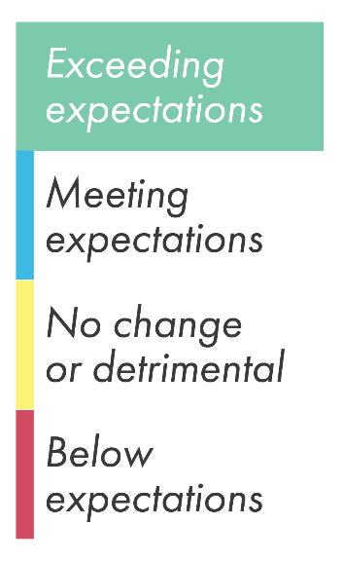
- The health sector was well informed about the introduction of the varicella vaccine to the NIS. The most common communication mechanisms seen or used by the vaccinator workforce were the Ministry’s immunisation monthly update, the hardcopy version of the Immunisation Handbook, and the NIS changes fact sheet.
- All modes of information and communication were rated as ‘adequate’ or higher by over 90 percent of survey respondents for their effectiveness in providing information about the varicella vaccine introduction to the NIS. The information and communication methods that rated the highest were the hardcopy Immunisation Handbook, the Immunisation Advisory Centre (IMAC) website, the NIS Reference Card, and Ministry and IMAC fact sheets.
- The information and key messages were consistent across the resources provided by the Ministry, The Pharmaceutical Management Agency (PHARMAC), IMAC and GlaxoSmithKline (GSK).
- All of the training mechanisms were rated as ‘adequate’ or higher by at least 93 percent of survey respondents. In particular, the ‘train the trainer’ model was seen as an effective and efficient way to train the workforce, enabling vaccinators to feel prepared and confident to administer the varicella vaccine.
Communication and education to the public
The varicella vaccine introduction exceeded expectations in the communications and resources intended for parents/whānau. Key findings include:
- Vaccinators considered that the Immunise Against Chickenpox brochure and the Childhood Immunisation booklet were highly effective resources to aid their conversations with parents/whānau.
- Parents/whānau perceived that the resources were easy to understand, used simple language and provided relevant information. Māori and Pasifika parents/whānau considered the resources to be culturally appropriate.
- Nearly all parents/whānau stated that they were given enough information to make an informed decision about the vaccine.

Acceptability
The varicella vaccine introduction met expectations regarding its acceptability to vaccinators and parents/whānau. Key findings include:
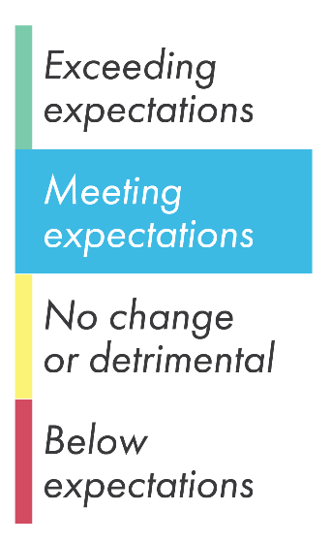
- The varicella vaccine is highly acceptable to the vaccinator workforce, with nearly 90 percent of survey respondents stating that they ‘fully accept’ the vaccine. There was some initial concern with the requirement to deliver four vaccines at once, but in practice most vaccinators have found this to be relatively straightforward.
- Some vaccine providers addressed concerns about administering four vaccines by using two nurses to deliver the 15-month immunisations. This is not in line with IMAC and Ministry practice recommendations.
- While vaccinators recommend to parents/whānau that their child receive all four injections at once, a small minority of parents/whānau (less than 5 percent of those whose children received the 15-month immunisations from July 2017 to February 2018) chose to split the vaccines. Two thirds of those who split returned for the remaining vaccines. Vaccinators are not always following clinical best practice in the order that the 15-month vaccines should be given when split over more than one visit.
- Most parents/whānau engaged with during the evaluation were confident about their children receiving the varicella vaccine. Decisions to split the vaccines are primarily driven by a perception that four injections at once is too much for the child’s immune system.
Coverage
The varicella vaccine introduction met expectations regarding uptake and coverage. Key findings include:
- 79 percent of children who turned 18 months of age between October 2017 and February 2018 received the varicella vaccine, compared to 83 percent of children who received the other three 15-month vaccines. This is comparable to the difference in coverage rates between the existing and new vaccine when rotavirus vaccine was introduced in 2014.
- National coverage rates for 15-month vaccines for the October -December 2017 quarter dropped by two percentage points compared to the same quarter in 2016. This mirrors a decline in coverage for the vaccinations measured at the 8-months milestone age over the same periods, suggesting that the lowered coverage rate is due to factors unrelated to the introduction of the varicella vaccine.

Impact on cold chain management
The varicella vaccine introduction met expectations in terms of its impact on cold chain management. Key findings include:
- Most vaccine providers reviewed their cold chain policies and processes to incorporate the introduction of the varicella vaccine. This was not always done as a direct response to the 2017 NIS changes, with many organisations waiting until their annual policy review was due.
- The introduction of the varicella vaccine had very little impact on processes for ordering and storing vaccines, and on the administrative load of receiving, unpacking and checking vaccines.
- Data show that while there have been several cold chain failures that resulted in the varicella vaccine being returned for destruction, there were no recorded breaches or failures associated with the additional varicella vaccine stock (such as overstocked refrigerators).
Impact on information management systems
The varicella vaccine introduction met expectations regarding its impact on information management systems. Key findings include:
- Practice management systems (PMS) were updated to record varicella vaccine events prior to the implementation of the July 2017 NIS changes. Not all vaccinators accessed the PMS release notes because they did not see it as part of their role or considered that the release notes were written from an IT perspective and did not meet the needs of the nursing workforce.
- Most vaccinators reported that they were confident in entering the varicella vaccine information into their PMS. However, the varicella vaccine introduction was one part of two scheduled changes to the NIS in 2017 which included changes to vaccine regimens for human papillomavirus (HPV) and rotavirus vaccines, among other changes. Some vaccinators discussed issues with entering rotavirus vaccine information into the MedTech system which in turn caused some general confusion in entering immunisation data related to the July 2017 NIS changes.
- The National Immunisation Register (NIR) and consumer-facing records were updated to record varicella vaccine events

Recommendations

Based on the above findings, the evaluation makes the following recommendations:
- The Ministry continue its current approach to informing and training the vaccinator workforce for future NIS changes. This should include: employing multiple communication channels and releasing a suite of information resources with varying degrees of detail; retaining the current processes for ensuring information consistency; and continuing to use the ‘train the trainer’ model.
- The Ministry and Health Promotion Agency (HPA) continue to develop resources to support future vaccine introductions. Resources should use plain language, provide the rationale for the vaccine, and detail potential harms if the disease is contracted.
- The Ministry and IMAC further investigate the evidence base regarding the acceptability of using two vaccinators to administer multiple vaccinations and release a position statement clarifying expectations for clinical practice.
- The Ministry and IMAC reinforce messages to the sector around clinical best practice on which vaccines should be administered first in cases of splitting the 15-month immunisations over more than one visit.
- The Ministry continue to monitor varicella vaccine coverage to assess whether the lower uptake of varicella vaccine than other 15-month immunisations is a short-term effect, and whether coverage for the 15-month immunisation event continues to align with coverage trends for other immunisation events.
- The Ministry communicate with immunisation providers to ensure they are aware of the requirement to update their cold chain policy in response to NIS changes, even if these occur between annually scheduled updates.
- The Ministry implement more frequent communication with PMS providers as they develop updates in response to future NIS changes, to reduce the likelihood of errors.

- Background and context
  - Evaluation context
Varicella, also commonly known as ‘chickenpox’, is a highly contagious disease caused by the varicella zoster virus. The symptoms of varicella include a small blister-like rash that covers the skin of those infected, as well as tiredness, fever and general aches and pains. Symptoms last between three and ten days depending on age.
Varicella is extremely common in children. Although serious complications resulting from varicella are rare, recent data show that hospital discharges resulting from severe complications of varicella are steadily increasing in New Zealand. In severe cases, the virus can lead to kidney and heart issues, pneumonia, and can affect the nervous system causing encephalitis, meningitis or stroke. While less common in adults, those who contract the virus at an older age tend to suffer the symptoms more severely than children. The virus can also remain dormant and, when re-activated, can lead to shingles in adulthood.
Vaccination for varicella has been available in New Zealand since 1999 for private purchase but was not funded on the National Immunisation Schedule (NIS) until 2014, at which time it was available only as a funded vaccine for special high-risk groups such as patients with immune deficiencies.
In 2016 PHARMAC commenced a review of the criteria for the funding of the varicella vaccine and released a request for feedback on a proposal to make amendments to the scope of funding and provision of the varicella vaccine, Varilrix., This resulted in the decision to introduce the varicella vaccine to the NIS.
On 1 July 2017 the varicella vaccine was introduced to the NIS. The introduction offered one dose of the varicella vaccine for children at 15 months old, to be administered alongside the measles, mumps, rubella vaccine (MMR), Haemophilus influenzae type b vaccine (Hib) and pneumococcal disease vaccinations; and one dose of the varicella vaccine for unvaccinated children at 11 years old who have not previously had chickenpox.
The Ministry of Health is responsible for the implementation of the National Immunisation Programme and the NIS. In accordance with World Health Organization (WHO) recommendations, the Ministry commissioned Allen + Clarke to evaluate the introduction of the varicella vaccine, using the new vaccine Post-Introduction Evaluation (PIE) tool to measure the impact of the introduction on the National Immunisation Programme and immunisation services.
  - The World Health Organization Post-Introduction Evaluation Tool
The WHO recommends that all countries conduct a post-introduction evaluation of newly introduced vaccines. The WHO PIE tool was developed as a framework to guide robust evaluations of vaccines newly introduced to immunisation programmes. The tool ensures consistency and comparability of vaccine introduction evaluations across post-vaccine evaluations. The WHO PIE tool has been used as the overarching framework for this evaluation of the implementation of the varicella vaccine introduction, with adaptation to account for the maturity of the New Zealand Immunisation Programme. The New Zealand Immunisation Programme has well established processes to ensure effective and safe delivery of vaccines that would not be expected to be affected by the introduction of the varicella vaccine (refer New Zealand Immunisation Handbook 2017).
The evaluation process commenced with a review of the WHO PIE tool to adapt the framework to the New Zealand context, appropriate to the available timeframe and budget. The key facets of change included increased emphasis on evaluation of process issues related to the vaccine introduction; decreased emphasis on quality assurance issues such as vaccine safety and waste management; and decreased emphasis on observation of facilities and data systems.
The main underlying principles of the PIE tool that were retained and shape the evaluation include:
- a focus on taking a systems level approach to the evaluation, with assessment of the impact of the vaccine introduction at the governance, delivery and recipient levels;
- the implementation of a case study approach to data collection, with emphasis on selecting a sample that is geographically representative and considers equity issues (such as ethnic disparities);
- mixed-method data collection that both documents the experience, perceptions and views of providers and recipients (qualitative methods) and analyses data related to vaccine uptake (quantitative methods); and
- a responsive evaluation approach that emphasises collaboration with those active in immunisation services.

- The evaluation
  - Evaluation purpose
The evaluation focused on the Ministry’s role and responsibilities related to the implementation of the varicella vaccine. The purpose of the evaluation of the varicella vaccine introduction is to:
- provide the Ministry with information on the success of the implementation of the varicella vaccine introduction, including identifying barriers and any challenges associated with the vaccine implementation, and
- provide recommendations for the future implementation of new vaccines.
The findings will contribute to the body of evidence that can be drawn on to inform future vaccine introductions.
  - Evaluation scope
The evaluation focused on the primary eligible age for receiving the vaccine, which is 15 months of age. A relatively small number of children are expected to be eligible for the varicella vaccine at 11 years of age because most children currently in this age have already been exposed to chickenpox. Although the evaluation did not seek to investigate 11-year-old experiences of the vaccine process, the evaluation sought provider perceptions about the processes related to the introduction and delivery of the vaccine to 11-year-olds.
Introduction of the varicella vaccine at age 15 months has increased the number of injections given at that immunisation event from three to four. The impact of this increase in the number of injections was in scope for this evaluation.
Because the evaluation focuses on the Ministry’s role and responsibilities, the following aspects related to the varicella vaccine introduction were out of scope for this evaluation:
- the PHARMAC-led processes related to the decision to add the varicella vaccine to the NIS;
- supply and distribution of the varicella vaccine; and
- the clinical efficacy of the varicella vaccine or of adding it to the NIS.
  - Evaluation questions
The evaluation explored the varicella vaccination implementation against six key criteria (or themes):
- communication and training to the health sector;
- communication and education to the public;
- acceptability;
- coverage;
- impact on cold chain management; and
- impact on monitoring and information systems.
Key evaluation questions (KEQs) and sub-questions to focus the evaluation were developed under these criteria. The evaluation also considered several overarching questions. The KEQs and sub-questions are outlined in Table 1.
Table 1: Key evaluation questions and sub-questions
Criteria | Key evaluation questions and sub-questions
Communication and training to the health sector | - How effective were communications and training at all levels of the health sector?  - Which communication channels (e.g. Ministry, IMAC, GSK) and mechanisms (e.g. journal articles, Monthly Immunisation Update email/fax, fact sheet) were the most effective?  - To what extent were the different sources consistent in messaging and information?  - How effective was the training provided to vaccinators?  - To what extent did the training enable providers to safely and effectively administer the new vaccine?  - To what extent do providers feel confident to discuss the new vaccine with parents/whānau?
Communication and education to the public | - How effective was the education and communication about the vaccine to the public?  - How appropriate were education and communication resources for Māori and Pasifika parents/whānau?
Acceptability | - How acceptable is the varicella vaccine to immunisation providers, parents/whānau and the public?  - How acceptable is the varicella vaccine to Māori and Pasifika parents/whānau?  - How acceptable is giving four injections in one vaccination event to immunisation providers and parents/whānau? What factors encourage or discourage splitting the vaccines over more than one visit?  - What are the main barriers to acceptance and how could they be overcome?
Coverage | - To what extent is coverage of the varicella vaccine meeting targets?  - How equitable is varicella vaccine coverage, across demographic variables (ethnicity, geography, deprivation)?  - To what extent, and in what ways, has the varicella vaccine impacted on uptake of other NIS vaccines?
Impact on cold chain management | - How effectively have immunisation providers adapted their cold chain management policies for the introduction of the varicella vaccine?
Impact on monitoring and information systems | - To what extent were appropriate information systems in place to meet the needs of providers to record vaccine events and monitor coverage?
  - Standards of performance
To answer the key evaluation questions, each criterion was broken down into specific standards of performance. These identify the desired achievements the Ministry sought from the introduction of the varicella vaccine, derived from the document review and discussion with the Ministry. This information was used to develop the desired achievements and specific performance indicators against which the varicella vaccine introduction was judged (Appendix A: Key evaluation questions, desired achievements and performance indicators.
The document review and discussions with the Ministry also fed into the development of an evaluation rubric (Appendix B: Evaluation rubric). This established the standards against which the varicella vaccine introduction was evaluated, identifying what is considered to have “exceeded expectations”, “met expectations”, be “below expectations”, or produced “no change/detrimental” under each performance criterion. This has formed the basis of our evaluative judgements against each criterion.
  - Evaluation methods
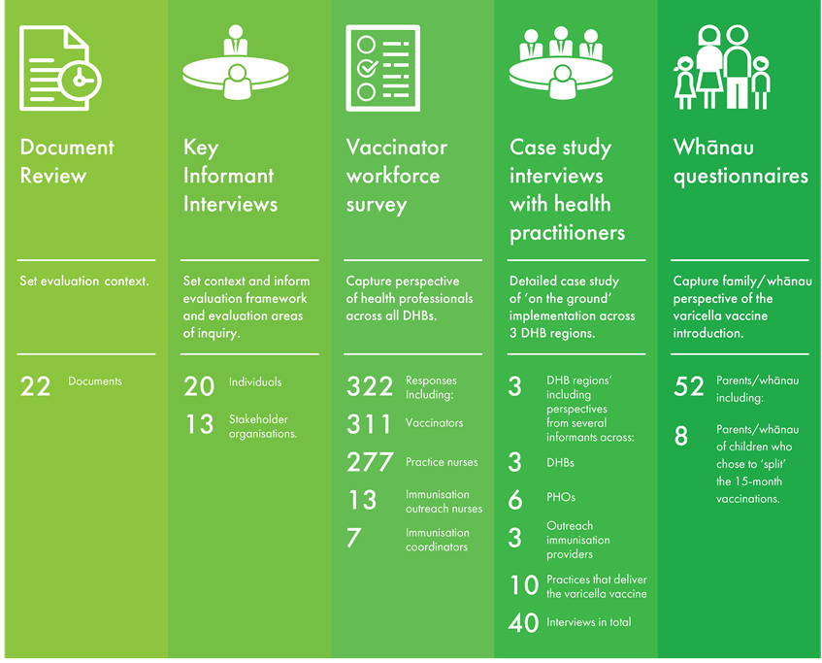
A three-phase mixed method approach was used, informed by the principles of the WHO PIE tool to evaluate the implementation of the varicella vaccine to the NIS. Central to the methodology was an emphasis on collaboration with the evaluation stakeholders. This involved establishing close working relationships between the evaluators, the Ministry, and those involved with the delivery of the vaccine. An overview of the data collection methods is outlined below in Table 2 and further details of key methods are outlined in sections 2.5.1 – 2.5.7.
Table 2: Methods of data collection 'at a glance'
    - Document review
A document review was carried out to provide context to the varicella vaccine and its introduction to the NIS. The Ministry provided the evaluation team with 18 documents directly associated with the varicella vaccine implementation, such as implementation and communication plans, National Immunisation Register (NIR) specifications, other planning documents and meeting minutes. Other documents were accessed online or were provided by evaluation interviewees, including training materials and resources for primary healthcare professionals, education and communication materials, and journal articles. The review allowed the project team to gain insight into the contextual background of the varicella vaccine introduction. The findings also fed in to the development of the project plan, the evaluation criteria and the evaluation tools.
    - Key informant interviews
The evaluation team interviewed 20 individuals from 13 organisations. These people were identified as key stakeholders in the implementation of the varicella vaccine introduction. These interviews were primarily context setting and enabled the evaluation team to refine the evaluation indictors and areas of inquiry. For instance, the key informant interviews:
- detailed the processes and timeframes used to introduce the varicella vaccine;
- defined the roles and responsibilities of key stakeholders;
- provided an overview of the key learnings, challenges and successes that each key stakeholder had experienced through the implementation of the varicella vaccine introduction; and
- provided context to key challenges that occurred during the implementation of the varicella vaccine introduction ahead of our case study visits (allowing us to triangulate the findings from other data collection sources).
The interviews were semi-structured, based on a guide tailored to the various roles of the people interviewed. Informed consent was obtained prior to the start of each interview. A de-identified list of key informants by organisation, is attached as Appendix C: Evaluation key informants.
    - Vaccinator workforce survey
The methods of data collection used in this evaluation allowed for the collection of rich qualitative data on primary healthcare professionals’ experiences of the varicella vaccine introduction. The evaluation team complemented this data with an online survey which aimed to obtain quantifiable data from health professionals across all DHB regions.
An anonymous online survey was administered to the vaccinator workforce using SurveyMonkey in November 2017, collecting information about the views, issues and impacts of the vaccine introduction. The survey primarily targeted practice nurses and outreach nurses but was also open to general practitioners, practice managers and immunisation coordinators.
The survey was completed by 322 respondents. Almost all respondents (97 percent) administered vaccines to children as part of their role: 86 percent were practice nurses; 4 percent were outreach immunisation nurses; 2 percent were immunisation coordinators; 1 percent were general practitioners and the remaining respondents had ‘other’ roles associated with vaccine administration. Further demographic detail about survey respondents is provided in Appendix D: Survey respondent demographics.
    - Case study interviews with health practitioners
The evaluation team carried out three case studies for an in-depth exploration of how the introduction of the varicella vaccine was implemented ‘on the ground’. The case studies involved data gathering at the DHB, PHO and practice levels.
The case study locations were selected to include a range of demographic and geographic characteristics and varying degrees of performance against immunisation targets. An overview of the case study sites is provided in Table 3. The selection of DHB regions was undertaken in consultation with the Ministry; and the selection of practices was undertaken in consultation with the regional immunisation coordinator and the relevant PHO.
Table 3: Characteristics of the case study sites
 | Demographic profile | Performance against 8-month milestone immunisation targets | Geographic profile
Case study one | High Māori and Pasifika populations | Meeting target but lower than desirable coverage of Māori | Urban  North Island
Case study two | High Māori population | Not meeting target | Urban/rural  North Island
Case study three | Predominantly Pākehā population | Meeting target | Urban/rural  South Island
Each case study involved two members of the evaluation team spending two or three days in the region to interview representatives from the DHB and PHO(s) including the local immunisation coordinator and visit two to four general practices and one or two outreach immunisation service providers to interview vaccinators. Forty interviews were conducted in total. A de-identified list of interviewees is provided in Appendix C: Evaluation key informants.
    - Whānau engagement
Capturing the perspectives of parents/whānau of children who were eligible to receive the varicella vaccine was an important component of this evaluation. Ethics approval for engaging with parents and whānau was received from the New Zealand Ethics Committee ahead of data collection.
The evaluation engaged with 52 parents/whānau of children who had been vaccinated, including eight parents/whānau who chose to ‘split’ the 15-month vaccinations over more than one visit. The engagement was based on a structured questionnaire, which sought parent/whānau views across the evaluation criteria following a thorough informed consent process. Feedback from parents/whānau was captured through a range of methods, including face-to-face discussions, telephone interviews and self-completion of an online questionnaire.
    - Quantitative analysis
All national immunisation schedule vaccinations given to children in New Zealand are recorded on the National Immunisation Register, other than the small number of families that choose to opt-off information on their child being stored on the NIR (0.7 percent of the population). Data from the NIR are downloaded to a DataMart platform to enable reporting.
We used NIR DataMart milestone age reports to assess immunisation coverage for varicella vaccine and the other 15-month vaccines for children who had reached the milestone age (18 months). The milestone age reports measure whether the child is fully immunised (or not) for the vaccine/s in question on the day they turn the milestone age. To allow for children not being immunised on time, the coverage for the 15-month immunisation event is measured at two milestone ages: 18 months and 24 months of age. Data for the milestone age of 24 months for varicella vaccine was not available at the time of the evaluation because only children born on or after 1 April 2016 are eligible for funded varicella vaccine. At the time of the evaluation (March 2018) none of these children had reached 24 months of age.
The NIR DataMart report data were analysed in the following ways:
- at the national, DHB and PHO levels,
- by ethnicity and level of deprivation,
- national immunisation coverage at the time of the introduction of the rotavirus vaccine in 2014 to allow comparison with the introduction of another new vaccine, and
- to assess rates of ‘splitting’ the 15-month immunisations and how many of those who ‘split’ returned for the subsequent vaccine(s).
Quantitative descriptive analysis was used to present these data.
    - Qualitative analysis
Thematic analysis was used to analyse the qualitative data. Interview notes were uploaded to NVivo Pro software to code the data and identify themes that were relevant to the evaluation questions. Qualitative information was then written up and arranged under each of the key evaluation questions/criteria.
Both the qualitative and quantitative information were analysed to identify recurring and divergent themes for each of the evaluation questions and criteria. This enabled the development of robust evaluative judgements, with qualitative data compared to and triangulated with insights gained from the quantitative evidence.
  - Structure of this report
Section 3 of this report presents the key findings of the evaluation by the six key evaluation questions relating to the implementation of the varicella vaccine introduction:
- communication and training to the health sector;
- communication and education to the public;
- acceptability;
- coverage;
- impact on cold chain management; and
- impact on monitoring and information systems.
Section 4 sets out the conclusions related to each of the key evaluation questions and provides a summary of the evidence on which the conclusions are based.

- Key Findings
  - Communications and training to the health sector
KEQ 1: How effective were communications and training at all levels of the health sector?
Four desired achievements were identified for KEQ 1:
- The health sector was informed of the varicella vaccine introduction
- The health sector received adequate training on the varicella vaccine
- Effective supporting resources were available to the health sector
- The training supported health professionals to deliver the vaccine.
The extent to which these have been achieved is discussed below.
    - The health sector was informed of the varicella vaccine introduction
The health sector was well informed about the introduction of the varicella vaccine to the NIS ahead of the ‘go live date’. Evaluation participants were able to recall the key messages from the communications that they received about the introduction of the varicella vaccine and felt that the modes of communication met their needs.

Communication channels and mechanisms
The evaluation found that the health sector was well informed about the introduction of the varicella vaccine to the NIS, prior to its introduction date of 1st July 2017.
The survey results, displayed in Figure 1, show that the three most common communication mechanisms seen or used by the vaccinator workforce came directly from the Ministry of Health. Over 93 percent of the survey respondents saw or used the Ministry’s immunisation monthly update, the hardcopy version of the Immunisation Handbook, or the NIS changes fact sheet. The Immunisation Advisory Centre (IMAC) fact sheet and the GlaxoSmithKline (GSK) vaccinator resources also had strong uptake.
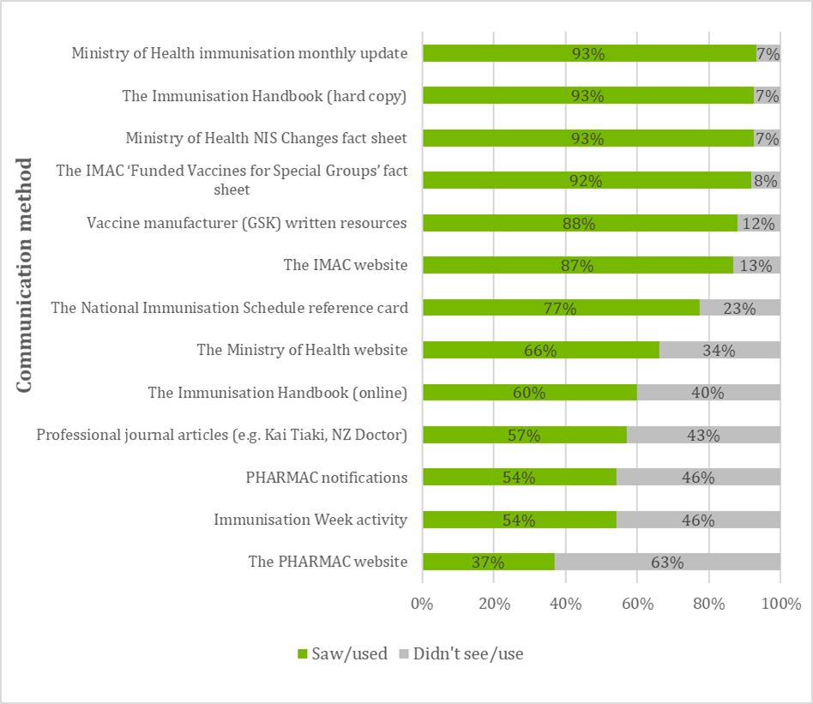
On the other hand, fewer survey respondents saw or used PHARMAC notifications, Immunisation Week activity or the PHARMAC website. These findings contrast with the feedback from key informants who commonly mentioned that they initially received communications about the 2017 NIS changes through PHARMAC. This is likely because many of the key informants were in management roles within DHBs and PHOs, which are a target for PHARMAC communications, while most of the survey respondents were ‘on the ground’ vaccinators.
Figure 1: Percentage of survey respondents who saw or used varicella vaccine communication mechanism (source: vaccinator workforce survey n = 322)
Regional communication mechanisms were also used to distribute information. For example, two case study regions used Immunisation Delivery Governance Group meetings to share initial communications about the introduction of the varicella vaccine. Regional newsletters, such as Canterbury’s ‘Hot Shots’ quarterly vaccinator workforce newsletter, were also used to disseminate information about the varicella vaccine introduction.

Effectiveness of information and communication
Communication was effective in ensuring that the vaccinator workforce was aware of the upcoming introduction: 99 percent of survey respondents were aware that the varicella vaccine would be added to the NIS, prior to its introduction on the 1st July 2017.
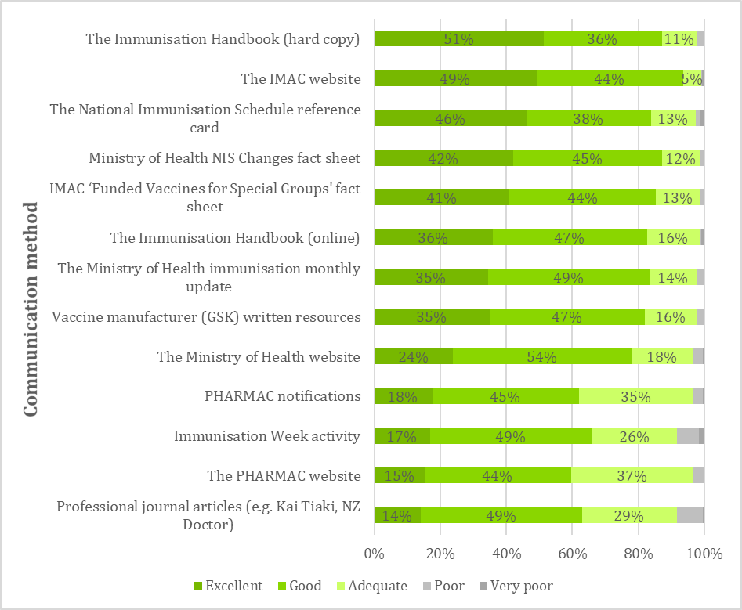
All the specific modes of information and communication were rated as ‘adequate’ or higher by over 90 percent of survey respondents (see Figure 2) for their effectiveness in providing information about the varicella vaccine introduction to the NIS.
Figure 2: Effectiveness of communication methods to inform the health sector about the varicella vaccine (source: vaccinator workforce survey n=322)
Information and communication methods that rated the highest were the hardcopy Immunisation Handbook, the IMAC website, the NIS Reference Card, and Ministry and IMAC fact sheets. The key features which made these resources effective, as described by vaccinators interviewed during the case studies and in survey comments, are provided in Table 4.
Table 4: Reasons for effectiveness of communications mechanism
Information/ communications resource | Vaccinator views on why this was effective
Immunisation Handbook (hardcopy) | Vaccinators saw the Handbook as a trusted and reliable source of information. They appreciated the detailed clinical information on the vaccine, its eligibility criteria and administration. Vaccinators reported that when a new version of the Handbook was released they typically read any updated information and referred to it frequently to check specific points related to the varicella vaccine.  “We call it ‘the bible’. It’s in almost daily use in our practice.”  – Practice nurse
IMAC website | The IMAC website was particularly useful for health professionals to source information related to specific queries, such as the logistics of administering the four injections. Several interviewees highlighted the ‘Frequently Asked Questions’ document, available on the IMAC website, as particularly helpful as a quick reference point to access “short and sharp” information on key issues.
National Immunisation Schedule reference card | Vaccinators liked that this provided ‘at a glance’ information, including pictures of the vaccine plus its brand name.
National Immunisation Schedule Changes fact sheet | Feedback on the effectiveness of the Ministry and IMAC fact sheets was similar; vaccinators considered that these met the needs of busy health professionals due to their clear format and because the fact sheets were short and easy to read. Vaccinators also liked that the information came from trusted sources and was therefore considered reliable.
IMAC ‘Funded Vaccines for Special Groups’ fact sheet
Ministry officials reported that they were very careful about how and when information was shared about new vaccine introductions to the NIS. This was particularly important during the varicella vaccine introduction as it was one part of two scheduled changes to the NIS in 2017. (Other changes included changes to vaccine regimens for human papillomavirus (HPV) and rotavirus vaccines, and vaccine brand changes.) The Ministry described using a “layering effect” to the introduction of the varicella vaccine so as not to overburden the audience with information.
Most vaccinators interviewed considered that the layering process had been successful. Receiving regular updates ensured that the varicella vaccine remained at ‘front of mind’ when juggling with health information of competing priority. Vaccinators also liked the variety of information provided, noting the mix of resources including short fact sheets supported by more comprehensive information in resources such as the Handbook.
On the other hand, a minority of interviewees considered that there was too much information provided, or that it was too dense. These interviewees tended to be in nurse team leader roles and had ‘sifted through’ and triaged information, sharing only the critical aspects of the information that they received with their workforce. However, these views were expressed by a minority of those spoken to, and the dominant view was that multiple sources of information with varying levels of detail provided was an effective means of informing the workforce of vaccine introductions.
“There was a lot of information coming through, and I didn’t read it all, but it was good to have regular reminders that this [varicella vaccine introduction] is coming. I knew the main points by the time it was launched.”
– Outreach immunisation nurse

Video resources
The suite of information resources available to the health sector included three videos created by IMAC and videos from GSK. These had lower uptake than the written resources but were well received by those who used them.
The IMAC ‘4 in a row’ video, showing how to administer four vaccinations in one visit, had the widest dissemination, with 59 percent of survey respondents having seen or used this video. Of these, 96 percent of respondents considered the video to be ‘adequate’ or higher. Immunisation coordinators interviewed during the case studies had shown the video at training sessions and considered it an effective way to address vaccinator concerns about administering four injections.
“Seeing something takes the heat out of it. Lots of nurses felt anxious about giving four vaccines at once, but I found that they were much more comfortable after seeing it demonstrated in the video.”
– Immunisation coordinator

The ‘NIS changes 2017’ video had been seen or used by 42 percent of survey respondents and was viewed as highly effective, rated as ‘adequate’ or higher by 100 percent of those who saw it. The video allowed vaccinators to quickly digest key information on the schedule changes.
The ‘Chickenpox and disease’ video had been seen or used by 40 percent of respondents, of which 99 percent rated it as adequate or higher. This video was used by vaccinators both for their own information, and in some cases to show parents/whānau who may be reluctant to vaccinate against varicella or who requested more information. Vaccinators who had used the video with families liked that it included “hard hitting” information on the potentially serious effects of the disease.
Fewer people had seen or used the GSK videos (only 23 percent of survey respondents) but these were also seen as effective (97 percent rating of adequate or higher).

Recall of key messages
Interview participants were able to recall the key messages which were promoted to them through the communication sources. The majority of those who were interviewed could recall:
- the 2017 NIS change date (the varicella vaccine ‘go live’ date);
- the eligibility criteria for the varicella vaccine;
- the correct technique to administer the varicella vaccine in conjunction with the other three vaccines at a 15-month immunisation event; and
- the correct order of vaccine administration at the 15-month immunisation event.
However, some interviewees (including immunisation coordinators and vaccinators) reported that there was some confusion around the wording of the varicella vaccine eligibility criteria in the initial suite of communications. Some interviewees stated that the date of birth information concerning eligibility for the 15-month event was either not clear or it was open to misinterpretation. Immunisation coordinators reported that a small number of non-eligible children were administered the vaccine free of charge during 15-month catch up immunisations because some vaccinators were confused about eligibility.
This issue was quickly identified and rectified by the Ministry and IMAC, who clarified the wording around the eligibility criteria in their information and communications resources.

Consistency of information
All vaccinators, immunisation coordinators and DHB/PHO personnel interviewed for this evaluation stated that the information provided by the Ministry (including those developed by HPA), PHARMAC, IMAC and GSK was consistent.
“It was all very consistent across the different resources we received. They used similar language and had a similar look and feel.”
– PHO representative

This suggests that the processes used to ensure consistency by the Ministry, HPA and its partners (GSK and IMAC), were effective. The Ministry’s communications personnel had regular meetings leading up to the introduction of the varicella vaccine to ensure that the information provided to the public and the health workforce remained consistent, and all resources were reviewed by the Ministry prior to release. Interviewees from both IMAC and GSK described an open and collegial working relationship with the Ministry, which enabled them to provide consistent and timely communications to their target audiences.
    - The health sector received adequate training on the varicella vaccine
Health professionals were able to access a range of training, which they considered effective in preparing them to administer the varicella vaccine.

Training mechanisms
The survey results, displayed in Figure 3, show that the vaccinator workforce accessed a range of training mechanisms on the July 2017 NIS changes.
Training to support the varicella vaccine introduction was mainly implemented through a ‘train the trainer’ model, under which IMAC (contracted by the Ministry) was responsible for designing and delivering a module to immunisation coordinators, who then delivered the training to vaccinators in their region.
The Ministry provided information to IMAC to develop the module, collaborating with them through a series of meetings and by providing written information. IMAC personnel reported that this process was generally effective and that they received sufficient information to develop the ‘train the trainer’ module. However, there was mention that “there was a little bit of rush at the end to receive some details” when the final draft of the updated Immunisation Handbook was provided to IMAC shortly before the training was launched.
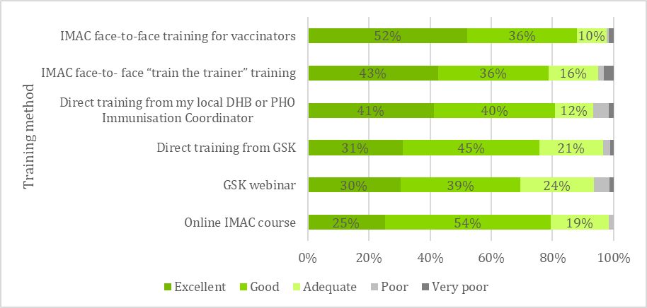
Only a small proportion of survey respondents were expected to have received the IMAC ‘train the trainer’ module: most vaccinators were expected to have received training from an immunisation coordinator. However, the survey respondents included a higher than expected number of people (62 people or 18 percent of respondents) who had received the ’train the trainer’ module developed by IMAC. Of these, only seven attendees were immunisation coordinators, the others being mainly practice nurses. Most were from the wider Auckland region.
Figure 3: Survey respondents’ uptake of training related to the varicella vaccine (source: vaccinator workforce survey, n=322)
IMAC reported that five ‘train the trainer’ sessions were held; one in Auckland, which had 60 participants; and others in Hamilton, Wellington, Christchurch and Dunedin, which each had 12 – 20 attendees. While the intended audience was immunisation coordinators, an open invitation was issued, which meant that attendees from a range of roles participated in the sessions.
Immunisation coordinators had a high degree of autonomy in how they delivered training to the vaccinator workforce. This was effective in allowing immunisation coordinators the ability to respond to local circumstances and deliver the training in the way that best suited their vaccinator workforce. While the content of the training was similar, different training mechanisms were used in each of the three case study regions:
- In case study one the training was led directly by the immunisation coordinator, who held a series of three evening training presentations at different locations within the region.
- In case study two the immunisation coordinator delivered three training sessions in partnership with the local GSK representative, who provided additional resources to those developed by IMAC.
- In case study three, the immunisation coordinator covering the urban part of the region held two evening workshops facilitated by IMAC’s Director, one intended for practice nurses and another intended for general practitioners (although in practice both were largely attended by nurses). The immunisation coordinator covering the rural part of the region delivered a series of small group training sessions to individual practices (where it was the only practice in a location) and small groups of practice staff (when there were several practices within a short driving distance).
In line with Ministry expectations, a high proportion of survey respondents (76 percent) received the direct training from their local immunisation coordinator. This aligns with verbal reports from immunisation coordinators across the three case study regions, who stated that the training sessions had good representation from vaccinators. For example, in case study two the immunisation coordinator stated that training was provided to at least one representative from every general practice in the region, either via attendance at the group training workshops or through ‘catch up’ visits to practices that did not attend the training sessions. The immunisation coordinators covering the urban area of case study three also estimated that the training reached the majority of practice nurses.
“We got about 60 percent of all [practice] nurses through the evening training sessions, which we videoed and sent a link to the ones who couldn’t make it. I’m pretty sure all practices had at least one attendee.”
– Immunisation coordinator
The IMAC face-to-face training for vaccinators was attended by about 40 percent of survey respondents. The availability of this service appears to have been inconsistent. In case study one, PHO representatives stated that IMAC regional advisors worked closely with them to deliver training and support activities leading in to the introduction. In contrast, the immunisation coordinator in case study two stated that she had requested that local IMAC educators support the training sessions but was informed that this was not part of their contracted role.
GSK offered two training mechanisms to support the roll out: face-to-face training to the vaccinator workforce, and a webinar. The direct training was received by 26 percent of respondents. Again, delivery appears to have been inconsistent between regions. The GSK representative was highly involved in the provision of training and support in case studies one and two, but in case study three neither immunisation coordinators nor vaccinators reported having any face-to-face engagement with GSK.
The webinar was a new initiative, offered by GSK to support the 2017 NIS changes. It was accessible to those who registered through a GSK portal. The survey results show that 24 percent of respondents accessed the webinar, which GSK stated was accessed by approximately 300 people. The webinar remains available to registered health professionals via the Health GSK portal.
The overall package of training had good uptake amongst the vaccinator workforce, with almost all survey respondents and interviewees stating that they had accessed at least one form of training on the varicella vaccine, helping to ensure that vaccinators were well prepared to administer the vaccine.
Effectiveness of training
The various training mechanisms offered to the health sector were all viewed by survey respondents as effective and meeting their education needs. The survey results (Figure 4) show that all the training mechanisms were rated as ‘adequate’ or higher by at least 93 percent of respondents.
Table 5 provides a summary of feedback from vaccinators and immunisation coordinators interviewed during the case studies.
Figure 4: Effectiveness of training methods (source: vaccinator workforce survey n=322)
Table 5: Reasons for effectiveness of training methods
Training method | Vaccinator/immunisation coordinator views on why this was effective
IMAC face-to-face training for vaccinators | Vaccinators described the training as translating the technicalities of the vaccine as outlined in the Immunisation Handbook into clear messages on how to administer the vaccine “at the coal face”. IMAC’s ability to translate complex messages into plain language was particularly praised.
IMAC ‘Train the trainer’ course | Four of the five immunisation coordinators considered that the train the trainer course had been effective in supporting them to train the vaccinator workforce. IMAC Facilitators were viewed as open to questions throughout the training and provided practical on-the-ground advice. Immunisation coordinators appreciated the provision of a PowerPoint presentation, handouts and videos, which ensured they felt that they were delivering correct and consistent messages to vaccinators.  Several immunisation coordinators stated that the PowerPoint presentation was too long and detailed for a vaccinator audience, but they were happy to modify it to better suit their needs.
Direct training from immunisation coordinator | Despite the differing ways in which training was provided by immunisation coordinators, feedback from vaccinators was relatively consistent that the training was fit-for-purpose. Vaccinators stated that the immunisation coordinators provided ‘need to know’ information to prepare them to deliver the vaccine and to respond to challenges such as how to deal with ‘splitting’ requests and how to administer four vaccines at one event.
Direct training from GSK | GSK had an active role in training the vaccinator workforce about the varicella vaccine in two of the three case study sites. In these areas the training was delivered in partnership with DHB/PHO immunisation coordinators, who stated that representatives from GSK worked well with them at a local level to ensure that the vaccinator workforce were fully informed about the introduction of the varicella vaccine to the NIS.  One immunisation coordinator attributed the success of her regional varicella vaccine implementation to a GSK representative, who helped her to operationalise the IMAC ‘train the trainer’ materials to suit the target audience.
GSK webinar | The GSK webinar was an effective source of information for those who were not able to attend the regional training sessions in person. Vaccinators liked the convenience of being able to attend from home or their workplace, particularly those in more remote locations. Both GSK and IMAC stated that they intend to use webinars for training in future NIS introductions.
Online IMAC course | While 39 percent of survey respondents stated that they attended this course, and 79 percent of those rated it as good or excellent, no qualitative comments on its quality or effectiveness were provided by survey respondents.
The training was delivered in time for the NIS change, with most of the NIS update training offered in early 2017. Most of the qualitative feedback noted that train the trainer sessions began in February 2017, with vaccinator training taking place between March and May of 2017. This ensured that health professionals and vaccinators felt prepared to implement and administer the varicella vaccine when it became available in July.
    - Effective supporting resources are available to the health sector
Vaccinators mainly rely on the Immunisation Handbook and 0800 IMMUNE telephone line for ongoing support.

Access to additional support to deliver the vaccine
As well as being used as a source of initial information on the vaccine, The Immunisation Handbook was heavily relied on by the vaccinator workforce for ongoing support. Most vaccinators interviewed preferred using a hardcopy of the Handbook to the online version. This aligned with survey results, which showed that 93 percent of respondents accessed the hardcopy version, compared to 60 percent for the online version. Interviewees stated that online resources can be difficult to access because access to the internet is limited for nurses in some practices and for those working in outreach services.
If we use the web copy [of The Immunisation Handbook] we need an internet connection and it’s not always available when we’re in the field. I’d be worried if they [the Ministry] stopped printing it.
- Outreach immunisation nurse

Information provided by the Ministry and IMAC confirmed that The Immunisation Handbook was updated prior to the Schedule change and the hardcopy was released in May 2017. However, there was a perception amongst some of those interviewed during the case studies that it had been late in arriving despite an online version being released and made available prior to the hardcopy being released. While vaccinators at general practices typically considered that the Handbook had been sent to them in plenty of time, several interviewees (including DHB personnel, immunisation coordinators and outreach immunisation nurses) stated that it had arrived late or not at all. This is likely because the Ministry does not automatically send a hardcopy to those who are not practising vaccinators, meaning stakeholders such as DHB funding and planning personnel had to request a copy.
The IMAC ‘0800 IMMUNE’ telephone line and website were also important sources of ongoing support. These were described as accessible and reliable sources of information, allowing vaccinators to get clear and trustworthy answers to their queries. Vaccinators liked that they could get timely advice, noting that the ‘open hours’ match when practice nurses are working and that calls are generally answered immediately. Several interviewees stated that telephone line staff went to great lengths to ensure that they provided the required information.
They really go the extra mile…if it’s a tricky or unusual question and they don’t have an immediate answer they’ll go away and find the information and provide supporting evidence for their advice. It’s a great service.
- Immunisation coordinator

IMAC showed that they had experienced an increase in the number of calls received immediately after the 2017 schedule change, but this increase was in line with previous schedule changes. The way that IMAC codes call data does not record information on questions about specific vaccines, so it was not possible to undertake quantitative analysis of this information. However, IMAC stated that the number of calls specifically related to varicella vaccine was “about what we would expect”.
Immunisation coordinators were also available to provide ongoing support to the workforce. Immunisation coordinators in the case studies areas did not generally contact general practices and outreach services to check whether follow up support was needed, but instead invited vaccinators to contact them if needed.
The extent to which the immunisation coordinator was considered to be providing effective support varied between case study regions. In case studies one and two the coordinator was described as effective in providing initial training but difficult to reach for ongoing support. Vaccinators in these areas tended to rely on the 0800 IMMUNE telephone line if they needed immediate assistance. In case study three the immunisation coordinators were relied on as the first point of contact for additional support.
She has a wealth of knowledge, is always easy to access, and responds quickly to my requests. I rely on her quite heavily.
- Vaccinator

These varying experiences may be due to the different arrangements through which the immunisation coordinator service is delivered across the case studies. Both case study one (which covers a heavily populated urban area) and case study two (which covers a mixture of rural and urban areas) are served by only one immunisation coordinator, whereas case study three has several immunisation coordinators serving the urban area and one specifically assigned to the rural area.
    - The training supports health professionals to deliver the vaccine
Vaccinators reported that the training was adequate to prepare them to deliver the varicella vaccine as part of the 15-month immunisation event.

Vaccinator confidence to deliver the varicella vaccine
To further explore training efficacy, survey respondents were asked to rate the extent to which they agreed with the following statements:
- The communications and training were adequate in preparing me to administer the varicella vaccine.
- The communications and training were adequate in preparing me to administer four injections at the 15-month immunisation event.
- The eligibility criteria for the varicella vaccine catch-up vaccine for 11-year-olds was clear and easy to understand.
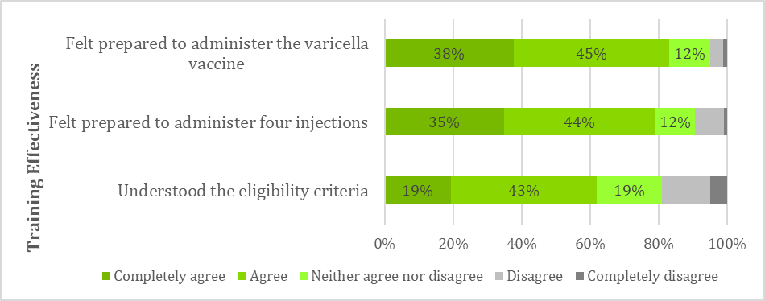
As shown in Figure 5, the majority of survey respondents ‘agreed’ or ‘completely agreed’ that the communications and training had been adequate to prepare them to administer the vaccine, and to administer four injections. The strength of agreement regarding the clarity of eligibility criteria for 11-year-olds was slightly weaker. Aligned with this finding, some interviewees noted that most of the resources focused on the 15-month event and that very little was available about the catch-up vaccine for 11-year-olds. In one case study area the DHB created its own resource which it planned to distribute to immunisation providers.
Figure 5: Effectiveness of the training in preparing vaccinators to administer the varicella vaccine (source: vaccinator workforce survey n = 322)
A small number of interviewees and survey respondents also raised concerns about the extent to which general practitioners were prepared for the varicella vaccine introduction. Immunisation coordinators noted that GPs were difficult to engage in training yet were often asked questions by parents about immunisation and sometimes provided inaccurate information. This caused some challenges for nurses, typically where parents had been given incorrect information about eligibility and expected to be able to access the vaccine for free when their children did not meet the criteria.

Errors in vaccine preparation and administration
Verbal information provided by vaccinators during case study interviews indicated that the introduction of the varicella vaccine has not led to an increase in preparation errors or administration errors. Several nurses noted that their practice had systems and processes to minimise errors, such as vaccine preparation being checked by another nurse prior to being delivered.
Some vaccinators stated that the time required to prepare has increased with the addition of a fourth vaccine to the 15-month event. This has prompted some practices to increase appointment times from fifteen to thirty minutes. Vaccinators were pleased with this change, noting that while varicella vaccine provided the ‘tipping point’ for this to occur, it had been difficult to fit the 15-month event into fifteen minutes, even prior to the additional vaccine being added.
  - Education and communication to the public
KEQ 2: How effective was the education and communication about the vaccine to the public?
Two desired achievements were identified for KEQ 2:
- Communication and education resources are appropriate to the target audiences
- Communications and education are effective in increasing family/whānau knowledge of the varicella vaccine.
The evidence supporting and contradicting each of these desired states is discussed below.
    - Communication and education resources are appropriate to the target audiences
Vaccinators saw the Immunise Against Chickenpox brochure and Childhood Immunisation booklet as very effective resources that assisted their discussions with parents/whānau. Parents thought that the resources were easy to understand and culturally appropriate.

Vaccinator use of family/whānau resources
Most vaccinators reported holding verbal discussions with whānau about the 15-month immunisations. This was supplemented with written resources such as brochures if the whānau appeared reluctant or uncertain about immunising, requested additional information or had a lot of questions.
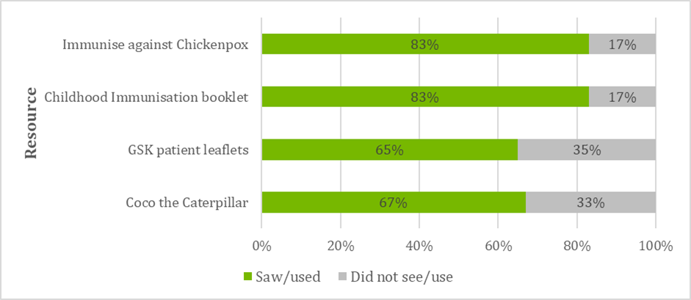
When consumer-facing resources were used, vaccinators stated that they typically used the Immunise Against Chickenpox brochure and the Childhood Immunisation booklet. The survey results, displayed in Figure 6, show that these resources were used by 83 percent of respondents. Patient leaflets developed by the vaccine manufacturer (GSK) and distraction aids such as Coco the Caterpillar had slightly lower uptake, having been used by around 65 percent of survey respondents. The perceived effectiveness of each of these resources is discussed below.
Figure 6: Survey respondents' use of consumer-facing resources (source: vaccinator workforce survey n=322).
Survey respondents rated the effectiveness of most consumer-facing resources very highly. The Immunise Against Chickenpox brochure was rated as ‘adequate’ or higher by 99 percent of respondents. Vaccinators considered that the brochure was written in appropriate language for the intended audience and contained clear messages. Making the brochure available in te reo Māori was appreciated, particularly by those working in kaupapa Māori health services. Importantly, the brochure provided a clear rationale on why it was important to immunise against varicella.
Lots of parents think that chickenpox is common so why do they need a vaccine for it. The brochure helps to explain how serious it can be.
– Survey respondent

The Childhood Immunisation booklet was also rated as ‘adequate’ or higher by 99 percent of respondents. Vaccinators stated that they used the booklet when talking with families about the benefits, risks, and potential side effects of vaccines.
It’s a cracking little booklet. It’s aimed at patients, not too wordy and easy to read.
– Practice nurse

The GSK patient leaflets were also rated highly, with 98 percent of respondents stating these were ‘adequate’ or higher. Several interviewees commented that they were happy to use the resources as the information aligned with that provided by the Ministry, giving them confidence that it was not “drug company spin”.

On the other hand, ‘Coco the Caterpillar’, a distraction aid provided by GSK, did not receive such positive feedback. Sixty-seven percent of survey respondents rated it as ‘adequate’ or higher, with 33 percent stating it was ‘poor’ or ‘very poor’. Reasons included: it was not suitable for children aged 15 months (the packaging stated that it was intended for children aged three years and above); it was too fragile and broke easily; and children wanted to touch it (not just look). Vaccinators interviewed stated that they typically used other distraction aids such as bubbles instead.

Appropriateness to target audience
Of the 52 families engaged with during the evaluation, 32 people (62 percent) recalled seeing or being given resources about the varicella vaccine, 17 (33 percent) said that they had not seen any resources, and 4 (8 percent) could not remember. Of those who had seen resources, half recalled seeing the Immunise Against Chickenpox leaflet, and a further 37 percent had seen the Childhood Immunisation booklet (See Figure 7).
The pictures were good…the kids looked like Kiwi kids.
– Parent

Nearly all the parents/whānau that took part in the evaluation perceived that the resources were easy to understand, noting that they used simple language and were not too ‘wordy’. The majority of parents/whānau also perceived that the information was relevant to their information needs. Only two people considered that the resources were not easy to understand; one felt that there was “too much jargon” and the other stated that the pamphlet they were given was too long.
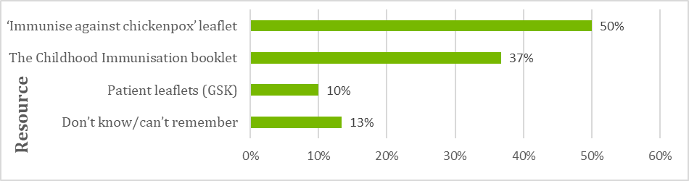
The 12 parents of Māori ethnicity and six parents of Pasifika ethnicities who took part in the evaluation broadly agreed that the resources were culturally appropriate.
Figure 7: Resources seen or used by whānau engaged with during this evaluation (source: whānau questionnaire n=52)
    - Communications and education are effective in increasing parent/whānau knowledge of the varicella vaccine
Most of the parents/whānau engaged with during the evaluation had discussed varicella risks and benefits with their vaccine provider and felt equipped to make an informed decision.
The experience of the whānau that engaged with the evaluation suggests that vaccinators are effectively informing parents/whānau about the varicella vaccine. All of those who participated were informed by their vaccination provider that the varicella vaccine would be administered as part of the 15-month immunisation event.
Of the 52 families that took part in the evaluation, Table 6 shows that most recalled discussing the benefits and risks of the varicella vaccine with their health practitioner.
Table 6: Percentage of parents/whānau who stated that they discussed varicella vaccine benefits and risks
 | Discussed benefits | Discussed risks
Yes | 65% | 58%
No | 25% | 24%
Can’t remember | 10% | 18%
About one quarter of parents/whānau stated that they did not discuss the benefits and risks of varicella vaccine with the vaccinator. Most of these people did recall having a general discussion about immunisation benefits and risks but could not remember being told anything specific about the varicella vaccine.
However, three people did raise specific concerns about the information they were provided. They all considered that the information placed too much emphasis on the benefits of varicella vaccine and did not recall being told much about risks, or that their concerns about risks were not taken seriously.
For those whānau that did recall their discussions, benefits that were typically remembered included that the vaccine would prevent serious cases of chickenpox that may require hospitalisation, prevent shingles later in life, and mitigate the need for 10 days isolation if the child did contract chickenpox (which would require time off work to care for the child). Parents/whānau were also able to recall discussing risks such as fever, rash and the child becoming unsettled.
Nearly all (90 percent) of parents/whānau stated that they were given enough information to make an informed decision about the vaccine. While most of those spoken to had already been planning to accept all the 15-month immunisations, one parent stated that this discussion had been important in convincing her to accept the varicella vaccine.
I wasn't sure about getting the chickenpox one because I didn't realise it was so serious. The nurse showed me some pictures of kids with severe chicken pox and that changed my mind!
– Parent

The small number of parents/whānau (10 percent) who stated that they did not receive enough information to make an informed decision on varicella immunisation would have liked more details about how it also prevents shingles, links to websites, and why it is necessary to have four injections at the 15-month event.

  - Acceptability
KEQ 3: How acceptable is the varicella vaccine to immunisation providers and parents/whānau?
Three desired achievements were identified for KEQ 3:
- The varicella vaccine is acceptable to immunisation providers
- The varicella vaccine is acceptable to parents/whānau
- The varicella vaccine is acceptable to Māori and Pasifika parents/whanau.
The evaluation findings related to these desired achievements are discussed below.
    - The varicella vaccine is acceptable to immunisation providers
The varicella vaccine is acceptable to immunisation providers, who are happy to promote it to parents/whānau during the 15-month immunisation event. Initial concerns about delivering four injections at once have largely been addressed. Splitting the 15-month vaccines is relatively rare, but when it does occur vaccinators are not always following clinical best practice.

Vaccinator perceptions of vaccine acceptability
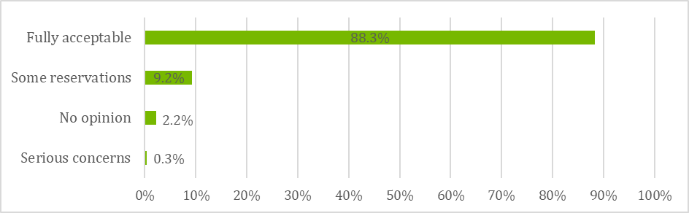
The evaluation found that the varicella vaccine was very acceptable to the vaccinator workforce. As shown in Figure 8, nearly 90 percent of survey respondents stated that they ‘fully accept’ the vaccine.
Figure 8: Survey respondents’ perceptions of varicella vaccine acceptance (source: vaccinator workforce survey n=322)
The survey results align with the views of vaccinators interviewed during the case studies. Nearly all of those interviewed stated that they fully accepted the addition of varicella vaccine to the NIS. Several interviewees noted that they had previously recommended the chickenpox vaccine that was available for purchase and were now pleased to be able to offer it for free.
Vaccinator confidence in the varicella vaccine means that they are comfortable promoting it as a standard part of the 15-month immunisations. Two of the vaccinators interviewed had been particularly proactive in promoting the varicella vaccine. An immunisation outreach nurse stated that she drops the Immunise Against Chickenpox brochure to local kōhanga reo; and a practice nurse asks parents to share positive immunisation stories and encourage other whānau members to see whether their child is eligible for the vaccine.

Acceptability of administering four injections
Those that expressed reservations (9 percent of survey respondents) mainly raised concerns with the requirement to deliver four vaccines at once, noting that it can be “somewhat traumatic for the child and parent despite our best explanations and professionalism in administering” (survey respondent).
However, this concern appears to be reducing. Many of the vaccinators interviewed stated that, while they had initially held concerns about administering four injections prior to the vaccine’s introduction, they found that in practice it was relatively easy.
Some nurses initially felt terrible while doing it [the four injections] but this anxiety has lessened since the introduction. At the training, about half of the people there were not confident and raised concerns, but after a couple of ‘goes’ they’re fine… I’m not getting any negative feedback now.
- Immunisation coordinator

Some practices (including about 20 percent of the case study practices) have addressed concerns about administering four vaccines by using two nurses to deliver the 15-month immunisations. This was typically seen as quicker and less traumatic for the child and family. Several immunisation coordinators that were interviewed expressed concerns about this practice, stating that it raised issues of consent (i.e. if the parent had consented to immunisation from one nurse but not the other) and resourcing (i.e. if practice nurses were being taken off other duties).
In preparation for its training delivery, IMAC undertook a scan of existing published research on the issue of using multiple vaccinators. The results suggested that the perception of vaccinations being delivered by two nurses simultaneously being less traumatic is incorrect: having two adults deliver vaccines at once was found to be scary for the child. IMAC therefore recommended during its training that using a single vaccinator was best practice.
It may be beneficial for the Ministry to investigate this issue and provide a position statement clarifying its expectations.

Splitting the 15-month vaccinations
All the vaccinators interviewed in the case study practices stated that they recommend to parents/whānau that their child receive all four injections at once.
About one quarter of those interviewed stated that they had had at least one request to split the vaccines. This was similar to the survey results, which found that 24 percent of respondents stated that they had split the vaccines on at least one occasion. All of those who had split the vaccines had done so at the request of the parent/whānau: no vaccinators in either the survey or interviews had recommended splitting the vaccines. In fact, vaccinators actively discouraged families from splitting by providing the clinical rationale for delivering all four injections at once and emphasising that it is less traumatic for the child to ‘get it over all at once’. Vaccinators reported that in most cases, the family agreed for their child to receive all four vaccinations at once.
Analysis of quantitative data shows that splitting vaccines is not common, and that most of those who do choose to split, return for the remaining vaccines. Of a total 29,246 15-month immunisation events from 1 July 2017 to 28 February 2018:
- 95 percent (27,803 cases) received all four vaccines on the same day;
- three percent (807 cases) received all four vaccines across multiple days (i.e. split the vaccines and returned for all of the remaining vaccines);
- two percent (460 cases) received less than four vaccines on the same day and had not returned for the remainder during the time period studied (i.e. split the vaccines and did not return for the remaining vaccines); and
- less than one percent (59 cases) received fewer than four vaccines across multiple days and had returned for some, but not all, of the remaining 15-month vaccines (i.e. split the vaccines and returned to receive some, but not all, of the other 15-month vaccines).
Where families do insist on splitting, most vaccinators recommend giving the MMR vaccine first. Of the 65 survey respondents who answered the question “What was your recommendation on which vaccine/s were to be given in the first visit?”:
- 53 recommended that MMR vaccine be given first. Most of these (44 respondents) recommended that MMR and varicella vaccines be given first.
- 10 gave the parents/whānau the choice of which vaccine(s) to receive first.
- two recommended Hib and Pneumococcal vaccines be given first.
The last of these answers does not align with clinical best practice recommendations in The Immunisation Handbook, which state that MMR and varicella vaccines should be given in the first visit. Giving parents/whānau the choice of which vaccines to receive first is also concerning. This suggests that there is some misinformation in the sector and it would be beneficial for the Ministry and IMAC to reinforce messages around clinical best practice on which vaccines should be administered first.

    - The varicella vaccine is acceptable to parents/whānau, including Māori and Pasifika
Most parents/whānau are confident in accepting the varicella vaccine. Those that choose to split the vaccine did so due to concerns about their child’s immune system being able to handle multiple vaccines in a single day.

Family/whānau perceptions of acceptability
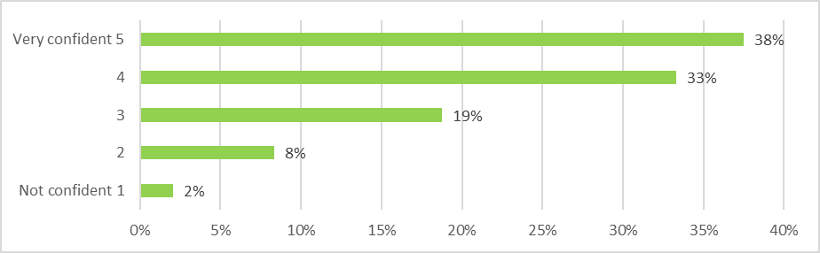
As shown in Figure 9 most whānau engaged with during the evaluation were confident about their children receiving the varicella vaccine.
Figure 9: Parent/whānau confidence in receiving the varicella vaccine (source: whānau questionnaire n=52)
Reasons for this confidence included: trust in their health professional’s recommendations, a desire to protect their child from chickenpox, and being pro-vaccination in general. Several parents/whānau stated that they did not particularly like seeing their child receive the injections but recognised that it was necessary to keep them healthy.
Confidence of Māori and Pasifika parents/whānau/aiga mirrored this finding, with 82 percent reporting they were confident or very confident for their child to receive the vaccine.
I didn't want him to go through the pain and discomfort and possible scarring of having chicken pox, when it is now preventable.
– Parent

Acceptability of four injections
Most of the parents/whānau who took part in the evaluation accepted receiving four vaccines as part of their child’s 15-month immunisation event.
The evaluation included engagement with eight parents/whānau who had split the vaccine. Most of these parents (six out of eight) had decided to split that vaccines because of a perception that four injections at once was too much for the child’s immune system.
Their immune systems are not fully developed at this age and I was not willing to give my son so many different vaccines at one time.
– Parent

One parent had decided to split the vaccines out of concern that her child may experience a bad reaction to multiple injections, and the remaining parent stated that she had been advised to split the injections by the doctor and practice nurse due to her child’s small size. All eight parents/whānau who had chosen to split the 15-month event stated that they had returned for the subsequent set of injections.
  - Coverage
KEQ 4: To what extent is coverage of the varicella vaccine meeting targets?
Two desired achievements were identified for KEQ 4:
- The varicella vaccine coverage is similar to that of the 15-month event prior to the introduction of the varicella vaccine
- The introduction of the varicella vaccine has not negatively impacted on other NIS vaccine uptake.
The evidence related to these desired achievements is discussed below.
    - The varicella vaccine coverage is similar to that of the 15-month event prior to the introduction of the varicella vaccine
Data from the National Immunisation Register show that varicella vaccination rates are lower when compared to other 15-months vaccines. This mirrors patterns typically seen when a new vaccine is introduced to the Schedule.
Coverage reports look at the number of children who have received the scheduled vaccines by the “milestone age”, which is 18 months of age for the 15-month event. As well as for the total eligible population, data are reported according to the child’s ethnicity; the DHB and level of deprivation where they live; and the PHO with which they are enrolled.
Children born on or after 1 April 2016 were eligible to receive the varicella vaccine once they turned 15 months – that is on or after 1 July 2017. The 18-month milestone age for the first children eligible for the newly scheduled vaccine was 1 October 2017. The analysis below uses NIR DataMart data for all eligible children turning 18 months of age between 1 October 2017 and 28 February 2018. This represents the full dataset available at the time of the evaluation.

Rates of varicella vaccination compared to other 15-month vaccines
Overall varicella vaccine rates are slightly lower than for other vaccines at 15 months. There were 25,432 children that turned 18 months of age between 1 October 2017 and 28 February 2018. 79 percent (20,011) of these children received the varicella vaccine. In the same period 83 percent of children received all the other 15-month vaccines. Figure 10 shows how these rates vary according to the child’s ethnicity. Children that identified as Māori have lower rates of varicella vaccination compared to the national total; New Zealand European children have slightly higher rates; children of Asian ethnicity have noticeably higher rates; and children identified as Pacific have rates equivalent to the national total. New Zealand European children appear to have reduced rates of varicella vaccination compared to other 15-month vaccines while for Māori, Pacific and Asian children there is less difference.
Figure 10 also shows that there are 669 more children recorded as declined for the varicella vaccination (1,848) than for the other 15-month vaccines (1,179), seven percent versus five percent. This can account for about half of the lower coverage rates.
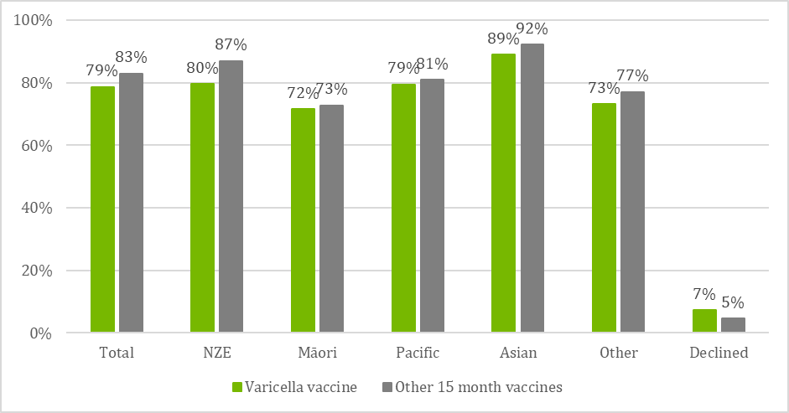
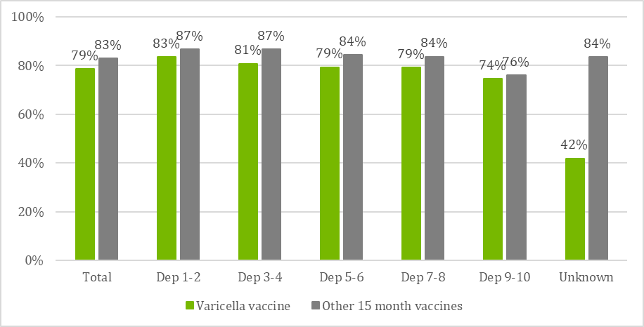
Figure 11 shows overall vaccination rates by New Zealand Index of Deprivation (NZDep) areas; the scale ranges from 1 (least deprived) to 10 (most deprived). Overall there was a slight decline in the rates of varicella vaccination for children in the highest deprivation quintile (74 percent) compared to children in the lowest deprivation quintile (83 percent). This trend was also reflected in a relative decline in vaccination rates for other 15-month vaccines across deprivation quintiles, suggesting that deprivation did not uniquely impact on varicella vaccination rates.
Figure 10: Vaccination coverage at 18-month milestone age for October 2017 - February 2018 by ethnicity (source: National Immunisation Register)
Figure 11: Vaccination coverage at 18-month milestone age for October 2017 - February 2018 by NZDep areas (source: National Immunisation Register).

Experience with the introduction of a new vaccine to the Schedule suggests that in the early months uptake of the new vaccine tends to be lower than for the existing vaccines and this may also be an explanation for the lower varicella vaccine coverage. To examine this effect, coverage rates of the rotavirus vaccine for the first full quarter after introduction in July 2014 were examined compared to other vaccinations measured at the milestone age of 8 months. As shown in Figure 12, the early experience for both varicella and rotavirus vaccines is that uptake is noticeably lower for the new vaccine than it is for the existing vaccines. There was one exception to this pattern: for children who identified as Pacific, vaccination rates during the first full quarter were higher for the varicella vaccine (82 percent) compared with other 15-month vaccines (81 percent). It is also worth noting that the decline rates were similar for the two new vaccines, with the rates for both being higher than that of the established vaccines.

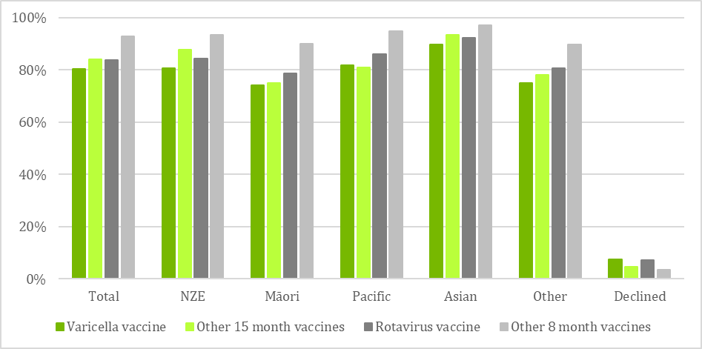
Coverage data by DHB
Figure 12: Varicella vaccine (measured at 18 months of age) and rotavirus vaccine (measured at 8 months of age) compared to other vaccines for the same events in the first full quarter after introduction of new vaccines, by ethnicity (source: National Immunisation Register).
Figure 13 shows coverage rates for the varicella vaccine and the other 15-month vaccines for each DHB. As with the national figures, varicella vaccine rates are a little lower than other 15-month vaccines in most DHBs. For no obvious reasons the difference is greater than 10 percentage points in Lakes (64 percent varicella vaccine coverage compared to 77 percent coverage for other 15-month vaccines) and Wairarapa (80 to 91 percent), and only about two-percentage points or less in Whanganui (76 to 77 percent), Northland (73 to 74 percent), and Tairawhiti (73 to 71 percent).

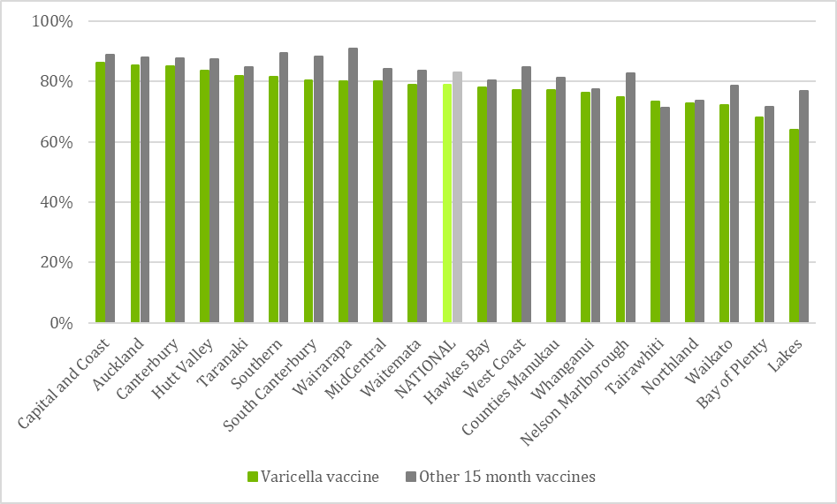
Coverage data by PHO
Figure 13: Coverage by DHB: Varicella vaccine compared to other 15-month vaccines at 18-month milestone age for October 2017 - February 2018 (source: National Immunisation Register).
Figure 14 and Figure 15 show coverage data by PHO for varicella vaccination and the other 15-month vaccinations. These graphs have been separated into those that are achieving at or above the national average, and those that are achieving below the national average. In most PHOs varicella vaccine rates are lower than the other 15-month vaccines. There are a few PHOs where this difference is marked: Midlands Health Network-Lakes (52 percent coverage for varicella vaccination compared to 76 percent coverage for other vaccinations), Midlands Health Network-Waikato (71 to 81 percent) and Compass Health-Wairarapa (81 to 93 percent). There are also several where varicella vaccine rates are higher than the other 15-month vaccines: Ngāti Porou Hauora Charitable Trust (69 to 66 percent), Midlands Health Network-Tairawhiti (76 to 75 percent), Total Healthcare Charitable Trust (79 to 78 percent), Eastern Bay Primary Health Alliance (71 to 70 percent), Te Tai Tokerau PHO (69 to 68 percent), and for children not enrolled with a PHO (57 percent to 50 percent).
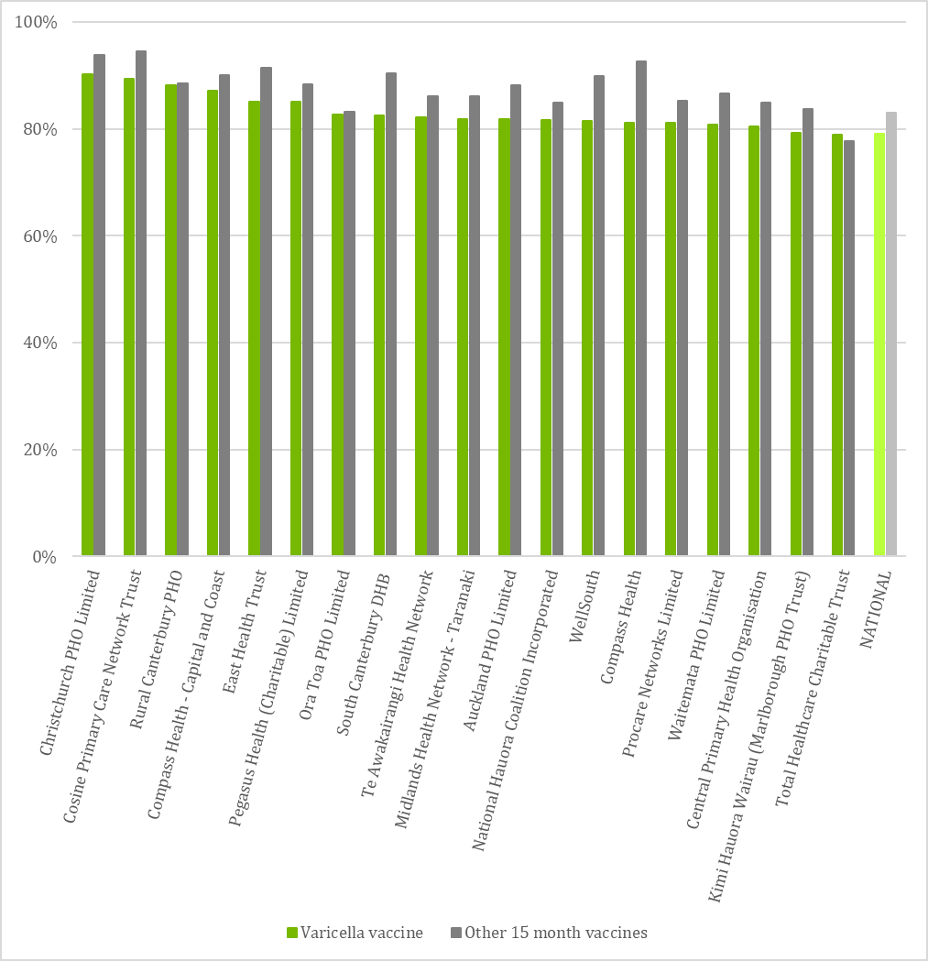
Figure 14: Vaccination coverage by PHO at 18-month milestone age for October 2017 - February 2018; PHOs at or above the national average (source: National Immunisation Register)
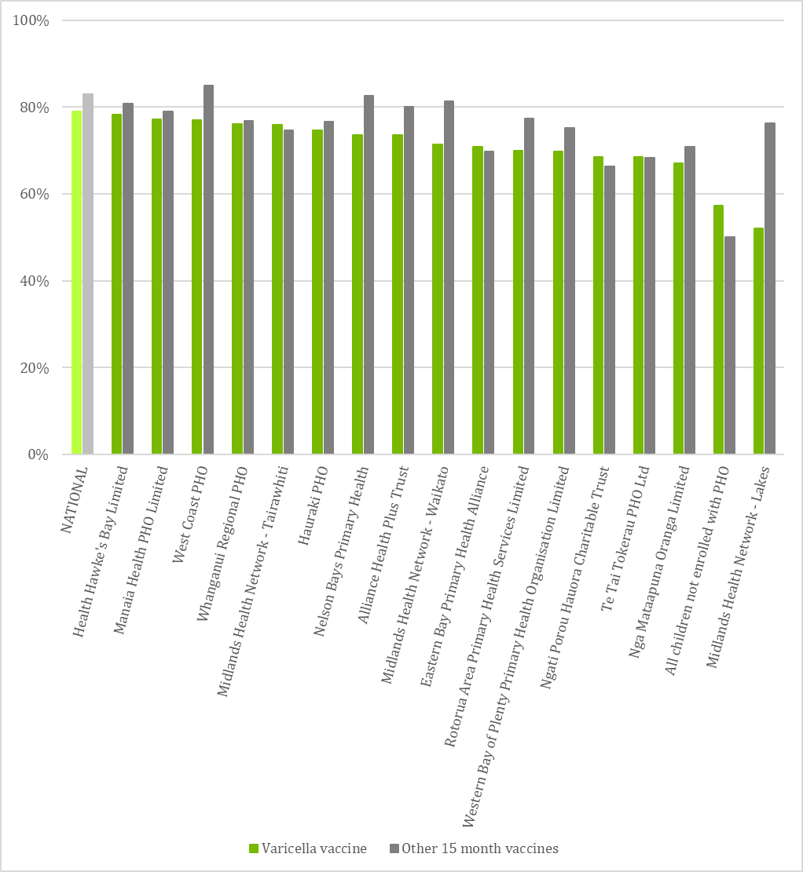
Figure 15: Vaccination coverage by PHO at 18-month milestone age for October 2017 - February 2018; PHOs below the national average (source: National Immunisation Register).

    - The introduction of the varicella vaccine has not negatively impacted on NIS vaccine uptake
Coverage for 15-month immunisations is lower following the introduction of the varicella vaccine than for the same quarter the previous year. However, this mirrors coverage patterns for the vaccines that are measured at the 8-month milestone age and the drop is unlikely to be due to the introduction of the varicella vaccine.
The evaluation also considered whether the introduction of a fourth vaccine as part of the 15-month vaccination event may have influenced the overall proportion of children being vaccinated at that age. To examine this, the national data for 15-month vaccines excluding the varicella vaccine (measured at the 18-month milestone age) for the October to December quarter in 2017 (i.e. after varicella vaccine introduction) were compared to the same quarter in 2016 (i.e. prior to varicella vaccine introduction).
The results, displayed in Figure 16, show that the national coverage rates for 15-month vaccines were 86 percent in the October – December 2016 quarter and 84 percent in the October – December 2017 quarter. When examined by ethnicity the difference ranges from zero to four percentage points, although there were some outliers. For example, vaccination rates for children who identified as Māori were four percentage points higher in 2016 (79 percent) than in 2017 (75 percent), whereas rates for children who identified as Asian were the same for both years (93 percent). Such differences may be random data fluctuations rather than any consistent pattern. Further analysis may be helpful when a full year of data is available.
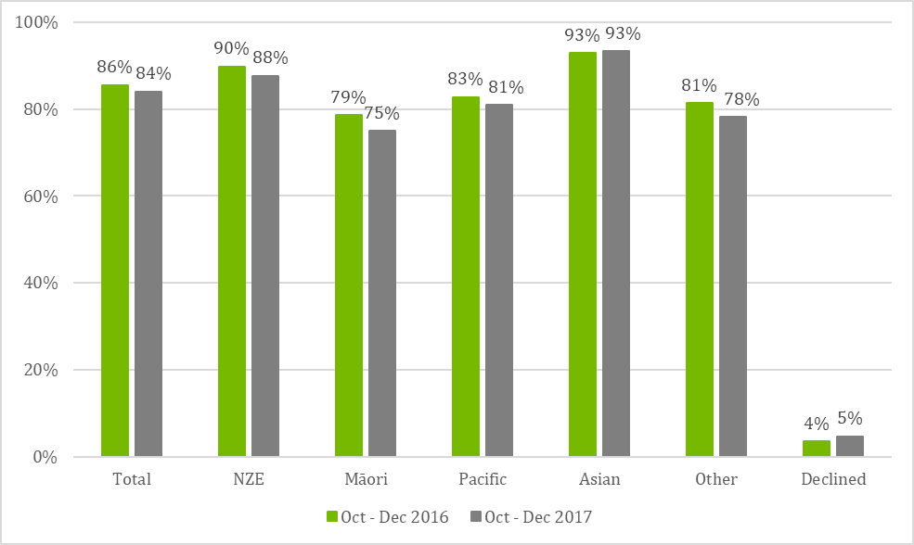
Figure 16: National 15-month vaccination coverage (excluding varicella vaccine) measured at 18-month milestone age for October - December 2016 and October - December 2017, by ethnicity (source: National Immunisation Register).
The data for 15-month vaccinations has been compared to coverage for the vaccines measured at 8-months over the same periods, to see whether there have been similar changes in coverage. As shown in Figure 17, there are also lower rates for vaccines measured at the 8-month milestone age in 2017 compared to 2016. This suggests that the lower coverage rate is due to other factors, and it is unlikely that the introduction of varicella vaccine at 15 months has had an effect on reducing coverage for all 15-month vaccines.
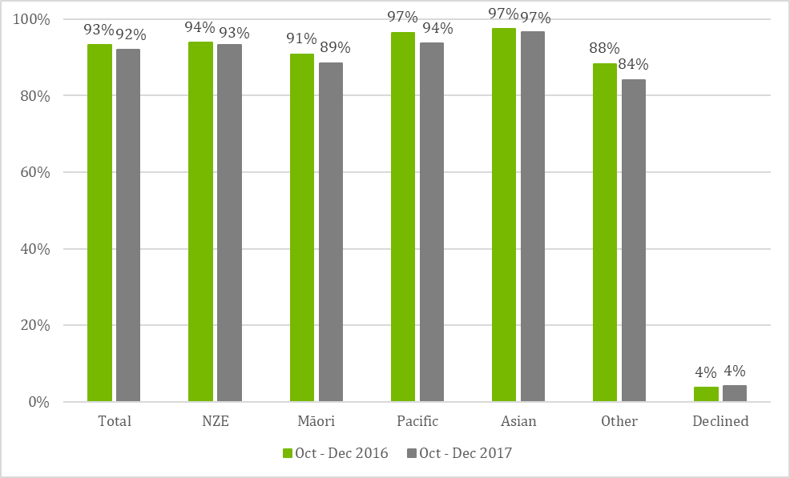
Figure 17: National vaccination coverage measured at 8-month milestone age for October - December 2016 and October - December 2017, by ethnicity (source: National Immunisation Register).

  - Impact on cold chain management
KEQ 5: How effectively has the cold chain adapted to the introduction of the varicella vaccine?
Two desired achievements were identified for KEQ 5:
- Immunisation providers adapt their cold chain management processes to the new vaccine
- The cold chain is maintained for the varicella vaccine from the national vaccine store until when it administered.
The evidence related to these desired achievements is discussed below.
    - Immunisation providers adapt their cold chain management processes to the new vaccine
While most immunisation providers have updated their cold chain policy to include the varicella vaccine, the update was not always completed immediately in response to the NIS changes.

Cold chain policy
The Ministry’s National Standards for Vaccine Storage and Transportation for Immunisation Providers 2017 state that vaccine providers’ cold chain policy should be reviewed and updated when “the designated cold chain staff, vaccine equipment or processes change”. As such, vaccine providers should have updated their cold-chain polices in response to the July 2017 NIS changes.
The survey results found that 66 percent of respondents stated that their workplace had reviewed its cold chain policy and processes to incorporate the introduction of the varicella vaccine. This issue was explored in further detail during the case studies. While most of the general practices and immunisation outreach providers had updated their cold chain policy, only about half had done this as a direct response to the 2017 NIS changes.
The remaining practices stated that they updated their policy on an annual basis and made all relevant changes as part of these periodic updates. Many of the vaccination providers spoken to did not appear to be aware of the requirement to update the policy in response to any changes outside of the annual update. This suggests that there is a need for Ministry communication to immunisation providers to reinforce messages regarding the cold chain policy review expectations outlined in the National Standards.
The immunisation coordinators interviewed confirmed that the content of the cold chain policies for practices in their regions complied with the cold chain standards. Most vaccinators interviewed were able to provide examples of how their practice aligns with the standards, for example undertaking routine temperature checks, and storing vaccines for different events on separate shelves.
Vaccine storage
Vaccination providers interviewed during the case studies reported that the introduction of the varicella vaccine had very little impact on their processes for ordering and storing vaccines. Many immunisation providers had recently upgraded their refrigerators after the previous ones (which were often purchased during the Meningococcal B Immunisation Programme) had reached the ten-year limit. Practices stated that they had purchased large refrigerators with plenty of capacity in anticipation of more vaccines being added to the NIS.
Immunisation coordinators in each of the case study areas confirmed that they had not received any reports of issues with storage capacity of either refrigerators or chilly bins being impacted by the varicella vaccine.
Providers stated that they did not really need to consider the capacity of their refrigerators when ordering stock, but typically based orders on how many enrolled children would turn 15 months of age in the next two- or four-week period.
The varicella vaccine was also reported to have had very little impact on the administrative load of receiving, unpacking and checking vaccines.
There’s a couple of extra boxes to unpack but it doesn’t take long. I haven’t really noticed any difference in the time I spend [on this task].
– Practice nurse

    - The cold chain is maintained for the varicella vaccine from the national vaccine store until administered
There have been no reported cold chain breaches, excursions or failures related to the additional storage required for varicella vaccine stock.
Data reported by IMAC to the Ministry shows that for the period 1 July to 31 December 2017 there were eight cold chain failures that resulted in the varicella vaccine being returned for destruction. The reasons for failure were mainly related to the refrigerator temperature ‘running warm’ or dropping too low, due to refrigerator malfunction, or to events such as power cuts. There were no recorded breaches or failures associated with the additional varicella vaccine stock (such as overstocked refrigerators).
This aligns with the survey results, which reported no cold chain breaches, excursions or failures related to the additional storage required for varicella vaccine stock.

  - Impact on monitoring and information systems
KEQ 6: How effectively have information systems adapted to monitor coverage and record vaccine events?
Three desired achievements were identified for KEQ 6:
- Practice Management Systems have been adapted to record varicella vaccine events
- The National Immunisation Register has been updated to record varicella vaccine events
- Consumer-facing immunisation records have been updated.
The evidence related to each of these desired states is discussed below.
    - Practice Management Systems have been adapted to record and report on varicella vaccine events
PMSs were updated on time and functioned effectively for recording the varicella vaccine.
The immunisation providers engaged with during the case studies used a variety of practice management systems (PMS), including MedTech, Profile, Indici and myPractice. All interviewees and 92 percent of survey respondents reported that their PMS had been updated to record varicella vaccine events prior to the implementation of the July 2017 NIS changes.
When a PMS is updated, provider release notes inform users of any changes to the system and include instructions for entering new vaccines into the PMS. 68 percent of survey respondents stated that they had read the PMS release notes. Interviews with practice nurses and outreach nurses found that many did not see it as part of their role to read the notes, stating that it was the responsibility of the practice manager or nurse manager, who then ensured that the practice nurses could enter the information correctly. In one case study area, the immunisation coordinator and PHO personnel visited practices in their area to ensure that staff understood how to enter the information.
Other interviewees, including nurses and immunisation coordinators, considered that the release notes were written from an IT perspective and did not necessarily meet the needs of the nursing workforce. This view was particularly prevalent where myPractice and Indici were used as the PMS provider. For example, one practice nurse stated that the Indici release notes were around 20 pages long and not written in language that was accessible for nurses.
While most vaccinators reported that they were confident in entering the varicella vaccine information into their PMS, issues with entering rotavirus vaccine into the MedTech system caused some confusion in entering data related to the July 2017 NIS changes. This was related to a brand and regimen change, under which the PMS updated to the new brand on the changeover date and removed the ability to enter data related to the previous brand. This meant that vaccine providers who were using up old brand stock could not enter it into the system.
While not directly related to varicella vaccine, this affected the confidence of some vaccinators to enter the immunisation events, and immunisation coordinators noted that they received a lot of calls from nurses related to this issue.
It’s difficult to separate the varicella [vaccine] experience from the other brand changes which occurred last year. The rotavirus [vaccine] issue meant we were dealing with a lot of noise. I do acknowledge it’s not varicella [vaccine] related but it caused a lot of headaches.
– Immunisation coordinator

    - The National Immunisation Register and consumer-facing records have been updated to record varicella vaccine events
The NIR and consumer-facing records were updated on time to record varicella vaccine events.
The Ministry of Health and interviewees such as immunisation coordinators confirmed that the NIR was updated to record varicella immunisation events from 1 July 2017. There was a slight delay in getting NIR DataMart reports in place because of the need to wait for the eligible population to reach the appropriate milestone age (i.e 18 months of age). The earliest data available on the cohort of children eligible for funded varicella vaccine was for the quarter ending 31 December 2017. Varicella vaccine NIR DataMart reports were available from March 2018.
Verbal information from the Ministry’s IT team stated that at the time of data collection there had been no increase in errors or reported issues since the NIR was updated to include varicella vaccine.
The Ministry and the majority of case study interviewees also stated that immunisation records and certificates in the Well Child Tamariki Ora My Health Book were updated by 1 July 2017.

- Conclusions and Recommendations
This section sets out the conclusions related to each of the key evaluation questions and provides a summary of the evidence on which the conclusions are based. The criteria on which the evaluative judgements were made are provided in Appendix B: Evaluation rubric.
KEQ 1: How effective were communications and training at all levels of the health sector?
The evaluative judgement for KEQ 1 is that the varicella vaccine introduction exceeded expectations in providing timely, effective and appropriate communications and training to the vaccinator workforce. Evidence shows that messages were consistent across all information sources, and that high-quality training has enabled health professionals to effectively deliver the vaccine.
The Ministry employed a variety of information channels and mechanisms to reach different parts of the health sector, and evidence shows that this was very effective in getting key messages out: nearly all the vaccinator workforce was aware of the 2017 NIS changes prior to their implementation and were able to recall the main messages associated with the varicella vaccine introduction. The effectiveness of information provision was supported by the delivery of information sources that provided both detailed clinical information (such as The Immunisation Handbook) as well as ‘at a glance’ resources (such as Fact Sheets). This approach met vaccinator information needs and should be continued for future introductions.
The fact that the messaging was consistent across multiple information sources is a notable achievement, and provides a strong endorsement for the Ministry’s processes, including regular meetings between the Ministry, HPA, IMAC and the vaccine provider.
The training provided to the vaccinator workforce was also very effective. The ‘train the trainer’ model allowed immunisation coordinators to ensure that they were providing relevant and consistent information to vaccinators, but also offered flexibility to meet local needs and contexts in the way that the training was delivered. The learnings received by training participants were practical and clear enabled the vaccinator workforce to overcome initial concerns (particularly related to delivering four injections) and feel confident to administer the varicella vaccine.
Recommendation 1
The Ministry continue its current approach to informing and training the vaccinator workforce for future NIS changes.
This should include: employing multiple communication channels and releasing a suite of information resources with varying degrees of detail; retaining the current processes for ensuring information consistency; and continuing to employ the ‘train the trainer’ model.

KEQ2: How effective was the education and communication about the vaccine to the public?
The evidence shows that the consumer-facing communication and education resources used to support the varicella vaccine introduction were very well received by both vaccinators and parents/whānau.
Vaccinators considered that the resources developed by the Ministry and HPA (the Immunise Against Chickenpox brochure and the Childhood Immunisation booklet) used appropriate language for the intended audience and, importantly, provided the rationale for the vaccine and details of the potentially serious impacts of the disease. This helped to overcome some parents’ initial view that the vaccine was unnecessary for what they saw as a common childhood illness.
Parents/whānau feedback on the resources that they saw was also positive. Those that participated in the evaluation considered the information easy to understand, and Māori and Pasifika parents reported that it was culturally appropriate. Parents/whānau felt able to make an informed decision about vaccinating their child for varicella.
Recommendation 2
The Ministry and HPA continue to develop resources to support future vaccine introductions.
Resources should use plain language, provide the rationale for the vaccine, and detail potential harms if the disease is contracted.
KEQ3: How acceptable is the varicella vaccine to immunisation providers, parents/whānau and the public?
The varicella vaccine has met expectations in terms of its acceptance by vaccinators and parents/whānau. Almost all the vaccinator workforce engaged with during the evaluation were enthusiastic about its addition to the NIS and were happy to promote it alongside the other 15-month vaccines.
Parents/whānau also demonstrated high acceptance of the varicella vaccine, with 80 percent of those spoken to stating that they were confident for their children to receive it. Parental acceptance was enhanced by having a trusting relationship with their health professional and being provided with information that illustrated the value of protecting their child from chickenpox. Māori and Pasifika parents also stated high levels of acceptance of the vaccine.
While there were few barriers to acceptance of the vaccine, the fact that there are now four injections has caused some trepidation amongst a few vaccinators and parents/whānau, although vaccinator concerns have reduced with more experience of giving the four injections. Some practices have implemented a system of using two nurses to deliver the 15-month immunisations, which aims to make the experience faster and less traumatic for the child and family. However, this practice was not supported in IMAC’s investigation of published research and is not recommended by IMAC and the Ministry.
Analysis of data found that 95 percent of those that receive the 15-month immunisations accepted all four vaccines on the same day. Splitting the vaccines is relatively rare, and about two thirds of those who do split the vaccines return for the subsequent vaccines. Engagement with parents/whānau suggested that splitting is primarily driven by concerns that four vaccinations may overwhelm a young child’s immune system.
Vaccinators reported that they are actively discouraging splitting. However, where parents/whānau do insist on splitting, vaccinators are not always following the clinical best practice of giving MMR and varicella vaccines in the first visit, or they are allowing parents to choose which vaccines their child receives first.
Recommendation 3
The Ministry and IMAC further investigate the evidence base regarding the acceptability of using two vaccinators to administer multiple vaccinations and release a position statement clarifying expectations for clinical practice.
Recommendation 4
The Ministry and IMAC reinforce messages to the sector around clinical best practice on which vaccines should be administered first in cases of splitting the 15-month immunisations over more than one visit.
KEQ4: To what extent is coverage of the varicella vaccine meeting targets?
Coverage for the varicella vaccination at the 18-month milestone age was several percentage points lower compared to other 15-month vaccines from October 2017 to February 2018. This pattern was mirrored across ethnicities and deprivation levels, and DHBs and PHOs. At face value, this appears concerning. However, comparison with another recently-introduced vaccine (the introduction of the rotavirus vaccine to the primary infant immunisation series) shows that coverage was also lower for that new vaccine than it was for the existing vaccines. Based on this comparison of two newly introduced vaccines, it appears that it may not be uncommon for there to be lower early uptake. This finding may warrant further research.
The evaluation also found that national coverage rates for the 15-month vaccines excluding varicella vaccine, had dropped from October to December 2016 (prior to the varicella vaccine introduction) compared to the same quarter in 2017 (after the introduction). When compared to vaccinations measured at age 8 months over the same time periods, the data shows similar changes in coverage. This suggests that the lower coverage rate is not due to the introduction of varicella vaccine but rather reflects a more general decrease in uptake in immunisations in the 2017/18 year.
Recommendation 5
The Ministry continue to monitor varicella vaccine coverage to assess whether the lower uptake of varicella vaccine than other 15-month immunisations is a short-term effect, and whether coverage for the 15-month immunisation event continues to align with coverage trends for other immunisation events.
KEQ5: How effectively have immunisation providers adapted their cold chain management policies for the introduction of the varicella vaccine?
The evaluation found that most immunisation providers have adapted their cold chain management policies and processes to incorporate the introduction of the varicella vaccine. However, only about half of those interviewed reviewed the cold chain policy as a direct response to the 2017 NIS changes. Other providers had incorporated the varicella vaccine into the cold chain policy only when undertaking their annual review of their cold chain management policy, meaning that many practices were operating for some time without a current cold chain policy.
The introduction of the varicella vaccine had little impact on processes for ordering and storing vaccines as most providers had purchased large refrigerators and chilly bins with adequate capacity to store additional vaccines added to the NIS. There was also little impact on time spent undertaking administration activities such as unpacking boxes. While there were several cold chain failures that resulted in the destruction of varicella vaccine stock, none of these were due to the additional storage required for varicella vaccine stock.
Recommendation 6
The Ministry communicate with immunisation providers to ensure they are aware of the requirement to update their cold chain policy in response to NIS changes, even if these occur between annually scheduled updates.
KEQ6: To what extent were appropriate information systems in place to meet the needs of providers to record vaccine events and monitor coverage?
Evidence shows that the NIR, consumer-facing records and PMSs were adapted on time to record and report on varicella vaccine events. There has been no increase in errors or reported issues since the NIR was updated to include the varicella vaccine.
The evaluation found that many front-line vaccinators, such as practice nurses and outreach nurses, are not reading the PMS release notes. This is either because they do not perceive this to be part of their role, or because the notes are considered too technical and not written in appropriate language for nurses. While not a direct issue with the varicella vaccine introduction, the effectiveness of the PMS update was compromised by an error in the MedTech software. This affected the overall confidence of nurses to enter immunisation information in their PMS system after the 2017 NIS changes.
Recommendation 7
The Ministry implement more frequent communication with PMS providers as they develop updates in response to future NIS changes, to reduce the likelihood of errors.

Appendix A: Key evaluation questions, desired achievements and performance indicators
Criteria | Desired achievements | Performance indicators | Sources of information
KEQ1: How effective were communications and training at all levels of the health sector?
Communication and training to the health sector | The health sector was informed of the varicella vaccine introduction | - Key informants (health sector organisations, DHB personnel, PHO personnel, general practice staff) report that they received communication about the varicella vaccine introduction (e.g. Fact Sheet, Immunisation Update fax, online resources)  - Key informants report that the communications met their information needs  - Key informants recall key messages related to the varicella vaccine introduction (date of NIS change, age of eligible children, etc)  - Key informants report that the information that they received from the different information sources was consistent in messaging and information  - Survey participants rate the NIS communication mechanisms as ‘adequate’ or higher | - Key informant interviews  - Case study interviews  - Survey
 | The health sector received adequate training on the varicella vaccine | - IMAC received sufficient information from the Ministry of Health, PHARMAC and GSK to develop the ‘train the trainer’ training  - Immunisation coordinators report that the ‘train the trainer’ format allowed them to effectively train vaccinators  - Immunisation coordinators report that the majority of their general practices and other relevant health professionals (e.g. Plunket) were represented at the vaccinator training  - Key informants (health sector organisations, DHB personnel, PHO personnel, general practice staff) report that NIS update training session met with education needs  - Key informants and survey participants report that the training was delivered in time for the NIS change  - Survey participants rate the training mechanisms as ‘adequate’ or higher | - Interviews with IMAC personnel  - Interviews with DHB Immunisation coordinators  - Key informant interviews  - Review of documents and data  - Case study interviews  - Survey
 | Effective supporting resources are available to the health sector | - Resources for the health sector (e.g. The Immunisation Handbook, Ministry of Health website) have been updated on time  - The resources provided consistent information and messages between the different information sources  - Key informants (health sector organisations, DHB personnel, PHO personnel, general practice staff) and survey participants report that the updated resources met their information needs | - Review of documents  - Key informant interviews  - Case study interviews  - Survey
 | The training supports health professionals to deliver the vaccine | - Vaccinators effectively and appropriately discuss the varicella vaccination with parents/whānau  - Vaccinators safely and effectively administer the varicella vaccine alongside the three other vaccines of the 15-month event  - Vaccinators are able to access additional support to deliver the vaccine (e.g. 0800 Immune)  - Vaccinators report that they received appropriate support from immunisation coordinators (e.g. they were contacted about the schedule change, able to access information and support when needed, followed up after the schedule change to make sure no problems have arisen)  - The number of calls to support lines (0800 Immune calls, immunisation coordinators) is comparable to other schedule changes  - The introduction of the varicella vaccine has not caused an increase in preparation errors in preparing the four vaccines for the 15-month event (such as incorrect diluent, preparing wrong vaccine etc)  - The introduction of the varicella vaccine has not caused an increase in administration errors (such as incorrect vaccinations being administered) | - Case study interviews  - Interviews with IMAC, immunisation coordinators  - Call monitoring data from 0800 Immune
KEQ2: How effective was the education and communication about the vaccine to the public?
Communication and education to the public | Communication and education resources are appropriate to the target audience | - Vaccinators report that the client-facing resources provided (e.g. the ‘immunise against chicken pox’ leaflet) assist their discussions with parents/whānau  - Parents/whānau report that they were informed about the benefits and risks of the varicella vaccine by their health provider  - Parents/whānau report that education resources (such as the ‘immunise against chicken pox’ leaflet) are easy to understand and relevant to their information needs  - Māori and Pasifika whānau/aiga report that information provided is culturally appropriate | - Case study interviews  - Interviews with parents/ whānau
 | Communications and education are effective in increasing family/whānau knowledge of the varicella vaccine | - Parents/whānau report that they were informed by the provider that the varicella vaccine will be administered during the 15-month immunisation event  - Parents/whānau report that they received adequate information to make an informed decision about the varicella vaccination  - Parents/whānau can describe the benefits and risks of the varicella vaccine | - Interviews with parents/ whānau
KEQ3: How acceptable is the varicella vaccine to immunisation providers and parents/whānau?
Acceptability | The varicella vaccine is acceptable to immunisation providers | - Vaccinators report that the varicella vaccine is acceptable  - Vaccinators promote the varicella vaccine to parents/whānau  - Vaccinators recommend to parents/whānau that their child receive all four injections at once (i.e. they do not recommend splitting the vaccines over more than one visit)  - If the four vaccines are split, the MMR vaccine is given first | - Case study interviews  - Survey
 | The varicella vaccine is acceptable to parents/whānau | - Parents/whānau feel safe and confident with their child receiving the varicella vaccine  - Parents/whānau accept their child receiving four injections at once  - Parents/whānau that do split the vaccine return for the second set of vaccines  - Families do not experience barriers to access and uptake of the varicella vaccine | - Interviews with parents/whānau
 | The varicella vaccine is acceptable to Māori and Pasifika | - Māori and Pasifika whānau/aiga feel safe and confident with their child/tamariki receiving the varicella vaccine  - Māori and Pasifika whānau/aiga do not experience cultural barriers to access and uptake of the varicella vaccine | - Interviews with Māori and Pasifika whānau/aiga
KEQ4: To what extent is coverage of the varicella vaccine meeting targets?
Coverage | The varicella vaccine coverage is similar to that of the 15-month event prior to the introduction of the varicella vaccine | - Coverage rates for the 15-month immunisation events are similar to that prior to the introduction of the varicella vaccine, by ethnicity and deprivation at the national, DHB and PHO levels  - The majority of eligible children receive all four vaccines at the 15-month event  - Parents/whānau that do request the vaccines to be split return for the second set of vaccines | - Ministry of Health coverage data  - Ministry of Health data on rates of vaccine splitting, and rates of return for the second vaccines
 | The introduction of the varicella vaccine has not negatively impacted on NIS vaccine uptake | - Declines for the 15-month event are comparable to decline rates prior to the introduction of the varicella vaccine  - Timeliness for the 15-month event (measured at age 18 months) is similar to that prior to the introduction of the varicella vaccine | - Ministry of Health coverage data
KEQ5: How effectively has the cold chain adapted to the introduction of the varicella vaccine?
Impact on cold chain management | Immunisation providers adapt their cold chain management processes to the new vaccine | - Immunisation providers have reviewed their Cold Chain Policy to include any changes necessitated by the introduction of the varicella vaccine  - The Cold Chain Policy complies with the new Cold Chain Standards.  - Immunisation providers have considered their capacity for the vaccine in their vaccine refrigerators (and off-site chilly bins if required) and taken this into account when ordering vaccines  - Immunisation providers report that the administrative load of receiving, unpacking and checking vaccines has not unduly increased | - Survey  - Case study document review  - Case study interviews
 | The cold chain is maintained for the varicella vaccine from the national vaccine store until administered | - Key informants (health sector organisations, DHB personnel, PHO personnel, general practice staff) report that the cold chain has been maintained and they have not experienced any cold chain breaches or failures associated with additional vaccine stock  - National Cold Chain Audit data shows that the cold chain is maintained from the vaccine distributor to the provider (and for up to 2 weeks) | - Key informant interviews  - Case study interviews  - Survey  - Review of Cold Chain Audit data
KEQ6: How effectively have information systems adapted to monitor coverage and record vaccine events?
Impact on monitoring and information systems | Practice Management Systems (PMS) have been adapted to record and report on varicella vaccine events | - General practices uploaded the latest release of their PMS prior to 1 July 2017  - Practices ensured their clinical staff had access to and had read the release notes from the PMS provider prior to 1 July 2017  - Immunisation providers report that they received adequate information on the changes to the PMS  - Immunisation providers report that they are confident to enter the varicella immunisation in the PMS | - Case study interviews  - Survey
 | The National Immunisation Register (NIR) has been updated to record varicella vaccine events | - The NIR was updated to record varicella immunisation events from 1 July 2017  - NIR DataMart reports were in place to monitor coverage from the end of the first quarter after the varicella vaccine introduction  - The number of NIR errors related to the varicella vaccine is comparable to other vaccines given at the 15-month event | - Key informant interviews  - Document and data review
 | Consumer-facing records have been updated | - Immunisation records and certificates in the Well Child Tamariki Ora My Health Book were updated by 1 July 2017 | - Document review

Appendix B: Evaluation rubric
The rubric below (Table 7) establishes the standards against which the varicella vaccine introduction was evaluated. This identifies what is considered to have “exceeded expectations”, “met expectations”, be “below expectations”, or “no change/detrimental” under each performance criterion.
All criteria additionally include a category “unable to be determined”, which is used when inadequate evidence is available to make a robust evaluative judgement.
Table 7: The Evaluation Rubric
Criteria | Exceeding expectations | Meeting expectations | Below expectations (with some positive achievements) | No change or detrimental
Generic performance standards | Excellent performance against all indicators and no substantive weaknesses.  Clear examples of exemplary performance. | Reasonably good performance overall; may have a few slight weaknesses but nothing serious. | Fair performance, some serious, but non-fatal; weaknesses on a few aspects. | Clear evidence of unsatisfactory functioning; serious weaknesses on crucial aspects.
Communication and training to the health sector | Communication to the health sector was timely, effective and appropriate. Messages are consistent across all information sources. High quality training has enabled health professionals to effectively deliver the vaccine. | Communication and training to the health sector was mostly effective, timely, appropriate and consistent, but could be enhanced by minor improvements. | Communication and training was provided to the health sector, but with some weaknesses related to its effectiveness, timeliness, appropriateness or consistency. | There are weaknesses in key aspects of the communication and training provided to the health sector. Major amendments are required for future schedule changes.
Communication and education to the public | Communication and education resources are very well received by the target audience, providing a highly effective and culturally appropriate means to understand and accept the varicella vaccine. | Communication and education provided to the public are appropriate to the target audience and are effective in increasing family/whānau knowledge of the varicella vaccine. | Some communication and education resources are effective, but some are not culturally appropriate or not understood by the target audience. | Communication and education resources are of poor quality, culturally inappropriate, inaccurate and/or not understood by the target audience.
Acceptability | The varicella vaccine administered alongside the other three vaccines of the 15-month immunisation event is acceptable to immunisation providers and whānau, and to Māori and Pasifika stakeholders. No barriers to access and uptake of the varicella vaccine were identified. | The varicella vaccine administered alongside the other three vaccines of the 15-month immunisation event is acceptable to most immunisation providers and whānau, and to most Māori and Pasifika stakeholders. There are few barriers to access and uptake. | Immunisation providers and whānau report concerns about the varicella vaccine and/or administration of four vaccines in one event. Māori and Pasifika also express concerns. The target groups experience barriers to access and uptake. | The varicella vaccine and/or administration of four vaccines in one event is unacceptable to immunisation providers, whānau and Māori and Pasifika. The target groups experience substantial barriers to access and uptake.
Coverage | Coverage of the varicella vaccine is better than that of the other vaccines given at the 15-month event, nationally, regionally and across demographic groups. | Coverage of the varicella vaccine is similar to that of the other vaccines given at the 15-month event, nationally, regionally and across demographic groups. | Coverage of the varicella vaccine is lower than that of the other vaccines given at the 15-month event and/or there are inequities in coverage regionally or across demographic groups. | Coverage of the varicella vaccine is significantly lower than that of the other vaccines given at the 15-month event. There are substantial inequities in coverage regionally and/or across demographic groups.
Impact on cold chain management | All immunisation providers have adapted their cold chain management processes in time and in line with the Cold Chain Standards.  The cold chain is maintained for the varicella vaccine from the national vaccine store until when it administered. | Most immunisation providers have adapted their cold chain management processes to the new vaccine. The cold chain is maintained for the varicella vaccine from the national vaccine store until when it administered. | Most immunisation providers have adapted their cold chain management processes to the new vaccine, but the review was not completed in time and/or policies are not in line with the Cold Chain Standards. There is some evidence that the cold chain has been breached (e.g. minor cold chain breaches are more frequent than prior to the varicella vaccine introduction). | Few immunisation providers have adapted their cold chain management policies and/or there is evidence that the cold chain has been broken (cold chain failures or major cold chain breaches more frequent than prior to the varicella vaccine introduction).
Impact on monitoring and information systems | The NIR, consumer-facing records and PMSs have been adapted on time, to record and report on varicella vaccine events. There are no concerns with increased NIR messaging errors. | The NIR, consumer-facing records and PMSs have been adapted on time, to record and report on varicella vaccine events. There are some minor concerns with increased errors in NIR messaging. | The NIR, consumer-facing records and PMSs have been adapted to record and report on varicella vaccine events, but there are concerns with timeliness. And/or there are some concerns with increased errors in NIR messaging. | The NIR, consumer-facing records and PMSs have not been adapted on time. And/or there are significant concerns with increased errors in NIR messaging.

Appendix C: Evaluation key informants
Table 8 below lists the 20 individuals interviewed from national level organisations for the evaluation of the varicella vaccine introduction.
Table 8: Key informants by organisation
Organisation | Number of people interviewed
Ministry of Health Immunisation Team | 3
Ministry of Health Communications | 1
Ministry of Health Senior Advisor (NIR/PMS) Immunisation and IT | 3
Ministry of Health Disease Surveillance Group | 1
Ministry of Health Chief Advisor | 1
Medsafe | 1
PHARMAC | 2
IMAC | 1
The Health Promotion Agency | 1
GSK | 1
College of Midwives | 1
Royal New Zealand College of General Practitioners | 1
Plunket | 2
College of Primary Healthcare Nurses | 1
TOTAL | 20

Table 9 provides an overview of the people interviewed during the case study site visits.
Table 9: Key Informants by case study area
Case study area | Role | Number of people interviewed
Case study one | DHB representative | 1
 | PHO representative | 2
 | Immunisation coordinator | 1
 | Outreach immunisation nurse | 4
 | Practice nurse | 5
Case study two | DHB representative | 1
 | PHO representative | 2
 | Immunisation coordinator | 1
 | Outreach immunisation nurse | 3
 | Practice nurse | 6
Case study three | DHB representative | 2
 | PHO representative | 2
 | Immunisation coordinator | 2
 | Outreach immunisation nurse | 1
 | Practice nurse | 7
TOTAL |  | 40

Appendix D: Survey respondent demographics
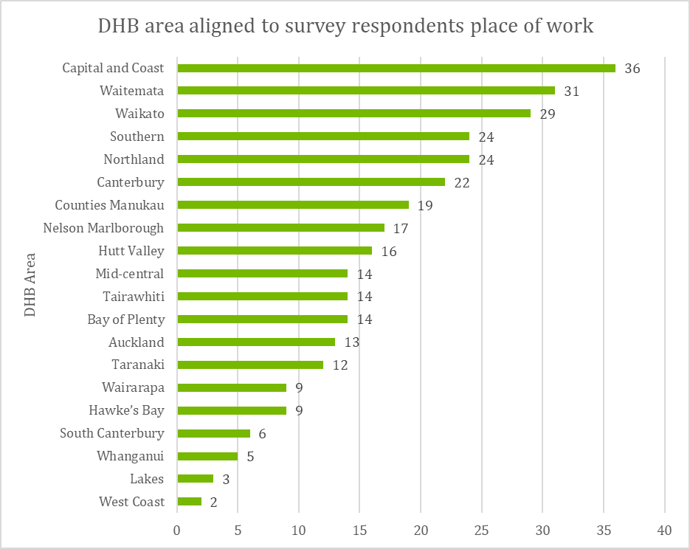
Of the 338 respondents who began the survey, 322 completed the demographic section of the survey. As shown in Figure 18, responses were received from all DHB areas, with most respondents working in the Capital and Coast, Waitemata and Counties Manukau DHB areas. Respondents were asked to select their main work place. The majority (86 percent) worked within a general practice. In Table 10 and Table 11, percentages are rounded to the nearest whole number.
Figure 18: DHB area aligned with the survey respondents place of work (source: vaccinator workforce survey n=322)

Table 10: Survey respondents’ workplace
Work place | Percentage | Number
General practice | 86 | 276
Immunisation outreach service | 5 | 15
Kaupapa Māori health service | 1 | 4
Pacific Island health service | 0 | 0
District Health Board | 3 | 9
Primary Health Organisation | 3 | 11
Other | 2 | 5

Survey participants were also asked their role relational to the implementation of the varicella vaccine. The majority (86 percent) were employed as a practice nurse.
Table 11: Survey respondents' role
Role | Percentage | Number
Practice Nurse | 86 | 277
Immunisation Outreach Nurse | 4 | 13
Immunisation Coordinator | 2 | 7
General Practitioner | 1 | 4
Other | 6 | 19
97 percent of respondents stated that they were responsible for vaccinating children in their role, and 92 percent were registered as an authorised vaccinator.

‘Chickenpox’ is the common name used to describe varicella, the disease which is caused by the varicella zoster virus.
Which are measured at the milestone age of 18-months.
Such as coverage of the 5-month immunisation event.
The first change to the NIS occurred in January 2017 to extend HPV vaccine to boys, increase the upper age limit, and change the HPV vaccine type and regimen. The second NIS change, which included the introduction of the varicella vaccine and changes to various other vaccine regimens and brands, occurred in July 2017.
Further information can be found at http://www.immune.org.nz/diseases/varicella
Further information can be found at http://immunisation.book.health.govt.nz/21+Varicella+(chickenpox)/21.3+Epidemiology#21.3.2+New+Zealand+epidemiology
Macartney, K., & Burgess, M. (2008). Varicella Vaccination in Australia and New Zealand. The Journal of Infectious Diseases 2008; 197:S191–5. Retrieved online, 07 February 2018.
Further information regarding Varilrix can be found at http://www.medsafe.govt.nz/profs/datasheet/v/Varilrixinj.pdf
Further information can be found at https://www.pharmac.govt.nz/news/consultation-2016-05-30-immunisation-schedule/#Varicella
World Health Organization (2010). New Vaccine Post-Introduction Evaluation (PIE) Tool. Retrieved 15 January 2017 from http://apps.who.int/iris/bitstream/10665/70436/1/WHO_IVB_10.03_eng.pdf
GSK are the varicella vaccine supplier.
The first change to the NIS occurred in January 2017 to extend HPV vaccine to boys, increase the upper age limit, and change the HPV vaccine type and regimen. The second NIS change, which included the introduction of the varicella vaccine and changes to various other vaccine regimens and brands, occurred in July 2017.
It is important to note that this is a very small sample, and the findings are not intended to be generalisable.
Note that the vaccination rates presented for the varicella vaccine and other 15-month vaccines differ from those presented in other figures because this data relates to vaccination rates from October – December 2017.
This could be due to the smaller population numbers covered by the Wairarapa DHB.
National Standards for Vaccine Storage and Transportation for Immunisation Providers 2017, p. 11
Coverage for the 5-month immunisation event is measured at the milestone age of 8 months.

