Evaluation of the Cancer Nurse Coordinator Initiative
Second Annual Report
21 October 2015

Contents
Introduction 3
CNCI profile 9
Engagement and patient profile 18
Knowledge of CNCI role 38
Relationships between CNCs and providers 38
Contribution to system improvements 46
Coordination of patient pathway 49
Contribution to timely diagnosis and treatment 53
CNCs linking services 55
Improving patient experience 55
Evaluative assessments 75

Introduction

CNCI, evaluation and report purpose
CNCI purpose:
- To improve patient outcomes by coordinating care for patients with cancer and facilitating timely diagnosis and initiation of treatment

Evaluation purpose to assess CNCI implementation:
- Improve patients’ experience
- Improve access and timeliness of access to diagnostic and treatment services

CNCI success defined as:
- Targeted those with greatest need
- Positive patient experience
- Identified improvements in care coordination and patient pathway.

Report purpose:
- To present the results of the second year of data collection that occurred between November 2014 and June 2015

Report written to answer agreed outputs and short and mid-term outcomes for CNCI (as circled)
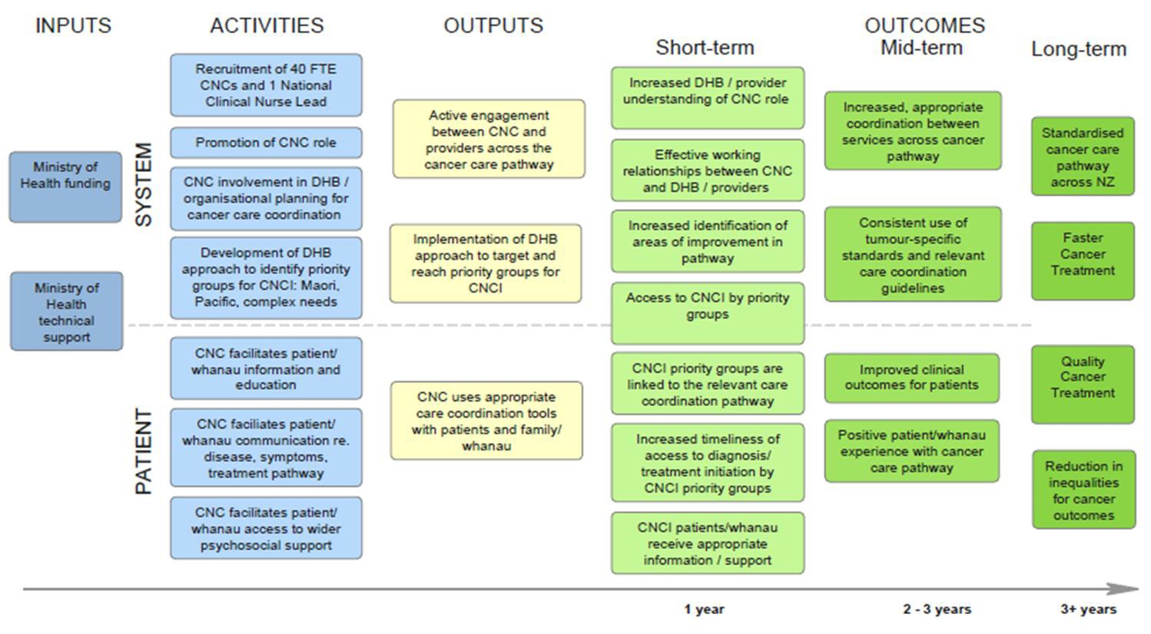

Evaluation data sources: 2015 annual CNCI evaluation report draws on a wider range of data sources than the 2014 report
Review phase: Following the 2014 annual CNCI report, the provider and patient surveys and CNCI database were reviewed and revised based on the results and feedback received. Key changes: the CNCI database was streamlined and new questions were asked relating to transport issues; the provider survey was modified to enable providers engaging with CNCs across a number of DHBs to complete the survey multiple times; and a survey for patients with high suspicion of cancer was developed.

CNCI database: provides information about the activity and function of the nurses such as the demographic profile of patients accessing the CNCI, meetings attended by CNCs, and nursing actions taken. The revised CNCI database was distributed to each CNC in November 2014 and returned April 2015. All 20 DHBs provided information on patient care activity. One DHB provided collated data.

Systems logs: In May 2015, CNCs were asked to complete a log detailing the system improvement projects they had been involved in or initiated over the last six months. In total, 19 DHBs returned systems logs detailing 211 system projects that are currently being undertaken or completed in the last 12–24 months.

Three DHB case studies were completed for: Canterbury DHB involving interviews with three patients and their families and the CNCs; Tairawhiti DHB involving interviews with three Māori patients and the CNC; Counties Manukau DHB involving interviews with three Pacific patients and the lead CNC. Kaipuke undertook the interviews with Māori patients, and Integrity Professionals with Pacific patients. The description of the CNCI in these DHBs was reviewed and refined by the CNCs, and their permission was sought and received to include their case in the annual report. Refer Appendix 1 for the detailed cases.

CNC online survey: profiles CNCs and their activities, and their contribution and perceived effect on patient experience. 48 out of 71 CNCs completed the survey. The response rate is 68%. The maximum margin of error at a 95% confidence limit, factoring for a small population, is 8.1%. The CNC survey profile is in Appendix 2.

Provider online survey: assesses understanding and perceived effects of CNC role. 876 providers across 20 DHBs completed the survey. Response rate is estimated at around 60%. The maximum margin of error is 3.3% at a 95% confidence limit. The provider survey profile is in Appendix 2.

Patient survey assesses patient experience of the role and its contribution. 664 patients with cancer completed a patient experience survey across 20 DHBs. The maximum margin of error is 3.8% at a 95% confidence limit. 68 patients with a high suspicion of cancer completed a patient experience survey across 11 DHBs. The maximum margin of error is 11.9% at a 95% confidence limit. Response rate for the total patient response is estimated at around 41%. Profiles for patients with cancer and high suspicion of cancer who completed a survey are in Appendix 2.

Senior management survey: across 20 DHBs and Regional Cancer Networks to identify their perceptions of the impact of the CNCI. In total, 38 out 63 senior managers including Directors of Nursing, Service Managers, Cancer Network Managers and Nursing leads completed the survey across 20 DHBs. The response rate is 60%. Refer Appendix 2 for the sample profile of senior managers.

Refer evaluation plan for description of methods and the CNCI website for data collection tools; tools were pretested and informed consent procedures were used.

Data quality has improved compared to 2014 report
Data sources | Quality | Comments on quality
CNCI database | Low | All DHBs completed the CNCI database or sent in collated patient data. Compared to 2014 annual report, the data quality of the CNC database has improved: all DHBs provided data and the data was more consistently collected within DHBs. However, not all CNCs within DHBs supplied data for their patients thus the number of patients is an under-representation. In the patient profile section of the CNCI database, there was some variation in time periods completed. To consistently profile patients accessing CNCI, a snapshot analysis for a 6-month period was undertaken. There appears to be some variation in the definitions of how patients are being included within the CNCI database reflecting the different CNCI models of care being used.  Missing data continues to be a challenge, particularly coding of patients’ ethnicity. Ethnicity recorded is multiple counts. For example, if patients are recorded as Māori and Pacific, they get counted as Māori and Pacific. There are only 11 cases where multiple counts are given. In total 454 patients had no assigned ethnicity.  While the CNCI database offers insight into the patients using the service, it does not offer insight on whether there are patients with cancer or high suspicion of cancer who have complex needs and are not being referred to the service. In this context, the question of whether the CNCI is equitable is unknown.
System log | High | CNCs from 19 DHBs completed the system log, giving a good overview of the types of projects CNCs are leading or contributing to. Care is needed in the interpretation of the number of projects due to the differing time periods across DHBs for the projects.
Case studies | Medium | Sample size: undertaking 3 Māori, 3 Pacific, and 3 Pākehā patient interviews means that not all patient experiences will have been identified. However, it is anticipated that significant themes have been identified.  Targeted sub-groups: This approach offers no understanding of other groups’ CNCI experiences and does not address the diversity of Māori or Pacific patients.
CNC survey | High | Reflects the high response rate.
Provider survey | Medium | All DHBs distributed the survey and the number of completed questionnaires was higher than 2014. Potential selection bias due to CNCs selecting and distributing the survey to providers based on their engagement.  Completion rates: There is variation in completion rates across DHBs ranging from 5 for Lakes DHB to 79 for Canterbury DHB. It is notable that in Tairawhiti DHB, 71 providers completed the survey. This completion rate is high, given the relatively small size of the DHB. Analysis was undertaken to assess whether provider response varied for Tairawhiti DHB compared to other smaller DHBs. No notable difference was identified in this analysis.  Potential focus on CNC performance: Photos were used to identify CNCs (from other nurses). This may create focus on individual performance and not the initiative. However without the photos it would be unknown if providers are focusing on CNCI or other cancer nursing services.
Patient survey | Medium | Potential selection bias: Patients and whānau are selected by CNCs as it may not be clinically appropriate for all patients to receive a questionnaire. MidCentral DHB only distributed the survey designed for patients with a high suspicion of cancer.  Low response rate: It is estimated that around 40% of patients completed the survey, it is not known if those who completed the survey are different from those who did not.  Data weighting: The proportion of patients sampled varied across DHBs, along with the number of surveys completed. To offer more certainty around the patient survey, the data received from patients with cancer has been weighted to allow for varying sampling fractions and to be more representative of patients using the CNCI service. The data from patients with a high suspicion of cancer has not been weighted due to the relatively small sample size.
Senior management survey | Medium | Reflects the high response rate.

Report structure
With the exception of the CNCI profile section, each findings section corresponds to noted components of the CNCI outcomes model.

The first chart presents a summary of key findings for this section; the following charts present the evidence and its interpretation.

Findings have been presented in the graphs at a total sample level and key differences noted across sub-groups (e.g. CNCI type, or patients with cancer versus those with a high suspicion of cancer) are noted in the text. Appendix 3 graphically presents the survey results for patients with high suspicion of cancer.

Where appropriate, comparisons are made to the 2014 Annual Report results. Comparisons across time are indicative only and need to be treated cautiously due to sampling differences and data quality issues in 2014, especially for patients. Green upward or red downward arrows indicate a significant increase or decrease in ratings.

Graphs and quotes are coloured coded to differentiate between data sources:
- CNCs are green
- Providers are blue
- Patients are purple
- High suspicion of cancer patients are orange
- Senior management are maroon.

CNCI profile

Section summary of CNCI profile
As intended, the CNCI has evolved over the last two years. There is variation in CNCI models adopted across DHBs to meet differing population needs within existing cancer care pathways and to strengthen and integrate with the cancer workforce.

In 2015, there are three CNCI models of care: Generalist, Tumour Stream and Population. The larger DHBs in the Auckland region have adopted a whole-of-systems tumour stream approach so the CNCI includes other nurses working on the cancer pathways. In total, there are 71 nurses involved in the CNCI across the 20 DHBs, these are very experienced nurses, with respected cancer expertise and leadership. The CNCI does not cover all cancer care pathways across the 20 DHBs.

Compared to 2014, CNCs appear to have greater clarity and confidence about their role and its contribution to improving patients’ experience and cancer care pathways.

CNCs’ daily activities focus on timely care coordination which involves communicating with health professionals about patient care management, patient advocacy, and gaining patients and their whānau access to services. Compared to 2014, more time is spent triaging patients ensuring those with most complex needs are supported and on facilitating system improvements.

Key successes for the CNCI, as noted by CNCs, providers and senior managers, is the CNCs’ integration into the existing workforce enabling improved and timely patient care coordination, improving patient and family experience, and identifying system improvements. CNCs are seen by providers as the patient’s dedicated person with oversight of the patients’ case and advocating for their needs.

Ongoing challenges to the implementation of the CNCI is the level of FTE which constrains CNCS’ ability to deliver all aspects of an advanced and complex nursing and system-focused role. While understanding of the role has improved amongst providers, it is not well understood or appreciated by all primary and secondary care providers. Further CNCs are aware of the limitations of their influence to speed up processes and appointments for patients, and to make system changes. CNCs note the challenge of working across the cancer care pathway’s established boundaries.

Overview of the CNCI models of care: tumour stream
With the introduction of the CNCI, DHBs wanted flexibility to tailor the role to be responsive to their population and existing cancer care pathways. At a system level, it was intended that the CNCI would contribute to greater consistency in the quality and standard of care for patients and a positive patient experience regardless of DHB or patient type. It was intended that the CNC role would evolve during the implementation of the initiative to integrate effectively with existing roles and nurses’ clinical expertise.

During the early implementation stages of the CNCI, there was uncertainty amongst health professionals and managers about the CNC role and how it fitted with other specialist cancer nursing roles (e.g. Cancer Nurse Specialists [CNS]). For larger DHBs, the CNC role was been used to address nursing gaps in the tumour streams.

10 DHBs have adopted a tumour stream approach which involves specialist nurses responsible for the care of patients in a particular tumour stream. There are two sub-categories:
- Tumour stream coverage – Where a DHB does not have full CNS coverage in all tumour streams, a CNC is placed in a tumour stream where there is no existing CNS. While a focus of this role is facilitating care and treatment in a specific part of the patient journey (much like a CNS), the CNC also prioritises care coordination activity particularly from a system perspective and supports the implementation of this across the whole CNS team.
- Four DHBs focus on front of pathway – The CNC supports patients with high suspicion of cancer at the front of the pathway and facilitates their transition to an established CNS or another identified health professional where they are in place. These CNCs also identify and address systems improvements associated with the front of the pathway. The Canterbury DHB case in Appendix 1 describes how their tumour stream and front of pathway approach has evolved and patients and families’ perceptions of this service.

Overview of the CNCI approaches: population and generalist
Two DHBs have population-focused roles where specialist nurses focus on reducing barriers to care through working with a specific population such as Māori, Pacific or Asian patients. These CNCs are a key point of contact at the front end of the pathway, and are focused on improving equity of access. The Counties Manukau case in Appendix 1 describes how their tumour stream approach with population roles has evolved and Pacific patients and families’ perceptions of this service.

10 DHBs have adopted a generalist approach where specialist nurses focus on care coordination for all cancer patients in the region. Generalist CNCs tend to be individual roles based in small DHBs. These CNCs have a strong focus on the front of the pathway. They work with patients considered most at-risk of experiencing problems with care coordination and they are closely linked to Faster Cancer Treatment (FCT) work programmes and systems improvement. The Tairawhiti DHB case in Appendix 1 describes how their generalist approach has evolved and offers Māori patients and whānau perceptions of this service.
A systems approach was initially adopted by Capital and Coast and Auckland DHB to identify gaps in service delivery and undertake projects around the tumour pathway. This system-focused CNCI approach had no patient interface and the roles were less satisfying for nurses. In mid-2014, Capital and Coast and Auckland DHB reconfigured their CNCI approach to be front of pathway and tumour stream respectively.

Across the 20 DHBs, MoH funds 40 FTE CNC positions. Counties Manukau, Waitemata, and Auckland DHBs have adopted a whole-of-systems tumour stream approach so the CNCI includes other nurses working on the cancer care pathways. These DHBs tend to have a lead CNC to inform other nurses’ practice on meeting the CNCI requirements. The lead CNC participates in regional and national CNCI activities. In total, there are 71 nurses involved in the CNCI across the 20 DHBs.

10 DHBs with an integrated tumour stream: CNCI model
DHB | Other CNCI attributes | Case mix | MOH funded 40 FTE* | No. of CNCs  71**
Counties Manukau | CNCI lead  Population roles for Māori and Pacific patients | Urology, sarcoma, gynaecology, breast, lung, haematology, colorectal, melanoma, head and neck, Pacific, upper GI, thyroid | 4.1 | 14
Waitemata | CNCI lead  Population roles for Māori and Pacific patients | Breast, colorectal, lung, GI, gynaecology, melanoma, urology, Māori, Pacific, head and neck, urology, neurology, sarcoma | 4.1 | 12
Canterbury | Front of pathway | Skin, upper GI, colorectal, neurology and sarcoma, lymph node biopsy (haematology), head and neck | 4.1 | 5
Auckland | CNCI lead  Priority Māori and Pacific patients | Breast, GI, lung, head and neck and melanoma | 3.5 | 6
Waikato | Front of pathway | Melanoma, neurology, haematology, upper GI, non-specific, e.g., gynaecology | 3.2 | 5
Northland |  | Head and neck, skin, upper GI, urology | 1.6 | 4
Capital & Coast | Front of pathway | Lung and gynaecology, sarcoma and upper GI, colorectal and breast | 2.2 | 3
Bay of Plenty | Front of pathway/generalist | Generalist – Whakatane; tumour stream – lung, neurology, melanoma, gynaecology and others and others | 2.1 | 3
Hawke’s Bay |  | Lung, haematology, head and neck and skin | 1.5 | 3
MidCentral |  | Gynaecology, lung | 1.5 | 2
* FTE is the MOH funded CNCI positions. 40 FTE includes FTE in DHBs with a generalist CNCI model (next chart).
** Includes part and full-time MOH funded CNCs positions and other DHB funded positions (e.g. Counties Manukau and Waitemata DHB). 71 CNCs includes CNCs working in DHBs with a generalist CNCI model (next chart).

10 DHBs with a generalist CNCI model
DHB | Other CNCI attributes | MOH funded FTE*  40 FTE | Number of CNCs  71**
Southern |  | 2.6 | 3
Nelson Marlborough | CNCI lead | 1.3 | 2
Hutt Valley |  | 1.2 | 2
Lakes |  | 1.0 | 1
South Canterbury | CNCI lead | 1.0 | 1
Taranaki |  | 1.0 | 1
Tairawhiti |  | 1.0 | 1
Wairarapa |  | 1.0 | 1
West Coast |  | 1.0 | 1
Whanganui |  | 1.0 | 1
* FTE is the MOH funded CNCI positions. 40 FTE includes FTE in DHBs with a tumour stream CNCI model (previous chart).
** Includes part and full-time MOH funded CNCs positions and other DHB funded positions (e.g. Counties Manukau and Waitemata DHB). 71 CNCs includes CNCs working in DHBs with a tumour stream CNCI model (previous chart)

CNCs very experienced, respected, and growing more confident in the role
CNCs are advanced and highly experienced nurses:
- 97% over 11 plus years; 65% more than 20 years
- 83% have a post-graduate qualification
- 87% been in role more than 12 months
- 98% of CNCs are in permanent roles
- 71% are on 0.7 – 1 FTE; 21% are on 0.5 FTE or less; 34% have another position in the same DHB.

CNCs’ and providers’ agreement that CNCs have cancer expertise and leadership has increased, in 2015:
- 77% of providers agree/strongly agree that CNCs offer cancer expertise and leadership compared to 67% in 2014
- 98% of CNCs agree/strongly agree that they offer cancer expertise and leadership compared to 89% in 2014.

Source: CNCs (n=48) and Providers (n=878) who answered the questions.
Refer Appendix 2 for detailed profile of CNCs who completed the survey.

CNCs and providers perceive the CNC role offers cancer expertise and leadership; increase in strongly agree ratings from 29% (CNC) and 31% (providers) in 2014
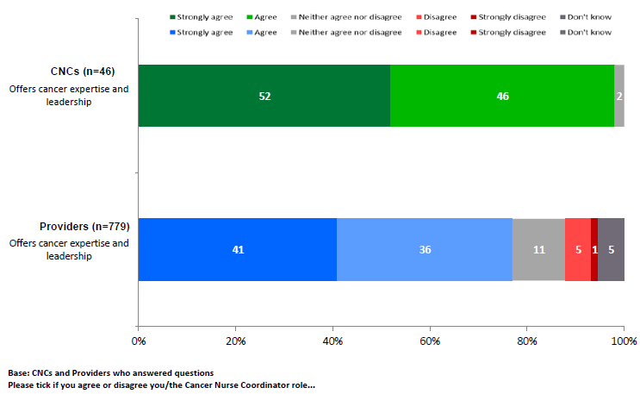

CNCs’ daily activities focus on timely care coordination via communications with other health professionals, patient advocacy, and gaining patient access to other services
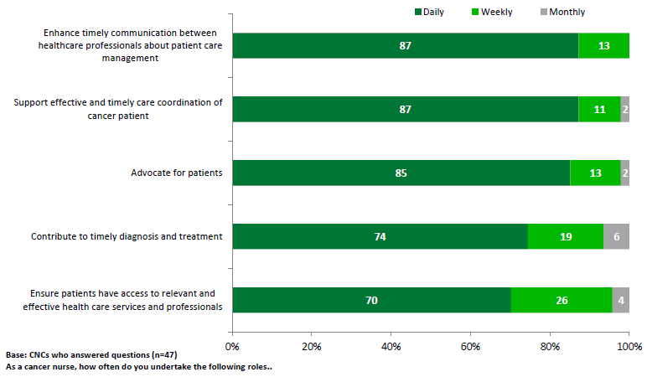

Compared to 2014, more time is spent on triaging patients and facilitating system enhancements on a daily basis
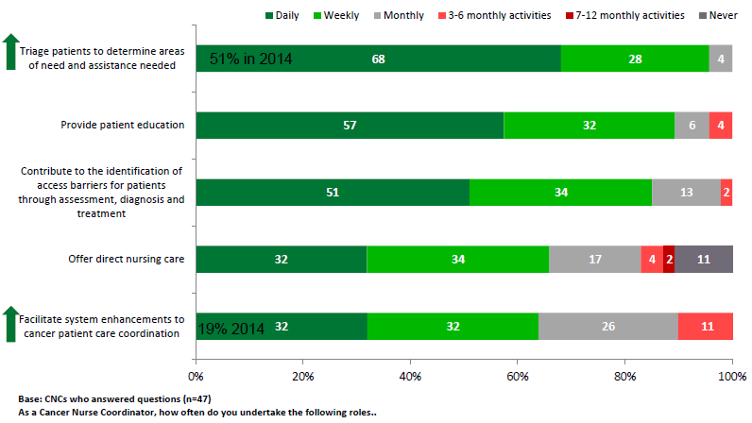

CNC role: an advanced patient and whānau-centred cancer nursing role with a helicopter view across the patient journey
At the outset of the introduction of the CNCI, there was confusion across health professionals and CNCs about the role and how it fitted in with other specialist cancer nursing roles (e.g. CNS). For CNCs, the role of the National Nurse lead, the regular regional CNC meetings and the annual national CNC forum were key in enabling the establishment of the role through leadership and shared dialogue. The CNC network also strengthened connections across DHBs benefitting patients and whānau by ensuring smooth transfers across services and DHBs.

CNCs in larger DHBs note the benefits from the collegial support of their CNC colleagues through the establishment of this new initiative. In smaller DHBs, the CNC role could be more isolated and had greater challenges in seeking to fit into the established cancer team and for the role to be seen as a strategic system based advanced nursing role and not simply another nursing FTE.

Over the last two years, CNCs have noted that the role is increasingly being viewed as an advanced cancer nursing role that has unique patient and whānau-centred responsibilities and autonomy to cross traditional cancer pathway boundaries to:
- identify, using a triage tool (refer Appendix 10), those patients and whānau with complex needs and to facilitate their cancer journey from initial contact with the health system through various departments and services in secondary and primary care settings
- connect and monitor patients’ progress within and across DHBs to ensure appointments are timely in line with FCT and tumour standards and that processes are streamlined for patients
- support patients and whānau to understand both their disease and the treatment options within the context of their lives and circumstances, and how to navigate the health system
- consider the equity of access to services for Māori, Pacific and other patients with complex needs. CNCs interviewed note this is an area where there is a need for further focus, particularly with regard to the population roles.
- question existing systems and processes to identify improvements than benefit patient and whānau and align with tumour standards. CNCs are active in identifying system improvements; although in some DHBs consideration of system issues is still in its infancy.
Sources: DHB cases refer Appendix 1, and CNC survey refer Appendix 4, provider survey Appendix 5, and senior management survey Appendix 6.

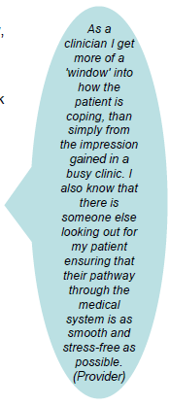
CNCs contribute to an integrated team offering improved and timely patient care coordination, and identifying system improvements
CNCs who commented in the survey identified their successes as building relationships with other providers to work as a part of an integrated cancer care team across the cancer pathway, and through these relationships are able to support and meet patient needs, and enable facilitated service access. CNCs also noted their success in identifying system barriers and working with others to facilitate improvements. The successes identified by the CNCs are also marked in the qualitative feedback from providers and senior DHB and regional cancer network managers.

Providers who commented in the survey note that the CNCI has contributed to patients having improved coordination of care through increased timeliness of referrals, diagnosis and access to treatment, and other services. Providers comment there is a more holistic approach to patient care through the CNC being the one point of contact for patients, and patients have an increased understanding of their cancer and treatment. When asked the best thing about the CNC, the most commonly mentioned attribute by providers is that the CNC is the patient’s dedicated person with oversight of their case and working to advocate for their needs. For providers this makes the CNC the go-to-person for information about the patient.

Senior management across DHBs were asked what had changed with the introduction of the CNCI. Nearly half of those senior managers who responded acknowledged that the CNCI had improved and streamlined the coordination of the patient pathway especially for patients with complex needs. The CNCI is seen to complement CNS roles and offer nursing expertise and resource, and support to other health professionals indicating that the role is integrating with others on the cancer care pathway. The CNCs are described as offering patient-centred care which is enhancing patients’ experience and easing difficulties for patients in their journey resulting in patients having a better understanding of and timely access to services. They are also acknowledged as identifying barriers within and across DHBs and seeking to improve care pathways. CNCs are seen to have a real-time overview of the system.
Sources: DHB cases refer Appendix 1, and CNC survey refer Appendix 4, provider survey Appendix 5, and senior management survey Appendix 6.

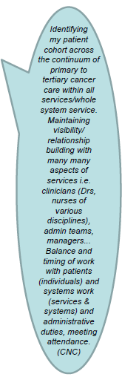
Ongoing challenges are need for more FTE, role awareness and integration, and building on system improvements
While the CNCI has achieved positive gains and greater recognition, there continues to be ongoing challenges for the initiative. CNCs and providers note that CNCs are constrained by their FTE levels and as result they struggle to deliver all aspects of an advanced and complex nursing and system-focused role. In particular CNCs note the challenges of identifying all patients with complex needs and working across traditional service boundaries.

CNCs and providers recognise that the role continues to be not well understood or appreciated by all providers, and there is room to further improve the integration of the CNCI. This feedback is mirrored by a few providers who note the introduction of the CNCI has not made a difference or has duplicated existing CNS roles.

This lack of benefit may reflect that the CNCI does not cover all the cancer care pathways in DHBs due to the models of care adopted and limited FTE within DHBs. It may also reflect that a lack of understanding of the CNCs’ unique helicopter perspective across the cancer pathway, and that the role is to walk alongside the patient and whānau irrespective of traditional service boundaries.

Qualitative feedback suggests that the CNCI tended to gain more traction in DHBs where the CNCs report to a manager with leadership and responsibilities across the cancer care pathway, and not just one component of it.

CNCs also note the limitations of their influence on being able to speed up processes and appointments for patients. Further, seeking to make system changes is particularly challenging given ingrained processes and behaviour within and across DHBs.

Some senior managers noted that the initial role description for CNCs was unclear and created confusion, and as a result some CNCs are not well integrated in the DHB. Further, the CNCI contribution to system improvements is unclear within some DHBs. This is reflective of feedback from some CNCs who note the challenges in gaining traction to make system changes and that their focus on system enhancement is only commencing.
Sources: DHB cases refer Appendix 1, and CNC survey refer Appendix 4, provider survey Appendix 5, and senior management survey Appendix 6.

Engagement and patient profile
Outputs | Short-term outputs  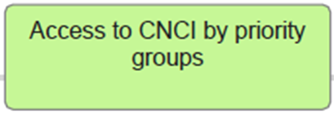

Section summary of provider engagement and CNCI patient profile
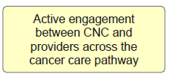  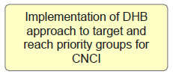  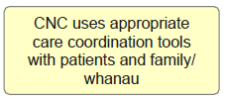 | CNCs are engaging and building relationships with a wide range of providers across the cancer pathway as demonstrated in the provider survey profile (refer Appendix 2) and referral sources. CNC engagement with primary care appears to be less well developed across most DHBs with the exception of Waikato DHB. As noted, there continues to be room to improve engagement across the diverse range of providers across the cancer care pathway.  The triage tool is used to assess patients by CNCs across 19 DHBs (refer Appendix 10 for draft triage tool), where patients are triaged as a one or two a comprehensive assessment is undertaken. Auckland DHB has adopted a priority patients process to support Māori and Pacific patients who DNA at ADHB Cancer and Blood Services. Across DHBs, CNCs are active in sourcing patients for referral to the CNCI via review of lab results, review of admission and ED databases.  Surgeons, physicians and MDMs refer around half of patients to CNCs across 19 DHBs. Referral sources vary by DHBs, dependent on CNC location and relationships. Less than one in ten referrals are from primary care indicating this is an area to enhance awareness of the CNCI.  In a six month period, 6008 patients had a contact with CNCs. There is evidence that priority groups are accessing CNCs as just under half of CNC patients were classified as Triage 1 and 2.  Māori and Pacific patients are accessing the CNCI. Access varies across DHBs for Māori and Pacific patients, and appear low. Consideration is needed on how to remove access barriers for Māori and Pacific patients to the CNCI.

Referrals to the CNCI are reasonably prompt following DHB referral. CNCs are moving patients onto other services
More than two thirds of patients were referred to CNCs in under a month; four in ten in less than a week. It may be assumed that those patients referred to the CNCI six months or more after referred to the DHB may be patients with cancer whose care has become increasingly complex thereby triggering the referral to the CNCI.

Half of patients were discharged in under a month and nine in 10 by three months.

Days between DHB referral and CNC referral  Base: patients with recorded dates | Total 3558 % |  | Days between CNC referral to and discharge from the CNC  Base: patients with recorded dates | Total 1902 %
0 days | 20% |  | 0 days | 5%
1–7 days | 21% |  | 1–7 days | 12%
More than 1 week, within 1 month | 30% |  | More than 1 week, within 1 month | 35%
More than 1 month, within 3 months | 16% |  | More than 1 month, within 3 months | 40%
More than 3 months, within 6 months | 6% |  | More than 3 months, within 6 months | 5%
More than 6 months, within 1 year | 3% |  | More than 6 months, within 1 year | 1%
1–2 years | 1% |  | 1–2 years | 1%
2+ years | 2%
Source: CNCI database of 6008 patients across 18 DHBs for a six-month period.

Over 60% of referrals to CNCI are from surgeons, physicians and CNCs searching system databases; 6% of referrals are from GPs suggesting low levels of awareness of CNCI in primary care
Referrals to CNCI  Base: number of patients where referral source is completed | Total 5293 % | Referrals sources vary across DHBs reflecting the model of care, location, and relationships of CNC and their level of integration:  - Surgeon referrals to CNCs are higher in Taranaki (65%), Northland (58%), CMDHB (56%), Lakes (46%), Canterbury (41%), West Coast (40%), Waitemata (39%).  - CNCs sourcing referrals from system sources are higher in Tairawhiti (71%), Nelson Marlborough (56%), Whanganui (42%), BOP (40%), Waikato (39%), C&C (34%). It is intended over time that CNCs sourcing patients via these mechanisms will decrease as referrals increase from other sources.  - Physician referrals are higher in MidCentral (80%), HBDHB (24%), CMDHB (21%), Taranaki (21%).  - MDM referrals are higher in Lakes (39%), South Canterbury (39%), C&C (27%), NMDHB (26%).  - CNS referrals are higher in Wairarapa (17%) and BOP (11%).  - GP referrals are higher in Waikato (23%).
Surgeon | 29%
Systems referral sourced by CNC via lab results, review of admission and ED databases | 23%
Physician | 12%
MDM | 9%
Other nurse | 8%
GP | 6%
CNS | 4%
Booking clerk/administrative | 4%
Consultant | 1%
Patient/carer self-referral | 1%
Other | 2%
6008 patients had contact with CNCs over a six-month period
Source: CNCI database of 6008 patients across 19 DHBs for a six-month period. |  |  | 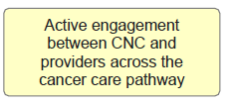

Reflecting tumour stream CNCI DHBs, patients with lung, skin and GI cancers are more frequently engaged with a CNC. The range of tumour sites highlights that CNCs are focusing on a range of patients with complex cancers.
Tumour site | n=5875  No. | n=5875  % | Notes:  CNCI does not cover all tumour streams.  To complement existing staff, DHBs undertook workforce analysis to determine where CNCs resource would be located across tumour streams.  As capacity allows and interest in the CNC role grows, CNCs in generalist CNCI approaches are increasing their support across the range of tumour streams. However, some providers are not interested in working with the CNCs which limits access to some tumour streams.
Lung | 1054 | 18%
Skin | 982 | 17%
Lower gastrointestinal | 833 | 14%
Upper gastrointestinal | 659 | 11%
Gynaecological | 493 | 8%
Urological | 443 | 8%
Breast | 421 | 7%
Head and neck | 335 | 6%
Haematological | 234 | 4%
Brain / central nervous system | 171 | 3%
Sarcoma | 93 | 2%
Thyroid | 27 | <0%
Other | 130 | 2%
Source: CNCI database of 6008 patients across 19 DHBs for a six-month period.

Most patients referred to the CNCI are accepted. Patients have a range of needs and around half are rated as having the most complex needs. Just under half of these patients have an assessment of their needs.
In most DHBs between 0–4% are not accepted into the CNCI. The exceptions are CMDHB (9%), South Canterbury (10%), Waikato (17%), Wairarapa (44%), West Coast (25%), Whanganui (27%).

Initial assessment  Base: patients with assessment coded (17 DHBs) | Nov  789  % | Dec  785  % | Jan  779  % | Feb  1016  % | Mar  998  % | Apr  725  % | Total  5089  No.
Accepted into CNCI | 92% | 89% | 89% | 90% | 90% | 88% | 4565
Not accepted into CNCI | 8% | 11% | 11% | 10% | 10% | 12% | 524

Patients’ needs change overtime therefore they have multiple CNC triages. The table below shows the highest triage score given to patients over the six month period. Just under half had a triage score of 1 or 2 (most complex). One in ten had no score coded which may reflect they were newly referred to the CNC or codes were missing.

Patients triaged as a 1 or 2 have a comprehensive patient assessment. In the table below, the base is therefore less than 6008. The table is based on number of assessments completed as patients may receive multiple assessments.

Highest triage score given to CNC patients over a six-month period  Base: all patients triaged (19 DHBs) | Total  n=6008 | Total  %
1 Most complex needs | 1179 | 20%
2 | 1509 | 25%
3 | 1578 | 26%
4 High suspicion | 1022 | 17%
No score coded | 720 | 12%

CNCI is working with the new psychological workforce on distress screening tool for patients.

Patient assessments completed  Base: all those with an assessment recorded (19 DHBs) | Nov  586  % | Dec  598  % | Jan  593  % | Feb  736  % | Mar  745  % | Apr  602  % | Total  3860  No.
Comprehensive assessment completed | 37% | 31% | 30% | 28% | 29% | 27% | 1168
Distress screen and comprehensive assessment completed | 8% | 5% | 5% | 7% | 5% | 5% | 222
Distress screen completed | 10% | 11% | 12% | 13% | 14% | 12% | 469
Not completed | 45% | 54% | 53% | 52% | 52% | 55% | 2001
Source: CNCI database of 6008 patients across 17-19 DHBs for a six month period.

Of 6008 patients enrolled in the CNCI for the six month period, 2733 were discharged/transferred demonstrating that CNCs are working to ensure patients are connected with wider cancer services.
Discharge/transfer | Nov  275  % | Dec  358  % | Jan  424  % | Feb  484  % | Mar  501  % | Apr  691  % | Total  2733  No.
Care transferred to another CNC (within your DHB) | 3% | 5% | 8% | 3% | 6% | 2% | 120
Care transferred to another CNS (within your DHB) | 6% | 13% | 12% | 13% | 12% | 13% | 329
Care transferred to another DHB | 27% | 21% | 18% | 19% | 17% | 10% | 465
CNC episode complete | 35% | 38% | 37% | 43% | 42% | 21% | 951
Deceased | 3% | 2% | 5% | 5% | 5% | 2% | 98
Discharge to another DHB (e.g. patient has relocated) | 1% | 1% | 0% | 1% | 1% | 0% | 15
Discharge to palliative care | 16% | 13% | 13% | 9% | 9% | 4% | 262
Discharged from service (well and/or no follow-up) | 0% | 0% | 0% | 0% | 0% | 43% | 298
Other | 9% | 8% | 7% | 9% | 8% | 4% | 195
Source: CNCI database of 6008 patients across 19 DHBs for a six-month period.

Māori and Pacific patients are accessing the CNCI. Access varies across DHBs for Māori and Pacific patients. Access rates for Māori and Pacific patients are not high. Consideration is needed on how to remove access barriers to the CNCI for Māori and Pacific patients.
Ethnicity | n=6008  No. | n=6008  % | Access for Māori patients is higher in Tairawhiti DHB (38%), BOP (24%), Lakes (22%) and Hawkes Bay (20%).  Access for Pacific patients is higher in CMDHB (16%), Auckland (9%) and C&C (8%).
Māori | 749 | 12%
Pacific people | 309 | 5%
NZ European | 3777 | 63%
Other | 719 | 12%
Not coded | 454 | 8%

More than half of Māori and Pacific people accessing the CNCI have a triage score of 1 or 2 (most complex needs).

Highest triage score given to CNC patients over a six-month period  Base: all patients triaged (19 DHBs) | Māori  n=749  % | Pacific  n= 309  % | Other  n=4496
1 Most complex needs | 28% | 30% | 19%
2 | 29% | 25% | 25%
3 | 16% | 19% | 27%
4 High suspicion | 14% | 9% | 17%
No score coded | 13% | 17% | 11%
Source: CNCI database of 6008 patients across 20 DHBs for a six-month period.

CNC patients tend to be older. Both male and female patients are accessing the service.
Age range | n=5729  No. | n=5729  % |  | Biological sex | n=5727  No | n=5727  %
0–14 years | 11 | 0% |  | Female | 2867 | 51%
15–24 years | 73 | 1% |  | Male | 3760 | 49%
25–34 years | 144 | 3%
35–44 years | 325 | 6%
45–54 years | 749 | 13%
55–64 years | 1225 | 21%
65–74 years | 1684 | 29%
75+ years | 1518 | 26%
Source: CNCI database of 6008 patients across 20 DHBs for a six-month period.

Knowledge of CNCI role
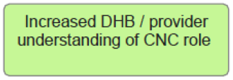

Section summary of knowledge about CNCI role
Awareness and understanding about the CNCI and the CNC role is improving amongst providers especially for patient advocacy and enabling timely diagnosis and treatment.

Providers appreciate that the role is about patient care coordination for cancer patients, enhancing communications across health care professionals, about care and advocating for patients to access heath and support services.

While this shift is positive and reflects the work of the CNCs over the last year, there is room to further enhance awareness and understanding of the CNC role across the diversity of providers.

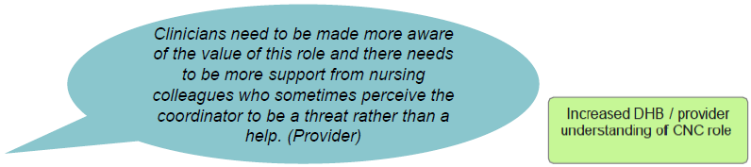

Compared to 2014, CNCs’ agreement their role is well understood by other health care professionals has increased (from 38% agree to 48% agree/strongly agree) correspondingly disagreement has declined (from 41% to 22%).
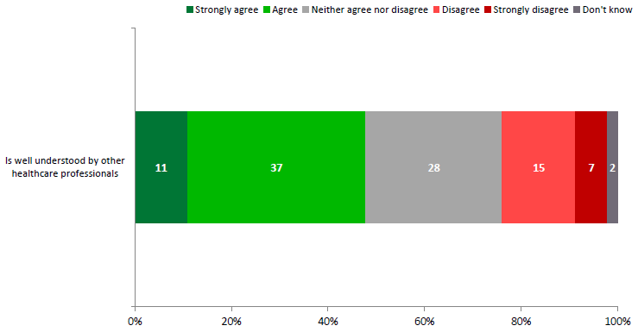
Base: Providers who answered question (n=46)
Please tick if you agree or disagree that your Cancer Nurse Coordinator role ...

Providers’ agree CNC role is care coordination for cancer patients, enhancing communications across health care professionals about care and advocating for patients to access heath and support services.
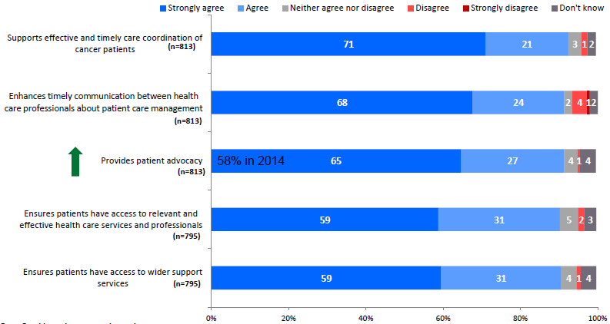
Base: Providers who answered questions.
Please click if you agree the Cancer Nurse Coordinator role ...

Provider agreement that the CNC role ensures patients have access to support services is higher for the tumour stream approach (94%) than generalist approach (86%).

Less agreement by providers that the CNC role enables timely diagnosis and treatment (although agreement is increasing) or direct nursing care*
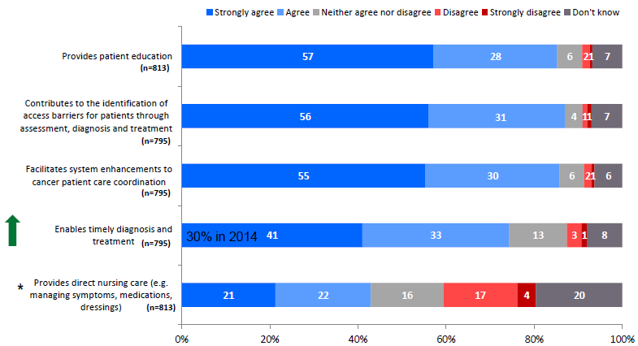
Base: Providers who answered questions
Please click if you agree or disagree that the Cancer Nurse Coordinator role ...
* This attribute is confusing for providers as it is unclear what is meant by direct nursing care in this context.

Provider agreement is higher for the tumour stream approach than generalist approach for patient education (90% to 78%), timely diagnosis (79% to 68%), and direct nursing care (48% to 36%).

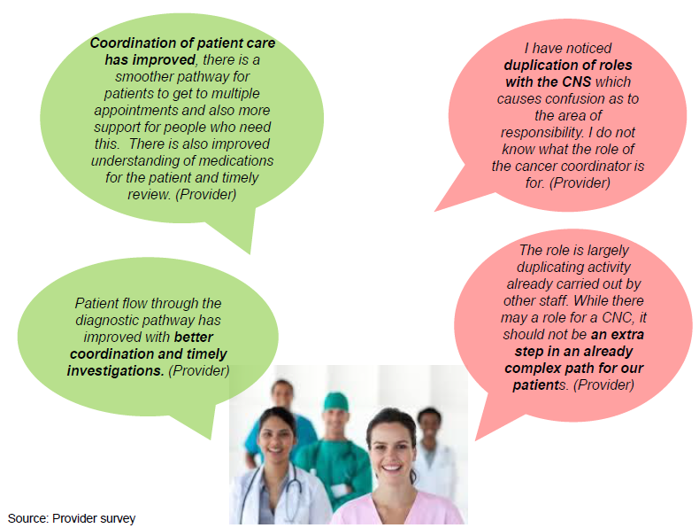

Relationships between CNCs and providers
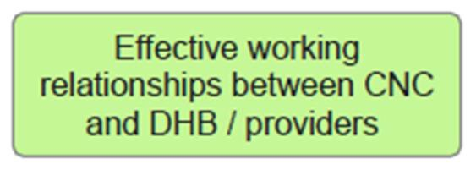

Section summary of effective working relationship
Mainly positive and effective working relationships with other health professionals.

Compared to 2014, CNCs are more confident in their ability to work effectively with other professionals, and support and alleviate their workload.

Providers agree CNCs have an effective working relationship with other health professionals, and their role works to improve communications between health professionals about patients.

Some providers continue to perceive that CNCs duplicate other roles.

Compared to 2014, CNCs are more confident in their ability to work effectively with other professionals and alleviating workload. CNCs’ self-recognition as an important team member and delivery of education is increasing but there is room to improve.
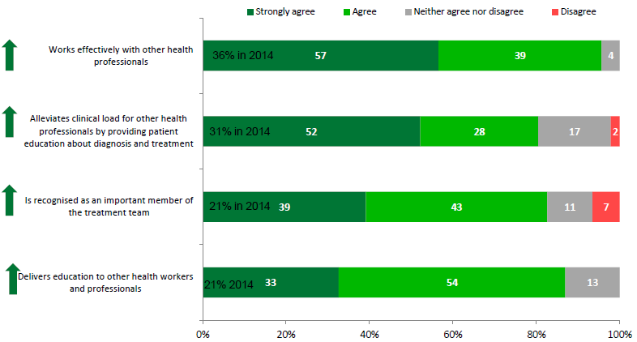
Base: CNCs who answered questions (n=46)
Please click if you agree or disagree that your Cancer Nurse Coordinator role ...

Providers agree CNCs have an effective working relationship with other health professionals and improve communications between health professionals about patients. A quarter of providers agree CNCs duplicate other roles.
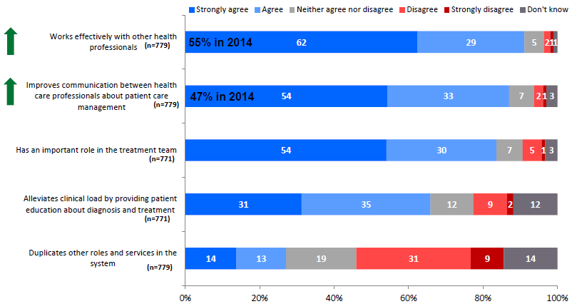
Base: Providers who answered questions
Please click if you agree or disagree that the Cancer Nurse Coordinator role ...
Provider agreement is higher for the tumour stream approach than generalist approach for important role in team (88% to 78%), and alleviating clinical load (72% to 57%).

CNCs offer providers a single point of contact with an overview of patient and whānau needs. CNC/provider relationship strengthened through more CNCs and better understanding of role.
In the provider survey, providers were asked to describe the best thing about the CNC. Overall, having a dedicated person tasked with patient oversight who has in-depth knowledge of patients’ cases, can advocate for patients and ensure patients do not get lost in the system was mentioned by a quarter of providers as the best things about the CNCI.

For providers this means CNC are their ‘go-to’ person for information on patient cases. Providers are also reassured that the CNC can support patients and whānau, act as their single point of contact for queries and advice, and facilitate their pathway.

Providers also mentioned that the CNC facilitates communication and relationships with other health care professionals, and improves the transfer of patients between DHBs. As a result of these CNC activities, providers acknowledged the role supports and can alleviate their and others workload.

In the provider survey, providers were asked how the CNCI could be improved. A quarter of providers mentioned the need to increase the CNC FTE and number of roles. Other improvements suggested were ways to enable the CNCs in this role through increased education for CNCs and research to inform best practice, greater administrative support and enhanced IT and information system to support information sharing and patient tracking. Providers also mentioned the need to increase the awareness and understanding of CNC role, to reduce duplication with other roles, and to enhance communication and relationships with other health care professionals.

Source: Provider survey refer Appendix 5.

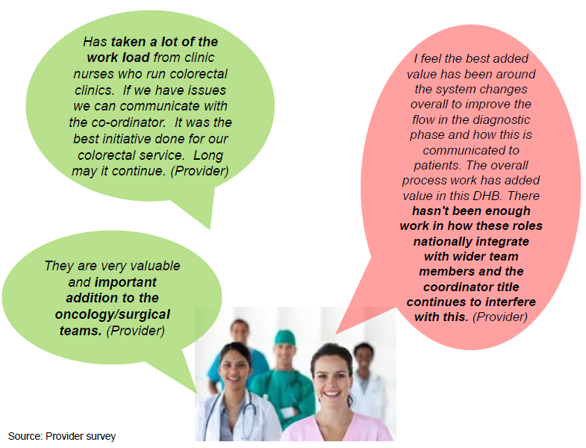

Contribution to system improvements
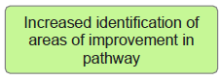

Section summary of identifying areas of improvement in pathway
CNCs are actively identifying system issues and working with other professionals to address them. This system-focused role is acknowledged by providers.

CNCs in 19 DHBs were or are involved in 211 system projects. Projects are similar across DHBs. Common projects relate to patient pathways, supporting MDMs, data collection and developing tools.

CNCs note that there are a number of barriers that impede their system improvement role including lack of buy-in, high CNC workload and lack of IT infrastructure or support.

Feedback from CNCs indicate projects are achieving positive outcomes including the creation or implementation of a tool or protocol, and systems becoming more standardised and streamlined. Some projects are perceived by CNCs to have contributed to improving timeliness along parts of the cancer pathway for specific patients.

CNCs agree they are actively identifying system issues and working with other professionals to address them; 8 in 10 providers acknowledge CNCs’ system role
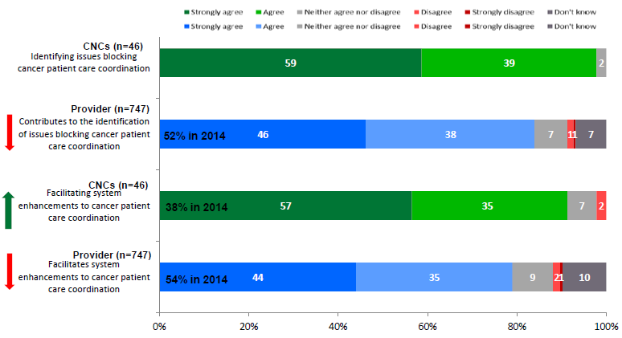
Base: CNCs and Providers (n=747) who answered questions.
Please click if you agree or disagree that the Cancer Nurse Coordinator role ...

211 system projects completed or in progress. Common projects related to patient pathways, supporting MDMs and data collection and developing tools.
Since 2013, 19 DHBS reported that CNCs have contributed to or lead 211 projects to address system issues identified (refer Appendix 9 for the breakdown of the number of projects across DHBs).

The types of projects undertaken by CNCs is similar across DHBs. The most common system projects being undertaken across DHBs are:
- Reviewing and revising patient pathways including the mapping of tumour streams and seeking tumour stream improvements, e.g. a tumour stream project where six tumour streams with the largest volume of patients are being mapped and CNCs are working across the hospital to improve pathways and processes to meet FCT targets. In March 2015, a cancer governance board was formed, tumour stream projects identified, teams formed, pathways mapped and resource allocated to implement a database across all tumour streams for cancer trackers.
- Developing or supporting MDMs (e.g. A DHB neurosurgery oncology MDM is a systems project that has been put in place to ensure all patients with diagnosed or potential tumours relative to neurosurgery are registered at MDM. The project has resulted in weekly meetings, creation of a proforma, timeliness of documented outcomes and improved referral process. These projects are more likely to occur in DHBs with a CNCI tumour stream approach.
- Developing and implementing protocols and tools e.g. patient tracking system, MOSAIQ, DNA reminder system, Screening for Distress and Triage.
- Enabling FCT data collection, advice or system development. These projects are more likely to occur in DHBs
- with a CNCI generalist approach.
- Equity projects including Screening for Distress, DNAs, National Travel Assistance, and improving cancer care pathway for Māori. CNCs at one DHB implemented a project to increase the E te Iwi Cancer education programme. This programme aims to increase Māori education around cancer and involves the delivery of information at various hui. Positive feedback has been received from participants and facilitators. This programme is also improving CNC relationships with primary care and Whānau Ora health services.

Other less frequently mentioned system projects include:
- Developing patient information resources are more likely to occur in DHBs with a CNCI tumour stream approach. For example one DHB created a booklet for surgical patients to educate them around the surgical process, another CNC has local and regional resources for patients with a high suspicion of cancer and nurses in the outpatients department. The project involved the collection of brochures and information packs in the department, the CNCs’ involvement in the creation of regional patient handouts. This project resulted in relevant education resources being available and used regularly.
- Supporting the establishment of Tumour Standards, e.g. one DHB reviewed 30 patients diagnosed and treated for colorectal cancer to assess current care and management of bowel cancer services at the DHB against national bowel cancer tumour standards.
- Facilitating/improving processes for working between different DHBs.
- Referral process between secondary care and primary care.
- Developing resources to support assessment, care planning, transition or referral.

Lack of buy-in, high CNC workload and lack of IT infrastructure or support are key barriers to system projects.
While CNCs have had success in identifying system issues and working with others to address them, CNCs indicate there are a number of barriers when seeking to implement system change. The most frequently mentioned barriers are:
- Lack of buy-in from other health professionals including other health professionals not undertaking agreed duties, and a general resistance to changing existing protocols and practice. Creating buy into change projects are challenging for CNCs due to the difficulties of coordinating and communicating across a diverse group of people with a range of opinions especially in larger DHBs, and where there are personnel changes. The lack of awareness of the system component of the CNC role can also compound the challenges
- High CNC workload resulting in a lack of time for system projects. This is compounded by a lack of resources
- Current IT systems or the lack of IT support can hinder the implementation of the desired system improvements. For example one DHB was unable to implement mandatory coding of ED patients presenting with a high suspicion of cancer as the IT team was unavailable to set up the mandatory field in the patient admission forms.

Feedback from CNCs indicate projects are achieving positive system changes
36 projects have resulted in the creation or implementation of a tool or protocol. An example is an FCT data collection system development project which resulted in the creation of an online live data system that shows when patients breach FCT time.

29 projects have resulted in tumour streams being mapped, barriers identified and systems becoming more standardised and streamlined. An example is one DHB initiating a project to map all tumour streams to a point of diagnostic certainty. The project identified a number of barriers and plans have been put in place to address them.

22 systems projects are reported by CNCs to have improved referral and timeliness or access to treatment. An example is a project where CNCs attend MDMs to identify patients that require increased input or urgent treatment and initiating support that resulted in all identified high grade NET patients receiving timely appointments and access to treatment.

12 systems projects have lead to useful data being collected. An example is an FCT data collection project which resulted in consistent data being supplied to MoH on FCT targets. CNCs are responsible for data collection in their own tumour streams to increase validity of the data. CNCs are continuing to monitor the data to ensure validity and consistency.

11 projects have been noted by CNCs as improving timeliness and access to treatment and investigations for patients via streamlining referral pathways, ensuring awareness of pathways, and enhanced communications. CNCs perceive these projects have contributed to improved timeliness on specific parts of the cancer pathway (e.g. access to radiology) or group of patients. Review of FCT data for the DHBs where CNCs noted these effects demonstrates mixed results – FCT data is improving in some and not in others. Where there is an improvement in FCT data, the change noted cannot be attributed to CNCI system projects alone.

10 systems projects are facilitating communication within and between DHBs. One DHB established a video link with another DHB to improve interaction between sites to facilitate the decision making process. Current IT systems were a barrier but the link has been established.

9 projects have also resulted in education programmes being delivered to other staff.

Source: Systems logs from CNCs across 19 DHBs refer Appendix 9.

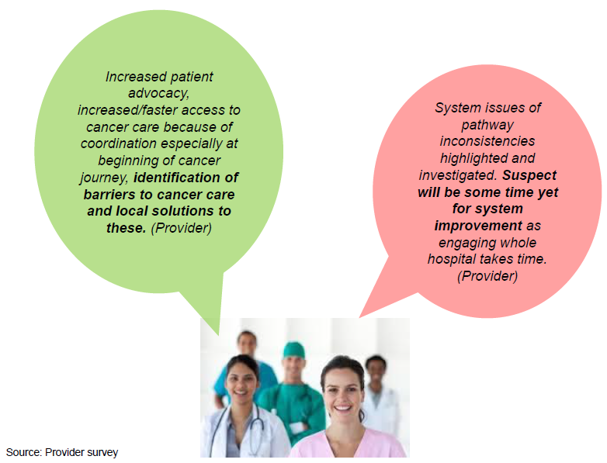

Coordination of patient pathway
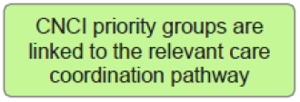

Section summary of CNC contribution to a coordinated patient journey
Most patients agreed CNCs helped them to know the next steps in their treatment.

Qualitative interviews with patients in the case studies highlighted a key benefit was the ability of the CNC to proactively help them navigate the complexity of cancer services and appointments at a time when they were tired, stressed, and physically and emotionally unable to cope with this additional burden.

CNCs’ internal knowledge were seen as enabling them to negotiate and facilitate patients’ progress along the pathway particularly when they needed to travel across DHBs boundaries.

In contrast, around 5% of patients who completed the survey had little contact with the CNC, did not understand the role and gained no benefit from their initial contact. It is possible these patients where assessed as not having complex needs and therefore the CNCs did not provide further support. The feedback from patients however indicates that CNCs need to consider ways to manage this process so patients have a clearer understanding of the role in the context of their care pathway.

Most CNCs and providers agreed the CNCI has contributed to improving patient experience by enabling a more coordinated cancer journey and ensuring they know the next steps in their treatment.

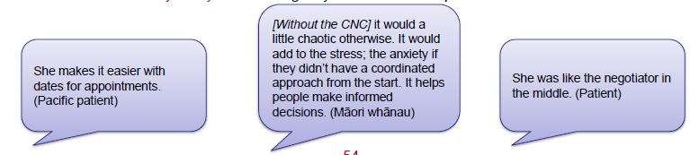
Sources: DHB cases refer Appendix 1, and Patient survey

CNC ‘go to person’ for patient so they know the next steps
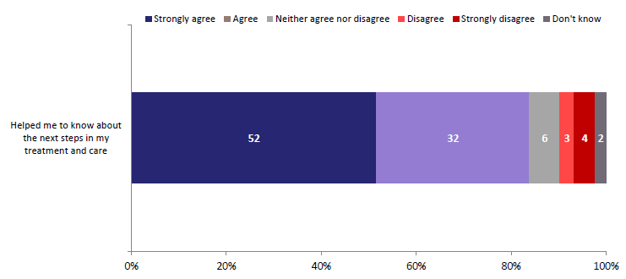
Base: Patients who answered the question (n=647)
Please tick if you agree or disagree that my Cancer Nurse Coordinator …

In the patient survey, ratings of the CNCI was consistent by ethnicity of patient, and location of patients (i.e. tumour stream or generalist CNCI approach). Some differences were noted in ratings of CNCI between patients diagnosed with cancer and those with a high suspicion of cancer.

CNCs contribute to a more coordinated patient journey
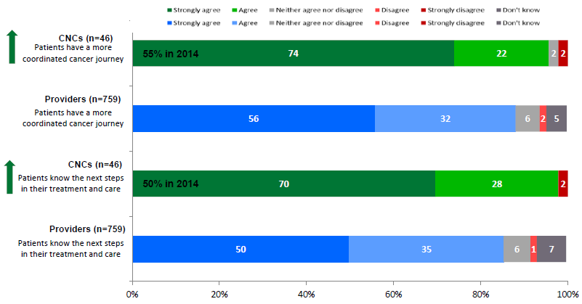
Base: CNCs (n=46) and Providers (n=759) who answered questions
Please click if you agree or disagree that the Cancer Nurse Coordinator role ...

Provider agreement is higher for the tumour stream approach than generalist approach for the ratings above, (91% to 83% coordinated journey and 90% to 78% knowing next steps.

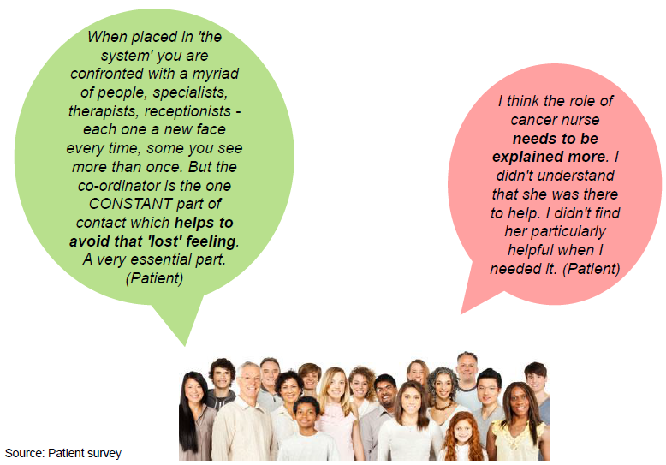

Contribution to timely diagnosis and treatment
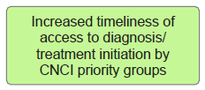

Section summary of contribution to timely diagnosis and treatment
The evaluation cannot definitively answer whether the CNCI has increased timeliness and access to diagnosis and treatment for CNC patients. This reflects there is no comparative group of cancer patients to benchmark changes in access and timeliness.

Assessment of CNCI’s contribution to improving timeliness of access and treatment has therefore been based on providers’ perception of their contribution. Seven in ten providers who completed the survey agreed that the CNC role is facilitating a timely process for patients. While providers acknowledge CNC contribution to timely diagnosis and reducing DNAs, some are uncertain about this contribution.

For patients, the focus was placed on assessing whether they understood their cancer pathway rather than measuring a perception of timeliness. In this context, eight in ten patients agreed that the CNC explained the appointment process and likely timeframes.

CNCs agree they contribute to timely diagnosis and manage patients’ appointment expectations.

Patients aware of appointment and test process and likely timeframes
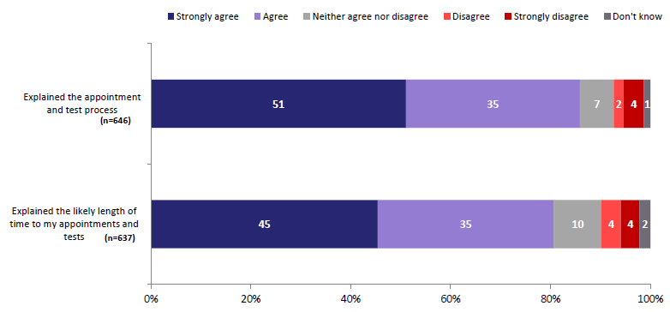
Base: Patients who answered the question
Please tick if you agree or disagree that my Cancer Nurse Coordinator ...

Analysis of the patient survey identified no differences in patient experience by those accessing CNCs via a tumour stream or generalist approach.

CNCs have increased confidence their role contributes to patients understanding their appointments, timely diagnosis and reduced DNAs. Providers acknowledge the CNC role in facilitating timely process. While providers acknowledge CNC contribution to timely diagnosis and reducing DNAs, some are uncertain about this contribution.
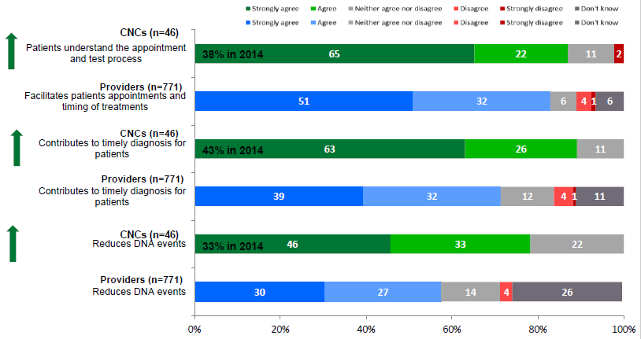
Base: CNCs and Providers who answered questions
Please click if you agree or disagree that the Cancer Nurse Coordinator role ...
Provider agreement is higher for the tumour stream approach than generalist approach for the ratings above, (in order 88% and 76%, 77% to 64% , and 64% to 48%).

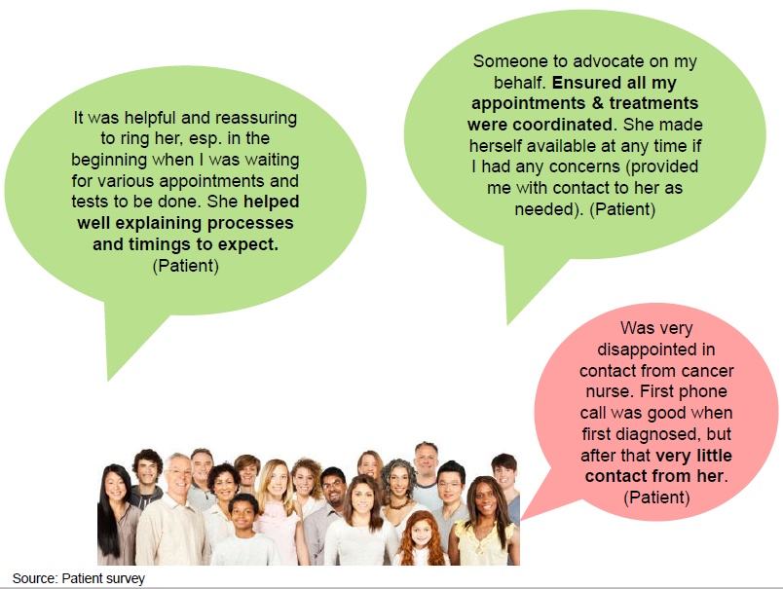
Source: Patient survey

CNCs linking services
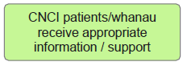

Section summary of CNCs linking to services
CNCs are putting patients in touch with other services as needed, as acknowledged by the CNCs and providers.

Further support could be offered by CNCs to link patients to access help relating to financial and emotional support services.

A quarter of patients asked by CNCs have transport issues particularly when transferring between DHBs. Patients in more rural areas struggle with the distance to appointments especially if no transport is available.

CNCs are connecting patients to services
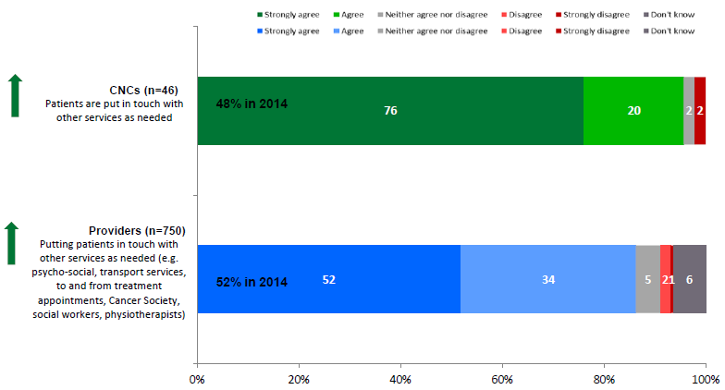
Base: CNCs and Providers who answered questions
Please click if you agree or disagree that the Cancer Nurse Coordinator role ...

Patients are receiving help from CNCs to access services needed. Further support could be offered by CNCs to link patients to access help relating to financial and emotional support services.
Cancer Nurse Coordinator helped with …  Base: Patients who answered the question and needed the services | Base: Patients who wanted help | Patients who did NOT receive help when needed  %
Other services I needed to help me with financial support | n=186 | 21%
Other services I needed to help with my worries, fears or emotional issues | n=222 | 16%
Other services I needed e.g. nurse specialists, physios, culturally appropriate groups | n=271 | 12%
Written information and resources I needed about my cancer | n=342 | 10%
Services I needed about transport to and from treatment appointments | n=205 | 7%
Source: Patient survey (weighted data)

A quarter of patients have transport issues particularly when transferring between DHBs. Patients in more rural areas struggle with the distance to appointments especially when no transport is available.
Transport issues | Total  3684  % | Mention of transport issues are higher amongst Hawkes’ Bay (50%), South Canterbury (63%), Tairawhiti (70%), West Coast (81%), and Wairarapa (99%).
Yes | 26%
No | 50%
Don’t know / not discussed | 24%

Transport problems identified  Base: Patients with codes relating to transport issues | Total  3684  % | Higher mention of transport issues across DHBs
Transferring between DHBs | 15% | Northland (26%), South Canterbury (60%), Tairawhiti (56%), Wairarapa (66%), West Coast (73%), Whanganui (22%)
Distance from appointment / No transport | 10% | Hawkes’ Bay (44%), Northland (19%), Tairawhiti (33%), Wairarapa (74%), West Coast (23%)
Ineligible for NTA | 4% | Hawkes’ Bay (31%), Wairarapa (34%), West Coast (24%)
No parking available | 1% | West Coast (19%)
Using public transport | 1% | –
Source: CNCI database of 6008 patients across 16 DHBs for a six-month period.

Improving patient experience
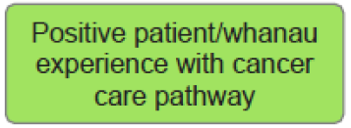

Section summary of improving patient experience
Being diagnosed with a high suspicion of cancer or cancer is extremely traumatic for people and their family/whānau. It is a time when people may be physically unwell and tired and they and their family/whānau are emotionally fragile and stressed. People and family/ whānau, who have little exposure to the health system, can find the diagnosis process bewildering, particularly if they have other health, social needs.

In this context, patients describe their CNC as their ‘go-to-person’ who enables the coordination of the process by ensuring appointments are set up, and they can access their appointments. For patients, CNCs’ clinical nursing expertise underlies the benefits they gain from the role, by having an expert who understands what they are going through, is able to explain clinical information in lay terms, knowledgeable about the next steps in care and how to navigate the system to ensure they occur, and being aware of other support services and how to access them.

For patients, the CNC role is much more than an administrative navigation role. Having a CNC resulted in patients being more confident about what is happening and when, knowing more about their cancer and treatment, and having their family/ whānau involved as wanted.

Feedback suggests being referred to the CNC early in the diagnosis process maximises patients’ benefits. Although for some patients with a high suspicion of cancer being referred to a CNC can be concerning as the word ‘cancer’ in their title can be seen to confirm they have cancer.

Feedback from patients, who have had cancer or experience of cancer services before the initiative, suggests the introduction of CNCs has enhanced their and their family/whānau’s service experience compared to their pre-CNCI experience.

Patients surveyed were mainly happy with the role. Improvement areas suggested by patients are improved introduction of the CNC and explanation of the role, better information sharing and handover to other services , and more regular contact.

These benefits were also noted by CNCs and providers. While overall ratings of CNCs are high, areas to strengthen going forward are respecting culture, values and beliefs, helping family/ whānau, and involving patients in decisions about their cancer and treatment.

Meeting patients’ cultural and belief needs; not rated as highly as other attributes; although there is an increase in CNCs self-ratings compared to 2014
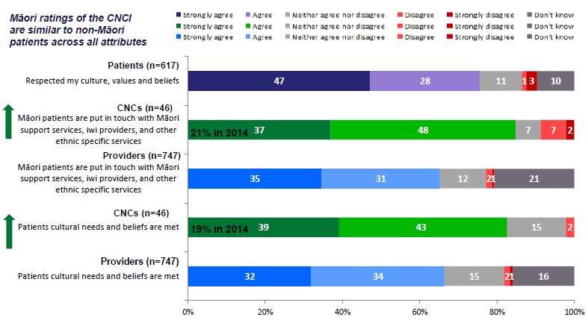
Base: Patients, CNCs and Providers who answered questions
Please tick/click if you agree or disagree that the Cancer Nurse Coordinator role ...

Provider agreement is higher for the tumour stream approach than generalist approach for the ratings above, (in order 69% and 59%, and 72% to 59%).

Referral to Māori support services continues to be the key activity used by CNCs to improve the experience of Māori patients and their whānau in the cancer pathway, as well as ensuring timely communication, and inclusion of whānau
Involve all whānau members in FSA, diagnostic procedures and breaking serious news appointments in a way they support and comfort the patient. Offer iwi support/navigation or services particularly after diagnosis made to support in community setting. (CNC) | What are the two most important activities you undertake in your CNC role to improve the experience of Māori patients and their whānau in the cancer pathway?  Base: Number of CNCs who answered question | n=46  %
 | Referral to Māori support services | 67%
 | Ensuring timely and accessible communication | 35%
 | Inclusion of whānau | 26%
 | Cultural awareness/appropriateness | 22%
 | Education | 17%
 | Coordination of care/transport/appointments | 13%
 | Referral to Māori CNC | 11%
 | Identification of barriers  Ensure assistance is available  to get patients to where they  need to be without barriers  such as travel, finance etc. CNC | 9%

Tairawhiti DHB: Māori patient and whānau experience of CNC roles
The four Māori patients and whānau interviewed were extremely positive about the CNC role and the benefits it offered them.

Patient understanding of the role: The patients were introduced to the CNC role by their doctor/specialist or during their diagnosis process. Patients and whānau had little expectations of the role as they were not aware of its existence before their diagnosis. Patients identified two key services offered by the CNCs: 1) provision of information about their cancer, their rights, diagnosis and treatment process, other cancer related services, and 2) facilitating the set up and attendance of their appointments through reminders, arranging transport, managing their expectations, accompanying them to appointments, and discussing next steps after their appointments.
‘The key … is continuity of trust. That person has the important information. That’s how I see it, [CNC] offered a one-stop-shop on the cancer journey and going forward.’ (Māori whānau)

Positive patient experience: Patients were positive about the role of the CNC being their key contact with expert knowledge about cancer and the cancer journey and being able to share this knowledge in an accessible and everyday way. Both patients and whānau noted that the CNC was proactive in engaging with whānau to enable them to better support the patient.
‘You have the transition period from hospital to whatever department you are thrown into but the cancer nurse fills the gap in the middle.’ (Māori whānau)
Patient and whānau benefits: Include helping them understand the cancer, tests and treatment through information provision, assistance with navigating treatment pathways which alleviated stress, more seamless transitions between different health and other services. Support with transport and other logistics was also noted particularly for those located rurally. The CNC also attended appointments and debriefed with patients after. Patients were reassured by the CNCs translation of medical jargon and the discussion of the next steps in the treatment process.
‘You would leave appointments and think ‘Oh I should have asked this’. Being able to have that ability to just fire off an email to someone and get quite a speedy response, during a time when everyone is sort of on edge and not understanding details of what and where treatment will be and what the diagnosis actually means it was really good to be able to get that sort of information. Or they would chase it up for us.’ (Māori whānau)

Improvement areas: A stronger message answering system to ensure that if patients do make the initial contact there is a prompt response from CNC. Patients and whānau were impressed with the level of service received, however, they did feel that the CNC could possibly use more support. Whānau members feel that older members of the community, especially those who live alone, are at risk and need the education, support and encouragement provided by a CNC.
‘[Without the CNC] it would a little chaotic otherwise. It would add to the stress; the anxiety if they didn’t have a coordinated approach from the start. It helps people make informed decisions.’ (Māori whānau)

Counties Manukau DHB: patient experience of CNCI
All three Pacific patients and their whānau interviewed were extremely positive about the CNC role and the benefits it offered them.

Patients understood the CNC role to be about explaining their cancer, tests and treatment, and ensuring they were emotionally supported and enabled to attend their appointments. CNCs are seen as kind, experienced, and trustworthy.

Positive experience: Patients were introduced to the CNC fairly early in their cancer journey. For example, one patient was referred to a specialist by their doctor and the patient was introduced to CNC at the hospital on the same day as she met her specialist. The CNC explained their role and how they were going to help. Patient and family interviewed noted the following benefits gained in their engagement with the CNC:
- More coordinated care by helping patients keep on top of appointments. CNC were also noted for helping patients to navigate the hospital and explaining how to get to appointments. Being advised where to go made the experience less stressful. CNCs also attended hospital appointments with patients and family. The CNCs were therefore able to explain any points that were unclear or the questions that the patient or family thought about at a later point in time.
‘She makes it easier with dates for appointments.’
- Better understanding of their cancer, the treatment pathway and the care they would receive. CNCs were described as acting as an interpreter by being able to translate medical jargon. CNCs advised about their cancer and how to manage it through discussions and provision of written information. Family particularly appreciated the easy accessibility of the CNC particularly being able to email the CNC with outstanding questions and receiving a prompt reply.
- Patients and their families greatly value the emotional support and friendship provided by CNCs.
‘She tells me not to give up and look to the future.’
‘How she deals with other people like me … she finds a way to make me comfortable to not make me upset.’

Improvement areas: No major improvements were noted by Pacific people interviewed.
‘This illness needs love and support and without it [CNC] I don’t know how it will be, it is a very important role.’

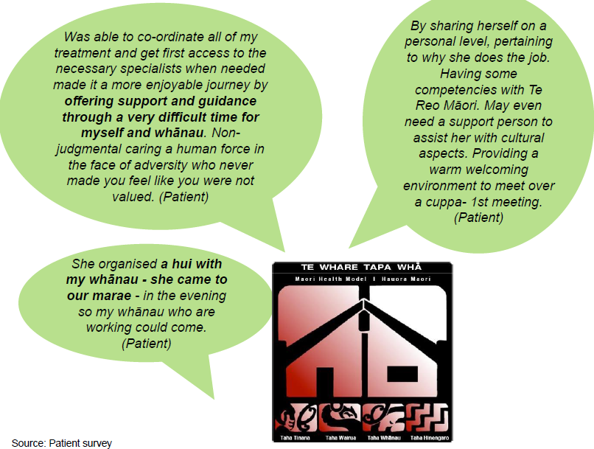

Patients strongly agree CNCs listen, answer questions, are accessible and supportive. About a quarter of patients are uncertain about whether the CNCs helped their family/whānau.
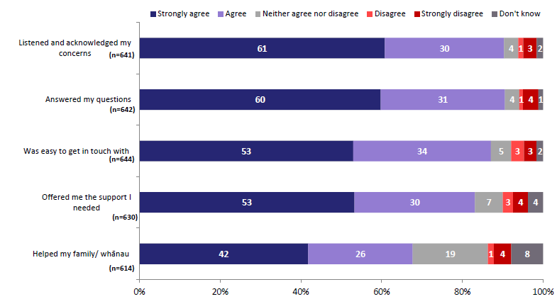
Base: Patients who answered the question
Please tick if you agree or disagree that my Cancer Nurse Coordinator ...

Patients with high suspicion of cancer rated CNCs higher for answering their questions (72% strongly agree).

As a result of interacting with CNCs, patients are more confident about process, and knowledgeable about their treatment and care. Areas to strengthen are involving patients and whānau in care and educating about cancer.
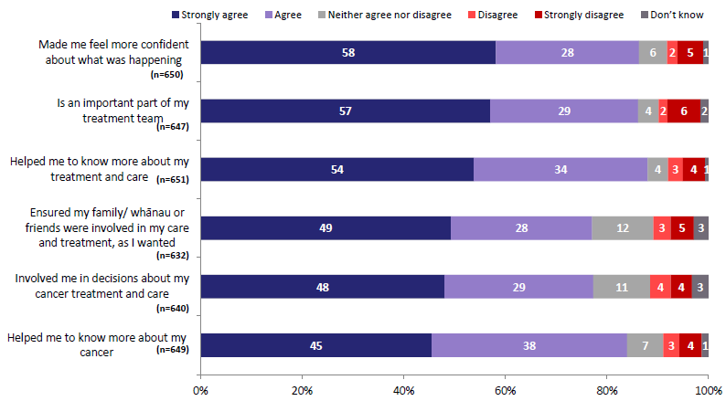
Base: Patients who answered questions
Please tick if you agree or disagree that my Cancer Nurse Coordinator ...

Patients with high suspicion of cancer rated CNCs higher for making them feel more confident about what was happening (71% strongly agree).

Canterbury DHB: patient experience of CNC roles
All three patients and whānau interviewed were extremely positive about the CNC role and the benefits it offered them.

Patients understood the CNC role to be one of helping them to navigate their health journey and co-ordinating their care, advocating for them and overseeing any issues arising. CNCs were the human-face of their care and offered support and a reassuring ear. CNCs were seen to be experienced cancer nurses who understood their disease and could explain their tests and treatment in plain English.
‘She was like the negotiator in the middle.’

Positive patient experience
One patient interviewed felt they had been lost in the system and had a great sense of relief when referred to the CNC who offered support, and help to negotiate appointments. The CNC was also able to explain their cancer, tests and treatment.
‘It was incredibly reassuring that I had a phone number… someone at the end of the phone to call.’ (Whānau)
For other patients the key benefit of the CNC was having an experienced and knowledgeable nurse dedicated to them to navigate a surprise diagnosis that had significant implications for their family.
‘It is really worthwhile … many situations are like ours where its changes overnight virtually so you have to come to terms with quite a lot of things and get to know what is going to happen and treatment. It would be very difficult without the [CNC].’

Other benefits of the CNC role as noted by patients and whānau interviewed include:
- Coordinating their appointments and care thereby reducing stress and wait times
- Educating and informing patients and whānau about their cancer by translating medical jargon, providing written information, and being a key contact for follow up questions
- Referring patients and whānau to other services e.g. counselling service
- Checking on patients and whānau to ensure all issues resolved
- Coordinating care in emergency situations.
‘To know that there are people there that actually advocate… be a reassuring ear as well … because it is a completely new journey.’

Improvement area – discharge: When CNCs discharged their patients, they can be concerned about who to contact or how to proceed if their journey does not progress smoothly.

CNC agreement with the perceived outcomes from their interactions with patients is higher. Patients know about care, their cancer and are involved in decisions.
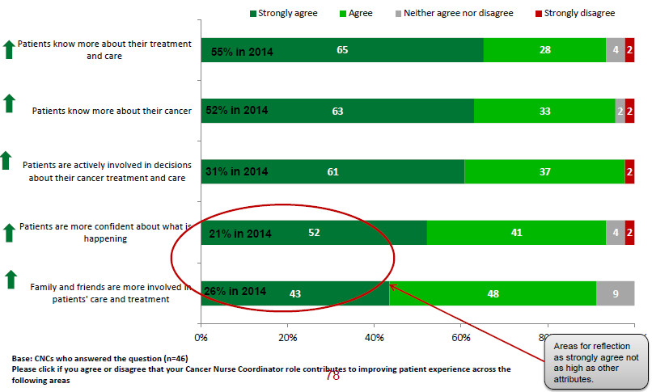

Providers value CNC contribution as patients are confident and know more about their cancer and treatment
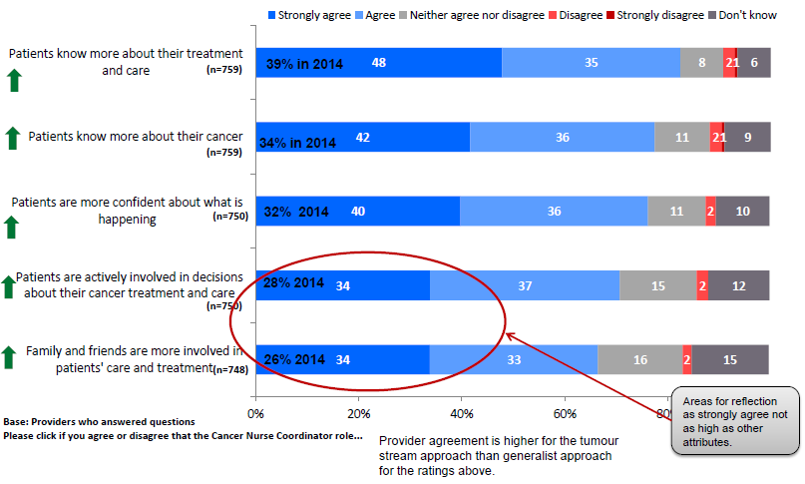

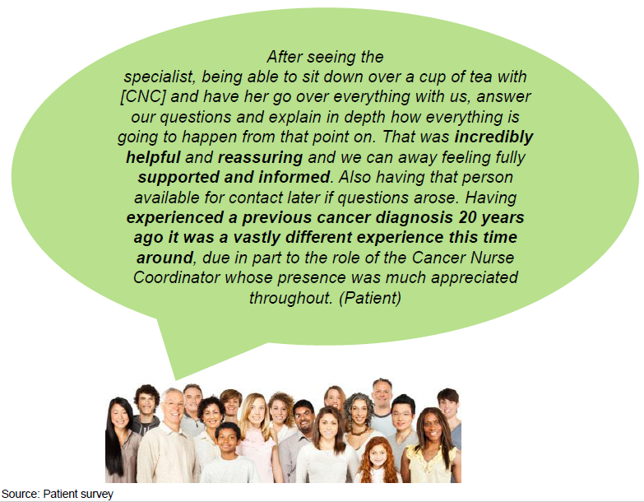
Source: Patient survey

Evaluative assessments

Evaluative judgements
CNCI success criteria | Evaluative judgement | Assessment rationale | Area of future focus
Targeted those with greatest need | Partially achieved | Unable to assess proportion of priority patients not accessing CNCI.  Patients with a range of cancers and triaged as 1 and 2 (most complex needs) are accessing the CNCI.  Māori and Pacific people are accessing CNCI but not at high levels. | Consideration is needed on how to remove access barriers to the CNCI for Māori and Pacific patients.  The benefits of population based roles requires further investigation as they become more established.  CNCs need to focus more on ensuring cultural needs and beliefs are met.  Consideration is needed on the role of primary care in referring patients to the CNCI.
Improve access and timeliness of access to diagnostic and treatment services | Not measureable  Perception CNCI is contributing to timely access and treatment | No definitive measure on timeliness.  Providers and senior managers perceive the CNC role is facilitating timely process, and contributing to timely diagnosis through improved patient care coordination.  Patients are aware of the appointment process and likely timeframes. | Ongoing focus on ensuring the role and its benefits are well understood by providers to integrate and increase the influence of the CNCI to facilitate patient pathways.
Positive patient experience | Achieved | Patients’ and providers’ feedback indicate positive patient experience.  Exception is patients who have an initial CNC contact and then no further interaction. | Need to ensure patients have a clear understanding of the role especially if they are assessed as not requiring the support of the CNC (at that point in time).  Continue to facilitate patients to be linked to other services especially financial and emotional support services.  Increase focus on whānau involvement and involving patients in decisions.  Improve information sharing and handovers and offer (if appropriate and possible in FTE allocation) more regular contact.
Identified improvements in care coordination and patient pathway | Achieved | Systems projects are occurring across all DHBs. Some are demonstrating positive change. | Consider further review of the system projects being undertaken to assess whether they are having sustained and positive impact on improving the patient experience and pathways.  Seek to address the ongoing barriers that impede the CNC system improvement role including lack of buy-in, high CNC workload and lack of IT infrastructure or support.

