Epilepsy Consumer Experience Survey 2018
Report on findings from the survey

Thank you
The Ministry of Health would like to thank all of the people with epilepsy and their whānau who gave their time to participate in the 2018 Epilepsy Consumer Experience Survey. Your views, comments and openness were greatly appreciated and provide valuable insight into living with epilepsy.
The Ministry of Health would also like to acknowledge the support of Epilepsy New Zealand in developing this survey, and making it available to people with epilepsy.
Citation: Ministry of Health. 2019. Epilepsy Consumer Experience Survey 2018: Report on findings from the survey. Wellington: Ministry of Health.
Published in March 2019 by the Ministry of Health
PO Box 5013, Wellington 6140, New Zealand
ISBN 978-1-98-856867-6 (online)
HP 7058
This document is available at health.govt.nz
This work is licensed under the Creative Commons Attribution 4.0 International licence. In essence, you are free to: share ie, copy and redistribute the material in any medium or format; adapt ie, remix, transform and build upon the material. You must give appropriate credit, provide a link to the licence and indicate if changes were made.

Contents
Introduction 1
Background 1
Methodology 2
Part 1: About you and your epilepsy 3
About people with epilepsy 3
About people’s epilepsy 11
Information to support living with epilepsy 23
Part 2: Social and community factors 26
Impact on life 26
Part 3: Health services 34
Principal health service providers 34
Overall feelings about hospital and health services 38
Accessing health services 42
Epilepsy consumer experience of health services 48

List of Figures
Figure 1: Age distribution 4
Figure 2: Ethnicity 4
Figure 3: Location, by DHB 5
Figure 4: Work and school participation 6
Figure 5: Work and school participation, by age 6
Figure 6: When diagnosed 11
Figure 7: Type of seizure 12
Figure 8: Estimated number of seizures in the past 12 months 13
Figure 9: Number of seizures, by type 13
Figure 10: Time of most recent seizure 14
Figure 11: Time of most recent seizure, by type 15
Figure 12: Consumer view of whether their epilepsy is controlled 16
Figure 13: Consumer view of whether their epilepsy is controlled, by type 16
Figure 14: Number of seizures in the past 12 months and consumer rating of how well their epilepsy is controlled 17
Figure 15: Social and community support areas where respondents considered fact sheets would be useful, by topic 24
Figure 16: Medical areas where respondents considered fact sheets would be useful, by topic 24
Figure 17: Social challenges experienced, by type of challenge 26
Figure 18: Social challenges experienced, by frequency 28
Figure 19: Impressions about ability to access social and community support, by type of support – all responses 29
Figure 20: Impressions about ability to access social and community support, by type of support – rating provided 29
Figure 21: Overall feelings about social and community support 31
Figure 22: Principal health service providers 35
Figure 23: Impressions of how well epilepsy is managed among respondents for whom a general practitioner is their primary health service provider 36
Figure 24: Impressions of how well epilepsy is managed among respondents for whom a paediatric clinic is their primary health service provider 37
Figure 25: Impressions of how well epilepsy is managed among respondents for whom an adult neurology (or medical) clinic is their primary health service provider 38
Figure 26: Overall rating of health services 39
Figure 27: Time to see a specialist 42
Figure 28: Frequency of contact with a health provider in the past 12 months, by type of provider 44
Figure 29: Ease of contact with health care providers, by type of provider 45
Figure 30: Survey response to question on ability to access appointments or services if needed, by type of service 46
Figure 31: Satisfaction with ability to access services if needed, by type of service 47
Figure 32: Extent to which respondents felt listened to and involved 48
Figure 33: Proportion of respondents who have an emergency management plan 49
Figure 34: Aspects of respondents’ emergency management plans 50
Figure 35: Receiving information about aspects of epilepsy in a way that could be understood 51

List of Tables
Table 1: Areas identified for additional fact sheets 25
Table 2: Services with the largest number of responses 30

Introduction

Background
Epilepsy is a condition defined by the occurrence of epileptic seizures. Epileptic seizures are events that arise due to abnormal electrical activity in the brain. There are many causes of epilepsy and many types of seizures that can be experienced.

There is no data on the number of people affected by epilepsy in New Zealand but it is thought to be from 45 to 50 thousand, with approximately 2,000 people newly diagnosed each year. About one third of the people with epilepsy have a type that is resistant to anti-epilepsy drugs (AEDs) Children and the elderly are more likely to be diagnosed with epilepsy than other age groups. Approximately 60 people die from an epilepsy related cause each year.

People with epilepsy are high users of health and social services. Health and social costs for people with drug-resistant epilepsy will be even higher than others, because of the frequency of seizures, greater care and supervision requirements, and complex medical needs.

Epilepsy is considered a ‘hidden burden’ with a low profile in the health system, and limited understanding of how it affects those living with the condition and their families and whānau.

In 2015 the World Health Organization (WHO) passed a resolution that was endorsed by all 194 Member States including New Zealand. The resolution aims to ensure that people with epilepsy can receive timely treatment and also benefit from educational and occupational opportunities free from stigma and discrimination. Countries were encouraged to undertake public awareness activities to reduce misconceptions about epilepsy and encourage more people to seek treatment.

The Ministry of Health is working with an advisory group to improve services to people living with epilepsy in New Zealand. To do this we developed a consumer survey to help understand what is important to people with epilepsy, and particularly how to ensure community and health services meet their needs. We wanted to understand what services worked well for people with epilepsy and those that they thought needed improvement.

The survey was available online for three months, from February to May 2018, and could also be completed in hard copy.

Methodology
We published the survey on the Epilepsy New Zealand website and made a hard copy available from Epilepsy New Zealand and the Ministry of Health. We sent a poster advertising the survey to district health boards (DHBs) for distribution. We also sent it to the chief executives of all primary health organisations, and to pharmacy networks with a request that it be displayed. Epilepsy New Zealand provided their registered members with a link to the survey, as did the Epilepsy Foundation.

We received a total of 276 completed surveys, lower than we hoped for. Responses did provide good geographical and age distribution, but did not accurately represent ethnicity – the majority of respondents self-identified as New Zealand European. Responses from Māori with epilepsy in the survey were low. We are aware that 22 percent of people admitted into hospital for experiencing seizures are Māori, and 29 percent of people admitted multiple times in a year are Māori.

To determine a respondent’s location, the survey asked people to identify the town they lived in and their postcode. If a respondent provided a town/city but not a postcode, we matched the town with an appropriate postcode. If a respondent provided a postcode but not a town, we matched the postcode with an appropriate town/city. We then organised locations into DHB regions, and loosely grouped them into ‘urban’ and ‘rural’ categories. For example, we considered Palmerston North urban, and Fielding rural. We assigned Auckland locations to a DHB based on the postcode, rather than strict application of the DHB boundaries. For some DHBs, even if respondents were from the main city in the region, we classified them as rural (eg, Gisborne and Greymouth).

Given the low number of responses and lack of accurate ethnic representation, we consider that the information the survey produced is not sufficiently robust to draw conclusions about prevalence, ethnicity or where people with epilepsy live. However we believe it does help us to understand what is important to people living with epilepsy and where improvements are required.

Structure of this document
This document is organised in three parts: information about the people who completed the survey, including they type of epilepsy they have and how it affects their lives; information about people with epilepsy’s experiences of social and community services; and information about people with epilepsy’s experiences of the health system.

Each section includes graphs depicting responses to survey questions, and some analysis of the themes that emerged from comments. These comments provided are rich in content, providing excellent insight into the lived experience of epilepsy.

Part 1: About you and your epilepsy

About people with epilepsy
Two hundred and seventy-six people completed the survey. Of these, 167 (60.5%) completed it for themselves, 98 (35.5%) completed it for a child with epilepsy and 11 (4%) completed it for ‘someone else’.

Seventy-four people commented about why they were completing the survey for a child or someone else:
- 14 were on behalf of people (teens or an adult) unable to complete the survey themselves for reasons including being unable to read, comprehension or communication problems and work commitments
- 6 were on behalf of people with autism spectrum disorder
- 13 were on behalf of people with another learning difficulty or developmental delay
- 1 was on behalf of a deceased adult (whose death was attributable to sudden unexpected death in epilepsy (SUDEP))
- the remainder were on behalf of minor children.

The age distribution of people with epilepsy (Figure 1) shows that:
- 74 (27%) were younger than 16 years and, therefore, users of child health services in most DHBs
- 23 (8%) were 16–20 years, primarily attending school or university
- 172 (62%) were of working age, and users of adult services
- 6 (2%) were above general retirement age.

Figure 1: Age distribution
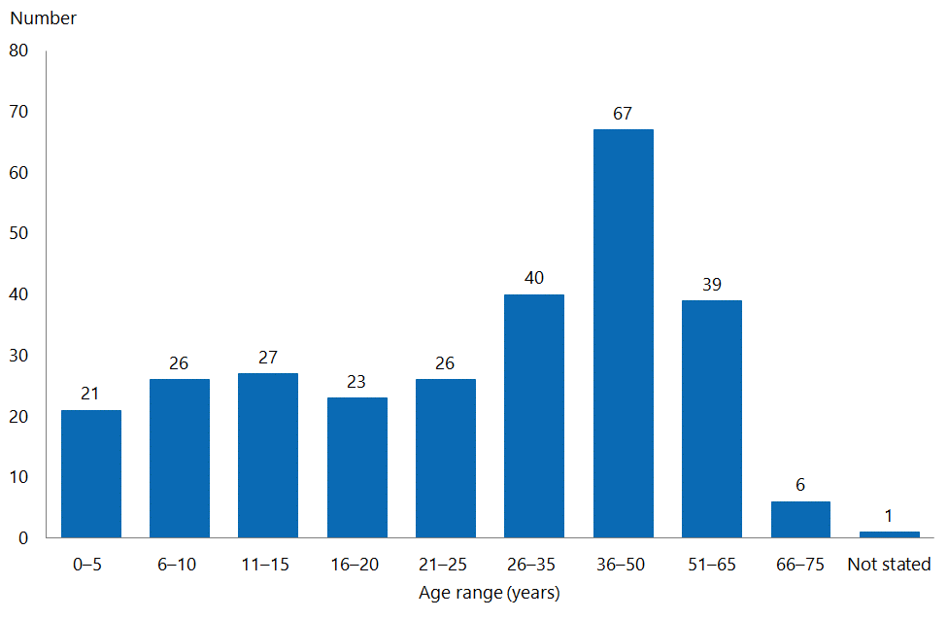

More females than males completed the survey (157 compared to 112). Three people identified as gender diverse, and four respondents did not state their gender.

Respondents were able to select more than one ethnicity. The majority of people (253, or 91.7%) identified as New Zealand European. This is more likely to reflect the limited reach of the survey than the actual ethnic distribution of people with epilepsy.

Figure 2: Ethnicity
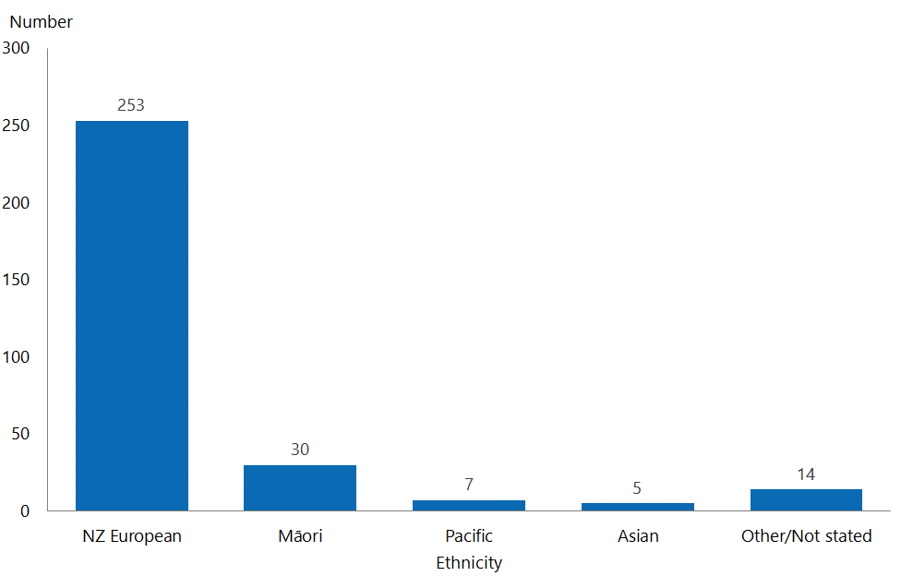

Survey responses came from most DHB regions, the exception being Nelson Marlborough DHB. The number of responses from some small DHBs were low, but we cannot assume that this is because few people with epilepsy live in those regions.

The DHB that provided the greatest number of survey responses was Capital & Coast (serving Wellington and the Kapiti Coast), followed by Canterbury DHB, which had a mix of urban and rural respondents. The three Auckland DHBs combined produced 51 responses (18% of the total). Only three respondents did not identify either a town/city or a postcode.

Figure 3: Location, by DHB

Work and school
The survey asked people about whether they were at school or in work. Some people selected more than one option (eg, saying that they went to school part-time and worked part-time). Around one-third (99 people) of respondents said they were in school full- or part-time; eight (3%) said they were homeschooled. This latter group includes preschool children whose parents felt that they were not able to be in daycare.

One hundred respondents (37%) said they were in full-time or part-time work, and 76 (28%) said they were not employed.

Figure 4: Work and school participation
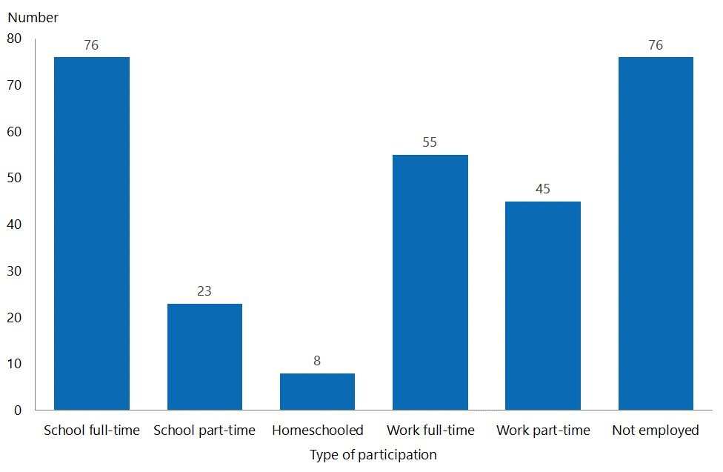

When comparing this information to respondents’ ages, it becomes evident that many people of working age with epilepsy are not employed.

Figure 5: Work and school participation, by age
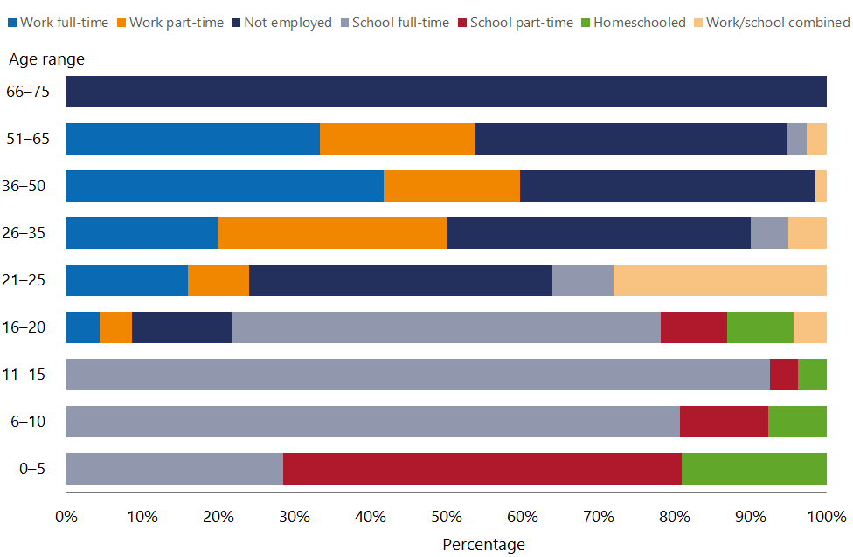

Among respondents:
- most preschool children with epilepsy were in part-time ‘school’, and most children between the ages of 6 and 15 years were in full-time school (three were homeschooled and four were in part-time school). Most aged between 16 and 20 years (13 of 23) were also still in full-time school. Four were in work (full- or part-time) and three were not employed
- the largest percentage of respondents aged between 21 and 25 years were not employed (10 of 26); seven (27%) were at school and also working
- there were 40 people aged between 26 and 35 years; of these, eight were in full-time work, 12 were in part-time work and 16 were not employed
- the largest age group was between 36 and 50 years (67 people). Of these, 28 were in full-time work, 12 were in part-time work and 26 were not employed
- a similar distribution was found in people aged between 51 and 65 years; 13 were in full-time work, eight were in part-time work and 16 were not employed
- all people aged more than 65 years were not employed (ie, retired).

One hundred and eighty people made a comment about the impact of epilepsy on their work or schooling. The following section draws together themes from these comments.

Comments about work
People commented about discrimination or lack of understanding on the part of employers, making it difficult to find work, even when their epilepsy would not present a health and safety risk.
It [epilepsy] doesn't [present a risk], but try explaining that to would-be employers!
When telling the employee that you have epilepsy, they immediately dismiss you (in an interview) and hire someone else. But I must be honest.
[Name] rarely has seizures at work, but his employer has insisted that when he does have one at work (even if there is clearly no blood or injury) an ambulance be called, which usually results in us being at the hospital for up to six to eight hours ... They then say he has to have the next day off work and must go to the GP) for a medical clearance ... Our GP has written saying that this is an ineffective waste of time because ... All this is so frustrating. Employers should be made to educate themselves on epilepsy and what it means for each individual.
I believe I am not employed because one of the questions on an application form is ‘do you have epilepsy?’ and ticking the box means you won't get any further, so why bother. There are no questions like ‘do you have cancer?’ or any other condition, so why ask if you have epilepsy? That just puts you straight to the bottom.
I have been discriminated upon by past employees because of my epilepsy ... one organisation changed my working conditions (ie, [I] was not allowed to meet with customers, not allowed to be on customers’ premises) after three years of [my] exceeding performance requirements ... This meant I was not able to perform my job, so I was told by my employer that I would have to take a lower position and approximately a 50 percent pay cut or leave the organisation and go find a job somewhere else if I didn't like that ... I have also had co-workers who moved desks because they refused to sit next to me in case I had a seizure at work.

Some respondents considered occupational safety and health (OSH) requirements to be a barrier to their employment. Comments indicated that either epilepsy limited the type of work a person could safely perform, or employers were unwilling to risk employing someone with epilepsy.
There are areas [name] is now not allowed to go into at all, and some areas where he is not allowed to go alone – OSH.
They are a danger to themselves and others in the workplace.
He cannot drive or operate machinery, so his choice in regards to finding meaningful employment is extremely reduced.
This has become heightened after the national government made health and safety laws stricter.
The new health and safety regulations that have come into effect now also make it harder for employment, as [epilepsy] could be classed as a liability to employers.

Being unable to drive was a barrier for some people, either preventing them from getting to work or excluding them from some types of jobs.
I’m a car mechanic and unable to drive.
Being unable to drive prevents me carrying out the job I’m trained for.
Inability to drive for 12 months after each seizure impacts family and work life significantly, due to the inconvenience of public transport and the cost of taxis.
[The fact] he cannot drive due to epilepsy has impacted on his ability to get a job. Job adverts usually say a person must have a clean driving licence: even jobs in the disability sector. This is a massive issue in New Zealand.
Most job adverts require a 'full driver’s licence', and so she has not been able to [apply], as she was told she had to be two years seizure-free.

Respondents commented on physiological impacts that limited their ability to get or keep employment, including seizure activity and/or recovery time, tiredness, falls and injuries, cognitive impairment and memory loss.
The epileptic seizures that occur result in numerous falls and head injuries. The result of this is partial paralysis on one side, which causes difficulty in walking and functional use of the hand. As this is ongoing I am housebound, with limited social interaction and outings.
My epilepsy exhausts me greatly. When I have a seizure, sometimes I miss classes in the morning because I need to sleep, or have to take a day off of work. It also affects my concentration.
I am yet to get side effect-free control with my medications. They leave me with significant memory loss, dizziness, nausea, [reduced] coping ability, [reduced] decision-making [ability], etc. So much so I am now under performance review.
I often miss university classes or shifts at work due to having seizures. It is not the seizure that is the problem; it is either before or after that I worry about. I can be angry or irritable, have mood swings or say strange things that can be offensive before a seizure. Afterwards I can be childlike, loving or hyperactive, or want to sleep. I work in retail, and this does not make for good customer service. At university I do not want to ruin any classes for my peers.
Short-term memory loss, [fear] of having a seizure … no one hears me as I stay in a dorm room alone. I get depressed because no one understands, or is it the meds? After a seizure I get disoriented, sometimes violent.

Comments about school
Many of the comments about school were from parents concerned about their child’s ability to attend school or fully participate in school activities.

Two people made positive comments about the ability of schools to support their children.
Thankfully school are awesome. Seizures happen at school and are managed.
My daughter attends a special school where the ratio of students to adults is high. This enables her to attend, as she [needs] constant monitoring, as her seizures are very regular and can cause injury.

Three people commented on being bullied at school because of epilepsy.
When I was at school I hated it, and ran home, as I was called all sorts of names ... Some teachers were not very good either.
At school she was bullied. She had seizures in front of the class a few times, but generally her close friends were there for her.
I hated school. Even teachers didn't understand back then. But kids are cruel – they are just being kids, looking back. Hopefully they are more educated now and accepting.

Some people commented on the need for their children to be supervised at school, or for additional support to help with learning or ensure safety, especially during activities.
Schools do not have the time, the resources or the understanding of what our child needs to learn at school, and so now we homeschool.
During periods of poor seizure control, mood and behaviour are affected, and attendance has been limited by school due to their inability to cater to the needs that surround her during periods of poor seizure control and associated difficult behaviours.
My son needs to have someone watching him all the time at kindergarten, but at this time we only have one hour a day from a support worker from the Ministry of Education.
He is unable to participate in some activities without one-to-one teacher aide support (eg, swimming). He is unable to access his class, as [it is] up on the second floor with concrete steps, without a support person, as his seizures are so frequent. He is unable to participate in the classroom fully without the help of a teacher aide, as his epilepsy and medications have caused a development delay, so his cognitive and social skills are not at the same level as his peers.
We have one daughter who only just last year has finally met [the] criteria due to a new diagnosis of intellectual disability, so she can access a very small amount of support. Prior to this there [was] no box that epilepsy fits into for teacher aide support or any other support.

A number of respondents made comments about the impact of epilepsy and/or medications on learning.
Absence seizures were causing issues with missing instructions, and teachers were missing it was a seizure, so now we homeschool.
She is able to attend school; has absence seizures hundreds of times per day. This makes it hard for her to take information in and retain some information.
Epilepsy has affected my literacy levels, and affects my ability to remember names and details. I am still good with maths, but often cannot express what I am feeling because I have lost the words.
[He] has lots of absence seizures that affect his focus and learning ability, so he [is] about one year behind at school, and not learning as well as he should. He is also on [multiple] medications that have side effects.
After a seizure she had no memory of the previous 48 hours (approximately), so any learning was gone out the window.

Respondents commented on physiological impacts that limited their ability to fully participate at school, or that affected learning, including seizure activity and/or recovery time, tiredness, cognitive impairment and memory loss.
My daughter has daily seizures, and this impacts on her ability to function at school all day. She attends four half days and one full day. She gets extremely tired, and needs to sleep in the afternoons.
Seizures make her extremely tired. She cannot attend school for several days afterwards. She also has to be driven to school every day, as taking the bus/bike/walking is too risky. The seizures also affect her memory, making learning harder.
He hasn't had a full nights’ sleep since he was two and a half, so he deals with tiredness on a daily basis. He also has severe refractory epilepsy, [and] we have yet to have it controlled with medication, so while we are trialling the different medications the side effects can be tiredness, lack of concentration, anxiety ... It also affects his behaviour, so he has some challenging behaviours as he's trying to come to terms with everything that is going on.
I miss heaps of school as I am so tired after seizures. It is really hard to get up and out of bed, so I often miss the first hour or so of school. Going to school is so exhausting; I can't concentrate for more than about 15 minutes, and forget what I learn each day anyway. I try so hard, but it is so exhausting. I come home and crash into bed everyday after school. I literally don't have any energy left for anything else.

About people’s epilepsy
The survey asked people a number of questions about their epilepsy, including when they were diagnosed, the type and frequency of their seizures, when their last seizure occurred and how well they felt their epilepsy was controlled.

Epilepsy diagnosis
There was wide variation in how long people had been living with epilepsy; a recent diagnosis was the least common response (9%). Similar numbers reported living with epilepsy for other time periods.

Figure 6: When diagnosed
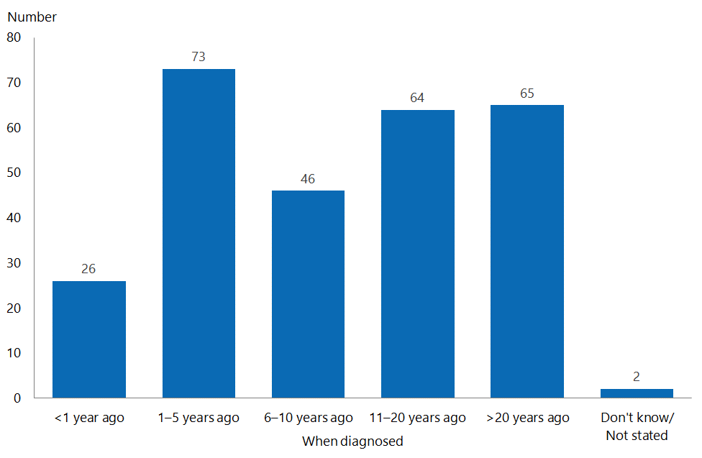

Type and number of seizures
The survey asked people to provide a free-text description of the type of seizures they have. The responses were varied; several respondents demonstrated a good understanding of their epilepsy, and were able to clearly state the type or types of seizures they had. Others were less clear, or provided vague labels or descriptions of their seizures (eg, ‘jerks’ or ‘strong’).

To help with our analysis, we grouped responses on this question into types. If the respondent described three or more seizure types, we generally grouped these into ‘multiple’. If a respondent described two seizure types, we grouped these into the seizure type listed first, unless ‘tonic-clonic’ was one of the two, in which case we classified it as ‘tonic-clonic’.

Figure 7: Type of seizure
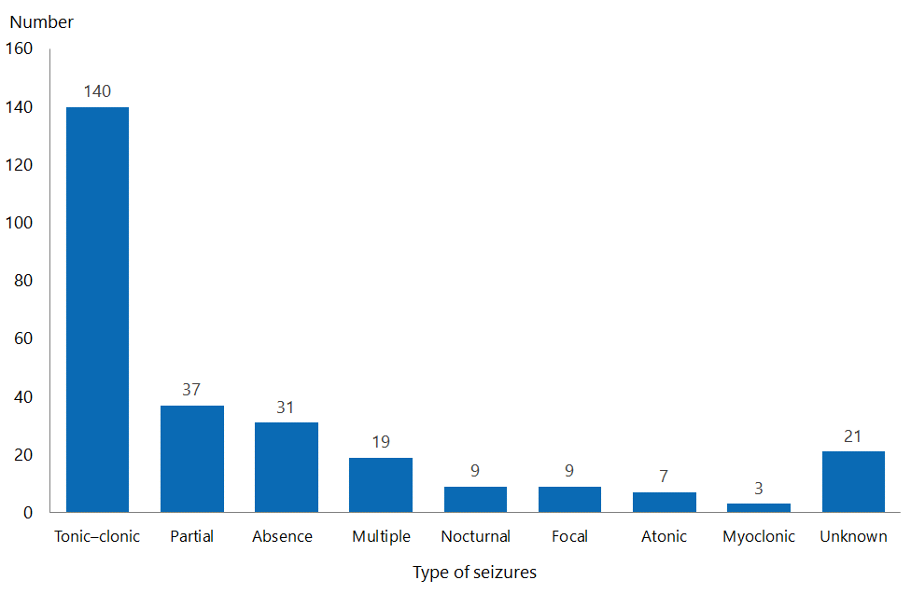

Figure 8 shows the estimated number of seizures that respondents reported experiencing in the previous 12 months. The largest response was ‘more than 90’ (68 respondents). Fifty-one people reported no recent seizure activity, and another 50 reported between one and five seizures in the past year.

Figure 8: Estimated number of seizures in the past 12 months
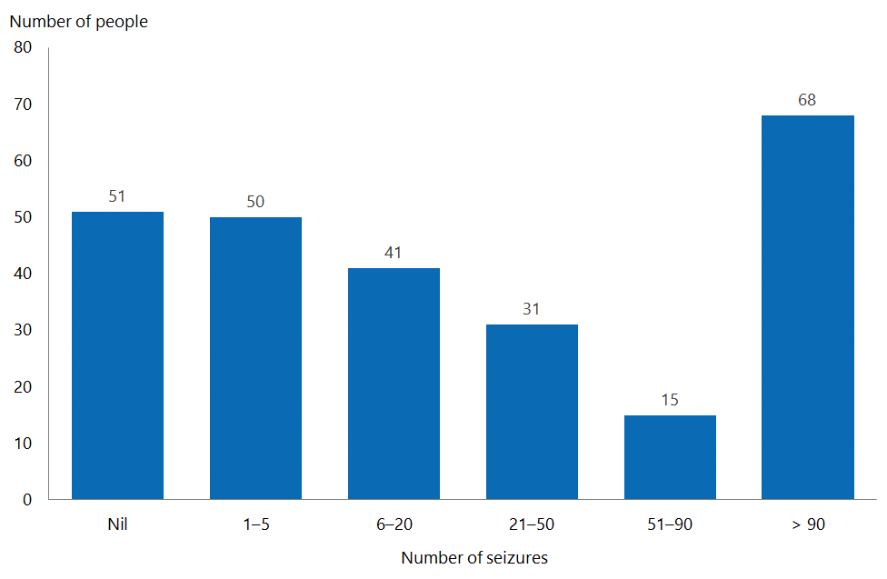

We analysed the number of seizures by seizure type. People with predominantly tonic-clonic, partial and nocturnal seizures reported fewer seizures. People with predominantly absence, focal, atonic and myoclonic seizures were more likely to report 90 or more seizures over the past year. As the ‘multiple’ group is made up of these seizure types, the high percentage of people reporting 90 or more seizures is not surprising.

Figure 9: Number of seizures, by type
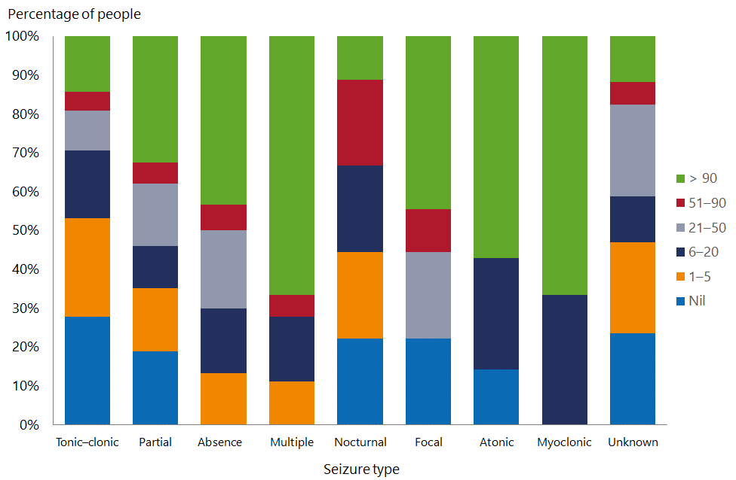

The survey also asked people when their last seizure had occurred, inviting a free-text response. We grouped these responses into broad timeframes.

The majority of respondents reported that their last seizure had occurred recently (ie, within the preceding week). Eleven people reported they had been seizure-free for more than five years.

Figure 10: Time of most recent seizure
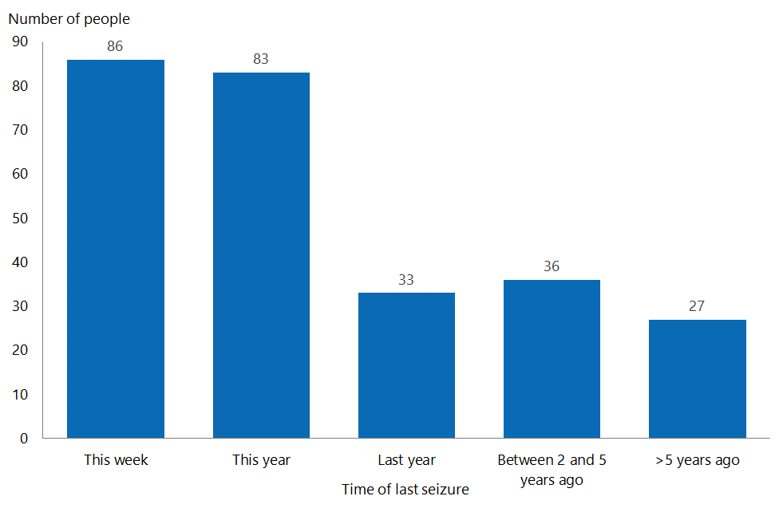

As with seizure frequency, the people reporting recent seizures were most likely to be those reporting absence, focal and atonic seizures, or those reporting multiple seizure types.

Figure 11: Time of most recent seizure, by type
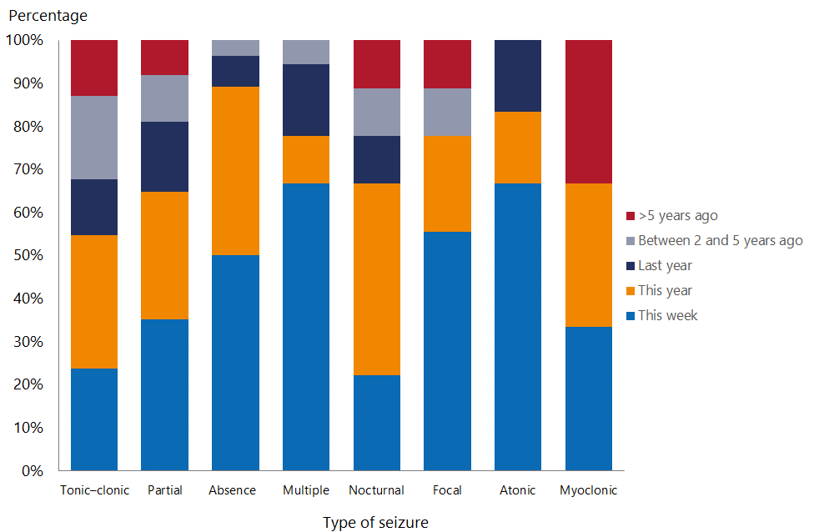

Overall epilepsy control
The survey asked respondents how well they felt their epilepsy was controlled. Thirty-four people either did not know or did not complete this question. Despite the high frequency of seizures many respondents reported, 152 people (63%) felt their epilepsy was either well controlled or very well controlled. Ninety people (37%) felt their epilepsy was not well controlled.

Figure 12: Consumer view of whether their epilepsy is controlled
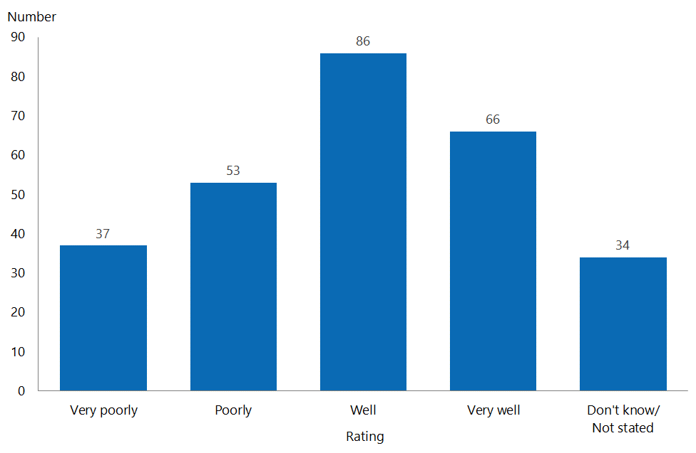

The people most likely to report that their epilepsy was not well controlled were people with multiple seizure types, focal, myoclonic or atonic seizures.

Figure 13: Consumer view of whether their epilepsy is controlled, by type
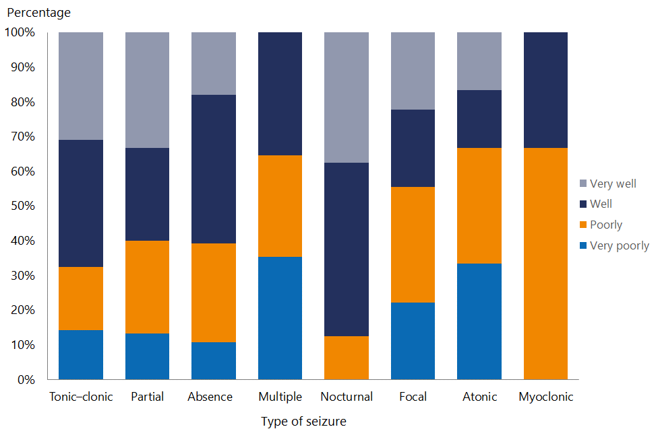

Figure 14 correlates the consumer rating of how well their epilepsy is controlled with the number of seizures experienced in the previous 12 months. We note from this correlation that responses to the question about epilepsy control were very subjective. Some people reported that their epilepsy was ‘very well’ controlled despite having had more than 90 seizures in the past 12 months, while one person felt their epilepsy was ‘very poorly’ controlled despite having had no recent seizures. One person reported that her epilepsy was ‘poorly controlled’ but reported only three tonic-clonic seizures in 20 years, and that she was taking no anti-epilepsy drugs (AEDs).

Despite the subjectivity from some respondents, for the most part there was good correlation between the number of seizures and consumer perceptions of epilepsy control. Respondents who reported experiencing the greatest number of seizures were more likely to consider their epilepsy to be poorly controlled, while those who had experienced fewer than five seizures in the past year were more likely to consider their epilepsy to be well controlled.

Figure 14: Number of seizures in the past 12 months and consumer rating of how well their epilepsy is controlled
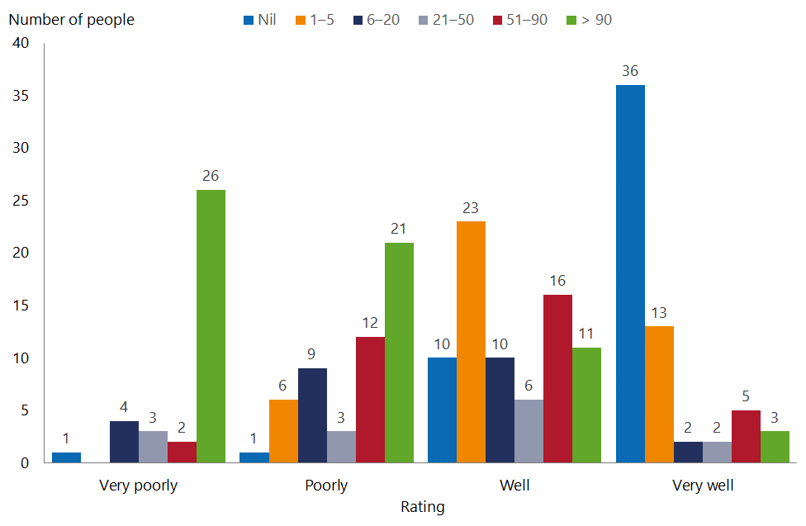

Comments about epilepsy control
One hundred and thirty-six people made a general comment about the extent to which they felt in control of their epilepsy. For the most part, comments highlighted the challenges or difficulties people faced. We have grouped comments into three general areas, as follows:
- medications – changes required to control epilepsy, side effects, access to the right medication, and medication compliance
- support and advice – community or social support, medical care or advice, and access to epilepsy treatments
- the impact of continued seizures – including injuries.

Medications
Respondents commented on medication side effects, including physiological effects such as tiredness, depression, headaches and cognitive impairment.
Medication seems to have unwanted side effects – lethargy, depression
My epilepsy is controlled well, as I do not appear to have had any further seizures, but unfortunately the medication we have to take has a number of side effects that are hard to control or sometimes hard to deal with.
I have had no more seizures, but [I am] suffering with how the medication is making me feel.
My epilepsy may be controlled, but sometimes I think the medication is worse than the seizures.
[My] epilepsy was well controlled using Epilim and Gabapentin for many years. But when my daughter reached 16 (child-bearing age) the neurologist wanted to change drugs … Six months and many drugs later, after approximately 500+ seizures, my daughter is back on Epilim. Now the seizures are fairly well controlled, but her migraine frequency has increased to the extent they occur most days, along with intensity that renders her unable to participate in life. She is currently lying in her bed, sleeping on and off most days with migraines. This was not how her life was in October 2017 when the drug change started, and we have not yet managed to help her find her way back to better health.

One of the most frequently occurring themes was that of medication trials and changing medications; many people reported taking part in medication trials over prolonged periods of time to gain improved seizure control.
We are dealing with a difficult epileptic condition, and much care and effort has gone into her regime over the years. Essentially she is doing the best she can given the treatments currently available to her.
I had, until my surgery in 2005, uncontrolled epilepsy. This was despite the very dedicated [DHB] team who trialled every medication available at that time.
It took nearly 10 years for the doctor to get my medication correct. While I was still having [seizures] I started smoking marijuana, as it was the only thing that stopped them.
My son is currently at the end of changing medication, as his seizures had moved to day seizures also. The doctor is now thinking they have possibly removed the wrong [medication] and replaced it. It's a long frustrating process.
[I] have tried 12 different medications over a seven-year period, and have never had control.
We are still working [with the] paediatrician to get [the] right meds.

A number of people commented on the potential use of cannabis to help control seizures, and three explicitly felt that cannabis should be available and funded for people with epilepsy. Respondents also commented on the need for people in New Zealand to have access to the same drugs as people in other countries.
[He] needs medical cannabis to manage seizures and other health issues, but cannot afford to pay for a legal supply.
If there [was] any further support available to be able to trial cannabinoid oil, we would take it in a heartbeat. Epilepsy has changed our lives in every single way.
Please start funding CBD oil. We have started seeing amazing results since trialling this. Other prescribed drugs didn’t give us these results.
Without access to the same drugs as Australia or the rest of the world, I believe New Zealanders are poorly serviced in this area. Trials of other drugs are very limited in New Zealand, and restrict advancements of potential drugs.
Respondents commented on the need to maintain compliance with the medication regime to ensure seizure control and to have ready access to medication.
It’s great when I take my medication regularly. When I miss my doses I have a seizure.
Most failure to control my epilepsy comes from forgetting to have my medication. It leaves little room for human error.
Generally the seizures only occur when a dose of medication is missed.
As a teenager my daughter rebelled completely – wanting to be like her friends with parties etc. It has only been in the last few years that she has finally accepted her condition and is managing her lifestyle. There were many emotional outbursts and anger and, as such, alienated friends and family at one point.
[Being] unable to obtain more than a single month supply of valproate from [the] pharmacy is frustrating. [It] can lead to supply of tablets running out more frequently. Costs are increased.

Support and advice
Some respondents’ comments about their ability to access specialist treatment (eg, a ketogenic diet) demonstrated major dissatisfaction with the care they had received from doctors and their frustrations at the lack of support. Given the extent of issues respondents raised, we have included more comment examples in this section, including some longer narratives (with locations removed).

Comments on hospital or specialist support included the following.
[I have] always been concerned about the level of Epilim I take … and the drug itself, but my doctor has never been particularly bothered, and I have never been referred to anyone like a neurologist concerning my medication.
It has been very hard to engage the help of neurologists in [DHB]. I have been dealing with epilepsy for a long time, and keep being sent to neurologists who refuse to look at my updated notes from my GP or take the time to listen to me.
I worry every day that my son could die as a result of his epilepsy. He lives alone, with little or no support, as New Zealand is lacking in such services.
A few years later in [DHB, I] had another grand mal. [I was] taken to hospital [and] told [I had] epilepsy, [and] put on medication. [There was] no follow-up, no support services suggested. [I took] medication as supplied. Three years later, [I had] another grand mal seizure. [A] few years later [I had] this final seizure and now [an increased] dose of medicine.
I find that the initial support a person gets when first diagnosed with epilepsy is really bad. It’s a shocking and life-changing condition, and no support was or is given.
As the sufferer is a teenager and he keeps outgrowing his medication, it needs to be changed constantly, and unfortunately getting hold of his paediatrician is usually quite tricky, so management is sporadic at best.
Doctors don’t really seem to care how it’s going, and the gaps between appointments [are] too big, and often if you want to know anything you’ve got to call.
I wish doctors would give me more information about my condition, since that is their job, rather than me having to rely on Google to try and figure things out for myself.
I have recently been told by another outpatient I met online that there is a nurse at the clinic where I go that you can ring at any time to talk to or ask questions. I have been attending this clinic since 1985, and have never been told I could do this, so have had to wait each time for my next appointment to come around. Sometimes these were one year apart, I have not been sent an appointment since my last visit, which was three years ago, and as far as I know have [not] been discharged. My epilepsy is far from under control, so [I] need these appointments. No one has monitored me for three years, and it is very scary.
Our neurologist in [DHB] until recently said he was unable to see [name] frequently in the clinic because he was too busy (he told us this at our appointment more than two years ago: that he did not want to see [name] again because he said he may grow out of epilepsy in 20/30 years – as we were walking out the door!). So [name] has only recently been seen again (after a referral from [other department in hospital]). I think this is disgraceful. The specialist had no time for him, and got quite annoyed that I enquired if medical cannabis could help.
[His epilepsy is] not managed by drugs … [there is] not a lot of support doctor-wise. [We] have never been talked through options, and have only been told about additional support we might be able to receive (eg, WINZ supplements, taxi chits, [a] community services card, [a] medical bracelet and counselling from [name] from [the] Epilepsy Foundation)! After a specialist casually mentioned he had hypothalamic hamartoma … we looked into it further to find it was very rare and often isn't helped by AEDs. When we ask [our] GP about it she says to ask [the] neurologist, as she doesn't know. When we ask [the] neurologist he says he doesn't know, as he more specialises in [another neurological condition]. He is the main specialist we see, but he's only here every three months … he has no interest in video evidence or any background knowledge. All he wants to know is if he is better. If not [he] tries the next drug on his list – that’s all the does! He says he doesn't know [and] to ask the big specialist, who we've met once and … when we [ask] ‘what is his condition?’ … tells me to Google it. That's crazy. When we see the GP (which we [have to] pay for [to get] repeat scripts all the … time) they ask us what drugs he's on! Which is about 18+ a day, and some of these have side effects [that] are [as] debilitating as the seizures. We need a medical revolution, because what happens now doesn't work! Too much drug pushing with no background knowledge to figure out properly how to help someone! We would like to look into medical cannabis, and while no doctor will deny the benefits, they can't help, while the drugs they are happily peddling have much [bigger] problems. It makes no sense. I used to look up to the medical industry [and] now I think it's a joke. Most people I know would agree, and [we have] heard countless stories of people being let down. [We] have had a lot of help from [the] Epilepsy Foundation and nurses we have met, but all GPs and specialists can go spend all the money they earn being pretty much just legal drug dealers and suck a big one.
Comments on diet therapy included the following.
The ketogenic diet needs to be offered more as a therapy for seizure control. This diet is very successful, and it's disappointing this is not available in many DHBs. [There are so few] places where it is available [that] one can't access it.
Medications have not helped my daughter for long. The Modified Atkins Diet she started in April last year has seen a HUGE reduction in her seizure number. This diet is not readily accessible, however, and we had to fight to get the support from our DHB for funding for a dietician. The smaller areas of New Zealand do not get help in this area, but in the long run surely it is more expensive to have a child on masses of medications and in hospital and needing carers to help the family cope.
We are currently waiting for a place on the Ketogenic Diet Trial, but as there [are] only 10 available the wait list is long. His seizures are unresponsive to medications; this is our hope for some control.
We requested a referral for ketogenic dietary therapy when we were up to our third drug, but were declined as our DHB does not provide dietary care for children with medically refractory epilepsy. Our visiting neurologist recommended that our son undergoes a ketogenic dietary trial, and this would have been fully funded if we lived in the [name] DHB region. It is appalling that postcodes are used to restrict access to treatment. Fortunately, we were in a position to self-fund the appropriate treatment for our son. Since starting the ketogenic diet [three months ago] our son's seizures have reduced by about half, [and] in the last three months we have weaned [him off] half his medications. He is much brighter in himself, and is starting to regain some of the skills he had lost while on so many drugs and seizing frequently. Life has been hideous since our son's epilepsy started eight months ago. The ketogenic diet is the first thing that has helped, and things are finally starting to turn a corner. I fear for other vulnerable families in New Zealand suffering from drug trial after drug trial because of the lack of funding for more effective therapy and in some cases ignorance by paediatricians and neurologists about other treatments besides medication for epilepsy. It is a disgrace that our DHB neglects to provide evidence-based care through the provision of dietary therapy for refractory epilepsy.

Respondents tended to be more complimentary about the support received from epilepsy nurses, but some expressed concerns about access to community support.
The help, advice and support we have received from the local representative has been so valuable to us. Having someone to talk to face to face is so helpful, as they can visit the client in their home/work environment and help with specific problems. In the early or new onset of the illness, having the support helps not only the client but the whole family/friends cope during an often very stressful time. I am very grateful that we had access to such a fantastic service.
Epilepsy Waikato's information officer, [name], has been amazing. We've appreciated her home visit and thorough explanation of what to expect. [They] provided picture books for us and for kindy [and] were very thoughtful.
Frustrated that I can't get funding for him as he is not 'bad enough'. He has potential but needs a teacher aide to help him work and focus.
She needs some groups to go to [but I am] not sure where.
There is not much support at all for parents with kids with epilepsy.
Seizures suck. And the support for the person with seizures and their families is very poor in New Zealand.

Impact of continued seizures
A number of respondents commented that the seizures they were having, or the medication they were taking, caused physiological side effects.
[My epilepsy is] controlled as well as it can be – [I] can't have surgery; [the] ketogenic diet made me sick; vagus nerve [stimulation was] not available, and [had] little chance of working (also side effects [disallowed it]). So [I am on] medication – none of which [controls it], but which have slightly decreased [its] severity.
My neurologist insists on keeping me on Lamotrigine despite my continued seizures on this medication.
My daughter has chronic fatigue, attributed to seizure activity … her tonic-clonic seizure activity is well controlled; however, her [complex absence seizures] are not, and she can experience up to 60–80 per day. My daughter has had multiple medication reviews and changes during this time, with some dramatic side effects.
From the first seizure, the longest period without seizures [has been] three months. For the past 10 years a typical week involves at least one cluster of seizures, if not daily. Seizures affect everything for her. Quality of life is balanced between seizure control and the side effects of seizure medications. Currently my daughter is on three medications and the ketogenic diet. On this regime weekly clusters persist.

Information to support living with epilepsy
Respondents were asked to identify, from a list, areas where they thought additional information (in the form of ‘fact sheets’) might help them understand their epilepsy and support their independence. We derived these areas from consumer and Epilepsy New Zealand input, and also from a review of the information available on international epilepsy support websites.

Questions about fact sheets that focused on general information were included in Part 2 (‘Social and community factors’). Questions about fact sheets that focused on information to help people understand their medical condition were in and Part 3 (‘Health services’).

The responses to questions about fact sheets have been grouped together to provide an overview of the type of information people with epilepsy indicated they would find useful.

Respondents could select as many areas as they wished; most selected multiple areas. Some respondents selected all listed fact sheets.

Most people felt that the more information there was readily available, that was valid and accurate, the better. Many respondents expressed a desire for information to improve health literacy and self-management. Some mentioned the need to raise public awareness to reduce stigma associated with epilepsy.
Any kind of fact sheet would be good; as I have said, we have been left to our own devices and [I have] had to learn everything myself using what I have found online. So far I have been very disappointed with the health system in New Zealand; they have constantly let my son down.
I have read up a lot on epilepsy, but it can be very confusing to the non-medical person, and it is very hard to understand.
Open up a public discussion to help people of all walks of life understand more about epilepsy and get rid of the stigma, as we are all human, and there are other people with some medical problems, and we all shouldn't be judged on these conditions.

Social and community support fact sheets
Figure 15 shows the areas in which respondents considered social and community support fact sheets would be most beneficial. Twenty people did not answer this question.

Figure 15: Social and community support areas where respondents considered fact sheets would be useful, by topic
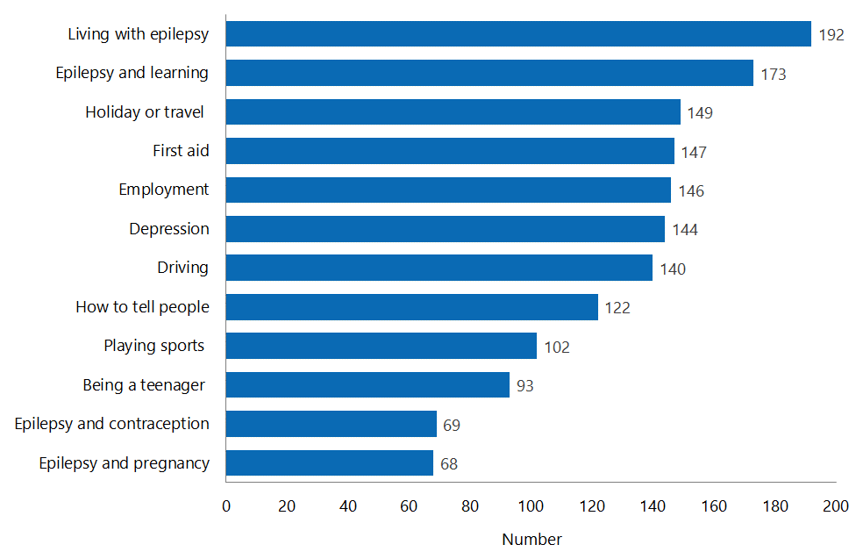

Medical fact sheets
Figure 16 shows the areas in which respondents considered medical fact sheets would be most beneficial. Twenty-one people did not answer this question.

Figure 16: Medical areas where respondents considered fact sheets would be useful, by topic
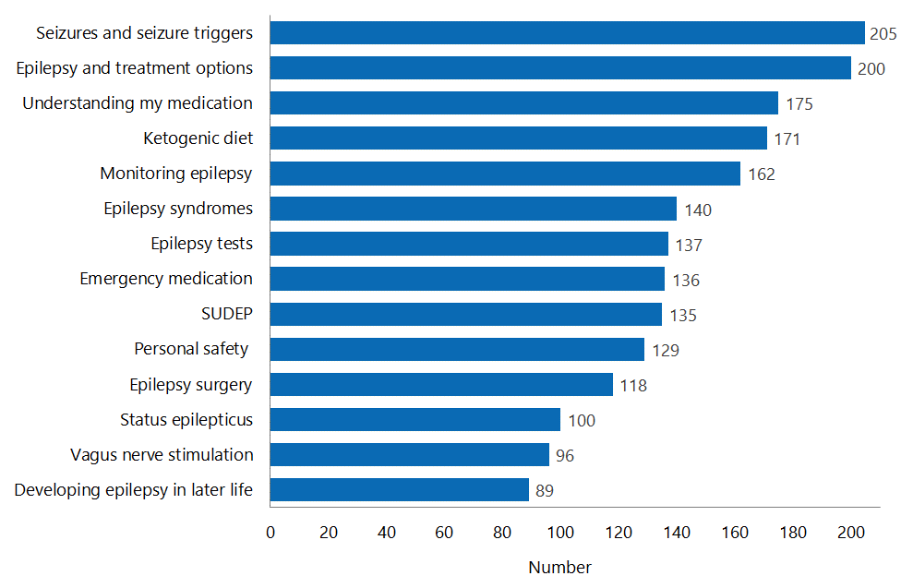
SUDEP: Sudden Unexpected Death from Epilepsy
Fifty-four people commented about social and community support fact sheets, and 36 people commented about medical fact sheets.

In general, respondents either commented on other (non-listed) areas where information would be useful, or noted that there was not enough information to support people with epilepsy at the time that they were diagnosed. Table 1 identifies some of the specific areas respondents commented on for additional fact sheets.

Table 1: Areas identified for additional fact sheets
Additional areas to consider for fact sheets | - Seizure dogs (4)  - Cannabinoid oil (5)  - How to get social help or navigate support agencies (8)  - Having a child with epilepsy (6)  - Epilepsy combined with other physical or intellectual disorders (5)
The following additional areas were raised by a single person | - Being safe in the water  - Teacher’s guide  - Epilepsy and the theatre  - Epilepsy and the courts/judicial system  - Epilepsy research  - Driving  - Causes of epilepsy (including traumatic brain injury)
Additional sub-areas within fact sheets in the offered list | - Emotional issues and memory problems (3)  - Injury prevention (2)  - SUDEP and status epilepticus (3)  - Information about tests (2)  - Seizures (3)  - Pregnancy and contraception (3)  - Diet therapy (4)  - Drugs and drug side effects (7)  - Aging with epilepsy (3)
General comments | - Raising awareness (3)  - General comments on the value of information or the need for information (13)

Part 2: Social and community factors
Part 2 of the survey sought information on how epilepsy affected respondents’ social and community interactions, and what supports they used or considered important.

Impact on life

Social challenges
Consumers were asked to select from a list of social issues thought to affect people with epilepsy so that we could identify the social challenges they faced in relation to their epilepsy. Consumers had the option to comment further using free text. Many people reported multiple challenges; being unable to drive was the most frequently reported challenge. Anxiety or depression, physical injury, social restrictions and discrimination were the next most frequently mentioned challenges.

Figure 17: Social challenges experienced, by type of challenge
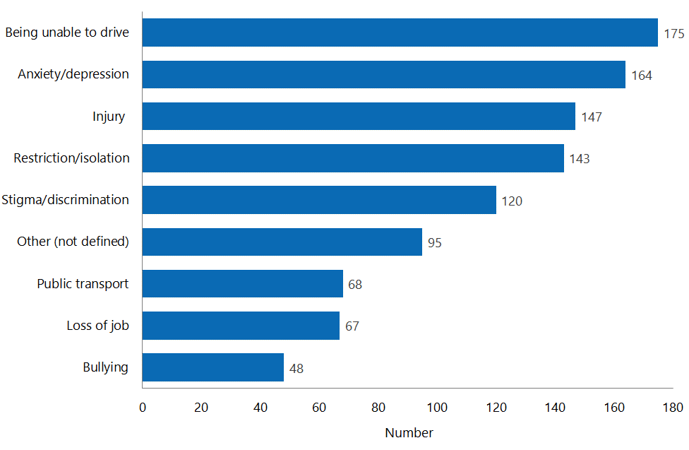

In this context, respondents’ comments reflected similar themes to those identified in the previous section. There was an additional focus on the difficulty of obtaining support because of how epilepsy is ‘classified’, and on feelings of isolation and stigmatisation.
I try to make epilepsy fit around me and not let it rule my life, but sometimes peoples’ attitudes can drag [me] up and down at times, and it can also limit some of the things we love to do, and that's why it's so important to have such a great support network in place, and a support group of people who know what it's like in our everyday shoes and don't judge.
I will never be able to drive; I will never hold down a job. I require 24/7 care due to my seizures and developmental delay. I struggle to fit in anywhere. I am 'too bright' for specialist schooling, yet constantly challenge my teachers and aides in the special needs unit at a mainstream school. I long for friendships but struggle to relate to others my own age. My epilepsy can be very isolating.
My son slips through the cracks when it comes to applying for support for him. Doctors won’t admit that his seizures, medication and brain surgery are the cause for his behavioural problems and cognitive limitations, so we cannot gain any support from them. Mental health assessments say he is not a mental health user, so we can't get help from them. He is not ‘IHC’, so we can't use their resources either. So he is basically left to fend for himself. Epilepsy is like an invisible cloak whereby the individual appears to have no issues until they [have] seizures, and this often frightens people so much that they pull away and distance themselves, causing epileptics to feel extremely isolated. It's very sad.

Frequency impacted
Most respondents reported that having epilepsy affected their lives at least some of the time. Sixty people (22%) reported they were affected by epilepsy ‘All the time’, and 120 people (43%) reported they were affected ‘Sometimes’.

Figure 18: Social challenges experienced, by frequency
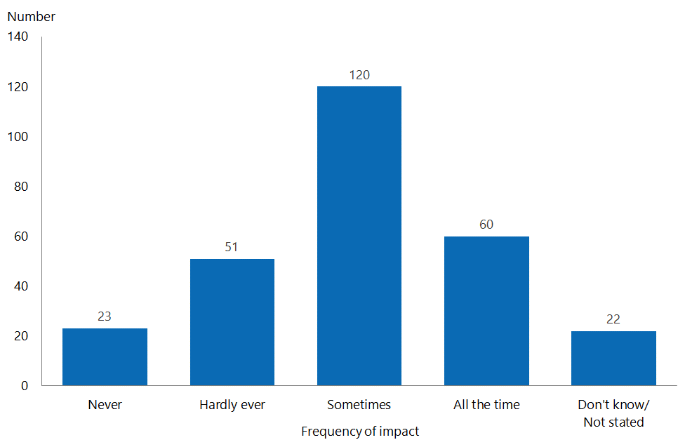

Impressions about access to social and community support services
Consumers were asked about their ability to access a range of social and community support services that people with epilepsy might be eligible to receive, or that might be available to them. In all of the support services listed, at least half of the respondents identified that they didn’t know about the service, or that it was not applicable for them (ie, they didn’t feel they needed it).

The areas that the most respondents identified not knowing about were ‘Diet treatment’ and ‘Local peer support’. The areas that the most respondents identified they either knew about or considered applicable for them were ‘WINZ assistance’ and ‘Epilepsy support’.

Figure 19: Impressions about ability to access social and community support, by type of support – all responses
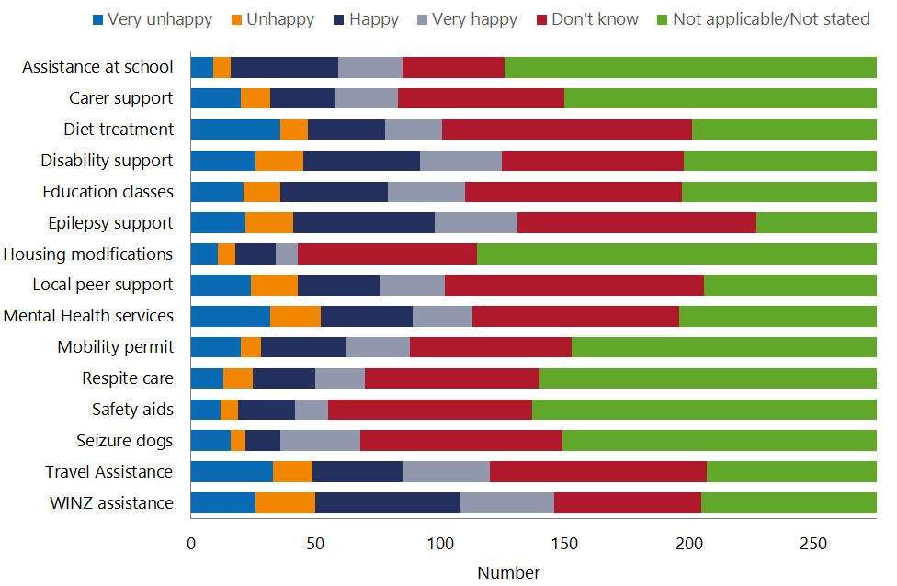

Where people were aware of services and rated their experience, the majority reported that they were ‘Happy’ or ‘Very happy’ with their ability to access support, but this varied widely by type of support (eg, 53 percent stated that they were happy with their access to diet support, while 81 percent were happy with their access to assistance at school).

Figure 20: Impressions about ability to access social and community support, by type of support – rating provided
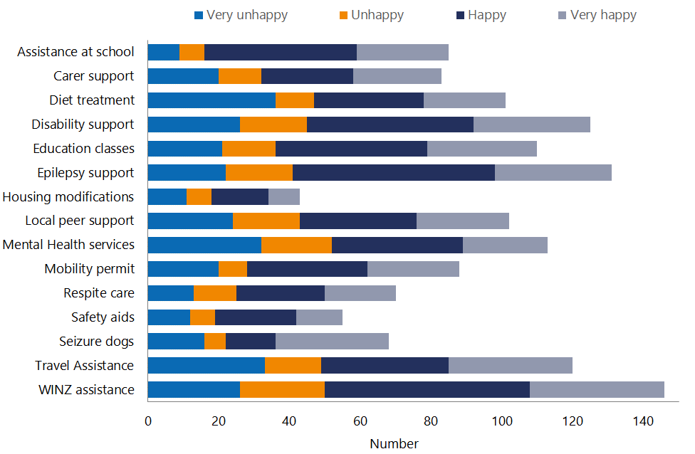

Table 2 presents the five services rated by the most people. While the majority of people reported they were happy with access to these services, responses reveal certain areas where services are not meeting needs as consistently (eg, ‘Mental health services’ and ‘Travel assistance’).

Table 2: Services with the largest number of responses
Service | Total rated | ‘Happy’ or  ‘Very happy’ |  | ‘Unhappy’ or  ‘Very unhappy’
 |  | N | % | N | %
WINZ assistance | 146 | 96 | 66% | 50 | 34%
Epilepsy support | 131 | 90 | 69% | 41 | 31%
Disability support | 125 | 80 | 64% | 45 | 36%
Travel assistance | 120 | 71 | 59% | 49 | 41%
Mental health services | 113 | 61 | 54% | 52 | 46%

The services that most respondents were not aware of (ie, that elicited a ‘Don’t know’ response) were ‘Local peer support’, ‘Diet treatment’, ‘Epilepsy support’, ‘Education classes’ and ‘Travel assistance’/

Many respondents expressed frustration over their lack of awareness of potential assistance:
As a parent, I feel there is not enough support for my son and his epilepsy. Everything relating to his epilepsy I have had to find out for myself.
I would be happy to share my experience with a support group: certainly dealing with the first period of diagnosis and finding the right treatment for you.
[I] have never been offered any of the above. [It] makes me upset if I am allowed some of them.
We aren't aware of any of the above. How do we find out more about these services, and what my son is entitled to?

Overall feelings about social and community support
Forty-one percent of respondents felt the social and community support available to them was ‘Poor’ or ‘Very poor’. While 33 percent reported support was ‘Good’ or ‘Very good’, only 10 people (4%) indicated that it was ‘Very good’.

Figure 21: Overall feelings about social and community support
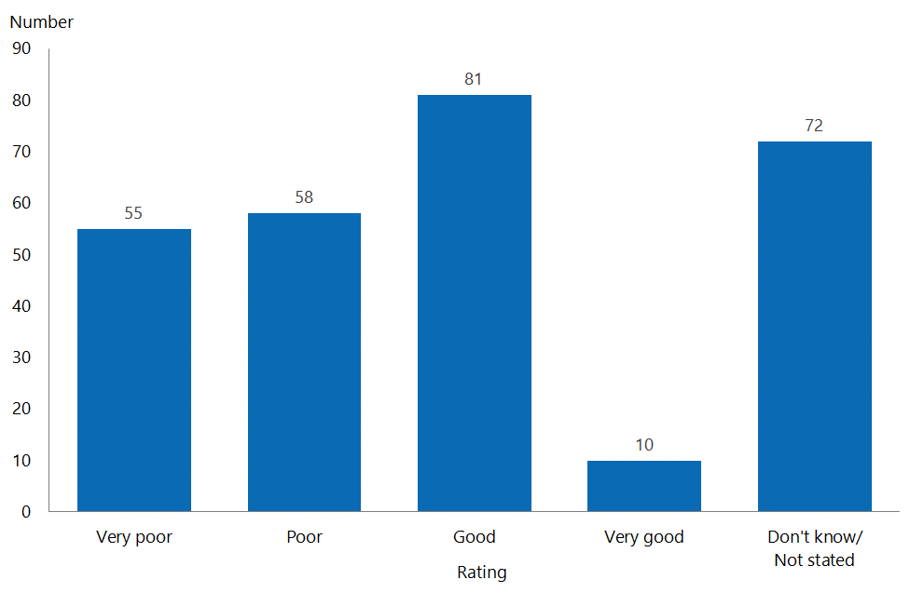

We have grouped comments about social support into three main themes: lack of awareness, gaps in services and the need to increase health literacy and people’s ability to self-manage.

Lack of awareness
While some respondents assumed that all people with epilepsy would be able to access the support services listed, many commented that they did not feel informed about what might be available, or about where to go for help. The clear message was that, at the point of diagnosis, people needed more information.
Epilepsy support has been great from [the] support worker, but it was self-initiated. It would be great if information about Epilepsy New Zealand was available following diagnosis at the hospital.
We weren’t advised by the neurologist, doctor or any other medical staff or WINZ staff of community support groups etc. Anything I found was because I had gone looking.
It's not that the support provided is poor, but that we have not been advised by hospitals/paediatrician etc about services available. More information at the doctor’s would be good, as this is the first point of contact for many families. Make sure doctors give information on where to access support.

Gaps in services
Comments on gaps in services covered a range of areas, but primarily related to people being ‘ineligible’ for services, such as day programmes, local peer-support groups, local non-governmental organisation (NGO) support and transport.
I am not aware of any local support available regarding epilepsy. We have not had a [needs assessment and service coordination] assessment, as my son does not have a clear diagnosis ([his condition is] currently labelled as global developmental delay, but as he is 10 years that label no longer applies, we are told). We are waiting for psychology assessment currently.
I do not come within the criteria for [Name] and [Name] … to receive or access support or services.
I still struggle to understand why buses aren't free. It was great to receive a mobility card, which allowed me to have half-price taxis, but when you have children and have to get them to school etc it becomes pretty expensive to use taxis, so [I] never did. If I was injured and under ACC it would all be free. I understand epilepsy is a disorder of the brain, but it’s appalling the lack of anything epilepsy sufferers seem to receive.
There is no local peer-support groups in [city]. I mean support groups; not talking on the phone to someone you only hear, will never see or meet, [who’s] in [city]. I need face-to-face [services] that help those like myself ... meeting others; the feeling you are not alone in this crazy world of ours, in talking about our day-to-day weeks to months and years of struggling, like with depression, home and work life, etc etc. [It would] be nice to meet others locally and form new friendships with [people] you can talk to that understand you.

Need to increase health literacy and people’s ability to self-manage
Some people commented on the need for more information to help them manage their epilepsy. Two respondents felt that the information they had received from epilepsy NGOs was insufficient to meet their needs.
I know my epilepsy is controlled, but it would be useful to know a little bit more about my medication and the effects on my body, instead of reading a bit on ‘Dr Google’ and [receiving information about] the adverse effects Epilim has on pregnant women.
I last sought assistance from the [name] about 10 years ago. The information provided was useful as a basic introduction, but after doing my own reading I arrived at a point where the support worker was unable to answer any of my questions … it strikes me that there is little for people who are at the more functional end of the continuum.
There's not enough pathways readily available for information – you stumble across things because someone happens to say something in passing. There needs to be an information pack of what is available when your child is diagnosed with epilepsy that is given to all paediatricians/hospitals to give to parents. It needs to have a checklist [stating] ‘these are the options available for you to explore when your child is diagnosed’ [and list] entities who are actually versed in supporting epilepsy.

The majority of comments in this section were about the value of the support provided by NGOs such as Epilepsy New Zealand and the Epilepsy Foundation. However some respondents did comment on difficulty accessing the services of NGOs.
[Regarding] support, I have joined [NGO] but only had contact when I initiated it. No newsletters?
I have tried many [times] to contact [NGO] about some information/support groups – but have never been contacted back. I know that this is a general comment from people in [city] about our local chapter.
I found [support worker from NGO]’s information archaic and frankly dangerous to be handing out, as a person in a position where what they are telling people tends to be listened to.
[NGO] destroyed thriving local branches, and subsequently the social/peer support on offer has all but vanished in places … Those field workers/educators are absolutely vital, especially for newly diagnosed people, as clinicians in general don't have a clue about the practical experience of living with epilepsy; nor do they often mention basic things that they should be [mentioning].
As stated above, I have tried many times to get some support from [NGO] and found them very distant and unhelpful.
I have tried to join [NGO] via the webpage on multiple occasions in order to access discounted taxi services; however, I have never been successful, so I have given up trying.

Part 3: Health services

Principal health service providers
The survey asked respondents who provided the most care or treatment for their epilepsy, to gain an understanding of which providers are delivering services to people with epilepsy. People could (and did) select more than one response. We cross-referenced this information with people’s responses as to how well they felt their epilepsy was controlled when the principal provider is general practice, a paediatric clinic and an adult neurology clinic.

Nine people reported that no one was providing them with epilepsy care; three of these stated that their epilepsy was well controlled, and five felt their epilepsy was poorly controlled. One answered ‘Don’t know’. Three of these people were children (aged younger than 10 years).

Fifty-three people said that their pharmacist was their primary provider, but only three of these did not identify any other health provider. One of these 53 was an adolescent (aged 11–15 years). One felt their epilepsy was poorly controlled.

General practitioners were involved in the care of 157 respondents (57%). Sixty-nine people (44%) also reported a specialist was involved in providing their care; 13 of these included a private specialist.

Only 19 people (including the 13 mentioned above) reported that a private specialist was involved in their care.

Figure 22: Principal health service providers
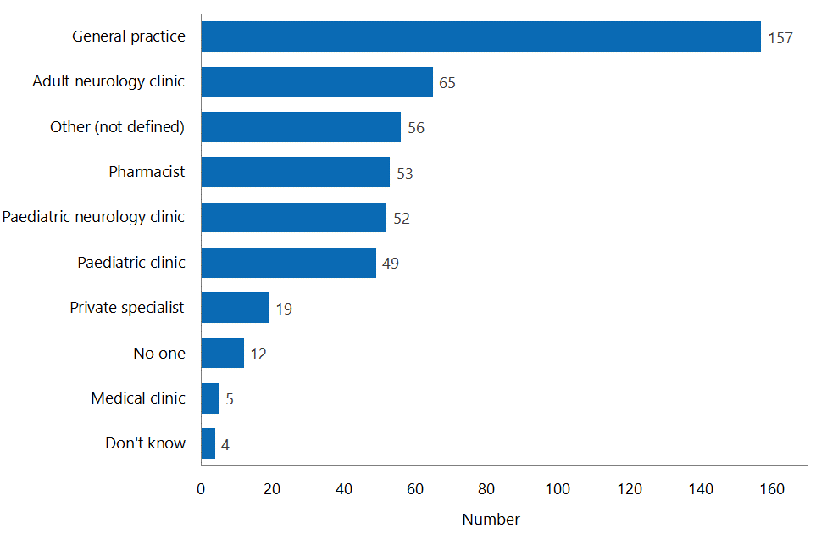

Primary care
The 88 people who reported that a specialist was not involved in their care were mostly adults, but there were 22 children (nine were 0–5 years, seven were 6–10 years, and six were 11–15 years). While the majority of people being cared for by GPs felt their epilepsy was well controlled (47 people), 29 people (33%) felt that it was not. Comments about primary care were both positive and negative.
Until now my GP has been the only one to take me really seriously, a problem I have found in the medical community. Whenever I have to see a doctor on short notice I don't bring up my epilepsy just in case they decide to review my medication and take it off me – something I shouldn't have to live in fear of.
GPs are always useless at knowing anything about epilepsy. I always find I have to educate them.
Our pharmacist and GP are amazing.

Figure 23: Impressions of how well epilepsy is managed among respondents for whom a general practitioner is their primary health service provider
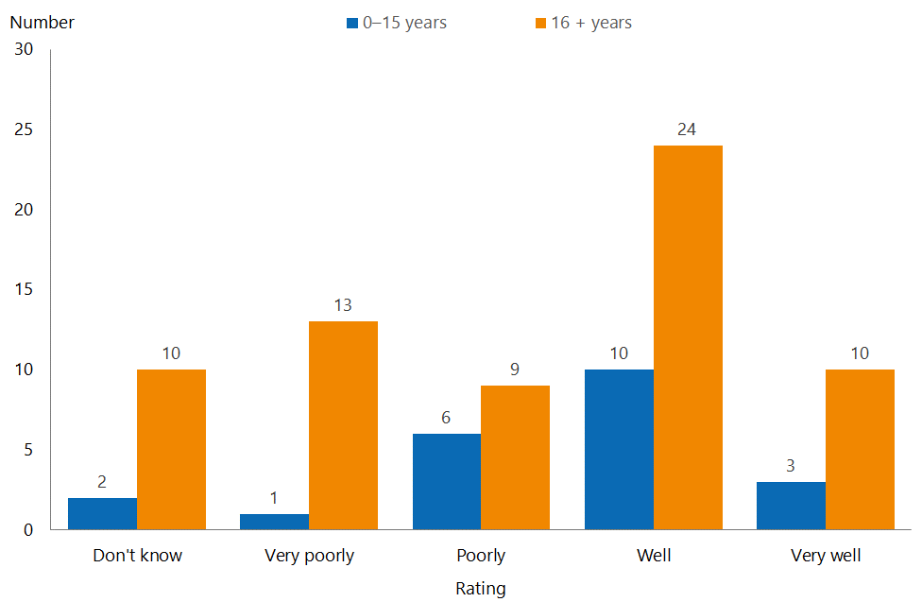

Paediatric care
Eighty people reported being cared for in a paediatric clinic. Of these, 28 were in a general paediatric clinic only, 30 were in a paediatric neurology clinic only and 22 were in both general paediatric and paediatric neurology clinics. Only 25 of the 80 people were children (aged 0–15 years), and another five were aged 16–20 years. Others were adults and it is assumed they were treated in a paediatric clinic in the past.

Of those respondents in paediatric care, 51 percent reported their epilepsy was well controlled, and 38 percent reported that it was poorly controlled. Comments about paediatric care identified problems with access to paediatric neurologists, and with being listened to.
Our experience with the general paediatric clinics has been very poor. All they want to do is throw drugs at you to take away the side effects of the anti-epileptic drugs. They don’t listen to the parents, and in most cases have very basic knowledge of epilepsy.
We do not have [a] local paediatric neurologist, so have [to] wait to see [one], and that's not occurred for 18 months. We see a paediatrician every three to four months due to services available locally.
[The] local paediatrician monitors and liaises with other doctors to determine medication changes. [We are] awaiting review by [a] paediatric neurologist ([we were] last seen three years ago).

Figure 24: Impressions of how well epilepsy is managed among respondents for whom a paediatric clinic is their primary health service provider
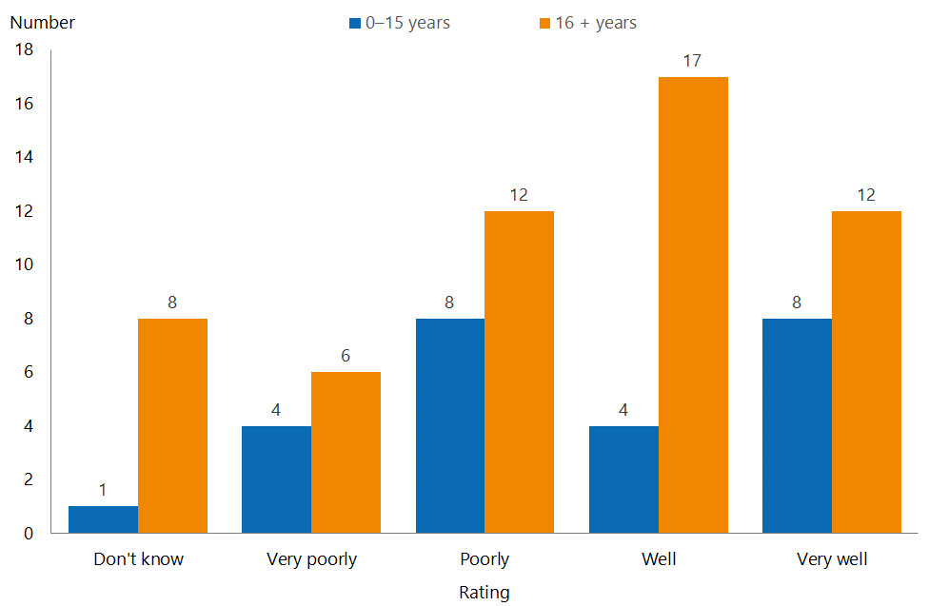

Adult services care
Sixty-nine people reported being cared for in an adult clinic (65 in a neurological clinic and four in a general medical clinic). Twelve of these were children (aged 0–15 years). Of these people, 68 percent reported that their epilepsy was well controlled, and 20 percent reported that it was poorly controlled. Comments reflected two main themes: access to a neurology specialist, often in smaller DHBs, and concern at the care received.
It is difficult to get appointments with [a] neurologist. I have been once only, and then appointments were rescheduled many times. I have difficulty getting transport to clinics.
[I have received] almost no care and attention. The neurologist clearly had no recollection of who we were each time he saw us, but had no hesitation in making sweeping changes at whim. This was quite alarming to me …
I’m heartened to see a new breed of specialists who are vastly better at listening and making helpful and well-thought-out suggestions.
The last time I saw a neurology specialist was in 1992 … I had epilepsy from when I was a baby.

Figure 25: Impressions of how well epilepsy is managed among respondents for whom an adult neurology (or medical) clinic is their primary health service provider
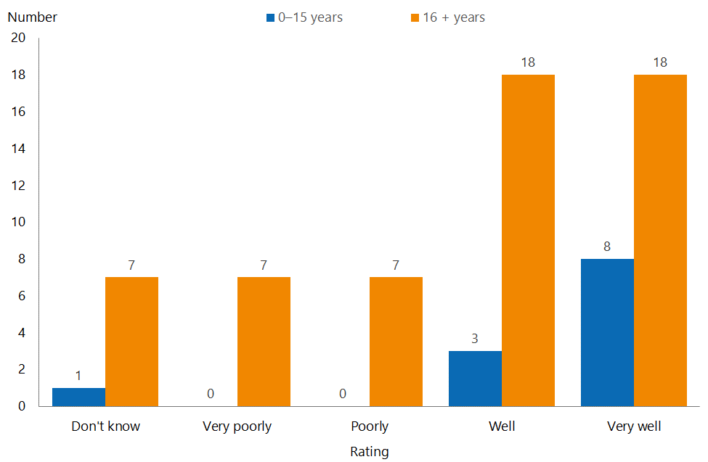

Overall feelings about hospital and health services
The survey asked respondents to provide an overall rating of the hospital and health services available to them for their epilepsy. The largest number of respondents rated these services as ‘Good’ (n=120, 43%) or ‘Very good’ (n= 27, 10%). One hundred and six people (38%) rated services as ‘Poor’ (n= 65, 24%) or ‘Very poor’ (n=41, 15%). Twenty-three people did not respond, or responded with ‘Don’t know’.

Figure 26: Overall rating of health services
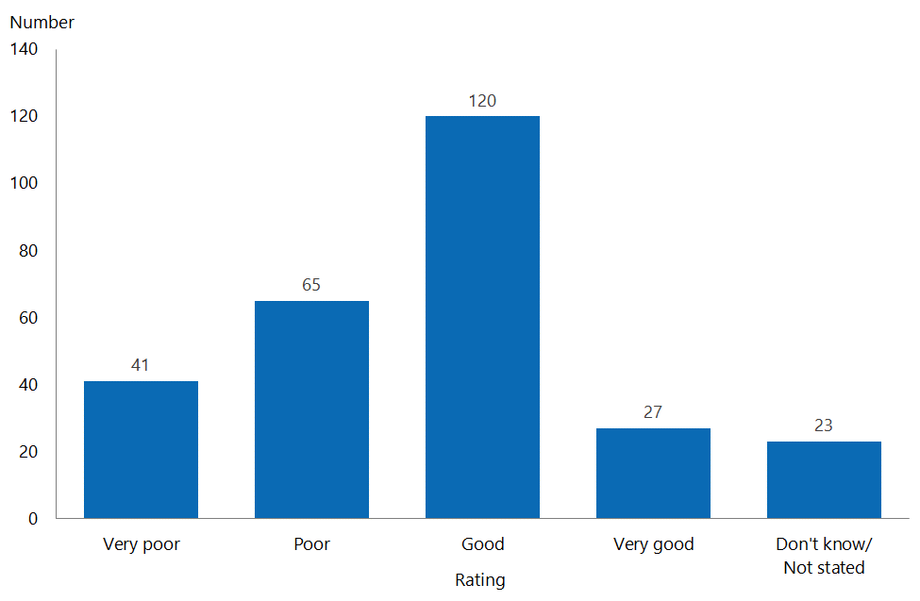

Respondents made 102 comments about hospital and health services. Many of these repeated or reflected comments made in other sections. We have grouped comments into three general areas: quality of health services, broader health and social system issues and raising awareness.

Quality of health services
Several people commented positively on the health services they had received and the expertise and care specialists provided. However, even positive statements usually included an area identifying room for improvement.
Once we get in to see our doctors they are very professional and supportive, but without a clear pathway of who to ring when things change it is stressful.
[We receive] great information from the specialist, [but] they are really busy, so difficult to access in a timely manner.
I am very happy with the level of care available to me, and the epilepsy nurse that I have is amazing. I would like to know more about different services, however.
We have a fabulous GP who cares and follows up. It feels like hospital services are improving for us now, but familiarity with epilepsy in the hospital in [the emergency department] or on a ward was poor – almost no one recognised the seizures, despite them being large and nasty generalised convulsive events.
It is generally good; however, as my daughter’s advocate, I must be on to it and be asking the questions – things don't happen unless I push for them or ask the questions. We have an amazing team assigned to her, and they do listen to my incessant questions and requests.

There were a larger number of negative comments, some outlining situations with potentially serious quality implications.
If people had explained what Epilim could do to my planned IVF baby, I would have changed meds. But no support or advice was given … Now my precious IVF girl is affected forever, from lack of correct information and advice.
I have had horrible experiences with some of my doctors at [name] Hospital, who have bullied and berated me and minimised my problems as if they weren't important. I do not feel like I can talk to my doctor if I have a problem, and I certainly do not feel supported … When I transitioned to [adult neurology] from [a paediatric clinic] I got a letter saying they aimed to see me in four months. My seizures were very bad at this point, and I didn't see a specialist for nine months. There was no support available to me at all during that time period, because I was in the middle, under nobody's care.
We have previously tried to change appointments and basically been told (by overworked receptionists) that it wasn't possible. What do you do? If you cancel the appointment, it looks like you're 'non-compliant'.
A lot of times we have felt desperate and alone and in the dark about our issues. [We] have never had anyone take the time to explain our diagnosis, or go through a plan forward. Even if it were bad, it would have been nice [for them] to say they don’t know, or offer other services which might have helped our path … the whole health system seems disjointed, with no one knowing whose job it is to tell you anything.
Overall I think we were diagnosed and dumped … most of what I learnt about epilepsy is because I read it on the internet.

Broader health and social system issues
A number of people highlighted broader issues with access to health services or across a range of social system providers.
Please improve the services available to people with epilepsy! It needs to improve big time. We need much easier access to good people who can help us: especially neurologists and psychologists. We need specialists that know what they are doing to help us. Thanks for the opportunity to do this survey. Please make sure that our voices are heard and appropriate action is taken to vastly improve the services we can easily access.
Unfortunately epilepsy is a condition that until you have it you don't really know what it is about. It’s hard work to try and deal with, to try and control while working, looking after a family and also trying to look after yourself. Some more support/funding for people with this disorder would be great. Even a support person (not your GP) who keeps in touch with you regularly to see how you are getting on would be good!
If I did not have the active support of my parent, I would really struggle with navigating the health and social services system. I feel [that], apart from the fact that my GP and neurologist work reasonably well together, across [the Ministry of Health, the Ministry of Social Development] and DHBs there is a lack of understanding and responsibility here about who actually takes accountability and responsibility for services for a person such as myself who has a number of health concerns, the most significant [of which] is epilepsy.
WINZ ‘reforms’ of the last nine years are causing people with disabilities/chronic health conditions so much unnecessary stress that it's resulting in very unnecessary acute hospitalisations for said conditions, which I'm sure is costing the health system a lot of money. WINZ is now a seizure trigger for me – they never used to be – to the point that I can't do the paperwork to get all the disability benefit I’m entitled to because I've already had five admissions from seizure clusters due to their behaviour, so it's medically dangerous for me to go anywhere near them. Perhaps someone at the [Ministry of Health] would like to have words to someone at [the Ministry of Social Development] and work out what you're going to do to fix this?

Raising awareness
It was evident from some comments that the general public of New Zealand, educators and employers have limited knowledge of epilepsy and how it affects people.
[I] would just love epilepsy to be out in the public eye, as my son has been struggling at school and the school's knowledge has been very limited, and so they were treating him with difficult behaviour, which he does have, but they weren't really looking at the greater picture.
I think people misunderstand epilepsy, and need to be educated a lot more than what I've seen. It's not good enough having someone flustered around you because they never received the information on how to react when someone's having a seizure. I dislocated my arm because, in the process of someone helping me, they tried to put me in the recovery position while I was still jolting. It's not their fault it happened; it was just a panicked reaction.
I was in denial for a long time, and nicknamed it ‘the disgusting E’ because of the stigma around epilepsy. My poor partner has had to watch some of my seizures, which hasn’t been pretty. I think more needs to be done to raise awareness of the different types of seizure and what to do. An advertising campaign much along the same lines as the stroke FAST campaign could be really helpful: to show people what to do.

Accessing health services

Referral to a specialist
The survey asked people when they were referred to a specialist because of their epilepsy. In some cases, people were in hospital or the emergency department and saw a specialist immediately – we included these responses in the ‘Within one week’ category. A small number of people noted that they waited several years to be referred to a specialist. It is not clear whether these people were having seizures during this period of time or not. We included these responses in the ‘Other’ group. Seventy-four people reported that they did not recollect how long they had waited to see a specialist. Six people said they had never seen a specialist.

Figure 27: Time to see a specialist
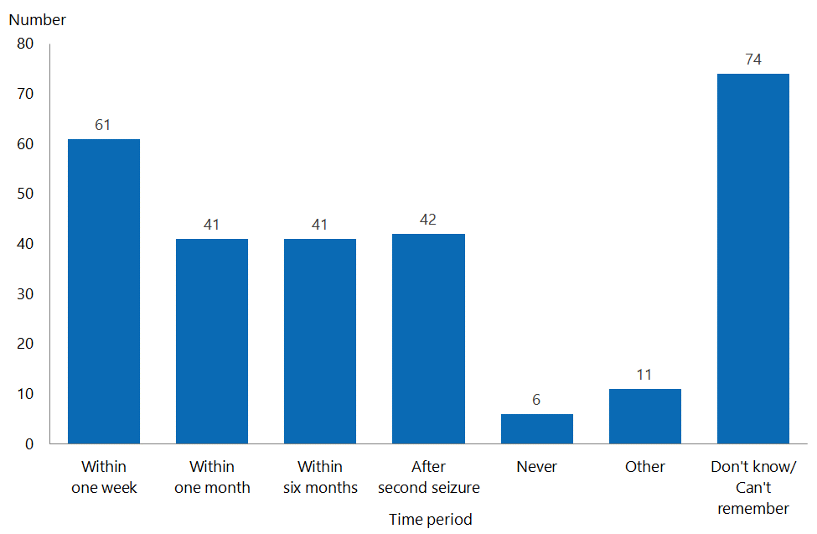

Some people commented that there had been a delay in their referral to a neurologist because it was assumed their seizures were febrile convulsions.
- We called an ambulance immediately. He was three months old. We were told to go home – it was only a febrile seizure. No one listened to us until he was 5.5 years old. In the meantime he was having hundreds of absence seizures a day and multiple tonic-clonics that were always put down as febrile.
- Even with a trip in an ambulance to [the emergency department], we were 'blown off' by a couple of fairly junior doctors with a fact sheet on febrile seizures. Despite a history … of age and eye movements inconsistent … with febrile seizures … Clearly there's an … opportunity for professional development in this space.

Others commented that they had experienced GPs not referring them to a specialist, or long waiting lists.
It was a few years before I saw a specialist because the frequency was about once a year. It was only when the frequency increased [that] the GP [was forced] to send me to hospital to see the consultant neurologist.
Our son's epilepsy deteriorated badly around [age 21/22 years]; he was on [the] waiting list in [the] public health system – we eventually went private. He was contacted 13 months later by the public health system! Hopefully it has improved over the last 15 years.
The wait list was incredibly long, so I had to wait months to be seen.

Frequency of contact with health care providers
The survey asked people how frequently they had contacted health care providers, either by phone, email or at a face-to-face visit, in the past 12 months. Figure 28 presents these responses by type of provider, excluding ‘Not applicable’ and ‘Other’ responses. ‘Other’ types of providers were generally an emergency department, a dietitian, an NGO support worker or a mental health worker.

Twenty-three people reported that they had no contact with a pharmacist, and 24 reported that had no contact with their GP. Cost was one of the reasons given for this. Around one-third of respondents reported having had no contact with a hospital specialist.

Conversely, 35 people reported having had contact with a pharmacist more than 20 times during the year, and 16 people reported having contacted their GP more than 20 times.

The majority of respondents had contacted health care providers between one and five times by the majority of people with epilepsy.

Figure 28: Frequency of contact with a health provider in the past 12 months, by type of provider
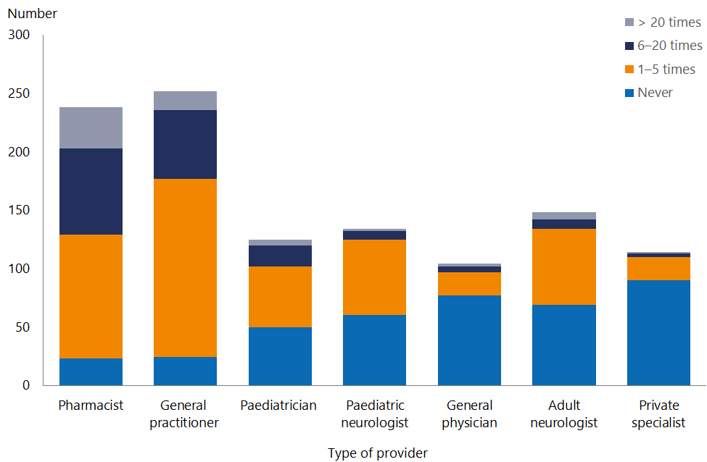

People generally felt it was difficult to get hold of hospital specialists, but some commented that they had made contact with an epilepsy nurse as a way of contacting the neurologist. One person living in a regional centre reported using telehealth.
[It has been] over four years since [I] last [saw] a specialist. GP fees are expensive.
[I contacted an] epilepsy nurse/assistant at [a] neurology clinic as an initial way to contact [the] neurologist.
Its extremely difficult and confusing trying to contact a paediatrician or paediatric neurologist. [It] causes quite a bit of stress [not being able to] call or email.
As we live away from the main centres, we are only under a GP and paediatrician for care. Our son has not seen a neurologist since we moved here seven years ago. An option for achieving multidisciplinary care could be an e-clinic, due to the geographic spread of patients and expert clinicians.

Accessibility of health care providers
The survey asked people to rate how hard it was to contact their health care providers. Respondents reported that pharmacists and GPs were the easiest to contact. Neurologists were the hardest to contact (98 reported that they were ‘Hard’ or ‘Very hard’ to contact, compared to 42 reporting that they were ‘Easy’ or ‘Very easy’. Respondents were more likely to consider paediatric neurologists difficult to contact (n=50) than easy to contact (n=13). Around 50 percent of people found paediatricians easy to contact, and a similar number considered them hard to contact.

Figure 29: Ease of contact with health care providers, by type of provider
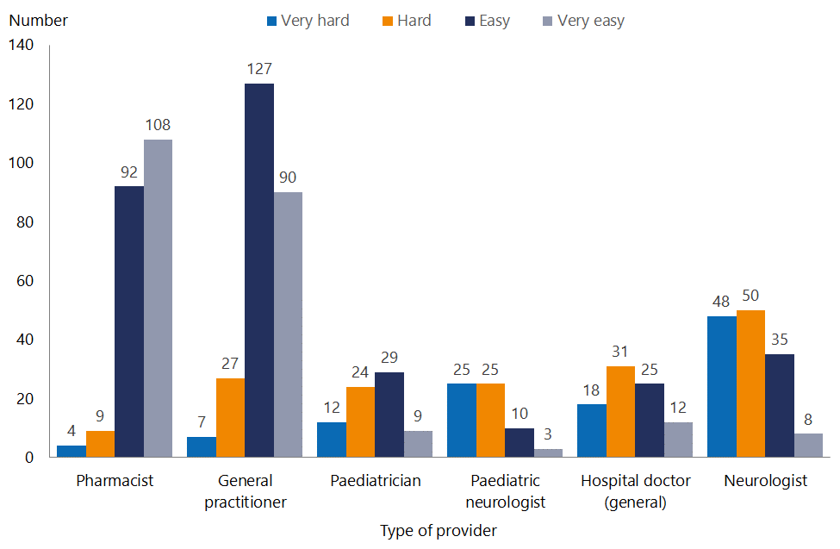

For the most part, people commented on stress associated with trying to contact a specialist about changes in their/their child’s condition. Respondents did not always see GPs as an option, some mentioning GPs’ lack of expertise in epilepsy care.
At first, the paediatrician was easier to contact, but it has become harder to get responses.
Apart from medication scripts, I choose not to speak to my GPs (three in four years) regarding seizure activity due to the very poor understanding of my epilepsy.

As noted above, some respondents mentioned that epilepsy nurses were easy to contact, and saw them as a conduit to the neurologist.
I have an epilepsy nurse specialist who is brilliant and always available via phone or email.
[I] can always get in contact quickly with my neurologist’s epilepsy nurse.

Access to health services
The survey asked respondents if they were happy with their ability to access a range of health service providers. Most people responded to questions about access to GPs, hospital specialists and tests. For other services, the majority of people chose either ‘Don’t know’ or ‘Not applicable’.

Figure 30: Survey response to question on ability to access appointments or services if needed, by type of service
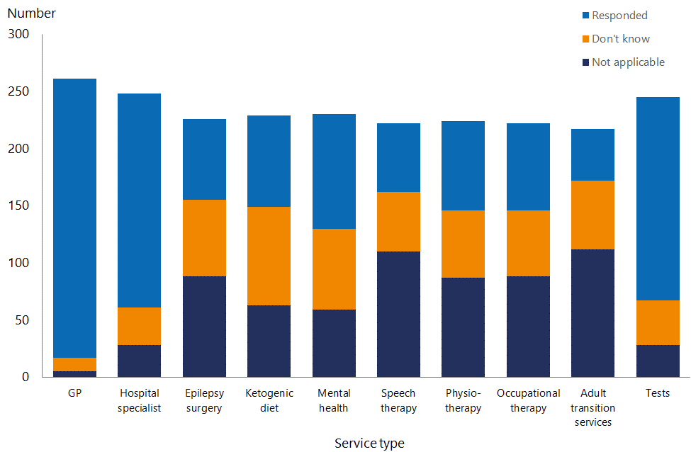

Many comments were about a lack of awareness of services that might potentially be available to them.
It would be nice to have these things; [I] didn't even know about them.
[These services] have not been offered or even discussed with us.
[I] didn’t know most of them existed. I have paid for all my own therapies. When I pushed a tooth out due to a seizure, I had to fight ACC.

People who did respond to the question about access were generally happy about their ability to access services (90% were happy about their access to a GP, 68% were happy about access to a hospital specialist and 71% were happy about access to tests).

In terms of services for which the response rate was lower, people were more likely to be happy than unhappy (with a range of 53–63% ‘Happy’ or ‘Very happy’).

For ‘Occupational therapy’, the greatest number of respondents were ‘Very unhappy’ with access to this allied health service (28 of 76 responses).

The area where respondents considered their access least satisfactory was ‘Adult transition services’. Out of 45 responses, 22 (49%) were ‘Very unhappy’.

Figure 31: Satisfaction with ability to access services if needed, by type of service
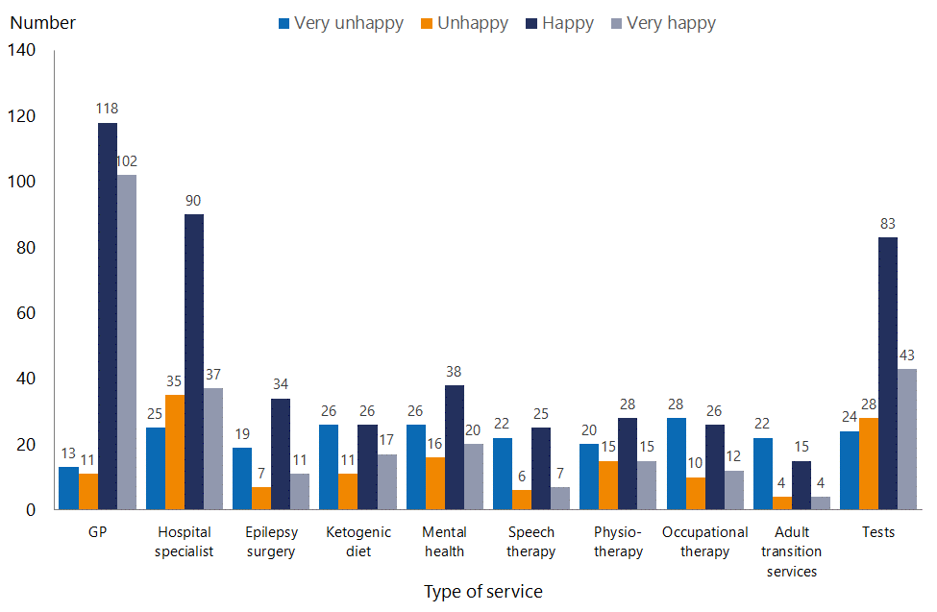

Some respondents commented that they had had to travel to see a specialist or have tests; others that they had had a long wait. People also commented about being obliged to access services privately because the services were not offered or available in the public system.
[I] have to drive three hours each way – to [city] for an [electroencephalogram (EEG)]. It involved having to take the whole family and having to stay the night, as we don’t have access to an EEG in our area.
NONE of this has ever been offered to us. We have gone round and round in circles BEGGING for help with our son. We have paid for private paediatricians, private occupational therapy, even though we can't afford it because there is NO help publicly.
Access to ketogenic treatment is very poor for anyone wanting to try this treatment. It is the best treatment for my son. Doctors need to know more about services that are available.
Our GP has merged into a big health care centre, so you can't get in to your regular doctor, and it is very hard to get any appointment unless you book more than a week out. I was told they had no appointments for the whole week when I rang about my son’s increase in seizures, but they arranged for my GP to ring me directly and then rang the paeds clinic. So [it was] a good outcome but very stressful when you don't know who to turn to.

Epilepsy consumer experience of health services

Being listened to and involved
Overall, 73 percent of respondents (151) reported that they felt listened to and involved in their care. Thirty-five people (17%) reported that they felt ‘Not well’ listened to or involved in their care. Twenty-one people (10%) responded ‘Not at all’ to this question.

Figure 32: Extent to which respondents felt listened to and involved
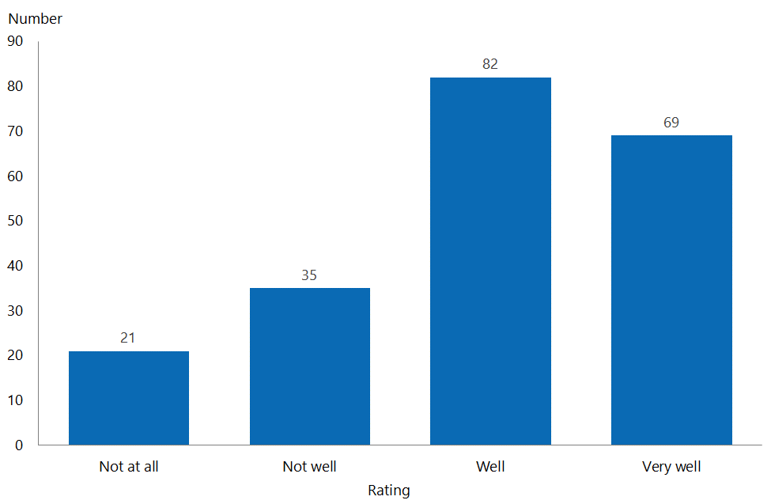

Reflecting the ratings, many respondents commented positively in this regard.
He has a fantastic neurologist.
The neurologist I went to last was very attentive, and I felt very safe in her hands.
I have been very impressed with the help and effort my neurologist has given us.
They are absolutely lovely; however, they are too busy to see [me] often. They will always check up on me and everything – acts like a parent. It’s lovely.

While many respondents mentioned positive relationships and experiences with specialists, some comments demonstrated that people’s experience of hospital specialists can be influenced by a provider’s communication or interpersonal skills.
Terrible. Arrogant. Not interested. Complete lack of understanding and knowledge. Not willing to learn new things. Appalling people skills. I gave up years ago … [I was] reduced to tears.
There are times [I feel] not well [listened to or involved] at all. I do not feel listened to, especially as I know my own body and the different effects. My plan is sometimes dictated, and they don't understand how debilitating this is and frustrating, especially the [really bad] side effects of medication and my real fear.
Patronising, unhelpful, impersonal, scathing of my questions and viewpoint about the crippling side effects of conventional drug therapy for epilepsy, after trialling seven different drugs – a pointless and traumatic exercise in suffering inflicted on my son.
My doctor does not listen to what I have to say, and doesn't respond well when I ask questions. She doesn't like it if I bring a family member to my appointment, and can get very angry very quickly if I have concerns. She has tried to suggest that my seizures weren't real or as frequent as I had been saying they were … It was only when I went in to hospital for more video monitoring last year that she believed me about what my seizures were like. As a result I do not feel that she is willing to take into account anything that I have to say about my treatment plan or care, which is difficult for me because I am the one relying on her to tell me what is best.

Emergency management plans
Only 84 people (31%) reported that they had an emergency management plan. One hundred and sixty-eight (62%) did not, and the remainder did not know.

Figure 33: Proportion of respondents who have an emergency management plan
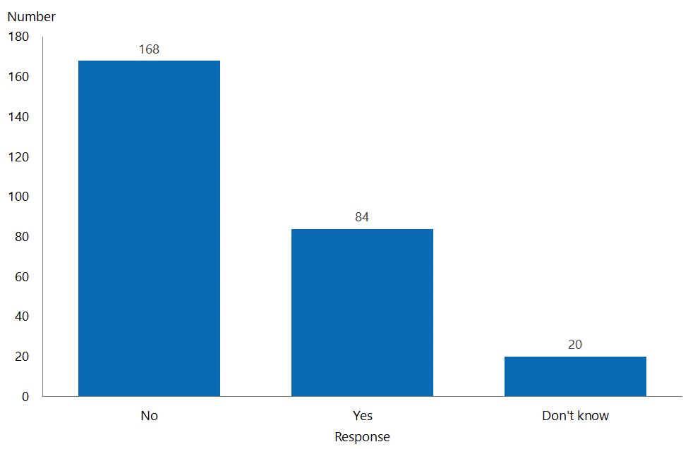

The survey asked respondents who did have an emergency management plan a range of questions about it, including whether they had been involved in developing it, whether their GP had a copy and whether it was updated regularly. It also asked them about some questions about the content of the plan itself.

Figure 34: Aspects of respondents’ emergency management plans
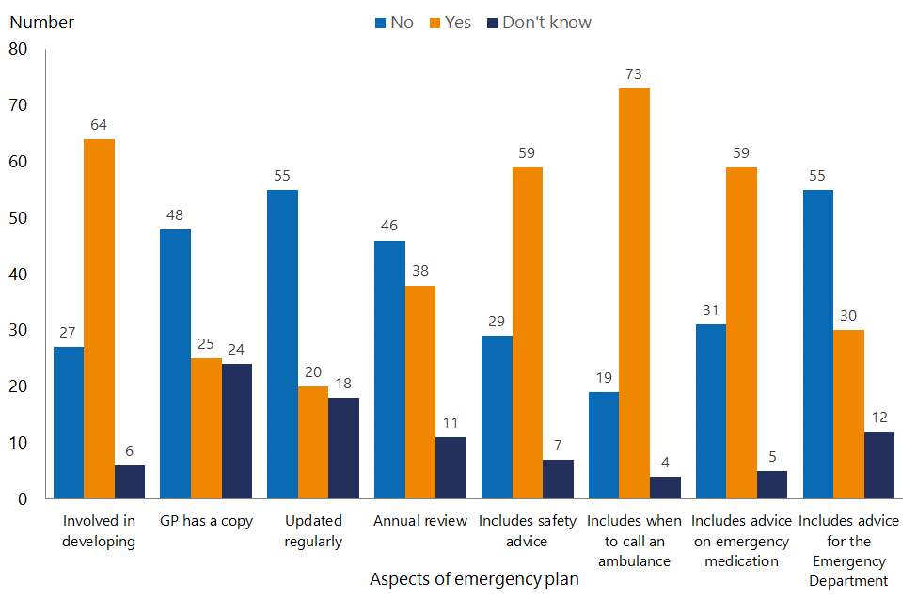

Most respondents who had an emergency management plan had been involved in developing it, but many reported that their plans were not regularly updated, and that their GP did not have a copy. While not all plans included a recommended annual review, or provided advice for an emergency department, they did tend to include safety advice, advice on when to call an ambulance and advice on emergency medications.

Comments on plans generally covered three areas: plans for school, self-developed plans and whether the respondent had a plan at all.
The plan is only for school. As he is never left with anyone else, this is the only place we need one at the moment.
This is a plan and instructions we have developed as a family; mainly for when our child is out of our care during the day at a vocational centre.
I did not have this until I personally asked for it, because I would arrive at the hospital and the doctors would have no idea what to do for me. There had been occasions that in the extensive time it had taken for them to figure out what to do I had come close to status epilepticus.

Communication and information
The survey asked respondents about whether they received information about epilepsy symptoms, effects, treatments and support in a way that they could understand. In general, people reported that they felt adequately informed about their epilepsy, seizure types, driving and treatments. However, they were more likely to respond ‘No’ to feeling adequately informed about areas such as long-term effects, SUDEP and possible treatment (eg, a ketogenic diet or surgical treatment). They were also unlikely to feel well advised about available community support.

Figure 35: Receiving information about aspects of epilepsy in a way that could be understood
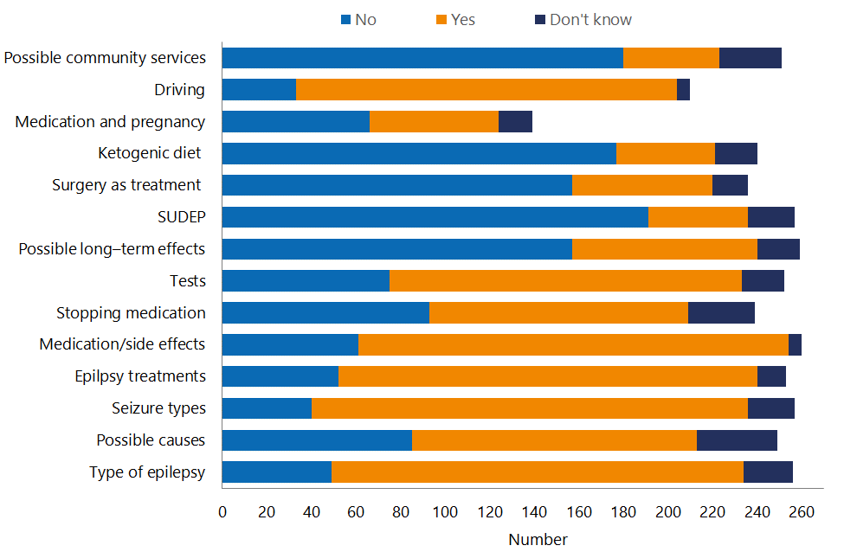
SUDEP: Sudden Unexpected Death from Epilepsy

Most respondents reported that they had received good information about their epilepsy, but a significant number still felt uninformed; for example, 61 people reported that they had not received or understood information on medication side effects, and 49 people reported that they had not received or understood information on they type of epilepsy they have.
The arrogant neurologist failed to tell me how having a child could effect your epilepsy, [and] the side effects of my medication [were] never discussed with me. I was treated as [if] I was too stupid to understand.
Side effects of medications were never explained. It was never explained that drugs are hit and miss and need to be trialled in each individual patient. We had no idea that we would be going through multiple drugs. Dietary therapy was not explained until we investigated it ourselves, and it was mentioned in our neurologist’s letter posted out after the appointment. Surgery has not been discussed.
Minimal information was voluntarily provided by the medical staff. Most of the information was drawn out by my mother asking questions. [The] internet has been more helpful than medics.
My neurologist is very selective about the things that she tells me about, giving me an odd and unclear image of what's happening so she can control my treatment.

