Emergency Department Use

2014/15

Citation: Ministry of Health. 2016. *Emergency Department Use 2014/15*.  
Wellington: Ministry of Health.

Published in August 2016  
by the Ministry of Health  
PO Box 5013, Wellington 6140, New Zealand

ISBN 978-0-947515-29-4 (online)

HP 6436

This document is available at health.govt.nz



 This work is licensed under the Creative Commons Attribution 4.0 International licence. In essence, you are free to: share ie, copy and redistribute the material in any medium or format; adapt ie, remix, transform and build upon the material. You must give appropriate credit, provide a link to the licence and indicate if changes were made.

Contents

Executive summary vii

Introduction 1

Interpretation notes 1

Analytical methods 2

Additional information 3

Patients 4

Overview 4

District health board region 5

Gender 6

Age 7

Ethnicity 11

Deprivation 15

Frequency of emergency department use 18

Events 22

Overview 22

Location 22

Day of the week 23

Seasonality 24

Urgency at presentation 26

Service provider 28

Length of stay 29

Outcomes 31

Additional notes 34

Inclusion criteria 34

Ethnicity 34

Deprivation 35

Rates 35

Maps 37

Facilities and service providers 39

Outcomes 40

References 41

List of Tables

Table 1: Purchase unit codes used for identifying emergency department events 34

Table 2: WHO world population 37

Table 3: List of facilities with an emergency department in New Zealand 39

Table 4: Outcome categories and relevant event end type codes 40

List of Figures

Figure 1: Rate of people who were patients at an emergency department at least once during the year, 2010/11–2014/15 4

Figure 2: Distribution of people who were patients at an emergency department at least once during the year, by DHB of residence, 2014/15 5

Figure 3: Rate of people who were patients at an emergency department at least once during the year, by DHB of residence, 2010/11 and 2014/15 6

Figure 4: Rate of people who were patients at an emergency department at least once during the year, by gender, 2010/11–2014/15 7

Figure 5: Distribution of people who were patients at an emergency department at least once during the year, by age group (years), 2014/15 7

Figure 6: Rate of children and adults who were patients at an emergency department at least once during the year, 2010/11–2014/15 8

Figure 7: Rate of people who were patients at an emergency department at least once during the year, by age group (years), 2010/11 and 2014/15 9

Figure 8: Rate of children who were patients at an emergency department at least once during the year, by DHB of residence, 2010/11 and 2014/15 10

Figure 9: Rate of adults who were patients at an emergency department at least once during the year, by DHB of residence, 2010/11 and 2014/15 10

Figure 10: Rate of children and adults who were patients at an emergency department at least once during the year, by gender, 2010/11 and 2014/15 11

Figure 11: Distribution of people who were patients at an emergency department at least once during the year, by ethnic group, 2014/15 12

Figure 12: Rate of people who were patients at an emergency department at least once during the year, by ethnic group, 2010/11–2014/15 12

Figure 13: Rate of Māori who were patients at an emergency department at least once during the year, by DHB of residence, 2010/11 and 2014/15 13

Figure 14: Rate of non-Māori who were patients at an emergency department at least once during the year, by DHB of residence, 2010/11 and 2014/15 14

Figure 15: Rate of children and adults who were patients at an emergency department at least once during the year, by ethnic group, 2010/11 and 2014/15 14

Figure 16: Distribution of people who were patients at an emergency department at least once during the year, by neighbourhood deprivation quintile, 2014/15 15

Figure 17: Rate of people who were patients at an emergency department at least once during the year, by neighbourhood deprivation quintile, 2010/11–2014/15 16

Figure 18: Rate of people residing in the most deprived neighbourhoods (quintile 5) who were patients at an emergency department at least once during the year, by DHB of residence, 2010/11 and 2014/15 16

Figure 19: Rate of children and adults who were patients at an emergency department at least once during the year, by neighbourhood deprivation quintile, 2010/11 and 2014/15 17

Figure 20: Rate of people in each ethnic group who were patients at an emergency department at least once during the year, by neighbourhood deprivation quintile, 2010/11 and 2014/15 17

Figure 21: Distribution of people who were patients at an emergency department at least once during the year, by the number of visits, 2014/15 18

Figure 22: Rate of single use and repeat use patients at an emergency department, 2010/11–2014/15 19

Figure 23: Rate of people who were patients at an emergency department once during the year (single use), by DHB of residence, 2010/11 and 2014/15 19

Figure 24: Rate of people who were patients at an emergency department more than once during the year (repeat use), by DHB of residence, 2010/11 and 2014/15 20

Figure 25: Rate of children and adults who had single and repeated use of emergency department services, 2010/11 and 2014/15 20

Figure 26: Rate of people who had single and repeated use of emergency department services, by ethnic group, 2010/11 and 2014/15 21

Figure 27: Rate of people who had single and repeated use of emergency department services, by neighbourhood deprivation quintile, 2010/11 and 2014/15 21

Figure 28: Number of emergency department events, 2010/11–2014/15 22

Figure 29: Distribution of emergency department events, by DHB region of facility, 2014/15 23

Figure 30: Distribution of emergency department events, by day of the week, 2014/15 23

Figure 31: Proportion of emergency department events that occur during weekends by DHB region of facility, 2010/11 and 2014/15 24

Figure 32: Distribution of emergency department events, by month of event, 2014/15 25

Figure 33: Number of emergency department events per day, by month of event, 2010/11 and 2014/15 25

Figure 34: Distribution of emergency department events, by triage level, 2014/15 26

Figure 35: Distribution of emergency department events, by triage level,  
2010/11–2014/15 27

Figure 36: Proportion of immediately or potentially life-threatening emergency department events, by DHB region of facility, 2010/11 and 2014/15 27

Figure 37: Distribution of emergency department events, by service provider, 2010/11 and 2014/15 28

Figure 38: Distribution of emergency department events, by length of stay, 2014/15 29

Figure 39: Distribution of emergency department events, by length of stay,  
2010/11–2014/15 30

Figure 40: Proportion of emergency department events requiring less than six hours to complete, by service provider, 2010/11 and 2014/15 31

Figure 41: Distribution of emergency department events, by outcome, 2014/15 32

Figure 42: Distribution of emergency department events, by outcome, 2010/11–2014/15 32

Figure 43: Distribution of weekday and weekend events, by outcome, 2010/11 and 2014/15 33

Figure 44: Distribution of immediately or potentially life-threatening events (triage levels 1–3) and of potentially serious or less urgent events (triage levels 4–5), by outcome, 2010/11 and 2014/15 33

# Executive summary

The purpose of this report is to present descriptive statistics about emergency department (ED) events and the demographic profile of ED patients in New Zealand. A summary of the key findings is provided below.

**Over a million ED events were attended by almost 700,000 patients in 2014/15**

There were 1,062,047 ED events reported in 2014/15: an increase of 10% from the 969,849 ED events in 2010/11. The events in 2014/15 were attended by 693,681 unique patients:

* 6 in 10 patients were in the European or Other ethnic group (64.5%)
* 3 in 10 patients resided in the most deprived neighbourhoods (31.0%)
* 2 in 10 patients resided in the Waitemata and Counties Manukau DHB regions combined (20.4%)
* 1 in 10 patients was a young child under the age of 5 years (11.2%)
* 1 in 10 patients attended ED three or more times during the same year (11.1%).

**For every 100 people in New Zealand, 15 were ED patients at least once during the year**

About 15 in every 100 people who reside in New Zealand were patients at an ED at least once during 2014/15; a slight increase in the age-standardised rate of ED use in 2011 (from 14.4 to 14.9 per 100 population).

**Rates of ED use were highest among the elderly and very young, and lowest among those in their 40s and 50s**

One in three people aged 85 years and over were patients at an ED at least once during year. Other age groups with higher rates of ED use were the 80–84 years (28.9 per 100 population) and under 5 years (25.5 per 100 population) age groups. The lowest were among people in their 40s and 50s (under 12 per 100 population).

**One in every four children residing in four DHB regions were patients at an ED at least once during the year**

One in every four children residing in the Lakes, Taranaki, Wairarapa and West Coast DHB regions were patients at an ED at least once during the year, compared with a national rate of one in six children. Rates of ED use were lower for adults than for children in the majority of DHB regions.

**Males had a higher rate of ED use than females**

The rate of ED use was consistently higher for males than females over the last five years. However, this gap is closing as the rate for females has increased from 13.7 to 14.5 per 100 population while the rate for males remained stable (average of 15.3 per 100 population) over the same time period.

**All ethnic groups showed an increase in the rate of ED use**

Pacific peoples had the highest age-standardised rate of ED use in 2014/15 (19.3 per 100 population), followed by Māori (18.0 per 100 population). All ethnic groups showed an increase in the rate of ED use from 2010/11 to 2014/15. The largest increase was by 13% in the rate for the Asian ethnic group (from 8.3 to 9.4 per 100 population).

**Rates of ED use increased with level of neighbourhood deprivation**

The rate of ED use increased with each level of neighbourhood deprivation:

* 1 in 11 people residing in the least deprived neighbourhoods were ED patients at least once during the year (8.7 per 100 population)
* 1 in 5 people residing in the most deprived neighbourhoods were ED patients at least once during the year (21.7 per 100 population).

**Rates of single and repeated use of ED had similar trends**

Rates of single and repeated use of ED had similar trends across most demographic groups. Demographic groups with a higher rate of single ED use tended to have a higher rate of repeated ED use as well.

**Over 100,000 ED events in Middlemore Hospital**

The vast majority of ED treatment is provided by DHBs in New Zealand, through hospitals located within each region. Facilities in the five most populated DHB regions combined accounted for 46% of ED events in 2014/15: Waitemata, Auckland, Counties Manukau, Waikato and Canterbury DHB regions. Middlemore Hospital (Counties Manukau DHB) had the most with over 100,000 events.

**One in three ED events occurred during a weekend**

ED events were more common on Sundays and Mondays, and less common on Wednesdays and Thursdays. One in three ED events occurred during a weekend (from Friday 5 pm to Monday 8 am). The proportion of weekend events ranged widely between individual facilities, ranging from 28.5% to 59.3% of ED events at the facility.

**More ED events per day during summer and winter months**

Summer and winter months generally had a higher number of ED events per day, compared with spring and autumn months. August 2014 was the month with the highest number of ED events during 2014/15. On average there were over 3000 ED events per day during August 2014.

**The vast majority of ED events were completed within six hours**

Over 92% of all ED events in 2014/15 were completed within six hours of the patient presenting to ED: an increase from 87.7% of events in 2010/11.

**Over half of ED events were determined to be immediately or potentially life-threatening**

Almost 54% of ED events in 2014 were of patients presenting to ED with a condition that was immediately to potentially life-threatening (triage levels 1–3). A further 39.6% were determined to be potentially serious and 6.7% of events were determined to be less urgent.

**One in three ED events ended with the patient being admitted to hospital**

One in three ED events during 2014/15 ended with the patient being admitted to hospital. About 65% of ED events ended as a routine discharge from ED and a very small proportion (<2%) of events ended with the patient discharging themselves from ED. A total of 594 people (<0.1%) died while in ED in 2014/15.

# Introduction

In New Zealand, emergency departments (EDs) provide care and treatment for patients with real or perceived, serious injuries or illness. This includes providing resuscitation and stabilisation of critically unwell or injured patients that often require admission to hospital. An ED will conduct sufficient work-up of a patient (eg, physical examination, laboratory tests, x-rays) to decide whether the patient should be discharged or admitted to the hospital.

The vast majority of EDs are open 24 hours a day, seven days a week. They are publicly-funded, although some facilities may charge for general practitioner (GP)-level care at an ED.

The purpose of this report is to present descriptive statistics about ED events and the demographic profile of ED patients in New Zealand. This includes:

* the distribution, demographic detail and frequency of use of people who were patients at ED at least once during the year
* the location, timing, seasonality, urgency of condition at presentation, service provider, length of stay and outcome of reported ED events.

Reasons for why people present to ED are not part of the National Collection on which this report is based and is therefore not included in this report.

## Interpretation notes

This report has been compiled from data supplied by DHBs to the National Non-admitted Patient Collection. It is important to note that:

* differences in the data presented may be an artefact of changes in hospital processes or classifications
* results presented in this report may differ from other reports as different methods and criteria are used to analyse the data.

### Time periods and trends

This report presents numbers and rates by financial year. This means that the year 2014/15 refers to events from 1 July 2014 to 30 June 2015.

Although the focus of this report is on ED use in the 2014/15 financial year, events from 2010/11 to 2013/14 are often included and presented as a five-year period (2010/11–2014/15) to provide context and to help with interpreting the information.

### Numbers and rates

The number of events refers to the number of ED events that occurred during the year. Some people have more than one event during the year. The number of patients refers to the number of people who were patients at ED at least once during the year (ie, a person who visited ED three times during 2014/15 is only counted once).

Rates of ED use are presented in the chapter on patients, and refers to the number of people in a demographic group who were patients at least once during the year, as a proportion of the population for that demographic group. For example, a rate of ED use of 15.4 per 100 population for males means that for every 100 males in the population, about 15 were patients at an ED at least once during the year. The number of people of people for each demographic group may include people who are not New Zealand residents.

### Figures

Graphs and maps are included to help you to visualise the quantitative information more easily. They are intended to highlight trends and relationships rather than as a means to look up individual values. The underlying numbers used to create graphs and maps in this report are provided in the accompanying online tables.

Geographical information for ED patients (not events) is usually presented as two maps side-by-side:

* The first map (left) shows the 2014/15 rate of ED use for the stated demographic group, with going from the lowest rates (lightest shade) to the highest rates (darkest shade).
* The second map (right) shows whether there has been a statistically significant change in the rate of ED use between 2010/11 and 2014/15, with each category denoted by a different shade (ie, a significant increase, a significant decrease, or no significant difference).

Further details about interpreting maps is provided in the Additional notes chapter.

## Analytical methods

Data quality management has been applied at several points in the collection, extraction and analysis of the data to report the data presented here in a consistent manner. All efforts have been made to ensure that duplicate events are not included in the analyses.

### Getting the data

Data for this report was extracted from emergency department events reported to the Ministry of Health’s National Non-Admitted Patient Collection (NNPAC) on 20 April 2016. NNPAC information includes event-based purchase units that relate to medical and surgical outpatient events and emergency department events. Data recorded on NNPAC is provided monthly by district health boards (DHBs) that are individually responsible for ensuring the completeness and quality of data supplied.

### Counting patients and events

In the chapter on events, the key measure presented is the number of events. This includes attended ED events with a service date between 1 July 2010 and 30 June 2015.

In the chapter on patients, a key measure is the number of ED patients. The information presented is based on the first admission event for the person during the year. All demographic information about that patient is based on that first admission (eg, age, DHB of residence, ethnicity, and neighbourhood deprivation). This is to ensure that the rates by demographic groups are not swamped by the same people use emergency services repeatedly during the year. The demographic profile of patients who used emergency services multiple times during the year is presented in the ‘Frequency of emergency department use’ section.

### Rates of ED use

Rates presented are primarily age-standardised rates. Age-specific rates are only presented when the rate is calculated for a specific age group (eg, children aged under 15 years).

Age-specific rates were calculated by counting the number of patients in a particular age group and dividing by the population count of that particular age group and multiplying by 100.

Age-standardised rates were calculated using direct standardisation; that is to sum the age-specific rates of each five-year age group multiplied by the proportion of each five-year age group of the standard population. The WHO World Population (Ahmad et al 2001) was used as the standard population.

Population data used to calculate rates was sourced from multiple data sets provided by Statistics New Zealand. The list of data sets used is provided in the Additional notes chapter.

### Statistical significance

Lack of commentary regarding the difference between statistics does not necessarily suggest that the difference was tested and found to be not significant. Differences discussed in this report have not been tested for statistical significance, unless noted otherwise. Confidence intervals for two rates that do not overlap are considered to be statistically significantly different in this publication. 95% confidence intervals were calculated using the method presented in Keyfitz (1966).

## Additional information

The accompanying online tables include the following:

* Number and rate of people who were patients at an ED at least once during the year by gender, ethnic group, neighbourhood deprivation quintile and frequency of ED use for selected DHB region and age group.
* Number and distribution of ED events by gender, ethnic group and neighbourhood deprivation quintile at first ED event of the year, and frequency of ED use, for selected DHB region and age group.
* Number and distribution of ED events by day of the week, month, length of stay, triage level and outcome of event, for selected service provider or facility of event.
* Other summary tables used to produce graphs and tables presented in this publication.

If you require information not included in this report or in the accompanying online tables, the Ministry of Health is able to produce customised data extracts tailored to your needs. These may incur a charge (at Official Information Act rates). The contact details are provided below.

Postal address: Analytical Services

Ministry of Health

PO Box 5013

Wellington 6145

New Zealand

Email: [data-enquiries@moh.govt.nz](mailto:data-enquiries@moh.govt.nz?subject=Report%20on%20Maternity,%202012)

Phone: (04) 496 2000

# Patients

This chapter presents descriptive statistics about the demographic profiles of patients who presented to an ED in New Zealand. Numbers and rates of ED use are presented by DHB region of residence, gender, age, ethnicity and deprivation for people who were patients at an ED at least once during the year. These analyses are also presented for people who used the ED once and for people who used the ED more than once during the same year in the final section (‘Frequency of emergency department use’).

## Overview

Almost 700,000 people were patients at an ED at least once during the 12-month period ending 30 June 2015. This equates to approximately 15 in every 100 people in the population being patients at an ED at least once during 2014/15 (age-standardised rate of 14.9 patients per 100 population).

From 2010/11 to 2014/15, the number of people who were ED patients increased from approximately 640,000 to 690,000 people. The rate of ED use also increased, from 14.4 to 14.9 patients per 100 population (Figure 1).

Figure 1: Rate of people who were patients at an emergency department at least once during the year, 2010/11–2014/15



Note: Rates presented are standardised to the WHO World Population. The number above each marker is the number of people.

## District health board region

The geographic distribution of ED patients presented in this section is based on the DHB region of the patient’s usual residence (ie, DHB of domicile). Rates and numbers in this section are intended to reflect the usually resident population of the DHB region, and not necessarily the facilities run by that DHB. See the ‘Maps’ section in Additional notes for a map showing the location of each DHB region.

People who attended an ED at least once during 2014/15 most commonly resided in the Waitemata DHB region (10.5%), followed by the Counties Manukau DHB region (9.9%). Patients residing in the following five DHB regions each accounted for less than 2% of patients who attended ED during the year: Tairāwhiti, Whanganui, Wairarapa, West Coast and South Canterbury (Figure 2).

Figure 2: Distribution of people who were patients at an emergency department at least once during the year, by DHB of residence, 2014/15



Note: The number on each bar is the number of patients. The denominator used to calculate the percentage is the total number of people who were patients at an ED at least once during the year, excluding those where DHB was unknown (11,294 patients, 1.6%).

Although ED patients residing in the West Coast DHB region accounted for only 1% of all ED patients, the age-standardised rate of ED use in the West Coast DHB region was higher than any other region at 24.0 per 100 population. Other regions with higher rates of ED use were Lakes, Taranaki and Wairarapa DHB regions (Figure 3).

Ten DHB regions showed an increase in the rate of ED use from 2010/11 to 2014/15. The regions with rates that increased by more than 10% were Lakes, Bay of Plenty, Hawke’s Bay, Capital & Coast and Hutt Valley. Conversely, the rate of ED use decreased by more than 10% in the Wairarapa DHB region (Figure 3).

Figure 3: Rate of people who were patients at an emergency department at least once during the year, by DHB of residence, 2010/11 and 2014/15

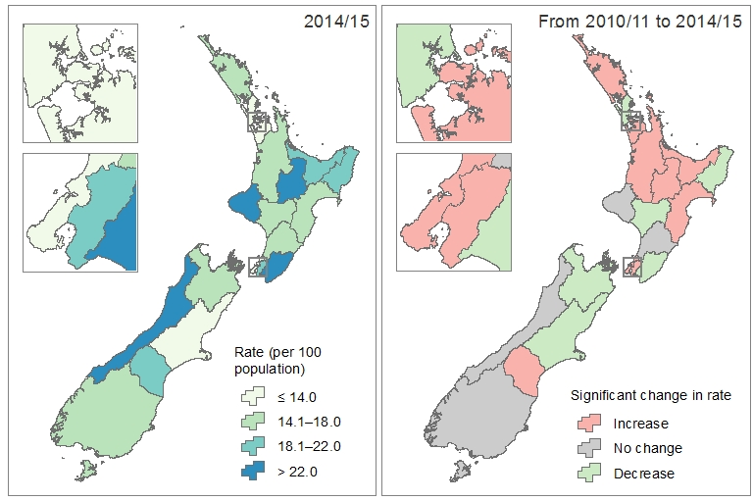

Note: Rates presented are standardised to the WHO World Population.

## Gender

Overall, there were more male patients with at least one visit to an ED in 2014/15 than female patients (349,828 male patients and 343,813 female patients).

The age-standardised rate of ED use in 2014/15 was 15.4 per 100 population for males and 14.5 per 100 population for females. While the rate of ED use for males was consistently higher than females from 2010/11 to 2014/15, this gap has reduced over time. There was an increase in the female rate from 13.7 to 14.5 per 100 population, while the rate for males remained stable (ranging from 15.2 and 15.4 per 100 population) (Figure 4).

The rate of ED use for males was slightly higher than the rate for females across all DHB regions from 2010/11 to 2014/15.

Figure 4: Rate of people who were patients at an emergency department at least once during the year, by gender, 2010/11–2014/15



Note: Rates presented are standardised to the WHO World Population.

## Age

One in five patients at ED in 2014/15 were children (<15 years). The under 5 years age group had the largest number people attending ED at least once during the year, accounting for 11.2% of all ED patients. Among the adults, the 20–24 years age group (8.2%) was most common and the 80–84 years age group (3.5%) was least common (Figure 5).

Figure 5: Distribution of people who were patients at an emergency department at least once during the year, by age group (years), 2014/15



Note: The number on each bar is the number of patients.

Almost one in every six children and one in every seven adults in the population were patients at an ED at least once during 2014/15 (16.9 per 100 population for children and 14.6 per 100 population for adults). Since 2010/11, the rate of ED use has increased by 6% for children and by 3% for adults (Figure 6).

Figure 6: Rate of children and adults who were patients at an emergency department at least once during the year, 2010/11–2014/15



Note: Rates presented are specific to the age group and not standardised.

Rates of ED use varied more broadly when comparing between five-year age groups, with notably higher rates among the elderly and the very young. Over a third of people aged 85 years and over were patients at an ED at least once during 2014/15: an age-specific rate of 37.2 per 100 population. People aged 80–84 years and children aged under 5 years also had higher rates of ED, at 28.9 and 25.5 per 100 population, respectively. The lowest rates were among people in their 40s and 50s (between 11.4 and 11.9 per 100 population) (Figure 7).

Compared with 2010/11, most of the age groups (presented in Figure 7) had an increase in the rate of ED use. The largest increases were among children aged under 5 years (from 23.4 to 25.5 per 100 population) and adults aged 50–54 years (from 10.8 to 11.6 per 100 population). Rates of ED use showed a decreasing trend among teens aged 15–19 years (from 16.1 to 15.4 per 100 population) and elderly aged 75–79 years (from 22.9 to 21.6 per 100 population).

Figure 7: Rate of people who were patients at an emergency department at least once during the year, by age group (years), 2010/11 and 2014/15



Note: Rates presented are specific to the age group and not standardised.

One in every four children residing in the Lakes, Taranaki, Wairarapa and West Coast DHB regions were patients at an ED at least once during 2014/15 (age-specific rate of approximately 25 per 100 population). From 2010/11 to 2014/15, nine DHB regions showed a significant increase in the rate of ED use among children. The largest increases were by 22.2% and by 21.2%, respectively, among children in the Capital & Coast (from 10.6 to 12.9 per 100 population) and Auckland (from 14.8 to 17.9 per 100 population) DHB regions. Rates of ED use among children decreased by 10–13% in in the following DHB regions: Whanganui, Wairarapa and Canterbury (Figure 8).

Rates of ED use were lower for adults than for children in 17 of the 20 DHB regions in 2014/15 (all but MidCentral, Whanganui and Canterbury DHB regions). Nine DHB regions showed a significant increase in the rate of ED use among adults from 2010/11 to 2014/15. The largest increase was by 15.6%, among adults in the Bay of Plenty DHB region (from 16.1 to 18.6 per 100 population). In contrast, rates of ED use decreased by 11.0% and 13.4%, respectively, among adults in the Wairarapa and Nelson Marlborough DHB regions (Figure 9).

Figure 8: Rate of children who were patients at an emergency department at least once during the year, by DHB of residence, 2010/11 and 2014/15

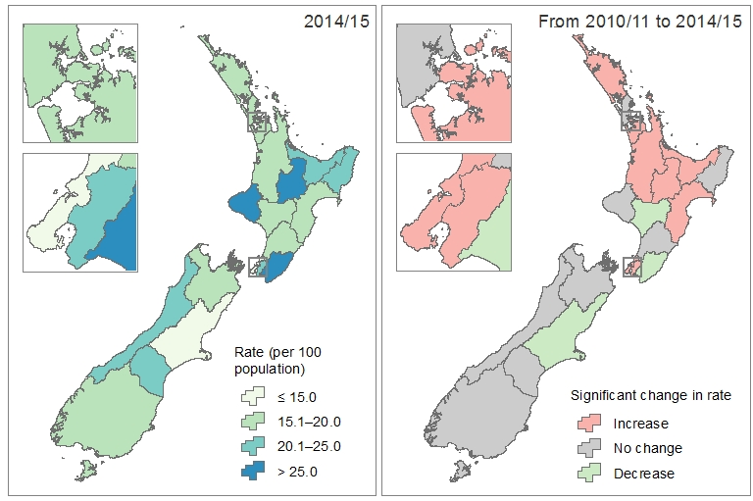

Note: Rates presented are specific to children aged under 15 years and are not standardised.

Figure 9: Rate of adults who were patients at an emergency department at least once during the year, by DHB of residence, 2010/11 and 2014/15

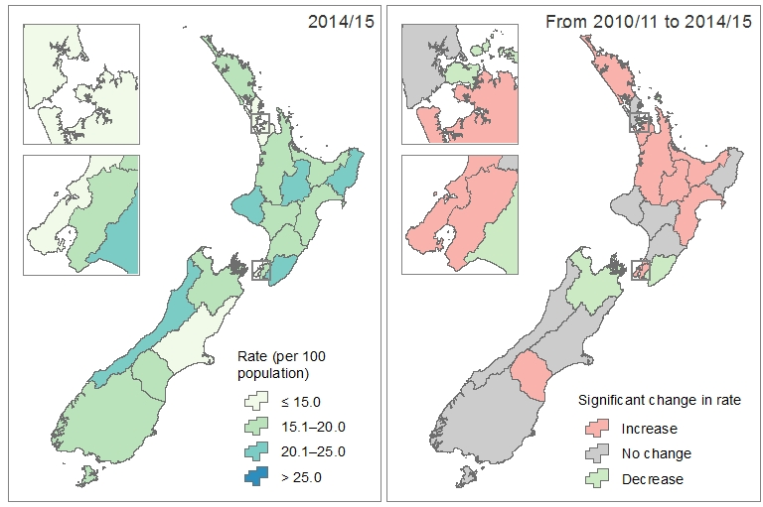

Note: Rates presented are specific to adults aged 15 years and over and are not standardised.

An increase in the rate of ED use for children was seen in both male and female children: the rate increased by 6.8% for female children (from 14.5 to 15.5 per 100 population) and by 4.6% for male children (from 17.4 to 18.2 per 100 population). The overall increase in the rate of ED use among adults (Figure 6) was primarily driven by a 5.1% increase in the rate for female adults (from 13.8 to 14.5 per 100 population), while the male adult rate remained stable at about 14.8 per 100 population (Figure 10).

The rate of ED use among children was consistently higher than the rate for adults from 2010/11 to 2014/15. This disparity is larger among males, as the rate for male children was 1.2 times the rate for male adults, while the rate for female children was 1.1 times the rate for female adults (Figure 10).

Figure 10: Rate of children and adults who were patients at an emergency department at least once during the year, by gender, 2010/11 and 2014/15

Figure 10: Rate of children and adults who were patients at an emergency department at least once during the year, by gender, 2010/11 and 2014/15

Note: Rates presented are specific to the age group and not standardised.

## Ethnicity

The ethnicity of each patient is self-reported; a person may identify with more than one ethnic group. Therefore, numbers and rates are presented by *prioritised ethnicity*, whereby each person represented in the data is allocated to a single ethnic group. These groups are (in order of prioritisation): Māori, Pacific, Asian, and European or Other. See the ‘Ethnicity’ section in Additional notes for more information.

One in every five people who were patients at an ED at least once in 2014/15 were Māori (128,312 patients, 19.1%). A further 8.5% were Pacific, with Samoan and Tongan patients in the majority. Almost 8% were in the Asian ethnic group, where two in every three Asian patients were Indian or Chinese. The majority of patients at ED were of European ethnicity (Figure 11).

Figure 11: Distribution of people who were patients at an emergency department at least once during the year, by ethnic group, 2014/15



Note: The number on each bar is the number of people. The denominator used to calculate the percentage excludes those with unknown ethnicity (20,820 patients, 3.0%).

Pacific peoples had the highest age-standardised rate of ED use in 2014/15 (19.3 per 100 population), followed by the Māori (18.0 per 100 population), European or Other (14.5 per 100 population) and Asian (9.4 per 100 population) ethnic groups. All ethnic groups showed an increase in the rate of ED use from 2010/11 to 2014/15, the largest being among the Asian ethnic group. The rate of ED use for the Asian ethnic group increased by 13%, rising from 8.3 to 9.4 per 100 population (Figure 12).

Higher rates of ED use among Pacific and Māori were sustained from 2010/11 to 2014/15 as Pacific and Māori rates were about two times the rate for the Asian ethnic group, and 1.3 times the rate for the European or Other ethnic group (Figure 12).

Figure 12: Rate of people who were patients at an emergency department at least once during the year, by ethnic group, 2010/11–2014/15



Note: Rates presented are standardised to the WHO World Population.

In 2014/15, rates of ED use among Māori were generally higher in the North Island, particularly in the midland region. One in every four Māori people residing in the Lakes and Taranaki DHB regions were patients at an ED at least once during the year (age-standardised rates of 26.2 and 25.1 per 100 population, respectively). Rates of ED use for Māori were lowest in the Capital & Coast and Canterbury DHB regions at approximately 12 per 100 population (Figure 13).

Since 2010/11, rates of ED use among Māori have increased significantly in nine DHB regions. The largest increase was by 26.3% in the South Canterbury DHB region (from 12.9 to 16.2 per 100 population). Māori in Waitemata DHB region showed a significant decrease in rates of ED use, falling from 14.6 to 13.9 per 100 population. All other DHB regions had fluctuating rates of ED use from 2010/11 to 2014/15 (Figure 13).

Figure 13: Rate of Māori who were patients at an emergency department at least once during the year, by DHB of residence, 2010/11 and 2014/15

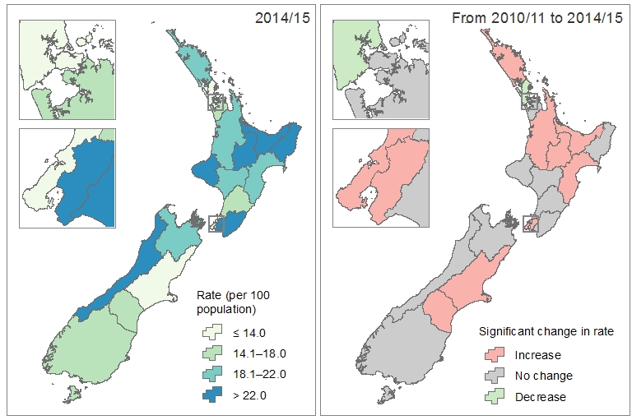

Note: Rates presented are standardised to the WHO World Population.

Rates of ED use among non-Māori[1] were lower than rates among Māori in all DHB regions in 2014/15. Rates among non-Māori were also less variable, ranging from 5.4 per 100 population in Canterbury DHB region to 11.2 per 100 population in the West Coast DHB region. Rates of non-Māori ED use for 2014/15 were significantly higher than for 2010/11 in nine DHB regions. The largest increases were by approximately 14% in Lakes, Bay of Plenty and Capital & Coast DHB regions. Conversely, rates of ED use were significantly lower in 2014/15 compared with 2010/11 in five DHB regions, particularly in the Wairarapa DHB region where rates of ED use among non-Māori fell by 15% (Figure 14).

Figure 14: Rate of non-Māori who were patients at an emergency department at least once during the year, by DHB of residence, 2010/11 and 2014/15

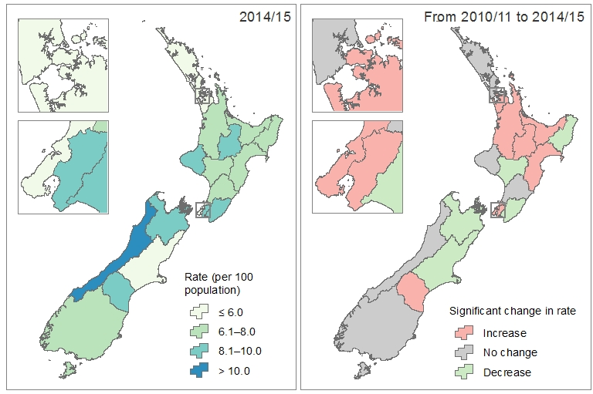

Note: Rates presented are standardised to the WHO World Population.

In 2014/15, children of Pacific ethnicity had the highest age-specific rate of ED use (21.9 per 100 population), followed by children of Māori (17.2 per 100 population), European or Other (16.1 per 100 population) and Asian (14.6 per 100 population) ethnicities. Rates among Māori and Pacific adults were the same at 18.1 per 100 population, while the rate for adults of Asian and of European or Other ethnicities were lower (Figure 15).

Between 2010/11 and 2014/15, rates of ED use were consistently higher for children than for adults in all ethnic groups, except the Māori ethnic group (Figure 15). This disparity was most notable among the Asian ethnic group, where the rates of ED use for children was 1.8–1.9 times the rate for adults each year.

Figure 15: Rate of children and adults who were patients at an emergency department at least once during the year, by ethnic group, 2010/11 and 2014/15

Figure 15: Rate of children and adults who were patients at an emergency department at least once during the year, by ethnic group, 2010/11 and 2014/15

Note: Rates presented are specific to the age group and not standardised.

## Deprivation

Deprivation is calculated using a range of variables at each Census, such as income, home ownership, support, employment, qualifications, living space, communication and transport.

In this report, deprivation quintiles are based on the characteristics of the neighbourhood in which the patient resides. They range from 1 (least deprived) to 5 (most deprived), and are based on the NZDep2013 index of socioeconomic deprivation. Approximately equal numbers of the total New Zealand population reside in areas associated with each of the five deprivation quintiles. See the ‘Deprivation’ section in Additional notes for more information.

ED patients were unevenly distributed across the five deprivation quintiles in 2014/15, even though the overall New Zealand population is equally distributed across the all deprivation quintiles. There were considerably more ED patients who resided in the most deprived neighbourhoods than the least deprived neighbourhoods (Figure 16). The proportion of ED patients in the most deprived neighbourhoods (31% in quintile 5) was more than double the proportion of those in the least deprived neighbourhoods (12% in quintile 1).

Figure 16: Distribution of people who were patients at an emergency department at least once during the year, by neighbourhood deprivation quintile, 2014/15



Note: The number on each bar is the number of people. The denominator used to calculate percentages excludes those with unknown neighbourhood deprivation (42,189 patients, 6.1%).

The age-standardised rate of ED use in 2014/15 increased with each level of neighbourhood deprivation. The lowest rate of ED use was among people residing in the least deprived neighbourhoods (8.7 per 100 population) and the highest rate was among people residing in the most deprived neighbourhoods (21.7 per 100 population). This trend was sustained over the five-year period ending 2014/15 (Figure 17).

Figure 17: Rate of people who were patients at an emergency department at least once during the year, by neighbourhood deprivation quintile, 2010/11–2014/15



Note: Rates presented are standardised to the WHO World Population.

In 2014/15, rates of ED use among people in the most deprived neighbourhoods (quintile 5) varied considerably across New Zealand, ranging from 10.6 per 100 population in the Capital & Coast DHB region to 35.5 per 100 population in the Lakes DHB region. Eight DHB regions had a significantly higher rate of ED use among people in the most deprived neighbourhoods in 2014/15 than in 2010/11. These DHB regions were primarily in the middle area of the North Island. Three DHB regions showed a significant decrease in the rate of ED use among people in the most deprived neighbourhoods: Whanganui, Wairarapa and Canterbury (Figure 18).

Figure 18: Rate of people residing in the most deprived neighbourhoods (quintile 5) who were patients at an emergency department at least once during the year, by DHB of residence, 2010/11 and 2014/15

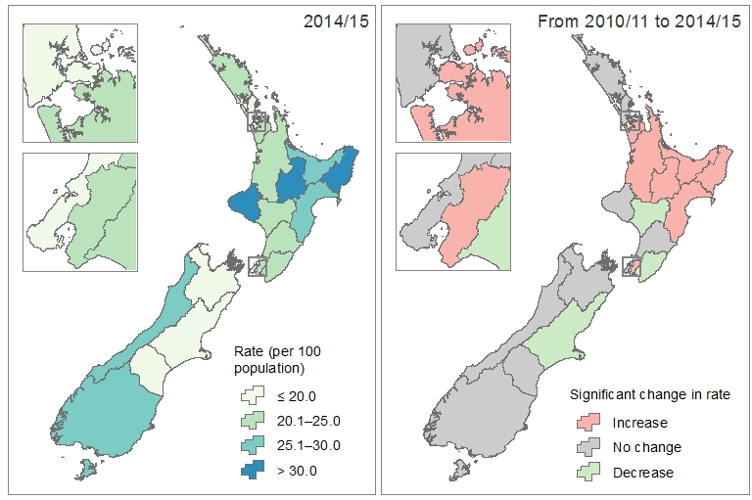

Note: Rates presented are standardised to the WHO World Population.

At every level of neighbourhood deprivation, the age-specific rate of ED use among children was approximately 1.1 times the rate of ED use among adults. As with overall rates of ED use, rates for both children and adults increased with each level of neighbourhood deprivation, the lowest being for people in least deprived neighbourhoods and the highest being for people in the most deprived neighbourhoods (Figure 19).

Figure 19: Rate of children and adults who were patients at an emergency department at least once during the year, by neighbourhood deprivation quintile, 2010/11 and 2014/15

Figure 19: Rate of children and adults who were patients at an emergency department at least once during the year, by neighbourhood deprivation quintile, 2010/11 and 2014/15

Note: Rates presented are specific to the age group and not standardised.

Age-standardised rates of ED increased gradually with each level of neighbourhood deprivation in all ethnic groups, except the Asian ethnic group (Figure 20). Rates of ED use for the Asian ethnic group were generally low across deprivation quintiles 1–4 (under 4.5 per 100 population), and noticeably higher for quintile 5, the most deprived neighbourhoods (6.6 per 100 population in 2014/15).

Figure 20: Rate of people in each ethnic group who were patients at an emergency department at least once during the year, by neighbourhood deprivation quintile, 2010/11 and 2014/15

Figure 20: Rate of people in each ethnic group who were patients at an emergency department at least once during the year, by neighbourhood deprivation quintile, 2010/11 and 2014/15

Note: Rates presented are standardised to the WHO World Standard Population.

## Frequency of emergency department use

**Single use patients** are people who were patients at an ED once during the year.

**Repeat use patients** are people who were patients at an ED two or more times during the year.

Over 200,000 people were patients at an ED two or more times during 2014/15, including 1579 people (0.2%) who used an ED more than 10 times over the 12-month period. The vast majority of ED patients only presented once during the year (Figure 21).

Figure 21: Distribution of people who were patients at an emergency department at least once during the year, by the number of visits, 2014/15



Note: The number on each bar is the number of people.

One in every 10 people in New Zealand were patients at an ED once during 2014/15 (age-standardised rate of 10.7 per 100 population), while one in every 25 people in New Zealand were patients at an ED two or more times during the year (4.2 per 100 population). From 2010/11 to 2014/15 the rate of ED use increased by 2.7% among single use patients, and by 5.2% among repeat use patients (Figure 22).

Figure 22: Rate of single use and repeat use patients at an emergency department, 2010/11–2014/15



Note: Rates presented are standardised to the WHO World Standard Population.

In 2014/15, rates of single and repeated use of ED by DHB region showed a similar pattern (Figure 23 and Figure 24). The less populated DHB regions had higher rates of both single use and repeated use of ED: Lakes, Tairāwhiti, Hawke’s Bay, Wairarapa and West Coast. Conversely, the more populated DHB regions had lower rates of both single use and repeated use of ED: Waitemata, Auckland, Counties Manukau, Capital & Coast and Canterbury.

Figure 23: Rate of people who were patients at an emergency department once during the year (single use), by DHB of residence, 2010/11 and 2014/15

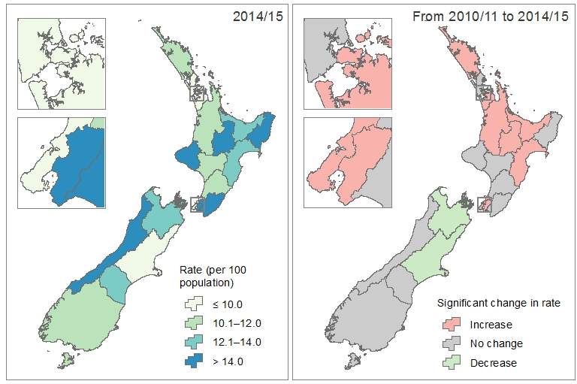

Note: Rates presented are standardised to the WHO World Population.

Figure 24: Rate of people who were patients at an emergency department more than once during the year (repeat use), by DHB of residence, 2010/11 and 2014/15

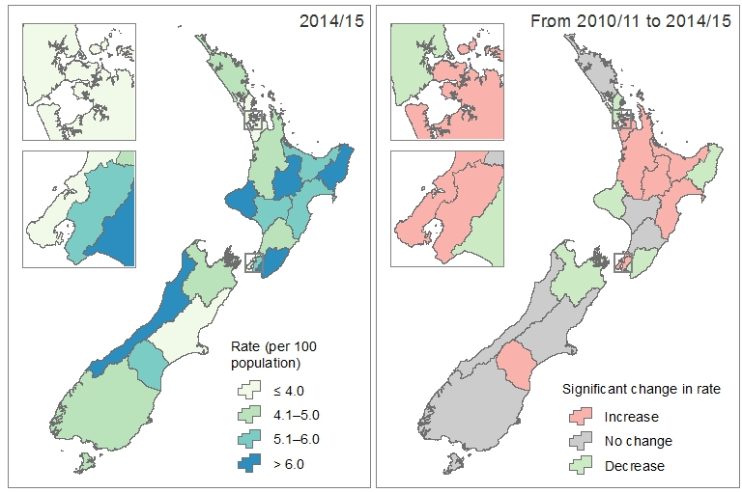

Note: Rates presented are standardised to the WHO World Population.

The rate of children who were patients at an ED once during 2014/15 was 12.3 per 100 population. This was higher than the corresponding rate among adults (10.3 per 100 population). Rates of repeated use of ED were similar among children and adults, at 4.1–4.6 per 100 population annually (Figure 25).

Figure 25: Rate of children and adults who had single and repeated use of emergency department services, 2010/11 and 2014/15

Figure 25: Rate of children and adults who had single and repeated use of emergency department services, 2010/11 and 2014/15

Note: Rates presented are specific to the age group and not standardised.

Rates of ED use by ethnic group showed similar patterns among both single use and repeated use patients, with higher rates among Māori and Pacific people and the lowest rate among Asian people (Figure 26). Ethnic disparities in the rate of ED use were more evident among repeat use patients. On average:

* 1 in every 8 Māori and Pacific people were patients at an ED once during the year, compared with 1 in every 15 Asian people.
* 1 in every 18 Māori and Pacific people were patients at an ED more than once during the year, compared with 1 in every 47 Asian people.

Figure 26: Rate of people who had single and repeated use of emergency department services, by ethnic group, 2010/11 and 2014/15

Figure 26: Rate of people who had single and repeated use of emergency department services, by ethnic group, 2010/11 and 2014/15

Note: Rates presented are standardised to the WHO World Population.

Rates of ED use by neighbourhood deprivation quintile showed similar patterns among both single use and repeated use patients. The highest rates were for people residing in the most deprived neighbourhoods and the lowest rates were for those residing in the least deprived neighbourhoods (Figure 27). Disparities between neighbourhood deprivation in the rate of ED use was more evident among repeat use patients. On average:

* 1 in every 7 people residing in the most deprived neighbourhoods (quintile 5) were patients at an ED once during the year, compared with 1 in every 15 people residing in the least deprived neighbourhoods.
* 1 in every 15 people residing in the most deprived neighbourhoods (quintile 5) were patients at an ED more than once during the year, compared with 1 in every 50 people residing in the least deprived neighbourhoods.

Figure 27: Rate of people who had single and repeated use of emergency department services, by neighbourhood deprivation quintile, 2010/11 and 2014/15

Figure 27: Rate of people who had single and repeated use of emergency department services, by neighbourhood deprivation quintile, 2010/11 and 2014/15

Note: Rates presented are standardised to the WHO World Population.

# Events

This chapter presents descriptive statistics about ED events in New Zealand. Numbers and proportions are presented by location, timing, seasonality, urgency at presentation, service provider, length of stay and outcome of reported ED events.

## Overview

Over a million ED events were reported in New Zealand during 2014/15. These events were attended by 693,681 unique patients, resulting in an average of 1.5 ED events per patient.

The number of ED events has steadily increased over the five years. The number of events in 2014/15 (1,062,047) was 3.6% higher than 2013/14 (1,025,585) and 9.5% higher than 2010/11 (969,849) (Figure 28).

Figure 28: Number of emergency department events, 2010/11–2014/15



Note: The number on each bar is the number of ED events.

## Location

ED facilities in the more populated areas of New Zealand had considerably more events in 2014/15 than facilities in the less populated areas (Figure 29).

ED facilities in the five most populated DHB regions combined (Waitemata, Auckland, Counties Manukau, Waikato and Canterbury DHB regions) accounted for 46% of ED events in 2014/15. Middlemore Hospital (Counties Manukau DHB region) had the most ED events in 2014/15 with over 100,000 events.

ED facilities in the five least populated DHB regions combined (Tairāwhiti, Whanganui, Wairarapa, West Coast and South Canterbury DHB regions) accounted for less than 8% of ED events in 2014/15.

Figure 29: Distribution of emergency department events, by DHB region of facility, 2014/15



Note: The number on each bar is the number of events. The region of facility is derived from location of facility. Numbers presented may include patients who ordinarily reside in a different DHB region.

## Day of the week

In 2014/15, ED events were more common on Sundays and Mondays, and less common on Wednesdays and Thursdays. Over 320,000 ED events occurred on Sundays and Mondays combined, accounting for over 30% of all events. In comparison, there were 31,000 fewer ED events on Wednesdays and Thursdays combined during the year (Figure 30).

Figure 30: Distribution of emergency department events, by day of the week, 2014/15



Note: The number on each bar is the number of ED events.

One in three ED events during 2014/15 occurred during a weekend (from Friday 5 pm to Monday 8 am). The proportion of weekend ED events ranged widely between facilities, going from a low of 28.5% at the Bay of Islands Hospital (Northland DHB region) to a high of 59.3% at Reefton Health Services (West Coast DHB region). The range was much smaller when comparing weekend ED events by DHB regions of facility, which ranged from 33.2% for EDs in the Whanganui DHB region to 37.9% for EDs in the Canterbury DHB region (Figure 31).

The proportion of weekend ED events has remained fairly steady over the previous five years, ranging from 35.7% to 36.4% of all events each year. Despite the variability at a facility level, the proportion of weekend ED events between DHB regions (based on location of facility) were fairly steady between 2010/11 and 2014/15, ranging from 33% to 38% (Figure 31).

Figure 31: Proportion of emergency department events that occur during weekends by DHB region of facility, 2010/11 and 2014/15



Note: DHB region of facility is derived from location of facility. Numbers presented may include patients who ordinarily reside in a different DHB region.

## Seasonality

In 2014/15, the month in which the most ED events occurred was August 2014 with about 94,000 events, followed by January 2015 with over 91,000 events. February and April 2015 had the lowest number of events with fewer than 84,000 events each (Figure 32). Most facilities had higher numbers of ED events during winter (July and August 2014) and summer (December 2014 and January 2015) months.

Figure 32: Distribution of emergency department events, by month of event, 2014/15



Note: The number on each bar is the number of events.

On average, there were over 3000 ED events per day during August 2014, the month with the most ED events during 2014/15. The month with the lowest number of events per day was April 2015 with almost 2800 events per day (Figure 33).

From 2010/11 to 2014/15, summer and winter months generally had a higher number of events per day, compared with spring and autumn months. The highest number of events per day was during August for both 2010/11 and 2014/15 (Figure 33).

Figure 33: Number of emergency department events per day, by month of event, 2010/11 and 2014/15



Note: Events per day was calculated by dividing the total number of events during the month by the number of days in the month.

## Urgency at presentation

All patients who present at ED are assessed by a triage nurse (or doctor). The triage nurse assesses the clinical urgency of the patient and assigns the patient a triage acuity level, which is a proxy measure of how long an individual patient can safely wait for a medical screening examination and treatment. The definition of each triage level is provided below.

**Triage level 1**: immediately life-threatening.

**Triage level 2**: imminently life-threatening, or important time-critical.

**Triage level 3**: potentially life-threatening, potential adverse outcomes from delay of more than 30 minutes, or severe discomfort or distress.

**Triage level 4**: potentially serious, or potential adverse outcomes from delay of more than 60 minutes, or significant complexity or severity, or discomfort or distress.

**Triage level 5**: less urgent, or dealing with administrative issues only.

Almost 54% of ED events in 2014/15 were for patients presenting to ED with a condition that was immediately to potentially life-threatening (triage levels 1–3). A further 39.6% were determined to be potentially serious and 6.7% of ED events were determined to be less urgent (Figure 34).

Figure 34: Distribution of emergency department events, by triage level, 2014/15



Note: The number on each bar is the number of events. The denominator used to calculate the percentage excludes those with unknown triage level (1118 events, 0.1%).

From 2010/11 to 2014/15, the proportion of less urgent (level 5) ED events fell from 9.9% to 6.7%. Conversely, the proportion of life-threatening (levels 1–3) events increased over the same time period (Figure 35).

The proportion of immediately to potentially life-threatening events (triage levels 1–3) in 2014/15 ranged broadly across the different regions, from 35% at facilities in the Tairāwhiti and South Canterbury DHB regions to 66% at facilities in the MidCentral DHB region (Figure 36).

Most DHB regions had a higher proportion of immediately to potentially life-threatening events in 2014/15 than in 2010/11, notably for facilities in the Taranaki DHB region which increased from 42.1% to 53.3% of ED events. Facilities in the Auckland, Bay of Plenty, Canterbury and South Canterbury DHB regions had a slightly lower proportion of immediately to potentially life-threatening events in 2014/15 than in 2010/11 (Figure 36).

Figure 35: Distribution of emergency department events, by triage level, 2010/11–2014/15



Note: Level 1 represents immediately life-threatening events, Level 2 represents imminently life-threatening events, Level 3 represents potentially life-threatening events, Level 4 represents potentially serious events and Level 5 represents less urgent events.

Figure 36: Proportion of immediately or potentially life-threatening emergency department events, by DHB region of facility, 2010/11 and 2014/15



Note: Immediately or potentially life-threatening events are those assigned as triage levels 1–3. The DHB region of facility is derived from location of facility. Numbers presented may include patients who ordinarily reside in a different DHB region.

## Service provider

Most EDs in New Zealand are located within public hospitals (ie, owned and run by a DHB). Several EDs located in the Southern DHB region are located within a private facility: Clutha Health First, Dunstan Hospital, Gore Hospital and Oamaru Hospital. Gore Hospital and Oamaru Hospital ED data for 2014/15 was not available for reporting.

In New Zealand, the vast majority of ED services are provided by DHBs. In 2014/15, Counties Manukau DHB and Waikato DHB had the most ED events, with over 100,000 ED events each. Non-DHB agencies provided ED services for just over 1000 ED events in 2014/15 (447 by Clutha Health First and 671 by Dunstan Charitable Trust) (Figure 37).

The distribution of ED events by service provider was fairly similar from 2010/11 to 2014/15:

* the DHBs with the highest number of ED events were Waitemata DHB, Auckland DHB, Counties Manukau DHB and Waikato DHB (9%–10% of all events each)
* the DHBs with the lowest number of ED events were Tairāwhiti DHB, Whanganui DHB, West Coast DHB and South Canterbury DHB (1%–2% of all events each)
* Non-DHB agencies accounted for less than 1% of all ED events each year.

Figure 37: Distribution of emergency department events, by service provider, 2010/11 and 2014/15



Note: The numbers next to each bar are the number of ED events: 2010/11 | 2014/15.

## Length of stay

ED length of stay is an important measure of the quality of acute (emergency and urgent) care in our public hospitals, because:

* EDs are designed to provide urgent (acute) health care; the timeliness of treatment delivery (and any time spent waiting) is by definition important for patients
* long stays in emergency departments are linked to overcrowding of the ED
* the medical and nursing literature has linked long stays and overcrowding in EDs to negative clinical outcomes for patients such as increased mortality and longer inpatient lengths of stay
* over-crowding can lead to compromised standards of privacy and dignity for patients, for instance, through the use of corridor trolleys to house patients.

Length of stay is presented as the number of hours from when the patient presents to the ED (either the triage nurse or clerical staff) to when the patient is admitted, discharged or transferred from the ED. A patient’s length of stay may include a period of observation in the ED observation unit/ED short stay unit if the patient does not need to be admitted, but requires a short period of observation before being discharged.

The ED length of stay information presented in this report will differ from the ‘Shorter stays in EDs’ health target results as the data sources, mix of facilities and frequency of reporting are different.

Over 92% of all ED events in 2014/15 were completed within six hours of the patient presenting to ED: 51.3% were completed under three hours and 41.1% were completed within three and less than six hours (Figure 38).

Figure 38: Distribution of emergency department events, by length of stay, 2014/15



Note: The number on each bar is the number of ED events. The denominator used to calculate the percentage excludes those with an unknown length of stay (1118 events, 0.1%).

The proportion of ED events by length of stay showed small fluctuations over the five-year period, 2010/11–2014/15 (Figure 39). Some notable trends were:

* the proportion of ED events that took between three to six hours to complete increased from 35.8% in 2010/11 to 41.1% in 2014/15
* a lower proportion of ED events requiring six or more hours to complete, falling from 12.3% in 2010/11 to 7.6% in 2014/15.

Figure 39: Distribution of emergency department events, by length of stay,   
2010/11–2014/15



Note: The ‘9+ hours’ category includes events in the ‘9–<12 hours’ and ‘12+ hours’ categories.

Length of stay varied by service provider in 2014/15, particularly when comparing the proportion of events requiring less than six hours to complete. The majority of service providers had a higher proportion of ED events requiring less than six hours to complete in 2014/15 than in 2010/11 (Figure 40).

Figure 40: Proportion of emergency department events requiring less than six hours to complete, by service provider, 2010/11 and 2014/15



Note: Length of stay was unknown for events where non-DHB agencies were the service providers. The criteria used to identify events requiring less than six hours to complete in this figure is different from the criteria used for the ‘Shorter stays in EDs’ health target.

## Outcomes

In this report, the outcome of an event is derived from the event end type code. The codes have been grouped into the following categories: routine discharge, admitted to hospital, self-discharged and died. Admission to hospital includes both admission to a different department or specialist unit within the same facility or a different facility. See the ‘Outcomes’ section in Additional notes for more information.

The majority of ED events in 2014/15 ended as a routine discharge from ED (64.8%). One in three ED events ended with the patient being admitted to hospital. A very small proportion of events ended with the patient discharging themselves from ED (1.7%). A total of 594 people (<0.1%) died while in ED in 2014/15 (Figure 41).

Figure 41: Distribution of emergency department events, by outcome, 2014/15



Note: The number on each bar is the number of ED events. The denominator used to calculate the percentage excludes those unknown outcome of event (1118 events, 0.1%).

From 2010/11 to 2014/15, the distribution of ED events by outcome showed little variation from year to year, except:

* a slight increase in the proportion of events ending in routine discharge, going from 63.2% to 64.8% of ED events
* a slight decrease in events ending with the patient being admitted to hospital, falling from 35.1% to 33.4% of ED events (Figure 42).

Figure 42: Distribution of emergency department events, by outcome, 2010/11–2014/15



Note: The proportion of patients who died in ED is not presented due to very low proportions each year (<0.1%).

In 2014/15, events ending in routine discharge and self-discharge were more common among patients who presented to ED during the weekend than during a weekday (Figure 43). Conversely, there was a larger proportion of events where the patient was admitted to hospital during a weekday than the weekend. There was little difference in the proportion of events during a weekday or weekend that ended with the patient dying. The distribution of events by outcome was fairly stable from 2010/11 to 2014/15 for events that occurred during weekdays and weekends (Figure 43).

Figure 43: Distribution of weekday and weekend events, by outcome, 2010/11 and 2014/15

Figure 43: Distribution of weekday and weekend events, by outcome, 2010/11 and 2014/15

Note: The proportion of patients who died in ED is not presented due to very low proportions each year (<0.1%).

Of the events in 2014/15 where the patient presented to ED with an immediately to potentially life-threatening condition (triage levels 1–3):

* 52.1% ended in routine discharge
* 46.6% ended with admission to hospital
* 1.2% ended with the patient discharging themselves
* 0.1% (583 events) ended with the patient dying while in the ED (Figure 44).

In comparison, a much higher proportion of potentially serious or less urgent events (triage levels 4–5) in 2014/15 ended in routine discharge (79.6%) and self-discharge (2.2%), and a smaller proportion ended in admission to hospital (2.2%). Very few events ended in death (11 deaths).

Figure 44: Distribution of immediately or potentially life-threatening events (triage levels 1–3) and of potentially serious or less urgent events (triage levels 4–5), by outcome, 2010/11 and 2014/15

Figure 44: Distribution of immediately or potentially life-threatening events (triage levels 1–3) and of potentially serious or less urgent events (triage levels 4–5), by outcome, 2010/11 and 2014/15

Note: The proportion of patients who died in ED is not presented due to very low proportions each year (<0.1%).

# Additional notes

## Inclusion criteria

A core data set of ED events was extracted from NNPAC. These events:

* had a service date between 1 July 2010 and 30 June 2015
* had one of the codes specified in Table 1 as the purchase unit code
* were completed (ie, excludes events where the patient did not wait to complete)
* do not include follow-up appointments.

From this core data set of events, the first event during the financial year for the patient was identified and all demographic detail presented in this report is based on details recorded for that first event.

Table 1: Purchase unit codes used for identifying emergency department events

|  |  |
| --- | --- |
| **Purchase unit code** | **Description** |
| ED02001 | Emergency Department – Level 2 |
| ED02001A | Emergency Department – Level 2 Admitted |
| ED03001 | Emergency Department – Level 3 |
| ED03001A | Emergency Department – Level 3 Admitted |
| ED04001 | Emergency Department – Level 4 |
| ED04001A | Emergency Department – Level 4 Admitted |
| ED05001 | Emergency Department – Level 5 |
| ED05001A | Emergency Department – Level 5 Admitted |
| ED06001 | Emergency Department – Level 6 |
| ED06001A | Emergency Department – Level 6 Admitted |

## Ethnicity

Ethnicity is the ethnic group or groups that people may identify with or feel they belong to. Ethnicity is self-perceived; a person may identify with more than one ethnic group. The standard question for collecting ethnicity data in the health and disability sector mirrors the Statistics New Zealand 2001 Census ethnicity question (Ministry of Health 2004).

This report uses *prioritised ethnicity*, whereby each person represented in the data is allocated to a single ethnic group using the priority system Māori > Pacific > Asian > Other ethnicities > European. The aim of prioritisation is to ensure that where it is necessary to assign people to a single ethnic group, ethnic groups that are small or important in terms of policy are not swamped by the European ethnic group. This is also a more robust method of dealing with the low rate of multiple ethnicities in health sector data. Further information on ethnicity data protocols for the health and disability sector is available from the Ministry of Health ethnicity protocols (Ministry of Health 2004).

Individuals recorded as being of Other ethnicities are primarily Middle Eastern, Latin American or African. The number of individuals in the Other ethnic group is small, and therefore the ‘Other’ group is often included with the European group for analysis.

## Deprivation

The New Zealand Deprivation Index (NZDep) is a measure of socioeconomic status calculated for small geographic areas. The calculation uses nine variables from each Census of Population and Dwellings such as income, home ownership, support, employment, qualifications, living space, communication and transport. It then provides a summary deprivation score between 1 and 10 for each meshblock (small geographical unit containing a median of 90 people). At a national level, approximately equal numbers of the population reside in neighbourhoods associated with each of the 10 deprivation score areas (Salmond et al 2002).

The Ministry of Health maps the meshblocks to domicile codes, which are built up to the relevant geographic scale using weighted average census usually resident population counts. Further information about socioeconomic deprivation in New Zealand is available on the [University of Otago website](http://www.otago.ac.nz/wellington/departments/publichealth/research/hirp/otago020194.html#atlas).

In this report, deprivation quintiles are based on the characteristics of the neighbourhood in which the patient resides. They range from 1 (least deprived) to 5 (most deprived), and are based on the NZDep2013 index of socioeconomic deprivation. A neighbourhood deprivation quintile is reported as unknown if the domicile recorded was based on a 2001 or 2006 domicile code and could not be mapped to a 2013 domicile code.

## Rates

Rates of ED use are calculated to show the number of people in a demographic group who were patients at least once during the year, as a proportion of the population for that demographic group. For example, a rate of ED use of 15.4 per 100 population for males means that for every 100 males in the population, about 15 were patients at an ED at least once during the year.

### Different types of rates

Two types of rates are presented in this report: age-specific rates and age-standardised rates. Rates presented in this report are primarily age-standardised rates. Age-standardised rates account for differences in population structure, and can be used to compare groups with different age structures (eg, males and females, or Māori and non-Māori) and data from different years.

Age-specific rates are only presented when the rate is calculated for a specific age group, such as children aged under 15 years or adults in the 40–44 years age group. Age-specific rate is the rate at which a particular event (eg, attendance at an emergency department) occurs in each age group of a population as some unit of the population-at-risk.

Details about calculating age-specific and age-standardised rates can be found in *Standardising Rates of Disease* (Borman 1998).

### Population data used

The following data sets were used as the denominators to calculate rates in this report:

* estimated resident population by age and sex as at 30 June, 2011–2015
* estimated resident population by prioritised ethnicity, age, sex and DHB as at 30 June,  
  2011–2013
* population projections derived from the estimated resident population as at 30 June, by prioritised ethnicity, age, sex and DHB, 2014–2015
* estimated resident population by deprivation quintile, age, sex and DHB as at 30 June 2013.

All data sets were supplied as customised extracts from Statistics New Zealand. Further information about the methods used to prepare estimates and projections, as well as their limitations, is available on the Statistics New Zealand website ([www.stats.govt.nz](http://www.stats.govt.nz)).

The standard population used in this report is the WHO World Population (Table 2) (Ahmad et al 2001).

### Choosing the right denominator

When choosing a denominator for calculating rates, we used:

* the estimated resident population count wherever possible as it is considered the best available population
* the population count as at the end of the financial year (eg, rate for 2014/15 is calculated using the population count as at 30 June 2015).

Population counts by neighbourhood deprivation quintile were derived by:

* generating the proportion of people in each deprivation quintile for the demographic group, based on the estimated resident population as at 30 June 2013 (as the data required is only available on census years)
* applying the best available population count for the selected demographic group to the proportion generated.

Table 2: WHO World Population

|  |  |
| --- | --- |
| **Age group (years)** | **Population** |
| 0–4 | 8,860 |
| 5–9 | 8,690 |
| 10–14 | 8,600 |
| 15–19 | 8,470 |
| 20–24 | 8,220 |
| 25–29 | 7,930 |
| 30–34 | 7,610 |
| 35–39 | 7,150 |
| 40–44 | 6,590 |
| 45–49 | 6,040 |
| 50–54 | 5,370 |
| 55–59 | 4,550 |
| 60–64 | 3,720 |
| 65–69 | 2,960 |
| 70–74 | 2,210 |
| 75–79 | 1,520 |
| 80–84 | 910 |
| 85+ | 635 |
| **Total** | **100,035** |

Source: Ahmad et al 2001.

## Maps

Geographical information for ED patients (not events) is usually presented as two maps side by side:

* 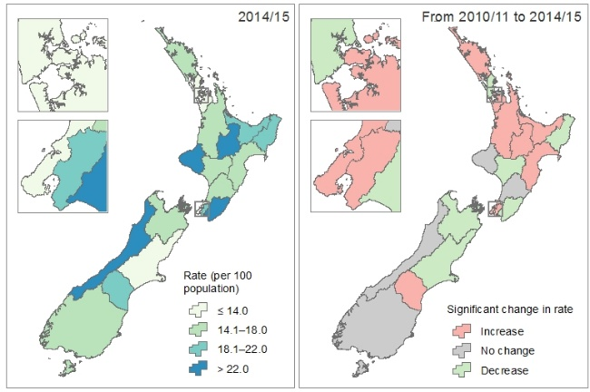The first map (left) shows the 2014/15 rate of ED use for the stated demographic group. The darkest colour represents the highest rate and the lightest colour the lowest rate.
* The second map (right) shows whether there has been a statistically significant change in the rate of ED use between 2010/11 and 2014/15. Regions shaded red have had a significant increase in the rate of ED use, regions shaded green have had a significant decrease in the rate of ED use, and the rate was not significantly different between 2010/11 and 2014/15 for regions shaded in grey.

See the diagram below for location of DHBs in New Zealand and help with reading maps in this report.

Description of key components in a map and the location of DHBs in New Zealand.

## Facilities and service providers

All facilities providing emergency services in New Zealand are public hospitals (ie, owned and run by a DHB), except a few facilities located in the Southern DHB region (Table 3).

Table 3: List of facilities with an emergency department in New Zealand

| **Facility** | **DHB region** | **Service provider** | **Events in 2014/15** |
| --- | --- | --- | --- |
| Ashburton Hospital | Canterbury | Canterbury DHB | 5,224 |
| Auckland City Hospital | Auckland | Auckland DHB | 60,065 |
| Bay of Islands Hospital | Northland | Northland DHB | 4526 |
| Buller Health | West Coast | West Coast DHB | 2,558 |
| Christchurch Hospital | Canterbury | Canterbury DHB | 88,459 |
| Clutha Health First 1 | Southern | Clutha Health First | 447 |
| Dunedin Hospital | Southern | Southern DHB | 39,411 |
| Dunstan Hospital 1 | Southern | Dunstan Charitable Trust | 671 |
| Gisborne Hospital | Tairāwhiti | Tairāwhiti DHB | 16,258 |
| Gore Hospital 1 2 | Southern | Gore Health Limited | – |
| Greymouth Base Hospital | West Coast | West Coast DHB | 9,146 |
| Hawera Hospital | Taranaki | Taranaki DHB | 15,357 |
| Hawke’s Bay Hospital | Hawke’s Bay | Hawke’s Bay DHB | 41,334 |
| Hutt Hospital | Hutt Valley | Hutt Valley DHB | 44,170 |
| Kaitaia Hospital | Northland | Northland DHB | 5,932 |
| Lakes District Hospital | Southern | Southern DHB | 6,591 |
| Middlemore Hospital | Counties Manukau | Counties Manukau DHB | 103,399 |
| Nelson hospital | Nelson Marlborough | Nelson Marlborough DHB | 16,331 |
| North Shore Hospital | Waitemata | Waitemata DHB | 48,284 |
| Oamaru Hospital 1 3 | Southern | Oamaru Charitable Trust | – |
| Opotiki Community Care Centre | Bay of Plenty | Bay of Plenty DHB | 1,688 |
| Palmerston North Hospital | MidCentral | MidCentral DHB | 40,014 |
| Reefton Health Services | West Coast | West Coast DHB | 226 |
| Rotorua Hospital | Lakes | Lakes DHB | 34,078 |
| Southland Hospital | Southern | Southern DHB | 29,058 |
| Starship Hospital | Auckland | Auckland DHB | 32,775 |
| Taranaki Base Hospital | Taranaki | Taranaki DHB | 30,066 |
| Taumarunui Community Hospital | Waikato | Waikato DHB | 5,709 |
| Taupo Hospital | Lakes | Lakes DHB | 11,839 |
| Tauranga Hospital | Bay of Plenty | Bay of Plenty DHB | 44,890 |
| Te Kuiti Community Hospital | Waikato | Waikato DHB | 2,463 |
| Thames Hospital | Waikato | Waikato DHB | 15,103 |
| Timaru Hospital | South Canterbury | South Canterbury DHB | 17,488 |
| Tokoroa Hospital | Waikato | Waikato DHB | 10,002 |
| Waikato Hospital | Waikato | Waikato DHB | 72,070 |
| Wairarapa Hospital | Wairarapa | Wairarapa DHB | 15,613 |
| Wairau Hospital | Nelson Marlborough | Nelson Marlborough DHB | 19,961 |
| Wairoa Hospital & Health Centre | Hawke’s Bay | Hawke’s Bay DHB | 3,313 |
| Waitakere Hospital | Waitemata | Waitemata DHB | 43,775 |
| Wellington Hospital | Capital & Coast | Capital & Coast DHB | 52,850 |
| Whakatane Hospital | Bay of Plenty | Bay of Plenty DHB | 18,650 |
| Whanganui Hospital | Whanganui | Whanganui DHB | 18,673 |
| Whangarei Hospital | Northland | Northland DHB | 33,580 |

1 The service provider for these hospitals are non-DHB agencies.

2 Southern DHB was the service provider 2010/11 and Gore Health Limited was the service provider for  
2010/11–2013/14. Data for 2014/15 was not available for reporting.

3 Data for 2011/12–2014/15 was not available for reporting.

## Outcomes

The outcome categories presented in this report are derived using the event end type codes in the Collection. See Table 4 for list of codes associated with each outcome category.

Table 4: Outcome categories and relevant event end type codes

|  |  |  |
| --- | --- | --- |
| **Outcome** | **Code** | **Description** |
| Routine discharge | ER | Routine discharge from an emergency department acute facility |
| Admitted to hospital | DW | Discharge to other service within same facility |
| EA | Discharge from ED acute to specialist facility (neonates and burns only) |
| ET | Discharge from ED acute facility to another healthcare facility |
| Self-discharged | EI | Self-discharge from an ED acute facility with indemnity signed |
| ES | Self-discharge from an ED facility without indemnity |
| Died | ED | Died while still in emergency department acute facility |

# References

Ahmad O, Boschi-Pinto C, Lopez AD, et al. 2001. *Age Standardization of Rates: A new WHO standard*. GPE Discussion Paper Series No. 31. Geneva: World Health Organization. URL: [www.who.int/healthinfo/paper31.pdf](http://www.who.int/healthinfo/paper31.pdf) (accessed 7 April 2016).

Borman B. 1998. *Standardising rates of disease*. Wellington: Ministry of Health.

Keyfitz N. 1966. Sampling variance of standardized mortality rates. *Human Biology* 38: 309–17.

Salmond C, Crampton P. 2002. *NZDep2001 Index of Deprivation User’s Manual*. Wellington: Wellington School of Medicine and Health Sciences.

1. Pacific, Asian, and European or Other ethnic groups combined.