Demographic Report of Disabled People Accessing Manatū Hauora (the Ministry of Health) Disability Support Services
2020 update

Citation: Ministry of Health. 2022. Demographic Report of Disabled People Accessing Manatū Hauora (the Ministry of Health) Disability Support Services. Wellington: Ministry of Health.
Published in November 2022 by the Ministry of Health
PO Box 5013, Wellington 6140, New Zealand
ISBN 978-1-99-110094-8 (online)
HP 8645
This document is available at health.govt.nz
This work is licensed under the Creative Commons Attribution 4.0 International licence. In essence, you are free to: share ie, copy and redistribute the material in any medium or format; adapt ie, remix, transform and build upon the material. You must give appropriate credit, provide a link to the licence and indicate if changes were made.

Contents
Executive summary xiv
Introduction xiv
Disability support services overview xiv
Disability support services allocations xiv
Enabling Good Lives xviii
Environmental support services xviii
Assessment, treatment and rehabilitation xix
Trends xix
Introduction 1
Purpose 1
Audience 1
Scope 1
Terminology 2
Methodology 4
Data sources 4
Time periods 4
Count 4
Ethnicity 5
Location of regions 5
Disability support services overview 6
Disability support services allocations 8
People allocated ongoing disability support services through Needs Assessment and Service Coordination organisations compared with the New Zealand population 10
Overall disability support services demographics 13
Disability support services demographics by service 22
Disability support services demographics by principal disability 102
Disability support services demographics by domicile region 113
Enabling Good Lives 144
Age, sex, and ethnicity 144
Principal disability 146
Location 147
Environmental support services 149
Equipment and modifications services 149
Hearing services 153
Vision services 156
Assessment, treatment and rehabilitation 160
Age, sex and ethnicity 160
Location 162
Appendix 1: Disability types and conditions 165
Appendix 2: Abbreviations 169

List of Tables
Table 1: Data sources 4
Table 2: Number of people who accessed disability support services, by service type, 2019/20 financial year 6
Table 3: Number of people allocated disability support services, by Needs Assessment and Service Coordination organisation, 2019/20 financial year 8
Table 4: Ethnicity of disability support services recipients compared with New Zealand population, 2019/20 financial year* 12
Table 5: Number of people allocated disability support services, by age and sex, 2019/20 financial year 13
Table 6: Number of people allocated disability support services, by ethnicity, 2019/20 financial year 13
Table 7: Number of people allocated disability support services, by sex and principal disability, 2019/20 financial year 15
Table 8: Number of people allocated disability support services, by marital status and sex, 2019/20 financial year 16
Table 9: Number of people allocated disability support services, by accommodation type and sex, 2019/20 financial year 16
Table 10: Number of people allocated disability support services, by domicile region, 2019/20 financial year 17
Table 11: Number of people allocated disability support services, by support package allocation level, 2019/20 financial year 19
Table 12: Home and community support services population, by age and sex, 2019/20 financial year 22
Table 13: Carer support population, by age and sex, 2019/20 financial year 28
Table 14: Community residential support services population, by age and sex, 2019/20 financial year 34
Table 15: Younger people in aged residential care population, by age and sex, 2019/20 financial year* 40
Table 16: Supported living population, by age and sex, 2019/20 financial year 46
Table 17: Respite services population, by age and sex, 2019/20 financial year 52
Table 18: Behaviour support services population, by age and sex, 2019/20 financial year 58
Table 19: Day services population, by age and sex, 2019/20 financial year 64
Table 20: High and Complex Framework population, by age and sex, 2019/20 financial year 70
Table 21: Choice in community living population, by age and sex, 2019/20 financial year 74
Table 22: Individualised funding population, by age and sex, 2019/20 financial year 80
Table 23: Enhanced individualised funding population, by age and sex, 2019/20 financial year 86
Table 24: Funded family care population, by age and sex, 2019/20 financial year 91
Table 24: Community rehabilitation population, by age and sex, 2019/20 financial year 97
Table 26: Disability support service allocations for people whose principal disability is physical disability, by age, 2019/20 financial year 105
Table 27: Disability support service allocations for people whose principal disability is autism, by age and sex, 2019/20 financial year 107
Table 28: Disability support service allocations for people whose principal disability is sensory disability, by age, 2019/20 financial year 109
Table 29: Disability support service allocations for people whose principal disability is neurological disability, by age, 2019/20 financial year 111
Table 30: Northland disability support service allocations, by age and sex, 2019/20 financial year 113
Table 31: Auckland disability support service allocations, by age and sex, 2019/20 financial year 116
Table 32: Waikato disability support service allocations, by age and sex, 2019/20 financial year 118
Table 33: Bay of Plenty disability support service allocations, by age and sex, 2019/20 financial year 120
Table 34: Hawke’s Bay disability support service allocations, by age and sex, 2019/20 financial year 122
Table 35: Gisborne disability support service allocations, by age and sex, 2019/20 financial year 124
Table 36: Taranaki disability support service allocations, by age and sex, 2019/20 financial year 126
Table 37: Manawatu–Whanganui disability support service allocations, by age and sex, 2019/20 financial year 129
Table 38: Wellington disability support service allocations, by age and sex, 2019/20 financial year 131
Table 39: Nelson–Marlborough–Tasman disability support service allocations, by age and sex, 2019/20 financial year 133
Table 40: West Coast disability support service allocations, by age and sex, 2019/20 financial year 135
Table 41: Canterbury disability support service allocations, by age and sex, 2019/20 financial year 137
Table 42: Otago disability support service allocations, by age and sex, 2019/20 financial year 139
Table 43: Southland disability support service allocations, by age and sex, 2019/20 financial year 141
Table 44: Enabling Good Lives participants, by age and sex, 2019/20 financial year 144
Table 45: Equipment and modifications services population, by age and sex, 2019/20 financial year 149
Table 44: Number of people with hearing loss who received hearing aid services, 2019/20 financial year 153
Table 45: Number of people who received a funded cochlear implant, by age and sex, 2019/20 financial year 155
Table 46: Number of people who received a funded cochlear implant, by sex, from 2017/18 to 2019/20 financial year 155
Table 47: Number of children receiving spectacle subsidies, 2019/20 financial year 156
Table 48: Number of new people receiving specialist vision assessment and rehabilitation services, by age and sex, 2019/20 financial year 157
Table 49: Number of people receiving contact lens subsidies, 2019/20 financial year 159
Table 49: Assessment, treatment and rehabilitation services population, by age and sex, 2019/20 financial year 160
Table A1: Principal disability types and related conditions among people allocated disability support services, 2019/20 financial year 165

List of Figures
Figure 1: Number of people allocated disability support services, by Needs Assessment and Service Coordination organisation and sex, 2019/20 financial year 9
Figure 2: Disability support services population, by age and sex, 2019/20 financial year 10
Figure 3: New Zealand population, by age and sex, 2020 11
Figure 4: Ethnicity distribution of disability support services recipients compared with New Zealand population, 2019/20 financial year 12
Figure 5: Number of people allocated disability support services, by ethnicity, age and sex, 2019/20 financial year 14
Figure 6: Number of people allocated disability support services, by principal disability and sex, 2019/20 financial year 15
Figure 7: Number of people allocated disability support services, by domicile region and ethnicity, 2019/20 financial year 18
Figure 8: Number of people allocated disability support services, by age and support package allocation level, 2019/20 financial year* 19
Figure 9: Number of people allocated disability support services, by sex, from 2015/16 to 2019/20 financial year 20
Figure 10: Number of people allocated disability support services, by age, from 2015/16 to 2019/20 financial year 20
Figure 11: Number of people allocated disability support services, by ethnicity, from 2015/16 to 2019/20 financial year 21
Figure 12: Number of people allocated disability support services, by principal disability, from 2015/20 to 2019/20 financial year* 21
Figure 13: Home and community support services population, by age and sex, 2019/20 financial year 23
Figure 14: Home and community support services population, by ethnicity, 2019/20 financial year 23
Figure 15: Home and community support services population, by domicile region, 2019/20 financial year 24
Figure 16: Home and community support services population, by principal disability type and sex, 2019/20 financial year 25
Figure 17: Home and community support services population, by support package allocation level and sex, 2019/20 financial year 26
Figure 18: Home and community support services population, by sex, from 2015/16 to 2019/20 financial year 27
Figure 19: Home and community support services population, by ethnicity, from 2015/16 to 2019/20 financial year 27
Figure 20: Carer support population, by age and sex, 2019/20 financial year 29
Figure 21: Carer support population, by ethnicity, 2019/20 financial year 29
Figure 22: Carer support population, by domicile region, 2019/20 financial year 30
Figure 23: Carer support population, by principal disability type and sex, 2019/20 financial year 31
Figure 24: Carer support population, by support package allocation level and sex, 2019/20 financial year 32
Figure 25: Carer support services population, by sex, from 2015/16 to 2019/20 financial year 33
Figure 26: Carer support services population, by ethnicity, from 2015/16 to 2019/20 financial year 33
Figure 27: Community residential support services population, by age and sex, 2019/20 financial year 34
Figure 28: Community residential support services population, by ethnicity, 2019/20 financial year 35
Figure 29: Community residential support services population, by domicile region, 2019/20 financial year 36
Figure 30: Community residential support services population, by principal disability type and sex, 2019/20 financial year 37
Figure 31: Community residential support services population, by support package allocation level and sex, 2019/20 financial year 38
Figure 32: Community residential support services population, by sex, from 2015/16 to 2019/20 financial year 39
Figure 33: Community residential support services population, by ethnicity, from 2015/16 to 2019/20 financial year 39
Figure 34: Younger people in aged residential care population, by age and sex, 2019/20 financial year 41
Figure 35: Younger people in aged residential care population, by ethnicity, 2019/20 financial year 41
Figure 36: Younger people in aged residential care population, by domicile region, 2019/20 financial year 42
Figure 37: Younger people in aged residential care population, by principal disability type and sex, 2019/20 financial year 43
Figure 38: Younger people in aged residential care population, by support package allocation level and sex, 2019/20 financial year 44
Figure 39: Younger people in aged residential care population, by sex, from 2015/16 to 2019/20 financial year 45
Figure 40: Younger people in aged residential care population, by ethnicity, from 2015/16 to 2019/20 financial year 45
Figure 41: Supported living population, by age and sex, 2019/20 financial year 46
Figure 42: Supported living population, by ethnicity, 2019/20 financial year 47
Figure 43: Supported living population, by domicile region, 2019/20 financial year 48
Figure 44: Supported living population, by principal disability type and sex, 2019/20 financial year 49
Figure 45: Supported living population, by support package allocation level and sex, 2019/20 financial year 50
Figure 46: Supported living services population, by sex, from 2015/16 to 2019/20 financial year 51
Figure 47: Supported living services population, by ethnicity, from 2015/16 to 2019/20 financial year 51
Figure 48: Respite services population, by age and sex, 2019/20 financial year 53
Figure 49: Respite services population, by ethnicity, 2019/20 financial year 53
Figure 50: Respite services population, by domicile region, 2019/20 financial year 54
Figure 51: Respite services population, by principal disability type and sex, 2019/20 financial year 55
Figure 52: Respite services population, by support package allocation level and sex, 2019/20 financial year 56
Figure 53: Respite services population, by sex, from 2015/16 to 2019/20 financial year 57
Figure 54: Respite services population, by ethnicity, from 2015/16 to 2019/20 financial year 57
Figure 55: Behaviour support services population, by age and sex, 2019/20 financial year 59
Figure 56: Behaviour support services population, by ethnicity, 2019/20 financial year 59
Figure 57: Behaviour support services population, by domicile region, 2019/20 financial year 60
Figure 58: Behaviour support services population, by principal disability type and sex, 2019/20 financial year 61
Figure 59: Behaviour support services population, by support package allocation level and sex, 2019/20 financial year 62
Figure 60: Behaviour support services population, by sex, from 2015/16 to 2019/20 financial year 63
Figure 61: Behaviour support services population, by ethnicity, from 2015/16 to 2019/20 financial year 63
Figure 62: Day services population, by age and sex, 2019/20 financial year 65
Figure 63: Day services population, by ethnicity, 2019/20 financial year 65
Figure 64: Day services population, by domicile region, 2019/20 financial year 66
Figure 65: Day services population, by principal disability type and sex, 2019/20 financial year 67
Figure 66: Day services population, by support package allocation level and sex, 2019/20 financial year 68
Figure 67: Day services population, by sex, from 2015/16 to 2019/20 financial year 68
Figure 68: Day services population, by ethnicity, from 2015/16 to 2019/20 financial year 69
Figure 69: High and Complex Framework population, by age and sex, 2019/20 financial year 70
Figure 70: High and Complex Framework population, by ethnicity, 2019/20 financial year 71
Figure 71: High and Complex Framework population, by region*, 2019/20 financial year 72
Figure 72: High and Complex Framework population, by sex, from 2015/16 to 2019/20 financial year 73
Figure 73: High and Complex Framework population, by ethnicity, from 2015/16 to 2019/20 financial year 73
Figure 74: Choice in community living population, by age and sex, 2019/20 financial year 74
Figure 75: Choice in community living population, by ethnicity, 2019/20 financial year 75
Figure 76: Choice in community living population, by principal disability type and sex, 2019/20 financial year 77
Figure 77: Choice in community living population, by support package allocation level and sex, 2019/20 financial year 78
Figure 78: Choice in community living services population, by sex, from 2015/16 to 2019/20 financial year 79
Figure 79: Choice in community living services population, by ethnicity, from 2015/16 to 2019/20 financial year 79
Figure 80: Individualised funding population, by age and sex, 2019/20 financial year 80
Figure 81: Individualised funding population, by ethnicity, 2019/20 financial year 81
Figure 82: Individualised funding population, by domicile region, 2019/20 financial year 82
Figure 83: Individualised funding population, by principal disability type and sex, 2019/20 financial year 83
Figure 84: Individualised funding population, by support package allocation level and sex, 2019/20 financial year 84
Figure 85: Individualised funding population, by sex, from 2015/16 to 2019/20 financial year 85
Figure 86: Individualised funding population, by ethnicity, from 2015/16 to 2019/20 financial year 85
Figure 87: Enhanced individualised funding population, by age and sex, 2019/20 financial year 86
Figure 88: Enhanced individualised funding population, by ethnicity, 2019/20 financial year 87
Figure 89: Enhanced individualised funding population, by principal disability type and sex, 2019/20 financial year 88
Figure 90: Enhanced individualised funding population, by support package allocation level and sex, 2019/20 financial year 89
Figure 91: Enhanced individualised funding population, by sex, from 2015/16 to 2019/20 financial year 90
Figure 92: Enhanced individualised funding population, by ethnicity, from 2015/16 to 2019/20 financial year 90
Figure 93: Funded family care population, by age and sex, 2019/20 financial year 91
Figure 94: Funded family care population, by ethnicity, 2019/20 financial year 92
Figure 95: Funded family care population, by domicile region, 2019/20 financial year 93
Figure 96: Funded family care population, by principal disability type and sex, 2019/20 financial year 94
Figure 97: Funded family care population, by support package allocation level and sex, 2019/20 financial year 95
Figure 98: Funded family care population, by sex, from 2015/16 to 2019/20 financial year 96
Figure 99: Funded family care population, by ethnicity, from 2015/16 to 2019/20 financial year 96
Figure 100: Community rehabilitation population, by age and sex, 2019/20 financial year 97
Figure 101: Community rehabilitation population, by ethnicity, 2019/20 financial year 98
Figure 102: Community rehabilitation population, by domicile region,* 2019/20 financial year 99
Figure 103: Community rehabilitation population, by principal disability type and sex, 2019/20 financial year 100
Figure 104: Community rehabilitation population, by support package allocation level and sex, 2019/20 financial year 101
Figure 105: Community rehabilitation population, by sex, from 2015/16 to 2019/20 financial year 101
Figure 106: Community rehabilitation population, by ethnicity, from 2015/16 to 2019/20 financial year 102
Figure 107: Disability support service allocations for people whose principal disability is intellectual disability, by age and sex, 2019/20 financial year 103
Figure 108: Disability support service allocations for people whose principal disability is intellectual disability, by ethnicity, 2019/20 financial year 104
Figure 109: Disability support service allocations for people whose principal disability is intellectual disability, from 2015/16 to 2019/20 104
Figure 110: Disability support service allocations for people whose principal disability is physical disability, by age and sex, 2019/20 financial year 105
Figure 111: Disability support service allocations for people whose principal disability is physical disability, by ethnicity, 2019/20 financial year 106
Figure 112: Disability support service allocations for people whose principal disability is physical disability, from 2015/16 to 2019/20 106
Figure 113: Disability support service allocations for people whose principal disability is autism, by age and sex, 2019/20 financial year 107
Figure 114: Disability support service allocations for people whose principal disability is autism, by ethnicity, 2019/20 financial year 108
Figure 115: Disability support service allocations for people whose principal disability is autism, from 2015/16 to 2019/20 108
Figure 116: Disability support service allocations for people whose principal disability is sensory disability, by age and sex, 2019/20 financial year 109
Figure 117: Disability support service allocations for people whose principal disability is sensory disability, by ethnicity, 2019/20 financial year 110
Figure 118: Disability support service allocations for people whose principal disability is sensory disability, from 2015/16 to 2019/20 110
Figure 119: Disability support service allocations for people whose principal disability is neurological disability, by age and sex, 2019/20 financial year 111
Figure 120: Disability support service allocations for people whose principal disability is neurological disability, by ethnicity, 2019/20 financial year 112
Figure 121: Disability support service allocations for people whose principal disability is neurological disability, from 2015/16 to 2019/20 112
Figure 122: Northland disability support service allocations, by principal disability type and sex, 2019/20 financial year 114
Figure 123: Northland disability support service allocations, by service type and ethnicity, 2019/20 financial year 114
Figure 124: Northland disability support service allocations, from 2015/16 to 2019/20 115
Figure 125: Auckland disability support service allocations, by principal disability type and sex, 2019/20 financial year 116
Figure 126: Auckland disability support service allocations, by service type and ethnicity, 2019/20 financial year 117
Figure 127: Auckland disability support service allocations, from 2015/16 to 2019/20 financial year 117
Figure 128: Waikato disability support service allocations, by principal disability type and sex, 2019/20 financial year 119
Figure 129: Waikato disability support service allocations, by service type and ethnicity, 2019/20 financial year 119
Figure 130: Waikato disability support service allocations, from 2015/16 to 2019/20 financial year 120
Figure 131: Bay of Plenty disability support service allocations, by principal disability type and sex, 2019/20 financial year 121
Figure 132: Bay of Plenty disability support service allocations, by service type and ethnicity, 2019/20 financial year 121
Figure 133: Bay of Plenty disability support service allocations, from 2015/16 to 2019/20 financial year 122
Figure 134: Hawke’s Bay disability support service allocations, by principal disability type and sex, 2019/20 financial year 123
Figure 135: Hawke’s Bay disability support service allocations, by service type and ethnicity, 2019/20 financial year 123
Figure 136: Hawke’s Bay disability support service allocations, from 2015/16 to 2019/20 financial year 124
Figure 137: Gisborne disability support service allocations, by principal disability type and sex, 2019/20 financial year 125
Figure 138: Gisborne disability support service allocations, by service type and ethnicity, 2019/20 financial year 125
Figure 139: Gisborne disability support service allocations, from 2015/16 to 2019/20 financial year 126
Figure 140: Taranaki disability support service allocations, by principal disability type and sex, 2019/20 financial year 127
Figure 141: Taranaki disability support service allocations, by service type and ethnicity, 2019/20 financial year 127
Figure 142: Taranaki disability support service allocations, from 2015/16 to 2019/20 financial year 128
Figure 143: Manawatu–Whanganui disability support service allocations, by principal disability type and sex, 2019/20 financial year 129
Figure 144: Manawatu–Whanganui disability support service allocations, by service type and ethnicity, 2019/20 financial year 130
Figure 145: Manawatu–Whanganui disability support service allocations, from 2015/16 to 2019/20 financial year 130
Figure 146: Wellington disability support service allocations, by principal disability type and sex, 2019/20 financial year 131
Figure 147: Wellington disability support service allocations, by service type and ethnicity, 2019/20 financial year 132
Figure 148: Wellington disability support service allocations, from 2015/16 to 2019/20 financial year 132
Figure 149: Nelson–Marlborough–Tasman disability support service allocations, by principal disability type and sex, 2019/20 financial year 133
Figure 150: Nelson–Marlborough–Tasman disability support service allocations, by service type and ethnicity, 2019/20 financial year 134
Figure 151: Nelson–Marlborough–Tasman disability support service allocations, from 2015/16 to 2019/20 financial year 134
Figure 152: West Coast disability support service allocations, by principal disability type and sex, 2019/20 financial year 135
Figure 153: West Coast disability support service allocations, by service type and ethnicity, 2019/20 financial year 136
Figure 154: West Coast disability support service allocations, from 2015/16 to 2019/20 financial year 136
Figure 155: Canterbury disability support service allocations, by principal disability type and sex, 2019/20 financial year 137
Figure 156: Canterbury disability support service allocations, by service type and ethnicity, 2019/20 financial year 138
Figure 157: Canterbury disability support service allocations, from 2015/16 to 2019/20 financial year 138
Figure 158: Otago disability support service allocations, by principal disability type and sex, 2019/20 financial year 139
Figure 159: Otago disability support service allocations, by service type and ethnicity, 2019/20 financial year 140
Figure 160: Otago disability support service allocations, from 2015/16 to 2019/20 financial year 140
Figure 161: Southland disability support service allocations, by principal disability type and sex, 2019/20 financial year 141
Figure 162: Southland disability support service allocations, by service type and ethnicity, 2019/20 financial year 142
Figure 163: Southland disability support service allocations, from 2015/16 to 2019/20 financial year 142
Figure 164: Enabling Good Lives participants, by age and sex, 2019/20 financial year 145
Figure 165: Enabling Good Lives participants, by ethnicity, 2019/20 financial year 145
Figure 166: Enabling Good Lives participants, by principal disability type and sex, 2019/20 financial year 146
Figure 167: Enabling Good Lives participants, by region and sex, 2019/20 financial year 147
Figure 168: Enabling Good Lives participants, by region, from 2015/16 to 2019/20 financial year 148
Figure 169: Enabling Good Lives participants, by ethnicity, from 2015/16 to 2019/20 financial year 148
Figure 170: Equipment and modifications services population, by age and sex, 2019/20 financial year 150
Figure 171: Equipment and modifications services population, by ethnicity, 2019/20 financial year 150
Figure 172: Equipment and modifications services population, by region, 2019/20 financial year 151
Figure 173: Equipment and modifications services population, by sex, from 2015/16 to 2019/20 financial year 152
Figure 174: Equipment and modifications services population, by ethnicity, from 2015/16 to 2019/20 financial year 152
Figure 175: Ethnic distribution of people with hearing loss who received hearing aids services, 2019/20 financial year 153
Figure 176: Number of people with hearing loss who received hearing aid services, from 2016/17 to 2019/20 financial year 154
Figure 177: Number of children receiving spectacles subsidies, from 2015/16 to 2019/20 financial year 156
Figure 178: Number of new people receiving specialist vision assessment and rehabilitation services, by region and sex, 2019/20 financial year 157
Figure 179: Number of new people receiving specialist vision assessment and rehabilitation services, by sex, from 2016/17 to 2019/20 financial year 158
Figure 180: Number of people receiving contact lens subsidies, from 2015/16 to 2019/20 financial year 159
Figure 181: Assessment, treatment and rehabilitation services population, by age and sex, 2019/20 financial year 161
Figure 182: Assessment, treatment and rehabilitation services population, by ethnicity, 2019/20 financial year 161
Figure 183: Assessment, treatment and rehabilitation services population, by region, 2019/20 financial year 162
Figure 184: Assessment, treatment and rehabilitation services population, by sex, from 2015/16 to 2019/20 financial year 163
Figure 185: Assessment, treatment and rehabilitation services population, by ethnicity, from 2015/16 to 2019/20 financial year 163

Executive summary

Introduction
This report provides demographic information and trends for people accessing disability support services (DSS) funded by the Ministry of Health during the financial year from July 2019 to June 2020 (2019/20).

Where applicable, this report presents a trend over five years from 2015/16. The report includes DSS allocations collected in the Socrates database, which collects and stores data on people who have been assessed by Needs Assessment and Service Coordination organisations for eligibility to access Ministry-funded DSS. It also includes information about Enabling Good Lives (EGL) approaches (in Christchurch, MidCentral and Waikato); equipment and modification services (EMS); hearing services; vision services; and assessment, treatment and rehabilitation (AT&R) services.

Disability support services overview
- Disability support services are a wide range of services for people with disabilities.
- The three most accessed supports in 2019/20 were EMS, carer support and the children’s spectacle subsidy.

Disability support services allocations

Summary demographics
- A total of 40,064 people allocated one or more DSS in the 2019/20 financial year.
- More males (60%) than females (40%) were allocated DSS. Male individuals were significantly more represented than females in the 5–14-year age group.
- People allocated DSS were more prevalent in the 5–14 and 45–64-year age groups.
- The ethnic composition of people allocated DSS was 65% European/Other, 21% Māori, 7% Pacific peoples and 7% Asian.
- Compared to the New Zealand population, Māori and European/Other were over-represented among people allocated DSS. Asian people were significantly under-represented, while Pacific peoples were equally represented.
- Approximately half of people allocated DSS had an intellectually disability.
- Nearly one-third of people allocated DSS had a diagnosis of autism. There were significantly more males than females in this group.
- Conversely, more females than males were represented among people with a physical disability.
- Half of the people allocated DSS lived on their own or in their family home.
- The majority of people (63%) allocated DSS resided in the most populated regions of New Zealand, including Auckland, Canterbury, Waikato and Wellington.
- Most people (97%) allocated DSS required medium or higher levels of support package allocation.

Disability support services allocated

Home and community support services
Females outnumbered males among people allocated home and community support services (HCSS), in contrast to people allocated DSS in general. Numbers for both sexes allocated HCSS peaked in the 45–64-year age group. More than half of people allocated HCSS had a physical disability.

Carer support
People allocated carer support were significantly concentrated in the 5–14-year age group (46%) and were predominantly male (66%). The proportion of Māori among people allocated carer support was significantly higher compared to the general population.

Community residential support services
A large proportion of people (47%) allocated community residential support services were aged 45–64 years. People of European/Other ethnicity were significantly over-represented. Conversely, Asian and Pacific peoples were significantly under-represented. Of those allocated these services, 82% had an intellectual disability.

Younger people in aged residential care
Of younger people in aged residential care (YPD), females exceeded males, in contrast to people allocated DSS in general, among whom males are more highly represented. Most of the people allocated YPD were older than 44 years (95%). Physical disability was the dominant principal disability type for people allocated YPD support. The proportions of Pacific peoples and Asian people among those allocated YPD were significantly lower in comparison to their distributions in the New Zealand population.

Supported living
About 75% of people allocated supported living were in 25–44 and 45–64-year age groups. Nearly two-thirds of these people had an intellectual disability as their principal disability. The proportions of Pacific peoples and Asian people allocated supported living were disproportionally low.

Respite services
Of people allocated respite services, the number of males was almost double that of females, and the 15–24-year age group was most represented. Māori and Pacific peoples allocated respite services were over-represented, while Asian and European/Other groups were under-represented compared to the New Zealand population. A higher number of people allocated respite services resided in the Auckland region, comprising 39% of all people allocated respite services.

Behaviour support services
Children aged 5–14 years were the major group of people allocated behaviour support services (BSS) (64%). Most people allocated BSS were male. Compared to the New Zealand population, the percentage of Māori among people allocated BSS was considerably higher. An overwhelming majority of people allocated BSS were autistic (55%) or had an intellectual disability (41%).

Day services
The highest number of people allocated day services were aged 45–64 years; these people made up half of day service delivery. European/Other and Māori allocated day services were largely over-represented; conversely, Asian people and Pacific peoples were significantly under-represented compared to the New Zealand population. The overwhelming majority (91%) of people allocated day services had an intellectual disability.

High and Complex Framework
Of people who received services under the High and Complex (H&C) Framework, 87% were male. The 25–44-year age group (55%) represented the largest cohort of people accessing H&C services. Māori were significantly over-represented compared to New Zealand population.

Choice in community living
The highest number of people allocated choice in community living (CiCL) were in the 25–44-year age group (52%). Most people allocated CiCL (67%) had an intellectual disability. This service is only available in some regions; most recipients of CiCL (94%) resided in either the Auckland or Waikato regions.

Individualised funding
People allocated individual funding (IF) were generally younger; over 60% were aged 5–24 years. In this age range, the proportion of males was almost double that of females. There was a significantly higher proportion of Māori people, and a lower proportion of Asian people, among those allocated IF compared to the New Zealand population.

Enhanced individualised funding
More than half of people allocated enhanced individualised funding (EIF) were in the 5–14 and 15–24-year age groups. There was a significantly higher proportion of Māori people, and, in contrast, significantly lower proportions of Pacific peoples and Asian people compared to the New Zealand population. Note that currently EIF is only available in the Bay of Plenty region.

Funded family care
Almost all people (98%) allocated funded family care (FFC) were aged 15–64 years; nearly two-thirds of recipients of FFC were in the 25–44-year age group. Māori and particularly Pacific peoples were disproportionately highly represented compared with the New Zealand population.

Community rehabilitation
All people allocated community rehabilitation services were aged 15–79, and 71% of them were in the 45–64-year age group. Māori were over-represented compared with the New Zealand population.

Principal disability types

Intellectual disability
People with an intellectual disability as their principal disability were spread relatively evenly throughout the age groups from 5–14 to 45–64 years. Males significantly outnumbered females. Compared to the overall population of people allocated DSS, there was a higher proportion of Māori among people with an intellectual disability. Conversely, the proportion of Asian people with an intellectual disability was lower.

Physical disability
People with a physical disability as their principal disability were most prevalent in the 45–64-year age group (43%). Females significantly outnumbered males. European/Other people with a physical disability were over-represented compared to the overall population allocated DSS. However, Māori and Asian people were under-represented.

Autism
Approximately two-thirds of autistic people were in the 5–14-year age group. The number of male autistic people was almost four times higher than the equivalent female number. The proportions of autistic people who were Māori and Asian respectively were significantly higher compared to the overall population allocated DSS.

Sensory disability
The 45–64-year age group (38%) was the largest for people whose principal disability is sensory. Males and females were evenly distributed. Māori were significantly over-represented and Asian people significantly under-represented compared to the overall population allocated DSS.

Neurological disability
Less than half of people (45%) with a neurological disability were in the 45–64-year age group. The distribution between males and females was approximately equal. The European/Other ethnicity group was significantly over-represented compared to the overall population allocated DSS.

Enabling Good Lives
The highest number of EGL participants were in the 15–24-year age group (35%). Male participants outnumbered female participants. Māori and European/Other were over-represented and Pacific and Asian participants significantly under-represented compared to the New Zealand population. There were 43% of EGL participants whose principal disability was intellectual, 26% who were autistic and 17% who had a physical disability.

Environmental support services
- There were 42,971 people using equipment and modification services (EMS) in 2019/20. People accessing EMS were predominately older: 77% were aged 65 years and above.
- Females significantly outnumbered males, and there was a markedly higher proportion of people of European/Other ethnicity among those accessing EMS in comparison to the New Zealand population.
- A total of 22,865 people accessed hearing aid funding subsidies in 2019/20. Compared to the wider population, people of European/Other ethnicity were significantly over-represented. Conversely, Māori, Pacific peoples and Asian people were significantly under-represented.
- In 2019/20, there were 109 people who received a funded cochlear implant. Females slightly outnumbered males among recipients.
- There were 21,288 children who received the children’s spectacle subsidy in 2019/20.
- A total of 6,715 people with significant vision loss received Blind Low Vision services in 2019/20. Significantly more females than males accessed these services. Approximately one in three people using these services were in the 75–89-year age group.
- There were 6,645 people who received the contact lens benefit in 2019/20. The vast majority received subsidies for both new lenses and lens replacement.

Assessment, treatment and rehabilitation
A total of 5,470 people received AT&R services in 2019/20. The majority of these people were in the 45–64-year age group (68%). Males and females were equally distributed. Māori and Pacific peoples were over-represented, while Asian people were significantly under-represented compared to the New Zealand population.

Trends

Disability support services allocations
- The number of people allocated DSS increased steadily from 2015/16 to 2019/20. The number of males increased at a slightly higher rate than the number of females. The number of disabled children aged 5–14 years increased rapidly over the five-year period.
- The number of autistic people and people with an intellectual disability allocated disability support increased from 2015/16 to 2019/20; there was a more rapid increase in those with autism. However, the number of people with a physical, sensory or neurological disability remained relatively stable over the five-year period.
- There was a noticeable increase in people allocated DSS from 2015/16 to 2019/20 in the regions including Northland, Auckland, Waikato, Bay of Plenty, Wellington, Canterbury and the West Coast. There was a slight increase evident in the remaining regions.

Changes occurred in terms of types of service:
- The number of people allocated HCSS decreased from 2015/16 to 2019/20, particularly from 2017/18 to 2018/19.
- The number of people allocated carer support increased continuously from 2015/16 to 2019/20; the number of males increased at a slightly higher rate.
- The numbers of males and females allocated community residential support services remained stable over the five-year period.
- The number of people allocated YPD fluctuated moderately over the years from 2015/16 to 2019/20. There was a slight increase in 2017/18, followed by a moderate decrease in 2018/19, and then a notable increase in 2019/20.
- The number of people allocated supported living increased continuously from 2015/16 to 2018/19 then plateaued from 2018/19 to 2019/20.
- There was a significant increase in people allocated respite services from 2016/17 to 2017/18, but a slight decrease from 2018/19 to 2019/20.
- Following an increase from 2015/16 to 2017/18, the number of people allocated BSS decreased from 2017/18 to 2019/20.
- The number of people allocated day services continued to decrease from 2015/16 to 2019/20.
- Following a slight increase from 2015/16 to 2016/17, the number of people allocated H&C services decreased year by year from 2016/17 to 2019/20.
- There was a marked increase in the number of males and females allocated CiCL from 2016/17 to 2019/20.
- The number of people allocated IF increased rapidly from 2015/16 to 2019/20, and in 2019/20 was more than double the number for 2015/16.
- The number of people allocated EIF decreased moderately from 2015/16 to 2019/20. The decrease in females was more noticeable than that in males.
- The number of people allocated FFC increased annually from 2015/16 to 2019/20; there was faster growth from 2018/19 to 2019/20.
- The number of people allocated community rehabilitation services generally decreased from 2015/16 to 2019/20.

Enabling Good Lives
The number of EGL participants increased significantly from 2015/16 to 2019/20. The marked increase in participants from 2018/19 to 2019/20 was driven by the inclusion of Mana Whaikaha in MidCentral.

Environmental support services
- The number of people accessing EMS gradually increased from 2015/16 to 2018/19. There was a moderate decrease in people accessing EMS from 2018/19 to 2019/20.
- The number of people receiving hearing aid services increased from 2016/17 to 2018/19, followed by a decrease from 2018/19 to 2019/20.
- The number of children receiving high-level spectacles subsidies increased rapidly from 2016/17 to 2018/19, followed by a plateau that remained to 2019/20. Over the years to 2018/19, children receiving the standard spectacles subsidies gradually decreased, followed by a marked decrease from 2018/19 to 2019/20.
- There was a moderate increase in the number of people with significant vision loss accessing specialist vision and rehabilitation services from 2016/17 to 2019/20.
- The number of people receiving the contact lens benefit increased significantly from 2015/16 to 2016/17, followed by a gradual increase from 2016/17 to 2018/19. There was a moderate decrease in the number of people accessing the contact lens benefit from 2018/19 to 2019/20.

Assessment, treatment and rehabilitation services
The number of people receiving AT&R services fluctuated over the years from 2015/16 to 2019/20. There was a slight increase from 2015/16 to 2016/17, followed by a slight decrease during the following year, and then a noticeable increase from 2017/18 to 2019/20.

Introduction

Purpose
This report provides the Ministry of Health and the wider disability sector with demographic information and trends for people accessing disability support services (DSS) funded by the Ministry.

The first demographic report was published for 2013, followed by three reports for 2014, 2016 and 2018. This 2020 report represents the report’s fifth iteration.

This 2020 report presents the information over a financial year from July to June of the following year (for example, July 2019 to June 2020). The purpose of this approach is to provide a better fit with information needs such as planning and funding. This is the first time that the demographic report has provided information by financial year.

Audience
The principal intended audience of this report is the Ministry of Health’s Disability Directorate, which is involved in developing and implementing strategic and annual plans for the commissioning of disability supports. The information in this report will inform disability support commissioning decisions.

The report may also be of use to providers of DSS as they plan future service delivery options; to organisations representing people with disabilities; and to people accessing funded DSS and their families, whānau, aiga and carers.

Scope
This report provides demographic information for people who access a range of DSS funded by the Ministry of Health. The information relates to people who accessed DSS during the financial year from July 2019 to June 2020 (2019/20). It also presents five-year trends back to 2015/16, where applicable. The DSS types covered in this report are:
- DSS allocations:
- home and community support services (HCSS)
- carer support
- community residential support services
- choice in community living (CiCL)
- younger people in aged residential care (YPD)
- supported living
- respite services
- behaviour support services
- day services
- services under the High and Complex (H&C) Framework
- individualised funding (IF)
- enhanced individualised funding (EIF)
- funded family care (FFC)
- community rehabilitation
- Enabling Good Lives (EGL)
- environmental support services:
- equipment and modification services (EMS)
- hearing services
- vision services
- assessment, treatment and rehabilitation (AT&R).

This report excludes people who accessed the child development service and disability information and advisory service, due to data unavailability.

The following demographic information is presented, where applicable:
- age
- sex
- ethnicity
- marital status
- type of accommodation
- regional location
- type of disability
- support package allocation (SPA).

Terminology
Throughout this report the noun ‘recipient’ is used to refer to a person/s with a disability who access the Ministry-funded DSS (except in the case of EGL).

This report presents information on two types of service access – service allocation and service use. ‘Service allocation’ refers to services allocated to people; ‘service use’ refers to services actually used.

This report uses the terms ‘autism’ and 'autistic people’ to reflect identity-first language generally preferred by the autistic community. The diagnostic and clinical term for this condition is ‘autism spectrum disorder’ or ASD.

It is important to note that caution should be exercised when comparing the data presented in this report with that within other reports. Comparisons should only proceed if the same methodology and inclusion/exclusion criteria have been applied between the reports compared.

Methodology

Data sources
Data presented in this report was collated from multiple sources. The table below lists the data sources used for each DSS type.

Table 1: Data sources
Data | Data source
Disability support service allocations* | Socrates database
Enabling Good Lives | Socrates database, EGL sites
Equipment and modification services | Equipment and modification services data collections
Contact lens benefit | Sector operation ProClaim payment system
Vision services (other than contact lens benefit) | Service providers
Hearing services | Service providers
Assessment, treatment and rehabilitation | National inpatient and outpatient data collections
New Zealand population 2020 | Stats NZ population estimates, 2021 update (specially prepared for the Ministry of Health

* Disability support service allocations mostly comprise 13 service types, presented in relevant later sections of this report.

Time periods
Data in this report covers eligible people accessing DSS during the financial year from July 2019 to June 2020 (2019/20). For the purpose of demonstrating five-year trends, the previous four financial years cover the equivalent time of each financial year (2015/16 to 2018/19). Where necessary, the most recent record for a person with multiple records within a financial year has been selected for that financial year.

Count
In the section covering DSS allocations, two types of person counting were employed. For the total number of people, each person was counted once within each financial year. However, for service type allocated, each person was counted once for each service type allocated within each financial year. For all the other service accesses in this report, each person was counted once for each service type accessed within each financial year. This means that anyone who accessed multiple services (including service use and allocation) within a financial year was included in each service they accessed in that financial year.

In the section covering DSS allocations, people with an ‘active’ status during the service allocation periods covered in this report have been included. In other words, if a person exited from their service allocation before the end of a financial year, that person has been excluded from that financial year. However, if a person exited after the date when a service allocation ended but before the end of that financial year, that person has been included for the service allocation in the financial year.

Ethnicity
The Ministry of Health assigns a single ethnicity to a person with multiple ethnicity records based on a ‘prioritisation’ classification. The priority rule applied is Māori>Pacific Peoples>Asian>European/Other. A person identifying with both Māori and European ethnic groups, for example, would be classified as Māori. A very small number of unstated ethnicity (0.01%) is included in the ‘Other’ ethnic group.

Location of regions
Regional council areas have been applied for regions in this report (where applicable), as Stats NZ does. Nelson–Marlborough–Tasman is a combined region of three regional council areas. Chatham Island is included in the Canterbury region in this report. Wairarapa is included in the Wellington region. Location of regions have been assigned based on people’s residential/domicile addresses (except for people receiving H&C supports, whose location have been assigned according to where services were provided). For a small number of people without a physical address or area of location provided, the locations of the Needs Assessment and Service Coordination (NASC) providers who assessed them or the service providers who provided the services were assigned.

Disability support services overview
Table 2 provides an overview of people who accessed all types of DSS this report covers.

Table 2: Number of people who accessed disability support services, by service type, 2019/20 financial year
Disability support service type | Female | Male | Total
Disability support service allocations:
Behaviour support services | 647 | 1,791 | 2,438
Carer support | 7,568 | 14,823 | 22,391
Choice in community living | 126 | 142 | 268
Community rehabilitation | 33 | 39 | 72
Community residential support services | 2,856 | 3,848 | 6,704
Day services | 565 | 840 | 1,405
Enhanced individualised funding | 161 | 205 | 366
Funded family care | 221 | 306 | 527
High and Complex Framework | 32 | 209 | 241
Home and community support services | 4,595 | 3,530 | 8,125
Individualised funding | 2,904 | 4,086 | 6,990
Respite services | 1,290 | 2,417 | 3,707
Supported living | 1,817 | 2,378 | 4,195
Younger people in aged residential care | 451 | 403 | 854
Enabling Good Lives | 713 | 1,036 | 1,749
Environmental support services:
Equipment and modification services | 24,937 | 18,034 | 42,971
Cochlear implants | 50 | 59 | 109
Hearing aids services | na | na | 22,865
Blind Low Vision services | 3,963 | 2,752 | 6,715
Children’s spectacles subsidy | na | na | 21,288
Contact lens benefit | na | na | 6,645
Assessment, treatment and rehabilitation | 2,760 | 2,710 | 5,470
Note: People are counted more than once if they accessed more than one service type.

Observations
- Disability support services are a wide range of services provided to people with a disability.
- Equipment modification services, Carer support, and the Children’s spectacles subsidy are the top three most accessed services. This can be explained by there being multiple subcategory service provisions within the EMS and Carer support service and also the high demand for Children’s spectacles subsidy. Later sections of this report provide details for each service description
- The Community Rehabilitation service was accessed by the smallest number of people.

Disability support services allocations
This section provides demographic information for the people allocated DSS (here referred to as ‘DSS recipients’). The information is obtained from the Ministry of Health’s Socrates database, which collects data on all people who have been assessed by NASC organisations for eligibility to access Ministry-funded DSS. There are 15 NASCs across New Zealand. There is one national Forensic Coordination Service that provides needs assessment and service coordination for people supported under the H&C Framework. The following table and figure present information on the distribution of people allocated DSS across NASCs.

Later sections provide information about people who accessed other DSS not collected in Socrates.

Table 3: Number of people allocated disability support services, by Needs Assessment and Service Coordination organisation, 2019/20 financial year
Needs Assessment and Service Coordination organisation | Number | %
Access Ability ‒ Otago | 2,890 | 7.2%
Access Ability ‒ Wanganui | 582 | 1.5%
Access Ability ‒ Taranaki | 1,170 | 2.9%
Capital Support ‒ Wellington | 2,004 | 5.0%
Disability Support Link ‒ Waikato | 3,565 | 8.9%
Enable New Zealand ‒ Manawatu | 1,699 | 4.2%
Focus ‒ Wairarapa | 368 | 0.9%
LIFE Unlimited ‒ Hutt Valley | 1,401 | 3.5%
LIFE Unlimited Charitable Trust ‒ Gisborne | 380 | 0.9%
Life Links ‒ Canterbury | 5,796 | 14.5%
NorthAble ‒ Northland | 1,810 | 4.5%
Options Hawke's Bay | 1,324 | 3.3%
Support Net Kupenga Hao Ite Ora Tauranga | 3,344 | 8.3%
Support Works ‒ Nelson | 1,487 | 3.7%
Taikura Trust ‒ Auckland | 12,025 | 30.0%
Needs Assessment and Service Coordination subtotal | 39,845 | 99%
Forensic Coordination Auckland | 68 | 0.2%
Forensic Coordination Central | 55 | 0.1%
Forensic Coordination Midland | 37 | 0.1%
Forensic Coordination South Island | 59 | 0.1%
Forensic Coordination Service subtotal | 219 | 0.5%
Total | 40,064 | 100%

Figure 1: Number of people allocated disability support services, by Needs Assessment and Service Coordination organisation and sex, 2019/20 financial year
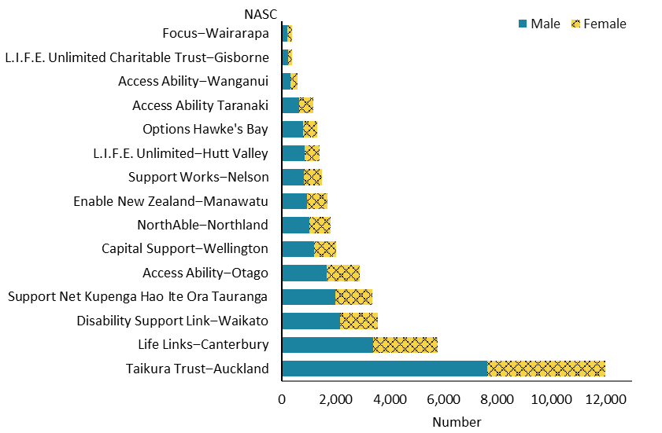

Observations
- Taikura Trust in Auckland serves nearly one-third of the total number of people allocated DSS; Life Links in Canterbury serves about one-seventh of the total number.
- Males served by Taikura Trust significantly outnumbered females. Males and females were more evenly distributed in the populations served by Enable New Zealand ‒ Manawatu, Access Ability ‒ Taranaki and Focus ‒ Wairarapa.

People allocated ongoing disability support services through Needs Assessment and Service Coordination organisations compared with the New Zealand population

Age and sex
Figure 2: Disability support services population, by age and sex, 2019/20 financial year
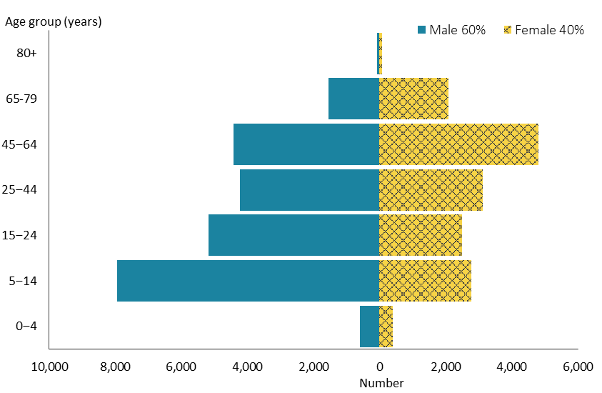

Figure 3: New Zealand population, by age and sex, 2020
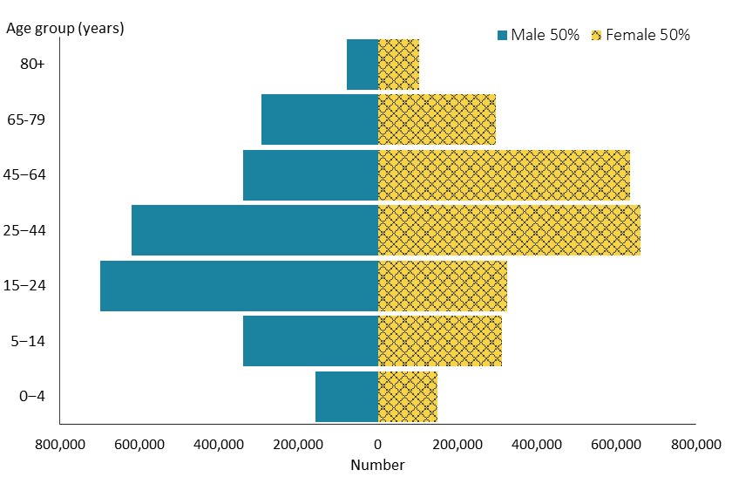

Observations
- The age and sex distribution of people allocated DSS is notably different from that of the New Zealand population.
- Recipients of DSS are more concentrated in the 5–14 and 45–64-year age groups. In comparison, the 25–44-year age group has the highest proportion in the New Zealand population.
- Males significantly outnumber females among DSS recipients, while males and females are evenly distributed in the New Zealand population.
- Generally, only people aged under 65 are eligible for DSS, which explains the lower numbers of people in the over-65-year age group compared with the New Zealand population.

Ethnicity
Table 4: Ethnicity of disability support services recipients compared with New Zealand population, 2019/20 financial year*
Ethnicity (prioritised) | DSS recipients | New Zealand population
European/Other | 25,984 | 3,047,700
Māori | 8,470 | 850,900
Pacific peoples | 2,726 | 343,200
Asian | 2,884 | 846,000
Total | 40,064 | 5,087,800
* A very small number of unstated ethnicity (0.01%) is included in European/Other.

Figure 4: Ethnicity distribution of disability support services recipients compared with New Zealand population, 2019/20 financial year

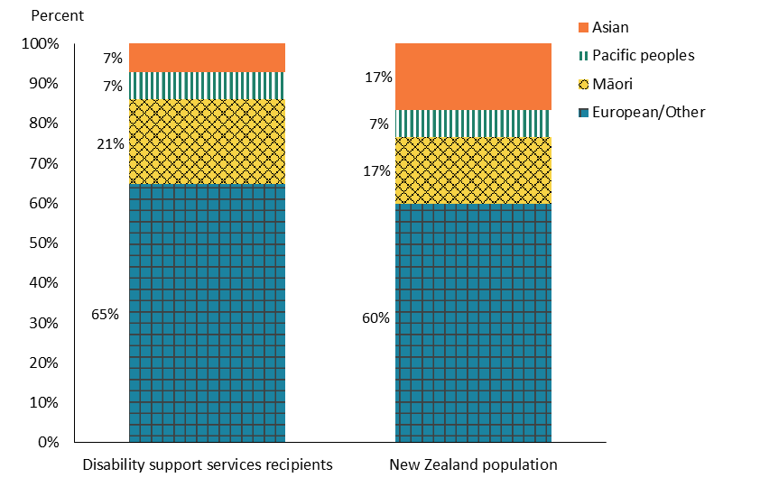

Observations
- Compared to the New Zealand population, recipients of Māori and European/Other ethnicities were over-represented among DSS recipients.
- In contrast, people of Asian ethnicity among the DSS population were significantly under-represented.
- The proportion of Pacific peoples among DSS recipients was the same as for the ethnic distribution nationally.

Overall disability support services demographics

Age, sex and ethnicity
Table 5: Number of people allocated disability support services, by age and sex, 2019/20 financial year
Age group | Female | Male | Total | %
0–4 | 302 | 598 | 900 | 2.2%
5–14 | 3,030 | 7,931 | 10,961 | 27.4%
15–24 | 2,651 | 5,173 | 7,824 | 19.5%
25–44 | 3,190 | 4,216 | 7,406 | 18.5%
45–64 | 4,593 | 4,425 | 9,018 | 22.5%
65–79 | 2,207 | 1,537 | 3,744 | 9.3%
80+ | 141 | 70 | 211 | 0.5%
Total | 16,114 | 23,950 | 40,064 | 100%

Table 6: Number of people allocated disability support services, by ethnicity, 2019/20 financial year
Ethnicity | Female | Male | Total
European/Other | 10,829 | 15,155 | 25,984
Māori | 3,321 | 5,149 | 8,470
Pacific peoples | 1,001 | 1,725 | 2,726
Asian | 963 | 1,921 | 2,884
Total | 16,114 | 23,950 | 40,064

Figure 5: Number of people allocated disability support services, by ethnicity, age and sex, 2019/20 financial year
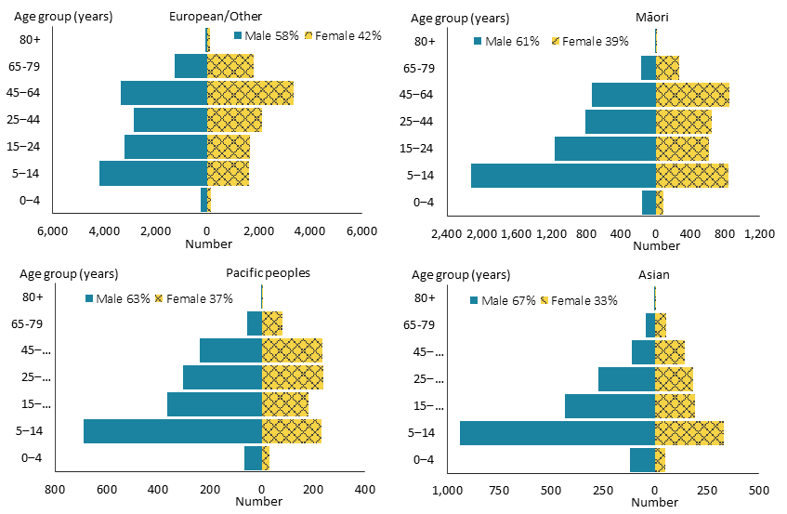

Observations
- There were significantly more males than females among DSS recipients. DSS recipients were most represented in the 5–14-year and 45–64-year age groups.
- Males outnumbered females in all ethnic groups receiving DSS; this was particularly so among Asian people but less so for people of European/Other ethnicity.
- Māori, Pacific and Asian ethnicity among DSS recipients were markedly concentrated in the 5–14-year age group. However, the highest number of people of European/Other ethnicity were in the 45–64-year age group.
- Males were significantly more prevalent in the 5–14-year age group for Asian, Pacific and Māori ethnicities.

Principal disability
The database Socrates records principal disabilities for DSS recipients. There are six disability classes: intellectual, physical, autism, sensory, neurological and other (see Appendix 1).

Where Socrates records a person as having more than one principal disability, it selects a prioritised disability based on the disability type prioritisation list. The same rule is applied where a principal disability falls into more than one disability type. The list of disability types in Table 6 shows the order of prioritisation.

Table 7: Number of people allocated disability support services, by sex and principal disability, 2019/20 financial year
Disability | Female | Male | Total | %
Intellectual | 8,259 | 11,209 | 19,468 | 49%
Sensory | 530 | 542 | 1,072 | 3%
Physical | 4,798 | 3,521 | 8,319 | 21%
Neurological | 135 | 145 | 280 | 1%
Autism | 2,285 | 8,454 | 10,739 | 27%
Other | 107 | 79 | 186 | 0%
Total | 16,114 | 23,950 | 40,064 | 100%

Figure 6: Number of people allocated disability support services, by principal disability and sex, 2019/20 financial year
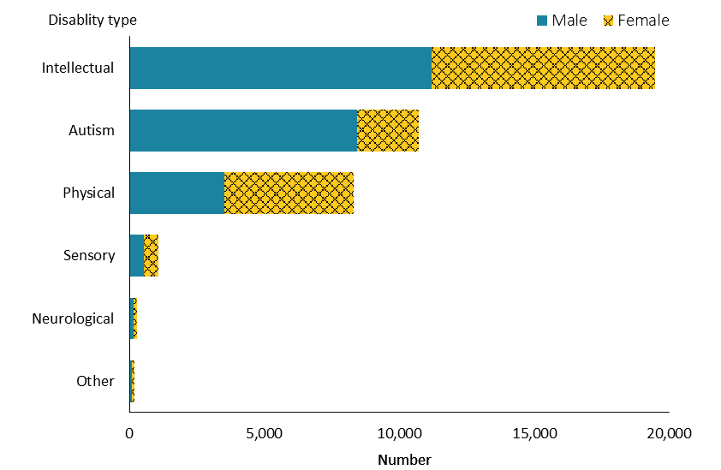

Observations
- Approximately half of the people allocated DSS were intellectually disabled. Nearly one-third were autistic.
- There were significantly more males than females among autistic people. Conversely, there were more females than males among people with a physical disability.

Marital status
Table 8: Number of people allocated disability support services, by marital status and sex, 2019/20 financial year
Marital status | Female | Male | Total | %
Married/partnered | 1,050 | 614 | 1,664 | 4%
Non-partnered, once married | 581 | 268 | 849 | 2%
Non-partnered, never married/not further defined | 4,160 | 6,215 | 10,375 | 26%
Unstated/undefined | 10,323 | 16,853 | 27,176 | 68%
Total | 16,114 | 23,950 | 40,064 | 100%

Observations
- Marital status was not recorded for 68% of DSS recipients.
- Of people for whom data was recorded, the majority (81%) were never married or non-partnered.

Accommodation
Table 9: Number of people allocated disability support services, by accommodation type and sex, 2019/20 financial year
Accommodation | Female | Male | Total | %
Own / family home | 7,812 | 12,330 | 20,142 | 50%
Rental accommodation | 2,884 | 4,220 | 7,104 | 18%
Kāinga Ora* or council accommodation | 1,092 | 1,432 | 2,524 | 6%
Community residential home | 2,580 | 3,642 | 6,222 | 16%
Rest home / continuing care hospital | 364 | 342 | 706 | 12%
Unit in a retirement village | 55 | 19 | 74 | 0.2%
Boarder | 137 | 199 | 336 | 1%
No fixed abode | 6 | 23 | 29 | 0.1%
Prison | 6 | 23 | 29 | 0.1%
Other/unknown | 1,178 | 1,720 | 2,898 | 7%
Total | 16,114 | 23,950 | 40,064 | 100%
* Former name is Housing New Zealand.

Observations
- Half of DSS recipients lived in their own or their family home; 61% of these people were male.
- About one-third of DSS recipients lived in either rental accommodation or in a community residential home.

Location
Table 10: Number of people allocated disability support services, by domicile region, 2019/20 financial year
Region | Female | Male | Total | %
Auckland | 4,328 | 7,468 | 11,796 | 29%
Bay of Plenty | 1,249 | 1,778 | 3,027 | 8%
Canterbury | 2,300 | 3,251 | 5,551 | 14%
Gisborne | 154 | 227 | 381 | 1%
Hawke's Bay | 560 | 782 | 1,342 | 3%
Manawatu–Wanganui | 1,031 | 1,280 | 2,311 | 6%
Nelson–Marlborough–Tasman | 634 | 781 | 1,415 | 4%
Northland | 798 | 1,013 | 1,811 | 5%
Otago | 822 | 1,157 | 1,979 | 5%
Southland | 433 | 554 | 987 | 2%
Taranaki | 527 | 645 | 1,172 | 3%
Waikato | 1,579 | 2,534 | 4,113 | 10%
Wellington | 1,573 | 2,297 | 3,870 | 10%
West Coast | 126 | 183 | 309 | 1%
Total | 16,114 | 23,950 | 40,064 | 100%

Figure 7: Number of people allocated disability support services, by domicile region and ethnicity, 2019/20 financial year
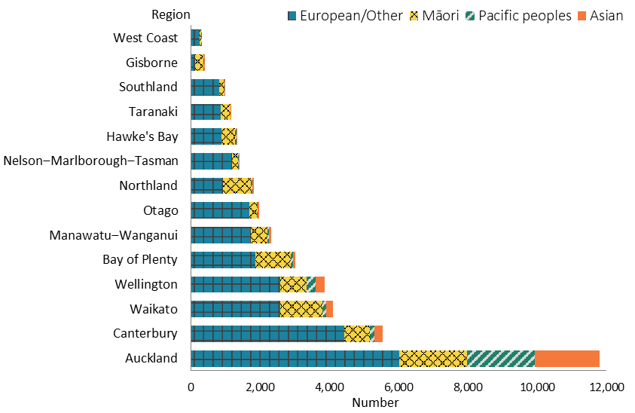

Observations
- The majority (63%) of DSS recipients resided in the most populated regions: Auckland, Canterbury, Waikato and Wellington.
- The Auckland region is by far the most ethnically diverse. Of DSS recipients nationally, 72% of Pacific peoples and 65% of Asian people resided in the Auckland region.
- About two-thirds of DSS recipients who resided in the Gisborne region, and nearly half of people living in the Northland region, were Māori.

Support package allocation
‘Support package allocation’ refers to the funding or range of DSS allocated to people to address their disability support needs, as identified by a NASC organisation. Support package allocations are categorised across five levels, ranging from ‘very low’ to ‘very high’.

Table 11: Number of people allocated disability support services, by support package allocation level, 2019/20 financial year
Support package allocation level | Female | Male | Total | %
Very high | 5,087 | 7,015 | 12,102 | 30%
High | 6,025 | 9,015 | 15,040 | 38%
Medium | 4,554 | 7,113 | 11,667 | 29%
Low | 413 | 600 | 1,013 | 3%
Very low | 4 | 19 | 23 | 0.1%
Undefined | 31 | 188 | 219 | 1%
Total | 16,114 | 23,950 | 40,064 | 100%

Figure 8: Number of people allocated disability support services, by age and support package allocation level, 2019/20 financial year*

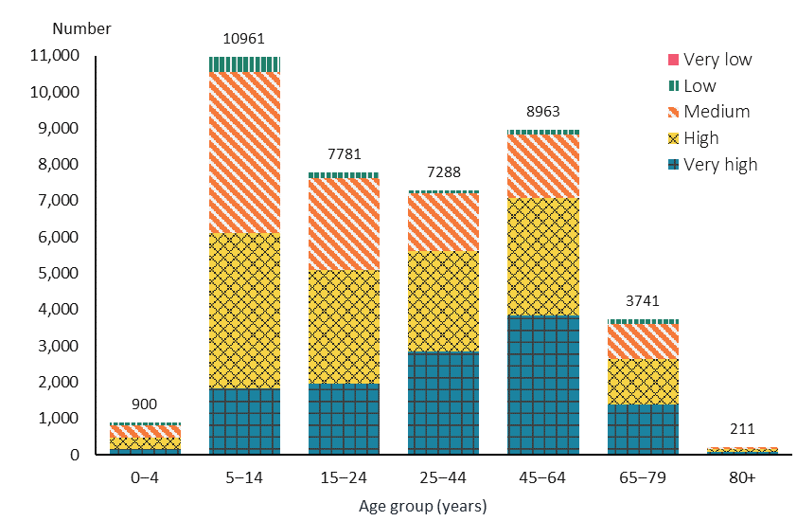

* This figure excludes a small amount (1%) of information with an undefined SPA level.

Observations
- Most people (97%) allocated DSS required medium or higher levels of SPA.
- The number of people receiving ‘very high’ SPA increased by age group until age 45–64 years, after which it dropped (as did the number of DSS recipients).
- Medium SPA levels were more common in the 0–4 and 5–14-year age groups.

Trends

Figure 9: Number of people allocated disability support services, by sex, from 2015/16 to 2019/20 financial year
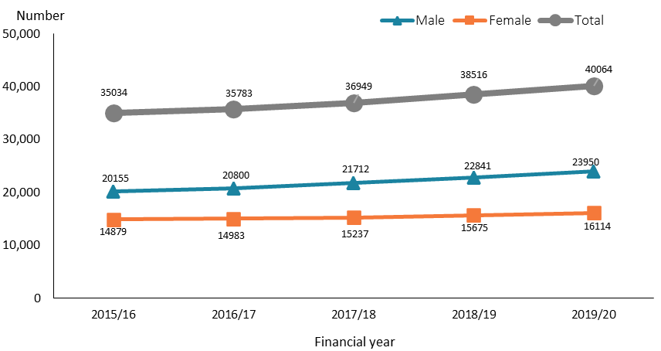

Figure 10: Number of people allocated disability support services, by age, from 2015/16 to 2019/20 financial year
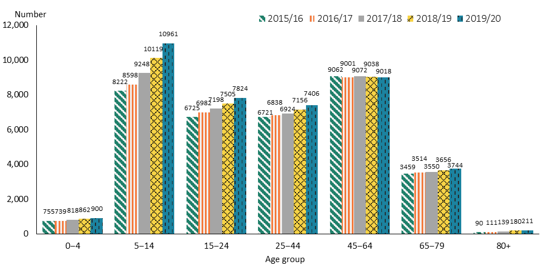

Figure 11: Number of people allocated disability support services, by ethnicity, from 2015/16 to 2019/20 financial year
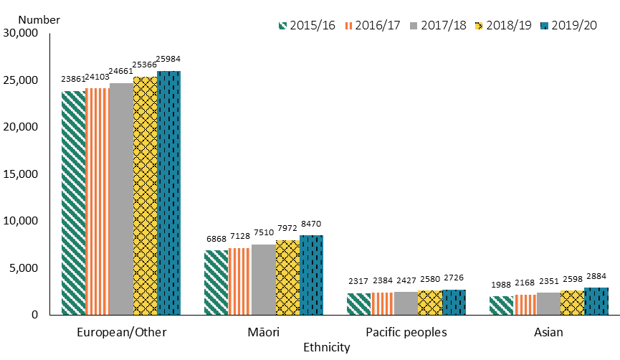

Figure 12: Number of people allocated disability support services, by principal disability, from 2015/20 to 2019/20 financial year*
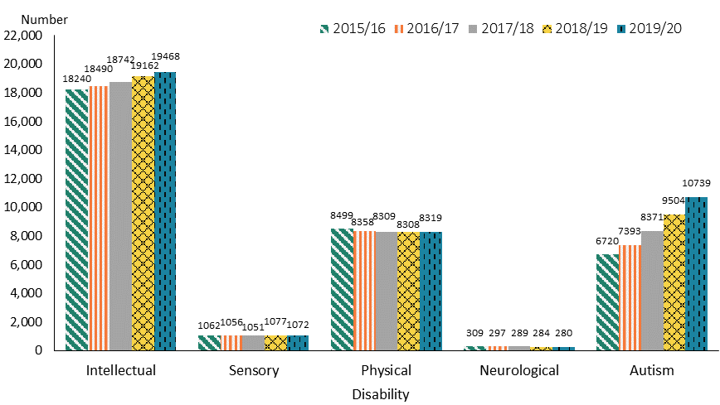
* This figure excludes a small number of ‘Other’ disability group.

Observations
- The number of people allocated DSS increased steadily between the 2015/16 and 2019/20 financial years. The rate of increase was higher for males than females. Overall, there were 5,030 more people allocated DSS in 2019/20 than in 2015/16.
- Except for the 45–64-year age group, numbers in all age groups increased over the five years. The number of people aged 5–14 years increased the most over this period, with the greatest increases occurring over the last two financial years. A likely contributing factor is the increase in the number of autistic children being allocated DSS during this period.
- There was a steady increase in the number of DSS recipients across all ethnicities from 2015/16 to 2019/20 financial year.
- The number of autistic people and people with an intellectual disability increased over the five-year period; the greatest increase was observed for people with autism. By contrast, the number of people with a physical, sensory or neurological disability remained relatively stable over the five-year period.

Disability support services demographics by service

Home and community support services
Home and community support services support people to live at home. These services include household management and personal care, and support for people to access the community.

Age, sex and ethnicity
Table 12: Home and community support services population, by age and sex, 2019/20 financial year
Age group | Female | Male | Total
0–4 | 13 | 18 | 31
5–14 | 195 | 347 | 542
15–24 | 269 | 385 | 654
25–44 | 703 | 637 | 1,340
45–64 | 1,983 | 1,420 | 3,403
65–79 | 1,350 | 694 | 2,044
80+ | 82 | 29 | 111
Total | 4,595 | 3,530 | 8,125

Figure 13: Home and community support services population, by age and sex, 2019/20 financial year

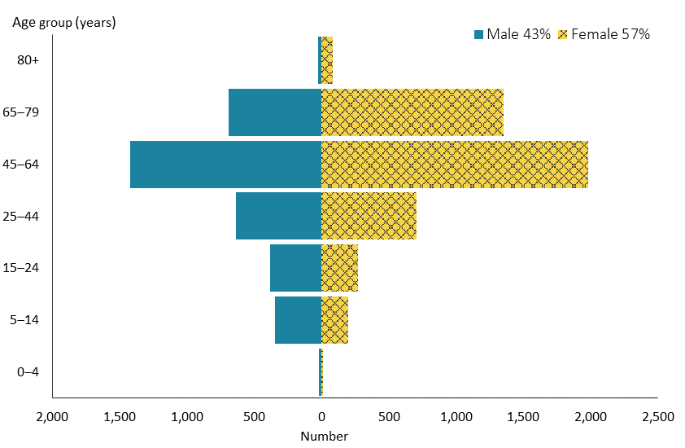

Figure 14: Home and community support services population, by ethnicity, 2019/20 financial year
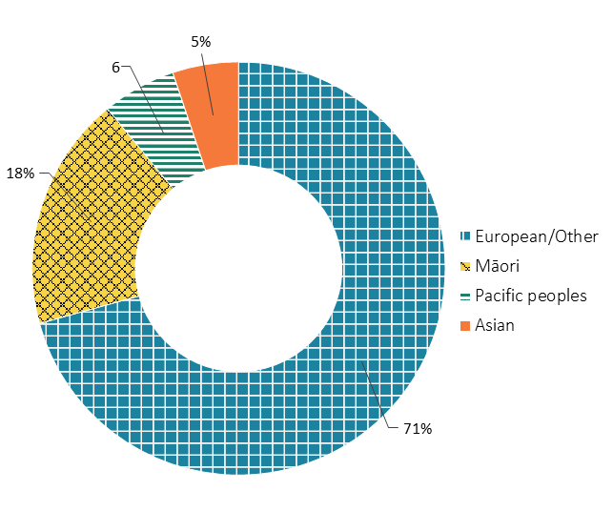

Observations
- In contrast to the sex distribution for total DSS recipients, HCSS recipients included more females than males.
- The peak in numbers of HCSS recipients for both sexes occurred in the 45–64-year group.
- People of European/Other ethnicity were over-represented and Asian people significantly under-represented in HCSS recipients, compared to their representation nationally.

Location
Figure 15: Home and community support services population, by domicile region, 2019/20 financial year
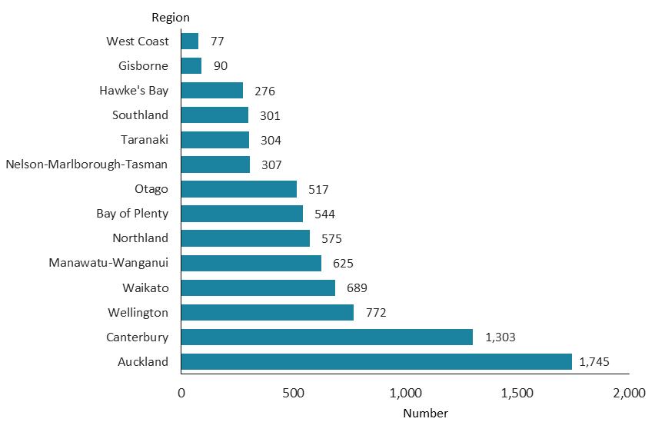

Observations
- The two regions where the highest numbers of HCSS recipients reside were Auckland and Canterbury.

Principal disability
Figure 16: Home and community support services population, by principal disability type and sex, 2019/20 financial year
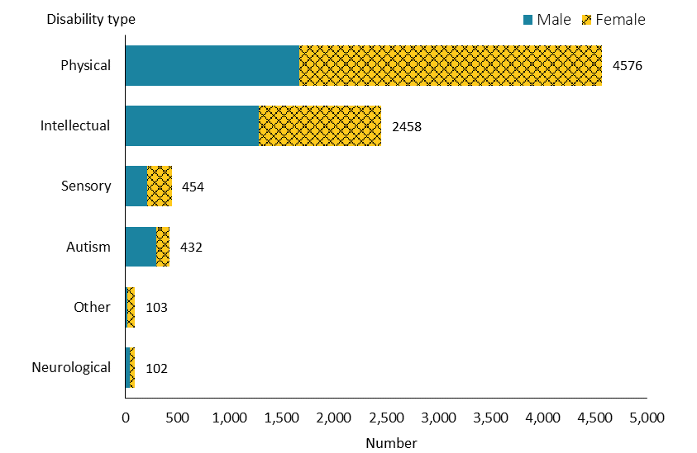

Observations
- More than half of HCSS recipients had a physical disability.
- Unlike among HCSS recipients, there were more males than females among people with autism.

Support package allocation
Figure 17: Home and community support services population, by support package allocation level and sex, 2019/20 financial year
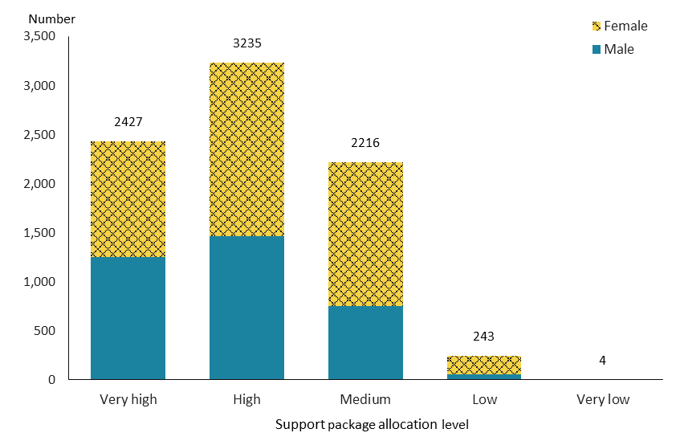

Observations
- About 40% of HCSS recipients had a ‘high’ SPA level, and nearly 30% had a ‘very high’ SPA level. The numbers of males and females having a ‘very high’ SPA level were similar.

Trends
Figure 18: Home and community support services population, by sex, from 2015/16 to 2019/20 financial year
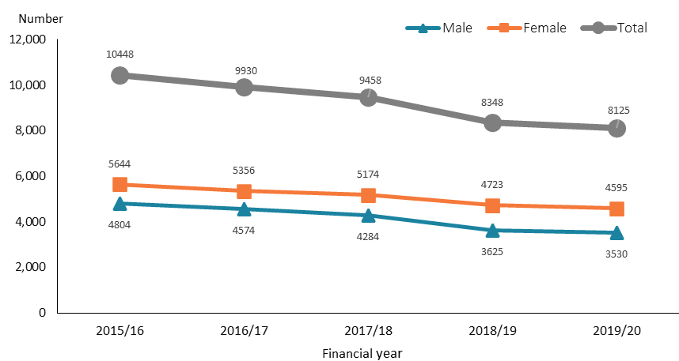

Figure 19: Home and community support services population, by ethnicity, from 2015/16 to 2019/20 financial year
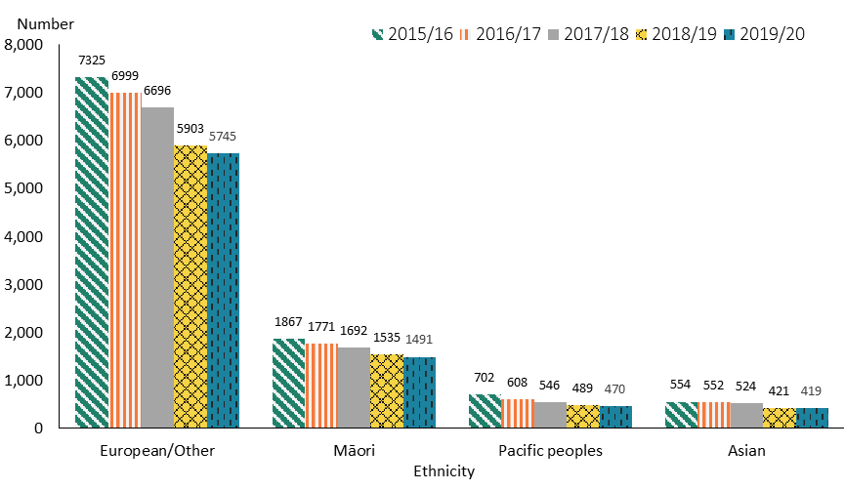

Observations
- The number of people allocated HCSS decreased from 2015/16 to 2019/20, and particularly from 2017/18 to 2018/19. This decline is likely to be related to the number of people who transferred from HCSS to IF. It may also be partially related to the record change for the family whānau support service, which was recorded as HCSS and changed to the respite service from 2017/18.
- The number of people of all ethnicities allocated HCSS decreased over the five-year period.

Carer support
Carer support is allocated to an eligible disabled person to enable their full-time, unpaid carer to take time out for themselves and support them to continue in their caring role. The subsidy provides a contribution towards the costs of accessing a support person to care and support a disabled person during this time.

Age, sex and ethnicity
Table 13: Carer support population, by age and sex, 2019/20 financial year
Age group | Female | Male | Total
0–4 | 267 | 561 | 828
5–14 | 2,808 | 7,381 | 10,189
15–24 | 2,143 | 4,291 | 6,434
25–44 | 1,194 | 1,615 | 2,809
45–64 | 785 | 700 | 1,485
65–79 | 363 | 265 | 628
80+ | 8 | 10 | 18
Total | 7,568 | 14,823 | 22,391

Figure 20: Carer support population, by age and sex, 2019/20 financial year
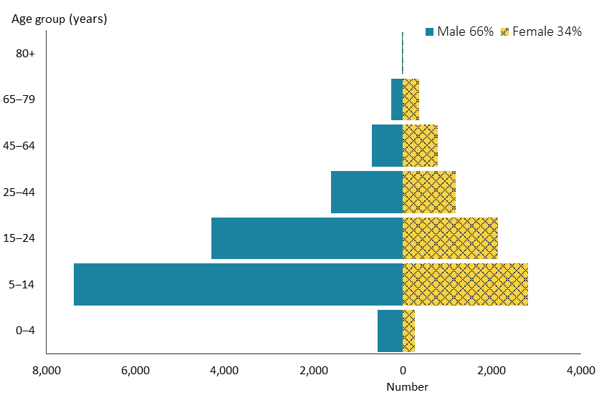

Figure 21: Carer support population, by ethnicity, 2019/20 financial year
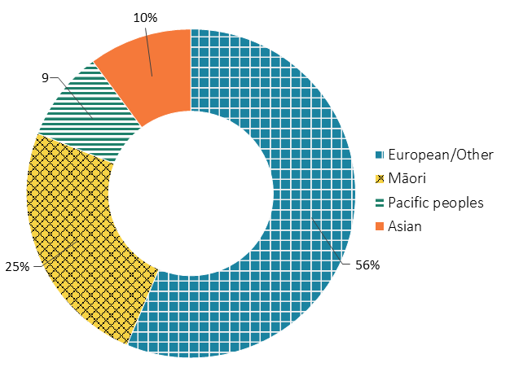

Observations
- People allocated carer support were significantly concentrated in the 5–14-year age group.
- Historically, people allocated carer support have predominantly been male. This is particularly the case for the 5–14-year age group.
- The proportion of Māori among carer support recipients was significantly higher, and the proportions of European/Other and Asian people lower, compared to the ethnic distribution in New Zealand.

Location
Figure 22: Carer support population, by domicile region, 2019/20 financial year
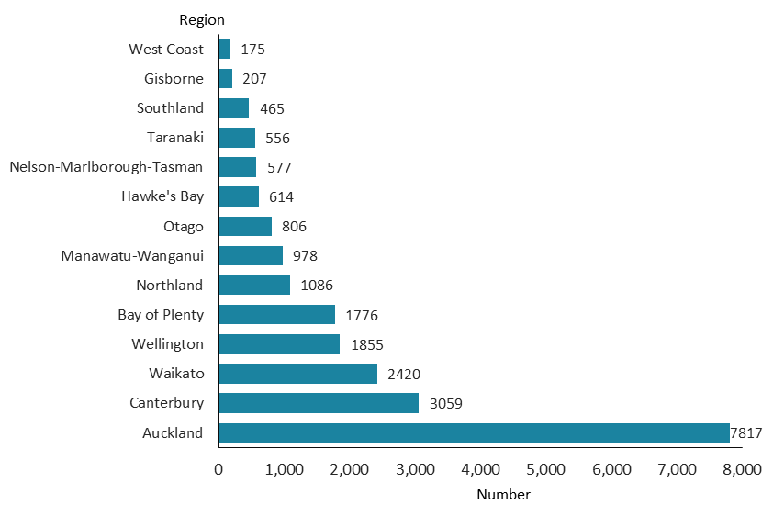

Observations
- One-third of total carer support recipients resided in the Auckland region; this reflects the fact that Auckland contains one-third of the New Zealand population.

Principal disability
Figure 23: Carer support population, by principal disability type and sex, 2019/20 financial year
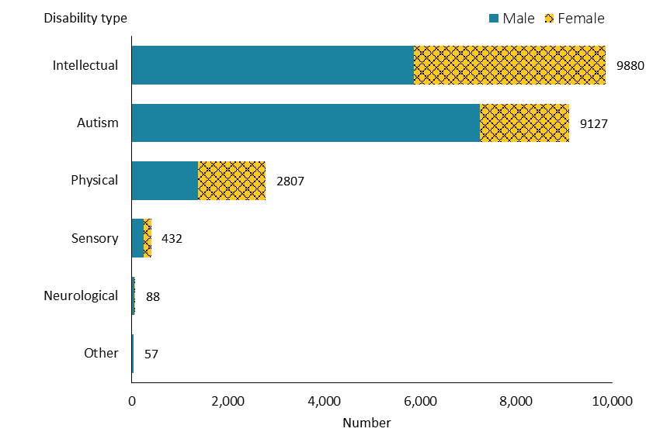

Observations
- A large majority of people (85%) allocated carer support either had an intellectual disability or were autistic.
- In contrast to carer support recipients who are predominately male, there are similar numbers of male and female recipients with a physical disability.

Support package allocation
Figure 24: Carer support population, by support package allocation level and sex, 2019/20 financial year
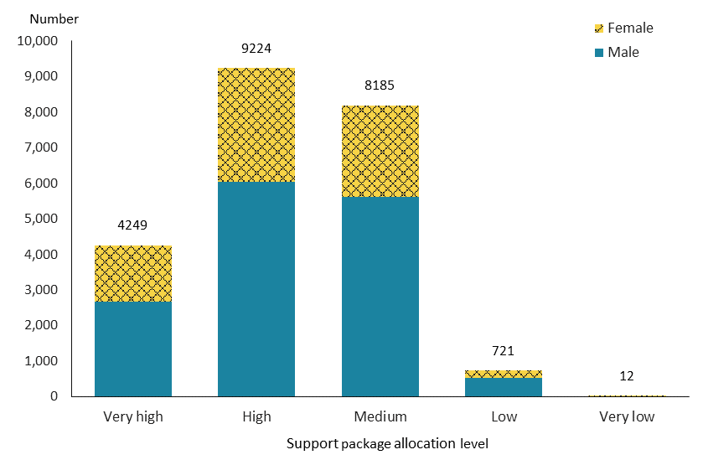

Observations
The majority (78%) of people accessing carer support had a ‘medium’ or ‘high’ SPA level; the largest number of people required a ‘high’ SPA level.

Trends

Figure 25: Carer support services population, by sex, from 2015/16 to 2019/20 financial year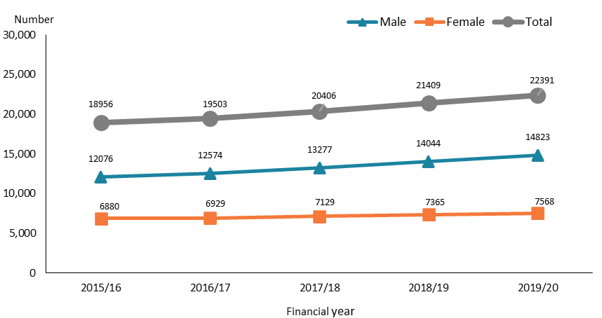

Figure 26: Carer support services population, by ethnicity, from 2015/16 to 2019/20 financial year
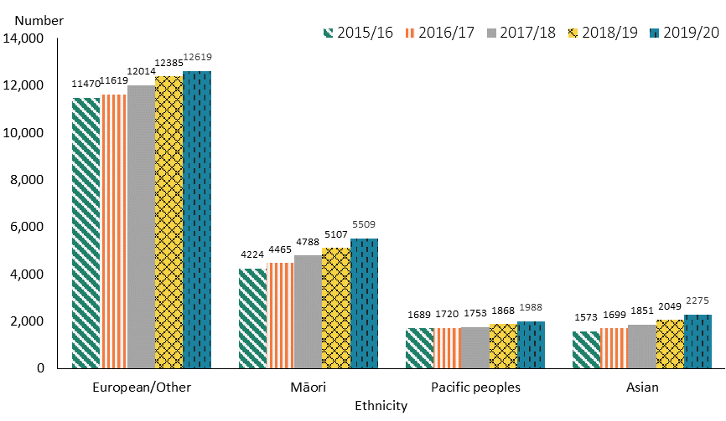

Observations
- The number of people who were allocated carer support increased continuously from 2015/16 to 2019/20, with the increase evident at a higher rate for males than females.
- The number of carer support recipients of all ethnicities increased steadily over the five-year period.

Community residential support services
Community residential support services provide people with support for up to 24 hours a day in a home-like setting in the community. This support may include help with activities such as shopping, cooking, household chores, personal cares and getting out in the community.

Age, sex and ethnicity
Table 14: Community residential support services population, by age and sex, 2019/20 financial year
Age group | Female | Male | Total
5–14 | 8 | 15 | 23
15–24 | 165 | 323 | 488
25–44 | 830 | 1,280 | 2,110
45–64 | 1,394 | 1,737 | 3,131
65–79 | 413 | 459 | 872
80+ | 46 | 34 | 80
Total | 2,856 | 3,848 | 6,704

Figure 27: Community residential support services population, by age and sex, 2019/20 financial year
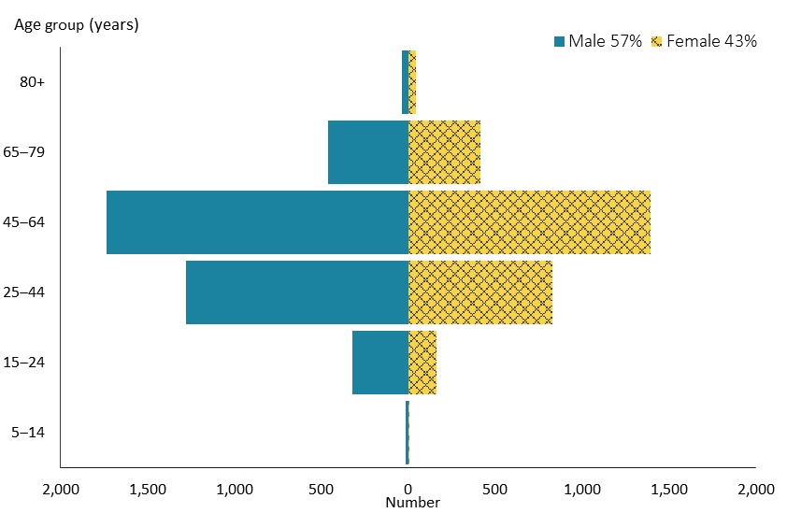

Figure 28: Community residential support services population, by ethnicity, 2019/20 financial year
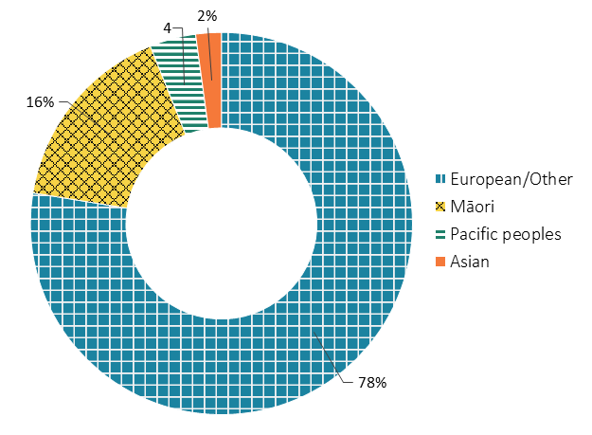

Observations
- A large proportion of people (48%) allocated community residential support services were aged 45–64 years.
- More males than females were allocated community residential support services.
- People of European/Other ethnicity allocated community residential support services were significantly over-represented and Asian people and Pacific peoples significantly under-represented compared to their distribution in the New Zealand population.

Location
Figure 29: Community residential support services population, by domicile region, 2019/20 financial year
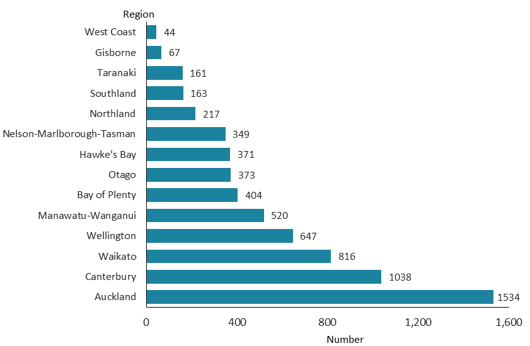

Observations
- The proportion of people allocated community residential support services in the Auckland region was markedly lower compared to the national DSS cohort.
- Most people accessing community residential support services resided in the most populated regions: Auckland, Canterbury, Waikato and Wellington.

Principal disability
Figure 30: Community residential support services population, by principal disability type and sex, 2019/20 financial year
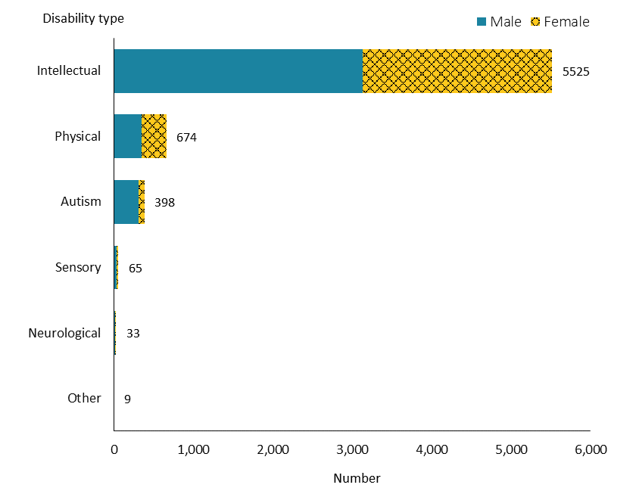

Observations
- The majority of people (82%) allocated community residential support services had an intellectual disability.

Support package allocation
Figure 31: Community residential support services population, by support package allocation level and sex, 2019/20 financial year
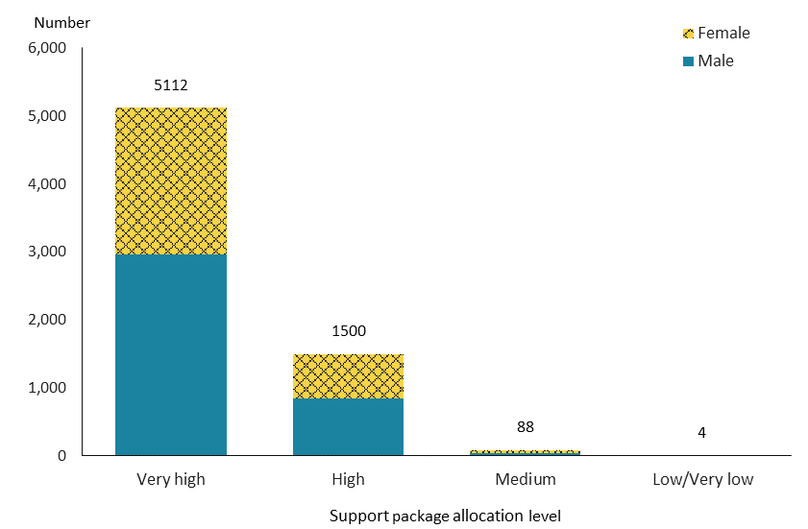
Note: Due to a small number of people, ‘low’ and ‘very low’ levels are combined into one group.

Observations
- Of people allocated community residential support services, 76% had a ‘very high’ SPA level.

Trends
Figure 32: Community residential support services population, by sex, from 2015/16 to 2019/20 financial year
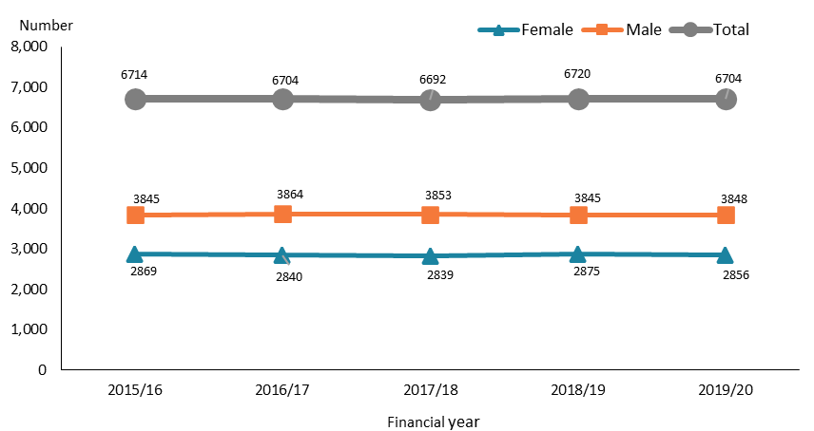

Figure 33: Community residential support services population, by ethnicity, from 2015/16 to 2019/20 financial year
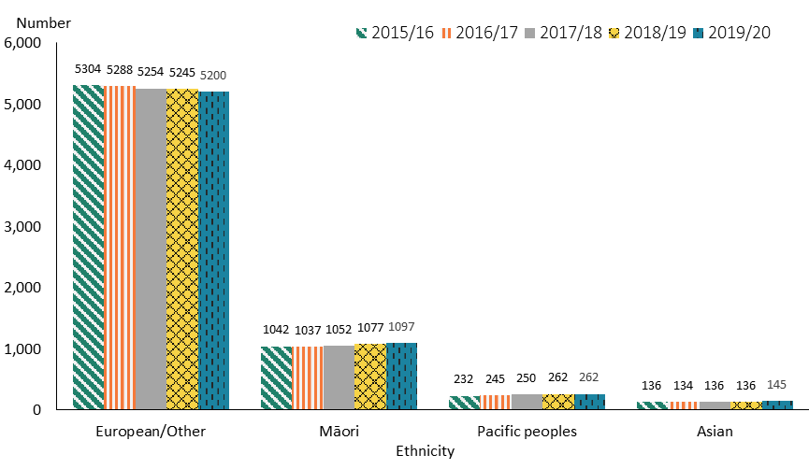

Observations
- The number of people allocated community residential support services remained stable from 2015/16 to 2019/20, and the ratio of males to females remained unchanged over this period.
- The number of people of European/Other ethnicity allocated community residential support services slightly decreased over the five-year period. However, the numbers of Māori and Pacific peoples showed a slightly increasing tendency.

Younger people in aged residential care
Younger people in aged residential care services provide 24-hour residential support in aged care facilities for people aged under 65 with physical disabilities who require clinical supports not available in community residential support services.

Age, sex and ethnicity
Table 15: Younger people in aged residential care population, by age and sex, 2019/20 financial year*
Age group | Female | Male | Total
15–44** | 23 | 20 | 43
45–64 | 245 | 220 | 465
65–79 | 176 | 159 | 335
80+ | 7 | 4 | 11
Total | 451 | 403 | 854
* Some people were allocated YPD when they were younger than 65 years and have continued to be supported by such services after that age.
** Due to a small number of people, the 15‒24 and 25‒44-year age groups are combined into one group.

Figure 34: Younger people in aged residential care population, by age and sex, 2019/20 financial year
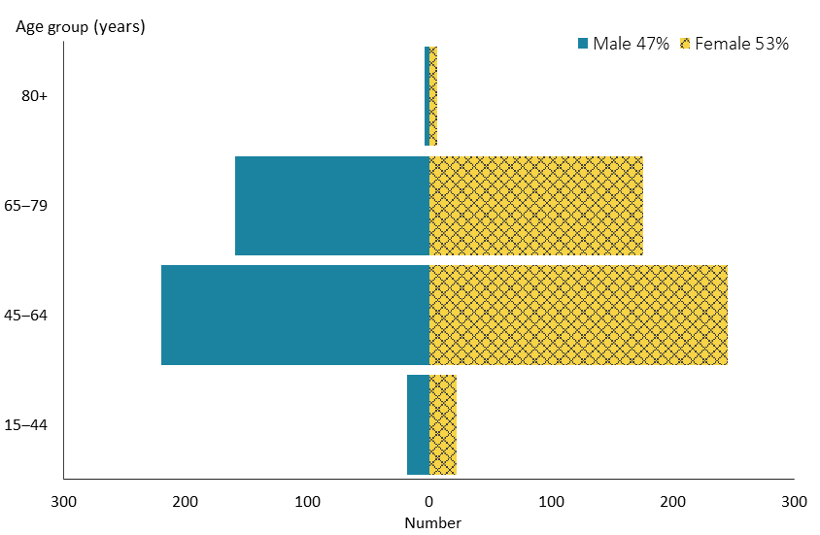

Figure 35: Younger people in aged residential care population, by ethnicity, 2019/20 financial year
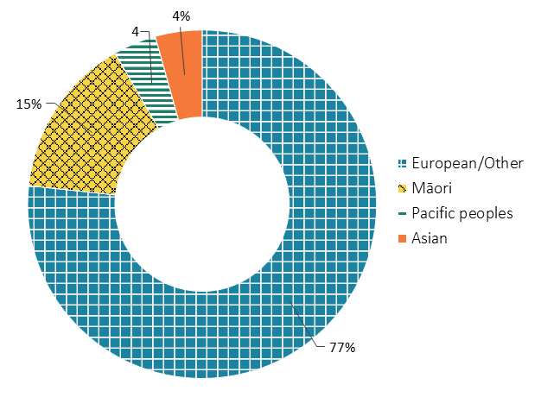

Observations
- Most people (94%) allocated YPD services were aged 45–79 years.
- As opposed to overall DSS recipients, who were predominately male, females exceeded males among those allocated YPD services.
- While people of European/Other ethnicity remained over-represented among those allocated YPD services, Pacific peoples and Asian people were significantly under-represented compared to their distribution in the New Zealand population.

Location
Figure 36: Younger people in aged residential care population, by domicile region, 2019/20 financial year
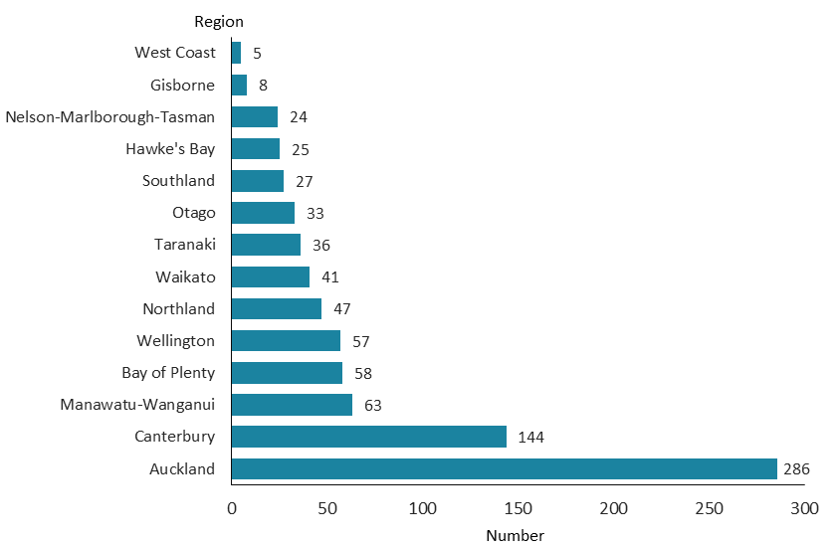

Observations
- People allocated YPD services were largely concentrated in the Auckland (33%) and Canterbury (17%) regions.

Principal disability
Figure 37: Younger people in aged residential care population, by principal disability type and sex, 2019/20 financial year
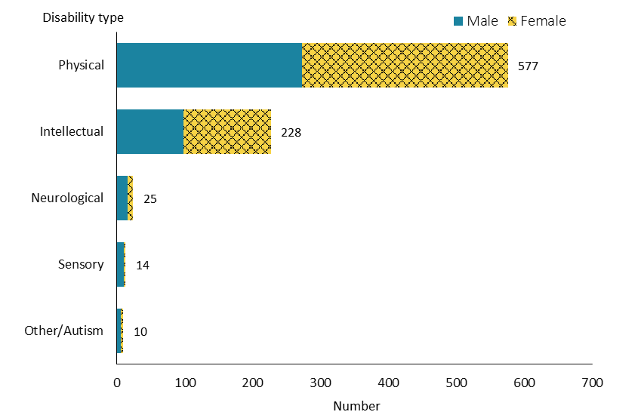
Note: Due to a small number of people, autism and Other disability types are combined into one group.

Observations
- Physical disability was the dominant principal disability type for people allocated YPD services, 68% of whom had a physical disability.

Support package allocation
Figure 38: Younger people in aged residential care population, by support package allocation level and sex, 2019/20 financial year
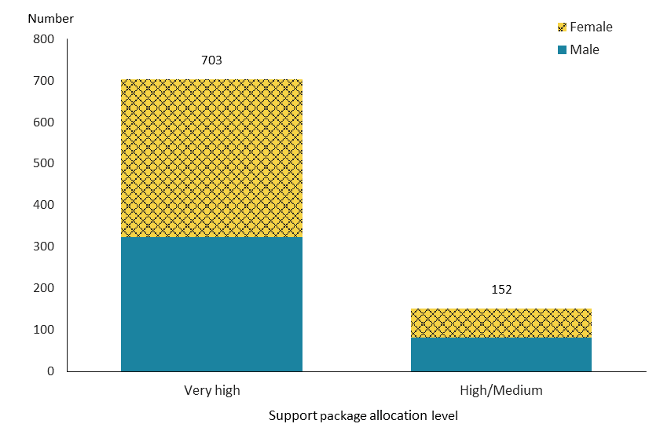
Note: Due to a small number of people with ‘medium’ level, ‘high‘ and ‘medium’ levels are combined into one group.

Observations
- Almost all people allocated YPD services required either ‘very high’ or ‘high’ SPA levels in 2019/20; the majority (82%) required a ‘very high’ SPA level.

Trends
Figure 39: Younger people in aged residential care population, by sex, from 2015/16 to 2019/20 financial year
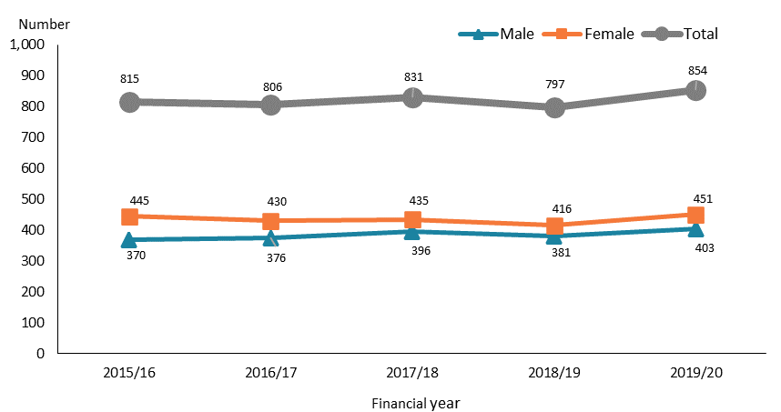

Figure 40: Younger people in aged residential care population, by ethnicity, from 2015/16 to 2019/20 financial year
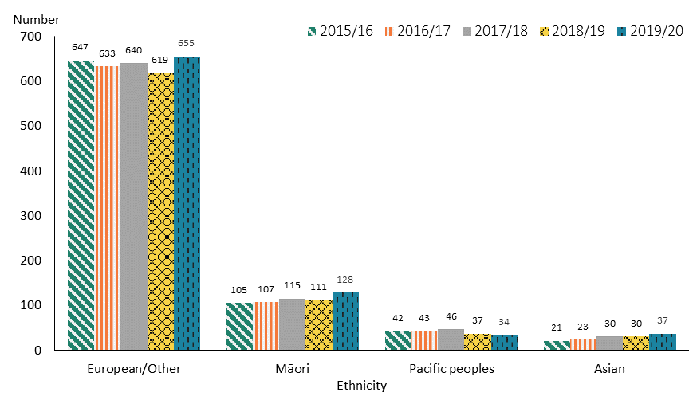

Observations
- The number of people allocated YPD services fluctuated slightly over the years from 2015/16 to 2019/20, with a slight increase in 2019/20. The increase was marginally higher for females than males.
- The number of people allocated YPD services changed marginally across ethnic groups over the five years.

Supported living
Supported living services help people to live independently. They provide support with social connection and facilitating activities such as accessing community facilities, shopping and cooking, and interacting with agencies. A support worker works with the disabled person either in their own home or in the community.

Age, sex and ethnicity
Table 16: Supported living population, by age and sex, 2019/20 financial year
Age group | Female | Male | Total
0–4 | 2 | 11 | 13
5–14 | 40 | 104 | 144
15–24 | 236 | 338 | 574
25–44 | 707 | 908 | 1,615
45–64 | 683 | 840 | 1,523
65+ | 149 | 177 | 326
Total | 1,817 | 2,378 | 4,195
Note: Due to a small number of people, the 65‒79 and 80+ year age groups are combined into one group.

Figure 41: Supported living population, by age and sex, 2019/20 financial year
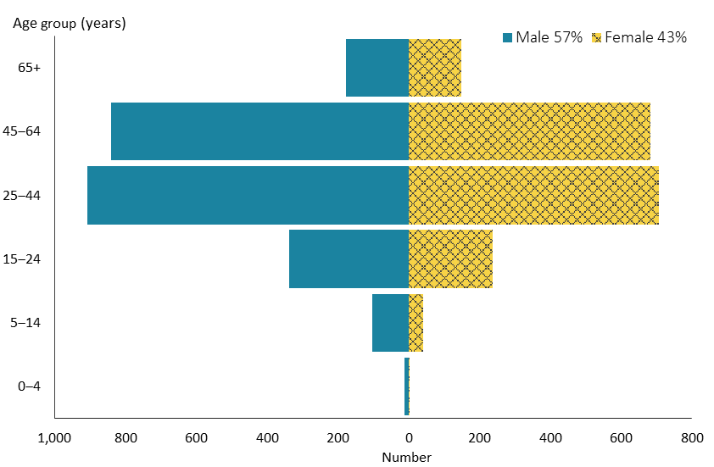

Figure 42: Supported living population, by ethnicity, 2019/20 financial year
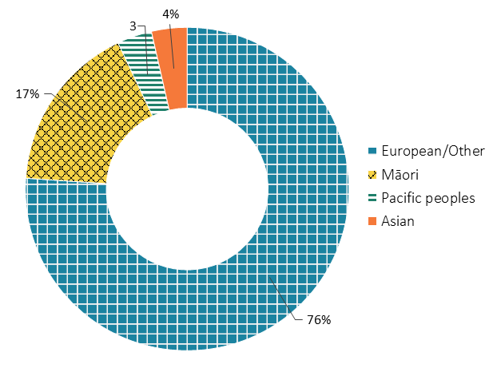

Observations
- There were slightly more males than females allocated supported living services.
- About three-quarters of people accessing supported living services were in the 25–44 and 45–64-year age groups.
- Compared to their distribution in the New Zealand population, the proportion of people of European/Other ethnicity accessing supported living services was much higher, and the proportions of Pacific peoples and Asian people significantly lower.

Location
Figure 43: Supported living population, by domicile region, 2019/20 financial year
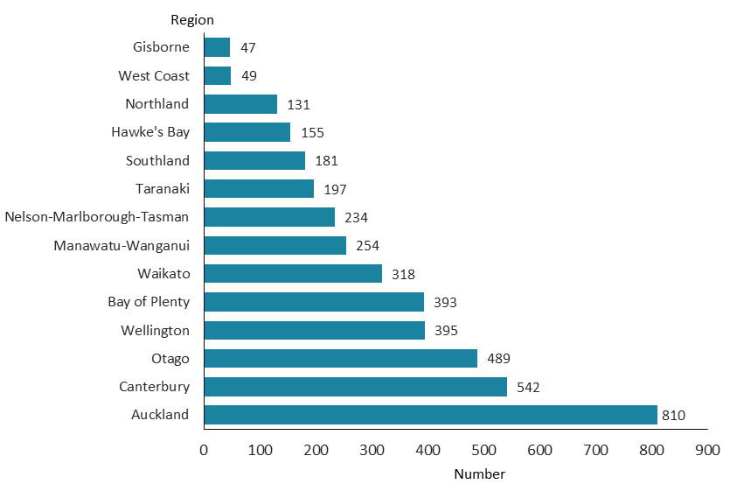

Observations
- The Otago region had the third-highest number of supported living recipients (12%), after the Auckland and Canterbury region (despite the fact that the Otago region only contains 5% of the New Zealand population).

Principal disability
Figure 44: Supported living population, by principal disability type and sex, 2019/20 financial year
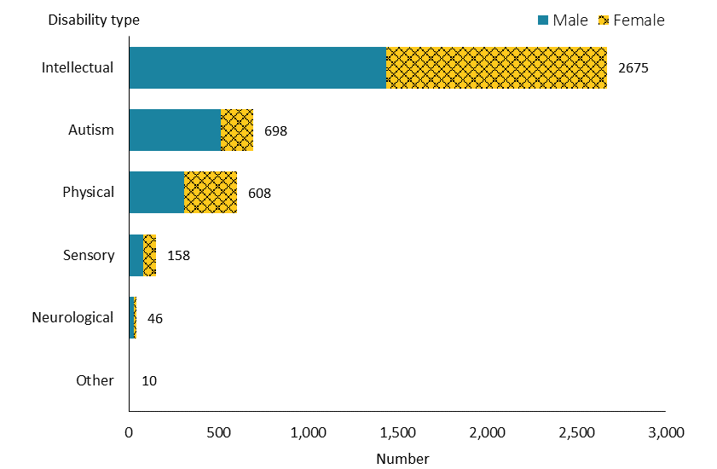

Observations
- Nearly two-thirds (64%) of people allocated supported living services had an intellectual disability.
- Unlike the overall number of DSS recipients with an intellectual disability, among whom there are more males than females, the number of males and females was similar among people with an intellectual disability accessing supported living.

Support package allocation
Figure 45: Supported living population, by support package allocation level and sex, 2019/20 financial year
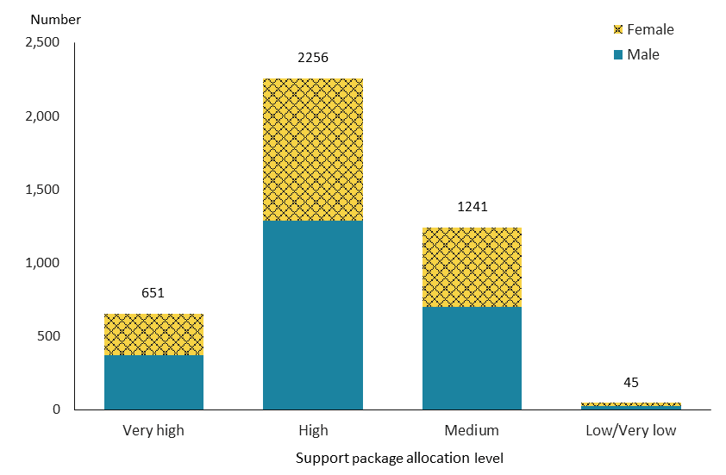
Note: Due to a small number of people, ‘very low’ and ‘low’ levels are combined into one group.

Observations
- Over half the people allocated supported living had a ‘high’ level of support, followed by nearly one-third who had a ‘medium’ level of support.

Trends
Figure 46: Supported living services population, by sex, from 2015/16 to 2019/20 financial year
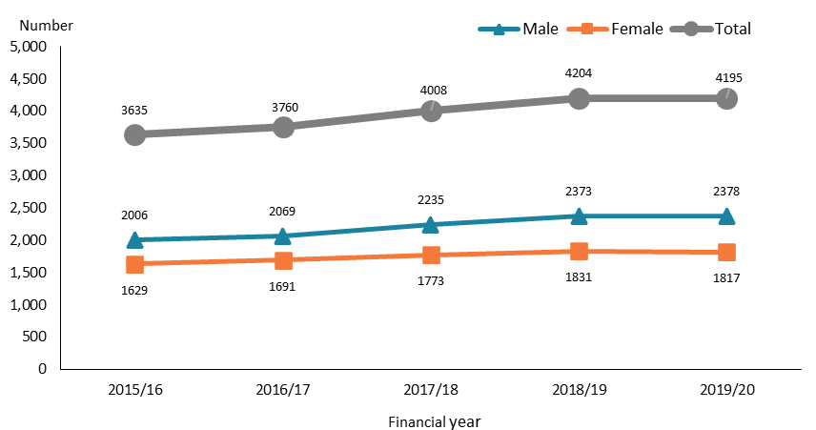

Figure 47: Supported living services population, by ethnicity, from 2015/16 to 2019/20 financial year
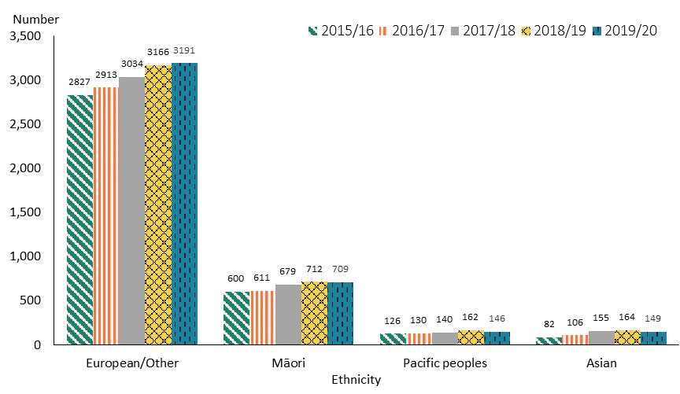

Observations
- The number of people allocated supported living services increased continuously from 2015/16 to 2018/19, the number of males increasing slightly faster than the number of females. However, the number remained steady from 2018/19 to 2019/20.
- The number of people allocated supported living showed an increase across all ethnicities during the first four years. This appears to have stabilised over the final year to 2019/20, with a possible trend down for Pacific peoples and Asian people in this period.

Respite services
Respite services provide short-term breaks for the carers of a disabled person while also providing a positive, stimulating and beneficial experience for the disabled person. The services include facility-based and home-based respite.

Age, sex and ethnicity
Table 17: Respite services population, by age and sex, 2019/20 financial year
Age group | Female | Male | Total
0–4 | 7 | 5 | 12
5–14 | 247 | 641 | 888
15–24 | 451 | 992 | 1,443
25–44 | 311 | 476 | 787
45–64 | 191 | 224 | 415
65+ | 83 | 79 | 162
Total | 1,290 | 2,417 | 3,707
Note: Due to a small number of people, the 65‒79 and 80+ year age groups are combined into one group.

Figure 48: Respite services population, by age and sex, 2019/20 financial year
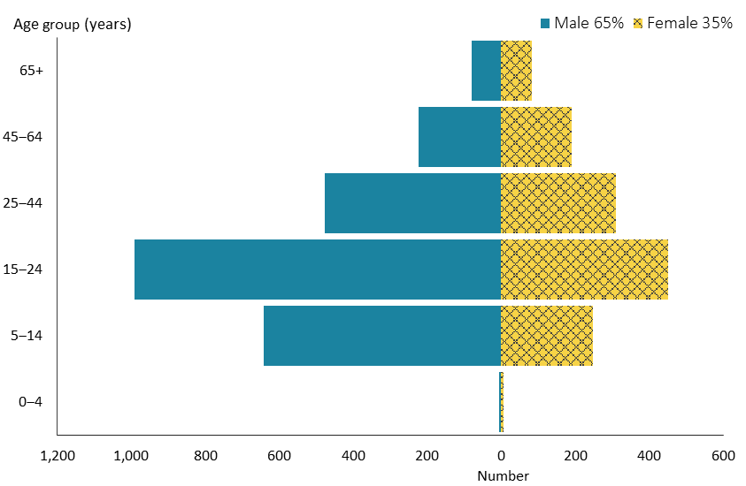

Figure 49: Respite services population, by ethnicity, 2019/20 financial year

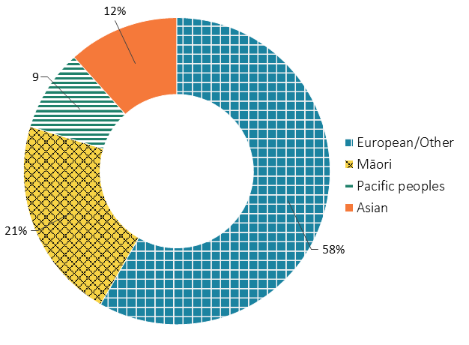

Observations
- People accessing respite services were highly concentrated in the 15–24-year age group.
- The number of males was almost double that of females (65% and 35% respectively).
- Māori and Pacific peoples allocated respite services were over-represented, while Asian people were under-represented, compared to the New Zealand population.

Location
Figure 50: Respite services population, by domicile region, 2019/20 financial year
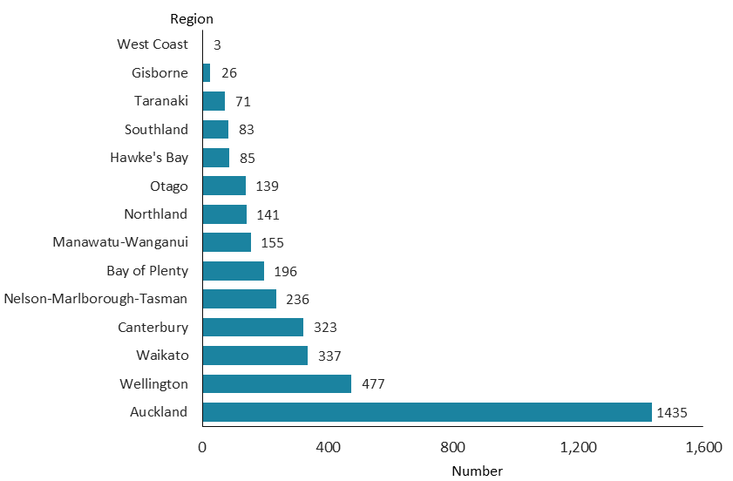

Observations
- A higher number of people allocated respite services resided in the Auckland region, making up 39% of total numbers.

Principal disability
Figure 51: Respite services population, by principal disability type and sex, 2019/20 financial year
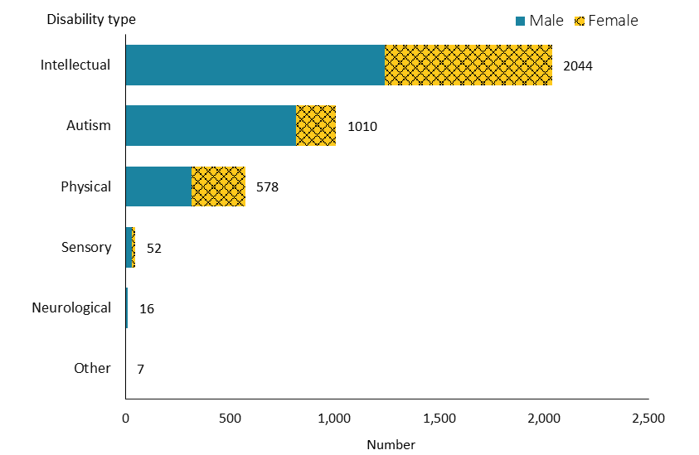

Observations
- More than half (55%) of people accessing respite services had an intellectual disability.

Support package allocation
Figure 52: Respite services population, by support package allocation level and sex, 2019/20 financial year
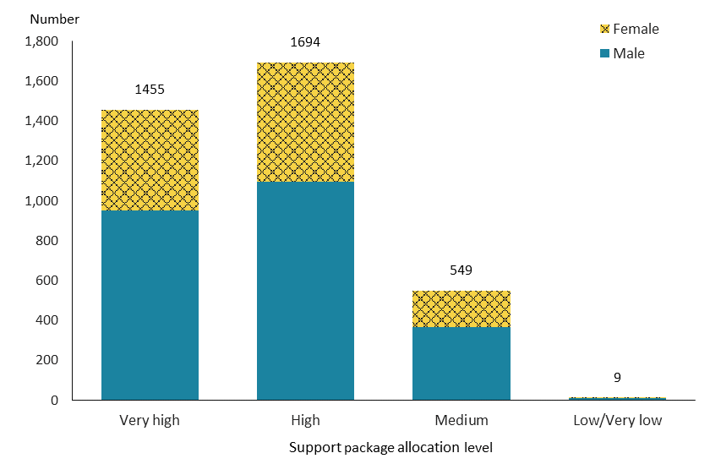
Note: Due to a small number of people, ‘low’ and ‘very low’ levels are combined into one group.

Observations
- Most people accessing respite services had either a ‘high’ (46%) or ‘very high’ (39%) SPA level.

Trends
Figure 53: Respite services population, by sex, from 2015/16 to 2019/20 financial year
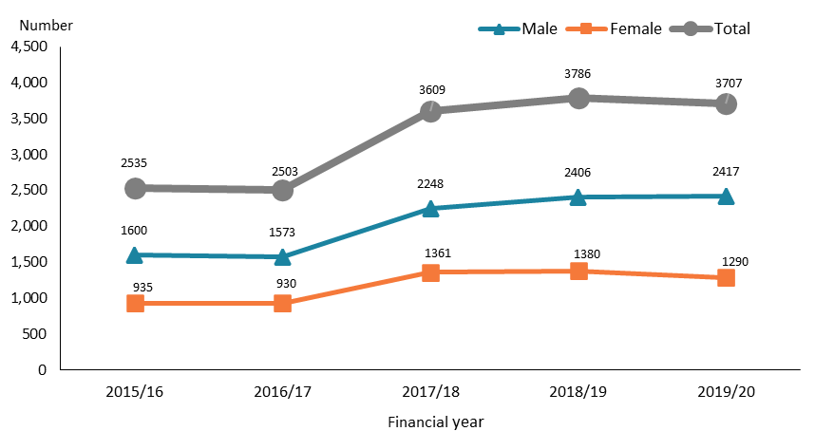

Figure 54: Respite services population, by ethnicity, from 2015/16 to 2019/20 financial year
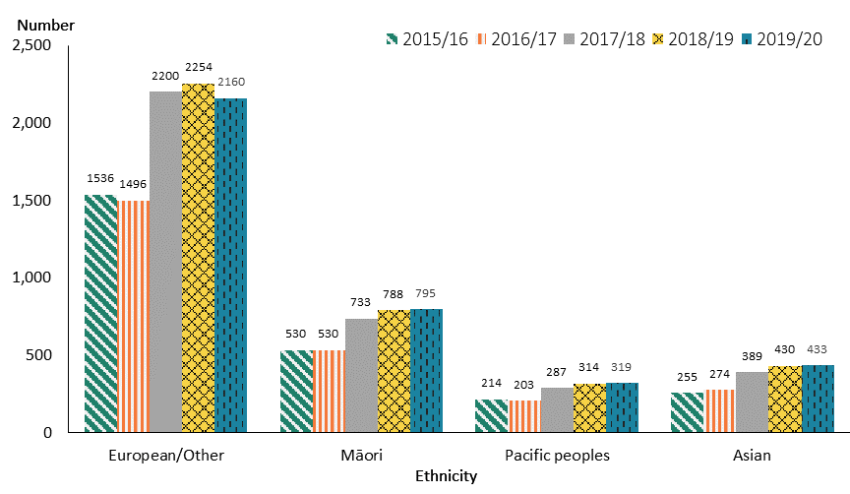

Observations
- There was a significant increase in people allocated respite services from 2016/17 to 2017/18, but a slight decrease from 2018/19 to 2019/20, which appears to reflect a slight downward trend for females only. This increase is likely to be associated with the record change for the family whānau support service, which was initially recorded as HCSS and changed to respite services from 2017/18.
- The number of people accessing respite services across all ethnicities demonstrated a significant increase between 2016/17 and 2017/18.

Behaviour support services
Behaviour support services aim to improve the quality of life of people who have behaviours of concern, making it easier for them to be independent and involved in the community. These services work with people and their support networks to develop and implement plans to reduce the impact of challenging behaviour.

Age, sex and ethnicity
Table 18: Behaviour support services population, by age and sex, 2019/20 financial year
Age group | Female | Male | Total
0–4 | 43 | 106 | 149
5–14 | 365 | 1,213 | 1,578
15–24 | 144 | 300 | 444
25–44 | 67 | 118 | 185
45–64 | 22 | 51 | 73
65+ | 6 | 3 | 9
Total | 647 | 1,791 | 2,438
Note: Due to a small number of people, the 65‒79 and 80+ year age groups are combined into one group.
Figure 55: Behaviour support services population, by age and sex, 2019/20 financial year
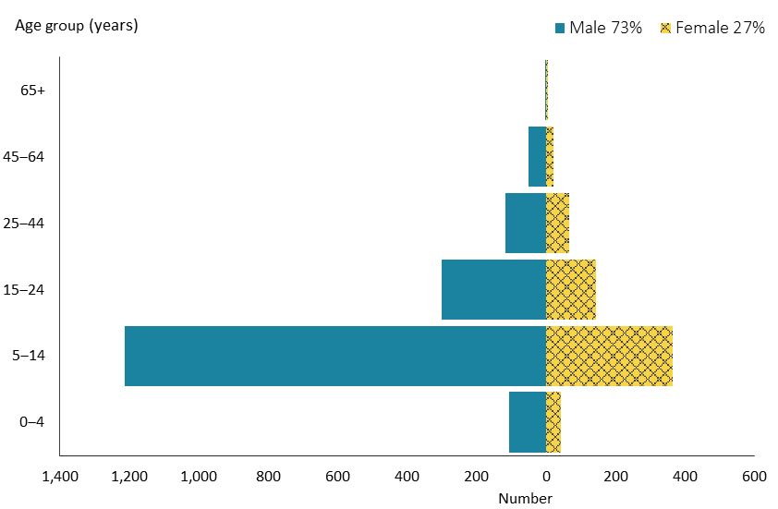

Figure 56: Behaviour support services population, by ethnicity, 2019/20 financial year
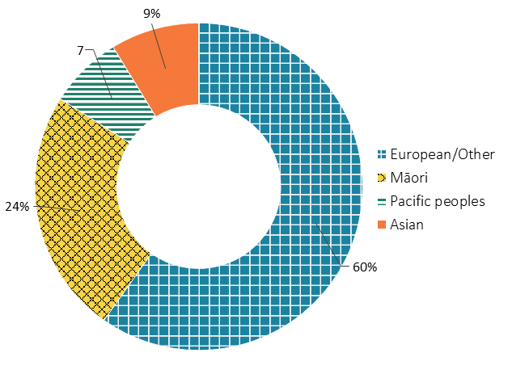

Observations
- Children aged 5–14 years made up the majority of people allocated BSS, comprising 64% of recipients.
- Recipients of BSS were predominantly male.
- In comparison to the New Zealand population, the percentage of Māori among people accessing BSS was considerably higher, while the percentage of Asian ethnicity was relatively lower.

Location
Figure 57: Behaviour support services population, by domicile region, 2019/20 financial year
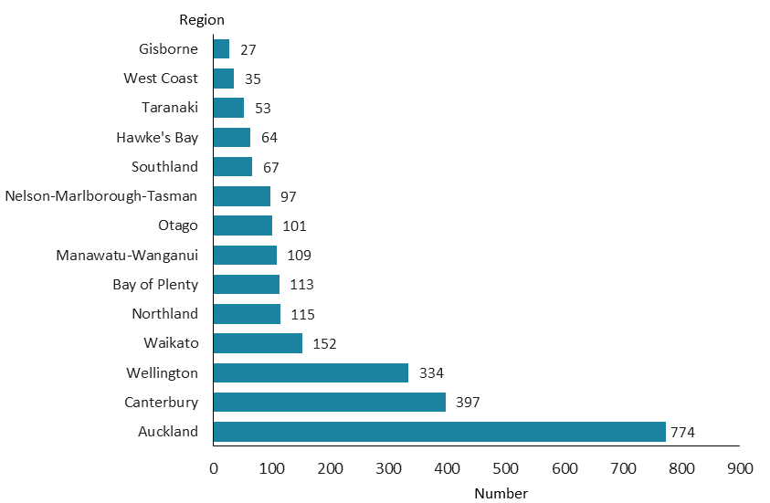

Observations
- The regional spread of BSS recipients was largely consistent with the distribution of DSS recipients in general.

Principal disability
Figure 58: Behaviour support services population, by principal disability type and sex, 2019/20 financial year
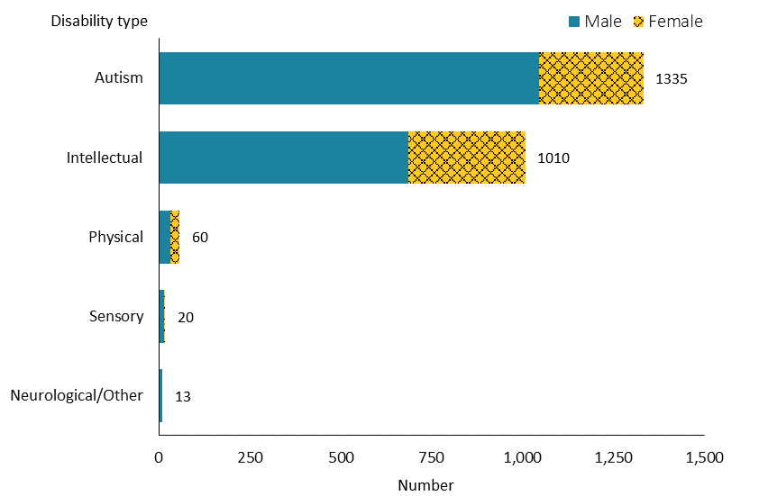

Note: Due to a small number of people, neurological and Other disability types are combined into one group.

Observations
- An overwhelming majority of people allocated BSS either were autistic (55%) or had an intellectual disability (41%).

Support package allocation
Figure 59: Behaviour support services population, by support package allocation level and sex, 2019/20 financial year
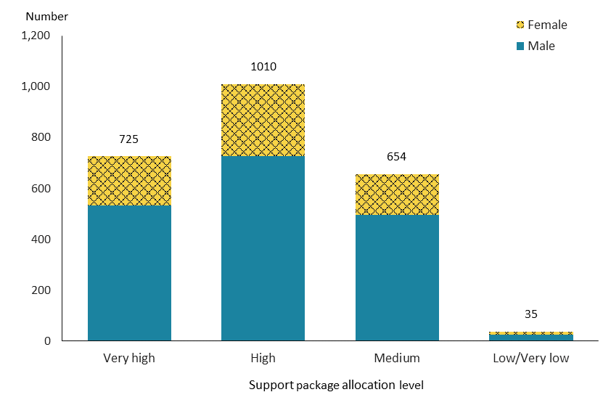
Note: Due to a small number of people, ‘low’ and ‘very low’ levels are combined into one group.

Observations
- About 41% of BSS recipients received a ‘high’ SPA level, followed by 31% who received a ‘very high’ SPA level and 27% who received a ‘medium’ SPA level. This distribution was similar to the distribution of SPA levels among DSS recipients nationally.

Trends
Figure 60: Behaviour support services population, by sex, from 2015/16 to 2019/20 financial year
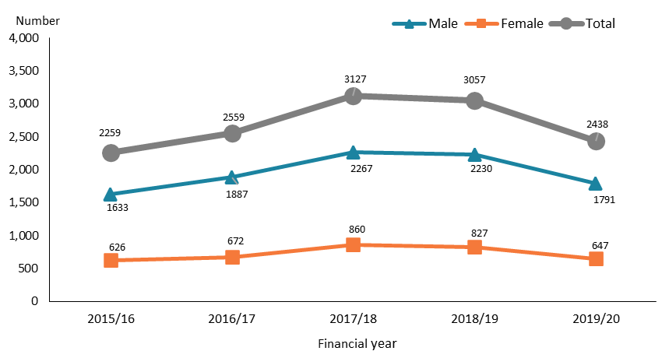

Figure 61: Behaviour support services population, by ethnicity, from 2015/16 to 2019/20 financial year
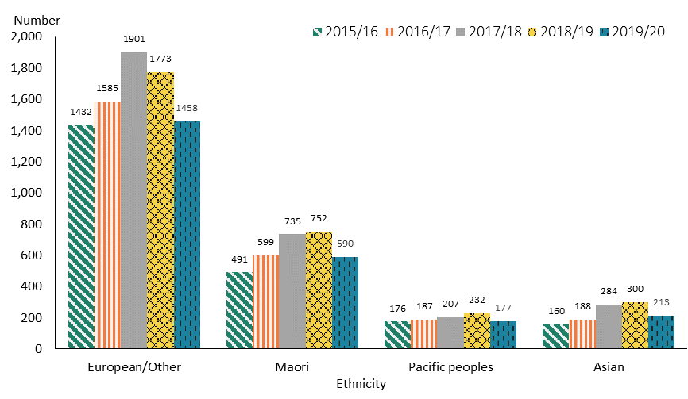

Observations
- Following an increase from 2015/16 to 2017/18, people allocated BSS decreased from 2017/18 to 2019/20. This trend was more significant in males compared to females. The initial increase may be partially related to an increased number of autistic children accessing the services. The subsequent decrease has partially been affected by a lengthening waiting list, which delayed service access and deterred the number of referrals. The reduction in 2019/20 may also be in part due to the impact of the COVID-19 lockdown.
- While a similar trend is shown for different ethnicities, the peak number of people of European/Other ethnicity allocated BSS was in 2017/18, whereas the peak number of people of the other three ethnicities was in 2018/19.

Day services
Day services help disabled adults who are not able to gain employment to participate in their community and improve their personal skills, by providing them access to regular meaningful social contact and stimulating activities. The services include a range of activities, depending on the provider and the individual disabled person’s interests and abilities, that may include training in daily living skills, education and learning activities, social activities, and recreation and leisure activities.

Age, sex and ethnicity
Table 19: Day services population, by age and sex, 2019/20 financial year
Age group | Female | Male | Total
5–24 | 6 | 23 | 29
25–44 | 141 | 255 | 396
45–64 | 294 | 421 | 715
65–79 | 107 | 128 | 235
80+ | 17 | 13 | 30
Total | 565 | 840 | 1,405
Note: Due to a small number of people, the 5–14 and 15–24-year age groups are combined into one group.

Figure 62: Day services population, by age and sex, 2019/20 financial year
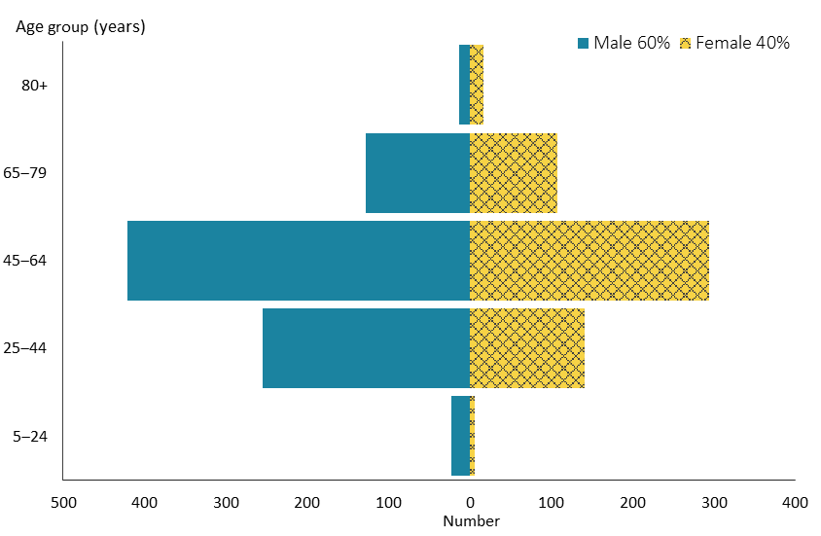

Figure 63: Day services population, by ethnicity, 2019/20 financial year
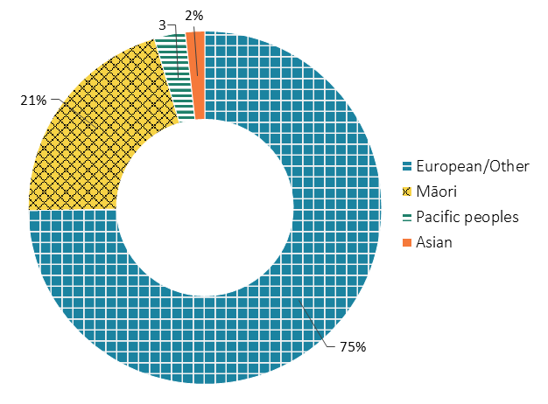

Observations
- The highest number of people allocated day services were in the 45–64-year age group, who made up about half of day services recipients.
- About three-fifths of the recipients of day services were male.
- People of European/Other and Māori ethnicity allocated day services were largely over-represented, and Asian and Pacific peoples were significantly under-represented in comparison to the New Zealand population.

Location
Figure 64: Day services population, by domicile region, 2019/20 financial year
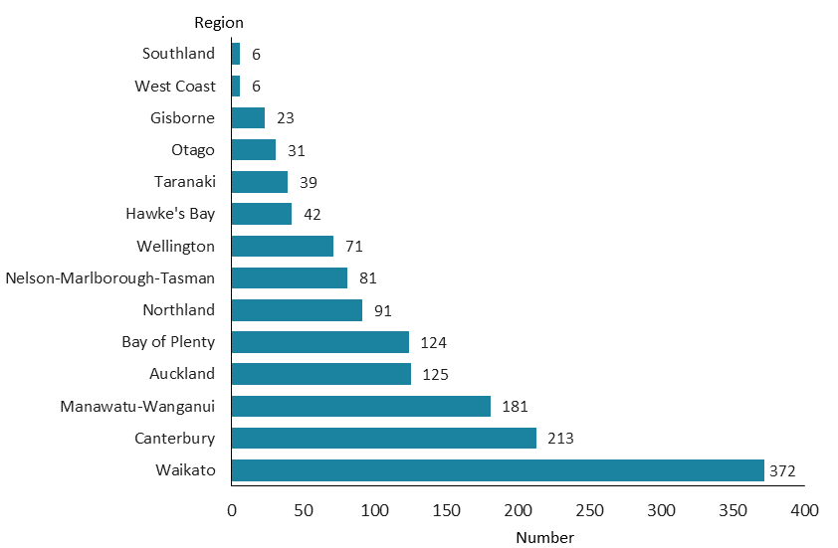

Observations
- The Waikato region had the highest number of people allocated day services, followed by the Canterbury and Manawatu–Whanganui regions. Those regions supported 26%, 15% and 13% of total day services recipients respectively.
- The high numbers of day services recipients in these three regions is likely to be related to the closures of Tokanui Psychiatric Hospital, Sunnyside Hospital and the Kimberley Centre respectively, and the subsequent agreement of the Government to continue to fund day services for people from those facilities.

Principal disability
Figure 65: Day services population, by principal disability type and sex, 2019/20 financial year
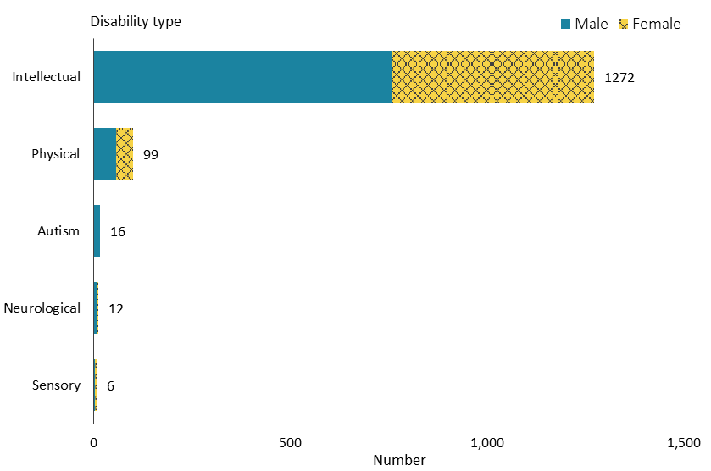

Observations
- The overwhelming majority (91%) of people allocated day services had an intellectual disability.

Support package allocation
Figure 66: Day services population, by support package allocation level and sex, 2019/20 financial year
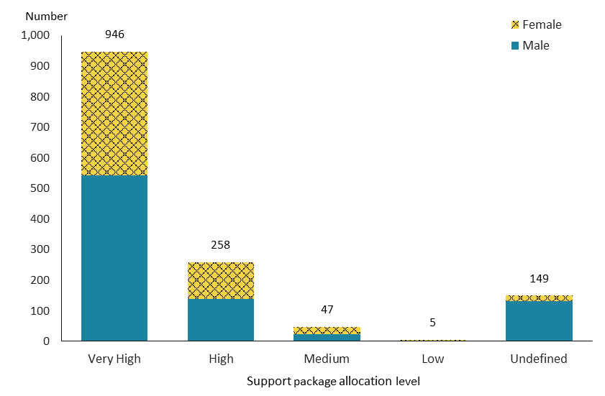

Observations
- Two-thirds of day services recipients required a ‘very high’ SPA level.

Trends

Figure 67: Day services population, by sex, from 2015/16 to 2019/20 financial year
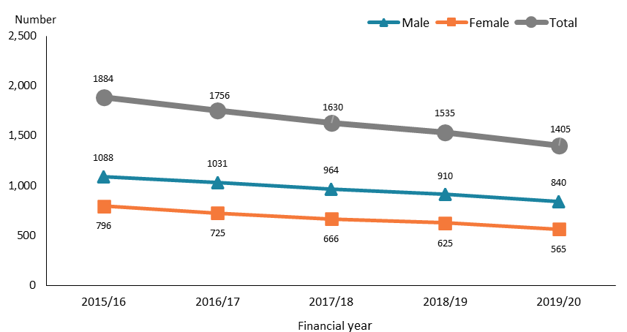

Figure 68: Day services population, by ethnicity, from 2015/16 to 2019/20 financial year
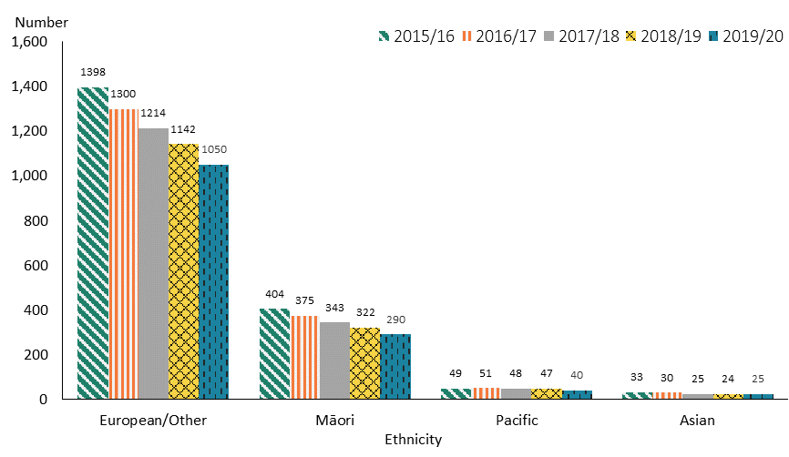

Observations
- The number of people allocated day services continued to decline from 2015/16 to 2019/20 at a similar rate for males and females.
- The number of day services recipients of all ethnicities decreased over the five years.

High and Complex Framework
High and Complex (H&C) Framework services provide care and rehabilitation for people with an intellectual disability under the Intellectual Disability (Compulsory Care and Rehabilitation) Act 2003. The services include regional intellectual disability secure services and regional intellectual disability supported accommodation services. These services are coordinated by the Forensic Coordination Service. The principal disability of all people allocated H&C services is intellectual disability. Support package allocation levels are not applicable for H&C people.

Age, sex and ethnicity
Table 20: High and Complex Framework population, by age and sex, 2019/20 financial year
Age group | Female | Male | Total
15–24 | 7 | 39 | 46
25–44 | 9 | 124 | 133
45–79 | 16 | 46 | 62
Total | 32 | 209 | 241
Note: Due to a small number of people, the 45–64 and 65–79 year age groups are combined into one group.

Figure 69: High and Complex Framework population, by age and sex, 2019/20 financial year
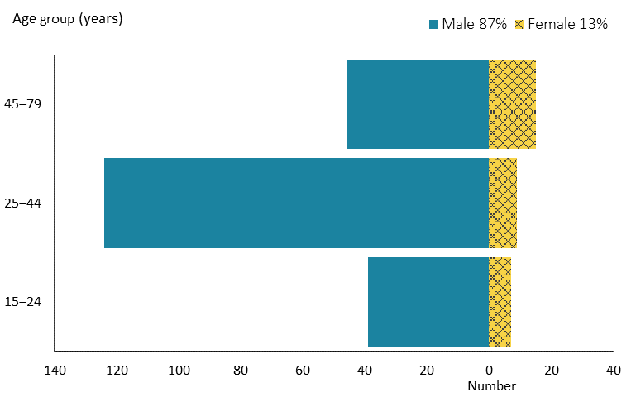

Figure 70: High and Complex Framework population, by ethnicity, 2019/20 financial year
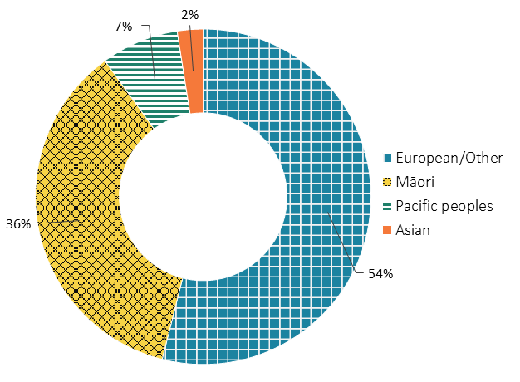

Observations
- There are substantially more males than females among people receiving H&C services.
- People accessing H&C services fall predominately in the 25–44-year age group, comprising 55% of total H&C services recipients.
- Māori are significantly over-represented among H&C services recipients, while European/Other and Asian ethnicities are under-represented, compared to the national ethnicity composition.

Location
Figure 71: High and Complex Framework population, by region*, 2019/20 financial year
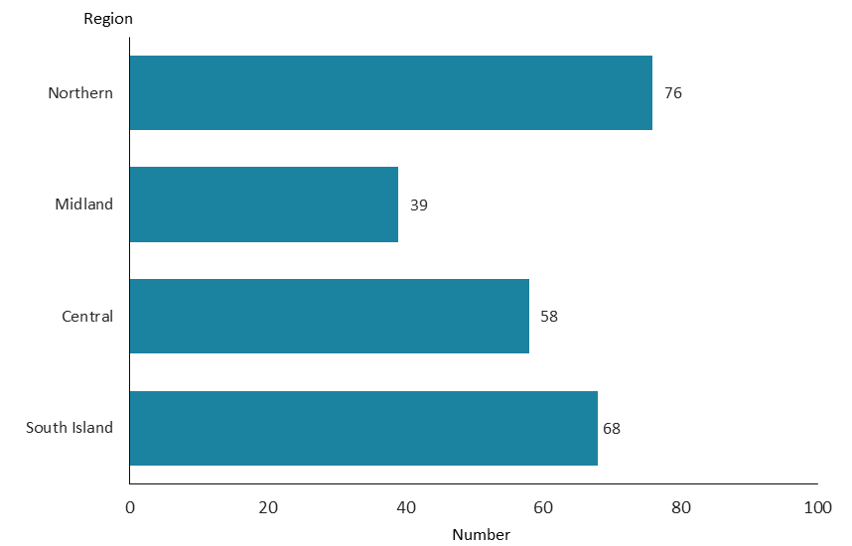
* The locations of H&C services recipients are assigned according to the four regions where H&C services are allocated.

Observations
- The distribution of H&C services recipients varies across regions: the highest number are in the Northern service region and the lowest in the Midland region.
- Nearly one-third of H&C services recipients are in the Northern region.

Trends
Figure 72: High and Complex Framework population, by sex, from 2015/16 to 2019/20 financial year
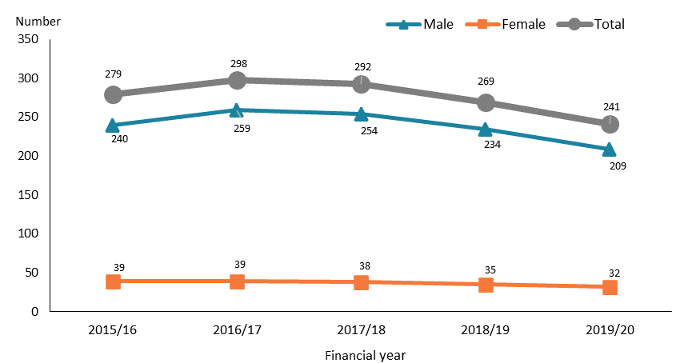

Figure 73: High and Complex Framework population, by ethnicity, from 2015/16 to 2019/20 financial year
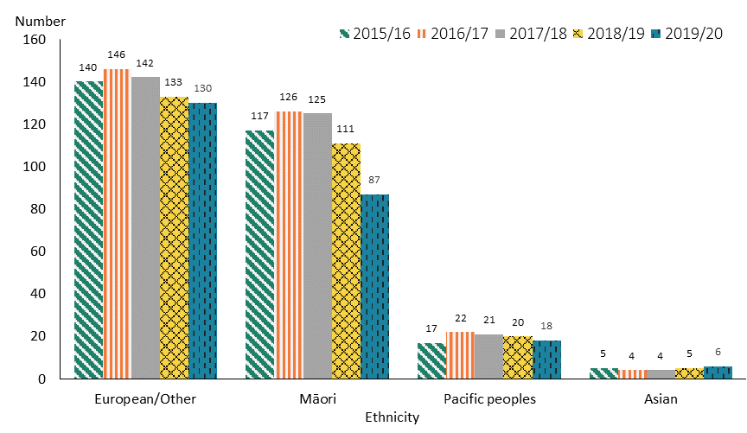

Observations
- Following a slight initial increase after 2015/16, the numbers of H&C services recipients showed a decreasing trend from 2016/17 to 2019/20. This trend was more noticeable for males than for females.
- Numbers were relatively stable for the small number of Pacific peoples and Asian people, but the trend for the European/Other and Māori ethnicities followed the same pattern over time, with a more significant drop apparent from 2018/19 to 2019/20 for Māori.

Choice in community living
Choice in community living is an alternative to residential services and aims to give people more choice and control of their living circumstances – where they live, who they live with and how they are supported. In addition, CiCL aims to assist with the development of skills and capabilities to support independent living and create opportunities for relationships, community access and participation.

Age, sex and ethnicity
Table 21: Choice in community living population, by age and sex, 2019/20 financial year
Age group | Female | Male | Total
15–24 | 4 | 15 | 19
25–44 | 67 | 73 | 140
45–64 | 43 | 45 | 88
65–79 | 12 | 9 | 21
Total | 126 | 142 | 268

Figure 74: Choice in community living population, by age and sex, 2019/20 financial year
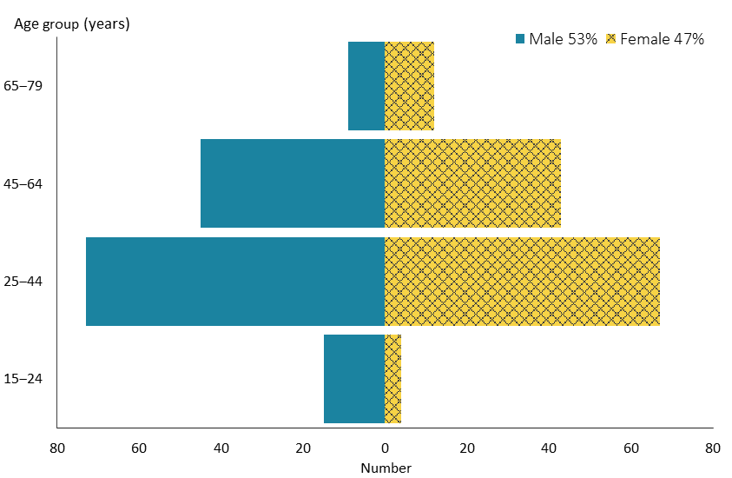

Figure 75: Choice in community living population, by ethnicity, 2019/20 financial year
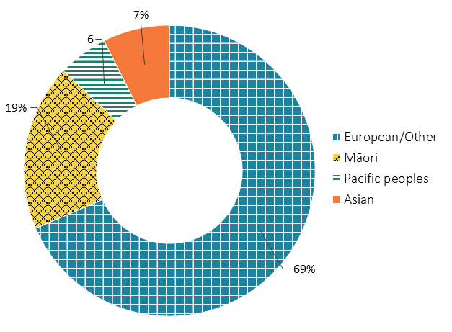

Observations
- Most people allocated CiCL were aged 25–79 years, with the highest number in the 25–44-year age group, which made up 52% of total CiCL recipients.
- Males slightly outnumbered females among CiCL recipients.
- Compared to the total New Zealand population, the proportions of Māori and European/Other ethnicities among CiCL recipients were higher; however, the proportion of Asian people was significantly lower.

Location
Figure 54: Choice in community living population, by domicile region, 2019/20 financial year
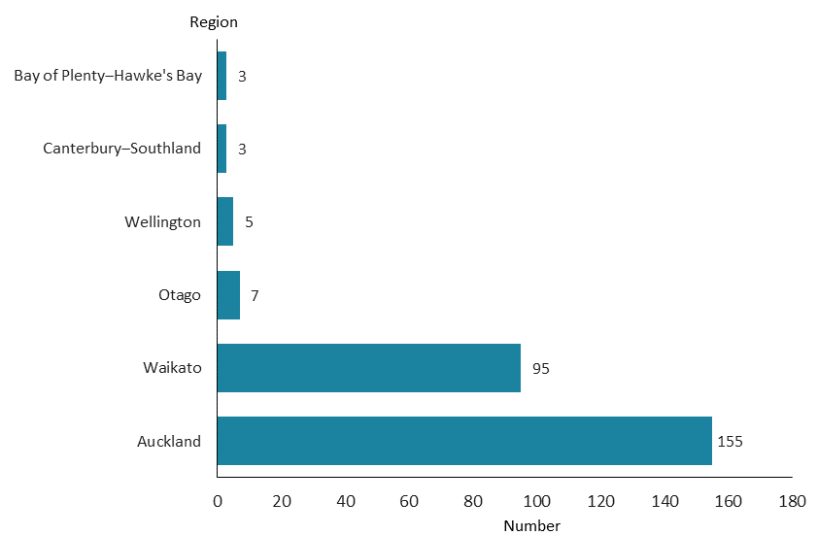
Note: Due to a small number of people, Bay of Plenty and Hawke's Bay regions are combined into one group, and Canterbury and Southland regions are combined into one group.

Observations
- Choice in community living was originally only demonstrated in two regions, Auckland and Waikato, where most people still accessed the services in 2019/20 (58% in Auckland, 36% in Waikato). Since 2016, CiCL has been demonstrated in two new regions: Hutt Valley (Wellington region) and Otago/Southland.

Principal disability
Figure 76: Choice in community living population, by principal disability type and sex, 2019/20 financial year
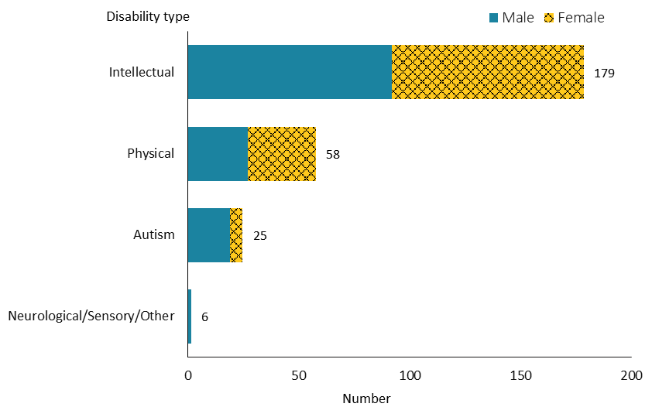
Note: Due to a small number of people, neurological, sensory and Other disability types are combined into one group.

Observations
- The majority (67%) of people accessing CiCL had an intellectual disability.

Support package allocation
Figure 77: Choice in community living population, by support package allocation level and sex, 2019/20 financial year
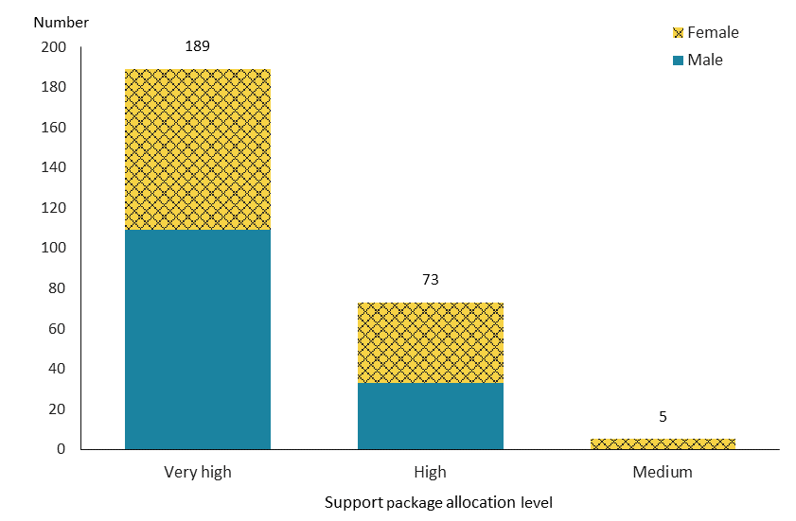

Observations
- Apart from a very small number of people who had a ‘medium’ SPA level, more than two-thirds (70%) of CiCL recipients had a ‘very high’ SPA level and just over one-quarter (27%) had a ‘high’ SPA level.
- This distribution of SPA levels for CiCL recipients contrasted significantly to that for DSS recipients overall, for whom ‘very high’, ‘high’ and ‘medium’ SPA levels were more evenly distributed and the highest number of whom had a high SPA level. This is because eligible CiCL recipients must be assessed as having disability support needs equivalent to those of people requiring a community residential service allocation.

Trends
Figure 78: Choice in community living services population, by sex, from 2015/16 to 2019/20 financial year
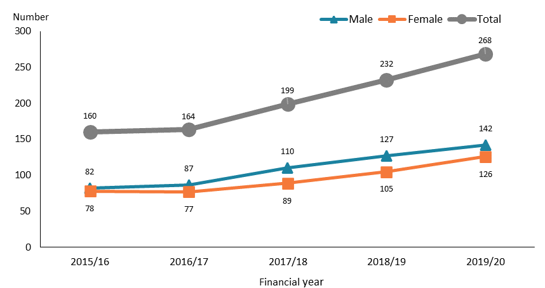

Figure 79: Choice in community living services population, by ethnicity, from 2015/16 to 2019/20 financial year
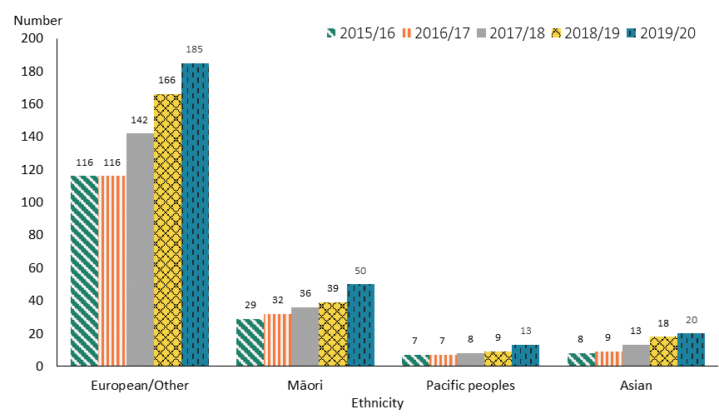

Observations
- There was a marked increase in CiCL recipients of both sexes from 2016/17 to 2019/20.
- CiCL recipients of all ethnicities followed a similar trend over the years; the increase for Māori and Pacific peoples was particularly higher between 2018/19 and 2019/20.

Individualised funding
Individualised funding allows people to directly purchase their own HCSS and respite services. It gives people more choice, control and flexibility in terms of how they are supported.

Age, sex and ethnicity
Table 22: Individualised funding population, by age and sex, 2019/20 financial year
Age group | Female | Male | Total
0–4 | 68 | 69 | 137
5–14 | 739 | 1,559 | 2,298
15–24 | 737 | 1,261 | 1,998
25–44 | 580 | 678 | 1,258
45–64 | 572 | 397 | 969
65+ | 208 | 122 | 330
Total | 2,904 | 4,086 | 6,990
Note: Due to a small number of people, the 65–79 and 80+ year age groups are combined into one group.

Figure 80: Individualised funding population, by age and sex, 2019/20 financial year
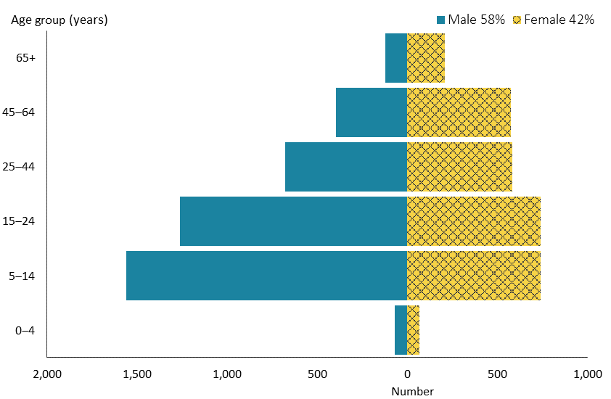

Figure 81: Individualised funding population, by ethnicity, 2019/20 financial year
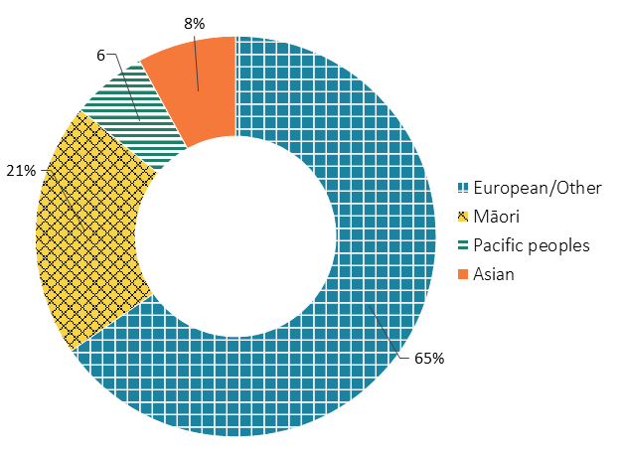

Observations
- People allocated IF were generally younger. Over three-fifths were aged 5–24 years.
- The proportion of males to females accessing IF closely mirrored the sex structure in the wider DSS cohort.
- There were significantly more males than females among younger IF recipients (aged 5–24 years). However, more females than males were older IF recipients (aged 45–79 years).
- There was a significantly higher proportion of Māori, and a significantly lower proportion of Asian people, among IF recipients compared to their counterparts in the wider New Zealand population.

Location
Figure 82: Individualised funding population, by domicile region, 2019/20 financial year
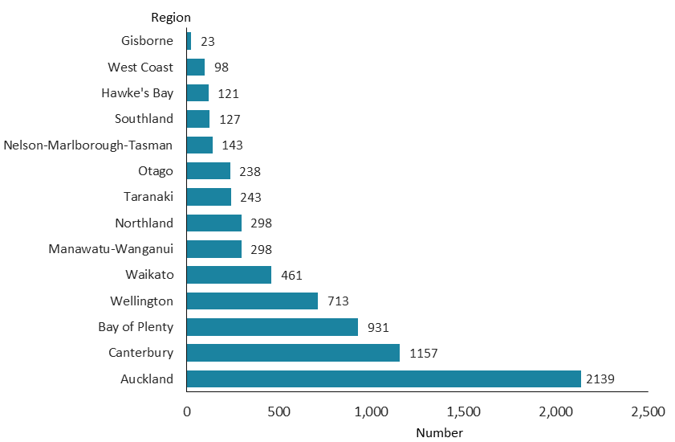

Observations
- Nearly one-third (31%) of IF recipients resided in the Auckland region. The Bay of Plenty had the third-highest number of IF recipients; 13% resided in the region, despite the region only having 5% of New Zealand’s population.

Principal disability
Figure 83: Individualised funding population, by principal disability type and sex, 2019/20 financial year
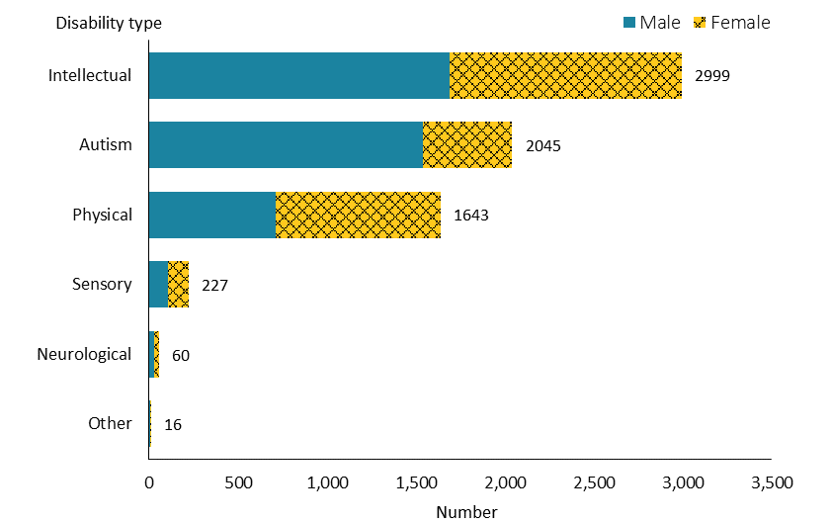

Observations
- Over two-fifths of IF recipients had an intellectual disability. Nearly one-third were autistic, and nearly one-quarter had a physical disability.

Support package allocation
Figure 84: Individualised funding population, by support package allocation level and sex, 2019/20 financial year
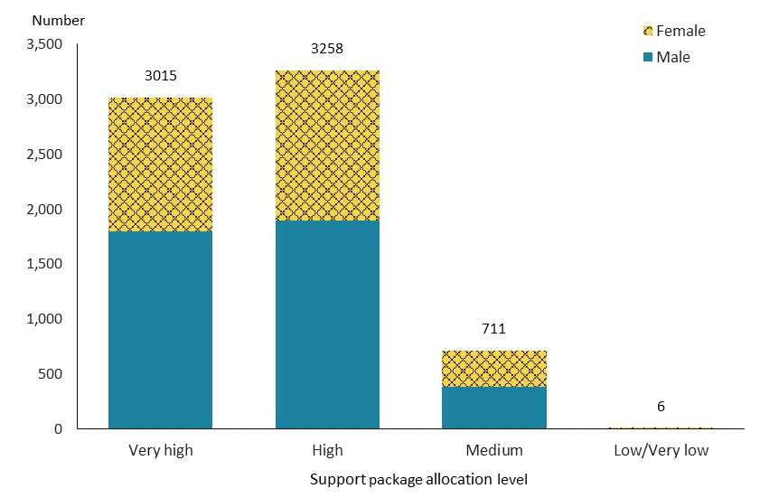
Note: Due to a small number of people, ‘low’ and ‘very low’ levels are combined into one group.

Observations
- About 90% of IF recipients required a ‘very high’ (43%) or ‘high’ (47%) SPA level.

Trends
Figure 85: Individualised funding population, by sex, from 2015/16 to 2019/20 financial year
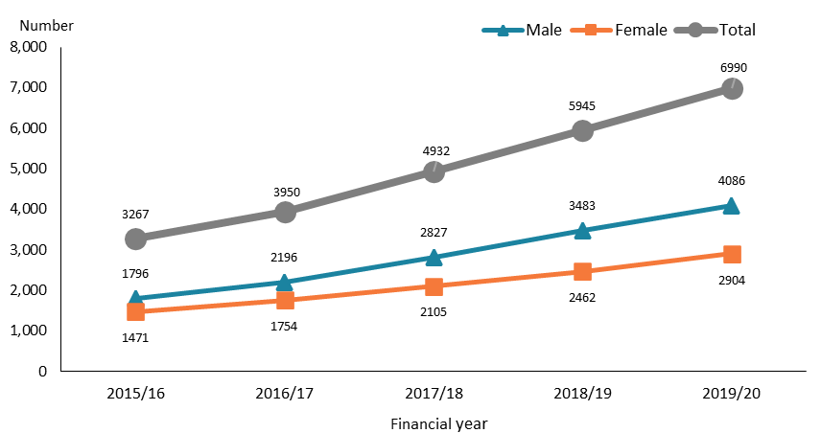

Figure 86: Individualised funding population, by ethnicity, from 2015/16 to 2019/20 financial year
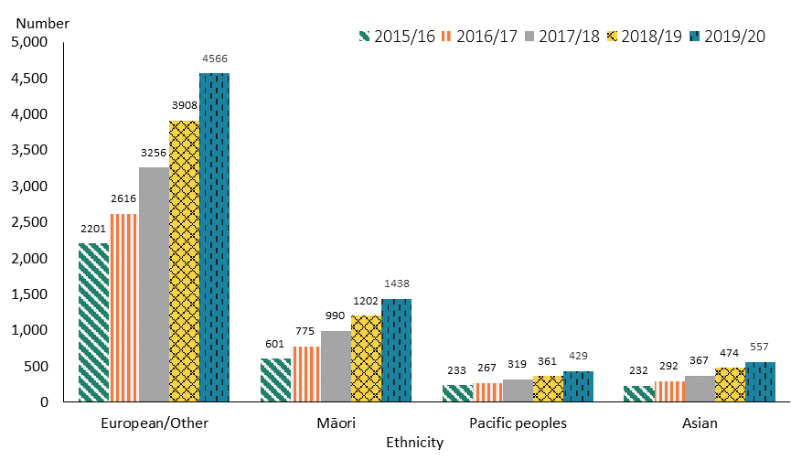

Observations
- The number of IF recipients more than doubled from 2015/16 to 2019/20. The number of males increased at a higher rate than that of females over the five years.
- The increase over the five-year period occurred across all four ethnic groups.

Enhanced individualised funding
Enhanced individualised funding allows people to directly purchase the full range of disability supports they need, under an individualised plan that helps people to achieve their goals. Unlike IF, EIF is not restricted to HCSS and respite services. It is provided by the Ministry of Health, rather than other government agencies (such as the Ministry of Education). Currently, EIF is only available in the Bay of Plenty.

Age, sex and ethnicity
Table 23: Enhanced individualised funding population, by age and sex, 2019/20 financial year
Age group | Female | Male | Total
0–4 |  | 5 | 5
5–14 | 32 | 72 | 104
15–24 | 39 | 58 | 97
25–44 | 43 | 39 | 82
45–64 | 32 | 23 | 55
65–79 | 15 | 8 | 23
Total | 161 | 205 | 366

Figure 87: Enhanced individualised funding population, by age and sex, 2019/20 financial year
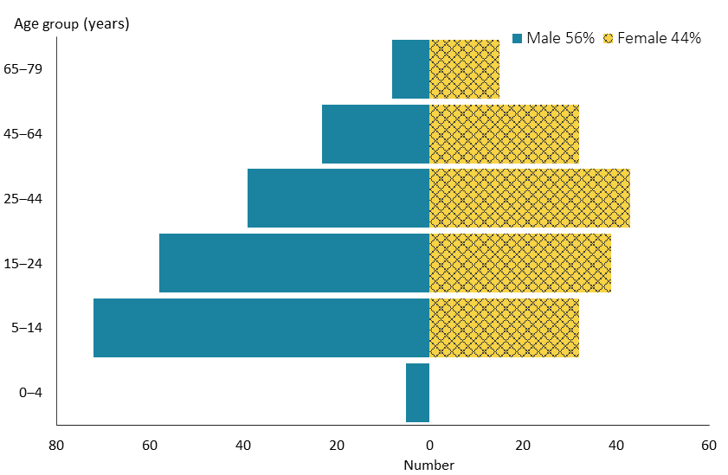

Figure 88: Enhanced individualised funding population, by ethnicity, 2019/20 financial year
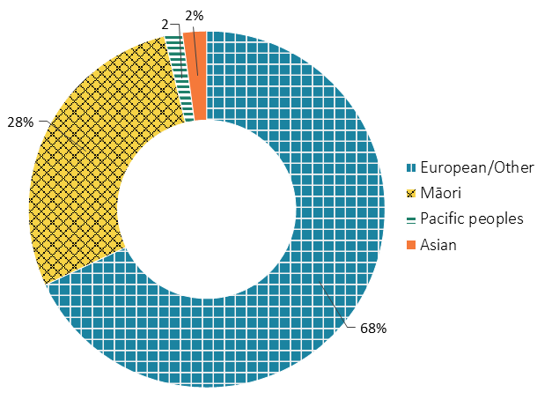

Observations
- More than half (54%) the people allocated EIF were in the 5–14 and 15–24-year age groups.
- There were generally more males than females among EIF recipients, while the sex distributions differed with age. Males significantly exceeded females among younger EIF recipients (those aged 5 to 24 years). Conversely, females greatly outnumbered males among older recipients (those aged 45–79 years).
- There was a significantly higher proportion of Māori among EIF recipients compared with those in the New Zealand population. A contributory factor is likely to be that the EIF demonstration is based in the Bay of Plenty, which as a region has a higher proportion of Māori (26%).
- Conversely, proportions of Pacific peoples and Asian people were significantly lower among EIF recipients in comparison to those ethnicities in the wider population. This may reflect lower proportions of those ethnicities in the Bay of Plenty region (2% and 7% respectively) compared to nationally.

Principal disability
Figure 89: Enhanced individualised funding population, by principal disability type and sex, 2019/20 financial year
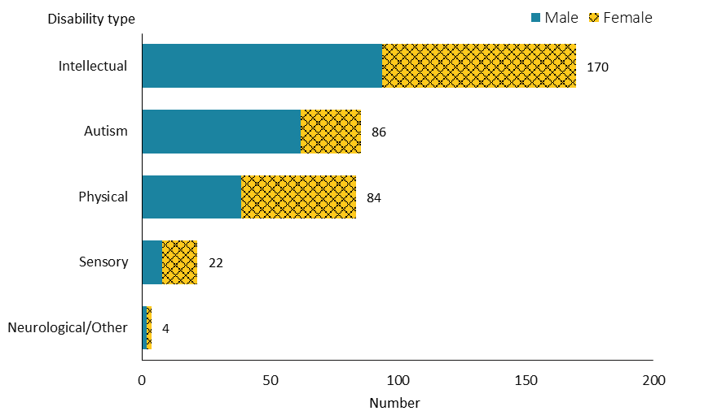
Note: Due to a small number of people, neurological and Other disability types are combined into one group.

Observations
- Just under half (46%) of people accessing EIF had an intellectual disability. A similar number of people either were autistic or had a physical disability (46%).

Support package allocation
Figure 90: Enhanced individualised funding population, by support package allocation level and sex, 2019/20 financial year
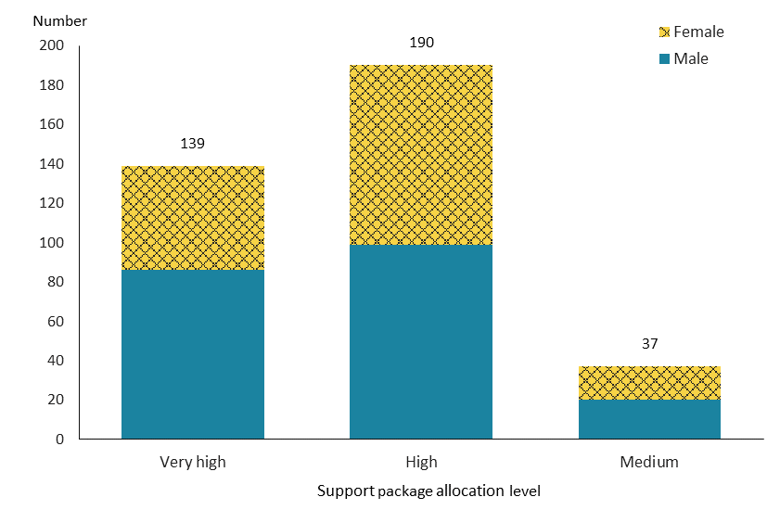

Observations
- All EIF recipients had SPA levels from ‘medium’ to ‘very high’; the highest number of people required a ‘high’ SPA level.

Trends
Figure 91: Enhanced individualised funding population, by sex, from 2015/16 to 2019/20 financial year
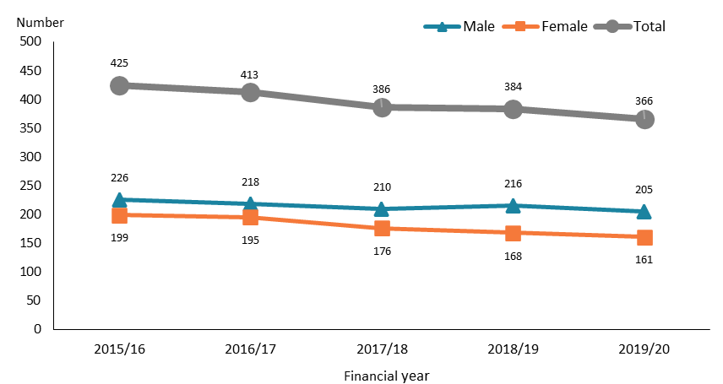

Figure 92: Enhanced individualised funding population, by ethnicity, from 2015/16 to 2019/20 financial year
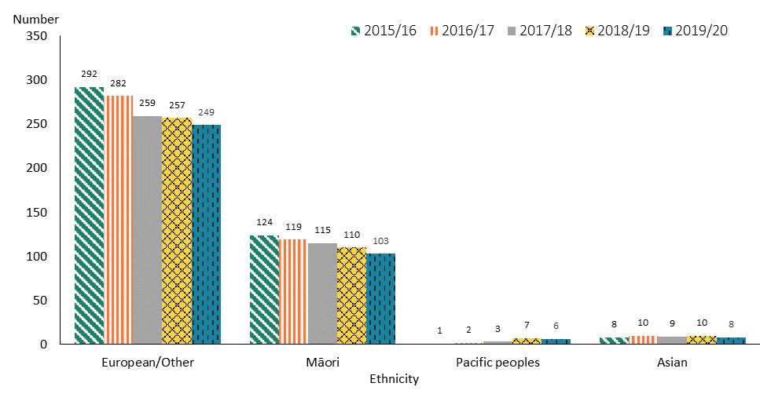

Observations
- The number of people allocated EIF decreased moderately from 2015/16 to 2019/20. The number of females trended down slightly more than the equivalent number for males.
- The number of people of European/Other and Māori ethnicity allocated EIF declined over the five years, whereas the number of Pacific peoples and Asian people allocated EIF remained lower.

Funded family care
Funded family care allows eligible people to employ their parents / family members / whānau aged over 18 years who they live with to provide them with personal care and/or household management.

Note that this service ceased when section 4A of the New Zealand Public Health and Disability Act 2000 was repealed, effective from 1 September 2020.

Age, sex and ethnicity
Table 24: Funded family care population, by age and sex, 2019/20 financial year
Age group | Female | Male | Total
15–24 | 45 | 72 | 117
25–44 | 130 | 180 | 310
45–64 | 39 | 49 | 88
65+ | 7 | 5 | 12
Total | 221 | 306 | 527
Due to a small number, people aged 65 years and over are combined into one group.

Figure 93: Funded family care population, by age and sex, 2019/20 financial year
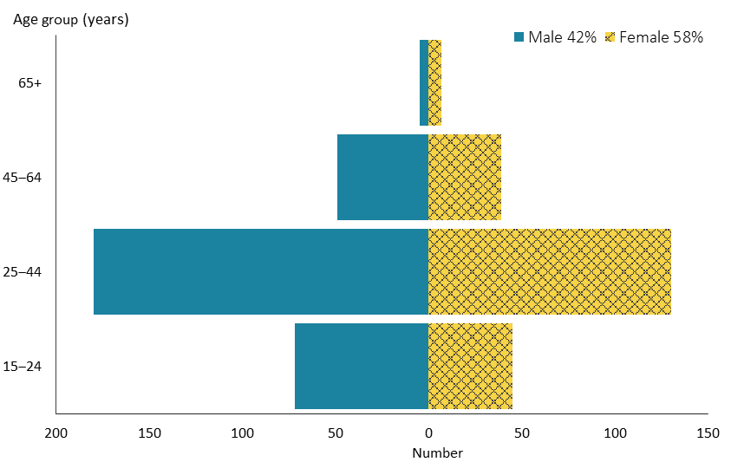

Figure 94: Funded family care population, by ethnicity, 2019/20 financial year
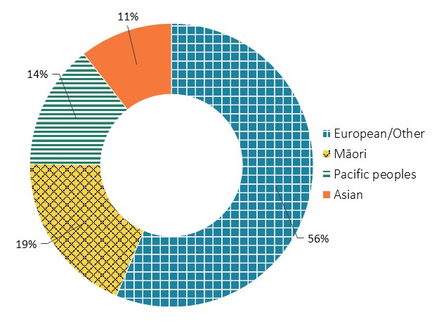

Observations
- Almost all people (98%) allocated FFC were aged 15–64 years; nearly two-thirds were in the 25–44-year age group.
- As among DSS recipients nationally, males significantly exceeded females among people accessing FFC.
- In comparison with the New Zealand population, Māori and particularly Pacific peoples were disproportionately highly represented among FFC recipients, whereas people of European/Other and particularly Asian ethnicity were disproportionately under-represented.

Location
Figure 95: Funded family care population, by domicile region, 2019/20 financial year
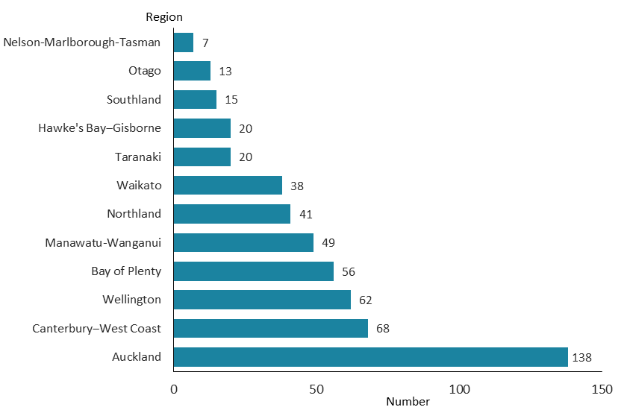

Observations
- Over one-quarter (26%) of FFC recipients resided in the Auckland region. The Canterbury and Wellington regions had the second highest number of FFC recipients: 13% and 12% respectively.

Principal disability
Figure 96: Funded family care population, by principal disability type and sex, 2019/20 financial year
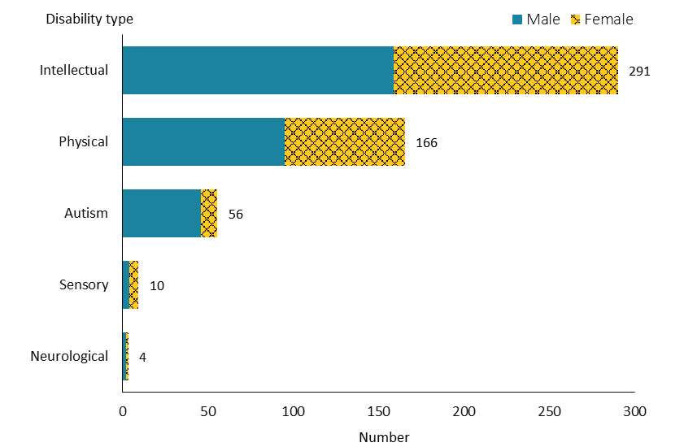

Observations
- Intellectual disability was the most represented disability type among FCC recipients (55%). A further one-third of FCC recipients had a physical disability as their principal disability.

Support package allocation
Figure 97: Funded family care population, by support package allocation level and sex, 2019/20 financial year
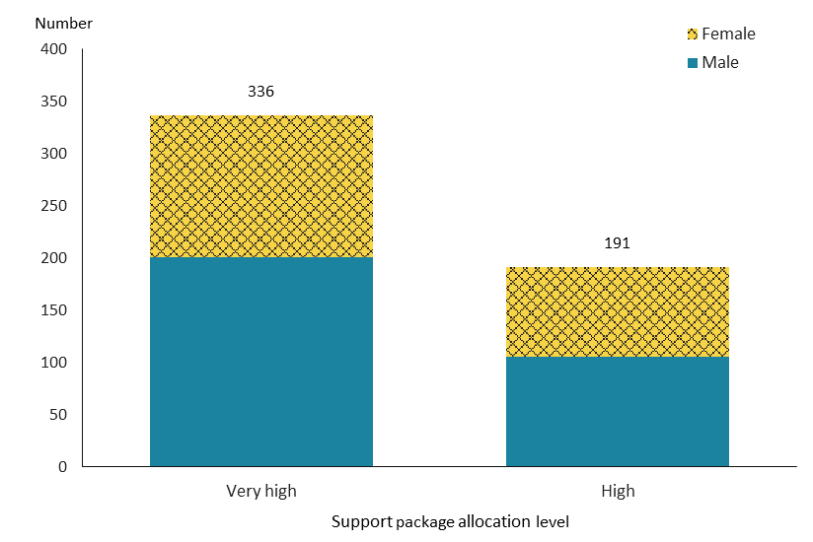

Observations
- Funded family care was solely provided to people who required a ‘very high’ or ‘high’ level of SPA.
- A majority of FFC recipients (64%) had a ‘very high’ SPA level.

Trends
Figure 98: Funded family care population, by sex, from 2015/16 to 2019/20 financial year
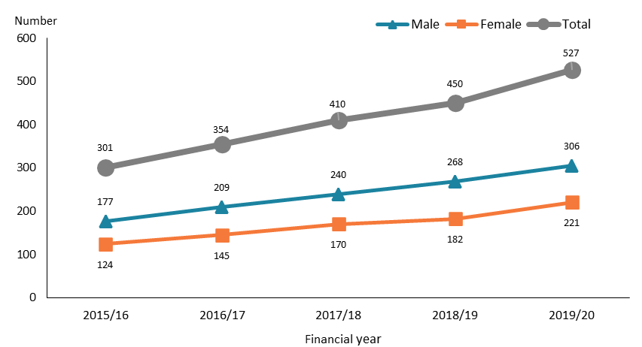

Figure 99: Funded family care population, by ethnicity, from 2015/16 to 2019/20 financial year
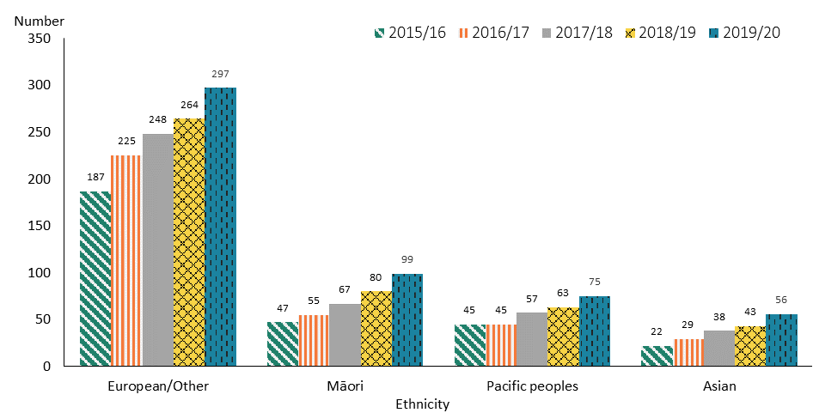

Observations
- The number of FFC recipients increased annually from 2015/16 to 2019/20. There was faster growth from 2018/19 to 2019/20, which likely reflects the introduction of expanded eligibility for FFC.
- The number of FFC recipients across all ethnicities markedly increased from 2018/19 to 2019/20.

Community rehabilitation
Community rehabilitation services help eligible people to maximise their functional independence and participation in the community.

Age, sex and ethnicity
Table 24: Community rehabilitation population, by age and sex, 2019/20 financial year
Age group | Female | Male | Total
15–44 | 10 | 6 | 16
45–79 | 23 | 33 | 56
Total | 33 | 39 | 72
Note: Due to a small number of people, the 15–24 and 25–44-year age groups are combined into one group, and 45–64 and 65–79-year age groups are combined into one group.

Figure 100: Community rehabilitation population, by age and sex, 2019/20 financial year
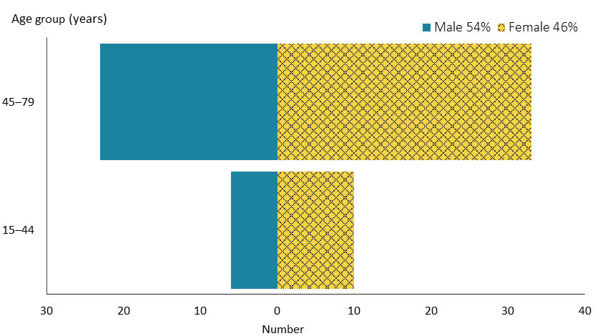

Figure 101: Community rehabilitation population, by ethnicity, 2019/20 financial year
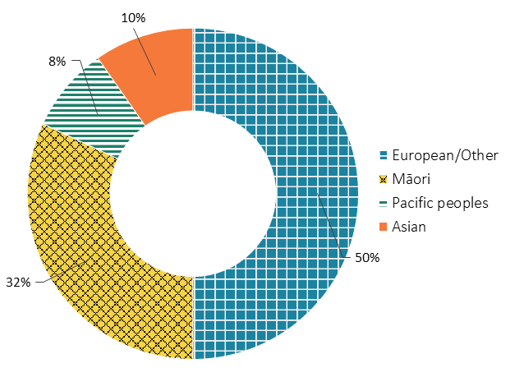

Observations
- All people allocated community rehabilitation services were aged 15–79 years, and 71% were in the 45–64-year age group.
- Males slightly outnumbered females among people accessing the service.
- Compared with the New Zealand ethnic distribution, Māori were over-represented, and people of European/Other and Asian ethnicity were under-represented.

Location
Figure 102: Community rehabilitation population, by domicile region,* 2019/20 financial year
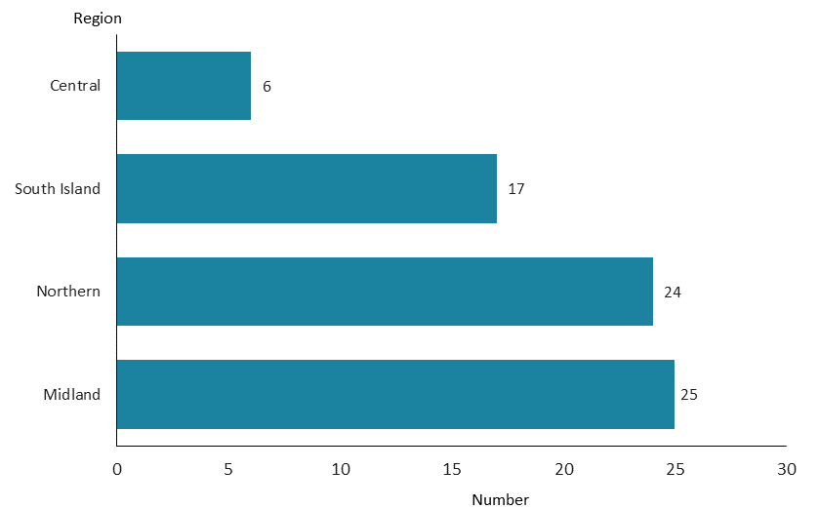
* Due to a small number of people, the location of people allocated community rehabilitation service is presented by four regions.

Observations
- The majority of community rehabilitation recipients resided in the Midland (35%) and Northern (33%) regions.

Principal disability
Figure 103: Community rehabilitation population, by principal disability type and sex, 2019/20 financial year
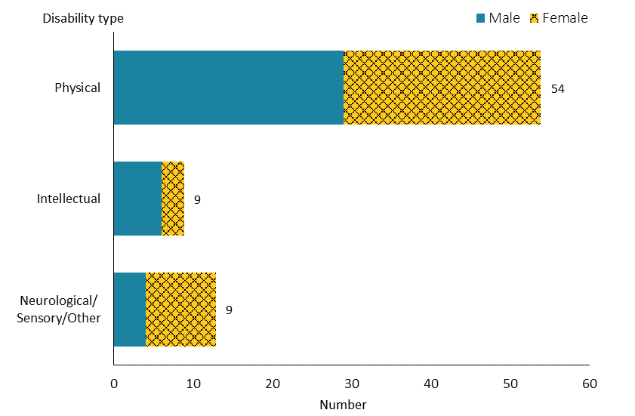
Note: Due to a small number of people, neurological, sensory and Other disability types are combined into one group.

Observations
- Three-quarters of community rehabilitation recipients had a physical disability.

Support package allocation
Figure 104: Community rehabilitation population, by support package allocation level and sex, 2019/20 financial year
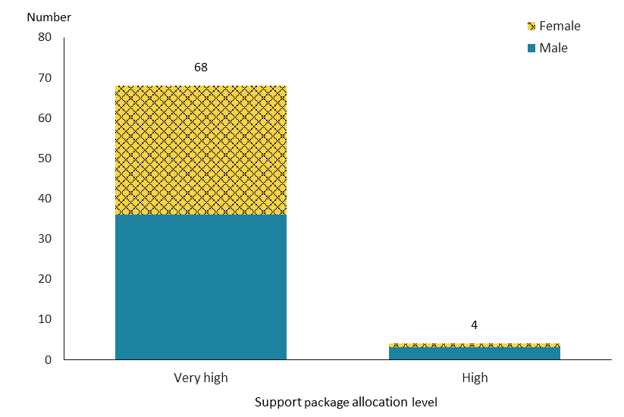

Observations
- All community rehabilitation recipients required either a ‘very high’ or ‘high’ level of SPA; most (94%) required a ‘very high’ level of support.

Trends
Figure 105: Community rehabilitation population, by sex, from 2015/16 to 2019/20 financial year
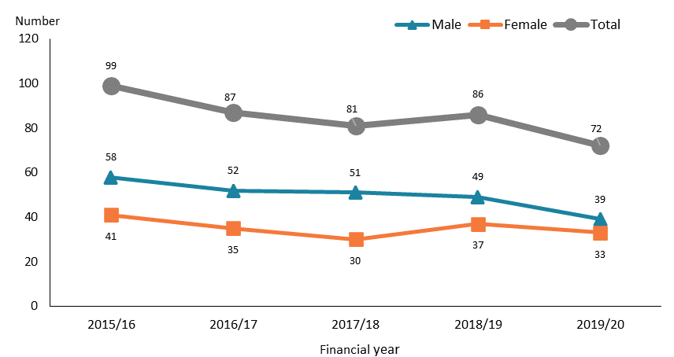

Figure 106: Community rehabilitation population, by ethnicity, from 2015/16 to 2019/20 financial year
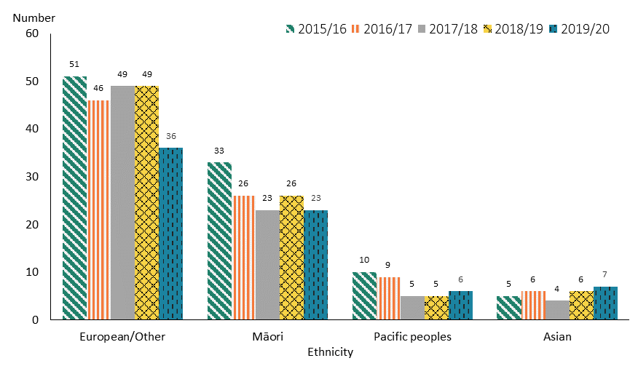

Observations
- The number of people allocated community rehabilitation services continued to decline from 2015/16 to 2019/20, particularly for males.
- Over the five-year period, numbers of people allocated community rehabilitation services generally declined across ethnic groups, with a notable decrease after 2018/19 for those of European/Other ethnicity. Numbers were more stable for the small number of Asian people.

Disability support services demographics by principal disability

This section provides the demographic profiles of DSS recipients with each of five principal disability types. Appendix 1 provides more details about disability types and related conditions.

As illustrated earlier in this report, data presented in this section includes only people allocated DSS as recorded in Socrates, and excludes people accessing DSS which not collected in Socrates. Of note, many people with a sensory disability access hearing and vision services that are not recorded in Socrates. Later sections provide this information.

Intellectual disability

Table 25: Disability support service allocations for people whose principal disability is intellectual disability, by age and sex, 2019/20 financial year
Age group | Female | Male | Total
0–4 | 162 | 233 | 395
5–14 | 1,501 | 2,647 | 4,148
15–24 | 1,660 | 2,364 | 4,024
25–44 | 2,178 | 2,757 | 4,935
45–64 | 2,111 | 2,515 | 4,626
65–79 | 595 | 653 | 1,248
80+ | 52 | 40 | 92
Total | 8,259 | 11,209 | 19,468

Figure 107: Disability support service allocations for people whose principal disability is intellectual disability, by age and sex, 2019/20 financial year
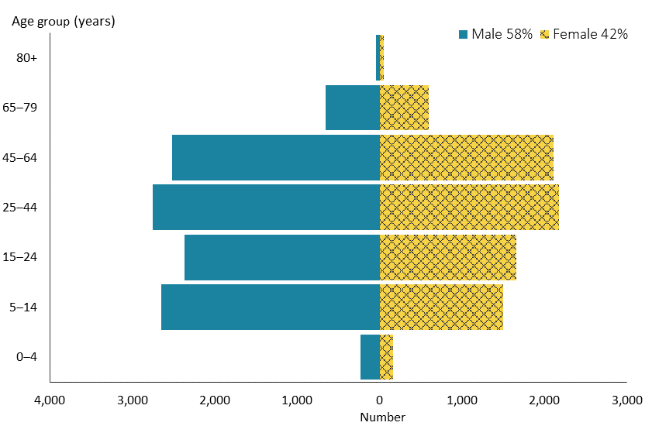

Figure 108: Disability support service allocations for people whose principal disability is intellectual disability, by ethnicity, 2019/20 financial year

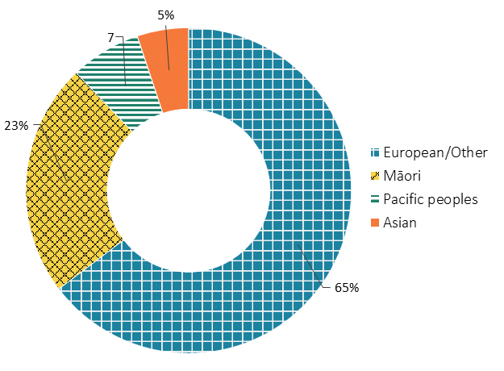

Figure 109: Disability support service allocations for people whose principal disability is intellectual disability, from 2015/16 to 2019/20
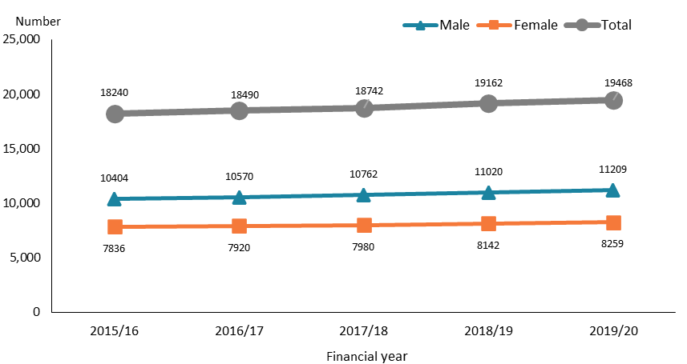

Observations
- People with an intellectual disability were spread relatively evenly across the age groups from 5–14 to 45–64 years.
- Nearly three-fifths of people with an intellectual disability were male.
- Compared to the ethnic composition of DSS recipients in general, there was a higher proportion of Māori among those who had an intellectual disability. Conversely, the proportion of Asian people with an intellectual disability was lower.
- There was a slight annual increase in people with an intellectual disability who were allocated DSS from 2015/16 to 2019/20.

Physical disability

Table 26: Disability support service allocations for people whose principal disability is physical disability, by age, 2019/20 financial year
Age group | Female | Male | Total
0–4 | 42 | 37 | 79
5–14 | 230 | 318 | 548
15–24 | 265 | 326 | 591
25–44 | 620 | 580 | 1,200
45–64 | 2,125 | 1,477 | 3,602
65–79 | 1,441 | 757 | 2,198
80+ | 75 | 26 | 101
Total | 4,798 | 3,521 | 8,319

Figure 110: Disability support service allocations for people whose principal disability is physical disability, by age and sex, 2019/20 financial year
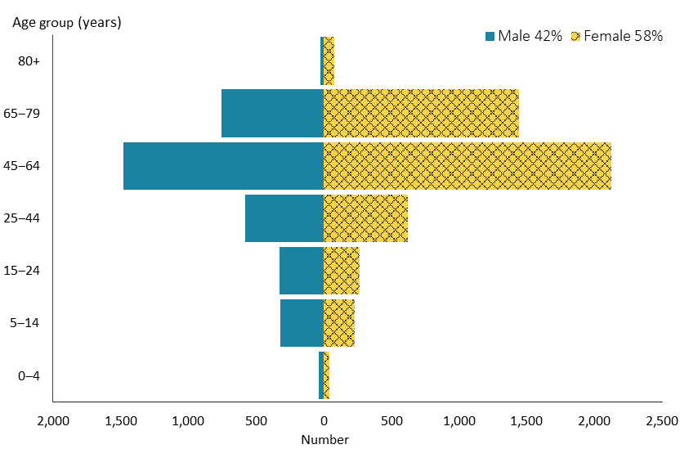

Figure 111: Disability support service allocations for people whose principal disability is physical disability, by ethnicity, 2019/20 financial year
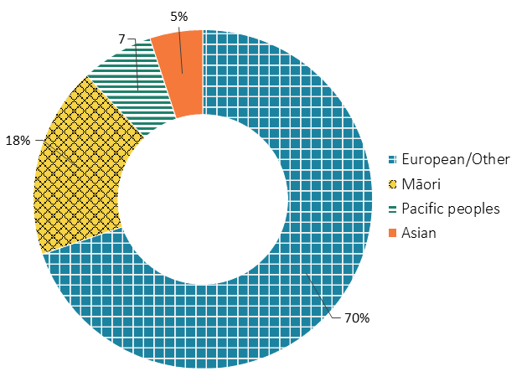

Figure 112: Disability support service allocations for people whose principal disability is physical disability, from 2015/16 to 2019/20
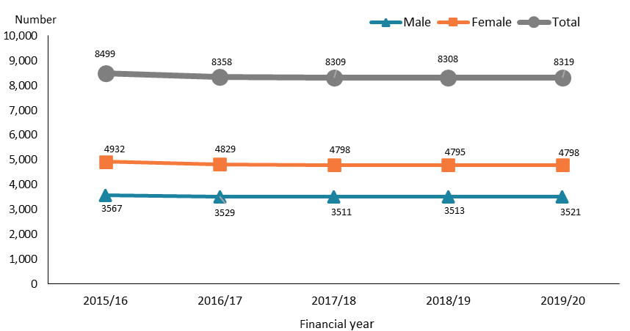

Observations
- People with a physical disability were markedly prevalent in the 45–64-year age group (43%), followed by the 65–79-year age group (26%).
- In contrast to people with an intellectual disability, nearly three-fifths of people with a physical disability were female, and about two-fifths were male.
- People of European/Other ethnicity were over-represented among those with a physical disability compared to DSS recipients overall. However, Māori and Asian people were under-represented.
- The number of people whose principal disability is physical disability was stable over the five-year period, with the possibility of a marginal trend down over this time.

Autism

Table 27: Disability support service allocations for people whose principal disability is autism, by age and sex, 2019/20 financial year
Age group | Female | Male | Total
0–4 | 89 | 319 | 408
5–14 | 1,226 | 4,850 | 6,076
15–24 | 666 | 2,376 | 3,042
25–44 | 243 | 753 | 996
45–64 | 52 | 143 | 195
65–79 | 9 | 13 | 22
Total | 2,285 | 8,454 | 10,739

Figure 113: Disability support service allocations for people whose principal disability is autism, by age and sex, 2019/20 financial year
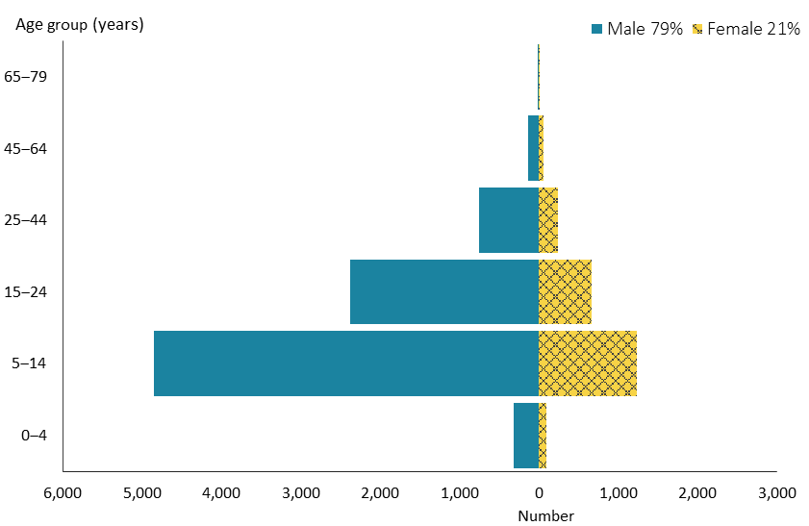

Figure 114: Disability support service allocations for people whose principal disability is autism, by ethnicity, 2019/20 financial year
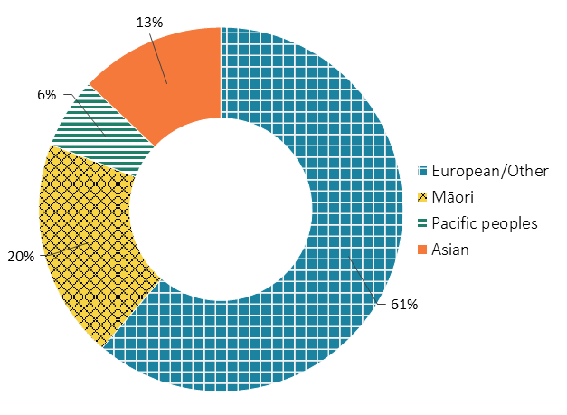

Figure 115: Disability support service allocations for people whose principal disability is autism, from 2015/16 to 2019/20
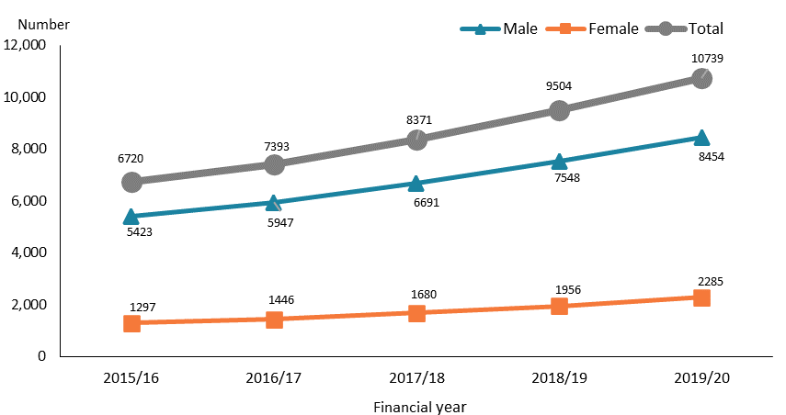

Observations
- People with autism were predominately younger; two-thirds were in the 5–14-year age group.
- There were almost four times as many males with autism as females.
- While the proportions of European/Other and Pacific peoples among the DSS recipients with autism were slightly lower compared to those for DSS recipients generally, the proportions for Māori and Asian people were significantly higher.
- There was a significant growth in the number of autistic people allocated DSS from 2015/16 to 2019/20. This was particularly the case for autistic males.

Sensory disability

Table 28: Disability support service allocations for people whose principal disability is sensory disability, by age, 2019/20 financial year
Age group | Female | Male | Total
0–4 | 5 | 7 | 12
5–14 | 56 | 91 | 147
15–24 | 51 | 84 | 135
25–44 | 118 | 88 | 206
45–64 | 208 | 194 | 402
65–79 | 82 | 76 | 158
80+ | 10 | 2 | 12
Total | 530 | 542 | 1,072

Figure 116: Disability support service allocations for people whose principal disability is sensory disability, by age and sex, 2019/20 financial year
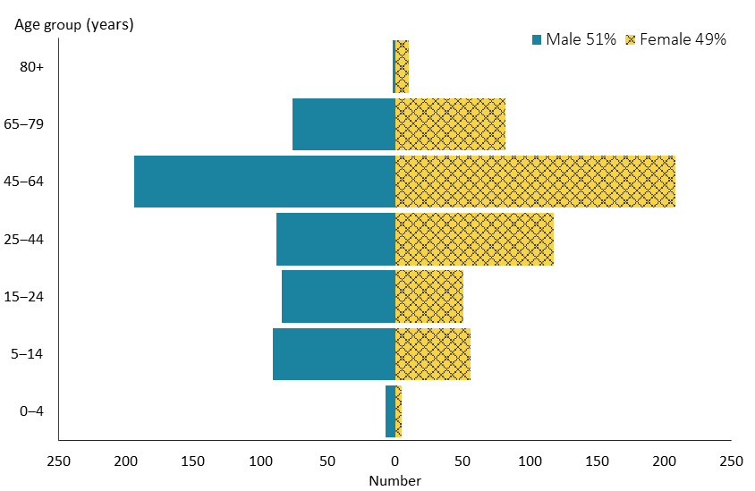

Figure 117: Disability support service allocations for people whose principal disability is sensory disability, by ethnicity, 2019/20 financial year
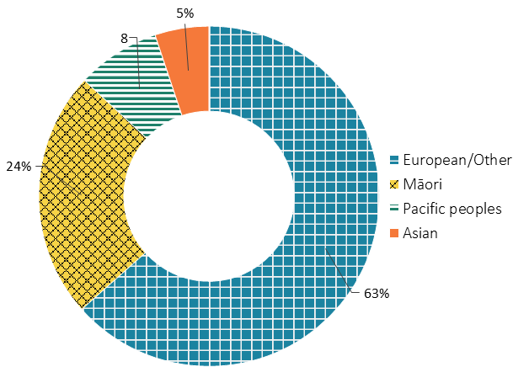

Figure 118: Disability support service allocations for people whose principal disability is sensory disability, from 2015/16 to 2019/20
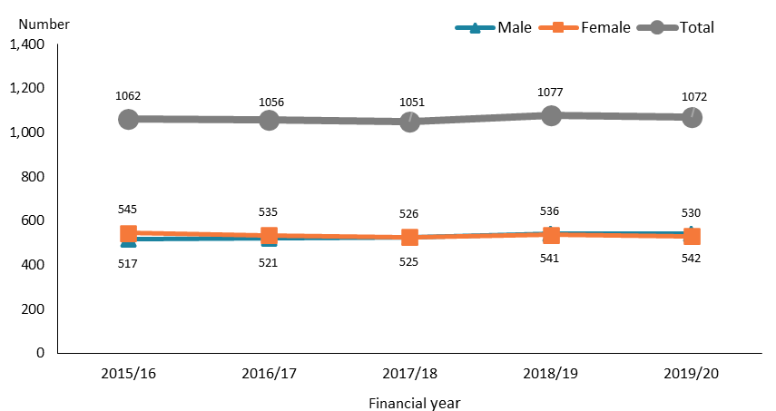

Observations
- There was a significantly higher number of people in the 45–64-year age group (38%) among DSS recipients with a sensory disability.
- The number of males and females with a sensory disability was very similar.
- Māori among DSS recipients with a sensory disability were significantly over-represented and, conversely, Asian people were significantly under-represented compared to DSS recipients overall.
- The number of DSS recipients with a sensory disability remained relatively stable over the five-year period.

Neurological disability

Table 29: Disability support service allocations for people whose principal disability is neurological disability, by age, 2019/20 financial year
Age group | Female | Male | Total
0–14 | 14 | 12 | 26
15–24 | 6 | 10 | 16
25–44 | 23 | 26 | 49
45–64 | 55 | 70 | 125
65+ | 37 | 27 | 64
Total | 135 | 145 | 280
Note: Due to a small number of people, the 0‒4 and 5‒14-year age groups are combined into one group, and people aged 65 years and over are combined into one group.

Figure 119: Disability support service allocations for people whose principal disability is neurological disability, by age and sex, 2019/20 financial year
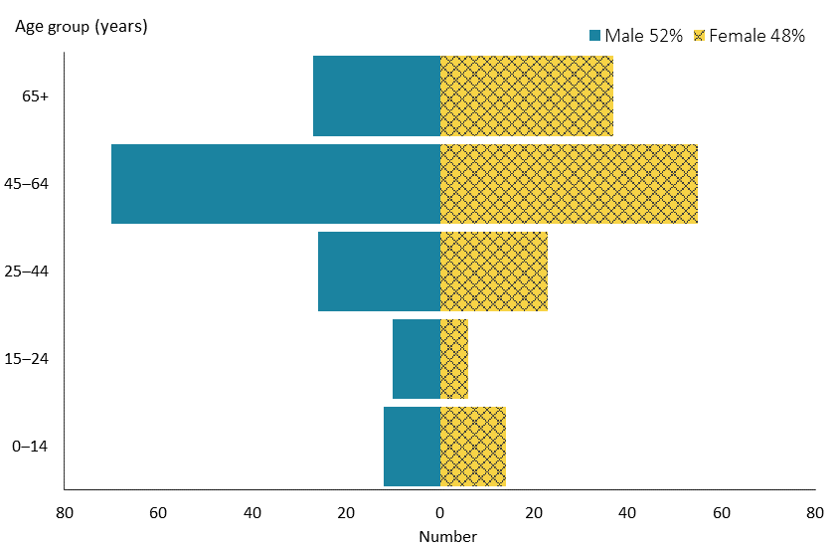

Figure 120: Disability support service allocations for people whose principal disability is neurological disability, by ethnicity, 2019/20 financial year
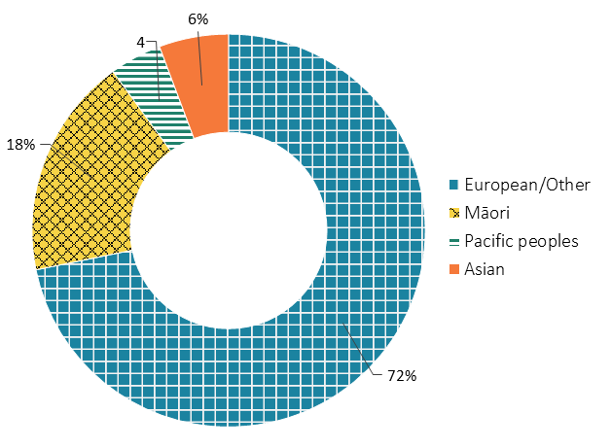

Figure 121: Disability support service allocations for people whose principal disability is neurological disability, from 2015/16 to 2019/20
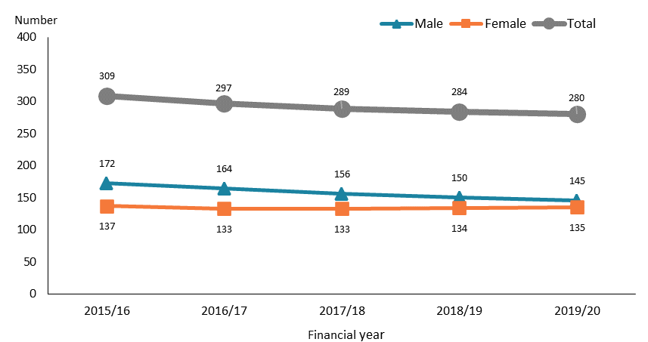

Observations
- Most DSS recipients whose principal disability is neurological were aged 45 years or older, with 45% in the 45–64-year age group and 22% in the 65–79-year age group.
- The distribution between males and females of people with neurological disability was approximately equal.
- While Pacific peoples, Māori and Asian people were under-represented, the European/Other ethnic group was significantly over-represented among DSS recipients with a neurological disability in contrast to the ethnic distribution of DSS recipients overall.
- The number of males with a neurological disability reduced slightly from 2015/16 to 2091/20, while the number of females in this group remained stable.

Disability support services demographics by domicile region
Regional council areas have been applied for regions in this report, as Stats NZ does. Nelson–Marlborough–Tasman is a combined region of three regional council areas. Chatham Island is included in the Canterbury region, and Wairarapa is included in the Wellington region.

Northland
Table 30: Northland disability support service allocations, by age and sex, 2019/20 financial year
Age group | Female | Male | Total
0–4 | 14 | 28 | 42
5–14 | 169 | 329 | 498
15–24 | 128 | 195 | 323
25–44 | 138 | 157 | 295
45–64 | 222 | 219 | 441
65+ | 127 | 85 | 212
Total | 798 | 1,013 | 1,811
Note: Due to a small number of people, the 65–79 and 80+ year age groups are combined into one group.

Figure 122: Northland disability support service allocations, by principal disability type and sex, 2019/20 financial year
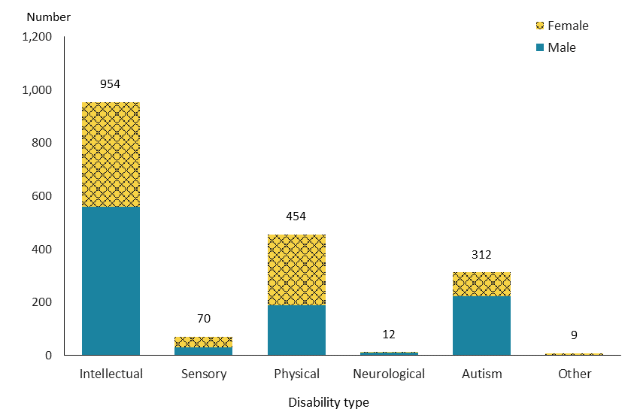

Figure 123: Northland disability support service allocations, by service type and ethnicity, 2019/20 financial year
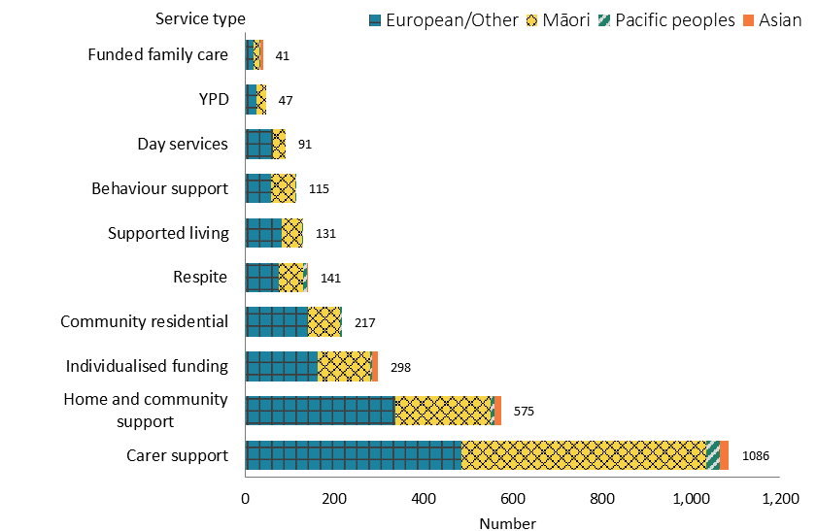

Figure 124: Northland disability support service allocations, from 2015/16 to 2019/20
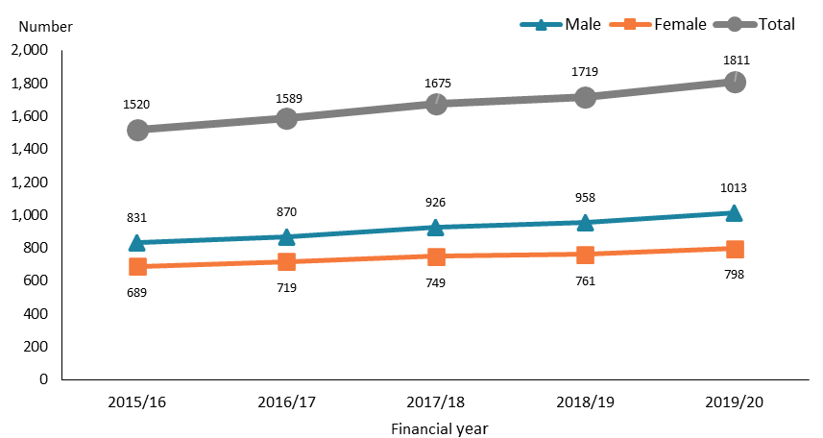

Observations
- There were two peaks in the numbers for Northland DSS recipients, in the 5–14 (27%) and 45–64-year (24%) age groups.
- Over half of DSS recipients in Northland (53%) had an intellectual disability. The proportion of autistic people in this group was significantly lower in the Northland region (17%) than for DSS recipients nationally (27%).
- About three-fifths of DSS recipients in Northland were allocated carer support.
- The number of DSS recipients in the Northland region increased steadily from 2015/16 to 2019/20.

Auckland
Table 31: Auckland disability support service allocations, by age and sex, 2019/20 financial year
Age group | Female | Male | Total
0–4 | 129 | 257 | 386
5–14 | 1,005 | 2,784 | 3,789
15–24 | 806 | 1,754 | 2,560
25–44 | 882 | 1,237 | 2,119
45–64 | 1,042 | 1,075 | 2,117
65–79 | 426 | 344 | 770
80+ | 38 | 17 | 55
Total | 4,328 | 7,468 | 11,796

Figure 125: Auckland disability support service allocations, by principal disability type and sex, 2019/20 financial year
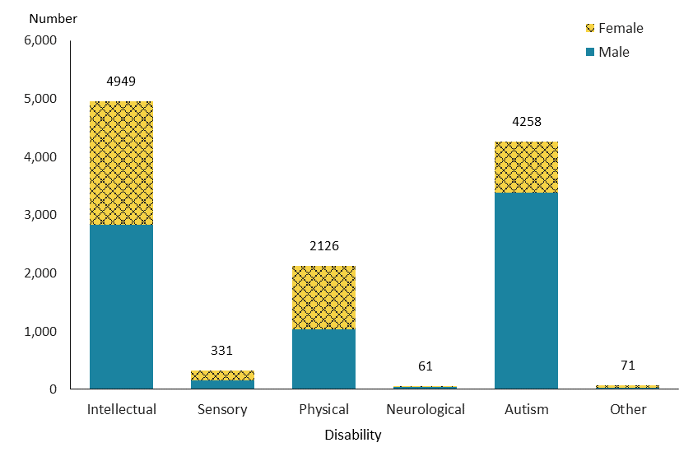

Figure 126: Auckland disability support service allocations, by service type and ethnicity, 2019/20 financial year
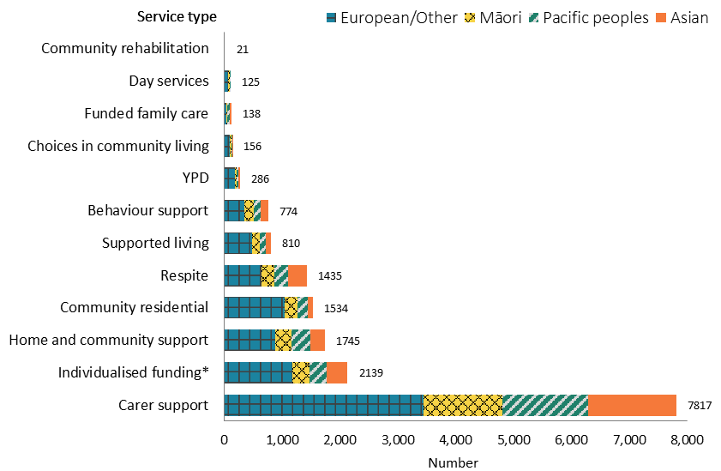
*Due to a very small number of people, Enhanced individualised funding is included in Individualised funding service.

Figure 127: Auckland disability support service allocations, from 2015/16 to 2019/20 financial year
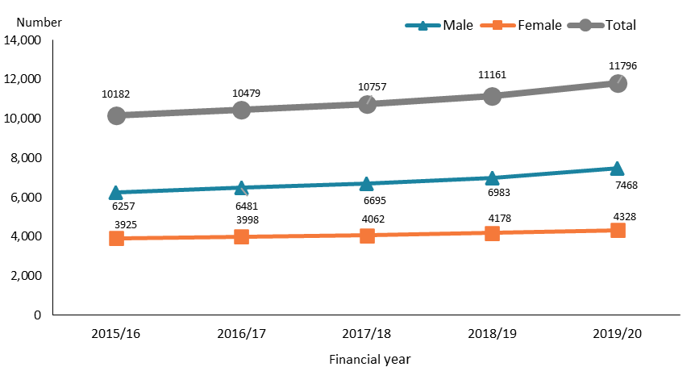

Observations
- The highest number of DSS recipients in the Auckland region was in the 5–14-year age group (32%); there was an even distribution among the age groups from 15-24 to 45–64 years.
- There were significantly more male than female DSS recipients in the Auckland region.
- People with an intellectual disability constituted 42% of Auckland DSS recipients, followed by autistic people, constituting 36%.
- A higher number of DSS recipients (67%) were allocated carer support than all other service allocations in the Auckland region. Carer support recipients in the region were over-represented among Asian and Pacific peoples, and under-represented among those of European/Other ethnicity.
- There was an increase in DSS recipients in the Auckland region from 2015/16 to 2019/20, with males increasing at a slightly faster pace than females.

Waikato
Table 32: Waikato disability support service allocations, by age and sex, 2019/20 financial year
Age group | Female | Male | Total
0–4 | 34 | 79 | 113
5–14 | 314 | 928 | 1,242
15–24 | 259 | 490 | 749
25–44 | 322 | 420 | 742
45–64 | 467 | 472 | 939
65–79 | 175 | 138 | 313
80+ | 8 | 7 | 15
Total | 1,579 | 2,534 | 4,113

Figure 128: Waikato disability support service allocations, by principal disability type and sex, 2019/20 financial year
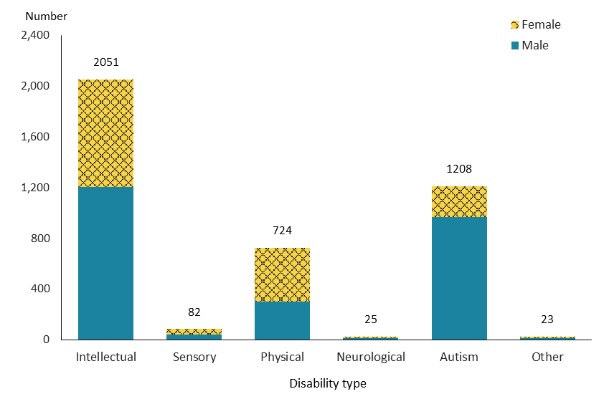

Figure 129: Waikato disability support service allocations, by service type and ethnicity, 2019/20 financial year
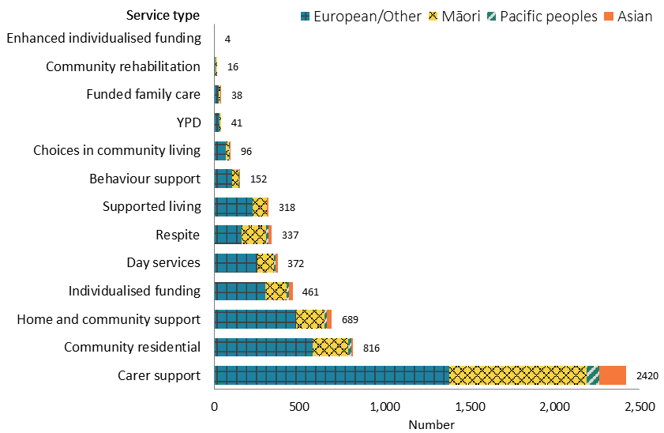

Figure 130: Waikato disability support service allocations, from 2015/16 to 2019/20 financial year
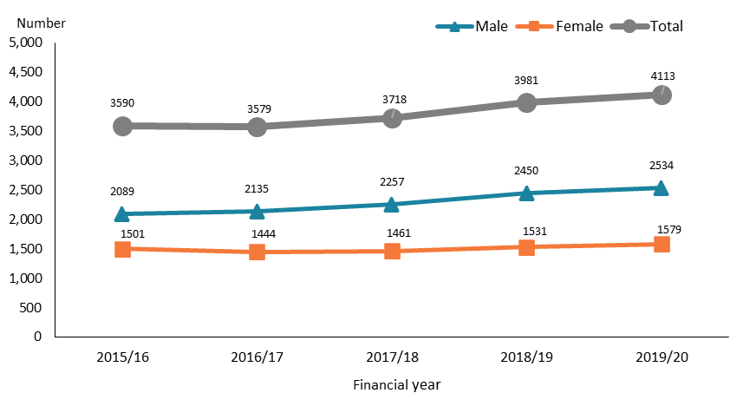

Observations
- About 30% of DSS recipients in the Waikato region were in the 5–14-year age group.
- Similar to DSS recipients nationally, half of DSS recipients in the Waikato region had an intellectual disability, followed by nearly one-third who were autistic.
- Nearly three in five DSS recipients who lived in the Waikato region were allocated carer support.
- The number of males allocated DSS increased from 2015/16 to 2019/20 in the Waikato region. Conversely, the number of females remained relatively stable.

Bay of Plenty
Table 33: Bay of Plenty disability support service allocations, by age and sex, 2019/20 financial year
Age group | Female | Male | Total
0–4 | 24 | 52 | 76
5–14 | 270 | 646 | 916
15–24 | 208 | 393 | 601
25–44 | 268 | 301 | 569
45–64 | 322 | 297 | 619
65+ | 157 | 89 | 246
Total | 1,249 | 1,778 | 3,027
Note: Due to a small number of people, the 65–79 and 80+ year age groups are combined into one group.

Figure 131: Bay of Plenty disability support service allocations, by principal disability type and sex, 2019/20 financial year
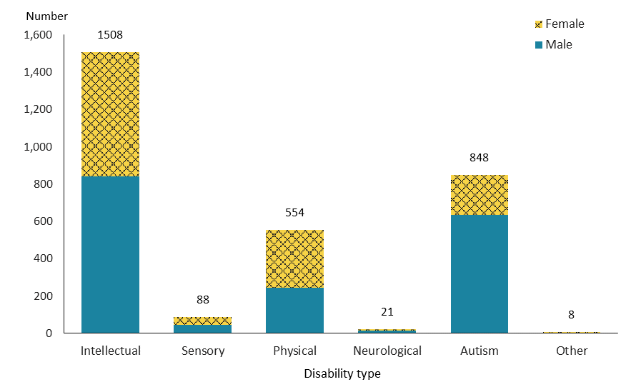

Figure 132: Bay of Plenty disability support service allocations, by service type and ethnicity, 2019/20 financial year
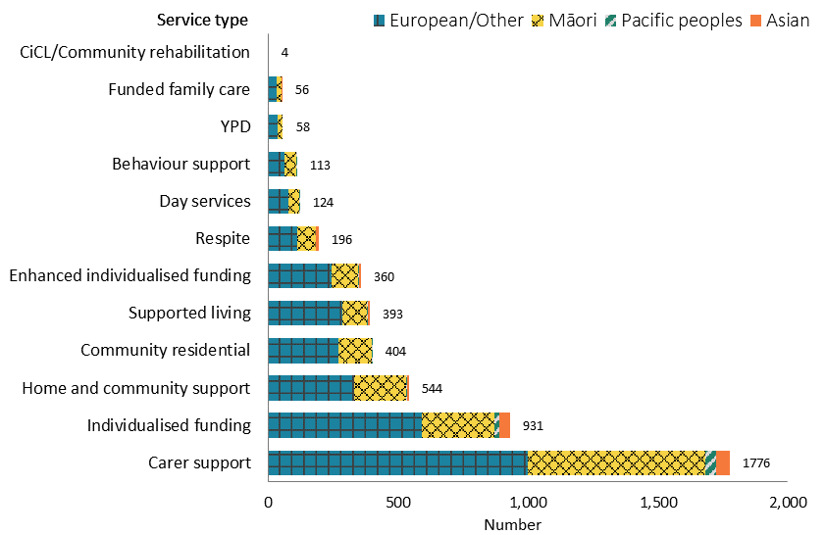
Note: Due to a small number of people, Choice in Community Living and Community rehabilitation services are combined into one group.
Figure 133: Bay of Plenty disability support service allocations, from 2015/16 to 2019/20 financial year
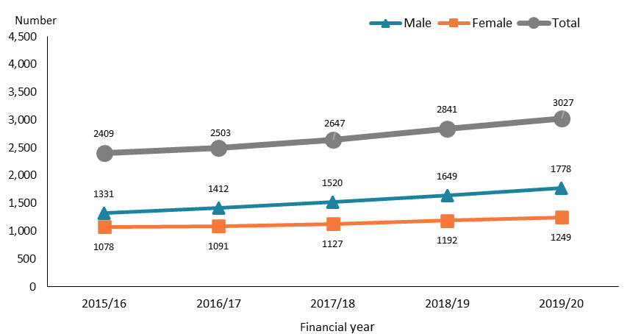

Observations
- As in the Auckland region, the highest number of DSS recipients in the Bay of Plenty region were in the 5–14-year age group (30%), whereas there was an even distribution among the 15 to 64 year age groups.
- The percentage of Bay of Plenty people allocated IF (31%) was markedly higher compared to that among DSS recipients generally (17%).
- Disability support services recipients in the Bay of Plenty region increased noticeably from 2015/16 to 2019/20.

Hawke’s Bay
Table 34: Hawke’s Bay disability support service allocations, by age and sex, 2019/20 financial year
Age group | Female | Male | Total
0–4 | 4 | 9 | 13
5–14 | 101 | 209 | 310
15–24 | 87 | 168 | 255
25–44 | 135 | 185 | 320
45–64 | 165 | 161 | 326
65+ | 68 | 50 | 118
Total | 560 | 782 | 1,342
Note: Due to a small number of people, the 65–79 and 80+ year age groups are combined into one group.

Figure 134: Hawke’s Bay disability support service allocations, by principal disability type and sex, 2019/20 financial year
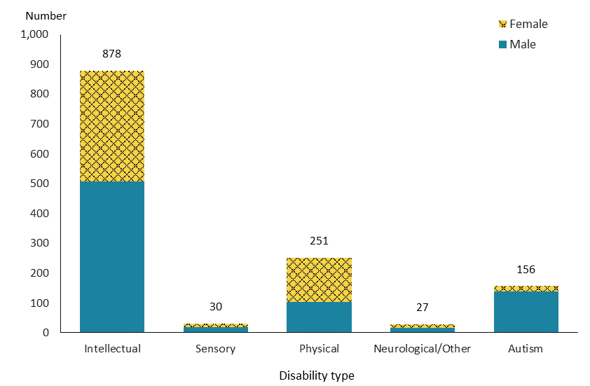
Note: Due to a small number of people, Other and neurological disability types are combined into one group.

Figure 135: Hawke’s Bay disability support service allocations, by service type and ethnicity, 2019/20 financial year
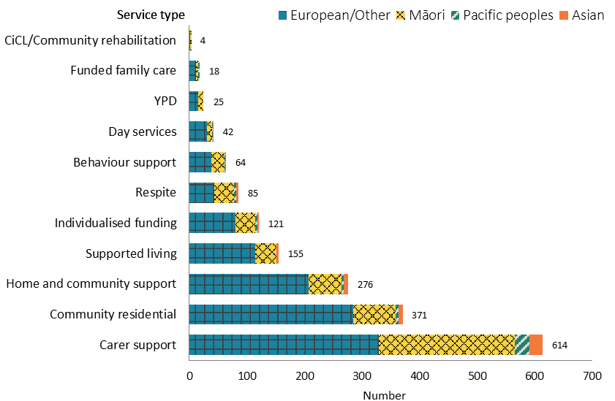
Note: Due to a small number of people, Choice in Community Living and Community rehabilitation services are combined into one group.

Figure 136: Hawke’s Bay disability support service allocations, from 2015/16 to 2019/20 financial year
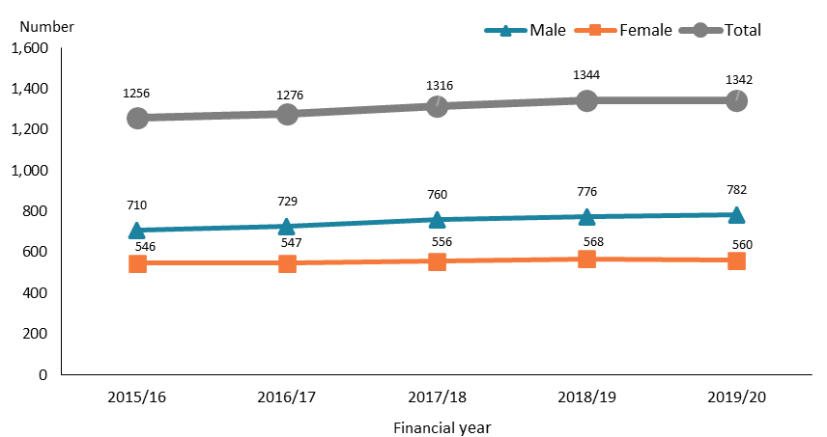

Observations
- Disability support services recipients in the Hawke’s Bay region were quite evenly distributed among the age groups from 5–14 to 45–64 years.
- Approximately two-thirds of DSS recipients in Hawke’s Bay (65%) had an intellectual disability.
- There was a slight increase in DSS recipients in the Hawke’s Bay region over the five-year period.

Gisborne
Table 35: Gisborne disability support service allocations, by age and sex, 2019/20 financial year
Age group | Female | Male | Total
0–4 | 2 | 4 | 6
5–14 | 26 | 91 | 117
15–24 | 25 | 38 | 63
25–44 | 30 | 32 | 62
45–64 | 51 | 42 | 93
65+ | 20 | 20 | 40
Total | 154 | 227 | 381
Note: Due to a small number of people, the 65–79 and 80+ year age groups are combined into one group.

Figure 137: Gisborne disability support service allocations, by principal disability type and sex, 2019/20 financial year
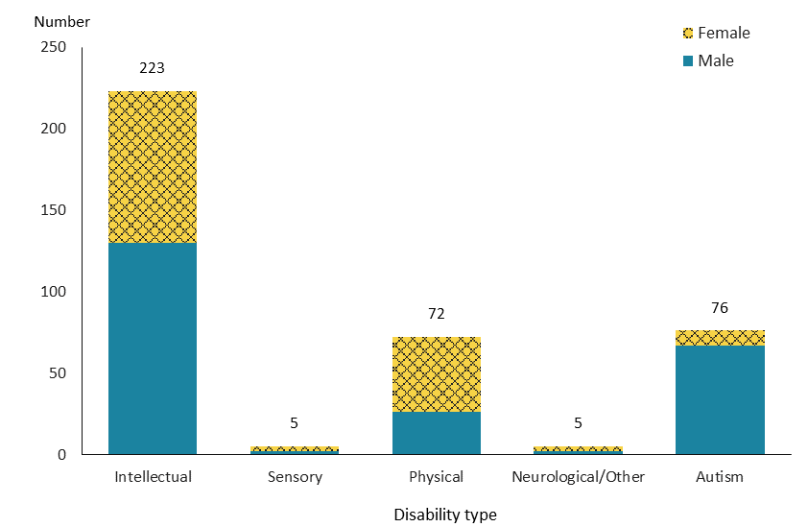
Note: Due to a small number of people, Other and neurological disability types are combined into one group.

Figure 138: Gisborne disability support service allocations, by service type and ethnicity, 2019/20 financial year
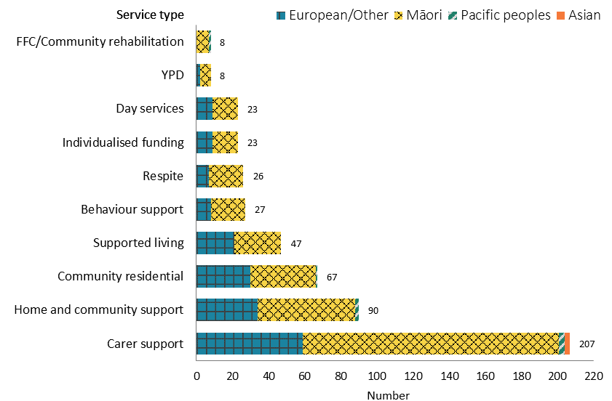
Note: Due to a small number of people, Funded family care and Community rehabilitation services are combined into one group.

Figure 139: Gisborne disability support service allocations, from 2015/16 to 2019/20 financial year
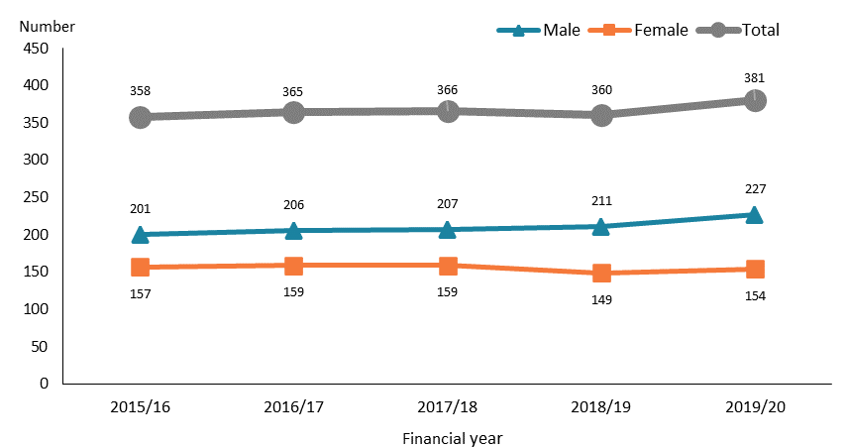

Observations
- Most Gisborne DSS recipients were in the 5–14 and 45–64-year age groups (31% and 24% respectively).
- Māori were over-represented among Gisborne DSS recipients compared to DSS recipients nationally. This is likely to reflect a high proportion of Māori in the Gisborne population.
- Following a relatively flat period during the first four years, there was a small increase in male DSS recipients from 2018/19 to 2019/20 in the Gisborne region.

Taranaki
Table 36: Taranaki disability support service allocations, by age and sex, 2019/20 financial year
Age group | Female | Male | Total
0–4 | 3 | 11 | 14
5–14 | 71 | 180 | 251
15–24 | 93 | 152 | 245
25–44 | 107 | 129 | 236
45–64 | 168 | 115 | 283
65+ | 85 | 58 | 143
Total | 527 | 645 | 1,172
Note: Due to a small number of people, the 65–79 and 80+ year age groups are combined into one group.

Figure 140: Taranaki disability support service allocations, by principal disability type and sex, 2019/20 financial year
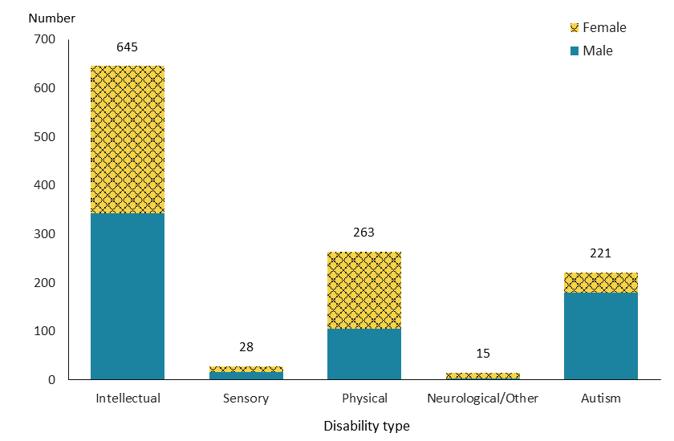
Note: Due to a small number of people, Other and neurological disability types are combined into one group.

Figure 141: Taranaki disability support service allocations, by service type and ethnicity, 2019/20 financial year
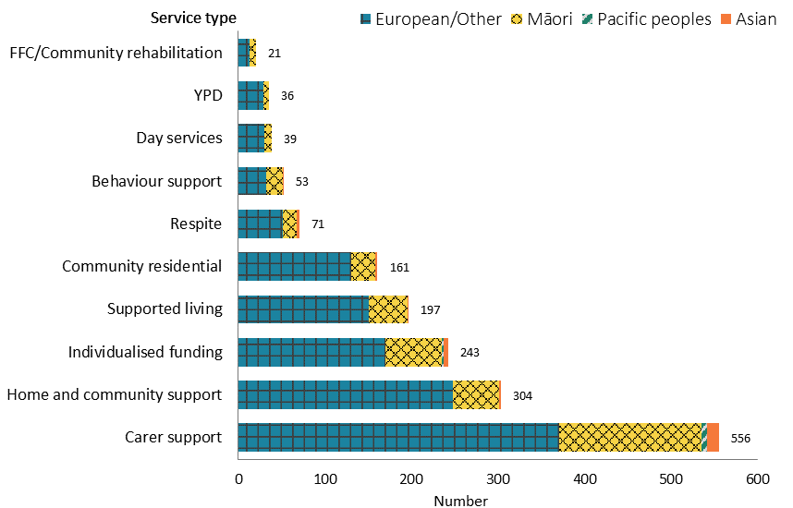

Note: Due to a small number of people, Funded family care and Community rehabilitation services are combined into one group.

Figure 142: Taranaki disability support service allocations, from 2015/16 to 2019/20 financial year
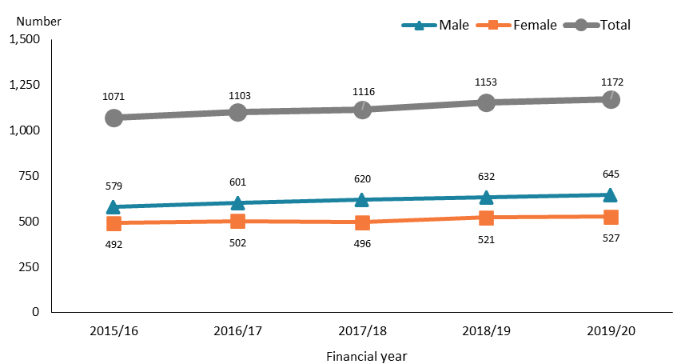

Observations
- Disability support services recipients in the Taranaki region were quite evenly distributed in the age groups from 5–14 to 45–64 years.
- The proportion of autistic DSS recipients from Taranaki was relatively lower (19%) than the proportion of autistic DSS recipients nationally (27%).
- After carer support and HCSS, IF was the third-largest service allocation in the Taranaki region, allocated to 21% of DSS recipients.
- The number of DSS recipients in the Taranaki region increased steadily from 2015/16 to 2019/20.

Manawatu–Whanganui
Table 37: Manawatu–Whanganui disability support service allocations, by age and sex, 2019/20 financial year
Age group | Female | Male | Total
0–4 | 3 | 7 | 10
5–14 | 108 | 300 | 408
15–24 | 138 | 264 | 402
25–44 | 211 | 239 | 450
45–64 | 366 | 345 | 711
65–79 | 198 | 121 | 319
80+ | 7 | 4 | 11
Total | 1,031 | 1,280 | 2,311

Figure 143: Manawatu–Whanganui disability support service allocations, by principal disability type and sex, 2019/20 financial year
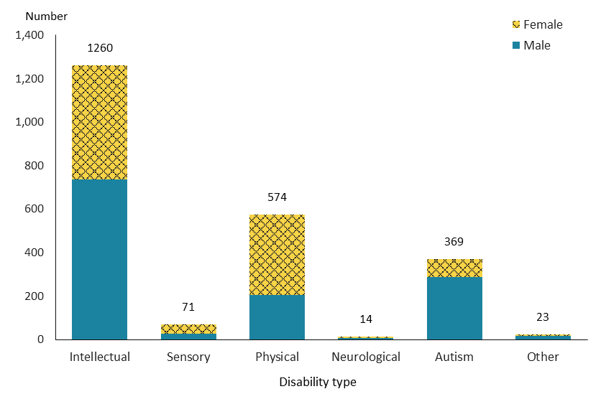

Figure 144: Manawatu–Whanganui disability support service allocations, by service type and ethnicity, 2019/20 financial year
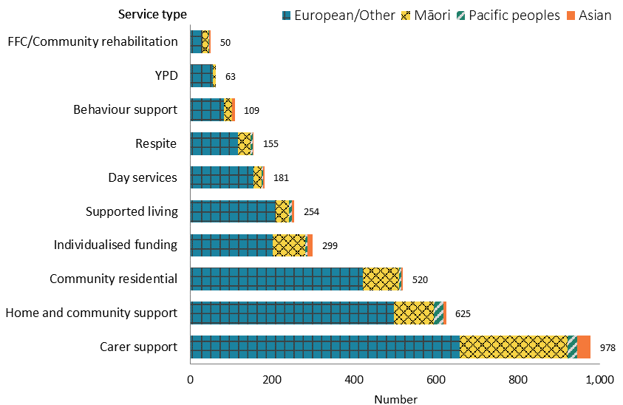
Note: Due to a small number of people, Funded family care and Community rehabilitation services are combined into one group. Due to a very small number of people, Enhanced individualised funding is included in Individualised funding services.

Figure 145: Manawatu–Whanganui disability support service allocations, from 2015/16 to 2019/20 financial year
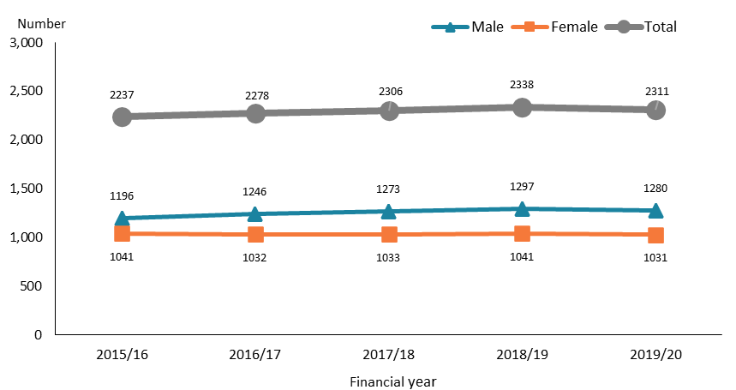

Observations
- The highest number of DSS recipients in the Manawatu–Whanganui region was in the 45–64-year age group (31%).
- Compared to autistic DSS recipients nationally (27%), the proportion of Manawatu–Whanganui recipients with autism (16%) was significantly lower.
- The number of DSS recipients in the Manawatu–Whanganui region changed minimally from 2015/16 to 2019/20.

Wellington
Table 38: Wellington disability support service allocations, by age and sex, 2019/20 financial year
Age group | Female | Male | Total
0–4 | 29 | 43 | 72
5–14 | 311 | 765 | 1,076
15–24 | 240 | 506 | 746
25–44 | 310 | 446 | 756
45–64 | 445 | 388 | 833
65–79 | 229 | 144 | 373
80+ | 9 | 5 | 14
Total | 1,573 | 2,297 | 3,870

Figure 146: Wellington disability support service allocations, by principal disability type and sex, 2019/20 financial year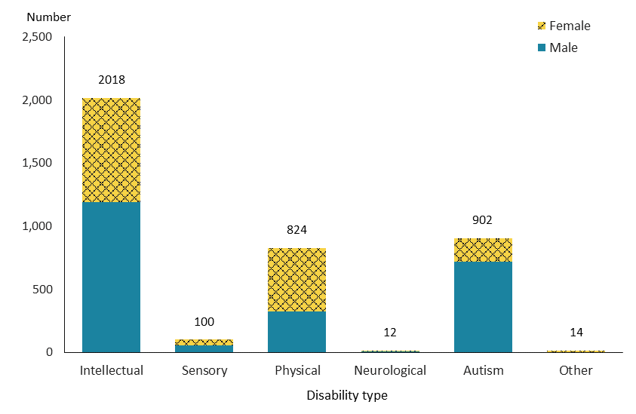
Figure 147: Wellington disability support service allocations, by service type and ethnicity, 2019/20 financial year
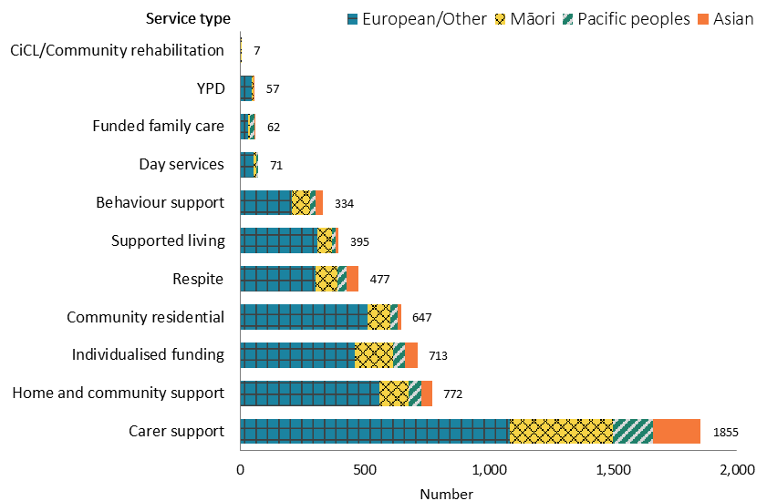
Note: Due to a small number of people, Choice in community living and Community rehabilitation services are combined into one group.

Figure 148: Wellington disability support service allocations, from 2015/16 to 2019/20 financial year
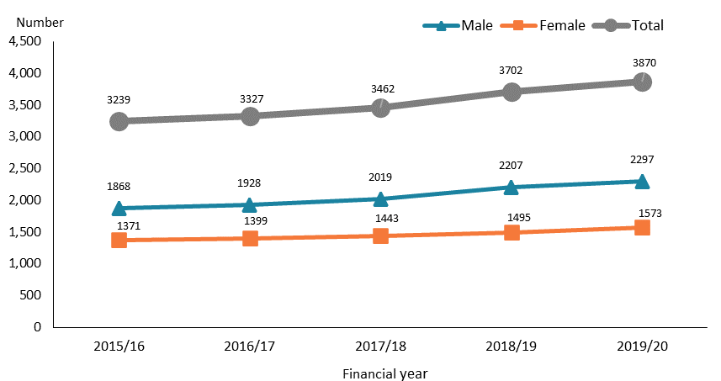

Observations
- The number of DSS recipients in the Wellington region was highest in the 5–14-year age group.
- Nearly half of DSS recipients in Wellington (48%) were allocated carer support services.
- There was a noticeable annual increase in DSS recipients from 2015/16 to 2019/20 in the Wellington region, particularly among males.

Nelson–Marlborough–Tasman
Table 39: Nelson–Marlborough–Tasman disability support service allocations, by age and sex, 2019/20 financial year
Age group | Female | Male | Total
0–4 | 6 | 12 | 18
5–14 | 80 | 197 | 277
15–24 | 83 | 152 | 235
25–44 | 118 | 163 | 281
45–64 | 192 | 174 | 366
65–79 | 135 | 79 | 214
80+ | 20 | 4 | 24
Total | 634 | 781 | 1,415

Figure 149: Nelson–Marlborough–Tasman disability support service allocations, by principal disability type and sex, 2019/20 financial year
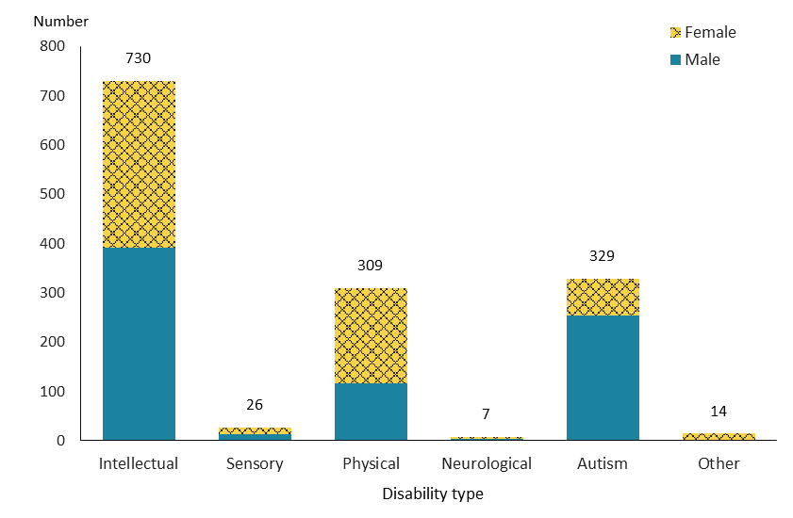

Figure 150: Nelson–Marlborough–Tasman disability support service allocations, by service type and ethnicity, 2019/20 financial year
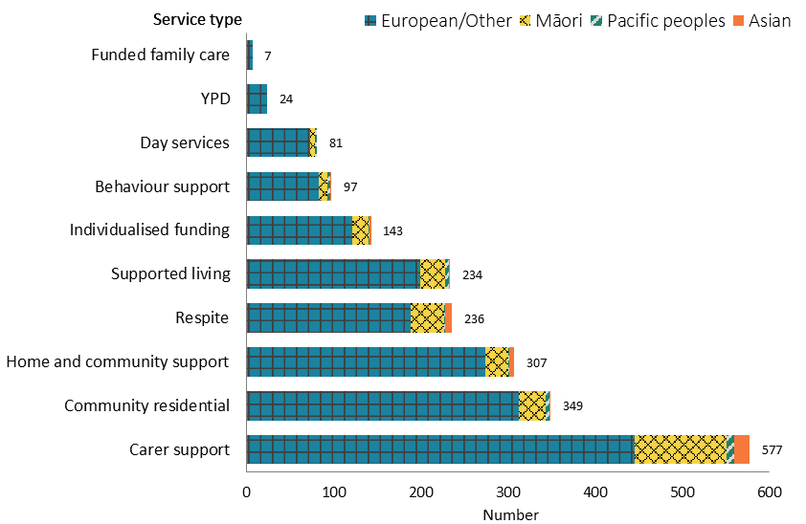

Figure 151: Nelson–Marlborough–Tasman disability support service allocations, from 2015/16 to 2019/20 financial year
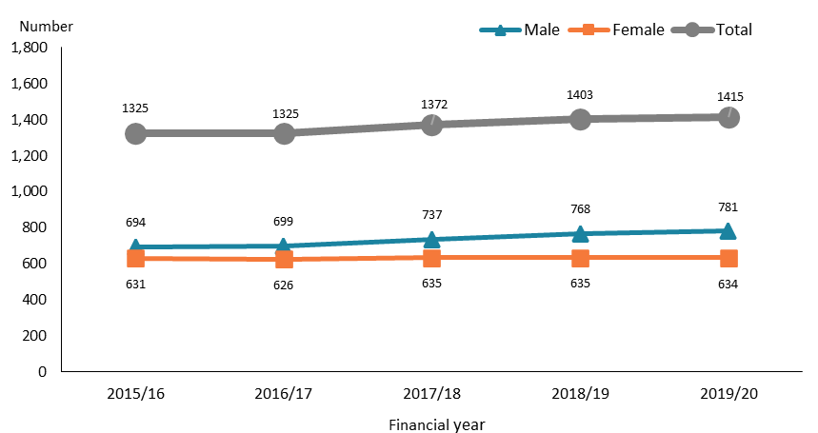

Observations
- The 45–64-year age group was the largest (26%) among DSS recipients in the Nelson–Marlborough–Tasman region.
- People of European/Other ethnicity were over-represented among DSS recipients in the region compared to the DSS cohort nationally.
- While the number of female DSS recipients remained stable over the five-year period, the number of males increased from 2016/17 to 2019/20.

West Coast
Table 40: West Coast disability support service allocations, by age and sex, 2019/20 financial year
Age group | Female | Male | Total
0–14 | 21 | 55 | 76
15–24 | 19 | 56 | 75
25–44 | 17 | 24 | 41
45–64 | 51 | 40 | 91
65+ | 18 | 8 | 26
Total | 126 | 183 | 309
Note: Due to a small number of people, the 0–4 and 5–14-year age groups are combined into one group, and the 65–79 and 80+ year age groups are combined into one group.

Figure 152: West Coast disability support service allocations, by principal disability type and sex, 2019/20 financial year
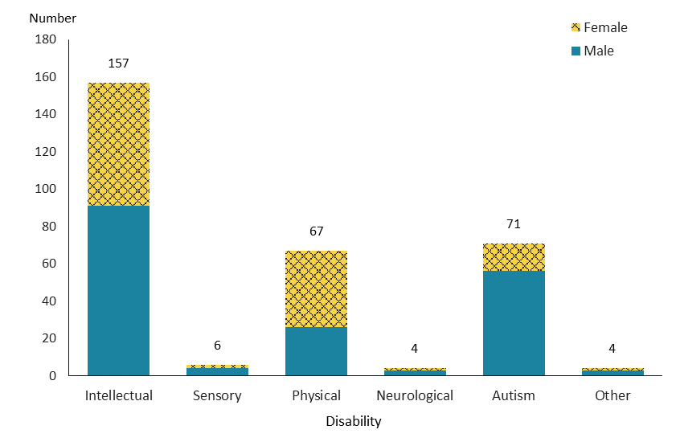

Figure 153: West Coast disability support service allocations, by service type and ethnicity, 2019/20 financial year
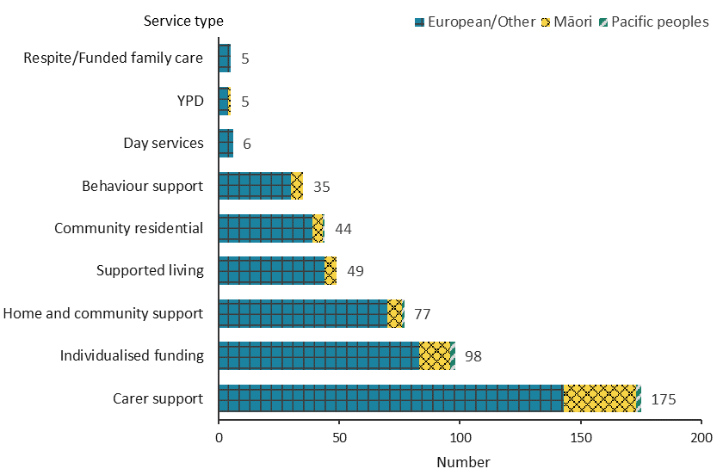
Note: Due to a small number of people, Respite and Funded family care services are combined into one group.

Figure 154: West Coast disability support service allocations, from 2015/16 to 2019/20 financial year
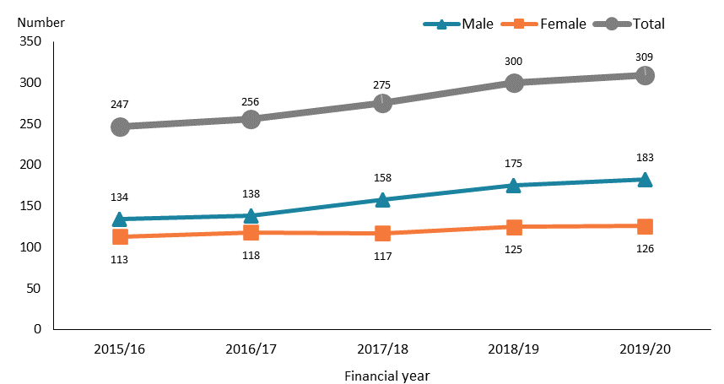

Observations
- Numbers of DSS recipients in the West Coast region were highest in the age groups 45–64 (29%), 15–24 (24%) and 5–14 (24%) years.
- Most DSS recipients in the West Coast region were allocated carer support services, followed by IF.
- There was a gradual increase in the number of DSS recipients over 2016/17–2019/20 in the West Coast region, mostly among males.

Canterbury
Table 41: Canterbury disability support service allocations, by age and sex, 2019/20 financial year
Age group | Female | Male | Total
0–4 | 46 | 73 | 119
5–14 | 396 | 1,029 | 1,425
15–24 | 379 | 649 | 1,028
25–44 | 427 | 555 | 982
45–64 | 693 | 670 | 1,363
65–79 | 337 | 262 | 599
80+ | 22 | 13 | 35
Total | 2,300 | 3,251 | 5,551

Figure 155: Canterbury disability support service allocations, by principal disability type and sex, 2019/20 financial year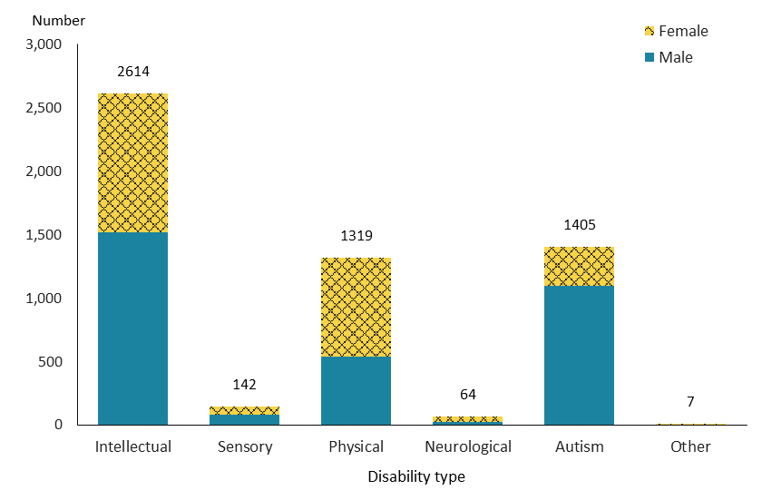

Figure 156: Canterbury disability support service allocations, by service type and ethnicity, 2019/20 financial year
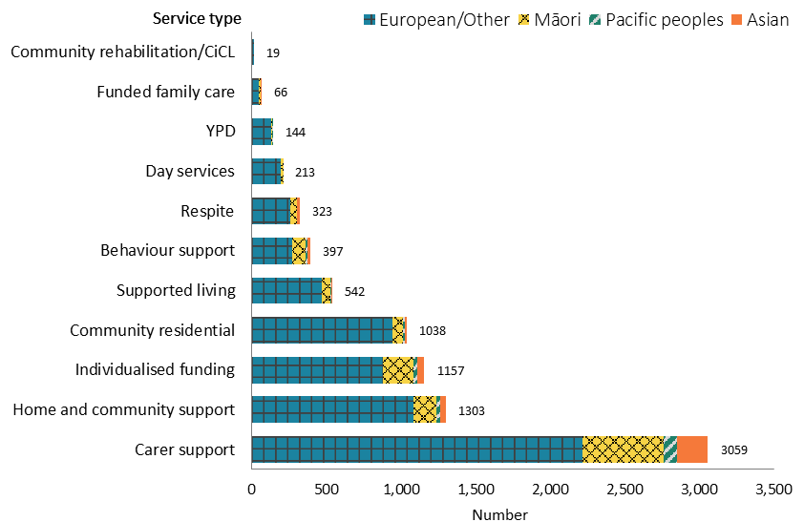

Note: Due to a small number of people, Community rehabilitation and Choice in community living services are combined into one group.

Figure 157: Canterbury disability support service allocations, from 2015/16 to 2019/20 financial year
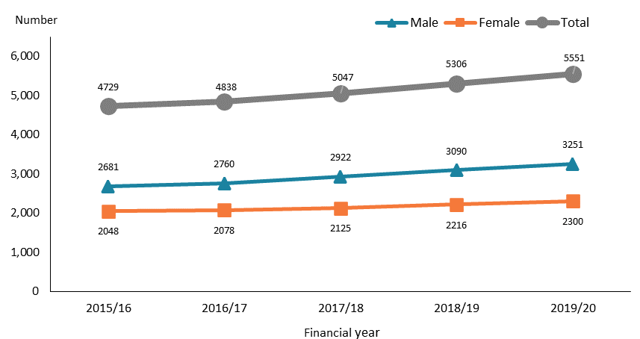

Observations
- Approximately half of DSS recipients in the Canterbury region were in the age groups 5–14 (26%) and 45–64 (24%) years.
- Carer support was allocated to more than half of DSS recipients in the Canterbury region.
- The number of DSS recipients in the Canterbury region increased steadily year by year from 2015/16 to 2019/20.

Otago
Table 42: Otago disability support service allocations, by age and sex, 2019/20 financial year
Age group | Female | Male | Total
0–4 | 4 | 15 | 19
5–14 | 110 | 256 | 366
15–24 | 120 | 245 | 365
25–44 | 146 | 228 | 374
45–64 | 265 | 300 | 565
65–79 | 161 | 107 | 268
80+ | 16 | 6 | 22
Total | 822 | 1,157 | 1,979

Figure 158: Otago disability support service allocations, by principal disability type and sex, 2019/20 financial year
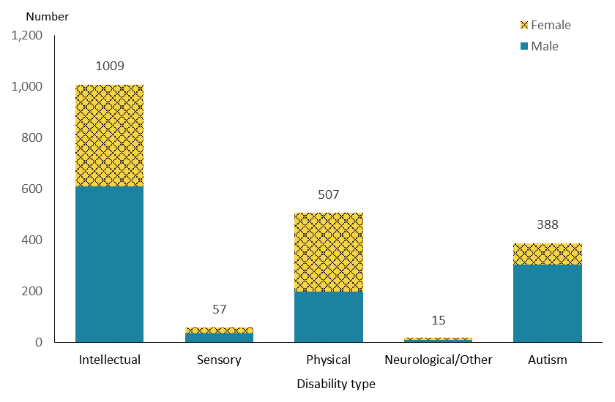
Note: Due to a small number of people, neurological and Other disability types are combined into one group.
Figure 159: Otago disability support service allocations, by service type and ethnicity, 2019/20 financial year
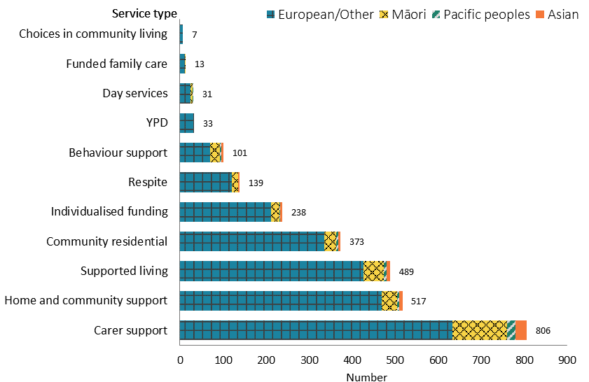

Figure 160: Otago disability support service allocations, from 2015/16 to 2019/20 financial year
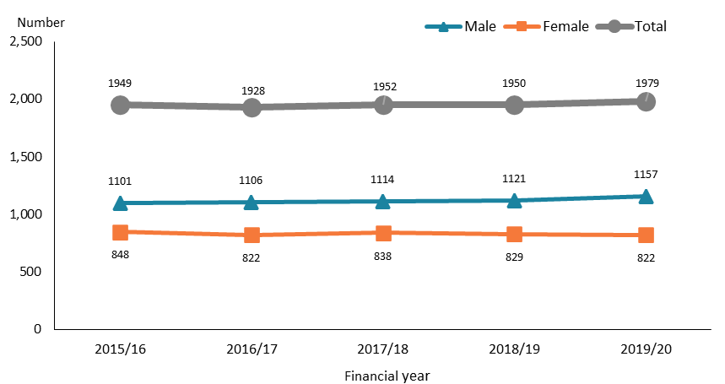

Observations
- The 45–64-year age group (29%) was the largest among DSS recipients in the Otago region.
- People with autism in Otago as a proportion of DSS recipients (20%) were under-represented compared to the national average (27%).
- Supported living was the third-largest service allocation to DSS recipients in the Otago region, after carer support and HCSS.
- The number of DSS recipients in the Otago region remained stable over the five-year period.

Southland
Table 43: Southland disability support service allocations, by age and sex, 2019/20 financial year
Age group | Female | Male | Total
0–4 | 3 | 7 | 10
5–14 | 49 | 163 | 212
15–24 | 66 | 111 | 177
25–44 | 79 | 100 | 179
45–64 | 144 | 127 | 271
65–79 | 88 | 43 | 131
80+ | 4 | 3 | 7
Total | 433 | 554 | 987

Figure 161: Southland disability support service allocations, by principal disability type and sex, 2019/20 financial year
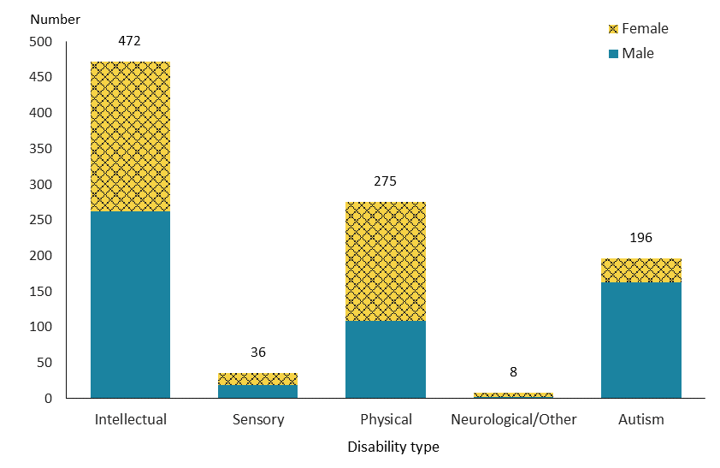
Note: Due to a small number of people, neurological and Other disability types are combined into one group.
Figure 162: Southland disability support service allocations, by service type and ethnicity, 2019/20 financial year
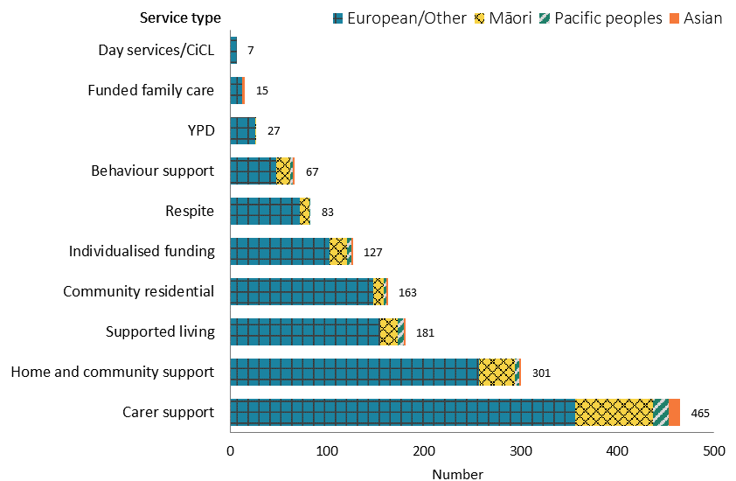

Figure 163: Southland disability support service allocations, from 2015/16 to 2019/20 financial year
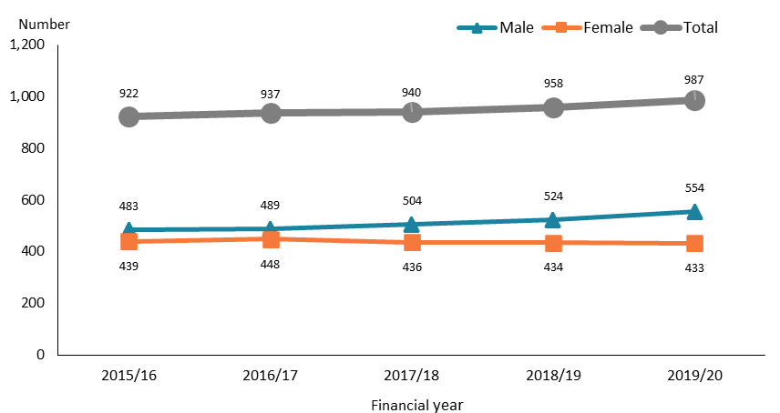

Observations
- Numbers of DSS recipients in the Southland region were highest in the 45–64-year (27%) and 5–14-year (21%) age groups.
- As in the Otago region, DSS recipients with autism in Southland (20%) were under-represented compared to the national average (27%).
- Carer support and HCSS were the two largest service allocations to DSS recipients in the Southland region.
- The number of male DSS recipients increased moderately from 2015/16 to 2019/20, while the number of females remained stable over the five years.

Enabling Good Lives
Enabling Good Lives is a new approach to supporting people with disabilities, It is an approach that offers people greater choice and control over the supports they receive and the lives they lead. Enabling Good Lives started demonstrations in Christchurch and Waikato. In 2018, a prototype based on EGL named ‘Mana Whaikaha’ started in the MidCentral region. Enabling Good Lives pools funding from the Ministries of Health, Education and Social Development, allocating the funding directly to people to enable them to purchase the supports that best meet their needs.

The EGL data is partially sourced from the Socrates database and partially from EGL sites, which supplied information not yet collected in the Socrates database.

Age, sex, and ethnicity
Table 44: Enabling Good Lives participants, by age and sex, 2019/20 financial year
Age group | Female | Male | Total
0-4 | 12 | 29 | 41
5-14 | 136 | 311 | 447
15-24 | 239 | 375 | 614
25-44 | 180 | 207 | 387
45-64 | 118 | 98 | 216
65-79 | 28 | 16 | 44
Total | 713 | 1,036 | 1,749

Figure 164: Enabling Good Lives participants, by age and sex, 2019/20 financial year
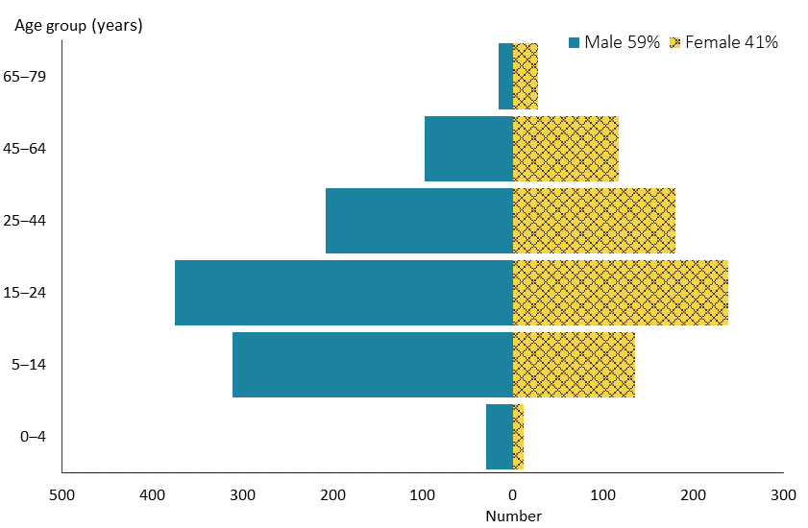

Figure 165: Enabling Good Lives participants, by ethnicity, 2019/20 financial year
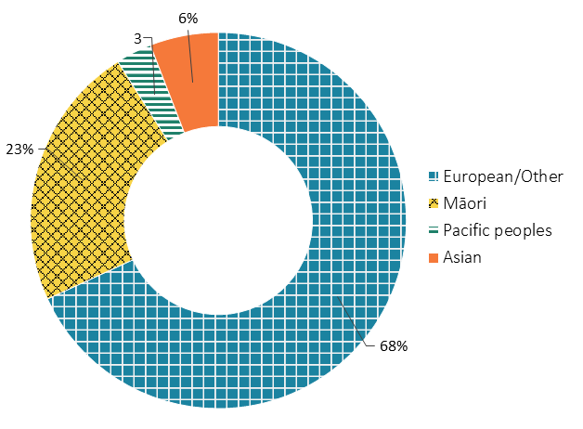

Observations
- The 15–24-year age group (35%) was the largest age group for EGL participants, followed by the 5–14-year age group (26%). This is largely because, to date, EGL Christchurch has only been available to people of high school or school leaving age.
- The sex distribution among EGL participants closely matched that of DSS recipients nationally.
- Māori and European/Other were markedly over-represented among EGL participants, and Pacific peoples and Asian people were significantly under-represented compared to the ethnicity distribution of the wider population.

Principal disability
Figure 166: Enabling Good Lives participants, by principal disability type and sex, 2019/20 financial year
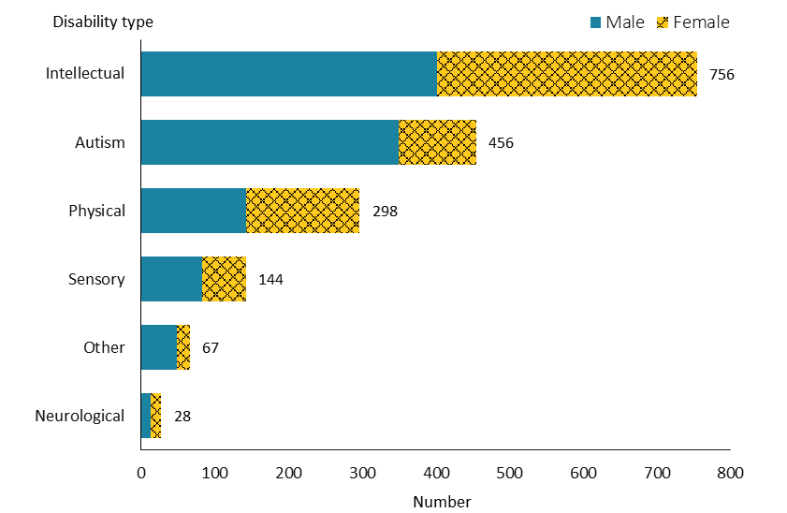

Observations
- Among EGL participants, 43% had an intellectual disability, followed by 26% who were autistic and 17% with a physical disability. This distribution was similar to that of DSS recipients nationally.

Location
Figure 167: Enabling Good Lives participants, by region and sex, 2019/20 financial year
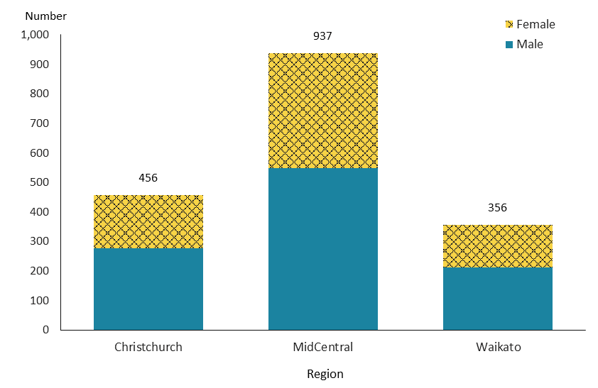

Observations
- Enabling Good Lives is currently operating in the Canterbury, Waikato and MidCentral regions only.
- More than half of EGL participants resided in the MidCentral region.

Figure 168: Enabling Good Lives participants, by region, from 2015/16 to 2019/20 financial year
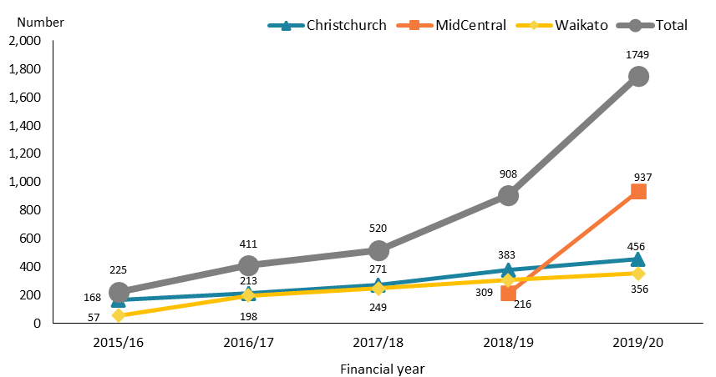

Figure 169: Enabling Good Lives participants, by ethnicity, from 2015/16 to 2019/20 financial year
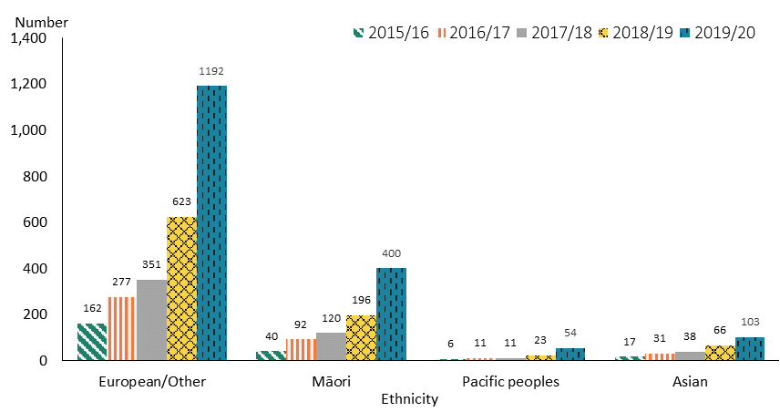

Observations
- The number of EGL participants increased significantly from 2015/16 to 2019/20. The big leap from 2018/19 to 2019/20 was driven by the inclusion of Mana Whaikaha in MidCentral in 2018.
- The number of participants in all four broad ethnic groups continued to grow over the five years.

Environmental support services
Environmental support services are services for the provision of equipment, vehicle grants, vehicle and housing modifications and a range of artificial aids and appliances to support people to live as independently and safely as possible. Unlike other DSS, which generally support people under 65 years of age, environmental support services are provided to people of all ages. The services mainly include EMS, hearing services and vision services. This section provides demographic and trend information, where applicable, for people using particular types of environmental support service.

Equipment and modifications services
Equipment and modification services provide equipment, vehicle grants, and vehicle and housing modifications to eligible people to help them to undertake everyday activities.

Age, sex and ethnicity
Table 45: Equipment and modifications services population, by age and sex, 2019/20 financial year
Age group | Female | Male | Total
0–15 | 930 | 1,355 | 2,285
16–64 | 4,443 | 3,277 | 7,720
65–79 | 8,166 | 6,096 | 14,262
80+ | 11,398 | 7,306 | 18,704
Total | 24,937 | 18,034 | 42,971

Figure 170: Equipment and modifications services population, by age and sex, 2019/20 financial year
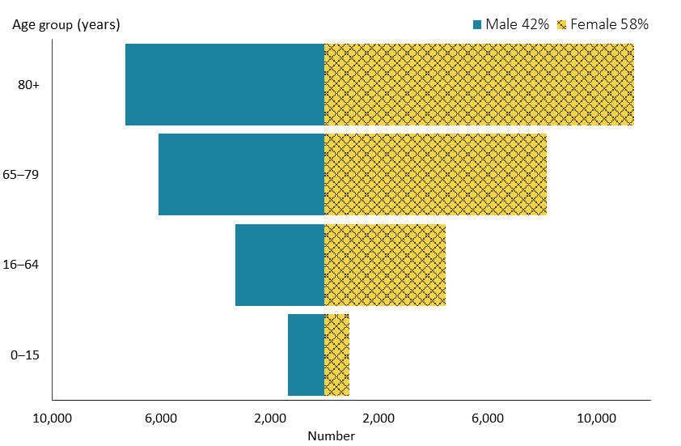

Figure 171: Equipment and modifications services population, by ethnicity, 2019/20 financial year
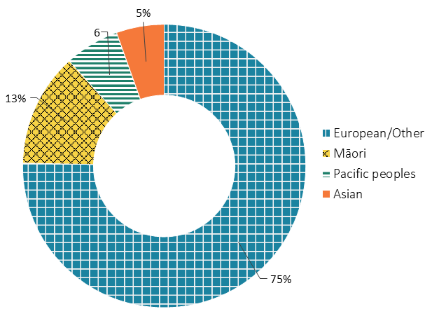

Observations
- People accessing EMS were predominately older: 44% were aged 80 years and older and 33% were aged 65–79 years.
- There were significantly more females than males among EMS recipients, which may in part be due to the higher life expectancy of women.
- People of European/Other ethnicity were disproportionally more highly represented among EMS recipients, whereas numbers of Māori, Asian people and Pacific peoples were disproportionally low in comparison to ethnic distribution nationally.

Location

Figure 172: Equipment and modifications services population, by region, 2019/20 financial year
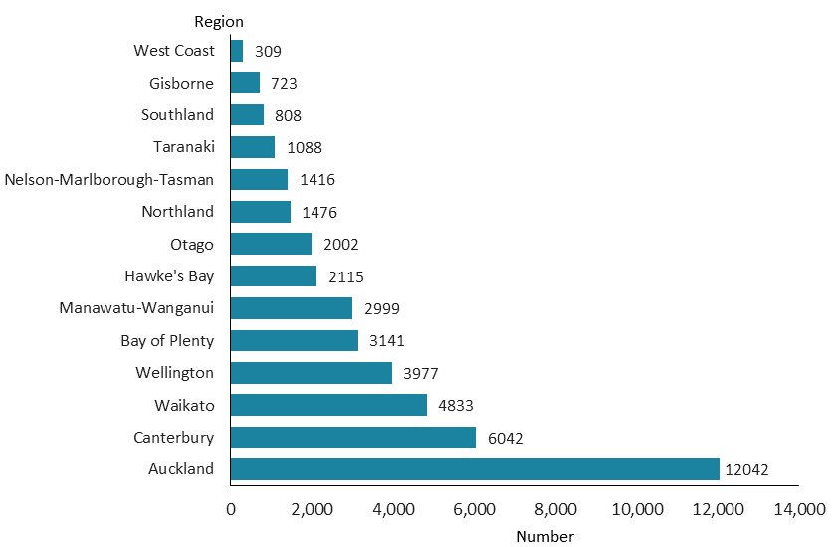

Observations
- More than one-quarter of EMS recipients (28%) resided in the Auckland region, followed by 14% in the Canterbury region and 11% in the Waikato region.

Figure 173: Equipment and modifications services population, by sex, from 2015/16 to 2019/20 financial year
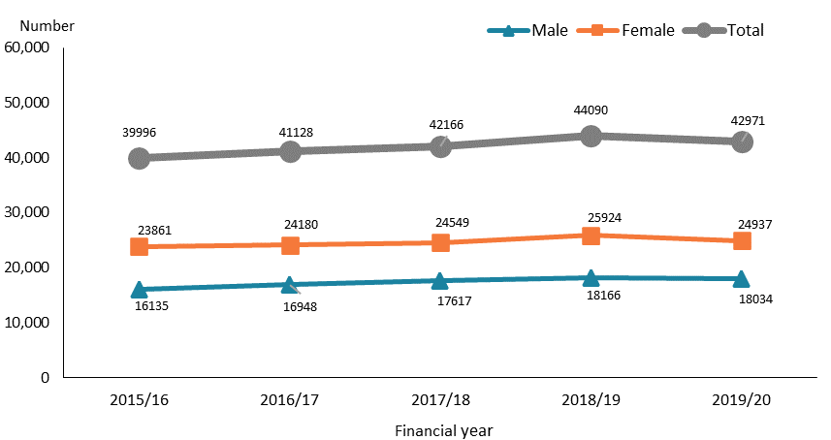

Figure 174: Equipment and modifications services population, by ethnicity, from 2015/16 to 2019/20 financial year
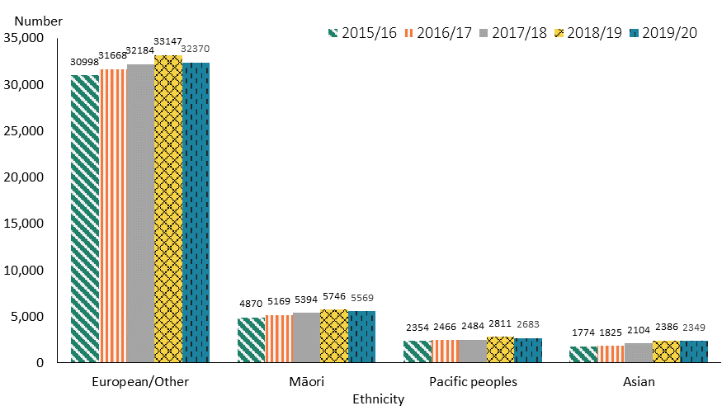

Observations
- The number of people accessing EMS services gradually increased from 2015/16 to 2018/19. There was a small decline in EMS recipients from 2018/19 to 2019/20. This decline is largely due to the COVID-19 lockdown in 2020, which resulted in service request delays.
- Changes over the five years did not vary by ethnicity.

Hearing services

Hearing aids services
Disability support services provide hearing aid services to people with long-term hearing loss. Eligible people may access funding for their hearing aids under the Hearing Aid Funding Scheme. People not eligible for other government funding for their hearing aids may access a subsidy under the Hearing Aid Subsidy Scheme.

Table 44: Number of people with hearing loss who received hearing aid services, 2019/20 financial year
Support type | number
Receiving Hearing Aid Funding Scheme | 4,437
Receiving Hearing Aid Subsidy Scheme | 18,428
Total | 22,865

Figure 175: Ethnic distribution of people with hearing loss who received hearing aids services, 2019/20 financial year
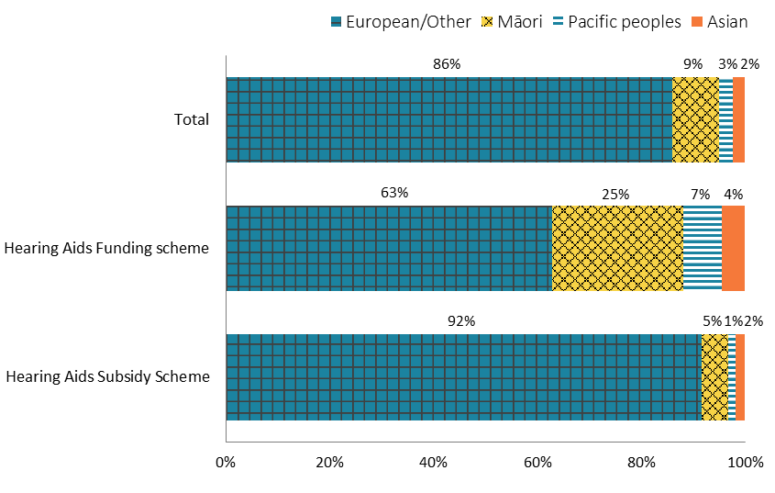

Figure 176: Number of people with hearing loss who received hearing aid services, from 2016/17 to 2019/20 financial year
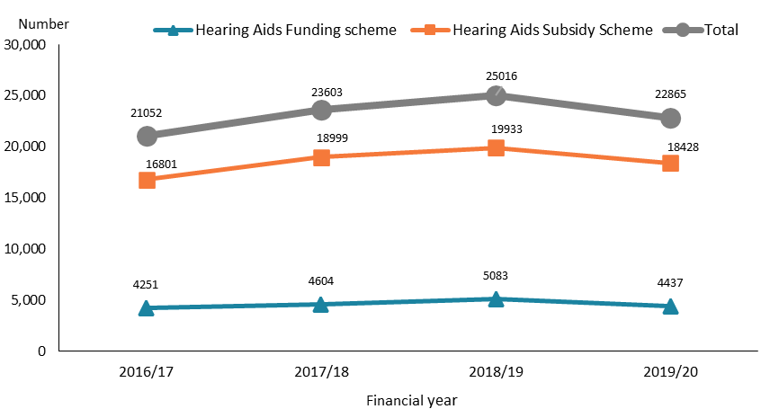

Observations
- The number of people receiving funding under the Hearing Aid Subsidy Scheme was more than four times higher than the number of people receiving funding under the Hearing Aid Funding Scheme.
- Compared to the national population, Māori accessing the Hearing Aid Funding Scheme were significantly over-represented. The reverse was true for Asian people.
- A different ethnic distribution was apparent for people accessing the Hearing Aid Subsidy Scheme: in that context, people of European/Other ethnicity were over-represented and the other three reported ethnicities under-represented compared to national distributions.
- People receiving hearing aids services increased significantly from 2016/17 to 2018/19, followed by a drop between 2018/19 and 2019/20. This reduction is related to the COVID-19 lockdown in 2020, which hindered face-to-face assessments for people accessing these services.

Cochlear implants
Cochlear implant services are provided to eligible people with severe to profound hearing loss who have been identified as suitable recipients. Follow-up services are provided over the person’s lifetime.

Table 45: Number of people who received a funded cochlear implant, by age and sex, 2019/20 financial year
 |  |  | number | %
Age group  (year) | 0-4 | 31 |  | 28%
 | 5-18 | 10 |  | 9%
 | 19-64 | 41 |  | 38%
 | 65+ | 27 |  | 25%
Sex | Female | 59 |  | 54%
 | Male | 50 |  | 46%
Total |  |  | 109 | 100%

Table 46: Number of people who received a funded cochlear implant, by sex, from 2017/18 to 2019/20 financial year
 | 2017/18 | 2018/19 | 2019/20
Male | 84 | 76 | 59
Female | 95 | 62 | 50
Total | 179 | 138 | 109

Observations
- Adults aged 19–64 years and children aged younger than 5 years were the two largest groups of people who received a funded cochlear implant in 2019/20.
- Female recipients of a cochlear implant slightly outnumbered males.
- There was a significantly high volume of people receiving a cochlear implant in 2017/18, which was the result of a one-off funding allocation in that year.

Vision services

Children’s spectacles subsidy
Disability support services provides a subsidy towards the costs of certain vision services for eligible children aged 15 years and under. The children’s spectacles subsidy is intended to assist low-income families with eligible children who need their vision corrected with prescription spectacles (glasses). Eligible children receive either a ‘standard’ level spectacles subsidy or a ‘high’ level spectacles subsidy if a child has more complex vision needs.

Table 47: Number of children receiving spectacle subsidies, 2019/20 financial year
Subsidy type | Number of children
Standard level | 19,103
High level | 2,185
Total | 21,288

Figure 177: Number of children receiving spectacles subsidies, from 2015/16 to 2019/20 financial year
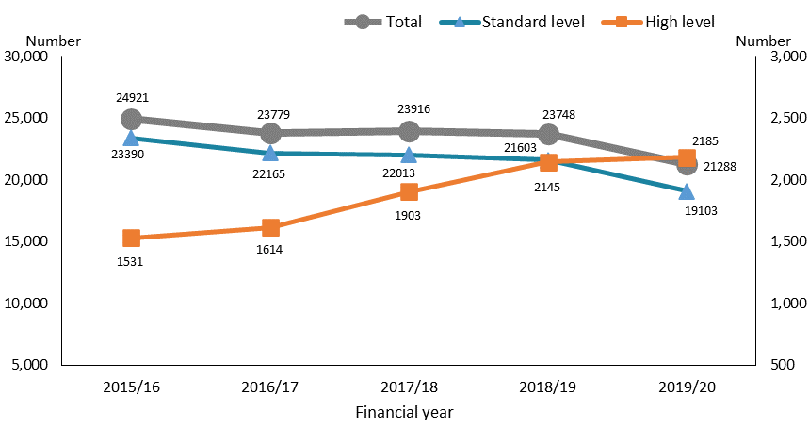

Observations
- The number of children receiving ‘high’ level spectacles subsidies increased over time, with the greatest increase between 2016/17 and 2018/19. The number of children receiving the ‘standard’ level spectacles subsidy decreased slightly after the 2015/16 period, and then decreased again sharply in 2019/20 (which reflects barriers to service delivery associated with the COVID-19 lockdown).

Services for people who are blind and people with significant vision loss

Blind Low Vision services provide people who are blind and eligible people with significant vision loss with specialist vision assessment and rehabilitation services.

Table 48: Number of new people receiving specialist vision assessment and rehabilitation services, by age and sex, 2019/20 financial year
Age group | Female | Male | Total | %
0–16 | 289 | 324 | 613 | 9%
16–25 | 161 | 190 | 351 | 5%
26–64 | 762 | 701 | 1,463 | 22%
65–74 | 383 | 331 | 714 | 11%
75–89 | 1,512 | 836 | 2,348 | 35%
90+ | 856 | 370 | 1,226 | 18%
Total | 3,963 | 2,752 | 6,715 | 100%

Figure 178: Number of new people receiving specialist vision assessment and rehabilitation services, by region and sex, 2019/20 financial year
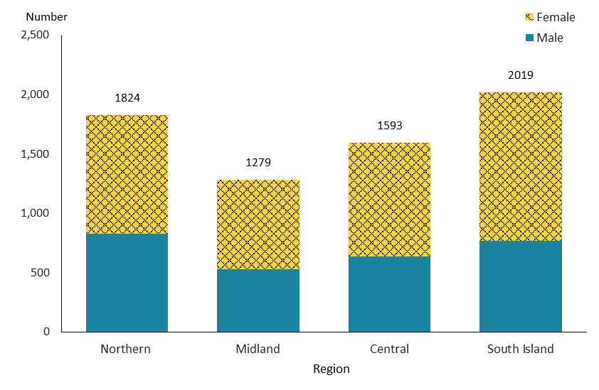

Figure 179: Number of new people receiving specialist vision assessment and rehabilitation services, by sex, from 2016/17 to 2019/20 financial year
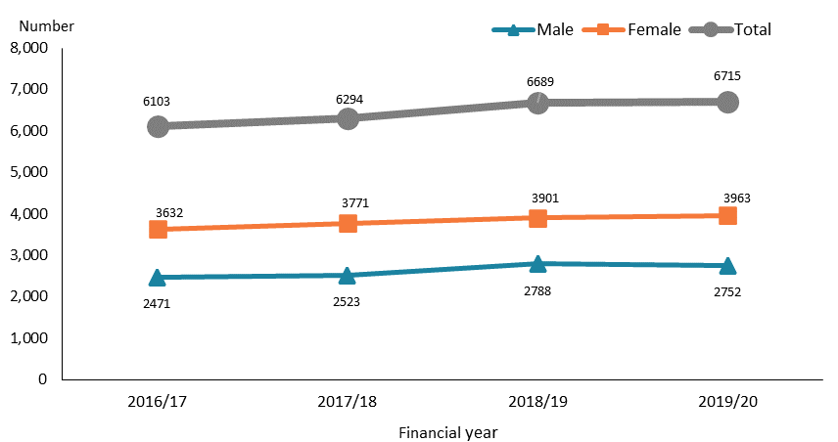

Observations
- Overall, significantly more females than males accessed specialist vision and rehabilitation services. This was particularly the case for older people. However, more males than females accessed services in younger age groups (up to the age of 25 years).
- Approximately one in three people using the services were in the 75–89-year age group.
- The South Island region had the highest number of people accessing the services (30%), followed by the Northern region (27%).
- The number of service recipients has marginally increased from 2016/17 to 2018/19 before plateauing during the last year, for reasons that may relate to the COVID-19 lockdown in 2020.

Contact lens benefit
The contact lens benefit subsidises the cost of contact lenses for people with long-term vision loss who cannot wear glasses for specified medical reasons. The service is available to new people and to people who need reassessment as their needs have changed, or who need a replacement due to loss, damage or wear. Data in this section includes services directly funded by the Ministry of Health and excludes a small number of services funded through district health boards.

Table 49: Number of people receiving contact lens subsidies, 2019/20 financial year
 |  |  | Number
Receiving contact lens subsidies |  |  |  | 6,645
Subsidy type* |  | New contact lens |  | 4,532
 |  | Lens replacement |  | 5,307
* People are counted more than once if they received both types of subsidy.

Figure 180: Number of people receiving contact lens subsidies, from 2015/16 to 2019/20 financial year
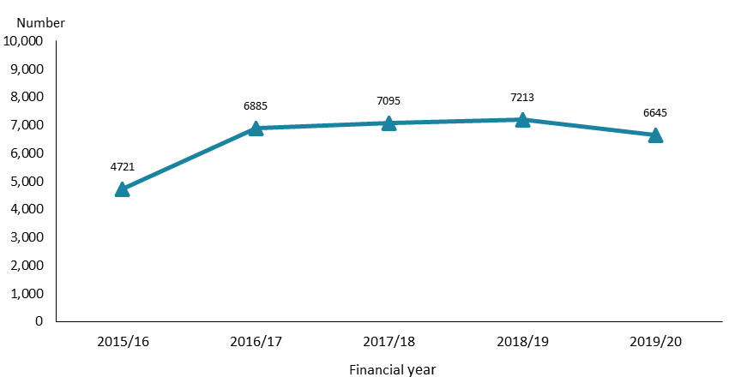

Observations
- The majority of people accessing contact lens benefit received subsidies for both new lenses and lens replacement in 2019/20.
- The number of people receiving contact lens subsidies increased significantly from 2015/16 to 2016/17, plateauing from 2016/17 to 2018/19 before dropping slightly in 2019/20, possibly due to the COVID-19 lockdown in 2020.

Assessment, treatment and rehabilitation
The provision of AT&R services is a coordinated multidisciplinary response that is customised to meet the complex needs of disabled people. The services include providing specialised and clinical assessment, delivering appropriate clinical treatment, restoring or maximising a person’s functional ability and enabling them to live as independently as possible. Disability support service AT&R is provided to disabled people aged younger than 65 years.

Age, sex and ethnicity
Table 49: Assessment, treatment and rehabilitation services population, by age and sex, 2019/20 financial year
Age group | Female | Male | Total
0–4 | 127 | 193 | 320
5–14 | 78 | 126 | 204
15–24 | 124 | 127 | 251
25–44 | 541 | 428 | 969
45–64 | 1,890 | 1,836 | 3,726
Total | 2,760 | 2,710 | 5,470

Figure 181: Assessment, treatment and rehabilitation services population, by age and sex, 2019/20 financial year
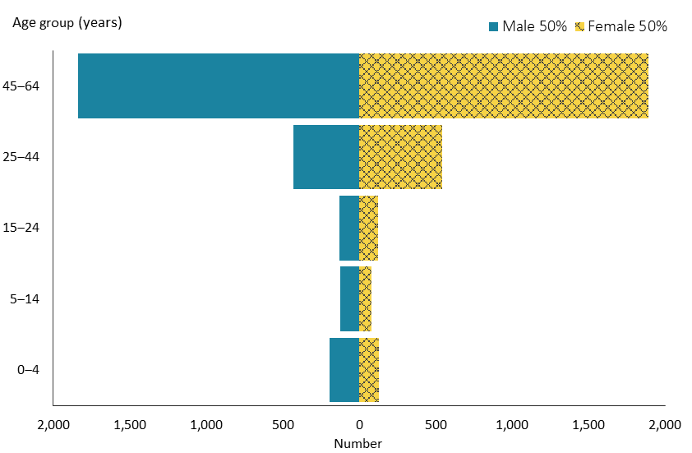

Figure 182: Assessment, treatment and rehabilitation services population, by ethnicity, 2019/20 financial year
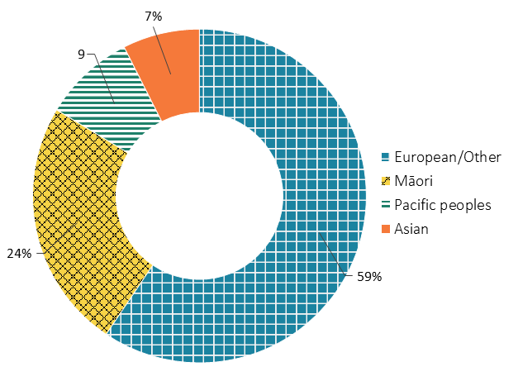

Observations
- Disabled people accessing AT&R services were highly concentrated in the 45–64-year age group, making up 68%.
- Males and females were equally distributed among people accessing AT&R.
- Māori and Pacific peoples were over-represented, and Asian people significantly under-represented, among people accessing AT&R services compared to the ethnic distribution across the national population.

Location
Figure 183: Assessment, treatment and rehabilitation services population, by region, 2019/20 financial year
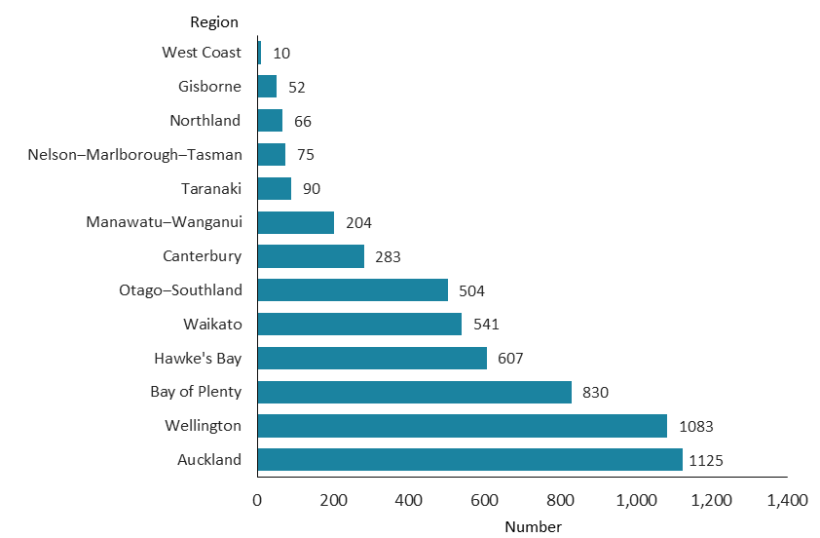

Observations
- Auckland and Wellington had the highest numbers of people receiving AT&R services, with 21% in the former region and 20% in the latter.

Figure 184: Assessment, treatment and rehabilitation services population, by sex, from 2015/16 to 2019/20 financial year
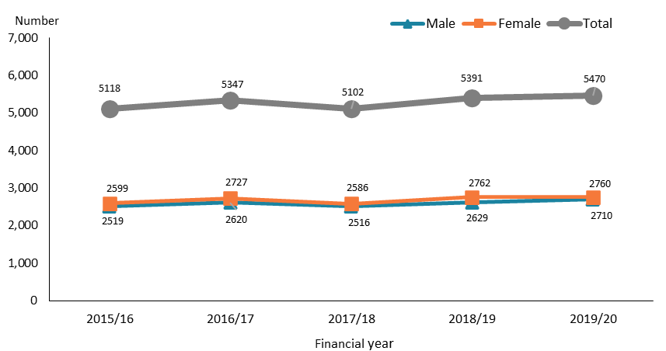

Figure 185: Assessment, treatment and rehabilitation services population, by ethnicity, from 2015/16 to 2019/20 financial year
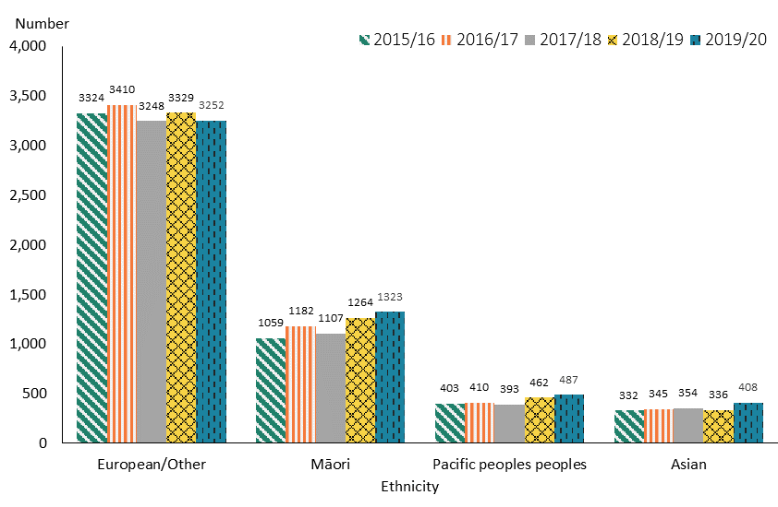

Observations
- The number of disabled people accessing AT&R services fluctuated slightly over the years from 2015/16 to 2019/20. There was a slight increase from 2015/16 to 2016/17, followed by a slight fall during the following year, and then a noticeable increase from 2017/18 to 2019/20.
- In general, the number of Māori, Pacific peoples and Asian people slightly increased over the last year or two, while the number of people of European/Other ethnicity remained relatively stable, with a possible slight trend down over this period.

Appendix 1: Disability types and conditions
Table A1: Principal disability types and related conditions among people allocated disability support services, 2019/20 financial year
(Note: If a person has two principal disability-related conditions, both conditions are counted in their relevant condition categories.)
Disability type | Disability-related condition | Number
Intellectual | Birth asphyxia or intrauterine hypoxia | 17
 | Developmental delay | 2,543
 | Down syndrome | 2,143
 | Edwards' syndrome (Trisomy 18) | 10
 | Fragile X syndrome | 123
 | Klinefelter's syndrome | 35
 | Learning disability/difficulty/delay, type not specified | 794
 | Microcephalu/microcephaly | 89
 | Other intellectual, learning or developmental disorder (specify) | 490
 | Prader-Willi syndrome | 42
 | Intellectual disability (type not specified) | 12,091
 | Total | 18,377
Physical | Amputation of limbs | 183
 | Ankylosing spondylitis | 37
 | Arthrogryposis | 46
 | Ataxia | 175
 | Back injury | 28
 | Cerebral palsy | 1,970
 | Club foot or feet | 21
 | Congenital absence / partial absence of limb | 20
 | Guillain Barre syndrome | 35
 | Kyphosis/lordosis/scoliosis | 86
 | Low birth weight / prematurity / short gestation | 45
 | Multiple sclerosis | 975
 | Muscular dystrophy | 289
 | Non-malignant growth/tumour | 18
 | Osteoarthritis | 631
 | Paralysis/paresis | 508
Physical (continued) | Patau's syndrome (Trisomy 13) | 2
 | Polio and post-polio | 81
 | Polymyalgia rheumatica | 8
 | Prolapsed disc / disc degeneration / sciatica | 31
 | Rheumatoid arthritis | 406
 | Short stature/dwarfism | 44
 | Spina bifida | 340
 | Spinal muscular atrophy | 39
 | Spinal stenosis | 85
 | Spondylosis | 39
 | Stroke | 1,912
 | Systemic lupus erythematosus | 22
 | Other bone/joint/cartilage/connective tissue disorder | 196
 | Other conditions originating around time of birth | 62
 | Other muscle/tendon/musculoskeletal disorders | 231
 | Other spine or back disorder | 188
 | Total | 8,753
Autism | Asperger’s syndrome | 994
 | Autistic spectrum disorder | 10,786
 | Total | 11,780
Sensory | Blind or vision impaired | 680
 | Congenital cataract | 16
 | Deaf or hearing impaired | 379
 | Glaucoma | 15
 | Optic neuritis / optic atrophy | 17
 | Retinopathy, retinal dystrophy, retinitis pigmentosa, detached retina | 68
 | Other cataract | 5
 | Other ear or hearing disorder | 47
 | Other eye or vision disorder | 144
 | Total | 1,371
Neurological | Brain injury | 234
 | Encephalitis | 46
 | Other brain or nervous system disorder | 92
 | Total | 372
Physical / intellectual | Other congenital or chromosomal defects affecting multiple systems | 963
Physical / neurological | Huntington’s disease | 155
 | Meningitis | 24
 | Motor neuron disease | 134
 | Parkinson’s disease | 213
 | Total | 526
Physical / intellectual / neurological | Hydrocephalus/Hydrocephaly | 92
 | Other brain or nervous system disorder | 694
 | Total | 786
Other | Alcohol- / drug-related disorder (excluding Korsakov's syndrome) | 7
 | Alzheimer's dementia | 3
 | Asthma | 23
 | Attention deficit / hyperactivity | 167
 | Cancer | 27
 | Chronic back pain / chronic pain syndrome | 20
 | Chronic fatigue syndrome / myalgic encephalomyelitis | 26
 | Chronic obstructive pulmonary disease / other respiratory disorder | 28
 | Diabetes / other nutritional, hormonal or metabolic disorder | 75
 | Digestive conditions/disorders | 14
 | Eczema and dermatitis / other skin and subcutaneous tissue disorder | 11
 | Epidermolysis bullosa | 1
 | Epilepsy/seizures | 276
 | Fibromyalgia | 28
 | Foetal alcohol syndrome | 41
 | Genitourinary disorders | 9
 | Heart diseases | 38
 | Hypertension | 15
 | Lymphoedema | 4
 | Mental disorders | 157
 | Motor delay / developmental dyspraxia | 34
 | Mute | 6
 | Neurofibromatosis | 13
 | Obesity | 4
 | Osteoporosis | 26
 | Peripheral vascular disease | 1
Other  (continued) | Recurrent or chronic otitis media or ear infections (glue ear) | 1
 | Renal failure / renal dialysis / haemodialysis | 4
 | Sleep disorder | 4
 | Systemic sclerosis/scleroderma | 4
 | Other dementia (including Korsakov's syndrome) | 8
 | Other heart or blood vessel disorder | 57
 | Other speech disorder | 43
 | Other bone/joint/cartilage/connective tissue disorder | 11
 | Other conditions | 74
 | Total | 1,260

Appendix 2: Abbreviations
AT&R | Assessment, treatment and rehabilitation
BSS | Behaviour support services
CS | Carer support
CiCL | Choice in community living
DSS | Disability support services
EGL | Enabling Good Lives
EIF | Enhanced individualised funding
EMS | Equipment and modification services
FFC | Funded family care
H&C | High and complex
HCSS | Home and community support services
IF | Individualised funding
NASC | Needs Assessment and Service Coordination
SPA | Support package allocation
YPD | Younger people in aged residential care

The FFC service ceased when section 4A of the New Zealand Public Health and Disability Act 2000 was repealed, effective from 1 September 2020.
This is largely because EGL Christchurch has been almost exclusively offered to people of high school or school-leaving age.
The FFC support service ceased when section 4A of the New Zealand Public Health and Disability Act 2000 was repealed, effective from 1 September 2020.
The Ministry of Social Development is the primary funder of day services. The Ministry of Health funds day services for people who are deinstitutionalised and people with high and complex needs and an intellectual disability.

