Demographic Report for Clients Allocated the Ministry of Health’s Disability Support Services

2018 update

Citation: Ministry of Health. 2019. *Demographic Report for Clients Allocated the Ministry of Health’s Disability Support Services: 2018 update*. Wellington: Ministry of Health.

Published in December 2019 by the Ministry of Health  
PO Box 5013, Wellington 6140, New Zealand

ISBN 978-1-98-859752-2 (online)  
HP 7289



This document is available at health.govt.nz

|  |  |
| --- | --- |
| **CCBY** | This work is licensed under the Creative Commons Attribution 4.0 International licence. In essence, you are free to: share ie, copy and redistribute the material in any medium or format; adapt ie, remix, transform and build upon the material. You must give appropriate credit, provide a link to the licence and indicate if changes were made. |

Contents

Executive summary xiii

Introduction xiii

Overall client demographics xiii

Disability support services xiv

Disability types xvii

Trends xviii

Key facts xix

Introduction 1

Purpose 1

Audience 1

Scope 2

Exclusions 3

Methodology 4

Data sources 4

Time periods 4

Client count 4

Ethnicity 4

Location of regions 5

Disability Support Services clients compared with the New Zealand population 6

Age and sex 6

Ethnicity 8

Disability services 9

Types of disability support services 9

Overall client demographics 10

Age and sex 10

Ethnicity 11

Marital status 12

Accommodation 12

Principal disability 14

Support package allocation 16

Needs assessment and service coordination organisations 18

Client demographics by service 20

Home and community support services 20

Carer support 26

Community residential services 31

Younger people in aged residential care 36

Supported living 41

Respite services 46

Behaviour support services 51

Day services 56

High and Complex Framework 61

Choice in community living 64

Individualised funding 69

Enhanced individualised funding 74

Funded family care 78

Client demographics by principal disability 83

Intellectual disability 83

Physical disability 84

Autism spectrum disorder 86

Sensory disability 87

Neurological disability 88

Clients’ service allocation by client domicile region 89

Northland 89

Auckland 91

Waikato 92

Bay of Plenty 94

Hawke’s Bay 95

Gisborne 97

Taranaki 98

Manawatu–Whanganui 100

Wellington 101

Nelson–Marlborough–Tasman 103

West Coast 104

Canterbury 106

Otago 107

Southland 109

Appendix 1: Descriptions of disability support services 111

Appendix 2: Disability types and conditions 114

Appendix 3: Abbreviations 118

List of Tables

Table 1: Ethnicity of Disability Support Services clients compared with New Zealand population, 2018 8

Table 2: Number of Disability Support Services clients, by service type, 2018 and 2016 9

Table 3: Number of Disability Support Services clients, by age and sex, 2018 and 2016 10

Table 4: Number of Disability Support Services clients, by ethnicity, 2018 and 2016 11

Table 5: Number of Disability Support Services clients, by marital status and sex, 2018 and 2016 12

Table 6: Number of Disability Support Service clients, by accommodation type and sex, 2018 and 2016 12

Table 7: Number of Disability Support Services clients, by client domicile region, 2018 and 2016 13

Table 8: Number of Disability Support Services clients, by sex and principal disability, 2018 and 2016 15

Table 9: Number of Disability Support Services clients, by support package allocation level, 2018 and 2016 16

Table 10: Number of Disability Support Services clients, by Needs Assessment and Service Coordination service (NASC), 2018 and 2016 18

Table 11: Home and community support services client numbers, by age, 2018 and 2016 20

Table 12: Carer support client numbers, by age, 2018 and 2016 26

Table 13: Community residential services client numbers, by age, 2018 and 2016 31

Table 14: Younger people in aged residential care client numbers, by age, 2018 and 2016 36

Table 15: Supported living client numbers, by age, 2018 and 2016 41

Table 16: Respite services client numbers, by age, 2018 and 2016 46

Table 17: Behaviour support services client numbers, by age, 2018 and 2016 51

Table 18: Day services client numbers, by age, 2018 and 2016 56

Table 19: High and Complex Framework client numbers, by age, 2018 and 2016 61

Table 20: Choice in community living client numbers, by age, 2018 and 2016 64

Table 21: Individualised funding client numbers, by age, 2018 and 2016 69

Table 22: Enhanced individualised funding client numbers, by age, 2018 and 2016 74

Table 23: Funded family care client numbers, by age, 2018 and 2016 78

Table 24: Disability Support Services clients whose principal disability is intellectual, by age, 2018 and 2016 83

Table 25: Disability Support Services clients whose principal disability is physical, by age, 2018 and 2016 84

Table 26: Disability Support Services clients whose principal disability is autism spectrum disorder, by age, 2018 and 2016 86

Table 27: Disability Support Services clients whose principal disability is sensory, by age, 2018 and 2016 87

Table 28: Disability Support Services clients whose principal disability is neurological, by age, 2018 and 2016 88

Table 29: Northland Disability Support Services clients, by age and sex, 2018 and 2016 89

Table 30: Auckland Disability Support Services clients, by age and sex, 2018 and 2016 91

Table 31: Waikato Disability Support Services clients, by age and sex, 2018 and 2016 92

Table 32: Bay of Plenty Disability Support Services clients, by age and sex, 2018 and 2016 94

Table 33: Hawke’s Bay Disability Support Services clients, by age and sex, 2018 and 2016 95

Table 34: Gisborne Disability Support Services clients, by age and sex, 2018 and 2016 97

Table 35: Taranaki Disability Support Services clients, by age and sex, 2018 and 2016 98

Table 36: Manawatu–Whanganui Disability Support Services clients, by age and sex, 2018 and 2016 100

Table 37: Wellington Disability Support Services clients, by age and sex, 2018 and 2016 101

Table 38: Nelson–Marlborough–Tasman Disability Support Services clients, by age and sex, 2018 and 2016 103

Table 39: West Coast Disability Support Services clients, by age and sex, 2018 and 2016 104

Table 40: Canterbury Disability Support Services clients, by age and sex, 2018 and 2016 106

Table 41: Otago Disability Support Services clients, by age and sex, 2018 and 2016 107

Table 42: Southland Disability Support Services clients, by age and sex, 2018 and 2016 109

Table A1: Principal disability types and related conditions, number of Disability Support Services clients, 2018 114

List of Figures

Figure 1: Disability Support Services client population, by age and sex, 2018 6

Figure 2: New Zealand population, by age and sex, 2018 7

Figure 3: Ethnicity distribution of Disability Support Services clients compared with New Zealand population, 2018 8

Figure 4: Disability Support Services clients, by ethnicity, age and sex 11

Figure 5: Number of Disability Support Services clients, by client domicile region and ethnicity, 2018 14

Figure 6: Number of Disability Support Services clients, by principal disability and sex, 2018 15

Figure 7: Number of Disability Support Services clients, by age and support package allocation level, 2018 17

Figure 8: Number of Disability Support Services clients, by Needs Assessment and Service Coordination service and sex, 2018 19

Figure 9: Home and community support services client population, by age and sex, 2018 21

Figure 10: Home and community support services client population, by ethnicity, 2018 22

Figure 11: Home and community support services client population, by client domicile region, 2018 23

Figure 12: Home and community support services client population, by principal disability type and sex, 2018 24

Figure 13: Home and community support services client population, by support package allocation level and sex, 2018 25

Figure 14: Carer support client population, by age and sex, 2018 26

Figure 15: Carer support client population, by ethnicity, 2018 27

Figure 16: Carer support client population, by client domicile region, 2018 28

Figure 17: Carer support client population, by principal disability type and sex, 2018 29

Figure 18: Carer support client population, by SPA level and sex, 2018 30

Figure 19: Community residential services client population, by age and sex, 2018 31

Figure 20: Community residential services client population, by ethnicity, 2018 32

Figure 21: Community residential services client population, by client domicile region, 2018 33

Figure 22: Community residential services client population, by principal disability type and sex, 2018 34

Figure 23: Community residential services client population, by SPA level and sex, 2018 35

Figure 24: Younger people in aged residential care client population, by age and sex, 2018 36

Figure 25: Younger people in aged residential care client population, by ethnicity, 2018 37

Figure 26: Younger people in aged residential care client population, by client domicile region, 2018 38

Figure 27: Younger people in aged residential care client population, by principal disability type and sex, 2018 39

Figure 28: Younger people in aged residential care client population, by support package allocation level and sex, 2018 40

Figure 29: Supported living client population, by age and sex, 2018 41

Figure 30: Supported living client population, by ethnicity, 2018 42

Figure 31: Supported living client population, by client domicile region, 2018 43

Figure 32: Supported living client population, by principal disability type and sex, 2018 44

Figure 33: Supported living client population, by support package allocation level and sex, 2018 45

Figure 34: Respite client population, by age and sex, 2018 46

Figure 35: Respite client population, by ethnicity, 2018 47

Figure 36: Respite client population, by client domicile region, 2018 48

Figure 37: Respite client population, by principal disability type and sex, 2018 49

Figure 38: Respite client population, by support package allocation level and sex, 2018 50

Figure 39: Behaviour support services client population, by age and sex, 2018 51

Figure 40: Behaviour support services client population, by ethnicity, 2018 52

Figure 41: Behaviour support services client population, by client domicile region, 2018 53

Figure 42: Behaviour support services client population, by principal disability type and sex, 2018 54

Figure 43: Behaviour support services client population, by support package allocation level and sex, 2018 55

Figure 44: Day services client population, by age and sex, 2018 56

Figure 45: Day services client population, by ethnicity, 2018 57

Figure 46: Day services client population, by client domicile region, 2018 58

Figure 47: Day services client population, by principal disability type and sex, 2018 59

Figure 48: Day services client population, by support package allocation level and sex, 2018 60

Figure 49: High and Complex Framework client population, by age and sex, 2018 61

Figure 50: High and Complex Framework client population, by ethnicity, 2018 62

Figure 51: High and Complex Framework client population, by region,* 2018 63

Figure 52: Choice in community living client population, by age and sex, 2018 64

Figure 53: Choice in community living client population, by ethnicity, 2018 65

Figure 54: Choices in community living client population, by client domicile region, 2018 66

Figure 54: Choice in community living client population, by principal disability type and sex, 2018 67

Figure 55: Choice in community living client population, by support package allocation level and sex, 2018 68

Figure 56: Individualised funding client population, by age and sex, 2018 69

Figure 57: Individualised funding client population, by ethnicity, 2018 70

Figure 58: Individualised funding client population, by client domicile region, 2018 71

Figure 60: Individualised funding client population, by principal disability type and sex, 2018 72

Figure 61: Individualised funding client population, by support package allocation level and sex, 2018 73

Figure 62: Enhanced individualised funding client population, by age and sex, 2018 74

Figure 63: Enhanced individualised funding client population, by ethnicity, 2018 75

Figure 64: Enhanced individualised funding client population, by principal disability type and sex, 2018 76

Figure 65: Enhanced individualised funding client population, by support package allocation level and sex, 2018 77

Figure 66: Funded family care client population, by age and sex, 2018 78

Figure 67: Funded family care client population, by ethnicity, 2018 79

Figure 68: Funded family care client population, by client domicile region, 2018 80

Figure 69: Funded family care client population, by principal disability type and sex, 2018 81

Figure 70: Funded family care client population, by support package allocation level and sex, 2018 82

Figure 71: Disability Support Services clients whose principal disability is intellectual, by age and sex, 2018 83

Figure 72: Disability Support Services clients whose principal disability is physical, by age and sex, 2018 85

Figure 73: Disability Support Services clients whose principal disability is autism spectrum disorder, by age and sex, 2018 86

Figure 74: Disability Support Services clients whose principal disability is sensory, by age and sex, 2018 87

Figure 75: Disability Support Services clients whose principal disability is neurological, by age and sex, 2018 88

Figure 76: Northland Disability Support Services clients, by principal disability type and sex, 2018 90

Figure 77: Northland Disability Support Services clients, by service type and ethnicity, 2018 90

Figure 78: Auckland Disability Support Services clients, by principal disability type and sex, 2018 91

Figure 79: Auckland Disability Support Services clients, by service type and ethnicity, 2018 92

Figure 80: Waikato Disability Support Services clients, by principal disability type and sex, 2018 93

Figure 81: Waikato Disability Support Services client, by service type and ethnicity, 2018 93

Figure 82: Bay of Plenty Disability Support Services clients, by principal disability type and sex, 2018 94

Figure 83: Bay of Plenty Disability Support Services clients, by service type and ethnicity, 2018 95

Figure 84: Hawke’s Bay Disability Support Services clients, by principal disability type and sex, 2018 96

Figure 85: Hawke’s Bay Disability Support Services clients, by service type and ethnicity, 2018 96

Figure 86: Gisborne Disability Support Services clients, by principal disability type and sex, 2018 97

Figure 87: Gisborne Disability Support Services clients, by service type and ethnicity, 2018 98

Figure 88: Taranaki Disability Support Services clients, by principal disability type and sex, 2018 99

Figure 89: Taranaki Disability Support Services clients, by service type and ethnicity, 2018 99

Figure 90: Manawatu–Whanganui Disability Support Services clients, by principal disability type and sex, 2018 100

Figure 91: Manawatu–Whanganui Disability Support Services clients, by service type and ethnicity, 2018 101

Figure 92: Wellington Disability Support Services clients, by principal disability type and sex, 2018 102

Figure 93: Wellington Disability Support Services clients, by service type and ethnicity, 2018 102

Figure 94: Nelson–Marlborough–Tasman Disability Support Services clients, by principal disability type and sex, 2018 103

Figure 95: Nelson–Marlborough–Tasman Disability Support Services clients, by service type and ethnicity, 2018 104

Figure 96: West Coast Disability Support Services clients, by principal disability type and sex, 2018 105

Figure 97: West Coast Disability Support Services clients, by service type and ethnicity, 2018 105

Figure 98: Canterbury Disability Support Services clients, by principal disability type and sex, 2018 106

Figure 99: Canterbury Disability Support Services clients, by service type and ethnicity, 2018 107

Figure 100: Otago Disability Support Services clients, by principal disability type and sex, 2018 108

Figure 101: Otago Disability Support Services clients, by service type and ethnicity, 2018 108

Figure 102: Southland Disability Support Services clients, by principal disability type and sex, 2018 109

Figure 103: Southland Disability Support Services clients, by service type and ethnicity, 2018 110

# Executive summary

## Introduction

The purpose of this report is to provide demographic information about the disabled people allocated the majority of disability support services funded by the Ministry of Health’s Disability Support Services (DSS). This report refers to disabled people allocated DSS supports as ‘clients’. It excludes information about disabled people allocated the following services: child development, enabling good lives, environmental support services (including all equipment and modification services and hearing and vision services not allocated through the normal assessment process) and hospital-based assessment, treatment and rehabilitation.

This report is based on information about services that Needs Assessment and Service Coordination (NASC) organisations allocate to people, rather than the services people actually use.

## Overall client demographics

* In September 2018 there were 38,342 disabled people allocated one or more Ministry-funded disability support services. This is a 6.4 percent increase since 2016.
* More males (59 percent) than females (41 percent) are allocated disability support services. Males dominate the age groups from 5 to 24 years.
* The median age of DSS clients is 26 years (2014: 31 years).
* The most significant change in client numbers by age since 2016 is the 14.1 percent increase in the 5–14 years age range.
* The ethnicity of clients allocated disability support services in 2018 is: 69 percent European/Other, 19 percent Māori, 6 percent Pacific and 6 percent Asian.
* European/Other and Māori people are over-represented among DSS clients when compared with their prevalence within the total New Zealand population; Asian people are significantly under-represented, while Pacific people are equally represented.
* Males make up 57 percent of clients with a principal disability that is intellectual. Females make up 57 percent of clients with a principal disability that is physical.
* Males (80 percent) dominate clients with a principal disability of autism spectrum disorder (ASD).
* Almost half (49 percent) of DSS clients live in their own home or their family home.
* Almost two-thirds (62 percent) of DSS clients reside in the four most populated regions, which include the major cities of Auckland, Christchurch, Hamilton and Wellington.
* Half of all DSS clients have an intellectual disability as their principal disability. Many of these clients may also have a physical disability.
* Just less than one-quarter (23 percent) of DSS clients have a principal disability that is physical.
* The same proportion (23 percent) of DSS clients have a principal disability of ASD.
* Only 4 percent of DSS clients have a sensory (hearing or sight) or neurological disability.
* Between 2016 and 2018 there has been an 11 percent increase in very high support package allocation (SPA) levels and a 9.6 percent increase in high SPA levels.

## Disability support services[1]

### Home and community support services

The median age of home and community support services (HCSS) clients is 54 years. People with physical disabilities now make up over half (56 percent) of HCSS clients. Just over half (56 percent) of HCSS clients are female. While the proportions of Pacific and Māori HCSS clients are equivalent to the proportions of those ethnicities in the general population, European/Other people are significantly over-represented among HCSS clients, and Asian people are under-represented.

### Carer support

The median age of carer support clients remains 15 years. People with a principal disability that is intellectual make up 46 percent of carer support clients. Carer support is used predominantly by male clients (65 percent) and by clients aged under 24 years (77 percent). Māori, Pacific and Asian people are over-represented among carer support clients, while European/Other clients are equally represented and Asian people are under-represented.

### Community residential services

The median age of community residential services clients is 49 years (2016: 48 years). There are more males (57 percent) than females allocated community residential services. Clients of community residential services are predominantly European/Other (80 percent) and Māori (15 percent): Pacific and Asian people are notably under-represented. People with a principal disability that is intellectual account for 86 percent of community residential services clients.

### Younger people in aged residential care

The median age of younger clients in aged residential care (YPD) is 62 years: only 6 percent of this group is aged under 44 years. People with a principal disability that is physical make up 65 percent of YPD clients. YPD clients are predominantly European/Other (76 percent) and Māori (14 percent). Asian YPD clients (4 percent) are significantly under-represented.

### Supported living

The median age of supported living clients is 40 years, and 56 percent are male. People with a principal disability that is intellectual make up 65 percent of supported living clients. People using supported living services are predominantly European/Other (77 percent) and Māori (16 percent). Pacific and Asian supported living clients are under-represented.

### Respite services

The median age of respite services clients is 20 years (2016: 19 years). Almost two-thirds (63 percent) of clients allocated respite services are male. Māori represent 19 percent, Pacific people 7 percent and Asian people 11 percent of respite services clients. Over four-fifths (83 percent) of respite clients have very high or high SPA levels.

### Behaviour support services

The median age of behaviour support services (BSS) clients is 11 years. Almost three-quarters (72 percent) of BSS clients are male. The proportion of European/Other (63 percent) and Pacific (7 percent) BSS clients is equivalent to the proportion of people of those ethnicities in the wider population, while Māori (21 percent) are over-represented and Asian people (9 percent) are under-represented. Over half (51 percent) of BSS clients have a principal disability of ASD, while 45 percent have a principal disability that is intellectual.

### High and Complex Framework

The median age of High and Complex (H&C) Framework clients is 30 years. The majority (87 percent) of H&C clients are male. European/Other (49 percent) are significantly under-represented among H&C clients, while Māori (41 percent) are significantly over-represented. Pacific people (9 percent) are marginally over-represented, while Asian people (1 percent) are very under-represented.

### Choices in community living

The median age of choices in community living (CiCL) clients is 38.5 years; 54 percent of CiCL clients are male. European/Other (74 percent) are over-represented, while Māori (17 percent) are equally represented and Pacific people (4 percent) and Asian people (6 percent) are under-represented. Almost three-quarters (70 percent) of CiCL clients have a principal disability that is intellectual, while 21 have a principal disability that is physical, and 6 percent have a principal disability of ASD.

### Day services

The median age of day services clients is 51 years. There are more male day services clients (59 percent) than female. Just under half (49 percent) of day services clients are aged between 45 and 64 years. European/Other people (76 percent) are significantly over-represented among day services clients. The vast majority (89 percent) of day services clients have a principal disability that is intellectual.

### Individualised funding

The median age of individualised funding (IF) clients is 19 years. Over half (58 percent) of IF clients are male. European/Other (69 percent) and Māori (18 percent) are over-represented among IF clients. The proportion of Pacific (6 percent) IF clients is equivalent to the proportion of Pacific people in the wider population, while Asian people (7 percent) are under-represented. Among IF clients, 45 percent have a principal disability that is intellectual, 27 percent have a principal disability that is physical and 23 percent have a principal disability of ASD.

### Enhanced individualised funding (Bay of Plenty only)

The median age of enhanced individualised funding (EIF) clients is 20 years. Over half (55 percent) of EIF clients are male. European/Other (69 percent) and Māori (28 percent) EIF clients are over-represented, while Pacific (1 percent) and Asian (2 percent) clients are significantly under-represented. Less than half (46 percent) of EIF clients have a principal disability that is intellectual, while 24 percent have a principal disability that is physical and 23 percent have a principal disability of ASD.

### Funded family care

The median age of funded family care (FFC) clients is 28 years. Over half (58 percent) of FFC clients are male. European/Other FFC clients (61 percent) and Asian FFC clients (8 percent) are under-represented, Māori FFC clients (18 percent) are slightly over-represented, and Pacific FFC clients (13 percent) are significantly over-represented. Half (53 percent) of FFC clients have a principal disability that is intellectual, while 34 percent have a principal disability that is physical and 10 percent have a principal disability of ASD.

## Disability types

### Intellectual disabilities

The median age of clients whose principal disability is intellectual is 28 years. These clients make up over half of all DSS clients. Many of them also have a physical disability. There are significantly more males (57 percent) than females among this group. Within the group, there is an even spread throughout the age group profiles for both sexes between 5 and 64 years.

### Physical disabilities

The median age of clients whose principal disability is physical is 56 years. These clients make up just under one-quarter (23 percent) of all DSS clients. Females make up 57 percent of this group.

### Autism spectrum disorder

The median age of clients whose principal disability is ASD is 12 years. Clients with a principal disability of ASD are predominantly male (80 percent). These clients make up just under one-quarter (23 percent) of all DSS clients.

### Sensory disabilities

The median age of clients whose principal disability is a sensory disability is 45 years. Males (49 percent) and females (51 percent) are more evenly represented in this group. These clients make up 3 percent of all DSS clients.

### Neurological disabilities

The median age of clients whose principal disability is neurological is 54 years. Just over two-thirds (68 percent) of these clients are aged over 45 years. Males (54 percent) make up the majority of this group.

## Trends

The number of clients allocated disability support services increased by 6.4 percent between September 2016 and September 2018.

Over the 2016–2018 period, the following changes occurred in terms of ethnicity:

* European/Other: 3.8 percent increase to 26,391 clients
* Māori: 11.5 percent increase to 7,151 clients
* Pacific peoples: 5.8 percent increase to 2,350 clients
* Asian peoples: 23.6 percent increase to 2,450 clients.

The following changes occurred in terms of types of service:

* BSS: 30.4 percent increase to 3,334 clients
* supported living: 13.8 percent increase to 4,215 clients
* day services: 12.5 percent decrease to 1,653 clients
* carer support: 8.7 percent increase to 21,233 clients
* HCSS: 16.3 percent decrease to 8,890 clients
* respite services: 47 percent increase to 3,740 clients.

The following changes occurred in terms of principal disability types:

* intellectual disability: 3.7 percent increase to 19,277 clients
* physical disability: 1.8 percent decrease to 8,662 clients
* ASD: 26.3 percent increase to 8,858 clients
* sensory disability: 2.6 percent decrease to 1,096 clients
* neurological disability: 1 percent decrease to 303 clients.

There was no significant change in the locations of DSS clients from 2016 to 2018.

Over the 2016–2018 period, the following changes occurred in terms of SPA levels:

* very high: 11 percent increase
* high: 9.6 percent increase
* medium: 0.4 percent increase
* low and very low: 24.7 percent decrease.

## Key facts

The proportion of clients with very high and high SPA levels is increasing, while the proportion of those with medium, low and very low levels are decreasing.

There has been a 16 percent decrease in numbers of people using HCSSs over the past two years.

A growth in DSS clients can be seen in the younger age groups: between 2016 and 2018 there was an increase of over 40 percent in clients aged 24 years or younger.

Since 2016, every client domicile region has recorded an increase in client numbers receiving supported living services.

There has been a 4.5 percent growth in clients receiving supported living who have a principal disability of ASD.

Clients using respite services on average have higher SPA levels than the national average among DSS clients.

The majority of clients accessing CiCL services do so in the Auckland and Waikato regions.

The number of disabled persons accessing FFC has increased by 35.6 percent from 2016.

Since 2016 there has been an 8 percent decrease in user numbers for EIF.

# Introduction

## Purpose

Given the size and complexity of the disability sector, Disability Support Services (DSS) internally commissioned a report to provide the Ministry of Health and the wider disability sector with demographic trend data about clients allocated disability support services.

The first report was published for 2013; two more followed for 2014 and 2016. This 2018 report will represent the report’s fourth iteration. The Ministry intends to continue to collate data and report on trends in this area every couple of years.

Critically, this report uses data taken from a continuous 12-month period, as opposed to a single snapshot point in time. The purpose of this method is to increase visibility over the extent of demographic changes and movements in people using the services over a whole year period.

## Audience

The principal intended audience of this report is staff and managers of DSS who are involved in developing and implementing strategic and annual plans for the procurement of services.

Therefore, the report principally aims to be informative, reflective and to some extent a confirmation of what has happened in the disability space, rather than a significant future-looking planning tool for either the Ministry or external parties.

The information in this report will inform DSS’s funding decisions.

It may also be of use to providers of disability support services as they plan future service delivery options, and to disabled people’s organisations; disabled people using funded disability support services; and disabled people’s families, whānau, aiga or carers.

## Scope

This report provides demographic information obtained from the Ministry’s Socrates database (see ‘Methodology’ below) collected by Needs Assessment and Service Coordination (NASC) organisations from disabled people who have been allocated Ministry-funded disability support services. This report includes demographic information over 12 months to September 2018 on clients allocated to 13 different service types (compared with 16 service types in the 2016 report):

* home and community support services (HCSSs)
* carer support
* community residential services
* choices in community living (CiCL)
* younger people in aged care services (YPD)
* supported living
* respite services
* behaviour support services (BSS)
* day services
* high and complex framework (H&C)
* individualised funding (IF)
* enhanced individualised funding (EIF)
* funded family care (FFC).

The demographic information presented relates to clients’:

* age
* sex
* ethnicity
* marital status
* type of accommodation
* regional location within New Zealand
* type of disability
* support package allocation (SPA).

## Exclusions

This report excludes people allocated the following Ministry-funded services:

* child development
* enabling good lives (EGL)
* environmental support services (including equipment and modification services and hearing and vision related services)
* assessment, treatment and rehabilitation.

The Ministry is currently considering a separate report focusing on EGL services.

It is important to note that this report is based on information about services allocated, rather than services used.

# Methodology

## Data sources

Data in this report comes from the Ministry of Health’s Socrates database, which collects data on all clients who have ever been assessed by NASC organisations for eligibility to access Ministry-funded disability support services. There are 15 NASCs across New Zealand; in addition, National Intellectual Disability Care Agencies (NIDCAs).

The New Zealand population projection 2018 is sourced from Stats NZ’s population projections 2018 update (2013 based), which was specially prepared for the Ministry of Health.

## Time periods

Data for 2018 in this report covers eligible clients allocated with disability services during the period 1 October 2017 to 30 September 2018. Comparative data for 2016 in this report covers eligible clients allocated with disability services during the period 1 October 2015 to 30 September 2016. Where necessary, we have selected the most recent record for clients with multiple records within the reporting time period.

## Client count

With the exception of client count by service type allocated, our analysis counted each client once during the reporting time period. However, for service type allocated, we counted each client once for each service type allocated to that client. This means that we counted any client accessing multiple services more than once; such clients will be included in more than one service-type-related table.

## Ethnicity

The Ministry of Health assigns a single ethnicity to a client with multiple ethnicity records based on ‘prioritisation’ classification. The priority rule is: Māori>Pacific>Asian>European/Other. A person identifying with both Māori and European ethnic groups, for example, would be classified as Māori. We have included ‘unknown’ ethnicity in the ‘Other’ ethnic group.

## Location of regions

We have applied regional council areas for regions in this report, as Stats NZ does. Nelson–Marlborough–Tasman is a combined region of three regional council areas. We assigned clients to regions based on client domicile addresses (except for H&C services, which assigns client locations according to where services are allocated). For a small number of clients without a physical address or area of location provided, we assigned regions based on the locations of the NASCs who assessed them.

# Disability Support Services clients compared with the New Zealand population

## Age and sex

Figure 1: Disability Support Services client population, by age and sex, 2018

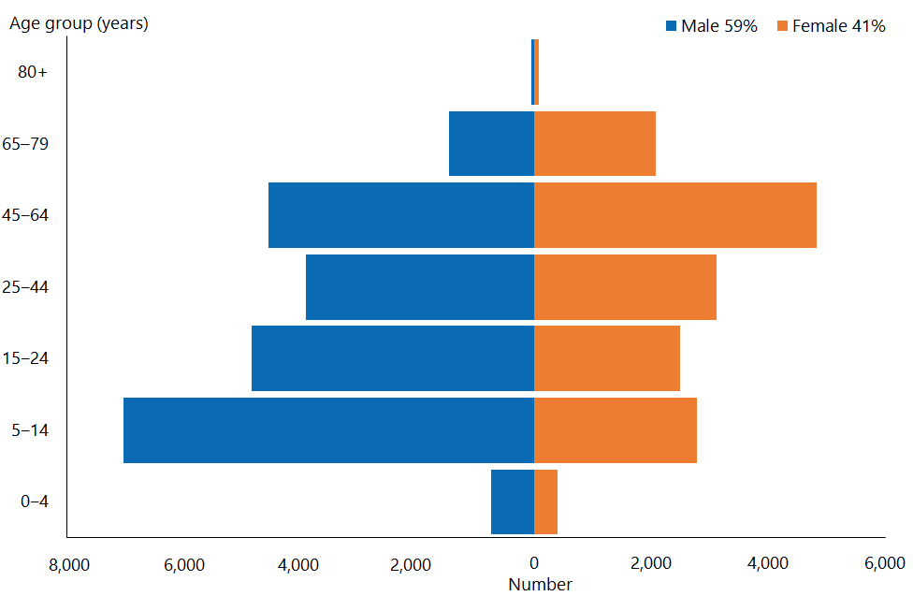

Figure 2: New Zealand population, by age and sex, 2018

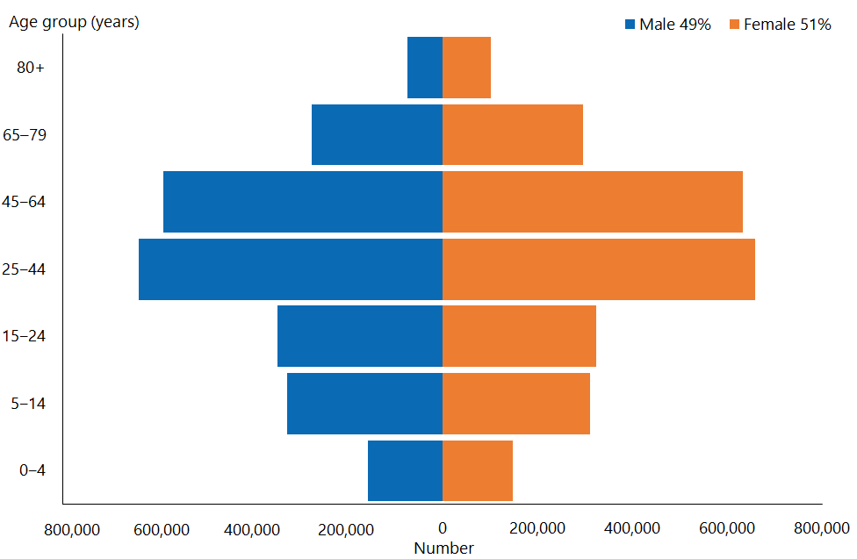

### Observations

* There are notable differences between the age and sex demographics of DSS clients compared with the overall New Zealand population.
* DSS clients are markedly more concentrated in the 5–24-year age group; males are predominant in the younger age groups and females slightly more predominant in the older age groups.
* Generally, only people aged under 65 are eligible for DSS services, hence the lower numbers of people in the over-65 age groups compared with the general population. In 2018, there were 3,681 DSS clients aged 65+ years (9.6 percent of the DSS client population; in comparison, people aged 65+ years make up 15.3 percent of the total New Zealand population).

## Ethnicity

Table 1: Ethnicity of Disability Support Services clients compared with New Zealand population, 2018

|  |  |  |
| --- | --- | --- |
| **Ethnicity (prioritised)** | **DSS clients** | **New Zealand population** |
| European/Other | 26,391 | 3,075,260 |
| Māori | 7,151 | 765,270 |
| Pacific | 2,350 | 315,845 |
| Asian | 2,450 | 728,460 |
| **Total** | **38,342** | **4,884,835** |

Note: A very small number of unstated ethnicity is included in European/Other.

Figure 3: Ethnicity distribution of Disability Support Services clients compared with New Zealand population, 2018

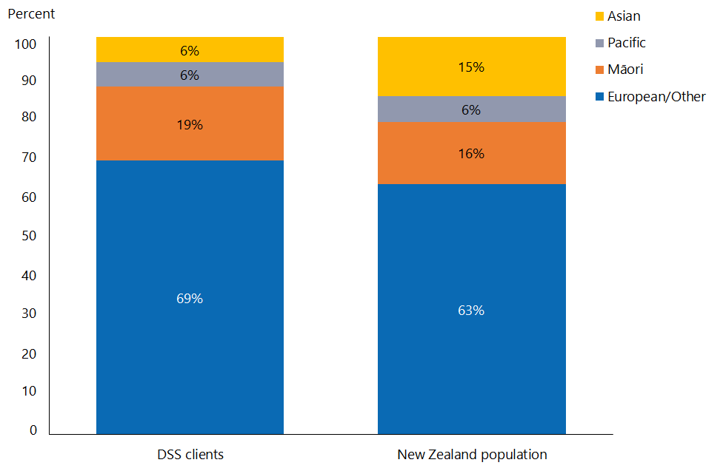

### Observations

* Compared to the total New Zealand population, the European/Other and Māori ethnicities are slightly over-represented in the DSS client group.
* The Asian ethnicity is significantly under-represented among clients of DSS services, while Pacific peoples are equally represented.
* Since 2014 there has been:
* a 34 percent increase (1,799) in the number of Māori DSS clients
* a 24 percent increase (457) in the number of Pacific DSS clients
* a 60 percent increase (918) in the number of Asian DSS clients.

# Disability services

## Types of disability support services

Table 2: Number of Disability Support Services clients, by service type, 2018 and 2016

|  |  |  |  |
| --- | --- | --- | --- |
| **DSS service type** | **Client number 2018** | **Client number 2016** | **Change from 2016 to 2018 (%)** |
| Behaviour support services (BSS) | 3,334 | 2,557 | 30.4 |
| Carer support | 21,233 | 19,539 | 8.7 |
| Choices in community living (CiCL) | 216 | 172 | 25.6 |
| Community rehabilitation | 86 | 104 | -17.3 |
| Community residential | 6,782 | 6,791 | -0.1 |
| Day services | 1,653 | 1,889 | -12.5 |
| Enhanced individualised funding (EIF) | 396 | 432 | -8.3 |
| Funded family care (FCC) | 431 | 318 | 35.5 |
| High and complex (H&C) | 304 | 293 | 3.8 |
| Home and community support services (HCSS) | 8,890 | 10,626 | -16.3 |
| Individualised funding (IF) | 5,338 | 3,483 | 53.3 |
| Respite | 3,740 | 2,544 | 47.0 |
| Supported living | 4,215 | 3,705 | 13.8 |
| Younger people in aged care residential services (YPD) | 878 | 835 | 5.1 |

### Observations

* The number of clients placed in residential care and using community day services continues to decrease as NASCs respond to DSS’ direction of providing clients with alternative more community-based services.
* The number of clients accessing IF and FCC is increasing significantly; the Ministry believes this is a result of the noticeable shift away from historical reliance on family/whānau and other natural supports.
* An increasing number of clients are accessing respite services, due to the increasing flexibility associated with this service.
* The decreasing number of clients using Home and community support services appears to be a result of clients using other more specific support services.

# Overall client demographics

## Age and sex

Table 3: Number of Disability Support Services clients, by age and sex, 2018 and 2016

|  |  |  |  |  |  |  |
| --- | --- | --- | --- | --- | --- | --- |
| **Age group** | **2018** | | | | **2016** | **Change from 2016 to 2018 (%)** |
| **Female** | **Male** | **Total** | **%** |
| 0–4 | 396 | 737 | 1,133 | 3.0 | 1,039 | 9.0 |
| 5–14 | 2,783 | 7,034 | 9,817 | 25.6 | 8,606 | 14.1 |
| 15–24 | 2,476 | 4,837 | 7,313 | 19.1 | 6,768 | 8.1 |
| 25–44 | 3,111 | 3,913 | 7,024 | 18.3 | 6,793 | 3.4 |
| 45–64 | 4,820 | 4,554 | 9,374 | 24.4 | 9,303 | 0.8 |
| 65–79 | 2,078 | 1,465 | 3,543 | 9.2 | 3,447 | 2.8 |
| 80+ | 83 | 55 | 138 | 0.4 | 91 | 51.6 |
| **Total** | **15,747** | **22,595** | **38,342** | **100** | **36,047** | **6.4** |
|  | 41% | 59% | 100% |  |  |  |

### Observations

* The total number of individuals allocated disability support services has increased by 18.9 percent (from 32,247) since 2014.
* The median age of DSS clients was:
* 31 years in 2014
* 28 years in 2016
* 26 years in 2018.

This drop is due to the increasing numbers of Māori, Pacific and Asian clients, who tend to be younger.

* The number and percentage of DSS clients aged over 65 (3,681) has increased by 2 percent since 2013, when 7.6 percent (2377) of clients were aged over 65. In 2016, 9.8 percent (3,538) of clients were aged over 65; in 2018, the figure was 9.6 percent (3,681).

## Ethnicity

Table 4: Number of Disability Support Services clients, by ethnicity, 2018 and 2016

|  |  |  |  |
| --- | --- | --- | --- |
| **Ethnicity** | **2018** | **2016** | **Change from 2016 to 2018 (%)** |
|
| European/Other | 26,391 | 25,428 | 3.8 |
| Māori | 7,151 | 6,415 | 11.5 |
| Pacific | 2,350 | 2,222 | 5.8 |
| Asian | 2,450 | 1,982 | 23.6 |
| **Total** | **38,342** | **36,047** | **6.4** |

Figure 4: Disability Support Services clients, by ethnicity, age and sex

|  |  |
| --- | --- |
| This bar graph shows European/Other clients. 42% are female and 58% are male. The biggest age group is male 5-14, with about 4000 clients. The next most likely groups are men and women 45-64, with between 3500 and 4000 clients each. | This shows the statistics for Māori clients, where 40% are female and 60% are male. Males 5-14 are the most represented group, with about 1600 clients. Males 15-24 are the next biggest group with about 1000 clients, and women 45-64 have about 800. All other groups are less than 800. |
| This bar graph shows the demographics of Pacific clients, which are 61% male and 39% female. The largest group is males 5-14, with about 500 clients, followed by males 15-24 with about 350, and males 25-44 at about 300. All other groups are at or below 200 clients. | This bar graph shows the demographics of Asian clients, which are 66% male and 34% female. Males 5-14 are the largest population, with about 700 clients. There were about 400 male clients between 15-24. There were just over 200 female clients 5-14, but all other groups had fewer than 200 clients. |

### Observations

* The median age of clients in the European/Other group is 31 years (2016: 34 years).
* The median of age of Māori clients is 21 years (2016: 23 years).
* The median age of Pacific clients is 22 years (2016: 22 years).
* The median age of Asian clients is 16 years (2016: 17 years).

## Marital status

Table 5: Number of Disability Support Services clients, by marital status and sex, 2018 and 2016

|  |  |  |  |  |  |  |  |
| --- | --- | --- | --- | --- | --- | --- | --- |
| **Marital status** | **2018** | | | **2016** | | | **Change from 2016 to 2018 (%)** |
| |  | | --- | | **Female** | | **Male** | **Total** | |  | | --- | | **Female** | | **Male** | **Total** |
| Married/partnered | 1,073 | 669 | 1,742 | 1,077 | 665 | 1,742 | 0.0 |
| Non-partnered, once married | 590 | 269 | 859 | 571 | 268 | 839 | 2.4 |
| Non-partnered, never married/no further defined | 3,958 | 5,842 | 9,800 | 3,715 | 5,404 | 9,119 | 7.5 |
| Unstated/undefined | 10,126 | 15,815 | 25,941 | 9,912 | 14,435 | 24,347 | 6.5 |
| **Total** | **15,747** | **22,595** | **38,342** | **15,275** | **20,772** | **36,047** | **6.4** |

### Observations

Given that limited information is available for over 67.7 percent of clients recorded (2016: 67.5 percent), it may not be helpful to place emphasis on this data.

## Accommodation

Table 6: Number of Disability Support Service clients, by accommodation type and sex, 2018 and 2016

|  |  |  |  |  |  |
| --- | --- | --- | --- | --- | --- |
| **Accommodation** | **2018** | | | **2016** | **Change from 2016 to 2018 (%)** |
| **Female** | **Male** | **Total** |
| Own/family Home | 7,456 | 11,294 | 18,750 | 17,255 | 8.7 |
| Rental accommodation | 2,653 | 3,774 | 6,427 | 5,449 | 17.9 |
| Housing NZ or council accommodation | 1,041 | 1,299 | 2,340 | 2,117 | 10.5 |
| Community residential home | 2,537 | 3,629 | 6,166 | 6,135 | 0.5 |
| Rest home/continuing care hospital | 379 | 344 | 723 | 652 | 10.9 |
| Unit in a retirement village | 50 | 15 | 65 | 56 | 16.1 |
| Boarder | 151 | 199 | 350 | 344 | 1.7 |
| No fixed abode | 7 | 17 | 24 | 19 | 26.3 |
| Prison | 13 | 24 | 37 | 23 | 60.9 |
| Other/unknown | 1,460 | 2,000 | 3,460 | 3,997 | -13.4 |
| **Total** | **15,747** | **22,595** | **38,342** | **36,047** | **6.4** |

### Observations

* 48.9 percent of DSS clients (2016: 47.9 percent) live in their own or their family home; 60 percent of these clients are male.

Table 7: Number of Disability Support Services clients, by client domicile region, 2018 and 2016

|  |  |  |  |  |
| --- | --- | --- | --- | --- |
| **Region** | **2018** | | **2016** | **Change from 2016 to 2018 (%)** |
| **Number** | **%** |
| Auckland | 11,260 | 29 | 10,784 | 4.4 |
| Bay of Plenty | 2,766 | 7 | 2,508 | 10.3 |
| Canterbury | 5,161 | 13 | 4,753 | 8.6 |
| Gisborne | 387 | 1 | 379 | 2.1 |
| Hawke's Bay | 1,370 | 4 | 1,278 | 7.2 |
| Manawatu–Wanganui | 2,358 | 6 | 2,236 | 5.5 |
| Nelson–Marlborough–Tasman | 1,458 | 4 | 1,405 | 3.8 |
| Northland | 1,693 | 4 | 1,526 | 10.9 |
| Otago | 1,999 | 5 | 1,972 | 1.4 |
| Southland | 897 | 2 | 886 | 1.2 |
| Taranaki | 1,188 | 3 | 1,103 | 7.7 |
| Waikato | 3,852 | 10 | 3,565 | 8.1 |
| Wellington | 3,658 | 10 | 3,397 | 7.7 |
| West Coast | 295 | 1 | 255 | 15.7 |
| **Total** | **38,342** | **100** | **36,047** | **6.4** |

Figure 5: Number of Disability Support Services clients, by client domicile region and ethnicity, 2018

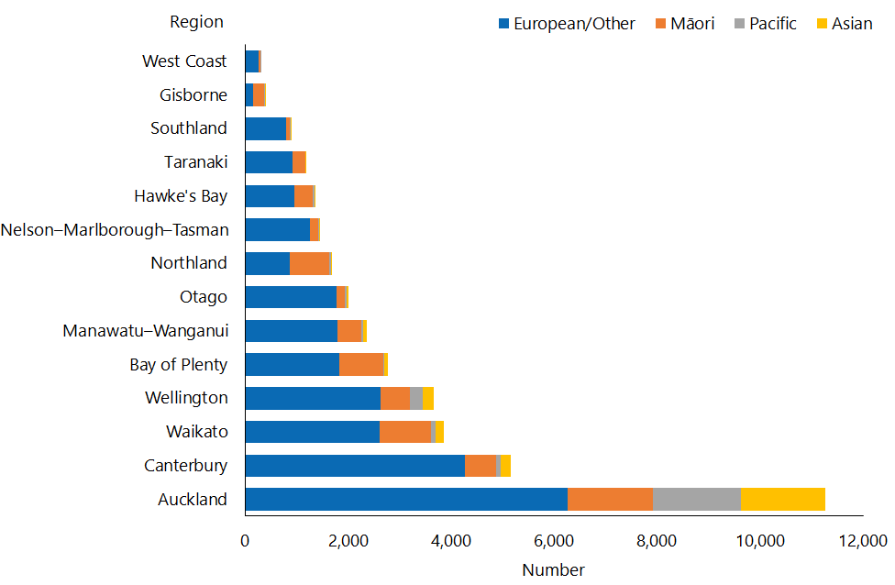

### Observations

* Over half of DSS clients reside in the three most populated regions, which include the major cities of Auckland, Christchurch and Hamilton.
* The Auckland region has by far the greatest variation of ethnicities, and has very high populations of Pacific and Asian clients.
* After Auckland, the next three regions with the highest populations of Māori are Waikato, Bay of Plenty and Northland.

## Principal disability

Socrates records principal disabilities for each DSS client. There are six disability classes: intellectual, physical, autism spectrum disorder (ASD), sensory, neurological and other (see Appendix 2).

Where Socrates records a client as having more than one principal disability, it selects a prioritised disability based on the disability type prioritisation list. The same rule is applied where a principal disability falls into more than one disability type. The list of disability types in the table below shows the order of prioritisation.

Table 8: Number of Disability Support Services clients, by sex and principal disability, 2018 and 2016

|  |  |  |  |  |  |  |
| --- | --- | --- | --- | --- | --- | --- |
| **Type of principal disability** | **2018** | | | | **2016** | **Change from 2016 to 2018 (%)** |
| **Female** | **Male** | **Total** | **%** |
| Intellectual | 8,200 | 11,027 | 19,227 | 50 | 18,548 | 3.7 |
| Sensory | 540 | 556 | 1,096 | 3 | 1,125 | -2.6 |
| Physical | 4,975 | 3,687 | 8,662 | 23 | 8,824 | -1.8 |
| Neurological | 140 | 163 | 303 | 1 | 333 | -9.0 |
| Autism spectrum disorder | 1,765 | 7,093 | 8,858 | 23 | 7,014 | 26.3 |
| Other | 127 | 69 | 196 | 1 | 203 | -3.4 |
| **Total** | **15,747** | **22,595** | **38,342** | **100** | **36,047** | **6.4** |

Figure 6: Number of Disability Support Services clients, by principal disability and sex, 2018

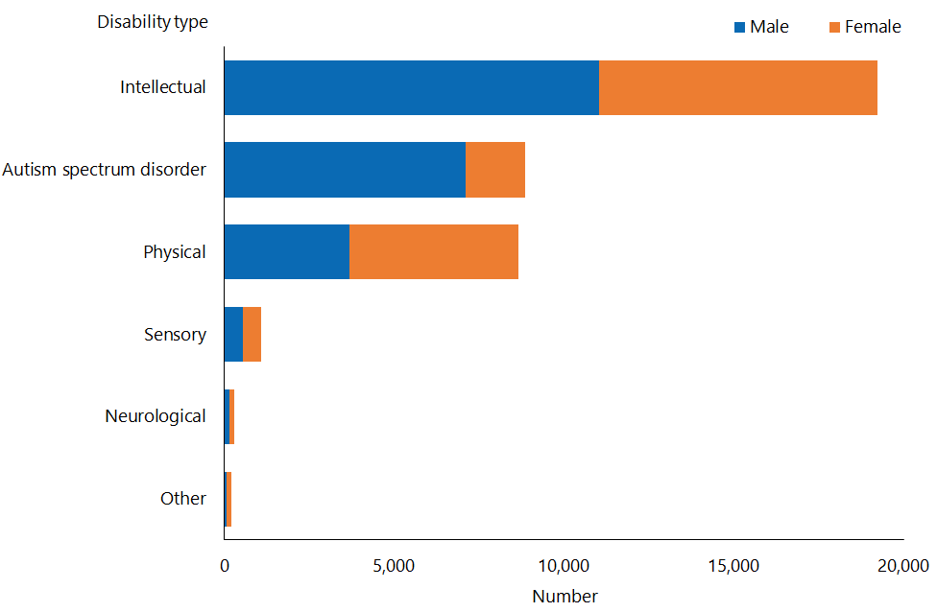

### Observations

* Just over 50 percent of all DSS clients have an intellectual disability as their principal disability. This proportion has decreased slightly, from 51.5 percent in 2016. Many of these clients also have a physical disability.
* The proportion of clients whose principal disability is physical is decreasing: it fell from 30.1 percent in 2014 to 22.6 percent in 2018 (2016: 24.5 percent).
* The proportion of clients with a principal disability of ASD is increasing sharply, rising from 15.7 percent in 2014 to 23.1 percent in 2018 (2016: 19.5 percent).
* Males are predominant in the group of clients with ASD, and also in the group of clients with a principal disability that is intellectual. These proportions have remained the same over the past three years.
* Females are predominant in the group of clients with a principal disability that is physical.

## Support package allocation

‘Support package allocation’ (SPA) refers to the funding or range of disability support services allocated to a disabled client to address their disability support needs, as identified by a NASC. Support package allocations are categorised by level, from ‘very low’ to ‘very high’.

Table 9: Number of Disability Support Services clients, by support package allocation level, 2018 and 2016

|  |  |  |  |  |  |  |
| --- | --- | --- | --- | --- | --- | --- |
| **SPA level** | **2018** | | | | **2016** | **Change from 2016 to 2018 (%)** |
| **Female** | **Male** | **Total** | **%** |
| Very high | 4,504 | 6,232 | 10,736 | 28.0 | 9,670 | 11.0 |
| High | 5,773 | 8,290 | 14,063 | 36.7 | 12,831 | 9.6 |
| Medium | 4,948 | 7,163 | 12,111 | 31.6 | 12,061 | 0.4 |
| Low | 481 | 657 | 1,138 | 3.0 | 1,194 | -4.7 |
| Very low | 8 | 16 | 24 | 0.1 | 30 | -20.0 |
| Undefined | 33 | 237 | 270 | 0.7 | 261 | 3.4 |
| **Total** | **15,747** | **22,595** | **38,342** | **100** | **36,047** | **6.4** |

### Observations

* The proportions of clients across medium, high and very high SPA levels were slightly higher in 2018 compared to 2016.
* The proportions of clients on low and very low SPA levels were about the same from 2016 to 2018. More male clients have higher SPA levels.

Figure 7: Number of Disability Support Services clients, by age and support package allocation level, 2018

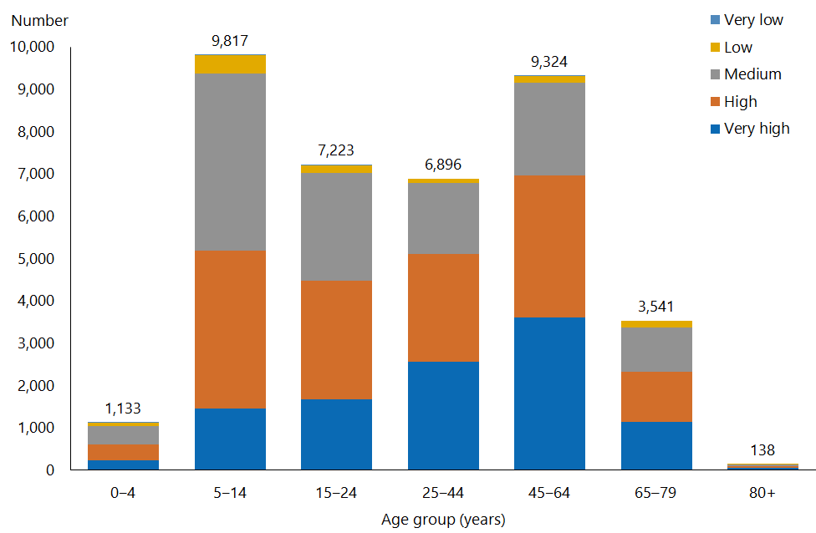

Note: This figure excludes a small amount (1 percent) of information with an undefined SPA level.

### Observations

* Up to age 64, clients SPA levels seem to increase with age.
* Older clients tend to have higher SPA levels.
* The proportion of clients on very high and high SPA bands is increasing, while those on medium, low and very low are decreasing.

## Needs assessment and service coordination organisations

Table 10: Number of Disability Support Services clients, by Needs Assessment and Service Coordination service (NASC), 2018 and 2016

|  |  |  |  |  |
| --- | --- | --- | --- | --- |
| **NASC** | **2018** | | **2016** | **Change from 2016 to 2018 (%)** |
| **Number** | **%** |
| Access Ability ‒ Otago | 2,889 | 7.5 | 2,855 | 1.2 |
| Access Ability ‒ Wanganui | 562 | 1.5 | 534 | 5.2 |
| Access Ability Taranaki | 1,185 | 3.1 | 1,099 | 7.8 |
| Capital Support ‒ Wellington | 1,845 | 4.8 | 1,635 | 12.8 |
| Disability Support Link ‒ Waikato | 3,426 | 8.9 | 3,251 | 5.4 |
| Enable New Zealand ‒ Manawatu | 1,770 | 4.6 | 1,650 | 7.3 |
| Focus ‒ Wairarapa | 393 | 1.0 | 378 | 4.0 |
| LIFE Unlimited ‒ Hutt Valley | 1,323 | 3.5 | 1,283 | 3.1 |
| LIFE Unlimited Charitable Trust ‒ Gisborne | 381 | 1.0 | 381 | 0.0 |
| Life Links ‒ Canterbury | 5,384 | 14.0 | 4,950 | 8.8 |
| NorthAble ‒ Northland | 1,681 | 4.4 | 1,514 | 11.0 |
| Options Hawke's Bay | 1,371 | 3.6 | 1,277 | 7.4 |
| Support Net Kupenga Hao Ite Ora Tauranga | 3,063 | 8.0 | 2,722 | 12.5 |
| Support Works ‒ Nelson | 1,450 | 3.8 | 1,401 | 3.5 |
| Taikura Trust ‒ Auckland | 11,349 | 29.6 | 10,856 | 4.5 |
| **NASC subtotal** | **38,072** | **99** | **35,786** | **6.4** |
| NIDCA Auckland | 87 | 0.2 | 84 | 3.6 |
| NIDCA Central | 59 | 0.2 | 73 | -19.2 |
| NIDCA Midland | 50 | 0.1 | 36 | 38.9 |
| NIDCA South Island | 74 | 0.2 | 68 | 8.8 |
| **NIDCA subtotal** | **270** | **0.7** | **261** | **3.4** |
| **Total** | **38,342** | **100** | **36,047** | **6.4** |

Figure 8: Number of Disability Support Services clients, by Needs Assessment and Service Coordination service and sex, 2018

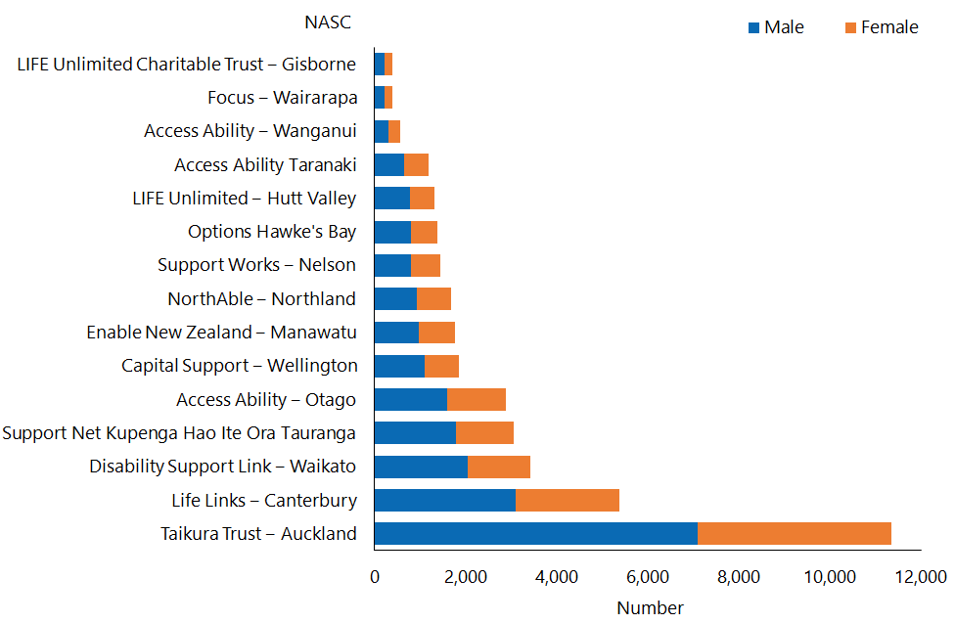

### Observations

* Taikura Trust in the Auckland region continues to have more than twice as many clients as the second largest NASC; it works with 29.6 percent of all DSS clients.
* The client male-to-female ratio is similar for all regions, and remains consistent with the 2016 results.
* The most significant increases in client numbers have been in Wellington, Northland and Bay of Plenty.

# Client demographics by service

A description of each disability support service can be found in Appendix 1 in this report.

## Home and community support services

### Age, sex and ethnicity

Table 11: Home and community support services client numbers, by age, 2018 and 2016

|  |  |  |
| --- | --- | --- |
| **Age group** | **Client number 2018** | **Client number 2016** |
| 0–4 | 71 | 91 |
| 5–14 | 636 | 1,088 |
| 15–24 | 879 | 1,660 |
| 25–44 | 1,497 | 1,784 |
| 45–64 | 3,731 | 3,891 |
| 65–79 | 2,015 | 2,085 |
| 80+ | 61 | 27 |
| **Total** | **8,890** | **10,626** |

Figure 9: Home and community support services client population, by age and sex, 2018

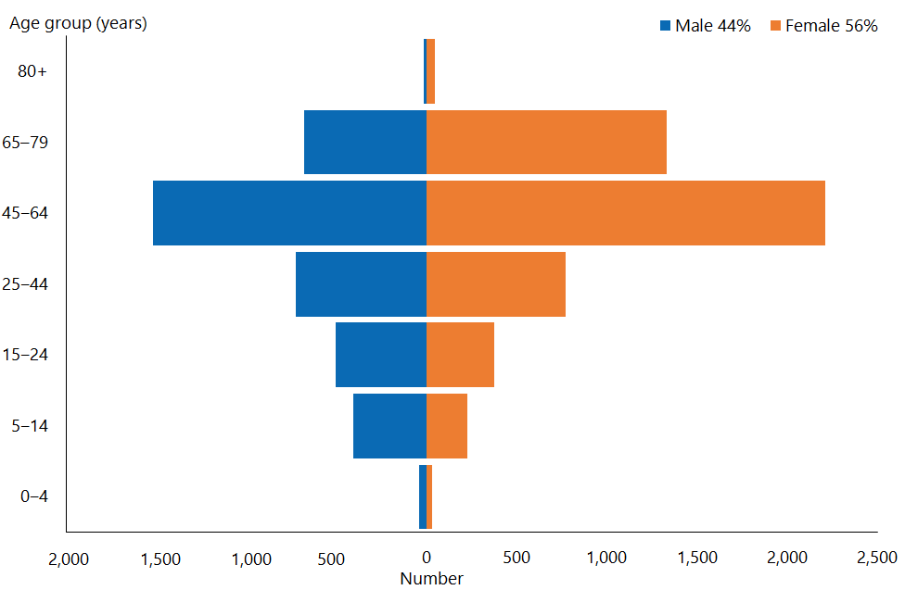

#### Observations

* Home and community support services have historically had more female than male clients.
* The peak in numbers of HCSS clients for both genders occurs in the 45–64-year age group.
* The median age of clients has increased to 54 years (2016: 50 years and 2014: 46 years).
* There has been a 16 percent decrease in the number of people using HCSSs over the past two years.

Figure 10: Home and community support services client population, by ethnicity, 2018

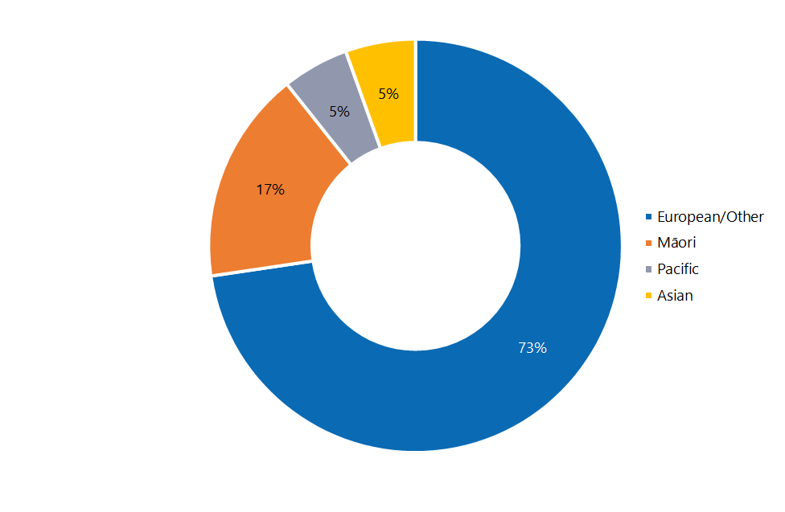

#### Observations

* The ethnicity of HCSS clients in 2018 remains very similar to that in 2016.
* Proportions of Māori and Pacific HCSS clients are equivalent to proportions of Māori and Pacific people in the wider New Zealand population (16 percent and 6 percent respectively).
* European/Other are significantly over-represented and Asian people significantly under-represented in the population of HCSS clients when compared to the equivalent relevant national percentages (63 percent and 15 percent respectively).

### Location

Figure 11: Home and community support services client population, by client domicile region, 2018

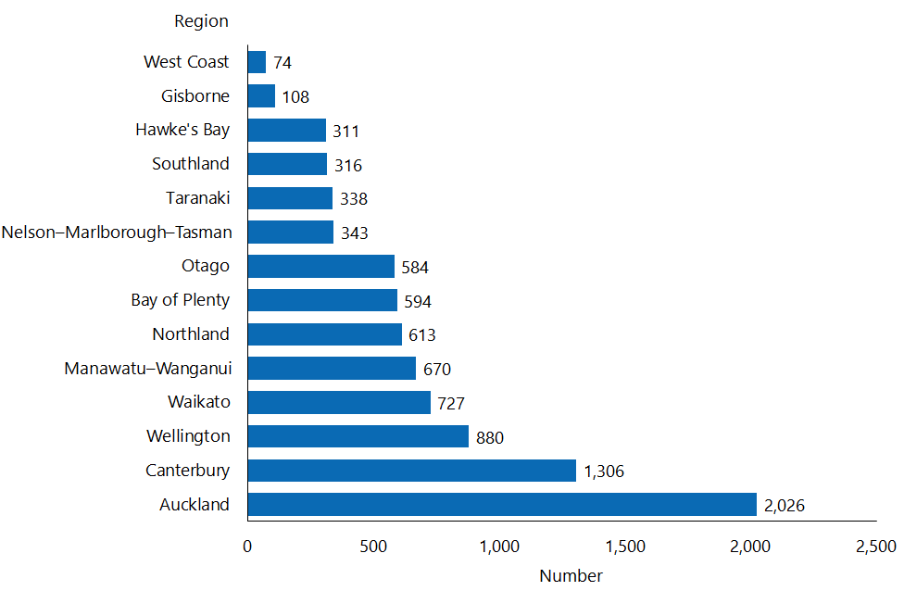

#### Observations

* The Auckland region continues to record the largest ethnic diversity of HCSS clients.
* There has been a decline in use of HCSS services in the Auckland region: in 2018 HCSS clients in Auckland made up 22.8 percent of the total population of HCSS clients, compared to 29.8 percent in 2016.

### Principal disability

Figure 12: Home and community support services client population, by principal disability type and sex, 2018

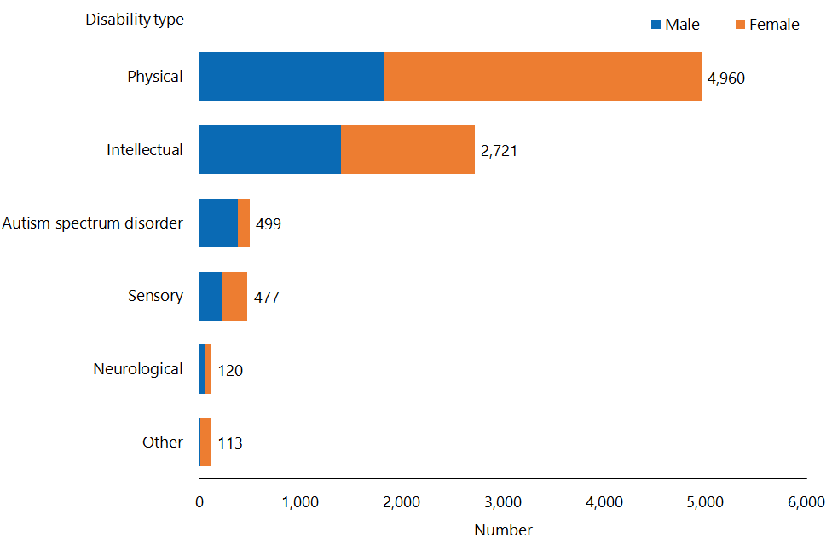

#### Observations

* There has been a significant increase in the number of HCSS clients whose principal disability is physical. In 2018, such clients made up 55.8 percent of the total, up from 48.1 percent in 2016.
* The reverse is true for clients whose principal disability is intellectual: the percentage of such clients has fallen from 34.4 percent in 2016 to 30.6 percent in 2018.

### Support package allocation

Figure 13: Home and community support services client population, by support package allocation level and sex, 2018

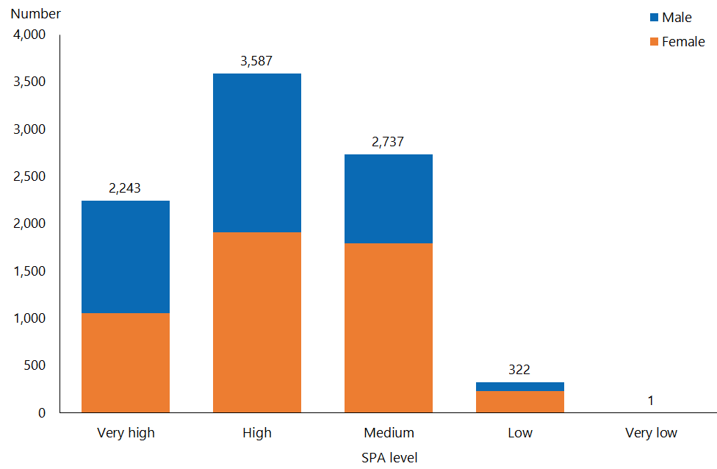

#### Observations

* In 2018, 25.2 percent of HCSS clients have a very high SPA level, and 40.3 percent have a high SPA level, as compared to averages among DSS clients of 28 percent and 36.7 percent respectively.

## Carer support

### Age, sex and ethnicity

Table 12: Carer support client numbers, by age, 2018 and 2016

|  |  |  |
| --- | --- | --- |
| **Age group** | **Client number 2018** | **Client number 2016** |
| 0–4 | 1,048 | 986 |
| 5–14 | 9,308 | 8,260 |
| 15–24 | 6,003 | 5,513 |
| 25–44 | 2,556 | 2,368 |
| 45–64 | 1,668 | 1,745 |
| 65–79 | 638 | 664 |
| 80+ | 12 | 3 |
| **Total** | **21,233** | **19,539** |

Figure 14: Carer support client population, by age and sex, 2018

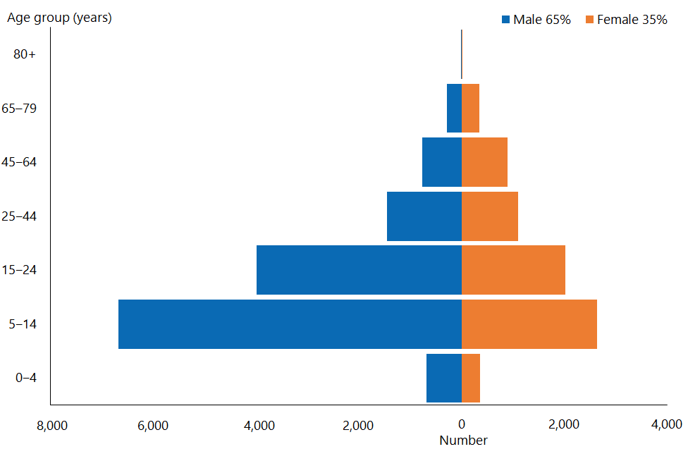

#### Observations

* The median age of carer support clients is still 15 years; this has remained constant since 2014.
* 77.1 percent of clients whose carers are receiving carer support are aged under 24 (2016: 75.5 percent).
* Historically, clients receiving carer support have been predominantly male.

Figure 15: Carer support client population, by ethnicity, 2018

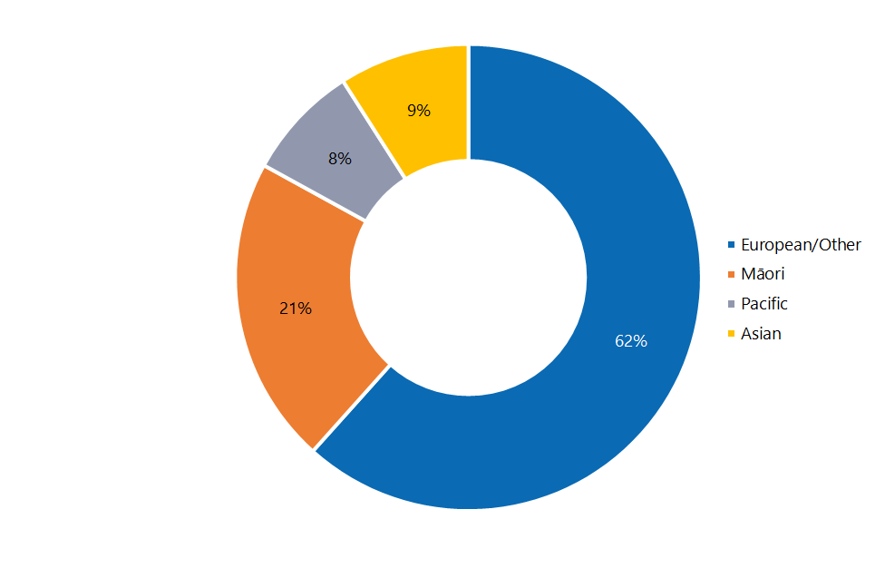

#### Observations

* The proportion of European/Other carer support clients is equivalent to the proportion of people of European/Other ethnicity in the wider New Zealand population (63 percent), while Asian clients are significantly under-represented (Asian people make up 15 percent of New Zealand’s total population).
* Māori and Pacific people are both over-represented among carer support clients (compared to national percentages of 16 percent and 6 percent respectively).

### Location

Figure 16: Carer support client population, by client domicile region, 2018

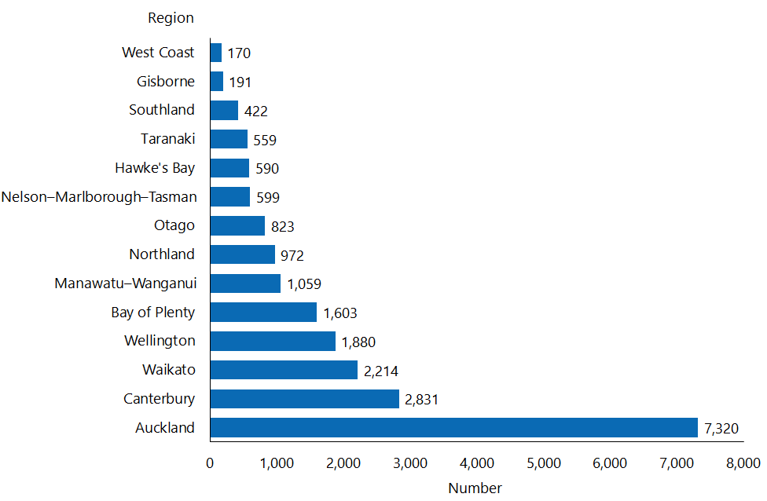

#### Observations

* In 2018 over one-third of carer support clients (34.5 percent) live in the Auckland region (2016: 36.5 percent).
* All regions retain a percentage of carer support clients that is in keeping with previously reported trends.
* Other than the Auckland region, in the vast majority of other regions numbers of carer support clients are consistent with the national DSS client percentage distribution.

### Principal disability

Figure 17: Carer support client population, by principal disability type and sex, 2018

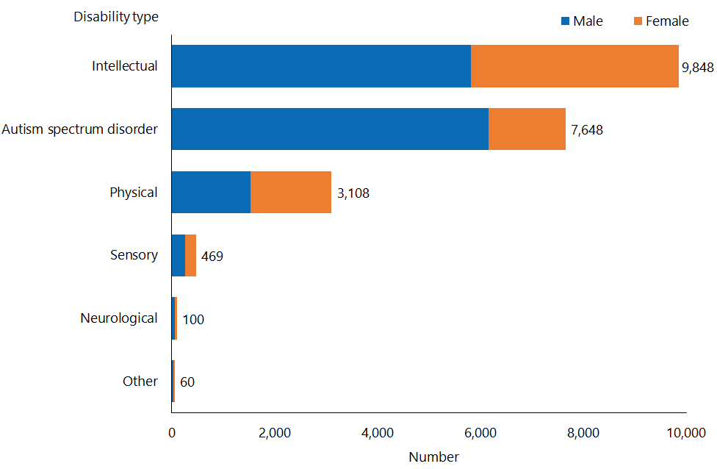

#### Observations

* The principal disability type of an increasing proportion of carer support clients is ASD: 36 percent in 2018, up from 32 percent in 2016. The proportion of clients with a principal disability type of ‘intellectual’ remained the same as in 2016, at 46 percent.
* The proportions of clients with other principal disability types have decreased very slightly since 2016.
* 80 percent of carer support clients with ASD are male (2016: over 80 percent).

### Support package allocation

Figure 18: Carer support client population, by SPA level and sex, 2018

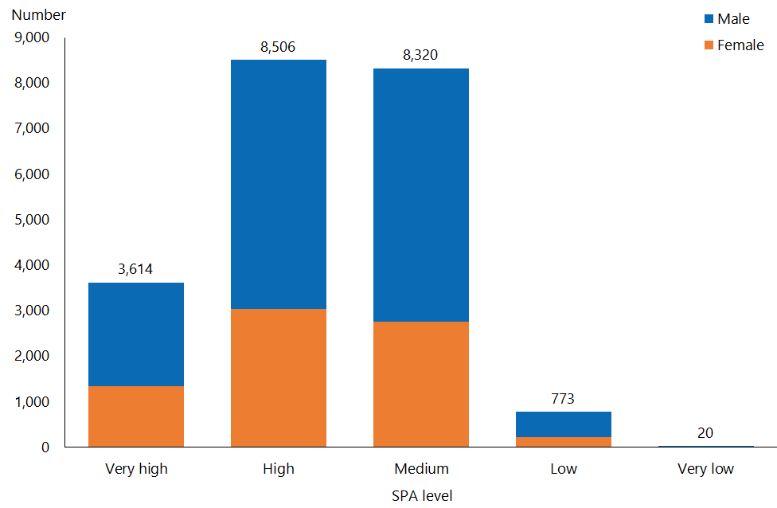

#### Observations

* 79.2 percent of carer support clients have either a medium or a high SPA level (2016: 81 percent).
* The proportion of carer support clients with a high or very high SPA level has increased, from 54 percent in 2016 to 57.1 percent in 2018.
* The proportion of carer support clients with a very high SPA level (17 percent) is well below the equivalent proportion among DSS clients as a whole (the national percentage is 28 percent). With this exception, there is general alignment in SPA levels among carer support clients and DSS clients respectively.

## Community residential services

### Age, sex and ethnicity

Table 13: Community residential services client numbers, by age, 2018 and 2016

|  |  |  |
| --- | --- | --- |
| **Age group** | **Client number 2018** | **Client number 2016** |
| 5–14 | 40 | 37 |
| 15–24 | 535 | 590 |
| 25–44 | 2,153 | 2,223 |
| 45–64 | 3,205 | 3,180 |
| 65–79 | 781 | 701 |
| 80+ | 68 | 60 |
| **Total** | **6,782** | **6,791** |

Figure 19: Community residential services client population, by age and sex, 2018

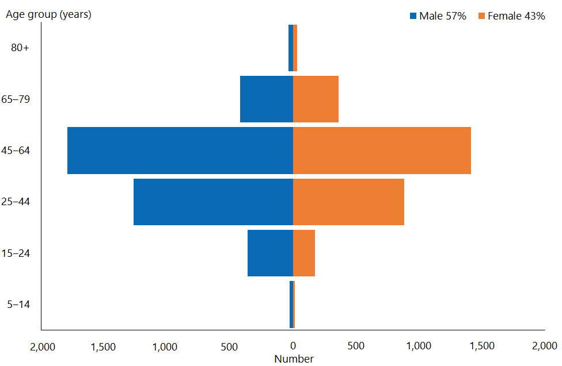

#### Observations

* The median age of community residential clients is 49 years (2016: 48 years).
* There are significantly more males than females using community residential services, as in 2016 (when the proportion of males was exactly the same).
* The 45–64-year age group contained the largest proportion of community residential clients, for both genders.

Figure 20: Community residential services client population, by ethnicity, 2018

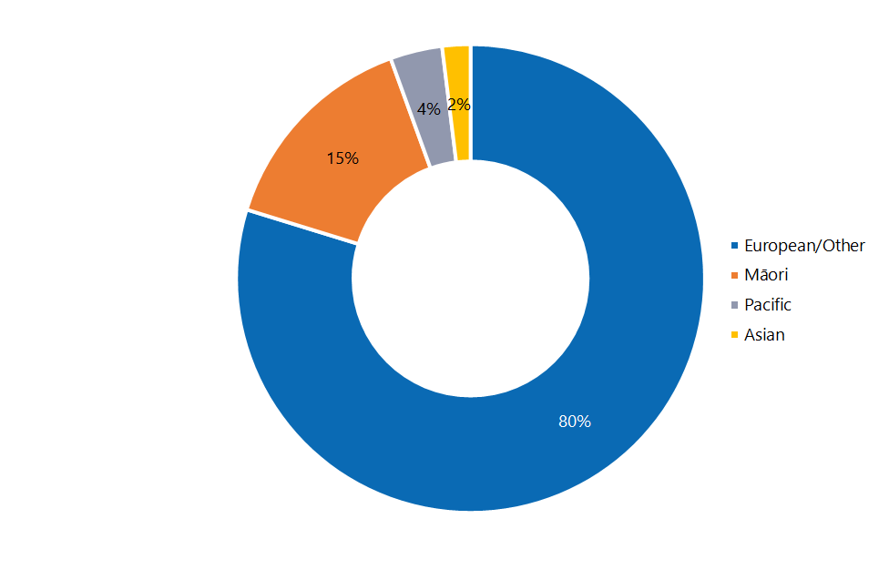

#### Observations

* The ethnicity of individuals receiving community residential services in 2018 is similar to that in 2016.
* In 2018, Pacific and Asian people remain significantly under-represented among community residential services clients compared to the wider population (those ethnicities comprise 6 percent and 15 percent of the New Zealand total respectively), while European/Other are significantly over-represented (the European/Other ethnicity accounts for 63 percent of New Zealand’s total population).
* The proportion of Māori community residential services clients, at 15 percent, is equivalent to the proportion of Māori in the New Zealand population.

### Location

Figure 21: Community residential services client population, by client domicile region, 2018

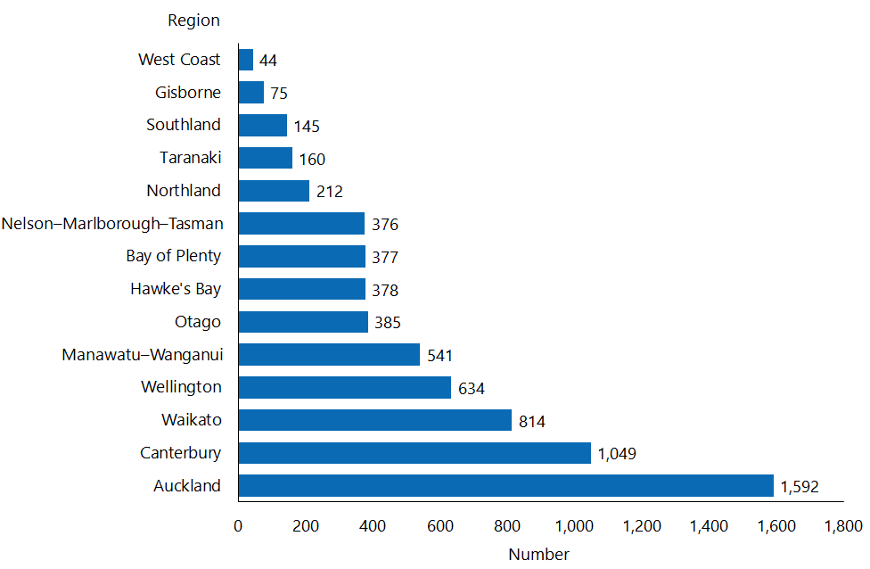

#### Observations

* In 2018 just under one-quarter of community residential services clients (23.5 percent) live in the Auckland region (2016: 36.5 percent).
* Other than the Auckland region, which is significantly under-represented with community residential services clients as compared to the national DSS cohort, in the vast majority of other regions numbers of community residential services clients are reasonably consistent with the national DSS client percentage distribution.

### Principal disability

Figure 22: Community residential services client population, by principal disability type and sex, 2018

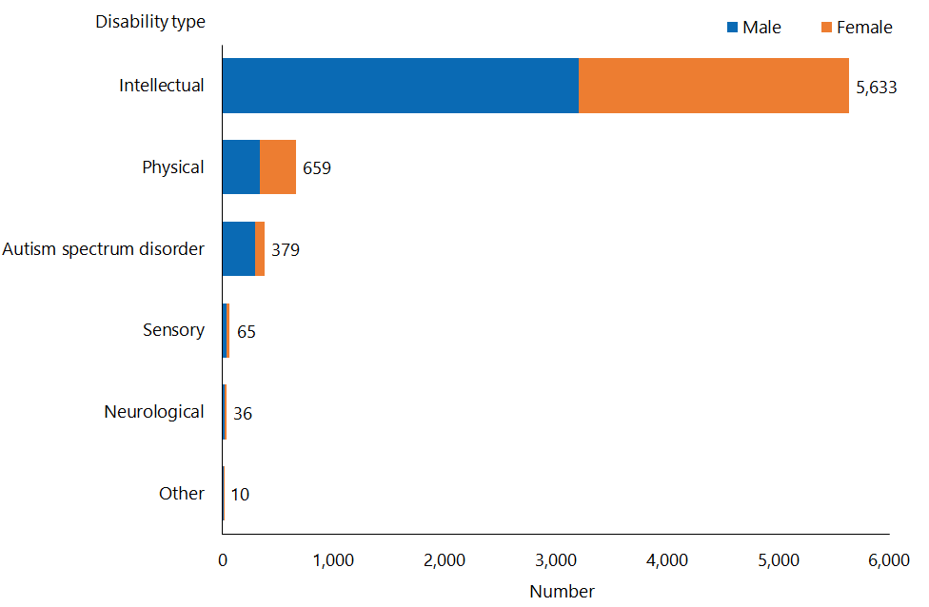

#### Observations

* A significant majority (86.4 percent) of community residential services clients (2016: 83 percent) have a principal disability type of ‘intellectual’.
* Many of these clients also have a physical disability.
* There has been no discernible change in the distribution of principal disability types within community residential services clients.

### Support package allocation

Figure 23: Community residential services client population, by SPA level and sex, 2018

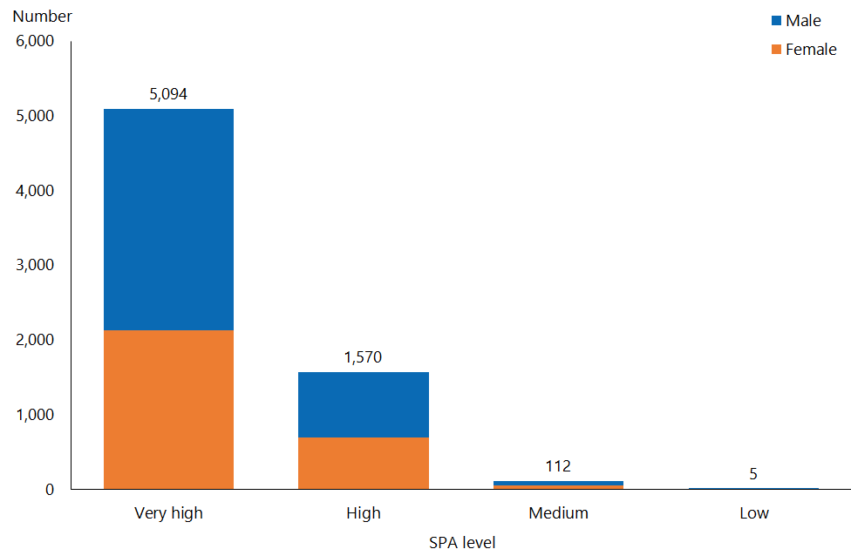

#### Observations

* The proportion of community residential services clients who have high or very high SPA levels has increased since 2014, from 92 percent to 97.9 percent.
* There has been a slight increase in community residential services clients who have a very high SPA level, from 72 percent in 2016 to 73.8 percent. There has been a corresponding decrease in those with a high SPA level over the same period.

## Younger people in aged residential care

### Age, sex and ethnicity

Table 14: Younger people in aged residential care client numbers, by age, 2018 and 2016

|  |  |  |
| --- | --- | --- |
| **Age group** | **Client number 2018** | **Client number 2016** |
| 15–24 | 4 | 2 |
| 25–44 | 48 | 38 |
| 45–64 | 492 | 490 |
| 65–79 | 328 | 301 |
| 80+ | 6 | 4 |
| **Total** | **878** | **835** |

Note: Some clients were allocated to YPD when they were younger than 65 years, and have continued to be supported by such services after that age.

Figure 24: Younger people in aged residential care client population, by age and sex, 2018

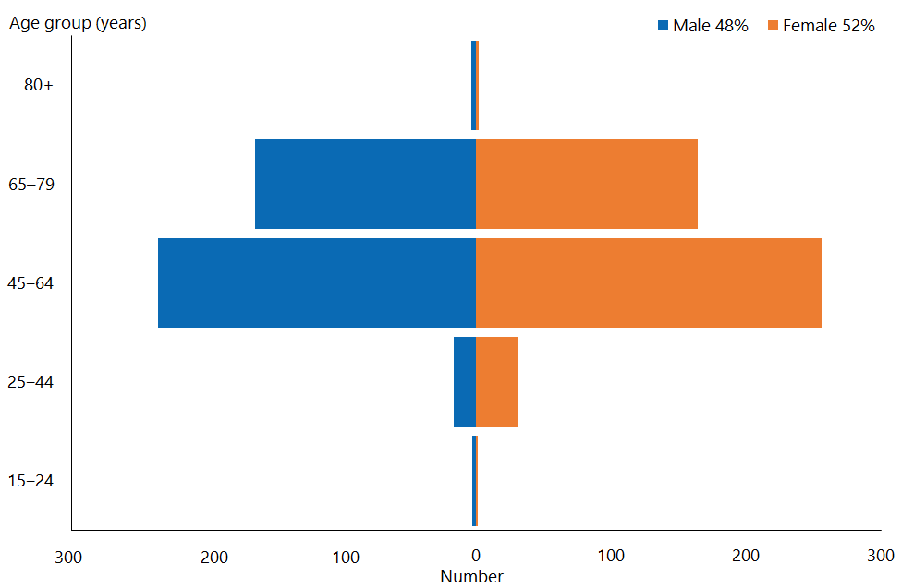

#### Observations

* Although numbers of YPD clients have only increased marginally, there has been a change in the gender mix. The male-to-female ratio has changed, from 45:55 percent in 2016 to 48:52 percent in 2018. This still remains contrary to the overall trend for DSS clients, who are predominantly male.
* Only 6 percent of YPD clients are aged under 44 years (2016: 5 percent).
* The median age of YPD clients has remained static, at 62.

Figure 25: Younger people in aged residential care client population, by ethnicity, 2018

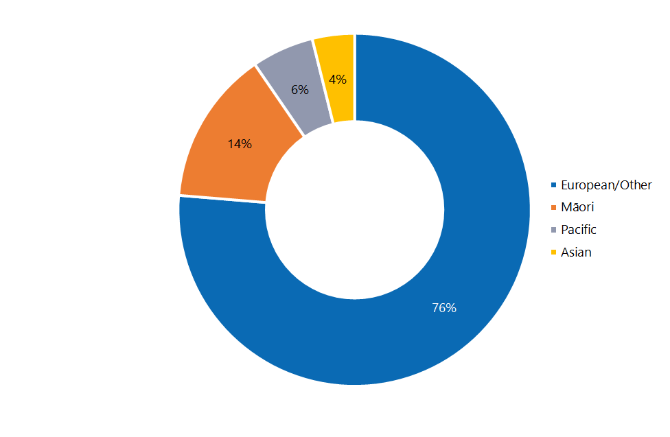

#### Observations

* European/Other people remain over-represented, at 76 percent of YPD clients (2016: 78 percent) compared to the New Zealand population (of which 63 percent are European/Other). Māori are slightly under-represented at 14 percent (2016: 13 percent) compared to the New Zealand population (of which 16 percent are Māori); Pacific YPD clients, at 6 percent (2016: 5 percent) are equally represented compared to the New Zealand population.
* The proportion of Asian YPD clients, at 4 percent (2016: 3 percent) remains significantly smaller than the proportion of Asian people in the New Zealand population (15 percent).

### Location

Figure 26: Younger people in aged residential care client population, by client domicile region, 2018

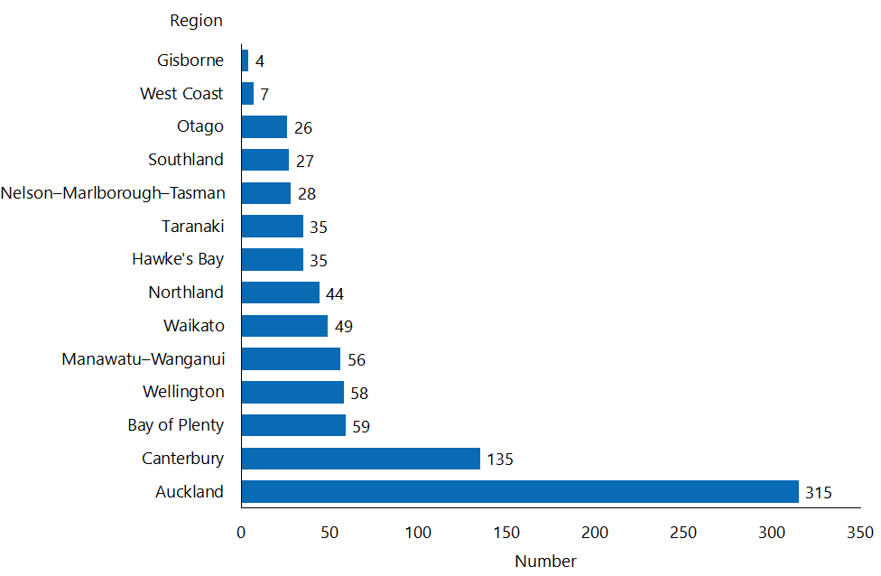

#### Observations

* The Auckland and Canterbury regions continued to be over-represented among YPD clients: 35.9 percent of YPD clients live in Auckland (whereas 29 percent of all DSS clients live there) and 15.4 percent of YPD clients live in Canterbury (whereas 13 percent of all DSS clients live there).
* Conversely, the Wellington and Waikato regions are under-represented: 6.6 percent of YPD clients live in Wellington and 5.5 percent live in Waikato, whereas 10 percent of all clients live in each of those regions.

### Principal disability

Figure 27: Younger people in aged residential care client population, by principal disability type and sex, 2018

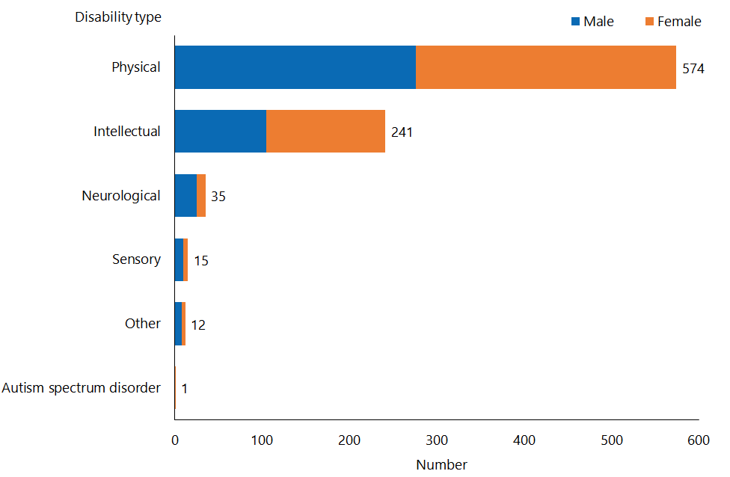

#### Observations

* 65.4 percent of YPD clients have a principal disability type of ‘physical’ (2016: 67 percent).
* Marginally more female YPD clients than males have either a physical or an intellectual disability, but the reverse is true for YPD clients with a neurological disability.

### Support package allocation

Figure 28: Younger people in aged residential care client population, by support package allocation level and sex, 2018

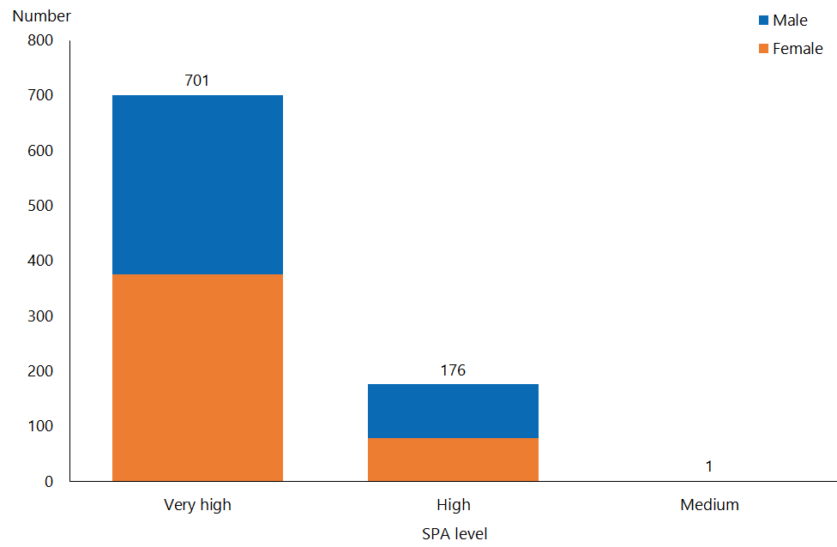

Observations

* Just under four-fifths (79.8 percent) of YPD clients have a very high SPA level, representing an increase since 2016 (when this figure was 76 percent).
* Correspondingly, the proportion of YPD clients with a high SPA level has decreased, from 24 percent in 2016 to 20 percent in 2018.
* Both of these trends are significantly at odds with the proportions of very high and high SPA levels among DSS clients as a whole: 28 percent and 36.7 percent respectively.

## Supported living

### Age, sex and ethnicity

Table 15: Supported living client numbers, by age, 2018 and 2016

|  |  |  |
| --- | --- | --- |
| **Age group** | **Client number 2018** | **Client number 2016** |
| 0–4 | 56 | 5 |
| 5–14 | 166 | 33 |
| 15–24 | 601 | 549 |
| 25–44 | 1,561 | 1,485 |
| 45–64 | 1,533 | 1,390 |
| 65–79 | 291 | 237 |
| 80+ | 7 | 6 |
| **Total** | **4,215** | **3,705** |

Figure 29: Supported living client population, by age and sex, 2018

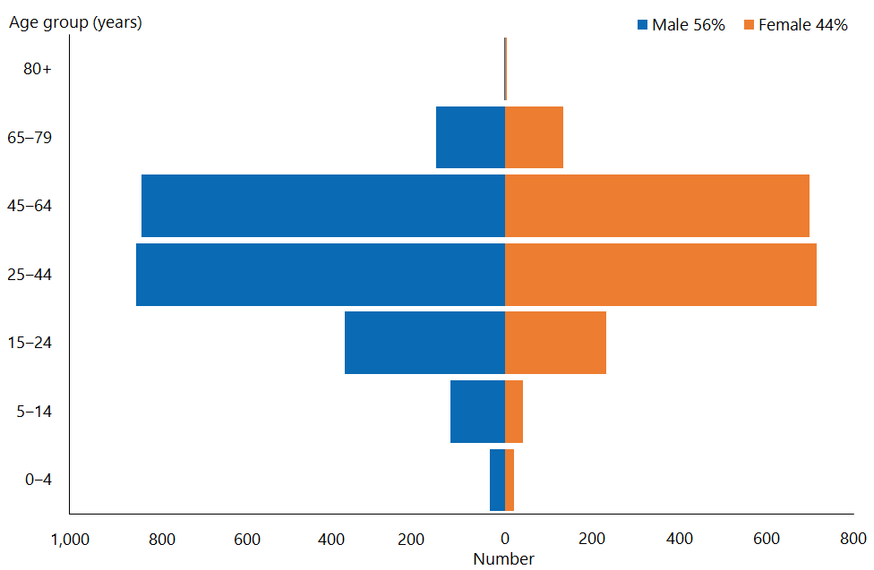

#### Observations

* The median age of supported living clients is 40 (2016: 41).
* Of clients who receive supported living services, 56 percent are male, and 44 percent female; this is similar to previously reported proportions.
* The total number of clients using supported living services has increased by over 13.8, from 3,705 in 2016 to 4,215 in 2018.
* The growth in clients can be seen in the younger age groups: the number of supported living clients aged 24 or younger has increased by 40 percent since 2016.

Figure 30: Supported living client population, by ethnicity, 2018

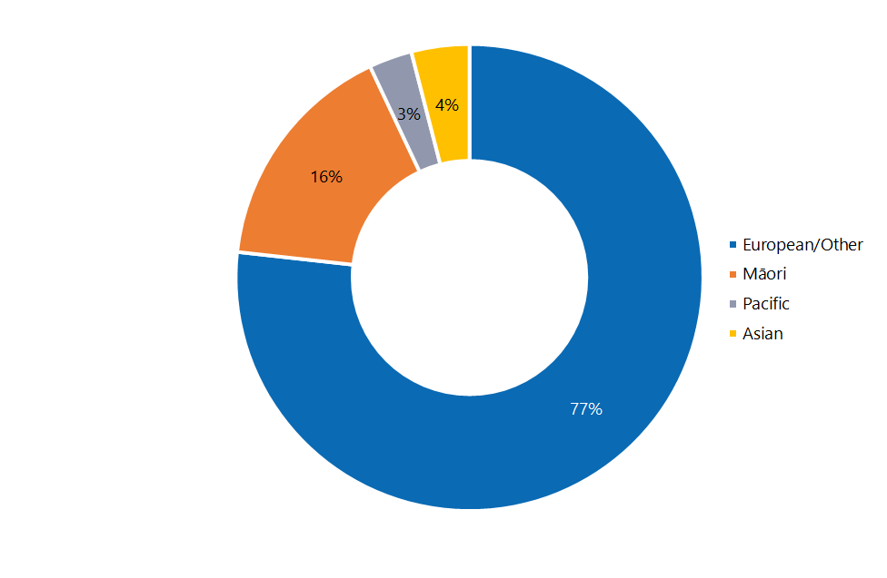

#### Observations

* The ethnicity of clients receiving supported living services remains similar to that recorded in 2016.
* European/Other people remain significantly over-represented, at 77 percent of supported living clients (2016: 80 percent) compared to the New Zealand population (of which 63 percent are European/Other). Pacific are under-represented and Asian significantly under-represented.
* Māori supported living clients are equally represented compared to the New Zealand population.

### Location

Figure 31: Supported living client population, by client domicile region, 2018

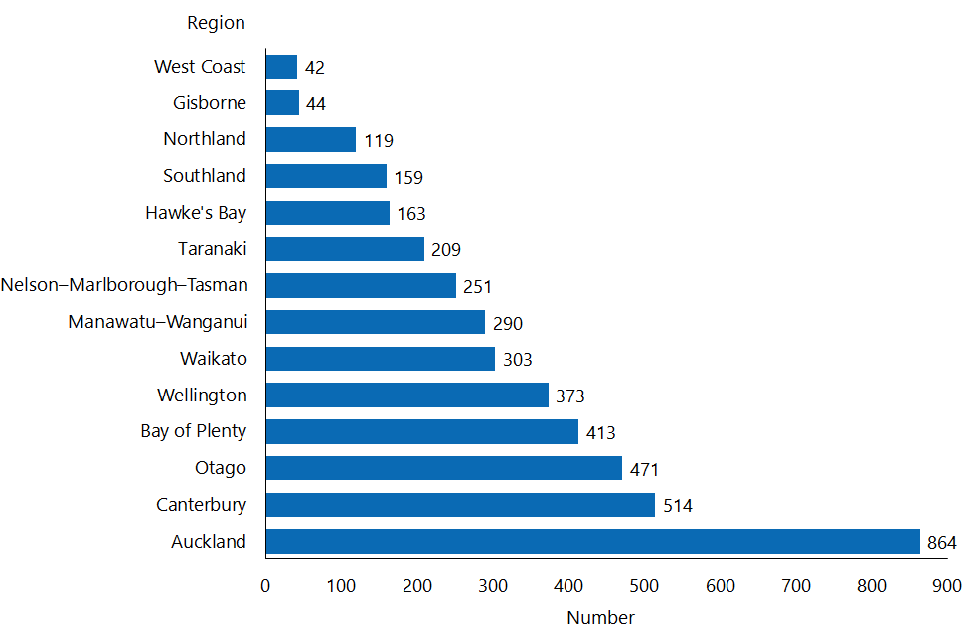

#### Observations

* Since 2016, every single client domicile region has recorded an increase in the numbers of clients receiving supported living services.
* Compared to DSS national clients by domicile region, the Bay of Plenty and Otago regions remain significantly over-represented in terms of people using supported living services.

### Principal disability

Figure 32: Supported living client population, by principal disability type and sex, 2018

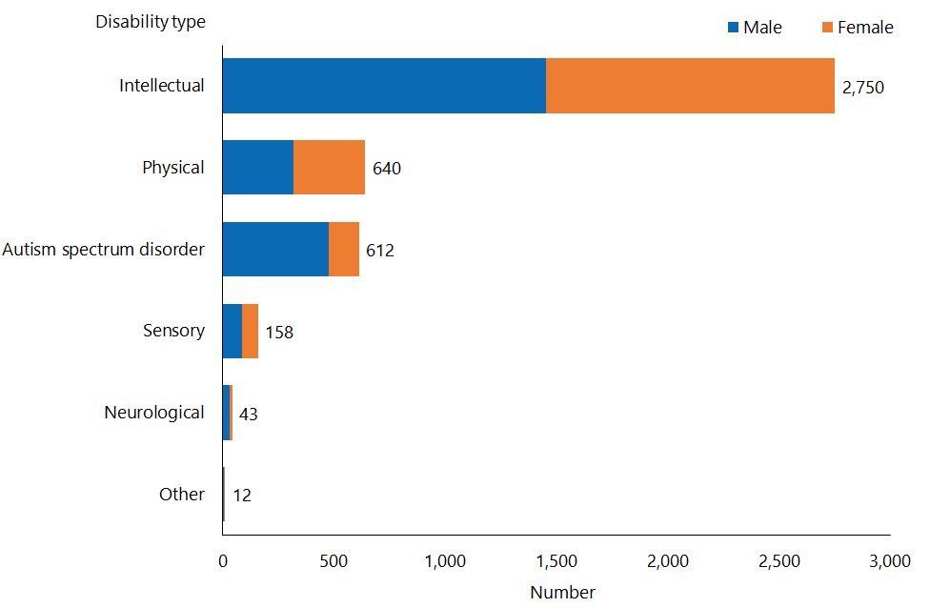

#### Observations

* Although there has been a growth in supported living client numbers, the percentages of clients who have intellectual and physical disabilities respectively have reduced since 2016. The proportion of clients whose principal disability is intellectual in 2018 is 65 percent, down from 68 percent in 2016. The proportion of clients whose principal disability is physical in 2018 is 15 percent, down from 17 in 2016.
* There has been a 4.5 percent growth in supported living clients who have ASD.

### Support package allocation

Figure 33: Supported living client population, by support package allocation level and sex, 2018

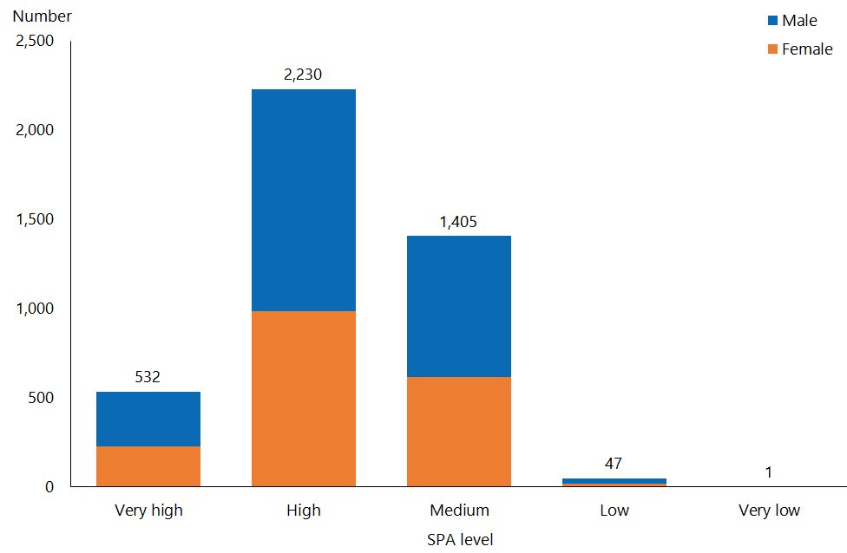

#### Observations

* Most supported living clients (86 percent) have a medium or high SPA level (33 percent and 53 percent respectively); these proportions remain almost identical to the 2016 proportions.
* The percentages of supported living clients with very high and high SPA levels (13 percent and 53 percent respectively) do not reflect those of DSS clients in total (28 percent and 36.7 percent respectively); this is to be expected given the nature of the service.

## Respite services

### Age, sex and ethnicity

Table 16: Respite services client numbers, by age, 2018 and 2016

|  |  |  |
| --- | --- | --- |
| **Age group** | **Client number 2018** | **Client number 2016** |
| 0–4 | 31 | 30 |
| 5–14 | 932 | 714 |
| 15–24 | 1,419 | 922 |
| 25–44 | 700 | 347 |
| 45–64 | 482 | 372 |
| 65–79 | 173 | 155 |
| 80+ | 3 | 4 |
| **Total** | **3,740** | **2,544** |

Figure 34: Respite client population, by age and sex, 2018

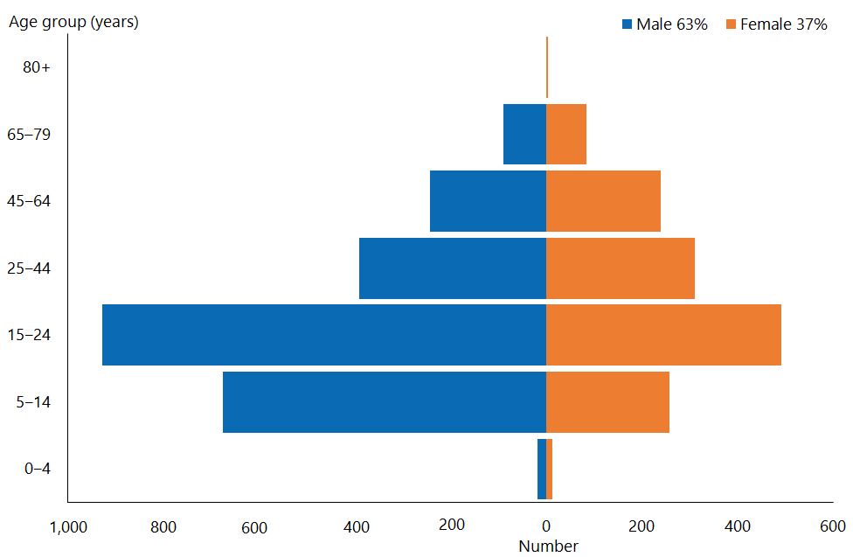

#### Observations

* The median age of respite clients is now 20 years: in 2016 it was 19 years.
* There has been a significant increase (47 percent) in the number of clients using respite services, from 2,544 in 2016 to 3,740 in 2018.
* 60 percent of the growth in clients using respite services has occurred in the 24‑years-and-younger age categories.
* Respite services clients continue to be predominantly male (63 percent in 2018, and 62 percent in 2016).

Figure 35: Respite client population, by ethnicity, 2018

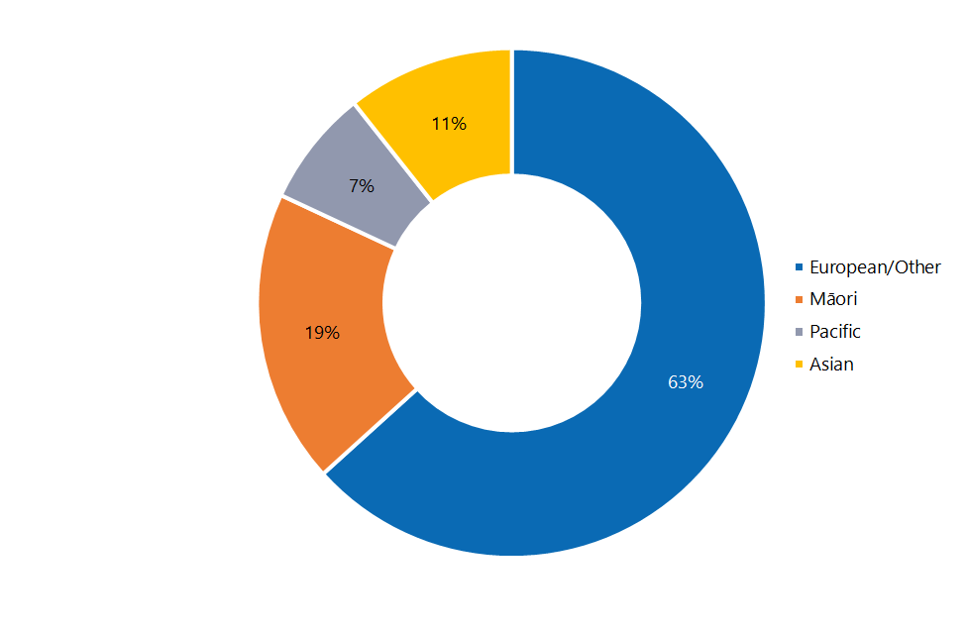

#### Observations

* Asian people are under-represented among respite services clients compared to the proportion of Asian people in the wider New Zealand population, while Māori and Pacific peoples are slightly over-represented (the proportion of Asian, Māori and Pacific people in the total population is 15 percent, 16 percent and 6 percent respectively).
* European/Other respite services clients continue to be equally represented compared to the total population (63 percent).
* The ethnicity of respite services clients is consistent with previously reported ethnicity of this group.

### Location

Figure 36: Respite client population, by client domicile region, 2018

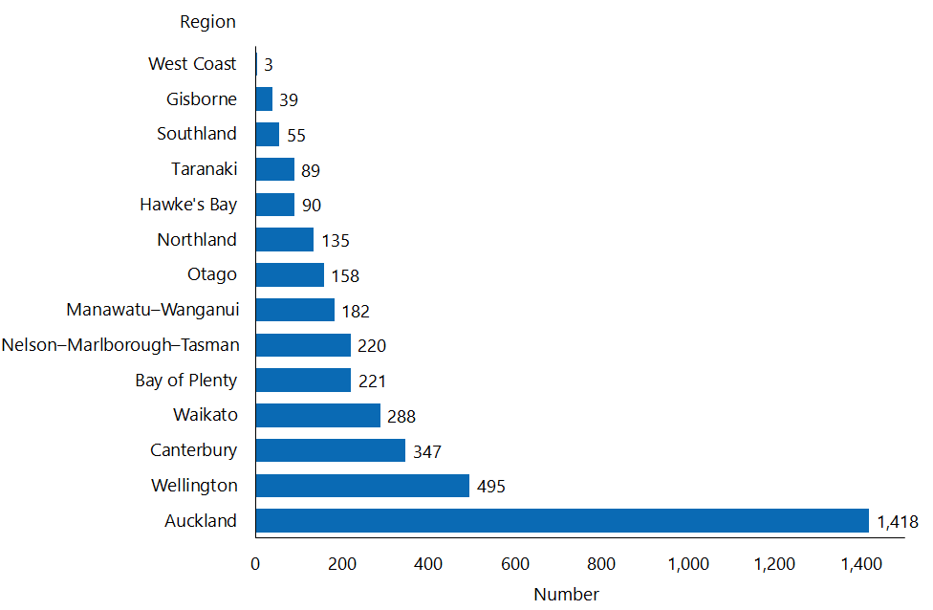

#### Observations

* There are regional disparities in the allocation of respite services.
* The Auckland region continues to be over-represented among users of respite services: 38 percent of respite services clients live in the Auckland region (2016:42 percent), whereas 29 percent of DSS clients in total do so.
* Wellington is slightly over-represented, and Canterbury slightly under-represented: 13.3 percent of respite services clients live in Wellington (2016: 13 percent) and 9.3 percent (2016: 11 percent) live in Canterbury, whereas 10 percent and 13 percent respectively of DSS clients in total live in those regions.

### Principal disability

Figure 37: Respite client population, by principal disability type and sex, 2018

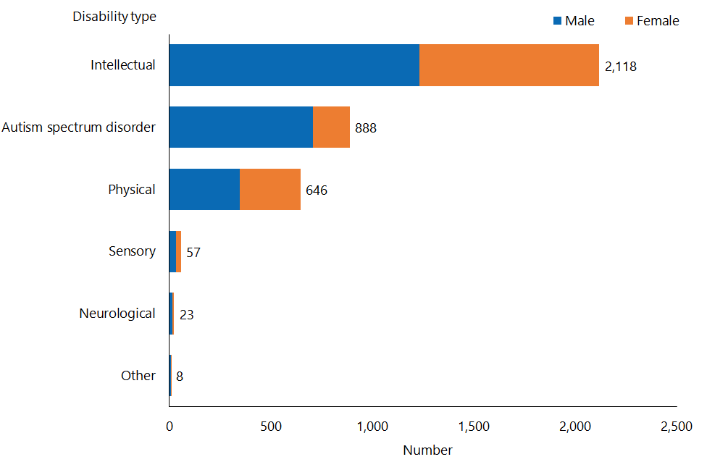

#### Observations

* Respite services clients with a principal disability that is intellectual now make up 56.6 percent of respite services users (2016: 49 percent).
* In contrast, the proportion of respite services clients with a principal disability that is physical has decreased, from 23 percent in 2016 to 17 percent in 2018.
* Interestingly, the proportion of respite services clients with ASD has remained static since 2016, at approximately 24 percent.

### Support package allocation

Figure 38: Respite client population, by support package allocation level and sex, 2018

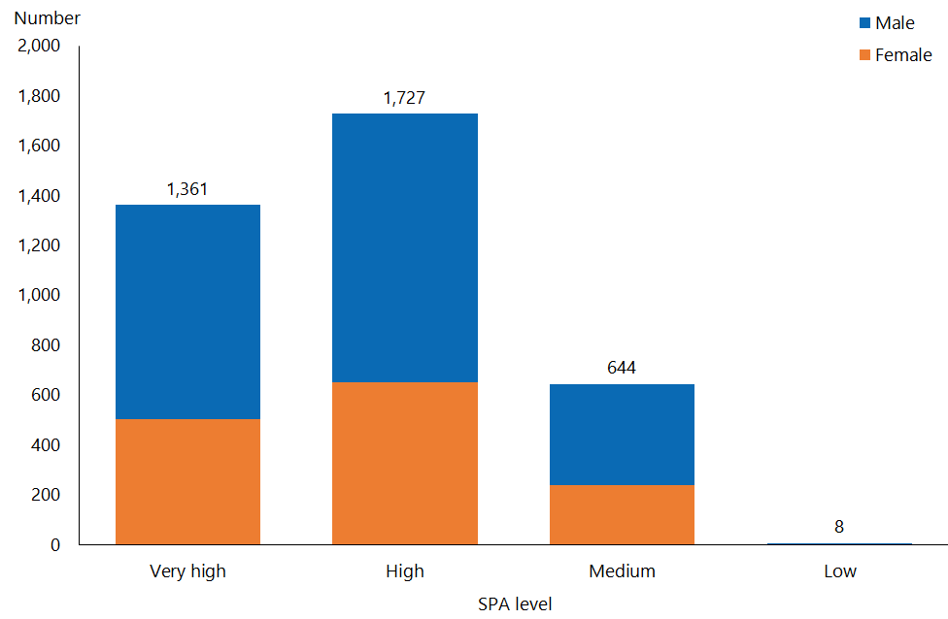

#### Observations

* There has been a change in the proportion of clients using respite services with reference to their SPA levels. Clients with very high SPA levels are using respite services less: 36.4 percent of respite services clients had a very high SPA level in 2018 compared to 44 percent in 2016. Conversely, respite services clients with a medium SPA level are increasing: from 11 percent in 2016 to 17 percent in 2018.
* 83 percent of respite clients have very high or high SPA levels.
* On average, respite services clients have higher SPA levels than DSS clients in total.

## Behaviour support services

### Age, sex and ethnicity

Table 17: Behaviour support services client numbers, by age, 2018 and 2016

|  |  |  |
| --- | --- | --- |
| **Age group** | **Client number 2018** | **Client number 2016** |
| 0–4 | 289 | 135 |
| 5–14 | 2,046 | 1,438 |
| 15–24 | 572 | 580 |
| 25–44 | 263 | 246 |
| 45–64 | 145 | 146 |
| 65–79 | 18 | 12 |
| 80+ | 1 |  |
| **Total** | **3,334** | **2,557** |

Figure 39: Behaviour support services client population, by age and sex, 2018

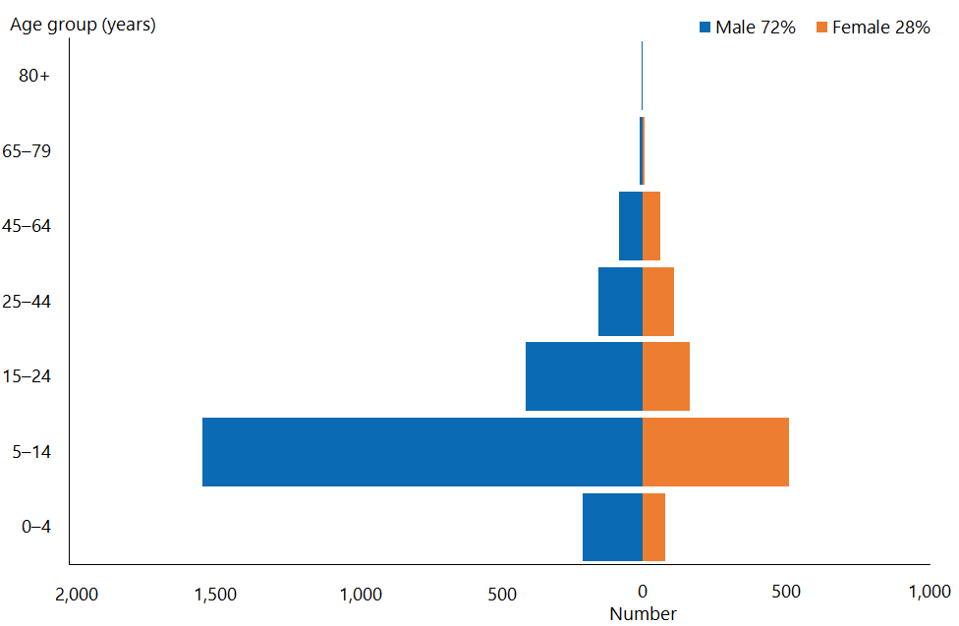

#### Observations

* The median age of BSS clients is 11 years (2016: 12).
* The gender ratio among users of these services remains heavily weighted in favour of males, who comprised 72 percent of this group in both 2016 and 2018.
* In 2018, over 70 percent of BSS clients were aged 14 years or under (2016: 62 percent). The Ministry expects this: BSSs are specifically allocated and used as a form of early intervention.

Figure 40: Behaviour support services client population, by ethnicity, 2018

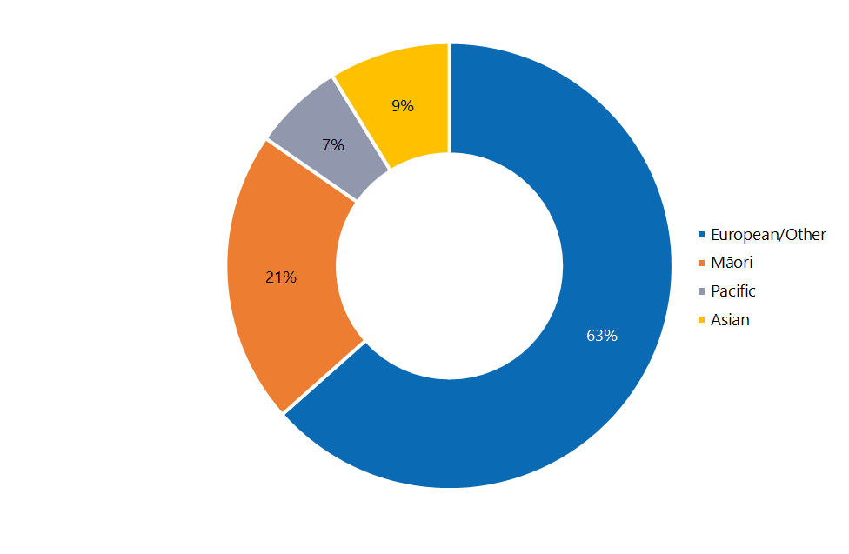

#### Observations

* In 2018, slightly more Māori and Asian clients are accessing BSSs than they did in 2016, when the figures were 19 percent and 7 percent respectively.
* In comparison to New Zealand national population figures, the proportions of European/Other and Pacific users of BSSs respectively are comparable, while Māori are over-represented and Asian people under-represented as users of BSSs.

### Location

Figure 41: Behaviour support services client population, by client domicile region, 2018

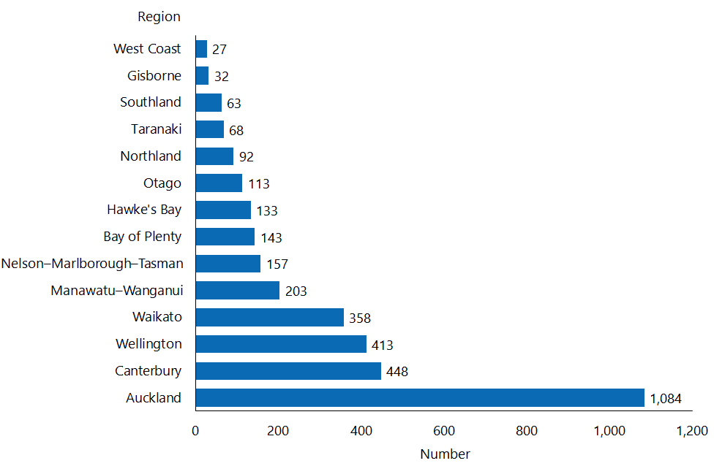

#### Observations

* The spread of BSS clients by domiciled region in 2018 is only slightly different to the spread recorded in 2016.
* The regional spread of BSS clients is largely consistent with the national distribution of DSS clients by domicile region.

### Principal disability

Figure 42: Behaviour support services client population, by principal disability type and sex, 2018

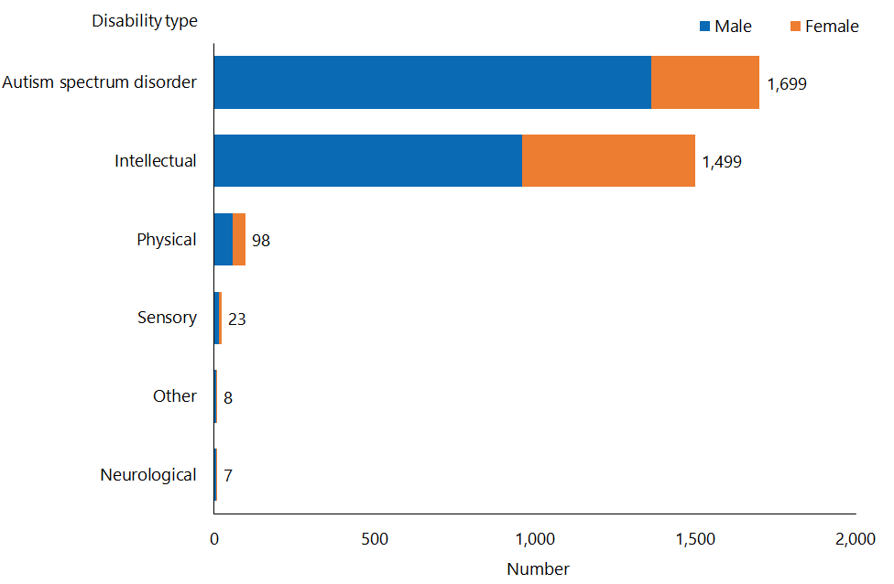

#### Observations

* There has been significant change in terms of the principal disability type of users of these services. Clients with ASD as a proportion of those who access BSS have increased significantly, from 40 percent in 2016 to 51 percent in 2018.
* In comparison, just under 25 percent of DSS clients nationally have ASD as a principal disability.
* There has been a corresponding drop in clients accessing BSSs recording an intellectual disability as their principal disability, from 54 percent in 2016 down to 45 percent in 2018.

### Support package allocation

Figure 43: Behaviour support services client population, by support package allocation level and sex, 2018

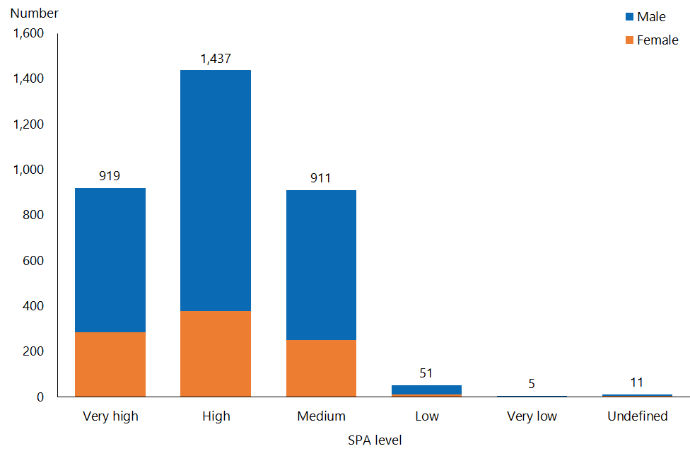

#### Observations

* More than two-thirds (70.7 percent) of BSS clients have very high or high SPA levels (2016: 71 percent).
* The distribution of SPA levels for clients accessing BSSs is similar to the distribution of SPA levels among DSS clients nationally.

## Day services

### Age, sex and ethnicity

Table 18: Day services client numbers, by age, 2018 and 2016

|  |  |  |
| --- | --- | --- |
| **Age group** | **Client number 2018** | **Client number 2016** |
| 15–24 | 62 | 105 |
| 25–44 | 498 | 605 |
| 45–64 | 808 | 905 |
| 65–79 | 256 | 245 |
| 80+ | 29 | 29 |
| **Total** | **1,653** | **1,889** |

Figure 44: Day services client population, by age and sex, 2018

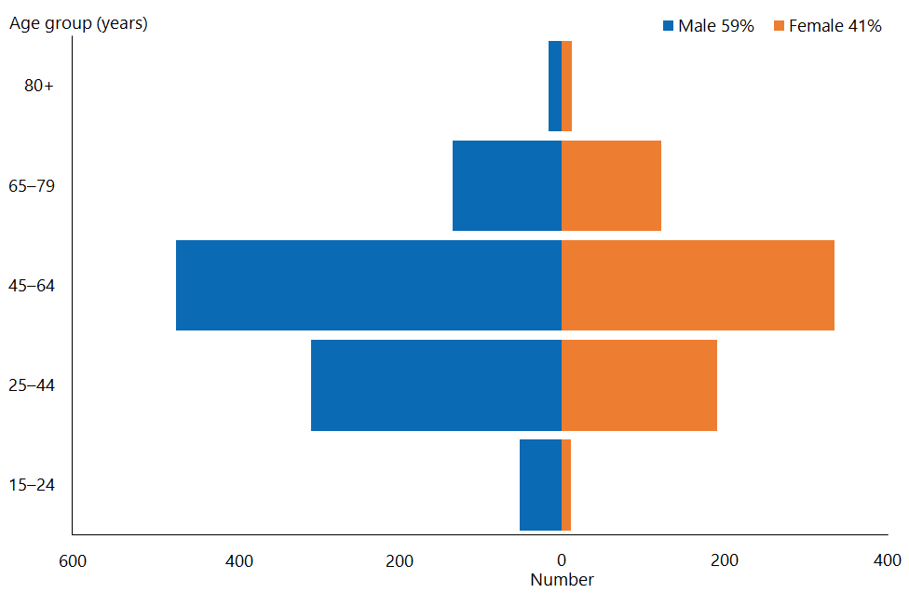

#### Observations

* The median age of day services clients is 51 (2016: 50). This has increased by six years since 2014, largely due to the ageing of clients eligible for the limited day services funded by DSS.
* The total number of clients accessing day services has reduced by 12.5 percent since 2016.
* Just under half (49 percent) of day services clients are now aged 45–64 years (2016: 48 percent).
* Generally, more males than females access day services; this proportion has increased slightly since 2016.

Figure 45: Day services client population, by ethnicity, 2018

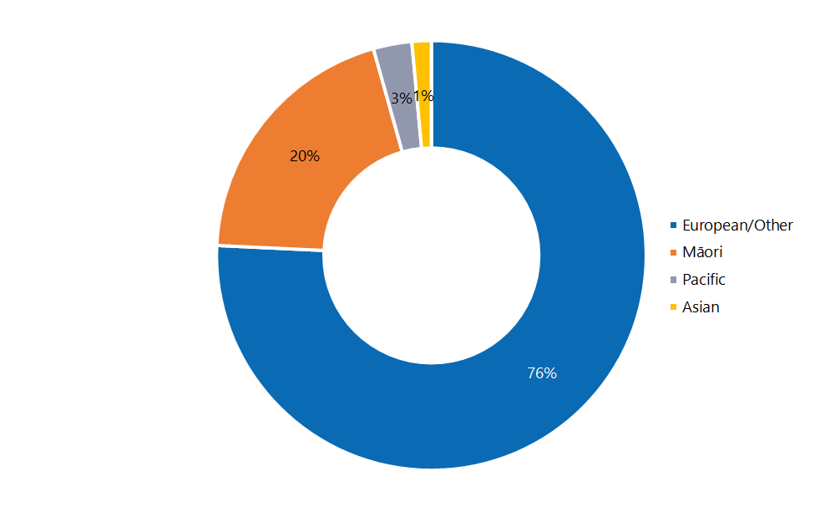

#### Observations

* European/Other people and Māori remain significantly over-represented among day services clients as compared to prevalence in the national population (63 percent and 16 percent respectively).
* In contrast, Pacific and Asian people are significantly under-represented among day services clients (national proportions of those ethnicities are 6 percent and 15 percent respectively).

### Location

Figure 46: Day services client population, by client domicile region, 2018

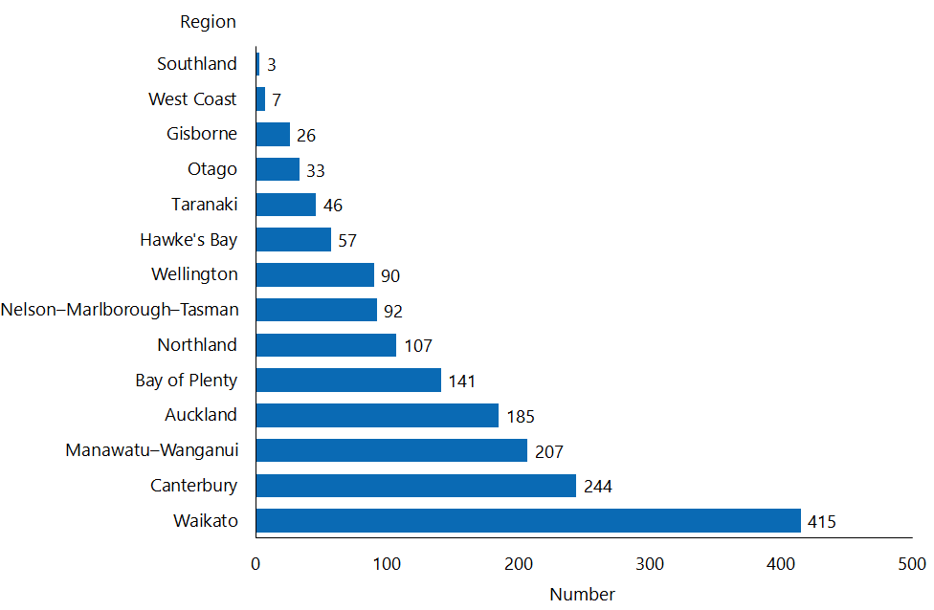

#### Observations

* The Waikato and Manawatu–Wanganui regions are significantly over-represented among day services clients: those regions respectively contain 25.1 percent and 12.5 percent of total day services clients, compared to 10 percent and 6 percent of DSS clients nationally.
* The Auckland and Wellington regions are respectively significantly under-represented among day services clients, those regions respectively contain 11.2 percent and 5.4 percent of total day services clients, compared to 29 percent and 10 percent of DSS clients nationally.
* The reason that Waikato, Canterbury and Manawatu–Wanganui have the largest numbers of day services clients is the closures of Tokanui Psychiatric Hospital, Sunnyside Hospital and the Kimberley Centre in these areas respectively, and the subsequent agreement of the Government to continue to fund day services for clients from those institutions.

### Principal disability

Figure 47: Day services client population, by principal disability type and sex, 2018

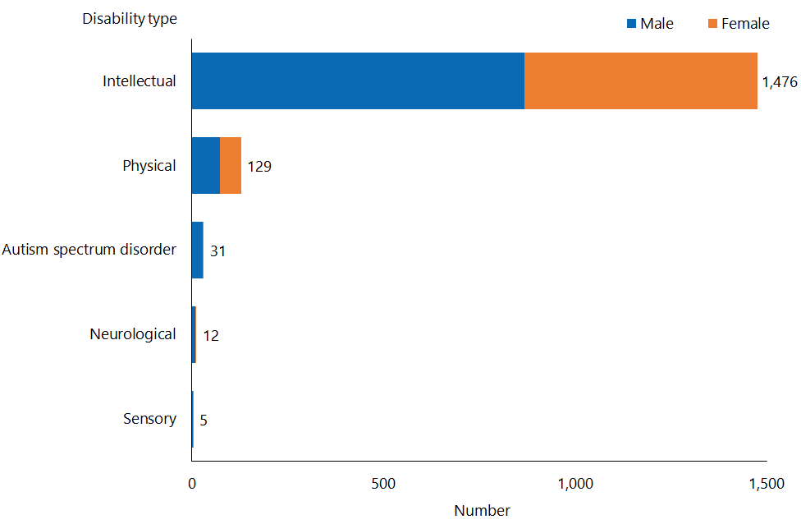

#### Observations

* The vast majority (89 percent) of clients using day services have an intellectual disability.

### Support package allocation

Figure 48: Day services client population, by support package allocation level and sex, 2018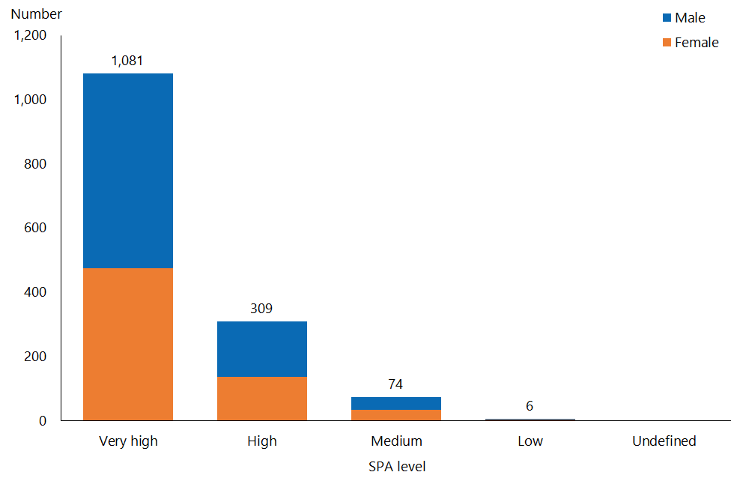

#### Observations

* Over two-thirds (65 percent) of day services clients have a very high SPA level (2016: 65 percent), and a further 19 percent (2016: 22 percent) have a high SPA level.
* The distribution of SPA levels for clients accessing day services contrasts significantly to the national distribution: 28 percent of all DSS clients have a very high SPA level, and 36.7 percent a high SPA level.

## High and Complex Framework

### Age, sex and ethnicity

Table 19: High and Complex Framework client numbers, by age, 2018 and 2016

|  |  |  |
| --- | --- | --- |
| **Age group** | **Client number 2018** | **Client number 2016** |
| 15–24 | 97 | 87 |
| 25–44 | 143 | 138 |
| 45–64 | 61 | 66 |
| 65–79 | 3 | 2 |
| **Total** | **304** | **293** |

Figure 49: High and Complex Framework client population, by age and sex, 2018

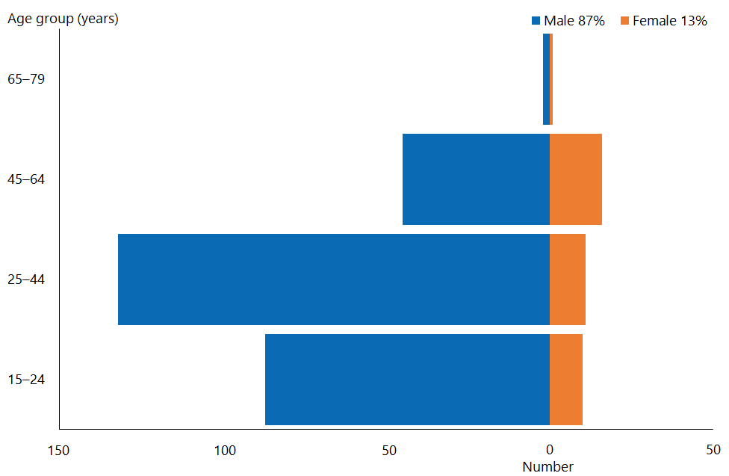

#### Observations

* The median age of H&C clients is 30 years (2016: 31 years).
* As in previous years, there are significantly more males (87 percent) than females among H&C clients (2016: 86 percent)
* Over three-quarters (78.9 percent) of H&C clients are aged between 15 and 44 (2016: 76.8 percent).

Figure 50: High and Complex Framework client population, by ethnicity, 2018

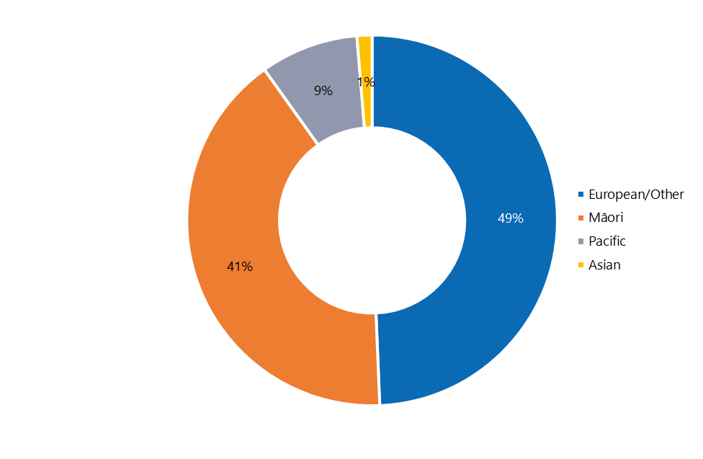

#### Observations

* Māori are significantly over-represented among H&C clients, while Asian and European/Other people are significantly under-represented, compared to national ethnicity percentages (respectively 16 percent, 15 percent and 63 percent).
* Pacific clients are slightly over-represented among H&C clients compared to the proportion of Pacific peoples in the New Zealand population (6 percent).
* The ethnic distribution of H&C clients in 2018 is comparable with that of 2016.

### Location

Figure 51: High and Complex Framework client population, by region,* 2018

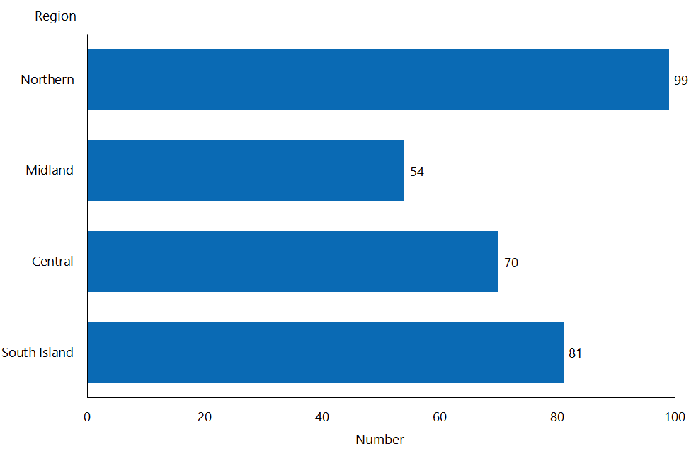

* The locations of H&C clients are assigned according to the four regions where H&C services are allocated.

#### Observations

* The location of H&C clients is determined by the location of secure facilities, which only exist in some regions.
* The distribution of H&C clients across regions varies, with the highest number in the Northern service region and the lowest in the Midland service region.
* The Northern and Midland service regions have predominantly Māori clients.
* The Northern service region has the majority of Pacific clients.

### Principal disability

The principal disability of all clients allocated to H&C services is intellectual.

### Support package allocation

SPA levels are not applicable for H&C clients.

## Choice in community living

### Age, sex and ethnicity

Table 20: Choice in community living client numbers, by age, 2018 and 2016

|  |  |  |
| --- | --- | --- |
| **Age group** | **Client number 2018** | **Client number 2016** |
| 5–14 | 1 |  |
| 15–24 | 24 | 38 |
| 25–44 | 104 | 71 |
| 45–64 | 74 | 57 |
| 65–79 | 13 | 6 |
| **Total** | **216** | **172** |

Figure 52: Choice in community living client population, by age and sex, 2018

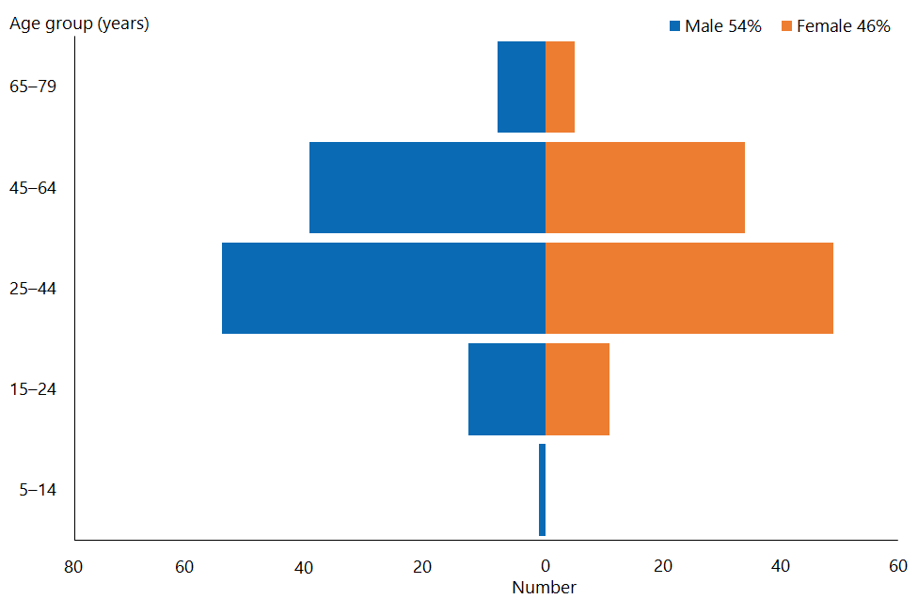

#### Observations

* The median age of choice in community living (CiCL) clients is 38.5 years (2016: 37 years).
* There has been an increase of 25.6 percent since 2016 in the number of clients using CiCL services.
* The ratio of male clients to female clients using this service is one of the most balanced among DSS services.
* Just under half of CiCL clients (48 percent) are in the 25–44-year age bracket (2016: 41 percent).

Figure 53: Choice in community living client population, by ethnicity, 2018

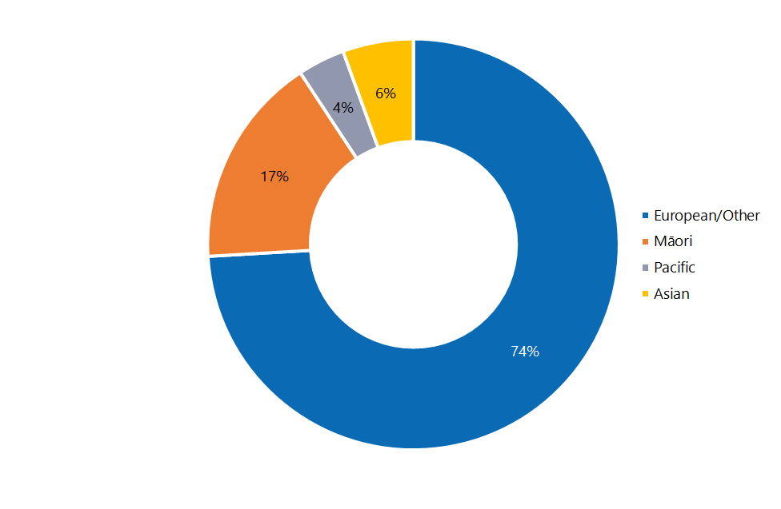

#### Observations

* European/Other people remain significantly over-represented among CiCL clients, compared to their prevalence in the New Zealand population as a whole (63 percent), while Māori are equally represented in comparison to the total population (of which Māori make up 16 percent).
* Pacific people are under-represented and Asian people significantly under-represented among CiCl clients; comparable percentages of those ethnicities in the total population are 6 percent and 15 percent respectively.

### Location

Figure 54: Choice in community living client population, by client domicile region, 2018

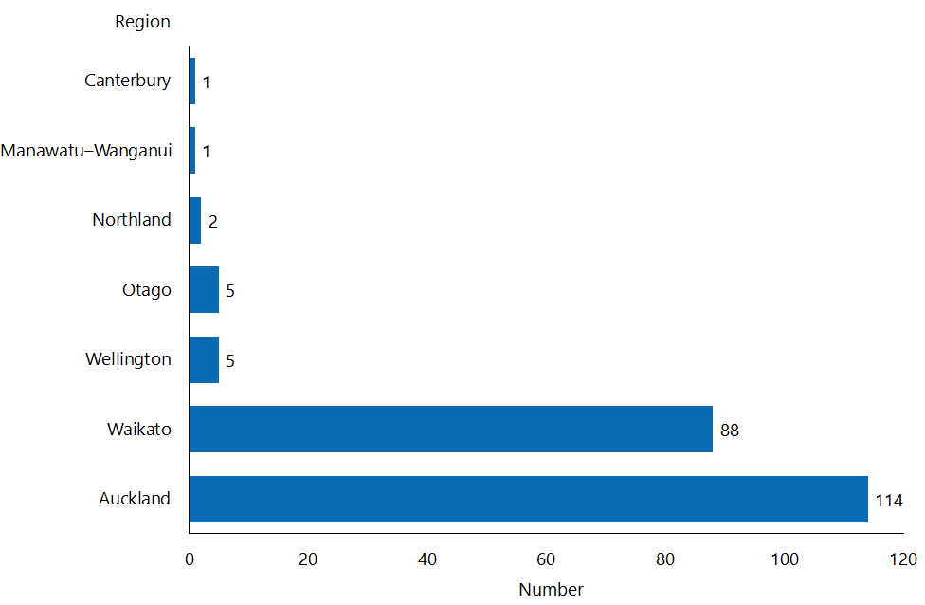

#### Observations

* Originally, CiCL services were only offered in four regions. Since 2016, they have been offered in two new regions: Greater Wellington and Otago.
* However, the vast majority of CiCL clients access services in the Auckland and Waikato regions.

### Principal disability

Figure 54: Choice in community living client population, by principal disability type and sex, 2018

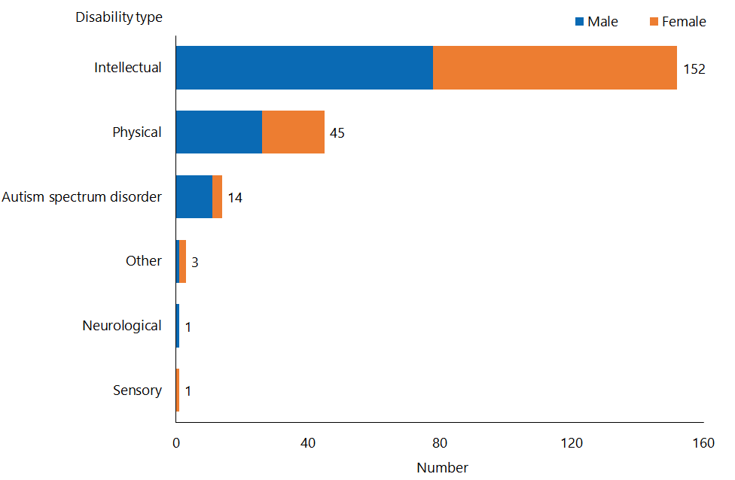

#### Observations

* In 2018, the principal disability of 70.3 percent of CiCL clients was intellectual (2016: 71 percent).
* There has been a slight decrease in the number of CiCL clients whose principal disability is physical, from 22 percent in 2016 to 20.88 percent in 2018.

### Support package allocation

Figure 55: Choice in community living client population, by support package allocation level and sex, 2018

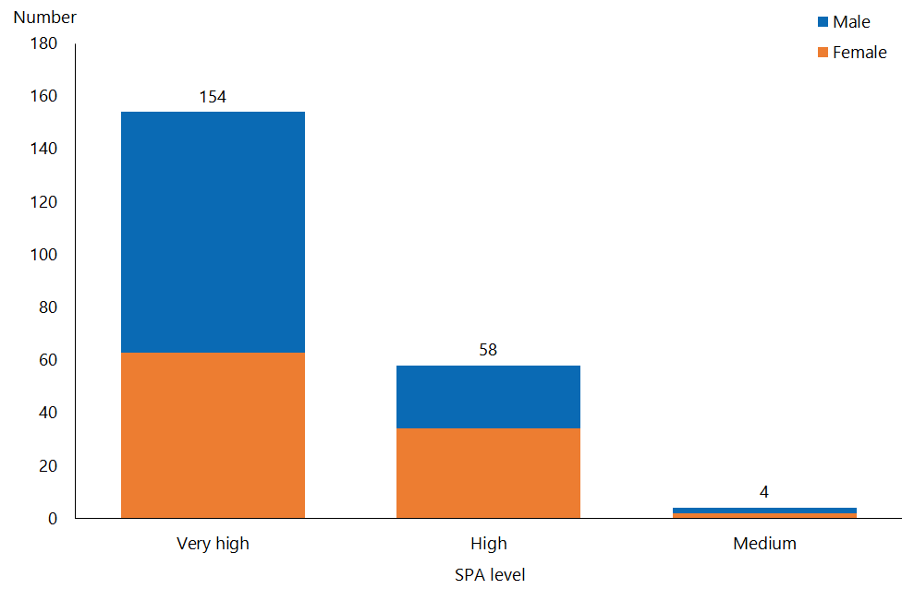

#### Observations

* Over two-thirds (71.3 percent) of clients receiving CiCL support have a very high SPA level (2016: 71 percent), and over one-quarter (26.9 percent: 2016: 22 percent) have a high SPA level.
* The distribution of SPA levels for CiCL clients contrasts significantly to the national distribution: 28 percent of all DSS clients have a very high SPA level, and 36.7 percent have a high SPA level.

## Individualised funding

### Age, sex and ethnicity

Table 21: Individualised funding client numbers, by age, 2018 and 2016

|  |  |  |
| --- | --- | --- |
| **Age group** | **Client number 2018** | **Client number 2016** |
| 0–4 | 174 | 115 |
| 5–14 | 1,659 | 951 |
| 15–24 | 1,496 | 899 |
| 25–44 | 929 | 658 |
| 45–64 | 837 | 663 |
| 65–79 | 236 | 197 |
| 80+ | 7 |  |
| **Total** | **5,338** | **3,483** |

Figure 56: Individualised funding client population, by age and sex, 2018

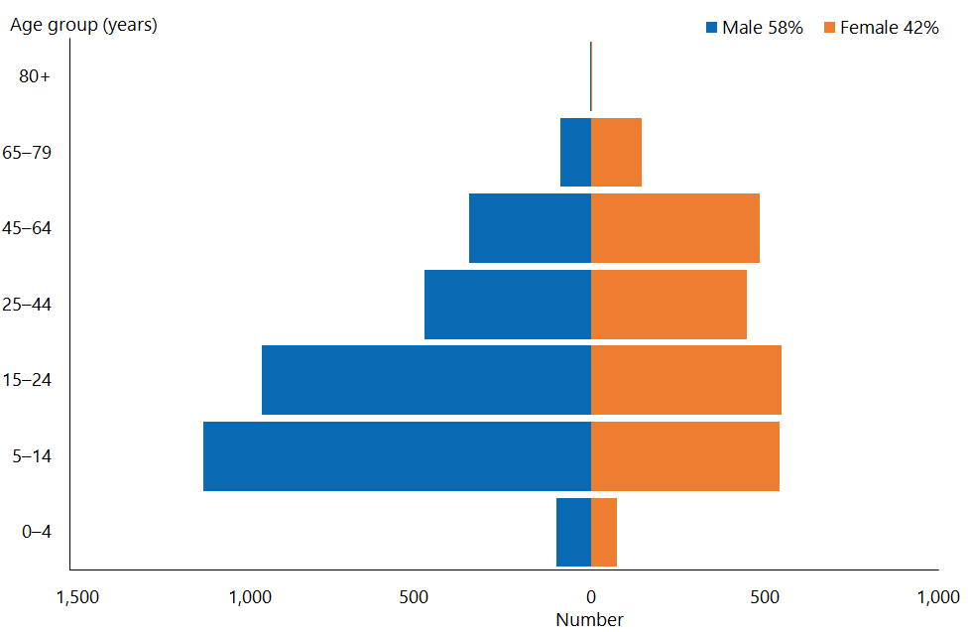

#### Observations

* IF clients are generally younger than DSS clients overall; their median age in 2018 was 19 years (2016: 22 years).
* There has been a significant (53.3 percent) increase in the number of clients accessing IF since 2016.
* The proportion of males to females accessing IF closely mirrors the proportion of males in the wider DSS client cohort.

Figure 57: Individualised funding client population, by ethnicity, 2018

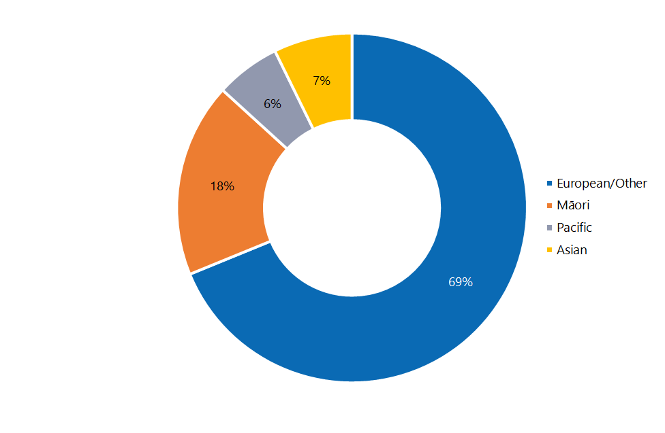

#### Observations

* European/Other people and Māori are over-represented among IF clients compared to their proportions in the New Zealand population (63 percent and 16 percent respectively); Pacific people are equally represented compared to the proportion of Pacific peoples in the New Zealand population (6 percent).
* Asian people remain significantly under-represented among IF clients when compared to the proportion of Asian people in the national population (15 percent).

### Location

Figure 58: Individualised funding client population, by client domicile region, 2018

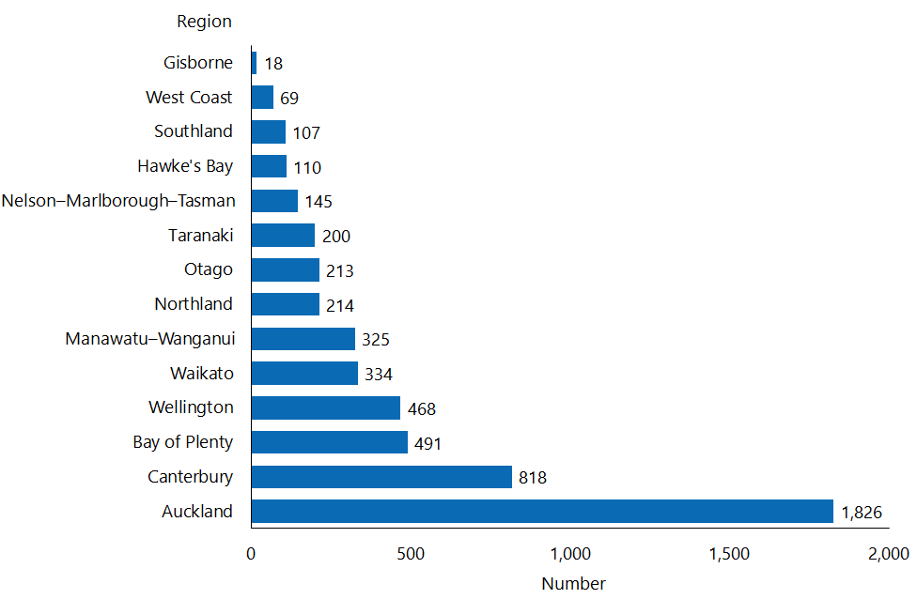

#### Observations

* Over one-third (34.2 percent) of IF clients reside in Auckland; this figure is similar to the proportion of the New Zealand population as a whole who live in Auckland (33.4 percent).
* Overall, the growth in IF clients has meant that the distribution of IF clients now more readily matches that of the wider DSS cohort.

### Principal disability

Figure 60: Individualised funding client population, by principal disability type and sex, 2018

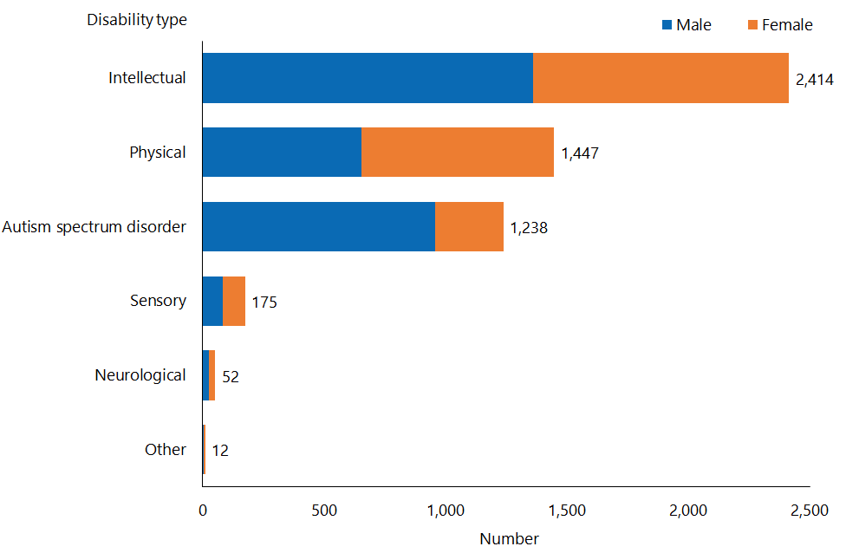

#### Observations

* Clients with a principal disability that is intellectual are under-represented among IF clients (45.2 percent), compared with the wider DSS cohort (50 percent).
* Clients with a principal disability that is physical are slightly over-represented among IF clients (27.1 percent), while the proportion with a principal disability of ASD matches the equivalent proportion among DSS clients nationally.

### Support package allocation

Figure 61: Individualised funding client population, by support package allocation level and sex, 2018

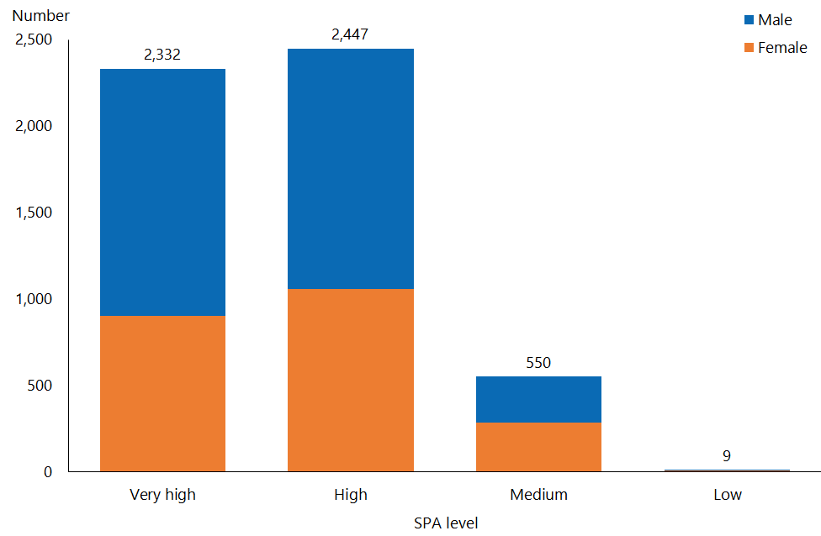

#### Observations

* Over 90 percent of IF clients have very high or high percent SPA levels (43.7 percent and 45.8 percent respectively); these figures are consistent with those of 2016 (45 percent and 43 percent respectively).
* The proportions of IF clients with very high and high SPA levels are much greater than the proportions of DSS clients generally with those levels (28 percent and 36.7 percent respectively).

## Enhanced individualised funding

### Age, sex and ethnicity

Table 22: Enhanced individualised funding client numbers, by age, 2018 and 2016

|  |  |  |
| --- | --- | --- |
| **Age group** | **Client number 2018** | **Client number 2016** |
| 0–4 | 10 | 22 |
| 5–14 | 124 | 141 |
| 15–24 | 98 | 100 |
| 25–44 | 85 | 86 |
| 45–64 | 57 | 70 |
| 65–79 | 22 | 13 |
| **Total** | **396** | **432** |

Figure 62: Enhanced individualised funding client population, by age and sex, 2018

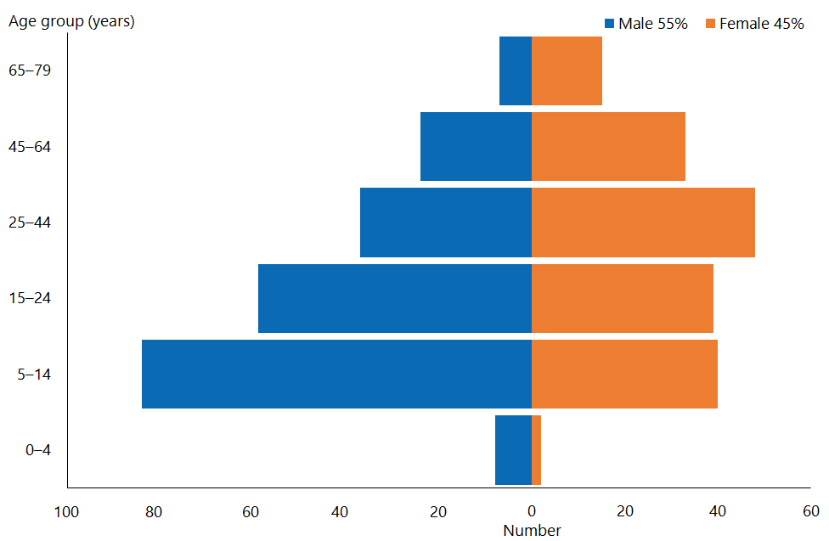

#### Observations

* Since 2016 there has been an 8.3 percent decrease in the number of clients accessing EIF.
* The median age of clients accessing EIF is 20 years (2016: 19 years).
* The proportion of males using EIF services is increasing: in 2016 it was 52 percent, and in 2018 it was 55 percent.
* Noticeably more females access EIF services in the older age groups.

Figure 63: Enhanced individualised funding client population, by ethnicity, 2018

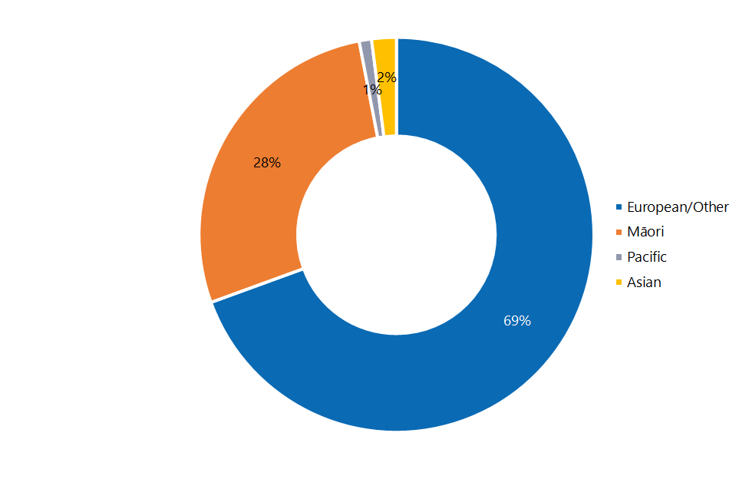

#### Observations

* Māori continue to be significantly over-represented among EIF users compared with the proportion of Māori in the wider New Zealand population (16 percent). A contributory factor to this is the fact that the EIF pilot is based in the Bay of Plenty, which as a region has a higher proportion of Māori (25 percent).
* Pacific and Asian people are significantly under-represented among EIF users, in comparison to the prevalence of those ethnicities in the wider population (6 percent and 15 percent respectively). This may be due in part to: the proportions of those ethnicities in the Bay of Plenty are lower (2 percent for Pacific people and 8 percent for Asian) than they are nationally.

### Location

Location figures for EIF clients do not appear here, because EIF services are only available in the Bay of Plenty region.

### Principal disability

Figure 64: Enhanced individualised funding client population, by principal disability type and sex, 2018

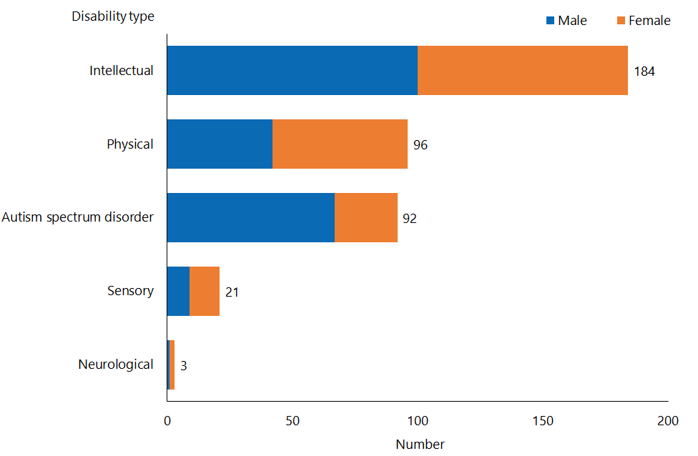

#### Observations

* Of clients accessing EIF services, 46.5 percent have a principal disability that is intellectual (2016: 46 percent), 24.2 percent have a principal disability that is physical (2016: 26 percent) and 23.2 percent have a principal disability type of ASD (2016: 20 percent).
* The distribution of principal disability types for clients accessing EIF services is comparable to the distribution of principal disability types among all DSS clients.

### Support package allocation

Figure 65: Enhanced individualised funding client population, by support package allocation level and sex, 2018

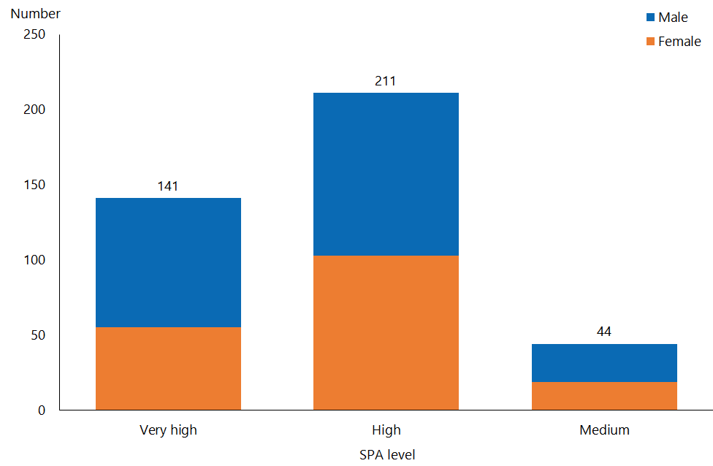

#### Observations

* EIF users have significantly higher SPA levels than the overall DSS group:
* 35.6 percent have a very high SPA level, compared to 28 percent among the overall group
* 53.3 percent have a high SPA level, compared to 36.7 percent among the overall group.
* There are significantly fewer EIF users with a medium SPA level (11 percent), compared to the proportion of the overall DSS group with a medium SPA level (31.6 percent).
* SPA level figures for 2018 differ from the equivalent figures for 2016, when:
* 32 percent had a very high SPA level
* 53 percent had a high SPA level
* 15 percent had a medium SPA level.

## Funded family care

### Age, sex and ethnicity

Table 23: Funded family care client numbers, by age, 2018 and 2016

|  |  |  |
| --- | --- | --- |
| **Age group** | **Client number 2018** | **Client number 2016** |
| 15–24 | 127 | 127 |
| 25–44 | 225 | 137 |
| 45–64 | 66 | 42 |
| 65–79 | 13 | 12 |
| **Total** | **431** | **318** |

Figure 66: Funded family care client population, by age and sex, 2018

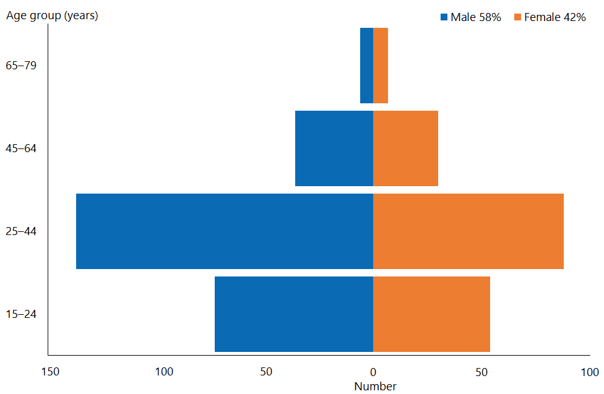

#### Observations

* The median age of FFC clients is 28 years (2016: 27 years).
* As in 2016, significantly more males than females access FFC.
* The number of people accessing FFC has increased by 35.6 percent since 2016.

Figure 67: Funded family care client population, by ethnicity, 2018

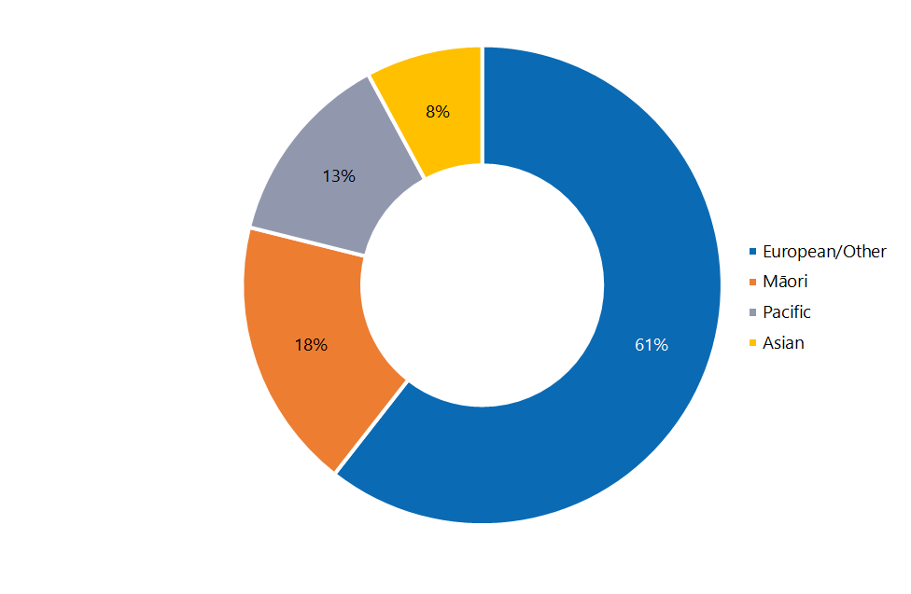

#### Observations

* European/Other people are slightly under-represented and Asian people significantly under-represented among FFC clients compared with the proportions of those ethnicities in the total New Zealand population (63 percent and 15 percent respectively).
* Māori are equally represented compared to the proportion of Māori in the wider population (16 percent).
* Pacific people are significantly over-represented among FFC clients compared to the proportion of Pacific people in the New Zealand population (6 percent).

### Location

Figure 68: Funded family care client population, by client domicile region, 2018

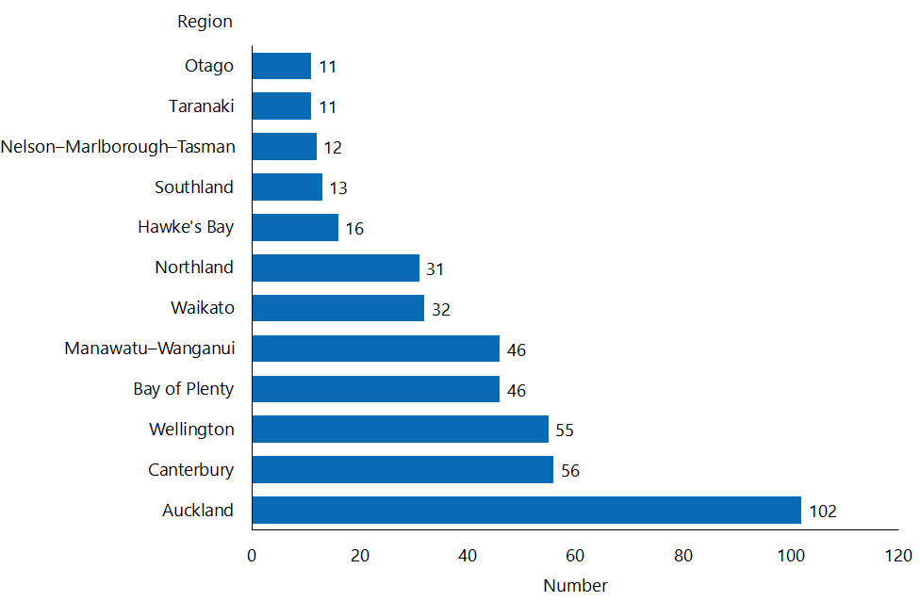

#### Observations

* The Auckland (24 percent) and Waikato (7 percent) regions are under-represented among FFC clients, compared to 29 percent and 10 percent DSS clients nationally.
* However, the Wellington (13 percent), Bay of Plenty (11 percent) and Manawatu–Wanganui (11 percent) regions are over-represented among FFC clients, compared to 10 percent, 7 percent and 6 percent DSS clients nationally.

### Principal disability

Figure 69: Funded family care client population, by principal disability type and sex, 2018

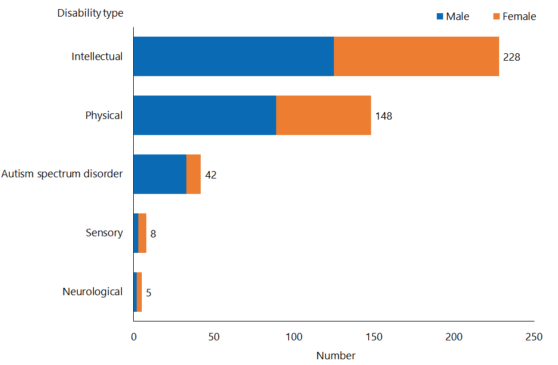

#### Observations

* The distribution of principal disability types for FFC clients in 2018 is comparable with the distribution in 2016.
* FFC clients whose principal disability is intellectual (52.9 percent) are slightly over-represented, and those whose principal disability is physical (34.3 percent) significantly over-represented, compared with the wider DSS wider cohort (among whom 50 percent have a principal disability that is intellectual and 23 percent have a principal disability that is physical).
* FFC clients whose principal disability is ASD (9.7 percent) are significantly under-represented compared with the DSS wider cohort (among whom 23 percent have a principal disability of ASD).

### Support package allocation

Figure 70: Funded family care client population, by support package allocation level and sex, 2018

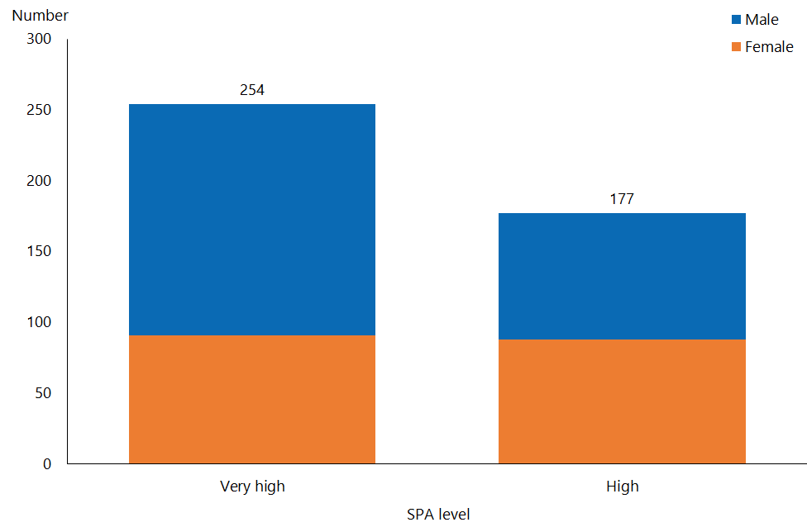

#### Observations

* The SPA levels of FFC clients are generally higher than those of the total DSS client cohort:
* 59 percent of FFC clients have a very high SPA level, compared with 28 percent of DSS clients in total
* 41 percent of FFC clients have a high SPA level, compared with 37 percent of DSS clients in total.
* The distribution of SPA levels among FFC clients has changed noticeably since 2016, when 51 percent had a very high and 49 percent had a high SPA level.

# Client demographics by principal disability

## Intellectual disability

Table 24: Disability Support Services clients whose principal disability is intellectual, by age, 2018 and 2016

|  |  |  |
| --- | --- | --- |
| **Age group** | **Client number 2018** | **Client number 2016** |
| 0–4 | 531 | 500 |
| 5–14 | 4,038 | 3,881 |
| 15–24 | 4,027 | 3,881 |
| 25–44 | 4,719 | 4,632 |
| 45–64 | 4,718 | 4,589 |
| 65–79 | 1,113 | 998 |
| 80+ | 81 | 67 |
| **Total** | **19,227** | **18,548** |

Figure 71: Disability Support Services clients whose principal disability is intellectual, by age and sex, 2018

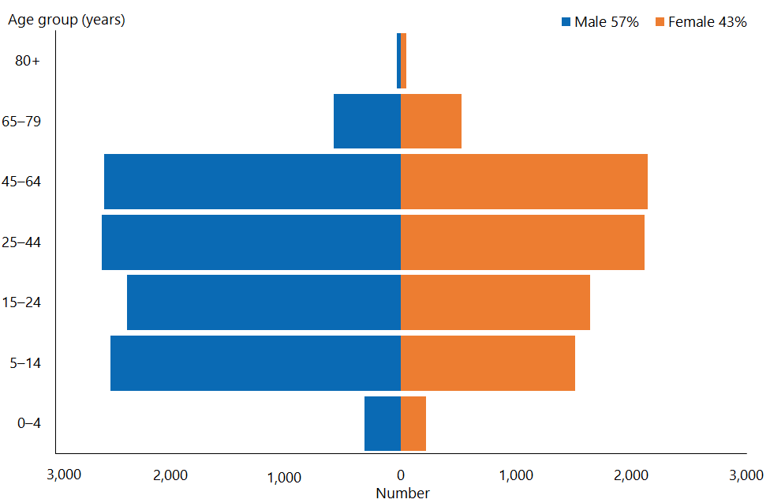

#### Observations

* The median age of clients whose principal disability is intellectual is 28 years, as it was in 2016.
* There are still significantly more males (57 percent) than females with a principal disability that is intellectual in the wider DSS client group. This proportion has not changed since 2013.
* There is an even spread throughout the age groupings between 5 and 64 years.

## Physical disability

Table 25: Disability Support Services clients whose principal disability is physical, by age, 2018 and 2016

|  |  |  |
| --- | --- | --- |
| **Age group** | **Client number 2018** | **Client number 2016** |
| 0–4 | 105 | 110 |
| 5–14 | 582 | 616 |
| 15–24 | 656 | 697 |
| 25–44 | 1,249 | 1,272 |
| 45–64 | 3,884 | 3,937 |
| 65–79 | 2,136 | 2,170 |
| 80+ | 50 | 22 |
| **Total** | **8,662** | **8,824** |

Figure 72: Disability Support Services clients whose principal disability is physical, by age and sex, 2018

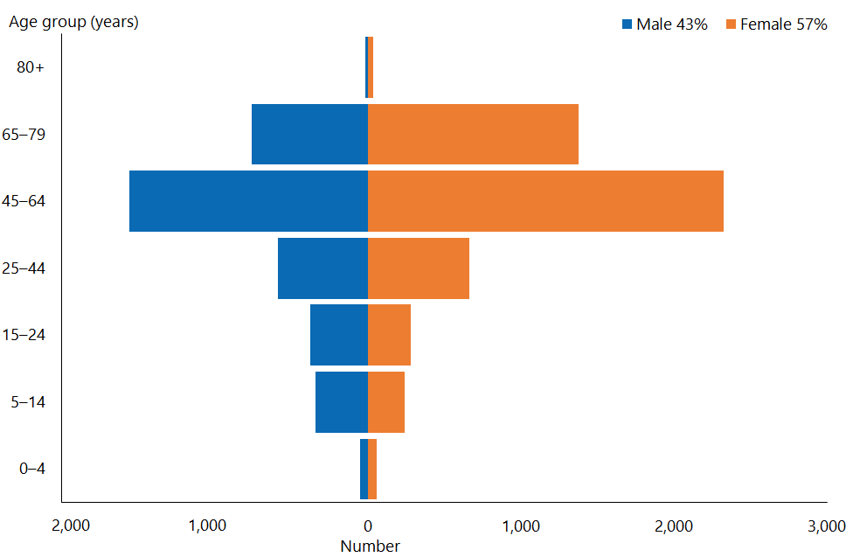

#### Observations

* The median age of clients with a principal disability that is physical is markedly older, at 56 years (2016: 54 years).
* There are significantly more females (57 percent) than males whose principal disability is physical in the wider DSS client group (2016: 58 percent).
* The depicted age-sex structure has not changed significantly since 2013.

## Autism spectrum disorder

Table 26: Disability Support Services clients whose principal disability is autism spectrum disorder, by age, 2018 and 2016

|  |  |  |
| --- | --- | --- |
| **Age group** | **Client number 2018** | **Client number 2016** |
| 0–4 | 469 | 393 |
| 5–14 | 4,997 | 3,887 |
| 15–24 | 2,447 | 1,991 |
| 25–44 | 771 | 596 |
| 45–64 | 157 | 132 |
| 65–79 | 17 | 14 |
| 80+ |  | 1 |
| **Total** | **8,858** | **7,014** |

Figure 73: Disability Support Services clients whose principal disability is autism spectrum disorder, by age and sex, 2018

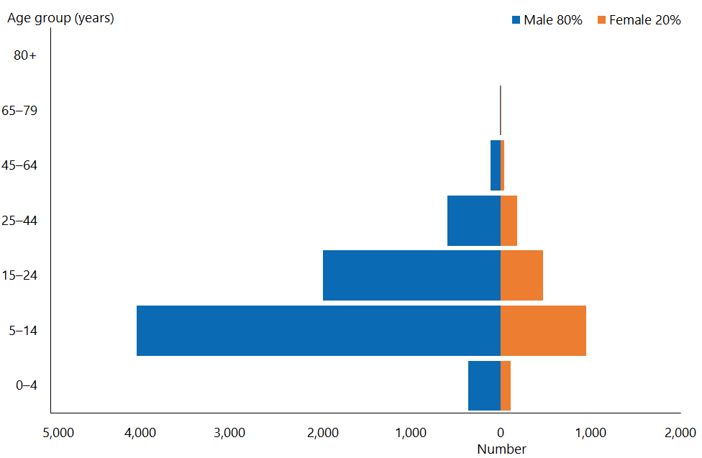

#### Observations

* ASD clients are predominantly young: the median age of clients whose principal disability is ASD is 12 years. This has remained unchanged since 2014.
* 80 percent of ASD clients are male (2016: 81 percent).
* The depicted age-sex structure has changed minimally since 2016.

## Sensory disability

Table 27: Disability Support Services clients whose principal disability is sensory, by age, 2018 and 2016

|  |  |  |
| --- | --- | --- |
| **Age group** | **Client number 2018** | **Client number 2016** |
| 0–4 | 19 | 27 |
| 5–14 | 167 | 182 |
| 15–24 | 141 | 162 |
| 25–44 | 212 | 213 |
| 45–64 | 404 | 403 |
| 65–79 | 149 | 137 |
| 80+ | 4 | 1 |
| **Total** | **1,096** | **1,125** |

Figure 74: Disability Support Services clients whose principal disability is sensory, by age and sex, 2018

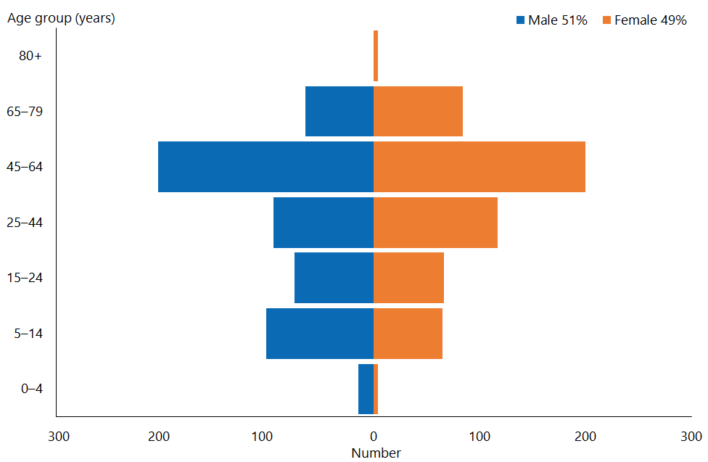

#### Observations

* The median age of clients with a principal disability that is sensory is 45 years (2016: 43 years). This is an increase of five years since 2014.
* There is a fairly even number of males and females with a principal disability that is sensory.
* 37 percent of clients in this group are aged 45–64 (2016: 36 percent).

## Neurological disability

Table 28: Disability Support Services clients whose principal disability is neurological, by age, 2018 and 2016

|  |  |  |
| --- | --- | --- |
| **Age group** | **Client number 2018** | **Client number 2016** |
| 0–4 | 5 | 5 |
| 5–14 | 18 | 26 |
| 15–24 | 20 | 18 |
| 25–44 | 53 | 61 |
| 45–64 | 141 | 170 |
| 65–79 | 65 | 53 |
| 80+ | 1 |  |
| **Total** | **303** | **333** |

Figure 75: Disability Support Services clients whose principal disability is neurological, by age and sex, 2018

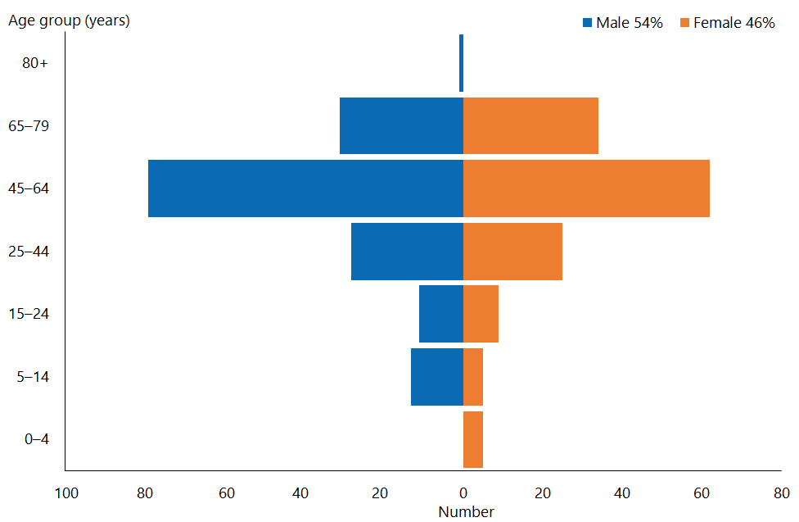

#### Observations

* The median age of clients whose principal disability is neurological (such as brain injury or multiple sclerosis) is 54 years (2016: 53 years).
* Over two-thirds (68 percent) of clients whose principal disability is neurological are aged 45 or over (2016: 67 percent).

# Clients’ service allocation by client domicile region

We have applied regional council areas for regions in this report, as Stats NZ does. Nelson–Marlborough–Tasman is a combined region of three regional council areas.

## Northland

Table 29: Northland Disability Support Services clients, by age and sex, 2018 and 2016

|  |  |  |  |  |  |
| --- | --- | --- | --- | --- | --- |
| **Age group** | **2018** | | | | **2016** |
| **Female** | **Male** | **Total** | **%** |
| 0–4 | 5 | 36 | 41 | 2.4 | 48 |
| 5–14 | 160 | 275 | 435 | 25.7 | 348 |
| 15–24 | 106 | 176 | 282 | 16.7 | 248 |
| 25–44 | 126 | 148 | 274 | 16.2 | 261 |
| 45–64 | 231 | 232 | 463 | 27.3 | 416 |
| 65–79 | 117 | 80 | 197 | 11.6 | 205 |
| 80+ |  | 1 | 1 | 0.1 |  |
| **Total** | **745** | **948** | **1,693** | **100** | **1,526** |

Figure 76: Northland Disability Support Services clients, by principal disability type and sex, 2018

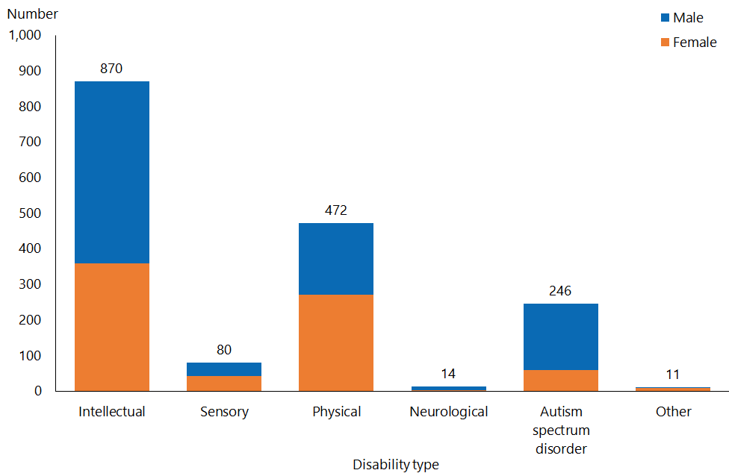

Figure 77: Northland Disability Support Services clients, by service type and ethnicity, 2018

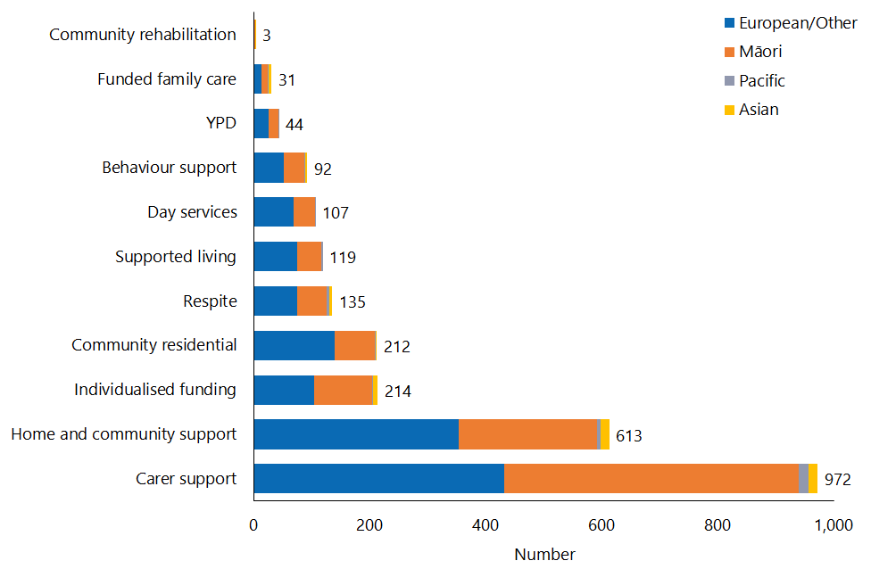

## Auckland

Table 30: Auckland Disability Support Services clients, by age and sex, 2018 and 2016

|  |  |  |  |  |  |
| --- | --- | --- | --- | --- | --- |
| **Age group** | **2018** | | | | **2016** |
| **Female** | **Male** | **Total** | **%** |
| 0–4 | 162 | 320 | 482 | 4.3 | 449 |
| 5–14 | 919 | 2,482 | 3,401 | 30.2 | 3,149 |
| 15–24 | 758 | 1,656 | 2,414 | 21.4 | 2,316 |
| 25–44 | 839 | 1,118 | 1,957 | 17.4 | 1,878 |
| 45–64 | 1,086 | 1,085 | 2,171 | 19.3 | 2,167 |
| 65–79 | 443 | 367 | 810 | 7.2 | 816 |
| 80+ | 17 | 8 | 25 | 0.2 | 9 |
| **Total** | **4,224** | **7,036** | **11,260** | **100** | **10,784** |

Figure 78: Auckland Disability Support Services clients, by principal disability type and sex, 2018

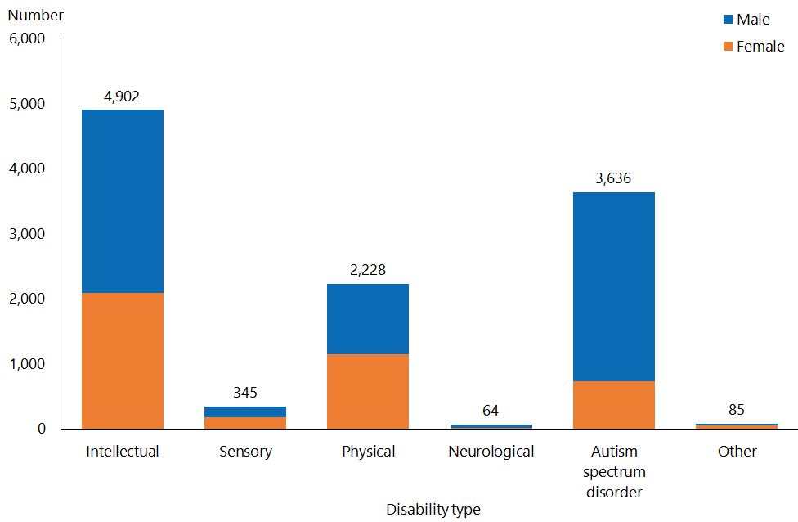

Figure 79: Auckland Disability Support Services clients, by service type and ethnicity, 2018

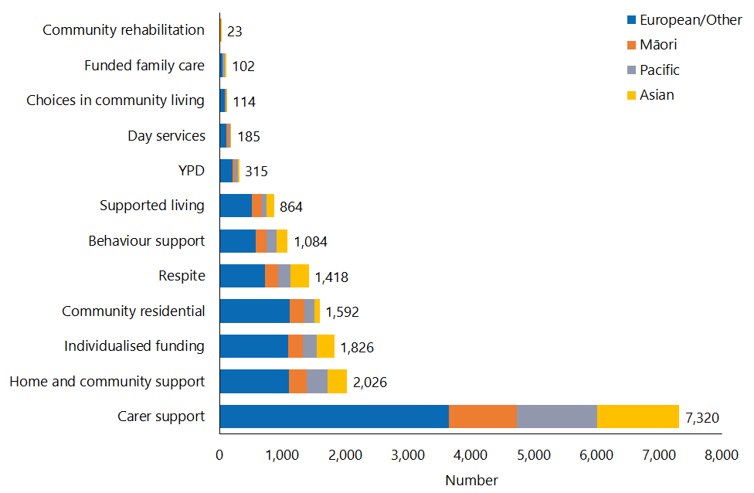

## Waikato

Table 31: Waikato Disability Support Services clients, by age and sex, 2018 and 2016

|  |  |  |  |  |  |
| --- | --- | --- | --- | --- | --- |
| **Age group** | **2018** | | | | **2016** |
| **Female** | **Male** | **Total** | **%** |
| 0–4 | 38 | 96 | 134 | 3.5 | 100 |
| 5–14 | 276 | 768 | 1,044 | 27.1 | 896 |
| 15–24 | 255 | 463 | 718 | 18.6 | 679 |
| 25–44 | 309 | 390 | 699 | 18.1 | 668 |
| 45–64 | 460 | 502 | 962 | 25.0 | 942 |
| 65–79 | 161 | 122 | 283 | 7.3 | 276 |
| 80+ | 5 | 7 | 12 | 0.3 | 4 |
| **Total** | **1,504** | **2,348** | **3,852** | **100** | **3,565** |

Figure 80: Waikato Disability Support Services clients, by principal disability type and sex, 2018

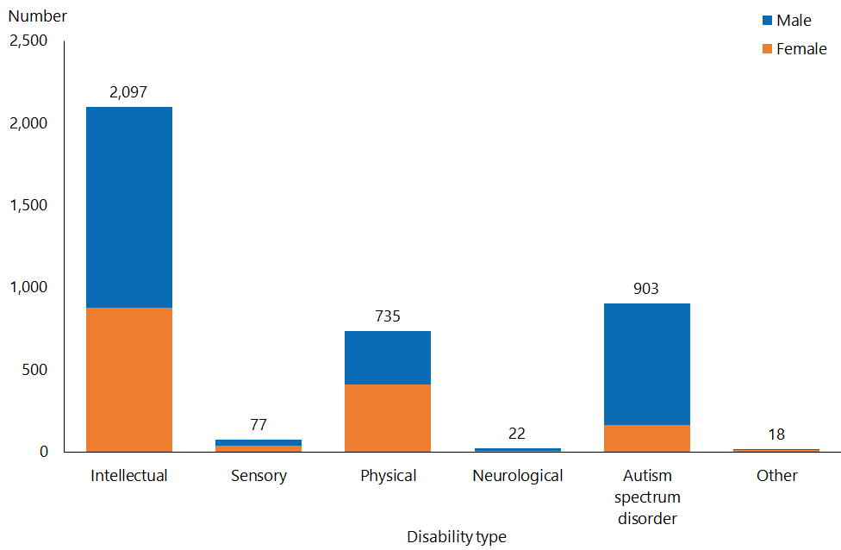

Figure 81: Waikato Disability Support Services client, by service type and ethnicity, 2018

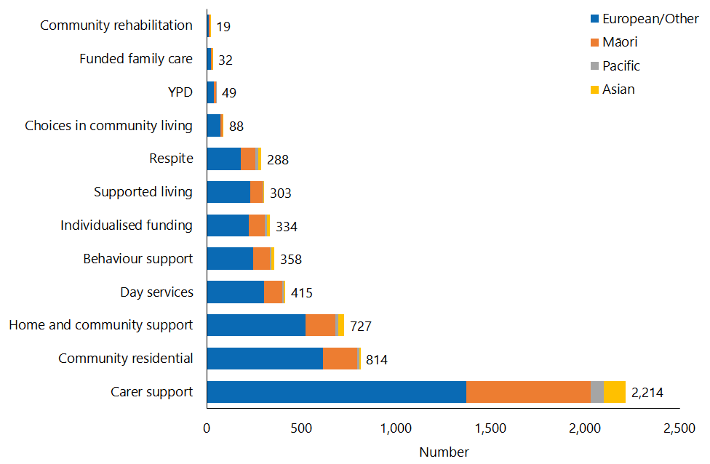

## Bay of Plenty

Table 32: Bay of Plenty Disability Support Services clients, by age and sex, 2018 and 2016

|  |  |  |  |  |  |
| --- | --- | --- | --- | --- | --- |
| **Age group** | **2018** | | | | **2016** |
| **Female** | **Male** | **Total** | **%** |
| 0–4 | 39 | 58 | 97 | 3.5 | 81 |
| 5–14 | 224 | 541 | 765 | 27.7 | 608 |
| 15–24 | 174 | 333 | 507 | 18.3 | 452 |
| 25–44 | 268 | 280 | 548 | 19.8 | 497 |
| 45–64 | 331 | 286 | 617 | 22.3 | 655 |
| 65–79 | 141 | 86 | 227 | 8.2 | 208 |
| 80+ | 4 | 1 | 5 | 0.2 | 7 |
| **Total** | **1,181** | **1,585** | **2,766** | **100** | **2,508** |

Figure 82: Bay of Plenty Disability Support Services clients, by principal disability type and sex, 2018

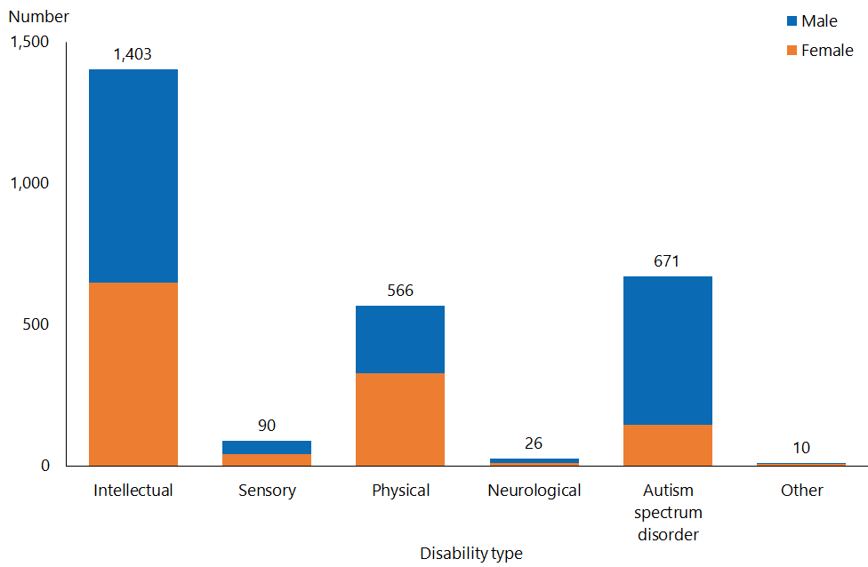

Figure 83: Bay of Plenty Disability Support Services clients, by service type and ethnicity, 2018

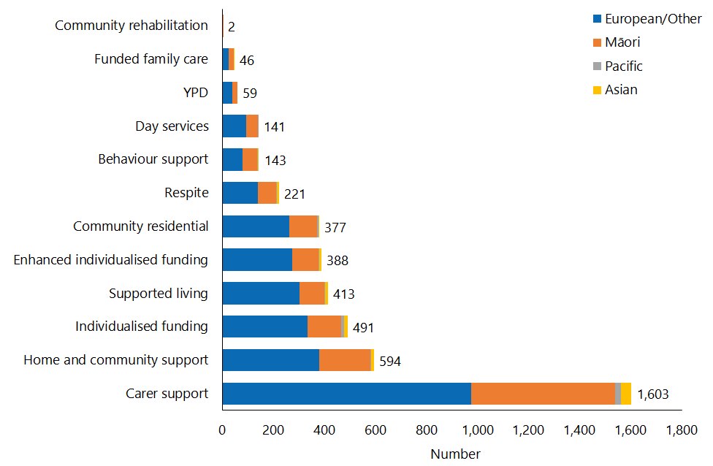

## Hawke’s Bay

Table 33: Hawke’s Bay Disability Support Services clients, by age and sex, 2018 and 2016

|  |  |  |  |  |  |
| --- | --- | --- | --- | --- | --- |
| **Age group** | **2018** | | | | **2016** |
| **Female** | **Male** | **Total** | **%** |
| 0–4 | 15 | 16 | 31 | 2.3 | 29 |
| 5–14 | 93 | 208 | 301 | 22.0 | 277 |
| 15–24 | 85 | 176 | 261 | 19.1 | 235 |
| 25–44 | 146 | 170 | 316 | 23.1 | 315 |
| 45–64 | 190 | 173 | 363 | 26.5 | 340 |
| 65–79 | 54 | 38 | 92 | 6.7 | 79 |
| 80+ | 2 | 4 | 6 | 0.4 | 3 |
| **Total** | **585** | **785** | **1,370** | **100** | **1,278** |

Figure 84: Hawke’s Bay Disability Support Services clients, by principal disability type and sex, 2018

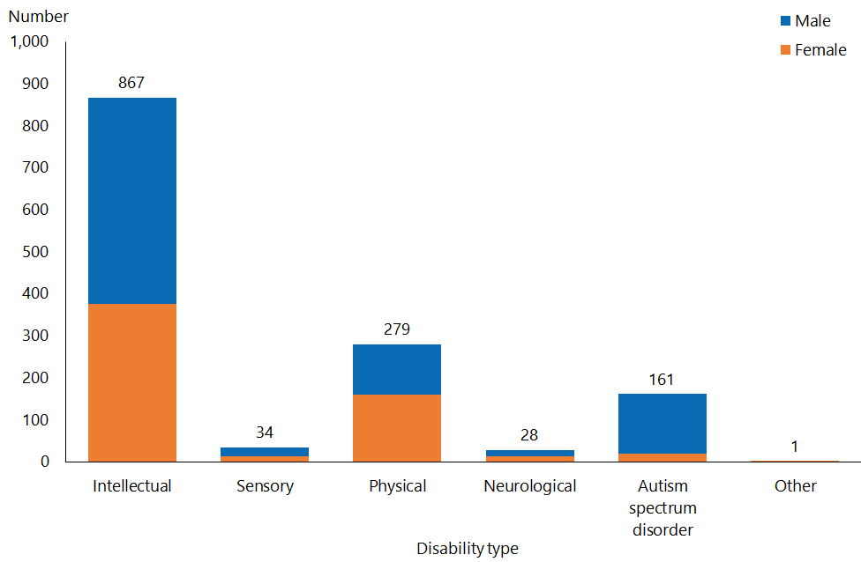

Figure 85: Hawke’s Bay Disability Support Services clients, by service type and ethnicity, 2018

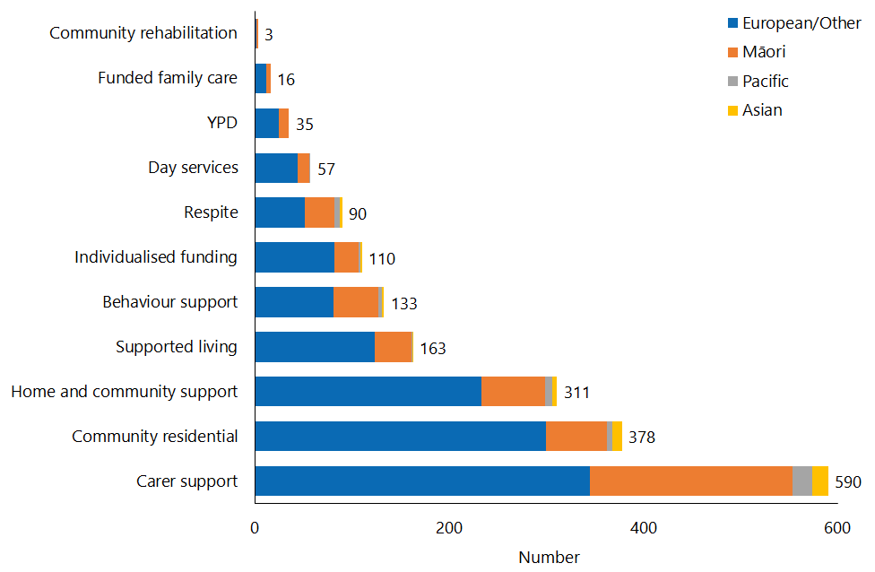

## Gisborne

Table 34: Gisborne Disability Support Services clients, by age and sex, 2018 and 2016

|  |  |  |  |  |  |
| --- | --- | --- | --- | --- | --- |
| **Age group** | **2018** | | | | **2016** |
| **Female** | **Male** | **Total** | **%** |
| 0–4 | 6 | 5 | 11 | 2.8 | 8 |
| 5–14 | 28 | 68 | 96 | 24.8 | 79 |
| 15–24 | 25 | 36 | 61 | 15.8 | 55 |
| 25–44 | 29 | 34 | 63 | 16.3 | 67 |
| 45–64 | 54 | 50 | 104 | 26.9 | 117 |
| 65–79 | 24 | 28 | 52 | 13.4 | 53 |
| **Total** | **166** | **221** | **387** | **100** | **379** |

Figure 86: Gisborne Disability Support Services clients, by principal disability type and sex, 2018

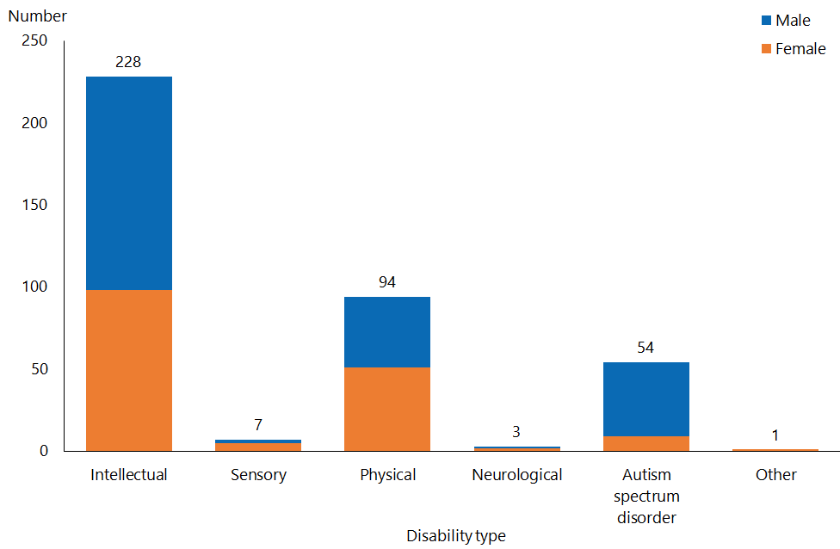

Figure 87: Gisborne Disability Support Services clients, by service type and ethnicity, 2018

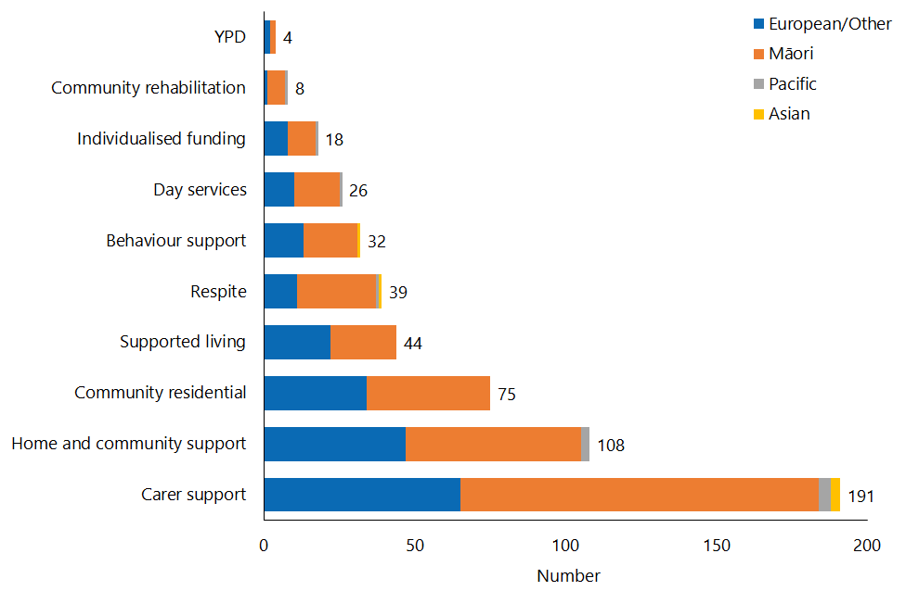

## Taranaki

Table 35: Taranaki Disability Support Services clients, by age and sex, 2018 and 2016

|  |  |  |  |  |  |
| --- | --- | --- | --- | --- | --- |
| **Age group** | **2018** | | | | **2016** |
| **Female** | **Male** | **Total** | **%** |
| 0–4 | 6 | 7 | 13 | 1.1 | 26 |
| 5–14 | 62 | 178 | 240 | 20.2 | 226 |
| 15–24 | 98 | 154 | 252 | 21.2 | 211 |
| 25–44 | 116 | 134 | 250 | 21.0 | 228 |
| 45–64 | 178 | 129 | 307 | 25.8 | 305 |
| 65–79 | 73 | 50 | 123 | 10.4 | 106 |
| 80+ | 1 | 2 | 3 | 0.3 | 1 |
| **Total** | **534** | **654** | **1,188** | **100** | **1,103** |

Figure 88: Taranaki Disability Support Services clients, by principal disability type and sex, 2018

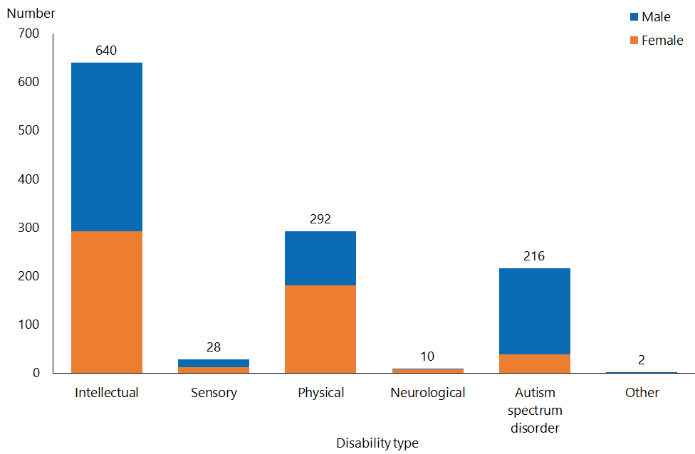

Figure 89: Taranaki Disability Support Services clients, by service type and ethnicity, 2018

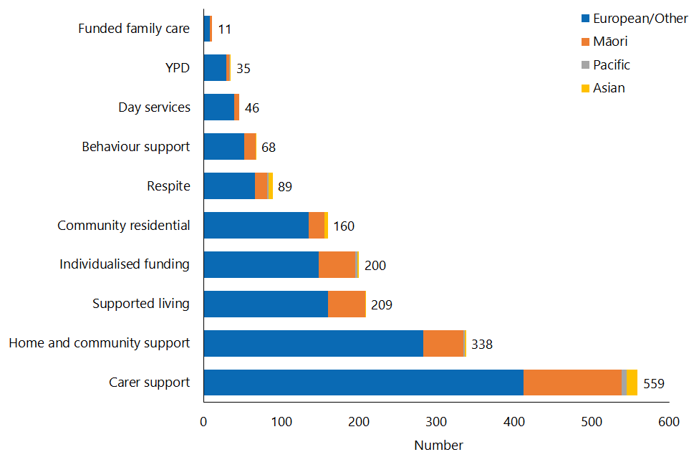

## Manawatu–Whanganui

Table 36: Manawatu–Whanganui Disability Support Services clients, by age and sex, 2018 and 2016

|  |  |  |  |  |  |
| --- | --- | --- | --- | --- | --- |
| **Age group** | **2018** | | | | **2016** |
| **Female** | **Male** | **Total** | **%** |
| 0–4 | 13 | 19 | 32 | 1.4 | 27 |
| 5–14 | 121 | 322 | 443 | 18.8 | 382 |
| 15–24 | 140 | 250 | 390 | 16.5 | 358 |
| 25–44 | 198 | 230 | 428 | 18.2 | 436 |
| 45–64 | 396 | 376 | 772 | 32.7 | 751 |
| 65–79 | 180 | 106 | 286 | 12.1 | 279 |
| 80+ | 4 | 3 | 7 | 0.3 | 3 |
| **Total** | **1,052** | **1,306** | **2,358** | **100** | **2,236** |

Figure 90: Manawatu–Whanganui Disability Support Services clients, by principal disability type and sex, 2018

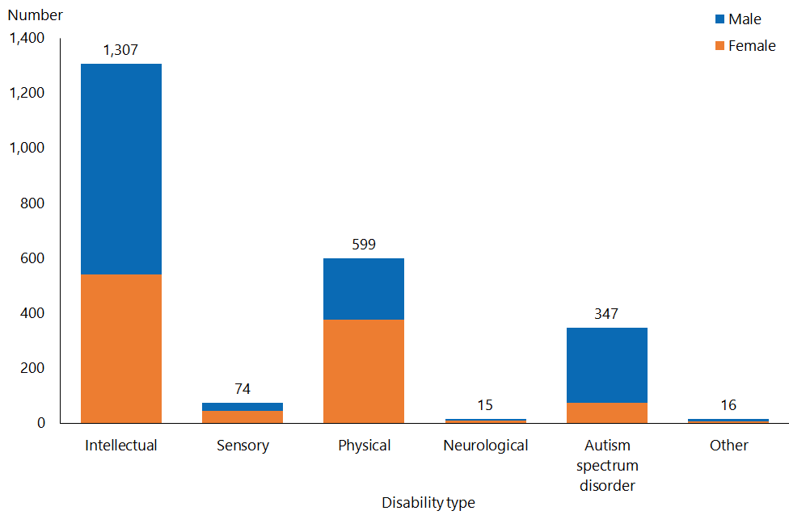

Figure 91: Manawatu–Whanganui Disability Support Services clients, by service type and ethnicity, 2018

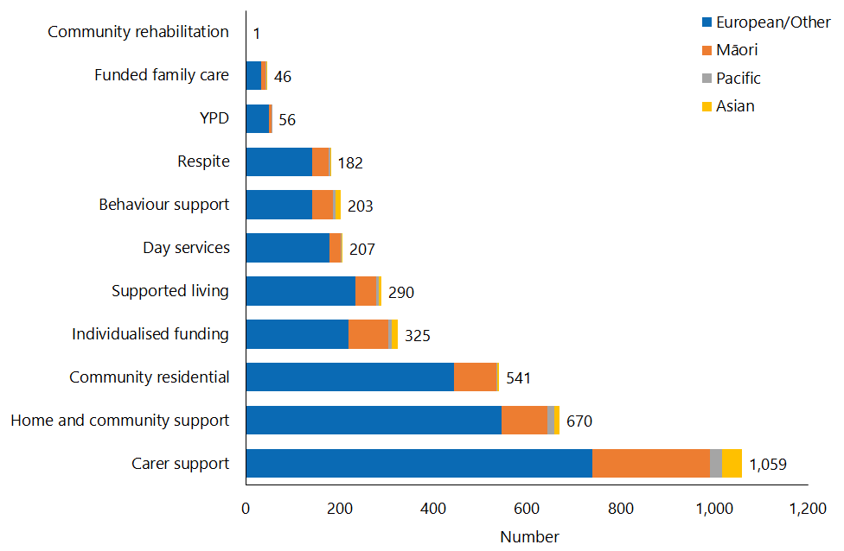

## Wellington

Table 37: Wellington Disability Support Services clients, by age and sex, 2018 and 2016

|  |  |  |  |  |  |
| --- | --- | --- | --- | --- | --- |
| **Age group** | **2018** | | | | **2016** |
| **Female** | **Male** | **Total** | **%** |
| 0–4 | 38 | 61 | 99 | 2.7 | 88 |
| 5–14 | 274 | 681 | 955 | 26.1 | 808 |
| 15–24 | 221 | 478 | 699 | 19.1 | 622 |
| 25–44 | 295 | 409 | 704 | 19.2 | 688 |
| 45–64 | 481 | 383 | 864 | 23.6 | 856 |
| 65–79 | 196 | 135 | 331 | 9.0 | 328 |
| 80+ | 4 | 2 | 6 | 0.2 | 7 |
| **Total** | **1,509** | **2,149** | **3,658** | **100** | **3,397** |

Figure 92: Wellington Disability Support Services clients, by principal disability type and sex, 2018

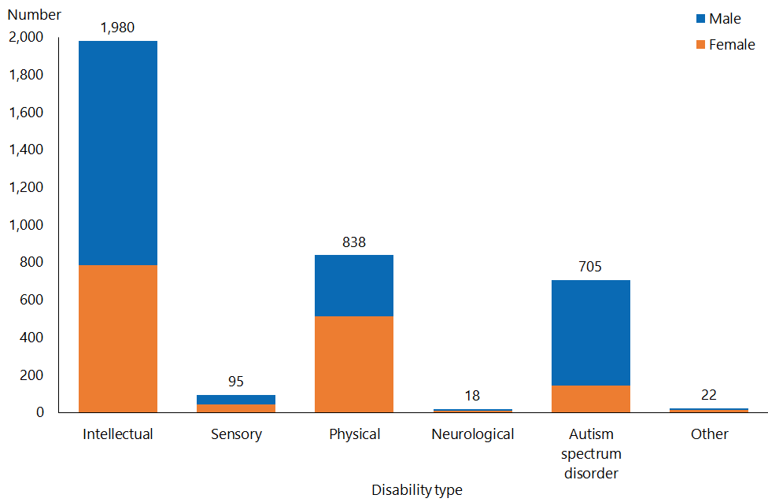

Figure 93: Wellington Disability Support Services clients, by service type and ethnicity, 2018

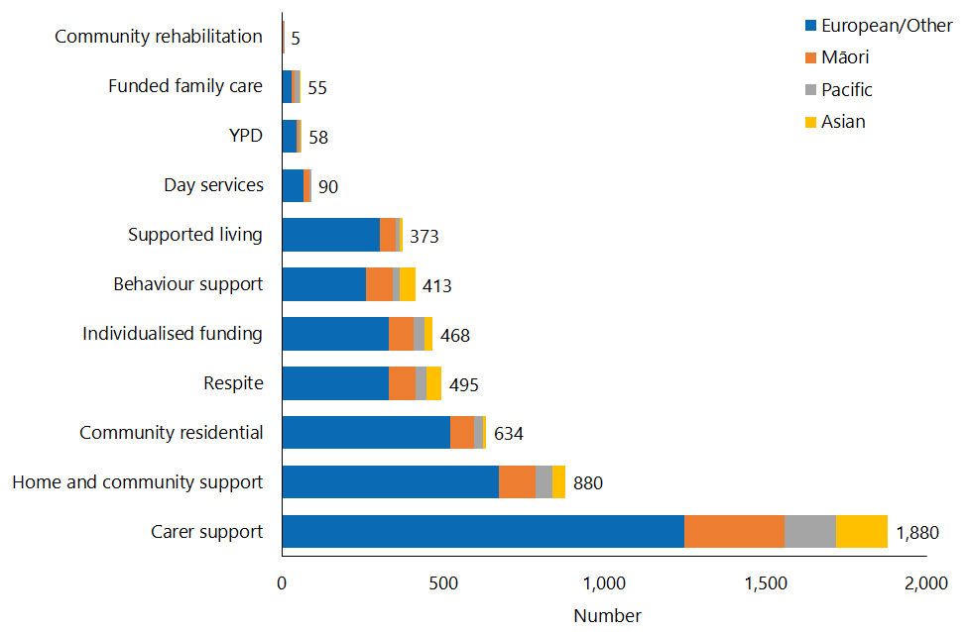

## Nelson–Marlborough–Tasman

Table 38: Nelson–Marlborough–Tasman Disability Support Services clients, by age and sex, 2018 and 2016

|  |  |  |  |  |  |
| --- | --- | --- | --- | --- | --- |
| **Age group** | **2018** | | | | **2016** |
| **Female** | **Male** | **Total** | **%** |
| 0–4 | 8 | 11 | 19 | 1.3 | 22 |
| 5–14 | 89 | 184 | 273 | 18.7 | 240 |
| 15–24 | 83 | 171 | 254 | 17.4 | 229 |
| 25–44 | 125 | 143 | 268 | 18.4 | 250 |
| 45–64 | 205 | 196 | 401 | 27.5 | 414 |
| 65–79 | 141 | 82 | 223 | 15.3 | 237 |
| 80+ | 13 | 7 | 20 | 1.4 | 13 |
| **Total** | **664** | **794** | **1,458** | **100** | **1,405** |

Figure 94: Nelson–Marlborough–Tasman Disability Support Services clients, by principal disability type and sex, 2018

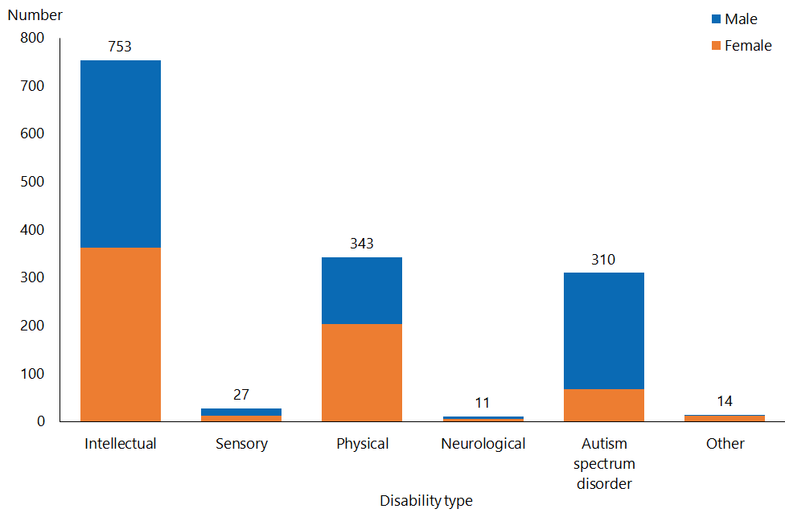

Figure 95: Nelson–Marlborough–Tasman Disability Support Services clients, by service type and ethnicity, 2018

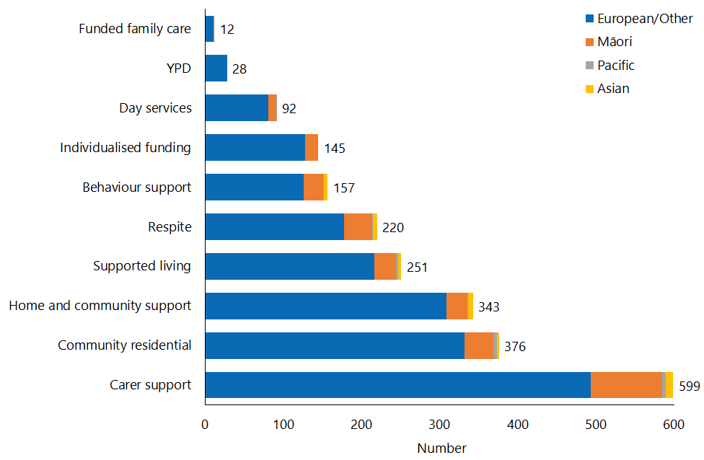

## West Coast

Table 39: West Coast Disability Support Services clients, by age and sex, 2018 and 2016

|  |  |  |  |  |  |
| --- | --- | --- | --- | --- | --- |
| **Age group** | **2018** | | | | **2016** |
| **Female** | **Male** | **Total** | **%** |
| 0–4 |  | 1 | 1 | 0.3 | 6 |
| 5–14 | 23 | 49 | 72 | 24.4 | 60 |
| 15–24 | 20 | 55 | 75 | 25.4 | 43 |
| 25–44 | 14 | 22 | 36 | 12.2 | 38 |
| 45–64 | 48 | 32 | 80 | 27.1 | 78 |
| 65–79 | 22 | 9 | 31 | 10.5 | 29 |
| 80+ |  |  |  | 0.0 | 1 |
| **Total** | **127** | **168** | **295** | **100** | **255** |

Figure 96: West Coast Disability Support Services clients, by principal disability type and sex, 2018

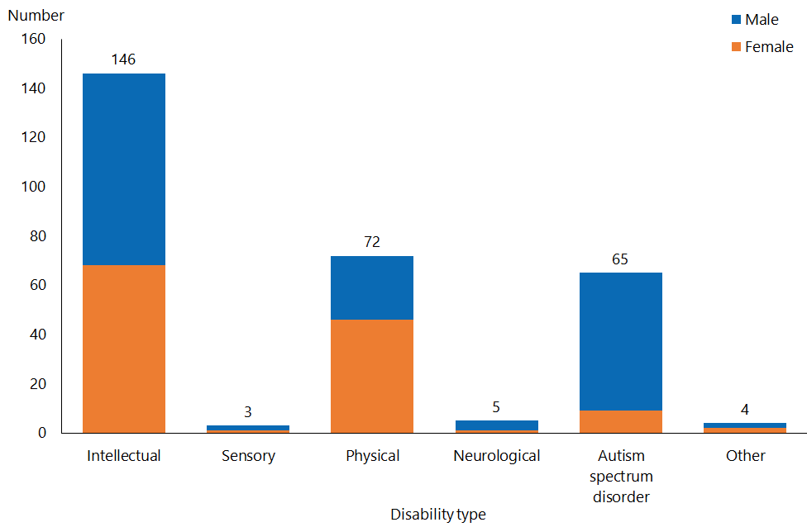

Figure 97: West Coast Disability Support Services clients, by service type and ethnicity, 2018

This bar graph shows that West Coast DSS had 3 clients in respite services, 7 each in day services and YPD, 27 in behaviour support, 42 in supported living, 44 in community residential, 69 in individualised funding, 74 in home and community support and 170 in carer support.

## Canterbury

Table 40: Canterbury Disability Support Services clients, by age and sex, 2018 and 2016

|  |  |  |  |  |  |
| --- | --- | --- | --- | --- | --- |
| **Age group** | **2018** | | | | **2016** |
| **Female** | **Male** | **Total** | **%** |
| 0–4 | 51 | 81 | 132 | 2.6 | 105 |
| 5–14 | 345 | 891 | 1,236 | 23.9 | 1,033 |
| 15–24 | 353 | 577 | 930 | 18.0 | 842 |
| 25–44 | 414 | 515 | 929 | 18.0 | 912 |
| 45–64 | 706 | 685 | 1,391 | 27.0 | 1,371 |
| 65–79 | 290 | 228 | 518 | 10.0 | 464 |
| 80+ | 16 | 9 | 25 | 0.5 | 26 |
| **Total** | **2,175** | **2,986** | **5,161** | **100** | **4,753** |

Figure 98: Canterbury Disability Support Services clients, by principal disability type and sex, 2018

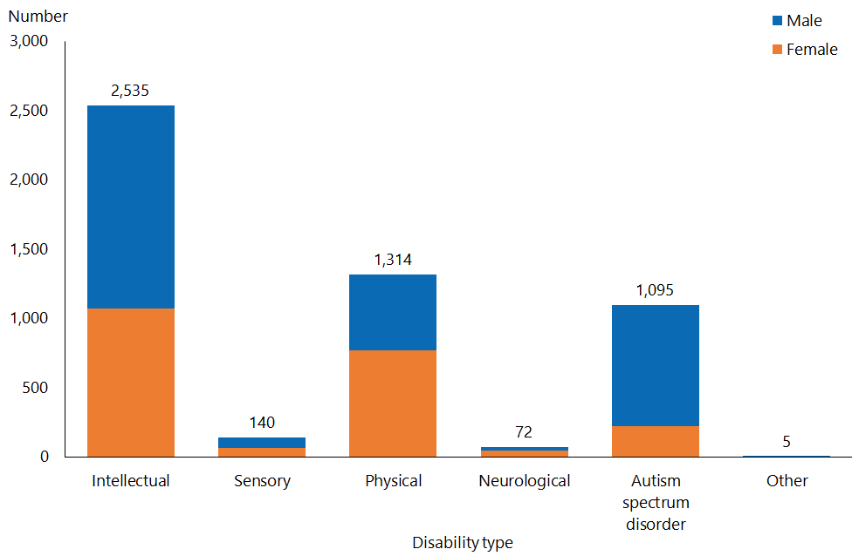

Figure 99: Canterbury Disability Support Services clients, by service type and ethnicity, 2018

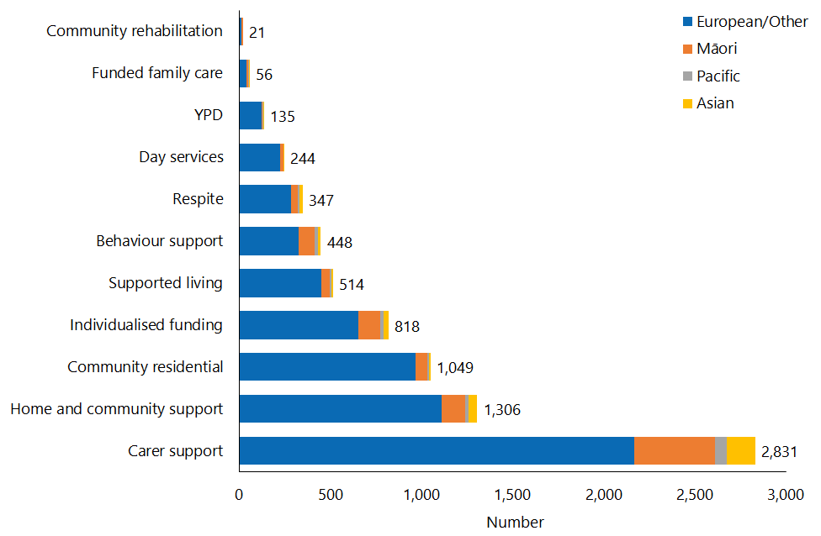

## Otago

Table 41: Otago Disability Support Services clients, by age and sex, 2018 and 2016

|  |  |  |  |  |  |
| --- | --- | --- | --- | --- | --- |
| **Age group** | **2018** | | | | **2016** |
| **Female** | **Male** | **Total** | **%** |
| 0–4 | 11 | 17 | 28 | 1.4 | 33 |
| 5–14 | 117 | 254 | 371 | 18.6 | 340 |
| 15–24 | 101 | 211 | 312 | 15.6 | 318 |
| 25–44 | 153 | 233 | 386 | 19.3 | 394 |
| 45–64 | 304 | 315 | 619 | 31.0 | 611 |
| 65–79 | 163 | 98 | 261 | 13.1 | 262 |
| 80+ | 14 | 8 | 22 | 1.1 | 14 |
| **Total** | **863** | **1,136** | **1,999** | **100** | **1,972** |

Figure 100: Otago Disability Support Services clients, by principal disability type and sex, 2018

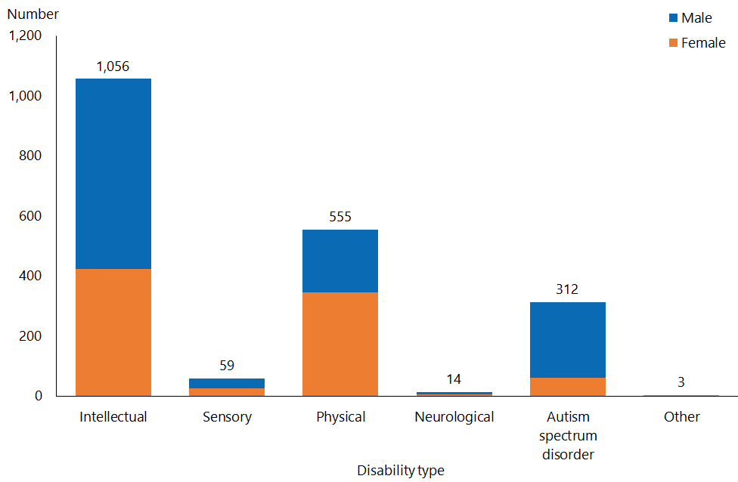

Figure 101: Otago Disability Support Services clients, by service type and ethnicity, 2018

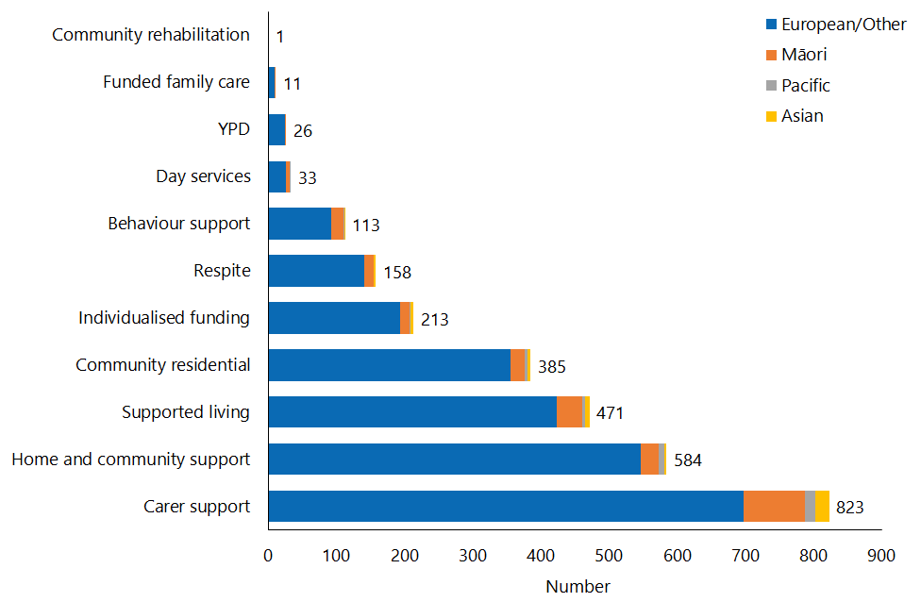

## Southland

Table 42: Southland Disability Support Services clients, by age and sex, 2018 and 2016

|  |  |  |  |  |  |
| --- | --- | --- | --- | --- | --- |
| **Age group** | **2018** | | | | **2016** |
| **Female** | **Male** | **Total** | **%** |
| 0–4 | 4 | 9 | 13 | 1.4 | 16 |
| 5–14 | 52 | 133 | 185 | 20.6 | 160 |
| 15–24 | 57 | 101 | 158 | 17.6 | 161 |
| 25–44 | 79 | 87 | 166 | 18.5 | 161 |
| 45–64 | 150 | 110 | 260 | 29.0 | 280 |
| 65–79 | 73 | 36 | 109 | 12.2 | 105 |
| 80+ | 3 | 3 | 6 | 0.7 | 3 |
| **Total** | **418** | **479** | **897** | **100** | **886** |

Figure 102: Southland Disability Support Services clients, by principal disability type and sex, 2018

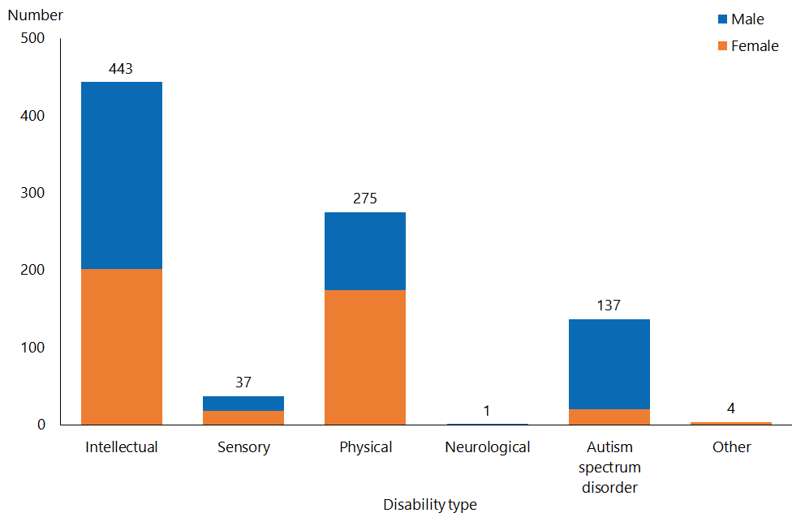

Figure 103: Southland Disability Support Services clients, by service type and ethnicity, 2018

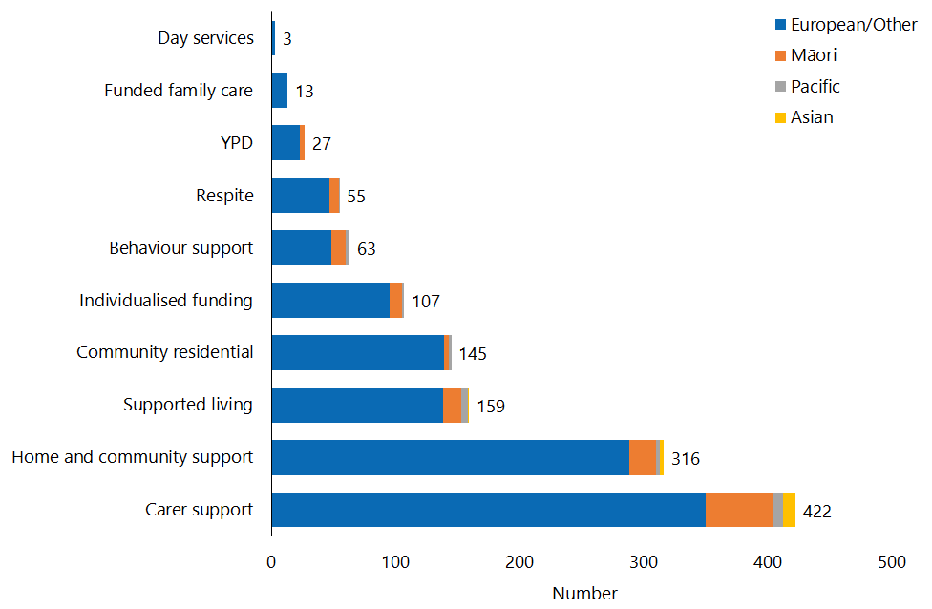

# Appendix 1: Descriptions of disability support services

| **Disability support service type** | **Description** |
| --- | --- |
| Behaviour support services (BSS) | BSSs aim to improve the quality of life for people who have challenging behaviour, making it easier for them to be independent and involved in the community.  BSSs work with disabled people and their support networks to develop and implement plans to reduce the impact of challenging behaviour. |
| Carer support | Carer support is available to full-time, unpaid carers for disabled people, to allow them to take time out for themselves and support them to continue in their caring role.  Carer support provides reimbursement of some of the costs of using a support person to care and support a disabled person. |
| Choice in community living (CiCL) | CiCL is an alternative to residential services and aims to give disabled people more choice in and control of their living circumstances – where they live, who they live with and how they are supported. In addition, CiCL aims to assist with the development of skills and capabilities to support independent living and creating opportunities for relationships, community access and participation.  CiCL is being demonstrated in the Auckland and Waikato regions only. |
| Community residential services | Community residential support services provide disabled people with support for up to 24 hours a day in a home-like setting in the community. This might include help with things like:   * shopping * preparing and cooking meals * household chores (eg, clothes washing, cleaning) * personal cares (eg, eating and drinking, getting dressed and undressed, taking a shower) * getting out and doing things in the neighbourhood (eg, going to see a movie).   Services are provided in a range of community settings, such as small or large homes, or groups of small homes or flats where disabled people can have their own space and sense of personal belonging. |
| Community rehabilitation | Community rehabilitation services are provided to disabled people under 65 and aim to help them to maximise their functional independence and participation in society. |
| Day services | Day services help disabled adults who cannot find work to take part in their community and improve their personal skills, by providing them access to regular meaningful social contact and stimulating activities.  Day services include a range of activities, depending on the provider and the individual disabled person’s interests and abilities. Activities may include daily living skills, education and learning activities, social activities, and recreation and leisure activities. |
| Enhanced individualised funding (EIF) | EIF allows disabled people to directly purchase the full range of disability supports they need. Unlike IF, it is not restricted to HCSS and respite services.  EIF can be spent on support that is:   * a disability support * part of the disabled person’s plan that helps them to achieve their goals * the responsibility of the Ministry of Health and not provided by other government agencies (such as education).   EIF is being demonstrated in the Bay of Plenty only. |
| Funded family care (FFC) | FFC is Ministry of Health-funded care for eligible disabled people to employ their parents or family members over 18 who they live with to provide them with personal care and/or household management disability supports.  FFC cannot be used to pay a disabled person’s spouse or partner, or to pay for non-disability supports. |
| High and Complex (H&C) Framework services | H&C services provide secure residential facilities for people with an intellectual disability under the Intellectual Disability (Compulsory Care and Rehabilitation) Act 2003.  H&C services include:   * National Intellectual Disability Secure Services * Regional Intellectual Disability Secure Services * Regional Intellectual Disability Supported Accommodation Services. |
| Home and community support services (HCSS) | HCSS help disabled people to live at home. They can include:   * household management services, which may include help with: * meal preparation * washing, drying or folding clothes * house-cleaning * personal care services, which may include help with: * eating and drinking * getting dressed and undressed * getting up in the morning and getting ready for bed * showering and going to the toilet * getting around the home. |
| Individualised funding (IF) | IF allows disabled people to directly purchase their own HCSS and respite services. It gives disabled people more choice, control and flexibility in how they are supported. |
| Respite services | Respite services provide short-term breaks for the carers of a disabled person, while also providing a positive, stimulating and worthwhile experience for the disabled person. |
| Supported living | Supported living services help disabled people to live independently by providing them support with activities such as:   * using community facilities (eg, libraries, swimming pools) * shopping, budgeting or cooking * dealing with agencies (eg, WINZ, banks).   A support worker works with the disabled person, usually at their home, but also at other agreed places. |
| Younger people in aged residential care (YPD) | YPD services provide 24-hour residential support in aged care services for people aged under 65 with physical disabilities who require clinical supports not available in community residential support services. |

# Appendix 2: Disability types and conditions

Table A1: Principal disability types and related conditions, number of Disability Support Services clients, 2018

(Note: If a client has two principal disability-related conditions, both conditions are counted in their relevant condition categories.)

| **Disability type** | **Disability-related condition** | **Number** |
| --- | --- | --- |
| Intellectual | Birth asphyxia or intrauterine hypoxia | 17 |
| Developmental delay | 2,393 |
| Down syndrome (Trisomy 21) | 2,149 |
| Edwards’ syndrome (Trisomy 18) | 11 |
| Fragile X syndrome | 125 |
| Klinefelter’s syndrome | 28 |
| Prader-Willi syndrome | 36 |
| Microcephalu/microcephaly | 91 |
| Learning disability/difficulty/delay (type not specified) | 914 |
| Other intellectual, learning or developmental disorder | 506 |
| Intellectual disability (type not specified) | 11,814 |
| **Total** | **18,084** |
| Physical | Amputation of limbs | 213 |
| Ankylosing spondylitis | 33 |
| Arthrogryposis | 42 |
| Ataxia | 197 |
| Back injury | 29 |
| Cerebral palsy | 1,973 |
| Club foot or feet | 17 |
| Congenital absence/partial absence of limb | 26 |
| Guillain Barre syndrome | 24 |
| Kyphosis/lordosis/scoliosis | 91 |
| Low birth weight/prematurity/short gestation | 43 |
| Multiple sclerosis | 1,013 |
| Muscular dystrophy | 299 |
| Non-malignant growth/tumour | 15 |
| Osteoarthritis | 696 |
| Paralysis/paresis | 555 |
| Physical (continued) | Patau’s syndrome (Trisomy 13) | 2 |
| Polio and post-polio | 88 |
| Polymyalgia rheumatica | 7 |
| Prolapsed disc/disc degeneration/sciatica | 35 |
| Rheumatoid arthritis | 447 |
| Short stature/dwarfism | 43 |
| Spina bifida | 346 |
| Spinal muscular atrophy | 35 |
| Spinal stenosis | 78 |
| Spondylosis | 33 |
| Stroke | 1,957 |
| Systemic lupus erythematosus | 27 |
| Other spine or back disorder | 190 |
| Other muscle/tendon/musculoskeletal disorders | 241 |
| Other conditions originating around time of birth | 53 |
| Other bone/joint/cartilage/connective tissue disorder | 200 |
| **Total** | **9,048** |
| Autism spectrum disorder | Asperger’s syndrome | 1,112 |
| Autistic spectrum disorder | 8,618 |
| **Total** | **9,730** |
| Sensory | Blind or vision impaired | 689 |
| Congenital cataract | 17 |
| Deaf or hearing impaired | 398 |
| Glaucoma | 12 |
| Optic neuritis/optic atrophy | 15 |
| Retinopathy, retinal dystrophy, retinitis pigmentosa, detached retina | 68 |
| Other cataract | 5 |
| Other ear or hearing disorder | 47 |
| Other eye or vision disorder | 145 |
| **Total** | **1,396** |
| Neurological | Brain injury | 252 |
| Encephalitis | 44 |
| Other brain or nervous system disorder | 99 |
| **Total** | **395** |
| Physical/ intellectual | Other congenital or chromosomal defects affecting multiple systems | 941 |
| Physical/ neurological | Huntington’s disease | 158 |
| Meningitis | 22 |
| Motor neuron disease | 131 |
| Parkinson’s disease | 227 |
| **Total** | **538** |
| Physical/ intellectual/ neurological | Hydrocephalus/Hydrocephaly | 92 |
| Other brain or nervous system disorder | 708 |
| **Total** | **800** |
| Other | Alcohol/drug related disorder (excluding Korsakov’s syndrome) | 9 |
| Alzheimer’s dementia | 3 |
| Asthma | 23 |
| Attention deficit/hyperactivity | 150 |
| Cancer | 29 |
| Chronic back pain/chronic pain syndrome | 22 |
| Chronic fatigue syndrome/myalgic encephalomyelitis | 27 |
| Chronic obstructive pulmonary disease/other respiratory disorder | 30 |
| Diabetes/other nutritional, hormonal or metabolic disorder | 88 |
| Digestive conditions/disorders | 16 |
| Eczema and dermatitis/other skin and subcutaneous tissue disorder | 9 |
| Epidermolysis bullosa | 1 |
| Epilepsy/seizures | 291 |
| Fibromyalgia | 35 |
| Foetal alcohol syndrome | 47 |
| Genitourinary disorders | 8 |
| Heart diseases | 46 |
| Hypertension | 18 |
| Lymphoedema | 4 |
| Mental disorders | 163 |
| Motor delay/developmental dyspraxia | 30 |
| Mute | 4 |
| Neurofibromatosis | 13 |
| Obesity | 3 |
| Osteoporosis | 30 |
| Peripheral vascular disease | 1 |
| Other (continued) | Recurrent or chronic otitis media or ear infections | 1 |
| Renal failure/renal dialysis/haemodialysis | 9 |
| Sleep disorder | 4 |
| Systemic sclerosis/scleroderma | 5 |
| Other heart or blood vessel disorder | 47 |
| Other dementia (including Korsakov’s syndrome) | 12 |
| Other speech disorder | 39 |
| Other bone/joint/cartilage/connective tissue disorder | 11 |
| Other conditions | 54 |
| **Total** | **1,282** |

# Appendix 3: Abbreviations

|  |  |
| --- | --- |
| ASD | Autism spectrum disorder |
| BSS | Behaviour support services |
| CS | Carer support |
| CiCL | Choice in community living |
| DSS | Disability Support Services |
| EIF | Enhanced individualised funding |
| FFC | Funded family care |
| H&C | High and Complex Framework services |
| HCSS | Home and community support services |
| IF | Individualised funding |
| NASC | Needs Assessment and Service Coordination |
| NIDCA | National Intellectual Disability Care Agency |
| NIDSS | National Intellectual Disability Secure Services |
| RIDCA | Regional Intellectual Disability Care Agency |
| RIDSAS | Regional Intellectual Disability Supported Accommodation Service |
| RIDSS | Regional Intellectual Disability Secure Services |
| SPA | Support package allocation |
| YPD | Younger people with physical disability (generally living in residential care) |

1. See Appendix 1 for a description of each disability support service included in this report.