Demographic Information on Clients Using the Ministry of Health’s Disability Support Services
as at September 2013
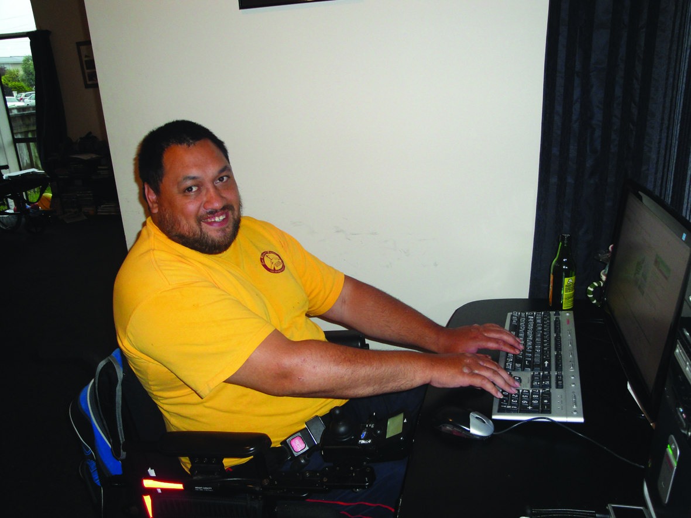

Citation: Ministry of Health. 2015. Demographic Information of Clients Using the Ministry of Health’s Disability Support Services as at September 2013. Wellington: Ministry of Health.
Published in April 2015
by the Ministry of Health
PO Box 5013, Wellington 6145, New Zealand
ISBN: 978-0-478-44491-9 (online)
HP 6132
This document is available at www.health.govt.nz

This work is licensed under the Creative Commons Attribution 4.0 International licence. In essence, you are free to: share ie, copy and redistribute the material in any medium or format; adapt ie, remix, transform and build upon the material. You must give appropriate credit, provide a link to the licence and indicate if changes were made.

Contents
Executive summary ix
Introduction 1
Purpose 1
Audience 1
Scope 1
Exclusions 2
Terminology 2
Methodology 3
Demographic profile data 3
Client transaction data 3
Statistics New Zealand census data 3
DSS clients compared with the New Zealand population 4
Age and sex 4
Ethnicity 5
Disability services 7
Disability Support Services groups 7
Overall client demographics 8
Age and sex 8
Ethnicity 10
Ethnicity-age profiles 11
Marital status 12
Accommodation 12
Deprivation 13
Location 15
District health board area 16
Principal disabilities 17
Disability top 10 18
Support package allocation 19
Needs Assessment Service Coordination organisations 20
Client demographics by service 22
Home and community support 22
Carer support 28
Community residential services 38
Supported living 44
Respite care services 49
Client demographics by disability 56
Intellectual disability 56
Physical disability 59
Autism spectrum disorder 61
Sensory disability 64
Neurological disability 67
Service usage by ethnicity 70
Client turnover 72
Introduction 72
New clients 72
Terminating clients 77
Deceased clients 82
Turnover rates 84
National and international disability trends 85
New Zealand disability trends 85
Australian Disability Demographics 2011–12 86
United Kingdom Family Resources Survey 89
Canada disability rates, 2006 91
WHO 2011 World Report on Disability 92
Glossary 93
References 94
Appendices
Appendix 1: Down syndrome 95
Appendix 2: Total client demographics excluding ASD 97
Appendix 3: Disability types 98
Appendix 4: Demographics of day-programme clients 102

List of Tables
Table 1: Ethnicity of DSS clients compared with the New Zealand population, aged
0–79 years 5
Table 2: Client numbers per service type 7
Table 3: DSS clients by age and sex, September 2013 8
Table 4: DSS clients by age and ethnicity 10
Table 5: DSS clients by marital status and sex 12
Table 6: DSS clients by accommodation type and sex 12
Table 7: DSS clients by ethnicity and deprivation level 14
Table 8: DSS clients by ethnicity and region 15
Table 9: DSS clients by district health board area and deprivation level 16
Table 10: DSS clients by sex and class of principal disability 17
Table 11: DSS clients by the 10 most prevalent disability types 18
Table 12: DSS clients by SPA level and age 19
Table 13: DSS clients by NASC 20
Table 14: HCSS clients by age and sex 22
Table 15: HCSS by age and ethnicity 23
Table 16: HCSS clients by marital status 24
Table 17: HCSS clients by sex and accommodation type 25
Table 18: HCSS clients by region and ethnicity 26
Table 19: HCSS clients by principal disability type and sex 27
Table 20: HCSS clients by SPA level and sex 28
Table 21: Care support clients by age and sex 29
Table 22: Carer support clients by age and ethnicity 30
Table 23: Carer support clients by sex and accommodation type 31
Table 24: Carer support clients by marital status and sex 31
Table 25: Carer support clients by ethnicity and deprivation level 32
Table 26: Carer support clients by region and ethnicity 33
Table 27: Carer support clients by district health board (DHB) and deprivation level 34
Table 28: Carer support clients by sex and principal disability 35
Table 29: Carer support clients by support package allocation (SPA) level and sex 36
Table 30: Age distribution of full-time carers receiving a carer support subsidy 37
Table 32: Community residential services clients by age and sex 38
Table 33: Community residential services clients by ethnicity and age 39
Table 34: Community residential services clients by marital status and sex 40
Table 35: Community residential services clients by accommodation type and sex 41
Table 36: Community residential services clients by region and ethnicity 41
Table 37: Community residential services clients by principal disability and sex 42
Table 38: Community residential services clients by SPA level and sex 43
Table 39: Clients receiving supported living services, by age and sex 44
Table 40: Clients receiving supported living services, by ethnicity and age 45
Table 41: Clients receiving supported living services, by marital status and sex 46
Table 42: Clients receiving supported living services, by accommodation type and sex 46
Table 43: Clients receiving supported living services, by ethnicity and region 47
Table 44: Clients receiving supported living services, by principal disability and sex 48
Table 45: Clients receiving supported living services by SPA level and sex 49
Table 46: Respite care users by age and sex 50
Table 47: Respite care users by age and ethnicity 51
Table 48: Respite care users by sex and marital status 52
Table 49: Respite care users by sex and accommodation type 52
Table 50: Respite care users by ethnicity and region 53
Table 51: Respite care users by sex and disability type 54
Table 52: Respite care users by SPA level and sex 55
Table 53: Clients with intellectual disability by age and sex 57
Table 54: Clients with intellectual disability by ethnicity and deprivation 58
Table 55: Clients with physical disability by age and sex 59
Table 56: Clients with physical disability by ethnicity and deprivation 60
Table 57: Clients with ASD by age and sex 61
Table 58: ASD clients by ethnicity and deprivation 62
Table 59: ASD clients by sex and service usage 63
Table 60: Sensory disability clients by age and sex 65
Table 61: Clients with sensory disability by ethnicity and deprivation 66
Table 62: Clients with neurological disability by age and sex 67
Table 63: Clients with neurological disability by ethnicity and deprivation 68
Table 64: New clients by sex and age 73
Table 65: New clients by ethnicity and deprivation decile 74
Table 66: New clients by principal disability 75
Table 67: New clients by service used 76
Table 68: Reasons for client terminating with DSS 77
Table 69: Terminating clients by sex and age 78
Table 70: Terminating clients by ethnicity 79
Table 71: Terminating clients by principal disability 79
Table 72: Terminating clients by service used 80
Table 73: Deceased clients by age and sex 82
Table 74: Deceased clients by ethnicity 83
Table 75: Deceased clients by service used 83
Table 76: Net movement of clients entering and departing DSS 84
Table 77: Australian disabled people by service type 2007–2012 86
Table 78: Australian disability service users by age 87
Table 79: Australian disabled people using government-funded supports by principal disability 88
Table 80: Australian disability clients by residential setting 89
Table 81: Canadian people with disabilities by age and sex 91
Table A1: Down syndrome clients by age and sex 95
Table A3: Principal disability types by numbers of DSS clients 98
Table A4: Day-programme clients by age and sex 102
Table A5: Day-programme clients by age and ethnicity 103
Table A6: Day-programme clients by region 104
Table A7: Day-programme clients by principal disability 105
Table A8: Day-programme clients by SPA level 106

List of figures
Figure 1: Age and sex of DSS clients compared with the New Zealand population, 2013 4
Figure 2: Ethnicity of DSS clients compared with the New Zealand population, aged
0–79 years 5
Figure 3: DSS client profiles by age/sex 9
Figure 4: DSS clients by age and ethnicity 10
Figure 5: DSS clients by main ethnicity group 11
Figure 6: DSS clients by accommodation type and sex 13
Figure 7: DSS clients by ethnicity and deprivation level 14
Figure 8: DSS clients by ethnicity and region 15
Figure 9: DSS clients by district health board area and deprivation level 17
Figure 10: DSS clients by sex and class of principal disability 18
Figure 11: DSS clients by the 10 most prevalent disability types 19
Figure 12: DSS clients by SPA level and age 20
Figure 13: DSS clients by NASC 21
Figure 14: HCSS clients by age and sex 23
Figure 15: HCSS by age and ethnicity 24
Figure 16: HCSS clients by region and ethnicity 26
Figure 17: HCSS clients by principal disability type and sex 27
Figure 18: HCSS clients by SPA level and sex 28
Figure 19: Age/sex of carer support clients 29
Figure 20: Carer support clients by age and ethnicity 30
Figure 21: Carer support clients by ethnicity and deprivation level 32
Figure 22: Carer support clients by region and ethnicity 33
Figure 23: Carer support clients by district health board (DHB) and deprivation level 35
Figure 24: Carer support clients by sex and principal disability 36
Figure 25: Carer support clients by support package allocation (SPA) level and sex 36
Figure 26: Age distribution of full-time carers receiving a carer support subsidy 37
Figure 28: Age/sex of community residential services clients 39
Figure 29: Community residential services clients by ethnicity and age 40
Figure 30: Community residential services clients by region and ethnicity 42
Figure 31: Community residential services clients by principal disability and sex 43
Figure 32: Community residential services clients by SPA level and sex 43
Figure 33: Age/sex of clients receiving supported living services 44
Figure 34: Clients receiving supported living services, by ethnicity and age 45
Figure 35: Clients receiving supported living services, by ethnicity and region 47
Figure 36: Clients receiving supported living services, by principal disability and sex 48
Figure 37: Clients receiving supported living services by SPA level and sex 49
Figure 38: Age/sex of respite care users 50
Figure 39: Respite care users by age and ethnicity 51
Figure 40: Respite care users by ethnicity and region 53
Figure 41: Respite care users by sex and disability type 54
Figure 42: Respite care users by SPA level and sex 55
Figure 43: Age/sex of clients with intellectual disability 57
Figure 44: Clients with intellectual disability by ethnicity and deprivation 58
Figure 45: Clients with physical disability by age and sex 59
Figure 46: Clients with physical disability by ethnicity and deprivation 60
Figure 47: Age/sex of clients with ASD 62
Figure 48: ASD clients by ethnicity and deprivation 63
Figure 49: ASD clients by sex and service usage 64
Figure 50: Age/sex of clients with sensory disabilities 65
Figure 51: Clients with sensory disability by ethnicity and deprivation 66
Figure 52: Age/sex of clients with neurological disability 68
Figure 53: Clients with neurological disability by ethnicity and deprivation 69
Figure 54: Overall service usage by ethnicity 70
Figure 55: Service usage by clients of European/Other ethnicity 70
Figure 56: Service usage by clients of Māori ethnicity 70
Figure 57: Service usage by clients of Pacific ethnicity 71
Figure 58: Service usage by clients of Asian ethnicity 71
Figure 59: Age/sex of new clients 73
Figure 60: New clients by ethnicity and deprivation decile 74
Figure 61: New clients by principal disability 75
Figure 62: New clients by service used 76
Figure 63: Age/sex of terminating clients 78
Figure 64: Terminating clients by ethnicity 79
Figure 65: Terminating clients by principal disability 80
Figure 66: Terminating clients by service used 81
Figure 67: Age/sex of deceased clients 82
Figure 68: Deceased clients by ethnicity 83
Figure 69: Deceased clients by service used 84
Figure 70: Change in number of clients receiving each service in Australia 2007–2012 86
Figure 71: Australian disability service users by age 87
Figure 72: Australian disabled people using government-funded supports by principal disability 88
Figure 73: Canadian people with disabilities by age and sex 91
Figure A1: Down syndrome clients by age and sex 96
Figure A2: Total DSS clients 97
Figure A3: Total DSS clients excluding ASD clients 97
Figure A4: Day-programme clients by age and sex 103
Figure A5: Day-programme clients by age and ethnicity 104
Figure A6: Day-programme clients by region 105
Figure A7: Day-programme clients by principal disability 106
Figure A8: Day-programme clients by SPA level 107

Executive summary

Introduction
The purpose of this report is to provide demographic information about the disabled people allocated the majority of disability support services funded by the Ministry of Health’s Disability Support Services (DSS), that is: home and community support, carer support, community residential, supported living and respite.

The report excludes disabled people allocated the following services: equipment and modifications, behaviour support, child development and assessment, treatment and rehabilitation.

It is important to note that the report is based on information about services allocated to people by the Needs Assessment and Service Coordination organisations. It is not based on services used.

This report presents its findings in a variety of ways in acknowledgement of the specific focus of different interest groups.

Overall client demographics
- Significantly more males (56%) than females (44%) receive disability support services. Males dominate the age groups from 5–25 years; females dominate the 50–70 years age groups.
- The ethnicity percentages are: 69% European/Other, 16% Māori, 6% Pacific, 5% Asian, with 4% of unknown ethnicity.
- The Māori and Pacific age profiles reflect the lower life expectancy of these groups.
- Among Asian clients, males have a significant presence in the 5–24 years age group.
- The distribution of clients is skewed towards high-deprivation deciles. Māori and Pacific are over-represented in high-deprivation deciles, with 44% of Māori and 53% of Pacific clients in deciles 9 or 10. Asian and European clients are fairly evenly spread across all deprivation deciles.
- Males make up 57% of clients with intellectual disabilities. Females make up 58% of clients with physical disabilities. Males (80%) dominate the clients with autism spectrum disorder (ASD).
- As at September 2013, 51% of the clients receiving home and community support had a physical disability.

Disability support services

Home and community support
- People with physical disabilities make up 38% of the clients receiving home and community support.
- 25% of home and community support clients have very high Support Package Allocations.

Carer support
- People with intellectual disabilities make up 42% of the clients receiving carer support.

Residential care
- There are significantly more males than females in residential care.
- Pacific and Asian clients do not use residential care services to a significant degree.
- People with intellectual disabilities account for 73% of the clients in residential care.

Supported living
- The age distribution of clients in supported living is flat across ages 20–59 years.
- Supported living clients are heavily skewed towards high-deprivation deciles, especially Māori and Pacific clients. Asian supported living clients are highest in the middle deprivation decile range.
- People with intellectual disabilities make up 63% the clients using supported living.

Respite care
- Respite care is used predominantly for teenagers.
- Māori represent 20% and Pacific represent 7% of the clients using respite care.

Disability types

Intellectual disabilities
- Amongst people with intellectual disabilities, Māori are over-represented (19%) in disability support services compared to 16% of all clients being Māori.
- 27% of clients with intellectual disabilities are in the 9–10 deprivation deciles.

Physical disabilities
- Females make up 63% of clients with a physical disability.
- 61% of physical disability clients are aged between 45 and 74 years.
- 30% of physical disability clients are in the 9–10 deprivation deciles.
- Māori and Pacific clients make up a large proportion of clients with a physical disability in the high-deprivation deciles.

Autism spectrum disorder
- The clients with ASD are very dominantly male (80%).
- The majority (75%) of ASD clients are 5–19 years old.
- ASD clients are evenly distributed across all deprivation deciles.
- Asian clients make up a disproportionately large portion (12%) of those with ASD using disability support services, as against 5% of total clients.

Trends
- The number of clients receiving disability support services grew by 2.1% in 2013. There was an intake of 7.6% and an outflow of 5.5% in that year.
- Carer support is the fastest growing support at 3.65% per year.
- Residential care, as a group, is declining at 1.77% per year.
- All service groups, except supported living, showed steady growth from 2008 up to the year ending June 2012 and a slight decline to the year ending June 2013.
- Supported living showed growth in each year, but its rate of growth declined in the year ending June 2013.

Introduction

Purpose
The purpose of this report is to inform decision-making regarding planning and procuring disability support services.

The report provides demographic information about the disabled people and their families/ whānau who use the services funded by Disability Support Services (DSS) of the New Zealand Ministry of Health (the Ministry). It also provides information about trends in disability support within New Zealand and in other comparable countries.

Audience
The principal audience of this document is the staff and managers of DSS who are involved in developing annual business and procurement plans as well as the next four-year DSS strategic plan.

Scope
The report provides demographic information obtained from the Ministry’s Socrates database collected by the Needs Assessment Service Coordination (NASC) organisation from the disabled people who are accessing Ministry-funded disability support services.

The information relates to people who were receiving the following disability support services as at September 2013:
- home and community support
- carer support
- community residential
- supported living
- respite.

The demographics presented relate to:
- age
- sex
- ethnicity
- marital status
- type of accommodation
- location within New Zealand
- district health board (DHB) area
- deprivation
- type of disability
- support package allocation (SPA)
- Needs Assessment Service Coordination (NASC)
- trend information.

Exclusions
It is important to note that this report excludes people receiving the following Ministry-funded services as they are not recorded in the Socrates database:
- equipment and modifications
- child development
- assessment, treatment and rehabilitation
- behaviour support.

It is important to note that the report is based on information about services allocated to people by the Needs Assessment Service Coordination organisations. It is not based on services used.

Terminology
Throughout this report, we have used the noun ‘client’ to refer to a person with a disability who receives a service from DSS.

Methodology
This report analyses data about people who were using Ministry-funded disability support services as at September 2013.

Demographic profile data
The majority of the data discussed in this report was derived from the Ministry’s Socrates database in an extract provided by the Contract and Information Support (CIS) team within the National Services Purchasing Unit. The Socrates database includes all clients who have ever been assessed by NASC for eligibility to access Ministry-funded disability support services. There are 16 NASCs across New Zealand.

The extract obtained for the purposes of this report included all NASC clients with a client status of ‘active’, that is, clients who are currently working with NASCs. Two fields were manually added to this extract: NASC Name, and General Ledger Account Description, both fields were added to assist the readability of the extract.

The extract contained one record for each client for each service being delivered to that client. This means that the demographic data for any client accessing multiple services appears more than once, that is, in each service-related table.

A copy of the extract was used to make a table with one record per client. A second extract was provided for the geospatial information on each client. This extract was taken at a time when Socrates had geospatial data, as meshblock numbers, for 94% of clients. The meshblock data was used to assign clients to district health board (DHB) areas, district authority areas, and deprivation deciles.

Client transaction data
A third extract from Socrates contained records of major changes in client status (active or Inactive) over the period 1 January 2013 to 25 September 2013 inclusive. This was used to inform the section of the report devoted to client turnover.

Statistics New Zealand census data
When this report was initially being prepared in late 2013, only a limited range of provisional data was available from the 2013 census. Hence the majority of comparisons with the New Zealand population made in the report use the 2006 New Zealand census data.

During 2014, some parts of the report were updated to compare with 2013 census data, which became available in mid-2014.

Note: Many tables do not total 100% due to rounding.

DSS clients compared with the New Zealand population
There are notable differences between the age and sex demographics of DSS clients compared with the overall New Zealand population, using the 2013 census data.

Age and sex
Figure 1: Age and sex of DSS clients compared with the New Zealand population, 2013
DSS clients, 2013 | New Zealand national population, 2013, provisional  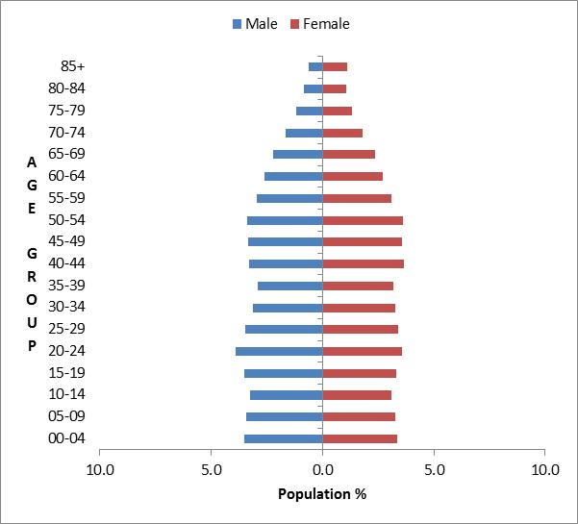

Observations:
- DSS clients are more concentrated in the 5–19 and 45–65 age groups.
- Generally eligibility for DSS services is for people aged under 65, hence the lower numbers of people in the over 65 age groups compared with the general population.

Ethnicity
A comparison can also be made between DSS clients’ ethnicities in 2013 compared with the 2013 census ethnicity statistics for people aged 0–79 years. (As at September 2013, there were only 47 people aged 80+ years who were clients of DSS.)

Table 1: Ethnicity of DSS clients compared with the New Zealand population,
aged 0–79 years
Ethnicity | Numbers |  | Percentages
 | DSS clients  2013 | Census 2013  0–79-year-olds in the NZ population | DSS clients  2013 | Census 2013  0–79-year-olds in the NZ population
European/Other | 21,407 | 2,945,220 | 68.8% | 72.1%
Māori | 5030 | 594,135 | 16.2% | 14.5%
Pacific | 1839 | 293,814 | 5.9% | 7.2%
Asian | 1426 | 467,769 | 4.6% | 11.4%
Not stated | 1399 | 212,253 | 4.5% | 5.2%
Total | 31,101 | 4,087,707 | 100.0% | 110.4%

Figure 2: Ethnicity of DSS clients compared with the New Zealand population,
aged 0–79 years

Observations:
- European/Other and Pacific ethnicities are slightly under-represented in the DSS client group.
- Asian ethnicity is significantly under-represented in DSS services.
- Māori are slightly over-represented in the DSS client group.

Caveat: Care is needed when making inferences from comparisons between DSS and New Zealand wide numbers for the following reasons:
- New Zealand population statistics are based on people’s chosen ethnicity and people may, and do, have multiple ethnicities.
- DSS ethnicities are ‘prioritised’, and this will tend to exaggerate Māori and Pacific over Asian, European and Other.

Disability services

Disability Support Services groups
The Socrates database provides client and service delivery information for the following services.

Table 2: Client numbers per service type
Service group description | Clients | Group total | Demographics analysed
Home support | 7968 | 14,969 | Yes
Home support: personal care | 4647
Home support: personal care: IF (individualised funding) | 1600
Home support: IF (individualised funding) | 687
Home support: EIF (enhanced individualised funding) | 67
Carer support | 15,890 | 15,890 | Yes
Residential: community | 6475 | 7191 | Yes
Residential: hospitals | 485
Residential: rest homes | 231
Supported living | 2797 | 2797 | Yes
Respite care | 1637 | 1637 | Yes
Day programmes | 2300 | 2300 | Partially in Appendix 4
Total non-unique client users |  | 44,784

This report considers the following major services:
- home support (also referred to as home and community support)
- carer support
- community residential services
- supported living
- respite.

Day programmes are predominantly funded by the Ministry of Social Development, and this service has not been analysed in detail in this report. However, the Ministry of Health does fund day programmes for 2300 people and Appendix 4: Demographics of day-programme clients provides some demographic analysis of this group.

Overall client demographics
This section shows the demographic details of all the clients receiving services from DSS service providers. The total number of clients as at 12 September 2013 was 31,101.

Age and sex
Table 3: DSS clients by age and sex, September 2013
Age group  (in years) | Male | Female | Total
0–4 | 939 | 491 | 1430
5–9 | 2369 | 1037 | 3406
10–14 | 2627 | 1242 | 3869
15–19 | 1992 | 1068 | 3060
20–24 | 1260 | 901 | 2161
25–29 | 872 | 686 | 1558
30–34 | 762 | 587 | 1349
35–39 | 761 | 682 | 1443
40–44 | 895 | 883 | 1778
45–49 | 1060 | 994 | 2054
50–54 | 1067 | 1183 | 2250
55–59 | 978 | 1213 | 2191
60–64 | 936 | 1239 | 2175
65–69 | 588 | 914 | 1502
70–74 | 254 | 447 | 701
75–79 | 55 | 72 | 127
80–84 | 16 | 20 | 36
85+ | 7 | 4 | 11
Total | 17,438 | 13,663 | 31,101
 | 56.1% | 43.9%

Figure 3: DSS client profiles by age/sex

Observations:
- There are significantly more males (56%) than females (44%) using DSS services.
- There are two high points in the age profiles of DSS clients: one in teenage years and the second in the 50–69 years age groups.
- Males dominate the age groups from 0–25 years, and females are significantly more numerous than males in the 50–70 years age groups.

Ethnicity
Table 4: DSS clients by age and ethnicity
Age group | European/  Other | Māori | Pacific | Asian | Not stated | Total
0–4 | 710 | 288 | 126 | 102 | 204 | 1430
5–9 | 2019 | 624 | 232 | 254 | 277 | 3406
10–14 | 2463 | 711 | 251 | 278 | 166 | 3869
15–19 | 2011 | 576 | 220 | 199 | 54 | 3060
20–24 | 1452 | 348 | 170 | 144 | 47 | 2161
25–29 | 1069 | 257 | 106 | 72 | 54 | 1558
30–34 | 939 | 248 | 84 | 52 | 26 | 1349
35–39 | 1050 | 233 | 95 | 27 | 38 | 1443
40–44 | 1305 | 280 | 81 | 35 | 77 | 1778
45–49 | 1492 | 349 | 93 | 51 | 69 | 2054
50–54 | 1686 | 327 | 87 | 56 | 94 | 2250
55–59 | 1634 | 332 | 94 | 45 | 86 | 2191
60–64 | 1695 | 248 | 85 | 49 | 98 | 2175
65–69 | 1166 | 146 | 82 | 39 | 69 | 1502
70–74 | 561 | 52 | 32 | 23 | 33 | 701
75–79 | 112 | 9 | 1 | 0 | 5 | 127
80–84 | 33 | 2 | 0 | 0 | 1 | 36
85+ | 10 | 0 | 0 | 0 | 1 | 11
Total | 21,407 | 5,030 | 1,839 | 1,426 | 1,399 | 31,101
Percentage | 68.8% | 16.2% | 5.9% | 4.6% | 4.5%

Figure 4: DSS clients by age and ethnicity

Observation:
- The age profiles for Māori and Pacific DSS clients reflect the lower life expectancies of these groups in wider society.

Ethnicity-age profiles
There are distinct differences in the age profiles of the four main ethnic groups.

Figure 5: DSS clients by main ethnicity group
European/Other  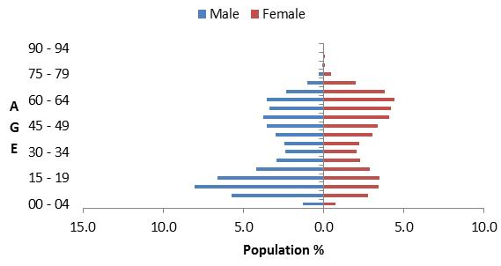 | Māori  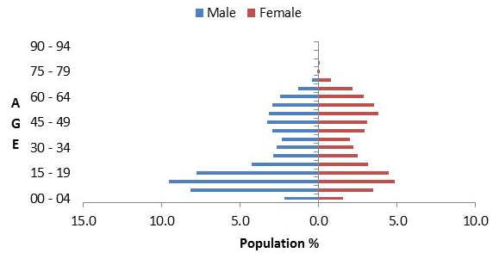
Pacific  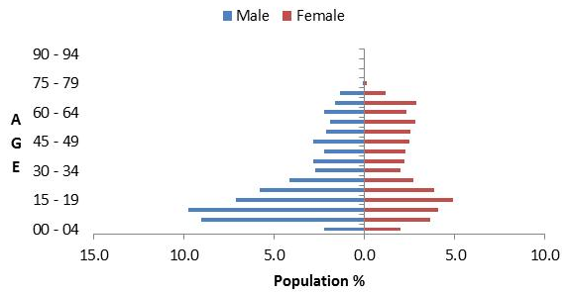 | Asian  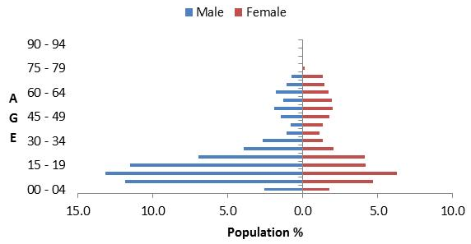

Marital status
Table 5: DSS clients by marital status and sex
Marital status | Male | Female | Total
Blank | 11,535 | 8573 | 20,108
Non-partnered, not further defined | 3246 | 2379 | 5625
Non-partnered, never married | 1479 | 916 | 2395
Married (not separated), not further defined | 429 | 782 | 1211
Not stated | 360 | 296 | 656
Non-partnered, divorced | 87 | 197 | 284
Partnered, not further defined | 116 | 133 | 249
Non-partnered, widowed | 39 | 184 | 223
Non-partnered, separated | 93 | 124 | 217
First marriage (not separated) | 17 | 30 | 47
Don’t know | 14 | 18 | 32
Response outside scope | 13 | 7 | 20
Opposite-sex partnership | 6 | 8 | 14
Remarried (not separated) | 4 | 10 | 14
Same-sex partnership | 1 | 5 | 6
Total | 17,439 | 13,662 | 31,101

Observations:
- Marital status is not recorded for 65% of DSS clients.
- Of DSS clients where data is recorded, 73% do not have partners.

Accommodation
Table 6: DSS clients by accommodation type and sex
Accommodation | Male | Female | Total
Own/family home | 8185 | 6294 | 14479
Community residential home | 3284 | 2341 | 5625
Rental accommodation | 2180 | 1759 | 3939
Other | 1034 | 855 | 1889
Housing New Zealand accommodation | 708 | 720 | 1428
Rest home / continuing care hospital | 255 | 289 | 544
Boarder | 159 | 122 | 281
Council accommodation | 88 | 69 | 157
Unit in a retirement village | 16 | 21 | 37
Prison | 13 | 7 | 20
Unit in a retirement village – licence to occupy | 3 | 6 | 9
No fixed abode | 4 | 4 | 8
Unknown | 1510 | 1175 | 2685
Total | 17,439 | 13,662 | 31,101

Figure 6: DSS clients by accommodation type and sex

Observations:
- Almost half of DSS clients live in their own or their family home, and over half (57%) of these are male.
- The accommodation profiles for male and female DSS clients are generally similar.
- The greater number of males in most accommodation options presumably reflects the greater number of males receiving disability support services. The slight predominance of females in rest homes / continuing care hospitals may reflect the longer life span of females.

Deprivation
The New Zealand census statistics allocate a deprivation decile to each meshblock where:
- a meshblock is one of thousands of small adjacent geographical areas in New Zealand
- each client is assigned to a meshblock through their address
- a decile rating is calculated for each meshblock, based on the average income of all census respondents within that meshblock
- the higher the decile number, the higher the deprivation level.

The information in this section was generated when geospatial coding in the Socrates database was at 94%.

Table 7: DSS clients by ethnicity and deprivation level
Ethnicity | Deprivation decile |  |  |  |  |  |  |  |  |  |  |  |  |  |  |  | Total
 | Lowest |  |  |  |  |  |  |  |  |  |  |  |  |  | Highest
 | 1 | 2 |  | 3 |  | 4 |  | 5 | 6 | 7 |  | 8 |  | 9 |  | 10
European/Other | 1554 | 1748 |  | 1788 |  | 1945 |  | 2024 | 2108 | 2436 |  | 2383 |  | 2265 |  | 1868 | 20,119
Māori | 126 | 179 |  | 254 |  | 250 |  | 316 | 391 | 519 |  | 636 |  | 913 |  | 1169 | 4753
Pacific | 25 | 30 |  | 47 |  | 72 |  | 88 | 98 | 135 |  | 259 |  | 368 |  | 649 | 1771
Asian | 121 | 112 |  | 132 |  | 144 |  | 149 | 163 | 150 |  | 149 |  | 142 |  | 121 | 1383
Not stated | 138 | 106 |  | 107 |  | 101 |  | 149 | 141 | 130 |  | 147 |  | 157 |  | 138 | 1314
Total | 1964 | 2175 |  | 2328 |  | 2512 |  | 2726 | 2901 | 3370 |  | 3574 |  | 3845 |  | 3945 | 29,340
% of total | 7% | 7% |  | 8% |  | 9% |  | 9% | 10% | 11% |  | 12% |  | 13% |  | 13%

Figure 7: DSS clients by ethnicity and deprivation level

Observations:
- The distribution of DSS clients is skewed towards the higher-deprivation deciles.
- Māori and Pacific clients are over-represented in high-deprivation deciles:
- 44% of Māori clients are in deciles 9 or 10.
- 53% of Pacific clients are in deciles 9 or 10.
- Asian and European clients are fairly evenly spread across all deprivation deciles.

Location
Table 8: DSS clients by ethnicity and region
Region | European/ Other | Māori | Pacific | Asian | Not stated | Total | %
Auckland | 5181 | 1242 | 1368 | 976 | 681 | 9448 | 30.4%
Canterbury | 3397 | 319 | 59 | 89 | 351 | 4215 | 13.5%
Waikato | 1986 | 751 | 60 | 77 | 114 | 2988 | 9.6%
Wellington | 2035 | 361 | 197 | 131 | 101 | 2825 | 9.1%
Bay of Plenty | 1433 | 611 | 26 | 33 | 13 | 2116 | 6.8%
Manawatu-Wanganui | 1487 | 317 | 32 | 29 | 31 | 1896 | 6.1%
Otago | 1598 | 116 | 25 | 23 | 29 | 1791 | 5.8%
Northland | 696 | 522 | 17 | 18 | 3 | 1256 | 4.0%
Hawke’s Bay | 710 | 219 | 27 | 20 | 27 | 1003 | 3.2%
Taranaki | 768 | 172 | 5 | 10 | 5 | 960 | 3.1%
Southland | 723 | 73 | 8 | 2 | 4 | 810 | 2.6%
Nelson | 681 | 72 | 5 | 15 | 2 | 775 | 2.5%
Marlborough | 283 | 49 | 1 | 2 |  | 335 | 1.1%
Gisborne | 144 | 180 | 7 | 1 | 9 | 341 | 1.1%
West Coast | 161 | 11 | 1 |  | 29 | 202 | 0.6%
Tasman | 124 | 15 | 1 |  |  | 140 | 0.5%
Total | 21,407 | 5,030 | 1,839 | 1,426 | 1,399 | 31,101
Note: This table was generated when geospatial coding in the database was at 94%.

Figure 8: DSS clients by ethnicity and region

Observations:
- Half of DSS clients reside in the three most populated regions, which include the major cities of Auckland, Christchurch and Hamilton.
- 75% of clients reside in the six most populated regions in the country.
- 68% of Asian clients reside in the Auckland region, with no Asian clients residing in the West Coast or Tasman regions.
- 74% of Pacific clients reside in the Auckland region.

District health board area
Table 9: DSS clients by district health board area and deprivation level
DHB | Lowest |  |  |  |  |  |  |  | Highest |  | Total
 | 1 | 2 | 3 | 4 | 5 | 6 | 7 | 8 | 9 | 10
Canterbury | 336 | 306 | 301 | 357 | 328 | 405 | 360 | 471 | 374 | 342 | 3580
Counties Manukau | 238 | 277 | 233 | 216 | 267 | 251 | 260 | 407 | 572 | 851 | 3572
Waitemata | 270 | 342 | 397 | 380 | 361 | 349 | 428 | 329 | 246 | 77 | 3179
Waikato | 150 | 137 | 145 | 271 | 219 | 274 | 316 | 327 | 492 | 437 | 2768
Auckland | 156 | 180 | 174 | 181 | 194 | 185 | 229 | 282 | 244 | 358 | 2183
Otago | 94 | 119 | 131 | 130 | 145 | 168 | 166 | 209 | 181 | 173 | 1516
Bay of Plenty | 48 | 78 | 126 | 106 | 154 | 148 | 131 | 140 | 237 | 200 | 1368
Capital & Coast | 188 | 139 | 103 | 148 | 125 | 137 | 104 | 110 | 131 | 179 | 1364
Nelson Marlborough | 66 | 67 | 138 | 133 | 118 | 160 | 218 | 177 | 124 | 45 | 1246
Northland | 29 | 62 | 46 | 51 | 88 | 119 | 123 | 174 | 268 | 218 | 1178
Hutt Valley | 106 | 80 | 63 | 73 | 128 | 95 | 155 | 115 | 170 | 172 | 1157
MidCentral | 57 | 62 | 87 | 99 | 108 | 110 | 108 | 168 | 184 | 143 | 1126
Hawke’s Bay | 60 | 63 | 59 | 93 | 125 | 96 | 171 | 106 | 101 | 157 | 1031
Taranaki | 37 | 40 | 89 | 62 | 99 | 140 | 164 | 127 | 106 | 106 | 970
Southland | 54 | 44 | 54 | 42 | 89 | 60 | 101 | 103 | 93 | 84 | 724
Lakes | 20 | 50 | 57 | 33 | 35 | 29 | 110 | 57 | 79 | 114 | 584
Whanganui | 26 | 24 | 37 | 42 | 38 | 56 | 44 | 50 | 95 | 102 | 514
South Canterbury | 18 | 45 | 30 | 61 | 46 | 44 | 57 | 68 | 42 | 27 | 438
Tairawhiti | 1 | 30 | 24 | 9 | 12 | 24 | 43 | 47 | 38 | 115 | 343
Wairarapa | 9 | 18 | 32 | 2 | 26 | 31 | 55 | 66 | 43 | 25 | 307
West Coast | 2 | 12 | 3 | 22 | 22 | 22 | 31 | 41 | 24 | 15 | 194
Total | 1965 | 2175 | 2329 | 2511 | 2727 | 2903 | 3374 | 3574 | 3844 | 3940 | 29,342
Notes:
This table was generated when geospatial coding in Socrates was at 94%, hence not all clients are included.
Otago and Southland DHBs were subsequently merged to form Southern DHB.

Figure 9: DSS clients by district health board area and deprivation level

Observation:
- Counties Manukau, Waikato and Auckland DHBs have a significantly higher proportion (40%) of clients in deciles 9 and 10.

Principal disabilities
Each DSS client is recorded in Socrates with a principal disability (see Appendix 3: Disability types). Some clients have multiple disability types, and occasionally a client will have two principal disabilities. Only the first principal disability is referred to in the data presented in this report.

There are six disability classes: intellectual, physical, autism spectrum disorder (ASD), sensory, neurological and not DSS, for example, mental health, cancer, medical.

Table 10: DSS clients by sex and class of principal disability
Disability class | Male | Female | Total | %
Intellectual | 8177 | 6222 | 14,399 | 46%
Physical | 3650 | 4645 | 8295 | 27%
ASD | 3850 | 1048 | 4898 | 16%
Not DSS | 708 | 749 | 1457 | 5%
Sensory | 553 | 544 | 1097 | 4%
Neurological | 501 | 454 | 955 | 2%
Total | 17,439 | 13,662 | 31,101

Figure 10: DSS clients by sex and class of principal disability

Observations:
- Almost half of all DSS clients have an intellectual disability.
- A further quarter have a physical disability.
- Males are predominant in the groups of clients with autism (79%) and intellectual disabilities (57%).
- Females (58%) are predominant in the group of clients with physical disabilities.

Disability top 10
Ten disability types account for almost three-quarters of DSS clients.

Table 11: DSS clients by the 10 most prevalent disability types
Principal disability | Male | Female | Total | %
Intellectual disability, type not specified | 4346 | 3293 | 7639 | 25%
Autism spectrum disorder (ASD) | 2309 | 658 | 2967 | 10%
Down syndrome (Trisomy 21) | 1702 | 1420 | 3122 | 10%
Stroke, brain/subarachnoid haemorrhage, cerebrovascular accident (CVA), parietal / cerebral / cerebellar / middle cerebral artery (MCA) / thalamic / frontal lobe infarct | 1068 | 984 | 2052 | 7%
Cerebral palsy | 884 | 726 | 1610 | 5%
Developmental delay, type not specified | 946 | 616 | 1562 | 5%
Asperger syndrome | 904 | 210 | 1114 | 4%
Multiple sclerosis | 207 | 608 | 815 | 3%
Other ASD | 637 | 180 | 817 | 3%
Learning disability/difficulty/delay, type not specified | 422 | 349 | 771 | 2%
Total | 13,425 | 9044 | 22,469 | 74%
 | 59.7% | 40.3%

Figure 11: DSS clients by the 10 most prevalent disability types

Observations:
- Stroke and cerebral palsy are the two most common physical disability types amongst DSS clients.

Support package allocation
Each DSS client has a support package allocation (SPA) determined by their NASC on the basis of a detailed needs assessment.

Table 12: DSS clients by SPA level and age
Age (in years) | Very high | High | Medium | Low | Very low | Blank | Total
0–4 | 182 | 484 | 636 | 126 | 2 |  | 1430
5–9 | 376 | 1033 | 1773 | 218 | 6 |  | 3406
10–14 | 529 | 1223 | 1957 | 155 | 3 | 2 | 3869
15–19 | 676 | 1094 | 1168 | 83 | 2 | 37 | 3060
20–24 | 583 | 812 | 666 | 54 |  | 46 | 2161
25–29 | 502 | 565 | 417 | 36 |  | 38 | 1558
30–34 | 477 | 438 | 369 | 29 |  | 36 | 1349
35–39 | 491 | 535 | 357 | 28 |  | 32 | 1443
40–44 | 642 | 615 | 449 | 43 |  | 29 | 1778
45–49 | 744 | 699 | 535 | 58 | 2 | 16 | 2054
50–54 | 770 | 785 | 632 | 51 |  | 12 | 2250
55–59 | 683 | 752 | 655 | 93 |  | 8 | 2191
60–64 | 547 | 726 | 763 | 135 |  | 4 | 2175
65–69 | 340 | 484 | 559 | 117 |  | 2 | 1502
70–74 | 169 | 215 | 263 | 54 |  |  | 701
75–79 | 46 | 41 | 35 | 4 | 1 |  | 127
80–84 | 14 | 16 | 5 | 1 |  |  | 36
85+ | 6 | 5 |  |  |  |  | 11
Total | 7777 | 10,522 | 11,239 | 1285 | 16 | 262 | 31,101
 | 25% | 34% | 36% | 4% | 0% | 1%
Figure 12: DSS clients by SPA level and age

Observation:
- Medium SPA levels are more common in the 5–19 years age groups.

Needs Assessment Service Coordination organisations
Table 13: DSS clients by NASC
NASC | Male | Female | Total
Taikura Trust (Auckland) | 5609 | 3775 | 9384
Life Links (Christchurch) | 2370 | 1999 | 4369
Disability Support Link (Hamilton) | 1575 | 1210 | 2785
Access Ability Otago | 1365 | 1198 | 2563
Support Net (Tauranga) | 1199 | 1084 | 2283
Enable (Palmerston North) | 696 | 672 | 1368
Capital Support (Wellington) | 740 | 567 | 1307
NorthAble (Whangarei) | 651 | 592 | 1243
Support Works (Nelson) | 665 | 579 | 1244
Life Unlimited Lower Hutt | 626 | 517 | 1143
Options Hawke’s Bay | 582 | 421 | 1003
Access Ability Taranaki | 515 | 445 | 960
Access Ability Whanganui | 257 | 261 | 518
Life Unlimited Tairawhiti | 189 | 152 | 341
Focus (Masterton) | 173 | 154 | 327
LifeLinks – National Intellectual Disability Care Agency (NIDCA) | 80 | 13 | 93
Access Ability Auckland – NIDCA | 67 | 9 | 76
Capital Support NIDCA | 46 | 12 | 58
Disability Support Link – NIDCA | 34 | 2 | 36
Total | 17,439 | 13,662 | 31,101

Figure 13: DSS clients by NASC

Observation:
- Taikura Trust in Auckland is more than twice as large as the second largest NASC and works with 30% of DSS clients.

Client demographics by service

Home and community support
This section provides demographic profiles for the 14,969 DSS clients who are receiving home and community support services (HCSS).

Age and sex
Table 14: HCSS clients by age and sex
Age (in years) | Female | Male | Total
0–4 | 110 | 163 | 273
5–9 | 291 | 493 | 784
10–14 | 413 | 775 | 1,188
15–19 | 484 | 799 | 1,283
20–24 | 437 | 556 | 993
25–29 | 334 | 344 | 678
30–34 | 260 | 278 | 538
35–39 | 370 | 283 | 653
40–44 | 509 | 318 | 827
45–49 | 595 | 424 | 1,019
50–54 | 824 | 547 | 1,371
55–59 | 940 | 566 | 1,506
60–64 | 1,161 | 656 | 1,817
65–69 | 892 | 429 | 1,321
70–74 | 451 | 183 | 634
75–79 | 49 | 21 | 70
80–84 | 8 | 5 | 13
85+ | 1 |  | 1
Total | 8,129 | 6,840 | 14,969
 | 54% | 46%

Figure 14: HCSS clients by age and sex
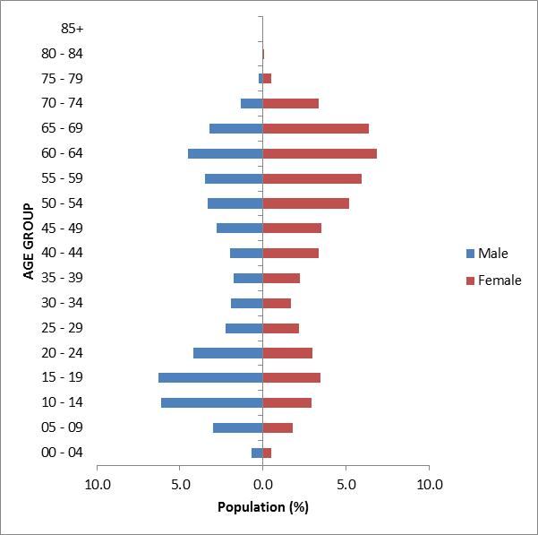

Observations:
- There are more female than male HCSS clients.
- There are two peaks in the age distribution of HCSS clients: male teenagers and females in the 55–69-year age range.

Ethnicity
Table 15: HCSS by age and ethnicity
Age  (in years) | European/ Other | Māori | Pacific | Asian | Not stated | Total
0–4 | 160 | 51 | 24 | 14 | 24 | 273
5–9 | 490 | 125 | 48 | 73 | 48 | 784
10–14 | 749 | 205 | 82 | 117 | 35 | 1188
15–19 | 824 | 214 | 113 | 116 | 16 | 1283
20–24 | 671 | 138 | 84 | 88 | 12 | 993
25–29 | 441 | 107 | 66 | 46 | 18 | 678
30–34 | 375 | 94 | 35 | 26 | 8 | 538
35–39 | 457 | 95 | 70 | 15 | 16 | 653
40–44 | 566 | 149 | 53 | 24 | 35 | 827
45–49 | 697 | 199 | 70 | 27 | 26 | 1019
50–54 | 945 | 242 | 84 | 58 | 42 | 1371
55–59 | 1067 | 261 | 79 | 44 | 55 | 1506
60–64 | 1406 | 203 | 87 | 47 | 74 | 1817
65–69 | 987 | 143 | 99 | 35 | 57 | 1321
70–74 | 484 | 52 | 38 | 28 | 32 | 634
75–79 | 66 | 2 | 2 |  |  | 70
80–84 | 13 |  |  |  |  | 13
85+ | 1 |  |  |  |  | 1
Total | 10,399 | 2280 | 1034 | 758 | 498 | 14,969
 | 70% | 15% | 7% | 5% | 3%
Figure 15: HCSS by age and ethnicity

Observations:
- European/Other and Pacific clients are slightly over-represented in the HCSS client group.
- Māori clients are slightly under-represented (compared with 16.2% of all DSS clients).

Marital status
Table 16: HCSS clients by marital status
Marital status | Female | Male | Total
Non-partnered, not further defined | 1348 | 1410 | 2758
Married (not separated), not further defined | 797 | 385 | 1182
Non-partnered, never married | 423 | 599 | 1022
Non-partnered, divorced | 213 | 90 | 303
Non-partnered, widowed | 227 | 44 | 271
Non-partnered, separated | 147 | 102 | 249
Partnered, not further defined | 115 | 89 | 204
First marriage (not separated) | 25 | 15 | 40
Remarried (not separated) | 11 | 3 | 14
Opposite-sex partnership | 5 | 3 | 8
Same-sex partnership | 4 |  | 4
Don’t know | 21 | 12 | 33
Not stated | 251 | 195 | 446
Response outside scope | 5 | 3 | 8
Blank | 4538 | 3889 | 8427
Total | 8130 | 6839 | 14,969

Observations:
- Marital status was not recorded for most clients (60%).
- Of the clients who did record marital status, 76% were not in any form of partnership or marriage.

Accommodation
Table 17: HCSS clients by sex and accommodation type
Usual place of residence | Female | Male | Total
Own/family home | 4375 | 3673 | 8048
Rental accommodation | 1236 | 1068 | 2304
Housing New Zealand accommodation | 708 | 533 | 1241
Community residential home | 203 | 270 | 473
Council accommodation | 77 | 76 | 153
Boarder | 52 | 37 | 89
Unit in a retirement village | 24 | 17 | 41
Rest home/continuing care hospital | 10 | 11 | 21
Unit in a retirement village – license to occupy | 7 | 3 | 10
No fixed abode | 1 | 1 | 2
Prison | 1 | 1 | 2
Other | 534 | 420 | 954
Unknown | 902 | 729 | 1631
Total | 8130 | 6839 | 14,969

Observation:
- Of the HCSS clients whose accommodation type was recorded, the majority (65%) lived in their own home or their family home.

Location
Table 18: HCSS clients by region and ethnicity
Region | European/ Other | Māori | Pacific | Asian | Not stated | Total | %
Auckland | 2570 | 580 | 806 | 547 | 171 | 4674 | 31%
Canterbury | 1523 | 162 | 26 | 46 | 172 | 1929 | 13%
Wellington | 910 | 139 | 93 | 71 | 57 | 1270 | 8%
Manawatu-Wanganui | 865 | 177 | 29 | 12 | 25 | 1108 | 7%
Waikato | 791 | 228 | 25 | 26 | 23 | 1093 | 7%
Bay of Plenty | 656 | 285 | 8 | 15 | 9 | 973 | 7%
Otago | 836 | 39 | 14 | 8 | 3 | 900 | 6%
Northland | 481 | 338 | 10 | 14 | 3 | 846 | 6%
Taranaki | 454 | 92 | 2 | 3 |  | 551 | 4%
Southland | 384 | 40 |  | 1 | 2 | 427 | 3%
Hawke’s Bay | 308 | 71 | 14 | 4 | 2 | 399 | 3%
Nelson | 234 | 20 | 2 | 11 |  | 267 | 2%
Marlborough | 188 | 26 |  |  |  | 214 | 1%
Gisborne | 65 | 76 | 4 |  | 13 | 158 | 1%
West Coast | 67 | 1 | 1 |  | 18 | 87 | 1%
Tasman | 67 | 6 |  |  |  | 73 | 0%
Total | 10,399 | 2280 | 1034 | 758 | 498 | 14,969

Figure 16: HCSS clients by region and ethnicity

Observations:
- The data shows that 31% of HCSS clients live in the Auckland region.
- The Auckland region has the largest ethnic diversity of HCSS clients: 55% European/Other; 17% Pacific; 12% Māori; 12% Asian.

Principal disability
Table 19: HCSS clients by principal disability type and sex
Disability type | Female | Male | Total | %
Physical | 3448 | 2275 | 5723 | 38.2%
Intellectual | 2086 | 2271 | 4357 | 29.1%
ASD | 339 | 885 | 1224 | 8.2%
Physical and neurological | 785 | 351 | 1136 | 7.6%
Not DSS | 570 | 306 | 876 | 5.9%
Sensory | 380 | 299 | 679 | 4.5%
Neurological and intellectual and physical | 241 | 183 | 424 | 2.8%
Physical and intellectual | 157 | 136 | 293 | 2.0%
Neurological | 105 | 113 | 218 | 1.5%
Intellectual and neurological and physical | 13 | 16 | 29 | 0.2%
Neurological and physical | 5 | 5 | 10 | 0.1%
Total | 8129 | 6840 | 14,969

Figure 17: HCSS clients by principal disability type and sex

Observation:
- The single largest principal disability type among HCSS clients is physical disabilities (38.2%).

Support package allocation
Table 20: HCSS clients by SPA level and sex
SPA level | Female | Male | Total | %
Very high | 1636 | 2139 | 3775 | 25%
High | 3383 | 3052 | 6435 | 43%
Medium | 2764 | 1522 | 4286 | 29%
Low | 347 | 124 | 471 | 3%
Very low |  | 1 | 1 | 0%
Blank |  | 1 | 1 | 0%
Total | 8130 | 6839 | 14,969

Figure 18: HCSS clients by SPA level and sex

Observations:
- Two-thirds of HCSS clients have high (43%) or medium (29%) SPAs.
- One-quarter of HCSS clients have very high SPAs.

Carer support
This section provides demographic profiles for the 15,890 DSS clients whose carers were allocated the carer support subsidy of $76 per day in order to access a break from caring.

The NASC assesses the number of days per year allocated to each carer on the basis of need. Some of these clients also appear in demographics for other services.

Age and sex
Table 21: Care support clients by age and sex
Age (in years) | Female | Male | Total
0–4 | 468 | 911 | 1379
5–9 | 1009 | 2298 | 3307
10–14 | 1180 | 2504 | 3684
15–19 | 895 | 1659 | 2554
20–24 | 524 | 713 | 1237
25–29 | 285 | 369 | 654
30–34 | 182 | 213 | 395
35–39 | 171 | 186 | 357
40–44 | 178 | 168 | 346
45–49 | 176 | 176 | 352
50–54 | 227 | 172 | 399
55–59 | 222 | 168 | 390
60–64 | 228 | 196 | 424
65–69 | 167 | 138 | 305
70–74 | 53 | 44 | 97
75–79 | 4 | 4 | 8
80–84 | 1 | 1 | 2
Total | 5970 | 9920 | 15,890
 | 37.6% | 62.4%

Figure 19: Age/sex of carer support clients
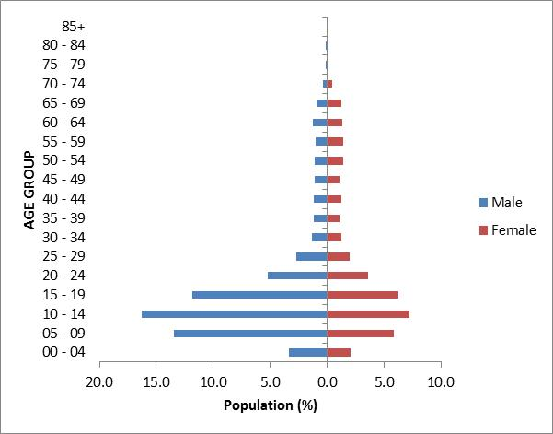

Observation:
- Young (5–19 years age group) males are significantly over-represented among clients whose carers received carer support.

Ethnicity
Table 22: Carer support clients by age and ethnicity
Age (in years) | European/ Other | Māori | Pacific | Asian | Not stated/ don’t know | Total
0–4 | 687 | 278 | 120 | 96 | 198 | 1379
5–9 | 1966 | 598 | 227 | 246 | 270 | 3307
10–14 | 2345 | 677 | 241 | 267 | 154 | 3684
15–19 | 1669 | 471 | 196 | 172 | 46 | 2554
20–24 | 786 | 204 | 119 | 108 | 20 | 1237
25–29 | 415 | 111 | 72 | 38 | 18 | 654
30–34 | 253 | 79 | 36 | 22 | 5 | 395
35–39 | 238 | 64 | 41 | 10 | 4 | 357
40–44 | 222 | 60 | 44 | 9 | 11 | 346
45–49 | 218 | 71 | 34 | 20 | 9 | 352
50–54 | 254 | 79 | 35 | 17 | 14 | 399
55–59 | 243 | 69 | 47 | 17 | 14 | 390
60–64 | 272 | 63 | 47 | 22 | 20 | 424
65–69 | 182 | 48 | 50 | 12 | 13 | 305
70–74 | 60 | 10 | 17 | 7 | 3 | 97
75–79 | 4 | 2 | 1 |  | 1 | 8
80–84 | 2 |  |  |  |  | 2
Total | 9816 | 2884 | 1327 | 1063 | 800 | 15,890
 | 61.8% | 18.1% | 8.4% | 6.7% | 5.0%

Figure 20: Carer support clients by age and ethnicity

Observations:
- Māori, Pacific and Asian clients are over-represented among the DSS clients using carer support.
- European/Other are under-represented in carer support, compared with 68.8% in the DSS client population.

Accommodation
Table 23: Carer support clients by sex and accommodation type
Usual place of residence | Female | Male | Total | %
Own/family home | 3962 | 6561 | 10,523 | 66%
Rental accommodation | 775 | 1332 | 2107 | 13%
Housing New Zealand accommodation | 328 | 452 | 780 | 5%
Other | 289 | 473 | 762 | 5%
Boarder | 32 | 38 | 70 | 0%
Community residential home | 10 | 20 | 30 | 0%
Rest home / continuing care hospital | 1 | 9 | 10 | 0%
Council accommodation | 1 | 7 | 8 | 0%
Unit in a retirement village | 1 | 6 | 7 | 0%
Prison | 4 | 2 | 6 | 0%
Unit in a retirement village – license to occupy | 1 | 3 | 4 | 0%
No fixed abode |  | 3 | 3 | 0%
Unknown | 566 | 1014 | 1580 | 10%
Total | 5970 | 9920 | 15,890

Observation:
- Two-thirds of carer support clients are living in their own homes.

Marital status
Table 24: Carer support clients by marital status and sex
Marital status | Female | Male | Total
Non-partnered, not further defined | 1030 | 1684 | 2714
Non-partnered, never married | 472 | 853 | 1325
Married (not separated), not further defined | 347 | 254 | 601
Partnered, not further defined | 37 | 40 | 77
Non-partnered, divorced | 14 | 10 | 24
Non-partnered, separated | 14 | 8 | 22
Non-partnered, widowed | 14 | 8 | 22
First marriage (not separated) | 10 | 9 | 19
Remarried (not separated) | 3 | 4 | 7
Opposite-sex partnership | 3 | 1 | 4
Same-sex partnership | 2 |  | 2
Not stated | 107 | 160 | 267
Don’t know | 6 | 7 | 13
Response outside scope | 4 | 11 | 15
Blank | 3907 | 6871 | 10,778
Total | 5970 | 9920 | 15,890

Observations:
- Marital status was not recorded for 68% carer support clients.
- Of the remaining clients, carer support is used mostly by clients who have do not have partners.

Deprivation
Table 25: Carer support clients by ethnicity and deprivation level
Ethnicity | 1 | 2 | 3 | 4 | 5 | 6 | 7 | 8 | 9 | 10 | Total
European/Other | 1108 | 1115 | 993 | 1061 | 952 | 943 | 990 | 902 | 773 | 640 | 9477
Māori | 82 | 104 | 135 | 140 | 175 | 233 | 255 | 402 | 542 | 735 | 2803
Pacific | 19 | 23 | 28 | 48 | 57 | 76 | 89 | 188 | 283 | 510 | 1321
Asian | 112 | 86 | 109 | 111 | 112 | 125 | 109 | 111 | 100 | 76 | 1051
Not stated/don’t know | 108 | 72 | 76 | 57 | 88 | 89 | 68 | 65 | 80 | 76 | 779
Total | 1429 | 1400 | 1341 | 1417 | 1384 | 1466 | 1511 | 1668 | 1778 | 2037 | 15,431
Note: This table was generated when geospatial coding in the Socrates database was at 94%, hence the total figure of 15,431 does not equate with the full number of carer support clients (15,890).

Figure 21: Carer support clients by ethnicity and deprivation level

Observations:
- The distribution of clients is markedly skewed towards high-deprivation deciles.
- Māori and Pacific clients using carer support are significantly skewed towards high-deprivation deciles.

Location
Table 26: Carer support clients by region and ethnicity
Region | European/ Other | Māori | Pacific | Asian | Not stated | Total
Auckland | 2830 | 757 | 1041 | 761 | 571 | 5960
Canterbury | 1639 | 214 | 37 | 74 | 118 | 2082
Waikato | 918 | 441 | 42 | 51 | 25 | 1477
Wellington | 877 | 187 | 126 | 85 | 35 | 1310
Bay of Plenty | 726 | 366 | 19 | 23 | 5 | 1139
Manawatu-Wanganui | 514 | 152 | 16 | 23 | 8 | 713
Otago | 616 | 60 | 11 | 12 | 7 | 706
Northland | 320 | 301 | 8 | 12 | 3 | 644
Taranaki | 311 | 91 | 2 | 5 | 3 | 412
Hawke’s Bay | 228 | 109 | 14 | 10 | 8 | 369
Southland | 308 | 46 | 4 | 1 | 2 | 361
Nelson | 199 | 33 | 2 | 4 |  | 238
Marlborough | 134 | 24 |  | 1 |  | 159
Gisborne | 55 | 85 | 5 | 1 | 2 | 148
West Coast | 78 | 7 |  |  | 13 | 98
Tasman | 63 | 11 |  |  |  | 74
Total | 9816 | 2884 | 1327 | 1063 | 800 | 15,890

Figure 22: Carer support clients by region and ethnicity

Observations:
- The majority (38%) of carer support clients live in the Auckland region.
- Auckland is the only region where less than half (47%) of carer support are European/Other.

DHB area
Table 27: Carer support clients by district health board (DHB) and deprivation level
DHB | 1 | 2 | 3 | 4 | 5 | 6 | 7 | 8 | 9 | 10 | Total
Counties Manukau | 204 | 217 | 164 | 158 | 167 | 171 | 128 | 246 | 359 | 581 | 2395
Waitemata | 223 | 244 | 265 | 248 | 223 | 236 | 239 | 188 | 142 | 44 | 2052
Canterbury | 244 | 198 | 165 | 209 | 189 | 185 | 146 | 165 | 147 | 153 | 1801
Auckland | 135 | 140 | 115 | 133 | 126 | 130 | 135 | 150 | 144 | 229 | 1437
Waikato | 113 | 80 | 96 | 125 | 99 | 124 | 127 | 162 | 199 | 222 | 1347
Bay of Plenty | 40 | 60 | 79 | 57 | 80 | 64 | 62 | 77 | 103 | 107 | 729
Capital & Coast | 138 | 76 | 63 | 79 | 43 | 52 | 48 | 48 | 46 | 94 | 687
Otago | 64 | 75 | 60 | 81 | 73 | 62 | 55 | 69 | 58 | 32 | 629
Northland | 11 | 37 | 33 | 31 | 39 | 60 | 71 | 101 | 116 | 106 | 605
Hutt Valley | 63 | 48 | 29 | 40 | 52 | 50 | 66 | 60 | 66 | 73 | 547
Nelson Marlborough | 38 | 27 | 53 | 44 | 51 | 64 | 89 | 61 | 34 | 9 | 470
MidCentral | 28 | 27 | 33 | 39 | 36 | 52 | 42 | 48 | 70 | 50 | 425
Taranaki | 17 | 25 | 42 | 37 | 46 | 60 | 63 | 44 | 36 | 45 | 415
Hawke’s Bay | 25 | 28 | 29 | 21 | 29 | 40 | 48 | 36 | 54 | 66 | 376
Southland | 37 | 31 | 33 | 31 | 42 | 21 | 45 | 48 | 50 | 25 | 363
Lakes | 17 | 33 | 22 | 19 | 24 | 20 | 54 | 42 | 43 | 68 | 342
South Canterbury | 14 | 19 | 17 | 27 | 30 | 23 | 28 | 32 | 20 | 15 | 225
Whanganui | 8 | 4 | 13 | 20 | 16 | 26 | 25 | 25 | 38 | 41 | 216
Tairawhiti | 1 | 15 | 15 | 4 | 3 | 7 | 8 | 20 | 21 | 59 | 153
Wairarapa | 6 | 10 | 14 | 2 | 7 | 14 | 19 | 21 | 19 | 12 | 124
West Coast | 3 | 6 | 1 | 12 | 9 | 5 | 13 | 25 | 13 | 6 | 93
Total | 1429 | 1400 | 1341 | 1417 | 1384 | 1466 | 1511 | 1668 | 1778 | 2037 | 15,431
Note: This table was generated when geospatial coding in the database was at 94%.

Figure 23: Carer support clients by district health board (DHB) and deprivation level

Observations:
- Overall, 25% of DSS clients live in deprivation deciles 9 and 10.
- In the Counties Manukau DHB area, 39% of clients are in deciles 9 and 10.

Principal disability
Table 28: Carer support clients by sex and principal disability
Disability class | Male | Female | Total | %
Intellectual | 2799 | 3973 | 6772 | 42.6%
ASD | 805 | 3334 | 4139 | 26.0%
Physical | 1196 | 1326 | 2522 | 15.9%
Not DSS | 250 | 348 | 598 | 3.8%
Sensory | 264 | 297 | 561 | 3.5%
Physical and intellectual | 201 | 209 | 410 | 2.6%
Physical/neurological | 248 | 151 | 399 | 2.5%
Neurological/intellectual/physical | 140 | 160 | 300 | 1.9%
Neurological | 46 | 85 | 131 | 0.8%
Intellectual/neurological/physical | 18 | 30 | 48 | 0.3%
Neurological and physical | 3 | 7 | 10 | 0.1%
Total | 5970 | 9920 | 15,890

Figure 24: Carer support clients by sex and principal disability

Observation:
- Two-thirds of carer support clients have intellectual disabilities or ASD.

Support package allocation
Table 29: Carer support clients by support package allocation (SPA) level and sex
SPA level | Female | Male | Total | %
Very high | 789 | 1315 | 2104 | 13%
High | 2247 | 3422 | 5669 | 36%
Medium | 2673 | 4657 | 7330 | 46%
Low | 257 | 516 | 773 | 5%
Very low | 4 | 10 | 14 | 0%
Total | 5,970 | 9,920 | 15,890

Figure 25: Carer support clients by support package allocation (SPA) level and sex

Observation:
- Most carer support clients have medium to high SPA levels.

Age of carers
Table 30: Age distribution of full-time carers receiving a carer support subsidy
Age (in years) | Number | %
0–14 | 28 | 0.2%
15–19 | 21 | 0.1%
20–24 | 124 | 0.8%
25–29 | 480 | 3.1%
30–34 | 1145 | 7.3%
35–39 | 2033 | 13.0%
40–44 | 3022 | 19.4%
45–49 | 2810 | 18.0%
50–54 | 2185 | 14.0%
55–59 | 1503 | 9.6%
60–64 | 942 | 6.0%
65–69 | 597 | 3.8%
70–74 | 371 | 2.4%
75–79 | 185 | 1.2%
85 + | 137 | 0.9%
Total | 15,583
Note: There are fewer carers than there are care support clients as some carers care for more than one client.

Figure 26: Age distribution of full-time carers receiving a carer support subsidy
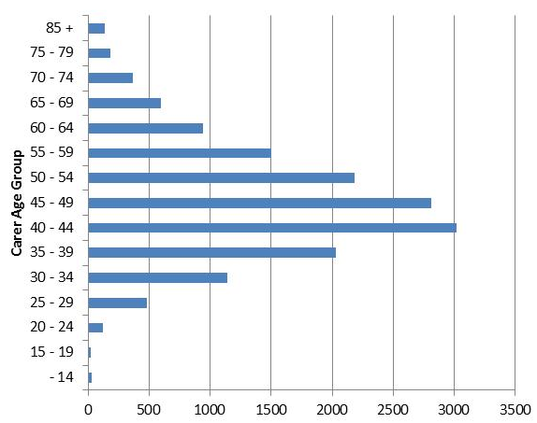

Observations:
- Date of birth of the carer was recorded for 98% of carers who receive the carer support subsidy.
- Just over 8% of carers are past the New Zealand standard retirement age of 65 years.

Community residential services
This section provides demographic profiles of the 6475 DSS clients receiving community residential services. It does not analyse residential clients living in hospitals or rest home services.

Some community residential clients will also appear in demographics for other services.

Age and sex
Table 32: Community residential services clients by age and sex
Age (in years) | Female | Male | Total
0–4 | 1 |  | 1
5–9 | 3 | 5 | 8
10–14 | 8 | 31 | 39
15–19 | 81 | 174 | 255
20–24 | 180 | 294 | 474
25–29 | 193 | 303 | 496
30–34 | 193 | 347 | 540
35–39 | 243 | 356 | 599
40–44 | 326 | 447 | 773
45–49 | 362 | 504 | 866
50–54 | 376 | 479 | 855
55–59 | 291 | 345 | 636
60–64 | 183 | 241 | 424
65–69 | 126 | 135 | 261
70–74 | 70 | 79 | 149
75–79 | 32 | 31 | 63
80–84 | 14 | 12 | 26
85+ | 3 | 7 | 10
Total | 2685 | 3790 | 6475
 | 41% | 59%

Figure 28: Age/sex of community residential services clients
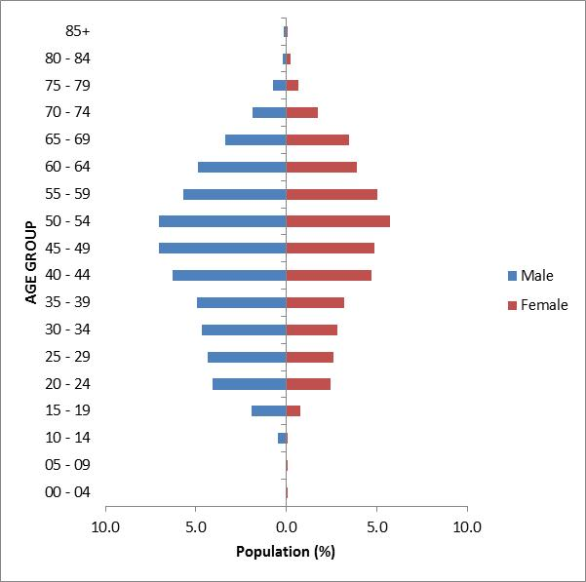

Observations:
- There are significantly more males than females using community residential services.
- The 45–54 age groups are the largest for both males and females.

Ethnicity
Table 33: Community residential services clients by ethnicity and age
Age  (in years) | European/ Other | Māori | Pacific | Asian | Not stated | Total
0–4 | 1 |  |  |  |  | 1
5–9 | 4 | 2 |  | 1 | 1 | 8
10–14 | 27 | 10 |  | 1 | 1 | 39
15–19 | 174 | 60 | 9 | 9 | 3 | 255
20–24 | 353 | 73 | 18 | 19 | 11 | 474
25–29 | 348 | 85 | 20 | 18 | 25 | 496
30–34 | 379 | 102 | 31 | 19 | 9 | 540
35–39 | 447 | 99 | 27 | 7 | 19 | 599
40–44 | 593 | 111 | 25 | 10 | 34 | 773
45–49 | 653 | 140 | 31 | 11 | 31 | 866
50–54 | 681 | 99 | 21 | 7 | 47 | 855
55–59 | 513 | 82 | 8 | 5 | 28 | 636
60–64 | 352 | 46 | 6 |  | 20 | 424
65–69 | 225 | 18 | 6 | 3 | 9 | 261
70–74 | 132 | 6 |  | 2 | 9 | 149
75–79 | 54 | 7 |  |  | 2 | 63
80–84 | 23 | 2 |  |  | 1 | 26
85+ | 9 |  |  |  | 1 | 10
Total | 4968 | 942 | 202 | 112 | 251 | 6475
 | 77% | 15% | 3% | 2% | 3%
Figure 29: Community residential services clients by ethnicity and age

Observations:
- Pacific and Asian clients are significantly under-represented users of residential services.
- Māori are well represented in all age groups between 15 and 64 years.
- European/Other clients are over-represented in all age groups between 10 and 79 years.

Marital status
Table 34: Community residential services clients by marital status and sex
Marital status | Female | Male | Total | %
Non-partnered, not further defined | 583 | 814 | 1397 | 21.6%
Non-partnered, never married | 219 | 376 | 595 | 9.2%
Not stated | 43 | 101 | 144 | 2.2%
Married (not separated), not further defined | 31 | 21 | 52 | 0.8%
Non-partnered, divorced | 9 | 9 | 18 | 0.3%
Partnered, not further defined | 5 | 9 | 14 | 0.2%
Non-partnered, separated | 6 | 7 | 13 | 0.2%
Non-partnered, widowed | 7 | 1 | 8 | 0.1%
First marriage (not separated) |  | 2 | 2 | 0.0%
Opposite-sex partnership | 2 |  | 2 | 0.0%
Response outside scope | 1 | 1 | 2 | 0.0%
Same-sex partnership | 1 | 1 | 2 | 0.0%
Blank | 1778 | 2448 | 4226 | 65.3%
Total | 2685 | 3790 | 6475

Observations:
- Marital status is not recorded for almost two-thirds of community residential services clients.
- Of those who did record marital status, 16% were in some form of partnership.

Accommodation
Table 35: Community residential services clients by accommodation type and sex
Usual place of residence | Female | Male | Total
Community residential home | 2154 | 3056 | 5210
Own/family home | 127 | 203 | 330
Unknown | 52 | 82 | 134
Boarder | 47 | 62 | 109
Rental accommodation | 50 | 51 | 101
Rest home / continuing care hospital | 26 | 35 | 61
Housing New Zealand accommodation | 4 | 6 | 10
Council accommodation | 2 | 2 | 4
Prison |  | 1 | 1
Other | 223 | 292 | 515
Total | 2685 | 3790 | 6475

Observation:
- The majority (80%) of clients are living in community residential homes.

Location
Table 36: Community residential services clients by region and ethnicity
Region | European/ Other | Māori | Pacific | Asian | Not stated | Total
Auckland | 1098 | 248 | 137 | 71 | 18 | 1572
Canterbury | 833 | 43 | 7 | 4 | 99 | 986
Waikato | 515 | 174 | 9 | 6 | 61 | 765
Wellington | 496 | 79 | 25 | 10 | 26 | 636
Manawatu-Wanganui | 437 | 84 | 2 | 2 | 12 | 537
Otago | 327 | 22 | 4 | 4 | 12 | 369
Bay of Plenty | 240 | 81 | 2 | 1 | 2 | 326
Hawke’s Bay | 249 | 48 | 6 | 8 | 13 | 324
Nelson | 252 | 21 | 2 | 3 | 1 | 279
Northland | 128 | 71 | 4 | 1 |  | 204
Southland | 136 | 5 | 2 |  | 1 | 144
Taranaki | 121 | 20 |  | 1 | 1 | 143
Gisborne | 30 | 34 |  |  | 1 | 65
Marlborough | 52 | 9 | 1 | 1 |  | 63
West Coast | 36 | 2 | 1 |  | 4 | 43
Tasman | 18 | 1 |  |  |  | 19
Total | 4968 | 942 | 202 | 112 | 251 | 6475

Figure 30: Community residential services clients by region and ethnicity

Principal disability
Table 37: Community residential services clients by principal disability and sex
Disability type | Female | Male | Total | %
Intellectual | 2014 | 2784 | 4798 | 74.1%
Physical | 257 | 348 | 605 | 9.3%
ASD | 110 | 278 | 388 | 6.0%
Not DSS | 117 | 145 | 262 | 4.0%
Sensory | 55 | 80 | 135 | 2.1%
Physical/neurological | 49 | 56 | 105 | 1.6%
Physical/intellectual | 36 | 40 | 76 | 1.2%
Neurological/intellectual/physical | 24 | 29 | 53 | 0.8%
Neurological | 12 | 25 | 37 | 0.6%
Intellectual/neurological/physical | 5 | 5 | 10 | 0.2%
Neurological/physical | 6 |  | 6 | 0.1%
Total | 2685 | 3790 | 6475

Figure 31: Community residential services clients by principal disability and sex

Observation:
- Three-quarters of clients in community residential services have an intellectual disability.

Support package allocation
Table 38: Community residential services clients by SPA level and sex
SPA level | Female | Male | Total | %
Very high | 1732 | 2425 | 4157 | 64%
High | 800 | 1023 | 1823 | 28%
Medium | 122 | 132 | 254 | 4%
Low | 3 | 10 | 13 | 0%
Very low | 1 | 1 | 2 | 0%
Blank | 27 | 199 | 226 | 4%
Total | 2685 | 3790 | 6475

Figure 32: Community residential services clients by SPA level and sex

Observation:
- Over 90% of community residential services clients have high or very high support package allocations (SPAs).

Supported living
This section provides demographic profiles of the 2797 DSS clients receiving supported living services. Some of these clients will also appear in demographics for other services.

Age and sex
Table 39: Clients receiving supported living services, by age and sex
Age (in years) | Female | Male | Total
0–4 | 1 | 3 | 4
5–9 |  | 6 | 6
10–14 | 3 | 10 | 13
15–19 | 44 | 80 | 124
20–24 | 153 | 197 | 350
25–29 | 136 | 157 | 293
30–34 | 131 | 144 | 275
35–39 | 127 | 128 | 255
40–44 | 160 | 155 | 315
45–49 | 142 | 165 | 307
50–54 | 143 | 166 | 309
55–59 | 119 | 117 | 236
60–64 | 83 | 95 | 178
65–69 | 33 | 58 | 91
70–74 | 10 | 20 | 30
75–79 | 4 | 3 | 7
80–84 | 1 | 2 | 3
85+ | 1 |  | 1
Total | 1291 | 1506 | 2797
 | 46% | 54%

Figure 33: Age/sex of clients receiving supported living services
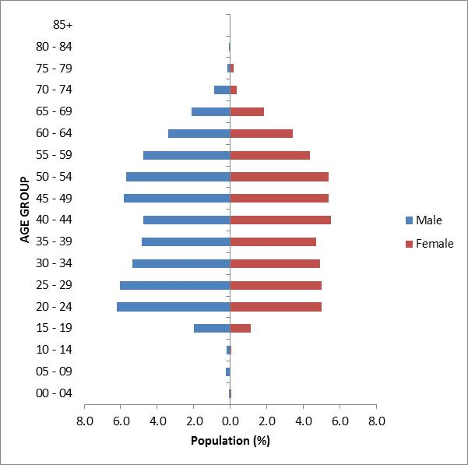

Observations:
- There are slightly more males than females receiving supported living services.
- The age distribution is relatively flat across ages 20–59 years.

Ethnicity
Table 40: Clients receiving supported living services, by ethnicity and age
Age (in years) | European/  Other | Māori | Pacific | Asian | Not stated | Total
0–4 | 1 | 2 |  |  | 1 | 4
5–9 | 3 |  | 3 |  |  | 6
10–14 | 9 | 2 |  | 1 | 1 | 13
15–19 | 92 | 19 | 6 | 4 | 3 | 124
20–24 | 256 | 52 | 22 | 11 | 9 | 350
25–29 | 229 | 46 | 4 | 8 | 6 | 293
30–34 | 209 | 41 | 11 | 3 | 11 | 275
35–39 | 195 | 40 | 10 | 3 | 7 | 255
40–44 | 255 | 40 | 6 | 3 | 11 | 315
45–49 | 250 | 39 | 2 | 3 | 13 | 307
50–54 | 258 | 33 | 3 | 1 | 14 | 309
55–59 | 190 | 33 | 2 | 5 | 6 | 236
60–64 | 148 | 16 | 3 | 1 | 10 | 178
65–69 | 77 | 8 |  |  | 6 | 91
70–74 | 29 | 1 |  |  |  | 30
75–79 | 7 |  |  |  |  | 7
80–84 | 3 |  |  |  |  | 3
85+ | 1 |  |  |  |  | 1
Total | 2212 | 372 | 72 | 43 | 98 | 2797
 | 79% | 13% | 3% | 2% | 3%

Figure 34: Clients receiving supported living services, by ethnicity and age

Observations:
- European/Other are significantly over-represented amongst users of supported living services.
- Māori are slightly under-represented.
- Pacific and Asian are significantly under-represented.

Marital status
Table 41: Clients receiving supported living services, by marital status and sex
Marital status | Female | Male | Total | %
Non-partnered, not further defined | 239 | 319 | 558 | 19.9%
Non-partnered, never married | 104 | 122 | 226 | 8.1%
Married (not separated), not further defined | 47 | 44 | 91 | 3.3%
Partnered, not further defined | 28 | 20 | 48 | 1.7%
Non-partnered, divorced | 13 | 5 | 18 | 0.6%
Non-partnered, separated | 10 | 7 | 17 | 0.6%
First marriage (not separated) | 6 | 1 | 7 | 0.3%
Non-partnered, widowed | 6 | 1 | 7 | 0.3%
Opposite-sex partnership | 3 | 1 | 4 | 0.1%
Don’t know | 1 | 2 | 3 | 0.1%
Not stated | 22 | 28 | 50 | 1.8%
Blank | 812 | 956 | 1768 | 63.2%
Total | 1291 | 1506 | 2797

Observations:
- Marital status was not recorded for most clients.
- Of the remaining clients, supported living is used mainly by clients without a partner.

Accommodation
Table 42: Clients receiving supported living services, by accommodation type and sex
Usual place of residence | Female | Male | Total | %
Own/family home | 442 | 518 | 960 | 34.3%
Rental accommodation | 419 | 456 | 875 | 31.3%
Community residential home | 76 | 112 | 188 | 6.7%
Other | 79 | 108 | 187 | 6.7%
Housing New Zealand accommodation | 79 | 63 | 142 | 5.1%
Boarder | 30 | 41 | 71 | 2.5%
Council accommodation | 27 | 39 | 66 | 2.4%
Rest home / continuing care hospital | 3 | 3 | 6 | 0.2%
Unit in a retirement village | 2 | 2 | 4 | 0.1%
No fixed abode | 3 |  | 3 | 0.1%
Unit in a retirement village – license to occupy | 2 |  | 2 | 0.1%
Unknown | 129 | 164 | 293 | 10.5%
Total | 1291 | 1506 | 2797

Observations:
- One-third of clients receiving supported living services are living in their own or the family home.
- Almost another third live in rental accommodation.

Location
Table 43: Clients receiving supported living services, by ethnicity and region
Region | European/ Other | Māori | Pacific | Asian | Not stated | Total
Auckland | 260 | 64 | 37 | 22 | 15 | 398
Canterbury | 302 | 18 | 5 | 1 | 38 | 364
Otago | 318 | 19 | 5 | 5 | 3 | 350
Bay of Plenty | 273 | 62 | 2 | 5 | 1 | 343
Wellington | 200 | 30 | 8 | 1 | 8 | 247
Waikato | 150 | 34 | 4 | 2 | 17 | 207
Manawatu-Wanganui | 149 | 22 | 3 | 3 | 6 | 183
Taranaki | 135 | 26 | 1 | 1 | 1 | 164
Nelson | 103 | 10 |  | 2 | 1 | 116
Southland | 100 | 12 | 2 |  |  | 114
Hawke’s Bay | 84 | 22 | 2 |  | 2 | 110
Northland | 48 | 27 | 2 |  |  | 77
Marlborough | 49 | 11 |  | 1 |  | 61
Gisborne | 18 | 13 |  |  | 2 | 33
West Coast | 14 | 1 |  |  | 4 | 19
Tasman | 9 | 1 | 1 |  |  | 11
Total | 2212 | 372 | 72 | 43 | 98 | 2797

Figure 35: Clients receiving supported living services, by ethnicity and region

Observation:
- The Bay of Plenty and Otago regions are significantly over-represented in numbers of people using supported living services.

Principal disability
Table 44: Clients receiving supported living services, by principal disability and sex
Disability type | Female | Male | Total | %
Intellectual | 828 | 919 | 1747 | 62.5%
Physical | 194 | 217 | 411 | 14.7%
ASD | 61 | 157 | 218 | 7.8%
Not DSS | 58 | 75 | 133 | 4.8%
Sensory | 54 | 60 | 114 | 4.1%
Neurological/intellectual/physical | 26 | 21 | 47 | 1.7%
Physical/neurological | 30 | 15 | 45 | 1.6%
Neurological | 17 | 24 | 41 | 1.5%
Physical/intellectual | 20 | 14 | 34 | 1.2%
Intellectual/neurological/physical | 3 | 1 | 4 | 0.1%
Neurological/physical | 0 | 3 | 3 | 0.1%
Total | 1291 | 1506 | 2797
 | 46% | 54%

Figure 36: Clients receiving supported living services, by principal disability and sex

Observation:
- The majority of clients receiving supported living services have an intellectual disability (63%).

Support package allocation
Table 45: Clients receiving supported living services by SPA level and sex
SPA level | Female | Male | Total | %
Very high | 149 | 190 | 339 | 12%
High | 664 | 780 | 1444 | 52%
Medium | 466 | 515 | 981 | 35%
Low | 12 | 21 | 33 | 1%
Total | 1291 | 1506 | 2797

Figure 37: Clients receiving supported living services by SPA level and sex

Observation:
- Most clients receiving supported living services have medium (35%) or high (52%) support package allocations (SPA).

Respite care services
This section provides demographic profiles of the 1637 DSS clients receiving respite care services. Some of these clients will also appear in demographics for other services.

Age and sex
Table 46: Respite care users by age and sex
Age (in years) | Female | Male | Total
0–4 | 19 | 35 | 54
5–9 | 63 | 158 | 221
10–14 | 132 | 265 | 397
15–19 | 105 | 232 | 337
20–24 | 55 | 82 | 137
25–29 | 36 | 38 | 74
30–34 | 15 | 25 | 40
35–39 | 18 | 22 | 40
40–44 | 27 | 20 | 47
45–49 | 20 | 22 | 42
50–54 | 25 | 30 | 55
55–59 | 20 | 29 | 49
60–64 | 41 | 39 | 80
65–69 | 22 | 22 | 44
70–74 | 4 | 12 | 16
75–79 | 3 | 1 | 4
Total | 605 | 1032 | 1637
 | 37% | 63%

Figure 38: Age/sex of respite care users
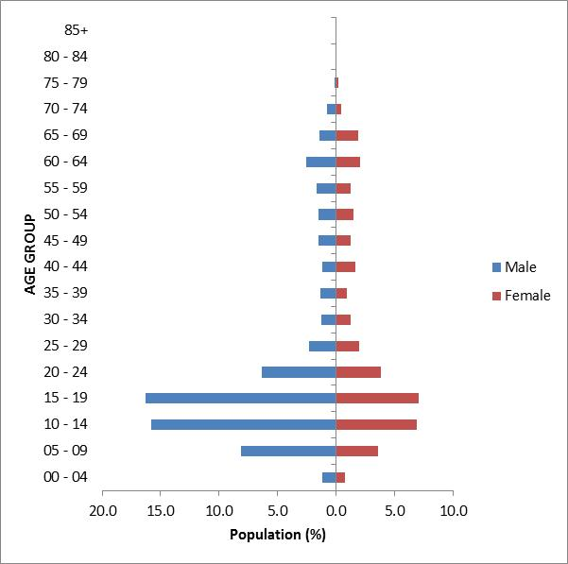

Observations:
- There are significantly more males (63%) than females using respite care.
- About 70% of respite care users are under the age of 25 years.

Ethnicity
Table 47: Respite care users by age and ethnicity
Age  (in years) | European/ Other | Māori | Pacific | Asian | Not stated | Total
0–4 | 22 | 13 | 10 | 7 | 2 | 54
5–9 | 124 | 59 | 21 | 10 | 7 | 221
10–14 | 251 | 80 | 21 | 34 | 11 | 397
15–19 | 219 | 63 | 24 | 29 | 2 | 337
20–24 | 86 | 25 | 7 | 18 | 1 | 137
25–29 | 49 | 11 | 8 | 5 | 1 | 74
30–34 | 26 | 10 | 2 | 2 |  | 40
35–39 | 24 | 10 | 6 |  |  | 40
40–44 | 34 | 9 | 1 | 1 | 2 | 47
45–49 | 29 | 7 | 2 | 3 | 1 | 42
50–54 | 43 | 10 |  | 1 | 1 | 55
55–59 | 39 | 8 | 1 | 1 |  | 49
60–64 | 63 | 7 | 5 | 1 | 4 | 80
65–69 | 38 |  | 1 | 4 | 1 | 44
70–74 | 11 | 3 | 1 |  | 1 | 16
75–79 | 4 |  |  |  |  | 4
Total | 1062 | 315 | 110 | 116 | 34 | 1637
 | 65% | 19% | 7% | 7% | 2%

Figure 39: Respite care users by age and ethnicity

Observations:
- European/Other and Asian people are slightly under-represented amongst users of respite care.
- Māori and Pacific people are slightly over-represented amongst users of respite care.

Marital status
Table 48: Respite care users by sex and marital status
Marital status | Female | Male | Total | %
Non-partnered, not further defined | 115 | 186 | 301 | 18.4%
Non-partnered, never married | 43 | 110 | 153 | 9.3%
Married (not separated), not further defined | 42 | 40 | 82 | 5.0%
Not stated | 17 | 19 | 36 | 2.2%
Partnered, not further defined | 7 | 11 | 18 | 1.1%
Non-partnered, separated | 4 | 2 | 6 | 0.4%
Non-partnered, widowed | 6 |  | 6 | 0.4%
Non-partnered, divorced | 4 | 1 | 5 | 0.3%
Response outside scope |  | 3 | 3 | 0.2%
Don’t know | 1 |  | 1 | 0.1%
Remarried (not separated) | 1 |  | 1 | 0.1%
Blank | 365 | 660 | 1025 | 62.6%
Total | 605 | 1032 | 1637

Observation:
- Almost three-quarters of people for whom marital status is recorded are single. This aligns with the large numbers of respite clients who are aged under 19 years.

Accommodation
Table 49: Respite care users by sex and accommodation type
Usual place of residence | Female | Male | Total | %
Own/family home | 371 | 640 | 1011 | 61.8%
Rental accommodation | 79 | 106 | 185 | 11.3%
Housing New Zealand accommodation | 32 | 65 | 97 | 5.9%
Boarder | 1 | 5 | 6 | 0.4%
Community residential home | 3 | 2 | 5 | 0.3%
Council accommodation | 2 | 3 | 5 | 0.3%
Unit in a retirement village |  | 2 | 2 | 0.1%
Rest home / continuing care hospital | 1 |  | 1 | 0.1%
Other | 46 | 100 | 146 | 8.9%
Unknown | 70 | 109 | 179 | 10.9%
Total | 605 | 1032 | 1637

Observation:
- The majority of respite care users live in their own home or the family home.

Location
Table 50: Respite care users by ethnicity and region
Region | European/ Other | Māori | Pacific | Asian | Not stated | Total | %
Auckland | 230 | 91 | 72 | 71 | 13 | 477 | 29.1%
Wellington | 175 | 35 | 20 | 19 | 3 | 252 | 15.4%
Bay of Plenty | 80 | 42 | 2 | 8 | 2 | 134 | 8.2%
Canterbury | 106 | 13 | 3 | 2 | 9 | 133 | 8.1%
Waikato | 90 | 28 | 3 | 3 | 3 | 127 | 7.8%
Manawatu-Wanganui | 90 | 20 | 2 | 1 | 1 | 114 | 7.0%
Taranaki | 62 | 14 | 1 | 2 |  | 79 | 4.8%
Hawke’s Bay | 47 | 20 | 3 | 4 | 3 | 77 | 4.7%
Northland | 34 | 26 | 2 | 3 |  | 65 | 4.0%
Otago | 53 | 5 |  | 1 |  | 59 | 3.6%
Marlborough | 34 | 3 |  |  |  | 37 | 2.3%
Nelson | 31 | 3 | 1 | 2 |  | 37 | 2.3%
Gisborne | 8 | 11 |  |  |  | 19 | 1.2%
Southland | 13 | 3 | 1 |  |  | 17 | 1.0%
Tasman | 8 | 1 |  |  |  | 9 | 0.5%
West Coast | 1 |  |  |  |  | 1 | 0.1%
Total | 1062 | 315 | 110 | 116 | 34 | 1637

Figure 40: Respite care users by ethnicity and region

Observations:
- There are marked disparities in regional use of respite care.
- The Wellington region is over-represented, with 9% of the country’s DSS clients living in the region, but 15% of those clients using respite care.
- The Canterbury region is under-represented, with 13.5% of the country’s DSS clients living in the region, but only 8% of those clients using respite care.

Principal disability
Table 51: Respite care users by sex and disability type
Disability type | Female | Male | Total | %
Intellectual | 294 | 459 | 753 | 46.0%
Physical | 109 | 195 | 304 | 18.6%
ASD | 57 | 226 | 283 | 17.3%
Physical/neurological | 53 | 32 | 85 | 5.2%
Not DSS | 31 | 32 | 63 | 3.8%
Physical/intellectual | 20 | 26 | 46 | 2.8%
Neurological/intellectual/physical | 15 | 27 | 42 | 2.6%
Sensory | 14 | 18 | 32 | 2.0%
Neurological | 10 | 12 | 22 | 1.3%
Intellectual/neurological/physical | 2 | 4 | 6 | 0.4%
Neurological/physical |  | 1 | 1 | 0.1%
Total | 605 | 1032 | 1637
 | 37% | 63%

Figure 41: Respite care users by sex and disability type

Observation:
- Clients with intellectual disabilities make up 46% of respite care users.

Support package allocation
Table 52: Respite care users by SPA level and sex
SPA level | Female | Male | Total | %
Very high | 270 | 489 | 759 | 47%
High | 259 | 450 | 709 | 43%
Medium | 74 | 89 | 163 | 10%
Low | 2 | 4 | 6 | 0%
Total | 605 | 1032 | 1637

Figure 42: Respite care users by SPA level and sex

Observation:
- Most respite care users have high (43%) to very high (47%) support package allocations (SPA).

Client demographics by disability
This section focuses on five specific disability types and provides the demographic profiles of the disability support service users with each of these disabilities.

While all clients are recorded as having one principal disability, some clients listed two principal disabilities. This report focuses on only the first principal disability that was presented.

Principal disability
Intellectual | 14,339
Physical | 8295
Autism Spectrum Disorder (ASD) | 4898
Sensory | 1097
Neurological | 955

See also Appendix 3: Disability.

Intellectual disability
This section relates to clients who have one of the following disabilities:
- birth asphyxia or intrauterine hypoxia
- Down syndrome (Trisomy 21)
- fragile X syndrome
- intellectual disability (ID), type not specified
- learning disability/difficulty/delay, type not specified
- other intellectual, learning or developmental disorder
- developmental delay, type not specified
- Edwards’ syndrome (Trisomy 18)
- hydrocephalus/hydrocephaly
- Klinefelter’s syndrome
- microcephalus/microcephaly.

For an analysis of clients with Down syndrome, see Appendix 1: Down.

Age and sex
Table 53: Clients with intellectual disability by age and sex
Age (in years) | Female | Male | Total
0–4 | 250 | 377 | 627
5–9 | 494 | 902 | 1396
10–14 | 670 | 1028 | 1698
15–19 | 601 | 900 | 1501
20–24 | 549 | 661 | 1210
25–29 | 417 | 510 | 927
30–34 | 337 | 482 | 819
35–39 | 380 | 469 | 849
40–44 | 483 | 574 | 1057
45–49 | 462 | 618 | 1080
50–54 | 512 | 555 | 1067
55–59 | 406 | 425 | 831
60–64 | 313 | 322 | 635
65–69 | 203 | 202 | 405
70–74 | 97 | 98 | 195
75–79 | 34 | 35 | 69
80–84 | 11 | 13 | 24
85+ | 3 | 6 | 9
Total | 6222 | 8177 | 14,399
 | 43.2% | 56.8%

Figure 43: Age/sex of clients with intellectual disability
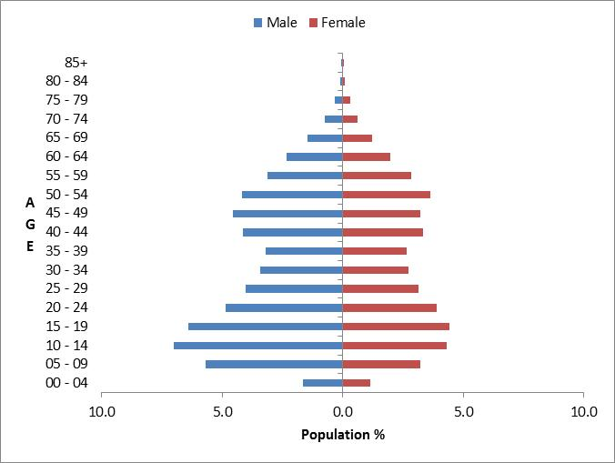

Observations:
- There are significantly more males (57%) with an intellectual disability using DSS than females.
- There are two peaks in the age group profiles for both sexes: 10–19 years and 40–54 years.

Ethnicity and deprivation
Table 54: Clients with intellectual disability by ethnicity and deprivation
Deprivation decile | European/ Other | Māori | Pacific | Asian | Total | %
1 | 656 | 67 | 12 | 49 | 784 | 6%
2 | 759 | 103 | 10 | 35 | 907 | 7%
3 | 836 | 136 | 22 | 49 | 1043 | 8%
4 | 823 | 146 | 36 | 45 | 1050 | 8%
5 | 912 | 174 | 41 | 54 | 1181 | 9%
6 | 929 | 203 | 36 | 64 | 1232 | 10%
7 | 1150 | 283 | 61 | 47 | 1541 | 12%
8 | 1161 | 312 | 131 | 59 | 1663 | 13%
9 | 999 | 461 | 166 | 53 | 1679 | 13%
10 | 868 | 562 | 300 | 46 | 1776 | 14%
Total | 9093 | 2447 | 815 | 501 | 12,856
 | 71% | 19% | 6% | 4%

Figure 44: Clients with intellectual disability by ethnicity and deprivation
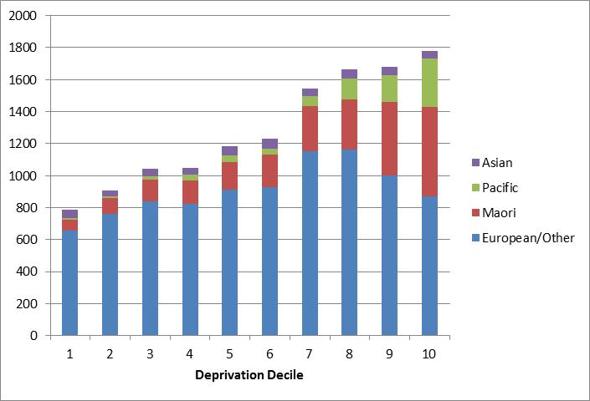

Observations:
- Māori and European/Other clients are over-represented for intellectual disability across all deciles.
- Asian and Pacific clients are under-represented across all deciles.
- Māori and Pacific clients with intellectual disabilities are strongly over-represented in the highest deprivation deciles.

Physical disability

Age and sex
Table 55: Clients with physical disability by age and sex
Age (in years) | Female | Male | Total
0–4 | 110 | 138 | 248
5–9 | 171 | 196 | 367
10–14 | 198 | 276 | 474
15–19 | 205 | 315 | 520
20–24 | 170 | 216 | 386
25–29 | 153 | 142 | 295
30–34 | 152 | 117 | 269
35–39 | 201 | 160 | 361
40–44 | 271 | 192 | 463
45–49 | 363 | 274 | 637
50–54 | 477 | 334 | 811
55–59 | 595 | 393 | 988
60–64 | 712 | 465 | 1177
65–69 | 550 | 306 | 856
70–74 | 279 | 109 | 388
75–79 | 33 | 14 | 47
80–84 | 5 | 3 | 8
85+ |  | 0 | 0
Total | 4645 | 3650 | 8295
 | 60% | 40%

Figure 45: Clients with physical disability by age and sex
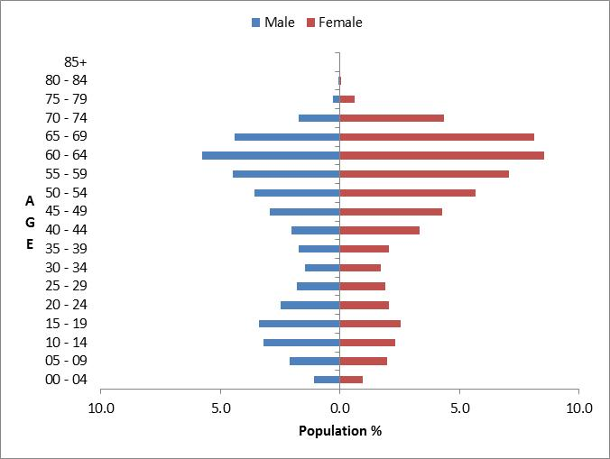

Observations:
- Females make up 60% of clients with a physical disability.
- Clients with a physical disability are a markedly prevalent in the older age groups, with 59% of clients aged over 45 years.

Ethnicity and deprivation
Table 56: Clients with physical disability by ethnicity and deprivation
Deprivation decile | European/ Other | Māori | Pacific | Asian | Total | %
1 | 359 | 22 | 5 | 23 | 409 | 5%
2 | 450 | 34 | 10 | 23 | 517 | 6%
3 | 470 | 67 | 5 | 21 | 563 | 7%
4 | 585 | 54 | 24 | 29 | 692 | 9%
5 | 580 | 62 | 27 | 29 | 698 | 9%
6 | 630 | 90 | 27 | 27 | 774 | 10%
7 | 745 | 113 | 36 | 39 | 933 | 12%
8 | 715 | 174 | 67 | 34 | 990 | 12%
9 | 770 | 258 | 128 | 34 | 1190 | 15%
10 | 623 | 360 | 208 | 37 | 1228 | 15%
Total | 5927 | 1234 | 537 | 296 | 7994
 | 74% | 15% | 7% | 4%

Figure 46: Clients with physical disability by ethnicity and deprivation
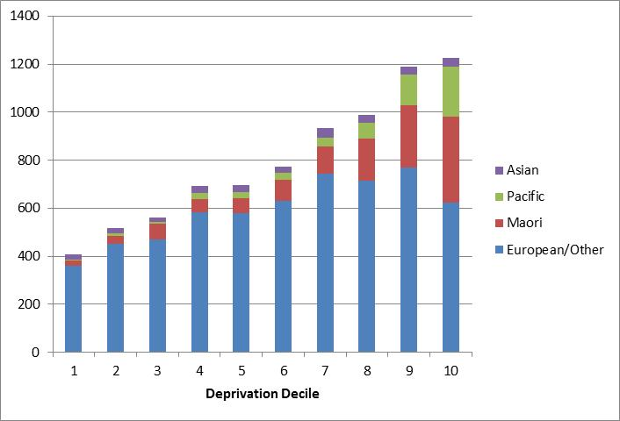

Observations:
- European/Other clients with physical disability are over-represented across all deciles.
- Just under one-third (30%) of clients with physical disabilities are in the 9–10 deprivation deciles.
- Māori and Pacific clients make up a large proportion in the high-deprivation deciles.

Autism spectrum disorder
This section describes clients who have one of the following disabilities:
- Asperger’s syndrome
- autism spectrum disorder (ASD)
- other ASD.

Age and sex
Table 57: Clients with ASD by age and sex
Age (in years) | Female | Male | Total
0–4 | 76 | 346 | 422
5–9 | 266 | 1104 | 1370
10–14 | 259 | 1116 | 1375
15–19 | 143 | 599 | 742
20–24 | 87 | 261 | 348
25–29 | 41 | 133 | 174
30–34 | 28 | 72 | 100
35–39 | 24 | 52 | 76
40–44 | 20 | 43 | 63
45–49 | 25 | 36 | 61
50–54 | 24 | 35 | 59
55–59 | 21 | 17 | 38
60–64 | 16 | 18 | 34
65–69 | 13 | 10 | 23
70–74 | 4 | 6 | 10
75–79 |  | 2 | 2
80–84 | 1 |  | 1
Total | 1048 | 3850 | 4898
 | 21% | 79%

Figure 47: Age/sex of clients with ASD
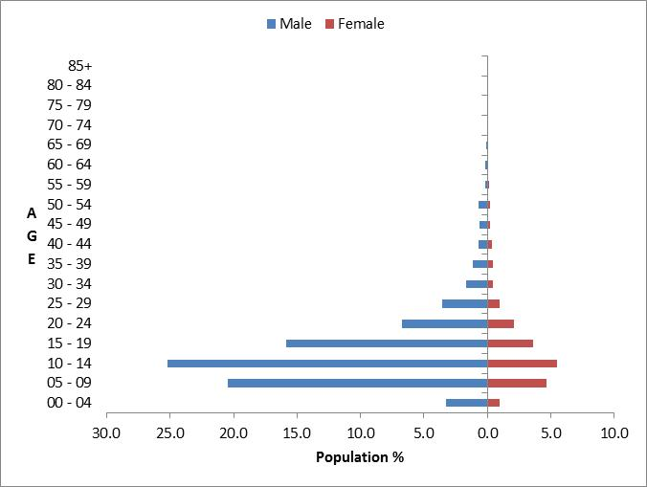

Observations:
- ASD clients are predominantly male (79%).
- ASD clients are predominantly young (65% of ASD clients are less than 15 years old).

Ethnicity and deprivation
Table 58: ASD clients by ethnicity and deprivation
Deprivation decile | European/ Other | Māori | Pacific | Asian | Total | %
1 | 390 | 24 | 6 | 36 | 456 | 10%
2 | 390 | 30 | 4 | 47 | 471 | 11%
3 | 340 | 35 | 15 | 52 | 442 | 10%
4 | 358 | 25 | 11 | 59 | 453 | 10%
5 | 350 | 47 | 15 | 50 | 462 | 11%
6 | 329 | 52 | 21 | 56 | 458 | 10%
7 | 324 | 69 | 19 | 52 | 464 | 11%
8 | 270 | 79 | 33 | 40 | 422 | 10%
9 | 243 | 83 | 34 | 38 | 398 | 9%
10 | 177 | 113 | 54 | 28 | 372 | 8%
Total | 3171 | 557 | 212 | 458 | 4398
 | 72% | 13% | 5% | 10%

Figure 48: ASD clients by ethnicity and deprivation
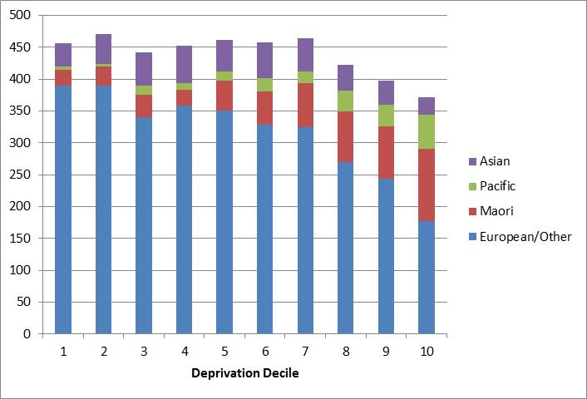

Observations:
- ASD clients are relatively evenly distributed across deprivation deciles 1–8.
- Māori and Pacific ASD clients are over-represented in the higher deprivation deciles.
- Asian ethnicities are significantly over-represented amongst ASD clients.

Service usage
Table 59: ASD clients by sex and service usage
Service type | Female | Male | Total | %
Carer support | 622 | 2665 | 3287 | 67%
Home support | 235 | 626 | 861 | 18%
Community residential | 84 | 238 | 322 | 6%
Respite care | 36 | 153 | 189 | 4%
Supported independent living | 51 | 135 | 186 | 4%
Other | 20 | 33 | 53
Total | 1048 | 3850 | 4898

Figure 49: ASD clients by sex and service usage

Observation:
- Two-thirds of ASD service users use carer support services, which is by far the most used disability support service used by this disability group.

Sensory disability
This section describes clients who have one of the following disabilities:
- blind or vision impaired, type not specified
- optic neuritis, optic atrophy
- retinopathy, retinal dystrophy, retinitis pigmentosa, detached retina
- glaucoma
- congenital cataract (present at birth)
- other cataract
- other eye or vision disorder
- deaf or hearing impaired, type not specified
- other ear or hearing disorder.

Age and sex
Table 60: Sensory disability clients by age and sex
Age (in years) | Female | Male | Total
0–4 | 22 | 25 | 47
5–9 | 43 | 55 | 98
10–14 | 52 | 68 | 120
15–19 | 38 | 53 | 91
20–24 | 35 | 38 | 73
25–29 | 30 | 25 | 55
30–34 | 20 | 31 | 51
35–39 | 27 | 28 | 55
40–44 | 29 | 32 | 61
45–49 | 43 | 41 | 84
50–54 | 51 | 42 | 93
55–59 | 54 | 48 | 102
60–64 | 46 | 32 | 78
65–69 | 35 | 14 | 49
70–74 | 17 | 19 | 36
75–79 | 2 | 1 | 3
85+ |  | 1 | 1
Total | 544 | 553 | 1097
 | 50% | 50%

Figure 50: Age/sex of clients with sensory disabilities
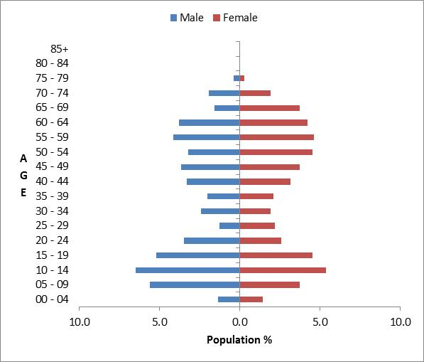

Observations:
- Males and females are evenly represented in this disability group.
- There are two peaks in the age distributions with slightly more males in the 10–24 years age and slightly more females in 45–69 years groups.

Ethnicity and deprivation
Table 61: Clients with sensory disability by ethnicity and deprivation
Deprivation decile | European/ Other | Māori | Pacific | Asian | Total | %
1 | 42 | 6 |  | 5 | 53 | 6%
2 | 47 | 3 |  | 1 | 51 | 5%
3 | 38 | 7 | 2 | 4 | 51 | 5%
4 | 55 | 11 |  | 5 | 71 | 8%
5 | 48 | 9 | 1 | 8 | 66 | 7%
6 | 69 | 18 | 5 | 7 | 99 | 11%
7 | 68 | 22 | 6 | 3 | 99 | 11%
8 | 75 | 23 | 11 | 7 | 116 | 12%
9 | 85 | 50 | 16 | 5 | 156 | 17%
10 | 68 | 55 | 42 | 4 | 169 | 18%
Total | 595 | 204 | 83 | 49 | 931
 | 64% | 22% | 9% | 5%

Figure 51: Clients with sensory disability by ethnicity and deprivation
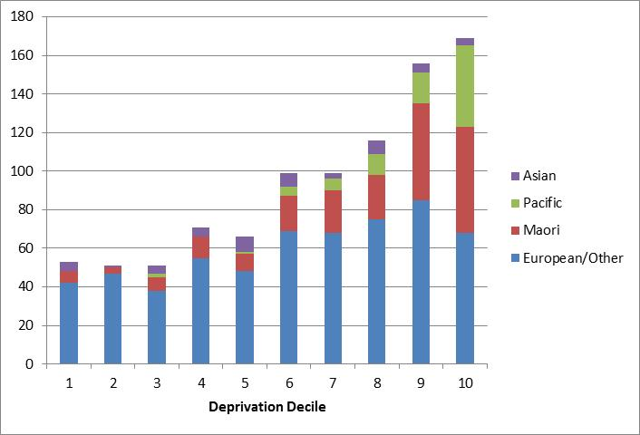

Observations:
- The deprivation profile is heavily skewed to the high end, with 35% of clients with sensory disabilities in deciles 9 or 10.
- Māori (22%) and Pacific (9%) clients are over-represented in the sensory disability group compared with DSS-funded clients as a whole.

Neurological disability
This section describes clients who have one of the following disabilities:
- brain/head injury caused by accident
- brain injury, cause not specified
- encephalitis
- meningitis
- neurological disorder/disability, type not specified
- other brain or nervous system disorder.

Age and sex
Table 62: Clients with neurological disability by age and sex
Age (in years) | Female | Male | Total
0–4 | 19 | 32 | 51
5–9 | 30 | 39 | 69
10–14 | 27 | 40 | 67
15–19 | 32 | 42 | 74
20–24 | 24 | 26 | 50
25–29 | 13 | 20 | 33
30–34 | 27 | 23 | 50
35–39 | 19 | 19 | 38
40–44 | 33 | 28 | 61
45–49 | 36 | 38 | 74
50–54 | 45 | 53 | 98
55–59 | 53 | 51 | 104
60–64 | 58 | 50 | 108
65–69 | 29 | 31 | 60
70–74 | 9 | 7 | 16
75–79 |  | 2 | 2
Total | 454 | 501 | 955
 | 48% | 52%

Figure 52: Age/sex of clients with neurological disability
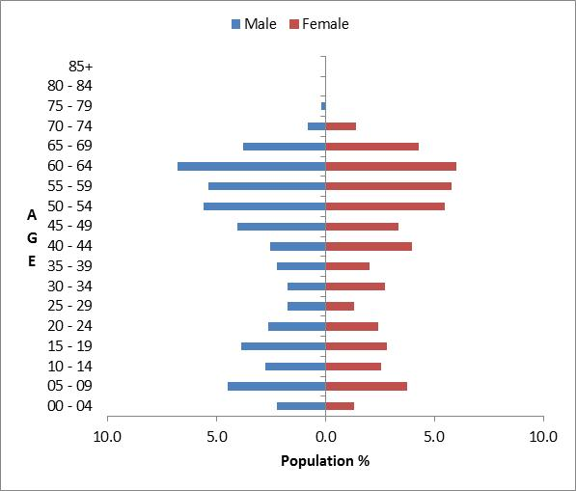

Observation:
- Almost half of clients with neurological disabilities are aged over 45 years.

Ethnicity and deprivation
Table 63: Clients with neurological disability by ethnicity and deprivation
Deprivation decile | European/ Other | Māori | Pacific | Asian | Total | %
1 | 59 | 4 |  | 3 | 66 | 8%
2 | 48 | 4 | 2 | 3 | 57 | 7%
3 | 44 | 7 | 3 | 2 | 56 | 6%
4 | 54 | 5 | 1 | 2 | 62 | 7%
5 | 57 | 11 | 2 | 7 | 77 | 9%
6 | 75 | 11 | 7 | 5 | 98 | 11%
7 | 75 | 20 | 7 | 4 | 106 | 12%
8 | 75 | 16 | 7 | 4 | 102 | 12%
9 | 84 | 22 | 13 | 3 | 122 | 14%
10 | 59 | 34 | 28 | 3 | 124 | 14%
Total | 630 | 134 | 70 | 36 | 870
 | 72% | 15% | 8% | 4%

Figure 53: Clients with neurological disability by ethnicity and deprivation
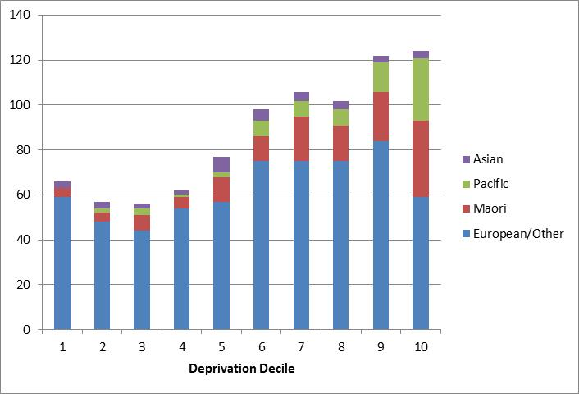

Observations:
- The deprivation profile is markedly skewed towards the high deciles, with 28% of clients with neurological disability in deprivation deciles 9 and 10.
- Māori and Pacific clients are over-represented in the high deprivation deciles 7–10.

Service usage by ethnicity
This section assesses the service usage for each of the four ethnicity groups: European/Other, Māori, Pacific and Asian.

Figure 54: Overall service usage by ethnicity

Figure 55: Service usage by clients of European/Other ethnicity

Figure 56: Service usage by clients of Māori ethnicity

Figure 57: Service usage by clients of Pacific ethnicity

Figure 58: Service usage by clients of Asian ethnicity

Client turnover

Introduction
This section presents major changes of status for DSS clients between 1 January and 25 September 2013 (268 days). During this period 10% (3000) clients had a change of status.

Change of client status occurs when:
- a new client begins receiving a service or services
- a client changes from one service to another
- a client changes NASC
- a client ceases receiving a service or services
- a client dies.

These changing statuses can be grouped into three categories. The sections below examine the demographics of:
- new clients
- terminating clients
- deceased clients.

New clients
There were 1752 clients who first began receiving a service between 1 January and 25 September 2013.

Age and sex
Table 64: New clients by sex and age
Age (in years) | Male | Female | Total
0–4 | 146 | 84 | 230
5–9 | 252 | 95 | 347
10–14 | 137 | 76 | 213
15–19 | 98 | 56 | 154
20–24 | 51 | 38 | 89
25–29 | 21 | 17 | 38
30–34 | 29 | 23 | 52
35–39 | 21 | 30 | 51
40–44 | 31 | 30 | 61
45–49 | 62 | 45 | 107
50–54 | 51 | 58 | 109
55–59 | 65 | 76 | 141
60–64 | 60 | 71 | 131
65–69 | 13 | 12 | 25
70–74 | 1 | 2 | 3
75–79 |  | 1 | 1
Total | 1038 | 714 | 1752
 | 59% | 41%

Figure 59: Age/sex of new clients
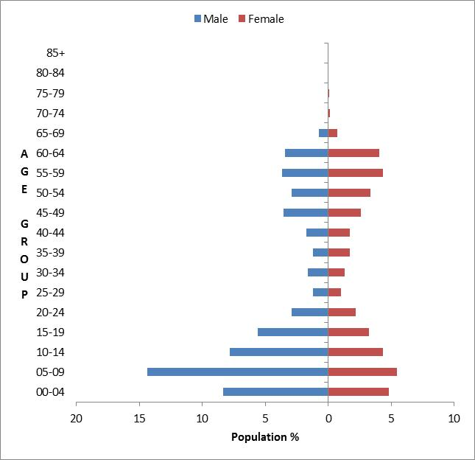

Observations:
- There are two peaks in the age groups of new clients: 5–19 years and 45–64 years
- Males dominate as new clients, and this is most pronounced in the 0–19 years age group.

Ethnicity and deprivation
Table 65: New clients by ethnicity and deprivation decile
Deprivation decile | European/ Other | Māori | Pacific | Asian | Total | %
1 | 71 | 9 | 1 | 7 | 88 | 6%
2 | 80 | 16 |  | 6 | 102 | 7%
3 | 73 | 10 |  | 8 | 91 | 7%
4 | 81 | 10 | 3 | 5 | 99 | 7%
5 | 96 | 19 | 3 | 6 | 124 | 9%
6 | 79 | 18 | 3 | 12 | 112 | 8%
7 | 120 | 29 | 9 | 11 | 169 | 12%
8 | 102 | 47 | 13 | 7 | 169 | 12%
9 | 96 | 60 | 19 | 6 | 181 | 13%
10 | 104 | 99 | 48 | 8 | 259 | 19%
Total | 902 | 317 | 99 | 76 | 1394
 | 65% | 23% | 7% | 5%
Note: Deprivation decile is not recorded for every client.

Figure 60: New clients by ethnicity and deprivation decile
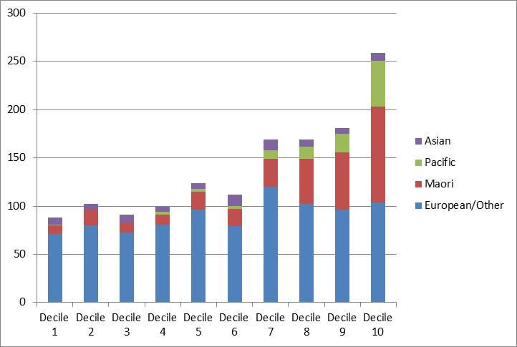

Observations:
- Māori are over-represented among new clients (23%) compared to the overall DSS client base (16% Māori).
- New clients are dominantly found in high-deprivation deciles; 32% in deciles 9–10 and another 24% in deciles 7–8.
- Māori and Pacific clients are significantly over-represented in deprivation decile 10.

Principal disability
Table 66: New clients by principal disability
Disability class | Male | Female | Total | %
Intellectual | 370 | 275 | 645 | 36.8%
Physical | 252 | 278 | 530 | 30.3%
ASD | 310 | 85 | 395 | 22.5%
Sensory | 40 | 28 | 68 | 3.9%
Neurological | 40 | 26 | 66 | 3.8%
Not DSS | 26 | 22 | 48 | 2.7%
Total | 1038 | 714 | 1752
 | 59% | 41%

Figure 61: New clients by principal disability
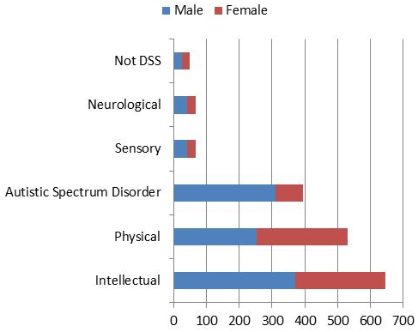

Observations:
- Intellectual and physical disabilities account for 67% of new clients.
- Over one-fifth (22.5%) of new clients have ASD as their principal disability.

Services used
Table 67: New clients by service used
Service | Male | Female | Total
Carer support | 642 | 348 | 990 | 58%
Home support | 226 | 271 | 497 | 29%
Supported living | 68 | 43 | 111 | 6%
Residential | 53 | 26 | 79 | 5%
Respite care | 24 | 11 | 35 | 2%
Total | 1013 | 699 | 1712
Note: A further 40 clients used services not listed here.

Figure 62: New clients by service used
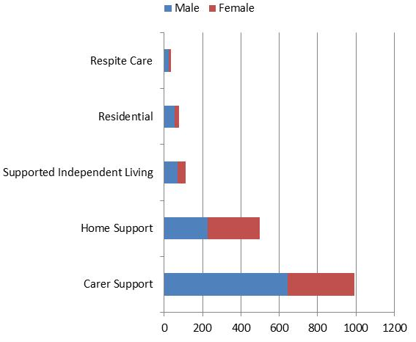

Observation:
- The majority (87%) of new clients are accessing carer support and home and community support services.

Terminating clients
There are 1281 clients who stopped using DSS between 1 January and 25 September 2013.

Reason for terminating
Table 68: Reasons for client terminating with DSS
Reason for terminating | Male | Female | Total | %
No service needed/wanted/required | 233 | 145 | 378 | 29.5
Deceased | 152 | 146 | 298 | 23.3
Moved out of region or country | 67 | 64 | 131 | 10.2
No client response | 68 | 31 | 99 | 7.7
Transfer to older person health or ACC | 43 | 56 | 99 | 7.7
Unable to locate client | 44 | 20 | 64 | 5.0
Transfer to another NASC | 30 | 26 | 56 | 4.4
Not eligible for funding | 30 | 21 | 51 | 4.0
Other | 29 | 10 | 39 | 3.0
No Community Services Card | 3 | 12 | 15 | 1.2
Client withdrew request | 10 | 5 | 15 | 1.2
Moved to / supported by family | 6 | 2 | 8 | 0.6
Moved to hospital services | 3 | 4 | 7 | 0.5
Self-discharge | 4 | 3 | 7 | 0.5
Palliative care register | 3 | 3 | 6 | 0.5
Over 65 | 3 | 1 | 4 | 0.3
Moved to acute care | 2 |  | 2 | 0.2
Transfer to mental health | 2 |  | 2 | 0.2
Total | 732 | 549 | 1281
 | 57.2% | 42.8%

Observation:
- Just over half of clients stopped using DSS because they no longer wanted/needed the services or because they had died.

Age and sex
Table 69: Terminating clients by sex and age
Age (in years) | Male | Female | Total
0–4 | 6 | 10 | 16
5–9 | 73 | 26 | 99
10–14 | 101 | 46 | 147
15–19 | 142 | 45 | 187
20–24 | 78 | 41 | 119
25–29 | 31 | 18 | 49
30–34 | 18 | 11 | 29
35–39 | 9 | 29 | 38
40–44 | 20 | 20 | 40
45–49 | 29 | 22 | 51
50–54 | 39 | 46 | 85
55–59 | 48 | 51 | 99
60–64 | 46 | 61 | 107
65–69 | 52 | 77 | 129
70–74 | 31 | 33 | 64
75–79 | 2 | 8 | 10
80–84 | 5 | 3 | 8
85–89 | 1 |  | 1
Total | 731 | 547 | 1278
 | 57% | 43%

Figure 63: Age/sex of terminating clients
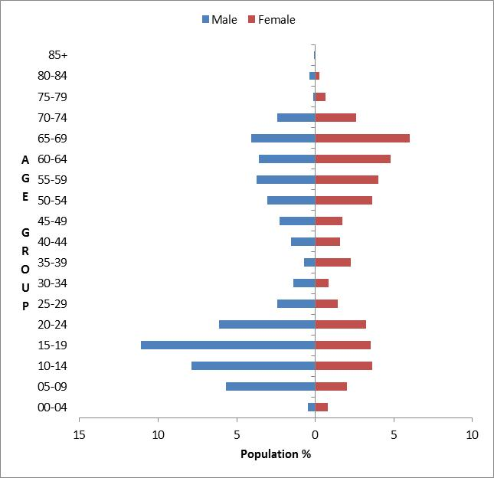

Observations:
- There are two peaks in the age distribution of terminating clients:
- males in the 10–24 age group
- females in the 65–69 age group.
- The age/sex profile for terminating clients is similar to that for new clients to DSS.

Ethnicity
Table 70: Terminating clients by ethnicity
Ethnicity | Total | %
European/Other | 842 | 66%
Māori | 260 | 20%
Not stated/don’t know | 75 | 6%
Pacific | 52 | 4%
Asian | 49 | 4%
Total | 1278

Figure 64: Terminating clients by ethnicity

Observation:
- Māori are slightly over-represented among clients who stopped using DSS.

Principal disability
Table 71: Terminating clients by principal disability
Disability class | Male | Female | Total | %
Intellectual | 283 | 177 | 460 | 36.0%
Physical | 203 | 240 | 443 | 34.7%
ASD | 161 | 36 | 197 | 15.4%
Not DSS | 33 | 49 | 82 | 6.4%
Sensory | 30 | 23 | 53 | 4.1%
Neurological | 21 | 22 | 43 | 3.4%
Total | 731 | 547 | 1278
 | 57% | 43%

Figure 65: Terminating clients by principal disability
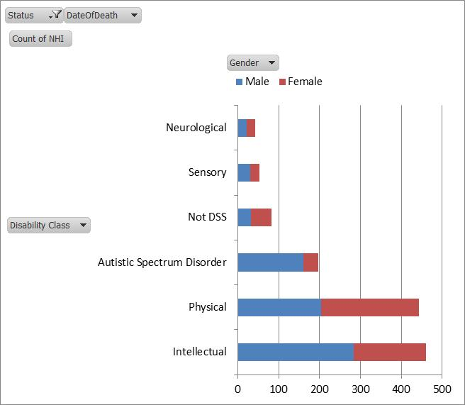

Observations
- About two-thirds (67%) of clients who stopped using DSS have intellectual or physical disabilities.
- Males (61%) with intellectual disabilities significantly outnumber females with intellectual disabilities among those who stopped using DSS.

Services used
Table 72: Terminating clients by service used
Service | Male | Female | Total | %
Carer support | 407 | 203 | 610 | 49%
Home support | 131 | 204 | 335 | 27%
Residential | 114 | 77 | 191 | 15%
Supported living | 47 | 46 | 93 | 7%
Respite care | 18 | 9 | 27 | 2%
Total | 717 | 539 | 1256
 | 57% | 43%
Note: This table does not total to 1278 because some clients were receiving services not analysed in this report.

Figure 66: Terminating clients by service used
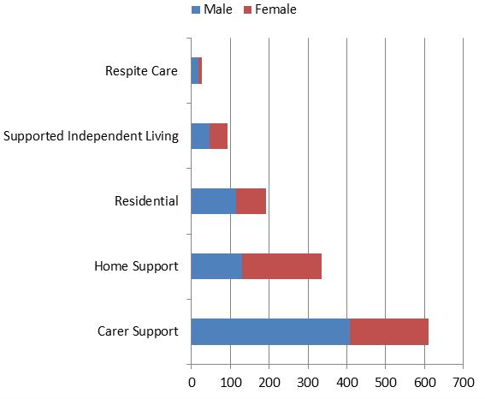

Observation:
- Carer support is the dominant service (49%) for clients who stop using DSS.

Deceased clients
In the 1 January to 25 September 2013 period, 298 DSS clients were recorded as having died.

Age and sex
Table 73: Deceased clients by age and sex
Age (in years) | Male | Female | Total
0–4 | 2 | 1 | 3
5–9 | 2 | 2 | 4
10–14 | 3 | 1 | 4
15–19 | 2 | 1 | 3
20–24 | 1 |  | 1
25–29 | 3 |  | 3
30–34 | 2 | 2 | 4
35–39 | 4 | 5 | 9
40–44 | 7 | 6 | 13
45–49 | 9 | 8 | 17
50–54 | 23 | 17 | 40
55–59 | 29 | 26 | 55
60–64 | 29 | 24 | 53
65–69 | 19 | 36 | 55
70–74 | 13 | 13 | 26
75–79 | 2 | 3 | 5
80–84 | 2 | 1 | 3
Total | 152 | 146 | 298
 | 51% | 49%

Figure 67: Age/sex of deceased clients
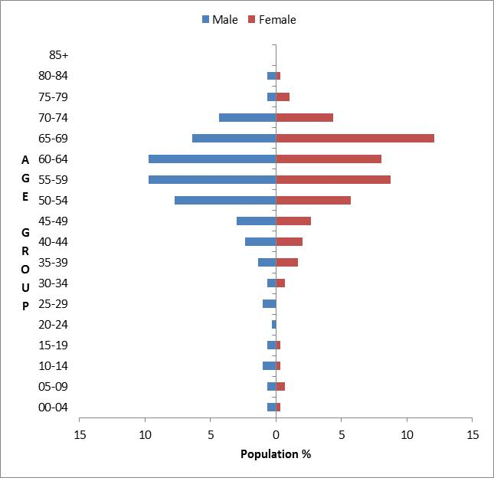

Observations:
- The largest number of deaths occurred in the 50–69 age groups for both sexes of client.

Ethnicity
Table 74: Deceased clients by ethnicity
Ethnicity | Total | %
European/Other | 216 | 72%
Māori | 41 | 14%
Pacific | 20 | 7%
Not stated/don’t know | 13 | 4%
Asian | 8 | 3%
Total | 298

Figure 68: Deceased clients by ethnicity

Observation:
- Clients of European/Other ethnicity are over-represented among deceased clients.

Services used
Table 75: Deceased clients by service used
Service | Male | Female | Total | %
Residential | 71 | 58 | 129 | 45%
Home support | 40 | 54 | 94 | 33%
Carer support | 26 | 27 | 53 | 18%
Supported living | 4 | 3 | 7 | 2%
Respite care | 5 | 1 | 6 | 2%
Total | 146 | 143 | 289
Note: This table does not total to 298 because some clients were receiving services not included in the five services listed and analysed in this report.

Figure 69: Deceased clients by service used
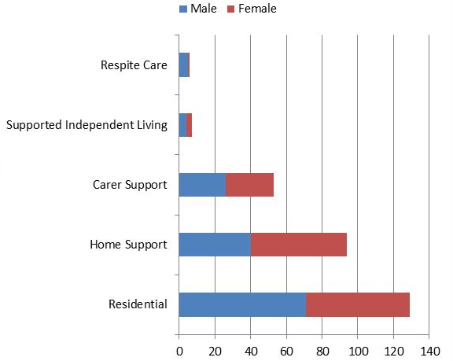

Observation:
- Almost half of all deceased DSS clients were using residential services at the time of their death.

Turnover rates
Table 76: Net movement of clients entering and departing DSS
Principal disability | New clients  1 January–25 September 2013 | Departing clients  1 January–25 September 2013 | Net gain/(loss)
Intellectual | 645 | 460 | 185
Physical | 530 | 443 | 87
ASD | 395 | 197 | 198
Not DSS | 48 | 82 | (34)
Sensory | 68 | 53 | 15
Neurological | 66 | 43 | 23
Total | 1752 | 1278 | 474

Observations:
- The highest pressure for DSS is from new clients using the service whose principal disability is intellectual or ASD.
- The label ‘Not DSS’ clients include those with cancer or medical conditions. They are receiving disability support services however.

National and international disability trends
This section looks at the demographics of disability and trends in services to people with disabilities in New Zealand, Australia, the United Kingdom and Canada.
The prevalence of people requiring daily care is expected to rise from 4.7% in 2010 to 5.3% in 2050 for ‘established market economies’.
(Saville-Smith and James 2006)

New Zealand disability trends

2006 Disability Survey
The major findings of the 2006 Disability Survey were as follows:
- In 2006, about 82% of people with disability were adults living in households, 5% were adults living in residential facilities and 14% were children (under 15 years) living in households.
- The percentage of people with a disability increased with age, from 10% for children aged less than 15 years to 45% for adults aged 65 years and over.
- An estimated 5% of children had special education needs, and this was the most common disability type for children. Chronic conditions or health problems and psychiatric or psychological disabilities were the next most common disability types.
- Conditions or health problems that existed at birth and disease or illness were the most common causes of disability for children.
- The most common disability types for adults were physical and sensory disabilities. This reflects the fact that the majority of people with disabilities manage their impairment without needing support from DSS.
- Disease or illness and accidents or injuries were the most common causes of disability for adults. The most common type of accident or injury causing disability was one that occurred at work.
- Nearly all adults living in residential care facilities reported having a disability (99.7%) and most had multiple disabilities (94%) and high support needs (82%). (Statistics New Zealand 2007).

Australian Disability Demographics 2011–12
Disability Support Services: Appendix 2011–12 (AIHW 2013) provides detailed demographic data across all states and territories in Australia. The totalled figures are presented below.

Disability service groups
Australia classifies their services into the following five groups:
- accommodation support
- community support
- community access
- respite
- employment.

Client service numbers
Table 77: Australian disabled people by service type 2007–2012
Service group | 2007–08 | 2008–09 | 2009–10 | 2010–11 | 2011–12 | % change  2007–08 to 2011–12
Community support | 159,534 | 181,086 | 198,237 | 227,408 | 215,542 | 35.1%
Employment | 95,592 | 110,552 | 122,133 | 130,556 | 134,442 | 40.6%
Community access | 65,637 | 68,490 | 67,849 | 71,282 | 73,508 | 12.0%
Respite | 42,447 | 46,081 | 48,205 | 50,509 | 50,616 | 19.2%
Accommodation support | 42,484 | 43,364 | 43,694 | 48,385 | 46,042 | 8.4%
Total | 405,694 | 449,573 | 480,118 | 528,140 | 520,150 | 28.2%

Figure 70: Change in number of clients receiving each service in Australia 2007–2012
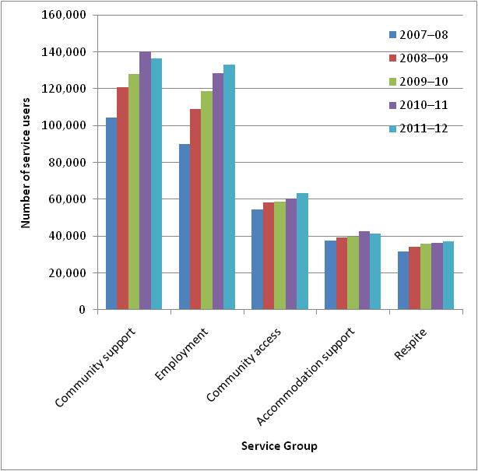

Observation:
- All service groups have shown significant overall growth in client numbers between 2007 and 2012.

Age and sex
The Australian report does not provide an age and sex profile by age group. There is an age distribution, but it does not use standard five-year age groups.

Table 78: Australian disability service users by age
Age (in years) | Clients | % | DSS NZ %
0–4 | 21,161 | 6.7% | 2.9%
5–14 | 40,436 | 12.7% | 22.7%
15–17 | 15,195 | 4.8% | 6.4%
18–24 | 44,283 | 13.9% | 11.5%
25–44 | 92,974 | 29.3% | 19.9%
45–59 | 69,555 | 21.9% | 20.7%
60–64 | 15,747 | 5.0% | 7.1%
65–74 | 9,015 | 2.8% | 8.1%
75–84 | 4,886 | 1.5% | 0.7%
85+ | 4,364 | 1.4% | 0.1%
Total | 317,616

Figure 71: Australian disability service users by age
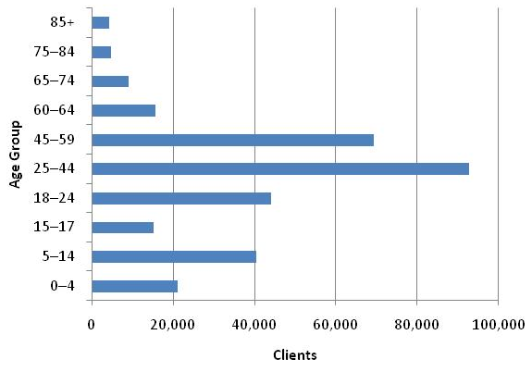

Observations:
- New Zealand appears to have a larger proportion of younger service users in the 5–17 years age group. However, this may be accounted for by the fact that the Australian statistics include employment support, while in New Zealand, this data is held by the Ministry of Social Development and has not been included in DSS data for this report.

Ethnicity
The Australian tables do not list ethnic groups (European, Pacific, Asian, etc) but do tabulate indigenous peoples and country of birth.

Principal disability groups
Table 79: Australian disabled people using government-funded supports by principal disability
Principal disability | Clients | %
Intellectual | 85,550 | 26.9%
Psychiatric | 56,733 | 17.9%
Physical | 50,682 | 16.0%
Autism | 18,639 | 5.9%
Neurological | 18,060 | 5.7%
Vision | 13,928 | 4.4%
Specific learning / ADD | 13,709 | 4.3%
Hearing | 11,658 | 3.7%
Acquired brain injury | 10,989 | 3.5%
Developmental delay | 10,391 | 3.3%
Speech | 3,843 | 1.2%
Deaf–blind | 999 | 0.3%
Not stated | 20,368 | 6.4%
Not collected | 2,067 | 0.7%

Figure 72: Australian disabled people using government-funded supports by principal disability
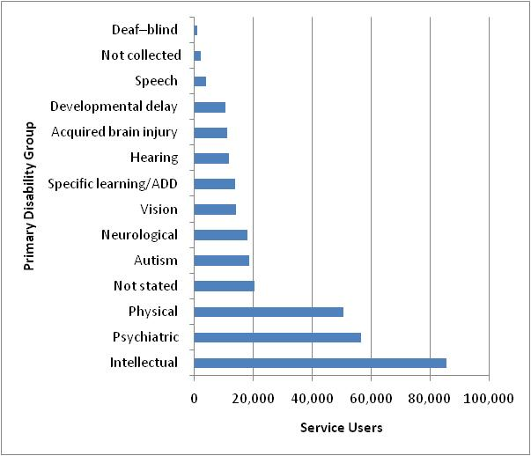

Observation:
- The Australian profile for primary disabilities is similar to New Zealand’s profile for primary disabilities but is not directly comparable because of differing classification systems, for example, our DSS does not report on mental health or employment services.

Accommodation
Table 80: Australian disability clients by residential setting
Residential setting | Clients | %
Private residence | 201,263 | 63%
Domestic-scale supported living facility | 17,395 | 5%
Boarding house / private hotel | 11,665 | 4%
Supported accommodation facility | 9778 | 3%
Residence within an Aboriginal community | 2535 | 1%
Residential aged care facility | 1968 | 1%
Short-term crisis, emergency, transitional accommodation | 1822 | 1%
Psychiatric / mental health community care facility | 1384 | 0%
Independent unit within a retirement village | 597 | 0%
Hospital | 396 | 0%
Public place / temporary shelter | 209 | 0%
Other | 2738 | 1%
Not stated | 63,557 | 20%
Not collected (recreation/holiday programmes) | 2309 | 1%
Total | 317,616

Observation:
- Like New Zealand, the majority of Australian disabled clients live in a private residence.

United Kingdom Family Resources Survey
The Family Resources Survey, United Kingdom, 2011/12 (Department for Work and Pensions 2013).

Disability
Major conclusions:
- The percentage of disabled people differed by age group: in 2011/12, 6% (0.8 million) of children were disabled compared to 16% (5.8 million) of adults of working age and 45% (5.3 million) of adults over state pension age (67 years). The estimated percentage of the population who were disabled remained relatively constant over time at around 19%, although the number of disabled people has increased (from 10.7 million in 2002/03 to 11.9 million in 2011/12), as a result of the increasing overall population.
- In 2011/12, 6.4 million (21%) females and 5.5 million (18%) males were disabled in the United Kingdom. The disability prevalence estimates by sex remained broadly stable over time. For example, in 2002/03, 5.7 million (19%) females and 5.0 million (18%) males in the United Kingdom were disabled.
- The percentages of the disabled population affected by different impairment types varies widely, ranging from 56% (6.7 million) reporting a mobility impairment to 7% (0.8 million) reporting an impairment with recognising when they are in danger.
- Disabled people of state pension age were more likely than those disabled people of working age to report impairment in a number of areas, including mobility and lifting and carrying. Disabled people of working age were more likely than those of state pension age to report problems with a memory/concentration/learning impairment.
- The impairment types that were most likely to affect disabled children were memory/ learning/concentration, communication, mobility and recognising when they are in danger.
- While the vast majority of those receiving disability-related benefits have rights under the Equality Act (2010), not all covered by this Act will be receiving a disability-related benefit, and not all those receiving a disability-related benefit will consider themselves to be disabled.
- Families that included a disabled person were more likely to be receiving a government benefit compared with families with no disabled people.
- In 2011/12, 38% of benefit households with at least one disabled adult and no disabled children were receiving income-related benefits, and 80% were receiving non-income-related benefits, including: 9% reporting receiving an attendance allowance, 20% reporting receiving a disability living allowance (care) and 19% reporting receiving a disability living allowance (mobility). This compares with 12% of benefit units with no disabled members receiving income-related benefits and 46% receiving non-income-related benefits.

Carers
The major conclusions are:
- Many people in the United Kingdom provide informal care to others. In 2011/12, 5.1 million individuals were carers (8% of the population). In 2011/12, there were 3.6 million adults of working age (10%), 1.4 million adults of state pension age (67 years) (12%) and 0.1 million children (1%) who were carers. The percentage of carers by age has remained broadly stable over time.
- Females were more likely to report caring than males. Overall 10% of females and 7% of males in 2011/12 reported providing care to someone. In 2011/12, 60% of individuals who reported caring responsibilities were female, and this has been stable over time.
- In 2011/12, 61% of informal carers in the United Kingdom were providing care to someone living outside their own household. Family members were the main recipients of informal care from both household and non-household members.
- Many carers balance their caring responsibilities with paid work. Those in full-time employment made up the largest group (35%) of carers in the United Kingdom in 2011/12. The next largest group was those in retirement (25%) followed by those who were economically inactive (20%) and then those in part-time employment (17%).

Canada disability rates, 2006

Overall age and sex
Table 81: Canadian people with disabilities by age and sex
Age (in years) | Male | Female | Total
0–4 | 17,770 | 9770 | 27,540
5–14 | 111,440 | 63,370 | 174,810
15–24 | 100,940 | 94,560 | 195,500
25–44 | 326,460 | 370,070 | 696,530
45–64 | 724,130 | 841,780 | 1,565,910
65–74 | 346,720 | 392,790 | 739,510
75 + | 397,240 | 620,850 | 1,018,090
Total | 2,024,700 | 2,393,190 | 4,417,890

Figure 73: Canadian people with disabilities by age and sex
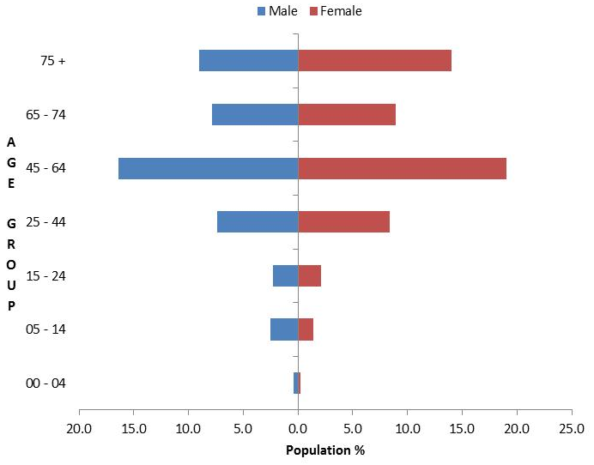
Source. Statistics Canada 2009.

Observations:
- The overall disability rate in Canada rose from 12.4% in 2001 to 14.3% in 2006. In 2001, approximately 3.6 million people in Canada self-identified as having a disability. In 2006, approximately 4.5 million people in Canada self-identified as having a disability.
- The rate of self-reported disability increases as people age.
- Problems related to pain, mobility and agility affect the largest number of adults both nationally and provincially.
- A large percentage of people with disabilities experience multiple activity limitations.
- The severity of disability for Canada as a whole is: mild 35.4%, moderate 24.8%, severe 26.3%, very severe 13.5%.
- Nova Scotia has the highest provincial rate of disability, at 20% in 2006.
- In 2006, only 47% of people with disabilities were in the labour force in Nova Scotia, versus 73% of people without disabilities.
Source: Nova Scotia, Canada 2006.

WHO 2011 World Report on Disability

Key findings
- Over a billion people, about 15% of the world’s population, have some form of disability.
- Between 110 million and 190 million adults have significant difficulties in functioning.
- Rates of disability are increasing due to increased life expectancy, population ageing and increases in chronic health conditions, among other causes.
- People with disabilities have less access to health care services and therefore experience unmet health care needs.

Main messages
- There has been a paradigm shift in approaches to disability. The move has been away from a medical understanding towards a social understanding. Disability arises from the interaction between people with a health condition and their environment.
- Disability disproportionately affects vulnerable populations. Disability is more common among women, older people and households that are poor. Lower income countries have a higher prevalence of disability than higher income countries.
- Disability is very diverse. While disability correlates with disadvantage, not all people with disability are equally disadvantaged.
- People with disabilities face widespread barriers in accessing services (health, education, employment, transport as well as information).
- People with disabilities have worse health and socioeconomic outcomes. People with disabilities have poorer health, lower education achievements, less economic participation and higher rates of poverty than people without disabilities.

Recommendations
1. Enable people with disabilities to have access to all mainstream policies, systems and services.
2. Invest in specific programmes and services for people with disabilities.
3. Adopt a national disability strategy and plan of action.
4. Involve people with disabilities.
5. Improve human resource capacity.
6. Provide adequate funding and improve affordability.
7. Increase public awareness and understanding of disability.
8. Improve disability data collection.
9. Strengthen and support research on disability.

Glossary
ASD | Autism spectrum disorder.
Decile | The division of a population into 10 parts so that each of the parts contains the same number of observations.
Deprivation decile | A fixed proportion, one tenth, of the New Zealand population with the same level of socioeconomic deprivation as measured by Statistics New Zealand in a nationwide census.  The deprivation index is a measure of socioeconomic deprivation that combines nine variables from the 2006 Census, which reflect eight dimensions of deprivation. NZDep2006 provides a deprivation score for each meshblock in New Zealand. The NZDep2006 index of deprivation ordinal scale ranges from 1 to 10, where 1 represents the areas with the least deprived scores and 10 the areas with the most deprived scores. For example, a value of 10 indicates that the meshblock is in the most deprived 10% of areas in New Zealand, according to the NZDep2006 scores.
DHB | District health board. An organisation operating in a defined area of New Zealand charged with providing or funding specified health services to people residing within that area.
EIF | Enhanced individualised funding. As at September 2013, this was being trialled in the Bay of Plenty, used by 75 disabled people to purchase the full range of disability support services. It is intended that the number of disabled people using EIF will increase.
FMIS | Financial Management Information System.
Geospatial data | Information stored in a computer system in a form that can be represented on a map or plan and that can be selected by inclusion or exclusion from a geographic boundary.
IF | Individualised funding. As at September 2013, this was being used by 1700 disabled people nation-wide to purchase home and community support services (HCSS) only. It is intended that numbers of disabled people using IF will increase.
Meshblock | A geographical area defined by Statistics New Zealand, containing a median of approximately 87 people in 2006.
NASC | Needs Assessment and Service Coordination organisation. An organisation contracted by the Ministry of Health to work with disabled people to assess the level of disability support need and allocate and coordinate Ministry-funded disability support services.
Population pyramid | A conventional graphic used by demographers to depict the age and sex structure of a country or region. By convention, the graph has a central vertical axis; males are on the right and females on the left; and age groups are shown in five-year bands. The horizontal axis indicates the percentage of total population.
Socrates | A Ministry of Health information system, consisting of a database and computer application for managing the delivery of services to DSS clients.
SPA | Support package allocation. This is the funding or range of disability support services allocated to a disabled person, to address their disability support needs, as identified by the Needs Assessment and Service Coordination organisation (NASC).

References
AIHW. 2013. Disability Support Services: Appendix 2011–12. Disability series. Cat. No. AUS 173. Canberra: Australian Institute of Health and Welfare (AIHW). URL: www.aihw.gov.au/WorkArea/DownloadAsset.aspx?id=60129543840 (accessed 10 September 2014).
Department for Work and Pensions. 2013. Family Resources Survey, United Kingdom, 2011/12. London: Surveys Branch, Department for Work and Pensions. URL: www.gov.uk/government/uploads/system/uploads/attachment_data/file/206887/frs_2011_12_report.pdf (accessed 7 September 2014).
Nova Scotia, Canada. 2006. Disability statistics. URL: http://novascotia.ca/coms/newstats/disability/index.html (accessed 7 September 2014).
Salmond C, Crampton P, Atkinson J. 2007. NZDep2006 Index of Deprivation. Wellington: Department of Public Health, University of Otago. URL: www.otago.ac.nz/wellington/otago020348.pdf (accessed 7 September 2014).
Saville-Smith K, James B. 2006. Disability Prevalence Forecasting & Housing: A selected review. Working Paper 1. Wellington: Centre for Housing Research New Zealand. URL: www.chranz.co.nz/pdfs/working-paper-1.pdf (accessed 7 September 2014).
Statistics Canada. 2009. Persons with Disabilities, By Age Group and Sex (2006). URL: www.statcan.gc.ca/tables-tableaux/sum-som/l01/cst01/health71a-eng.htm (accessed 10 September 2014).
Statistics New Zealand. 2007. 2006 Disability Survey. Wellington: Statistics New Zealand. URL: www.stats.govt.nz/browse_for_stats/health/disabilities/disabilitysurvey2006_hotp06.aspx (accessed 12 September 2014).
WHO. 2011. World Report on Disability. Geneva: World Health Organization (WHO). URL: www.who.int/disabilities/world_report/2011/en/index.html (accessed 7 September 2014).

Appendix 1: Down syndrome
There are 3122 clients using disability support services whose first principal disability is Down syndrome. A further 78 clients have Down syndrome as their second principal disability.

Age and sex
Table A1: Down syndrome clients by age and sex
Age | Male | Female | Total
0–4 | 71 | 70 | 141
5–9 | 164 | 106 | 270
10–14 | 224 | 150 | 374
15–19 | 212 | 142 | 354
20–24 | 159 | 146 | 305
25–29 | 119 | 95 | 214
30–34 | 105 | 67 | 172
35–39 | 94 | 103 | 197
40–44 | 133 | 92 | 225
45–49 | 118 | 121 | 239
50–54 | 97 | 94 | 191
55–59 | 80 | 99 | 179
60–64 | 65 | 65 | 130
65–69 | 40 | 43 | 83
70–74 | 14 | 25 | 39
75–79 | 6 | 1 | 7
80–84 | 0 | 1 | 1
Total | 1702 | 1420 | 3122
 | 54.5% | 45.5%

Figure A1: Down syndrome clients by age and sex

Observations:
- There are more males (54%) than females (46%) with Down syndrome using DSS-funded services.
- This is a youthful population with the median age in the low 20s (compared with the median age of all DSS service users, which is in the low 30s).

Appendix 2: Total client demographics excluding ASD
The following graphs show the difference in the population pyramid of current clients when the Autism Spectrum Disorder (ASD) clients are removed. It is useful to compare the graphs below to identify the significant impact of ASD clients in the young male cohort.

Figure A2: Total DSS clients
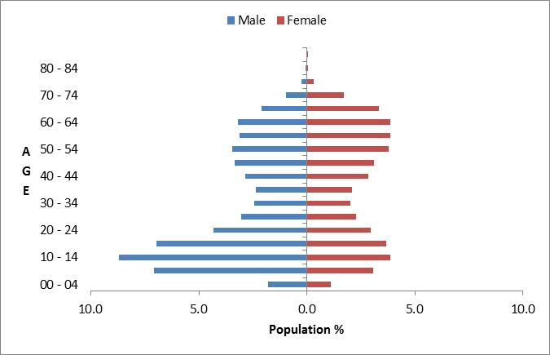

Figure A3: Total DSS clients excluding ASD clients
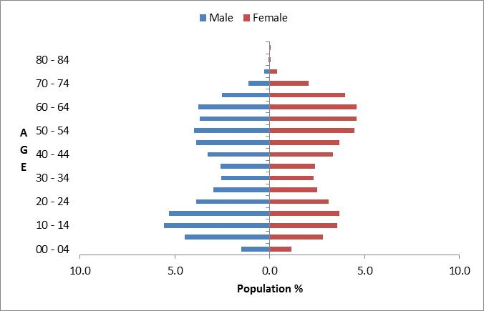

Observations:
- The population pyramid with ASD clients removed is more balanced between males and females
- The population profile with ASD removed is older overall.

Appendix 3: Disability types
Table A3: Principal disability types by numbers of DSS clients
Disability class | Principal disability | Count
Intellectual | Birth asphyxia or intrauterine hypoxia | 19
 | Developmental delay, type not specified | 1708
 | Down syndrome (Trisomy 21) | 1947
 | Edwards’ syndrome (Trisomy 18) | 8
 | Fragile X syndrome | 97
 | Hydrocephalus/hydrocephaly | 92
 | Intellectual disability (ID), type not specified | 9769
 | Klinefelter’s syndrome | 28
 | Learning disability/difficulty/delay, type not specified | 1278
 | Microcephalus/microcephaly | 82
 | Other intellectual, learning or developmental disorder | 579
Intellectual total |  | 15,607
Physical | Amputation/partial amputation of arm/hand | 22
 | Amputation/partial amputation of leg/foot | 149
 | Ankylosing spondylitis | 32
 | Arthrogryposis | 35
 | Ataxia (cerebellar, spinocerebellar, Friedreich’s) | 167
 | Back injury due to accident (external cause) | 24
 | Cerebral palsy | 1863
 | Club foot or feet (talipes) | 22
 | Congenital absence/partial absence of arm/hand (upper limb reduction) | 11
 | Congenital absence/partial absence of leg/foot (lower limb reduction) | 20
 | Guillain-Barré syndrome | 21
 | Huntington’s disease | 135
 | Kyphosis, lordosis or scoliosis | 71
 | Low birth weight / prematurity / short gestation | 37
 | Motor neuron disease | 92
 | Multiple sclerosis | 930
 | Muscular dystrophy | 249
 | Non-malignant growth/tumour | 13
 | Osteoarthritis | 736
 | Other bone, joint or cartilage disorder | 212
 | Other conditions originating around time of birth | 58
 | Other congenital or chromosomal defects affecting multiple systems | 731
 | Other muscle and tendon disorder | 80
 | Other musculoskeletal | 141
Physical (continued) | Other spine or back disorder | 178
 | Paralysis, paresis (hemiplegia, paraplegia, tetraplegia, quadriplegia, diplegia) | 551
 | Parkinson’s | 198
 | Patau syndrome (Trisomy 13) | 1
 | Polio and post-polio | 88
 | Polymyalgia rheumatica | 8
 | Prolapsed disc, disc degeneration, sciatica | 38
 | Rheumatoid arthritis | 527
 | Short stature / dwarfism, eg, achondroplasia | 40
 | Spina bifida | 342
 | Spinal muscular atrophy | 30
 | Spinal stenosis | 62
 | Spondylosis | 26
 | Stroke, brain/subarachnoid haemorrhage, cerebrovascular accident (CVA), parietal / cerebral / cerebellar / middle cerebral artery (MCA) / thalamic / frontal lobe infarct | 1642
 | Systemic lupus erythematosus (lupus, SLE) | 28
Physical total |  | 9610
Autism spectrum disorder | Asperger syndrome | 1204
 | Autism spectrum disorder (ASD) | 3222
 | Other ASD | 949
ASD total |  | 5375
Sensory | Blind or vision impaired, type not specified | 633
 | Congenital cataract (present at birth) | 18
 | Deaf or hearing impaired, type not specified | 435
 | Glaucoma | 16
 | Optic neuritis, optic atrophy | 5
 | Other cataract | 5
 | Other ear or hearing disorder | 51
 | Other eye or vision disorder | 126
 | Retinopathy, retinal dystrophy, retinitis pigmentosa, detached retina | 50
Sensory total |  | 1339
Neurological | Brain/head injury caused by accident (external cause) | 110
 | Brain injury, cause not specified | 167
 | Encephalitis | 37
 | Meningitis | 24
 | Neurological disorder/disability, type not specified | 95
 | Other brain or nervous system disorder | 676
Neurological total |  | 1109
Not DSS | Alcohol/drug related disorder (excluding Korsakov’s syndrome) | 5
 | Alzheimer’s (including early onset) | 12
 | Angina | 4
 | Anxiety disorder | 47
 | Asthma | 36
 | Attention deficit / hyperactivity, eg, ADD, ADHD | 199
 | Behavioural problem/issue, type not specified | 168
 | Bipolar disorder (manic depression) | 23
 | Cancer (malignant, CA), eg, leukaemia, lymphoma, melanoma, breast, lung, prostate, colon, neuroblastoma, etc | 16
 | Chronic back pain, type not specified | 27
 | Chronic fatigue syndrome / ME (myalgic encephalomyelitis) | 38
 | Chronic obstructive pulmonary or respiratory disease (COPD/CORD), eg, chronic bronchitis, emphysema | 29
 | Chronic pain / chronic pain syndrome, cause not specified (excludes chronic back pain) | 3
 | Cleft lip/palate | 4
 | Congenital heart disease/defects/problems | 23
 | Cystic fibrosis | 11
 | Depression | 22
 | Diabetes (NIDDM or IDDM) | 97
 | Dyslexia, reading delay | 6
 | Eczema and dermatitis | 3
 | Epidermolysis bullosa | 2
 | Epilepsy, seizures | 392
 | Faecal incontinence, encopresis | 2
 | Fibromyalgia | 56
 | Foetal alcohol syndrome (FAS) | 36
 | Gout | 1
 | Haemophilia | 1
 | Heart attack (myocardial infarction) | 10
 | Heart failure | 5
 | Hypertension / high blood pressure | 33
 | Inflammatory bowel disease, eg, Crohn’s disease, ulcerative colitis, other non-infective bowel disease | 6
 | Ischaemic heart disease (IHD), type not specified | 21
 | Korsakoff’s syndrome / alcohol-related dementia | 6
 | Language delay | 23
 | Liver disease, eg, hepatitis, cirrhosis | 4
 | Lymphoedema | 4
 | Motor delay, developmental dyspraxia | 57
 | Mute | 4
 | Neurofibromatosis | 23
 | Obesity | 5
Not DSS (continued) | Osteoporosis | 54
 | Other | 33
 | Other cancer/tumour | 23
 | Other connective tissue disorder | 23
 | Other dementia | 11
 | Other digestive disorder | 13
 | Other genitourinary disorder | 7
 | Other heart or blood vessel disorder | 67
 | Other nutritional, hormonal or metabolic disorder | 18
 | Other psychiatric disorder | 22
 | Other respiratory disorder | 16
 | Other skin and subcutaneous tissue disorder | 9
 | Other speech disorder | 14
 | Peripheral vascular disease | 4
 | Personality disorder | 9
 | Pick’s disease | 2
 | Recurrent or chronic otitis media or ear infections (glue ear) | 2
 | Renal (kidney) failure, renal dialysis, haemodialysis | 14
 | Schizophrenia | 62
 | Sleep disorder, eg, narcolepsy, sleep apnoea | 4
 | Speech delay | 16
 | Systemic sclerosis / scleroderma | 12
 | TIA (transient ischaemic attack) | 4
 | Unknown condition / no diagnosis available | 3
 | Urinary incontinence, enuresis | 1
 | Vascular dementia | 3
Not DSS total |  | 1910
Total |  | 34,950
Note: If a person has two principal disabilities, then both disabilities are counted.

Appendix 4: Demographics of day-programme clients
This section provides demographic profiles of the 2300 clients receiving day-programme services (FMIS Code 6661) from DSS.

Many of these clients also appear in the demographics for other services.

Age and sex
Table A4: Day-programme clients by age and sex
Age in years | Male | Female | Total
10–14 | 1 |  | 1
15–19 | 35 | 15 | 50
20–24 | 101 | 50 | 151
25–29 | 117 | 59 | 176
30–34 | 109 | 85 | 194
35–39 | 112 | 69 | 181
40–44 | 158 | 100 | 258
45–49 | 177 | 101 | 278
50–54 | 153 | 130 | 283
55–59 | 129 | 116 | 245
60–64 | 111 | 100 | 211
65–69 | 58 | 52 | 110
70–74 | 42 | 49 | 91
75–79 | 26 | 22 | 48
80–84 | 7 | 8 | 15
85–89 | 5 | 3 | 8
Total | 1341 | 959 | 2300
 | 58% | 42%

Figure A4: Day-programme clients by age and sex
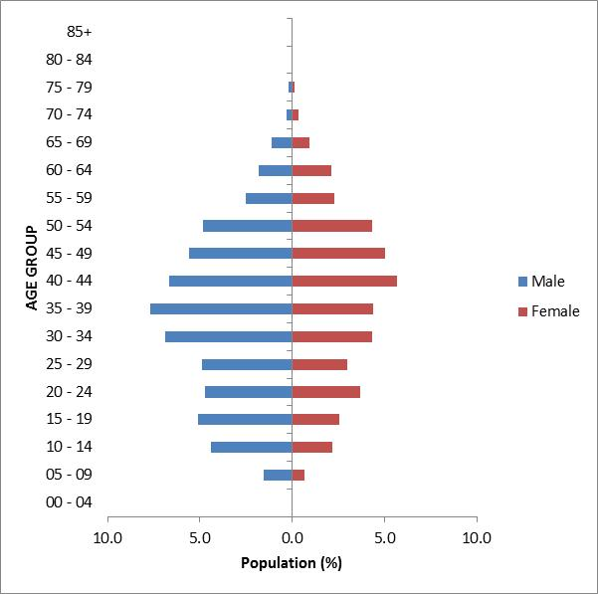

Observations:
- There are more male day-programme clients (58%) than female day-programme clients (42%).
- The majority of day-programme clients are aged between 30 and 55 years.

Ethnicity
Table A5: Day-programme clients by age and ethnicity
Age in years | European/ Other | Māori | Pacific | Asian | Total
10–14 |  |  |  | 1 | 1
15–19 | 29 | 18 | 3 |  | 50
20–24 | 85 | 45 | 7 | 6 | 143
25–29 | 124 | 35 | 9 | 2 | 170
30–34 | 126 | 46 | 5 | 13 | 190
35–39 | 122 | 47 | 7 | 2 | 178
40–44 | 176 | 69 | 5 | 2 | 252
45–49 | 208 | 54 | 5 | 2 | 269
50–54 | 218 | 48 | 2 | 1 | 269
55–59 | 192 | 33 | 3 | 1 | 229
60–64 | 165 | 30 | 4 | 2 | 201
65–69 | 89 | 15 | 2 |  | 106
70–74 | 82 | 6 |  | 1 | 89
75–79 | 45 | 2 |  |  | 47
80–84 | 15 |  |  |  | 15
85–89 | 6 |  |  |  | 6
Total | 1682 | 448 | 52 | 33 | 2215
 | 76% | 20% | 2% | 1%
Note: Ethnicity records are not complete for the full 2300 clients, hence the total is slightly less than 2300.

Figure A5: Day-programme clients by age and ethnicity
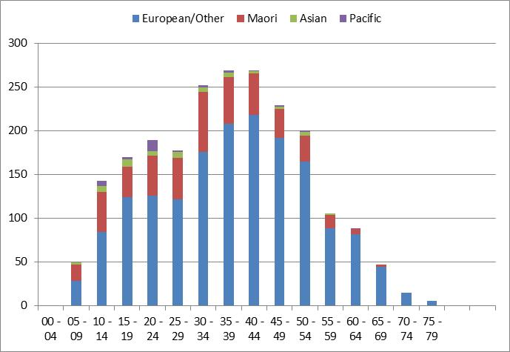

Observations:
- European/Other (76%) are significantly over-represented in day-programme clients.
- Māori (20%) are slightly over-represented.
- Pacific (2%) and Asian (1%) are significantly under-represented.

Location
Table A6: Day-programme clients by region
Region | European/  Other | Māori | Pacific | Asian | Total | %
Waikato | 382 | 139 | 10 | 15 | 546 | 27%
Canterbury | 296 | 13 | 1 |  | 310 | 16%
Manawatu-Wanganui | 176 | 22 | 1 | 2 | 201 | 10%
Auckland | 114 | 35 | 12 | 8 | 169 | 8%
Bay of Plenty | 103 | 60 | 4 | 1 | 168 | 8%
Northland | 97 | 45 |  |  | 142 | 7%
Wellington | 77 | 12 | 6 | 1 | 96 | 5%
Hawke’s Bay | 70 | 12 | 3 |  | 85 | 4%
Nelson | 69 | 12 |  | 1 | 82 | 4%
Taranaki | 51 | 13 |  |  | 64 | 3%
Gisborne | 14 | 25 |  |  | 39 | 2%
Otago | 34 |  | 4 |  | 38 | 2%
Tasman | 29 |  | 1 |  | 30 | 2%
West Coast | 10 |  |  |  | 10 | 1%
Marlborough | 6 | 1 |  |  | 7 | 0%
Southland | 5 |  |  |  | 5 | 0%
Total | 1533 | 389 | 42 | 28 | 1992
Note: Region has not been recorded for all 2300 clients.
Figure A6: Day-programme clients by region
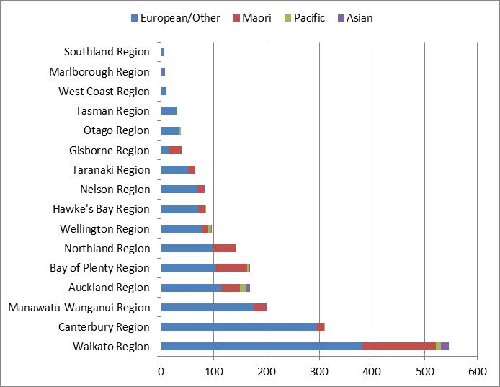

Observations:
- Waikato region has the largest number of clients in day-programme services.
- Waikato, Bay of Plenty and Northland have significantly more Māori clients in day-programme services.

Principal disability
Table A7: Day-programme clients by principal disability
Disability case | Male | Female | Total
Intellectual | 1109 | 798 | 1907 | 83%
Physical | 115 | 94 | 209 | 9%
Autism spectrum disorder | 53 | 19 | 72 | 3%
Not DSS | 34 | 16 | 50 | 2%
Neurological | 20 | 20 | 40 | 2%
Sensory | 10 | 12 | 22 | 1%
Total | 1341 | 959 | 2300
 | 58% | 42%

Figure A7: Day-programme clients by principal disability
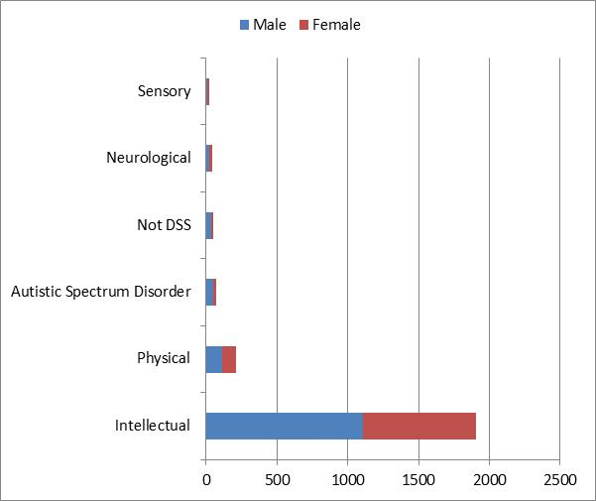

Observation:
- The majority of clients using day-programme services (83%) have intellectual disabilities.

Support package allocation
Table A8: Day-programme clients by SPA level
SPA level | Male | Female | Total
Very high | 707 | 591 | 1298 | 63%
High | 353 | 266 | 619 | 30%
Medium | 67 | 74 | 141 | 7%
Low |  | 2 | 2 | 0%
Very low |  | 1 | 1 | 0%
Total | 1127 | 934 | 2061
Note: SPA level has not been recorded for all 2300 clients.

Figure A8: Day-programme clients by SPA level
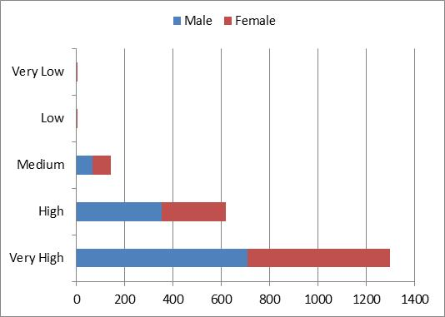

Observation:
- A large majority of day-programme clients (63%) have a very high support package allocation level, and a further 30% have a high level.

This total is less than the sum of the figures, as some people identify as more than one ethnicity.
Some people identify as more than one ethnicity.
Many clients use more than one service.
See NZDep2006 Index of Deprivation (Salmond et al 2007).
Where a client was recorded as having two principal disabilities, only the first one was used in this analysis.
Where clients recorded two principal disabilities, only the first one was used in this analysis.
Where clients recorded two principal disabilities, only the first one has been used in this research.
Not everyone who is allocated carer support takes advantage of the subsidy.
Where clients recorded two principal disabilities, this research has used only the first one.
Where a client recorded two principal disabilities, this research has used only the first one.
Where a client recorded two principal disabilities, this research has used only the first one.
Where a client recorded two principal disabilities, this research has used only the first one.
Where a client recorded two principal disabilities, this research has used only the first one.
This figure is lower than the total with intellectual disability, as not every client recorded their ethnicity.
For a list of disabilities included in the Physical Disability Type see Appendix 3: Disability.
This figure is lower than the total with physical disability, as not every client recorded their ethnicity.
This figure is lower than the total with ASD, as not every client recorded their ethnicity.
This figure is lower than the total with sensory disabilities, as not every client recorded their ethnicity.

