Data and Information Strategy for Health and Disability |
He Rautaki Raraunga,
He Rautaki Pārongo mō te Pūnaha Hauora, Whaikaha hoki
Stronger evidence, better decisions,
improved health and wellbeing |
Hei whakapakari ake i ngā taunakitanga, ngā whakataunga me te hauora o te tangata
2021

Acknowledgements
The development of the Data and Information Strategy for Health and Disability has involved valued input from people across the sector. The breadth of engagement and contributions demonstrate the high value that the sector places on data and information. The Ministry of Health acknowledges and thanks healthAlliance for its work in the development of this strategy and roadmap, and recognises the advice and comments provided by the following contributors: the Office of the Privacy Commissioner, the Social Wellbeing Agency, Stats NZ, the Department of Internal Affairs, Te Mana Raraunga, the University of Auckland, Waikato District Health Board, New Zealand Health IT, the Health Navigator Consumer Council, Precision Driven Health, the Ministry of Education, the Health Quality & Safety Commission, the National Health CIO Forum, the Primary Care CIO Forum, Waitemata District Health Board, WellSouth, Aseco, Patients First, Southern Alliance and Health Informatics New Zealand.
Citation: Ministry of Health. 2021. Data and Information Strategy for Health and Disability: Stronger evidence, better decisions, improved health and wellbeing. Wellington: Ministry of Health.
Published in December 2021 by the Ministry of Health
PO Box 5013, Wellington 6140, New Zealand
ISBN 978-1-99-100769-8 (online)
HP 7908
This document is available at health.govt.nz
This work is licensed under the Creative Commons Attribution 4.0 International licence. In essence, you are free to: share ie, copy and redistribute the material in any medium or format; adapt ie, remix, transform and build upon the material. You must give appropriate credit, provide a link to the licence and indicate if changes were made.

Foreword
Delivering health care to New Zealanders in the future will require a significant shift in the way we think about data, including the very concept of what constitutes information.

We’ll need a health and disability system capable of delivering equitable health outcomes for all New Zealanders, generating insights people can act on for good policy and decision-making, able to adapt more readily to the needs of the system and rapidly to changing situations (such as a pandemic), and up to the task of sharing health information securely in real-time and with appropriate authorisation.

As a sector, that means being smarter, more innovative and inclusive in how we define, collect, manage, use and share health data. We’ll need to broaden our definition of data to include data produced by emerging technologies or existing technologies for new purposes. For instance, we’ll increasingly draw on sources as varied as non-health sector information regarding the determinants of health, artificial intelligence, an array of images, and genomics to support improved diagnostics, population health management, more targeted interventions and to support communicable disease management, as we’ve done in the current COVID-19 pandemic.

Embracing these changes will challenge our thinking on a number of fronts, including the ethics of data use, issues around consent and access to information, the protocols for privacy and security, our obligations under Te Tiriti o Waitangi, and how the sector can address inequities in health rather than embedding them. We’ll also need to think about the type of information collected and its value to health outcomes, and our role as stewards rather than owners of the information entrusted to us by individuals, whānau and communities.

These are big questions, and they require careful consideration. It’s about finding the best ways to support New Zealanders to have lives of health and wellbeing, to manage their own health and to have input into the design of health and disability services. It’s also about understanding how the health system as a whole is performing and whether it is capable of learning and adapting. It is particularly timely to consider these issues as the sector transitions to new structures and operating models under the Government’s health reforms. Data and digital technologies have been identified as key enablers for the health and disability system.

This strategy and the accompanying roadmap are intended as guides to the actions needed within the sector (and beyond) to transform our management and use of health data. I encourage you to read both documents and consider how you might bring the recommendations to life within your own organisations and in support of whole-of-system efforts.

Shayne Hunter
Deputy Director-General Data and Digital
Ministry of Health

Kupu Whakataki
Ko te manaaki i ngā iwi katoa o Aotearoa mō te taha hauora hei te anamata, me panoni nui ō tātou whakaaro mō tēnei mea te rarauranga, tae rā anō ki te tikanga o tēnei mea te pārongo.

Me whai pūnaha hauora, whaikaha hoki e āhei ana ki te whakatutuki i ngā putanga tōkeke hauora mō ngā iwi katoa o Aotearoa, e hua ai he māramatanga e taea ana e te tangata te whakatinana i roto i ngā kauapapa here, whakataunga hoki, e āhei ai te urutau i runga i te tere ki ngā hiahia o te pūnaha ki ngā panonitanga auau nei (pēnei me te urutā), ā, kia taea ai hoki te tohatoha pārongo i runga i te haumarutanga i te rere o te wā me te kupu whakaae e tika ana.

Hei rāngai, ko tōna tikanga me koi ake, kia whakahōu ake, ā, me nui ake te mahi tahi i tā tātou tautuhi, kohikohi, whakamahi me te tohatoha i ngā pārongo hauora. Me whakawhānui atu tā tātou whakamārama o te raraunga kia kuhu hoki ai nga raraunga e puta nei mā ngā hangarau te ara ake nei, ngā hangarau kē o te wā nei ki ngā aronga hōu. Hei tauira, ka nui ake tā tātou whakamahinga i ngā puna hōu tae ake ki ngā pārongo kore hāngai ki te ratonga hauora otiia, he pānga ki ngā putanga o te hauora, mōhiotanga horihori, he kohinga whakaahua me ngā huinga ira kia tautoko i ngā whakataunga, te whakahaeretanga hauora taupori, kia rahi ake ngā aro whai waahi atu ki te tautoko i ngā ārai mate hōrapa pēnei anō i tā tātou me te Mate Korona.

Ko te whakahiapo i ēnei panonitanga ka wero nei i ō tātou whakaaro i ngā tūmomo āhuatanga maha, arā ko te whakamahinga o ngā raraunga i runga i te matatika, ngā take mō te whakaaetanga me te whai waahitanga ki ngā pārongo, ngā tikanga matatapu, whakahaumaru hoki, ā tātou here ki te Tiriti o Waitangi, ā, ka pehea hoki te rāngai e taea ana te kōrero ngā tōrite i te ao hauora engari anō tēnā i te whakatinana. Me whakaaro hoki e mātou ki te momo pārongo e kohikohi ai me ōna whai take ki ngā putanga hauora, ā, tā mātou tūranga hei kaitiaki engari anō hei rangatira i ngā pārongo kua whakaponohia mai mātou e te takitahi, e ngā whānau e ngā hapori.

He pātai nui ēnei me āta whakaaro iho. Ko te kimi i ngā ara pai ake ki te tautoko i ngā iwi o Aotearoa te aronga, kia whai oranga hauora, toiora hoki, mā te tangata anō tōna hauora e whakahaere, ā, kia whai waahi atu ki te āhua o ngā ratonga hauora, whaikaha hoki. Ko te noho mārama anō hoki e pehea nei te pai o te pūnaha hauora e mahi ana, ā, mēnā rā e āhei ana ki te akoako me te urutau. E ao ana te wā nei kia āta whakaarohia ēnei take nō te ratonga e whakawhiti ana ki ngā hanganga, me ngā whakahaeretanga tauira i raro i ngā whakahoutanga hauora a te Kawanatanga. Ko ngā rauranga me ngā hangarau matihiko kua tautohua hei mea whakakaha i ngā pūnaha hauora, whaikaha hoki.

Ko te rautaki me tōna mahere whakahaere hei ārahi i ngā mahi e hiahia ana i te rāngai (ki tua atu hoki) ki te whakahou i tā mātou whakahaere me te whakamahinga i ngā raraunga hauora. E ākina ana koe e au kia pānuihia ngā pukapuka e rua kia whaiwhakaaro e pehea ai koe e whakatinana i ngā whaikupu ki roto i ō ake roopu, ā, kia tautokona hoki ngā mahi o te pūnaha whānui.

Shayne Hunter
Deputy Director-General Data and Digital
Ministry of Health

Contents
Foreword iii
Kupu Whakataki iv
Executive summary vii
He whakarāpopototanga x
Overview 1
The case for change 2
Drivers for change 3
Te Tiriti o Waitangi 3
Health equity 3
Consumer expectations 4
Sector change and system enablers 4
Emerging technology 6
Values and behaviours 7
Identifying what matters 9
Priorities for improvement 11
Data foundations 11
Equity and data sovereignty 15
Consumer participation 19
People and leadership 21
Data and information accessibility 24
Next steps 26
References 27
Appendix A: Challenges and opportunities 29

Executive summary
If we want a connected, equitable and sustainable health system that actively supports good health outcomes for all New Zealanders, we need to improve the way we collect, manage, use and share data and information. Ensuring people have access to and control of their own health information is essential, as well as making sure quality data is available for evidence-based decision-making. Data and information need to flow to the right parts of the health system, and to other sectors which influence and/or enable health and wellbeing.
This strategy describes the improvements we need to make to support better data management, governance and transparency. While this guidance is primarily for the health and disability sector, we intend for it to be of value to other sectors, social services, agencies, private providers and industries using health and disability data in New Zealand. The strategy should be read in conjunction with the accompanying roadmap.

The health sector is skilled at collecting vast amounts of data, but has struggled to convert this data into rich contextual information and useful insights. The transition from paper-based systems to digital health records has been slow, and most patient information collected cannot be easily accessed or shared across the system. Investment in digital technology has been ad hoc, and the sector as a whole is grappling with aging infrastructure.

At the same time, there are a number of significant drivers for change. These include obligations on the sector to address issues of equitable access and health outcomes and to act in accordance with the principles of Te Tiriti o Waitangi, increasing expectations of consumer participation, and new and emerging technologies. The Ministry of Health is collaborating with a wide range of sector organisations and industry partners to develop systems capable of responding to these drivers. In addition, the Government has announced structural changes for the sector that will also provide opportunities for improvement. Access to data to inform decision-making is going to be critical to realising the benefits of these changes.

Consultation across the sector (and beyond) during our development of this strategy identified the following areas in which we need to focus our effort: data foundations, equity and data sovereignty, consumer participation, people and leadership, and data accessibility.

Data foundations
Stakeholders raised data quality as an issue requiring immediate action. Stakeholders saw a need for implementation of data standards within the sector and greater investment in data governance, data infrastructure and management practices.

Proposed actions include:
- establishing a national health data and information function to oversee implementation of the strategy and roadmap
- establishing a national terminology service and requiring use of Health Information Standards Organisation (HISO) standards and other health information, data and interoperability standards
- developing a national catalogue of health data compliant devices, tools and technology
- migrating national data collections to a new cloud platform designed for data science.

Equity and data sovereignty
Robust and consistent data standards, collection methods, data quality and governance will help address disparities in health outcomes, such as those between Māori and non-Māori.

Proposed actions include:
- establishing a national health data sovereignty engagement framework and a wānanga to define a data and information approach that works for Māori
- developing equity measures for data standards
- developing resources and training to help address data bias.

Consumer participation
Consumer representation in data governance is fundamental to ensuring that we make people-centred decisions.

Proposed actions include:
- providing a national health and disability data and information service to provide transparency for consumers in terms of the use and management of health data
- creating a way for consumers to manage authorisation of access to their health data
- encouraging greater consumer participation in data governance
- establishing a health consumer data right to provide clarity on issues such as data ownership
- ensuring that health information in electronic systems is available to consumers easily and free of charge.

People and leadership
The health and disability sector requires a health workforce skilled in data governance and use. We need to invest in building the sector’s data literacy, governance and data capabilities.

Proposed actions include:
- developing training and resources to improve data literacy in the health and disability workforce
- encouraging greater sector investment in dedicated data roles
- establishing national and local health data governance councils, to partner with Māori and consumers, and to be representatives of local communities.

Data accessibility
We need to improve our ability to share health data within the sector and with others as appropriate (for example, with iwi and hapū, with private providers or with social services).

Proposed actions include:
- ensuring a national terminology service is integrated with the sector’s new applications and platforms
- developing a health data sharing and accessibility framework.

The roadmap accompanying this strategy outlines our next steps and timeframes.

He whakarāpopototanga
Ki te hiahia tātou ki tētahi pūnaha hauora tūhono, tōkeke, toitū hoki e āta whai ana kia hua ake ngā putanga hauora mō ngā iwi katoa o Aotearoa, me whakapai ake te āhuatanga o te kohikohi, whakahaere, whakamahi me te tohatoha i ngā raraunga me ngā pārongo. He mea nui kia whai waahi ai te tangata ki tōna anō hauora me āna anō pārongo hauora, waihoki kia whakatūturu kia wātea ai ngā raraunga hei kōrero taunakitanga whakataunga. Me rere ngā raruranga me ngā pārongo ki ngā wāhanga tika o te pūnaha hauora, ā, ki rāngai kē atu e whai pānga ana, e whakakaha ana rānei i te toiora.
Ka whakamārama te rautaki i ngā whakapaitanga e hiahia ana mātou ki te tautoko i te whakahaeretanga pai ake i ngā raraunga, te mana whakahaere me te māramatanga. Ahakoa, whakawhaiti ana ēnei kōrero ārahi ki ngā rāngai hauora, whaikaha hoki, e takune ana kia whai take ai ki ētahi atu rāngai, arā ngā ratonga ā-iwi, ngā umanga, ngā ratonga o te tūmataiti me ngā ahumahi e whakamahi ana I ngā raraunga hauora, whaikaha hoki i Aotearoa. Me pānui tahi te rautaki me te mahaere whakahaere.

He tautōhito te rāngai hauora ki te kohikohi i ngā raraunga maha otiia, kua nonoke ki te whakatahuri i ēnei raraunga hei pārango whai take, hei mōhiohiotanga whai take hoki. He pōturi te whakawhitinga atu, mai i pūnaha pepa ki ngā pūnaha matihiko, ā, ko te nuinga o ngā pārongo mō ngā tūroro kua kohia mai he uaua ki te tomo, ki te toha haere hoki puta atu i te pūnaha. Kāore i āta maheretia te whakangao ki ngā haungarau matihiko, ā, ko te rāngai whānui e uaua ana te mahi me ngā rawa tahito.

I te wā kotahi anō, e ruarua ngā take nui hei panoni. Arā, ko ngā here ka tau ana ki te rāngai ki te kōrero i ngā take tōkeke tomo, ā, ngā putanga hauora me te whai i ngā mātāpono o te Tiriti o Waitangi, ngā kawatau nui o te tūroro whai waahi mai me ngā hangarau hōu te ara ake. E mahi tahi ana a Te Manatū Hauora me ētahi atu tūmomo roopu o te rāngai whānui me ngā hoa ahumahi ki te whakawhanake pūnaha e āhei ana ki te urupare atu i ēnei take. Waihoki, kua tauākītia e te Kawanatanga ka panoni nuitia ngā whakahaere mō te rāngai e puta ai ngā angitūtanga whakapaipai. Ko te tomo ki ngā raraunga kia whakamōhiotia ngā whakataunga e tino hira ana e pahawa ai ngā hua pai o ēnei panonitanga.

Ko te uiui haere puta i te rāngai (tua atu hoki) i te wā o tā mātou whakawhanaketanga i tēnei rautaki i tautohua ngā wāhanga e whai nei hei whakapau kaha mā mātou: ngā tuapapa raraunga, te tōkeke me te rangatiratanga o ngā raraunga, te whai waahitanga a te hunga kiritaki, ngā tāngata me te ārahitanga me te tomonga ki ngā raraunga.

Ngā tuapapa raraunga
Ko te hunga whaipānga i mea ake ko te kounga o ngā raraunga me huri tonu atu ki te whai hohenga. Ka kite i te hunga whaipānga i te hiahia kia whakatinana iho he taumata raraunga ki roto i te rāngai, ā, kia nui ake te whakangao mō te mana whakahaere o ngā raraunga, ngā rawa raraunga me ngā tikanga whakahaere.

Ngā tāpaetanga panonitanga e whai nei:
- ko te whakatū i tētahi mahinga raraunga, pārongo hoki kia whakahaere tikanga mō te whakatinanatanga o te rautaki me te mahere whakahaere
- ko te whakatū i tētahi ratonga kupu ā-motu, ā, e herea ana te whakamahi i tētahi Roopu
- Taumata Pārongo Hauora (HISO) taumata me ētahi atu pārongo hauora me ngā taumata whakawhitiwhiti
- ko te whakawhanake i tētahi rārangi raraunga haora ā-motu me ngā ngohe pāraharaha, hangarau hoki
- he whakawhitinga kohinga raraunga ā-motu ki tētahi kapua atamira hōu mō te pūtaiao raraunga.

Tōkeke me te rangatiratanga raraunga
Ko ngā taumata raraunga kaha, auau hoki, ngā tikanga kohikohinga, ngā raraunga kounga me te mana whakahaere e tautoko ai i te whakatikahanga i ngā wehenga tōrite hua hauora, pēnei me ērā i waenga i te Māori me iwi kē atu ehara i te Māori.

Ngā tāpaetanga panonitanga e whai nei:
- ko te whakatū i tētahi anga raraunga hauora rangatiratanga ā-motu, ā, kia wānangahia he tikanga kohikohi raraunga, pārongo hoki e pai ai ki te Māori
- ko te whakawhanake i ngā whakaine taumata tōkeke
- ko te whakawhanake i ngā rauemi me ngā whakangungu e kite ai i te mariutanga raraunga.

Te whai waahitanga a te kiritaki
Ko te whakakanohitanga kiritaki i te mana whakahaere raraunga he mea nui mā mātou kia noho ko te kiritaki hei uho o ngā whakataunga.

Ngā tāpaetanga panonitanga e whai nei:
- kia whakarawe mai he ratonga raraunga hauora, whaikaha hoki ā-motu kia mārama ai ngā kiritaki mō te āhua o te whakamahinga me te mana whakahaere o ngā raraunga hauora
- kia waihanga ake he ara ki ngā kiritaki ki te whakaae atu ki te tomonga ki ā rātou raraunga hauora ake
- kia ākina ngā kiritaki ki te uru ki ngā mahi mana whakahaere raraunga
- kia whakatū mai i ngā matatika kiritaki kia mārama ai ki ngā take nā wai ngā raraunga
- kia taea noatia ai e ngā kiritaki te toro atu ki ngā pārongo hauora i ngā pūnaha hiko, kia utu kore.

Ngā tāngata me te ārahitanga
Me whai te rāngai hauora, whaikaha hoki tētahi hunga kaimahi e pūkenga ana ki te whakahaere raraunga, whakamahinga hoki. Me whakangao e mātou ki te mōhiotanga raraunga o te rāngai nei, mana whakahaere me ngā āheinga raraunga.

Ngā tāpaetanga panonitanga e whai nei:
- he whakawhanake whakangungu me ngā rauemi ki te whakapai ake i te mōhiotanga raraunga i te hunga kaimahi hauora, whaikaha hoki
- he āki kia nui ake te whakangao rāngai ki ngā tūranga pūmau raraunga
- ko te whakatūnga i ngā kaunihera mana whakahaere ā-rohe, ā-motu kia hoa haere ki te Māori me ngā kiritaki, ā, hei whakakanohi i ngā hapori.

Te tomonga raraunga
Me whakapai ake e mātou tā mātou āheinga ki te toha i ngā raraunga hauora i roto i te rāngai me ētahi atu mēnā ia e tika ana (arā, ko ngā iwi, hapū me ngā ratonga tūmataiti, ratonga ā-iwi rānei).

Ngā tāpaetanga panonitanga e whai nei:
- ko te whakatuturu iho i te ratonga kupu ā-motu e kōtuia ana ki ngā pūmanawa tautono, atamira hōu o te rāngai
- ko te whakawhanake he anga tohatoha, tomonga raraunga hauora
- ko te mahere whakahaere i tēnei rautaki e whakamārama ana i ngā mahi te haere ake nei me ngā angawā.

Overview
Data is the bedrock of an evidence-based health and disability system.
Data can tell us about the health and wellbeing of people, whānau and communities and provide powerful insights into issues of health access, outcomes and equity. These insights can help transform the delivery of population health programmes and personal health services to improve the health of New Zealanders. Ensuring people have access to and control of their own health information is fundamental to this, as is ensuring clinicians, health managers, policy-makers and communities have the data they need for good decision-making.

Data and information need to flow in a timely way to the right parts of the health system, and to other sectors that influence or enable health and wellbeing.

If we want a connected, equitable and sustainable health system that actively supports good health outcomes for all New Zealanders, we need to improve the way we collect, manage, use and share data and information. Improving our management of data and modernising our approach to data will improve our ability to deliver personalised and predictive health care and move from treating disease towards focusing on prevention and wellness.

This strategy aims to provide guidance for the health and disability sector by describing the improvements we need, the current context and challenges and the engagement we have undertaken to develop our priorities. We intend that this strategy will also be of value to other sectors, social services, agencies, private providers and industries using health and disability data or contributing to health and disability outcomes. The strategy should be read in conjunction with the accompanying roadmap, which outlines actions and timeframes for bringing this strategy to life.

The case for change
New Zealand’s heath system generates large amounts of data, but collectively we are not effectively ensuring that data flows to the right places and is available to the right people in the right ways. Some important data is not collected, and we lack clarity on how best to use the data we do collect. Smarter use of existing data must be a focus, as well as collecting new data as a by-product of the system addressing unmet need.
We face the following challenges.
- The health sector is skilled at collecting vast amounts of data, but has struggled to convert it into rich, useful contextual information for decision-making.
- The transition from paper-based systems to digital health records has been slow and somewhat siloed across the sector.
- Successes in the past have left legacy systems that are no longer fit-for-purpose in domains where New Zealand was previously a leader (for example, primary care information systems and collation of national data collections).
- Most patient information we collect cannot easily be accessed and shared across the system.
- It is difficult for consumers to access their own health information or to consent to their personal information being shared with whānau and caregivers.
- Innovation in data management has not kept pace with demand or the development of tools to use and analyse data.
- Investment in digital technology has been ad hoc across the sector, affecting the quality of data we collect.
- While organisations generally understand their responsibilities regarding clinical data, they do not see that they have an obligation to routinely share data.

The sector as a whole is grappling with aging infrastructure, limited mechanisms for accessing data and information, workforce shortages and data literacy challenges.

The Ministry of Health’s Report 1 on the National Asset Management Programme (Ministry of Health 2020c) noted:
‘New Zealand has lacked the investment levels necessary to embrace rapid changes in health IT technologies … IT strategy, governance and asset management have operated at a basic level. There are multiple versions and customisations of core applications, ageing infrastructure, limited network capacity and devices not fit for purpose. This reduces productivity, increases costs for maintenance and support and increases cyber security risk.’

The Appendix to this document outlines the challenges and opportunities in more detail.

Drivers for change

Te Tiriti o Waitangi
Te Tiriti o Waitangi underpins all relationships between the Crown and iwi, hapū and whānau. The Crown is expected to act consistently with regard to the principles and articles of Te Tiriti o Waitangi. The health and disability sector has a commitment to fulfilling the special relationship between Māori and the Crown under Te Tiriti o Waitangi. This is necessary to realise the overall aims of He Korowai Oranga: Māori Health Strategy (Ministry of Health 2014) and Whakamaua: Māori Health Action Plan 2020–2025 (Ministry of Health 2020d).

This strategy aligns with the charter developed by Te Mana Raraunga, the Māori Data Sovereignty Network (Te Mana Raraunga 2016). Under that charter, all health professionals, organisations and agencies should respect, care for and share health data and information and recognise that:
- data is a living tāonga and is of strategic value to Māori
- Māori data refers to data produced by Māori or which is about Māori and the environments Māori have relationships with
- Māori data is subject to the rights articulated in Te Tiriti o Waitangi and the United Nations Declaration on the Rights of Indigenous Peoples, to which New Zealand is a signatory.

Health equity
The health and disability system has a core responsibility to address inequities in health and wellness. Differences in health outcomes for Māori, Pacific peoples, disabled people in particular are both long-standing and well-documented. Inequities in health outcomes are driven by socioeconomic factors outside of health, but also by access to services and treatment within the health and disability system. The Ministry of Health has adopted the following definition of equity: “In Aotearoa New Zealand, people have differences in health that are not only avoidable but unfair and unjust. Equity recognizes that different people with different levels of advantage require different approaches and resources to get equitable health outcomes”.

There is a role for better access to and use of data and information to assist with the goal of achieving equity. Monitoring of inequities requires the collection of good quality data and analysis using well-chosen metrics. Decision-making about how to address inequities within the system requires that data is fit-for-purpose and is used to bring about positive change. Access to data and information can be a powerful tool to empower groups to take greater control over their own health outcomes. To support this the system must be responsive to the data needs of consumers and communities. Action in each of these areas is more likely to be effective if we involve representatives of groups that experience significant health inequalities in the governance of data.

Consumer expectations
New Zealanders engaging with health and disability services have certain expectations that the current system only partially meets. People expect to be in control of their own health information and to be able to choose how they share this information. They do not want to provide the same information repeatedly to different health professionals in order to access care. They expect health professionals to have all of the information they need for diagnosis and treatment at their fingertips. As consumers of health services, they expect their interactions with the health system to match or exceed the interactions they have in other parts of their lives.

When they have access to their own health information and are able to contribute to their health records, people can make decisions about their health and wellbeing and how they interact with the health system.

Sector change and system enablers
The health and disability system reforms (DPMC 2021) commissioned by the Government emphasised the importance of ensuring consumers, whānau and communities are at the heart of the system, and identified data and digital technologies as key system enablers (among others). The Health and Disability System Review (HDSR 2021) noted the need to move ‘from an ecosystem of tens of thousands of systems that do not easily connect, to a system that routinely shares data and more effectively supports all those working in or using the system’.

The review identified quality data as critical for:
- consumer empowerment
- improved patient safety, care and outcomes – ensuring clinicians can see complete, up-to-date patient data across the continuum of care
- new models of care that require multiple clinicians across different settings to have access to real-time patient data to support multi-disciplinary care
- decision-making and research that require timely access and analytical capacity to extract meaning from large data sets.
In April 2021, the Government announced structural changes (Beehive, 2021) to improve the equitable delivery of health services and health outcomes.

The reform announcements included five key outcomes the Government expected of the system – equity of access and outcomes; partnership with Māori; sustainability via a focus on prevention of ill health; person and whanāu-centred care; and excellence in leadership and quality of services. In practice, the system will need to:
- reinforce Te Tiriti principles and obligations
- provide access to a wider range of care and support in the community for everyone
- provide emergency and specialist care that is accessible and consistently outstanding
- enable digital services that are far more accessible, making close-to-home care far more common
- value and support for health and care workers.

To enable each of these outcomes, the government wants to build a system that is much more focused on delivering value through data. To achieve this, a step-change in data capability is required, aiming to achieve higher quality data, more sharing, improved access, better insights and an enhanced capability to act on insights. The system must rapidly build new data infrastructure and platforms that support interoperability and sharing, implement common data standards to improve quality, and increase the capability for analytics and intelligence to inform planning and the delivery of care.

The reforms provide us with opportunities to further accelerate work within the sector to create an ecosystem of insight-rich data and interoperable digital technologies. The Ministry of Health has been collaborating with sector leaders and organisations, industry partners and developers, government agencies and clinical groups on a wide range of significant initiatives to this end.

The work under way with the sector on the Hira programme, for example, will transform consumers’ access to and use of health and disability information. Hira will draw together a person’s latest health information as needed to create a single view; a virtual electronic health record rather than a single electronic health record. This work will deliver key components of the Ministry’s Digital Health Strategic Framework (Ministry of Health 2019a).

Emerging technology
The potential benefits of digital technologies in health are limitless. We need a modern data-rich environment to make use of new and emerging technologies such as wearables, genomics and precision medicine, robotics, cloud services, natural language processing, machine learning and artificial intelligence. These tools, along with technologies not yet invented, will enable disruptive innovation and insights in health care, to optimise diagnosis and treatment and to give us a better understanding of how the system is performing and responding to change. Emerging technologies have the potential to enhance the consumer experience in health and further move us towards a consumer- centric approach to delivering health care.

The health and disability sector is complex. A range of drivers have influenced the development of this strategy. Figure 1 illustrates this.

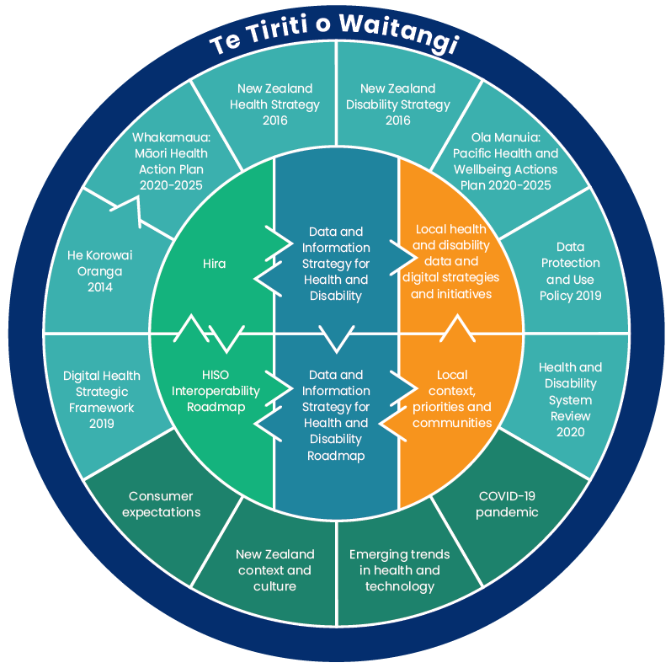

Values and behaviours
Underpinning this strategy is a set of guiding values and behaviours outlined in the Data Protection and Use Policy of New Zealand (Social Wellbeing Agency 2019), which was developed to ensure that the ways that social sector (including health and disability) organisations use and manage data reflects the expectations of New Zealanders.
The values and behaviours set out in the Data Protection and Use Policy are intended to reinforce each other and illustrate what ‘doing the right thing’ looks like in the context of collecting and using people’s data and information. For example, people expect that:
- health and disability providers, organisations and agencies will share a common approach in the way they work with people and their information
- health and disability providers, organisations and agencies will work inclusively to develop and share valuable insights that result in the improved health and wellbeing of people and communities
- people who use health and disability services will know what to expect, and will have confidence in the way health providers use their personal information.

The five values and behaviours that underpin this strategy are as follows.

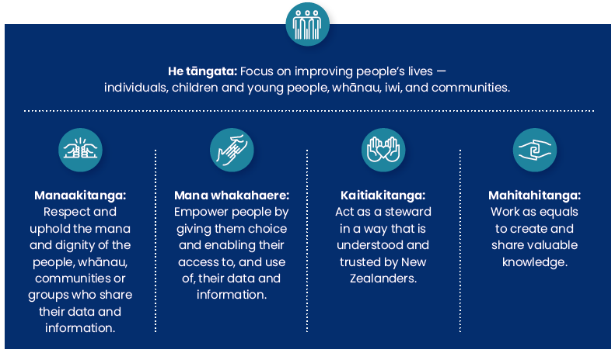

He tāngata
He tāngata has a special role: it wraps around all of the principles. It reminds us that everything we do with data and information should be done with the following question in mind: ‘how does this contribute toward the health and wellbeing of the individual or community?’ For example, we must:
- strive to create positive outcomes from any collection, sharing or use of health data and information
- use appropriate checks and balances, and ensure that information is suitable and reasonably necessary for the intended outcome.

Manaakitanga
Manaakitanga reminds us to:
- recognise and incorporate diverse cultural interests, worldviews, perspectives and needs
- include and involve consumers whenever possible
- incorporate the needs and priorities of people with a specific interest in what is done with their data and information.

Mana whakahaere
Mana whakahaere reminds us to:
- give people easy access to and oversight of their information wherever possible.

Kaitiakitanga
Kaitiakitanga reminds us to:
- be open and support people’s need to understand
- keep data and information safe and secure, and respect its value
- act swiftly in the event of a privacy breach.

Mahitahitanga
Mahitahitanga reminds us to:
- confidentially share relevant information between professionals as needed
- share (de-identified) data, analysis, results and research findings to build collective knowledge and improve health and disability services.

Identifying what matters
A key task for the development of this strategy has been to understand the issues, barriers and priorities for consumers and people working in, and providing leadership to, the health and disability sector. We carried out consultation both online and face-to-face through video-conferencing, a digital survey and discussions within existing networks and regular meetings. We converted some planned in-person hui to digital engagements during the COVID-19 response. Our consultation process involved health and disability system organisations, government agencies and consumers.
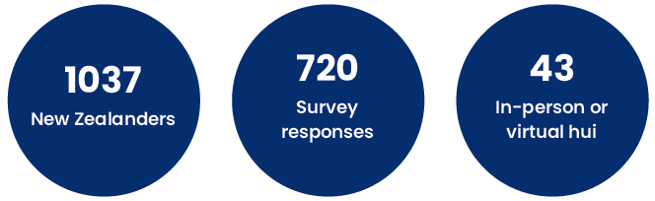

Our consultation identified the following as important requirements in the context of the development of a data and information strategy for health and disability:
- a clear focus on improving health outcomes, addressing health inequities (particularly for Māori, Pacific peoples and disabled people) and providing consumer-centred care
- a need for better quality data and information across the health and disability system
- making data more accessible and able to be shared appropriately, and removing information silos
- improved access to de-identified data for research and innovation, and to develop modern public health and population health initiatives
- greater collaboration across health and social systems, to enable more effective use of data
- leadership to establish data governance across the health system, with an emphasis on data sovereignty, including partnering with consumers and Māori
- more explicit guidance from government agencies on data sharing and accessibility
- a mandate or regulation from government agencies to accelerate interoperability and data accessibility through the implementation of data standards, where applicable
- support and resourcing for the health and disability workforce to become more data literate, more innovative, better data leaders and more effective at data governance and stewardship.

Priorities for improvement
As a result of the consultation and engagement process, we developed five priority areas for improving data use and management: data foundations, equity and data sovereignty, consumer participation, people and leadership, and data accessibility. These are the focus of this strategy.
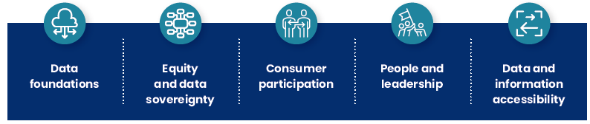

The following sections describe these in more detail.

Data foundations
The health and disability sector needs good data foundations to achieve a modern data and information system, including quality national data collections, standards, and data collection and use that enables timely and accurate health research and innovation at national and local levels. During our engagement with the sector, stakeholders raised data quality as an issue requiring immediate action. Improvements in data quality would support greater interoperability and provide us with insights that could then drive system transformation. Stakeholders saw a need for implementation of data standards within the sector and greater investment in data governance, data infrastructure and management practices.

Improvements to our approach to managing data and information will ensure that data are more accessible and stored in more consistent formats, enabling data access and sharing so the system can develop and use real-time insights for decision-making. The system must ensure data informs performance improvements, new models of care, policy, investment and funding decisions.

Specifically, there is a need to:
- develop a consistent information management operating model
- accelerate the implementation of data standards
- publish consistent data architecture and models
- develop and publish data-sharing frameworks
- adopt a data-first approach to procurement whereby data quality, standards and interoperability are prioritised in requirements and selection.
The implementation of cloud technologies and platforms will improve data sharing capabilities and enhance business intelligence, data science and innovation.

To adopt a consistent approach to the use and deployment of health information technology across New Zealand, the following data architecture principles should apply:
Data is treated as a shared asset/resource: Data is an asset that has value to consumers, health providers and the health and disability system as a whole and is managed accordingly.
Data is secure and accessible: Data is protected from unauthorised use and disclosure. As well as the traditional aspects of national security classification, this includes protection of sensitive, proprietary and evaluation information. Data is accessible for users to perform their functions.
Data is understandable: Data is defined consistently throughout the health and disability sector, and users understand what it means.
Data quality is specified and managed: Data standards specify the qualities of data elements required to meet business process needs, as well as clinical and organisational decision-making. Regular monitoring and measurement ensure compliance with data quality standards.
Data copies are minimised: Any time data is moved or copied, precious time and resources are consumed and data fidelity is potentially compromised.

Enablers
In the roadmap that accompanies this strategy, the first two years focus on addressing the set of data foundation enablers we need to support a modern health and disability system. We will need to carry out ongoing work to maintain these data foundations.

We have identified the following enablers for data foundations:

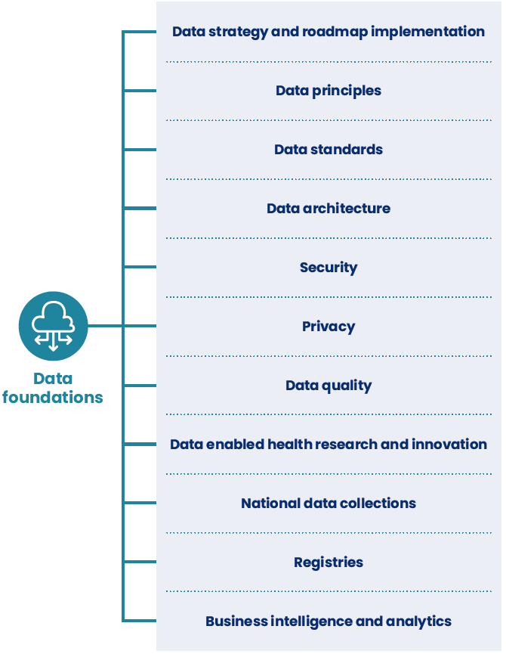

Data strategy and roadmap implementation
We will establish a national health data and information function to oversee and manage implementation of the strategy and roadmap. This will include new roles and capability at a national level with support at the local level.
Responsibilities will include:
confirming the data and information priorities for Health NZ, the Māori Health Authority, the Ministry of Health and other key agencies
development of a data and information management operating model that can be reused and scaled across the sector
development and publication of companion documents and activities to support the five themes of this strategy
establishing a sector data and information maturity model and assessments for benchmarking and measuring progress that includes Māori data maturity and makes use of an all-of-government approach (Stats NZ 2021a)
refreshing the roadmap
establishing sector working groups to support delivery
reviewing, managing and coordinating the programme of work and delivery targets.
Data principles
We will support the sector-wide adoption of current data principles, including those outlined in the Data Protection and Use Policy and the data architecture principles. We will develop and publish information management principles.
Data standards
Data standards specify the qualities of data elements required to meet business process needs and decision-making. We need to undertake regular monitoring, measurement and change management to ensure compliance with data standards.
This enabler requires:
the establishment and ongoing maintenance of a national terminology service
increased requirements for the health and disability sector and industry to use HISO and other health information data and interoperability standards
local organisations to implement tools and mechanisms to maintain data standards, and to document and audit data provenance.
Data architecture
We will establish a national health data architecture capability in the national health data and information group, and develop national tools such as shared platforms and apps to support the health and disability sector.
Security
We will develop a national catalogue of health data compliant devices, tools and technology.
Privacy
We will continue to implement protections and consumer controls over New Zealanders’ health and disability data and information while ensuring data is safely accessible in the many places it is required.
Data quality
We will develop a national health data catalogue/dictionary and a framework detailing the minimum standards for data compliance in sector contracts and commissioning arrangements.
Data enabled health research and innovation
We will establish a data service for researchers and innovators, supporting health care improvements through near real-time data-driven insights.
National data collections
We will migrate national data collections to a modern national platform designed for data science that is able to efficiently perform machine-learning activities. The platform will enable the Government to consolidate and transform large data sets so they are analytics-ready.
Registries
We will transition registries into modern domain-specific data services that support service quality assurance and improvement.
Business intelligence and analytics
We will collaborate across the sector, sharing and scaling tools, platforms and resources to reduce duplication. We will provide mechanisms for health professionals, researchers, innovators and decision-makers to access data-driven insights.

Equity and data sovereignty
This strategy supports the partnership between Māori and the Crown, underpinned by Te Tiriti o Waitangi. Disparities in health outcomes between Māori and non-Māori have been the subject of numerous reports ever since the 19th century. Good practices for data collection and the use and sharing of information are essential if we want to create a health and disability system that is more equitable.

Equity and data sovereignty are individually important themes that affect Māori and other groups in New Zealand. These two themes are intrinsically interlinked; we have therefore combined them into a single priority for the purposes of this strategy.

Inequities in health outcomes are prevalent in many specific population groups within New Zealand, including Pacific peoples, disabled people and people living in poverty. We need robust, reliable and consistent data standards, collection methods, data quality and governance to address these inequities.

One in four New Zealanders has a physical, sensory, learning, mental health or other impairment. The New Zealand Government has committed to collecting better data about disabled people and addressing health inequities between disabled and non-disabled people.

There is a risk of introducing more inequity into the health and disability system with the introduction of new digital technologies, if not all New Zealanders are able to access these technologies or benefit from them. At the same time, digital solutions can provide services, data and information that improve equity. The insights we can gain from data and information will help the sector to prioritise opportunities to target inequity and to improve health for those with the poorest outcomes. A key way we can do this is by partnering with Māori and embracing co-design of programmes of work that aim to ensure Māori have the information needed to make evidence-based decisions. This principle is about collecting the right data for Māori and ensuring that it is available for use by iwi and Māori health providers.

Enablers
We have identified the following enablers for equity and data sovereignty:

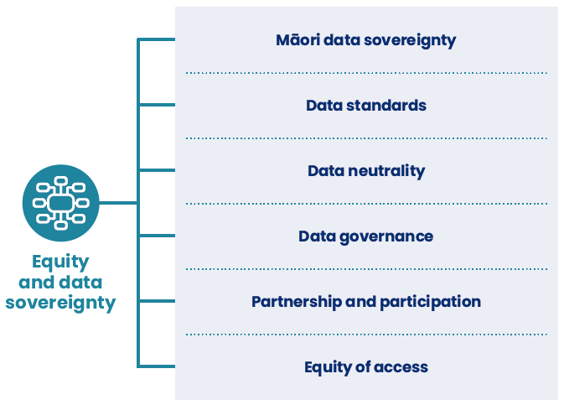

Māori data sovereignty
We will establish a national health data sovereignty engagement framework and a wānanga to define the data and information approach that best works for Māori, by Māori. A Māori data sovereignty education/literacy approach should be included in data literacy initiatives.
Data standards
We will develop equity measures for data standards in collaboration with HISO and Stats NZ, covering data collection methods and data models that ethically capture data for all New Zealanders.
Data neutrality
Organisations and industry have a responsibility to understand, neutralise and mitigate disparities of health care provision and outcomes resulting from data bias and artificial intelligence and machine-learning design that may compound the effects of data bias. We will develop resources and training to help address data bias.
Data governance
We will prioritise co-design with Māori on health data governance approaches and decision-making as part of a national health data sovereignty engagement framework.
Partnership and participation
We will assist health organisations to meet their responsibilities to engage with local iwi and community groups, to better understand local requirements, to develop partnerships and to meet their obligations under Te Tiriti o Waitangi.
Equity of access
We will ensure equitable access to information by addressing issues pertaining to literacy levels, accessibility, mode of delivery and cultural differences.

Consumer participation
All people should have access to their health records so they can actively manage their own health and wellbeing. Consumer representation in data governance is fundamental to ensuring that our approach to health data management meets consumer expectations.

New Zealanders currently have limited access to their own health and disability data and information. Due to the sector’s fragmented and siloed approach to collecting, sharing and storing data, people are often asked to repeat their health information to a succession of providers as they navigate the health system. Differences in digital and data literacy, and a growing digital divide, mean that not all people are able to interact digitally with the health and disability system.

Improving data literacy is a key step to improving this situation. The health and disability sector should provide consumer-focussed information about how health and disability data is used, making sure to incorporate the perspectives of consumers and their whānau to show the value of data to health care. People should be able to trust in the quality, security and privacy of their health and disability data, and be able to access, update, contribute to and – as needed – correct their own health information. People need to be able to authorise or delegate access to their health information (for example, to whānau members), and see the details of access that has been granted to others. People also need to be able to report on their own health outcomes, through consumer experience and outcome measures.

Enablers
We have identified the following enablers for consumer participation:

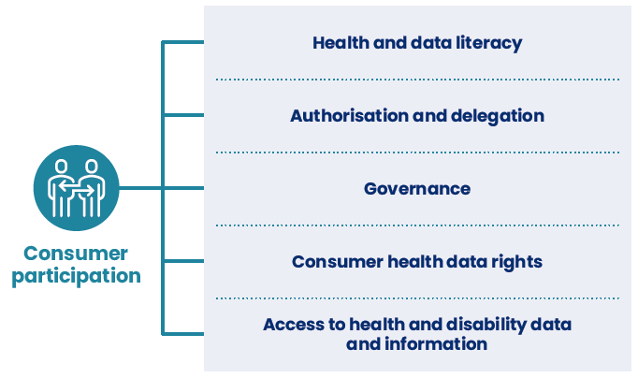

Health and data literacy
We will provide a multi-channel national health and disability data and information service that enables people to find out how data is used and why, what safeguards are in place, how decisions are made and what they can expect from health professionals and health and disability providers regarding the use of their data. Such a service will ensure transparency and build the public’s support and trust.
Authorisation and delegation
We will develop a way for consumers to manage authorisation of access (and delegated access) to their health data. This will require developing a national authorisation and delegation framework and implementing a national digital health identity programme.
Governance
We will provide education and support to encourage greater consumer participation in data governance at local and national levels.
Consumer health data rights
New legislation may be required to establish a health consumer data right and supporting health provider responsibilities. This would provide the sector with clarity on the question of data ownership and the mandate for data use for system stewardship, research and innovation.
Access to health and disability data and information
Health providers, policy-makers and industry must provide mechanisms that allow consumers to have full access to all of their health data and information, including all patient notes, test results, images, appointments, assessments, letters and reports. Additional legislation may be required for this purpose. Health information contained within electronic systems must be made available free of charge to consumers, and people must be able to update, contribute to and - as needed - correct their own health information.

People and leadership
The health and disability sector requires a workforce skilled in data governance and which uses and respects data as a taonga. Central to this is the sector’s responsibility to act in accordance with its role as the kaitiaki, rather than the owner, of health data and information.

The Health and Disability System Review (HDSR 2020) advised that for the health and disability system to get the most value from investment in digital transformation, investment will be needed in people as well as processes and technology. The planned shift of much of the health workforce to Health NZ will require accurate workforce data. Investment in building human capability and a data-savvy workforce is essential to creating a data-driven health system. About 220,000 people currently work in the health and disability sector, with varying levels of data literacy. Improving data quality would benefit health leaders relying on evidence for decision-making, increase their confidence in the use of data, and improve the sector’s workforce planning and development. New and emerging health data roles will also require investment and resourcing, so that we can improve the way we manage, use and interrogate data. We need to be able to make the most of emerging technologies reliant on rich data sets.

Data and information leadership and governance needs to take both system-wide and local approaches. If we wish to accelerate progress, sharing knowledge and resources, and scaling and reusing tools and capability will be essential.

Specifically, we need to:
- work together at a systems level, developing a data governance network to coordinate and collaborate across the health and disability sector
- develop rules and guidance on who can share and access data and for what purposes, with clarity on decision-making powers and accountabilities
- ensure ethical use of data and information for secondary purposes, such as research
- develop guidance on how to store, access and manage data with respect for data sovereignty and consumer rights
- enable innovation and support the lifecycle from research to innovation to initial adoption and then enable the scaling of this via replication across the system
- use data to drive decision-making across the system to support operational performance gains and monitor system performance
- improve access to data for innovators and researchers by creating a data service that will help accelerate innovation within the sector
- enhance public trust and confidence by implementing good governance mechanisms, including clear information on good practices, terms of reference, roles and responsibilities
- ensure the participation of and representation from local communities, reflecting diversity and inclusive of consumers, family/whānau and Māori in data governance and the co-design of data management systems at both national and local levels.

Enablers
We have identified the following enablers for people and leadership:

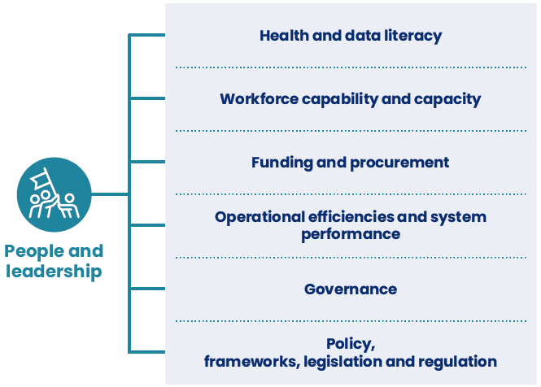

Health and data literacy
Data literacy is the ability to read, work with, analyse and communicate with data. Such literacy is a skill that empowers health workers at all levels to ask the right questions of data, build knowledge, make decisions and communicate with others. We could improve data literacy for health workers through a range of initiatives at all levels, from undergraduate and technical training providers through to local employers or national literacy programmes.
Workforce capability and capacity
New data roles are emerging, and more will be required in the future as the sector matures in its approach to data management. National and local organisations will need to invest in dedicated data roles to support better information management literacy, practices and capability.
Funding and procurement
Funding and procurement mechanisms need a data-first approach, making use of existing investment and embedding the approach into health system operations.
Operational efficiencies and system performance
Data-informed decision-making could lead to operational improvements and a better ability to monitor the system’s performance. Access to real-time operational data allows business decision-making to happen at pace, and enables us to monitor and adjust the system in response to changing demands. A whole-of-system view of data will provide us with longer-term insights to enable strategic planning and new models of care.
Governance
This strategy and roadmap have identified a need for national and local health data governance councils, for partnership with Māori and consumers and for our systems to be representative of local communities, including Pacific communities.
Data governance is foundational to ensuring compliance with data standards, architecture, privacy, security and sharing requirements, and for improved collaboration, networking and sharing of scarce resources. Data governance that enables innovation and research through improved access to de-identified or synthetic data will support the development of new models of care and improve the way we deliver health and disability care. We will support our health data governance through development of a framework that is co-designed with consumers and Māori. We will need to implement data governance training at board and executive levels, and for all people on data governance councils.
Policy, frameworks, legislation and regulation
We will work to define the regulatory, legislative and policy changes we need to make to accelerate implementation of this strategy and its companion roadmap. Legislative changes may be required to support improved data access for consumers and to meet the Crown’s obligations under Te Tiriti o Waitangi with respect to health data and data sovereignty.

Data and information accessibility
Much health and disability data and information is siloed within organisations. While most organisations and providers understand their responsibilities regarding clinical data, they do not see that they have an obligation to routinely share data with consumers, other health providers or other services. While some parts of the health system have established mechanisms for sharing data between primary and secondary care, there is little access to health and wellbeing data in the community, for iwi and hapū, for private providers or social services, or to data held or generated by consumers. Making health data more accessible and useful is fundamental to improving the health outcomes of all New Zealanders.

We need effective data sharing frameworks, authorisation and delegation frameworks and sector contract requirements, along with mechanisms to better support innovation and research. Improving how the sector manages and codes health data will support data accessibility and interoperability. Much data is currently held in inconsistent formats and code sets. Providing mechanisms to share, reuse and maintain clinical data will support the quality of data being shared, the consistency of reporting and the quality of the insights we can gain through analytics and machine learning.

Enablers
We have identified the following enablers for data and information accessibility:

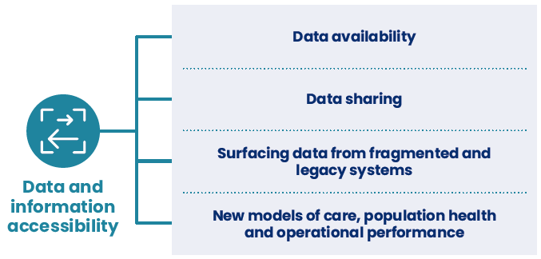

Data availability
The use of a national terminology service will improve data quality at the point of care, and provide more context to health information for both clinicians and consumers. Providers would need to integrate this service with new applications and platforms through their contract and procurement arrangements.
Data sharing
If we want to create an ecosystem in which health data is effectively shared or made appropriately accessible, we will need to develop guidance for the sector, which in turn will require new frameworks. The development and implementation of a new health data sharing and accessibility framework will be critical to making data more accessible in ways that are consistent with public and consumer expectations. We will support new provisions for data sharing and accessibility through changes to contracts and procurement systems and a review of legislation, including the Privacy Act 2020 and Health Information Privacy Code.
Surfacing data from fragmented and legacy systems
There is a need for the system to provide access to data rapidly, even where application consolidation and the replacement of legacy systems can only happen in the longer term. We can realise the value from data in the short and medium term by ensuring data can flow from fragmented and legacy systems into modern platforms that provide access for analytical and decision-making purposes.
New models of care, population health and operational performance
We need to develop new models of care and population health measures to address inequities in care provision and outcomes and ensure all New Zealanders enjoy good health and wellbeing. We can use the insights we derive from big data sets to improve the health system’s operational performance. We will need to develop access to big data and agreements about access and use.

Next steps
Improving the sector’s governance, use and sharing of data and information will require a high degree of collaboration across organisations, nationally and locally. If health data is the bedrock of the health and disability system, then the priority areas outlined in this strategy are its essential components.
The accompanying roadmap outlines actions and timeframes for operationalising this strategy.

References
Beehive. 2021. Major reforms will make healthcare accessible for all NZers. URL: https://www.beehive.govt.nz/ release/major-reforms-will-make-healthcare-accessible-all-nzers (accessed 28 June 2021).
Data Futures Partnership. 2019. Trusted Data Use in Aotearoa New Zealand Guidelines. Wellington: Data Futures Partnership.
Department of Prime Minister and Cabinet (DPMC). 2021. The new health system. URL: https://dpmc.govt.nz/our-business-units/transition-unit/response-health-and-disability-system-review/information (accessed 28 June 2021).
Durie M. 1994. Whaiora: Maori Health Development. Auckland: Oxford University Press.
Gwee S. 2021. The Importance of Increasing Access to High-quality Health Data. URL: https://www.oecd-forum.org/posts/the-importance-of-increasing-access-to-high-quality-health-data (accessed 15 June 2021).
HDSR. 2020. Health and Disability System Review: Final Report: Pūrongo Whakamutunga. Wellington: Health and Disability System Review.
Health, Quality & Safety Commission New Zealand. 2011. The Triple Aim. URL: https://www.hqsc.govt.nz/news-and-events/news/126/ (accessed 15 June 2021).
Ministry of Business, Innovation and Employment. 2020. Consumer Data Right. URL: https://www.mbie.govt. nz/business-and-employment/business/competition-regulation-and-policy/consumer-data-right/ (accessed 15 June 2021).
Minister of Health. 2016. New Zealand Health Strategy: Future direction. Wellington: Ministry of Health.
Ministry of Health. 2014. He Korowai Oranga. URL: https://www.health.govt.nz/our-work/populations/maori-health/he-korowai-oranga (accessed 15 June 2021).
Ministry of Health. 2019a. Digital Health Strategic Framework. URL: https://www.health.govt.nz/our-work/digital-health/digital-health-strategic-framework (accessed 15 June 2021).
Ministry of Health. 2019b. Vision for health technology. URL: https://www.health.govt.nz/our-work/digital-health/vision-health-technology (accessed 15 June 2021).
Ministry of Health. 2020a. Annual Report for the Year Ended 30 June 2020: Ministry of Health. Wellington: Ministry of Health.
Ministry of Health. 2020b. HISO 10083:2020 Interoperability roadmap: Driving the shift to a fully interoperable digital health ecosystem. Wellington: Ministry of Health.
Ministry of Health. 2020c. The National Asset Management Programme for District Health Boards. Report 1: The current-state assessment. Wellington: Ministry of Health.
Ministry of Health. 2020d. Whakamaua: Māori Health Action Plan 2020–2025. Wellington: Ministry of Health.
Ministry of Health. 2020e. Ola Manuia: Pacific Health and Wellbeing Action Plan
2020–2025. Wellington: Ministry of Health.
Ministry of Social Development. 2016. New Zealand Disability Strategy 2016–2026. Wellington: Office for Disability Issues.
NZ Tech. 2021. Digital Skills for our Digital Future. URL: https://nztech.org.nz/reports/digital-skills-for-our-digital-future/ (accessed 15 June 2021).
Office of the National Coordinator for Health Information Technology (United States). 2020. 21st Century Cures Act: Interoperability, Information Blocking, and the ONC Health IT Certification Program. https://www.healthit.gov/curesrule/ (accessed 15 June 2021).
Social Wellbeing Agency. 2019. Data Protection and Use Policy. Wellington: Social Wellbeing Agency.
Stats NZ. 2018. Data Strategy and Roadmap for New Zealand. URL: https://www.data.govt.nz/about/data-strategy-and-roadmap-setting-the-direction-for-new-zealands-data/data-strategy-and-roadmap/ (accessed 15 June 2021).
Stats NZ. 2020. COVID-19 Lessons Learnt: Recommendations for improving the resilience of New Zealand’s government data system. Wellington: Stats NZ.
Stats NZ. 2021a. Mana Ōrite Relationship Agreement. URL: https://www.stats.govt.nz/about-us/what-we-do/mana-orite-relationship-agreement/ (accessed 28 June 2021).
Stats NZ. 2021b. Government Data Strategy and Roadmap 2021. URL: https://www.data.govt.nz/docs/data-strategy-and-roadmap-for-new-zealand-2021/ (accessed 15 September 2021).
Te Mana Raraunga. 2016. Te Mana Raraunga Māori Data Sovereignty Network Charter. URL: https://www.temanararaunga.maori.nz/ (accessed 15 June 2021).
Understanding Patient Data. 2017. Introducing Patient Data. URL: https://understandingpatientdata.org.uk/ (accessed 15 June 2021).
Waitangi Tribunal. 2019. Hauora: Report on Stage One of the Health Services and Outcomes Kaupapa Inquiry: WAI 2575. Lower Hutt: Legislation Direct.

Appendix A: Challenges and opportunities
Current state | Future state | Outcomes
Health data and information is siloed and difficult to access, share or use for real-time insights | Health data and information is accessible and available in consistent formats, enabling synchronous data sharing and real-time insights and decision-making. System performance improvements, new models of care, policy, investment and funding decisions are data-driven. | Improved quality, safety and experience of care
Data is not readily available for research, analytics or innovation | Data sets are available, supported by guidance on accessibility and governance.
Health care professionals cannot access a person’s complete health care record | Complete health records, including contextual information as relevant from other agencies, are available when needed.
People cannot access or contribute to their own health records, and they have limited ability to access health care themselves or to consent to data sharing with whānau and care providers | People actively participate in their own health care. They can access and contribute to their own health records. They are able to schedule, manage and access care.
Aging infrastructure and investment is not coordinated, collaborative or consistent, affecting our ability to aggregate and analyse data | Accelerated adoption of cloud technologies results in efficiencies, collaboration at scale, and coordinated change. | Best value for public health system resources
Health workforce shortages and a deficit in skilled leaders and data specialists contribute to a lack of sector-wide capability and capacity to manage, govern and use data effectively | A skilled and proficient health workforce governs, uses and respects data as a taonga. As new data management professions emerge, the health sector is seen as an aspirational place to work, and attracts and retains highly capable talent.
There is a risk of introducing more inequity into the system with new technology and advances in the use of data, and existing inequities in care and outcomes persist | Equity is measured, understood and addressed at a system-wide level and at a personal level with consumers. Māori and consumers are active participants in data governance, and their contributions create more effective data management. | Improved health and equity for all populations

