COVID-19 Mortality in Aotearoa NEW ZEALAND
Inequities in Risk
September 2022

Citation: Public Health Agency. 2022. COVID-19 Mortality in Aotearoa New Zealand: Inequities in Risk. Wellington: Ministry of Health.
Published in September 2022 by the Ministry of Health
PO Box 5013, Wellington 6140, New Zealand
ISBN 978-1-99-110080-1 (online)
HP 8611
This document is available at health.govt.nz
This work is licensed under the Creative Commons Attribution 4.0 International licence. In essence, you are free to: share ie, copy and redistribute the material in any medium or format; adapt ie, remix, transform and build upon the material. You must give appropriate credit, provide a link to the licence and indicate if changes were made.

Summary
Over the past year, Aotearoa New Zealand SARS-CoV-2 (COVID-19) has been circulating in the community. During this period, deaths attributed to COVID-19 (that is, deaths where COVID-19 was identified as the underlying cause or a contributory cause of death) have increased in number. Prior to 2022, 55 deaths in Aotearoa New Zealand were attributed to COVID-19. Between 1 January and 26 August 2022 there were a further 1,797 such deaths (158 in Māori, 111 in Pacific peoples, 60 in Asian people and 1,458 in ‘European and Other’ people).
- From 1 January to 26 August 2022, the population-based mortality risk (often called mortality rate) from COVID-19 was 33.7 per 100,000 of population, and the case fatality risk (CFR; often called case fatality rate) was 107.0 per 100,000 reported cases. The infection fatality risk will lie between the population-based and case-based risks, but cannot be estimated from available data.
- A population-based mortality risk estimate incorporates both the risk of becoming infected and the risk of poor outcomes following infection. A CFR estimates the risk of death attributable to COVID-19 among reported cases. However, the CFR is more challenging to interpret, because estimates are affected by the proportion of infections that are identified and reported as cases.
With the rise in COVID-19-attributed deaths, it is increasingly important to examine inequities in the direct health effects of COVID-19 across our population. The Public Health Agency has undertaken exploratory analysis of COVID-19-attributed mortality to identify and quantify inequities in the burden of COVID-19 mortality in Aotearoa New Zealand. This report presents the results of that analysis.
While age is the strongest predictor of population-based COVID-19 mortality, this analysis suggests the following (after accounting for age differences between groups):
- There was higher risk for Māori and Pacific peoples: respectively 2.0 and 2.5 times the risk seen in the European and Other group.
- The absolute level of risk increases with age across all ethnicities. However, in all age groups, the risk was higher for Māori and Pacific peoples than it was for the European and Other group. For example, in those aged 70–79 years, there were 43 deaths (corresponding to a risk of 170.3 per 100,000) among Māori and 264 (82.2 per 100,000) among European and Other, and in those aged under 60 years this figure was 24 (3.4 per 100,000) and 35 (1.5 per 100,000) respectively.
- There was increased risk for those in socio-economically deprived groups: the most deprived 20% of the population had 3 times the risk of those in the least deprived 20%. Similar to ethnicity patterns, the absolute risk varied by age group, but in all age groups the 20% most deprived had the highest risk. For example, in those aged 70–79 years, there were 100 deaths (a risk of 158.2 per 100,000) in the 20% most deprived and 32 (37.3 per 100,000) in the 20% least deprived. In those aged under 60 years this was 36 deaths (4.1 per 100,000) and 4 deaths (0.5 per 100,000) respectively.
- The presence of one or more comorbidities was associated with 6.3 times the risk seen in those without comorbidities.
- Around a quarter of the higher age-adjusted risk in Māori and Pacific peoples was mediated by socio-economic deprivation. Less than half of the increased risk was explained by sex, comorbidities and vaccination status (when considered as fewer than 2 doses or 2 or more doses). However, when the effect of booster doses was considered in a separate analysis, vaccination status accounted for around a quarter of the increased risk for Māori and Pacific peoples compared with European and Other.
While the risk of COVID-19-attributed mortality was much lower in younger people than in older groups (there were 78 deaths among those aged under 60 years), inequity in population-based risk was substantial: the age-adjusted estimates for those aged under 60 years showed that the risk was 3.7 times for Māori and 3.9 times for Pacific peoples that of European and Other.
- The mortality risk for Māori and Pacific peoples was more likely to be mediated by socio-economic deprivation (half of the increased risk was explained by deprivation) for those aged under 60 than for all age groups considered together.
- Having a serious comorbidity is uncommon in under 60-year-olds but imparted a risk of mortality 78 times that of those with no comorbidity; comorbidities were recorded for 72 of the 78 under 60-year-olds whose deaths were attributable to COVID-19. Comorbidity explained 59% of the increased risk for Māori and 69% of the increased risk for Pacific peoples in this age group.
CFRs were also higher in Māori and Pacific peoples compared with the CFR in European and Other, especially in those aged under 60 years of age. The effect of comorbidities on CFR was also more substantial in those aged under 60 than it was in all age groups considered together.
There was consistent evidence across all analyses that vaccination had a strong protective effect: there was a 62% reduction in the risk of death during the analysis period for those who had received 2 or more vaccination doses compared with those who had received fewer than 2 (from population-based risk estimates). Manatū Hauora is planning a full analysis of vaccine effectiveness as a separate report.
Aotearoa New Zealand has a low level of COVID-19 mortality compared with other countries. However, a substantial portion of the population is experiencing a higher risk of mortality, as the analysis in this report shows.
For the next phase of pandemic management, Manatū Hauora, Te Whatu Ora and Te Aka Whai Ora will continue to engage with Māori through the National Iwi Chairs Forum, Māori and Pacific health providers, community groups and other organisations to inform the overall COVID-19 response, and ensure equitable outcomes for Māori and Pacific peoples.

Contents
Summary iii
Introduction 1
Objectives 2
Methods 3
Data sources 3
Definitions of mortality, ethnicity and other factors of interest 4
Descriptive analysis 4
Risk analyses 5
Results 6
Population characteristics on 1 January 2022 6
COVID-19 mortality and time trends in 2022 7
COVID-19-attributed mortality in priority populations 8
Regression analysis: population-based risk of COVID-19-attributed mortality 11
Regression analysis: COVID-19-attributed case fatality risks 15
Discussion 17
Summary 17
Strengths and limitations 17
Comparing Aotearoa New Zealand’s COVID-19 mortality inequities with Australia, the United Kingdom and the United States 20
Health equity with a systems approach 21
Conclusion and next steps 22
References 23
Appendix: Regression results tables 26

List of tables
Table 1: Population characteristics of Aotearoa New Zealand on 1 January 2022 6
Table 2: COVID-19-attributed death counts* (with risks and 95% CI per 100,000 of population) by age group and ethnicity, 1 January to 26 August 2022 9
Table 3: COVID-19-attributed death counts* (with risks and 95% CI per 100,000 of population) by age group and deprivation quintile, 1 January to 26 August 2022 9
Table 4: Regression analysis: population-based COVID-19-attributed mortality risk, 1 January to 26 August 2022 26
Table 5: Regression analysis: COVID-19 case fatality risk, 1 January to 26 August 2022 27

List of figures
Figure 1: Weekly death counts by cause of death, 1 January to 22 August 2022 7
Figure 2: Age-standardised risk (and 95% confidence intervals) of mortality attributed to COVID-19 by ethnicity and by socio-economic deprivation 10
Figure 3: Regression analysis: Age-adjusted* risk ratios, population-based COVID-19 attributed mortality risk, 1 January to 26 August 2022 12
Figure 4: Regression analysis: Fully-adjusted* risk ratios, population-based COVID-19 attributed mortality risk, 1 January to 26 August 2022 12

Introduction
Globally, the COVID-19 pandemic has exacerbated social, economic and health inequities. Population groups such as ethnic minorities, indigenous people, people living in more deprived socio-economic areas, those who have disabilities and those who have underlying comorbidities have experienced higher rates of COVID-19 morbidity and mortality (World Health Organisation (WHO) 2021).

The impact of health inequities is also evident in Aotearoa New Zealand. Research has found evidence of social and economic gradients in health status and mortality both historically and now. For example, analysis of the 1918 influenza pandemic indicates mortality rates that were 7-fold higher in Māori compared with New Zealand Europeans (Summers et al 2018). Life expectancy still varies substantially between population groups. In 2017–2019, the average life expectancy for Māori was more than 6 years shorter than the national average, and for Pacific peoples it was more than 4 years shorter. Over those years, for those who lived in the most socio-economically deprived areas, life expectancy was almost 10 years shorter than it was for those who lived in the least deprived areas (Stats NZ Tatauranga Aotearoa 2021). Māori die at twice the rate as non-Māori from cardiovascular disease, and tamariki Māori have a mortality rate 1.5 times the rate of non-Māori children (Wehipeihana et al 2022).

Avoidable causes of death are large contributors to the difference in life expectancy. Recent research has estimated that nearly half of all deaths for Pacific peoples (47.3%) and over half of all deaths for Māori (53.0%) can be potentially attributed to avoidable causes of death, compared with less than one quarter (23.2%) for the non-Māori, non-Pacific peoples population (Walsh and Grey 2019).

Access to health care varies by ethnicity. In 2020, about 20% of Māori and 16% of Pacific peoples had unmet need for general practice services due to cost barriers, compared with 11% for Asian people and 13% for European and Other (Ministry of Health 2022b).

Geographical areas with a higher risk of an unequal impact of a COVID-19 outbreak were those areas with higher socio-economic deprivation, lower access to care and higher reported comorbidities. These areas tend to have higher populations of Māori and Pacific peoples (Wiki et al 2021). There are strong disparities between Māori, Pacific peoples and other ethnic groups in terms of the prevalence of conditions that may exacerbate the impact of COVID-19, such as chronic pulmonary, liver or renal disease (Gurney et al 2020). Māori and Pacific adults are at greater risk of hospitalisation due to COVID-19 and severe COVID-19 (Steyn 2021).

COVID-19 has put a spotlight on inequity: particularly Māori health inequity. Māori are overrepresented in figures for many types of illness. Unequal distribution of and exposure to the determinants of poor health could increase the risk of COVID-19 infection and mortality for Māori (Wehipeihana et al 2021).

Manatū Hauora has an obligation under Te Tiriti o Waitangi to reduce and eliminate disparities in health and its determinants for all people. Prior to 2022, there had been 55 deaths attributed to COVID-19. In the 8 months since (1 January to 26 August 2022), there were a further 1,797 deaths. Past pandemics (the 1918 influenza pandemic and the H1N1 virus) have disproportionately affected Māori (Wehipeihana et al 2021). In the light of accumulating levels of mortality and other poor health outcomes, it is becoming imperative that we consider inequities in the impact of COVID-19 mortality.

Objectives
This report provides analysis of inequities in COVID-19 mortality through:
- examining the time trends in cases and mortality figures to understand past risk and potential future risk
- using age-stratified data to quantify differences by ethnicity and/or socio-economic deprivation
- exploring the intersection between ethnicity, deprivation and other determinants of inequity using available surveillance data, including examination of inequities for those aged under 60 years where larger disparities have previously been noted.

Methods

Data sources
For the purposes of this report, we based population denominators on the COVID-19 Vaccination and Immunisation Programme (CVIP) Population Status: this is a list of the known population and their vaccination status. The list includes individuals who are part of the Health Service User (HSU) 2021 population, have an activity recorded in the COVID-19 Immunisation Register or have a booking recorded in the National Immunisation Booking System. This data may differ from published statistics, as it is sourced directly from systems that will not reflect any manual adjustments made when preparing for media releases / daily briefings. This data uses the HSU 2021 population, which was a point-in-time object. A person was included in the 2021 HSU if they received any health services, including a COVID-19 vaccine, in the 12-month period between 1 January 2021 and 31 December 2021. All person records had an NHI; this was used to link all other data.

We sourced date of death (from any cause) from the NHI database, and COVID-19-specific mortality from a variety of sources, including mortality data and death documents. We sourced COVID-19 case-related data from national notifiable disease surveillance database (EpiSurv) and supplemented it with data from the National Contract Tracing System. We retrieved sex, age and ethnicity data from the NHI database and supplemented it with data from EpiSurv where otherwise unavailable. We linked socio-economic deprivation, based on the residential area NZDep2018 score (Salmond and Crampton 2012), to NHI via the most recent address listed in the NHI database.

M3 and P3 comorbidity indices draw on in-hospital diagnosis codes and pharmaceutical dispensing data, respectively. The M3 index uses ICD-10 coded diagnoses from National Minimum Dataset hospital discharge records to code long-term conditions for the 5-year period to 1 June 2022 (noting that there will not be complete data across 5 years for all deaths in 2022) (Stanley and Sarfati 2017). The P3 index uses pharmaceutical dispensing data covering all community-dispensed medications for the study population in the year to 1 June 2022, coded using a modified version of the Anatomical Therapeutic Classification system (Stanley et al 2020). The M3 and P3 indices provide data on presence of specific conditions and classes of medications dispensed, respectively, and provide a severity score based on which condition and mediations have been identified.

We extracted and merged all data on 26 August 2022, with cases and deaths data that had been reported up to 5pm on that day.

Definitions of mortality, ethnicity and other factors of interest
Deaths for which COVID-19 was determined to be the underlying cause or a contributing cause of the death are termed COVID-19 ‘attributed’ deaths. This includes deaths that occurred more than 28 days after the case report. For the purpose of calculating the denominator for CFRs, we defined a case as a person who reported a positive COVID-19 test during 2022.

We coded sex as male or female. We measured age at 1 January 2022, and used this as a continuous variable for age-adjusting estimates and as a categorised variable (0–59, 60–69, 70–79, 80–89 and ≥90 years) for presenting the crude effect of age on mortality. Age under 60 years was not further stratified when used as a categorical variable, due to the small number of deaths in those aged under 60 years. We prioritised ethnicity into a categorical variable, the hierarchy being Māori, Pacific peoples, Asian, European and Other (all other ethnicities). NZDep2018 deciles were recoded into quintiles, from the 20% least deprived to the 20% most deprived.

We used the comorbidity M3 and P3 indices to create the comorbidity variables: we coded ‘any hospital-identified comorbidity’ as yes if the M3 index score was greater than 0, meaning at least one comorbidity had been identified, or otherwise no. Similarly, we generated ‘any pharmacy-identified comorbidity’ based on the P3 index score. We also used the M3 index score to generate a categorical variable, ‘hospital-identified comorbidity severity’, defined as no comorbidity (a score of 0), moderate (a score of >0 but <1) and severe (a score of 1 or more).

We defined vaccination status in 2 ways. The primary variable for analysis was vaccination status on 1 January 2022 for population-based analyses, defined as ‘fewer than 2 doses’ (that is, no doses or one dose) or ‘2 or more doses.’ For case-based analyses, vaccination status was based on status when reported as a case. As uptake of the third (‘booster’) dose increased substantially in the first 6 weeks of 2022, it was not possible to further differentiate the number of doses for an analysis covering mortality over this period. To examine the impact of a third dose on deaths from 1 March 2022, we defined vaccination status on 1 March 2022 by number of doses (fewer than 2 doses, 2 doses or 3 or more doses); for cases, the vaccination status was defined based on status when reported as a case.

Descriptive analysis
We undertook all analyses using STATA MP/17.0 (StataCorp, LLC) statistical software.

We censored the population for deaths before 1 January 2022 to include only those alive at the beginning of the year. We described the population by ethnicity and other explanatory variables (counts and frequencies). We calculated the weekly death frequencies of deaths with COVID-19 by cause of death (whether COVID-19 was the underlying cause, a contributory cause or unrelated to the cause, or this was unknown) to examine the time trends. We stratified frequencies of COVID-19-attributed mortality by ethnicity and by deprivation quintile by age, and calculated risk and 95% confidence intervals (95% CI). We then calculated the age-standardised risk of mortality for ethnicity and for deprivation categories, standardising to the Māori population age structure on 1 January 2022 within the CVIP population status dataset.

Risk analyses
We calculated population-based risk (cumulative incidence) of COVID-19-attributed mortality and CFRs per 100,000 of population and cases, respectively. We estimated risk ratios with 95% CIs for all variables (for vaccination, this was the binary variable measure on 1 January 2022) using Poisson regression with robust standard errors.

We also produced adjusted models: firstly, we produced a model for each variable adjusted for age (as a continuous variable), then the age-adjusted ethnicity model had each of the other variables tested one at a time to examine how much of the ethnicity risk ratios could be explained by each. We also undertook this process for the age-adjusted deprivation model.

We included all explanatory variables defined above, except deprivation, in the final fully adjusted model; we separately examined deprivation in this model, but did not include it due to its being on the causal pathway between ethnicity and mortality. Any hospital-identified comorbidity was substituted in a sensitivity analysis by (a) the hospital-identified comorbidity severity categorical variable and (b) any hospital-identified comorbidity; we used the M3 index-based hospital-identified comorbidity as the main comorbidity measure, as noted in Gurney et al 2020. The M3 index reflects more serious comorbidity and includes conditions for which pharmaceuticals are not used.

We undertook restricted analyses for under 60-year-olds and those for whom COVID-19 was an underlying or contributing cause of death and undertook a secondary analysis with the population censored for deaths before 1 April 2022, and an age-adjusted ethnicity model was produced as above, and a fully adjusted using the 3-level vaccination variable.

For all adjusted models, we assessed model fit using Akaike's information criterion, and also assessed co-variance.

Results

Population characteristics on 1 January 2022
According to the CVIP data source, the population totalled 5,325,456 people, after censoring the dataset for all deaths before 2022 (Table 1). There were almost equal numbers of males and females, and three quarters of the population was under 60 years of age. In terms of ethnicity, 15% were Māori, 7% Pacific peoples and 15% Asian. With respect to comorbidities, 13% of people had any hospital-identified comorbidity, likely reflecting more serious health conditions than the 42% with any pharmacy-identified comorbidity score. Almost three quarters of the population in Aotearoa New Zealand had had 2 or more COVID-19 vaccination doses by 1 January 2022.

Table 1: Population characteristics of Aotearoa New Zealand on 1 January 2022
 |  | Number | (%)
Sex | Male | 2,648,311 | (49.7)
 | Female | 2,670,934 | (50.2)
 | Missing | 6,211 | (0.1)
Age group* | <60 | 4,133,023 | (77.6)
 | 60–69 | 579,270 | (10.9)
 | 70–79 | 390,463 | (7.3)
 | 80–89 | 173,814 | (3.3)
 | ≥90 | 37,800 | (0.7)
 | Missing | 11,086 | (0.2)
Prioritised ethnicity | Māori | 803,785 | (15.1)
 | Pacific | 393,462 | (7.4)
 | Asian | 837,068 | (15.7)
 | Other | 3,289,944 | (61.8)
 | Missing | 1,197 | (0.0)
Any hospital-identified comorbidity | No | 4,622,301 | (86.8)
 | Yes | 703,148 | (13.2)
Any pharmacy-identified comorbidity | No | 3,088,664 | (58.0)
 | Yes | 2,236,792 | (42.0)
Has had 2 or more doses of COVID-19 vaccine | No | 1,428,300 | (26.8)
 | Yes | 3,897,156 | (73.2)
 | Total | 5,325,456
* Age not further stratified due to low numbers of deaths in those aged under 60 years

COVID-19 mortality and time trends in 2022
Figure 1 shows total weekly COVID-19 mortality (including all deaths within 28 days of the case report and/or deaths attributed to COVID-19) in 2022 to 22 August. Of the 2,598 deaths where COVID-19 was a factor from 1 January to 26 August 2022, COVID-19 was the underlying cause for 1,146 and the contributing cause in a further 651 deaths; 539 deaths were incidental; and the cause of death was not available for 262 deaths.

The 1,797 deaths attributed to COVID-19 (that is, for which COVID-19 was the underlying or a contributory cause) represent a population mortality risk of 33.7 per 100,000 of population in this period, and a CFR of 107.0 per 100,000 cases among the almost 1.7 million cases in the year to date. Mortality peaked in the week ending 31 July, when almost 150 deaths were attributed to COVID-19, following the shift in case trends towards older age groups, among whom mortality risk is higher.

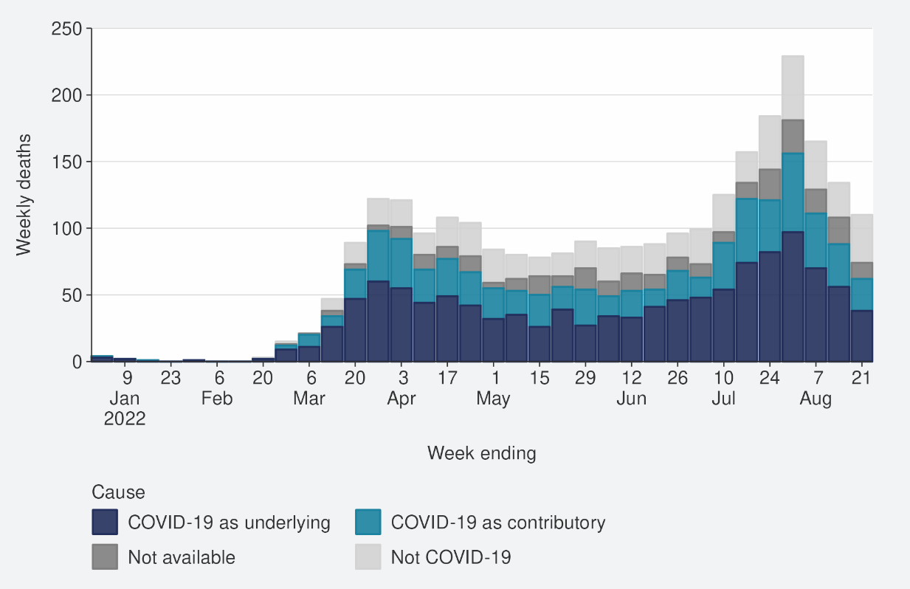
Figure 1: Weekly death counts by cause of death, 1 January to 22 August 2022

COVID-19-attributed mortality in priority populations
Of the 1,797 COVID-19-attributed deaths, 158 were in Māori, 111 in Pacific peoples, 60 in Asian people and 1,458 in European and Other people. There were 78 deaths among those aged under 60, as follows: 24 in Māori, 13 in Pacific peoples, 6 in Asian people and 35 in European and Other people.

Table 2 shows that all age-specific risks were higher for Māori and Pacific peoples compared with the European and Other group. The differences in risks between ethnicities within each age stratum varied from a 1.4-fold difference up to an almost 5-fold difference. Small numbers of deaths in some subgroups increases the uncertainty of some of the risk estimates. Nonetheless, we observed a consistent trend between ethnicities across age strata.

These inequities are not visible when considering overall risks by ethnicity. This is because the age structure varies across these ethnic groups, and risk of death increases with age. Consequently, the overall unadjusted COVID-19-attributed mortality risks were substantially lower for Māori (19.7 per 100,000 of population) than they were for the European and Other group (33.7 per 100,000); the risk for Pacific peoples was also lower (27.8 per 100,000). Table 3 shows the population-based mortality risk age stratified by deprivation. While overall risk indicates consistent excess risk with increasing deprivation, the age strata show this excess risk is more substantial at younger ages.

To account for the differences in age structure, we applied the age-stratified population-based mortality risks to the Māori population structure to calculate age-standardised risks (Figure 2). The age-standardised risks more clearly demonstrate the substantial disparity in COVID-19-attributed mortality risks between populations, as follows.
- If the European and Other group had the same (younger) age structure as the Māori population, we would expect its risk to be 9.7 per 100,000 population (95% CI 9.1–10.2 per 100,000). The observed risk in Māori of 19.7 per 100,000 (95% CI 16.6–22.8 per 100,000) was 2.2 times the risk of European and Other. Risk in Pacific peoples (25.2 per 100,000, 95% CI 20.5–30.0 per 100,000) was 2.8 times the risk in the European and Other group.
- Age-standardisation did not have as substantial an impact on the comparison between deprivation groups as it did on the comparison between ethnicity groups. Mortality for those in areas of medium deprivation (quintile 3, with a risk of 10.9 per 100,000 of population, 95% CI 9.6–12.3 per 100,000) was 2.2 times the risk of those in quintile 1, the 20% least deprived (4.9 per 100,000, 95% CI 4.1–5.7 per 100,000). In quintile 5, the 20% most deprived, the age-standardised risk (18.4 per 100,00, 95% CI 16.4–20.3 per 100,000) was 3.6 times the risk of those who were least deprived.

Table 2: COVID-19-attributed death counts* (with risks and 95% CI per 100,000 of population) by age group and ethnicity, 1 January to 26 August 2022
 | Māori |  | Pacific peoples |  | Asian |  | European and Other |  | Total
Age | N | Risk (95% CI) | N | Risk (95% CI) | N | Risk (95% CI) | N | Risk (95% CI) | N | Risk (95% CI)
0–59 | 24 | 3.4 (2.3–5.0) | 13 | 3.7 (2.2–6.4) | 6 | 0.8 (0.4–1.8) | 35 | 1.5 (1.1–2.1) | 78 | 1.9 (1.5–2.4)
60–69 | 35 | 60.6 (43.5–84.3) | 21 | 80.2 (52.3–122.9) | 7 | 11.5 (5.5–24.1) | 73 | 16.8 (13.4–21.1) | 136 | 23.5 (19.8–27.8)
70–79 | 43 | 170.3 (126.3–229.6) | 27 | 201.4 (138.1–293.5) | 17 | 55.8 (34.7–89.8) | 264 | 82.2 (72.8–92.7) | 351 | 89.9 (81.0–99.8)
80–89 | 38 | 517.5 (376.8–710.4) | 32 | 744 (526.6–1050.2) | 26 | 239.8 (163.3–352.0) | 565 | 373.4 (343.9–405.4) | 661 | 380.3 (352.4–410.4)
≥90 | 18 | 2064.2 (1304.3–3252.3) | 16 | 2898.6 (1783.1–4678.5) | 12 | 788.4 (448.3–1383.1) | 519 | 1489.1 (1367.1–1621.7) | 565 | 1494.7 (1377.2–1622.1)
Total | 158 | 19.7 (16.9–23.0) | 109 | 27.8 (23.0–33.5) | 68 | 8.1 (6.4–10.3) | 1456 | 44.3 (42.1–46.7) | 1791 | 33.7 (32.2–35.3)
* Excludes 6 deaths where ethnicity and/or age group were unknown

Table 3: COVID-19-attributed death counts* (with risks and 95% CI per 100,000 of population) by age group and deprivation quintile, 1 January to 26 August 2022
 | Quintile 1:  20% least deprived |  |  |  | Quintile 2 |  | Quintile 3 |  |  | Quintile 4 |  |  | Quintile 5:  20% most deprived |  |  | Total
Age |  | N | Risk (95% CI) | N |  | Risk (95% CI) |  | N | Risk (95% CI) |  | N | Risk (95% CI) |  | N | Risk (95% CI) |  | N | Risk (95% CI)
0–59 |  | 4 | 0.5 (0.2–1.3) | 8 |  | 1.0 (0.5–2.1) |  | 16 | 2.0 (1.2–3.3) |  | 13 | 1.6 (0.9–2.8) |  | 36 | 4.1 (3–5.7) |  | 77 | 1.9 (1.5–2.4)
60–69 |  | 10 | 7.7 (4.1–14.3) | 22 |  | 18.5 (12.2–28.1) |  | 27 | 24.2 (16.6–35.2) |  | 23 | 21.5 (14.3–32.4) |  | 52 | 52.7 (40.1–69.1) |  | 134 | 23.7 (20–28.0)
70–79 |  | 32 | 37.3 (26.4–52.8) | 57 |  | 69.6 (53.7–90.2) |  | 59 | 75.8 (58.7–97.8) |  | 90 | 120.2 (97.8–147.8) |  | 100 | 158.2 (130.0–192.4) |  | 338 | 88.1 (79.2–98.0)
80–89 |  | 57 | 193.4 (149.2–250.7) | 129 |  | 355.3 (299.1–422.1) |  | 151 | 401.4 (342.3–470.6) |  | 159 | 421.3 (360.7–491.9) |  | 142 | 508.1 (431.2–598.7) |  | 638 | 377.3 (349.2–407.7)
≥90 |  | 50 | 1064.1 (807.4–1401.2) | 112 |  | 1463.1 (1217.1–1757.9) |  | 134 | 1552.4 (1312.0–1835.9) |  | 149 | 1604.7 (1368.2–1881.4) |  | 999 | 1697.5 (1395.9–2062.9) |  | 544 | 1506.8 (1386.2–1637.8)
Total |  | 153 | 14.6 (12.5–17.2) | 328 |  | 32.1 (28.8–35.8) |  | 387 | 37.8 (34.2–41.7) |  | 434 | 41.8 (38–45.9) |  | 429 | 39.9 (36.3–43.9) |  | 1731 | 33.3 (31.7–34.9)
* Excludes 62 deaths where deprivation and/or age group were unknown
Figure 2: Age-standardised risk (and 95% confidence intervals) of mortality attributed to COVID-19 by ethnicity and by socio-economic deprivation
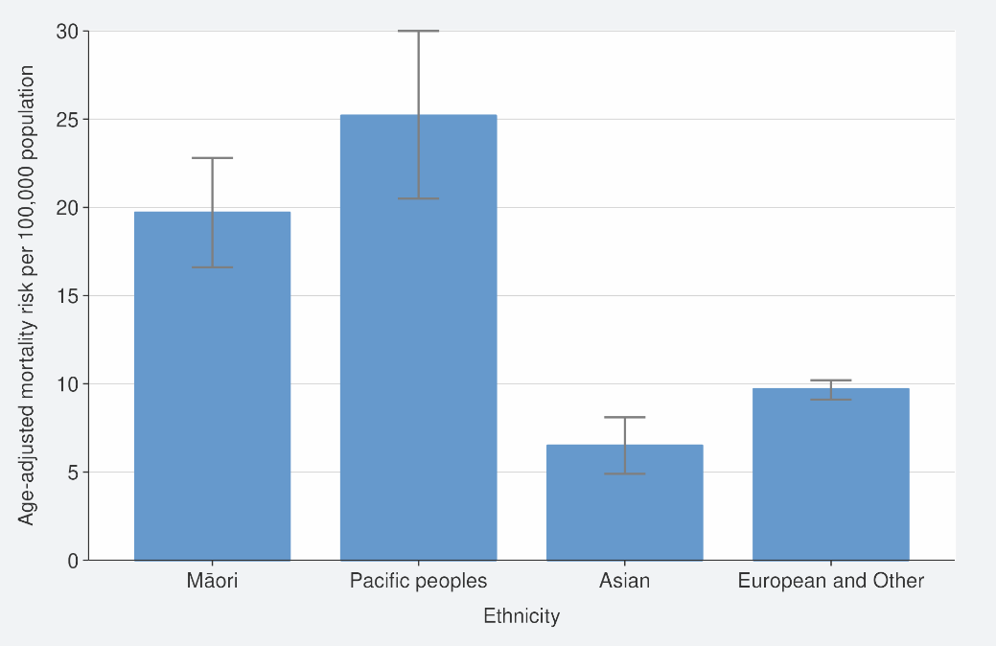 | 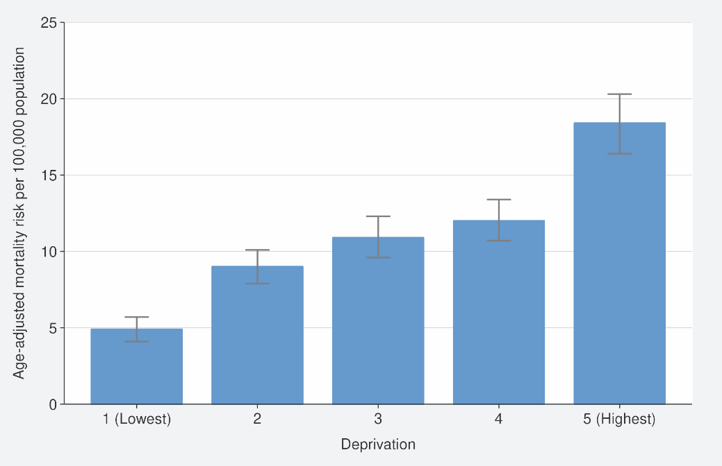

Regression analysis: population-based risk of COVID-19-attributed mortality
As demonstrated in the data on age-standardised risks above, the risk of death is confounded by age. This is particularly true for ethnicity, but also for comorbidity and vaccination, as they are both strongly associated with age. It is important to evaluate the impact on the risk of death independently of other factors, if possible. However, stratification becomes infeasible when there are multiple confounding or other factors of interest. Therefore, we undertook further analyses of the complex relationship between deaths and demographic factors, comorbidity and vaccination.

The following regression estimates adjust for confounding across multiple factors of interest to better reflect the extent to which each of these contributes independently to excess risk. Table 4 in the appendix gives population mortality risk ratio estimates.

Risk ratios of population-based mortality risk by ethnicity and by deprivation
The age-adjusted risk ratios for Māori (2.0, 95% CI 1.7–2.4) and Pacific peoples (2.5, 95% CI 2.1–3.0) compared with the European and Other group were substantial, as already shown in the data on age-standardised risks (see Figure 2). Figure 3 and Table 4 show the age-adjusted risk ratios for all factors of interest.
- Very little of the increased risk for Māori and Pacific peoples was explained by the other factors of interest that we examined: when we examined the contribution of each factor individually, we found that when sex, hospital-identified comorbidity or vaccination status (when included as fewer than 2 doses or 2 or more doses) was included in a model with age and ethnicity, the ethnicity estimates remained similar to the age-adjusted ethnicity risk ratios (data not shown). However, it should be noted that when we performed the date-restricted analysis to include vaccination as fewer than 2 doses, 2 doses or 3 or more doses, differences in vaccination did explain part of the risk (see ‘Risk ratios for other factors of interest’ on page 13).
- When the age-adjusted ethnicity model incorporated deprivation, the age- and deprivation-adjusted risk ratio was 1.8 (95% CI 1.5–2.1) for Māori and 2.1 (95% CI 2.2–3.0) for Pacific peoples compared with the European and Other group. This suggests that around a quarter of the ethnicity-associated risk was mediated by deprivation.
- The fully adjusted risk ratios (adjusted for all factors of interest apart from deprivation) of 1.7 (95% CI 1.4–2.0) for Māori and 1.9 (95% CI 1.6–2.4) for Pacific peoples compared with the European and Other group were not substantially different from the age-adjusted risk. This equates to 30% and 40% of the increased risk for Māori and Pacific peoples respectively being explained by a combination of sex, comorbidities and vaccination status (included as fewer than 2 doses or 2 or more doses). Figure 4 and Table 4 show the fully adjusted risk ratios for ethnicity and all other factors of interest in the final model.

The age-adjusted estimates for deprivation showed that risk for the 20% most deprived quintile was 3.0 times (95% CI 2.5–3.6) that for the 20% least deprived quintile. We saw a similar pattern to ethnicity when we further adjusted the age-adjusted risk for the other factors of interest, and the observed risk ratios changed very little (data not shown).
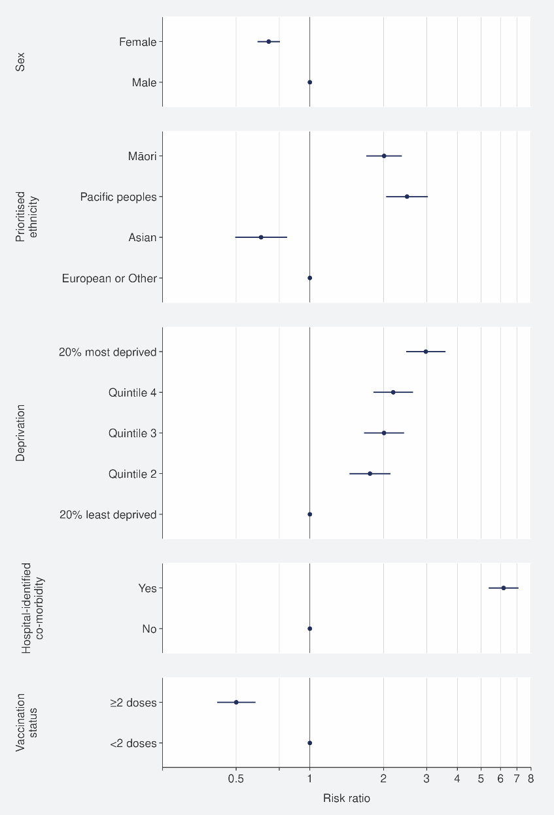  Figure 3: Regression analysis: Age-adjusted* risk ratios, population-based COVID-19 attributed mortality risk, 1 January to 26 August 2022 | Figure 4: Regression analysis: Fully-adjusted* risk ratios, population-based COVID-19 attributed mortality risk, 1 January to 26 August 2022
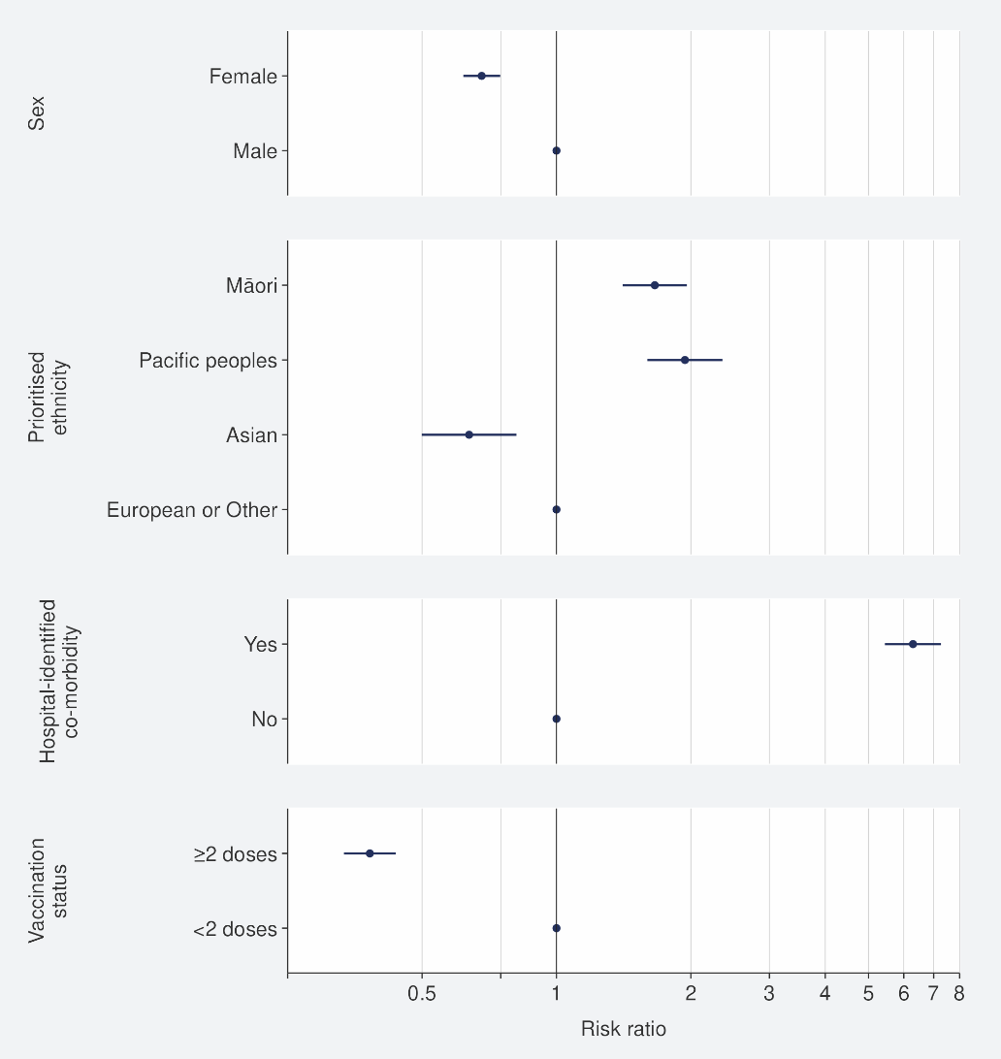
*Adjusted for age as a continuous variable (risk ratio: 1.1, 95% CI 1.1–1.1 per year increase in age); fully adjusted model also adjusts for sex, ethnicity, comorbidity and vaccination status. Table 4 presents the full set of estimates for the population regression analyses. The last category in each variable is the reference category for the risk ratios

Risk ratios for other factors of interest
All other factors examined were also independently associated: in a fully adjusted model, the risk ratios were 0.7 (95% CI 0.6–0.8) for females compared with males, 6.3 (95% CI 5.4–7.3) for any hospital-identified comorbidity compared with none and 0.38 (95% CI 0.33–0.44) for those who had 2 or more vaccination doses compared with those who had one dose or no doses (see Figure 4 and Table 4). This is equivalent to a reduction in the risk of death of 62% for those who had received 2 or more doses compared to those who had received one dose or no doses. Table 4 presents results restricted to deaths where COVID-19 was the underlying cause and where it was a contributing cause.

We also examined the fully adjusted model using the hospital-identified comorbidity severity variable: the adjusted risk ratio was 3.0 (95% CI 2.6–3.5) for moderate comorbidity and 14.3 (95% CI 12.2–16.7) for severe comorbidity, when compared with no comorbidity. Using this comorbidity severity variable reduced the ethnicity estimates slightly but had no impact on any other adjusted estimates (data not shown). However, when having any hospital-identified comorbidity was replaced by having any pharmacy-identified comorbidity, the effect of having had 2 or more vaccination doses compared with having had fewer than 2 doses was stronger, with an adjusted risk of 0.29 (95% CI 0.25–0.33); this is equivalent to a reduction in the risk of death of 71%. There was little change in the other estimates. Having any pharmacy-identified comorbidity was associated with an 11.1 (95% CI 7.5–16.3) times increase in mortality risk.

It was not possible to examine the effect of the booster vaccination from the start of 2022, as most people who received a booster dose did so during January and February. Therefore, we examined this by restricting deaths data to 1 March onwards and examining the impact of vaccination status as of that date. Compared with those who had fewer than 2 doses, those who had 2 doses had a fully adjusted risk ratio of 0.77 (95% CI 0.65–0.91); for those who had had 3 or more doses, the ratio was 0.34 (95% CI 0.29–0.40). This is equivalent to a reduction in the risk of death of 23% for those who had received 2 doses (compared with those who had received one dose or no doses) and 66% for those who had received 3 or more doses compared to those who had received fewer than 2 doses.
- When the effect of boosters was examined in an age-adjusted ethnicity model, an impact of differences in booster uptake was notable, with vaccination status accounting for 21% of the increased risk for Māori and 29% of the increased risk for Pacific peoples compared with the European and Other group; this effect was not detectable when vaccination was categorised as fewer than 2 doses or 2 or more doses.

Mortality risk ratios for those aged under 60 years
The mortality risk was much lower in those aged under 60 years: only 4% of deaths (78/1,797) were in those aged under 60. Therefore, the results were largely driven by those aged over 60, and examining risk across all ages may not reflect risk in those aged under 60 years. While COVID-19-atrributed mortality is rare in those aged under 60 years, there has been concern that a disproportionate burden of mortality in those aged under 60 years may fall upon Māori and Pacific peoples. For this reason, we undertook analyses restricted to data pertaining to people aged under 60 years (see Table 4 for the fully adjusted risks in those aged under 60 years).

- Although, overall, the risk in those aged under 60 years was low (1.9 per 100,000 across all ethnicities), the age-adjusted estimates showed that in those aged under 60 years the risk was 3.7 (95% CI 2.2–6.2) and 3.9 (95% CI 2.0–7.4) times the risk of the European and Other group for Māori and Pacific peoples respectively. There was no statistically significant difference in the risk for Asian people (data not shown).
- While adding sex into the age-ethnicity model did not affect the ethnicity risk ratio estimates, differences in comorbidity explained a substantial proportion (around 59% for Māori and 69% for Pacific peoples) of the increased risk. The fully adjusted risks for mortality were 1.9 (95% CI 1.2–3.2) and 2.2 (95% CI 1.2–4.2) times the risk for the European and Other group for Māori and Pacific peoples respectively (see Table 4).
- A higher proportion of excess risk was mediated by deprivation in those aged under 60 than when the whole population was included; the age-adjusted risk ratios reduced by 47% for Māori and 53% for Pacific peoples when deprivation was included in the age-ethnicity model (data not shown).

Hospital-identified comorbidities are uncommon in those aged under 60 (8% of this population has a hospital-identified comorbidity, compared with 32% of those aged 60 or more). Hospital-identified comorbidities are associated with a very substantial increase in the risk of COVID-19 attributed mortality.
- Comorbidities were recorded for 72 of the 78 under 60-year-olds whose deaths were attributable to COVID-19. Of those 72 people with comorbidities, 57 had a comorbidity that was classified as severe (a comorbidity score of 1 or more).
- The fully adjusted risk ratio (adjusted for the combined effects of sex, age, ethnicity and vaccination status) was 77.9 (95% 33.0–183.9) for any hospital-identified comorbidity compared with none (that is, those with a comorbidity had around 80 times the risk of those without a comorbidity).
The fully adjusted risk ratio for those who had 2 or more vaccination doses was 0.45 (95% CI 0.27–0.75), compared with those who had had fewer than 2 doses. This is equivalent to a reduction in the risk of death of 55% for those who had received 2 or more doses.
- When data were restricted to 1 March onwards to examine the effect of booster doses, the fully adjusted risk ratio was 0.69 (95% CI 0.39–1.21) for those who had received 2 doses and 0.27 (95% CI 0.15–0.49) for those who had had 3 or more doses compared with those who had fewer than 2 doses. When compared with those who had received one dose or no doses, this is equivalent to a reduction in the risk of death of 31% for those who had received 2 doses and 73% for those who had received 3 or more doses.

It should be noted that these analyses are based on a small number of deaths: this is reflected in the wider confidence intervals around the estimates.

Regression analysis: COVID-19-attributed case fatality risks

Case fatality risk ratios by ethnicity and other factors of interest
Table 5 gives results for COVID-19-attributed CFRs and risk ratios among COVID-19 cases. The age-adjusted risks for Māori and Pacific peoples compared with the European and Other group were 1.9 (95% CI 1.6–2.2) and 2.0 (95% CI 1.6–2.4) respectively.

- When we examined the contribution of each factor of interest to this age-adjusted risk ratio individually, we found that sex had no impact on the age-adjusted risk ratios observed in Māori and Pacific peoples compared with the European and Other group. Comorbidity explained around one third of the increased risk, and differences in vaccination status explained 18% and 26% of the increased risk for Māori and Pacific peoples respectively. Around a third of the age-adjusted increased mortality was mediated by deprivation (data not shown).
- After adjusting for age, sex, ethnicity, comorbidity and vaccination status simultaneously, the independent risks in Māori and Pacific peoples were around 50% higher than the risks in the European and Other group; these risk ratios were 1.5 (95% CI 1.3–1.8) and 1.4 (95% CI 1.2–1.7) respectively.

Overall, while age remains the greatest risk for case fatality attributed to COVID-19, the strongest modifiable risk was vaccination: those who were reported as cases who had had 2 or more vaccination doses had 0.24 (95% CI 0.21–0.28) times the risk of mortality compared with those who had received fewer than 2 doses; this is equivalent to a reduction in the risk of death of 76%. However, the potential risk of bias in CFR-based analyses from under-reporting of cases should be noted.
- After restricting deaths data to 1 March onwards to further examine the effect of vaccination on case fatality risk, we found that compared with those who had fewer than 2 doses, those who had 2 doses had a fully adjusted risk ratio of 0.52 (95% CI 0.44–0.62), and for those who had had 3 or more doses, this was 0.22 (95% CI 0.19–0.25).

Case fatality risk ratios for those aged under 60 years
Table 5 shows several restricted analyses, including for those aged under 60. In this analysis, the inequitable case fatality risks for Māori and Pacific peoples and those in areas of high deprivation were more pronounced.
- The age-adjusted risks for those aged under 60 for Māori and Pacific peoples compared with the risk for the European and Other group were 3.8 (95% CI 2.3–6.5) and 3.4 (95% CI 1.8–6.5) respectively. The age-adjusted risk was substantially reduced when comorbidity was introduced into age-adjusted models; the age and comorbidity ethnicity risk ratios were 45–50% lower than the ratio that was age-adjusted alone (data not shown).
- We also examined deprivation separately. Age-adjusted deprivation was strongly associated with mortality; there was 12.8 (95% CI 4.6–35.8) times the risk comparing the 20% least and 20% most deprived (data not shown). Deprivation also explained half of the increased risk for Māori and almost two-thirds of the increased risk for Pacific peoples, suggesting that among those aged under 60, a greater proportion of case fatality might be mediated though deprivation than for those aged 60 or more years.
- After adjusting for factors of interest for which we had data (that is sex, age, ethnicity, hospital-identified comorbidity and vaccination status), excluding deprivation, increased risk remained: 2.0 (95% CI 1.2–3.3) and 1.8 (95% CI 1.0–3.5) times that of the European and Other group for Māori and Pacific peoples respectively.
- In people under the age of 60, having a comorbidity carried 72.7 (95% CI 30.9–170.9) times the mortality risk of not having a comorbidity.
- Having received 2 or more doses of COVID-19 vaccine compared with fewer than 2 doses was associated with a substantially decreased risk: 0.17 (95% CI 0.10–0.29), equivalent to a reduction in the risk of death of 83%. When we examined the impact of booster doses from 1 March onwards, we found that the fully adjusted risk ratio was 0.34 (95%CI 0.19–0.61) for those who had received 2 doses and 0.11 (95%CI 0.06–0.20) for those who had received 3 or more compared with those who had received fewer than 2 doses. However, the potential risk of bias in CFR-based analyses from under-reporting of cases should be noted.

Discussion

Summary
These analyses have clearly demonstrated the higher risk of COVID-19 mortality for Māori, Pacific peoples and people in highly socio-economically deprived areas, after accounting for the effect of age, comorbidity and vaccination uptake. Furthermore, multivariable regression showed that while ethnicity and deprivation are interrelated, they both have independent effects on risk. The analysis also demonstrated the higher risk for those with comorbidities, especially the risk of death in those aged under 60 years. Vaccination had a strong protective effect against COVID-19-attributed mortality. In the date-restricted analysis, where we considered differences in booster doses between groups (unlike in the main analysis, where we only considered vaccination as 2 or more doses versus one dose or no doses), inequities in vaccination accounted for around a quarter of the excess risk for Māori and Pacific peoples.

Strengths and limitations
This report provides a relatively complete picture of COVID-19-related mortality, as it includes all deaths in 2022 in the analysis. We made use of date of birth data, date of death data, case report data, and vaccination date data that was available for the whole population, along with nationally consistent measures for ethnicity and deprivation and validated measures for comorbidity.

However, this analysis is not based on a bespoke research study and is limited to the data collected for surveillance and operational purposes. There may be risk factors we have not included in this analysis due to lack of availability that are likely to be important for an investigation into case fatality risk, such as health care access and engagement.

The population-based mortality risk estimates in this analysis incorporate both the risk of becoming infected and the risks of poor outcomes following infection. This measure is likely to be very robust. However, CFR estimates address the risk after a person is identified as a case. Many infections are not tested for or reported, including asymptomatic infections, in which case an infected person may be unaware of being infected. It is important to note that CFR is distinct from the infection fatality risk, which is the risk of death following infection. Hence, the interpretation of the CFR depends on biases in case ascertainment (detection and reporting) as well as the intrinsic clinical risks following infection, and these factors are often not easily separated. These issues can make it particularly challenging to interpret ratio measures that use the CFR. For example, comparisons of CFR between the old and the young, or between the vaccinated and unvaccinated, will be biased if one of the groups being compared reports a lower proportion of cases than the other group. Another example of potential bias pertains to deprivation: those of lower socio-economic status are more likely to under-report, due to a range of factors; particularly the barriers such people face in needing to isolate from work and family if positive. If so, the CFR would be biased upwards for those in areas of high deprivation.

The accuracy of the data provided by the administrative datasets used for this analysis needs to be considered. Of particular importance is the accuracy of ethnicity recording. Comparisons between the 2020 HSU and the 2018 New Zealand Census have shown that the HSU under-counted Māori, and the use of prioritised ethnicity in the HSU may have contributed to an under-estimate of Pacific peoples (Stats NZ Tatauranga Aotearoa 2022). It is possible that these factors biased estimates upwards for Māori and Pacific peoples, given their risk ratios were generally higher than that of the European and Other group. However, any over-estimate is unlikely to be substantial.

Residual confounding in the measurement of the variables in use is also likely to exist to some extent in this analysis, especially for deprivation (which is an area-based and not an individual measure) and comorbidity (which is a hospitalisation data-based index, so relies on access and interaction with health care). For example, residual confounding is suggested by the slight variation in the adjusted risk ratio for ethnicity when we examined the hospital-identified comorbidities using a severity-based categorical variable rather than a binary ‘any comorbidity’ variable. Both deprivation and comorbidity data are complex and multifactorial and can be challenging to measure, and although it may be beneficial to further explore available comorbidity data, further refinement of measures of deprivation will be very challenging.

Additionally, the main analysis does not fully capture vaccination status. Although vaccination status is well recorded for individuals, factors such as exact number of doses and time since last dose are not part of the analysis. However, Manatū Hauora is planning a further analysis of vaccination as a separate report. It should also be noted that, although those aged under 5 years who are not eligible for vaccination are included in these analyses, we have adjusted for age in analyses, and there were no deaths in those aged under 5 in the time period covered by this report. Preliminary analyses show that removing those aged under 5 from analyses did not result in important changes in estimates (data not shown).

Factors contributing to inequities in this analysis
In this analysis, we explored a number of factors to assess whether they contributed to the increased age-adjusted risk of COVID-19-attributed death in Māori and Pacific peoples. Factors we examined included socio-economic deprivation, comorbidities and vaccination status. Adjustment for socio-economic deprivation somewhat reduced the risk ratios of the age-adjusted risk for Māori and Pacific peoples (compared with the European and Other group) when examined across the whole population. This suggests that deprivation explains a modest amount of the differences between ethnicities over the whole population. However, the effect on the risk ratios of adjusting for deprivation was more substantial in those aged under 60 years of age, meaning deprivation may be a stronger driver of inequities for younger Māori and Pacific peoples. Additionally, while adjusting for comorbidities had a modest impact on ethnicity risk ratios over the whole population, there was a substantial reduction in risk ratios in the analysis of those aged under 60 years of age, suggesting that differences in comorbidities also play an important role in inequities in this age group.

Adjusting for vaccination status (fewer than 2, or 2 or more doses) did not have a substantial effect on the risk ratios for the age-adjusted risk of COVID-19-attributed death for Māori and Pacific peoples. However, it should be noted that there is now little variation in coverage of the first 2 doses of vaccine in older age groups (those most at risk of COVID-19 death) across ethnicities (Ministry of Health 2022a). Disparities in coverage of additional (booster) doses of vaccine across ethnicities are likely to explain more differences in risk of death. This is evidenced by the risk ratio estimates when restricted to March onwards, where around a quarter of the increased risk for Māori and Pacific peoples was explained after adjusting for vaccination status when categorised as fewer than 2 doses, 2 doses or 3 or more doses. We will explore this more fully in future analyses.

Additionally, as mentioned above, imperfect measures for deprivation and comorbidity will likely result in residual confounding; therefore, it is likely that these factors will explain more of the ethnicities differences than this analysis suggests.

Deprivation affects the risk of poor health outcomes though multiple pathways. For example, high deprivation is associated with living conditions, such as over-crowded damp housing, that will affect the risk of transmission/infection and the risk of poor outcomes via pathways such as increased risk of respiratory conditions (like asthma) and ability to access primary care. Deprivation is also, in general, part of a causal pathway that leads to increased risk of comorbidities, consistent with our finding in this analysis of increased risk for Māori and Pacific peoples aged under 60 years. Gurney et al 2020 found a substantially higher prevalence of comorbidities in Māori and Pacific peoples compared with all other ethnicities in Aotearoa New Zealand across the majority comorbidities where there was data. This disparity was strongest for the most common conditions and emerged at younger ages.

In this analysis, we found a higher risk of COVID-19-attributed death in men than in women. Sex disparities have been noted previously in countries such as the United States of America, where the magnitude of the effect has been seen to vary considerably over time and state (Danielsen et al 2022). Danielsen et al suggest that the disparities likely vary in relation to context-sensitive variables, which may include health behaviours, pre-existing health status, occupation, ethnicity and other markers of social experience. In our own analysis, we found that ethnicity did not affect the association between sex and mortality (and vice versa: sex had no impact on the increased risk of COVID-19-attributed death in Māori and Pacific peoples).

It should be noted that we examined only a select set of risk factors in this analysis, and even when considering deprivation and differences in comorbidities, a substantial proportion of the increased risk in Māori and Pacific peoples could not be explained. No measures of health care needs and access were available; potentially inequitable health access and care in the health system and health policies may be one of the contributors to this unexplained increased risk of death.

Comparing Aotearoa New Zealand’s COVID-19 mortality inequities with Australia, the United Kingdom and the United States
Making comparisons between Aotearoa New Zealand and other countries can be complex, given the timing of the epidemics and way in which countries define a COVID-19 death, and other population differences, such as age structure. However, COVID-19 mortality in Aotearoa New Zealand, even when defined relatively crudely as death within 28 days of a positive test (that is, including deaths that were unlikely to be due to COVID-19), has been substantially lower than in many other countries. The COVID-19 total death toll, from 2020 to the most recently available data, has climbed to 300 per 100,000 in both the United Kingdom and the United States. There were 42 deaths per 100,000 in the United States and 64 per 100,000 in the United Kingdom during 2022 (Centers for Disease Control and Prevention 2022, UK Health Security Agency 2022).

The level of mortality this year in these 2 countries remains substantially higher than the level in Aotearoa New Zealand (34 per 100,000), despite the Aotearoa New Zealand population not having any immunity from prior infection.

This is likely a reflection of Aotearoa New Zealand’s control strategies before vaccines became widely available while more severe variants were circulating, and the high level of vaccination coverage that has been achieved in Aotearoa New Zealand. In Australia, where there have been similar policies and similar levels of vaccination coverage (Our World in Data 2022), mortality has also been relatively low. Between 15 December 2021 (the start of their Omicron outbreak) and 3 July 2022, there has been a total death rate of 29 per 100,000 (Australian Government: Department of Health and Aged Care 2022).

However, despite low mortality in Aotearoa New Zealand, there are substantial inequities within the population. This has also been observed in other countries.

Inequities in Australia
Data from the Australia Bureau of Statistics shows that people with a country of birth overseas had an age-standardised death rate 3 times higher than that of people who were born in Australia (Australian Bureau of Statistics 2022). Furthermore, those living in poverty were 3 times as likely to die from COVID-19 that those who were wealthy, and over half of deaths registered by 31 January 2022 were in people who had underlying comorbidities (Australian Bureau of Statistics 2022).

An Australian research survey aiming to quantify general health risk specifically for Aboriginal and Torres Strait Islander adults found that the risk of severe illness from COVID-19 was high, as 59% of those surveyed had one or more health-related risk factors and/or were aged over 65 (Thurber et al 2021).

Inequities in the United Kingdom
A study using the UK Biobank cohort found evidence of ethnic inequalities in COVID-19 hospitalisations and mortality. The finding shows that the odds of mortality were 5 times and 2 times higher for people from the Black and South Asian communities respectively, compared with the White community (Batty et al 2022). A study of excess years of life lost (YLL) using mortality data from the United Kingdom during 2020 concluded that long-standing existing inequalities exacerbated the patterns of COVID-19-attributed mortality in the United Kingdom. This study found a strong deprivation gradient in all-cause excess YLL, with rates per 100,000 population ranging from 916 (95% CI: 820–1,012) for the least deprived quintile to 1,645 (95% CI: 1,472–1,819) for the most deprived quintile (Kontopantelis et al 2022).

Inequities in the United States
A study using mortality data from the United States during 2020 showed that most ethnic minority populations had higher age-adjusted COVID-19 mortality rates than non-Hispanic White populations, including when comparing within levels of educational attainment, a proxy for deprivation (Feldman and Bassett 2021). A systematic review and meta-analysis from the United States found that, of 4.3 million patients from 68 studies, African American, Hispanic and Asian American individuals had a higher risk of COVID-19 positivity and intensive care admission than White individuals. Socio-economic disparity and lower access to health care were associated with COVID-19 incidence and mortality in racial and ethnic minority groups (Magesh et al 2021).

Health equity with a systems approach
Our analysis has highlighted the impact of COVID-19 mortality on groups of people who are already experiencing the great impact of health inequity. Our collection of COVID-19 mortality and demographic data allows for the identification of some of the risk factors that contribute to excess death in Māori, Pacific peoples and other at-risk groups. Contributors to health inequity are multifaceted and exist both within and outside the health system: for example, they include issues of education, housing and employment. We need to work towards a systems approach to addressing health inequity issues, especially the causes and barriers. In this way, we will have a better chance of reducing and removing inequity and its impact on health and life expectancy.

Conclusion and next steps
Aotearoa New Zealand has a low level of COVID-19 mortality compared with other countries. However, certain portions of the population experience a higher risk of mortality, as the analysis in this report has shown. Inequitable health access and care in the health system and health policies may contribute to this.

Protecting Māori and Pacific wellbeing has been an integral part of Aotearoa New Zealand’s ongoing COVID-19 response. Throughout this response, Manatū Hauora has taken a collaborative and comprehensive approach at multiple levels to ensure Māori and Pacific communities stay safe. Some of the issues require longer-term policies and interventions to address, such as those associated with socio-economic deprivation that can lead to consequences of comorbidities at younger ages. Having a culturally responsive health care system that responds to the needs of all people is crucial for health equity and outcomes, especially in the context of a pandemic and other forms of the outbreak of diseases. In the shorter term, vaccination can mitigate the risk of mortality and reduce inequality and should remain a strong focus in the COVID-19 response strategy.

For the next phase of pandemic management, Manatū Hauora, Te Whatu Ora and Te Aka Whai Ora will continue to engage with Māori through the National Iwi Chairs Forum, Māori and Pacific health providers, community groups and other organisations to inform the overall COVID-19 response, and ensure equitable outcomes for Māori and Pacific peoples.

Monitoring and evaluation of indicators of health care access, uptake of therapeutics, vaccination and severe outcomes (for example, hospitalisation and mortality) following infection could also provide insight into related factors contributing to health inequity. Manatū Hauora will continue to analyse data on these indicators. It will undertake further exploration of vaccine effectiveness and is identifying options for reporting on disabilities in collaboration with partner agencies. The Public Health Agency will publish the results of future analyses.

References
Australian Bureau of Statistics. 2022. COVID-19 Mortality in Australia, Deaths registered to 31 January 2022. URL: https://www.abs.gov.au/articles/covid-19-mortality-australia-deaths-registered-31-january-2022 (accessed 29 September 2022).
Australian Government: Department of Health and Aged Care. 2022. COVID-19 Australia: Epidemiology Report 63: Volume 46. URL: https://www1.health.gov.au/internet/main/publishing.nsf/Content/C50CAE02452A48A7CA2587320081F7BF/$File/covid_19_australia_epidemiology_report_63_reporting_period_ending_3_july_2022.pdf (accessed 29 September 2022).
Batty GD, Gaye B, Gale CR, et al. 2022. Explaining Ethnic Differentials in COVID-19 Mortality: A Cohort Study. American Journal of Epidemiology. 2022; 191(2): 275–81.
Centers for Disease Control and Prevention. 2022. COVID Data Tracker. URL: https://covid.cdc.gov/covid-data-tracker (accessed 29 September 2022).
Danielsen AC, Lee KMN, Boulicault M, et al. 2022. Sex disparities in COVID-19 outcomes in the United States: Quantifying and contextualizing variation. Social Science & Medicine. 2022; 294: 114716.
Feldman JM, Bassett MT. 2021. Variation in COVID-19 Mortality in the US by Race and Ethnicity and Educational Attainment. JAMA Network Open 4(11): e2135967.
Gurney J, Stanley J, Sarfati D. 2020. The inequity of morbidity: Disparities in the prevalence of morbidity between ethnic groups in New Zealand. Journal of Comorbidity 10: 2235042X20971168.Journal of Comorbidity. 2020; 10: 2235042X20971168.
Kontopantelis E, Mamas MA, Webb RT, et al. 2022. Excess years of life lost to COVID-19 and other causes of death by sex, neighbourhood deprivation, and region in England and Wales during 2020: A registry-based study. PLOS Medicine 19(2): e1003904.
Magesh S, John D, Li WT, et al. 2021. Disparities in COVID-19 Outcomes by Race, Ethnicity, and Socioeconomic Status: A Systematic-Review and Meta-analysis. JAMA Network Open 4(11): e2134147.
Ministry of Health. 2022a. COVID-19: Vaccine data. URL: https://www.health.govt.nz/covid-19-novel-coronavirus/covid-19-data-and-statistics/covid-19-vaccine-data (accessed 28 September 2022).
Ministry of Health. 2022b. Health and Independence Report 2020. Wellington: Ministry of Health. URL: https://www.health.govt.nz/publication/health-and-independence-report-2020 (accessed 28 September 2022).
Our World in Data. 2022. COVID-19 Data Explorer: Share of people who received at least one dose of COVID-19 vaccine. URL: https://ourworldindata.org/explorers/coronavirus-data-explorer?zoomToSelection=true&time=2020-03-01..latest&facet=none&pickerSort=desc&pickerMetric=new_cases_smoothed_per_million&Metric=People+vaccinated&Interval=Cumulative&Relative+to+Population=true&Color+by+test+positivity=false&country=NZL~AUS (accessed 29 September 2022).
Salmond CE, Crampton P. 2012. Development of New Zealand's Deprivation Index (NZDep) and Its Uptake as a National Policy Tool. Canadian Journal of Public Health / Revue Canadienne de Sante'e Publique 103: S7–S11.
Stanley J, Doughty RN, Sarfati D. 2020. A Pharmaceutical Dispensing-based Index of Mortality Risk From Long-term Conditions Performed as well as Hospital Record-based Indices. Medical Care 58(2): e9–e16.
Stanley J, Sarfati D. 2017. The new measuring multimorbidity index predicted mortality better than Charlson and Elixhauser indices among the general population. Journal of Clinical Epidemiology 92: 99–110.
Stats NZ Tatauranga Aotearoa. 2021. National and subnational period life tables: 2017–2019. URL: https://www.stats.govt.nz/information-releases/national-and-subnational-period-life-tables-2017-2019 (accessed 28 September 2022).
Stats NZ Tatauranga Aotearoa. 2022. Review of Health Service User population methodology. URL: https://www.stats.govt.nz/reports/review-of-health-service-user-population-methodology (accessed 29 September 2022).
Steyn N, Binny, RN, Hannah K, et al. 2021. Māori and Pacific people in New Zealand have a higher risk of hospitalisation for COVID-19. New Zealand Medical Journal 134(1538).
Summers JA, Baker M, Wilson N. 2018. New Zealand's experience of the 1918–19 influenza pandemic: a systematic review after 100 years. New Zealand Medical Journal 131(1487): 54–69.
Thurber KA, Barrett EM, Agostino J, et al. 2021. Risk of severe illness from COVID-19 among Aboriginal and Torres Strait Islander adults: the construct of 'vulnerable populations' obscures the root causes of health inequities. Australia and New Zealand Journal of Public Health 45(6): 658–63.
UK Health Security Agency. 2022. Coronavirus (COVID-19) in the UK: Coronavirus Tracker. URL: https://coronavirus.data.gov.uk/details/deaths?areaType=overview&areaName=United%20Kingdom (accessed 29 September 2022).
Walsh M, Grey C. 2019. The contribution of avoidable mortality to the life expectancy gap in Māori and Pacific populations in New Zealand – a decomposition analysis. New Zealand Medical Journal 132(1492): 46–60.
Wehipeihana N, Sebire K, Spee K, et al. 2021. More Than Just a Jab: Evaluation of the Māori Influenza Vaccination Programme as part of the COVID-19 Māori Health Response. Wellington: Ministry of Health. URL: https://www.health.govt.nz/publication/more-just-jab-evaluation-maori-influenza-vaccination-programme-part-covid-19-maori-health-response (accessed 28 September 2022).
Wehipeihana N, Sebire K, Spee K, et al. 2022. In Pursuit of Māori Health Equity: Evaluation of the Māori Influenza and Measles Vaccination Programme. Wellington: Ministry of Health. URL: https://www.health.govt.nz/system/files/documents/publications/evaluation-of-the-maori-influenza-and-measles-vaccination-programme-in-pursuit-of-maori-health-equity-jun22.pdf (accessed 28 September 2022).
Wiki J, Marek L, Hobbs M, et al. 2021. Understanding vulnerability to COVID-19 in New Zealand: a nationwide cross-sectional study. Journal of the Royal Society of New Zealand 51(sup1): S179–S96.
World Health Organization. 2021. COVID-19 and the social determinants of health and health equity: evidence brief October 2021. URL: https://apps.who.int/iris/rest/bitstreams/1389412/retrieve (accessed 28 September 2022).

Appendix: Regression results tables

Table 4: Regression analysis: population-based COVID-19-attributed mortality risk, 1 January to 26 August 2022
 |  |  |  |  |  |  | Unadjusted risk |  |  | Age-adjusted risk* |  |  | Fully-adjusted risk† |  |  | Aged under 60 years† |  | COVID-19 was underlying cause† |  | COVID-19 was contributory cause†
 |  |  |  | Deaths  n | Population  N | Risk  (per 100k) | Risk ratio | (95% CI) |  | Risk ratio | (95% CI) |  | Risk ratio | (95% CI) |  | Risk ratio | (95% CI) | Risk ratio | (95% CI) | Risk ratio | (95% CI)
Total |  |  |  | 1,797 | 5,325,456 | (33.7)
Sex | Male |  |  | 948 | 2,648,311 | (35.8) | Reference
 | Female |  |  | 849 | 2,670,934 | (31.8) | 0.89 | (0.81–0.97) |  | 0.68 | (0.61–0.75) |  | 0.68 | (0.62–0.75) |  | 0.55 | (0.35–0.86) | 0.71 | (0.62–0.80) | 0.64 | (0.55–0.75)
Age group (years) | 0–59 |  |  | 78 | 4,133,023 | (1.9) | 0.08 | (0.06– 0.11)
 | 60–69 |  |  | 136 | 579,270 | (23.5) | Reference
 | 70–79 |  |  | 351 | 390,463 | (89.9) | 3.83 | (3.14–4.67)
 | 80–89 |  |  | 661 | 173,814 | (380.3) | 16.20 | (13.47–19.48)
 | ≥90 |  |  | 565 | 37,800 | (1494.7) | 63.68 | (52.83–76.77)
Prioritised ethnicity | Māori |  |  | 158 | 803,785 | (19.7) | 0.44 | (0.38–0.52) |  | 2.01 | (1.70–2.38) |  | 1.66 | (1.41–1.96) |  | 1.94 | (1.16–3.24) | 1.79 | (1.45–2.20) | 1.44 | (1.09–1.89)
 | Pacific |  |  | 111 | 393,462 | (28.2) | 0.64 | (0.52–0.77) |  | 2.49 | (2.05–3.03) |  | 1.94 | (1.60–2.35) |  | 2.22 | (1.17–4.22) | 2.01 | (1.58–2.56) | 1.80 | (1.29–2.50)
 | Asian |  |  | 69 | 837,068 | (8.2) | 0.19 | (0.15–0.24) |  | 0.63 | (0.50–0.81) |  | 0.64 | (0.50–0.81) |  | 1.08 | (0.46–2.55) | 0.67 | (0.49–0.90) | 0.59 | (0.39–0.89)
 | Other |  |  | 1,458 | 3,289,944 | (44.3) | Reference
Any hospital-identified co-morbidity |  |  | No | 308 | 4,622,265 | (6.7) | Reference
 |  |  | Yes | 1,489 | 703,148 | (211.8) | 31.78 | (28.11–35.93) |  | 6.18 | (5.37–7.10) |  | 6.29 | (5.44–7.27) |  | 77.91 | (33.01–183.90) | 5.65 | (4.71–6.77) | 8.03 | (6.31–10.22)
Vaccination status | <2 doses |  |  | 289 | 1,428,300 | (20.2) | Reference
 | ≥2 doses |  |  | 1,508 | 3,897,156 | (38.7) | 1.91 | (1.69–2.17) |  | 0.50 | (0.42–0.60) |  | 0.38 | (0.33–0.44) |  | 0.45 | (0.27–0.75) | 0.33 | (0.28–0.39) | 0.54 | (0.42–0.68)
Deprivation | 20% least deprived |  |  | 154 | 1,046,517 | (14.7) | Reference
 | Quintile 2 |  |  | 328 | 1,022,353 | (32.1) | 2.18 | (1.80–2.64) |  | 1.76 | (1.45–2.13)
 | Quintile 3 |  |  | 388 | 1,027,026 | (37.8) | 2.57 | (2.13–3.09) |  | 2.01 | (1.66–2.42)
 | Quintile 4 |  |  | 436 | 1,040,472 | (41.9) | 2.85 | (2.37–3.42) |  | 2.19 | (1.82–2.64)
 | 20% most deprived |  |  | 429 | 1,076,320 | (39.9) | 2.71 | (2.25–3.26) |  | 2.97 | (2.47–3.58)
* Adjusted for age as a continuous variable (adjusted risk ratio for age was 1.1, 95% CI 1.1–1.1 per year increase in age).
† Adjusted for age as a continuous variable, and for other variables described in the table (sex, ethnicity, comorbidity and vaccination status)

Table 5: Regression analysis: COVID-19 case fatality risk, 1 January to 26 August 2022
 |  |  |  |  |  |  | Unadjusted risk |  |  | Age-adjusted risk* |  |  | Fully-adjusted risk† |  |  | Aged under 60 years† |  | COVID-19 was underlying cause† |  | COVID-19 was contributory cause†
 |  |  |  | Deaths  n | Cases N | CFR  (per 100k) | Risk ratio | (95% CI) |  | Risk ratio | (95% CI) |  | Risk ratio | (95% CI) |  | Risk ratio | (95% CI) | Risk ratio | (95% CI) | Risk ratio | (95% CI)
Total |  |  |  | 1,797 | 1,679,538 | (107.0)
Sex | Male |  |  | 948 | 779,886 | (121.6) | Reference
 | Female |  |  | 849 | 898,208 | (94.5) | 0.78 | (0.71–0.85) |  | 0.66 | (0.60–0.72) |  | 0.67 | (0.62–0.74) |  | 0.45 | (0.29–0.71) | 0.69 | (0.61–0.77) | 0.65 | (0.55–0.75)
Age group (years) | 0–59 |  |  | 78 | 1,427,473 | (5.5) | 0.05 | (0.04–0.07)
 | 60–69 |  |  | 136 | 133,743 | (101.7) | Reference
 | 70–79 |  |  | 351 | 69,986 | (501.5) | 4.93 | (4.05–6.01)
 | 80–89 |  |  | 661 | 29,813 | (2217.2) | 21.80 | (18.14–26.22)
 | ≥90 |  |  | 565 | 7,783 | (7259.4) | 71.39 | (59.28–86.06)
Prioritised ethnicity | Māori |  |  | 158 | 251,045 | (62.9) | 0.45 | (0.38–0.53) |  | 1.89 | (1.61–2.22) |  | 1.54 | (1.31–1.81) |  | 1.97 | (1.18–3.31) | 1.68 | (1.37–2.07) | 1.32 | (1.00–1.74)
 | Pacific |  |  | 111 | 142,896 | (77.7) | 0.56 | (0.46–0.67) |  | 1.96 | (1.62–2.37) |  | 1.42 | (1.18–1.72) |  | 1.82 | (0.96–3.45) | 1.50 | (1.18–1.89) | 1.29 | (0.93–1.80)
 | Asian |  |  | 69 | 240,285 | (28.7) | 0.21 | (0.16–0.26) |  | 0.84 | (0.66–1.07) |  | 0.78 | (0.61–1.00) |  | 1.18 | (0.50–2.79) | 0.83 | (0.62–1.12) | 0.70 | (0.46–1.06)
 | Other |  |  | 1,458 | 1,044,116 | (139.6) | Reference
Any hospital-based co-morbidity |  |  | No | 308 | 1482524 | (20.8) | Reference
 |  |  | Yes | 1,489 | 196973 | (755.9) | 36.39 | (32.19–41.13) |  | 5.09 | (4.39–5.90) |  | 4.72 | (4.09–5.46) |  | 72.71 | (30.94–170.85) | 3.96 | (3.32–4.72) | 6.60 | (5.11–8.53)
Vaccination status | <2 doses |  |  | 289 | 318,243 | (90.8) | Reference
 | ≥2 doses |  |  | 1,508 | 1,361,295 | (110.8) | 1.14 | (1.00–1.30) |  | 0.23 | (0.20–0.26) |  | 0.24 | (0.21–0.28) |  | 0.17 | (0.10–0.29) | 0.22 | (0.18–0.25) | 0.32 | (0.25–0.42)
Deprivation | 20% least deprived |  |  | 154 | 348,894 | (44.1) | Reference
 | Quintile 2 |  |  | 328 | 325,308 | (100.8) | 2.28 | (1.89–2.77) |  | 1.73 | (1.43–2.09)
 | Quintile 3 |  |  | 388 | 323,101 | (120.1) | 2.72 | (2.26–3.28) |  | 1.95 | (1.62–2.36)
 | Quintile 4 |  |  | 436 | 328,404 | (132.8) | 3.01 | (2.50–3.61) |  | 2.00 | (1.66–2.41)
 | 20% most deprived |  |  | 429 | 329,867 | (130.1) | 2.95 | (2.45–3.54) |  | 2.72 | (2.26–3.27)
* Adjusted for age as a continuous variable (adjusted risk ratio for age was 1.1, 95% CI 1.1–1.1 per year increase in age).
† Adjusted for age as a continuous variable, and for other variables described in the table (sex, ethnicity, comorbidity and vaccination status)

A death is attributed to COVID-19 if COVID-19 was determined to be the underlying or contributing cause, regardless of time elapsed since infection report date.
Areas of high deprivation are ones where there is poor access to the internet, low incomes, higher number of welfare recipients, increased unemployment, people without any qualifications, single parent families and higher prevalence of people living in rented accommodation and/or in homes that are overcrowded and damp. It is imotrant to note
ICD-10 is the 10th revision of the International Statistical Classification of Diseases and Related Health Problems (ICD), a medical classification list by the World Health Organization (WHO). It contains codes for diseases, signs and symptoms, abnormal findings, complaints, social circumstances, and external causes of injury or diseases.
The National Minimum Dataset is a national collection of public and private hospital discharge information, including coded clinical data for inpatients and day patients.
Age standardisation involves using the age group-specific risks applied to a reference population structure to calculate the risk we would expect if these populations all had the same age structure. This then reduces the confounding effect of age when comparing risks, and is essential for making an accurate comparison of mortality risk between populations.
A Biobank is a collection of biological or medical data and/or tissue samples stored for research purposes.

