COVID-19 Māori Vaccine and Immunisation Plan

  - Supplementary to the Updated
COVID-19 Māori Health Response Plan

2021

COVID-19 Māori Vaccine and Immunisation Plan

Citation: Ministry of Health. 2021. COVID-19 Māori Vaccine and Immunisation Plan: Supplementary to the Updated COVID-19 Māori Health Response Plan. Wellington: Ministry of Health.
Published in March 2021 by the Ministry of Health
PO Box 5013, Wellington 6140, New Zealand
ISBN 978-1-99-100700-1 (online)
HP 7629
This document is available at health.govt.nz
This work is licensed under the Creative Commons Attribution 4.0 International licence. In essence, you are free to: share ie, copy and redistribute the material in any medium or format; adapt ie, remix, transform and build upon the material. You must give appropriate credit, provide a link to the licence and indicate if changes were made.

Executive summary
The COVID-19 Māori Vaccine and Immunisation Plan (the plan) builds on the Updated COVID-19 Māori Health Response Plan implemented in 2020. In particular, the plan outlines key initiatives that will be undertaken to ensure that the COVID-19 Vaccine and Immunisation Programme addresses its obligations under Te Tiriti o Waitangi and supports Māori health and equity. Appendix One provides an overview of the COVID-19 Māori Vaccine and Immunisation approach.
The COVID-19 response has been a collective effort involving hapū, iwi, hapori Māori (Māori communities), and the wider health and disability provider network, along with the wider health and disability system, workforce and broader government. The achievements and progress made are the result of collaboration and kotahitanga.
It is imperative the Ministry of Health (the Ministry) continues to encourage and enable this unified effort as part of the COVID-19 Elimination Strategy for Aotearoa New Zealand. The successful delivery of the COVID-19 Vaccine and Immunisation Programme will be critical to meeting the objectives of the Elimination Strategy.
The Ministry is committed to fulfilling its obligations under Te Tiriti o Waitangi as part of the COVID-19 Maori health response, including through the delivery of the Programme. This document outlines key initiatives incorporated across the Programme that ensures Te Tiriti o Waitangi and Māori health equity remain at the centre of the vaccination roll-out. These initiatives include:
- governance and partnership
- targeted vaccination approach
- Māori health and disability provider support
- workforce development
- tailored communications.
The Programme will help to manage the impact of COVID-19 on whānau, hapū, iwi and hapori Māori. This is because it helps us to:
- actively protect people from the potential harm of contracting COVID-19
- potentially reduce the risk of transmission in the community
- support the health and disability system’s readiness and resilience if there is an outbreak, both by vaccinating certain health workers early and by vaccinating the groups most at risk of severe illness if they contract COVID-19.
This document is supplementary to the Updated COVID-19 Māori Health Response Plan. Both documents will be updated as necessary to reflect any changes to the Government’s broader approach to COVID-19 response.

Further information
For more information about the Māori health COVID-19 response, please go to https://www.health.govt.nz/.

For the latest updates and information on the COVID-19 response, please go to https://covid19.govt.nz/.
Contents
COVID-19 Māori Vaccine and Immunisation Plan 1
Executive summary 2
The COVID-19 Vaccine and Immunisation Programme 6
Monitoring progress 12
Appendix One 15
Appendix Two 16
Appendix Three 18

The COVID-19 Vaccine and Immunisation Programme
The COVID-19 Elimination Strategy for Aotearoa New Zealand (the Elimination Strategy) can be described as four pillars – border controls, robust case detection and surveillance, effective contact tracing and quarantine, and strong community support of control measures. Each pillar describes a range of public health measures and controls that will help us to mitigate and manage the risk of COVID-19.
The COVID-19 Vaccine and Immunisations Programme (the Programme) is a key part of the Elimination Strategy, as it will help to mitigate the impact of COVID-19 on whānau, hapū, iwi, hapori Māori and our response systems by:
- protecting people from the potential harm of contracting COVID-19
- potentially reducing the risk of transmission in the community
- supporting the health and disability system’s readiness and resilience if there is an outbreak, both by vaccinating certain health workers early and by vaccinating the groups most at risk of severe illness if they contract COVID-19.
The health and disability system is committed to upholding and honouring Te Tiriti o Waitangi (te Tiriti), including in the design and delivery of the Programme. The Ministry of Health’s (the Ministry) Te Tiriti o Waitangi Framework and Whakamaua: the Māori Health Action Plan 2020-2025 have guided the development of the Programme and how it will be delivered. Honouring Te Tiriti o Waitangi and ensuring equitable outcomes is fundamental to the success of the Programme.
The COVID-19 Vaccine and Immunisation Programme
The overarching goal of the Programme is to ensure as many people receive the vaccine as early as possible, whilst upholding the Crown’s obligations under Te Tiriti o Waitangi. The Ministry’s Tiriti obligations are outlined through the Waitangi Tribunals’ WAI2575 Hauora Report and are guided by the principles of equity, active protection, options, partnership, and tino rangatiratanga.
Within the context of the Programme, the Ministry needs to:
- prioritise equitable health and wellbeing outcomes, including vaccination uptake, for Māori
- partner with Māori across Māori communities and all levels of the Programme and wider health and disability system
- actively protect Māori health and wellbeing through implementation and monitoring of the Programme
- recognise Māori tino rangatiratanga and self-determination in developing and engaging with the Programme
- enable options for Māori through adequately resourcing Māori health providers and ensuring non-Māori health providers are equipped to support whānau Māori.
In addition to this expression of Te Tiriti, the Programme’s design and delivery is centred around the principles of legacy, wellbeing, and equity. These principles speak to the need to support a holistic approach that will contribute to a stronger, more aligned health and disability system, whilst recognising the differential health outcomes across population groups.
The Ministry is investing directly into Māori initiatives to ensure that the programme is effective, equitable, and Tiriti compliant. These key initiatives include:
- governance and partnership
- targeted vaccination approach
- Māori health and disability provider support
- workforce development
- tailored communications.
Each of these are detailed further in the next section.

Key Māori health initiatives
This section outlines the key initiatives that are incorporated across the Programme to ensure equitable outcomes for Māori and the fulfilment of Tiriti obligations. These have been developed based on existing insights about what has worked well for Māori across the COVID-19 response. The outcomes, objectives and priority areas for action from Whakamaua have also informed these initiatives.

Governance and partnership
Māori leadership and participation in governance is a significant enabler for tino rangatiratanga and Māori health and wellbeing. A recent study by Te Pūtahitanga o te Waipounamu indicated the success of the Manaaki20 COVID-19 response was partly due to the leadership displayed by Māori communities and organisations that mobilised immediately during the first outbreak of COVID-19 (more information on the strength of hapori Māori is attached at Appendix Two).
The Ministry is committed to ensuring consultation and seeking advice from key Māori stakeholders and representatives from across Aotearoa New Zealand (Aotearoa) as part of process. This includes working closely with a broad range of iwi and Māori representatives at every level of the Programme, such as the Immunisation Implementation Advisory Group (IIAG), the Māori Monitoring Group (MMG), Māori clinicians and sector representatives, Māori providers, and Māori communications experts, including the iwi communications network.
To ensure an equitable response in what could be a rapidly changing environment, we know that allowing flexibility and agility in our own planning and design is a necessity. The Ministry will continue to work closely with Māori stakeholders who have the skills, expertise and knowledge to provide advice and guidance in all areas of the Programme, in particular service delivery and implementation.

Provider support
The Ministry will be working closely with Māori health providers to ensure they are resourced and supported to deliver targeted and tailored service delivery. The ‘2020 Māori Influenza Vaccination Programme – More than just a jab’ evaluation demonstrates that increasing equitable outcomes for Māori is possible if providers are supported to deliver services to Māori in a way that recognises the additional barriers many Māori may face in accessing the vaccine. These learnings will be crucial to ensuring the Programme’s delivery is responsive to Māori health aspirations (an outline of the Māori Influenza Vaccination Programme is attached as Appendix Three).

Preparedness
Māori health providers have been critical to the success of the COVID-19 response, so far. The Ministry recognises that an effective and equitable vaccination programme will require well-resourced and well-prepared providers. To support provider preparedness, the Ministry has ring-fenced an initial $11 million of funding to support providers in preparing to implement the Programme across their communities, including options to provide holistic care to whānau.
The funding will ensure that there is base-level operational infrastructure in place to support the roll-out of the Programme and allow providers to prepare for any contingency planning that may needed due to the evolving nature of COVID-19. Investing in infrastructure contributes to the legacy of the programme, as it will build the capability and capacity of the Māori health sector for future immunisations and outreach programmes.
An additional $24.5 million is being allocated to develop a COVID-19 Māori vaccine support service. This funding will support and empower whānau by providing national, regional, and local community presence across the vaccine lifecycle, ensuring whānau are informed and can easily access the vaccination services.

Delivery
Supporting providers will be particularly important in the delivery of vaccine services. Funding to support providers to undertake vaccinations will be additional to the $11 million for preparedness and $24.5 million to establish a support service.
Providers hold unique relationships with their communities and, we saw through the MIVP, that innovative, whānau-centred outreach services increase the number of Māori who receive vaccinations. Providers delivering the vaccine on the ground will need adequate resourcing to ensure they can reach whānau where they are or bring whānau to the clinics – it needs to be easy for people to access the vaccine.
In addition to the funding, 40,000 vaccines have been ring-fenced for Māori and Pacific health providers. Early access to the vaccine will ensure these providers can proactively begin protecting those most at risk of severe outcomes from COVID-19.

Targeted vaccination approach
The Government has purchased enough COVID-19 vaccines for everyone that is eligible to access over time. However, while supplies are initially limited there will be a need to target specific population groups and communities who are at increased risk – of exposure or transmission, or likely to experience severe health outcomes if they contracted COVID-19.
This will require an initial approach that is targeted and tailored, and as supply increases the scope of vaccination will broaden. The roll-out will be progressed across four groups, starting with those that are at the highest risk of infection and transmission (such as border workers and frontline health staff) and then look to target those that are at risk of severe outcomes if they contract COVID-19.
Ensuring that equitable approaches are consistent across these groups will be critical in the success of the Programme, in particular as we move to the wider population groups. A core mechanism for this will be the additional support and resourcing for providers, as outlined above. Māori health and disability providers have strong community networks and enabling these providers to spearhead the roll-out, including deciding on models of care, will drive equitable delivery and uptake of the vaccine amongst whānau, hapū, iwi, and wider hapori.

Group 1: Border workers
Group one consists of our 50,000 border and MIQ workers, their households contacts and the people they live with. Focusing on border workers and MIQ staff promotes wellbeing and equitable outcomes by providing the first line of defence against the virus and enhancing the protection in place for everyone in New Zealand. This group is at greatest risk of infection and transmission because of their proximity to cases coming through the border and ensuring they are protected from contracting COVID-19 will form a security net around the country.

Group 2: Frontline (non-border workers) and people in high-risk settings or locations
While vaccine supply remains limited, the Programme will continue to focus on groups who are at increased risk of exposure and transmission of COVID-19. This means focusing on other areas of the health workforce, in particular workforces that regularly engage with vulnerable people, such as staff working in COVID-19 testing stations.
The Programme will then look to vaccinate groups living in settings or locations that are ‘high risk’, this includes people in long-term residential care where a high proportion of residents are at-risk of severe outcomes (such as aged residential care (ARC) facilities). In parallel with this, to account for the underrepresentation of Māori in ARC facilities, Māori health providers will offer vaccination to koroua and kuia aged 65+ and to people with co-morbidities.
This roll-out will begin in the Counties Manukau DHB region, with subsequent roll-out to other regions as vaccine supply increases. This region has been identified due to its proximity to the border, number of MIQs in the area, and the recent resurgence cases in the area.

Group 3: Priority populations / Group 4: Everyone else
Following this, the roll-out will move to the wider priority population groups – those who are at high-risk of severe outcomes if they catch COVID-19. This includes koroua and kuia and those with co-morbidities living outside of the Counties Manukau district.
Once those that are at the highest risk of mortality and morbidity from COVID-19 have been vaccinated, the Programme will look to immunise the wider population.

Workforce development
The successful delivery of the Programme will heavily rely on having a workforce that is capable and representative of the population they are immunising. Increasing the vaccinator workforce capacity began in the initial lockdown period in 2020, with the Immunisation Advisory Centre’s (IMAC) free vaccinator course. Currently, New Zealand has around 11,000 vaccinators.
The Ministry has dedicated $1.5 million to workforce funding Māori health providers, and their staff. This funding will assist in providing core training for kaimahi Māori, including immunisation, vaccines, cultural competency, media training, and other core skills to support the COVID-19 vaccine support service.
To ensure this workforce can respond to Māori needs and can provide clinically and culturally safe services, the Ministry has commissioned IMAC to develop kaupapa Māori vaccinator training in partnership with a Māori health organisation. This training will focus on the holistic wellbeing of the patient and consider the broader cultural factors surrounding whānau Māori. Additionally, the workforce development strategy is considering how we can draw on already existing workforces that have strong Māori representation, including the non-regulated health workforce such as our Kaiāwhina. This will be integral for increasing the capacity of the vaccinator workforce and for providing cultural support to whānau Māori.
Utilising the non-regulated workforce will contribute to a stronger health and disability system in the long-term, as it will contribute to a more diverse and culturally responsive health workforce overall and provide important development opportunities for the non-regulated workforce.

Whānau-centred communications
A critical success factor of the 2020 COVID-19 Māori health response has been the targeted and tailored communications campaign. The campaign was developed in a uniquely ‘by Māori, for Māori’ approach whereby Māori communications professionals in government collaborated with iwi communications professionals throughout the country to design and deliver content that resonated strongly with Māori communities.
The campaign utilised channels, messaging, and community champions that Māori communities could relate to. Because of this, whānau Māori could hear their own voices and see themselves reflected in the campaign content. It is important that the Programme builds off the strength of the initial campaign. At their peak, the campaign videos reached 11 million people.
To do this, the Ministry has allocated an initial $2 million to provide tailored communications to whānau, hapū, iwi, and the Māori health sector. Additionally, the Ministry is working closely with iwi communications professionals and has engaged a Māori creative agency to develop targeted communications materials that will raise awareness and increase education about the COVID-19 vaccine and the wider programme. The aim here is to increase trust and confidence in the health and disability system for whānau Māori, and address concerns around vaccine hesitancy and safety.

Monitoring progress
The Updated COVID-19 Māori Health Response Plan included a monitoring framework to ensure we focused on the right things and did them well. This framework has guided the whole of system monitoring over the last 9 months on the impact for Māori from COVID-19. Regular reports have been provided to the Māori Monitoring Group (MMG) to inform their discussions and their advice to the Ministry. The MMG discussed updates and insights at meetings and identified further lines of enquiry. Additional areas for enquiry have included the delivery of maternity services to Māori over the higher alert levels, trends in the number of cases of rheumatic fever for Māori, information on waiting times for Māori, among others.
As we move into the COVID-19 Vaccine and Immunisations Programme, the monitoring framework (see Table 1) has been updated to reflect changes in the overall approach and the new immunisation focus area.

Table 1: Updated monitoring framework
Monitoring component | Sources and type of data | Why this is important?
Surveillance | Ethnicity and geography data across:  - confirmed and probable cases  - testing – positive and negative  - close contact tracing  - economic and social support for people  - COVID-19 specific hospitalisations  - influenza vaccination access coverage | - To maintain close oversight of the impact of COVID-19 on Māori communities  - To inform internal strategy and planning of the COVID-19 Māori health response
Monitoring of system performance | Ethnicity and geography data across:  - utilisation of inpatient and outpatient services, including:  - ambulatory sensitive hospitalisations  - attendances at emergency departments  - utilisation of outpatient services  - missed appointment rates for outpatient services  - utilisation of community care services (eg, pharmaceuticals, childhood immunisations)  - psychosocial insights | - To maintain oversight of potential impact of COVID-19 on Māori access to services
Māori-specific COVID-19 actions | - Insights from contracts, including outcomes and outputs  - Qualitative insights from Māori communities and Māori health and disability service providers | - To track the progress and impact of investment  - To enable accountability to the Ministry for delivering on COVID-19 response actions
COVID-19 immunisation | Ethnicity, age and geography data across:  - Number of COVID-19 immunisations delivered  - Proportion of the population who has completed the first and second doses of the vaccine | - To track the progress of the immunisation roll-out for the Māori population
The roll-out of the Programme has created an opportunity to update and enhance the information collected and reported by the Ministry. Firstly, the Ministry is committed to collecting or updating ethnicity information during the immunisation visits, in accordance with the Ethnicity Data Protocols. This will enable accurate reporting on the immunisation programme roll out for Māori, as well has having flow on benefits for other reporting by ethnicity.
In addition, the new data system for COVID-19 immunisation presents an opportunity to collect iwi affiliation. Implementing iwi affiliation data collection is intended to further improve Māori health and well-being through more informed decision making. Any collection, access to, sharing and use of iwi affiliation data will respect and maintain the trust and confidence of those who provide the data. The Ministry is will work closely with iwi representatives, under the framework the Mana Ōrite Relationship Agreement, to achieve these aims.

Next steps
The Ministry will continue to report regularly to the COVID-19 Māori Monitoring Group on the above monitoring framework. To build on this, the Ministry will also provide an update on the actions included in the Updated COVID-19 Māori Health Response Plan.
The monitoring framework for Whakamaua: Māori Health Action Plan 2020-2025 will report on the progress of that plan, which covers Māori health development more broadly.

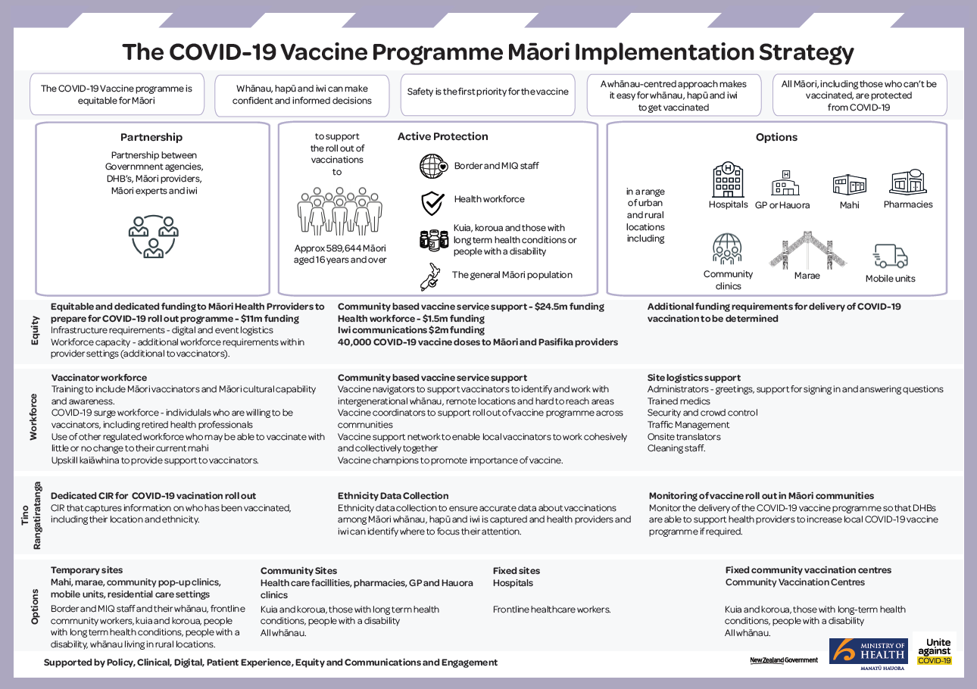
Appendix One

Appendix Two
The strength of hapori Māori
The COVID-19 response has, for the most part, been successful in protecting Māori whānau, hapū, and iwi (see figure 1). At an overall level, the rate of infection for Māori has remained at around half the rate observed for non-Māori. There are currently no active community cases of COVID-19 amongst Māori.
A research report commissioned by Te Pūtahitanga o te Waipounamu indicated that this success was, in particular, due to the leadership displayed by Māori communities and organisations that mobilised immediately during the first outbreak of COVID-19. Māori health providers and iwi organisations capitalised on their strong network connections provide holistic care where it was needed, when it was needed.
The pandemic has required the Ministry to meaningfully partner with iwi and Māori organisations and establish more permissive relationships. The research report highlighted this as a ‘welcome demonstration of trust and recognition of the unique value of iwi and Māori partners’.
The Human Rights Commission (the Commission) indicated that a core success of the initial COVID-19 response was the practical examples of partnering between Māori and the Crown – for example at the rāhui checkpoints. The Commission recommended that the Ministry build on these gains and continues to partner with Māori stakeholders across the health and disability sector and recognise that community organisations understand their community’s needs and are best placed to provide ongoing, equitable care to whānau Māori.

Figure 1: Confirmed and probable cases, Māori and non-Māori, crude rate per 100,000 people to 2 February 2021

Appendix Three
The Māori Influenza Vaccination Programme
The Māori Influenza Vaccination Programme (MIVP) was first announced in April 2020 as part of the Initial COVID-19 Māori Health Response Plan. The MIVP’s objective was to increase access to the influenza vaccine for Māori groups entitled to free vaccinations, particularly kaumātua aged 65 and over. MIVP aimed to do this by increasing access to the influenza vaccine through outreach services, including ‘pop-up clinics’ at local venues such as marae, ‘drive-through vaccine stations’, mobile clinics and other innovative services.
An independent evaluation of the MIVP found that overall, the MIVP made a worthwhile and valuable contribution to improving health outcomes for Māori as follows:
- The National Immunisation Register recorded significantly higher vaccination rates for Māori than in previous years (see figure 2)
- Influenza vaccination rates for Māori 65+ increased from 45.8% in 2019 to 59.0% in 2020. This was significant given the small improvement observed between 2015 and 2019
- The overall influenza equity gap for Māori 65+ reduced in 2020 from -12.1% to -8.4%.
In addition, the evaluation identified three core strategies that made a difference for whānau Māori:
- Mobilising services to go into the community
- Taking a whānau-centred approach
- Focusing on Māori workforce capability and capacity.
The critical learning was that the delivery of vaccinations is ‘more than just a jab’. Continuing to integrate the above learnings into the Programme will be critical to its success. The Ministry is considering how the evaluation and subsequent insights can be fully applied within the Programme, to build responsiveness to Māori and to ensure it caters to holistic whānau needs.

Figure 2: Cumulative proportion of people aged 65 years and above vaccinated against influenza by ethnicity, 2019–2020
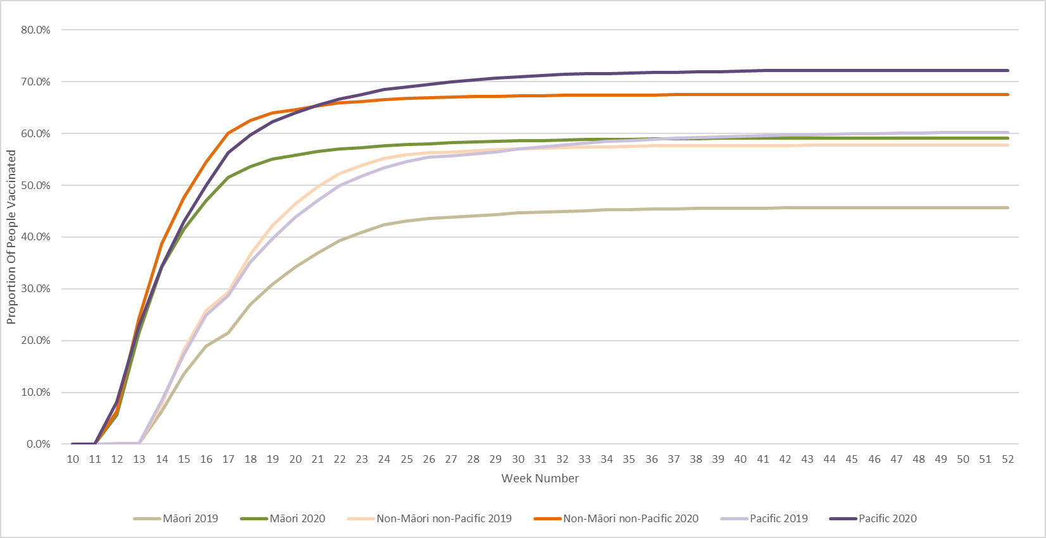

The original focus area of support for people in self-isolation and quarantine was based on the assumption of large number of people isolating in the community. This focused changed once community elimination was achieved.
Note the Ministry’s preference for the neutral term ‘missed appointment’ rather than ‘did not attend’ which places sole responsibility on the service user.
Note that the specific psychosocial survey has ended. However, this data will now be collected as part of the wider New Zealand Health Survey
HISO 10001:2017 Ethnicity Data Protocols https://www.health.govt.nz/publication/hiso-100012017-ethnicity-data-protocols
https://www.stats.govt.nz/about-us/what-we-do/mana-orite-relationship-agreement/
As at 9 March 2021. For updates see: https://www.health.govt.nz/our-work/diseases-and-conditions/covid-19-novel-coronavirus/covid-19-data-and-statistics/covid-19-current-cases
Savage, C., Goldsmith, L., Standring, K., Quinn, S., Selwyn, S., Kus-Harbord, L., and Hynds, A. (2020) Manaaki 20; Inform, Prepare, Uplift. Research into the COVID-19 Response Plan for Te Pūtahitanga o Te Waipounamu. Ihi Research. P. 66.
Human Rights Commission. 2020. Human Rights and Te Tiriti o Waitangi: COVID-19 and Alert Level 4 in Aotearoa New Zealand. Wellington, Human Rights Commission
Wehipeihana, N., Sebire, K. W., Spee, K. & Oakden, J. (2020). More than just a jab: Evaluation of the Māori influenza vaccination programme as part of the COVID-19 Māori health response. Wellington: Ministry of Health.

