2021 COVID-19 Māori Health Protection Plan
May 2022 Monitoring Report

Citation: Ministry of Health.2022. COVID-19 Māori Health Protection Plan: May 2022 Monitoring Report. Wellington: Ministry of Health.
Published in May 2022 by the Ministry of Health
PO Box 5013, Wellington 6140, New Zealand
ISBN 978-1-99-110053-5 (online)
HP 8184
This document is available at health.govt.nz
This work is licensed under the Creative Commons Attribution 4.0 International licence. In essence, you are free to: share ie, copy and redistribute the material in any medium or format; adapt ie, remix, transform and build upon the material. You must give appropriate credit, provide a link to the licence and indicate if changes were made.

Ngā mihi -
Acknowledgements
E rere ana ngā tai o mihi ki ngā ringa miti tai heke nā koutou tēnei pūrongo i whakarite mō tōna whakarewatanga, mei kore ake koutou kua noho tonu tēnei waka ki uta, heoi anō rā, tēnei te whakarewa atu i tēnei waka ki ōna pae tata, ki ōna pae tawhiti, me tā mātou mihi atu ki a koutou, tēnā rawa atu koutou katoa.

Tēnā hoki koutou e ngā ringa atawhai o te motu nā koutou te iwi Māori i tiaki, i manaaki, i whakahaumaru hoki i te wā o te Mate Kowheori. E mōhio pū ana mātou ko koutou te pou tokomanawa e tū ai te whare hauora Māori, ko mātou noa ngā kaitiaki.

We wish to thank everyone who has contributed to the development of this report. We also want to acknowledge our health providers, iwi partners, and Māori health and community workers for your combined contributions to the Māori COVID-19 response. Your commitment to the continued protection of Māori communities has kept our communities safe throughout the pandemic. We hope to continue working with you moving forward in our collective journey towards pae ora, healthy futures for Māori.

Contents
Ngā mihi - Acknowledgements i
He whakarāpopoto - Executive summary 1
Kōrero whakataki - Introduction 3
Te Tiriti and Whakamaua: Māori Health Action Plan 2020– 2025 continue to guide our response 3
Kei hea tātou ināianei? - Where we are now? 5
Omicron: a new phase of the COVID-19 response 5
The Māori Protection Plan in action for Māori 6
Ngā tatauranga matua - Key statistics 10
Health impact of COVID-19 on Māori 10
E neke whakamua ana - Next steps 19
Ngā āpitihanga - Appendices 20
Appendix One: Overview of the Omicron Response Strategy 21
Appendix Two: Delta response support funding activities – reporting to date 23
Appendix Three: COVID-19 Māori Health Protection Plan Monitoring Framework and additional COVID-19 Māori health data and statistics 26
Appendix Four: Wider health system performance 32

List of Figures
Figure 1: Whakapapa of the Monitoring Report to the COVID-19 Māori Health Protection Plan 4
Figure 2: Care in the Community Framework 8
Figure 3: Number of Māori cases reported daily, 17 August 2021 to 1 April 2022 11
Figure 4: Rate of cumulative COVID-19 cases per 1,000 people by ethnicity, 17 August 2021 to 1 April 2022 11
Figure 5: Rate of COVID-19 hospitalisations per 100,000 people by ethnicity, 17 August 2021 to 1 April 2022 12
Figure 6: Vaccination status of Māori COVID-19 cases, 17 August 2021 to 1 April 2022 13
Figure 7: Vaccination status of Māori COVID-19 hospitalisations, 17 August 2021 to 1 April 2022 13
Figure 8: Cumulative booster uptake per 100 people by ethnicity over time, at 1 April 2022 16
Figure 9: Cumulative paediatric first dose uptake per 100 children aged 5 to 11 by ethnicity over time, at 1 April 2022 16
Figure 10: Current RAT Collection Sites in Aotearoa New Zealand 17
Figure 11: Number of health services provided through Delta response funding 23
Figure 12: Number of whānau support items provided through the Delta response funding 24
Figure 13: Number of staff supported through the Delta response funding 25
Figure 14: Cumulative case rate per 1,000 people by ethnicity and age group, between 17 August 2021 and 1 April 2022 27
Figure 15: First dose uptake per 100 people by ethnicity over time, as at 1 April 2022 28
Figure 16: Second dose uptake per 100 people by ethnicity over time, as at 1 April 2022 28
Figure 17: First dose uptake per 100 people by ethnicity and district health board, as at 1 April 2022 29
Figure 18: Second dose uptake per 100 people by ethnicity and district health board, as at 1 April 2022 29
Figure 19: Cumulative booster uptake per 100 people by ethnicity and district health board, as at 1 April 2022 30
Figure 20: Cumulative paediatric first dose uptake per 100 children aged 5 to 11 years by ethnicity and district health board, as at 1 April 2022 31
Figure 21: Number of tests per person by ethnicity and district health board, 24 March 2022 to 31 March 2022 31
Figure 22: Percent of Māori tamariki that had completed scheduled childhood vaccinations for the 18-month and 24-month age groups, by quarter 2016 to 2021 32
Figure 23: Ambulatory sensitive hospitalisation rate for children aged 0 to 4 by ethnicity and quarter, 2018 to 2022 33
Figure 24: Rate of emergency department usage by ethnicity per month, 1 January 2018 to 1 April 2022 34
Figure 25: Percentage of missed first specialist appointments by ethnicity and quarter, 2016 to 2022 35

List of Tables
Table 1: Number of deaths within 28 days of being reported as a positive case, by ethnicity and age group 14
Table 2: COVID-19 Māori Health Protection Plan Monitoring Framework 26

He whakarāpopoto -
Executive summary
This Monitoring Report provides an overview of the progress being made against the COVID-19 Māori Health Protection Plan (the Māori Protection Plan). Since the Māori Protection Plan was published in December 2021, Aotearoa New Zealand’s COVID-19 pandemic has evolved from isolated outbreaks of the Delta variant to community-wide transmission of the Omicron variant.

Demonstrating a commitment to Te Tiriti o Waitangi and the achievement of Māori health equity remains a critical priority in the COVID-19 Māori health response. This Monitoring Report is the latest in a suite of strategic documents that have guided the work of the Ministry of Health (the Ministry) and the health and disability sector in responding to COVID-19 for Māori as outlined in Figure 1.

Although our response to COVID-19 has pivoted again to respond to the new challenges presented by the Omicron variant, the drivers, enablers and actions of the Māori Protection Plan remain relevant. Improving Māori vaccination rates and building community resilience remain integral to protecting Māori health and wellbeing in response to the COVID-19 pandemic, as well as positioning communities to recover from the impacts of the pandemic into the future.

Progress continues to be made against the priorities outlined in the Māori Protection Plan. This includes targeted communications tailored for and with Māori, increased funding to Māori providers to deliver services, equitable access for Māori to testing and testing supplies, and joined-up, tailored care provision for whānau isolating at home through the Care in the Community programme.

Monitoring the impact of COVID-19 on Māori health has been integral to informing the evolving response of the health and disability system to give effect to the principles of Te Tiriti. The data presented in this Monitoring Report demonstrates where there have been improvements in addressing equity for Māori. For example, the equity gap in the first and second dose vaccination rates for Māori compared to non-Māori, non-Pacific has narrowed significantly since the Māori Protection Plan was released (the second dose equity gap has decreased from 14.2 percentage points as at 26 December 2021 to 8.2 percentage points at 1 April 2022).

The data continues to highlight the disproportionate impact that COVID-19 has had on Māori. Persistent inequities remain in COVID-19 infection and hospitalisation rates, and COVID-19 third (booster) dose and child immunisation rates.

More work is needed across the system to protect whānau, hapū, iwi and hapori Māori from the impacts of COVID-19 and to mitigate existing impacts.

The Ministry will continue to monitor the impact of COVID-19 on Māori health, including the impact of the pandemic on wider health system performance, as part of monitoring and reporting progress under both the Māori Protection Plan Monitoring Framework and Whakamaua: Māori Health Action Plan 2020–2025. A further monitoring update will be released before the end of 2022.

Contact details and more information
For the latest updates and information on the COVID-19 response, please go to: covid19.govt.nz

Kōrero whakataki -
Introduction
The Māori Protection Plan was published in December 2021 to respond to the changing landscape of the COVID-19 pandemic as a result of the Delta variant. Although our response to COVID-19 has pivoted again to respond to the new challenges presented by the Omicron variant, the drivers, enablers and actions of the Māori Protection Plan remain relevant in guiding action for Māori health.

This Monitoring Report outlines the progress being made against the Māori Protection Plan’s drivers, enablers and actions that continue to be relevant to the Ministry of Health’s (the Ministry) Omicron response. It also provides an overview of Māori infection rates, hospitalisations and deaths; vaccination coverage; and broader health system performance.

Monitoring the impact of COVID-19 on Māori health has been integral to informing the evolving response of the health and disability system and giving effect to the articles and principles of Te Tiriti o Waitangi (Te Tiriti).

Te Tiriti and Whakamaua: Māori Health Action Plan 2020– 2025 continue to guide our response
Demonstrating a commitment to Te Tiriti and the achievement of Māori health equity remains a critical priority in the COVID-19 Māori health response. This is particularly important following the release of the Waitangi Tribunal’s Haumaru: the COVID-19 Priority Report, which, among other recommendations, indicates that the Crown must further support and resource Māori providers, whānau, hapū, iwi and hapori Māori in the COVID-19 response.

The Ministry has set out its commitment to and expression of Te Tiriti in the context of the health and disability system in Whakamaua: Māori Health Action Plan 2020–2025 (Whakamaua), which includes the Ministry’s Te Tiriti framework. This Monitoring Report, alongside the Māori Protection Plan, are framed within the strategic context of Whakamaua and its relevant COVID-19 actions.
- Action 5.3: Support the cross-government COVID-19 response to mitigate the impacts of COVID-19 on whānau, hapū, iwi and Māori communities.
- Action 6.5: Manage the protection of Māori health through the COVID-19 Māori health programme.
Figure 1 gives an overview of the Ministry’s strategic COVID-19 Māori health response, which has led to the development of the Māori Protection Plan and this Monitoring Report.

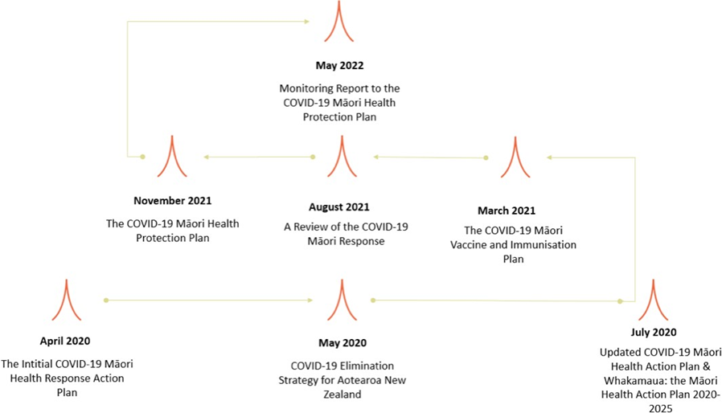
Figure 1: Whakapapa of the Monitoring Report to the COVID-19 Māori Health Protection Plan

Kei hea tātou ināianei? -
Where we are now?

Omicron: a new phase of the COVID-19 response
The World Health Organization designated Omicron as a variant of concern on 26 November 2021. The arrival of the Delta variant in August 2021 resulted in a significant shift in the response landscape, and the communities of Aotearoa New Zealand have again quickly adapted to the new challenges of Omicron.

The Omicron variant has spread rapidly around the globe and is now the major variant in most countries. Omicron is much more transmissible than previous variants of the COVID-19 virus, including Delta. We anticipated that once Omicron started to spread, Aotearoa would see an unprecedented number of infections, hospitalisations and deaths in our communities.

The Omicron Response Strategy
To respond to the new context of the Omicron variant, Aotearoa introduced the Omicron Response Strategy, which is designed to work within the existing COVID-19 Protection Framework (also known as the traffic light system). As elimination was no longer possible given the transmissibility of Omicron, this strategy aimed to manage the impact of COVID-19 with a focus on protecting those most at risk of adverse outcomes and maintaining health system capacity to provide care when needed. This required changes to our testing, contact tracing, isolation and quarantine systems.

The Ministry’s approach to COVID-19 is continuously evolving alongside the pandemic. Appendix One provides an overview of the Omicron Response Strategy that reflects the key changes from previous approaches to dealing with COVID-19. The COVID-19 Protection Framework and associated strategies will be updated as needed to ensure the health system, whānau, hapū, iwi and hapori Māori are well placed to respond to any changes in the pandemic.

Under the government’s minimisation and protection strategy, people with COVID-19 still need to isolate to contain the spread of the virus, to keep our communities safe. Because the health impact of Omicron is relatively milder than previous variants for the majority of people – particularly those who have received a complete primary course of the COVID-19 vaccination as well as a third (booster) dose – Aotearoa has shifted to a system where most people are able to safely self-isolate in the community. This helps to ensure our hospitals are available for those who really need it, whether for COVID-19 care or acute or planned admissions.

The Māori Protection Plan in action for Māori
The COVID-19 Māori Health Protection Plan provides a platform for a range of health work underway, with two key drivers.

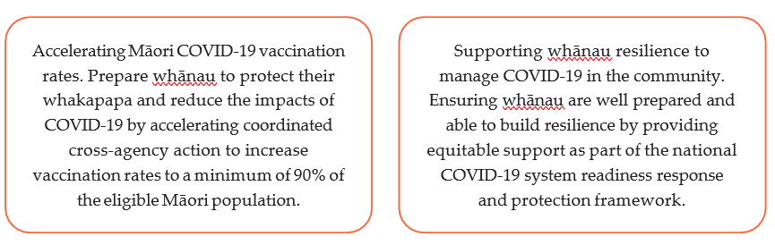
Within the plan, a range of actions are identified that support the achievement of these drivers. These actions are separated under two key enablers focused on targeting information for whānau and increasing integrated health services that are easier to access.

Enabler 1: Target and localise information and education for whānau
This enabler and the associated actions focus on getting information out to whānau that is accessible, locally tailored, accurate and evidence-based. This has included understanding any public health requirements and how COVID-19 is going to be managed in the community.

As part of this, we have invested in Māori campaigns, including Ngāti Rangatahi, which is an iwi- led initiative, and Karawhiua, which is led by Te Puni Kōkiri. We’ve also continued to produce and release content through Ministry channels, including the Time to Boost campaign for whānau, to ensure Māori have access to a variety of content online that communicates public health guidelines and what they mean for whānau.

In the engagement space, we have increased hui with iwi partners and Māori health stakeholders to better understand their needs, communicate public health guidelines, and gather insights to inform the continued development of the COVID-19 Māori health response. Through the COVID-19 vaccination rollout, the National Immunisation Programme mobilisation team has been engaging with iwi, hauora providers and community collectives across the motu. This has included supporting grassroots communication campaigns and activities for Māori in locations where vaccination rates have been lagging, including Tāmaki Makaurau, Bay of Plenty, Tairāwhiti, Manawatū and Waikato.

Since late 2021, the Māori Health Directorate has also been sending out a daily pānui, directly from John Whaanga, Deputy Director-General of Māori Health. This pānui, called Mai i te Manatū provides the Māori health and disability sector with the latest COVID-19 updates. At 29 April 2022, there were 1,293 subscribers to this pānui.

Enabler 2: Increase integrated outreach health and social services for and with Māori.
This enabler focuses on building on the investment into outreach services during the COVID-19 response through delivering joined-up health and social services that mitigate the inequitable impacts of COVID-19 on Māori. It aims to empower and resource local communities to coordinate a response to outbreaks quickly, and enable Māori providers to offer timely and tailored health and social services to support whānau through sickness and recovery.

Funding
Resourcing the Māori health sector and wider Māori communities has been integral to the ongoing COVID-19 response. This has better ensured that Māori health needs have been addressed and that whānau, hapū, iwi and hapori Māori could adequately respond to the pandemic as it evolved. A total of $283.6 million has been invested in the COVID-19 Māori health response. By the end of December 2021, $254 million has been allocated to Māori providers and broader Māori organisations to coordinate COVID-19 related health and social services. The Government allocated an additional $29.6 million in February 2022, to enable providers to continue to support whānau and prepare for future potential waves or variants. This is the biggest investment in Māori health services in over 20 years. Appendix Two provides an overview of how this funding has been used by providers to date.

National Immunisation Programme
In addition, the National Immunisation Programme has made available complementary funding to support holistic, enterprising and whānau-centric immunisation services. This funding aims to expand the scope of outreach/mobile immunisation services for COVID-19 vaccinations to include the full range of immunisations under the National Immunisations Schedule (including influenza, measles, mumps and rubella, and other childhood immunisations). A total of $5.35 million has been allocated to support Māori providers to expand their current services to deliver all nationally approved immunisations.

Evidence gathered from a series of Māori Influenza and Measles Vaccination Programme evaluations indicated that enabling and resourcing Māori providers to take a holistic approach to immunisation through flexible, high-trust commissioning models was crucial to addressing inequities in vaccination rates. The evidence and insights gathered through this Programme, which funded Māori providers and district health boards (DHBs) to deliver innovative, outreach vaccination programmes to Māori, are informing the broader immunisation approach.

An example was seen throughout the series of sprint vaccination events, held over a four-week period from 21 February 2022. Māori providers, DHBs and the Ministry’s National Immunisation Programme Equity team worked in collaboration to deliver vaccination events to increase booster and paediatric uptake in communities where rates were low. These events were community-led, held at times and locations convenient and comfortable for whānau (such as weekend or evening clinics on marae, or in partnership with schools/kura kaupapa), and featured incentives designed not only to encourage vaccination but also to offer practical support for whānau in the Omicron outbreak.

Care in the Community
The Care in the Community programme supports a nationally resourced, regionally coordinated and locally led approach to support whānau who are isolating at home with COVID-19. This approach is based on the understanding that local providers know their communities best, and that welfare and wellbeing support should be tailored to respond to individual and whānau needs.

Figure 2: Care in the Community Framework
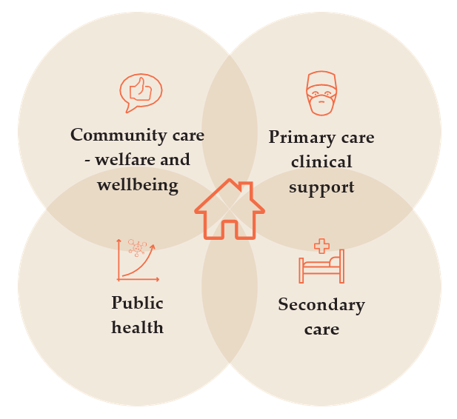

Care coordination hubs in each region bring together local providers of public health and welfare support, including DHBs, public health teams, general practice teams, the Ministry of Social Development, welfare providers, iwi, and Māori and Pacific providers. The support available through the care coordination hubs includes:
- welfare support (eg, kai packs, financial support)
- alternative accommodation coordination
- health services, including active health management, health assessment, testing and monitoring in the home, escalation to hospital services when needed, referral to other health services
- manaaki services, centred on holistic wrap-around assistance such as supporting whānau to access digital systems, health service navigation and medication deliveries.

To date, 52 hubs have been set up. The majority of these hubs are Māori integrated, and many are Māori/iwi-led.

All hubs have an expectation to ensure equity is prioritised. The equity and Te Tiriti expectations of hubs are laid out in the COVID-19 Care in the Community Framework and are reiterated in the COVID-19 Care in the Community Framework Omicron Update.

Ngā tatauranga matua -
Key statistics

Health impact of COVID-19 on Māori
This section provides an update on key statistics on the overall impact of COVID-19 on Māori since the beginning of the August 2021 Delta outbreak. Both the Delta and Omicron variants have been circulating through communities over the past several months. Because the Ministry has not differentiated between cases when collecting data, these statistics cover both variants. Further detailed data and insights are in Appendix Three, alongside the Māori Protection Plan Monitoring Framework.

COVID-19 cases over time
Since the beginning of the Delta outbreak (17 August 2021), more than 138,000 Māori have contracted COVID-19, with 90 percent (125,000 cases) occurring since 24 February 2022. The peak of the Omicron outbreak occurred for Māori on 7 March 2022 (5,315 new reported Māori cases). Since this date, daily Māori cases have decreased to nearly half of the peak (2,686 Māori cases reported on 31 March 2022).

Māori have been disproportionately affected through both the Delta and Omicron outbreaks. Since the beginning of the Delta outbreak in August 2021, Māori have been 75 percent more likely to contract COVID-19 (201.6 cases per 1,000 Māori compared to 116.4 cases per 1,000 non-Māori non- Pacific). After accounting for age, Māori were 2.4 times more likely to contract COVID-19 (330.5 cases per 1,000 Māori compared to 136.3 cases per 1,000 non-Māori non-Pacific).

See Appendix Three for a breakdown of the cumulative case rate by age group.

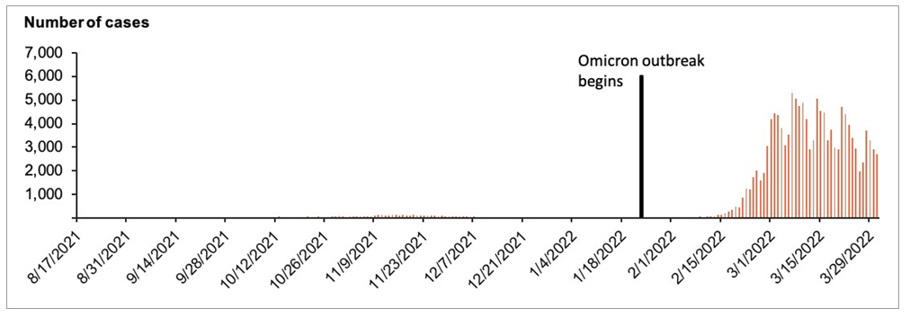
Figure 3: Number of Māori cases reported daily, 17 August 2021 to 1 April 2022

COVID-19 cases by district health board
Between the beginning of the Delta outbreak (17 August 2021) and 1 April 2022, Māori had a higher rate of infection for COVID-19 compared to non-Māori non-Pacific across all DHBs. The equity gap is largest in Northland DHB, where Māori were more than twice as likely to have contracted COVID-19 over this timeframe when compared to non-Māori non-Pacific (168.2 cases per 1,000 Māori compared to 76.5 cases per 1,000 non-Māori non-Pacific).

The equity gap is smallest in Canterbury DHB where Māori were one-and-a-half times more likely to contract COVID-19 between 17 August 2021 and 1 April 2022 (181.3 cases per 1,000 Māori compared to 121.6 cases per 1,000 non-Māori, non-Pacific).

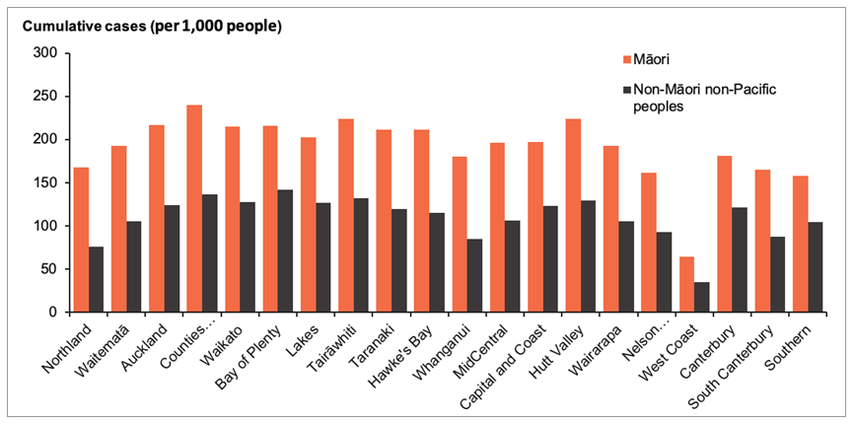
Figure 4: Rate of cumulative COVID-19 cases per 1,000 people by ethnicity, 17 August 2021 to 1 April 2022

COVID-19 hospitalisation rate
Between the beginning of the Delta outbreak (17 August 2021) and 1 April 2022, more than 1,200 Māori were hospitalised with COVID-19. Māori with COVID-19 were 80 percent more likely to be hospitalised than non-Māori non-Pacific with COVID-19 (909.4 hospitalisations per 100,000 Māori compared to 495.5 hospitalisations per 100,000 non-Māori non-Pacific).

Figure 5 shows the COVID-19 hospitalisation rate per 100,000 people between 17 August 2021 and 1 April 2022. The majority of COVID-19 hospitalisations occurred in the Auckland Metro region (Waitematā, Auckland and Counties Manukau DHBs). Auckland had a high rate of total hospitalisations, with 569.8 hospitalisations per 100,000 Māori compared to 126.3 hospitalisations per 100,000 non-Māori non-Pacific.

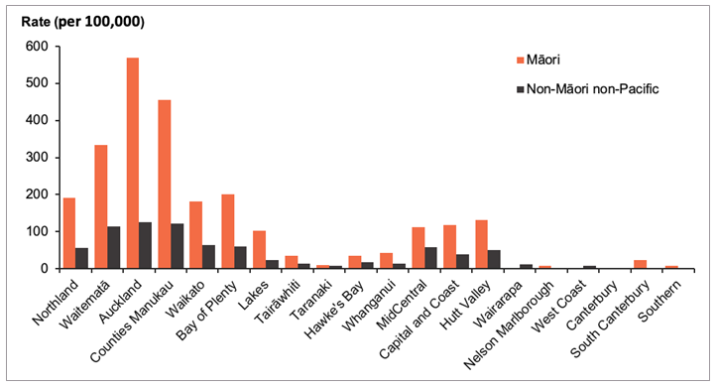
Figure 5: Rate of COVID-19 hospitalisations per 100,000 people by ethnicity, 17 August 2021 to 1 April 2022

Vaccination status of cases and hospitalisations
High rates of vaccination are critical to prevent severe disease and death, especially for people and whānau more at risk from the impacts of COVID-19. Increasing and maintaining vaccination coverage remains a key goal of the Māori Protection Plan. A person is significantly less likely to be severely sick, hospitalised or die from Omicron if vaccinated, especially following the booster. Vaccination also provides some protection against contracting and transmitting the Omicron variant.

Figure 6 shows the vaccination status of Māori COVID-19 cases between 17 August 2021 and 1 April 2022. Similarly, Figure 7 shows the vaccination status of Māori hospitalised with COVID-19 between 17 August 2021 and 1 April 2022.
Just under half of Māori COVID-19 cases were fully vaccinated (47.7 percent of Māori cases had received at least two doses). This increase from 20 December 2021 (10 percent) reflects the increasing uptake of the vaccine by Māori over this time (see Appendix Three for details). However, the majority of Māori who were hospitalised in this time period were either unvaccinated or not fully vaccinated (36.4 percent).

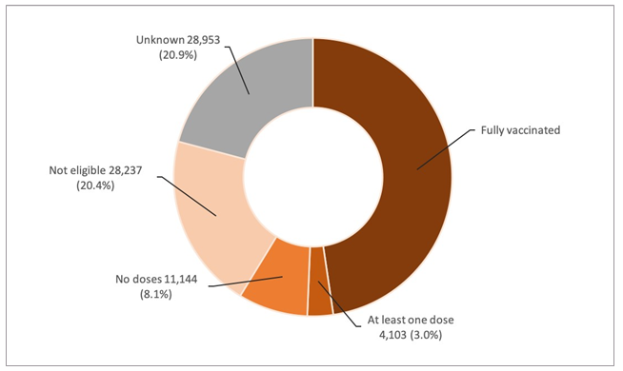
Figure 6: Vaccination status of Māori COVID-19 cases, 17 August 2021 to 1 April 2022

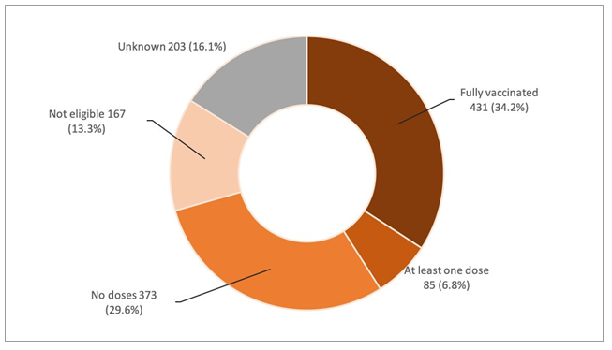
Figure 7: Vaccination status of Māori COVID-19 hospitalisations, 17 August 2021 to 1 April 2022

Deaths
E whai whakaaro ana mātou o Te Manatū Hauora ki a rātou ngā mate tāruru nui i riro atu rā i te wā o te Mate Kowheori. Nei mātou ka kī atu ki a rātou, haere koutou ki te Pūtahitanga o Rēhua, ki te whare whakamoe ariki, ki reira koutou moe ai, okioki e.

As at 1 April 2022, 57 Māori had died within 28 days of being reported as a positive case of COVID-19.

The majority of these deaths occurred in Māori aged 0 to 59 (32 percent). In comparison, 188 non-Māori non-Pacific died within 28 days of being reported as a positive case of COVID-19. The majority of these deaths occurred in the 80 to 89 year age group (33 percent).

These numbers represent people who died within 28 days of contracting COVID-19, but not all of the deaths will be attributable to COVID-19. Further investigation will determine whether COVID-19 was the cause of death, a contributing cause of death, or unrelated to the cause of death.

Table 1 shows the number of Māori and non-Māori non-Pacific peoples by age group who have died within 28 days of being reported as a positive COVID-19 case.

In reporting these deaths, we recognise the significant loss for whānau and hapori Māori throughout the country. These deaths represent more than just numbers for both the Ministry and Māori communities, and our condolences continue to be with all who are grieving the loss of a loved one during the pandemic.

Table 1: Number of deaths within 28 days of being reported as a positive case, by ethnicity and age group
 | Deaths within 28 days of being reported as a case |  | Proportion of deaths in age group
Age group | Māori | Non-Māori non-Pacific | Māori | Non-Māori non-Pacific
0 to 59 years | 18 | 13 | 32% | 7%
60 to 69 years | 11 | 16 | 19% | 9%
70 to 79 years | 13 | 44 | 23% | 23%
80 to 89 years | 8 | 62 | 14% | 33%
90+ years | 7 | 53 | 12% | 28%
Total | 57 | 188 | 100% | 100%

Booster and paediatric vaccination rates
Figure 8 shows the uptake of booster vaccinations per 100 population by ethnicity over time. Similarly, Figure 9 shows the first dose uptake of paediatric (aged 5 to 11 years) vaccinations per 100 population by ethnicity over time.

These figures reflect the slower rollout of the vaccine programme for Māori, using an age-based approach. Despite this, mahi from iwi Māori in partnership with the Crown has closed the equity gap for first and second dose uptake for Māori to less than 10 percent.

Since the beginning of the booster dose rollout, Māori have been approximately 40 percent less likely to have received their booster dose compared to non-Māori non-Pacific. At 1 April 2022, 40.2 percent of eligible Māori have received their booster vaccine.

The equity gap is larger for the paediatric programme, where Māori aged 5 to 11 were more than 50 percent less likely to have received their first dose of the vaccine compared to non-Māori non- Pacific children. This equity gap has slowly decreased to 44 percent less likely by 1 April 2022 (35.1 percent of tamariki Māori had received their first dose of the vaccine, compared to 62.7 percent of non-Māori non-Pacific children).

Vaccination uptake for tamariki Māori aged 5 to 11 has increased from 8 percent fully vaccinated at 2 April 2022 to 11 percent at 02 May 2022. The gap between tamariki Māori vaccination rates and the total vaccination rates for 5 to 11 year olds is 13 percent (overall full vaccination rate for 5 to 11 year olds is 24 percent).

There continues to be a critical focus on increasing booster vaccinations and the paediatric rollout for Māori whānau and tamariki. This is being done through engagement with key stakeholders and the continuation of locally led, community-centred vaccination services catered to tamariki.

Appendix Three provides the cumulative uptake of first and second doses per 100 population aged 12 years and above by ethnicity over time.

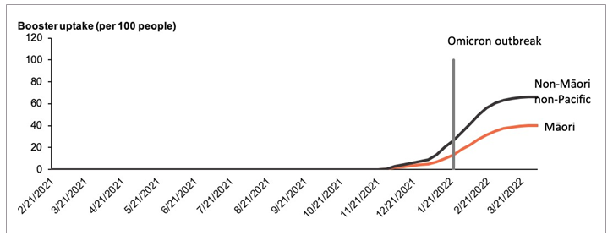
Figure 8: Cumulative booster uptake per 100 people by ethnicity over time, at 1 April 2022
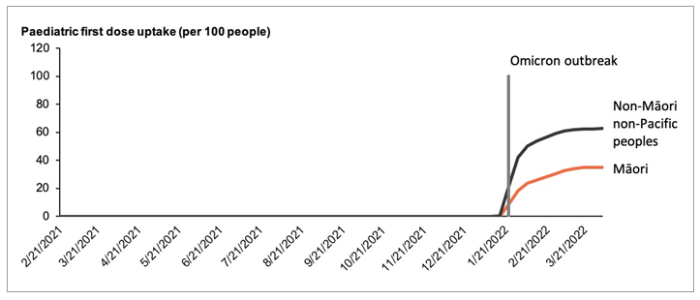
Figure 9: Cumulative paediatric first dose uptake per 100 children aged 5 to 11 by ethnicity over time, at 1 April 2022

A focus on tamariki Māori vaccinations
Initiatives to increase tamariki vaccinations have incorporated lessons learnt during the adult rollout and the initial stages of the paediatric rollout. The adult vaccination rollout tended to leave whānau feeling reluctant to receive their vaccinations together as parents worried about looking after tamariki while receiving their vaccinations. Sprint events held over a four-week period from 21 February 2022 (and subsequent sprint-style events that have occurred since) removed this barrier and had a strong tamariki focus. Events often included prizes and kai for tamariki, while providing special areas for them to be vaccinated and entertained while they wait. This focus
on tamariki has supported whānau in bringing their tamariki to be vaccinated at these events. Whānau are also able to receive their boosters or primary doses while feeling confident that their tamariki are well looked after following their vaccination.

Examples of events with a strong focus on tamariki include the Bay of Plenty’s ‘Supermoko’ superhero-themed vaccination event held in April 2022, and the recent performance roadshow and vaccination events held in Northland, featuring well-loved children’s entertainers Mahi Pai. The Turanga Health sprint event in Tairāwhiti on 20 March 2022 was targeted at tamariki and whanau – the 227 vaccinations delivered were an increase of 759% and 167% for the weeks ending 13 and 20 March when compared to other vaccination weekly totals. Of the total number of vaccinations delivered, 62 percent were to Māori, and 145 vaccinations were delivered to tamariki. Turanga Health has used their successful model for vaccinating tamariki multiple times, with drive- through clinics in various schools.

In the kura context, equity regional account managers have been invited by Te Matakahuki (a collective of chief executive officers for whare wānanga, kura kaupapa, kura ā iwi and kohanga reo) to engage with kura kaupapa Māori and kohanga reo (health providers are not used in the contexts of early childhood education centres and schools). This engagement will ensure that vaccination events, discussions and education can be supported in kura and kohanga around the motu, with specific approaches tailored to each kura/kohanga setting and their whānau and community.

Testing
As we’ve evolved our Omicron response and COVID-19 testing strategy, there has been significant effort to ensure the readiness of testing and the supply of personal protective equipment in case of another large outbreak or new variant.

An eight-point testing and supply action plan has been developed, which takes an intersectional approach to improving the current approach and building resilience in communities via Māori providers.

For example, the establishment of the Māori-provider distribution channel in February 2022 has led to a network of over 1,000 community partners to ensure that Māori have good access to tests. We estimate that 95.4 percent of Māori are within a 20-minute drive of a rapid antigen test (RAT) access point (compared to 95.8 percent of the total Aotearoa population). To date over 9 million RATs and 3 million masks have been provided for distribution through this channel.
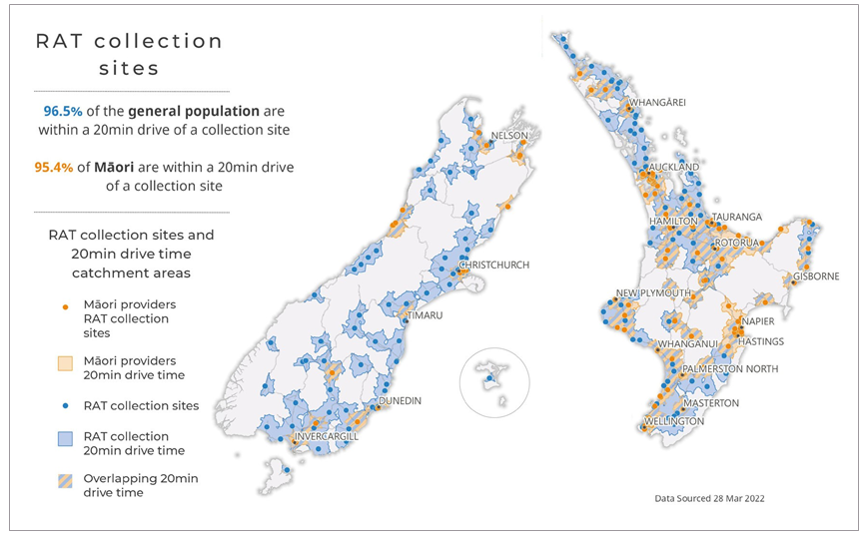
Figure 10: Current RAT Collection Sites in Aotearoa New Zealand

Wider health system performance
COVID-19 has affected the wider health system, for example the impact of lockdowns on service deferral in areas like screening and elective surgeries. It will be important for the Ministry to monitor and understand how the health system is performing more broadly, to mitigate the effects on Māori health beyond the immediate impacts of COVID-19 infection. Appendix Four provides an overview of key indicators of wider health system performance for Māori that will help to inform the recovery phase of the COVID-19 response.

E neke whakamua ana -
Next steps
The Māori Protection Plan’s drivers remain critical to the ongoing COVID-19 Māori health response. As our borders open, driving uptake of broader immunisations will be integral to protecting Māori health and wellbeing. Work to improve vaccination access and uptake for Māori across the various immunisation programmes is underway, with a focus on supporting vaccination services that meet Māori where they are.

The second key driver, which focuses on building the resilience of whānau, hapū, iwi and hapori Māori, will better position communities to recover from the impacts of the pandemic into the future. The Care in the Community model has received significant positive feedback, especially in delivering wrap-around services for whānau. A wider community-based model of care is being further developed to support delivery of services during winter 2022 and into the future.

The Ministry will continue to monitor the ongoing response to COVID-19 for Māori and report on progress, with the next update to be provided before the end of 2022. With the evolving nature of the COVID-19 pandemic, it will be important to continue to learn what works for Māori and embed these learnings into system settings that contribute to more equitable health outcomes for Māori and achieve the aims of pae ora (healthy futures).

Ngā āpitihanga -
Appendices

Appendix One: Overview of the Omicron Response Strategy

Appendix Two: Delta response support funding activities – reporting to date

Appendix Three: Additional COVID-19 Māori health data and statistics

Appendix Four: Wider health system performance

Appendix One: Overview of the Omicron Response Strategy
Goal | Minimise hospitalisations and deaths
Principles | - Equity – Protect at-risk communities and individuals  - Sustainability – ensure health system can sustain response to COVID-19, while continuing to deliver non-COVID health care effectively  - Agility – adapt our approach and actions as needed
Scenarios | LOW: There are some cases in the community, but containment appears possible | MEDIUM: Sustained and substantial spread of Omicron in the population | HIGH: Widespread community cases, possibly via multiple and/or super-spreader events
Objectives + approach | Phase I: Stamp it out – Contain and eliminate outbreaks as quickly as possible | Phase II: Minimise and protect – minimise and slow further spread and focus on protecting the most vulnerable | Phase III: Manage it – move to self-management, protect vulnerable, preserve critical services and infrastructure by targeting resources
Rationale | Delay Omicron becoming widespread, buying time to vaccinate as many New Zealanders as possible and prepare the system to manage large numbers of cases | Reduce potential for harm by lessening overall numbers of cases, leading to less impact on primary care, hospitals and protecting most at risk (by reducing probability of getting ill and ensuring priority access to care) | Protect primary care and hospitals from being overwhelmed and ensure most at risk receive priority access to care to protect from poor health outcomes. This includes ensuring that non-COVID health services can continue to be delivered.
Actions to give the strategy effect (across key work pillars)
Testing | Intensive PCR testing to enable fast, highly reliable results, and rapid isolation to help contain and eliminate outbreaks. PCR testing for symptomatic, close contacts and international arrivals. | Start shift from intensive PCR testing to RAT self- testing but keep PCR testing available to confirm diagnoses if needed. Allow healthcare and critical workers who are close contacts to return to work following a negative RAT if asymptomatic. | Focus PCR testing on priority populations only. Move to RAT testing for the remaining population. Allow healthcare and critical workers who are close contacts to return to work following a negative RAT if asymptomatic.
Case investigation & contact tracing | Cases investigated as usual, using active management approaches (eg, health sector-led investigations). Push notifications (QR scanning), Bluetooth and locations of interest used to identify contacts. | Digital technology is utilised more as cases grow  – eg, text via mobile, self-investigation via online tools. Support available for those not digitally enabled. Start the shift from intensive health-sector led investigations to self-investigations. | Full self-service model – eg, contacts automatically notified from online self-investigation, and option for cases to self-notify their contacts. Only highest risk contacts will be traced and required to isolate. Limited use of push notifications, locations of interest or Bluetooth.
Isolation and quarantine | Cases isolate for 14 days. Contacts isolate for 10 days.  Extra support in place for health and critical workforces. | Cases isolate for 10 days. Contacts isolate for 7 days.  Extra support in place for health and critical workforces. | Cases isolate for 10 days. Contacts isolate for 7 days.  Extra support in place for health and critical workforces.
Health and social support | Clinical care delivered by primary care teams, supported by the local care coordination hub. Plan for shift to self-service. All steps taken to support positive cases to isolate in their usual place of residence. | Support for most positive cases to isolate in their usual place of residence. Alternative  accommodation options across the regions are still available. Support by local care coordination hub for those with a need for ongoing clinical care. Begin shift to self-service. | Support for positive cases to isolate in their usual place of residence and alternative accommodation for cases that are unable to safely isolate at home. Majority of positive cases are self-managed. Clinical care, wrap-around health and welfare support focused on anyone with high needs.
Comprehensive communications strategy that helps public (and health system) to understand & respond at each stage

Appendix Two: Delta response support funding activities – reporting to date
As at 1 April 2022, 125 Māori providers were required to report back on the use of allocated 2021 Delta response funding, with 13 of these providers reporting in mid-April. Of the remaining 116 providers, 78 completed the response survey (67.2 percent of total required providers have responded). This appendix sets out the results of this feedback.

COVID-19 related services provided to support whānau
Figure 11 shows the number and types of services delivered to whānau from Māori providers, with assistance from the Delta response funding.

The largest number of services provided was in the COVID-19 vaccinations category (52 providers offered services in this category), with more than 718,000 vaccinations given with assistance from the Delta response funding. Of the non-COVID-19 specific services, more than 185,000 GP consultations were subsidised, or other barriers, such as transport, were addressed. In addition, more than 55,000 mental health services were provided.
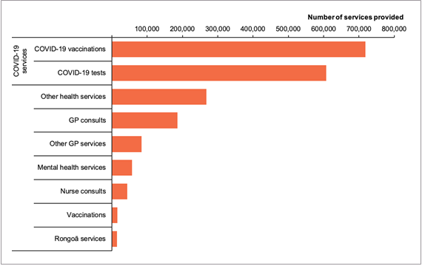
Figure 11: Number of health services provided through Delta response funding

Whānau support provided
Figure 12 shows the number of whānau support services delivered with assistance from the Delta response funding. The majority of providers (65) used the funding to distribute more than 121,000 hygiene packages, making this the most frequently provided service to whānau through this funding. Providers also supplied nearly 90,000 kai packages and more than 40,000 rongoā packages to whānau through this funding. These packages supported the holistic health of whānau through offering supplies and resources that responded to broader health needs.

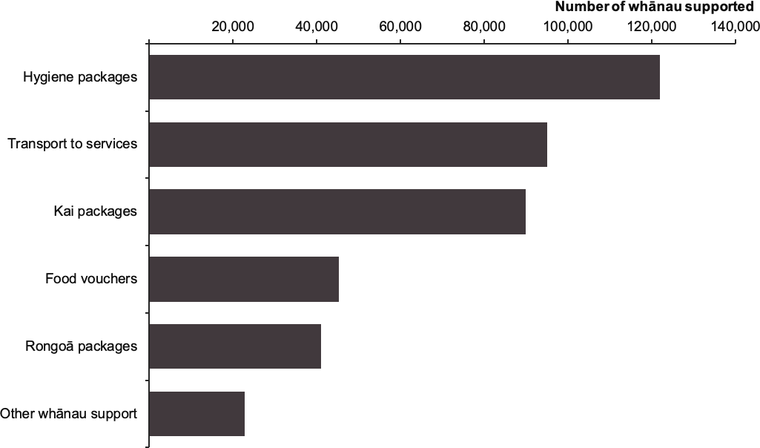
Figure 12: Number of whānau support items provided through the Delta response funding

Staff support provided
Figure 13 shows the number of staff supported with assistance from the Delta response funding. This may have included overtime pay, koha and wellbeing packs for staff, and funding for surge capacity. The majority of providers used the funding to support staff in the kaiāwhina profession (58 providers used this funding to support more than 750 kaiāwhina). More than 350 nurses and more than 200 rangatahi in support roles also received support through this funding.

Figure 13: Number of staff supported through the Delta response funding
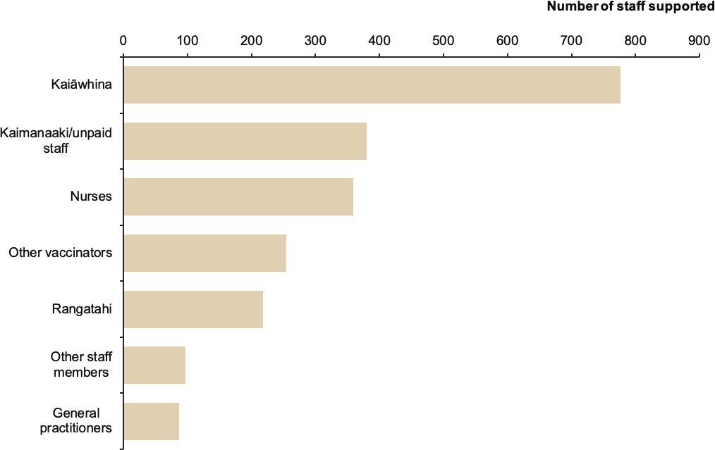

Appendix Three: COVID-19 Māori Health Protection Plan Monitoring Framework and additional COVID-19 Māori health data and statistics
The Monitoring Framework set out in the COVID-19 Māori Health Protection Plan is provided below. In addition to the key statistics in this report, this appendix provides more detailed data on each of the components set out in the Monitoring Framework. Fortnightly data is also shared on the Ministry’s website at http://www.health.govt.nz/covid-19-novel-coronavirus/covid-19-data-and-statistics/covid-19-data-about-maori-and-pacific-peoples.

Table 2: COVID-19 Māori Health Protection Plan Monitoring Framework
Monitoring component | Sources and type of data | Why this is important?
Surveillance | Ethnicity and geography data across:  - confirmed and probable cases  - testing – positive and negative  - close contact tracing  - economic and social support for people  - hospitalisations for COVID-19 specifically  - influenza vaccination access coverage | To maintain close oversight of the impact of COVID-19 on Māori communities  To inform internal strategy and planning of the COVID-19 Māori Health Response
Monitoring of system performance | Ethnicity and geography data across:  - use of inpatient and outpatient services, including:  - ambulatory sensitive hospitalisations  - attendances at emergency departments  - use of outpatient services  - missed appointment rates for outpatient services  - use of community care services (e.g,  - pharmaceuticals, childhood immunisations)  - psychosocial insights | To maintain oversight of potential impact of COVID-19 on Māori access to services
Māori- specific COVID-19  actions | Insights from contracts, including outcomes and outputs  Qualitative insights from Māori communities and Māori health and disability service providers | To track the progress and impact of investment  To enable accountability to the Ministry for delivering on COVID-19 response actions
COVID-19  immunisation | Ethnicity, age and geography data across:  - number of COVID-19 immunisations delivered  - proportion of the population who has completed the first and second doses of the vaccine | To track the progress of the immunisation rollout for the Māori population

COVID-19 cases by age group
Figure 14 shows the number of COVID-19 cases between 17 August 2021 and 1 April 2022 by ethnicity and age group. This figure highlights how COVID-19 has had worse effects on Māori in the younger age groups than non-Māori non-Pacific. The highest COVID-19 case rate for Māori is in the 1 to 4 age group (461.7 cases per 1,000). In comparison, the highest COVID-19 case rate for non-Māori non- Pacific is in the 15 to 19 age group (205.6 cases per 1,000).

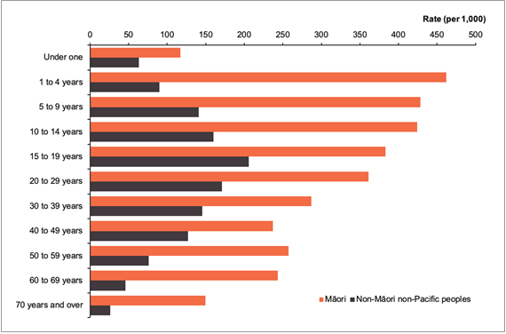
Figure 14: Cumulative case rate per 1,000 people by ethnicity and age group, between 17 August 2021 and 1 April 2022

COVID-19 first and second dose vaccination uptake over time
Figure 15 shows the first dose uptake for the COVID-19 vaccine for people aged 12 and over by ethnicity over time. Figure 16 shows the same for the second dose. Both of these figures highlight the delay in vaccine uptake for Māori, which is now evident in the booster uptake campaign.

Despite this delay, work by iwi and Māori providers has seen a considerable decrease in the equity gap for the first and second doses. At 1 April 2022, 91.4 percent of eligible Māori had received at least one dose of the vaccine and 88.4 percent had received at least two doses.

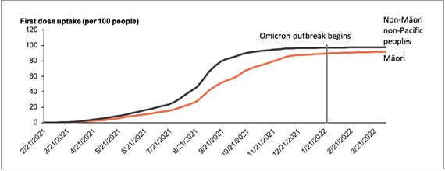
Figure 15: First dose uptake per 100 people by ethnicity over time, as at 1 April 2022

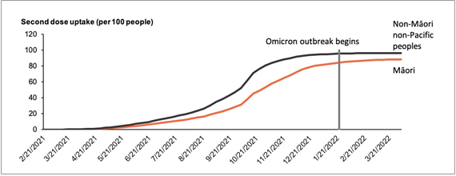
Figure 16: Second dose uptake per 100 people by ethnicity over time, as at 1 April 2022

COVID-19 first and second dose vaccination uptake by DHB
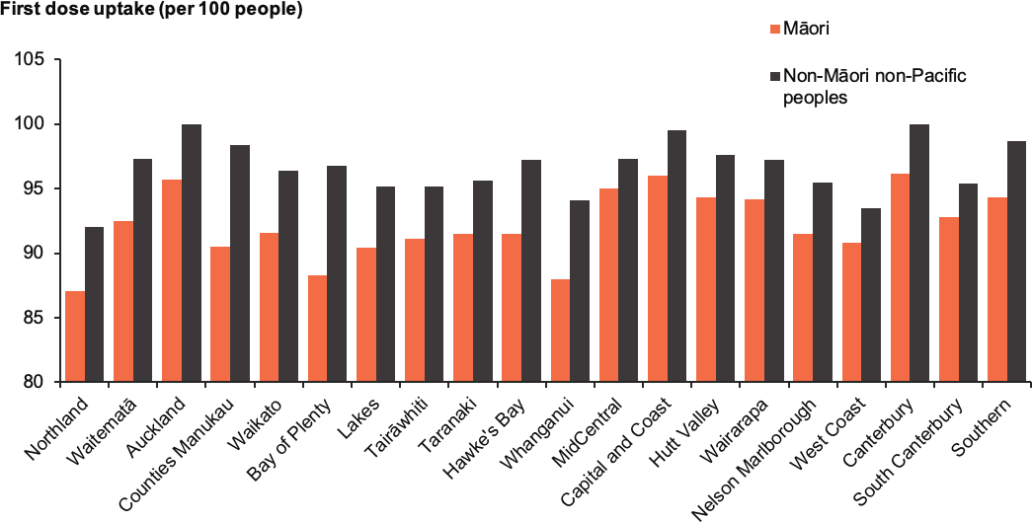
Figure 17: First dose uptake per 100 people by ethnicity and district health board, as at 1 April 2022

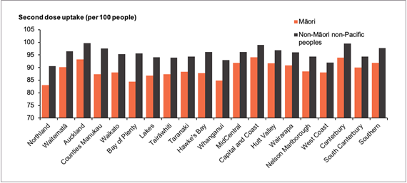
Figure 18: Second dose uptake per 100 people by ethnicity and district health board, as at 1 April 2022

Booster and paediatric vaccination uptake by DHB
Figure 19 shows the booster uptake per 100 eligible people (aged 18 or over and having received the second dose at least three months earlier) by DHB and ethnicity. Similar to the national trend, all DHBs showed an equity gap between Māori and non-Māori non-Pacific for booster uptake.

As at 1 April 2022, Capital and Coast DHB had the highest booster uptake for Māori (67.1 percent). This reflects the region’s strong performance in first and second dose uptake for Māori (more than 90 percent).

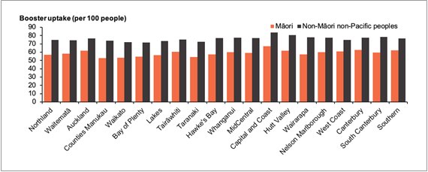
Figure 19: Cumulative booster uptake per 100 people by ethnicity and district health board, as at 1 April 2022

Figure 20 shows the first dose uptake per 100 children aged 5 to 11 by ethnicity and DHB. Similar to the national trend, all DHBs show an equity gap between Māori and non-Māori non-Pacific for paediatric first dose uptake.

At 1 April 2022, Capital and Coast DHB had the highest first dose uptake for Māori aged 5 to 11 (50 percent). However, tamariki Māori aged 5 to 11 were 33 percent less likely to have received their first dose of the vaccine when compared to non-Māori non-Pacific children aged 5 to 11.

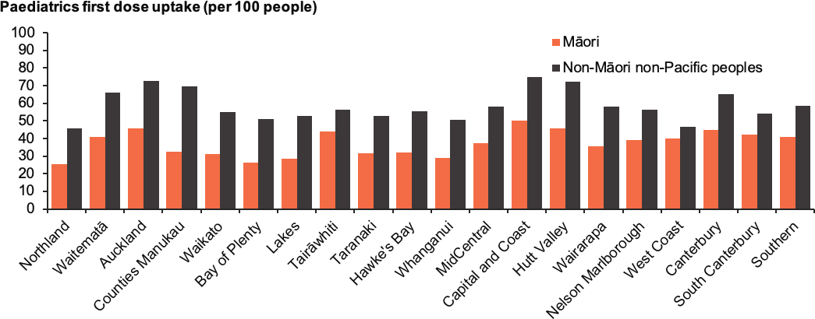
Figure 20: Cumulative paediatric first dose uptake per 100 children aged 5 to 11 years by ethnicity and district health board, as at 1 April 2022

Testing
This data reflects testing rates for polymerase chain reaction (PCR) tests, as the same information is not yet available for RATs. Information on RAT results is provided on page 18.

Figure 21 shows the PCR testing rate per 1,000 people by ethnicity and DHB over the 7 days to 31 March 2022.

Southern DHB had the highest testing rate for Māori over the period (11.1 tests per 1,000 Māori). The largest positive equity gap in testing rates is in Northland DHB, where Māori were 1.4 times (40 percent) more likely to receive a test compared to non-Māori non-Pacific (2.1 tests per 1,000 Māori compared to 1.5 tests per 1,000 non-Māori non-Pacific).

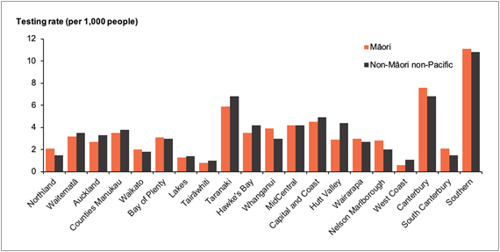
Figure 21: Number of tests per person by ethnicity and district health board, 24 March 2022 to 31 March 2022

Appendix Four: Wider health system performance

Standard immunisation uptake

Childhood immunisation uptake
Figure 22 shows the proportion of tamariki that have completed their childhood vaccinations at 18 and 24 months over time (quarterly). More detail on the childhood vaccination schedule is available on the Ministry of Health website.

For the quarter ending 1 April 2022, Māori tamariki aged 18 months (46 percent completed vaccinations) were 42 percent less likely (1.72 times less likely) to have completed their vaccinations compared to non-Māori non-Pacific children of the same age (78.8 percent completed vaccinations).

Over the same period Māori tamariki aged 24 months (74 percent completed vaccinations) were 19 percent less likely (1.23 times less likely) to have completed their vaccinations compared to non-Māori non-Pacific children of the same age (90.9 percent completed vaccinations). Māori childhood immunisation uptake has continuously declined since 2016 for both the 18 months and 24 months childhood milestones.

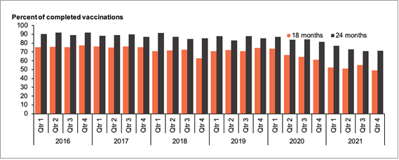
Figure 22: Percent of Māori tamariki that had completed scheduled childhood vaccinations for the 18-month and 24-month age groups, by quarter 2016 to 2021

Influenza immunisation uptake
The 2022 Influenza Immunisation Programme started on 1 April 2022 for the whole population, with a focus on immunising people eligible for funded vaccines, particularly those in more vulnerable populations such as Māori and Pacific peoples. This means that data on the 2022 influenza immunisation uptake for Māori is not yet available. Statistics on the influenza immunisation uptake for 2021 are available in the Māori Protection Plan.

Access to the funded influenza vaccine has been broadened this year to include Māori and Pacific peoples aged between 55 and 64. The change will mean that 100,000 Māori and Pacific people aged over 55 will be offered the vaccine free of cost.

Service usage

Ambulatory sensitive hospitalisations
Ambulatory sensitive hospitalisations (ASH) are admissions that are considered potentially reducible through interventions provided at the primary health care level. This is a key multi- morbidity measure of how well the primary health care system is working for Māori tamariki.

Figure 23 shows the ASH rate per 1,000 people. In the latest quarter (between 1 January 2022 and 1 April 2022), Māori tamariki aged 0 to 4 (90.2 ASH events per 1,000) were 1.37 times more likely (37 percent more likely) to experience an ASH compared to non-Māori non-Pacific children of the same age (66 ASH events per 1,000). This equity gap is the smallest compared to the same quarter for the previous five years.

The ASH rate for Māori tamariki in the quarter to 1 April 2022 is lower than that for the same quarter in 2021. This is potentially due to the delay in reporting to the National Minimum Dataset (Ministry of Health), as not all ASH events for the 2022 quarter may have been reported yet.

The ASH rate in quarters two and three in 2020 remains the lowest for all ethnic groups due to the impact of the lockdown on accessing hospital services.

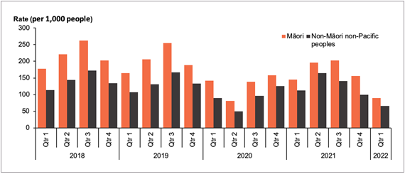
Figure 23: Ambulatory sensitive hospitalisation rate for children aged 0 to 4 by ethnicity and quarter, 2018 to 2022

Attendances at emergency departments
Figure 24 shows the rate of emergency department (ED) attendances per 1,000 people by ethnicity and whether the patient was admitted to hospital or discharged over time. During February 2022, Māori (22.3 ED attendances per 1,000 Māori) were 1.37 times more likely (36.8 percent more likely) to attend an ED when compared with non-Māori non-Pacific peoples (16.3 ED attendance per 1,000 non-Māori non-Pacific peoples). Additionally, Māori (58.9 percent of Māori ED attendances ended in discharge) were 1.14 times more likely (14.1 percent more likely) to be discharged from an ED attendance when compared to non-Māori non-Pacific peoples (51.6 percent non-Māori non-Pacific peoples ED attendances ended in discharge).

There was a large decrease in ED attendances across all ethnic groups during the Level 4 lockdown from 25 March to 27 April 2020. A similar decrease occurred in the August Delta lockdown (17 August 2021 to 31 August 2021) for Māori and Pacific peoples, with a lower decrease for non-Māori non-Pacific peoples.

It is too soon to determine how the Omicron outbreak has affected ED attendances. ED attendance rates will continue to be monitored monthly to determine any potential impacts from the Omicron outbreak.

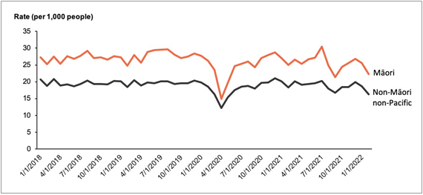
Figure 24: Rate of emergency department usage by ethnicity per month, 1 January 2018 to 1 April 2022

Missed appointment rates for outpatient services
Outpatient services that are safe and appropriate for Māori patients and their whānau are essential to improving health outcomes for Māori. This measure places responsibility on DHBs to offer services at times, in settings and in ways that build trust and work for Māori. See Figure 25 for the proportion of specialist appointments missed by ethnicity, specialist type and time.

In the latest quarter (1 January to 1 April 2022), Māori (13.5 percent missed) were 3.21 times more likely (221 percent more likely) to experience a missed appointment for first specialist services compared to non-Māori non-Pacific peoples (4.2 percent missed). This is the smallest equity gap when compared to the same quarter across the previous seven years.
For Māori, the highest proportion of missed appointments occurred in the maternity specialist group (10.9 percent of first appointments missed). Maternity had the highest number of missed appointments for Māori (155 missed appointments).

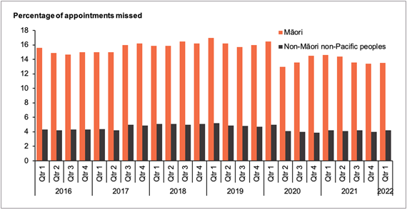
Figure 25: Percentage of missed first specialist appointments by ethnicity and quarter, 2016 to 2022

Episurv, ESR and National Contact Tracing System, Ministry of Health, 17 August 2021 to 1 April 2022.
Rate is age-standardised to the Māori 2001 Census population.
Episurv, ESR and National Contact Tracing System, Ministry of Health, 17 August 2021 to 1 April 2022. Health Service User population 2020.
Episurv, ESR and National Contact Tracing System, Ministry of Health; National Minimum Dataset, Ministry of Health, 17 August 2021 to 1 April 2022; Health Service User population 2020.
Episurv, ESR and National Contact Tracing System, Ministry of Health, 2022; COVID-19 Immunisation Register, Ministry of Health, 2022.
https://www.health.govt.nz/covid-19-novel-coronavirus/covid-19-data-and-statistics/covid-19-case-demographics#aug-2021
Booster uptake for the entire population is shown here to give an indication of population coverage and the impact of a slower second dose uptake. Elsewhere in this document ‘eligible people’ is used as the denominator to show the uptake for people that can be vaccinated.
COVID-19 Immunisation Register, Ministry of Health, 2022.
The Ministry’s preference is for the neutral term ‘missed appointment’ rather than ‘did not attend’, which places sole responsibility on the service user.
The specific psychosocial survey has ended. However, this data will now be collected as part of the wider New Zealand Health Survey.

