COVID-19 RISK AMONG DISABLED PEOPLE
16 December 2022

Citation: Ministry of Health. 2023. COVID-19 Risk Among Disabled People. Wellington: Ministry of Health.
Published in March 2023 by the Ministry of Health
PO Box 5013, Wellington 6140, New Zealand
ISBN 978-1-991075-08-6 (online)
HP 8722
This document is available at health.govt.nz
This work is licensed under the Creative Commons Attribution 4.0 International licence. In essence, you are free to: share ie, copy and redistribute the material in any medium or format; adapt ie, remix, transform and build upon the material. You must give appropriate credit, provide a link to the licence and indicate if changes were made.

Contents
Key Points 1
Background 2
COVID-19 risk for disabled people receiving Disability Support Services 3
Disability Support Services (DSS) (primary data source) 3
Case rates in DSS recipients 4
Hospitalisation risk in DSS recipients 6
Mortality risk in DSS recipients 7
International comparisons 8
Data Limitations 9
Conclusion 10
References 11

List of Figures
Figure 1: National weekly reported case rates in those aged less than 70 years by disability status, 01 January – 16 November 2022 4
Figure 2: National age-standardised reported case rates (and 95% confidence intervals) in those aged less than 70 years by disability status, 01 January – 16 November 2022 5
Figure 3: National age-standardised reported hospital admission rates (and 95% confidence intervals) by disability status in those aged less than 70 years, 01 January – 16 November 2022 6
Figure 4: National crude mortality rates (and 95% confidence intervals) where COVID-19 was the underlying or contributory cause in those aged less than 70 years by disability status, 01 January – 16 November 2022 7

Key Points
      - Disability was identified though Disability Support Services (DSS); exploration of patterns and risk for this cohort of disabled people have been limited to the 43,000 DSS recipients aged under 70 years.
      - There are an estimated 1.1 million disabled people living in New Zealand. DSS recipients are a relatively small subgroup of disabled people who are substantially more likely to be highly vulnerable with complex impairments. The data in this analysis reflects the risk experienced by DSS recipients and is not generalisable to all disabled people in Aotearoa.
      - DSS recipients’ cumulative risk of being reported as a case has been around 15% lower than the rest of the population during 2022.
      - DSS recipients have had four times the risk of hospitalisation and 13 times the risk of COVID-19 attributed mortality compared with the rest of the population during 2022.
      - Mortality risk from non-COVID related causes was also substantial, with DSS recipients having 19 times the risk compared with the rest of the New Zealand population.
      - Overall, the data suggest that DSS recipients have been at substantially greater risk of severe outcomes (hospitalisation and death) after infection with SARS-CoV-2.

Background
The 2013 New Zealand Disability Survey estimated 24% of the total population were disabled, with those aged 65 or more years more likely to be disabled (59%) than adults under 65 years (21%) or children under 15 years (11%). (1) The survey also found that Māori and Pacific peoples had higher than average disability rates, after adjusting for age differences. Disabled people in Aotearoa generally experience poorer physical and mental health outcomes, those with intellectual disability have been identified as particularly vulnerable to poor health outcomes. (2, 3)

There is evidence of disproportionate impacts from COVID-19 on disabled people: they were more likely to have felt lonely, face barriers in access to primary care and emergency services, delay seeking healthcare due to fear of contracting COVID-19, and further concerns around access to appropriate support services, lack of emotional support, financial strain, unemployment and a lack of adequate and timely communication to vulnerable groups. (4-7)

Due to data constraints, there is limited evidence available regarding the direct impacts of COVID-19 on disabled people in Aotearoa, such as infection, hospitalisation, mortality and long COVID. The objective of this analysis is to take an initial step towards addressing this information gap by providing estimates for disabled people who can be identified by NHI: those who receive support services.

COVID-19 risk for disabled people receiving Disability Support Services

Disability Support Services (DSS) (primary data source)
Whaikaha is responsible for the provision of DSS to eligible people. DSS recipients are likely to have more complex impairments and co-morbidities than the wider disabled community. DSS is often used to describe a range of support that may be available, including disability information and advisory services; environmental support, child development services, personal care, respite, individualised funding, supported living, behaviour support and residential support. Disability data for this analysis are drawn from the DSS database (those who were current recipients on 01 January 2022); this is currently the only readily available dataset counting disabled people.

As older disabled people are more likely to be supported by Te Whatu Ora and those eligible for DSS have a shorter life expectancy and must have had their disability identified before age 65 years, the DSS clients tend to be younger than the general population. Therefore, exploration of patterns and risk for this cohort of disabled people have been limited to those under 70 years.

There were just over 45,000 people in Aotearoa receiving DSS on 01 January 2022, of which almost 43,000 were under the age of 70.

Case rates in DSS recipients
From 01 January to 16 November 2022 almost 14,000 (32%) DSS recipients aged less than 70 years have been reported as a COVID-19 case. Time trends have been similar to the rest of the population, with case rates increasing again in recent weeks (see Figure 1). After taking age into account, DSS recipients’ cumulative risk of being reported as a case has been around 15% lower than the rest of the population during 2022 (see Figure 2).

Figure 1: National weekly reported case rates in those aged less than 70 years by disability status, 01 January – 16 November 2022
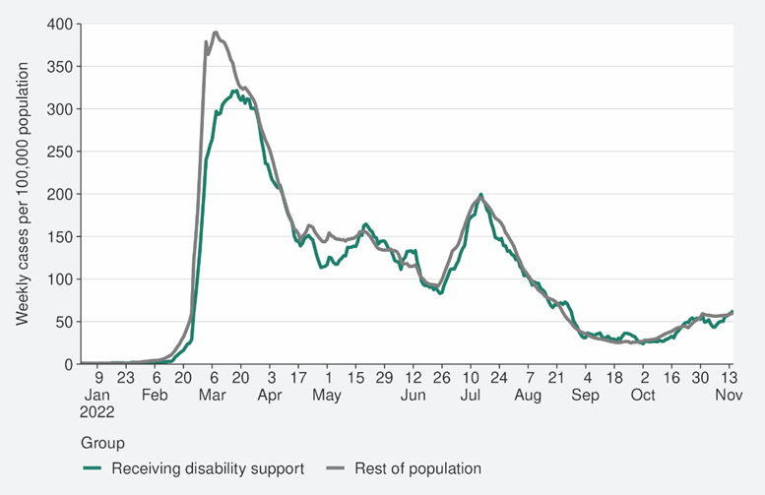
Source: NCTS/EpiSurv, and CVIP population estimates, 16 November 2022, Disability Support Services database

Figure 2: National age-standardised reported case rates (and 95% confidence intervals) in those aged less than 70 years by disability status, 01 January – 16 November 2022
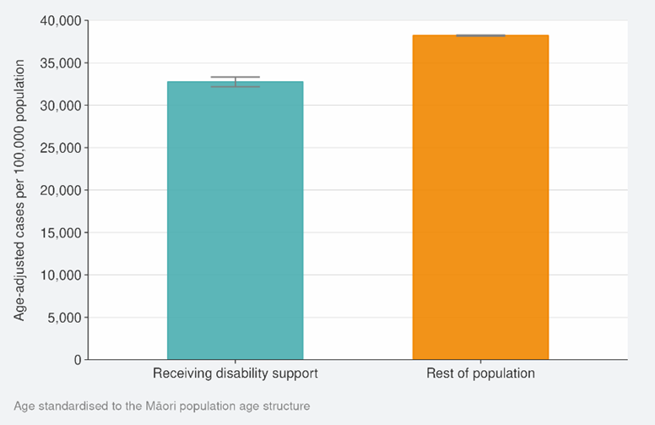
Source: NCTS/EpiSurv, and CVIP population estimates, 01 January 2022 to 16 November 2022, Disability Support Services database

Hospitalisation risk in DSS recipients
During 2022, 431 (1,046 per 100,000 of population) DSS recipients aged less than 70 years have been hospitalised due to COVID-19; after taking into account age, DSS recipients have had four times the risk of hospitalisation compared with the rest of the population during 2022 (see Figure 3). While hospitalisation rates demonstrate that DSS recipients are at greater risk of poor COVID-19 health outcomes, it also indicates that disabled people continued to access hospital services while systems were under pressure.

Figure 3: National age-standardised reported hospital admission rates (and 95% confidence intervals) by disability status in those aged less than 70 years, 01 January – 16 November 2022
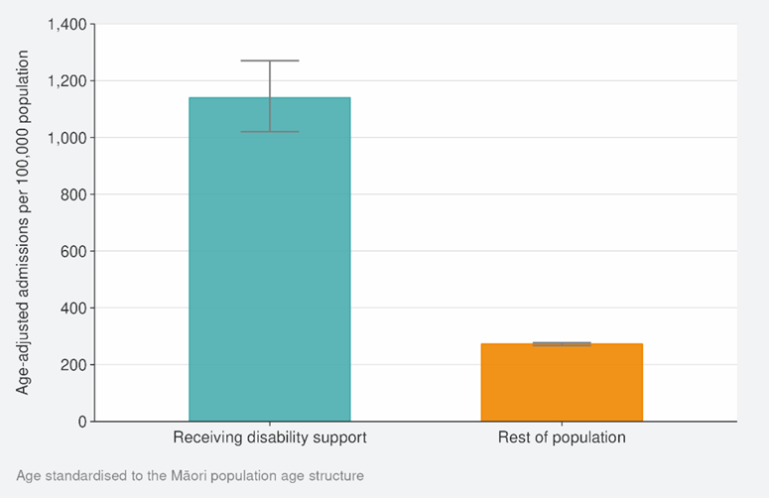
Source: NCTS/EpiSurv, NMDS, Inpatient Admissions dataset and CVIP population estimates, 01 January 2022 to 30 October 2022, Disability Support Services database

Mortality risk in DSS recipients
There have been 28 (66 per 100,000 of population) DSS recipients aged less than 70 years who have died with COVID-19 as the underlying or contributory cause during 2022. The risk cannot be further adjusted for age due to low numbers. However, as the data were restricted to people aged less than 70 years, this still enables a comparison to be made between people of a similar age. Figure 4 shows that during 2022, DSS recipients under 70 years old have had 13 times the mortality risk compared with the rest of the population aged under 70 years old.

The substantially higher risk of COVID-19 attributed deaths among DSS clients is also seen for all-cause mortality where the mortality risk is 19 times higher than for the rest of the New Zealand population.

Figure 4: National crude mortality rates (and 95% confidence intervals) where COVID-19 was the underlying or contributory cause in those aged less than 70 years by disability status, 01 January – 16 November 2022
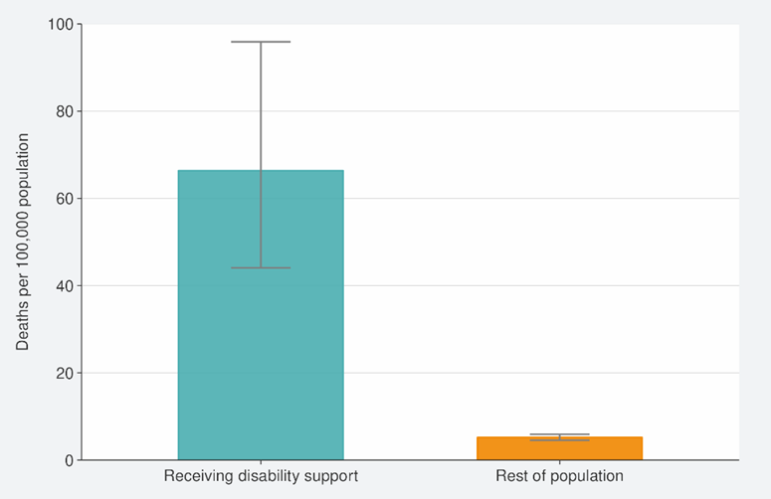
Source: EpiSurv/NCTS, Death Documents, Mortality Collections Database, Healthcare User database and CVIP population estimates, 01 January 2022 to 16 November 2022, Disability Support Services database

International comparisons
Whilst defining who is disabled, and international comparisons, can be difficult, globally disabled people are recognised as a vulnerable group who are likely to be at higher risk of contracting SARS-CoV-2 and experiencing severe COVID-19 related health outcomes. (8) Disabled people continue to experience many barriers to inclusion in the COVID-19 response and have been differentially affected by COVID-19 because of increased risk of poor outcomes from the disease itself, reduced access to routine health care, information, and increased risk of adverse psychological/social impacts of efforts to mitigate the pandemic.

Evidence from the United States suggests that infection risk for disabled people living in residential facilities may be five times greater than the general population, (9) and hospitalisation rates for disabled people were 50% higher than non-disabled people. (10) A Canadian study also found that disabled people were 77% more likely to be hospitalised and had 36% longer hospital stays than those without disabilities. (11)

Analyses in England showed higher age-adjusted mortality involving COVID-19 among disabled people who were limited ‘a lot’ (3.0 times higher for men; 3.5 for women) and disabled people who were limited ‘a little’ (1.9 times higher for men; 2·0 for women) than among non-disabled people. (12) A Scottish study found that people with intellectual disabilities (ID) had a mortality ratio of 3.3 and that overall adults with ID had more COVID-19 infections, and worse outcomes once infected, particularly adults under 70 years. (13)

Data Limitations
DSS recipients are a relatively small subgroup of disabled people who are substantially more likely to be highly vulnerable with complex impairments. The data in this analysis reflects the risk experienced by DSS recipients and is not generalisable to all disabled people in Aotearoa. However, there are currently no reliable data to quantify risks for the full number of disabled New Zealanders who are at risk of poorer COVID-19 outcomes.

Furthermore, DSS recipients are on average, younger than the overall disabled population, and younger than the NZ population. This is because older disabled people usually receive support through other funded services outside of Whaikaha and so are not included in this data. However, statistical adjustments (age standardisation and age restriction) have been made to increase the validity of comparisons of COVID-19 outcomes between DSS recipients and the rest of the population. It should be noted that these risk estimates have not been further adjusted for other factors such as sex, ethnicity, comorbidities, or vaccination status. The impact of anti-viral medications would also be an important consideration for a future analysis.

Conclusion
Overall, although the risk of being a reported COVID-19 case among DSS recipients was slightly lower than the rest of the population, the data suggests that DSS recipients have been at substantially greater risk of severe outcomes (hospitalisation and death) once they have become infected with SARS-CoV-2.

While these results should not be generalised to the wider disabled population, because DSS recipients have more complex impairments on average and do not include the older disabled community, they do provide valuable insight into the burden faced by a subset of disabled people. This is an initial step to gather robust evidence into the impact of COVID-19 on disabled people, and the effectiveness of COVID-19 policy and service access for disabled people, to complement lived-experience and other evidence provided by the disability community.

References
      - Statistics New Zealand Tatauranga Aotearoa. Disability Survey: 2013. 2014 [Available from: https://www.stats.govt.nz/assets/Uploads/Disability-survey/Disability-survey-2013/Disability-survey-2013-additional-documents/Disability-Survey-2013.pdf]
      - Ministry of Health. Health Indicators for New Zealanders with Intellectual Disability.: Ministry of Health; 2011 2 September 2011.
      - Brandford S. Counting for Something – How New Zealand agencies record, investigate and review deaths of people with intellectual disability Wellington, New Zealand2020 [Available from: https://static1.squarespace.com/static/599f868a579fb358f076d0a4/t/5fc43a83145a8629dc36b3d5/1606695571591/Counting+for+Something+November+2020.pdf]
      - Statistics New Zealand Tatauranga Aotearoa. Wellbeing statistics: December 2020 quarter. 2021 [Available from: https://www.stats.govt.nz/information-releases/wellbeing-statistics-december-2020-quarter#loneliness]
      - Office for Disability Issues. COVID-19 Data analysis. 2022 [updated 1 April 2022. [Available from: https://www.odi.govt.nz/guidance-and-resources/covid-19-data-analysis/]
      - Health Quality and Safety Commission New Zealand. The health care experience of disabled people during COVID-19: Summary of findings from the COVID-19 patient experience survey. 2021 [Available from: https://www.hqsc.govt.nz/resources/resource-library/the-health-care-experience-of-disabled-people-during-covid-19-summary-of-findings-from-the-covid-19-patient-experience-survey/]
      - Office for Disability Issues. Towards a non-disabling New Zealand - the annual report from the Minister for Disability Issues to the House of Representatives on implementation of the New Zealand Disability Strategy. 2020 [Available from: https://www.odi.govt.nz/about-us/corporate-publications/]
      - Kamalakannan S, Bhattacharjya S, Bogdanova Y, Papadimitriou C, Arango-Lasprilla JC, Bentley J, et al. Health Risks and Consequences of a COVID-19 Infection for People with Disabilities: Scoping Review and Descriptive Thematic Analysis. Int J Environ Res Public Health. 2021;18(8):4348
      - Okonkwo NE, Aguwa UT, Jang M, Barré IA, Page KR, Sullivan PS, et al. COVID-19 and the US response: accelerating health inequities. BMJ evidence-based medicine. 2021;26(4):176-9.
      - Yuan Y. COVID-19 cases and hospitalizations among Medicare beneficiaries with and without disabilities—United States, January 1, 2020–November 20, 2021. MMWR Morbidity and Mortality Weekly Report. 2022;71(24):791-6.
      - Brown HK, Saha S, Chan TC, Cheung AM, Fralick M, Ghassemi M, et al. Outcomes in patients with and without disability admitted to hospital with COVID-19: a retrospective cohort study. Canadian Medical Association Journal. 2022;194(4):E112-E21.
      - Bosworth ML, Ayoubkhani D, Nafilyan V, Foubert J, Glickman M, Davey C, et al. Deaths involving COVID-19 by self-reported disability status during the first two waves of the COVID-19 pandemic in England: a retrospective, population-based cohort study. The Lancet Public Health. 2021;6(11):e817-e25.
      - Henderson A, Fleming M, Cooper S-A, Pell JP, Melville C, Mackay DF, et al. COVID-19 infection and outcomes in a population-based cohort of 17 203 adults with intellectual disabilities compared with the general population. Journal of Epidemiology and Community Health. 2022;76(6):550-5

Eligible people are likely to have a physical, sensory, intellectual disability or autism which has been identified before the age of 65 and not the result of an accident.
Age standardisation was used to make comparisons between population that may have different age structures, this is particularly important if examining an outcome where the risk is strongly related to age, such as being hospitalised.
While definitions of disability vary, there in a consistent focus on how disabled people experience and interact with society and their environment.

