COVID-19 in Health Care and Support Workers in Aotearoa New Zealand
2020

Acknowledgements
New Zealand surveillance data was provided by ESR and funded by the Ministry of Health with the cooperation of the diagnostic laboratories. Analysis on transmission chains between health care workers and contacts was carried out by ESR. The report was written by T Luff (Office of the Director of Public Health) and M Turley (COVID-19 Science and Insights team) with input from ESR.
Citation: Ministry of Health. 2020. COVID-19 in Health Care and Support Workers in Aotearoa New Zealand. Wellington: Ministry of Health.
Published in October 2020 by the Ministry of Health
PO Box 5013, Wellington 6140, New Zealand
ISBN 978-1-99-002947-9 (online)
HP 7478
This document is available at health.govt.nz
This work is licensed under the Creative Commons Attribution 4.0 International licence. In essence, you are free to: share ie, copy and redistribute the material in any medium or format; adapt ie, remix, transform and build upon the material. You must give appropriate credit, provide a link to the licence and indicate if changes were made.

Contents
Key findings 1
Purpose of this report 2
Definition of health care and support worker 3
Who is included in this report? 4
Number of COVID-19 cases in health care and support workers 5
Source of infection in health care and support workers 7
Demographic characteristics of cases 8
Location of cases and links to clusters 10
Outcomes of cases in health care and support workers 11
Profile of people affected by workplace transmission 12
Types of health care and support workers infected by a patient, resident or client 14
Types of health care and support workers infected by another health care worker 15
Types of health care and support workers infected by a patient/ resident or another health care worker 16
Settings where health care and support workers were a vector for transmission to patients, residents or clients 17
What this tells us 18
Next steps 19
Appendix: Data analysis information 20

List of Tables
Table 1: Likely settings and sources of infection for health care and support worker cases of COVID-19 7
Table 2: Ethnicity of Aotearoa New Zealand Nurses 2019 (from Nursing Council data provided by Health Workforce New Zealand) 9
Table 3: Workplace-acquired COVID-19 in health care and support workers by setting and health care worker role 13
Table 4: Workplace-acquired COVID-19: cases in health care and support workers likely transmitted from a patient or resident 14
Table 5: Workplace-acquired COVID-19: cases in health care and support workers likely transmitted from another health care worker 15
Table 6: Workplace-acquired COVID-19 cases in health care and support workers likely transmitted from either another health care worker or a patient or resident 16
Table 7: Roles and settings in which health care and support workers appeared to be vectors for transmission to patients or residents 17

List of Figures
Figure 1: COVID-19 in health care and support workers by reporting date, compared with all other cases in Aotearoa New Zealand 6
Figure 2: Percentage of health care worker cases of COVID-19 in Aotearoa New Zealand by age, compared with percentage of total cases until 12 June 8
Figure 3: Ethnicity of health care and support workers with COVID-19 (as reported in EpiSurv) 9
Figure 4: Health care and support worker cases of COVID-19 by District Health Board 10
Figure 5: Workplace-acquired COVID-19 in health care and support workers by setting and health care worker role 13

Key findings
- As at 12 June 2020 there had been 167 cases of COVID-19 in health care and support workers, which represents 11% of total cases.
- Ninety-six health care and support workers with COVID-19 were likely to have been infected in the workplace. This represents 6.4% of total cases at 12 June 2020.
- Nine health care and support workers required hospitalisation as a result of COVID-19, with two receiving intensive care. None of the workers died.
- More health care assistants/caregivers in aged residential care were affected compared with other health care and support worker groups.
- Most transmission between health care and support workers and patients or residents happened in the aged residential care setting.
- The majority of health care and support worker cases were part of a cluster.
- There were very few instances of transmission in community health care settings.

Purpose of this report
Health care and support workers are an essential and valuable workforce. The nature of their occupation or workplace means that many are at increased risk of contracting COVID-19.

The purpose of this report is to describe COVID-19 cases in health care and support workers in Aotearoa New Zealand until 12 June 2020, which encompasses the ‘first wave’ of the virus. The report summarises the basic descriptive epidemiology of COVID-19 among these workers.

While this report summarises likely transmission pathways with regards to health care and support workers, it does not apportion blame to any individuals and does not give insights into how transmission happened. The report describes the demographics of all health care and support workers diagnosed with COVID-19 and then focuses on transmission in the workplace, to help identify areas of the COVID-19 response for review and strengthening.

Definition of health care and support worker
The national notifiable diseases database, EpiSurv, asks ‘Is the case a health care worker (any job in a health care setting)?’ as well as asking the specific occupation and workplace setting.

The term health care and support worker includes health care assistants and caregivers, nurses, community support workers, doctors, allied health professionals (such as occupational therapists), and administration staff who work in a health care setting such as aged residential care or a hospital. It also includes those whose work is not directly related to health care but who work in a health care setting, such as kitchen staff or security personnel working at a hospital.

Who is included in this report?
A total of 182 people diagnosed with COVID-19 were classified as health care and support workers in EpiSurv, as at 12 June. Fifteen of these 182 cases have been excluded from this report for the following reasons.
- It was clear that nine people who were recorded in EpiSurv as health care and support workers were not working in a health care setting at, or around, the time they had COVID-19. This included people who were retired health care and support workers, those who worked in a non-health care setting, such as an office environment outside the health care setting, and those who worked overseas but were visiting Aotearoa New Zealand at the time of diagnosis.
- Six people initially categorised as health care and support workers were excluded because there was insufficient information available to determine their role or their work setting. All of these six cases were imported.

Number of COVID-19 cases in health care and support workers
The first case of COVID-19 in a health care or support worker was reported on 17 March 2020.

After exclusions, 167 people diagnosed with COVID-19 were recorded as health care and support workers with an Aotearoa New Zealand workplace as at 12 June. This can be broken down into:
- 73 (43.7%) health care assistants, caregivers or support workers
- 49 (29.3%) nurses
- 16 (9.6%) allied health professionals
- 11 (6.6%) administration staff
- 9 (5.4%) doctors
- 9 (5.4%) in other occupations such as cleaners, students, or catering staff.

Of the 167 cases, 101 were confirmed (60.5%) and 66 were probable (39.5%). For total cases of COVID-19 over the same time period, 78.8% were confirmed. The difference is likely to be because, compared to all cases, a higher proportion of health care and support worker cases were identified in relation to clusters between 1 and 8 April when a symptomatic close contact of a case was considered a probable case and not tested. From 8 April to 7 May, symptomatic close contacts who tested negative could also be called a probable case based on a risk assessment by the medical officer of health. Probable cases were otherwise managed in the same way as confirmed cases.

Of the 1,504 cases in Aotearoa New Zealand until 12 June 2020, 11% were health care and support workers. Figure 1 shows health care and support worker infections in relation all other cases, showing a pattern generally similar to all cases. Ninety-six health care and support workers acquired COVID-19 in the workplace, representing 6.4% of total infections.

Figure 1: COVID-19 in health care and support workers by reporting date, compared with all other cases in Aotearoa New Zealand
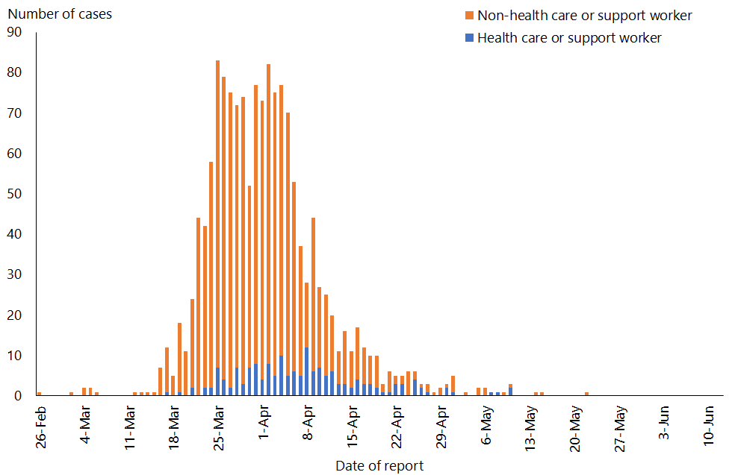

Source of infection in health care and support workers
Of the 167 cases in health care and support workers, 60 (35.9%) were found to have been infected outside the workplace (primarily transmission within their household or imported from overseas). For 11 cases (6.6%) the source was not able to be identified but was thought unlikely to be the workplace (Table 1).

Of the 96 health care and support workers (57.5%) who were likely to have been infected in the workplace:
- 42 people (25.1%) were likely to have been infected by a patient, resident or client
- 32 people (19.2%) were found to have been infected by another health care worker.

For 22 health care or support worker cases (13.2%), it was not possible to determine the exact transmission pathway; however, epidemiological investigation found it probable they were infected by either another health care or support worker or a patient (or resident or client) at the workplace.

Table 1: Likely settings and sources of infection for health care and support worker cases of COVID-19
Source of infection | Number of cases (%)
Workplace | 96 (57.5%)
Patient/resident/client |  | 42 (25.1%)
Another health care or support worker |  | 32 (19.2%)
Either health care or support worker or patient/resident/client |  | 22 (13.2%)
Outside of workplace | 60 (35.9%)
Imported |  | 22 (13.2%)
Household |  | 29 (17.4%)
Non-household, non-workplace |  | 9 (5.4%)
Unknown | 11 (6.6%)
Total | 167

Demographic characteristics of cases
77.2% of health care and support workers who were diagnosed with COVID-19 were recorded as female, and 22.8% as male. This is compared with 55.7% of total cases recorded as female and 44.3% as male. The age of health care and support workers ranged from 20 to 69 with a mean age of 41, reflective of the working age population. Two health care and support workers were over 65. The age distribution is seen in Figure 2, in comparison to total cases.

Figure 2: Percentage of health care worker cases of COVID-19 in Aotearoa New Zealand by age, compared with percentage of total cases until 12 June
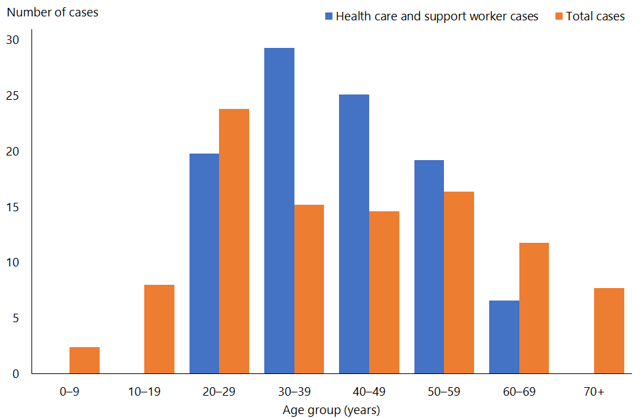

The ethnicity of the health care and support workers who were diagnosed with COVID-19 can be broken down as follows (see Figure 3):
- 4.8% Māori (compared to 8.6% of all cases)
- 9.6% Pacific peoples (compared to 5.4% of all cases)
- 35.3% Asian (compared to 12.6% of all cases)
- 50.3% European or Other (including Pākehā/New Zealand European) (compared to 73.4% of all cases).
Figure 3: Ethnicity of health care and support workers with COVID-19 (as reported in EpiSurv)
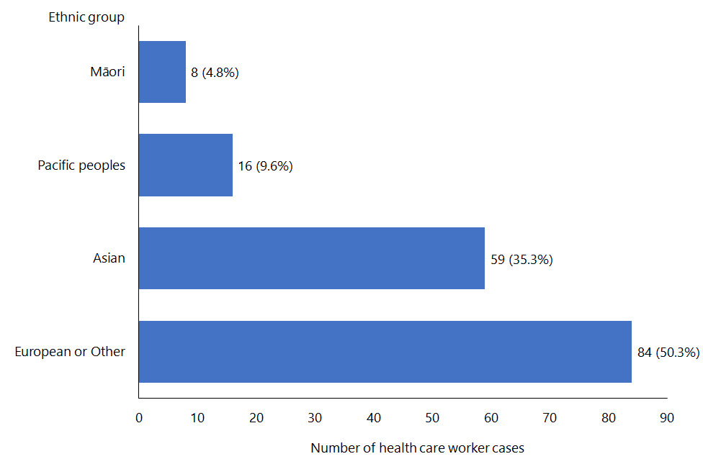

Demographic characteristics of all health care and support workers in New Zealand were not available in full to enable comparison. In particular, health care assistant/caregiver data was not available; however, nursing data suggests the recorded ethnicity of health care worker cases is reflective of the workforce (see Table 2).

Table 2: Ethnicity of Aotearoa New Zealand Nurses 2019 (from Nursing Council data provided by Health Workforce New Zealand)
Ethnicity | Nurses working across all specialities | Nurses working in continuing care of older people  (aged residential care)
Māori | 7.5% | 5.5%
Pacific peoples | 3.7% | 3.4%
Asian/Indian | 22.3% | 45%
European/Other | 66.4% | 46%

Overall, the demographic characteristics of health care worker cases are likely to reflect the health care workforce demographics (in particular aged residential care) with a high proportion of female health care and support workers, people of working age and a majority of people of Asian and European/Other ethnicity.

Location of cases and links to clusters
Of the health care and support worker cases, 132 (79%) were linked to a cluster (of three or more cases and involving more than one household), compared with 46% of all cases. While this includes clusters unrelated to health care settings, three major clusters in aged residential care facilities accounted for nearly half (49%) of all cases in health care and support workers.

Figure 4 shows the distribution of cases in health care and support workers by district health board (DHB). DHBs that did not have any cases in health care and support workers are not listed.

The DHB areas with the largest number of cases in health care and support workers were Canterbury (48), Waitematā (37), Waikato (21) and Auckland (18). The higher numbers of health care and support worker cases in these regions reflect clusters in these areas.

Figure 4: Health care and support worker cases of COVID-19 by District Health Board
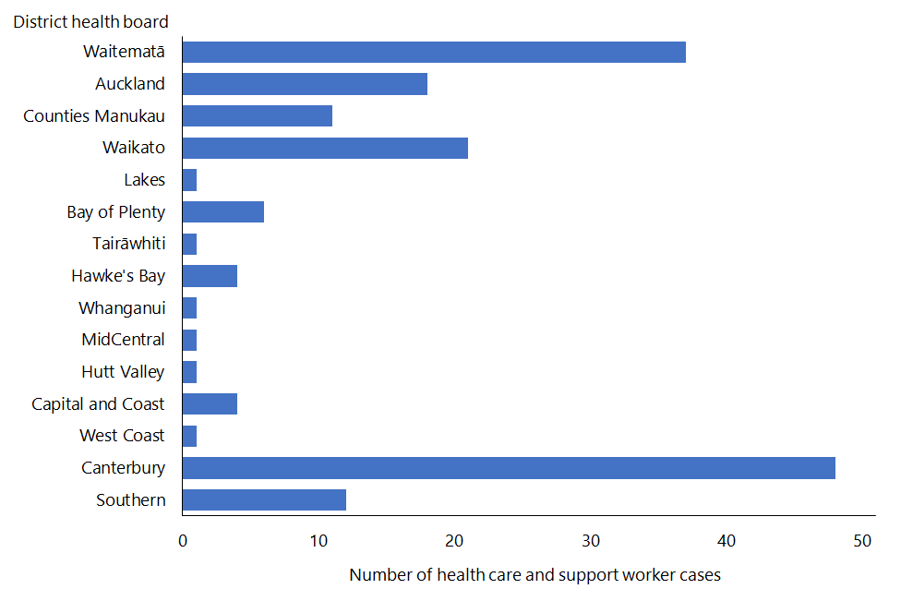

Outcomes of cases in health care and support workers
Nine health care and support workers required hospitalisation as a result of COVID-19, with two receiving intensive care.

A lower proportion of health care worker with COVID-19 were hospitalised compared with overall cases (3% compared with 6% of total cases).

None of the nine hospitalised health care and support workers were over the age of 65, but two were over 60. Of the health care and support worker cases up to 12 June, all have been recorded as recovered and there were no deaths.

Profile of people affected by workplace transmission
Of the 96 health care and support workers who were infected in the workplace:
- 60 (62.5%) worked in an aged residential care setting
- 26 (27%) worked in a hospital
- 10 (10.4%) worked in the community.

As seen in Figure 5 and Table 3, the majority (76.7%) of health care workers in aged residential care worked in a health care assistant/caregiver role and 20% were nurses. This pattern was different in the hospital setting, where the highest proportion of infections was among nursing staff (76.7%) and health care assistants/caregivers made up only 11.5% of cases.

The length of time spent with COVID-19 positive patients or residents (exposure time) is a factor in the risk of a health care or support worker being infected with COVID-19. This may be a contribution to the higher numbers of health care assistants/caregivers seen in the aged residential care setting and for nurses in the hospital setting.

Figure 5: Workplace-acquired COVID-19 in health care and support workers by setting and health care worker role
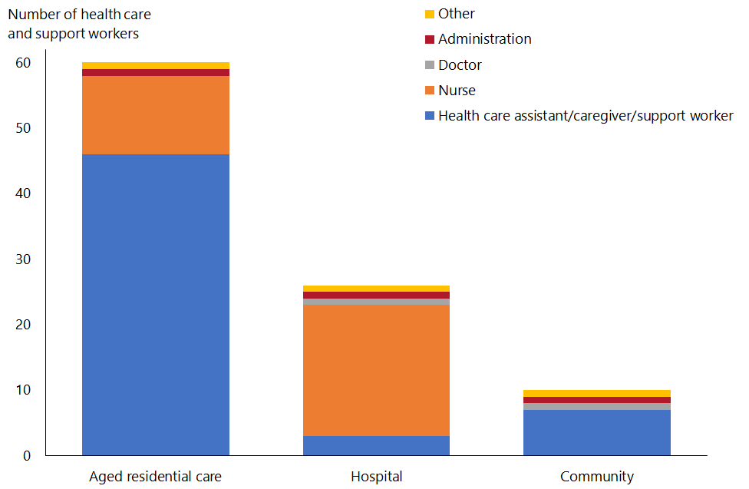

Table 3: Workplace-acquired COVID-19 in health care and support workers by setting and health care worker role
 | Aged residential care | Hospital | Community | Total
Health care assistant/caregiver/ support worker | 46 | 3 | 7 | 56
Nurse | 12 | 20 | 0 | 33
Doctor | 0 | 1 | 1 | 2
Allied health professional | 0 | 0 | 0 | 0
Administration | 1 | 1 | 1 | 3
Other | 1 | 1 | 1 | 3
Total | 60 | 26 | 10 | 96

Types of health care and support workers infected by a patient, resident or client
Of the 42 health care and support workers likely to have been infected by a patient or resident, over half were health care assistants/caregivers and nurses working in aged residential care (Table 4).

Until 12 June 2020, 94 people with COVID-19 were cared for in hospitals across the country with only 11 instances of patient-to-staff transmission. This indicates overall infection, prevention and control (IPC) practices were good and protected the majority of our health care and support workers in hospitals. Seven of the 10 hospital-based nurses who were diagnosed with COVID-19 were caring for residents transferred from aged residential care settings, as was the one health care assistant in a hospital setting.

Other than one doctor in a community care setting, there were no other instances of doctors, allied health professionals, support workers, administration staff, or other staff based in a health care setting (such as security or kitchen staff) who were likely to have been infected by a patient, resident or client.

Of the 42 cases involving transmission from patient/resident/client to health care or support worker, 40 were associated with clusters.

Table 4: Workplace-acquired COVID-19: cases in health care and support workers likely transmitted from a patient or resident
 | Aged residential care | Hospital | Community | Total
Health care assistant/caregiver/ support worker | 19 | 1 | 4 | 24
Nurse | 6 | 10 | 0 | 16
Doctor | 0 | 0 | 1 | 1
Allied health professional | 0 | 0 | 0 | 0
Administration | 0 | 0 | 0 | 0
Other | 1 | 0 | 0 | 1
Total | 26 | 11 | 5 | 42

Types of health care and support workers infected by another health care worker
It is likely that 32 health care and support workers with COVID-19 were infected by another health care or support worker in the workplace (Table 5). All but one of these cases were linked to a cluster and the majority were in the aged residential care setting.

Table 5: Workplace-acquired COVID-19: cases in health care and support workers likely transmitted from another health care worker
 | Aged residential care | Hospital | Community | Total
Health care assistant/caregiver/ support worker | 14 | 0 | 3 | 17
Nurse | 4 | 6 | 0 | 10
Doctor | 0 | 1 | 0 | 1
Allied health professional | 0 | 0 | 0 | 0
Administration | 1 | 1 | 0 | 2
Other | 0 | 1 | 1 | 2
Total | 19 | 9 | 4 | 32

Types of health care and support workers infected by a patient/ resident or another health care worker
In some instances, it was possible to determine that a health care worker was infected in the workplace but not possible to tell if the virus was transmitted from a patient/resident or another health care worker. Each of these 22 cases was linked to a cluster and the majority were working in the health care assistant/caregiver role in aged residential care (Table 6).

Table 6: Workplace-acquired COVID-19 cases in health care and support workers likely transmitted from either another health care worker or a patient or resident
 | Aged residential care | Hospital | Community | Total
Health care assistant/caregiver/ support worker | 13 | 2 | 0 | 15
Nurse | 2 | 4 | 0 | 6
Doctor | 0 | 0 | 0 | 0
Allied health professional | 0 | 0 | 0 | 0
Administration | 0 | 0 | 1 | 1
Other | 0 | 0 | 0 | 0
Total | 15 | 6 | 1 | 22

Settings where health care and support workers were a vector for transmission to patients, residents or clients
Of the total 167 health care and support workers who had COVID-19, 50 were likely to have infected one or more people, either at home or in the workplace.

Seventeen health care and support workers were thought to be the likely source for 20 cases in patients, residents or clients (14 health care and support workers likely transmitted to one resident/patient/client each and three health care and support workers to two residents/patients/clients). The roles and settings of these health care and support workers are outlined in Table 7.

Most transmission to residents/patients appears to have been in the aged residential care setting or nurses working in public hospitals (including one nurse caring for residents transferred from an aged residential care facility). In the community setting, transmission most likely occurred between an occupational therapist and their client, and between a disability support worker and their client.

Table 7: Roles and settings in which health care and support workers appeared to be vectors for transmission to patients or residents
 | Aged residential care | Hospital | Community | Total
Health care assistant/caregiver/ support worker | 8 | 1 | 1 | 10
Nurse | 3 | 3 | 0 | 6
Doctor | 0 | 0 | 0 | 0
Allied health professional | 0 | 0 | 1 | 1
Administration/other | 0 | 0 | 0 | 0
Total | 11 | 4 | 2 | 17

What this tells us
- Just over half (57%) of health care and support workers were infected at work (96 out of 167, representing 6.4% of total cases).
- Most workplace-acquired COVID-19 cases were in the aged residential care setting, with health care assistants/caregivers being the most affected of this group.
- Only 10% of workplace-acquired infections in health care and support workers were in a community health care setting, suggesting good IPC and other effective public health measures were in place.
- Seventeen health care and support workers likely passed the infection on to patients, residents or clients, and at least 32 cases in health care and support workers appear to be as a result of transmission from another staff member (primarily in aged residential care).
- There were few instances of transmission between some types of health care and support workers and patients, residents or clients, such as doctors and allied health professionals. This may reflect the difference in length and type of their interactions compared with nurses or caregivers.
- In the hospital setting, nurses made up the highest proportion of cases infected at the workplace; however, there were few transmissions to hospital workers in comparison to the number of cases hospitalised, which indicates good IPC practices.

Next steps
This descriptive analysis of COVID-19 in health care and support workers highlights the importance of protecting them, particularly nurses and health care assistants/ caregivers working in aged residential care, as a priority in Aotearoa New Zealand’s ongoing COVID-19 response, especially when there is community transmission.

As this is a descriptive review of cases in health care and support workers, it cannot tell us about the reasons and circumstances related to transmission between health care and support workers and patients/residents/clients, nor give insight into the experience of health care and support workers who had COVID-19 (including their mental health and wellbeing). There are several reviews that provide some of these answers, including the Waitematā DHB Incident Review Report of COVID-19 Staff Infections and the Independent Review of COVID-19 Clusters in Aged Residential Care Facilities (the ARC Cluster Report). A further step is the consideration of research into the lived experience of health care and support workers with COVID-19.

The Ministry of Health developed and is now implementing an action plan to address the recommendations made in the ARC Cluster Report. The seven workstreams were tested with the sector and are being implemented in order of reported priority. To address the first two workstreams, a cross-sector, multidisciplinary working group, with representatives from the aged residential care sector, DHBs, public health units (PHUs) and unions has been formed to develop a nationally consistent approach to managing pandemics in the aged residential care sector. This will include establishing baseline principles of how this sector, DHBs, PHUs and the Ministry of Health will work together, as well as guidance for planning and preparedness at the local level. The Ministry of Health is linking with other organisations within the health and disability sector to implement other workstreams within the action plan. The implementation of this action plan complements other work essential to the protection of health care and support workers such as ongoing review of IPC practice, and the management of personal protective equipment supply and the national reserve system.

Appendix: Data analysis information
We identified the EpiSurv numbers of all recorded contacts of all health care workers using two fields in EpiSurv. We excluded contacts whose onset date was outside the 14 days prior to onset of the health care worker.

Based on this, we determined the possible chain of transmission between the health care worker and their contact using onset dates. The occupation, place of work and address fields were used to determine whether the contact was another health care worker, a patient/resident/client, household contact, or other.

Where a health care worker had multiple contacts of different types (eg, another health care worker or ARC resident), we followed up with the PHUs to seek any additional information about which contact was the most likely source. It was not always possible for the PHU to determine this based on the information obtained in their case and/or outbreak investigation.

There may be local variations in the categorisation of a workplace as a health care setting; however, this is not expected to be significant for the purposes of this analysis.
For the purposes of this report, support workers are grouped with health care assistants and caregivers as data was not available to differentiate between these roles in every case.
The Organisation for Economic Co-operation and Development (OECD) definition of the working age population is those aged 15 to 64 years. https://data.oecd.org/pop/working-age-population.htm
Ethnicity as reported in EpiSurv.
Recovered cases are people who had the virus, are at least 10 days since onset and have not exhibited symptoms for 72 hours, and have been cleared by the health professional responsible for their monitoring.
Shepherd M, Andrew P, Kirkwood G, et al. 2020. Waitematā DHB Incident Review Report of COVID-19 Staff Infections Waitakere Hospital. Waitematā District Health Board, April.
Jackways T, Manuel R, Wood P, et al. 2020. Independent Review of COVID-19 Clusters in Aged Residential Care Facilities. Report prepared for the Ministry of Health, New Zealand, May.
Ministry of Health. Action Plan for the Recommendations of the Independent Review of COVID 19 Clusters in Aged Residential Care Facilities. https://www.health.govt.nz/independent-review-action-plan.

