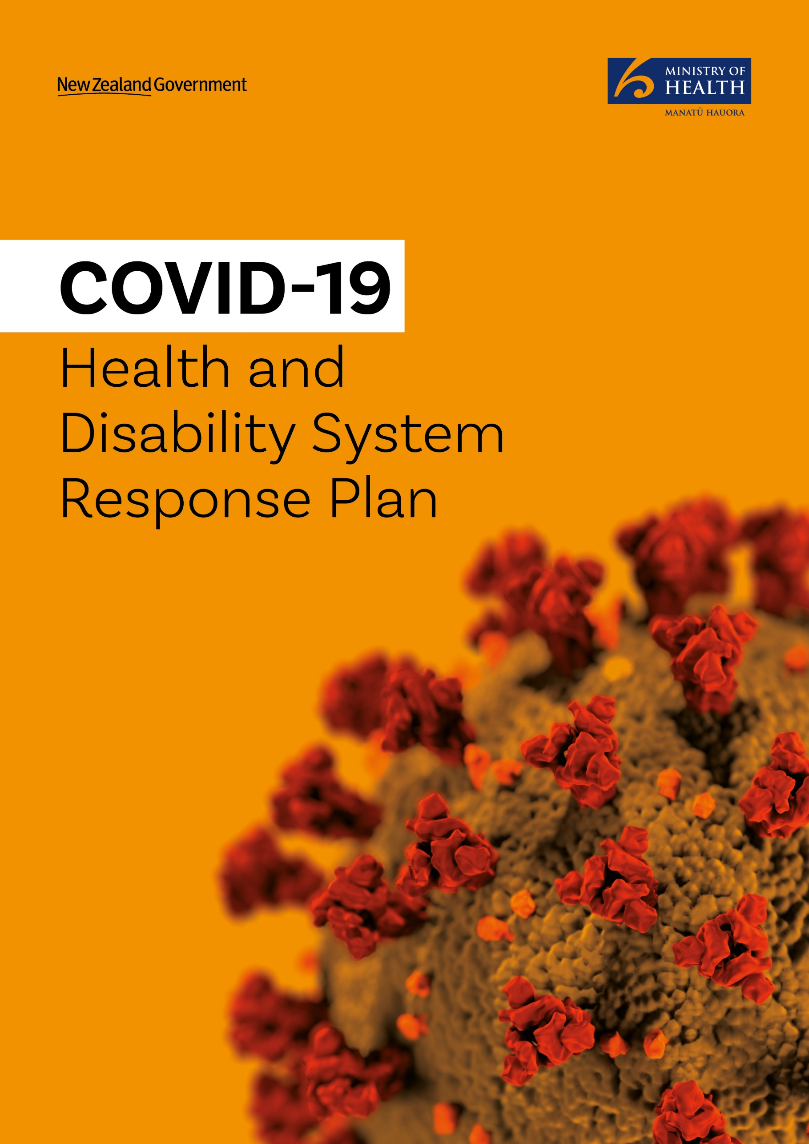

Citation: Ministry of Health. 2020. COVID-19 Health and Disability System Response Plan. Wellington: Ministry of Health.
Published in April 2020 by the Ministry of Health
PO Box 5013, Wellington 6140, New Zealand
ISBN 978-1-98-859777-5 (online)
HP 7363
This document is available at health.govt.nz
This work is licensed under the Creative Commons Attribution 4.0 International licence. In essence, you are free to: share ie, copy and redistribute the material in any medium or format; adapt ie, remix, transform and build upon the material. You must give appropriate credit, provide a link to the licence and indicate if changes were made.

‘I think the key learning from China is speed — it’s all about the speed. The faster you can find the cases, isolate the cases, and track their close contacts, the more successful you’re going to be.’
Bruce Aylward, World Health Organization Joint Mission to China (February 2020)

Foreword
The COVID-19 Health and Disability System Response Plan establishes a framework to prepare for and manage the national response to the outbreak of novel coronavirus disease 2019 (COVID-19) in New Zealand. It is aimed primarily at the health and disability sector but includes some components relevant to other agencies and sectors.

This Plan is derived from the framework provided by the New Zealand Influenza Pandemic Plan (2017) and relevant information from other sources. We are currently pursuing a version of an elimination strategy that seeks to eradicate or minimise cases of COVID-19 from New Zealand to a level that is manageable by the health system, until a vaccine becomes available to achieve population-level immunity.

As lead agency, the Ministry of Health is responsible for coordinating the health and disability sector, providing regular situation reports, ensuring Ministers are well-briefed, coordinating preparedness and response activities across government agencies and leading the development of key messages and public messaging.

While mindful of the needs of the wider population, special attention needs to be given to those groups expected to be susceptible to COVID-19. The priority population groups of focus include Māori, Pacific peoples, older people, people with disabilities, people with mental health conditions, people in residential care settings, people with pre-existing conditions including immunosuppressive disorders and refugees and migrant communities.

Whether it is from COVID-19 directly, or from the effects of public health measures and system service responses, shut down of essential services is likely to increase existing inequities across these groups. Equity will be a critical feature central to the national response to COVID-19.

At present there is no vaccine available for COVID-19 and there is no current evidence of anti-viral treatments being effective for prophylaxis or treatment (although clinical trials are underway). Clinical management will include supportive treatments and treatment of any concurrent bacterial pneumonia.

The threat posed by COVID-19 is serious. We have seen through other countries experience that the situation can become very serious, very quickly. For this reason, everybody has a part to play in helping keep themselves and their communities safe. We also know that protecting frontline staff, especially health care workers, is a vital component of an effective and sustainable response.

Overall though, New Zealand is in a good position. The COVID-19 Health and Disability System Response Plan sets out key actions that will be taken to respond to this pandemic.

Contents
Foreword ii
Executive summary 1
Pandemic response phases and alert levels 2
What we know about COVID-19 4
Epidemiology 4
Clinical 5
Proportionate response 7
Application of outbreak impact levels to decision making 7
Clinical Severity 7
Transmission 8
A commitment to Te Tiriti o Waitangi 10
Indigenous health inequities in New Zealand 10
Socioeconomic factors increase risk 10
Applying the principles of Te Tiriti o Waitangi in response to COVID-19 11
Other priority populations 12
Equity at the centre of the national response 13
Integrating equity into decision-making 13
Psychosocial response and recovery plan for COVID-19 15
Summary of Roles 16
All-of-government response 16
Ministry of Health (lead agency) 16
District health boards 17
Communication during the response 18
Stand down and evaluation of the response 18
Health and Disability System Response Action Plan 19
Planning framework 19
Appendix 1: Other information guiding the COVID-19 response 29
Ethical Framework for COVID-19 response 29
Legal Framework for COVID-19 response 29
Accessing Powers under the Epidemic Preparedness Act 2006 31

Executive summary
This plan covers the high-level actions for each of the key health and disability sector agencies and organisations to drive and support. Implementing this plan will require strong leadership across the sector and a concerted and long-lasting effort across all providers of health and disability services and agencies. Operational plans will be developed based on the evolving situation and requirements.

As lead agency, the Ministry of Health is responsible for coordinating the health and disability sector and this Plan is written primarily for the health sector to inform operational planning and ensure a coordinated and consistent response.

The purpose of this Plan is to:
- describe the health and disability system actions that will be triggered or could be considered
- provide additional detail to support activities under the COVID-19 Plan at an operational level
- be used by planners prior to or during an outbreak as an operational checklist of activities that will likely need to be implemented.

Targeted response measures focus on:
- ensuring a proportionate and effective response
- providing a coordinated and consistent approach
- supporting and maintaining quality health and disability services
- focusing on priority, at-risk populations
- communications to engage, empower and build confidence in the wider community.

Measures must be taken in a way that actively protects the health and wellbeing of the priority population groups. Critically, this means that equity will be at the centre of each level of the alert system. There will be a requirement nationally and within DHBs, as well as across other sectors, to ensure priority population groups have the resources to undertake and respond to public health measures to prevent and/or manage the spread of the virus.

Not all measures need be adopted concurrently. Similarly, measures may be implemented differently within different geographic regions, reflecting different progress of the outbreak, resource parameters and community needs.

Regularly reviewing measures and tailoring their implementation, especially as more information about COVID-19 in the New Zealand context emerges, will allow measures to be adjusted as appropriate.

Pandemic response phases and alert levels

There are a number of possible pandemic strategies and options. Each option seeks to produce a different balance between the critical factors faced by Government in tackling the impact of the disease in a manageable way, balancing a range of factors including:
- the extent and focus of protection of the population
- health system preparedness and capacity
- economic and social costs; and
- public and political consensus.

We are currently pursuing an elimination strategy that aims to eradicate or minimise cases of COVID-19 from New Zealand to a level that is manageable by the health system, until a vaccine becomes available to achieve population-level immunity.

The rationale for this strategy is:
- It affords the greatest protection to vulnerable groups and the lowest loss of life by minimising infection and keeping case numbers low
- Once the epidemic spread and impact of the disease has abated, it allows for a staged opening up of domestic movement and markets (whilst maintaining strict border measures and distancing in higher risk areas).
- New Zealand’s particular characteristics (geographical, economic, societal) compared to many other countries and epidemiological forecasting suggest a strong chance of eliminating or severely reducing the spread of COVID-19.

Success under this strategy means that COVID-19 is eliminated in New Zealand or reduced to a small number of cases, the large majority of which are “imported” and linked to international travel.

Achieving this and maintaining it over time will be challenging, and requires the deployment of a range of control measures to:
- Identify and stop transmission: through rigorous testing and community surveillance; rapid, intensive contact tracing and action to manage clusters including quarantine and isolation.
- Prevent undetected transmission: through protocols for self-isolation of suspected cases; prohibiting mass gathering; physical distancing and hand hygiene.
- Prevent overseas infection spreading: through border measures, restrictions on travel, and isolation or quarantine.

The extent to which these control measures are required to be adopted is defined by the Government’s Alert Level system, which describes the relative risk of the outbreak and the intensity of control measures that are necessary from Levels 1-4.

New Zealand’s four-level COVID-19 alert system specifies public health and social measures to be taken against COVID-19.

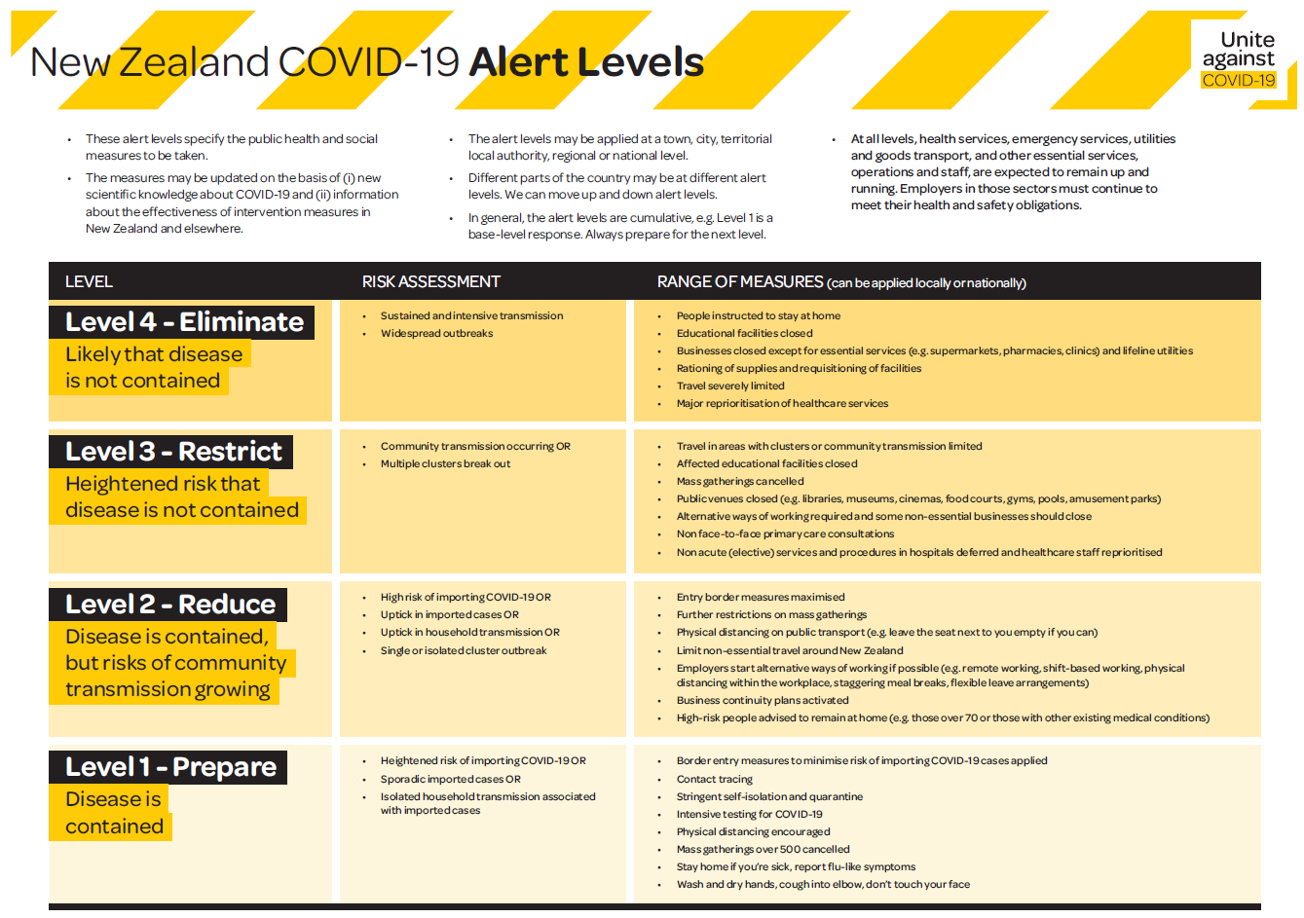

The measures may be updated based on new scientific knowledge about COVID-19 and information about the effectiveness of intervention measures in New Zealand and elsewhere.

The alert levels may be applied at a town, city, territorial local authority, regional or national level. Different parts of the country may be at different alert levels. We can move up and down alert levels. In general, the alert levels are cumulative (e.g., Level 1 is a base-level response).

At all levels, health services, emergency services, utilities and goods transport and other essential services, operations and staff are expected to remain up and running. Employers in those sectors must continue to meet their health and safety obligations.

What we know about COVID-19

Epidemiology
At 14 March 2020, the following epidemiological information was available about COVID-19 (source: Ministry of Health’s website).

Incubation period
Provisionally, the incubation period for COVID-19 is considered to be up to 14 days (average 5-6 days).

Mode of transmission
Transmission is considered to occur primarily through respiratory droplets and secretions. Transmission likely occurs through virus contact with respiratory mucosa or conjunctivae, either by direct exposure or by transfer on hands from contaminated fomites. The current evidence does not support airborne transmission, except during aerosol-generating procedures which include intubation, suctioning, bronchoscopy, tracheostomy, cardiopulmonary resuscitation.

Period of communicability
Provisionally, the period of communicability may commence 48 hours before onset of symptoms and continue until all the criteria are met in the release from isolation of confirmed or probably COVID-19 cases.

Infectivity
The reproductive number (R0) has been estimated to be around 2.2. R0 estimate: Majumder et al. 2.0-3.1, Li et al. 2.2 (95% CI, 1.4 to 3.9), Wu et al. 2.68 (95% CI, 2.47 to 2.86). ESR simulations using a combination of data points would indicate a slightly more conservative value, trending to below 2.9 (95% CI, 1.85 – 3.73). With effective measures we aim to lower the R0 value towards 1.5 or lower if possible.

Clinical
Three major patterns of clinical course of infection at this stage seem to be mild illness with upper respiratory tract symptoms; non-life-threatening pneumonia; and severe pneumonia with acute respiratory distress syndrome that may begin with mild symptoms for several days, followed by deterioration to requirements for high and intensive dependency care.

Severity can be assessed by usual clinical means to identify respiratory compromise or other organ dysfunction and current research into COVID-19 severity predictors.

Most people with COVID-19 (about 80 percent) will have milder illness and be able to recover at home. Hospital inpatient care will be needed for about 20 percent, including people requiring oxygen therapy and for management of concurrent co-morbidities. Antibiotics for bacterial infection and influenza antivirals (e.g., oseltamivir) have a role when these are also clinically suspected, but do not work for COVID-19. Evidence-based treatment for COVID-19 is currently supportive, including oxygen therapy to correct hypoxia. Guidelines for medical care have been developed by DHBs and several professional societies and are regularly updated as new knowledge becomes available. Currently there are no approved or evidence-based antiviral therapies for COVID-19, although active research is occurring on both existing repurposed and new medications.

Severe disease is more likely among older people and those with co-morbidities. Health workers and carers are at higher risk of infection. As in previous epidemics and pandemics of infectious respiratory agents, severe disease burden is likely to fall unequally on Māori, Pacific peoples and older people.

Reported international experience to date is that children are affected less and have less severe illness.

Effectiveness of prevention
The WHO Joint Mission report into the outbreak in China clearly demonstrates the effectiveness of containment. China was reporting over 3000 new cases a day early in February; in mid- March this number was less than 50 a day. The Republic of Korea has managed to reverse a rapidly expanding outbreak leading to over 7000 cases and the number of new cases is rapidly declining. This is despite having an outbreak characterised by the US CDC as ‘sustained (ongoing) community transmission’. Singapore and Japan also seem to have brought their outbreaks under control.

Importantly, containment activities are far more likely to succeed against COVID-19 than they did for pandemic influenza in 2009. One of the reasons for this is that it takes much longer for a person exposed to COVID-19 to develop infection and then transmit it (5-6 days) than influenza (2 days), so contacts can be traced and reached in time to prevent transmission.

It is estimated that small outbreaks of 5, 20 and 40 cases could be controlled if very high levels of contact tracing and timely isolation is achieved. The leader of the WHO Joint Mission to China Dr Bruce Aylward has stressed the importance of rapid case identification and contact isolation.

This means that COVID-19 containment activities (contact tracing and physical distancing measures) continue to have benefit in the setting of sustained community transmission.

Proportionate response
The level of impact that a COVID-19 response has on New Zealand will depend on several factors, including:
- clinical severity, which will affect the number of people that present at primary care, the number who require hospitalisation, ICU care and the number of deaths
- the transmissibility of the virus between humans will affect the speed and distribution across New Zealand
- the vulnerability of the population, none of whom have immunity to the virus
- the capacity of the health system to respond. Any outbreak will result in sustained pressure on both primary and secondary services and sustained community level transmission would be extremely disruptive
- the likelihood of repeated outbreaks of infection, influenced by the response measures taken, the global situation and the development of a treatment or vaccine.

Application of outbreak impact levels to decision making
Potentially significant impacts need to be anticipated and operational planning should:
- provide a response that is proportionate to the level of impact
- allocate resources where they are needed
- inform public messaging and guidance to agencies
- reduce the risk to vulnerable groups
- anticipate and minimise disruptions.

Clinical Severity
The clinical severity will impact mortality and morbidity at a population level, the burden on the health system and the concern within the community. As clinical severity increases, so too will demand for:
- services such as primary care, secondary care, High Dependency and Intensive Care Units (HDU/ICU) and laboratory services
- information and support for priority groups and the general public
- measures to promote prompt presentation and diagnosis while minimising opportunities for transmission
- services to manage the deceased.

Transmission
Understanding transmission will help determine the likely speed of spread and the timing of the demand for health services. As transmission rises:
- the timeliness of measures to limit spread becomes critical
- demand for health services rises more quickly
- health services and response measures need to be scaled up more quickly
- the peak burden and final total burden on the health system will be higher
- the overall duration of the event will be shorter
- assessments and decisions need to be made more quickly.

As COVID-19 is new, it will impact at-risk population groups. For this reason, efforts to ‘flatten’ the epidemic curve through public health interventions will be important to buy more time for preparedness, reduce the peak demand on health services, reduce the overall number of cases (i.e., the area under the curve) and may help with attenuation of severity.

Epidemic curves and the impact of public health measures

Epidemic curves for the spread of the COVID-19 pandemic in New Zealand for three different reproduction numbers and at 25% “general contact reduction” intervention for six months (albeit the epidemic curve for R0 = 1.5 is largely suppressed) Wilson, et al 2020

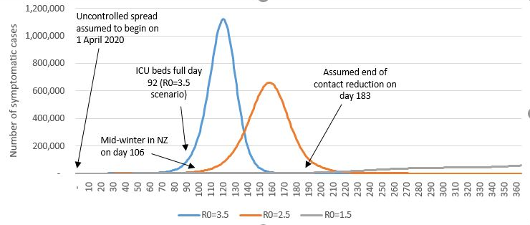

This early work helped inform the Government’s decision to move to Level 3 and then Level 4 Alert Levels.
More recent modelling takes account of New Zealand specific data and this will help inform future scenarios.

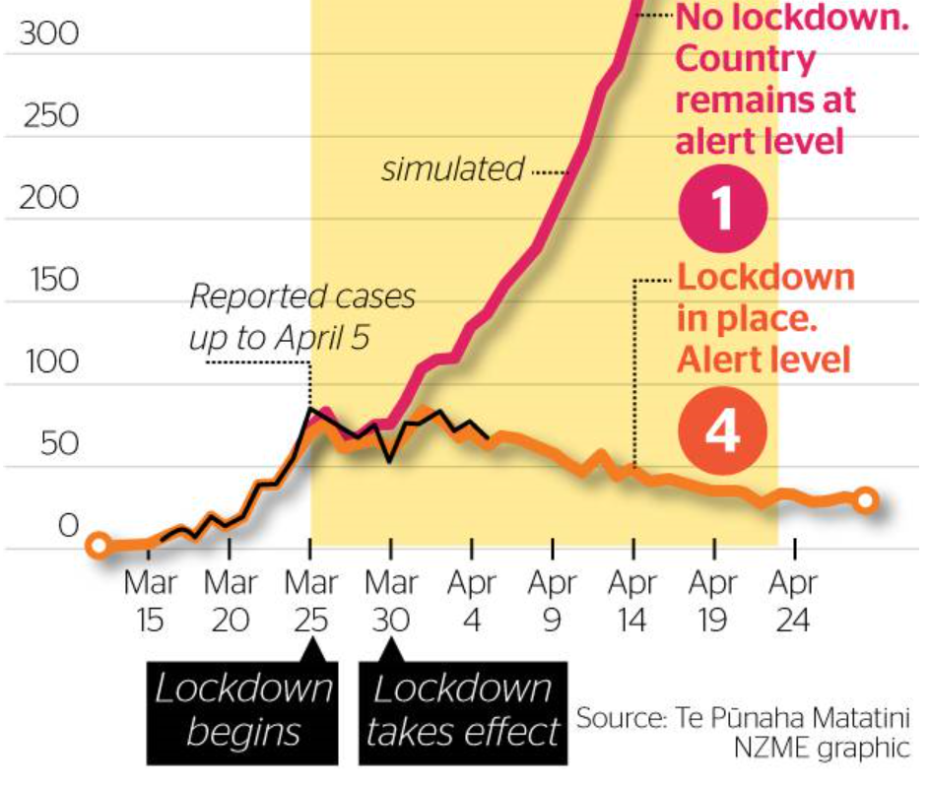

A commitment to Te Tiriti o Waitangi
Māori have been identified as a priority population group in the national response to COVID-19, given the severe impact of the 1918/19 pandemic on Māori and the increased susceptibility of Māori to the 2009 H1N1 Influenza A pandemic (H1N1 pandemic). It is evident from previous pandemic responses that the model previously used preferentially benefited non-Māori and failed to protect whānau, hapū, iwi and Māori communities from the worst outcomes. Considering the specific needs of Māori, particularly equity and active protection, should be integral to the national response to COVID-19.

Indigenous health inequities in New Zealand
Indigenous ethnic inequities in infectious diseases are marked. Māori experience higher rates of infectious diseases than other New Zealanders. One example that highlights the ethnic difference within close contact infectious diseases was the higher rates of hospitalisations reported for Māori and Pacific peoples, compared with other New Zealanders, during the H1N1 pandemic. (Māori RR=3.0, 95% CI: 2.9–3.2, Pacific peoples RR=6.7, 95% CI: 6.2–7.1).

Historically, individuals at risk of close contact infectious diseases are generally children, pregnant women, older people, individuals with underlying chronic medical conditions and individuals with immunosuppressed disorders. For COVID-19, older people and individuals with underlying health conditions are at increased risk of severe infection. Māori generally have higher rates of chronic conditions and co-morbidities and are likely to have an increased risk of severe infection should a community outbreak occur.

Socioeconomic factors increase risk
Health differences between ethnic groups are often a reflection of variables including socioeconomic factors and access to health care services. An increase in the incidence of close-contact infection is associated with crowded living conditions and lower socioeconomic status. The incidence of close-contact infectious diseases is higher among individuals who live in the most deprived areas. Māori and Pacific peoples are more likely than other New Zealanders to live in higher deprivation and in crowded households or higher-density housing conditions. The psychosocial impacts for Māori arising from public health measures such as self-isolation, physical distancing and general societal anxiety is likely to exacerbate existing mental health conditions and place increased pressure on the wider whānau units.

A necessary shift is required to ensure Māori receive high-quality, appropriate and responsive health care. The ability to quickly mobilise resources to communities (and therefore whānau) is pertinent to preventing, mitigating and protecting Māori from potential COVID-19 outbreaks.

Applying the principles of Te Tiriti o Waitangi in response to COVID-19
The Ministry of Health has a responsibility to contribute to the Crown meeting its obligations under Te Tiriti o Waitangi/Treaty of Waitangi. The principles of Te Tiriti o Waitangi, as articulated by the Courts and the Waitangi Tribunal, provide the framework for how we will meet our obligations. These principles are applicable to the wider health and disability system, including the response to COVID-19. The principles include:

- Tino rangatiratanga: The guarantee of tino rangatiratanga, provides for Māori self-determination and mana motuhake. This means that Māori are key decision-makers in the design, delivery and monitoring of health and disability services and the response to COVID-19.
- Equity: The principle of equity, which requires the Crown to commit to achieving equitable health outcomes for Māori and to eliminate health disparities resulting from COVID-19. This includes the active surveillance and monitoring of Māori health to ensure a proportionate and coordinated response to health need.
- Active protection: The principle of active protection, which requires the Crown to act, to the fullest extent practicable, to protect Māori health and achieve equitable health outcomes for Māori in the response to COVID-19. This requires the Crown to implement measures equip whānau, hapū, iwi and Māori communities with the resources to undertake and respond to public health measures to prevent and/or manage the spread of COVID-19.
- Options: The principle of options, requires the Crown to provide for and properly resource kaupapa Māori health and disability services in the response to COVID-19. Furthermore, the Crown is obliged to ensure that all health and disability services are provided in a culturally appropriate way that recognises and supports the expression of hauora Māori models of care.
- Partnership: The principle of partnership, which requires the Crown and Māori to work in partnership in the governance, design, delivery and monitoring of the response to COVID-19. This contributes to a shared responsibility for achieving health equity for Māori.

Meeting our obligations under Te Tiriti o Waitangi is necessary to realise the overall aim of Pae Ora (healthy futures for Māori) under He Korowai Oranga (the Māori Health Strategy). These principles underpin actions outlined in subsequent sections. Further information is set out in the Ministry’s Māori Strategy Response Plan.

Other priority populations
Fortunately, while children and young adults can be infected with COVID-19, they are not at particular risk. In addition to Māori, other groups may be at risk and therefore require special consideration in terms of response planning.

We have identified eight priority populations who face specific risks as a result of COVID-19 and require a targeted approach to support these groups. As well as Māori, the following priority populations have been identified within the COVID-19 Health and Disability System Response Plan:
- Pacific peoples in New Zealand
- older people, especially those over 70 years
- people with long-term conditions
- people with disabilities
- people with mental health conditions
- people living in residential facilities (e.g., aged residential care facilities, hostels, university accommodation or Department of Corrections facilities)
- refugees and migrant community members.

The specific needs of diverse Pacific communities in Aotearoa/New Zealand must be recognised and addressed at all stages of COVID-19 preparedness and response.
For Tokelau, Niue and the Cook Islands, constitutional relationships and New Zealand citizenship require close working relationships to help them prepare for and respond to COVID-19.

Equity at the centre of the national response
A fair health and disability system prioritises equity. Equity recognises different people with different levels of advantage require different approaches and resources to get equitable health outcomes. Differential access to resources, services and opportunities on the basis of social identity (e.g., ethnicity, age, gender, able-ness), as well as inappropriate or inaction in response to health need, are key drivers of health inequity. To mitigate inequity, the national response commits to the following equity principles.

Fairness
- supporting priority population groups to get what they are entitled to
- ensuring that priority population groups get a fair go
- minimising health and disability inequities for priority population groups
- prioritising fairly when there are limited resources for all to get the services they seek.

Respect
- supporting priority population groups to make their own decisions wherever possible
- supporting those who make decisions on behalf of individuals who can’t make their own decisions
- restricting freedom as little as possible, if freedom must be restricted for the public good.

Integrating equity into decision-making
Applying an equity analysis to planning and operational activities requires the following actions:
- identify which of the priority populations are relevant to the specified action
- decide on the actions to meet the needs of the identified priority populations
- use and implement the actions, focusing on tailored and appropriate delivery
- monitor and track the results for the identified priority population group

In addition to Te Tiriti o Waitangi principles, this approach will help us to:
- prioritise resources to improve access
- improve pathways of care
- address structural inequities for priority population groups
- ensure the active protection of these groups
- ensure the provision of options for these groups
- partner with communities to make their own decisions.

Psychosocial response and recovery plan for COVID-19
On 31 December 2019, Wuhan, China reported the first case of novel coronavirus disease (COVID-19). In the months following, COVID-19 spread rapidly around the world, causing a spike of fear and anxiety in communities and raising concerns about the psychological and social wellbeing of those directly and indirectly affected by the illness.

Distress, anxiety and grief are normal reactions to emergent situations such as COVID-19 and the majority of people will recover with time. People may need additional support and some may be at risk of developing more severe and long-lasting symptoms. These impacts may be immediate or delayed.

The psychosocial response to COVID-19 must meet the needs of the entire population and recognise that preparedness, response and recovery coexist throughout the event rather than proceeding in a linear sequence. The psychosocial impacts occur amongst those who become unwell or are at high risk of becoming unwell, as well as generating significant distress amongst the wider population due to fear and anxiety about becoming unwell, disruption to normal activity, economic impacts and exacerbation of existing vulnerabilities.

The Ministry of Health has developed a Psychosocial Response and Recovery Plan for COVID-19. This complements other actions under way to support priority populations and communities as part of the Government’s wider response to meeting needs of those impacted by COVID-19.

In implementing this plan, the Ministry will continue to liaise with government departments, DHBs and other agencies such as the National Telehealth Service, the New Zealand Red Cross and the Health Promotion Agency.

Summary of Roles
This COVID-19 plan is written primarily for the health and disability sector as well as government decision-makers to inform planning and ensure a coordinated and consistent response. A decision to escalate under the COVID-19 plan will signal that participating parties should:
- commence use of agreed governance and communication arrangements
- undertake their roles and responsibilities as detailed in this plan
- advise stakeholders of the approach that will be taken by government agencies
- allocate resources and reprioritise existing activities to support the outbreak response.

If the COVID-19 response escalates, agencies, industry and commercial activity across the country are likely to be affected by high levels of illness among staff and disruptions to supply and distribution processes.

All-of-government response
Each government agency is responsible for leading the response for the sector it serves and developing relevant materials for that purpose that are based on the direction set and resources developed by the Ministry of Health.

Ministry of Health (lead agency)
As the lead agency, the Ministry of Health is responsible for:
- coordinating the health and disability sector response and providing consistent instructions, advice and guidelines
- maintaining standard operating procedures for the National Health Coordination Centre (NHCC) that clearly identify roles and responsibilities
- ensuring sufficient trained staff are available in the NHCC
- undertaking national intelligence and planning, including liaising with WHO and other international bodies responsible for providing high-level advice and recommendations to national authorities
- convening advisory groups and disseminating clinical and public health advice nationally
- ensuring that there is a nationally coordinated response to the needs of groups that are expected to be most at risk to COVID-19
- providing advice and information to ministers
- liaising with and advising other government agencies and the National Emergency Management Centre
- escalating the response if indicated, including use of legislative measures (for example, to enforce more significant ‘physical distancing’)
- collating information for dissemination and use in New Zealand informed by the best scientific advice available
- providing public information, including through 0800 advice lines and digital media and providing travel advisories that border control agencies produce.

Each government agency, informed and coordinated by the Ministry of Health, is responsible for leading, planning, preparedness and response in the sectors it serves. This includes Police, Ministry for Foreign Affairs and Trade, NZ Defence, Ministry for Primary industries, the Ministry of Education, National Emergency Management Agency (NEMA), Te Puni Kokiri, and the Ministry of Transport.

District health boards
District health boards are responsible for the delivery and funding of health services and planning the local and regional response to COVID-19. This includes:
- protecting and reassuring the health care workforce including infection control and prevention services, providing protective personal equipment and training, organizing COVID-19 treatment areas and teams, systems for efficiently testing symptomatic staff and clear plans for absenteeism and quarantine
- providing appropriate support to Public Health Units and Medical Officers of Health so they can carry out their core functions (e.g., surveillance, contact tracing, appropriate control or mitigation measures)
- implementing instructions, advice and guidelines issued by the Ministry of Health
- ensuring general practice, other primary care providers, hospitals and other services are prepared to respond to the demands of an outbreak of COVID-19, including service planning for scenarios of surge in acute COVID-19 illness volumes and impacts on planned care
- managing patients and agreeing on COVID-19 triage criteria (if required)
- tailoring and implementing infection prevention control (IPC) measures to manage the risks relevant to the virus
- ensuring occupational health contingency plans are made for health care staff COVID-19-related illness, quarantine, absences (e.g., family care) and testing facilities
- communicating with and supporting health and disability providers in its region including Māori and Pacific providers and non-government organisations
- liaising with other agencies at a local level as appropriate (including local government, local and regional CDEM Groups, education providers, welfare agencies, border agencies etc.)
- maintaining and seeking to minimise disruption to normal day-to-day activities across the wider health and disability sector as far as possible.

Communication during the response
The Ministry of Health is responsible for national communications to the public, the health care sector and government agencies at a national level. It is also responsible to and liaises with the WHO as required under the International Health Regulations. The Ministry is responsible for sharing information from the WHO surveillance and other sources with relevant stakeholders.

The Ministry of Health is responsible for providing advice on case and contact management, quarantine/isolation, outbreak risk assessment and advice on the use of Health Act powers.

Stand down and evaluation of the response
The Ministry of Health will coordinate the stand down of enhanced measures, manage the transition of COVID-19 outbreak specific processes into normal business arrangements and undertake public communication regarding changing risk and the stand down of measures.

When standing down, the Ministry will provide appropriate messages to health care providers, the public and all of government.

Health and Disability System Response Action Plan

Planning framework
We have eight areas of focus for planning:
- workforce
- public health
- hospitals
- care in the community
- laboratories
- infection prevention and control
- health and disability supply chain
- support for priority populations.

The following tables can be used by planners as an operational checklist of activities that may need to be implemented.

Workforce
Planning objective | High level actions
The workforce is prepared for the expected increases in demand. | Put in place procedures to keep the workforce safe and well including:  - systematic approach to unwell staff – absenteeism and symptomatic  - an efficient system for testing health care workers symptomatic of possible COVID-19  - service plans regarding deployment of health care workers at higher COVID-19 exposure risk  - management plans for health care workers who are older (>50-60 years) or who have co-morbidities
 | 20 DHB and/or health sector approach to workforce policy and contractual matters.
 | Increase the capacity of the health workforce.
 | Enable the health workforce to work and match available skills and capability with health workforce need.
 | Enable the health workforce to work at the top of their scopes of practice and enable broader practice where appropriate.
 | Ensure the health workforce is trained for what they need to do.
 | Provide health workers with easy access to the latest clinical advice.

Public Health
Planning objective | High level actions
Public Health Units can scale up to meet increased demand for contact tracing; contact management, including quarantine and self-isolation measures; and case management, including isolation measures. | Relevant local incident management plans are in place and can be activated at short notice, including identification of key decisions required and the trigger for these to occur (e.g., decisions about whether to restrict or pause other services such as screening, well child and oral health).
 | Public Health Units are nationally coordinated for containment activities, including active case finding, isolation of cases, contact tracing and quarantine of contacts.
 | Contact tracing capacity is lifted to 50 cases nationally per day initially, with an ability to scale.
 | Outbreak investigation and management plans are in place in residential care facilities, schools, prisons and other residential institutions.
 | Relevant legislation is enacted as required (e.g., epidemic notice, extension of authorisation for use of Health Act Special Powers)
 | Non-essential functions provided by PHUs are de-prioritised (e.g., tobacco control, S&SA Act Licensing Reviews) so staff can redeploy to the response.
 | Maintain capacity to respond to other significant outbreaks.
Individuals, families and groups are well supported by the community to self-isolate and have their primary needs meet. | Wellbeing guidance is available to those self-isolating.
 | Provision has been made for those self-isolating without someone available to deliver critical medicine or other supplies.
 | Emergency accommodation is made available for those unable to reach their regular accommodation or those without secure accommodation (led by Ministry of Business, Innovation and Employment).
 | There is access to benefit payments for those without remaining leave, in insecure employment or who work for themselves (led by Ministry of Social Development).
 | Telehealth providers undertake telephone checks and answer calls to resolve issues/concerns.
 | Funding for Māori-led, Māori-specific vaccination programme to address equity issues, including a targeted health promotion campaign.
There is access to mechanisms to ensure compliance with self-isolation measures. | The population is educated to understand the requirements of self-isolation/quarantine and why it is an important step in managing COVID-19 for New Zealand.
 | Telephone monitoring is in place to identify individuals who may be at risk of non-compliance.
 | NZ Police target visits to those at risk of non-compliance to provide education and identify any additional support requirements.
Strategies are in place to support the population’s mental health and wellbeing (as well as that of essential workers) and help ensure we all continue looking after ourselves and each other during difficult times. | Resources that provide wellbeing advice and messaging to the public, including children, are easily available and shared.
 | Practical guidance is available for at-risk populations on maintaining wellbeing.
 | Targeted support services are in place to enable self-help for psychological distress and ensure ongoing access to primary care services.
 | DHBs and front-line agencies deliver a community-based response and promote and maintain community cohesion.
 | Provide clarity about support available if people do end up in isolation.
 | Work with the Ministry of Social Development and other agencies to ensure financial needs are met.
 | Information is accessible to different groups (e.g., for children, older people, people with learning disabilities and in different languages).

Hospitals
Planning objective | High level actions
DHBs can scale up to meet increased demand for hospital services. | Ministry of Health maintains a high-level overview of pressures within DHBs across the country and can respond to emerging risks as required.
 | DHB incident management plans are in place (and include worst case scenario plans and ICU capacity planning) and have been activated, including identification of key decisions required and the trigger for these to occur (e.g., when to stop elective care and outpatient clinics).
 | DHBs are coordinated nationally to meet surge capacity and workforce requirements.
 | Hospital-at-home arrangements are in place to care for patients outside of the hospital setting where feasible.
 | Virtual care technology is in place for staff to support patients that can be managed outside of an acute setting and support Māori organisations to provide innovative technology solutions to the telehealth and communication challenges facing their communities.
 | Strategies to maintain services for at-risk patients are in place and enacted as required.
 | Rapid discharge processes are in place (developed with aged care, Needs Assessment and Service Coordination service providers, primary and community providers).
 | Patient flows within DHBs, regionally and nationally are developed and understood, including emergency departments, respiratory units, intensive care units, general medical beds and community facilities.
 | Alternative care setting options (including utilising private hospitals and non-health care settings) are in place to support hospitals that reach capacity.
 | Mortuary facilities are increased to meet anticipated demand.
 | Establish workforce that can provide surge capacity and respond where there is ill health within the workforce (refer to workforce plan).
Hospitals apply appropriate clinical management practices for COVID-19 suspected and confirmed cases. | Update triage protocols to identify suspected cases, test and direct to the right facility (home/hospital) are consistently applied and changed when context requires it.
 | Ambulance services can effectively triage patients to avoid unnecessary hospital admissions.
 | DHBs have planned with ambulance services how to use transport (including aeromedical evacuation) while limiting the risk of transmission.
Infection Prevention and Control teams reinforce public health messaging and practices to prevent further spread of COVID-19. | Hand and respiratory hygiene and other infection prevention techniques are emphasised through education, policies, signage and easy availability of supplies.
 | Environmental services, room decontamination and waste management plans are in place and enacted as required.
 | Provide and reinforce regular, clear and updated clinical diagnosis protocols to primary care, aged care, midwives and other appropriate clinicians.
 | Make PPE available for all staff that need it (refer to health supply chain plan).

Care in the Community
Planning objective | High level actions expected
Primary and community-based health care providers can scale up to meet increased demand for services | Put in place incident management plans (e.g., primary care response plans), including key decision points (such as to cancel all non-urgent appointments except for at-risk populations/urgent care).
 | Implement care plans that reduce the number of staff caring for suspect/confirmed cases and protocolise care.
 | Put in place communication tools (for example, clinician helplines) to support community-based health professionals.
 | Establish workforce that can provide surge capacity and respond where there is ill health within the workforce (refer to workforce plan).
 | Put in place multiple pathways to guide care that can be adapted depending on need and provide COVID-19-specific, evidence-based decision health pathways.
 | Implement self-management tools to enable patients and their families to care for themselves at home where appropriate.
Primary and community-based health care providers reinforce and implement public health messaging and practices to prevent further spread of COVID-19. | Education for health care personnel about COVID-19 is in place, including at-risk populations, complications, treatment prevention and control, self-care, transmission and family protection and normal stress response.
 | Hand and respiratory hygiene and other infection prevention techniques are emphasised through education, policies, signage and easy availability of supplies.
 | Establish practices to ensure suspect cases are isolated from other patients.
 | Make PPE available for all staff that need it (refer to health supply chain plan).
People who are self-isolating can continue to have their primary and community care needs met. | Establish alternative delivery channels for medications (including insulin and flu vaccination) from pharmacies for people who are self-isolating or ill with mild symptoms.
 | Establish alternative delivery channels for diagnosis (e.g., telehealth) and ensure these are available in predominantly Māori communities, including in Northland and Tairāwhiti.
 | Support local Māori communities (marae, hapū, iwi and organisations) to provide whānau-based support, for those who are self-isolating, unwell or are generally in need of additional assistance.
 | Provide financial support for Māori provider networks to help them meet increased demand.
Large groups can be self-isolated at contained facilities if required. | Large-scale accommodation, transport and medical care options for those required to go into quarantine are made available.
 | Providing spaces for self-isolation in communities for those who do not have access to adequate housing (due to overcrowded housing, homelessness etc.).
Continuity of pharmacy and medical/health care supplies is maintained. | Put in place limits in dispensing and enact as required.
 | Pharmacies coordinate to support and provide surge capacity and staffing where required.
 | Put in place alternative arrangements for dispensing should a pharmacy close down due to staff illness/shortages.

Laboratories
Planning objective | High level actions expected
Increase laboratory testing capacity and capability for COVID-19. | Add additional laboratory sites and capacity for COVID-19 testing, including university research laboratories.
 | Obtain sufficient lab swabs and testing kits to meet demand.
 | Acquire commercial test kits, which smaller laboratories will be able to use with existing equipment.
 | The workforce is in place to enable testing at scale (refer to workforce plan).
 | Establish and update lab swabbing protocols process for positive results as required.
 | Communicate with the public about testing and reasons for our testing approach.
 | Develop primary care messaging and guidelines on who can complete swabbing and the impact on current resources.
 | Non-COVID-19 urgent testing capabilities are maintained.

Infection prevention and control
Planning objective | High level actions expected
National infection control guidance, measures and contingencies are in place. | Regularly update infection prevention and control protocols based on surveillance data, latest scientific/clinical knowledge and PPE holdings.
 | Enable extensive disinfecting (deep clean) of locations like public places, health settings (e.g. pharmacies) and public transport.
 | Maintain accurate stocktake of health sector PPE stocks for their projected use.
 | Determine how infection prevention and control interventions and messages may need to be reinforced in the manage it phase (nationally and/or regionally) and prepare for this.
 | Provide guidance on cleaning standards for people to minimise transmission at home.
 | Ensure that information on contact tracing protocols and action is up to date.
Protect individuals who are most at risk of severe infections from exposure to COVID-19. | Provide information that:  - has clear definitions of at-risk groups  - defines and establishes protected workspaces  - defines levels of physical distancing rigour.
 | Require physical distancing for people working in or with at-risk communities (protected environments) and family/whānau, visitors, community interactions and aged residential care.
 | Identify interventions to protect people who are high risk, if they or their close contacts develop COVID-19.

Health and Disability Supply Chain
Planning objective | High level actions expected
Health supplies required specifically for COVID-19 response are available to meet expected increase in demand. | Identify what medicines, devices and supplies are likely to be in high demand during a response and update regularly as we gain greater knowledge about COVID-19 and its treatment.
 | Understand current levels of stock on hand in the supply chain – in DHBs and in the community supply chain (from wholesaler through to community pharmacy).
Increase stocks of:
- face masks
- lab swabs and testing kits.
 | Prevent key health and disability supplies, including key PPE, from being exported or stockpiled inappropriately.
 | Provide guidance about who is required to have PPE and ensure health care workers are trained in the correct use of PPE.
 | Identify and resolve areas of low PPE supply and prioritise if necessary.
 | Determine processes for identifying and acting on potential shortages of medicines, medical devices and equipment.
Maintain continuity of health supplies to enable continued care for all New Zealanders. | Put in place Order in Council to provide optimal legislative flex under the Medicines Regulations and Misuse of Drugs Regulations to allow continuity of access to medicines and top-of-scope practice for prescribers and dispensers.
 | Ensure medicines from wholesalers are guaranteed and put in place enhanced transport models if required.
 | Establish delivery mechanisms for medicines or health and disability equipment to people self-isolating in their homes.
 | Pharmacy Council to reach out to retired and/or inactive pharmacists that don’t have a current annual practicing certificate and activate.
 | Pharmacy sector has memoranda of understanding between local pharmacies in place.

Support for priority populations
Planning objective | High level actions
Ensure Māori have targeted support to manage COVID-19. | The response to COVID-19 needs to include Māori leadership and governance at every level of the health and disability system to ensure that it is by Māori, for Māori, with Māori.
 | Ensure actions are supported by tailored communications for Māori through appropriate and trusted channels.
 | Provide additional resources and support for Māori health providers to redirect efforts towards COVID-19.
 | Support providers to deliver locally-specific support to kuia and koroua, as well as for Māori who are self-isolating, unwell or in general need of assistance.
 | Support whānau, hapū, iwi and Māori communities to plan for and prevent the spread of COVID-19.
 | Enable providers to partner alongside other sector entities to deliver holistic support to whānau, hapū, iwi and Māori communities.
 | Provide accurate and accessible data and evidence to drive an effective response to COVID-19. Ensuring relevant information is available to the health and disability sector and iwi, hapū, whānau and wider Māori communities will improve the safety and quality of services provided to Māori.
 | Support Māori workforce capability and capacity to allow it to respond to the evolving needs of Māori as COVID-19 progresses and changes.
Ensure Pacific peoples have targeted support to manage COVID-19. | Establish Pacific leadership to guide and support delivery of the Ministry of Health (MoH) National Emergency response to COVID-19.
 | Develop and disseminate messages and materials in Pacific languages that are tailored to Pacific peoples.
 | Centralise all national messaging and communications for Pacific peoples on health advice for COVID-19 to ensure the right messages reach Pacific communities in a timely and effective way.
 | Harness key influencers in the Pacific health sector and community (local influencers such as community leaders, religious leaders, volunteers) to speed up knowledge and dissemination of information in a fast-changing environment to diverse networks.
 | Mobilise providers of health and social services to Pacific communities and ensure funding support.
 | Ensure that appropriate health services are available for Pacific non-residents living, working and travelling in New Zealand.
 | Conduct research to understand target audiences, perception concerns, influencers and preferred communication channels.
 | Create a single, consolidated response for the community to ensure a coordinated response (e.g., diplomatic response, social services, housing).
 | Establish large-scale community engagement for social and behavioural changes to ensure preventative health and hygiene practices, along with the rapid assessment work recommendations.
 | Develop training material to be delivered through public health units, seven Pacific units and key NGOs.
 | Recruit and train a public health navigator workforce to work alongside Pacific households and communities to support them during the manage it phase. Ensure PPE is in place for this workforce.
Ensure older people have targeted support to manage COVID-19. | For older people in aged care facilities, refer to planning for residential facilities.
 | Provide targeted advice on how to self-manage or access services.
Ensure people with pre-existing conditions (including immune-compromised) have targeted support to manage COVID-19 | Strategies to maintain services are in place, and where necessary, provide separate services separate from COVID-19 cases.
 | Bring forward the annual influenza vaccination programme.
 | Target communications to ensure that these groups understand how to keep themselves safe.
 | Individuals with pre-existing conditions/co-morbidities should have a personal plan to ensure they can manage and are supported with their ongoing care needs.
Ensure disabled people have targeted support to manage COVID-19. | Disability providers have incident management plans in place (including worst case scenario plans) that can be activated at short notice.
 | Ensure all communications are in accessible formats.
 | Encourage people with disabilities to follow broad public service advice and encourage public health services to recognise and address access issues.
 | Complete a stocktake of disability-related equipment from DHBs, Enable NZ and Access Enable in order to identify shortages in any locations.
 | Develop processes for delivery of more advanced care at their usual facility if hospital beds are unavailable.
 | Develop guidance on how the providers and facilities across regions will work together to support and provide surge capacity and staffing where required.
 | Establish a workforce that can provide surge capacity and respond where there is ill health within the workforce (refer to workforce plan).
Ensure people with mental health needs have targeted support to manage COVID-19. | Mental health providers have incident management plans in place (including worst case scenario plans) that can be activated at short notice.
 | Develop and implement a psychosocial response and recovery plan, in order to mitigate and respond to societal stress and minimise the effects of public health measures like self-isolation and physical distancing.
 | Provide families with information about stress responses, resilience and professional mental health services.
 | Put in place strategies to manage changes in behaviour which increase the risk of COVID-19 transmission.
Ensure people in residential facilities (e.g. aged care facilities, other care facilities, prisons, universities) have targeted support to manage COVID-19. | Residential facilities’ incident management plans are in place (including worst case scenario plans) and can be activated at short notice, including identification of key decisions required and the trigger for these to occur (e.g., putting in place clear notices and barriers for people to pause when entering facilities, whether to close facilities to visitors etc.).
 | Plans are ready to implement if facilities must be closed to visiting family and friends to minimise the risk for residential populations contracting COVID-19.
 | Corrections and Ministry of Justice have established procedures to prevent ingress of any at-risk persons into prison populations.
 | Universities have established arrangements for resident students who are required to self-isolate.
 | The Corrections workforce is trained to identify risk factors for isolation of those in custody.
 | The Ministry of Health has provided guidance to residential facilities around the prevention of the spread of COVID-19 to residents, clients, their families and workers.
 | Put in place guidance requiring people who are ill (experiencing cold and flu-like symptoms), have been ill over the last 48 hours, have been anywhere overseas within the last 14 days or have been in close contact with someone with COVID-19 to stay away from residential facilities. This includes workers who must not attend work under these circumstances.
 | Establish outbreak investigation and management plans at all residential facilities with infection prevention control teams and Medical Officers of Health.
 | Make PPE available for all staff that need it (refer to health supply chain plan).
Ensure refugees have targeted support to manage COVID-19. | Public messaging is translated and shared directly with the refugee community through existing relationship models.
 | Ensure refugee resettlement process is protected.

Appendix 1: Other information guiding the COVID-19 response

Ethical Framework for COVID-19 response
The National Ethics Advisory Committee (NEAC), Kāhui Matatika o te Māori, is an independent advisor to the Minister of Health on ethical issues of national significance concerning health and disability matters. In 2007, the committee developed Getting Through Together: Ethical Values for a Pandemic which identifies widely shared ethical values for planning for and responding to a pandemic. The values from Getting Through Together for the COVID-19 response are as follows:
- in good decision-making processes we are: open, inclusive, reasonable, responsible
- good decisions are those we base on: minimising harms, respect, fairness, whanaungatanga (close connection between people), reciprocity and kotahitanga (unity).

The NEAC are working on guidance for the response and will develop a framework for decision-makers.

Legal Framework for COVID-19 response
The Health Act 1956 is the primary statute for the prevention and control of infectious diseases within the country and at the border. The Health Act infectious disease provisions are only operable for named conditions and novel coronavirus was added to the list with effect from 30 January 2020. More recently, COVID-19 was also added. The Health Act works alongside the more general CDEM Act and other statutes. The Epidemic Preparedness Act 2006 could provide additional legislative provisions should the outbreak escalate.

Under the New Zealand Public Health and Disability Act 2000, an objective of DHBs is to improve promote and protect the health of people and communities. To this end, DHBs have a number of statutory functions, including ensuring ‘the provision of services for its resident population … [and] collaborat[ing] with relevant organisations to plan and co-ordinate at local, regional, and national levels for the most effective and efficient delivery of health services.’

On 31 January 2020 (NZ time), WHO determined that the COVID-19 outbreak constituted a Public Health Emergency of International Concern (PHEIC) under the International Health Regulations 2005. This allows WHO to issue Temporary Recommendations, which it has done. New Zealand is currently compliant with most of WHO’s advice but has chosen to implement temporary travel restrictions to reduce and delay the risk of spread to New Zealand (and through New Zealand, into the Pacific).

Accessing Powers under the Epidemic Preparedness Act 2006
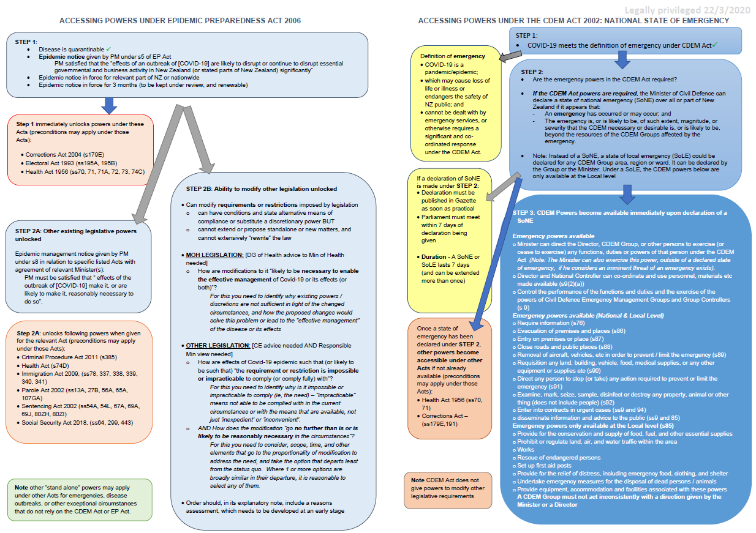

health.govt.nz/your-health/healthy-living/emergency-management/pandemic-planning-and-response/influenza-pandemic-plan
https://covid19.govt.nz/assets/COVID_Alert-levels_v2.pdf
health.gov.au/news/australian-health-protection-principal-committee-ahppc-coronavirus-covid-19-statement-on-21-march-2020

