COVID-19 disruptions to hospital and general practice activity

A working report on the impact of COVID-19 on hospital and
general practice activity in New Zealand
Citation: Ministry of Health. 2020. COVID-19 disruptions to hospital and general practice activity. Wellington: Ministry of Health.
Published in November 2020 by the Ministry of Health
PO Box 5013, Wellington 6140, New Zealand
ISBN 978-1-99-002958-5 (online)
HP 7504
This document is available at health.govt.nz
This work is licensed under the Creative Commons Attribution 4.0 International licence. In essence, you are free to: share ie, copy and redistribute the material in any medium or format; adapt ie, remix, transform and build upon the material. You must give appropriate credit, provide a link to the licence and indicate if changes were made.

Contents
Summary iii
Background and data 1
Summary of results 1
Introduction 3
Background 3
Purpose of report 3
Data and analysis 3
Key dates 4
Mortality 5
Notes on data 5
Results 5
Key points 7
Primary care 8
Notes on data 8
Results 8
Key points 10
Overall hospital activity 11
Notes on data 11
Results 11
Key points 17
Planned care 18
Notes on data 18
Results 18
Key points 32
Unplanned care 33
Notes on data 33
Results 33
Key points 36
Unmet need 37
Notes on data 37
Results 37
Key points 37
Conclusions 38
Appendix 1: Number of qualifying encounters per 1,000 enrolees by age group, 7 March to 12 July in 2019 and 2020 39
Appendix 2: Number of discharges year to date February, and by month from March to June 2018–2020 41
Appendix 3: Number of discharges by region, March to June 2018–2020 44
Appendix 4: Number of case-weighted discharges year to date February, and by month from March to June 2018–2020 45
Appendix 5: Number of case-weighted discharges by region, March to June 2018–2020 47
Appendix 6: Number of planned care interventions delivered by region, March to June 2018–2020 48
Appendix 7: Number of planned care intervention case-weighted discharges by region, March to June 2018–2020 49
Appendix 8: Number of first specialist assessments delivered by region, March to June 2018–2020 50
Appendix 9: Number of follow-up appointments delivered by region, March to June 2018–2020 51
Appendix 10: Elective Services Patient Flow Indicator 2 (ESPI 2) by region, July 2019–June 2020 52
Appendix 11: Elective Services Patient Flow Indicator 5 (ESPI 5) by region, July 2019–June 2020 53
Appendix 12: Number of emergency department (ED) attendances by region, March to June 2018–2020 54

List of Tables

Table 1: Death rate per 1,000 Disability Support Services clients across the period of March to May 2019 and 2020 (provisional) 6
Table 2: Death rate per 1,000 Disability Support Services clients living in community residential services across the period of March to May 2019 and 2020 (provisional) 7
Table 3: Percentage change in Elective Services Patient Flow Indicator 5 (ESPI 5) nationally, July 2019–June 2020, by ethnicity 31

List of Figures

Figure 1: Number of deaths by week in the first 22 weeks (beginning of January to end of May) of 2020, 2019 and 2015–2019 average for the total population 5
Figure 2: Total number of Disability Support Services client deaths by month from March to May 2019 and 2020 (provisional) 6
Figure 3: Number of deaths of Disability Support Services clients living in community residential services from March to May 2019 and 2020 (provisional) 7
Figure 4: Number of qualifying encounters in 2019 and 2020 – seven-day running total (7 March to 12 July) 9
Figure 5: Number of qualifying encounters per 1,000 enrolees from 1 March 2020 to 12 July 2020 by ethnicity – seven-day running total 10
Figure 6: Number of discharges nationally from March to June 2018–2020 12
Figure 7: Number of case-weighted discharges nationally from March to June 2018–2020 13
Figure 8: Number of discharges nationally from March to June 2018–2020, by ethnicity 13
Figure 9: Number of case-weighted discharges nationally from March to June 2018–2020, by ethnicity 14
Figure 10: Number of elective discharges nationally from March to June 2018–2020, by ethnicity 15
Figure 11: Number of arranged discharges nationally from March to June 2018–2020, by ethnicity 16
Figure 12: Number of discharges nationally from March to June 2018–2020, by activity type 17
Figure 13: Number of planned care interventions delivered nationally from March to June 2018–2020 19
Figure 14: Number of case-weighted discharges for planned care interventions nationally from March to June 2018–2020 20
Figure 15: Number of planned care interventions delivered nationally from March to June 2018–2020, by type of intervention 21
Figure 16: Number of planned care interventions delivered nationally from March to June 2018–2020, by ethnicity 22
Figure 17: Number of first specialist assessments delivered nationally from March to June 2018–2020 23
Figure 18: Number of first specialist assessments delivered nationally from March to June 2018–2020, by ethnicity 24
Figure 19: Number of follow-up appointments delivered nationally from March to June 2018–2020 25
Figure 20: Number of follow-up appointments delivered nationally from March to June 2018–2020, by ethnicity 26
Figure 21: Elective Services Patient Flow Indicator 2 (ESPI 2) nationally, July 2019–June 2020 27
Figure 22: Elective Services Patient Flow Indicator 5 (ESPI 5) nationally, July 2019–June 2020 28
Figure 23: Elective Services Patient Flow Indicator 5 (ESPI 5) for Māori nationally, July 2019–June 2020 29
Figure 24: Elective Services Patient Flow Indicator 5 (ESPI 5) for Pacific peoples nationally, July 2019–June 2020 29
Figure 25: Elective Services Patient Flow Indicator 5 (ESPI 5) for non-Māori, non-Pacific nationally, July 2019–June 2020 30
Figure 26: Number of acute discharges nationally from March to June 2018–2020, by ethnicity 34
Figure 27: Number of emergency department (ED) attendances nationally from March to June 2018–2020 35
Figure 28: Average number of minutes spent in emergency departments (ED) nationally from March to June 2018–2020 35
Figure 29: Number of emergency department (ED) attendances nationally from March to June 2018–2020, by ethnicity 36

Summary
Overview of the impact of COVID-19 lockdown on health outcomes and health service use
Overall, health service use decreased during the COVID-19 lockdown period across planned, unplanned and primary care. Despite this reduction, early data indicates mortality did not increase over this period compared with the same time in 2019. The data also indicates that while overall activity levels in hospitals were similar across ethnic groups, some differences occurred in relation to specific services in the health system, such as delivery of Planned Care Interventions and acute activity.

Background and data
- The purpose of this analysis was to provide an overview of the impact of COVID-19 and the lockdown period on hospital and general practice activity.
- The report, particularly in making comparisons between 2020 and previous years, does not consider other variables that may have affected health-seeking behaviour or service delivery in any given period.
- The report does not include analysis of disruption caused by the re-emergence of COVID-19 in August 2020 in the Auckland region.
- This is a working report to help with recovery planning. We will undertake further analysis as more data becomes available.

Summary of results

Mortality
- Early data suggests mortality decreased over the lockdown period, compared with the past five years.

Primary care
- The COVID-19 lockdown had an impact on the number of qualifying encounters patients have with a general practice. As at 12 July 2020, this number continued to be low compared with 2019.
- Qualifying encounters include a range of interactions between a patient and the general practice they are enrolled with. They include, but are not limited to: doctor and nurse consultations (face-to-face and remote) and follow-up communications, prescription requests, and immunisations.

Overall hospital activity
- Overall, hospital activity was lower in March to June 2020 compared with the same months in 2018 and 2019. The relative decrease was greatest in April.
- Available data indicates that, overall, ethnic groups differed slightly in the level of activity disruption they experienced. The discharge numbers of Māori, Pacific and non-Māori, non-Pacific groups all decreased by between 37.7% and 40.5% in April 2020 compared with April 2019.

Planned care
- Among the ethnic groups, Māori experienced the greatest disruption in the delivery of Planned Care Interventions (PCIs) in April 2020 compared with April 2019.
- The impact of the lockdown was greater on inpatient treatment, which reduced by 63.8% in April 2020 compared with April 2019, than on minor procedures, which decreased by 25.5%.
- Delivery of first specialist assessments (FSAs) was impacted more than follow-up delivery, although the extent of the impact also differed by region. Among ethnic groups, non-Māori, non-Pacific populations experienced the greatest decrease in the delivery of FSAs (by percentage), while Pacific peoples experienced the smallest decrease.
- The percentage of patients waiting more than four months for treatment (Elective Services Patient Flow Indicator 5) increased during the lockdown for all ethnic groups. In an analysis of how many patients were waiting for more than four months as a percentage of the total number waiting for treatment in each ethnic group, Māori had the highest percentage followed by Pacific peoples.

Unplanned care
- Acute activity was lower in March to June 2020 compared with the same months in 2019.
- From April to June 2020, the decrease in acute presentation nationally was greatest for Pacific peoples compared with the same months in 2019.

Unmet need
- From 27 April to 28 June 2020, the amount of self-reported unmet need remained steady, with about 9% of the adult population agreeing with the statement that ‘Since the beginning of COVID-19 Alert Level 4 until now there had been a time when you needed health care but could not get it’. This is lower than the amount reported through a similar indicator measured in the New Zealand Health Survey in 2018/2019. In that survey, approximately 30% of adults reported that in the last year they’d been unable to access health care, either at a general practitioner (GP) clinic or an after-hours service, due to cost or transport requirements, or were unable to access a GP within 24 hours when they wanted to.

Introduction

Background
In the global context, New Zealand has, so far, fared relatively well against COVID-19. Our approach of closing the border early and following a COVID-19 elimination strategy prevented our health system from being overrun. Many of the usual health care services were reduced so that they had capacity to respond to the unpredictable COVID-19 situation, and measures were put in place to protect those who are immunocompromised from the spread of COVID-19.

During the first months of the response to the COVID-19 pandemic, the Ministry worked closely with district health boards (DHBs) to support the ongoing delivery of health care services. This included identifying and addressing barriers to the provision of services during the lockdown. However, we don’t yet fully understand the impact of the lockdown on health outcomes including mortality rates and the use of planned, unplanned and primary care. The sudden disruption in usual care could lead to a backlog of unmet need, and may have a disproportionate impact on those who already experience greater barriers to accessing care, particularly Māori and Pacific peoples.

Understanding how health service delivery and use changed nationally and regionally during the lockdown period and in the months following, including the impact on existing inequities, will help with recovery planning and inform future pandemic planning.

Purpose of report
This report collates evidence on the impact of COVID-19 and the lockdown on hospital and general practice service delivery, outcomes and people’s health-seeking behaviours. As well as helping with recovery planning, this evidence will support informed decision-making in relation to the relative benefits and harms of future policy decisions. This report expands on the reports released since May 2020 by Te Aho o Te Kahu, the Cancer Control Agency, which describe the impact of COVID-19 on cancer diagnosis and treatment.

Data and analysis
The majority of data in this report comes from Ministry of Health national collections, while a small amount is from other sources. Each section of the report begins with information on the source and any limitations of the data.
DHB and regional data used in this report relates to DHB region of service (the DHB region where the patient received the service), rather than DHB region of domicile/population (the DHB region where the patient lives).

We have used national, regional, ethnicity and disability data to identify the extent to which COVID-19 and the lockdown had a disproportionate impact on certain communities in relation to health outcomes and access to health care services.
The report makes direct comparisons between years. It does not consider pre-existing need, predicted increase in need over time or variables outside of COVID-19 and the lockdown.

The report does not include analysis of disruption caused by the re-emergence of COVID-19 in August 2020 in the Auckland region.

This is a working report, developed to help with recovery planning. We will undertake further analysis as more data becomes available.

Key dates
This report focuses primarily on data from March to June in the years 2018, 2019 and 2020. The key dates over the lockdown period in the first half of 2020 were:
- 21 March: Alert system introduced, Alert Level 2 announced
- 22 March: COVID-19 National Hospital Response Framework released
- 23 March: Alert Level 3
- 26 March: Alert Level 4
- 28 April: Alert Level 3
- 14 May: Alert Level 2
- 8 June: Alert Level 1.

Mortality

Notes on data
- The Health Quality & Safety Commission (HQSC) provided general mortality data on 22 June 2020, based on publicly available data from Statistics New Zealand.
- We collected disability data through the Ministry of Health’s Disability Support Services client database, and identified client deaths from national mortality collections.
- Disability death data is provisional due to potential late submissions.
- Data provided by HQSC includes information from the beginning of January to the end of May. The Ministry of Health’s data covers the months of March and April.

Results

Overall mortality
HQSC’s early analysis of mortality data in June 2020 indicated that the total number of deaths between the last week of March and the last week of May is lower in 2020 than in 2019 and the average number across the last five years (Figure 1).

The data suggests that from the last week of March (Week 13) to the last week of May (Week 22), just under 300 fewer deaths occurred than would be expected based on the five-year average.

Figure 1: Number of deaths by week in the first 22 weeks (beginning of January to end of May) of 2020, 2019 and 2015–2019 average for the total population
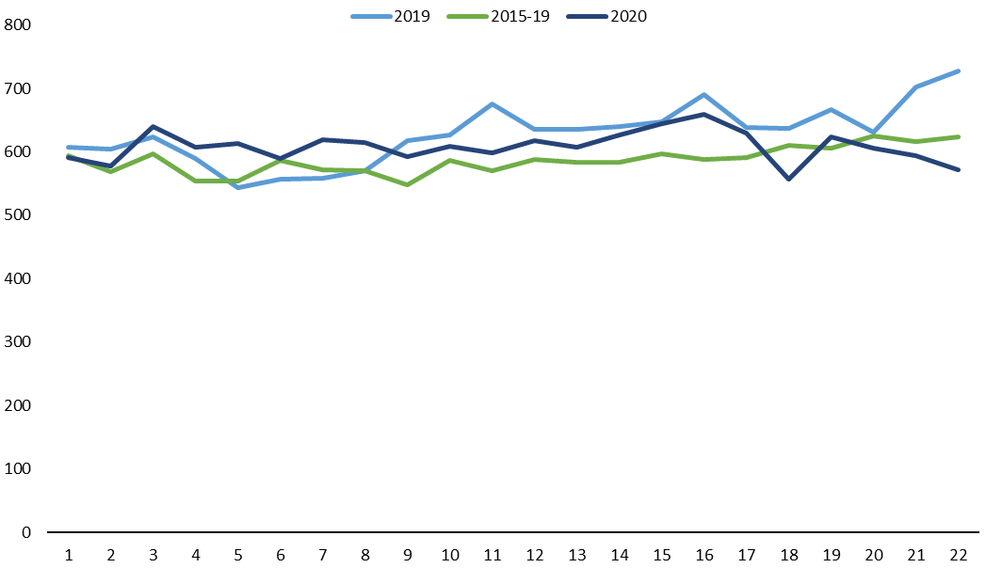

Disability Support Services (DSS) client mortality
Figure 2 shows the total number of deaths of DSS clients in March, April and May of 2019 and 2020. According to provisional data, 52 DSS client deaths occurred in March 2020, 45 in April 2020 and 37 in May. By comparison, 38 DSS client deaths occurred in March 2019, 39 in April 2019 and 55 in May 2019.

Figure 2: Total number of Disability Support Services client deaths by month from March to May 2019 and 2020 (provisional) 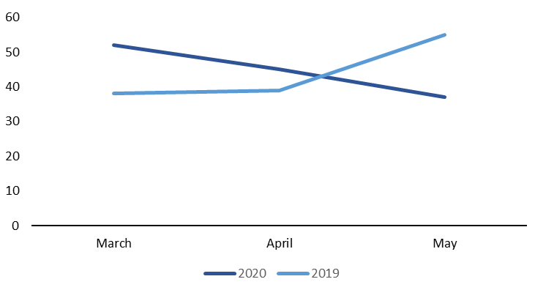
Table 1 shows the total number of deaths of DSS clients in the period of March to May in 2019 and 2020, along with the total number of DSS clients and the death rate per 1,000 clients, according to provisional data. The table indicates that, although the number of deaths increased from 132 in 2019 to 134 in 2020, the number of DSS clients also increased by 1,812. The DSS client death rate of 3.4 per 1,000 in 2020 is not significantly different from the rate of 3.5 per 1,000 in 2019.

Table 1: Death rate per 1,000 Disability Support Services clients across the period of March to May 2019 and 2020 (provisional)
Year | Total DSS deaths from March - May | Number DSS clients from March – May | Death rate per 1,000
2019 | 132 | 37,669 | 3.5
2020 | 134 | 39,481 | 3.4

The total number of deaths of disabled people living in community residential services was 20 in March 2020, 21 in April and 8 in May. This compares with 12 deaths in March 2019, 11 in April 2019 and 20 in May 2019. The totals are within with the usual monthly range. Figure 3 shows the number of deaths of disabled people living in community residential services for these three months in 2020 compared with 2019, according to provisional data. Table 2 gives the death rate per 1,000 for the total deaths in this period for each year.

Figure 3: Number of deaths of Disability Support Services clients living in community residential services from March to May 2019 and 2020 (provisional)
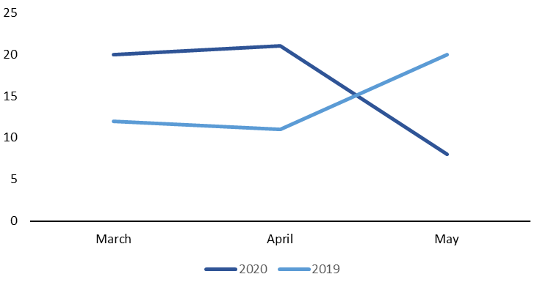
Table 2: Death rate per 1,000 Disability Support Services clients living in community residential services across the period of March to May 2019 and 2020 (provisional)
Year | Total DSS community residential deaths from March – May | Number DSS community residential clients from March – May | Death rate per 1,000
2019 | 43 | 7,125 | 6.0
2020 | 49 | 7,119 | 6.9

Key points
- HQSC’s early analysis of mortality data indicates that mortality rates in 2020 are lower than those in 2019 and the average of the past five years.
- Provisional DSS client data indicates that DSS client mortality rates in 2020 are similar to those in 2019.
- Further analysis of mortality rates is needed to better understand how mortality may have been impacted by COVID-19 and the lockdown period.

Primary care

Notes on data
- Data comes from the National Enrolment Service (NES).

Results

Number and rates of qualifying encounters overall
The data on qualifying encounters shows the impact of the COVID-19 lockdown on general practice activity. Qualifying encounters include a range of interactions between a patient and the general practice they are enrolled with. They include, but are not limited to: doctor and nurse consultations (face-to-face and remote) and follow-up communications, prescription requests, and immunisations.

Figure 4 shows the total number of qualifying encounters from 7 March to 12 July in 2020 and 2019. The graph shows a peak in encounters leading up to Alert Level 4, followed by a rapid decrease and numbers largely remained below the same dates in 2019. Following Queen’s Birthday weekend, the number of qualifying encounters in 2020 has risen and the difference between 2020 and 2019 is less pronounced than in May.

The increase in qualifying encounters before the Government announced Alert Level 4 was impacted by the uptake of flu vaccinations, which were made available to high-risk groups on 18 March 2020.

The main reason why qualifying encounters in 2020 have not recovered to the levels of 2019 by the end of this period is that levels for enrolees under 14 years of age remain lower than the levels of the same age group in 2019, in contrast to the older age groups. This may be in part because the measles epidemic in 2019 led to elevated levels of qualifying encounters for this age group in that year. Appendix 1 shows the number of qualifying encounters per 1,000 enrolees from 7 March to 12 July in 2019 and 2020 by age group.

Figure 4: Number of qualifying encounters in 2019 and 2020 – seven-day running total (7 March to 12 July)
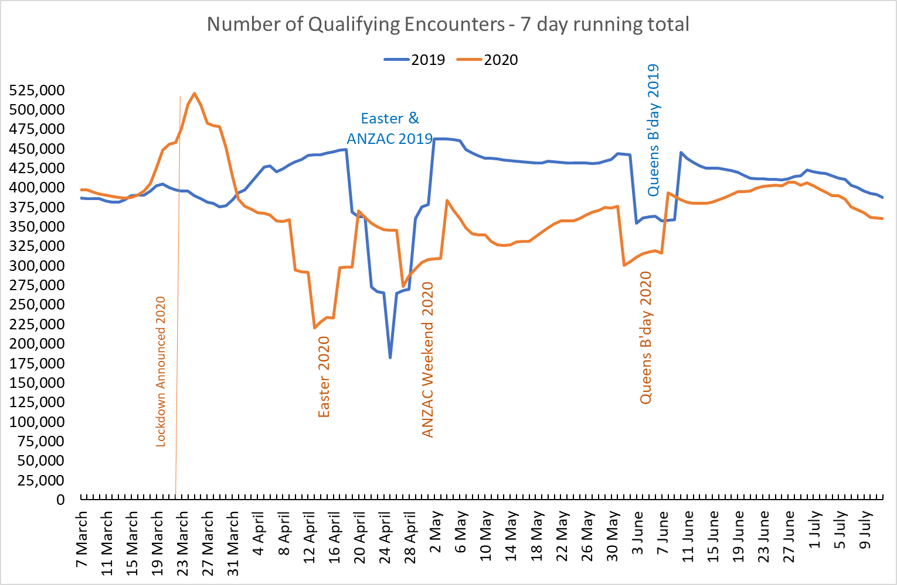

Qualifying encounters per 1,000 enrolees by ethnicity
Figure 5 shows the number of qualifying encounters per 1,000 enrolees for each ethnic group from 1 March 2020 to 12 July 2020. The ethnic groups in this analysis are: Māori, Pacific peoples, Asian, MELAA (Middle Eastern, Latin American and African) and Other (all people who do not identify as Māori, Pacific, Asian or MELAA).

The Asian group had the lowest number of qualifying encounters per 1,000 enrolees, including during Alert Level 4, while the Other group had the highest.

Figure 5: Number of qualifying encounters per 1,000 enrolees from 1 March 2020 to 12 July 2020 by ethnicity – seven-day running total

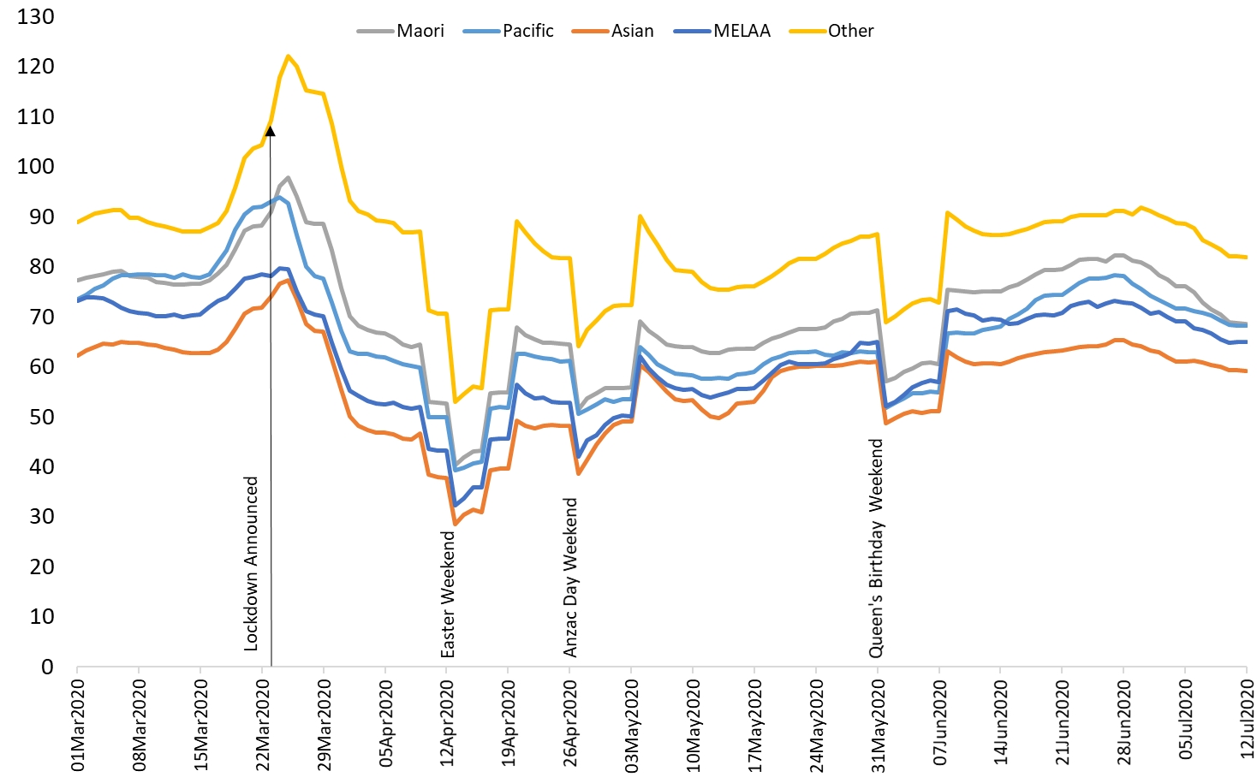

Key points
- Alert Level 4 had an impact on the number of qualifying encounters.
- The number of qualifying encounters increased sharply before Alert Level 4, and then decreased quickly when it began.
- As at 12 July 2020, the number of qualifying encounters remains lower than at the same time in 2019.
- The main reason why qualifying encounters in 2020 have not recovered to the levels of 2019 is that the qualifying encounter levels for enrolees under 14 years of age remain below 2019 levels.
- From 1 March 2020 to 12 July 2020, the Asian ethnic group had the lowest number of qualifying Encounters per 1,000 enrolees, while the Other group had the highest. All ethnic groups followed the overall finding of a sharp increase in qualifying encounters before Alert Level 4, followed by a steep drop when it began.

Overall hospital activity

Notes on data
- Data comes from National Minimum Data Set (NMDS).
- The data reflects publicly funded services only and covers both casemix-included and casemix-excluded discharges. For further details on casemix please refer to this website (https://www.health.govt.nz/publication/new-zealand-casemix-system-overview-0 ).
- Data is based on the patient’s DHB of service.
- Numbers have been rounded to one decimal place.
- Case weights measure the relative complexity of the treatment given to each patient. For example, a cataract operation will receive a case weight of approximately 0.5, while a hip replacement will receive 4 case weights. This difference reflects the resources needed for each operation, in terms of theatre time, number of days in hospital, etc.
- Elective activity is a planned admission where the admission date is seven or more days after the date when the specialist decided that the admission was necessary.
- Arranged activity is a planned admission where the admission is less than seven days after the date when the specialist decided that the admission was necessary.
- Acute activity is an unplanned admission on the day that the patient presents at the admitting health care facility.
- National data includes all four DHB regions along with an ‘Other’ group. The ‘Other’ group refers to services provided in a non-DHB agency. We have included it in this report to maintain consistency across reporting, as it is also part of the total population data in the National COVID-19 Recovery Dashboard. The following analysis does not show ‘Other’ group data separately.

Results

Number of discharges overall
This report measures hospital activity by the number of discharges. If the number of discharges changes, we interpret that as indicating a change in activity levels. Figure 6 shows number of discharges nationally from March to June 2018–2020.

Data from year to date (YTD) February 2020 indicates the number of discharges nationally was 0.6% lower than the total for YTD February 2019. Following the arrival of COVID-19 in New Zealand, the number of discharges nationally fell by 14.1% in March 2020, 38.6% in April 2020, 21.3% in May 2020 and 5.3% in June 2020 compared with the same month in 2019 (Appendix 2).

The greatest disruption occurred in April 2020, which had 37,959 fewer discharges than in April 2019. The smaller reduction in June indicates some return to activity levels observed in previous years; however, the number of discharges still remained lower than the levels in June for the previous two years.

Figure 6: Number of discharges nationally from March to June 2018–2020
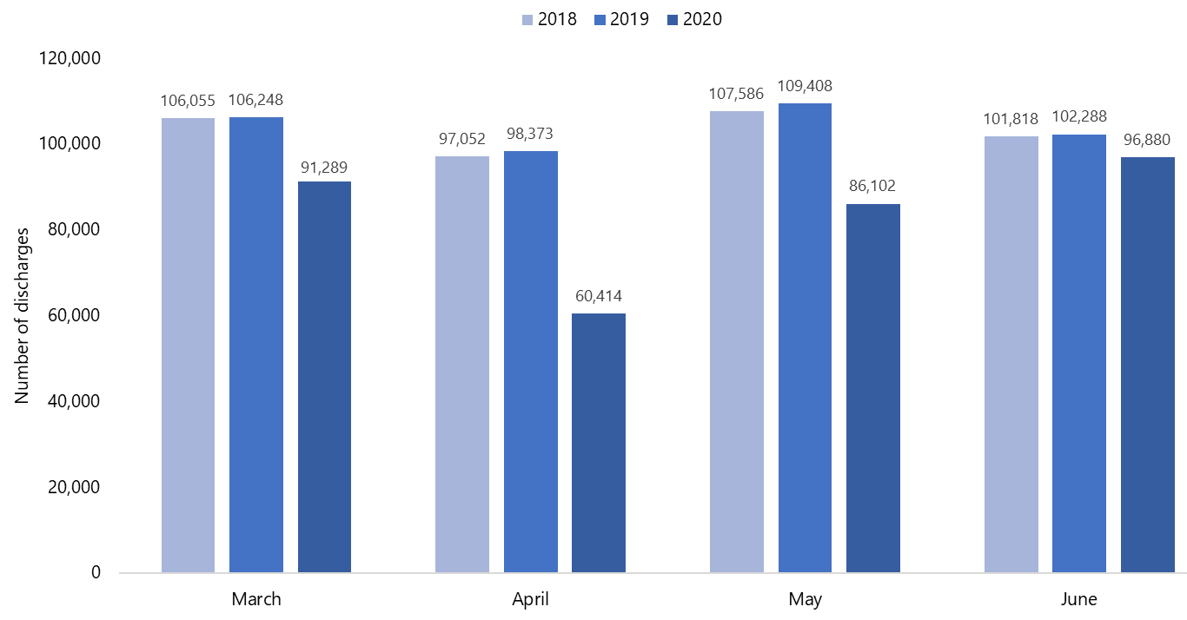

Appendix 3 shows the number of discharges by region, comparing March to June 2020 with the same months in 2018 and 2019. Midland Region had the largest reduction in number of discharges (down by 39.9%), while Central Region had the smallest reduction in number of discharges (down by 33.6%), in April 2020 compared with April 2019. By the end of June 2020, Central Region had the greatest reduction in discharges compared with June 2019 (down by 5.6%) and Midland Region had the smallest reduction (down by 2.5%).

Case-weighted discharges
Figure 7 shows the number of case-weighted discharges (CWDs) nationally in each month from March to June 2018–2020. The number of CWDs was 6.8% lower in YTD February 2020 than YTD February 2019, while the decrease was by 10.1% in March 2020, 39.1% in April 2020, 21.1% in May 2020 and 7.4% in June 2020 compared with the same month in 2019 (Appendix 4).

In April 2020 compared with April 2019, South Region had the largest reduction in CWDs at 38.7%, and Central Region had the smallest at 33.1%. At the end of June 2020, Central Region had the greatest reduction of 7.2% and Northern Region had the smallest (down by 1.1%). Appendix 5 shows the number of CWDs by region, from March to June 2018–2020.

Figure 7: Number of case-weighted discharges nationally from March to June 2018–2020
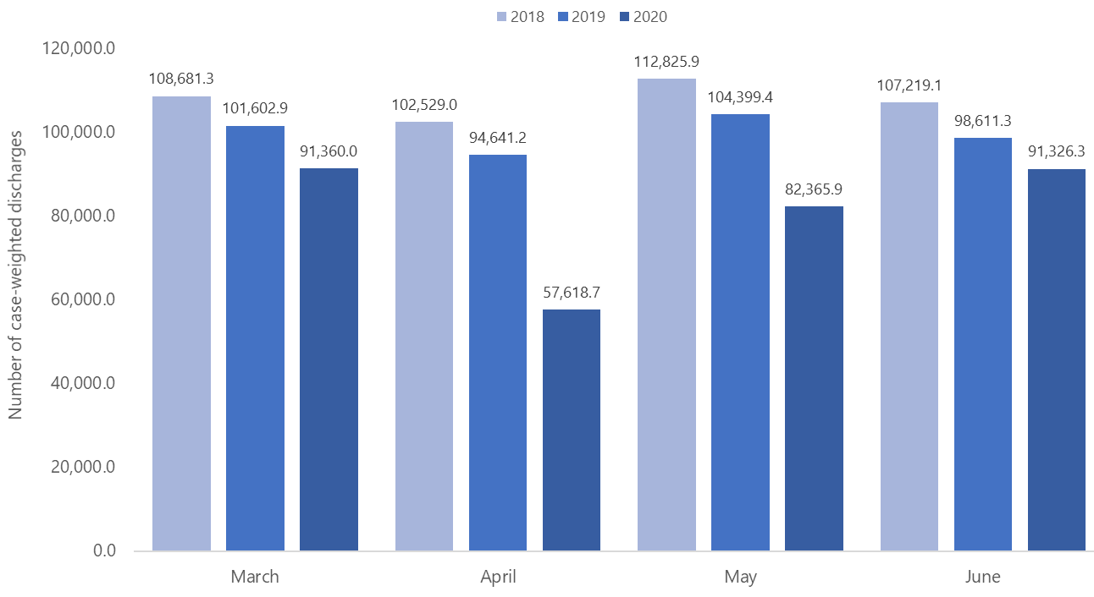

Percentage of discharges by ethnicity
This analysis presents ethnicity data in the following groups: Māori, Pacific peoples and non-Māori, non-Pacific. Non-Māori, non-Pacific refers to all people who do not identify as Māori or Pacific.

Figure 8 shows the ethnic breakdown as a percentage of the total number of discharges. In March 2020, Māori made up 17.7% of discharges nationally. This decreased to 17.5% in April 2020 and 17.1% in May 2020, before increasing to 17.8% in June 2020. Pacific peoples made up 7.7% of national discharges in March 2020, 7.5% in April 2020, 7.2% in May 2020 and 7.4% in June 2020. Non-Māori, non-Pacific made up 74.6% of discharges nationally in March 2020, 75.0% in April 2020, 75.6% in May 2020 and 74.9% in June 2020.

Figure 8: Number of discharges nationally from March to June 2018–2020, by ethnicity
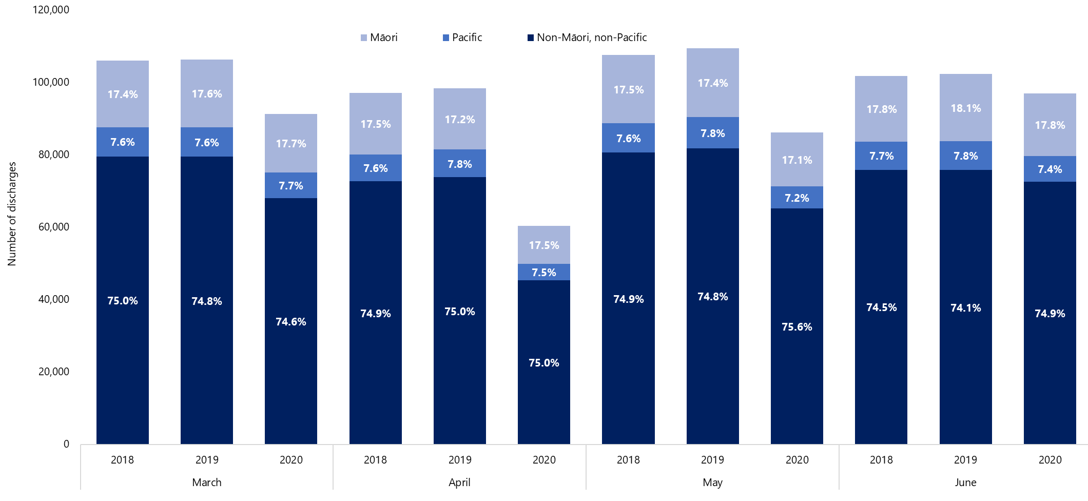

Appendix 2 shows the percentage changes in number of discharges between these three ethnic groups over March to June in 2019 and 2020. Comparing the number of discharges in 2020 with 2019, for YTD February and March the percentage of non-Māori, non-Pacific fell by the greatest amount, whereas in April, May and June Pacific people experienced the greatest percentage reduction.

Case-weighted discharges by ethnicity
Figure 9 shows the percentage of the total number of CWDs that each of the three ethnic groups contributed. Māori made up 17.6% of discharges nationally in March 2020, 16.5% in April 2020, 17.2% in May 2020 and 17.8% in June 2020. Pacific peoples made up 7.1% of national discharges in March 2020, 7.4% in April 2020, 7.0% in May 2020 and 7.1% in June 2020. Non-Māori, non-Pacific made up 75.3% of discharges nationally in March 2020, 76.1% in April 2020, 75.8% in May 2020 and 75.1% in June 2020.

Comparing the percentages of CWDs for the three ethnic groups in 2020 with those in 2019, in June non-Māori, non-Pacific people experienced the greatest reduction in CWDs, in March and May Pacific peoples experienced the greatest reduction in CWDs and Māori experienced the greatest reduction in CWDs in April. Appendix 4 shows the percentage changes in the number of CWDs within each of these ethnic groups for YTD February and each month from March to June 2018–2020.

Figure 9: Number of case-weighted discharges nationally from March to June 2018–2020, by ethnicity

Elective activity by ethnicity
Figure 10 shows the total number of elective discharges in March to June 2018–2020, along with the percentage that each of the three ethnic groups contributed to these monthly totals.

Nationally, the level of elective activity disruption in March 2020 was similar for each ethnic group: elective activity reduced by 25.9% for Māori, 22.2% for Pacific peoples and 22.0% for non-Māori, non-Pacific, compared with March 2019. In April 2020 all groups experienced larger reductions in elective activity, which fell by 73.0% for Māori, 70.8% for Pacific peoples and 68.5% for non-Māori, non-Pacific peoples, compared with elective activity levels in April 2019.

Elective activity was less disrupted in May 2020 than in April 2020. Pacific populations had the smallest decrease of 19.4% in May 2020 compared with May 2019, while the decrease was 25.2% for non-Māori, non-Pacific and 28.7% for Māori. In June 2020, elective activity levels increased compared with June 2019: by 3.0% for non-Māori, non-Pacific, 8.5% for Māori and 10.0% for Pacific peoples.

Figure 10: Number of elective discharges nationally from March to June 2018–2020, by ethnicity
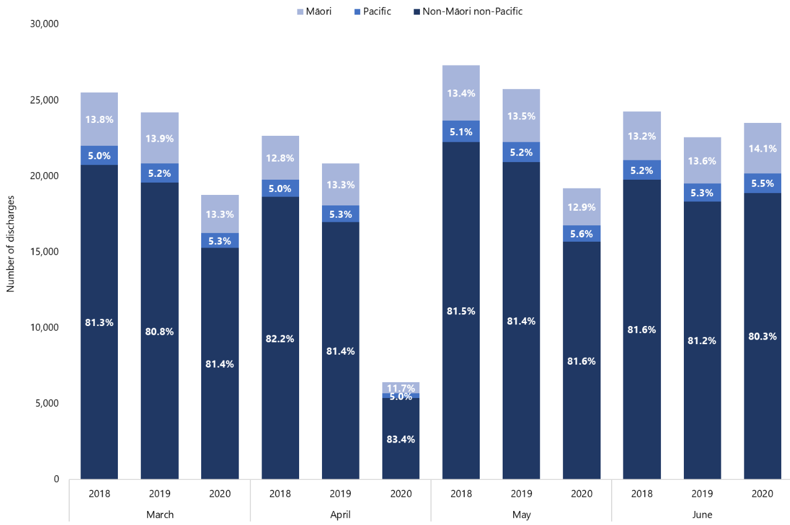

Arranged activity by ethnicity
Figure 11 shows the total number of discharges for arranged activity from March to June 2018–2020, along with the percentage that each of the three ethnic groups contributed to these monthly totals.

Nationally, in March 2020 the number of arranged discharges reduced across all three ethnic groups compared with March 2019: by 11.7% for non-Māori, non-Pacific, 11.8% for Māori and 13.4% for Pacific peoples. In April 2020 the decrease was larger and differences between the three ethnic groups were clearer. Compared with April 2019, the reduction was greatest for non-Māori, non-Pacific at 31.0%, followed by Pacific peoples at 27.0% and Māori at 19.2%.

In May 2020, the disruption to arranged activity was slightly lower, falling by 25.0% for non-Māori, non-Pacific, 17.8% for Pacific peoples and 16.0% for Māori compared with May 2019.
Although discharges for arranged activity continued to increase slowly in June 2020, the activity level was still below the levels in June 2018 and 2019. Compared with June 2019, arranged activity discharges reduced by 12.7% for Pacific peoples, 12.2% for non-Māori, non-Pacific and 11.0% for Māori.

Figure 11: Number of arranged discharges nationally from March to June 2018–2020, by ethnicity
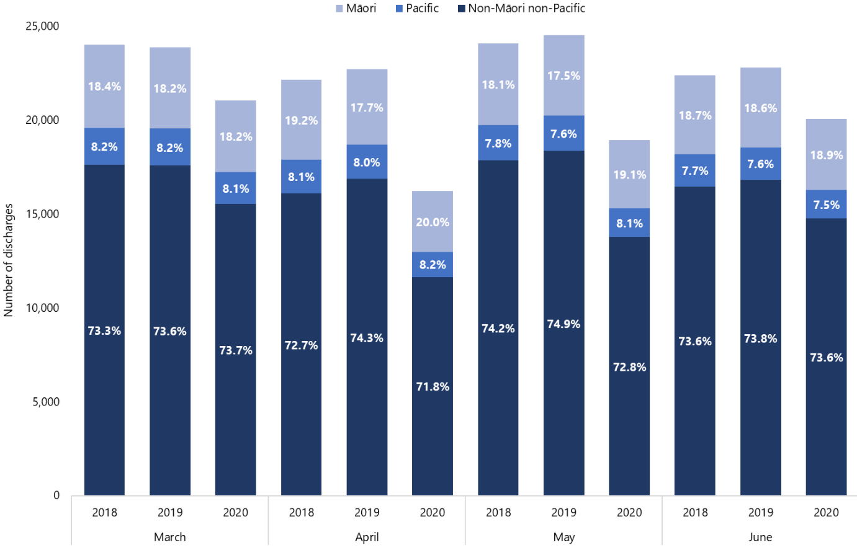

Number of the different types of activity
Figure 12 provides a national comparison of the level of acute, arranged and elective activity nationally from March to June 2018–2020, as measured by the number and percentage of discharges. Both nationally and regionally, the decrease in elective activity was greater than that for arranged and acute activity. By percentage, the greatest disruption to all of these activity types occurred in April 2020.

In March 2020, the number of elective discharges fell by 22.5% compared with March 2019, while acute discharges fell by 11.5% and arranged discharges by 11.9%. In April 2020 compared with April 2019, elective discharges were down by 69.2%, acute discharges by 31.1% and arranged discharges by 28.6%. In May 2020, the level of activity for all activity types continued to be lower than for May 2019 but by a smaller percentage: 25.3% for elective activity, 18.9% for acute activity and 22.9% for arranged activity. These smaller reductions reflect how a wider range of hospital activity became increasingly available as New Zealand moved down the Alert Level framework. In June 2020 compared with June 2019, elective activity increased by 4.1%, acute activity reduced by 6.3% and arranged activity decreased by 12.1%.
Figure 12: Number of discharges nationally from March to June 2018–2020, by activity type
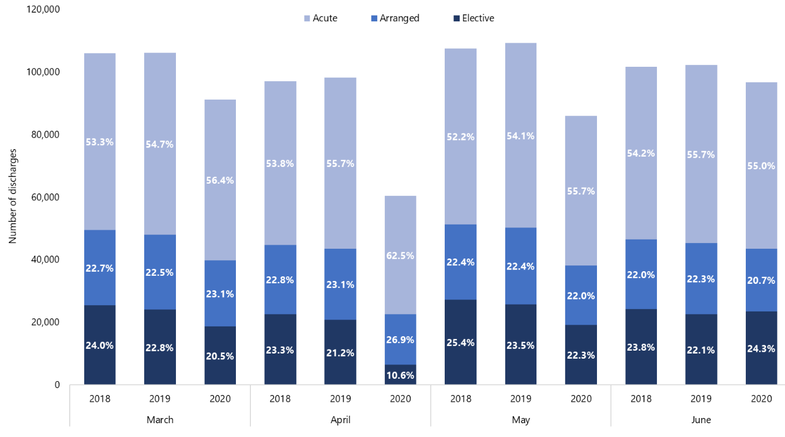

Key points
- Overall hospital activity levels fell, as measured by a decrease in the number of discharges and CWDs during Alert Levels Four and Three compared with the same months in 2018 and 2019.
- Nationally, the decrease was greater in April than in March, which corresponds with the time of Alert Level 4. Conversely, the number of discharges was higher in May and June than in April 2020, reflecting how the country moved down Alert Levels in those months.
- Pacific peoples were most affected by the decrease in hospital activity levels: of the three ethnic groups, they experienced the largest reductions in number of discharges and CWDs each month from March to June 2020.
- In general, elective activity levels reduced more than arranged and acute activity levels in March, April and May 2020 compared with the same months in 2019 and 2018. However, in June 2020 more elective activity occurred than in June 2019, indicating that hospitals were beginning to address the backlog of disrupted elective activity from March to May 2020.
- Among ethnic groups, Māori were most affected by the disruption to elective activity, as measured by the percentage of discharges in March, April and May 2020 compared with the same months in 2019.
- Non-Māori, non-Pacific populations in April and May 2020 and Pacific peoples in March and June 2020 were most affected by the disruption to arranged activity, as measured by the percentage of discharges in these months compared with the same months in 2019.

Planned care

Notes on data
- Data in this section comes from the NMDS and the National Non-Admitted Patient Collection (NNPAC).
- First specialist assessment (FSA) and follow-up data is based on selected NNPAC purchase units.
- The data reflects publicly funded services only.
- Numbers have been rounded to one decimal place.
- DHB and regional data is based on DHB region of service, rather than DHB region of domicile.
- Planned care interventions (PCIs) include elective and arranged surgical activity and selected minor procedures and non-surgical interventions reported to NNPAC and NMDS. Surgical activity includes surgical purchase units and casemix-included discharges from a non surgical purchase unit with a surgical diagnosis-related group. Casemix-excluded activity and non-surgical (including maternity) activity are not part of the planned care intervention definition.
- Elective Services Patient Flow Indicator 2 (ESPI 2) data is not currently available by ethnicity.

Results

Number of planned care interventions delivered overall
Figure 13 shows the number of PCIs delivered in March, April and May 2020 was lower than the same month in 2019. However, June 2020 saw more PCIs delivered than in June 2019.

Specifically, compared with the same month in 2019, the number of PCIs delivered decreased nationally by 7.8% in March 2019, fell by a substantially greater 49.9% in April 2019 and recovered somewhat to decrease by 10.2% in May 2020. Then in June 2020, PCI delivery levels were 16.2% higher than in June 2019, reflecting the re-opening of wider planned care services.

Figure 13: Number of planned care interventions delivered nationally from March to June 2018–2020
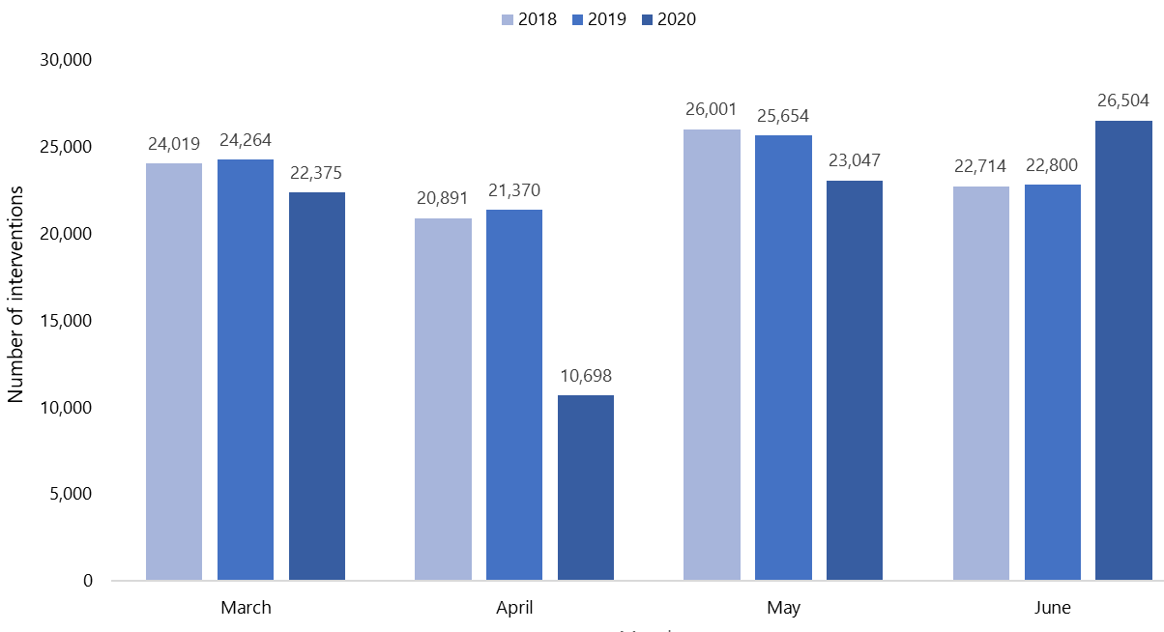
Regionally, Midland and Northern regions experienced the greatest impact in April 2020: in each region, PCI delivery decreased by over 50.0% compared with April 2019. South Region was the first region to show signs of returning to normal activity in May 2020, when it delivered 2.8% more PCIs than in May 2019. Then in June 2020 all regions were delivering more PCIs than in June 2019, but again South Region had the greatest percentage increase. Appendix 6 shows the number of PCIs delivered that region delivered in March to June 2018–2020.

Planned care intervention case-weighted discharges
Figure 14 shows the number of PCI CWDs between March and June 2018–2020. It shows that the greatest impact on PCI CWDs occurred in April 2020.

Nationally, compared with the same months in 2019, the number of CWDs decreased by 11.2% in March 2020, by a much larger 57.6% in April 2020 and by 11.6% in May 2020. By the end of June 2020 the number of PCI CWDs was 7.3% higher than the number in June 2019.

Regionally, Midland Region experienced the greatest disruption in March 2020. In April 2020 the most affected region was Northern Region with a 62.7% reduction in PCI CWDs compared with April 2019, while the least affected was Central Region with a 46.1% reduction. Northern Region continued to be the most affected in May 2020. In June 2020 all regions had more PCI CWDs than in June 2019, with increases ranging from 1.6% to 15.4% (Appendix 7).

Figure 14: Number of case-weighted discharges for planned care interventions nationally from March to June 2018–2020
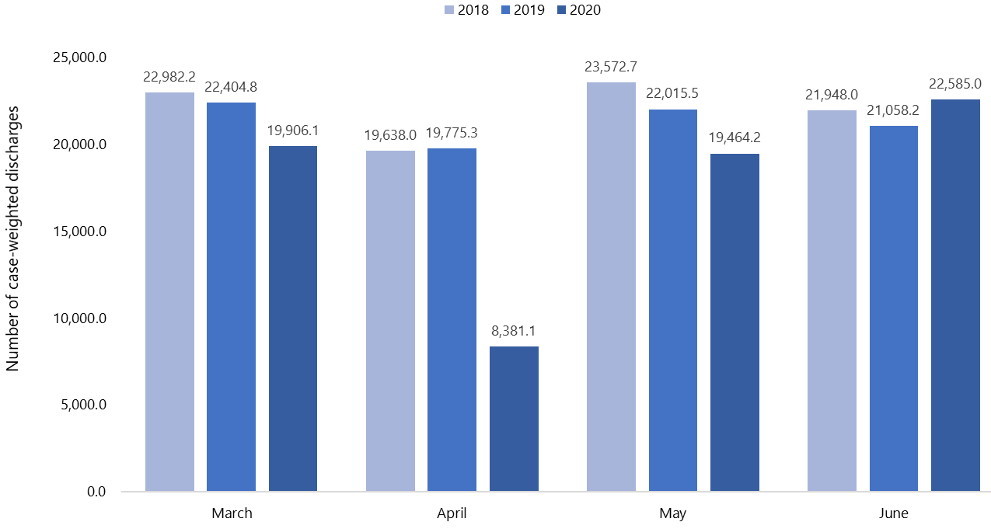

Delivery of planned care interventions by type of intervention
DHBs delivered three types of PCIs in 2019 and 2020: inpatient treatment, minor procedures and non-surgical interventions. In this report, for the purposes of comparison, we have grouped minor procedures and non-surgical interventions into a single category of 'minor procedures', while keeping the category of inpatient treatment the same.

At a national level, delivery numbers of inpatient treatment changed by larger percentages than minor procedures when comparing March, April and May of 2019 and 2020 (Figure 15). Compared with the same months in 2019, inpatient treatment reduced by 16.4% in March 2020, 63.8% in April and 15.8% in May 2020. In contrast, in June 2020 inpatient delivery increased by 9.2% compared with June 2019.

Delivery of minor procedures was less disrupted than inpatient treatment. Delivery levels did not decrease in March 2020 compared with March 2019. However, they did fall by 25.5% in April 2020 and 0.4% in May 2020 compared with the same month in 2019. By June 2020 minor procedures delivered were above June 2019 levels by 29.5%.

Figure 15: Number of planned care interventions delivered nationally from March to June 2018–2020, by type of intervention
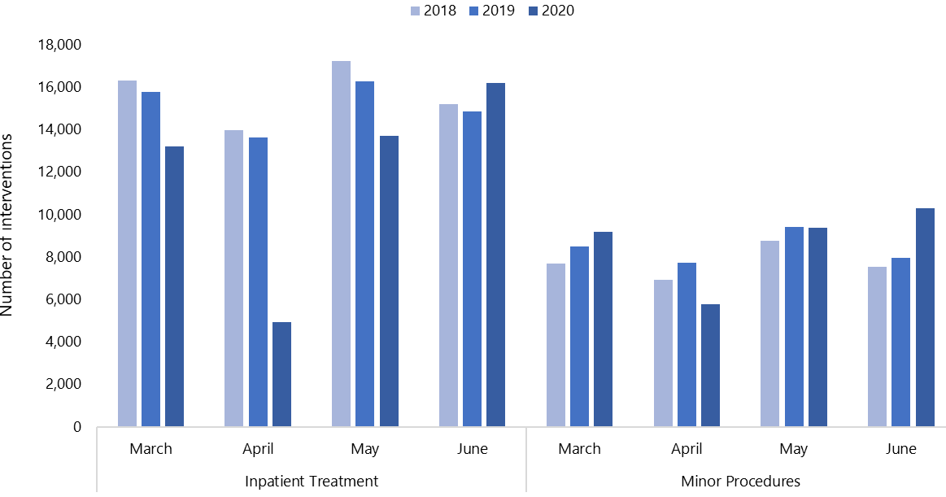

Delivery of planned care interventions by ethnicity
The percentage change in the number of PCIs delivered varied across ethnic groups. Comparing the number of PCIs delivered in March 2020 and March 2019, activity decreased by 16.1% for Māori, 11.9% for Pacific peoples and 6.3% for non-Māori, non-Pacific. In April 2020 the number of interventions dropped further compared with April 2019: by 61.8% for Māori, 58.6% for Pacific peoples and 47.7% for non-Māori, non-Pacific. This indicates a 14.1% difference in the relative decrease of PCI delivery between Māori and non-Māori, non-Pacific in April. In May 2020 this difference narrowed to 8.8% as PCI delivery for Māori reduced by 17.7% compared with May 2019, delivery for Pacific decreased by 14.9% and delivery for non-Māori, non-Pacific reduced by 8.8%. June 2020 saw a rise in PCI delivery across all three ethnic groups compared with June 2019, with an increase of 15.1% for Pacific peoples, 15.3% for Māori and 16.5% for non-Māori, non-Pacific.

Figure 16 shows what percentage of the total number of PCIs was delivered to each ethnic group from March to June 2018–2020. In March 2020, 10.7% of PCIs delivered were to Māori, 5.5% to Pacific peoples and 83.8% to non-Māori, non-Pacific. In April 2020, the pattern shifted to 8.7% of PCIs being delivered to Māori, 4.9% to Pacific peoples and 86.4% to non-Māori, non-Pacific. In May 2020, 10.3% of PCIs were delivered to Māori, 5.5% to Pacific peoples and 84.2% to non-Māori, non-Pacific. In June 2020, 11.2% of the total number PCIs delivered nationally were to Māori, 5.8% to Pacific peoples and 83.1% to non-Māori, non-Pacific.

Figure 16: Number of planned care interventions delivered nationally from March to June 2018–2020, by ethnicity
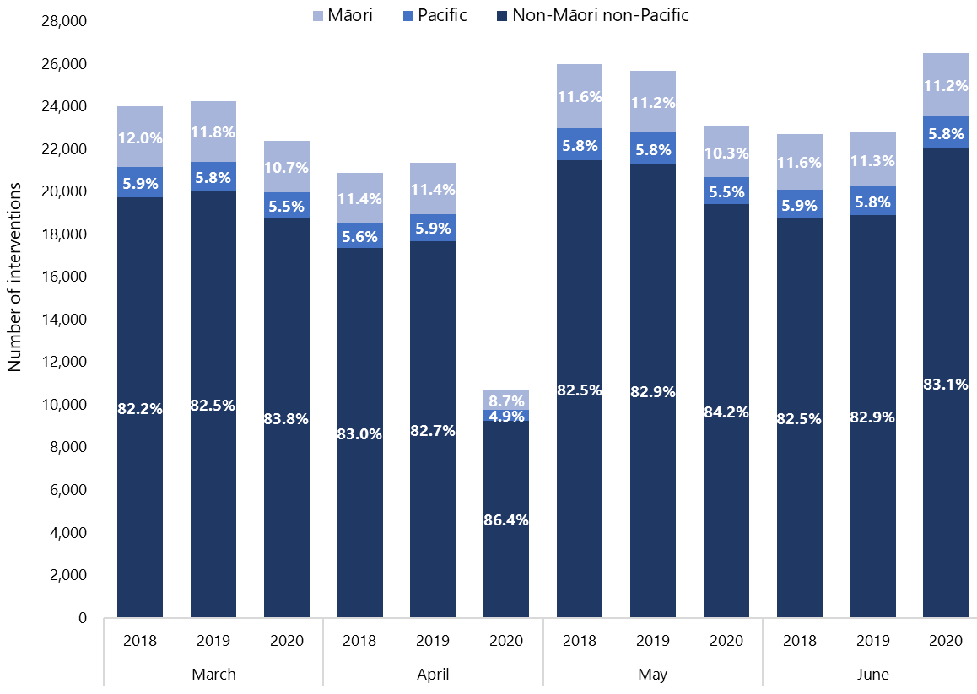

Delivery of first specialist assessments
Nationally, delivery of FSAs decreased by 8.2% in March 2020 and 36.2% in April 2020 compared with the same month in 2019. In May 2020 the numbers began to rise but FSA delivery was still 26.8% lower than in May 2019. However, in June 2020 the delivery of FSAs was 10.7% higher than in 2019, reflecting how services became more available in Alert Level 1 than they had been at previous Alert Levels and indicating the beginning of a period of recovery. Figure 17 shows the number of FSAs nationally from March to June 2018–2020.

Appendix 8 shows FSA deliveries by region from March to June 2018–2020. South Region experienced the largest reduction in FSAs delivered across all four months in 2020 compared with the same months in 2019, and was the only region that had a reduction in FSAs in June 2020 compared with June 2019 (down by 4.3%). Central Region had the smallest reduction in FSAs in March 2020 (2.8%) and April 2020 (22.2%) compared with the same months in 2019, while Northern Region had the smallest reduction in May 2020 (20.8%) compared with May 2019. FSA delivery increased in Central, Midland and Northern regions in June 2020 compared with June 2019, with the greatest increase (18.1%) in Northern Region.

Figure 17: Number of first specialist assessments delivered nationally from March to June 2018–2020
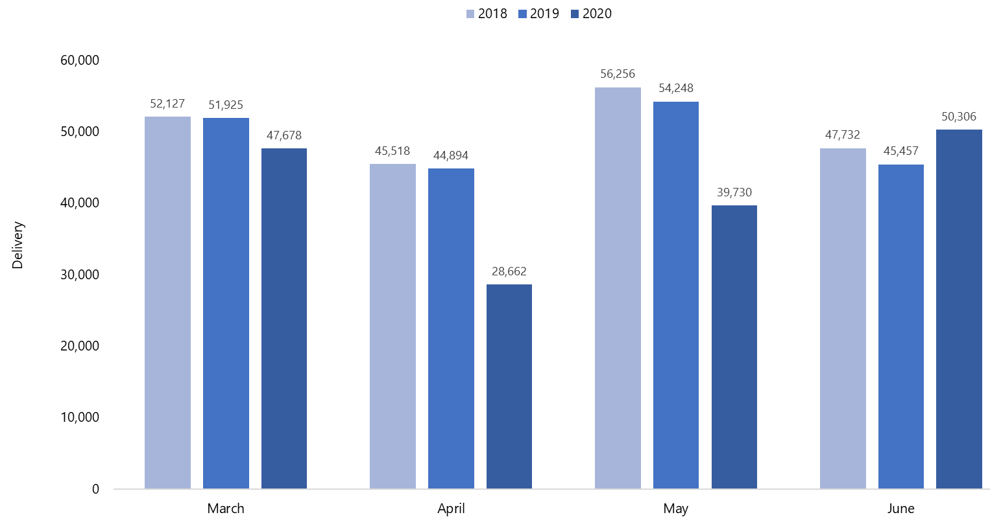

Figure 18 shows what percentage of the total number of FSAs nationally was delivered to each of the three ethnic groups between March and June 2018–2020. Delivery of FSAs decreased most for non-Māori, non-Pacific, by 9.7% in March 2020 compared with March 2019, while it fell by 1.2% for Māori and 0.04% for Pacific peoples. In April 2020, all groups experienced an even greater disruption to FSA delivery, with numbers falling by 37.5% for non-Māori, non-Pacific, 31.6% for Māori and 25.5% for Pacific peoples compared with April 2019.

Disruption continued in May 2020 but somewhat less than in April. Pacific peoples were the least affected, with a decrease in FSA delivery of 16.1% compared with May 2019, while the reduction was 24.4% for Māori and 27.8% for non-Māori, non-Pacific over the same period. In June 2020, FSA delivery to all three ethnic groups was above June 2019 levels: up 17.4% for Pacific peoples, 16.2% for Māori and 9.4% for non-Māori, non-Pacific.

Figure 18: Number of first specialist assessments delivered nationally from March to June 2018–2020, by ethnicity
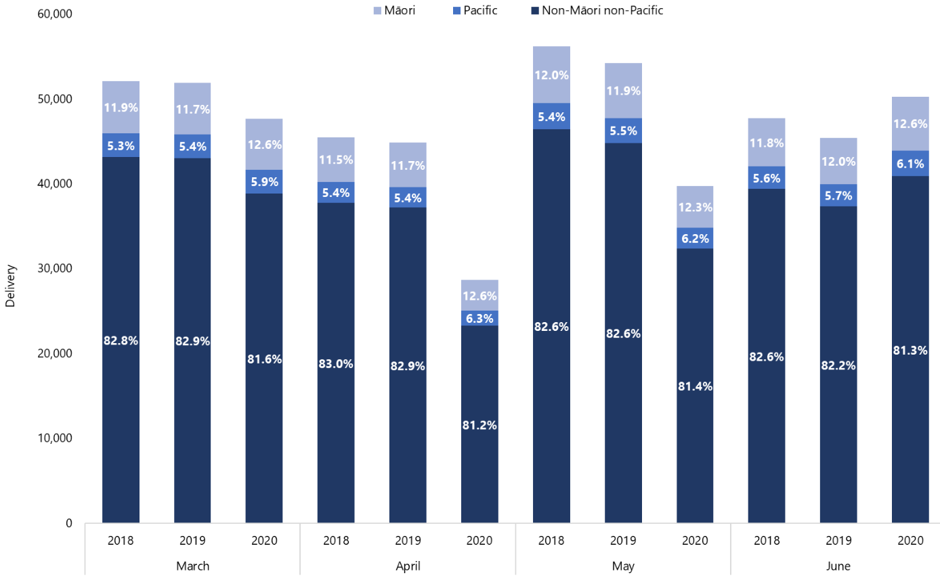

Delivery of follow-up appointments
COVID-19 had a smaller impact on national delivery of follow-up appointments than it did on FSA delivery. Compared with the same month in 2019, delivery of follow-up appointments decreased by 4.5% in March 2020, 23.1% in April 2020 and 18.7% in May 2020. By June 2020, the number of follow-up appointments was 15% higher than in June 2019 (Figure 19). This increase reflects the reopening of a range of health services at Alert Level 1 and efforts to recover from decreased service delivery during Alert Levels 2, 3 and 4 in March, April and May.
Figure 19: Number of follow-up appointments delivered nationally from March to June 2018–2020
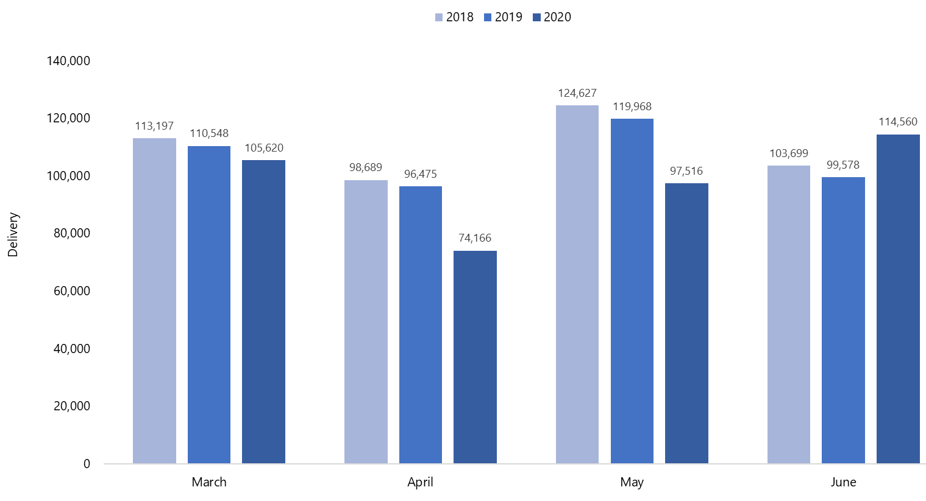
Regionally, South Region experienced the greatest decrease in follow-up delivery during the lockdown period, decreasing by 10.3% in March 2020, 32.6% in April 2020 and 27.7% in May 2020, compared with the same months in 2019. Northern Region was the only region to see an increase in follow-up delivery in March 2020 (1.5%) compared with March 2019, and also was the region with the smallest decrease in follow-up delivery in April 2020 (15.6%) and May 2020 (14.5%) compared with the same months in 2019.

In June 2020, the number of follow-up appointments was higher in all regions than in June 2019. The increase was smallest for South Region (4.6%) and largest for Northern Region (21.3%). Appendix 9 shows the number of follow-up appointments delivered in each region from March to June 2018–2020.

Figure 20: Number of follow-up appointments delivered nationally from March to June 2018–2020, by ethnicity
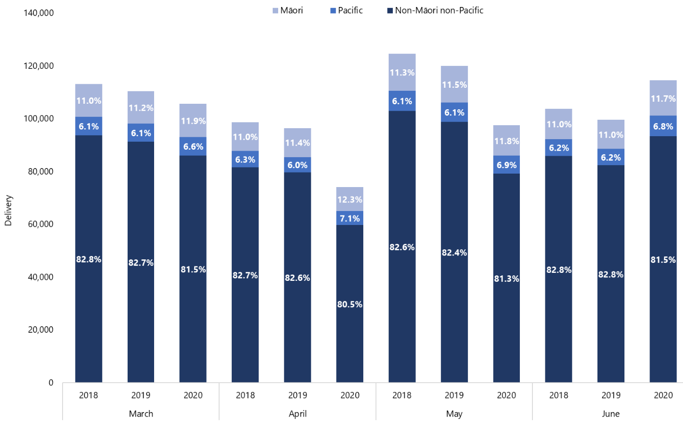

In March 2020 follow-up delivery to Māori and Pacific peoples did not change, whereas it decreased by 5.8% to non-Māori, non-Pacific compared with follow-up delivery in March 2019. In the next two months, follow-up delivery to Pacific peoples reduced the least: by 9.1% in April 2020 and 8.3% in May 2020 compared with the same months in 2019. Follow-up delivery decreased by 16.5% for Māori in both months and decreased the most for non-Māori, non-Pacific, by 25.1% in April 2020 and 19.8% in May 2020 compared with the same months in 2019. In June 2020, follow-up delivery across all ethnic groups was higher than June 2019: up by 26.2% for Pacific peoples and 13.3% for both Māori and non-Māori, non-Pacific. (Figure 20).

Waitlist impacts
Waiting times for elective services are managed through a suite a national indicators known as the Elective Services Patient Flow Indicators (ESPIs). Further information about the ESPIs is available from the Ministry of Health website here: https://www.health.govt.nz/our-work/hospitals-and-specialist-care/elective-services/elective-services-and-how-dhbs-are-performing/latest-summary-elective-services-patient-flow-indicators-espis

This section presents data on the following Elective Services Patient Flow Indicators (EPSIs) between July 2019 and June 2020:
- ESPI 2: Patients waiting longer than four months for their FSA
- ESPI 5: Patients given a commitment to treatment but not treated within four months.

Elective Services Patient Flow Indicator 2
As Figure 21 shows, the total number of patients waiting for their FSA decreased in the period of February to June 2020, and as at June 2020 remained lower than in the months leading up to COVID-19. However, within this total number the proportion of patients waiting longer than four months for FSA increased. This proportion had begun to increase in January, but became considerably larger over the lockdown period. In February 2020, 11.9% of patients were waiting more than four months for their FSA. This increased to 14.5% in March 2020, 22.1% in April 2020 and 25.8% in May 2020.

June 2020 saw a slight decrease to 24.4%, which represents 24,568 patients waiting more than four months for their FSA out of a total of 76,131 patients. This decrease from May 2020 is promising and hopefully marks the beginning of a recovery period.

Figure 21: Elective Services Patient Flow Indicator 2 (ESPI 2) nationally, July 2019–June 2020
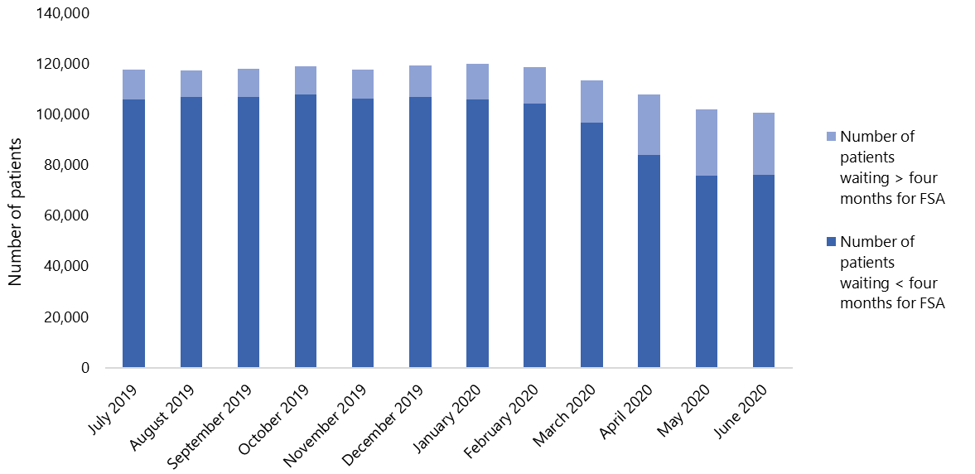

Appendix 10 provides a regional breakdown of the number of patients waiting more than four months for their FSA and the number waiting less than four months from July 2019 to June 2020. Midland Region had the greatest percentage of patients waiting more than four months for their FSA in March 2020 (20.2%) and April 2020 (27.1%) compared with the same months in 2019. The region with the lowest percentage of patients waiting for their FSA was Northern Region in March 2020 (11.7%), Central Region in April 2020 (18.6%) and May 2020 (22.0%), and Northern Region in June (20.0%).

Elective Services Patient Flow Indicator 5
The number of patients waiting more than four months for treatment increased through COVID-19, as did the total number of patients waiting for treatment. As Figure 22 shows, the total number of patients waiting for treatment increased during Alert Level 4 and then decreased slightly as restrictions were eased, but the percentage of patients waiting longer than four months for treatment increased.

In March 2020, 20.7% of patients were waiting longer than four months for treatment, which increased further to 29.4% in April 2020 and 33.6% in May 2020 before decreasing slightly in June 2020 to 32.6%. This represents 15,825 patients waiting more than four months for specialist treatment out of a total of 32,649 patients who are waiting for specialist treatment.

Figure 22: Elective Services Patient Flow Indicator 5 (ESPI 5) nationally, July 2019–June 2020
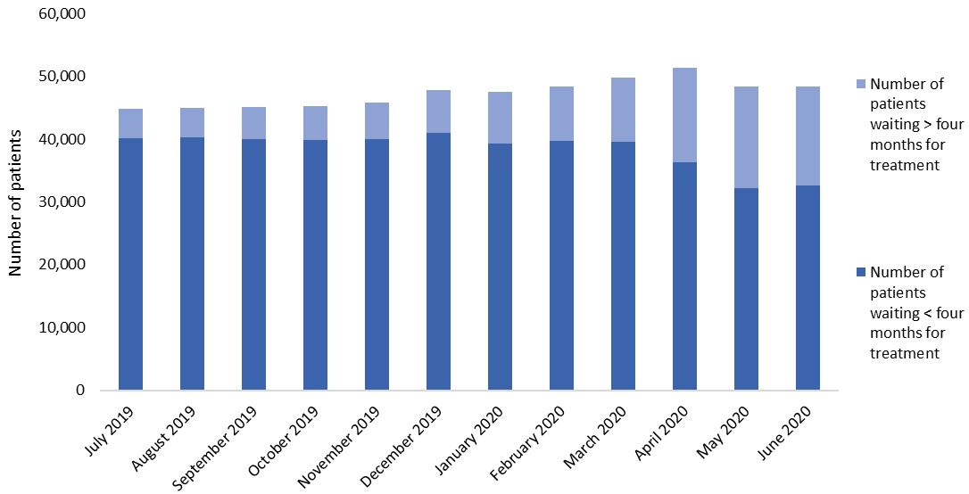

Appendix 11 shows the number of patients in each region who were waiting more than four months for treatment and the number who were waiting for less than four months from July 2019 to June 2020. Northern Region had the lowest percentage of patients waiting longer than four months for treatment in April 2020 (27.0%), while Central Region had the highest (32.7%). By June 2020, Midland Region had the lowest percentage of patients waiting longer than four months for treatment (30.5%), while Central Region had the highest (36.2%).

Figure 23 to Figure 25 show the number of patients in each of the three ethnic groups who were waiting more than four months for treatment and the number who were waiting less than four months for treatment from July 2019 to June 2020. For all of these ethnic groups, the proportion of people waiting more than four months for treatment increased each month from March 2020 to May 2020, before decreasing slightly in June. Across all ethnicities, the overall number of patients waiting for treatment increased each month between January 2020 and April 2020, before beginning to decrease in May and continuing to decrease in June. The May and June figures indicate the start of the recovery with an increase in service delivery compared with the lockdown months.

From December 2019 to June 2020, Māori had the highest percentage of people waiting over four months for treatment, followed by Pacific peoples and then non-Māori, non-Pacific (see Table 3).

Figure 23: Elective Services Patient Flow Indicator 5 (ESPI 5) for Māori nationally, July 2019–June 2020
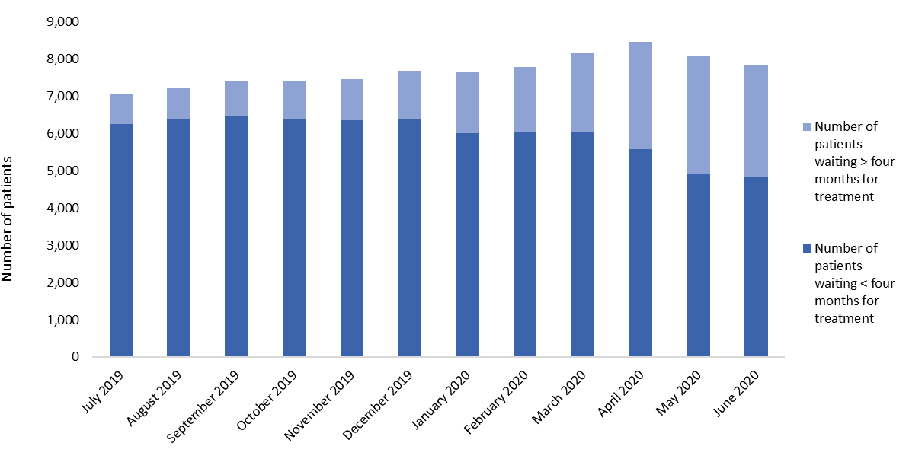

Figure 24: Elective Services Patient Flow Indicator 5 (ESPI 5) for Pacific peoples nationally, July 2019–June 2020
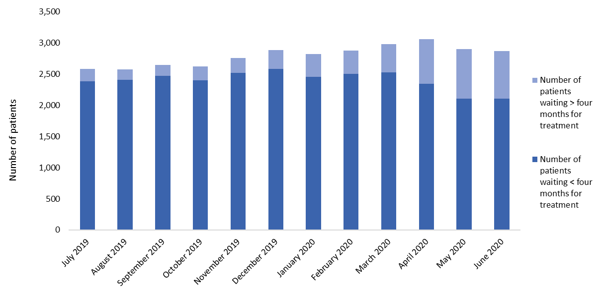
Figure 25: Elective Services Patient Flow Indicator 5 (ESPI 5) for non-Māori, non-Pacific nationally, July 2019–June 2020
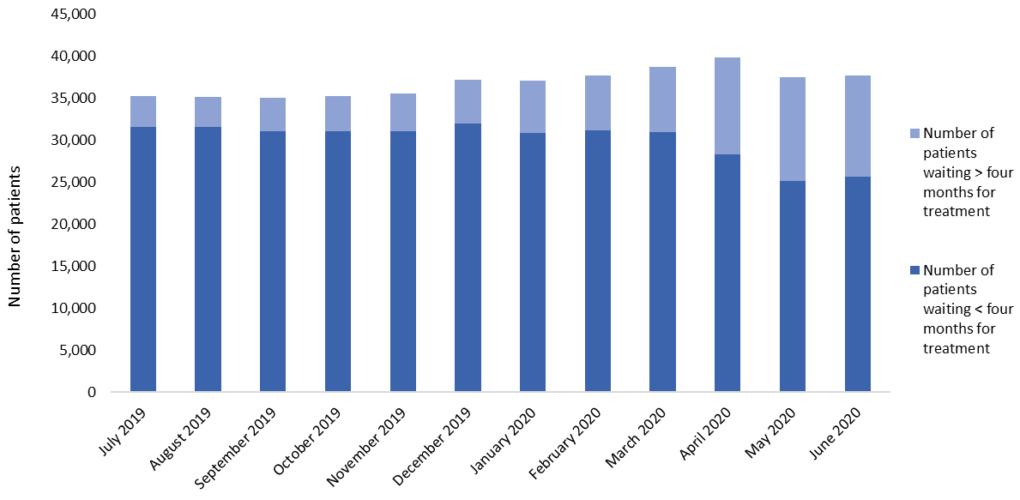

Table 3: Percentage change in Elective Services Patient Flow Indicator 5 (ESPI 5) nationally, July 2019–June 2020, by ethnicity
 | Māori |  |  | Non-Māori, non-Pacific |  |  | Pacific
 | Number of patients waiting > four months for treatment | Total number of patients waiting for treatment | ESPI 5 % | Number of patients waiting > four months for treatment | Total number of patients waiting for treatment | ESPI 5 % | Number of patients waiting > four months for treatment | Total number of patients waiting for treatment | ESPI 5 %
July 2019 | 819 | 7,061 | 11.6% | 3,666 | 35,242 | 10.4% | 200 | 2,582 | 7.7%
August 2019 | 835 | 7,223 | 11.6% | 3,632 | 35,211 | 10.3% | 170 | 2,574 | 6.6%
September 2019 | 955 | 7,414 | 12.9% | 3,938 | 35,071 | 11.2% | 175 | 2,643 | 6.6%
October 2019 | 1,011 | 7,407 | 13.6% | 4,219 | 35,280 | 12.0% | 220 | 2,619 | 8.4%
November 2019 | 1,082 | 7,465 | 14.5% | 4,522 | 35,597 | 12.7% | 239 | 2,756 | 8.7%
December 2019 | 1,296 | 7,684 | 16.9% | 5,289 | 37,274 | 14.2% | 302 | 2,887 | 10.5%
January 2020 | 1,641 | 7,642 | 21.5% | 6,211 | 37,100 | 16.7% | 363 | 2,817 | 12.9%
February 2020 | 1,737 | 7,793 | 22.3% | 6,533 | 37,753 | 17.3% | 368 | 2,873 | 12.8%
March 2020 | 2,092 | 8,147 | 25.7% | 7,768 | 38,770 | 20.0% | 455 | 2,978 | 15.3%
April 2020 | 2,875 | 8,448 | 34.0% | 11,534 | 39,906 | 28.9% | 713 | 3,056 | 23.3%
May 2020 | 3,162 | 8,073 | 39.2% | 12,359 | 37,514 | 32.9% | 790 | 2,898 | 27.3%
June 2020 | 3,007 | 7,841 | 38.3% | 12,057 | 37,764 | 31.9% | 761 | 2,869 | 26.5%

Key points
- PCI delivery was heavily disrupted in April 2020, in both number of discharges and CWDs, with the greatest impact on inpatient treatment. A higher percentage of Māori experienced a drop in the delivery of PCIs than other ethnic groups in March, April and May 2020 compared with the same months in 2019.
- Delivery of FSAs decreased by a greater percentage than follow-up delivery, and the level of disruption differed between regions. A higher percentage of non-Māori, non-Pacific was affected than Māori and Pacific peoples.
- The total number of people waiting for their FSA decreased during the lockdown period. However, the proportion of patients waiting more than four months for their FSA (ESPI 2) increased.
- The percentage of patients waiting more than four months for treatment (ESPI 5) and the total number of patients waiting for treatment increased during the lockdown period. Inequity between ethnic groups was apparent throughout the period from December 2019 to April 2020: the percentage of patients waiting for treatment was highest for Māori, followed by Pacific peoples and then the non-Māori, non-Pacific group.
- The percentages for ESPI 2 and ESPI 5 decreased in June 2020 from those in May 2020, indicating the beginning of recovery.

Unplanned care

Notes on data
- Emergency department (ED) data comes from the NNPAC.
- Data includes publicly funded services only.
- DHB and regional data is based on DHB region of service, rather than DHB region of domicile.
- The analysis does not include Did Not Attend (DNA) and Did Not Wait (DNW) data.

Results

Acute activity by ethnicity
Figure 26 shows the number of discharges from acute services for each ethnic group. At a national level, acute activity levels decreased for all three ethnic groups by between 10.1% and 11.9% in March 2020 compared with March 2019. In April 2020 the reduction was greatest for Pacific peoples, with a 38.7% decrease in acute activity, while the decrease was 35.4% for Māori and 29.1% for non-Māori, non-Pacific, compared with April 2019. In May 2020 the disruption to acute activity was slightly lower than in April: the number of acute discharges decreased by 32.0% for Pacific peoples, 23.1% for Māori and 16.1% for non-Māori, non-Pacific compared with May 2019. Disruption was lower still in June 2020, when numbers of acute discharges were down by 14.8% for Pacific peoples, 9.5% for Māori and 4.4% for non-Māori, non-Pacific compared with June 2019 volumes.

Figure 26: Number of acute discharges nationally from March to June 2018–2020, by ethnicity
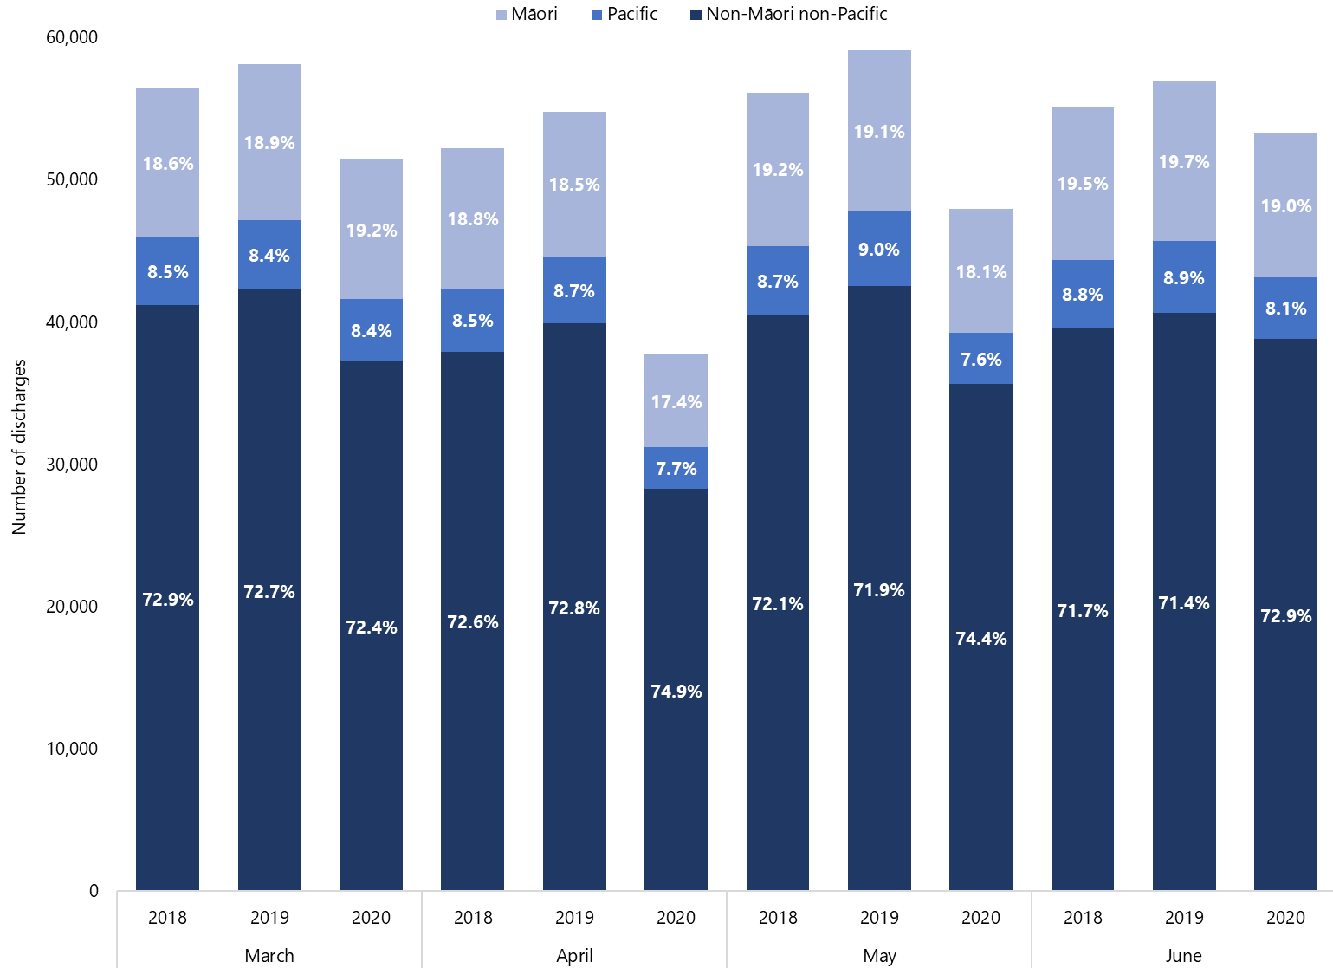

Emergency department attendance
Figure 27 shows the number of ED attendances and Figure 28 shows the average number of minutes each patient spent in ED, from presentation to departure, from March to June 2018–2020. The lockdown period had a greater effect on the number of ED attendances than on the average number of minutes spent in ED.

In March 2020, the number of ED attendances decreased by 17.6% and average time in ED decreased by 0.8% (2 minutes) compared with March 2019. Of the four months from March to June 2020, April saw the largest reductions compared with the same month in 2019: the number of ED attendances fell by 37.6%, representing 33,486 fewer ED attendances, and the average number of minutes in ED reduced by 8.4% (19 minutes). In May 2020, ED attendances decreased by 26.4% (25,019 fewer attendances) and the average number of minutes in ED decreased by 5.5% (13 minutes) compared with May 2019. In June 2020, ED attendances decreased by 12.4% (11,617 fewer attendances) and the average number of minutes spent in ED reduced by 7.2% (18 minutes).

Figure 27: Number of emergency department (ED) attendances nationally from March to June 2018–2020
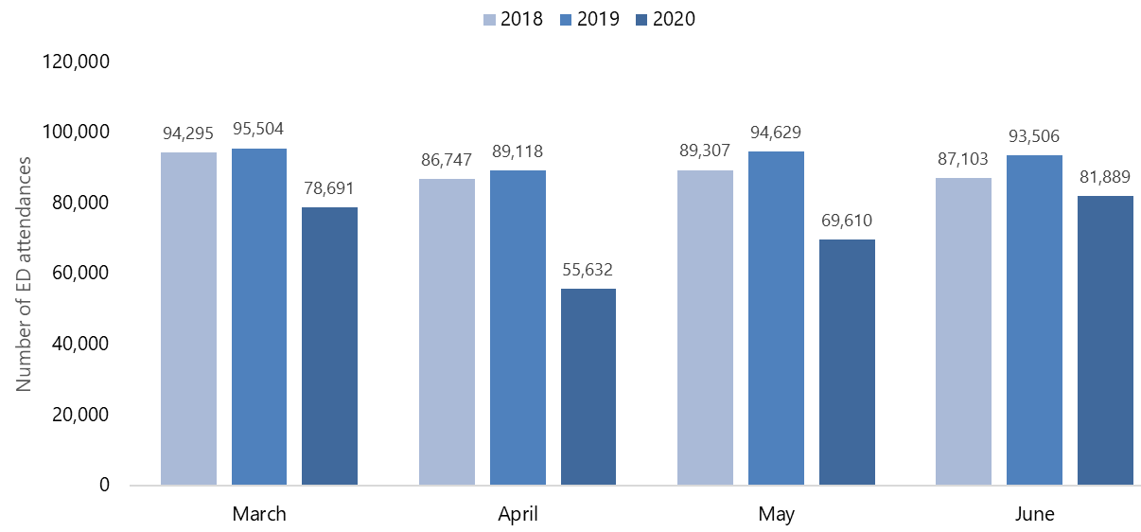

Figure 28: Average number of minutes spent in emergency departments (ED) nationally from March to June 2018–2020
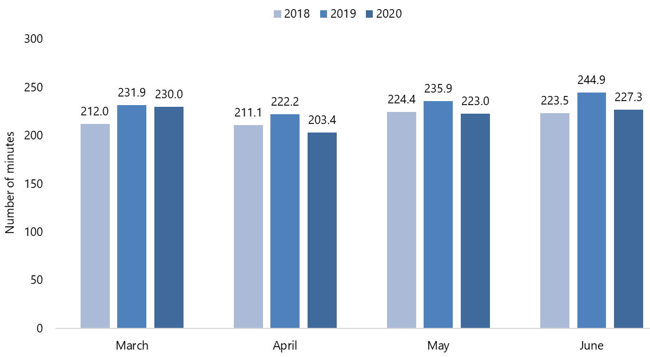

Appendix 12 presents a regional breakdown of the number of ED attendances in March to June 2020 compared with the same months in 2018 and 2019. In March 2020, Central Region had the greatest reduction in number of ED attendances, reducing by 19.4% compared with March 2019. In the following three months, Northern Region had the largest reduction in number of ED attendances: down by 39.3% in April 2020, 28.4% in May 2020 and 15.6% in June 2020 compared with the same months in 2019. South Region had the smallest reduction in ED attendances in March 2020 (down by 16.5%) and June 2020 (down by 9.6%) compared with the same months in 2019. In April 2020, Central Region had the smallest reduction in ED attendances (down by 34.2%) and in May 2020 Midland had the smallest reduction (down by 23.8%) compared with the same months in 2019.

Figure 29 shows the number of ED attendances for each of the three ethnic groups nationally from March to June 2018–2020. For all groups, ED attendances decreased in each of these months compared with the same months in 2019. In March 2020 compared with March 2019, the reduction in ED attendances was greatest among non-Māori, non-Pacific, with a decrease of 18.8%, while ED attendances decreased by 14.5% for Māori and by 14.6% for Pacific peoples.

April 2020 saw even larger reductions in ED attendances compared with April 2019: by 50.2% for Pacific peoples, 42.0% for Māori and 34.6% for non-Māori, non-Pacific. In May 2020 Pacific continued to have the largest reduction in ED attendances (down by 44.9%), followed by 30.8% for Māori and 22.4% for non-Māori, non-Pacific, compared with May 2019. Pacific peoples again had the largest reduction in ED attendances in June 2020 compared with June 2019, with a fall of 27.6%, while the reduction was 14.0% Māori and 9.8% for non-Māori, non-Pacific.

Figure 29: Number of emergency department (ED) attendances nationally from March to June 2018–2020, by ethnicity
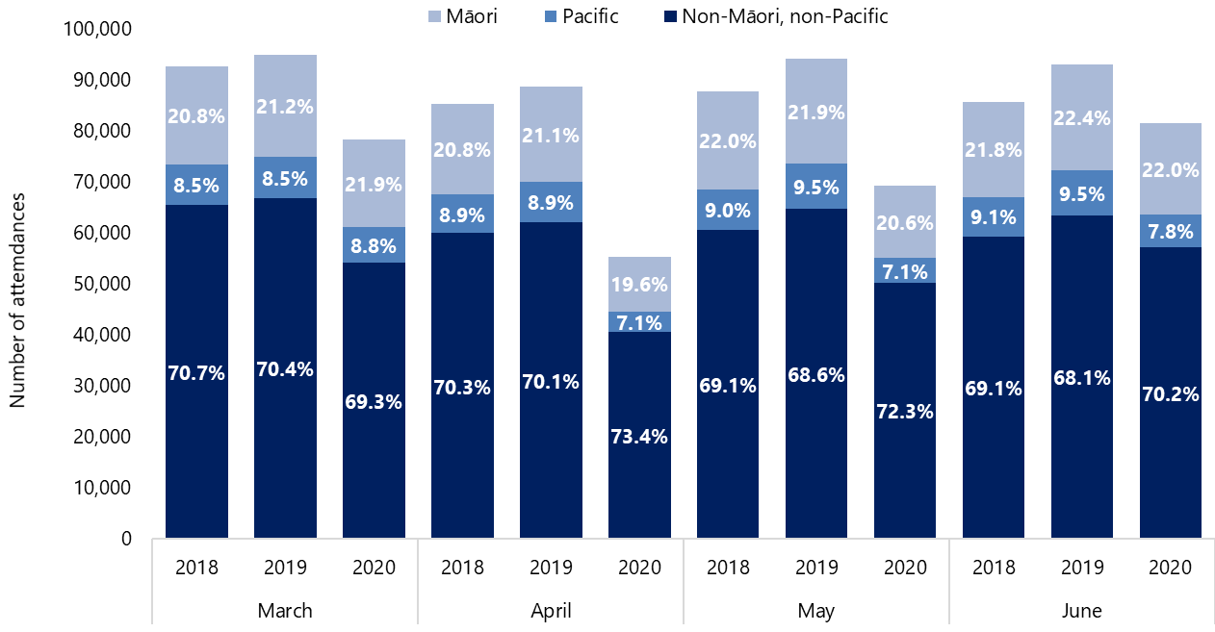

Key points
- The numbers of acute activity discharges and ED attendances were lower from March to June 2020 compared with the same months in 2019. The difference was greatest in April, reflecting the time during the lockdown period when hospital services were most restricted.
- Of the three ethnic groups, Pacific peoples experienced the highest reduction in acute activity by percentage.
- From March to June 2020, the number of ED attendances decreased markedly but reductions were smaller in the average number of minutes a patient spent in ED.

Unmet need

Notes on data
- The daily Health and Wellbeing Survey has collected self-reported data around unmet need since April, which is collated weekly.
- Data is currently available from the beginning of Alert Level 4 but not yet before this point.
- The data below is provisional. We will undertake further analysis as more data becomes available.

Results
From 27 April to 28 June 2020, about 9% of the adult population agreed with the statement that ‘Since the beginning of COVID-19 Alert Level 4 until now there had been a time when you needed health care but could not get it’. Although the length of time that this question covered increased as Alert Level 4 continued, there was not much variation on a week-by-week basis.

Of those who reported having unmet need, each week between 36% and 50% stated that they required care from a general practitioner (GP) or nurse.

The New Zealand Health Survey contains a similar indicator of unmet need. In 2018/19, about 30% of adults responding to the survey reported that in the last year they’d been unable to access health care, either at a GP clinic or an after-hours service, due to cost or transport requirements, or were unable to access a GP within 24 hours when they wanted to.

Key points
- The amount of self-reported unmet need remained steady over the lockdown period.
- We will undertake further analysis as more data becomes available.

Conclusions
- The COVID-19 lockdown period resulted in changes to health care activity levels across New Zealand.
- Activity levels decreased across planned care, unplanned care and primary care during March, April, May and June 2020 compared with the same months in 2018 and 2019. April had the greatest reduction in activity levels. In June 2020, some activity returned to or was higher than the levels reported in 2018 and 2019; however, some activity remained lower than June 2019 levels.
- Despite the decrease in health care activity, early data suggests that the mortality rate from March to May was lower than the same months in 2019 and lower than the expected rate based on the average of the last five years.
- The percentage of people waiting longer than four months for treatment or their FSA increased over the period of March to June 2020.
- According to available data, some ethnic groups experienced more disruption than others across different services in the health system. More analysis is needed to determine the extent to which COVID-19 and the lockdown period increased inequities in health.
- The purpose of this analysis was to measure the impact of the COVID-19 lockdown on existing service delivery. The analysis does not take into account pre-existing unmet need, any projected increase in need over time or variables outside of COVID-19 and the lockdown period.
- This is a working report, developed to help with recovery planning. We will undertake further analysis as more data becomes available.
- Clear planning is needed to keep reducing inequities as a key focus during the recovery phase.

Appendix 1:
Number of qualifying encounters per 1,000 enrolees by age group, 7 March to 12 July in 2019 and 2020
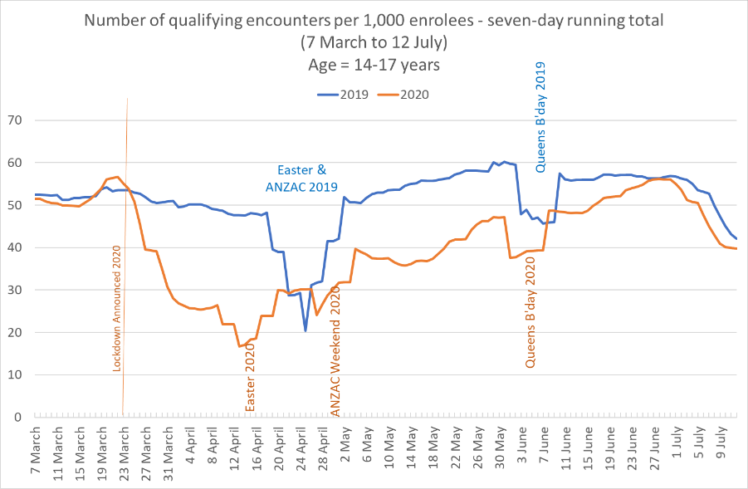
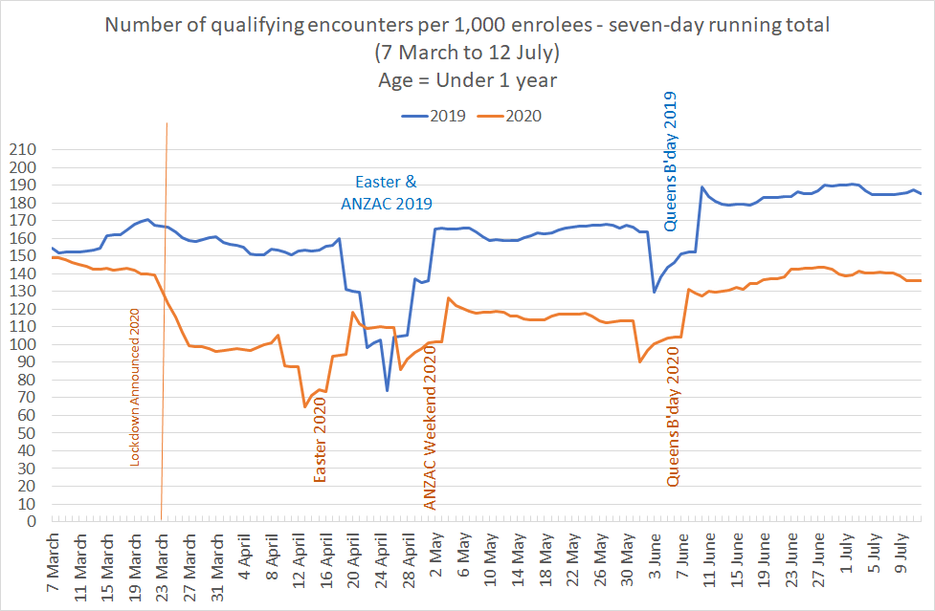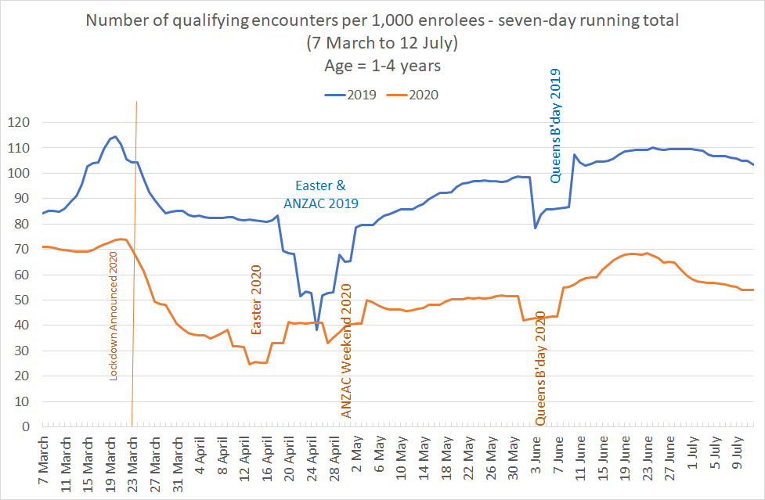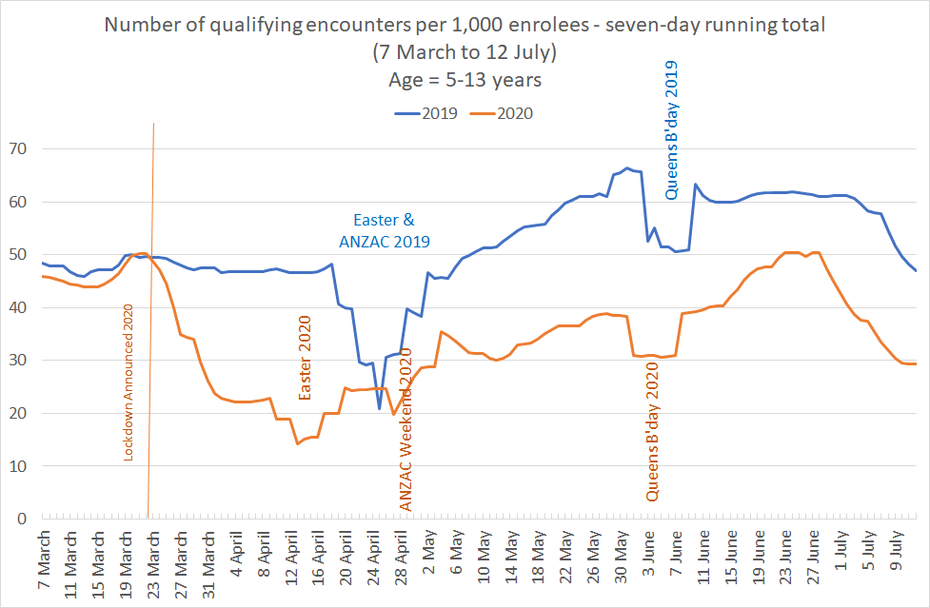

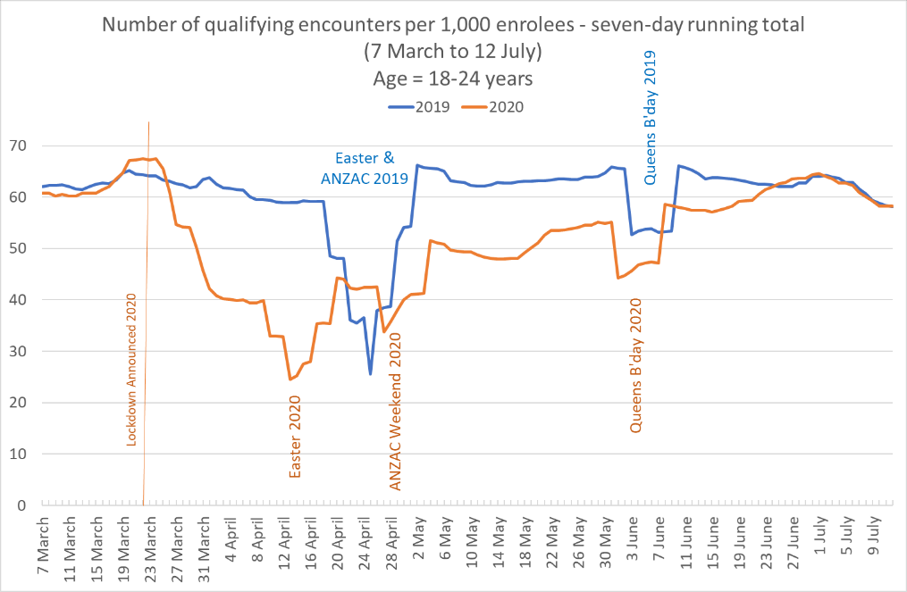
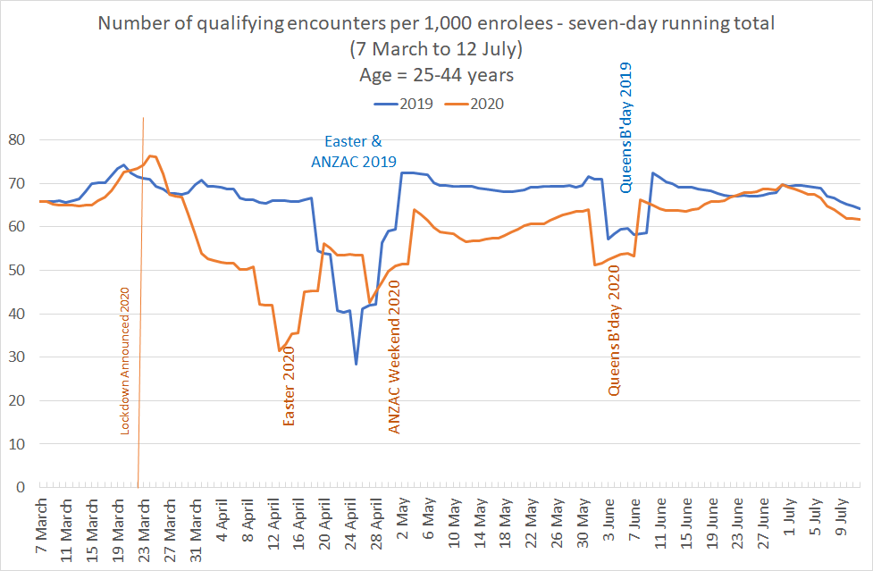

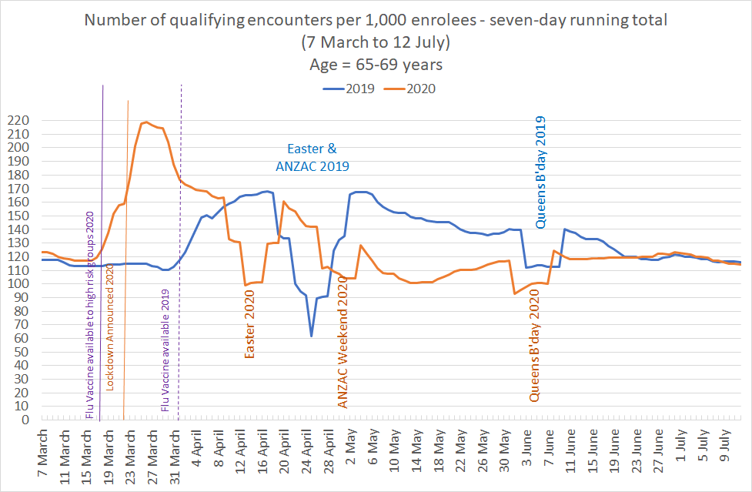
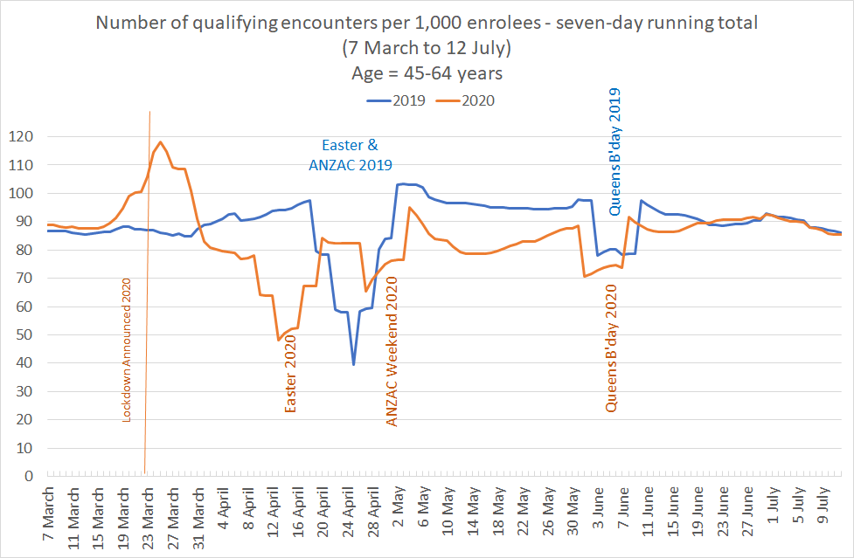

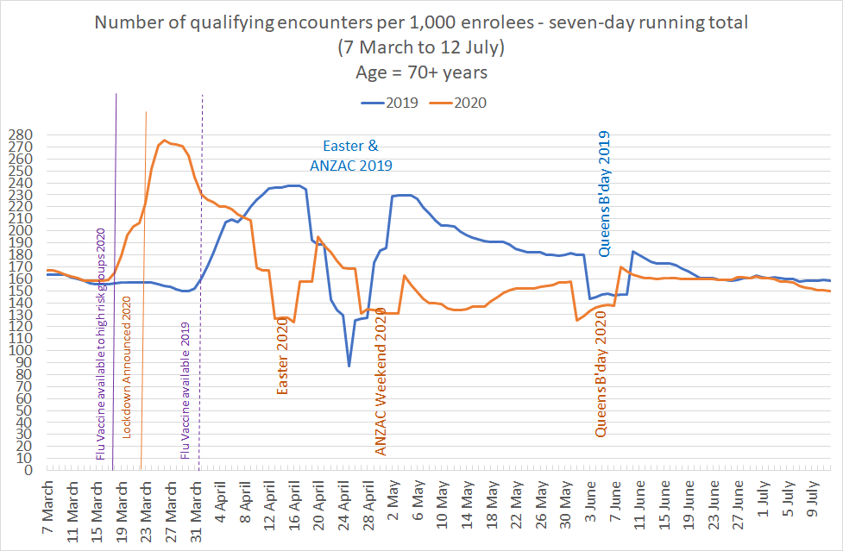

Appendix 2:
Number of discharges year to date February, and by month from March to June 2018–2020
Ethnicity group | YTD February
 | Number of discharges |  |  | Change  (2018 vs 2019) | % Change (2018 vs 2019) | Change  (2019 vs 2020) | % Change (2019 vs 2020)
 | 2018 | 2019 | 2020
Māori | 143,179 | 146,366 | 146,250 | 3,187 | 2.2% | -116 | -0.1%
Pacific | 60,868 | 62,300 | 62,203 | 1,432 | 2.4% | -97 | -0.2%
Non-Māori, non-Pacific | 613,241 | 615,905 | 611,032 | 2,664 | 0.4% | -4,873 | -0.8%
Total | 817,288 | 824,571 | 819,485 | 7,283 | 0.9% | -5,086 | -0.6%
Ethnicity group | March
 | Number of discharges |  |  | Change  (2018 vs 2019) | % Change (2018 vs 2019) | Change  (2019 vs 2020) | % Change (2019 vs 2020)
 | 2018 | 2019 | 2020
Māori | 18,470 | 18,681 | 16,188 | 211 | 1.1% | -2,493 | -13.3%
Pacific | 8,020 | 8,114 | 7,035 | 94 | 1.2% | -1,079 | -13.3%
Non-Māori, non-Pacific | 79,565 | 79,453 | 68,066 | -112 | -0.1% | -11,387 | -14.3%
Total | 106,055 | 106,248 | 91,289 | 193 | 0.2% | -14,959 | -14.1%

Ethnicity group | April
 | Number of discharges |  |  | Change  (2018 vs 2019) | % Change (2018 vs 2019) | Change  (2019 vs 2020) | % Change (2019 vs 2020)
 | 2018 | 2019 | 2020
Māori | 16,999 | 16,950 | 10,564 | -49 | -0.3% | -6,386 | -37.7%
Pacific | 7,374 | 7,658 | 4,557 | 284 | 3.9% | -3,101 | -40.5%
Non-Māori, non-Pacific | 72,679 | 73,765 | 45,293 | 1,086 | 1.5% | -28,472 | -38.6%
Total | 97,052 | 98,373 | 60,414 | 1,321 | 1.4% | -37,959 | -38.6%
Ethnicity group | May
 | Number of discharges |  |  | Change  (2018 vs 2019) | % Change (2018 vs 2019) | Change  (2019 vs 2020) | % Change (2019 vs 2020)
 | 2018 | 2019 | 2020
Māori | 18,832 | 19,044 | 14,759 | 212 | 1.1% | -4,285 | -22.5%
Pacific | 8,138 | 8,531 | 6,233 | 393 | 4.8% | -2,298 | -26.9%
Non-Māori, non-Pacific | 80,616 | 81,833 | 65,110 | 1,217 | 1.5% | -16,723 | -20.4%
Total | 107,586 | 109,408 | 86,102 | 1,822 | 1.7% | -23,306 | -21.3%
Ethnicity group | June
 | Number of discharges |  |  | Change  (2018 vs 2019) | % Change (2018 vs 2019) | Change  (2019 vs 2020) | % Change (2019 vs 2020)
 | 2018 | 2019 | 2020
Māori | 18,164 | 18,509 | 17,233 | 345 | 1.9% | -1,276 | -6.9%
Pacific | 7,825 | 7,984 | 7,131 | 159 | 2.0% | -853 | -10.7%
Non-Māori, non-Pacific | 75,829 | 75,795 | 72,516 | -34 | 0.0% | -3,279 | -4.3%
Total | 101,818 | 102,288 | 96,880 | 470 | 0.5% | -5,408 | -5.3%

Appendix 3:
Number of discharges by region, March to June 2018–2020
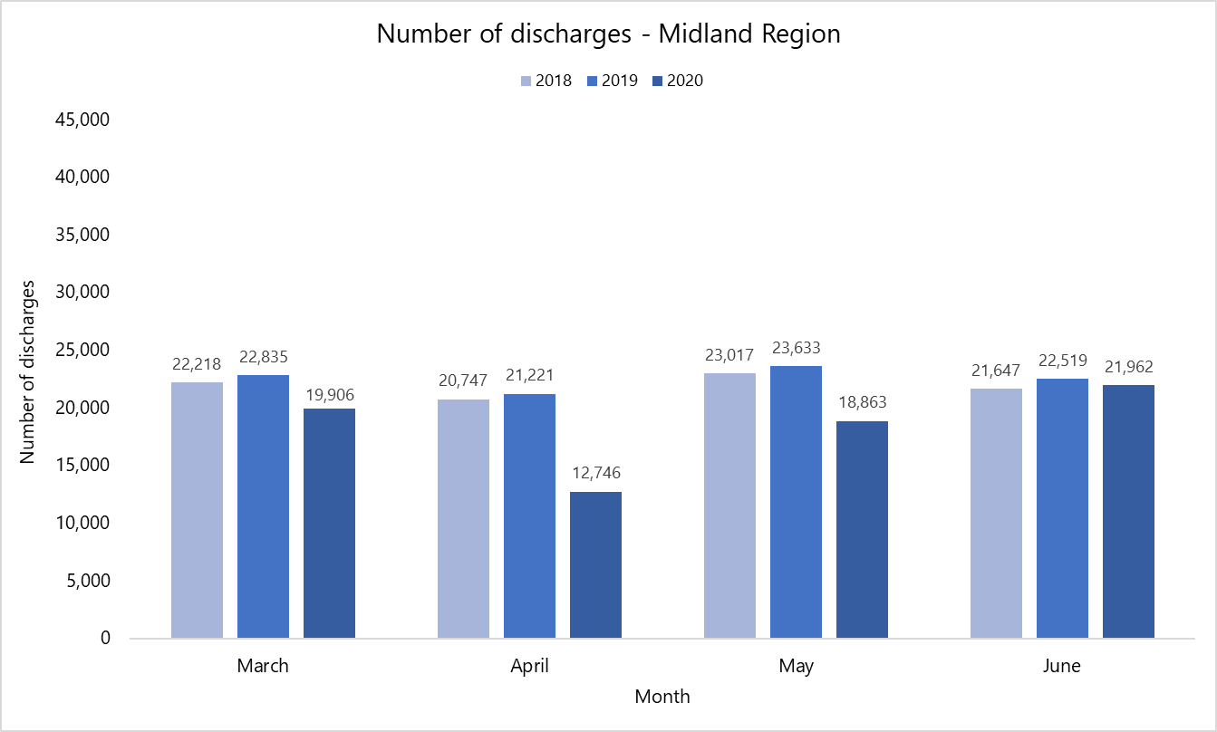
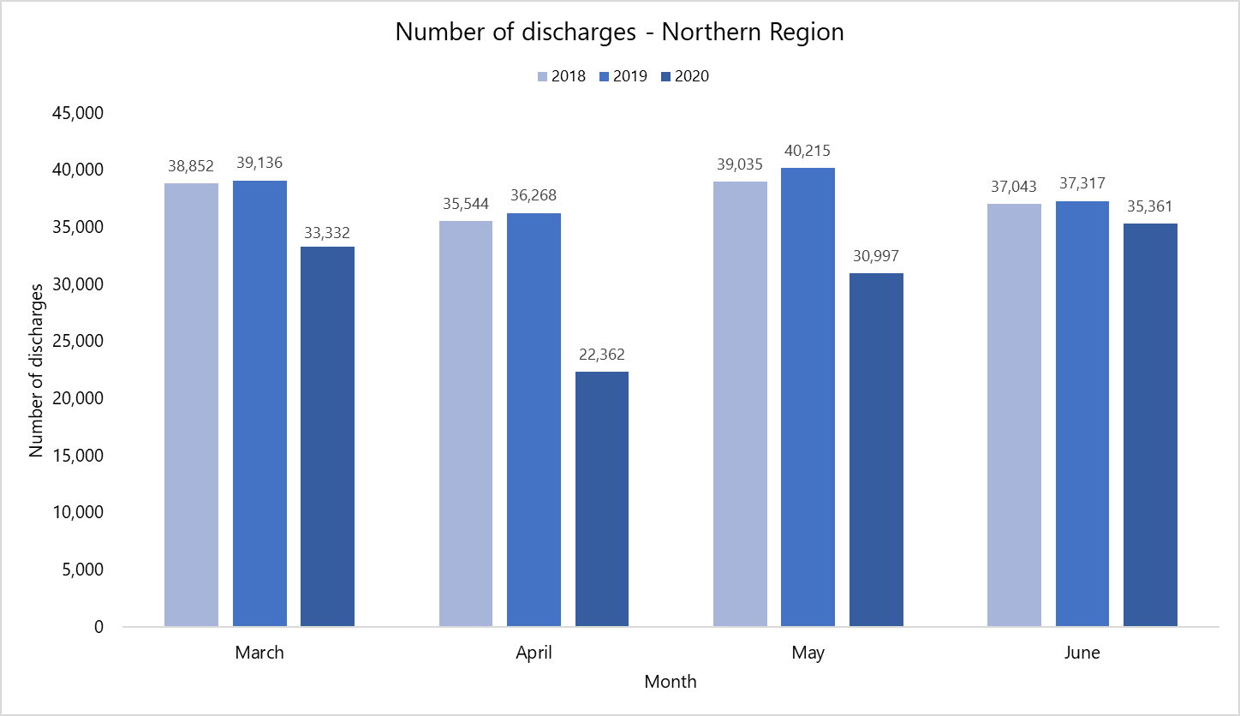
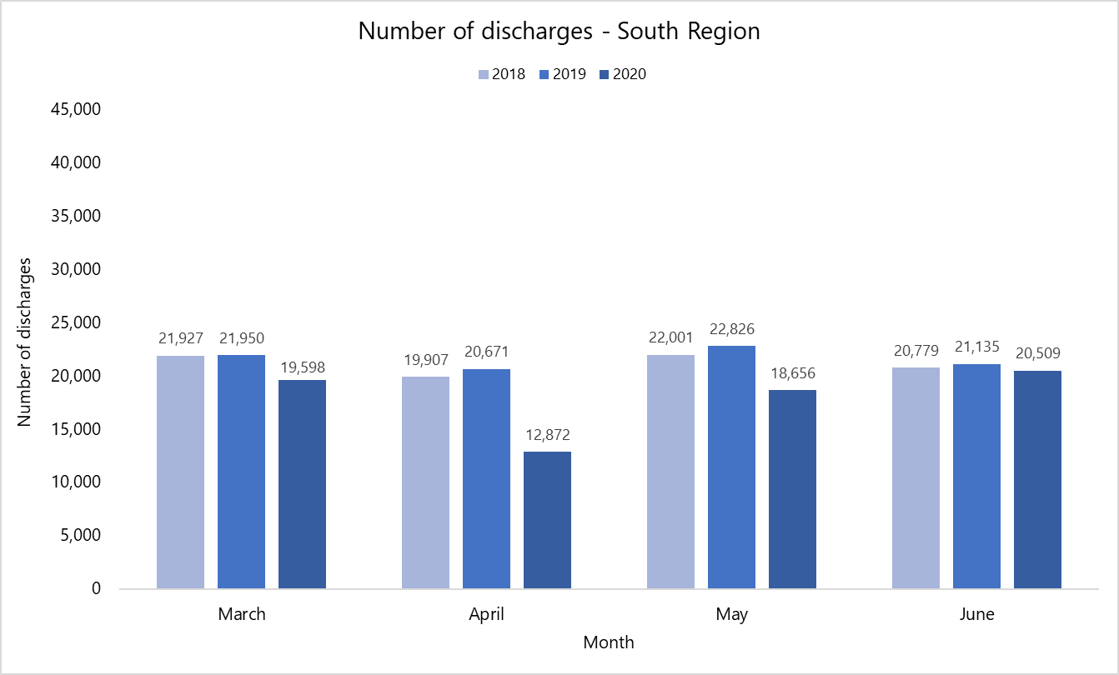
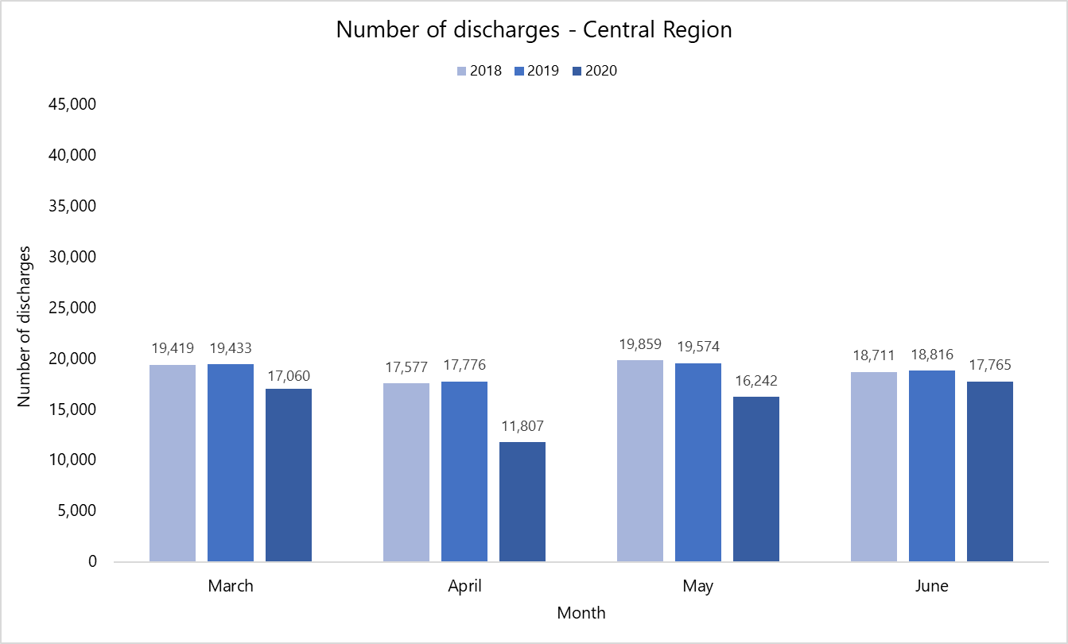

Appendix 4:
Number of case-weighted discharges year to date February, and by month from March to June 2018–2020
Ethnicity group | YTD February
 | Number of discharges |  |  | Change  (2018 vs 2019) | % Change (2018 vs 2019) | Change  (2019 vs 2020) | % Change (2019 vs 2020)
 | 2018 | 2019 | 2020
Māori | 138,430.3 | 136,481.1 | 134,137.3 | -1,949.2 | -1.4% | -2,343.7 | -1.7%
Pacific | 56,212.0 | 57,372.1 | 56,996.9 | 1,160.1 | 2.1% | -375.2 | -0.7%
Non-Māori, non-Pacific | 685,144.0 | 630,464.7 | 577,111.1 | -54,679.3 | -8.0% | -53,353.6 | -8.5%
Total | 879,786.4 | 824,317.8 | 768,245.3 | -55,468.5 | -6.3% | -56,072.5 | -6.8%
Ethnicity group | March
 | Number of discharges |  |  | Change  (2018 vs 2019) | % Change (2018 vs 2019) | Change  (2019 vs 2020) | % Change (2019 vs 2020)
 | 2018 | 2019 | 2020
Māori | 17,595.9 | 17,575.0 | 16,096.8 | -20.9 | -0.1% | -1,478.2 | -8.4%
Pacific | 7,105.6 | 7,619.6 | 6,472.5 | 514.0 | 7.2% | -1,147.1 | -15.1%
Non-Māori, non-Pacific | 83,979.9 | 76,408.3 | 68,790.7 | -7,571.6 | -9.0% | -7,617.5 | -10.0%
Total | 108,681.3 | 101,602.9 | 91,360.0 | -7,078.5 | -6.5% | -10,242.9 | -10.1%

Ethnicity group | April
 | Number of discharges |  |  | Change  (2018 vs 2019) | % Change (2018 vs 2019) | Change  (2019 vs 2020) | % Change (2019 vs 2020)
 | 2018 | 2019 | 2020
Māori | 15,727.0 | 16,301.5 | 9,525.3 | 574.6 | 3.7% | -6,776.2 | -41.6%
Pacific | 6,918.5 | 6,832.5 | 4,238.2 | -86.1 | -1.2% | -2,594.3 | -38.0%
Non-Māori, non-Pacific | 79,883.5 | 71,507.2 | 43,855.3 | -8,376.3 | -10.5% | -27,651.9 | -38.7%
Total | 102,529.0 | 94,641.2 | 57,618.7 | -7,887.8 | -7.7% | -37,022.4 | -39.1%
Ethnicity group | May
 | Number of discharges |  |  | Change  (2018 vs 2019) | % Change (2018 vs 2019) | Change  (2019 vs 2020) | % Change (2019 vs 2020)
 | 2018 | 2019 | 2020
Māori | 18,312.2 | 17,259.4 | 14,160.6 | -1,052.8 | -5.7% | -3,098.8 | -18.0%
Pacific | 7,632.6 | 8,064.8 | 5,746.5 | 432.2 | 5.7% | -2,318.3 | -28.7%
Non-Māori, non-Pacific | 86,881.1 | 79,075.2 | 62,458.8 | -7,805.9 | -9.0% | -16,616.4 | -21.0%
Total | 112,825.9 | 104,399.4 | 82,365.9 | -8,426.6 | -7.5% | -22,033.4 | -21.1%
Ethnicity group | June
 | Number of discharges |  |  | Change  (2018 vs 2019) | % Change (2018 vs 2019) | Change  (2019 vs 2020) | % Change (2019 vs 2020)
 | 2018 | 2019 | 2020
Māori | 17,418.8 | 17,289.3 | 16,236.4 | -129.4 | -0.7% | -1,053.0 | -6.1%
Pacific | 7,145.6 | 6,846.3 | 6,485.8 | -299.4 | -4.2% | -360.4 | -5.3%
Non-Māori, non-Pacific | 82,654.7 | 74,475.7 | 68,604.1 | -8,178.9 | -9.9% | -5,871.7 | -7.9%
Total | 107,219.1 | 98,611.3 | 91,326.3 | -8,607.7 | -8.0% | -7,285.0 | -7.4%

Appendix 5:
Number of case-weighted discharges by region, March to June 2018–2020
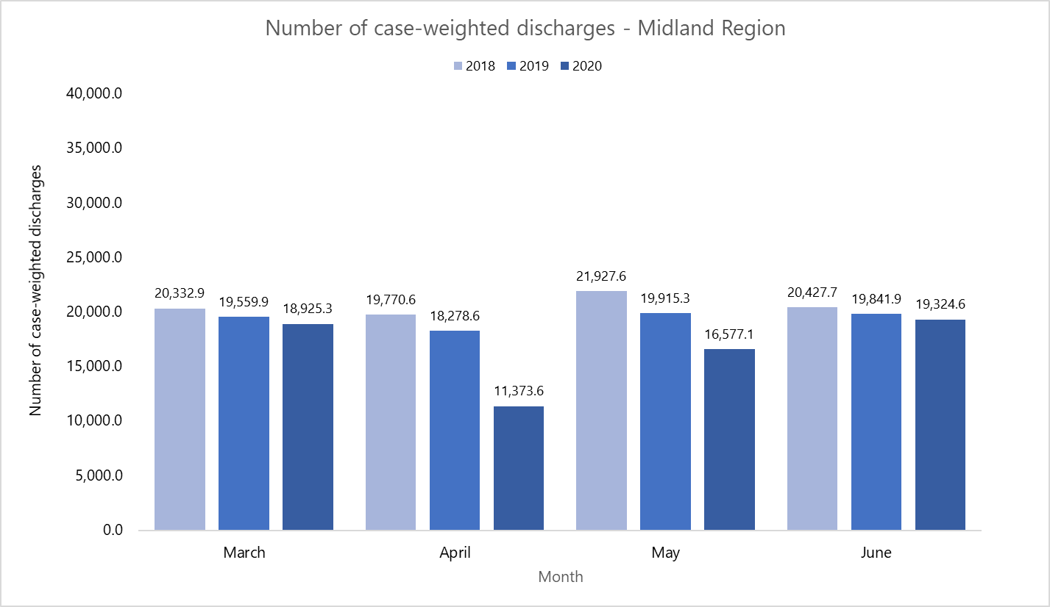
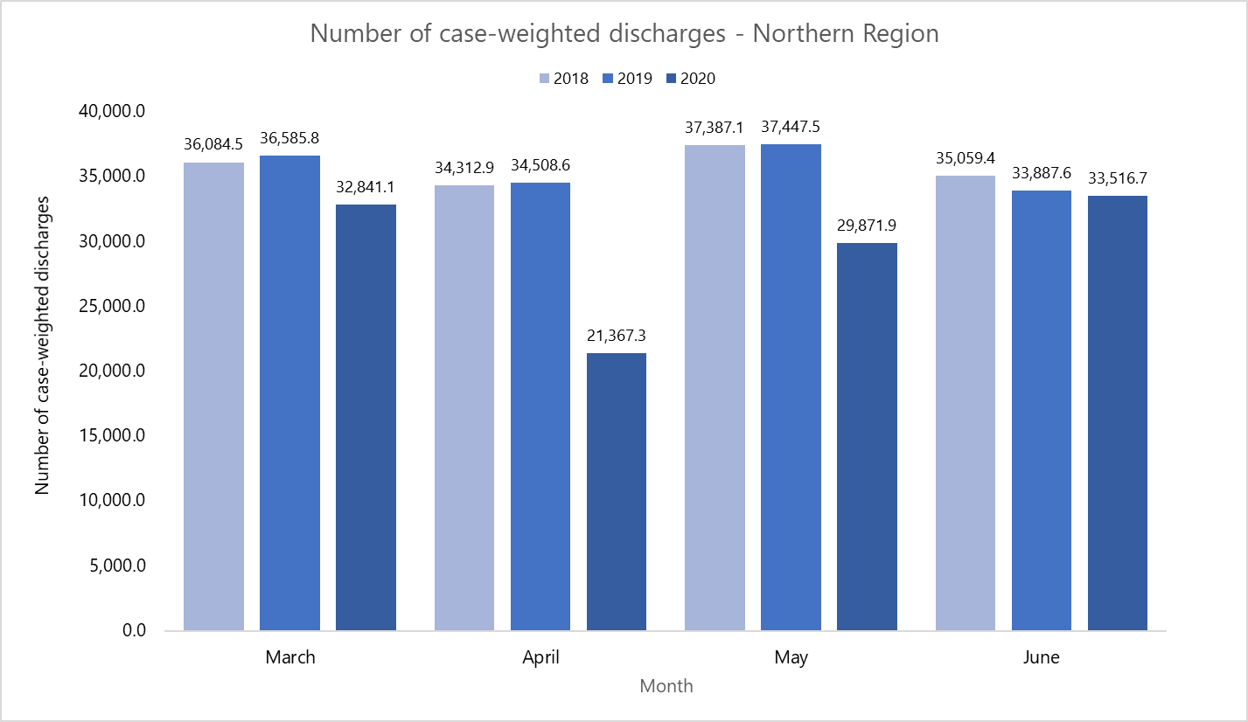
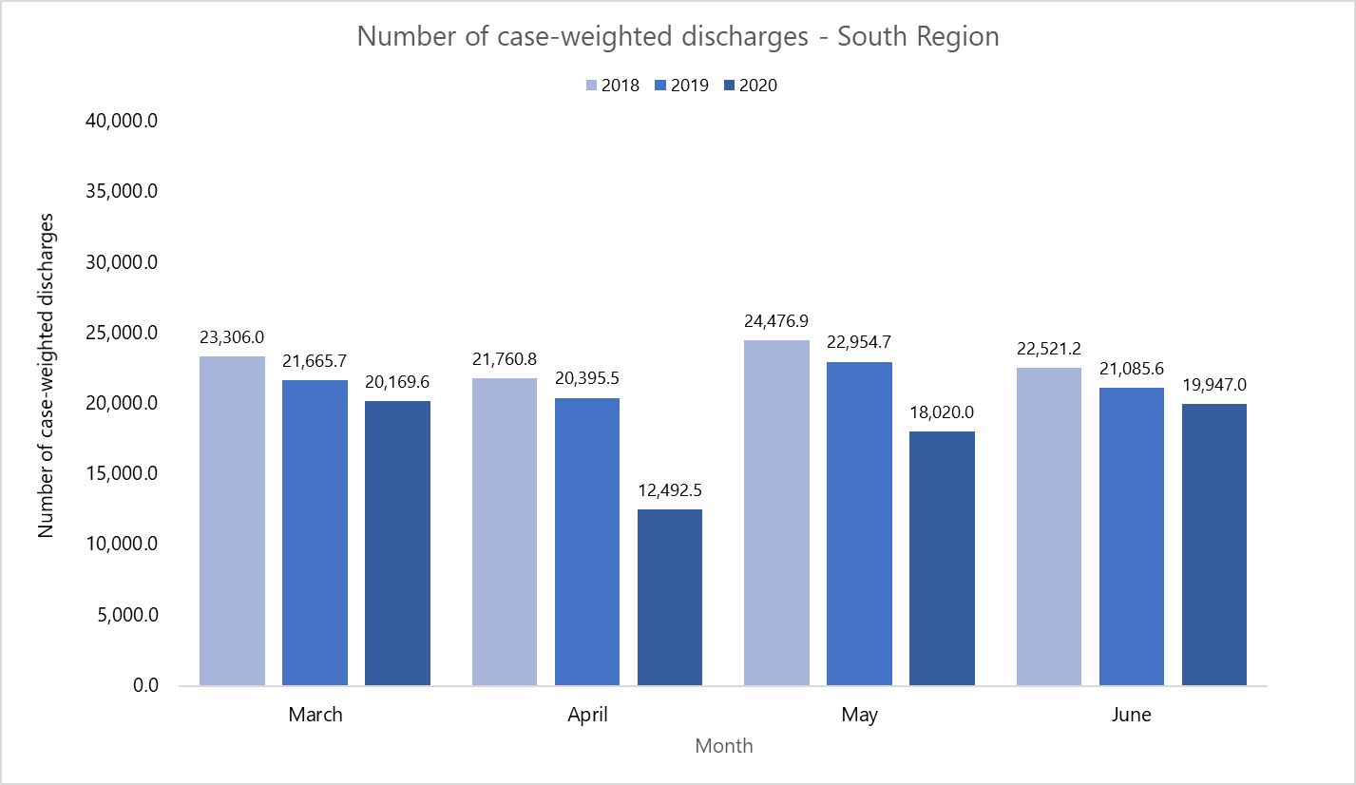
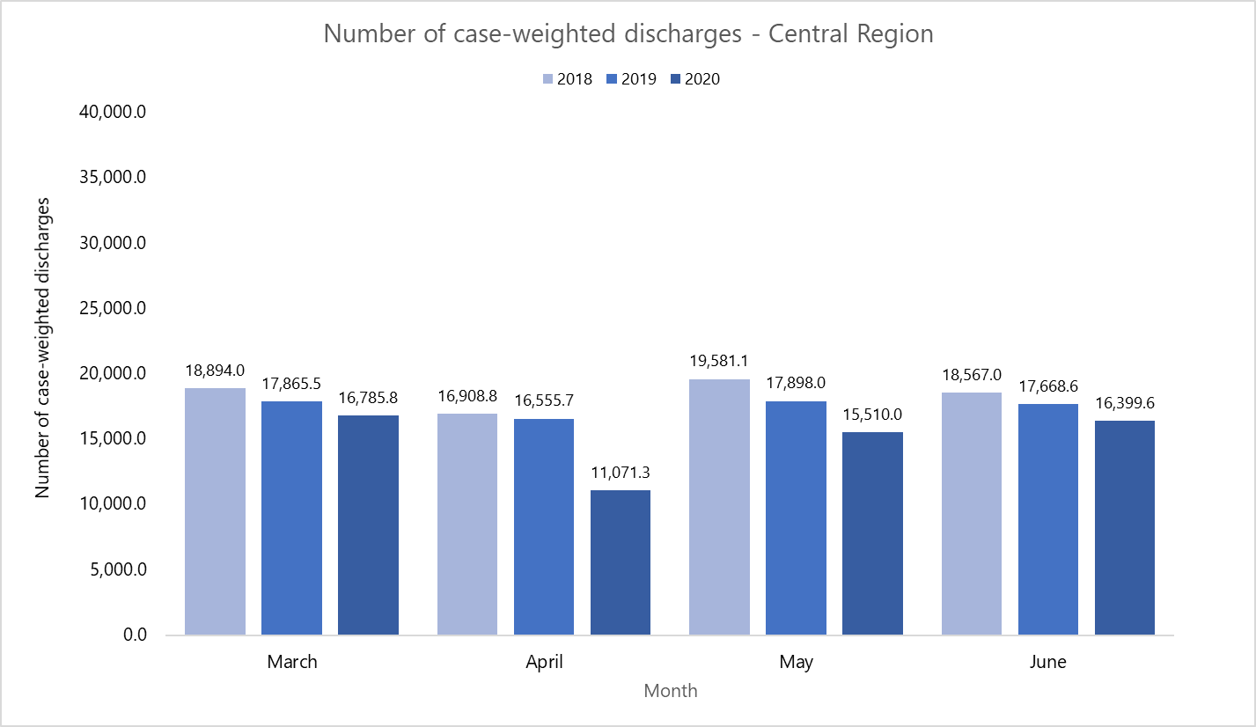

Appendix 6:
Number of planned care interventions delivered by region, March to June 2018–2020

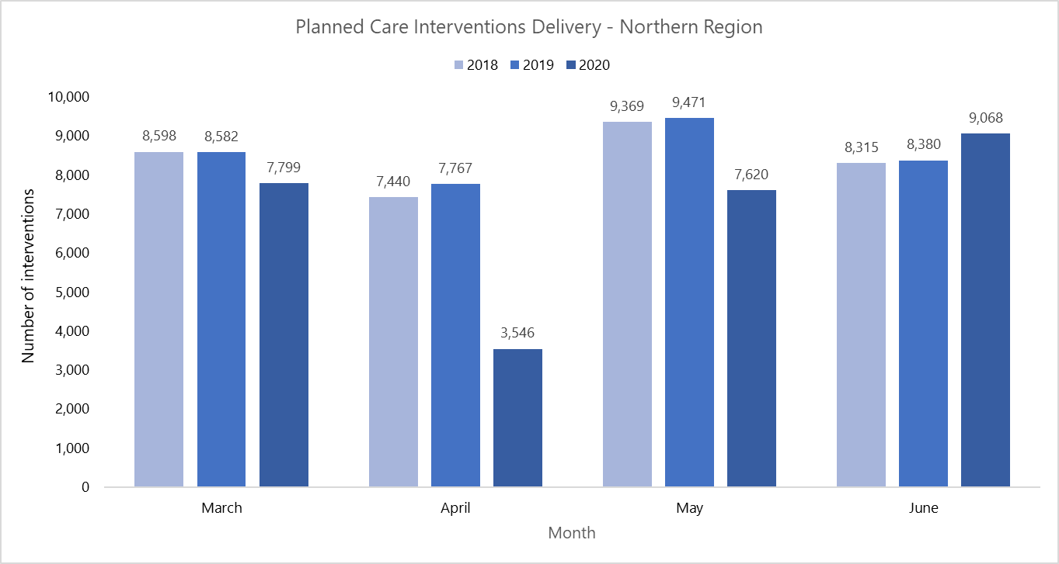
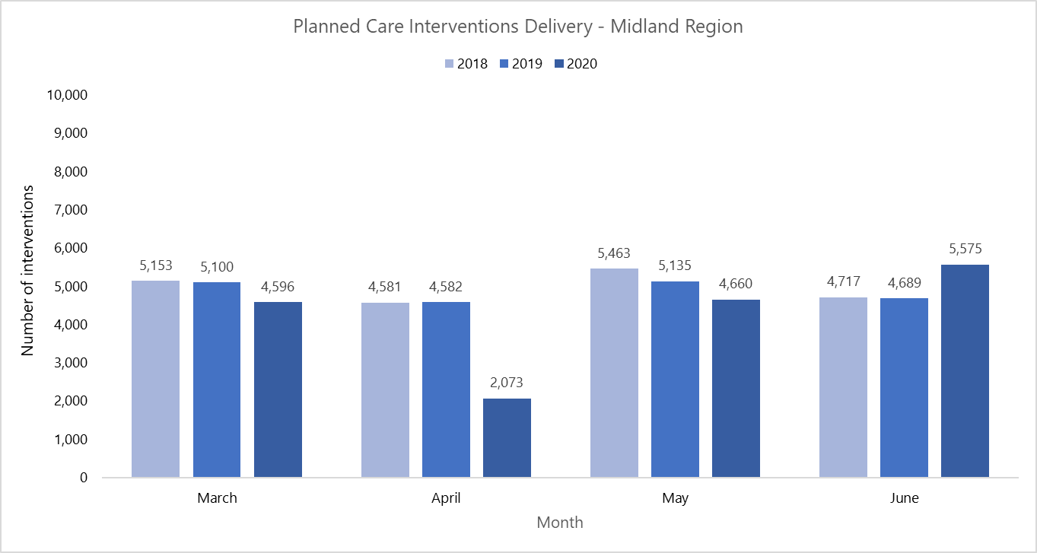

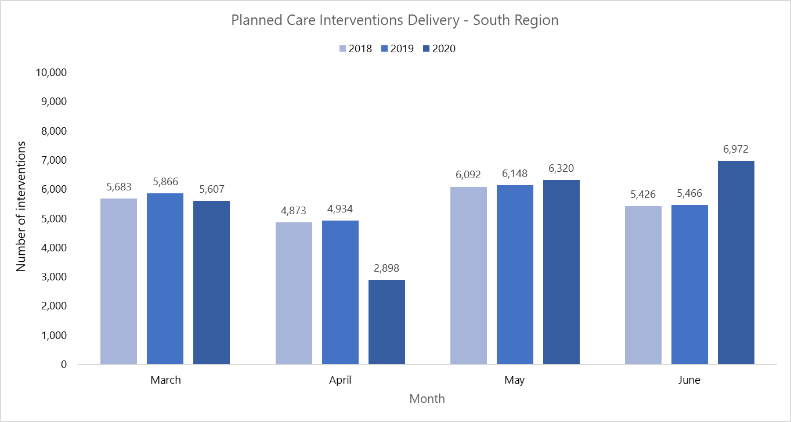
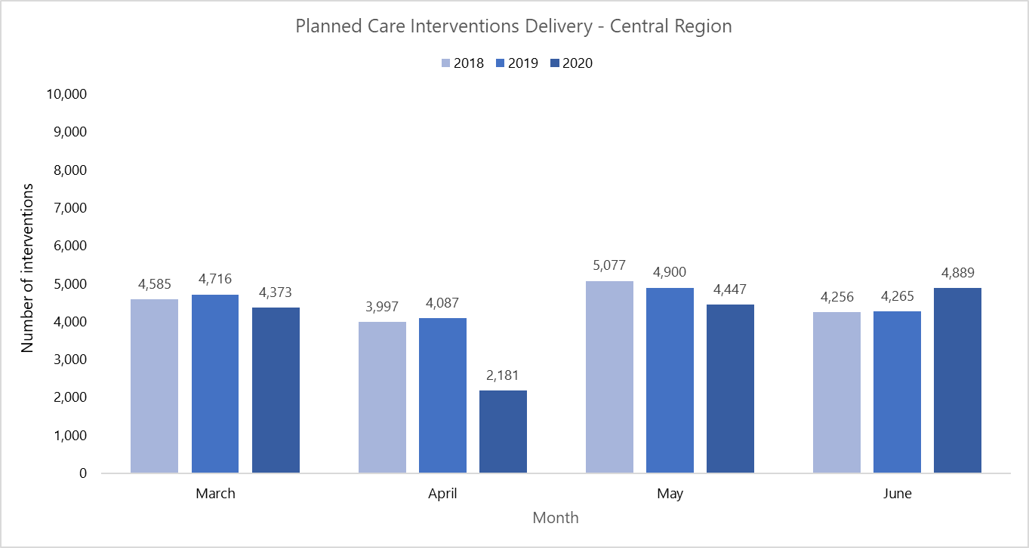

Appendix 7:
Number of planned care intervention case-weighted discharges by region, March to June 2018–2020
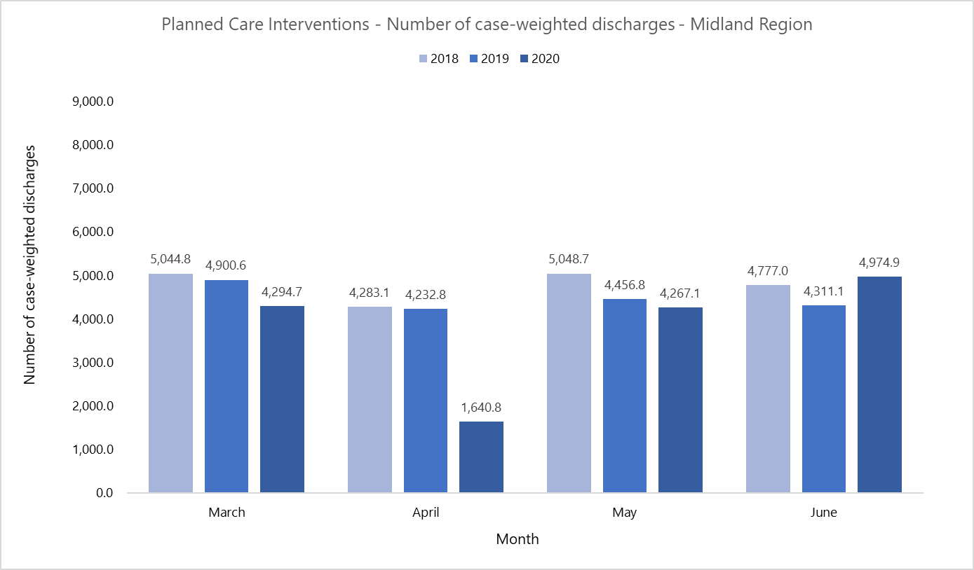
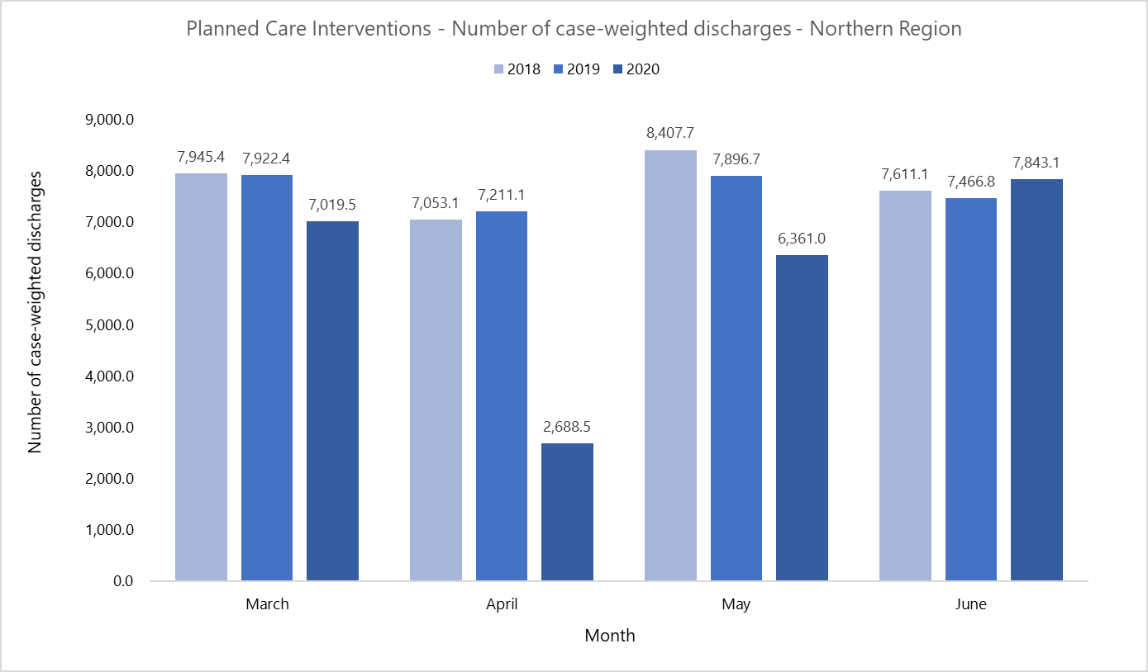

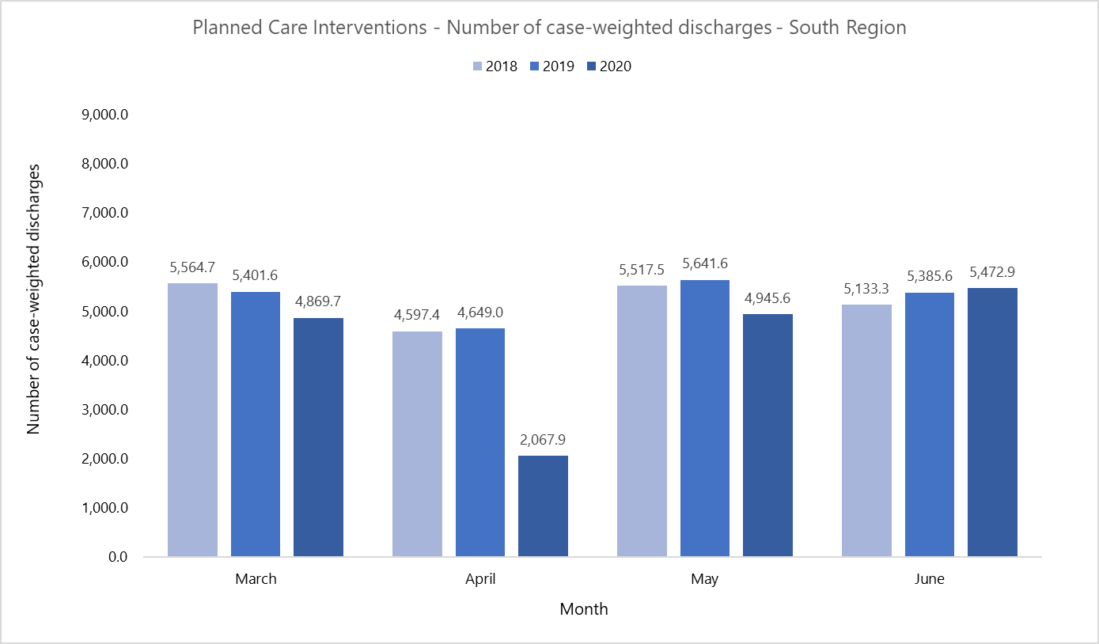
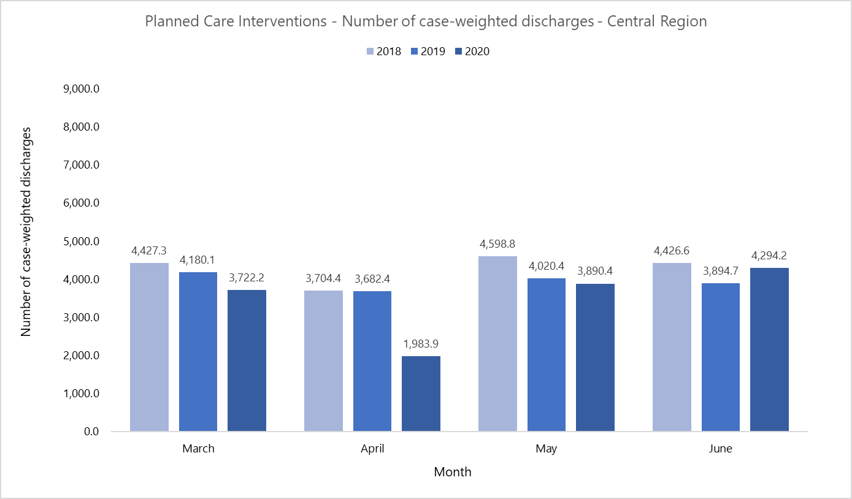

Appendix 8:
Number of first specialist assessments delivered by region, March to June 2018–2020
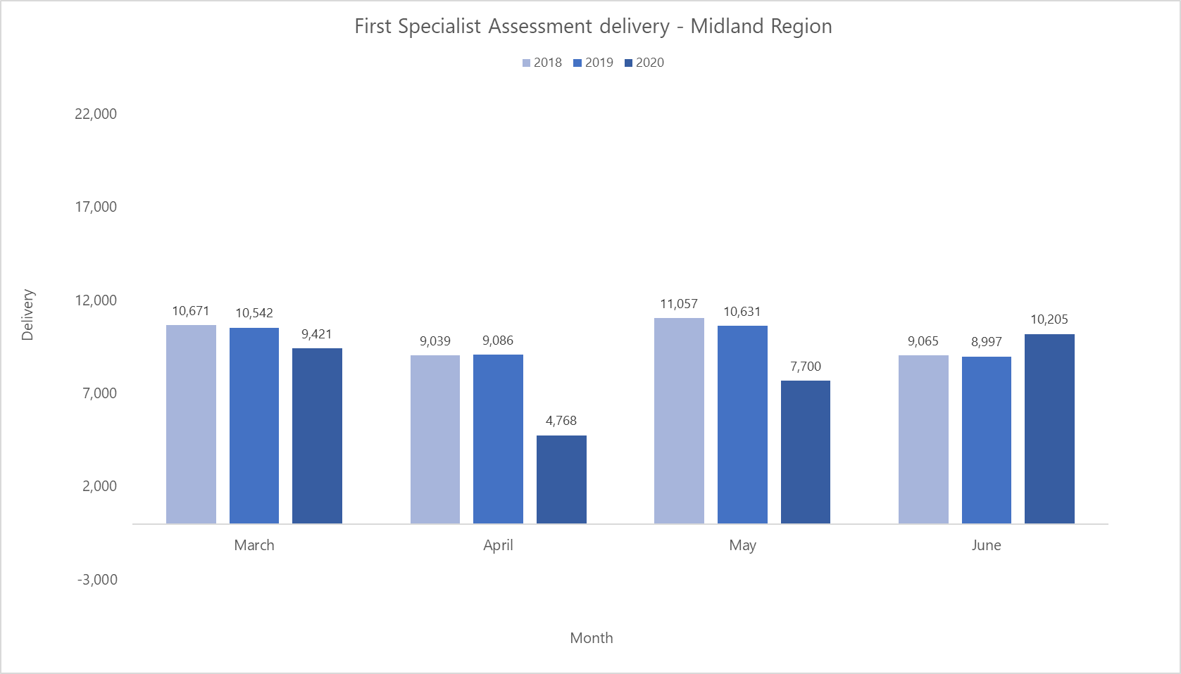
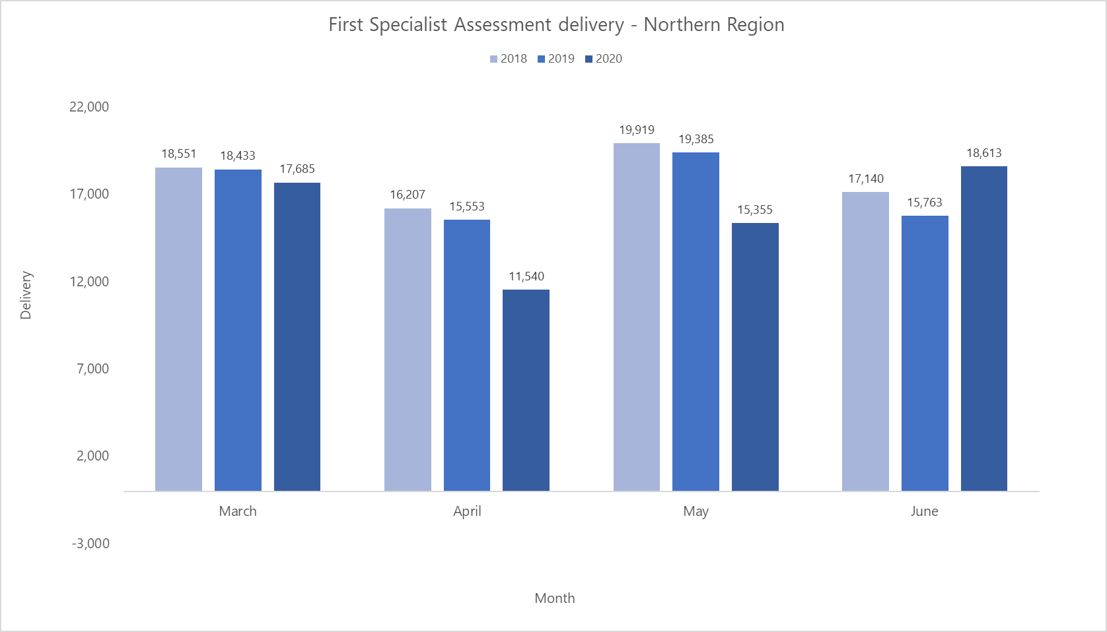
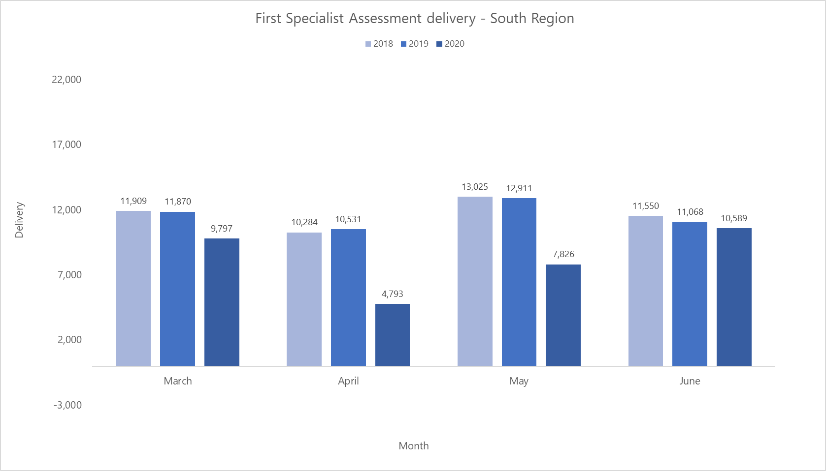
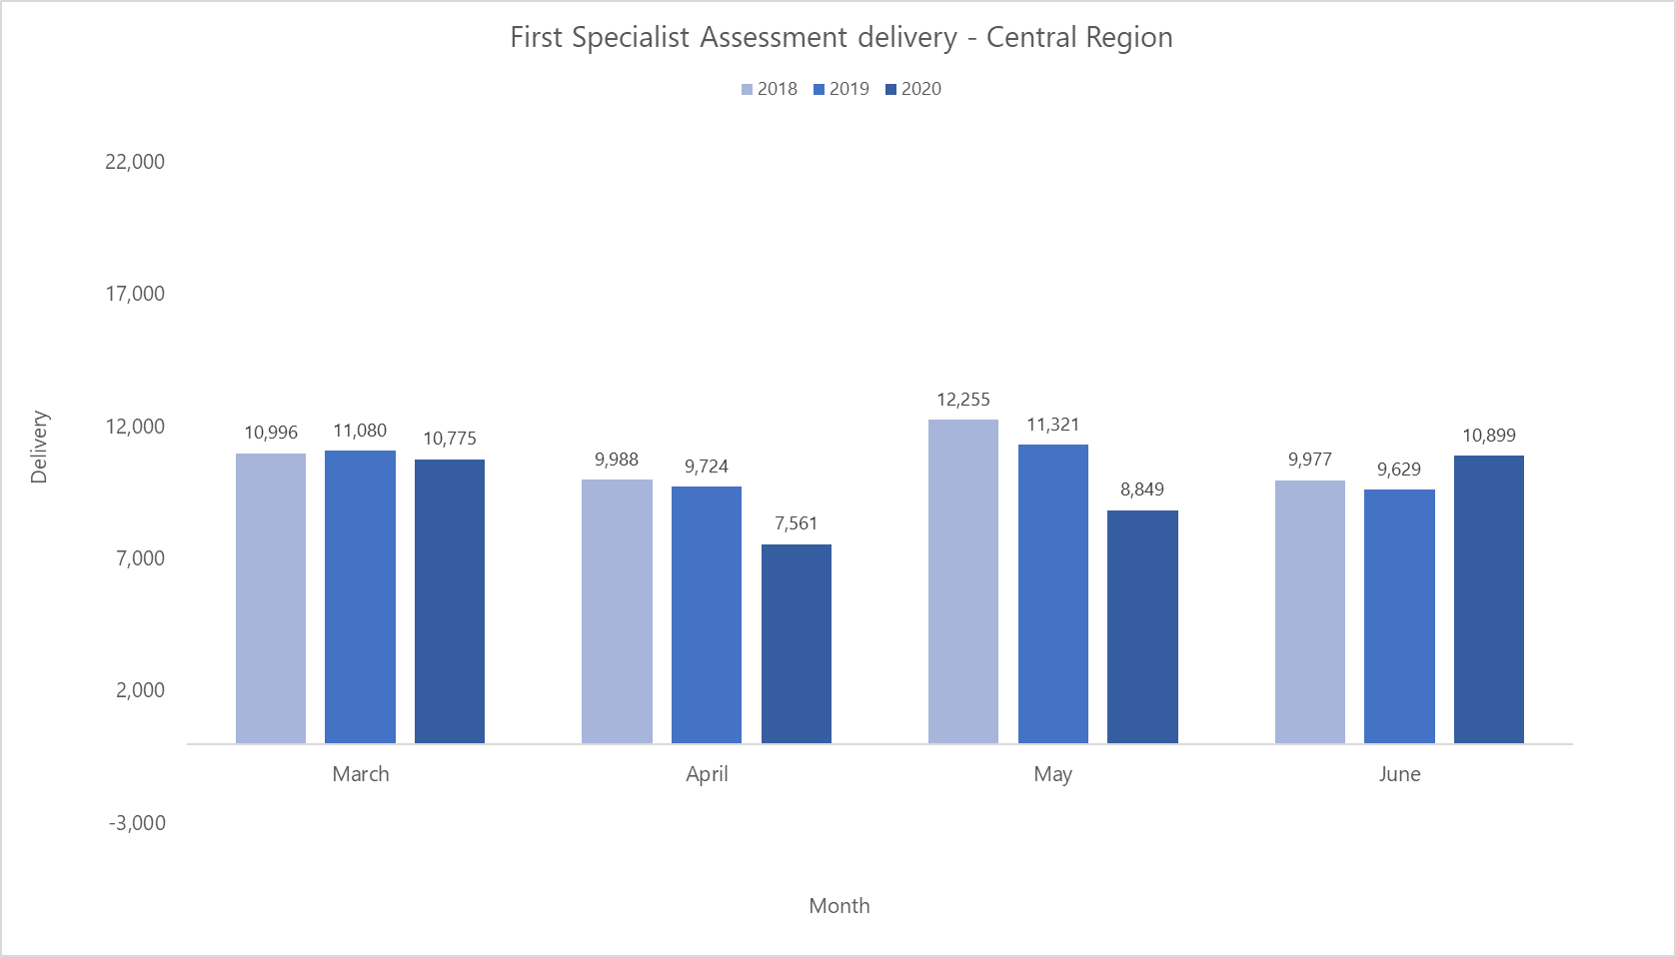

Appendix 9:
Number of follow-up appointments delivered by region, March to June 2018–2020
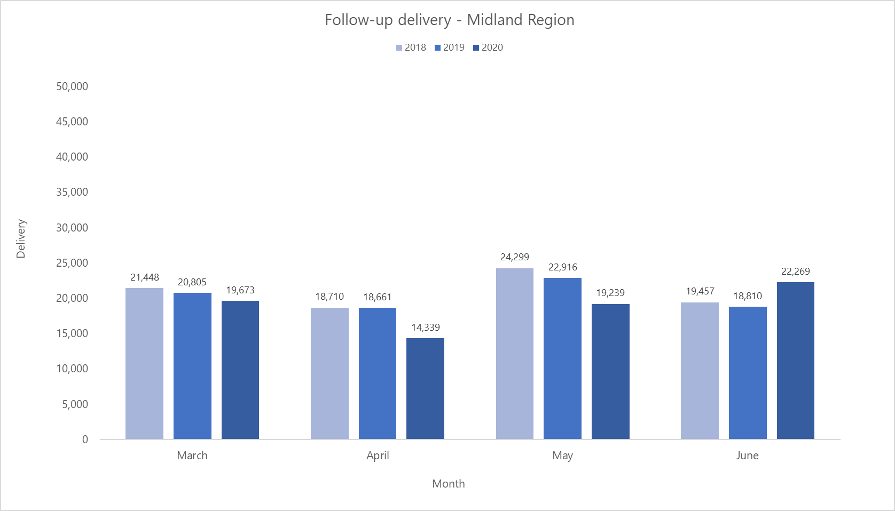
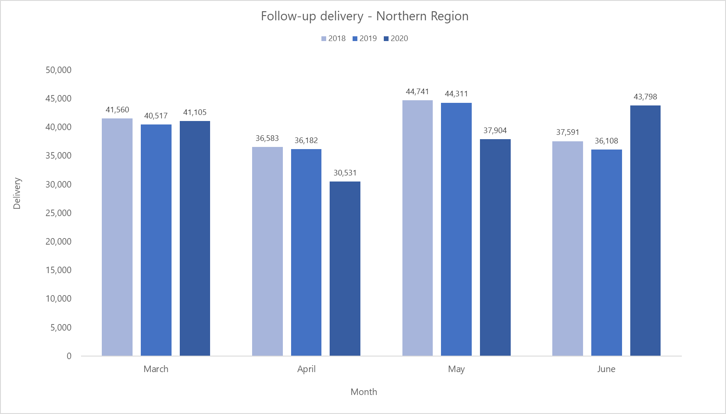
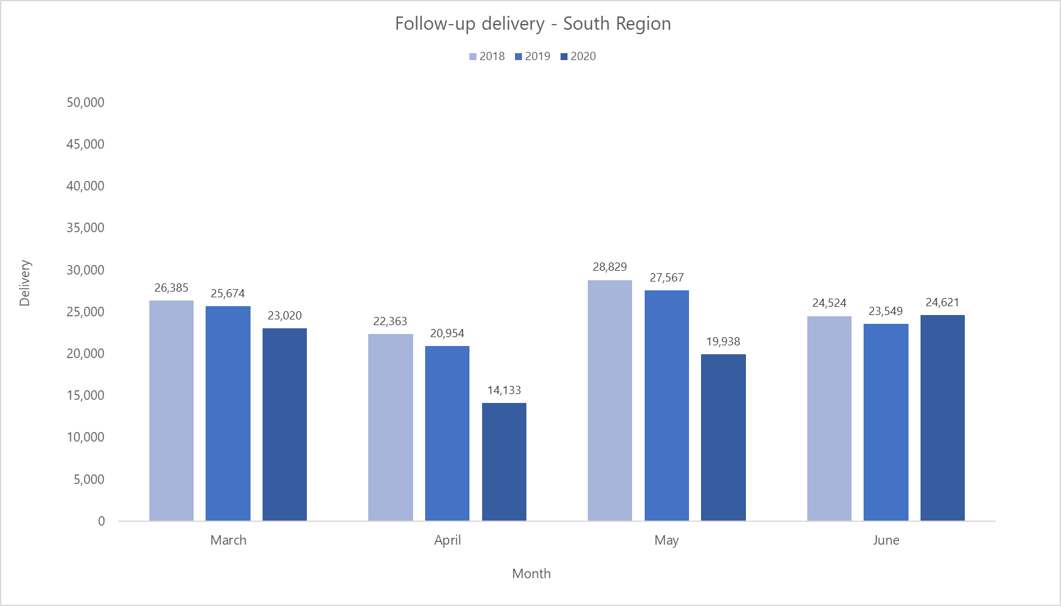
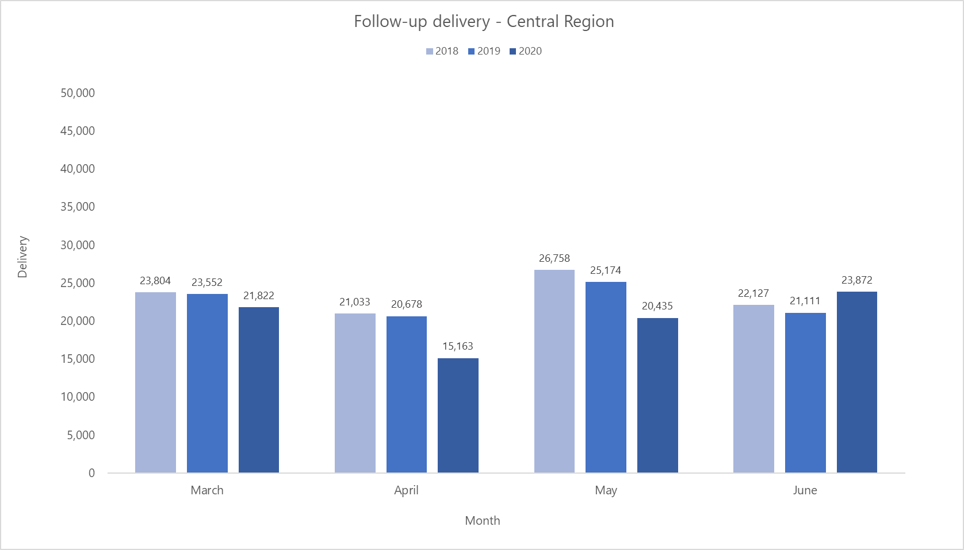

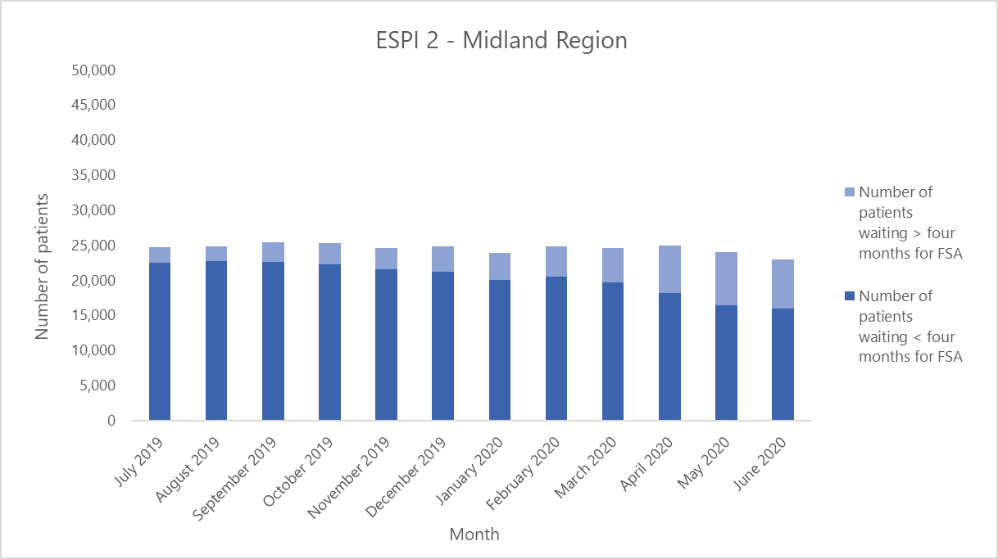
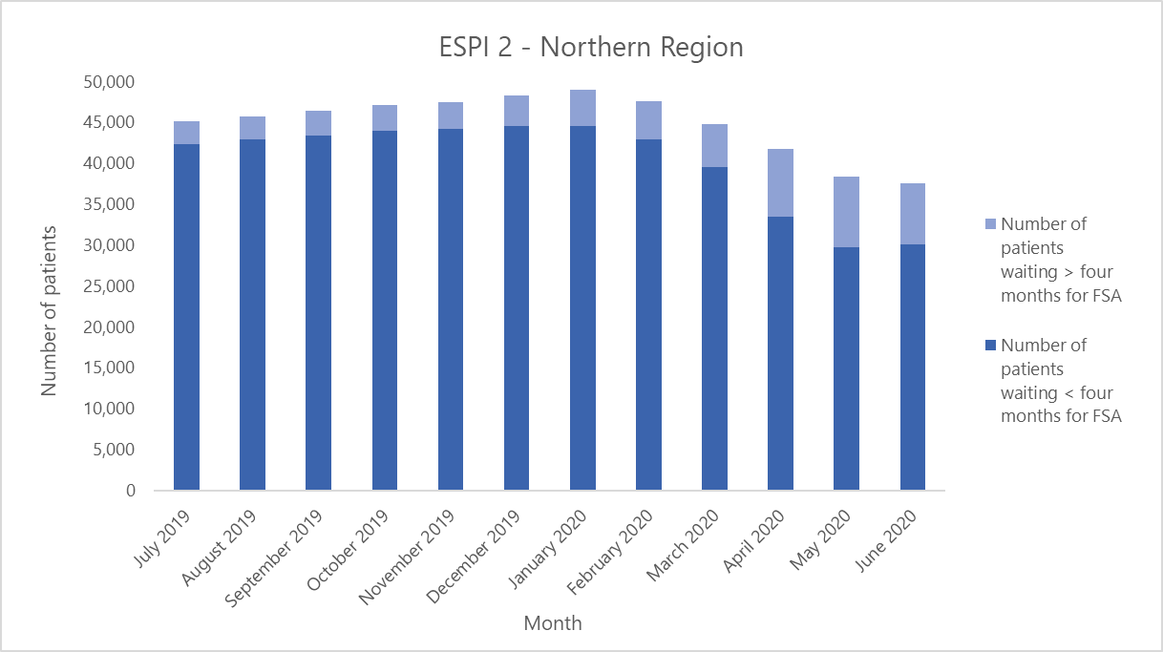
Appendix 10:
Elective Services Patient Flow Indicator 2 (ESPI 2) by region, July 2019–June 2020

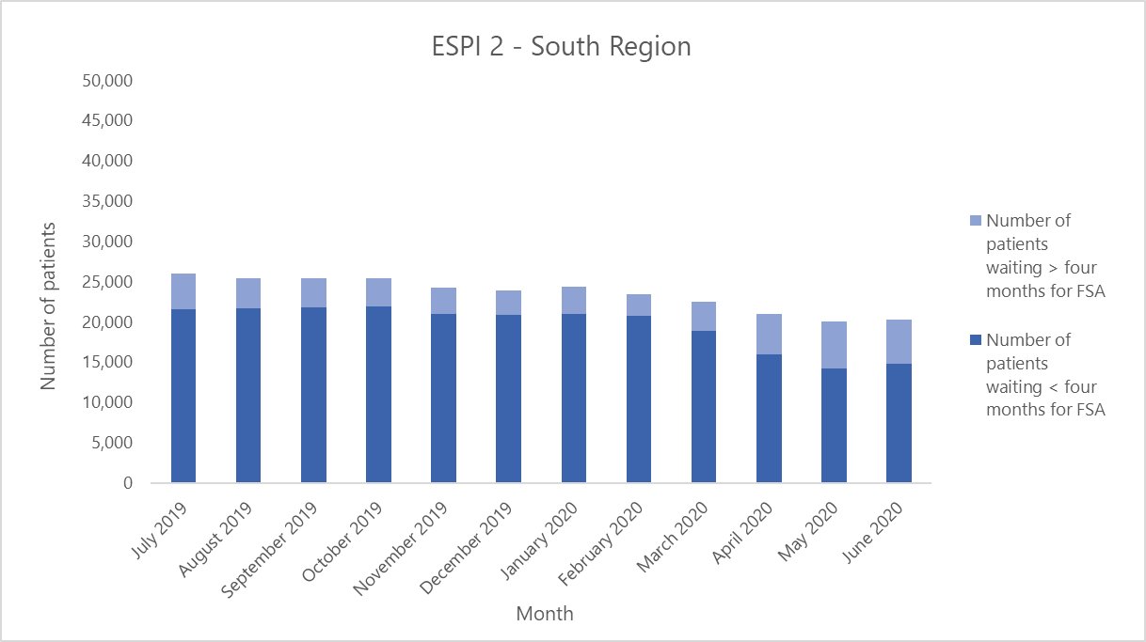
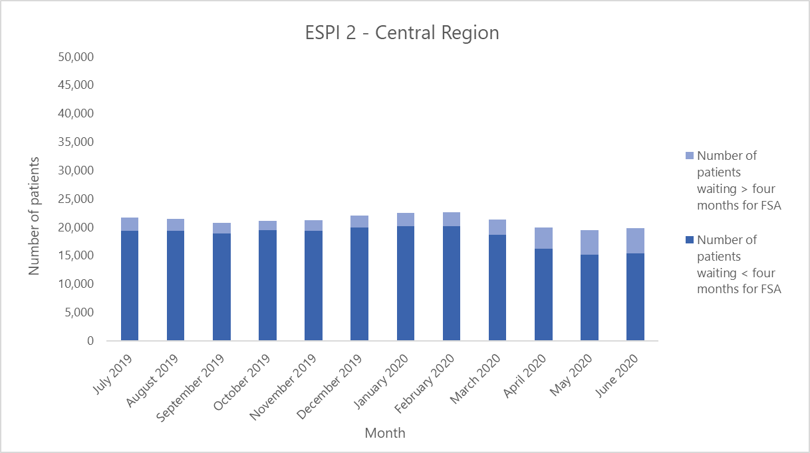
Appendix 11:
Elective Services Patient Flow Indicator 5 (ESPI 5) by region, July 2019–June 2020
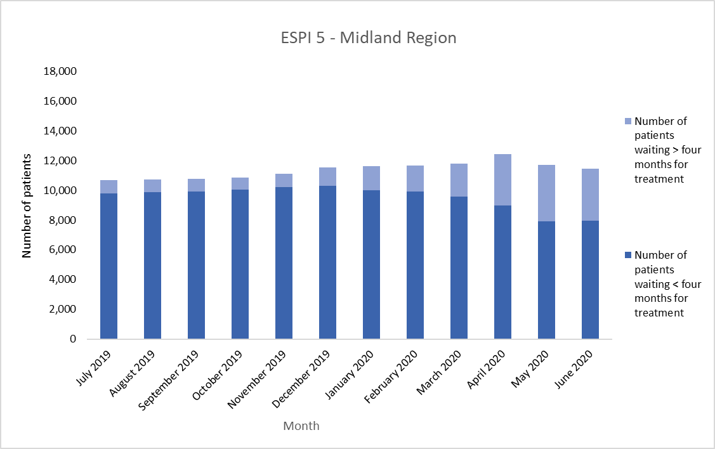
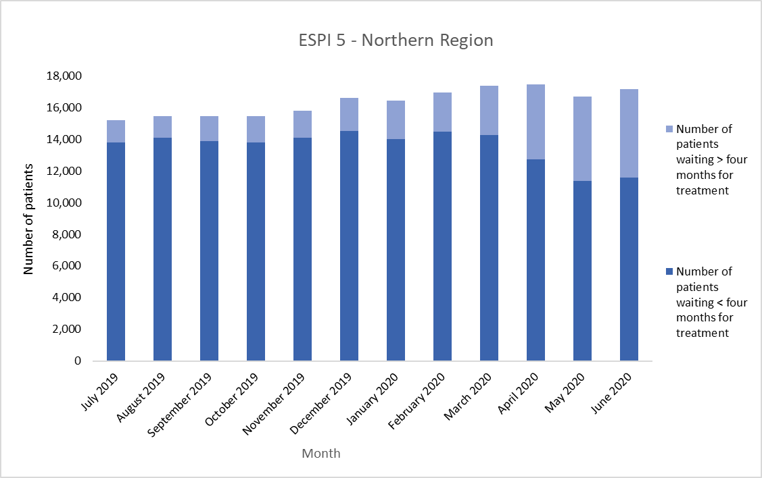
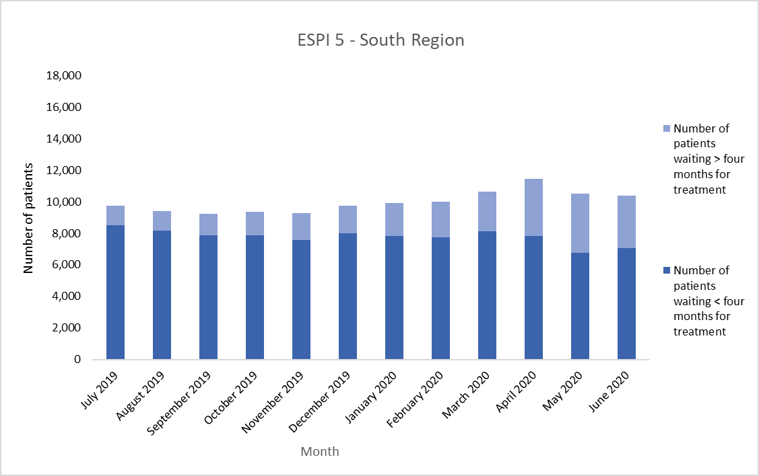
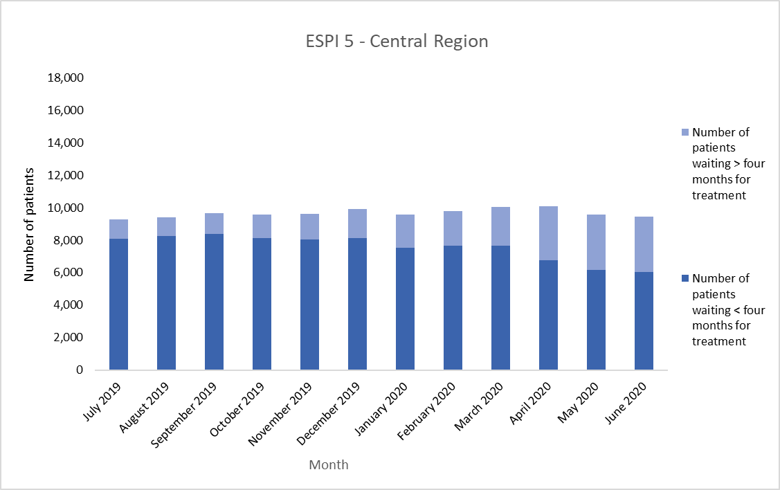

Appendix 12:
Number of emergency department (ED) attendances by region, March to June 2018–2020
