Contraception
Findings from the
2014/15 New Zealand Health Survey
2019

Acknowledgements
The New Zealand Health Survey would not have been possible without the support and enthusiasm of many individuals, including the many thousands of New Zealanders who gave their time to participate in it and the interviewers who worked so diligently to collect the data. Thank you for your generosity.
This data brief was written by Nigel Dickson (University of Otago), Bridget Murphy (Ministry of Health), Jennie Connor (University of Otago), Antoinette Righarts (University of Otago) and Peter Saxton (University of Auckland). The data analysis was undertaken by Barry Gribben (CBG Health Research), Thomas Zhang (CBG Health Research) and James Stanley (University of Otago).
Citation: Ministry of Health. 2019. Contraception: Findings from the 2014/15 New Zealand Heath Survey. Wellington: Ministry of Health.
Published in November 2019 by the Ministry of Health
PO Box 5013, Wellington 6140, New Zealand
ISBN 978-1-98-859743-0 (online)
HP 7267
This document is available at health.govt.nz
This work is licensed under the Creative Commons Attribution 4.0 International licence. In essence, you are free to: share ie, copy and redistribute the material in any medium or format; adapt ie, remix, transform and build upon the material. You must give appropriate credit, provide a link to the licence and indicate if changes were made.

Contents
Key findings v
Introduction 1
Contraception methods 2
Contraception need met by modern method 5
Common contraceptive methods 7
Sterilisation 10
Long-acting reversible contraception 12
Sources of contraception 14
Interpretation notes 18
Overview of survey methodology 20
References 23

List of Tables
Table 1: Participation in the Sexual and Reproductive Health module of the New Zealand Health Survey, by ethnicity 21

List of Figures
Figure 1: Contraception methods (among people aged 16–49 years who had had vaginal sex in the four weeks preceding the survey), by age group and gender 2
Figure 2: Contraception methods (among people aged 16–49 years who had had vaginal sex in the four weeks preceding the survey), by ethnic group and gender 3
Figure 3: Contraception methods (among people aged 16–49 years who had had vaginal sex in the four weeks preceding the survey), by neighbourhood deprivation and gender 4
Figure 4: Need for contraception satisfied using modern methods (among women not trying to get pregnant aged 16–49 years who had had vaginal sex in the four weeks preceding the survey), by age group 6
Figure 5: Contraception methods used (among women aged 16–49 years who had had vaginal sex in the four weeks preceding the survey) 8
Figure 6: Most effective group of contraception methods (among women aged 16–49 years who had had vaginal sex in the four weeks preceding the survey), by age group 9
Figure 7: Use of vasectomy or female sterilisation (among women aged 16–49 who had had vaginal sex in the four weeks preceding the survey), by age group 10
Figure 8: Use of LARC (among people aged 16–49 who had had vaginal sex in the four weeks preceding the survey), by age group 12
Figure 9: Sources of contraception (among women aged 16–49 years who had vaginal sex in the four weeks preceding the survey and were using a modern method of contraception), by age group 15
Figure 10: Sources of contraception (among women aged 16–49 years who had vaginal sex in the four weeks preceding the survey and were using a modern method of contraception), by ethnic group 16
Figure 11: Sources of contraception (among women aged 16–49 who had vaginal sex in the four weeks preceding the survey and were using a modern method of contraception), by neighbourhood deprivation 17

Key findings
This report describes types of contraception used by women or their male partner, among those who had had vaginal sex in the four weeks preceding the survey (referred to as ‘sexually active’ in this report). Consideration of the types of contraception people use is important, as some types are considerably more reliable than others.

Key findings include the following.
- 83 percent of men and 80 percent of women (aged 16–49 years) who were sexually active used at least one form of contraception.
- 78 percent of sexually active men and 74 percent of sexually active women used a modern method of contraception.
- Sexually active Māori and Pacific adults were less likely to use any contraceptive methods than non-Māori and non-Pacific adults.
- Sexually active adults living in the most socioeconomically deprived neighbourhoods were less likely to use any contraceptive methods than those in the least deprived neighbourhoods.
- 82 percent of sexually active women who were not trying to get pregnant used modern methods of contraception.
- To account for the use of multiple methods of contraception, use of different contraception methods were analysed after prioritisation based on order of effectiveness. After prioritisation, the most common contraceptive methods used by sexually active women were the pill (23 percent), the male condom (18 percent) and their partner’s vasectomy (10 percent).
- Type of contraceptive used varied by neighbourhood deprivation. After adjustment for age and ethnicity, women in the most deprived neighbourhoods were 6.1 times as likely to rely on injections than those in the least deprived neighbourhoods, and 0.7 times as likely to rely on their partner’s vasectomy.
- 15 percent of women aged 16–24 used some form of long-acting reversible contraception (LARC), a group comprising implants, intrauterine devices (IUDs) and intrauterine systems (IUSs). The equivalent rate for women aged 35–44 was 12 percent.
- A medical centre/general practice was the commonest source of contraception for women at all ages (41 percent).

Introduction
Contraception helps heterosexually active individuals and couples realise their right to decide if, when, and how many children they will have (United Nations 2015). Worldwide, the increasing use of contraception has resulted in improvements to educational, economic and health-related outcomes, such as reduced maternal and infant mortality, for girls and women (Ahmed et al 2012; Canning and Schultz 2012; Joshi and Schultz 2013; Bhutta et al 2014).

The most recent comprehensive national survey of contraceptive use was the New Zealand Women: Family, Employment and Education Survey (Pool et al 1999), undertaken in 1995. Since then, a number of new contraceptive methods have become available, and social changes might have resulted in changes to the desired family size and timing of children. There has been no previous national study of how well the need for contraception has been met, or where contraception is obtained in New Zealand.

The Ministry of Health included contraception questions in the Sexual and Reproductive Health module of the 2014/15 New Zealand Health Survey (the survey). This report presents key findings about contraceptive use by gender, age group, ethnicity and neighbourhood deprivation at the time of the survey interview.

Methods of contraception were analysed after prioritisation based on the United Nations order of decreasing effectiveness: implant, male sterilisation, IUS, female sterilisation, IUD, injections, the pill, male condom, rhythm/temperature/calendar, diaphragm, female condom, lactational amenorrhea, withdrawal, foam, emergency contraception and breastfeeding. The ‘effectiveness’ of a method is based on usual use, which was the data collected in the survey, and is not the same as the ‘efficacy’ of a method, which relates to perfect use.

The report also covers the extent that people’s need for contraception has been met, and sources of contraception for women.

You can find more information and results from the survey, including data tables by relationship status in the data explorer, online at minhealthnz.shinyapps.io/nz-health-survey-2014-15-srh-data-explorer/

Contraception methods
The survey asked women and men aged 16–49 years who had had vaginal sex in the last 12 months: ‘What contraception method is your usual method these days?’ Analyses were further restricted to people that were sexually active (defined as those who had vaginal sex with an opposite-gender partner in the last four weeks).

Modern methods of contraception include implants (including Jadelle), vasectomy, IUD, IUS (including Mirena), tubal ligation, hysterectomy, injections (including Depo-Provera), the pill, male condoms, diaphragms, female condoms, spermicides, the morning-after pill and the emergency IUD.

Other methods of contraception asked about in the survey were natural family planning (timing intercourse to avoid the fertile period) and withdrawal.

Nearly 82 percent of sexually active 16–49-year-old adults used contraception
- 78 percent of sexually active men and 74 percent of sexually active women used a modern method of contraception.
- The percentages of women and men using any, and a modern method of contraception was slightly higher for men and decreased with age for women and men (Figure 1).

Figure 1: Contraception methods (among people aged 16–49 years who had had vaginal sex in the four weeks preceding the survey), by age group and gender
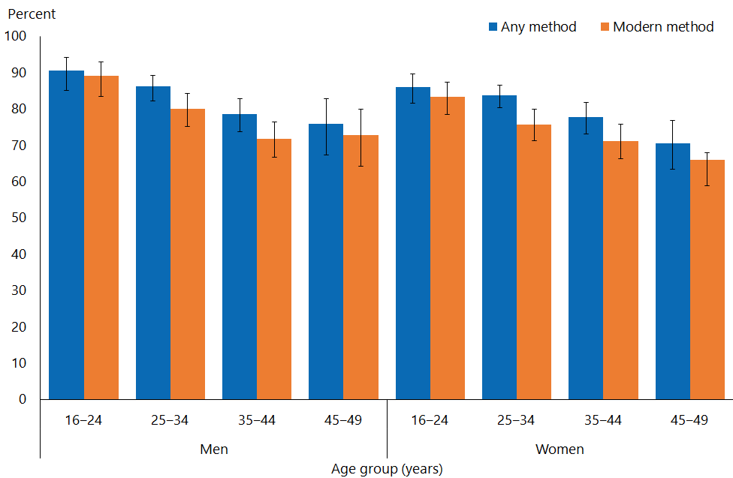

Pacific people were less likely to use modern methods of contraception
- Use of modern contraception among sexually active women varied by ethnicity: 52 percent of Pacific women, 70 percent of Māori women, 71 percent of Asian women and 78 percent of European/Other women used modern contraception (Figure 2).
- After adjustment for age, both Māori women and Māori men were 0.9 times as likely to use any, and a modern method of contraception as non-Māori women and non-Māori men. Pacific women and men were 0.8 times as likely as non-Pacific women and men to use any, and a modern method of contraception. Pacific women were 0.7 times as likely to use a modern method of contraception as non-Pacific women.

Figure 2: Contraception methods (among people aged 16–49 years who had had vaginal sex in the four weeks preceding the survey), by ethnic group and gender
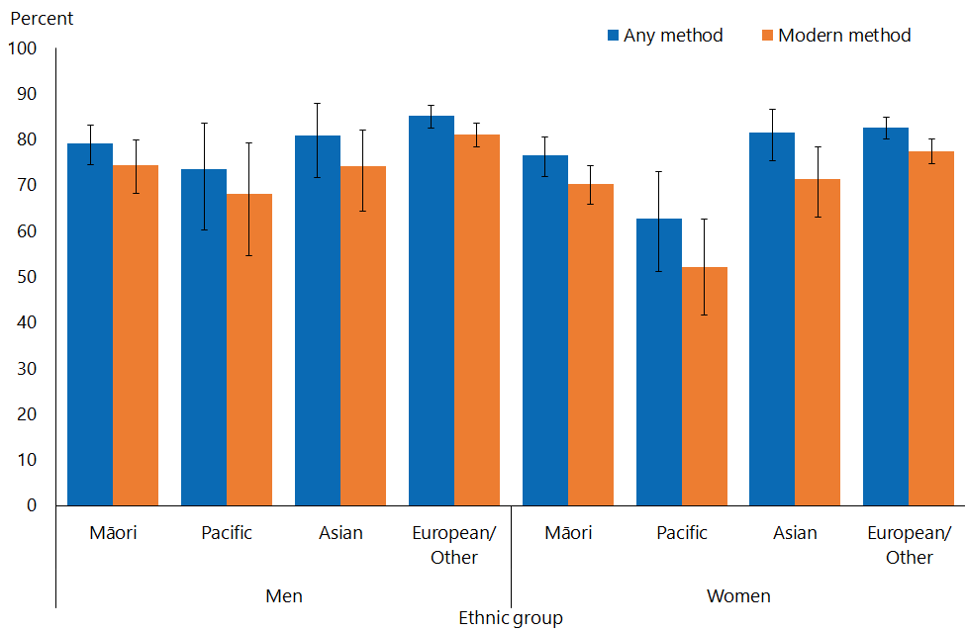
Note: Adults who reported more than one ethnic group are counted once in each group reported. This means that the total number of responses for all ethnic groups can be greater than the total number of adults who stated their ethnicities.

Contraceptive use was less prevalent among sexually active adults living in the most deprived neighbourhoods
- For both women and men, there was slight, and not totally consistent, variation in both any and modern contraceptive use according to neighbourhood deprivation (Figure 3).
- 71 percent of people living in the most deprived neighbourhoods used modern methods, compared with 79 percent in the least deprived areas.
- After adjustment for age and ethnicity, women and men living in the most deprived neighbourhoods were 0.9 times as likely to use any contraceptive methods as those living in the least deprived neighbourhoods. After adjustment for age and ethnicity, men living in the most deprived neighbourhoods were 0.8 times as likely to use a modern method as those living in the least deprived neighbourhoods.

Figure 3: Contraception methods (among people aged 16–49 years who had had vaginal sex in the four weeks preceding the survey), by neighbourhood deprivation and gender
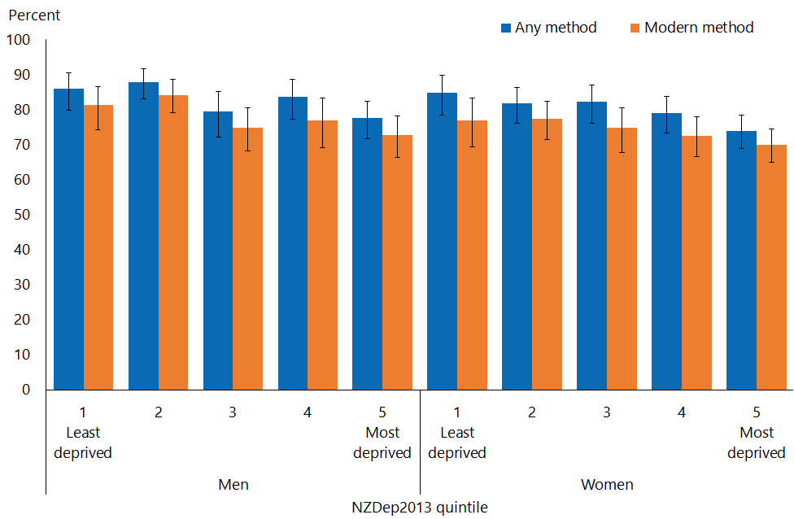

Contraception need met by modern method
This section presents information on modern contraceptive use among those women considered most in need of contraception; that is, those who had had vaginal sex within the last four weeks and were not trying to but who could get pregnant (ie, had not reached the menopause and were not pregnant).

Women not trying to get pregnant responded 2, 3 or 4 to the question:
‘Which of these statements best describes the way you feel about having a child or more children?
      - I would definitely like a child or more children, and I’m currently trying
      - I would definitely like a child or more children, but I’m not currently trying
      - I might like a child or more children in the future, I’m not sure yet
      - I would definitely not like a child or more children’

- Most women who do did not want to get pregnant used a modern method of contraception. Overall, 82 percent of women aged 16–49 years who did not want to get pregnant used a modern method of contraception.
- This figure was higher among the younger women: it was 88 percent and 87 percent for those aged 16–24 and 25–34 years respectively, reducing to 77 percent and 72 percent for those aged 35–44 and 45–49 years respectively (Figure 4).

Figure 4: Need for contraception satisfied using modern methods (among women not trying to get pregnant aged 16–49 years who had had vaginal sex in the four weeks preceding the survey), by age group
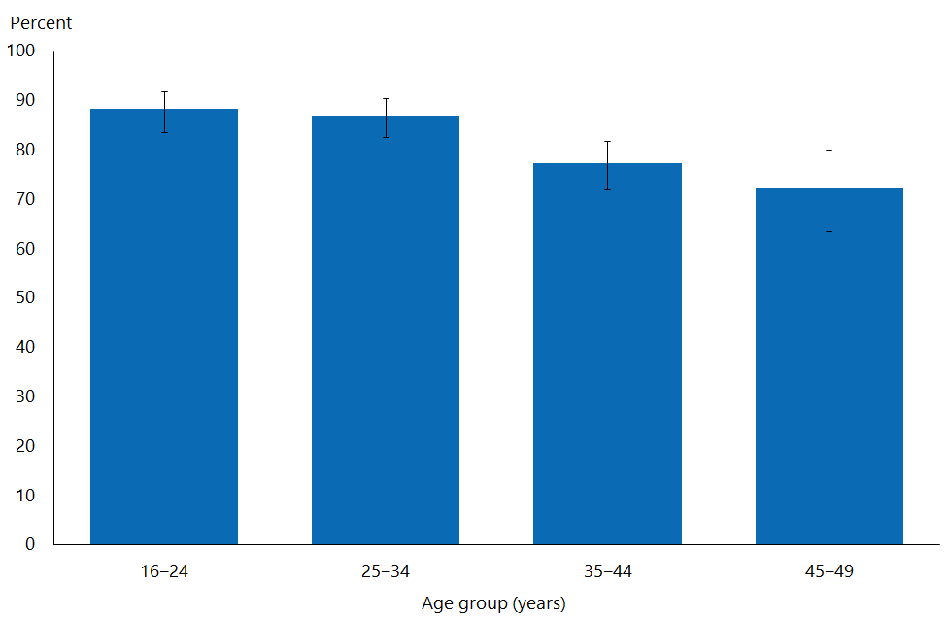

Māori and Pacific women who did not want to get pregnant were less likely to have had their contraceptive needs met by a modern method than non-Māori and non-Pacific women
- Among Māori women, 77 percent had their need for contraception met by a modern method. The equivalent figure for Pacific women was 57 percent. 85 percent of women of European/Other ethnicity and 79 percent of Asian women used modern contraceptive methods.
- After adjustment for age, Māori women were 0.9 times as likely to have their contraception needs met with a modern method as non-Māori women, and Pacific women 0.7 times as likely as non-Pacific women.
- After adjustment for age and ethnicity, there was no difference in contraception needs being met with a modern method between those living in the most and least deprived neighbourhoods.

Common contraceptive methods
The use of different contraception methods was analysed according to whether a method was used at all and after prioritisation based on the United Nations order of effectiveness. For example, if a woman used both the pill and condoms, she is counted under both ‘the pill’ and ‘condoms’ in the ‘current use’ analysis. She is counted as just using ‘the pill’ in the ‘most effective method’ analysis.

Figure 5 compares methods in current use and most effective methods used by women aged 16–49 who had had sex in the four weeks preceding the survey.

The most common contraception methods used by women were the pill, the male condom and their partners’ vasectomy
- The three contraceptive methods most commonly used by women aged 16–49 years were the male condom (26 percent), the pill (24 percent) and their partner’s vasectomy (10 percent) (Figure 5).
- When considering only the most effective methods women used, the most common methods were the pill (23 percent), the male condom (18 percent) and partners’ vasectomy (10 percent).

Figure 5: Contraception methods used (among women aged 16–49 years who had had vaginal sex in the four weeks preceding the survey)
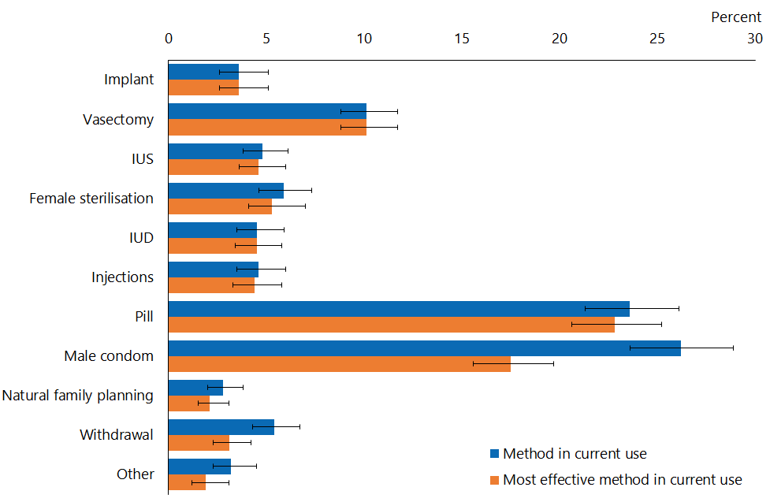
Note: Women may have reported using more than one type of contraception, so the total of ‘method in current use’ adds to more than 100 percent. The ‘Other’ category includes diaphragms, female condoms, the morning-after pill, the emergency IUD, spermicides and other methods.

To simplify analyses of contraceptive use by age, contraceptive methods have been grouped into six groups. These six groups are: (1) LARCs – IUD, IUS (most commonly Mirena) and implant (most commonly Jadelle); (2) Depot medroxyprogesterone acetate injection (commonly Depo-Provera); (3) the pill; (4) the male condom; (5) sterilisation (vasectomy, tubal ligation, hysterectomy); and (6) all other modern methods (including diaphragm, the female condom and the emergency contraceptive pill) and traditional methods (withdrawal and rhythm). Where more than one method was used, only the most effective is reported.

Contraceptive methods used by women vary markedly by age
- Young women are more likely to use the pill and LARCs, whereas older women are more likely to use sterilisation (Figure 6).

Figure 6: Most effective group of contraception methods (among women aged 16–49 years who had had vaginal sex in the four weeks preceding the survey), by age group
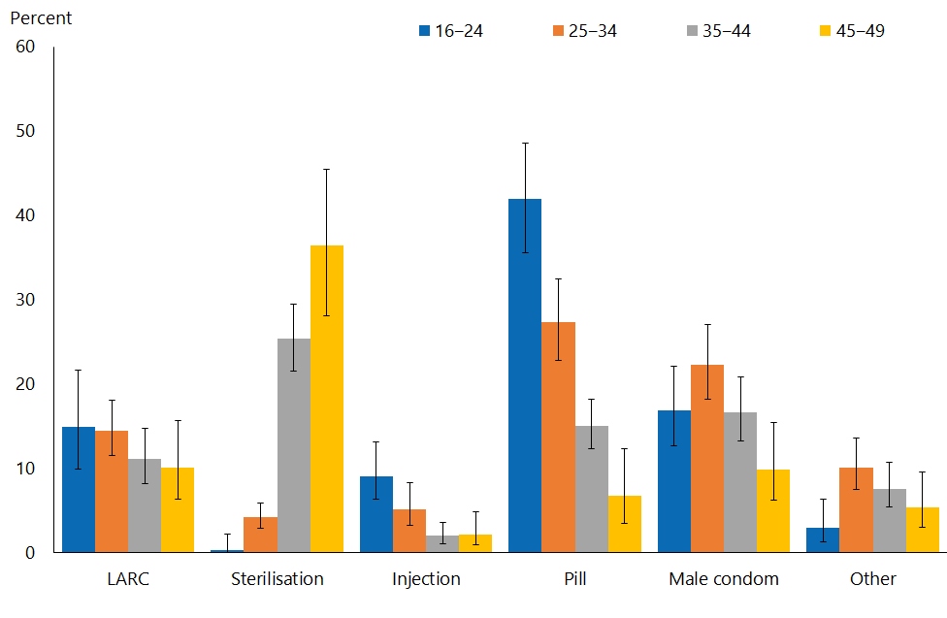

Sterilisation
‘Sterilisation’ refers to tubal ligation (‘having one’s tubes tied’), hysterectomy or a partner’s vasectomy.

Sterilisation – particularly their partner’s vasectomy – was the commonest form of contraception for women aged 45–49 years
- Women’s partners’ vasectomy was a more common form of sterilisation than their own sterilisation (Figure 7).
- One in five (22 percent) women aged 45–49 years relied on their partner’s vasectomy.
- Both their partner’s vasectomy and their own sterilisation were uncommon methods used in women under 35 years but increased markedly with age.

Figure 7: Use of vasectomy or female sterilisation (among women aged 16–49 who had had vaginal sex in the four weeks preceding the survey), by age group
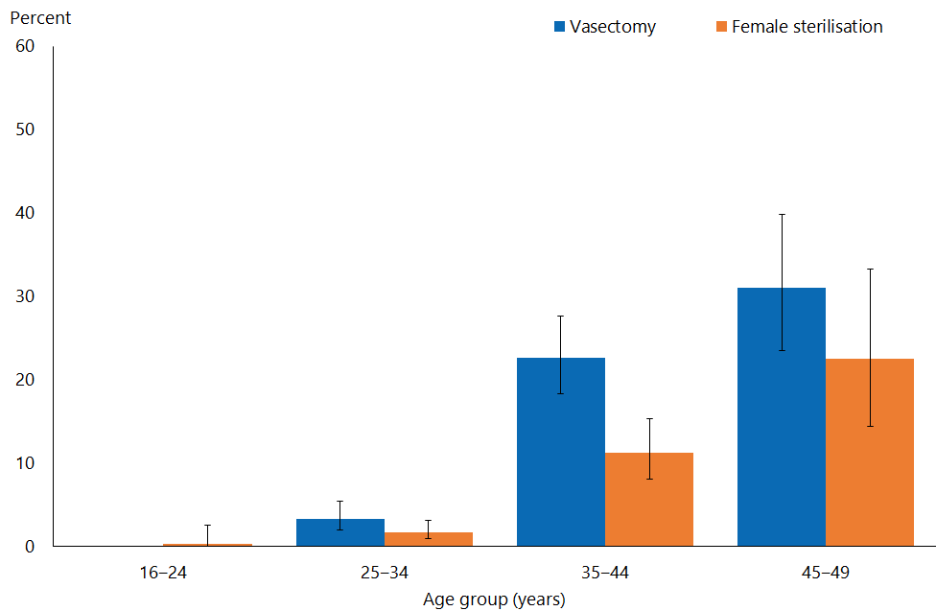
Note: Adults who reported more than one contraception method are counted once in each group reported.

Relying on their partner’s vasectomy was much less common among Pacific and Asian women
- 13 percent of women of European/Other ethnicity used their partner’s vasectomy as their most effective method of contraception. For Māori women this figure was 6 percent, for Pacific women it was 1.3 percent and for Asian women it was 0.5 percent.
- After adjustment for age, there was no difference between the rates of Māori women and non-Māori women who used their partner’s vasectomy as their most effective contraception. However, Pacific women were 0.1 times as likely to do so as non-Pacific women, and Asian women 0.05 times as likely to do so as non-Asian women.
- There was a clear trend for a decreasing proportion of women to use their partner’s vasectomy as the most effective contraception among those living in areas of lower neighbourhood deprivation.
- After adjustment for age and ethnicity, women living in the most deprived neighbourhoods were 0.6 times as likely to use their partner’s vasectomy as their most effective contraception as those living in the least deprived neighbourhoods.

Female sterilisation does not vary by ethnicity.
- Female sterilisation as the most effective form of contraception was used by a similar proportion of Māori (5.2 percent) women and those of European/Other ethnicity (5.6 percent).

Long-acting reversible contraception
‘Long-acting reversible contraception’ means an IUD, an IUS (eg, Mirena), or an implant (eg, Jadelle).

Types of long-acting reversible contraception women used varied markedly by age
- The use of any form of LARC was most common among women aged 16–24 and 25–34 years (Figure 7).
- The commonest type of LARC among women aged 16–24 years was an implant (Figure 8).
- Both IUDs and IUSs (which release a progesterone hormone), were used by a similar proportion of women between the ages of 25 and 49 years, and fewer women under 25 years (Figure 8).

Figure 8: Use of LARC (among people aged 16–49 who had had vaginal sex in the four weeks preceding the survey), by age group
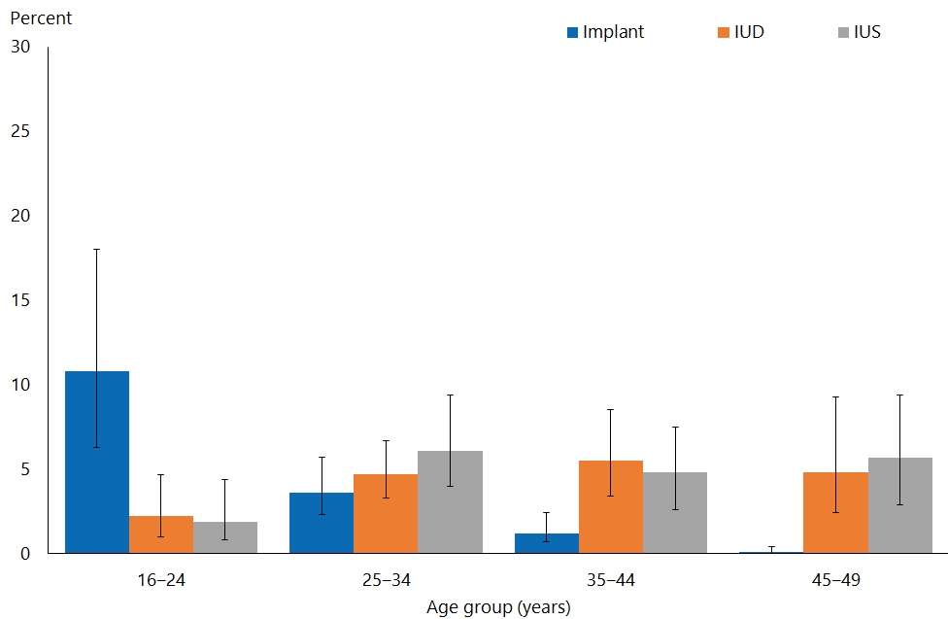
Note: Adults who reported more than one contraception method are counted once in each group reported.

Māori and Pacific women more likely to use implants as their most effective form of contraception
- Implants as the most effective form of contraception were used by more Māori (10 percent) and Pacific (4.4 percent) women than women of Asian (1.2 percent) and European/Other (3.1 percent) ethnicity.
- After adjustment for age, Māori women were 2.9 times as likely to use implants as non-Māori women; Pacific women were 1.2 times as likely to use them as non-Pacific women; and Asian women were one-third as likely to use them as non-Asian women.
- There was a general trend for women living in the more deprived neighbourhoods to be more likely to use implants. However, numbers of women doing so living in the less deprived neighbourhoods were too small to make reliable estimates.

Use of intrauterine devices and intrauterine systems as the most effective form of contraception did not vary by ethnicity or neighbourhood deprivation
- IUDs and IUSs as the most effective form of contraception were used by a similar proportion of Māori women (5 percent and 6 percent) and women of European/Other ethnicity (both 5 percent).
- There was no trend in IUD or IUS use by neighbourhood deprivation, or difference after adjustment for age and ethnicity.

Sources of contraception
The survey asked all respondents that had had vaginal sex with an opposite-gender partner in the last 12 months: ‘In the last 12 months have you got contraception from any of these sources? You may choose more than one answer.
      - Medical centre or GP
      - Family Planning Clinic
      - Sexual health clinic
      - Ante-natal clinic / midwife
      - Student or youth health clinic
      - Pharmacy / chemist
      - Internet website
      - Over the counter at a supermarket / petrol station / other shop
      - Vending machine
      - Hospital emergency (ED) department
      - Somewhere else
      - I have not got contraception in the last 12 months

The analyses in this section have been restricted to women aged 16–49 who had vaginal sex in the four weeks preceding the survey and were using a modern method of contraception. Some adults reported having used no source of contraceptive supplies in the past year, although their partner may have done so. Some adults may have not got contraception from any of the sources in the past year because they use sterilisation or LARCs.

A medical centre/general practice was the commonest source of contraception for women at all ages
- Around half of all women under 35 years (53.3 percent aged 16–24 years and 50.3 percent aged 25–34 years), around one-third (37 percent) of women aged
35–44 years, and 18 percent of women aged 45–49 years used a medical centre or general practice to get contraception (Figure 9).
- More women aged 16–24 years used a family planning clinic than older women.

Figure 9: Sources of contraception (among women aged 16–49 years who had vaginal sex in the four weeks preceding the survey and were using a modern method of contraception), by age group
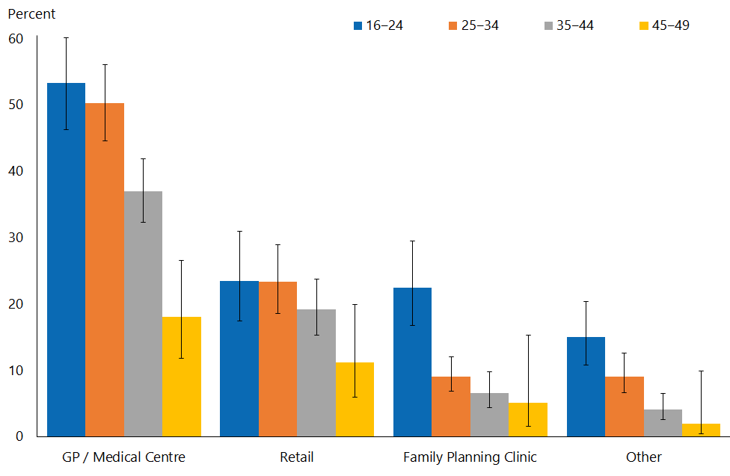
Note: More than one source could be provided, so the total for each age group could total more than 100 percent.

Asian women were less likely to access contraception from a medical centre/general practice, and more likely to access it from a retail outlet
- Figure 10 shows sources of contraception by ethnicity. The main difference is that Asian women were least likely to access contraception from a medical centre or family planning clinic, and more likely to do so from a retail outlet.

Figure 10: Sources of contraception (among women aged 16–49 years who had vaginal sex in the four weeks preceding the survey and were using a modern method of contraception), by ethnic group
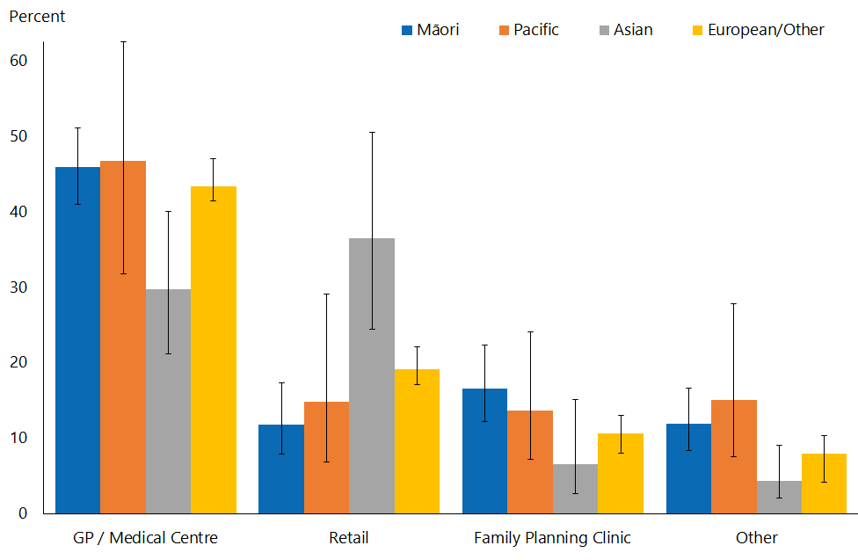
Note: Adults who reported more than one ethnic group are counted once in each group reported. This means that the total number of responses for all ethnic groups can be greater than the total number of adults who stated their ethnicities.

- After adjustment for age, Asian women were 0.6 times as likely as non-Asian women to access contraception from a medical centre/general practice, and twice as likely as non-Asian women to do so from a retail outlet. Māori women were half as likely to access contraception from a retail outlet as non-Māori women.

People in more deprived neighbourhoods were more likely to use a medical centre to access contraception
- Figure 11 shows sources of contraception by neighbourhood deprivation. There was an overall trend for more women to attend a medical centre/general practice for contraception with increasing deprivation. However, after adjustment for age and ethnicity, there was no differences in source in use of medical centres for contraception between those living in the least and the most deprived neighbourhoods.

Figure 11: Sources of contraception (among women aged 16–49 who had vaginal sex in the four weeks preceding the survey and were using a modern method of contraception), by neighbourhood deprivation
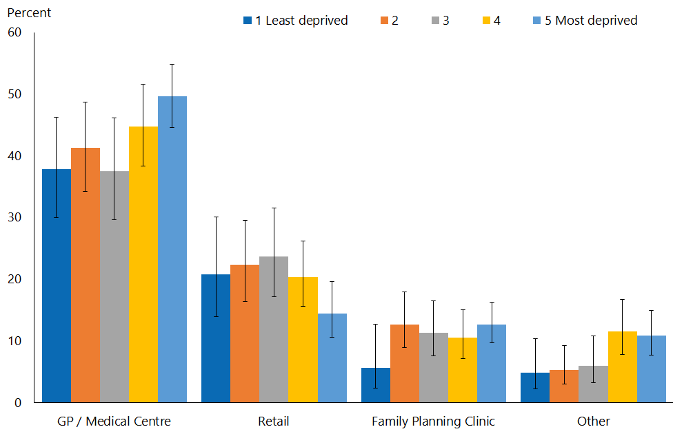

Interpretation notes
This section provides some key points for interpreting the survey results presented in this report. For more details about the survey methodology, see the Methodology Report 2014/15: New Zealand Health Survey (Ministry of Health 2015b) and Sexual and Reproductive Health Indicator Interpretation Guide 2014/15: New Zealand Health Survey (Ministry of Health 2019).

Statistical significance
Unless otherwise specified, the results discussed in this report only refer to differences that are statistically significant at the 5 percent level (ie, those with a p-value of less than 0.05). ‘Statistically significant’ means that the difference between the sample groups is likely to reflect real differences in the population groups, rather than being caused by chance. A statistically significant difference does not necessarily mean the difference between the population groups is meaningful.

Confidence intervals
We use 95% confidence intervals to show the statistical precision of the estimates. Wider confidence intervals indicate less precise estimates than narrow intervals, caused by higher variation with a sample and/or smaller numbers in a sample. Confidence intervals generally agree with statistical significance. When confidence intervals for two estimates don't overlap, there is a statistically significant difference between the estimates. However, the opposite may not always be true.

Comparing population subgroups
This report uses adjusted ratios to test if the prevalence of indicators is statistically significantly different between groups. We have adjusted these ratios for demographic factors that may be influencing the comparison, such as age, gender and ethnicity. The adjusted ratio indicates whether the results are less or more likely in the group of interest than the comparison group. A ratio of less than 1 indicates that the result is less likely and a ratio greater than 1 indicates that it is more likely.

The survey uses the New Zealand Index of Deprivation 2013 (NZDep2013) to measure neighbourhood deprivation. The survey groups neighbourhoods into five quintiles (the label ‘quintile 1’ applies to neighbourhoods with the lowest levels of deprivation, and ‘quintile 5’ to those with the highest). Indicators are reported for each quintile. The adjusted ratios for deprivation compare the highest and lowest deprivation areas, after adjusting for age, ethnic group, gender and the pattern across all five quintiles.

Gender
Gender is self-defined by respondents in the survey. For some people, their gender is not the same as their biological sex at birth. Respondents were asked if they were male or female, and while what these options meant was open to the respondent’s interpretation, gender-diverse options (eg, ‘gender non-conforming’ or ‘other’) were not available. The Ministry of Health acknowledges the need to improve data collection in this area, and is considering implementing the statistical standard for gender identity in future surveys (Statistics New Zealand 2015).

Non-sampling error
The survey results may underestimate or overestimate some indicators because the data is self-reported. The accuracy of a person’s memory may vary depending on many factors, including social norms, the importance of the event being recalled, the individual’s age at the time and the period of time that has passed since the event occurred.

Overview of survey methodology
This section gives a brief overview of the survey methodology for the New Zealand Health Survey.

How were people selected for the survey?
The 2014/15 results refer to the sample selected for the period July 2014–June 2015. The survey has a multi-stage sampling design that involves randomly selecting a sample of small geographic areas, households within the selected areas and individuals within the selected households. One adult aged 15 years or older and one child aged 14 years or younger (if there were any) were chosen at random from each selected household. Adults aged 16–74 years who had completed the 2014/15 survey were invited to participate in the Sexual and Reproductive Health module. Further details are available in The New Zealand Health Survey: Sample design, years 1–3 (2011–2013) (Ministry of Health 2011).

How was data collected?
Professional surveyors from CBG Health Research Ltd collected data in respondents’ homes. For the core part of the survey, data was collected through a face-to-face interview. However, participants completed the Sexual and Reproductive Health module by themselves, directly entering responses into a program run on a tablet computer. Surveyors provided minimal assistance, and reiterated that they would not be able to see the answers. Respondents could answer ‘Don’t know’ or ‘Choose not to answer’ to any question. If they chose either of those options for the question about having ever had sex with someone of a different sex, then they were not asked to complete the rest of the survey module.

How many people took part?
11,993 adults aged 16–74 years completed the core 2014/15 survey and were eligible for the Sexual and Reproductive Health module. This report is based on the responses from 10,198 adults (or 87 percent of eligible respondents). Some eligible respondents were not included in the final data set for the following reasons.
- 668 respondents (5.6 percent of those who were eligible) did not start the module, either because they refused or because of English language and/or cognitive difficulties.
- 991 respondents (6.5 percent of eligible respondents) started the module but stopped before the end of the module.
- 123 respondents (1.2 percent of eligible respondents) completed the module but their records were discarded because at least half of their responses were ‘Don’t know’ or ‘Choose not to answer’.

Of the people who completed the Sexual and Reproductive Health module, 4,358 gave their gender as male and 5,840 as female. The table below summarises the 10,198 survey respondents by ethnic group.

Table 1: Participation in the Sexual and Reproductive Health module of the New Zealand Health Survey, by ethnicity
Ethnic group | Number
Māori | 2,460
Pacific | 619
Asian | 814
European/Other | 7,542
Note: Adults who reported more than one ethnic group are counted once in each group reported. This means that the total number of responses for all ethnic groups can be greater than the total number of adults who stated their ethnicities.

Survey weights
The Sexual and Reproductive Health data set was weighted so that the responding sample represented the New Zealand ‘usually resident’ population in that year, using external population benchmarks (age, sex, ethnicity and neighbourhood deprivation) and demographic and behavioural benchmarks (eg, educational level and hazardous drinking). After an initial selection weight was calculated, it was adjusted for those who did not complete the module (for any reason). This should have minimised the impact of any differences in the characteristics of people who did or did not participate in the Sexual and Reproductive Health module. For more detail about the survey methodology, refer to the Methodology Report 2014/15 (Ministry of Health 2015b).

Additional information
See also the following documents:
- The New Zealand Health Survey: Sample design years 1–3 (2011–2013) (Ministry of Health 2011). Note, despite the report title being 2011-13, this sample design was used for the 2014/15 Health Survey
- Methodology Report 2014/15: New Zealand Health Survey (Ministry of Health 2015b)
- Content Guide 2014/15: New Zealand Health Survey (Ministry of Health 2015a)
- Questionnaires for the New Zealand Health Survey 2014/15 (Ministry of Health 2016a; Ministry of Heath 2016b)
- Sexual and Reproductive Health Indicator Interpretation Guide 2014/15: New Zealand Health Survey (Ministry of Health 2019).

References
Ahmed S, Li Q, Liu, L, et al. 2012. Maternal deaths averted by contraceptive use: an analysis of 172 countries. The Lancet 380(9837): 111–25.
Bhutta ZA, Das JK, Bahl R, et al. 2014. Can available interventions end preventable deaths in mothers, newborn babies, and stillbirths, and at what cost? The Lancet 384(9940): 347–70.
Canning D, Schultz TP. 2012. The economic consequences of reproductive health and family planning. The Lancet 380(9837): 165–71.
Joshi S, Schultz TP. 2013. Family planning and women’s and children’s health: Long-term consequences of an outreach program in Matlab, Bangladesh. Demography 50(1): 149–80.
Ministry of Health. 2011. The New Zealand Health Survey: Sample design, years 1–3 (2011–2013). Wellington: Ministry of Health.
Ministry of Health. 2015a. Content Guide 2014/15: New Zealand Health Survey. Wellington: Ministry of Health.
Ministry of Health. 2015b. Methodology Report 2014/15: New Zealand Health Survey. Wellington: Ministry of Health.
Ministry of Health. 2016a. Adult Sexual Reproductive Health Module (Year 4). Wellington: Ministry of Health.
Ministry of Health. 2016b. New Zealand Health Survey Adult Questionnaire (Year 4). Wellington: Ministry of Health.
Ministry of Health. 2019. Sexual and Reproductive Health Indicator Interpretation Guide 2014/15: New Zealand Health Survey. Wellington: Ministry of Health.
Pool I, Dickson J, Dharmalingam A, et al. 1999. New Zealand’s Contraceptive Revolutions. Hamilton: Population Studies Centre, University of Waikato. URL: https://www.msd.govt.nz/about-msd-and-our-work/publications-resources/journals-and-magazines/social-policy-journal/spj13/review-new-zealands-contraceptive-revolution.html (accessed 31 July 2019).
United Nations. 2015. Trends in Contraceptive Use Worldwide. New York: United Nations Department of Economic and Social Affairs, Population Division (ST/ESA/SER.A/349).

‘Modern’ methods of contraception include implants (including Jadelle), vasectomy, IUS (including Mirena), tubal ligation, hysterectomy, IUD, injections (including Depo-Provera), the pill, male condoms, diaphragms, female condoms, spermicides, the morning-after pill and the emergency IUD. ‘Traditional’ methods of contraception include natural family planning (safe period, rhythm method) and withdrawal.
The order of decreasing effectiveness (provided by United Nations) are implant, male sterilisation, IUS, female sterilisation, IUD, injections, the pill, male condom, rhythm/temperature/calendar, diaphragm, female condom, lactational amenorrhea, withdrawal, foam, emergency contraception, breastfeeding. This order has been used to prioritise the response options available in the survey.

