Consultation on amendments to the schedules of specified prescription medicines for designated pharmacist prescribers
Analysis of submissions
2021

Acknowledgements
The Ministry of Health engaged with several key stakeholders when developing the consultation, in partnership with the Pharmacy Council of New Zealand.
We would like to particularly acknowledge members of the Clinical Advisory Pharmacists Association network who contributed their time and expertise throughout the process.
Citation: Ministry of Health. 2021. Consultation on amendments to the schedules of specified prescription medicines for designated pharmacist prescribers: Analysis of submissions. Wellington: Ministry of Health.
Published in November 2021 by the Ministry of Health
PO Box 5013, Wellington 6140, New Zealand
ISBN 978-1-99-100768-1 (online)
HP 7905
This document is available at health.govt.nz
This work is licensed under the Creative Commons Attribution 4.0 International licence. In essence, you are free to: share ie, copy and redistribute the material in any medium or format; adapt ie, remix, transform and build upon the material. You must give appropriate credit, provide a link to the licence and indicate if changes were made.

Contents
Introduction 1
1 Description of respondents 4
1.1 Level of support 6
2 Analysis by themes 9
2.1 Removing the need for a schedule 9
2.2 Unapproved medicines 11
2.3 Period of supply for controlled drugs 13
2.4 Prescribing methylphenidate, a controlled drug with prescribing restrictions 13
2.5 Prescribing controlled drugs such as benzodiazepine and drugs for opioid substitution therapy 14
2.6 Sharing prescribing data 15
2.7 Queries about pharmacy prescriber practice 16
3 Analysis by therapeutic class 17
3.1 Musculoskeletal and joint diseases 17
3.2 Respiratory system 17
3.3 Central nervous system 17
3.4 Immunological products and vaccines 18
3.5 Endocrine system and emergency treatment of poisoning 18
3.6 Malignant disease and immunosuppression 19
3.7 Nutrition and blood 19
3.8 Infections 19
3.9 Obstetrics, gynaecology and urinary-tract disorders 19
3.10 Cardiovascular system 20
3.11 Anaesthesia 20
3.12 Controlled drugs 21
3.13 Not yet classified – now all prescription medicines 21
3.14 Summary of level of support 22
4 Future considerations 23
4.1 Review process for updating the schedules 23
4.2 Drugs excluded from the list 25
Appendices 26
Appendix 1: Consultation document 26
Appendix 2: Consultation questions 34
Appendix 3: Organisations consulted 38

List of Tables
Table 1: Type of respondent 4
Table 2: Respondent professional role 6
Table 3: Level of support 7
Table 4: Level of support by type of respondent 8

List of Figures
Figure 1: Type of respondent 4
Figure 2: Respondent professional role 6
Figure 3: Level of support 7
Figure 4: Level of support by type of respondent 8
Figure 5: Summary of the review process for consultation on amendments to the schedules of specified prescription medicines for designated pharmacist prescribers 24

Introduction
The Medicines (Designated Pharmacist Prescribers) Regulations 2013 have not been updated since their inception. In June 2021, the Clinical Advisory Pharmacists Association (CAPA) approached both the Ministry of Health (the Ministry) and the Pharmacy Council (the Council) to request an update of the schedule to the Medicines (Designated Pharmacist Prescribers) Regulations 2013 and Schedule 1B to the Misuse of Drugs Regulations 1977. Together, these schedules set out the entire list of medicines and controlled drugs that a designated pharmacist prescriber may prescribe.

CAPA submitted a preliminary list of medicines and controlled drugs for the updated schedule. Council team members, in collaboration with the Ministry, further refined the list by removing medicines that met any of the following exclusion criteria:
- holding restricted medicine, pharmacy-only medicine or general sale classification
- being subject to prescribing restrictions under section 23 of the Medicines Act 1981 or regulation 22 of the Misuse of Drugs Regulations 1977 (see Section 4.3 for more detail)
- absence of an approved human indication
- an indication for use as a volatile anaesthetic.

On 21 June 2021 a proposed list of 198 prescription-only medicines and three controlled drugs was formally submitted to the Ministry. Proposed additions to the list include a range of medicines in the following categories:
- anaesthesia
- cardiovascular system
- central nervous system
- controlled drugs
- endocrine system and emergency treatment of poisoning
- immunological products and vaccines
- infections
- malignant disease and immunosuppression
- musculoskeletal and joint diseases
- nutrition and blood
- obstetrics, gynaecology and urinary-tract disorders
- respiratory system.

The Ministry (on behalf of the Director-General of Health) must consult individuals or organisations that may be affected by a change to the specified prescription medicines before making a legal change by Gazette notice as specified in section 105E(2) of the Medicines Act 1981.

Designated pharmacist prescribers practise within collaborative health care team environments and within a defined clinical area of practice in which they have a required level of knowledge and competence. These teams are multidisciplinary and use the range of different professional experiences and strengths among their practitioners for the benefit and safety of the patient. This peer environment adds another level of safety to the practice of designated pharmacist prescribers.

Including a medicine or controlled drug in a relevant schedule does not automatically give the designated pharmacist prescriber the right to prescribe that medicine or controlled drug. A designated pharmacist prescriber may only prescribe a medicine if all the following conditions are met:
- they possess the appropriate knowledge and competence (both clinical and cultural)
- the condition and medicine lie within their specified clinical area of practice
- the medicine has a brand that Medsafe has approved
- designated pharmacist prescribers are not excluded from prescribing the medicine under section 23 of the Medicines Act 1981 or regulation 22 of the Misuse of Drugs Regulations 1977
- the medicine is listed on the relevant schedules to the Medicines (Designated Pharmacist Prescribers) Regulations 2013 or Misuse of Drugs Regulations 1977.

These multiple conditions demonstrate that robust safeguards are in place to ensure that designated pharmacist prescribing is appropriate and safe.

The update of schedules for designated prescribers is comparable to the classification of new prescription medicines for authorised prescribers. When new prescription medicines are reclassified, authorised prescribers will only prescribe within their level and areas of competence, following workplace protocols and meeting their ethical, professional and legislative obligations. These same safeguards and obligations apply to designated pharmacist prescribers.

This report is a summary of the submissions received during the four-week consultation period, starting on 12 July 2021 and ending on 12 August 2021. Key stakeholders were identified and the Ministry emailed them with a personal invitation to take part in the consultation. Organisations and groups were encouraged to share the consultation link within their networks to ensure a wide coverage. The consultation was hosted on the Ministry’s Health Consultation Hub webpage.

The Pharmacy team themed the data collected in the comments and free text sections of the submissions. The resulting themes were peer-reviewed and included in the analysis. The summary of submissions is presented in four sections.
      - Section 1 describes those who have made submissions.
      - Section 2 presents the feedback from respondents by theme.
      - Section 3 presents the feedback from respondents by therapeutic class.
      - Section 4 summarises issues outside the scope of the current consultation to consider in the future.

Appendix 1 includes a copy of the consultation document.
Appendix 2 includes a copy of the consultation questions.
Appendix 3 includes a list of organisations who were consulted.

Description of respondents
We received a total of 59 submissions, of which 30 (50.9%) were from individuals and 29 (49.1%) were from organisations or groups. No submissions were excluded (Figure 1 and Table 1).

Figure 1: Type of respondent
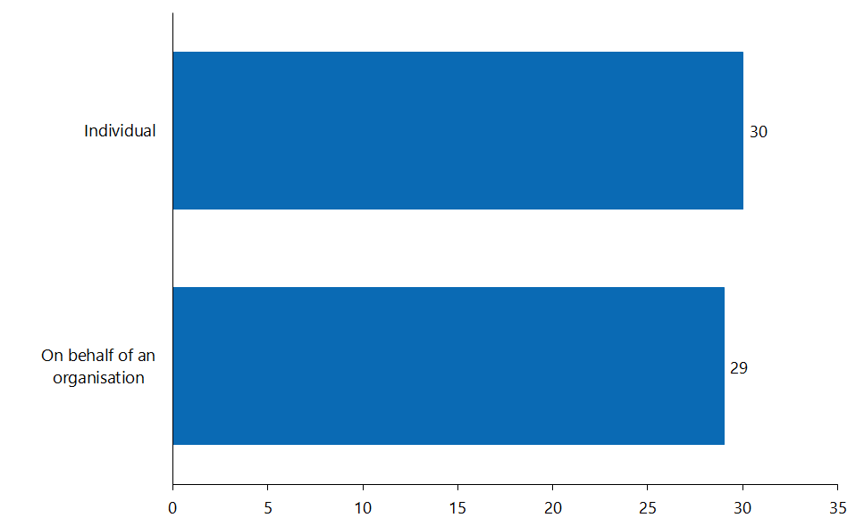

Table 1: Type of respondent
Option | Total
Individual | 30
On behalf of an organisation | 29
Not answered | 0

The following organisations have provided a submission.
Professional bodies of professions with prescribing scopes | Australian and New Zealand College of Anaesthetists & Faculty of Pain Medicine  Australasian College for Emergency Medicine  New Zealand College of Midwives  New Zealand Medical Association  New Zealand Nurses Organisation  New Zealand Society of Anaesthetists  Nurse Practitioners New Zealand  Royal Australasian College of Physicians  Royal Australian and New Zealand College of Obstetricians and Gynaecologists  Royal New Zealand College of General Practitioners
Pharmacy professional bodies | Clinical Advisory Pharmacists Association  Independent Pharmacists’ Association of New Zealand  New Zealand Hospital Pharmacists’ Association  Pharmaceutical Society of New Zealand  Pharmacy Defence Association  Pharmacy Guild of New Zealand
Educational institutions | School of Pharmacy, The University of Auckland
District Health Boards (DHBs) | Waitematā District Health Board (DHB)  Nelson Marlborough DHB  MidCentral DHB  Counties Manukau DHB
Other | Family Planning New Zealand  Health and Disability Commissioner  IStar Ltd  Medicines Control  National Directors of Allied Health, Scientific & Technical  Totem Group of Pharmacies  Westbury Pharmacy and Mahara Health GP Practice

Figure 2 and Table 2 show the types of health professionals who have made submissions. The majority of the respondents were pharmacists. Most respondents in the ‘other’ category were organisations and professional bodies.

Figure 2: Respondent professional role
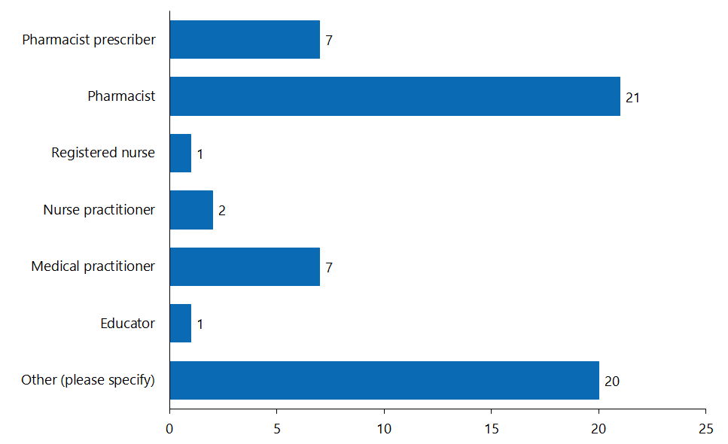

Table 2: Respondent professional role
Option | Total
Pharmacist prescriber | 7
Pharmacist | 21
Registered nurse prescriber | 0
Registered nurse | 1
Nurse practitioner | 2
Medical practitioner | 7
Educator | 1
Consumer | 0
Other (please specify) | 20
Not answered | 0

Level of support
Respondents were asked if they agreed with the medicines on the proposed list (Yes/No). They had an opportunity to provide comments if they answered ‘No’. A total of 36 respondents (61.0%) agreed with the proposed changes and 23 respondents (39.0%) disagreed (Figure 3 and Table 3).

Figure 3: Level of support
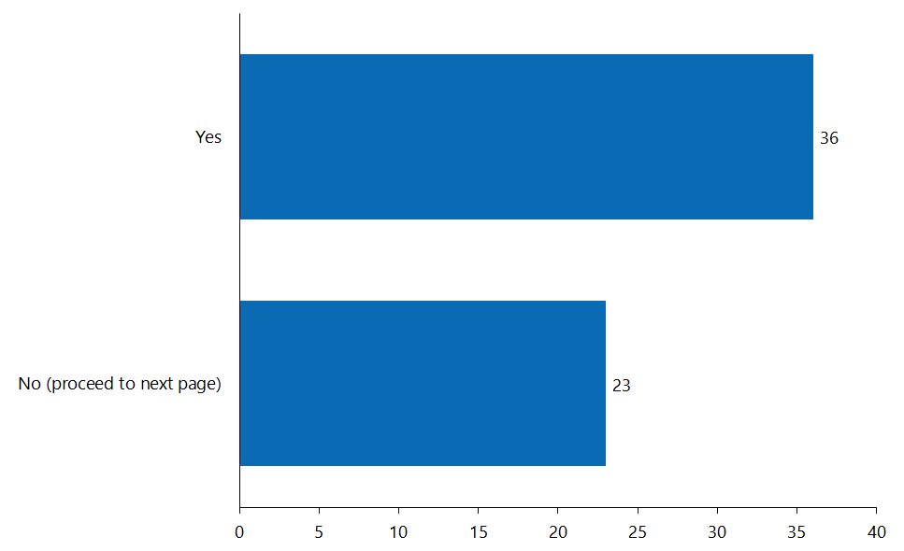

Table 3: Level of support
Option | Total
Yes | 36
No (proceed to next page) | 23
Not answered | 0

Figure 4 and Table 4 show the level of support from individuals and organisations. Among the 23 respondents who disagreed with the proposed changes, 17 (28.8%) were organisations and 6 (10.2%) were individuals. Out of the 17 organisations that were not in favour of the proposed changes, the majority were from other non-pharmacy professional groups such as medical and nursing groups that were questioning the pharmacist prescriber’s scope of practice and their extent. Note that one organisation that disagreed with the proposals responded twice.

Figure 4: Level of support by type of respondent
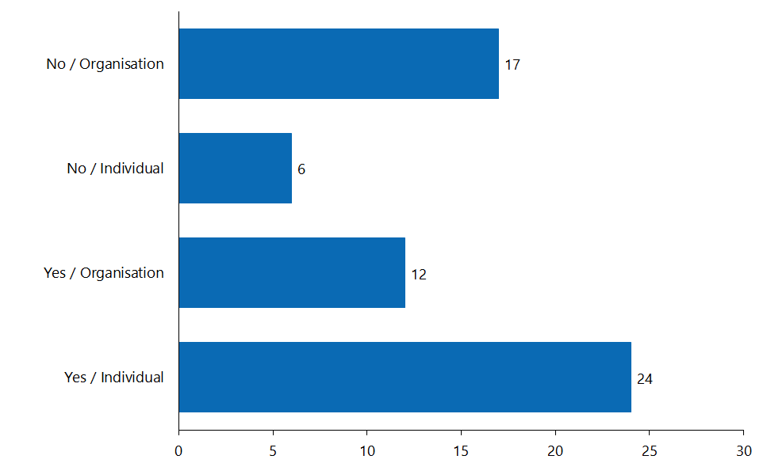

Table 4: Level of support by type of respondent
Option | Total
No – Organisation | 17
No – Individual | 6
Yes – Organisation | 12
Yes – Individual | 24
Not answered | 0

Analysis by themes
The majority of the respondents generally agreed that adding the proposed medicines to the schedules for pharmacist prescribers will contribute to making vital medicines more broadly accessible, which in turn helps to achieve pae ora (healthy futures). The remainder of the comments were grouped together and listed by themes below.

Removing the need for a schedule
There is significant support from the pharmacy sector to change the need for a schedule that allows pharmacist prescribers to prescribe. Under the Medicines Act 1981, pharmacist prescribers are a designated prescriber, which allows them to prescribe specific prescription medicines, or a specific class or description of prescription medicines. This contrasts with an authorised prescriber who can prescribe any prescription medicine.

Numerous submissions commented on the need for more timely updates to the medicines list so that pharmacist prescribers can provide access to medicines. Respondents noted that medicines are often funded and listed on the New Zealand pharmaceutical schedule years before the medicines list for pharmacist prescribers is updated to include them. The delays create inefficiencies for pharmacist prescribers, increase the workload for other prescribers, and reduce access to medicines for patients.

Going forward please can consideration be given to adding new medicines to the specified medicines list for designated pharmacist prescribers at the point where the medicine is given authorisation for distribution within New Zealand. This will mean that the list is a living document and will allow it to ‘keep up with’ changes in the optimal medicine treatment of New Zealanders.
Respondent

One of the solutions offered was to remove the need for a ‘schedule’ and include the class of medicines instead. The suggestion was to amend the definition of ‘specified prescription medicines’ under regulation 4 of the Medicines (Designated Pharmacist Prescribers) Regulations 2013 to include a medicine that ‘belongs to a class or description of prescription medicines that are specified for prescription by pharmacist prescribers’, which occurs already, for example, under the Medicines (Designated Prescriber—Registered Nurses) Regulations 2016.

Reasons why respondents supported changing this requirement can be grouped under two major themes: medicine access equity; and the difficult or resource-intensive nature of the review process

Medicine access equity
We have received anecdotal evidence showing the need for pharmacists to prescribe medicines such as empagliflozin. If the schedule is not updated in a timely manner, treatment for patients requiring empagliflozin is delayed while they are waiting for authorised prescribers to write their prescriptions. This is of concern as many pharmacist prescribers work in clinics serving high-needs or rural populations where it can be difficult to arrange for patients to return to collect a prescription.

As a prescriber professional body highlights, ‘inclusion [of a medicine in the list] does not imply these medicines will be prescribed by pharmacist prescribers’. This is consistent with the daily practice of authorised prescribers such as dentists and medical practitioners, who under legislation can prescribe any medicine but they only prescribe medicines within their scope of practice. The professional body also notes the current process of updating the schedule makes it harder to realise the benefits of pharmacist-prescribing, particularly when unanticipated medicines gain Medsafe approval between now and the next update.

Pharmacist prescribers work in a variety of practice settings. Many are working in general practices with high unmet need, such as Very Low Cost Access (VLCA) practices, marae-based clinics and in secondary care. Pharmacist prescribers therefore need to be able to prescribe from the full range of medicines in order to meet the individual needs of their patient to optimise their medicines and help them get the best possible health outcomes from medicines.
Professional body

Difficult or resource-intensive process
Other respondents have pointed out the process required to add medicines to the schedule is resource intensive and difficult and cannot feasibly be conducted in a timely manner. As mentioned in the Introduction, the schedule has not been updated since its inception in 2013.

The required consultation process creates a barrier and delays access to new medicines for patients and potentially fragments care. New medicines become available frequently and it is not feasible under the current system to allocate the required amount of time and resources into starting a consultation process often enough so as to keep up with the rapidly developing prescribing guidelines involving up-to-date pharmaceuticals. It is a waste of resources for everyone.
We are hopeful that in the new Therapeutic Products legislation a better, more streamlined, less resource-heavy approach will be taken. In the meantime, we suggest that pharmacist prescribers regulations be amended so that the definition of ‘specified prescription medicine’ include classes of drugs as well, such as the case under the regulations in relation to registered nurse prescribers. This would promote a better system that could potentially require less frequent updates.
Respondent

Unapproved medicines
With COVID-19 and ongoing stock shortages and changes, this has highlighted the inadequacy of the current process of section 29 unregistered medications in New Zealand and both pharmacist prescribers and nurse practitioners not being legally allowed to prescribe these medications. This is putting barriers to patient care and affecting health outcomes especially when a medication may not have been a section 29 medication on the first dispensing but is on subsequent dispensing’s. Again we seek a review and mitigation of this to allow both pharmacist prescribers and nurse practitioners to be allowed to prescribe section 29 medicines with some urgency.
Respondent

Legislation does not currently permit designated pharmacist prescribers to prescribe unapproved medicines under section 29 of the Medicines Act 1981. While all the medicines on the proposed medicines list held current prescription or controlled drug classification, not all medicines had a Medsafe-approved brand.

Unapproved medicines were included as a practical measure to provide a level of future-proofing for the schedules. Limiting the proposed list to medicines with only currently approved brands available would result in the list becoming out of date almost as soon as it is gazetted. A prime example is dulaglutide, a medicine to manage type 2 diabetes. During the consultation period, Medsafe was processing an application for approval of Trulicity. Approval was granted on 12 August 2021. If this medicine had been left out of the consultation, the public would not have been able to access this medicine through designated pharmacist prescribers until the next review of the schedules. Because designated pharmacist prescribers may not prescribe unapproved medicines, scheduling of medicines without an approved brand does not bypass any safeguards, but does allow potential access once a brand gains Medsafe approval.

Section 20 of the Medicines Act 1981 requires that ministerial consent (delegated to Medsafe) is given before any medicine can be sold, supplied, distributed or advertised in New Zealand. These medicines are often referred as ‘approved medicines’.

However, some patients may require treatment with medicines for which consent has not been granted (known as ‘unapproved medicines’). Medicines may also need to be used for indications or in ways that are different to the approved use (as described in the medicine’s data sheet). Provisions in the Medicines Act 1981 allow unapproved medicines to be obtained or administered, and allow approved medicines to be used outside their approved use.

Section 29 of the Medicines Act 1981 only allows the sale or supply of unapproved medicines to registered medical practitioners. Some in the sector support amending the legislation to enable pharmacist prescribers to prescribe these unapproved medicines. However, others in the sector oppose allowing pharmacist prescribers to prescribe unapproved medicines. The main reason for their opposition is that Medsafe has not assessed the quality, efficacy and safety of unapproved medicines.

It is important to note that although pharmacist prescribers are not legally permitted to prescribe unapproved medicines, Medsafe provides clear guidance about the use, prescribing and dispensing of these unapproved or section 29 medicines.

Although the subject is outside of the scope of this consultation, many individuals have voiced concern about stock issues where unapproved medicines have replaced commonly used approved medicines because the COVID-19 pandemic has disrupted global medicine supply chains. These unapproved versions of approved medicines still can only be prescribed by medical practitioners, potentially reducing access to them in populations that rely on non-medical prescribing.

Period of supply for controlled drugs
Regulation 21(5)(b) of the Misuse of Drugs Regulations 1977 permits pharmacist prescribers to only prescribe up to a maximum of three days’ supply of a Class B or C controlled drug. This is in contrast with what is allowed for:
- medical and nurse practitioners, and veterinarians (one month for Class B, three months for Class C)
- dentists (seven days for both classes)
- midwives (can only prescribe pethidine, morphine and fentanyl for one month maximum).

Several pharmacists have commented that this restriction is a barrier to accessibility as it limits pharmacists’ ability to prescribe enough medicine to cover patient needs. Settings in which this has been a problem include postoperative pain management, sleep management with benzodiazepines in acute settings, and opioid-substitution treatment clinics.

The review of the current period of supply for controlled drugs by prescribing pharmacists is outside the scope of this consultation. The legislative work programme does not include any planned updates or changes to the Misuse of Drugs Regulations 1977 in this area, so pharmacist prescribers must keep to the current maximum period of three days’ supply. Feedback from this consultation advocating for future changes to this piece of legislation has been forwarded to the Strategy and Policy team within the Ministry. The team is currently working through what changes are required to enable electronic controlled drugs prescriptions.

Prescribing methylphenidate, a controlled drug with prescribing restrictions
One respondent commented on the possibility of adding methylphenidate to the pharmacist prescriber schedule. It is important to note that pharmacist prescribers are currently not legally permitted to prescribe methylphenidate. The respondent stated that, rather than looking to initiate treatment with this medicine, they would be prescribing for the purpose of ‘re-charting medication charts, correcting omission on admission to hospital, etc’.

Currently the only practitioners who can prescribe methylphenidate are ‘vocational medical practitioners’ or any medical or nurse practitioner acting on their written approval. Adding pharmacist prescribers to this list would require ministerial approval under section 22 of the Misuse of Drugs Regulations 1977, which is outside of the scope of this consultation. Feedback from this consultation advocating for future changes to this piece of legislation has been forwarded to the Strategy and Policy team within the Ministry.

For more information on prescribing methylphenidate, please visit https://www.medsafe.govt.nz/profs/riss/restrict.asp.

Prescribing controlled drugs such as benzodiazepine and drugs for opioid substitution therapy
A respondent commented that benzodiazepine and drugs for opioid substitution treatment should be added to the pharmacist prescriber list. It is important to note that:
- benzodiazepines (eg, alprazolam, clobazam, clonazepam) are already listed under Schedule 1B to the Misuse of Drugs Regulations 1977
- methadone is listed under Schedule 1B to the Misuse of Drugs Regulations 1977 (number 13 on the list)
- buprenorphine is already listed under Schedule 1B to the Misuse of Drugs Regulations 1977 (number 2)
- naloxone is already listed under the schedule to the Medicines (Designated Pharmacist Prescribers) Regulations 2013 (number 944).

The medicines the respondent recommended for inclusion are already listed in the respective schedules given above (noting that there is currently a limit on the period of supply for controlled drugs). No further actions on this matter are required.

Sharing prescribing data
One respondent asked the Ministry to share any data it may have on the extent of current pharmacist prescribing as well as any evidence of the impacts of pharmacist prescribing on access to medicines.

A recent article examined the non-medical prescribing (NMP) trends in New Zealand for a four-and-a-half-year period from 2016 to 2020. It found pharmacist prescribers contributed to 9% of all NMP prescriptions during that period overall. Within that period, however, their contributions increased from 2% in 2016 to 11% in 2019. The proportion of prescriptions written by NMP providers and patients receiving NMP prescriptions also increased from 1.8% in 2016 to 14.4% in 2019.

The authors commented that NMPs could be further used to reach communities who are experiencing unmet primary health care needs in rural New Zealand. NMP providers could reduce the prescribing burden on GPs and improve access to medicines by prescribing for acute conditions that require pain relief or antibiotics.

Current New Zealand pharmacist prescriber practice indicates that they prescribe more medicines for long term conditions and for a higher proportion of older patients. New Zealand pharmacist prescribing services could be improved in primary care to help manage the increasing prescribing burden associated with long term conditions and an aging population.
Raghunandan et al.

There are opportunities for pharmacist prescribers to play a greater role in NMP as the Health and Disability System Reforms (the Reforms) look to develop models of care and funding models to support the new provider networks within Tier 1 locality structures. Key deliverables from the Reforms should break down cultural differences across professions and ensure a collaborative approach to care. For more information about the Reforms, please visit https://dpmc.govt.nz/our-business-units/transition-unit/response-health-and-disability-system-review/information.

Queries about pharmacy prescriber practice
We forwarded a small number of respondents’ questions to the Council for response. One respondent asked for clarification on whether individual schedule entries would prevent pharmacists from prescribing combination products. The Council clarified that a combination entry is not required to prescribe a combination product, though all active ingredients in the combination product must be scheduled.

Another respondent asked for clarification on what the process of compiling the list involved. The Council provided the details of the process as described in the Introduction.

Two other respondents asked for the rationale behind the medicines included in the obstetrics, gynaecology and urinary-tract disorders category. The response outlined the defined and collaborative environment in which designated pharmacist prescribers work, and the additional safeguards in place to ensure patient safety. For more detail on the submissions on medicines in the obstetrics, gynaecology and urinary-tract disorders category, see Section ‎3.9.

Analysis by therapeutic class
The Pharmacy team grouped the data collected in the comments and free text sections of the submissions by therapeutic class. Comments about specific medicines have been mentioned by respondents have been included for clarity.

Musculoskeletal and joint diseases
No submissions opposed the inclusion of medicines in the musculoskeletal and joint diseases category.

Respiratory system
No submissions opposed the inclusion of medicines in the respiratory system category.

Central nervous system

Cannabidiol (CBD)
Two respondents had concerns about the inclusion of cannabidiol on the list. Although both respondents shared the view that only specialists should prescribe cannabidiol, their reasons for it were different.

One felt a specialist is required to ‘comprehensively assess the client’s motivation to want to use CBD products, as well as assessing their clinical need. Given that there are many individuals with huge variety of conditions who may want to trial CBD products to see if they are suitable to assist.’

The other felt cannabidiol should not be scheduled because the medicine is not funded, nor widely included in clinical guidelines. They also felt including and prescribing it would contradict the ‘ethical principle that Pharmacist Prescribers must be evidence-based in your prescribing practice and prescribe in accordance with accepted best practice and any relevant local and national guidelines’.

Esketamine
One respondent was against including esketamine on the list, noting esketamine ‘is a very specialized drug’ and is ‘currently infrequently prescribed due to the intensive time required for supervision and monitoring’. They also thought ‘a specialist mental health provider has to assess and diagnose the mental health condition, trial numerous other medications before esketamine would be considered an option’.

Ziprasidone
Another respondent opposed the inclusion of ziprasidone as it is ‘an atypical antipsychotic that is seldomly used. It could be fifth line treatment that is almost always commenced following involvement of a specialist and multidisciplinary team (MDT).’

Immunological products and vaccines
No submissions opposed the inclusion of medicines in the immunological products and vaccines category.

Several respondents supported initiatives that increase the access to vaccines.

Endocrine system and emergency treatment of poisoning
No submissions opposed the inclusion of medicines in the endocrine system and emergency treatment of poisoning category.

One respondent supported adding fomepizole to the list to treat toxic alcohol poisoning.

Malignant disease and immunosuppression
No submissions explicitly opposed the inclusion of medicines in the malignant disease and immunosuppression category.

One respondent did comment that most medicines in this category were ‘biologics’ and thus extremely expensive. The respondent recommended that these medicines should be ‘prescribed only by specialists with explicit knowledge and training in their use’.

Nutrition and blood
No submissions opposed the inclusion of medicines in the nutrition and blood category.

Infections
Although not explicitly against including any medicines on this list, one respondent noted that ‘many antivirals have marginal benefits and much like antibiotics, have significant potential for over-prescribing. Once again we could hope there is significant control over indications and prescriptions of these medications’.

Obstetrics, gynaecology and urinary-tract disorders
A total of 11 submissions from the obstetrics and gynaecology sector were against the inclusion of carboprost, dinoprostone and mifepristone in the list. Nearly all of these respondents stated that carboprost and dinoprostone are point-of-care medicines used in medical emergencies and a pharmacist should not be providing care in that situation. Two respondents pointed to the need for considerable clinical assessment and investigation before prescribing mifepristone, along with the need for further psychological support and potentially surgical intervention after its use, all of which pharmacists are not well placed to provide.

One medical professional body was in favour of including mifepristone. It noted that ‘widening access through pharmacist prescribers will allow easier access for people in need and contribute to reducing location-based inequity in access to abortion services throughout Aotearoa New Zealand’.

Although pharmacists are working within obstetrics and gynaecology teams currently, they are not designated pharmacist prescribers. However, new roles for designated pharmacist prescribers are constantly being developed and pioneered and there is no reason why a designated pharmacist could not be a member of such a team in the future. In that role, a designated pharmacist prescriber would have the competence to prescribe relevant medicines and be working within workplace authority and protocols; the team itself would include midwifery and/or obstetrics experience.

Cardiovascular system
No submissions opposed the inclusion of medicines in the cardiovascular system category.

Anaesthesia
Several respondents were against the inclusion of medicines in the anaesthesia category, as well as of alfentanil in the controlled drug category. The reason that most of them gave for their opposition related to the clinical skills required to safely administer these medicines. One respondent submitted that they ‘cannot envisage when, or why, it would ever be appropriate or necessary for pharmacists to prescribe such medicines, even within a multidisciplinary team’. Another felt ‘prescriptions of anaesthesia medicine should not be done by anyone who does not possess the skills necessary to provide life support after administration of these drugs’, and that its inclusion in the list ‘appears to be wildly out of scope and dangerous’.

However, one of the medicines in this category, glycopyrronium, is also used as an antimuscarinic bronchodilator to treat chronic obstructive pulmonary disease (COPD). Excluding it from the schedule would restrict its use in that setting as well. No respondents opposed the inclusion of glycopyrronium as a bronchodilator.

A current designated pharmacist prescriber noted that in the United Kingdom pharmacist prescribers had scope to potentially prescribe any medicine in the British National Formulary. They would regularly prescribe medicines as part of a multidisciplinary team caring for critical care unit patients. In this unit, medicines such as alfentanil and muscle relaxants were required for patients with specific conditions or for patients undertaking specific treatments. While no designated pharmacist prescribers currently work in this clinical area in New Zealand, a body of overseas evidence shows critical care pharmacists are valuable. Where they are involved in critical care, outcomes improve for patients, in situations where accurate medicine dosing is difficult due to unstable and complex conditions, and fewer medication-related errors and costs occur.

Controlled drugs

Alfentanil
One respondent noted that, as an intravenous short-acting opioid, alfentanil has ‘significant abuse potential’ and they would like to ‘ensure that the use of this medication does not cause harm’.

Nabilone
One respondent noted nabilone is ‘not funded or widely included in guidelines for use’ and therefore the proposal to allow pharmacist prescribers to prescribe it conflicts with the ‘ethical principle that pharmacist prescribers must be evidence-based’. Another respondent commented that no nabilone product consented by Medsafe is yet available for distribution in New Zealand, so pharmacist prescribers are currently unable to prescribe the medicine regardless of whether it is scheduled or not.

Tapentadol
One respondent supported the inclusion of tapentadol. They noted it can have significantly fewer side effects in the older population compared with tramadol. Another respondent noted there is no approved tapentadol product yet in New Zealand.

Not yet classified – now all prescription medicines
For details on submissions on the appropriateness of pharmacists prescribing unapproved medicines, see section ‎2.2.

Summary of level of support
Key
Strong support for inclusion in the schedule
Some support for inclusion in the schedule
Little or no support for inclusion in the schedule

Therapeutic class |  | Level of support
Musculoskeletal and joint diseases |  | Support for inclusion
Respiratory system |  | Support for inclusion
Central nervous system |  | No support for inclusion of cannabidiol (CBD), esketamine, ziprasidone and riluzole
Immunological products and vaccines |  | Support for inclusion
Endocrine system and emergency treatment of poisoning |  | Support for inclusion  Add fomepizole (competitive alcohol dehydrogenase inhibitor)
Malignant disease and immunosuppression |  | Support for inclusion
Nutrition and blood |  | Support for inclusion
Infections |  | Support for inclusion
Obstetrics, gynaecology and urinary-tract disorders |  | Some support for inclusion  Some strong opposition
Cardiovascular system |  | Support for inclusion
Anaesthesia |  | Some strong opposition  No opposition to the inclusion of glycopyrronium as a bronchodilator
Controlled drugs |  | Resource, time and/or effort to change Schedule 1B to Misuse of Drugs Regulations 1977 – not supported
Not yet classified (unapproved medicines)  Re-labelled as ‘active pharmaceutical ingredients’ |  | Some support for inclusion  Some strong opposition if they were unapproved medicines

Future considerations
This is the first time that the schedule to the Medicines (Designated Pharmacist Prescribers) Regulations 2013 has been updated since its inception. The process involves stakeholder consultation, as required by the Medicines Act and working collaboratively with the Council. We will need to consider how future review of the schedule could be improved on.

Review process for updating the schedules
We request consideration to determine a regular and appropriate review frequency of the current schedule of prescription medicines. This is to ensure that the current schedule does not hinder pharmacist prescribers undertaking best practice prescribing.
Respondent

One respondent raised concerns that the process involved in reviewing the pharmacist prescriber schedule and the fact that it happens so rarely have impacted on the practice of pharmacist prescribers. Figure 5 summarises the review process. Please note it does not include internal engagements within the Ministry.

Figure 5: Summary of the review process for consultation on amendments to the schedules of specified prescription medicines for designated pharmacist prescribers
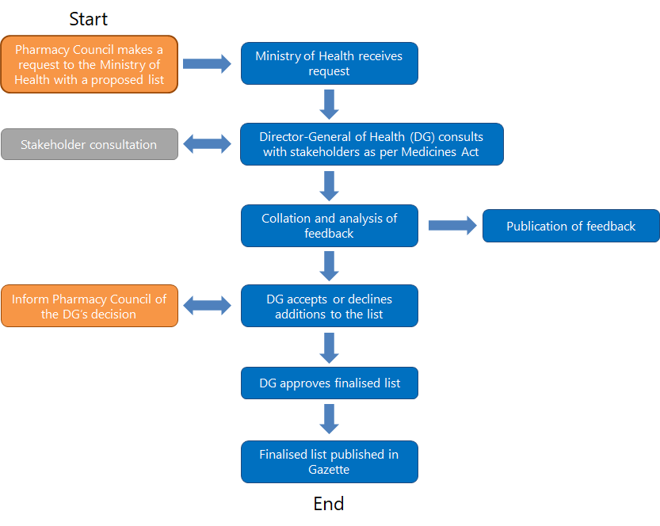

The process that the Ministry and Council follow aligns with current requirements under the relevant legislation. See the Introduction for details of this legislation.

At the end the process set out in Figure 5, after publication of the list in the Gazette, the Ministry and Council will undertake a debrief of the consultation process. We anticipate this will include reviewing feedback from the stakeholders about, for example, the consultation process and format.

One of the objectives of this review is to further streamline and structure the process while meeting legislative requirements to give pharmacist prescribers greater access to medicines.

In the longer term, the Ministry and Council will engage in opportunities to gather feedback on the current regulatory framework. Feedback will address the benefits of an updated process that is more responsive to changes in practice.
Pharmacy Council

Drugs excluded from the list
Numerous submissions were about medicines that were not included on the proposed list (eg, methylphenidate).

The Ministry of Health and Council compiled a preliminary list of medicines and controlled drugs from a proposed list that CAPA submitted. In doing so, they removed from the list active pharmaceutical ingredients that met any of the following exclusion criteria:
- holding restricted medicine, pharmacy-only medicine, or general sale classification
- being subject to prescribing restrictions under section 23 of the Medicines Act 1981 or regulation 22 of the Misuse of Drugs Regulations 1977
- absence of an approved human indication
- an indication for use as a volatile anaesthetic.

Clozapine, riluzole and thalidomide were excluded on the basis of restrictions under section 23 of the Medicines Act 1981.

Similarly, dexamphetamine, ephedrine, pseudoephedrine and methylphenidate were excluded due to restrictions under regulation 22 of the Misuse of Drugs Regulations 1977. For more information on these restrictions, visit the Medsafe website.

The Council submitted the reviewed list to the Ministry on 21 June 2021.
Pharmacy Council

Appendices

Appendix 1: Consultation document

Submission on amendments to the schedule of the Medicines (Designated Pharmacist Prescribers) Regulations 2013 and Schedule 1B of the Misuse of Drugs Regulations 1977

Purpose
The Ministry of Health invites submissions on proposed amendments to the schedule of specified prescription medicines for designated pharmacist prescribers.

The Ministry of Health, on behalf of the Director-General, must consult with those people or organisations that may be affected by a change to the schedules before making a legal change by Gazette notice.

This submission will allow you to provide feedback on the proposed medicines, or to propose medicines that have not been referenced.
- View the proposed medicines list

Please submit your feedback on the proposed amendments by 12 August 2021.

Note that specific questions you may have about the proposed prescription medicines or controlled drugs for designated pharmacist prescribers should be directed to the Pharmacy Council.

Background
Designated pharmacist prescribers have met specific requirements and are registered in an additional scope of practice by the Pharmacy Council. They work in collaborative multidisciplinary health care teams and only prescribe medicines within their specific area of practice. Additional information on requirements and practice context is provided in the “Who/What is a Designated Pharmacist Prescriber?” section.

The current schedule of 1,517 prescription medicines has been in effect since the Medicines (Designated Pharmacist Prescribers) Regulations passed into legislation in June 2013. Since then, additional medicines have become available in New Zealand, to which wider access would benefit patients. The schedule needs to be amended to reflect these additional medicines.

Required Amendments to Schedules
Following work with pharmacist prescribers and Ministry of Health, the Pharmacy Council recommends 198 prescription medicines should be added to the schedule of the Medicines (Designated Pharmacist Prescribers) Regulations 2013.

Schedule 1B of the Misuse of Drugs Regulations 1977 specifies 25 controlled drugs that may be prescribed by designated pharmacist prescribers. Three controlled drugs should be added to this schedule.

Who/What is a Designated Pharmacist Prescriber?
The Medicines (Designated Pharmacist Prescribers) Regulations 2013 and Misuse of Drugs Regulations 1977 permit designated pharmacist prescribers to prescribe specified prescription medicines.

Pharmacy Council sets the Pharmacist Prescriber scope of practice and the required qualifications to enter the scope. These are published in a Gazette notice. The prescribing activities of designated pharmacist prescribers are therefore tightly regulated via the Medicines Act 1981, the Misuse of Drugs Act 1975, and the Health Practitioners Competence Assurance Act 2003.

Pharmacy Council also sets expected levels of competence and requirements for entry into the scope. Requirements include:
- holding an annual practising certificate in the Pharmacist scope of practice
- having at least three (3) years of recent and appropriate post-registration experience working in a collaborative health care team environment
- holding a qualification prescribed by the Pharmacy Council for entry into the Pharmacist Prescriber scope
- submission of a practice plan which is endorsed by the clinical lead of their collaborative health care team
- a declaration that their current practice includes competence standards M1, M2 and O1 from the Competence Standards for the Pharmacy Profession, and all the Pharmacist Prescriber Competence Standards.
Designated pharmacist prescribers must prescribe within a collaborative and multidisciplinary health care team setting. In this environment it is inherent that the designated pharmacist prescriber is part of the patient’s collaborative health care team. Although the designated pharmacist prescriber is not the primary diagnostician in the collaborative health care team, they must be able to carry out clinical assessments and monitoring that are relevant to the medicines and conditions for which they prescribe.

The designated pharmacist prescriber must only prescribe within the limits of their professional expertise, competence and ethical codes of practice. They are responsible and accountable for the prescribing decisions they make and the care they provide. A designated pharmacist prescriber may only prescribe a medicine if:
- they possess the appropriate knowledge and competence (both clinical and cultural)
- the condition and medicine lie within their specified clinical area of practice
- the clinical lead of the collaborative team is satisfied that pharmacist prescribing of the medicine is safe, aligns with legal and workplace protocols, and is in the best interests of the patient.

Additional information on designated pharmacist prescribers including requirements to enter the scope of practice and competence standards can be found on the Pharmacy Council website.

View the proposed medicines list
Pharmacological class | Proposed prescription medicines to be added to the schedules
Musculoskeletal and joint diseases (6) | Apremilast  Benzbromarone  Febuxostat  Neostigmine  Nusinersen  Secukinumab
Respiratory system (9) | Bee venom  Ivacaftor  Mepolizumab  Olodaterol  Pirfenidone  Squill  Umeclidinium bromide  Vilanterol  Wasp venom allergy treatment
Central nervous system (9) | Cannabidiol  Dimethyl fumarate  Erenumab  Esketamine  Ocrelizumab  Riluzole  Rufinamide  Teriflunomide  Ziprasidone
Immunological products and vaccines (7) | COVID-19 vaccine  Diphtheria, tetanus and pertussis (acellular, component) vaccine  Immunoglobulins  Influenza vaccine  Varicella (chickenpox) vaccine  Varicella vaccine  Varicella zoster (shingles) vaccine
Endocrine system and emergency treatment of poisoning (3) | Empagliflozin  Fomepizole  Menotrophin
Malignant disease and immunosuppression (43) | Abiraterone  Afatinib  Alectinib  Apalutamide  Atezolizumab  Axitinib  Bendamustine  Brentuximab vedotin  Carfilzomib  Cobimetinib  Crizotinib  Dabrafenib mesilate  Daratumumab  Durvalumab  Enasidenib  Encorafenib  Entrectinib  Enzalutamide  Gilteritinib  Ibrutinib  Ixazomib  Larotrectinib  Lenvatinib  Lorlatinib
Malignant disease and immunosuppression (43) (continued) | Neratinib  Nintedanib  Nivolumab  Obinutuzumab  Olaparib  Osimertinib  Palbociclib  Pegaspargase  Pembrolizumab  Pertuzumab  Pomalidomide  Regorafenib  Ribociclib  Ruxolitinib  Siltuximab  Trametinib dimethyl sulfoxide  Trastuzumab emtansine  Venetoclax  Vismodegib
Nutrition and blood (4) | Betaine  Elosulfase alfa  Emicizumab  Zinc
Infections (13) | Artesunate  Bedaquiline  Ceftolozane  Cobicistat  Dolutegravir  Elvitegravir  Fidaxomicin  Fosfomycin  Glecaprevir  Ledipasvir  Nitazoxanide  Pibrentasvir  Sulfadiazine
Obstetrics, gynaecology, and urinary-tract disorders (3) | Carboprost  Dinoprostone  Mifepristone
Cardiovascular system (2) | Idarucizumab  Sacubitril
Anaesthesia (10) | Atracurium  Dexmedetomidine  Etomidate  Glycopyrronium  Mivacurium  Pancuronium  Rocuronium  Sugammadex  Suxamethonium  Vecuronium
Controlled drugs (3) | Alfentanil  Nabilone  Tapentadol
No class assigned (89) | Abemaciclib  Acalabrutinib  Aclidinium bromide  Adrafinil  Alitretinoin  Alogliptin  Alpelisib  Avanafil  Avelumab  Avibactam  Baloxavir marboxil  Bamlanivimab  Baricitinib  Benralizumab  Bezlotoxumab  Bictegravir  Blinatumomab  Bosutinib  Brigatinib  Brolucizumab  Cabotegravir  Cabozantinib  Canagliflozin  Carglumic acid  Cefaloridine  Ceritinib  Daclatasvir  Darolutamide  Dasabuvir  Decitabine
No class assigned (89) (continued) | Defibrotide  Deoxycholic acid  Dulaglutide  Dupilumab  Elotuzumab  Ertugliflozin  Evolocumab  Fenfluramine  Ferric derisomaltose  Fremanezumab  Galcanezumab  Grazoprevir  Guselkumab  Hexaminolevulinate  Inotuzumab ozogamicin  Isatuximab  Isavuconazole  Ixekizumab  Lanadelumab  Letermovir  Lipegfilgrastim  Lurasidone  Macitentan  Micafungin  Midostaurin  Milnacipran  Nebacumab  Niraparib  Olaratumab  Ombitasvir  Paritaprevir  Pasireotide  Peramivir  Perampanel  Polatuzumab vedotin  Ponatinib  Ramucirumab  Ranolazine  Remdesivir  Reslizumab  Risankizumab  Romosozumab
No class assigned (89) (continued) | Sarilumab  Semaglutide  Simeprevir  Sofosbuvir  Sonidegib  Talazoparib  Teduglutide  Tivozanib  Tofacitinib  Tucatinib  Upadacitinib  Vandetanib  Vedolizumab  Velpatasvir  Veruprevir  Vortioxetine  Voxilaprevir

Appendix 2: Consultation questions
1 What is your name?

2 What is your email address?

3 What is your organisation?

4 Are you submitting as an individual or on behalf of an organisation?
- Individual
- On behalf of an organisation

5 What is your job title?

6 Which of these best describes you?
Options
Pharmacist prescriber
Pharmacist
Registered nurse prescriber
Registered nurse
Nurse practitioner
Medical practitioner
Educator
Consumer
Other (please specify)

7 Do you agree with the proposed medicines on the list?
- Yes
- No (proceed to the next page)

8 I disagree with medicines for musculoskeletal and joint diseases
Please name the medicine(s) and state your reason(s) why you disagree with its inclusion on the list.

9 I disagree with medicines for respiratory system
Please name the medicine(s) and state your reason(s) why you disagree with its inclusion on the list.

10 I disagree with medicines for central nervous system
Please name the medicine(s) and state your reason(s) why you disagree with its inclusion on the list.

11 I disagree with medicines for immunological products and vaccines
Please name the medicine(s) and state your reason(s) why you disagree with its inclusion on the list.

12 I disagree with medicines for endocrine system and emergency treatment of poisoning
Please name the medicine(s) and state your reason(s) why you disagree with its inclusion on the list.

13 I disagree with medicines for malignant disease and immunosuppression
Please name the medicine(s) and state your reason(s) why you disagree with its inclusion on the list.

14 I disagree with medicines for nutrition and blood
Please name the medicine(s) and state your reason(s) why you disagree with its inclusion on the list.

15 I disagree with medicines for infections
Please name the medicine(s) and state your reason(s) why you disagree with its inclusion on the list.

16 I disagree with medicines for obstetrics, gynaecology, and urinary-tract disorders
Please name the medicine(s) and state your reason(s) why you disagree with its inclusion on the list.

17 I disagree with medicines for cardiovascular system
Please name the medicine(s) and state your reason(s) why you disagree with its inclusion on the list.

18 I disagree with medicines for anaesthesia
Please name the medicine(s) and state your reason(s) why you disagree with its inclusion on the list.

19 I disagree with controlled drugs being included on the list
Please name the medicine(s) and state your reason(s) why you disagree with its inclusion on the list.

20 I disagree with medicines that do not have the pharmaceutical class assigned being included on the list
Please name the medicine(s) and state your reason(s) why you disagree with its inclusion on the list.

21 I disagree with all the medicines on the list
Please state your reason(s) why all the medicines should not be on the list

22 Is there anything else that you would like to tell us relating to the proposed amendment to the specified prescription medicine list for designated pharmacist prescribers?

Appendix 3: Organisations consulted
Responsible authorities with prescribing scopes | Dental Council  Dietitians Board  Medical Council  Midwifery Council  Nursing Council  Optometrists and Dispensing Opticians Board
Professional bodies of professions with prescribing scopes | Australian and New Zealand College of Anaesthetists & Faculty of Pain Medicine  College of Nurses Aotearoa  Council of Medical Colleges  Dietitians NZ  New Zealand Association of Optometrists  New Zealand College of Midwives  New Zealand Dental Association  New Zealand Medical Association  New Zealand Nurses Organisation  Nurse Practitioners New Zealand  Royal Australasian College of Physicians  Royal Australian and New Zealand College of Obstetricians and Gynaecologists  Royal New Zealand College of General Practitioners  Te Ora Māori Medical Practitioners
Pharmacy professional bodies | Canterbury Community Pharmacy Group  Clinical Advisory Pharmacists Association  Independent Pharmacists’ Association of New Zealand  Māori Pharmacists’ Association  MidCentral Community Pharmacy Group  Midlands Community Pharmacy Group  New Zealand Hospital Pharmacists’ Association  Nirvana Pharmacy Group  Pacific Pharmacists’ Association  Pharmaceutical Society of New Zealand  Pharmacy Defence Association  Pharmacy Guild of New Zealand
Educational institutions | Nursing and Health Science | Eastern Institute of Technology  Nursing, Midwifery and Medical Imaging, Ara Institute of Canterbury Ltd  Otago Medical School, University of Otago  School of Clinical Sciences, Auckland University of Technology  School of Medicine, The University of Auckland  School of Nursing, Massey University  School of Pharmacy, The University of Auckland  School of Pharmacy, University of Otago
Commissioners | District health boards  DHB Chief Medical Officers  DHB Directors of Allied Health  DHB Directors of Nursing  DHB Hospital Pharmacy Managers  DHB Pharmacy Portfolio Managers  Primary health organisations
Other | Allied Health Aotearoa New Zealand  Family Planning New Zealand  Health and Disability Commissioner  Health Quality & Safety Commission  Medsafe  National Directors of Allied Health, Scientific & Technical  Ngā Pou Mana – Tangata Whenua Allied Health  Pasifika Allied Health Aotearoa New Zealand (PAHANZ)  PHARMAC  Totem Group of Pharmacies  Westbury Pharmacy and Mahara Health GP Practice

CAPA is a professional body that represents the designated pharmacist prescribers.
The original closing date was 9 August 2021. It was extended to 12 August 2021 due to a request for an extension from the sectors involved in the consultation.
https://www.health.govt.nz/our-work/populations/maori-health/he-korowai-oranga/pae-ora-healthy-futures
Medicine access equity means that everyone should have a fair opportunity to access funded medicines to achieve their full health potential, and that no one should be disadvantaged from achieving this potential. PHARMAC. 2020. Achieving Medicine Access Equity in Aotearoa New Zealand: Towards a theory of change. Wellington: Pharmaceutical Management Agency. URL: http://www.pharmac.govt.nz/assets/achieving-medicine-access-equity-in-aotearoa-new-zealand-towards-a-theory-of-change.pdf (accessed 8 October 2021).
Trulicity is a specific brand of medicine that contains the active ingredient dulaglutide.
https://www.medsafe.govt.nz/profs/RIss/unapp.asp
Raghunandan R, Marra CA, Tordoff J, et al. 2021. Examining non-medical prescribing trends in New Zealand: 2016–2020. BMC Health Services Research 21: 418. URL: https://link.springer.com/content/pdf/10.1186/s12913-021-06435-y.pdf (accessed 11 August 2021).
Non-medical prescribers include dentists, midwives, nurse prescribers (nurse practitioners and registered nurse prescribers), pharmacist prescribers, optometrists and dietitian prescribers.
It is unclear whether the respondent meant hospital specialist medical practitioners or pharmacist prescribers who have explicit knowledge and training in their use.
Preslaski CR, Lat I, MacLaren R, et al. 2013. Pharmacist contributions as members of the multi-disciplinary ICU team. Chest 144(5): 1687–95.
Restrictions under section 23 of the Medicines Act 1981.
The original closing date was 9 August 2021. It was extended to 12 August 2021 due to the pharmacy sector’s request for an extension.
Pharmacy Council is the regulator for the pharmacy profession (including pharmacist prescribers) in Aotearoa New Zealand and is mandated by the Health Practitioners Competence Assurance Act 2003.
Not all of the medicines proposed are currently Medsafe approved. Current legislation does not authorise pharmacist prescribers to prescribe unapproved products, therefore these proposals are forward-looking to avoid barriers accessing important medicines which may become available in New Zealand (such as dulaglutide for type 2 diabetes).
View the full Competence Standards for the Pharmacy Profession 2015 and Pharmacist Prescriber: Prescribing competency framework and standards at https://pharmacycouncil.org.nz/pharmacist/competence-standards/.
As listed on the New Zealand Formulary as of 28 June 2021.
The Ministry of Health is collaborating with the Pharmacy Council on this consultation.

