EFFECTIVENESS OF FACE-TO-FACE GAMBLING INTERVENTIONS: A RANDOMISED CONTROLLED TRIAL

FINAL REPORT

28 June 2021

Prepared for | Authors
Ministry of Health | Maria E. Bellringer
PO Box 5013 | Katie Palmer du Preez
Wellington | Alain C. Vandal
 | Stéphane Janicot
 | Takayoshi Ikeda
 | David C. Hodgins
 | Malcolm Battersby
 | Kirsten van Kessel
 | Sean Sullivan
 | Ben Riley
 | Braden Te Ao
 | Nathan Henry
 | Laura Mauchline
 | Jason Landon

- ACKNOWLEDGEMENTS

The authors are highly appreciative of The Salvation Army Addiction Services - Gambling (Oasis) nationwide. Oasis was the partner organisation for this clinical trial and were fully committed to making it a success despite many challenges. Oasis staff including managers, counsellors and administrators embraced the trial with enthusiasm and recruited all participants, providing the interventions with fidelity and integrity. Without Oasis’ commitment, this research would not have been possible. We particularly thank Lisa Campbell for her tireless efforts in championing the trial from start to finish.

Sincere thanks are due to Professor Max Abbott, whose vision led to the development of the trial with our international collaborators (report authors Professor David Hodgins and Professor Malcolm Battersby) and who led the first few years, providing valuable advice and insights.

The authors are very grateful to Dr Simone Rodda who led the development of the text messages for this trial, Emma Witt who was the data manager for several years and our conduit to the IT team, our team of research assistants who conducted all the interview assessments (Donna Broederlow, Fiona Francis, Ian Gutteridge, Peter Jo, Mia Meckel, Ellen Michie, Jodie Trainor and Teresa Xu) and Dr Komathi Kolandai-Matchett who oversaw administration of the trial for a five-month period in 2016.

Grateful acknowledgement is made of all the Oasis service users who participated. We thank them for their commitment to the research.

We also thank Professor Jon E. Grant and Associate Professor Jeremiah Weinstock who peer reviewed this report and provided useful, critical commentary.

The majority of this trial was funded by the New Zealand Ministry of Health. A small proportion was funded by Auckland University of Technology.

Disclaimer

This report was prepared under contract to the New Zealand Ministry of Health (Contract no. 352593). The copyright in this article is owned by the Crown and administered by the Ministry. The views of the authors do not necessarily represent the views or policy of the New Zealand Ministry of Health. The Ministry makes no warranty, express or implied, nor assumes any liability or responsibility for use of, or reliance on, the contents of this report.

Suggested citation

Bellringer, M. E., Palmer du Preez, K., Vandal, A.C., Janicot, S., Ikeda T., Hodgins, D. C., Battersby, M., van Kessel, K., Sullivan, S., Riley, B., Te Ao, B., Henry, N., Mauchline, L., & Landon, J. (2021). Effectiveness of face-to-face gambling interventions: A randomised controlled trial. Auckland: Auckland University of Technology, Gambling and Addictions Research Centre.

CONTENTS

1. ACKNOWLEDGEMENTS 1
2. EXECUTIVE SUMMARY 7
2.1. What do we already know? 7
2.2. What did we do in our study? 7
2.3. What did we find? 7
2.4. What can we conclude? 8
3. BACKGROUND 9
4. BRIEF REVIEW OF THE LITERATURE 10
4.1. Overview of problematic gambling and gambling-related harms 10
4.2. Overview of gambling treatments 11
4.2.1. Cognitive Behaviour Therapy 12
4.2.2. Motivational Interviewing 14
4.2.3. Cognitive behaviour therapy and motivational interviewing 15
4.3. Text message interventions 15
4.4. Relapse 16
5. RESEARCH METHODS 18
5.1. Ethical approval 18
5.2. Advisory Board and Data Monitoring Committee 18
5.3. Trial design 19
5.4. Participants 19
5.4.1. Eligibility criteria 19
5.4.2. Setting and location 20
5.5. Pilot study 20
5.6. Interventions 21
5.6.1. Cognitive Behavioural Therapy (CBT) 21
5.6.2. Motivational Interviewing + self-help Workbook + Booster sessions (MI+W+B) 23
5.6.3. Text messaging 23
5.6.4. Counsellor training 24
5.6.5. Therapist competence and fidelity 24
5.7. Measures 26
5.7.1. Primary outcome and endpoints 26
5.7.2. Secondary outcome measures 26
5.7.3. Baseline assessment 27
5.7.4. Follow-up assessments 28
5.8. Sample size 29
5.9. Randomisation 29
5.10. Blinding 30
5.11. Trial hypotheses and statistical methods 30
5.11.1. Trial investigation 30
5.11.2. Trial hypothesis 30
5.11.3. Analysis sets 31
5.11.4. Statistical methods 31
5.12. Relative cost analyses 34
5.13. Qualitative analyses 35
6. RESULTS 36
6.1. Participants 36
6.1.1. Participant flow and study sample 36
6.1.2. Received interventions 37
6.1.3. Number of participants 37
6.2. Baseline participant characteristics 38
6.2.1. Sociodemographic characteristics 38
6.2.2. Gambling characterisation 39
6.2.3. Treatment assistance and goal 40
6.3. Primary outcomes 40
6.3.1. Days gambled 41
6.3.2. Money lost 42
6.3.3. ITT data set: Days gambled and Money lost - inferential analyses 43
6.3.4. PP data set: Days gambled and Money lost - inferential analyses 44
6.4. Secondary outcomes - ITT data set 46
6.4.1. Gambling risk level 46
6.4.2. Gambling urge 47
6.4.3. Motivation to overcome gambling-related problems 49
6.4.4. Confidence in success of meeting treatment goal 50
6.4.5. Goal achievement 51
6.4.6. Control over gambling 53
6.4.7. Gambling consequences 54
6.4.8. Substance use 57
6.4.9. Mental health 59
6.4.10. Quality of life 62
6.4.11. Workbook and booster sessions 64
6.4.12. Intervention experience 66
6.5. Relative cost analyses 67
6.6. Treatment competence and fidelity 71
6.6.1. MI+W+B intervention 71
6.6.2. CBT intervention 72
7. DISCUSSION AND CONCLUSION 73
7.1. Primary and secondary hypotheses 73
7.2. Secondary outcome measures and interpretation of findings 75
7.3. Relative cost analyses 77
7.4. Limitations 77
7.5. Challenges in conducting this multi-site clinical trial in a real-world setting 78
7.6. Conclusion 80
8. OTHER INFORMATION 82
8.1. Registration 82
8.2. Protocol 82
8.3. Funding 82
9. REFERENCES 83
10. APPENDICES 92
APPENDIX 1: Text messages content 92
APPENDIX 2: Distribution of covariates by assessment 95
APPENDIX 3: Distribution of baseline covariates by intervention group 96
APPENDIX 4: Distribution of primary problematic gambling activity by intervention group 97

LIST OF TABLES

Table 1: CBT intervention protocol outline 20
Table 2: Number and delivery schedule of text messages 23
Table 3: Number and percentage of sessions attended by intervention group 37
Table 4: ITT data set at each assessment 38
Table 5: Duration of gambling problems 39
Table 6: Number of days since last gamble 40
Table 7: Current and past treatment 40
Table 8: ITT data set - Days gambled and Money lost, CBT vs. MI+W+B, text messaging vs. none 44
Table 9: PP data set - Days gambled and Money lost, CBT vs. MI+W+B, text messaging vs. none 45
Table 10: Gambling risk level, CBT vs. MI+W+B, text messaging vs. none 47
Table 11: Gambling urge, CBT vs. MI+W+B, text messaging vs. none 49
Table 12: Motivation to overcome gambling problems, CBT vs. MI+W+B, text messaging vs. none 50
Table 13: Confidence in treatment success, CBT vs. MI+W+B, text messaging vs. none 51
Table 14: Goal achievement, CBT vs. MI+W+B, text messaging vs. none 53
Table 15: Control over gambling, CBT vs. MI+W+B, text messaging vs. none 54
Table 16: Gambling consequences, CBT vs. MI+W+B, text messaging vs. none 57
Table 17: Substance use, CBT vs. MI+W+B, text messaging vs. none 59
Table 18: Mental health, CBT vs. MI+W+B, text messaging vs. none 62
Table 19: Quality of life, CBT vs. MI+W+B, text messaging vs. none 64
Table 20: Workbook receipt and use 65
Table 21: Booster telephone sessions helpfulness 66
Table 22: Most and least helpful aspects of the intervention 67
Table 23: Cost of CBT intervention 69
Table 24: Cost of MI+W+B intervention 70

LIST OF FIGURES

Figure 1: Participant flow 36
Figure 2: Monthly average number of days gambled by intervention group 41
Figure 3: Monthly average number of days gambled by text messaging group 42
Figure 4: Monthly average money lost by intervention group 43
Figure 5: Monthly average money lost by text messaging group 43
Figure 6: Percentages of participants meeting Per Protocol criteria 45
Figure 7: Mean PGSI score, past 12-month time frame 46
Figure 8: Mean PGSI score, past three-month time frame 47
Figure 9: Gambling urge by intervention group 48
Figure 10: Gambling urge by text messaging group 49
Figure 11: Confidence in success of meeting treatment goal by intervention group 50
Figure 12: Confidence in success of meeting treatment goal by text messaging group 51
Figure 13: Goal achievement by intervention group 52
Figure 14: Goal achievement by text messaging group 52
Figure 15: Control over gambling by intervention group 53
Figure 16: Control over gambling by text messaging group 54
Figure 17: Negative consequences of gambling by intervention group 55
Figure 18: Negative consequences of gambling by text messaging group 56
Figure 19: Substance use by intervention group 58
Figure 20: Substance use by text messaging group 58
Figure 21: Psychological distress by intervention group 60
Figure 22: Psychological distress by text messaging group 60
Figure 23: Depression by intervention group 61
Figure 24: Depression by text messaging group 61
Figure 25: Quality of life by intervention group 63
Figure 26: Quality of life by text messaging group 63
Figure 27: Motivational interviewing proficiency across all assessed recordings 71
Figure 28: Motivational interviewing inter-rater reliability 71
Figure 29: CBT integrity ratings across all assessed recordings 72

- EXECUTIVE SUMMARY

  - What do we already know?

In New Zealand, there are currently two national face-to-face gambling treatment services and several regional services that provide gambling treatment, with each organisation using therapeutic approaches that it deems best suit its clients. Prior research has shown that Cognitive Behavioural Therapy (CBT) and Motivational Interviewing (MI) are effective treatment approaches for gambling-related issues. However, there is limited information about the effectiveness of the gambling treatment services currently operating in New Zealand.

  - What did we do in our study?

We conducted a randomised controlled trial to assess the relative effectiveness of a face-to-face 10-session combined cognitive + cue exposure therapy (referred to as CBT in this report), and a six-session MI intervention that comprised one face-to-face session, a self-help workbook and five ‘booster’ telephone sessions (MI+W+B). Participants were randomised to receive one of these interventions, both of which were intended to be delivered over a 12-week period. Participants were further randomised to either receive, or not receive, a nine-month SMS text messaging intervention, which commenced after completion of the CBT and MI+W+B interventions. The purpose was to assess the effectiveness of text messages for sustaining therapeutic gains and for relapse prevention. The trial was set within a community-based national face-to-face gambling treatment service.

  - What did we find?

Overall, participants were more likely to commence the CBT intervention (80%) than MI+W+B (60%), but more participants completed MI+W+B (29.5%) compared with CBT (8%). This means that less than 25% of participants received half or more of the scheduled CBT sessions compared with 43.5% of MI+W+B participants. As the CBT intervention was designed as a high intensity treatment, the intervention received by most participants in that group is, therefore, considered more like a low intensity CBT. In response to open-ended questions, participants indicated that they had various preferences for different treatment aspects, with the therapeutic relationship the most frequently valued.

Both interventions were associated with reduced gambling behaviour (measured as days spent gambling and money lost gambling) immediately after treatment (assessed at three-months) and in the medium-term when assessed one year after baseline (about nine months after completion of treatment). Māori and Pacific subgroups were not significantly different from the other study participants in regard to gambling behaviour. There was a reduction in negative consequences associated with gambling behaviour (on professional and social life, family life and home responsibilities, and physical health) and improved quality of life. The proportion of participants reporting legal consequences due to their gambling generally stayed the same over time.

Along with reduced gambling behaviour, participants in both treatment groups substantially reduced the severity of their Problem Gambling Severity Index (PGSI) scores at the three-month assessment; this reduction was generally maintained at the 12-month assessment. The additional text messaging intervention did not have any benefits in sustaining therapeutic gains or preventing relapse. Both CBT and MI+W+B were associated with a reduction in urge to gamble at three months and 12 months.

Improved mental health (general psychological distress, minor depression and dysthymia) was noted in both intervention groups but neither treatment influenced levels of major depression or substance use.

Relative estimated cost analyses showed no material differences in the cost of providing either the MI+W+B intervention or the CBT intervention when other health care and social costs were taken into consideration. However, if the other health care and social costs are not considered, the estimated cost analyses indicated that the MI+W+B intervention in this trial was about one-quarter cheaper to provide than the CBT intervention.

  - What can we conclude?

- Both a low intensity CBT and MI+W+B were effective in reducing gambling behaviour, and the costs of both interventions were broadly comparable when wider health care and social costs were factored in.

- A one-size-fits-all approach to gambling treatment is unlikely to suit everyone. Tailoring of treatment approaches on a per-person basis, taking into account personal circumstances and preferences, is more likely to ensure optimal outcomes at an individual level.

- A stepped care system could be considered where both high and low intensity services could be provided by a gambling treatment service, for example, low intensity CBT or MI+W+B could be offered as the first step. At assessment or during therapy, if warranted or requested by a client, a more intensive face-to-face CBT intervention could be provided that also addresses issues such as substance use and major depression, along with gambling.

- This trial only investigated short-term outcomes. There may be longer-term differences between the low intensity CBT and MI+W+B interventions that are not yet apparent. A 24-month assessment has been completed and the results are expected to be available in 2022.

- BACKGROUND

Longitudinal general population studies have found that problematic gambling has a fluctuating natural history, with many people transitioning into and out of problematic states of varying severity and duration (Abbott et al., 2018a; Bellringer et al., 2019; Billi et al., 2014; Williams et al., 2015). Although natural recovery rates appear to be high, greater problem severity and comorbidity are associated with chronicity and relapse (Abbott et al., 2018a; Billi et al., 2014; el-Guebaly et al., 2015; Williams et al., 2015). This highlights the importance of interventions that maintain treatment outcomes and reduce the frequency of relapse.

Almost three decades ago, New Zealand was one of the first countries worldwide to introduce gambling treatment services. Since that time, substantial financial resources have been allocated to gambling treatment. The New Zealand National Gambling Study (NGS) found that most people who reported seeking help for gambling-related problems considered it to be beneficial (Abbott et al., 2014b). Although it is known that Cognitive Behavioural Therapy (CBT) and Motivational Interviewing (MI) both are effective treatment approaches for gambling-related issues (Abbott, 2019), there is limited information about the effectiveness of gambling treatment services currently available in New Zealand, and whether comparable or superior outcomes could be achieved more cost effectively. Interventions provided by New Zealand face-to-face gambling treatment services tend not to follow strict methodological approaches.

The national gambling helpline’s service has been examined for its effectiveness. A randomised controlled trial (RCT) found that clients who received the helpline’s standard care or one of three motivational interventions improved significantly, and these outcomes were maintained when re-assessed one and three years later (Abbott et al., 2015b, 2018b). Furthermore, after three years, participants in the group that received the most intensive treatment comprising a motivational interviewing session plus a CBT-based self-help workbook plus up to four additional short motivational interviewing sessions (reported as the MI+W+B intervention) had improved outcomes compared with participants in the other intervention groups. The improved outcomes included lower gambling risk level and higher perceived treatment success, compared with the other intervention groups (Abbott et al., 2015b).

The current research was developed in response to a Request for Proposals (RfP) for an RCT that included CBT and MI. The RfP also stressed the importance of ethnic diversity and addressing health disparities. Therefore, the current research is an RCT that evaluated the effectiveness of a CBT and an MI based intervention set within a community-based national face-to-face gambling treatment service. The main components of the current research are:
- A CBT intervention that was developed by Battersby and colleagues from therapies used in the South Australian State-wide Gambling Therapy Service and in Québec, Canada (Ladouceur et al., 2003; Ladouceur & Lachance, 2007) and had been evaluated in a pilot RCT (Battersby et al., 2013).
- A MI intervention that was the one shown to be most effective in the previously mentioned helpline RCT, namely the MI+W+B intervention, which had been developed by Hodgins et al. (Hodgins et al., 2001, 2004, 2013).
- An addition to the CBT and MI+W+B interventions to assess the effectiveness of sustaining therapeutic gains and relapse prevention using SMS text messaging.

- BRIEF REVIEW OF THE LITERATURE

  - Overview of problematic gambling and gambling-related harms

In New Zealand, it is estimated that 70% of the general adult population engages in at least one type of gambling activity per year (Ministry of Health, 2019) and approximately 0.2% of the adult population meet the criteria for problem gambling, with a further 6.4% at risk of developing problems with gambling (Abbott et al., 2018a). While this relatively small proportion of the adult population gambles in a risky or problematic manner, this behaviour has been associated with a wide range of harms to individuals, families and communities (Abbott et al., 2014a, 2014b; Browne et al., 2017). It has been estimated that, for every individual with gambling problems, there are an additional five to ten other people (e.g. family and friends) who are adversely affected (Goodwin et al., 2017; Productivity Commission, 2010).

Beyond the adverse financial aspects of problematic gambling, many other harms have been identified. These include negative consequences to quality of life, family and other relationship disruptions, and social issues. Gambling problems are also associated with several mental health disorders such as depression and anxiety disorders, and alcohol and substance use disorders (Abbott et al., 2015c; Browne, et al., 2017; Petry, 2005; Smith et al., 2015). Individuals who experience mental health disorders along with gambling problems are more likely to have more severe problems generally and, thus, more severe consequences (Ladd & Petry, 2003; Hall et al., 2000). A recent scoping review showed that individuals who experience mental health disorders along with gambling problems are more likely to have more severe problems and generally poorer functioning. The impact of comorbidity on gambling treatment outcome is less clear (Yakovenko & Hodgins, 2018).

Certain populations are disproportionally affected by gambling harms. Since the first prevalence studies in New Zealand (Abbott & Volberg, 1991, 1992, 2006), Māori and Pacific people have consistently experienced four to six times higher rates of problem gambling relative to other ethnicities. Furthermore, Māori and Pacific ethnicity were found to be independent predictors of problem gambling when other confounding factors were controlled (Abbott et al., 2014b).

Regular gambling on electronic gaming machines (EGMs), widely available in clubs, pubs and casinos, has been shown to be potentially harmful. Their addictive nature is due to the variable-ratio schedule of reinforcement, and the continuous nature of the activity (i.e. allowing for multiple rapid bets and knowledge of outcome). This combination encourages individuals to keep gambling, hoping to gain more winnings as they gamble (Blaszczynski et al., 2005). Studies have found that individuals who gambled on EGMs preferred to make bets that they believed would increase their chances of winning, such as making smaller denomination bets across multiple lines (Landon et al., 2018; Livingstone et al., 2008). The potentially addictive nature of EGMs has led to some effort to minimise harm, such as encouraging voluntary limit setting on the amount that can be gambled in a session (Auer & Griffiths, 2013; Blaszczynski et al., 2011). However, gamblers, particularly those who experience greater levels of harm, tend not to voluntarily limit their use (Nower & Blaszczynski, 2010). One potential reason for this may be that gamblers overestimate their chances of winning, due to a lack of education and cognitive biases around how EGMs, as well as other types of gambling, work (Wohl et al., 2014).

  - Overview of gambling treatments

New Zealand was one of the first countries to introduce intervention services for gamblers in 1992. Since then, significant resources have been allocated to gambling intervention services. In the recent strategy to minimise gambling harm, $25.2 million was allocated to intervention services from 2019 to 2022 to treat and support gamblers, as well as family and others affected by gambling (Ministry of Health, 2019). This funding is provided to a variety of services including a national gambling helpline and several national and regional face-to-face counselling services. However, there remains limited evidence for the effectiveness and efficacy of these services. For the most part, individuals who report seeking help for gambling from these services, as well as other sources, have found it to be beneficial (Abbott et al., 2014b). However, only a small proportion of gamblers with problems seek treatment for their gambling. Fewer than 15% of problem gamblers receive treatment (Slutske, 2006), and those with severe problems rarely seek help (Petry, 2005).

Along with the small proportion of gamblers seeking help, gamblers often reschedule, cancel or fail to attend sessions (Toneatto, 2005). Most research on this phenomenon has focused on gamblers who start treatment but later drop out (Ronzitti et al., 2017), with limited research on pre-treatment dropout of individuals who have made contact to attend treatment but who fail to commence therapy (Ronzitti et al., 2017). An early study found that 31% of clients who made contact dropped out prior to the start of treatment or after a single session, with both pre-treatment and in-treatment dropouts more likely to be younger, and to have started gambling at a younger age (Sylvain et al., 1997). Robson et al. (2002), reported a similar percentage of participants who dropped out pre-treatment (31%), which was greater than the percentage who dropped out during treatment (1%), though they found no difference between the groups. In a study of 846 gamblers, approximately one-quarter of the participants were classified as pre-treatment dropouts (Ronzitti et al., 2017). As with the earlier study by Sylvain et al (1997), Ronzitti et al. (2017) found that pre-treatment dropout participants were more likely to be younger than those who dropped out after treatment commenced. Additionally, they found that pre-treatment dropouts were more likely to have used drugs in the past month. Given the high risk of pre-treatment dropouts, Melville et al. (2007) suggested that it was necessary to consider participants who drop out prior to commencing treatment, and prior to the completion of treatment, differently. Ronzitti et al. (2017) suggested that pre-treatment dropouts could benefit from interventions such as motivational interviewing, given its aim to enhance individuals’ motivation to change (Miller & Rollnick, 2002). However, this would only be effective if participants started treatment.

Many interventions have been developed to assist individuals who are, or are at risk of, experiencing harms from gambling. These include helplines, help groups, online resources, pharmacological treatments, and a wide range of professionally delivered psychological treatments (Abbott, 2019). Of the psychological treatments that are available, these are predominantly delivered face-to-face, though some have been adapted to be delivered remotely such as by telephone or online (Carlbring & Smit, 2008). The interventions vary in intensity, determined by the amount of contact an individual has with a therapist. Minimal interventions generally consist of a single therapy session of limited duration (e.g. 5 to 30 minutes), brief interventions (1 to 4 sessions), moderate interventions (5 to 7 sessions), and intensive interventions of eight or more sessions. Minimal and brief interventions are typically used to treat gamblers who either have less severe problems, or those who are unwilling to attend more intensive therapies (Hodgins et al., 2011). However, for problem gamblers, interventions that are less intense may be just as effective as interventions that are longer, and more intensive, particularly given high dropout rates. Less intensive interventions include those such as brief motivational interviewing and self-help workbooks (e.g. Hodgins et al., 2011).

Research on the outcomes of psychological treatments has often suffered limitations including methodological issues such as small sample sizes, high attrition, a lack of ‘intent to treat’ analysis, and a lack of evaluation for manualised treatments. Of these, one of the most important barriers to developing evidenced-based treatment is small sample sizes (Westphal & Abbott, 2006; Cowlishaw et al., 2012), which leads to issues such as lower statistical power, missing or skewed data, heterogeneous samples, and higher rates of non-specific treatment response. According to Westphal and Abbott (2006), one way in which this can be combatted is through conducting studies that take place in multiple sites, as well as collaboration between investigators and treatment providers.

A Cochrane review of psychological therapies for treating gambling-related issues (Cowlishaw et al., 2012), found that cognitive behavioural therapy (CBT) was efficacious in reducing the problematic behaviour associated with gambling, as well as other related symptoms. However, although the effects were maintained in the short-term, long-term benefits remain relatively unknown. The review also indicated that there was some evidence for motivational interviewing (MI) being effective in reducing gambling behaviour though, at that point in time, this type of intervention had less evidence to support it (Carlbring et al., 2010; Diskin & Hodgins, 2009; Hodgins et al., 2001, 2004, 2009; Petry et al., 2008, 2009). Further research is, thus, required to examine long-term outcomes of these treatments, as well as to develop ways in which to sustain treatment effects and to prevent relapse (Cowlishaw et al., 2012).

CBT and MI are two types of psychological intervention with the greatest evidence for efficacy in treating problematic gambling, at least in the short-term. The efficacy of these interventions has been supported by a number of systematic reviews and meta-analyses (Pallesen et al., 2005; Petry et al., 2017; Yakovenko et al., 2015), as well as randomised controlled trials (e.g. Carlbring et al., 2010; Petry et al., 2006, 2016). For both CBT and MI, a high rate of treatment dropout and refusal has been reported, which has affected understanding of the efficacy for these treatments (Dowling et al., 2006; Melville et al., 2007; Swift & Greenberg, 2012).

    - Cognitive Behaviour Therapy

CBT is a psychological intervention that has been used to treat a wide range of psychological conditions. It is one of the few therapies that is empirically supported, having been shown to be effective across a range of addiction disorders (Carroll et al., 2011). CBT as a treatment for gambling has some of the best evidence, and has been the most researched, with most of the rigorous clinical trials containing at least some aspect of CBT (Gooding & Tarrier, 2009). Two dominant approaches for explaining gambling disorder, cognitions such as erroneous thoughts, and psychobiological states, make up the theoretical underpinning of CBT (Clark, 2010). However, when examining which specific aspects of CBT are most effective the findings are unclear due to the level of heterogeneity between studies. Of the core techniques within CBT, it has been suggested that the cognitive therapy aspect has an added advantage when compared to no treatment (Gooding & Tarrier, 2009).

The two components of CBT, cognitive therapy (CT) and behavioural therapy (BT) are used to challenge erroneous beliefs, as well as to guide a client to change the behaviours that lead to, and maintain, problematic outcomes. In treating problem gambling, CT focuses predominantly on teaching clients the underlying mechanisms of gambling, such as the concept of randomness. CT also focuses on the erroneous beliefs of the gambler and the inaccurate perceptions of chance that coincide with this (Ladouceur et al., 2001). BT targets psychobiological-related gambling pathologies, using techniques such as exposure therapy and urge extinction (Smith et al., 2015). Exposure therapy, which is grounded in both classical and operant conditioning, has been found to be beneficial in treating problem gambling, particularly in comparison to other types of BT, such as aversion therapy (Smith et al., 2015).

Efficacy and effectiveness of CBT

In one of the first studies to examine CT for gambling problems, 59 patients with gambling disorder in Canada were randomised to one of two conditions: CT or a wait-list control. Treatment involved patients attending up to 20 sessions, or until their gambling ceased. About half of the patients who were assigned to the CT condition completed their treatment, and about one-third of those (32%) were found to have clinically significant improvements in gambling on a global index. For patients in the wait-list control, only seven percent improved. Patients who completed the intervention also decreased the number of days on which they gambled, and the money spent gambling, compared to the wait-list control (Ladouceur et al., 2001). However, these analyses did not take into account treatment non-completion.

In a later study that used the same CT in a group setting, Ladouceur et al. (2003) randomised 71 patients with gambling disorder to a CT condition or a wait-list control condition. In this study, 74% of the participants in the CT condition completed all ten sessions of the group therapy. Using an intent-to-treat analysis, 43% of patients in the CT group substantially reduced their gambling, in comparison to eight percent in the waitlist condition. For participants who completed treatment, there were improvements in scores of DSM-based criteria for problem gambling.

In a study comparing CT and exposure therapy, Smith et al. (2015) assigned 87 patients to two conditions. The first condition, exposure therapy, had patients encounter gambling situations where they would not wager. The CT was the same as in the earlier study by Ladouceur et al. (2001). Both treatment groups had a reduction in gambling at a three-month follow-up, assessed with the Victorian Gambling Screen, though there were no differences between groups. At the six-month follow up, 79% of the CT and 83% of the exposure therapy group continued to have improved scores on the Victorian Gambling Screen. The authors suggested that larger trials are needed to compare CT and exposure therapy both individually and combined, particularly to increase retention rates and reduce the number of patients who drop out of treatment. Based on a larger percentage of drop outs in the exposure therapy group, and the larger percentage of relapse in the CT group, Smith et al. (2015) suggested that cognitive training might be more acceptable, but fewer sessions of exposure therapy could produce the same results.

Petry et al. (2006) assessed the efficacy of CBT in a trial where 231 participants were randomised into one of three conditions: referral to Gamblers Anonymous (GA), referral to GA with a CBT-based self-help workbook, or referral to GA with CBT. CBT in this instance comprised eight sessions intended to help clients to identify the situations that put them at risk of gambling, by developing coping mechanisms. Each of the eight sessions introduces new material, with each session building on the previous one. The individual sessions addressed: (1) discovering gambling triggers, (2) functional analysis, (3) increasing pleasant activities, (4) self-management planning, (5) coping with gambling urges, (6) gambling refusal skills and assertiveness training, (7) changing irrational thinking, and (8) coping with lapses. In addition to these topics, gambling debt was covered, and additional homework exercises were provided after most of the sessions (as cited in Petry et al., 2006). The CBT and CBT workbook comprised the same material, though the former group had this delivered in an individual therapy session. Referral to GA was used as the control as this is the standard of care in the United States of America. While GA participation was similar across all three conditions, there was greater treatment non-completion in the two CBT conditions. For the workbook group, only 37% completed six or more chapters; 61% of the CBT therapy group completed six or more sessions. At the completion of treatment, 69% of the CBT therapy group no longer met DSM criteria for gambling disorder, compared with 52% of the CBT workbook group, and 47% of the GA only group. At the 12-month follow-up, 60% of the participants had maintained improvements in gambling; however, there were no noticeable differences between groups.
In Australia, Oei et al. (2010) randomised 102 patients to one of three conditions: a waitlist control, individual CBT, or group CBT. CBT sessions were weekly for six weeks. In comparison to the waitlist control, both the treatment conditions showed a significant improvement in all post-treatment outcome measures (reductions in dollars and days gambled, gambling urges and gambling cognitions). These improvements were maintained at a six-month follow-up. In a later Australian study, Oakes et al. (2012) used CBT based on behavioural therapies that used cue exposure as well as response prevention (Battersby et al., 2008). Cue exposure has historically been advocated as an effective treatment for addictions (e.g. Drummond et al., 1990, Hammersley, 1992; Loeber et al., 2006). Cue exposure in treatment of addictions is based on the idea that repeatedly exposing a client to cues associated with their problematic behaviour, in the absence of the addictive stimulus, should lead to the extinction of their response to the stimulus. Over time, this reduces the likelihood of craving and relapse (Drummond et al., 1990). In the case of the CBT intervention developed for problematic gambling (Battersby et al., 2008), clients are encouraged to repeatedly expose themselves to the object or situation that leads to their gambling urges, and are provided with coping skills to deal with the urges. In the Oakes at al. study (2012), though the sample size was extremely small (n=7), the results indicated that none of the participants were problematic gamblers at the end of treatment, with the improvement maintained for five of the participants at the 12-month follow-up.

A later study by Campos et al. (2016) aimed to determine whether therapist contact could improve a patient’s outcomes in addition to receiving a CBT workbook. Eighty-seven problem gamblers were assigned to two different treatment groups. All participants received a CBT workbook, with half being randomised to also attend five sessions with a therapist to review the workbook materials. The workbook only group also received brief contact with a research assistant to track workbook completion, at the same frequency as the therapist sessions. The results of this study are unclear due to low levels of treatment completion at the one-year follow-up assessment (about 50% dropout in both groups), though participants in the therapist support group showed a greater level of abstinence from gambling. There were no differences between groups long-term.

    - Motivational Interviewing

MI takes a client-centred approach and assumes that an individual’s ambivalence hinders their ability to change (Hettema at al., 2005). It is this ambivalence that causes cognitive dissonance, with conflict between maintaining or changing behaviours. Some specific techniques used in MI include targeted reflective listening, and verbalisations that favour change. These techniques aim to engage a client to talk in a way that facilitates a change in their behaviour. When clients describe their own reasonings to change, this reduces the ambivalence they feel towards changing and assists in strengthening their commitment (Miller & Rose, 2009). The therapeutic relationship in MI treatment is a collaborative relationship between therapist and client, as opposed to one that is more authoritarian. The collaborative nature of this relationship is important, as eliciting a client’s motivation to change rather than instilling it is a key aspect of MI in terms of a client’s autonomy (Miller & Rose, 2009). In other words, it strives for the client’s involvement in therapy and their process of changing, as well as supporting their self-efficacy. The various therapeutic techniques used in MI are based on these underpinnings (Hettema et al., 2005).

Trials that have used MI as one of the treatments have done so using it on its own, or by combining it with other treatments or self-help interventions, such as workbooks. Recent reviews have found that MI, when delivered on its own, is efficacious for treating problem gambling (DiClemente et al., 2017; Goslar et al., 2017; Petry et al., 2017). However, as with CBT, the long-term outcomes are uncertain, with few studies conducted that show improvements after 12 months. Studies on MI have found that, regardless of the intensity of treatment, similar outcomes are achieved. This is also the case where MI is combined with other psychological treatments such as CBT (Petry et al., 2016).

Efficacy and effectiveness of MI

While MI has been found to be efficacious in reducing gambling behaviours, there is less evidence for its effectiveness in maintaining treatment effects over time (Carlbring et al., 2010; Diskin & Hodgins. 2009). As with CBT, further research is required to determine the long-term outcomes of this treatment, and to develop ways that treatment effects can be sustained, to reduce the likelihood of relapse.

In New Zealand, a pragmatic trial compared the effectiveness of three MI interventions for problem gamblers who contacted the national gambling helpline. Four hundred and fifty-one participants were randomly assigned to one of four conditions. All three of the treatment groups received a single motivational interview. In two groups, there was the addition of a CBT self-help workbook, and in one group there was also the addition of follow-up MI calls from the therapist. The control group received a standardised version of the usual care from the helpline. The primary outcome measures were number of days gambled, amount of money lost gambling, and whether participants met their treatment goals. Problem severity, control over gambling, impacts of gambling, psychiatric comorbidity, psychological distress and quality of life were secondary outcome measures. The main findings after one year were that participants in all four groups had clinically significant improvements on both the primary and secondary outcome measures, with no significant differences between the groups. However, in subgroup analyses, participants of Māori ethnicity, who had more severe gambling problems, who had greater psychological distress, or who wanted to control gambling rather than abstain, had better outcomes in the most intensive therapy (MI interview with workbook and follow-up calls; Abbott et al., 2012). At the 36-month follow-up, the most intensive therapy group had better outcomes in terms of improving or stopping gambling behaviour, relative to the less intensive interventions (Abbott et al., 2015).

    - Cognitive behaviour therapy and motivational interviewing

Using the CBT content of Petry et al. (2006), Larimer et al. (2012) randomly assigned 147 university students to one of three conditions: an assessment only control, a single MI session, or eight group CBT sessions. Although participants in both treatment groups showed decreased gambling symptoms compared to the control group, those who received the MI intervention also had a reduced frequency of gambling.

In a subsequent study, Petry et al. (2016) assigned 217 patients who had been screened for problem gambling to one of three conditions: brief psychoeducation on gambling, brief advice, or one session of MI with three CBT sessions. Despite a high level of attrition in the MI plus CBT group, this condition still resulted in the best short- and long-term treatment outcomes. Compared to the brief advice group, the MI plus CBT group showed reductions in dollars wagered as well as reduced scores on the South Oaks Gambling Screen, with these benefits sustained at a two-year follow-up.

  - Text message interventions

Text message interventions have been found to improve health-related outcomes, such as with tobacco smoking cessation (Free et al., 2011; Whittaker et al., 2016) where the motivational and behaviour change messages that are used in face-to-face smoking support are delivered via text messaging. However, there is a lack of evidence for sustained effects of post-treatment text messaging interventions (Agyapong et al., 2013).

Text message support has the potential to be beneficial as it can be delivered independently of an individual’s location, and it can engage individuals to potentially obtain extra help via interactive components. The message content can be adapted to suit any individual, for example, according to their age, gender or ethnicity (Free et al., 2009; Rodgers et al., 2005). Two RCTs have assessed text message support on smoking cessation after six weeks and found that the messages doubled the level of self-reported smoking cessation compared with the control group. Findings were less clear as to whether the effect was maintained at six months though appeared positive (Free et al., 2011; Rodgers et al., 2005). Another study found that a text messaging intervention resulted in reduced consumption of cigarettes, but no short-term effects were found in terms of smoking cessation, though occasional smokers in the intervention group made more attempts to quit smoking than those in the control group (Haug et al., 2013). These studies suggest that text messaging can be an effective intervention to reduce levels of smoking, particularly in the short-term.

This type of intervention has also been used to provide additional support for people with depression comorbid with alcohol use disorder (Agyapong et al., 2012), as well as for young adults who presented to an emergency department with alcohol use disorder (Suffoletto et al., 2012). In the former study, the text messaging intervention was associated with significant improvements to participants’ levels of depression, as well as a greater number of cumulative days abstinence from alcohol at the end of the treatment period, and at a three-month follow-up (Agyapong et al., 2012). The significant differences observed in the alcohol-related outcome were no longer observed at the six-month follow-up (Agyapong et al., 2013). However, there was an indication that more participants who received the supportive text messages used alcohol for the first time in the period after the messages ceased. This suggested that text messages used as part of an intervention are only supportive whilst being delivered, but not beyond that period (Agyapong et al., 2013). In the Suffoletto et al. (2012) study, there was some evidence that text messages used as part of an intervention reduced binge-drinking in the short-term, with sustained reductions in alcohol consumption at six-months (Suffoletto et al., 2015).

There has been very little research on the potential effectiveness of text message interventions for individuals experiencing gambling problems. This review of literature only found one study that examined whether text messages improved gambling outcomes in comparison to other e-mental health interventions (Rodda et al., 2018). One hundred and ninety-eight participants were randomised to one of two groups - a treatment as usual control group, and an intervention group which received 12 weeks of twice-weekly text messaging. At both the four-week and the 12-week follow-up of this feasibility study, no differences were found in any of the outcome measures between groups (Rodda et al., 2018).

  - Relapse

Research on the prevalence and predictors of gambling relapse is scarce, predominantly from longitudinal population level studies. Other research on gambling relapse has been limited to samples of gamblers who are already seeking treatment, and typically sample sizes are small. A problematic factor in the measurement of relapse is its definition. This is important as, to date, research on relapse has measured it in different ways. To try to combat this, a Delphi Study with 22 experts from several countries proposed a definition for relapse, being ‘more than one episode of gambling after a period of abstinence or controlled gambling’ (Battersby et al., 2010). However, ways in which relapse can be measured remain uncertain, as well as the risk factors and potential triggers for relapse.
From longitudinal population studies, the rate of relapse appears high. For instance, in the New Zealand National Gambling Study, it was found that three-quarters of new problem and moderate-risk gamblers had experienced previous problems with gambling, and were relapsing (Abbott et al., 2015). Other longitudinal studies have also found a high prevalence of relapse. In Australia, the Victorian Gambling Study found that during a one-year period, two-thirds of new problem gamblers were individuals who had relapsed (Billi et al., 2014). Two studies in Canada found similar results, with one-third of participants relapsing in the short-term; the authors suggested that long-term rates of relapse were likely to be much higher (el-Guebaly et al., 2015; Williams et al., 2015).

To understand why gamblers relapse, it is important to understand the risk factors. However, little research has been conducted in this area. Ledgerwood and Petry (2006) suggested that psychological, psychobiological, social and environmental factors may be predictors of relapse. Daughters et al. (2005) explored whether negative affect and distress tolerance was associated with relapsing during an abstinence attempt. There were two groups of participants, delayed relapsers and immediate relapsers. Delayed relapsers were defined as gamblers who had one period of gambling abstinence that lasted a minimum of three months, and immediate relapsers were defined as gamblers who had not remained abstinent for a period longer than two weeks (Daughters et al., 2005). Immediate relapsers were found to have greater levels of both negative affect and stress reactivity in comparison to the delayed relapsers. Additionally, the immediate relapse group were more likely to terminate in a psychological stress task, suggesting that a gambler’s ability to tolerate initial distress during an abstinence attempt may play a role in gambling treatment outcome (Daughters et al., 2005). However, due to the small sample size in that study (n=32) further research is required. A later study found that 52% of problem gamblers had relapsed within 12 months of treatment. The predictors associated with relapse were longer time gambling, lower disinhibition, and disadvantageous decision-making (Goudriaan et al., 2008).

Hodgins et al. (2007) explored relapse prevention in a study with relapse prevention booklets, with the participants randomly assigned to receive either a single booklet, or a series of booklets over an 11-month period. While participants in the repeated mailing group were more likely to meet goals, there was no difference in terms of frequency of gambling and extent of gambling losses compared to the single booklet group.

Since the available data show that rates of relapse among gamblers is high, further research needs to be conducted exploring relapse prevention, as well as long-term effectiveness of gambling treatments.

- RESEARCH METHODS

  - Ethical approval

Ethical approval was granted by the Ministry of Health accredited Central Health and Disability Ethics Committee on 27 August 2015 (ref: 15/CEN/99). Further ethical approval to change eligibility criteria and minor changes to delivery of the MI+W+B intervention, following the results of a pilot study, was granted by the same ethics committee on 2 June 2016 (ref: 15/CEN/99/AM01).

During the trial, all participants were given a code to protect their identity and no personal identifying information has been reported. Participants were informed that involvement in the research was voluntary and that they could withdraw at any time, prior to data reporting.

The trial was registered with the Australian New Zealand Clinical Trials Registry (ANZCTR), study registration number: ACTRN12615000637549.

  - Advisory Board and Data Monitoring Committee

An Advisory Board was established to review progress and provide specialist and cultural advice on the trial. It comprised people knowledgeable in the conduct of clinical trials or health economics. Members included:
- Two academic experts in the conduct of RCTs including an international expert
- An academic expert in health economics
- An academic expert in Māori health research
- Two academic experts in Pacific health research
- An academic expert in Asian health research
- An international academic expert in CBT and gambling treatment and research
- An academic expert in the cultural adaptation of CBT therapies for Māori
- A Pacific gambling treatment service counsellor
- Two gambling treatment provider operations advisors
- A lived experience representative.

The Advisory Board members met face-to-face/by teleconference on three occasions:
- Prior to the trial’s commencement to discuss the proposed recruitment and initial assessment process, ethical and cultural issues, and the initial assessment questionnaire.
- Prior to the trial’s commencement to discuss cultural appropriateness and tailoring of the CBT and MI+W+B intervention protocols.
- After completion of the pilot recruitment process to discuss eligibility criteria, the MI+W+B intervention process, treatment fidelity monitoring, and Māori tikanga workshops in relation to delivery of the CBT and MI+W+B interventions.

Subsequently, and as is good practice for a clinical trial, the Advisory Board was replaced by a formal Data Monitoring Committee (DMC), comprising six members not actively involved in the trial. They included two biostatisticians (one of whom was the DMC chairperson), a Māori academic/clinical psychologist, a Pacific academic, a gambling researcher and a gambling treatment service counsellor. The DMC met on two occasions to discuss: 1) Recruitment and retention rates, and 2) Interim analyses, recruitment and consequences of early termination of recruitment.
  - Trial design

The study design was a single-blind pragmatic RCT of two interventions, each with and without the addition of text messages directed towards sustaining therapeutic gains and preventing relapse. Trial assessments took place pre-randomisation (baseline), at three months and 12 months.

The interventions were:
- Face-to-face Cognitive Behavioural Therapy (CBT), using a balanced and flexible application of cognitive restructuring with graded imaginal and live cue-exposure.
- Face-to-face Motivational Interviewing (MI) plus a cognitive behavioural self-instructional workbook (W) and follow-up telephone motivational (booster) sessions (B).
- Intervention 1 plus text messaging.
- Intervention 2 plus text messaging

Trial interventions 1 and 2 were conducted over 12 weeks. Following the three-month assessment, participants receiving interventions 1 and 2 who were allocated to the text conditions received text messaging for nine months (interventions 3 and 4).

It was a multi-site RCT with participants randomly assigned (see Randomisation below) to one of the four treatment combinations in a 1:1:1:1 ratio:
- Cognitive Behavioural Therapy
  - With text messaging
  - Without text messaging
- Motivational Interviewing plus self-help Workbook plus Booster sessions
  - With text messaging
  - Without text messaging.

Half of the participants assigned to each of the CBT and MI+W+B groups were randomised to receive text messages.

The intention was to recruit 300 participants, with 150 each being assigned to either the CBT or MI+W+B interventions. However, as the recruitment rate was substantially slower than anticipated, recruitment was terminated after 227 participants had been randomised.

  - Participants

    - Eligibility criteria

Participants were recruited from people seeking help from The Salvation Army Addiction Services - Gambling (Oasis) for problems with their own gambling. They were informed about the RCT by the administrator or counsellor with whom they made initial contact.

The inclusion criteria were:
- Minimum age of 18 years
- Self-perception of having a gambling problem
- Willingness to read materials related to the study
- Willingness to participate in counselling and other treatment components (including the ownership of a mobile phone with ability to receive text messages)
- Willingness to have counselling sessions recorded and to provide follow-up data on gambling.

Following a pilot study (see below), the inclusion criterion of ‘ownership of a mobile phone with ability to receive text messages’ was removed as it led to undue attrition.

Present or past involvement in treatment or mutual help groups for gambling or other mental health problems was documented and did not preclude participation. The exclusion criteria were active psychosis or suicidal intent.

Participants were asked to provide the details of a collateral person (e.g. family member or friend) for the purposes of follow-up (i.e. staying in touch when contact details changed). Participants were not excluded from taking part if they did not provide details of collateral persons.

    - Setting and location

The trial took place at The New Zealand Salvation Army Addiction Services - Gambling (Oasis) centres located in Auckland, Christchurch, Dunedin, Waikato and Wellington. Recruitment and delivery of interventions occurred from 24 November 2015 to 30 April 2019 (including the pilot study - see below) and was conducted by Oasis counsellors.

The baseline and post-treatment assessments were made by telephone by trained university research assistants from Auckland University of Technology (AUT), Auckland, New Zealand. Research assistants were blind to participants’ intervention group allocation. After completion of each assessment, participants were given a $20 petrol voucher as a token of appreciation for their time.

  - Pilot study

Over a five-month period from 24 November 2015 to 3 May 2016, the trial design was piloted with 19 Auckland-based participants to ensure best process for client recruitment, intervention delivery, and counsellor and researcher satisfaction with the study protocols. The Advisory Board discussed the pilot results and, based on the slow recruitment rate, agreed on two amendments to the trial procedures. These were subsequently confirmed by the Study Statistician and Principal Investigator. The amendments were to:
- Remove the eligibility criterion of ownership of a SMS capable mobile phone.
- Allow one or more additional face-to-face sessions in the MI+W+B intervention if participants strongly desired this.

As no changes were made to the interventions or assessments following the pilot study, the pilot participants were considered part of the RCT for analysis purposes.

  - Interventions

    - Cognitive Behavioural Therapy (CBT)

Participants received ten face-to-face sessions over a 12-week period. The therapy included imaginal and real-life cue-exposure to gambling triggers and habituation/urge extinction, as well as interventions directed towards understanding randomness and erroneous beliefs, awareness of inaccurate perceptions, and cognitive correction to erroneous perceptions. Regular homework sessions were incorporated, focused on behavioural and cognitive goals, and recorded in diaries. This was discussed in the sessions and participant progress was reinforced.

The sessions provided exposure (cue reactivity) and cognitive therapy in a sequential and combined approach. Counsellors were flexible in the use of the two approaches to allow for participants who were not willing or able to undertake one or the other. This was discussed in the first session with a participant when the rationale for both approaches was provided, describing that therapy would start with exposure, and cognitive therapy would be introduced sequentially. However, if that was not acceptable to a participant, a greater focus on cognitive approaches was used. This allowed for flexibility by a counsellor to introduce either the cognitive or exposure approaches later in the therapy as a participant changed their need for, or interest in, the approaches. A detailed protocol outline for the CBT intervention is presented in Table 1.

Table 1: CBT intervention protocol outline
Session no. | Approach description | Focus area
1 | Screening assessment | Identify participant’s main problem and determine suitability for treatment.  Provide rationale for exposure therapy and cognitive therapy.
2 | History | Complete psychosocial history, including past psychiatric history, and developmental history.
 | Problems and goals | Collaboratively develop measurable problem and goal statements with participant and rate these in each therapy session.
 | Introduction to exposure therapy | Grade initial exposure hierarchies, and plan exposure tasks in conjunction with participant, but only after participant is carefully prepared, fully understands the purpose, and is willing to engage in exposure therapy.  Create grading of exposure tasks and introduce the initial cue. Complete the first exposure in session (counsellor led), assisting a participant to anchor into the task through a focus on their physiological response.  Identify and agree first exposure task, document homework schedule and explain use of homework diary.
3 | Review | Review exposure homework diary and problem solve any difficulties encountered. Agree new exposure task.
 | Psychoeducation | Introduce participant to an activity to differentiate games of skill from games of chance.  Demonstrate ‘independence of events’.  Introduce the concept of ‘illusions of control’.
4 | Exposure task | Review completed cue exposure task, problem solving.  Continue graded exposure tasks.
5 | Exposure task | Review completed cue exposure task, problem solving.  Continue graded exposure tasks.
 | Cognitive awareness# | Introduce ABCD model:  - A = High-risk situations which generate…  - B = Gambling-related thoughts which lead participant to…  - C = Gambling behaviour where participant spends more time or money than they intended, leading to…  - D = Consequences  Introduce concept of automatic thoughts and increase awareness.  Introduce ‘cognitive distortions’.
6-9 | Exposure task | Review completed cue exposure task, problem solving.  Continue graded exposure tasks.
 | Cognitive restructuring# | Identify and restructure unhelpful cognitions through application of the ABCD model, identifying the thoughts (often automatic) which drive gambling behaviour. Encourage participants to challenge these thoughts, perceptions and beliefs in this session through recall exercises and Socratic questioning techniques.  Introduce behavioural experiments to test beliefs, where appropriate. These must be carefully designed to not expose a participant to increased risk of gambling and will be counsellor-led in the first instance (in vivo).
10 | Problem solving (optional) and relapse prevention# | As required, introduce formal problem-solving techniques, and help participants to apply this to problems influencing their gambling.  Introduce the concepts of ‘slips’ and ‘relapse’ and help participants to develop a relapse prevention plan through the identification of early warning signs, identification of useful strategies, and planning to ask for help in need.
# Content could take more than one session

    - Motivational Interviewing + self-help Workbook + Booster sessions (MI+W+B)

Participants received a face-to-face motivational interview structured to encourage a commitment to change by emphasising the reasons why change is desirable. This approach was shaped by five therapeutic guidelines:
- Expression of empathy (acceptance of individual and recognition that ambivalence about change is normal).
- Development of a discrepancy between a participant’s present behaviour and their goals and self-image.
- Avoidance of argumentation and confrontation.
- Rolling with resistance (looking for opportunities to reinforce accurate perceptions versus correcting misperceptions).
- Support of self-efficacy.

Interviews ended with a summary of participants’ stated reasons for changing and specific therapeutic goals. Participants were then given (via post or Email) a self-help workbook (‘Becoming a winner: Defeating problem gambling’; Hodgins et al., 2001, 2004) that was adapted for the New Zealand context. Participants received five follow-up motivational booster telephone sessions of 10 to 15 minutes duration at approximately one, two, four, eight and 12 weeks. These sessions focused on motivation of, and reinforcement for, behaviour change through the workbook.

Following the pilot study, the MI+W+B protocol was slightly amended to accommodate participants who strongly desired more than one face-to-face contact. In such cases, the first booster session was conducted face-to-face (rather than by telephone), and then the participant was encouraged to complete the remaining four sessions by telephone. If, after two face-to-face sessions, a participant insisted on further face-to-face contact, this was accommodated.

    - Text messaging

Participants allocated to the text messaging intervention received the messages from week 13 until the 12-month assessment (i.e. for nine months), delivered via an in-house automated SMS service. Message content was informed by a large-scale investigation of self-help strategies and actions used by people to change or manage their gambling (Lubman et al., 2015). The messages were designed to sustain therapeutic gains and facilitate ongoing behaviour change including relapse prevention and recovery. They were grouped into six strategies:
- CBT or MI specific, dependent on the intervention received by a participant.
- Cognitive.
- Plan and delay.
- Connect and engage.
- Wellbeing.

Text messages were delivered on Mondays and Thursdays at 10.00 am for 39 weeks, then in the ninth month were reduced to one a fortnight (total of 72 messages). Each message was personalised with the greeting “Kia ora [participant name]”. The number of text messages delivered per month and delivery schedule are shown in Table 2. The text messages content is detailed in full in Appendix 1. Participants could opt out of the text messages by replying ‘STOP’.

Table 2: Number and delivery schedule of text messages
 | Stage 1 (Month 1-3) |  |  | Stage 2 (Month 4-6) |  |  | Stage 3 (Month 7-9) |  |  | Total
Message content | Number of messages per month
MI/CBT specific | 4 | 4 | 2 |  |  |  |  |  |  | 10
Cognitive |  |  | 3 | 4 | 5 | 4 | 4 | 4 | 2 | 26
Plan & delay | 4 | 4 | 5 |  |  |  |  |  |  | 13
Connect & engage |  |  |  | 4 | 5 | 4 |  |  |  | 13
Well-being and health |  |  |  |  |  |  | 4 | 4 | 2 | 10

    - Counsellor training

Counsellors received training in how to deliver both the CBT and the MI+W+B interventions. Training took place on multiple occasions and was delivered by psychologists specialising in CBT and MI interventions:
- All counsellors in the Auckland Oasis centre were initially trained to enable the pilot study to proceed.
- Prior to commencement of the main trial, all remaining Oasis counsellors were trained.
- New Oasis counsellors who joined the treatment service during the time of participant recruitment were trained shortly after commencing employment.

Training took seven days over three blocks of time. The MI+W+B training lasted three days, the cue exposure element of the CBT intervention and the CBT training each lasted two days. There was a gap of about two weeks between each block of training so that counsellors could practice, be supervised, and become competent in the interventions. The trainers were available to provide supervision and support on the CBT and MI+W+B interventions throughout the recruitment period of the RCT. This was provided face-to-face, by telephone, by email or by videoconferencing dependent on each counsellor’s requirements. Both the training and the supervision emphasised the importance of adhering to the type of intervention being provided to each participant.

    - Therapist competence and fidelity

The same counsellors delivered both the CBT and the MI+W+B interventions. To assess how well the counsellors delivered each intervention and to ensure that there was no cross-contamination between interventions (i.e. to assess treatment integrity and fidelity), all counselling sessions were digitally recorded. A random selection of approximately one-fifth of the recordings was subsequently (usually within one month) listened to by the intervention trainers. Following assessment of the recordings, personal feedback and, where required, additional training was provided to counsellors. Approximately one-third of the assessed recordings were also evaluated by the intervention developers to check the reliability of the first assessment of the recordings.

Motivational interviewing assessment process

MI+W+B recordings were coded based on the Motivational Interviewing Treatment Integrity (MITI) scale (Moyers et al., 2005) tailored for the current trial. The MITI scale was used as both an integrity tool (indicating compliance with the protocol) and a competency tool (good administration of motivational interviewing techniques). Assessment was divided into two sections: Global ratings and Behaviour counts. Global ratings assessed technical and relational components. Behaviour counts assessed instances of types of reflective statements and ratio of questions to reflections.

Global ratings:
- ‘Technical components’ included how well counsellors cultivated change talk with a participant and reduced or ‘softened’ a participant’s statements around not changing their gambling behaviour (sustaining their gambling). A rating score between a low of 1 and a high of 5 was given that best represented how well participants were encouraged to engage in change talk and avoid a focus on maintaining the current gambling behaviour or status quo. An average score of 3 or higher was used for these two technical components to demonstrate proficiency.
- ‘Relational components’ included partnership (how well counsellors explained that expertise and wisdom about change resides mostly within a participant) and empathy (efforts in trying to understand a participant’s perspective/experience). An average score of 3.5 or higher was sought for the two relational components.

Behaviour counts:
- Reflections: The desire was to increase the number of complex reflections to simple reflections. To demonstrate proficiency, at least 40% of reflections had to be complex reflections.
- Ratio of total reflections to questions: For competency, there had to be at least as many reflections (simple plus complex) as questions.

CBT assessment process

CBT treatment integrity checklist items were based on the work of Smith et al. (2013), highlighting key cognitive therapy and exposure therapy elements. The assessment form was divided into a cognitive and a behavioural section. Each of eight major items was assessed for presence/absence, and an overall integrity score (range 0-10) was given to each section. Proficiency was demonstrated by integrity in the higher levels (i.e. higher than an integrity rating of 6 for cognitive and/or behavioural techniques as appropriate to the session).

Cognitive items:
- Eliciting automatic thoughts: Gambling-related
- Case conceptualisation: Linking beliefs and thoughts with behaviour, eliciting feedback from participant regarding validity and usefulness
- Sharing conceptualisation with participant: Using meaningful examples
- Eliciting core beliefs/schemata: Gambling-related
- Addressing key issues: Raising key issues and relating them to cognition and behaviour
- Guided discovery: Socratic questioning, reflective/confronting (e.g. what would that mean?) and interpretive responses to guide participant understanding
- Asking for alternative thoughts: Alternative views/explanations appropriately followed through
- Use of alternative cognitive techniques: Appropriately selected and applied, relevant to therapy goals.
Behavioural items:
- Cash Management: Effective plan established and agreed by participant
- Case conceptualisation: Linking autonomic responses with behaviour, eliciting feedback from participant regarding validity and usefulness
- Sharing conceptualisation with participant: Using meaningful examples
- Eliciting autonomic symptoms, thoughts, and behaviours: Gambling-related
- Setting and conduct of exposure tasks: Appropriately graded, focused, prolonged and repeated; agreed by participant; relevant to therapy goals
- Addressing key issues: Raising key issues and relating them to urge and behaviour
- Habituation: Evidence that counsellor assisted participant to identify and habituate to spontaneous urges
- Using alternative behavioural techniques: Appropriately selected and applied, relevant to therapy goals.

  - Measures

All measures were carefully examined by the research team, Oasis Auckland counsellors and a person with lived experience, and cognitively tested. Items were then considered for appropriateness with major ethnic groups, utilising representatives from those groups and the Advisory Board.

    - Primary outcome and endpoints

There were two primary outcomes:
- Self-reported monthly average number of days spent gambling (Days gambled)
- Self-reported monthly average amount of money lost per day gambling (Money lost).

Pre-treatment outcome values were collected, averaged over the two months prior to trial entry. Post-treatment outcome values were collected in the period from one to three months at the three-month assessment, and on the past six months for the 12-month assessment. The corresponding averages at three and 12 months were used in most analyses with weights proportional to the number of measures averaged. The original data ventilated by month were retained for secondary analyses of smoothed outcome trajectories.

The corresponding primary endpoints were Days gambled and Money lost at 12 months post-randomisation. After the blind review, the primary outcomes were discovered to be difficult to regress using usual families and even continuous transformations. Accordingly, they were categorised as ordinal variables, as presented in the Results section.

    - Secondary outcome measures

Gambling risk (Problem Gambling Severity Index; PGSI score and gambling risk level [PGSI category]) were the main secondary outcomes and underwent all analyses planned for primary outcomes. Other secondary outcome measures included control over gambling, gambling urge, motivation to overcome gambling problems, confidence in overcoming gambling problems, gambling impacts, goal achievement, quality of life, general psychological distress, substance use and psychiatric comorbidity.

Secondary outcome measures were also categorised in ordinal or nominal data. The categorisation schemes are presented in the Results section.

A transitional aim was to assess the relative cost of the CBT and MI+W+B interventions.

    - Baseline assessment

At the first contact with an Oasis centre, eligible participants provided telephone contact details and were given a clinical appointment at least seven days hence. Contact details were passed to the researchers who administered the baseline assessment using a Computer Assisted Telephone Interview (CATI) before the date of the first clinical appointment. In cases where participants required urgent treatment, the baseline assessment was conducted within 24 hours, if possible. The baseline assessment measures comprised the following:

Gambling/problem gambling history, impacts and past help-seeking: A brief gambling history was obtained including length of gambling problem; gambling activity/ies causing problems; number, nature and outcomes of past attempts to quit or reduce gambling; and past professional and informal treatment.

Gambling risk level: The nine-item Problem Gambling Severity Index (PGSI; Ferris & Wynne, 2001) was used to measure gambling risk level. The nine items, each scored from 0 to 3, yielded a total score between 0 and 27. The scored categories are non-problem gambler (score 0), low risk gambler (score 1-2), moderate risk gambler (score 3-7) and problem gambler (score 8-27). The PGSI has been validated against clinician-derived DSM-IV pathological gambling diagnoses and other problem gambling measures. It was administered in both a past 12-month and a past three-month time frame.

Gambling urge: The Gambling Urge Scale (GUS) is an adapted version of the Alcohol Urge Scale (Raylu & Oei, 2004a). Higher scores indicate greater urges to gamble with a range 0 to 42. The GUS has demonstrated concurrent, predictive and criterion validity among non-clinical gamblers and has also been used successfully in clinical samples (Smith et al., 2010).

Treatment goal: Participants were asked whether their goal was to stop all gambling activities, stop only problematic gambling activities, or reduce their gambling.

Self-efficacy: A simple rating was used to assess belief in likelihood of achieving treatment goal (0 “not at all confident” to 10 “extremely confident”) in the next three months.

Motivation and perceived control over gambling: Treatment goal motivation was measured on a 0 to 10-point scale (“not at all” to “extremely”). Participant-rated sense of control over gambling was also assessed using a 0 to 10-point scale (“no control” to “total control”).

General psychological distress: The Kessler 10 (K10) questionnaire provided a continuous measure of general psychological distress. It has been well validated internationally and produces a summary measure indicating probability of currently experiencing an anxiety or depressive disorder (Kessler & Mroczek, 1994).

Depressive disorders: The mood module of the Primary Care Evaluation of the Mental Disorders (PRIME-MD, Spitzer et al., 1994) provided diagnoses of major depressive disorder, minor depressive disorder, dysthymia and bipolar disorder. This structured interview was designed for use by primary care clinicians and researchers. It has been validated against the Structured Clinical Interview for the DSM-IV and has been shown to yield valid diagnoses when administered by telephone (Spitzer et al., 1994; Kobak et al., 1997).

Hazardous alcohol use: To identify hazardous alcohol consumption or active alcohol use disorders (including alcohol abuse or dependence) a brief version (AUDIT-C, three-item scale) of the Alcohol Use Disorders Identification Test (AUDIT; Saunders et al., 1993) was administered. In a review of research using the AUDIT and shortened versions, the AUDIT-C was reported as showing promise in being time-efficient and accurate when compared with full AUDIT results (Reinert & Allen, 2002). Individual questions on quitting behaviour and treatment were also included.

Drug use/dependence: A brief 10-item version of the Drug Abuse Screening Test (DAST; Skinner, 1982) was used due to its simple response options allowing it to be quickly administered by telephone. It has very good internal reliability in samples of substance abusers and psychiatric patients and correlates strongly with several drug use measures (Cocco & Carey, 1998). Individual questions on quitting behaviour and treatment were also included.

Tobacco use: Individual questions were asked about current tobacco use, quitting behaviour and treatment.

Quality of life/wellbeing: Quality of life was assessed by the EUROHIS-QOL 8, an eight-item version derived from the WHOQol- BREF. This short form has been used in several countries, is robust psychometrically, and overall performance is strongly correlated with scores from the original WHOQoL instrument (Schmidt, Muhlan & Power, 2005).

Cost data: Self-reported data on direct and indirect costs associated with productivity losses (e.g. days off work), health care (e.g. medications and supplements) and out-of-pocket expenses such as amount of money lost due to gambling and transportation costs were collected.

Socio-demographics: Age, gender, ethnicity and other demographic data were collected, including the eight-item New Zealand Index of Socioeconomic Deprivation for Individuals (NZDI; Salmond, 2006).

    - Follow-up assessments

Follow-up assessments were conducted at three and 12- months post-randomisation. Interviewers were blind to each participant’s intervention. At each follow-up assessment, a timeline follow-back interview was conducted to capture the number of days of gambling and the amount of money lost on each occasion. Participants were asked whether they had met their goal (not at all, partially, mostly, completely), their present goal and personal sense of control over their gambling (0 ‘no control’ to 10 ‘total control’).

Participants were also asked whether they had received the workbook (‘Becoming a winner: Defeating problem gambling’) and, if so, whether they had read it (not at all, some sections, completely), followed the exercises (not at all, to some extent, completely) and used the strategies (not at all, occasionally, regularly).

At each follow-up assessment, participants were also asked open-ended questions on what they had found to be most and least helpful from: (a) the treatment and, (b) the workbook, in reaching their goal during the follow-up period, and why. There were also open-ended questions on what other treatment or help, if any, participants received for their gambling during the follow-up period. For each, participants were asked how often the treatment or help was obtained (number of occasions) and how helpful it was in reaching their goal (not at all, partially, mostly, completely).

Additionally, gambling impacts, PGSI, GUS, K10, PRIME-MD, AUDIT-C, DAST (not at three months), EUROHIS-QOL 8, current tobacco use, NZDI (not at three months) and cost questions were re-administered. At the 12-month assessment, participants were also asked to reflect on their overall experience during the past 12 months in seeking and receiving help for gambling and making changes in their lives. They were invited to make suggestions for changes that could make treatment more accessible, appropriate and effective.

  - Sample size

The intention was to recruit a sample of 300 participants, expecting to re-assess 270 (90%) at three months, and 225 (75%) at 12 months. There would have been 150 participants per intervention group, with half of those assigned to the text messaging intervention. However, very slow recruitment led to a decision to halt recruitment after almost three years, at which point 227 participants had been randomised. The decision to halt recruitment was independent of any efficacy or safety result.

A blind review of the data showed that an expected 64% retention to 12 months, 100% completeness for number of Days gambled and 83% completeness for Money lost. The blind review also provided updated estimates for the residual variance of the primary outcomes and evinced the need for a logarithmic transformation (lo[x+1]) of Money lost. The residual variances were obtained from regression of days gambled at 12 months on the baseline value of days gambled, and the regression of the transformed money lost on ethnicity and gender. These models were selected as having the best Akaike Information Criterion (AIC) from the set of models considered and did not involve the intervention group.

The figures indicated that an expected 59 complete records per intervention group. With this number of participants, we expected to detect a difference of 1.5 days gambled per month and an approximate halving of the amount of money lost with 80% power at a two-sided significance level of 0.05, accounting for False Discovery Rate control (Pounds & Cheng, 2005). To provide a scale, the 5% trimmed mean of Money lost at 12 months amongst participants who had lost some money (73% of participants) was $12.50 per day. This power computation compared favourably with the original computation (based on the 300 sample size), which posited detectable differences of 1.7 days gambled and $7.90 per day at 80% power. The difference arises from the smaller variances evinced in the current trial.

  - Randomisation

Following the baseline assessment, the interviewers initiated the randomisation process (without being privy to the outcome). Participants were allocated to one of the four treatment combinations in a 1:1:1:1 ratio (CBT or MI+W+B plus text messaging, CBT or MI+W+B without text messaging).
Block randomisation was used, with random block sizes varying between 4 and 12 to promote concealment. The block size distribution was kept secret until the unblinding process. Block randomisation was stratified on recruitment site and self-declared ethnicity defined on three levels: Māori, Pacific and European/Other ethnicity. The randomisation schedule algorithm was coded by AUT Information Technology staff (supervised by the trial statistician) and implemented by an independent party who selected a seed for the pseudorandom number generator and generated the schedule. The treatment allocation information was transferred from AUT to the relevant Oasis centre ahead of a participant’s scheduled appointment.

  - Blinding

Counsellors were aware of allocated interventions as they had to deliver the interventions to the participants. AUT research assistants conducting the follow-up assessments were kept blinded to the allocations; the blind was only broken at the end of the trial for data analyses.

  - Trial hypotheses and statistical methods

    - Trial investigation

Primary efficacy investigation

Evaluate the relative effectiveness of two of the best developed and most promising forms of therapy for problematic gambling, namely face-to-face motivational interviewing combined with a self-help workbook and follow-up telephone ‘booster’ sessions (MI+W+B), and face-to-face cognitive behaviour therapy (CBT).

Secondary efficacy investigations

- Text messaging: Evaluate the effectiveness of gambling-related post-treatment text messaging in preventing relapse and sustaining treatment gains at 12 months.
- Secondary outcomes: Evaluate the extent to which common comorbidities diminish following therapy.
- Moderators: Identify which, if either, of the interventions is more effective for Māori and Pacific populations.

    - Trial hypothesis

12-month pragmatic trial

Primary hypothesis

CBT participants will show greater clinically meaningful reductions in gambling and problem gambling than MI+W+B participants at 12 months.
Secondary hypotheses

- CBT and MI+W+B will be equivalent with respect to reductions in gambling and problem gambling at three months.
- Participants allocated to the post-treatment text messaging intervention, in both the CBT and MI+W+B groups, will show greater clinically meaningful reductions in gambling and problem gambling at 12 months than those in the non-text messaging intervention.
- CBT participants will have greater reductions in depression and anxiety than MI+W+B participants at 12 months.

    - Analysis sets

The primary analysis set was Intention-to-Treat (ITT), comprising all participants with their original treatment allocation, for whom at least one primary outcome measure was available. All planned analyses were carried out in the ITT set. A Per Protocol (PP) analysis set was also constituted, comprising participants who did not undergo any major protocol violation. Any highly influential outlying observation was retained in the ITT set but removed from the PP set. Planned primary analyses took place in the PP set, as a sensitivity check on the ITT results.

The PP analysis was conducted on data from participants who attended at least half of the intervention sessions as detailed in the respective treatment protocols. This equated to five of 10 sessions in the CBT group and three of six sessions in the MI+W+B group.

    - Statistical methods

Blind review

A blind review of the data was carried out after the end of data collection by the trial statisticians, prior to allocation being revealed. Its quality control purpose was to generate queries regarding egregious data and to identify influential observations. Its model-tuning purposes were to determine the appropriateness of transforming the outcomes, to select between adjustment or inclusion as repeated measures for baseline outcome values, to identify final covariate adjustments, and to select an appropriate covariance structure for repeated measures data.

The model-tuning component of the review was based on fitted regression models of the data accounting for baseline outcome values and covariates, and comprised the following three steps.

- Alternative families and data transformation: Generalised linear mixed models for repeated measures were used for all outcome measures. Alternative families which were considered included binomial, quasi-binomial, multinomial, Gaussian, and Gamma distributions taken as semi-parametric models, depending on which outcome measure was being modelled. The selection of an appropriate generalised linear mixed model and link were carefully examined, thus avoiding data transformation. Outcomes were dichotomised or categorised based on thresholds commonly held in the literature or, failing the existence of such thresholds, based on the overall distribution of the outcome variable. Levels of categorical variables which contained low counts were collapsed.
- Selection of covariates: For each outcome subjected to regression analysis, the appropriateness of adjusting the model for the pre-selected covariates was assessed (still in the absence of knowledge regarding the treatment), primarily on the basis of the adjusted R² (coefficient of determination), and bearing in mind, in particular, that logistic models may yield biased treatment effect estimates even under randomisation if true explanatory covariates are left out of the model (Gail et al., 1984). Covariate assessments were based on complete case analysis of a mixed model including time point as a factor. The adjusted R² and adjusted partial R² were reported and the selection of covariates for each outcome was effected at this stage.
- Longitudinal modelling: The role of the time point in the modelling of longitudinal data was reviewed using formal tests of models and of residuals and information criteria in an appropriate mixed model. An appropriate covariance structure was sought. The search extended to reasonable models for random effects and for residual covariance. Preference was given to parsimonious covariance structures that improved the efficiency of the fixed effects estimates (excluding allocation as before).

Descriptive statistics and transformations

For each outcome, the initial range and transformations are given. Due to the low number of observations, quantitative and score variables were transformed into categorical variables to have more robust models and avoid estimation issues. The purpose was to create balanced categories with a sufficient number of observations in each. These categories were determined during the blind review.

Baseline covariate and outcome values were tabulated according to intervention groups. Missingness and attrition were reported by group. Unadjusted results per intervention group (CBT vs. MI+W+B, Text messaging vs. None, and full 2 x 2 factorial breakdown) were presented.

Covariate and baseline outcome adjustments

All analyses involved adjustment for the baseline value of the outcome, through inclusion either as a covariate or as a repeated measure with a dummy intervention allocation, based on the blind review. Two sets of covariates were considered (Appendix 2).
- Demographics: Gender, age, ethnicity, annual household income, employment, level of individual deprivation, and marital status.
- Factors related to gambling: Number of years of gambling, EGM is primary problematic gambling activity.

Covariance structure selection

Repeated measures auto-covariance over time were assessed during the blind review for each of the (potentially transformed) outcomes. A simple homogeneous one-parameter model was tested against a diagonal structure for significance and an unstructured variance matrix for adequacy of fit. Tests of covariance were carried out using the likelihood ratio and AIC. When a model did not converge with a specific covariance structure it was not further considered.

Outliers and influence

Outliers and influence were assessed during the blind review for the purpose of generating queries and potentially correcting data entry errors, and checking potential eligibility violations. Outlying and influential cases were retained in the ITT data set but removed based on tests and statistical judgment from the PP data set.

Missing data

Missing values occurred in age (two missing values), and number of years of gambling and being in paid employment (one missing value each). These missing values were singly imputed by regression.

The original analysis plan relied on the repeated measures structure of the data to alleviate bias due to missingness and attrition under an assumption of Missingness at Random (Carpenter & Kenward, 2007). A peer review subsequent to the execution of the initial plan caused this approach to be revised in favour of multiple imputation. Missing data were, thus, multiply imputed.

Subgroup analyses

Only two subgroups underwent a planned confirmatory analysis: Māori participants and Pacific participants. For this purpose, ethnicity was prioritised. Subgroup analyses were carried out using interaction of treatment with subgroup identifiers, in accordance with current RCT analysis guidelines (European Medicines Agency, 1998). The primary purpose of the analysis was to identify the presence of an effect in the subgroup rather than test subgroup heterogeneity.

Inferential analysis

The models used in the inferential analysis were those determined during the blind review. Additionally, the following interaction terms were included:
- Between assessment and intervention group (reference group: MI+W+B)
- Between assessment and being in text message intervention (reference group: no text messages).

These terms were used to test the effects of the intervention groups and text message groups on the outcomes at their respective assessments (three and 12 months for the intervention groups and 12 months for the text message groups).

The coefficients associated with these interaction terms are odds ratios. In this report, odds ratios are the odds of an event under consideration in the CBT group divided by the odds in the MI+W+B group, at either 3 or 12 months. An odds ratio that is significantly greater than 1 indicates that the event is more likely in the CBT group than in the MI+W+B group. For instance, gambling risk level measured by the PGSI is a binary outcome with two levels (‘non-risk to moderate-risk’ and ‘problem gambler’). We let ‘problem gambler’ be the event of interest. If the resulting odds ratio from the model associated to the CBT vs. MI+W+B treatment effect is greater than 1, then the odds of being in the ‘problem gambler’ category is greater in the CBT group than in the MI+W+B group. The opposite conclusion can be reached if the odds ratio is lower than 1. In the case of an ordinal model, the outcome has three or more ordered categories. An odds ratio higher than 1 indicates that a participant in the CBT group is more likely to be in a higher category than a participant in the MI+W+B group. P-values larger than 0.05 indicate that there is no reason to believe that an odds ratio is different from 1. Odds ratios (${\left[\frac{p_{1}}{1-p_{1}}\right]}/{\left[\frac{p_{0}}{1-p_{0}}\right]}$) only approximate risk ratios (${p_{1}}/{p_{0}}$) if the probability of the event in the MI+W+B group is small to begin with (p<0.1). Otherwise it can be seriously misleading to interpret odds ratios as risk ratios.

Logistic regression estimates and standard errors can sometimes suffer from a form of distortion leading to very large or very small estimates with wide Wald-type confidence intervals, a distortion known as the Hauck-Donner Effect (HDE). This occurs when there is a gross over-estimation of the standard error of the estimated odds ratio. The HDE only occurs when the log odds ratio estimate is greater than 2 (or less than -2), which is equivalent to an odds ratio greater than about 7.4 (or less than 0.13) (Yee, 2020), and yields large p-values which are not interpretable. When the HDE was present in a model, a Bayesian variant of the same model was used to regularise it. The Bayesian model used a non-informative inverse Gamma as a prior distribution for the covariates and a normal prior distribution for the fixed effects. This approach generally achieved a more reliable standard error estimate and narrower confidence intervals. However, estimates greater than 7.4 or lower than 0.13 still occurred after the estimation of the models with the Bayesian variant. There were also cases when the odds ratio was very large (or small) and there was a significant p-value associated to it. This was due to the possibility of complete separation in the data, in which there were zero cells in the raw data. These zeros often occurred when the outcome variable was highly imbalanced and/or in the sub-group analyses.

  - Relative cost analyses

Analysis was at the participant level, using the ITT data set, taking a New Zealand health funder perspective. A cost analysis was undertaken to allow reliable estimates to be made of the relative costs of the two main interventions (CBT and MI+W+B) and the secondary text messaging intervention.
Intervention costs were first estimated from the number of hours of training for each intervention. This determined staff time employed and was combined with a cost per counselling treatment hour. Then, to estimate the value of the CBT and MI+W+B intervention sessions, estimates of the number of completed sessions for each participant were obtained from the trial results. These were combined with a cost per counselling treatment hour. The cost of the intervention was the sum of the cost of training and delivering the treatment sessions. The cost of text messaging was valued at 99 cents per message.

Health services resource usage costs were estimated from participants’ self-recall of received services and support (i.e. General Practitioner visits, alcohol and drug treatment, other healthcare consultations, medications and hospital admissions) using a resource-based costing approach that measured the inputs required to deliver the gambling interventions (e.g. identifying the time to recruit counsellors, prepare and deliver the interventions, and time required to coordinate the care with other providers) and then applying market prices to each of these resources (e.g. cost per hour for a counsellor). The analysis does not include the cost of accessing other professional gambling treatment services or support groups.

The costs of out-of-pocket expenses relating to medication and alternative therapies (e.g. health/social service utilisation, medication, home care and other expenses) were estimated from the self-reported assessments of costs.

The cost of hospital admissions was estimated using Weighted Inlier Equivalent Separations for same-day Alcohol and Drug Dependence admissions (cost weight 0.1775) for the financial year 2020/21 with a national price of $5,545.26 (translating to $984.28 per hospital admission). The cost per same day Alcohol and Drug Dependence admissions were combined with the self-reported number of hospital admissions to estimate the cost of hospitalisation.

Social costs were assessed from the amount of money spent on gambling and financial debt (or borrowings for gambling) through self-reported data and reported average mean excess spending per participant. This estimate did not include the costs of the criminal justice system outside the trial.

Loss of income was measured from the self-reported number of days absent from work for each participant (due to changed working conditions or loss of employment) at the three-month assessment. To estimate the loss of income, the number of days absent from work was multiplied by the median hourly rate of $27, as reported by Statistics New Zealand for the 2019/2020 financial year. A short-term productivity loss was valued using a friction cost approach, which assumed that individuals absent from employment due to gambling would be replaced after a certain time. A friction period of three months was used.

A cost analysis was also conducted. Direct and indirect costs were summed by the intervention received (MI+W+B or CBT) as costs per person. This has been presented as means with 95% confidence intervals. Effect of treatment on resource use and cost was estimated using bootstrapping. Costings and frequency of usage per health resource use category are also presented for each intervention. Cost estimates are reported in terms of intervention costs, direct care costs (e.g. healthcare services and out of pocket expenses), and indirect costs (e.g. productivity loss and amount of money lost due to gambling). Cost estimates are reported as the average cost per person stratified by intervention group.

  - Qualitative analyses

A qualitative descriptive analysis was used to summarise the informational content of answers to open-ended questions (Sandelowski, 2000, 2010). Participants’ responses indicating the most and least helpful aspects of the treatment, workbook and text messages were read and re-read, and then coded into recurring descriptive elements. All codes were data-derived, that is, generated from the participants’ responses during the analysis process to ensure the best fit to the data. Responses were counted and summarised numerically with descriptive statistics (Morgan, 1993). They were described qualitatively adding some interpretation of the latent content of the data whilst remaining grounded in the terms set by the questions asked. The result of the analysis is a description of the patterns or regularities in the data that were discovered and then confirmed by the coding and counting processes. Coded data were analysed, using paper and coloured pens, to identify emerging trends and patterns across the two treatment groups.

- RESULTS

  - Participants

    - Participant flow and study sample

A total of 987 gambler clients accessing Oasis was assessed for eligibility in the trial. Seven hundred and sixty were excluded as they did not meet inclusion criteria, met exclusion criteria, or declined to participate. Thus, 227 participants were randomised: 112 to the CBT group and 115 to the MI+W+B group. Of these, 54 participants in the CBT group and 57 participants in the MI group were also randomised to receive the text messaging intervention. These 227 participants were included in the Intention-To-Treat analyses. Participant flow is detailed in Figure 1.

Figure 1: Participant flow
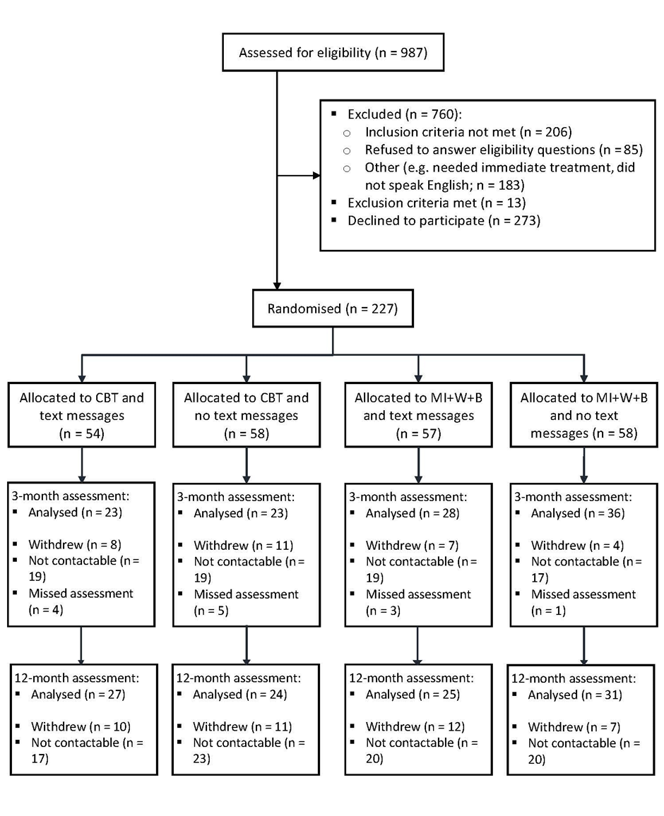
Note: Some uncontactable participants at the three-month assessment were contacted at the 12-month assessment.
    - Received interventions

One-fifth (20.5%) of participants randomised to the CBT intervention and two-fifths (40%) of participants randomised to the MI+W+B intervention did not receive any of the allocated intervention, with the majority failing to turn up for the first treatment session. Participants were not aware of the intervention to which they had been assigned until they attended their first treatment session. Four of the participants who did not receive the allocated intervention received an alternative intervention (e.g. focused on acute anxiety).

Only eight percent of CBT allocated participants completed the scheduled 10 weeks of treatment. Most participants dropped out of treatment after attending between one and three sessions, with a steady drop-out rate after each of the subsequent sessions. Conversely, 24.3% of MI+W+B allocated participants completed the scheduled six weeks of treatment, with a further 5.2% attending one to three additional sessions. Of the MI+W+B participants who did not complete treatment, the largest proportion dropped out after attending the first session. However, the drop-out rate after each of the subsequent sessions was much lower than for the CBT group.

Table 3 shows the number and percentage of participants in the CBT and MI+W+B intervention groups (with or without text messages combined) by the number of attended sessions.

Table 3: Number and percentage of sessions attended by intervention group
 | Number and percentage (%) of sessions received
Intervention | 0 | 1 | 2 | 3 | 4 | 5 | 6 | 7 | 8 | 9 | 10
CBT  N=112 | 23  (20.5) | 26  (23.2) | 15  (13.4) | 13  (11.6) | 10  (8.9) | 3  (2.7) | 4  (3.6) | 2  (1.8) | 5  (4.5) | 2  (1.8) | 9  (8.0)
% receiving each session | 20.5 | 79.5 | 56.3 | 42.9 | 31.3 | 22.4 | 19.7 | 16.1 | 14.3 | 9.8 | 8.0
MI+W+B N=115 | 46  (40.0) | 14  (12.2) | 5  (4.3) | 4  (3.5) | 8  (7.0) | 4  (3.5) | 28  (24.3) | 3  (2.6) | 2  (1.7) | 1  (0.9) | -
% receiving each session | 40.0 | 60.0 | 47.8 | 43.5 | 40.0 | 33.0 | 29.5 | 5.2 | 2.6 | 0.9

Of the 111 participants assigned to the text messaging intervention 22.5% (n=25) opted to stop receiving the messages before the scheduled end. Fourteen percent (n=16) were in the CBT intervention group and eight percent (n=9) in the MI+W+B group. They stopped receiving the messages between 27 days (received 8 of 72 messages) and 222 days (received 64 messages) from the date of their three-month assessment, which was when the text messages commenced.

    - Number of participants

Intention-To-Treat data set

Of the 227 participants recruited into the trial, 110 participants (48.5%) remained in the trial at the three-month assessment and 107 participants (47.1%) remained at the 12-month assessment. Participant retention varied between the groups at each assessment. There was slightly better retention in the MI+W+B group compared with the CBT group at the three-month assessment. However, the retention was similar at the 12-month assessment (Table 4).
Table 4: ITT data set at each assessment
 | Assessment
Intervention | Baseline | 3 months |  | 12 months
 | n | n | (%) | n | (%)
CBT | 112 | 51 | (45.9) | 51 | (45.5)
MI+W+B | 115 | 59 | (50.9) | 56 | (48.7)
Total | 227 | 110 | (48.5) | 107 | (47.1)

Per Protocol data set

The Per Protocol analyses were carried out on participants who did not have a major protocol violation, that is, who had attended at least half of the protocol scheduled sessions (i.e. 5 of 10 sessions in the CBT group and 3 of 6 sessions in the MI+W+B group). Less than half the participants in either intervention group completed protocol. CBT participants were less likely to have received at least half the sessions (n = 25, 22.3%) compared with participants in the MI+W+B group (n = 50, 42.9%).

  - Baseline participant characteristics

    - Sociodemographic characteristics

Sociodemographic characteristics of the participants at baseline are detailed in Appendix 3.

There were more males than females in all intervention groups (56.9% to 68.4% male, overall 60.8%). Slightly more than one-quarter of participants were Māori (25.9% to 29.8%), slightly more than one-tenth (12.1% to 13.8%) were of Pacific ethnicity, and the rest were of European/Other ethnicity (56.9% to 61.1%). Marital status was similar across the groups in that fewer than half of the participants were partnered (27.8% to 48.3%), compared with not being partnered. In the CBT with no text messages group, there was a relatively even split by age group (22.8% to 28.1%). However, for the other intervention groups the proportion of younger adults aged 18 to 34 years (35.1% to 42.6%) was greater than for the other age groups (16.7% to 24.6%).

The highest educational qualification achieved was relatively similar across groups although there were some fluctuations. In the MI+W+B with no text messages group, a higher proportion of participants had a school level qualification (42.1%) compared with the other groups (27.5 to 34.5). Consequently, a lower proportion had no formal qualification (14% vs. 19% to 21.6%) or a trade/vocational qualification (17.5% vs. 21.6% to 29.3%). Participants with university level education ranged from 17.2% in the CBT with no text messages group to 29.4% in the CBT with text messages group.

Participants in paid employment (full time or part time) comprised 43.1% to 59.6% of the sample in each intervention group, with about one-quarter unemployed (21.1% to 27.8%), and the rest comprising other participants (e.g. retired, student or homemaker; 19.3% to 31.0%). The lowest category of up to $50,000 annual household income comprised the largest proportion of participants in all groups (26.3% to 31%), although one-quarter or more of participants in each group refused to provide income data.

More than two-fifths of participants in all groups apart from the MI+W+B with text messages group experienced the highest levels of deprivation (experienced 3 to 7 indicators; 40.7% to 44%). For the MI+W+B with text messages group, 42.6% of the sample were in the mid-deprivation level (experienced 1 to 2 indicators).

    - Gambling characterisation

Problematic gambling activity

Participants’ primary problematic gambling mode at baseline was similar across the groups with a majority citing EGMs (74.1% to 84.5%). These comprised pub, casino and club EGMs. The remaining participants cited casino table games, track betting, sports betting, card gambling, Lotto, or other forms of gambling. Participants could report multiple primary problematic gambling activities. Problematic gambling activities reported by participants at baseline are detailed in Appendix 4.

Duration of gambling problems

In the CBT without text messages group, a majority of participants had been gambling for seven or more years (63.8%). For participants in the other intervention groups, the largest proportion of participants had gambled for up to six years (54.4% to 55.6%) (Appendix 4).

The median duration, reported at baseline, that participants had experienced gambling problems prior to accessing the current treatment varied from six to 10 years, meaning that, overall, problems were deep-rooted. The range was zero to 35 years. There were some variations in participant profile between the intervention groups (Table 5).

Table 5: Duration of gambling problems
 |  | CBT  no text | CBT  with text | MI+W+B  no text | MI+W+B  with text
Duration of gambling problems (years) | Mean | 11.1 | 8.8 | 8.7 | 9.2
 | Median | 10 | 6 | 6 | 6
 | Minimum | 0.3 | 0 | 0.2 | 0.1
 | Maximum | 30 | 29 | 30 | 35

Number of days since last gamble

At the baseline assessment, the median number of days that participants had gone without gambling was seven or fewer. The range was large, from zero to 730 days (two years) (Table 6).

Table 6: Number of days since last gamble
 |  | CBT  No text | CBT  With text | MI+W+B  No text | MI+W+B  with text
Number of days since last gamble | Mean | 27.1 | 30.4 | 15 | 32.2
 | Median | 7 | 6 | 5 | 7
 | Minimum | 0 | 0 | 0 | 0
 | Maximum | 730 | 730 | 212 | 540

    - Treatment assistance and goal

Treatment assistance

At the baseline assessment, between 5.6% and 17.9% of participants across the four groups were currently receiving professional treatment for their gambling problems with one-fifth to two-fifths (20.4% to 39.7%) having previously received professional treatment. Greater proportions of participants were currently (14.8% to 29.8%) receiving informal assistance (from family, friends or other support person) though fewer had received informal assistance in the past (10.5% to 17.2%) (Table 7).

Table 7: Current and past treatment
Treatment | Type | CBT  no text |  | CBT  with text |  | MI+W+B  no text |  | MI+W+B  with text
 |  | N | (%) | N | (%) | N | (%) | N | (%)
Current | Professional | 6 | (10.3) | 3 | (5.6) | 10 | (17.9) | 5 | (8.9)
 | Informal (e.g. family/friends) | 12 | (20.7) | 8 | (14.8) | 17 | (29.8) | 13 | (23.2)
Past | Professional | 23 | (39.7) | 11 | (20.4) | 18 | (31.0) | 18 | (31.6)
 | Informal (e.g. family/friends) | 10 | (17.2) | 9 | (16.7) | 9 | (16.4) | 6 | (10.5)

Treatment goal

At the baseline assessment, three quarters of participants wanted to quit some or all gambling activities (73.5% CBT, 75.2% MI+W+B) with the remaining participants wanting to gamble in a non-problematic manner or maintain current gambling abstinence.

  - Primary outcomes

The two primary outcomes were:
- Self-reported monthly average number of days spent gambling (Days gambled)
- Self-reported monthly average amount of money lost per day gambling (Money lost).

For Days gambled, the baseline range was 0 to 31 days. The outcome was transformed into a three-category variable: 0, 1 to 3, 4+ Days gambled.

For Money lost, the baseline range was $0 to $144,000. The outcome was transformed into a three-category variable: $0, $1 to $500, $501+ lost.

Text messaging analyses were not broken down by intervention group in the primary and secondary ITT and PP analyses because of low sample sizes.

    - Days gambled

At the baseline assessment, most participants had gambled, with slightly more than two-thirds (69%) gambling, on average, on four or more days per month. About five percent of participants in each intervention group had not gambled.

At the three-month assessment, the proportion of participants who had not gambled increased to slightly more than one-third, with a higher proportion noted for the CBT group (42.5%) compared with the MI+W+B group (34.5%). The proportions decreased slightly at the 12-month assessment.

The proportions of participants who gambled four or more times per month declined substantially at the three-month assessment, slightly more so for participants in the MI+W+B group (from 69.2% to 25.9%) than the CBT group (from 69.5% to 30%). The decreasing trend continued for the MI+W+B group at the 12-month assessment, offset by an increase in the proportion gambling one to three days per month: 26.2% at baseline, 39.7% at three-months, 51% at 12-months. This indicated controlled gambling rather than abstinence. A similar pattern was not observed with the CBT group.

Figure 2 shows the monthly average number of days gambled over time.

Figure 2: Monthly average number of days gambled by intervention group
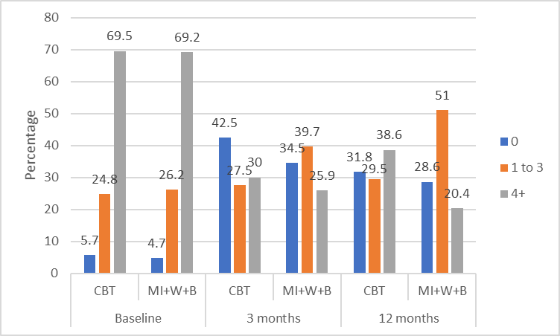

The text message relapse prevention intervention was administered following the three-month assessment until the 12-month assessment. Receipt of text messages did not appear to alter days gambled as proportions at the 12-month assessment were either similar between those receiving or not receiving the messages or were similar to the three-month proportions before the messages were administered (Figure 3).

Figure 3: Monthly average number of days gambled by text messaging group
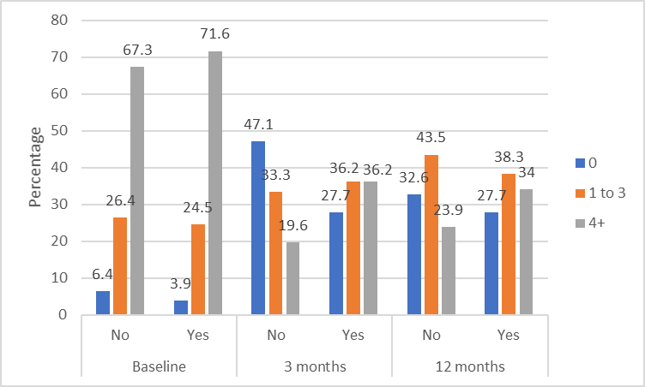

    - Money lost

At the baseline assessment, more than two-thirds (70.9% CBT, 69.5% MI+W+B) of participants had lost $501 or more per month on gambling. This reduced substantially at the three-month assessment to 28.2% of the CBT group and 20.8% of the MI+W+B group and remained essentially similar at the 12-month assessment. The proportions of participants losing $1 to $500 per month increased over time, more so for the MI+W+B group with the proportion doubling from the baseline assessment (25.7%) to the 12-month assessment (52.1%). This is an indication of controlled gambling for this group as a larger proportion of participants lost less money on gambling over time.

The proportion of participants who did not lose any money gambling (i.e. abstainers) increased from less than seven percent at baseline to slightly more than one-third at the three-month assessment, reducing slightly to just less than one-third at the 12-month assessment.

Figure 4 shows the monthly average money lost (dollars) gambling at each assessment.
Figure 4: Monthly average money lost by intervention group
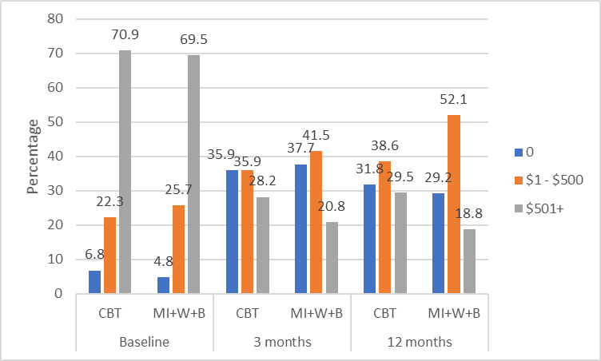

Receipt of text messages did not appear to alter money lost on gambling as proportions at the 12-month assessment were similar between those receiving and not receiving text messages (Figure 5).

Figure 5: Monthly average money lost by text messaging group
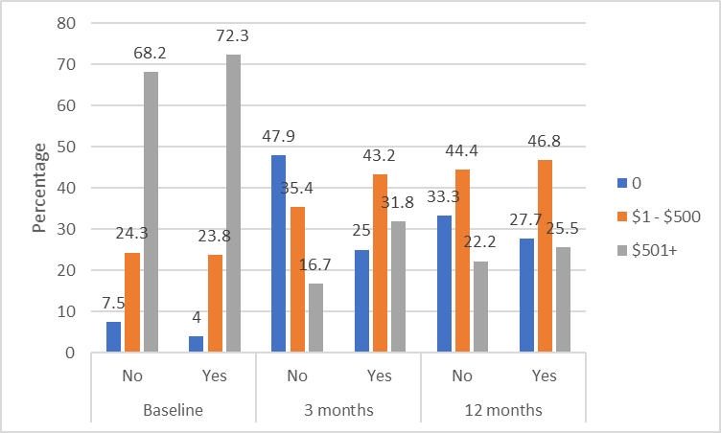

    - ITT data set: Days gambled and Money lost - inferential analyses

There were no significant differences in Days gambled or Money lost between the CBT and MI+W+B groups at either the three- or 12-month assessments in the ITT data set. Neither were there any significant differences in Days gambled or Money lost between participants receiving and not receiving text messages (Table 8).

Table 8: ITT data set - Days gambled and Money lost, CBT vs. MI+W+B, text messaging vs. none
 | Odds Ratio | (95% CI) | P-value
Days gambled
CBT - 3 months | 0.39 | (0.066, 2.32) | 0.28
CBT - 12 months | 1.35 | (0.34, 5.39) | 0.66
Text messaging - 12 months | 0.96 | (0.24, 3.87) | 0.95
Money lost
CBT - 3 months | 1.59 | (0.37, 6.81) | 0.51
CBT - 12 months | 0.87 | (0.31, 2.40) | 0.78
Text messaging - 12 months | 0.79 | (0.27, 2.28) | 0.65
MI+W+B group = reference group vs. CBT group
No text messages = reference group vs. received text messaging intervention
Adjusted for deprivation (Days gambled and Money lost) and employment (Money lost)
Bold text in table indicates statistical significance

Subgroup analyses by Māori and Pacific ethnicity

Due to very small sample sizes (particularly for the Pacific subgroup) at the three- and 12-month assessments, only Fisher’s exact test for independence could be performed. All results were non-significant (data not shown) meaning that there was no intervention effect for these ethnic subgroups that was different from the other participants.

    - PP data set: Days gambled and Money lost - inferential analyses

Twenty-five participants in the CBT group (22.3%) and 50 participants in the MI+W+B group (42.9%) fulfilled the criterion for the Per Protocol data set (Figure 6). Overall, 35 of the PP participants received text messages, whilst 40 were not in the text messaging intervention.

Figure 6: Percentages of participants meeting Per Protocol criteria
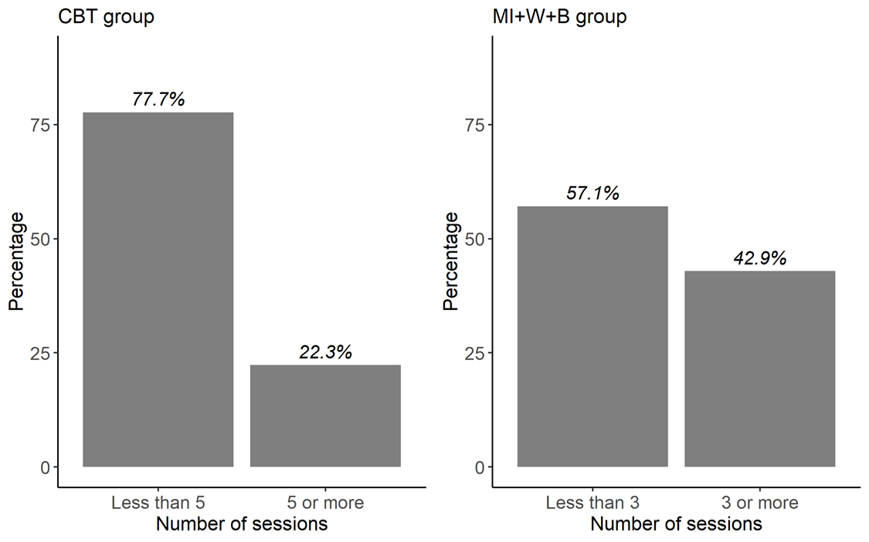

There were no significant differences in Days gambled or Money lost between the CBT and MI+W+B groups at either the three- or 12-month assessments in the PP data set. Neither were there any significant differences in Days gambled or Money lost between participants receiving and not receiving text messages (Table 9).

Table 9: PP data set - Days gambled and Money lost, CBT vs. MI+W+B, text messaging vs. none
 | Odds Ratio | (95% CI) | P-value
Days gambled
CBT - 3 months | 0.96 | (0.085, 10.89) | 0.97
CBT - 12 months | 0.33 | (0.046, 2.35) | 0.26
Text messaging - 12 months | 1.23 | (0.19, 8.06) | 0.82
Money lost
CBT - 3 months | 1.66 | (0.29, 9.49) | 0.55
CBT - 12 months | 0.54 | (0.092, 3.18) | 0.48
Text messaging - 12 months | 0.81 | (0.18, 3.53) | 0.77
MI+W+B group = reference group vs. CBT group
No text messages = reference group vs. received text messaging intervention
Adjusted for deprivation and employment (Money lost only)

  - Secondary outcomes - ITT data set

    - Gambling risk level

At the baseline assessment, almost all participants in the CBT and MI+W+B groups were categorised as problem gamblers via the past 12-month PGSI (92.2% and 92.6%, respectively). Amongst participants in the text messaging groups compared with the non-text messaging groups the percentages were similar (91.3% and 93.5%, respectively). The mean PGSI scores ranged from 14.4 to 15.8 for the four intervention groups. At the 12-month assessment, improvement was noted for all groups with slightly less than half of the participants being categorised as problem gamblers in the CBT and MI+W+B groups (46% and 43.4%, respectively) and in the text messaging versus non text messaging groups (43.1% and 46.2%, respectively). The mean PGSI scores ranged from 7.8 to 10 for the four intervention groups.

Mean PGSI scores are shown in Figure 7.

Figure 7: Mean PGSI score, past 12-month time frame
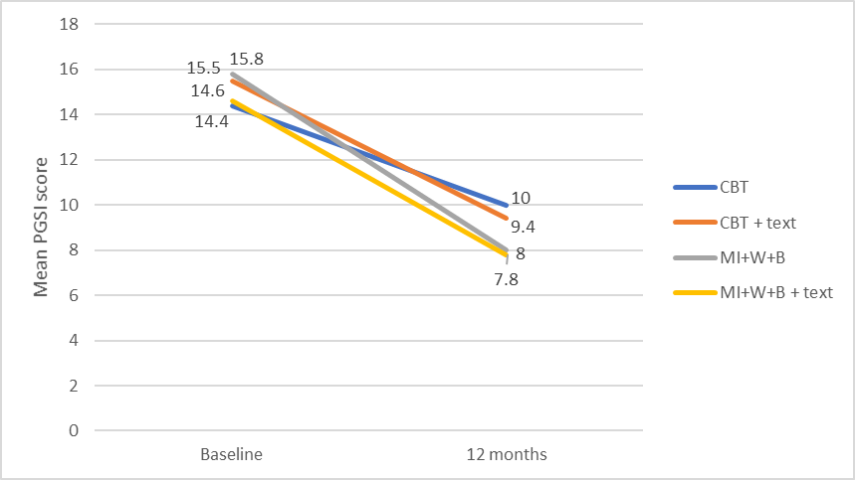

When a past three-month PGSI was administered there was evidence of a reduction in problem severity at the three-month assessment for all groups, with the mean PGSI scores being in the moderate risk range of three to seven. However, there appeared to be a slight reversal of this improvement at the 12-month assessment for the CBT group without text messages with the mean PGSI score being in the problem gambler category again, albeit at the lower end (score of 8.5 vs. a score of 14.9 at baseline). Participants in the CBT with text messages group and in both MI+W+B groups (with and without text messages) remained in the moderate risk category at the 12-month assessment with a marginal increase in mean score from the three-month assessment (Figure 8).

Figure 8: Mean PGSI score, past three-month time frame
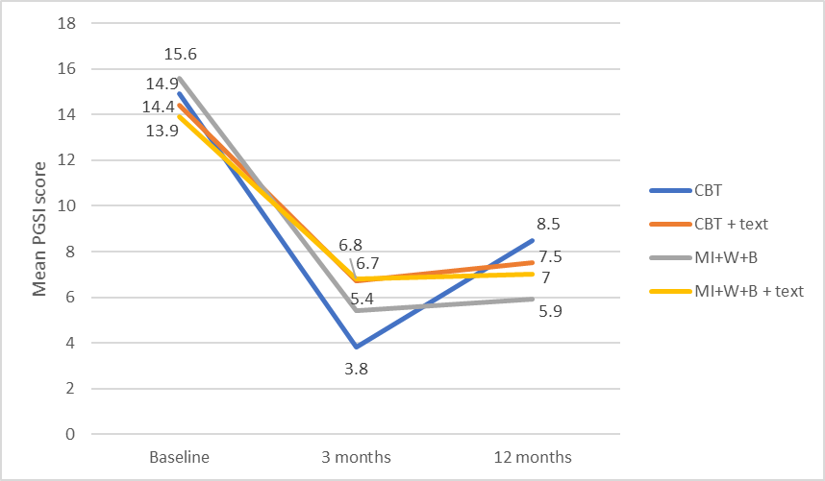

Inferential analyses showed that there were no significant differences in gambling risk level (analysed as a binary outcome of ‘non-risk to moderate-risk’ and ‘problem gambler’) between the CBT and MI+W+B groups at either the three- or 12-month assessments. Similarly, there were no significant differences in gambling risk level between those receiving and not receiving text messages (Table 10).

Table 10: Gambling risk level, CBT vs. MI+W+B, text messaging vs. none
 | Odds Ratio | (95% CI) | P-value
PGSI (3-month time frame)
CBT - 3 months | 0.73 | (0.20, 2.75) | 0.64
CBT - 12 months | 1.13 | (0.39, 3.30) | 0.82
Test messaging - 12 months | 1.21 | (0.43, 3.46) | 0.71
PGSI (12-month time frame)
CBT - 12 months | 1.03 | (0.39, 2.74) | 0.95
Text messaging - 12 months | 1.12 | (0.54, 2.34) | 0.76
MI+W+B group = reference group vs. CBT group
No text messages = reference group vs. received text messaging intervention
Adjusted for deprivation (PGSI 12-month time frame only)

    - Gambling urge

The urge to gamble was measured using the Gambling Urge Scale (GUS), whereby higher scores indicated greater urge. The baseline scores ranged from 0 to 42. For analysis, the scores were transformed into a three-category variable of 0, 1 to 7, 8+.
At the baseline assessment, a majority of participants (approx. 60%) scored eight or more (i.e. had a higher urge to gamble) and fewer than one-fifth scored zero (i.e. no gambling urge). At the subsequent assessments, a substantially greater proportion of CBT group participants scored zero compared with MI+W+B group participants, although the difference was less at 12 months than at three months (Figure 9). However, these differences were not statistically significant - see inferential analyses paragraph below.

Figure 9: Gambling urge by intervention group
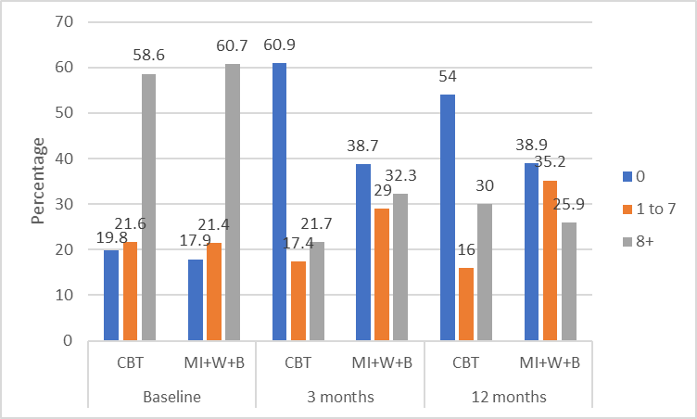

A greater proportion of participants who did not receive text messages had zero gambling urge at the 12-month assessment (52.7%) compared with participants who received text messages (38.8%). There were no major apparent differences between groups receiving, or not receiving, text messages and scoring eight or higher on the GUS. However, at both the three- and 12-month assessments a larger proportion of participants who received text messages scored one to seven (27.5% and 32.7%, respectively) than participants who did not receive text messages (21.1% and 20%, respectively) (Figure 10). These differences were not statistically significant - see inferential analyses paragraph below.

Figure 10: Gambling urge by text messaging group
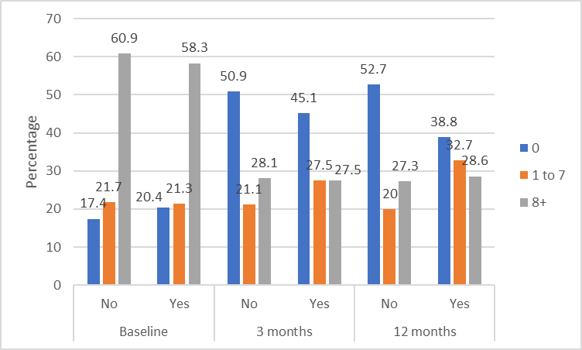

Inferential analyses showed that there were no significant differences in gambling urge between the CBT and MI+W+B groups at either the three- or 12-month assessments. Similarly, there were no significant differences in gambling urge between those receiving and not receiving text messages (Table 11).

Table 11: Gambling urge, CBT vs. MI+W+B, text messaging vs. none
Gambling Urge Scale | Odds Ratio | (95% CI) | P-value
CBT - 3 months | 0.79 | (0.25, 2.55) | 0.69
CBT - 12 months | 0.70 | (0.27, 1.82) | 0.45
Text messaging - 12 months | 1.33 | (0.68, 2.58) | 0.40
MI+W+B group = reference group vs. CBT group
No text messages = reference group vs. received text messaging intervention
Adjusted for deprivation

    - Motivation to overcome gambling-related problems

Participants’ motivation to overcome their gambling problems remained high throughout the trial, with the mean score ranging from 8.9 to 9.1 (out of a maximum score of 10) at baseline, to a range of 7.7 to 9.4 at the 12-month assessment.

For inferential analyses, the scores were transformed into a two-category variable of 0 to 9, and 10, and showed that there were no significant differences in motivation to overcome gambling problems between the CBT and MI+W+B groups at either the three- or 12-month assessments. Similarly, there were no significant differences in motivation to overcome gambling problems between those receiving and not receiving text messages (Table 12).

Table 12: Motivation to overcome gambling problems, CBT vs. MI+W+B, text messaging vs. none
Treatment motivation | Odds Ratio | (95% CI) | P-value
CBT - 3 months | 1.25 | (0.35, 4.48) | 0.72
CBT - 12 months | 0.77 | (0.31, 1.89) | 0.56
Text messaging - 12 months | 0.45 | (0.15, 1.36) | 0.15
MI+W+B group = reference group vs. CBT group
No text messages = reference group vs. received text messaging intervention
Adjusted for gender and ethnicity

    - Confidence in success of meeting treatment goal

The baseline scores ranged from 0 to 10. For analysis, the scores were transformed into a three-category variable of 0 to 7, 8 to 9, 10.

About two-fifths (40%) of participants in both intervention groups were completely confident (score 10) that they would meet their treatment goal, when asked at the baseline assessment. The percentage increased somewhat at the three-month assessment then decreased slightly at the 12-month assessment. There was no appreciable difference between the intervention groups. The proportion of CBT participants with lower confidence in their success (score 0 to 7) decreased slightly from baseline (29.1%) to three months (23.9%) but then increased at the 12-month assessment (41.2%). Whilst a similar pattern was observed for lower confidence in success from baseline to three-months for the MI+W+B group, an increase at the 12-month assessment was not observed (Figure 11). This difference was not statistically significant - see inferential analyses paragraph below.

Figure 11: Confidence in success of meeting treatment goal by intervention group
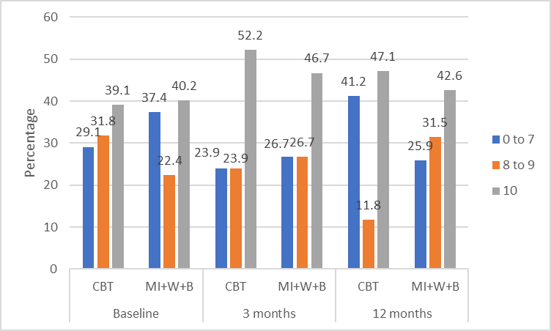

Receipt of text messages did not appear to alter confidence in treatment success as proportions at the 12-month assessment were broadly similar to those at the three-month assessment, before the text intervention commenced (Figure 12).

Figure 12: Confidence in success of meeting treatment goal by text messaging group
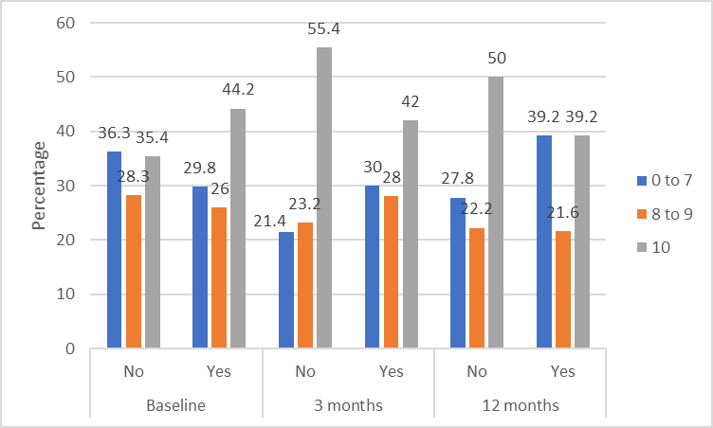

Inferential analyses showed that there were no significant differences in participants’ confidence in treatment success between the CBT and MI+W+B groups at either the three- or 12-month assessments. Similarly, there were no significant differences in confidence in success between those receiving and not receiving text messages (Table 13).

Table 13: Confidence in treatment success, CBT vs. MI+W+B, text messaging vs. none
Confidence in treatment success | Odds Ratio | (95% CI) | P-value
CBT - 3 months | 0.73 | (0.20, 2.72) | 0.63
CBT - 12 months | 1.06 | (0.44, 2.57) | 0.89
Text messaging - 12 months | 0.67 | (0.30, 1.47) | 0.31
MI+W+B group = reference group vs. CBT group
No text messages = reference group vs. received text messaging intervention
Adjusted for gender

    - Goal achievement

No major differences between the intervention groups were noted in terms of achieving the treatment goal of stopping all gambling activities, stopping only problematic gambling activities, or reducing gambling. At the three-and 12-month assessments, about two-fifths of participants reported they had completely met their treatment goal. However, the proportion who had not met their goal at all at the three-month assessment (15.2% CBT, 11.3% MI+W+B) increased substantially at the 12-month assessment (27.5% CBT, 21.8% MI+W+B) (Figure 13).

Figure 13: Goal achievement by intervention group
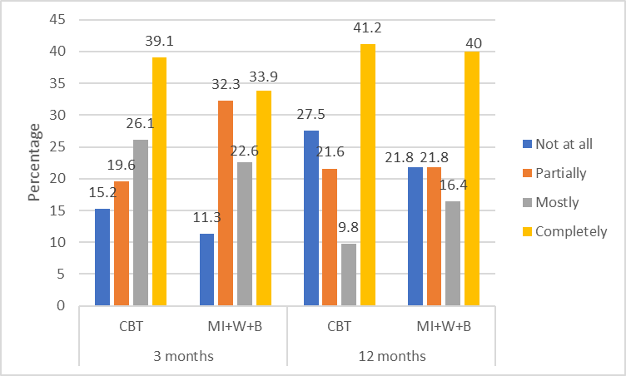

Receipt of text messages did not appear to affect goal achievement as proportions at the 12-month assessment were broadly similar between those receiving and not receiving the messages, and the spread was similar to the proportions noted at the three-month assessment (Figure 14).

Figure 14: Goal achievement by text messaging group
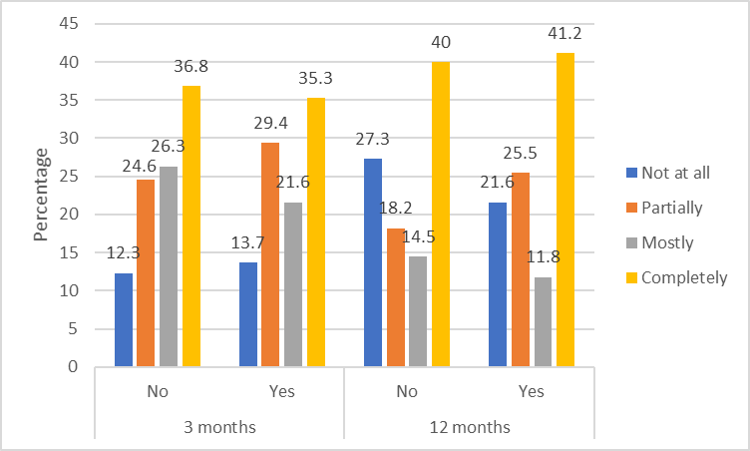

Inferential analyses showed that there were no significant differences in goal achievement between the CBT and MI+W+B groups at either the three- or 12-month assessments. Similarly, there were no significant differences in goal achievement between those receiving and not receiving text messages (Table 14).

Table 14: Goal achievement, CBT vs. MI+W+B, text messaging vs. none
Goal achievement | Odds Ratio | (95% CI) | P-value
CBT - 3 months | 0.70 | (0.24, 2.02) | 0.50
CBT - 12 months | 1.05 | (0.42, 2.66) | 0.91
Text messaging - 12 months | 1.28 | (0.61, 2.69) | 0.51
MI+W+B group = reference group vs. CBT group
No text messages = reference group vs. received text messaging intervention
Adjusted for ethnicity and deprivation

    - Control over gambling

The baseline scores ranged from 0 to 10. For analysis, the scores were transformed into a three-category variable of 0 to 6, 7 to 9, 10.

At baseline, about two-thirds of participants in both intervention groups had low control over their gambling (score 0 to 6). At the three-month assessment this had reduced to one-quarter or fewer of participants, remaining the same at the 12-month level for MI+W+B participants only. However, for the CBT group, the proportion with low control over gambling increased again at the 12-month assessment to 43.1%. The proportions showing moderate (score 7 to 9) control over gambling increased at the three-month assessment compared to baseline but decreased slightly at the 12-month assessment; the proportions remained higher than at baseline and double the percentage in the MI+W+B group (44.4%) showed this level of control compared with the CBT group (21.6%). A different profile was noted for participants with complete control over their gambling (score 10) whereby greater percentages in the CBT group indicated total control at the three-month assessment compared with the MI+W+B group (37.8% vs. 19.4). The difference reduced at the 12-month assessment (35.3% CBT vs. 29.6% MI+W+B) (Figure 15).

Figure 15: Control over gambling by intervention group
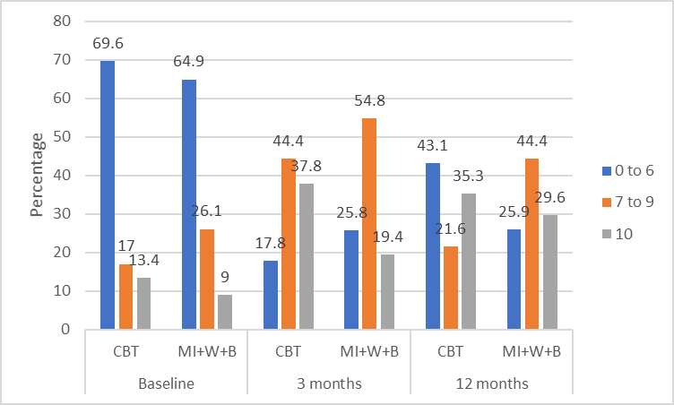

Receipt of text messages did not appear to affect control over gambling as proportions at the 12-month assessment were similar between those receiving and not receiving text messages (Figure 16).
Figure 16: Control over gambling by text messaging group
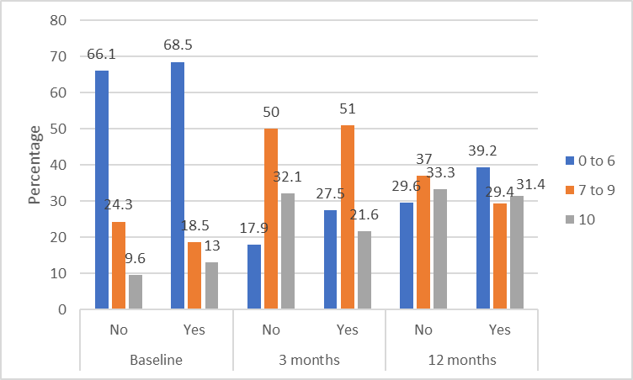

Inferential analyses showed that there were no significant differences in control over gambling between the CBT and MI+W+B groups at either the three- or 12-month assessments. There were no significant differences in control over gambling between those receiving and not receiving text messages (Table 15).

Table 15: Control over gambling, CBT vs. MI+W+B, text messaging vs. none
Control over gambling | Odds Ratio | (95% CI) | P-value
CBT - 3 months | 1.80 | (0.59, 5.53) | 0.29
CBT - 12 months | 0.79 | (0.29, 2.16) | 0.64
Text messaging - 12 months | 0.96 | (0.40, 2.29) | 0.93
MI+W+B group = reference group vs. CBT group
No text messages = reference group vs. received text messaging intervention
Bold text in table indicates statistical significance

    - Gambling consequences

No major differences between the intervention groups were noted in terms of experiencing negative consequences from gambling (Figure 17). At baseline, a majority of participants (58.6% to 83.5%) reported some level of negative consequences from their gambling on their professional life, social life, family life and home responsibilities, and physical health. At the three-month assessment, the proportions of participants reporting these negative consequences decreased substantially (14.3% to 33.3%) but increased slightly at the 12-month assessment (22.2% to 40%). Slightly less than one-fifth of participants at baseline reported legal consequences because of gambling, this remained broadly the same at the post-treatment assessments.

Figure 17: Negative consequences of gambling by intervention group
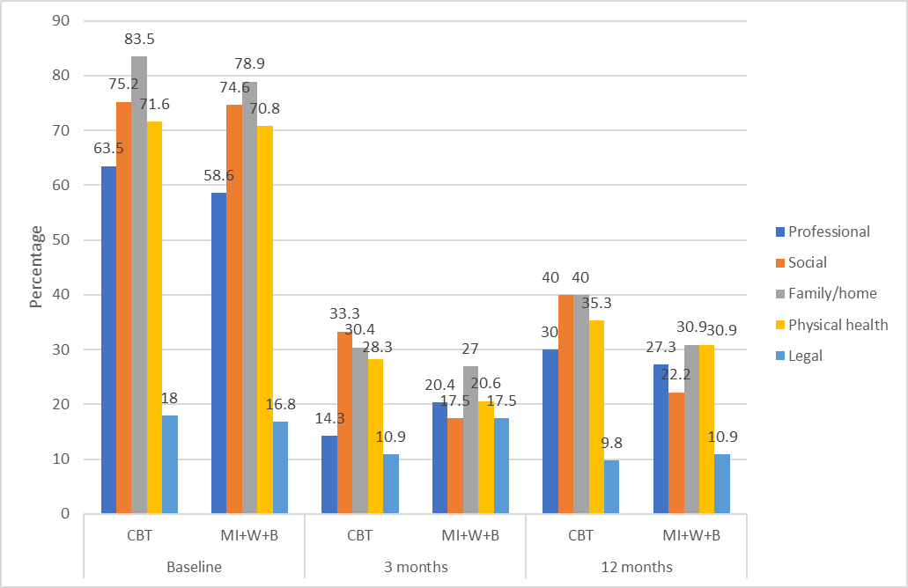

Figure 18 shows the percentages of participants experiencing negative consequences from gambling by whether they received the text messaging intervention. Receipt of text messages did not appear to affect the proportions of participants experiencing negative consequences from their gambling as at the 12-month assessment, percentages were broadly similar between those receiving or not receiving the messages, and the distribution was similar to the proportions noted at the three-month assessment. The exception was for legal problems where it appeared that a lower percentage of participants who received text messages experienced legal problems (5.9%) compared with those who did not receive the text messages (14.5%) at the 12-month assessment. Although the same trend had been noted at previous assessments (before the text messaging intervention had been delivered), the difference appeared larger at the 12-month assessment but was probably due to the very small sample sizes for this sub-population.

Figure 18: Negative consequences of gambling by text messaging group
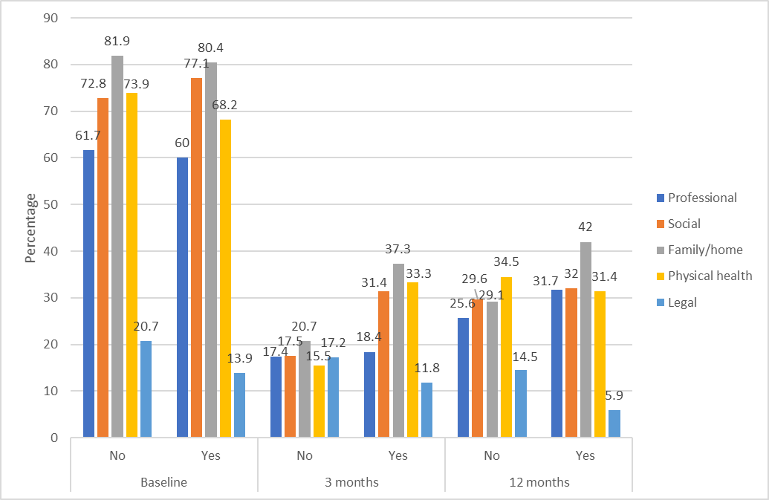

Inferential analyses showed that there were no significant differences in experiencing negative consequences from gambling between the CBT and MI+W+B groups at either the three- or 12-month assessments. Similarly, there were no significant differences in gambling consequences between those receiving and not receiving text messages (Table 16).

Table 16: Gambling consequences, CBT vs. MI+W+B, text messaging vs. none
Negative effects on: | Odds Ratio | (95% CI) | P-value
Professional lifeª
CBT - 3 months | 1.33 | (0.38, 4.73) | 0.65
CBT - 12 months | 0.66 | (0.28, 1.57) | 0.34
Test messaging - 12 months | 1.06 | (0.41, 2.76) | 0.90
Social life^{b}
CBT - 3 months | 1.14 | (0.24, 5.50) | 0.87
CBT - 12 months | 2.56 | (0.77, 8.56) | 0.13
Text messaging - 12 months | 0.87 | (0.27, 2.86) | 0.82
Family/home life
CBT - 3 months | 1.69 | (0.20, 14.48) | 0.63
CBT - 12 months | 0.32 | (0.029, 3.53) | 0.35
Text messaging - 12 months | 0.79 | (0.11, 5.76) | 0.81
Physical health
CBT - 3 months | 1.71 | (0.37, 8.00) | 0.49
CBT - 12 months | 1.14 | (0.35, 3.65) | 0.83
Text messaging - 12 months | 0.54 | (0.16, 1.76) | 0.30
Legal problems^{b}
CBT - 3 months | 1.07 | (0.17, 6.64) | 0.94
CBT - 12 months | 0.87 | (0.19, 4.04) | 0.85
Text messaging - 12 months | 0.63 | (0.20, 1.99) | 0.43
MI+W+B group = reference group vs. CBT group
No text messages = reference group vs. received text messaging intervention
ª Adjusted for ethnicity, annual household income and deprivation
^{b} Adjusted for deprivation

    - Substance use

Compared with the CBT group, participants in the MI+W+B group appeared to have better long-term outcomes in relation to smoking tobacco and drug use. At the 12-month assessment the proportions of participants in the MI+W+B group who reported smoking tobacco or drug use (37% and 15.1%, respectively) were substantially lower than in the CBT group (52% and 25%, respectively). These proportions were lower than at baseline for the MI+W+B group but not for the CBT group, and were not apparent at the three-month assessment for tobacco smoking (drug use data not collected at that time). However, these differences were not statistically significant - see inferential analyses paragraph below.

Although the proportions of participants with hazardous alcohol consumption reduced slightly over time, there was no appreciable difference between the CBT and MI+W+B groups with the same pattern between the groups noted at each assessment.

Figure 19 details the percentage of participants by intervention group who consumed alcohol in a hazardous manner, smoked tobacco or used drugs.

Figure 19: Substance use by intervention group
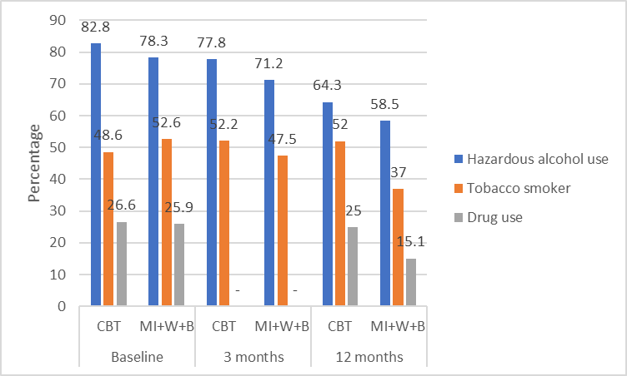
Note: Drug use data were not collected at the three-month assessment

Receipt of text messages did not appear to affect substance use as proportions at the 12-month assessment were broadly similar between those receiving or not receiving the messages or similar to the pattern noted at prior assessments before text messages were received (Figure 20).

Figure 20: Substance use by text messaging group
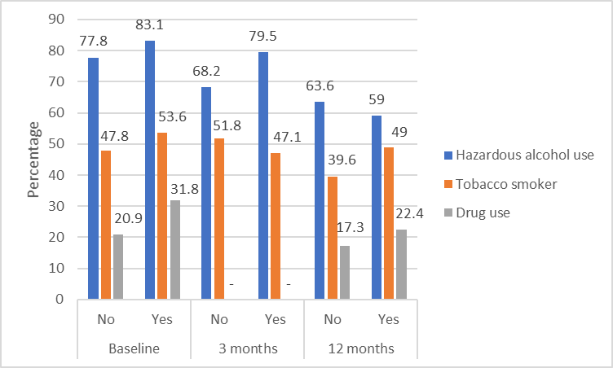
Note: Drug use data were not collected at the three-month assessment

Inferential analyses showed that there were no significant differences in hazardous alcohol consumption, tobacco smoking or drug use between the CBT and MI+W+B groups at either the three- or 12-month assessments. There were no significant differences in substance use between those receiving and not receiving text messages (Table 17).

Table 17: Substance use, CBT vs. MI+W+B, text messaging vs. none
Substance | Odds Ratio | (95% CI) | P-value
Hazardous alcohol consumption
CBT - 3 months | 1.13 | (0.25, 5.08) | 0.87
CBT - 12 months | 1.17 | (0.31, 4.45) | 0.81
Test messaging - 12 months | 0.54 | (0.20, 1.50) | 0.23
Tobacco smoking
CBT - 3 months | 1.49 | (0.33, 6.62) | 0.60
CBT - 12 months | 0.98 | (0.24, 3.91) | 0.97
Text messaging - 12 months | 2.16 | (0.58, 8.09) | 0.25
Drug use
CBT - 3 months | - | - | -
CBT - 12 months | 4.78 | (0.55, 41.56) | 0.15
Text messaging - 12 months | 0.85 | (0.067, 10.80) | 0.90
MI+W+B group = reference group vs. CBT group
No text messages = reference group vs. received text messaging intervention
Adjusted for age (tobacco smoking only)
Note: Drug use data were not collected at the three-month assessment

    - Mental health

Psychological distress

No major differences between the intervention groups were noted in terms of experiencing psychological distress (Figure 21). At baseline, about two-fifths of participants (40.4% to 45.4%) reported mild to severe levels of distress (measured with the Kessler 10). At the three-month assessment, the proportions of participants reporting this level of distress decreased substantially (13.6% to 21%). At the 12-month assessment, a continued decrease was noted for participants in the MI+W+B group (7.8%), which was not apparent in the CBT group (18%). However, this difference was not statistically significant - see inferential analyses paragraph below.

Figure 21: Psychological distress by intervention group
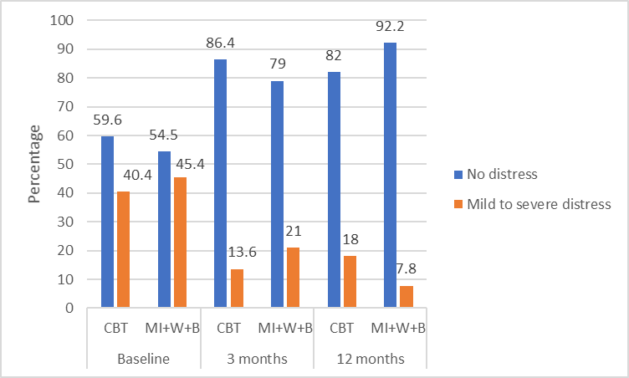

Receipt of text messages did not appear to affect psychological distress as proportions at the 12-month assessment were broadly similar between those receiving and not receiving text messages (Figure 22).

Figure 22: Psychological distress by text messaging group
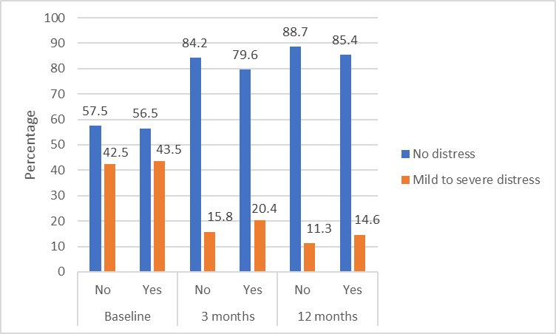

Depression

Fewer participants in the CBT group had minor depression at the three-month assessment (29.5%) compared with the MI+W+B group (46.7%), although both groups started with a prevalence of almost three-quarters (72%). The percentages remained similar between the three- and 12-month assessments. The prevalence of dysthymia also reduced from baseline to the 12-month assessment (but not at three-months) although there were no major differences between the intervention groups. Receiving an intervention did not affect levels of major depression nor bipolar disorder (Figure 23). The latter group had a very small sample size meaning that minor changes in number led to large percentage fluctuations.

Figure 23: Depression by intervention group
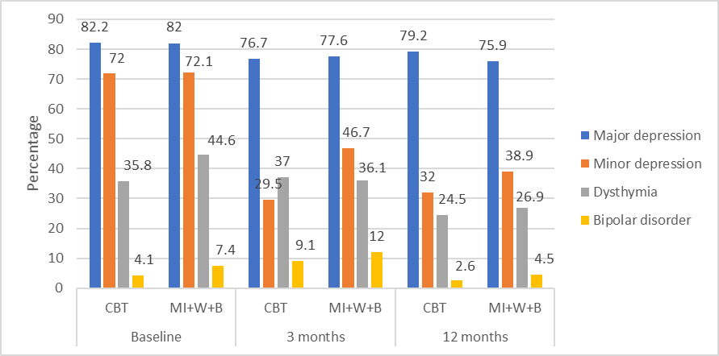

Receipt of text messages did not appear to affect depression as proportions at the 12-month assessment were broadly similar between those receiving and not receiving text messages (Figure 24).

Figure 24: Depression by text messaging group
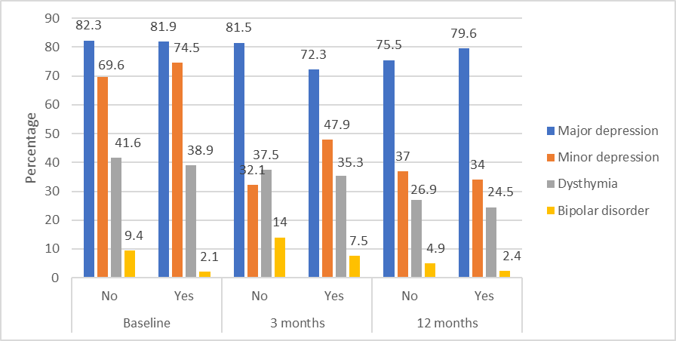

Inferential analyses showed that there were no significant differences in psychological distress or depression between the CBT and MI+W+B groups at either the three- or 12-month assessments. Similarly, there were no significant differences in mental health between those receiving and not receiving text messages (Table 18).

Table 18: Mental health, CBT vs. MI+W+B, text messaging vs. none
Mental health issue | Odds Ratio | (95% CI) | P-value
Psychological distressª
CBT - 3 months | 0.54 | (0.11, 2.73) | 0.44
CBT - 12 months | 1.27 | (0.36, 4.47) | 0.71
Test messaging - 12 months | 0.94 | (0.30, 2.96) | 0.91
Major depression^{b}
CBT - 3 months | 0.50 | (0.083, 2.95) | 0.43
CBT - 12 months | 2.09 | (0.46, 9.46) | 0.33
Text messaging - 12 months | 2.17 | (0.79, 5.97) | 0.13
Minor depression^{c}
CBT - 3 months | 0.75 | (0.20, 2.78) | 0.66
CBT - 12 months | 0.62 | (0.22, 1.75) | 0.36
Text messaging - 12 months | 0.56 | (0.23, 1.35) | 0.20
Dysthymia^{d}
CBT - 3 months | 2.93 | (0.92, 9.32) | 0.068
CBT - 12 months | 0.59 | (0.25, 1.44) | 0.24
Text messaging - 12 months | 0.75 | (0.30, 1.85) | 0.52
Bipolar disorder
CBT - 3 months | 2.86 | (0.077, 106.43) | 0.56
CBT - 12 months | 0.92 | (0.064, 13.22) | 0.95
Text messaging - 12 months | 1.07 | (0.092, 12.48) | 0.95
MI+W+B group = reference group vs. CBT group
No text messages = reference group vs. received text messaging intervention
ª Adjusted for deprivation
^{b} Adjusted for EGM gambling
^{c} Adjusted for gender
^{d} Adjusted for gender, age, annual household income and EGM gambling

    - Quality of life

At the baseline assessment, a majority of participants had low (score 0 to 17) or average (score 18 to 24) quality of life and fewer than one-fifth had a good quality of life (score 25 to 32). Quality of life improved at the three-month assessment. Greater improvement appeared to be noted for participants in the CBT group with only 20% reporting a low quality of life compared with 28.8% of the MI+W+B group. Whilst the proportion of participants reporting average quality of life was similar between the baseline and three-month assessments, a higher proportion reported a good quality of life, again with more participants in the CBT group (44.4%) compared with the MI+W+B group (28.8%). However, at the 12-month assessment, although the percentages of participants with a low quality of life remained similar to the three-month assessment, a larger proportion of participants in the MI+W+B group reported a good quality of life (43.4%) compared with the CBT group (36%); the opposite pattern to that noted at the three-month assessment. These differences were not statistically significant - see inferential analyses paragraph below.

Figure 25 details percentages of participants by intervention group reporting low, average or good quality of life.

Figure 25: Quality of life by intervention group
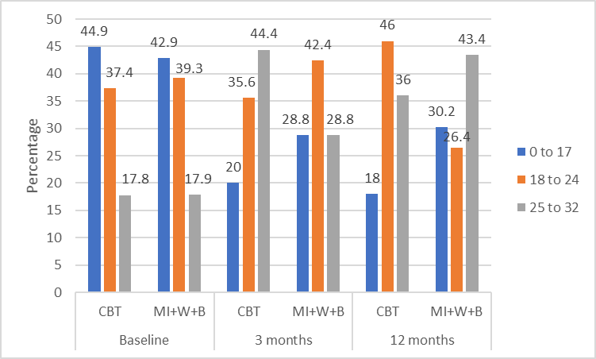

Receipt of text messages did not appear to affect quality of life as proportions at the 12-month assessment were broadly similar between those receiving and not receiving text messages or similar to the pattern noted at prior assessments (Figure 26).

Figure 26: Quality of life by text messaging group
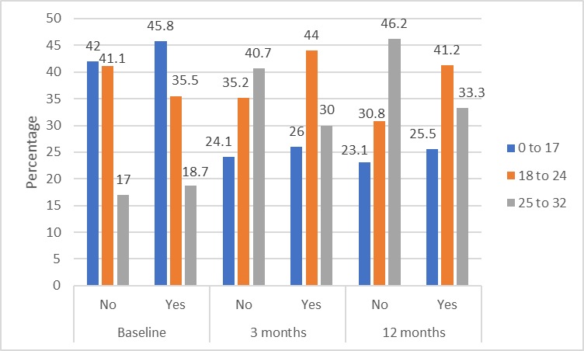

Inferential analyses showed that there were no significant differences in quality of life between the CBT and MI+W+B groups at either the three- or 12-month assessments. There were no significant differences in quality of life between those receiving and not receiving text messages (Table 19).

Table 19: Quality of life, CBT vs. MI+W+B, text messaging vs. none
Quality of life | Odds Ratio | (95% CI) | P-value
CBT - 3 months | 1.61 | (0.43, 6.09) | 0.47
CBT - 12 months | 1.26 | (0.40, 3.99) | 0.68
Text messaging - 12 months | 1.10 | (0.44, 2.71) | 0.84
MI+W+B group = reference group vs. CBT group
No text messages = reference group vs. received text messaging intervention
Adjusted for deprivation and paid employment

    - Workbook and booster sessions

As part of their intervention, participants in the MI+W+B group were given a self-help workbook called ‘Becoming a winner: Defeating problem gambling’. They were also scheduled to receive five follow-up motivational booster telephone sessions after their initial face-to-face session and were asked about these at the follow-up assessments. Participants in the CBT group were not given the ‘Becoming a winner’ workbook and were not scheduled to receive any telephone sessions; however, they received a workbook relevant to their CBT intervention (detailed as a ‘diary’ . As the researchers who conducted the assessments were blind to participants’ interventions, all participants were asked:
- Have you received a problem gambling self-help workbook in the mail or via email? This workbook is titled ‘Becoming a Winner: Defeating Problem Gambling’.
- Have you received any follow-up telephone calls from an Oasis counsellor since your initial face-to-face session with them? This does not include any telephone calls you may have received from an AUT researcher.

At the three-month assessment, slightly more than two-thirds (70.2%) of MI+W+B participants reported that they had received the workbook (Table 20), and about two-thirds (63.9%) reported receiving the telephone booster sessions (Table 21). It is of interest to note that more than half (55.6%) of CBT participants also reported receiving the ‘Becoming a Winner’ workbook and about one-quarter (23.9%) reported receiving the booster telephone calls.

At the three-month assessment, a majority of the MI+W+B group reported that they had read some or all sections of the workbook (n = 34) compared with seven participants who reported not having read any sections. Twice as many participants had completed some or all the exercises (n = 24) compared with those who had not completed any exercises (n = 12). Approximately equal numbers used the strategies (n = 19) compared with those who did not (n = 17) (Table 20).

When asked in open-ended questions about the most and least helpful aspects of the workbook, there were few responses. At the three-month assessment, 16 MI+W+B participants reported that the whole workbook was helpful, with eight reporting this at the 12-month assessment. Conversely, at the three-month assessment, six participants reported the whole workbook to be unhelpful, with three reporting this at the 12-month assessment.

Table 20: Workbook receipt and use
Workbook/booster sessions | Category | MI+W+B  3 months | CBT  3 months | MI+W+B  12 months | CBT  12 months
 |  | N | N | N | N
Received workbook | No | 17 (29.8) | 20 (44.4%) | 11 (20.8%) | 21 (44.7%)
 | Yes | 40 (70.2%) | 25 (55.6%) | 42 (79.2%) | 26 (55.3%)
Read workbook | Not at all | 7 | 2 | 21 | 9
 | Some sections | 20 | 19 | 12 | 11
 | Completely | 14 | 5 | 9 | 6
Exercise completion | None | 12 | 5 | 7 | 5
 | Some | 18 | 16 | 19 | 13
 | All | 6 | 4 | 6 | 5
Strategy use | None | 17 | 7 | 18 | 9
 | Occasionally | 15 | 10 | 11 | 11
 | Regularly | 4 | 7 | 4 | 3

Only two MI+W+B participants received the five scheduled booster telephone sessions; 13 participants received an additional six to 10 booster sessions and 12 participants reported not receiving any booster sessions. Thirty-seven participants found the booster sessions to be somewhat or very helpful compared with four who found them unhelpful (Table 21).

MI+W+B participants who responded to the open-ended questions with details of the helpful aspects reported that these included talking with a counsellor, the understanding and support of a counsellor and that the calls were reinforcement and/or encouragement for the changed behaviour. There were very few open-ended responses regarding unhelpful aspects of the booster calls.

Twenty-six MI+W+B participants reported that the booster sessions were as helpful or more helpful than the workbook, with three reporting the sessions to be less helpful. Similar profiles were noted at the 12-month assessment (Table 21). The main reason given for booster calls being more helpful than the workbook was the ability to talk with someone.
Table 21: Booster telephone sessions helpfulness
Workbook/booster sessions | Category | MI+W+B  3 months | CBT  3 months | MI+W+B  12 months | CBT  12 months
 |  | N | N | N | N
Received booster calls | No | 22 (36.1%) | 35 (76.1%) | 19 (35.2%) | 37 (72.5%)
 | Yes | 39 (63.9%) | 11 (23.9%) | 35 (64.8%) | 14 (27.5)
Number of booster calls received | 0 | 12 | 16 | 2 | 5
 | 1 | 4 | 8 | 2 | 4
 | 2 | 9 | 2 | 9 | 1
 | 3 | 6 | 2 | 7 | 1
 | 4 | 6 | 2 | 3 | 2
 | 5 | 2 | 0 | 3 | 0
 | 6 - 10 | 13 | 1 | 9 | 3
Booster helpfulness | Unhelpful | 4 | 2 | 5 | 2
 | Somewhat helpful | 17 | 5 | 13 | 4
 | Very helpful | 20 | 10 | 18 | 8
Booster helpfulness vs. workbook helpfulness | Less helpful | 3 | 1 | 4 | 1
 | Equally helpful | 9 | 6 | 10 | 4
 | More helpful | 17 | 4 | 13 | 5

    - Intervention experience

At the three- and 12-month assessments, participants were asked open-ended questions about aspects of the intervention they had received that were the most and the least helpful. Findings are presented in Table 22.

The most common helpful aspects reported by participants were the client-counsellor relationship and the talk therapy in general. The former aspect was reported by the most participants at both the three- and 12-month assessments, despite contact between clients and counsellors concluding after three-months. The third most cited aspect was individual face-to-face sessions. More participants in the MI+W+B group reported this at the three-month assessment (shortly after intervention completion) than participants in the CBT group. Conversely, some MI+W+B participants found the telephone calls to be the most helpful aspect. However, with the very small sample sizes, definitive conclusions cannot be drawn. Participants also valued specific elements of the CBT and MI+W+B interventions such as the tools that participants were given to cope with triggers, finding solutions to their problems, and learning how to control gambling urges. Of note is that very few participants specifically reported the workbook, CBT homework or text messages to be most helpful.

When asked about the least helpful aspect of the interventions, almost half of the respondents did not identify anything unhelpful. Of those who reported a least helpful aspect, the largest number did not like the treatment they received or did not have a good relationship with their counsellor. An intervention-related aspect was that more CBT than MI+W+B participants found the time or location of their sessions to be unsuitable. As the CBT intervention was solely by face-to-face appointments this could indicate a benefit of having some of the intervention delivered by telephone as in the MI+W+B intervention. Another aspect that appeared to be intervention-related was that slightly more participants in the MI+W+B group reported insufficient treatment contact compared with CBT participants. These participants indicated that they would have preferred to have longer, on-going support for their problems. A further MI+W+B related aspect was the small number of participants who did not like the telephone calls and would have preferred more face-to-face sessions.

Table 22: Most and least helpful aspects of the intervention
 | MI+W+B | CBT | MI+W+B | CBT | Total
 | 3 months | 3 months | 12 months | 12 months
 | N | N | N | N | N
Most helpful aspect
Total | 63 | 45 | 55 | 51 | 214
Good relationship with counsellor | 18 | 13 | 15 | 12 | 58
Talk therapy in general | 14 | 11 | 8 | 7 | 40
Individual/face-to-face sessions | 9 | 4 | 11 | 10 | 34
Specific elements of respective therapy | 6 | 9 | 2 | 7 | 24
Increase understanding of gambling problem | 3 | 5 | 4 | 2 | 14
Phone calls | 6 | 1 | 5 | 1 | 13
Nothing was helpful | 2 | 2 | 4 | 5 | 13
Service was good overall | 4 | 2 | 3 | 4 | 13
Other | 13 | 8 | 11 | 7 | 39
Not applicable/Don't know | 1 | 0 | 0 | 1 | 2
Least helpful aspect
Total | 63 | 45 | 55 | 51 | 214
Don't know/nothing unhelpful | 37 | 18 | 27 | 24 | 106
Did not like treatment received | 6 | 8 | 4 | 2 | 20
Time/location not suitable | 2 | 8 | 2 | 6 | 18
Poor relationship with counsellor | 0 | 5 | 5 | 5 | 15
Not enough contact | 5 | 1 | 6 | 2 | 14
Felt uncomfortable | 2 | 2 | 2 | 5 | 11
Did not like phone calls/prefer face-to-face | 5 | 0 | 5 | 0 | 10
Other | 5 | 2 | 5 | 6 | 18

Overall, at the 12-month assessment, two-thirds (66.1%, n=37) of MI+W+B participants and almost two-thirds (62.7%, n=32) of CBT participants reported that their needs had been met by the intervention they received. This question was not asked at the three-month assessment.

  - Relative cost analyses

The complete-case analysis results for the relative estimated costs of providing the CBT intervention and the MI+W+B intervention are provided in Table 23 and Table 24, respectively.

Overall, provision of the MI+W+B intervention (combined data from with or without the text messaging intervention) was less expensive at three-quarters the cost of the CBT intervention ($780 vs. $1,012). The MI+W+B intervention calculations included three days of training and 302 completed sessions, compared with the CBT intervention calculations that included four days of training and 336 completed sessions. The MI+W+B without the text messaging intervention cost $741 to provide per person, increasing to $819 with the addition of the text messaging intervention. The corresponding costs for the CBT intervention were $976 and $1,050.

However, once the estimated economic costs of additional health service utilisation, gambling losses or debt and loss of income were factored in, there were few differences between the interventions with the overall first year economic costs for a person receiving the CBT intervention being $9,064 and for the MI+W+B intervention being $10,430 (weighted across the entire study cohort). The very small sample sizes in some of the sub-cost category calculations may have inflated the mean costs, so any apparent differences between the interventions may not exist and the values presented could be somewhat over-estimated.

Table 23: Cost of CBT intervention
 | CBT overall |  |  | CBT and text messages |  |  | CBT no text messages
 | % | Mean | (95% CI) | % | Mean | (95% CI) | % | Mean | (95% CI)
Number of days gambled | 95 | 23.9 | (18.9, 28.9) | 94 | 27.8 | (20, 36) | 95 | 20.3 | (13.9, 26.8)
PROGRAMME COST
Intervention cost | 100 | $1,012† | (994, 1029) | 100 | $1,050 | (1027, 1073) | 100 | $976 | (952, 999)
DIRECT COST
Health services
Out-of-pocket medication | 30 | $54 | (31, 77) | 35 | $44 | (24, 63) | 26 | $67 | (18, 117)
Out-of-pocket alternative therapies | 5 | $322 | (77, 721) | 6 | $580 | # | 5 | $63 | #
General Practitioner or family doctor | 57 | $217 | (147, 259) | 63 | $239 | (145, 303) | 52 | $192 | (136, 248)
Alcohol and/or drug treatment specialist | 11 | $923 | (596, 1249) | 9 | $1,008 | # | 12 | $861 | (509, 1214)
Medical specialist (e.g. psychiatrist) | 18 | $568 | (380, 755) | 19 | $544 | (363, 725) | 17 | $592 | (217, 966)
Other healthcare professional | 22 | $444 | (304, 584) | 30 | $488 | (296, 679) | 16 | $366 | (133, 600)
Hospital admissions | 8 | $1,969 | # | 11 | $1,969 | # | 5 | $1,969 | #
Social
Amount of money spent on gambling | 93 | $6,358 | (3905, 8811) | 93 | $5,609 | (3673, 7545) | 93 | $7,052 | (2605, 11498)
Amount of money borrowed for gambling | 65 | $2,332 | (1545, 3118) | 65 | $2,304 | (1228, 3381) | 66 | $2,357 | (1167, 3547)
INDIRECT COSTS
Loss of income | 2 | $733 | # | 4 | $733 | # | - | - | -
TOTAL COSTS
First Year intervention + health services cost | 100 | $1,627 | (1445, 1809) | 100 | $1,806 | (1540, 2071) | 100 | $1,461 | (1210, 1710)
First Year intervention, health services + social cost | 100 | $9,051 | (6338, 11762) | 100 | $8,492 | (6102, 10882) | 100 | $9,570 | (4745, 14395)
First Year intervention, health services, social cost + indirect cost | 100 | $9,064 | (6347, 11780) | 100 | $8,520 | (6107, 10931) | 100 | $9,570 | (4745, 14395)
# Sample size too small to allow calculation of 95% Confidence Intervals
† 336 completed sessions

Table 24: Cost of MI+W+B intervention
 | MI+W+B overall |  |  | MI+W+B and text messages |  |  | MI+W+B no text messages
 | % | Mean | (95% CI) | % | Mean | (95% CI) | % | Mean | (95% CI)
Number of days gambled | 95 | 26.0 | (19.8, 32.1) | 91 | 26.6 | (19.3, 33.8) | 98 | 25.4 | (15.4, 35.3)
PROGRAMME COST
Intervention cost | 100 | $780† | (764, 796) | 100 | $819 | (798, 840) | 100 | $741 | (721, 761)
DIRECT COST
Health services
Out-of-pocket medication | 35 | $65 | (43, 87) | 33 | $63 | (26.8, 99.9) | 36 | $67 | (37, 96)
Out-of-pocket alternative therapies | 3 | $78 | # | - | - | - | 7 | $78 | #
General Practitioner or family doctor | 54 | $256 | (205, 306) | 53 | $252 | (186, 317) | 55 | $260 | (179, 340)
Alcohol and/or drug treatment specialist | 12 | $823 | (505, 1141) | 16 | $770 | (407, 1133) | 9 | $918 | #
Medical specialist (e.g. psychiatrist) | 23 | $640 | (469, 811) | 21 | $613 | (313, 913) | 26 | $661 | (432, 891)
Other healthcare professional | 30 | $426 | (319, 534) | 30 | $517 | (327, 709) | 29 | $335 | (231, 440)
Hospital admissions | 15 | $2,200 | (1864, 2536) | 7 | $2,461 | # | 22 | $2,120 | (1790, 2450)
Social
Amount of money spent on gambling | 92 | $7,500 | (2080, 12919) | 89 | $5,999 | (3846, 8151) | 95 | $8,891 | (1513, 19296)
Amount of money borrowed for gambling | 63 | $2,862 | (1803, 3920) | 60 | $2,767 | (1590, 3943) | 66 | $2,947 | (1183, 4710)
INDIRECT COSTS
Loss of income | 3 | $3,086 | # | 2 | $7,240 | # | 3 | $1,009 | #
TOTAL COSTS
First Year intervention + health services cost | 100 | $1,645 | (1411, 1879) | 100 | $1,550 | (1239, 1862) | 100 | $1,738 | (1381, 2094)
First Year intervention, health services + social cost | 100 | $10,350 | (5021, 15677) | 100 | $8,568 | (5975, 11161) | 100 | $12,099 | (1702, 22498)
First Year intervention, health services, social cost + indirect cost | 100 | $10,430 | (5091, 15768) | 100 | $8,695 | (6010, 11379) | 100 | $12,134 | (1737, 22533)
# Sample size too small to allow calculation of 95% Confidence Intervals
† 302 completed sessions

  - Treatment competence and fidelity

All trial counsellors were represented in the recordings, which were made throughout the recruitment and intervention delivery period.

    - MI+W+B intervention

Fifty-one digital recordings of the MI+W+B intervention delivery were assessed for treatment competence and fidelity. For global ratings of technical and relational components, adherence to treatment intervention was high, ranging from 72.5% for ‘reflections to questions ratio’ to 94.1% for ‘complex reflections’ (Figure 27).

Figure 27: Motivational interviewing proficiency across all assessed recordings
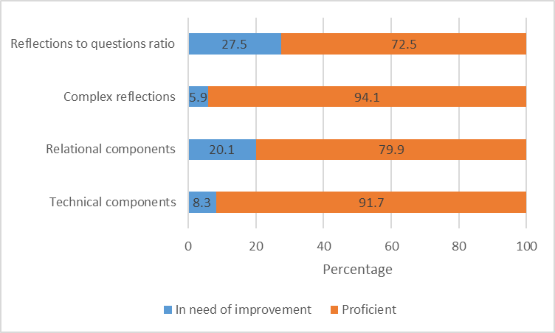

Inter-rater reliability was also very good across the recordings (Figure 28).

Figure 28: Motivational interviewing inter-rater reliability
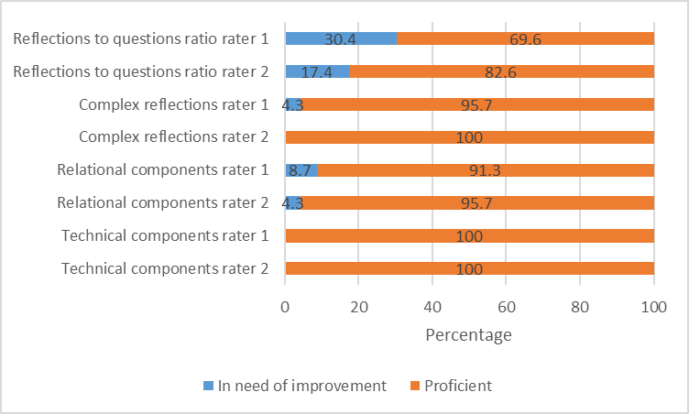
    - CBT intervention

Sixty-four digital recordings of the CBT intervention delivery were assessed for treatment integrity and fidelity. Rating of cognitive and behavioural integrity was high (Figure 3), with proficiency reached in 73.4% of cognitive and 81.2% of behavioural sessions recorded.

Figure 29: CBT integrity ratings across all assessed recordings
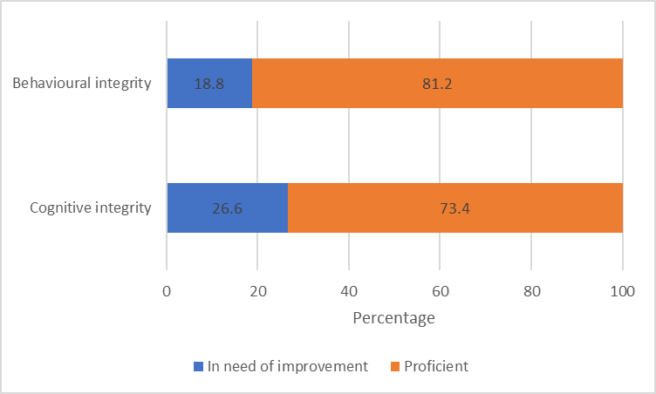

Inter-rater reliability was calculated by assessing the difference between integrity ratings of cognitive and behavioural techniques. A difference of +/- 1 point was considered acceptable. Inter-rater reliability was high, with an average inter-rater difference of 0.72 for cognitive integrity, and 0.82 for behavioural integrity scores.

- DISCUSSION AND CONCLUSION

The purpose of this randomised controlled trial was to evaluate the relative effectiveness of a face-to-face motivational interviewing intervention combined with a self-help workbook and follow-up telephone ‘booster’ sessions (MI+W+B), and face-to-face combined cognitive behaviour + cue exposure therapy (referred to as CBT in this report) in treating people with gambling-related problems.

The participants were people who sought help from a New Zealand national multi-centre gambling treatment service who had generally been gambling and experiencing problems from their gambling for several years. Most participants reported their primary problematic activity to be EGM gambling. A substantial minority had previously sought professional treatment for their gambling, and some were currently receiving assistance even as they contacted the national treatment service for help. This profile indicated that the participants in the current trial generally had deep-rooted gambling problems. There was a slight skew of male (60.8%) to female participants (39.2%); this was somewhat expected as the gender split of clients accessing face-to-face services in New Zealand during the time of this trial was also biased towards males although the difference in percentages was smaller (about 53% male; Ministry of Health website, 2020). However, the ethnic profile of the trial participants was different from the expected profile with fewer Māori and Pacific people and, consequently, more people of European/Other ethnicity. In the trial, slightly more than one-quarter of participants were of Māori ethnicity and slightly more than one-tenth were of Pacific ethnicity, compared with one-third Māori and one-fifth Pacific ethnicity seen in national data of clients accessing face-to-face services (Ministry of Health website, 2020). However, the national data included gamblers and affected others (who accessed services for assistance with someone else’s gambling behaviours) and the trial was only of gamblers, so this could have accounted for some of the differences in socio-demographic profiles.

  - Primary and secondary hypotheses

Overall, participants in both the CBT and the MI+W+B intervention showed improvement in their gambling behaviour immediately following treatment (i.e. at the three-month assessment), which continued to the 12-month assessment. The proportions who stopped (abstained) from gambling or who gambled on only one to three days in the prior month substantially increased from pre-treatment, and the proportion who gambled on four or more days per month substantially decreased. This suggested that, overall, participants in both intervention groups had more control over their gambling behaviour immediately after receiving their treatment and in the medium-term (12-month assessment). Inferential analyses adjusting for confounding factors showed that reduced gambling behaviour (measured as days spent gambling and money lost gambling) was noted for both interventions when assessed one year after commencement of treatment (about nine months after completion of treatment). Māori and Pacific subgroups were not statistically different from the other study participants.

There were no significant differences between the groups in terms of gambling risk level; however, participants in both groups substantially reduced the severity of their PGSI scores over time. At baseline, as expected, almost all participants were classified as problem gamblers with a high severity of problems evident in mean scores of between 14.4 and 15.8. A substantial reduction in scores was noted at the 12-month assessment for participants although, overall, only participants in the MI+W+B with text messaging group moved (just) into the moderate-risk category (mean score 7.8). Participants in the MI+W+B without text messaging and participants in the CBT with/without text messaging groups remained classified as problem gamblers albeit with lower severity than at baseline (mean scores of 8 to 10). Using the PGSI in a three-month time frame, gambling risk level scores were also measured immediately post-treatment completion (i.e. at three-months). Participants in all groups scored in the moderate-risk range (mean scores of 3.8 to 6.8). With the three-month PGSI, only the CBT without text messages group scored as problem gamblers at the 12-month assessment (mean score 8.5) with the other groups remaining as moderate-risk gamblers (mean scores of 5.9 to 7.5).

These findings did not support the primary hypothesis, which was that participants in the CBT group would have greater clinically meaningful reductions in gambling and problem gambling than participants in the MI+W+B group at the 12-month assessment. There were no statistically significant differences between the intervention groups in monthly average number of days spent gambling or in amount of money lost gambling per day at the 12-month assessment. This finding held for both the Intention-To-Treat (ITT) and Per Protocol (PP) analyses. Furthermore, there were no statistically significant differences between the two intervention groups and gambling risk level at the 12-month assessment. However, the first secondary hypothesis was supported in that the CBT and MI+W+B interventions were equivalent for reductions in gambling and problem gambling at three months.

The second secondary hypothesis was that participants allocated to the post-treatment text messaging intervention, in both the CBT and MI+W+B groups, would show greater clinically meaningful reductions in gambling and problem gambling at the 12-month assessment compared with participants in the non-text messaging intervention. This hypothesis was not supported as there were no statistically significant differences between the text message and non-text message groups in amount of money lost gambling per day at the 12-month assessment. Neither were there any differences between the two groups and gambling risk level. Thus, receiving an additional text messaging relapse prevention intervention after the main intervention did not have any benefits over not receiving text messages, in terms of gambling behaviour and gambling risk level.

The third secondary hypothesis was that CBT participants would have greater reductions in depression and anxiety than MI+W+B participants at the 12-month assessment. This hypothesis was not supported as there were no statistically significant differences between the intervention groups in psychological distress (which measured general levels of anxiety and depression) nor in measures of depression (major and minor), dysthymia (a type of mild but chronic depression) and bipolar disorder at the 12-month assessment. Overall, participants in both groups had improved mental health in terms of general psychological distress, minor depression and dysthymia. Neither the CBT nor the MI+W+B intervention influenced levels of major depression with three-quarters or more of participants reporting this at the pre- and both post-treatment assessments.

A possible explanation for the primary hypothesis and the third secondary hypothesis not being supported could relate to the low number of sessions attended by most participants in the CBT group (see next subsection). Instead of receiving the expected high intensity CBT intervention delivered over 10 sessions, most participants received what could be considered low intensity CBT. Although definitions and understandings of low intensity CBT vary, it can include low usage of therapist time (Bennett-Levy & Farrand, 2010, p.4), particularly compared with traditional high intensity CBT. It can also refer to CBT delivered by non-specialised CBT therapists, for example, by health care workers who have been trained to deliver CBT (Bennett-Levy & Farrand, 2010, p.7). This was the case in this trial whereby gambling counsellors, many of whom were not CBT specialists, received training in delivery of the CBT intervention. As the trial hypotheses were predicated on the delivery of the CBT intervention over 10 sessions, the delivery of fewer sessions to a majority of participants in that group, by non-CBT specialist counsellors meant that a low intensity CBT was mostly delivered and could have affected the outcome.

  - Secondary outcome measures and interpretation of findings

The results showed that both the CBT intervention and the MI+W+B intervention led to reduced gambling behaviour (in terms of days spent gambling and money lost gambling) that were apparent on completion of treatment (assessed at three-months) and were sustained in the medium-term (assessed at 12-months). There was an expected concurrent reduction in negative consequences associated with gambling behaviour (on professional and social life, family life and home responsibilities, and physical health) and, consequently, improved quality of life. The proportion of participants reporting legal consequences due to their gambling stayed relatively the same over time, possibly because legal processes are not usually resolved immediately, even if the gambling behaviour stops. There was no statistical difference between the interventions in clinical effectiveness despite the structure of the interventions being substantially different. The CBT intervention focused on cue reactivity and cognitive restructuring over (nominally) ten face-to-face structured sessions. The MI+W+B intervention was briefer, focused on encouraging a commitment to change, delivered in a face-to-face session and reinforced via a self-help workbook containing exercises and strategies, and (nominally) five follow-up telephone calls focused on reinforcing motivation and behaviour change. The findings from the current trial were similar to the findings of Carlbring et al’s (2010) trial of a cognitive behavioural group therapy and a motivational interviewing intervention, which also reported no differences between the interventions but significant within-group improvements on most outcome measures up to the 12-month assessment.

The overall reduced gambling behaviour occurred despite one-fifth of CBT participants and two-fifths of MI+W+B participants not receiving any intervention because they did not turn up to the first session. Furthermore, only eight percent of CBT participants completed the scheduled 10 weeks of treatment and slightly less than one-quarter completed half or more of the scheduled sessions. Most of the participants dropped out after receiving one to three sessions. A slightly different profile was noted for the MI+W+B participants whereby almost one-quarter completed the full six sessions of treatment and a further five percent had additional sessions. More than two-fifths completed half or more of the scheduled sessions although of those who dropped out, the largest proportion did so after the first session. The high rates of pre-treatment and in-treatment dropout were expected phenomena as they are common amongst gamblers seeking help (Robson et al., 2002; Ronzitti et al., 2017; Toneatto, 2005).

Only the first session of the MI+W+B intervention was delivered face-to-face, although participants who requested an additional face-to-face session received their second session in that manner. The participating service is known as a face-to-face gambling treatment provider and it is possible that gamblers contacting the service did so because they wanted to see a counsellor in person, rather than receiving treatment by telephone or digital means as would have occurred had they contacted the national gambling helpline. Thus, it is conceivable that some participants assigned to the MI+W+B intervention did not like the telephone and workbook format, and this could have accounted for the larger proportion dropping out of treatment after the initial face-to-face session, compared with the CBT intervention. Although relatively few participants provided responses to open-ended questions on intervention experience, of those who did, face-to-face sessions were the third most reported ‘most helpful’ aspect, with more MI+W+B participants reporting this at the post-treatment assessment than CBT participants, perhaps indicating that for these participants the initial face-to-face session was indeed valued. Similarly, a few MI+W+B participants indicated that the least helpful aspect was the telephone calls. However, this was offset by a similar number of participants who reported that the telephone calls were the most helpful aspect.

Another reason for the relatively large dropout rates is that most participants reported problems with EGM gambling. Recent research has identified that the type of problematic gambling activity can influence treatment dropout rates with EGMs identified as a significant predictor for dropping out before treatment commences (Ronzitti et al., 2018). As at least three-quarters of the participants in the current trial reported EGMs as their primary problematic gambling activity, this could also have played a part in the large proportion of participants who did not receive any treatment. This, together with the fact that a greater proportion of MI+W+B participants completed the full intervention compared with CBT participants, suggests that a one-size-fits-all approach to treating gambling problems may not be suitable for everyone, and that some tailoring of approaches may be necessary on an individual basis, assessed and agreed with a client at the start of the treatment process or when a client makes initial contact with a treatment service. Client choice of treatment approach is an important factor that this trial design did not address.

Overall, both the CBT and MI+W+B interventions were effective and this may have been due, in part, to the therapeutic alliance created between a counsellor and participant. The quality of the relationship between a counsellor and client is recognised as important for positive treatment outcomes (Ardito & Rabellino, 2011; Lambert & Barley, 2001; Martin et al., 2000). Responses to open-ended questions on intervention experience showed that the most reported helpful aspect for both interventions was the relationship with the counsellor and this was followed by ‘talk therapy in general’. The counsellor relationship was the most helpful aspect reported at both the three- and 12-month assessments, despite contact between participants and counsellors concluding after three-months. This could indicate that the relationship a participant had with their counsellor had a lasting effect, at least in the medium-term, and a positive relationship could have led participants to be more motivated to overcome their gambling problems. Even if the motivation were due to a desire to please the counsellor with whom the participant had a good relationship, this could have led to positive outcomes. Such social desirability bias results when a participant responds in a way to gain the counsellor’s approval (King & Bruner, 2000).

It is also plausible that ‘natural recovery’ played a part in the positive outcomes for both interventions, especially when the relatively large proportions who did not receive any treatment are taken into consideration. Natural recovery describes when a person recovers without any formal intervention. It is possible that participants with less severe gambling problems were able to control their gambling without intervention (Toneatto et al., 2009) and the process of contacting a treatment service, making an appointment and completing the baseline assessment may have been sufficient to motivate some participants to change their gambling behaviour. However, as the current trial did not have a control group, the role of natural recovery can only be surmised.

Despite one focus of the CBT intervention being the reduction of gambling urges (via the exposure therapy components) there were no significant differences between this group and the MI+W+B group in terms of gambling urge. The proportion of participants in both groups with a high urge to gamble decreased by at least half post-treatment and was sustained at the 12-month assessment, with a corresponding increase in the proportion of participants with no urge to gamble. This shows that, for those participants, both interventions helped with reducing gambling urges; this may be related to the finding that there were no significant differences in control over gambling between the interventions. There were also no statistically significant differences in goal achievement (quitting gambling, maintaining abstinence or reducing gambling behaviour).

Co-existing mental health and substance use issues are well-documented with risky and problematic gambling. The New Zealand National Gambling study identified a higher prevalence of psychological distress, hazardous alcohol consumption, tobacco smoking and other drug use (predominantly cannabis) amongst problem gamblers compared with non-problem gamblers (Abbott et al., 2014b). Participants in both the CBT and MI+W+B intervention groups had improved mental health in terms of general psychological distress, minor depression and dysthymia. This is likely to have been a result of the gambling interventions. A single brief telephone gambling intervention, administered to a New Zealand treatment-seeking sample, significantly reduced the prevalence of depression concurrent with reduced gambling risk level; the reduction in depression prevalence was found to be a treatment-related effect and not due to natural recovery (Ranta et al., 2019). The interventions did not appear to have any major effects on substance use (alcohol, tobacco or other drugs) with the implication that these co-existing issues may need to be treated concurrently.

Perhaps the most surprising finding to the trial investigators was that the addition of a nine-month text messaging relapse prevention intervention did not have any benefit. The amount of money lost gambling was not influenced by the text messaging intervention, nor were any of the secondary outcome measures. This finding is similar to the feasibility study results reported by Rodda et al. (2018), which also indicated that text messaging did not affect gambling outcomes in comparison to e-mental health interventions. Literature on the use of text messaging interventions in the tobacco and alcohol fields suggests there may be some benefit in the short-term or whilst the messages are being delivered but there is minimal evidence for any effects to be sustained. It is likely that problematic gambling, as a behavioural addiction, is similar to substance use addictions in this regard, though further research is required.

  - Relative cost analyses

Relative estimated costs analyses indicated that provision of the MI+W+B intervention (with and without text messaging combined) was 23% less expensive than provision of the CBT intervention. This was expected since the MI+W+B intervention had fewer sessions with a majority conducted by telephone as brief sessions. Thus, based purely on the cost of providing these interventions to treat gamblers, the MI+B+W intervention appeared to be the more cost-effective.

However, when estimated external costs were included in the calculations, such as additional health service utilisation and medications, and social costs relating to gambling, there was no difference between the interventions.

As the addition of a text messaging intervention increased the cost of intervention provision without any major benefit in terms of participant outcomes, it would appear prudent from a fiscal perspective to not include text messaging as an adjunct on other interventions.

Further research and analysis are required to obtain a true reflection of the costs associated with these treatments as there were very small sample sizes in some cases, which are likely to have led to large over-estimations of the actual costs.

  - Limitations

The findings detailed in this report should be contextualised in relation to the limitations of the trial. Although the sample size was relatively large for a gambling interventions clinical trial, there was quite high attrition both in terms of completing treatment and dropout from the trial. Visual examination of percentages of socio-demographic characteristics over time revealed no major differences. Whilst inferential analyses, taking into account confounding factors, showed no statistically significant differences between those who received the protocol scheduled treatments (the PP sample) compared with the full sample (the ITT sample), no analyses have been conducted comparing the sample of participants who dropped out of the trial with those who remained.

Furthermore, no control group was included in the trial to account for non-specific treatment effects such as natural recovery. However, in New Zealand, clients receive free treatment for gambling-related issues, generally as soon as they request it. Wait lists do not exist and it would have been unethical to include one in this trial. Moreover, there is no ‘standard’ face-to-face gambling treatment provided in New Zealand that could have been manualised into a control intervention. However, the trial was designed to evaluate the relative effectiveness of two interventions, CBT and MI+W+B. In that regard, it met its aims.

Due to attrition and reduced sample sizes at the post-treatment assessments, particularly the 12-month assessment, it was not possible to conduct inferential analyses on the effect of the text messaging intervention by CBT or MI+W+B. The initial powering of this trial with the anticipated sample of 300 participants did not allow for these analyses and the final sample comprised 227 participants. The length of time taken to recruit these 227 participants (almost three years) meant that the gambling environment changed during the life of the trial (e.g. online gambling became more accessible) and many of the counsellors providing the interventions changed (i.e. left the treatment service and were replaced). However, the effects of these on the trial are considered minor as most participants reported EGM gambling to be their most problematic activity (and the availability and accessibility of EGMs did not appreciably alter during this time) and all new counsellors received full intervention training and were assessed for intervention compliance and fidelity. However, there was some variation in treatment competence and, although good overall, up to one-quarter of some aspects of the assessed recordings indicated that further improvement in the delivery of those aspects was required. Counsellors in the trial had different levels of qualifications and prior knowledge of CBT and MI, and this is likely to have affected their ability to refresh or develop the skills required for the trial interventions.

All collected data were self-reported and these can be prone to demand characteristics, which refers to when a participant responds to questions based on what they think the interviewer wants to hear (Nichols & Maner, 2008). There was evidence of this in regard to questions on whether participants had received the workbook ‘Becoming a Winner: Defeating Problem Gambling’. This was only given to participants in the MI+W+B group, yet slightly more than half of CBT participants reported, at both post-treatment assessments, that they had received it, with a majority of those indicating that they had read some or all sections of it. Participants in the CBT intervention also received a workbook though it was not titled ‘Becoming a Winner’, but it is possible that there was some confusion about which workbook had been received.

Finally, it is important to note that the results of this trial have been reported on a group basis and individual participant trajectories have not been investigated as this was outside the scope of this report. Analysis of individual trajectories would provide more detailed information regarding outcomes for participants who received full or partial treatment, or who did not receive any treatment at all.

  - Challenges in conducting this multi-site clinical trial in a real-world setting

This study was conceptualised as a pragmatic trial to determine the effectiveness of cognitive–behavioural and motivational treatments in a real-life multi-centre gambling treatment service. It came with several challenges.

First, funding such a trial is expensive and the available research funding was marginally insufficient to cover the cost of the research. Consequently, the University agreed to contribute 8.4% of research costs as it recognised the importance of such a randomised trial in regard to gambling treatments. The bulk of the trial costs was funded by the Ministry of Health.

Incorporating a randomised controlled trial in a real-world treatment service brought myriad challenges which affected timings and budget. Extensive consultation and preparation work were required prior to set-up and delivery to ensure adequate treatment service staff support for the trial. Training staff, and retaining commitment and motivation were constantly required to ensure participant recruitment and robust intervention delivery. The cost of this long-term engagement with the treatment service was high and underestimated. For example, high counselling staff turnover meant that ongoing training support was necessary, averaging at two additional bouts of counsellor training in each 12-month period (over and above the originally anticipated training needs), with each counsellor being trained in delivery of both interventions. This came at substantial additional cost to the University (for training, monitoring and staff liaison).

The most significant challenge was slow study recruitment leading to extension of the trial. The original budget was for a 15-month recruitment phase. Recruitment started in May 2016 and continued for 36 months, more than twice that budgeted. There were several reasons for the slow recruitment. The initial trial proposal was written under the assumption that the partner treatment service was to be substantially expanded from 1 March 2015. This would have provided a significantly larger client base for recruitment into the trial. However, due to various political and legal issues, the expansion of the treatment service did not eventuate. This meant the client base from which to recruit participants remained much smaller than the trial design had been based on. Furthermore, the gambling treatment sector was characterised by a large amount of uncertainty between 2014 and 2016 because of the aforementioned political and legal issues. Uncertain of long-term employment, many counsellors left gambling treatment services. These staff were replaced but each replacement in the trial partner service had to be trained and assessed for competence in trial interventions delivery, further slowing the progress of the trial. Additionally, on one occasion in November 2016, slow recruitment was compounded by a major earthquake, the damage from which meant that, temporarily, recruitment could not occur in the treatment centre at that location due to structural building damage that required repair. At that time, many clients presented in a distressed state (due to the earthquake) and had to be treated immediately in alternative locations.

To mitigate these challenges, assistance with recruitment and referral to trial sites was sought from the national gambling helpline. Unfortunately, at the time of our approach to the helpline, they were about to begin implementation of the brief intervention that was found to be most effective in a previous clinical trial. This intervention comprised a motivational interviewing counselling session followed by provision of a self-help workbook and up to four further motivational interviewing sessions where progress and the workbook were discussed. This intervention was similar to one of the interventions in the current face-to-face trial. The Ministry of Health (the treatment funder) wanted the helpline to implement the intervention without delay and developed an “AUT Trial Referral Pathway” process with the helpline. This process indicated that if a gambler wanted a referral to face-to-face services that they would be invited into the trial and referred to a trial clinic. Only gamblers who refused participation in the trial would undergo the new intervention at the helpline. Although this process was implemented, it resulted in minimal referrals (n = 63) to the trial clinics, and not all of those agreed to participate. Additionally, partnership with another national gambling treatment provider was investigated but was unsuccessful as they could not commit to the robust trial procedures.

Important learnings

During this trial we engaged with the intricacies of politics and service provision. The choice of Oasis as our trial partner was made based on this organisation being a national service provider with clients of all major ethnicities. Furthermore, at the time the proposal was being prepared, Oasis had been awarded a contract to be the sole national provider of face-to-face gambling treatment services. The proposal was developed in consultation with senior Oasis managers and counsellors. Given the pragmatic nature of the trial, extensive consultation was necessary; this occurred over 18 months prior to proposal submission. As a result, we achieved strong support and enthusiasm for the project within Oasis around the country, in large part because management saw the considerable value of all counselling staff receiving consistent and intensive training in state-of-the-art CBT and MI approaches, initially from two international experts.

While management support was critical, equally crucial to the trial’s success was engagement from the counsellors who carried out the recruitment and treatment protocols. Learning from this trial and a previous trial of gambling treatments, early engagement with treatment services is vital. Oasis management staff were partners in the development of the trial plan. Identification of the main benefits for the counsellors were in alignment with the Oasis treatment provision ethos (i.e. an emphasis on staff development goals and informed evidence-based practice). Planning for ongoing engagement with staff, and communication of the benefits of such research to them and their clients was crucial to the successful operation and realisation of outcomes.

We found that attempting to conduct a large clinical trial with more than one provider risked the integrity of the study. Even with a single multi-site provider there were major logistical challenges in participant recruitment, counsellor engagement and training, treatment fidelity monitoring and blinded random allocation of clients to treatment. To accomplish this with multiple providers and to ensure timely coordination across them would have added substantial risk and multiple opportunities for problems to arise and compromise the study.

Currently there is substantial variation in the modes of counselling that are offered by gambling intervention services in New Zealand, and the effectiveness of these interventions and the counsellors who offer them is largely unknown. Ethnic-specific gambling treatment providers tend to develop tailored models of practice for their cultural groups. We found that it is difficult to obtain buy-in and support from a treatment service where counsellors are allowed, or encouraged, to be eclectic (or tailored) in their approaches. The Oasis service was committed to ensuring all their counsellors used evidence-based interventions to provide consistency and quality in nationwide service delivery. For example, an outcome for Oasis from this trial was a Model of Care for Gambling that they could integrate into their service.

Finally, it should be noted that in New Zealand, gambling treatment services compete for funding contracts and clients. This can complicate any efforts seen as pro-standardisation or which are perceived as threatening a service’s point of difference in the sector, or ‘market capture’.

  - Conclusion

Since both the CBT and MI+W+B interventions were effective, despite being different in their content and length, and despite only a minority completing the intervention programmes, it is possible that a good therapeutic alliance between counsellor and participant, or natural recovery have played a part. Further research is required to understand whether counsellor and/or participant factors led to comparatively fewer participants completing the CBT sessions compared with MI+W+B. Furthermore, it is possible that one intervention may be more effective than the other in the longer-term. This will be assessed in a two-year follow-up assessment. It is possible that different treatment approaches suit different people based on personal preference and situations. For example, receiving treatment by telephone with a self-help workbook could be preferable for people who have difficulty travelling to a physical location. Conversely, for those who want face-to-face contact with a counsellor, a telephone approach may be sub-optimal. Although, at a group level, both interventions were effective, it is likely that some tailoring of treatment approaches is required on a per person basis, to ensure optimal outcomes at an individual level.

A tailored stepped care system such as that operated by the Gambling Help Service in South Australia is a model that could be considered in New Zealand, whereby both low- and high- intensity therapies are provided by services with qualified practitioners. Low intensity CBT or MI+W+B could be initially offered to a client, taking into account preferences for face-to-face or telephone contact. At assessment or during therapy, if warranted or if requested by a client, a more intensive face-to-face CBT intervention could be provided that also addresses substance use and major depression, along with gambling.

Addressing co-existing substance use and mental health issues could be an important part of recovery from gambling problems. Although both interventions reduced general psychological distress, minor depression and dysthymia, they had no appreciable effect on major depression or substance use. These findings indicate that whilst CBT and MI+W+B treatment of gambling-related problems could relieve relatively minor mental health conditions, they are unlikely to affect more serious issues such as major depression or other harmful behaviours such as smoking, hazardous alcohol consumption and drug issues. A holistic approach that addresses co-existing substance-related issues and/or major depression as well as gambling-related issues could, therefore, be beneficial in creating positive overall outcomes.

- OTHER INFORMATION

  - Registration

The trial is registered with the Australian New Zealand Clinical Trials Registry (ANZCTR), study registration number: ACTRN12615000637549.

  - Protocol

The trial protocol is published in BMJ Open, available at http://dx.doi.org/10.1136/bmjopen-2016-013490 (Abbott et al., 2017).

  - Funding

The majority of the trial was funded by the New Zealand Ministry of Health. A small proportion was funded by the trial investigators’ institution. The Ministry of Health had no role in study design, data collection and analysis, or reporting, although they approved each of those stages and had the right to suggest changes. Final decision on content was exclusively retained by the trial investigators.

- REFERENCES

Abbott, M. W. (2019). Professionally delivered interventions for gambling disorder. Current Opinions in Psychiatry, 32, 313–319.

Abbott, M., Bellringer, M., Vandal, A., Hodgins, D., Palmer Du Preez, K., Landon, J., Sullivan, S., & Feigin, V. (2012). Effectiveness of problem gambling brief telephone interventions: A randomised controlled trial. Auckland: Auckland University of Technology, Gambling and Addictions Research Centre.

Abbott, M., Bellringer, M., Garrett, N., & Mundy-McPherson, S. (2014a). New Zealand 2012 National Gambling Study: Overview and gambling participation. Report number 1. Auckland: Auckland University of Technology, Gambling and Addictions Research Centre.

Abbott, M., Bellringer, M., Garrett, N., Mundy-McPherson, S. (2014b). New Zealand 2012 National Gambling Study: Gambling harm and problem gambling. Report number 2. Auckland: Auckland University of Technology, Gambling and Addictions Research Centre.

Abbott, M., Bellringer, M., Garrett, N., & Mundy-McPherson, S. (2015a). New Zealand National Gambling Study: Wave 2 (2013). Report number 4. Auckland: Auckland University of Technology, Gambling and Addictions Research Centre.

Abbott, M., Bellringer, M., Palmer du Preez, K., Pearson, J., Vandal, A., Garrett, N., & Hodgins, D. (2015b). Randomised controlled trial of problem gambling brief telephone interventions: Three years later. Auckland: Auckland University of Technology, Gambling and Addictions Research Centre.

Abbott, M., Binde, P., Clark, L., Hodgins, D., Korn, D., Pereira, A., Quilty, L., Thomas, A., Volberg, R., Walker, D., & Williams, R. (2015c). Conceptual framework of harmful gambling: An international collaboration. Revised Edition. Gambling Research Exchange Ontario (GREO), Guelph, Ontario, Canada.

Abbott, M., Bellringer, M., Vandal, A.C., Hodgins, D.C., Battersby, M., & Rodda, S.N. (2017). Effectiveness of problem gambling interventions in a service setting: A protocol for a pragmatic randomised controlled clinical trial. BMJ Open, 7: e013490. http://dx.doi.org/10.1136/bmjopen-2016-013490

Abbott, M., Bellringer, M., & Garrett, N. (2018a). New Zealand National Gambling Study: Wave 4 (2015). Report number 6. Auckland: Auckland University of Technology, Gambling and Addictions Research Centre.

Abbott, M., Hodgins, D. C., Bellringer, M., Vandal, A. C., Palmer du Preez, K., Landon, J., Sullivan, S., Rodda, S., & Feigin, V. (2018b). Brief telephone interventions for problem gambling: A randomised controlled trial. Addiction, 113, 883–895. https://doi:10.1111/add.14149

Abbott, M. W., & Volberg, R. A. (1991). Gambling and problem gambling in New Zealand. Research Series No. 12. Wellington: Department of Internal Affairs.

Abbott, M. W., & Volberg, R. A. (1992). Frequent gamblers and problem gamblers in New Zealand. Research Series No. 14. Wellington: Department of Internal Affairs.

Abbott, M. W., & Volberg, R. A. (2006). The measurement of adult problem and pathological gambling. International Gambling Studies, 6, 175–200.

Agyapong, V. I., Ahern, S., McLoughlin, D. M., & Farren, C. K. (2012). Supportive text messaging for depression and comorbid alcohol use disorder: single-blind randomised trial. Journal of Affective Disorders, 141(2-3), 168–176.

Agyapong, V. I., McLoughlin, D. M., & Farren, C. K. (2013). Six-months outcomes of a randomised trial of supportive text messaging for depression and comorbid alcohol use disorder. Journal of Affective Disorders, 151(1), 100–104.

Ardito, R. B., & Rabellino, D. (2011). Therapeutic alliance and outcome of psychotherapy: Historical excursus, measurements, and prospects for research. Frontiers in Psychology, 2(270). https:// doi.org/10.3389/fpsyg.2011.00270
Auer, M., & Griffiths, M. D. (2013). Voluntary limit setting and player choice in most intense online gamblers: An empirical study of gambling behaviour. Journal of Gambling Studies, 29(4), 647–660.

Battersby, M., Oakes, J., Tolchard, B., Forbes, A., & Pols, R. (2008). Cognitive behavioral therapy for problem gamblers. In M. Zangeneh, A. Blaszczynski, & N. Turner (Eds.), In the pursuit of winning (pp. 179-197). Springer, Boston, MA.

Battersby, M., Pols, R., Oakes, J., Smith, D., McLaughlin, K., & Baigent, M. (2010). The definition and predictors of relapse in problem gambling. Adelaide: Flinders University, Flinders Human behaviour and Health Research Unit.

Battersby, M. W., Smith, D., Harvey, P. W., & Pols, R. (2013), Cognitive versus exposure therapy for problem gambling: A pilot randomized controlled trial. Adelaide: Flinders Centre for Gambling Research.

Bellringer, M.E., Lowe, G., Paavonen, A-M., Palmer du Preez, K., Garrett, N., & Abbott, M. (2019). New Zealand National Gambling Study: Qualitative phase. NGS Series Report number 8. Auckland: Auckland University of Technology, Gambling and Addictions Research Centre.

Bennett-Levy, J., & Farrand, P. (2010). Low intensity CBT models and conceptual underpinnings. In J Bennett-Levy et al. (Eds.), Oxford guide to low intensity CBT interventions. Oxford: Oxford University Press.

Billi, R., Stone, C. A., Marden, P., & Yeung, K. (2014). The Victorian Gambling Study: A longitudinal study of gambling and health in Victoria 2008-2012. Victoria, Australia: Victorian Responsible Gambling Foundation.

Blaszczynski, A., Sharpe, L., Walker, M., Shannon, K., & Coughlan, M. J. (2005). Structural characteristics of electronic gaming machines and satisfaction of play among recreational and problem gamblers. International Gambling Studies, 5(2), 187–198.

Blaszczynski, A., Collins, P., Fong, D., Ladouceur, R., Nower, L., Shaffer, H. J., ... & Venisse, J. L. (2011). Responsible gambling: General principles and minimal requirements. Journal of gambling Studies, 27(4), 565–573.

Browne, M., Bellringer, M., Greer, N., Kolandai-Matchett, K., Langham, E., Rockloff, M., ... & Abbott, M. (2017). Measuring the burden of gambling harm in New Zealand. Wellington: Ministry of Health.

Campos, M. D., Rosenthal, R. J., Chen, Q., Moghaddam, J., & Fong, T. W. (2016). A self-help manual for problem gamblers: The impact of minimal therapist guidance on outcome. International Journal of Mental Health and Addiction, 14(4), 579–596.

Carlbring, P., & Smit, F. (2008). Randomized trial of internet-delivered self-help with telephone support for pathological gamblers. Journal of consulting and clinical psychology, 76(6), 1090–1094.

Carlbring, P., Jonsson. J., Josephson, H., & Forsberg, L. (2010). Motivational interviewing versus cognitive behavioral group therapy in the treatment of problem and pathological gambling: A randomised controlled trial. Cognitive Behaviour Therapy, 39(2), 92–103.

Carpenter, J. R., & Kenward, M. G. (2007). Missing data in randomised controlled trials: A practical guide. London School of Hygiene and Tropical Medicine.
https://researchonline.lshtm.ac.uk/id/eprint/4018500

Carroll, K. M., Kiluk, B. D., Nich, C., Babuscio, T. A., Brewer, J. A., Potenza, M. N., ... & Lejuez, C. W. (2011). Cognitive function and treatment response in a randomized clinical trial of computer-based training in cognitive-behavioral therapy. Substance use & misuse, 46(1), 23–34.

Clark, L. (2010). Decision-making during gambling: An integration of cognitive and psychobiological approaches. Philosophical Transactions of the Royal Society B: Biological Sciences, 365(1538), 319–330.

Cocco, K. M., & Carey, K. B. (1998). Psychometric properties of the Drug Abuse Screening Test in psychiatric outpatients. Psychological Assessment, 10, 408–414.

Cowlishaw, S., Merkouris, S., Dowling, N., Anderson, C., Jackson, A., & Thomas, S. (2012). Psychological therapies for pathological and problem gambling. Cochrane Database of Systematic Reviews, 11. https://www.cochranelibrary.com/cdsr/doi/10.1002/14651858.CD008937.pub2/epdf/full

Daughters, S. B., Lejuez, C. W., Strong, D. R., Brown, R. A., Breen, R. B., & Lesieur, H. R. (2005). The relationship among negative affect, distress tolerance, and length of gambling abstinence attempt. Journal of Gambling Studies, 21(4), 363–378.

DiClemente, C. C., Corno, C. M., Graydon, M. M., Wiprovnick, A. E., & Knoblach, D. J. (2017). Motivational interviewing, enhancement, and brief interventions over the last decade: A review of reviews of efficacy and effectiveness. Psychology of Addictive Behaviors, 31(8), 862–887.

Diskin, K. M., & Hodgins, D. C. (2009). A randomized controlled trial of a single session motivational intervention for concerned gamblers. Behaviour Research and Therapy, 47(5), 382–388.

Dowling, N., Smith, D., & Thomas, T. (2006). Treatment of female pathological gambling: The efficacy of a cognitive-behavioural approach. Journal of Gambling Studies, 22(4), 355–372.

Drummond, D. C., Cooper, T., & Glautier, S. P. (1990). Conditioned learning in alcohol dependence: implications for cue exposure treatment. British Journal of Addiction, 85(6), 725–743.

el-Guebaly, N., Casey, D. M., Currie, S. R., Hodgins, D. C., Schopflocher, D. P., Smith, G. J., & Williams, R. J. (2015). The Leisure, Lifestyle & Lifecycle Project (LLLP): A longitudinal study of gambling in Alberta. Final report for the Alberta Gambling Research Institute. Canada: Alberta Gambling Research Institute.

European Medicines Agency. (1998). Note for guidance on statistical principles for clinical trials. International Commission on Harmonization, European Medicines Agency.

Ferris, J., & Wynne, H. (2001). The Canadian Problem Gambling Index: Final report. Ottawa: Canadian Centre on Substance Abuse.

Free, C., Knight, R., Robertson, S., Whittaker, R., Edwards, P., Zhou, W., ... & Roberts, I. (2011). Smoking cessation support delivered via mobile phone text messaging (txt2stop): A single-blind, randomised trial. The Lancet, 378(9785), 49–55.

Free, C., Whittaker, R., Knight, R., Abramsky, T., Rodgers, A., & Roberts, I. G. (2009). Txt2stop: A pilot randomised controlled trial of mobile phone-based smoking cessation support. Tobacco Control, 18(2), 88–91.

Gail, M. H., Wieand, S., & Piantadosi, S. (1984). Biased estimates of treatment effect in randomized experiments with nonlinear regressions and omitted covariates. Biometrika, 71(3), 431–444.

Gooding, P., & Tarrier, N. (2009). A systematic review and meta-analysis of cognitive-behavioural interventions to reduce problem gambling: Hedging our bets? Behaviour Research and Therapy, 47(7), 592–607.

Goodwin, B. C., Browne, M., Rockloff, M., & Rose, J. (2017). A typical problem gambler affects six others. International Gambling Studies, 17(2). https://doi.org/10.1080/14459795.2017.1331252

Goslar, M., Leibetseder, M., Muench, H. M., Hofmann, S. G., & Laireiter, A. R. (2017). Efficacy of face-to-face versus self-guided treatments for disordered gambling: A meta-analysis. Journal of Behavioral Addictions, 6(2), 142–162.

Goudriaan, A. E., Oosterlaan, J., De Beurs, E., & Van Den Brink, W. (2008). The role of self-reported impulsivity and reward sensitivity versus neurocognitive measures of disinhibition and decision-making in the prediction of relapse in pathological gamblers. Psychological Medicine, 38(1), 41–50.

Hall, G. W., Carriero, N. J., Takushi, R. Y., Montoya, I. D., Preston, K. L., & Gorelick, D. A. (2000). Pathological gambling among cocaine-dependent outpatients. American Journal of Psychiatry, 157(7), 1127–1133.

Hammersley, R. (1992). Cue exposure and learning theory. Addictive Behaviors, 17(3), 297–300.

Hettema, J., Steele, J., & Miller, W. R. (2005). Motivational interviewing. Annual Review of Clinical Psychology, 1, 91–111.

Hodgins, D. C., Currie, S. R., & el-Guebaly. N. (2001). Motivational enhancement and self-help treatments for problem gambling. Journal of Consulting and Clinical Psychology, 69(1), 50–57.

Hodgins, D. C., Currie, S., el-Guebaly, N., & Peden, N. (2004). Brief motivational treatment for problem gambling: A 24-month follow-up. Psychology of Addictive Behaviors, 18(3), 293–296.
Hodgins, D. C., Currie, S. R., el-Guebaly, N., & Diskin, K. M. (2007). Does providing extended relapse prevention bibliotherapy to problem gamblers improve outcome? Journal of Gambling Studies, 23, 41– 54.

Hodgins, D. C., Currie, S. R., Currie, G., & Fick, G. H. (2009). Randomized trial of brief motivational treatments for pathological gamblers: More is not necessarily better. Journal of Consulting and Clinical Psychology, 77(5), 950–960.

Hodgins, D. C., Stea, J. N., & Grant, J. E. (2011). Gambling disorders. The Lancet, 378, 1874–1884.

Hodgins, D. C., Fick, G. H., Murray, R., & Cunningham, J. A. (2013). Internet-based interventions for disordered gamblers: Study protocol for a randomized controlled trial of online self-directed cognitive-behavioural motivational therapy. BioMed Central Public Health, 13:10.
www.biomedcentral.com/1471-2458/13/10.

Haug, S., Schaub, M. P., Venzin, V., Meyer, C., & John, U. (2013). Efficacy of a text message-based smoking cessation intervention for young people: A cluster randomized controlled trial. Journal of Medical Internet Research, 15(8), e171. https://doi.org/10.2196/jmir.2636

Kessler, R., & Mroczek, D. (1994). Final versions of our Non-Specific Psychological Distress Scale. Written communication-memo dated 10/3/94. Ann Arbour (MI), Surrey Research Center of the Institute for Social Research, University of Michigan.

King, M. F., & Bruner, G. C. (2000). Social desirability bias: A neglected aspect of validity testing. Psychology and Marketing, 17(2), 79–103.
Kobak, K. A., Taylor, L. H., Dottl, S. L., Greist, J. H., Jefferson, J. W., Burroughs, D., Mantle, J. M., Katzelnick, D. J., Norton, R., Henk, H. J., & Serlin, R. C. (1997). A computer-administered telephone interview to identify mental disorders. Journal of the American Medical Association, 278, 905–910.

Ladd, G. T., & Petry, N. M. (2003). A comparison of pathological gamblers with and without substance abuse treatment histories. Experimental and Clinical Psychopharmacology, 11(3), 202–209.

Ladouceur, R., & Lachance, S. (2007). Overcoming pathological gambling - therapist guide. Oxford University Press, USA.

Ladouceur, R., Sylvain, C., Boutin, C., Lachance, S., Doucet, C., Leblond, J., & Jacques, C. (2001). Cognitive treatment of pathological gambling. The Journal of Nervous and Mental Disease, 189(11), 774–780.

Ladouceur, R., Sylvain, C., Boutin, C., Lachance, S., Doucet, C., & Leblond, J. (2003). Group therapy for pathological gamblers: A cognitive approach. Behaviour Research and Therapy, 41, 587–596.

Lambert, M. J., & Barley, D. E. (2001). Research summary on the therapeutic relationship and psychotherapy outcome. Psychotherapy: Theory, Research, Practice, Training, 38(4), 357–361.

Landon, J., Palmer du Preez, K., Page, A., Bellringer, M., Roberts, A., & Abbott, M. (2018). Electronic gaming machine characteristics: It’s the little things that count. International Journal of Mental Health and Addiction, 16(2), 251–265.

Larimer, M. E., Neighbors, C., Lostutter, T. W., Whiteside, U., Cronce, J. M., Kaysen, D., & Walker, D. D. (2012). Brief motivational feedback and cognitive behavioral interventions for prevention of disordered gambling: A randomized clinical trial. Addiction, 107(6), 1148–1158.
Ledgerwood, D. M., & Petry, N. M. (2006). What do we know about relapse in pathological gambling? Clinical Psychology Review, 26, 216–228.
Livingstone, C. H., Woolley, R., Zazryn, T. R., Bakacs, L., & Shami, R. G. (2008). The relevance and role of gaming machine games and game features on the play of problem gamblers. South Australia: Independent Gambling Authority.

Loeber, S., Croissant, B., Heinz, A., Mann, K., & Flor, H. (2006). Cue exposure in the treatment of alcohol dependence: Effects on drinking outcome, craving and self‐efficacy. British Journal of Clinical Psychology, 45(4), 515–529.

Lubman, D., Rodda, S., Hing, N., Cheetham, A., Cartmill, T., Nuske, E., Hodgins, D., & Cunningham, J. (2015). Gambler self-help strategies: A comprehensive assessment of self-help strategies and actions. Melbourne, Gambling Research Australia.

Martin, D. J., Garske, J. P., & Davis, M. K. (2000). Relation of the therapeutic alliance with outcome and other variables: A meta-analytic review. Journal of Consulting Clinical Psychology, 68(3), 438–450.
Melville, K. M., Casey, L. M., & Kavanagh, D. J. (2007). Psychological treatment dropout among pathological gamblers. Clinical Psychology Review, 27(8), 944–958.

Miller, W. R., & Rollnick, S. (2002). Motivational interviewing: Preparing people for change. New York: Guilford Press.

Miller, W. R., & Rose, G. S. (2009). Toward a theory of motivational interviewing. American psychologist, 64(6), 527–537.

Ministry of Health. (2019). Strategy to Prevent and Minimise Gambling Harm 2019/20 to 2021/22. Wellington: Ministry of Health.

Ministry of Health website. (2020). Intervention client data. https://www.health.govt.nz/our-work/mental-health-and-addiction/addiction/gambling/service-user-data/intervention-client-data

Morgan, D. L. (1993). Pearls, pith and provocation. Qualitative content analysis: A guide to paths not taken. Qualitative Health Research, 3(1), 112–121.

Moyers, T. B., Martin, T., Manuel, J. K., Hendrickson, S. M. L., & Miller, W. R. (2005). Assessing competence in the use of motivational interviewing. Journal of Substance Abuse Treatment, 28(1), 19–26.

Nichols, A. L., & Maner, J. K. (2008). The good-subject effect: Investigating participant demand characteristics. The Journal of General Psychology, 135(2), 151–166.
Nower, L., & Blaszczynski, A. (2010). Gambling motivations, money-limiting strategies, and precommitment preferences of problem versus non-problem gamblers. Journal of Gambling Studies, 26(3), 361–372.

Oakes, J., Gardiner, P., McLaughlin, K., & Battersby, M. (2012). A pilot group cognitive behavioural therapy program for problem gamblers in a rural Australian setting. International Journal of Mental Health and Addiction, 10(4), 490–500.

Oei, T. P., Raylu, N., & Casey, L. M. (2010). Effectiveness of group and individual formats of a combined motivational interviewing and cognitive behavioral treatment program for problem gambling: A randomized controlled trial. Behavioural and Cognitive Psychotherapy, 38(2), 233–238.

Pallesen, S., Mitsem, M., Kvale, G., Johnsen, B. H., & Molde, H. (2005). Outcome of psychological treatments of pathological gambling: A review and meta‐analysis. Addiction, 100(10), 1412–1422.

Petry, N. (2005). Pathological gambling: Etiology, comorbidity, and treatments. Washington, DC: American Psychological Association.

Petry, N. M., Ammerman, Y., Bohl, J., Doersch, A., Gay, H., Kadden, R., ... & Steinberg, K. (2006). Cognitive-behavioral therapy for pathological gamblers. Journal of Consulting and Clinical Psychology, 74(3), 555–567.

Petry, N. M., Weinstock, J., Ledgerwood, D. M., & Morasco, B. (2008). A randomized trial of brief interventions for problem and pathological gamblers. Journal of Consulting and Clinical Psychology, 76(2), 318–328.

Petry, N. M., Weinstock, J., Morasco, B. J., & Ledgerwood, D. M. (2009). Brief motivational interventions for college student problem gamblers. Addiction, 104(9), 1569–1578.

Petry, N. M., Rash, C. J., & Alessi, S. M. (2016). A randomized controlled trial of brief interventions for problem gambling in substance abuse treatment patients. Journal of Consulting and Clinical Psychology, 84(10), 874–886.

Petry, N. M., Ginley, M. K., & Rash, C. J. (2017). A systematic review of treatments for problem gambling. Psychology of Addictive Behaviors, 31(8), 951–961.

Pounds, S., & Cheng, C. (2005). Sample size determination for the false discovery rate. Bioinformatics, 21(23), 4263–4271. https://doi.org/10.1093/bioinformatics/bti699

Productivity Commission. (2010). Gambling. Canberra: Productivity Commission.

Ranta, J., Bellringer, M., Garrett, N. & Abbott, M. (2019). Can a brief telephone intervention for problem gambling help to reduce co-existing depression? A three-year prospective study in New Zealand. Journal of Gambling Studies, 35, 617–633.

Raylu, N., & Oei, T. (2004a). The Gambling Urge Scale: Development, confirmatory factor validation, and psychometric properties. Psychology of Addictive Behaviors,18, 100–105.

Reinert, D. F., & Allen, J. P. (2002). The Alcohol Use Disorders Identification Test (AUDIT): A review of recent research. Alcoholosim: Clinical and Experimental Research, 26(2), 272–279.

Robson, E., Edwards, J., Smith, G., & Colman, I. (2002). Gambling decisions: An early intervention program for problem gamblers. Journal of Gambling Studies, 18, 235–255.

Rodda, S. N., Dowling, N. A., Knaebe, B., & Lubman, D. I. (2018). Does SMS improve gambling outcomes over and above access to other e-mental health supports? A feasibility study. International Gambling Studies, 18(2), 343–357.

Rodgers, A., Corbett, T., Bramley, D., Riddell, T., Wills, M., Lin, R. B., & Jones, M. (2005). Do u smoke after txt? Results of a randomised trial of smoking cessation using mobile phone text messaging. Tobacco Control, 14(4), 255–261.

Ronzitti, S., Soldini, E., Smith, N., Clerici, M., & Bowden-Jones, H. (2017). Gambling disorder: Exploring pre-treatment and in-treatment dropout predictors. A UK study. Journal of Gambling Studies, 33(4), 1277–1292.

Ronzitti, S., Soldini, E., Smith, N., Bayston, A., Clerici, M., & Bowden-Jones, H. (2018). Are treatment outcomes determined by type of gambling? A UK study. Journal of Gambling Studies, 34, 987–997.

Salmond, C., Crampton, P., King, P., & Waldegrave, C. (2006). NZiDep: A New Zealand index of socioeconomic deprivation for individuals. Social Science and Medicine, 62, 1474–1485.

Sandelowski, M. (2000). Focus on research methods - whatever happened to qualitative description? Research in Nursing and Health, 23(4), 334–340.

Sandelowski, M. (2010). What's in a name? Qualitative description revisited. Research in Nursing and Health, 33(1), 77–84.

Saunders, J. B., Aasland, O. G., Babor, T. F., De La Fuente, J. R., & Grant, M. (1993). Development of the Alcohol Use Disorders Identification Test (AUDIT): WHO collaborative project on early detection of persons with harmful alcohol consumption–II. Addiction 88,791–804.

Schmidt, S., Muhlan, H., & Power, M. (2005). The EUROHIS-QOL 8-item index: Psychometric results of a cross-cultural field study. European Journal of Public Health, 16(4), 420–428.

Skinner, H.A. (1982). The Drug Abuse Screening Test. Addictive Behaviors, 7, 363–371.

Slutske, W. S. (2006). Natural recovery and treatment-seeking in pathological gambling: Results of two US national surveys. American Journal of Psychiatry, 163(2), 297–302.

Smith, D., Harvey, P., Battersby, M., Pols, R., Oakes, J., & Baigent, M. (2010). Treatment outcomes and predictors of drop out for problem gamblers in South Australia: A cohort study. Australian and New Zealand Journal of Psychiatry, 44, 911–920.

Smith, D. P., Battersby, M. W., Harvey, P. W., Pols, R. G., & Ladouceur, R. (2013). Two-group randomised, parallel trial of cognitive and exposure therapies for problem gambling: A research protocol. BMJ open, 3(6).

Smith, D. P., Battersby, M. W., Harvey, P. W., Pols, R. G., & Ladouceur, R. (2015). Cognitive versus exposure therapy for problem gambling: Randomised controlled trial. Behaviour Research and Therapy, 69, 100–110.

Spitzer, R. L., Williams, J. B., Kroenke, K., Linzer, M., deGruy, F. V., Hahn, S. R., Brody, D., & Johnson, J. G. (1994). Utility of a new procedure for diagnosing mental disorders in primary care. The PRIME-MD 1000 study. Journal of American Medical Association, 272(22), 1749–1756.

Suffoletto, B., Callaway, C., Kristan, J., Kraemer, K., & Clark, D. B. (2012). Text‐message‐based drinking assessments and brief interventions for young adults discharged from the emergency department. Alcoholism: Clinical and Experimental Research, 36(3), 552–560.

Suffoletto, B., Kristan, J., Chung, T., Jeong, K., Fabio, A., Monti, P., & Clark, D. B. (2015). An interactive text message intervention to reduce binge drinking in young adults: A randomized controlled trial with 9-month outcomes. PloS one, 10(11), e0142877.
https://doi.org/10.1371/journal.pone.0142877

Swift, J. K., & Greenberg, R. P. (2012). Premature discontinuation in adult psychotherapy: A meta-analysis. Journal of Consulting and Clinical Psychology, 80(4), 547–559.

Sylvain, C., Ladouceur, R., & Boisvert, J. M. (1997). Cognitive and behavioral treatment of pathological gambling: A controlled study. Journal of Consulting and Clinical Psychology, 65, 727–732.
Toneatto, T. (2005). A perspective on problem gambling treatment: Issues and challenges. Journal of Gambling Studies, 21, 73–80.

Toneatto, T., Cunningham, J., Hodgins, D., Adams, M., Turner, N., & Koski-Jannes, A. (2009). Recovery from problem gambling without formal treatment. Addiction Research and Theory, 16(2). https://doi.org/10.1080/16066350801923638

Westphal, J., & W. Abbott, M. (2006). Models for multi-site problem gambling clinical trials. International Gambling Studies, 6(2), 129–145.

Whittaker, R., McRobbie, H., Bullen, C., Rodgers, A., & Gu, Y. (2016). Mobile phone‐based interventions for smoking cessation. Cochrane Database of Systematic Reviews, 4.
https://doi.org/10.1002/14651858.CD006611.pub4

Williams, R. J., Hann, R. G., Schopflocher, D., West, B., McLaughlin, P., White, N., King, K., & Flexhaug, T. (2015). Quinte longitudinal study of gambling and problem gambling. Guelph, Ontario: Ontario Problem Gambling Research Centre.

Wohl, M. J., Kim, H. S., & Sztainert, T. (2014). From the laboratory to the casino: Using psychological principles to design better responsible gambling tools. Responsible Gambling Review, 1(1), 16-26.

Yakovenko, I., & Hodgins, D. C. (2018). A scoping review of co-morbidity in individuals with disordered gambling. International Gambling Studies, 18(1), 143–172.

Yakovenko, I., Quigley, L., Hemmelgarn, B. R., Hodgins, D. C., & Ronksley, P. (2015). The efficacy of motivational interviewing for disordered gambling: Systematic review and meta-analysis. Addictive Behaviors, 43, 72-82.

Yee, T. W. (2020). On the Hauck-Donner Effect in Wald Tests: Detection, tipping points, and parameter space characterization. arXiv:2001.08431 [stat.ME]. Available at https://arxiv.org/abs/2001.08431

- APPENDICES

APPENDIX 1: Text messages content

Messages for CBT group (Stage 1)

- Welcome to txt support for preventing gambling relapse (TxtSupport). We’ll send you texts twice a week with tips and advice others have found helpful to help you stay on track. Today’s tip is: Some people find it helpful to complete an automatic thought diary exercise in their exercise book if they notice any gambling related thoughts. Txt STOP to opt out of these messages.
- Some people find it helpful to nip gambling urges in the bud and revisit some of their exposure tasks or the gambling cycle in their exercise book to see if they can identify the trigger.
- Some people find it helpful to remember if they experience an urge to gamble, it will eventually subside by itself without gambling. Sit with it and allow it to pass.
- Some people find it helpful to limit access to cash when performing new exposure tasks, particularly during early stages of the exposure program. This will allow you to grade it appropriately.
- Some people find it helpful to remember that the more you put in the more you’ll get out, so try and do a task from the exercise book every day.
- Some people find it helpful to remember repeated habituation through performing exposure tasks will eventually lead to conquering gambling urges.
- Some people find it helpful to remember that lapses or “bumps” are no big deal.
- Some people find it helpful to remember repeated habituation will eventually lead to extinction. Allowing yourself to experience your urge by focusing on it without gambling is called habituation.
- Some people find it helpful to ask what is the evidence for and against this thought if they notice a thought that tempts them to gamble. Are you jumping to conclusions without looking at all the facts?
- Some people find it helpful to remember the difference between games of skill and games of chance. In games of chance there is nothing you can do to influence or predict the outcome.

Messages for MI+W+B group (Stage 1)

- Welcome to txt support for preventing gambling relapse (TxtSupport). We’ll send you texts twice a week with tips and advice others have found helpful to stay on track. Today’s tip is: Some people find it helpful to re-read sections of the Becoming a Winner: Defeating Problem Gambling self-help workbook you received. Txt STOP to opt out of these messages.
- Some people find it helpful to read the section on Dealing with Urges in the Becoming a Winner workbook.
- Some people find it helpful to remind themselves periodically about the benefits and costs of gambling described in the Becoming a Winner workbook.
- Some people find it helpful to think again about the ideas provided in Becoming a Winner for limiting access to money.
- Some people find it helpful to consider whether there are other life issues that they should address (see Becoming a Winner).
- Some people find it valuable to review and revise their plan for dealing with slips that they made in Becoming a Winner.
- Some people find it motivating to share their personal gambling goals with other people (Becoming a Winner).
- Some people find it helpful to remind themselves of some of the consequences of their gambling that they listed in Becoming a Winner.
- Some people find it helpful to think about where they would like to be in life in 5 years and whether gambling might interfere with this.
- Some people find it helpful to re-read how they responded to the questions they completed in the Becoming a Winner workbook.

Cognitive (Stages 2 & 3)

- Some people find this helpful… think about how your money could be better spent.
- Some people find this helpful… remain hopeful about your future.
- Some people find this helpful… remind yourself that you don't need to gamble.
- Some people find this helpful… re-establish trust and belief in yourself.
- Some people find this helpful… make a resolution to continue changing your gambling.
- Some people find this helpful… make a daily affirmation such as staying positive or letting go.
- Some people find this helpful… focus on not gambling each day at a time.
- Some people find this helpful… concentrate on being strong or using will power.
- Some people find this helpful… monitor how your emotions relate to gambling.
- Some people find this helpful… monitor for signs that gambling is becoming a problem again.
- Some people find this helpful… Recontact your counsellor or peer support if a check-in could be helpful.
- Some people find this helpful… focus on regaining trust with family and friends.
- Some people find this helpful… continue to accept that you had a problem and move beyond testing yourself.
- Some people find this helpful… remember that if you are triggered by feeling sad, lonely, angry, hungry or tired gambling is not the best option.
- Some people find this helpful… monitor your progress. Have you had a change in the urge to gamble?
- Some people find this helpful… calculate your time and money spent gambling: this can really help put it into perspective.
- Some people find this helpful… keep a budget of your spending. This can help you to stay honest.
- Some people find this helpful… acknowledge when you are feeling flat or lonely. This can make you think twice about gambling.
- Some people find this helpful… save for a reward like a holiday or a dinner out.
- Some people find this helpful… think about the types of things that you could spend your money on.

Plan and delay (Stage 1)

- Some people find this helpful… take it easy on yourself or take it slow.
- Some people find this helpful… distract yourself or do something else until the urge to gamble passes.
- Some people find this helpful… postpone gambling until a later date to allow the urge to pass.
- Some people find this helpful… avoid gambling when feeling down, depressed or otherwise vulnerable.
- Some people find this helpful… avoid the first bet because the urge will pass soon enough.
- Some people find this helpful… Do things that are incompatible with gambling like meeting a friend, taking a walk without cash or having an early night.
- Some people find this helpful… plan ahead - leave credit cards and non-essential cash at home.
- Some people find this helpful… keep busy to avoid thinking about or engaging in gambling.
- Some people find this helpful… Be ready to implement your own personal strategies to deal with gambling triggers.
- Some people find this helpful… count days since you've made a change in your gambling.
- Some people find this helpful… keep track of money by setting up a budget and tracking spending.
- Some people find this helpful… plan ahead and limit the amount of money you carry.
- Some people find this helpful… plan to spend more time with other people.

Connect & engage (Stage 2)

- Some people find this helpful… tell a trusted friend or family member about the extent of your gambling.
- Some people find this helpful… be more open and honest with family and friends about gambling.
- Some people find this helpful… ask family or friends to help or support you.
- Some people find this helpful… engage in an activity that gives you a feeling of achievement.
- Some people find this helpful… participate in regular structured groups or sports like football or tennis.
- Some people find this helpful… engage in a new form of entertainment.
- Some people find this helpful… explore additional work or study-related activities.
- Some people find this helpful… listen, play, sing or dance to music.
- Some people find this helpful… complete daily activities around the house.
- Some people find this helpful… start a new hobby like arts, crafts or knitting.
- Some people find this helpful… plan a reward or something to look forward to.
- Some people find this helpful… taking a long walk can feel good as well as provide a chance to clear your head.
- Some people find this helpful… practice relaxation strategies like yoga, meditation or mindfulness.

Well-being and health (Stage 3)

- Some people find this helpful… ensure your physical health needs are met.
- Some people find this helpful… set up and regularly contribute towards a savings plan.
- Some people find this helpful… eat a healthy balanced diet that makes you feel good.
- Some people find this helpful… focus on managing issues that contribute to your gambling.
- Some people find this helpful… learn to forgive yourself for past actions and focus on the future: tomorrow is what you can change not yesterday.
- We're nearing the end of the txt program now and your texts will arrive less frequently from now on stopping in about a month. Today’s tip: Some people find this helpful… Be mindful of increasing fluid intake.
- Some people find this helpful… engage in regular exercise.
- Some people find this helpful… volunteer your time or help someone in need.
- Some people find this helpful… try methods to improve your sleep.
- Some people find this helpful… change your focus to other health issues: is it now time to give up smoking, alcohol or eating junk food?

APPENDIX 2: Distribution of covariates by assessment

 |  | Baseline |  | 3 months |  | 12 months
Covariate | Categories | N | (%) | N | (%) | N | (%)
Gender | Female | 89 | (39.2) | 42 | (38.2) | 47 | (43.9)
 | Male | 138 | (60.8) | 68 | (61.8) | 60 | (56.1)
Age (years) | 18-34 | 78 | (34.7) | 34 | (31.2) | 33 | (31.1)
 | 35-44 | 55 | (24.4) | 23 | (21.1) | 21 | (19.8)
 | 45-54 | 47 | (20.9) | 24 | (22.0) | 21 | (19.8)
 | 55+ | 45 | (20.0) | 28 | (25.7) | 31 | (29.2)
Ethnicity | Māori | 64 | (28.2) | 34 | (30.9) | 31 | (29.0)
 | Pacific | 29 | (12.8) | 8 | (7.3) | 11 | (10.3)
 | European/Other | 134 | (59.0) | 68 | (61.8) | 65 | (60.7)
Annual household income | ≤ $50,000 | 64 | (28.2) | 29 | (26.4) | 30 | (28.0)
 | $50,001 - $100,000 | 53 | (23.3) | 29 | (26.4) | 25 | (23.4)
 | > $100,000 | 35 | (15.4) | 15 | (13.6) | 15 | (14.0)
 | Refused | 75 | (33.0) | 37 | (33.6) | 37 | (34.6)
Employment | Employed | 116 | (51.3) | 59 | (54.1) | 53 | (50.0)
 | Unemployed | 55 | (24.3) | 25 | (22.9) | 25 | (23.6)
 | Other (e.g. retired, student) | 55 | (24.3) | 25 | (22.9) | 28 | (26.4)
Deprivation | 0 | 63 | (29.4) | 27 | (26.0) | 29 | (29.0)
 | 1-2 | 68 | (31.8) | 34 | (32.7) | 33 | (33.0)
 | 3-7 | 83 | (38.8) | 43 | (41.3) | 38 | (38.0)
Marital status | Other | 133 | (58.6) | 66 | (60.0) | 66 | (61.7)
 | Married/De-facto | 94 | (41.4) | 44 | (40.0) | 41 | (38.3)
Years of gambling | 0-6 | 113 | (50.0) | 54 | (49.1) | 49 | (45.8)
 | 7+ | 113 | (50.0) | 56 | (50.9) | 58 | (54.2)
EGM gambling is primary problematic activity | No | 47 | (20.7) | 28 | (25.5) | 24 | (22.4)
 | Yes | 180 | (79.3) | 82 | (74.5) | 83 | (77.6)

APPENDIX 3: Distribution of baseline covariates by intervention group

 |  | CBT  no text |  | CBT  with text |  | MI+W+B  no text |  | MI+W+B with text
Covariate | Categories | N | (%) | N | (%) | N | (%) | N | (%)
Gender | Female | 25 | (43.1) | 21 | (38.9) | 25 | (43.1) | 18 | (31.6)
 | Male | 33 | (56.9) | 33 | (61.1) | 33 | (56.9) | 39 | (68.4)
Age (years) | 18-34 | 15 | (26.3) | 23 | (42.6) | 20 | (35.1) | 20 | (35.1)
 | 35-44 | 16 | (28.1) | 11 | (20.4) | 14 | (24.6) | 14 | (24.6)
 | 45-54 | 13 | (22.8) | 11 | (20.4) | 10 | (17.5) | 13 | (22.8)
 | 55+ | 13 | (22.8) | 9 | (16.7) | 13 | (22.8) | 10 | (17.5)
Ethnicity | Māori | 16 | (27.6) | 14 | (25.9) | 17 | (29.3) | 17 | (29.8)
 | Pacific | 7 | (12.1) | 7 | (13.0) | 8 | (13.8) | 7 | (12.3)
 | European/Other | 35 | (60.3) | 33 | (61.1) | 33 | (56.9) | 33 | (57.9)
Annual household income | ≤ $50,000 | 18 | (31.0) | 15 | (27.8) | 16 | (27.6) | 15 | (26.3)
 | $50,001 - $100,000 | 11 | (19.0) | 10 | (18.5) | 16 | (27.6) | 16 | (28.1)
 | > $100,000 | 10 | (17.2) | 5 | (9.3) | 8 | (13.8) | 12 | (21.1)
 | Refused | 19 | (32.8) | 24 | (44.4) | 18 | (31.0) | 14 | (24.6)
Employment | Employed | 25 | (43.1) | 26 | (48.1) | 31 | (54.4) | 34 | (59.6)
 | Unemployed | 16 | (25.9) | 15 | (27.8) | 13 | (22.8) | 12 | (21.1)
 | Other (e.g. retired, student) | 18 | (31.0) | 13 | (24.1) | 13 | (22.8) | 11 | (27.8)
Highest educational level | No formal qual. | 11 | (19.0) | 11 | (21.6) | 8 | (14.0) | 11 | (19.6)
 | School qual. | 20 | (34.5) | 14 | (27.5) | 24 | (42.1) | 17 | (30.4)
 | Trade/vocational qual. | 17 | (29.3) | 11 | (21.6) | 10 | (17.5) | 13 | (23.2)
 | Degree/higher | 10 | (17.2) | 15 | (29.4) | 15 | (26.3) | 15 | (26.8)
Deprivation | 0 | 16 | (28.6) | 14 | (28.0) | 17 | (31.5) | 16 | (29.6)
 | 1-2 | 16 | (28.6) | 14 | (28.0) | 15 | (27.8) | 23 | (42.6)
 | 3-7 | 24 | (42.9) | 22 | (44.0) | 22 | (40.7) | 15 | (27.8)
Marital status | Other | 33 | (56.9) | 39 | (72.2) | 30 | (51.7) | 31 | (54.4)
 | Married/De-facto | 25 | (43.1) | 15 | (27.8) | 28 | (48.3) | 26 | (45.6)

APPENDIX 4: Distribution of primary problematic gambling activity by intervention group

 |  | CBT  no text |  | CBT  with text |  | MI+W+B  no text |  | MI+W+B with text
Covariate | Category | N | (%) | N | (%) | N | (%) | N | (%)
Years of gambling | 0 to 6 | 21 | (36.2) | 30 | (55.6) | 31 | (54.4) | 31 | (54.4)
 | 7+ | 37 | (63.8) | 24 | (44.4) | 26 | (45.6) | 26 | (45.6)
EGMs overall | Yes | 49 | (84.5) | 45 | (83.3) | 43 | (74.1) | 43 | (75.4)
Casino table games (NZ) | Yes | 8 | (13.8) | 7 | (13.0) | 6 | (10.3) | 7 | (12.3)
Casino table games (online) | Yes | 0 | - | 3 | (5.6) | 3 | (5.2) | 3 | (5.3)
Electronic table games | Yes | 0 | - | 0 | - | 0 | - | 0 | -
Casino EGMs (NZ) | Yes | 15 | (25.9) | 14 | (25.9) | 17 | (29.3) | 15 | (26.3)
Casino EGMs (online) | Yes | 6 | (10.3) | 8 | (14.8) | 14 | (24.1) | 9 | (15.8)
Pub EGMs | Yes | 42 | (72.4) | 41 | (75.9) | 36 | (62.1) | 38 | (66.7)
Club EGMs | Yes | 16 | (27.6) | 9 | (16.7) | 15 | (25.9) | 15 | (26.3)
Sports betting (NZ premises) | Yes | 2 | (3.4) | 0 | - | 4 | (6.9) | 1 | (1.8)
Sports betting (NZ phone/ online) | Yes | 2 | (3.4) | 0 | - | 4 | (6.9) | 2 | (3.5)
Sports betting (overseas phone/ online) | Yes | 2 | (3.4) | 0 | - | 2 | (3.4) | 0 | -
Track betting (NZ premises) | Yes | 8 | (13.8) | 4 | (7.4) | 7 | (12.1) | 4 | (7.0)
Track betting (NZ phone/online) | Yes | 4 | (6.9) | 2 | (3.7) | 3 | (5.2) | 1 | (1.8)
Track betting (overseas phone/ online) | Yes | 1 | (1.7) | 0 | - | 0 | - | 0 | -
Lotto (store) | Yes | 3 | (5.2) | 5 | (9.3) | 5 | (8.6) | 3 | (5.3)
Lotto (online) | Yes | 0 | - | 0 | - | 0 | - | 0 | -
Keno (store) | Yes | 0 | - | 0 | - | 0 | - | 0 | -
Keno (online) | Yes | 0 | - | 0 | - | 0 | - | 0 | -
Instant Kiwi | Yes | 2 | (3.4) | 1 | (1.9) | 4 | (6.9) | 1 | (1.8)
Overseas lotteries (bought at NZ premises) | Yes | 0 | - | 0 | - | 0 | - | 0 | -
Overseas lotteries (online) | Yes | 0 | - | 0 | - | 0 | - | 0 | -
Housie | Yes | 1 | (1.7) | 0 | - | 0 | - | 0 | -
Cards (NZ) | Yes | 0 | - | 0 | - | 1 | (1.7) | 0 | -
Cards (online) | Yes | 1 | (1.7) | 0 | - | 0 | - | 0 | -
Other gambling (NZ) | Yes | 3 | (5.2) | 1 | (1.9) | 1 | (1.7) | 1 | (1.8)
Other gambling (overseas) | Yes | 0 | - | 1 | (1.9) | 2 | (3.4) | 1 | (1.8)
More than one problematic gambling activity could be selected.

A few counsellors on one of the training occasions only received one day of each of the two blocks of CBT training, with the training elements compressed to fit within the day. This was due to logistical issues related to transporting trainers from one location to another.
The rationale for this hypothesis was based on the following. Many studies have failed to demonstrate outcome differences between different types and intensities of treatment for problematic gambling, which may be due to methodological factors such as lack of statistical power, and shared non-specific aspects of therapy such as client readiness to change, natural recovery, and client and therapist expectations. For these reasons, consideration was given to powering the comparisons between CBT and MI+W+B as an equivalence or non-inferiority trial. However, as gambling literature indicates that some forms of CBT have an impact on a wider range of outcomes than MI, a superiority design was chosen, with the expectation that CBT would be more effective than MI at 12 months.
We note that the mixed effects modelling solution retained for the analysis of repeated measures data naturally endows binomial and multinomial models with a flexible variance.
Text messaging was not broken down by intervention group in the primary and secondary ITT and PP analyses because of low sample sizes.
Participants with multiple ethnicities were categorised into one of three groups in the following order: Māori, Pacific, European/Other.
These were participants who attended at least half of the intervention sessions as detailed in the respective treatment protocols.
A score of 8 or more is in the problem gambler category.
Score 0 to 7 on the PGSI.
Score 8+ on the PGSI.
Irrespective of the response to this question, participants were asked to specify how many telephone calls they had received from the service and were asked questions on helpfulness/unhelpfulness. The discrepancy in numbers indicates some level of recall bias.
A few counsellors on one of the training occasions only received two days of CBT training.

