EFFECTIVENESS OF FACE-TO-FACE GAMBLING INTERVENTIONS: TWO YEARS LATER

FINAL REPORT

22 March 2022

Prepared for | Authors
Ministry of Health | Maria E. Bellringer
PO Box 5013 | Katie Palmer du Preez
Wellington | Alain C. Vandal
 | Nathan Henry
 | Laura Mauchline
 | David C. Hodgins
 | Malcolm Battersby
 | Jason Landon

ACKNOWLEDGEMENTS

The authors are highly grateful to the following organisation and people, without whom this research would not have been possible.
- The Salvation Army Addiction Services - Gambling (Oasis) nationwide, especially the managers, counsellors and administrators involved in this research, with special thanks to Lisa Campbell for championing the research.
- The Oasis service users who participated in the research.
- Professor Max Abbott, who designed the research with our international collaborators (report authors Professor David Hodgins and Professor Malcolm Battersby), and who led the first few years.
- Dr Kirsten van Kessel, Dr Sean Sullivan and Dr Ben Riley who trained the counsellors in the interventions.
- Mia Meckel and Ellen Michie who conducted the 24-month follow up assessments.

The authors thank Professor Jeremiah Weinstock and Associate Professor David Ledgerwood who peer reviewed this report and provided useful, critical commentary.

The majority of this research was funded by the New Zealand Ministry of Health. A small proportion was funded by Auckland University of Technology.

Disclaimer
This report was prepared under contract to the New Zealand Ministry of Health (Contract no. 352593). The copyright in this article is owned by the Crown and administered by the Ministry. The views of the authors do not necessarily represent the views or policy of the New Zealand Ministry of Health. The Ministry makes no warranty, express or implied, nor assumes any liability or responsibility for use of, or reliance on, the contents of this report.

Suggested citation
Bellringer, M. E., Palmer du Preez, K., Vandal, A.C., Henry, N., Mauchline, L., Hodgins, D. C., Battersby, M., & Landon, J. (2022). Effectiveness of face-to-face gambling interventions: Two years later. Auckland: Auckland University of Technology, Gambling and Addictions Research Centre.

CONTENTS

ACKNOWLEDGEMENTS 1
1. EXECUTIVE SUMMARY 6
1.1. CBT and MI are effective in reducing gambling behaviour in the short-term 6
1.2. It is important to investigate long-term outcomes of interventions 6
1.3. What did the research find at the 24-month assessment? 7
1.3.1. Both interventions had long-term treatment effects 7
1.3.2. Mental health remained improved in the long-term 7
1.3.3. Sociodemographic risk factors were found for pre-treatment/in treatment drop out 7
1.4. What can we conclude? 8
2. BACKGROUND AND RELEVANT RESEARCH 9
2.1. Background 9
2.2. Review of relevant research 10
2.2.1. Psychosocial interventions for gambling treatment 10
2.2.2. Long-term follow-up of gambling interventions 10
2.2.3. The New Zealand context 13
3. RESEARCH METHODS 15
3.1. Assessment measures at 24 months 15
3.2. Hypotheses at 24 months 16
3.2.1. Primary hypothesis 16
3.2.2. Secondary hypotheses 16
3.3. Data analysis 16
3.3.1. Categorisation of continuous outcomes 17
4. RESULTS 18
4.1. Participants 18
4.1.1. Participant numbers 18
4.1.2. Attrition 19
4.1.3. Profile of participants who attended treatment vs. those who did not 19
4.2. Primary outcomes 21
4.2.1. Days gambled 22
4.2.2. Money lost 23
4.2.3. Intention-To-Treat data set: Days gambled and Money lost - inferential analyses 25
4.2.4. Per Protocol data set: Days gambled and Money lost - inferential analyses 25
4.3. Secondary outcomes - ITT data set 26
4.3.1. Gambling risk level 26
4.3.2. Gambling urge 28
4.3.3. Motivation to overcome gambling-related problems 29
4.3.4. Confidence in success of meeting treatment goal 30
4.3.5. Goal achievement 31
4.3.6. Control over gambling 33
4.3.7. Gambling consequences 34
4.3.8. Substance use 36
4.3.9. Mental health 38
4.3.10. Quality of life 42
4.3.11. Workbook 44
4.3.12. Intervention experience 45
5. SUMMARY AND DISCUSSION OF RESULTS 47
5.1.1. Both interventions had long-term treatment effects 47
5.1.2. Mental health remained improved in the long-term 49
5.1.3. CBT and MI+W+B showed similar findings 50
5.1.4. Addition of text messaging did not alter long-term treatment outcomes 50
5.1.5. Sociodemographic risk factors were found for pre-treatment/in-treatment drop out 51
5.1.6. Conclusion 52
6. REFERENCES 54
7. APPENDICES 61
APPENDIX 1: Research methods 61
APPENDIX 2: Sociodemographic profile of participants by assessment 68
APPENDIX 3: Sociodemographic profile of participants attending treatment vs not attending 69
APPENDIX 4: Sociodemographic profile of participants attending at least half the treatment sessions vs less than half the sessions 70

LIST OF TABLES

Table 1. Length of time to last follow-up assessment, and intervention type 11
Table 2: Participant numbers and percentages completing assessments by intervention group 19
Table 3: Differences in sociodemographic profile for attending treatment vs. not attending 20
Table 4: Differences in sociodemographic profile for attending at least half of treatment sessions vs. less than half 21
Table 5: ITT data set - Days gambled and Money lost, 24-month assessment 25
Table 6: PP data set - Days gambled and Money lost, 24-month assessment 26
Table 7: Gambling risk level, 24-month assessment 27
Table 8: Gambling urge, 24-month assessment 29
Table 9: Motivation to overcome gambling problems, 24-month assessment 30
Table 10: Confidence in treatment success, 24-month assessment 31
Table 11: Goal achievement, 24-month assessment 33
Table 12: Control over gambling, 24-month assessment 34
Table 13: Gambling consequences, 24-month assessment 36
Table 14: Substance use, 24-month assessment 38
Table 15: Mental health, 24-month assessment 42
Table 16: Quality of life, 24-month assessment 44
Table 17: MI+W+B workbook receipt and use 45
Table 18: Most and least helpful aspects of the intervention 46

LIST OF FIGURES

Figure 1: Participant flow 18
Figure 2: Monthly average number of days gambled by intervention group 22
Figure 3: Monthly average number of days gambled by text messaging group 23
Figure 4: Monthly average money lost by intervention group 24
Figure 5: Monthly average money lost by text messaging group 24
Figure 6: Mean PGSI score, past 12-month time frame 27
Figure 7: Gambling urge by intervention group 28
Figure 8: Gambling urge by text messaging group 29
Figure 9: Confidence in success of meeting treatment goal by intervention group 30
Figure 10: Confidence in success of meeting treatment goal by text messaging group 31
Figure 11: Goal achievement by intervention group 32
Figure 12: Goal achievement by text messaging group 32
Figure 13: Control over gambling by intervention group 33
Figure 14: Control over gambling by text messaging group 34
Figure 15: Negative consequences of gambling by intervention group 35
Figure 16: Negative consequences of gambling by text messaging group 35
Figure 17: Substance use by intervention group 37
Figure 18: Substance use by text messaging group 37
Figure 19: Psychological distress by intervention group 39
Figure 20: Psychological distress by text messaging group 39
Figure 21: Depression by intervention group 40
Figure 22: Depression by text messaging group 41
Figure 23: Quality of life by intervention group 43
Figure 24: Quality of life by text messaging group 43

- EXECUTIVE SUMMARY

  - CBT and MI are effective in reducing gambling behaviour in the short-term

A 12-month randomised controlled trial to assess the relative effectiveness of two interventions for gambling was conducted in a community-based national face-to-face gambling treatment service. The interventions comprised: 1) a face-to-face 10 session combined cognitive plus cue exposure therapy (‘low intensity’ CBT) and, 2) a six-session motivational interviewing intervention comprising one face-to-face session, a self-help workbook, and five ‘booster’ telephone sessions (MI+W+B). Both interventions were designed to be delivered over 12 weeks. Two hundred and twenty-seven participants randomly received one of these interventions, then were further randomised to receive or not receive nine months of a text messaging (SMS) intervention. The purpose of the text messages was to sustain therapeutic gains and prevent relapse.

In brief, the results from both the Intention-To-Treat and Per Protocol analyses of the trial showed that at a 12-month follow up assessment, both interventions were associated with reduced gambling behaviour. The additional text messaging intervention did not have any benefits in sustaining therapeutic gains or preventing relapse. The cost of delivery of the two interventions was similar when wider health care and social costs were included. Without the wider costs included the MI+W+B intervention was about one-quarter cheaper to provide than the CBT intervention. The findings from the clinical trial are reported in full elsewhere (Bellringer et al., 2021).

  - It is important to investigate long-term outcomes of interventions

The 12-month trial only investigated short-term outcomes. However, it is important to investigate long-term effects of treatments to understand whether positive outcomes continue. This report details the findings from a 24-month follow-up assessment.

  - What did the research find at the 24-month assessment?

    - Both interventions had long-term treatment effects

Both the CBT and the MI+W+B interventions showed positive effects at the 24-month assessment, with a reduction in days and money spent gambling and reduced gambling risk level. No significant differences were noted between the groups receiving CBT or MI+W+B; neither did the receipt of text messages affect the long-term treatment outcomes. Almost two-thirds of participants showed evidence of recovery (61.3% CBT, 65.9% MI+W+B), as seen by a Problem Gambling Severity Index (PGSI) score below the cut-off for problem gambling.

Alongside reduced gambling behaviour was reduced gambling urge, increased perceived control over gambling, high motivation to quit or reduce gambling, and high confidence in success of meeting the treatment goal. Negative consequences of gambling (on professional, social and family/home life; physical health; and legal issues) reduced, and quality of life increased. Participants reported continued benefits from the intervention they had received.

    - Mental health remained improved in the long-term

There was a sustained long-term decrease in levels of general psychological distress and minor depression for both the CBT and MI+W+B groups. There were no changes in substance use behaviours (hazardous alcohol consumption, tobacco use or illicit drug use), this was not unexpected as the interventions did not directly target substance use.

    - Sociodemographic risk factors were found for pre-treatment/in treatment drop out

Younger adults and people experiencing a mid to high level of individual deprivation had a higher risk for both pre-treatment and in-treatment dropout, whilst Māori and people with lower educational level (no formal education or holding a trade/vocational qualification) had a higher risk for pre-treatment dropout.

  - What can we conclude?

This study has shown that a relatively low intensity CBT and a MI+W+B intervention, applied in a real-world community gambling treatment service, both have benefitted some people, with reduced gambling behaviour and improved quality of life, maintained after two years. Alongside improved gambling behaviours were reduced negative effects from gambling, and improvements in mental health and quality of life. The maintenance of the improvements from pre-treatment is reassuring; overall participants reported improved functioning two years later. However, results should be interpreted with caution and may not reflect the true long-term outcomes of the two interventions due to the high dropout rates and low sample size at the 24-month assessment, as well as potential statistical regression to the mean. Research to understand the characteristics of people who seek, undergo and benefit from these interventions is an important next step.

- BACKGROUND AND RELEVANT RESEARCH

  - Background

Often thought of as the ‘Gold standard’ for examining treatment effectiveness, a randomised controlled trial (RCT) is a highly controlled study designed to reduce the bias that often occurs in other types of study. Participants in a RCT are randomly allocated to intervention or control groups, and assessments are usually conducted ‘blind’, meaning that assessors do not know which intervention a participant has received. These and other strict controls, mean that cause and affect can be rigorously examined (Hariton & Locascio, 2018).

RCTs can be categorised into efficacy studies and effectiveness studies. In brief, efficacy studies are those conducted under laboratory-style conditions; that is, where the environment is controlled and is considered an ‘ideal’ setting, and participants are often homogeneous and not necessarily population-representative. This maximises the likelihood of observing an intervention effect. An effectiveness study, on the other hand, is generally set in a pragmatic real-life environment (e.g. community treatment service) where some factors cannot be rigorously controlled such as organisational and client behaviours, and this can mitigate the effect of interventions (Singal et al., 2014). Effectiveness studies often test out the findings from efficacy trials. Westphal (2008), in a review of gambling intervention studies, concluded that efficacy studies needed to be replicated by independent researchers, and that effectiveness studies of possibly efficacious interventions are required in community settings.

Very few RCTs include long-term follow-up of participants, which means that there is limited understanding of whether successful treatment effects continue over time. Relatively recent reviews of Cognitive Behavioural Therapies (CBT) and Motivational Interviewing (MI) therapies for gambling have concluded that there is lack of evidence for treatment durability and effectiveness in maintaining treatment gains in the long-term (Cowlishaw et al., 2012; Yakovenko et al., 2015). Yet, in 2006, an expert panel (The Banff Consensus) recommended that to understand the permanence of behaviour changes and to inform the development of best practice guidelines, four treatment follow-up assessments should be conducted: 1) post-treatment, 2) three to six months following treatment (short term follow-up), 3) one year following treatment (medium term follow-up), and 4) two years or more following completion of treatment (long-term follow-up) (Walker et al., 2006).

  - Review of relevant research

    - Psychosocial interventions for gambling treatment

There are many types of intervention available to assist people who experience harms from gambling, including helplines, pharmacological treatments, self-help groups, online resources and professionally delivered psychological treatments such as CBT and MI, with much of the evidence suggesting that CBT and MI interventions are efficacious and effective (Abbott, 2019). In addition to CBT and MI, other gambling interventions that have been evaluated include those based on mindfulness (Sancho et al., 2018), functional therapy (Maniaci et al., 2018), couples’ therapy and the involvement of significant others in treatment (Tremblay et al., 2018), transcranial magnetic stimulation (Dickler et al., 2018; Gay et al., 2017), brief advice and psychoeducation (Petry et al., 2016) and physical exercise (Penna et al., 2018). However, of available psychological interventions, only a few have been determined to be efficacious in treating problems associated with gambling. In a Cochrane review of psychological therapies for treating gambling-related issues, Cowlishaw et al. (2012) found that CBT was efficacious in reducing problematic behaviours associated with gambling, and other related symptoms. More recent reviews have found that MI is also efficacious for treating problematic gambling (DiClemente et al., 2017; Goslar et al., 2017; Petry et al., 2017). Overall, CBT and MI have been shown to be effective both in individual and group settings (Abbott, 2019).

    - Long-term follow-up of gambling interventions

Although research on the effectiveness of psychological treatments for people experiencing harms associated with their gambling has increased in recent years, it remains that there are few studies that follow-up participants later than one year. While the short-term effectiveness of interventions such as CBT and MI have been shown in RCTs, whether these interventions remain effective long-term is still relatively unknown (Cowlishaw et al., 2012; Petry et al., 2017).

Shown below in Table 1 is a snapshot of the timeframe of follow-up assessments in the six international gambling studies we could find where participants were assessed after more than one year. Half of these studies included a three-year re-assessment of participants and only one study had follow-up assessments greater than four years. The studies described in Table 1 used a range of different treatment modalities, though these could be broadly categorised into cognitive and behavioural therapies, and motivational therapies.

Table 1. Length of time to last follow-up assessment, and intervention type
 | Study and intervention type
Assessment length | Carlbring & Smit (2008)  I-CBT | Carlbring et al. (2012)  I-CBT | Hodgins et al. (2004)  MI and CBT workbook | Ladouceur et al. (2003)  Group CBT | McConaghy et al. (1991)  ID, Behavioural | Petry et al. (2016)  Brief, CBT, MET
16 months |  |  |  |  |  | ●
18 months | ● | ●
20 months |  |  |  |  |  | ●
2 years |  |  | ● |  |  | ●
3 years | ● | ● |  | ●
4+ years |  |  |  |  | ●*
* Follow-up assessment conducted with participants 2 to 9 years after treatment (mean 5.5 years)

Efficacy Studies

A number of the efficacy RCTs for treating gambling-related problems examined in this review delivered or included CBT in various formats. Carlbring and Smit (2008) examined internet-delivered CBT self-help with telephone support (I-CBT). Later, Carlbring et al. (2012) repeated the study with a larger pool of participants. In the initial study, participants who presented with depression were excluded due to concern about suicidal tendencies. In the later study, this exclusion criterion was removed to examine the efficacy of I-CBT in a more representative sample, with the aim of making gambling treatment more readily available. In both I-CBT studies, participants improved significantly on measures of problematic gambling, depression, generalised anxiety, and quality of life. These improvements were maintained at the three-year post-treatment assessment (Carlbring & Smit, 2008; Carlbring et al., 2012).

Hodgins et al. (2004) compared a self-help workbook based on the principles of CBT to a telephone session of Motivational Enhancement Therapy (MET). The MET group was found to have better outcomes than the self-help workbook-only group at the two-year assessment. Participants in the MET group gambled for fewer days, lost less money, had lower problem gambling scores, and were more likely to be categorised as improved. In a later study, Petry et al. (2016) examined three brief gambling treatments: 1) a brief psychoeducation intervention for gambling; 2) a brief advice intervention addressing gambling norms, risk factors, and how to prevent further problems; and 3) four 50-minute sessions of MET plus CBT. Participants were patients of a substance abuse treatment clinic who had coexisting gambling problems. This differed from the other three studies, which recruited participants via media announcements. Petry et al. (2016) found that the MET plus CBT group had greater improvements in outcome measures up to the two-year follow-up assessment, with lower gambling risk severity and a reduction in dollars wagered, in comparison to the brief advice group.

Effectiveness Studies

Two studies were found that examined the long-term effectiveness of cognitive and motivational interventions for treating gambling-related issues. Examining the effectiveness of group CBT, Ladouceur et al. (2003) recruited participants who contacting a gambling treatment centre directly or were referred by health professionals. The intervention had two components, cognitive correction and relapse prevention, and comprised 10 weekly sessions. Upon completion of treatment, 88% of participants no longer met criteria for problematic gambling, in comparison to 20% in a wait-list control group. Additionally, those in the treatment group had greater self-reported perception of self-efficacy and less desire to gamble post-treatment, and this was sustained at the two-year follow-up assessment. Conversely, perception of control was lower at the two-year assessment, compared to the post-treatment assessment. Overall, this study suggested that group CBT is an effective gambling treatment and has the potential to be a lower cost option for delivering treatment. However, more research is required to determine whether group therapy is as effective as individual treatments.

In a much earlier and completely different type of study, participants who were in-patients at a hospital behaviour therapy unit, who had received treatment for gambling, were re-contacted two to nine years after treatment (McConaghy et al., 1991). They were contacted by letter and asked about their response to the treatment they had received, which had comprised either imaginal desensitisation (ID), or other behavioural treatments such as aversive therapy, brief exposure and prolonged exposure. ID was found to be more effective in comparison to the other behavioural interventions, with 79% in this group having ceased or controlled their gambling, compared to 53% in the group who received other behavioural procedures. Though the authors of the study suggested that ID is superior to the other offered interventions, no other long-term studies have examined the effectiveness of ID, or the other behavioural interventions.

Though there are only a few studies that have examined long-term effectiveness of gambling interventions, overall, it appears MI and CBT-based interventions continue to be effective in the long-term. More intensive therapies with multiple components (e.g. MI plus CBT) may have increased effectiveness over interventions that use a single component.

    - The New Zealand context

In the current government strategy to minimise gambling harm, for the three-year period 2019/20 to 2021/22, $25.2 million was allocated to intervention services to treat and support gamblers, their families and others who were affected by gambling (Ministry of Health, 2019). Services throughout the country benefit from this funding allocation, including a national gambling helpline and several national and regional face-to-face counselling services. Interventions tend to be client-centred and psychosocial, with services being tailored to individual requirements, within organisational and funding constraints.

The effectiveness of brief motivational interventions, delivered by the national gambling helpline, was assessed in an effectiveness RCT, which included a three year follow up assessment (Abbott et al., 2017). In the medium term, at the one-year assessment, all interventions including the helpline’s standard treatment (control group) were found to be effective. At the three-year (long-term) assessment, although significant outcomes in terms of large reductions in days gambling and money lost gambling were sustained across all interventions, it was the group which received the most intensive intervention that also had improved outcomes in terms of gambling risk severity and quitting/reducing gambling, compared with the other groups, (Abbott et al., 2015). This most intensive intervention, named MI+W+B, involved a single motivational interview plus self-help workbook plus four ‘booster’ follow-up telephone interviews at 1, 4, 13 and 26 weeks after the initial interview.

Despite the findings of this and the aforementioned international studies, research on the long-term effectiveness of gambling interventions remains sparse. More research is required to understand the long-term effectiveness of various interventions, as well as to determine whether different treatment modalities and settings are more, or less, effective at reducing rates of gambling relapse. The confidence to deliver effective interventions in different settings is important (e.g. face-to-face, individual, group, online, telephone), as this improves accessibility for individuals who seek help.

The effectiveness of face-to-face interventions delivered in treatment services in New Zealand had not been hitherto ascertained in a RCT. Due to the proven effectiveness of the MI+W+B intervention in the helpline service, it was selected as one of two interventions for a face-to-face RCT, with minor modifications to tailor it to the different treatment setting and a 12-week intervention delivery frame. The other intervention selected was CBT, which has previously been shown to be effective in treating a range of addictive disorders including problematic gambling (Petry et al., 2017). This RCT was an effectiveness study set in a national face-to-face gambling treatment service. It examined two treatments, a CBT intervention (a face-to-face 10 session combined cognitive + cue exposure therapy) and a MI+W+B intervention (one face-to-face MI session, a self-help CBT-based workbook and five ‘booster’ telephone sessions at 1, 2, 4, 8 and 12 weeks). Follow-up assessments took place at three months (i.e. post-treatment, immediately after the 12-week intervention delivery period) and at 12 months. Both interventions were effective at the three and 12-month assessments. An additional text messaging intervention, received by half the participants in each intervention group, did not have any effect on therapeutic gains (Bellringer et al., 2021). However, to determine the durability of the interventions and to ascertain if both interventions continued to be effective over time, an additional 24-month follow-up assessment was conducted, the results of which are described in Chapter 4.

- RESEARCH METHODS

Research methods are described in full in the report of the 12-month RCT (Bellringer et al., 2021). However, to provide context for the results from the 24-month assessment presented in this report, an abbreviated description of the research methods is provided in Appendix 1. Details pertaining to the 24-month follow-up assessment are provided in this chapter.

  - Assessment measures at 24 months

The follow-up assessment at 24 months post-randomisation was the same as that conducted at three and 12 months. Questions that had been asked at the baseline assessment about gambling impacts, gambling risk level, gambling urge, general psychological distress, depressive disorders, hazardous alcohol consumption, illicit drug use/dependence, quality of life, current tobacco use and socioeconomic deprivation (see Appendix 1, Baseline assessment) were re-administered at the follow-up assessments. Participants were also asked to reflect on their overall experience in seeking and receiving help for gambling and making changes in their lives.

Additionally, a timeline follow-back interview captured the number of days of gambling and the amount of money lost on each occasion. Participants were asked whether they had met their treatment goal (not at all, partially, mostly, completely), and personal sense of control over their gambling (0 ‘no control’ to 10 ‘total control’).

Participants were also asked whether they had received the workbook ‘Becoming a winner: Defeating problem gambling’ and, if so, whether they had read it (not at all, some sections, completely), followed the exercises (not at all, to some extent, completely) and used the strategies (not at all, occasionally, regularly).

Open-ended questions queried which of the treatment or the workbook was the most or least helpful in reaching their goal during the follow-up period, and why.

  - Hypotheses at 24 months

    - Primary hypothesis

The primary hypothesis for the 24-month follow-up assessment was that CBT participants would show greater clinically meaningful reductions in gambling and problem gambling than MI+W+B participants at 24 months.

    - Secondary hypotheses

The secondary hypotheses were that:
- CBT and MI+W+B participants who received post-treatment text messaging would show greater clinically meaningful reductions in gambling at 24 months than those who did not.
- CBT participants would have greater reductions in depression and anxiety than MI+W+B participants at 24 months.

  - Data analysis

Analysis of data from the 24-month follow-up assessment included the primary and all applicable secondary analyses for the main RCT. It also included sustainability and attrition analyses, along with comparisons of demographic profiles. A detailed description of the analysis methods is found in Appendix 1. The primary analysis set was Intention-to-Treat (ITT), comprising all randomised participants. A Per Protocol (PP) analysis set was also constituted, comprising participants who attended at least half of the intervention sessions. Participant assessments of what they found most and least helpful from the interviews and text messaging in reaching treatment goals were examined quantitatively and qualitatively.

    - Categorisation of continuous outcomes

Primary and secondary outcomes were dichotomised or trichotomised according to the perceived level of skewness in the outcome observed in a blind review during the 12-month analyses. The 24-month analyses followed the same categorisation patterns to allow direct comparisons.

In the lead-up to the 12-month analyses, nearly absent or moderate skewness of a continuous outcome led to its dichotomisation, while clear skewness led to its trichotomisation. The decision to trichotomise was made to approximately preserve the distinction between mild, moderate and high values of the outcomes. The primary outcomes, for example, were found to be highly skewed; Figures 2 to 5 display marked differences in distributional patterns between time points that may have been occulted under dichotomisation, since in that case the values in the middle category would have been more or less evenly redistributed amongst the other two. Under approximate distributional symmetry of an outcome, the distinction between high and low values was deemed to adequately reflect its variability.

An advantage of these categorisation schemes is that they both allow estimated intervention effects to be reported as odds ratios. Categorisation of all continuous outcomes thus allowed uniform reporting of intervention effects for all outcomes as estimated odds ratios.

- RESULTS

  - Participants

    - Participant numbers

The baseline assessment was completed by 227 participants. Overall, the three-month assessment was completed by 48% of the participants (n = 110), the 12-month assessment by 47% (n = 107), and the 24-month assessment was completed by 34% (n = 78). Figure 1 details participant flow whilst Table 2 details the numbers and percentages of participants in each of the intervention groups. While 78 participants (34%) were assessed at 24 months, all 227 participants were analysed in the Intention-To-Treat (ITT) analyses and all 75 Per Protocol (PP) participants were analysed in the PP analyses.

Figure 1: Participant flow
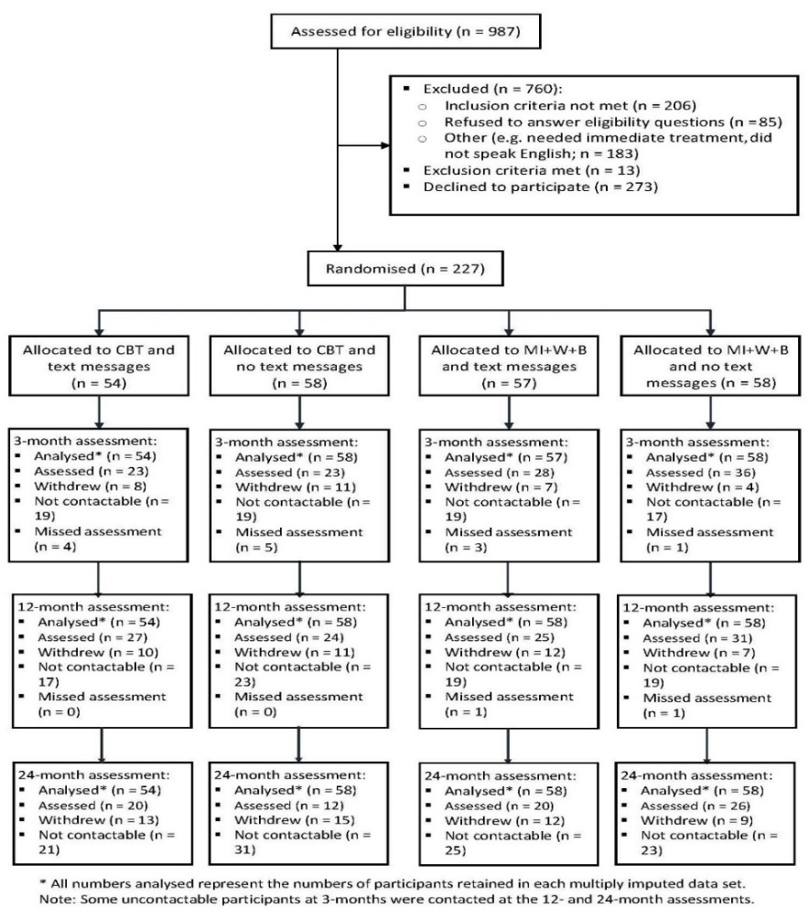
Table 2: Participant numbers and percentages completing assessments by intervention group
Assessment | CBT + text messaging  n (%) | CBT no text messaging  n (%) | MI+W+B + text messaging  n (%) | MI+W+B no text messaging  n (%) | Overall  n (%)
Baseline | 54 (100.0) | 58 (100.0) | 57 (100.0) | 58 (100.0) | 227 (100.0)
3 months | 23 (42.6) | 23 (39.7) | 28 (49.1) | 36 (62.1) | 110 (48.4)
12 months | 27 (50.0) | 24 (41.4) | 25 (43.9) | 31 (53.5) | 107 (47.2)
24 months | 20 (37.0) | 12 (20.7) | 20 (35.1) | 26 (44.8) | 78 (34.4)
Note: Some participants missed their three-month assessment (they could not be contacted) but completed subsequent assessments.

    - Attrition

There was no evidence for differential attrition in terms of sociodemographic factors. Attrition analyses (see Appendix 1 for details) according to sociodemographic factors showed no significant differences between factor categories at the 5% level, using Pearson’s chi-squared test (Appendix 2).

    - Profile of participants who attended treatment vs. those who did not

The 12-month report detailed that “one-fifth (20.5%) of participants randomised to the CBT intervention and two-fifths (40%) of participants randomised to the MI+W+B intervention did not receive any of the allocated intervention, with the majority failing to turn up for the first treatment session” (Bellringer et al., 2021, p.37). In a comparison of the sociodemographic profiles of the participants who did not attend any intervention sessions compared with those who attended at least one session, a difference between the two groups was found (using Pearson’s chi-squared test) for ethnicity, age, educational level and level of individual deprivation. The statistically significant findings are shown in Table 3. The full table is shown in Appendix 3.

Table 3: Differences in sociodemographic profile for attending treatment vs. not attending
Sociodemographic factor |  | Did not attend any sessions |  | Attended at least one session |  | p-value
 | Categories | N | (%) | N | (%)
Ethnicity | Māori | 30 | (43.5) | 34 | (21.5) | 0.0013
 | Pacific | 10 | (14.5) | 19 | (12.0)
 | European/Other | 29 | (42.0) | 105 | (66.5)
Age (years) | 18-34 | 29 | (42.0) | 49 | (31.4) | 0.027
 | 35-44 | 22 | (31.9) | 33 | (21.2)
 | 45-54 | 9 | (13.0) | 38 | (24.4)
 | 55+ | 9 | (13.0) | 36 | (23.1)
Highest educational level | No formal qual. | 18 | (26.9) | 23 | (15.0) | 0.011
 | School qual. | 18 | (26.9) | 57 | (37.3)
 | Trade/vocational qual. | 21 | (31.3) | 30 | (19.6)
 | Degree/higher | 10 | (14.9) | 43 | (28.1)
Deprivation | 0 | 12 | (17.9) | 51 | (34.7) | 0.018
 | 1-2 | 21 | (31.3) | 47 | (32.0)
 | 3-8 | 34 | (50.7) | 49 | (33.3)

Further analysis identified that a higher risk of not attending any sessions was noted for:
- Māori compared with European/Other participants (risk ratio 2.2; 95% CI 1.4, 3.3; p=0.0012)
- Participants aged 18 to 44 years, compared with participants aged 45 years and older (risk ratio 2.0; 95% CI 1.2, 3.1; p=0.018)
- Participants with no formal educational qualification or a trade/vocational qualification, compared with participants with at least school-level qualifications (risk ratio 1.9; 95% CI 1.3, 2.9; p=0.009)
- Participants with deprivation scores of 3 to 8, compared with those who did not experience any deprivation (risk ratio 2.2; 95% CI 1.2, 3.8; p=0.014).
When participants who attended at least half the scheduled intervention sessions (i.e. 5 or more of 10 sessions in the CBT group and 3 or more of 6 sessions in the MI+W+B group) were compared with those who did not attend at least half the sessions, a statistically significant difference was found for age and level of individual deprivation. The statistically significant findings are shown in Table 4 and the full table in Appendix 4.

Table 4: Differences in sociodemographic profile for attending at least half of treatment sessions vs. less than half
Sociodemographic factor |  | Attended at least half the sessions |  | Attended less than half the sessions |  | p-value
 | Categories | N | (%) | N | (%)
Age (years) | 18-34 | 21 | (28.4) | 57 | (37.7) | 0.002
 | 35-44 | 10 | (13.5) | 45 | (29.8)
 | 45-54 | 21 | (28.4) | 26 | (17.2)
 | 55+ | 22 | (29.7) | 23 | (15.2)
Deprivation | 0 | 28 | (41.2) | 35 | (24.0) | 0.014
 | 1-2 | 22 | (32.4) | 46 | (31.5)
 | 3-8 | 18 | (26.5) | 65 | (44.5)

Additional analyses identified that a higher risk for attending fewer than half of the intervention sessions was noted for participants aged 35 to 44 years, compared with those aged 45 to 54 years (risk ratio 1.5; 95% CI 1.1, 2.0 p=0.026) and those aged 55 years or older (risk ratio 1.6; 95% CI 1.2, 2.2; p=0.0077). A higher risk was also found for participants with deprivation scores of 3 to 8, compared with those who did not experience any deprivation (risk ratio 1.4; 95% CI 1.1, 1.8; p=0.012).

  - Primary outcomes

The two primary outcomes were:
- Self-reported monthly average number of days spent gambling (Days gambled)
- Self-reported monthly average amount of money lost per day gambling (Money lost).
    - Days gambled

At the 24-month assessment, the average number of days spent gambling per month was similar between participants in the CBT and the MI+W+B groups. About one-quarter had not gambled, slightly less than half gambled on 1 to 3 days, and about one-third gambled on 4 or more days (Figure 2). This profile was not considerably different from that noted at the 12-month assessment but substantially different from the baseline assessment.

Figure 2: Monthly average number of days gambled by intervention group
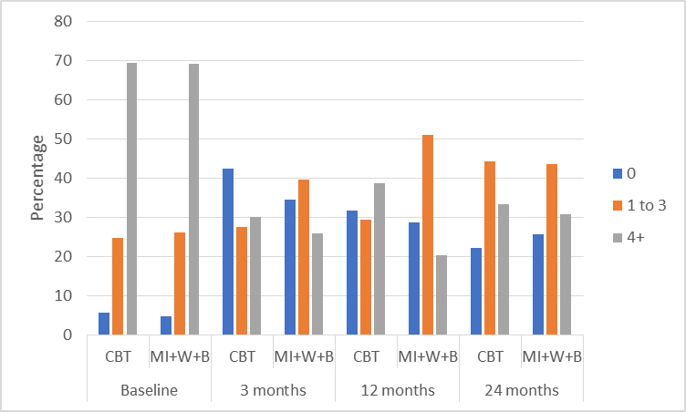

At the 24-month assessment, there were no major differences in average number of days gambled per month between participants who had received the text messaging intervention and those who had not received text messages. The largest proportions in both groups gambled on 1 to 3 days per month (Figure 3). This result was similar to that noted at the 12-month assessment.

Figure 3: Monthly average number of days gambled by text messaging group
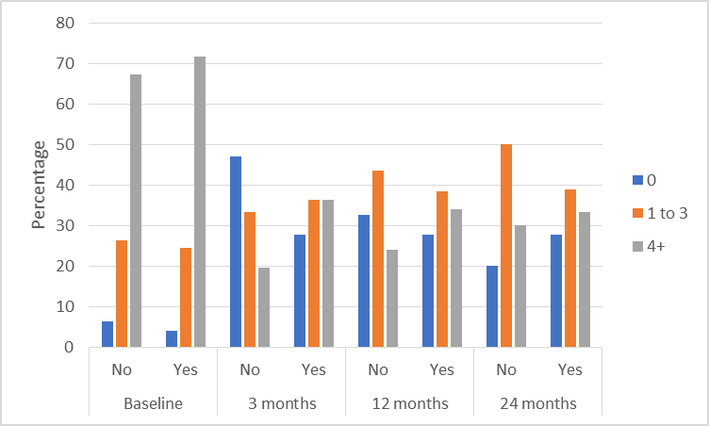

    - Money lost

At the 24-month assessment, average money lost gambling per month was similar between participants in the CBT and the MI+W+B groups. About one-quarter had not gambled, almost two-thirds lost between $1 and $500, and slightly more than one in ten participants lost more than $500 (Figure 4). This differed from the 12-month assessment with a greater proportion losing the lesser amount of money per month. This could indicate that of participants who continued to gamble, after 24 months their gambling was relatively controlled.

Figure 4: Monthly average money lost by intervention group
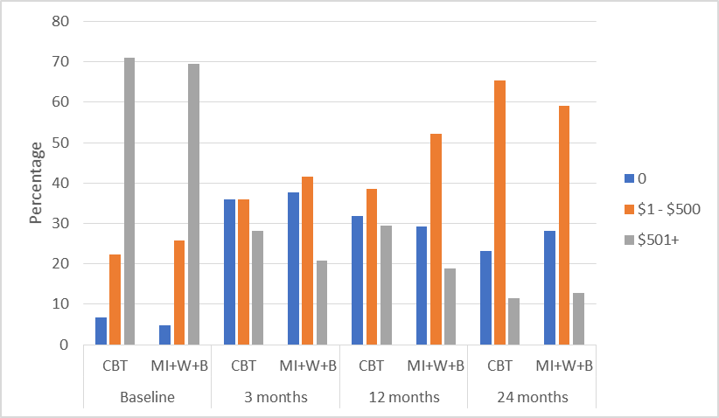

At the 24-month assessment, average money lost gambling per month was similar between participants in both the text message and no text message groups. About one-quarter had not gambled, a majority lost between $1 and $500, and fewer than two in ten participants lost more than $500 (Figure 5).

Figure 5: Monthly average money lost by text messaging group
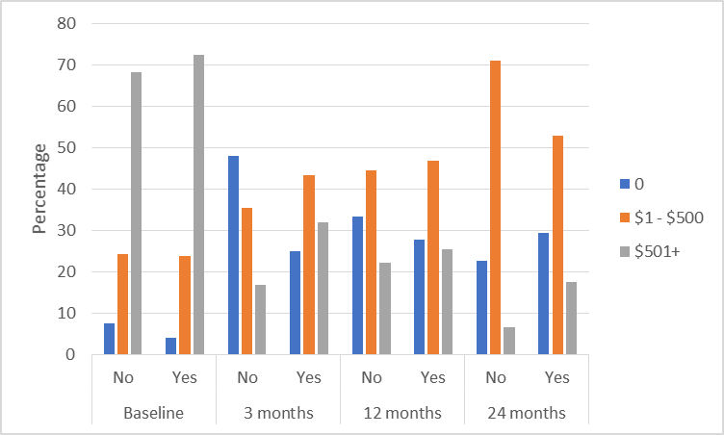

    - Intention-To-Treat data set: Days gambled and Money lost - inferential analyses

There were no statistically significant differences in Days gambled or Money lost between the CBT and MI+W+B groups at the 24-month assessment in the Intention-To-Treat (ITT) data set. Nor were there any significant differences between participants receiving and not receiving text messages (Table 5).

Table 5: ITT data set - Days gambled and Money lost, 24-month assessment
 | Odds Ratio | (95% CI) | P-value
Days gambled
CBT - 24 months | 0.95 | (0.28, 3.2) | 0.93
Text messaging - 24 months | 0.67 | (0.20, 2.2) | 0.48
Money lost
CBT - 24 months | 1.0 | (0.30, 3.4) | 0.98
Text messaging - 24 months | 0.68 | (0.26, 1.8) | 0.40
MI+W+B group = reference group vs. CBT group
No text messages = reference group vs. received text messaging intervention
Adjusted for deprivation (Days gambled and Money lost) and employment (Money lost)

Subgroup analyses by Māori and Pacific ethnicity

There was no intervention effect detected, at the 24-month assessment, for Māori and Pacific subgroups. Due to very small sample sizes (particularly for the Pacific subgroup), only Fisher’s exact test for independence could be performed. All results (not shown) were non-significant.

    - Per Protocol data set: Days gambled and Money lost - inferential analyses

There were no statistically significant differences in Days gambled or Money lost between the CBT and MI+W+B groups at the 24-month assessment in the Per Protocol (PP) data set. Neither were there any significant differences in Days gambled or Money lost between participants receiving and not receiving text messages (Table 6).

Table 6: PP data set - Days gambled and Money lost, 24-month assessment
 | Odds Ratio | (95% CI) | P-value
Days gambled
CBT - 24 months | 1.0 | (0.18, 5.6) | 0.98
Text messaging - 24 months | 0.96 | (0.24, 3.8) | 0.96
Money lost
CBT - 24 months | 1.0 | (0.29, 3.6) | 0.98
Text messaging - 24 months | 0.58 | (0.18, 1.9) | 0.36
MI+W+B group = reference group vs. CBT group
No text messages = reference group vs. received text messaging intervention
Adjusted for deprivation and employment (Money lost only)

  - Secondary outcomes - ITT data set

    - Gambling risk level

At the 24-month assessment, almost two-thirds of participants showed evidence of recovery (61.3% CBT, 65.9% MI+W+B), evidenced by a Problem Gambling Severity Index (PGSI) score below the cut-off for problem gambling. Amongst participants in the text messaging groups compared with the non-text messaging groups the percentages were similar (64.1% and 63.9%, respectively). The mean PGSI scores ranged from 5.2 to 7.2 for the four intervention groups (Figure 6), indicating that, overall, participants in each intervention group were in the moderate risk category. This showed continued improvement from the 12-month assessment, and a marked improvement from baseline (when mean scores showed a severe level of problem gambling).

Figure 6: Mean PGSI score, past 12-month time frame
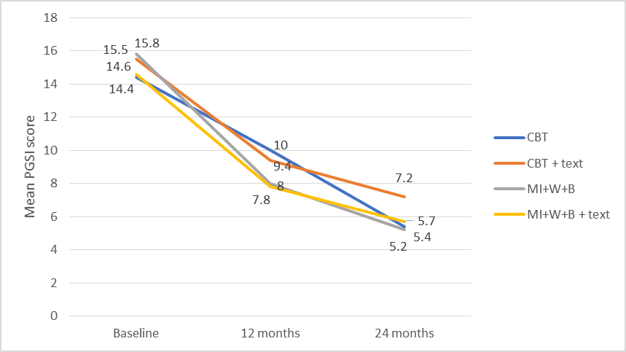

There were no statistically significant differences in gambling risk level (analysed as a binary outcome of ‘non-risk to moderate-risk’ and ‘problem gambler’) between the CBT and MI+W+B groups at the 24-month assessment. Similarly, there were no significant differences in gambling risk level between those receiving and not receiving text messages (Table 7).

Table 7: Gambling risk level, 24-month assessment
 | Odds Ratio | (95% CI) | P-value
PGSI (12-month time frame)
CBT - 24 months | 2.7 | (0.44, 15.9) | 0.27
Text messaging - 24 months | 1.0 | (0.24, 4.4) | 0.96
MI+W+B group = reference group vs. CBT group
No text messages = reference group vs. received text messaging intervention
Adjusted for deprivation

    - Gambling urge

Urge to gamble was measured using the Gambling Urge Scale (GUS), whereby higher scores indicated greater urge.

At the 24-month assessment, a higher proportion of CBT group participants appeared to have zero gambling urge compared with MI+W+B group participants, and a lower proportion scored 1 to 7 (Figure 7). Although these apparent differences were not statistically significant (see Table 8), they may be important as previous research has shown gambling urge to be the strongest predictor of relapse of disordered gambling (Smith et al., 2015). The proportions of participants with zero gambling urge were substantially higher compared with the baseline assessment.

Figure 7: Gambling urge by intervention group
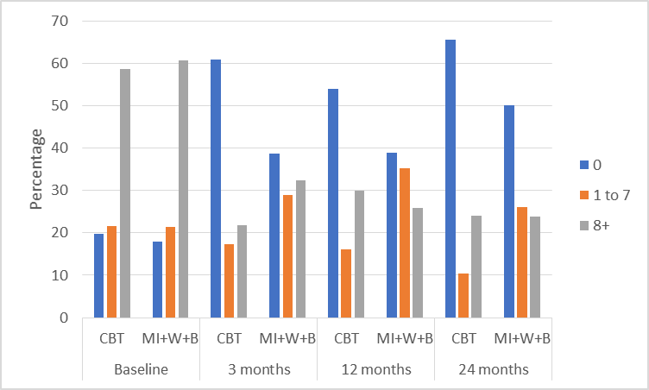

At the 24-month assessment, there were no apparent differences between groups receiving, or not receiving, text messages and having zero gambling urge. However, a higher proportion of participants who received text messages scored 8 or more on the GUS than participants who did not receive text messages, whilst a lower proportion scored 1 to 7 (Figure 8). These apparent differences have no importance as they were not statistically significant (see Table 8).

Figure 8: Gambling urge by text messaging group
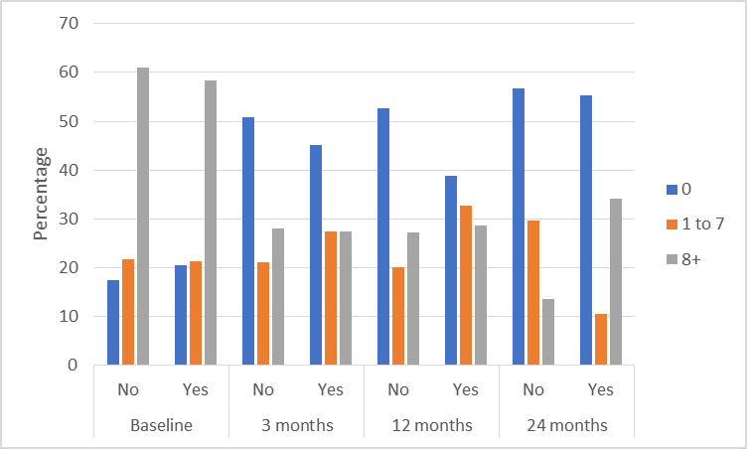

There were no statistically significant differences in gambling urge between the CBT and MI+W+B groups at the 24-month assessment (analysed as a three-category variable of score 0, 1 to 7, 8+). Similarly, there were no significant differences in gambling urge between those receiving and not receiving text messages (Table 8).

Table 8: Gambling urge, 24-month assessment
Gambling Urge Scale | Odds Ratio | (95% CI) | P-value
CBT - 24 months | 0.54 | (0.21, 1.4) | 0.18
Text messaging - 24 months | 2.0 | (0.69, 5.9) | 0.19
MI+W+B group = reference group vs. CBT group
No text messages = reference group vs. received text messaging intervention
Adjusted for deprivation

    - Motivation to overcome gambling-related problems

Participants’ motivation to overcome their gambling problems remained high at the 24-month assessment, with most participants in both the CBT and the MI+W+B groups having a mean score of 7 to 10 (90.7% and 95.6%, respectively). Similar proportions were noted for participants who received or did not receive text messages (90.0% and 97.4%, respectively).

There were no statistically significant differences in motivation to overcome gambling problems between the CBT and MI+W+B groups at the 24-month assessment (assessed as a two-category variable of 0 to 9, and 10). Similarly, there were no significant differences in motivation to overcome gambling problems between those receiving and not receiving text messages (Table 9).

Table 9: Motivation to overcome gambling problems, 24-month assessment
Treatment motivation | Odds Ratio | (95% CI) | P-value
CBT - 24 months | 0.85 | (0.25, 2.9) | 0.79
Text messaging - 24 months | 0.79 | (0.33, 1.9) | 0.58
MI+W+B group = reference group vs. CBT group
No text messages = reference group vs. received text messaging intervention
Adjusted for gender and ethnicity

    - Confidence in success of meeting treatment goal

At the 24-month assessment, participants’ confidence in success of meeting the treatment goal was similar to that at the 12-month assessment. Although there appeared to be some differences between the CBT and MI+W+B groups at the lower levels of confidence in success (Figure 9), the differences were not statistically significant (see Table 10) and are likely to have been artefacts of small sample sizes.

Figure 9: Confidence in success of meeting treatment goal by intervention group
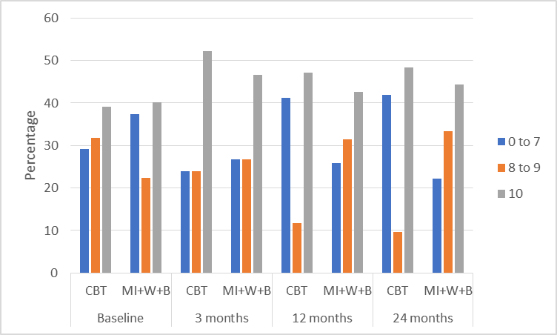

Receipt of text messages did not appear to alter confidence in treatment success as proportions at the 24-month assessment were broadly similar to those at the three-month assessment, before the text intervention commenced (Figure 10).
Figure 10: Confidence in success of meeting treatment goal by text messaging group
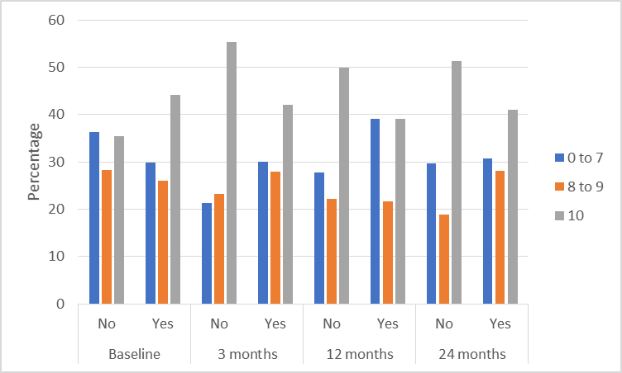

There were no statistically significant differences in participants’ confidence in treatment success between the CBT and MI+W+B groups at the 24-month assessment (analysed as a three-category variable of score 0 to 7, 8 to 9, and 10). Similarly, there were no significant differences in confidence in success between those receiving and not receiving text messages (Table 10).

Table 10: Confidence in treatment success, 24-month assessment
Confidence in treatment success | Odds Ratio | (95% CI) | P-value
CBT - 24 months | 0.44 | (0.17, 1.2) | 0.10
Text messaging - 24 months | 0.98 | (0.42, 2.3) | 0.97
MI+W+B group = reference group vs. CBT group
No text messages = reference group vs. received text messaging intervention
Adjusted for gender

    - Goal achievement

At the 24-month assessment, no major differences between the intervention groups were noted in terms of achieving the treatment goal of stopping all gambling activities, stopping only problematic gambling activities, or reducing gambling (Figure 11). Any apparent differences are likely to be an artefact of small sample sizes as the differences were not statistically significant (see Table 11). At the 24-month assessment, about two-fifths of participants reported they had completely met their treatment goal; this was similar to the proportions at the three and 12-month assessments.

Figure 11: Goal achievement by intervention group
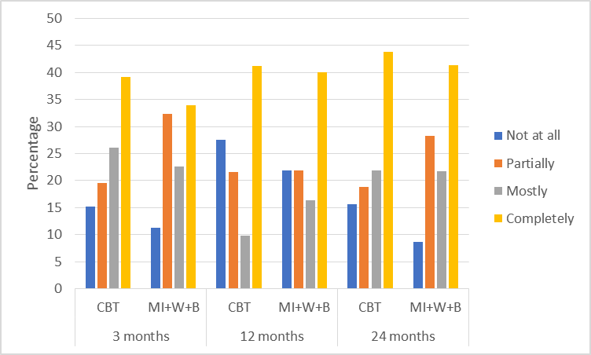

Receipt of text messages did not appear to affect goal achievement as proportions at the 24-month assessment were broadly similar between those receiving and not receiving the messages, and the distribution was similar to the proportions noted at the three-month assessment (Figure 12).

Figure 12: Goal achievement by text messaging group
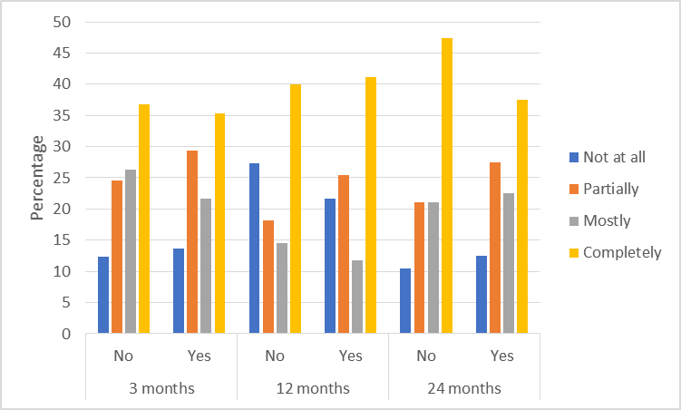

There were no statistically significant differences in goal achievement between the CBT and MI+W+B groups at the 24-month assessment. Similarly, there were no significant differences in goal achievement between those receiving and not receiving text messages (Table 11).
Table 11: Goal achievement, 24-month assessment
Goal achievement | Odds Ratio | (95% CI) | P-value
CBT - 24 months | 0.97 | (0.30, 3.1) | 0.96
Text messaging - 24 months | 1.4 | (0.55, 3.7) | 0.44
MI+W+B group = reference group vs. CBT group
No text messages = reference group vs. received text messaging intervention
Adjusted for ethnicity and deprivation

    - Control over gambling

At the 24-month assessment, there were no major differences in control over gambling reported by participants in the CBT and MI+W+B groups. With only about one-fifth of participants reporting low control over gambling (score 0 to 6), this remained a positive improvement from the approximately two-thirds of participants who reported this level of control prior to receiving their intervention (Figure 13).

Figure 13: Control over gambling by intervention group
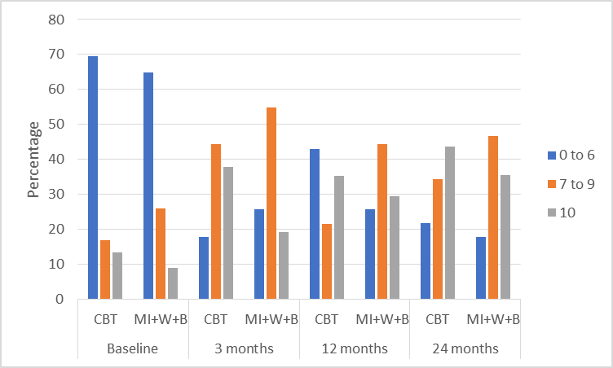

Receipt of text messages did not appear to affect control over gambling, with a similar profile of control noted at the 24-month assessment between those receiving and not receiving text messages (Figure 14).

Figure 14: Control over gambling by text messaging group
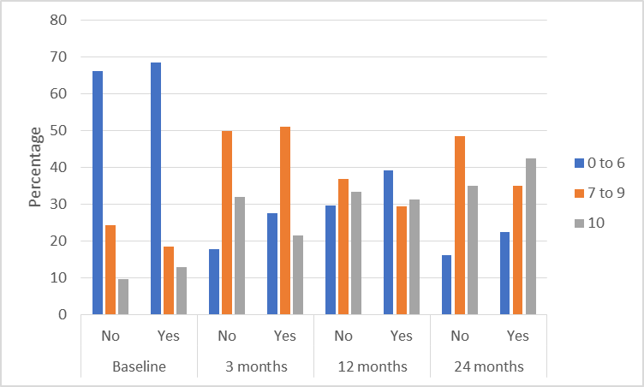

There were no statistically significant differences in control over gambling between the CBT and MI+W+B groups at the 24-month assessment (analysed as a three-category variable of score 0 to 6, 7 to 9, and 10). There were no significant differences in control over gambling between those receiving and not receiving text messages (Table 12).

Table 12: Control over gambling, 24-month assessment
Control over gambling | Odds Ratio | (95% CI) | P-value
CBT - 24 months | 1.1 | (0.37, 3.3) | 0.85
Text messaging - 24 months | 0.98 | (0.37, 2.6) | 0.97
MI+W+B group = reference group vs. CBT group
No text messages = reference group vs. received text messaging intervention

    - Gambling consequences

At the 24-month assessment, no major differences between the intervention groups were noted in the proportions who experienced negative consequences from gambling. The percentages of participants reporting the different types of gambling-related harm were broadly similar at all assessments following completion of intervention delivery (Figure 15).

Figure 15: Negative consequences of gambling by intervention group
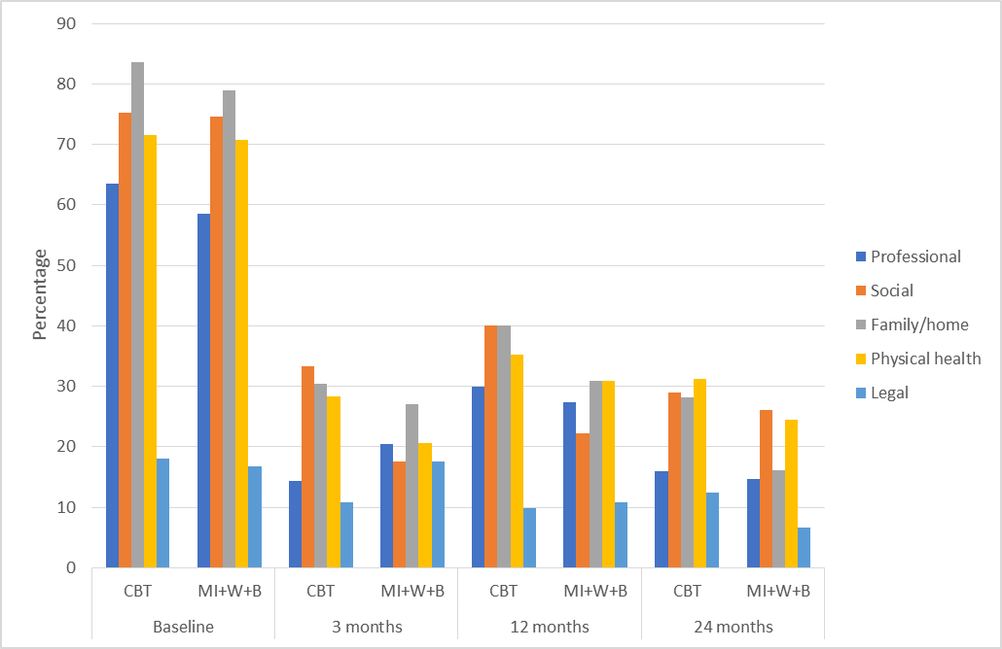

At the 24-month intervention, receipt of text messages did not appear to affect the proportions of participants experiencing negative consequences from their gambling, as percentages were broadly similar between those receiving or not receiving the messages (Figure 16). Although it appeared that larger proportions of participants who received the text message intervention experienced gambling-related harms compared with participants who did not receive the messages, this is likely to be an artefact of very small sample sizes.

Figure 16: Negative consequences of gambling by text messaging group
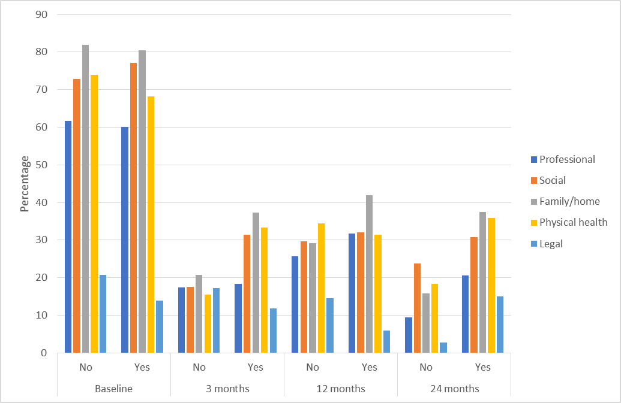
There were no statistically significant differences in negative consequences from gambling reported by the CBT and MI+W+B groups at the 24-month assessment. Similarly, there were no significant differences in gambling consequences between those receiving and not receiving text messages (Table 13). The wide 95% confidence intervals in some cases are due to the small sample sizes.

Table 13: Gambling consequences, 24-month assessment
Negative effects on: | Odds Ratio | (95% CI) | P-value
Professional lifeª
CBT - 24 months | 1.7 | (0.44, 6.3) | 0.43
Test messaging - 24 months | 1.2 | (0.38, 3.9) | 0.72
Social life^{b}
CBT - 24 months | 0.98 | (0.16, 6.0) | 0.98
Text messaging - 24 months | 0.88 | (0.16, 4.8) | 0.88
Family/home life
CBT - 24 months | 0.20 | (0.019, 2.0) | 0.17
Text messaging - 24 months | 2.9 | (0.43, 20.0) | 0.27
Physical health
CBT - 24 months | 0.34 | (0.065, 1.8) | 0.20
Text messaging - 24 months | 2.8 | (0.59, 13.2) | 0.20
Legal problems^{b}
CBT - 24 months | 2.6 | (0.39, 16.9) | 0.31
Text messaging - 24 months | 2.0 | (0.45, 9.0) | 0.34
MI+W+B group = reference group vs. CBT group
No text messages = reference group vs. received text messaging intervention
ª Adjusted for ethnicity, annual household income and deprivation
^{b} Adjusted for deprivation

    - Substance use
At the 24-month assessment, no major differences between the intervention groups were noted in relation to substance use (hazardous alcohol consumption, tobacco smoking or illicit drug use) (Figure 17). The proportions of participants reporting substance use were broadly similar to the baseline assessment with apparent differences likely to be related to the reduced sample size at the 24-month assessment. This indicates that the gambling interventions did not alter substance use. Hazardous alcohol consumption was the most reported co-existing substance used, with more than two-thirds of participants in both intervention groups reporting this.

Figure 17: Substance use by intervention group
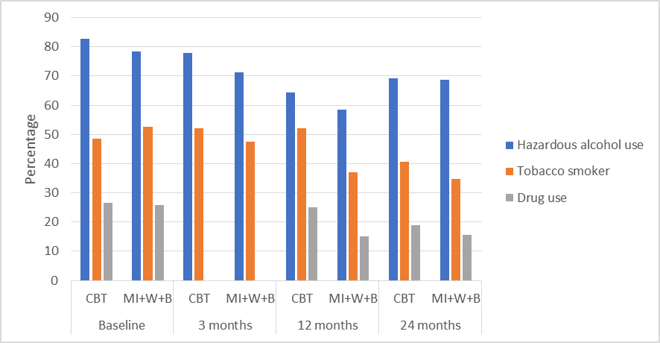
Note: Drug use data were not collected at the three-month assessment

Receipt of text messages did not appear to affect substance use as proportions at the 24-month assessment were broadly similar between those receiving or not receiving the messages, or similar to the pattern noted at prior assessments before text messages were received (Figure 18).

Figure 18: Substance use by text messaging group
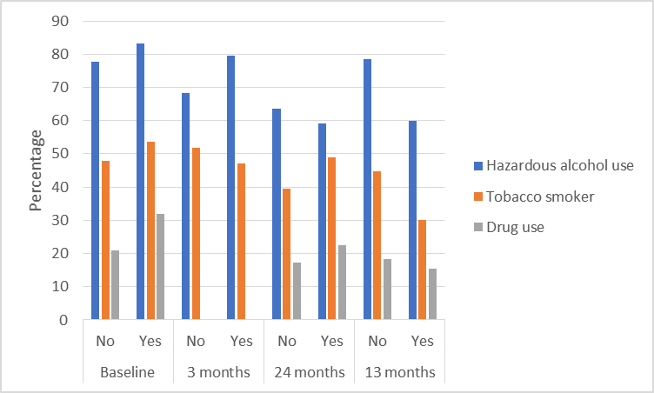
Note: Drug use data were not collected at the three-month assessment

There were no statistically significant differences in hazardous alcohol consumption, tobacco smoking or drug use between the CBT and MI+W+B groups at the 24-month assessment. There were no significant differences in substance use between those receiving and not receiving text messages (Table 14).

Table 14: Substance use, 24-month assessment
Substance | Odds Ratio | (95% CI) | P-value
Hazardous alcohol consumption
CBT - 24 months | 1.0 | (0.28, 3.8) | 0.96
Test messaging - 24 months | 0.38 | (0.091, 1.6) | 0.17
Tobacco smoking
CBT - 24 months | 1.4 | (0.27, 7.0) | 0.69
Text messaging - 24 months | 0.4 | (0.057, 2.8) | 0.34
Drug use
CBT - 24 months | 2.6 | (0.22, 29.7) | 0.44
Text messaging - 24 months | 0.45 | (0.057, 3.6) | 0.44
MI+W+B group = reference group vs. CBT group
No text messages = reference group vs. received text messaging intervention
Adjusted for age (tobacco smoking only)
Note: Drug use data were not collected at the three-month assessment

    - Mental health

Psychological distress

At the 24-month assessment, no major differences between the intervention groups were noted in general psychological distress, measured using the Kessler 10 questionnaire (Figure 19). There appeared to be minor improvement over time with lower proportions of participants reporting psychological distress compared with the 12-month assessment. Furthermore, there remained a substantial improvement from the baseline assessment.

Figure 19: Psychological distress by intervention group
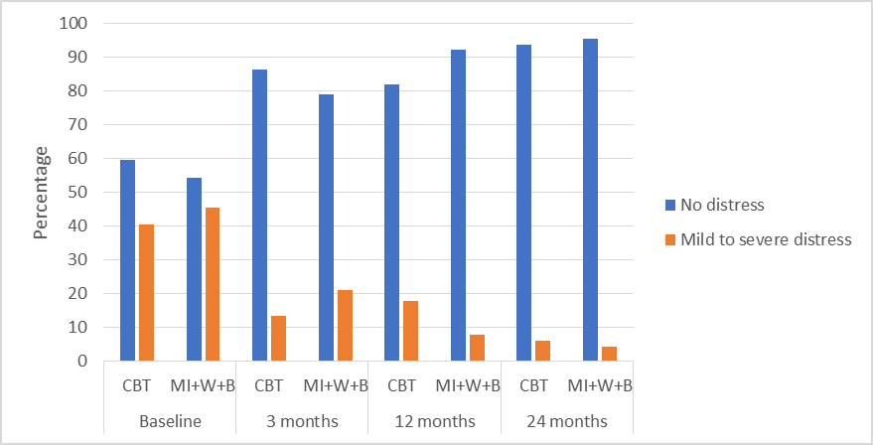

Receipt of text messages did not appear to affect general psychological distress as proportions at the 24-month assessment were broadly similar between those receiving and not receiving text messages (Figure 20).

Figure 20: Psychological distress by text messaging group
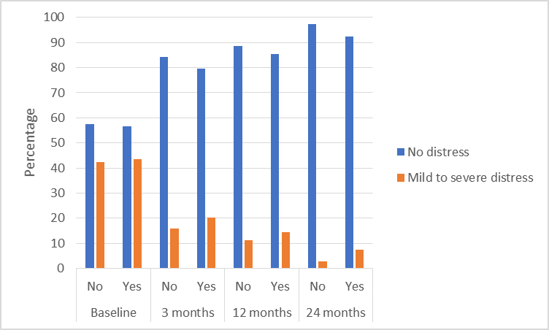

Depression

Varying types of depression (major, minor, dysthymia and bipolar disorder) were assessed using the mood module of the PRIME-MD.

At the 24-month assessment, there were no major differences between the CBT and MI+W+B groups in proportions of participants with major or minor depression (Figure 21). Neither treatment altered proportions of participants with major depression over time, but a reduction in prevalence of minor depression was noted. Apparent differences in the percentages of bipolar disorder are likely to be artefacts of very small sample sizes, which meant that minor changes in number led to large percentage fluctuations.

A lower proportion of participants in the MI+B+W group appeared to have dysthymia (persistent depressive order) at the 24-month assessment, compared with the CBT group. This was statistically significant (see Table 15). However, as detailed below, the significance of this finding should be treated with caution as the sample sizes in each group were very small.

Figure 21: Depression by intervention group
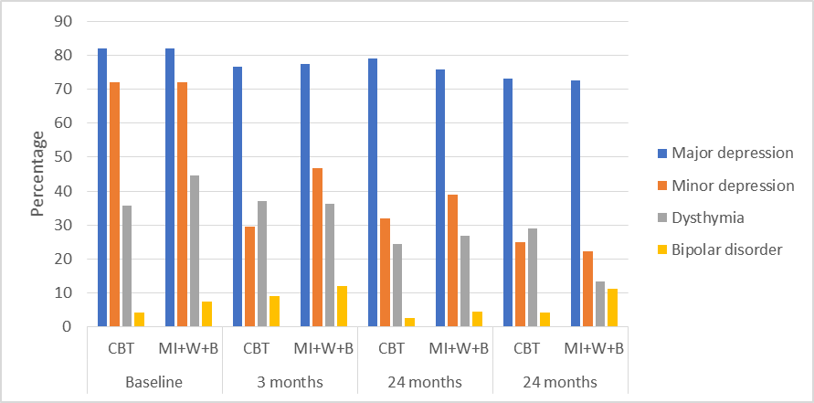

Receipt of text messages did not appear to affect depression as proportions at the 24-month assessment were broadly similar between those receiving and not receiving text messages (Figure 22).

Figure 22: Depression by text messaging group
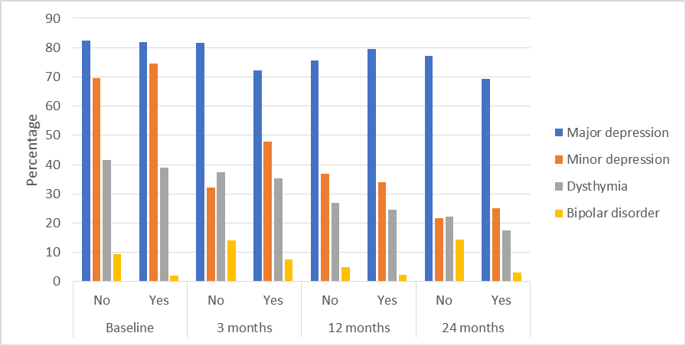

There were no significant differences in psychological distress, major or minor depression, or bipolar disorder between the CBT and MI+W+B groups at the 24-month assessment. Similarly, there were no significant differences in mental health between those receiving and not receiving text messages (Table 15). However, participants in the CBT group had 5.2 times higher odds for dysthymia than participants in the MI+W+B group at the 24-month assessment. This finding should, however, be treated cautiously as the sample sizes in each group were very small and the statistical significance was not replicated in the Per Protocol analysis (of participants who had received at least half of their scheduled intervention; odds ratio 3.0; 95% CI 0.29, 32.1; p = 0.35).

Table 15: Mental health, 24-month assessment
Mental health issue | Odds Ratio | (95% CI) | P-value
Psychological distressª
CBT - 24 months | 1.2 | (0.24, 5.9) | 0.82
Test messaging - 24 months | 1.4 | (0.31, 6.0) | 0.68
Major depression^{b}
CBT - 24 months | 0.51 | (0.10, 2.5) | 0.46
Text messaging - 24 months | 0.97 | (0.25, 3.8) | 0.97
Minor depression^{c}
CBT - 24 months | 0.8 | (0.12, 5.3) | 0.81
Text messaging - 24 months | 0.91 | (0.26, 3.2) | 0.88
Dysthymia^{d}
CBT - 24 months | 5.2 | (1.1, 24.1) | 0.036
Text messaging - 24 months | 0.53 | (0.15, 1.9) | 0.32
Bipolar disorder
CBT - 24 months | 0.75 | (0.079, 7.1) | 0.80
Text messaging - 24 months | 0.79 | (0.13, 4.7) | 0.79
MI+W+B group = reference group vs. CBT group
No text messages = reference group vs. received text messaging intervention
Bold text = statistical significance
ª Adjusted for deprivation
^{b} Adjusted for electronic gaming machine (EGM) gambling
^{c} Adjusted for gender
^{d} Adjusted for gender, age, annual household income and EGM gambling

    - Quality of life

At the 24-month assessment, there were no major differences in quality of life (measured using the EUROHIS-QOL 8) reported by participants in the CBT and MI+W+B groups (Figure 23). Improvement in quality of life was noted following intervention delivery for participants in both groups.

Figure 23: Quality of life by intervention group
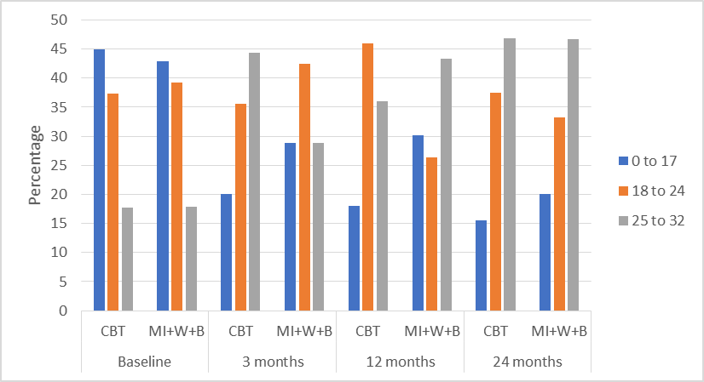

Receipt of text messages did not appear to affect quality of life as percentages of participants reporting a low quality of life (score 0 to 17) were similar between those receiving and not receiving text messages, at the 24-month assessment (Figure 24).

Figure 24: Quality of life by text messaging group
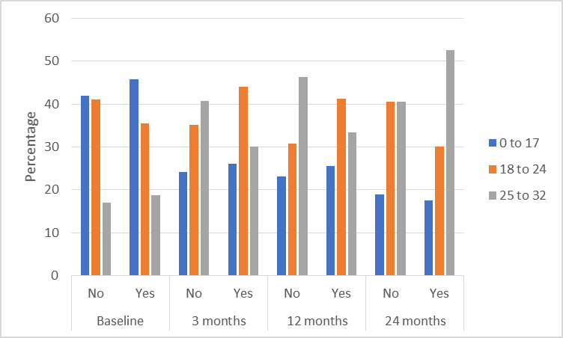
There were no statistically significant differences in quality of life between the CBT and MI+W+B groups at the 24-month assessment. There were no significant differences in quality of life between those receiving and not receiving text messages (Table 16).

Table 16: Quality of life, 24-month assessment
Quality of life | Odds Ratio | (95% CI) | P-value
CBT - 24 months | 1.1 | (0.39, 3.2) | 0.83
Text messaging - 24 months | 1.7 | (0.77, 3.6) | 0.19
MI+W+B group = reference group vs. CBT group
No text messages = reference group vs. received text messaging intervention
Adjusted for deprivation and paid employment

    - Workbook

At the 24-month assessment, a substantial minority of MI+W+B participants reported that they had continued to use the ‘Becoming a winner: Defeating problem gambling’ self-help workbook in the prior year (Table 17). Of the 30 participants who reported receiving the workbook, seven (23.3%) had read some or all the sections, 10 (33.3%) had completed some or all of the exercises and 10 (33.3%) had occasionally or regularly used one or more of the strategies, at the 24-month assessment.

There were few responses to open-ended questions on the most and least helpful aspects of the workbook. Of the 17 participants who provided a response, two reported that the workbook was helpful overall, and five others reported that specific aspects of the workbook were helpful, including the sections on triggers, alternative strategies, and daily diaries. Only two participants reported that there were aspects of the workbook that were unhelpful. Ten participants could not remember or did not know what was most or least helpful.

Table 17: MI+W+B workbook receipt and use
Workbook | Category | MI+W+B (n (%))
 |  | 3 months | 12 months | 24 months
Received workbook | No | 17 (29.8) | 11 (20.8%) | 14 (31.8)
 | Yes | 40 (70.2%) | 42 (79.2%) | 30 (68.2)
Read workbook | Not at all | 7 | 21 | 23
 | Some | 20 | 12 | 6
 | Completely | 14 | 9 | 1
Exercise completion | None | 12 | 7 | 6
 | Some | 18 | 19 | 8
 | All | 6 | 6 | 2
Strategy use | None | 17 | 18 | 5
 | Occasionally | 15 | 11 | 8
 | Regularly | 4 | 4 | 2

    - Intervention experience

Overall, of participants who completed the 24-month assessment, 78% (n=36) of MI+W+B participants and 69% (n=22) of CBT participants reported that their needs had been met by the intervention they received.

The most common helpful aspects of the intervention reported by participants, were slightly different from those reported at earlier assessments (Table 18). Talk therapy in general was the most reported, by 10 participants who had received the MI+W+B intervention and 12 who had received CBT. At prior assessments, a good relationship with the counsellor had been reported by more participants, indicating that without direct contact, it was the therapy in general that remained helpful. The only other finding that appeared different at the 24-month assessment was that eight MI+W+B participants reported an increased understanding of the gambling problem to be helpful compared with about half this number at earlier assessments.

When asked about aspects of the intervention that were least helpful, almost half of the respondents did not identify anything, which is consistent with the previous assessments. Of those who reported a least helpful aspect, the most commonly reported aspect was not liking the treatment.

However, the low number of responses reported by participants for the helpful and unhelpful aspects of the interventions means that it is not possible to generalise the findings to the rest of the participants in the MI+W+B and CBT intervention groups.

Table 18: Most and least helpful aspects of the intervention
 | MI+W+B |  |  | CBT
 | 3 month | 12 month | 24 month | 3 month | 12 month | 24 month
 | n | n | n | n | n | n
Most helpful aspect
Total N | 63 | 55 | 46 | 45 | 51 | 32
Good relationship with counsellor | 18 | 15 | 6 | 13 | 12 | 7
Talk therapy in general | 14 | 8 | 10 | 11 | 7 | 12
Individual/face-to-face sessions | 9 | 11 | 7 | 4 | 10 | 5
Specific elements of respective therapy | 6 | 2 | 6 | 9 | 7 | 7
Phone calls | 6 | 5 | 0 | 1 | 1 | 2
Increase understanding of gambling problem | 3 | 4 | 8 | 5 | 2 | 4
Service was good overall | 4 | 3 | 4 | 2 | 4 | 1
Don’t know/nothing was helpful | 3 | 4 | 4 | 2 | 6 | 5
Other | 8 | 9 | 13 | 7 | 9 | 3
Least helpful aspect
Total N | 63 | 55 | 46 | 45 | 51 | 32
Don't know/nothing unhelpful | 37 | 27 | 24 | 18 | 24 | 18
Did not like treatment received | 6 | 4 | 4 | 8 | 2 | 7
Not enough contact | 5 | 6 | 3 | 1 | 2 | 0
Did not like phone calls/prefer face-to-face | 5 | 5 | 3 | 0 | 0 | 1
Time/location not suitable | 2 | 2 | 2 | 8 | 6 | 0
Poor relationship with counsellor | 0 | 5 | 1 | 5 | 5 | 3
Other | 6 | 7 | 9 | 3 | 8 | 6

- SUMMARY AND DISCUSSION OF RESULTS

This report documents the findings from a 24-month follow up assessment of gamblers who participated in a randomised controlled trial of two interventions set within a national multi-centre gambling treatment service. The two interventions were: 1) a face-to-face 10 session combined cognitive plus cue exposure therapy (CBT) and, 2) a six-session motivational interviewing intervention comprising one face-to-face session, a self-help workbook and five ‘booster’ telephone sessions (MI+W+B). An additional text messaging intervention was received by half the participants in each intervention group.

There was a high level of attrition (i.e. reduced sample size) at the 24-month assessment (overall, 34.4% completed the final assessment). This is a common phenomenon in RCTs. In the previous RCT conducted in a New Zealand helpline setting, the sample size at the 36-month assessment was 37% (Abbott et al., 2015). The highest attrition in the present trial was noted from baseline to the 3-month assessment (48.4% remained in the trial) with a lower level of further attrition at the 12-month (47.2%) and 24-month (34.4%) assessments. Maintaining contact with participants is a challenge, especially over long time periods. Some participants declined to complete assessments for personal or other unstated reasons, and others withdrew from the trial. However, most participants lost to the study were not contactable and possibly had moved residence or changed telephone number. In expectation that this might happen, at each assessment all participants were asked to provide details of a collateral person who could be contacted to provide interviewers with the latest participant contact details, if necessary. However, most participants declined to provide a collateral person, possibly because they wanted to keep their gambling problem hidden from others. Other means of maintaining contact with participants in future studies should be considered, e.g. additional courtesy calls to maintain rapport and obtain updated contact details. However, such contact would require additional resources in terms of time and cost.

It is of note that due to the high level of attrition, there is reduced statistical power to test the hypotheses. Generalisation of the findings beyond the context of this trial requires caution.

    - Both interventions had long-term treatment effects

Both the CBT and the MI+W+B interventions were associated with positive findings at the 24-month assessment, with higher proportions of participants in both groups either abstaining from gambling or gambling on 1 to 3 days per month, and lower proportions gambling on 4 or more days per month, compared with pre-treatment. This finding had been noted immediately after completion of treatment (at the three-month assessment) and continued over time. It is timely to note here that participants could choose their treatment goal, which was either abstinence or to control gambling behaviour (i.e. stop only problematic gambling activities or reduce gambling). Furthermore, at the 24-month assessment, the proportion of participants who lost $500 or more per month on gambling remained substantially lower than pre-treatment, with the proportion losing this amount reduced further from the three- and 12-month assessments. Although these findings may indicate some evidence of sustained changes due to the interventions, they may also partially represent natural recovery (Slutske, 2006) and there is a statistical likelihood that they are the result of a regression to the mean (RTM) effect. This is a phenomenon where there is a tendency for high-risk people to have measurement values that become more moderate with re-testing (Linden, 2013).

The reduced gambling behaviour was reflected in reduced gambling risk level; almost two-thirds of participants in both treatment groups showed evidence of recovery from problem gambling. Overall PGSI scores indicated moderate risk gambling at the 24-month assessment compared with overall problem gambling scores both pre-treatment and at the 12-month assessment. However, slightly more than one-third of participants in both intervention groups remained classified as problem gamblers at the 24-month assessment, indicating that there was individual variation in responsiveness to treatment. It is also possible that the participants had lasting gambling harms that did not resolve with reduced gambling behaviours or abstinence; alternatively, there may have been some misinterpretation of certain PGSI questions. A recent Swedish study identified that some respondents misinterpreted the questions relating to guilt and criticism with, for example, feelings of regret being mistaken for guilt, or teasing from others being interpreted as criticism (Samuelsson et al., 2019). Similar misinterpretation of South Oaks Gambling Screen questions had been reported much earlier in an examination of the data from three studies conducted in Canada (Ladouceur et al., 2000). Such perceived ambiguities in the questions and responses could lead to some participants continuing to score as problem gamblers in the absence of other gambling-related behaviours. Another possible explanation is that participants who continued to score as problem gamblers were those who dropped out of treatment before they had received at least half of their intervention. We were unable to verify this as Per Protocol analysis of PGSI scores was inconclusive due to small sample sizes at the 24-month assessment. It is also possible that people with co-existing substance use are a more complex group to treat and this study identified high levels of substance use, particularly hazardous alcohol consumption. For example, Carlbring et al. (2012) found that higher alcohol consumption was one of the variables that could predict which participants would respond less to internet-delivered CBT for treatment of problematic gambling. Further examination of the data will be required to identify the characteristics of participants who retained a high PGSI score; this is outside the scope of this study.

Additional to the lasting reduction in days and money spent gambling, other positive behaviours at the 24-month assessment included reduced gambling urge, increased perceived control over gambling, and high motivation to quit or reduce gambling. High confidence in success of meeting the treatment goal was also maintained and was reflected in a majority of participants in both intervention groups who achieved their goal at least partially, with the largest proportions completely achieving their goal immediately post-treatment, and with similar proportions reporting these findings after 24 months. Furthermore, negative consequences from gambling reduced immediately post-treatment and remained reduced at the 24-month assessment. Consequently, quality of life improved for most participants. These findings align with those of previous research where treatment effects have been maintained in the long-term (Carlbring & Smit, 2008; Ladouceur et al., 2003).

At the 24-month assessment there were some participants who reported that they continued to use the self-help workbook provided as part of the MI+W+B intervention. Additionally, for both interventions, the talk therapy was reported as the most helpful aspect of the interventions at the 24-month assessment. These findings indicate that the interventions received continued to influence participants’ gambling behaviours even though the treatments themselves, and contact with a counsellor, had been completed about 21 months earlier.

    - Mental health remained improved in the long-term

There was a sustained long-term decrease in general psychological distress, with larger proportions of participants reporting no distress at the 24-month assessment compared with pre-treatment. A sustained long-term decrease in minor depression was also noted, with continued slight improvement at the 24-month assessment compared with the three-month assessment (and a large improvement from pre-treatment). A similar finding had previously been noted in a randomised controlled trial of gamblers seeking help from the New Zealand national helpline, where it was found that the gambling intervention substantially reduced the prevalence of depression and this was not caused by natural recovery (Ranta et al., 2019). However, that study did not distinguish between major and minor depression and dysthymia (persistent depressive disorder). In the present RCT, receiving a gambling intervention did not appear to affect major depression or bipolar disorder, and the findings for dysthymia were inconclusive.

Neither the CBT nor the MI+W+B interventions altered co-existing hazardous alcohol consumption, tobacco smoking or illicit drug use in the short or long term. As gambling treatment outcomes can be negatively affected by co-existing substance use (Dowling et al., 2016), holistic treatment approaches dealing with substance use/abuse in conjunction with gambling-related issues might be warranted. However, as cautioned by Dowling et al. (2016), research is lacking in this area and it remains unknown whether co-existing issues should be treated sequentially or concurrently.

    - CBT and MI+W+B showed similar findings

The primary hypothesis for the 24-month follow-up assessment was that CBT participants would show greater clinically meaningful reductions in gambling and problem gambling than MI+W+B participants. However, no significant differences were found between the two groups for number of days gambled per month, money lost gambling per month, or problem gambling level. No significant difference had been noted at the earlier 12-month assessment either and, as previously discussed (Bellringer et al., 2021, p. 74), this may have been related to participants receiving a relatively low intensity CBT intervention (due to the low number of sessions attended by most participants) rather than the intended high intensity CBT intervention. It may also be due to the low sample size remaining at the 24-month assessment reducing the statistical ability to identify differences between the interventions, although differences were not identified at the 12-month assessment either. Finding participant improvement but no statistically significant differences between interventions over time in a RCT is not wholly unexpected. The same phenomenon occurs in other addiction treatments such as was found for alcoholism in the project MATCH trial (Cutler & Fishbain, 2005; Project MATCH Research Group, 1998).

One of the two secondary hypotheses was that CBT participants would have greater reductions in depression and anxiety than MI+W+B participants at 24 months. Again, statistical analyses found no significant differences between the two interventions.

    - Addition of text messaging did not alter long-term treatment outcomes

The other secondary hypothesis was that CBT and MI+W+B participants who received post-treatment text messaging would show greater clinically meaningful reductions in gambling at 24 months than those who did not receive the text messages. However, there were no significant differences in number of days gambled per month or money lost gambling per month between participants who received text messages and those who did not receive them. The same finding had been noted at the 12-month assessment.
    - Sociodemographic risk factors were found for pre-treatment/in-treatment drop out

This RCT had a relatively high dropout rate with one-in-five CBT participants and two-in-five MI+W+B participants being pre-treatment dropouts; that is, not attending the first treatment session and, thus, not receiving any of the allocated intervention (Bellringer et al., 2021, p.37). Furthermore, in-treatment dropout was high with only 22.3% of CBT participants and 42.9% of MI+W+B participants attending at least half the scheduled treatment sessions (Bellringer et al., 2021, p.44). This level of dropout is common amongst gamblers who seek professional help and was, therefore, not unexpected (Melville et al., 2007; Roberts et al., 2020; Robson et al., 2002; Ronzitti et al., 2017; Toneatto, 2005). There is a paucity of studies that have examined the phenomenon of treatment dropouts (either pre-treatment or in-treatment). However, risk factors for dropout have included younger age (Baño et al., 2021; Ronzitti et al., 2017; Sylvain et al., 1997), alcohol and drug use (Echeburúa et al.; 2001; Ronzitti et al., 2017), and debt and unemployment (Brown, 1986; Hodgins et al. 2004).

In this RCT, four socio-demographic risk factors were identified for participant dropout. One of these factors, age, was similar to that noted in the earlier studies. Participants in the 18 to 44 years age group had twice the risk ratio for pre-treatment dropout, compared with participants in the 45 years and older age group. In other words, participants in the younger age group had a higher risk for not attending any treatment sessions. A similar age risk was also noted for in-treatment dropout with a higher risk for dropout (1.5 x) noted amongst participants in the 35 to 44 years age group compared with those in the 45 years and older age group.

Māori participants had more than twice the risk ratio for pre-treatment dropout, compared with European/Other participants. However, there was no statistical difference between the groups for attending or not attending at least half the intervention sessions. The reasons for the higher risk for pre-treatment dropout are unknown and require further investigation. However, it should be noted that the treatment service was a mainstream service. Morrison and Boulton (2013) in their qualitative study on the harmful effects of gambling for 20 Māori women identified barriers to accessing treatment that included mainstream services not always being suitable due to lack of a kaupapa Māori approach, or practical barriers such as lack of transport to access the service. Both these reasons may help to explain why an increased risk for pre-treatment dropout was noted for Māori participants in this trial. However, there are likely to be other influencing factors and further research is required to identify and understand these factors.

Participants experiencing mid to high levels of deprivation had higher risk ratios for pre-treatment and in-treatment dropout, compared with participants not experiencing any deprivation. Again, the reasons for this remain to be investigated but could include issues such as lack of transport, lack of options for dependent children whilst the participant receives treatment, or not understanding that treatment services are provided free of charge. Furthermore debt and unemployment coexist with deprivation, and these were found to be dropout risk factors in previous studies (Brown, 1986; Hodgins et al. 2004).

If lack of transport is a factor in clients dropping out of treatment services, an intervention which removes the necessity to physically access the service could be beneficial. In this RCT, the first session of MI+W+B was delivered face-to-face, with subsequent sessions delivered by telephone. It is possible that the telephone delivery was one contributor to more participants remaining in the MI+W+B intervention and completing at least half the treatment sessions, compared with the CBT intervention. Due to the sample size, this could not be tested in this study and warrants further investigation.

The final risk factor for treatment dropout identified in this RCT was educational status. Participants without formal education or with a trade/vocational qualification had almost twice the risk ratio for pre-treatment dropout compared with participants with at least school-level qualifications. This corresponds with a similar finding reported by Jiménez-Murcia et al. (2015) in a study of 440 participants receiving group CBT, although educational level was not found to be a risk factor in other studies of treatment dropout. Conversely, educational level was not a risk factor for in-treatment dropout in this RCT.

In this RCT, younger age and deprivation were risk factors for both pre-treatment and in-treatment dropout, whilst ethnicity and lower educational level were risk factors only for pre-treatment dropout. Further research is required to investigate such differences in order understand barriers to accessing treatment and continuing with it, once started. Better understanding can lead to improved provision of services and enhanced outcomes for those who require them.

    - Conclusion

The 24-month follow-up assessment of participants in our RCT of relatively low intensity CBT and MI+W+B gambling interventions found that of those who provided data, each group showed improvements in nearly all measures over time. Long-term gambling behaviour change, with clinically significant reductions in days of gambling per month, money spent on gambling per month and gambling risk level were noted at the 24-month assessment. Alongside the improved gambling behaviours were reduced negative effects from gambling, and increased mental health and quality of life. These findings may indicate some evidence of sustained changes due to the interventions. The findings should, however, be considered with caution due to the high dropout rates and high attrition (i.e. low sample size) at the 24-month assessment, as well as the influence of statistical regression to the mean.

Nonetheless, the relatively low intensity CBT and the MI+W+B intervention applied in a real-world community gambling treatment service, both have benefitted some people, with reduced gambling behaviour and improved quality of life, maintained after two years. Provision of gambling treatment interventions that are effective over the long term is important, not only to gamblers who seek assistance and others affected by their gambling, but from a wider public health perspective. Improved mental health and quality of life, together with reduced negative effects from gambling can lead to a reduction on the health burden, including reduced visits to health and social service professionals and reduced reliance on pharmaceuticals for treating issues such as depression and anxiety. However, further research is required to fully understand why people drop out of gambling treatment, to reduce that phenomenon and remove potential inequities for different populations in accessing treatment. Research is also required to ascertain how gambling treatment provision could be modified to minimise in-treatment dropout.

- REFERENCES

Abbott, M. W. (2019). Professionally delivered interventions for gambling disorder. Current Opinion in Psychiatry, 32(4), 313–319.

Abbott, M., Bellringer, M., Palmer du Preez, K., Pearson, J., Vandal, A., Garrett, N., & Hodgins, D. (2015). Randomised controlled trial of problem gambling brief telephone interventions: Three years later. Auckland: Auckland University of Technology, Gambling and Addictions Research Centre.

Abbott, M., Hodgins, D. C., Bellringer, M., Vandal, A. C., Palmer du Preez, K., Landon, J., ... & Feigin, V. (2017). Brief telephone interventions for problem gambling: A Randomized controlled trial. Addiction, 113, 883–895.

Baño, M., Mestre-Bach, G., Granero, R., Fernández-Aranda, F., Gómez-Peña, M., Moragas, L., ... & Jiménez-Murcia, S. (2021). Women and gambling disorder: Assessing dropouts and relapses in cognitive behavioural group therapy. Addictive Behaviors, 123.
https://doi.org/10.1016/j.addbeh.2021.107085

Bellringer, M. E., Palmer du Preez, K., Vandal, A. C., Janicot, S., Ikeda T., Hodgins, D. C., ... & Landon, J. (2021). Effectiveness of face-to-face gambling interventions: A randomised controlled trial. Auckland: Auckland University of Technology, Gambling and Addictions Research Centre.

Brown, R. I. F. (1986). Dropouts and continuers in gamblers anonymous: Life-context and other factors. Journal of Gambling Behavior, 2(2), 130–140.

Carlbring, P., & Smit, F. (2008). Randomized trial of internet-delivered self-help with telephone support for pathological gamblers. Journal of Consulting and Clinical Psychology, 76(6), 1090–1094.

Carlbring, P., Degerman, N., Jonsson, J., & Andersson, G. (2012). Internet-based treatment of pathological gambling with a three-year follow-up. Cognitive Behaviour Therapy, 41(4), 321–334.

Cowlishaw, S., Merkouris, S., Dowling, N., Anderson, C., Jackson, A., & Thomas, S. (2012). Psychological therapies for pathological and problem gambling (Review). The Cochrane Library, 11. John Wiley & Sons, Ltd.: The Cochrane Collaboration.

Cutler, R. B., & Fishbain, D. A. (2005). Are alcoholism treatments effective? The Project MATCH data. BMC Public Health, 5(75). https://doi.org/10.1186/1471-2458-5-75

DiClemente, C. C., Corno, C. M., Graydon, M. M., Wiprovnick, A. E., & Knoblach, D. J. (2017). Motivational interviewing, enhancement, and brief interventions over the last decade: A review of reviews of efficacy and effectiveness. Psychology of Addictive Behaviors, 31(8), 862–887.

Dickler, M., Lenglos, C., Renauld, E., Ferland, F., Edden, R. A., Leblond, J., & Fecteau, S. (2018). Online effects of transcranial direct current stimulation on prefrontal metabolites in gambling disorder. Neuropharmacology, 131, 51–57.

Dowling, N. A., Merkouris, S. S., & Lorains, F. K. (2016). Interventions for comorbid problem gambling and psychiatric disorders: Advancing a developing field of research. Addictive Behaviors, 58, 21–30.

Echeburúa, E., Fernández-Montalvo, J., & Báez, C. (2001). Predictors of therapeutic failure in slot-machine pathological gamblers following behavioural treatment. Behavioural and Cognitive Psychotherapy, 29(3), 379–383.

European Medicines Agency. (1998). Note for guidance on statistical principles for clinical trials. International Commission on Harmonization, European Medicines Agency.

Ferris, J., & Wynne, H. (2001). The Canadian Problem Gambling Index: Final report. Ottawa: Canadian Centre on Substance Abuse.

Gay, A., Boutet, C., Sigaud, T., Kamgoue, A., Sevos, J., Brunelin, J., & Massoubre, C. (2017). A single session of repetitive transcranial magnetic stimulation of the prefrontal cortex reduces cue-induced craving in patients with gambling disorder. European Psychiatry, 41(1), 68–74.

Goslar, M., Leibetseder, M., Muench, H. M., Hofmann, S. G., & Laireiter, A. R. (2017). Efficacy of face-to-face versus self-guided treatments for disordered gambling: A meta-analysis. Journal of Behavioral Addictions, 6(2), 142–162.

Hariton, E., & Locascio, J. L. (2018). Randomised controlled trials - the gold standard for effectiveness research. BJOG An International Journal of Obstetrics and Gynaecology. https://doi-org.ezproxy.aut.ac.nz/10.1111/1471-0528.15199

Hodgins, D. C., Currie, S. R., & el-Guebaly, N. (2001). Motivational enhancement and self-help treatments for problem gambling. Journal of Consulting and Clinical Psychology, 69(1), 50–57.

Hodgins, D. C., Currie, S., el-Guebaly, N., & Peden, N. (2004). Brief motivational treatment for problem gambling: A 24-month follow-up. Psychology of Addictive Behaviors, 18(3), 293–296.

Jiménez-Murcia, S., Granero, R., Fernández-Aranda, F., Arcelus, J., Aymani, M. N., Gómez-Peña, M., ... & Menchón, J. M. (2015). Predictors of outcome among pathological gamblers receiving cognitive behavioural group therapy. European Addiction Research, 21, 169–178.

Kessler, R., & Mroczek, D. (1994). Final versions of our Non-Specific Psychological Distress Scale. Written communication-memo dated 10/3/94. Ann Arbour (MI), Surrey Research Center of the Institute for Social Research, University of Michigan.

Ladouceur, R., Bouchard, C., Rhéaume, N., Jacques, C., Ferland, F., & Leblond, J. (2000). Is the SOGS an accurate measure of pathological gambling among children, adolescents and adults? Journal of Gambling Studies, 16(1), 1-24.

Ladouceur, R., Sylvain, C., Boutin, C., Lachance, S., Doucet, C., & Leblond, J. (2003). Group therapy for pathological gamblers: A cognitive approach. Behaviour Research and Therapy, 41(5), 587–596.

Linden, A. (2013). Assessing regression to the mean effects in health care initiatives. BMC Medical Research Methodology, 13, 119. https://doi.org/10.1186/1471-2288-13-119

Lubman, D., Rodda, S., Hing, N., Cheetham, A., Cartmill, T., Nuske, E., ... & Cunningham, J. (2015). Gambler self-help strategies: A comprehensive assessment of self-help strategies and actions. Melbourne, Gambling Research Australia.

Maniaci, G., La Cascia, C., Ferraro, L., Picone, F., Sideli, L., Seminerio, F., & Cannizzaro, C. (2018). The efficacy of a functional therapy program for gambling disorder: A Pilot study. Acta Medica Mediterranea, 34, 1447–1452.
McConaghy, N., Blaszczynski, A., & Frankova, A. (1991). Comparison of imaginal desensitisation with other behavioural treatments of pathological gambling. A two- to nine-year follow-up. The British Journal of Psychiatry, 159(3), 390–393.

Melville, K. M., Casey, L. M., & Kavanagh, D. J. (2007). Psychological treatment dropout among pathological gamblers. Clinical Psychology Review, 27(8), 944–958

Ministry of Health. (2019). Strategy to Prevent and Minimise Gambling Harm 2019/20 to 2021/22. Wellington: Ministry of Health.

Morgan, D. L. (1993). Pearls, pith and provocation. Qualitative content analysis: A guide to paths not taken. Qualitative Health Research, 3(1), 112–121.

Morrison, L., & Boulton, A. (2013). Reversing the harmful effects of gambling in indigenous families: The development of the Tu Toa Tu Maia intervention. Pimatisiwin: A Journal of Aboriginal and Indigenous Community Health, 11(2).
http://www.pimatisiwin.com/online/wp-content/uploads/2013/10/08MorrisonBoulton.pdf

Penna, A. C., Kim, H. S., de Brito, A. M. C., & Tavares, H. (2018). The impact of an exercise program as a treatment for gambling disorder: A randomized controlled trial. Mental Health and Physical Activity, 15, 53–62.

Petry, N. M., Rash, C. J., & Alessi, S. M. (2016). A randomized controlled trial of brief interventions for problem gambling in substance abuse treatment patients. Journal of Consulting and Clinical Psychology, 84(10), 874–886.

Petry, N. M., Ginley, M. K., & Rash, C. J. (2017). A systematic review of treatments for problem gambling. Psychology of Addictive Behaviors, 31(8), 951–961.

Project MATCH Research Group. (1998). Matching alcoholism treatments to client heterogeneity: Project MATCH three-year drinking outcomes. Alcoholism: Clinical and Experimental Research, 22(6), 1300–1311.

Ranta, J., Bellringer, M., Garrett, N. & Abbott, M. (2019). Can a brief telephone intervention for problem gambling help to reduce co-existing depression? A three-year prospective study in New Zealand. Journal of Gambling Studies, 35, 617–633.

Raylu, N., & Oei, T. (2004). The Gambling Urge Scale: Development, confirmatory factor validation, and psychometric properties. Psychology of Addictive Behaviors,18, 100–105.
Roberts, A., Murphy, R., Turner, J., & Sharman, S. (2020). Predictors of dropout in disordered gamblers in UK residential treatment. Journal of Gambling Studies, 36, 373–386.

Robson, E., Edwards, J., Smith, G., & Colman, I. (2002). Gambling decisions: An early intervention program for problem gamblers. Journal of Gambling Studies, 18, 235–255.

Roddy, E., Antoniak, M., Britton, J., Molyneux, A., & Lewis, S. (2006). Barriers and motivators to gaining access to smoking cessation services amongst deprived smokers - A qualitative study. BMC Health Services Research, 6, 147. https://doi.org/10.1186/1472-6963-6-147

Ronzitti, S., Soldini, E., Smith, N., Clerici, M., & Bowden-Jones, H. (2017). Gambling disorder: Exploring pre-treatment and in-treatment dropout predictors. A UK study. Journal of Gambling Studies, 33(4), 1277–1292.

Salmond, C., Crampton, P., King, P., & Waldegrave, C. (2006). NZiDep: A New Zealand index of socioeconomic deprivation for individuals. Social Science and Medicine, 62, 1474–1485.

Samuelsson, E., Wennberg, P., & Sundqvist, K. (2019). Gamblers’ (mis-)interpretations of Problem Gambling Severity Index items: Ambiguities in qualitative accounts from the Swedish Longitudinal Gambling Study. Nordic Studies on Alcohol and Drugs, 36(2), 140–160.

Sancho, M., De Gracia, M., Rodríguez, R. C., Mallorquí-Bagué, N., Sánchez-González, J., Trujols, J., ... & Menchón, J. M. (2018). Mindfulness-based interventions for the treatment of substance and behavioral addictions: A systematic review. Frontiers in Psychiatry, 9, 95.

Sandelowski, M. (2000). Focus on research methods - whatever happened to qualitative description? Research in Nursing and Health, 23(4), 334–340.

Sandelowski, M. (2010). What's in a name? Qualitative description revisited. Research in Nursing and Health, 33(1), 77–84.

Saunders, J. B., Aasland, O. G., Babor, T. F., De La Fuente, J. R., & Grant, M. (1993). Development of the Alcohol Use Disorders Identification Test (AUDIT): WHO collaborative project on early detection of persons with harmful alcohol consumption–II. Addiction 88,791–804.

Schmidt, S., Muhlan, H., & Power, M. (2005). The EUROHIS-QOL 8-item index: Psychometric results of a cross-cultural field study. European Journal of Public Health, 16(4), 420–428.

Singal, A. G., Higgins, P. D. R., & Waljee, A. K. (2014). A primer on effectiveness and efficacy trials. Clinical and Translational Gastroenterology, 5(1), e45. https://dx.doi.org/10.1038%2Fctg.2013.13

Skinner, H. A. (1982). The Drug Abuse Screening Test. Addictive Behaviors, 7, 363–371.

Slutske, W. S. (2006). Natural recovery and treatment-seeking in pathological gambling: Results of two US national surveys. American Journal of Psychiatry, 163(2), 297–302.

Smith, D., Harvey, P., Battersby, M., Pols, R., Oakes, J., & Baigent, M. (2010). Treatment outcomes and predictors of drop out for problem gamblers in South Australia: A cohort study. Australian and New Zealand Journal of Psychiatry, 44(10), 911–920.

Smith, D. P., Battersby, M. W., Pols, R. G., Harvey, P. W., Oakes, J. E., & Baigent, M.F. (2015). Predictors of relapse in problem gambling: A prospective cohort study. Journal of Gambling Studies, 31(1), 299–313.

Spitzer, R. L., Williams, J. B., Kroenke, K., Linzer, M., deGruy, F. V., Hahn, S. R., ... & Johnson, J. G. (1994). Utility of a new procedure for diagnosing mental disorders in primary care. The PRIME-MD 1000 study. Journal of American Medical Association, 272(22), 1749–1756.

Sylvain, C., Ladouceur, R., & Boisvert, J. M. (1997). Cognitive and behavioral treatment of pathological gambling: A controlled study. Journal of Consulting and Clinical Psychology, 65, 727–732.

Toneatto, T. (2005). A perspective on problem gambling treatment: Issues and challenges. Journal of Gambling Studies, 21, 73–80.

Tremblay, J., Dufour, M., Bertrand, K., Blanchette-Martin, N., Ferland, F., Savard, A. C., ... & Côté, M. (2018). The experience of couples in the process of treatment of pathological gambling: Couple vs. individual therapy. Frontiers in Psychology, 8, 2344.

Walker, M., Toneatto, T., Potenza, M. N., Petry, N., Ladouceur, R., Hodgins, D.C., ... & Blaszczynski, A. (2006). A framework for reporting outcomes in problem gambling treatment research: The Banff, Alberta Consensus. Addiction, 101(4), 504–511.

Westphal, J. R. (2008). How well are we helping problem gamblers? An update to the evidence base supporting problem gambling treatment. International Journal of Mental Health and Addiction, 6, 249–264.

Yakovenko, I., Quigley, L., Hemmelgarn, B. R., Hodgins, D. C., & Ronksley, P. (2015). The efficacy of motivational interviewing for disordered gambling: Systematic review and meta-analysis. Addictive Behaviors, 43, 72–82.

- APPENDICES

APPENDIX 1: Research methods

Research methods are described in full in the report of the 12-month RCT (Bellringer et al., 2021). However, to provide context for the results from the 24-month assessment presented in this report, an abbreviated description of the research methods is provided in this appendix.

Ethical approval

Ethical approval for the RCT and 24-month follow-up assessment was granted by the Ministry of Health accredited Central Health and Disability Ethics Committee on 27 August 2015 (ref: 15/CEN/99) with minor procedural amendments approved on 2 June 2016 (ref: 15/CEN/99/AM01).

All participants were given a code to protect their identity and no personal identifying information has been reported. Participants were informed that involvement in the research was voluntary and that they could withdraw at any time, prior to data reporting.

Trial design

A single-blind pragmatic multi-site RCT of two interventions, each with and without the addition of text messages aimed at sustaining therapeutic gains and preventing relapse. Trial assessments took place pre-randomisation (baseline), at three months and 12 months. Following the baseline assessment, participants were randomly allocated to one of the four treatment combinations in a 1:1:1:1 ratio (CBT or MI+W+B plus text messaging, CBT or MI+W+B without text messaging). Participants in the text messaging condition received text messaging for nine months. A final follow-up assessment was conducted at 24 months.

Participants

Participants were recruited from people seeking help from The Salvation Army Addiction Services - Gambling (Oasis) for problems with their own gambling. They were informed about the RCT by the administrator or counsellor with whom they made initial contact.

The RCT took place at Oasis centres located in Auckland, Christchurch, Dunedin, Waikato and Wellington. Recruitment and delivery of the CBT and MI+W+B interventions occurred from 24 November 2015 to 30 April 2019 and was conducted by Oasis counsellors who were trained in delivery of the interventions.

The baseline and post-treatment assessments were conducted by telephone by trained research assistants from Auckland University of Technology (AUT). Research assistants were blind to intervention group allocation. After completion of each assessment, participants were given a $20 petrol voucher as a token of appreciation for their time.

Interventions

Cognitive Behavioural Therapy (CBT)

The CBT intervention was designed to be delivered via 10 face-to-face sessions over a 12 week period. It comprised imaginal and real-life cue-exposure to gambling triggers and habituation/urge extinction, as well as interventions directed towards understanding randomness and erroneous beliefs, awareness of inaccurate perceptions, and cognitive correction to erroneous perceptions. Regular homework sessions were incorporated, focused on behavioural and cognitive goals, and recorded in diaries. This was discussed in the sessions and participant progress was reinforced. The sessions provided exposure (cue reactivity) and cognitive therapy in a sequential and combined approach, but with flexibility, dependent on a participant’s situation and requirements.

Motivational Interviewing plus self-help Workbook plus Booster sessions (MI+W+B)

The MI+W+B intervention comprised one face-to-face motivational interview, structured to encourage a commitment to change by emphasising the reasons why change is desirable, and ending with a summary of reasons for changing and specific therapeutic goals. Participants were then sent (via post or Email) a self-help workbook (‘Becoming a winner: Defeating problem gambling’; Hodgins et al., 2001, 2004). At one, two, four, eight and 12 weeks following the motivational interview, participants received a motivational booster telephone session lasting 10 to 15 minutes. These sessions focused on motivation of, and reinforcement for, behaviour change through the workbook.

Text messaging

Participants allocated to the text messaging intervention received the messages from week 13 until the 12-month assessment (i.e. for nine months), delivered via an AUT in-house automated Short Message Service (SMS) service. Message content was informed by a large-scale investigation of self-help strategies and actions used by people to change or manage their gambling (Lubman et al., 2015). The messages were designed to sustain therapeutic gains and facilitate ongoing behaviour change including relapse prevention and recovery.

Baseline assessment

The baseline assessment was administered before the date of the first clinical appointment (i.e. before any intervention was provided). The baseline assessment measures were:

Gambling/problem gambling history, impacts and past help-seeking: A brief gambling history was obtained including length of gambling problem; gambling activity/ies causing problems; number, nature and outcomes of past attempts to quit or reduce gambling; and past professional and informal treatment.

Gambling risk level: The nine-item Problem Gambling Severity Index (PGSI; Ferris & Wynne, 2001) was used to measure gambling risk level and was administered in a past 12-month time frame. The nine items, each scored from 0 to 3, yielded a total score between 0 and 27. The scored categories are non-problem gambler (score 0), low risk gambler (score 1-2), moderate risk gambler (score 3-7) and problem gambler (score 8-27).

Gambling urge: This was measured using the Gambling Urge Scale (GUS; Raylu & Oei, 2004). Higher scores indicate greater urges to gamble, with a range of 0 to 42.

Treatment goal: Participants were asked whether their goal was to stop all gambling activities, stop only problematic gambling activities, or reduce their gambling.

Self-efficacy: A simple rating was used to assess belief in likelihood of achieving treatment goal (0 “not at all confident” to 10 “extremely confident”) in the next three months.

Motivation and perceived control over gambling: Treatment goal motivation was measured on a 0 to 10-point scale (“not at all” to “extremely”). Participant-rated sense of control over gambling was also assessed using a 0 to 10-point scale (“no control” to “total control”).
General psychological distress: The Kessler 10 (K10) questionnaire provided a continuous measure of general psychological distress (Kessler & Mroczek, 1994).

Depressive disorders: The mood module of the Primary Care Evaluation of the Mental Disorders (PRIME-MD; Spitzer et al., 1994) measured major depressive disorder, minor depressive disorder, dysthymia and bipolar disorder.

Hazardous alcohol use: To identify hazardous alcohol consumption, the AUDIT-C, a brief three item version of the Alcohol Use Disorders Identification Test (AUDIT; Saunders et al., 1993) was administered.

Drug use/dependence: A brief 10 item version of the Drug Abuse Screening Test (DAST; Skinner, 1982) was used.

Tobacco use: Individual questions were asked about current tobacco use, quitting behaviour and treatment.

Quality of life/wellbeing: Quality of life was assessed by the EUROHIS-QOL 8, an eight item version derived from the WHOQol-BREF (Schmidt, Muhlan & Power, 2005).

Socio-demographics: Age, gender, ethnicity and other demographic data were collected, including the eight item New Zealand Index of Socioeconomic Deprivation for Individuals (NZDI; Salmond, 2006).

Primary outcome and endpoints

The two primary outcomes were:
- Self-reported monthly average number of days spent gambling (Days gambled)
- Self-reported monthly average amount of money lost per day gambling (Money lost).

The corresponding primary endpoints were Days gambled and Money lost at 12 months post-randomisation.

Secondary outcome measures

Gambling risk (Problem Gambling Severity Index; PGSI; score and gambling risk level category) were the main secondary outcomes and underwent all analyses planned for primary outcomes. Other secondary outcome measures included control over gambling, gambling urge, motivation to overcome gambling problems, confidence in overcoming gambling problems, gambling impacts, goal achievement, quality of life, general psychological distress, substance use and psychiatric comorbidity.

Data analysis sets

The primary analysis set was Intention-to-Treat (ITT), comprising all randomised participants. All planned analyses were carried out in the ITT set. A Per Protocol (PP) analysis set was also constituted, comprising participants who did not undergo any major protocol violation. This was considered to be participants who attended at least half of the intervention sessions as detailed in the respective treatment protocols; that is, five of 10 sessions in the CBT group and three of six sessions in the MI+W+B group. This was determined based on earlier research in which a minimum effective dose was arbitrarily considered to be half the treatment sessions (Smith et al., 2010). Any highly influential outlying observation was retained in the ITT set but removed from the PP set. Planned primary analyses took place in the PP set, as a sensitivity check on the ITT results.

Statistical methods

Descriptive statistics and transformations

For each outcome, the initial range and transformations are given. Due to the low number of observations, quantitative and score variables were transformed into categorical variables to promote robustness and avoid numerical issues. Categorical transformation adhered to the criterion of creating balanced categories with a sufficient number of observations in each.

Baseline covariate and outcome values were tabulated according to intervention groups. Missingness and attrition were reported by group. Unadjusted results per intervention group (CBT vs. MI+W+B, Text messaging vs. None, and full 2 x 2 factorial breakdown) are presented.

Covariate and baseline outcome adjustments

All analyses involved adjustment for the baseline value of the outcome, through inclusion either as a covariate or as a repeated measure with a dummy intervention allocation. Two sets of covariates were considered.
- Sociodemographics: Gender, age, ethnicity, annual household income, employment, level of individual deprivation, and marital status.
- Factors related to gambling: Number of years of gambling, electronic gaming machine is primary problematic gambling activity.

Outliers, influence and missing data

Outlying and influential cases were retained in the ITT data set but removed based on tests and statistical judgment from the PP data set. Missing data (i.e. where a participant declined to respond to a question) were multiply imputed. This is a rigorous and scientifically validated statistical approach to account for missing data by creating several different, but credible, data sets with the missing data imputed (i.e. a value assigned in place of the missing data) and combining the results obtained from these imputed data sets.

Subgroup analyses

Only two subgroups underwent a planned confirmatory analysis: Māori participants and Pacific participants. For this purpose, ethnicity was prioritised. Subgroup analyses were carried out using interaction of treatment with subgroup identifiers, in accordance with current RCT analysis guidelines (European Medicines Agency, 1998). The primary purpose of the analysis was to identify the presence of an effect in the subgroup rather than test subgroup heterogeneity.

Inferential analysis

The models used in the inferential analysis included:
- Between assessment and intervention group (reference group: MI+W+B)
- Between assessment and text message intervention (reference group: no text messages).

The coefficients associated with these interaction terms are odds ratios. Odds ratios are the odds of an event under consideration in the CBT group divided by the odds in the MI+W+B group. An odds ratio that is significantly greater than 1 indicates that the event is more likely in the CBT group than in the MI+W+B group. The opposite conclusion can be reached if the odds ratio is lower than 1. Similarly for the text message group vs. the no text message group.

Sociodemographic profiles, intervention adherence and attrition rates

Intervention adherence (measured by the number of sessions attended) was compared across each sociodemographic factor using Pearson’s chi-squared test. Sociodemographic profiles were compared between participants who dropped out without having completed any treatment sessions, versus those who had completed at least one session, regardless of whether they were randomised to an intervention. Profiles were also compared between participants who dropped out before half of the treatment sessions were completed, versus those who completed at least half of the sessions. Additionally, attrition rates across each sociodemographic profile were measured at each of the assessment points (baseline, 3 months, 12 months and 24 months) and compared between each sociodemographic profile, again using Pearson’s chi-squared test on the counts of participants last seen at each time point. By contrast, the tables presented in Appendices 2 to 4 display the number and percentage of participants assessed at each time point.

Within sociodemographic factors for which a significant p-value for the chi-squared test was found (˂ 0.05), the risk ratio of attrition between each pair of categories was calculated. Bonferroni’s correction was applied to each value thus found to adjust for the number of comparisons being performed. Confidence levels were not adjusted, and nominal 95% confidence intervals were estimated.

Qualitative analyses

A qualitative descriptive analysis was used to summarise the informational content of answers to open-ended questions (Sandelowski, 2000, 2010). Participants’ responses indicating the most and least helpful aspects of the treatment, workbook and text messages were coded into recurring descriptive elements. All codes were data-derived, that is, generated from the participants’ responses during the analysis process to ensure the best fit to the data. Responses were counted and summarised numerically with descriptive statistics (Morgan, 1993).

APPENDIX 2: Sociodemographic profile of participants by assessment

Socio-demographic factor |  | Baseline |  | 3 months |  | 12 months |  | 24 months |  | p-value
 | Categories | N | (%) | N | (%) | N | (%) | N | (%)
Gender | Female | 89 | (100.0) | 55 | (61.8) | 47 | (52.8) | 34 | (38.2) | 0.85
 | Male | 138 | (100.0) | 84 | (60.9) | 62 | (44.9) | 44 | (31.9)
Age (years) | 18-34 | 78 | (100.0) | 44 | (56.4) | 33 | (42.3) | 17 | (21.8) | 0.43
 | 35-44 | 55 | (100.0) | 29 | (52.7) | 22 | (40.0) | 17 | (30.9)
 | 45-54 | 47 | (100.0) | 31 | (66.0) | 22 | (46.8) | 17 | (36.2)
 | 55+ | 45 | (100.0) | 34 | (75.6) | 31 | (68.9) | 26 | (57.8)
Ethnicity | Māori | 64 | (100.0) | 43 | (67.2) | 32 | (50.0) | 23 | (35.9) | 0.95
 | Pacific | 29 | (100.0) | 13 | (44.8) | 11 | (37.9) | 7 | (24.1)
 | European/Other | 134 | (100.0) | 83 | (61.9) | 66 | (49.3) | 48 | (35.8)
Annual household income | ≤ $50,000 | 64 | (100.0) | 37 | (57.8) | 30 | (46.9) | 22 | (34.4) | 1.00
 | $50,001 - $100,000 | 53 | (100.0) | 33 | (62.3) | 26 | (49.1) | 19 | (35.8)
 | > $100,000 | 35 | (100.0) | 19 | (54.3) | 16 | (45.7) | 12 | (34.3)
 | Refused | 75 | (100.0) | 50 | (66.7) | 37 | (49.3) | 25 | (33.3)
Employment | Employed | 116 | (100.0) | 74 | (63.8) | 55 | (47.4) | 38 | (32.8) | 1.00
 | Unemployed | 55 | (100.0) | 33 | (60.0) | 25 | (45.5) | 20 | (36.4)
 | Other (eg retired/student) | 55 | (100.0) | 31 | (56.4) | 28 | (50.9) | 19 | (34.5)
Highest educational level | No formal qual. | 41 | (100.0) | 25 | (61.0) | 22 | (53.7) | 18 | (43.9) | 0.99
 | School qual. | 75 | (100.0) | 48 | (64.0) | 36 | (48.0) | 22 | (29.3)
 | Trade/vocational qual. | 51 | (100.0) | 29 | (56.9) | 22 | (43.1) | 15 | (29.4)
 | Degree/higher | 53 | (100.0) | 33 | (62.3) | 27 | (50.9) | 21 | (39.6)
Deprivation | 0 | 63 | (100.0) | 35 | (55.6) | 29 | (46.0) | 20 | (31.7) | 1.00
 | 1-2 | 68 | (100.0) | 44 | (64.7) | 34 | (50.0) | 25 | (36.8)
 | 3-8 | 83 | (100.0) | 52 | (62.7) | 39 | (47.0) | 27 | (32.5)
Marital status | Married/de-facto | 94 | (100.0) | 53 | (56.4) | 42 | (44.7) | 30 | (31.9) | 0.91
 | Other | 133 | (100.0) | 86 | (54.7) | 67 | (50.4) | 48 | (36.1)

APPENDIX 3: Sociodemographic profile of participants attending treatment vs not attending

Socio-demographic factor |  | Did not attend any sessions |  | Attended at least one session |  | p-value
 | Categories | N | (%) | N | (%)
Gender | Female | 26 | (29.2) | 63 | (70.8) | 0.87
 | Male | 43 | (31.2) | 95 | (68.8)
Age (years) | 18-34 | 29 | (37.2) | 49 | (62.8) | 0.027
 | 35-44 | 22 | (40.0) | 33 | (60.0)
 | 45-54 | 9 | (19.1) | 38 | (80.9)
 | 55+ | 9 | (20.0) | 36 | (80.0)
Ethnicity | Māori | 30 | (46.9) | 34 | (53.1) | 0.0013
 | Pacific | 10 | (34.5) | 19 | (65.5)
 | European/Other | 29 | (21.6) | 105 | (78.4)
Annual household income | ≤ $50,000 | 23 | (35.9) | 41 | (64.1) | 0.38
 | $50,001 - $100,000 | 12 | (22.6) | 41 | (77.4)
 | > $100,000 | 9 | (25.7) | 26 | (74.3)
 | Refused | 25 | (33.3) | 50 | (66.7)
Employment | Employed | 34 | (29.3) | 82 | (70.7) | 0.90
 | Unemployed | 18 | (32.7) | 37 | (67.3)
 | Other (e.g. retired, student) | 17 | (30.9) | 38 | (69.1)
Highest educational level | No formal qual. | 18 | (43.9) | 23 | (56.1) | 0.011
 | School qual. | 18 | (24.0) | 57 | (76.0)
 | Trade/vocational qual. | 21 | (41.2) | 30 | (58.8)
 | Degree/higher | 10 | (18.9) | 43 | (81.1)
Deprivation | 0 | 12 | (19.0) | 51 | (81.0) | 0.018
 | 1-2 | 21 | (30.9) | 47 | (69.1)
 | 3-8 | 34 | (41.0) | 49 | (59.0)
Marital status | Married/De-facto | 27 | (28.7) | 67 | (71.3) | 0.75
 | Other | 42 | (31.6) | 91 | (68.4)

APPENDIX 4: Sociodemographic profile of participants attending at least half the treatment sessions vs less than half the sessions

Socio-demographic factor |  | Attended at least half the sessions |  | Attended less than half the sessions |  | p-value
 | Categories | N | (%) | N | (%)
Gender | Female | 27 | (30.3) | 62 | (69.7) | 0.58
 | Male | 48 | (34.8) | 90 | (65.2)
Age (years) | 18-34 | 21 | (26.9) | 57 | (73.1) | 0.002
 | 35-44 | 10 | (18.2) | 45 | (81.8)
 | 45-54 | 21 | (44.7) | 26 | (55.3)
 | 55+ | 22 | (48.9) | 23 | (51.1)
Ethnicity | Māori | 18 | (28.1) | 46 | (71.9) | 0.54
 | Pacific | 9 | (31.0) | 20 | (69.0)
 | European/Other | 48 | (35.8) | 86 | (64.2)
Annual household income | ≤ $50,000 | 16 | (25.0) | 48 | (75.0) | 0.13
 | $50,001 - $100,000 | 22 | (41.5) | 31 | (58.5)
 | > $100,000 | 15 | (42.9) | 20 | (57.1)
 | Refused | 22 | (29.3) | 53 | (70.7)
Employment | Employed | 45 | (38.8) | 71 | (61.2) | 0.11
 | Unemployed | 13 | (23.6) | 42 | (76.4)
 | Other (e.g. retired, student) | 16 | (29.1) | 39 | (70.9)
Highest educational level | No formal qual. | 8 | (19.5) | 33 | (80.5) | 0.072
 | School qual. | 24 | (32.0) | 51 | (68.0)
 | Trade/vocational qual. | 17 | (33.3) | 34 | (66.7)
 | Degree/higher | 24 | (45.3) | 29 | (54.7)
Deprivation | 0 | 28 | (44.4) | 35 | (55.6) | 0.014
 | 1-2 | 22 | (32.4) | 46 | (67.6)
 | 3-8 | 18 | (21.7) | 65 | (78.3)
Marital status | Married/De-facto | 32 | (34.0) | 62 | (66.0) | 0.90
 | Other | 43 | (32.3) | 90 | (67.7)

Overall, 47.2% of participants remained in the trial at 12 months. Eighty percent of CBT and 60% of MI+W+B participants commenced treatment, with 25% of CBT participants and 43.5% of MI+W+B participants attending at least half of the treatment sessions.
Score 8 or more.
The rationale for this hypothesis was that gambling literature indicates that some forms of CBT have an impact on a wider range of outcomes than MI and, as the CBT intervention was more intensive, it was hypothesised to have the greater effect. This assumption was based on the previous RCT of MI gambling interventions delivered in a telephone helpline service in New Zealand, whereby the most intensive intervention showed greater clinically meaningful reductions in gambling risk severity and quitting/reducing gambling in the long-term than the less intensive interventions (Abbott et al., 2015).
Per Protocol refers to participants who attended at least half of the protocol-scheduled intervention sessions.
The Per Protocol analyses in the 24-month clinical trial analyses were carried out on participants who did not have a major protocol violation. Attending fewer than half of the protocol-scheduled intervention sessions was deemed a major protocol violation.
The ITT data set comprised all participants with their original treatment allocation, for whom at least one primary outcome measure was available.
The PP data set comprised participants who did not undergo any major protocol violation; that is, who attended at least half of the intervention sessions as detailed in the respective treatment protocols (5 of 10 sessions in the CBT group and 3 of 6 sessions in the MI+W+B group). At the 24-month assessment, 10 participants in the CBT group and 28 participants in the MI+W+B group fulfilled the criterion for the Per Protocol data set. Overall, 18 of the PP participants received text messages, whilst 20 were not in the text messaging intervention.
Score 8 or more.
Score 3 to 7.
Score 0 to 7.
At the 24-month assessment, 10 participants in the CBT group and 28 participants in the MI+W+B group fulfilled the criterion for the Per Protocol data set. Overall, 18 of the PP participants received text messages, whilst 20 were not in the text messaging intervention.
Participants who strongly desired more than one face-to-face contact were accommodated with one or more booster sessions provided face-to-face.
Adapted for the New Zealand context.
Text messaging was not broken down by intervention group in the primary and secondary ITT and PP analyses because of low sample sizes.
Participants with multiple ethnicities were categorised into one of three groups in the following order: Māori, Pacific, European/Other.

