Children’s Dietary Habits
Findings from the 2018/19 and 2019/20 New Zealand Health Survey
2022

Acknowledgements
The dietary habits module of the New Zealand Health Survey was developed by the Ministry of Health Health Survey team. The survey was conducted by CBG Health Research Ltd with the support of many survey participants.
This report was written by James Greenwell and Megan Grant with input and review from many of their colleagues including Steven Johnston and Shari Mason.
Citation: Ministry of Health. 2022. Children’s Dietary Habits – Findings from the 2018/19 and 2019/20 New Zealand Health Survey. Wellington: Ministry of Health.
Published in October 2022 by the Ministry of Health
PO Box 5013, Wellington 6140, New Zealand
ISBN 978-1-99-110066-5 (online)
HP 8513
This document is available at health.govt.nz
This work is licensed under the Creative Commons Attribution 4.0 International licence. In essence, you are free to: share ie, copy and redistribute the material in any medium or format; adapt ie, remix, transform and build upon the material. You must give appropriate credit, provide a link to the licence and indicate if changes were made.

Contents
Summary 1
Key findings 3
Background 5
Measuring dietary habits in the New Zealand Health Survey 6
Vegetables and fruit 7
Vegetable and fruit (combined indicator) 7
Vegetables 9
Fruit 10
Dietary exclusions 12
Processed meat 13
Red meat 15
Fish and other seafood 17
Takeaways 18
Legumes 20
Sweet baked items including biscuits 22
Confectionery 24
Cordial 26
Fruit juice 28
Fizzy drink 30
Breakfast 32
Bread type 35
Weight perception 37
Weight management 40
Household food insecurity 42
Implications for policy 45
Interpretation notes 46
Statistical significance 46
Confidence intervals 46
Comparing population subgroups 46
Gender 46
Ethnicity 47
NZDep 47
Overweight/obese 47
BMI Categories 48
Household food insecurity 48
Pooled data 48
References 49

List of Tables
Table 1: Prevalence of children meeting the combined vegetable and fruit recommendation 7
Table 2: Prevalence of children meeting the combined vegetable and fruit recommendation by age group and sex 8
Table 3: Characteristics of children meeting the combined vegetable and fruit recommendation by ethnicity and sex 8
Table 4: Prevalence of children meeting the vegetable recommendation 9
Table 5: Characteristics of children meeting the vegetable recommendation 9
Table 6: Prevalence of children meeting the fruit recommendation 10
Table 7: Prevalence of children meeting the fruit recommendation by age group and sex 10
Table 8: Characteristics of children meeting the fruit recommendation 11
Table 9: Prevalence of children excluding food from their diet, by food group or ingredient 12
Table 10: Frequency of children eating processed meat 13
Table 11: Characteristics of children eating processed meat frequently 14
Table 12: Frequency of children eating red meat 15
Table 13: Characteristics of children who ate red meat frequently 16
Table 14: Frequency of children eating seafood 17
Table 15: Characteristics of children who never or infrequently ate seafood by ethnicity 17
Table 16: Frequency of children eating takeaways 18
Table 17: Characteristics of children who ate takeaways frequently 19
Table 18: Frequency of children eating legumes 20
Table 19: Characteristics of children who infrequently ate legumes 21
Table 20: Frequency of children eating biscuits 22
Table 21: Characteristics of children who ate biscuits frequently 23
Table 22: Frequency of children eating confectionery 24
Table 23: Characteristics of children who ate confectionery frequently 25
Table 24: Frequency of children drinking cordial 26
Table 25: Characteristics of children who drank cordial frequently 27
Table 26: Frequency of children drinking fruit juice 28
Table 28: Characteristics of children who drank juice frequently 29
Table 29: Frequency of children drinking fizzy drink 30
Table 31: Characteristics of children who drank fizzy drink frequently 31
Table 32: Frequency of children eating breakfast 32
Table 32: Frequency of children eating breakfast by age group 33
Table 32: Frequency of children eating breakfast by sex 33
Table 32: Characteristics of children who ate breakfast seven days a week 34
Table 41: Prevalence of children eating white, light grain and heavy grain bread 35
Table 42: Characteristics of children who ate white bread 36
Table 46: Caregivers’ perception of their child’s weight by the child’s age and sex 38
Table 47: Characteristics of children whose caregivers perceived them to be overweight 39
Table 48: Prevalence of weight management actions among children aged 10–14 years by sex 40
Table 48: Characteristics of children who were trying to lose weight 41
Table 48: Prevalence of children living in a food insecure household by age and sex 43
Table 48: Characteristics of children who lived in a food insecure household 43
Table 48: Food security status of obese children 44

Summary
By analysing the dietary habits questionnaire (DHQ) responses, we can learn more about selected eating habits among children in different demographic groups. The findings highlight areas to focus on in future surveys and indicate the range of healthy eating challenges facing New Zealand children and young people.

Diets are most likely to lead to morbidity and premature mortality when they are:
- low in vegetables, legumes and whole grains, nuts, seeds, milk, calcium, seafood and polyunsaturated fats
- high in red meat, processed meat, sugary drinks, low-fibre foods, trans fatty acids and sodium (Farouzanfar et al 2015).

The findings in this report indicate that some children and young people eat a varied, mixed diet as recommended in the New Zealand Food and Nutrition Guidelines for Children and Young People (Aged 2–18 years) (the Guidelines) (Ministry of Health 2012). However, the reported intake for a significant number of children and young people does not follow the recommended healthy dietary pattern and may contribute to the development of non-communicable diseases. For example, less than half of all children met the combined daily fruit and vegetable recommendation.

The distribution of both healthy and unhealthy eating patterns of children across age, ethnic and socioeconomic groups is inequitable. Pacific children were more likely to have a low combined vegetable and fruit intake. Pacific children, Asian children, and tamariki Māori were likely to eat less than the recommended daily intake of vegetables. Pacific children and Asian children were less likely to eat the recommended fruit intake per day. Pacific children and tamariki Māori were more likely to have three or more servings of takeaways a week. Pacific children and tamariki Māori were also more likely to drink fizzy drink each week, less likely to eat breakfast and more likely to eat white bread. Tamariki Māori were more likely to eat more red meat and more processed meat a week than is recommended.

Parents of tamariki Māori and Pacific children were more likely to perceive their children as being overweight or obese, and measurements were more likely to show these children were obese.

More children from food insecure households did not meet the recommendations for fruit, vegetable or the combined fruit and vegetable intake. Children living in food insecure households ate more processed meat and takeaways, were more likely to eat white bread, drank more cordial, fruit juice and fizzy drink, ate breakfast less often and ate fewer legumes.

Children who were overweight or obese were also more likely to be from food insecure households. Caregivers of children living in food insecure households were more likely to perceive their children as being overweight.

The analysis of the DHQ responses leave important questions unanswered and highlight areas we could address through an ongoing nutrition survey. The COVID-19 pandemic brought an early end to the field stage in the second year of the DHQ survey, with the DHQ module in the field winding up when the first national lockdown began in March 2020. The interaction between eating patterns and the lockdowns during New Zealand’s COVID-19 response is not well understood.

This report will inform planning, funding and research decisions within the health sector that target the highlighted inequities. More effort is required to change the food environment so that unhealthy food is less available across New Zealand and people have easier access to healthy food choices.

Key findings
- Overall, 44.1 percent of children surveyed ate the recommended combined number of servings of fruit and vegetables. Within ethnic groups, 51.3 percent of European/ other children, 41.5 percent of tamariki Māori, 27.3 percent of Pacific children and 28.8 percent of Asian children met this recommendation.
- Around one in ten children ate takeaways three or more times per week. Children living in the most socioeconomically deprived quintile were more likely to eat takeaways three or more times a week (13.6 percent) compared with children living in the least deprived quintile (2.8 percent).
- More than four out of five (84.1 percent) primary caregivers of children did not perceive their children as being overweight. Where children were overweight or obese according to measured results, their caregivers often did not perceive them to be overweight. Only 12.0 percent of caregivers of overweight children and 48.5 percent of caregivers of obese children considered their child was overweight.
- Older children consumed less fruit and vegetables and more takeaways, confectionery and fizzy drink than younger children.
- Most New Zealand children (around 66.0 percent) did not make exclusions to their diet.
- More than two-thirds (70.9 percent) of children drank little or no fizzy drink. Older children were more likely than younger children to drink fizzy drinks often.
- About 10.1 percent of children aged 10–14 years were trying to lose weight and 9.1 percent were trying to maintain their weight.
- Less than one in five children (15.6 percent) ate legumes at least three times per week.
- Around half of children (49.8 percent) ate red meat three or more times a week.
- Confectionery consumption increased with age. The prevalence of high confectionery consumption (three or more times a week) was 34.1 percent in the youngest age group (2–4 years) and 42.0 percent in the oldest age group (10–14 years).
- Around three-quarters of children (74.5 percent) never or infrequently drank cordial. Few children living in the least deprived quintile (7.5 percent) drank cordial frequently; however, this prevalence increased to 24.1 percent among children in the most deprived quintile.
- Over half the children (59.1 percent) had seafood once or twice a week, compared with 28.8 percent who never ate seafood or ate it infrequently. Tamariki Māori and European/ other children were more likely than Pacific or Asian children to have a diet low in fish or seafood.
- Under one in ten children (7.5 percent) ate heavy grain bread. Two in five (40.0 percent) ate white bread and around half of children (51.0 percent) ate light grain bread.
- Around three in five children (58.3 percent) did not drink fruit juice or drank it infrequently. Asian (27.7 percent) and Pacific (22.2 percent) children were most likely to drink fruit juice frequently.
- Nearly 40 percent (39.3 percent) of children ate processed meat three or more times a week. Tamariki Māori and Pacific children were more likely than other ethnic groups to eat three or more servings of processed meat a week
- Nearly three-quarters (72.8 percent) of children ate biscuits at least three times per week. Eating biscuits frequently was more common among children living in the least deprived quintile (79.8 percent) than those in the most deprived quintile (65.0 percent).
- Children who were overweight or obese were more likely to be living in food insecure households. These children were also less likely to eat healthy foods and more likely to eat unhealthy foods.
- Overall, 84.0 percent of children ate breakfast every day. Children living in the most deprived quintile were less likely than those living in the least deprived quintile to eat breakfast daily.

Background
Having optimal nutrition during childhood is essential to maintain growth and good health. Establishing healthy eating patterns in childhood contributes to good health throughout life.

Having a less healthy diet is an important modifiable risk factor contributing to morbidity and mortality (Forouzanfar et al 2015) In 2015, 21 percent of total global deaths were attributed to these risks, which include diets low in fruit, whole grains and vegetables, and diets high in red meat and sugar-sweetened beverages.

This report examines healthy eating patterns that include vegetables and fruit, selecting whole grain and lower-fat options of core foods, avoiding high-fat takeaways and limiting sugary drink consumption. It compares such patterns across characteristics such as age groups, sex, ethnicity, level of deprivation and household food security.

The analyses presented in this report are only a small proportion of those that could be undertaken, and in many ways they raise more questions than they answer. A team of Ministry technical experts prioritised areas to feature in the report. Comparisons of dietary habits over time have not been possible because of changes in questions since the last survey in 2002. Interpretation of more complex results is difficult currently without an ongoing survey collection to provide a time series.
.

Measuring dietary habits in the New Zealand Health Survey
The DHQ was completed for children aged 2–14 years by the primary caregiver living in the same household as the child as part of the New Zealand Health Survey in years 2018/19 and 2019/20, where each survey year began on 1 July. Some indicators are also repeated in the annual New Zealand Health Survey Data Explorer publication but are not comparable because results in this report have been pooled from consecutive surveys. It is important to note that these responses may not always translate directly into what individual children consume or experience.

During the development of this project, decisions had to be made to focus on some of the variation or similarities at the expense of other areas. Bona fide researchers can access the full data sets (see link below).

To access the survey questions and answer card prompts, go to the Ministry of Health website www.health.govt.nz/publication/questionnaires-and-content-guide- 2019-20-new-zealand-health-survey

Note that this report uses unadjusted prevalences and total response ethnicity in reporting results.

To find out more
You can find the latest dietary habits results from the survey, including data tables in the Data Explorer, at https://www.health.govt.nz/publication/annual-update-key-results-2020-21-new-zealand-health-survey

How to access survey microdata

Confidentialised unit record files of Ministry of Health population surveys are potentially available to bona fide public-good researchers, government agencies and non- governmental organisations – subject to certain terms and conditions.

Statistics New Zealand (Stats NZ) manages researcher access to these data sets.

Please go to Confidentialised unit record files on the Stats NZ website http://www.stats.govt.nz/integrated-data/apply-to-use-microdata-for-research/confidentialised-unit-record-files-curfs/ to view the eligibility criteria, the protocol for applying for access and the application form to access microdata.

Vegetables and fruit

Vegetable and fruit (combined indicator)
Primary caregivers were asked how many servings of fruit on average their child ate a day. The question included fresh, frozen, canned and stewed fruit, but not fruit juice and dried fruit. It described a ‘serving’ as one medium piece or two small pieces of fruit, or half a cup of stewed fruit. For example, one apple and two small apricots provides two servings.

Caregivers were also asked how many servings of vegetables on average their child ate a day. The question included fresh, frozen and canned vegetables, but not vegetable juices. It described a ‘serving’ as one medium potato or kūmara, or half a
cup of cooked vegetables or one cup of salad vegetables. For example, two medium potatoes and half a cup of peas provide three servings.

The combined indicator includes both vegetable and fruit intake defined according to the Guidelines current at the time of the survey.

Table 1: Prevalence of children meeting the combined vegetable and fruit recommendation
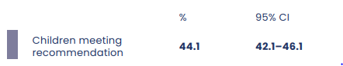

Overall, 44.1 percent of children surveyed ate the recommended combined number of servings of vegetable and fruit (Table 1).

The prevalence of both boys and girls meeting the combined target declined sharply between 2–4 years and 5–9 years (Table 2). This decline in the combined intake
is driven by the drop in the vegetable intake over the same age range (see the next section). This measured age-related change is worth exploring more in future surveys.

The analysis used the indicator of five or more servings a day
Table 2: Prevalence of children meeting the combined vegetable and fruit recommendation by age group and sex
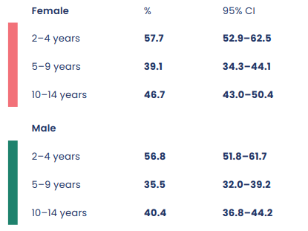

Just over one in two European/other children met the combined recommendation (51.3 percent) and tamariki Māori had the next highest prevalence (41.5 percent). In contrast, only 27.3 percent of Pacific children and 28.8 percent of Asian children ate five or more servings a day (Table 3). Nearly half of those living in the least deprived quintile met the combined recommendation while only a third of those in the most deprived quintile did so.

Table 3: Characteristics of children meeting the combined vegetable and fruit recommendation by ethnicity and sex
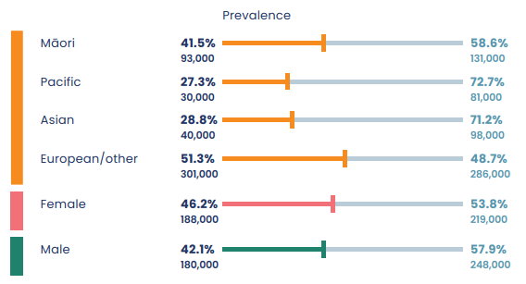

Vegetables
Nearly half of all children (45.8 percent) (Table 4) and nearly two-thirds (65.3 percent) of the youngest age group met the recommendation for vegetable servings. Vegetable intake varied across ethnic and age groups and between children living in food secure and food insecure households (Table 5).

This analysis used the indicator of 3+ servings a day.
Table 4: Prevalence of children meeting the vegetable recommendation
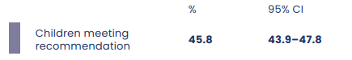

Table 5: Characteristics of children meeting the vegetable recommendation
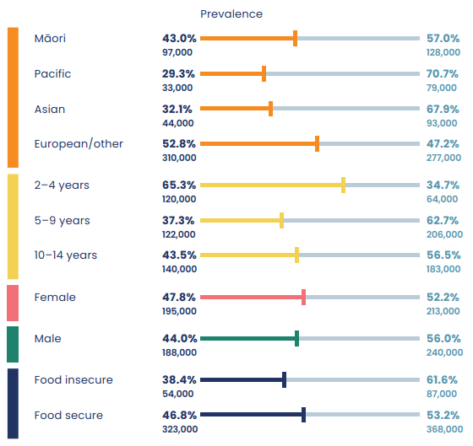

Fruit
The Guidelines current at the time of the survey recommended at least two servings of fruit a day for all age groups.

The overall prevalence for meeting the fruit recommendation (71.4 percent) was higher than for the vegetable recommendation (Table 6).

The youngest children were more likely to meet the recommendation (77.8 percent) than the oldest age group (65.3 percent). Among ethnic groups, 74.4 percent of European/other children, 73.4 percent of tamariki Māori, 66.3 percent of Pacific children and 62.8 percent of Asian children met the recommendation (Table 8).
Younger girls and boys had similar patterns of fruit intake but among those aged 10–14 years, girls had a significantly higher intake than boys (Table 7).

The analysis used the indicator of 2 or more fruit servings a day
Table 6: Prevalence of children meeting the fruit recommendation
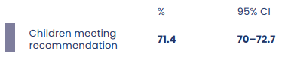

Table 7: Prevalence of children meeting the fruit recommendation by age group and sex
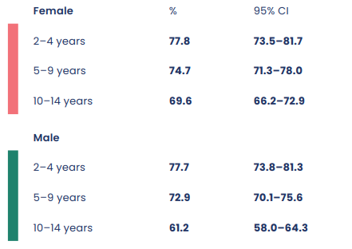

Table 8: Characteristics of children meeting the fruit recommendation
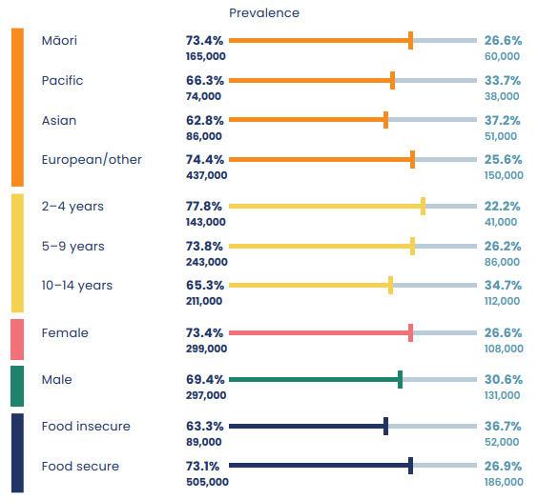

Dietary exclusions
Caregivers were asked whether their child completely excluded from their diet any of the following: seafood; nuts; red meat; eggs; chicken; gluten; dairy. The definition of ‘completely exclude’ was that they ‘never eat the item on its own, or as part of a prepared dish’. Caregivers were not asked for the reason for the dietary exclusions.

Two-thirds of children (around 66 percent) did not exclude any foods from their diet.

The food groups or ingredients they were most likely to exclude were seafood and nuts (Table 9).

Table 9: Prevalence of children excluding food from their diet, by food group or ingredient
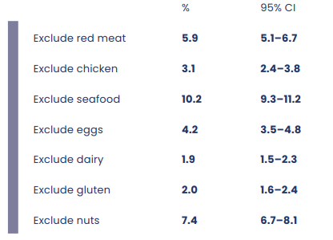

Processed meat
Caregivers were asked how often their child ate processed meat products, such as ham, bacon, sausages, luncheon, smoked chicken, canned corned beef, pastrami or salami.

The Guidelines recommend children limit processed meat intake. Eating processed meat results in an increased intake of saturated fat and salt and is linked to a higher risk of colorectal cancer in adulthood.

Most children ate processed meat at least weekly (Table 10).

Tamariki Māori (45.9 percent) and Pacific children (42.7 percent) were most likely to eat three or more servings of processed meat a week. The prevalence was lower for European/other (38.8 percent) and Asian (31.5 percent) children.

Younger children were less likely than older children to eat more than three servings a week: one out of three (33.6 percent) children aged 2–4 years and two in five (41.5 percent) children aged 5–9 years had this intake of processed meat.

Some kinds of processed meat are a lower-cost food item. The cost difference may be driving the higher intake among children in food insecure households (Table 11).

Table 10: Frequency of children eating processed meat
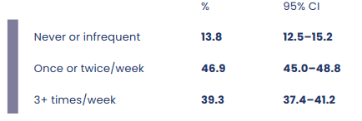

This analysis used the indicator of 3+ times a week
Table 11: Characteristics of children eating processed meat frequently
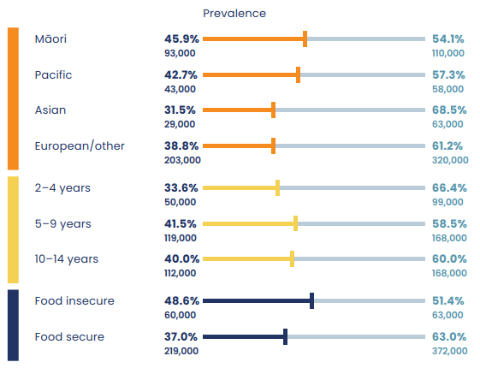

Red meat
Caregivers were asked how often their child ate red meat, such as beef, pork, mutton, lamb, goat or venison. The question excluded processed meat products, such as ham, bacon, sausages, luncheon, smoked chicken, canned corned beef, pastrami and salami.

The Guidelines recommend eating red meat no more than three times a week.

Around half of children (49.8 percent) ate red meat three or more times a week (Table 12). Tamariki Māori (54.2 percent) were more likely than European/other children (49.5 percent) to eat red meat this frequently. Pacific (47.0 percent) and Asian children (46.0 percent) were slightly less likely to eat red meat three or more times a week.

The prevalence of children eating red meat three or more times a week increased slightly with age. Nearly half (47.1 percent) of children aged 2–4 years ate red meat frequently, compared with 51.9 percent of those aged 10–14 years.

Only 5.3 percent of children never ate red meat or ate it infrequently. This is similar to the proportion of children who completely excluded red meat from their diet (5.9 percent of all children; Table 9). The analysis showed little difference across levels of deprivation or between boys and girls (Table 13).

Table 12: Frequency of children eating red meat
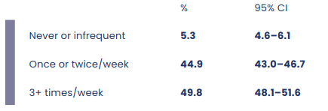

This analysis used the indicator of 3+ times a week
Table 13: Characteristics of children who ate red meat frequently
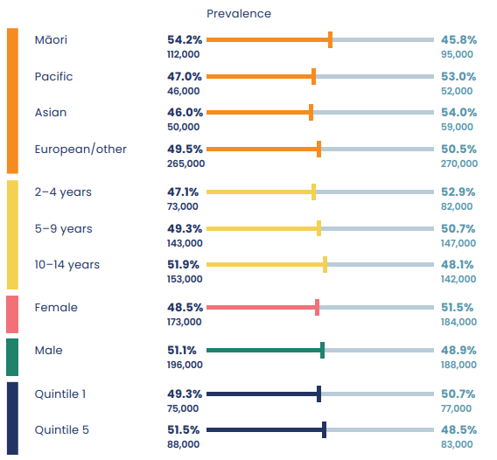

Fish and other seafood
Caregivers were asked how often their child ate fish or other seafood, including canned seafood, but excluding deep-fried fish or other deep-fried seafood.

The Guidelines recommend eating some seafood. Seafood is a source of iodine. Some fish types (oily fish such as salmon, tuna, sardines and mackerel) are also good sources of omega three fatty acids, which are linked to a lower risk of heart disease and stroke.

Over half the children (59.1 percent) had seafood once or twice a week, while 28.8 percent never ate seafood or ate it infrequently (Table 14).

More tamariki Māori (35.0 percent) and European/other children (32.2 percent) than Pacific (25.2 percent) and Asian (15.4 percent) children never or infrequently ate seafood (Table 15).

The prevalence of children who never or infrequently ate seafood (28.8 percent) is higher than the reported proportion of children who completely excluded seafood from their diet (10.2 percent; Table 9). This difference suggests there are other reasons beyond dietary exclusion why these children never or infrequently ate seafood.

Table 14: Frequency of children eating seafood
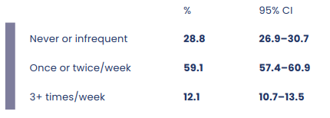

This analysis used the indicator of never or infrequent
Table 15: Characteristics of children who never or infrequently ate seafood by ethnicity
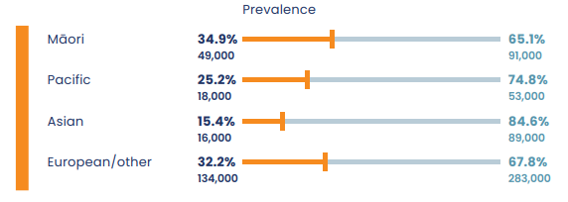

Takeaways
Caregivers were asked how often their child ate fish and chips, burgers, fried chicken or pizza, hot dogs, chicken nuggets and deep- fried food that has been purchased from a fast food or takeaway shop.

The question excluded fast food and takeaways such as sushi, wraps or curries because they tend to be lower in saturated fat, salt and sugar and higher in vegetables and fibre.

The Guidelines recommend replacing takeaways higher in fat and salt with lower-fat options.

Most children did not eat takeaways three or more times a week. Fewer than one in ten children ate takeaways three or more times a week, which is considered ‘high consumption’ (Table 16). However, the prevalence of ‘high consumption’ was higher than the national average for some populations.

The prevalence of high consumption was higher among Pacific children (18.6 percent) and tamariki Māori (11.0 percent). In contrast, 5.8 percent of Asian children and 3.8 percent of European/other children had a high consumption of takeaways.

Children living in the most deprived quintile (13.6 percent) were more likely to eat takeaways three or more times a week than children living in the least deprived quintile (2.8 percent).

The prevalence of high takeaway consumption among overweight children was
9.8 percent and among obese children was 14.3 percent (Table 17).

Table 16: Frequency of children eating takeaways
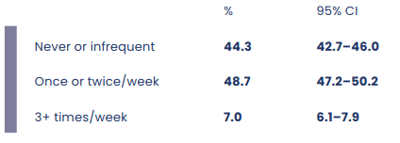

This analysis used the indicator of 3+ times per week
Table 17: Characteristics of children who ate takeaways frequently
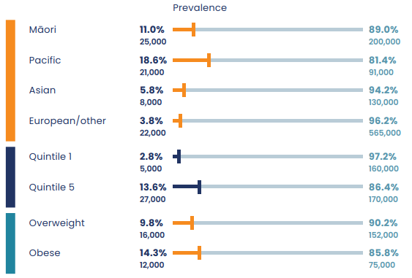

Legumes
Caregivers were asked how often their child ate legumes, such as lentils, chickpeas, kidney beans or baked beans. The question also gave examples of foods containing legumes, such as hummus and soups.

The Guidelines recommend eating some legumes, which are rich in nutrients and high in fibre as well as a source of protein. Legumes are usually a lower-cost protein source than animal protein and are also more likely to contribute to environmental sustainability.

Fewer than one in five children (15.6 percent) ate legumes at least three times a week (Table 18).

Well over half of tamariki Māori (58.1 percent) and Pacific children (60.1 percent) infrequently or never ate legumes. The prevalence was around one in two
(50.9 percent) for European/other children and 46.9 percent for Asian children.

More children in food insecure households (59.1 percent) never or infrequently ate legumes compared with those living in food secure households (49.6 percent) (Table 19).

Table 18: Frequency of children eating legumes
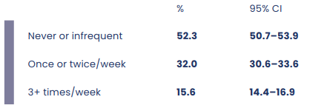

This analysis used the indicator of never or infrequent
Table 19: Characteristics of children who infrequently ate legumes
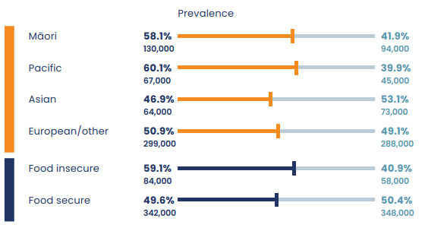

Sweet baked items including biscuits
Caregivers were asked how often their child ate biscuits, cakes, slices, muffins, sweet pastries or muesli bars.

The Guidelines recommend replacing foods high in refined grains, sugar and fat such as sweet biscuits or cake with snacks based on fresh fruit or vegetables, yoghurt, mini sandwiches, and low-fat dip.

Around two-thirds of children ate biscuits at least three times a week (Table 20).

Among ethnic groups, European/other children (77.4 percent) were most likely to eat biscuits at least three times a week. The prevalence was lower among Pacific children (61.6 percent), Asian children (62.6 percent) and tamariki Māori (72.1 percent).

Around two-thirds (66.1 percent) of the youngest age group (2–4 years) ate biscuits frequently. High consumption increased with age: three out of four children aged 10–14 years (75.1 percent) ate biscuits three times a week. Boys were more likely than girls to eat biscuits often.

The prevalence of high biscuit consumption was 79.8 percent among children living in the least deprived quintile and 65.0 percent among those in the most deprived quintile (Table 21).

Table 20: Frequency of children eating biscuits
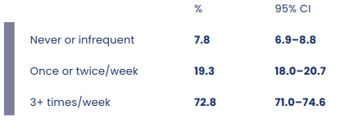

This analysis used the indicator of 3+ times per week
Table 21: Characteristics of children who ate biscuits frequently
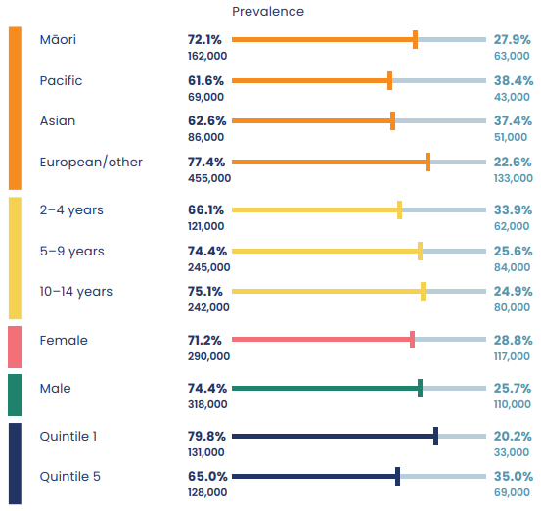

Confectionery
Caregivers were asked how often their children ate lollies, sweets, chocolate or confectionery.

High confectionery consumption increases sugar and energy intake. The Guidelines recommend replacing confectionery such as chocolate or sweets with fruit or vegetable-based snacks.

More than one third of children (38.9 percent) ate confectionery three or more times a week (Table 22). Confectionery consumption increased with age. The prevalence of children eating confectionery three or more times a week was 34.1 percent in the youngest age group (2–4 years) and 42.0 percent in the oldest age group (10–14 years).

Confectionery consumption also varied across ethnicities. Asian children (44.4 percent) were most likely to eat confectionery three or more times a week, followed by Pacific children (40.8 percent), tamariki Māori (40.3 percent) and European/other children (36.5 percent) (Table 23).

Table 22: Frequency of children eating confectionery
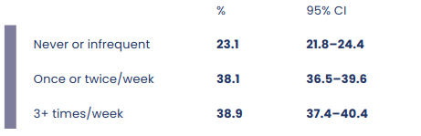

This analysis used the indicator of 3+ times a week
Table 23: Characteristics of children who ate confectionery frequently
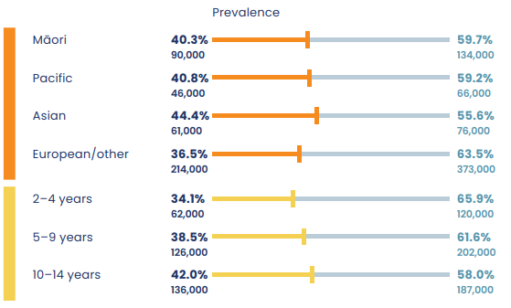

Cordial
Caregivers were asked how often their child had a drink made from cordial, concentrate or powder (excluding diet or reduced- sugar varieties).

The Guidelines recommend children drink plain water or plain milk rather than sugary drinks such as cordial.

Around three-quarters of children (74.5 percent) never or infrequently drank cordial (Table 24).

The prevalence of frequent cordial consumption (three or more times a week) was highest among Pacific children at around one in four (26.7 percent), followed by one in five tamariki Māori (21.3 percent). Frequent cordial consumption was much less common for European/other children (10.7 percent) and Asian children had the lowest prevalence (7.1 percent).

The prevalence of frequent cordial consumption increased with age. While 10.8 percent of the youngest group (2–4 years) drank cordial frequently, 16.4 percent of the oldest group (10–14 years) did so.

Few children living in the least deprived quintile (7.5 percent) drank cordial frequently. However, the prevalence increased to 24.1 percent among those in the most deprived quintile (Table 25).

Table 24: Frequency of children drinking cordial
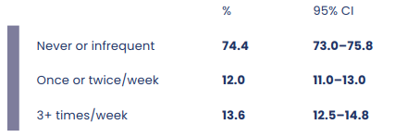

This analysis used the indicator of 3+ times a week
Table 25: Characteristics of children who drank cordial frequently
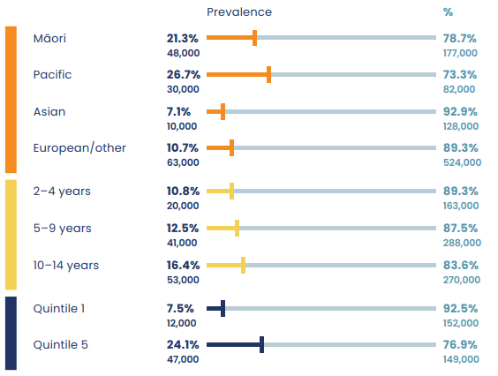

Fruit juice
Caregivers were asked how often their child drank fruit juice. The question described juice as including freshly squeezed varieties and ready-to-drink juice blends, but not drinks made from cordial, concentrate or powder.

The Guidelines recommend drinking water and plain milk.

Around three in five children (58.3 percent) never or infrequently drank fruit juice. About one in five children (23.0 percent) drank fruit juice one or two times a week and about one in five (18.7 percent) drank juice three or more times a week (Table 26).

Asian (27.7 percent) and Pacific (22.2 percent) children were most likely to drink fruit juice frequently. The prevalence was lower for European/other children (15.4 percent) and tamariki Māori (17.0 percent).

More children living in the most deprived quintile (23.0 percent) than those in the least deprived quintile (16.3 percent) drank fruit juice frequently.

Table 26: Frequency of children drinking fruit juice
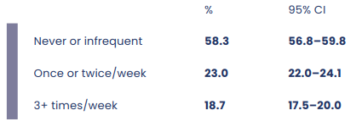

This analysis used the indicator of 3+ times a week
Table 28: Characteristics of children who drank juice frequently
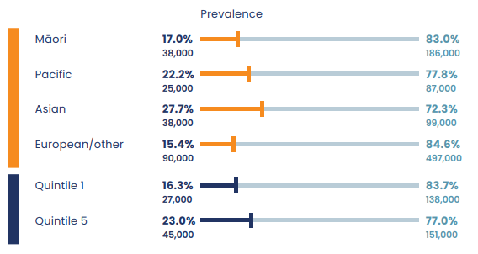

Fizzy drink
Caregivers were asked how often their children drank soft drinks, fizzy drinks, sports drinks or energy drinks. The question excluded diet and reduced-sugar varieties.

The Guidelines recommend limiting fizzy drinks.

More than two-thirds of children drank little or no fizzy drink (Table 28).

Fizzy drink consumption varied by ethnicity. Tamariki Māori (14.8 percent) and Pacific children (18.9 percent) were more likely to drink fizzy drink three or more times a week. European/other children (6.8 percent) were least likely to drink fizzy drinks often, while the prevalence for Asian children was 8.1 percent.

Older children were more likely than younger children to drink fizzy drinks often. The prevalence was lowest for the youngest age group (2–4 years) at 4.3 percent and highest in the age group of 10–14 years (14.1 percent).

The children living in the most deprived quintile (4.1 percent) were more likely than those living in the least deprived quintile (18.4 percent) to drink fizzy drinks often (Table 29). Larger servings of sugary fizzy drinks frequently feature in supermarket discounts and could be seen as an affordable option.

The children living in the most deprived quintile (4.1 percent) were more likely than those living in the least deprived quintile (18.4 percent) to drink fizzy drinks often (Table 29). Larger servings of sugary fizzy drinks frequently feature in supermarket discounts and could be seen as an affordable option.
Table 29: Frequency of children drinking fizzy drink
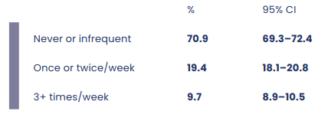

This analysis used the indicator of 3+ times a week
Table 31: Characteristics of children who drank fizzy drink frequently
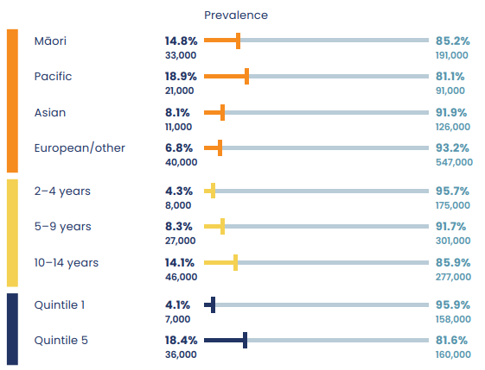

Breakfast
Caregivers were asked how often their child ate breakfast. The question asked them to include weekends and weekdays. It described breakfast as ‘usually the first meal of the day, eaten within two hours of getting up’. Breakfast could be a breakfast drink such as a smoothie or shake, but not other drinks without food. For example, only having a glass of milk or a cup of tea was not counted as having breakfast.

Eating breakfast is part of a healthy eating pattern (Ministry of Health 2012) and is linked to healthier weight and improved nutrition.

Around 84 percent of children ate breakfast every day (Table 30).

Younger children (under 10 years of age) were more likely than older children to eat breakfast daily. Among children aged 10–14 years, 74.3 percent ate breakfast daily while around one in four did not (Table 31). Boys (85.9 percent) were more likely than girls (82.3 percent) to eat breakfast daily (Table 32).

The ethnic groups that were least likely to eat breakfast daily were tamariki Māori (78.3 percent) and Pacific children (73.1 percent). This compares with 86.4 percent of European/other children and the highest prevalence of 88.9 percent among Asian children.

Children living in the most deprived quintile (76.3 percent) were less likely than those living in the least deprived quintile (91.3 percent) to eat breakfast daily (Table 33).

Table 32: Frequency of children eating breakfast
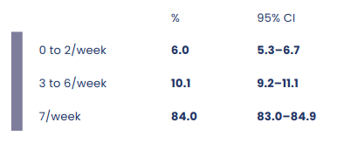

Table 32: Frequency of children eating breakfast by age group
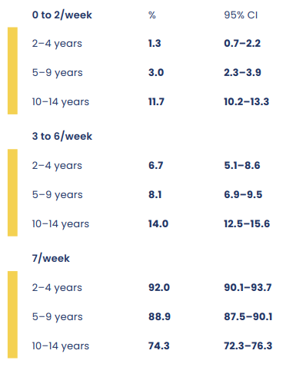

Table 32: Frequency of children eating breakfast by sex
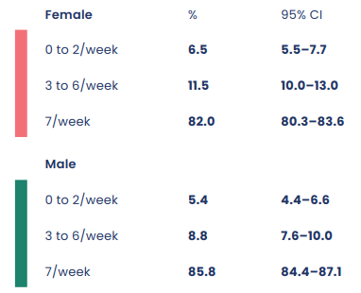

This analysis used the indicator of breakfast 7 days a week
Table 32: Characteristics of children who ate breakfast seven days a week
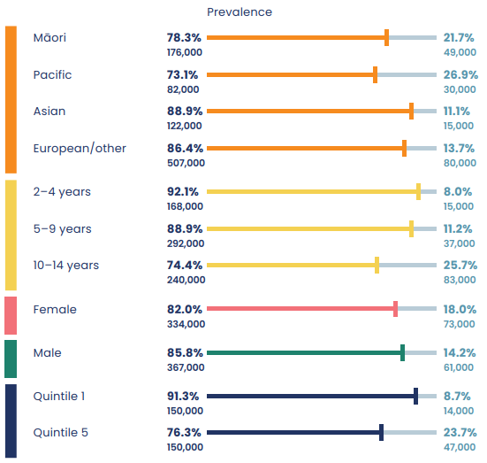

Bread type
Caregivers were asked how many slices of bread, slices of toast or bread rolls their child ate per day. They were also asked about the type of bread the children ate. Options were white bread, light grain (such as Molenberg or Freya’s) or heavy grain (such as Vogel’s or Burgen). Gluten-free breads were classified within each of these categories.

Bread is part of a food group (along with cereals, rice, pasta and foods made from grain) that provides energy, carbohydrate, dietary fibre (especially whole grains), protein and B vitamins (except B12). Breads and cereals have also been shown to be an important source of energy for children and young people.

The Guidelines recommend increasing the proportion of breads and cereals that are whole grain as children get older.

Fewer than one in ten children (7.5 percent) ate heavy grain bread. Forty percent of children ate white bread and around half of children (51.0 percent) ate light grain bread (Table 34).

Over half of tamariki Māori (52.0 percent) and Pacific children (56.1 percent) ate white bread. Fewer Asian (43.6 percent) and European/other (32.8 percent) children ate white bread.

Among children living in the least deprived quintile, 28.1 percent ate white bread, compared with 56.4 percent of children in the most deprived quintile (Table 35).

Table 41: Prevalence of children eating white, light grain and heavy grain bread
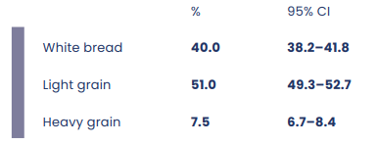

This analysis used the indicator of white bread
Table 42: Characteristics of children who ate white bread
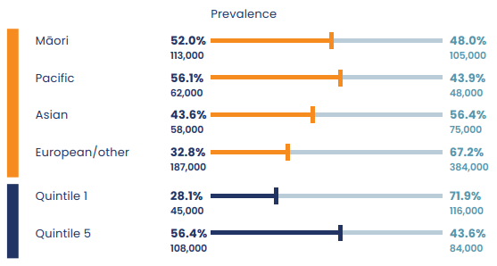

Weight perception
Caregivers were asked how they viewed the weight of their child. They could choose from the options of: very underweight; underweight; neither underweight or overweight; overweight; very overweight. Interviewers also measured children’s weight and height as part of the New Zealand Health Survey.

More than four out of five (84.1 percent) primary caregivers did not perceive their child to be overweight. Caregivers of older children were more likely to perceive their child as being overweight (Table 36).

Caregivers of obese children were more likely to perceive their child as overweight than the caregivers of non-obese children.

About one in ten caregivers of tamariki Māori (9.6 percent) perceived their children as overweight. This perception was higher among caregivers of Pacific children (17.4 percent). It was lower among caregivers of Asian (7.6 percent) and European/ other (6.7 percent) children.

Just over one in ten caregivers of children aged 10–14 years (11.6 percent) perceived their child as overweight. The caregivers’ perceptions of boys and girls appeared to diverge in the oldest age group (Table 36).

Among caregivers of children living in the least deprived quintile, 4.5 percent perceived their child to be overweight. In contrast, 11.9 percent of caregivers of children in the most deprived quintile took this view.

Where children were overweight or obese according to measured results, their caregivers often did not perceive them to be overweight. Twelve percent of caregivers of overweight children and 48.5 percent of caregivers of obese children considered their child was overweight (Table 37).

A recent pan-European study that included data from 22 European countries indicated 64.1 percent of parents categorised their child’s weight status accurately relative to the WHO growth charts (Salas et al 2021). However, parents were more likely to underestimate their child’s weight if the child was overweight (82.3 percent) or obese (93.8 percent).

Table 46: Caregivers’ perception of their child’s weight by the child’s age and sex
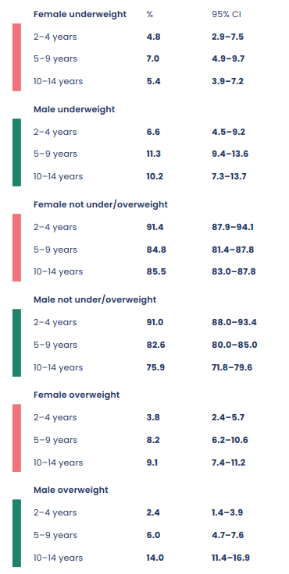

This analysis used the indicator of overweight
Table 47: Characteristics of children whose caregivers perceived them to be overweight
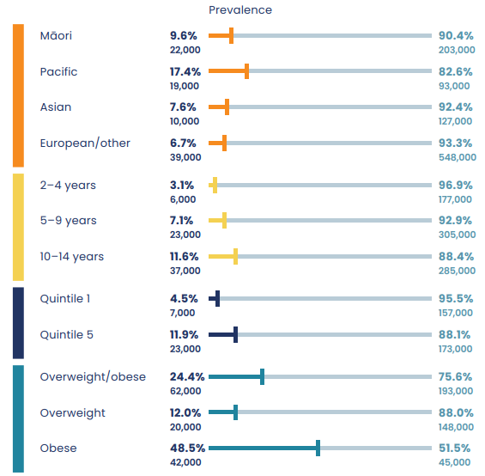

Weight management
Caregivers of children aged 10–14 years were asked if their child was currently trying to lose weight, stay the same weight or gain weight, or not trying to do anything about their weight.

Among caregivers of children aged 10–14 years, the majority (nearly four out of five) indicated their child was not trying to lose weight. Around 10.1 percent said their child was trying to lose weight and 9.1 percent said their child was trying to maintain weight.

According to caregivers’ reports, Pacific children were most likely to be trying to lose weight, at 23.2 percent, followed by Asian children (14.9 percent), tamariki Māori
(11.5 percent) and European/other children (7.7 percent).

Caregivers of children living in the most deprived households were more likely to report their child was trying to lose weight (17.1 percent) compared with those living in the least deprived households (5.7 percent). The caregivers of children who were obese were more likely to report that their child was trying to lose weight (42.5 percent) (Table 39).

This analysis provides some insight into the relationship between children’s body weight and the weight-related perceptions and management of their caregivers. In this way, we can gain the understanding needed to support families in achieving and maintaining a healthy weight.

Table 48: Prevalence of weight management actions among children aged 10–14 years by sex
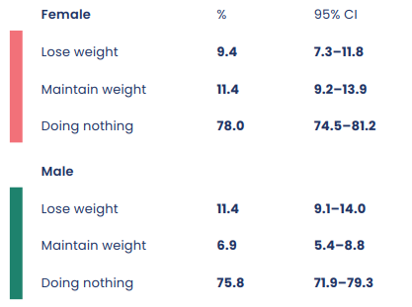

This analysis used the indicator of lose weight
Table 48: Characteristics of children who were trying to lose weight
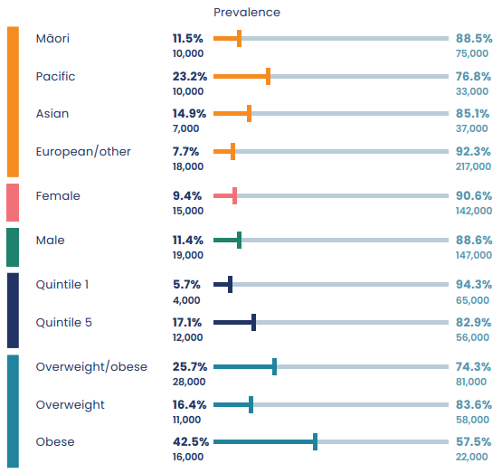

Household food insecurity
Food insecurity is defined as a limited or uncertain availability of nutritionally adequate and safe foods or limited ability to acquire personally acceptable foods that meet cultural needs in a socially acceptable way (Ministry of Health 2019). This analysis calculated food security using an eight-item questionnaire (see interpretation notes).

Overall, 15.7 percent of children lived in a food insecure household. Among ethnic groups, 26.5 percent of tamariki Māori and 35.8 percent of Pacific children lived in a food insecure household.

Household food insecurity was about seven times more likely among children living in the most deprived quintile (33.7 percent) than among children in the least deprived quintile (4.6 percent) (Table 41).

Children from food insecure households were less likely to have healthy eating patterns and more likely to eat unhealthy foods. As the findings in previous sections show, compared with children from food secure households, children from food insecure households were less likely to meet the recommendations for fruit, vegetable or combined fruit and vegetable intake. They ate more processed meat, takeaways and white bread, drank more cordial, fruit juice and fizzy drink, and ate breakfast less often.

Children who were obese were more likely to live in a food insecure household (Table 42).

This analysis used the indicator of household food insecurity
Table 48: Prevalence of children living in a food insecure household by age and sex
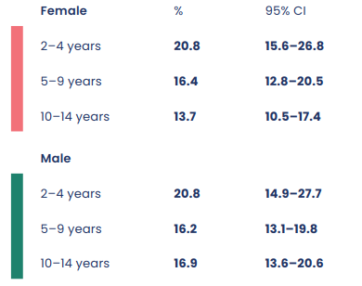

Table 48: Characteristics of children who lived in a food insecure household
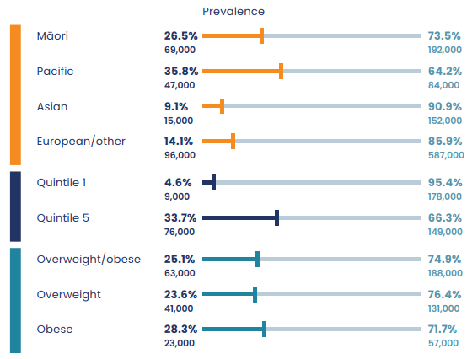

Table 48: Food security status of obese children
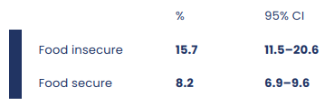

Implications for policy
The findings in this report highlight the inequities in healthy dietary habits among New Zealand children and the impact of food insecurity and deprivation on the food and drink children consume. They point to the need for policy action and programmes to address the range of socioeconomic factors that influence the extent to which people, including children, can eat well. There is also a need for regular nutrition surveillance.

Interpretation notes
This section provides some key information to help interpret the survey results presented in this report. For more details about the survey methodology, see the Methodology Report 2019/20 (Ministry of Health 2020).

Statistical significance
Unless otherwise specified, the results discussed in this report only refer to differences that are statistically significant at the five percent level (ie, those with a p-value of less than 0.05). ‘Statistically significant’ means that the difference between the sample groups is likely to reflect real differences in the population groups, rather than being due to chance. A statistically significant difference does not necessarily mean the difference between the population groups is meaningful.

Confidence intervals
We use 95 percent confidence intervals to show the statistical precision of the estimates. Wider confidence intervals indicate less precise estimates than narrow intervals, which may be caused by higher variation and/or smaller numbers in a sample. Confidence intervals generally agree with statistical significance. When confidence intervals for two estimates do not overlap, the difference between the estimates is statistically significant. However, the opposite may not always be true.

Comparing population subgroups
Analyses that make ethnic comparisons often adjust the data for age to make different groups more comparable, but this report does not take this approach. Age adjusting rates is a way to make fairer comparisons between groups with different age distributions. For example, Māori have a younger population than non-Māori. Younger people may have a lower rate of a particular disease, so it could appear that Māori had a lower rate than non-Māori for that disease, just because they are younger.

Gender
Respondents defined the gender of their child in the survey. For some people, their gender is not the same as their biological sex at birth. Respondents were asked if their child was male or female, and while what these options meant was open to the respondent’s interpretation, gender-diverse options (eg, ‘gender non-conforming’ or ‘other’) were not available. The Ministry of Health acknowledges the need to improve data collection in this area, and is implementing the Statistical standard for gender, sex, and variations of sex characteristics in the 2022/23 New Zealand Health Survey (Stats NZ 2021).

Ethnicity
Where a primary caregiver reported more than one ethnic group for their child, the child is counted once in each group reported. This means that the total number of responses for all ethnic groups can be greater than the total number of children whose caregiver stated their ethnicities.

NZDep
The survey uses the New Zealand Index of Deprivation 2013 (NZDep2013) to measure neighbourhood deprivation. The survey groups neighbourhoods into five quintiles: the label ‘quintile 1’ applies to neighbourhoods with the lowest levels of deprivation, and ‘quintile 5’ to those with the highest.

Overweight/obese
Weight and height are measured (by interviewers and entered directly into laptop computers), rather than reported by caregivers.

Body mass index (BMI) was calculated by dividing weight in kilograms by height in metres squared (kg/m²).

As for adults, children aged two years and over were weighed to the nearest 0.1 kg using weighing scales (Tanita HD-351) that measure up to a maximum of 200 kg. From July 2012, height has been measured to the nearest 0.1 cm using a laser meter (Precaster CA770), replacing traditional stadiometers, which were used in the 2006/07 and 2011/12 New Zealand Health Survey.

Children aged five years and over also had their waist circumference measured to the nearest 0.1 cm with a 2-metre anthropometric measuring tape (Lufkin W606PM).

Each of these measurements (height, weight and waist) was taken twice for each child, and if the two measurements differed by more than 1 percent, then a third measurement was taken. The final height, weight and waist measurements were calculated for each child by taking the mean of the closest two measurements.

BMI Categories
Body mass index (BMI) was calculated by dividing weight in kilograms by height in metres squared (kg/m²). For children aged 2–14 years, the analysis used age- and sex-specific BMI cut-off points developed by the International Obesity Taskforce (IOTF) to define BMI categories equivalent to those used for adults (Cole et al 2000, 2007; Cole and Lobstein 2012).

The IOTF designed its BMI cut-off points to coincide with the WHO BMI cut-off points for adults at the age of 18 years. See IOTF website (https://www.worldobesity.org/ about/about-obesity/obesity-classification) for a summary of the table of IOTF BMI cut-off points for different ages between 2 and 18 years.

Children aged 2–14 years who are overweight or obese have a BMI equivalent to an adult BMI of 25.0 (or greater).

For children, ‘underweight’ means low weight for age.

Household food insecurity
Food insecurity is defined as a limited or uncertain availability of nutritionally adequate and safe foods or limited ability to acquire personally acceptable foods that meet cultural needs in a socially acceptable way. An aggregate index score derived using an eight-item questionnaire measures household food insecurity; for more information, see the Ministry of Health (2019) report Household Food Insecurity among Children: New Zealand Health Survey.

Pooled data
Combining two years of data (2018/19 and 2019/20) increases the sample size, so that more reliable results can be provided for subgroups in the population (eg, based on age, ethnicity and neighbourhood deprivation).

The 2019/20 survey was conducted before the COVID-19 pandemic. It is important to note that data was collected for three-quarters of the survey year only. On 19 March 2020 the interviewing for the New Zealand Health Survey was suspended to reduce any risks of transmitting COVID-19 between interviewers and respondents.

References
Cole TJ, Bellizzi MC, Flegal KM, Dietz WH. Establishing a standard definition for child overweight and obesity worldwide: international survey BMJ 2000; 320:1240 doi:10.1136/bmj.320.7244.1240.
Cole TJ, Flegal KM, Nicholls D, Jackson AA. Body mass index cut offs to define thinness in children and adolescents: international survey BMJ 2007; 335 :194 doi:10.1136/ bmj.39238.399444.55.
Cole TJ, Lobstein T. Extended international (IOTF) body mass index cut-offs for thinness, overweight and obesity. Paediatric Obesity. 2012 Aug;7(4):284-94. doi: 10.1111/j.2047-6310.2012.00064.x. Epub 2012 Jun 19. PMID: 22715120.
Forouzanfar MH, Alexander L, Anderson HR, et al. 2015. Global, regional, and national comparative risk assessment of 79 behavioural, environmental and occupational, and metabolic risks or clusters of risks in 188 countries, 1990–2013: a systematic analysis for the Global Burden of Disease Study 2013. Lancet 386(10010): 2287–323. DOI: 10.1016/ S0140-6736(15)00128-2 (accessed 16 May 2022).
Ministry of Health. 2012. Food and Nutrition Guidelines for Healthy Children and Young People (Aged 2–18 years): A background paper – Revised February 2015. Wellington: Ministry of Health.
Ministry of Health. 2019. Household Food Insecurity among Children: New Zealand Health Survey report. Wellington: Ministry of Health.
Ministry of Health. 2020. Methodology Report 2019/20: New Zealand Health Survey. Wellington: Ministry of Health.
Salas XR, Buoncristiano M, Williams J, et al. 2021. Parental perceptions of children’s weight status in 22 countries: The WHO European Childhood Obesity Surveillance Initiative: COSI 2015/2017. Obesity Facts 14(6): 658–74. DOI: 10.1159/000517586 (accessed 22 May 2022).
Stats NZ. 2021. Statistical standard for gender, sex, and variations of sex characteristics. URL: www.stats.govt.nz/methods/statistical-standard-for-gender- sex-and-variations-of-sex-characteristics (accessed 19 May 2022).

‘Biscuits’ refers to a category that includes sweet biscuits, cakes, slices, muffins, sweet pastries and muesli bars.
This analysis examines socioeconomic deprivation as defined by the New Zealand Deprivation Index 2013. It groups areas in New Zealand into fifths, or quintiles, based on their level of deprivation. See the interpretation notes for more detail.
At the time of the survey, the recommendation for vegetable servings was two servings for children aged 2–4 years and at least three servings for those aged 5–14 years. The recommendation for fruit was at least two servings of fruit for both age groups.
Four or more servings for children aged 2–4 years.
Two or more servings for children aged 2–5 years: three servings for those aged 5–14 years.
Food insecurity is limited or uncertain availability of nutritionally adequate and safe foods or limited ability to access such foods personally.
Two or more servings for children aged 2–4 years.
‘Biscuits’ is shorthand for the wider category described above, which includes sweet biscuits, cakes, slices, muffins, sweet pastries and muesli bars.

