Wharekauri, Rēkohu,
Chatham Islands
Health and Social Needs
Prepared for the
Ministry of Health
14 January 2014

Acknowledgements
This report has been prepared for the Ministry of Health by Liz Smith and Sally Duckworth from Litmus Limited with contribution from Marama Parore, PHARMAC.
We wish to express our deepest thanks to the people of Chatham Islands who warmly welcomed us and openly shared their views on the strengths and challenges of maintaining health and social wellbeing when living on a remote island.
We especially acknowledge and thank:
- Barby Joyce, Ha O Te Ora O Wharekauri Trust – Māori Community Services for facilitating the visit to Chatham Islands, and her guidance and assistance in preparing this report
- Wiremu (Bill) Kaua for his advice, guidance, support and great humour
- Sally Bills, a resident of Pitt Island, who spoke with all the residents of Pitt Island to ensure their voices were heard in this report.
We also acknowledge the support and advice received from Whiti Turner, Te Puni Kōkiri; Geoffrey Giller, Ministry of Social Development; Claire Caddie, Hawke’s Bay District Health Board; and Stephen Lungley and Heidi Cannell, Ministry of Health.
Cover image kindly supplied by Sally Duckworth of Litmus.
If you have any questions about this report, please contact Liz Smith: liz@litmus.co.nz
If you have any queries about the work of Ha O Te Ora O Wharekauri Trust – Māori Community Services on Chatham Island, please contact Barby Joyce: barby@haoteora.org.nz

Citation: Litmus Ltd. 2014. Wharekauri, Rēkohu, Chatham Islands Health and Social Needs Report. Wellington: Ministry of Health.
Published in January 2014 by the Ministry of Health
PO Box 5013, Wellington 6145, New Zealand
ISBN 978-0-478-41566-7 (print)
ISBN 978-0-478-41567-4 (online)
HP 5770
This document is available at www.health.govt.nz

Contents
1. Executive summary 1
1.1 Background 1
1.2 Chatham Islands’ Whānau Ora 1
1.3 Chatham Islands health and wellbeing needs 2
1.4 Investigation of proposed Health and Wellbeing Day 3
2. Introduction 4
2.1 Whānau Ora 4
2.2 Report development 6
2.3 Notes to report 7
3. Chatham Islands: place, people, services and lifestyle 9
3.1 Place 9
3.2 History 12
3.3 People 12
3.4 Health and social services on Chatham Islands 13
3.5 Living on Chatham Islands 26
4. Whānau/family needs across the generations 42
4.1 Focus on pēpi 42
4.2 Focus on tamariki 44
4.3 Focus on rangatahi 44
4.4 Focus on pākeke 44
4.5 Focus on kuia and kaumātua 46
5. Whānau/family health and wellbeing: strengths and needs 49
5.1 2002 Chatham Islands health status 49
5.2 Maintaining whānau health and wellbeing 50
5.3 Whānau health and wellbeing needs 52
6. Feasibility of Health and Wellbeing Day 58
6.1 Overview of Health and Wellbeing Day concepts 58
6.2 Interest in Health and Wellbeing Day 58
6.3 Underlying rationale 59
6.4 Recommendation 59
7. Considerations for moving forward 60
Bibliography and references 62
Appendices 64
Appendix 1: Participants 64
Appendix 2: Research tools 65

List of Tables
Table 1: National Travel Assistance Scheme reimbursement levels 17
Table 2: Overview of the allied health professionals who visit, frequency and duration
of visit, number of patients seen and proposed next visit 22
Table 3: Government agencies for which the Heartland Services Centre provides
information and support 23
Table 4: Overview of educational institutions on Chatham Islands 32
Table 5: Enrolments in play groups and Te Kōhanga Reo by year 33
Table 6: Cigarette smoking rate 51
Table 7: The number of workplace accident insurance claims reported to ACC per
1000 full-time equivalent employees, excluding those who received accident
and emergency treatment only 52

1. Executive summary

1.1 Background
Whānau Ora is about the transformation of whānau/family – with whānau/family setting their direction. Whānau Ora is driven by a focus on outcomes: that whānau/family will be self-managing; living healthy lifestyles; participating fully in society; confidently participating in te ao Māori (the Māori world); economically secure and successfully involved in wealth creation; and cohesive, resilient and nurturing (Te Puni Kōkiri 2013).
Ha O Te Ora O Wharekauri Trust – Māori Community Services (‘Māori Community Services’) is one of 34 Whānau Ora provider collectives across New Zealand. Within these Whānau Ora provider collectives, there are approximately 180 service providers. The number of providers within each provider collective varies from 1 to 20. Ha O Te Ora O Wharekauri Trust is one of the few Whānau Ora provider collectives with only one provider: their service arm Māori Community Services.
Te Whānau Whāriki: Whānau Ora Business Plan was developed by Māori Community Services (2011) to ensure business continuity, enhance management and governance, and put in place adequate infrastructure and appropriately trained staff to support Whānau Ora-based delivery programmes. The business plan seeks innovative opportunities to do things differently to support whānau/families to realise their aspirations.
The Ministry of Health commissioned a report on the health and social needs of Chatham Islands. Māori Community Services intends to use the report to guide their work based on the aspirations and realities of whānau/families living on Chatham Islands.
Māori Community Services were also keen to explore the feasibility of holding a Health and Wellbeing Day on Chatham Island, potentially using a model similar to PHARMAC’s One Heart Many Lives Program.
It is intended that this report will inform other health and social organisations based on Chatham Islands and on the ‘mainland’, so they can work together to support whānau/families on Chatham Islands to realise their aspirations in both the short and long term.

1.2 Chatham Islands’ Whānau Ora
Overall, there is a strong sense of whānau/family connection, resilience and nurturing on Chatham Islands. For whānau/families to maximise their health and wellbeing requires economic security. Currently, whānau/families’ long-term economic security and health and wellbeing are being affected by failing infrastructure, insecure employment, lack of training and professional development opportunities, the high cost of living and a lack of and poor quality housing stock. Chatham Islands Council and Chatham Islands Enterprise Trust are actively exploring ways to foster sustainable economic growth through partnership with the New Zealand and other governments and the private sector.
The ability for whānau/family to participate fully in society is variable. For Chatham Island residents, access to primary care health services is mainly good; free primary care health services and medications are available via the Chatham Islands Health Centre at Waitangi. Chatham Island residents also have reasonably regular access to a range of secondary care and specialist services that periodically come to Chatham Island to hold clinics. In contrast, Pitt Island residents face significant cost and geographical barriers to access the free primary health care on Chatham Island, and visiting specialist services. Primary care visits to Pitt Island are sporadic.
Limited training and professional development opportunities were highlighted as impeding the development of capacity on the islands for individuals, whānau/family, professionals and organisations. Ongoing capacity and capability building in leadership and governance structures are important to enable self-management and effective succession planning on Chatham Island.
Beliefs and actions about healthy lifestyles on Chatham Islands are contradictory. There is some evidence of a move to healthy eating, a positive shift in attitudes to smoking and an increase in exercise. This is counterbalanced by ongoing binge drinking and drug culture among some people.
Ngāti Mutunga O Wharekauri Iwi Trust and Marae Whakamaharatanga are focused on strengthening kaupapa and tikanga Māori.
The ongoing strengthening and revival of Moriori culture, heritage and identity was also evident.

1.3 Chatham Islands health and wellbeing needs
Overall Chatham Island has a good core of primary health care and social services.
Free access to primary health care and prescriptions is an important factor that enables whānau/family living on Chatham Island to maintain health and wellbeing, given high living costs. Pitt Island residents are seeking improved access to primary care through annual or twice yearly visits from the GP and nurse. Ideally, Pitt Island residents would like the nurse living on the island to be employed (at least part time) by the Chatham Islands Health Centre.
Whānau/family and service providers on Chatham Island consistently identified three health and safety needs:
- ongoing improvements to housing stock
- earlier and more effective response to mental health, alcohol and drug addictions and behavioural issues
- consistent and effective response and interventions for family violence via an interagency and community approach.
Whānau/family recognise the positive contribution of the Chatham Islands Health Centre to the community. However, many people noted their concern that services are not coordinated and delivered to best meet the needs of the community. Concerns noted include the limited availability of GP services (ie only in the mornings), the inflexibility of service delivery, a lack of cultural competency and community outreach.
Chatham Islands Health Centre has an important role in strengthening whānau/family health and wellbeing. Consideration is needed on the service delivery model used by Chatham Islands Health Centre, in particular ensuring the service is whānau/family-centred, culturally competent and integrated with other service providers.
Strengthening whānau/family on Chatham Island requires the community and local service organisations to agree the pathway and priorities forward to develop a cohesive, joined–up, step-by-step process of implementation. The process should also make clear where external agencies can best contribute.

1.4 Investigation of proposed Health and Wellbeing Day
Māori Community Services and some service providers were interested in a Health and Wellbeing Day, similar to PHARMAC’s One Heart Many Lives Program. However, there was a lack of a clearly defined rationale or health and wellbeing need to be met through the event. Others on Chatham Island were less receptive to the idea.
Pitt Island residents noted that they would not attend a Health and Wellbeing Day held on Chatham Island due to the costs of travelling to Chatham Island.
PHARMAC’s One Heart Many Lives Program targets Māori and Pacific men who are known not to access primary care and have high risks of heart disease, diabetes and obesity. On Chatham Island, there is high primary care access and an existing programme of positively received health promotion events. No unmet needs were clearly identified that would be best addressed through such an event. Further, men working in fishing may have difficulty attending such an event. Given other pressing health and wellbeing needs, energy and resources may be better invested in seeking to address them.

2. Introduction

2.1 Whānau Ora
‘Whānau Ora is about empowering whānau to take control of their future. What we want for our whānau is to be self-determining, to be living healthy lifestyles, to be participating fully in society and to be economically secure.’ (Hon Tariana Turia, Minister responsible for Whānau Ora)
Whānau Ora is an inclusive approach to providing services and opportunities to all families in need across New Zealand. Whānau Ora empowers whānau/family as a whole – rather than focusing separately on individual family members and their problems. Whānau Ora requires multiple government agencies to work together with families, rather than separately with individual relatives (Te Puni Kōkiri 2013 and 2013a).
Whānau Ora is about the transformation of whānau/family – with whānau/family setting their direction. Whānau Ora is driven by a focus on outcomes: that whānau/family will be self-managing; living healthy lifestyles; participating fully in society; confidently participating in te ao Māori (the Māori world); economically secure and successfully involved in wealth creation; and cohesive, resilient and nurturing (Te Puni Kōkiri 2013 and 2013a).
Ha O Te Ora O Wharekauri Trust – Māori Community Services (‘Māori Community Services’) is one of 34 Whānau Ora provider collectives across New Zealand. Within these Whānau Ora provider collectives, there are approximately 180 service providers. The number of providers within each provider collective varies from 1 to 20. Ha O Te Ora O Wharekauri Trust is one of the few Whānau Ora providers with only one provider: their service arm Māori Community Services.
Te Whānau Whāriki: Whānau Ora Business Plan was developed by Māori Community Services (2011) to ensure business continuity, enhance management and governance, and put in place adequate infrastructure and appropriately trained staff to support Whānau Ora-based delivery programmes. The Business Plan seeks innovative opportunities to do things differently to support whānau/families to realise their aspirations.
Māori Community Services’ vision for Whānau Ora is:
‘The whānau having created an outstanding enviable environment and standard of living now see our people and mokopuna living well, linked to our tupuna, with opportunity and wealth in all its forms, and with the mana of all islanders ensured.’ (Māori Community Services 2011 p12)
The concept of ‘Te Whānau Whāriki’ underpins their vision:
‘The dreams and aspirations of our island people are shared across iwi/imi boundaries. They are our universal dreams. Our Whānau Whāriki is bordered by our island people and by the taonga and tikanga given to us by our tipuna. Within the borders of our whāriki are our dreams, the strands of which have been carefully woven together to ensure a beautiful, robust and timeless whāriki – a beautiful vision for our future.’ (Māori Community Services 2011 p12)
In 2011–2012, Whānau Ora plans were developed for 15 whānau/families living on Chatham Island. Whānau/family worked with a New Zealand-based navigator to identify their needs, develop a plan to address those needs and broker (as needed) access to a range of health and social services. Some common themes in whānau plans include education and skills development and health and cultural wellness.
Currently, another 15 whānau/families are about to complete their whānau plans using a planning tool called the PATH (Planning Alternative Tomorrows with Hope). The focus of the whānau PATHs is to support whānau/families to determine their aspirations and identify a number of short- to medium-term goals to empower and support their changed lifestyles in the long term. These whānau PATHs have been co-facilitated by two New Zealand-based PATH facilitators, who have worked alongside other Whānau Ora provider collectives supporting the training of PATH facilitators to work with whānau/families.
The establishment of a Whānau Learning Centre has been put forward in the Business Plan as a key method to achieve a number of Whānau Ora outcomes through self-determination. The Whānau Learning Centre is intended to reduce isolation and increase access to wider opportunities. The Trust believes that the Centre will enable people to access resources to support them to achieve their aspirations. The goal of the Centre is for whānau/families to value life-long learning and appreciate ‘learning through connection’, either locally, nationally or globally. Boffa Miskell (2013) have recently completed a feasibility study of the Whānau Learning Centre.
In the interim, Māori Community Services has developed the Computer Hub, which is located in their conference room. The need for access to computers was identified in the first 15 whānau plans, which highlighted that whānau/families and the wider community wanted to gain basic computer skills to help with applications and to undertake correspondence classes. | 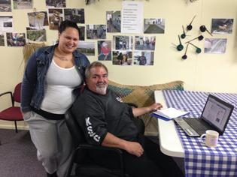
Critical success factors for Whānau Whāriki (Māori Community Services 2011 p5) as listed in the Business Plan are:
- number of whānau/families using whānau plans
- reduction in critical health statistics, including cardio-vascular disease, diabetes, hypertension, obesity, smoking, mental health disorders, whānau abuse and chronic conditions (alcohol/gambling, etc)
- number of whānau/families using ongoing training opportunities
- positive engagement with Māori/Moriori
- positive engagement with community
- positive engagement with the Chatham Islands Council
- positive engagement with the private sector.
‘Whānau potential is high and ready to be unleashed; Whānau Ora provider networks are extensive, committed, innovative and ready to learn from each other; and Whānau Ora is already anchored on solid foundations that will bring fresh opportunities and gains for whānau in the decade ahead.’ (Professor Sir Mason Durie – Chair, Whānau Ora Governance Group)

2.2 Report development
Litmus Ltd was commissioned by the Ministry of Health to work collaboratively with Māori Community Services, Te Puni Kōkiri, PHARMAC, Hawke’s Bay District Health Board (DHB) and the Ministry of Social Development to develop a profile of health and social needs on Chatham Islands.
Litmus also worked with PHARMAC to explore access to and use of medications on Chatham Islands, and the feasibility of holding a Health and Wellbeing Day on Chatham Island, modelled on PHARMAC’s One Heart Many Lives.
Litmus’ approach to developing the report draws from the advice of Pipi et al (2004) – ‘listen to, and give voice to, the kaupapa, aspirations and day-to-day realities of participants’. Litmus also endeavoured with leadership and guidance from Matua Bill Kaua to adhere to Smith’s (1999 p120) seven kaupapa Māori practices to guide researchers:
- aroha ki te tangata (have respect for people)
- kanohi kitea (the seen face; that is, present yourself to people face-to-face)
- titiro, whakarongo . . . korero (look, listen . . . speak)
- manaaki ki te tangata (share and host people, be generous)
- kia tupato (be cautious)
- kaua e takahia te mana o te tangata (do not trample over the mana of the people)
- kaua e mahaki (do not flaunt your knowledge).
A whānau/family-centred approach to health and wellbeing was used, which had a holistic approach and also acknowledged the differing needs of pēpi, rangatahi, pākeke and kaumātua within whānau/family.
Litmus and PHARMAC visited Chatham Island from 4 to 10 June 2013, talking with residents and service providers. The team talked with over 70 people, both individually and in collective settings across all ages and stages of life: kaumātua and kuia, Ngāti Mutunga, Moriori and European, whānau, women and men, people with disabilities, young people, whānau/family who have lived on Chatham Islands for generations and new arrivals.
The team were unable to visit Pitt Island due to time pressures and travel conditions. Māori Community Services arranged for Pitt Island resident Sally Bills to interview the other residents on Pitt Island to ensure their health and social needs were included in the report.
Discussions focused on learning about the strengths and challenges for whānau/family living on Chatham Islands, health and social services available, unmet health and social needs, and ideas to strengthen whānau/family health and wellbeing in the future.
Before leaving Chatham Island, two hui were held to present the key findings and discuss their implications for Chatham Island residents and service providers.
In preparation for the visit to Chatham Islands, a literature and data search was undertaken to identify existing reports on the health and social needs of whānau/family living on Chatham Islands. Only a few reports were found, and most were over ten years old.
Interviews were also conducted with the Ministry of Health, Te Puni Kōkiri, Hawke’s Bay DHB, Ministry of Social Development and PHARMAC to gain their advice and guidance on the report before visiting Chatham Island.
The primary purpose of this report is to inform the ongoing implementation of Whānau Whāriki (the Business Plan) and to assess the feasibility of holding a Health and Wellbeing Day. It is hoped that the report will be of value to other health and social organisations based on Chatham Islands and on the ‘mainland’, so they can work together to support whānau/family and individuals on Chatham Islands to realise their aspirations in the short and long term.

2.3 Notes to report
This report contains:
- an overview of life on Chatham Islands
- a review of the health and social needs of Chatham Island residents
- a review of the feasibility of holding a Health and Wellbeing Day on Chatham Island.
The report was primarily informed by discussions with the community and the feedback received from Pitt Island residents, supported by quantitative data where available. Quantitative data available for this report included:
- Statistics New Zealand 2006 Census information
- Chatham Islands results from the 2002/2003 New Zealand Health Survey (Ministry of Health 2005)
- The Social Report 2009 – Territorial Authority indicators for Chatham Islands
- Education Counts data on preschools and schools
- Education Review Office reports
- service usage and administrative data from a range of service providers.
Pictures have been used in this report to offer a photo-story of the life and people of Chatham Islands. Unless otherwise stated, the pictures were taken between 4 and 10 June 2013 by the researchers. Consent was given to use the images for the sole purpose of this report.
Some residents have agreed to have their stories and images presented in this report. These stories cannot be used for any other purpose without their agreement.
Litmus is confident that this report accurately represents the views of participants who contributed to the report. Feedback received on the strengths and challenges of living on Chatham Islands, critical health and social needs, and future directions were very consistent across the interviews. In total, more that 10 percent of Chatham Island residents and all Pitt Island residents contributed to the report.
A key limitation of the report is a lack of recent quantitative data on health and social wellbeing, Census data and iwi data for Chatham Islands. It is suggested the report is updated when the 2013 Census data becomes available for Chatham Islands.
The draft report was reviewed by the Ministry of Health, Te Puni Kōkiri, PHARMAC, Hawke’s Bay DHB, the Ministry of Social Development, Māori Community Services and importantly providers and residents on Chatham Islands. The draft report was revised based on the feedback received.

3. Chatham Islands: place, people, services and lifestyle
This section provides an overview of Chatham Islands – the place, people, and health and other services available. Using the outcomes sought from Whānau Ora as a basis for analysis, the strengths and realities of living on remote islands are presented.

3.1 Place
Chatham Islands is made up of 25 scattered islands that lie about 860 km east of Christchurch at around 44°S and 176°W. Only the two largest islands, Chatham Island (90,000 hectares) and Pitt Island (63,000 hectares) are inhabited. Chatham Islands form one of New Zealand’s smaller districts, both in area and population, and one of the remotest.
Ngāti Mutunga’s name for Chatham Island is Wharekauri. The Moriori name is Rēkohu. Pitt Island is called Rangiāuria by Ngāti Mutunga and Rangihaute by Moriori.
The climate is oceanic and can be harsh with cool, windy conditions. In summer, temperatures range from 15 to 24°C and in winter from 6 to 10°C. The local time zone is ahead of New Zealand by 45 minutes (Lawrie and Powell 2012).

Map of Chatham Islands
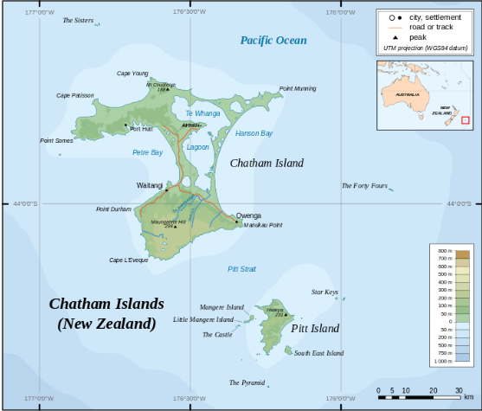

Images of Chatham Island
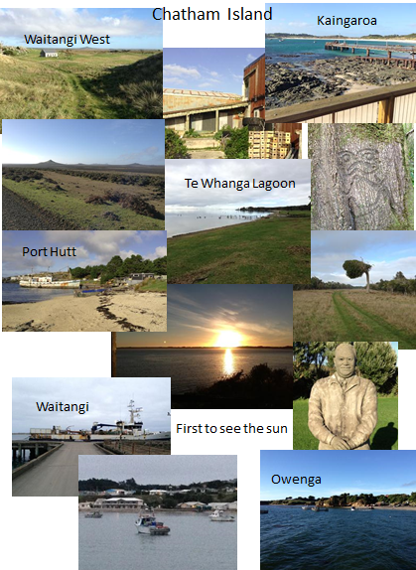

Images of Pitt Island
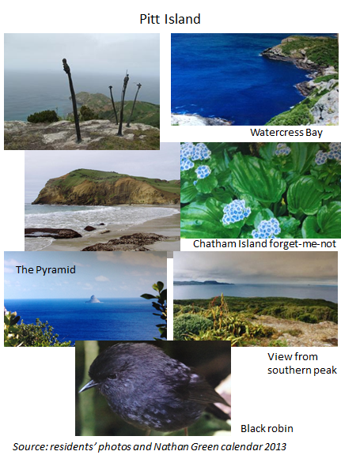

3.2 History
The original inhabitants of Chatham Islands were the Moriori, who are estimated to have arrived some 1000 years ago. The Moriori adapted their culture and lifestyle to the harsh climate of the islands, and developed a sacred covenant of peace, which has remained unbroken for 600 years.
The first European to arrive was Lieutenant William Robert Broughton, R.N. in 1791 on HM Brig Chatham. European settlement commenced in the early 1800s: first by sealers, followed by whalers and farmers.
In 1835 Ngāti Tama and Ngāti Mutunga arrived and settled on Chatham Islands. By 1861, the Moriori population had declined to 60. By this time, the sealing and whaling stations had almost disappeared.

3.3 People
While it is impossible to characterise a population, common themes emerged in discussions with residents. Reflecting the challenges of island life and harshness of the climate, many people described themselves and other Chatham Islanders as strong, resilient and adaptive. Underlying this strength, they acknowledge there is a sense of shyness and reservation. Being ‘shy’ and resilient meant Chatham Islanders may not ask early for help and may simply go on until a crisis point is reached.
‘We are strong, resilient, adaptive with a hint of stubbornness’(Resident)
‘Chatham Islanders are shy’ (Resident)

Population, ethnicity, gender and age
- 600 people lived in Chatham Islands in 2013 (Census 2013). This was a decrease of 9 people from the 2006 Census and 108 people, since the 2001 Census. Thirty-six people currently live on Pitt Island (actual count by residents in June 2013).
- 345 are men (57%) and 267 are female (43%).
- 64.2% of people describe themselves as belonging to the Māori ethnic group, compared with 14.6 percent for all of New Zealand. 65.6 percent of people belong to the European ethnic group.
- 23 percent of people are aged under 15 years, which is similar to the figure of 21.5 percent for all of New Zealand.
- 8.8 percent of people are aged 65 years and over, compared with 12.3 percent of the total New Zealand population.

Source: New Zealand Statistics Census 2006

Households
- One-family households make up 66.2 percent of all households.
- 69 people (or 27.5 percent) live in one-person households.
- The average household size is 2.4 people, compared with 2.7 people for all of New Zealand.

Source: New Zealand Statistics Census 2006

Families
- Couples with children make up 46.4 percent of all families in Chatham Islands, while couples without children make up 39.3 percent of all families.
- 14.3 percent of families are one parent with children families.

Source: New Zealand Statistics Census 2006

Languages spoken
- After English, the most common language spoken is Māori (13.7 percent of people).

Source: New Zealand Statistics Census 2006

3.4 Health and social services on Chatham Islands
Below is an overview of the health and social services available on Chatham and Pitt Islands.

3.4.1 Chatham Island health services overview
In 1949, at the request of the New Zealand Ministry of Health, the government hospital on Chatham Islands was staffed by nuns from the Missionary Sisters of the Society of Mary and a resident general practitioner (GP).  This arrangement continued up to 2000, when the nuns went to take up missionary work on other Pacific islands. Many Chatham Island residents fondly remember the nuns and the service they offered at the then Chatham Island Hospital. Many talked of their deep kindness and excellence in patient care. | 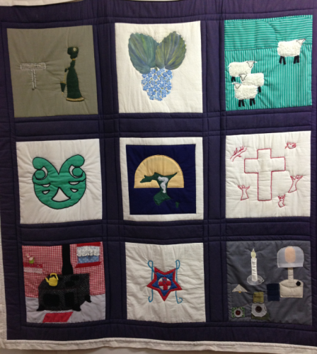  Quilt made by the Missionary Sisters of the Society of Mary
Since 1998, the renamed Chatham Islands Health Centre has come under the administration of the Hawke’s Bay DHB. Before 1998, Canterbury DHB was responsible for Chatham Islands.
The Chatham Islands Health Centre is routinely staffed by a GP, four nurses including the Health Centre manager, a care associate and a receptionist/accruals clerk. Currently the GP is a locum with psychiatric training and experience. GP locums tend to stay on the island for between one and three months. Among the four nurses, there is a broad range of skills and expertise; two nurses have mental health training. Some nurses have completed the PRIME (Primary Response in Medical Emergencies) programme.
A free GP clinic is run for four hours in the mornings, five days a week. Nurses are available eight hours a day, five days a week at the Health Centre. Their role covers walk-ins and appointments for immunisations, dressings, arranged assessments, blood-taking, medications, over-the-counter pharmacy requirements, stock control, community visits, cervical smears and mental health services.
Other services offered include Well Child Tamariki Ora checks, usually undertaken by the GP at the same time as immunisations are given.
Chatham Island has 24 hour/seven days cover for emergencies; a nurse is first on call and the GP second on call. The Health Centre has two inpatient beds, which are used as required. When there is an inpatient, the nurses work shifts to ensure cover for 24 hours a day,
The Health Centre has an emergency room for acute presentations, a nurses’ triage room for assessments and treatment, an over-the-counter pharmacy and digital radiology equipment. The nurses take chest and extremity X-rays when requested by the GP. There is residential accommodation at the back of the Health Centre: rooms for up to five people can be used by GPs and specialists.
There is no public health nurse on Chatham Island. There are no defined health promotion activities, although health promoters (including smoking cessation and family violence workers) do periodically visit Chatham Islands. Some GP locums have run health promotions, which tend to focus on their areas of specialism. For example, the 45 plus men’s wellness check was well attended due to commercial pāua divers requiring a health certificate to continue diving using tanks. Nurses are also involved in community events, providing health checks such as blood pressure and blood glucose measures at events such as Tu Meke Tu Ra.
The Chatham Islands Health Centre offers free sexual and reproductive health services to the community, and access to free emergency contraception, a free condom pick-up point and free pregnancy tests. In June 2001 and November 2009, a Hawke’s Bay DHB health promotion advisor and a Family Planning health promoter visited Chatham Island to provide workforce development and support on current health promotion and health education initiatives. In 2009, an adolescent health advisor also attended to provide knowledge and skills for adolescents.

Health Centre usage statistics for the nine-month period July 2012–March 2013
- 2,010 GP appointments were booked out of a maximum of 2,204 appointments available (ie, there was a 91% GP appointment booking rate). 55 appointments were a ‘did not attend’, representing 2.7 percent of booked appointments. In total, 89 percent of appointments available were used.
- Air Chathams completed six Life Flight airlifts dealing with nine ambulatory patients.
- 11 inpatients stayed overnight.
- 88 X-rays were taken.
- 165 after-hours call-outs occurred.
- There were 31 ante-natal and three post-natal visits by a lead maternity carer (LMC).

Source: Chatham Islands Health Centre Monthly Report March 2013

Overview of Chatham Islands Health Centre
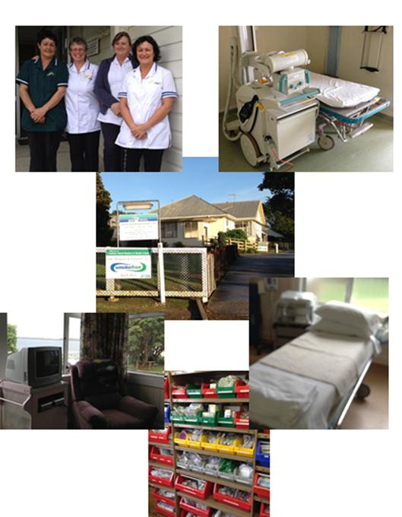
Pharmacy services: Pharmacy services are contracted by Hawke’s Bay DHB to Kilbirnie Pharmacy in Wellington. Prescriptions are written by the GP, visiting specialists or the Lead Maternity Carer (LMC) and sent to Kilbirnie Pharmacy for dispensing.
The prescription, once dispensed by Kilbirnie Pharmacy, is placed in a sealed bag with information about the medications. A double label with the patient’s name and address is placed on the bag. All patient prescriptions are placed in a blue security sealed box and then sent by Air Chathams to the Health Centre twice a week in winter and three times a week in summer. On arrival at the Health Centre, the prescriptions are checked against the records to ensure they are still appropriate based on the patient’s current state of health. Patients (or their nominated representatives) collect their medications at the Health Centre. On collection, the patient signs one of the labels on the bag, which indicates collection, and this signed label is stuck into a record book.
Emergency medication stock is held on Chatham Island and Pitt Island, and includes antibiotics, inhalers and other commonly used drugs. The emergency supply is maintained in acknowledgement that there can be times when the islands can become cut off. People on long-term medication are encouraged to have at least a two-week supply.
Chatham Islands Health Centre holds over-the-counter medication, which can be purchased.
Patients are asked for a $2 koha towards prescriptions. It is estimated that about 80 percent pay the koha. The money collected from the koha is used by the Friends of the Hospital to purchase items for the Health Centre (eg, storage bins, an intraosseous drill).
The Kilbirnie pharmacist visits Chatham Islands every six to eight months to undertake a stocktake and review the process of pharmaceutical delivery to the islands, storage and dispensing.

Over-the-counter pharmacy layout and the blue box
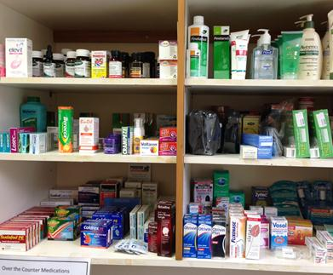 | 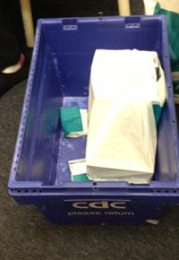
Laboratory: Aotea Pathology Wellington provides a same-day-result laboratory service. This service is dependent on whether a plane can fly the samples out. For the community, blood samples are taken early Monday or Friday morning, to ensure the samples are ready for the Air Chathams plane departure at 10.15am. Bloods are taken at the Chatham Islands Health Centre. For whānau/families living in West Waitangi or Kaingaroa it takes about an hour to drive to Waitangi; therefore they need to leave home very early to have a sample taken. In the winter, this means travelling in dark. If the plane is unable to leave on a particular day, the trip to give a blood sample may need to be repeated the next day.
The Hospital Liaison Committee was set up to enhance communications between the Chatham Island community, Hawke’s Bay DHB and medical and nursing staff at the Health Centre. The Committee has eight members from the Chatham Island community. The Committee is described as the voice of the community. | 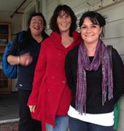
St John Ambulance: A voluntary ambulance service is provided by St John and run by five trained volunteers. The ambulance is located in Waitangi.
The National Travel Assistance Scheme: Chatham Islands Health Centre does not offer specialist secondary care health services, although as discussed in section 3.4.4 specialists do periodically visit Chatham Islands. People living on Chatham Islands access specialist services either via Hawke’s Bay DHB or other DHBs offering specialist services not provided by Hawke’s Bay DHB. Given the remoteness of Chatham Islands, patients referred by the GP or a specialist visiting Chatham Islands to a mainland specialist service are entitled to financial assistance via the Ministry of Health’s National Travel Assistance Scheme.
Support people may also be eligible for funding where the specialist recommends the patient have a support person to assist them with clinical decision-making or to provide physical support. When a child is eligible for travel and accommodation assistance, they are automatically eligible for assistance towards a support person's costs. Decisions about travel assistance for support people are currently being made in Hawke’s Bay DHB.
The National Travel Assistance Scheme offers assistance with travel and accommodation costs. Costs are claimed back after they occur.

Table 1: National Travel Assistance Scheme reimbursement levels
Reimbursement levels | Cost values
Mileage | 28c per kilometre
Accommodation* | Up to $100 per night
Public transport | Actual cost
Air travel** | Actual cost
Taxi** | Actual cost
Notes:
* It is preferable that a person uses their DHB’s preferred accommodation providers.
** The referring specialist must specifically authorise eligibility for air and/or taxi travel.

Hospital discharges
- In 2011/12 there were 102 publicly funded hospital discharges.

Outpatients
In 2011/12 there were:
- 2 assessments
- 339 attendances
- 20 procedures.

Source: Ministry of Health; National Non-Admitted Patients Collection data on outpatient services

3.4.2 Māori Community Services (Ha O Te Ora O Wharekauri Trust)
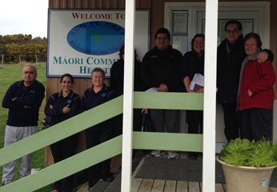 | Ha O Te Ora O Wharekauri Trust – Māori Community Services was established in December 2003 to achieve improvements in the health status of Māori. This objective is to be achieved by working cooperatively with Māori, the wider community and other health providers to ensure all residents are able to take responsibility for their health needs.
Māori Community Services is contracted by Hawke’s Bay DHB and Te Puni Kōkiri to provide services to all residents of the Chatham Islands, as set out below.
Hawke’s Bay DHB funded services
- A Whānau Ora – Māori community health service, which includes a range of general health, education and promotion, advisory, liaison and coordination activities. The contract requires that existing services are coordinated and effectively targeted and used by Māori, although the services are available to the whole community. The services are delivered through whānau health plans using face-to-face sessions with individuals and whānau/family to identify needs and strategies. Hauora Wānanga (health education and information from a Māori perspective of health) underpins the service delivery; specifically taha tinana (physical wellbeing), taha wairua (spiritual wellbeing), taha hinengaroa (mental wellbeing) and taha whānau (family wellbeing).
- A Whānau Ora mobile service, which seeks to improve prevention and self-care of the population through empowering whānau/family to manage and improve their own health and health decision-making. Two full-time equivalents of kaiāwhina, community health worker or enrolled nurse (currently working as General Manager) deliver a range of services across the lifespan, including:
- health education to individual or whānau groups including (but not limited to) at schools, marae and for whānau, including Smokefree events and Tu Meke Tu Ra
- health assessment and monitoring as appropriate, including height and weight checks for children under five and dental advice
- health and social service referrals
- support and management within scope of practice for acute and long-term conditions, including transportation of people to attend the Health Centre and community events, collection and delivery of medications (where consent has been given), house visits and shopping for kaumātua
- health care integration and coordination, and facilitation of access to services
- support, referrals and advocacy for people trying to access health services
- care planning and collaboration with other providers
- a Smokefree cessation programme
- brief interventions in certain areas, including breastfeeding, family violence, alcohol, drugs and problem gambling
- dealing with whānau/family concerns confidentially.
Service delivery is undertaken in a range of settings, including homes, provider clinics, marae, kōhanga reo, playcentres, play groups, schools and any other community setting appropriate to needs of whānau/families.
- Community health promotion, which involves encouraging increased physical activity and healthy eating. Māori Community Services has established a 24-hour/seven-day gym with a personal trainer, yoga classes twice a week, circuit training once a week and line dancing weekly. Other activities include after school activities, reducing isolation by encouraging socialisation through planned activities, a Rongoā programme to build whānau capacity, smoking cessation support, diet and nutrition personal management, community gardening, a fruit–tree planting programme, education on preserving kai, a traditional kai-gathering programme lead by kaumātua and rangatahi support.
Te Puni Kōkiri funded services
Reflecting their objective and the contracts held with Hawke’s Bay DHB, Māori Community Services seeks to deliver wrap-around services that meet whānau/family and individual needs.
The delivery of wrap-around services is supported through funding from Te Puni Kōkiri to provide PATH whānau planning and from a three-year contract to implement their Whānau Ora Programme of Action (POA). As part of the POA development, Māori Community Services is being funded to complete a feasibility study to examine the opportunities and risks associated with establishing a learning and skill development centre.
Māori Community Services employs a general manager, two community workers and a half-time administrator. The general manager role was established in 2012, and is funded for another two years. Community concerns were raised about the uncertainty of this tenure and the long-term implications for both the community and Māori Community Services.
‘In this together … We offer a level of care, commitment and aroha to the community.’ (Service provider)
‘If you see something, you do it. Help whānau from womb to tomb.’ (Service provider)
Since October 2012, the new manager of Māori Community Services has attended meetings with other providers on Chatham Island (eg, the Chatham Islands Enterprise Trust, the Chatham Islands Council and New Zealand Police) to ensure Māori health needs are considered as a part of wider decision-making for Chatham Islands.
Māori Community Services reflected noted that it was initially challenging to implement a Whānau Ora approach in their services. In part, this reflects the shift from ‘doing and helping’ to ‘empowering whānau to be self-determining’.

3.4.3 The Medical Relief Fund
The Medical Relief Fund was set up to provide financial support to people who have to leave Chatham Islands to receive health care. The Medical Relief Fund recognises that the National Travel Assistance will not cover all costs associated with receiving health care on the mainland, and that payments received are based on costs incurred and not upfront payments. Many people living on Chatham Islands struggle financially to cover the additional (and at times unexpected) costs associated with receiving health care on the mainland.
The Medical Relief Fund undertakes fundraising activities, and seeks grants to maintain the fund. The Medical Relief Fund has been successful in being awarded grants through the Department of Internal Affairs’ Community Organisation Grant Scheme. In the past, the Medical Relief Fund has received $6983 per annum through this scheme. Over the last two years the amount of money received via the grant has declined to $4000. Reflecting this decline, the Medical Relief Fund has reduced the koha (financial support offered to an individual person) from $200 to $100, to ensure the funding could continue be received by a large number of people.

3.4.4 Other allied health services that come periodically to Chatham Island
Maternity care: An LMC service based in Wellington is contracted to undertake low-risk ante- and post-natal maternity services. The LMC visits Chatham Island on a two- to four-weekly basis depending on need.
Pregnant women are expected to leave Chatham Islands at around 36 weeks so they can access full maternity services during the final period of their pregnancies. They have a choice of delivery suites in New Zealand. Parents indicated that the selection tends to be dependent on where they have wider whānau/family or other support to help and stay with. Travel and accommodation costs can be claimed back via the National Travel Assistance Scheme, providing the LMC, GP or specialists have signed it off.
Dental services: For children living on Chatham Island a dental therapist and dentist from Hawke’s Bay Oral Health Services visit twice a year. Children on Pitt Island see the dental therapist once a year when they come to Chatham Island for Sports Day. In New Zealand, primary school-aged children who are low risk are supposed to see a dental therapist once a year. Those deemed at higher risk from dental caries are supposed to see the dental therapist every six months.
For adults, dental services are also available when the dental therapist and dentist are visiting Chatham Island. The cost of dental services on Chatham Island is significantly lower than in the rest of New Zealand. Hawke’s Bay DHB charges at a cost recovery level, recognising that adults on Chatham Islands are dentally disadvantaged compared to the rest of New Zealand (Jamieson and Thomson 2003).

Dental clinic at Te One School
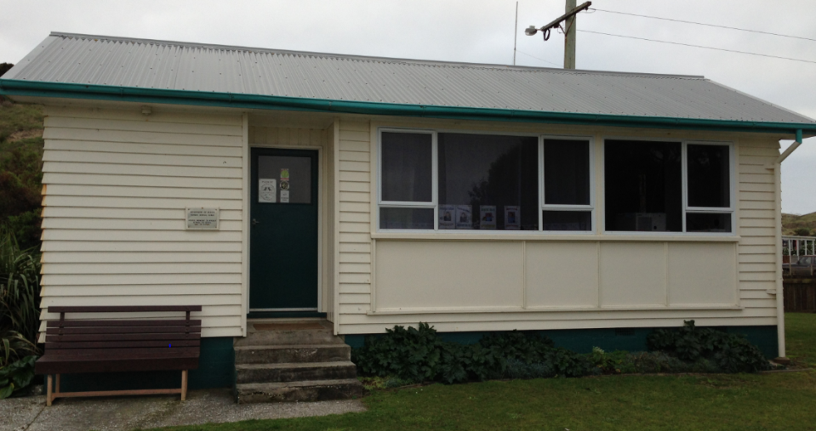
Breast screening (locally known as the ‘booby trip’): Once every two years, women aged 45 to 60 years living on Chatham Island have the opportunity to fly to Palmerston North to have a mammogram, cervical smears and mole maps undertaken. The flights and accommodation are paid for under the National Travel Assistance Scheme. Women can, if preferred, have cervical smears at the Chatham Islands Health Centre.
Breast screening coverage rates in Chatham Islands
In December 2009, 56.7 percent of eligible (45–69 years) Māori women and 68.9 percent of women in the ‘other’ ethnic group had been screened in the previous two years.
In 2013, it was estimated by a health provider that around 80 women went on the ‘booby trip’.
Source: Hawke’s Bay DHB
Life flights: Emergency retrieval flights (including ACC transfers) are arranged when required.
Allied health professionals: During the course of a year, a range of allied health professionals may visit Chatham Islands Health Centre. Table 2 provides details.

Table 2: Overview of the allied health professionals who visit, frequency and duration of visit, number of patients seen and proposed next visit
Allied health professional | Frequency | Days on island | Patients | Proposed next visit
Dental therapist – school | 6 monthly | 14 by 2 visits | 70 | Nov 13
Dentist | 6 monthly | 14 by 2 visits | 125+121 | Dec 13
Physiotherapist | 6 monthly | 3–4 | 20 | Nov 13
Mental health nurse | 3–6 monthly | 2–3 | 10 | Nov 13
Mental health  psychiatrist | 6–12 monthly | 3 | 10–15 | Sept 13
Diabetes nurse specialist | Annually | 2 | 15 | Not known
Gynaecologist | Annually | 2–3 | 50 | April 2014
Orthopaedic specialist | Annually | 4 | 70 | April 2014
Radiographer | Annually | 4 | 75 | April 2014
Paediatrician | Annually | 2 | 10 | Nov 13
Midwife | Dependent on number of pregnancies | Variable | 4 | As required
Geriatric specialist | Annually (not visited for two years) | Not known | Not known | Not known
Podiatrist | Annually | Not known | Not known | Not known
Optometrist | Every 2 years | Not known | Not known | Not known
Private massage therapist | 6 monthly | 14 | Not known | Sept 13
Private naturopath | 6 monthly | 14 | Not known | Not known

3.4.5 Other health and social services on Chatham Island
Social and iwi/imi services
The Heartland Services Centre was opened in 2005 to make it easier for whānau/families on Chatham Islands to get information about government services. People can visit the Centre or seek information via phone, fax, email or letter. All information sought is treated in the strictest confidence.
One staff member works at the Heartland Services Centre, which is funded by the Ministry of Social Development. This person assists and supports people to find the information they require from a broad range of government services, as listed in table 3. Government agencies periodically send over representatives to address the information needs of people living on Chatham Islands.
From 1 July 2012 to 31 July 2013, the Heartland Services undertook more than 3,885 consultations with people by phone, email or fax or face-face. Currently, the most common information and assistance requests are about the Work and Income reforms. In late 2013, a Work and Income case manager will visit Chatham Island to address these needs.

Table 3: Government agencies for which the Heartland Services Centre provides information and support
Government agency | Notes
Work and Income | Case manager to visit in late 2013
Inland Revenue | Visited in 2013
ACC | Visited in 2012
NZ Transport Agency | Visited in 2013
Māori Land Court | Registrar visited in 2013
Courts | Courts sit on the island every three months. Heartland Services will support people with information, including contact details of lawyers
Department of Corrections | A representative visits at the same time as the courts
Canterbury Law Centre | Contact for legal assistance and advice is through Aranui Heartland Services Centre
Senior Services | Visited in 2013
Child, Youth and Family | Visited in 2013. Contact tends to be by phone or email
Family Violence | Face-to-face contact with people who visit. Heartland Services offers information, support and assistance
Counselling and mental health services | Heartland Services supports and assists people wanting to use or make contact with these services
Occupational safety and health | Visited in 2013. Contact can also be made by phone, fax or email
StudyLink | Heartland Services offers information, support and assistance
Te Puni Kōkiri (TPK) | Heartland Services provides appropriate referral and coordination pathways for TPK services. TPK visits several times a year.
Statistics New Zealand | Heartland Services offers information
Ministry of Education | Heartland Services offers information, support and assistance
Department of Labour | Contact with Department of Labour representative. Heartland Services offers support and assistance
Career Services | Heartland Services offers information and support
Department of Conservation | Heartland Services advises people to contact Chatham Island branch
Tenancy services | Heartland Services offers information and support
Department of Internal Affairs | Heartland Services offer information and applications for passports and immigration
Chatham Islands Community Focus Trust is funded by the Ministry of Social Development to offer budgeting advice, support community events (eg, the annual Chatham Islands Festival, market days), support community organisations (eg, Golden Oldies) and organise adult education and school holiday programmes. The Trust also organises and manages the online weekly community newsletter. The Chatham Islands Community Focus Trust and the Chatham Islands Heartland Services Centre work closely in coordinating delivery of services.
The Trust’s Budget Services bring a budget advisor over to Chatham Islands on occasion.
Hokotehi Moriori Trust is the organisation that represents the Moriori people on Rēkohu (Chatham Island) and Rangihaute (Pitt Island), in New Zealand and elsewhere. The Trust operates from Kopinga Marae, and has operational support based on mainland New Zealand. Hokotehi Moriori Trust is involved in several sectors of the Islands economy, including fishing, farming and tourism. The Trust also provides cultural, social and educational services for members.
Ngāti Mutunga O Wharekauri Iwi Trust’s tikanga is to promote and preserve the identity, mana, tino rangatiratanga, culture and heritage of Ngāti Mutunga o Wharekauri. The Trust has a well-established cultural support programme, including a Ruia Kākano reo programme, mau rākau programme and Kaumātua tautoko programme. Ngāti Mutunga O Wharekauri Iwi Trust has been active in building social housing.
Māori Committee – Marae Whakamaharatanga is responsible for the management of Marae Whakamaharatanga.
Māori Wardens: Chatham Island has five Māori Wardens, who are an integral part of the community. The service is voluntary, and can be seen at a number of community events, providing security, traffic control, crowd control, first aid and confidence for the public.

Enforcement agencies
The New Zealand Police have one constable on Chatham Island. One fisheries officer from the Ministry of Primary Industries is also based on the Island. The two agencies work closely together.
There is a Volunteer Fire Brigade, which is overseen by Hawke’s Bay Fire Service. There are 12 plus volunteers aged 50 plus. The Volunteer Fire Brigade struggles to get young volunteers.

Local government
The Chatham Islands Council is a unitary council with both regional council and territorial authority responsibilities. The Council employs seven staff (excluding Heartland Services staff). Services provided include looking after the environment and protecting the islands from biosecurity risks, emergency management, waste and water services and resource consents.

The Chatham Islands Council’s vision
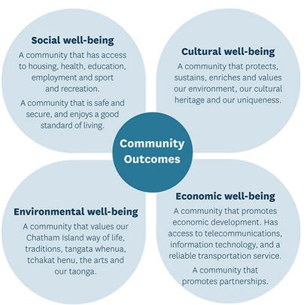
The Chatham Islands Council (2013) aims to:
- promote community development through recreation, arts and cultural heritage
- enhance the health and safety of the community through an effective and reliable administration of relative legislation
- provide a service in a cost-effective and sustainable manner
- investigate the potential establishment of a library and additional housing.

Business groups
Chatham Islands Enterprise Trust was established to promote the economic development and wellbeing of the islands. Chatham Islands Enterprise Trust’s vision is to proactively use its resources ‘to secure a vibrant and healthy Chatham Islands community, enjoying positive growth while protecting the unique environment and lifestyle’ (Chatham Islands Enterprise Trust 2013 p2).
Private sector companies also have a legislated responsibility for health and safety. These can be important levers to ensure best practice in high-risk industries and in encouraging health checks.

3.4.6 Pitt Island health and social services
Pitt Island has no health or social services located on the Island, or other private sector services or shops. The only community facilities are the church, Our Lady of the Antipodes, which has occasional church services; the wharf shed, where residents gather for barbeques on shipping days; and the primary school, which is the community hub.
To access primary care Pitt Island residents must travel to Chatham Islands Health Centre, incurring significant travel costs. There are no contracted health professionals on Pitt Island. A resident who had trained as a nurse provides voluntary health care and medical advice, including:
- responding to emergency situations, to assist with treatment of the patient and transfer to Chatham Island. Since 2009, this has occurred on average once per year
- assisting with accidents on Pitt Island by managing patients and coordinating care with the nurses and the GP on Chatham Island
- providing education on medications and advising on GP contact for further prescriptions. At times, phoning the GP on behalf of residents
- dressing wounds (In the last four months, she assisted with dressing three chronic wounds)
- responding to general requests about once a week to assess people on common colds, infected cuts, burns, aches and pains. Assessments are informal, and are accompanied with the suggestion to phone the Chatham Islands Health Centre for further assessment
- phoning or visiting elderly people to support with management of chronic conditions.
About once every year, the GP and a nurse from Chatham Islands Health Centre travel to Pitt Island to hold a clinic in someone’s house. Recently, visits by the GP and nurse have not been occurring on an annual basis, as expected by Hawke’s Bay DHB.
Primary school children access dental services once a year on Chatham Island. An annual sporting event between Chatham Island and Pitt Island children is timed to coincide with the dental therapist and dentist visit. For Pitt Island adults, the cost and inconvenience of travel to Chatham Island can act as barriers to accessing dental services.
First aid equipment and emergency pharmacy supplies are held at Pitt School, recognising the remoteness of Pitt Island. If needed, someone will call Chatham Islands Health Centre to authorise its use. Feedback from Pitt Island residents suggests there is a low level of awareness of the supplies, and uncertainty about who has the authority to use them. Kilbirnie Pharmacy audits these supplies on a regular basis.
Residents noted that in an emergency the community pulls together. The Life Flight cannot land on Pitt Island due to the grass runway. In an emergency, sick or injured people are transferred to Chatham Island by charter plane or boat. In poor weather transport off the Island by boat or plane may not be possible.

3.5 Living on Chatham Islands
Discussions with whānau/families and service providers on Chatham Island highlighted many interwoven strengths and challenges, reflecting the myriad of factors that create and hinder whānau/family aspirations. To inform Whānau Whāriki, the strengths and challenges of living on Chatham Islands were presented against the outcomes sought from Whānau Ora; namely, that whānau/families will be (Ministry of Health 2011; Durie et al 2010):
- cohesive, resilient and nurturing
- economically secure and successfully involved in wealth creation
- participating fully in society
- self-managing
- living healthy lifestyles
- confidently participating in te ao Māori.

3.5.1 Cohesive, resilient and nurturing
‘Whānau resilience depends not only on the will to succeed but on the capacity of whānau to remain connected.’ (Durie et al 2010 p47)
Community spirit is very strong on Chatham Islands. Those active in island life tend to wear multiple hats, and sit on committees of many community organisations. For example, Barby Joyce, who is the general manager of Māori Community Services, is also on the Hospital Liaison Committee and the Medical Relief Fund Committee.
Residents are strongly whānau/family-focused, in particular ensuring the needs of tamariki and kuia and kaumātua are met. Resources are shared; for example, kai from fishing and hunting and wood for heating are dropped off to the elderly. For tamariki, growing up on Chatham Islands is seen as an idyllic, safe childhood.
Whānau/families living on Chatham Islands feel very safe. People do not lock their doors at night, and leave cars unlocked with the keys in the ignition. New arrivals to Chatham Island talk about having to adjust from a mentality of ‘lock it or lose it’ to one of safety and community protection. The only exception is the pub, where someone may ‘borrow’ an unlocked car with keys to get home.
‘If you lock the car, they will know you are from the mainland.’ (Resident)
Chatham Island and Pitt Island communities excel at responding to emergencies, or situations when whānau/families are seen to be under significant stress. Examples highlighted include community fundraising for whānau/families with sick children, the traditional community support of whānau/families at funerals, and responses to boating accidents near Chatham Islands or other emergencies requiring whānau/families to leave the islands.
Residents have a strong sense of pride in Chatham Islands, in their ability to survive in the harsh climate and the realities of island life. As one participant explained, winter can involve an ‘indoor existence’ due to the poor weather. Many men and women noted their enjoyment of opportunities presented by the beautiful environment, especially the fishing and pig hunting.
A number of community events and celebrations are held annually on Chatham Island that bring residents together, including:
- a fishing competition in January
- Waitangi Day celebrations
- pig, possum and eeling competitions
- the Matariki SmokeFree event
- the Chatham Island Festival
- Race Day
- Tu Ra Tu Meke (a health promotion event).
As in many communities, there are disagreements and rivalries that can impede whānau/family cohesion. Tensions are evident between some Moriori and Ngāti Mutunga communities.
On Pitt Island, the need to be organised and able to live off the land and sea is critical. There are no shops on Pitt Island, and infrequent boats. Most whānau/families have vegetable gardens and fruit trees, and will share resources such as flour should anyone run out before their next shipment.
Summary: Overall, there is a strong sense of whānau/family connection, resilience and nurturing on Chatham Islands.

3.5.2 Economically secure and successfully involved in wealth creation
‘Wellbeing requires economic security.’ (Durie et al 2010 p46)
Employment is high on Chatham Islands. The key industries on Chatham Islands are fishing, farming and tourism. The fishing industry contributes 60 percent of the income of Chatham Islands, and employs about 33 percent of the adult working population (Lawrie and Powell 2012). Chatham Islands fishing and agriculture contributes around $200 million a year to the national economy.
Farm production is the second biggest contributor to the economy. Agriculture production is limited, due to poor soil quality. Sheep and cattle are grazed (Lawrie and Powell, 2012) and sent to the mainland for slaughter. Whānau/families tend to work their own farms; there are few employment opportunities for non-whānau/family members.
Tourism is Chatham Island’s fastest growing industry: there are about 1500 visitors a year. However, high business start-up costs on Chatham Islands are seen by some as impeding this growth. While tourism is seen by many as a means to boost the local economy and employment, others are concerned that tourism may impact negatively on the environment and local culture.
Work (population aged 15 years and over)
- The unemployment rate is 1.4 percent for people aged 15 years or over.
- The unemployment rate of Māori aged 15 years and over is 1.3 percent.
- The equivalent unemployment rate for all of New Zealand is 5.1 percent.
- The most common occupational group in Chatham Islands is 'labourers'. 'Professionals' is the most common occupational group in New Zealand.

Source: New Zealand Statistics Census 2006
Work on the island is seasonal. Incomes fluctuate throughout the year and across years, depending on the success of the fishing and farming industries. For those on low income, this can be significantly challenging, requiring the discipline to set aside money in good times to cover lean times. People tend to have multiple part-time jobs to achieve a reasonable income. As a result, parents/caregivers may see little of each other.
Annual income levels are comparable to those throughout New Zealand.
Income (population aged 15 years and over)
- For people aged 15 years and over, the median income (half earn more, and half less, than this amount) in Chatham Islands Territory is $24,200. This compares with a median of $24,400 for all of New Zealand.
- 40.6 percent of people have an annual income of $20,000 or less, compared with 43.2 percent of New Zealanders.
- 16.7 percent of people have an annual income of more than $50,000, compared with 18 percent of New Zealanders.
- Māori and non-Māori incomes are similar.

Source: New Zealand Statistics Census 2006
The high cost of living on Chatham Islands has a significant impact on the ability of whānau/families on low incomes to be economically secure. The high cost of living is predominantly driven by the cost of freighting goods to the island.
Grocery shopping: People on Chatham Island have several shopping options. There are two general grocery stores. One offers the ability to pay ‘on the tick’, which is helpful for those trying to cope between salary or benefit payments (eg, those receiving New Zealand superannuation).
People can also order goods via the internet (eg, via PAK’nSAVE or the Warehouse) and have them shipped in. Freight costs are $3 per kilogram, which tends to add an estimated 20 percent to the purchase price. Whānau/families using these services tend to buy in bulk. Examples were given of undertaking bulk grocery shops every two to three months to the value of $1000–$3000. For Pitt Island residents, the need to buy in bulk and freight is a necessity, due to the infrequency of the ships and the absence of shops on the Island.

Comparative grocery prices – Chatham Island vs Wellington on 10 June 2013
On Chatham Island and Wellington the grocery items shown opposite were purchased for the following prices.  Chatham Island = $57.40  Wellington = $31.15  Items were $26.25 more expensive on Chatham Island – ie, 84 percent more expensive than Wellington. | 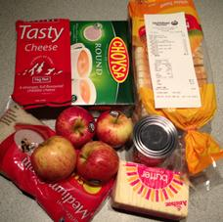

Shipping freight costs to Chatham Island
A 10- to 12-day shipping service from mainland New Zealand carries produce and general cargo to and from Waitangi, Chatham Island.
Freight is charged at whichever is greatest, weight or volume. The minimum charge is $20.
Transport costs: Like groceries, the cost of petrol and diesel is about 20 percent more expensive on Chatham Island than in New Zealand. People are reliant on private transport, as there is no public transport service, although the pub does offer a shuttle service to encourage people not to drink and drive.
Comparative petrol and diesel prices – Chatham Island vs Wellington on 9 June 2013
Fuel type | Chatham Island  Prices noted on 9 June 2013 | Wellington  Prices noted on 24 June 2013
Diesel | $1.84 per litre | $1.49 per litre
Petrol | $2.83 per litre | $2.25 per litre

The cost of diesel and petrol on Chatham Island is around 25 percent more expensive than in Wellington (23.5% and 25.8% respectively).
Flying from Chatham Island to New Zealand is expensive – the cheapest return fare for an adult is $754 and the most expensive $1230. For children, the cost ranges from $542 to $874. Air Chathams is the only airline flying to Chatham Island, and operates flights from Wellington, Christchurch and Auckland. Flights to Wellington are the most frequent: there are three flights per week in summer and two per week in winter. The flight time is around 90 minutes.
Alternatively, people can use Chatham Islands Shipping, which offers 12 berths (four cabins). A ship tends to leave every 10 to 12 days. The trip takes approximately two days between Napier and Waitangi. The cost including meals and bedding for the 40 hour voyage is $300 plus GST for an adult and $150 plus GST for a child aged under 15 years who must be accompanied.
For Pitt Island residents, there is the additional cost of travelling to Chatham Island by plane or boat. There are no regular flights to Pitt Island. Flights are made on a demand basis. Due to poor weather conditions or the grass runway being waterlogged, there are times when there is no transport on or off Pitt Island. The cost to charter a plane from Pitt Island to Chatham Island is $450, and the cost to charter a boat is estimated at $1500 plus GST. By air, the journey to Pitt Island takes approximately 20 minutes, and by sea one to two hours.
Home heating and electricity costs: Chatham Island residents comment they have the most expensive electricity in the world: the price per unit is 88 cents. As illustrated below, the per-unit cost of electricity from one provider in Wellington is 35 cents. The price of power in Chatham Island is therefore 151 percent higher than Wellington.
‘The cost of electricity or energy on this island is killing the island socially and economically … it is a classic chicken and egg: how do you stimulate economic growth, when you have energy costs at that sort of level?’ (Service provider)
During winter months, residents comment that it is not unusual for a monthly power bill to exceed $700. As a result, Chatham Islands whānau/families try to cut back on heating in poorly insulated homes to avoid high electricity bills. Research clearly shows that cold and damp homes can have a negative impact on the health and wellbeing of whānau/families (Baker et al 2013).
‘When you consider health, I see this all wrapped up. We all hear the excuses about people can’t pay their monthly power bill because they just can’t get their priorities right or they can’t manage their finances … but there are people on this island that just cannot literally afford to pay their power bill every month. Or they try and manage it by trying to turn energy sources off and we know that houses are very poorly insulated on the island.’ (Service provider)

Comparison of electricity costs on Chatham Island and Wellington

- In April 2013, a two-person household in a three-bedroom house received a power bill for $370.25 (a price-per-unit cost of 88 cents).
- In April 2013, a four-person household in a four-bedroom house in Wellington had a power bill of $275.25 (a price-per-unit cost of 35 cents). The bill was reduced to $247.72 due to prompt payment.

Chatham Island resident’s power bill

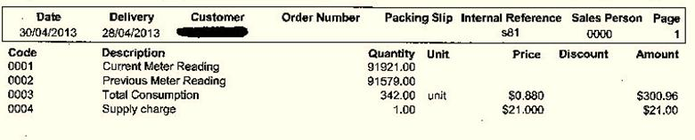

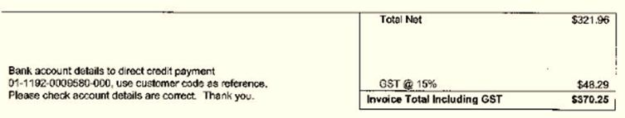
‘The electricity company is deliberately run at break even. You cannot run it as a commercial entity because socially you would kill the island. Same with the ports and our airport.’ (Service provider)
Diesel is another key fuel source that is used to power back-up generators. Moves are being made to explore more energy-efficient sources, such as wind and micro hydro units. In 2010, two wind turbines were installed for generators on Chatham Island.
On Pitt Island, there is no mainline or centrally supplied electricity. Households create their electricity mainly via diesel generators. Five households have wind turbines, and three to four solar panels. A number of households do not have full-time electricity.
Building and building maintenance: The costs of maintaining and building houses are also high on Chatham Island, reflecting the cost of freighting in materials. As one Pitt Island resident explained, if you break a window you simply board it up, as there is no glazier or hardware store and it will be several months before a replacement will arrive.
Summary: While employment is high, and incomes are similar to mainland New Zealand, the seasonal nature of employment and the high cost of living impacts adversely on whānau/families’ economic security and ability to maximise health and wellbeing.

3.5.3 Participating fully in society
‘Access to health services, quality schooling, recreational facilities, housing, commercial ventures, meaningful employment and levels of income adequate for whānau needs are necessary for whānau wellbeing.’ (Durie et al 2010 p45)
Access to primary care health service is good for Chatham Island residents and poor for Pitt Island residents. Chatham Island residents have free access to core primary care health services and medications on the Island. In contrast, Pitt Island residents face significant cost and geographical barriers to access the free primary health care on Chatham Island (see section 5.3.1).
Early childhood and primary education is available on Chatham Island and Pitt Island. The Chatham Islands Community Focus Trust has also started an after school and school holiday programme.

Table 4: Overview of educational institutions on Chatham Islands
Educational type | Roll | Profile | Teachers
Te Kōhanga Reo O Wharekauri | 19 | 9 girls, 10 boys  14 Māori, 5 Pākehā | 1 full-time and 5 part-time teachers
Te One Playcentre | 19 | 9 girls, 10 boys  15 Māori, 4 Pākehā | Parent-led
Te One School (full primary) | 47 | 19 girls, 28 boys  32 Māori, 15 Pākehā | 1 principal and 3 teachers
Kaingaroa School (full primary with an early childhood education centre beside the school) | 7 | 6 girls, 1 boy  7 Māori | 1 principal/teacher
Pitt Island Primary School | 6 | Not known | 1 principal/teacher

Table 5: Enrolments in play groups and Te Kōhanga Reo by year
Year | Play groups | Te Kōhanga Reo
2002 | 6 | 19
2003 | 7 | 23
2004 | 10 | 18
2005 | 25 | 18
2006 | 5 | 24
2007 | 25 | 17
2008 | 26 | 19
2009 | 28 | 19
2010 | 21 | 15
2011 | 29 | 17
2012 | 19 | 20
Feedback from parents and service providers and a review of the Education Review Office reports suggest that the quality of primary school education has strengthened over the last five years. Focus has been placed on equipping the schools with information and communication technology to increase access for students and teachers to external resources, wider connections and professional development. There is also evidence of an increased bicultural focus, through te reo and tikanga Māori and whānau/family support. Management and governance structures were noted as areas of ongoing work.
Most teenagers leave Chatham Islands for their college education. The Ministry of Education covers the cost of the transport to and from Chatham Island each school holidays, and pays a boarding grant of $2700. Whānau/families pay between $10,000 and $12,000 per year in boarding fees, over and above the boarding grant allowance. Some parents/caregivers view leaving Chatham Island for college education as a positive opportunity for young people that widens their life experiences. Some are concerned about how well prepared teenagers are to cope away from home. Some families opt for a parent/caregiver to go and live on the mainland too, to be able to offer their teenagers support and guidance during these years.

Education
- 33.6 percent of people aged 15 years and over have a post-school qualification, compared with 39.9 percent of people throughout New Zealand. 30.8 percent of Māori aged 15 years and over have a post-school qualification, compared with 27.9 percent of Māori throughout New Zealand.
- 35.9 percent people aged 15 years and over have no formal qualifications, compared with 25 percent for New Zealand. 39.7 percent of Māori aged 15 years and over have no formal qualifications, compared with 39.9 percent of New Zealand's Māori population.

Source: New Zealand Statistics Census 2006

Educational institutions on Chatham Island
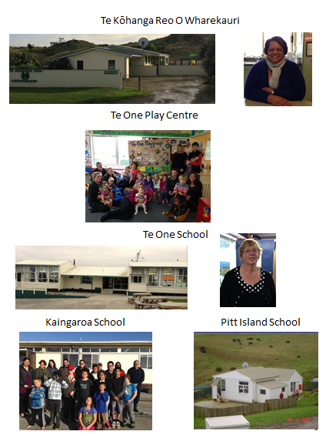

Chatham Islands has a lack of housing. Housing New Zealand does not have any rental housing on the Islands. There is some rental housing on Chatham Island attached to employment (eg Chatham Islands Enterprise Trust, Chatham Islands Council, Downers, and Ministry of Education). Consequently, there is a lack of affordable rentals for those on low income, particularly for residents of Chatham Islands.
Existing houses are poorly maintained, which reflects the costs and challenges of upkeep on a remote island. Older houses are poorly insulated, and cold and damp due to high power costs. EECA’s Energywise funding was available for a period to help insulate homes through the Government's insulation programme Warm Up New Zealand: Heat Smart. Some people were unable to access the grant, as their homes were not suitable to be insulated (eg, there was not enough space below the floor to put in insulation).
Chatham Islands’ lack of housing and poor housing stock is likely to be having a detrimental effect on health for some whānau/families. The relationship between poor housing (or a lack of housing) and poor mental and physical health is well established (Baker et al 2013).
‘We live in a house just up on the hill and when the southerly blows the curtains are literally at 45 degrees – might as well have the window wide open because the winds are just going straight through. I’ve never lived in a house with so much mould. We’ve done the warm homes thing.’ (Service provider)
New houses are being built. Ngāti Mutunga O Wharekauri Asset Holding received a government grant, and with the aid of commercial loans has built five new homes for low-income families. Recognising the ongoing shortage, the Government has invested $400,000 for new state housing on Chatham Island.

The new Ngāti Mutunga O Wharekauri houses
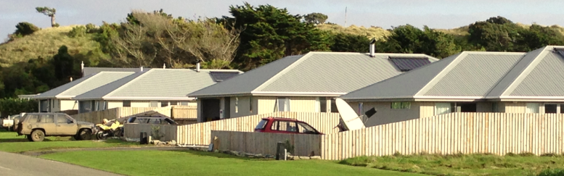

Housing on Chatham Islands  - There are 255 occupied dwellings and 51 unoccupied dwellings.  - 46.7 percent of householders in private occupied dwellings own the dwelling, with or without a mortgage (the equivalent figure for New Zealand as a whole is 54.5%).  Source: New Zealand Statistics Census 2006 | Household crowding: The proportion of the population living in crowded housing (ie, requiring one or more additional bedrooms, as defined by the Canadian Crowding Index) has been as follows since 1986.  Year Total  Number %  1986 201 26.7  1991 123 17.7  1996 75 11.2  2001 81 13.6  2006 18 3.3  Source: The Social Report 2009
Access to the internet on Chatham Island are lower than in New Zealand. Currently, it is expensive to install internet due to the need to purchase a satellite dish (approximately $1000). Further, the capacity to link more users to the existing satellite has run out. Even when whānau/families have internet access, the current service configuration means that there may not be continuous service, particularly in stormy weather.
The need for better internet access was identified, particularly to maintain whānau/family connection. The internet is seen as an essential tool for health and social providers, to facilitate their professional development, links to ‘mainland’ colleagues and training opportunities on Chatham Island.
Currently, there is no cellphone coverage on Chatham Island.
The Ministry of Business, Innovation and Employment, as part of the Rural Broadband Initiative, has requested proposals to enhance Chatham Islands’ connectivity, particularly for schools, the Health Centre and the Chatham Islands Council (up to the standard of two-way video). It is currently unknown whether the proposed telecommunications improvements would enhance the connectivity of businesses or households.

Internet and cellphone access
- 56 percent of households have access to the internet, compared with 60.5 percent throughout New Zealand.
- 2.7 percent of households have access to a cellphone, compared with 74.2 percent of households throughout New Zealand.

Source: New Zealand Statistics Census 2006

Summary: The ability for whānau/families to participate fully in society is variable on Chatham Islands, and differs between Chatham and Pitt Island. Primary health care is free on Chatham Islands, although Pitt Island residents face significant travel costs and geographical barriers to access primary health care on Chatham Island. There is access to early childhood education and primary school education, the quality of which is improving. Housing stock is limited, and much is of poor quality. Internet access is expensive and capacity is limited.

3.5.4 Self-managing
‘Whānau wellbeing is largely dependent on the capacity of whānau to determine their own pathways and manage their own affairs’ (Durie et al 2010 p44)
Whānau//families on Chatham Islands are managing their own decisions, addressing their own needs and supplying their own care. However, community-wide there are challenges with self-managing common assets and maintaining leadership that provides continuity between the past and the future.
Chatham Islands face significant infrastructural challenges, which impact on the economic wellbeing of the Islands and the lives and future of whānau/families. Chatham Islands Enterprise Trust owns and operates the Islands’ infrastructure, including the airport, ports, electricity, fishing quota, forestry and shipping.
Chatham Islands Enterprise Trust faces significant challenges, due to a deteriorating financial position and thus an inability to effectively maintain assets. Pitt Island wharf has failed, and Waitangi wharf on Chatham Island is failing. Both are critical access points on and off the islands. The port at Waitangi is not an all-weather port facility; ships are unable to dock in heavy seas. The airport needs lengthening and strengthening for modern aircraft. Pitt Island has a grass landing strip, which, if waterlogged (as it often is in winter) cannot be used.
Waitangi wharf
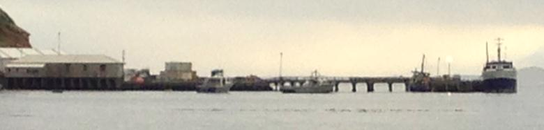
A public water supply is only available in Waitangi on Chatham Island. Water testing of the public water in Waitangi shows that the water quality is good. However, many household water storage tanks are old; this can taint the water. The rest of Chatham Island and Pitt Island collect rain water or have local bores.
The success of the key industries of fishing and farming rises and falls with world markets and events in New Zealand (eg, sheep farmers struggled after the drought on the mainland, as they were unable to graze their sheep before selling). Chatham Island has no meat works; therefore, all cattle and sheep must be freighted off for slaughter, at significant cost to farmers. Live freighting raises the potential risk of international backlash to Chatham Island produce if concerns are raised about animal welfare.
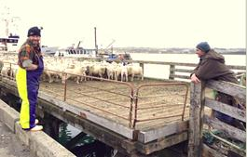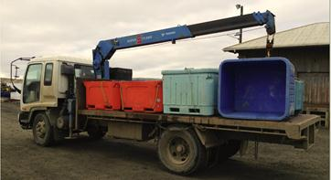
Developing a sustainable economic base is critical. As noted by one service provider, the maintenance of all assets is a priority, given their deteriorating state. Chatham Islands Enterprise Trust is working with other Chatham Island organisations to seek and secure new funding sources to future-proof infrastructure services, along with other economic and social development initiatives. Support and leadership is being sought from central government. In particular, those on the Islands question why Chatham Islands is treated differently than the rest of the New Zealand in relation to electricity prices and telecommunications access. Within the community, there tends to be a high level of distrust and suspicion of ‘outsiders’, due to past broken promises of help.
Internationally, there has been growing interest in Chatham Islands as the ‘food bowl’ for some Asian countries. The potential of these investments could result in population increases, job growth and improved economic stability. As with increases in tourism, such development may also bring changes less liked by the community.
Building the capacity and capability of leadership and governance structures to ensure sustainable self-management is an area of ongoing focus. Leadership and governance roles within a small community can be particularly challenging, as decisions may not be seen favourably by all in the community, or can even be taken as a personal affront. As evident with Māori Community Services and with schools’ boards of trustees, some organisations are placing greater emphasis on building good governance structures and developing strong leadership – key foundations for ongoing and effective self-management.
There are differing management lines for services coming onto Chatham Islands. While many government services are linked through Heartland Services, the location of the main offices that make key decisions for the Islands are dispersed across the mainland. For example, Work and Income and Inland Revenue are linked to offices in Christchurch, environment issues are dealt with via Environment Canterbury, ACC is managed in Wellington, the Minister for Parliament representing Chatham Islands is in the Rongotai electorate and the Health Centre is managed via Hawke’s Bay DHB.
The variability of incomes on the islands can create challenges with self-management of tax and ACC payments and Work and Income entitlements.
Given the relatively small population, there is a continuous pull for people to be engaged and involved. As a result their resources and personal energy can be significantly stretched. While the sense of community spirit and contribution is commendable, Chatham Islands residents recognise there are risks of burnout.
Service providers noted a lack of processes to support and supervise staff who are in positions where they have to make decisions that can affect whānau/family life in a small community. For those in sensitive roles, there can be a need for support from New Zealand to supervise decisions and to act as stress release valves, where confidentiality is closely maintained. The need for offshore support and supervision reflects that some organisations are only operated by one or two people. In some instances, decision-making about entitlements has been transferred to colleagues on the mainland. While this delegation avoids potential tensions within the community, it may also be an indicator of a lack of local self-management.
Within the community, the lack of training and professional development opportunities were noted by both service providers and whānau/families. In particular, nurses noted the challenge of maintaining professional competencies due to low volumes, and the need therefore to undertake refresher and professional development courses.
Summary: Discussions with residents of Chatham Island indicated the recognition that, where possible, solutions to issues arising need to come from the community. To achieve this requires strong leadership, governance processes, and access to training and professional development, and at times external financial assistance (especially for upgrading key infrastructure).

3.5.5 Living healthy lifestyles
‘Whānau can shape lifestyles by establishing codes of conduct that will endorse healthy behaviours.’ (Durie et al 2010 p44)
Role modelling of healthy lifestyles on Chatham Islands is variable. While there is an abundant availability of fresh fish, fruit and vegetables can be lacking due to cost and availability. Some people are seeking to address this through the re-establishment of vegetable gardens.
Involvement in sport and recreational activities appears to be increasing. People regularly engage in physical activity through Saturday netball, line dancing, rugby and other activities. A yearly half marathon has recently been initiated; over 100 whānau/family members (men, women and children) take part in some capacity. Māori Community Services has developed a gym, and attendance is steadily growing.

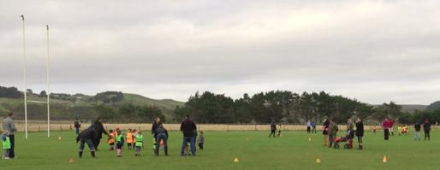
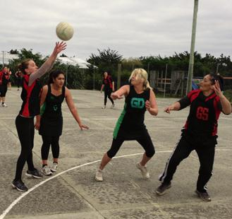 | 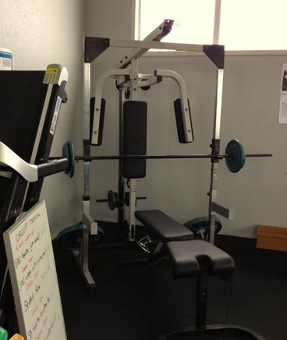
Whānau/families and service providers report that binge drinking is common, and marijuana is regularly used across generations. As discussed in section 4, this issue is of significant concern for whānau/family and service providers.

Living healthy lifestyles
Results from the 2002/03 New Zealand Health Survey on Chatham Islands highlighted that compared to their New Zealand counterparts Chatham Island males and females were:
- significantly more active
- significantly less likely to report eating at least two servings of fruit per day
- more likely to be current smokers
- more likely to have used marijuana in the preceding 12 months
- more likely to have potentially hazardous drinking habits.

Source: Ministry of Health 2005
There is a lack of parenting education programmes, although support and guidance is offered to parents/caregivers who attend Te One Playcentre and Te Kōhanga Reo O Wharekauri.
Summary: As in many communities, attitudes and behaviours towards healthy lifestyles in Chatham Islands are varied and at times contradictory. There is some evidence that the community is adopting healthy eating and physical activity behaviours. In contrast, the community has significant concerns about the existing drug and binge drinking culture.

3.5.6 Confidently participating in te ao Māori
‘The goal of being part of te ao Māori is that whānau will be able to enjoy active participation in Māori society and that Māori society will be sufficiently aligned to the needs of whānau to be able to meet their needs.’ (Durie et al 2010 p46)
Moriori philosophy, customs and values and Māori tikanga guide island life. It is important to acknowledge that people living on Chatham Islands have protocols that are unique and of deep value to them. For example, in the Chatham Islands the custom is for those who have passed away to lie at their home.
Moriori, through the Moriori Identity Trust, are working to ‘ensure that Moriori, as a separate and distinct indigenous culture of Aotearoa/New Zealand, is not lost to this country. And that the covenant of peace that was observed by Moriori is preserved for posterity and future generations’. There is an ongoing revival and recognition of Moriori culture, heritage and identity on Rēkohu, in New Zealand and internationally. | 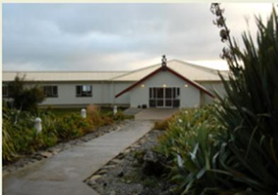
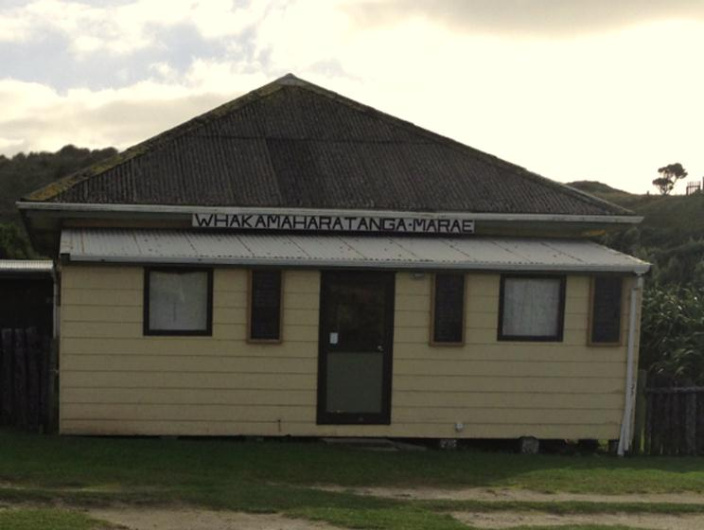 |  | Ngāti Mutunga O Wharekauri Iwi Trust and Marae Whakamaharatanga are actively promoting and preserving the identity, mana, tino rangatiratanga, culture and heritage of Ngāti Mutunga o Wharekauri. Ngāti Mutunga O Wharekauri Iwi Trust note that in one generation te reo Māori was lost on Chatham Islands.
Most Ngāti Mutunga remember a time when their grandparents spoke te reo Māori. However, their grandparents took the decision not to pass on te reo Māori, as it was not perceived as useful; a direct response to the level of colonisation their tūpuna were subject to.
Ngāti Mutunga believe te reo Māori is intricately tied to their wellbeing. There is much ongoing effort by Ngāti Mutunga O Wharekauri Iwi Trust to recover te reo Māori.
Summary: On Chatham Islands there is an ongoing strengthening and revival of Moriori culture, heritage and identity. Ngāti Mutunga O Wharekauri Iwi Trust and Marae Whakamaharatanga are focused on strengthening kaupapa and tikanga Māori. Residents of Chatham Islands value those customs and values that are unique to the Islands.

4. Whānau/family needs across the generations
This section presents specific feedback from the community on the experiences and challenges for particular whānau/family members living on Chatham Islands across the lifespan. The voice of Chatham Islands residents is central to this section.

4.1 Focus on pēpi
There is a strong medical preference for pregnant women to travel to New Zealand at 36 weeks to await the delivery of their babies. This decision reflects concern that if anything adverse happened during delivery on Chatham Islands, there could a life-threatening delay before mother or baby could be transferred to a tertiary centre. Regardless of this potential risk, some pregnant women want to deliver their babies on Chatham Islands; particularly those who already have children.
Mothers in the main are happy with their ante-natal and post-natal care. Mothers find travelling off-island when 36 weeks pregnant challenging, particularly for those with toddlers. Pregnant women often feel isolated from whānau/family and other support networks on Chatham Islands while they wait alone in motel accommodation for the baby to arrive. DHB-recommended motel accommodation is described by some mothers as unclean and not toddler-friendly.
For pregnant women, living off Chatham Islands can be an expensive time, particularly if their partner joins them and is not earning. While some costs are covered by national travel assistance, not all are.
‘It’s a big expense. My husband was off work for weeks not earning.’ (Mother)
In summary, needs identified include:
- toddler-safe DHB-recommended accommodation
- for some, the choice to deliver their baby on Chatham Island.

Having a baby … the Pitt Island reality
Katrina lives with her whānau of eight on Pitt Island. She is the partner of the local teacher. Katrina has agreed to share the story of her pregancy and the birth of her daughter to show the logistical challenges and costs of having a baby when living on Pitt Island. Katrina was very happy with the services received from her LMC in Wellington and Christchurch and from Hawke’s Bay Hospital.
Katrina’s pregnancy occurred at a time when the small plane that services Pitt Island was out of action for nearly year. Access to and from Pitt Island at this time was solely by fishing boat, which could be chartered for around $1500 plus GST.
Katrina’s LMC was based in Wellington, and her services were organised by the Chatham Islands Health Centre. Given the remoteness of Pitt Island and the absence of regular flights or boat access, ante-natal care was primarily organised around times when the LMC or Katrina were flying through Chatham Island or Christchurch Airport. For example, when Katrina was returning from a school trip to the North Island, they met on Chatham Island. On another occasion, as Katrina was arriving in Christchurch and the LMC was travelling through, they met at the airport.
Katrina had planned to deliver her baby in Christchurch Hospital. However, she started to have contractions before her due date. As a result, the GP on Chatham Island went to Pitt Island on a boat to bring Katrina and her whānau across to Chatham Island. Katrina does not have other family living on Pitt Island, so the children had to come with them.
Katrina and her husband were then flown by Life Flight to Hawke’s Bay Hospital, while her five children stayed for a night in the nurses’ accomodation on Chatham Island. The following day the five children flew on Air Chathams to a support person (their uncle) who lives in Wellington. Katrina was admitted to Hawke’s Bay Hospital, where the contractions were stopped. Due to being close to Christmas, there was not enough seats available on the bus for the children to travel all the way to Hawke’s Bay. Her children were sent by bus to Palmerston North, where they were met by their father.
Katrina was discharged from Hawke’s Bay Hospital, but due to the late stage of her pregnancy she was advised not to fly to Christchurch, where whānau lived who could offer support. After being discharged, the family had to find accomodation in Hawke’s Bay. As Katrina had been discharged from hospital they were told by hospital staff that they were unable to stay in the Little Elms accommodation. They eventually found accomodation that suited the needs of their family, and stayed close to Hawke’s Bay Hospital for a week. They hired a van, as Katrina had had rapid deliveries in the past. For Katrina, ensuring the needs of her children was critical during this time.
The family then travelled in the rental van down to Wellington and flew to Christchurch to stay with family. Postively, their baby girl was born healthy and well in Christchurch. Katrina’s husband returned back to Pitt Island to start work. Katrina stayed with her family for another four weeks after the delivery, to access post-natal care and whānau support. Her decision to stay in Christchurch also reflected the fact that there are no post-natal or other health services on Pitt Island.
While the family received travel and accomodation support during this time, they estimated they spent around $8000 extra through the whole process. This was a significant amount of money for the family.

4.2 Focus on tamariki
In the main, tamariki are well catered for on Chatham Islands, in terms of both education and opportunities to access a safe outdoor environment.
In seeking to strengthen the health and wellbeing of children, the following gaps were noted by parents and caregivers.
- Inconsistent Well Child Tamariki Ora (WCTO) checks: The GP usually undertakes these checks (particularly the six-week check) alongside immunisation. Māori Community Services undertakes height and weight measurements at early childhood educational centres. It is unknown whether babies and children generally receive all eight WCTO core contacts, or whether the processes used follow the WCTO practice guidelines, or cover all the domains of each core contact.
- Nurses comment they have minimal training or experience in WCTO checks. The challenges of encouraging parents to bring their children into the Health Centre for the B4 School Check, even following reminders, were noted. Children do not appear to be receiving vision and hearing tests.

4.3 Focus on rangatahi
Teenagers are seen as whānau/family members whose needs are less well supported on Chatham Island. Most teenagers leave Chatham Islands for their college education, and return for school holidays. Currently, there are no services or facilities to positively engage youth during school holidays (eg, a youth centre).
Sexual and reproductive health services are free at the Health Centre. However, it is unknown how comfortable young people are at accessing this mainstream service. In 2009 Hawke’s Bay DHB’s adolescent health advisor visited and conducted puberty workshops with young people.
Few teenagers were interviewed for this report, as most were off-island at college. The voice of teenagers is therefore missing, particularly in relation to their specific health and social needs.

4.4 Focus on pākeke

Injuries
Work on Chatham Islands is physically demanding. A common complaint (if quietly voiced) is that most men suffer from bad backs due to heavy lifting. While men have access to treatment for injuries (although some feel they are slow to seek help), there are significant challenges and costs in gaining regular access to regular physiotherapy appointments to facilitate rehabilitation and to avoid further injury.
A physiotherapist visits Chatham Island about every six monthly. The visits are seen as too infrequent.

Men – hard work and injuries
John suffered a rotator cuff injury. As is normal for Chatham Island residents, John travelled to Hawke’s Bay Hospital for treatment, with his daughter as his support person. John was advised to undertake regular physiotherapy to enable the return to full movement. In Hawke’s Bay Hospital the physiotherapist showed his daughter which therapy (exercises) was required. Being aware of the lack of regular physiotherapy on Chatham Island, and because he had no whānau in Hawke’s Bay, John chose to recuperate in Christchurch with family for a month rather than return to Chatham Island where the temptation to work would be greater.

Disabled people
Disabled people, like all New Zealanders, aspire to a good life. Research shows that in New Zealand disabled people face many barriers and costs to achieving an ordinary life (Minister for Disability Issues 2001). It is not known how many people are living on Chatham Islands with disabilities.

Challenges to living an enabling life on Chatham Island
Marana has faced and continues to face a number of barriers to accessing services on Chatham Island and beyond. Until very recently, Marana did not have a home that enabled her to live independently by being wheelchair friendly. The delay in her gaining a suitable living environment reflects the slow process of obtaining agreement on her entitlements.
Marana reflected on the significant frustrations of dealing with government agencies that she feels do not understand the challenges and realities of life on Chatham Island.
The prohibitive cost of internet access means that Marana does not have access to services and the local and wider world through this media. Further, at the time of the interview Marana discovered that there were no more linkages to the satellite available.

4.5 Focus on kuia and kaumātua
Kuia and kaumātua are well cared for and respected in the Chatham Islands community. Services and support are provided to ensure engagement in the community and the sharing of knowledge and wisdom across generations (eg, through Senior Citizens gatherings, Golden Oldies clubs, line dancing, and a traditional kai-gathering programme lead by kaumātua).
It is challenging to age positively on Chatham Islands, particularly for those with long-term conditions. As they age, some kuia and kaumātua may move off the Islands to live with whānau/family on the mainland.
The need for respite care was a common theme across the community. Suggestions were put forward that the accommodation at the back of Chatham Islands Health Centre could be available for this service, using whānau/family and Māori Community Services to support the initiative. Having respite care was seen as important to ensure the health and wellbeing of whānau/family, and to offer kuia and kaumātua the choice to remain in their place and contribute to the community. The need for a rest home was also raised.
People on Chatham Island currently receive a higher level of support care than mainland New Zealanders do, to make up for the lack of respite care. The provision of personal care received is also higher, to account for their isolation.

Aging positively on Chatham Island
Significant challenges exist for kuia and kaumātua living on the Chatham Islands with long-term or chronic conditions. On Chatham Island, they lack immediate access to support programmes, regular physiotherapy, victim support, mental health counselling services and education services to support effective self-management.

Following an acute flare-up of a long-term chronic condition, one kuia decided to move to New Zealand to live with her daughter. The decision reflected her need to access regular services more readily available offshore. The kuia spent five years on the mainland learning about her condition, recognising signs of decline, how to self-manage, how to self-medicate and how to access appropriate physio/cardio programmes, counselling services and nutrition and dietary education, which regularly kept her on track. Ultimately the kuia learned to accept that a complete return to full health would not be likely, and so made the decision to move home to her place of birth and upbringing – Chatham Islands.

The move was enabled by access to new warm dry housing (through the Ngāti Mutunga O Wharekauri Iwi Trust’s new housing development), making it an acceptable decision to her New Zealand medical team. The return home was a warmly welcomed move; living positively requires a range of support services and help with day-to-day activities. Whānau and Māori Community Services meet a range of these needs. Māori Community Services has signed the necessary paperwork to pick up prescriptions from the Health Centre and deliver them to the kuia (there is no door-to-door service). Māori Community Services also undertakes shopping when needed, and provides travel where and when necessary to and from hospital appointments. Options Hawke’s Bay provides some personal care and home help.

The Chatham Islands Health Centre is supportive, but their services are limited. The kuia and others like her who wish to continue to live on the Islands would like to see respite or palliative care/services available on the Island, as well as the current support services.

Whānau/family care
Whānau/family are central to ensuring the safety, comfort and wellbeing of kuia and kaumātua. Recognising the significance of the role and assistance offered, some whānau/family members are employed as personal carers. Lavinia’s story below highlights the importance of this role, both for her grandmother and for the whānau/family as a whole.

Whānau/family caring for whānau/family
Lavinia is the personal carer for her grandmother and (like many people) has other part-time jobs. Lavinia is a committee member of the Medical Relief Fund.
Lavinia is paid by Options Hawke’s Bay to provide 10 hours of care to her grandmother per week, including showers and dressing, preparation and supervision of medication, cutting wood, trips to the Health Centre and preparing meals.
Lavinia checks her grandmother is up and about and monitors her medication use, thereby ensuring her comfort and safety. This monitoring has ensured the safe use of medication and avoided unintended effects from under- or overuse.
A recent review of Options personal care hours has resulted in a decrease of Lavinia’s paid hours from 10 to 4. The change has significant implications. For Lavinia’s grandmother, the reduction results in less support to enable her to live a full and positive life in her home. It also creates anxiety about whether her granddaughter can find another job to supplement her whānau’s income. Finding another job will be particularly challenging; there are few part-time jobs currently available on Chatham Island.
Lavinia believes the review is unfair; while the paid hours are cut, in reality the level of care remains unchanged. She is seeking a review of the decision. Lavinia has indicated that she will continue to ensure her grandmother’s safety and comfort regardless of the changes.
Lavinia’s care for her grandmother demonstrates the critical role of whānau supporting kaumātua and kuia to continue to live comfortably and safely in their homes and community. On Chatham Islands, there is no rest home or respite care for elderly; thus whānau/family support is critical. As noted by one provider, unlike in New Zealand there are no other care options on the island to support kuia and kaumātua and whānau/family in need.

Summary: Whānau Ora advocates the holistic strengthening of whānau/family. Across the generations, whānau/family members face certain needs; when these are not met whānau/family as a whole are affected.

5. Whānau/family health and wellbeing: strengths and needs
This section presents an overview of the health status of Chatham Islands as measured in 2002. Current whānau/family and service provider feedback is presented, to highlight the factors that maintain health and wellbeing on the islands as well as some improvements noted in the community. Health and social needs identified by the community are then listed, followed by service delivery issues that impede the maintenance of health and wellbeing.

5.1 2002 Chatham Islands health status
To offer a context for considering whānau/family health and wellbeing, the executive summary from Chatham Islands Focus: Results from the 2002/03 New Zealand Health Survey (Ministry of Health 2005) is presented below. The summary highlights that in 2002, there were a number of strengths relating to health and wellbeing for residents of Chatham Islands, as well as a number of challenges.
While caution is advised in reviewing the data summarised below, as it is more than 10 years old, the findings are consistent with the feedback from the community in 2013.

Health status
- Nine in ten Chatham Islands adults rated their health as good, very good or excellent.
- On average, Chatham Islands males reported better mental health and females reported worse social functioning compared with the total New Zealand population.

Protective factors
- Chatham Islands adults appeared to be more active than adults from the total New Zealand adult population but the differences were not always significant.
- Eating the recommended three servings of vegetables per day was similar between Chatham Islands adults and the total New Zealand adult population, but consumption of the recommended two servings of fruit was significantly lower for Chatham Islands adults.

Risk factors
- More than one in four Chatham Islands adults were obese. Chatham Islands adults tended towards a higher percentage with overweight and obesity than the total New Zealand adult population.
- More than one in three Chatham Islands adults were current smokers.
- A higher percentage of Chatham Islands adults used marijuana and had potentially hazardous drinking patterns than the total New Zealand adult population.

Chronic diseases
- The percentages of adults having been diagnosed with selected chronic diseases were mostly similar between Chatham Islands adults and the total New Zealand adult population, other than a higher percentage with asthma in non-Māori Chatham Islands males aged under 45 and a higher percentage of Chatham Islands females reporting back and neck problems.

Use of health services
- About 9 in 10 Chatham Islands adults had a health practitioner or service they usually went to see first when they were unwell or injured.
- A lower percentage of Chatham Islands adults tended to have used public hospitals compared to the total New Zealand adult population. A higher percentage of Chatham Islands Māori males and non-Māori females tended to have consulted with medical specialists compared with their total New Zealand population counterparts.
- Chatham Islands females were similarly likely (possibly more likely) to have received preventive health care services such as mammography and cervical screening in the previous three years as females from the total New Zealand adult population.

Chatham Islands’ rating on the Deprivation Index
The 2006 Deprivation Index assigned a value of 6 to the Chatham Islands domicile code. In this scale, 1 is the least deprived decile and 10 is the most deprived decile.

5.2 Maintaining whānau health and wellbeing
Whānau/family living on Chatham Island believe that having free primary health care and free prescriptions enhances their ability to access health care and maintain their health and wellbeing, given the high cost of living. Feedback indicates that most people can get an appointment on the day they request it. For those living in West Waitangi and Kaingaroa, travel and transport can be barriers to access of primary care.

Access to Chatham Islands Health Centre
In August 2012, 667 patients were enrolled with the Chatham Islands Health Centre. Given the Census population of 600 in 2013, it would appear that most if not all residents are enrolled.
- Between August 2011 and August 2012, 535 registered patients were seen at least once – that is, 80 percent of enrolled patients.
- The contact level ranged from 1 to 66 contacts per patient.

Note: Interdistrict flows apply to non-Hawke’s Bay DHB patients, as per the standard process for any DHB.
Wrap-around services offered by Māori Community Services enhance the delivery of primary care by enabling whānau/families access to health and social services, offering support to adhere with treatment or care plans, strengthening whānau/families’ health through health promotion and advice, and offering emotional support and comfort.
Access to specialists who visit Chatham Island, mainly from Hawke’s Bay DHB, is greatly appreciated. Whānau/families also recognise that they do not face long wait times to receive secondary health care in Hawke’s Bay DHB.
Health promotion and other activities appear to be increasing in their range and effectiveness.
- Focus on healthy eating: This is evidenced through the resurgence of vegetable gardens.  - Increased physical activity: The community believes this is evidenced by the increased attendance at the gym. | 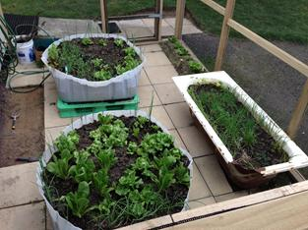
- Increasing acknowledgement that family violence is an issue: Whānau/families and service providers now more openly acknowledge family violence and its impacts as an issue of concern for Chatham Islands, and one that needs to be addressed. This increased acknowledgement of family violence is reflected in an increase of police-recorded family violence incidents, from fewer than 5 in 2001 to more than 10 to date in 2013.
- Possible decrease in smoking rates: While many on the Islands still smoke and attitudes to smoking probably lag behind those on the mainland, residents feel that attitudes to smoking are starting to shift.

Table 6: Cigarette smoking rate

Based on the proportion (%) of the population in the area aged 15 years and over who currently smoke cigarettes (Social Report 2009)
Sex | European |  | Māori |  | Total
 | Number | % | Number | % | Number | %
Male | 42 | 27.9 | 51 | 34.5 | 90 | 43.7
Female | 24 | 16.2 | 36 | 27.2 | 84 | 43.5
Total | 93 | 37.7 | 120 | 48.6 | 171 | 45.1
- More focus on workplace injury: Businesses are introducing new health and safety practices and greater accountability. Whether this is having an impact on the number of injuries is not known.

Table 7: The number of workplace accident insurance claims reported to ACC per 1000 full-time equivalent employees, excluding those who received accident and emergency treatment only
December year | Number of claims |  |  | % of claims by sex
 | Male | Female | Total | Male | Female
2002 | 77 | 17 | 94 | 81.9 | 18.1
2003 | 85 | 11 | 96 | 88.5 | 11.5
2004 | 66 | 14 | 80 | 82.5 | 17.5
2005 | 69 | 14 | 83 | 83.1 | 16.9
2006 | 79 | 19 | 98 | 80.6 | 19.4
2007 | 71 | 8 | 79 | 89.9 | 10.1

Summary: Free access to primary health care and prescriptions enables whānau/families living on Chatham Islands to seek to maintain their health and wellbeing. While there continue to be health and wellbeing issues, there appear to be signs of positive shifts in some ingrained attitudes and behaviours.

5.3 Whānau health and wellbeing needs

5.3.1 Significant barriers to accessing primary health care for those on Pitt Island
Whānau/families living on Pitt Island face significant travel costs to access primary health care. Travelling off-island to access primary care also impacts on their ability to care for whānau/family and to work. Consequently, Pitt Island residents tend to wait until they have a significant health concern before travelling to the Chatham Islands Health Centre. As a result, whānau/families living on Pitt Island self-report that their overall health is poor, and that the majority of residents have one or more health issues.
Pitt Island residents comment they have little awareness of the wider health and social services available on Chatham Island. They also note they are not kept updated by the Chatham Islands Health Centre about visiting allied health professionals, so face access barriers due to a lack of information.
Pitt Island residents are seeking more regular access to health services on Pitt Island. Ideally, the community would prefer that the women who had trained as a nurse currently living on Pitt Island be contracted on a part-time basis to the Chatham Islands Health Centre. Recognising the small population on Pitt Island, the long-term viability of this role has been questioned due to its requirement for a broad scope of practice, the ability to maintain ongoing competencies given the volume of work, and access to clinical supervision.
We have a registered nurse and would like her to be employed by the Health Centre. In emergencies, we rely on the role and cannot access an employed health practitioner. We have an asset and don’t want to lose it. (Resident)

5.3.2 Chatham Islands health and safety needs
Discussions with whānau/families and service providers on Chatham Islands consistently identified three key health and safety areas that people felt were not well addressed at present – alcohol and drug abuse, family violence and mental health issues.

Alcohol and drug abuse
Binge drinking and – for some – the normalised use of marijuana across the generations is common. ‘P’ is known to be on the Islands, although it was not identified as a significant issue. Linked to binge drinking are concerns with drunk driving, family violence and workplace injury.
Substance abuse is the critical issue. Whether P, marijuana, or alcohol, the abuse of these substances is of critical concern to us. The abuse of any substance has a net negative impact on whakapapa. The negative health impacts of substance abuse on the individual represent a significant impact on the mana of that person. That is exacerbated when that individual commits violent and/or negative actions on their whānau and those whom they interact with. Our view is that these negative impacts are further exacerbated by the isolation the Island brings. (Service provider)
Currently on Chatham Island there are no services to support people seeking to stop excessive drinking or taking illicit drugs (such as psychosocial interventions, counselling or other support services), apart from brief interventions by the GP. People seeking to address alcohol and drug abuse need to leave the island to access appropriate services (eg, Alcoholics Anonymous). Māori Community Services seeks to offer support, although its employees have no formal training in this area or a contract to deliver this service.
Counselling services do come intermittently to Chatham Island. However, the time lag between visits and lack of continuity make it challenging to gain traction and maintain gains. The lack of regular support services and interventions also limits the sentencing options available for judges dealing with crimes related to alcohol and drugs.
We are firmly of the view that more support must be given to Māori Community Services and iwi/imi to assist in supporting our whānau. Regular counselling services on-island and within the context of whānau are required. (Service provider)

Family violence
Whānau/families acknowledge that family violence is an issue that causes significant harm to women and children, and is perceived to be linked to the culture of binge drinking. For some, family violence is inter-generational. Family violence is now being recognised in the community as not acceptable.
Concern was raised that the response to family violence on Chatham Islands is inadequate for women, their children and wider whānau/family. Chatham Islands have no safe houses, and given the lack of housing stock this is likely to remain a challenge. There does not appear to be a coordinated response to family violence that ensures support for whānau/families as needed. The response to family violence on Chatham Islands needs to recognise how living on a small island may impact on effective interventions.
In court cases relating to family violence on Chatham Island, there is also a lack of sentencing options (such as anger management, or alcohol and drug counselling) for perpetrators.
Whānau violence is a major issue on the island. It is a legacy passed to us from our tūpuna. It is a legacy that must be broken. A great deal of support is required to assist us in breaking the cycle of violence both in the way in which (predominantly) our tāne perpetuate it, and the manner in which our wāhine/whānau often accept it. We agree there is a lack of sentencing options, and are equally aware that ‘time out’ is not (perhaps) used often enough. (Service provider)

Mental health
Whānau/families noted significant concern about existing support and treatment for mental health issues and addictions. Examples were given of people with mental health conditions not receiving proactive support or follow up, and whānau/family struggling to support whānau/family members to maintain their mental wellbeing. Fears were also raised about safety in the community due to limited support and supervision.
Two nurses at the Health Centre have training and experience in mental health services. Whānau/families and health service providers noted there was a reluctance to use these services, as nurses are seen as part of the community. Concerns about confidentiality of information are noted as the reason for this reluctance. However, it may also be driven by a lack of understanding and stigma about mental health.
As noted in section 3.4.4, mental health nurses and mental health psychiatrists periodically visit the Islands. The concern of whānau/families is to ensure continuity of support and access to appropriate interventions.

Other health needs
Other health needs less frequently mentioned included:
- High smoking rates: While there has been a perceived improvement in smoking rates, overall there is a perception that smoking attitudes lag behind those in the rest of New Zealand.
- Limited access to dental services: Whānau/families commented that if they miss the twice yearly visits, they have a long wait for the next appointment. If a dental emergency arises, people have to travel to the mainland.
- Limited access to optometrists: Children requiring eye tests and glasses must travel to the mainland, and some have had to wait several months before they receive an eye test and glasses. These delays were noted by some service providers as potentially having a detrimental effect on children’s schooling.

5.3.3 Service delivery issues
Feedback from whānau/families on Chatham Islands identified a number of service delivery issues that affected their service experience and ability to maintain their health and wellbeing.

Need for greater awareness, knowledge and transparency
Discussions with whānau/family highlighted a lack of awareness and knowledge about services available on Chatham Islands. Improvements suggested included the following.
- More clarity about the roles of different service providers: For example, Māori Community Services was highly praised for its contribution to the community. However, some people were unclear of the scope of its role or its interface with other services. This perception was common for other services. Further, there was confusion about the range and level of service offered by the Chatham Islands Health Centre. A common suggestion was a booklet detailing the breadth of services available across Chatham Islands.
- Ensuring the criteria for travel assistance entitlements and decisions are transparent: Entitlement to National Travel Assistance when accessing secondary care in New Zealand, particularly for support people, is an area of much dissatisfaction and great frustration for some whānau/families. Decisions about travel assistance for support people are currently being made in Hawke’s Bay DHB, to avoid on-island tension. Many whānau/families perceive decision-making as inconsistent, not recognising people’s needs, or the challenges of travelling to Hawke’s Bay by plane to Wellington and then taking a bus to Hawke’s Bay when ill. Some perceived a sense of favouritism within the decision-making process.
- Promoting awareness of the over-the-counter pharmacy in the Heath Centre, and of what can be purchased by who.
- Informing the community of when allied health professionals are visiting, and the process for accessing these services. The community needs to recognise that to access many allied health services and specialists they require a referral from the GP.
- Ensuring whānau/families on Pitt Island are kept informed about the range of services available, and if appropriate the availability of access to allied health professionals on Chatham Island.

Need for patient advocate

The need for a patient advocate was suggested by some in the community, to address the lack of awareness and knowledge about services, and that many Chatham Island people will not advocate for their rights with health services. As noted, Māori Community Services and the Medical Relief Fund fill this role to some extent, but not everyone is seeking their support. Increasing awareness that Hawke’s Bay DHB and Māori Community Services can offer this support will go some way towards addressing this concern. However, consideration is needed to determine whether Māori Community Services should be contracted to undertake this role on an ‘as needs’ basis.

Aligning primary health care delivery with community needs
Chatham Islands Health Centre does not have a clear identity as a primary health care provider. Some in the community continue to perceive the Health Centre as a hospital, which creates expectations about the type and range of services that should be delivered that cannot be met.
As is typical for rural areas, Hawke’s Bay DHB faces significant challenges in recruiting and retaining GPs and nurses for the Chatham Islands Health Centre. As noted, locum GPs are currently used to staff the Health Centre. This is seen by the community as both a positive and a negative. On one hand having GP locums means there is the possibility for a second opinion when a new GP arrives. On the other, frequent changes in GPs can result in inconsistencies in treatment (for example, drugs prescribed for kuia and kaumātua), which can be unsettling and in some case detrimental to health and wellbeing.
Descriptions of services received by whānau/families highlights that the Health Centre appears to be providing reactive services to the community and not working for the community. For most services, whānau/families are required to come to the Health Centre and fit into the Centre’s preferred ways of working. There appears to be little flexibility to determine how services could be structured to better meet the community’s needs, and few outreach or community services. The Health Centre informs Māori Community Services of its service support needs. However, there appears to be little strategic planning about how Health Centre and Māori Community Services could be strategically coordinated to best meet needs of the Chatham and Pitt Islands communities.
The Health Centre is seen as the gatekeeper to services such as the GP, pharmacy and other services. Feedback suggests that requests for service ‘outside of standard practice’ (eg, appointments with the doctors in the afternoon or evening for men working on fishing boats) are not positively received and facilitated. Consequently, there are concerns that some may be missing out.
Currently, whānau/families perceive that the focus of service delivery in the health centre is on managing staff workload, stress and costs. These are all important concerns. However, consideration is needed to determine a service delivery that better meets the needs of the community, while also meeting the workforce challenges of delivering health care remotely.
Not made to feel awkward but made to feel inadequate. I don’t like fitting in. In New Zealand you have a choice of providers. I worry that the quiet voices are not accommodated. (Whānau)
Feedback from the community suggests that service delivery is not welcoming for Māori. Some Māori commented that putting up posters with Māori designs on them does not make the service culturally appropriate. They questioned the kaupapa of services, and wondered whether cultural competency was being actively monitored. Some Māori commented on the need for all Chatham Islands health services to demonstrate cultural competency.
I am not connected to the hospital. It is about culture and action. No Māori face, not being acknowledged and looking at me as Māori. (Whānau)
The need for confidentiality in a small community is seen as critical. Whānau/families want confidence that when they are engaging with nurses on reception, their health issues cannot be heard by others. Some feel the current layout does not facilitate private and confidential conversations, and is not welcoming and engaging.

DHB affiliation
Chatham Islands Health Centre lies under the administration of the Hawke’s Bay DHB. This arrangement worked reasonably well when there was a direct flight to Napier from Chatham Island.
Discussion with whānau/families highlighted a preference for Chatham Islands Health Centre to be aligned with either Capital & Coast DHB or Canterbury DHB. This preference reflects that those DHBs have tertiary health centres accessible on a direct flight from Chatham Island, and that some have whānau/family living in the cities to support them when seeking secondary care. While logistically shifting administration to a tertiary centre may be more appealing, it is unknown whether another DHB would facilitate the same level of access to specialist services on Chatham Islands, or the impact this shift may have on the current very timely rates of access to secondary services.

Summary: Whānau/families living on Pitt Island face significant travel costs to access primary health care, and have little awareness of the wider health and social services available on Chatham Island. Across Chatham Islands, three health and safety needs stood out as priorities to be addressed – alcohol and drug abuse, family violence and mental health issues. While whānau/families recognised the positive contribution of the Chatham Islands Health Centre to the community, their comments suggested both health services and Māori Community Services could be more strategically aligned with the community’s needs.

6. Feasibility of Health and Wellbeing Day

6.1 Overview of Health and Wellbeing Day concepts
Māori Community Services was keen to explore the feasibility of holding a Health and Wellbeing Day on Chatham Island, potentially using a model similar to PHARMAC’s One Heart Many Lives programme.
Developed in 2002, the One Heart Many Lives Program goal is to create awareness and educate tāne aged 35 years and older about heart disease, diabetes and obesity. Tāne are targeted recognising that they are less likely to access primary care. A multi-disciplinary team is set up at community events to interact tāne in fun and informative activities to promote a healthier lifestyle, and provide a range of free heart checks, including body mass index, blood glucose and blood pressure.
In 2011, drawing from the experiences of the One Heart Many Lives Program, The Whānau Hauora Village was initiated at Te Matatini o te Rā to set up a nurturing, inspiring space where whānau/family could come over the four days to select a health service, feel welcome and receive positive and proactive health care (PHARMAC 2011).

6.2 Interest in Health and Wellbeing Day
Feedback from the community indicated mixed interest in the idea of a Health and Wellbeing Day on Chatham Islands. It was noted that there are a number of ad hoc and annual health and wellbeing events already held on Chatham Island, specifically:
- Tu Ra Tu Meke (annual event), which has a broader focus than health promotion. In 2013, the theme was Chatham Island Safety, with a focus on safe kai-gathering (administered by the Department of Conservation), seat belts and life jackets, as well as Smokefree and other health promotions, eg, diabetes awareness
- the Warrant of Fitness for men (ad hoc), led by the Health Centre, which focused on health checks including cardiovascular checks
- the Matariki Smokefree event.
Whānau/families also mentioned social events that are held each year, including the Chatham Island Festival and Race Day. Event organisers would be reluctant to incorporate a health and wellbeing event, given the focus of these events on food and alcohol.
If a health and wellbeing event was undertaken, there was a preference for the focus to be holistic, on whānau/family, similar to the Whānau Hauora Village concept.

6.3 Underlying rationale
Discussion with whānau/families and service providers identified no clear rationale or need for a Health and Wellbeing day on Chatham Island. There was generic level of interest in the concept as a ‘good idea’ for the community, and some suggested a focus on men.
An underlying driver for the One Heart Many Lives Program and the Whānau Hauora Village is to enable access to primary care services particularly among those who do not typically use them. As noted, on Chatham Island there is high level of access to primary care (with the exception of Pitt Island residents) and Māori Community Services is proactive in undertaking community-level health promotions linked to Whānau Ora. The employment of men in the fishing industry means they are unlikely to be available for a one-off health event.
Pitt Island residents do have a need for a concept like the Whānau Hauora Village to help them access primary health care, health promotion and wider support services. Due to the cost of travel, Pitt Island residents stated they were unlikely to come to Health and Wellbeing Day on Chatham Island.

6.4 Recommendation
The resourcing of a Health and Wellbeing Day is not recommended. There is some general interest in a Health and Wellbeing Day. However, there are no unmet needs that would be best addressed through such an event, due to current high primary care access and the number of existing and positively received health promotion events. Given other pressing health and wellbeing issues (ie, alcohol and drug abuse, mental health and family violence) noted, energy and resources would be better spent elsewhere.

7. Considerations for moving forward

Overall reflection
Chatham Island has a good core of health and social services. The strengths of the services on Chatham Island are acknowledged. Further needs identified by whānau/families, together with considerations for moving forward, are set out below.

Maintaining and enhancing primary health care
Free primary health care and free prescriptions are important enablers for whānau/families living on Chatham Island to access and maintain health and wellbeing. For those living on Pitt Island, there is a need to enhance access to primary health care with annual or twice yearly visits by the GP and nurses, as well as linking to other service providers on Chatham Island (eg, Māori Community Services). Pitt Island whānau/families have also proposed a local solution: the part-time employment of a nurse living on the island.
Chatham Islands Health Centre has an important role in strengthening whānau/family health and wellbeing. Consideration is needed on the service delivery model used by Chatham Islands Health Centre, in particular ensuring the service is whānau/family-centred, culturally competent and integrated with other service providers.

Three key needs
Three key needs have been identified by the community to strengthen whānau/families’ health and wellbeing:
- ongoing improvements to housing stock
- earlier and more effective response to mental health, alcohol and drug addictions and behavioural issues: Evidence shows that responding earlier and more effectively can improve people’s lives, avoid negative impacts on society and reduce the level and intensity of demand for services arising later (Fonagy et al 2000; Merry et al 2008). The Mental Health Commission (2012) advocates a life course approach to enable early intervention from across the whole of the health sector and broader social, education and justice sectors, as well as the mental health and addition sector. Consideration is needed as to how this framework can be applied effectively on a remote island
(The community is seeking more consistent and regular access to counselling services. Further consideration is needed to determine the most effective intervention for whānau/families living on Chatham Islands.)
- consistent and effective response and interventions for family violence, via an interagency and community approach: Fanslow and Robinson (2010) highlight that family violence is not necessarily a ‘private problem’, and that women are seeking help. However, the responses they receive from their informal support networks and institutions tend not to be helpful. Fanslow and Robinson recommend a broader community outreach approach to ensure whānau/family and friends are able to provide appropriate support for women in abusive relationships.
Te Puni Kōkiri suggests that kaupapa Māori approaches are required to address family violence from a Māori worldview, structured using Māori tikanga approaches (Te Puni Kōkiri 2010; Te Puni Kōkiri 2010a). On Chatham Islands, possible programmes and responses to family violence need to consider using models based on a kaupapa Māori framework and inviting input from across whānau, hapū, iwi and Māori communities to intervene and transform current experiences. This approach recognises that whakapapa and whānau are central to relationships (Te Puni Kōkiri 2010).
In determining appropriate responses and strategies for Chatham Islands, consideration of the existing evidence base is recommended to identify effective practices both to enable and support victims of family violence and to offer/enforce interventions for perpetrators (eg, anger management courses).

Other issues
Other services that would contribute to strengthening whānau/families’ health and wellbeing, particularly if there is continuity and consistency of services, include:
- parent education services
- WCTO checks together with hearing and vision tests
- improved information about services and entitlements, transparency in decision-making and patient advocacy
- access to regular physiotherapy and injury prevention
- respite care.
The needs of teenagers on Chatham Islands require further exploration.

Self-determination and capacity building
Strengthening whānau/family on Chatham Island requires community and local service organisations to agree the pathway forward and priorities to develop a cohesive, joined-up step-by-step process of implementation that also makes clear where external agencies can best contribute. | 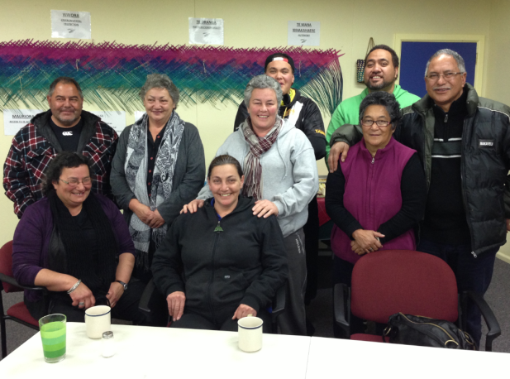
In seeking to strengthen health and wellbeing, the ongoing capacity and capability building of service providers on Chatham Islands supported by good governance and leadership is essential.

Economic wellbeing
For whānau/families to maximise their health and wellbeing requires economic security. The Chatham Islands Council and Chatham Islands Enterprise Trust are actively exploring ways to foster sustainable economic growth, through partnership with the New Zealand and other governments and the private sector.

Need for a Health and Wellbeing Day
The idea of a Health and Wellbeing Day inspired a general level of interest as a ‘good idea’ for the community. However, there are no clearly identified unmet needs that would be best addressed through such an event, due to currently high rates of primary care access and the number of existing and positively received health promotion events.

Bibliography and references
Arif Leow NM, Muhammad Nor AB, Hao Ong Q, Ovenden C, O’Fallon C, ’`Rourke C, Pfeiffenberger A, Rowsell J, Singh A, Stevenson E, Todd S, White S, Wilson C, Wynne A. 2011. One Heart Many Lives: Evaluation Report. Group A2. Fourth Year Medical Students. Public Health Project. Wellington: School of Medicine and Health Sciences, University of Otago.
Baker MG, McDonald A, Zhang J, Howden-Chapman P. 2013. Infectious Diseases Attributable to Household Crowding in New Zealand: A systematic review and burden of disease estimate. Wellington: He Kainga Oranga/Housing and Health Research Programme, University of Otago.
Boffa Miskell. 2013. Draft Chatham Islands (Wharekauri/Rēkohu) – Learning Centre and Housing – a Chatham Islands Solution Learning Centre Feasibility and Housing Study. Prepared for WhareKauri Maori Committee, Ha O Te Ora O Wharekauri Trust & Ngāti Mutunga O Wharekauri Iwi Trust. Auckland: Boffa Miskell.
Chatham Islands Council. 2013. Chatham Islands Council Annual Report 2013–2014. Chatham Island: Chatham Islands Council.
Chatham Islands Enterprise Trust. 2013. Strategic Plan 1 July 2013–30 June 2014. Chatham Island: Chatham Islands Enterprise Trust.
Durie M. 1998. Whaiora Māori Health Development. (2nd edition). Auckland: Oxford University Press.
Durie M, Cooper R, Grennell D, Snively S, Tuaine N. 2010. Whānau Ora: Report of the Taskforce on Whānau-Centred Initiatives. To Hon Tariana Turia Minister for the Community and Voluntary Sector.
ERO. 2010. Te Kōhanga Reo O Wharekauri Education Review. Wellington: Education Review Office (ERO).
ERO. 2010a. Te One School Education Review. Wellington: Education Review Office (ERO).
ERO. 2010b. Kaingaroa School Education Review. Wellington: Education Review Office (ERO).
Fanslow J, Robinson M. 2010. Help-seeking behaviors and reasons for help seeking reported by a representative sample of women victims of intimate partner violence in New Zealand. Journal of Interpersonal Violence 25: 929–951.
Fonagy P, Target M, Cottrell D, Phillips J, Kurz Z. 2000. A review of the outcomes of all treatments for psychiatric disorder in childhood. MCH 17–33.
Green N. 2013. Native Birds & Scenes of Rangatira Island. Chatham Cottage Gifts.
Ha O Te Ora O Wharekauri Trust – Māori Community Services. 2011. Te Whānau Whāriki, Whānau Ora – Business Plan, Wharekauri, Rēkohu, Chatham Islands. Chatham Island: Ha O Te Ora O Wharekauri Trust – Māori Community Services.
Jamieson L, Thomson W. 2003. Dental Health of Chatham Islanders: An investigation of the oral health of Chatham Islands residents. New Zealand Dental Journal 99 No 4: 90–97.
Lawrie C, Powell J. 2012. Discover the Chatham Islands: First to see the sun. Australia: Deerubbin Press.
Mental Health Commission. 2012. Blueprint II: How things need to be. Wellington: Mental Health Commission.
Merry S, Woulds T, Elder H, Guy D, Faleafa M, Cargo T. 2008. CMDHB Infant Mental Health Report. Auckland: Counties Manukau District Health Board.
Midlands Health Network. 2011. Integrated Family Heath Care Centres: Putting the patient at the centre of primary care. Hamilton: Midlands Health Network.
Minister for Disability Issues. 2001. The New Zealand Disability Strategy: Making a World of Difference Whakanui Oranga. Wellington: Ministry of Health.
Ministry of Health. 2005. Chatham Islands Focus: Results from the 2002/03 New Zealand Health Survey. Wellington: Ministry of Health.
Ministry of Health. 2011. Whānau Ora: Transforming our futures. Wellington: Ministry of Health.
Patterson S. 2013. Overview of Chatham Island Heath Centre. Waitangi: S Patterson.
PHARMAC. 2012. The Whānau Hauora Village: Te Matatini o te Rā. Wellington: PHARMAC.
Pipi K, Cram F, Hawke R, Hawke S, Huriwai T, Mataki T, Milne M, Morgan K, Tuhaka H, Tuuta C. 2004. A Research Ethic for Studying Māori and Iwi Provider Success. Social Policy Journal of New Zealand 23: 141–153.
Smith LT. 1999. Decolonizing Methodologies: Research and indigenous peoples. Zed Books: London.
Te Puni Kōkiri. 2010. Arotake tukino whānau: Literature review on family violence. Wellington: Te Puni Kōkiri.
Te Puni Kōkiri. 2010a. Rangahau Tūkino whānau: Māori research agenda on family violence. Wellington: Te Puni Kōkiri.
Te Puni Kōkiri. 2013. Whānau Ora: Fact Sheet: Paenga-whāwhā. April 2013. Wellington: Te Puni Kōkiri.
Te Puni Kōkiri. 2013a. Whānau Ora: Fact Sheet: Paenga-whāwhā. June 2013. Wellington: Te Puni Kōkiri.

Appendices

Appendix 1: Participants
- Māori Committee – Marae Whakamaharatanga
- Māori Community Services
- Chatham Islands Health Centre
- Hospital Liaison Committee
- Ngāti Mutunga O Wharekauri Iwi Trust
- Hokotehi Moriori Trust
- Senior Citizens
- New Zealand Police
- New Zealand Fire Service
- Ministry of Primary Industries
- Te Kōhanga Reo O Wharekauri
- Te One Playcentre plus parents/caregivers
- Te One School plus parents/caregivers
- Kaingaroa School plus parents/caregivers
- Chatham Islands Council
- Chatham Islands Enterprise Trust
- Heartland Services Centre
- Chatham Islands Community Focus Trust
- Chatham Island residents
- Pitt Island residents.

Appendix 2: Research tools

Panui
Panui for Health and Wellness of Chatham Islands Hui

Tēnā koutou katoa
A pōwhiri and hui are to be held on Tuesday 4 June at the Whakamaharatanga Marae.
The hui starts after the plane arrives and is being led by Ha O Te Ora O Wharekauri Trust – Māori Community Services.
Ha O Te Ora O Wharekauri Trust – Māori Community Services is working with the Ministry of Health, Te Puni Kōkiri, and PHARMAC to develop a profile of the health and social needs on the Chatham Islands to guide their work. Litmus (a social research company) has been asked by the Ministry of Health to work with Ha O Te Ora O Wharekauri Trust – Māori Community Services to write the health and social needs report.
PHARMAC (the government agency responsible for buying medicines) is also exploring what would be required to hold a Health and Wellbeing Day on Chatham Islands. Litmus is supporting PHARMAC to prepare the scoping report.
PHARMAC and Litmus are visiting Chatham Island from 4–10 June 2013. They will be meeting and talking with whānau and a range of service providers. Discussions will explore:
- the health and social needs of whānau
- services provided to meet these needs
- ideas to strengthen whānau health and wellbeing in the future.
At the hui, PHARMAC and Litmus are keen to hear your reflections on the health and social needs of whānau, and the idea of holding a Health and Wellbeing Day on Chatham Islands.
We look forward to meeting you and your whānau and listening and learning from the kōrero.

Nau mai haere mai

For further information, please contact:
- Barby Joyce, General Manager, Ha O Te Ora O Wharekauri Trust – Māori Community Services, ph 03 3050 211, barby@haoteora.org.nz
- Marama Parore, General Manager: Access & Optimal Use/Māori Health, PHARMAC, ph 04 916 559, marama@pharmac.govt.nz
- Liz Smith, Partner, Litmus, ph 04 473 3885, liz@litmus.co.nz

Information sheet
What is the purpose of the project? | Ha O Te Ora O Wharekauri Trust – Māori Community Services is working with the Ministry of Health, Te Puni Kōkiri, and PHARMAC to develop a profile of the health and social needs on the Chatham Islands to guide their work. Litmus has been asked by the Ministry of Health to work with Ha O Te Ora O Wharekauri Trust – Māori Community Services to write the health and social needs report.  PHARMAC (the government agency responsible for buying medicines) is also exploring what would be required to hold a Health and Wellbeing Day on Chatham Islands. Litmus is supporting PHARMAC to prepare the scoping report.
What will I be asked to do? | PHARMAC and Litmus are visiting Chatham Island from 4 – 10 June 2013. We want to meet and talk with whānau, service providers and community leaders to find out more about the health and social needs of whānau on Chatham Islands.  You may be asked to take part in an interview to discuss the health and social needs of whānau, services provided to meet these needs, and ideas to strengthen whānau health and wellbeing in the future. If you are service provider you will be asked whether you have any data or existing information that may help inform the report.  You will also be asked your opinion on the idea of a health and wellness day, what this might look like, what would work best for Chatham Islands, and whether you are keen to be involved. The interview will take about 60 minutes and will be face-to-face.
Why have you asked me? | Ha O Te Ora O Wharekauri Trust – Māori Community Services has identified you as someone who has knowledge about health and social needs on Chatham Islands, or someone who delivers health and social services.
How will my information be used? | The kōrero, information and data will inform the Health and Social Needs report and the scoping report about a potential Health and Wellbeing Day. Litmus will present data in a non-identifiable way, and present information in themes about the strengths and areas for improvement.  If you agree, your organisation (or if appropriate, your name) will be listed in the report as having taken part. Listing those who have taken part will offer readers assurance that a broad range of whānau, providers and organisations have contributed to the report.  The reports will be used to guide the future work of Ha O Te Ora O Wharekauri Trust – Māori Community Services, and central government agencies.
Can I change my mind? | You may stop the interview at any time. You do not need to give a reason. You can withdraw your information after completing an interview, up until reporting starts.
Who is doing the report? | The report is being written by Litmus, an independent social research company. For more information about Litmus go to www.litmus.co.nz
What if I have any questions? | If you have any questions about this project, please contact:  Liz Smith, Partner, Litmus, ph 04 473 3885, liz@litmus.co.nz  Barby Joyce, General Manager, Ha O Te Ora O Wharekauri Trust – Māori Community Services, ph 03 3050 211, barby@haoteora.org.nz  Marama Parore, General Manager: Access & Optimal Use/Māori Health, PHARMAC, ph 04 916 559, marama@pharmac.govt.nz  Heidi Cannell, Advisor, Whānau Ora, Māori Health Policy, Māori Health; Ministry of Health, ph 04 816 3950, Heidi_Cannell@moh.govt.nz

Consent form
Chatham Islands Health and Social Needs Report & Scoping for a Health and Wellness Day
I (insert name) …………………………………………………………………………………….
of (insert organisation) ..……………………………………………...........…………………….
agree to take part in an interview to inform the development of the Chatham Islands Health and Social Needs Report and the scoping report for a Health and Wellness Day. I understand that:
- My participation in the project is voluntary and I can withdraw at any time.
- Whether or not I take part will not affect any current or future relationships.
- If I withdraw, I can request that any information collected from me be returned or destroyed.
- I can choose not to answer any questions I do not wish to answer (without saying why).
- I can request any information collected from me be withdrawn at any time up until the reporting stage.
- The process followed by Litmus will seek to keep my information confidential. No information in the report will be attributed to me.
- The interview, with my permission, will be taped and may be transcribed.
- I have the right to request a copy of the audio or written notes of my discussion.
- Digital recordings, notes and summaries will be securely stored at Litmus and will not identify me. They will be kept for two years and then securely destroyed.
I have read the information sheet and this consent form, and have been given the opportunity to ask questions and have them answered. I give my consent to participate in this research.
Participant’s signature: __________________________

Date: _________________

Listing in report
I agree/do not agree to be listed in the appendix of the report has having taken part in the research.
If agree, please complete the details you wish to be listed:

Question areas for interviews
Chatham Islands Health and Social Needs Report & Scoping for a Health and Wellness Day
Question Areas

Hui at Marae (4 June 2013)
- Overview of purpose of visit
Health and Social Needs report
- What are the strengths of whānau living on Chatham Island?
  - What are the wellness and wellbeing strengths of whānau?
- What is working well with health and social services to Chatham Island?
- Over the last ten years, how has the health and wellbeing of whānau changed?
  - What are the drivers of this change?
- What are the key needs/concerns of whānau?
  - What are the priority health needs?
  - What are the priority social needs?
- How well are these needs being met?
- How can these needs be better addressed?
  - Via existing services?
  - Via new services?
Health and Wellness Day
PHARMAC works with communities around New Zealand to run health and wellness days sometimes for whānau and at other times focusing on the men (eg One Heart, Many Lives).
- How interested is the community in having a health and wellness day?
- What would we want to achieve in having this day?
- Who would the day be focused at?
- What would our ideal health and wellness day look like?

Discussions with whānau
- What are the good things about living on Chatham Island?
- What are the things that are challenging about living on Chatham Island, particularly in seeking to keep whānau healthy and strong?
- What are the strengths of whānau living on Chatham Island?
  - What are the wellness and wellbeing strengths of whānau?
- What is working well with health and social services to Chatham Island?
- What are the key needs/concerns of whānau?
  - What are the priority health needs? (What are the priority social needs?)
- How well are these needs being met?
- How can these needs be better addressed?
  - Via existing services?
  - Via new services?
Health and Wellness Day
PHARMAC works with communities around New Zealand to run health and wellness days sometimes for whānau and at other times focusing on the men (eg One Heart, Many Lives).
- How interested are we in having a health and wellness day?
- What would we want (not want) from this day?
- Who would the day be focused at?
- What would our ideal health and wellness day look like?

Other comments

Discussions with health and other service providers/community leaders

Service-specific information
- Please describe the service your organisation offers.
- Who uses the service?
- What are the key results the organisation is trying to achieve?
- What is working well? Not so well?
- Data request (if appropriate) collated data that demonstrate a measure of health and wellbeing, service use.

Health and wellbeing
- What is your overall perception of the health and wellbeing status on Chatham Island?
- How has it changed over the last ten years?
  - Better, worse, stayed the same
  - Drivers of change/no change
- What keeps whānau healthy and well?
- What is working well with health and social services to Chatham Island?
- What are the key risk factors to whānau’s health and wellbeing?
- What are the key needs/concerns of whānau?
  - What are the priority health needs?
  - What are the priority social needs?
- How well are these needs being met?
- How can these needs be better addressed?
  - Via existing services?
  - Via new services?

Health and Wellness Day
PHARMAC works with communities around New Zealand to run health and wellness days sometimes for whānau and at other times focusing on the men (eg One Heart, Many Lives).
- How interested is the community in having a health and wellness day?
- What would we want to achieve in having this day?
- Who would the day be focused at?
- What would our ideal health and wellness day look like?

The name ‘Māori Community Services’ has been used in the report as it is the familiar name for the Chatham Island community.
Many Chatham Islanders call New Zealand the ‘mainland’.
Chatham Island is the main island in the Chatham Islands. Most of the population live here.
www.tpk.govt.nz/_documents/whanau-ora-april2013factsheet.pdf accessed 22 June 2013.
The name ‘Māori Community Services’ has been used in the report as the Chatham Island community is most familiar with this name.
www.tpk.govt.nz/_documents/whanau-ora-fact-sheet-june-2013.pdf accessed 22 June 2013.
www.oneheartmanylives.co.nz/ accessed 22 June 2013.
In this report, the term ‘service provider’ refers to a range of health and social services. The term ‘health service provider’ is used where this is relevant.
Appendix 1 provides a list of organisations who participated in interviews and agreed to be listed in the report.
Appendix 2 contains the information sheet, informed consent sheet, questions and panui.
Chatham Islands NZ Statistics: www.stats.govt.nz/Census/2006CensusHomePage/QuickStats/AboutAPlace/SnapShot.aspx?id=2000067&type=ta&ParentID=1000099 accessed 24 May 2013.
www.socialreport.msd.govt.nz/2009/regional/t-authorities/location/chatham-islands.html#telephone-internet accessed 24 May 2013.
www.educationcounts.govt.nz/statistics/schooling/teaching_staff accessed 24 May 2013.
www.chathams.com accessed 22 June 2013.
http://en.wikipedia.org/wiki/File:Chatham-Islands_map_topo_en.svg accessed 27 May 2013.
www.discoverthechathamislands.co.nz/visit/history/ accessed 23 June 2013.
Only total population figures are available at the time of writing.
The ‘Māori’ ethnic group includes those people who stated Māori as being either their sole ethnic group or one of several ethnic groups.
www.stats.govt.nz/Census/2006CensusHomePage/QuickStats/AboutAPlace/SnapShot.aspx?id=2000067&type=ta&ParentID=1000099 accessed 24 June 2013.
Patterson 2013 and www.hawkesbay.health.nz/page/pageid/2145869816 accessed 24 May 2013.
The receptionist/accruals clerk works three to four hours per day, four days a week during clinic times to free the nurses for nursing duties.
The PRIME programme is a jointly commissioned project funded by the Ministry of Health and ACC and administered by St John. It has been developed to facilitate the coordinated response and appropriate management of emergencies in rural locations. It uses the skills of specially trained rural GPs and/or rural nurses to support the ambulance service where the response time for assistance would otherwise be significant or where additional medical skills would assist with the patient’s condition: http://prime.stjohn.org.nz/about/default.aspx accessed 30 June 2013.
Friends of the Hospital funds are pooled from the koha collective. Purchases made are normally for items over and above what the DHB should buy or they cannot due to exceeded budget allocation. The fund is usually used for patient focused purchases not day-to-day running.
www.health.govt.nz/publication/national-travel-assistance-scheme-your-guide-claiming-travel-assistance-brochure accessed 30 August 2013.
www.health.govt.nz/publication/national-travel-assistance-scheme-your-guide-claiming-travel-assistance-brochure accessed 30 August 2013.
The second visit on Chatham Island is for those children that are deemed at risk. Pitt Island children can be seen on the second visit if they are on Chatham Island The Hawke’s Bay DHB also runs a ‘Brush In Programme’ to help the children and communities of low-decile schools by creating awareness of the importance of oral hygiene both to the child and whānau.
www.hawkesbay.health.nz/file/fileid/37682 accessed 30 June 2013.
Note: The actual number of contacts is higher than stated, as in the first few months of 2012 and the beginning of 2013 no phone/email or fax contacts were recorded. Contact statistics are measured on a monthly basis. If a person visits Heartland Services three or four times in one month and every visit is about Inland Revenue, this is recorded as one visit for that month. The same applies if a person faxes, emails or phones more than once a month wanting information from one department.
www.chathams.co.nz/index.php/community/38-community-focus-newsletter accessed 30 June 2013.
www.moriori.co.nz/home/about-the-trust/ accessed 30 June 2013.
www.nmow.co.nz/Home.htm accessed 30 June 2013.
Whānau Ora is for all families (Ministry of Health 2011, p4), and has therefore been applied to the diversity of whānau/families living on Chatham Islands.
www.stuff.co.nz/national/politics/7686220/Key-in-for-grilling-on-Chatham-Islands accessed 23 June 2013.
www.chathamislandsshipping.co.nz/price-schedule accessed 25 June 2013.
www.airchathams.co.nz/fares.html accessed 25 June 2013.
ERO 2010.
www.educationcounts.govt.nz/statistics/schooling/teaching_staff accessed 24 May 2013.
ERO 2010a.
ERO 2010b.
www.educationcounts.govt.nz/statistics/schooling/teaching_staff accessed 24 May 2013.
The Ministry of Education website states that the boarding allowance for 2014 is $3,200 and covers transport costs www.minedu.govt.nz/parents/yourteen/boardingallowances/faqs.aspx accessed 3 December 2013.
Cellphones are only for use on the ‘mainland’.
Self-managing in this context refers to the management of assets that are held collectively by the community.
www.moriori.co.nz/home/te-keke-tura-moriori-identity-trust/ accessed 26 June 2013.
This rule has now been changed.
Options Hawke's Bay is an assessment and service coordination agency that assists people with a disability, and their whānau/family, to maintain independence in their home and community, or a residential setting: www.hawkesbay.health.nz/page/pageid/2145870562 accessed 25 August 2013.
Personal communication from Chatham Island nurse manager to Hawke’s Bay DHB dated 31 August 2012.
www.socialreport.msd.govt.nz/2009/regional/t-authorities/location/chatham-islands.html accessed 24 May 2013.
www.socialreport.msd.govt.nz/2009/regional/t-authorities/location/chatham-islands.html accessed 24 May 2013.
Note: Hawke's Bay DHB provide patient advocacy on request and patients would be directed to services in the Hawke’s Bay. To date no one has requested this.
It was not in the scope of this report to undertake an extensive review of services offered.

