Te Pūtahitanga o Te Waipounamu | Direct Whānau Commissioning: Commissioning for Pae Ora | Healthy Futures case study
2023

Acknowledgements
This is one of a series of case studies funded by Manatū Hauora – the Ministry of Health (Ministry) looking at commissioning as a tool to improve health equity.
Thanks to Helen Leahy, Pouārahi of Pūtahitanga o Te Waipounamu, staff and whānau for sharing their journey and insights into direct commissioning with whānau.
Citation: Te Pūtahitanga o Te Waipounamu; Ministry of Health (ed). 2023. Te Pūtahitanga o Te Waipounamu | Direct Whānau Commissioning: Commissioning for Pae Ora | Healthy Futures case study. Wellington: Ministry of Health.
Published in January 2023 by the Ministry of Health
PO Box 5013, Wellington 6140, New Zealand
HP 8653
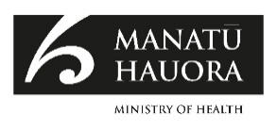
This document is available at health.govt.nz
This work is licensed under the Creative Commons Attribution 4.0 International licence. In essence, you are free to: share ie, copy and redistribute the material in any medium or format; adapt ie, remix, transform and build upon the material. You must give appropriate credit, provide a link to the licence and indicate if changes were made.

Contents
Purpose 1
Method 2
Whānau Ora Commissioning 3
Te Pūtahitanga o Te Waipounamu 4
Vision 5
Te Pūtahitanga o Te Waipounamu ecosystem approach 6
An innovative social enterprise approach 7
Theoretical approach underpinning the commissioning pipeline 8
Shifting from social engineering to a participant-based approach 9
How the wave funding works 10
Post-funding capability-building support 11
Learning from the innovation 12
Measuring outcomes that matter 13
Critical success factors in commissioning relationships 14
Challenges in commissioning 18

List of Figures
Figure 1: Relationships between success factors of kaupapa initiatives and commissioning agency 17
List of Tables
Table 1: Success factors for kaupapa initiatives 14
Table 2: Success factors for commissioners 15

Purpose
This case study examines the innovative commissioning approach used by Te Pūtahitanga o Te Waipounamu to commission outcomes directly from whānau through kaupapa initiatives.

The study captures how the South Island Whānau Ora agency’s commissioning approach has evolved over the past six years of commissioning and identifies factors for successful commissioning.

Method
This analysis draws on interviews with commissioning agency staff, whānau who have been successful recipients of the funding, previous research and evaluation of the commissioning pipeline, and documents supplied by Te Pūtahitanga o Te Waipounamu. The data is sourced from across 11 waves of funding, beginning in 2014 and concluding with Wave 11 (which ended in August 2021).

Whānau Ora Commissioning
In 2010, Whānau Ora was launched as an innovative whānau-centred approach to supporting whānau wellbeing and development. In 2014, the second phase of Whānau Ora moved implementation to three non-government commissioning agencies. The commissioning agencies are contracted to invest directly into their communities. The design was intended to ensure funding decisions are made closer to communities and allow for flexible and innovative approaches to meet the needs and aspirations of whānau. Each agency has the autonomy to create and develop its own pathways to achieve Whānau Ora.

The Whānau Ora commissioning model is a devolution model that has seen the transfer of significant resourcing and relative autonomy for decision-making from government to Māori. The model is recognised as allowing Māori to ‘lead their own transformation journeys, premised on cultural knowledge and holistic concepts of wellbeing’.

Within the context of Whānau Ora, commissioning is the process of direct investment in a portfolio of new or existing initiatives led by whānau for whānau with the aim of improving collective wellbeing. It also includes the monitoring, evaluation and review of whānau investments.

Te Pūtahitanga o Te Waipounamu is the organisation responsible for promoting and supporting the kaupapa of Whānau Ora in the South Island.

Te Pūtahitanga o Te Waipounamu
Te Pūtahitanga o Te Waipounamu was formed in 2014 to realise the aspirations of Te Waipounamu iwi through Whānau Ora. It is a legal partnership between the nine iwi of Te Waipounamu: Ngāi Tahu, Ngāti Apa ki te Rā Tō, Ngāti Tama, Ngāti Kuia, Ngāti Koata, Te Ātiawa, Ngāti Toa Rangatira, Rangitāne and Ngāti Rārua. This is a significant collaboration where iwi have joined forces to support whānau self-determination.

In 2014, Te Pūtahitanga o Te Waipounamu presented a proposal grounded in social enterprise, innovation and creativity utilising a strengths-based approach. The agency wanted to be bold in its commissioning methodology to ensure it fostered innovation, self-determination and reach across Te Waipounamu.

Vision
Te Pūtahitanga o Te Waipounamu mahi is driven by a vision where whānau are able to fulfil their dreams and aspirations, are culturally connected, thriving and contributing members of their communities. The long-term goal of the model is to enable and facilitate a shift from a reliance on government funding siloed into programmes and services to the realisation of indigenous autonomy across all aspects of living.

Te Pūtahitanga o Te Waipounamu ecosystem approach
Te Pūtahitanga o Te Waipounamu has created five pathways to achieve Whānau Ora:
- a social enterprise model (the commissioning pipeline)
- Whānau Ora navigator model
- capability development model
- whānau resiliency model
- research, innovation and advocacy model.

These models interact with one another, creating multiple pathways for all whānau to engage with Te Pūtahitanga o Te Waipounamu. This has been termed ‘Te Pūtahitanga o Te Waipounamu Whānau Ora Ecosystem’. This case study focuses on the commissioning pipeline investment, which is directly responsive to whānau needs and aspirations.

Te Pūtahitanga o Te Waipounamu holds open funding rounds directly investing in whānau-centred initiatives. These rounds are called waves, representative of the ‘momentum of change’ that derives from whānau strength. Wave rounds open twice a year and applicants must reside in Te Waipounamu.

The model is an innovative approach to commissioning, directly funding whānau to bring about their own change through aspirational activity. The model operates to empower whānau to overcome the barriers to success as they see and experience them. Through whānau commissioning, resources are provided to in-community change agents who are committed to enacting social transformation they know meets the aspirations, needs and values of their whānau/community. Those change agents use ‘kaupapa initiatives’, a new organisation, service, programme, social business entity or the like to bring about social change.

Evaluations note how 11 funding waves over the past six years have supported a network of over 350 kaupapa initiatives across Te Waipounamu.

An innovative social enterprise approach
The commissioning model draws on Māori knowledge to reframe whānau wellbeing through a strengths-based approach. Whānau self-determination is recognised as critical for Māori to realise social, economic and cultural aspirations and wellbeing. The model challenges traditional government top-down approaches through an organic process where change is driven by Māori communities, with and for Māori communities.

The commissioning pipeline of Te Pūtahitanga o Te Waipounamu has been noted as being ‘at the cutting edge of innovation in the Whānau Ora commissioning context’. Wehipeihana and colleagues describe Te Pūtahitanga o Te Waipounamu model of commissioning as ‘unique’ within the context of Whānau Ora, as it ‘stands out for its social enterprise and social capital focus’ that promote Māori forms of social entrepreneurship. They describe the model of commissioning:

A distinguishing feature of Te Pūtahitanga o Te Waipounamu’s approach is the prominence of their engagement directly with whānau and whānau initiatives. Whānau are at the forefront, in the driver’s seat, or being supported and encouraged to nurture and grow their ideas, and to translate these into whānau plans and funding applications. While they have relationships with providers, primarily as navigator host organisations, they also have relationships with coaches and enterprise advisors who support whānau to generate, refine and implement their ideas.

The model of commissioning developed by Te Pūtahitanga o Te Waipounamu is innovative and unique, built on a sound theoretical foundation and ever responsive to the lived experiences of whānau in Te Waipounamu.

Theoretical approach underpinning the commissioning pipeline
The commissioning model is viewed as preventative rather than reactive, forefronting whānau self-determination. Self-determination is key to Te Pūtahitanga o Te Waipounamu approach and at the heart of Whānau Ora.

In commissioning Whānau Ora, Te Pūtahitanga o Te Waipounamu does not provide a particular service or programme; but rather we are stewards of an approach that seeks to empower whānau to identify and meet their own needs. The approach is premised upon building whānau capability to independently address and manage their own lives; in a word, to be ‘self-determining’.

The commissioning is highly participatory (whānau are directly involved) and based on the premise that whānau in their own communities already have the ideas, knowledge, tools and capabilities required to create their own innovative solutions to the challenges they see and experience in their communities.

The kaupapa initiatives engage in a diverse set of activities in which networks of whānau, marae, hapū and iwi work to generate bottom-up solutions for sustainable development. This type of innovation provides ‘novel solutions that respond to the local situation and the interests and values of the communities involved; and where those communities have control over the process and outcomes’.

The initiatives are highly contextual, utilising local resources and experience. The activities align with the intention of the overall change theory to realise Whānau Ora. Evidence across the evaluation cycles shows that the whānau commissioning model is deeply rooted in an approach that emphasises compassion, social obligation and mutual determination.

Shifting from social engineering to a participant-based approach
In recent research, Sacha McMeeking examined the underpinning theory that drives social change through social enterprise. Her analysis describes the tension and contrast between a ‘social engineering logic’ and a ‘participatory logic’. Expert-led interventionist approaches tend to be a result of socially engineering a change within an individual or community, whereas approaches that actively engage participants in self-generating change are a distinct participatory approach. These are more commonly described as ‘done to’ versus ‘done with’ and ‘done by’ approaches. Through her analysis, McMeeking claims participatory logic is important to social change and may be essential for generating social transformation over time.

Participatory logic has direct relevance to Te Pūtahitanga o Te Waipounamu’s model of commissioning and is a key mechanism of change. The model forefronts whānau capability development and social enterprise through participatory logic. This means whānau are engaged in self-work and self-generating change. This is in direct contrast to ‘done to’ methods of change that emphasise the involvement and expertise of outsiders who hold the power, in deciding what will be done and how it will be done. ‘Done to’ methods of change struggle to achieve long-term change because there is a lack of ownership and self-work by the participants in the process.

How the wave funding works
Wave funding rounds are generally held twice yearly. Over the 11 waves, a support pathway for whānau to advance their applications through the wave process has been developed by Te Pūtahitanga o Te Waipounamu. Six weeks prior to wave funding starting, Te Pūtahitanga kaimahi visit regions to lead workshops focused on the application process. Te Pūtahitanga o Te Waipounamu provides enterprise coaches to assist whānau with the application process, and operates a website help portal and a phone service to support whānau enquiries.

An independent panel is contracted to determine the successful applications. All decisions are recorded and assessed against key criteria developed by the panel. This includes:
- an understanding of the Whānau Ora devolution model, which identifies all projects as needing to be whānau-led, with the whānau voice permeating across its design
- a business plan that is realistic and sustainable and reflects building opportunities post-funding
- clarity about the purpose of the initiative, how it is going to be achieved and how it supports continuing whānau self-determination. This includes knowledge of current services and organisations in a region, and how the initiative offers opportunities outside of, or alongside, these services and organisations
- clarity about what sustainability looks like for the whānau, iwi and hapū involved in the initiative. This includes understanding sustainability within economic, social and cultural contexts of wellbeing
- awareness of other funding agencies, their criteria and making choices about which organisation is most appropriate for the purpose of the initiative.

All applicants receive a letter from the Pouārahi informing them of the panel’s decision regarding their outcome. If an application is declined, the specific reason for the decision is explained and followed up by Te Pūtahitanga kaimahi, who offer support to strengthen the application for a future wave round. Across the 11 waves of commissioning, Te Pūtahitanga o Te Waipounamu has scrutinised over 800 applications.

Post-funding capability-building support
The commissioning pipeline has a capability development programme running parallel with the funding, comprised of innovation start-up programmes, incubation, innovation coaching, workshops, knowledge-sharing conferences and events designed to inspire emergent innovators to action. Whānau enterprise coaches and contract advisors are employed directly by Te Pūtahitanga o Te Waipounamu to offer tailored assistance to support whānau to achieve their aspirations.

In 2015, a review of capability was undertaken to examine how Te Pūtahitanga o Te Waipounamu might strengthen approaches to capability building through coaching and mentoring. As a result of the review, a 10-week accelerator programme involving six wānanga that addressed the core components of the start-up journey was developed. The result was ‘Te Pāpori o Whakatere’, a structured capability development programme that has run annually for the past four years. Whānau entities can access Te Pāpori o Whakatere whether they have been successful or unsuccessful in the application process; or simply if they have indicated an interest in preparing themselves to submit a wave application.

Learning from the innovation
Through the commissioning waves, Te Pūtahitanga o Te Waipounamu has evolved and adapted its support for whānau in response to key learnings through feedback, research and evaluation. The changes it has made include:
- establishing business enterprise coaches and contract advisors to support the commissioning process and completion of applications
- establishing champion connector roles to support decision-making in response to declined applications
- simplifying the application process
- whānau and the commissioning agency co-designing the outcomes
- online quarterly reporting, with whānau determining measures of success
- holding wānanga to support understanding of the commissioning process
- having the flexibility to amend outcomes and measures throughout the contract to suit innovation
- providing opportunities for entities to network with each other
- producing workbooks to support sustainability and success
- offering support to complete feasibility studies, environmental scans and scoping activities that may strengthen an initiative’s concept
- developing an annual symposium to showcase successful initiatives, normalising the concept of whānau capability development and self-determination.

Measuring outcomes that matter
Te Pūtahitanga o Te Waipounamu recognised that the investment would be scrutinised and critiqued. Evaluation was considered a key tool to demonstrate value, directly address any myths or misunderstandings and provide compelling proof of value at individual, whānau and entity levels, which in turn provided a platform for further funding. Over the past six years, every commissioning wave has been evaluated by Ihi Research.

Each evaluation has focused on specific aspects of the commissioning pipeline process, including the impact on whānau wellbeing, rangatahi and kaumātua aspirations, sustainability, the link between mātauranga and intellectual property rights, identifying critical success factors and understanding how grassroots commissioning can effect social change for Māori. The evaluations have provided numerous examples of initiatives supporting social, economic and cultural change, creating stronger connections and capabilities for whānau to support each other across Te Waipounamu.

Evaluations of previous commissioning initiatives have demonstrated how collective whānau-led enterprises can support transformation and understandings of Māori capability and wellbeing as whānau have experienced positive cultural, social and economic outcomes. While initiatives may vary somewhat in the degree of their impact, it has been recognised that all initiatives impact positively on whānau in some way.

As well as individual impacts, collective impact is apparent across the Whānau Ora system in Te Waipounamu. Through developing solutions collectively and fostering active whānau participation, the initiatives counter the trend towards individualisation and social isolation; instead they build social capital and capacities to create cohesive communities.

This was particularly apparent in the recent research into the Te Waipounamu COVID-19 response. The research demonstrated how the kaupapa initiatives across Te Waipounamu mobilised within their respective communities, supporting whānau at greatest risk and ensuring vital aid got through to isolated whānau and communities. The evidence demonstrates that as the kaupapa initiatives mature, they become snowball-like, accelerating the trajectory towards a tipping point generated by a social movement of self-determination.

Critical success factors in commissioning relationships
The Wave 10 evaluation investigated the relationship between the commissioning agency and the kaupapa initiatives. A framework for a successful commissioning relationship was identified. This relationship is reciprocal, with responsibilities identified by the commissioning agency and the kaupapa initiatives.

Table 1 presents success factors identified for kaupapa initiatives, while Table 2 presents the success factors for the commissioning agency. Figure 1 then summarises both groups of success factors and the relationships between them.
Table 1: Success factors for kaupapa initiatives
Success factor | Description
The model supports whānau-centred self-determination | Whānau articulate aspirations and determine their futures. Whānau strengths, assets and abilities are the starting point for future growth. Whānau capability building supports independence and interdependence not dependence.
Whānau decide their own solutions | Localised solutions address issues that exist within a whānau/community and/or take advantage of strengths and/or opportunities that are evident in the community. Solutions leverage the local conditions and resources available.
Highly participatory social activity | Whānau actively participate and lead change for themselves and others. Activity creates opportunities for social connection, relationship building and intergenerational participation, and promotes whānau and community social cohesion.
Whānau learn through activity and build their capability | Whānau identify their own capability needs and have access to appropriate support. Whānau are actively learning new skills. Kaupapa whānau, initiative leaders and kaimahi plan, implement and monitor their activity. Whānau capability development results in whānau leaders who are growing skills and attributes, enabling positive contributions for whānau, hapori, hapū and/or iwi.
The wider community benefits through increased capability | Kaupapa initiatives become part of the wider Whānau Ora social change community across Te Waipounamu. Whānau participate in mentoring and reciprocal learning opportunities. There are direct benefits for iwi strategic intent through networking and capability development.
The activity is culturally anchored | Kaupapa initiatives are active in the revitalisation of te reo Māori, mātauranga Māori, mahinga kai, whakapapa, tikanga and/or whenua. Kaupapa initiatives support the reclamation of a ‘Māori way of life’ through participation and leadership in kaupapa. Where appropriate, whānau are actively sharing knowledge through intergenerational pathways, resulting in sustained impact and capability building within kaupapa initiatives.
The impact is sustained over time | The activity results in a sustained change or has a sustained impact over time; the activity may cease but the change endures. Kaupapa initiatives lead to, and support, intergenerational shifts and impact.
Whānau are accountable to the commissioning agent and whānau | Kaupapa whānau express a level of responsibility and accountability to their whānau, hapū and/or iwi for the investment and the outcomes.
Table 2: Success factors for commissioners
Success factor | Description
Commissioning complements a multi-solution-based model | Direct wave commissioning is part of a suite of investment streams based on, and responsive to, whānau aspirations with a strong focus on innovation. It is part of the solution, not all of the solution.
Whānau dreams and aspirations are worthy of investment | The investment is mana-enhancing for whānau, recognising the value of their dreams and aspirations. Investment provides an opportunity for whānau to actively achieve their own goals.
High-trust relationships support success | Commissioner and whānau work together to design and deliver solutions that elevate whānau potential for sustainable change. Partnerships are present at all levels of the whānau commissioning model. High-trust relationships support effectiveness, while providing confidence for whānau to lead. Partnership funders are encouraged by the commissioning agent, with the commissioner ensuring the flexibility, innovation and strengths-based kaupapa are supported through high-trust funding arrangements.
Cultural knowledge and practices (both traditional and contemporary) are valued | Commissioning values and invests in the revitalisation of te reo Māori, mātauranga Māori, mahinga kai, whakapapa, tikanga and/or whenua. Whānau Ora pou lead the strategic investment in which cultural aspirations are achieved through whānau participation.
The commissioning approach is committed to innovation and learning despite risk | Commissioning needs to be willing to accept considered risk as innovation is inherently risky and developing an innovative model to strengthen whānau capability can be challenging. Investment in whānau innovation, learning and capability development requires time and continued government funding.
Commissioning approach is agile and flexible | Commissioning can reflect, adapt and respond rapidly for positive change. Learning through innovation is an important part of the commissioning approach with many initiatives adapting their activity and aspirations through the funding period. Whānau can pivot activity as they learn through participation how to achieve the outcomes/goals they have set for themselves.
The agency maintains accountability and transparency, whānau lead change | Systems and structures within the commissioning agency ensure procedures are transparent, independent and robust. The criteria are shared with whānau; applications are supported to ensure accessibility for all whānau. Kaupapa that are not successful are provided with explanations and support to reapply in subsequent wave rounds. Te Pūtahitanga o Te Waipounamu kaimahi participate in co-designing outcomes led by whānau. Monitoring and accountability support whānau capability building. Kaupapa initiatives are provided opportunities to share their success and tell their impact story.
Governance and management structure are enabling and protective of the approach | As an iwi-led commissioning agency, Te Taumata sets the strategic direction and vision. This structure enhances the likelihood that Whānau Ora in Te Waipounamu enables whānau rangatiratanga. Te Taumata is an expression of rangatiratanga. Together, the nine iwi are able to express their authority, making decisions about the strategic intent, directions and structures of Whānau Ora in Te Waipounamu.
Capability development is provided across the ecosystem | This means self-determination and capability development must occur at all levels of the wider ecosystem – macro (devolution at government policy level), meso (autonomy for local decision-making to meet whānau aspirations) and micro (whānau autonomy and capability development) levels.
Strategic planning of priorities supports investment | Commissioning is part of an investment plan, identifying funding priorities and associated investment streams that reflect a thorough understanding of the aspirations and needs of whānau. Strategic planning enables pivoting to address pressing need (evidenced in the COVID-19 response).

Figure 1: Relationships between success factors of kaupapa initiatives and commissioning agency
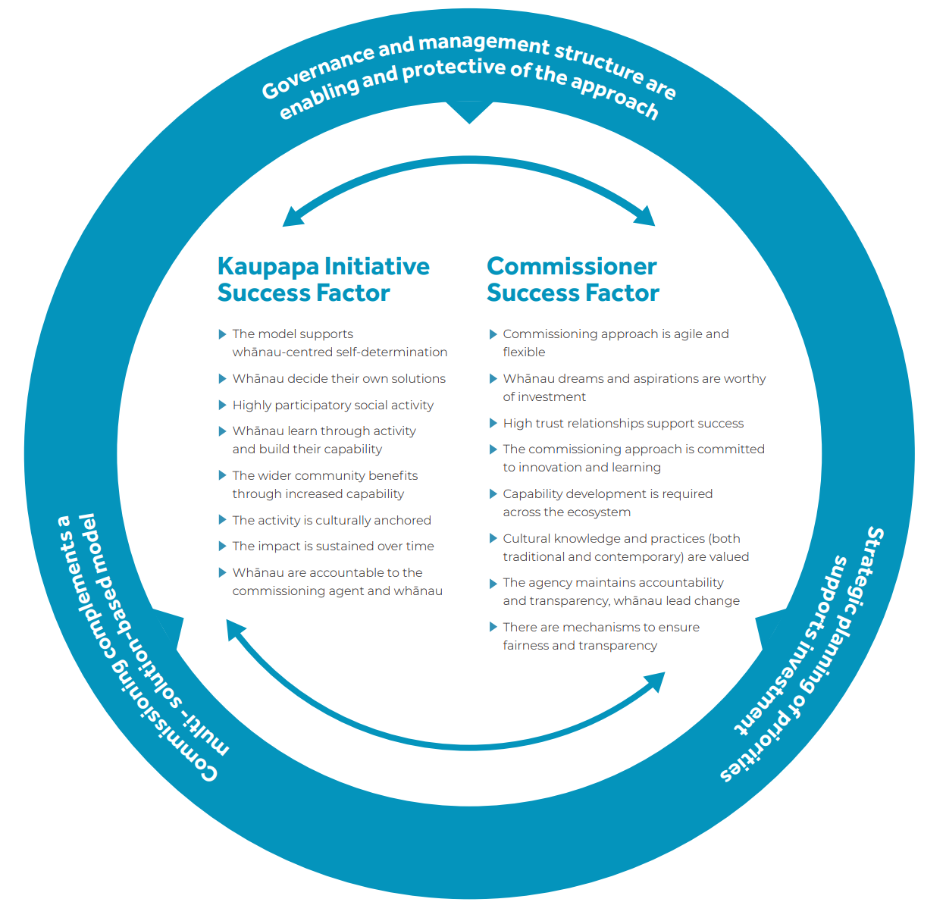

Challenges in commissioning
The most significant challenge or barrier to whānau capability development is the lack of connectivity and coherence between Te Pūtahitanga o Te Waipounamu and the wider government ecosystem. This is particularly important when considering government policies, funding and systems arrangements that are needed to sustain whānau capability development through social enterprise.

The need for government agencies to support a Whānau Ora approach has been noted in numerous reports and reviews. In 2018, the Whānau Ora Review noted a culture shift was needed within government agencies to ‘capture opportunities and address the perceived barriers that inhibit the uptake of Whānau Ora’.

The creation of such an innovative model, commissioning outcomes directly from whānau, came with significant risk and challenge to normative social engineering models of delivery.

The commissioning agency has continued to manage this risk and has steadfastly committed to the commissioning pipeline, despite pressure to revert to traditional service delivery models. Te Pūtahitanga o Te Waipounamu believes the commissioning pipeline complements service delivery rather than replacing it, and funds service delivery providers, as kaupapa entities, to provide innovative approaches to whānau-led solutions.

The success of the commissioning model requires an ongoing pipeline of investment in whānau capability and a high-trust environment that is supportive of innovation. McMeeking highlights that, of the three commissioning agencies, Te Pūtahitanga o Te Waipounamu is ‘particularly committed to investing in whānau and community innovation’. Despite this, Te Pūtahitanga o Te Waipounamu receives ‘substantially less total funding than the North Island commissioning agency due to population, deprivation, income, and geography’. This means it has less funding to invest in whānau capability development and organisational development.

Many of the innovations seeded through Te Pūtahitanga o Te Waipounamu are solutions designed to address inequity for Māori and could be funded through government agencies and ministries. Greater commitment from government agencies to both Māori innovation and Māori-led solutions would see greater investment, sustained activity and stronger support for driving commissioning for outcomes under the Whānau Ora approach.

McMeeking S. 2019. Whānau Ora: building Māori self-determination in Aotearoa New Zealand. In W Nikolakis, S Cornell and HW Nelson (eds), Reclaiming Indigenous Governance: Reflections and insights from Australia, Canada, New Zealand, and the United States. Tucson: University of Arizona Press.
Wehipeihana N, Were L, Akroyd S et al. 2016. Formative Evaluation of the Whānau Ora Commissioning Agency Model: An independent evaluation report. URL: www.tpk.govt.nz/en/o-matou-mohiotanga/whanau-ora/formative-evaluation-of-the-whanau-ora-model (accessed 7 December 2022).
Te Pūtahitanga o Te Waipounamu. 2017. Investment Plan.
Te Pūtahitanga o Te Waipounamu. 2017. Te Pūtahitanga o Te Waipounamu Annual Report, 1 July 2016 – 30 June 2017. Christchurch: Te Pūtahitanga o Te Waipounamu, p 16.
McMeeking S. 2020. Staircased Social Change Pathways: Exploring the Mechanisms of Social Impact Creation through an Indigenous Case Study. Unpublished master’s thesis, University of Cambridge, Judge Business School, United Kingdom.
Wehipeihana et al 2016, op. cit., p 57.
Ibid.
Wehipeihana et al 2016, op. cit., p 58.
Te Pūtahitanga o Te Waipounamu 2017, op. cit., p 19
Turia T. 2018. The importance of growing whanau capacity capability and independence. Keynote speech at Whānau Ora Symposium, Marlborough Convention Centre, Blenheim.
Te Pūtahitanga o Te Waipounamu. 2019. Te Pūtahitanga o Te Waipounamu Annual Report, 1 July 2018 – 30 June 2019. Christchurch: Te Pūtahitanga o Te Waipounamu, p 15
Savage C, Leonard J, Te Hēmi H, et al. 2018. The Evaluation of Wave 6 Whānau initiative for Te Pūtahitanga o Te Waipounamu. Ihi Research.
Gupta AK, Sinha R, Koradia D, et al. 2003. Mobilizing grassroots technological innovations and traditional knowledge, values and institutions: articulating social and ethical capital. Futures 35(9): 975–987.
Seyfang G, Smith A. 2007. Grassroots innovations for sustainable development: towards a new research and policy agenda. Environmental Politics 16(4): 584–603.
Savage et al 2018, op. cit.
Mair J, Battilana J, Cardenas J. 2012 Organizing for society: a typology of social entrepreneuring models. Journal of Business Ethics 111(3): 353–73.
Stott N, Tracey P. 2018. Organizing and innovating in poor places. Innovation 20(1): 1–17.
McMeeking S, Richards H. 2016. Whānau Ora. Paper delivered at ISIR Conference.
Savage C, Dallas-Katoa W, Leonard J, et al. 2017. Evaluation of Wave 2 and 3 initiatives for Te Pūtahitanga o Te Waipounamu. Ihi Research.
Savage C, Goldsmith L, Standring K, et al. 2020. Research into the COVID-19 Response Plan for Te Pūtahitanga o Te Waipounamu. Ihi Research.
McMeeking S, Leahy H, Savage C. 2020. An Indigenous self-determination social movement response to COVID-19. AlterNative 16(4): 395–8.
Wehipeihana et al 2016, op. cit.
McMeeking et al 2020, op. cit.
Te Puni Kōkiri. 2019. Whānau Ora Review – Tipu Matoro ki te Ao: Final report to the Minister for Whānau Ora. Wellington: Te Puni Kōkiri, p 12.
McMeeking 2019, op. cit.

