Healthy Families NZ ‘Community Up’ Approach to Improving Wellbeing and Equity: Commissioning for Pae Ora | Healthy Futures case study
2023

Citation: Healthy Families NZ; Ministry of Health (ed). 2023. Healthy Families NZ ‘Community Up’ Approach to Improving Wellbeing and Equity: Commissioning for Pae Ora | Healthy Futures case study. Wellington: Ministry of Health.
Published in January 2023 by the Ministry of Health
PO Box 5013, Wellington 6140, New Zealand
HP 8653
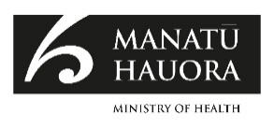
This document is available at health.govt.nz
This work is licensed under the Creative Commons Attribution 4.0 International licence. In essence, you are free to: share ie, copy and redistribute the material in any medium or format; adapt ie, remix, transform and build upon the material. You must give appropriate credit, provide a link to the licence and indicate if changes were made.

Contents
Purpose 1
Healthy Families NZ 2
The Healthy Families NZ locations 2
Healthy Families NZ prevention workforce 3
Te ao Māori approach 3
Systems-based approaches 5
New context and changes sought from the new health system 6
Principles and Conditions of Systems Change 6
Locally shaped and connected to the broader system 7
How success is measured and the outcomes to date 8
Outcomes to date 9
Examples of Healthy Families NZ initiatives 10
Appendix 1: Healthy Families NZ Principles 11
Appendix 2: Conditions of systems change 12
Appendix 3: Types of outcomes from Healthy Families NZ 13

Purpose
Healthy Families NZ recognises that communities are best placed to understand and prioritise their own health and wellbeing. This initiative aims to mobilise local action to prevent chronic disease in the places where people live, learn, work and play.

Healthy Families NZ
Healthy Families NZ takes a systems-based, community-centric approach to:
- enable people, whānau and communities to increase their control over their own lives
- address the social, cultural, political and economic determinants that underpin health and wellbeing
- build partnerships with other systems and sectors, like welfare, sport, employment and education, in finding solutions.

Investing in community leadership and empowerment means people, whānau and communities can do more for themselves earlier and reduce the need for escalation of issues to a more formal ‘service’ response.

Community-led COVID-19 responses also demonstrated the power of having strong, resilient communities that could quickly mobilise to support others and reach people who weren’t already connected to build trust in government services.

The Healthy Families NZ locations
There are 10 Healthy Families NZ communities across Aotearoa, and 11 lead providers that include iwi, Whānau Ora, local government, regional sports trusts and Pacific-led social change organisations. This deliberate design has allowed organisations that may not traditionally work in health or kaupapa Māori spaces to expand their own practice, and vice versa, bringing new ideas to the table.

Locations | Local lead
Far North | Te Rūnanga o Whaingaroa
Waitākere | Sport Waitākere
South Auckland | The Southern Initiative (Auckland Council) and The Cause Collective
Waikato | Te Kōhao Health
Rotorua | Te Arawa Whānau Ora
East Cape | Te Ao Hou Trust
Whanganui, Rangitīkei Ruapehu | Te Oranganui
Hutt Valley | Hutt City Council
Christchurch | Sport Canterbury
Invercargill | Active Southland

The locations are geographically spread and come from areas with:
- higher than average rates of preventable chronic diseases (such as diabetes)
- higher than average rates of risk factors for these diseases (such as smoking), and/or
- high levels of economic deprivation.

Healthy Families NZ prevention workforce
The Healthy Families NZ workforce consists of approximately 70 full-time equivalent staff across the country. As the initiative has evolved, lessons have been learned about what kinds of workforce skills and focus are needed. These lessons have informed changes to roles to better match skills and emphasise strategic systems change and community co-design approaches.

The workforce includes managers, strategic communication managers, systems innovators, Māori systems innovators, strategic relationships managers, system activators, people and practice leads, system designers and kaiārahi Māori.

Ensuring Healthy Families NZ can provide valuable evidence from across its different locations on what works for a diverse range of communities will potentially impact the lives of over a million New Zealanders.

Te ao Māori approach
Healthy Families NZ has an explicit focus on improving equity and health and wellbeing outcomes for Māori. The design of Healthy Families NZ ensures Māori are prioritised. Having Māori participation and decision-making at all levels of planning and implementation is critical. Healthy Families NZ teams are taking the lead in their wider community networks on promoting kaupapa Māori (normalising Māori ways of knowing and being), mātauranga Māori and the use of traditional knowledge such as the maramataka.

Instead of focusing solely on those most at risk for a specific disease, an indigenous perspective considers individuals and their whānau (extended family) within their social and everyday circumstances. In contrast to individual health promotion, which is dominated by an emphasis on individual lifestyle choices, community and settings-based health promotion incorporates participatory community-level interventions. This type of approach respects that people and communities have the right to define what health means for them and are empowered to have control over decision-making processes which impact their health

Systems-based approaches
A research report from the Young Foundation reinforces the need for more investment in approaches like Healthy Families NZ, where the focus shifts ‘… to systems that create health instead of just mitigating illness – Health Creation’.

Health creation isn’t about ‘doing health to people’, nor is it about telling them what to do in order to be healthy and prevent disease. It’s about empowerment and fostering community agency. Health creation is about walking alongside people with humility and at their pace to discover the realities of their lives in relation to their health. Using a health creation approach means working with them to generate new ideas that they will drive to create better health. It’s radical because it isn’t easy or straightforward, but it’s important and necessary. We believe that with the right support and facilitation, the answers to our health crisis lie with communities themselves.

Healthy Families NZ has historically been an ‘outlier’ in a health system that has tended to focus on providing targeted interventions, programmes or services. Focusing prevention efforts solely at the individual or household level, or on one issue or focus area can create and perpetuate a passive attitude among people, whānau and communities. Prevention in a Healthy Families NZ context focuses on addressing the underlying conditions that impact health and wellbeing.

We want to strengthen community leaders and to see that they’re not outside of this prevention system. They are at the very heart of it. In fact, their role and influence is more powerful than ours in some situations because they influence people in a way that we can’t.
Workforce member

New context and changes sought from the new health system
The changes sought from the Pae Ora (Healthy Futures) Act 2022 are for a more Te Tiriti o Waitangi grounded, people-centred and equitable health system, with better integration of services and stronger public health responses. The new Pae Ora Act also introduces the locality model which, along with Iwi-Māori Partnership Boards, enables:
- a stronger voice for iwi and communities in deciding what’s needed in their local area
- collaboration across health and wellbeing organisations to improve people’s experiences of health care and address broader determinants of health.

Healthy Families NZ already operates in ways that the Pae Ora Act 2022 is seeking to support, as it:
- reflects the unique context of Aotearoa New Zealand communities, and the special relationship between Māori and the Crown, including obligations under Te Tiriti o Waitangi
- has an explicit focus on equity, improving Māori health and improving health equity for groups at increased risk of chronic diseases
- takes a locality approach.

Principles and Conditions of Systems Change
There are two key practice frameworks that structure the implementation of Healthy Families NZ across the lead provider teams: the Healthy Families NZ Principles and the Healthy Families NZ Conditions of Systems Change.

The Healthy Families NZ Principles guide action across the 11 location teams. In Phases 1 and 2 of the initiative, the Principles were an effective mechanism for guiding both the workforce and leadership on what systems change activities teams should be prioritising. The Principles ensure integrity to the whole-of-system approach to prevention.
The Conditions of Systems Change recognise that there are ‘conditions’ that make it harder to be happy and healthy. These conditions might be structural – for example, policies or regulations, practices (how things are done) or where resources (money, people, knowledge and assets) are or are not available. The conditions could also be relational – for example, the relationships, connections and power dynamics within and between communities and society. The conditions that hold a problem in place can be implicit – for example, habits of thought and the systems and environments as they are experienced. The Conditions of Systems Change are based on international best-practice literature that identifies levers for intervening in a system.

Locally shaped and connected to the broader system
Healthy Families NZ combines both local support and community leadership with a national lens, where insights can be shared from around the country. This mix of local and national helps identify where there are common issues, problems or constraints that require a change to the system conditions, such as funding constraints.

The partnership between the Healthy Families NZ national team (based in Te Whatu Ora – Health New Zealand) and the lead providers is seen as fundamental to the success of the initiative. The Healthy Families NZ national team’s role is to provide central resources and strategic leadership to the Healthy Families NZ movement, and to build relationships within government to align investment in prevention and build awareness of Healthy Families NZ’s systems approach.

The Healthy Families NZ location teams and leaders were almost all of the view that the relationship with the Healthy Families NZ national team was stronger than ever, and unusually strong for a contracting relationship. Key words used were close, responsive, trusting, open and supportive.

How success is measured and the outcomes to date
Success is now measured through wider wellbeing indicators and evidence that the overall prevention system has been influenced, instead of focusing only on disease-specific measures. Four key outcome domains relate to the actions to support community self-determination, local priorities, leadership and system change.

Outcomes | Action
Community self-determination | Involvement of diverse communities within leadership, projects and initiatives. Sharing of power and decision-making, supported by good communication and collaborative ways of working.  The community usually has things done to them, and so what we are trying to share with our stakeholders is that our community are a part of the solution, and they hold a lot of the answers, so their input is valuable, and that whole process takes time … Workforce member
Communities define issues and solutions | Partnership involvement of groups in defining issues of focus, designing solutions and advocating for changes in power, resources and the system.
Leadership and connection | Mana whenua co-design the leadership structures. Support is provided for community leaders, and connections made between organisations, kaimahi and communities.
Systems practice | Processes are used that ensure:  - multiple perspectives are considered  - the focus is on prevention  - Te Tiriti o Waitangi principles are embedded  - culturally safe ways of working and communicating are practised  - sharing of power and resources  - development of more equitable system structures  - prevention is understood within a system  - change is made across the system.

Outcomes to date
The recent summative evaluation report 2022, Community-up System Change for Health and Wellbeing, found that across the locations the standout areas for change were: the food/kai system, development of resources promoting Māori systems thinking and mātauranga; and physical environment change particularly relating to physical activity opportunities. Policy was a key focus area in some locations but was not consistently influenced in all.

At a community level, a new community-up leadership approach was reported – one that enables more people to be leaders, particularly those with less structural power such as rangatahi. The tikanga of māhaki (humility) is emerging. Teams increasingly know when to step back and let other partners or community members take the lead. Elevating community voices also has an important advocacy function and helps teams to decide priority activities to focus on.

Storytelling and narrative change stories are shifting mindsets. They make visible how change happens and that change is possible, influencing decisions and reducing perceived barriers. Shifting mindsets can also lead to systems change and better prioritisation of system-level responses, the application of mātauranga Māori and strengths-based approaches. Storytelling has also been important because it speaks to intentionality and a broader view of wellbeing.

Examples of Healthy Families NZ initiatives
More information on Healthy Families NZ, including examples of Healthy Families NZ initiatives, can be accessed at the Healthy Families NZ website: www.healthyfamiliesnz.org.

Appendix 1: Healthy Families NZ Principles
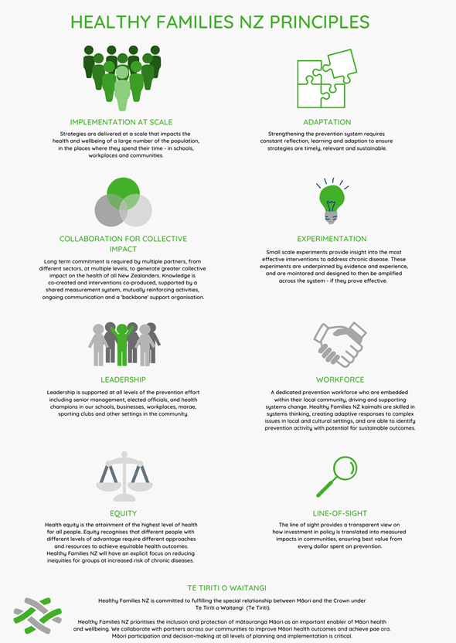

Appendix 2: Conditions of systems change
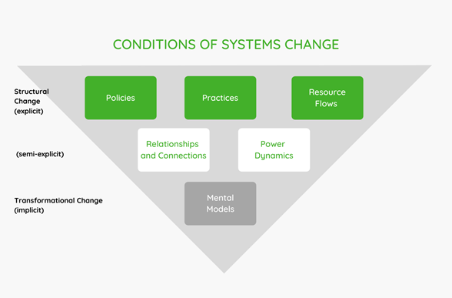

Appendix 3: Types of outcomes from Healthy Families NZ
Outcomes | Description
Policy change | A policy change at the organisational, local and/or national levels on, for example, smokefree, healthier food, access to alcohol, urban planning.
Provision of tangible resource | A tangible resource such as water fountains, healthier food environment, greater funding leveraged.
Physical environment change | A physical environment change, such as cycleways, better place for kids to play, making urban environments more conducive to social interaction.
Community event held | Community events promoting better practices and sharing information related to, for example, food, physical activity, natural environment.
Relationships strengthened | Strengthening of relationships within local community and/organisations through goals, resourcing, collective impact.
Norm/paradigm changing | Changing of norms in local community or organisations – for example, spreading goals and understandings of equity and healthier environments and practices.
Collaborative group organised | Bringing groups together for purposes such as food systems, urban planning, maramataka.
Resource development | Resources such as a workplace training resource, food preparation, storytelling.
Learning events/insight gathering | Learning event held or insight gathering activity such as co-design workshops, lived experience gathering activities.
Education/knowledge sharing | Educational or knowledge-sharing activity, for example, symposiums including systems change in practice webinars and explainers.
Source: Matheson et al (2022) Community-up System Change for Health and Wellbeing: Healthy Families NZ Summative Evaluation Report 2022. Wellington: Victoria University of Wellington.

World Health Organization. 2009. Track 1: Community empowerment. 7th Global Conference on Health Promotion. URL: www.who.int/teams/health-promotion/enhanced-wellbeing/seventh-global-conference/community-empowerment (accessed 8 December 2022).
New Economics Foundation. 2008. Co-production: A manifesto for growing the core economy. URL: https://neweconomics.org/uploads/files/5abec531b2a775dc8d_qjm6bqzpt.pdf (accessed 8 December 2022).
Inspiring Communities. 2020. Shaping the Future – Enabling Community-led Change. URL: https://inspiringcommunities.org.nz/ (accessed 8 December 2022).
A tender process was used to select local providers to lead Healthy Families NZ in their communities.
Matheson A, Wehipeihana N, Gray R, et al. 2022. Community-up System Change for Health and Wellbeing: Healthy Families NZ Summative Evaluation Report 2022. Wellington: Victoria University of Wellington.
www.tpk.govt.nz/documents/download/1025/understanding-whanau-centred-approaches.pdf
Transforming Health: Shifting our health systems from illness treatment and prevention to health creation URL: www.youngfoundation.org/our-work/publications/transforming-health-shifting-our-health-systems-from-illness-treatment-and-prevention-to-health-creation/ (accessed 9 January 2023).
In: Matheson A, Gray R, Wehipeihana N, et al. 2020. Interim Report: Evaluation of Healthy Families NZ. Wellington: Victoria University of Wellington. URL: www.health.govt.nz/system/files/documents/publications/interim_report_healthy_families_nz_evaluation-_november_2020.pdf (accessed 8 December 2022).
Future of Health. Localities. URL: www.futureofhealth.govt.nz/about-the-reforms/how-health-system-changing/localities/ (accessed 10 December 2022).
See Appendix 1 for Healthy Families NZ Principles.
Kania J, Kramer MR, Senge P. 2018. The Water of Systems Change. FSG.
Meadows D. 1999. Leverage Points: Places to Intervene in a System. Hartland, VT: Sustainability Institute. URL: http://donellameadows.org/wpcontent/userfiles/Leverage_Points.pdf (accessed 10 December 2022).
Matheson et al (2022), op. cit.
See Appendix 3 for examples of outcomes.
Matheson et al (2022), op. cit.
Matheson et al (2022), op. cit.
Matheson et al (2022), op. cit.
Matheson et al (2022), op. cit.

