A Kaupapa Māori Informed Approach to Commissioning Mental Health and Addiction Services: Commissioning for Pae Ora | Healthy Futures case study
2023

Acknowledgements
This is one of a series of case studies funded by Manatū Hauora – the Ministry of Health (the Ministry) looking at commissioning as a tool to improve health equity.
Thanks to Research Evaluation Consultancy and ThinkPlace for preparing this case study, and the contributions of the Ministry of Health staff in the mental health and addictions and commissioning teams.
Citation: Research Evaluation Consultancy and ThinkPlace; Ministry of Health (ed). 2023. A Kaupapa Māori Informed Approach to Commissioning Mental Health and Addiction Services: Commissioning for Pae Ora | Healthy Futures case study. Wellington: Ministry of Health.
Published in January 2023 by the Ministry of Health
PO Box 5013, Wellington 6140, New Zealand
HP 8653
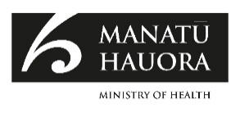
This document is available at health.govt.nz
This work is licensed under the Creative Commons Attribution 4.0 International licence. In essence, you are free to: share ie, copy and redistribute the material in any medium or format; adapt ie, remix, transform and build upon the material. You must give appropriate credit, provide a link to the licence and indicate if changes were made.

Contents
Purpose 1
Commissioning process 2
Background to expanding Māori access to and choice of primary mental health and addiction services 3
Commissioning a new kaupapa Māori Primary (Community) Mental Health and Addiction Service 4
Kaupapa Māori aspects that guided the commissioning process 6
Kaupapa Māori as foundational 6
Whānau and community-led service design 6
A mana-enhancing process supporting provider capability development 9
Supporting the authentic expression of mātauranga Māori in service design 10
What is the value of the kaupapa Māori commissioning aspects? 12
What has been learned? 14
Supporting different ways of thinking and working 14
Understanding and communicating constraints and requirements 15
Strengthening a kaupapa Māori commissioning approach 17
Conclusion 19
Appendix 1: Process map for the Tuākana stream 20
Appendix 2: Process map for the Tēina stream 21

List of Tables
Table 1: Definitions of kaupapa Māori, tikanga Māori and mātauranga Māori 4
Table 2: Kaupapa Māori services paradigm 7
Table 3: The seven elements of Te Kawa 7

Purpose
This case study focuses on a new approach to commissioning, guided and informed by kaupapa Māori for the new kaupapa Māori Primary Mental Health and Addiction (PMH&A) Service. It sets out the key aspects and processes of a tikanga Māori informed commissioning process and explores the lessons learned in implementing this new approach to commissioning. (See Table 1 for definitions of kaupapa Māori and tikanga Māori.)

Commissioning process
The Ministry went out to service providers and also, significantly, to whānau, iwi and communities. There were 17 hui ā-motu (nationwide hui) with over 700 attendees. The Associate Minister of Health attended some of the hui, confirming their importance.

It was a Māori-led process and Māori cultural processes were observed.

The commissioning process allowed for the use of te reo Māori and English. The use of te reo Māori is fundamental to the expression of mātauranga Māori (see Table 1). Providers could ‘think’ Māori and did not have to do the cross-cultural translation so that non-Māori could understand.

Background to expanding Māori access to and choice of primary mental health and addiction services
He Ara Oranga: The Government Inquiry into Mental Health and Addiction identified the need to expand the access to and broaden the choices of primary mental health and addiction services. The 2019 Wellbeing Budget broadened the definition of success for New Zealand ‘to one that incorporates not just the health of our finances, but also of our natural resources, people and communities’. A key component was addressing disparities in the health status of Māori people, who are less likely to report having good, very good or excellent health than any other group. For example:
- 30% of Māori experienced mental health and addiction (MH&A) challenges in the past year, compared with 20% of non-Māori
- the suicide rate among Māori is 2.1 times higher than among non-Māori.

The Ministry established the Expanding Access and Choice Programme to support and implement the budget initiative. The programme aims to expand access to existing primary mental health and addiction services and develop new services to better meet the needs of New Zealanders, especially those who experience inequities in mental health and wellbeing, including whānau, Māori, rangatahi and Pacific peoples. It also includes procuring kaupapa Māori services and commissioning new kaupapa Māori PMH&A services as one of the programme focus areas.

Commissioning a new kaupapa Māori Primary (Community) Mental Health and Addiction Service
The primary aim of the kaupapa Māori PMH&A service was to increase choice of and access to services through contracting new and different community-based kaupapa Māori PMH&A services from new and existing Māori providers. To achieve this, new Māori providers needed encouragement and support, and existing Māori providers needed to be able to effectively showcase their capability. A secondary aim was to make the process as easy as possible, with the commissioning team reducing compliance costs and providing additional support, particularly for new providers.

For this procurement, the onus should always be on us (the Ministry) to do the heavy lifting of the mahi. It should never be on the providers … We are the kaimahi, we are the servants of the people so the burden of all the mahi should be on our plates not on our whānau, not on our small providers. I think the word ‘servant’ in public servant means to make the huarahi (pathway) as smooth as we possibly can.

What emerged was a kaupapa Māori informed approach to procurement that weaves in elements of tikanga Māori (Māori protocols, processes, language and rituals that recognise Māori worldviews), while still complying with procurement and probity rules.
Table 1: Definitions of kaupapa Māori, tikanga Māori and mātauranga Māori
What is kaupapa Māori?
Kaupapa Māori literally means a ‘a normal or Māori way of doing things’; the concept of ‘kaupapa’ signals a way of framing and structuring how things are thought about and conducted from a tikanga Māori perspective and ‘Māori’ from the position of Māori as normal or ordinary. Kaupapa Māori is a way of thinking that positions Māori in charge of change and facilitating solutions for Māori. It is often expressed as by Māori, for Māori, with Māori, as Māori and led by Māori.
What is tikanga Māori?
Tikanga are the customary systems of practices and values that are expressed in every social context. Based on the root word ‘tika’ (to be right or correct), it can be understood as ‘the correct thing’ or appropriate thing to do in any given circumstance. ‘It is the constant, yet flexible, gravity of the Māori universe.’
What is mātauranga Māori?
Mātauranga Māori is a cultural system of knowledge about everything that is important in the lives of the people. Lessons learned in the past are added to the knowledge system.
Tā Mason Durie has observed, ‘Mātauranga evolved with the environmental shift, and with the social development that occurred.’

Kaupapa Māori aspects that guided the commissioning process
Four core aspects of the commissioning process are evident:
- kaupapa Māori as foundational
- whānau- and community-led service design
- a mana-enhancing process supporting provider capability
- supporting the authentic expression of mātauranga Māori and tikanga Māori in service design.

Kaupapa Māori as foundational
The Ministry intentionally prioritised kaupapa Māori and created a space for tikanga Māori as part of the commissioning process. From the outset, the Ministry recognised the importance of being guided by kaupapa Māori to:
- honour and observe tikanga Māori
- ensure kaupapa Māori services and the commissioning process were aligned
- allow providers to fully express the tikanga that underpin their services including mātauranga Māori, mātauranga ā-iwi and mātauranga ā-whānau
- enable the use of tikanga Māori and ‘familiar’ processes to facilitate engagement with Māori.

Whānau and community-led service design
A Māori-led process and Māori cultural processes were observed. The hui process also supported and encouraged attendees to discuss and design the core kaupapa Māori elements of the new PMH&A services. It gathered ‘grass roots’ feedback from a mix of voices and perspectives – particularly from whānau and from tangata whaiora. Whānau and providers were asked what they thought was important and needed.
The guiding light and beacon came from our hui back in 2019 … The kōrero was so important and that’s what really drives everything. We got the analysis done and that has been published. It’s transparent, everything’s been transparent.

As a result of the hui ā-motu and whānau and provider feedback, the Ministry made explicit that the proposed new services would be based on a kaupapa Māori paradigm (see Table 2). Te Kawa (the service specifications and requirements) for the new kaupapa Māori PMH&A services was also developed. It identified seven components, all of which were seen as necessary and interconnected, so that they needed to be considered holistically (see Table 3).
Table 2: Kaupapa Māori services paradigm
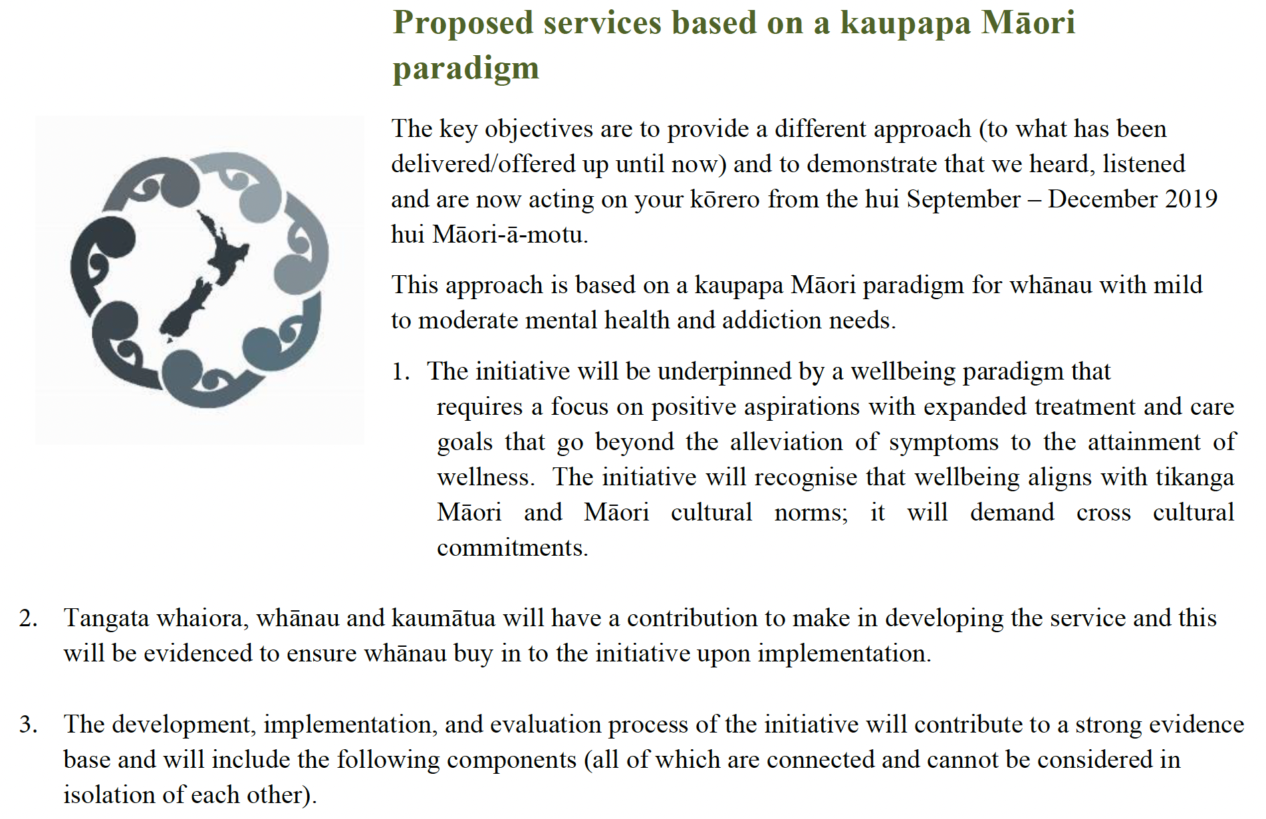
Source: Ministry of Health. New Kaupapa Māori PMH&A registration of interest: Part 1 Requirements and Instructions, p 15.
Table 3: The seven elements of Te Kawa
- Whānau-centred
Whānau-centred refers to the idea that service design and delivery must meet the needs of whānau first and foremost. Whānau-centred means delivering a service response that is informed by and accountable to whānau aspirations.
- For Māori, by Māori
For Māori, by Māori conceptualises a Māori way of working and delivering services to whānau. It is the notion of Māori meeting the needs of other Māori in a uniquely Māori way. For Māori, by Māori illustrates the need to have more Māori leadership and learning systems that support the uptake of kaupapa Māori practices for the mental health and addictions services.
The initiative will uphold the mana of collective thought and action and support the implementation of Māori service principles within an organisation. By Māori will illustrate the need to have more Māori leadership – rangatiratanga and learning systems that support the uptake of kaupapa Māori practices and acknowledge Te Tiriti o Waitangi.
- Kaupapa Māori
Kaupapa Māori was recognised as an asset for optimising whānau outcomes, and a diverse and credible range of models and practices that are mana-enhancing and strengths-based. It encompasses the use of established cultural practices that drive and shape collective action and impact.
- Te reo Māori
Te reo Māori was identified as an important tool for delivering to and engaging with whānau needing support. Te reo Māori is a vehicle for connecting with whānau, and for supporting whānau to nurture and grow as part of their healing journeys.
- Tikanga
Tikanga can be described as a set of Māori principles and practices that are observed and upheld to ensure whānau needs are met. Tikanga was not described in detail, indicating that local and tailored approaches may be required to meet the criteria of this principle.
The initiative will use and adhere to cultural practices that are determined as unique to Māori – taonga tuku iho. Tikanga will be represented as a set of principles and practices that the organisation will build and promote as a way of working with whānau. Tikanga will be used when engaging with whānau and when working in a Māori way to address whānau needs.
- Mātauranga Māori
Mātauranga Māori represented a significant strength and will to work in a Māori way. It presents and denotes a commitment to supporting Māori leadership and action across all modalities of health and wellbeing.
The initiative will understand that Māori principles and practices have always contained a range of tools and strategies that can regenerate health. Mātauranga Māori will be used as an approach that restores Māori ways of working as legitimate and strengths-based.
- Rongoā
Rongoā is a set of Māori principles and practices that support healing within whānau. It was presented as a Māori worldview on how health is restored and regenerated alongside whānau. Rongoā was also described as a complementary therapy alongside others under the guidance of best practice from rongoā leaders.
The initiative will identify the importance of wairua and include rongoā alongside other therapies under the guidance of best practice from rongoā leaders (tohunga). Rongoā refers to therapeutic healing and reconnection to Māori models of care, te ao Māori and te taiao.
Source: Ministry of Health. New Kaupapa Māori PMH&A registration of interest: Part 1 Requirements and instructions, pp 16–17.

A mana-enhancing process supporting provider capability development
Two commissioning streams were established.
- Tuākana (‘Established’) stream is for established Māori providers with well-developed infrastructure and services who have previous or existing experience within MH&A or other social services.
- Tēina (‘Incubator’) stream is for incubator or new and/or smaller Māori providers that may not have previous or existing experience within the MH&A field, but may have experience working with Māori in other social or rehabilitation services, and would benefit from further support.

What was beautiful about the Tuākana and Tēina streams is that it recognised the strength that already sits there but it also gives us (the Ministry) the opportunity to support provider development because we need new and more kaupapa Māori providers and services – not just more of the same.

The two commissioning streams recognised the variable capacity and capability within the Māori provider sector, and particularly so for the new kaupapa Māori services envisaged for the PMH&A services.

We had a theory that sometimes the best people on the ground who know their whānau best may not be the ones who are best at writing a document, if that makes sense.

We’re actually building the capability of new and first-time tenderers to know how to respond to a government process. This has implications – if we want new and different, then we need to actually help new and different and not to set them up for failure.

The objective was to set up Tēina providers for success, by making the process as easy as possible, providing additional support and with the Ministry doing some of the ‘heavy lifting’ such as by doing the initial drafting of service design and specifications using information orally provided by the provider. At the same time, taking a capability approach would allow for new providers and innovative ideas to emerge.

The Tēina stream enabled the smaller providers to have their fair share and to enable really grass root, innovative ideas to come through. We’ve received a proposal to support gang whānau, another using rugby league access to support wellbeing, and we had another based on the metaphor of a hīkoi or baking bread. They didn’t all make it through, but there were ideas that on a larger scale probably wouldn’t have got funding, but on a small scale, some did and the things we learn will inform our longer-term thinking.

There was one overall process – with responses tailored to the two streams. There were different timeframes for the Tuākana and Tēina streams, recognising the time required to provide capacity development support for Tēina providers. This support included the development of a workbook to assist providers to develop their service scope, advice around legal entity and business systems and processes, and bringing providers together to work through the process and get to know one another.

We wanted to move away from the traditional heavy procurement processes and make it more innovative and more kaupapa and tikanga based, based on kōrero and direct interaction. We did wānanga for stage two to create a good platform for providers to come in and talk about their idea and we gave a lot of support for the Tēina providers in order for them to meet the government requirements.

Process maps for Tuākana and Tēina streams are included in the appendices.

Capacity building as part of the commissioning process
A mana-enhancing, capacity-building approach was used to support Tēina providers to engage in the process. Capacity development is not normally part of a tender process as organisations are expected to have capability to both deliver the service being purchased and to engage in the tender and contracting process. However, the bigger picture in terms of being able to deliver new and innovative kaupapa Māori services is that these will be delivered by new and emerging organisations, and the process needed to set them up for success.

Supporting the authentic expression of mātauranga Māori in service design
The commissioning process allowed for the use of te reo Māori and English. Providers could choose to present their proposal either fully in te reo Māori or English, or in a combination of both. There were also two response options for registration of interest – a video presentation or a written submission.

The whole purpose was to be verbal tenders, verbal in respecting tikanga and respecting oral traditions. We wanted to enable providers to orally tell us their stories and for us to try and transcribe that into a service spec and a contract with minimum effort required by providers.

Oracy is a prized competency in Māori culture. Whaikōrero (formal speech-making) is typically a strength of and familiar process for many Māori. Oral presentations in te reo Māori allow providers to express their ideas and concepts more effectively and are particularly valuable for those who may not have the same level of competency when presenting or writing in English.

It [video presentation] levelled that playing field. It allowed kaumātua to give expression to their kōrero in a way that works for them, in a way that they feel comfortable with.

A set of four questions was developed to guide video presentations and written submissions. For each of these questions, a set of criteria with weightings was developed to be used by a panel to assess video and written submissions. It was suggested that the video could be recorded using the video feature on mobile phones. This was a low-cost and highly accessible option.

One of the advantages of a video presentation was that it provided an on-the-ground picture of and ‘feel’ for the people, the community, the organisation, partners, supporters and the proposed service.

The very best ones [videos] literally walked us through their service or showed us what they were proposing doing and who would be delivering the service on the ground. They’d actually have tangata whaiora there or groups or they’d say, ‘This is our group, this is our tangata whaiora.’ Some of them had other aligned services actually giving them verbal references at that point. So, they might have someone from Whānau Ora, MSD [Ministry of Social Development] or Police or a community group to give two or three sentences on the organisation.

The videos layered in more information than could normally be shared in a document. Videos with higher-production quality (eg, using professional drone footage, music and editing) had no advantage over less polished videos that might more fully articulate the proposed service and answer the core questions. The content mattered more than the production quality.

What is the value of the kaupapa Māori commissioning aspects?
The Ministry tested three new commissioning aspects: taking a provider capability-building approach; encouraging the use of te reo Māori; and allowing oral (video) submissions.

The provider capability-building approach resulted in new providers and new, more innovative service offerings.

The use of te reo Māori allowed providers to share their mātauranga more easily, and the video submission process played to the oral language strengths of Māori, particularly in te reo Māori.

For potential providers, these changes together signalled the commissioning process as being more accessible and quite different from the standard procurement process.

The kaupapa Māori commissioning approach supported the procurement of a range of new kaupapa Māori services that responded to local needs by using local cultural capacity and capability. It also extended the scope of current services, intentionally making space to be able to tap into mātauranga Māori as well as more traditional approaches to dealing with mental health and wellbeing.

I think it democratised government procurement and made it more open and more accessible. Whether they use video or not, I think the fact we had it sends a strong message of ‘This is different, here’s a range of options, anyone can do this if you’ve got a good story, fit the kaupapa’.

As of March 2022, a total of 27 services were funded, as well as 164 new Māori full-time equivalent staff, with more recruitment still underway. Over 14,000 service appointments have been delivered to tangata whaiora.

So, it’s not only just more, but it’s also different and it’s also coming from that te ao Māori, mātauranga Māori space. The process has supported providers to bring the uniqueness of their offering, tailored to their capabilities and communities that is now available to be made to whānau and tangata whaiora.

Kaimahi Māori felt that non-Māori Ministry personnel had experienced a cultural education through the kaupapa Māori commissioning processes and, as a result, had a better understanding of how to engage with Māori. Early on, the non-Māori Ministry personnel involved also identified that this project was special and required some ‘unlearning’ of standard processes and some European-centric work-practices. There was an early realisation that the collective team needed to co-design some new approaches that better enabled a kaupapa Māori worldview. For many, this immersion into kaupapa Māori was enlightening.

They’ve been sensitised to a te ao Māori world, te reo Māori, whakaaro Māori and a way of thinking and being that they may not have been part of before. Also, a deeper knowing amongst some of our colleagues who now feel more able to be an ally.

What has been learned?
The kaupapa Māori commissioning approach has not been without challenges including the inherent tensions of innovation, particularly given the bicultural context of the project. The main challenge has been navigating the procurement and probity rules and regulations and at times being constrained by legal and process requirements, while attempting to enable kaupapa Māori and tikanga Māori.

The procurement team used this question to guide its work:
What does the kaupapa Māori version of government procurement look like – and how far can we reinvent it while complying within the Government Procurement Rules?

New Zealand law is derived or developed from English and Western legal concepts and rules. The resulting commissioning and procurement systems, processes and regulation can therefore reflect and privilege non-Māori values and worldviews. They determine what is appropriate and necessary as part of commissioning. These rules, regulations and processes ‘hold’ the current system in place and can make it challenging to give effect to tikanga even when there is a strong commitment to work in a kaupapa Māori way.

Supporting different ways of thinking and working
The team did their best collectively to understand each other’s perspectives and to collaborate to co-design an approach that appropriately enabled kaupapa Māori needs, while meeting Government Procurement Rules and other related government requirements.

With any innovation there is the inherent ‘storming’ as the team works through the Old versus New approach. Sometimes these discussions could be misconstrued as discussions from a European versus Māori perspective, when in fact they may have been discussions about, for example, written versus video, or current versus future.

Notwithstanding this, the programme did require those working in the Ministry to unlearn some things and embrace some new ways of working and engaging with Māori providers. For the commissioning and legal teams, it was a continual balancing act to move from traditional procurement practices to a way of working that enabled kaupapa- and tikanga-based approaches. At the same time, they needed to ensure the new, innovative approaches complied with Government Procurement Rules both legally and procedurally.

It was important to have a really strong backbone of integrity and legality. The work itself has to be sound because the worst thing we can do is introduce an innovative process and it ends up in the media or subject to a legal challenge because there was something missing in the strength of the process itself.

Understanding and communicating constraints and requirements
Across government commissioning entities, procurement specialists have deep functional expertise, including an understanding of how to reduce and manage risk when entering into contracts within a public service context. In addition to financial probity, government entities need to ensure there is fairness and transparency in the way they undertake procurement processes, and that political and reputational risk is also managed well. Many procurement specialists have had the experience of promising initiatives being stymied or stopped due to their non-compliance with contracting or process requirements.

There can be challenges in explaining why certain steps are needed in the procurement process and what value they add, as often they are mitigating future risk. For those unfamiliar with potential pitfalls, or eager to move to action, procurement can seem overly process-heavy and based in a lack of trust. Those seeking to innovate can find that procurement processes seem to hold them to the old ways of doing things.

The funding of roles within the proposed kaupapa Māori services also generated discussion. In similar services, only two types of roles are funded. A clinical role is funded at approximately $130,000 a year and a non-clinical role at approximately $95,000 per year. The clinical role is tied to very strict qualification registration definitions, and to a minimum registration level. Kaumātua and tohunga were originally classified as non-clinical. After working this through together, the team established a new role of kaupapa Māori clinical advisor for kaumātua.

Conflict of interest was another area where kaupapa Māori and probity and procurement rules reflected different worldviews. A conflict of interest perspective values independence, objectivity or impartiality as necessary for fair and transparent decisions. Traditional procurement processes manage the person around the process or eliminate the person from the process. Having a close family member working at a provider would be considered a conflict of interest that needed to be managed. In contrast, Māori value connections and interconnections, history and relationships as contributing to informed decisions. Good, fair and transparent decisions therefore come from being part of the process and not separate from it. In some communities and in some sectors, there are multiple connections (or conflicts of interest) and, because of the small number of tohunga or experts, it is almost impossible for Māori to not have multiple connections (or conflicts of interest). Essentially there was an element of ‘everyone knew everyone’ that made more conservative management of conflict of interest more challenging.

When everyone knows everyone, it becomes almost offensive to ask multiple times about conflict of interests. The challenge is to identify the key ones [conflicts] and have well-documented decisions and processes for the biggest.

One aspect of probity is that it sets out the rules about who can talk to whom, when and about what at various stages of the procurement process. When Māori are removed from the process, this cuts across whanaungatanga (relational tikanga) and puts relationships at risk. What emerged over the course of the commissioning approach was that procurement people stepped back from their traditional role as the ‘point of contact’ and supported key Māori staff to communicate with providers orally in te reo Māori, while sharing the same information with all and staying within accepted probity boundaries.

Strengthening a kaupapa Māori commissioning approach
Kaupapa Māori commissioning is a new and challenging space. The kaupapa Māori Primary Mental Health and Addiction (PMH&A) Service reinforced a common finding that adequate time is needed to build relationships, teams and a shared understanding of any existing parameters and constraints to innovation.

Considerable learning and value have been created in relation to legal processes and documentation, which will be invaluable as the health sector moves to implement the Pae Ora (Healthy Futures) Act 2022, and its commitment to iwi Māori.

Pae Ora (Healthy Futures) Act 2022
- Commit to achieving Māori health equity, and stronger mechanisms for Māori partnership, decision-making and accountability.
- Embed mechanisms to ensure the system is accountable to the Government and the communities it serves, including whānau, hapū and iwi Māori.
- The Minister, their agents and entities are to deliver on the commitment to Te Tiriti o Waitangi (Te Tiriti) and the pursuit of equity for Māori.
- Review every five years to remain fit for purpose and reflect maturing application of Te Tiriti principles.

For example, one lesson was that Government Procurement Rules don’t include verbal offers or one-stage oral presentation processes. Offers to the government (proposals) need to be made in written form. To address this issue, the procurement team developed a submission form that stated the proposer’s video was a legal offer to the Crown. Staff signed a declaration that they were writing up and sending back the provider’s (verbal) offer.

Another example is regarding the use of te reo Māori and verbal submissions. The procurement team had to ensure they understood what was shared – which was challenging for those who were not fluent in te reo Māori and had to turn the oral content into an evaluation report and later into contracts. This proved more difficult than anticipated so a lawyer with te reo Māori capability was contracted to attend wānanga to ‘transcribe and translate’ and to help with initial service specifications. Further, a legal glossary of Māori terms for use in contracts and service specifications was developed.

We’ve got a defined piece of collateral which is a table that defines what is the English word and what do we actually mean in a kaupapa Māori sense. That lives now. That is a written document that lives beyond us, and we can incorporate some of that content in the contracts. That work was done because we recognised at the time that it was needed.

There was considerable additional work and cost. Initially the plan was to write a new contract, with a unique Māori flavour, which could be adapted for use with all providers, but the time needed and complexity involved meant this was not achievable. However, as it turned out, a bespoke service specification for every service better recognised the unique local service delivery context over a more generic approach.

Every single service spec is different. There are two elements to it. There’s the Ministry kawa, which is the standard element including the seven elements to the kawa and some core clinical components that are required for tangata whaiora safety. But every other aspect is different because the tikanga of each proposal and the way each provider serves their population and their whānau is completely different. So, if you were to read the service spec for Southland and compare it to the one for West Auckland, they’re not going to be the same services.

Clarity and productivity were hampered by a lack of an agreed list of terms that accounted for different dialects and, for example, whether Māori words have a macron or are capitalised. Some Māori terms could be one or two words – such as tangata ‘whaiora’ or ‘whai ora’. Some of the meanings of the Māori words were too broad to use in a legal sense; for example, kawa or whānau have many potential interpretations. Considerable time and resource were needed to get the service specifications representative and accurate. If the team was doing the work again, it would consider having a te reo Māori specialist to help with the final specifications.

Conclusion
Developing the kaupapa Māori commissioning approach has at times been challenging. Some challenges are to be expected for new projects and innovation, and some related to cross-cultural communication. The main challenge has been navigating the procurement and probity rules and regulations and the constraints imposed by legal and process requirements, while attempting to give effect to kaupapa Māori and tikanga Māori.

For the commissioning and legal teams, it was a continual balancing act between conventional procurement practices and kaupapa- and tikanga-based approaches, while ensuring compliance with Government Procurement Rules (both legally and procedurally). Real efforts were made to co-design within these parameters, and to communicate where there was flexibility to change, and where there were hard constraints. This required learning for all those involved.

Other constraints emerged, with the requirement for the evaluation panel to include a mental health clinician, while Māori had been advocating for kaumātua with strong community connections and a tangata whaiora wellness focus instead of a deficit framing.

Despite the challenges, the insights and lessons learned to guide future kaupapa Māori approaches to procurement can be celebrated. These will help guide the sector as it moves to implement the Pae Ora (Healthy Futures) Act 2022 and its commitment to improve health outcomes and equity for Māori.

Appendix 1: Process map for the Tuākana stream
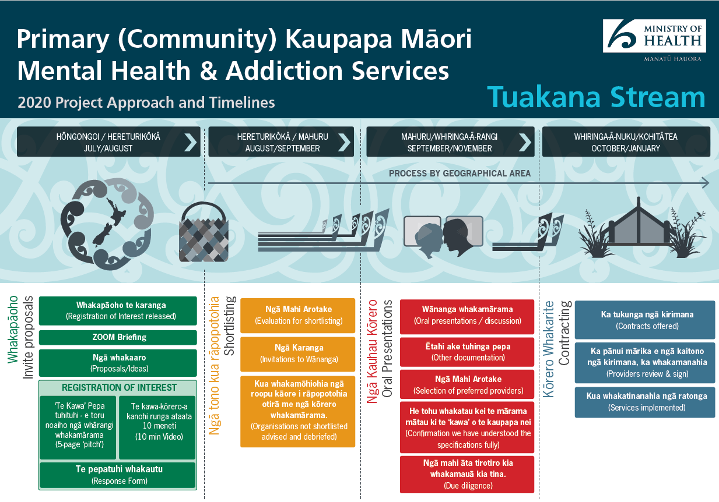

Appendix 2: Process map for the Tēina stream
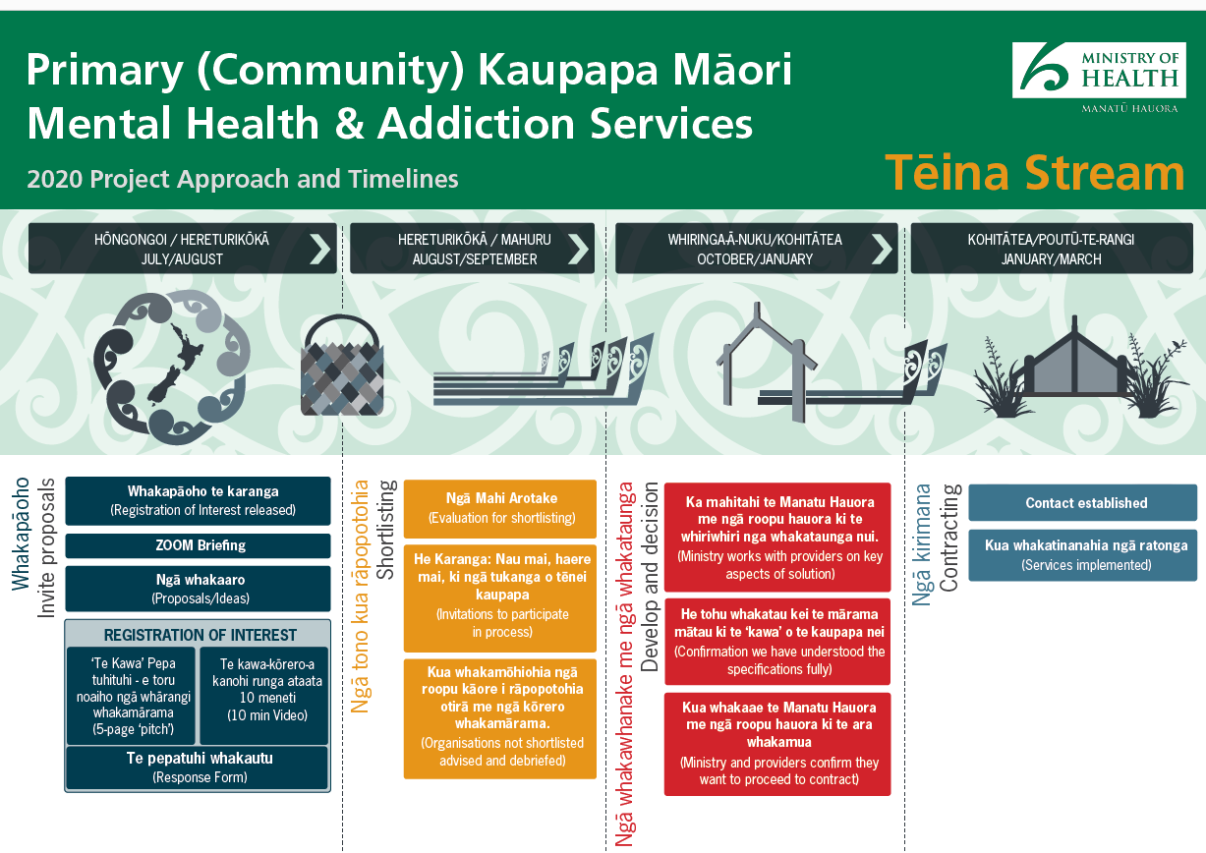

Interviews were conducted with Ministry of Health staff and managers from the mental health and commissioning teams and a focus group with the evaluation panel who assessed whānau and provider registration of interests. Ministry of Health tender documentation (registration of interest, oral presentation request for proposal and process maps) and process explanation videos also contributed to this case study.
Government Inquiry into Mental Health and Addiction. 2018. He Ara Oranga: Report of the Government Inquiry into Mental Health and Addiction. Wellington: Government Inquiry into Mental Health and Addiction.
Opai K. 2021. Tikanga: An introduction to te ao Māori. Auckland: Upstart Press Limited.
Mead HM. 2012. Understanding Mātauranga Māori Conversations on Mātauranga Māori (pp 9–14). Wellington: New Zealand Qualifications Authority.
Durie MH, Hoskins TK, Jones A. 2012.Interview: Kaupapa Māori: shifting the social. New Zealand Journal of Educational Studies 47(2): 21–9.
Awa Associates. 2021. Ngai Māori Insights for a Kaupapa Māori Primary (Community) Mental Health and Addictions Service Model: The analysis. Wellington: Ministry of Health.
A Māori person seeking wellness and wellbeing who is affected by varying degrees of mental distress; a Māori mental health consumer; or a Māori person with lived experience.
New Zealand Government. Government procurement principles. URL: www.procurement.govt.nz/procurement/principles-charter-and-rules/government-procurement-principles/; Government Procurement Rules. URL: www.procurement.govt.nz/procurement/principles-charter-and-rules/government-procurement-rules/ (accessed 7 December 2022).

