Care and Support Workforce Qualification Attainment
October 2019

Citation: Ministry of Health. 2020. Care and Support Workforce Qualification Attainment. Wellington: Ministry of Health.
Published in January 2020 by the Ministry of Health
PO Box 5013, Wellington 6140, New Zealand
ISBN 978-1-98-859765-2 (online)
HP 7313
This document is available at health.govt.nz
This work is licensed under the Creative Commons Attribution 4.0 International licence. In essence, you are free to: share ie, copy and redistribute the material in any medium or format; adapt ie, remix, transform and build upon the material. You must give appropriate credit, provide a link to the licence and indicate if changes were made.

Contents
1 Introduction 1
2 Key findings 2
3 Background 3
4 Data and methodology 4
4.1 Home and community, disability, and mental health and addiction sectors 4
4.2 Aged residential care sector 5
5 Analysis 6
6 Increase in qualification levels of workers in 2017/18 7
6.1 Home and community support sector 7
6.2 Disability sector 7
6.3 Mental health and addiction sector 8
6.4 Aged residential care sector 8
7 Qualification movement of unqualified workers: home and community support, disability and mental health and addiction sectors 9
8 Conclusion 11
Appendices 12
Appendix 1: Home and community support, mental health and addiction, and disability sectors: comparison of qualification levels by numbers of workers 12
Appendix 2: Home and community support, mental health and addiction, and disability sectors: comparison of qualification levels by worked hours 14
Appendix 3: Home and community support sector: comparison of qualification levels by number of workers and worked hours 16
Appendix 4: Disability sector: comparison of qualification levels by number of workers and worked hours 20
Appendix 5: Mental health and addiction sector: comparison of qualification levels by number of workers and worked hours 24
Appendix 6: Aged residential care data 28

List of Figures
Figure 1: Percentage of workers in home and community support, mental health and addiction and disability sectors, by qualification level, 2017/18 12
Figure 2: Percentage of workers in home and community support, mental health and addiction and disability sectors, by qualification level, February 2019 13
Figure 3: Percentage of worked hours in home and community support, mental health and addiction and disability sectors, by qualification level, 2017/18 14
Figure 4: Percentage of worked hours in home and community support, mental health and addiction and disability sectors, by qualification level, February 2019 15
Figure 5: Percentage of home and community support sector workers, by qualification level, 2017/18 16
Figure 6: Percentage of home and community support sector workers, by qualification level, February 2019 17
Figure 7: Percentage of home and community support sector worked hours, by qualification level, 2017/18 18
Figure 8: Percentage of home and community support sector worked hours, by qualification level, February 2019 18
Figure 9: Percentage of disability sector workers, by qualification level, 2017/18 20
Figure 10: Percentage of disability sector workers, by qualification level, February 2019 21
Figure 11: Percentage of disability sector worked hours, by qualification level, 2017/18 22
Figure 12: Percentage of disability sector worked hours, by qualification level, February 2019 22
Figure 13: Percentage of mental health and addiction sector workers, by qualification level, 2017/18 24
Figure 14: Percentage of mental health and addiction sector workers, by qualification level, February 2019 25
Figure 15: Percentage of mental health and addiction sector worked hours, by qualification level, 2017/18 26
Figure 16: Percentage of mental health and addiction sector worked hours, by qualification level, February 2019 26
Figure 17: Percentage of aged residential care sector workers, by qualification level, March 2019 28
Figure 18: Percentage of aged residential care sector worked hours, by qualification level, March 2019 28

List of Tables
Table 1: Number of workers, by sector (excluding aged residential care) who had no qualifications prior to 1 January 2018 and still no qualifications as at February 2019 10
Table 2: Number of workers in home and community support, mental health and addiction and disability sectors, by qualification level, 2017/18 and February 2019 13
Table 3: Number of worked hours in home and community support, mental health and addiction and disability sectors, by qualification level, 2017/18 and February 2019 15
Table 4: Number of home and community support sector workers, by qualification level, 2017/18 and February 2019 17
Table 5: Number of home and community support sector worked hours, by qualification level, 2017/18 and February 2019 19
Table 6: Number of disability sector workers, by qualification level, 2017/18 and February 2019 21
Table 7: Number of disability sector worked hours, by qualification level, 2017/18 and February 2019 23
Table 8: Mental health and addiction sector workers, by qualification level, 2017/18 and February 2019 25
Table 9: Mental health and addiction sector worked hours, by qualification level, 2017/18 and February 2019 27
Table 10: Aged residential care staff numbers and worked hours, by qualification level, March 2019 29

Introduction
This report uses care and support workforce data from 2017/18 and 2019 to identify trends in qualification attainment among care and support workers. The purpose of this report is to provide information on care and support worker qualification attainment to employers, unions, funders, and researchers.

Key findings
Analysis of data collected in 2017/18 and 2019 on care and support workers shows that:
    - there has been a significant increase in support workers with qualifications in the home and community support, disability, and mental health and addiction sectors
    - support workers with higher qualifications deliver relatively more hours of care than unqualified workers
    - there are a number of workers with no qualifications who are paid based on their length of service, and are therefore unlikely to take up training opportunities.

Background
The Care and Support Workers (Pay Equity) Settlement Act 2017 increased the wage rates of care and support workers in New Zealand’s aged and disability residential care and home and community support services. Wages are now based on a worker’s level of qualification or length of service, whichever is the most advantageous to the worker. The Act redresses the past undervaluation of care and support work, which is carried out by a predominantly female workforce.

The original Act excluded mental health and addiction support workers. However, a separate agreement covering these workers (the Mental Health and Addiction Support Workers (Pay Equity) Settlement 2018) was reached in 2018; it closely follows the original Act.

The cost of the Act and the mental health and addiction support worker settlement to the Crown through to its expiry on 30 June 2022 is $2.2 billion; this includes funding for employers to facilitate training for their workforce. The provision for training is an important part of this agreement; it should, over time, result in a more consistent workforce with higher qualifications.

Data and methodology

Home and community, disability and mental health and addiction sectors
Throughout the home and community support (HCS), disability, and mental health and addiction (MH&A) sectors, 2017/18 payments were made to eligible providers so that the increase in wage rates was determined by each worker’s actual hours (using their unique identifier from providers’ payrolls), qualifications and length of service. Advance interim payments to providers were made based on the estimated additional cost resulting from the settlement. For the purposes of this report, detailed data based on individual support workers’ actuals hours, qualifications and length of service was undertaken for the periods:
- 1 July 2017–30 September 2017 (Quarter 1 data)
- 1 October 2017–31 March 2018 (Quarters 2 and 3 data)
- 1 July 2017–30 June 2018 (2017/18 full-year data).

It should be noted that the Quarter 1 data is likely to under-report people’s actual level of qualification attainment, because it took up to 10 weeks for Careerforce to assess workers’ qualifications as equivalent to a New Zealand Certificate in Health and Wellbeing.

During the 2017/18 full-year data, 397 providers submitted their workforce data. Not all employers working across sectors could identify what contract their employees were employed under, resulting in 26 percent of support worker unique identifiers not being mapped to a service/sector.

All providers receive pay equity funding through contract price adjustments, which account for the associated support worker wage increase and increased qualifications.

The Ministry of Health is now collecting care and support worker data through an annual survey of providers. For the 2019 survey, providers chose a fortnight period that aligned with their payroll cycle that fell between 28 January 2019 and 24 February 2019, and submitted data on that period. Overall, 316 providers submitted data: this represents an 80 percent response rate from providers that received funding in 2017/18. The 2019 survey included the 100 largest employers, based on 2017/18 data, and therefore had a higher response rate based on number of employees. The 81 providers that did not respond to the 2019 survey are smaller providers that generally have less than 10 employees.

The Ministry considers that the time period specified for the 2019 workforce survey represents an average worked period, and accurately reflects the workforce at that time. However, there are limitations. The survey excludes workers who were not working during the period (that is, workers who were sick or on annual leave). The data is comparable to the 2017/18 full-year data of qualification growth, but it cannot be used to analyse the total numbers of workers across the periods; that total is calculated by counting the number of unique staff identifiers within a period. For example, the 2017/18 full-year data includes any support workers paid during the 2017/18 financial year, regardless of how long the person worked during the year. There were 42,901 support workers employed during 2017/18, and 28,934 workers employed during the February 2019 survey period (see Appendix 1).

Another limitation of the data is the use of the unique employee identifier from providers’ payroll systems. The Ministry understands that a small number of workers have multiple employers. Typically, this happens in the HCS sector. This factor could result in over-reporting of the number of workers. However, it is unlikely to be material. Additionally, changes in unique identifiers due to providers merging meant that a small number of workers could not be matched between the different datasets.

Aged residential care sector
Data was not collected for the aged residential care (ARC) sector in 2017/18, because unlike the other sectors funding for pay equity was negotiated into contract prices from 1 July 2017. This means that there is no reliable reference point to track qualification attainment for this sector. We note that the New Zealand Aged Care Association undertook a survey of some of its members in 2018; however, this data is not comparable.

The Ministry collected data on the ARC sector in March 2019, and will collect it again until at least the completion of the settlement in 2021/22. Like providers in the HCS, disability and MH&A sectors, for the purposes of the data collection ARC providers selected a two-week period that fell between 25 February 2019 and 31 March 2019 that represented an average worked period. Of an expected 350 providers, 284 ARC providers submitted workforce data. All the largest ARC providers submitted data; thus, the data represents a high coverage of support workers in the ARC sector.

Analysis
Analysis of workers by level of qualifications from the start of 2017/18 to February 2019 shows a significant increase in the percentage of workers with higher qualifications (see Appendix 1). From 1 July 2017 to February 2019, there was an increase of workers with a Level 3 or Level 4 New Zealand Certificate in Health and Wellbeing (or a qualification assessed as equivalent), from 37 percent to 48 percent. Conversely, the percentage of unqualified workers (Level 0) reduced, from 43 percent to 28 percent.

Similarly, analysis of hours performed by level of qualification shows a significant increase in the percentage of hours worked by workers with higher levels of qualification (see Appendix 2). From 1 July 2017 to February 2019, there was an increase in hours worked by workers with a Level 3 or Level 4, from 45 percent to 53 percent. Conversely, the percentage of hours performed by unqualified workers reduced, from 34 percent to 25 percent.

Though the data shows a steady overall increase in workers with qualifications, it should be noted that the number of workers with qualifications deemed equivalent to the New Zealand Certificate in Health and Wellbeing is unknown; that is, some of the increase in the number of qualified workers is due to the process of recognition of equivalent qualifications.

Increase in qualification levels of workers in 2017/18
Employees in the February 2019 data were matched with data from the 2017/18 full-year data, to assess whether workers progressed through the qualification levels. This process matched 22,787 employees (79 percent of eligible workers in the February 2019 data).

As at February 2019, there were 4,086 (14 percent) new workers; that is, workers who had started after 30 June 2018. This mostly explains why 21 percent of the data does not match. Other reasons are providers merging and changing employee identifiers.

The detailed data captured in 2017/18 allows us to analyse data by sector, though it should be noted that this applies to only 16,785 support workers of the total 22,787.

Home and community support sector
Overall, qualification attainment in the HCS sector significantly improved. From July 2017 to February 2019, the percentage of staff with Level 3 qualifications increased from 27 percent to 33 percent, and the percentage with Level 4 qualifications increased from 8 percent to 13 percent. The percentage of staff in this sector with no qualifications dropped, from 35 percent to 17 percent (see Appendix 3).

Disability sector
Levels of qualification also increased significantly in the disability sector. At the beginning of 2017/18, only 19 percent of these staff held Level 4 qualifications, and 25 percent held Level 3 qualifications. These figures had jumped to 27 percent and 26 percent respectively by February 2019. Conversely, the number of unqualified workers decreased, from 45 percent to 33 percent (see Appendix 4).

Mental health and addiction sector
The mental health Settlement parties agreed for 80 percent of care and support workers in this sector to have Level 4 qualifications by 30 June 2020. This is reflected in the figures for this sector. At the beginning of 2017/18, almost 60 percent of MH&A support workers held Level 4 qualifications; 32 percent had no qualifications. The February 2019 data shows that 66 percent of these workers have a Level 4 qualification (see Appendix 5).

Aged residential care sector
As explained above, the first data collection for this sector took place in 2019. Fifty-three percent of workers have a Level 3 or Level 4 qualification; 58 percent of hours worked are undertaken by workers with these levels of qualification. As at February 2019, the ARC sector had the highest percentage of unqualified workers (36 percent) by sector, compared to HCS (17 percent), disability (33 percent) and MH&A (25 percent) (see Appendix 6).

Qualification movement of unqualified workers: home and community support, disability and mental health and addiction sectors
The Act requires employers to take reasonably practical steps to ensure that care and support workers are able to attain qualifications. The Act does not define the phrase ‘take all reasonably practical steps’; however, the Government has indicated that training or up-skilling could include on-the-job training, time off for training/examinations and contribution towards course costs.

The Act specifies that workers must have the opportunity to attain a Level 2 qualification within the first 12 months of their continuous employment with their employer, a Level 3 qualification within the first 36 months and a Level 4 qualification within the first 72 months.

The length of time a worker takes to complete these qualifications will depend on individual circumstances. It is generally accepted that it takes between 6 and 12 months to attain a Level 2 qualification, approximately 18 months for Level 3 and up to two years for Level 4.

We undertook analysis of workers without qualifications prior to 1 January 2018 to see if these workers attained higher qualifications between then and February 2019. This period is slightly longer than 12 months, so gives a good indication as to whether workers are attaining Level 2 qualifications within the legislated timeframe. We found that 4,347 unqualified support workers were employed prior to 1 January 2018 and were still employed as unqualified support workers in February 2019.

Our analysis also showed 2,322 support workers who had been employed for more than 12 months, had no qualifications and were paid based on their length of service. As at February 2019, 2,025 unqualified support workers had been employed for more than 12 months and were not paid based on length of service.

Table 1: Number of workers, by sector (excluding aged residential care) who had no qualifications prior to 1 January 2018 and still no qualifications as at February 2019
 | HCS | Disability | MH&A | Unknown | Total
Workers | 1,511 | 1,003 | 521 | 1,400 | 4,347
Workers not paid based on length of service | 797 | 516 | 344 | 417 | 2,025

Because we did not have data from 2017/18 for the ARC sector, we could not undertake comparative analysis. However, we note that there were 5,960 support workers employed in this sector who did not have a qualification and were employed prior to 1 January 2018. Of these, 1,811 received wages based on length of service.

Conclusion
Across the disability, HCS and MH&A sectors, the care and support workforce is becoming more qualified, and workers with higher qualifications are delivering more hours of support.

Unfortunately, we cannot currently draw conclusions regarding the ARC sector in terms of qualification growth. However, we note that this sector has a relatively high percentage of unqualified workers.

Appendices

Appendix 1: Home and community support, mental health and addiction, and disability sectors: comparison of qualification levels by numbers of workers
Figure 1: Percentage of workers in home and community support, mental health and addiction and disability sectors, by qualification level, 2017/18
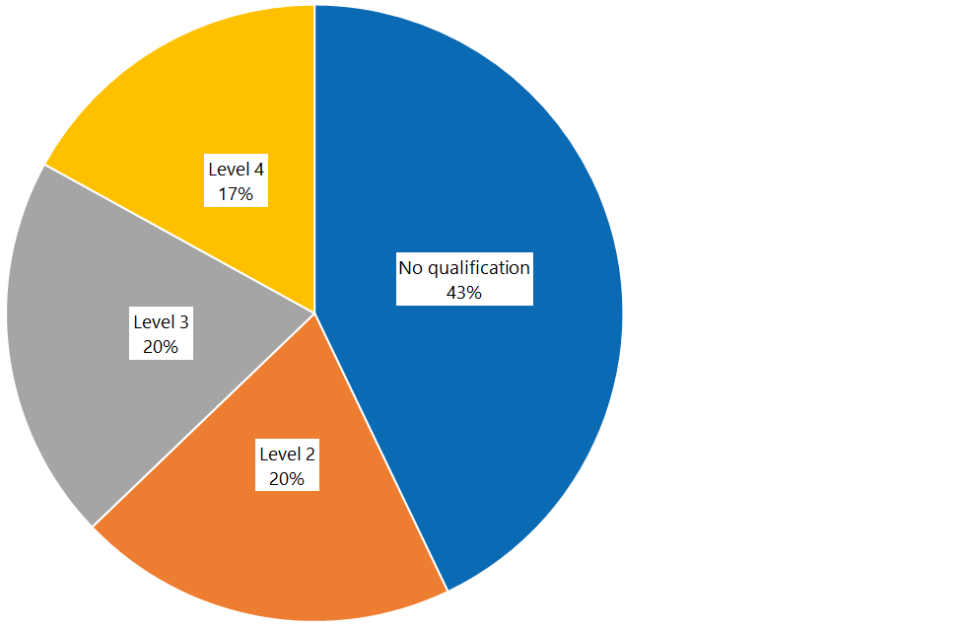

Figure 2: Percentage of workers in home and community support, mental health and addiction and disability sectors, by qualification level, February 2019
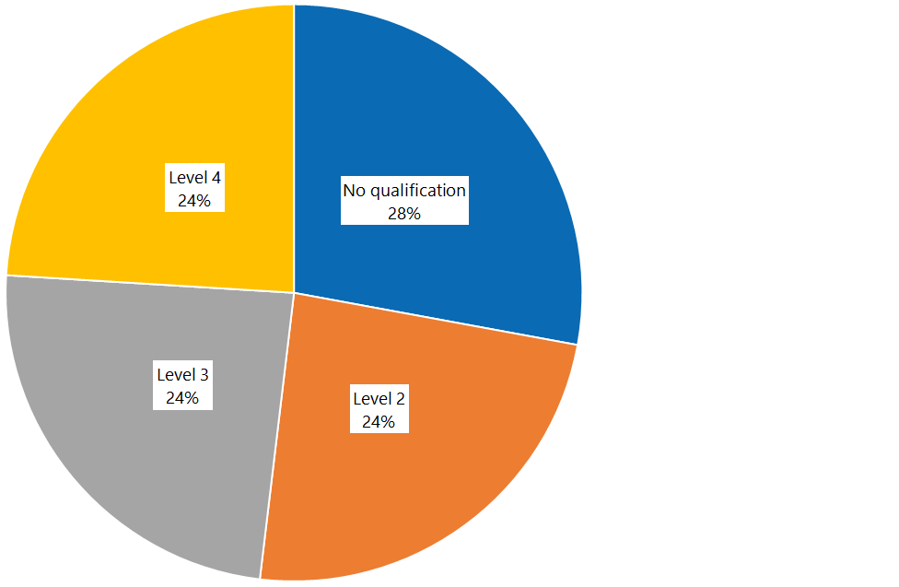

Table 2: Number of workers in home and community support, mental health and addiction and disability sectors, by qualification level, 2017/18 and February 2019
 | Level 0 | Level 2 | Level 3 | Level 4 | Total
2017/18 full-year data | 18,400 | 8,552 | 8,663 | 7,286 | 42,901
February 2019 | 8,071 | 6,944 | 6,966 | 6,953 | 28,934

Appendix 2: Home and community support, mental health and addiction, and disability sectors: comparison of qualification levels by worked hours
Figure 3: Percentage of worked hours in home and community support, mental health and addiction and disability sectors, by qualification level, 2017/18
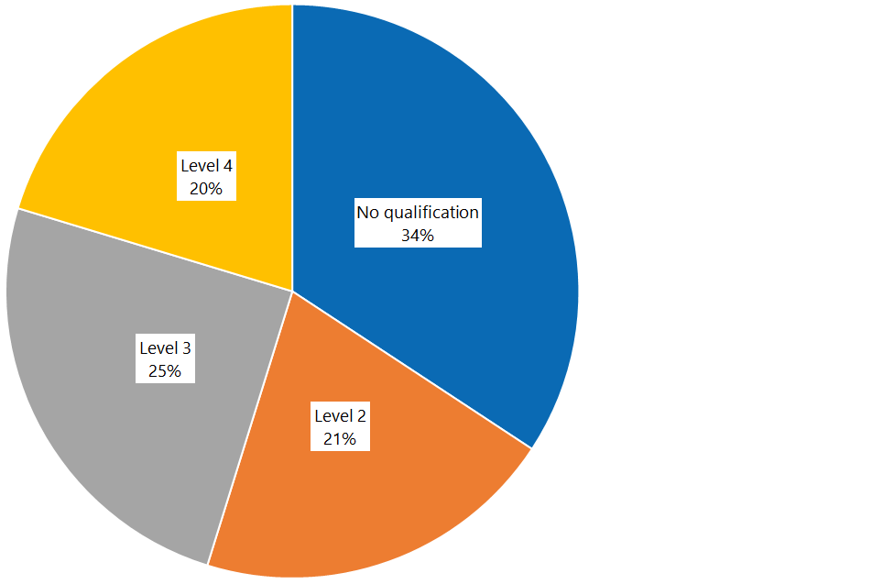

Figure 4: Percentage of worked hours in home and community support, mental health and addiction and disability sectors, by qualification level, February 2019
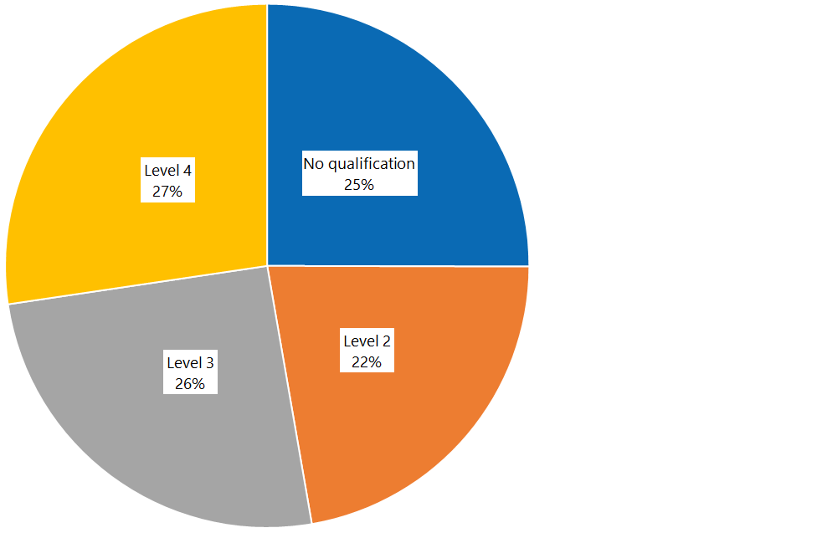

Table 3: Number of worked hours in home and community support, mental health and addiction and disability sectors, by qualification level, 2017/18 and February 2019
 | Level 0 | Level 2 | Level 3 | Level 4 | Total
2017/18 full-year data* | 3,235,635 | 7,935,932 | 9,611,771 | 7,852,833 | 38,636,171
February 2019** | 359,625 | 319,207 | 364,402 | 392,646 | 1,435,880
* The worked hours collected in the 2017/18 full-year data pertain to a full-year period: 1 July 2017–30 June 2018.
** The worked hours collected in the February 2019 data pertain to a fortnight period: 28 January 2019–24 February 2019.

Appendix 3: Home and community support sector: comparison of qualification levels by number of workers and worked hours
Figure 5: Percentage of home and community support sector workers, by qualification level, 2017/18
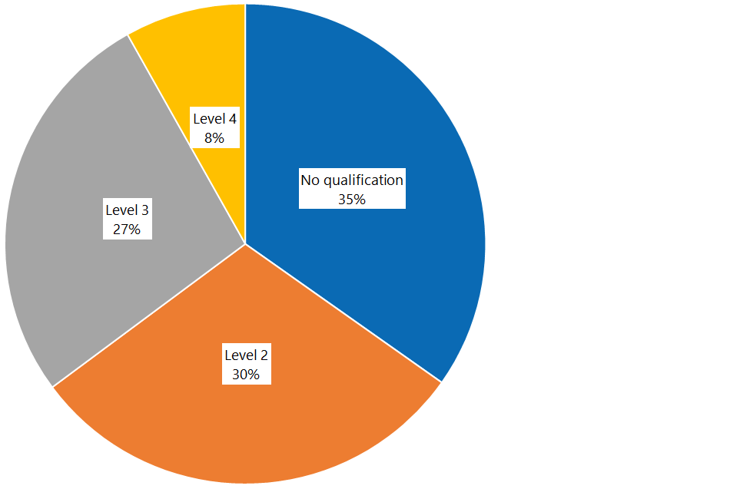

Figure 6: Percentage of home and community support sector workers, by qualification level, February 2019
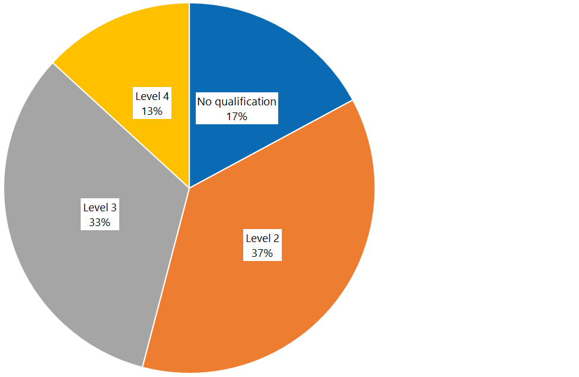

Table 4: Number of home and community support sector workers, by qualification level, 2017/18 and February 2019
 | Level 0 | Level 2 | Level 3 | Level 4 | Total
2017/18 full-year data | 3,620 | 3,126 | 2,812 | 848 | 10,406
February 2019 | 1,781 | 3,846 | 3,409 | 1,370 | 10,406

Figure 7: Percentage of home and community support sector worked hours, by qualification level, 2017/18
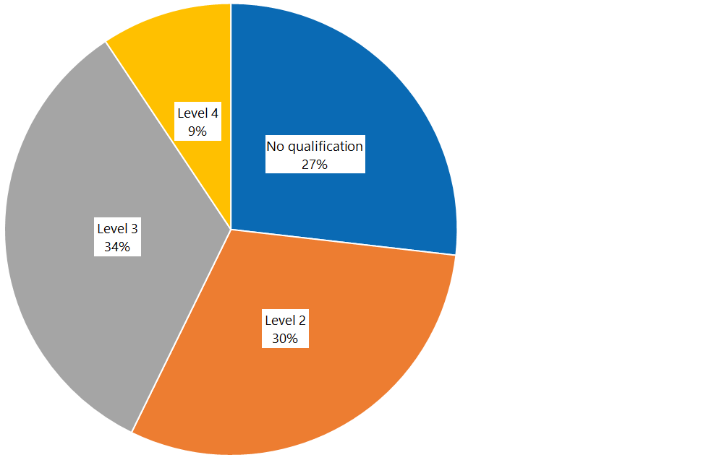

Figure 8: Percentage of home and community support sector worked hours, by qualification level, February 2019
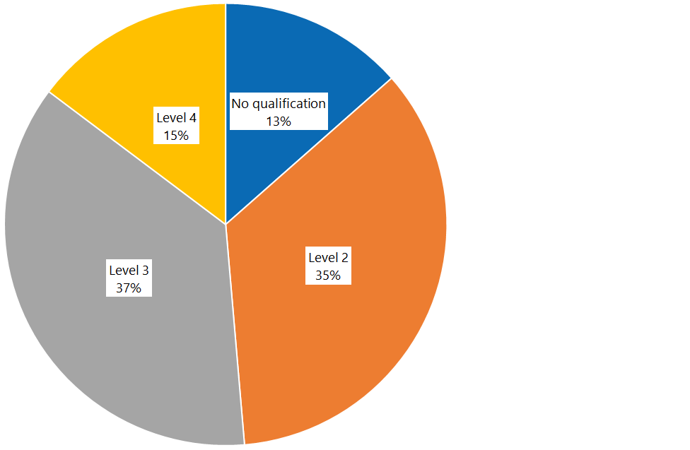

Table 5: Number of home and community support sector worked hours, by qualification level, 2017/18 and February 2019
 | Level 0 | Level 2 | Level 3 | Level 4 | Total
2017/18 full-year data* | 2,578,856 | 2,924,104 | 3,212,640 | 898,820 | 9,614,419
February 2019** | 58,651 | 152,734 | 159,129 | 64,053 | 434,567
* The worked hours collected in the 2017/18 full-year data pertain to a full-year period: 1 July 2017–30 June 2018.
** The worked hours collected in the February 2019 data pertain to a fortnight period: 28 January 2019–24 February 2019.

Appendix 4: Disability sector: comparison of qualification levels by number of workers and worked hours
Figure 9: Percentage of disability sector workers, by qualification level, 2017/18
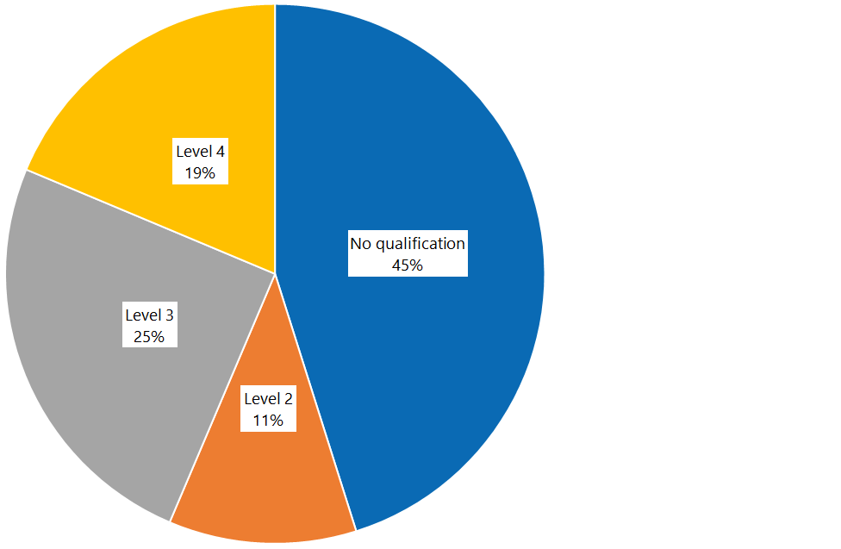

Figure 10: Percentage of disability sector workers, by qualification level, February 2019
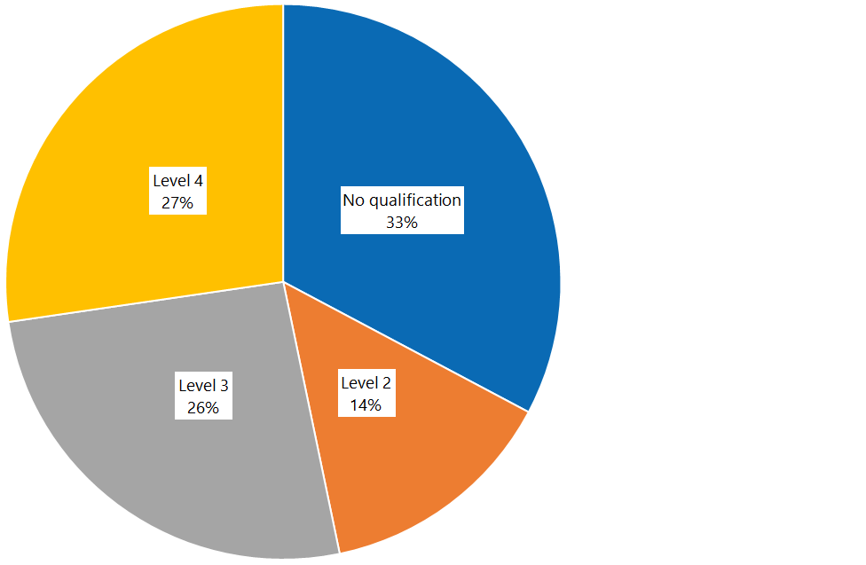

Table 6: Number of disability sector workers, by qualification level, 2017/18 and February 2019
 | Level 0 | Level 2 | Level 3 | Level 4 | Total
2017/18 full-year data | 1,628 | 406 | 899 | 674 | 3,607
February 2019 | 1,182 | 504 | 936 | 985 | 3,607

Figure 11: Percentage of disability sector worked hours, by qualification level, 2017/18
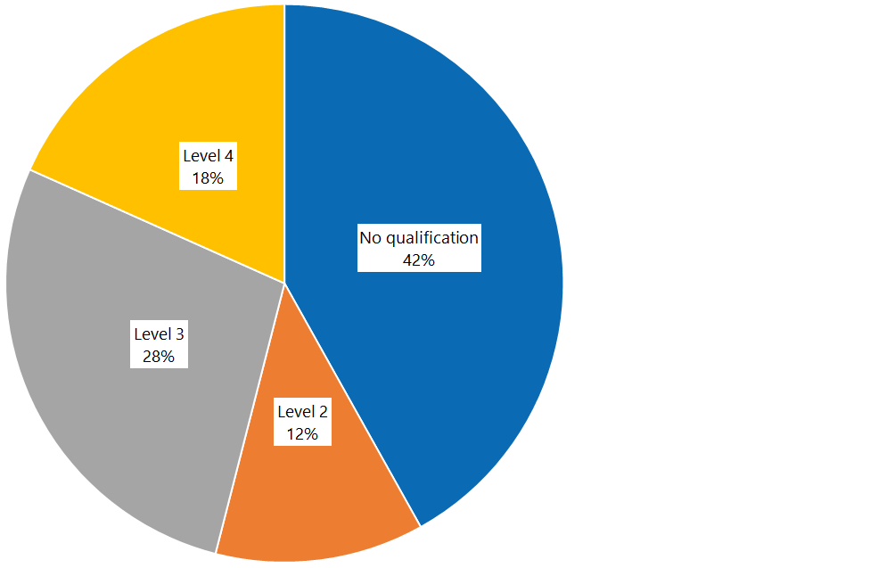

Figure 12: Percentage of disability sector worked hours, by qualification level, February 2019
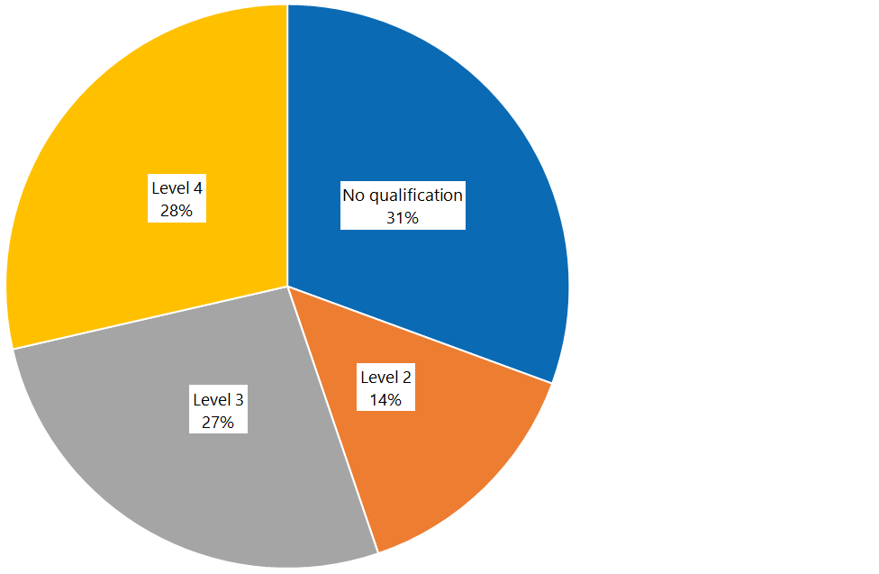

Table 7: Number of disability sector worked hours, by qualification level, 2017/18 and February 2019
 | Level 0 | Level 2 | Level 3 | Level 4 | Total
2017/18 full-year data* | 1,876,159 | 542,108 | 1,240,612 | 820,610 | 4,479,490
February 2019** | 64,820 | 30,039 | 56,423 | 60,541 | 211,823
* The worked hours collected in the 2017/18 full-year data pertain to a full-year period: 1 July 2017–30 June 2018.
** The worked hours collected in the February 2019 data pertain to a fortnight period: 28 January 2019–24 February 2019.

Appendix 5: Mental health and addiction sector: comparison of qualification levels by number of workers and worked hours
Figure 13: Percentage of mental health and addiction sector workers, by qualification level, 2017/18
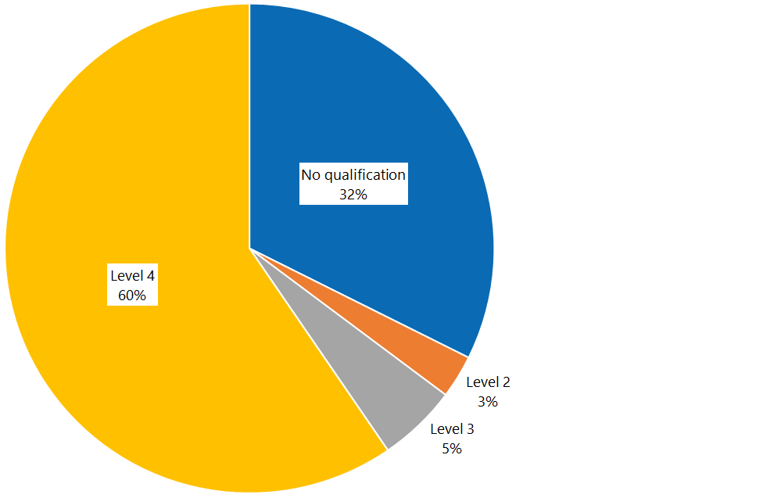

Figure 14: Percentage of mental health and addiction sector workers, by qualification level, February 2019
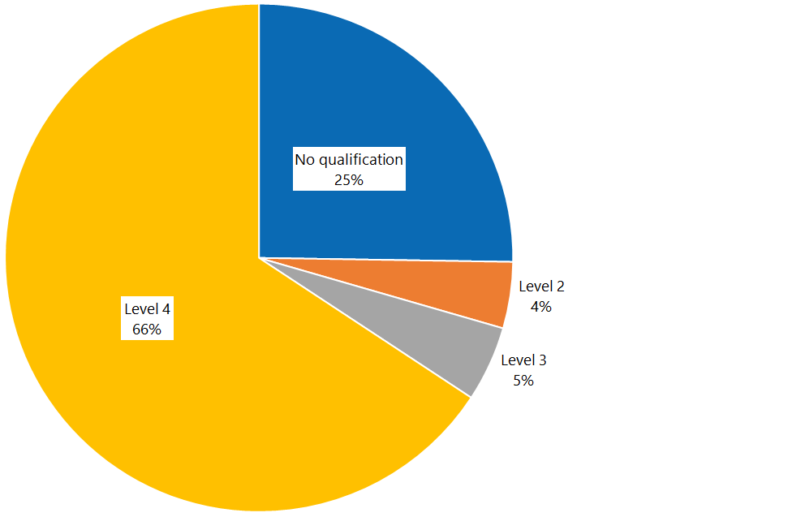

Table 8: Mental health and addiction sector workers, by qualification level, 2017/18 and February 2019
 | Level 0 | Level 2 | Level 3 | Level 4 | Total
2017/18 full-year data | 897 | 79 | 145 | 1,651 | 2,772
February 2019 | 700 | 117 | 133 | 1,822 | 2,772

Figure 15: Percentage of mental health and addiction sector worked hours, by qualification level, 2017/18
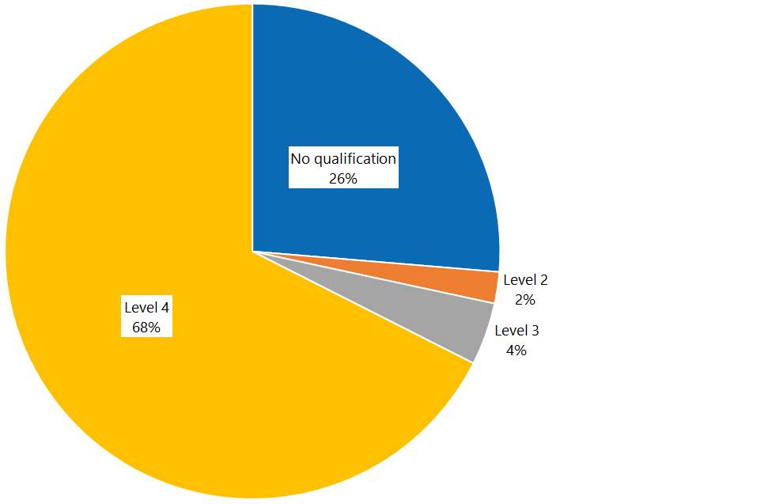

Figure 16: Percentage of mental health and addiction sector worked hours, by qualification level, February 2019
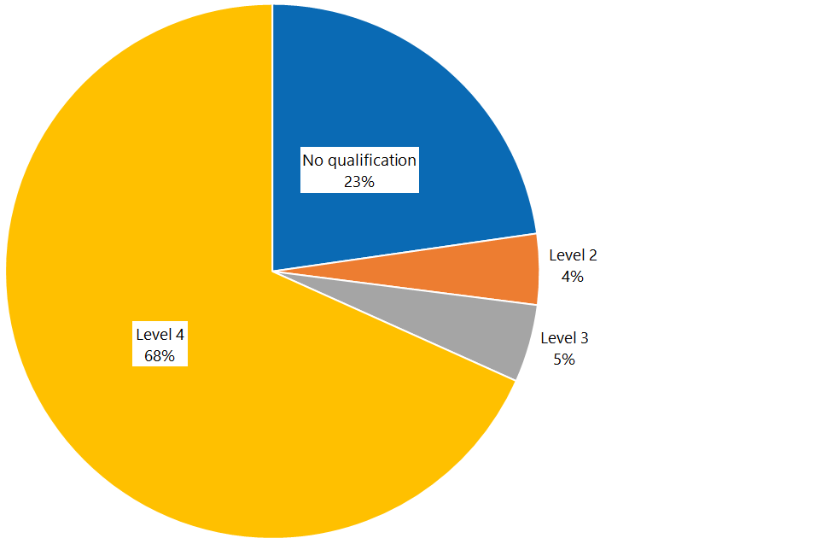

Table 9: Mental health and addiction sector worked hours, by qualification level, 2017/18 and February 2019
 | Level 0 | Level 2 | Level 3 | Level 4 | Total
2017/18 full-year data* | 885,432 | 69,075 | 137,288 | 2,271,751 | 3,363,546
February 2019** | 35,782 | 6,740 | 7,408 | 107,460 | 157,389
* The worked hours collected in the 2017/18 full-year data pertain to a full-year period: 1 July 2017–30 June 2018.
** The worked hours collected in the February 2019 data pertain to a fortnight period: 28 January 2019–24 February 2019.

Appendix 6: Aged residential care data
Figure 17: Percentage of aged residential care sector workers, by qualification level, March 2019
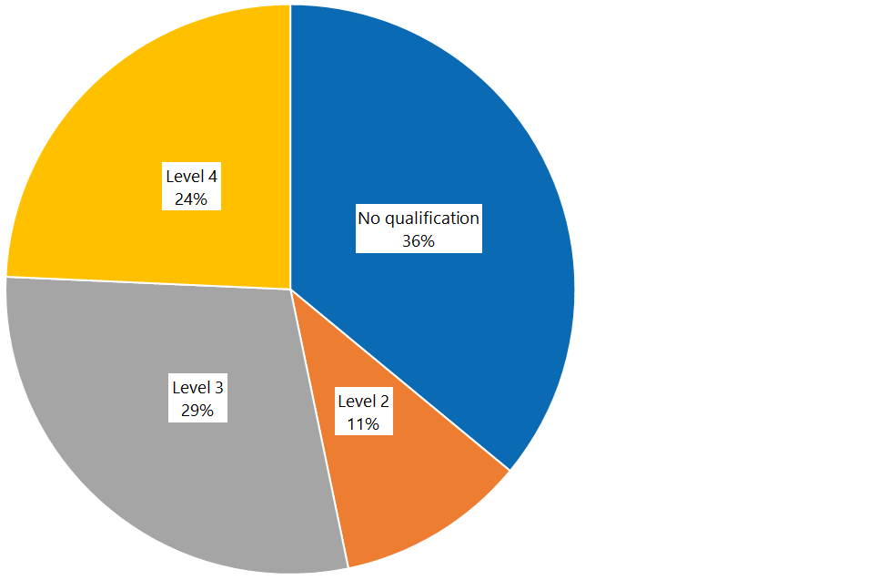

Figure 18: Percentage of aged residential care sector worked hours, by qualification level, March 2019
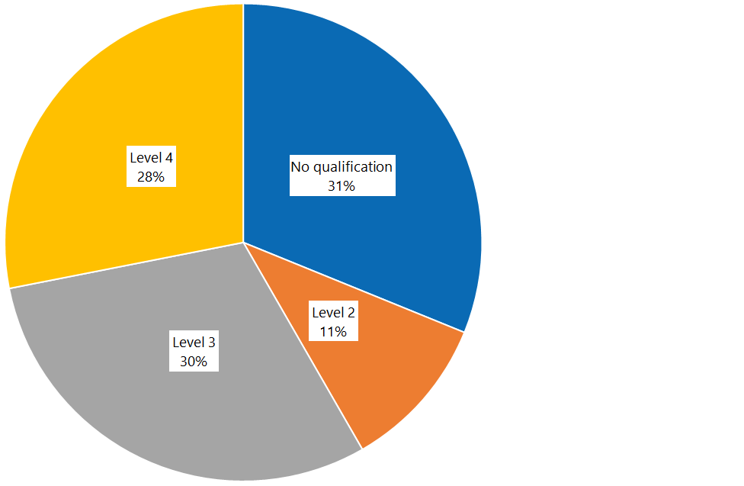

Table 10: Aged residential care staff numbers and worked hours, by qualification level, March 2019
 | Level 0 | Level 2 | Level 3 | Level 4 | Total
Number | 6,763 | 2,021 | 5,443 | 4,567 | 18,794
Worked hours | 333,273 | 112,738 | 323,350 | 300,535 | 1,069,897

Data on support worker qualifications was not previously collected. 2017/18 data is by default the baseline data.
All new eligible care and support workers from 1 July 2017 progress through the pay bands only on the basis of obtaining qualifications.
The Support Workers (Pay Equity) Settlements Amendment Bill is currently being considered by Parliament. The Bill seeks to do this by clarifying that mental health and addiction support workers are included.
The Settlement allows for prior learning to be recognised if an employee’s qualification is assessed as equivalent to a New Zealand Certificate in Health and Wellbeing by the relevant industry training organisation (ITO). Careerforce is the relevant ITO for the care and support workforce.
https://www.health.govt.nz/new-zealand-health-system/pay-equity-settlements/care-and-support-workers-pay-equity-settlement/pay-equity-settlement-implementation-information-providers
We found 802 unqualified workers whose start date was later than 1 January 2018 and who were still employed as unqualified support workers in February 2019 (that is, whose length of service was less than 12 months).
Some employers operate multiple services, and could not identify which contract a specific employee was employed under; this generally explains the ‘unknown’ column.
The total figure is not equal to the sum of the sector figures, because some employees work in multiple sectors.
Employees employed in HCS sector in 2017/18 financial year and still employed in February 2019 are used as analysis sample.
Employees employed in the disability sector in the 2017/18 financial year and still employed in February 2019 were used as an analysis sample.
Employees employed in the mental health and addiction sector in the 2017/18 financial year and still employed in February 2019 were used as an analysis sample.

