Cancer
New registrations and deaths
2011

Citation: Ministry of Health. 2014. Cancer: New registrations and deaths 2011. Wellington: Ministry of Health.
Published in September 2014
by the Ministry of Health
PO Box 5013, Wellington 6145, New Zealand
ISBN: 978-0-478-42874-2 (online)
HP 5968
This document is available at www.health.govt.nz

This work is licensed under the Creative Commons Attribution 4.0 International licence. In essence, you are free to: share ie, copy and redistribute the material in any medium or format; adapt ie, remix, transform and build upon the material. You must give appropriate credit, provide a link to the licence and indicate if changes were made.

Acknowledgements
Many people have assisted in the production of this publication. In particular, the Ministry of Health thanks the peer reviewers for their valuable contribution.

Source
Cancer registration data for this publication is sourced from the New Zealand Cancer Registry, and mortality data is sourced from the New Zealand Mortality Collection. Both are held by the Ministry of Health.

Copyright
The copyright owner of this publication is the Ministry of Health, which is part of the New Zealand Crown. The Ministry of Health permits the reproduction of material from this publication without prior notification, provided that all the following conditions are met:
- the content is not distorted or changed
- the information is not sold
- the material is not used to promote or endorse any product or service
- the material is not used in an inappropriate or misleading context having regard to the nature of the material
- any relevant disclaimers, qualifications or caveats included in the publication are reproduced
- the Ministry of Health is acknowledged as the source.

Disclaimer
The purpose of this publication is to inform discussion and assist policy development. The opinions expressed in the publication do not necessarily reflect the official views of the Ministry of Health.

All care has been taken in the production of this publication. The data is considered to be accurate at the time of publication, but may be subject to slight changes over time as further information is received. It is advisable to check the current status of figures given here with the Ministry of Health before quoting or using them in further analysis.

National collection, coding and collation of cancer registrations is a complex process. This is because the information in the New Zealand Cancer Registry comes from laboratory reports, hospital information and mortality information, and cannot be finalised until data has become available from all sources. In addition, several steps are required to ensure the final information is of good quality.

The Ministry of Health makes no warranty, expressed or implied, nor assumes any legal liability or responsibility for the accuracy, correctness, completeness or use of the information or data in this publication. Further, the Ministry of Health shall not be liable for any loss or damage arising directly or indirectly from the information or data presented in this publication.

The Ministry of Health welcomes comments and suggestions about this publication.

Contents
Acknowledgements iii
Selected facts for 2011 xiii
Introduction 1
Clinical coding of cancer registration and death from cancer data 1
Ethnicity data for cancer registrations 1
Ethnicity data for cancer deaths 2
Registrations 3
Most common cancer registrations 6
Deaths 7
Most common deaths from cancer 10
Cancer registrations and deaths, by age 11
Cancer registrations and deaths in people aged 0─24 years 14
Cancer registrations and deaths in people aged 25─44 years 15
Cancer registrations and deaths in people aged 45─64 years 16
Cancer registrations and deaths in people aged 65─74 years 17
Cancer registrations and deaths in people aged 75 years and over 18
Cancer registrations and deaths, by ethnic group 20
Registrations 20
Deaths 20
Cancer registrations, by ethnic group 21
Deaths from cancer, by ethnic group 25
Cancer registrations and deaths, by deprivation quintile 29
Cancer registrations, by deprivation quintile 30
Deaths from cancer, by deprivation quintile 31
Selected cancers: trends in registrations and deaths 33
Bladder cancer (ICD code C67) 33
Uterine cancer (ICD code C54) 37
Cervical cancer (ICD code C53) 41
Colorectal and anal cancer (ICD codes C18–C21) 45
Female breast cancer (ICD code C50) 49
Lung cancer (ICD codes C33 and C34) 53
Melanoma (ICD code C43) 57
Ovarian cancer (ICD code C56) 61
Pancreatic cancer (ICD code C25) 65
Prostate cancer (ICD code C61) 69
Stomach cancer (ICD code C16) 73
Lymphohaematopoietic cancers 77
Leukaemia (ICD codes C91–C95) 77
Non-Hodgkin lymphoma (ICD codes C82–C85 and C96) 81
Classification of cancers of the blood and lymphatic system 85
Cancer registrations and deaths by district health board region, 2009–2011 86
Explanatory notes 90
Cancer registration data 90
Re-extraction of registration data from the Cancer Registry 92
Timeliness of data 92
Changes in legislation 92
Ethnicity 92
Rate calculations 93
Confidence intervals 95
Deprivation 96
The Ministry of Health’s Cancer Projections publication 96
Additional information available from the Ministry of Health 97
Appendix 1: Full text of the Cancer Registry Act 1993 98
Appendix 2: Full text of the Cancer Registry Regulations 1994 101
References 104

List of Tables
Table 1: Numbers and age-standardised rates of cancer registrations, by sex,
2001–2011 3
Table 2: Numbers and age-standardised rates of cancer registrations by ICD group and selected ICD codes by sex, 2011 5
Table 3: Numbers and age-standardised rates of the most commonly registered cancers for males and females, 2011 6
Table 4: Numbers and age-standardised rates of cancer mortality, by sex, 2001–2011 7
Table 5: Age-standardised mortality rates for selected causes, by sex and ethnic group, 2011 8
Table 6: Numbers and age-standardised rates of cancer mortality by ICD group and selected ICD codes by sex, 2011 9
Table 7: Numbers and age-standardised rates of the most common causes of cancer death for males and females, 2011 10
Table 8: Number and age-standardised rate of registration for selected cancers, by ethnic group and sex, 2011 24
Table 9: Numbers and age-standardised rate of mortality for selected cancers, by ethnic group and sex, 2011 28
Table 10a: Numbers of registrations and deaths for bladder cancer, by sex and ethnic group, 2001–2011 34
Table 10b: Age-standardised registration and mortality rates for bladder cancer, by sex and ethnic group, 2001–2011 34
Table 11a: Numbers of registrations and deaths for cancer of the uterus, by ethnic group, 2001–2011 38
Table 11b: Age-standardised registration and mortality rates for cancer of the uterus, by ethnic group, 2001–2011 38
Table 12a: Numbers of registrations and deaths for cervical cancer, by ethnic group, 2001–2011 42
Table 12b: Age-standardised registration and mortality rates for cervical cancer, by ethnic group, 2001–2011 42
Table 13a: Numbers of registrations and deaths for colorectal cancer, by sex and ethnic group, 2001–2011 46
Table 13b: Age-standardised registration and mortality rates for colorectal cancer, by sex and ethnic group, 2001–2011 46
Table 14a: Numbers of registrations and deaths for female breast cancer, by ethnic group, 2001–2011 50
Table 14b: Age-standardised registration and mortality rates for female breast cancer, by ethnic group, 2001–2011 50
Table 15a: Numbers of registrations and deaths for lung cancer, by sex and ethnic group, 2001–2011 54
Table 15b: Age-standardised registration and mortality rates for lung cancer, by sex and ethnic group, 2001–2011 54
Table 16a: Numbers of registrations and deaths for melanoma, by sex and ethnic group, 2001–2011 58
Table 16b: Age-standardised registration and mortality rates for melanoma, by sex and ethnic group, 2001–2011 58
Table 17a: Numbers of registrations and deaths for ovarian cancer, by ethnic group, 2001–2011 62
Table 17b: Age-standardised registration and mortality rates for ovarian cancer, by ethnic group, 2001–2011 62
Table 18a: Numbers of registrations and deaths for pancreatic cancer, by sex and ethnic group, 2001–2011 66
Table 18b: Age-standardised registration and mortality rates for pancreatic cancer, by sex and ethnic group, 2001–2011 66
Table 19a: Numbers of registrations and deaths for prostate cancer, by ethnic group, 2001–2011 70
Table 19b: Age-standardised registration and mortality rates for prostate cancer, by ethnic group, 2001–2011 70
Table 20a: Numbers of registrations and deaths for stomach cancer, by sex and ethnic group, 2001–2011 74
Table 20b: Age-standardised registration and mortality rates for stomach cancer, by sex and ethnic group, 2001–2011 74
Table 21a: Numbers of registrations and deaths for leukaemia, by sex and ethnic group, 2001–2011 78
Table 21b: Age-standardised registration and mortality rates for leukaemia, by sex and ethnic group, 2001–2011 78
Table 22a: Numbers of registrations and deaths for non-Hodgkin lymphoma, by sex and ethnic group, 2001–2011 82
Table 22b: Age-standardised registration and mortality rates for non-Hodgkin lymphoma, by sex and ethnic group, 2001–2011 82
Table 23: Numbers and age-standardised rates of registration for lymphohaematopoietic cancers, by morphology code, 2011 85
Table N-1: The World Health Organization world standard population 93
Table N-2: Population data, 2011 94
Table N-3: ICD-O (version 3) morphology codes used to group lymphohaematopoietic cancers 95

List of Figures
Figure I-1: Data and the New Zealand Cancer Registry 2
Figure 1: Age-standardised cancer registration rates, by sex, 2001–2011 4
Figure 2: Percentage distribution of most commonly registered cancers, 2001–2011 6
Figure 3: Mortality rates for cancer, by sex, 2001–2011 8
Figure 4: Percentage distribution of the most common causes of cancer death, 2001–2011 10
Figure 5: Age-specific rates of registrations and deaths from cancer for males, by age group, 2011 11
Figure 6: Age-specific rates of registrations and deaths from cancer for females, by age group, 2011 11
Figure 7: Male age-specific cancer registration rates, 2001–2011 12
Figure 8: Female age-specific cancer registration rates, 2001–2011 12
Figure 9: Male age-specific cancer mortality rates, 2001–2011 13
Figure 10: Female age-specific cancer mortality rates, 2001–2011 13
Figure 11: The most common cancer registrations for males and females aged 0–24 years, 2011 14
Figure 12: The most common causes of death from cancer for males and females aged 0–24 years, 2011 14
Figure 13: The most common cancer registrations for males and females aged 25–44 years, 2011 15
Figure 14: The most common causes of death from cancer for males and females aged 25–44 years, 2011 16
Figure 15: The most common cancer registrations for males and females aged 45–64 years, 2011 16
Figure 16: The most common causes of death from cancer for males and females aged 45–64 years, 2011 17
Figure 17: The most common cancer registrations for males and females aged 65–74 years, 2011 17
Figure 18: The most common causes of death from cancer for males and females aged 65–74 years, 2011 18
Figure 19: The most common cancer registrations for males and females aged 75 years and over, 2011 19
Figure 20: The most common causes of death from cancer for males and females aged 75 years and over, 2011 19
Figure 21: Cancer registration rates, by ethnic group, 2001–2011 21
Figure 22: Male cancer registration rates, by ethnic group, 2001–2011 21
Figure 23: Female cancer registration rates, by ethnic group, 2001–2011 22
Figure 24: Most commonly registered cancers for males, by ethnic group, 2011 22
Figure 25: Most commonly registered cancers for females, by ethnic group, 2011 23
Figure 26: Cancer mortality rates, by ethnic group, 2001–2011 25
Figure 27: Male cancer mortality rates, by ethnic group, 2001–2011 26
Figure 28: Female cancer mortality rates, by ethnic group, 2001–2011 26
Figure 29: Most common causes of death from cancer for males, by ethnic group, 2011 27
Figure 30: Most common causes of death from cancer for females, by ethnic group, 2011 27
Figure 31: Cancer registration and mortality rates, by deprivation quintile, 2011 29
Figure 32: Registration rates for the most common male cancers, by deprivation quintile, 2011 30
Figure 33: Registration rates for the most common female cancers, by deprivation quintile, 2011 31
Figure 34: Mortality rates for the most common male cancers, by deprivation quintile, 2011 31
Figure 35: Mortality rates for the most common female cancers, by deprivation quintile, 2011 32
Figure 36: Registration rates for bladder cancer, 2001–2011 35
Figure 37: Male registration rates for bladder cancer, by ethnic group, 2001–2011 35
Figure 38: Female registration rates for bladder cancer, by ethnic group, 2001–2011 35
Figure 39: Mortality rates for bladder cancer, 2001–2011 36
Figure 40: Male mortality rates for bladder cancer, by ethnic group, 2001–2011 36
Figure 41: Female mortality rates for bladder cancer, by ethnic group, 2001–2011 36
Figure 42: Registration rates for cancer of the uterus, 2001–2011 39
Figure 43: Registration rates for cancer of the uterus, by ethnic group, 2001–2011 39
Figure 44: Mortality rates for cancer of the uterus, 2001–2011 40
Figure 45: Mortality rates for cancer of the uterus, by ethnic group, 2001–2011 40
Figure 46: Registration rates for cervical cancer, 2001–2011 43
Figure 47: Registration rates for cervical cancer, by ethnic group, 2001–2011 43
Figure 48: Mortality rates for cervical cancer, 2001–2011 44
Figure 49: Mortality rates for cervical cancer, by ethnic group, 2001–2011 44
Figure 50: Registration rates for colorectal cancer, 2001–2011 47
Figure 51: Male registration rates for colorectal cancer, by ethnic group, 2001–2011 47
Figure 52: Female registration rates for colorectal cancer, by ethnic group, 2001–2011 47
Figure 53: Mortality rates for colorectal cancer, 2001–2011 48
Figure 54: Male mortality rates for colorectal cancer, by ethnic group, 2001–2011 48
Figure 55: Female mortality rates for colorectal cancer, by ethnic group, 2001–2011 48
Figure 56: Registration rates for female breast cancer, 2001–2011 51
Figure 57: Registration rates for female breast cancer, by ethnic group, 2001–2011 51
Figure 58: Mortality rates for female breast cancer, 2001–2011 52
Figure 59: Mortality rates for female breast cancer, by ethnic group, 2001–2011 52
Figure 60: Registration rates for lung cancer, 2001–2011 55
Figure 61: Male registration rates for lung cancer, by ethnic group, 2001–2011 55
Figure 62: Female registration rates for lung cancer, by ethnic group, 2001–2011 55
Figure 63: Mortality rates for lung cancer, 2001–2011 56
Figure 64: Male mortality rates for lung cancer, by ethnic group, 2001–2011 56
Figure 65: Female mortality rates for lung cancer, by ethnic group, 2001–2011 56
Figure 66: Registration rates for melanoma, 2001–2011 59
Figure 67: Male registration rates for melanoma, by ethnic group, 2001–2011 59
Figure 68: Female registration rates for melanoma, by ethnic group, 2001–2011 59
Figure 69: Mortality rates for melanoma, 2001–2011 60
Figure 70: Male mortality rates for melanoma, 2001–2011 60
Figure 71: Female mortality rates for melanoma, 2001–2011 60
Figure 72: Registration rates for ovarian cancer, 2001–2011 63
Figure 73: Registration rates for ovarian cancer, by ethnic group, 2001–2011 63
Figure 74: Mortality rates for ovarian cancer, 2001–2011 64
Figure 75: Mortality rates for ovarian cancer, by ethnic group, 2001–2011 64
Figure 76: Registration rates for pancreatic cancer, 2001–2011 67
Figure 77: Male registration rates for pancreatic cancer, by ethnic group, 2001–2011 67
Figure 78: Female registration rates for pancreatic cancer, by ethnic group, 2001–2011 67
Figure 79: Mortality rates for pancreatic cancer, 2001–2011 68
Figure 80: Male mortality rates for pancreatic cancer, by ethnic group, 2001–2011 68
Figure 81: Female mortality rates for pancreatic cancer, by ethnic group, 2001–2011 68
Figure 82: Registration rates for prostate cancer, 2001–2011 71
Figure 83: Registration rates for prostate cancer, by ethnic group, 2001–2011 71
Figure 84: Mortality rates for prostate cancer, 2001–2011 72
Figure 85: Mortality rates for prostate cancer, by ethnic group, 2001–2011 72
Figure 86: Registration rates for stomach cancer, 2001–2011 75
Figure 87: Male registration rates for stomach cancer, by ethnic group, 2001–2011 75
Figure 88: Female registration rates for stomach cancer, by ethnic group, 2001–2011 75
Figure 89: Mortality rates for stomach cancer, 2001–2011 76
Figure 90: Male mortality rates for stomach cancer, by ethnic group, 2001–2011 76
Figure 91: Female mortality rates for stomach cancer, by ethnic group, 2001–2011 76
Figure 92: Registration rates for leukaemia, 2001–2011 79
Figure 93: Male registration rates for leukaemia, by ethnic group, 2001–2011 79
Figure 94: Female registration rates for leukaemia, by ethnic group, 2001–2011 79
Figure 95: Mortality rates for leukaemia, 2001–2011 80
Figure 96: Male mortality rates for leukaemia, by ethnic group, 2001–2011 80
Figure 97: Female mortality rates for leukaemia, by ethnic group, 2001–2011 80
Figure 98: Registration rates for non-Hodgkin lymphoma, 2001–2011 83
Figure 99: Male registration rates for non-Hodgkin lymphoma, by ethnic group, 2001–2011 83
Figure 100: Female registration rates for non-Hodgkin lymphoma, by ethnic group, 2001–2011 83
Figure 101: Mortality rates for non-Hodgkin lymphoma, 2001–2011 84
Figure 102: Male mortality rates for non-Hodgkin lymphoma, by ethnic group, 2001–2011 84
Figure 103: Female mortality rates for non-Hodgkin lymphoma, by ethnic group, 2001–2011 84
Figure 104: Cancer registration rates, by DHB region, 2009−2011 86
Figure 105: Comparison of DHB region cancer registration rates with national rate, 2009–2011 87
Figure 106: Cancer mortality rates, by DHB region, 2009−2011 88
Figure 107: Comparison of DHB region cancer mortality rates with national rate, 2009–2011 89

Selected facts for 2011

Cancer registrations
- In 2011, there were 21,050 new cases of cancer registered in New Zealand; 52.5% of these were male.
- The age-standardised registration rate decreased by 7.8%, from 359.1 per 100,000 population in 2001 to 331.0 per 100,000 in 2011.

Deaths from cancer
- Cancer was the most common cause of death for both males and females in New Zealand in 2011, accounting for nearly a third of all deaths.
- 8891 people had cancer recorded as their underlying cause of death; 52.3% of these were male.
- Between 2001 and 2011 the age-standardised death rate from cancer decreased by 13.4%, from 145.5 to 125.9 per 100,000 population.

Most common cancers
- The most commonly registered cancer was colorectal (3030 registrations), followed by prostate cancer (3023 registrations), together accounting for 28.8% of registrations. Breast cancer and melanoma were the next most commonly registered cancers.
- For males, the most commonly registered cancer was prostate cancer, which accounted for 27.3% of all male registrations; the next most common were colorectal cancer, and melanoma.
- For females, breast cancer was the most common cancer registered, accounting for 28.7% of female registrations. As with males, colorectal cancer and melanoma were the next most commonly registered cancers.

Most common causes of cancer death
- Lung cancer accounted for the most deaths from cancer (18.9%). Colorectal cancer was the next most common cause of death from cancer, followed by breast and prostate cancers.
- For males, the most common cause of death from cancer was lung cancer (19.5%), followed by colorectal cancer and prostate cancer.
- For females, the most common cause of death from cancer was also lung cancer (18.2%), followed by breast cancer and then colorectal cancer.

Age and sex
- Fifty-seven percent of all new cancers registered in 2011 were for people aged 65 and over.
- Seventy-three percent of all deaths from cancer in 2011 were people aged 65 and over.
- In people aged 0–24 years, the most common cancer registration was leukaemia for both males and females. In this age group, males who died of cancer most commonly died of brain cancer, and females of brain cancer and leukaemia.
- In people aged 25–44 years, melanoma was the most common cancer registration for males, and breast cancer for females. Males in this age group who died of cancer most commonly died of brain cancer; females most commonly died of breast cancer.
- In people aged 45–64 years, the most common cancer registration was prostate cancer for males and breast cancer for females. The most common cause of death from cancer in this age group was lung cancer for males and breast cancer for females.
- In people aged 65–74 years, the most common cancers registered were the same as for the 45–64 years age group. Lung cancer was the most common cause of death from cancer for both men and women in this age group.
- In people aged 75 years and over, the most common cancer registration and the most common cause of death from cancer was prostate cancer for men, and colorectal cancer for women.

Ethnic group

Cancer registrations, 2011
- A total of 1991 Māori and 19,059 non-Māori were registered with cancer.
- Māori had an age-standardised cancer registration rate of 409.8 per 100,000 population, compared to the non-Māori rate of 324.3 per 100,000 population.
- Between 2001 and 2011 the Māori cancer registration rate was variable and showed no clear trend; the corresponding non-Māori rate was less variable and fell by 9.2%.

Deaths from cancer, 2011
- A total of 939 Māori and 7952 non-Māori died from cancer.
- Māori had an age-standardised cancer mortality rate of 204.6 per 100,000 population, compared to 118.9 for non-Māori.
- Between 2001 and 2011 the Māori cancer mortality rate dropped by 10.3%, and the non-Māori rate fell by 14.3%.

Introduction
Cancer: New registrations and deaths 2011 presents information about new cases of primary cancer diagnosed and reported to the New Zealand Cancer Registry for the 2011 calendar year. It also presents information on deaths registered in New Zealand in the same time period where cancer was recorded as the underlying cause of death.

This publication covers cancers located in specific organs or tissues, as well as systemic cancers such as leukaemia and lymphoma. In situ cancers are not included. The New Zealand Cancer Registry database records multiple primary cancers in the same person, of which only some are counted for incidence purposes according to the rules of the International Agency for Research on Cancer and the International Association of Cancer Registries (see ‘Explanatory notes’).

Clinical coding of cancer registration and death from cancer data
The International Statistical Classification of Diseases and Related Health Problems, Tenth Revision, Australian Modification (ICD-10-AM), sixth edition was used to classify sites and topography for the data used in this report. The International Classification of Diseases for Oncology (ICD-O), third edition was used to classify the morphology (histology, type and behaviour) of tumours.

The third edition of ICD-O contains a revised morphology section. New classifications were introduced and new codes assigned to accommodate them. This has resulted in changes to the coding of cancers diagnosed since 1 January 2003. For some tumour types, particularly haematological malignancies and ovarian cancer, these changes may affect incidence reporting. Thus, for particular cancer sites, registrations from 1 January 2003 may not be directly comparable with those from 2002 and earlier. See ‘Explanatory notes’ for further details of these changes.

Since 1 January 2005, superficial transitional cell carcinoma of the bladder has not been coded as an invasive cancer. This coding change has resulted in a decrease in the number of bladder cancer registrations when compared with previous years.

Ethnicity data for cancer registrations
In 2009 the New Zealand Cancer Registry adjusted the way it recorded ethnicities, in order to rectify a perceived undercount of some ethnicities. Updated registration data was used in Cancer: New registrations and deaths 2006 (Ministry of Health 2011a). This change means that information relating to ethnicities in publications prior to 2006 cannot be directly compared with that presented in this publication.

Ethnicity data for cancer deaths
Data in this publication relating to deaths comes from the New Zealand Mortality Collection. There have been no recent changes in the way ethnicity is assigned to death records. Ethnicity information for the Mortality Collection comes from the Notification of Death for Registration form.

Figure I-1 shows how data enters the New Zealand Cancer Registry.

Figure I-1: Data and the New Zealand Cancer Registry
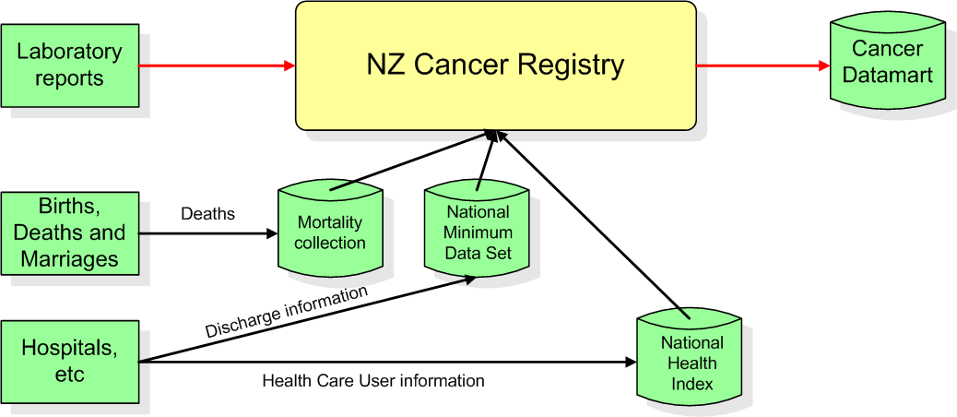

Registrations
In 2011, 21,050 new registrations of primary cancer were reported to the New Zealand Cancer Registry. Males accounted for 11,057 of these registrations (52.5%) and females for 9993 (47.5%).

Table 1 shows numbers and age-standardised rates of cancer registration for males and females from 2001 to 2011. Age-standardised rates are a way of comparing groups that may have different age structures (for example, one group may be older on average than the other), and the same group where the age structure has changed over time. The rates presented in this publication are age-standardised per 100,000 population, standardised to the World Health Organization (WHO) standard population, unless stated otherwise (see ‘Explanatory notes’ for more information).

Between 2001 and 2011 the actual number of new registrations increased by 17.1%, from 17,978 to 21,050 (see Table 1). However, after adjusting for age and population growth, the registration rate decreased slightly over this period, from 359.1 per 100,000 population to 331.0 (a drop of 7.8%).

Table 1: Numbers and age-standardised rates of cancer registrations, by sex, 2001–2011
Year | Males |  | Females |  | Total
 | Number | Rate  (per 100,000) | Number | Rate  (per 100,000) | Number | Rate  (per 100,000)
2001 | 9606 | 413.0 | 8372 | 320.6 | 17,978 | 359.1
2002 | 9421 | 396.0 | 8570 | 319.4 | 17,991 | 351.3
2003 | 9900 | 404.7 | 8781 | 319.7 | 18,681 | 356.5
2004 | 10,224 | 407.1 | 9129 | 324.4 | 19,353 | 360.1
2005 | 9754 | 380.3 | 9022 | 314.3 | 18,776 | 343.0
2006 | 9849 | 373.4 | 9046 | 306.8 | 18,895 | 335.9
2007 | 10,425 | 381.2 | 9311 | 309.1 | 19,736 | 340.5
2008 | 10,482 | 374.2 | 9835 | 320.4 | 20,317 | 344.0
2009 | 11,151 | 388.3 | 9724 | 307.2 | 20,875 | 344.4
2010 | 11,068 | 375.4 | 10,167 | 316.3 | 21,235 | 342.9
2011 | 11,057 | 362.9 | 9993 | 304.6 | 21,050 | 331.0
Source: New Zealand Cancer Registry
Note: ICD-10 codes D45–D47 are included from 2003 onwards: see ‘Explanatory notes’.

Figure 1 shows cancer registration rates for males and females between 2001 and 2011. Female registration rates were significantly lower than male rates (as indicated by confidence intervals; see ‘Explanatory notes’ for further explanation of these).

Between 2001 and 2011, the male registration rate fell by 12.1%; the corresponding female rate fell by 5.0%.

Figure 1: Age-standardised cancer registration rates, by sex, 2001–2011
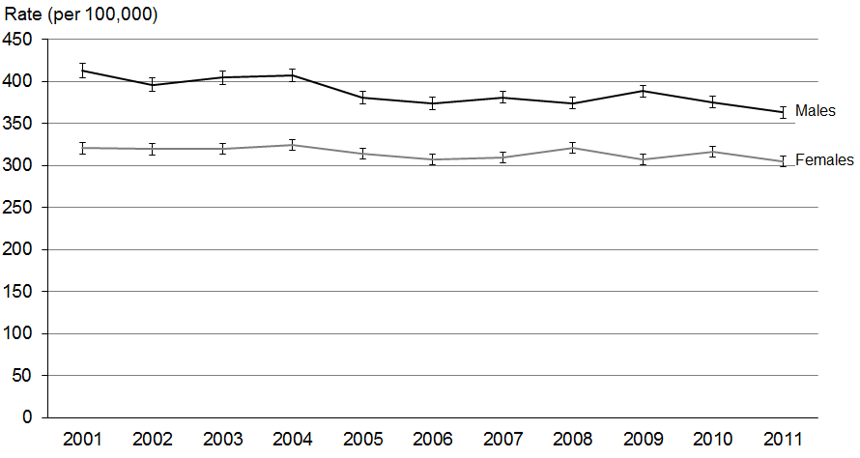
Source: New Zealand Cancer Registry
Note: 95% confidence intervals.

Table 2 shows the numbers of registrations and registration rates for selected cancers and groups of cancers in 2011.

Table 2: Numbers and age-standardised rates of cancer registrations by ICD group and selected ICD codes by sex, 2011
Cancer (ICD code) | Number of registrations |  |  | Rate (per 100,000)
 | Total | Males | Females | Total | Males | Females
All cancers (C00–C96 and D45–D47) | 21,050 | 11,057 | 9993 | 331.0 | 362.9 | 304.6
Lip, oral cavity and pharynx (C00–C14) | 379 | 255 | 124 | 6.2 | 8.9 | 3.7
Lip and tongue (C00–C02) | 153 | 107 | 46 | 2.5 | 3.7 | 1.3
Digestive organs (C15–C26) | 4814 | 2684 | 2130 | 70.6 | 85.5 | 57.3
Oesophagus (C15) | 266 | 185 | 81 | 3.9 | 5.8 | 2.1
Stomach (C16) | 391 | 248 | 143 | 6.0 | 8.0 | 4.3
Colorectum and anus (C18–C21) | 3030 | 1635 | 1395 | 44.2 | 52.0 | 37.3
Liver and intrahepatic bile ducts (C22) | 327 | 230 | 97 | 5.1 | 7.7 | 2.6
Pancreas (C25) | 454 | 228 | 226 | 6.5 | 7.1 | 6.0
Respiratory system and intrathoracic organs (C30–C39) | 2161 | 1161 | 1000 | 32.1 | 36.6 | 28.5
Nasal cavity, middle ear, accessory sinuses and larynx (C30–C32) | 123 | 100 | 23 | 1.9 | 3.3 | 0.8
Lung (C33–C34) | 2016 | 1046 | 970 | 29.8 | 32.8 | 27.5
Bones, joints and cartilage (C40–C41) | 29 | 16 | 13 | 0.7 | 0.8 | 0.6
Skin (C43–C44) | 2328 | 1282 | 1046 | 37.8 | 42.6 | 34.0
Melanoma (C43) | 2204 | 1199 | 1005 | 36.1 | 40.1 | 33.0
Mesothelial and soft tissue (C45–C49) | 226 | 157 | 69 | 3.8 | 5.5 | 2.2
Mesothelioma (C45) | 78 | 67 | 11 | 1.1 | 2.1 | 0.3
Breast (C50) | 2894 | 27 | 2867 | 48.6 | 0.9 | 92.5
Female genital organs (C51–C58) | 996 | … | 996 | … | … | 32.6
Cervix (C53) | 165 | … | 165 | … | … | 6.6
Uterus (C54) | 447 | … | 447 | … | … | 14.2
Ovary (C56) | 276 | … | 276 | … | … | 8.6
Male genital organs (C60–C63) | 3199 | 3199 | … | … | 105.5 | …
Prostate (C61) | 3023 | 3023 | … | … | 97.4 | …
Testis (C62) | 151 | 151 | … | … | 7.3 | …
Urinary tract (C64–C68) | 886 | 601 | 285 | 13.5 | 19.5 | 8.2
Kidney, except renal pelvis (C64) | 508 | 339 | 169 | 8.2 | 11.4 | 5.3
Bladder (C67) | 324 | 232 | 92 | 4.5 | 7.2 | 2.3
Eye, brain and other parts of the central nervous system (C69–C72) | 364 | 218 | 146 | 6.6 | 8.2 | 5.1
Brain (C71) | 295 | 180 | 115 | 5.2 | 6.7 | 3.9
Thyroid and other endocrine glands (C73–C75) | 281 | 81 | 200 | 5.5 | 3.1 | 7.6
Thyroid gland (C73) | 264 | 73 | 191 | 5.1 | 2.8 | 7.3
Ill-defined, secondary or unspecified sites  (C76–C80) | 466 | 221 | 245 | 6.2 | 6.7 | 5.8
Lymphoid, haematopoietic and related tissue (C81–C96, D45–D47) | 2027 | 1155 | 872 | 32.3 | 39.1 | 26.5
Lymphomas (C81–C85, C96) | 829 | 438 | 391 | 13.7 | 15.4 | 12.3
Hodgkin lymphoma (C81) | 100 | 59 | 41 | 2.1 | 2.5 | 1.7
Non-Hodgkin lymphoma (C82–C85, C96) | 729 | 379 | 350 | 11.6 | 12.9 | 10.5
Multiple myeloma and malignant plasma cell neoplasms (C90) | 297 | 182 | 115 | 4.4 | 5.7 | 3.2
Leukaemia (C91–C95) | 563 | 328 | 235 | 9.5 | 11.6 | 7.7
Chronic myeloproliferative disorders and myelodysplastic syndromes (D45–D47) | 316 | 194 | 122 | 4.3 | 5.9 | 3.1
Source: New Zealand Cancer Registry
… = Not applicable.

Most common cancer registrations
Colorectal cancer was the most common cancer registration in 2011, with 3030 new cases. Prostate cancer was the second commonest with 3023 new cases. Together, colorectal and prostate cancer accounted for 28.8% of all registrations. These were followed by breast cancer (2894), melanoma (2204), and lung cancer (2016). These five leading cancers accounted for 62.6% of all registrations. Figure 2 shows that the percentage distribution of these cancers between 2001 and 2011 has remained relatively stable. Between 2010 and 2011 breast, prostate, lung and colorectal registrations increased slightly, and only melanoma registrations decreased.

Figure 2: Percentage distribution of most commonly registered cancers, 2001–2011
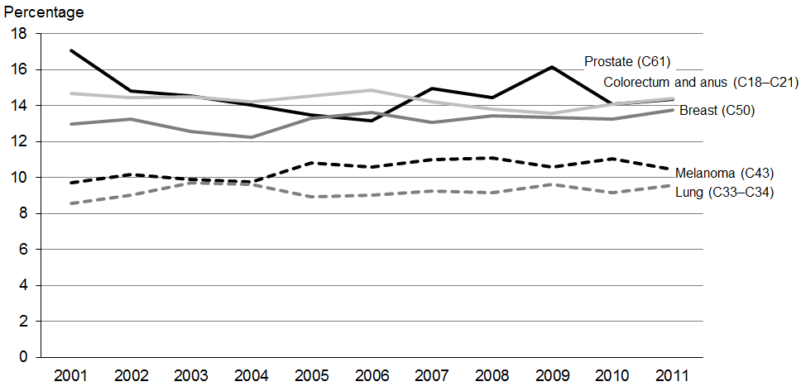
Source: New Zealand Cancer Registry

Prostate cancer and breast cancer were the most commonly registered cancers for males and females, respectively. Registration rates for colorectal cancer, melanoma and lung cancer were all lower for females (Table 3).

Table 3: Numbers and age-standardised rates of the most commonly registered cancers for males and females, 2011
Males |  |  | Females
Cancer (ICD code) | Number | Rate  (per 100,000) | Cancer (ICD code) | Number | Rate  (per 100,000)
Prostate (C61) | 3023 | 97.4 | Breast (C50) | 2867 | 92.5
Colorectum and anus (C18–C21) | 1635 | 52.0 | Colorectum and anus (C18–C21) | 1395 | 37.3
Melanoma (C43) | 1199 | 40.1 | Melanoma (C43) | 1005 | 33.0
Lung (C33–C34) | 1046 | 32.8 | Lung (C33–C34) | 970 | 27.5
Non-Hodgkin lymphoma (C82–C85, C96) | 379 | 12.9 | Uterus (C54) | 447 | 14.2
Source: New Zealand Cancer Registry

Deaths
In 2011 there were 8891 deaths from cancer (4650 males and 4241 females). Between 2001 and 2011 the total number of deaths from cancer increased by 13.8% (Table 4). However, when adjusted for age and population growth, the total cancer mortality rate decreased by 13.4% over this time.

Table 4: Numbers and age-standardised rates of cancer mortality, by sex, 2001–2011
Year | Males |  | Females |  | Total
 | Number | Rate  (per 100,000) | Number | Rate  (per 100,000) | Number | Rate  (per 100,000)
2001 | 4166 | 175.7 | 3644 | 124.6 | 7810 | 145.5
2002 | 4125 | 168.9 | 3675 | 120.9 | 7800 | 140.7
2003 | 4292 | 170.1 | 3735 | 121.7 | 8027 | 141.8
2004 | 4246 | 164.1 | 3899 | 124.1 | 8145 | 140.7
2005 | 4184 | 156.6 | 3787 | 116.9 | 7971 | 133.6
2006 | 4144 | 151.3 | 3950 | 118.5 | 8094 | 132.4
2007 | 4539 | 159.4 | 3980 | 117.3 | 8519 | 135.1
2008 | 4561 | 154.9 | 4005 | 115.3 | 8566 | 132.3
2009 | 4402 | 145.4 | 4035 | 112.6 | 8437 | 126.8
2010 | 4511 | 143.9 | 4082 | 110.6 | 8593 | 125.2
2011 | 4650 | 143.3 | 4241 | 112.6 | 8891 | 125.9
Source: New Zealand Mortality Collection
Note: ICD-10 codes D45–D47 are included from 2003 onwards: see ‘Explanatory notes’.

Historically, the total number of deaths from cancer has generally increased year on year. The increasing population size and the ageing population structure in New Zealand are factors in this trend.

Figure 3 shows that between 2001 and 2011 the mortality rate for both males and females displayed a general downward trend. Over this time, the male rate fell by 18.4% and female rate by 9.7%. The confidence intervals show that male rates were consistently significantly higher than female rates. In 2011 the male cancer mortality rate was 27.3% higher than the female rate.

Figure 3: Mortality rates for cancer, by sex, 2001–2011
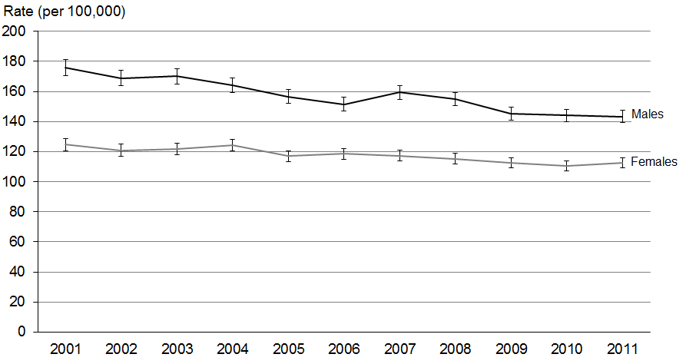
Source: New Zealand Mortality Collection
Note 1: 95% confidence intervals.
Note 2: ICD-10 codes D45–D47 are included from 2003 onwards: see ‘Explanatory notes’.

Cancer was the most common cause of death for both males and females in 2011, accounting for 29.4% of all deaths, followed by ischaemic heart disease (18.3% of deaths). Table 5 shows cancer mortality rates in the context of mortality rates for several different causes. Table 6 presents male and female mortality from a range of cancers for 2011.

Table 5: Age-standardised mortality rates for selected causes, by sex and ethnic group, 2011
Cause | Total deaths | Percentage of deaths |  | Rate (per 100,000)
 |  |  |  | Māori |  | Non-Māori |  | Total
 |  | Male | Female | Male | Female | Male | Female | Male | Female
Cancer | 8891 | 52.3 | 47.7 | 206.4 | 204.0 | 137.7 | 104.2 | 143.3 | 112.6
Lung | 1682 | 54.0 | 46.0 | 61.1 | 71.7 | 25.3 | 17.1 | 28.0 | 21.2
Female breast | 636 | … | 100.0 | … | 27.3 | … | 17.4 | … | 18.3
Prostate | 585 | 100.0 | … | 22.1 | … | 16.2 | … | 16.5 | …
Cervix | 53 | … | 100.0 | … | 5.4 | … | 1.4 | … | 1.7
Melanoma of the skin | 359 | 67.7 | 32.3 | 1.8 | 0.3 | 8.3 | 3.4 | 7.8 | 3.2
Cerebrovascular disease | 2665 | 38.0 | 62.0 | 30.6 | 38.5 | 28.1 | 29.4 | 28.7 | 30.6
Diabetes mellitus | 835 | 52.5 | 47.5 | 55.5 | 36.0 | 10.5 | 7.6 | 13.7 | 9.4
Intentional self-harm | 493 | 76.5 | 23.5 | 26.3 | 9.5 | 14.9 | 4.0 | 17.0 | 5.1
Ischaemic heart disease | 5534 | 53.0 | 47.0 | 134.5 | 95.5 | 81.4 | 44.1 | 85.9 | 47.3
Motor vehicle accidents | 305 | 72.5 | 27.5 | 16.2 | 5.1 | 8.5 | 3.0 | 9.8 | 3.3
Source: New Zealand Mortality Collection
... = Not applicable.

Table 6: Numbers and age-standardised rates of cancer mortality by ICD group and selected ICD codes by sex, 2011
Cancer (ICD code) | Number of deaths |  |  | Rate (per 100,000)
 | Total | Males | Females | Total | Males | Females
All cancers (C00–C96 and D45–D47) | 8891 | 4650 | 4241 | 125.9 | 143.3 | 112.6
Lip, oral cavity and pharynx (C00–C14) | 127 | 81 | 46 | 1.9 | 2.7 | 1.2
Lip and tongue (C00–C02) | 24 | 12 | 12 | 0.4 | 0.4 | 0.3
Digestive organs (C15–C26) | 2658 | 1451 | 1207 | 37.2 | 45.1 | 30.2
Oesophagus (C15) | 262 | 174 | 88 | 3.8 | 5.5 | 2.2
Stomach (C16) | 296 | 193 | 103 | 4.4 | 6.0 | 3.0
Colorectum and anus (C18–C21) | 1191 | 602 | 589 | 16.2 | 18.4 | 14.2
Liver and intrahepatic bile ducts (C22) | 240 | 164 | 76 | 3.6 | 5.3 | 2.0
Pancreas (C25) | 429 | 219 | 210 | 6.1 | 6.8 | 5.5
Respiratory system and intrathoracic organs (C30–C39) | 1738 | 953 | 785 | 25.0 | 29.4 | 21.6
Nasal cavity, middle ear, accessory sinuses and larynx (C30–C32) | 42 | 35 | 7 | 0.6 | 1.1 | 0.2
Lung (C33–C34) | 1682 | 909 | 773 | 24.2 | 28.0 | 21.2
Bones, joints and articular cartilage (C40–C41) | 12 | 5 | 7 | 0.2 | 0.2 | 0.3
Skin (C43–C44) | 513 | 342 | 171 | 7.1 | 10.6 | 4.2
Melanoma (C43) | 359 | 243 | 116 | 5.3 | 7.8 | 3.2
Mesothelial and soft tissue (C45–C49) | 154 | 101 | 53 | 2.4 | 3.3 | 1.6
Mesothelioma (C45) | 71 | 60 | 11 | 1.0 | 1.8 | 0.3
Breast (C50) | 641 | 5 | 636 | 9.7 | 0.2 | 18.3
Female genital organs (C51–C58) | 417 | ... | 417 | ... | ... | 11.8
Cervix (C53) | 53 | ... | 53 | ... | ... | 1.7
Uterus (C54) | 94 | ... | 94 | ... | ... | 2.6
Ovary (C56) | 199 | ... | 199 | ... | ... | 5.5
Male genital organs (C60–C63) | 593 | 593 | ... | ... | 16.8 | ...
Prostate (C61) | 585 | 585 | ... | ... | 16.5 | ...
Testis (C62) | 1 | 1 | ... | ... | 0.0 | ...
Urinary tract (C64–C68) | 421 | 254 | 167 | 5.8 | 7.8 | 4.0
Kidney, except renal pelvis (C64) | 192 | 110 | 82 | 2.8 | 3.5 | 2.2
Bladder (C67) | 200 | 126 | 74 | 2.6 | 3.8 | 1.6
Eye, brain and other parts of the central nervous system (C69–C72) | 264 | 147 | 117 | 4.5 | 5.3 | 3.8
Brain (C71) | 249 | 136 | 113 | 4.3 | 4.9 | 3.7
Thyroid and other endocrine glands (C73–C75) | 45 | 22 | 23 | 0.7 | 0.8 | 0.7
Thyroid gland (C73) | 32 | 13 | 19 | 0.5 | 0.4 | 0.5
Ill–defined, secondary or unspecified sites (C76–C80) | 378 | 164 | 214 | 4.9 | 4.7 | 5.0
Lymphoid, haematopoietic and related tissue (C81–C96, D45–D47) | 930 | 532 | 398 | 12.8 | 16.4 | 9.9
Lymphomas (C81–C85, C96) | 304 | 164 | 140 | 4.2 | 5.0 | 3.5
Hodgkin lymphoma (C81) | 16 | 9 | 7 | 0.2 | 0.3 | 0.2
Non–Hodgkin lymphoma (C82–C85, C96) | 288 | 155 | 133 | 3.9 | 4.7 | 3.3
Multiple myeloma and malignant plasma cell neoplasms (C90) | 192 | 115 | 77 | 2.6 | 3.5 | 1.9
Leukaemia (C91–C95) | 318 | 191 | 127 | 4.6 | 6.1 | 3.4
Chronic myeloproliferative disorders and myelodysplastic syndromes (D45–D47) | 105 | 53 | 52 | 1.3 | 1.6 | 1.1
Source: New Zealand Mortality Collection
... = Not applicable.

Most common deaths from cancer
Lung cancer was the most common cause of cancer death in 2011, accounting for 1682 or 18.9% of all deaths from cancer. Colorectal cancer was the second most common cause of cancer death (1191), followed by breast (641), prostate (585), and pancreatic cancer (429). These five cancers accounted for half (50.9%) of all deaths from cancer in 2011.

Figure 4 shows the distribution of these cancers as a percentage of all cancer deaths between 2001 and 2011, and indicates that the distributions remained relatively stable over this period.

Figure 4: Percentage distribution of the most common causes of cancer death, 2001–2011
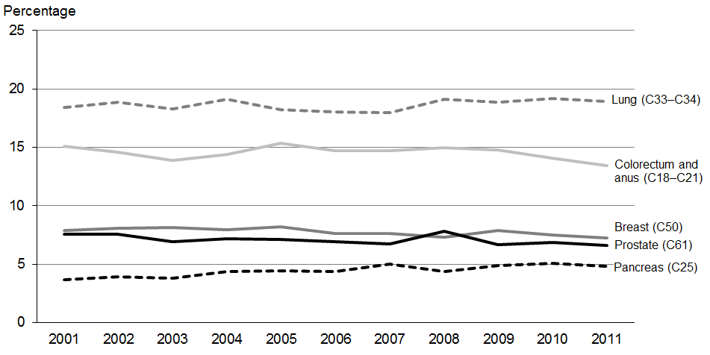
Source: New Zealand Mortality Collection

Lung cancer had the highest rate of cancer death for both sexes. Females experienced lower mortality rates for all sites in Figure 4, with the exception of breast cancer. Table 7 shows mortality rates for the most common causes of cancer death for each sex in 2011.

Table 7: Numbers and age-standardised rates of the most common causes of cancer death for males and females, 2011
Male |  |  | Female
Cancer (ICD code) | Number | Rate  (per 100,000) | Cancer (ICD code) | Number | Rate  (per 100,000)
Lung (C33–C34) | 909 | 28.0 | Lung (C33–C34) | 773 | 21.2
Colorectum and anus (C18–C21) | 602 | 18.4 | Breast (C50) | 636 | 18.3
Prostate (C61) | 585 | 16.5 | Colorectum and anus (C18–C21) | 589 | 14.2
Melanoma (C43) | 243 | 7.8 | Pancreas (C25) | 210 | 5.5
Pancreas (C25) | 219 | 6.8 | Ovary (C56) | 199 | 5.5
Source: New Zealand Mortality Collection

Cancer registrations and deaths, by age
Figures 5 and 6 show cancer registration and mortality rates, by sex and five-year age group, in 2011. Registration and death rates were higher for children aged 0─4 than those aged 5─9 years, after which both rates increased with age.

Figure 5: Age-specific rates of registrations and deaths from cancer for males, by age group, 2011
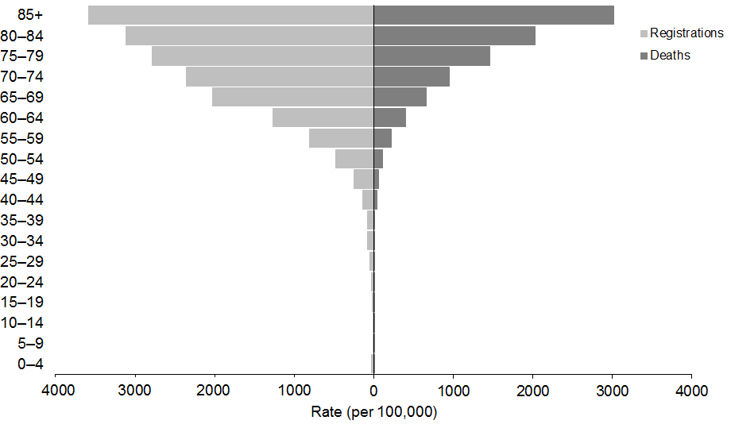
Source: New Zealand Cancer Registry and New Zealand Mortality Collection

Figure 6: Age-specific rates of registrations and deaths from cancer for females, by age group, 2011
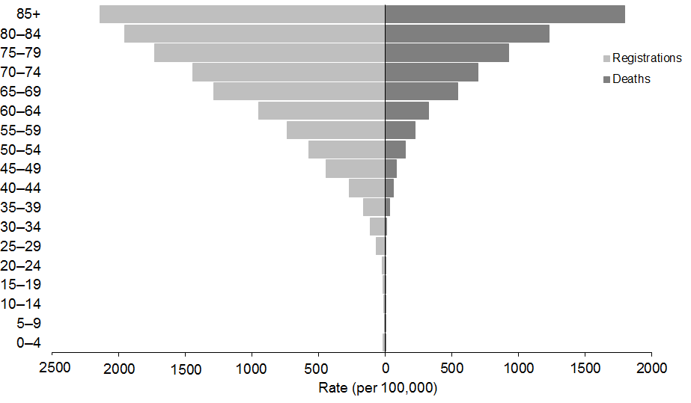
Source: New Zealand Cancer Registry and New Zealand Mortality Collection

Figure 7 shows the change in age-specific registration rates for males over time. Male cancer registrations in the 65–74 and 75+ years age groups showed a downward trend between 2001 and 2011. Rates in other age groups appeared relatively stable.

Figure 7: Male age-specific cancer registration rates, 2001–2011
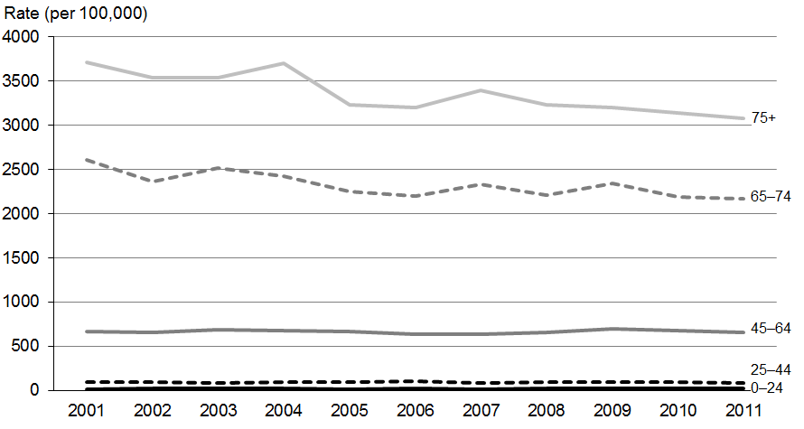
Source: New Zealand Cancer Registry
Note: The rate shown is the age-specific rate per 100,000 males.

Figure 8 shows age-specific registration rates for females between 2001 and 2011. In contrast to the male trends, female rates did not show any obvious downward trends by age group, and the rates of registrations for each group remained relatively constant.

Figure 8: Female age-specific cancer registration rates, 2001–2011
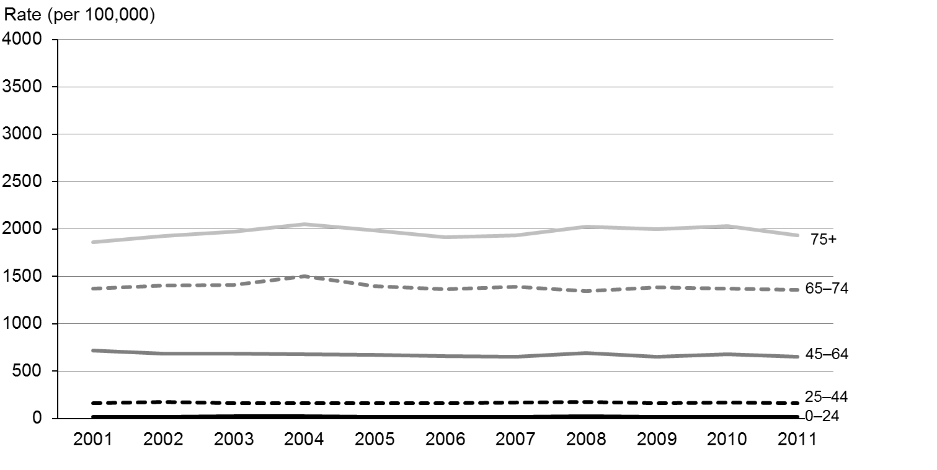
Source: New Zealand Cancer Registry
Note: The rate shown is the age-specific rate per 100,000 females.

Figures 9 and 10 show age-specific cancer mortality rates between 2001 and 2011 for males and females. As with registrations, mortality rates increased with age. Mortality rates for males in all age groups showed a general downward trend over time, although the rate was more variable for those aged 75 years and over (Figure 9). Female rates also slightly decreased for all age groups except the 75+ group, which increased slightly (Figure 10). The overall cancer mortality rates fell by 18.4% and 9.7% in males and females, respectively, between 2001 and 2011 (see Table 4).

Figure 9: Male age-specific cancer mortality rates, 2001–2011
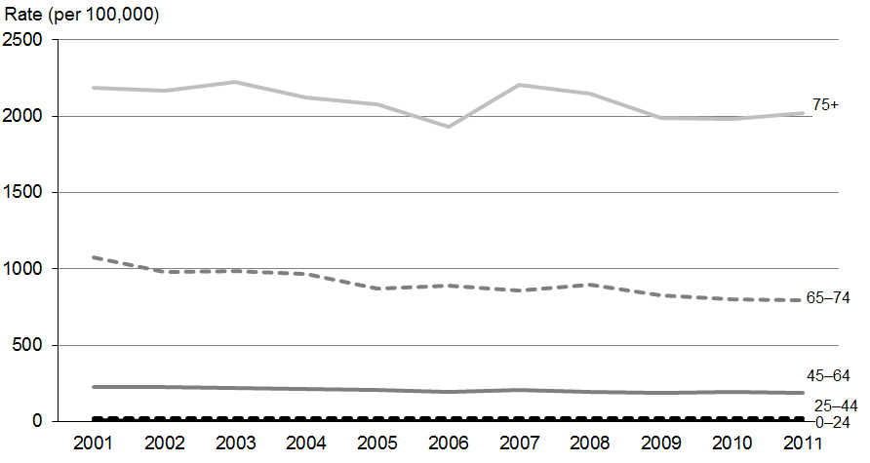
Source: New Zealand Mortality Collection
Note: The rate shown is the age-specific rate per 100,000 males.

Figure 10: Female age-specific cancer mortality rates, 2001–2011
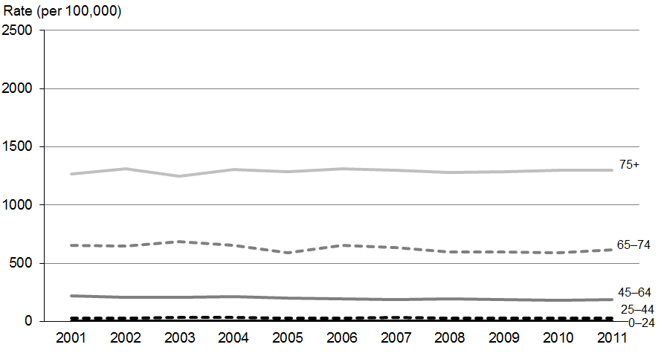
Source: New Zealand Mortality Collection
Note: The rate shown is the age-specific rate per 100,000 females.

Cancer registrations and deaths in people aged 0─24 years
People in the 0–24 years age group accounted for 1.3% of all cancer registrations in 2011 (274 registrations, comprising 150 males and 124 females).

Leukaemia was the most commonly registered cancer for males, followed by testicular cancer (Figure 11). For females, leukaemia, followed by melanoma, was the most commonly registered cancer.

Figure 11: The most common cancer registrations for males and females aged 0–24 years, 2011
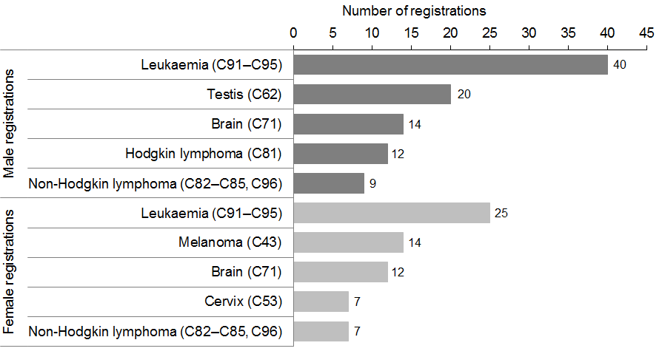
Source: New Zealand Cancer Registry

In 2011 there were 52 deaths from cancer among children and youth (29 males and 23 females), accounting for 0.6% of all deaths from cancer.

Brain and leukaemia cancers caused the most cancer deaths in males and females aged
0–24 years in 2011 (Figure 12).

Figure 12: The most common causes of death from cancer for males and females aged
0–24 years, 2011
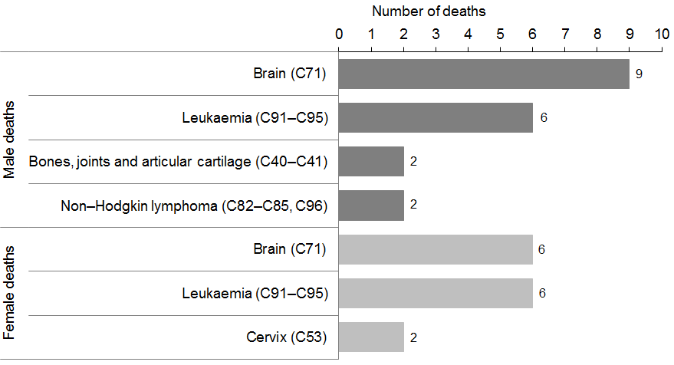
Source: New Zealand Mortality Collection

Cancer registrations and deaths in people aged 25─44 years
In 2011, 6.9% of all cancers were registered in the 25–44 years age group (493 male and 957 female registrations). The age-specific rate for cancer registrations for males in this age group (87.2 per 100,000) was much lower than the female rate (158.2 per 100,000).

The most common male registration in this age group was for melanoma, followed by testicular cancer (Figure 13). For females, breast cancer accounted for 332 registrations, and was the most commonly registered cancer in this age group. Melanoma was the second most common.

Figure 13: The most common cancer registrations for males and females aged 25–44 years, 2011
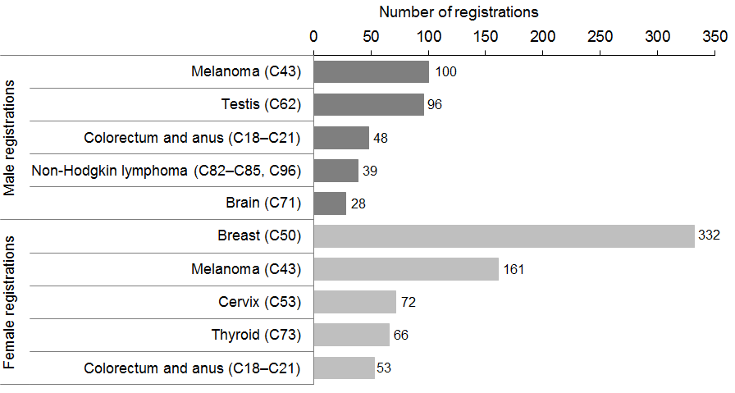
Source: New Zealand Cancer Registry

In 2011, 3.2% of all deaths from cancer (115 male and 169 female) were recorded in the
25–44 years age group. The age-specific cancer mortality rate for males in this age group was 20.3 per 100,000; the corresponding rate for females was 27.9 per 100,000.

Brain cancer caused the most deaths in males (21 deaths), followed by melanoma. For females, the most common cause of cancer death was breast cancer (52 deaths), which greatly exceeded the number of deaths from other cancers.

Figure 14: The most common causes of death from cancer for males and females aged
25–44 years, 2011
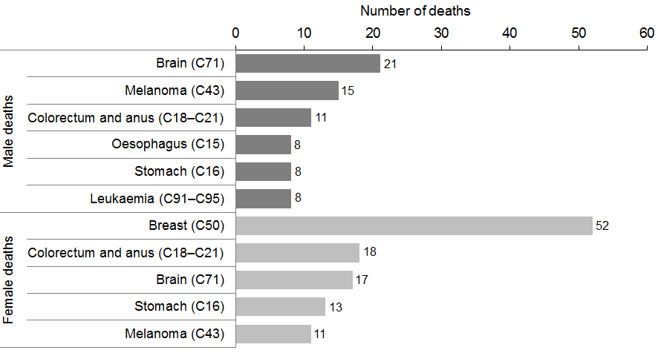
Source: New Zealand Mortality Collection

Cancer registrations and deaths in people aged 45─64 years
The 45–64 years age group accounted for 34.7% of all cancer registrations (3579 males and 3719 females) in 2011. The age-specific registration rate for males in this age group was 660.3 registrations per 100,000 males, and 652.8 per 100,000 for females.

The most common cancer registered for males in this age group was prostate cancer, and for females was breast cancer. Melanoma was the second most common registration in both sexes.

Figure 15: The most common cancer registrations for males and females aged 45–64 years, 2011
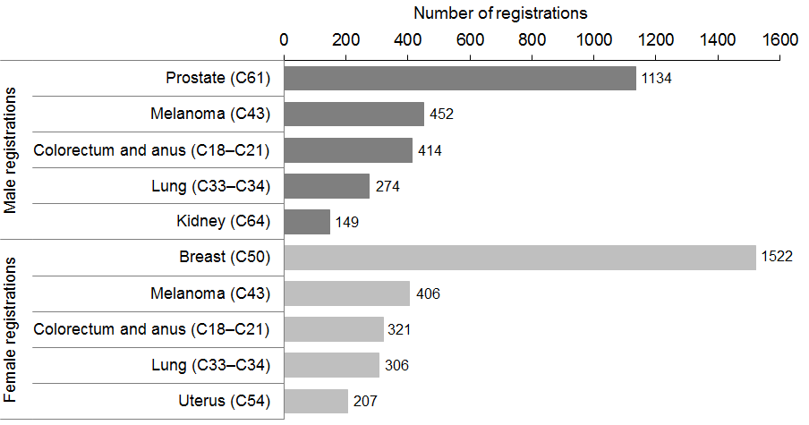
Source: New Zealand Cancer Registry

There were 2062 deaths from cancer in this age group (1011 males and 1051 females) in 2011, equating to 23.2% of all cancer deaths. This age group had age-specific cancer mortality rates of 186.5 and 184.5 per 100,000 for males and females, respectively.

Figure 16 shows that, for males in this age group, lung cancer was the most common cause of death from cancer, followed by colorectal cancer. For females, breast cancer was the most common cancer death, closely followed by lung cancer.

Figure 16: The most common causes of death from cancer for males and females aged
45–64 years, 2011
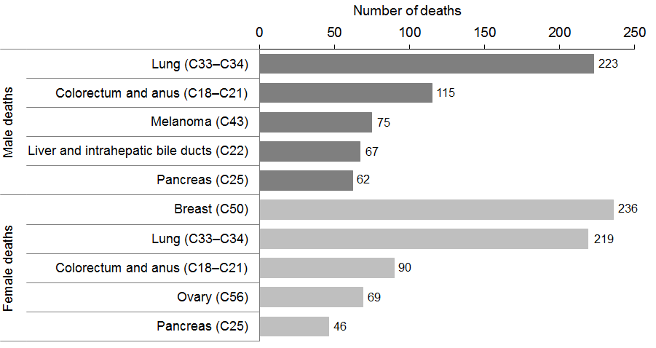
Source: New Zealand Mortality Collection

Cancer registrations and deaths in people aged 65─74 years
The 65–74 years age group accounted for 27.1% of all new cancer registrations in 2011 (3430 males and 2285 females). Within this age group, males had an age-specific registration rate of 2172.3 per 100,000; the female rate was 1357.6 per 100,000.

The most commonly registered cancer was prostate cancer for males and breast cancer for females. Colorectal cancer was the second most common registration for both sexes.

Figure 17: The most common cancer registrations for males and females aged 65–74 years, 2011
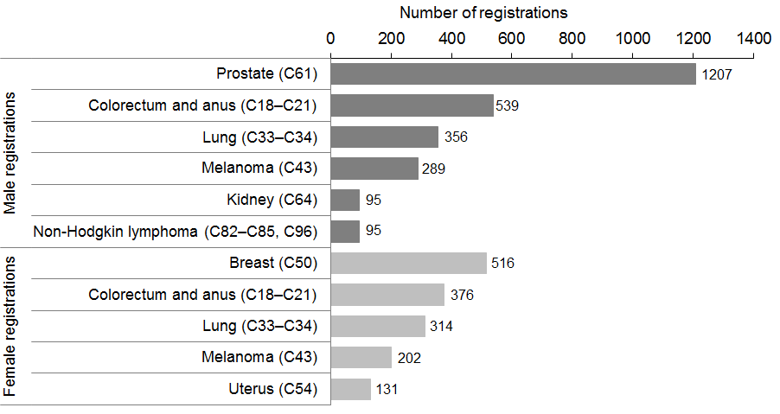
Source: New Zealand Cancer Registry

The 65–74 years age group accounted for 25.8% of all deaths from cancer in 2011, with 2296 deaths (1256 males and 1040 females). The age-specific cancer mortality rates for this age group were 795.4 per 100,000 for males and 617.9 per 100,000 for females.

Figure 18 shows that lung and colorectal cancer were the most common causes of death from cancer in this age group in 2011 for both males and females.

Figure 18: The most common causes of death from cancer for males and females aged
65–74 years, 2011
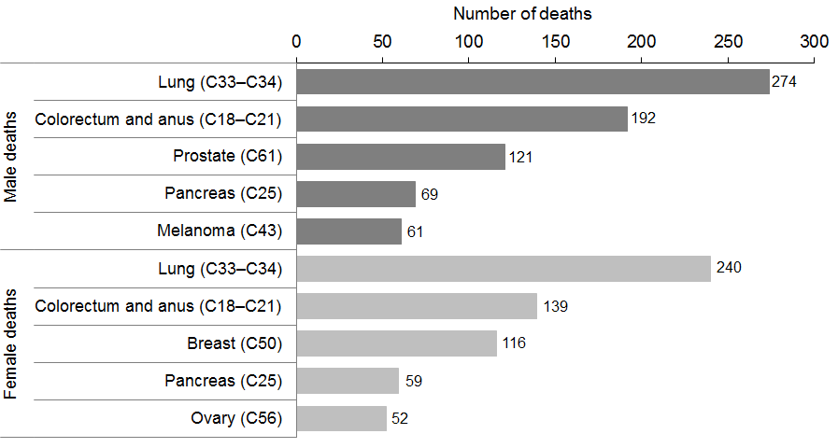
Source: New Zealand Mortality Collection

Cancer registrations and deaths in people aged 75 years and over
The 75 years and over age group accounted for 30.0% of all new cancer registrations in 2011 (3405 males and 2908 females). The age-standardised registration rate was 3073.4 per 100,000 for males and 1928.9 per 100,000 for females.

The most common cancer registered for males in this age group was prostate cancer, followed by colorectal cancer. For women, the most common registration was for colorectal cancer, followed by breast cancer.

Figure 19: The most common cancer registrations for males and females aged 75 years and over, 2011
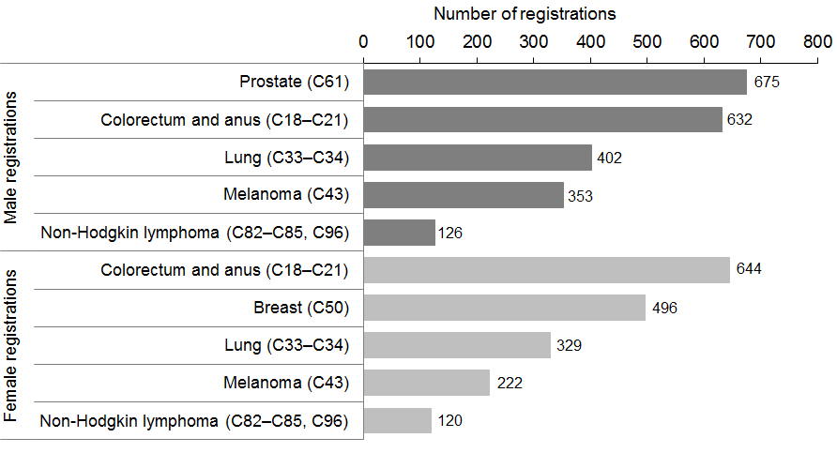
Source: New Zealand Cancer Registry

This age group accounted for 47.2% of all deaths from cancer. There were 4197 deaths (2239 male and 1958 female) in 2011.

Prostate cancer and colorectal cancer were the most common causes of cancer death among males and females, respectively. Lung cancer was the next most common cause in both sexes (Figure 20).

Males in this age group had an age-specific cancer mortality rate of 2020.9 deaths per 100,000; the female rate was 1298.8 per 100,000.

Figure 20: The most common causes of death from cancer for males and females aged 75 years and over, 2011
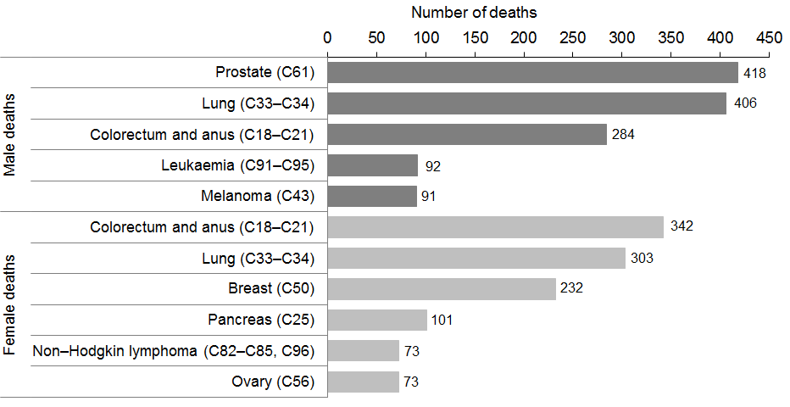
Source: New Zealand Mortality Collection

Cancer registrations and deaths, by ethnic group

Registrations
In 2009 the New Zealand Cancer Registry adjusted its approach to the collection of ethnicity information in order to rectify a perceived undercount within some ethnicities. The changes were applied to information from 1989 onwards, and resulted in some significant changes in the proportions of cancer registrations allocated to particular ethnicities. Cancer: New registrations and deaths 2006 (Ministry of Health 2011a) was the first publication to use this approach; it has since been applied to all publications in the series. Registration information published prior to 2009 cannot be directly compared with information in this document.

For cancer registrations, ethnicity information is based on self-identification. Individuals may have selected up to three ethnicities to which they felt they belonged. This publication uses ‘prioritised ethnicity’, by which each person represented in the data is allocated to a single ethnicity using a priority system: Māori>Pacific>Asian>European/other (see ‘Explanatory notes’). In this publication, ethnicity information has been categorised as either Māori or non-Māori.

In 2011 ethnicity was not recorded for 702 registrations (3.3%). The proportion of registrations lacking ethnicity data was higher for some types of cancer; for example, prostate cancer (249 cases: 8.2% of all prostate registrations) and melanoma (172 cases: 7.8% of all melanoma registrations). It should be noted that, typically, a number of patients with these cancers are treated outside of secondary care, and fewer interactions with secondary care reduce the chance of a patient’s ethnicity being recorded.

Within this publication, registrations without an ethnic identification have been included in the non-Māori group.

Deaths
Ethnicity data used for deaths is sourced from Births, Deaths and Marriages. Ethnicity data is provided to funeral directors by family members or others assisting with a death registration and recorded on the BDM28 ‘Notification of Deaths for Registration’ form.

There have been no changes with regard to the collection of ethnicity information relating to deaths from cancer.

All records of deaths from cancer in 2011 included ethnicity.

For more information and a discussion of the issues associated with ethnicity coding, see the section on ‘Ethnicity’ in ‘Explanatory notes’.

Cancer registrations, by ethnic group
In 2011 there were 1991 cancer registrations for Māori (859 males and 1132 females) and 19,059 for non-Māori (10,198 males and 8861 females) (see Table 8).

Figure 21 shows age-standardised cancer registration rates for Māori and non-Māori between 2001 and 2011. In 2011 the rate for Māori was 409.8 per 100,000 population, which was 20.9% higher than the rate for non-Māori (324.3 per 100,000 non-Māori population). Māori registration rates were consistently significantly higher than non-Māori rates between 2002 and 2011.

Between 2001 and 2011 the Māori registration rate was variable and showed no clear trend. Non-Māori rates showed less variability over time than Māori rates, and decreased by 9.2% over this period. Smaller numbers for Māori likely contributed to the greater variation.

Figure 21: Cancer registration rates, by ethnic group, 2001–2011
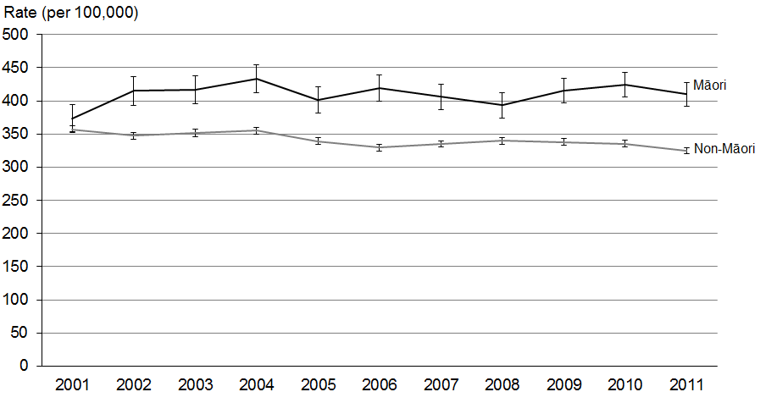
Source: New Zealand Cancer Registry
Note: 95% confidence intervals.

In 2011 the Māori male age-standardised registration rate was 391.8 per 100,000; over time this rate was much more variable than the non-Māori male rate (360.8 in 2011).

Figure 22: Male cancer registration rates, by ethnic group, 2001–2011
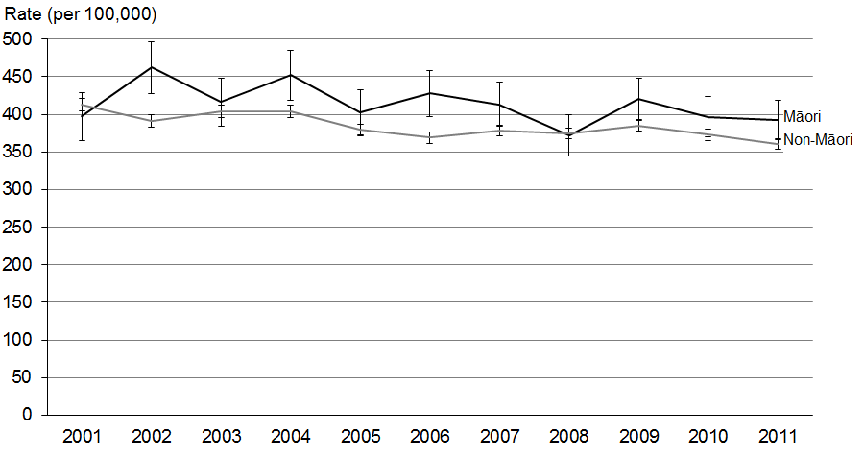
Source: New Zealand Cancer Registry
Note: 95% confidence intervals.
In 2011 the Māori female age-standardised registration rate was 426.5 per 100,000; this was 45.3% higher than the non-Māori rate of 293.6. The confidence intervals in Figure 23 show that, from 2001 to 2011, Māori females had significantly higher registration rates than non-Māori females. Females had greater disparity between the Māori and non-Māori rates than males.

Figure 23: Female cancer registration rates, by ethnic group, 2001–2011
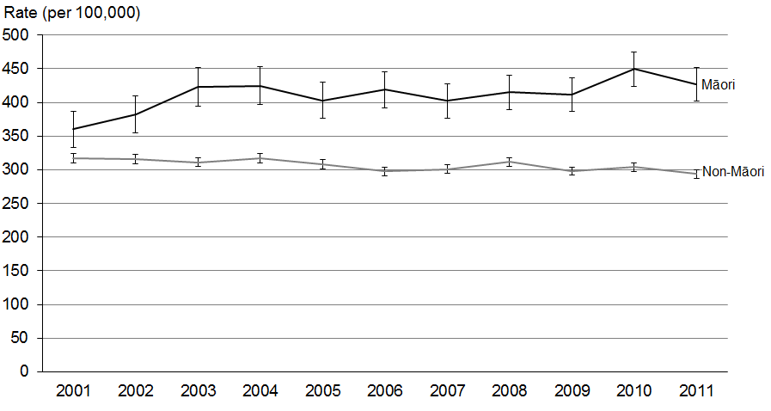
Source: New Zealand Cancer Registry
Note: 95% confidence intervals.

Figures 24 and 25 show the most common cancers registered in males and females presented by ethnic group (Māori and non-Māori), expressed as age-standardised rates of registration. Further analyses of registration rates by ethnic group for individual cancers can be found in ‘Selected cancers’.

Figure 24: Most commonly registered cancers for males, by ethnic group, 2011
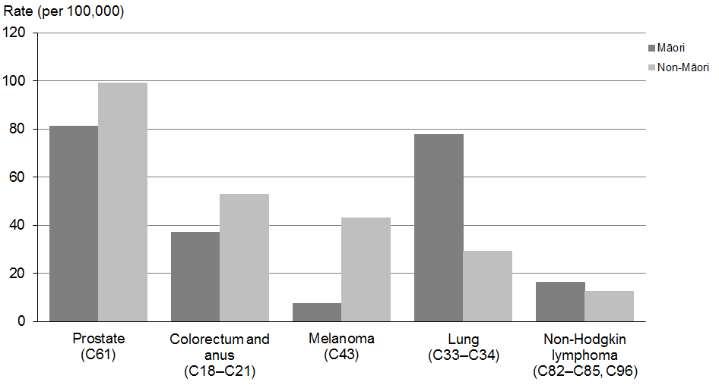
Source: New Zealand Cancer Registry

Figure 25: Most commonly registered cancers for females, by ethnic group, 2011
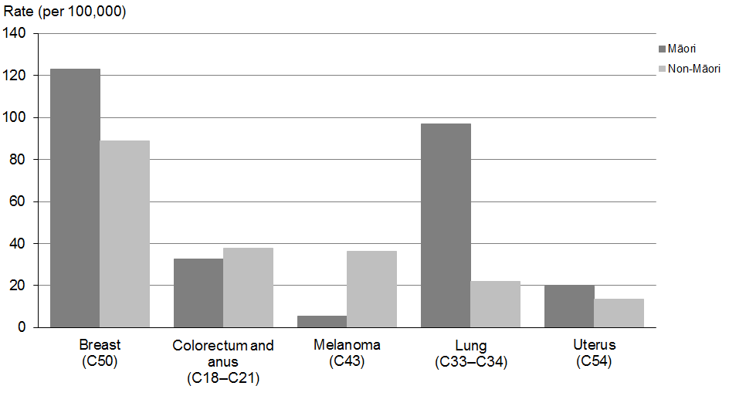
Source: New Zealand Cancer Registry

Table 8: Number and age-standardised rate of registration for selected cancers, by ethnic group and sex, 2011
Cancer (ICD code) | Males |  |  |  | Females |  |  |  | Total
 | Māori |  | Non-Māori |  | Māori |  | Non-Māori |  | Māori |  | Non-Māori
 | No. | Rate | No. | Rate | No. | Rate | No. | Rate | No. | Rate | No. | Rate
All cancers (C00–C96 and D45–D47) | 859 | 391.8 | 10,198 | 360.8 | 1132 | 426.5 | 8861 | 293.6 | 1991 | 409.8 | 19,059 | 324.3
Oesophagus (C15) | 21 | 9.6 | 164 | 5.5 | 7 | 2.8 | 74 | 2.0 | 28 | 6.0 | 238 | 3.7
Stomach (C16) | 41 | 18.6 | 207 | 7.1 | 40 | 14.9 | 103 | 3.2 | 81 | 16.4 | 310 | 5.0
Colorectum and anus (C18-C21) | 81 | 37.1 | 1554 | 52.8 | 78 | 32.6 | 1317 | 37.8 | 159 | 34.9 | 2871 | 44.9
Liver and intrahepatic bile ducts (C22) | 42 | 17.4 | 188 | 6.8 | 15 | 5.5 | 82 | 2.2 | 57 | 11.1 | 270 | 4.4
Pancreas (C25) | 18 | 9.0 | 210 | 6.9 | 28 | 11.2 | 198 | 5.5 | 46 | 10.2 | 408 | 6.2
Lung (C33–C34) | 163 | 77.9 | 883 | 29.3 | 237 | 96.8 | 733 | 21.9 | 400 | 87.8 | 1616 | 25.2
Melanoma (C43) | 16 | 7.5 | 1183 | 43.1 | 14 | 5.4 | 991 | 36.2 | 30 | 6.3 | 2174 | 39.2
Breast (C50) | 2 | 0.8 | 25 | 0.9 | 350 | 122.9 | 2517 | 88.9 | 352 | 66.0 | 2542 | 46.6
Cervix (C53) | ... | ... | ... | ... | 36 | 12.3 | 129 | 5.9 | 36 | ... | 129 | ...
Uterus (C54) | ... | ... | ... | ... | 53 | 19.8 | 394 | 13.6 | 53 | ... | 394 | ...
Ovary (C56) | ... | ... | ... | ... | 32 | 11.7 | 244 | 8.2 | 32 | ... | 244 | ...
Prostate (C61) | 168 | 81.4 | 2855 | 99.0 | ... | ... | ... | ... | 168 | ... | 2855 | ...
Testis (C62) | 30 | 10.2 | 121 | 6.7 | ... | ... | ... | ... | 30 | ... | 121 | ...
Kidney, except renal pelvis (C64) | 41 | 18.2 | 298 | 10.9 | 18 | 6.9 | 151 | 5.2 | 59 | 12.3 | 449 | 7.9
Bladder (C67) | 14 | 7.0 | 218 | 7.1 | 12 | 5.1 | 80 | 2.0 | 26 | 6.0 | 298 | 4.4
Brain (C71) | 15 | 6.0 | 165 | 6.9 | 5 | 1.6 | 110 | 4.1 | 20 | 3.6 | 275 | 5.5
Thyroid gland (C73) | 13 | 5.2 | 60 | 2.7 | 33 | 10.7 | 158 | 6.7 | 46 | 8.1 | 218 | 4.8
Non-Hodgkin lymphoma (C82–C85, C96) | 35 | 16.2 | 344 | 12.7 | 26 | 10.2 | 324 | 10.6 | 61 | 12.8 | 668 | 11.6
Multiple myeloma and malignant plasma cell neoplasms (C90) | 24 | 11.8 | 158 | 5.3 | 15 | 5.7 | 100 | 2.9 | 39 | 8.4 | 258 | 4.0
Leukaemia (C91–C95) | 31 | 12.1 | 297 | 11.6 | 28 | 10.1 | 207 | 7.5 | 59 | 11.0 | 504 | 9.5
Chronic myeloproliferative disorders and myelodysplastic syndromes (D45–D47) | 13 | 6.1 | 181 | 5.9 | 5 | 2.4 | 117 | 3.2 | 18 | 4.2 | 298 | 4.4
All other cancers | 91 | ... | 1087 | ... | 100 | ... | 832 | ... | 191 | ... | 1919 | ...
Source: New Zealand Cancer Registry
No.= number; ... = Not applicable

Deaths from cancer, by ethnic group
In 2011 there were 939 Māori deaths from cancer (428 males and 511 females) and 7952 non-Māori deaths (4222 males and 3730 females) (see Table 9).

Figure 26 shows age-standardised cancer mortality rates for Māori and non-Māori between 2001 and 2011. Māori rates were significantly higher than non-Māori rates during this period. In 2011 the Māori rate (204.6 deaths from cancer per 100,000 population) was 72.1% higher than the non-Māori rate (118.9 per 100,000 population).

Non-Māori cancer mortality rates decreased by 14.3% between 2001 and 2011, while Māori cancer rates decreased by 10.3%.

Figure 26: Cancer mortality rates, by ethnic group, 2001–2011
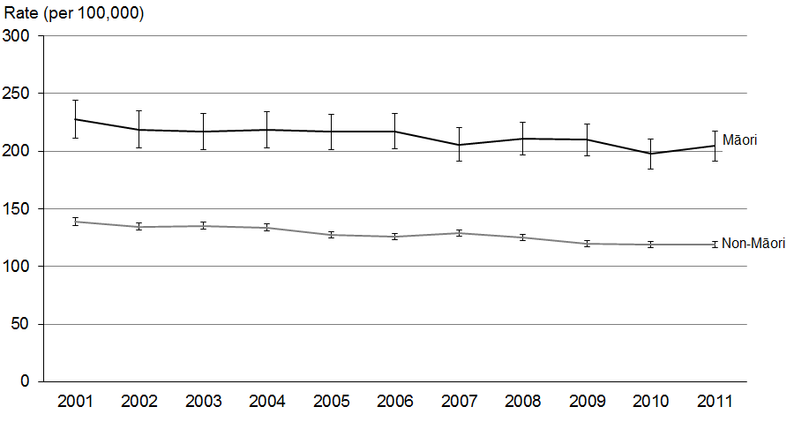
Source: New Zealand Mortality Collection
Note 1: 95% confidence intervals.
Note 2: ICD-10 codes D45–D47 are included from 2003 onwards: see ‘Explanatory notes’.

In 2011 the Māori male age-standardised cancer mortality rate was 206.4 per 100,000 population, which was 49.9% higher than the non-Māori rate of 137.7 per 100,000 (Figure 27). This disparity between ethnic groups remained largely unchanged from 2001 to 2011, although both groups showed an overall downward trend over this time. The ethnic disparity for males was more pronounced for mortality than it was for registration rates (see Figures 27 and 22 respectively).

Figure 27: Male cancer mortality rates, by ethnic group, 2001–2011
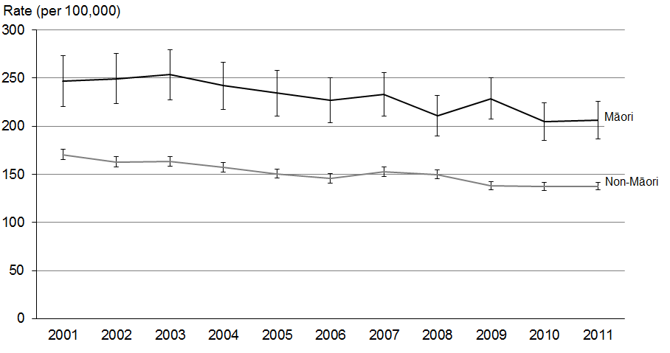
Source: New Zealand Mortality Collection
Note 1: 95% confidence intervals.
Note 2: ICD-10 codes D45–D47 are included from 2003 onwards: see ‘Explanatory notes’.

In 2011 the Māori female age-standardised cancer mortality rate was 95.8% higher than the non-Māori female rate (204.0 compared with 104.2 per 100,000 population). This disparity between ethnic groups remained relatively unchanged between 2001 and 2011.

Figure 28: Female cancer mortality rates, by ethnic group, 2001–2011
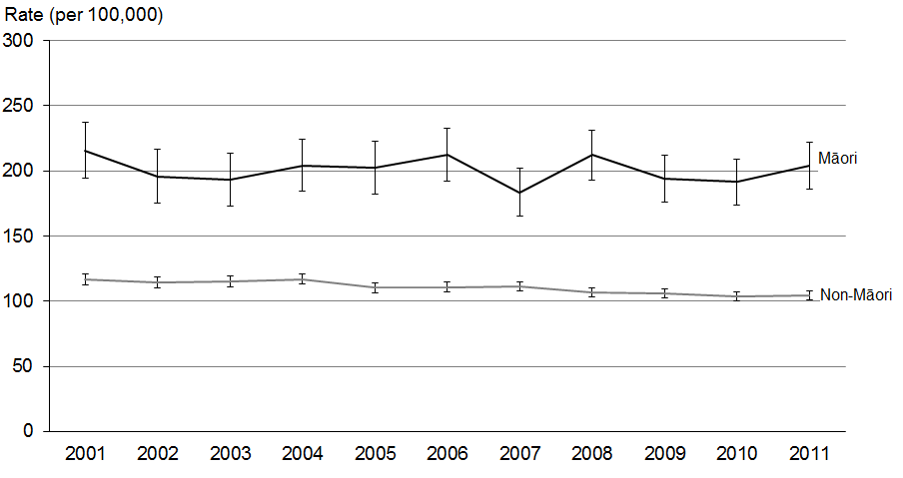
Source: New Zealand Mortality Collection
Note 1: 95% confidence intervals.
Note 2: ICD-10 codes D45–D47 are included from 2003 onwards: see ‘Explanatory notes’.

Figures 29 and 30 show the most common cancers causing death (using age-standardised rates) for males and females, by ethnic group. Māori experienced higher rates than non-Māori for all of the causes shown, with the exception of pancreatic cancer and melanoma in males. Further analysis of mortality rates by ethnic group for individual cancers can be found in ‘Selected cancers’.

Figure 29: Most common causes of death from cancer for males, by ethnic group, 2011
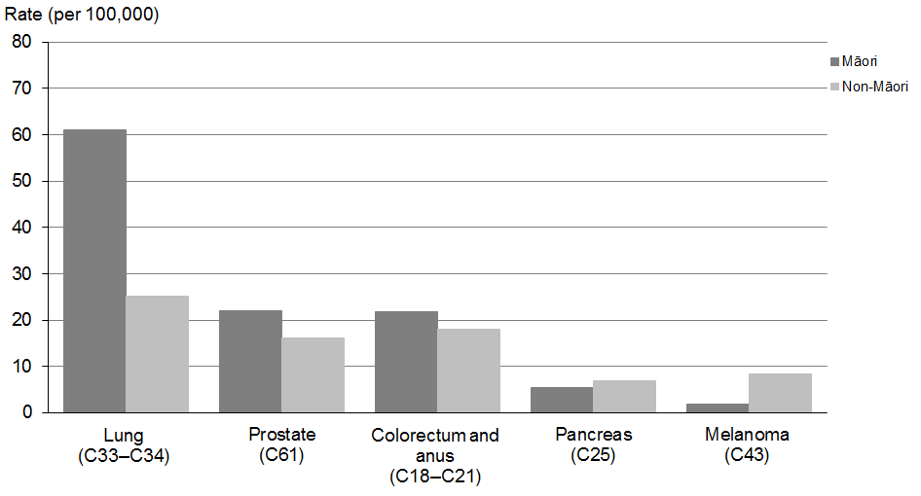
Source: New Zealand Mortality Collection

Figure 30: Most common causes of death from cancer for females, by ethnic group, 2011
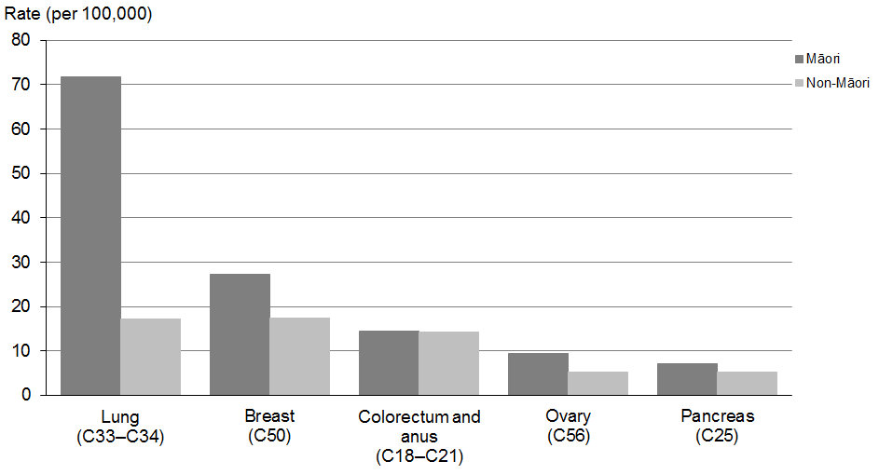
Source: New Zealand Mortality Collection

Table 9: Numbers and age-standardised rate of mortality for selected cancers, by ethnic group and sex, 2011
Cancer (ICD code) | Males |  |  |  | Females |  |  |  | Total
 | Māori |  | Non-Māori |  | Māori |  | Non-Māori |  | Māori |  | Non-Māori
 | No. | Rate | No. | Rate | No. | Rate | No. | Rate | No. | Rate | No. | Rate
All cancers (C00–C96 and D45–D47) | 428 | 206.4 | 4222 | 137.7 | 511 | 204.0 | 3730 | 104.2 | 939 | 204.6 | 7952 | 118.9
Oesophagus (C15) | 16 | 7.7 | 158 | 5.3 | 10 | 4.2 | 78 | 2.1 | 26 | 5.8 | 236 | 3.6
Stomach (C16) | 21 | 10.9 | 172 | 5.7 | 20 | 6.9 | 83 | 2.5 | 41 | 8.6 | 255 | 4.0
Colorectum and anus  (C18–C21) | 46 | 21.9 | 556 | 18.0 | 33 | 14.4 | 556 | 14.1 | 79 | 18.2 | 1112 | 15.9
Liver and intrahepatic bile ducts (C22) | 31 | 14.0 | 133 | 4.6 | 9 | 3.3 | 67 | 1.8 | 40 | 8.2 | 200 | 3.1
Pancreas (C25) | 12 | 5.5 | 207 | 6.9 | 18 | 7.1 | 192 | 5.2 | 30 | 6.3 | 399 | 6.0
Lung (C33–C34) | 129 | 61.1 | 780 | 25.3 | 174 | 71.7 | 599 | 17.1 | 303 | 66.8 | 1379 | 20.8
Melanoma (C43) | 3 | 1.8 | 240 | 8.3 | 1 | 0.3 | 115 | 3.4 | 4 | 0.9 | 355 | 5.7
Breast (C50) | 0 | 0.0 | 5 | 0.2 | 72 | 27.3 | 564 | 17.4 | 72 | 14.7 | 569 | 9.3
Cervix (C53) | ... | ... | ... | ... | 14 | 5.4 | 39 | 1.4 | 14 | ... | 39 | ...
Uterus (C54) | ... | ... | ... | ... | 16 | 6.7 | 78 | 2.3 | 16 | ... | 78 | ...
Ovary (C56) | ... | ... | ... | ... | 24 | 9.4 | 175 | 5.2 | 24 | ... | 175 | ...
Prostate (C61) | 37 | 22.1 | 548 | 16.2 | ... | ... | ... | ... | 37 | ... | 548 | ...
Testis (C62) | 0 | 0.0 | 1 | 0.1 | ... | ... | ... | ... | 0 | 0.0 | 1 | ...
Kidney, except renal pelvis (C64) | 11 | 4.6 | 99 | 3.3 | 8 | 3.1 | 74 | 2.1 | 19 | 3.8 | 173 | 2.7
Bladder (C67) | 5 | 2.7 | 121 | 3.8 | 4 | 1.8 | 70 | 1.6 | 9 | 2.2 | 191 | 2.6
Brain (C71) | 17 | 7.2 | 119 | 4.8 | 11 | 4.0 | 102 | 3.6 | 28 | 5.5 | 221 | 4.2
Thyroid gland (C73) |  |  | 13 | 0.4 | 4 | 1.7 | 15 | 0.4 | 4 | 1.0 | 28 | 0.4
Non-Hodgkin lymphoma (C82–C85, C96) | 7 | 3.9 | 148 | 4.8 | 9 | 3.7 | 124 | 3.3 | 16 | 3.7 | 272 | 4.0
Multiple myeloma and malignant plasma cell neoplasms (C90) | 14 | 7.1 | 101 | 3.3 | 7 | 2.7 | 70 | 1.7 | 21 | 4.7 | 171 | 2.4
Leukaemia (C91–C95) | 17 | 8.0 | 174 | 5.9 | 9 | 3.3 | 118 | 3.4 | 26 | 5.4 | 292 | 4.5
Chronic myeloproliferative disorders and myelodysplastic syndromes (D45–D47) | 1 | 0.7 | 52 | 1.6 | 3 | 1.2 | 49 | 1.0 | 4 | 1.0 | 101 | 1.3
All other cancers | 61 | ... | 595 | ... | 65 | ... | 562 | ... | 126 | ... | 1157 | ...
Source: New Zealand Mortality Collection.
No.= number; ... = Not applicable.

Cancer registrations and deaths, by deprivation quintile
Socioeconomic deprivation has been associated with a number of adverse health outcomes. From the social inequalities literature it is clear that those who are most deprived generally experience poorer health (Benzeval et al 2001; White et al 2008).

This publication presents cancer registration and mortality rates by deprivation quintile of residence according to the New Zealand Deprivation Index 2006 (NZDep 2006). Note that this is an area unit measurement, so it is not necessarily a good proxy for individual level socioeconomic status. See ‘Explanatory notes’ for more information.

Figure 31 shows total cancer registration and mortality rates by deprivation quintiles, where quintile 1 is the least deprived and quintile 5 is the most deprived. In 2011, rates for cancer registrations and deaths from cancer displayed the same pattern: those residing in more deprived quintiles experienced higher rates of both registration and death. Registration and mortality rates in quintiles 1─3 were significantly lower than rates in quintiles 4 and 5, and furthermore quintile 3 rates were significantly higher than quintiles 1 and 2.

Figure 31: Cancer registration and mortality rates, by deprivation quintile, 2011
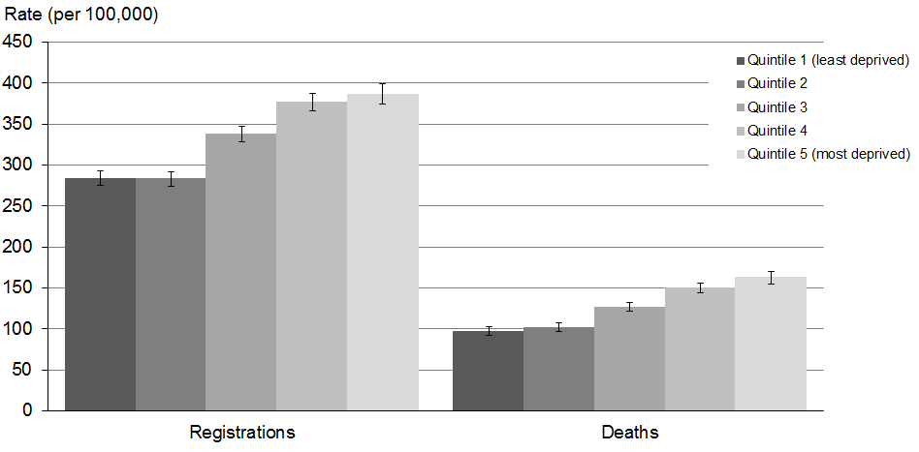
Source: New Zealand Cancer Registry and New Zealand Mortality Collection
Note 1: The rate shown is the age-standardised rate per 100,000 quintile population; 95% confidence intervals.
Note 2: There were 65 registrations (0.3%) and 24 deaths (0.3%) with no deprivation quintile information.

Cancer registrations, by deprivation quintile
Figure 32 shows registration rates for the most common male cancers, presented by deprivation quintile.

Lung cancer registration rates showed increased registrations are associated with areas of higher deprivation. In 2011 male lung cancer rates in the most deprived areas were 3.2 times higher than those in the least deprived areas.

Prostate and colorectal cancer registration rates were highest in deprivation quintile 4, followed by quintile 5.

Melanoma showed the opposite trend; registration rates were significantly higher in quintile 1 than 5.

Figure 32: Registration rates for the most common male cancers, by deprivation quintile, 2011
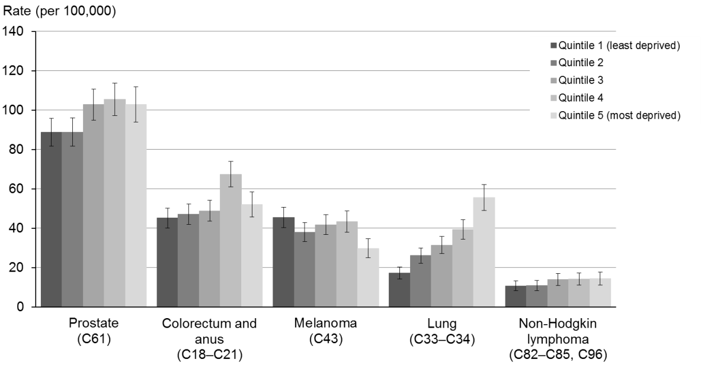
Source: New Zealand Cancer Registry
Note: The rate shown is the age-standardised rate per 100,000 quintile population; 95% confidence intervals.

Figure 33 shows rates for the most common female cancers in 2011, by deprivation quintile. Breast, lung and uterine cancer rates showed an increased trend with increasing deprivation, except quintile 2 rates were lower than quintile 1. For lung cancer, quintile 5 registration rates were 3.3 times higher than the lowest registration rate in quintile 2.

Registration rates for breast cancer were significantly higher in deprivation quintiles 3 to 5 compared to rates for quintiles 1 and 2. Similarly, uterine cancer rates were significantly higher in deprivation quintile 5 compared to quintile 1.

There was no significant difference in registration rates for colorectal cancer between deprivation quintiles. Female melanoma registration rates showed a similar trend to males.

Figure 33: Registration rates for the most common female cancers, by deprivation quintile, 2011
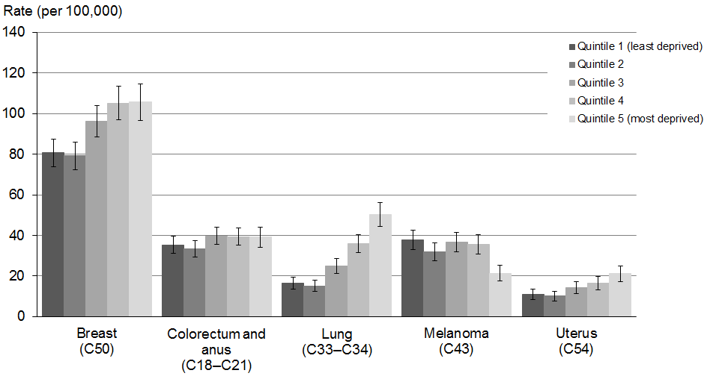
Source: New Zealand Cancer Registry
Note: The rate shown is the age-standardised rate per 100,000 quintile population; 95% confidence intervals.

Deaths from cancer, by deprivation quintile
Figure 34 shows the most common causes of cancer death for males in 2011, with age-standardised rates broken down by deprivation quintile. The relationship between deprivation and cancer mortality rates was most pronounced for lung cancer: male lung cancer rates in quintile 5 were nearly two and a half times higher than those in quintile 1. Mortality rates for prostate, colorectal and pancreatic cancer showed a general increase with deprivation, although the difference between quintiles was much smaller. There was no obvious relationship between mortality rate and deprivation for melanoma.

Figure 34: Mortality rates for the most common male cancers, by deprivation quintile, 2011
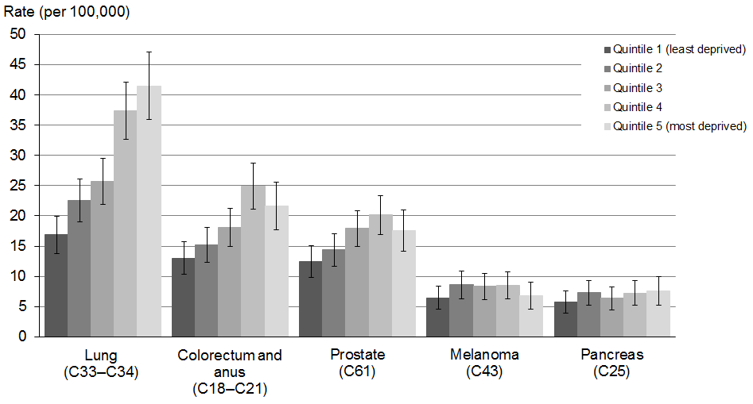
Source: New Zealand Mortality Collection
Note: The rate shown is the age-standardised rate per 100,000 quintile population; 95% confidence intervals.

Figure 35 shows female cancer mortality rates by deprivation quintile. Rates of lung cancer mortality in females, as in males, showed a strong relationship with deprivation; females in the most deprived areas had mortality rates 2.5 times higher than those in the least deprived areas.

There was a general increase but more varied pattern in breast and colorectal cancer mortality rates with deprivation. Nonetheless, mortality rates were still significantly different between quintiles 1 and 5 for breast cancer.

Figure 35: Mortality rates for the most common female cancers, by deprivation quintile, 2011
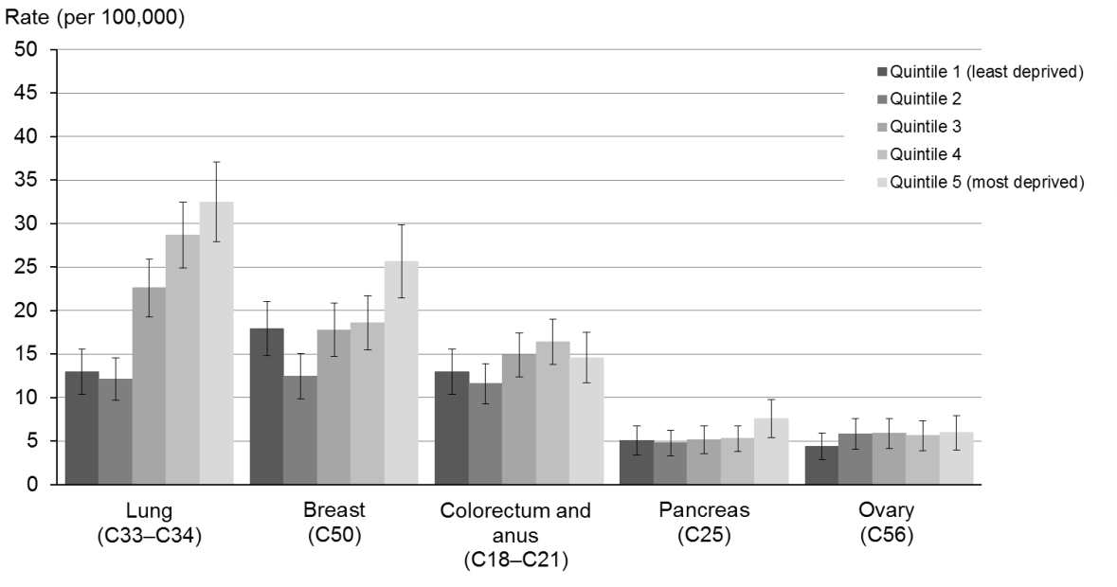
Source: New Zealand Mortality Collection
Note: The rate shown is the age-standardised rate per 100,000 quintile population; 95% confidence intervals.

Selected cancers: trends in registrations and deaths

Bladder cancer (ICD code C67)

Registrations and deaths
- Bladder cancer was the 13th most common cancer registration and cause of death from cancer in 2011.
- Males had higher rates of bladder cancer than females for both registrations and deaths: in 2011 registration rates were more than three times higher in males than females.

Ethnic group
- The number of Māori registrations and deaths for bladder cancer are small (26 registrations and 9 deaths in 2011) and therefore rates between ethnicities should be compared with caution.
- There were more pronounced differences in registration and mortality rates between Māori and non-Māori males than Māori and non-Māori females.

Trends over time
- Since 1 January 2005, superficial transitional cell carcinoma of the bladder has no longer been coded as an invasive cancer. This coding change resulted in a decrease in the number of bladder cancer registrations compared with previous years. It is therefore not appropriate to assess whether there were changes in registration rates for bladder cancer between 2001 and 2011.
- Registration rates remained relatively stable between 2005 and 2011; the total male rate decreased from 9.3 to 7.2 per 100,000, and the total female rate increased marginally from 2.2 to 2.3 per 100,000.
- Mortality rates from this cancer have not been affected by the coding change, as superficial transitional cell carcinoma of the bladder cannot be coded as an underlying cause of death. Figure 39 shows that mortality rates for this cancer were relatively stable between 2001 and 2011.

Table 10a: Numbers of registrations and deaths for bladder cancer, by sex and ethnic group, 2001–2011
 | Registrations |  |  |  |  |  | Deaths
 | Males |  |  | Females |  |  | Males |  |  | Females
 | Total | Māori | Non-Māori | Total | Māori | Non-Māori | Total | Māori | Non-Māori | Total | Māori | Non-Māori
2001 | 440 | 12 | 428 | 148 | 4 | 144 | 112 | 4 | 108 | 64 | 4 | 60
2002 | 427 | 8 | 419 | 160 | 8 | 152 | 128 | 4 | 124 | 56 | 4 | 52
2003 | 447 | 17 | 430 | 150 | 6 | 144 | 120 | 7 | 113 | 56 | 2 | 54
2004 | 448 | 18 | 430 | 156 | 9 | 147 | 124 | 3 | 121 | 56 | 4 | 52
2005 | 253 | 10 | 243 | 79 | 6 | 73 | 121 | 4 | 117 | 64 | 4 | 60
2006 | 240 | 7 | 233 | 80 | 4 | 76 | 146 | 8 | 138 | 51 | 2 | 49
2007 | 272 | 12 | 260 | 97 | 6 | 91 | 118 | 2 | 116 | 51 | 3 | 48
2008 | 238 | 11 | 227 | 119 | 8 | 111 | 134 | 3 | 131 | 66 | 4 | 62
2009 | 251 | 10 | 241 | 110 | 9 | 101 | 144 | 11 | 133 | 65 | 3 | 62
2010 | 286 | 14 | 272 | 103 | 9 | 94 | 126 | 2 | 124 | 49 | 2 | 47
2011 | 232 | 14 | 218 | 92 | 12 | 80 | 126 | 5 | 121 | 74 | 4 | 70
Source: New Zealand Cancer Registry and New Zealand Mortality Collection
Note: Prior to 1 January 2005, superficial transitional cell carcinoma of the bladder was registered as an invasive cancer; after this date this was no longer the case. This change has affected the number of recorded registrations of this cancer.

Table 10b: Age-standardised registration and mortality rates for bladder cancer, by sex and ethnic group, 2001–2011
 | Registration rate (per 100,000) |  |  |  |  |  | Mortality rate (per 100,000)
 | Males |  |  | Females |  |  | Males |  |  | Females
 | Total | Māori | Non-Māori | Total | Māori | Non-Māori | Total | Māori | Non-Māori | Total | Māori | Non-Māori
2001 | 18.3 | 8.9 | 18.8 | 4.8 | 2.3 | 5.0 | 4.6 | 5.3 | 4.6 | 1.7 | 2.7 | 1.6
2002 | 17.4 | 4.6 | 18.0 | 4.8 | 5.9 | 4.8 | 5.1 | 3.2 | 5.1 | 1.4 | 2.9 | 1.3
2003 | 17.6 | 10.9 | 17.8 | 4.9 | 3.3 | 5.1 | 4.6 | 6.8 | 4.5 | 1.4 | 1.4 | 1.4
2004 | 17.1 | 11.0 | 17.4 | 4.9 | 4.1 | 4.8 | 4.6 | 3.0 | 4.8 | 1.4 | 2.2 | 1.4
2005 | 9.3 | 6.3 | 9.4 | 2.2 | 3.6 | 2.1 | 4.4 | 2.5 | 4.4 | 1.6 | 2.0 | 1.5
2006 | 8.6 | 6.0 | 8.9 | 2.3 | 2.0 | 2.3 | 5.2 | 4.3 | 5.1 | 1.3 | 1.1 | 1.3
2007 | 9.4 | 9.4 | 9.5 | 2.6 | 3.0 | 2.6 | 4.0 | 1.2 | 4.1 | 1.2 | 1.2 | 1.2
2008 | 8.0 | 7.0 | 8.1 | 3.2 | 4.0 | 3.1 | 4.3 | 2.7 | 4.4 | 1.6 | 2.3 | 1.6
2009 | 8.1 | 5.7 | 8.3 | 2.9 | 4.2 | 2.8 | 4.5 | 7.0 | 4.4 | 1.6 | 1.3 | 1.5
2010 | 8.9 | 7.4 | 8.9 | 2.6 | 3.8 | 2.5 | 3.7 | 1.0 | 3.8 | 1.1 | 0.7 | 1.1
2011 | 7.2 | 7.0 | 7.1 | 2.3 | 5.1 | 2.0 | 3.8 | 2.7 | 3.8 | 1.6 | 1.8 | 1.6
Source: New Zealand Cancer Registry and New Zealand Mortality Collection
Note: Prior to 1 January 2005, superficial transitional cell carcinoma of the bladder was registered as an invasive cancer; after this date this was no longer the case. This change has affected the number of recorded registrations of this cancer.

Registrations
Figure 36: Registration rates for bladder cancer, 2001–2011
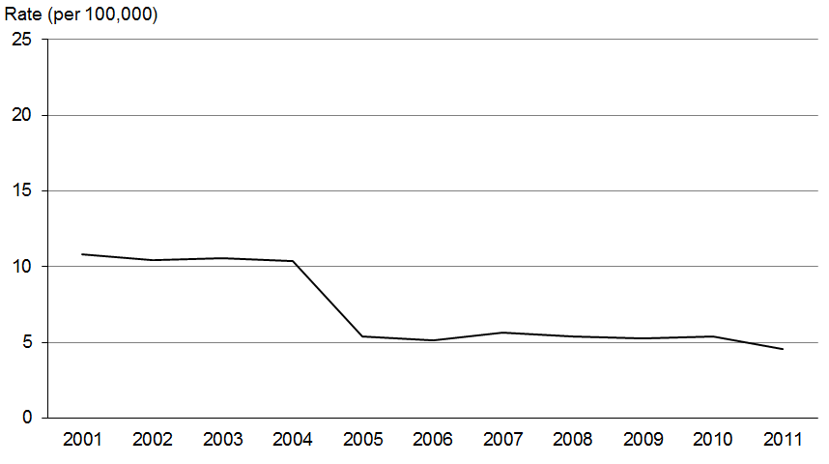

Figure 37: Male registration rates for bladder cancer, by ethnic group, 2001–2011
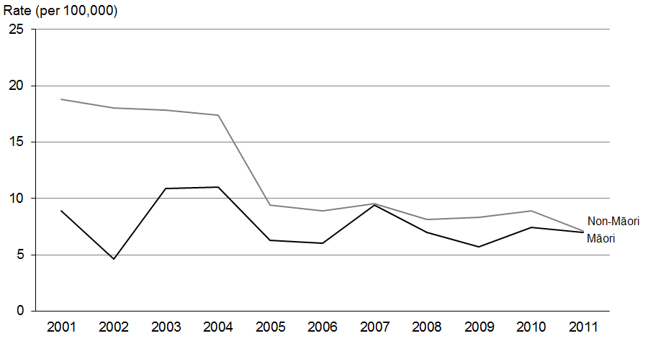

Figure 38: Female registration rates for bladder cancer, by ethnic group, 2001–2011
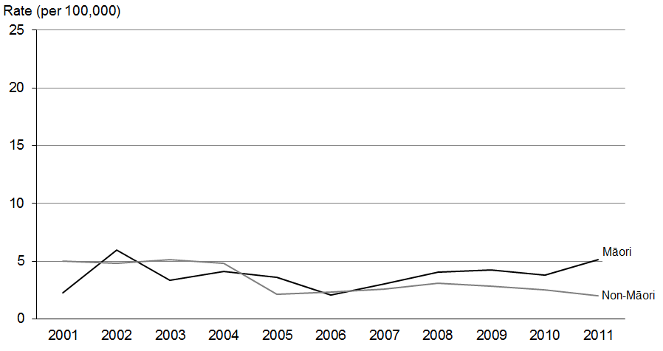
Source: New Zealand Cancer Registry
Note: Prior to 1 January 2005, superficial transitional cell carcinoma of the bladder was registered as an invasive cancer; after this date this was no longer the case. This change has affected the number of recorded registrations of this cancer.

Deaths
Figure 39: Mortality rates for bladder cancer, 2001–2011
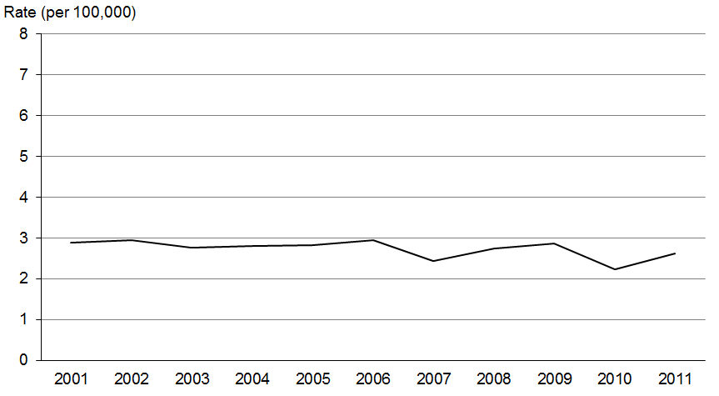

Figure 40: Male mortality rates for bladder cancer, by ethnic group, 2001–2011
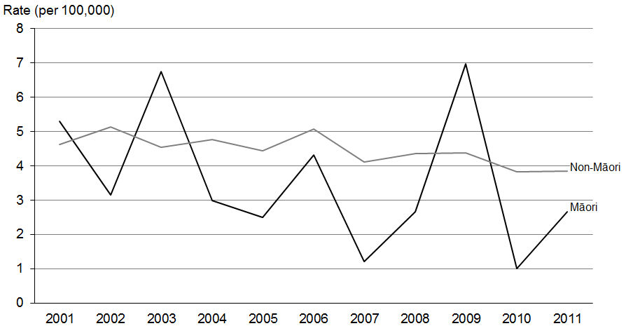

Figure 41: Female mortality rates for bladder cancer, by ethnic group, 2001–2011
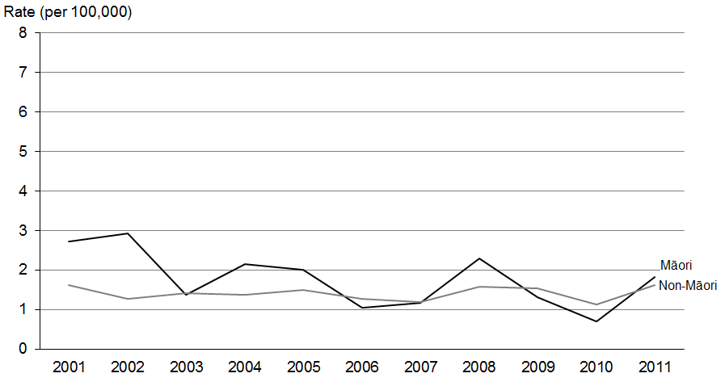
Source: New Zealand Mortality Collection

Uterine cancer (ICD code C54)

Registrations and deaths
- Cancer of the uterus was the fifth most commonly registered cancer in females, accounting for 4.5% of all female registrations in 2011.
- It was the 11th most common cause of death from cancer for females in 2011.

Ethnic group
- In 2011 the Māori registration rate was 1.5 times greater than the non-Māori rate.
- Mortality rates also showed a disparity. However, the number of Māori deaths from this cancer is generally very small (16 deaths compared to 78 non-Māori deaths in 2011); therefore rates should be compared with caution.

Trends over time
- Figure 42 shows an upward trend in registration rates for uterine cancer between 2001 and 2011: the rate increased by 14.5% over this time.
- A general upward trend was evident in both Māori and non-Māori registration rates, but the Māori rate was more variable.
- Total mortality rates were relatively stable between 2001 and 2011, but when separated by ethnic group the rates for Māori women were substantially more varied.

Table 11a: Numbers of registrations and deaths for cancer of the uterus, by ethnic group, 2001–2011
 | Registrations |  |  | Deaths
 | Total | Māori | Non-Māori | Total | Māori | Non-Māori
2001 | 309 | 37 | 272 | 78 | 14 | 64
2002 | 309 | 35 | 274 | 92 | 8 | 84
2003 | 313 | 45 | 268 | 69 | 8 | 61
2004 | 331 | 35 | 296 | 64 | 9 | 55
2005 | 382 | 47 | 335 | 80 | 14 | 66
2006 | 359 | 50 | 309 | 94 | 13 | 81
2007 | 392 | 42 | 350 | 81 | 12 | 69
2008 | 421 | 51 | 370 | 82 | 12 | 70
2009 | 430 | 56 | 374 | 98 | 10 | 88
2010 | 482 | 68 | 414 | 87 | 9 | 78
2011 | 447 | 53 | 394 | 94 | 16 | 78
Source: New Zealand Cancer Registry and New Zealand Mortality Collection

Table 11b: Age-standardised registration and mortality rates for cancer of the uterus, by ethnic group, 2001–2011
 | Registration rate (per 100,000) |  |  | Mortality rate (per 100,000)
 | Total | Māori | Non-Māori | Total | Māori | Non-Māori
2001 | 12.4 | 18 | 11.7 | 2.7 | 9.0 | 2.4
2002 | 12.0 | 17.4 | 11.4 | 3.0 | 3.9 | 2.8
2003 | 12.0 | 22.3 | 11 | 2.2 | 4.1 | 2.0
2004 | 12.5 | 17.3 | 12.1 | 2.2 | 5.1 | 2.0
2005 | 13.8 | 21.6 | 13 | 2.6 | 7.5 | 2.2
2006 | 12.6 | 21.9 | 11.6 | 3.0 | 6.0 | 2.8
2007 | 13.6 | 19.0 | 13.2 | 2.5 | 5.7 | 2.2
2008 | 14.3 | 20.7 | 13.7 | 2.5 | 5.4 | 2.2
2009 | 14.4 | 21.5 | 13.5 | 2.8 | 4.1 | 2.6
2010 | 15.7 | 26.8 | 14.8 | 2.4 | 3.6 | 2.3
2011 | 14.2 | 19.8 | 13.6 | 2.6 | 6.7 | 2.3
Source: New Zealand Cancer Registry and New Zealand Mortality Collection
Note: The rate shown is the age-standardised rate per 100,000 females.

Registrations
Figure 42: Registration rates for cancer of the uterus, 2001–2011
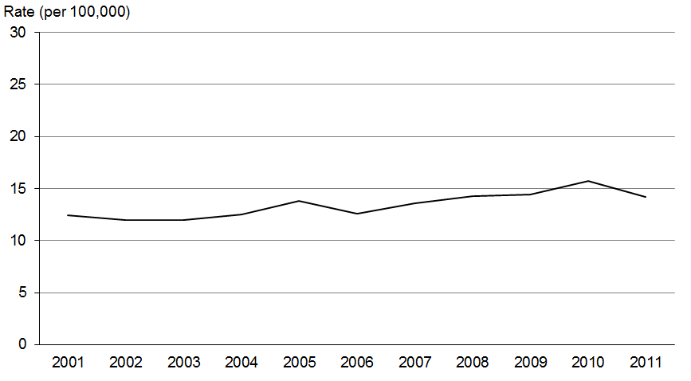

Figure 43: Registration rates for cancer of the uterus, by ethnic group, 2001–2011
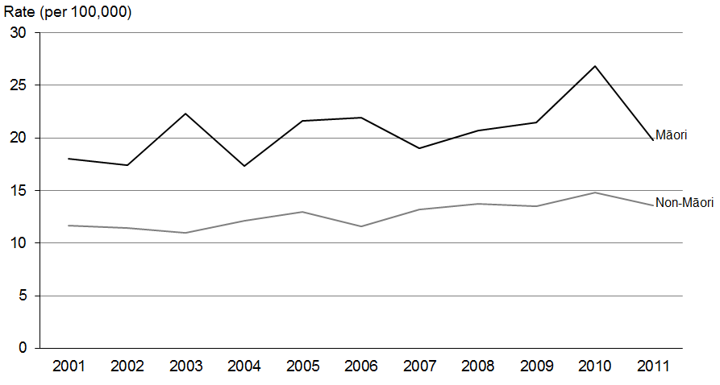
Source: New Zealand Cancer Registry
Note: The rate shown is the age-standardised rate per 100,000 females.

Deaths
Figure 44: Mortality rates for cancer of the uterus, 2001–2011
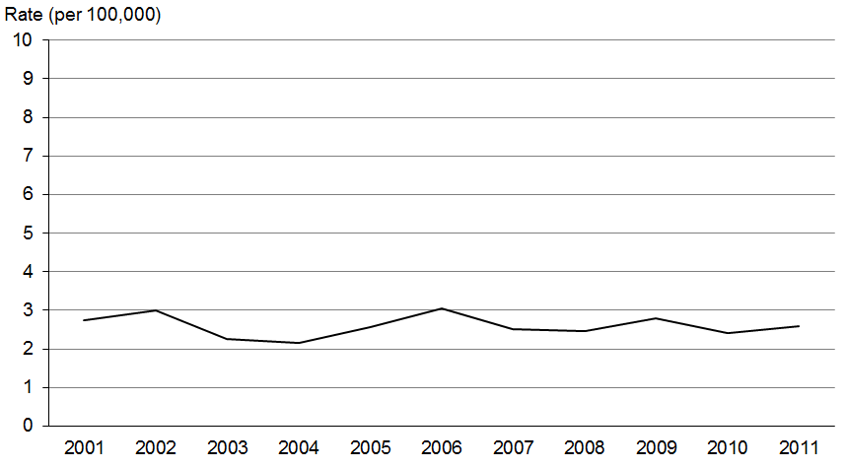

Figure 45: Mortality rates for cancer of the uterus, by ethnic group, 2001–2011
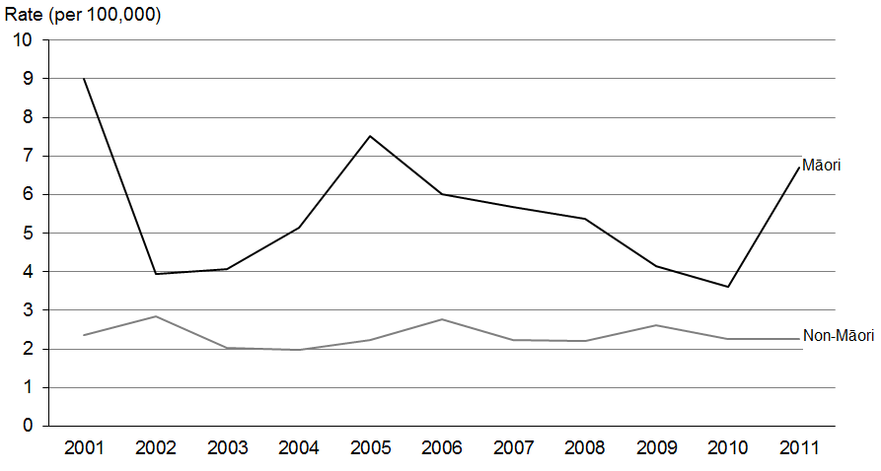
Source: New Zealand Mortality Collection
Note: The rate shown is the age-standardised rate per 100,000 females.

Cervical cancer (ICD code C53)

Registrations and deaths
- In 2011 cervical cancer accounted for 1.7% of all female cancer registrations and 1.2% of all female deaths from cancer.

Ethnic group
- In 2011 the registration rate for Māori women was twice that of non-Māori women.
- In 2011 the cervical cancer mortality rate for Māori women was 3.9 times higher than non-Māori women. However the numbers involved were small (14 and 39, respectively) and rates should therefore be compared with caution.

Trends over time
- Registrations for cervical cancer showed a general downward trend between 2001 and 2011, falling 22.4% over that time.
- The rate of death for this cancer also trended downwards, falling 27.3%.
- The large disparity between Māori and non-Māori registrations fluctuated little between 2001 and 2011; the registration rate for Māori women was at least 1.7 times greater than non-Māori women each year.
- Between 2001 and 2011, mortality rates for Māori women fell by 23.1%, compared to 31% for non-Māori women.

Table 12a: Numbers of registrations and deaths for cervical cancer, by ethnic group,
2001–2011
 | Registrations |  |  | Deaths
 | Total | Māori | Non-Māori | Total | Māori | Non-Māori
2001 | 189 | 33 | 156 | 63 | 13 | 50
2002 | 181 | 33 | 148 | 65 | 12 | 53
2003 | 178 | 33 | 145 | 58 | 8 | 50
2004 | 157 | 33 | 124 | 71 | 15 | 56
2005 | 154 | 25 | 129 | 54 | 13 | 41
2006 | 160 | 29 | 131 | 52 | 10 | 42
2007 | 159 | 33 | 126 | 65 | 11 | 54
2008 | 175 | 37 | 138 | 59 | 12 | 47
2009 | 141 | 29 | 112 | 44 | 9 | 35
2010 | 180 | 37 | 143 | 52 | 8 | 44
2011 | 165 | 36 | 129 | 53 | 14 | 39
Source: New Zealand Cancer Registry and New Zealand Mortality Collection

Table 12b: Age-standardised registration and mortality rates for cervical cancer, by ethnic group, 2001–2011
 | Registration rate (per 100,000) |  |  | Mortality rate (per 100,000)
 | Total | Māori | Non-Māori | Total | Māori | Non-Māori
2001 | 8.5 | 13.7 | 8 | 2.4 | 7.0 | 2.0
2002 | 7.7 | 15.1 | 7.2 | 2.4 | 5.8 | 2.1
2003 | 7.7 | 13.5 | 7.1 | 2.1 | 3.5 | 2.0
2004 | 6.6 | 14.1 | 5.9 | 2.7 | 5.8 | 2.2
2005 | 6.1 | 10.1 | 5.8 | 1.9 | 6.5 | 1.6
2006 | 6.5 | 11.6 | 6 | 1.7 | 4.4 | 1.4
2007 | 6.3 | 12.5 | 5.6 | 2.2 | 4.5 | 2.0
2008 | 7.1 | 13.3 | 6.3 | 1.9 | 4.9 | 1.5
2009 | 5.4 | 10.4 | 4.8 | 1.4 | 3.2 | 1.1
2010 | 7.1 | 12.3 | 6.3 | 1.7 | 3.2 | 1.6
2011 | 6.6 | 12.3 | 5.9 | 1.7 | 5.4 | 1.4
Source: New Zealand Cancer Registry and New Zealand Mortality Collection
Note: The rate shown is the age-standardised rate per 100,000 females.

Registrations
Figure 46: Registration rates for cervical cancer, 2001–2011
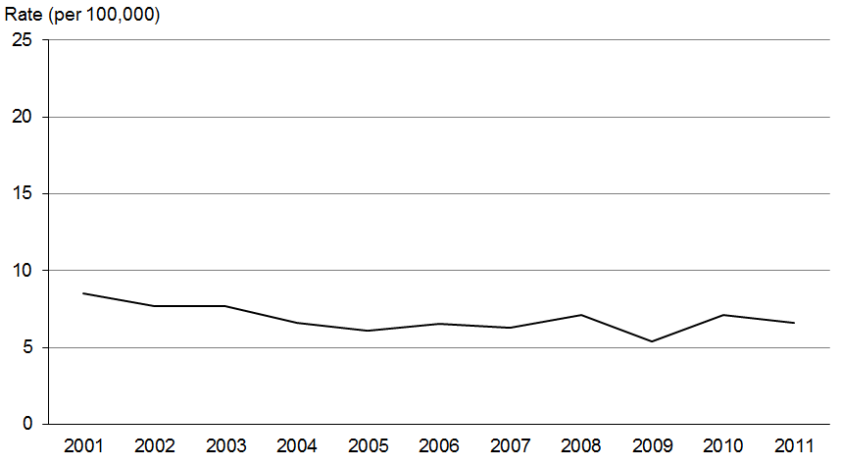

Figure 47: Registration rates for cervical cancer, by ethnic group, 2001–2011
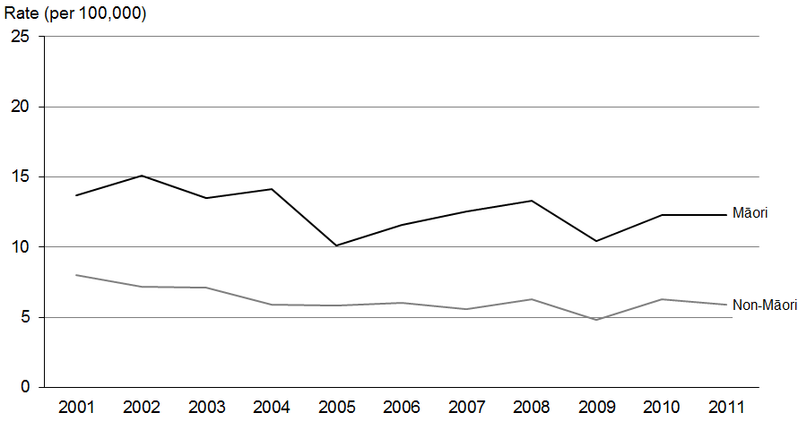
Source: New Zealand Cancer Registry
Note: The rate shown is the age-standardised rate per 100,000 females.

Deaths
Figure 48: Mortality rates for cervical cancer, 2001–2011
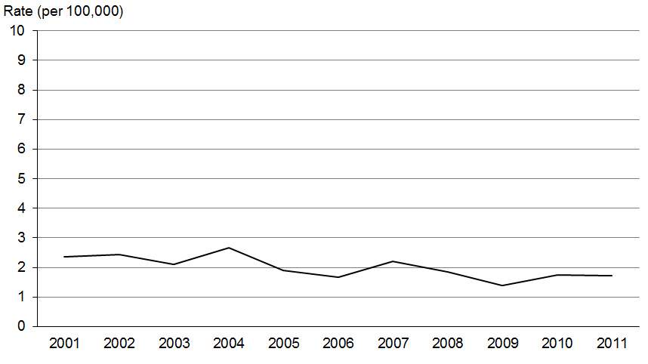

Figure 49: Mortality rates for cervical cancer, by ethnic group, 2001–2011
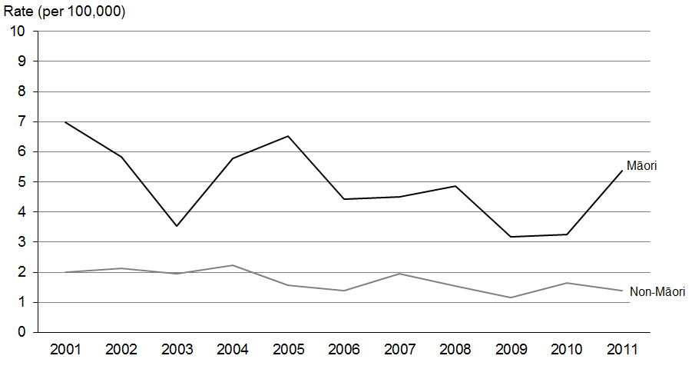
Source: New Zealand Mortality Collection
Note: The rate shown is the age-standardised rate per 100,000 females.

Colorectal and anal cancer
(ICD codes C18–C21)

Registrations and deaths
- In 2011 colorectal cancer was the most commonly registered cancer in New Zealand, accounting for 14.4% of registrations.
- Colorectal cancer was the second most common cause of death from cancer, accounting for 13.4% of cancer deaths.
- In 2011 the male registration rate for colorectal cancer was significantly higher than that for females.
- Registration rates fell between 2001 and 2011, with male and female registration rates dropping by 7.5% and 17.1%, respectively.
- Over the same time, mortality rates fell by 27.8% for males and 23% for females.

Ethnic group
- In 2011 colorectal cancer was the fourth most commonly registered cancer and the second most common cause of death from cancer for Māori.
- For non-Māori, colorectal cancer was the most common cancer registered and the second most common cause of death from cancer.
- Colorectal cancer is one of the few cancers for which Māori registration and mortality rates have historically been lower than non-Māori rates; however, recently the rates for Māori and non-Māori females have begun to converge.

Trends over time
- Māori female registration rates for colorectal cancer increased by 11.5% between 2001 and 2011; non-Māori female registration rates decreased by 17.7%.
- Registration rates for both non-Māori and Māori males, showed a downward trend between 2001 and 2011.
- Mortality rates for non-Māori males and females demonstrated a downward trend. Between 2001 and 2011 rates decreased by 30.3% for males and 24.1% for females.
- Māori mortality rates for males and females were much more variable.

Table 13a: Numbers of registrations and deaths for colorectal cancer, by sex and ethnic group, 2001–2011
 | Registrations |  |  |  |  |  | Deaths
 | Males |  |  | Females |  |  | Males |  |  | Females
 | Total | Māori | Non-Māori | Total | Māori | Non-Māori | Total | Māori | Non-Māori | Total | Māori | Non-Māori
2001 | 1328 | 63 | 1265 | 1307 | 52 | 1255 | 606 | 27 | 579 | 571 | 24 | 547
2002 | 1334 | 63 | 1271 | 1267 | 48 | 1219 | 590 | 37 | 553 | 545 | 15 | 530
2003 | 1366 | 63 | 1303 | 1340 | 52 | 1288 | 561 | 31 | 530 | 555 | 20 | 535
2004 | 1376 | 56 | 1320 | 1373 | 53 | 1320 | 570 | 25 | 545 | 603 | 29 | 574
2005 | 1333 | 64 | 1269 | 1393 | 54 | 1339 | 608 | 33 | 575 | 614 | 22 | 592
2006 | 1487 | 72 | 1415 | 1318 | 63 | 1255 | 565 | 27 | 538 | 625 | 30 | 595
2007 | 1453 | 69 | 1384 | 1356 | 66 | 1290 | 644 | 33 | 611 | 608 | 19 | 589
2008 | 1441 | 66 | 1375 | 1360 | 55 | 1305 | 693 | 41 | 652 | 587 | 30 | 557
2009 | 1463 | 95 | 1368 | 1374 | 69 | 1305 | 634 | 42 | 592 | 610 | 28 | 582
2010 | 1508 | 75 | 1433 | 1480 | 80 | 1400 | 618 | 33 | 585 | 590 | 25 | 565
2011 | 1635 | 81 | 1554 | 1395 | 78 | 1317 | 602 | 46 | 556 | 589 | 33 | 556
Source: New Zealand Cancer Registry and New Zealand Mortality Collection

Table 13b: Age-standardised registration and mortality rates for colorectal cancer, by sex and ethnic group, 2001–2011
 | Registration rate (per 100,000) |  |  |  |  |  | Mortality rate (per 100,000)
 | Males |  |  | Females |  |  | Males |  |  | Females
 | Total | Māori | Non-Māori | Total | Māori | Non-Māori | Total | Māori | Non-Māori | Total | Māori | Non-Māori
2001 | 56.2 | 44.1 | 56.8 | 45.0 | 29.2 | 45.9 | 25.5 | 20.5 | 25.7 | 18.4 | 13.2 | 18.6
2002 | 55.2 | 42.8 | 55.9 | 42.5 | 27.9 | 43.4 | 24.2 | 26.3 | 24.0 | 16.8 | 10.2 | 17.3
2003 | 55.0 | 38.9 | 55.6 | 44.0 | 28.9 | 44.9 | 22.2 | 20.8 | 22.1 | 17.0 | 11.2 | 17.2
2004 | 53.6 | 34.9 | 54.6 | 44.6 | 26.6 | 45.5 | 21.8 | 14.6 | 22.0 | 18.0 | 13.8 | 17.9
2005 | 50.8 | 39.4 | 51.5 | 44.1 | 27.6 | 45.2 | 22.6 | 21.9 | 22.6 | 17.7 | 11.4 | 18.0
2006 | 55.1 | 42.5 | 55.8 | 40.6 | 31.8 | 41.2 | 20.5 | 19.6 | 20.6 | 17.4 | 16.8 | 17.4
2007 | 51.8 | 38.9 | 52.5 | 40.4 | 31.0 | 40.9 | 22.6 | 18.0 | 22.6 | 16.8 | 9.9 | 17.2
2008 | 49.8 | 36.6 | 50.6 | 39.7 | 23.6 | 40.7 | 23.5 | 22.1 | 23.4 | 15.8 | 14.5 | 15.9
2009 | 49.6 | 46.5 | 49.6 | 39.4 | 27.8 | 39.9 | 20.9 | 22.8 | 20.7 | 16.0 | 13.2 | 16.2
2010 | 49.4 | 35.9 | 50.2 | 41.1 | 34.4 | 41.7 | 19.6 | 16.7 | 19.7 | 15.0 | 10.8 | 15.2
2011 | 52.0 | 37.1 | 52.8 | 37.3 | 32.6 | 37.8 | 18.4 | 21.9 | 18.0 | 14.2 | 14.4 | 14.1
Source: New Zealand Cancer Registry and New Zealand Mortality Collection

Registrations
Figure 50: Registration rates for colorectal cancer, 2001–2011
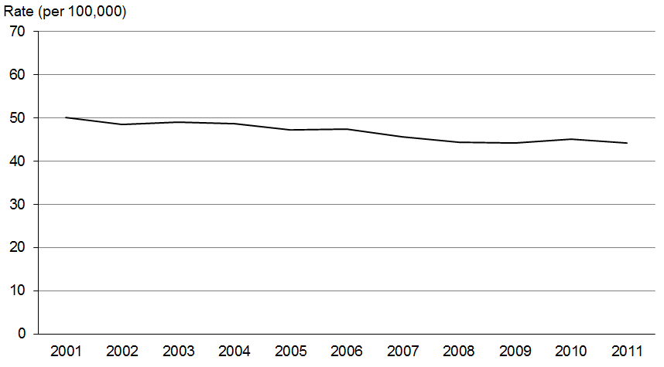

Figure 51: Male registration rates for colorectal cancer, by ethnic group, 2001–2011
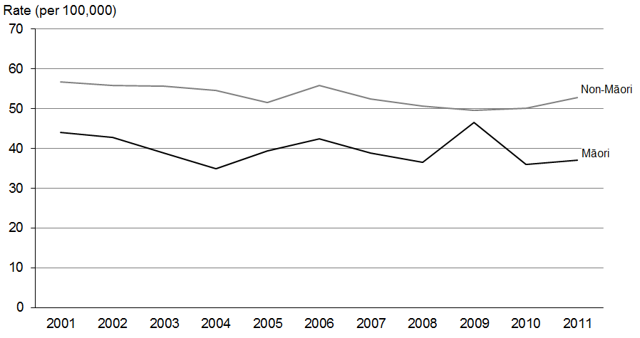

Figure 52: Female registration rates for colorectal cancer, by ethnic group, 2001–2011
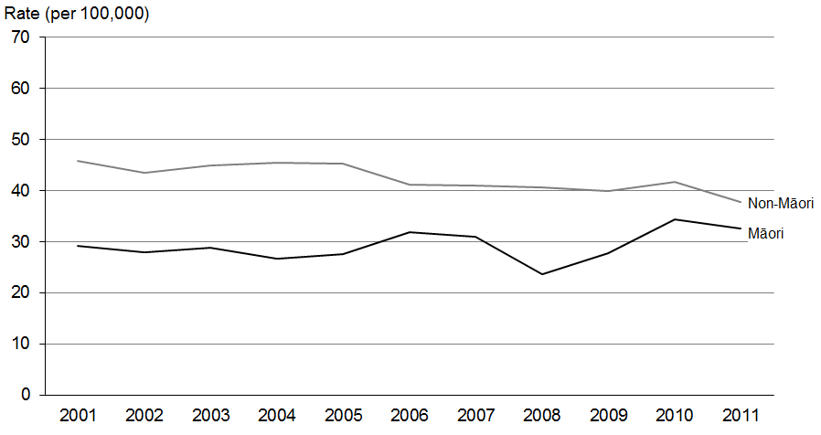
Source: New Zealand Cancer Registry

Deaths
Figure 53: Mortality rates for colorectal cancer, 2001–2011
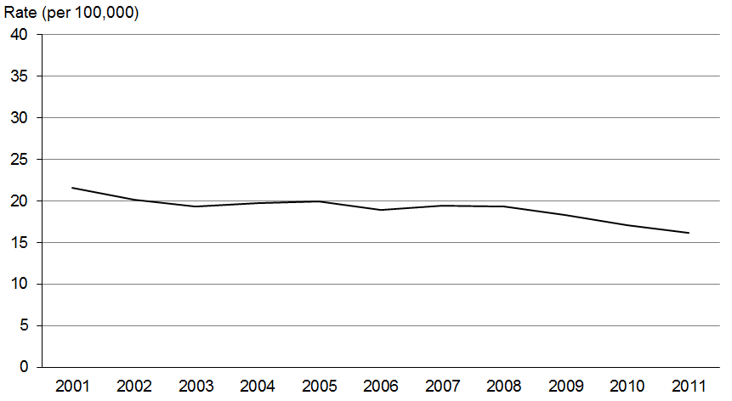

Figure 54: Male mortality rates for colorectal cancer, by ethnic group, 2001–2011
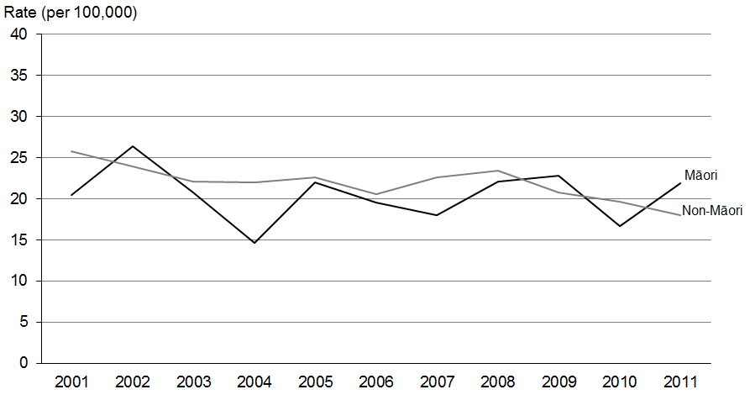

Figure 55: Female mortality rates for colorectal cancer, by ethnic group, 2001–2011
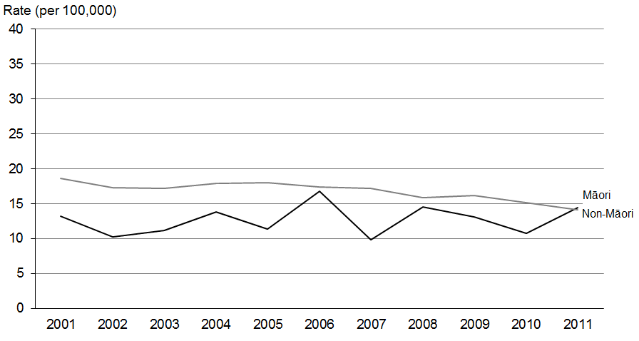
Source: New Zealand Mortality Collection

Female breast cancer (ICD code C50)

Registrations and deaths
- Breast cancer was the most commonly registered cancer for women, accounting for 28.7% of all female registrations and the third most common cancer registration overall.
- Breast cancer was the second most common cause of death from cancer for women in 2011, accounting for 15% of female cancer deaths. Overall, breast cancer was the third most common cause of cancer death.

Ethnic group
- In 2011 Māori females had a significantly higher registration rate for breast cancer than non-Māori females: 122.9 compared to 88.9 per 100,000, which was 1.4 times higher.
- In 2011, Māori females had a breast cancer mortality rate 1.6 times higher than non-Māori females.

Trends over time
- From January 1999 to July 2004 women in New Zealand were eligible for free breast screening between the ages of 50 and 64. Subsequently the eligible age range was extended to 45─69 years. This may have affected the number of breast cancer registrations.
- Registration rates for breast cancer in females remained relatively stable between 2001 and 2011, but mortality rates trended downwards over this time, falling by 19.6%.
- Between 2001 and 2011 the age-standardised breast cancer registration rate for Māori women largely showed an upward trend, increasing by 18.6%. In contrast, the non-Māori rate fluctuated but decreased overall by 4.2%. The disparity between the two ethnic groups is increasing.
- Over the same period the age-standardised mortality rates for Māori and non-Māori women were variable, but overall both showed a downward trend. Between 2001 and 2011 the rate decreased by 21% and 18.6% for Māori and non-Māori women, respectively.

Table 14a: Numbers of registrations and deaths for female breast cancer, by ethnic group, 2001–2011
 | Registrations |  |  | Deaths
 | Total | Māori | Non-Māori | Total | Māori | Non-Māori
2001 | 2314 | 219 | 2095 | 615 | 68 | 547
2002 | 2367 | 221 | 2146 | 625 | 82 | 543
2003 | 2335 | 244 | 2091 | 647 | 61 | 586
2004 | 2346 | 235 | 2111 | 642 | 81 | 561
2005 | 2474 | 265 | 2209 | 648 | 61 | 587
2006 | 2556 | 281 | 2275 | 614 | 77 | 537
2007 | 2565 | 303 | 2262 | 643 | 69 | 574
2008 | 2713 | 306 | 2407 | 618 | 76 | 542
2009 | 2759 | 337 | 2422 | 658 | 67 | 591
2010 | 2791 | 376 | 2415 | 641 | 84 | 557
2011 | 2867 | 350 | 2517 | 636 | 72 | 564
Source: New Zealand Cancer Registry and New Zealand Mortality Collection

Table 14b: Age-standardised registration and mortality rates for female breast cancer, by ethnic group, 2001–2011
 | Registration rate (per 100,000) |  |  | Mortality rate (per 100,000)
 | Total | Māori | Non-Māori | Total | Māori | Non-Māori
2001 | 94.3 | 103.6 | 92.8 | 22.7 | 34.6 | 21.4
2002 | 93.8 | 110.8 | 92.6 | 22.4 | 43.8 | 20.6
2003 | 89.5 | 113.1 | 87.1 | 23.1 | 29.4 | 22.4
2004 | 88.6 | 104.7 | 86.9 | 22.4 | 36.4 | 20.8
2005 | 92.5 | 113.6 | 90.5 | 21.7 | 29.5 | 21.2
2006 | 92.1 | 119.3 | 89.5 | 20.3 | 35.6 | 19.0
2007 | 90.3 | 124.6 | 87.2 | 20.8 | 29.9 | 20.0
2008 | 93.3 | 117.2 | 90.6 | 19.1 | 31.8 | 17.9
2009 | 93.0 | 125.5 | 89.6 | 19.9 | 27.4 | 19.2
2010 | 92.0 | 136.5 | 87.2 | 19.1 | 32.9 | 17.8
2011 | 92.5 | 122.9 | 88.9 | 18.3 | 27.3 | 17.4
Source: New Zealand Cancer Registry and New Zealand Mortality Collection
Note: The rate shown is the age-standardised rate per 100,000 females.

Registrations
Figure 56: Registration rates for female breast cancer, 2001–2011
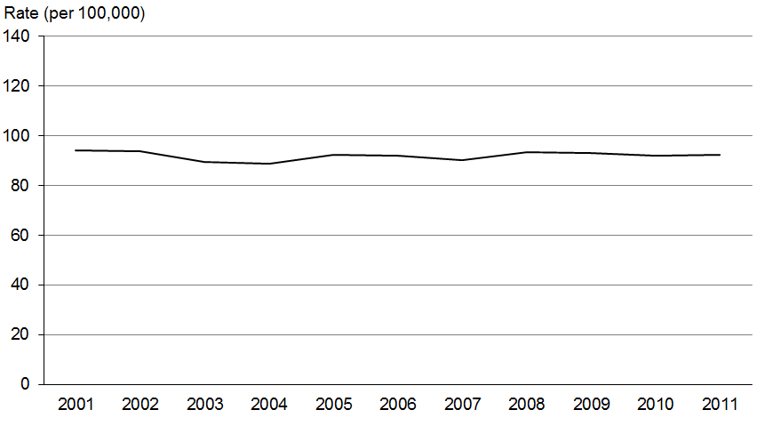

Figure 57: Registration rates for female breast cancer, by ethnic group, 2001–2011
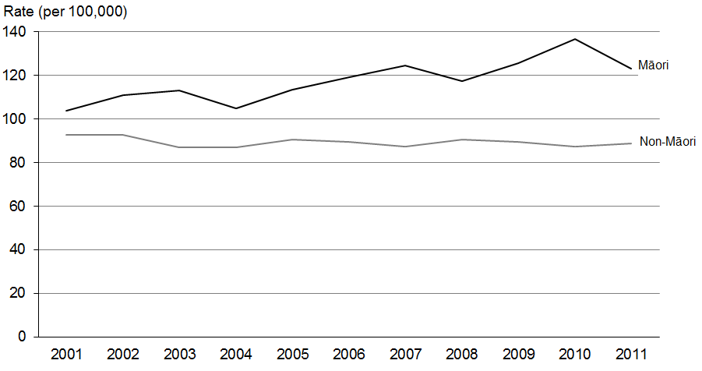
Source: New Zealand Cancer Registry
Note: The rate shown is the age-standardised rate per 100,000 females.

Deaths
Figure 58: Mortality rates for female breast cancer, 2001–2011
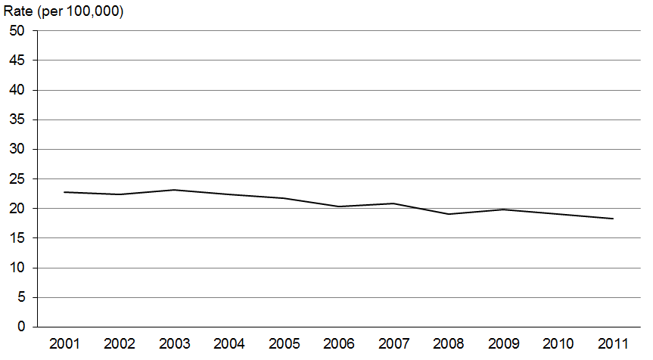

Figure 59: Mortality rates for female breast cancer, by ethnic group, 2001–2011
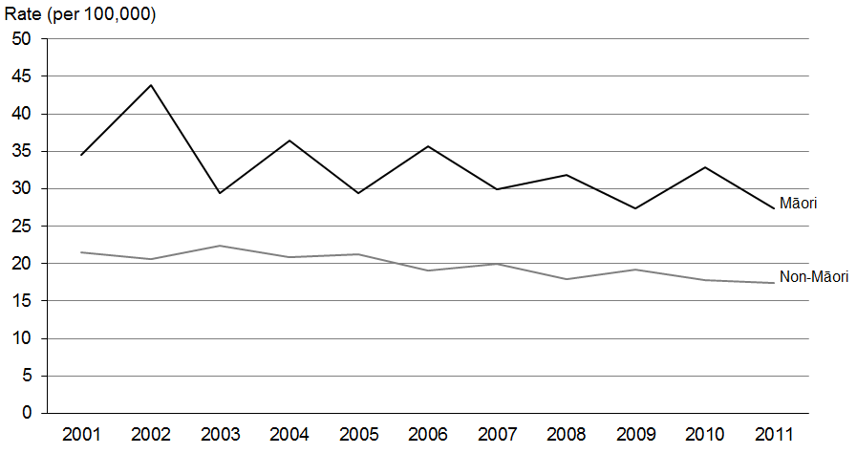
Source: New Zealand Mortality Collection
Note: The rate shown is the age-standardised rate per 100,000 females.

Lung cancer (ICD codes C33 and C34)

Registrations and deaths
- Lung cancer was the fifth most common cancer registered in New Zealand in 2011, accounting for 9.6% of all registrations.
- Lung cancer was the most common cause of death from cancer in 2011 (accounting for 18.9% of all cancer deaths).

Ethnic group
- For Māori, lung cancer was both the most commonly registered cancer and the most common cause of cancer death in 2011, accounting for nearly a third of all Māori cancer deaths.
- In 2011 the registration rate for Māori females was 4.4 times the rate for non-Māori women. Similarly, the Māori male rate was 2.7 times higher than non-Māori men.
- In 2011 the Māori female mortality rate was 4.2 times the rate for non-Māori females. The Māori male mortality rate was 2.4 times the non-Māori male rate.
- Registration and mortality rates for lung cancer were consistently significantly higher for Māori than for non-Māori between 2001 and 2011.

Trends over time
- Between 2001 and 2011, male registration rates decreased by 12.1%, while female registration rates increased by 14.8%.
- Male lung cancer registration rates decreased by 20.9% for non-Māori males and 23.7% for Māori males between 2001 and 2011, although smaller numbers of Māori have resulted in more yearly variation in rates.
- Between 2001 and 2011, Māori female registration rates for lung cancer were more variable than non-Māori female rates, which remained stable. The disparity between ethnicities is increasing.
- Between 2001 and 2011, overall male mortality rates decreased by 20.4%, whereas female mortality rates only decreased by 1.1%.
- There was considerable disparity between Māori and non-Māori female mortality rates between 2001 and 2011, which has not decreased.

Note: Lung (C33─C34) includes trachea and bronchus.

Table 15a: Numbers of registrations and deaths for lung cancer, by sex and ethnic group, 2001–2011
 | Registrations |  |  |  |  |  | Deaths
 | Males |  |  | Females |  |  | Males |  |  | Females
 | Total | Māori | Non-Māori | Total | Māori | Non-Māori | Total | Māori | Non-Māori | Total | Māori | Non-Māori
2001 | 889 | 118 | 771 | 649 | 113 | 536 | 841 | 113 | 728 | 594 | 133 | 461
2002 | 935 | 124 | 811 | 692 | 112 | 580 | 866 | 105 | 761 | 605 | 89 | 516
2003 | 1037 | 127 | 910 | 777 | 184 | 593 | 848 | 106 | 742 | 618 | 132 | 486
2004 | 1092 | 158 | 934 | 767 | 162 | 605 | 929 | 117 | 812 | 626 | 120 | 506
2005 | 957 | 125 | 832 | 721 | 150 | 571 | 864 | 121 | 743 | 587 | 133 | 454
2006 | 934 | 144 | 790 | 772 | 173 | 599 | 798 | 106 | 692 | 659 | 129 | 530
2007 | 1031 | 157 | 874 | 791 | 164 | 627 | 864 | 135 | 729 | 664 | 136 | 528
2008 | 986 | 142 | 844 | 878 | 200 | 678 | 889 | 109 | 780 | 745 | 178 | 567
2009 | 1105 | 170 | 935 | 903 | 203 | 700 | 876 | 142 | 734 | 717 | 150 | 567
2010 | 1046 | 159 | 887 | 896 | 207 | 689 | 893 | 130 | 763 | 757 | 169 | 588
2011 | 1046 | 163 | 883 | 970 | 237 | 733 | 909 | 129 | 780 | 773 | 174 | 599
Source: New Zealand Cancer Registry and New Zealand Mortality Collection

Table 15b: Age-standardised registration and mortality rates for lung cancer, by sex and ethnic group, 2001–2011
 | Registration rate (per 100,000) |  |  |  |  |  | Mortality rate (per 100,000)
 | Males |  |  | Females |  |  | Males |  |  | Females
 | Total | Māori | Non-Māori | Total | Māori | Non-Māori | Total | Māori | Non-Māori | Total | Māori | Non-Māori
2001 | 37.3 | 82.9 | 33.9 | 24.0 | 64.7 | 20.5 | 35.1 | 80.1 | 31.9 | 21.4 | 79.5 | 17.1
2002 | 38.1 | 93.9 | 34.7 | 24.5 | 65.3 | 21.2 | 35.1 | 77.1 | 32.3 | 20.7 | 53.4 | 18.1
2003 | 41.1 | 82.7 | 37.8 | 28.1 | 100.0 | 22.4 | 33.4 | 77.4 | 30.7 | 21.6 | 73.5 | 17.6
2004 | 42.4 | 104.4 | 38.2 | 26.4 | 89.9 | 21.8 | 35.9 | 76.1 | 32.9 | 21.5 | 66.6 | 18.2
2005 | 36.1 | 75.2 | 33.1 | 24.4 | 79.0 | 20.3 | 32.3 | 73.8 | 29.2 | 19.2 | 70.5 | 15.3
2006 | 34.4 | 85.5 | 30.6 | 25.3 | 86.4 | 20.5 | 29.2 | 63.9 | 26.6 | 21.2 | 64.7 | 17.8
2007 | 36.3 | 87.6 | 32.3 | 25.1 | 78.3 | 20.9 | 30.3 | 76.8 | 26.9 | 20.4 | 66.8 | 16.8
2008 | 33.8 | 76.7 | 30.4 | 27.2 | 92.3 | 22.1 | 30.1 | 58.0 | 27.7 | 22.6 | 81.0 | 17.8
2009 | 36.7 | 89.6 | 32.7 | 27.1 | 89.6 | 22.1 | 28.8 | 75.9 | 25.4 | 21.0 | 67.6 | 17.5
2010 | 33.9 | 73.3 | 30.3 | 25.8 | 87.4 | 20.6 | 28.7 | 60.6 | 25.7 | 21.2 | 72.3 | 17.1
2011 | 32.8 | 77.9 | 29.3 | 27.5 | 96.8 | 21.9 | 28.0 | 61.1 | 25.3 | 21.2 | 71.7 | 17.1
Source: New Zealand Cancer Registry and New Zealand Mortality Collection

Registrations
Figure 60: Registration rates for lung cancer, 2001–2011
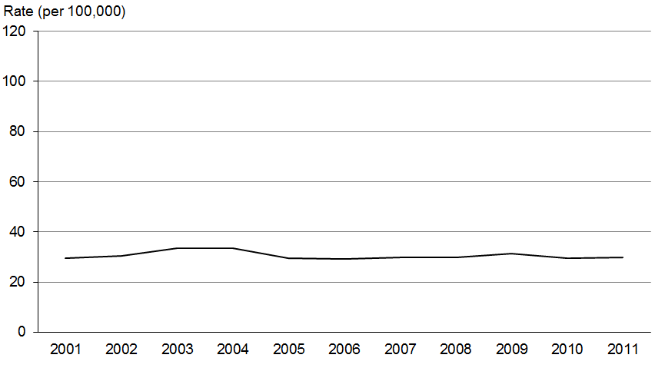

Figure 61: Male registration rates for lung cancer, by ethnic group, 2001–2011
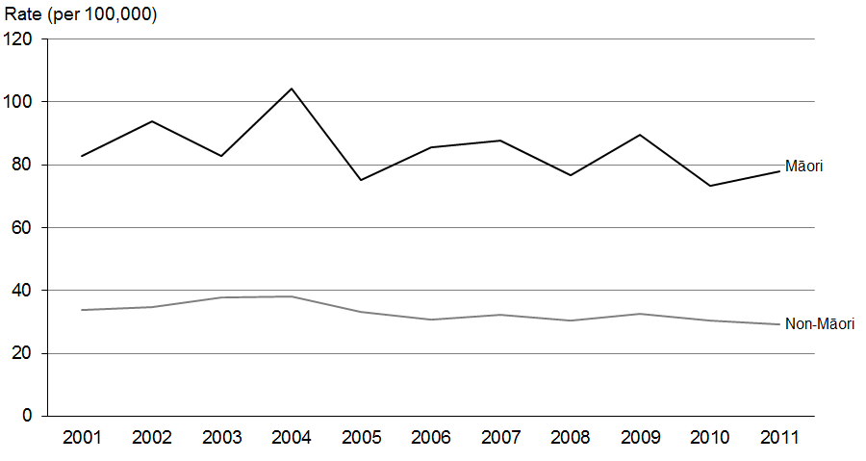

Figure 62: Female registration rates for lung cancer, by ethnic group, 2001–2011
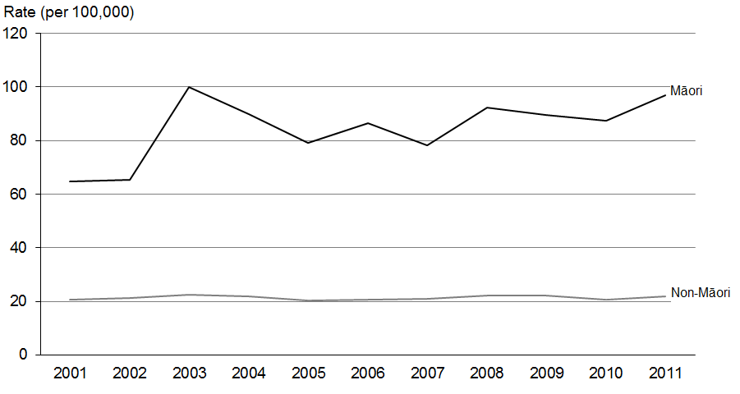
Source: New Zealand Cancer Registry

Deaths
Figure 63: Mortality rates for lung cancer, 2001–2011
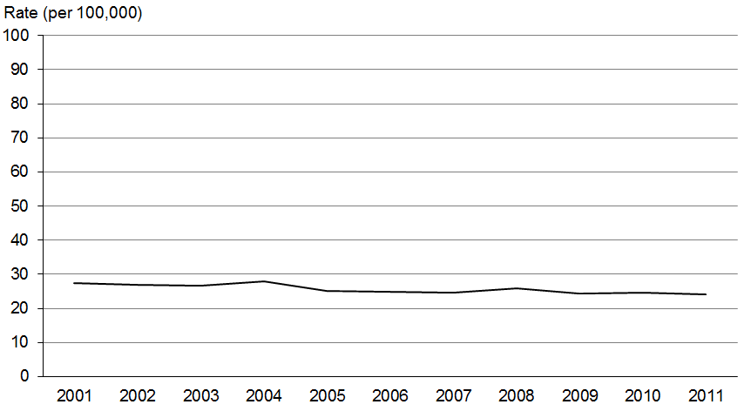

Figure 64: Male mortality rates for lung cancer, by ethnic group, 2001–2011
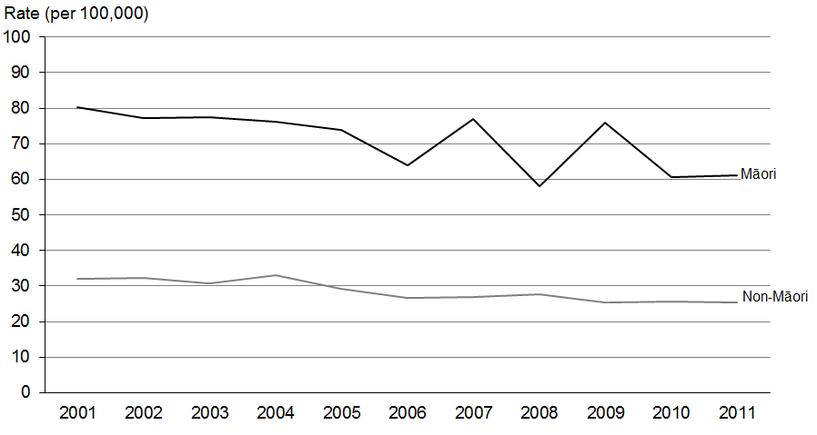

Figure 65: Female mortality rates for lung cancer, by ethnic group, 2001–2011
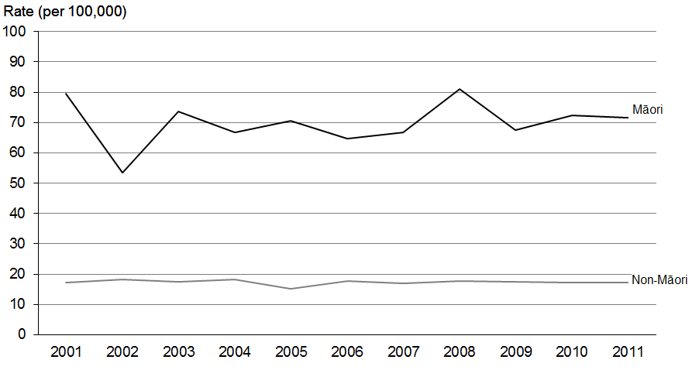
Source: New Zealand Mortality Collection

Melanoma (ICD code C43)

Registrations and deaths
- Melanoma was the fourth most commonly registered cancer (accounting for 10.5% of all registrations) and the sixth most common cause of death from cancer (accounting for 4% of cancer deaths) in 2011.
- In 2011 the male registration rate for melanoma was 21.5% higher than the female rate.

Ethnic group
- The registration and mortality rates for Māori were consistently lower than for non-Māori between 2001 and 2011. Melanoma accounted for less than 1.5% of total Māori cancer registration and deaths (30 registrations and 4 deaths).

Trends over time
- The total registration rate for melanoma decreased by 13.4% between 2001 and 2011, but the mortality rate increased by 12.3%.
- Female mortality rates for this cancer were relatively stable, but male rates showed an upward trend.
- Male registration and mortality rates for melanoma were consistently higher than female rates between 2001 and 2011.

Table 16a: Numbers of registrations and deaths for melanoma, by sex and ethnic group,
2001–2011
 | Registrations |  |  |  |  |  | Deaths
 | Males |  |  | Females |  |  | Males |  |  | Females
 | Total | Māori | Non-Māori | Total | Māori | Non-Māori | Total | Māori | Non-Māori | Total | Māori | Non-Māori
2001 | 862 | 8 | 854 | 888 | 18 | 870 | 156 | 3 | 153 | 88 | 1 | 87
2002 | 929 | 7 | 922 | 903 | 24 | 879 | 149 | 5 | 144 | 86 | 1 | 85
2003 | 959 | 12 | 947 | 888 | 12 | 876 | 174 | 3 | 171 | 111 | 1 | 110
2004 | 945 | 9 | 936 | 942 | 17 | 925 | 152 | 4 | 148 | 97 | 2 | 95
2005 | 1114 | 17 | 1097 | 915 | 12 | 903 | 156 | 4 | 152 | 113 | 2 | 111
2006 | 1060 | 6 | 1054 | 938 | 16 | 922 | 173 | 4 | 169 | 114 | 1 | 113
2007 | 1123 | 9 | 1114 | 1050 | 18 | 1032 | 178 | 2 | 176 | 114 | 5 | 109
2008 | 1180 | 10 | 1170 | 1076 | 13 | 1063 | 202 | 2 | 200 | 115 | 2 | 113
2009 | 1197 | 12 | 1185 | 1015 | 9 | 1006 | 213 | 2 | 211 | 113 | 5 | 108
2010 | 1241 | 15 | 1226 | 1100 | 17 | 1083 | 199 | 3 | 196 | 125 | 3 | 122
2011 | 1199 | 16 | 1183 | 1005 | 14 | 991 | 243 | 3 | 240 | 116 | 1 | 115
Source: New Zealand Cancer Registry and New Zealand Mortality Collection

Table 16b: Age-standardised registration and mortality rates for melanoma, by sex and ethnic group, 2001–2011
 | Registration rate (per 100,000) |  |  |  |  |  | Mortality rate (per 100,000)
 | Males |  |  | Females |  |  | Males |  |  | Females
 | Total | Māori | Non-Māori | Total | Māori | Non-Māori | Total | Māori | Non-Māori | Total | Māori | Non-Māori
2001 | 38.4 | 6.3 | 41.6 | 36.0 | 9.4 | 39.1 | 6.7 | 1.5 | 7.1 | 3.1 | 0.3 | 3.3
2002 | 40.4 | 4.2 | 43.7 | 36.8 | 11.1 | 39.7 | 6.3 | 4.3 | 6.6 | 3.1 | 0.6 | 3.3
2003 | 40.3 | 5.7 | 43.3 | 35.0 | 5.7 | 38.4 | 7.1 | 3.4 | 7.4 | 3.6 | 0.4 | 3.9
2004 | 38.7 | 4.5 | 41.7 | 35.8 | 7.7 | 38.9 | 6.1 | 2.1 | 6.3 | 3.0 | 1.4 | 3.2
2005 | 44.6 | 8.3 | 47.7 | 34.5 | 6.0 | 38.0 | 6.1 | 1.6 | 6.4 | 3.7 | 0.7 | 3.9
2006 | 41.2 | 3.2 | 44.6 | 33.4 | 6.7 | 36.3 | 6.4 | 2.0 | 6.7 | 3.4 | 0.6 | 3.7
2007 | 42.4 | 6.7 | 45.8 | 36.5 | 7.3 | 39.7 | 6.4 | 1.1 | 6.8 | 3.4 | 2.7 | 3.5
2008 | 43.0 | 5.1 | 46.4 | 37.4 | 5.5 | 41.0 | 7.2 | 0.8 | 7.7 | 3.2 | 1.2 | 3.5
2009 | 42.8 | 6.1 | 46.2 | 33.6 | 3.2 | 36.8 | 7.2 | 1.2 | 7.7 | 3.3 | 2.0 | 3.5
2010 | 43.4 | 6.1 | 46.8 | 36.1 | 6.8 | 39.4 | 6.5 | 1.0 | 6.9 | 3.5 | 1.6 | 3.7
2011 | 40.1 | 7.5 | 43.1 | 33.0 | 5.4 | 36.2 | 7.8 | 1.8 | 8.3 | 3.2 | 0.3 | 3.4
Source: New Zealand Cancer Registry and New Zealand Mortality Collection

Registrations
Figure 66: Registration rates for melanoma, 2001–2011
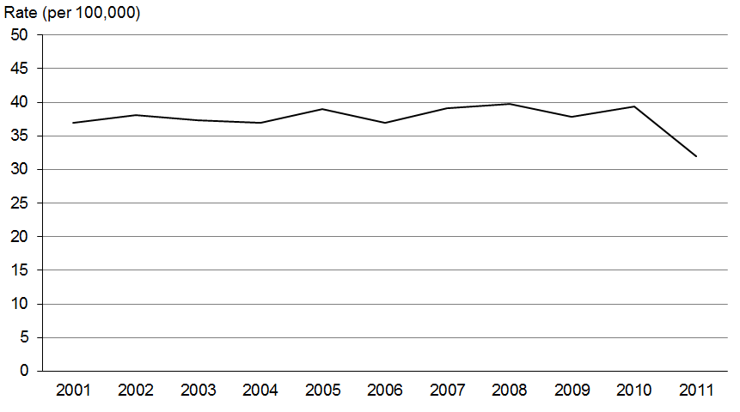

Figure 67: Male registration rates for melanoma, by ethnic group, 2001–2011
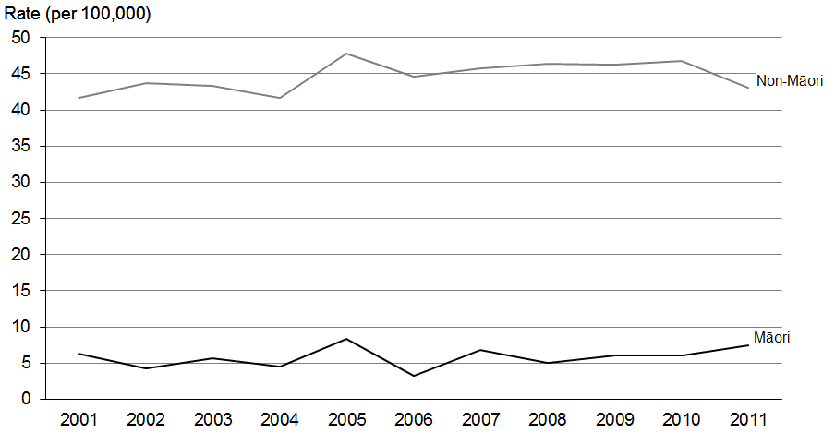

Figure 68: Female registration rates for melanoma, by ethnic group, 2001–2011
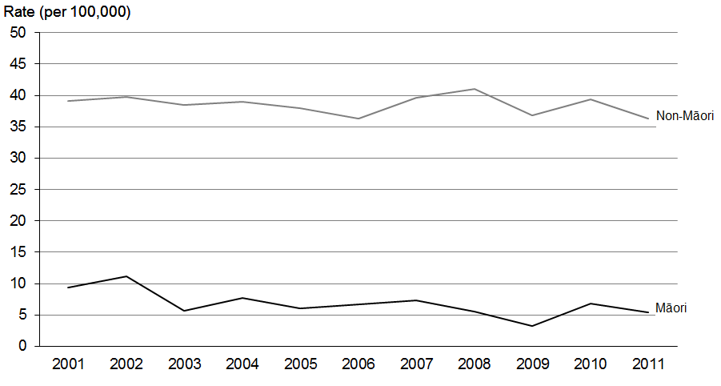
Source: New Zealand Cancer Registry

Deaths
Figure 69: Mortality rates for melanoma, 2001–2011
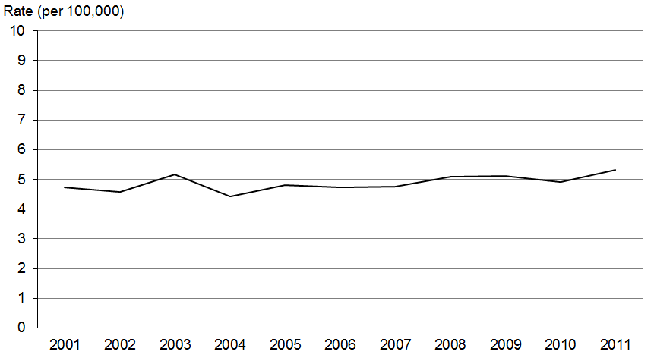

Figure 70: Male mortality rates for melanoma, 2001–2011
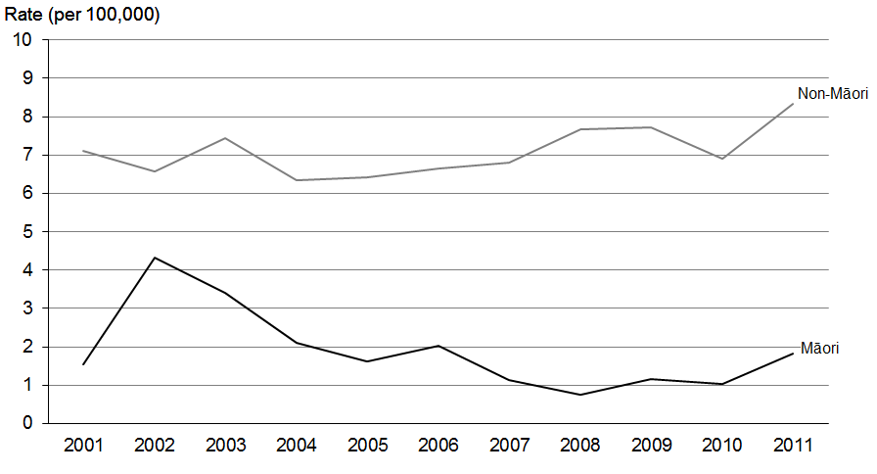

Figure 71: Female mortality rates for melanoma, 2001–2011
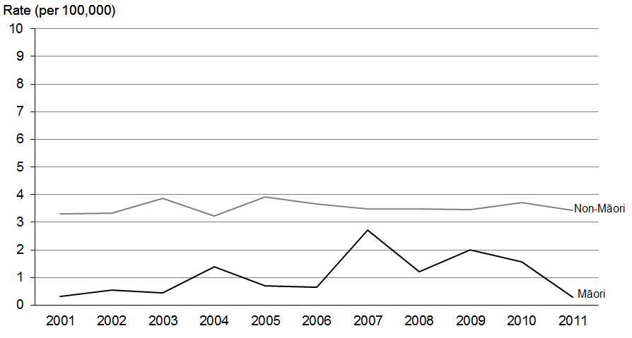
Source: New Zealand Mortality Collection

Ovarian cancer (ICD code C56)

Registrations and deaths
- Ovarian cancer was the seventh most commonly registered cancer for females in 2011, accounting for 2.8% of female registrations.
- It was the fifth most common cause of cancer death for females in 2011, accounting for 4.7% of all female deaths from cancer.

Ethnic group
- There does not appear to be any consistent ethnic disparity in rates of ovarian cancer between 2001 and 2011. Low numbers of registrations and deaths for ovarian cancer likely contributed to the wide year-to-year variation seen in both non-Māori and Māori rates. Caution should therefore be used when comparing these rates.

Trends over time
- From 1 January 2003 a change in coding practice resulted in some ovarian cancers being excluded from registration (see ‘Explanatory notes’). It is therefore not appropriate to compare changes in registration rates before and after this date.
- Total registration rates decreased 10.0% between 2003 and 2011.
- Rates of ovarian cancer deaths (for which the abovementioned coding change had no impact) were relatively stable between 2001 and 2011.

Table 17a: Numbers of registrations and deaths for ovarian cancer, by ethnic group,
2001–2011
 | Registrations |  |  | Deaths
 | Total | Māori | Non-Māori | Total | Māori | Non-Māori
2001 | 304 | 24 | 280 | 175 | 10 | 165
2002 | 313 | 30 | 283 | 173 | 13 | 160
2003 | 253 | 24 | 229 | 166 | 12 | 154
2004 | 285 | 27 | 258 | 187 | 18 | 169
2005 | 301 | 14 | 287 | 190 | 11 | 179
2006 | 270 | 31 | 239 | 210 | 20 | 190
2007 | 233 | 24 | 209 | 199 | 11 | 188
2008 | 294 | 28 | 266 | 184 | 15 | 169
2009 | 298 | 34 | 264 | 214 | 21 | 193
2010 | 303 | 40 | 263 | 212 | 12 | 200
2011 | 276 | 32 | 244 | 199 | 24 | 175
Source: New Zealand Cancer Registry and New Zealand Mortality Collection

Table 17b: Age-standardised registration and mortality rates for ovarian cancer, by ethnic group, 2001–2011
 | Registration rate (per 100,000) |  |  | Mortality rate (per 100,000)
 | Total | Māori | Non-Māori | Total | Māori | Non-Māori
2001 | 12.4 | 10.6 | 12.5 | 6.2 | 5.3 | 6.3
2002 | 12.2 | 15.1 | 12.0 | 5.9 | 7.6 | 5.8
2003 | 9.6 | 11.3 | 9.4 | 5.8 | 6.7 | 5.7
2004 | 10.2 | 13.5 | 9.9 | 6.2 | 8.7 | 5.9
2005 | 10.5 | 5.5 | 10.8 | 6.1 | 6.2 | 6.1
2006 | 9.3 | 14.0 | 8.9 | 6.5 | 9.9 | 6.2
2007 | 7.8 | 8.9 | 7.5 | 6.2 | 4.8 | 6.3
2008 | 9.9 | 10.9 | 9.8 | 5.7 | 6.3 | 5.6
2009 | 9.6 | 13.1 | 9.2 | 6.2 | 8.1 | 5.9
2010 | 9.6 | 14.6 | 9.0 | 6.0 | 4.8 | 6.0
2011 | 8.6 | 11.7 | 8.2 | 5.5 | 9.4 | 5.2
Source: New Zealand Cancer Registry and New Zealand Mortality Collection

Registrations
Figure 72: Registration rates for ovarian cancer, 2001–2011
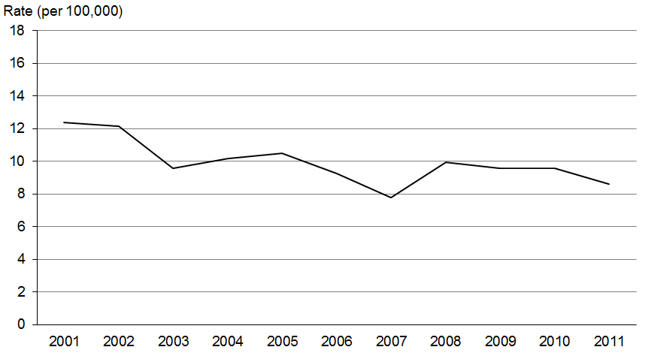

Figure 73: Registration rates for ovarian cancer, by ethnic group, 2001–2011
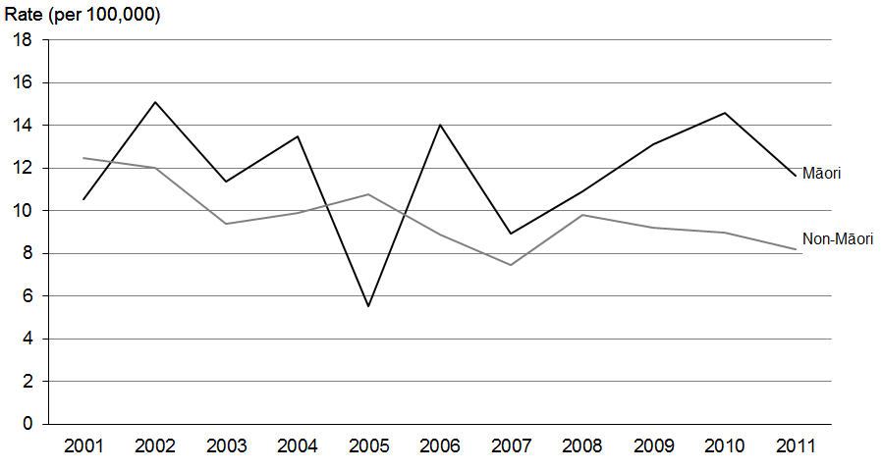
Source: New Zealand Cancer Registry
Note: The rate shown is the age-standardised rate per 100,000 females.

Deaths
Figure 74: Mortality rates for ovarian cancer, 2001–2011
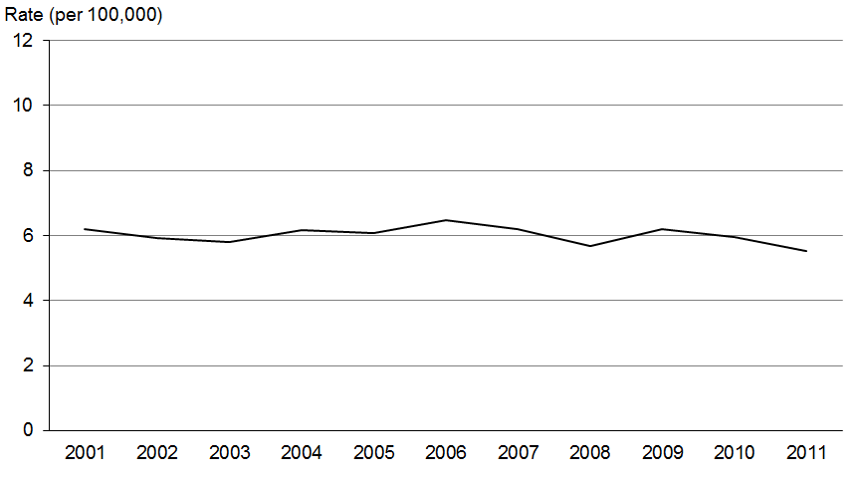

Figure 75: Mortality rates for ovarian cancer, by ethnic group, 2001–2011
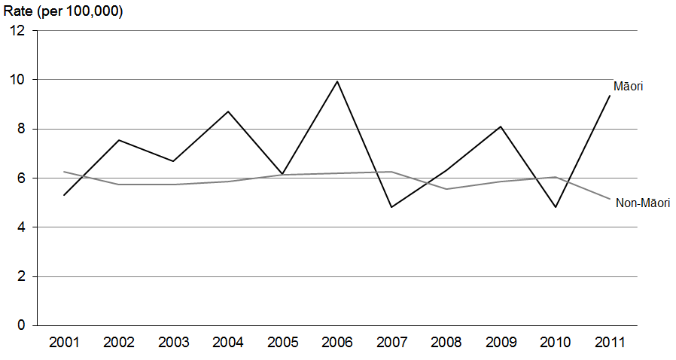
Source: New Zealand Mortality Collection
Note: The rate shown is the age-standardised rate per 100,000 females.

Pancreatic cancer (ICD code C25)

Registrations and deaths
- Pancreatic cancer was the ninth most common cancer registered in 2011, accounting for 2.2% of all registrations.
- Pancreatic cancer was the fifth most common cause of cancer death in 2011, accounting for 4.8% of all deaths from cancer.

Ethnic group
- Māori generally had higher registration and mortality rates than non-Māori between 2001 and 2011.
- Non-Māori male and female registration and mortality rates increased between 2001 and 2011.

Trends over time
- Between 2001 and 2011, pancreatic cancer registration and mortality rates for both males and females showed a slight upward trend.
- There was greater variation in Māori registration rates than non-Māori registration rates between 2001 and 2011 due to smaller numbers of registrations.

Table 18a: Numbers of registrations and deaths for pancreatic cancer, by sex and ethnic group, 2001–2011
 | Registrations |  |  |  |  |  | Deaths
 | Males |  |  | Females |  |  | Males |  |  | Females
 | Total | Māori | Non-Māori | Total | Māori | Non-Māori | Total | Māori | Non-Māori | Total | Māori | Non-Māori
2001 | 159 | 10 | 149 | 149 | 15 | 134 | 137 | 10 | 127 | 148 | 14 | 134
2002 | 160 | 16 | 144 | 167 | 13 | 154 | 150 | 12 | 138 | 153 | 14 | 139
2003 | 174 | 14 | 160 | 177 | 13 | 164 | 153 | 12 | 141 | 153 | 8 | 145
2004 | 178 | 20 | 158 | 187 | 21 | 166 | 172 | 15 | 157 | 183 | 9 | 174
2005 | 198 | 21 | 177 | 210 | 30 | 180 | 180 | 22 | 158 | 173 | 25 | 148
2006 | 177 | 15 | 162 | 216 | 23 | 193 | 155 | 7 | 148 | 197 | 21 | 176
2007 | 221 | 20 | 201 | 200 | 16 | 184 | 212 | 17 | 195 | 216 | 19 | 197
2008 | 207 | 25 | 182 | 226 | 31 | 195 | 176 | 21 | 155 | 197 | 21 | 176
2009 | 234 | 20 | 214 | 238 | 26 | 212 | 211 | 21 | 190 | 202 | 19 | 183
2010 | 255 | 29 | 226 | 238 | 20 | 218 | 220 | 23 | 197 | 215 | 21 | 194
2011 | 228 | 18 | 210 | 226 | 28 | 198 | 219 | 12 | 207 | 210 | 18 | 192
Source: New Zealand Cancer Registry and New Zealand Mortality Collection

Table 18b: Age-standardised registration and mortality rates for pancreatic cancer, by sex and ethnic group, 2001–2011
 | Registration rate (per 100,000) |  |  |  |  |  | Mortality rate (per 100,000)
 | Males |  |  | Females |  |  | Males |  |  | Females
 | Total | Māori | Non-Māori | Total | Māori | Non-Māori | Total | Māori | Non-Māori | Total | Māori | Non-Māori
2001 | 6.7 | 6.4 | 6.7 | 4.7 | 9.8 | 4.4 | 5.7 | 6.7 | 5.6 | 4.9 | 8.4 | 4.6
2002 | 6.6 | 9.7 | 6.3 | 5.2 | 7.3 | 5.0 | 6.2 | 7.2 | 6.0 | 4.7 | 7.3 | 4.4
2003 | 7.0 | 7.6 | 6.8 | 5.3 | 8.3 | 5.2 | 6.3 | 6.3 | 6.1 | 4.5 | 5.2 | 4.4
2004 | 7.1 | 11.4 | 6.7 | 5.7 | 12.0 | 5.3 | 6.7 | 8.6 | 6.5 | 5.3 | 5.2 | 5.3
2005 | 7.5 | 12.1 | 7.1 | 6.4 | 16.4 | 5.7 | 6.9 | 12.2 | 6.4 | 5.1 | 12.7 | 4.4
2006 | 6.5 | 11.1 | 6.3 | 6.0 | 12.8 | 5.6 | 5.6 | 5.2 | 5.7 | 5.3 | 13.1 | 5.0
2007 | 7.8 | 11.6 | 7.6 | 5.7 | 8.0 | 5.6 | 7.5 | 11.0 | 7.3 | 6.2 | 9.2 | 5.9
2008 | 7.3 | 12.4 | 6.8 | 6.5 | 14.0 | 5.8 | 6.1 | 11.2 | 5.6 | 5.3 | 10.5 | 4.9
2009 | 7.8 | 9.7 | 7.5 | 6.4 | 12.2 | 6.0 | 7.0 | 10.1 | 6.7 | 5.5 | 8.7 | 5.2
2010 | 8.3 | 14.0 | 7.8 | 6.3 | 9.0 | 6.1 | 7.1 | 11.2 | 6.7 | 5.6 | 9.0 | 5.3
2011 | 7.1 | 9.0 | 6.9 | 6.0 | 11.2 | 5.5 | 6.8 | 5.5 | 6.9 | 5.5 | 7.1 | 5.2
Source: New Zealand Cancer Registry and New Zealand Mortality Collection

Registrations
Figure 76: Registration rates for pancreatic cancer, 2001–2011
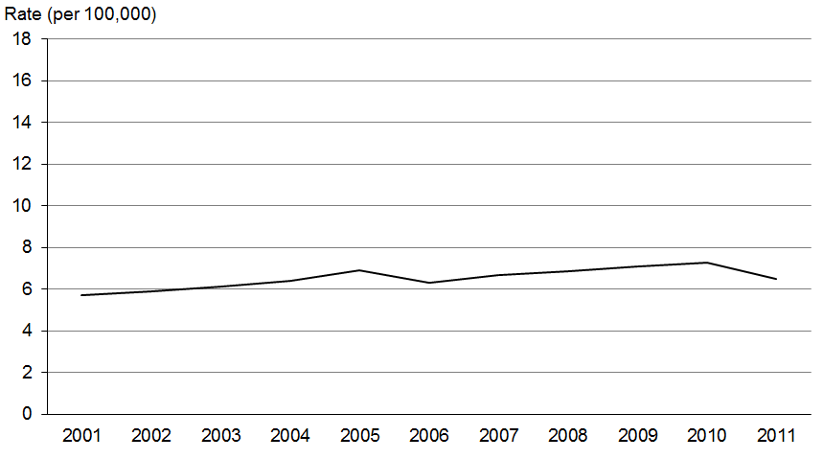

Figure 77: Male registration rates for pancreatic cancer, by ethnic group, 2001–2011
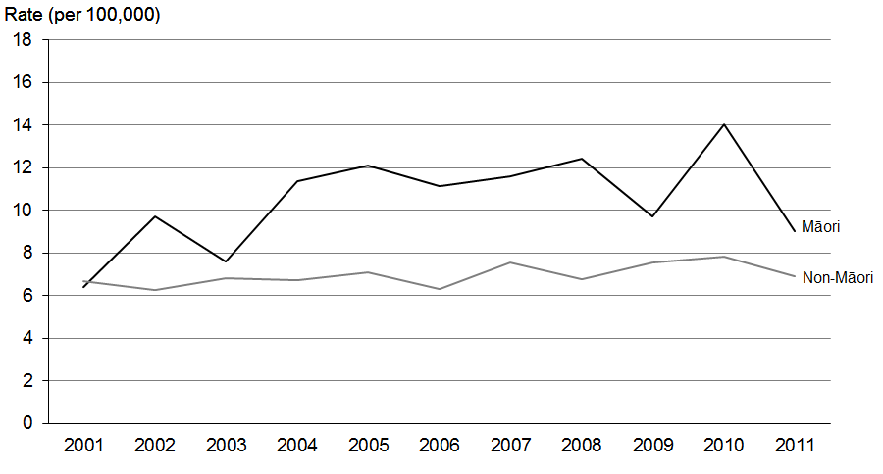

Figure 78: Female registration rates for pancreatic cancer, by ethnic group, 2001–2011
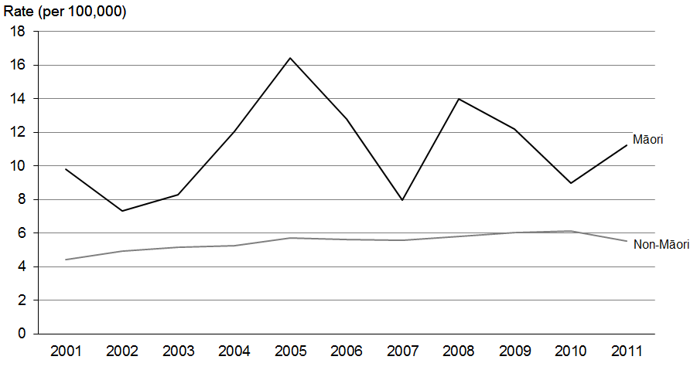
Source: New Zealand Cancer Registry

Deaths
Figure 79: Mortality rates for pancreatic cancer, 2001–2011
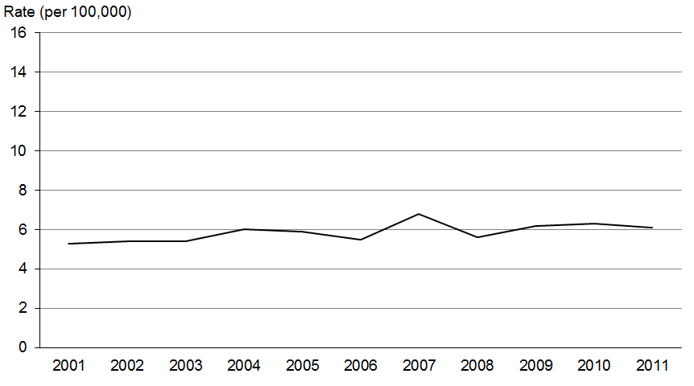

Figure 80: Male mortality rates for pancreatic cancer, by ethnic group, 2001–2011
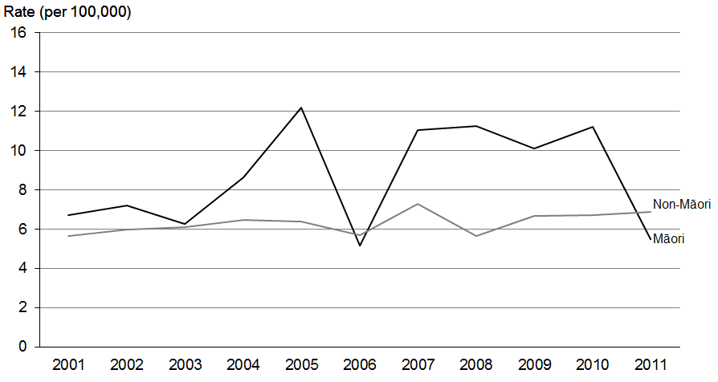

Figure 81: Female mortality rates for pancreatic cancer, by ethnic group, 2001–2011
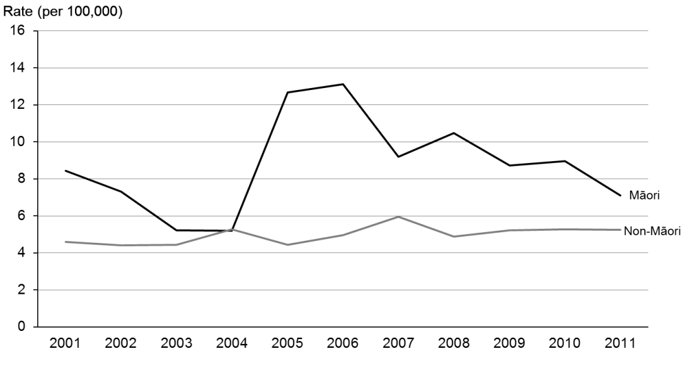
Source: New Zealand Mortality Collection

Prostate cancer (ICD code C61)

Registrations and deaths
- Overall, prostate cancer was the second most common cancer registered in 2011, accounting for 14.4% of all registrations.
- In males, it was the most common cancer registration, making up 27.3% of male registrations.
- Prostate cancer accounted for 12.6% of all male deaths from cancer, making it the third most common cause of death from cancer in men and the fourth most common overall.

Ethnic group
- Historically, Māori registration rates for prostate cancer have generally been lower than non-Māori rates. In 2011 the prostate cancer registration rate for Māori was 81.4 per 100,000, compared to 99.0 per 100,000 for non-Māori.
- The reverse is true for mortality rates. Figure 85 shows that in 2011 the prostate cancer mortality rate for Māori was 36.8% higher than for non-Māori.
- The Māori registration rate decreased by 18.4% between 2001 and 2011, compared to a 24.7% decrease in the non-Māori rate.
- The 2011 Māori mortality rate was the second lowest it had been in the previous 10-year period.

Trends over time
- Overall prostate cancer registration rates decreased by 24.9% between 2001 and 2011. Historically, registration rates for prostate cancer have been variable, which may reflect the volume of prostate-specific antigen (PSA) testing being undertaken in the community at any one time. This topic is discussed further in Cancer Projections: Incidence 2004–08 to
2014–18 (Ministry of Health 2011b). Further information on this document can be found in ‘Explanatory notes’.
- Mortality rates for this cancer had a downward trend between 2001 and 2011; the Māori and non-Māori rates fell approximately 32% over this time.

Table 19a: Numbers of registrations and deaths for prostate cancer, by ethnic group,
2001–2011
 | Registrations |  |  | Deaths
 | Total | Māori | Non-Māori | Total | Māori | Non-Māori
2001 | 3066 | 134 | 2932 | 592 | 33 | 559
2002 | 2665 | 143 | 2522 | 591 | 35 | 556
2003 | 2719 | 119 | 2600 | 556 | 20 | 536
2004 | 2720 | 142 | 2578 | 583 | 37 | 546
2005 | 2531 | 132 | 2399 | 564 | 36 | 528
2006 | 2484 | 123 | 2361 | 559 | 38 | 521
2007 | 2954 | 151 | 2803 | 574 | 36 | 538
2008 | 2939 | 141 | 2798 | 670 | 35 | 635
2009 | 3369 | 162 | 3207 | 562 | 38 | 524
2010 | 2988 | 169 | 2819 | 589 | 46 | 543
2011 | 3023 | 168 | 2855 | 585 | 37 | 548
Source: New Zealand Cancer Registry and New Zealand Mortality Collection

Table 19b: Age-standardised registration and mortality rates for prostate cancer, by ethnic group, 2001–2011
 | Registration rate (per 100,000) |  |  | Mortality rate (per 100,000)
 | Total | Māori | Non-Māori | Total | Māori | Non-Māori
2001 | 129.7 | 99.7 | 131.6 | 24.1 | 32.8 | 23.6
2002 | 110.1 | 119.4 | 110.3 | 23.3 | 36.4 | 22.7
2003 | 110.1 | 97.7 | 112.1 | 21.0 | 17.9 | 21.0
2004 | 107.1 | 100.5 | 108.0 | 21.5 | 34.8 | 20.9
2005 | 97.3 | 88.2 | 98.3 | 19.9 | 32.9 | 19.4
2006 | 91.8 | 81.4 | 93.0 | 19.4 | 31.0 | 18.8
2007 | 106.5 | 92.8 | 107.8 | 19.0 | 28.5 | 18.5
2008 | 103.3 | 81.9 | 105.4 | 21.5 | 25.6 | 21.2
2009 | 115.4 | 84.4 | 117.9 | 17.3 | 25.5 | 16.8
2010 | 99.0 | 86.4 | 100.2 | 17.4 | 28.7 | 16.7
2011 | 97.4 | 81.4 | 99.0 | 16.5 | 22.1 | 16.2
Source: New Zealand Cancer Registry and New Zealand Mortality Collection
Note: The rate shown is the age-standardised rate per 100,000 males.

Registrations
Figure 82: Registration rates for prostate cancer, 2001–2011
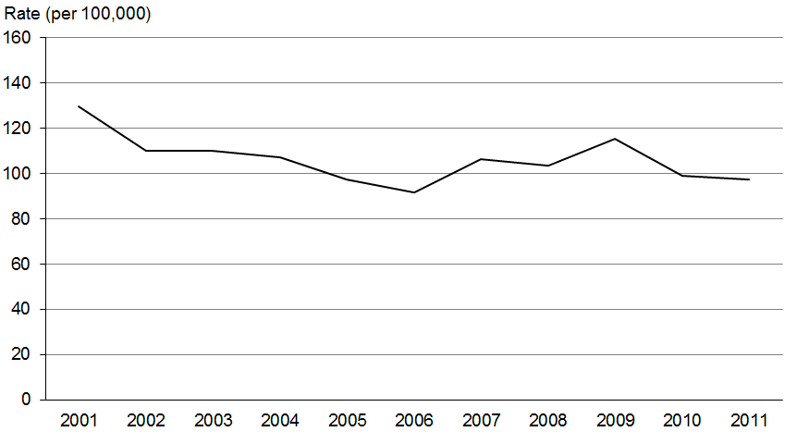

Figure 83: Registration rates for prostate cancer, by ethnic group, 2001–2011
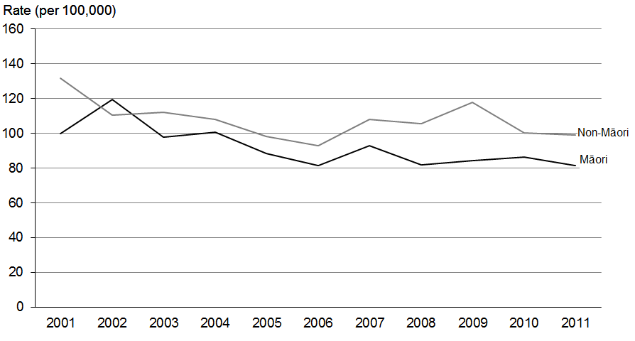
Source: New Zealand Cancer Registry
Note: The rate shown is the age-standardised rate per 100,000 males.

Deaths
Figure 84: Mortality rates for prostate cancer, 2001–2011
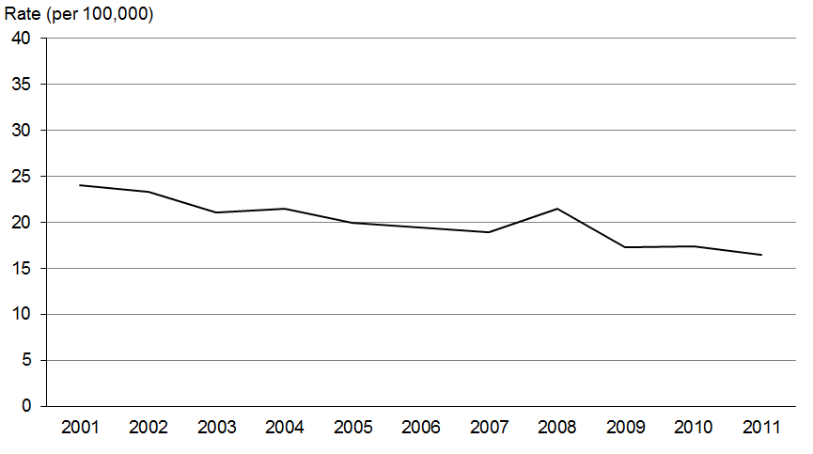

Figure 85: Mortality rates for prostate cancer, by ethnic group, 2001–2011
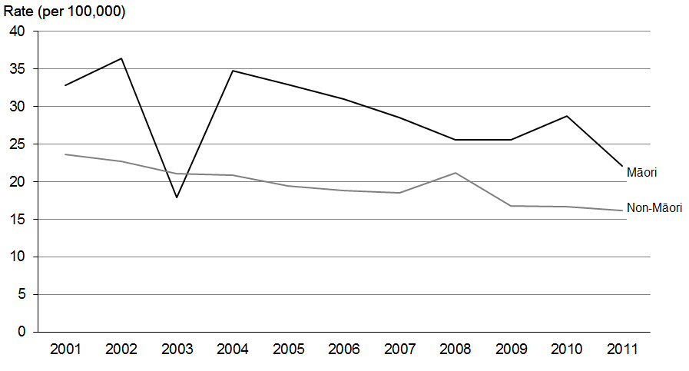
Source: New Zealand Mortality Collection
Note: The rate shown is the age-standardised rate per 100,000 males.

Stomach cancer (ICD code C16)

Registrations and deaths
- Stomach cancer was the 11th most common cancer registered in 2011, and the 8th most common cause of death.
- Stomach cancer affected more men than women; in 2011 the male registration rate was 1.9 times the female rate.
- Male mortality rates for stomach cancer were approximately twice female rates in 2011.

Ethnic group
- Māori had higher rates of both new registrations and deaths for stomach cancer than non-Māori in 2011.
- Māori registration rates were more variable than non-Māori rates between 2001 and 2011.
- In 2011 the Māori male and female registration rates were 2.6 and 4.7 times higher than non-Māori male and female rates, respectively.
- The mortality rate for stomach cancer for Māori males was 1.9 times higher than the non-Māori rate, and the rate for Māori females was 2.7 times higher than the rate for non-Māori females.

Trends over time
- Between 2001 and 2011 the registration rate for stomach cancer showed a slight downward trend for both males and females.
- The mortality rate for stomach cancer also showed a downward trend.
- Between 2001 and 2011 the disparity between Māori and non-Māori stomach cancer registration and mortality rates remained fairly constant.

Table 20a: Numbers of registrations and deaths for stomach cancer, by sex and ethnic group, 2001–2011
 | Registrations |  |  |  |  |  | Deaths
 | Males |  |  | Females |  |  | Males |  |  | Females
 | Total | Māori | Non-Māori | Total | Māori | Non-Māori | Total | Māori | Non-Māori | Total | Māori | Non-Māori
2001 | 228 | 25 | 203 | 154 | 27 | 127 | 195 | 24 | 171 | 108 | 17 | 91
2002 | 264 | 34 | 230 | 145 | 26 | 119 | 189 | 18 | 171 | 112 | 18 | 94
2003 | 251 | 42 | 209 | 140 | 28 | 112 | 206 | 32 | 174 | 109 | 15 | 94
2004 | 212 | 36 | 176 | 159 | 28 | 131 | 186 | 32 | 154 | 115 | 21 | 94
2005 | 203 | 30 | 173 | 140 | 33 | 107 | 143 | 19 | 124 | 113 | 18 | 95
2006 | 234 | 37 | 197 | 134 | 30 | 104 | 161 | 28 | 133 | 112 | 20 | 92
2007 | 234 | 41 | 193 | 138 | 37 | 101 | 184 | 33 | 151 | 113 | 28 | 85
2008 | 243 | 37 | 206 | 128 | 28 | 100 | 173 | 26 | 147 | 110 | 24 | 86
2009 | 242 | 38 | 204 | 128 | 36 | 92 | 164 | 28 | 136 | 84 | 23 | 61
2010 | 235 | 36 | 199 | 134 | 35 | 99 | 158 | 22 | 136 | 95 | 16 | 79
2011 | 248 | 41 | 207 | 143 | 40 | 103 | 193 | 21 | 172 | 103 | 20 | 83
Source: New Zealand Cancer Registry and New Zealand Mortality Collection

Table 20b: Age-standardised registration and mortality rates for stomach cancer, by sex and ethnic group, 2001–2011
 | Registration rate (per 100,000) |  |  |  |  |  | Mortality rate (per 100,000)
 | Males |  |  | Females |  |  | Males |  |  | Females
 | Total | Māori | Non-Māori | Total | Māori | Non-Māori | Total | Māori | Non-Māori | Total | Māori | Non-Māori
2001 | 9.6 | 17.8 | 8.9 | 5.2 | 15.2 | 4.4 | 8.2 | 15.3 | 7.6 | 3.5 | 9.1 | 3.0
2002 | 11.0 | 21.5 | 10.1 | 5.0 | 15.1 | 4.2 | 7.7 | 11.8 | 7.3 | 3.6 | 10.2 | 3.0
2003 | 10.1 | 25.0 | 8.8 | 4.6 | 12.8 | 3.6 | 8.1 | 22.6 | 7.2 | 3.4 | 7.1 | 2.9
2004 | 8.6 | 19.1 | 7.4 | 5.0 | 14.2 | 4.1 | 7.4 | 18.9 | 6.4 | 3.6 | 10.9 | 3.0
2005 | 7.9 | 17.6 | 7.1 | 4.5 | 15.2 | 3.4 | 5.4 | 10.6 | 4.9 | 3.5 | 8.6 | 3.0
2006 | 8.7 | 22.6 | 7.8 | 4.3 | 13.2 | 3.4 | 5.9 | 17.1 | 5.1 | 3.4 | 8.6 | 2.9
2007 | 8.4 | 21.8 | 7.4 | 4.5 | 16.8 | 3.4 | 6.5 | 19.1 | 5.6 | 3.6 | 11.6 | 2.7
2008 | 8.7 | 17.8 | 7.7 | 3.8 | 12.4 | 3.0 | 5.9 | 15.2 | 5.3 | 3.1 | 11.5 | 2.5
2009 | 8.2 | 19.3 | 7.3 | 3.8 | 15.2 | 2.8 | 5.5 | 13.8 | 4.7 | 2.4 | 9.6 | 1.7
2010 | 8.0 | 16.7 | 7.2 | 4.1 | 13.3 | 3.0 | 5.3 | 10.2 | 4.8 | 2.6 | 6.3 | 2.2
2011 | 8.0 | 18.6 | 7.1 | 4.3 | 14.9 | 3.2 | 6.0 | 10.9 | 5.7 | 3.0 | 6.9 | 2.5
Source: New Zealand Cancer Registry and New Zealand Mortality Collection

Registrations
Figure 86: Registration rates for stomach cancer, 2001–2011
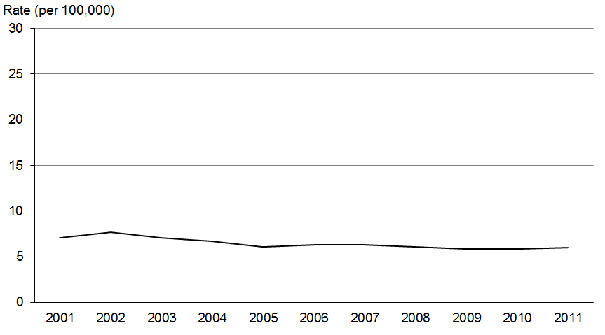

Figure 87: Male registration rates for stomach cancer, by ethnic group, 2001–2011
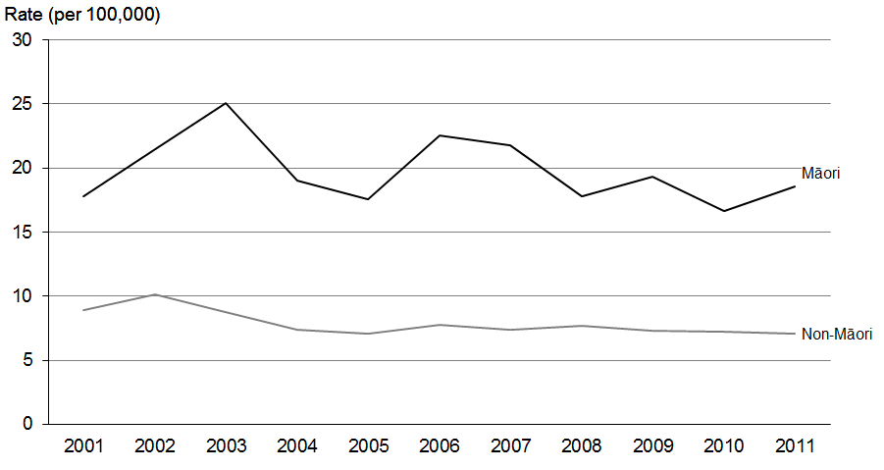

Figure 88: Female registration rates for stomach cancer, by ethnic group, 2001–2011
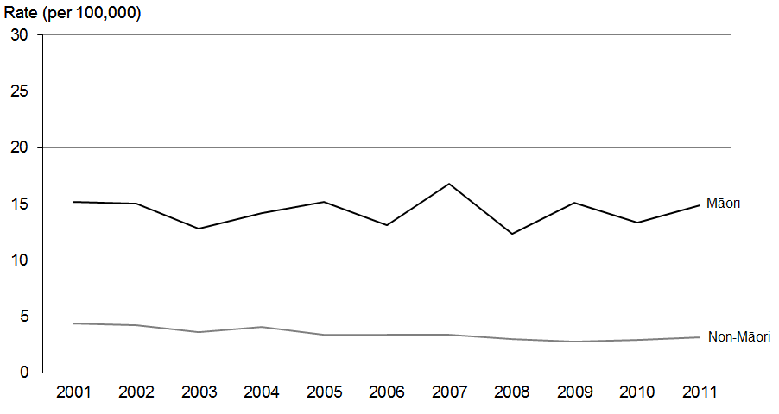
Source: New Zealand Cancer Registry

Deaths
Figure 89: Mortality rates for stomach cancer, 2001–2011
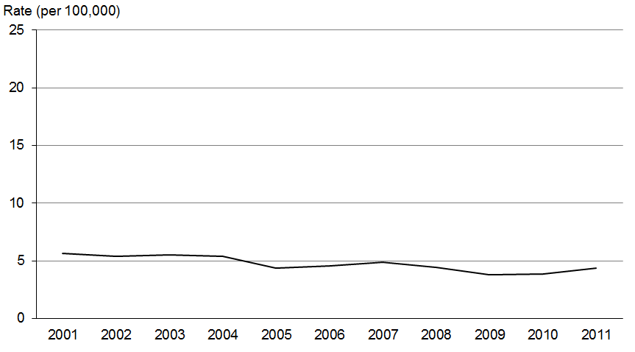

Figure 90: Male mortality rates for stomach cancer, by ethnic group, 2001–2011
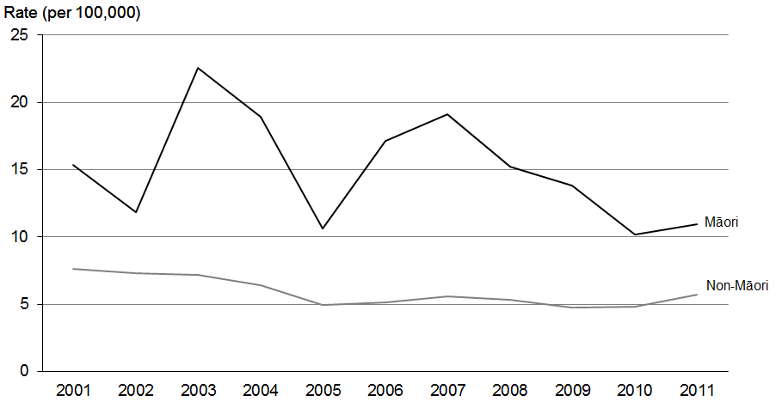

Figure 91: Female mortality rates for stomach cancer, by ethnic group, 2001–2011
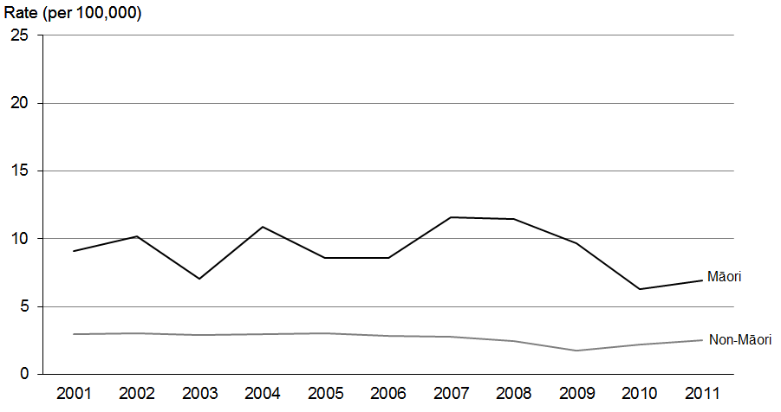
Source: New Zealand Mortality Collection

Lymphohaematopoietic cancers
Lymphohaematopoietic cancers can be defined as ‘those of, relating to, or involved in the production of lymphocytes and cells of blood, bone marrow, spleen, lymph nodes, and thymus’. These cancers are considered to be systemic as they can occur in many different parts of the body rather than being site specific. Leukaemia and non-Hodgkin lymphoma are the most common lymphohaematopoietic cancers and are discussed below.

Leukaemia (ICD codes C91–C95)

Registrations and deaths
- Leukaemia was the seventh most common cancer registration and death in 2011, accounting for 2.7% of all new cancer registrations and 3.6% of all deaths from cancer.
- Male registration rates for leukaemia were 1.5 times higher than female rates in 2011.
- The male mortality rate for leukaemia in 2011 was nearly twice as high as the female rate.

Ethnic group
- Māori registration and mortality rates were variable due to small numbers, with no consistent disparities between Māori and non-Māori between 2001 and 2011.

Trends over time
- Registration rates for leukaemia for both males and females decreased between 2001 and 2011.
- The total registration rates for leukaemia decreased between 2003 and 2006, after which they remained relatively stable.
- The total mortality rates for leukaemia were relatively stable over this time.

Table 21a: Numbers of registrations and deaths for leukaemia, by sex and ethnic group,
2001–2011
 | Registrations |  |  |  |  |  | Deaths
 | Males |  |  | Females |  |  | Males |  |  | Females
 | Total | Māori | Non-Māori | Total | Māori | Non-Māori | Total | Māori | Non-Māori | Total | Māori | Non-Māori
2001 | 371 | 32 | 339 | 272 | 29 | 243 | 136 | 12 | 124 | 116 | 11 | 105
2002 | 395 | 29 | 366 | 309 | 23 | 286 | 128 | 9 | 119 | 108 | 6 | 102
2003 | 438 | 33 | 405 | 326 | 21 | 305 | 158 | 11 | 147 | 111 | 9 | 102
2004 | 373 | 21 | 352 | 307 | 32 | 275 | 146 | 7 | 139 | 145 | 7 | 138
2005 | 336 | 28 | 308 | 250 | 25 | 225 | 159 | 10 | 149 | 148 | 11 | 137
2006 | 302 | 37 | 265 | 233 | 23 | 210 | 170 | 10 | 160 | 128 | 9 | 119
2007 | 317 | 24 | 293 | 246 | 25 | 221 | 172 | 13 | 159 | 134 | 11 | 123
2008 | 340 | 43 | 297 | 251 | 28 | 223 | 157 | 17 | 140 | 130 | 10 | 120
2009 | 328 | 42 | 286 | 246 | 19 | 227 | 145 | 13 | 132 | 121 | 8 | 113
2010 | 352 | 40 | 312 | 239 | 24 | 215 | 172 | 16 | 156 | 117 | 3 | 114
2011 | 328 | 31 | 297 | 235 | 28 | 207 | 191 | 17 | 174 | 127 | 9 | 118
Source: New Zealand Cancer Registry and New Zealand Mortality Collection

Table 21b: Age-standardised registration and mortality rates for leukaemia, by sex and ethnic group, 2001–2011
 | Registration rate (per 100,000) |  |  |  |  |  | Mortality rate (per 100,000)
 | Males |  |  | Females |  |  | Males |  |  | Females
 | Total | Māori | Non-Māori | Total | Māori | Non-Māori | Total | Māori | Non-Māori | Total | Māori | Non-Māori
2001 | 16.7 | 18.0 | 16.7 | 10.3 | 14.5 | 10.1 | 5.9 | 9.9 | 5.8 | 3.9 | 5.6 | 3.7
2002 | 17.1 | 15.7 | 17.1 | 11.4 | 10.5 | 11.4 | 5.4 | 7.3 | 5.3 | 3.6 | 3.0 | 3.6
2003 | 18.2 | 21.2 | 18.2 | 11.8 | 10.1 | 12.1 | 6.5 | 6.6 | 6.4 | 3.5 | 4.3 | 3.3
2004 | 15.1 | 12.4 | 15.5 | 11.3 | 15.0 | 11.1 | 5.8 | 3.2 | 5.9 | 4.7 | 2.9 | 4.8
2005 | 13.5 | 15.0 | 13.6 | 8.7 | 9.3 | 8.4 | 6.1 | 6.8 | 6.1 | 4.6 | 4.4 | 4.5
2006 | 12.2 | 16.0 | 11.7 | 7.9 | 8.5 | 7.6 | 6.4 | 6.0 | 6.5 | 3.5 | 5.9 | 3.5
2007 | 12.2 | 10.6 | 12.2 | 8.4 | 9.6 | 8.3 | 6.2 | 5.0 | 6.0 | 3.9 | 5.0 | 3.8
2008 | 12.9 | 17.8 | 12.3 | 8.7 | 9.7 | 8.4 | 5.6 | 8.8 | 5.3 | 3.7 | 3.8 | 3.6
2009 | 12.5 | 17.2 | 11.9 | 7.8 | 7.4 | 8.0 | 5.0 | 5.9 | 4.8 | 3.2 | 3.3 | 3.1
2010 | 12.8 | 16.9 | 12.6 | 7.7 | 9.6 | 7.8 | 5.7 | 7.7 | 5.5 | 3.0 | 1.3 | 3.2
2011 | 11.6 | 12.1 | 11.6 | 7.7 | 10.1 | 7.5 | 6.1 | 8.0 | 5.9 | 3.4 | 3.3 | 3.4
Source: New Zealand Cancer Registry and New Zealand Mortality Collection

Registrations
Figure 92: Registration rates for leukaemia, 2001–2011
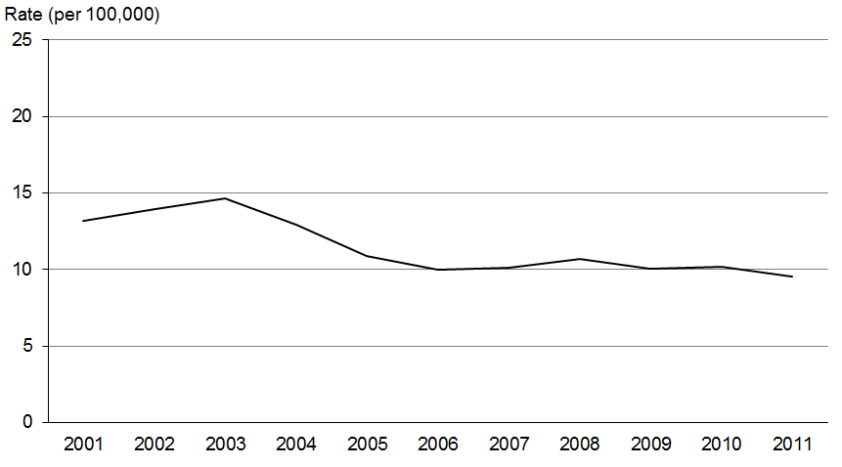

Figure 93: Male registration rates for leukaemia, by ethnic group, 2001–2011
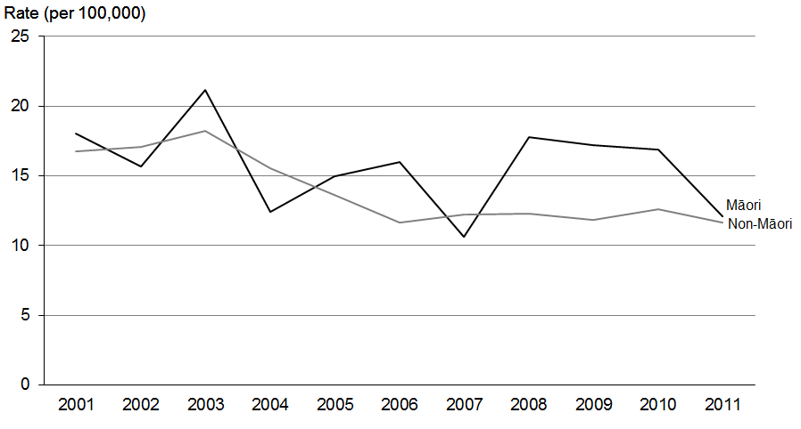

Figure 94: Female registration rates for leukaemia, by ethnic group, 2001–2011
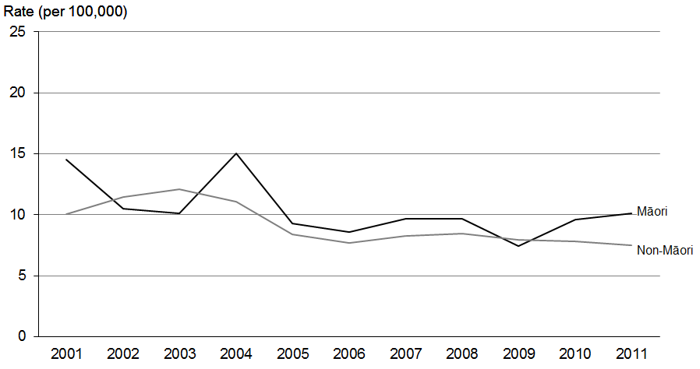
Source: New Zealand Cancer Registry

Deaths
Figure 95: Mortality rates for leukaemia, 2001–2011
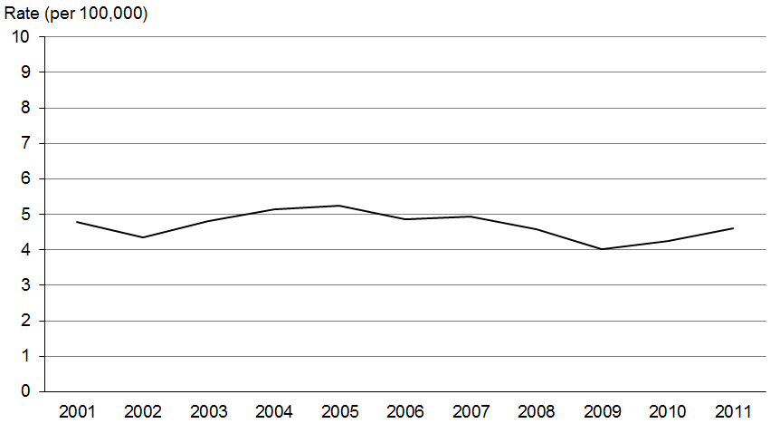

Figure 96: Male mortality rates for leukaemia, by ethnic group, 2001–2011
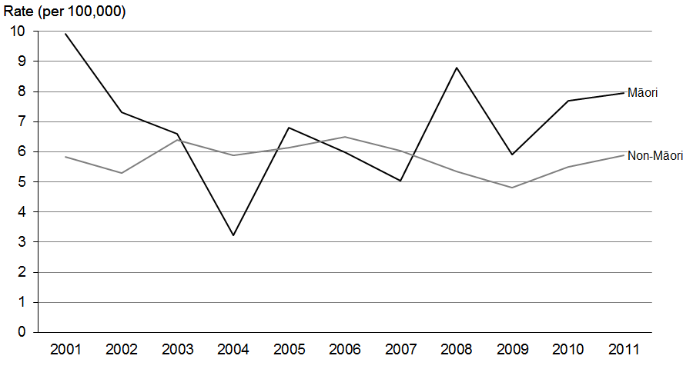

Figure 97: Female mortality rates for leukaemia, by ethnic group, 2001–2011
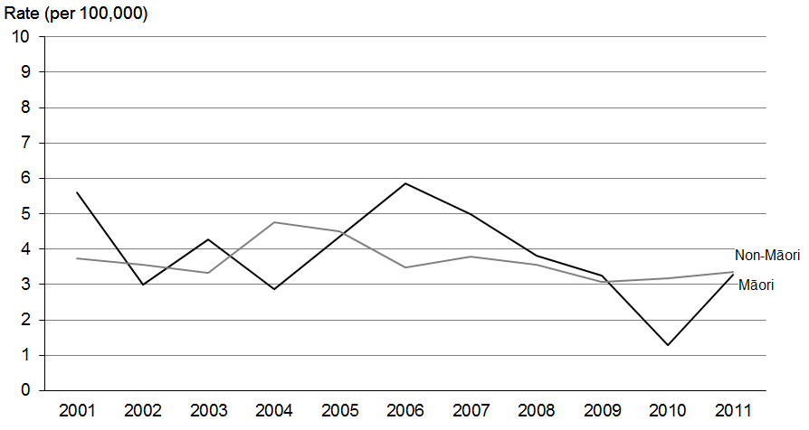
Source: New Zealand Mortality Collection

Non-Hodgkin lymphoma (ICD codes
C82–C85 and C96)
Like leukaemia, non-Hodgkin lymphoma is a lymphohaematopoietic cancer (see information in ‘Lymphohaematopoietic cancers’ above).

Registrations and deaths
- Non-Hodgkin lymphoma was the sixth most commonly registered cancer in 2011, accounting for 3.5% of all new cancer registrations and 3.2% of all deaths from cancer.
- The male registration rate for non-Hodgkin lymphoma was 1.2 times greater than the female rate in 2011.
- The mortality rate for males in 2011 was 42.3% higher than the female rate.

Ethnic group
- Registration and death rates for non-Hodgkin lymphoma did not show a clear disparity when compared by ethnic group; however, numbers of Māori registrations and deaths were low, so any rates should be compared with caution.

Trends over time
- Registration rates for both males and females remained relatively stable between 2001 and 2011.
- Total mortality rates trended downwards, falling by 29.4% over the period.

Table 22a: Numbers of registrations and deaths for non-Hodgkin lymphoma, by sex and ethnic group, 2001–2011
 | Registrations |  |  |  |  |  | Deaths
 | Males |  |  | Females |  |  | Males |  |  | Females
 | Total | Māori | Non-Māori | Total | Māori | Non-Māori | Total | Māori | Non-Māori | Total | Māori | Non-Māori
2001 | 333 | 23 | 310 | 288 | 17 | 271 | 170 | 10 | 160 | 130 | 10 | 120
2002 | 297 | 16 | 281 | 339 | 25 | 314 | 137 | 5 | 132 | 146 | 7 | 139
2003 | 352 | 25 | 327 | 273 | 30 | 243 | 177 | 14 | 163 | 158 | 16 | 142
2004 | 350 | 21 | 329 | 301 | 12 | 289 | 136 | 12 | 124 | 152 | 12 | 140
2005 | 375 | 24 | 351 | 313 | 15 | 298 | 155 | 16 | 139 | 108 | 4 | 104
2006 | 398 | 26 | 372 | 301 | 19 | 282 | 168 | 14 | 154 | 144 | 10 | 134
2007 | 370 | 29 | 341 | 331 | 21 | 310 | 164 | 14 | 150 | 142 | 7 | 135
2008 | 419 | 28 | 391 | 352 | 22 | 330 | 150 | 11 | 139 | 123 | 9 | 114
2009 | 440 | 39 | 401 | 329 | 27 | 302 | 148 | 7 | 141 | 143 | 13 | 130
2010 | 441 | 32 | 409 | 339 | 21 | 318 | 135 | 12 | 123 | 128 | 4 | 124
2011 | 379 | 35 | 344 | 350 | 26 | 324 | 155 | 7 | 148 | 133 | 9 | 124
Source: New Zealand Cancer Registry and New Zealand Mortality Collection

Table 22b: Age-standardised registration and mortality rates for non-Hodgkin lymphoma, by sex and ethnic group, 2001–2011
 | Registration rate (per 100,000) |  |  |  |  |  | Mortality rate (per 100,000)
 | Males |  |  | Females |  |  | Males |  |  | Females
 | Total | Māori | Non-Māori | Total | Māori | Non-Māori | Total | Māori | Non-Māori | Total | Māori | Non-Māori
2001 | 14.4 | 13.8 | 14.5 | 10.5 | 9.3 | 10.6 | 7.3 | 5.1 | 7.3 | 4.1 | 6.2 | 4.0
2002 | 12.6 | 9.4 | 12.8 | 12.4 | 13.3 | 12.2 | 5.7 | 3.1 | 5.8 | 4.7 | 4.6 | 4.8
2003 | 14.8 | 13.7 | 14.8 | 9.8 | 15.6 | 9.3 | 7.2 | 8.1 | 6.9 | 5.1 | 8.8 | 4.8
2004 | 14.4 | 11.4 | 14.7 | 10.6 | 5.9 | 11.0 | 5.4 | 7.2 | 5.2 | 4.6 | 7.0 | 4.5
2005 | 15.0 | 12.8 | 15.1 | 10.6 | 6.6 | 10.9 | 5.9 | 11.9 | 5.6 | 3.1 | 2.2 | 3.2
2006 | 15.7 | 14.1 | 16.0 | 10.2 | 9.0 | 10.3 | 6.2 | 7.8 | 6.1 | 4.2 | 5.1 | 4.1
2007 | 13.9 | 13.7 | 13.8 | 10.8 | 9.6 | 11.0 | 5.9 | 8.5 | 5.8 | 3.9 | 3.8 | 3.9
2008 | 15.5 | 13.4 | 15.7 | 11.3 | 9.8 | 11.5 | 5.2 | 6.4 | 5.1 | 3.3 | 4.2 | 3.2
2009 | 16.0 | 15.9 | 15.7 | 10.2 | 11.1 | 10.1 | 5.0 | 2.9 | 5.1 | 3.9 | 5.5 | 3.7
2010 | 15.5 | 13.9 | 15.6 | 10.4 | 8.5 | 10.6 | 4.3 | 5.9 | 4.1 | 3.1 | 2.0 | 3.2
2011 | 12.9 | 16.2 | 12.7 | 10.5 | 10.2 | 10.6 | 4.7 | 3.9 | 4.8 | 3.3 | 3.7 | 3.3
Source: New Zealand Cancer Registry and New Zealand Mortality Collection

Registrations
Figure 98: Registration rates for non-Hodgkin lymphoma, 2001–2011
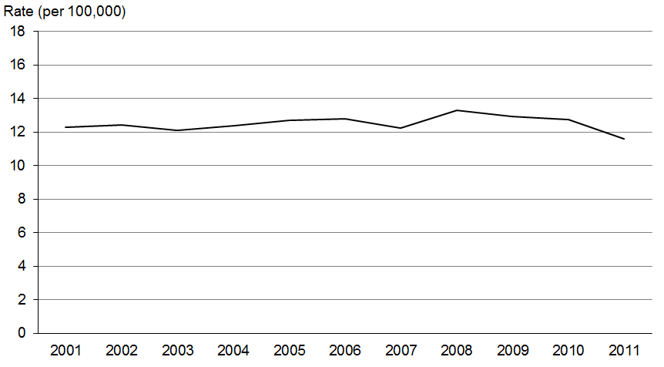

Figure 99: Male registration rates for non-Hodgkin lymphoma, by ethnic group, 2001–2011
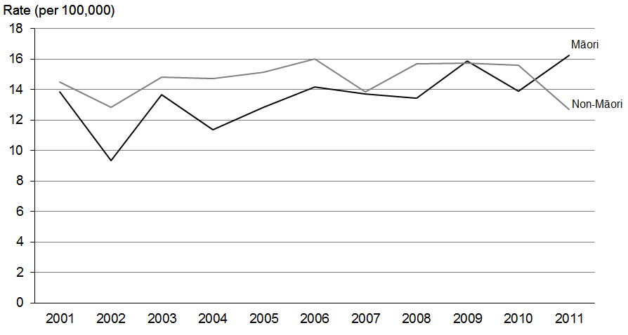

Figure 100: Female registration rates for non-Hodgkin lymphoma, by ethnic group,
2001–2011
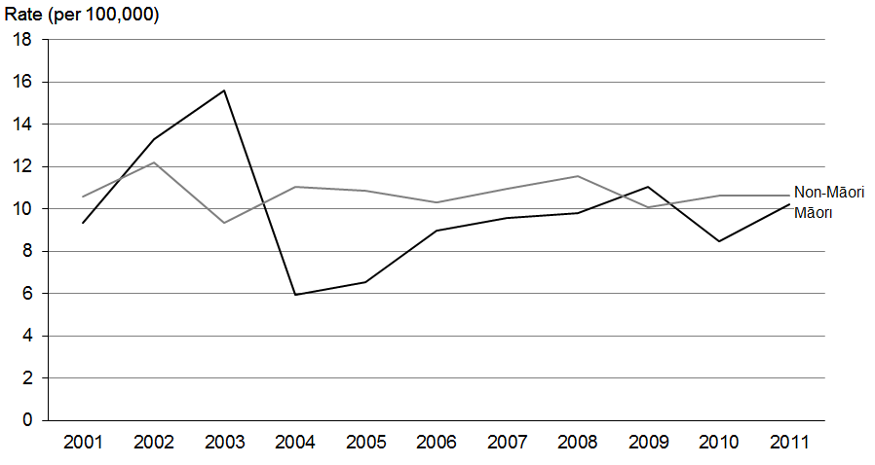
Source: New Zealand Cancer Registry

Deaths
Figure 101: Mortality rates for non-Hodgkin lymphoma, 2001–2011
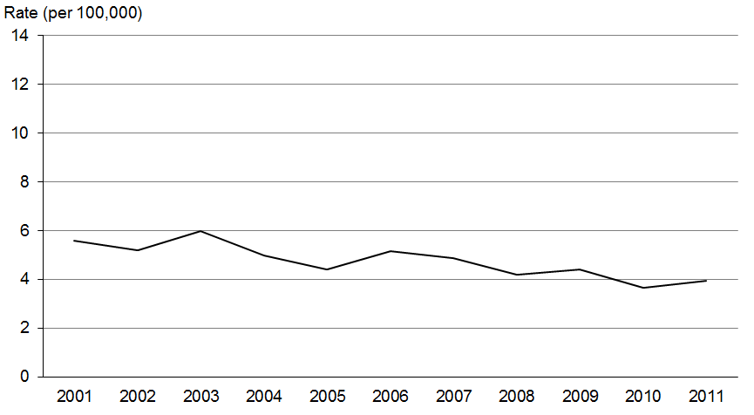

Figure 102: Male mortality rates for non-Hodgkin lymphoma, by ethnic group, 2001–2011
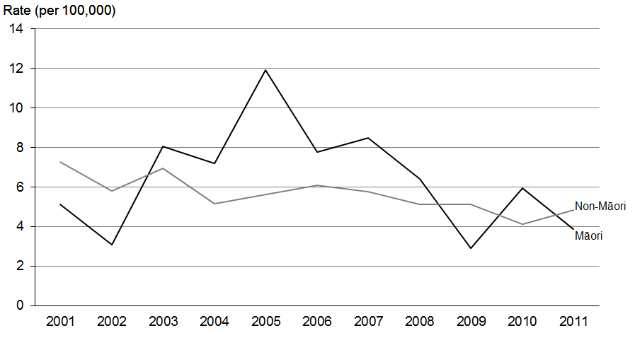

Figure 103: Female mortality rates for non-Hodgkin lymphoma, by ethnic group,
2001–2011
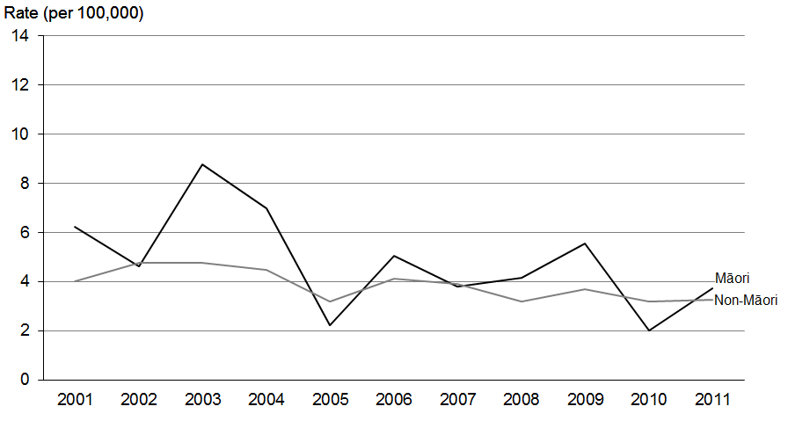
Source: New Zealand Mortality Collection

Classification of cancers of the blood and lymphatic system
For the purpose of incidence reporting, the lymphohaematopoietic cancers are classified according to the ICD-10 coding scheme, but it is also useful to classify them using morphology codes from the ICD-O classification system (see ‘Explanatory notes’). The ICD-O morphology codes for lymphohaematopoietic cancers are based on the WHO classification used by haematologists (Swerdlow et al 2008). In the WHO classification scheme, cancers of the blood and lymphatic systems are grouped according to their lineage, rather than site of origin.

Table 23 shows numbers and age-standardised rates of registrations in 2011 for lymphohaematopoietic cancers grouped by their morphology. Table N-3 in ‘Explanatory notes’ shows the ICD-O codes used to create each group.

Table 23: Numbers and age-standardised rates of registration for lymphohaematopoietic cancers, by morphology code, 2011
 | Males |  | Females |  | Total
 | Number | Rate | Number | Rate | Number | Rate
Lymphoid cancers | 815 | 28.1 | 630 | 19.6 | 1445 | 23.6
Hodgkin lymphoma | 59 | 2.5 | 41 | 1.7 | 100 | 2.1
Mature B-cell cancers | 636 | 20.8 | 479 | 13.9 | 1115 | 17.1
Chronic lymphocytic leukaemias/small lymphocytic lymphomas | 137 | 4.4 | 78 | 2.1 | 215 | 3.2
Diffuse large B-cell lymphomas | 148 | 4.9 | 150 | 4.5 | 298 | 4.7
Follicular lymphomas | 62 | 2.2 | 71 | 2.3 | 133 | 2.2
Plasma cell disorders | 182 | 5.7 | 115 | 3.2 | 297 | 4.4
Other mature B-cell cancers | 107 | 3.6 | 65 | 1.9 | 172 | 2.7
Mature T- and NK-cell cancers | 46 | 1.7 | 28 | 1.1 | 74 | 1.4
Acute lymphoblastic leukaemia | 36 | 1.9 | 34 | 1.6 | 70 | 1.8
Non-Hodgkin lymphoma, NOS | 10 | 0.3 | 20 | 0.5 | 30 | 0.4
Lymphoid cancers, NOS | 28 | 0.8 | 28 | 0.6 | 56 | 0.7
Myeloid cancers | 336 | 10.8 | 238 | 6.8 | 574 | 8.6
Acute myeloid leukaemias | 93 | 3.3 | 89 | 2.9 | 182 | 3.1
Chronic myeloid leukaemias | 26 | 0.9 | 21 | 0.7 | 47 | 0.8
Other chronic myeloproliferative diseases | 55 | 1.8 | 56 | 1.6 | 111 | 1.7
Myelodysplastic syndromes | 139 | 4.1 | 66 | 1.5 | 205 | 2.6
Myelodysplastic/myeloproliferative diseases | 23 | 0.7 | 6 | 0.1 | 29 | 0.4
Myeloid cancers, NOS | 0 | 0.0 | 0 | 0.0 | 0 | 0.0
Lymphoid/myeloid cancers, NOS | 3 | 0.1 | 3 | 0.1 | 6 | 0.1
Other lymphohaematopoietic cancers | 1 | 0.0 | 1 | 0.0 | 2 | 0.0
Total | 1155 | 39.1 | 872 | 26.5 | 2027 | 32.3
Note: NOS = Not otherwise specified.

Cancer registrations and deaths by district health board region, 2009–2011
This section presents cancer registration and mortality data by district health board (DHB) region of domicile as age-standardised rates. An age-standardised rate adjusts for differences in age distribution of the populations being compared and allows comparison to be made within differing groups – in this instance, different DHB regions.

The information in this section has not been adjusted for ethnic group. Different regions have different proportions of Māori in their populations, and the fact that Māori have higher rates of most cancers will affect regional rates of registration and death to some extent.

Figure 104 shows cancer registration rates by DHB region using 2009, 2010 and 2011 aggregated data (aggregated data was used to minimise the effects of year-to-year variance in the data). The confidence intervals indicate whether the DHB region differed significantly from the national rate. Over this time, four DHB regions had registration rates that were significantly higher than the national rate (Bay of Plenty, Taranaki, Whanganui and Canterbury DHBs). Four DHB regions had rates that were significantly lower (Waitemata, Counties Manakau, Capital & Coast and Southern). All of the other DHB regions had rates that had 95% confidence limits that overlapped with the mean New Zealand registration rate (see ‘Explanatory notes’), meaning they were not significantly different from the national mean.

Figure 104: Cancer registration rates, by DHB region, 2009−2011
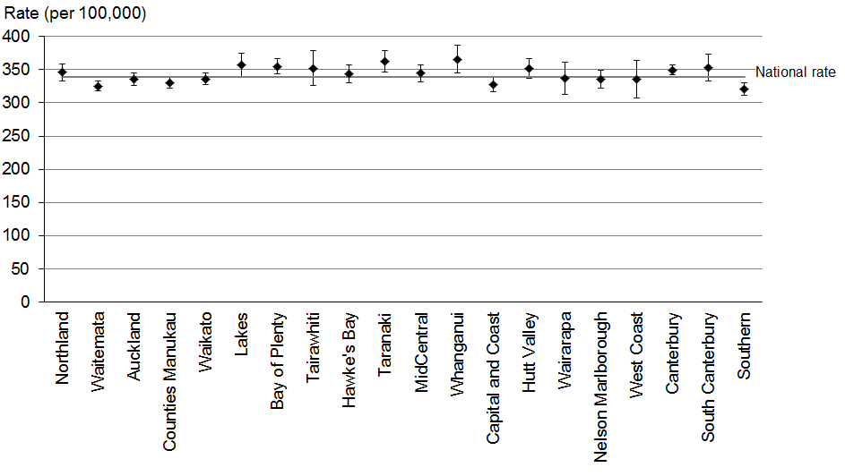
Source: New Zealand Cancer Registry
Note: The rate shown is the age-standardised rate per 100,000 DHB population, standardised to the WHO world standard population; 95% confidence intervals.

Figure 105 is a map of New Zealand showing a geographical representation of the information in Figure 104. The lighter and darker shades on the map distinguish DHB regions that have significantly lower or higher registration rates than the mean national rate.

Figure 105: Comparison of DHB region cancer registration rates with national rate,
2009–2011
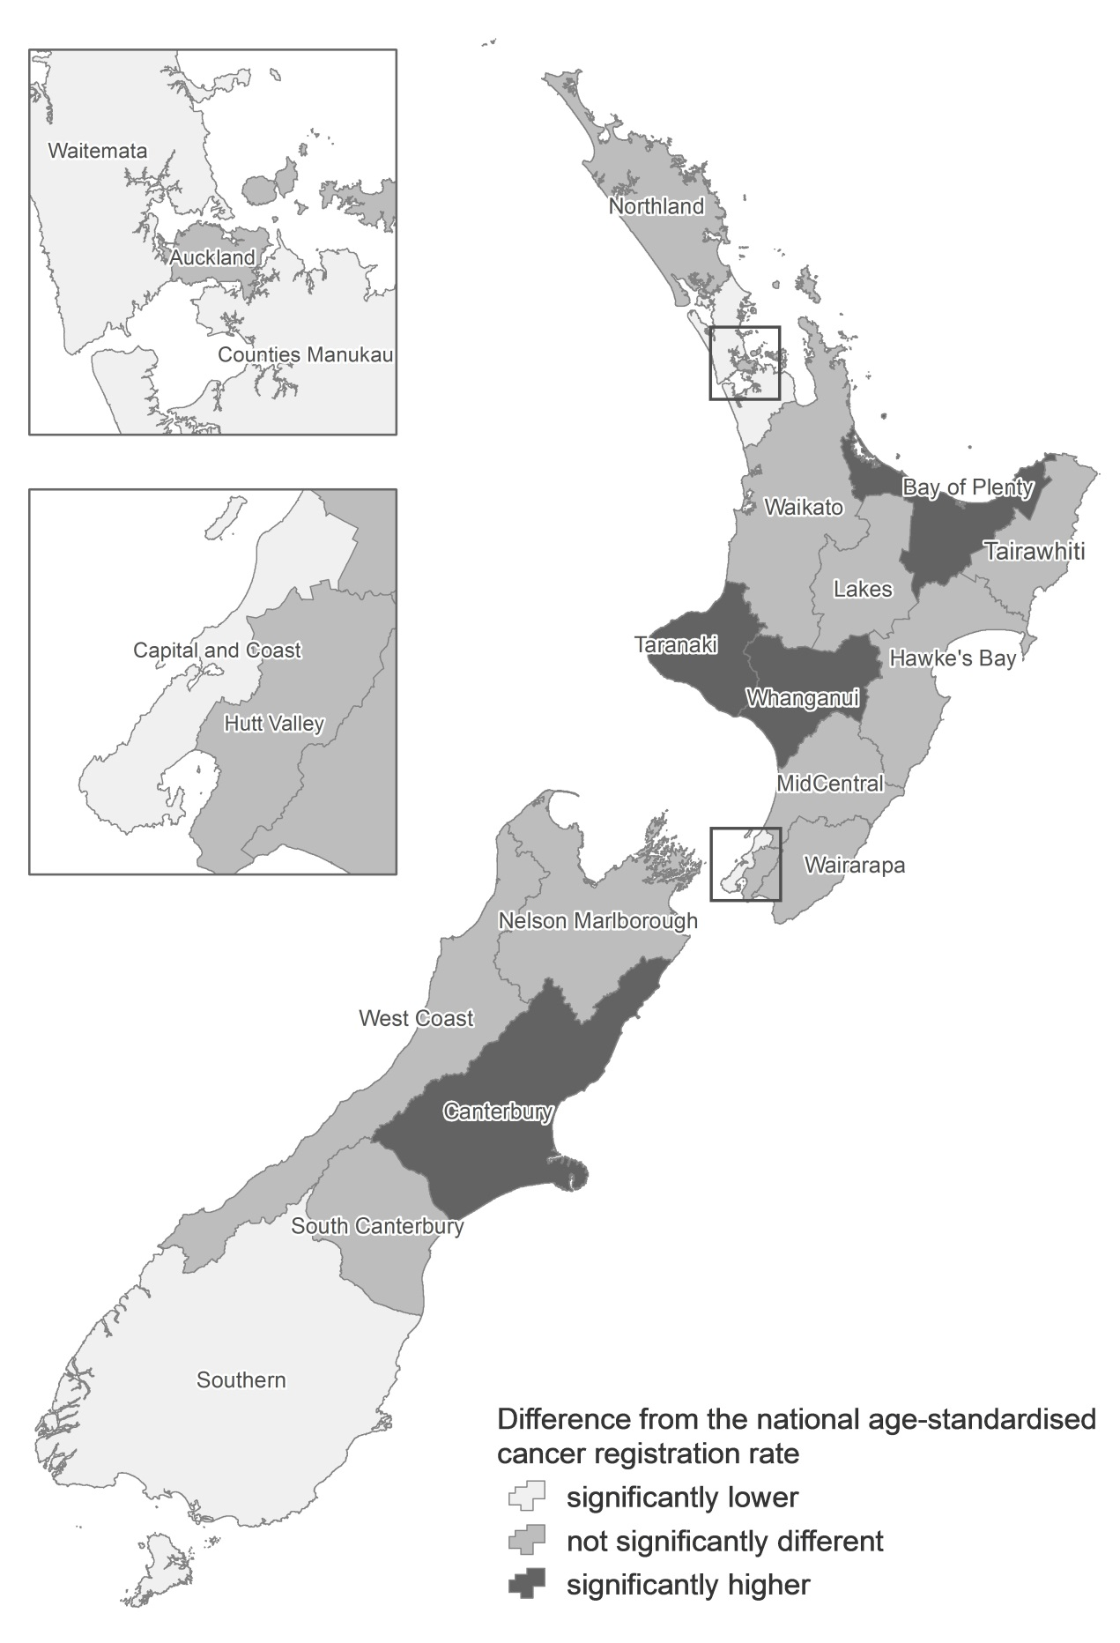
Source: New Zealand Cancer Registry
Note: The rate used is the age-standardised rate per 100,000 DHB population, standardised to the WHO world standard population; 95% confidence intervals.
Figure 106 shows age-standardised cancer mortality rates by DHB region for the years
2009–2011. Six regions had age-standardised cancer mortality rates significantly higher than the national mean: Northland, Lakes, Tairawhiti, MidCentral, Hutt Valley and Wairarapa DHBs. Five DHBs had mortality rates that were significantly lower than the national mean: Waitemata, Auckland, Capital & Coast, Nelson Marlborough and Canterbury.

Figure 106: Cancer mortality rates, by DHB region, 2009−2011
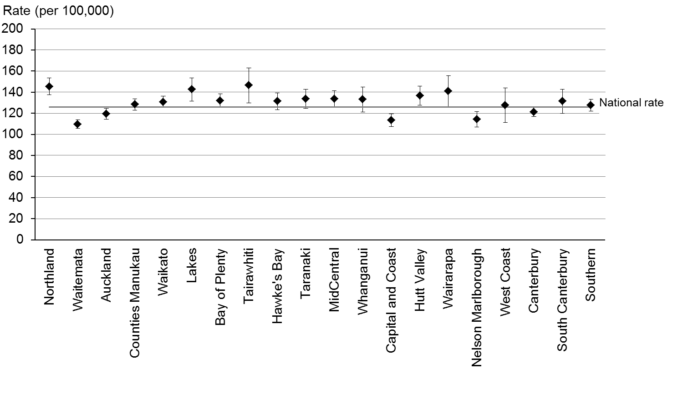
Source: New Zealand Mortality Collection
Note: The rate shown is the age-standardised rate per 100,000 DHB population; 95% confidence intervals.

Figure 107 is a map of New Zealand showing a geographical representation of the information in Figure 106. Again, the lighter and darker shades on the map distinguish DHB regions that have significantly lower or higher mortality rates than the national rate.

Figure 107: Comparison of DHB region cancer mortality rates with national rate,
2009–2011
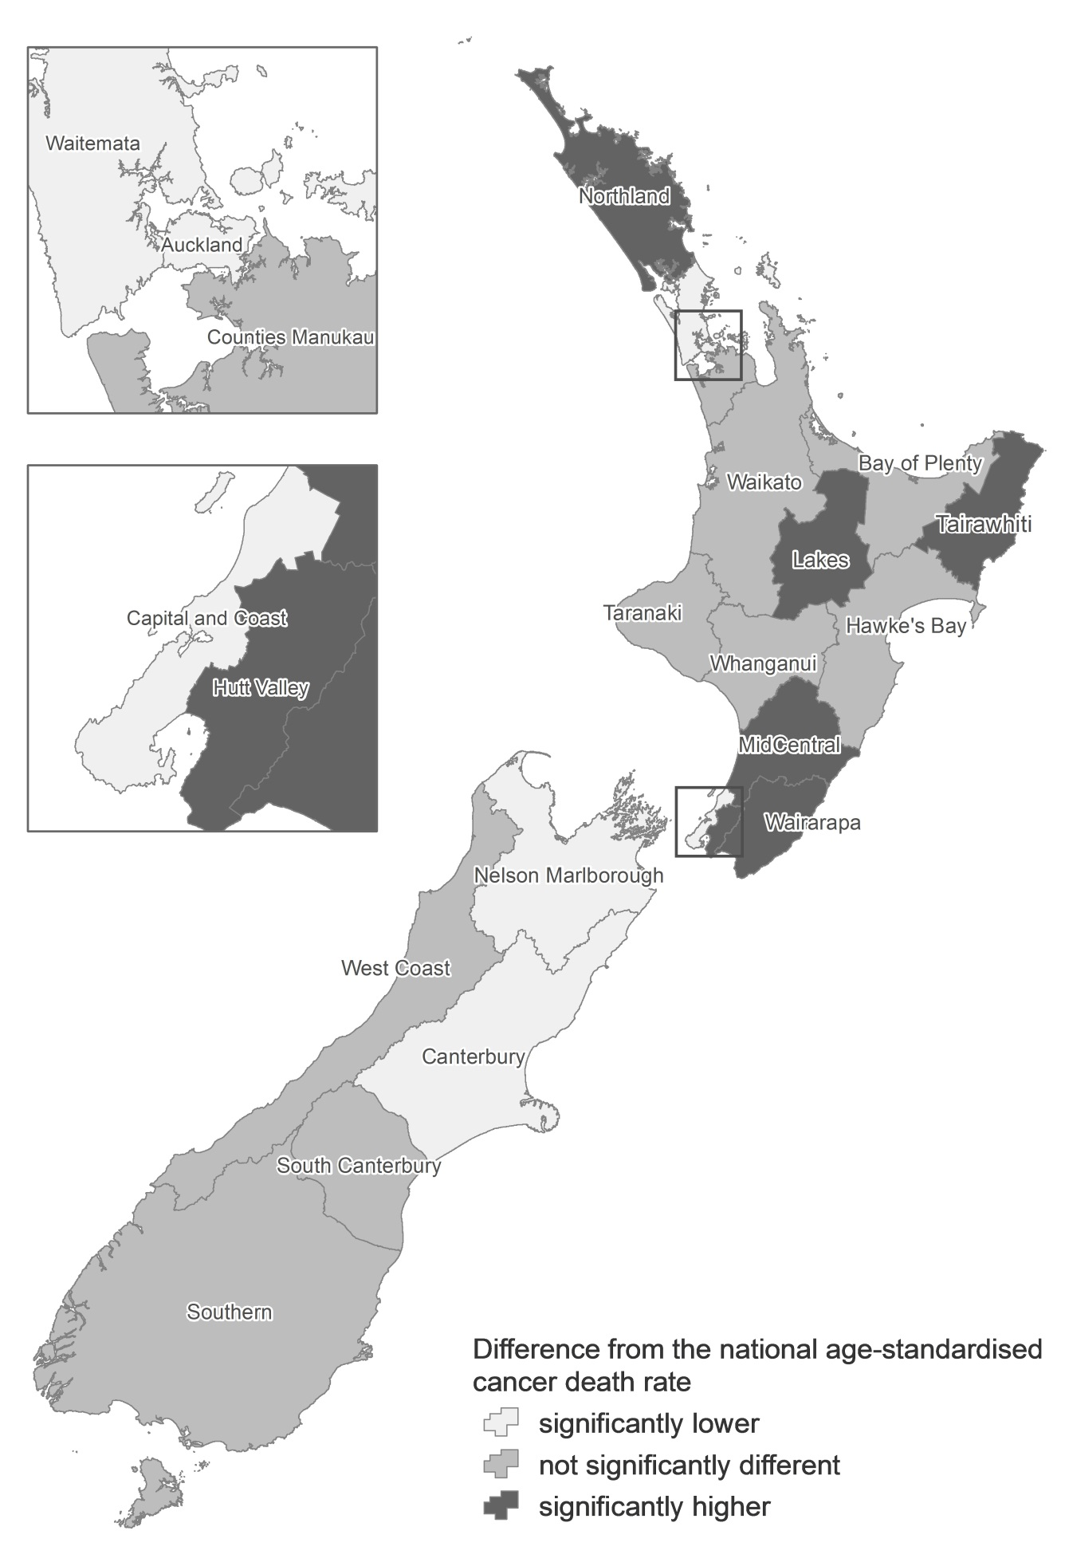
Source: New Zealand Mortality Collection
Note: The rate used is the age-standardised rate per 100,000 DHB population, standardised to the WHO world standard population; 95% confidence intervals.

Explanatory notes

Cancer registration data

Scope of the New Zealand Cancer Registry
The New Zealand Cancer Registry is a collection of data on malignant disease cases that have been diagnosed in New Zealand. Registrations are based on discrete primary cancer cases that are distinguished by differences in topography or histology. Cancers are registered once, in the year of their first known diagnosis (see the Cancer Registry Act 1993 in Appendix 1). Registrations cover new cases of primary cancer, or secondary cancers where the primary cancer is unknown.

To ensure a high standard of data, registry staff comprehensively screen all records before adding them to the registry. Deaths from cancer are reconciled with cancer registrations recorded on the registry.

Skin cancers
Basal cell epithelioma and squamous cell carcinoma of the skin are not recorded by the Cancer Registry except when of the skin of genital organs. The registration of these cancers was discontinued in 1958 because of resource considerations.

A small number of non-melanoma cases (for example, dermatofibrosarcoma and Merkel cell tumours) have been registered and classified to site ICD C44. Before 1993 these cases were coded to ICD-9 code 171: connective and other soft tissues.

In situ cancers
In situ cancers are localised lesions that have not invaded beyond the basement membrane. All in situ cancers have been excluded from the main statistical tables presented in this document.

Disease coding
Mortality data: The International Statistical Classification of Diseases and Related Health Problems, Tenth Revision, Australian Modification (ICD-10-AM), second edition was used to classify the cancer sites for the 2001–2007 mortality data used in this report. The ICD-10-AM sixth edition was used to classify the 2008–2011 mortality data. Prior to 2001 the International Statistical Classification of Diseases and Related Health Problems, Ninth Revision, Clinical Modification, Australia (ICD-9-CMA), second edition was used.

Registration data: The International Statistical Classification of Diseases and Related Health Problems, Tenth Revision, Australian Modification (ICD-10-AM), sixth edition was used to classify the site or topography for the 2009–2011 cancer registration. For data from 2003–2008 the ICD-10-AM third edition was used and for data from 2001 to 2002, the second edition. Prior to 2001 the ICD-9-CMA second edition was used.

Morphology
The International Classification of Diseases for Oncology (ICD-O) was used to classify the morphology (histology, type and behaviour) of tumours. For registrations with a diagnosis date prior to 1 January 2003, the ICD-O second edition was used, and for registrations with a diagnosis date after this time the ICD-O third edition was used.

From 1 January 2005 superficial transitional cell carcinoma of the bladder was no longer coded as an invasive cancer. This coding change resulted in a decrease in the number of bladder cancer registrations recorded compared with previous years.

The third edition of the ICD-O contains a revised morphology section. New classifications and codes were introduced. This has resulted in changes to the coding of cancers diagnosed since 1 January 2003. For some tumour types, particularly haematological malignancies and ovarian cancer, these changes may have affected incidence reporting. For particular cancer sites, registrations from 1 January 2003 onwards may not be comparable with those from 2002 and earlier.

Ovarian tumours of borderline malignancy were considered malignant in the second edition of the ICD-O, but were considered to be of uncertain behaviour in the third edition and have been excluded from incidence reporting since 2003. This has resulted in a slight reduction in the number of cases of ovarian cancer recorded since 2003.

A diagnosis of leukaemia in a person already registered with one of the above malignancies may not have been counted in incidence statistics because of the way the coding rules for multiple primary tumours have been applied (see ‘Multiple primary tumours’ below).

Codes in the range D45–D47
Polycythaemia vera, myelodysplastic syndromes and chronic myeloproliferative disorders are considered malignant in the third edition of the ICD-O, whereas in the second edition these diseases were considered to be of uncertain behaviour. The ICD-10 codes for these new malignancies are in the range D45–D47, and were included for the first time in the 2003 data. In this publication these are referred to as chronic myeloproliferative disorders and myelodysplastic syndromes.

For this reason, in this publication new malignancy registrations and deaths in the D45–D47 range are only included in the data from 2003.

Multiple primary tumours
Incidence counts and rates are based on the number of primary tumours, rather than the number of individuals with cancer. The New Zealand Cancer Registry database records multiple primary cancers in the same person, of which only some are counted for incidence purposes, according to rules set down by the International Agency for Research on Cancer and the International Association of Cancer Registries. In brief, these rules state the following.
1. Recognition of the existence of two or more primary cancers does not depend on time.
2. A primary cancer is one that originates in a primary site or tissue and is thus neither an extension, nor a recurrence or a metastasis (transfer of cancerous cells to other parts of the body) of a pre-existing tumour.
3. Only one tumour shall be recognised in an organ or pair of organs or tissue (as defined by a letter and a series of numerals of the ICD-10 topography) unless of different histology.
Under these rules, a cancer with a different histology in the same organ is counted as a new tumour. There are 12 defined groups of malignant neoplasms considered to be histologically different (Fritz et al 2001, p 37). Incidence reporting of multiple tumours is based on these groups.

Re-extraction of registration data from the Cancer Registry
The use of the new ethnic group system has produced a set of data that is not directly comparable with the data published prior to 2006. The cancer registration data in this publication relating to 1998–2005 was extracted from the Cancer Registry on 15 April 2009. The 2006 data was extracted on 9 February 2009, the 2007 data on 6 January 2011, the 2008 data on 31 August 2011, the 2009 data on 1 September 2011, the 2010 data on 25 July 2012 and the 2011 data on 22 August 2013.

Timeliness of data
The process of collecting, coding and collating national information on cancer registrations and deaths is complex. Data in the Cancer Registry comes from laboratory reports, hospital information and mortality information. Data in the Mortality Collection comes from certificates of cause of death from doctors or coroners, post-mortem reports from private pathologists and hospitals, and death registration forms. Neither set of information can be finalised until completed from all sources. The timing of publication of this data is affected by manual processing of death data and the need to wait until almost all coroners’ findings for any particular year have been received. In addition, there are several steps required to ensure the final information is of good quality.

Changes in legislation
On 1 July 1994 the Cancer Registry Act 1993 and Cancer Registry Regulations 1994 came into force, introducing fundamental changes to the collection of cancer data in New Zealand. The full text of the Cancer Registry Act and Cancer Registry Regulations is contained in the appendices to this publication. The effect of legislation on cancer registration statistics is discussed in Cancer: New registrations and deaths 1996 (Ministry of Health 2001).

Ethnicity
Ethnicity data is required to be collected and classified according to Ministry of Health ethnicity data protocols for the health and disability sector (see Ministry of Health 2004).

Under the protocols, ethnicity information is collected through self-identification or, when this is not possible, by appropriate proxy using a standard question format. Individuals may select up to three ethnicities they feel they belong to.

The ethnicity data in this publication is based on prioritised ethnic group. Each individual is allocated to a single ethnicity on the basis of the following priority: Māori, Pacific peoples, Asian, other groups except New Zealand European, New Zealand European. Thus, any person who selects Māori as one of their three ethnicities will be recorded as Māori.

The ethnicity information recorded on the Cancer Registry is taken from hospital discharge information, the National Health Index and the Mortality Collection. Therefore, the less contact a patient has with the hospital system, the less likely they are to have an accurate ethnicity recorded.

Registrations with unspecified ethnicity have been included in the non-Māori group in this report, so caution should be used when interpreting comparisons.

Rate calculations
Age-specific rates show the number of events (for example, cancer registrations or deaths) per 100,000 of the population in each age group for each year.

Age-standardised rates adjust for differences in age distribution of the populations being compared. They are calculated by the direct standardisation method, which multiplies the age-specific rates by a standard population. The standard population used in this publication is the WHO world standard population. All rates in this publication are age-standardised unless otherwise stated.

Prior to 2005, publications in the Cancer: New registrations and deaths series used Segi’s world population, and therefore the rates published are not comparable with those stated in this document. Rates for all years back to 1996 have been recalculated using the WHO world standard population (see Table N-1).

Table N-1: The World Health Organization world standard population
Age group | Population
0–4 | 8860
5–9 | 8690
10–14 | 8600
15–19 | 8470
20–24 | 8220
25–29 | 7930
30–34 | 7610
35–39 | 7150
40–44 | 6590
45–49 | 6040
50–54 | 5370
55–59 | 4550
60–64 | 3720
65–69 | 2960
70–74 | 2210
75–79 | 1520
80–84 | 910
85+ | 635
Total | 100,035
Source: Ahmad et al 2001

Table N-2 shows the estimated resident population of New Zealand by ethnic group, age and sex for the mean year ended 31 December 2011.

Table N-2: Population data, 2011
 | Total population |  |  | Māori population
 | Male | Female | Total | Male | Female | Total
Total | 2,165,900 | 2,241,600 | 4,407,400 | 331,100 | 342,300 | 673,400
0–4 | 161,370 | 152,920 | 314,290 | 47,240 | 44,170 | 91,410
5–9 | 147,070 | 140,220 | 287,290 | 36,140 | 34,360 | 70,500
10–14 | 149,820 | 142,910 | 292,730 | 35,150 | 33,520 | 68,660
15–19 | 163,390 | 154,250 | 317,630 | 34,720 | 32,690 | 67,410
20–24 | 167,850 | 157,730 | 325,580 | 29,390 | 29,570 | 58,960
25–29 | 146,820 | 147,550 | 294,370 | 20,250 | 22,260 | 42,510
30–34 | 131,440 | 141,500 | 272,940 | 19,540 | 22,260 | 41,790
35–39 | 138,170 | 152,290 | 290,460 | 19,590 | 22,540 | 42,140
40–44 | 149,250 | 163,480 | 312,730 | 19,150 | 21,880 | 41,030
45–49 | 154,200 | 164,840 | 319,040 | 18,250 | 20,520 | 38,770
50–54 | 145,580 | 153,050 | 298,640 | 15,760 | 17,720 | 33,480
55–59 | 126,190 | 131,240 | 257,440 | 11,940 | 13,100 | 25,040
60–64 | 116,060 | 120,540 | 236,590 | 9110 | 10,090 | 19,200
65–69 | 88,330 | 92,590 | 180,920 | 5960 | 6690 | 12,640
70–74 | 69,570 | 75,720 | 145,300 | 4480 | 5090 | 9570
75–79 | 49,260 | 56,710 | 105,970 | 2540 | 3070 | 5610
80–84 | 36,030 | 46,550 | 82,580 | 1230 | 1750 | 2980
85+ | 25,500 | 47,500 | 72,900 | 630 | 1020 | 1660
Source: Statistics New Zealand
Note: Because of rounding, individual figures in this table do not always sum to give the stated totals.

Table N-3: ICD-O (version 3) morphology codes used to group lymphohaematopoietic cancers
Type of cancer | Code(s)
Lymphoid cancers
Hodgkin lymphoma | 9650–55, 9659, 9661–65, 9667
Mature B-cell cancers
Chronic lymphocytic leukaemias/small lymphocytic lymphomas | 9670, 9823
Diffuse large B-cell lymphomas | 9680
Follicular lymphomas | 9690–91, 9695, 9698
Plasma cell disorders | 9731–34
Other mature B-cell cancers | 9671, 9673, 9675, 9678–79, 9684, 9687, 9689, 9699, 9761, 9764, 9826, 9833, 9940
Mature T- and NK-cell cancers | 9700–02, 9705, 9708–09, 9714, 9716–19, 9827, 9831, 9834, 9948
Acute lymphoblastic leukaemia | 9727–29, 9835–37
Non-Hodgkin lymphoma, NOS | 9591, 9766, 9820, 9832
Lymphoid cancers, NOS | 9590, 9596
Myeloid cancers
Acute myeloid leukaemias | 9805, 9840, 9861, 9866–67, 9870–74, 9891, 9895–97, 9910, 9920, 9930–31
Chronic myeloid leukaemias | 9863, 9875
Other chronic myeloproliferative diseases | 9950, 9960–64
Myelodysplastic syndromes | 9980, 9982–87, 9989
Myelodysplastic/myeloproliferative diseases | 9876, 9945–46
Myeloid cancers, NOS | 9860
Lymphoid/myeloid cancers, NOS | 9800–01
Other lymphohaematopoietic cancers | 9740–42, 9750, 9754–58, 9760, 9762
Note: NOS = Not otherwise specified.

Confidence intervals
The confidence intervals in this publication have been calculated using the methods presented in Keyfitz (1966). A confidence interval is a range of values used to describe the uncertainty around a single value (such as an age-standardised rate). Confidence intervals describe how different the estimate could have been if chance had led to a different set of data. Confidence intervals are calculated with a stated probability, typically 95% (which would indicate that there is a 95% chance that the true value lies within the confidence intervals).

Confidence intervals may assist in comparing rates over time for each cancer and all cancers combined. If two confidence intervals do not overlap, then it is reasonable to assume that the difference is not due to chance. If they do overlap, it is not possible to draw any conclusion about the significance of any difference between them.

Deprivation
The New Zealand Social Deprivation Index is a measure of socioeconomic status calculated for small geographic areas. The calculation uses a range of variables from the 2001 and 2006 Census of Population and Dwellings, which represent nine dimensions of social deprivation. The Social Deprivation Index is calculated at the level of meshblocks (geographical units containing a median of 90 people), and the Ministry of Health maps these to domicile codes, which are built up to the relevant geographic scale using weighted average ‘usually resident population’ counts from the Census. The nine variables (proportions in small areas) in the index, by decreasing weight, are:
- income: people aged 18 to 59 receiving a means-tested benefit
- employment: people aged 18 to 59 who are unemployed
- income: people living in an equivalised household whose income is below a certain threshold
- communication: people with no access to a telephone
- transport: people with no access to a car
- support: people aged under 60 living in a single-parent family
- qualifications: people aged 18 to 59 with no qualifications
- living space: people living in an equivalised household below a bedroom occupancy threshold
- owned home: people not living in their own home.

Further information can be obtained from:
www.health.govt.nz/publication/nzdep2006-index-deprivation

The Ministry of Health’s Cancer Projections publication
The Ministry of Health released Cancer Projections: Incidence 2004–08 to 2014–18 in 2011 to report on the estimated future burden of cancer in New Zealand. Like this publication, the Cancer Projections document uses data obtained from the New Zealand Cancer Registry. Cancer registration rates reported in the Cancer Projections publication have not been calculated using the same criteria as those used in this report, and therefore the two documents cannot be compared.

The Cancer Projections publication distinguishes between adult and childhood cancer; registrations for those aged 15 and under are therefore excluded in rate calculations for adult cancers. There are also other minor differences in the data and methodologies used in the two publications.

For full details of the methodology used in the Cancer Projections publication, see: www.health.govt.nz/publication/cancer-projections-incidence-2004-08-2014-18

Additional information available from the Ministry of Health
If you require additional information, analysis or material not included in this report, or material tabulated in different ways, please contact:
National Collections and Reporting
National Health Board
Ministry of Health
PO Box 5013
Wellington
New Zealand
Phone: (04) 496 2001
Fax: (04) 816 2898
Email: data-enquiries@moh.govt.nz

Further Ministry of Health publications can be found online at:
www.health.govt.nz/nz-health-statistics/publications-data-sets-and-stats

Appendix 1: Full text of the Cancer Registry Act 1993
1993 | Cancer Registry | No. 102

Title  1. Short Title and commencement  2. Interpretation  3. Act to bind the Crown  4. Maintenance of Cancer Registry  5. Reporting of cancer | 6. Director General may require supply of further information  7. Protection against actions  8. Offences  9. Regulations

1993, No. 102

An Act to make better provision for the compilation of a statistical record of the incidence of cancer in its various forms, to provide a basis for the better direction of programmes for research and for cancer prevention.

BE IT ENACTED by the Parliament of New Zealand as follows:
1. Short Title and commencement
(1) This Act may be cited as the Cancer Registry Act 1993.
(2) This Act shall come into force on the 1st day of July 1994.
2. Interpretation – In this Act, unless the context otherwise requires:
“Cancer”:
(a) means a malignant growth of human tissue that, if unchecked:
(i) is likely to spread to adjacent tissue or beyond its place of origin; and
(ii) may have the propensity to recur; and
(b) without limiting the generality of paragraph (a) of this definition, includes carcinoma-in-situ, carcinoma, sarcoma (including Kaposi’s sarcoma), any mixed tumour, leukaemia, any type of lymphoma, and melanoma; but
(c) does not include:
(i) any secondary or metastatic cancer, except where the primary cancer is not identified;
(ii) any type of cancer that is declared by regulations made under this Act to be a cancer to which this Act does not apply.
“Cancer test” means any examination or test (including the examination of any blood, cytological or tissue biopsy specimen, or other material) that is carried out in any pathology laboratory to determine the presence or absence of cancer in any person (including a deceased person).
“Director-General” means the Director-General of Health.
3. Act to bind the Crown – This Act binds the Crown.
4. Maintenance of Cancer Registry
(1) The Director-General shall maintain or arrange for the maintenance of a Cancer Registry.
(2) The purposes of the Cancer Registry are:
(a) to provide information on the incidence of, and mortality from, cancer; and
(b) to provide a basis for cancer survival studies and research programmes.
5. Reporting of cancer
(1) Where a cancer test indicates the presence of cancer in any person (including a deceased person) the person in charge of the laboratory where that test was carried out shall cause a report of that test to be made to the Director-General for the purposes of the Cancer Registry.
(2) Where a post-mortem examination of any deceased person indicates the presence of cancer in that person, the person who carried out that examination shall cause a report of that examination to be made to the Director-General for the purposes of the Cancer Registry.
(3) Every report under subsection (1) or subsection (2) of this section:
(a) shall be made within the prescribed time; and
(b) shall be made in the prescribed form and manner.
(4) No person is required to make a report under this section with respect to:
(a) any cancer test that indicates the presence of cancer in any person (including a deceased person); or
(b) any post-mortem examination of any deceased person that indicates the presence of cancer in that person –
if the first-mentioned person has good reason to believe that the presence of that particular cancer in that other person has already been reported to the Director-General, whether in a report made under this section or pursuant to any arrangements that were in place before the commencement of this Act or otherwise.
6. Director-General may require supply of further information
(1) Where any report made under section 5 of this Act is incomplete in any respect by reason that the person making the report does not have available to that person certain information necessary to enable a complete report to be made, the Director-General may, for the purpose of obtaining that information, by notice in writing require any person (being a medical practitioner or the person in charge of any hospital) that the Director-General reasonably believes may have all or any of that information to provide to the Director-General such information as may be specified in the notice.
(2) Every person to whom a notice is given under this section and who has any of the information specified in that notice shall provide that information within such time, and in such form and manner, as may be specified in the notice.
(3) In subsection (1) “medical practitioner” means a health practitioner who is, or is deemed to be, registered with the Medical Council of New Zealand continued by section 114(1)(a) of the Health Practitioners Competence Assurance Act 2003 as a practitioner of the profession of medicine.
7. Protection against actions
(1) No proceedings, civil or criminal, shall lie against any person by reason of that person having made available any information for the purposes of complying with the requirements of section 5 or section 6(2) of this Act.
(2) Nothing in subsection (1) of this section applies in respect of proceedings for an offence against section 8 of this Act.
8. Offences – Every person commits an offence and is liable on summary conviction to a fine not exceeding $500 who:
(a) fails, without reasonable excuse, to comply with the requirements of section 5 or section 6(2) of this Act; or
(b) knowingly supplies information that is false or misleading in purported compliance with section 5 or section 6(2) of this Act.
9. Regulations – The Governor-General may from time to time, by Order in Council, make regulations for all or any of the following purposes:
(a) prescribing the form and manner in which reports are to be made to the Director-General under section 5 of this Act:
(b) prescribing the time within which reports are to be made to the Director-General under section 5 of this Act:
(c) declaring any type of cancer to be a cancer to which this Act does not apply:
(d) providing for such other matters as are contemplated by or necessary for giving full effect to this Act and for its due administration.

This Act is administered by the Ministry of Health.

Appendix 2: Full text of the Cancer Registry Regulations 1994
1994/89
THE CANCER REGISTRY REGULATIONS 1994
CATHERINE A TIZARD, Governor-General
ORDER IN COUNCIL
At Wellington this 30th day of May 1994
Present:
Her Excellency the Governor-General in Council

Pursuant to section 9 of the Cancer Registry Act 1993, Her Excellency the Governor-General, acting by and with the advice and consent of the Executive Council, hereby makes the following regulations.

REGULATIONS
1. Title and commencement
(1) These regulations may be cited as the Cancer Registry Regulations 1994.
(2) These regulations shall come into force on the 1st day of July 1994.
2. Interpretation
(1) In these regulations, unless the context otherwise requires:
“the Act” means the Cancer Registry Act 1993;
“Report” means a report to the Director-General under section 5 of the Act.
(2) Where any expression used in these regulations is not defined in these regulations but is defined in the Act, that expression shall, unless the context otherwise requires, have, in these regulations, the meaning given to it by the Act.
3. Time within which reports to be made – Every report shall be made no later than 21 days after the end of the calendar month in which the cancer test to which the report relates was carried out.
4. Form of reports
(1) Every report shall contain the following information:
(a) The full name of the person who carried out the cancer test to which the report relates.
(b) In relation to the person who requested the carrying out of the cancer test to which the report relates:
(i) the full name of that person; and
(ii) the name of the health-care institution by which that person is employed or engaged or in which that person otherwise works (if any).
(c) In relation to the person in respect of whom the cancer test to which the report relates was carried out:
(i) either that person’s National Health Index Identifier or that person’s full name, maiden name (if any) and any known aliases;
(ii) that person’s date of birth;
(iii) that person’s sex;
(iv) where available, that person’s ethnic group;
(v) where available, that person’s full address;
(vi) where available, that person’s occupation.
(d) In relation to the cancer test to which the report relates:
(i) the category into which the test falls, which shall be one of the categories set out in subclause (2) of this regulation;
(ii) a description of the anatomical site from which the sample in respect of which the test was carried out was obtained, as indicated with the request for the test;
(iii) whether that site is the primary site or the secondary site of the cancer indicated by the test.
(e) In relation to the cancer indicated by the cancer test to which the report relates:
(i) a full description of the pathological nature of the cancer;
(ii) in the case of melanoma of the skin:
(A) the thickness of the tumour, measured in accordance with Breslow’s method;
(B) the extent of tumour invasion, expressed by reference to Clark’s levels;
(iii) where available, the stage of the cancer (other than for lymphoma, leukaemia, and melanoma of the skin).
(2) The categories referred to in subclause (1)(d)(i) of this regulation are as follows:
(a) the histology of the primary lesion or, in the absence of a known primary lesion, the metastases;
(b) cytology or haematology, or both;
(c) specific biochemical or immunological test, or both;
(d) autopsy with concurrent or previous histology.
(3) Where any information required to be included in any report is unavailable at the time the report is made, or is unobtainable:
(a) the report shall indicate that the information is unavailable or, as the case may be, unobtainable; and
(b) if that information subsequently becomes available, the person required to make the report shall, as soon as practicable, transmit that information to the Director-General.
5. Manner in which reports to be made – A report shall be made:
(a) in a written document; or
(b) on computer tape, disk, or diskette; or
(c) by directly inputting data into a database maintained in electronic form by the Director-General for the purposes of the Cancer Registry, such inputting being made by means of remote logon access to the database.
6. Act not to apply to certain cancers – It is hereby declared that the following types of cancer are cancers to which the Act does not apply:
(a) basal cell cancer arising in the skin
(b) squamous cell cancer arising in the skin.
MARIE SHROFF
Clerk of the Executive Council.

Explanatory note
This note is not part of the regulations, but is intended to indicate their general effect.
These regulations, which come into force on 1 July 1994, prescribe certain matters for the purposes of the Cancer Registry Act 1993. The regulations:
(a) prescribe the form and manner in which reports on cancer tests are to be made to the Director-General of Health under the Act; and
(b) prescribe the time within which such reports are to be made; and
(c) declare that certain types of cancer are cancers to which the Act does not apply.
Issued under the authority of the Acts and Regulations Publication Act 1989.
Date of notification in Gazette: 2 June 1994.

These regulations are administered by the Ministry of Health.

References
Ahmad O, Boschi-Pinto C, Lopez AD, et al. 2001. Age Standardization of Rates: A new WHO standard. GPE Discussion Paper Series No. 31. Geneva: World Health Organization. URL: www.who.int/healthinfo/paper31.pdf (accessed 7 May 2013).
Benzeval M, Judge K, Shouls S. 2001. Understanding the relationship between income and health: How much can be gleaned from cross-sectional data? Social Policy and Administration 35: 376–96.
Fritz A, Percy C, Jack A, et al. 2001. International Classification of Diseases for Oncology, third edition. Geneva: World Health Organization.
Keyfitz N. 1966. Sampling variance of standardized mortality rates. Human Biology 38: 309–17.
Ministry of Health. 2001. Cancer: New registrations and deaths 1996. Wellington: Ministry of Health.
Ministry of Health. 2004. Ethnic group Data Protocols for the Health and Disability Sector. Wellington: Ministry of Health.
Ministry of Health. 2011a. Cancer: New registrations and deaths 2006. Wellington: Ministry of Health.
Ministry of Health. 2011b. Cancer Projections: Incidence 2004–08 to 2014–18. Wellington: Ministry of Health.
National Centre for Classification in Health. 1996. Australian Version of the International Classification of Diseases, Ninth Revision, Clinical Modification, second edition. Sydney: National Centre for Classification in Health.
National Centre for Classification in Health. 2002. International Statistical Classification of Diseases and Related Health Problems, Tenth Revision, Australian Modification, third edition. Sydney: National Centre for Classification in Health.
Salmond C, Crampton P. 2002. NZDep2001 Index of Deprivation User’s Manual. Wellington: Wellington School of Medicine and Health Sciences.
Swerdlow SH, Campo E, Harris NL, et al (2008). WHO Classification of Tumours of Haematopoietic and Lymphoid Tissues, fourth edition. Lyon: International Agency for Research on Cancer.
White P, Gunston J, Salmond C, et al. 2008. Atlas of Socioeconomic Deprivation in New Zealand NZDep2006. Wellington: Ministry of Health.

Colorectal includes anus (C18─C21).
Lung includes trachea and bronchus (C33─C34).

