Briefing to the Incoming Minister of Health, 2017
The New Zealand Health and Disability System: Organisation

Citation: Ministry of Health. 2017. Briefing to the Incoming Minister of Health, 2017:
The New Zealand Health and Disability System: Organisation.
Wellington: Ministry of Health.
Published in November 2017
by the Ministry of Health
PO Box 5013, Wellington 6140, New Zealand
ISBN 978-1-98-853913-3 (print)
ISBN 978-1-98-853914-0 (online)
HP 6714
This document is available at:
health.govt.nz
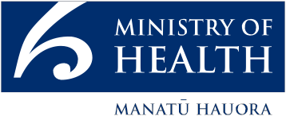
This work is licensed under the Creative Commons Attribution 4.0 International licence. In essence, you are free to: share ie, copy and redistribute the material in any medium or format; adapt ie, remix, transform and build upon the material. You must give appropriate credit, provide a link to the licence and indicate if changes were made.

Contents
We ensure that the system delivers for all 1
Our health and disability system is complex and collaborative 1
We are stewards and leaders of the system 4
Some of our people have statutory roles 5
Our Executive Leadership Team 6
Investing in health and disability support is important to improve outcomes 7
Building strong and positive relationships 8
Crown entities 8
District health boards 8
Accountability and performance of health Crown entities 9
Frontline – the workforce 9
The sector – health agencies and key organisations 12
We are looking forward to working with you 13

List of Figures
Figure 1: Overview of the New Zealand health and disability system 3
Figure 2: The Ministry of Health’s Executive Leadership Team 7

We ensure that the system delivers for all
We know that improving the health of all New Zealanders is a vital goal for this Government. We will need to work in new ways and collaboratively across the health and disability system to achieve a system that is fit for the future.

Our health and disability system performs well for most New Zealanders, helping them live longer, healthier and more independent lives. However, we face both opportunities and challenges as our population continues to age, grow and diversify. We know that we must be future-focused, and continually look for opportunities to improve, promote and protect the health of all New Zealanders.

Our health and disability system is complex and collaborative
A complex network of organisations and people deliver the New Zealand health and disability system. These organisations and people need to collaborate with each other and across government agencies, local government and communities. We want everyone to clearly understand their role and how we can work together.

You as Minister of Health, along with Cabinet and Government, develop policy for the health and disability sector and provide leadership. We, the Ministry of Health, alongside ministerial advisory committees, will support and advise you. We have a range of roles in the system, in addition to being the principal advisor and support to you, in your role as Minister. We fund an array of national services (in the order of $2 billion a year, including disability support and public health services), provide clinical and sector leadership and perform a monitoring, regulatory and protection functions.

District health boards (DHBs) administer most of the day-to-day business of the system, and nearly three-quarters of the funding. They plan, manage, provide and purchase health services for the population of their district; implement government health and disability policy; and ensure services are effective and efficient for all New Zealanders. They distribute funding for primary health care, hospital services, public health services, aged care services and services provided by other non-government health providers, including Māori and Pacific providers.

The Accident Compensation Corporation (ACC) funds an important range of health and support services for people suffering from injury resulting from an accident. There are common providers for many services funded by ACC and by DHBs. DHBs provide the majority of emergency and acute services for ACC.

There is also a large and strong private health sector in New Zealand. It encompasses private hospitals, private community services and natural health services. It is financed by health insurance and out-of-pocket expenditure. DHBs sometimes purchase health services (eg, elective surgery) from private providers.

The system extends beyond the Ministry and DHBs to ministerial advisory committees, other health Crown entities, primary health organisations, public health units, private providers (including Māori and Pacific providers) and independent general practitioners. It includes professional and regulatory bodies for all health professionals, including medical and surgical specialties, nurses and allied health groups. In addition, many non-governmental organisations (NGOs) and consumer bodies provide services and advocate for the interests of various groups.

Figure 1: Overview of the New Zealand health and disability system
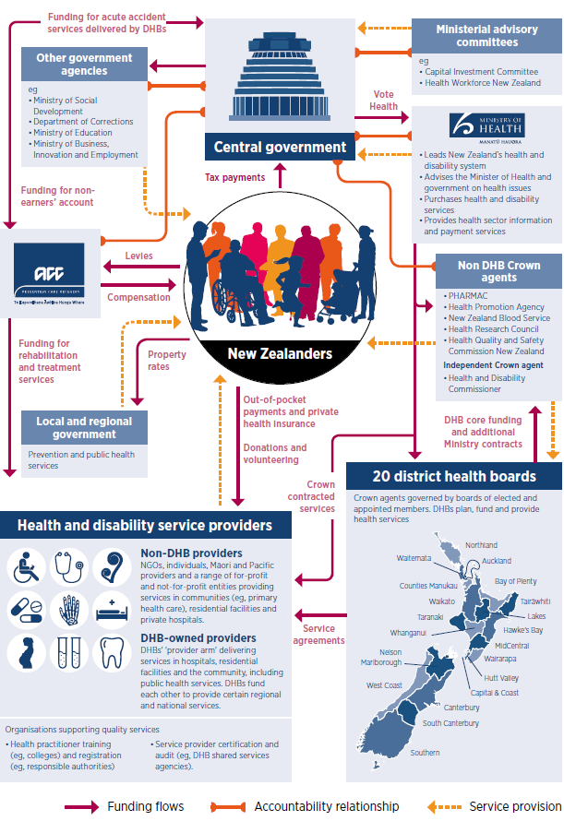

We are stewards and leaders of the system
The Ministry of Health plays a critical role in system stewardship and leadership. This involves keeping an overview of the whole system and ensuring that the capabilities and connections across organisations work together. We want to collectively deliver a health service that is improving, protecting and promoting the health and wellbeing of all New Zealanders.

We assist you by maintaining the regulatory environment and national policy settings that support the sector in providing good quality services for New Zealanders. We work with DHBs and other Crown entities, such as ACC and the Health Quality and Safety Commission, and support their own leadership roles.

We also look at the links between different parts of the system, and strengthen these where necessary to support a high-functioning health sector. Achieving the future that we envisage will require significant transformation and strong system leadership. We have already taken steps to support our capability for this transformation.

We are future-focused
To best meet the changing health needs of New Zealanders we need to think, work and act differently. Change is happening quickly, and we need to ensure our health and disability system is fit for the future. Although we cannot predict the future, we can envision what our ideal future state will look like, and start the process to get there.

We work across the sector
New Zealand’s health and disability system delivers services through a broad network of organisations. Each organisation has its role in working with others across and beyond the system to achieve better health and independence for New Zealanders.

Multiple factors play a role in the health and wellbeing of New Zealanders; in turn, their health and wellbeing have a huge impact on other parts of their daily lives.

Our people
We employ many passionate people through our policy, regulatory and sector implementation functions. Our employees bring different skills and specialities to their roles, but all play an active role in improving, promoting and protecting the health of all New Zealanders. We have regional offices in Auckland, Hamilton, Whanganui, Wellington, Christchurch and Dunedin.

Some of our people have statutory roles
Director-General of Health  Chai Chuah | The Director-General of Health, Chai Chuah, is the chief executive of the Ministry. In addition to responsibilities under the State Sector Act 1988, the Director-General has a number of other statutory powers and responsibilities under various pieces of health legislation. These include:  - powers relating to the appointment and direction of statutory public health officers, oversight of the public health functions of local government and authorisation of the use of special powers for infectious disease control under the Health Act 1956  - powers to certify providers under the Health and Disability Services (Safety) Act 2001  - powers to issue guidelines under the Intellectual Disability (Compulsory Care and Rehabilitation) Act 2003 and other Acts.  The Director-General is the Psychoactive Substances Regulatory Authority under the Psychoactive Substances Act 2013. This role is currently delegated to the Group Manager, Medsafe, and the Manager, Psychoactive Substances, Medsafe.
Director of Mental Health  Dr John Crawshaw | The Director of Mental Health is Dr John Crawshaw, and the Deputy Director of Mental Health is Dr Ian Soosay. The Mental Health (Compulsory Assessment and Treatment) Act 1992 provides for these two positions. The Director of Mental Health is responsible for the general administration of the Act, under the direction of the Minister and Director-General. The Director is also the Chief Advisor, Mental Health, and is responsible for advising the Minister on mental health issues.  The Director’s functions and powers under the Act allow the Ministry to provide guidance to mental health services, supporting the strategic direction provided in Rising to the Challenge: The Mental Health and Addiction Service Development Plan 2012–2017 and taking a recovery-based approach to mental health.  The Deputy Director of Mental Health is required to perform such duties as the Director may require. The Deputy Director is also the Ministry’s Senior Advisor, Mental Health.
Director of Public Health  Dr Caroline McElnay | The Director of Public Health is Dr Caroline McElnay, and the Deputy Director of Public Health is Dr Harriette Carr. The Health Act 1956 prescribes these two positions. The Director of Public Health has the authority to independently advise the Director-General and Minister on any matter relating to public health. The Director also provides national public health professional leadership and professional support and oversight for district medical officers of health. The Deputy Director of Public Health assists the Director of Public Health in carrying out both statutory and non-statutory responsibilities.
Chief Financial Officer  Stephen O’Keefe | The Chief Financial Officer is Stephen O’Keefe. The Public Finance Act 1989 requires all departments to have a chief financial officer responsible for the quality and completeness of the department’s statement of intent and annual accounts. The Chief Financial Officer ensures that internal controls are effective and efficient.

Our Executive Leadership Team
Our Executive Leadership Team focuses on strategic management, corporate governance and organisational performance. It supports the Director-General of Health by:
- setting our strategic direction and priorities within the context of the Government’s policy objectives for the health and disability system
- ensuring that we deliver on our strategies and goals by allocating resources, including purchasing health and disability services, performance monitoring organisations and accounting for the use of publicly funded resources
- ensuring that we have the capacity and capability to meet the Government’s objectives, including by having the people, information, structures, relationships, resources, culture and leadership to fulfil Government direction in the medium and long term
- supporting the Director-General’s financial and operational delegations by providing advice on key matters of health and disability public policy and implementation.

Figure 2: The Ministry of Health’s Executive Leadership Team
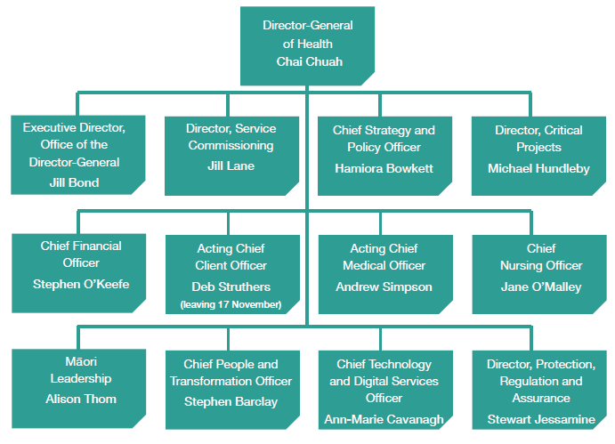

Investing in health and disability support is important to improve outcomes
Better health outcomes for the New Zealand population contribute to a more prosperous New Zealand for all.

Vote Health
The health and disability system’s funding comes mainly from Vote Health, which the Ministry of Health administers. For 2017/18 this totals $16.773 billion. Other significant funding sources include ACC, other government agencies, local government and private sources, such as insurance and out-of-pocket payments.

We allocate more than three-quarters of the public funds through Vote Health to DHBs, who use this funding to plan, purchase and provide health services, including public hospitals and the majority of public health services, within their areas. The Ministry of Health spends $2.4 billion to purchase national services. These comprise disability support services, national public health services and national personal health services.

Building strong and positive relationships
We provide leadership across the system, and we are the Government’s primary agent for implementing its health priorities and policies within the system. We also have a wider role; we coordinate action with other government agencies to deliver on the Government’s agenda across the spectrum of social sector services.

Key relationships with the Government and the health and disability system are very important to us. We aspire to be a trusted and respected source of reliable and useful information about health and disability matters for all New Zealanders and the wider international community.

Crown entities
There are 26 statutory entities in the Health portfolio. Twenty of these are DHBs; the table below sets out the others. In addition, DHBs hold shares in a number of companies, which are classed as ‘Crown entity subsidiaries’ for the purposes of the Crown Entities Act 2004.

Crown agents | - DHBs (20)
 | - Health Promotion Agency
 | - Health Quality & Safety Commission
 | - Health Research Council of New Zealand
 | - New Zealand Blood Service
 | - Pharmaceutical Management Agency (PHARMAC)
Independent Crown entity | - Health and Disability Commissioner

District health boards
DHBs are responsible for implementing the health policies of the Government, and for providing or funding the provision of health services in their districts. They fund primary health organisations to provide essential primary health care services to their populations, and own and fund public hospitals.

The Ministry expects DHBs to show a sense of social responsibility, to foster community participation in health improvement and to uphold the ethical and quality standards commonly expected of providers of services and public sector organisations.

We require DHBs to plan and deliver services regionally, as well as in their own individual districts. To do this, we group DHBs into four regions:
- Northern: Northland, Waitematā, Auckland and Counties Manukau DHBs
- Midland: Waikato, Lakes, Bay of Plenty, Tairāwhiti and Taranaki DHBs
- Central: Hawke’s Bay, Whanganui, MidCentral, Hutt Valley, Capital & Coast and Wairarapa DHBs
- South Island: Nelson Marlborough, West Coast, Canterbury, South Canterbury, and Southern DHBs.

The DHBs of each region are able to work together to improve health services for people in their wider community. However, regional planning is a flexible tool; any aggregations of DHBs can make regional plans as appropriate.

Accountability and performance of health Crown entities
Health Crown entities are governed by boards that are accountable to you for performing their duties. As Minister, you have a range of levers available to ensure strong performance and accountability from DHBs and other health Crown entities. These include:
- setting entities’ strategic direction and annual performance requirements (eg, through Letters of Expectation, Statements of Intent/Statements of Performance Expectations, setting funding parameters and giving directions)
- monitoring strategic direction and results (eg, through a monitoring agent, discussing results with entities, requesting information)
- board appointments, remuneration and removals (eg, appointing chairs and members, setting terms and conditions of appointment, ensuring quality induction and review processes).

The Ministry is responsible for monitoring DHB and other health Crown entity performance on your behalf, and providing you with advice. Entities must file (at a minimum) quarterly performance reports. Some additional performance and accountability measures exist for DHBs.

Frontline – the workforce
The health workforce comprises a wide variety of occupational groups, both regulated and non-regulated.

The regulated workforce
The Health Practitioners Competence Assurance Act 2003 regulates doctors, dentists, nurses, midwives and a number of allied health (including allied health science and technical) professions, which are together referred to as the regulated workforce. These practitioners must be registered with the relevant regulatory body; these bodies issue annual practising certificates, determine appropriate qualifications, consider complaints and take disciplinary action.

The non-regulated (kaiāwhina) workforce
A wide and varied range of non-regulated health workers are collectively referred to as kaiāwhina. They are monitored and regulated in other ways (eg, through industry standards, health and safety legislation and employment agreements).

Kaiāwhina include people working:
- in health-related corporate and administrative positions
- in drug and alcohol addiction support roles
- as aged or disabled carers in residential facilities
- as support workers for older, disabled or injured people living in their own homes.

Health professionals, medical technicians and health and welfare support workers that do not appear in the table below are large and important workforce groups. We do not hold up-to-date information on their numbers. They include paramedics, operating theatre technicians, nutritionists and traditional Māori health practitioners.

Professional area | Headcount | Professional area | Headcount
Nursing | 55,289 | Occupational therapy | 2,294
Medical | 15,761 | Optometry and optical dispensing | 856
Physiotherapy | 4,906 | Anaesthetic technology | 708
Pharmacy | 3,577 | Dietetics | 660
Medical laboratory science | 3,323 | Chiropractic | 580
Midwifery | 3,023 | Psychotherapy | 512
Medical radiation technology | 3,002 | Osteopathy | 432
Psychology | 2,640 | Podiatry | 399
Dentistry and dental therapy, hygiene or technology | 4,458 | Care and support workforce | 48,000
Source: These numbers, other than those for care and support workers, are based on the relevant responsible authority’s workforce report for 2017.

Employment relations
Unions represent approximately 70 percent of DHBs’ workforce and include a mix of health sector-specific unions and general unions. There is some overlapping coverage where two or more unions separately represent the same occupational group.

Currently there are 21 multi-employer collective agreements (MECAs) covering 85 percent of all DHB employees and 70 single employer collective Agreements (SECAs).

Bargaining is currently managed under a devolved model, with national issues jointly managed by DHBs through a shared services agency. The New Zealand Public Health and Disability Act 2000 requires DHB Chief Executives to consult with the Director-General of Health before settling any collective agreement. This model is one of a very broad range of options for how health sector bargaining could be conducted.

All staff are employed by DHBs and DHB chief executives have the authority to enter into collective or individual employment agreements. Generally speaking, DHBs have chosen to have national MECAs for groups that are part of a national or international labour market (doctors, nurses, midwives and allied health practitioners SECAs for other groups.

DHBs have chosen to jointly manage national employment relations issues through DHB Shared Services (DHBSS), a DHB-funded agency based in Wellington. This agency develops the strategies for and undertakes all national MECA bargaining on behalf of DHBs. It also provides advice and assistance to DHBs with SECA bargaining and other employment relations issues, as required. More recently, DHBSS also manages pay equity claims on behalf of DHBs.

Health Workforce New Zealand
Health Workforce New Zealand is a unit within the Ministry responsible for national coordination and leadership on workforce issues. It provides advice on workforce development and regulation, gathers workforce data and intelligence and invests in health workforce training. Its support is designed to ensure the health system has the right people, in the right place with the right skills to provide the safest care and best outcomes for our population.

Health Workforce New Zealand invests $185 million annually in training and developing the health and disability workforce. This funding supports the postgraduate training of nurses, dentists, midwives and a range of allied health professionals, and subsidises the costs of vocational (specialist) training for doctors, including general practice trainees. Demands on the health workforce are increasing due to our ageing and growing population, rapidly changing technology and developments in clinical practice and models of care. Health Workforce New Zealand aims to support and develop a health workforce that is sustainable and fit for purpose given those demands. An independent board oversees this work.

The sector – health agencies and key organisations
We aim to work with key organisations to ensure the health workforce can meet the needs of the New Zealand public. We do this by collaborating with educational bodies and employers to ensure that workforce planning and postgraduate training aligns with current and future service needs.

The table below briefly describes some of the key organisations we work with in this regard.

Capital Investment Committee | A section 11 committee (under the New Zealand Public Health and Disability Act 2000) that provides advice to the Ministers of Health and Finance on the prioritisation and allocation of funding for capital investment and health infrastructure.
Mental Health Review Tribunal | An independent body appointed by the Minister of Health under the Mental Health (Compulsory Assessment and Treatment) Act 1992, that:  - decides whether patients can be released from a compulsory treatment order  - makes recommendations about the status of special patients  - considers the status of restricted patients  - investigates complaints about breaches of patient rights  - appoints psychiatrists to give second opinions about patient treatment  - appoints psychiatrists to decide whether electro-convulsive treatment is in the interests of patients.
National Ambulance Sector Office | A joint office within ACC and the Ministry that:  - administers the New Zealand Ambulance Service Strategy  - provides a single voice for the Crown on strategic and operational matters • regarding emergency ambulance services (EASs)  - manages and monitors funding and contracts from both parent agencies related to the delivery of EASs.
Non-governmental organisations (NGOs) | A wide range of organisations providing a diverse range of services to the community. Non-governmental organisations have a long, well-established record of contribution to New Zealand’s health and disability service delivery.
Public health units (12) | DHB-owned units that deliver regional public health services. They focus on environmental health, communicable disease control, tobacco control and health promotion.
Health alliances (9) | Networks of primary health care providers and DHBs that have been helping to integrate primary and other health care since 2010. The nine health alliances cover 60 percent of New Zealand’s population. Similar initiatives are taking place in local areas, independent of the alliances.
Primary health organisations (31) | Organisations that fund primary health care services for their enrolled populations, including those provided by general practices.
Professional and regulatory bodies (16) | Authorities responsible for specific health professions. They describe scopes of practice and issue annual practising certificates, among other functions.
Ministerial health committees | Committees that provide you with independent expert advice, and offer a forum for the sector to have a role in decision-making. Health legislation requires the Minister of Health to establish a number of compulsory committees, and allows for the establishment of other discretionary committees. The Ministry provides secretariat support for nine committees (including committees on ethics, family violence and mortality review).

We are looking forward to working with you
Delivering the best possible advice and support to you as Minister is one of our key roles. We take that role very seriously, and we continually look at ways that we can improve and grow our capability in this regard.

We know that our staff, from our support staff through frontline staff to our Executive Leadership Team, are focused on improving the New Zealand health and disability system. We will make sure that the work that we do supports and delivers on the direction that you set for our system. We look forward to forging a strong relationship with you so that we can as a part of the wider system strive towards improved outcomes for New Zealanders.

