Briefing to the Incoming Minister of Health, 2017
The New Zealand Health and Disability System

Citation: Ministry of Health. 2017. Briefing to the Incoming Minister of Health, 2017:
The New Zealand Health and Disability System.
Wellington: Ministry of Health.
Published in December 2017
by the Ministry of Health
PO Box 5013, Wellington 6140, New Zealand
ISBN 978-1-98-853911-9 (print)
ISBN 978-1-98-853912-6 (online)
HP 6696
This document is available at:
health.govt.nz
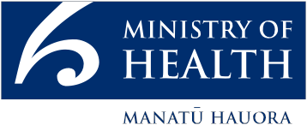
This work is licensed under the Creative Commons Attribution 4.0 International licence. In essence, you are free to: share ie, copy and redistribute the material in any medium or format; adapt ie, remix, transform and build upon the material. You must give appropriate credit, provide a link to the licence and indicate if changes were made.

Contents
Introduction 1
Summary 2
Where we are now 4
Our health 4
Good life outcomes are interconnected 5
Health and disability services 7
Institutional arrangements 14
Funding 15
We need to adapt to respond to the changes we face 17
Where we are going 21
What the future will look like 21
How we will get there 25
Strategic change to improve people’s lives 25
Where we can improve outcomes 26
Better directing investment to address inequity and improve people’s lives 28
Transforming the health and disability system for future sustainability 30
Endnotes 32

List of Figures
Figure 1: Age-standardised total DALYs 1990–2015 (projected) 5
Figure 2: Contribution of certain determinants to health outcomes 6
Figure 3: Immunisation coverage of eight-month-olds 10
Figure 4: Diabetes prevalence and impact (measured in DALYs) in New Zealand 2005 to 2015 11
Figure 5: Percentage of children and young people in care with completed immunisations, 2015 (compared to national immunisation rates) 13
Figure 6: Children and young people in care who received a mental health service, 2011 to 2015 (compared to national rates) 13
Figure 7: Vote Health operational funding 2000/01 to 2017/18 15
Figure 8: Combined district health board deficits 2008/09 to 2016/17 16
Figure 9: Health loss as a percentage of total disability-adjusted life years, 2013, by cause (risk cluster) 19

List of Tables
Table 1: Ethnic groups as a proportion of total population, Auckland and New Zealand, 2013 18

Introduction
E te Minita, tēnā koe

Congratulations on your appointment. The Ministry of Health (the Ministry) is committed to working with you to deliver on the Government’s priorities for health, including those identified in the 100-day programme of action:
- setting up a Ministerial inquiry on mental health
- introducing legislation to make medicinal cannabis available for people with terminal illnesses or in chronic pain.

Other Government policies that stand out as early priorities for implementation include:
- funding for additional health and disability services
- re-establishing the Mental Health Commission
- extending school-based mental health services in secondary schools
- providing 80 mental health professionals to primary and intermediate schools in Christchurch, Kaikōura and other earthquake-affected parts of Canterbury
- improving access to primary health care, including lowering the co-payments for General Practice (GP) visits from 1 July 2018
- improving cancer services, including establishing a national cancer agency
- rebuilding Dunedin Hospital.

We look forward to discussing with you, and assisting you to implement, the Government’s health policies.

We are also keen to discuss the information provided in this briefing on the challenges and opportunities facing the New Zealand health and disability system. This includes our advice on the strategic changes needed to shift the system to improve New Zealanders’ health and wellbeing.

Nāku noa, nā

Chai Chuah
Director-General of Health
Ministry of Health

Summary
The New Zealand health and disability support system has many strengths, and intersects the life of every New Zealander. It is looking after New Zealanders well, especially when we are acutely ill or injured. The system is, however, under pressure, is facing significant contextual change, and will need to operate very differently if it is to continue to deliver for New Zealanders.

Factors, including changes to population and ways of living, are putting pressure on health and disability support systems globally. Recent Ministry consultation with the New Zealand public and the sector confirms the immediacy of these factors.

Our health and disability support systems need to meet three main challenges.
      - Our population is growing and diversifying and life expectancy is increasing faster than health expectancy (the time spent in good health), so more people are spending longer in poor health.
      - Some New Zealanders, especially Māori, Pacific peoples, people with disabilities, and people living in low socioeconomic areas, have disproportionately poorer health.
      - Maintaining funding for services in light of increasing cost and demand.

Determinants outside the health system including education, housing, employment, and environment play a big part in the size and complexity of these challenges.

To meet the challenges, we need to:
- improve service delivery, through lifting the performance and value of current models of service and introducing new models of service focused on a life-course approach, with self-determination at their core
- improve collaboration across health and other sectors, and with communities and individuals, to address the non-health determinants of health outcomes, and health’s contribution to other life outcomes.

It will be important to tackle both dimensions at the same time in a coordinated approach. The key elements will be:
- getting right the policy settings that will enable, incentivise and support these changes: articulating a clear vision and strategic direction and providing clarity on the roles, responsibilities, and accountabilities within the sector
- using the correct levers to implement those policy settings. These include:
        - leadership and relationships throughout and beyond the sector
        - changes to legislation, regulation, and other legislative instruments where that is necessary, for instance in addressing institutional arrangements
        - the way in which services are commissioned
        - ownership
        - provision of information that helps and allows all contributors to align their contributions
- building the organisational and business models that make new service models possible
- providing an enabling environment with the right workforce, information systems, technologies, facilities and other capital items/

The rapidly changing context provides urgency for fundamental and strategic change, with the aim of a sustainable health and disability support system, well integrated with other sectors, and focused on the needs of people, their families and communities.

Where we are now

Our health
Our life expectancy at birth is above the OECD average, our life and health expectancies have increased steadily over the last 25 years, and we have achieved one of the fastest declines in health loss among high- income countries

New Zealanders’ health rates well internationally | New Zealanders born in 2015 have an average life expectancy of 81.7 years. This places our life expectancy 13th of 34 Organisation for Economic Co-operation and Development (OECD) countries and above the OECD average life expectancy of 80.6 years.  We are living longer lives, and the years we live in good health are also increasing. The average life expectancy for a male born in 2015 is 79.6 years, with a health expectancy of 69.9 years; the figures for a female born in 2015 are 83.3 years and 71.8 years respectively.
Our life and health expectancies have risen steadily over the last 25 years | Life expectancy has increased more over the last 25 years than health expectancy; that is, although we are living longer, we are spending a longer time in poor health.  New Zealand rates well against other high-income countries in terms of the amount of health lost – that is, the number of years of life lost prematurely plus the number of years spent in less than full health, adjusted for severity. Over the past 25 years, New Zealanders’ rate of health loss has declined more quickly than it has in other high-income countries. This is a major achievement for the health and wider social sector. We are doing well for most people, but we could be doing better for certain groups.
Figure 1: Age-standardised total DALYs 1990–2015 (projected)
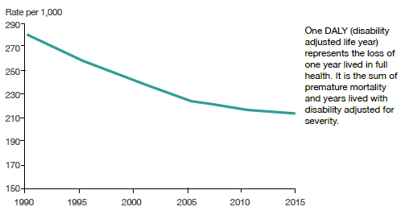

Good life outcomes are interconnected
Our social, economic and physical environment strongly influences our health, and poor health makes it difficult for people to engage in other aspects of life, like education and employment.
To make the greatest difference to people’s lives, health and other social and economic services must work together, and work with the communities they serve.

A good social, economic, cultural, and physical environment is important for good health | Our social, economic and physical environments strongly influence our physical and mental health, as well as our ability to adopt and maintain a healthy lifestyle.  Our social environment comprises our family and whānau structure, social connectedness, culture, and exposure to crime and violence, as well as our level of education. This environment influences our health literacy, our social norms, our lifestyles, the value we place on health and our ability to cope with life’s adversities. In terms of economic environment, income and poverty, employment status and occupation are strongly related to health and wellbeing.  In terms of our physical environment, cold, damp and overcrowded homes directly contribute to poor health outcomes. Six percent of New Zealanders live in homes with major damp or mould problems, and 10 percent live in crowded conditions. Household crowding is linked to a number of health conditions, including rheumatic fever, meningococcal disease, respiratory infections and skin infections.
 | Our day-to-day decisions also influence our health and wellbeing. Behaviours with positive effects (such as eating lots of vegetables and fruit, exercising regularly and having supportive social networks) are protective factors. Behaviours with negative effects are risk factors. Poor nutrition, obesity and smoking are the risk factors that cause the greatest health loss. There is significant scope for us to increase prevention of these risk factors, not only to improve health and wellbeing but also to reduce the cost to our health system of long-term conditions resulting from these factors.
 | Figure 2: Contribution of certain determinants to health outcomes
 | 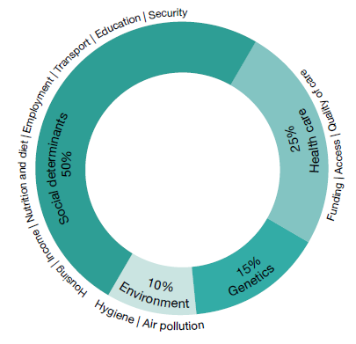
Good health is important for a good life | Good health supports people’s ability to engage fully in other aspects of life, like education and employment. Many people with poor health are engaged with other public services, such as income support and the justice sector.
We therefore need to work closely with others | Therefore, to have the best positive effect on people’s health and lives, we need to work well with partners across the health, social and economic sectors; with government agencies; and with communities, families and whānau and individuals.

Health and disability services
New Zealanders will receive a range of health and disability support services throughout their lives, delivered through public and private funding, and by a highly skilled workforce. More services are being delivered and quality has improved. Nonetheless, they are not achieving equitable results for groups of our population.

A comprehensive range of quality services is available ...
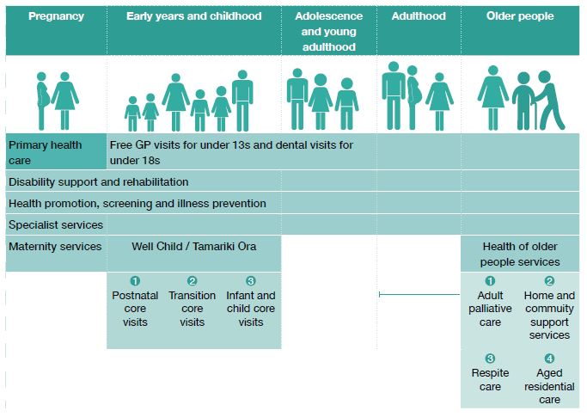

... provided by many organisations | Health services affect people’s lives often and at all stages of their lives, from maternity care through to palliative care. There are great opportunities for services to work together, within the health and disability system, within the wider social and economic sectors and in the community, to improve people’s life outcomes.  A range of public and private organisations provide health and disability services and supports:  - 1,013 general practices  - 20 district health boards (DHBs)  - 31 primary health organisations (plus South Canterbury DHB which acts as a PHO as well)  - 2,661 general dental practices  - 39 public hospitals  - 46 accident and medical centres  - 225 Māori health providers  - 35 Pacific health providers  - 991 pharmacies  - 664 certified rest home providers  - 76 private hospitals  - 950 disability support providers.
Volumes of service are increasing | The volumes of health and disability services New Zealanders use have increased across the system.  Between 2011/12 and 2016/17, publicly funded surgical discharges rose 10 percent to 342,285. In the same period, publicly funded medical discharges rose 17 percent to 495,919, short-stay emergency department events rose 26 percent to 165,553 and elective health target discharges rose 14 percent to 204,146.  Between 2011/12 to 2015/16, the number of general practitioner consultations increased by 7.51 percent, and nurse consultations increased by 39.1 percent.  Demand for mental health services has also grown. In 2016, 169,454 people accessed mental health services, up from 162,222 in 2015, 158,233 in 2014 and 154,523 in 2013.  Between 2011/12 and 2015/16, there was a 4.4 percent increase in the number of disabled people receiving community care services, and a 14 percent increase in the average hours of support disabled people received (from 21.8 to 24.9 hours per week).  From 2011/12 to 2015/16, there was a 5 percent increase in the number of people receiving age-related residential care support services, and a 22 percent increase in the average hours of home support older people received.
The effectiveness and quality of health services continue to improve | The effectiveness and quality of our services has also improved. Over the last 10 years, there have been fewer and fewer deaths that could have been avoided by prevention and treatment services.  The following examples are taken from the Health and Independence Report 2016:  - Immunisation coverage of eight-month-olds rose from 78 percent to 93 percent between 2009 and 2016.  Figure 3: Immunisation coverage of eight-month-olds  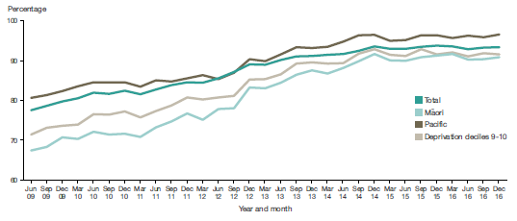  - New Zealand implemented the National Cervical Screening Programme for 20–69-year-old women in 1990. The incidence of cervical cancer reduced by 56 percent from 1985–1989 to 2009–2013.  - The prevalence of diabetes is increasing, but our screening and early intervention services have improved; we are diagnosing diabetes earlier and managing it more effectively. This means that the total impact of diabetes (measured in DALYs) has decreased.  - Over the last 25 years, health loss from coronary heart disease has halved and stroke rates are down 23 percent. People who have had strokes are living longer than they did 25 years ago.
Figure 4: Diabetes prevalence and impact (measured in DALYs) in New Zealand 2005 to 2015
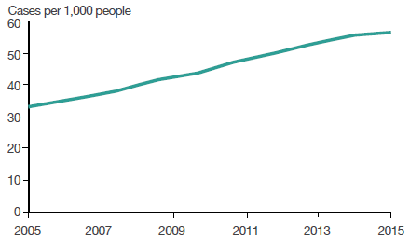
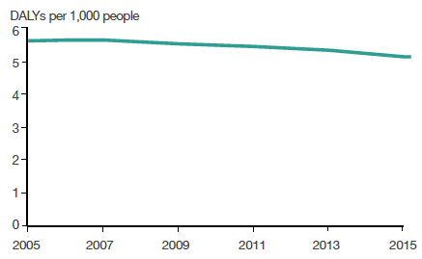
Even with these gains, it remains the case that 38 percent of our health loss is potentially preventable.
A highly skilled workforce provides our health services | The New Zealand health workforce plays a critical part in our ability to provide services where and how they are most needed, improve access to care, address health inequalities, manage cost pressures and improve the system’s performance.  In 2017, approximately 102,400 health professionals are regulated under the Health Practitioners Competence Assurance Act 2004; this includes 55,289 nursing and 15,761 medical professionals. In addition, the care and support workforce numbers about 48,000.  Other health professionals, medical technicians, and health and welfare support people comprise large and important workforce groups within our health systems. They include, for example, nutritionists, traditional Māori health practitioners, operating theatre technicians and paramedics. The Ministry of Health does not hold up-to-date information on numbers of workers within these groups.
Current health care services are not achieving equitable outcomes | Overall, most New Zealanders engage with health services, and our health is good. Despite this, the health of Māori, Pacific peoples and people living in lower socioeconomic areas is worse than average. Services do not always work well for some of the most vulnerable people, and sometimes miss them entirely. We need to better understand why this happens, and how we can improve our services to meet individual needs.
Current health care services are not meeting the needs of Māori | Māori adults have higher rates of cardiovascular disease, psychological distress, arthritis, asthma, diabetes and chronic pain than non-Māori adults. Māori children have higher rates of asthma, eczema and poor oral health than non-Māori children.  Māori report encountering barriers to accessing care at a higher rate than the population as a whole. They have a greater level of unmet need for primary health care than non-Māori; for example cost may be a barrier to accessing prescription medications. Māori adults and Māori children are more than twice as likely as non-Māori to have not collected a prescription due to cost.
... or the needs of Pacific peoples | Similarly, Pacific adults have higher rates of poor cardiovascular health, psychological distress, diabetes and poor oral health than non-Pacific adults.  Pacific adults and children are more than three times as likely to have not collected a prescription due to cost as non-Pacific adults and non-Pacific children. Pacific people are also more likely to report experiencing barriers to accessing primary health care, such as the cost of transport and the cost of appointments themselves.
People living in lower socioeconomic areas are also worse off | Adults living in areas of the highest socioeconomic deprivation experience significantly higher rates of poor cardiovascular health, psychological distress, diagnosed mood and/or anxiety disorders, arthritis, asthma, diabetes and chronic pain than those living in areas of the least socioeconomic deprivation.  Smoking, hazardous drinking, inadequate vegetable and fruit intake, physical inactivity and obesity are also more common among both adults and children living in these areas.  Although adults and children in these areas report similar rates of GP visits over the past year to those in the least deprived areas, they experience much poorer outcomes and much higher levels of unmet need for health care. Unmet need is of particular concern where it affects people who are already in poor health.
Services are failing to reach some of the most vulnerable people ... | Looking more closely at smaller groups of our most vulnerable people we see similar challenges for the health service to reach them and provide services effectively.  For example, our immunisation services are not adequately reaching children and young people in care who are thus missing out on the benefits of immunisation in their first year and a half of life.  Figure 5: Percentage of children and young people in care with completed immunisations, 2015 (compared to national immunisation rates)  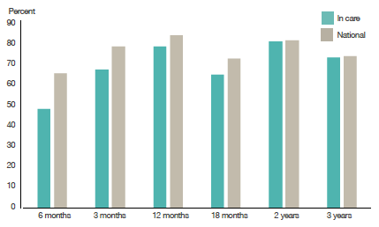
... or are not working effectively | Children in care are more likely to have received a mental health service than children not in care. However, once they are no longer in care their rates of self-harm or suicide are much higher than those for the rest of the population. This raises questions of the effectiveness of the health system’s ongoing support.  Figure 6: Children and young people in care who received a mental health service, 2011 to 2015 (compared to national rates)  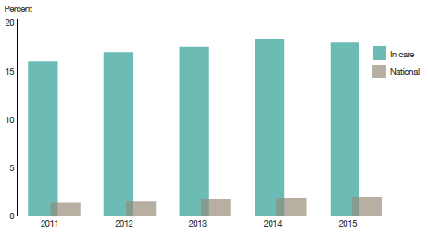

Institutional arrangements

The health and disability system delivers services and supports through a complex network of organisations with a range of interrelated roles and responsibilities.

The health and disability system has a complex set of institutional arrangements | The institutional arrangements that make up the health and disability system are a mix of publicly owned and privately owned organisations, with a network of interrelated roles, responsibilities, funding, accountability, and delivery arrangements.  The current system is semi-devolved. Central government sets the overall strategic direction, sets expectations about the standard of service delivery and provides funding; many day-to-day functions and detailed decisions happen at a local level, through DHBs, primary health care organisations (PHOs) and others.
Inherent strengths and challenges of the system | The strengths of the model lie in its ability for local organisations and health providers to meet the needs of the local people living in their communities. Some DHBs are planning and delivering services regionally, including sharing key personnel and back office functions. Challenges of the system include ensuring national consistency and equity of service delivery, maintaining value for money, and encouraging collaborative system leadership. Geographic boundaries that are not reflective of people’s movements (eg, between different DHBs that service connected urban centres) can create inequities in access.  Due to the system’s complex set of governance, ownership, business and accountability models, the levers available to you as Minister and the Ministry are varied and exert differing levels of control. These range from formal (eg, your ability to issue statutory directions, or tagging ongoing funding to specific performance outcomes) to informal (eg, influence and relationship management).  Considering whether the current institutional arrangements remain fit for purpose could identify opportunities for addressing some of the challenges to the system and building on its strengths.

Funding
Successive governments have made health funding a priority. Ongoing cost pressures means we will need to ensure adequate funding to meet demand for services and deliver on upcoming capital projects.

The system faces cost pressures that are expected to continue | Figure 7: Vote Health operational funding 2000/01 to 2017/18  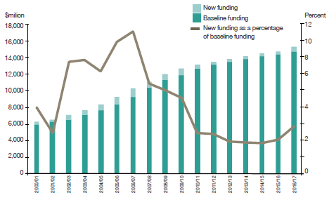  The health and disability system faces a range of cost pressures arising from changes in demographics, prices, and patterns of illness, in common with similar high-income countries around the world. Baseline funding for Vote Health has increased annually since 2000/01 (see Figure 7), however, successive governments’ policy decisions have led to different rates of increase.  The pressures on Vote Health are expected to continue however, and the track of DHB total deficits (see Figure 8) suggests that efficiency gains are becoming increasingly difficult. Similarly, ongoing efficiency gains in the $2.4 billion of health services purchased by the Ministry are becoming more difficult and demand and cost pressures bear on those frontline services too.
Figure 8: Combined district health board deficits 2008/09 to 2016/17
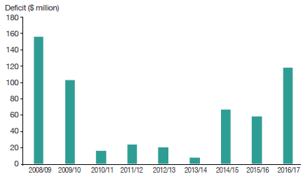
Note: This figure excludes insurance proceeds of $288 million relating to the Canterbury earthquakes of 2010 and 2011.
We need to continue to meet service demand ... | We urgently need new, more cost-effective, ways of delivering care that will meet demand and provide consistent experiences for people using services. To invest well, we need to better understand the pressures on costs in the way we currently deliver services, so that we can better manage those pressures to improve effectiveness, productivity and efficiency, and reduce waste.
... and address the queue of capital investment projects waiting | We need to invest in hospital developments (driven by the need to replace old assets alongside population growth and movements) as well as in delivering services closer to home, especially through new technologies such as mobile services and devices and telehealth. We will also need to consider these investments in the light of national and regional distribution of services, and against other priorities (such as an electronic health record for all New Zealanders) that have the potential to provide a clear step forward in transforming the system.  We need to find new models of service that can reduce the demand for hospital-based services in the future. Such solutions will, in turn, help to slow the rate of increase in new hospital beds needed and reduce the impact of that investment on operating expenditure (through, for example, capital charge for those DHBs with major hospital redevelopments).  We need to better manage delivery on our investments, to ensure we are getting the greatest possible value from them. Alternative governance arrangements may help.

We need to adapt to respond to the changes we face
The health sector has to continue to adapt to deal with the challenges it faces, including a growing, diversifying and ageing population, and changes in the way people are living. One way in which we can adapt is to promote changes to our lifestyles and environments that effectively improve our health.
Innovation and technological development provide another focus for adaptation; we need to seize the opportunities these factors create.
The health sector needs excellent leadership, a sound regulatory environment, good workforce support and development and effective means of sharing knowledge.

We have a growing, ageing and diversifying population | Changes in New Zealand’s population are creating new opportunities and challenges for the health and disability system.  Our growing and increasingly ethnically diverse population is living longer. Between 2006 and 2016, the percentage of New Zealanders aged 65 years and over increased from around 12 percent to around 15 percent. Because the average cost of providing health services rises with age, the ageing of the population places pressure on the health budget. In addition, different ethnic groups have different patterns of health and different ways of accessing and using health services. They therefore require different patterns of services delivered in different ways; as demographics change by ethnicity, so must the health system.
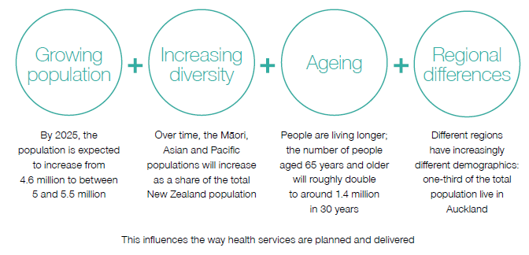

There are also regional population differences | Auckland is a particularly diverse part of the country. In 2013, around one-quarter of New Zealand’s population was born overseas. More overseas-born people lived in the Auckland region (39.1 percent) than in any other region (18.2 percent for the rest of New Zealand).  Pacific people in New Zealand comprise a young, fast-growing, urbanised population. In 2013, 92.9 percent of the Pacific population lived in the North Island, and two out of three lived in the Auckland region.  The distribution of the older population also varies by region. For example, in the Bay of Plenty DHB region, a considerably higher proportion of the population is aged over 65 when compared to New Zealand as a whole.  By contrast, the Auckland and Counties Manukau DHB regions have a comparatively low proportion of people aged over 65.  Table 1: Ethnic groups as a proportion of total population, Auckland and New Zealand, 2013  Self-reported ethnic group* Auckland (percent) New Zealand (percent)  European 59.3 74.0  Māori 10.7 14.9  Pacific peoples 14.6 7.4  Asian 23.1 11.8  Middle Eastern, Latin American, African 1.9 1.2  New Zealander 1.1 1.6  Other 0.1 0.0  * Where a person reported more than one ethnic group, they have been counted in each applicable group. As a result percentages do not add up to 100.
 | These regional differences mean that we need a difference mix of services in different parts of the country.
Long-term conditions are the major cause of health loss | Long-term conditions are ongoing or recurring conditions that have a significant impact on people’s lives. They include diabetes, cancers, cardiovascular diseases, respiratory diseases, mental illness (including depression and anxiety), chronic pain, chronic kidney disease, musculoskeletal conditions and other conditions. In 2013, long-term conditions were responsible for 88 percent of health loss in New Zealand, up from 83 percent in 1990.
More people are living with a disability | The proportion of people living with a disability increased from 20 percent in 2001 to 24 percent in 2013. The ageing population has contributed to this higher proportion, alongside other factors, including changes in public perceptions of disability (people are generally more willing than they have been in the past to self-identify as having a disability). Māori are more likely to be living with a disability than other New Zealanders.
Adding life to years is as important as adding years to life | There is a growing gap between health expectancy and life expectancy; we have been more successful in adding years to life than in adding life to years. One significant challenge we face is to find ways to maximise the time people spend in good health. To do this, we will need to address long-term conditions and their precursors.
Positive lifestyle, occupational and environmental changes could prevent over 30 percent of health loss | Certain behavioural risks (lifestyle factors) such as smoking and poor nutrition significantly contribute to health loss, accounting for over one quarter.  Biological risks, such as being overweight and having high cholesterol and hypertension, account for almost one-fifth of total health loss.  Occupational risks (such as workplace exposure to noise and carcinogens) and environmental risks (such as lead exposure and air pollution) account for 3 percent and 1 percent of health loss respectively.
Figure 9: Health loss as a percentage of total disability-adjusted life years, 2013, by cause (risk cluster)
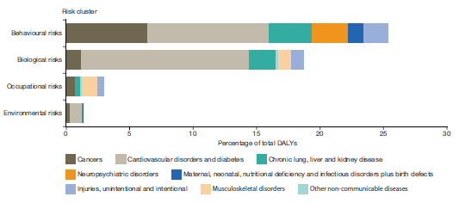
After adjusting for overlaps of risk, we can estimate that 38 percent of all health loss in the New Zealand population is attributable to known modifiable risk factors. This means that we could potentially reduce over one-third of the health loss our population experiences by making or promoting positive lifestyle, occupational and environmental changes, and improving our early treatment services.
There are new pressures from new technologies, the accelerating pace of life and new family dynamics | While we must centre much of our attention on long-term conditions, we should not forget the potential impact of infectious diseases, as anti- microbial resistance grows and spreads. Without corresponding medical advances, anti-microbial resistance may deeply disrupt current medical and surgical practice, our economy, and our way of life. New Zealand has recently released its Antimicrobial Resistance Action Plan, which addresses this threat on five fronts: awareness and understanding; surveillance and research; infection prevention and control; antimicrobial stewardship; and governance, collaboration and investment.  Rapid technological development and convergence will increasingly impact on the services we can deliver and the way in which people access and experience them. New technologies offer us tremendous opportunity to improve awareness of and access to services, enhance their quality, reduce costs and improve integration with the social and economic sectors. The very pace and depth of technological development means that change may arrive in a disruptive fashion, meaning the sector must consistently be ready for rapid innovation. There is also the challenge of ensuring equitable access to the benefits technological advances will bring.  Leaders throughout the sector will need to be receptive to innovation and technological development. We must build an environment across the health and disability system that is well placed to deploy these advances to best effect for New Zealanders, by ensuring an effective regulatory environment, strong workforce planning and support, assessment of funding and investment strategies, and active environmental scanning and knowledge dissemination.  As technological development advances, the pace of life continues to increase, and the way we live and interact with our families and whānau, friends and communities is changing. We need to focus on building our resilience, in order to meet this particular set of challenges and succeed in maintaining and improving our health and wellbeing.

Where we are going
The future health sector will deliver knowledge, support and services to people at the time and place and in the way that works best for them, increasingly making use of digital and mobile solutions, client influence and engagement, and non-traditional players and locations

What the future will look like
The future of the New Zealand health system will look different. Through engagement with the health sector, we have developed a vision for how the health system will operate 10 years from now. Specifically, the vision entails the following aspirations.

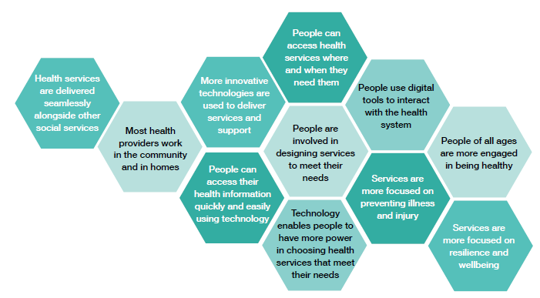

Realising this vision will require leadership throughout the sector and further investment, bringing with it a need for carefully considered tradeoffs.

The future vision can be grouped into five themes:

Person-centred
We will provide services in various ways, to reflect the varying needs of our diverse communities and to provide information that helps people take control of their health and wellbeing.

Understanding why young Māori women smoke
The Ministry initiated this project to address the challenge of smoking among young Māori women, a group of New Zealanders for whom the smoking rate remains persistently high despite efforts to reduce it. The project’s approach challenged our traditional ways of doing business by prioritising understanding people, their lives, and how these things influence their behaviour. It was an opportunity to test how we can put people more effectively at the centre of our business.
The project goal was to gain a better understanding of the reasons that Māori women aged 18–24 years start, continue and stop smoking. It also showed that it is possible to gather actionable insights into people’s lives in a very short timeframe (in this case, three months).
The team invited young Māori women in Northland, Auckland and Wellington who were current or past smokers to share stories about their lives, the place of smoking in their lives and the challenges they faced in quitting. By the end of the process a total of 50 young women had confirmed that what we had captured represented their story. The team is now investigating a range of ideas suggested by the young women to tackle smoking. These ideas could be developed through a co-design process with providers and young women in their communities.

Services and supports when, where, and how people need them
We will make it easier for people to access health services and to work with local communities to provide tailored support.

Pharmacists giving flu vaccinations
Since 2017, pharmacists have been able to provide publicly funded influenza vaccines to those aged 65 and over, and to pregnant women. Through data analysis, the Ministry identified these groups as most likely to benefit from accessing vaccination services closer to home, as they have a higher risk of influenza morbidity and mortality, and are more likely to have difficulty accessing GP services.

Best value
We will make better use of data to understand all the factors that affect health outcomes, and to put resources in the places they will make the most difference.

Bowel screening home testing kits
This is New Zealand’s only cancer screening programme in which the initial test is carried out at home. Developments in test technology make this a safe and simple test for people to do at their own convenience; they take a sample at home and return it in a Freepost envelope to the laboratory for testing. The programme provides health professional support to participants when they request it, and to those who return a positive test and are referred for further investigation – usually a colonoscopy. The programme invites participants with a negative result to screening again every two years while they are still eligible.
The programme also provides information via a free phone information line, an email address and a website.

Working together
We will ensure that government agencies, health care providers, non-government organisations (NGOs), experts, analysts and communities work together to design and deliver services and support.

Library and Child Health Hub: Te Aka Mauri (Rotorua)
Rotorua’s new Library and Child Health Hub, Te Aka Mauri, which will be officially opened late in November 2017, co-locates a Lakes DHB children’s health centre with the Rotorua Library.
Te Aka Mauri represents a way of delivering services for children and their families and whānau that is innovative, bold and collaborative. The project aims to make use of co-location to improve access to all child- and family-related agencies and services.
Lakes DHB and the Rotorua Lakes Council developed Te Aka Mauri through engagement with the community, iwi and government agencies. Services based at Te Aka Mauri will include:
- Infant, Child and Adolescent Mental Health Services
- the Child Development Team (an assessment and therapy service for children with developmental issues)
- the Public Health Nursing and Screening Service
- some paediatric clinics
- a community lactation service, Kia Wana
- maternity advice, and
- Rotorua Children’s Team.

Innovation ready
We will use technology to improve services and to make it easier to share information across the system, and to ensure that the system is ready to take advantage of new technology that improves health outcomes.

‘Need to talk?’ telehealth mental health advice and support service
The ‘Need to talk?’ service was launched in June 2017 as part of the existing helpline services in the National Telehealth Service. ‘Need to talk?’ is a free, 24/7 call or text service providing mental health advice and support.
So far 3,200 New Zealanders have accessed advice and support through ‘Need to talk?’; over half have made initial contact by text. Sixteen percent of contacts were from 13–19-year-olds, and 17 percent from 20–24-year-olds.
The National Telehealth Service was launched on 1 November 2015. It consolidates a range of health-funded helplines, including Healthline, Quitline, lines providing immunisation and poisons advice, the Depression helpline and other mental health lines. Within this service a professional workforce of over 220 frontline staff provides phone and online advice, support, assessment of symptoms, triage and referral advice. All services are free to access and available 24 hours a day, seven days a week, 365 days a year. Interpreter services are available in over 40 languages.
Ask Ruru
Capital & Coast DHB is developing Ask Ruru, a mobile app and desktop platform that supports mental health professionals to deliver safer, more effective crisis coaching to young adults and teenagers. It assists therapist to generate and log conversations via SMS based interactions. It decreases downstream crisis response expense, by enabling earlier interventions that promote greater personal health literacy.

How we will get there

Strategic change to improve people’s lives
We want a change in perspective toward wellbeing, greater convenience, flexibility, self-direction, and personalised experiences. We need to equip New Zealanders with the skills and knowledge to work with their service provider teams as expert and responsible partners.

We need coordinated strategic change on two fronts ... | Our large and complex health and disability system faces a number of challenges. To create the system we want for New Zealanders, we need coordinated and substantive strategic change on two fronts:  - better directed investment to improve equity and lift life outcomes  - transformation of the health and disability system for future sustainability.  The next section introduces five key service areas that we see as priorities for this strategic change. The two sections that follow expand on the nature of the change we think is required.
... while we continue to deliver existing services | We will also need to strike a balance between making these substantive strategic changes to prepare the sector for the future and maintaining current services (access, safety, and steady quality improvement). Major ongoing areas of current work include:  - improving health promotion and strengthening people’s capabilities to manage their health and lifestyle  - addressing workforce issues, by:  - taking a person-centred approach to developing our health workforce and models of care  - resolving workforce pressures, including forthcoming pay equity issues that are arising following the resolution of home and community support pay equity claims, and other major employment relations issues
 | - facilitating pathways into vocational practice that enable health practitioners to practice to the extent of their scope
- fostering innovative and collaborative models of practice, especially in primary care
- collecting comprehensive, robust, real-time workforce data and developing needs-based workforce modelling and planning
- focusing on keeping trained people in the workforce and directing them to the areas where we need them the most
- continually raising clinical quality
- improving the patient centredness of our hospital services; acute health episodes happen at any time of the day and week but some clinical functions of our hospitals are geared toward Monday to Friday business hours with implications for the quality of care available outside those hours
- increasing priority elective services
- implementing the New Zealand Antimicrobial Resistance Action Plan.

Where we can improve outcomes
We can improve health outcomes for groups who experience persistent inequities, by tackling challenges and taking advantage of opportunities in some key service areas.

Some of the health and disability system’s key service areas are facing specific challenges. By making changes in these areas, we can address persistent inequities across the system.

Mental health and addiction | More than half of New Zealanders are likely to experience a mental health disorder at least once in their lives. Each year approximately 20 percent of New Zealanders present to mental health services, and over 500 people die by suicide. New Zealand’s experience is not unique. Major depressive disorders ranked in the top 10 causes of ill health in all but four countries worldwide in 2016. New Zealand has one of the highest youth suicide rates in the OECD, and the overall suicide rate has remained static for the past decade. The prevalence of mental illness among Māori (23.9 percent) is significantly higher than it is among those of European/Other descent.  Demand for mental health and addiction services is rising, and specialist mental health services are under increasing pressure.
 | The societal impacts of mental illness are significant. The annual cost of serious mental illness, including addiction, in New Zealand is estimated at $12 billion per year (5 percent of gross domestic product). Mental distress, mental illness and addiction are often associated with other poor life outcomes, such as unemployment, poor physical health, interaction with the justice system, low levels of education, and housing instability.
The health of mothers, babies and young children | The years from pre-conception to age five (especially the first three years) are key for healthy brain development and lifelong physical and mental health.  At every point between birth and five years, high-quality universal services for children and their caregivers support good health and development. Although our universal services, for example, Well Child / Tamariki Ora, community health, and immunisation, have a high and growing enrolment, we need to improve our ability to reach those who are missing out on services.  Early services and support for babies and children are both more effective and cheaper than interventions later in life, and could reduce the number of people in at-risk population groups at a later age.
Primary health care | Primary health care serves as the first point of contact for most people seeking health services and support, and facilitates appropriate access to wider primary and secondary services. A range of health practitioners comprise the primary health workforce, including GPs, nurses, pharmacists, midwives, community health workers, ambulance workers and allied health workers (eg, physiotherapists and podiatrists). Primary health care accounts for around 5 percent of Vote Health ($920 million for 2017/18).  When it is working well, primary health care reduces demand on health services overall, coordinates care across the system, and helps keep people well. Internationally, there is evidence that health systems that prioritise primary health care have lower per-capita costs, better health outcomes and lower rates of premature mortality.  Delivery of primary health care services in New Zealand is not working well for everyone. Universal services are not reaching some of our most vulnerable groups to the degree needed (eg, Māori, Pacific peoples, youth, disabled people and those on low incomes), and we are not successfully addressing all barriers to access (including cost and opening hours).
Disability support services | We spend $1.2 billion per year on services for people who have intellectual, physical and sensory disabilities. Many support services are currently set up as ‘one size fits all’ services, and are not appropriately tailored to individuals’ needs.  The disability community provides strong leadership in the development of disability policy and, currently, the co-design of a transformation of the disability support system. The transformation programme is scheduled to start in the MidCentral region in July 2018. It emphasises self-determination, giving disabled people and their family and whānau increased choice and control over their support (eg, through personal budgets they can spend flexibly) and their lives.
Home and community support services for older people | Home and community support services for older people have increased over the last five years, and will continue to do so as our population ages.  Wages and pay equity for the workforce providing these services has increased as a result of the November 2014 In-Between Travel Settlement Agreement and the April 2017 $2 billion Pay Equity Settlement Agreement. This significant sector investment provides an opportunity to implement new models of care for home and community support services for older people.

Better directing investment to address inequity and improve people’s lives
We will maximise the health sector’s contribution to New Zealanders’ overall wellbeing by considering the totality of people’s lives, and providing people with choice and control over the delivery of their services and support.

Shifting the focus from illness to health and wellbeing means looking at people’s lives in terms of their place within a family and whānau and a community, and enhancing people’s choice and control over the services they use.

Encouraging health and wellbeing by taking a life-course approach | A life-course approach looks for clues about patterns of health and disease. It does this through examining an individual’s or a cohort’s life experiences, and even across generations. It recognises that past and present experiences are shaped by the wider social, economic and cultural context.
The approach helps identify chains of risk that can be broken and times of intervention that are the most effective; for instance, investing in promotion of healthy lifestyles to prevent the emergence of long-term conditions and enhance people’s wellbeing into older age. Particularly during key life transitions (eg, when a person starts school, has children or retires), we need to provide not just safety nets but springboards, which can alter people’s life-course trajectories and enhance their subsequent health. Broadening this approach to the totality of people’s lives makes people’s overall wellbeing the objective. Health and other social and economic services and the support that occurs naturally in families and whānau and communities will then be more connected and effective, benefitting both health and wider life outcomes and equity.
Taking a life-course approach supports investing in maternal and child health to set people up well for their life, earlier and more accessible and integrated primary health care services to support people to maintain health and treat illness, and better support throughout life for developing and maintaining mental health.
Giving people choice and control over the services and support they receive | Focusing on self-determination means helping people to make their own choices about what services and supports they receive, who delivers them, and where and when they receive them.  In a system that enables and supports self-determination, individuals, families and whānau and communities are able to play a substantial role in maintaining their health, people are able to independently lead fulfilling lives, and people can draw on a personalised set of supports that they need and value the most.

Transforming the health and disability system for future sustainability
We must underpin our investments in transformed approaches to supports and services with equally deep changes to how the health and disability system enables, incentivises and supports change. We need new approaches to leadership, performance, innovation and asset management.

Sector leadership must be aligned, and skilled in partnering | Shared leadership intention is vital to lifting the performance of the sector, and to success in the transformations we need to make. The sector needs leaders who are receptive to innovation and to working as part of one team focused tightly on the needs of New Zealanders. Leaders need skills in building and maintaining the wider team within the health sector; with other social and economic sectors; with Māori; and with the community, family and whānau and individuals.  We need to better develop, connect and support clinical and non-clinical leadership throughout the sector and beyond. We need to leverage our considerable existing skill and knowledge across organisational boundaries and interests.
We need a new approach to performance | The environment in which we all work must support and incentivise us. That starts with a new approach to performance, through:  - reviewing the systems and frameworks that support leadership in the sector, including governance, accountability and funding frameworks, and the prioritisation and use of capital  - gathering and sharing richer information to better align contributions – a more comprehensive analysis of people’s needs, better understanding of the performance of provider partners, effective delivery of support and services, the effectiveness of innovations and the drivers of cost of supports and services.
The health and disability system must encourage and support innovation ...  ... and be ready to take advantage of technological advances | The system as a whole, as well as its leaders, must support innovation that is beneficial and cost-effective. Information systems and technology and diagnostic and therapeutic technologies (including genomics, robotics and nanotechnology) are advancing rapidly. To take advantage of the opportunity that rapid technological development and convergence offers us to improve awareness and access, enhance quality and reduce costs in the health sector, and improve integration with the social and economic sectors, we will need:  - a clear innovation framework  - a good regulatory environment, including the frameworks to ensure quality across borders as information technologies globalise service delivery  - great workforce support and development  - information when, where, and how we need it  - active environmental scanning and knowledge dissemination.  We need step changes to create the environment and a culture that can deploy technological advances to best effect for New Zealanders.
We need to continue to invest in the core building blocks of the system | Successful health promotion and simple seamless health care depend on investment in the building blocks of our system. We need to prioritise projects needing capital expenditure in a way that best supports the country’s strategic direction. We need to balance potential hospital developments, the need to enhance national and regional distribution of services, and alternative and complementary investments such as a national electronic health record system. The balance will be influenced by the focus on delivering services closer to home and through new technologies.  We need to manage delivery on investments better, to ensure we are getting the greatest possible value for them. New models of service will, in turn, reduce the impact of investment in hospitals on operating expenditure (through, for example, capital charge or lease costs).

Endnotes

Where the Ministry for Vulnerable Children Oranga Tamariki has a legal responsibility to keep a child safe and secure, whether they are living with someone in their family or with other caregivers.
OECD. 2015. Life expectancy at birth. URL: https://data.oecd.org/healthstat/life-expectancy-at-birth.htm (accessed 5 October 2017).
Ministry of Health. 2017. Health and Independence Report 2016. Wellington: Ministry of Health.
Ministry of Health. 2016: Health Loss in New Zealand 1990–2013: A report from the New Zealand Burden of Diseases, Injuries and Risk Factors Study. Wellington: Ministry of Health.
Ministry of Health. 1998. The Social, Cultural and Economic Determinants of Health in New Zealand: Action to Improve Health: A Report from the National Advisory Committee on Health and Disability. Wellington: Ministry of Health.
Deloitte Centre for Health Solutions. 2017. Breaking the dependency cycle: Tackling health inequalities of vulnerable families. URL: https://www2.deloitte.com/uk/en/pages/life-sciences-and-healthcare/articles/breaking-dependency-cycling.html (accessed 10 October 2017).
Ministry of Health. 2017. National Minimum Dataset. Wellington: Ministry of Health.
Ministry of Health. 2017. Health and Independence Report 2016. Wellington: Ministry of Health.
Ministry of Health. 2017. Health and Independence Report 2016. Wellington: Ministry of Health.
Ministry of Health. 2017. Health and Independence Report 2016. Wellington: Ministry of Health.
Health Workforce New Zealand, from Responsible Authorities’ reports.
Ministry of Health. 2016. Annual Update of Key Results 2015/16: New Zealand Health Survey. Wellington: Ministry of Health.
Ministry of Health. 2016. Annual Update of Key Results 2015/16: New Zealand Health Survey. Wellington: Ministry of Health.
Ministry of Health. 2016. Annual Update of Key Results 2015/16: New Zealand Health Survey. Wellington: Ministry of Health.
Ministry of Health. 2016. Annual Update of Key Results 2015/16: New Zealand Health Survey. Wellington: Ministry of Health.
Ministry of Health. 2016. Annual Update of Key Results 2015/16: New Zealand Health Survey. Wellington: Ministry of Health.
Ministry of Health. 2016. Annual Update of Key Results 2015/16: New Zealand Health Survey. Wellington: Ministry of Health.
Ministry of Health. 2016. Annual Update of Key Results 2015/16: New Zealand Health Survey. Wellington: Ministry of Health.
Ministry of Health. 2016. Annual Update of Key Results 2015/16: New Zealand Health Survey. Wellington: Ministry of Health.
Ministry of Health. 2016. Annual Update of Key Results 2015/16: New Zealand Health Survey. Wellington: Ministry of Health.
Data sourced from Ministry of Social Development, 2017.
Data sourced from Ministry of Social Development, 2017.
Ministry of Health. 2017. Vote Health Four-year Plan 2017–2021. Wellington: Ministry of Health.
Ministry of Health. 2017. Health and Independence Report 2016. Wellington: Ministry of Health.
Statistics New Zealand. 2014. Half a million Aucklanders born overseas. URL: http://www.stats.govt.nz/ Census/2013-census/profile-and-summary-reports/qstats-culture-identity-auck-mr.aspx (accessed 19 October 2017).
Statistics New Zealand. 2013. Census QuickStats. Wellington: Statistics New Zealand.
Ministry of Health. 2017. Health and Independence Report 2016. Wellington: Ministry of Health.
Ministry of Health. 2017. Health and Independence Report 2016. Wellington: Ministry of Health.
Ministry of Health. 2016. Health Loss in New Zealand 1990–2013: A report from the New Zealand Burden of Diseases, Injuries and Risk Factors Study. Wellington: Ministry of Health.
Ministry of Health. 2016. Health Loss in New Zealand 1990–2013: A report from the New Zealand Burden of Diseases, Injuries and Risk Factors Study. Wellington: Ministry of Health.
Ministry of Health and Ministry for Primary Industries. 2017. New Zealand Antimicrobial Resistance Action Plan. Wellington: Ministry of Health and Ministry for Primary Industries.
The Lancet. 2017. Life, death, and disability in 2016 (editorial). The Lancet 390 (10100): 1083. DOI: http://dx.doi.org/10.1016/S0140-6736(17)32465-0 (accessed 17 October 2017).

