Bowel Cancer Quality Improvement Report
2019

This report publishes quality performance indicator data from patients diagnosed with colorectal cancer in New Zealand between 1 January 2013 and 31 December 2016.
Acknowledgements
This report is the result of a partnership between the Cancer Services team within the Ministry of Health and the National Bowel Cancer Working Group to identify and report on bowel cancer quality performance indicators.
This report is based on data from the New Zealand Cancer Registry and the Ministry of Health’s National Collections. Support from staff at the New Zealand Cancer Registry within the Ministry was invaluable to the authors’ understanding of the cancer registration data and how it could be used.
The support of Analytical Services staff within the Ministry, who provided access for clinicians to the National Collections data, was critical to developing confidence in the use of the data for national quality indicators.
The staff in Cancer Services – particularly those involved with the New Zealand Cancer Health Information Strategy – have supported all stages of the development of the indicators this report presents.
Authors
This report and the recommendations were prepared by a project team:
- Professor Ian Bissett, colorectal surgeon, Auckland District Health Board/ University of Auckland
- Dr Christopher Jackson, medical oncologist, Southern District Health Board
- Mr Christopher Harmston, general and colorectal surgeon, Northland District Health Board
- Ruth Pirie, senior analyst, Ministry of Health.
Disclaimer
The results in this report are not official statistics; they have been created for service quality improvement purposes from the Ministry of Health’s National Collections. The opinions, findings, recommendations and conclusions expressed in this report are those of the authors, not the Ministry of Health.
Citation: Ministry of Health. 2019. Bowel Cancer Quality Improvement Report. Wellington: Ministry of Health.
Published in February 2019 by the Ministry of Health, PO Box 5013, Wellington 6140, New Zealand
ISBN 978-1-98-856851-5 (online)
HP 7035
This document is available at health.govt.nz
This work is licensed under the Creative Commons Attribution 4.0 International licence. In essence, you are free to: share ie, copy and redistribute the material in any medium or format; adapt ie, remix, transform and build upon the material. You must give appropriate credit, provide a link to the licence and indicate if changes were made.

Contents
1 Executive summary vii
2 Key findings and recommendations 1
2.1 Care pathway 1
2.2 Surgical care 2
2.3 Rectal cancer 2
3 Introduction 4
3.1 Background 4
3.2 Context 4
3.3 News for 2018 5
3.4 Structure of this report 6
4 Methods 7
4.1 Methods summary 7
4.2 Data sources 7
4.3 Data linkage 7
4.4 Data processing 9
4.5 Data completeness 9
4.6 Privately funded service provider data 10
4.7 Definition of outcomes derived from the National Minimum Dataset 10
4.8 Definition of surgical urgency 11
4.9 Statistical analysis 12
4.10 Comparisons 13
5 Care pathway 14
5.1 Where are people diagnosed with bowel cancer presenting? 14
6 Surgical care 18
6.1 How many patients die within 90-days of major surgery? 18
6.2 How many patients have emergency surgery? 20
6.3 How long do patients stay in hospital after major bowel cancer resection? 21
6.4 How many patients have more than 12 lymph nodes examined? 22
7 Rectal cancer 24
7.1 How are patients with rectal cancer treated? 24
7.2 How often are patients stoma free at 18 months after surgery? 27
Appendix A: Data tables 29
1 Diagnosis and surgery 29
2 Bowel cancer surgery 31
3 Colon cancer surgery 33
4 Rectal cancer surgery 35
5 Radiotherapy 37
6 Stoma-free survival 39
Appendix B: Working group members 41

List of Figures
Figure 1: Referral sources for people diagnosed with bowel cancer, by district health board of domicile, 2013–16 15
Figure 2: Proportion of people diagnosed with bowel cancer following presentation at an emergency department, by district health board of domicile, 2013–16 15
Figure 3: Observed 90-day post-operative mortality (elective and emergency admissions) for patients diagnosed with bowel cancer, by district health board of service, 2013–16 18
Figure 4: Observed 90-day post-operative mortality (elective admissions only) for patients diagnosed with bowel cancer, by district health board of service, 2013–16 19
Figure 5: Observed emergency surgery rate for patients diagnosed with bowel cancer, by district health board of service, 2013–16 20
Figure 6: Proportion of people having colon cancer surgery who had 12 or more lymph nodes examined by district health board of service, 2013–16 22
Figure 7: Proportion of people with rectal cancer having no radiotherapy (surgery alone), by district health board of service for surgery, 2013–16 25
Figure 8: Proportion of people with rectal cancer having pre-operative short-course radiotherapy, by district health board of service for surgery, 2013–16 25
Figure 9: Proportion of people with rectal cancer having long-course pre-operative radiotherapy by district health board of service for surgery, 2013–16 26
Figure 10: Observed 18-month stoma-free rate by district health board of service for patients diagnosed with rectal cancer, 2013–15 28

List of Tables
Table 1: People who had bowel cancer surgery with pathological tumour, node, metastasis stage available on the New Zealand Cancer Registry, 2013–16 10
Table 2: People diagnosed with colorectal cancer following screening, presentation to an emergency department or referral to a clinic, by year, 2013–16 14
Table 3: People diagnosed with colorectal cancer following screening, presentation to an emergency department or referral to a clinic, by age group, sex, ethnic group and social deprivation, 2013–16 16
Table 4: 90-day mortality following surgery for people diagnosed with bowel cancer, by surgical urgency, 2013–16 20
Table 5: People with rectal cancer having surgery alone and short-course and long-course preoperative radiotherapy, 2013–16 24
Table 6: People diagnosed with colon and rectal cancer, number and percentage who had major surgery, by district health board of domicile, age group, sex and ethnic group, 2013–16 29
Table 7: People having major surgery for bowel cancer in public hospitals, 2013–16 31
Table 8: People having major surgery for colon cancer in public hospitals, 2013–16 33
Table 9: People having major surgery for rectal cancer in public hospitals, 2013–16 35
Table 10: Radiotherapy for people having major surgery for rectal cancer, 2013–16 37
Table 11: People having major surgery for rectal cancer with a stoma at 18 months, 2013–15 39

Executive summary
This report presents the first release of results of our investigation into the use of the Ministry’s National Collections to calculate quality performance indicators for bowel cancer.

The primary audience for this report includes those who deliver care to people with bowel cancer and manage the delivery of health services.

The aim of the report is to measure the quality of care and outcomes for people with bowel cancer in New Zealand and provide a baseline for ongoing quality improvement.

The report presents six quality performance indicators (QPIs) which have been identified and generally accepted as measures of good care.

The report compares the variation in these measures between district health boards (DHBs).

Geographic variation in services received and outcomes can be seen with all indicators. For some indicators there are also variations in access and outcomes for people belonging to different ethnic groups and ages.

Detailed evaluation of the indicators at DHB level is needed to understand the variation between DHBs.

The results of these investigations will likely present opportunities for improving service or care pathways and reducing inequalities. In some instances a national quality improvement programme will be needed to reduce treatment variation.

Key findings and recommendations
This section summarises the key findings and recommendations for the indicators based on our analyses of national administrative data for people diagnosed with bowel cancer in New Zealand. We have grouped the indicator results and recommendations under the following three headings: care pathway, surgical care and rectal cancer.

Care pathway
Between 2013 and 2016, the majority of people (71%) were diagnosed with bowel cancer following referral to a clinic. The proportion of people diagnosed following a referral from publicly funded screening services was 3 percent, and 26 percent were diagnosed following presentation at an emergency department (ED).

Māori and Pacific people were more likely to be diagnosed following an emergency presentation. Women and people younger than 50 years old, or 75 years old and over, were also more often diagnosed following an emergency presentation.

This report covers the period of the bowel screening pilot in Waitemata DHB. The indicator on route to diagnosis will provide a measure of the benefits and consequences of the Bowel Screening Programme as the programme is extended to all DHBs across New Zealand.

Recommendations
This indicator reflects inequalities in diagnostic pathways; evidence shows that patients who are diagnosed following an acute presentation have poorer outcomes.

Acute presentation is an indicator that varies across regions. We need to undertake detailed evaluation at DHB level to understand why a high proportion of patients are presenting acutely.

This will likely present us with an opportunity for improving service or care pathways.

Surgical care
The overall 90-day mortality following colorectal cancer resection was 4.0 percent.

In people with colon cancer, the 90-day mortality following resection was 4.8 percent. In people with rectal cancer, the 90-day mortality following resection was 1.9 percent.

The highest 90-day mortality rates following colon surgery were for people aged over 75 years old.

Of people with colorectal cancer, the proportion who undergo major surgical resection performed as an emergency in New Zealand was 19.6 percent. In people with colon cancer, the rate of emergency surgery was 24.7 percent, and in people with rectal cancer the rate was 4.4 percent.

The highest rates of emergency surgery were for Māori (23.8%), females (21.1%) and people younger than 50 years (27.1%) old and over 75 years old (21.2%).

Of people with colon cancer who had surgery and lymph node yield reported, 82 percent had 12 or more lymph nodes examined; there was wide variation between DHBs.

Recommendations
The overall post-operative mortality in patients undergoing surgery for colorectal cancer in New Zealand is acceptable, but there is currently wide variation between DHBs that needs investigating.

National initiatives to improve outcomes for patients undergoing emergency surgery, and to improve pathways that reduce the rate of emergency surgery, are likely to reduce overall post-operative mortality and improve equity of outcomes.

Rectal cancer
Of rectal cancer patients, 60 percent had publicly funded major surgery. Of these patients, 54 percent received preoperative radiotherapy treatment, either long-course (38%) or short-course (15%).

People with rectal cancer generally experience a higher quality of life after treatment if their surgery to remove the primary tumour does not result in a permanent stoma. The 18-month stoma-free survival for people who had rectal cancer surgery nationally was 54.7 percent. There is wide variation in this rate across individual DHBs, from 14 percent to 80 percent.

Recommendations
The Ministry of Health together with the NBCWG should consider measures to understand the variation between DHBs and consider a national quality improvement programme for the treatment of low rectal cancer (cancer within 6 cm of the anal verge), to reduce treatment variation.

Further work is needed to identify the reasons for the variability of pre-operative adjuvant therapy. This should involve the Radiation Oncology Working Group and other cancer service advisory groups involved in the multidisciplinary meeting process.

Introduction

Background
Bowel cancer is a leading cause of illness, disability and death in New Zealand.

During 2017 and 2018 the Ministry of Health and the National Bowel Cancer Working Group (NBCWG) have worked together to develop a set of proposed quality performance indicators (QPIs) for bowel cancer.

We selected the proposed QPIs to measure performance and drive quality improvement in bowel cancer diagnosis and treatment services in New Zealand. These indicators will support standards of service provision for bowel cancer. In some instances, the indicators cannot be measured using currently available data in national data collections. We have identified areas where national data quality improvement is required (eg, on stage and grade of cancer).

The Ministry of Health has prepared this report in collaboration with the NBCWG. The report presents the first release of results of an investigation into the use of National Collections to calculate QPIs for bowel cancer. It aims to measure the quality of care and outcomes for people with bowel cancer in New Zealand, and provide a baseline for quality improvement. The report presents QPIs that are generally accepted as measures of good care, and primarily describes the variation in these measures between district health boards (DHBs).

Some measures of equity (age, sex, ethnic group and deprivation) have been added for context.

The report includes data on 11,428 people diagnosed with bowel cancer between 1 January 2013 and 31 December 2016.

The primary audience for the report is those who deliver care to people with bowel cancer and manage the delivery of services.

Context
Timely access to high-quality cancer services and standardised treatment pathways can improve cancer treatment and overall survival.

The Ministry of Health’s New Zealand Cancer Plan: Better faster cancer care 2015–2018 tasks Cancer Services with improving the quality and consistency of care by implementing tumour standards that assist in the standardisation of treatment pathways.

The Ministry of Health also published the New Zealand Cancer Health Information Strategy in 2015. Its vision is to enable the Cancer Plan, and to deliver comprehensive, accessible and accurate information to support the delivery of quality care across the cancer patient pathway.

The Ministry of Health is committed to measuring health impact and outcome data to improve the delivery of high-quality health care for Māori, and provide critical analysis of organisational practices that maintain disparities in health care.

This report will assist health practitioners to review their own clinical practice and those of their peers through a health equity and quality lens.

News for 2018
This report is the first report on QPIs for a cancer group in New Zealand.

The Ministry of Health together with the NBCWG undertook a process in late 2017 to identify measures that will drive improvement in quality of care for people diagnosed with bowel cancer in New Zealand. Following consultation and feedback from the wider cancer care sector, 20 QPIs for bowel cancer were agreed (see Bowel cancer quality performance indicators: Descriptions, 2019).

After assessment of the data available in the Ministry of Health’s National Collections, we identified 10 indicators with potential for development. For one of these indicators (QI02: Time from histological diagnosis to first definitive treatment) the data required was not available in National Collections as expected. For another indicator (QI20: Unplanned return to theatre) a local audit of Auckland DHB patient records showed that the National Collections data did not provide enough accuracy to use our results for quality improvement. For other indicators (QI10: Lymph node yield and QI16: Radiotherapy), we made some changes from the original descriptions to fit with the available data.

No measures are risk adjusted in this report. The methods for developing the measures are still under development, and some key information needed for adjustment (eg, tumour, node, metastasis group stage) is missing from the National Collections.

The numbers of people in each DHB is small so the equity measures have been calculated for all people diagnosed and treated in publicly funded services across New Zealand. These national trends may not apply to individual DHBs.

Private hospital surgery data was available for only two of the four years analysed for this report. Therefore, this report includes only data on publicly funded care. More complete private data would allow us to include this data in future reports.

Structure of this report
The sources of data for the indicators and the methods of analysis are explained in Section 4.

The indicator results are presented in Sections 5--7. We present the pathway to care indicator (BCQI01 Route to diagnosis) in Section 5, surgical care indicators (BCQI07 Treatment survival, BCQI10 Lymph node yield, BCQI19 Emergency surgery) in Section 6 and indicators specific to rectal cancer (BCQI 16 Radiotherapy, BCQI 21 Stoma free survival) in Section 7.

Our results include commentary on geographical variation between DHBs, comparisons with similar indicators reported previously in New Zealand and recently in the United Kingdom and recommendations for improving quality of care and outcomes for patients accessing cancer services in New Zealand.

Methods

Methods summary
We extracted all data for people diagnosed with colorectal cancer from 1 January 2013 to 31 December 2016 from the New Zealand Cancer Registry. For the purposes of this report, our dataset only includes people with a new primary diagnosis of bowel cancer.

We linked data from the Ministry of Health’s National Collections to the cancer registrations at patient level using National Health Index (NHI) numbers to obtain information on patient care and follow-up.

We used funnel plots to make comparisons between district health boards (DHBs). We did not adjust outcomes for patient case-mix.

We contacted all DHBs prior to publication to inform them of their results and provide them with an opportunity to review results and consider areas where they could improve services and outcomes for patients.

Data sources
Data used in this report is on people diagnosed with bowel cancer in New Zealand between 1 January 2013 and 31 December 2016 who received publicly funded treatment following diagnosis.

All patient data for this report has come from administrative datasets held within the Ministry of Health’s National Collections.

Data linkage

New Zealand Cancer Registry
The New Zealand Cancer Registry (NZCR) is a population-based registry. It is the most comprehensive source of information on people who have been diagnosed with malignant cancer in New Zealand. It is primarily based on pathology reporting, but also includes information from other sources, including death certificates and review of the diagnosis coding for people admitted to public hospitals.

National Bowel Screening Data Warehouse
The National Bowel Screening Data Warehouse holds records for people who were diagnosed following bowel screening from a publicly funded bowel screening programme.

National Minimum Dataset
The National Minimum Dataset (NMDS) is a national collection of public and private hospital discharge information, including coded clinical data for inpatients and day patients.

Linking NZCR data to NDMS data allowed a view of the procedures particular patients underwent in public hospitals leading up to their diagnosis and following their diagnosis and treatment.

Radiotherapy dataset
The Radiation Oncology Collection is a national collection of delivered private and public courses of radiation therapy.

Treatment centres have submitted data electronically in an agreed format since 2018, although most providers have supplied historic data back to 2012.

Data collected for each course of radiation therapy delivered includes treatment centre, diagnosis code (according to the International Statistical Classification of Diseases and Related Health Problems, Tenth Revision, Australian Modification (ICD-10-AM), 8th edition), treatment site, intent of the treatment and number of treatment sessions.

National Non-Admitted Patients Collection
The National Non-Admitted Patients Collection (NNPAC) information includes event-based purchase units that relate to medical and surgical outpatient events and ED events. This includes information on the type of service provided and the health specialty involved.

The NNPAC allows the Ministry of Health and DHBs to monitor outpatient activity and ensure that DHBs are appropriately remunerated for the services they provide.

The NNPAC provides national consistent data on non-admitted patient (outpatient and ED) activity.

Data processing
We calculated all indicators from existing data within the Ministry of Health’s National Collections ie, no data was provided by DHBs specifically for these indicators.

For all people diagnosed with bowel cancer between 2013 and 2016, we used existing routinely available national administrative data sources to work backwards through individual patients’ cancer journeys to examine the sequence of events that took them to that diagnosis, treatment and outcome. These routes to diagnosis included emergency presentation, screening and referral to a clinic (as inpatients (NMDS) or outpatients (NNPAC)).

We processed data by linking data sources within the National Collections using the encrypted NHI.

We considered a patient to be diagnosed with primary bowel cancer when that patient was registered on the NZCR for the first time with a diagnosis of bowel cancer. We defined bowel cancer as C18, C19 or C20 according to the ICD-10-AM, 8th edition. We defined rectal cancer as C20 and colon cancer as C18 or C19. We assumed a patient’s diagnosis to be the first diagnosis if we could identify no previous diagnosis for that patient in the NZCR since 1 January 1995.

We excluded from all analyses people who were registered from death certificates only and those diagnosed with appendiceal cancer (C18.1), neuroendocrine tumours, gastrointestinal stromal tumours, lymphomas, squamous cell carcinomas and melanomas.

Data completeness
We defined data completeness as the proportion of people with complete data on all four of the variables age; sex; pathological tumour, node, metastasis (TNM) stage; and site of cancer, as we will use these variables for risk adjustment in future. In the future, the risk adjustment model will also need data on mode of admission and number of co-morbidities. We only assessed data completeness in patients who underwent major surgery, because only in these patients could we expect all six data items to be complete.

National Collections have high rates of completion of data fields. Mode of admission was available for all patients. For patients undergoing major surgery, data on all patients included sex, age and site of cancer.

The NZCR included data on T and N stage for most people (80% or more), but data on M stage only rarely (11%) (Table 1).

Table 1: People who had bowel cancer surgery with pathological tumour, node, metastasis stage available on the New Zealand Cancer Registry, 2013–16
Year | Total | Tumour  (T) |  | Node  (N) |  | Metastases  (M) |  | Any  (T, N or M) |  | All  (T, N and M)
 |  | N | % | N | % | N | % | N | % | N | %
Total | 7,170 | 5,791 | 80.8 | 5,671 | 79.1 | 821 | 11.5 | 5,797 | 80.9 | 820 | 11.4
2013 | 1,786 | 1,448 | 81.1 | 1,424 | 79.7 | 137 | 7.7 | 1,450 | 81.2 | 137 | 7.7
2014 | 1,851 | 1,482 | 80.1 | 1,455 | 78.6 | 243 | 13.1 | 1,482 | 80.1 | 243 | 13.1
2015 | 1,734 | 1,418 | 81.8 | 1,393 | 80.3 | 210 | 12.1 | 1,419 | 81.8 | 210 | 12.1
2016 | 1,799 | 1,443 | 80.2 | 1,399 | 77.8 | 231 | 12.8 | 1,446 | 80.4 | 230 | 12.8

Privately funded service provider data
The National Collections include all publicly funded hospital events. Private hospitals in New Zealand have recently begun voluntary submission of treatment data, but reporting was incomplete for the time period 2013–16. This report therefore does not include private care events. We hope that future quality reports will include this data.

Definition of outcomes derived from the National Minimum Dataset
We calculated length of hospital stay for patients undergoing major surgery, defined as the number of days between the date of surgical procedure as recorded in the NMDS and either discharge or death.

We derived data on unplanned return to theatre within 30 days of surgery for patients undergoing major surgery, defined as return to theatre for surgery involving abdominal or wound complications within 30 days of surgery.

We estimated 18-month stoma-free rates for rectal cancer patients undergoing major surgery. We assumed that patients undergoing an abdomino-perineal excision of the rectum (APER) (operation to remove the entire rectum and anal canal), Hartmann’s procedure (operation to remove an area of bowel on the left-hand side with part of the rectum, leaving a colostomy) or other identified stoma-forming procedures had a stoma at the time of their primary procedure. We classified this as permanent in patients having an APER.

We used NMDS data to capture whether patients received a stoma, and the type of stomas that were created. In patients having an anterior resection (AR) or Hartmann’s procedure, we also obtained information on subsequent stoma reversal from NMDS. We assumed a procedure code for reversal of ileostomy or colostomy within 18 months of surgery to mean that the patient had their stoma reversed.

We made no adjustments for case mix using risk factors. We pooled data over three years. (Note this is fewer years than for other indicators, to allow 18 months follow-up after surgery and to ensure a sufficient number of operations per DHB, to make comparisons.)

Definition of surgical urgency

Admission types
We defined acute admission according to the Ministry of Health’s Common Counting Standards 2013–14, as follows:
Acute Admission – An unplanned admission on the day of presentation at the admitting healthcare facility. Admission may have been from the emergency or outpatient departments of the healthcare facility or a transfer from another facility.

We defined all other admissions as ‘elective’.

We defined emergency surgery as any definite surgery procedure performed during an acute admission.

Statistical analysis
Most results reported in this report are descriptive. We report the results of categorical data as percentages (%). We typically group results by DHB of service (ie, where the service was located).

We also present results by year of diagnosis, ethnic group (prioritised), sex, age group (years) and NZDep2013 quintile (based on domicile at the time of diagnosis) in the data tables in Appendix A.

We have not presented results in the tables when there are fewer than 10 people in the denominator.

Funnel plots
This report uses funnel plots to make comparisons between DHBs. We plot the rate for each DHB against the total number of patients used to estimate the rate. The average across all DHBs appears as an orange line.

The funnel limits depend on the average rate and the number of patients included in the estimate; rate estimates have greater uncertainty when estimated from fewer patients. Results fall outside the inner limits if they are statistically different from the average at a 0.05 level, and outside the outer limits if they are statistically significantly different from the average at a 0.002 level.

We contacted all DHBs prior to publication of this report to inform them of their results and provide them with an opportunity to review results and consider areas where they could improve services and outcomes for patients.

Adjusted outcomes
We have made no risk adjustment to the data due to missing stage data and other risks, such as comorbidity.

We encourage service providers to interpret their results in context of the case mix of their unit. We have stratified data and present it in data tables in the appendix. Stratifying variables include age group, sex, ethnic group (prioritised) and NZDep2013 quintile with data from the New Zealand Cancer Registry. Other variables (such as TNM group stage and comorbidity) are not available in National Collections, but should be available for patients in local DHB records.

Comparisons
We have compared our results to two reports that have calculated and published similar bowel cancer indicators: the Piper Project and the 2017 National Bowel Cancer Audit (NBOCA) report. Note that differences in data collection or analysis methods may limit comparisons with these reports.

The PIPER Project
The New Zealand PIPER Project (‘PIPER’ stands for presentations, investigations, pathways, evaluation and Rx) looked at colorectal cancer survival according to rurality, ethnicity and socioeconomic deprivation. It was a national retrospective cohort study of all New Zealand residents diagnosed with colorectal adenocarcinoma in New Zealand from 1 January 2007 to 31 December 2008, with an extended cohort of Māori and Pacific people.

The study identified potential cases from the NZCR (ICD-10-AM codes C18–C20). Researchers obtained data from patient clinical records and national databases of hospitalisations and mortality.

The National Bowel Cancer Audit report
The NBOCA describes and compares the care and outcomes of patients diagnosed with bowel cancer in England and Wales. The Healthcare Quality Improvement Partnership commissions this Audit.

Our comparison looked at the 2017 Annual Report on the NBOCA, which is the eighth such report; it includes data on over 30,000 patients diagnosed with bowel cancer between 1 April 2015 and 31 March 2016. The overall case ascertainment for England and Wales was 95 percent.

Care pathway

Where are people diagnosed with bowel cancer presenting?
The majority of people (71%) were diagnosed with bowel cancer following referral to a clinic (Table 2). The proportion of patients diagnosed following a referral from screening services was 3 percent, and 26 percent were diagnosed following presentation at an ED (Table 2).

Table 2: People diagnosed with colorectal cancer following screening, presentation to an emergency department or referral to a clinic, by year, 2013–16
 | People diagnosed | ED presentation |  | Referral to clinic |  | Screening
 |  | Number | % | Number | % | Number | %
Total | 11,428 | 3,002 | 26.3 | 8,123 | 71.1 | 303 | 2.7
Year of diagnosis
2013 | 2,809 | 749 | 26.7 | 1,948 | 69.3 | 112 | 4.0
2014 | 2,933 | 729 | 24.9 | 2,137 | 72.9 | 67 | 2.3
2015 | 2,802 | 769 | 27.4 | 1,977 | 70.6 | 56 | 2.0
2016 | 2,884 | 755 | 26.2 | 2,061 | 71.5 | 68 | 2.4

Waitemata was the only DHB providing publicly funded screening services during the reporting period (Figure 1). Of people in Waitemata DHB who were diagnosed with colorectal cancer in this period, 22 percent were diagnosed following screening.

Figure 1: Referral sources for people diagnosed with bowel cancer, by district health board of domicile, 2013–16
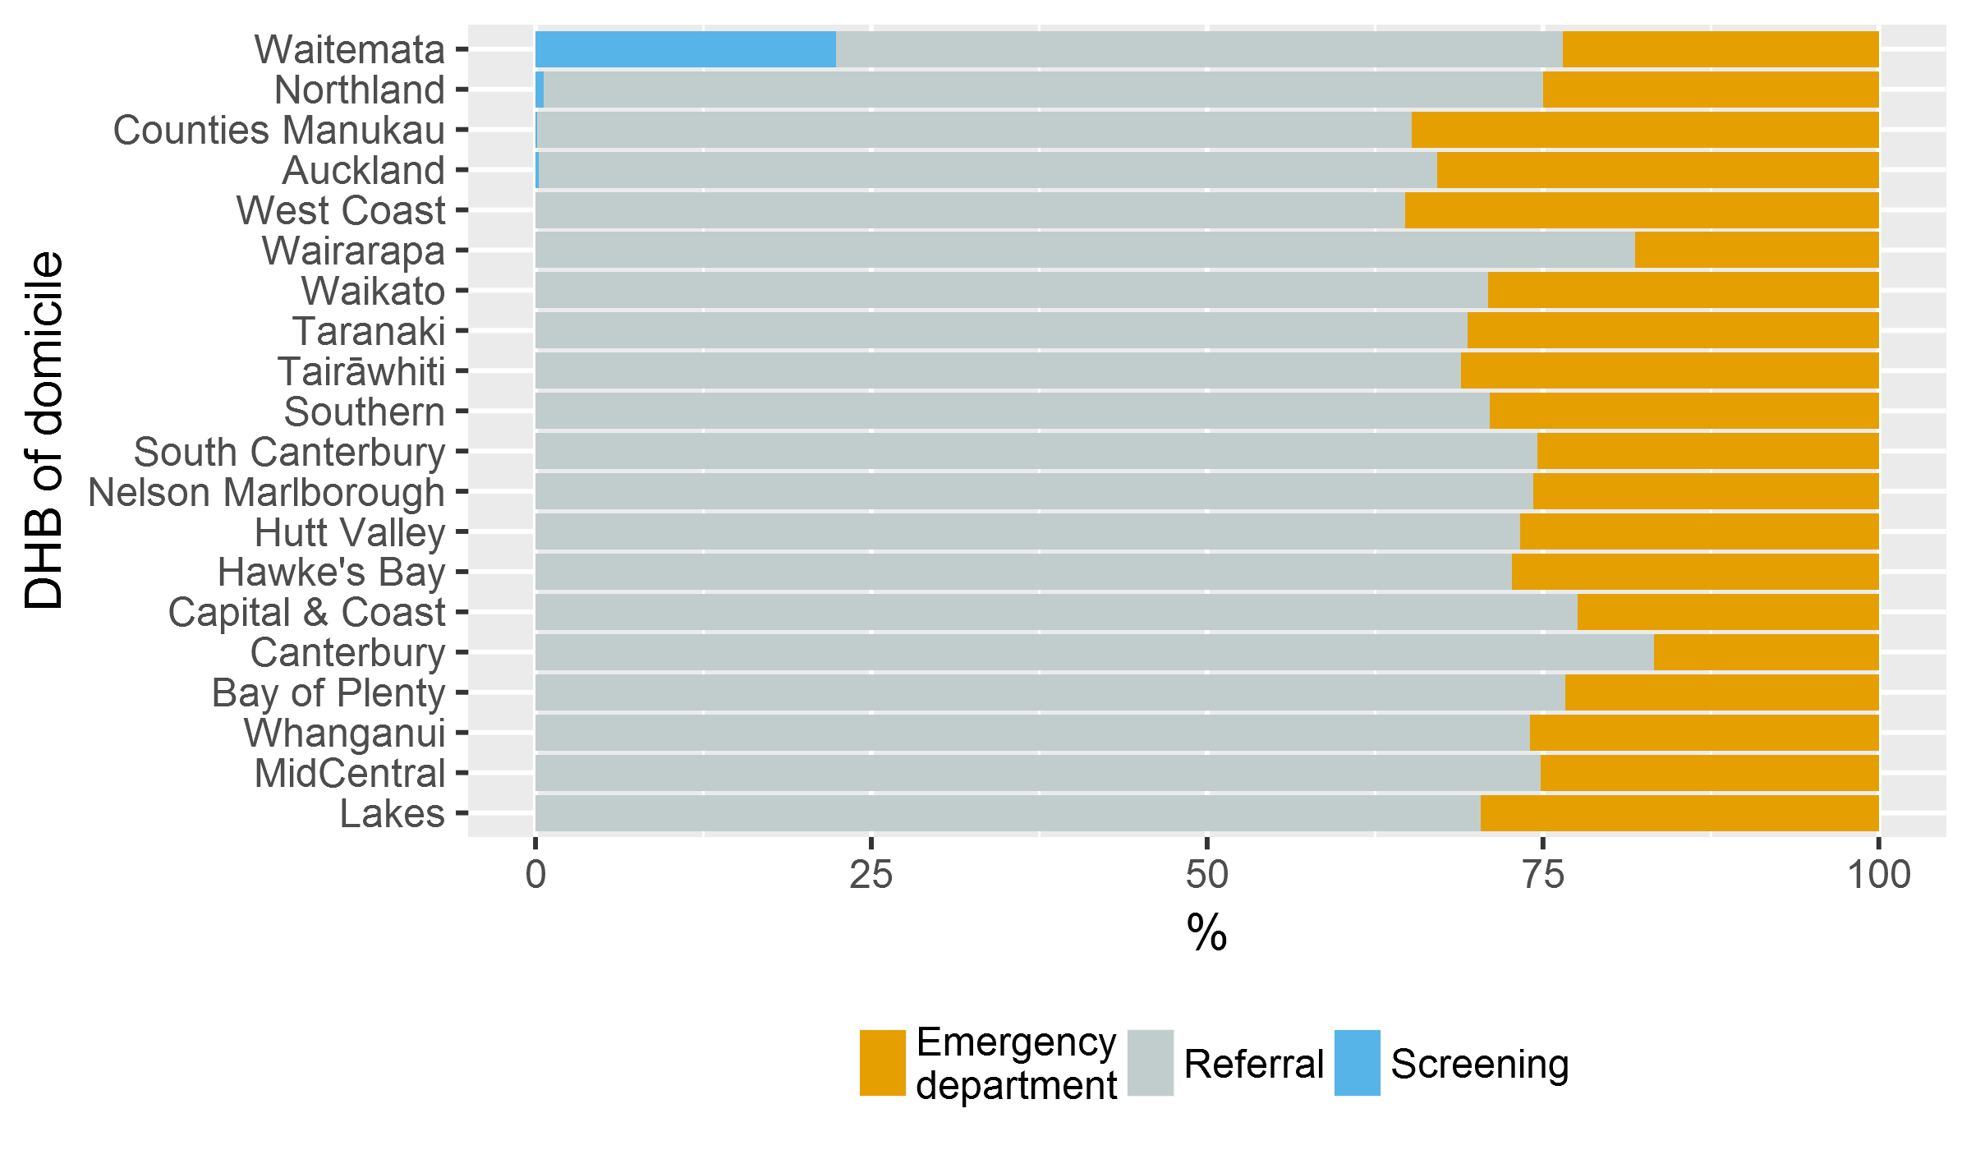

There was wide variation between DHBs for diagnosis following presentation at an ED (Figure 2). Two DHBs were outside the outer limits of the funnel plot.

Figure 2: Proportion of people diagnosed with bowel cancer following presentation at an emergency department, by district health board of domicile, 2013–16
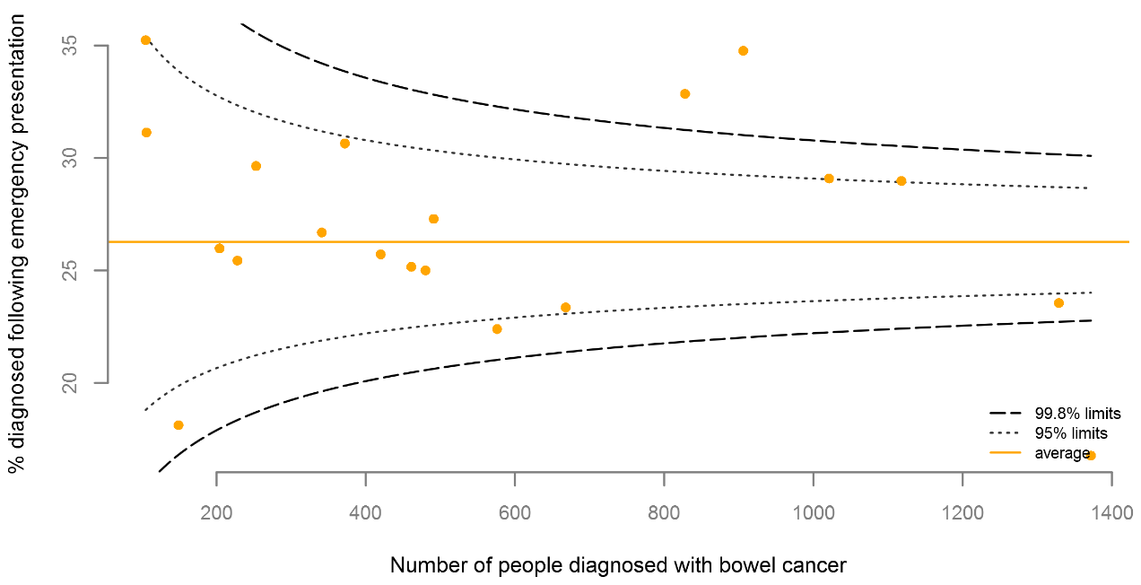

People aged younger than 50 years or 75 years and older, women, Pacific people, Māori and those living in areas of high social deprivation were more likely to be diagnosed after presenting at an ED (Table 3).

Table 3: People diagnosed with colorectal cancer following screening, presentation to an emergency department or referral to a clinic, by age group, sex, ethnic group and social deprivation, 2013–16
 | People diagnosed | ED presentation |  | Referral to clinic |  | Screening
 | N | N | % | N | % | N | %
Age group
18–49 | 733 | 239 | 32.6 | 494 | 67.4 | 0 | 0.0
50–59 | 1,371 | 333 | 24.3 | 967 | 70.5 | 71 | 5.2
60–74 | 4,434 | 951 | 21.4 | 3,253 | 73.4 | 230 | 5.2
75+ | 4,890 | 1,479 | 30.2 | 3,409 | 69.7 | 2 | 0.0
Sex
Female | 5,416 | 1,546 | 28.5 | 3,734 | 68.9 | 136 | 2.5
Male | 6,012 | 1,456 | 24.2 | 4,389 | 73.0 | 167 | 2.8
Ethnic group
Māori | 649 | 229 | 35.3 | 409 | 63.0 | 11 | 1.7
Pacific peoples | 264 | 115 | 43.6 | 141 | 53.4 | 8 | 3.0
Asian | 442 | 127 | 28.7 | 280 | 63.3 | 35 | 7.9
European/Other | 9,912 | 2,506 | 25.3 | 7,163 | 72.3 | 243 | 2.5
Unknown | 161 | 25 | 15.5 | 130 | 80.7 | 6 | 3.7
NZDep2013 quintile
1 | 2,049 | 442 | 21.6 | 1,521 | 74.2 | 86 | 4.2
2 | 2,117 | 539 | 25.5 | 1,496 | 70.7 | 82 | 3.9
3 | 2,494 | 622 | 24.9 | 1,797 | 72.1 | 75 | 3.0
4 | 2,643 | 709 | 26.8 | 1,902 | 72.0 | 32 | 1.2
5 | 2,125 | 690 | 32.5 | 1,407 | 66.2 | 28 | 1.3

The Bowel Screening Programme
The Bowel Screening Pilot began in Waitemata DHB in January 2012. The DHB offered screening to eligible people aged 50–74 living in its area.
Following completion of the pilot, the Ministry of Health is rolling out the National Bowel Screening Programme progressively across all DHBs. The eligible age range for the national programme is 60–74.
Two DHBs began free bowel screening from July 2017, and Waitemata transitioned from the pilot to the national programme in January 2018. As of August 2018, six DHBs offer free bowel screening. Other DHBs will follow in stages; the Ministry expects that all DHBs will offer free bowel screening by the end of 2021.

In the PIPER Project, 31 percent of people presented directly to an ED. Māori people were the most likely to present to ED (45%), followed by Pacific peoples (35%) and non-Māori/non-Pacific peoples (30%). After controlling for demographic characteristics and disease variables such as stage and grade at diagnosis, Māori patients (particularly rural Māori) and those in the highest quintile of deprivation were still significantly more likely to present directly to ED. This indicator is therefore likely to reflect inequalities in access to care.

A national bowel screening programme has been in place in England since 2006. In England in 2016, of patients diagnosed with bowel cancer, 55 percent of patients were diagnosed following general practitioner (GP) referral. Just under 10 percent of patients were diagnosed following referral from a screening service, and 23 percent were diagnosed following an emergency admission.

Recommendation
A detailed evaluation at DHB level of patients who present acutely is likely to uncover gaps in access to primary care or diagnostic services, and presents an opportunity to improve service or care pathways. The solutions required to reduce the proportion of people diagnosed following emergency presentation and increase the proportion of those diagnosed following screening or referral from GPs are likely to vary by region.

This indicator reflects inequalities in diagnostic pathways, and is likely to affect outcomes for patients.

This indicator provides an opportunity to monitor the consequences of the Bowel Screening Programme. As an increasing proportion of patients are diagnosed following screening, the proportion of people presenting with late-stage bowel cancer should decrease. People referred from screening services tend to have earlier cancers, and are more likely to be able to be treated with curative intent than people diagnosed via other referral means.

Surgical care

How many patients die within 90-days of major surgery?
In people with colorectal cancer, the overall 90-day mortality following colorectal cancer resection was 4.0 percent, and the overall 30-day mortality following colorectal cancer resection was 2.7 percent.

In people with colon cancer, the 90-day mortality following resection was 4.8 percent, and the 30-day mortality following resection was 3.2 percent. In people with rectal cancer, the 90-day mortality following resection was 1.9 percent, and the 30-day mortality following resection was 1.3 percent.

We observed a wide variation in the rate of post-operative mortality: 90-day post-operative mortality ranged from 0 to 7.6 percent across different DHBs (Figure 3). No DHBs were above the 95 percent confidence limits, and three units were below the 95 percent confidence limits.

Figure 3: Observed 90-day post-operative mortality (elective and emergency admissions) for patients diagnosed with bowel cancer, by district health board of service, 2013–16
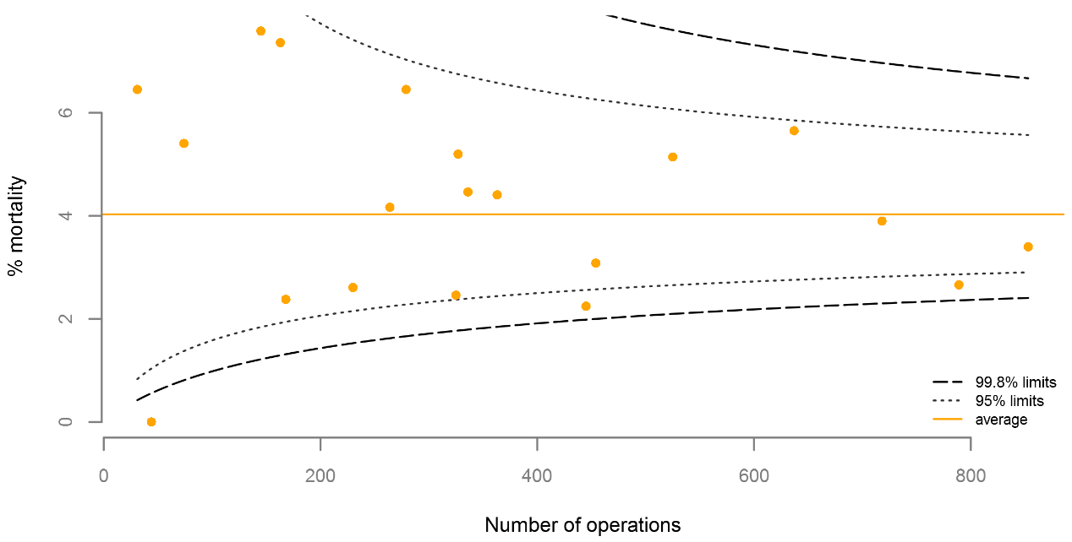

There was a significant increase in mortality associated with emergency surgery (see section 6.2).

The wide variation in mortality observed increased if we only considered elective procedures (Figure 4). One unit was above the 95 percent confidence limits, and four units were below the 95 percent confidence limits.

Overall, the 90-day post-operative mortality rate was highest for people aged 75 years and over (7.6 percent).

Figure 4: Observed 90-day post-operative mortality (elective admissions only) for patients diagnosed with bowel cancer, by district health board of service, 2013–16
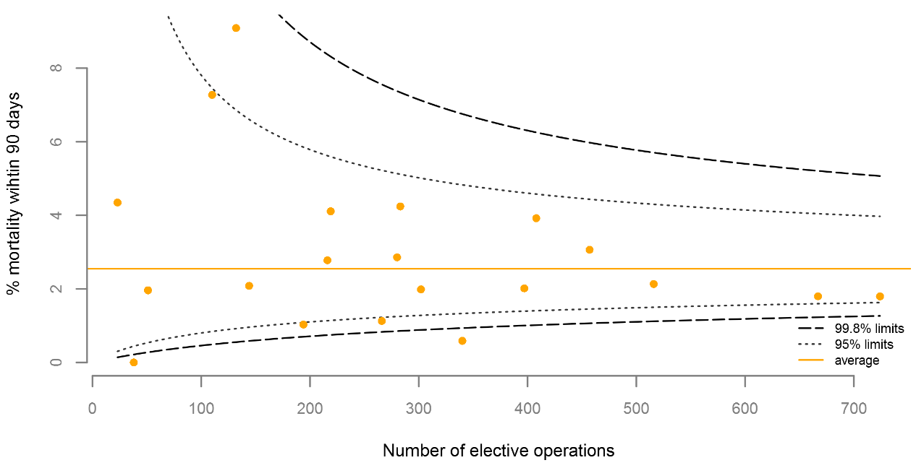

The 90-day post-operative mortality in patients undergoing major resection reported in the NBOCA audits for the four year period 2013–16 was 3.8 percent. In the 2017 report the 90-day mortality in patients undergoing emergency surgery was significantly higher than for those having elective surgery (10.3% compared to 1.9%). There was wide variation in 90-day mortality between trusts.

Recommendation
The overall post-operative mortality in patients undergoing surgery for colorectal cancer in New Zealand is acceptable, but there is currently wide variation between DHBs that needs investigating.

District health boards that have performed excellently against this indicator may be a helpful resource to support quality improvement programmes in DHBs with higher rates of mortality.

National initiatives to improve outcomes in patients undergoing emergency surgery and to improve pathways that reduce the rate of emergency surgery are likely to reduce overall post-operative mortality.

How many patients have emergency surgery?
The proportion of people with colorectal cancer who undergo major surgical resection performed as an emergency in New Zealand was 19.6 percent. In people with colon cancer, the rate of emergency surgery was 24.7 percent, and in people with rectal cancer the rate was 4.4 percent.

For both colon and rectal cancer, 90-day mortality was significantly higher in patients undergoing emergency surgery.

Table 4: 90-day mortality following surgery for people diagnosed with bowel cancer, by surgical urgency, 2013–16
 | Total people | 90-day mortality
 |  | All |  | Colon |  | Rectal
 |  | Number | % | Number | % | Number | %
Emergency surgery | 1,409 | 143 | 10.1 | 135 | 10.2 | 8 | 9.8
Elective surgery | 5,769 | 148 | 2.6 | 121 | 3.0 | 27 | 1.6

We observed a wide variation in the rate of emergency surgery, varying from 12.6 percent to 31.1 percent across individual DHBs (Figure 5). Four DHBs were above the 95 percent confidence limits, and five DHBs were below the 95 percent confidence limits.

Among people with colorectal cancer, the emergency colorectal cancer surgery rate was highest for Māori (23.8%) and people under 50 years old (27.1%). The emergency surgery rate for women (21.1%) was higher than it was for men (18.2%).

Figure 5: Observed emergency surgery rate for patients diagnosed with bowel cancer, by district health board of service, 2013–16
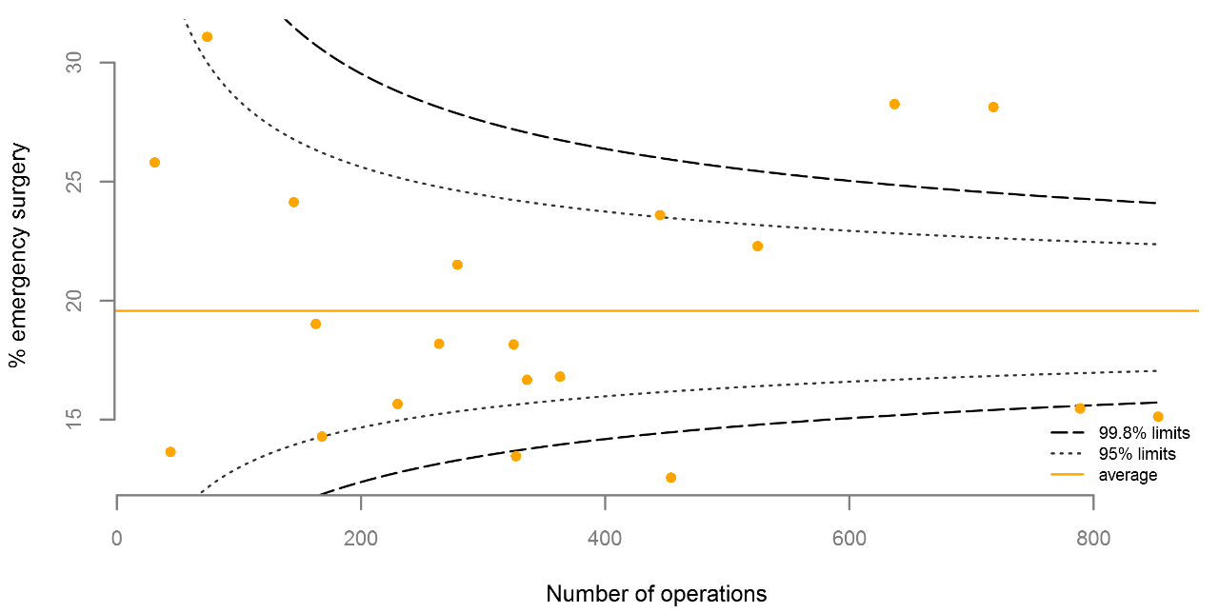

The proportion of people with colorectal cancer who underwent major colorectal surgical resection performed as an emergency (urgent cases also included) as reported in the 2017 NBOCA report was 16 percent (this was lower than audit years prior to 2017 when the emergency surgery rate was more than 22 percent). The audit also demonstrated a wide variation between units.

The 90-day mortality rate in patients undergoing major colorectal cancer resection as an emergency as reported in the 2017 NBOCA report was 10.3 percent, compared to 1.9 percent in elective patients.

Recommendation
The rate of emergency resections performed for colorectal cancer is high in New Zealand, and may contribute to worse cancer outcomes. The rate of emergency colorectal resection is highest in Māori, which contributes to inequality in outcomes.

The Ministry of Health together with the NBCWG should consider measures to understand variation in the rates of emergency colorectal cancer surgery between units in New Zealand.

To reduce overall mortality in colorectal cancer, we need to improve elective pathways and promote screening, especially for Māori and Pacific people.

How long do patients stay in hospital after major bowel cancer resection?
The median length of stay in hospital for people with bowel cancer following major resection was seven days. The median length of stay varied according to patient age (it was eight days for patients aged 75 years and over) and operative urgency (it was nine days for emergency surgery and seven days for elective surgery). The median length of stay for men was one day longer than it was for women.

The median length of stay after surgery was seven days for people with colon cancer and eight days for people with rectal cancer.

The median length of stay after surgery for bowel cancer ranged from six to eight days between DHBs.

How many patients have more than 12 lymph nodes examined?
Maximising the lymph node yield (ie, the number of lymph nodes resected and examined) enables reliable staging which influences the decisions made for the patient’s treatment. Current guidelines recommend a minimum of 12 nodes are harvested as the standard of care.

Pathology laboratories reported on the number of lymph nodes examined for 98 percent of people undergoing major colon surgery (including both metastatic and non-metastatic disease). Overall, 82 percent of people had 12 or more lymph nodes examined.

As Figure 6 shows, the proportion of people undergoing major colon surgery who had more than 12 lymph nodes examined varied considerably between DHBs, from 54.9 percent to 95.3 percent.

In contrast to other previous studies, our analysis found little difference between Māori and non-Māori (80.0 percent compared to 81.5 percent).

Figure 6: Proportion of people having colon cancer surgery who had 12 or more lymph nodes examined by district health board of service, 2013–16
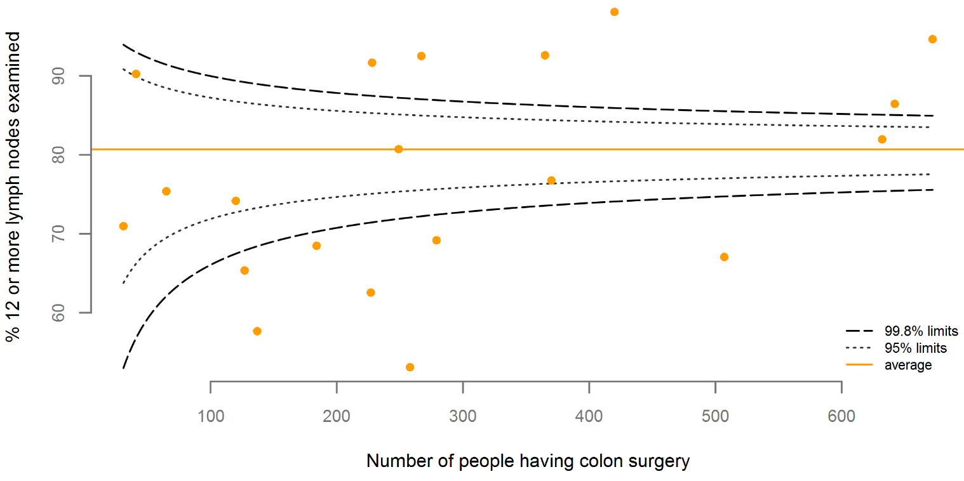

The 2017 NBOCA report stated that 83 percent of patients undergoing colorectal surgery had more than 12 lymph nodes examined: a rate very similar to New Zealand’s. As in New Zealand, there was wide geographical variation between trusts in England (from 37% to 98%) in the proportions of patients who had 12 or more lymph nodes reported.

The Piper Project found that 65 percent of patients with non-metastatic colon cancer had 12 or more lymph nodes examined. Māori patients had fewer lymph nodes examined (57%) compared with Pacific patients (85%) and non-Māori/non-Pacific patients (65%). Other New Zealand studies have also reported lower overall lymph node yield for Māori.

Recommendation
It is encouraging to see that the proportion of patients with 12 or more lymph nodes examined has increased since the Piper Project, and that the variation by ethnicity appears to have reduced since previous studies.

As lymph-node yield is related to patient outcomes and influences treatment options, this indicator may be valuable as a driver of quality improvement in DHBs with low lymph-node yield.

Overseas experience has shown that quality improvement programmes can result in higher reported lymph-node yields.

The reasons for variation in this indicator are likely to be complex. Review within DHBs will require a multi-disciplinary approach, and may benefit from external input. We recommend that DHBs with results below the 99.8 percent lower limits develop a quality improvement programme to improve harvesting, examination and reporting of lymph node yields.

Rectal cancer

How are patients with rectal cancer treated?
Surgical resection of the rectum is the most common intervention for the treatment of rectal cancer; 60 percent of rectal cancer patients have this publicly funded surgery. The rate of surgical resection varied from 57 percent to 80 percent across DHBs.

Of patients having publicly funded major surgery for rectal cancer, 54 percent received preoperative radiotherapy treatment: either short- or long-course (Table 5). 38 percent received long-course radiotherapy (LCRT) and 15 percent received short-course radiotherapy (SCRT).

Table 5: People with rectal cancer having surgery alone and short-course and long-course preoperative radiotherapy, 2013–16
 | Major surgery | Preoperative radiotherapy |  | LCRT |  | SCRT |  | No radiotherapy (surgery alone)
 | Number | Number | % | Number | % | Number | % | Number | %
Total | 1,808 | 984 | 54.4 | 692 | 38.3 | 273 | 15.1 | 800 | 44.2

For 27.7 percent of people, their preoperative radiotherapy was short-course. Wide variation was seen in the use of short-course radiotherapy between providers (from 12 percent to 54 percent).

There was wide variation between DHBs in the proportion of people with rectal cancer who received no publicly funded radiotherapy (Figure 7). Five DHBs were above the 95 percent confidence limits for this indicator, and seven DHBs were below the 95 percent confidence limits.

Figure 7: Proportion of people with rectal cancer having no radiotherapy (surgery alone), by district health board of service for surgery, 2013–16
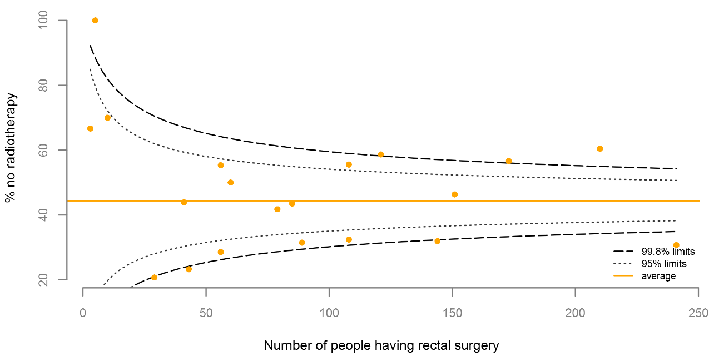

Wide variation in SCRT and LCRT use between cancer centres was the likely cause of variation at a DHB level (Figure 8 and Figure 9). In each case, three DHBs were above the 95 percent confidence limits, and five or more DHBs were below the 95 percent confidence limits.

Figure 8: Proportion of people with rectal cancer having pre-operative short-course radiotherapy, by district health board of service for surgery, 2013–16
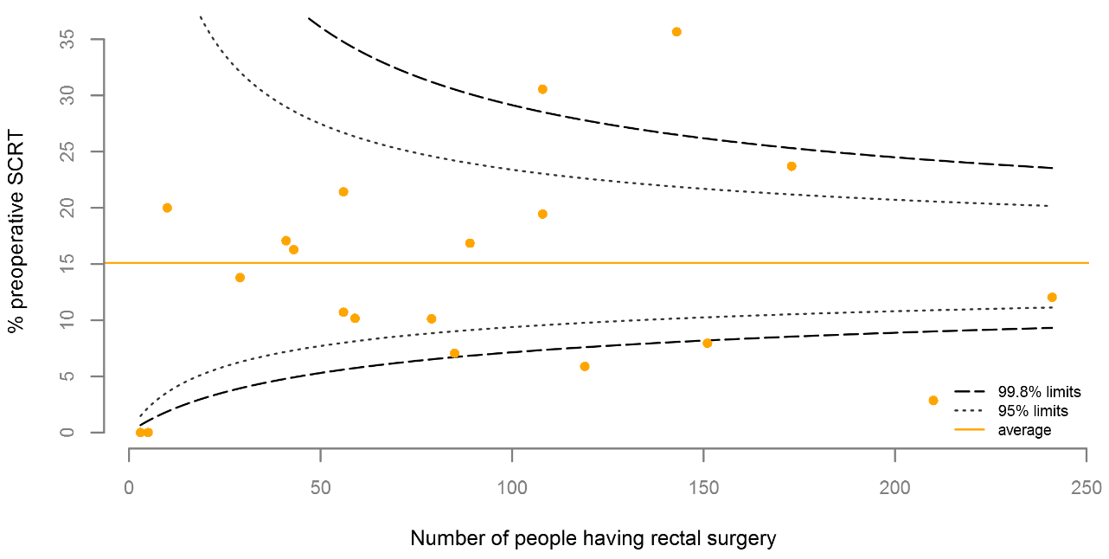

Figure 9: Proportion of people with rectal cancer having long-course pre-operative radiotherapy by district health board of service for surgery, 2013–16
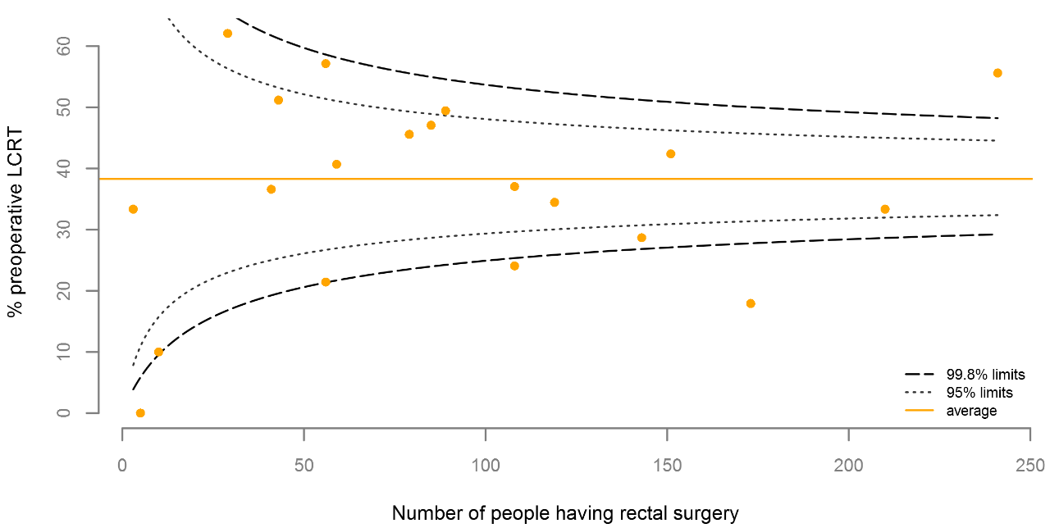

Māori had significantly lower rates (35%) of having no radiotherapy (surgery alone) than all other ethnic groups (45–49%). Pacific had lower SCRT rates (6%) than other ethnic groups (11–16%).

The use of radiotherapy for rectal cancer patients in New Zealand appears higher than use as reported in the United Kingdom NBOCA report.

The 2017 NBOCA report stated that 38 percent of all rectal cancer patients undergoing a major resection received pre-operative treatment, 26 percent of patients received LCRT and 8 percent of patients received SCRT. These results are lower than the results calculated from New Zealand publicly funded service data.

The Piper Project found that 52 percent of patients with non-metastatic rectal cancer received radiotherapy. Of the pre-operative strategies, 18 percent received SCRT and 82 percent received LCRT. Of patients who received radiotherapy, 10 percent were treated post-operatively rather than pre-operatively.

We were unable to ascertain whether individual patients’ rectal cancer was metastatic or non-metastatic, so our analyses do not exclude people with metastatic rectal cancer. Therefore our findings may not be directly comparable to the Piper Project, in which people with metastatic rectal cancer were excluded from the radiotherapy rates.

The proportion of people receiving SCRT appears to have increased since the Piper Project, with the caveat that the PIPER measure excluded metastatic rectal cancer.

Recommendation
Pre- or postoperative radiotherapy reduces the risk of pelvic recurrence of rectal cancer, but results in morbidity, so appropriate patient selection for this treatment is important. Preoperative radiotherapy results in fewer long-term side effects than postoperative radiotherapy.

The current New Zealand guidelines for the management of early colorectal cancer recommend either preoperative short-course radiotherapy or preoperative long-course chemoradiation for people with rectal cancer who are at risk of local recurrence. Preoperative long-course chemoradiation is recommended for people who have a low rectal cancer or a threatened circumferential resection margin.

Short-course radiotherapy is more convenient for patients, has fewer short-term side effects and uses fewer health resources, so it is should be considered for patients at increased risk of pelvic recurrence, who are not at risk of positive resection margins.

This indicator therefore needs to be interpreted in conjunction with the rate of margin positivity.

The reasons why Māori have lower rates of surgery alone are not immediately clear; this potential disparity may require focused audit. It may reflect the wide variation in practice between DHBs, and different ethnic population structures within DHBs.

Further work is needed to identify the reasons for the variability of pre-operative adjuvant therapy. This should involve the Radiation Oncology Working Group and other cancer service advisory groups involved in the multidisciplinary team process.

How often are patients stoma free at 18 months after surgery?
Stoma-free survival at 18 months after surgery for people with rectal cancer in New Zealand was 54.7 percent. The lowest 18-month stoma free survival rate was for people aged 75 years and over (42.5%).

The 18-month stoma-free survival rate varied widely, from 14.3 percent to 80.2 percent across individual DHBs. Four DHBs were below the 95 percent confidence limits, and three DHBs were above the 95 percent confidence limits.

Figure 10: Observed 18-month stoma-free rate by district health board of service for patients diagnosed with rectal cancer, 2013–15
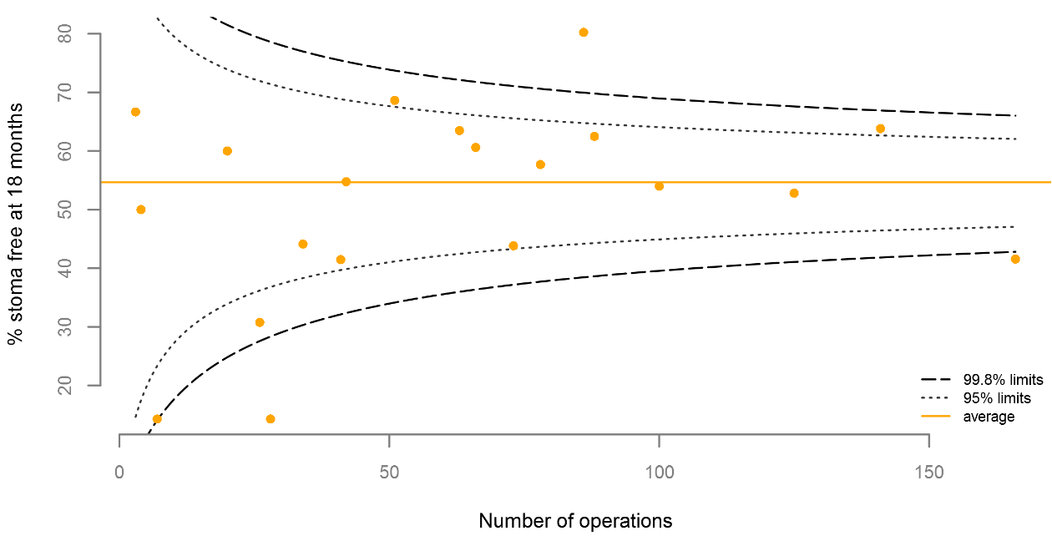

The NBOCA reports stoma rate, rather than stoma-free survival rate. The stoma procedures used to define the NBOCA stoma rate are different in some respects to the New Zealand stoma-free survival indicator.

The 18-month stoma rate in the 2017 NBOCA report was 52 percent. There was wide variation in the stoma rate between units.

The NBOCA report stated that 83 percent of rectal cancer patients had surgery resulting in a stoma. In New Zealand, the estimated stoma rate for people having rectal surgery was 88 percent. Our definition for rectal surgery resulting in a stoma was broader than that used in the United Kingdom, as we assumed all anterior resections were covered with a stoma, and we excluded people who died within 18 months. This may overestimate the stoma rate in New Zealand, as only 77 percent of anterior resections in the United Kingdom were covered with a stoma.

Recommendation
Stoma-free survival is an important indicator of quality in rectal cancer surgery. This indicator assesses the appropriateness of the multidisciplinary decision-making process for rectal cancer patients, the availability of resources and the timeliness of reversal of defunctioning stoma.

The 18-month stoma-free survival indicator is a composite surrogate marker of the success of sphincter-preserving surgery in rectal cancer surgery.

The Ministry of Health with the NBCWG should seek to understand the variation in the 18-month stoma-free survival rate between DHBs in New Zealand and consider a national quality improvement programme in the treatment of low rectal cancer to reduce treatment variation.

Appendix A: Data tables

1 Diagnosis and surgery
Table 6: People diagnosed with colon and rectal cancer, number and percentage who had major surgery, by district health board of domicile, age group, sex and ethnic group, 2013–16
 | Colon cancer |  |  | Rectal cancer
 | Number diagnosed | People having major surgery |  | Number diagnosed | People having major surgery
 | N | N | % | N | N | %
Total | 8,430 | 5,360 | 63.6 | 2,998 | 1,810 | 60.4
Year of diagnosis
2013 | 2,086 | 1,345 | 64.5 | 723 | 441 | 61.0
2014 | 2,122 | 1,346 | 63.4 | 811 | 505 | 62.3
2015 | 2,072 | 1,307 | 63.1 | 730 | 427 | 58.5
2016 | 2,150 | 1,362 | 63.3 | 734 | 437 | 59.5
DHB of domicile
Auckland | 603 | 321 | 53.2 | 225 | 114 | 50.7
Bay of Plenty | 516 | 347 | 67.2 | 152 | 108 | 71.1
Canterbury | 1,014 | 577 | 56.9 | 358 | 202 | 56.4
Capital and Coast | 409 | 239 | 58.4 | 167 | 79 | 47.3
Counties Manukau | 644 | 372 | 57.8 | 262 | 150 | 57.3
Hawke’s Bay | 370 | 257 | 69.5 | 121 | 85 | 70.2
Hutt Valley | 252 | 169 | 67.1 | 89 | 56 | 62.9
Lakes | 186 | 120 | 64.5 | 67 | 43 | 64.2
MidCentral | 331 | 233 | 70.4 | 130 | 82 | 63.1
Nelson Marlborough | 309 | 211 | 68.3 | 111 | 69 | 62.2
Northland | 346 | 246 | 71.1 | 134 | 89 | 66.4
South Canterbury | 163 | 130 | 79.8 | 65 | 44 | 67.7
Southern | 848 | 550 | 64.9 | 270 | 175 | 64.8
Tairāwhiti | 83 | 64 | 77.1 | 23 | 15 | 65.2
Taranaki | 282 | 225 | 79.8 | 90 | 59 | 65.6
Waikato | 769 | 489 | 63.6 | 252 | 142 | 56.3
Wairarapa | 95 | 59 | 62.1 | 54 | 40 | 74.1
Waitemata | 982 | 580 | 59.1 | 347 | 205 | 59.1
West Coast | 74 | 51 | 68.9 | 31 | 23 | 74.2
Whanganui | 154 | 120 | 77.9 | 50 | 30 | 60.0
Age group (years)
18–49 | 463 | 272 | 58.7 | 270 | 152 | 56.3
50–59 | 885 | 517 | 58.4 | 486 | 304 | 62.6
60–74 | 3,155 | 2,067 | 65.5 | 1,279 | 828 | 64.7
75+ | 3,927 | 2,504 | 63.8 | 963 | 526 | 54.6
Sex
Female | 4,305 | 2,789 | 64.8 | 1,111 | 658 | 59.2
Male | 4,125 | 2,571 | 62.3 | 1,887 | 1,152 | 61.0
Ethnic group
Māori | 447 | 288 | 64.4 | 202 | 123 | 60.9
Pacific peoples | 160 | 92 | 57.5 | 104 | 55 | 52.9
Asian | 292 | 181 | 62.0 | 150 | 89 | 59.3
European/Other | 7,417 | 4,725 | 63.7 | 2,495 | 1,512 | 60.6
Unknown | 114 | 74 | 64.9 | 47 | 31 | 66.0
NZDep2013 quintile
1 (least deprived) | 1,475 | 854 | 57.9 | 574 | 297 | 51.7
2 | 1,580 | 978 | 61.9 | 537 | 315 | 58.7
3 | 1,830 | 1,169 | 63.9 | 664 | 400 | 60.2
4 | 2,001 | 1,335 | 66.7 | 642 | 411 | 64.0
5 (most deprived) | 1,544 | 1,024 | 66.3 | 581 | 387 | 66.6

2 Bowel cancer surgery
Table 7: People having major surgery for bowel cancer in public hospitals, 2013–16
 | People having major surgery | Emergency surgery |  | Death within 90 days of surgery |  | Death within 90 days of elective surgery |  | Median length of stay
 | N | N | % | N | % | N | % | days
Total | 7,170 | 1,403 | 19.6 | 289 | 4.0 | 147 | 2.5 | 7
Year of diagnosis
2013 | 1,786 | 363 | 20.3 | 78 | 4.4 | 38 | 2.7 | 8
2014 | 1,851 | 363 | 19.6 | 86 | 4.6 | 44 | 3.0 | 7
2015 | 1,734 | 356 | 20.5 | 55 | 3.2 | 33 | 2.4 | 7
2016 | 1,799 | 321 | 17.8 | 70 | 3.9 | 32 | 2.2 | 7
DHB of service
Auckland | 445 | 105 | 23.6 | 10 | 2.2 | 2 | 0.6 | 8
Bay of Plenty | 454 | 57 | 12.6 | 14 | 3.1 | 8 | 2.0 | 8
Canterbury | 853 | 129 | 15.1 | 29 | 3.4 | 13 | 1.8 | 7
Capital and Coast | 363 | 61 | 16.8 | 16 | 4.4 | 6 | 2.0 | 7
Counties Manukau | 525 | 117 | 22.3 | 27 | 5.1 | 16 | 3.9 | 8
Hawke’s Bay | 336 | 56 | 16.7 | 15 | 4.5 | 8 | 2.9 | 7
Hutt Valley | 230 | 36 | 15.7 | 6 | 2.6 | 2 | 1.0 | 7
Lakes | 163 | 31 | 19.0 | 12 | 7.4 | 12 | 9.1 | 8
MidCentral | 327 | 44 | 13.5 | 17 | 5.2 | 12 | 4.2 | 8
Nelson Marlborough | 264 | 48 | 18.2 | 11 | 4.2 | 6 | 2.8 | 7
Northland | 325 | 59 | 18.2 | 8 | 2.5 | 3 | 1.1 | 7
South Canterbury | 168 | 24 | 14.3 | 4 | 2.4 | 3 | 2.1 | 7
Southern | 718 | 202 | 28.1 | 28 | 3.9 | 11 | 2.1 | 7
Tairāwhiti | 74 | 23 | 31.1 | 4 | 5.4 | 1 | 2.0 | 7
Taranaki | 279 | 60 | 21.5 | 18 | 6.5 | 9 | 4.1 | 6
Waikato | 637 | 180 | 28.3 | 36 | 5.7 | 14 | 3.1 | 7
Wairarapa | 44 | 6 | 13.6 | 0 | 0 | 0 | 0 | 6
Waitemata | 789 | 122 | 15.5 | 21 | 2.7 | 12 | 1.8 | 7
West Coast | 31 | 8 | 25.8 | 2 | 6.5 | 1 | 4.3 | 8
Whanganui | 145 | 35 | 24.1 | 11 | 7.6 | 8 | 7.3 | 7
Age group (years)
18–49 | 424 | 115 | 27.1 | 5 | 1.2 | 1 | 0.3 | 7
50–59 | 821 | 166 | 20.2 | 11 | 1.3 | 3 | 0.5 | 7
60–74 | 2,895 | 480 | 16.6 | 72 | 2.5 | 38 | 1.6 | 7
75+ | 3,030 | 642 | 21.2 | 201 | 6.6 | 105 | 4.4 | 8
Sex
Female | 3,447 | 727 | 21.1 | 136 | 3.9 | 61 | 2.2 | 7
Male | 3,723 | 676 | 18.2 | 153 | 4.1 | 86 | 2.8 | 8
Ethnic group
Māori | 411 | 98 | 23.8 | 22 | 5.4 | 13 | 4.2 | 8
Pacific peoples | 147 | 30 | 20.4 | 6 | 4.1 | 2 | 1.7 | 7
Asian | 270 | 43 | 15.9 | 3 | 1.1 | 2 | 0.9 | 7
European/Other | 6,237 | 1,212 | 19.4 | 258 | 4.1 | 130 | 2.6 | 7
Unknown | 105 | 20 | 19.0 | 0 | 0 | 0 | 0 | 7
NZDep2013 quintile
1 (least deprived) | 1,151 | 229 | 19.9 | 45 | 3.9 | 25 | 2.7 | 7
2 | 1,293 | 258 | 20.0 | 56 | 4.3 | 27 | 2.6 | 7
3 | 1,569 | 308 | 19.6 | 54 | 3.4 | 25 | 2.0 | 7
4 | 1,746 | 331 | 19.0 | 73 | 4.2 | 37 | 2.6 | 7
5 (most deprived) | 1,411 | 277 | 19.6 | 61 | 4.3 | 33 | 2.9 | 7

3 Colon cancer surgery
Table 8: People having major surgery for colon cancer in public hospitals, 2013–16
 | People having major surgery | Emergency surgery |  | Death within 90 days of surgery |  | Death within 90 days of elective surgery |  | Median length of stay | 12 or more lymph nodes reported
 | N | N | % | N | % | N | % | days | N | %
Total | 5,360 | 1,324 | 24.7 | 255 | 4.8 | 121 | 3.0 | 7 | 4,178 | 81.5
Year of diagnosis
2013 | 1,345 | 338 | 25.1 | 70 | 5.2 | 32 | 3.2 | 7 | 1,043 | 80.7
2014 | 1,346 | 341 | 25.3 | 73 | 5.4 | 34 | 3.4 | 7 | 1,044 | 81.2
2015 | 1,307 | 339 | 25.9 | 48 | 3.7 | 27 | 2.8 | 7 | 1,017 | 81.0
2016 | 1,362 | 306 | 22.5 | 64 | 4.7 | 28 | 2.7 | 7 | 1,074 | 83.3
DHB of service
Auckland | 326 | 98 | 30.1 | 10 | 3.1 | 2 | 0.9 | 7.5 | 285 | 93.1
Bay of Plenty | 346 | 55 | 15.9 | 13 | 3.8 | 7 | 2.4 | 7 | 259 | 77.5
Canterbury | 612 | 125 | 20.4 | 25 | 4.1 | 10 | 2.1 | 7 | 477 | 82.2
Capital and Coast | 254 | 59 | 23.2 | 16 | 6.3 | 6 | 3.1 | 7 | 168 | 70.9
Counties Manukau | 374 | 104 | 27.8 | 23 | 6.1 | 13 | 4.8 | 8 | 351 | 98.0
Hawke’s Bay | 255 | 52 | 20.4 | 12 | 4.7 | 6 | 3.0 | 6 | 222 | 93.3
Hutt Valley | 175 | 36 | 20.6 | 6 | 3.4 | 2 | 1.4 | 7 | 118 | 70.2
Lakes | 120 | 31 | 25.8 | 11 | 9.2 | 11 | 12.4 | 8 | 77 | 67.5
MidCentral | 238 | 41 | 17.2 | 13 | 5.5 | 9 | 4.6 | 8 | 186 | 82.3
Nelson Marlborough | 205 | 44 | 21.5 | 10 | 4.9 | 5 | 3.1 | 6 | 129 | 63.9
Northland | 240 | 57 | 23.8 | 8 | 3.3 | 3 | 1.6 | 7 | 123 | 54.9
South Canterbury | 127 | 24 | 18.9 | 3 | 2.4 | 2 | 1.9 | 7 | 74 | 61.2
Southern | 545 | 188 | 34.5 | 27 | 5.0 | 11 | 3.1 | 7 | 470 | 88.2
Tairāwhiti | 63 | 22 | 34.9 | 4 | 6.3 | 1 | 2.4 | 7 | 44 | 73.3
Taranaki | 223 | 58 | 26.0 | 17 | 7.6 | 8 | 4.8 | 6 | 200 | 92.6
Waikato | 494 | 169 | 34.2 | 29 | 5.9 | 9 | 2.8 | 6 | 320 | 67.8
Wairarapa | 41 | 6 | 14.6 | 0 | 0.0 | 0 | 0.0 | 6 | 37 | 92.5
Waitemata | 580 | 113 | 19.5 | 16 | 2.8 | 8 | 1.7 | 7 | 534 | 95.7
West Coast | 26 | 7 | 26.9 | 2 | 7.7 | 1 | 5.3 | 8 | 19 | 73.1
Whanganui | 116 | 35 | 30.2 | 10 | 8.6 | 7 | 8.6 | 7 | 85 | 76.6
Age group (years)
18–49 | 272 | 100 | 36.8 | 4 | 1.5 | 0 | 0.0 | 7 | 229 | 90.9
50–59 | 517 | 155 | 30.0 | 9 | 1.7 | 2 | 0.6 | 6 | 404 | 84.0
60–74 | 2,067 | 460 | 22.3 | 60 | 2.9 | 28 | 1.7 | 7 | 1,621 | 82.5
75+ | 2,504 | 609 | 24.3 | 182 | 7.3 | 91 | 4.8 | 7 | 1,924 | 79.3
Sex
Female | 2,789 | 691 | 24.8 | 125 | 4.5 | 51 | 2.4 | 7 | 2,221 | 83.0
Male | 2,571 | 633 | 24.6 | 130 | 5.1 | 70 | 3.6 | 7 | 1,957 | 79.9
Ethnic group
Māori | 288 | 96 | 33.3 | 20 | 6.9 | 11 | 5.7 | 7 | 216 | 80.0
Pacific peoples | 92 | 22 | 23.9 | 4 | 4.3 | 1 | 1.4 | 6 | 78 | 89.7
Asian | 181 | 38 | 21.0 | 3 | 1.7 | 2 | 1.4 | 6 | 156 | 92.3
European/Other | 4,725 | 1,151 | 24.4 | 228 | 4.8 | 107 | 3.0 | 7 | 3,663 | 81.0
Unknown | 74 | 17 | 23.0 | 0 | 0.0 | 0 | 0.0 | 6 | 65 | 87.8
NZDep2013 quintile
1 (least deprived) | 854 | 219 | 25.6 | 43 | 5.0 | 23 | 3.6 | 7 | 705 | 85.8
2 | 978 | 248 | 25.4 | 53 | 5.4 | 24 | 3.3 | 7 | 792 | 84.7
3 | 1,169 | 290 | 24.8 | 44 | 3.8 | 18 | 2.0 | 7 | 903 | 81.1
4 | 1,335 | 310 | 23.2 | 65 | 4.9 | 30 | 2.9 | 7 | 1,004 | 78.3
5 (most deprived) | 1,024 | 257 | 25.1 | 50 | 4.9 | 26 | 3.4 | 7 | 774 | 79.7

4 Rectal cancer surgery
Table 9: People having major surgery for rectal cancer in public hospitals, 2013–16
 | People having major surgery | Emergency surgery |  | Death within 90 days of surgery |  | Median length of stay
 | N | N | % | N | % | days
Total | 1,810 | 79 | 4.4 | 34 | 1.9 | 8
Year of diagnosis
2013 | 441 | 25 | 5.7 | 8 | 1.8 | 9
2014 | 505 | 22 | 4.4 | 13 | 2.6 | 8
2015 | 427 | 17 | 4.0 | 7 | 1.6 | 8
2016 | 437 | 15 | 3.4 | 6 | 1.4 | 8
DHB of service
Auckland | 119 | 7 | 5.9 | 0 | 0 | 9
Bay of Plenty | 108 | 2 | 1.9 | 1 | 0.9 | 9
Canterbury | 241 | 4 | 1.7 | 4 | 1.7 | 9
Capital and Coast | 109 | 2 | 1.8 | 0 | 0 | 9
Counties Manukau | 151 | 13 | 8.6 | 4 | 2.6 | 9
Hawke’s Bay | 81 | 4 | 4.9 | 3 | 3.7 | 9
Hutt Valley | 55 | 0 | 0 | 0 | 0 | 9
Lakes | 43 | 0 | 0 | 1 | 2.3 | 7
MidCentral | 89 | 3 | 3.4 | 4 | 4.5 | 9
Nelson Marlborough | 59 | 4 | 6.8 | 1 | 1.7 | 8
Northland | 85 | 2 | 2.4 | 0 | 0 | 8
South Canterbury | 41 | 0 | 0 | 1 | 2.4 | 9
Southern | 173 | 14 | 8.1 | 1 | 0.6 | 8
Tairāwhiti | 11 | 1 | 9.1 | 0 | 0 | 8
Taranaki | 56 | 2 | 3.6 | 1 | 1.8 | 7.5
Waikato | 143 | 11 | 7.7 | 7 | 4.9 | 7
Wairarapa | – | – | – | – | – | –
Waitemata | 209 | 9 | 4.3 | 5 | 2.4 | 9
West Coast | – | – | – | – | – | –
Whanganui | 29 | 0 | 0 | 1 | 3.4 | 8
Age group (years)
18–49 | 152 | 15 | 9.9 | 1 | 0.7 | 8
50–59 | 304 | 11 | 3.6 | 2 | 0.7 | 8
60–74 | 828 | 20 | 2.4 | 12 | 1.4 | 8
75+ | 526 | 33 | 6.3 | 19 | 3.6 | 10
Sex
Female | 658 | 36 | 5.5 | 11 | 1.7 | 8
Male | 1,152 | 43 | 3.7 | 23 | 2.0 | 9
Ethnic group
Māori | 123 | 2 | 1.6 | 2 | 1.6 | 8
Pacific peoples | 55 | 8 | 14.5 | 2 | 3.6 | 9
Asian | 89 | 5 | 5.6 | 0 | 0 | 8
European/Other | 1,512 | 61 | 4.0 | 30 | 2.0 | 8
Unknown | 31 | 3 | 9.7 | 0 | 0 | 9
NZDep2013 quintile
1 (least deprived) | 297 | 10 | 3.4 | 2 | 0.7 | 8
2 | 315 | 10 | 3.2 | 3 | 1.0 | 8
3 | 400 | 18 | 4.5 | 10 | 2.5 | 8
4 | 411 | 21 | 5.1 | 8 | 1.9 | 9
5 (most deprived) | 387 | 20 | 5.2 | 11 | 2.8 | 8
– Too few cases to report (<10).

5 Radiotherapy
Table 10: Radiotherapy for people having major surgery for rectal cancer, 2013–16
 | People having major surgery for rectal cancer | Pre-operative radio-therapy |  | Long-course RT |  | Short-course RT |  | No radio-therapy (surgery alone)
 | N | N | % | N | % | N | % | N | %
Total | 1,808 | 984 | 54.4 | 692 | 38.3 | 273 | 15.1 | 800 | 44.2
Year of diagnosis
2013 | 434 | 226 | 52.1 | 171 | 39.4 | 51 | 11.8 | 199 | 45.9
2014 | 507 | 309 | 60.9 | 206 | 40.6 | 98 | 19.3 | 193 | 38.1
2015 | 428 | 220 | 51.4 | 149 | 34.8 | 66 | 15.4 | 202 | 47.2
2016 | 439 | 229 | 52.2 | 166 | 37.8 | 58 | 13.2 | 206 | 46.9
DHB of service
Auckland | 119 | 50 | 42.0 | 41 | 34.5 | 7 | 5.9 | 69 | 58.0
Bay of Plenty | 108 | 73 | 67.6 | 40 | 37.0 | 33 | 30.6 | 35 | 32.4
Canterbury | 241 | 167 | 69.3 | 134 | 55.6 | 29 | 12.0 | 74 | 30.7
Capital and Coast | 108 | 48 | 44.4 | 26 | 24.1 | 21 | 19.4 | 60 | 55.6
Counties Manukau | 151 | 78 | 51.7 | 64 | 42.4 | 12 | 7.9 | 70 | 46.4
Hawke’s Bay | 79 | 44 | 55.7 | 36 | 45.6 | 8 | 10.1 | 33 | 41.8
Hutt Valley | 56 | 25 | 44.6 | 12 | 21.4 | 12 | 21.4 | 31 | 55.4
Lakes | 43 | 30 | 69.8 | 22 | 51.2 | 7 | 16.3 | 10 | 23.3
MidCentral | 89 | 60 | 67.4 | 44 | 49.4 | 15 | 16.9 | 28 | 31.5
Nelson Marlborough | 59 | 30 | 50.8 | 24 | 40.7 | 6 | 10.2 | 29 | 49.2
Northland | 85 | 46 | 54.1 | 40 | 47.1 | 6 | 7.1 | 37 | 43.5
South Canterbury | 41 | 23 | 56.1 | 15 | 36.6 | 7 | 17.1 | 18 | 43.9
Southern | 173 | 72 | 41.6 | 31 | 17.9 | 41 | 23.7 | 98 | 56.6
Tairāwhiti | 10 | 3 | 30.0 | 1 | 10.0 | 2 | 20.0 | 7 | 70.0
Taranaki | 56 | 39 | 69.6 | 32 | 57.1 | 6 | 10.7 | 16 | 28.6
Waikato | 143 | 93 | 65.0 | 41 | 28.7 | 51 | 35.7 | 45 | 31.5
Wairarapa | – | – | – | – | – | – | – | – | –
Waitemata | 210 | 80 | 38.1 | 70 | 33.3 | 6 | 2.9 | 127 | 60.5
West Coast | – | – | – | – | – | – | – | – | –
Whanganui | 29 | 22 | 75.9 | 18 | 62.1 | 4 | 13.8 | 6 | 20.7
Age group (years)
18–49 | 152 | 90 | 59.2 | 80 | 52.6 | 7 | 4.6 | 59 | 38.8
50–59 | 302 | 187 | 61.9 | 158 | 52.3 | 27 | 8.9 | 111 | 36.8
60–74 | 827 | 459 | 55.5 | 329 | 39.8 | 119 | 14.4 | 357 | 43.2
75+ | 527 | 248 | 47.1 | 125 | 23.7 | 120 | 22.8 | 273 | 51.8
Sex
Female | 657 | 372 | 56.6 | 257 | 39.1 | 108 | 16.4 | 281 | 42.8
Male | 1,151 | 612 | 53.2 | 435 | 37.8 | 165 | 14.3 | 519 | 45.1
Ethnic group
Māori | 120 | 77 | 64.2 | 61 | 50.8 | 16 | 13.3 | 42 | 35
Pacific peoples | 55 | 26 | 47.3 | 23 | 41.8 | 3 | 5.5 | 27 | 49.1
Asian | 89 | 47 | 52.8 | 36 | 40.4 | 10 | 11.2 | 41 | 46.1
European/Other | 1,513 | 819 | 54.1 | 561 | 37.1 | 240 | 15.9 | 675 | 44.6
Unknown | 31 | 15 | 48.4 | 11 | 35.5 | 4 | 12.9 | 15 | 48.4
NZDep2013 quintile
1 (least deprived) | 295 | 148 | 50.2 | 99 | 33.6 | 46 | 15.6 | 144 | 48.8
2 | 316 | 173 | 54.7 | 128 | 40.5 | 38 | 12.0 | 140 | 44.3
3 | 402 | 190 | 47.3 | 129 | 32.1 | 56 | 13.9 | 209 | 52
4 | 410 | 249 | 60.7 | 169 | 41.2 | 79 | 19.3 | 155 | 37.8
5 (most deprived) | 385 | 224 | 58.2 | 167 | 43.4 | 54 | 14.0 | 152 | 39.5
– Too few cases to report (<10).

6 Stoma-free survival
Table 11: People having major surgery for rectal cancer with a stoma at 18 months, 2013–15
 | Major surgery for rectal cancer | Stoma forming surgery |  | APER |  | People with stoma reversal |  | Stoma free survival for people with rectal surgery
 | N | N | % | N | % | N | % | N | %
Total | 1,242 | 1,108 | 89.2 | 282 | 22.7 | 545 | 49.2 | 679 | 54.7
Year of diagnosis
2013 | 391 | 356 | 91.0 | 101 | 25.8 | 174 | 48.9 | 209 | 53.5
2014 | 460 | 412 | 89.6 | 102 | 22.2 | 203 | 49.3 | 251 | 54.6
2015 | 391 | 340 | 87.0 | 79 | 20.2 | 168 | 49.4 | 219 | 56.0
DHB of service
Auckland | 86 | 81 | 94.2 | 14 | 16.3 | 64 | 79.0 | 69 | 80.2
Bay of Plenty | 73 | 68 | 93.2 | 19 | 26.0 | 27 | 39.7 | 32 | 43.8
Canterbury | 166 | 157 | 94.6 | 47 | 28.3 | 60 | 38.2 | 69 | 41.6
Capital and Coast | 78 | 74 | 94.9 | 19 | 24.4 | 41 | 55.4 | 45 | 57.7
Counties Manukau | 100 | 87 | 87.0 | 24 | 24.0 | 41 | 47.1 | 54 | 54.0
Hawke’s Bay | 51 | 49 | 96.1 | 8 | 15.7 | 33 | 67.3 | 35 | 68.6
Hutt Valley | 41 | 39 | 95.1 | 13 | 31.7 | 15 | 38.5 | 17 | 41.5
Lakes | 26 | 24 | 92.3 | 10 | 38.5 | 6 | 25.0 | 8 | 30.8
MidCentral | 66 | 54 | 81.8 | 20 | 30.3 | 28 | 51.9 | 40 | 60.6
Nelson Marlborough | 42 | 32 | 76.2 | 13 | 31.0 | 13 | 40.6 | 23 | 54.8
Northland | 63 | 45 | 71.4 | 8 | 12.7 | 22 | 48.9 | 40 | 63.5
South Canterbury | 28 | 27 | 96.4 | 16 | 57.1 | 3 | 11.1 | 4 | 14.3
Southern | 125 | 109 | 87.2 | 17 | 13.6 | 50 | 45.9 | 66 | 52.8
Tairāwhiti | 7 | 7 | 100 | 1 | 14.3 | 1 | 14.3 | 1 | 14.3
Taranaki | 34 | 31 | 91.2 | 8 | 23.5 | 12 | 38.7 | 15 | 44.1
Waikato | 88 | 79 | 89.8 | 17 | 19.3 | 46 | 58.2 | 55 | 62.5
Wairarapa | – | – | – | – | – | – | – | – | –
Waitemata | 141 | 119 | 84.4 | 27 | 19.1 | 68 | 57.1 | 90 | 63.8
West Coast | – | – | – | – | – | – | – | – | –
Whanganui | 20 | 20 | 100 | 1 | 5 | 12 | 60.0 | 12 | 60.0
Age group (years)
18–49 | 111 | 103 | 92.8 | 15 | 13.5 | 62 | 60.2 | 70 | 63.1
50–59 | 203 | 184 | 90.6 | 35 | 17.2 | 115 | 62.5 | 134 | 66.0
60–74 | 587 | 521 | 88.8 | 133 | 22.7 | 264 | 50.7 | 330 | 56.2
75+ | 341 | 300 | 88.0 | 99 | 29.0 | 104 | 34.7 | 145 | 42.5
Sex
Female | 458 | 406 | 88.6 | 107 | 23.4 | 197 | 48.5 | 249 | 54.4
Male | 784 | 702 | 89.5 | 175 | 22.3 | 348 | 49.6 | 430 | 54.8
Ethnic group
Māori | 77 | 70 | 90.9 | 22 | 28.6 | 33 | 47.1 | 40 | 51.9
Pacific peoples | 31 | 25 | 80.6 | 4 | 12.9 | 14 | 56.0 | 20 | 64.5
Asian | 63 | 60 | 95.2 | 9 | 14.3 | 38 | 63.3 | 41 | 65.1
European/Other | 1,049 | 933 | 88.9 | 241 | 23.0 | 448 | 48.0 | 564 | 53.8
Unknown | 22 | 20 | 90.9 | 6 | 27.3 | 12 | 60.0 | 14 | 63.6
NZDep2013 quintile
1 (least deprived) | 213 | 188 | 88.3 | 48 | 22.5 | 91 | 48.4 | 116 | 54.5
2 | 213 | 186 | 87.3 | 48 | 22.5 | 95 | 51.1 | 122 | 57.3
3 | 267 | 237 | 88.8 | 55 | 20.6 | 118 | 49.8 | 148 | 55.4
4 | 300 | 275 | 91.7 | 73 | 24.3 | 139 | 50.5 | 164 | 54.7
5 (most deprived) | 249 | 222 | 89.2 | 58 | 23.3 | 102 | 45.9 | 129 | 51.8
– Too few cases to report (<10).

Appendix B: Working group members
The National Bowel Cancer Working Group members in 2018 were:
- Professor Ian Bissett (chair), colorectal surgeon, Auckland District Health Board/ University of Auckland
- Dr Christopher Jackson (deputy chair), medical oncologist, Southern District Health Board
- Mr Adrian Secker, general surgeon, Nelson Marlborough District Health Board
- Anne Cleland, gastroenterology nurse, MidCentral District Health Board
- Mr David Vernon, general surgeon, Lakes District Health Board
- Denise Robbins, consumer representative
- Dr Helen Moore, radiologist, Auckland District Health Board
- Dr Iain Ward, radiation oncologist, Canterbury District Health Board
- Dr Janet Hayward, general practitioner, Nelson
- Dr Joe Feltham, radiologist, Capital and Coast District Health Board
- Dr John McMenamin, general practitioner, Whanganui
- Judith Warren, cancer nurse, Waikato District Health Board
- Dr Marianne Lill, general surgeon, Whanganui District Health Board
- Dr Nicole Kramer, pathologist, Auckland District Health Board
- Dr Nina Scott (Ngāti Whatua), public health physician, Waikato
- Mr Ralph Van Dalen, colorectal surgeon, Waikato District Health Board
- Mr Siraj Rajaratnam, general and colorectal surgeon and endoscopist, Waitemata District Health Board
- Associate Professor Susan Parry, gastroenterologist, Auckland District Health Board
- Dr Teresa Chalmers-Watson, gastroenterologist and hepatologist, Canterbury District Health Board.

The bowel cancer indicator development group members were:
- Dr Christopher Jackson (chair), medical oncologist, Southern District Health Board
- Professor Ian Bissett (deputy chair), colorectal surgeon, Auckland District Health Board/University of Auckland
- Mr Christopher Harmston, general and colorectal surgeon, Northland District Health Board
- Dr Sarah Derrett, Bowel Cancer New Zealand
- Dr Joe Feltham, radiologist, Capital and Coast District Health Board
- Dr Nicole Kramer, pathologist, Auckland District Health Board
- Dr Iain Ward, radiation oncologist, Canterbury District Health Board
- Dr Janet Hayward, general practitioner, Nelson.

Pathological M-stage is reported as not available where the M value is submitted as ‘not assessed’ (Mx) or ‘not recorded’ (M9).
An ileostomy is a surgical procedure that creates an opening for a stoma by bringing the end or loop of small intestine out onto the surface of the skin.
A colostomy is the surgical procedure that creates an opening in the large intestine.
Common Counting Technical Advisory Group and Ministry of Health. 2017. Common Counting Standards 2013/14. Wellington: Ministry of Health. URL: https://nsfl.health.govt.nz/system/files/documents/publications/commoncountingstandards2013-14final_0_0.docx (accessed 18 December 2018).
Atkinson J., Salmond C. and Crampton P. 2014. NZDep2013 Index of Deprivation. Dunedin: University of Otago.
Jackson C, Sharples K, Firth M, et al. 2015. The PIPER Project - An Internal Examination of Colorectal Cancer Management in New Zealand. URL: https://www.fmhs.auckland.ac.nz/assets/fmhs/sms/ctnz/docs/THE%20PIPER%20PROJECT%20Final%20deliverable%20report%207%20August%202015%20(HRC%2011_764%20FINDLAY).pdf (accessed 18 February 2019).
HQIP. 2016. National Bowel Cancer Audit Annual Report URL: https://www.acpgbi.org.uk/content/uploads/2016/07/nati-clin-audi-bowe-canc-2016-rep-v2.pdf (accessed 18 February 2019)
New Zealand Guidelines Group. 2011. Clinical practice guidelines for the management of early colorectal cancer. Wellington: New Zealand Guidelines Group. URL: https://www.health.govt.nz/system/files/documents/publications/early-management-colorectal-cancer-guideline.pdf (accessed 18 December 2018).
The edge or border of the tissue removed in cancer surgery. The margin is described as positive or involved when the pathologist finds cancer cells at the edge of the tissue, suggesting that all of the cancer has not been removed.
NICE. 2011. Colorectal cancer: diagnosis and management. National Institute for Health and Care Excellence; November.

