NGAI MĀORI INSIGHTS FOR A KAUPAPA MĀORI PRIMARY (COMMUNITY) MENTAL HEALTH AND ADDICTIONS SERVICE MODEL: The Analysis

Authors: AWA ASSOCIATES

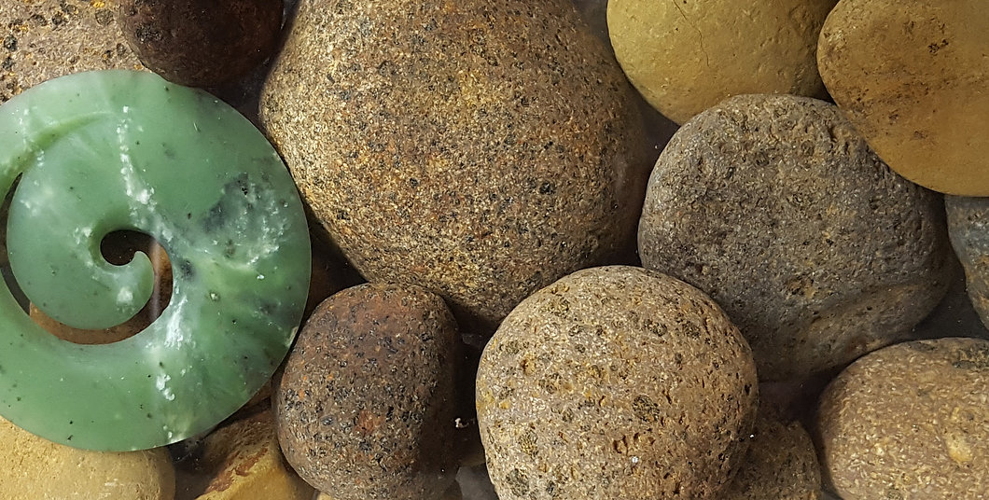

Report for: Te Manatu Hauora, Ministry of Health

Date: December 2019

Contents
Introduction 1
Executive Summary 2
Methodology 3
Limitations 3
Established Kaupapa Māori elements: Whānau and Āta 4
Theme 1: Whānau-centred 4
Other themes related to Whānau-centred 5
Theme 2: For Māori, by Māori 6
Theme 3: Kaupapa Māori 7
Other themes related to Kaupapa Māori and For Māori, by Māori 7
Theme 4: Te Reo Māori 10
Theme 5: Tikanga 11
Theme 6: Mātauranga Māori 12
Theme 7: Rongoā 13
Other themes related to Te Reo Māori, Tikanga, Mātauranga Māori, and Rongoā 13
Conclusion 19
Appendix 1 20
Appendix 2 21

Introduction

Ngā mihi maioha ki ngā mana, ngā reo, ngā kārangatanga maha o te motu whānui, i hōmai nei i ēnei kōrero hōhonu, kōrero rangatira, kia tīmata tātau ki te hanga i tēnei tāonga, "Kaupapa Māori Primary/Community Mental Health Service model". Tēnā koutou katoa.
Mental health and wellbeing is a key priority for the Government. The Government’s Inquiry into Mental Health and Addictions, “He Ara Oranga” charts a new direction for mental health and addiction in New Zealand, one that puts people at the centre. The Government accepts they have obligations under Te Tiriti o Waitangi to improve health outcomes for Māori and a commitment to reduce the significant inequities that exist for Māori. To ensure authenticity, we acknowledge that Te Tiriti o Waitangi is captured within the analysis through the voices and words of the people.

Expanding access to and choice of primary mental health and addiction services for whānau with mild to moderate need is a flagship initiative for the government and the cornerstone of the Wellbeing Budget 2019. The Ministry of Health carried out a series of hui Māori-a-motu from September through to November 2019 to gather information on the design and development of a Kaupapa Māori primary mental health and addiction service model with Māori in the sector.

Hui were held in five locations, Whāngārei, South Auckland, Rotorua, Palmerston North and Christchurch. Other locations such as Waikato, Gisborne, Porirua and Nelson also contributed feedback to the process. (See Appendix 2 for full list of locations and numbers of attendees.) Sector stakeholders provided information through submissions and email summaries of hui.

This marked the beginning of collaborative designing of a Kaupapa Māori Primary (Community) Mental Health and Addiction Service model. The Ministry acknowledges the clear message from hui participants asking for their korero to be externally analysed using a unique Māori lens.

This external and independent analysis of data from all hui and information has been provided by Awa Associates (Appendix 1). The analysis will inform Te Kawa o Aotearoa o ngā rātonga hāpori Kaupapa Māori Hauora Hinengaro, Hauora Wāranga (Aotearoa Kaupapa Māori Primary (Community) Mental Health and Addiction service specifications).

Hui kōrero has been generously given by over seven hundred whānau from across the motu.
Ngā mihi rangatira ki a koutou katoa.

Executive Summary

This Kaupapa Māori thematic analysis identified 23 themes of relevance to a Kaupapa Māori Primary Mental Health and Addictions service model. These themes were further analysed to identify dominant themes that were evident in the feedback data collected.

The dominant themes of the analysis were;

- Whānau-centred
- Delivering ‘For Māori, by Māori’
- Supportive of Kaupapa Māori principles and practices
- Strong in Te Reo Māori
- Skilled in Tikanga
- Steeped in Mātauranga Māori
- Experienced in Rongoā

There was a whānau of related themes that supported and extended each of the dominant themes. These related themes included;

- Whanaungatanga
- Whānau Ora
- Te Tiriti o Waitangi
- Mana motuhake
- Māori models of health
- Marae based approaches
- Te Ao Māori
- Te Taiao
- Tohunga
- Identity
- Whakapapa
- Kaumātua-Kuia
- Wairua
- Improving access for whānau affected by disability and location
- Workforce development
- Tangata whaiora involved and supporting service delivery environments

Methodology

This report presents a Kaupapa Māori thematic analysis of all the hui feedback notes and submissions received as part of the information gathering process for the design and development of a Kaupapa Māori primary mental health and addictions service model.

Awa Associates applied a Kaupapa Māori lens to all of the feedback data to identify 23 themes related to Kaupapa Māori principles essential to a mental health and addiction service model for whānau with mild to moderate needs. This Kaupapa Māori thematic analysis was undertaken using a whakapapa-based approach. Our whakapapa-based approach identifies the link that each of the 23 themes had to five established kaupapa Māori elements; Whānau, Āta, Kaupapa, Tāonga Tuku-Iho and Tikanga Māori.

A whakapapa-based approach presents the dominant themes under their related kaupapa Māori principle and describes aspects of other related themes. This approach privileges the nature of relationships and connections of the information that was shared in the feedback data.

The dominant themes are in tables and were analysed using three narratives found within the feedback data. These narratives were principle, process and practice. Principle refers to the aspiration within the idea, process identifies how it works or operates within the service and practice outlines the actions participants identified.

Limitations

It appears that the way information was collected varied across locations. Although feedback was gathered at hui, it was presented in note form so there is a lack of context and detail. Despite these limitations, participants contributions of essential kaupapa Māori principles for a primary health mental health and addictions service have been realised.

Established Kaupapa Māori elements: Whānau and Āta
The element of Whānau sits at the core of Kaupapa Māori. Through it we acknowledge, amplify and protect the relationships that Māori have to one another and to the world around them.

The element of Āta was developed by Pohatu (2005) primarily as a transformative approach within the area of social services. Āta relates specifically to the building and nurturing of relationships. It acts as a guide to the understanding of relationships and wellbeing when engaging with Māori.

Theme 1: Whānau-centred
Participant feedback data identified ‘whānau-centred’ as the main theme and this was described as delivering to the needs and circumstances of whānau, focusing on their strengths and regenerating connections for whānau to flourish. This theme included any descriptions of whānau, hapū and iwi, working with the whole whānau, and a service being whānau led.

Thematic description: Whānau centred
Whānau-centred refers to the idea that service design and delivery must meet the needs of whānau first and foremost. Whānau-centred means delivering a service response that is informed and accountable to whānau aspirations.
Principle | Process | Practice
Whānau-centred respects the relationships and collective journey of the whānau. It represents a place of deep healing and regeneration.  Whānau-centred amplifies the need to define a systems approach when supporting whānau on their health and wellbeing journey. | Whānau-centred ways of working are strengths based, grounded in aroha, and well resourced. Whānau-centred is a commitment to provide a multilayered response to whānau needing support.  Whānau-centred is an agile, informed approach that respects choices, level of readiness and lived experience of whānau Māori. | Whānau-centred as a practice could include;  - Links with Hapū and Iwi  - Kaupapa Māori based health literacy  - Skills training for whānau  - Wānanga  - Marae noho  - Whanaungatanga  - Mahi-Tahi approach  - Choices  - Education  - Empowerment  - Te Reo classes  - Aroha and Manaaki  - Whānau Ora

Other themes related to Whānau-centred
Whanaungatanga and Whānau Ora were themes related to the ‘whānau-centred’ theme. The following describes the nature of these themes as they were presented in the feedback data.

Whanaungatanga
Whanaungatanga was described as a practice of importance for kaupapa Māori service delivery. As a theme, whanaungatanga is the direct and deliberate action of forming relationships for better service engagement. It was situated amongst common kaupapa Māori service values like aroha, manaaki, and awhi.

Whanaungatanga was commonly described as a vital tool for whānau engagement and a uniquely kaupapa Māori style of service delivery. Whanaungatanga can be a valuable means for building connections and supporting whānau to value the role of healthy relationships as part of their Hauora journey.

“...Whakawhanaungatanga - establishing links and making connections and relating to people…”

“...Relationship services, the ability to have healthy productive relationships…”

Whānau Ora
Whānau Ora was described as a way of working that was a strength for whānau. As a theme Whānau Ora was positively described as a responsive approach to ensure whānau could have their needs met.

As a practice it acknowledges that relationships are at the heart of improving Māori health. It was commonly situated amongst models of care like Atua Māori, Te Whare Tapa Whā, and Te Kūwatawata. Whānau Ora was described as holistic, affirming and grounded in a Kaupapa Māori way of being. It respects whānau as the centre of health and wellbeing and takes account of the connections and relationships that sustain it.

“...Whānau ora is the link to achieving good mental health…”

“... Whānau ora contributes to Hauora Hinengaro…”

Established Kaupapa Māori element: Kaupapa
Kaupapa refers to the collective vision, aspiration and purpose of Māori communities. Kaupapa is larger than the topic of the research alone, and refers to the aspirations of the community. The research topic or intervention systems therefore are considered to be an incremental and vital contribution to the overall 'kaupapa'.

Participant feedback data described ‘For Māori, by Māori’ and Kaupapa Māori as examples of how services should operate and deliver their practices. These themes included any descriptions to ways of working that uphold the mana of collective thought and action and support the implementation of Māori service principles within an organisation.

Theme 2: For Māori, by Māori
Thematic description: For Māori, by Māori
For Māori, by Māori conceptualises a Māori way of working and delivering services to whānau. It is the notion of Māori meeting the needs of other Māori in a uniquely Māori way. For Māori By Māori illustrates the need to have more Māori Leadership and learning systems that supports the uptake of Kaupapa Māori practices for the mental health and addictions services.
Principle | Process | Practice
For Māori, by Māori was primarily expressed as a way of working within Māori paradigms and models. It involves direct and deliberate engagement with whānau that starts with building connections.  For Māori, by Māori also signaled strengths-based model of care that celebrated and supported whānau to engage with Māori approaches to positive change. | For Māori, by Māori represents an expectation that Māori ways of being will be mobilised in the sector.  For Māori, by Māori was recognised in the feedback as a centralised system of connection and engagement. For Māori, by Māori acknowledges a deep belief in our right to cultural aspirations to heal, regenerate and support whānau return to full health and wellbeing. | For Māori, by Māori as a practice could include:  - Use of Kaumātua and Kuia  - Kaupapa Māori practices  - Māori Kaimahi at all levels  - Marae style office spaces  - Marae based settings for Wānanga  - Links with Iwi & Hapū  - Workforce Development for Māori By Māori  - Mihi-whakatau  - Kōrero and Waiata  - Karakia, Hīmene  - Whakapapa

Theme 3: Kaupapa Māori
Thematic description: Kaupapa Māori
Kaupapa Māori was recognised as an asset for optimising whānau outcomes, and a diverse, and credible range of models and practices that are mana enhancing and strengths based. It encompassed the use of established cultural practices that drive and shape collective action and impact.
Principle | Process | Practice
Kaupapa Māori is the use and adherence of cultural practices that are determined as important to Māori.  Kaupapa Māori legitimates and endorses models of care that are centred in Te Ao Māori and connected to supportive relationships for positive change | Kaupapa Māori is an encompassing term that supports Māori models across all components of service delivery. Its approach involves working alongside whānau to ensure they attain their goals.  Kaupapa Māori is the direct and deliberate action of regenerating Māori knowledge systems in conjunction with other tools for health, and wellbeing. | Kaupapa Māori as a practice could include:  - Mihi/Powhiri  - Karakia  - Atua Māori models  - Use of Māori models - Te Whare Tapa Whā, Te Kūwatawata, Poutama, Pā Harakeke, Pā Tūwatawata  - Use of Whānau Ora  - Use of Kaumātua/Kuia  - Whanaungatanga  - Tohunga - Māori Healers  - Wānanga  - Connecting to Te Taiao

Other themes related to Kaupapa Māori and For Māori, by Māori
Te Tiriti o Waitangi, Mana motuhake, marae-based approaches, and Māori models were other themes related to the For Māori, by Māori and kaupapa Māori theme. The following describes the nature of these related themes as they were presented in participant insights.

Te Tiriti o Waitangi
Te Tiriti o Waitangi was presented as a foundation to building and supporting Kaupapa Māori within mental health and addictions. There was a sense of collective responsibility for ensuring Te Tiriti o Waitangi was adopted in all components of service design ranging from procurement, governance and service delivery. Most insights presented for Te Tiriti were related to recognising Māori rights and lack of equity in health outcomes. Te Tiriti was commonly listed around terms like mana motuhake, rangatiratanga, and For Māori, by Māori.

“...Te Tiriti o Waitangi is part of legislation...help Māori live longer with less illness…”

“...Influencing our legislation to impact on Hauora Māori, measuring outcomes and statistics for Māori…”

Mana motuhake
Mana motuhake was described as a key action for Māori to work alongside other Māori and use that as a basis to identify strengths. Mana motuhake is not widely defined or detailed. Mana motuhake was commonly listed within terms like mana enhancing, kaupapa Māori and tino rangatiratanga.

As a theme, mana motuhake included the regeneration of knowledge systems, practices and processes that support whānau leadership in all areas. Participants spoke about māra kai, papakāinga systems, mahingā-kai, and Toi Māori (kapahaka, Māori arts, carving, and mau rākau) which could be included as forms of mana motuhake.

“...mana motuhake - iwi centric, not one glove fits all, that approach is not Māori…”

“...Māori led, our own solutions, own healing and our own validation…”

Māori models of health
Māori models is a related theme of ‘For Māori, by Māori’ and kaupapa Māori. Māori models represented the rich and well resourced knowledge systems of Māori to create paths of wellness. They are the culmination of expansive knowledge systems that have guided and supported Māori mental health systems for whānau.

As a theme, Māori models of health were centred in a Kaupapa Māori way, leading with ‘For Māori, by Māori’. This was identified clearly in participant insights with many including the region, and the types of models that were considered to be effective Māori models. For example, models like Te Whare Tapa Whā, Te Kūwatawa, Poutama, Pā Tūwatawata and Te Waonui o Tāne. These models were described as a suite of tools and approaches that could make a difference to whānau affected by mental health and addictions.

“... follow the Te Kūwatawata model of service, holistic doorway, the whole system is Māori - Kaumātua and whānau with lived experience…”

“...kaitiakitanga modalities of Māori practice, Te Whare Tapa Whā, Poutama, Te Wheke and Io whakapapa…”

Marae based approaches
Marae based approaches illustrated the potential for marae settings to service as a place of healing and hope that could make a difference for whānau. The common links around this theme included cultural practices like mihi, pōwhiri and karakia, and Wānanga to connect with whānau.

As a theme, marae-based approaches highlight the need to design and deliver services outside of a narrow clinical lens and use environments that support whānau to flourish. Participant insights endorse marae as a key element of Te Ao Māori. The point underpinning marae-based approaches is the opportunity to reconnect generations, resolve conflict and growing skills alongside whānau.

“...Kaupapa Māori prevention drivers - determined by Māori iwi, hapū, Māori whānau driven, marae based…”

“...marae-based learning, bring them into the wharenui to connect with who we are as people…”

Established Kaupapa Māori elements: Tāonga Tuku Iho and Tikanga Māori
Tāonga Tuku Iho is the element of cultural aspiration. This element asserts the centrality and legitimacy of Te Reo Māori, Tikanga and Mātauranga Māori. Within a Kaupapa Māori paradigm, these Māori ways of knowing, doing and understanding the world are considered valid in their own right.

Tikanga Māori, refers to customary practices, ethics, cultural behaviours, considerations and obligations. Tikanga Māori is important in order to enable us to appropriately navigate and operate within a Māori context, and make judgements and decisions within this space.

Participant data around Te Reo Māori included descriptions of the use of language or kōrero within service principles such as pōwhiri and mihi. Tikanga included descriptions of protocols and practices that are drawn from Te Ao Māori, such as Wānanga and kaumātua-kuia. Mātauranga
Māori included references to knowledge systems and beliefs about Māori ways of being, such as atua and whaikōrero. Rongoā included references to healing, medicine and karakia.

Theme 4: Te Reo Māori
Thematic description: Te Reo Māori
Te Reo Māori was identified as an important tool for delivering to and engaging with whānau needing support. Te Reo Māori is a vehicle for connecting with whānau, and for supporting whānau to nurture and grow as part of their healing journey.
Principle | Process | Practice
Te Reo Māori is a flagship of the resurgence and regeneration of Te Ao Māori in Aotearoa. Te Reo Māori bears the cultural bloodline of our aspirations as a people  Te Reo Māori is the vehicle to reframe and restore Māori whānau narratives around health and wellbeing. Within its domain exists the fertile ground of hope, identity and collective impact for healthy whānau. | Te Reo Māori recognises the importance of communicating in a common language. It advocates for an inclusive and open learning system that nurtures whānau connection and identity.  Te Reo Māori practices are able to be mobilised across all areas of service design and delivery, and should be tailored to reach beginners as well as advanced. | Te Reo Māori as a practice could include;  - Kaumātua and Kuia in house  - Use of Pūrākau  - Whaikōrero  - Wānanga  - Marae noho  - Te Reo classes  - Mihi  - Karakia  - Whakapapa  - Pōwhiri  - Waiata  - Toi Māori  - Kapa Haka

Theme 5: Tikanga
Thematic description: Tikanga
Tikanga can be described as a set of Māori principles and practices that are observed and upheld to ensure whānau needs are met. Tikanga was not described in detail indicating somewhat that local and tailored approaches would be required to meet the criteria of this principle.
Principle | Process | Practice
Tikanga was encapsulated by the use and adherence of cultural practices that are determined as unique to Māori.  Tikanga was primarily referenced in terms of engagement with whānau/service users and denoted working in a Māori way to address whānau needs | Tikanga was represented as a set of principles and practices that an organisation would build and promote as a way of working with their clients. | Tikanga as a practice could include;  - Mihi/Pōwhiri  - Karakia  - Aroha  - Pono  - Manaakitia  - Āwhina  - Use of Kaumātua/Kuia  - whanaungatanga  - Honesty  - Accountability  - Kaupapa Māori

Theme 6: Mātauranga Māori
Thematic description: Mātauranga Māori
Mātauranga Māori represented a significant strength and will to work in a Māori way, it presents and denotes a commitment to supporting Māori leadership and action across all modalities of health and wellbeing.
Principle | Process | Practice
Mātauranga Māori is the understanding that Māori principles and practices have always contained a range of tools and strategies that can regenerate health.  Mātauranga Māori is an approach that restores Māori ways of working as legitimate and strength based. Service providers and service users alike connect and reshape health and wellness alongside whānau. | Mātauranga Māori highlighted a range of options for engaging with whānau from a strengths-based approach.  Mātauranga Māori mobilises and supports a complementary range of tools and strategies that are grounded in Te Ao Māori. Provider fluency in Mātauranga Māori and whānau readiness is critical | Mātauranga Māori as a practice could include:  - Kaumātua and Kuia in house  - Karakia  - Atua Mātua style workshops  - Wānanga  - Marae noho  - Te Reo classes  - Kaupapa Māori approaches  - Use of Māramataka  - Tikanga  - whanaungatanga  - Whakapapa  - Te Ao Māori frameworks  - Holistic and whānau centred

Theme 7: Rongoā
Thematic description: Rongoā
Rongoā is a set of Māori principles and practices that support healing within whānau. It was presented as a Māori world view on how health is restored and regenerated alongside whānau. Rongoā was also described as a complementary therapy alongside others under the guidance of best practice from Rongoā leaders.
Principle | Process | Practice
Rongoā is described as the use and adherence of cultural practices that are determined as unique to Māori.  Ronga was primarily referenced in terms of therapeutic healing and reconnection to Māori models of care. Generally, this was considered as part of a range of tools and techniques delivered under the care of a Rongoā leader. | Rongoā was represented as a set of principles and practices that an organisation could mobilise of supporting whānau health and wellbeing.  Rongoā embraces notions of talking therapies and the use of natural medicines. Feedback around Rongoā highlighted a need for training and recognition of Rongoā as a complementary therapy with best practice standards and guidelines. | Rongoā as a practice could include;  - Mirimiri  - Karakia  - Use of Kaumātua/Kuia  - Kaupapa Māori ways of being  - Rongoā Māori  - Healing centres  - Marae based healing  - Traditional Kai - Māra Kai  - Reconnection  - Whenua, Wai and whānau  - Sites of significance  - Waiata, Mōteatea  - Māori Mindfulness

Other themes related to Te Reo Māori, Tikanga, Mātauranga
Māori, and Rongoā
Te Ao Māori, Te Taiao, Tohunga, Identity, Whakapapa, Kaumātua and Kuia and Wairua were other themes related to Te Reo Māori, Tikanga, Mātauranga Māori, and Rongoā. The following describes the nature of these related themes as they were presented in participant insights.

Te Ao Māori
Te Ao Māori descriptions reinforced the legitimation of Māori systems and principles that are part of a long history of positive cultural behaviours for whānau. Within this theme participants signaled a connection to the collective aspirations and instruments of healing that are grounded in a Māori world view. The included things like pūrākau, karakia, Atua Māori, and iwi histories as protective factors for improving outcomes for whānau affected by mental health and addictions.

As a theme, it is the regeneration of collective thought and action to establish healing opportunities around whānau, hapū and iwi. Te Ao Māori was commonly listed around other aspects of Māori culture such as wairua, te taiao and whakapapa. These aspects are examples of the connection and depth of Māori systems that can be utilised to restore whānau health and wellbeing.

“...All are connected with their culture, no shame just pride. Reo katoa …. use of Te Reo is normalised…”

“...an identifiable Māori space, āhua o te whare ko Māori…”

Te Taiao
Te Taiao was represented as a service design approach that connected whānau to the environment and sites of significance to them. Te Taiao as described by participants is an acknowledgement that the health of Māori is related to the health of the Taiao. This theme highlights the importance of the natural environment and that to reconnect whānau with Te Taiao is supporting whānau to heal and flourish.

Te Taiao as a theme represents the commitment to connect people with the natural environment for their health and wellbeing. It is the capacity to build an identity and connection to the environment that sustains and protects Hauora. As a practice, Te Taiao includes māra kai, papakāinga, and Rongoā a Te Taiao. Within participant insights it was commonly listed around terms like whenua, māra, mahingā-kai, and whakapapa.

“...engaging kaitiaki and looking after the environment. The kaupapa sets the values

“...te taiao - the practices of protecting and preserving, mana atua and mana whenua…”

Tohunga
Tohunga was related to the skills and practices of Māori healing. Although Tohunga was not defined, its use by participants indicate it was firmly aligned to notions of medicine, traditional healing and actions to restore health.

Tohunga as a theme describes the application and evolution of Māori knowledge systems to heal and create paths to wellbeing. Participant insights around Tohunga highlight the legitimacy of Māori healing practices, utilising Māori world views.

Tohunga as a theme was commonly listed around terms like Kaumātua, Kuia, Rongoā and Karakia. Tohunga also reflected the deep and enduring value for Māori healing practices that could complement existing therapies within a Kaupapa Māori mental health and addictions service.

“...Imagine the beauty of formally educated practitioners ie tohunga coming together to provide care, equity of resourcing and care…”

“...tohunga as the first point of contact, not psychiatry , recognised value of tohunga - not an add on…”

Identity
Identity was described as a vital foundation to building an effective Kaupapa Māori mental health and addictions sector. Identity was presented commonly amongst terms with whānau, hapū, iwi, whenua and whakapapa. Identity as a theme was presented as a protective factor that supported Māori to regenerate positive change and health on their journey, for example knowing your identity and where you have connections can be the building blocks for recovery and deep healing.

Identity as a practice includes supporting whānau to learn pepeha, connections with iwi and hapū leaders, and working with whānau at their own pace. A few participant insights noted that discovery of identify and Te Ao Māori can be uncomfortable initially for Rangatahi and Tangata Whaiora, so a timely and adaptive approach is necessary.

“...I will be accepted entirely as I am, listen to me u am the expert on me…”

“...Rangatahi and some whaiora - can be initially intimidated by tikanga approaches so we need to be adaptive and timely…”

Whakapapa
Whakapapa encompasses the connections and relationships that are woven through Māori whānau. The theme of whakapapa enforced the importance of identity, knowing where you come from and supporting a whānau centred approach to health and wellbeing. Whakapapa was commonly linked in participant insights to terms like identity, whānau, iwi, and pepeha.

Whakapapa privileges pūrākau and Te Ao Māori centred narratives to explore health and wellbeing challenges for whānau. It extends and promotes a connected service pathway with established Kaupapa Māori values like aroha, pono and manaaki.

Whakapapa is the restoration of knowledge, skills and awareness for deep connection and a common purpose for whānau to flourish. Participant insights for whakapapa as a practice include things like Wānanga, training and development, and links with iwi and hapū organisations

“...helping you to go back to your origins, reconnecting to where you come from…”

“...tōku kīngitanga mai rā ano o te pō - I am already a king from my ancestors…”

Kaumātua-Kuia
Kaumātua-Kuia were highlighted as important to Kaupapa Māori service design and delivery. Roles included cultural oversight, access to mātauranga Māori and various pastoral care roles that are important in Kaupapa Māori mental health and addictions. Kaumātua-Kuia roles were commonly listed with related themes like whakapapa, mātauranga Māori, tikanga. Te Reo and tāonga tuku iho.

Kaumātua-Kuia roles recognise the knowledge and leadership that older generations can bring to those experiencing challenges in mental health. Kaumātua-Kuia were represented as useful allies to building connections and nurturing relationships for positive change. More importantly Kaumātua-Kuia ensure that whānau centred approaches are mobilised and that whānau are given the support to regenerate their own whānau strengths in the future.

“...roles for kaumātua-kuia, important for connections to Te Ao Māori and working in a whānau led way…”

“...connection - kaumātua there to guide and lead decision making, restoring our practices…”

Wairua
Wairua represented a way of working that involved Karakia, Wānanga and mātauranga Māori. Wairua encompasses working within a range of spiritual approaches to heal and manifest good health and wellbeing for whānau. It is recognition of the depth of connections needed for good health, and supports related themes such as Te Taiao, Tohunga and Rongoā.

Wairua as a theme demonstrates that whānau need a range of complementary therapies that can rebuild knowledge and skills for positive change. Working with wairua illustrates that service design can incorporate non-clinical models of wellness without compromise. Wairua as a principle means evolving and adapting healing therapies to meet the needs of whānau.

Participants identified that wairua could mean karakia, māra kai mahi, and waiata to clear the struggles that whānau may have, or it could also be the inclusion of wānanga in significant sites, and hikoi across whenua.

“...steeped in tikanga, atua Māori wairuatanga tohunga and māreīkura…”

“...Building circular communities, not just a house but a home within a community with a garden you share to build your wairua …”

Improving access for whānau affected by disability and location
Participants highlighted existing challenges of service delivery for whānau affected by disability and location. Access in particular for disability and rural whānau was a common description within this theme. Challenges around engagement and timeliness in terms of access was a persistent theme in the feedback data. Common solutions identified by participants included mobile services, whānau friendly hours and the use marae-based services.

Mobile services could reduce challenges of access for rural whānau and expand engagement in different community settings. Whānau friendly hours indicates the need to meet whānau in times that work for them and offering options to show support for access and engagement. Marae based services ensured that services are whānau-centred and easily accessible. Underpinning access for disabled populations was the recognition that different whānau have specific service needs related to their disability, for example tāngata turi (Māori Deaf) need services with staff who are fluent in New Zealand Sign Language (NZSL).

“...Free and easy access to services, mobilised services…”

“...all hapū and marae provide hauora and healing hubs, mobile services to reach all rohe and whānau…”

Workforce development
Participant insights were consistent regarding the need to have a trained and competent Kaupapa Māori mental health workforce. Workforce development related to two main areas, the content and style of workforce development, and the evolving nature of workforce development needs.

Content and style of workforce development identified an interest and need for Kaupapa Māori based training including topics like decolonisation, Te Tiriti, Rongoā and mātauranga
Māori. Style of delivery included references to marae-based training, delivered alongside kaumātua and whānau. This is consistent with the theme of whānau-centred and the need to provide workforce development approaches of importance to Māori like Wānanga.

“...develop our Māori workforce, whānau with lived experience, back to basics; mā ia iwi, mo ngā tāngata katoa…”

“...Building the workforce, investing in the workforce to be Māori led…”

Tangata whaiora involved and supporting service delivery environments

Tangata whaiora (people with lived experience) have a contribution to make in tailoring the service because they are the services users. They have lived experience. Their role was identified as a complementary engagement approach alongside Kaumātua-Kuia, and support for the application of Kaupapa Māori values including manaakitanga, wairuatanga and tohunga within services.

Participant insights around tangata whaiora also represented a shift away from narrow and culturally absent understanding of the strengths and challenges of whānau affected by mental health and addictions. A delicate strand within this theme included the need to balance matekite as a tāonga and a symptom of those adversely affected by mental health.

“...those with lived experience... Not only in advisory groups but fundamental to designing and leading services where lived experience “qualifications” are just as valid as clinical …”

“...Clinicians - no understanding of lived experience , we need to change mindsets…”

Interest Group Feedback
As part of the engagement and consultation for a Kaupapa Māori Primary Mental Health and Addictions service model, a range of interest groups also sent in contributions. Interest groups as a whole promoted a view around service models that can engage competently with whānau who have disabilities, and a focus on supporting Te Ao Māori across all levels of service design and delivery. Interest groups similarly identified workforce development as a key area to designing a Kaupapa Māori Primary Mental Health and Addictions service model. These broadly align with the key themes shared herein and are under consideration at the time of this report.

Conclusion
This thematic analysis presented a summary of themes that was informed by the voices of whānau and sector leaders who want a service model that is fit for purpose and able to meet the needs of whānau. Their contributions and efforts on the day are the backbone to this analysis. Together we have listened, learned and arrived at a Final common set of principles and themes that can be woven together to strengthen Mental Health and Addictions services for Māori and to inform Te Kawa o Aotearoa o ngā rātonga hāpori Kaupapa Māori Hauora Hinengaro, Hauora Wāranga (Aotearoa Kaupapa Māori Primary (Community) Mental Health and Addiction service specifications).

Appendix 1

awaassociates.co.nz

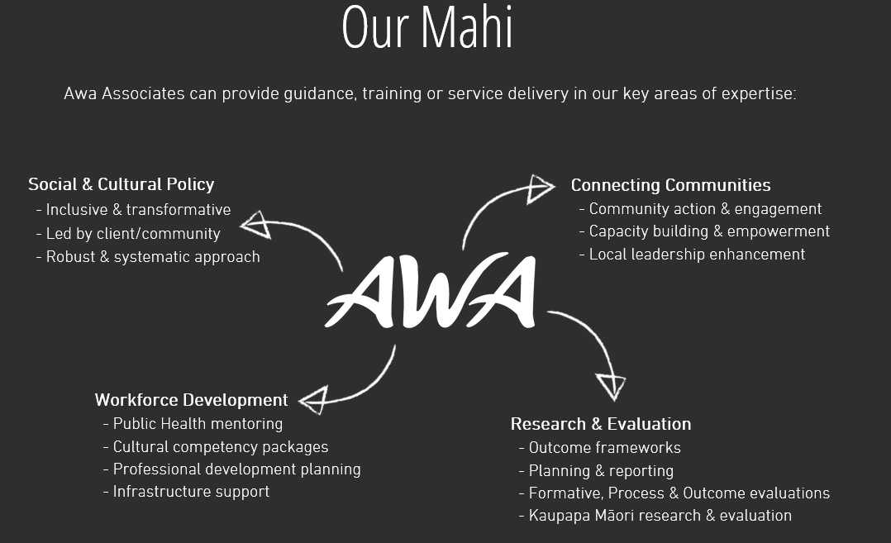
Awa Associates
Awa are a multi-discipline, multi-ethnic team committed to supporting your business or organisation to develop the right systems and tools to better deliver, understand, monitor and improve the social impact of your work. Our team of associates are specialists in social & cultural policy, research and evaluation, communications, workforce development, and infrastructure service support.
​Our strengths-based approach means our work is client-led, with a strong focus on producing innovative solutions and meaningful outcomes for your organisation and the people, audiences and communities you engage with. Our associates' strengths lie in their extensive networks and experience in the public, private and philanthropic sectors, and in working and engaging with high priority populations including Māori and Pacific peoples.
​Together we can make a difference, contribute to the success of others and enable change for a better future.

Appendix 2
Kaupapa Māori primary and mental health and addiction hui – Over 700 whānau attended
