Assessing the Fitness to Drive of People Sentenced under Section 65 of the Land Transport Act 1998
Standard operating procedures

Citation: Ministry of Health. 2017. Assessing the Fitness to Drive of People Sentenced under Section 65 of the Land Transport Act 1998: Standard operating procedures. Wellington: Ministry of Health.
Published in October 2017
by the Ministry of Health
PO Box 5013, Wellington 6140, New Zealand
ISBN 978-1-98-850295-3 (online)
HP 6692
This document is available at health.govt.nz
This work is licensed under the Creative Commons Attribution 4.0 International licence. In essence, you are free to: share ie, copy and redistribute the material in any medium or format; adapt ie, remix, transform and build upon the material. You must give appropriate credit, provide a link to the licence and indicate if changes were made.

Contents
Executive summary iv
1 Introduction 1
1.1 Background 1
1.2 Penalties for repeat offences (section 65) 1
1.3 Removal of disqualifications (section 100) 2
2 The assessment 3
2.1 Assessment 3
2.2 Assessor’s duty of care 3
2.3 Timeframes and sequence 4
3 The assessment process 6
3.1 At court 6
3.2 At the assessment centre 6
3.3 Information gathered in the assessment 7
3.4 How to conduct a risk assessment 8
4 Laboratory tests and a medical examination 9
4.1 Required laboratory tests 9
4.2 Medical examination 9
4.3 Timing for the laboratory tests and medical examination 10
5 Intervention 11
5.1 Education and treatment 11
5.2 Review: further face-to-face appointments 12
6 Final report to NZTA 13
6.1 When the recommendation is for the disqualification to remain in place 13
6.2 Complaints 14
6.3 Assessor payment 14
7 Becoming an approved assessment centre 15
7.1 Minimum requirements for assessment centre approval 15
7.2 Suspending or revoking approval 16
7.3 Medical practitioners 16
Appendices
Appendix A: Checklist for a comprehensive assessment 17
Appendix B: Final report to NZTA 18
Appendix C: Application for approval as an assessment centre 20
Appendix D: Yearly update for assessment centres 22
References and bibliography 23

Executive summary
These operating procedures reflect current New Zealand legislation, specifically the Land Transport Act 1998 (the Act). They set out the assessment process for people sentenced under section 65 of the Act, who, after serving the mandatory minimum disqualification period, wish to have their disqualification removed (as per section 100 of the Act), and re-apply for their driver licence.

The operating procedures were originally published as Assessment of Alcohol Dependence: A guide for health professionals assessing persons convicted of driving while intoxicated (Department of Health 1993). In 2006, they were updated as Guidelines for Assessing Substance Dependence and Risk of Re-offending of People Sentenced under Section 65 of the Land Transport Act 1998 (Ministry of Health 2006).

The operating procedures clarify the responsibilities of assessment centres and standardise the process that needs to be followed when carrying out assessments under section 65 of the Act. They also outline the criteria and approval process for assessment centres and the criteria assessment centres need to apply to appoint assessors. Finally, they clarify assessment centres’ accountability for providing regular reports to the New Zealand Transport Agency (NZTA).

The procedures have been developed to encompass the Health and Disability Commissioner Act 1994, which protects the rights of individuals who receive health and disability services.

Introduction

Background
These operating procedures provide the framework for effectively assessing a person’s alcohol and other drug use in relation to the risk of them re-offending because of impaired driving. The procedures replace previous guidelines and local protocols.

New Zealand, like many other countries, has strict legislation to protect against the impacts of people drinking alcohol and driving a vehicle. Other drug use, especially when combined with alcohol, also has an impact on people’s driving abilities and increases the risk of road accidents. Overall, the road safety risks from alcohol and other drug use include:
- impairment due to sedation effects
- impaired attention and judgement
- impaired motor function
- exacerbation of other risks, including cognitive impairment, mental health problems and some physical health conditions.

The process outlined in these operating procedures has been developed to minimise these road safety risks. It has three key objectives:
- to promote community safety by assessing the fitness to drive of repeat offenders sentenced for offences involving alcohol and other drugs
- to use section 65 of the Land Transport Act 1998 (the Act) to maximise the opportunity to change thinking and behaviour in repeat offenders convicted of offences involving alcohol and other drug use
- to ensure a consistent nationwide approach to the process that allows people sentenced under section 65 of the Act to apply to have their disqualification from driving removed.

The likelihood of achieving these objectives is maximised by the following key components of these operating procedures:
- a comprehensive alcohol and other drug assessment
- a supporting medical examination
- engagement with alcohol and drug treatment and other potential interventions as appropriate.

Penalties for repeat offences (section 65)
Section 65 of the Act relates to the mandatory penalties for repeat driving offences involving the use of alcohol or drugs. A person sentenced under section 65 of the Act must attend an assessment centre and is disqualified from holding or obtaining a driver licence until the Chief Executive of the New Zealand Transport Agency (NZTA) removes that disqualification under section 100 of the Act.

Removal of disqualifications (section 100)
Section 100 of the Act requires NZTA to remove an order for disqualification made under section 65 if:
- it is satisfied that the person is fit to hold a driver licence (section 100(1))
- the section 65 order has been in force for at least one year and one day (section 100(3)).

All people sentenced under section 65 seeking removal of their disqualification must go through the agreed assessment process. NZTA’s decision to remove a disqualification is based on a recommendation by an approved assessment centre. NZTA will take into account all evidence provided by the assessor in making its decision.

Note
NZTA’s decision to remove a disqualification does not mean that the applicant will automatically regain their licence. They will still need to re-apply for their licence.

The assessment

Assessment
Under sections 65 and 100 of the Act, a person applying for the removal of their disqualification must be assessed for fitness to drive, including whether they meet the criteria for mental health and or substance use disorders as described in the Diagnostic and Statistical Manual of Mental Disorders Volume 5 (DSMV) (American Psychiatric Association 1994). The DSMV describes substance use disorders as ‘a maladaptive pattern of substance use leading to clinically significant impairment or distress’.

If a person is assessed as having a substance use disorder, they are at greater risk of having an accident while driving. This risk increases if the person has a history of relapse and/or driving after or during substance use. A comprehensive assessment of the person can help identify and explain the factors that lead to and encourage driving after or during alcohol and other drug use, as well as factors that might encourage change (eg, motivation, support systems, mental health problems, cognitive impairment). Identifying and understanding the critical factors are central to assessors being able to develop effective, tailored interventions that can help the applicant avoid offending in the future.

Assessor’s duty of care
The process for removing a disqualification from driving requires the assessor to make the best possible recommendation as to the applicant’s fitness to drive based on their assessment and the applicant’s compliance with any agreed intervention (if one has been recommended).

In making their assessment, the assessor has a duty of care to both the applicant and to the New Zealand public to ensure the applicant is fit to drive. The assessor must honour the Code of Health and Disability Services Consumers’ Rights) Regulations 1996 (HDC 2009) and inform every applicant of their rights under the code. The code lays out 10 rights of consumers and duties of providers. They can be summarised as:
Right 1: The right to be treated with respect
Right 2: The right to freedom from discrimination, coercion, harassment and exploitation
Right 3: The right to dignity and independence
Right 4: The right to services of an appropriate standard
Right 5: The right to effective communication
Right 6: The right to be fully informed
Right 7: The right to make an informed choice and give informed consent
Right 8: The right to support
Right 9: Rights in respect of teaching or research
Right 10: The right to complain.

More information about the code of rights can be found on the Health and Disability Commissioner website (www.hdc.org.nz). Assessors are also expected to align with the code of ethics of the Addiction Practitioners’ Association Aotearoa New Zealand, otherwise known as dapaanz (see www.dapaanz.org.nz/code-of-ethics).

In performing their duty of care, assessors help to create safer communities. Their expertise helps those with a history of impaired driving offences make safer decisions about future substance use and driving a vehicle.

Timeframes and sequence
NZTA cannot remove a driving disqualification until:
- the mandatory disqualification period has been served (one year and one day)
- the required comprehensive assessment has been completed
- a report (including recent laboratory tests and results from a medical examination – see section 4: Laboratory tests and a medical examination) has been provided to NZTA.

Figure 1 below summarise the assessment and reporting process.
Figure 1: Assessment and reporting process for an application to remove a driving disqualification under section 65 of the Act
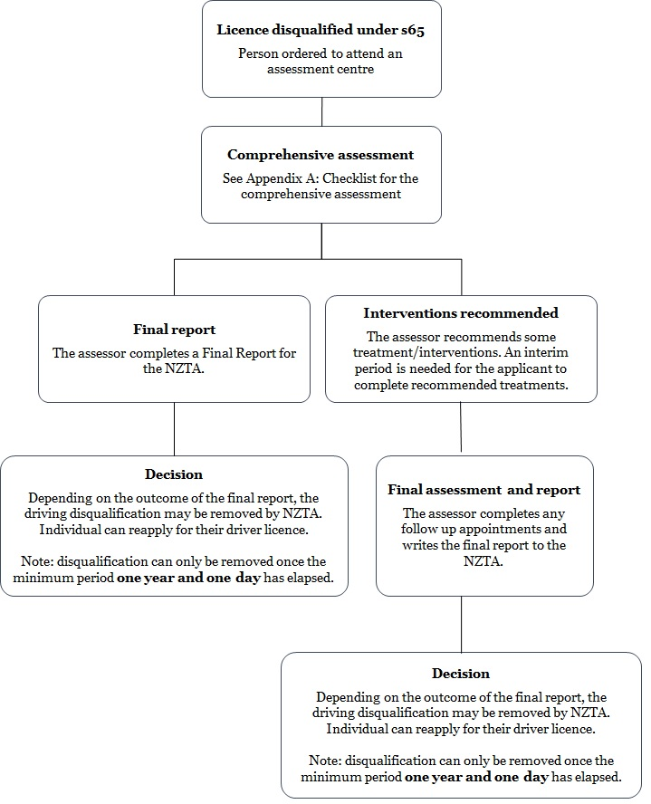

The assessment process
At court  A person who is sentenced under section 65 of the Act will be ordered to apply for a comprehensive assessment from an approved assessor to determine their suitability to drive again.  (Note: There is no penalty for not attending an assessment centre; the person’s disqualification will simply remain in place.) | 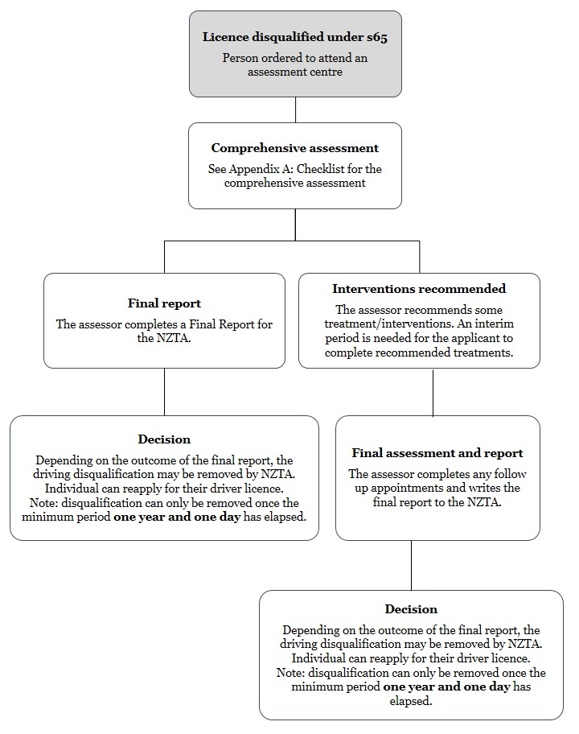
At the assessment centre  Once the applicant makes contact with an assessment centre, their assessor will schedule a face-to-face appointment to begin a comprehensive assessment.  The comprehensive assessment helps the assessor identify:  1) whether the applicant has a substance use problem and/or other issues that contribute to repeat impaired driving  2) how the problems should be addressed to minimise the risk of the applicant re-offending and any subsequent treatment recommendations. | 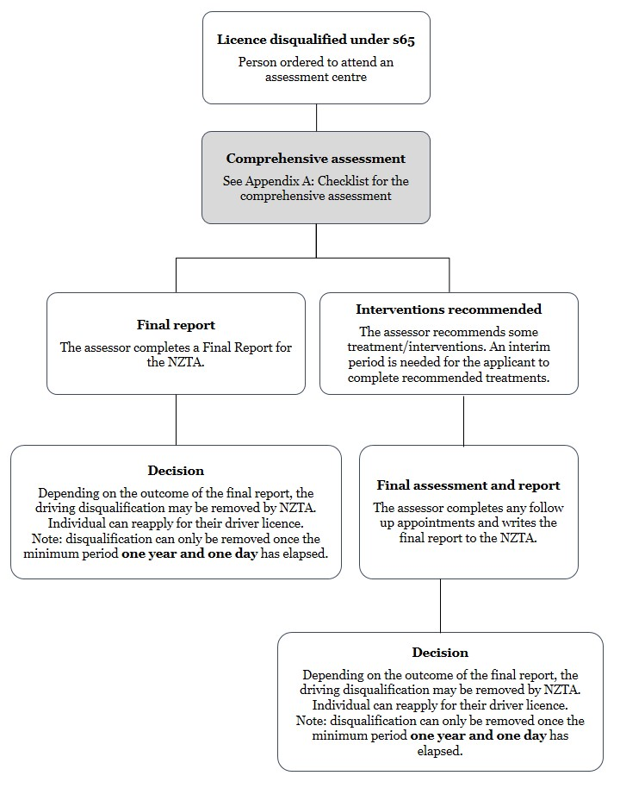

Notes
- More than one face-to-face appointment may be required to collect all the information needed to make a comprehensive assessment.
- Assessors need to be aware that many applicants will try to minimise the extent of their current or past substance use and offending.
- The results of the laboratory tests and medical examination (see section 4: Laboratory tests and a medical examination), as well as a review of previous convictions are useful when discussing the results of the assessment process with the applicant.

Information gathered in the assessment
At the first appointment, as a minimum, the assessor should:
- provide advice on treatment options
- identify the applicant’s rights under the Code of Health and Disability Services Consumers’ Rights (HDC 2009)
- outline requirements as necessary for any follow-up appointments and the final report to NZTA
- inform the applicant about the required laboratory tests
- inform the applicant about timeframes required to make an appointment with a registered medical practitioner for a medical examination
- inform the applicant that they will need to apply to regain their driver licence
- write referral letters to the appropriate service(s) (where treatment has been recommended).

The minimum information to be gathered in the comprehensive assessment includes:
- personal details (eg, name, age, current address, living arrangements, relationship status, parenting and caregiving responsibilities, gender, self-identified ethnicity, current employment status, and any changes in job, relationships and support systems)
- personal and developmental history
- mental health history, including previous treatments, and current status
- cognitive impairment and personality factors that may impact on impulsiveness and decision-making
- alcohol and other drug history, including previous treatments
- alcohol and other drug use in the last six months
- corroboration (eg, accounts from family/whānau and friends)
- referral information (eg, date of conviction, assessment dates)
- consent to obtain criminal conviction history (the greater the frequency of similar offending, the greater the risk of relapse)
- the applicant’s intentions, including strategies and their motivation to change their substance use and driving behaviour
- the applicant’s attitude towards driving (in particular those situations in which driving appears desirable or necessary)
- risk assessment (see 3.4 below)
- results of blood and urine drug screen tests interpreted by a registered medical practitioner, relevant medical history, current medications (see section 4: Laboratory tests and a medical examination).

Assessors will use any issues and concerns identified in the appointments to help work through an appropriate intervention with the applicant (if intervention is recommended).

See also Appendix A: Checklist for a comprehensive assessment.

Note
In their assessment, the assessor should consider the applicant’s previous list of convictions. This can be obtained, with the applicant’s consent, from the Criminal Records section of the Ministry of Justice (see: www.justice.govt.nz/criminal-records). The list should be requested at the first contact with the applicant. If the assessor is unable to obtain this information, for example, the applicant does not give their consent or the Ministry of Justice does not provide the information within a reasonable timeframe, they must state this, with reasons, in their final report to NZTA.

How to conduct a risk assessment
A risk assessment should identify key risk factors, protective factors and future potential risk factors to inform clinical judgement about a person’s risk of substance impaired driving. The risk assessment should also identify what needs to be done to manage that risk in a broad sense.

Risk factors specific to substance impaired driving include, but are not limited to:
- personality factors, such as aggression, hostility, recklessness, impulsiveness and thrill seeking
- cognitive impairment and/or indications of pervasive cognitive distortions
- offending patterns and attitudes to authority
- personality disorders
- physical and or social problems.

Note
The Ministry of Health (the Ministry) is developing an impaired driving risk assessment training programme, which will become a mandatory requirement for establishments applying to be an approved assessment centre under section 65 of the Act. In time, this training programme will become mandatory for every assessor to complete once every two years to demonstrate their ongoing competency.

Laboratory tests and a medical examination
The assessor’s final report to NZTA must include the results from recent laboratory tests and a medical examination. Thus, the assessor will need to ensure the applicant is referred to a laboratory for the appropriate tests and an appointment is made with a registered medical practitioner.

Required laboratory tests
- Liver function test (including gamma-glutamyltransferase, GGT)
- Aminotransferase (AST)
- Alanine aminotransferase (ALT)
- Complete blood count (eg, MCV)
- Drug detection test, for example, urine test.

The assessor may also want to run laboratory tests for:
- Ethyl glucuronide (EtG)
- Carbohydrate-deficient transferrin (CDT).

These additional tests are not mandatory.

For more information on the required laboratory tests, please see the Mental Health and Addiction Screening and Assessment Guidelines (Matua Raḵi 2011).

Medical examination
The registered medical practitioner will interpret the results of the laboratory tests (GGT, AST, ALT and MCV), paying particular attention to the GGT results. The medical practitioner must also carry out a medical examination that includes examining for:
- conjunctival injection
- abnormal skin vascularisation
- tongue tremor
- hand tremor
- hepatomegaly
- other physical sequalae of substance use
- other relevant health conditions that may impact on driving
- any relevant medication that may impact on the applicant’s ability to drive.

The results of these tests and their interpretation by a medical practitioner, must be included in the final report to NZTA. Unless all these tests are completed and included in the final report, NZTA reserves the right to decline a recommendation to remove a driver licence disqualification.

Timing for the laboratory tests and medical examination
The two scenarios described below are a guide to help assessors determine when to refer an applicant for the laboratory tests and subsequent medical examination.

Scenario 1: Following comprehensive assessment, the assessor is ready to progress to the final report
The assessor has gathered all the other required information for the comprehensive assessment and now needs the results of the laboratory tests and medical examination.
The results of the tests and medical examination either:
1) support the disqualification being lifted
2) do not support the disqualification being lifted.
If the results support the disqualification being lifted, the assessor can proceed to the final report to NZTA (section 6).
If the results do not support the disqualification being lifted, the assessor can design an intervention programme with the applicant (section 5 below).

Scenario 2: Following comprehensive assessment, the assessor recommends a structured intervention
The assessor has gathered all the required information for the comprehensive assessment, however, their assessment suggests that the applicant does not meet the criteria to have their disqualification lifted and the applicant would benefit from a structured intervention.
In this scenario, the assessor can either:
1) request the applicant undertake the required tests and medical examination, to help inform treatment planning, or:
2) recommend that the applicant undertake the required tests and medical examination after completing a recommended intervention.

For both scenarios 1 and 2 above, the assessor needs to ensure that their final report to NZTA includes recent results for a liver function test and a drug detection test (eg, urine test). If the tests were performed before the recommended intervention, they will need to be repeated, near to the completion of the final report.

Intervention
The assessor must keep the applicant well informed throughout the assessment and treatment processes. This includes explaining the results of all biochemical tests (and agreed others) and offering further information and advice.

Depending on the outcome of the comprehensive assessment, the assessor may recommend the applicant take part in an intervention programme.

Education and treatment  Some applicants will be assessed as having minimal or mild substance use disorders that would benefit from psycho-educational interventions. Applicants assessed as having a severe substance use disorder will need more intensive treatment. An intervention plan should be developed after discussions with the applicant and should include agreed goals and (ideally) a timeframe for achieving those goals.  The comprehensive assessment may also identify other issues that need to be addressed as part of ensuring the applicant’s fitness to drive. The specific interventions included in the intervention plan will depend on whether the applicant meets the criteria for a substance use disorder, their level of motivation, the | 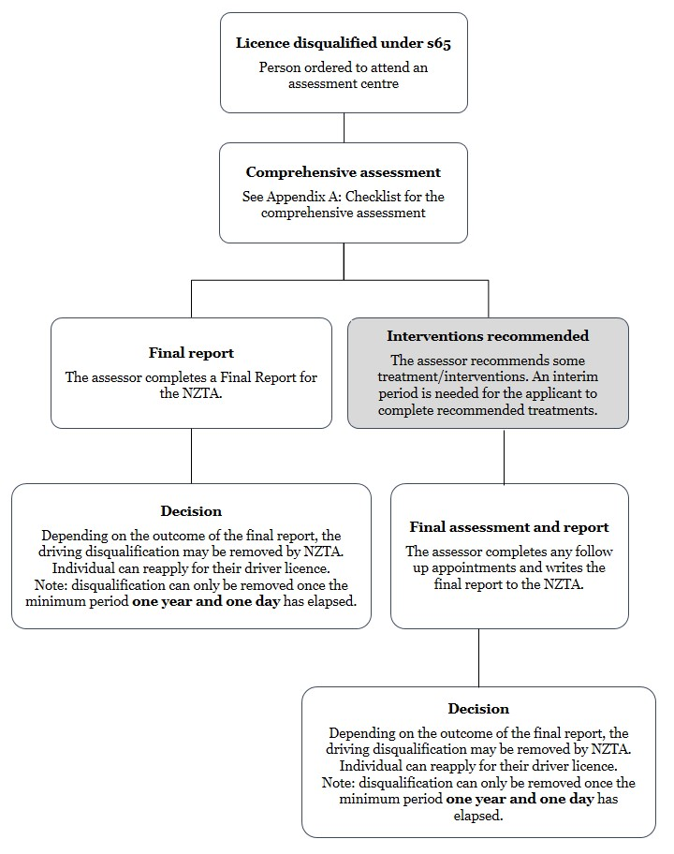
available treatment options and/or other personal factors, including (but not limited to), mental health disorders; personality disorders and personality features such as impulsiveness, risk taking and anti-authoritarian attitudes; and cognitive impairment.

Note
The assessor’s role is primarily to assess the applicant for their fitness to drive. This may include recommending treatment, and the assessor (as a qualified drug and alcohol practitioner) may offer to provide this treatment as appropriate (so long as alternative treatment providers are also offered should the applicant not wish to receive treatment from the assessor).

Review: further face-to-face appointments
After an agreed interim period, a treatment review in the form of a face-to-face appointment, needs to be undertaken to assess the applicant’s progress with respect to the recommended interventions. (The applicant may also be able to demonstrate a change in behaviour without having sought treatment.)

After this review appointment, the assessor should be ready to proceed to the final report to NZTA (see section 6: Final report) after obtaining laboratory test results and results from a medical examination. The results should support their recommendation (whether that recommendation be for the disqualification to be removed or to remain).

Note
If the applicant was referred for laboratory tests and a medical examination as part of the comprehensive assessment, a second round of tests will need to be carried out after the recommended interventions have been completed (see section 4.3: Timing for the laboratory tests and medical examination).

Final report to NZTA
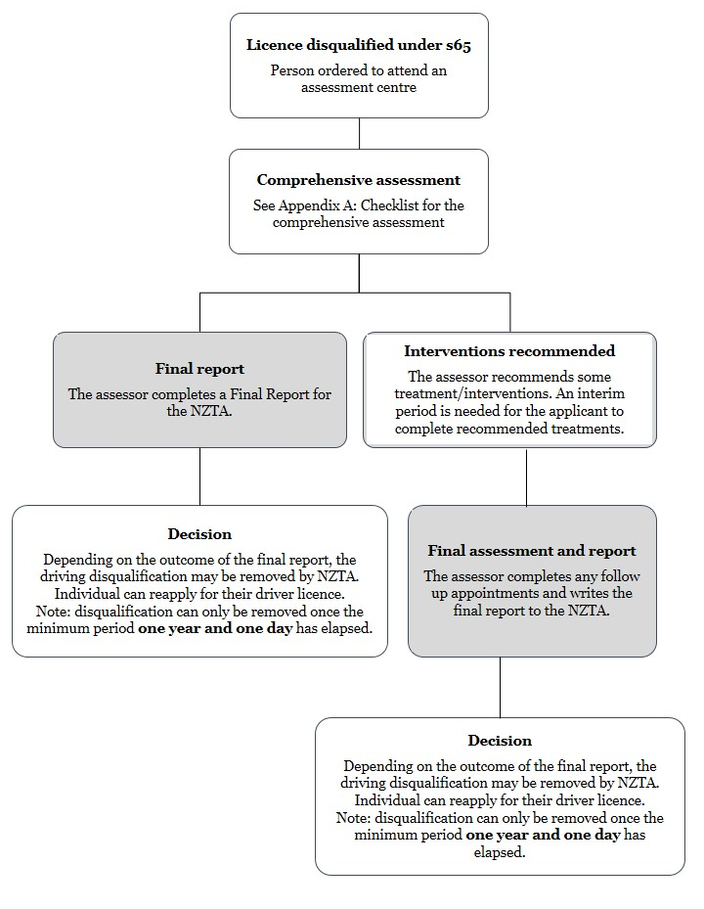 | The final report to NZTA must be completed on the form shown in Appendix B. This form summarises the information gathered during the assessment process and includes a recommendation on the applicant’s fitness to drive.  The assessor should keep a copy of the completed form in case of appeal.  The assessment will be reviewed by the Medical Review Advisor at NZTA before NZTA decides whether to make an order removing the disqualification, pursuant to section 100 of the Act.  The Chief Executive of NZTA makes the final decision as to whether the disqualification is removed, taking into account the assessor’s recommendation.  If the disqualification is removed, NZTA will advise the applicant in writing.

When the recommendation is for the disqualification to remain in place
The assessor must inform any applicant who is assessed as not meeting the requirements for their driver licence disqualification to be removed of:
- the reason(s) for the recommendation
- the applicant’s right to appeal the decision (via NZTA, at email: medical@nzta.govt.nz).

Options going forward
The assessor can:
- decide to delay making their final report to NZTA if they believe that further interventions and tests would change the recommendation
- suggest to the applicant that they obtain a second opinion from another assessor at their own cost
- inform the applicant that they may re-attempt the assessment process at their own cost once they have addressed any outstanding issues.

Complaints
The applicant has the right to complain about the assessor and quality of their assessment. Applicants’ complaints can be sent to dapaanz (email: office@dapaanz.org.nz).

Please note, in addressing a complaint, dapaanz may need to share information with the Ministry of Health on an as-needed basis.

Assessor payment
Assessors are paid a set fee for providing their report to NZTA on an applicant’s suitability to have their driving disqualification removed. The government sets the payment amount, and the fee is paid by NZTA.

The fee paid to the assessor also covers the cost of a registered medical practitioner interpreting the laboratory tests and providing the necessary medical assessment.

NZTA will pay the fee once it has received the appropriately completed Final Report to NZTA form (see Appendix B). As long as they complete their final report appropriately and submit it to NZTA, using the appropriate form, assessors will still be paid for their services, even if an applicant chooses not to complete an assessment or treatment process.

Notes
The fee is only available once for each applicant. Assessors should contact NZTA before they begin any assessment to confirm that NZTA has not already paid a fee for that applicant. If the fee has already been paid, the applicant will be need to pay for the assessment, and any related treatments, themselves.

Feedback and queries relating to the assessor’s fee (including the amount and when it is paid), should be directed to NZTA at medical@nzta.govt.nz or info@transport.govt.nz.

Becoming an approved assessment centre
The Director-General of Health approves establishments as assessment centres for the purpose of the Act (sections 2 and 65). Establishments can be:
a) legal entities, for example, district health boards (DHBs), companies or not-for-profit organisations that engage individuals as assessors
b) individuals who are appropriately qualified to undertake assessments.

To be approved, an establishment must meet the minimum requirements (set out below). Establishments must also maintain those requirements to ensure the approval is not suspended or revoked.

Minimum requirements for assessment centre approval
Establishments applying to be an approved assessment centre must demonstrate that they are competent in assessing alcohol and other drug problems as either a legal entity or an individual, as described above.

The following qualifications or experience are the minimum requirements of competence. The applicant for approval to be an assessment centre must:
- hold full registration as a registered alcohol and drug practitioner with either the Addiction Practitioners’ Association Aotearoa New Zealand (dapaanz) or the Fellow of the Australasian Chapter of Addiction Medicine (FAChAM) of the Royal Australasian College of Physicians (RACP)
- have at least three years supervised experience working as a practitioner in the assessment and treatment of addictive behaviours
- hold a qualification equivalent to or greater than the New Zealand Qualifications Framework level 7, related to assessing and/or treating addictive behaviours, particularly substance use disorders.

Note
The Ministry of Health (the Ministry) is developing an impaired driving risk assessment training programme, which will become a mandatory requirement for establishments applying to be an approved assessment centre under section 65 of the Act. In time, this training programme will become mandatory for every assessor to complete once every two years to demonstrate their ongoing competency.

Maintaining the minimum requirements
The Ministry will, from time to time, audit completed assessments provided to NZTA to ensure that approved assessment centres continue to meet the minimum requirements. An approved assessment centre that is unable to meet the minimum requirements should inform the Ministry immediately and not undertake any further assessments.

Further information about the approval process is provided in Appendix C: Application for approval as an assessment centre. Applications to become an approved assessment centre must be submitted on the form in Appendix C.

dapaanz will notify the Ministry if there is a lapse in an approved assessor’s registration. Any activity that constitutes misconduct under professional registration is grounds for revocation.

Suspending or revoking approval
The Director-General of Health may suspend or revoke the approval of an assessment centre if the centre does not meet the minimum requirements of competence listed above, or if their work does not meet an acceptable standard.

Before suspending or revoking an approval, the Director-General must:
- consider all relevant information relating to the assessment centre’s possible failure to comply with the minimum requirements
- advise the assessment centre of a provisional decision to suspend or revoke the approval
- invite the assessment centre to make a submission on the matter, in particular, to explain why the provisional decision should not be confirmed
- give the assessment centre 20 business days to provide a submission
- clarify with the assessment centre any matters in their submission (if necessary)
- dismiss or confirm the provisional decision and suspend or revoke the approval (if required).

The Director-General may set conditions for the assessment centre to meet if the decision is to suspend the approval.

The assessment centre may also voluntarily surrender their approved status. In such instances, the Director-General must accept the surrender and revoke the approval.

Medical practitioners
Medical practitioners do not need approval to interpret laboratory tests or conduct medical examinations. However, it should not be assumed that medical practitioners are capable of undertaking any other part of the assessment process. A medical practitioner must meet the minimum requirements for assessment centre approval listed above before they can become an approved assessor.

Appendix A: Checklist for a comprehensive assessment
The minimum information that needs to be gathered at the first face-to-face contact includes:
personal details
name, age, current address, living arrangements, relationship status, parenting and caregiving responsibilities, gender, self-identified ethnicity and current employment status
alcohol and other drug history, including previous treatments
alcohol and other drug use over the last six months
mental health history, including previous treatment
current mental health status and treatment/s
corroboration
validation of the self-report from significant others
referral information
date of conviction, date of presentation for assessment
personal history, developmental history
consent to obtain criminal conviction history
criminal conviction history reviewed
cognitive impairment and personality factors that may impact on impulsiveness and decision-making
risk assessment
results of blood and drug detection test (eg, urine test)
interpreted by a registered medical practitioner and including relevant medical history and current medications

In addition to the above information, have you:
- provided advice on treatment options (if needed)
- provided advice on the rights of the applicant as per the Code of Health and Disability Service Consumers’ Rights (HDC 2009)
- outlined requirements as necessary for any follow-up appointment and expectations to prepare the final report to NZTA
- informed the applicant about the required laboratory tests
- informed the applicant about timeframes required to make an appointment with a registered medical practitioner to undertake a medical examination
- informed the applicant that they will need to apply to regain their driver licence
- provided written referral letters to the appropriate service(s) (where treatment has been recommended).

Appendix B:
Final report to NZTA

Assessment centre:
Assessor:
Date report prepared:
Date of expiry for applicant’s section 65 order (if known):

Personal and contact details
Full name
Other or previous names (if any)
Date of birth
Current address
Conviction and assessment
Date of conviction
Date of medical examination and explanation of blood tests, etc
Date(s) of alcohol and other drug assessment  (Note the information contained in this report is based on information taken on the most recent assessment date) | 1.
 | 2.
Alcohol and other drug use | Last six months
Average alcohol use
(standard drinks per week)
Average cannabis use (per week)
Other drug use (specify drug and average use per week)
Assessment
Alcohol
Cannabis
Other drug (please specify)
Liver function tests, including GGT level (attached and reviewed by a medical practitioner)
Analysis of blood and drug detection tests (eg, urine test) attached (attached and reviewed by a medical practitioner) | Yes No
Other relevant mental health factors
Interventions recommended
Alcohol and other drug treatments undertaken or completed | Programme and date of completion
Education
Psychosocial intervention
Residential treatment
Summary of provider comments
Comments of the programme provider attached to file | Yes No
Motivation to change (tick as appropriate)
High
Medium
Low
Prognosis for the individual’s ongoing substance use
Other factors affecting fitness to drive
Is there any other condition that might affect the individual’s ability to safely operate a motor vehicle? | Yes No  Please specify:
Risk assessment
Risk assessment
Criminal conviction history reviewed (if you were unable to obtain, please provide reason) | Yes No  Comment on conviction history:  Comment if unable to obtain :
Recommendation for removing disqualification
Yes (why?)
No (why?)
Further comments
Signature of assessor:
dapaanz or other professional society membership number:
Date:

Send to: medical@nzta.govt.nz

Appendix C: Application for approval as an assessment centre
Use this form when applying to be approved as an assessment centre for the purpose of section 65 of the Land Transport Act 1998 (the Act) (see also the definition of assessment centre in section 2(1) of the Act).

I am applying as (please tick the relevant option):
an individual
organisation (eg, DHB, company or not-for-profit organisation).

First name |  | Surname
Organisation/company name |  | Position
Postal address
( ) |  | ( )
Telephone |  | Mobile phone
Email address
The locations/areas (ie, cities/towns/regions) of my assessment centre/s (this information will be used in listing approved assessment centres on the NZTA website):

Additional information
Individuals applying for approval as an assessment centre, please attach the following information to your application:
A letter of application detailing your qualifications, work experience and training in addiction problems
Proof of accreditation with dapaanz or FAChAM

Organisations applying for approval as an assessment centre, please attach the following information to your application:
A letter of application describing your organisation’s structure and its work in relation to the assessment and/or treatment of addictions issues
Proof of accreditation with dapaanz or FAChAM for all members of the organisation who will be undertaking assessments.

Agreement
I (the applicant):
1 agree that I meet, or the organisation I represent meets, the criteria for approval outlined in section 7.1: Minimum requirements for assessment centre approval
2 agree that if there are any changes to the above information I will notify the Ministry of Health immediately
3 agree to submit a yearly update to the Ministry of Health and NZTA as per Appendix D: Yearly update for assessment centres under section 65 of the Land Transport Act 1998
4 understand that my assessments may be audited from time to time
5 understand that dapaanz will inform the Ministry of Health if my registration, or the registration of anyone in my organisation, lapses
6 understand that the Ministry of Health reserves the right to suspend or revoke my approval if, at any point, I do not meet all the requirements of an assessment centre set out in section 7: Becoming an approved assessment centre.

Applicant signature
Print name
Date

Please email this completed form (with attachments) to:
Team Leader, Office of the Director of Mental Health
Email: mentalhealthadmin@moh.govt.nz

Appendix D: Yearly update for assessment centres
This update is due at the Ministry of Health and NZTA by 1 July each year.

I am providing this update as (please tick one):
an individual approved as an assessment centre
an organisation approved as an assessment centre (DHB, company or not-for-profit)

Name
Organisation/company name |  |  | Position
Postal address
( ) |  |  | ( )
Telephone |  |  | Mobile phone
Email address
Locations of my assessment centre/s:

Have there been changes to your address/info since approval or last year’s update? (this information will be used in listing approved assessment centres on the NZTA website)
Yes
No

Please list the dapaanz registered practitioner number (or FAChAM membership number) and expiry date for ALL the assessors in your organisation.
Name | dapaanz / FAChAM number | Expiry

Please email this completed form to:
- mentalhealthadmin@moh.govt.nz, and
- medical@nzta.govt.nz

References and bibliography
Alcohol Advisory Council of New Zealand. 1996. Guidelines for Alcohol and Drug Assessment: A review of alcohol and drug screening, diagnostic and evaluation instruments. Wellington: Alcohol Advisory Council of New Zealand.
Alcohol and Drug Treatment Workforce Development Advisory Group. 2000. Practitioners Competencies for Alcohol and Drug Workers. Wellington: Alcohol Advisory Council of New Zealand.
American Psychiatric Association. 1994. Diagnostic and Statistical Manual of Mental Disorders (4th ed) (DSM-IV). Washington: American Psychiatric Association.
Baker A. 1998. Brief interventions for alcohol and drug problems: a review with practitioner guidelines. In: JD Sellman, GM Robinson, R McCormack, et al (eds). The Long and Short of Treatment for Alcohol and Drug Disorders. Christchurch: Department of Psychological Medicine, Christchurch School of Medicine.
Bakker LW. 1999. The Driving Offender Treatment Scale. Wellington: Psychological Service, Department of Corrections.
Dawe S, Loxton N, Hides L, et al. 2002. Review of Diagnostic Screening Instruments for Alcohol and Other Drug Use and Other Psychiatric Disorders (2nd ed). Monograph Series no. 48. Canberra: Commonwealth of Australia.
Department of Health. 1993. Assessment of Alcohol Dependence: A guide for health professionals assessing persons convicted of driving while intoxicated. Wellington: Department of Health.
Donovan D. 1999. Chapter 11: Assessment strategies and measuring addictive behaviours. In: BS McCrady, EE Epstein (eds). Addictions: A comprehensive guide book. New York: Oxford University Press.
HDC. 2009. Code of Health and Disability Services Consumers’ Rights. Wellington: Health & Disability Commissioner (HDC). URL: www.hdc.org.nz/the-act-code/the-code-of-rights (accessed 16 August 2017).
Heather N. 1995. Brief intervention strategies. In: RH Hester, WR Miller (eds). Handbook of Alcoholism Treatment Approaches: Effective alternatives (2nd ed). Boston: Allyn & Bacon,
pp. 105–22.
Hulse G, White J, Cape G (eds). 2002. Management of Alcohol and Drug Problems. New York: Oxford University Press.
Land Transport Safety Authority. 2002. Medical Aspects of Fitness to Drive. Wellington: Land Transport Safety Authority.
Laumon B, Gadegbeku B, Martin J, et al. 2005. Cannabis intoxication and fatal road crashes in France: population based case-control study. British Medical Journal 331: 1371.
Matua Raki. 2011. Mental Health and Addiction Screening and Assessment Guideline. Updated November 2016. Wellington: The National Addiction Workforce Development Centre. URL: www.matuaraki.org.nz/resources/mental-health-and-addiction-screening-and-assessment-guideline/363 (accessed 16 August 2017).
Miller W, Rollnick S. 1991. Motivational Interviewing: Preparing people to change addictive behaviour. New York: Guilford.
Ministry of Health. 2006. Guidelines for Assessing Substance Dependence and Risk of Re-offending of People Sentenced under Section 65 of the Land Transport Act 1998. Wellington: Ministry of Health.
National Health Committee. 1999. Guidelines for Recognising, Assessing and Treating Alcohol and Cannabis Abuse in Primary Care. Wellington: National Health Committee on Health and Disability.
O’Hagan J, Robinson G, Whiteside E. 1993. Alcohol and Drug Problems: Handbook for health professionals. Wellington: Alcohol Advisory Council of New Zealand.

Formerly Land Transport New Zealand.
The Act defines an assessment centre as an establishment approved for the purposes of the Act by the Director-General of Health (Ministry of Health).

