Aotearoa/New Zealand’s COVID-19 elimination strategy: an overview
7 April 2020
Contents
Aotearoa/New Zealand’s COVID-19 elimination strategy: an overview 1
Executive summary 2
Document purpose 3
Note 3
Part 1: Decision-making principles for the COVID-19 response 4
Equity principle 4
Wellbeing principle 4
Weighting of principles 5
Part 2: Describing the strategy 5
Strategy aims 5
Strategy rationale 5
Intervention logic for elimination of COVID-19 6
Elimination strategy objectives 7
Additional considerations for elimination of COVID-19 in Aotearoa/New Zealand 7
Disease elimination success and failure indicators 8
Equity success indicators of elimination strategy 12
Transitions 14
Next steps 15
Appendix 1 16
International evidence 16
Strategy and measures used by China 16
References 18

Executive summary
This working paper presents an overview of New Zealand’s COVID-19 elimination strategy. It forms part of background work commissioned by the Ministry of Health (the Ministry) by the Director of Public Health to help inform the response to COVID-19.

All levels of the strategic response to COVID-19 must prioritise equity.

Aotearoa/New Zealand is implementing a strategy of elimination for COVID-19. The aims of this strategy are:
- to eliminate transmission chains in Aotearoa/New Zealand
- to prevent the emergence of new transmission chains originating from cases that arrive from outside the country.

Successful achievement of these aims requires multiple and comprehensive control measures, implemented at high intensity. The control measures support four main strategy objectives:
- to identify and stop each transmission chain
- to prevent undetected transmission
- to prevent seeding of new clusters into Aotearoa/New Zealand, using border control measures
- to prioritise equity.

An elimination strategy has strong potential to:
- avoid COVID-19-specific health inequities for Māori and Pacific peoples and those living in socioeconomic deprivation
- prevent high rates of COVID-19-related permanent disability and death
- allow earlier de-escalation of control measures and quicker resumption of normal activities including return to work and provision of comprehensive primary, secondary and preventative health care
- extract maximum benefit from necessary control measures.

Elimination will not be easy to achieve and there are important associated risks. There is the potential for equity failure with the exacerbation of existing inequities and the creation of new inequities. There is also potential for geographical and/or quantum failure, in part or in whole. On the other hand, if the strategy is successful very few people will acquire the infection and the population will remain susceptible until a vaccine is developed and delivered.

In this document we propose indicators of success and failure to identify and mitigate these risks.

Subsequent work will examine specific control measures needed to deliver the strategy. We note however that control measures have the heaviest impact on populations and households who already experience disadvantage, such as inequitable access to the health system and health determinants. This risk further underlines the need for a strong equity focus at all levels throughout the COVID-19 response.

Document purpose
Aotearoa/New Zealand is aiming to eliminate COVID-19. In this document we describe the overarching components of an elimination strategy, whether it is consistent with core principles for public health action in a pandemic, and indicators of success.

Document authors:

This is one of a number of papers to be prepared by the COVID-19 Public Health Response Strategy Team (a group of epidemiologists and public health medicine specialists seconded temporarily to the Ministry of Health). The team consists of: Dr Amanda Kvalsvig, Dr Caroline Shaw, Dr Lucy Telfar-Barnard, Dr Anja Mizdrak, Dr Polly Atatoa-Carr, Dr Mel McLeod, Dr Ruth Cunningham.

We thank the peer reviewers of this document for their helpful feedback.

Note
In this document we refer to pandemic strategies and control measures.

- Strategies are the high level approaches to managing the pandemic. Elimination is one of these strategies.
- Control measures are the specific interventions (eg, case finding, contact tracing, quarantine, school closures) that are needed to deliver on all the strategies. They are needed in different combinations and intensities and at different times for each strategy.

Part 1: Decision-making principles for the COVID-19 response
Planning and coordination of the COVID-19 response must begin by recognising the roles and responsibilities of the health system and the Crown, for and with Māori. These are affirmed through Te Tiriti o Waitangi and the Declaration on the Rights of Indigenous Peoples¹ as well as more recently in the Wai 2575 Inquiry² and the initial findings of the New Zealand Health and Disability Systems Review.³
These foundational and health systems documents recognise Māori sovereignty, the right of Māori to monitor and evaluate the decisions and actions of government, the primacy of Māori aspirations for ethical decision making and practice, the rights to protection of Māori health and wellbeing, and the system responsibilities for the elimination of health inequity.
Recognising the fundamental principles and obligations provided by Te Tiriti o Waitangi, we recommend that the equity principle is prioritised consistently across all levels of the strategic response to COVID-19. We also consider the importance of maximising wellbeing benefits while minimising harm.

Equity principle
The equity principle requires equitable: access to the determinants of health; access to health care: and quality of care received. Equitable outcomes also require equitable processes, and timely evaluation, measuring and monitoring.
Current and persistent health inequities in Aotearoa/New Zealand are most stark for Māori and Pacific peoples and those that have access to fewer socioeconomic resources. The COVID-19 pandemic can create new health inequities (systematic and unintended) and exacerbate existing health inequities, particularly for Māori and Pacific communities.
These inequities can occur directly through COVID-19 disease impacts as well as from non-COVID-19 adverse health impacts that are exacerbated or created by the pandemic through health system and health determinant disruption. COVID-19 disease is also likely to have a differential (and potentially inequitable) impact on other subpopulations in Aotearoa/New Zealand. This includes those defined by age group, gender, migration and labour-force status, the presence of underlying chronic health conditions and disability.
We prioritise the equity principle in our analysis of the COVID-19 control measures and mitigation responses.

Wellbeing principle
The wellbeing principle considers the opportunity to maximise health benefits (the protection of population health and wellbeing) and minimise health risks.

Health benefits relate to COVID-19 disease impacts as well as non-COVID-19 health (eg, mental wellbeing, prevention activities including screening, chronic disease management, comprehensive primary care, elective care).
Finally, maximising wellbeing requires attention to the broader health determinants (eg, economic support, employment, food security, housing, education and training, family and social support, cultural wellbeing, and freedom from racism and discrimination).

Weighting of principles
The relative weighting of these principles may vary at different stages of the strategy. However, where principles are in conflict, the equity principle is prioritised in our control measures - the application of the wellbeing principle or any other decision-making principles should not result in exacerbated inequities.
While Aotearoa/New Zealand currently can achieve elimination, we must recognise that success will likely require a pattern of control measures, sometimes intense, for a long period of time, for example until we have an effective COVID-19 vaccine or effective treatment.
Therefore, while there are opportunities to consider the evidence for COVID-19 disease health and equity impacts, the ongoing disruption to health services and to the economy (and therefore to socioeconomic determinants of health) will likely be substantial and long-lasting. Unless the strategy and related control measures for achieving elimination considers and mitigates inequitable impacts, particularly for Māori and Pacific, then it will have failed.

Part 2: Describing the strategy

Strategy aims
Elimination of COVID-19 (or any disease) means reducing new cases in a defined geographical area, in this case Aotearoa/New Zealand, to zero (or a very low defined target rate). Elimination is distinct from eradication.

Eradication refers to the complete and permanent worldwide reduction to zero new cases of the disease through deliberate efforts (eg, smallpox). Eradication of COVID-19 is not possible at this stage (and may not ever be possible).

The two primary aims of a COVID-19 elimination strategy are:
- to eliminate transmission chains in Aotearoa/New Zealand
- to prevent the emergence of new transmission chains originating from cases that arrive from outside the country.
Note: while COVID-19 elimination control measures are presumed to act nationally there is the ability to have local variation. For example, restricting access to isolated areas with no cases such as small communities or islands during the initial phase or after a measure of success has been achieved. Local variation may also be appropriate where there are regions with very low rates of COVID-9, noting the risk of transmission.

Strategy rationale
Motivating reasons for elimination in New Zealand have several benefits and risks.
- Elimination is a well-recognised outbreak strategy that has successfully ended other epidemics in Aotearoa/New Zealand. As an example, Aotearoa/New Zealand had previously eliminated measles (this was defined by WHO as no new cases having originated here for three years).⁴

There is early evidence that intensive control measures have been effective in achieving COVID-19 elimination-level containment in other countries - particularly China, as described in the appendix of this document.⁵

- Elimination is possible in Aotearoa/New Zealand because of the early entry into Alert Level 4. However, this does provide risks to population wellbeing and health equity through inequitable access to primary and preventative care, as well as an impact on health determinants, particularly economic.

- Elimination is a high-effort strategy, but it gives Aotearoa/New Zealand the potential to avoid additional health inequities from COVID-19 specific health impacts for Māori and Pacific peoples, and those living in socioeconomic deprivation. This aligns with the equity principle.

With most cases coming from overseas, COVID-19 cases in Māori and Pacific peoples is currently low (compared to European). Other strategies would likely mean inequities are seen in COVID-19 specific outcomes as well as the important equity impacts of a strained health system and the determinants of health.

It is important to recognise implementing elimination has a different set of equity challenges to manage. This includes economic impacts and the potential for delayed management of other health conditions.

- The consequences of uncontrolled spread of COVID-19 are severe, with potential deaths in the tens of thousands. ⁶ Elimination (at this stage of the Aotearoa/New Zealand response) has the potential to prevent substantial permanent COVID-19 related disability and death. It can also protect those that support and deliver our health care system and allow other health care activities to resume.

- Elimination (if successful) has the potential for strict transmission control measures within Aotearoa/New Zealand to be lifted earlier. This means health care and access to the broader determinants of health can resume, leading to enhanced equity and wellbeing. (Note disruption to the economy and health services while responding to the pandemic, as well as ongoing challenges of new cases from overseas present an equity challenge until a COVID-19 vaccine is available.)

- Most components of an elimination strategy are needed in other COVID-19 strategies. Some, such as surveillance and contact tracing, are universal. The elimination strategy has the potential for substantial health benefits for wellbeing and equity gained by implementing all strategy components early.

- There are important potential co-benefits that result from successful elimination. These include recognition of the special relationship between Aotearoa/New Zealand and Pacific nations and territories. Elimination of COVID-19 in Aotearoa/New Zealand supports protection of these Pacific nations and territories from COVID-19 impacts and related determinants of health (in addition to other in-Pacific strategies such as border control and community protection).

Intervention logic for elimination of COVID-19
To stop the COVID-19 pandemic, the reproduction number (the number of secondary cases per case) must be reduced throughout the country to <1, or down as near to 1 as possible. (In practice, pandemic spread may be halted once the reproduction number (R) is just above 1.⁷)
Figure 1 illustrates the three drivers of the reproduction number, and the control measures relevant to COVID-19 that attenuate these drivers. When a vaccine becomes available and a sufficient proportion of the population has been vaccinated, transmissibility will be greatly reduced because contacts of a case are more likely to be immune: socially disruptive control measures aimed at reducing contact rates can then be relaxed.
Figure 1: Reproduction number drivers and attenuation measures
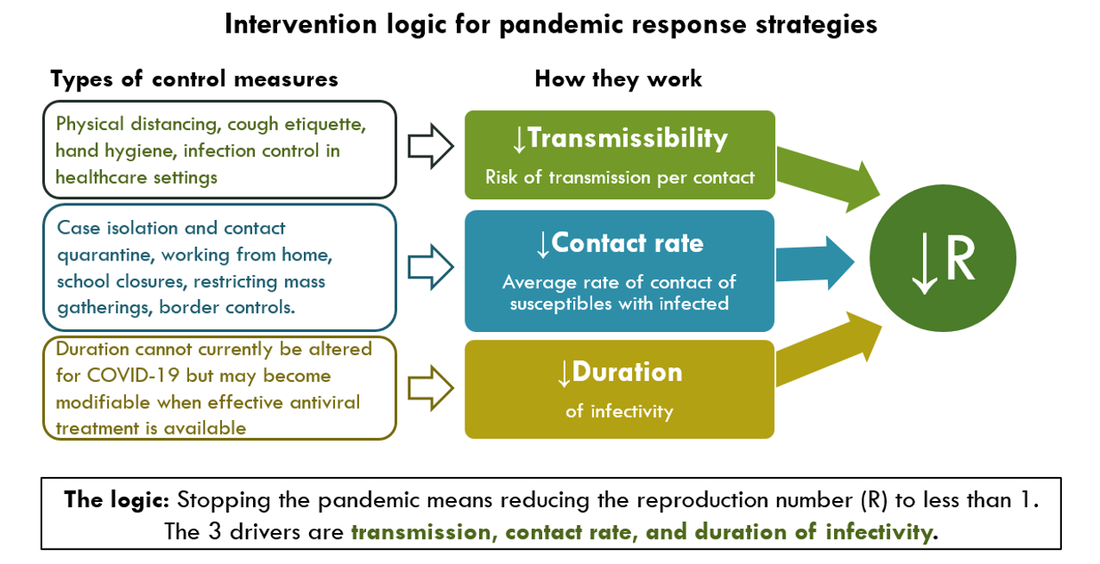
In the meantime, we face the challenge of a highly transmissible infection spreading in an almost completely susceptible population, with variance by important population subgroups (particularly Māori and Pasifika who are more likely than other population groups to live in crowded homes and to have multi-morbidities).
Another challenging feature of COVID-19 is that patients may be infectious for up to three days before they show any symptoms.⁸ Thus, there is a high risk of extremely rapid and inequitable spread.

Elimination strategy objectives
Based on the above aims, principles and intervention logic, the elimination strategy has four key objectives. These reflect activities which will need to be implemented and evaluated in three different settings (the health system, populations, and borders).
- Identify and stop each transmission chain. Highly active case detection is required, including active case finding in high-risk populations, with isolation of cases and rapid tracing, testing, and quarantine of contacts (ie, public health measures).
- Prevent undetected transmission. It is difficult to detect all transmission chains, so additional control measures outside of the public health system are needed to prevent undetected transmission (ie, population-level control measures to reduce transmissibility and contact rates, as in Figure 1).
- Prevent the introduction of new transmission chains into Aotearoa/New Zealand, using border control measures including travel restriction and/or quarantine of incoming travellers
- Ensure all actions taken are designed and implemented to promote equity and to reduce the burden of both the disease and the control measures on disadvantaged populations (ie, potential inequities in elimination strategies are anticipated, planned for and addressed where possible from the outset).

Additional considerations for elimination of COVID-19 in Aotearoa/New Zealand
Elimination is different from other strategies. Not because of the specific control measures used, but in the timing and intensity of these measures. There are further considerations for implementing the elimination strategy.
- This strategy requires multiple and comprehensive control measures implemented at high intensity, as no single control measure can be completely effective.
- An advantage of this comprehensive approach is that control measures have the potential to amplify one another when used in combination: for example, prohibition of mass gatherings enhances the feasibility of tracing all contacts of a case.
- An unusual feature of this strategy is that maximal control measure intensity is initiated at a time when there are still very few cases. Other strategies such as mitigation have maximal control measure intensity during the time period with the most cases. This is because of the different aims of each strategy.
- After the initial phase, these control measures may not need to be applied uniformly across the country. Depending on circumstances, regional or local variation may be appropriate, (ie, for isolated communities). However, travel restrictions will need to continue for an extended period to prevent cases coming into the country.

Disease elimination success and failure indicators
Criteria for assessing the elimination of infectious disease outbreaks are organism-specific. They are largely determined by transmission dynamics, types of surveillance used, and the availability of a suitable vaccine.
Elimination progress, success and maintenance can be assessed using common measures of viral spread such as:
- the size and duration of outbreak clusters
- the source of clusters (eg, the proportion of cases originating from international arrivals)
- whole genome sequencing
- estimates of R.^{9,10}
Commonly used measures of population susceptibility, such as seropositivity or vaccination-based estimates, are still in development for COVID-19.
As noted by Kelly et al., “It is clear that disease elimination cannot be declared in the absence of high quality laboratory-enhanced surveillance.”⁹ In order to ascertain elimination success, we need high quality outbreak data to be collected from multiple sources and analysed. Bias and error in this data should be minimal. Specific surveillance criteria for COVID-19, epidemiological criteria and thresholds must be established.
Sustained epidemiological elimination (ie, no transmission) is difficult to achieve without an effective vaccine. However, as the first stage of elimination, we can aim to achieve containment of the disease (ie, identifying and extinguishing transmission chains as they occur) in the near future. Potential indicators of containment are proposed in Table 1 below. We have not yet proposed time frames as these will be dependent on the emerging epidemiological picture in New Zealand and developing international evidence.
Table 1: Indicators of successful containment of COVID-19 in Aotearoa NZ
Strategy aim | Indicators of success | Comment
Aim 1: To eliminate transmission chains in Aotearoa NZ. | Community-level surveillance identifies no transmission nationally for a defined time period. Surveillance will need to demonstrate appropriate coverage of the general population and active case finding in high-risk and priority populations.  The majority (proportion to be defined) of cases presenting to health services are international arrivals.  Health service capacity is not exceeded due to COVID-19 not picked up by surveillance or case finding.  No new health inequities due to adequate and timely protection of high-risk populations from COVID-19 impacts.  Delays in diagnosis and management of non-COVID health conditions have been managed and have not increased existing health inequities. | Epidemiological evidence of lack of transmission.  This requires ongoing collection of high quality data that allows the assessment of the distribution of testing, cases, health system interactions and deaths (noting the potential importance of presymptomatic transmission).  Clinical evidence of lack of transmission.  Further statistical work is needed to calculate how many people, from which population, would need to be sampled to be sufficiently confident that the absence of positive tests indicated a true absence of infection.
Aim 2: To prevent the emergence of new transmission chains originating from cases that arrive from outside the country. | No new instances of ongoing local transmission related to international arrivals (these are cases linked to contact with international arrivals).  Cases in international arrivals and their close contacts are all detected and quarantined. | Indicates that the border is secure.
Note: Evidence on asymptomatic and presymptomatic transmission continues to be monitored. If high levels of asymptomatic transmission are considered likely, this finding will indicate a need to adjust any previously defined time periods.
Measures of failure are also important as they prompt consideration of how to improve the strategy or whether we should transition to other strategies. Potential indicators of failure are outlined in Table 2 below. It is important to clarify, however, that identification of cases may reflect effective case finding, rather than failure of control. Case numbers will need to be evaluated in context to assess whether transmission is increasing or decreasing.
Table 2: Indicators of unsuccessful containment of COVID-19 in Aotearoa/New Zealand
Aim |  | Failure indicator | Comment
Aim 1: To eliminate transmission chains in Aotearoa/New Zealand. | Complete failure  Equity failure | Increasing proportions of positive tests in community surveillance systems in multiple DHBs, mirrored by increasing hospital and /or ICU admissions.  Viral sequencing indicating ongoing transmission.  Demand for health care resources (eg, ICU beds or ventilators) exceeds capacity (note: late sign of failure).  Prioritisation protocols and processes of available healthcare resources are inequitable.  Mortality rates measured in severe acute respiratory infection (SARI) surveillance systems or the national collections, suggesting significant excess mortality from respiratory infections or significant excess all-cause mortality – for the total population, or within population subgroups (note: late sign of failure).  New inequities in COVID and non-COVID health outcomes.  High-risk populations not successfully protected and exacerbation of existing inequities.  Inability to deliver health care equitably and effectively for non-COVID-19 related illness (and prevention/promotion). | It will be essential to define and monitor a set of indicators that can give timely warning of impending health service failure for operational as well as pandemic control reasons.  It will also be essential to ensure that the quality of the data collected and recorded can confidently assess the extent and impacts of COVID-19 related health, and non-COVID-19 related health by population sociodemographics.
 | Partial failure (regional) | Increasing proportions of positive tests in community surveillance system in geographically isolated areas/single DHBs while other regions have achieved the measures of success outlined above.  Increasing proportions of positive tests in high risk regional population groups (eg, prisoners, or aged care residents) resulting in health inequity. | Important implications for data needs, quality assurance and accountability.
 | Partial failure (quantum – eg, continuing to get above a defined threshold of cases per day) | Reduction of new cases to a more manageable level, but not to a level that could be called elimination or could justify the lifting of all control measures. | For example, South Korea have said 50 cases per day is about what their health system can cope with.  The level for the Aotearoa/New Zealand health system would need to be defined.
 | Partial failure (border) | Clusters of local transmission (size to be defined) related to international arrivals (those are cases who are linked to contact with international arrivals) are being detected.  Cases in international arrivals are being detected after their quarantine period has ended.

Equity success indicators of elimination strategy
The earlier table considers the epidemiological and disease based indicators, as well as addressing equity success and failure indicators focused on COVID-19 disease outcomes. However there needs to be the same level of focus on the process indicators of equity within the elimination strategy to ensure that the adverse impacts of the pandemic and the response to the pandemic are not disproportionately experienced by Māori and other potentially disadvantaged groups. These are outlined in Table 3.

Table 3: Indicators of successful elimination strategy, focus on equity
Equity aim and outcome | Indicator of success
Aim 1. Māori governance and decision-making. | The Crown and its agencies ensure partnership with Māori in all levels of decision-making, monitoring of decisions, actions and inactions relating to the COVID-19 response.
Aim 2. Data is used to monitor, measure, resource and achieve equity. | High quality and timely data (eg, ethnicity data) is collected across the COVID-19 response to ensure that inequities can be measured, monitored and eliminated in a timely manner.
Aim 3. Existing health inequities are not exacerbated by the strategy. | Existing health inequities between Māori and non-Māori with respect to: COVID-19 health (eg, infection rates, transmissibility, severity, access to care); non-COVID-19 health (eg, chronic disease and access to health care); access to the broader determinants of health (eg, socioeconomic support) are understood and the strategy (and associated control measures - such as age cut-offs in decision making or resource allocation) is implemented so that these inequities are not exacerbated.  Existing health inequities for other population groups including those defined by age, ethnicity (particularly Pacific peoples), gender, socioeconomic status, and disability status are understood and the impact of the strategy (and associated control measures) is implemented so that these inequities are not exacerbated.
Aim 4. New health inequities are not created by the strategy. | The differential impacts from the strategy (and associated control measures) on health and wellbeing outcomes for Māori compared to non-Māori are anticipated, investigated in a timely manner, and are a key consideration in decision-making to ensure that new health inequities are not created.  The differential impact from the strategy (and associated control measures) on the health and wellbeing outcomes for key population groups including those defined by age, ethnicity (particularly Pacific peoples), gender, socioeconomic status, household structure, occupation (including essential workers), and disability status are planned for, monitored and responded to in a timely manner.
Aim 5. Health inequities resulting from the response are mitigated. | The impacts of the strategy (and related control measures) are monitored, measured and responded to (for Māori compared to non-Māori; and for key population groups including Pacific peoples and those in socioeconomic deprivation) in real-time to enable equitable outcomes.  The strategy includes active implementation of mitigation measures to ensure inequities are not exacerbated or created.  Resources are prioritised, reprioritised and redistributed to achieve equitable outcomes.  Māori and Pacific peoples are meaningfully and actively involved in making and monitoring decisions regarding the mitigation measures for achieving equity.

Transitions
There are a number of potential pathways out of elimination depending on the success or otherwise of the strategy.
The transition if COVID-19 containment is successful (defined in Table 1) is to a maintenance phase. This would involve:
- ongoing intensive surveillance and monitoring to detect any breaches, linked to capability and capacity to respond in a timely way that limits transmission
- staged lifting of control measures within Aotearoa/New Zealand - ideally from the least risky transitioning through to the most risky (this sequencing would need to be determined as part of further work)
- intense and sustained border restrictions, as these would now be our primary defence
- the ultimate end of this strategy, allowing lifting of border controls, would be through population vaccination to obtain herd immunity.
If elimination does not appear to work the transitions are more complex, and context specific. Some possible pathways are in Figure 2 below. These may change depending on specific circumstances. Further work is required to determine specific criteria for the decisions in these pathways, particularly the assessment of equity.

Figure 2: Elimination strategy failure pathways
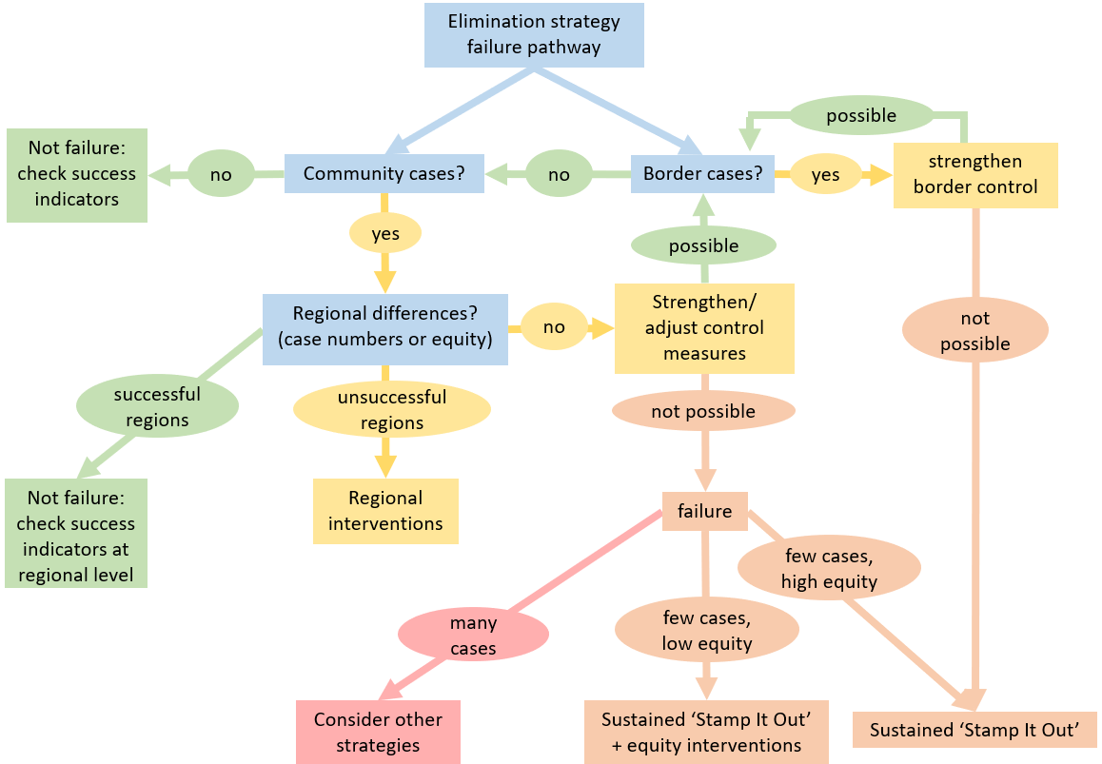
Equity: equitable infection and progression rates between Māori and non-Māori; and equitable infection and progression rates across population groups defined by ethnicity, gender, socioeconomic status, and disability status.

Next steps
This document contains a high level view of an elimination strategy. The elimination strategy has been activated very rapidly, without the detailed policy and technical scrutiny that would normally precede such a major initiative. Further work is needed to:
- examine the specific control measures needed to deliver the strategy in detail including any evidence of effectiveness and the equity impacts of them. It may be possible to enhance measures to address equity and alter current levels of control measures without endangering elimination. We need to plan a risk-based approach to lifting control measures assuming success, or allow for increased intensity of control measures if needed
- work up a detailed implementation plan including:
- identifying and rectifying any operational gaps in the key public health building blocks needed to deliver elimination (eg, contract tracing strategy, surveillance strategy)
- a harm mitigation plan - the control measures are harmful to some populations and will increase inequity. This needs to be specifically addressed
- a detailed equity analysis for each control measure needed as part of an elimination strategy
- a detailed risk analysis for each control measure needed as part of an elimination strategy
- specific work further defining the parameters of acceptable bounds for the containment parameters (eg, further defining time frames etc.)

Appendix 1

International evidence
Elimination (or elimination-level containment) has only (to our knowledge) been largely successful in China. Other jurisdictions such as South Korea and Taiwan may be aiming for elimination but have not yet achieved it. Given the successful outcome reported in China we have included a brief description of the strategy taken.
There may be other combinations of control measures that also achieve elimination. We note that there may also be countries that do not have the opportunity that Aotearoa/New Zealand has to eliminate COVID-19 due to their proximity to, or dependence on, jurisdictions with uncontrolled outbreaks. For example, case numbers and control measures in some European countries are similar to that of Aotearoa/New Zealand, but there are challenges of ongoing border control that make elimination unlikely (eg, Slovenia, Croatia).
Aotearoa/New Zealand has already taken a different approach from China. Prioritisation of the equity principle and other differences in the Aotearoa/New Zealand population and health context means our response to COVID-19 requires modifications compared to other nations, including China. Control measures used (and accepted by the population) in Hubei may not be similarly accepted or acceptable in Aotearoa/New Zealand.

Strategy and measures used by China
China has not employed a national approach to COVID-19; instead it has opted for a flexible (risk based) approach in different regions.
In this description below we focus on the measures used in the Hubei region (which includes Wuhan) where cases were most established. Other parts of China continue to experience rises and falls in new cases, with prevention and control measures applied by region as required. It is not currently possible to assess the evidence of effectiveness of the individual control measures used in China, or their contribution to the reported overall decline in transmission.
- Border controls: Hubei implemented border controls to prevent export of cases; travel within Hubei was also restricted. Entry restrictions have now been put in place to prevent COVID-19 being reimported. Border controls were also implemented early in other jurisdictions that appear to be pursuing an elimination approach - including in Hong Kong, Taiwan, Singapore, and South Korea.
- Physical distancing strategies: These were implemented in Wuhan from 23 January 2020. By that date there had been 623 confirmed cases and 17 deaths. Measures began with closures of public events and public transport, and restrictions on internal movement, followed on 25 January 2020 by school and workplace closures.
- Case identification: Widespread testing measures were put in place. Temperature and health screening was carried out in airports and stations, including the use of thermal temperature scanners. Cases and suspected cases were isolated, and case households were quarantined. High levels of testing are a common feature of countries with low levels of transmission. South Korea implemented high levels of testing early on with lower levels of population-based control measures that have only recently been stepped up. Singapore’s high levels of case identification have also meant that population-based control measures have been less influential in their response to date.
- Hygiene measures: In view of the degree of viral spread, streets and other public places were disinfected in Wuhan, both manually and by drone. Public health education on measures to prevent viral spread was broadly disseminated.
- Health care capacity: Critical care bed capacity was increased (and new hospitals built rapidly), and health professionals were paid extra.
- Contact tracing: 1800 teams of at least five people (including one epidemiologist) were deployed to trace close contacts of cases and isolate them for 14 days (around 80% were reported to have completed isolation). Among close contacts between 0.9-4.8% were COVID-19 positive.¹¹
- Surveillance: A national surveillance system was implemented, which included testing all suspicious illnesses and deaths. COVID-19 testing occurred as part of routine ILI and SARI surveillance systems and in fever clinics - this was used to determine if there was undetected transmission occurring in other parts of the country. ¹¹
China’s National Health Commission reports that almost all new cases are imported. Ferguson et al found that “For the first time since the outbreak began there have been no new confirmed cases caused by local transmission in China reported for five consecutive days up to 23 March 2020. This is an indication that the social distancing measures enacted in China have led to control of COVID-19.”¹²
China is now gradually, but not completely, lifting control measures. As control measures have been loosened, some cases have reappeared. New case numbers are reported as manageable with strong contact tracing and case isolation. However, there is considerable concern about the risk of a second wave of COVID-19; only a very small proportion of people in Hubei will actually now be immune to COVID-19.
It is important to note that in an elimination strategy, lifting/relaxing control measures follows, rather than coincides with, zero cases. For example, Wuhan started to lift lockdowns on 29 March 2020, 11 days after their first day with no new confirmed cases. Their lockdown had started 66 days prior, but the 17 deaths recorded at lockdown start would suggest local symptomatic case numbers of at least 3,500, and possibly as high as 13,000, rather than the 623 officially confirmed. Aotearoa/New Zealand’s lockdown started at only 283 cases. Once Aotearoa/New Zealand’s new case numbers start to decline, we can match to a similar declining case number point in Wuhan’s lockdown period.
The advantage Aotearoa/New Zealand has in being a ‘slightly later follower’ is that we will be able to observe whether cases in Wuhan (and elsewhere) remain low as control measures are lifted. Critical research is necessary in Aotearoa/New Zealand to assess whether similar criteria and timeframes would be applicable here.
Other successfully eliminated infectious diseases such as Ebola and SARS may also provide some useful precedents for elimination measures, but their different transmission dynamics mean that not all their control measures are applicable to the current pandemic.

References
1. UN General Assembly. United Nations Declaration on the Rights of Indigenous Peoples: resolution. In: Assembly abtG, ed2007.
2. Waitangi Tribunal. Wai 2575 Inquiry. 2019; https://waitangitribunal.govt.nz/inquiries/kaupapa-inquiries/health-services-and-outcomes-inquiry/. Accessed 7 April 2020, 2020.
3. Health and Disability System Review. Health and Disability System Review - Interim Report. Hauora Manaaki ki Aotearoa Whānui - Pūrongo mō Tēnei Wā. Wellington: HDSR;2019.
4. Wilson N, Baker MG. Celebrating 50 years of polio elimination in New Zealand: but inadequate progress in eliminating other vaccine-preventable diseases. N Z Med J. 2012;125(1365):67-74.
5. WHO-China Joint Mission. Report of the WHO-China Joint Mission on Coronavirus Disease 2019 (COVID-19). 2020.
6. Wilson N. Potential Worse Case Health Impacts from the COVID-19 Pandemic for New Zealand if Eradication Fails: Report to the NZ Ministry of Health. University of Otago; 24 March 2020.
7. Mercer GN, Glass K, Becker NG. Effective reproduction numbers are commonly overestimated early in a disease outbreak. Statistics in Medicine. 2011;30(9):984-994.
8. Wei WE, Li Z, Chiew CJ, Yong SE, Toh MP, VJ. L. Presymptomatic Transmission of SARS-CoV-2 — Singapore, January 23–March 16, 2020. MMWR Morb Mortal Wkly Rep. 2020;1 April.
9. Kelly H, Riddell M, Heywood A, Lambert S. WHO criteria for measles elimination: a critique with reference to criteria for polio elimination. Eurosurveillance. 2009;14(50):19445.
10. Durrheim DN, Crowcroft NS, Strebel PM. Measles – The epidemiology of elimination. Vaccine. 2014;32(51):6880-6883.
11. World Health Organization. Report of the WHO-China Joint Mission on Coronavirus Disease 2019 (COVID-19). 2020.
12. Ainslie KEC, Walters C, Fu H, et al. Report 11: Evidence of initial success for China exiting COVID-19 social distancing policy after achieving containment. London, UK: Imperial College;2020.

A detailed risk assessment is required for the strategy and each of the control measures

