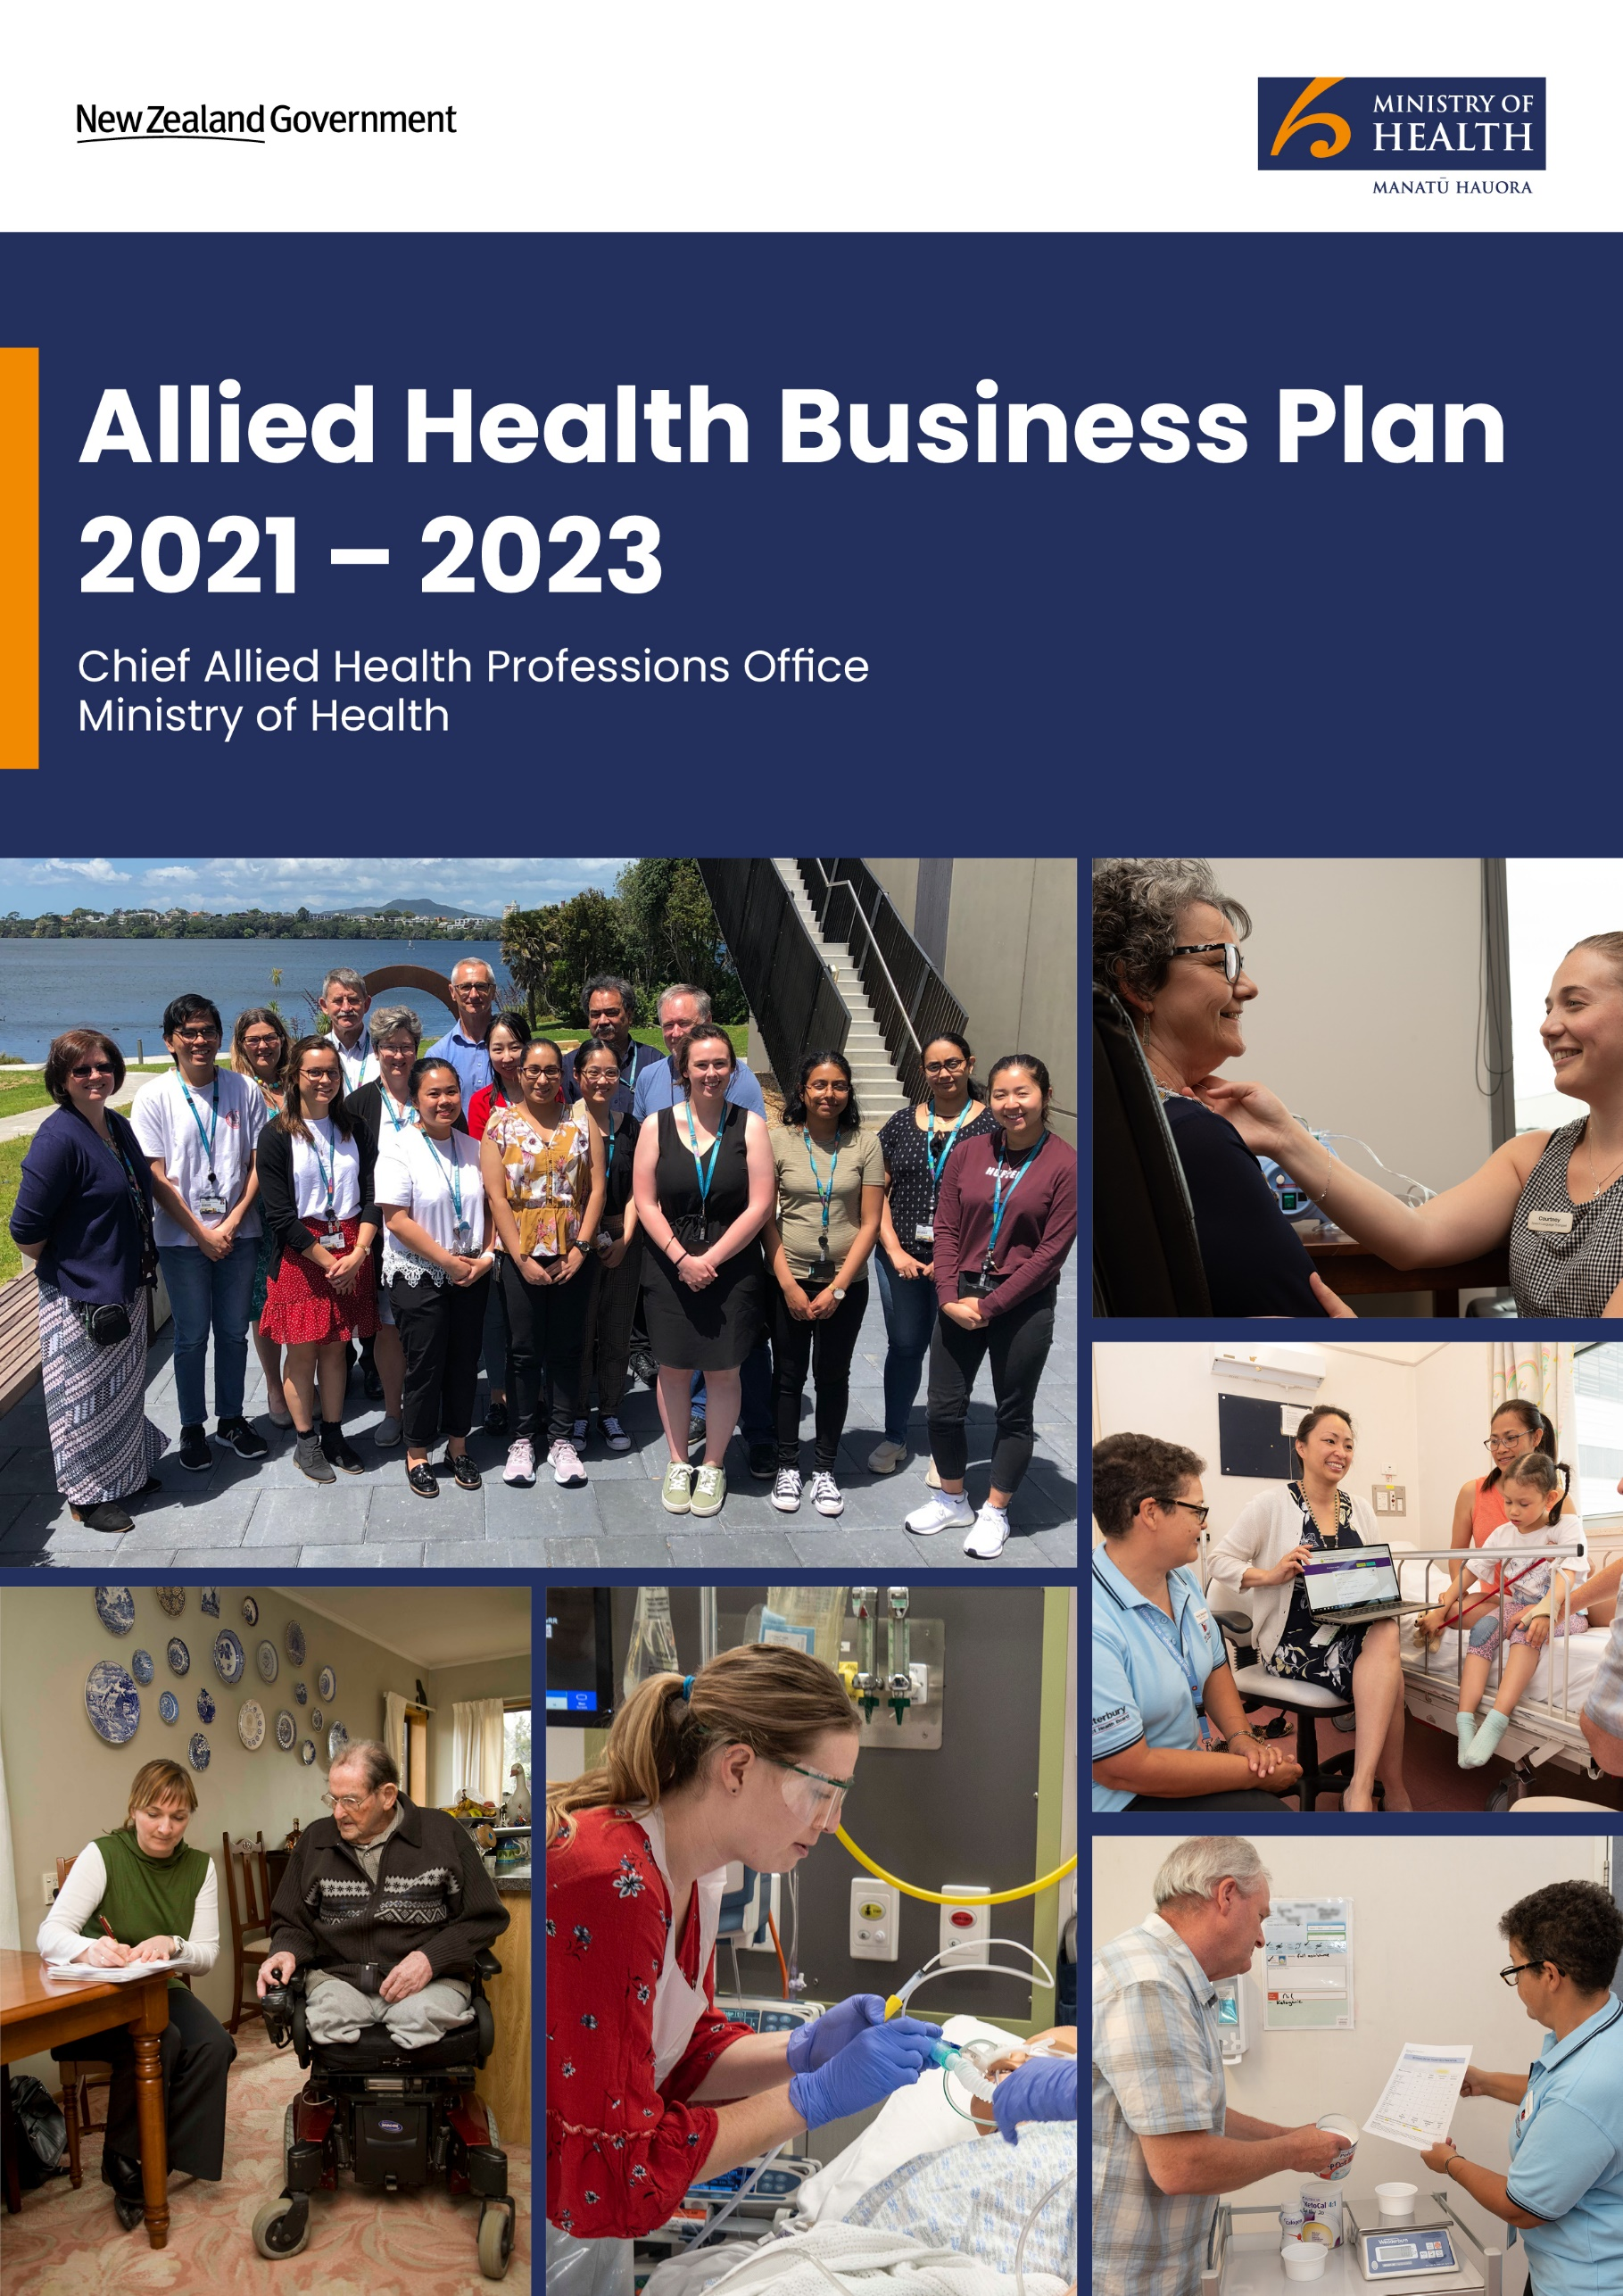

Citation: Ministry of Health. 2021. *Allied Health Business Plan 2021–2023*. Wellington: Ministry of Health.

Published in May 2021 by the Ministry of Health  
PO Box 5013, Wellington 6140, New Zealand

ISBN 978-1-99-100719-3 (online)  
HP 7620



This document is available at [health.govt.nz](http://www.health.govt.nz)

|  |  |
| --- | --- |
| **CCBY** | This work is licensed under the Creative Commons Attribution 4.0 International licence. In essence, you are free to: share ie, copy and redistribute the material in any medium or format; adapt ie, remix, transform and build upon the material. You must give appropriate credit, provide a link to the licence and indicate if changes were made. |

# Message from the Director-General of Health

As 2020 drew to a conclusion, I took the opportunity to reflect on a year that was vastly different from the one that was anticipated. It left me immensely proud of the New Zealand health and disability system, the people that enable it and how we responded collectively to the challenge that COVID-19 presented. As we reacted, it brought to the public eye areas of the health and disability system that often go unnoticed. The critical services of our laboratories and the scores of laboratory scientists and technicians who run them are one example of this. There was anxiety as to what might unfold and, along with our nursing and anaesthetic staff, our anaesthetic technicians, physiotherapists and social workers (to name but a few) planned for what they hoped would never eventuate. Equally, there is a need to acknowledge those members of the health and disability team who contributed by closing their practices as we entered the stringent level 4 restrictions. Many health practices, including chiropractors, osteopaths and podiatrists made significant sacrifices as they continued to care for their community as best they could during this unprecedented period.

It reinforced for me the value of our health care team, working as a team, and the clinical trio that is allied health, nursing and medicine. It was important in my role to ensure I had access to all three components for expert advice and to contribute to service planning.

The Allied Health Business Plan 2021–2023 seeks to lay the groundwork for key concepts around allied health and to communicate the work that is underway specific to allied health as well as the work allied health contributes to. In turn, it seeks to demonstrate how this work aligns to the broader Ministry of Health objective of achieving pae ora, healthy futures for all. There is no one simple solution as to how we are going to achieve this objective, but we do know that continuing to do what we are doing will not get us there. I look to the collaboration and innovation of allied health professions as we seek to use our collective skills and maximise our workforces. Such collaboration and innovation gives me confidence that we can begin to make progress.

In this plan, I see a challenge for the collective allied health group to identify themselves in the work that is described and define their role in contributing to its success.

Dr Ashley Bloomfield

Director-General of Health and Chief Executive, Ministry of Health

# Message from the Chief Allied Health Professions Officer

I feel very humbled to be writing what will be the introduction for the first business plan for the Chief Allied Health Professions Office within the Ministry of Health (the Ministry). To be able to produce this document is an acknowledgement of the contribution from the broad and skilled group of professions that make up our country’s allied health workforce. This document enables us to explore beyond the term ‘allied health’ – it includes the scientific and technical professions’ contributions to the delivery of effective and necessary health services for the population of New Zealand.

The Chief Allied Health Professions Office and the role of the Chief Allied Health Professions Officer (CAHPO) exist as part of clinical leadership within the Ministry, working in partnership with the Chief Nursing Officer and Chief Medical Officer. This clinical team functions in recognition of the fact that there are no easy answers when it comes to designing health services to better meet the future needs of our population. It is only by working together across boundaries and maximising our relative skill sets that we are likely to find the solutions we seek.

Many of the allied health professions have a rich and proud history that demonstrates a growing maturity, and we have worked hard in this document to ensure that we harness these skills, talents and abilities appropriately; and to look at how there can be a continual redirection to the changing needs of our country’s population. Within the Ministry, this work is articulated as ‘pae ora’, or healthy futures; where we live longer in good health, have improved quality of life and have health equity for Māori and all other peoples. Simply put, we need to ensure we are contributing to this goal, seeking to plan and deliver work that will contribute to this end.

This business plan instils in me a quiet confidence; I believe we have only just started the journey of truly harnessing the collective strength and benefit of the allied health professions. The business plan offers real solutions to how services can be provided to our people more effectively, more efficiently, and allowing greater access to services (which has always been a detractor to providing equitable services). The challenge lies in changing the system to be the enabler. However, if we have learnt nothing else from the COVID-19 period of 2020, it is that we can be nimble and can change rapidly when there is a collective will to do so.

As such, I offer to you the Allied Health Business Plan from the Ministry of Health for the period 2021–2023. No doubt the intent will change and morph over time, and this is why we have chosen to restrict this initial plan to three years. However, it marks the start of our work, and I invite you to see where you fit in our journey towards pae ora.

Dr Martin Chadwick signature

Dr Martin Chadwick

Chief Allied Health Professions Officer, Ministry of Health

Contents

Message from the Director-General of Health iii

Message from the Chief Allied Health Professions Officer iv

Introduction 1

Intention 1

Intended outcomes 2

Allied health: A term of inclusiveness in New Zealand 3

Scope 4

Commitment to Te Tiriti ō Waitangi 5

Tino rangatiratanga 5

Equity 6

Active protection 6

Options 6

Partnership 6

Office of the CAHPO vision statement 7

To improve health outcomes for priority populations in the community 7

To enhance the value of allied health services in preventing acute care need in primary health care 7

To provide high-quality services that meet the needs of consumers and their whānau 8

To support allied health services to use available technologies and digital therapies to enhance their practices 8

To support the allied health workforce to develop services based on contemporary and accurate data 8

Developing a common language for allied health services 9

Transdisciplinary 9

Model of care 11

Positioning allied health 12

Key Stakeholders: 13

National organisations 13

National providers/networks 13

International stakeholders 13

National health system stakeholders 14

Training 16

Systems and processes 16

Networks 16

Population health 16

Workforce personnel 17

Stakeholders 17

Setting an initial direction: The allied health five challenges of 2019 18

Key drivers 19

Tertiary drivers and work packages 21

Conclusion 25

References 26

List of Tables

Table 1: Distinction in terms that relate to the word ‘disciplinary’ in the health care setting 9

Table 2: Key issues to consider in applying a model of care in a health practice situation 11

List of Figures

Figure 1: The structure of the New Zealand health and disability sector 12

Figure 2: Key stakeholders in the Allied Health Business Plan 2021–2023 14

Figure 3: The intersect of influential factors across aspects of the allied health workforce context 15

Figure 4: The five challenges for allied health revisited 18

Figure 5: Key drivers 20

# Introduction

The allied health workforce is made up of professionals who are not part of the medical or nursing professions. There are at least 43 professions who are classed as allied health professions in New Zealand. They are autonomous practitioners who work in a variety of health and disability settings and often work in multidisciplinary teams. The adopted definition for the allied health professions comes from the 2012 International Chief Health Professions Officers network:

Allied Health Professions are a distinct group of health professionals who apply their expertise to prevent disease transmission, diagnose, treat and rehabilitate people of all ages and all specialties. Together with a range of technical and support staff they may deliver direct patient care, rehabilitation, treatment, diagnostics and health improvement interventions to restore and maintain optimal physical, sensory, psychological, cognitive and social functions. (University of Illinois 2021)

There is considerable breadth of scope in practice and models of care across the allied health, scientific and technical professions, with significant potential to meet the needs of the New Zealand population. Whilst our population continues to grow and the emphasis of its needs continues to change, the health system is continually looking to evolve and meet those identified needs. Allied health professions are uniquely positioned to provide preventative and restorative interventions alongside diagnostic, rehabilitative and sustaining services.

The allied health workforce is using opportunities to engage with the ‘whole-of-system’ model of services, addressing the continuity of service provision and fulfilling the patient-centred approach to service provision. It is actively engaged in driving initiatives that apply and integrate data and digital methods into everyday practices. Where allied health services are evolving to meet the current societal conditions, models of care, advanced scopes of practice and a transdisciplinary lens are strengthening the impact of those services in preventing health deterioration and sustaining the wellbeing of the population.

## Intention

The purpose of this document is to detail the business plan of the Office of the Chief Allied Health Professions Officer (CAHPO) of the Ministry of Health (the Ministry) for 2021–2023.

As the allied health community collectively and individually works to raise its profile, it has demonstrated its value to the health and disability system and develop novel models of care that meet the complex changing population health needs. This plan underpins and supports the role of the CAHPO to unite these intentions and establish a clear path forward to co-design effective health and disability services for the future.

This business plan’s content is subject to change and adjustment as events or ministerial priorities dictate.

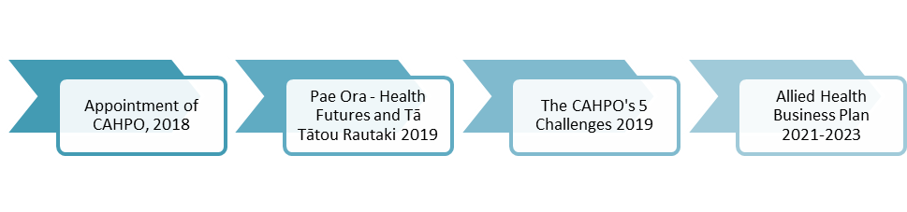

## Intended outcomes

* 1. To improve health outcomes for priority populations in our communities
  2. To evidence the value of allied health services working to prevent acute care need in primary health care
  3. To provide high-quality services that meet the needs of patients and their whānau
  4. To help the allied health workforce use available technologies and digital therapies to enhance its practices
  5. To support the allied health workforce to develop services based on contemporary and accurate data.

The Allied Health Business Plan 2021–2023 is framed by *Whakamaua: Māori Health Action Plan 2020–2025* (Ministry of Health 2020e) and aligns to pae ora – healthy futures and Tā Tātou Rautaki: Our strategy, the Ministry’s organisational strategy (Ministry of Health 2020b). Given the reforms proposed in the *Health and Disability System Review* (HDSR 2020), we will continue to to reconsider the alignment of this business plan as implementation of the HDSR progresses.

# Allied health: A term of inclusiveness in New Zealand

In its simplest sense, ‘allied health’ is a term that can have any meaning ascribed to it. Commonly in New Zealand within district health boards (DHBs), leadership roles for this workforce will be described as ‘Allied Health Scientific and Technical’ to ensure that the professions that fall under the ‘Scientific and Technical’ banner are not excluded. To be explicit, allied health is being used in this document in its broadest sense, a term to be inclusive of all 43+ professions, including scientific and technical professions not explicitly labelled as allied health professions.

There is a history to the term, originating in 1966 in the United States of America from a gathering of university deans who were struggling to formulate a descriptive term that encompassed the many professions that were not nursing or medical doctors but that related to health care, and so they settled on the term ‘allied health’. Today in the United States, the term adheres tightly to legislation, and professions often seek to remove themselves from its banner unless funding options are involved. In the United Kingdom, the term being imbedded in policy development around the many ‘other’ professions, and in Australia, the history is one of managing the ‘other’ professions.

But, in New Zealand, the situation is different. ‘Allied health’ has been about leadership from the first inception of the term in Auckland in the 1990s. And so it continues to be. This document does not intend to define who is ‘in or out’ but rather invites those who are professionals in their own right to have a home and advocacy option. The desire is for a profession to *want* to be included in the definition due to the benefits and direction this business plan seeks to define.

# Scope

As noted above, the New Zealand allied health workforce is made up of health professionals who are not part of the medical or nursing professions. Allied health professionals are autonomous practitioners who work in a variety of health care settings and often work in multidisciplinary teams. The allied health workforce is regulated in two ways: national regulation under the Health Practitioners Competence Assurance Act 2003 (HPCA Act) or the Social Workers Registration Legislation Act 2019 (SWRL Act). They may also be self-regulated by a professional body.

Identifying 43 professions as being allied health professions is somewhat arbitrary. The literature describes several attempts to define to a finite number of professions belonging to this whānau, but all fail to some degree to provide the definitive list. Thus, we are taking an inclusive approach to provide a home in the Ministry for the many professions that could fall under the allied health umbrella.

Sociologically there is much to support what it is to be a profession in health care. A useful framework is offered by Abraham Flexner (1916) and his thoughts that a profession must:

* do something, for example, have a specific skill set it applies
* have a body of knowledge specific to what it does
* have a defined training programme
* be organised in some way
* have ethical standards particular to what it does
* have an altruistic intent, that is, contribute to the betterment of society.

This framework is useful as it also provides a way to enable new forms of health care profession to emerge over time.

# Commitment to Te Tiriti ō Waitangi

The New Zealand health and disability system is committed to fulfilling the special relationship between Māori and the Crown specified under Te Tiriti ō Waitangi (Te Tiriti). Meeting our obligations under Te Tiriti is necessary if we are to realise the overall aims of [He Korowai Oranga: Māori Health Strategy](https://www.health.govt.nz/our-work/populations/maori-health/he-korowai-oranga) (Ministry of Health 2020a) and improve outcomes for the health and disability system as a whole. This includes a desire to see all New Zealanders living longer, healthier and more independent lives.

Te Tiriti obligations underpin [Whakamaua: Māori Health Action Plan 2020–2025](https://www.health.govt.nz/our-work/populations/maori-health/whakamaua-maori-health-action-plan-2020-2025) (Whakamaua) (Ministry of Health 2020e), which sets the government’s direction for Māori health advancement over the five years from 2020 to 2025. The Allied Health Business Plan 2021-2023 will support the implementation of Whakamaua and work to identify opportunities to partner with Māori health professionals as we deliver on our objectives.

Where the principles of Te Tiriti underpin the Ministry’s commitment to Te Tiriti and guide the actions outlined in Whakamaua, they also apply to the wider health and disability system (Ministry of Health 2020c, 2020e). Allied health professionals seek to fulfil their obligations to Te Tiriti with reference to Whakamaua, pae ora and Tā Tātou Rautaki (Ministry of Health 2019, 2020b, 2020d).

In aligning with Whakamaua, the Office of the CAHPO will seek to fulfil Te Tiriti principles through the following five strategic intentions.

## Tino rangatiratanga

Ngā Pou Mana and all identifiable Māori allied health groups are key stakeholders in this strategic plan, its associated work programmes and continued development of the plan in ongoing iterations. The Office of the CAHPO will work in partnership with these groups to address the design, delivery and monitoring of health and disability services.

## Equity

The Office of the CAHPO will work across public and private service providers to prioritise modelling delivery of services to achieve equitable health outcomes for Māori. We will be working on the principle that if we get it right for Māori, we get it right for all.

## Active protection

The Office of the CAHPO aims to identify specific work programmes that can improve Māori health outcomes and equity of service. We will seek to engage across our key stakeholders and sector services and regularly identify work initiated to address Māori health equity and improvements in Māori health outcomes.

## Options

Allied health services have significant potential to meet the needs of the Māori population and their communities. A focus will be on addressing the models of services delivery by supporting the expression of hauora Māori models of care, including kaupapa Māori and whānau-centred services.

## Partnership

Allied health professionals are inherently collaborative and take a predominantly biopsychosocial lens to service delivery. Working in partnership, across the whole system will serve to support partnership in governance, design, delivery and monitoring of health and disability services.

# Office of the CAHPO vision statement

“Allied health professions of the future will be appropriately positioned to meet the population’s health needs through the personalisation, rehabilitation and sustainment of their health and wellbeing” (Martin Chadwick, 2021).

It is essential that the allied health business plan align to the Ministry’s key priorities (see Figure 5). The tasks to achieve the plan’s elements will form part of the internal work programme of the CAHPO’s team.

## To improve health outcomes for priority populations in the community

There are groups of health consumers who have the potential to achieve better health outcomes, Allied health services will target those groups and develop responses to meet the needs of those groups and improve their health outcomes.

## To enhance the value of allied health services in preventing acute care need in primary health care

Allied health services use remedial and compensatory models of care to sustain and maintain health and prevent deterioration of health conditions in the community. They provide alternate and complimentary options to the usual medical services provided across the health and disability system. In partnership with other Ministry directorates, the CAHPO’s team will identify opportunities to develop allied health services across primary health care services. Collaboration with primary health care exemplar services will enable us to highlight the factors for success that can be shared across the allied health workforce.

## To provide high-quality services that meet the needs of consumers and their whānau

The allied health workforce provides consistent high-quality services when its resources match service demand. Patient health can be affected when workforce populations are vulnerable to training providers, critical volume or recruitment. Ensuring sustainability of the workforce’s skills and expertise is a key priority.

## To support allied health services to use available technologies and digital therapies to enhance their practices

As digital health solutions become increasingly integrated across health and disability services, the allied health workforce needs to integrate and implement solutions that enhance and contemporise its service delivery. Partnering with the health and disability sector to identify areas where digital advances can enhance practices will support effective and efficient service delivery.

## To support the allied health workforce to develop services based on contemporary and accurate data

The use of evidence-based knowledge to enhance and develop services is essential in our complex and fast-paced health and disability system. The ability to report on data from across New Zealand will positively influence service planning, provision and future design.

# Developing a common language for allied health services

As this is the first time such a business plan has been developed for allied health services, we recognise there may be terms that we use that are new and/or require specific definition. Below, we define the following two significant terms: ‘transdisciplinary’ and ‘model of care’.

## Transdisciplinary

Teams working in the health care setting have increasingly demonstrated their ability to improve service delivery. There is, however, often confusion around variants of the term ‘disciplinary’ as it relates to health service delivery. Table 1 below sets out standard definitions of the various terms.

Table : Distinction in terms that relate to the word ‘disciplinary’ in the health care setting

|  |  |
| --- | --- |
| **Term** | **Definition** |
| Intradisciplinary | ‘Within’: Where care is broadly provided by one person or professional group. |
| Interdisciplinary | ‘Between’: Where care is provided by engaging more than one person or profession. Interdisciplinary care requires communication to facilitate the delivery of care, with the communication predominantly via a formal referral process. |
| Multidisciplinary | ‘With’: Where a formal team is engaged in providing care delivery – the team has clearly defined roles and responsibilities and associated hierarchy. |
| Transdisciplinary | ‘Across’: Where a team is engaged in care delivery, with the person receiving the care being a part of the team. Roles and responsibilities within the team are understood with actual care delivery being fluid and dependent on who is best placed to be delivering services. |

It is difficult to provide a single clear definition of the term ‘transdisciplinary practice’. However, bespoke definitions for a practice setting and philosophy for the New Zealand context might be as follows.

* 1. As a practice context: Transdisciplinary practice integrates the components of a clinician’s experience and their beliefs and preferences, along with appropriate contextual evidence. When interpreted in the context of setting and available resources, this idea allows for shared and negotiated decision-making around appropriate care options.
  2. As a practice philosophy: Transdisciplinary practice recognises the strength of team and the benefit of individual expertise (including from the patient receiving the services and their whānau), while also recognising that, with a team approach, the allocation and delivery of tasks are shared across the team, often circumventing traditional professional boundaries.

These definitions contextualise the summation of international research and evidence into a New Zealand context. To make it both meaningful and helpful however, this concept needs to be considered from a Māori world view.

# Model of care

A “Model of Care” (MOC) broadly defines the way health services are delivered. It outlines best practice care and services for a person, population group or patient cohort as they progress through the stages of a condition, injury or event. It aims to ensure people get the right care, at the right time, by the right team and in the right place (Government of Western Australia in Agency for Clinical Innovation 2013, page 3).

To ensure that this concept is consistently discussed using the same lens, there are key issues to consider in applying or integrating a model of care into a health practice. These key issues are outlined in Table 2 below.

Table : Key issues to consider in applying a model of care in a health practice situation

|  |  |
| --- | --- |
| **Guiding principles** | **Integral factors** |
| * Is patient centric * Is contextualised and considers equity of access * Supports integrated care * Ensures efficient use of resources * Supports safe, quality care for patients * Has a robust and standardised set of outcome measures and evaluation processes * Is innovative and considers new ways of organising and delivering care * Sets the vision for services in the future. | * Is based on best available evidence * Links to strategic plans and initiatives * Has been developed in collaboration with key stakeholders across the system * Considers economic impact and opportunities * Extends across the patient journey through different care providers * Considers speciality and priority populations of patients. |

Source: Agency for Clinical Innovation 2013

It is important to note that a model of care can apply to person, population group or patient cohort. For the allied health workforce, there are significant opportunities to work collaboratively across professional groups in developing a model of care that will meet patient needs. The development approach can be intra-, inter-, multi- or transdisciplinary in order to best meet those needs.

# Positioning allied health

There are approximately 220,000 people in the New Zealand health and disability workforce, making it the largest single industry in the country (HDSR 2020, page 182). Allied health professionals work across the health and disability, public and private, primary, secondary and tertiary health sectors. They work in hospitals, aged care residences, clinics, hospices, schools, shelters, primary care health hubs and patients’ homes.

As indicated in Figure 1 below, allied health professionals are integrated across the structure of New Zealand’s health and disability sector. Providers such as the Accident Compensation Corporation (ACC), insurance companies, DHBs, private and non-governmental organisations all deliver allied health services. The funding and regulatory and contractual arrangements differ across services, professions and providers.

Figure : The structure of the New Zealand health and disability sector

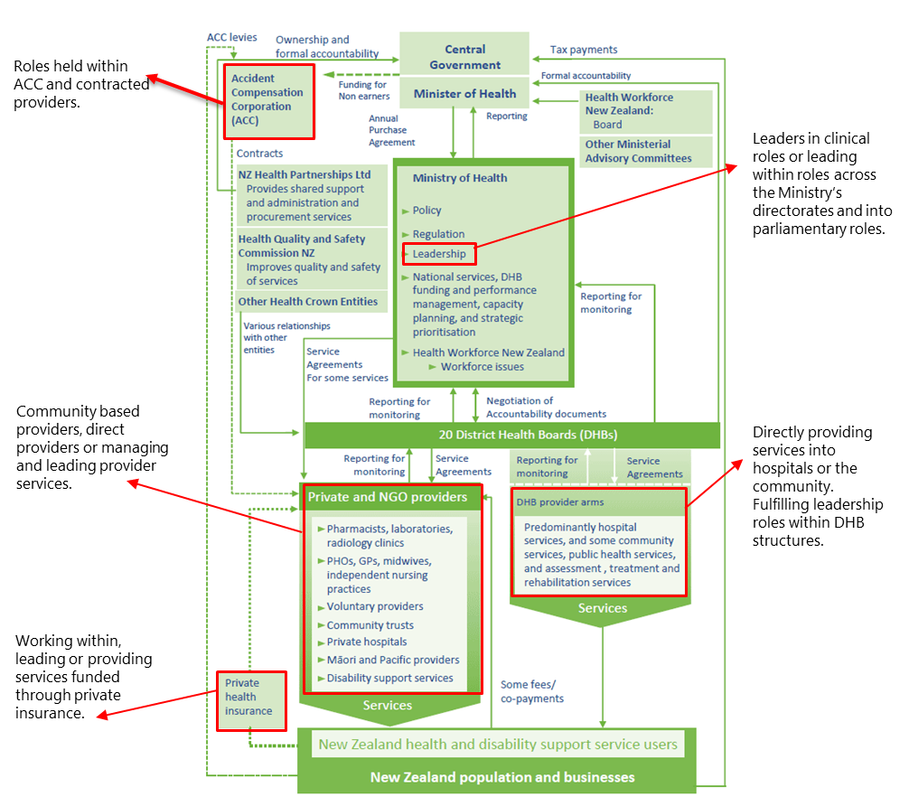

Source: Ministry of Health 2017

The connections and relationships between the health and disability sector and the chief clinical officers at the Ministry underpin the significance and value of the chief clinical officers’ leadership. The provision of clinical governance, stewardship and strategic oversight is essential in developing the future health and disability system. The success of any clinical governance role however depends on effective networks and relationships across the health and disability sector. Key sector relationships for allied health, include the following four groups.

## Key Stakeholders:

## National organisations

* Allied Health Aotearoa New Zealand[1]
* The profession’s responsible authorities
* Tertiary training organisations

## National providers/networks

* The National Directors of Allied Health, Scientific and Technical Forum
* The National Allied Health, Scientific and Technical Informatics Group
* The national Care Capacity and Demand Management (CCDM) Advisory Directors of Allied Health (DAH) Group
* National equity stakeholders – Ngā Pou Mana, Pasifika Allied Health Aotearoa New Zealand (PAHANZ)

## International stakeholders

* Chief Allied Health Officer, Department of Health, Australian Government
* Chief Allied Health Professions Officer, NHS England
* International Chief Allied Health Professions Officers (ICHPO)
* Allied Health Professions (AHPs), NHS Improvement, NHS England

## National health system stakeholders

* Union partners – Association of Professional and Executive Employees (APEX) and the New Zealand Public Service Association (PSA)[2]
* DHB chief executives
* Health Informatics New Zealand (HiNZ)**[3]**
* [Clinical Informatics Leadership Network (CiLN)](https://www.hinz.org.nz/page/CiLN)**[4]**
* [Safe Staffing, Healthy Workplaces (SSHW) Unit](https://tas.health.nz/employment-and-capability-building/safe-staffing-healthy-workplaces-sshw-unit/) governance group[5]

Figure : Key stakeholders in the Allied Health Business Plan 2021–2023

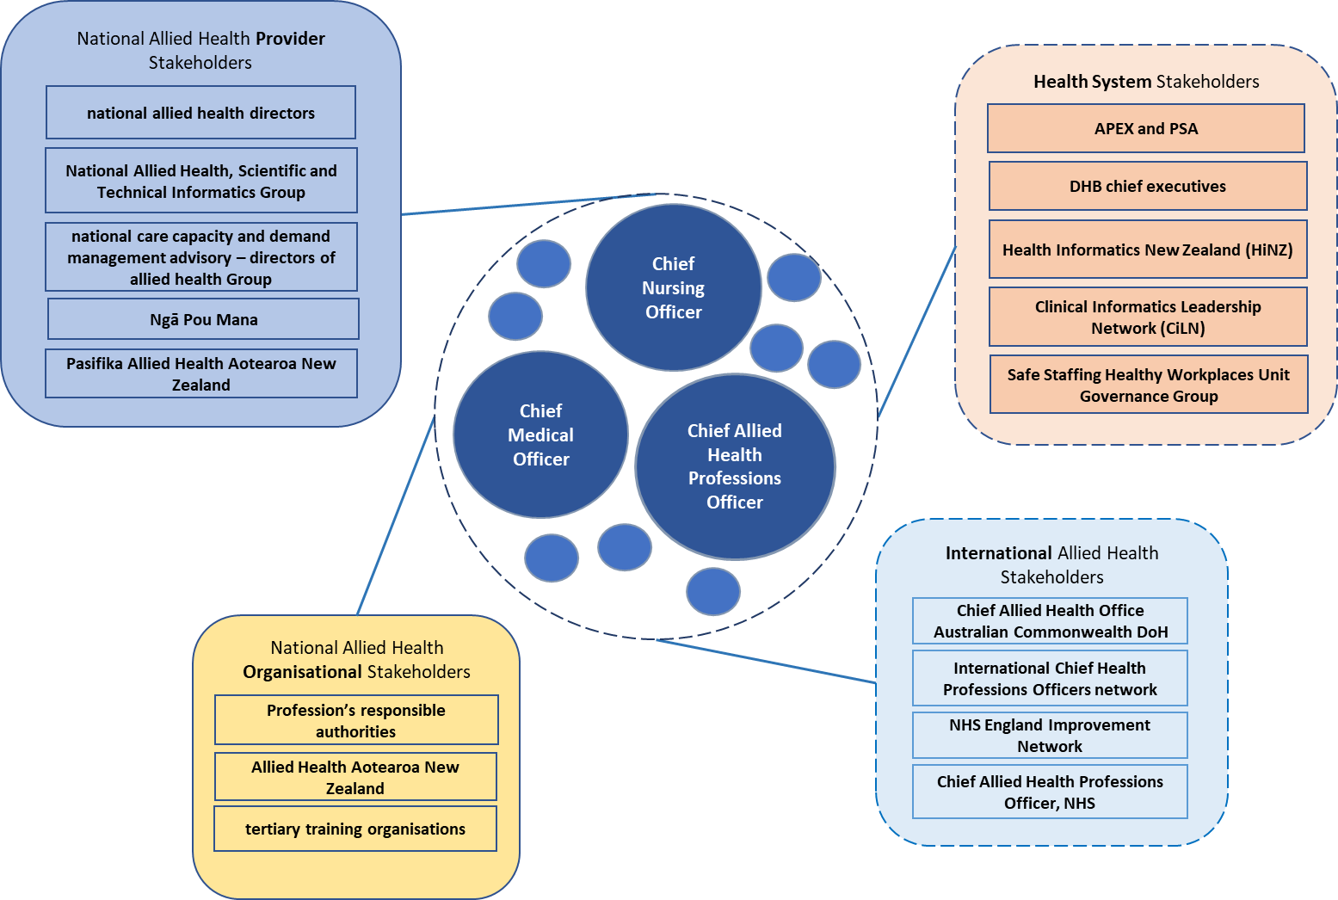

Source: Chief Allied Health Professions Office, 2021

The CAHPO recognises the wealth and depth of expertise accessible to them in their role in the Ministry and appreciates partnering with all who identify themselves as stakeholders in the allied health workforce of New Zealand.

The role of the CAHPO is to provide clinical governance across the allied health professions through advice and guidance to help develop professions and practices. In this context, clinical governance is defined as the context in which ‘organisations are accountable for continuously improving the quality of their services and safeguarding high standards of care by creating an environment in which excellence in clinical care will flourish’ (Scally and Donaldson 1998, page 61).

The CAHPO’s focus in providing clinical governance for the allied health workforce is on creating an environment in which excellence in clinical care will flourish. The vision for this aligns to the Ministry’s vision of being kaitiaki, to support the provision of fair, effective and sustainable allied health services. This strategic plan outlines the change concepts and action work plan, driven by the Ministry’s objectives, that will frame the culture of the allied health workforce’s environment within New Zealand.

Figure : The intersect of influential factors across aspects of the allied health workforce context

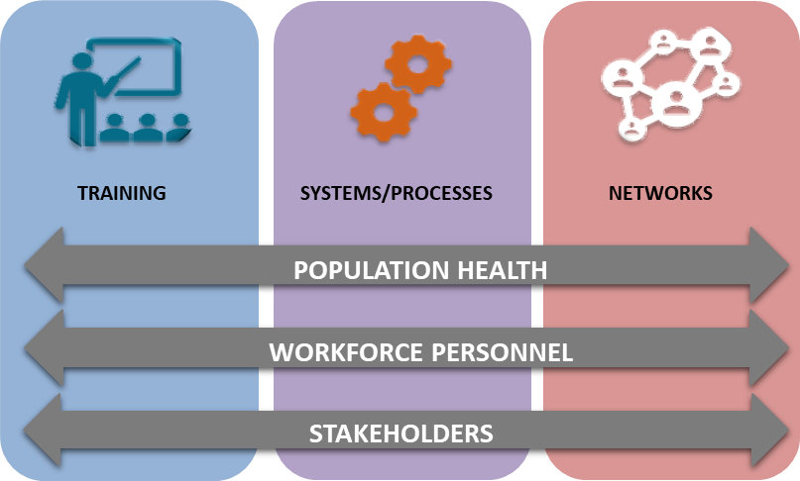

Source: Chief Allied Health Professions Office, 2021

Figure 3 illustrates the three aspects of the allied health context in New Zealand: training, systems/processes and networks. Each of these aspects play an integral role in the existence and practices of allied health professions. The horizontal overlaying of population health, workforce personnel and stakeholders demonstrates how each community influences and is impacted by the three aspects of context. The CAHPO considers each of these six factors when partnering with a profession or group of professions to effectively explore their potential.

## Training

A wide variety of stakeholders contribute to this aspect as well as socio-political and economic drivers, which influence access, equity and funding. The Ministry’s focus spans the interest and application by students to tertiary institutes for training, through the levels of accreditation provided, to recruitment into the workforce and finally to the sustained retention of staff within the health and disability system.

## Systems and processes

A model of care, service delivery or treatment programme often evolves with time. As a workforce, allied health is committed to providing evidence-based services and reviewing existing models to ensure that they align with contemporary evidence-based research. The CAHPO is able to partner with a profession or group to review and facilitate development opportunities.

As the individual professions evolve to meet the needs of the health population, opportunities present themselves for a workforce pipeline or service to be reviewed as well. The location of training providers, volume of staff and provider recruitment are all influential factors on the vulnerability of a workforce. The CAHPO and the Ministry seek to ensure that service delivery is sustainable and that actions are taken proactively to support the future of professional groups.

## Networks

The relationships, connections and networks that span professions, organisations, agencies and authorities are essential to ensure coordinated and co-designed work outcomes. The CAHPO has a broad understanding of how the various networks intersect and operate. This understanding supports the brokering and facilitating of connections to enhance the collaborative nature of allied health work and achieve the desired outcomes.

## Population health

As stated in the *Health and Disability System Review – Final Report*, ‘The challenge is clear. New Zealand has a diverse population with a history of experiencing significantly different health outcomes’ (HDSR 2020, page 3). The health and disability system, which is already facing challenges in managing resources, has now the additional impact of COVID-19, which resulted in significant socioeconomic implications on the delivery and provision of health services.

New Zealand has an increasing number of disabled people, an ageing population and many people living in rural and remote environments. Many people develop complex health conditions that require multidisciplinary involvement. The CAHPO is committed to creating a culture that provides services driven by patient need. Ensuring collaboration across boundaries defines the positive action work plan of this Allied Health Business Plan 2021–2023 (HDSR 2020).

## Workforce personnel

On its webpage ‘About Us’, Allied Health Aotearoa New Zealand reports that it represents 30,000 allied health professionals (Allied Health Aotearoa New Zealand 2020). We can expect that to be a conservative representation of the number of individuals making up this country’s allied health workforce. The workforce is the second largest in New Zealand and includes at least 43 different professional groups (Ministry of Health, 2021f). Working across private and public health and disability providers, the workforce provides generalist and specialist services that span the range, from birth to palliative care needs. The CAHPO seeks to partner across the workforce to empower and facilitate engagement in exploring what the future may look like.

## Stakeholders

Working with key stakeholders ensures transparency, rigour in process and effective communications across health and disability networks. Recognition of and partnerships with allied health stakeholder groups can generate the springboard from which the Ministry can explore options to develop effective clinical governance.

# Setting an initial direction: The allied health five challenges of 2019

At the beginning of 2019, the CAHPO identified five challenges that set the direction for developing the allied health workforce and service delivery and positioning professions within the health and disability system. These challenges provide a working philosophy for the work done by allied health services and considers how the CAHPO can meet the challenges within the Ministry and in turn can support the broader health and disability sector to do the same.

Figure : The five challenges for allied health revisited

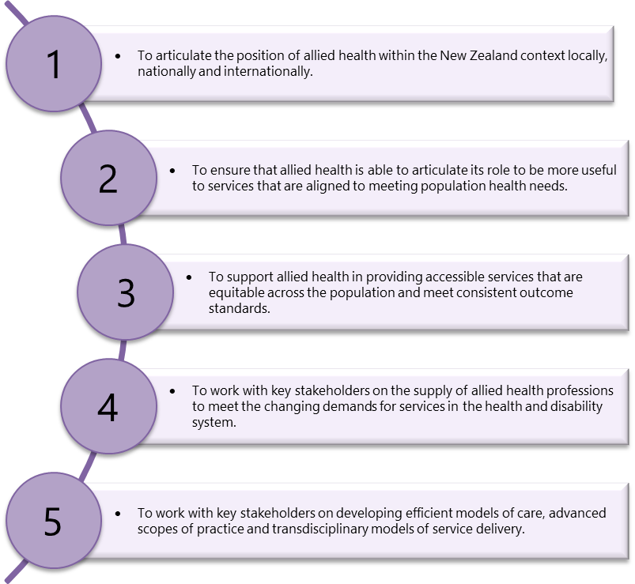

## Key drivers

To meet these five challenges, the CAHPO’s office has sought to align pieces of work already underway with future requirements. The office has reviewed the work in its entirety to ensure it aligns to the Ministry’s priorities. Figure 5 below outlines the key drivers that attempt to capture the work we have in progress and how this work flows through to align ultimately with the Ministry’s priorities. As previously stated, any updates to the Ministry’s broader organisational strategy will be reflected in the ongoing iterations of the allied health business plan.

Figure : Key drivers

- 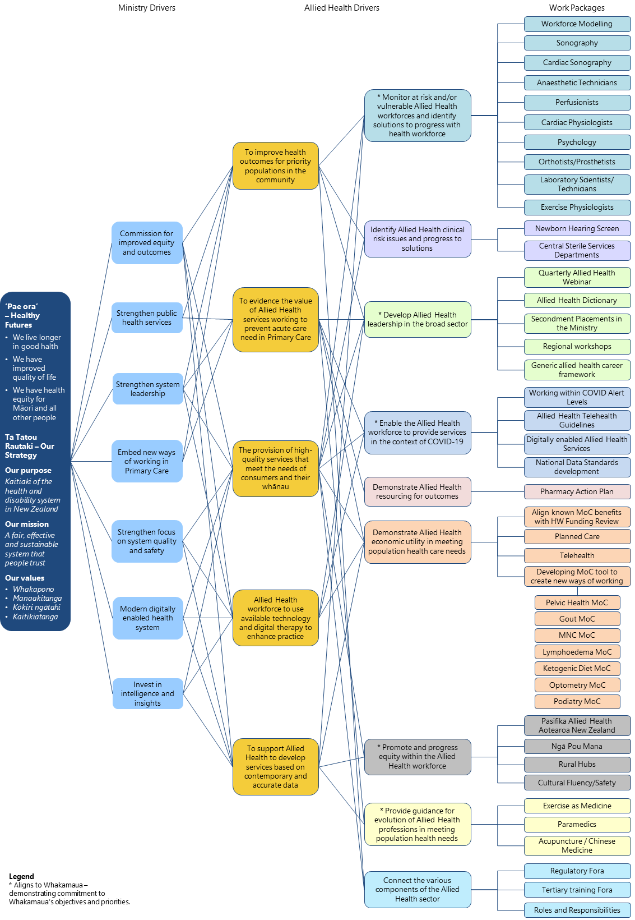

## Graphical user interfaceTextGraphical user interfaceGraphical user interfaceGraphical user interfaceGraphical user interface Tertiary drivers and work packages

The breakdown to tertiary drivers provides the opportunity to tailor a strategic response and the work packages required to ensure measurable outcomes. It allows for specificity and a focus on identifiable pieces of work. Work is underway in most of these areas and we will seek to report progress at each quarter.

| **Allied health drivers** | **Work packages** |  |
| --- | --- | --- |
| Monitor at risk/vulnerable allied health workforces and identify solutions to progress with the Health Workforce directorate of the Ministry  *Several allied health workforces are vulnerable due to a range of risk factors. These factors include size of workforce, training provision and attrition. Sustaining and developing the supply of staff into the health and disability system is essential to meet the ongoing demand for services.* | Workforce modelling | Work with the health workforce to better understand future costs and current and future workforce pressures. |
| Sonography | Work on establishing a sustainable workforce pipeline that produces a safe and competent workforce for the New Zealand health system. |
| Cardiac Sonography | Work on establishing a sustainable workforce pipeline that produces a safe and competent workforce for the New Zealand health system. |
| Anaesthetic Technicians | Transition to a new training programme and ensure sustainability. |
| Perfusionists | Work on establishing a sustainable workforce pipeline that produces a safe and competent workforce for the New Zealand health system. |
| Cardiac Physiologists | Work on establishing a sustainable workforce pipeline that produces a safe and competent workforce for the New Zealand health system. |
| Psychology | Work on establishing a sustainable workforce pipeline that produces a safe and competent workforce for the New Zealand health system. |
| Orthotists/Prosthetists | Model options for providing workforce training. |
| Laboratory scientists / technicians | Work on establishing a sustainable workforce pipeline that produces a safe and competent workforce for the New Zealand health system. |
| Exercise physiologists | Work on establishing a sustainable workforce pipeline that produces a safe and competent workforce for the New Zealand health system. |
| Identify allied health clinical risk issues and progress to solutions  *Where an opportunity arises to enhance practices and ensure that clinical risk can be reduced, this opportunity will be taken. Working in partnership with the health and disability sector to explore, solve and implement change is essential in mitigating the risk.* | Newborn hearing screening | Monitor quality controls to ensure a competent workforce delivery and continued screening service. |
| Central sterile services departments | Monitor implementation of solutions to assure quality standards are being met and abided by nationally. |
| Develop allied health leadership in the broad sector  *Improved health outcomes elicited from clinical staff’s effective leadership of health and disability services is evidenced by international research. The allied health workforce bring an inclusive biopsychosocial lens to the evolution of leadership in our future health and disability service.* | Quarterly allied health webinar | Deliver national webinars to communicate the current Ministry direction and associated allied health contributions. |
| Allied health dictionary | Deliver a concise collection of allied health professions, training pathways, professional support and current workforce issues. |
| Secondment placements at the Ministry of Health | Develop the Ministry’s understanding of the health and disability sector by making available short-term secondments into the Ministry. |
| Regional workshops on the CAHPO / the Ministry’s role | Develop sector understanding at the Ministry by making available short-term secondments into the Ministry. |
| Generic allied health career framework | Build on cross-sector understandings of career frameworks regardless of the setting. |
| Enable the allied health workforce to continue to provide expert services in the context of COVID-19  *In response to the COVID-19 pandemic, the allied health workforce has adapted to align its service delivery with alert levels. It is essential to partner with the health and disability sector in order to provide guidance, support and facilitate changes in practice.* | Working within COVID-19 alert levels | Develop key principles to guide services clearly should any alert level changes occur. |
| Use of telehealth guidelines | Build knowledge so that telehealth is seen as a viable and equivalent treatment option, not a step-down option. |
| Digitally enabled allied health services | Support allied health to make the most of data insights and digital solutions to enhance service delivery. |
| Data and the Care Capacity Demand Management (CCDM) programme – national standards development | Establish a data framework that will continue to demonstrate the efficacy of contributing to service delivery from an allied health perspective. |
| Demonstrate allied health resourcing for outcomes  *As medicines-related needs and inappropriate polypharmacy become more complex, there is a need for all-of-system support for medicines optimisation services to optimise medicines-related health outcomes and reduce medicines-related morbidity and mortality.* | Pharmacy action plan | Develop optimisation services that will support best use of our pharmacist medicines expert workforce and support medicines management upskilling across other health workforces. |
| Demonstrate the economic utility of the allied health workforce in meeting population health care needs  *The emphasis on economic efficiencies increases as we strive to provide effective services and meet a growing health service demand. Demonstrating the value of using allied health services and the impact their outcomes can have on socioeconomic factors is key. Identifying opportunities for allied health to provide alternate options demonstrates the services potential value across New Zealand.* | Align known model of care benefits with health workforce funding review | Adopt an investment philosophy to demonstrate where there is known evidence as to what improved outcomes could be delivered and invest into allied health services. |
| Planned care | Build on the principle of informed choice to identify alternate treatment pathways for planned care services. |
| Telehealth | Continue to develop the concept of telehealth services as a viable option in service delivery and not be seen as a step-down option. |
| Develop model of care tool to create new ways of working | To develop a framework that can be used consistently to deliver clinically focused MoC changes that improve service delivery. |
| Apply MoC tool in partnership with:   * Pelvic health * Gout * Motor Neurone Disease * Lymphedema services * Ketogenic diet services * Optometry * Podiatry. | Progressively work through the known clinical areas that are primed for MoC changes. |
| Promote and progress equity within the allied health workforce  *Building on existing partnerships and increasing the participation of aligned networks to protect and support the growth of a diverse workforce.* | Pasifika Allied Health Aotearoa New Zealand (PAHANZ) | Partner with PAHANZ to support Pacific allied health practitioners in identifying viable allied health profession options, as well as supporting them through training and into practice. |
| Ngā Pou Mana (NPM) | Partner with NPM to support Māori allied health practitioners in identifying viable allied health profession options, as well as supporting them through training and into practice. |
| Rural hubs | Identify allied health options to improve access to allied health services and sustainability of the workforce in the rural environment. |
| Cultural fluency and safety | Build sector awareness of the difference in a New Zealand context of cultural fluency (obligations within a bi-cultural society) and safety (living in a multi-cultural society). |
| Provide guidance for the evolution of allied health professionals to meet changing population needs  *Demonstrating the usefulness of allied health services also helps identify opportunities to evolve the diversity of the workforce. It is important to ensure that the population is aware of and is supported to make informed choices about their options for health services.* | Exercise as medicine | Take a sociological view as to how to guide and help professions to continue to grow and mature. |
| Paramedics | Take a sociological view as to how to guide and assist professions to continue to grow and mature. |
| Acupuncture / Chinese medicine | Take a sociological view as to how to guide and assist professions to continue to grow and mature. |
| Connect the various components for the allied health sector  *The allied health workforce and its key stakeholders present a crowded landscape. Bringing a cohesive framework and alignment to those stakeholders will improve partnerships and communication and support a coordinated approach to the strategic direction for the allied health sector.* | Regulatory forums | Bring together the allied health regulatory bodies to look for cohesion and collaboration and consistent information sharing. |
| Tertiary training forums | Bring together the allied health tertiary training agencies to look for cohesion and collaboration and consistent information sharing. |
| Roles and responsibilities | Work with the broader health care landscape to continue to develop understanding of the unique roles that groups have, as well as identifying areas for further and/or new areas of collaboration. |

# Conclusion

Changing demographics along with increasing comorbidities and technology will continue to increase the demand for all parts of the system to act in more multidisciplinary, collaborative ways. Providing services where they are most needed by consumers and in ways which are most accessible will require flexibility on the part of the workforce. Ensuring such behaviours are the norm rather than the exception will require the workforce to look beyond traditional professional scopes of practice and work together in different ways (HDSR 2020, page 202)*.*

Much of what has been discussed in this business plan has been about laying foundations and aligning work to the overarching goal of pae ora – healthy futures. But this is just a start. There is much that has not been covered that will need to be captured as this plan is revisited, updated and re-issued. There is much to be done to collate the many ways allied health can deliver very real solutions to the growing needs of our population. The commitment is to continue to work with everyone to ensure the potential of allied health services is realised for the benefit of our population.

# References

Agency for Clinical Innovation. 2013. *Understanding the Process to Develop a Model of Care.* Chatswood, NSW: Agency for Clinical Innovation.

Allied Health Aotearoa New Zealand. November 2020. *About Us*. Retrieved from Alllied Health Aotearoa New Zealand: [www.alliedhealth.org.nz/about-us.html](http://www.alliedhealth.org.nz/about-us.html).

Chief Allied Health Professions Office. 2021. Allied health stakeholders. *Key Stakeholders for Allied Health.* Wellington: Ministry of Health.

Chief Allied Health Professions Office. 2021. The intersect of influential factors across aspects of the allied health workforce context. *The Allied Health Workforce.* Wellington: Ministry of Health.

Flexner A. 1916. *A Modern School.* History of Education Book Gallery. Retrieved from <https://scholarworks.uni.edu/education_history/1/>

Health and Disability System Review. 2020. *Health and Disability System Review – Final Report – Pūrongo Whakamutunga.* Wellington: HDSR. Retrieved from <https://systemreview.health.govt.nz/assets/Uploads/hdsr/health-disability-system-review-final-report.pdf>.

Martin Chadwick CA. February 2021. *Allied Health Vision Statement*. Interviewer: Becky George.

Ministry of Health – Manatū Hauora. 2013. *He Korowai Oranga.* Wellington: Ministry of Health. Retrieved from <https://www.health.govt.nz/system/files/documents/pages/whakamaua-tiriti-o-waitangi-framework-a3-aug20.pdf>.

Ministry of Health. October 2019. *What we do.* Retrieved from Ministry of Health: <http://intranet.moh.govt.nz/about-ministry/what-we-do#Pae%20ora>.

Ministry of Health – Manatū Hauora. 2020. *Whakamaua: Māori Health Action Plan 2020-2025.* Wellington: Ministry of Health. Retrieved from [www.health.govt.nz/our-work/populations/maori-health/whakamaua-maori-health-action-plan-2020-2025](http://www.health.govt.nz/our-work/populations/maori-health/whakamaua-maori-health-action-plan-2020-2025).

Ministry of Health. 2020. *Work Programme 2019/20*. Retrieved 31 August 2020 from Ministry of Health: [www.health.govt.nz/about-ministry/what-we-do/work-programme-2019-20](http://www.health.govt.nz/about-ministry/what-we-do/work-programme-2019-20).

Ministry of Health. January 2021. *Leadership*. Retrieved February 2021 from Allied Health: [www.health.govt.nz/about-ministry/leadership-ministry/allied-health](http://www.health.govt.nz/about-ministry/leadership-ministry/allied-health).

Ministry of Health – Manatū Hauora. nd. *Te Tiriti o Waitangi Framework.* Wellington: Ministry of Health. Retrieved March 2021.

Ministry of Health – Manatū Hauora. nd. *Te Tiriti o Waitangi Position Statement.* Wellington: Ministry of Health. Retrieved March 2021.

Scally and Donaldson. 4 July 1998. Clinical Governance and the drive for quality improvement in the new NHS in England. *BMJ* 317(7150): 61–5. Retrieved from <https://www.ncbi.nlm.nih.gov/pmc/articles/PMC1113460/>.

University of Illinois. 2012. *Department of Allied Health*. Retrieved 1 September 2020 from University of Illinois: [www.uis.edu/alliedhealth/](http://www.uis.edu/alliedhealth/).

1. See Allied Health Aotearoa New Zealand at: [www.alliedhealth.org.nz](http://www.alliedhealth.org.nz)
2. See <https://apex.org.nz/> and [www.psa.org.nz/](http://www.psa.org.nz/) respectively.
3. See the Health Informatics New Zealand website at: [www.hinz.org.nz](http://www.hinz.org.nz)
4. See the Clinical Leaders Group webpage on the HiNZ website at: [www.hinz.org.nz/page/CiLN](http://www.hinz.org.nz/page/CiLN)
5. See the Safe Staffing, Healthy Workplaces (SSHW) Unit webpage on the Technical Advisory Services (TAS) website at: <https://tas.health.nz/employment-and-capability-building/safe-staffing-healthy-workplaces-sshw-unit/>